|  |  |  |
| --- | --- | --- |
|  | |  | | --- | |  | |
|  | **Poverty Reduction Support Facility (PRSF):**  **Implementation Planning**  **Product 1:**  **PRSF to end 2014**  **Final report**  **14th June 2013**  **The Inception Design Team** |
|  |  |

**Table of Contents**

1. Introduction 1

2. Current situation 1

2.1 Broader political environment 1

2.2 PRSF 2

2.3 TNP2K 2

2.4 AusAID 3

3. Priorities for Australian support until end 2014 4

3.1 PRSF – priority work with TNP2K 5

3.2 PRSF – work with GOI’s broader social protection agenda 6

3.3 PRSF – work with AusAID 7

3.4 AusAID’s role 7

4. PRSF implementation of priorities over next 18 months 8

4.1 PRSF management team: enhanced technical capacity to lead QA and clearer lines of accountability 9

4.2 PRSF governance and decision making 14

4.3 Quality assurance 16

4.4 PRSF budget and AusAID funding window 17

Annex 1: PRSF IPR issues to be addressed 2013-2015 23

Annex 2: Detailed quality assurance process 29

Annex 3. Guidance on pilots 32

**Preface**

In the context of AusAID’s support to social protection in Indonesia, AusAID contracted a design team to deliver an implementation strategy for one of the main investments in social protection by AusAID, the Poverty Reduction Support Facility (PRSF). The terms of reference for the design team ask, among other outputs, for a (single) implementation strategy document to guide program managers.

During the inception phase process, the design team and AusAID Indonesia agreed that two distinct implementation strategy documents would be produced: one outlining the period from July 2013 to end 2014 (Product 1) and a second outlining the subsequent period from January 2015 – June 2017. The reasons for this were numerous but most notably included uncertainty over how the current mandates and activities of government institutions, particularly the National Team for Accelerating Poverty Reduction (TNP2K), might change following the forthcoming Indonesian elections. Possible changes in institutional mandates and roles made it difficult for the design team to clearly identify future institutional priorities and activities in the social protection sector and to articulate a single management structure and workplan for PRSF across the full time period.

To overcome this problem, the design team and AusAID agreed that two products, covering distinct time periods of time would be more useful. Product 1 focuses on PRSF support to the activities of TNP2K until December 2014 but also provides guidance on how other funding for PRSF outside of TNP2K, the current ‘AusAID window’ will be used to support activities that lead into PRSF activities after 2014. Product 2 provides a strategic framework for the second phase including a theory of change, program logic and the three components that define the program’s structure, outputs and activities.

AusAID’s support for social protection in Indonesia began in 2010, when the Vice President’s office sought support for the National Team for Accelerating Poverty Reduction. This document has been prepared three years on to calibrate AusAID’s medium-term support, and consider arrangements for a possible next phase. It should not be read as a review of program progress to date, but rather focuses on adjusting management arrangements going forward.

**Acknowledgements**

The team would like to thank everyone who has helped us to deliver the product that AusAID needs, in order to support Government of Indonesia to reach where it wants to go.

In AusAID, Bernie provided intensive support before, during and after the mission, and we thank him immensely for managing this process and also helping us navigate our way through it. Fiona also provided lots of steer from the AusAID side, in particular the logistical requirements we needed to work with and design around. Scott was a constant source of information, advice and challenge, and we hope that what we have delivered is in some way able to respond to the depth of his understanding of the complexities of achieving change in the Indonesian context. In addition Jurist, Patricia, Thomas, and Jo all also helped us along as and when we needed help. Finally Rachael and Jacqui provided strategic steer to ensure we were in tune with wider objectives of the Australia aid program..

In PRSF we are again indebted to the core team of Patrick, Peter, Abdurrahman, Surya and Jean-Charles for their openness, and willingness to engage in discussions so freely, as well as their sage advice on the pros and cons of the various options we have discussed over time.

This mission did not draw upon TNP2K time as much as the groups mentioned above, largely because of the timeframe for the scale-up program which goes beyond TNP2K’s planned life. But we nevertheless benefitted immensely from guidance provided by both Pak Bambang and Pak Suahasil.

And thanks to all the many people we met with and discussed, as key informants – from government, development partners, civil society organisations, including in the theory of change workshop towards the end of our time in Jakarta.

We hope we have come up with products that you think will work and will help you to achieve what you want.

The design team, 14th June 2013:

Steve Ashley

Rachel Slater

Nicholas Freeland

Tony Land

Catherine Yates

Smita Notosusanto

Jess Dart

**1. Introduction**

Australian support to the Poverty Reduction Support Facility in Indonesia has been provided since 2010, comprising two stages to date: a rapid start-up stage and an implementation stage. In March 2013 AusAID fielded a team to design additional requirements to allow the PRSF to enter a phase of increased funding, starting in 2013-14.

The product of this team is divided into two parts:

* Product 1: this provides additional design suggestions for the period up to the end of 2014, with a primary focus on PRSF support to TNP2K
* Product 2: provides further design for a broader approach to supporting Government of Indonesia’s plans for expanding social protection, for the period 2015 – 2017.

This report is product 1, and is focused on shorter-term actions required to continue support to TNP2K, improve current performance and likely impacts, and direct an increase in funding.

**2. Current situation**

This section outlines the current broader political environment in which PRSF is operating and the possible constraints it may face. It then gives a brief overview of challenges and priorities now facing PRSF, TNP2K and AusAID.

## 2.1 Broader political environment

**Australia and Indonesia are entering political election periods in 2013 and 2014 respectively: this will be a constraint to how PRSF can do business over this period.** Indonesia is preparing for elections of DPR (House of Representatives) members and Presidential elections from April to September 2014. Consequently, the Vice President’s office is keen to leave a legacy of key poverty reduction outcomes focussing upon improving the four main social protection programs: *Raskin* (subsidised rice for the poor), BSM (scholarships for poor children), PKH (the conditional cash transfer program for health and education) and *Jamkesmas* (health fee waiver for the poor) (see table 1). The Vice President has just over 12 months to achieve this. A longer-term goal for Indonesia, as a middle-income country, is a comprehensive social protection program to reduce poverty and inequality but is something that cannot be achieved in the short term.

**Table 1: details of four main Indonesian social assistance programs**

|  |  |  |  |  |  |
| --- | --- | --- | --- | --- | --- |
| **Program** | **Transfer Type** | **Target group** | **Target number of beneficiaries** | **Coverage** | **Executing agency** |
| **Raskin** | subsidised rice | Poor and near-poor households | 15.5 million households | National (24% of poor households) | Bureau of Logistics (Bulog) |
| **Jamkesmas** | Health service fees waived | Poor and near-poor individuals | 86.4 million individuals | National (34.6% of population) | Ministry of Health |
| **BSM** | Cash & conditions | Students from poor households | 15.5 million households | National (24% of poor households) | Ministry of Education & Ministry of Religious Affairs |
| **PKH** | Cash & conditions | Very poor households | 2.4 million households | Pilot (3.7% of poor households in 33 provinces) | Ministry of Social Affairs |

## 2.2 PRSF

**PRSF is demand-driven, and flexible: though it is currently providing a largely administrative support role to TNP2K and needs to play a more facilitatory role.** As noted in the Independent Progress Report (IPR), PRSF is largely seen as an administrative support unit to TNP2K having little engagement with technical aspects of the work.

By doing this, PRSF has built the Government of Indonesia’s (GOI) confidence and trust that Australia can deliver flexible support. As such, PRSF at present is playing a more limited role than that envisaged in the managing contractor scope of services. However, working with TNP2K, as a political body that sits outside the government bureaucracy, requires aspects of a more exploratory and responsive facility. This requires that PRSF strengthens its technical capabilities so that it can go beyond performing predominantly administrative duties, and be more able to address the issues raised in the recent review of PRSF.

## 2.3 TNP2K

**In line with the Vice President’s directions, TNP2K is focussing on improving the four main national social protection programs.** Work is on-going to address various operational and methodological constraints related to *Raskin*, BSM, PKH and *Jamkesmas*, which TNP2K would like to complete by 2014**.** In addition,the Unified Database (UDB) is providing data for the extraction of beneficiary lists for the national programs. TNP2K is keen to refine this, then move it to a permanent institutional home.

**Pilots are seen as being ‘scatter-gun’** **– there is to be a greater focus on a few priority pilots.** TNP2K senior management has requested that the **pilots be moved to PRSF for direct management**, to give TNP2K scope to focus on its Vice Presidential direction of improving the four main programs. Senior management of TNP2K noted that knowledge gathering and management could be done through other institutions, such as by being contracted out to a university, NGO or think-tank. However, TNP2K will want to remain involved in the selection of proposed pilots. See annex 2 for guidance on pilot conceptualisation and selection.

**TNP2K is achieving significant successes; however, research results are not well disseminated.** TNP2K is playing an important initiation and knowledge brokerage role and is producing useful outputs on many different topics. The IPR noted the need to better consolidate and communicate evidence produced by TNP2K, for example in the format of succinct and focussed policy briefs.

The TNP2K Policy Working Group Coordinator indicates that he carries a heavy administrative load, which can distract from his key role. **Senior management support should be provided to the Coordinator immediately**.

## 2.4 AusAID

**AusAID is providing significant oversight of PRSF and TNP2K – but there is tension in AusAID’s relationship with TNP2K, caused by AusAID’s legitimate desire for rigorous quality assurance, and the countervailing imperative of rapid response in a charged political environment.** A lack of clear guidance on quality assurance processes from the outset of the program has hampered efforts to bring in changes two years after the facility’s establishment. Yet, given the scale of investments made into research activities, adequate quality assurance is essential.

That said, the realities of TNP2K reporting to the Vice President also mean it is politically unpalatable for long-lead times on quality assurance when there is an urgency to get things done. TNP2K and AusAID must find middle-ground between best practice and ‘good enough’ practice on quality assurance. Quality assurance should be rigorous, but not onerous.

**AusAID is considering a second phase of assistance to social protection** in Indonesia from 2015-2017. Background technical papers are being developed for this new investment strategy. This will be expanded, with a more strategic approach focusing on:

* Increasing the quality of social protection
* Joining up existing and emerging programs into a comprehensive social protection system
* Enhancing synergies with wider poverty reduction initiatives

Key issues arising include deciding which stakeholders to work with, developing appropriate engagement strategies and ensuring that both AusAID and the facility have the necessary capacity to perform their roles in the case of an increased program budget.

**3. Priorities for Australian support until end 2014**

Over the coming 18 months, PRSF will need to work within the boundaries of GOI’s immediate focus through TNP2K, Australia’s commitment to GOI’s broader social protection agenda, and AusAID’s need for greater quality control of significant investments. Priorities for Australian support and the operating environment are shown in figure 1 below, along with the planned expansion of PRSF post- 2014. Further details on this diagram are provided below.

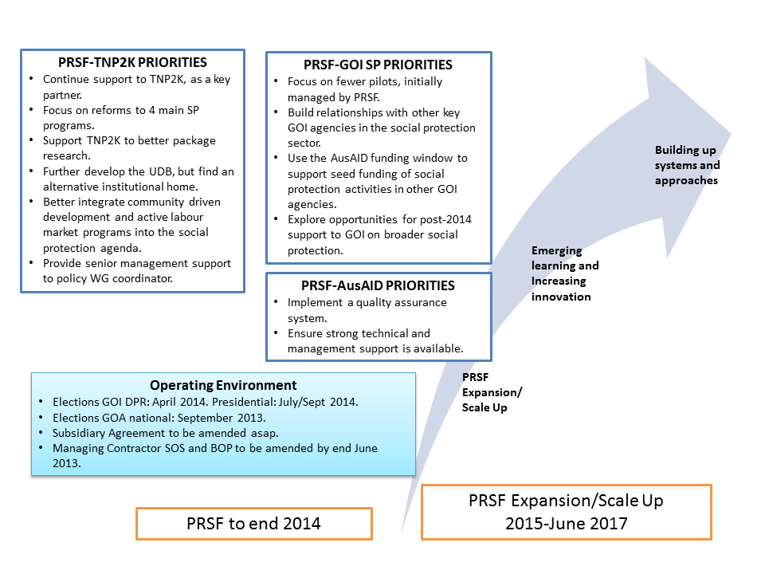

**Diagram 1: Social Protection support priorities and its operating environment (note the GOA election date is subject to change).**

## 3.1 PRSF – priority work with TNP2K

PRSF’s commitments to TNP2K will be honoured. PRSF is to maintain a strong working relationship with TNP2K. It is possible that TNP2K will remain a priority for an in-coming Indonesian government and TNP2K might continue to seek Australian support.

PRSF will continue to work within the scope of TNP2K’s broad three cluster approach until end 2014, that is: social assistance programs; community driven development; and medium and small enterprises.

Until end 2014, **PRSF will support TNP2K with its immediate agenda to**:

* **Improve the four main poverty reduction programs**: *Raskin*, BSM, PKH and *Jamkesmas*. Other broader social protection programs including social security reforms are currently not within TNP2K’s mandate from the Vice President
* **Improve TNP2K’s outreach and reform facilitation function by introducing alternative approaches to change management and process facilitation**
* **Better package and disseminate its research activities.** Good work is being done, but it is not well-known or is not easily accessible/digestible
* **Further develop the UDB**, in particular in partnership with local government, but an alternative institutional home will also need to be found
* **Better integrate community driven development and active labour market programs into the social protection agenda.** These indigenous social protection programs are a priority for GOI
* **Provide administrative support to the TNP2K Policy Working Group Coordinator**. This should remove some of his high administrative load, such as approving travel, and allow him to focus on policy reforms.

## 3.2 PRSF – work with GOI’s broader social protection agenda

**PRSF will, at the same time as working with TNP2K, be more proactive** in progressing the GOI social protection agenda: that is, it must look for opportunities to make things happen, over the next 18 months. PRSF will therefore:

* **Focus on fewer priority pilots, managed by PRSF, as per TNP2K request.** Pilots are a disparate mix of activities – there is scope to focus on what can realistically be done well between now and end 2014. Work on implementing new social assistance pilots (currently Cluster 1) is not an area TNP2K wishes to maintain at this stage. Pilots will sit in PRSF until an alternative institutional home is found.
* **Build relationships** **with other key GOI agencies** in the social protection sector. This is important to lay the groundwork for the next phase of support that will have a broader social protection remit.
* **Use the AusAID funding window to support funding of social protection activities** in other GOI agencies. This funding can be used to demonstrate Australia’s commitment, build trust in our ability to deliver and lead to greater co-operation. Support should not be scatter-gun but strategically in line with the broader social protection agenda and AusAID’s planned future support. Examples include integrating social protection aspects of Indonesia’s Masterplan for Poverty Reduction (MP3KI) into the medium term development plan
* **Explore opportunities for post-2014 support to GOI on broader social protection.** This should inform Australia’s next phase of support through PRSF: opportunities for a provincial presence and/or collaboration are to be a priority. Links with other AusAID programs in the social protection sphere, NGOs and the private sector should be considered.

A detailed description of potential activities under the AusAID window can be found in section 4.4

## 3.3 PRSF – work with AusAID

**PRSF will support AusAID in its need for strong quality control of its investments.** PRSF will:

* **Implement a quality assurance system** that meets AusAID requirements, and that could form the basis for future processes. PRSF also should be working towards a more collaborative approach to design drafting and peer review.
* **Firm-up its leadership role in quality assurance through providing strong technical and management support.** This will be key to taking the pressure off AusAID, giving greater support to TNP2K and producing stronger outcomes in the longer-term.

## 3.4 AusAID’s role

AusAID will need to work with PRSF to:

* **Ensure a smooth transition of more focussed support to TNP2K.** This should not be difficult, as it is in line with TNP2K requests. However, it is important that AusAID take a key role in explaining how the next 18 months of work is expected to unfold.
* **Oversee PRSF’s implementation of quality assurance processes.** While sound quality assurance must be put in place,the political realities facing TNP2K to deliver on its reform agenda of the four main social protection programs should be considered. The impact of being inflexible on all aspects of quality assurance could jeopardise the relationship between Australia and Indonesia. A middle-ground should be negotiated – perhaps funding aspects of a study, up to an agreed limit, before fully committing to a design so some progress can be made.
* **Approve PRSF’s introduction of more technical assistance to support its leadership role in quality assurance.** In line with the IPR, there is a need to get a few key advisers on board quickly. These positions should be long-term, as they can build stronger relationships with GOI and will be far more responsive to emerging needs (e.g. long-term: social protection, political economy, monitoring and learning, design quality assurance, institutional reform/change management, research and analysis, and policy briefing plus an embedded Bappenas (Indonesia’s National Development Planning Agency) poverty strategy adviser). PRSF is to draft TORs for any new long-term positions, state the business case for their employment and their immediate tasks for AusAID’s approval prior to advertisement of positions. Any other advisers should be on an ‘as-needed’ drawdown pool, possibly in a review desk-based role to limit expenditure on travel and per diems, at least in the medium-term. This pool would not need to be approved in the same way by AusAID, but there will be a spending cap on the pool set by AusAID.

In so doing AusAID should ensure thata separate facility bureaucracy is not established. But some PRSF adviser roles are critical and must be recruited urgently, particularly experts in social protection, institutional reform/change management, and political economy. The longer-term aim should be to have embedded sub-facility small teams (national staff wherever possible) within key GOI agencies – with good back-up support within PRSF in terms of social protection, quality assurance, change management etc, as needed by the sub-facilities to do their job. These internal PRSF positions should be proactive in working across GOI agencies. This has been shown in other facilities to get the most productive outcomes and strong cooperation. In addition the possibility of supporting fulltime staff by partnerships with relevant support organisations should be explored.

* **Agree plans and seek regular updates from the PRSF Team Leader on progress to lay the ground-work for the future direction of Phase 2.** Apart fromregular verbal updates, the Team Leader will provide a brief report (1-2 pages) every 2 months to AusAID on progress with stakeholder engagement, future opportunities for Phase 2 support and any challenges or risks that could hinder future assistance.
* **Support PRSF in negotiating entry points with other GOI agencies.** This might include: setting-up and attending a first introductory meeting with GOI partners and PRSF, giving PRSF scope to work with AusAID programs through introductions, or discussing with other donors opportunities for entry points.
* **Approve seed funding for social protection activities with other GOI agencies.** AusAID should sense-check these activities to ensure they are broadly in line with the second phase of its support. AusAID also needs to give PRSF the space to be more proactive and opportunistic in its work: flexibility and responsiveness will be key to building trust and cooperation as a base for future Phase 2 assistance.

AusAID also will need to consider **internal and logistical issues** to ensure smooth running of PRSF and the social protection agenda more broadly:

* **Set-up an internal AusAID working group on social protection:** PRSF will be required to explore opportunities with other AusAID programs for the future Phase 2 in 2014-15. AusAID staff will have a pivotal role in ensuring the sum of social protection inputs is greater than its parts; and that PRSF is able to leverage AusAID’s other considerable investments in Indonesia. Matching the demand and supply sides of social protection through linkages of policy and ‘front-line services’; and encouraging public debate will be critical. Ensuring these linkages and leverage between PRSF and other AusAID programs will not be easy. This should be addressed now, so that there is a greater chance of this being well-established prior to Phase 2 of AusAID’s support.
* **Consider PRSF’s call for a small satellite sub-office to develop relationships with other GOI agencies.** A small satellite PRSF sub-office from which to work with other line agencies could be considered by AusAID. A strong business case would need to warrant the additional expense, particularly when it is possible a move will occur late next year anyway.

**4. PRSF implementation of priorities over next 18 months**

In line with the new functions of PRSF outlined in Section 3 above, the management, staffing profile and governance of PRSF will need to change to meet the priorities outlined here. Agreed quality assurance procedures are to be put in place. The next 18 months should also prepare the ground for Phase 2 of Australia’s support to the broader social protection agenda.

PRSF will need to quickly engage a limited number of long-term technical advisers who will collectively lead on the issues of quality assurance, poverty reduction and institutional engagement/reform and others as required. At the same time, PRSF must focus on relationship building with other GOI partners, while continuing to support TNP2K and oversee the pilots. Diagram 2 below provides the suggested new management structure. Further details on this diagram are provided below.

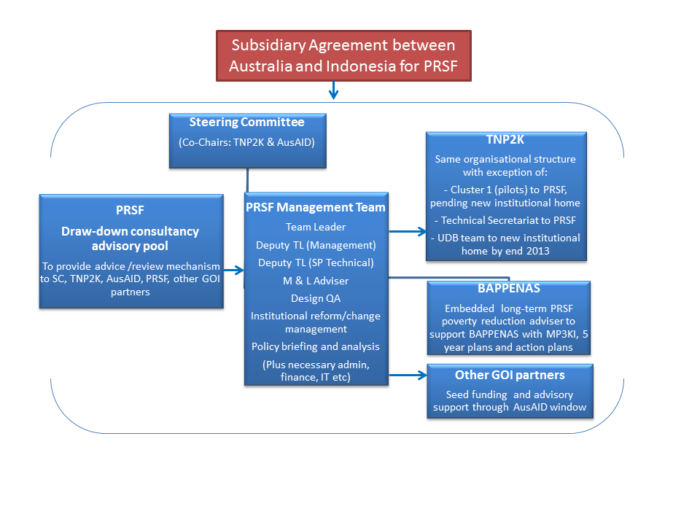

**Diagram 2: Suggested management structure for PRSF until end 2014**

## 4.1 PRSF management team: enhanced technical capacity to lead QA and clearer lines of accountability

PRSF management currently consists of a Team Leader, Deputy Team Leader and Monitoring and Evaluation adviser, providinglittle in the way of technical advice. This places a heavy load on AusAID’s Social Protection Unit and its Social Protection Expert Panel to support PRSF technically and to put in place quality assurance procedures that are within the mandate of PRSF. Consequently, the AusAID Unit has little room to engage in up-stream policy work on the broader social protection agenda. We provide here a way to reduce this burden; and a road-map on how PRSF will deliver on its amended role (as outlined in Section 3 above) over the next 18 months to:

* Support TNP2K with its immediate agenda
* Take a proactive approach to progressing the GOI social protection agenda
* Support AusAID in its need for strong quality control of its investments.

The following describes how PRSF will meet the management and enhanced technical capacity needs, and establish lines of accountability to respond to these three PRSF functions:

### 4.1.1 PRSF management and technical support to TNP2K in achieving its immediate agenda:

* Provide **access to a draw-down consultancy advisory pool and PRSF’s enhanced technical team** **to support TNP2K reform of the four main poverty reduction programs**
* Engage **technical assistance to better package TNP2K’s research** activities
* Engage **technical assistance to better support TNP2K’s outreach and facilitation** activities
* Work with TNP2K to find an **alternative institutional home for UDB**. Social protection technical advice and local government linkages should be able to support refinements to the database
* Continue to support and provide technical **assistance to Clusters 2 and 3**
* **PRSF will take over the role of managing Cluster 1 pilots**, in line with TNP2K’s request.
* **PRSF will manage the Technical Secretariat** (which currently sits with PRSF, but on the organogram is shown as being within the TNP2K structure)
* Provide **administrative support to the TNP2K Policy Working Group Coordinator**
* PRSF will continue to provide the **full range of administrative, financial, IT and other support** required by TNP2K. Where there is duplication of responsibilities or these roles could sit in PRSF and provide these services to other new GOI partners as well, they should sit in PRSF.

**Accountability lines:**

* TNP2K is accountable for its outputs to the co-chairs of the Steering Committee
* TNP2K staff (whether or not positions are funded by PRSF) are accountable for their day-to-day outputs to TNP2K management
* The PRSF Deputy Team Leader (management) is responsible for personnel management of TNP2K staff who are funded by PRSF
* The PRSF social protection technical Deputy Team Leader and his/her team (new positions to be appointed, for detail see Section 3.1.3) will support and offer quality assurance to TNP2K
* A consultancy advisory pool (to be established) is available for TNP2K use, upon request to the technical Deputy Team Leader.

### 4.1.2 PRSF approach to progressing the GOI social protection agenda

|  |
| --- |
| The **Team Leader** will ensure full and ongoing support to TNP2K; and provide quality assurance oversight of PRSF. Final responsibility for the team’s performance rests with the TL. All tasks outlined here are currently within the general TORs for the TL.  **Accountability lines:** The TL is accountable to the co-chairs of the Steering Committee for all PRSF outputs. The two Deputy Team Leaders (management and technical) are directly accountable to the TL.  Over the next 18 months, TL will also be given the space to be more proactive; that is, finding opportunities to make things happen:   * Work with TNP2K to find new institutional homes for pilots and UDB. * Test the waters with other GOI agencies, including managing the AusAID seed funding window with support of the two Deputy TLs and other TA. (Details of the AusAID seed funding window are in Section 4.4.). * Use the background technical paper on PRSF stakeholder engagement to shape and inform opportunities that will support the direction of Phase 2 support (use advisory support for further inputs on engagement and change management strategies). * Seek AusAID support in negotiating entry points to GOI agencies and other AusAID or donor programs, where necessary. * Build confidence in GOI agencies that Australia is ready and able to support the social protection sector. * Explore possibility of a provincial PRSF presence in longer term. * Scope opportunities for Phase 2 of AusAID’s support. * Make linkages with other AusAID programs on social protection. * Greater management attention of PNPM technical assistance and Cluster 1. * Provide a brief report (1-2 pages) every 2 months to AusAID on progress with stakeholder engagement, future opportunities for Phase 2 support and any challenges or risks that could hinder future assistance. * Ensure everyone is clear on lines of accountability. * See section 4.4 for suggested activities under the AusAID window. |

### 4.1.3 PRSF to support AusAID in its need for better quality control of its investments through good management and technical support:

**The IPR suggests an enhanced role for PRSF to provide support in technical issues and quality assurance.** A more thoughtful and strategic approach to bringing stakeholders along willingly through effective change management is needed. And there should be capacity building for evidence-based policy making. Critical systems were cited as being ad hoc, lacking guidance and open to interpretation by TNP2K, including management and accountability, quality control, and communication.

Some of these issues will be addressed through the design presented in this document and PRSF product 2, others will be resolved through the introduction of new staff capacity, and solutions to some are already underway. But PRSF management will need to ensure that these issues are acted upon, to avoid the possibility of a lack of action undermining PRSF achievements.

A **new long-term technical team** is proposed to address these shortfalls:

* **Technical Deputy Team Leader** to manage a small technical team of professionals focused on improving the overall quality of PRSF activities and outputs in the social protection sphere. She/he should have strong experience in social protection, quality assurance and management. PRSF is to engage this person, as a priority
* **Technical team which could include expertise on: monitoring and learning, design quality assurance, institutional reform/change management, policy packaging/briefing, research and analysis.** PRSF needs to negotiate with AusAID on the number of positions to be filled and the budget ceiling for the technical team needs
* An **embedded poverty strategy adviser to Bappenas** to assist on further development of the MP3KI, the five-year plan and its actions plans. PRSF has begun discussions with Bappenas – indications are that GOI is keen to proceed.

Long-term on the ground support is important in Indonesia; time must be spent building a strong relationship to be fully effective. Experience in other facilities shows that support embedded in GOI agencies has the most chance of success.

As noted in Section 2.4 above, AusAID is to play a key role in: (i) determining the scope and scale of a second phase of funding (ii) ensuring it is well sequenced to real needs, (ii) guarding against it building up a parallel bureaucracy and (iv) approving the need for any position before it is advertised.

The **TNP2K Technical Secretariat** **will be members of this technical team** – and will now formally sit with PRSF. This Secretariat will support the technical social protection Deputy Team Leader in delivery of the team’s activities and outputs.

|  |
| --- |
| The**Deputy Team Leader (technical)** will have primary responsibility for improving the overall quality of PRSF activities and outputs.  **Accountability lines:** The DTL (social protection – technical) is accountable to the TL for the outputs of the technical team. The technical team will report directly to this DTL. The Technical Secretariat will support this DTL and report to her/him. Both DTLs will work together to improve overall quality.   * Manage a small team of professionals focused on improving quality. * Lead on quality assurance of investment designs, especially pilots in Cluster 1, *prior* to submission to the Steering Committee. * Seek joint sign-off on quality assurance prior to submission of proposals to the Steering Committee (process detailed in section 3.4). * Oversee the appropriate sequencing and prioritisation of all social protection proposals, technical inputs and activity implementation. * Manage performance of other technical advisers and quality assurance of technical assistance outputs from the draw-down consultancy advisory pool (jointly with the Deputy Team Leader - management). * Remove pressure from AusAID and its Expert Panel as the frontline on-the-ground senior specialist source of social protection knowledge. |

|  |
| --- |
| The **Deputy Team Leader (Management)** will play a key role in quality management of systems, resources, HR management, budget and procedures. All tasks outlined here are currently within the general terms of reference (TORs) for this DTL.  **Accountability lines:** The DTL (management) is accountable to the TL for the management of PRSF. All support staff will report directly to this DTL. Both DTLs will work together to improve overall quality.   * Establish and ensure implementation of new quality assurance systems (in collaboration with the technical team, AusAID, and the Steering Committee). * Develop clear and agreed TORs for the Steering Committee. * Recruit immediately for senior administrative/management support for TNPK Policy Working Group Coordinator. * Draft all TORs for any new long-term positions, state the business case for their employment and their immediate tasks for AusAID’s approval prior to advertisement of positions. DTL (technical) should be the priority recruitment. * Recruit for approved long-term positions. * Recruit and manage a drawdown consultancy advisory pool to assist on specific issues. * Manage personnel issues (jointly with the Deputy Team Leader – social protection technical). * Realign people and their positions to best fit the evolving requirements of the facility. |

## 4.2 PRSF governance and decision making

The Steering Committee’s role is to be the official governance forum for strategic decision making on the scope and focus of PRSF. It should meet twice a year and be co-chaired by TNP2K and AusAID. It has responsibility for:

* The policy dialogue and strategic leadership of PRSF
* Reviewing and endorsing PRSF workplans and funding proposals.

**The present governance arrangements are atypical to a facility such as PRSF.** Usually, the Steering Committee would provide overall leadership, set broad policy and budget parameters but not get involved in the detail of quality assuring individual proposals – a Technical Approvals Board would review and approve investments reporting on progress to the Steering Committee.

We do not propose putting in place a Technical Approval Board, given that current agreements with TNP2K will expire end 2014. **The Deputy Team Leader (social protection – technical) and the technical team will take the lead on quality assuring investment designs *prior* to consideration by the Steering Committee.**

**PRSF is to develop Terms of Reference** **for the Steering Committee and seek co-chairs approval** of these TORs. The absence of TORs has led to role confusion and an unclear mandate.

Once the new technical team is taking a strong role on quality assurance the Steering Committee should become a more tightly focused small group of up to about 10 people. Steering Committee meetings should become the forum for robust debate and provide strategic guidance to PRSF on social protection, rather than acting as a technical approval board.

The box below highlights suggested Steering Committee functions over the coming 18 months:

|  |
| --- |
| **Steering Committee functions:**  Provide strategic guidance on PRSF’s social protection investments.    Oversee the global PRSF budget.   * Provide final approval on investment designs, once quality assured by the Deputy Team Leader (social protection – technical) and team. * Do all reasonably within its power to ensure the efficient and effective operation of PRSF and its programs. * Approve revised design quality assurance processes, ensuring they meet AusAID standards for funds approval but that onerous systems are not applied. * Approve six-monthly and annual reports. |

Once these new arrangements are in place **the AusAID Social Protection Unit will be able to take a more strategic policy approach to PRSF’s work** without getting involved in the minutiae of investment designs and PRSF processes.

The **AusAID Social Protection Expert Panel should play a role in independent peer review**. But this should be done in a collaborative way. The Indonesian team member engaged on this implementation plan notes that ‘*this kind of confrontation in an open forum is not part of Indonesia’s consensus approach to doing business: it leads to the potential loss of face*’.

## 4.3 Quality assurance

A poor and misunderstood process for quality assurance of significant investment designs is a key theme of the IPR. AusAID’s frustration with the process is evident, as it seeks to fulfil its legitimate role in ensuring that proposals are consistently of the highest quality. All parties should be aware that AusAID reserves the right and has the fiscal responsibility to reject proposals if standards are not met, but this should not be used as a trump card. All stakeholders should feel like true partners. Similarly, TNP2K is frustrated, though for different reasons. TNP2K has limited time, and faces political pressure to get things done, so the current approval procedures are seen as unnecessarily complicated and time-consuming. The size of individual activity investments has begun to grow over the past year, and as investments get bigger the need to improve the quality assurance process has grown pressing.

AusAID and PRSF have developed detailed guidelines, templates and flow-charts for quality assurance that are in line with AusAID requirements. The Steering Committee reviewed these documents on 1 May 2013. There is no reason these documents cannot be used and we do not intend to detail them here. But the **broader issue is the approval ‘process’ itself, along with the management and governance arrangements used to implement any agreed guidelines.**

We suggest **more focus on getting activities, concept notes and investment designs right upfront**; with less focus on the ‘rules’ of quality assurance processes after proposals have been fully designed. Quality assurance should be rigorous, but not onerous.

**Quality assurance upfront and *prior* to Steering Committee final approval** should be undertaken to foster a partnership approach to developing proposals with TNP2K, AusAID and advisers. This would lead not only to a better product but better relationships.

**Peer review is important but this does not fit well with our understanding of Indonesia’s consensus approach to decision making.**

**We propose a slightly different peer review process for approval**: this is not the ‘classic’ peer review process whereby all stakeholders critique a proposal after the concept or investment design is fully completed. Rather, a partnership approach is taken upfront. **All partners jointly sign-off on the quality assurance process *prior* to a peer review meeting.** The peer review co-chairs then provide a final review to resolve any outstanding issues and for approval purposes to the next stage (see Annex 2 for details of the process).

This should lessen the tension between getting the technical aspects right, AusAID’s role in quality assurance, GOI priorities and political realities.

## 4.4 PRSF budget and AusAID funding window

The budget for the activities and outcomes to be delivered by TNP2K has already been agreed with AusAID and not discussed here. This section provides a detailed and comprehensive but indicative list of the activities that the design team propose under the AusAID window.

The activities identified are closely linked to the longer term strategic plan outlined in the accompanying ‘Product 2’ document for PRSF from July 2015 – June 2017. That strategic plan is organised around three main components and some cross-cutting activities. Please see Product 2 for more information.

The gender strategy for the future PRSF implementation strategy is also articulated in full and embedded throughout Product 2. The core features of this strategy for the period up to June 2015 are outlined here:

**Overall objective: to ensure that all TNP2K and PRSF activities are gender-sensitive and that policy advice must include attention to gender and the promotion of gender equality**

This will entail:

* **Data collection and analysis:** Analysis for improvements taken from a gender perspective (sex-disaggregated data and analysis, perspectives of men and women)
* **Coordinating with gender-focused ministries/organisations:** Building relationships with gender-focused ministries/organisations
* **PRSF activities to support gender equality** (ensuring equal access to social protection by men and women) and explore and identify opportunities to promote women’s empowerment in a more strategic way
* **Quality assurance incorporates gender indicators**
* **Building staff capacity on gender** – particularly leader and advisory roles (e.g. through receiving gender training, internal AusAID working group on social protection should include gender-sensitive staff, TOR team leaders have responsibility to implement gender strategy, include gender experts in the pool of advisors)
* **Monitor key gender inputs / processes**

An indicative selection of possible activities are outlined below; Australia could choose to fund some (not all) of the following:

|  |
| --- |
| Component 1 |
| Activity description |
| Support to socialisation for social security programs (either pensions and / or health initially, followed by old age savings / accidents / death benefits). *What is the program? Who is responsible (nationally and locally for delivery? How will the program work?* |
| Support to Ministries to deliver required changes to existing program implementing systems and procedures to establish new social security programs (initially either health or pensions). |
| Technical Assistance provided in Ministries to provide improvements in quality of delivery of four main social assistance program (program coverage, benefit type, benefit level, benefit duration). |
| Social Protection Status Report involving consultation, updating of World Bank Public Expenditure Review and identification of major challenges in the sector. |
| Flexible and responsive research window managed as a consultative process, to ensure ownership and understanding that leads to policy dialogue and subsequent reform. Informed by the status report. Examples of possible research include how to do PKH in Eastern Indonesia, implications of social protection where informal / community-based mutual reciprocity systems are important, assessment of implications of Raskin dilution / benefit sharing on intended beneficiaries beyond 15kg to 4 kg reduction. |
| Impact evaluations to explore effectiveness of social assistance programs. Large-scale evaluations, not restricted to randomised control trial models, exploring range of impacts across social protection programs. |
| Rapid response teams / initial appraisals and evaluations to tackle immediate design or implementation challenges of social security roll out. |
| Social assistance action learning pilots preparation (Steps 1 and 2): Implementing action learning about innovations in social assistance programs by providing funding to local government and other stakeholders at local level. Indication examples include testing innovations to make PKH context-variable / testing alternative systems for *Raskin* benefits (e.g. food versus cash; changing targeting) / testing alternate financial transfer systems for BSM. |
| Social assistance action learning pilots preparation (Steps 3 and 4): Implementing pilots by providing funding to local government and other stakeholders at local level and delivering program reforms. |
| Delivering policy dialogue to allow more open public debate among stakeholders about the effectiveness and efficiency of specific programs including discussion of appropriateness of conditions in PKH, duration of benefits received, options for improvement payments mechanisms for BSM. |

|  |
| --- |
| Activity description |
| TA and core function support to the National Social Security Council Secretariat to enhance research, analysis and M&E capabilities |
| Research on optimal mix of programs / responsibilities for vulnerability across a suit of programs in social assistance and social security including; most appropriate roles for social assistance and social security programs; identification of (new) gaps tackling poverty and vulnerability given emergence of social security programs. This activity augmented by TA to incorporate disability and other vulnerabilities including into UDB |
| Policy dialogue to ensure learning about an optimal mix of programs / responsibilities and wider questions about what range of social protection programs Indonesia should provide, how much expenditure on social protection is appropriate and affordable. |
| Delivering exposure to wider international experience in social protection: study tours, conferences, exchanges, placements, in order to tackle four key quality issues (most appropriate levels of coverage, benefit size and type, duration of support) |
| Pilot preparation: Establishing effective grievance mechanisms. Achievement of Pilot Steps 1 (design) and 2 (start up) |
| Pilot preparation: Local-national linkages for effective targeting. Achievement of Pilot Steps 1 (design) and 2 (start up) |
| Pilot implementation: Establishing effective grievance mechanisms. Steps 3 (implementation and learning) and possibly 4 (analysis, dialogue and policy reform). |
| Pilot implementation: Local-national linkages for effective targeting. Steps 3 (implementation and learning) and possibly 4 (analysis, dialogue and policy reform). |
| Pilot support unit / data clearing house to provide all data and monitoring information about program coverage, delivery systems, etc. to all pilots to maximise lesson learning (location / partner in government dependent on future of TNP2K post-2014). |
| (Support to) delivering Unified Database (UDB) whether it is located in TNP2K or under PRSF in a caretaker role, or elsewhere in government. |
| Flexible and responsive research window managed as a consultative process, to ensure ownership and understanding that leads to policy dialogue and subsequent reform. Delivering research to, for example, establish optimal level of program coverage / beneficiaries, types of benefits, levels of benefits and program duration. |
| Action learning about program access and graduation, especially from recertification, and support to subsequent policy reform |

|  |
| --- |
| Activity description |
| Embedded TA to support mid-term strategies and budget development processes (RPJMN) in Bappenas for social assistance and social security and MP3KI. This activity could extend to a MP3KI Secretariat depending on the institutional landscape and mandates post-2014. |
| Pilot preparation and implementation: Local level institutions to manage supply and demand. Achievement of Pilot Steps 1 (design), 2 (start up) and 3 (implementation and learning). |
| Pilot implementation: Local level institutions to manage supply and demand. Completion of pilot steps 3 (implementation) and 4 (analysis, policy dialogue and policy or program reform). |
| Support for quick wins in MP3KI. For example, provide support to design and roll out of livelihoods programs in three districts or help Bappenas to explore and articulate linkages between social protection, livelihoods, access to jobs and finance, including through relationships with private sector. |
| Flexible and responsive research window managed as a consultative process, to ensure ownership and understanding that leads to policy dialogue and subsequent reform. Delivering research to, for example, assess the impacts of social protection on human capital development or household asset portfolios or access to employment. |
| Policy Dialogue (e.g. on appropriate linkages between social protection and social service delivery and between social protection and support to household livelihoods, access to jobs, etc). |

|  |
| --- |
| Activity description |
| Local voices: working with a range of civil society organisations to get learning from the grassroots into policy and program design. |
| Development of political economy strategy which identifies opportunities and constraints for PRSF partnering / working with various different parts of government and other stakeholders (therefore helping the decision about who does what after 2014) and b) informs the specific nature and focus of, and approach to, policy dialogue activities. |
| National stakeholder exposure to international experiences: study tours, international conferences. |

**4.5 Approach to M&E 2013-14**

Building on the strengths of the recently revised monitoring and evaluation (M&E) plan (Dec 2012), PRSF should continue to implement the plan as suggested with a few minor changes. The M&E plan is detailed and of high quality and should be built on rather than replaced. The strengths include that it:

* Adopts a modern approach to M&E with evaluation questions, end-of-program outcomes that complies with the AusAID standards for M&E
* Provides detailed guidance and templates for all levels of reporting
* Offers sensible suggestions for the approach to M&E and makes big steps forward from the M&E system outlined in the design (2010)
* Offers a sound methodology with different levels of indicators, supplemented with case studies
* Offers a sensible approach to attribution, using contribution analysis, although perhaps it could be spelled out in more detail
* Has clear and consistent focus on gender throughout the M&E plan supported by a thorough gender strategy.

However, the 2012 M&E plan is overly weighted towards activity/output level reporting. This is a function of setting the end-of-program outcomes at a low level. The bulk of the effort in this M&E plan appears to be placed on whether activities did good research, and delivered the products they set out to. A far more useful focus is on whether and how these activities led to changes in policy and practice. This is picked up in the case studies, but not so much in the activity monitoring. The M&E plan may benefit from some additional questions that really illustrate the key points that this M&E plan should focus on. For example:

* Which type of studies/activities had the most influence and why?
* Were key targeted individuals engaged appropriately throughout the cycle of knowledge creation?
* When outcomes around improved policy and practice did happen, what happened, and what was the role of PRSF in this?
* To what extent were projects done in a manner to maximise the chance of uptake/influence?

The templates included in the 2012 M&E plan do not appear to include questions about who are the targeted stakeholders for each piece of work, nor how they were engaged. This needs to be included in the reports provided by proponents.

**4.5.1 M&E for facilities**

Facilities may require a different approach to M&E than for programs, at the activity level at least, since the activities are not known in advance. Facilities are often used as a modality for one of two reasons i) because there is a need to be responsive and flexible to the partner government ii) because it is uncertain how to best intervene in the development process due to the highly complex environment, or a new area where little is known about how best to engage[1].

For PRSF the facility modality is appropriate for both reasons. There is a clear need to be responsive and flexible to the changing needs of the Indonesian Government. With an election in 2014, there will almost certainly be need to adapt to the incoming Government’s priorities, and social protection is a rapidly evolving area in Indonesia. Secondly, PRSF operates in a highly complex environment in which it is difficult to predict what type of activities will get the most traction. It largely attempts to influence policy and procedure through provision of evidence - which, while important, is not necessarily sufficient to guarantee policy change. As well as evidence, it will take relationships, trust and credibility, and clear and deliberate influencing strategies to maximise the chance of influencing policy making process and content.

For PRSF it is this second reason that most affects the M&E approach. PRSF can be conceptualised as a mechanism for trialling different types of intervention in an attempt to learn more about what type of assistance is most likely to work in this context. If sufficient knowledge can be gained through trialling initiatives and ideas, dropping those that don’t work and building on what does work, then the chances of success are higher.

This requires care to ensure that M&E in PRSF is conceptualised not only for its accountability dimensions but also for its contribution to ongoing program learning, adaptive management, and consequently improvement. To capitalise on this possibility, sufficient real time data will be needed to inform program managers about which interventions are working, and also there must be a commitment to flexibility to respond to lessons learned. This can be referred to as ‘learning-based M&E’, where the primary driver for M&E is formative rather than summative. In this scenario, M&E will play a very large role and this role will need a substantial effort and associated budget. But its focus must be on outcomes, and what is required to achieve them, rather than what is done at the activity level.

**Annex 1: PRSF IPR issues to be addressed 2013-2015**

**PRSF achievements to date**

The PRSF has achieved an enormous amount in the short time it has been in existence. It has established an office, staffed it to a high level, established management systems, developed a degree of clarity on what it is meant to do, has worked out modalities for how to do it, has developed good relations with key stakeholders, and has managed an upscale of both financial flows and staffing far in excess of that originally envisaged. This is all reflected in a very good Contractor Performance Assessment completed by AusAID.

TNP2K/PRSF has launched a variety of activities on many different topics that reflect the priorities of the Vice President, TNP2K ministers and GOI poverty reduction efforts. Such activities have already generated useful outputs and promise to continue to generate relevant evidence as the activities progress over the next few months.

TNP2K/PRSF is also considered to have an important initiation and knowledge-brokerage role. Some of these activities are difficult to capture in written form but are taking place in practice.

TNP2K/PRSF activities are already being used for national reform. This is the case of the UDB, which is supplying data for the extraction of beneficiary lists of national programmes. More recently-launched activities also promise to generate information that could be used to inform national policy.

Whether this policy-influencing and support trend continues and is strengthened over time depends crucially on the ability of TNP2K/PRSF to:

* Secure the sustainability and continuity of outputs (e.g. in the case of the UDB, updating information and coordinating with other data sources),
* Strengthen communication and coordination with other institutions including line ministries and local governments,
* Ensure that evidence produced is high quality and consolidated and communicated in a clear and transparent format to a variety of stakeholders.

At this stage, existing evidence does not permit the assessment of TNP2K/PRSF’s contribution to the poverty reduction effectiveness of programmes. Results arising from TNP2K/PRSF activities currently being implemented should yield information in the near future on which policy design and implementation alternatives promote poverty reduction.

**PRSF implementation and strategic issues**

The IPR identified 10 issues that arise through examination of PRSF performance to date, where there is potential for improvement. All fall into the three general categories of **strategy, management and systems**, which give an indication of where effort will be needed to address them. They are:

1. Strategy
2. Management and accountability
3. Institutional arrangements
4. Institutionalisation and sustainability
5. Change management
6. Learning
7. Quality control
8. Communication,
9. Managing transition
10. AusAID window

**1. On strategy**

The IPR finds that there are five key aspects of strategy requiring attention by PRSF, as discussed in more detail in section 3.1. These are:

* That there would be many gains from addressing the gap in TNP2K/PRSF functional strategy that would enhance the potential achievements of PRSF
* That the lack of application of a coherent and consistent framework for the various strategic planning activities in PRSF/TNP2K constrains joined up strategic thinking and therefore program effectiveness
* That the lack of clarity and quality in PRSF’s internal strategic planning, as represented by the M&E framework approved by AusAID, has contributed to many of the other management problems observed by the IPR and should be revised going forward
* That the narrowing of TNP2K focus as 2014 draws near is within the framework of the agreement between GOI and AusAID but is not sufficient if AusAID’s desire is to support the wider debate on establishment of a comprehensive social protection framework in Indonesia
* That greater conceptual and strategic justification should be applied to new proposals for reforms or pilots, before getting into the detail of the quality of design.

**2. On management and accountability**

In practice PRSF has been seen by both TNP2K and PRSF Secretariat as an administrative support unit, whose role is to support TNP2K activities, but not to engage heavily in technical aspects of this work, which is considered to be the role of the policy working groups and TNP2K management team.

In the view of the IPR this is a more limited role than envisaged in the managing contractor scope of services. However it is consistent with the current balance of staffing and skills in PRSF, which is predominantly administrative in nature.

As a result of the working arrangement that has been reached, lines of accountability for work conducted under PRSF are unclear. The IPR is clear that the administrative functions of PRSF are being relatively effectively managed and have appropriate systems to manage them, but is less clear that the same applies to the technical work conducted under PRSF.

Moreover there is an ongoing and sometimes heated debate in PRSF/TNP2K over what is an appropriate role for both PRSF and AusAID in management and accountability arrangements. Clearly some work needs to be done to resolve these issues so that everyone is clear on agreed systems that provide PRSF and TNP2K what they need.

Key systems requiring attention following this IPR are discussed in detail in section 3.1 to 3.9, and include the following:

* Strategy
* Management and accountability
* Institutional arrangements
* Institutionalisation and sustainability
* Change management
* Learning
* Quality control
* Communication,
* Managing transition

**3. On institutional arrangements**

The management structure for PRSF and TNP2K is complex and yet not particularly effective in dealing with some of the more challenging issues they face, as discussed in section 3.3. While financial and administrative management appears secure, technical systems management is less so. All partners feel the need for rationalisation of the core management structures and functions.

Furthermore the PRSF Steering Committee has not been effective at playing the important role envisaged for it in the original design, and is not acting as an effective higher level accountability mechanism for PRSF. It would benefit from a full review including to its mandate, management, membership, and authority.

**4. On Institutionalisation and sustainability**

If policy reform is to be sustainable it must institutionalise change in the formal and informal rules that determine how business is done. This includes legislation, mandates and formal policy, but also guidance, common practice and shared understandings.

The same argument applies to the introduction of new working practices, or processes, such as evidence-based policy making. If these are to be retained in future, these must also be institutionalised in the formal and informal rules that determine people’s behaviours in organisations.

At present this perspective appears secondary in practice to the drive for quick results before 2014. There are many examples where short-term delivery-oriented decisions are being taken rather than longer-term sustainability-oriented decisions.

**5. On change management**

In the view of the IPR, there is much room for improvement on change management in PRSF and TNP2K, and this would lead to greater chances of success of both TNP2K’s influencing activities and also the likelihood of sustainable adoption of the substance and process of what TNP2K is advocating. It is our view that a more thoughtful, strategic and informed change management approach is needed, and that this would be more effective at bringing along stakeholders willingly.

**6. On learning**

There are few of the formal mechanisms for learning and sharing within the PRSF/TNP2K that would be required if it was to be considered a learning organisation. The culture at present is not one of sharing, questioning, thinking, learning, using information.

Equally, there are few formal systems to ensure that learning is systematically used to enhance program performance. Given the complexity of what is being attempted, and the challenging context in which it is taking place, the IPR suggest that all opportunities to reflect on what is and is not working, and how it might be improved, should be taken. But this requires solid systems to ensure this is well-planned and effective.

**7. On quality control**

Quality control systems for PRSF are currently under review, and this issue has stirred some strong feelings within the TNP2K team, some of whom have questioned the role that AusAID should play in scrutinising government decision-making, in a government program.

The view of the IPR on this is clear, and can be summarised as follows:

* There is a clear need for transparency and accountability in the dealings of the PRSF and the results it achieves through the use of its funds.
* This is a reasonable expectation both externally – so as to be able to justify the value for money of Australian funds – but also internally, to ensure that everyone is held accountable for doing the best job possible as part of routine performance management.
* There is an issue which must be addressed sensitively and in a way which balances legitimate concerns for a) programme effectiveness, b) Indonesian government ownership and sovereignty, and c) ensuring Australian money funds quality work.
* Although this has become something of a contested issue for PRSF, the IPR believes that reasonable discussion between all parties will swiftly allow a mutually-agreeable and beneficial solution to be reached, in the context of building systems to enhance PRSF performance as discussed in section 3.2.

**8. On communication**

Communication is an issue which potentially touches all parts of TNP2K activities, and has the potential to play a central role in enhancement of TNP2K performance. This goes well beyond a simple notion of communication as sharing knowledge, in a public relations sense. In the view of the IPR it will be very important to get a rounded and strategic view of how communication fits in to TNP2K, and can proactively maximise its role in contributing to TNP2K’s objectives. We do not yet feel this point has been reached, and the communication and knowledge management team will require support to reach that point.

Central to this shift will be a clear conceptualisation by the communication and knowledge management team, but also others in TNP2K, of:

* The role of communication in reform efforts.
* The needs for information arising from TNP2K advocacy and influencing.
* The role of communication in change management.
* The link between communication and efforts to sharpen the learning cycle in TNP2K.

**9. On managing transition**

In the view of the IPR the current approach adopted by the TNP2K and PRSF together is unlikely to lead to fully embedded reform across the areas they are currently working on. There may be some permanent change, and hopefully the recommendations of this IPR will help steer progress in that direction, but we believe it likely that many of the attempted reforms will be only incompletely embedded by end 2014.

The implication is that if this issue is not addressed, there remains the potential for some hard-won progress arising from TNP2K effort to date to be lost post-2014, which is in no-one’s interest. It is therefore advisable for TNP2K/PRSF to soon begin thinking about and planning how to bridge progress made under TNP2K and what follows.

**10. On the AusAID window**

The IPR finds that the AusAID window has funded some good work, but that it is currently an ad hoc mechanism which is not firmly tied to clear development objectives. Addressing this issue would raise the potential for it to have meaningful impact.

**Annex 2: Detailed quality assurance process**

**Commonwealth Government Procurement Guidelines** are:

* $3 million plus or of high risk must have QAE review
* $500,000 plus must go to open tender
* $250,000 plus requires a prequalified short-list or open tender
* Below $250,000 must show reasonable justification why not tendered.

We suggest that activities of below $3 million are subject to the same guidelines as below, but taken to Steering Committee co-chairs out of session if there is a need to progress quickly.

Diagram 3 below was developed by PRSF and AusAID to present to the Steering Committee. It provides a solid basis for quality assurance. Noted in green letters (a, b, c, through to g) with corresponding notes on the following page are suggestions for the ‘process’ of delivery and the technical inputs needed.

Additionally, we suggest a **fast-track process to be used as agreed** – see green box (f).

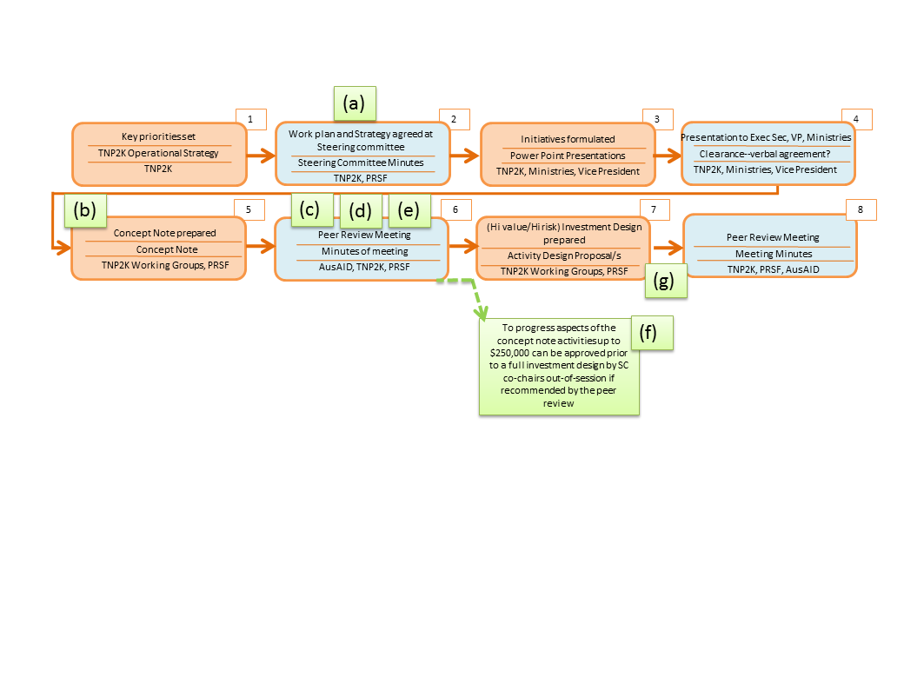**Diagram 3: Quality assurance flow chart and inputs**

**Proposed steps in the approval chain for investment designs (over $3 million or considered potentially high risk):**

1. **Technical DTL sense-checks work plans and strategies** that go before the Steering Committee to ensure: no overlap with other donor programs; and that there is appropriate prioritization and sequencing of investments
2. **Technical DTL and team work with the TNP2K or Cluster 1** **to develop the proposal to concept note stag**e. Draw-down of core advisory pool, as needed (eg gender, social inclusion, financial costings)
3. AusAID Social Protection Expert Panel and/or an independent reviewer from the core advisory pool does a ‘quality at entry report’ (QAE).
4. **Comments from the QAE are incorporated into the concept note *prior*** **to a formal peer review meeting**. QAE reports, designer responses and how they have been incorporated into the concept note are available for discussion at the peer review meeting. Any points of disagreement are noted for discussion at the peer review
5. No concept note should go before peer review before there is **written agreement between all parties to the proposal that a quality product is being submitted** (even if disagreements are noted). The technical DTL will be responsible for seeking joint sign-off of key stakeholders
6. If there is a political imperative to get a design moving and/or there is value to be added by commencing small activities within the concept note prior to developing a full investment design, the peer review co-chairs can recommend **funding up to $250,000 to the PRSF co-chairs for an out-of-session decision**
7. **For the investment design a similar partnership approach of**: design, QAE and joint sign-off should be carried out for the next stage of developing and submitting.

**Annex 3. Guidance on pilots**

**What are ‘pilots’?**

The term pilot is used in different ways in different contexts.

**Experimentation** is when the outcomes of a program are uncertain and need to be tested. A control group is required if the findings are to be scientifically legitimate. Experiments that mix different program features (cash and food transfers or conditional versus unconditional or different targeting methods) are increasingly common but experiments that maintain a control group by excluding some eligible households from the program are very rare because they raise ethical dilemmas. One way that this is addressed is by rolling out a program over time and comparing households in different cohorts (for example those in the program for longer and shorter periods of time) but, because experimental pilots are often of short duration (a couple of years), this tends to happen when programs are already underway.

**Proof of concept** is similar to experimentation but less objective. Donors or governments have an idea that they think will work and they do a pilot to prove it. The most common pilots in recent years have been cash pilots that seek to prove that poor people who have previously received food transfers are able to make sensible expenditure decisions and that cash can be delivered without leakage through existing or new administrative systems.

**Practicing delivery** happens when a planned or emerging national program is carried out in a more limited geographical context to iron out design and implementation problems before attempting to go to scale. Practising delivery can be useful for ensuring that there is capacity to implement potentially complex institutional processes involving a range of actors. Within the PRSF there would be enormous value in providing funding to the local level to improve institutional, administrative and financial systems. This would allow action learning (about, for example, how to link the universal database with existing local systems of targeting or how to get improved planning at the local level that enables a better balance between supply and demand) that leads to better quality programs, improved systems and, overall, better outcomes for poor people. It can also enable programs (as opposed to individual projects or instruments) to be tested. With this type of pilot there is an existing commitment and funding to scale up to national level and the pilot is a risk management tool to ensure that money is not wasted by scaling up before knowing how to get the project right.

Despite these benefits, practice pilots are rare and experimentation and proof of concept pilots are much more common. However, experimentation and proof of concept pilots also tend to be of much more limited use for a number of reasons. They are often ‘designed to succeed’, and so involve massive levels of technical support in both design and implementation and do not reflect the conditions in which they would be implemented in the real world. This means that experimental and proof of concept pilots rarely ‘fail’ at pilot level but then face significant problems when they go to scale and produce disappointing results.

For these reasons, the design team proposes that the main focus for PRSF should be on practising delivery pilots – both of individual programs and of the wider social protection and poverty reduction systems. It is possible to embed elements of proof of concept (as long as this is done without making the concept succeed) or experiments within practicing delivery pilots. For example, existing programs could be temporarily adjusted to try and incorporate elements of nutrition programming, or programs that distribute food could trial distributing cash in certain districts or among particular beneficiaries.

A set of proposed criteria for pilot activities are provided below. The key principles are ‘do no harm’, produce sustainable outcomes and impacts and have a clear strategic objective.

* Pilots should have sustainable outcomes and impacts that will endure after the pilot period.
* Pilots should not be used to provide temporary support to beneficiaries with chronic needs (because appropriate exit strategies or graduation are impossible / highly unlikely within the timeframe of PRSF) but could be used to test mechanisms by which shorter term / transitory needs can be met.
* Pilots should have clearly articulated learning objectives and be supported by adequately-resourced mechanisms that are designed to maximise learning without providing artificial support. This is an area where practicing delivery can add more resources than would normally be expected in future implementation, since these are for learning rather than paying for additional implementation support that influences the success of the pilot itself.
* Pilots should have a robust vision of how the pilot is on the pathway to a larger transformation/reform, and will contribute to:
* an improvement in the quality of a social protection program
* the coherence and functioning of Indonesia’s social protection systems
* enhancing effective planning and implementation linkages between social protection and wider poverty reduction efforts
* Pilot designs should focus on tackling implementation constraints and bottlenecks rather than designing new programs or target groups (new programs may well be needed but they should be delivered using government resources rather than aid funding, particularly in a middle income context).
* Pilot designs should clearly articulate the design or implementation puzzle that are meant to tackle and explain why another approach (for example policy influencing, using other international or national evidence) is not more appropriate.
* Pilots should incorporate safeguards to protect beneficiaries from impoverishment that results from disruptions to social protection support.

1. Draft Discussion paper: Design, Monitoring and Evaluation of Facilities (Sue Dawson) 2009