

EVALUATION REPORT

Evaluation Title: PROSPERA INDEPENDENT STRATEGIC EVALUATION

Type of Evaluation: Independent

Country: Indonesia

10 of April 2025

Evaluation team contact | Client Contact
Dr Gitte Heij  Team Leader  Cara Consulting Pty Ltd  gitte.heij@caraconsulting.net | Sam Porter  Counsellor  Australian Embassy Jakarta  Sam.Porter@dfat.gov.au

Disclaimer:
This evaluation was undertaken by Dr Gitte Heij (Team Leader), Frances Barns (GEDSI Specialist), and Dr Anna Retnawati (Economic Governance Specialist). The views expressed in this report are those of the review team and do not necessarily reflect those of the Government of Indonesia and the Australian Government, Department of Foreign Affairs and Trade (DFAT).

Table of Contents
Table of Contents i
Acronyms and Abbreviations ii
Executive Summary 1
The PROSPERA Program 6
1.1. Country context 6
1.2. Project background 6
The Evaluation 9
2.1. Evaluation Purpose 9
2.2. Evaluation Scope 9
2.3. Users of the Final Evaluation 9
2.4. Evaluation Methodology Summary 10
2.5. Evaluation Criteria and Questions 10
2.6. Evaluation Limitations 11
Key Findings and Analysis 11
3.1. Relevance 11
3.2. Effectiveness 16
3.3. Sustainability 28
Conclusion 31
Recommendations 32
Annex 1: Prospera’s Framework Logic and its Evolving Theory of Change - 1 -
Theory of Change in Prospera - 1 -
Program Logic in Prospera - 4 -
Annex 2: Methodology, Evaluation Questions, and Strength of Evidence Matrix - 11 -
​​Methodology - 11 -
​​Evaluation Questions - 12 -
Strength of Evidence Matrix - 14 -
Annex 3: Interview Protocol and Survey Instrument - 19 -
Annex 4: List of Interviews - 24 -

Acronyms and Abbreviations
3C | Click, Call, Connect
ABS | Australian Bureau of Statistics
ACCC | Australian Competition and Consumer Commission
AES | Australasian Evaluation Society
AI | Artificial Intelligence
AIECO | Australia Indonesia Economic Partnership
AIMR | Annual Investment Monitoring Reporting
AIPEG | Australia Indonesia Partnership for Economic Governance
AML | Anti-Money Laundering
ANAO | Australian National Audit Office
APRA | Australian Prudential Regulation Authority
APS | Australian Public Service
APSC | Australian Public Service Commission
ASEAN | Association of Southeast Asian Nations
ASIC | Australian Securities and Investment Commission
ATO | Australian Tax Office
BAPPENAS | Badan Perencanaan Pembangunan, Ministry for National Development Planning
BAST | Record of Transfer
BEPS | Base Erosion and Profit Shifting
BI | Bank Indonesia
BKF | Badan Kebijakan Fiskal, Fiscal Policy Agency
BKPM | Badan Koordinasi Penanaman Modal / Kementerian Investasi dan Hilirisasi, Ministry of Investment and Downstream Industry
BOS | Bantuan Operasional Sekolah, Education Operating Assistance
BPS | Badan Pusat Statistik, Statistics Indonesia
BPUM | Bantuan Produktif Usaha Mikro, Micro Business Productive Assistance
BT | Break through
CE | Centre of Exellence
CoP | Community of Practice
COVID | Coronavirus Disease
COVID-19 | Coronavirus Disease 2019
CSO | Civil Society Organisation
CMEA | Coordinating Ministry for Economic Affairs
CMMIA | Coordinating Ministry of Maritime and Investment Affairs
CTAS | Core Tax Administration System
CTF | Counter-Terrorism Financing
DAK | Dana Alokasi Khusus, Special Allocation Funds
DEFA | ASEAN Digital Economy Framework Agreement
DFAT | Australian Department of Foreign Affairs and Trade
DG | Directorate General
DG Tax | Directorate General of Taxation
DTA | Digital Transformation Agency
EOPO | End-of-Program-Outcomes
ERIA | Economic Research Institute for ASEAN and East Asia
ET | Evaluation Team
ETFs | Exchange-Traded Funds
FDI | Foreign Direct Investment
FGD | Focus Group Discussion
FY | Financial Year
GDP | Gross Domestic Product
GEDSI | Gender Equality, Disability, and Social Inclusion
GFMRAP | Government Financial Management and Revenue Administration Project
GoA | Government of Australia
GoI | Government of Indonesia
GPF | The Australian Government Partnership Fund
GRP | Good Regulatory Practices
IA-CEPA | Indonesia-Australia Comprehensive Economic Partnership
ICT | Information and Communication Technologies
IDaD | Institutional Development and Dialogue
IDD | Investment Design Document
IDX | Indonesia Stock Exchange
ILO | International Labour Organisation
IMR | Investment Monitoring Reporting
IoT | Internet of Things
ISD | Indonesia Services Dialogue
IW | Investing in Women
KATALIS | IA-CEPA Economic Cooperation Program, Katalis
KemenPANRB | Ministry of Administrative and Bureaucratic Reform
KIAT | Indonesia Australia Partnership for Infrastructure
KIIs | Key Informant Interviews
KPL | Knowledge, Performance, Learning
KRISNA | Kolaborasi Perencanaan dan Informasi Kinerja Anggaran, Collaboration on Budget Planning and Performance Information
KSI | Knowledge Sector Initiative
KSSK | Komite Stabilitas Sistem Keuangan; Financial System Stability Committee
LANSOW | Leading a National Statistics Office Workshop
Logframes | Logical frameworks
LPS | Lembaga Penjamin Simpanan, Deposit Insurance Corporation
LSP | Logistics Support Program
LTA | Long Term Adviser
MANTRA | Manajemen Integrasi Informasi dan Pertukaran, data-sharing system for citizens online access to public services
MEL | Monitoring, Evaluation, and Learning
M&E | Monitoring and Evaluation
MoA | Ministry of Administration
MoE | Ministry of Education
MoEnv | Ministry of Environment
MoF | Ministry of Finance
MoSA | Ministry of Social Affairs
MoU | Memorandum of Understanding
MSME | Micro, Small and Medium Enterprises
MTEF | Medium-Term Expenditure Framework
MTR | Mid-term Review
NASA | National Aeronautics and Space Administration
OECD-DAC | The Organisation for Economic Co-operation and Development - Development Assistance Committee
NLE | National Logistics Ecosystem
OJK | Otoritas Jasa Keuangan, Financial Services Authority
OPM | Oxford Public Management
OSS | Online Single Submission
PEN | National Economic Recovery Program
PFM | Public Financial Management
PMO | Project Management Office
PP | Peraturan Pemerintah, Government Regulation
PPA | Partner Performance Assessment
PPATK | Indonesian Transaction Reports and Analysis Centre
PPP | Public-Private Partnership
PSIAP | Core Tax Administration System
PT | Perseroan Terbatas, Limited Liability Company
QRIS | Quick Response Code Indonesia Standard
RBA | Reserve Bank of Australia
RCEP | Regional Comprehensive Economic Partnership
RIA | Regulatory Impact Analysis
RPJMN | Rencana Pembangunan Jangka Menengah Nasional, National Medium-Term Development Plan
RPJP | National Long Term Development Plan
SADIT | Sistem Asesmen Disabilitas Indonesia Terpilah, Disaggregated Indonesian Disability Assessment System
SAKTI | Sistem Aplikasi Keuangan Tingkat Instansi, Agency Level Financial Application System
SEZ | Special Economic Zones
SKALA | Sinergi dan Kolaborasi untuk Layanan Dasar, Synergies and Collaboration for Service Delivery Acceleration
SLT | Prospera Senior Leadership Team
SME | Small and Medium Sized Enterprise
SMERU | Social Monitoring and Early Response Unit
SOE | State-Owned Enterprise
SPBE | Electronic-Based Government Systems
STA | Short Term Adviser
TA | Technical Assistance
TAMF | The Indonesia-Australia Technical Assistance Management Facility for Economic Governance
ToC | Theory of Change
ToR | Terms of Reference
TNP2K | Secretariat of the National Team for the acceleration of Poverty Reduction
UNICEF | United Nations Children's Fund
UNDP | United Nations Development Program
UN Women | United Nations Organisation for Gender Equality and the Empowerment of Women
UU P2SK | Financial Sector Development and Strengthening Law
VAT | Value Added Tax
VET | Vocational Education and Training
VfM | Value for Money
WTO | World Trade Organisation
XBRL | Extensible Business Reporting Language

Executive Summary
The Prospera Program
Prospera is an AUD 277 million, eight-year partnership (2018–2026) between the Governments of Australia (GoA) and Indonesia (GoI), managed by Australia’s Department of Foreign Affairs and Trade (DFAT).Building on two decades of economic cooperation, the program merges two predecessor initiatives—the Australia Indonesia Partnership for Economic Governance (AIPEG) and the Governance Partnership Fund (GPF)—to support Indonesia’s economic reforms through policy advisory assistance, institutional strengthening, and partnerships between Australian and Indonesian government agencies.
The program’s overarching goal, initially framed as fostering effective economic institutions for strong, sustainable, and inclusive growth, was refined in 2018 to focus directly on achieving "strong, sustainable, and inclusive economic growth in Indonesia." To realise this objective, Prospera is structured around three Breakthrough Outcomes (BTs):
- Expanding markets and creating jobs by improving business regulations, trade policies, and transport/logistics infrastructure.
- Safeguarding economic and financial stability through stronger macroeconomic policies, financial oversight, and anti-money laundering frameworks.
- Improving public finances and government performance via tax system modernisation, efficient public spending, and governance reforms.
Prospera delivers its support through multiple mechanisms. A team of 128 long-term advisers and 59 short-term specialists provides evidence-based policy recommendations to Indonesian counterparts. Institutional partnerships between 20 Australian and 32 Indonesian government agencies facilitate knowledge exchange and capacity building. Additionally, Tim Asistensi, a group of senior Indonesian policy experts, ensures alignment with government priorities. Cross-cutting themes such as gender equality, disability inclusion (GEDSI), and data analytics are integrated across all interventions.
The program has demonstrated adaptive management, adjusting its approach to reflect evolving priorities. In response to the COVID-19 pandemic, Prospera incorporated health security and economic stability measures in 2021–2022. More recently, it expanded into clean energy and green transition initiatives (2023–2024) to align with DFAT’s strategic focus. In 2023, Prospera assumed responsibility for implementing the Policy and Regulatory pillar of Kinetik, a GoI and GoA partnership aimed at supporting Indonesia’s transition to net zero by building the nations clean energy capacity.
Financially, Prospera’s expenditure from 2018 to 2024 highlights its priorities. BT Area 3 (public finances and governance) received the largest allocation (34.38%), followed by BT Area 2 (economic stability, 20.78%) and BT Area 1 (market expansion, 17.73%). The Centre of Excellence (15.34%), which covers data analytics and public sector reform, also received significant investment, while support functions such as the CMEA Hub and APS partnerships were allocated smaller shares.
According to the Investment Design Document (IDD), the cornerstone of Prospera’s approach is capacity building and sustainability. The program fosters local ownership through knowledge-sharing platforms and the 70/20/10 learning framework, which blends formal training with hands-on experience. Its sustainability strategy, aligned with OECD principles and DFAT’s localisation policies, ensures reforms endure beyond the program’s lifespan by strengthening institutions and empowering local stakeholders.
The Independent Final Evaluation
This independent final evaluation of Prospera aims to inform decision-making for the next phase of Prospera investment (learning, formative) and has assessed performance against the end-of-program outcomes (accountability, summative). The evaluation was guided by a set of evaluation questions focused on relevance, effectiveness, and sustainability.
This evaluation employed a rigorous, qualitative-led mixed-methods approach to assess Prospera's relevance, effectiveness, and sustainability. Drawing from over 60 key informant interviews (KIIs), detailed document reviews, and Indonesian government statistical data, the team triangulated findings to ensure robust evidence. Targeted case studies and specialised analytical techniques, including contribution analysis and structured surveys, provided deeper insights into complex program outcomes. Cross-cutting themes like COVID-19 response and GEDSI were examined through stakeholder perspectives and policy analysis. The evaluation also assessed Prospera's Monitoring, Evaluation, and Learning (MEL) systems. Ethical safeguards and adherence to DFAT, Australasian Evaluation Society, and OECD-DAC standards were maintained throughout. A utilisation-focused approach, incorporating validation workshops, ensured actionable findings for decision-makers. Ethical safeguards and adherence to international evaluation standards were maintained throughout. However, the evaluation faced limitations, including weak program evaluability due to limited reporting and a complex activity landscape, hindering a comprehensive assessment of the full breadth of activities as well as long-term impacts and sustainability. Despite these challenges, a utilisation-focused approach, incorporating stakeholder validation, ensured actionable findings for DFAT and Indonesian partners.
Key Findings
Relevance
Prospera’s interventions demonstrate strong relevance to Indonesia’s development priorities, Australia’s strategic interests in the region, and the objectives outlined in the 2017 Australia-Indonesia Subsidiary Arrangement. The program aligns with Indonesia’s long-term vision (Indonesia Emas 2045), focusing on fiscal sustainability, human capital development, and economic transformation—key pillars of the nation’s growth strategy. While the evaluation was constrained by limited MEL data, Prospera’s design and delivery modality reflect a coherent approach to addressing Indonesia’s economic challenges. Prospera’s three Breakthrough Outcomes provide policy-relevant pathways for inclusive growth: maintaining fiscal discipline, expanding revenue, and fostering high-value job creation. These interventions are critical in a volatile global economy, helping Indonesia preserve crisis resilience while pursuing sustainable development.
The relevance of breakthrough outcomes
Breakthrough Outcome 1: Expanding Markets & Creating Jobs supports Indonesia’s need for job creation, reduced inequality, and economic diversification. Reforms like the Omnibus Law on Job Creation reduce bureaucracy, attract investment, and strengthen small medium enterprises (SMEs)—key drivers of growth. Trade liberalisation and logistics improvements enhance connectivity, vital for Indonesia’s archipelagic economy.
Breakthrough Outcome 2: Safeguarding Economic Stability strengthens Indonesia’s resilience to external shocks (e.g., commodity volatility, climate risks) through robust macroeconomic policies and financial oversight. Efforts to combat financial crime (e.g., Anti-Money Laundering, AML/Counter-Terrorism Financing, CTF) bolster investor confidence and systemic integrity.
Breakthrough Outcome 3: Improving Public Finances & Governance addresses Indonesia’s low tax-to-GDP (Gross Domestic Product) ratio by modernising revenue collection and promoting transparent budgeting. Governance reforms, including anti-corruption measures, enhance public trust and service delivery—critical for equitable growth.
Prospera’s broad, flexible approach has allowed it to adapt to changing needs in the evolving operating context. When the COVID-19 pandemic hit, Prospera’s response was highly relevant to Indonesia’s urgent economic and social challenges. The program quickly adapted to support critical areas such as fiscal space creation, vaccine rollout, digital transformation, health security, social protection, and economic recovery, demonstrating its flexibility and alignment with Indonesia’s immediate needs. Post COVID, Prospera has continued to adapt to support Indonesia's evolving policy priorities engaging in complex, high-impact areas such as fostering the digital economy, advancing Artificial Intelligence (AI) adoption, facilitating the green energy transition, promoting industry and value chain development, and supporting downstream processing initiatives – all critical to Indonesia's future economic transformation and sustainable growth.
Prospera’s ability to maintain relevance stems from its strong, long-term relationships with key Indonesian decision-makers, built over two decades of bilateral cooperation. GoI stakeholders highlighted the accessibility and responsiveness of Prospera advisers, who consistently provided timely expertise to support evolving priorities. Prospera’s relevance was further underscored by its responsiveness to the GoI priorities, including support for its G20 Presidency (2022) and Association of Southeast Asian Nations (ASEAN) Chairmanship (2023). By aligning with GoI’s evolving demands, Prospera strengthened its advisory role, advocating for evidence-based policies that promoted market openness, fiscal discipline, and efficient public spending, shaping Indonesia’s policy narrative during a critical period.
Expanding Scope
Prospera's facility model demonstrated its relevance by successfully adapting to Indonesia's changing priorities, though this flexibility also presented challenges. When COVID-19 shifted government focus to crisis response, Prospera expanded beyond its core economic governance mandate to support health, social protection, and food security initiatives. This responsiveness came at a cost - the diversion into social sectors diluted Prospera's traditional strengths in high-level economic policy analysis.
The program's move into complex technical areas like digital transformation (with 50-60 digital activities across four pillars) and green transition revealed gaps in specialist expertise. While Prospera's general economists provided valuable policy input, deeper technical knowledge in fields like AI and renewable energy systems was often lacking. Senior Indonesian government officials noted the need for more dedicated experts in specialised fields to support Indonesia's OECD accession and other technical reforms.
The 2017 Subsidiary Agreement's (SA) broad provisions for technical assistance (TA) modalities (including mentoring, training, and study tours) were implemented, though some Coordinating Ministry for Economic Affairs (CMEA) stakeholders felt capacity building components could have been stronger. While Australian advisers brought technical skills, the intended focus on sustained institutional capacity development was not always fully realised in practice.
Institutional Strengthening: Design vs implementation
Prospera's original design placed significant emphasis on institutional strengthening, with clear frameworks for building both organisational capacity (systems, processes, strategic planning) and individual skills (technical expertise, competencies). The 2018 Public Sector Strategy outlined four key pillars for institutional transformation: leadership, policy frameworks, resource capacity, and evidence-based decision making. This structured approach was intended to guide activity selection and ensure meaningful institutional impact. In practice, however, implementation fell short of this vision. Despite delivering numerous capacity building activities, Prospera staff reported not using the designed frameworks (IDD, Knowledge, Performance, Learning (KPL) Framework, Public Sector Strategy) in their work, nor developing alternative approaches. This gap meant the program missed opportunities to systematically link individual activities to broader institutional reforms, lacked consistent methods to assess institutional readiness for change and could not generate comparative evidence about what capacity-building approaches worked best. Prospera’s implementation evolved from the original design documents. Prospera and DFAT coordinate closely to ensure the program remains responsive to emerging priorities and delivers on its intended outcomes.
While many discrete capacity building activities succeeded, the absence of the planned cross-cutting framework limited Prospera's ability to demonstrate coherent contributions to sustainable institutional change - a key challenge also evident in other areas of the program's work.
Prospera's role in the bilateral relationship
Prospera significantly enhanced the Australia-Indonesia partnership through its responsive, evidence-based approach. During COVID-19, the program's rapid deployment of forecasting tools and policy advice directly supported Indonesia's crisis response, including co-designing the BPUM (Micro Business Productive Assistance) program that assisted 12 million micro-businesses. Indonesian officials consistently praised Prospera's ability to deliver timely, relevant support. The program deepened institutional connections between Australian and Indonesian agencies, though some challenges emerged. DFAT noted occasional communication gaps regarding Prospera's activities, while quality concerns in technical areas like tax reform required careful management.
Australian Public Service (APS) agencies maintained valuable independent relationships with Indonesian counterparts, complementing Prospera's work. APS recruitment processes sometimes limited access to Indonesia-experienced staff, and differing views about private sector delivery required ongoing management. The appointment of a dedicated coordinator helped align these efforts. Crucially, Prospera's model proved most effective when supporting - not replacing - direct agency partnerships, creating a resilient framework for cooperation.
Achievements under the Breakthrough Outcome areas
Due to the lack of clearly defined and consistently tracked outcome indicators, this evaluation cannot systematically measure Prospera's achievements against predetermined expectations. Instead, the assessment documents observable policy changes and reforms where Prospera played a substantiated role. The program has demonstrably contributed to economic policy reforms across its three BT Outcomes:
- In expanding markets and job creation, Prospera influenced critical business environment reforms including the Omnibus Law's risk-based licensing system, which processed over 1.5 million business registrations. The program supported trade modernisation through Regional Comprehensive Economic Partnership (RCEP) implementation and digital economy development, while transforming vocational training programs to better match labour market needs.
- For economic stability, Prospera provided technical foundations for financial sector reforms, including pension system modernisation and sustainable finance frameworks. The program strengthened financial regulators' capacity, particularly in digital banking supervision, while expanding inclusive financial services for MSMEs and underserved groups.
- In public financial management, Prospera supported budget reforms, tax administration digitalisation, and Indonesia's OECD accession preparations. The program helped implement performance-based budgeting and medium-term expenditure frameworks, while developing analytical tools that informed crisis-era policymaking.
The evaluation confirms Prospera's significant role in shaping Indonesia's economic reforms, though measuring precise outcomes remains challenging given the program's nature as a technical advisor rather than direct implementer. Prospera operates in a complex policy environment where external political and institutional factors frequently influence reform trajectories, making clear attribution difficult.
Several structural factors complicate outcome assessment. While Prospera's original design included robust monitoring frameworks through the IDD and KPL systems, these were never fully operationalised nor replaced with alternative approaches. This creates an accountability gap where the program's technical contributions are evident but systematic measurement of its influence remains elusive. The evaluation identified recurring patterns in implementation challenges:
Policy Reforms vs Political Realities
There were often complications in the path towards outcome achievement. Technical successes like the Omnibus Law's streamlined licensing system (processing 1.5 million registrations) coexisted with implementation barriers, including disconnected environmental licensing processes and constitutional challenges to labour reforms.
Operationally, Prospera has contended with human resource challenges - particularly in recruiting and retaining specialist expertise - and quality assurance risks in its outsourced delivery model. The program's effectiveness often relies heavily on individual advisor relationships rather than institutionalised systems, raising sustainability questions.
Prospera has delivered valuable capacity building support to Indonesian government agencies, though with mixed effectiveness. The program's embedded advisory model produced several successful outcomes, particularly where long-term engagement allowed for sustained knowledge transfer. Overall, the program approach lacked relevance in relation to building sustainability. It focused mostly on short-term, project-based outcomes in response to GoI requests rather than continuing its longer-term institutional strengthening approach. This meant the program lacked a structured approach to bureaucratic reform, aligned with the GoI’s goals and guided by frameworks like KPL Framework. Equally, the approach meant that the program did not have a long-term focus on breaking down silos, building capacity and fostering interagency collaboration, contributing to a more cohesive and effective public service.
The original design proposed structured frameworks for institutional strengthening; however, the application of these in implementation was limited, and alternative systems for guiding and measuring capacity development were not developed. The shift to crisis response during the pandemic led to prioritising immediate policy outputs over systematic institutional development. While stakeholders valued Prospera's responsive technical assistance, this service-delivery approach risked creating dependency rather than fostering sustainable institutional capabilities.
APS agencies work under the Prospera framework and use M&E frameworks that were reviewed and approved by Prospera and DFAT. While the ET team reviewed APS reports and interviewed stakeholders, the scale and complexity of Prospera meant the ET’s assessment had inherent limitations in depth, comprehensiveness, and systematic coverage of APS contributions Nevertheless, available evidence indicates important achievements in the Australia-Indonesia institutional partnership. The APS engagement model combined high-level policy dialogues with practical capacity building through study visits, workshops, and digital collaboration. This approach delivered measurable outcomes, including Indonesia's removal from maritime safety blacklists, implementation of gender-responsive budgeting practices, enhanced national accounts systems through statistical cooperation and improved transport safety standards alignment.
The APS distinguished its approach through consistent application of the KPL Framework, deliberately integrating technical assistance with institutional strengthening. Unlike Prospera's adviser model, APS activities systematically incorporated capacity building objectives from the design stage. The establishment of an APS Centre of Excellence improved coordination, while new focus areas like climate finance expanded the partnership's relevance.
Prospera has achieved some success in coordinating with DFAT programs like the Indonesia Australia Partnership for Infrastructure (KIAT), Katalis, and Proaktif as well as international partners, particularly in fiscal management, disaster resilience, and economic governance. These collaborations have pooled resources and expertise to address complex challenges, such as inclusive growth and fiscal decentralisation. However, challenges like divergent mandates, lack of formal coordination mechanisms, and procurement delays have hindered synergy creation.
The program did not adhere to its frameworks like MEL, KPL and the IDD. This reduced the relevance of its outcomes. Specifically, Prospera did not build capacity at an institutional level as envisaged, which is required to sustain outputs and intermediate outcomes delivered by the program. Institutional capacity building was designed to complement and amplify the relevant and responsive technical advice and individual level capacity building the program delivered. Prospera’s framework, aimed to link activities to its three breakthrough outcomes through a Theory of Change (ToC). However, implementation has been inconsistent since 2018, with limited staff awareness or use of the framework. While adaptive management allowed flexibility, it led to fragmented efforts and no clear tracking of long-term outcomes.
The Prospera program emphasises inclusiveness by integrating gender and disability considerations into Indonesia’s economic growth and sustainable development. It addresses challenges like low female labour force participation (around 50%) and disability marginalisation through a twin-track strategy: targeted actions to overcome barriers and mainstreaming gender and disability into broader economic policies. However, challenges remain in fully mainstreaming gender equality, disability, and social inclusion (GEDSI).
Sustainability of Program Outcomes
Prospera has driven sustainable policy advancements in Indonesia, with initiatives like the National Logistics Ecosystem (NLE), maritime safety reforms, and the Omnibus Law on Job Creation now independently sustained by GoI. Successful partnerships, such as with BPS and Australian Treasury show potential, with a greater focus on institutional strengthening and knowledge transfer is needed for long-term sustainability.
The broader context limits certain outcomes. During COVID-19, Prospera supported fiscal management, including the National Economic Recovery Program, but rising debt, geopolitical instability, and climate change pose ongoing risks. But with the COVID-19 crisis, Prospera showed its strength, its Data Analytics work demonstrated the potential of how good the Facility Model can be. Its approach and effectiveness led to sustainability derived from innovative, rigorous, demand driven initiatives. Its work deserves close examination to draw positive lessons.

The PROSPERA Program

Country context
Indonesia is Southeast Asia’s largest economy and has demonstrated consistent progress in economic development and poverty reduction over the past two decades, strengthening its status as a dynamic emerging middle-income country. The nation has maintained stable, albeit moderate, economic growth, averaging around 5% annually, driven by domestic consumption, an expanding services sector, and substantial infrastructure development under the leadership of President Joko Widodo. Despite the significant advancements achieved during President Joko Widodo's tenure, Indonesia grapples with significant challenges. Pre-pandemic socio-economic data indicated that millions of citizens remained vulnerable. The COVID-19 pandemic exacerbated the vulnerability of the economy, severely disrupting supply chains, curtailing economic activity, and resulting in widespread job losses. The pandemic reversed years of progress. Although the economy rebounded, the recovery has been uneven, with the manufacturing sector remaining sluggish and informal employment on the rise, posing long-term risks to social protection and economic stability. Persistent challenges (i.e., governance concerns, regional disparities, inconsistent progress on economic inclusivity, and industrial modernisation) must be addressed to achieve Vision 2045 towards high-income status.

Project background
Prospera is an AUD 304 million eight-year partnership (March 2018 – Feb 2026) between the Governments of Australia (GoA) and Indonesia (GoI) that builds on two decades of Australian support for economic development in Indonesia. Managed by the Australian Department of Foreign Affairs and Trade (DFAT), Prospera supports Indonesia’s economic reforms through policy advisory assistance and institutional strengthening. Upon commencement, Prospera represented the combining of two programs: the Australia Indonesia Partnership for Economic Governance (AIPEG) managed by a managing contractor and the Governance Partnership Fund (GPF) which supported partnerships between Australian Federal and Indonesian Government agencies.
The overarching Goal of the Facility in the 2017 Australia Indonesia Economic Cooperation Partnership (AIECO) outlined in the IDD and the 2018 Prospera Knowledge, Performance and Learning (KPL) Framework, was:,

“To foster more effective Indonesian economic institutions and policies that contribute to strong, sustainable and inclusive economic growth.”
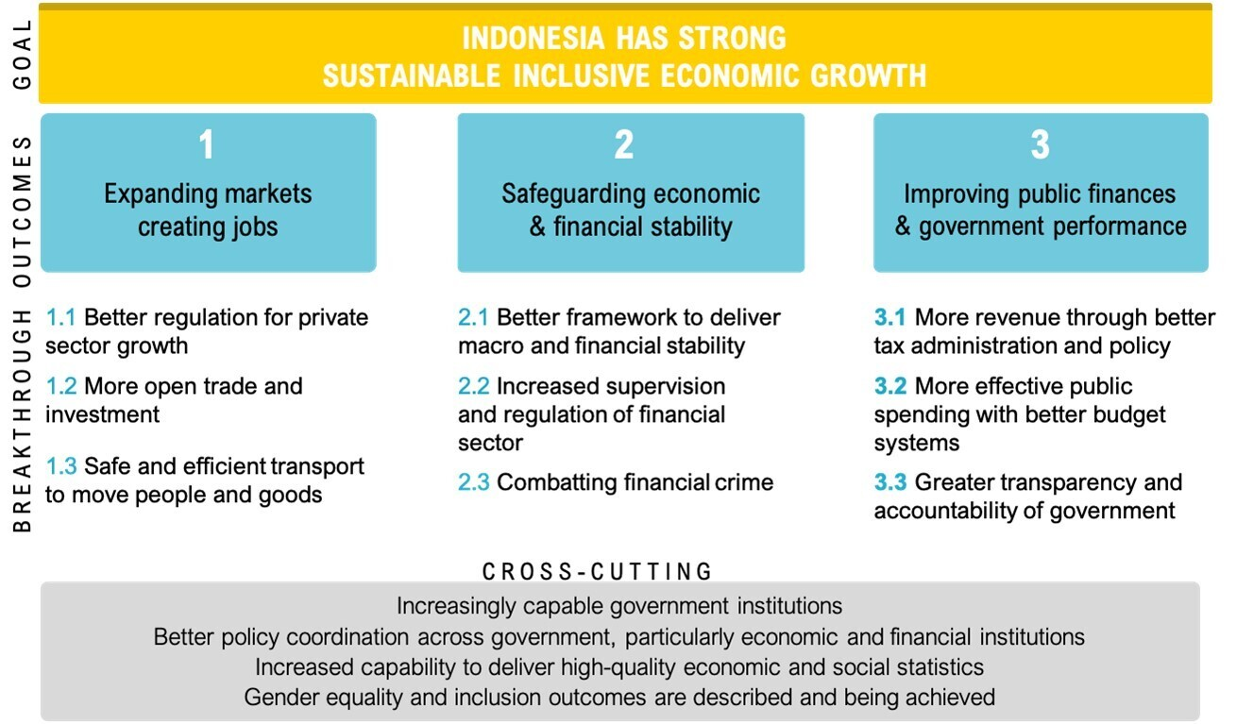
Figure 1. Prospera Program Logic
Prospera as directed by DFAT, changed this in 2018 in its KPL Framework Component 1 to: “Indonesia has strong, sustainable and inclusive economic growth.”,
Broadly speaking, the Facility has been structured around three ‘Breakthrough (BT) Outcomes’ sometimes referred to as ‘Breakthrough (BT) Areas’ which are: (1) Expanding markets and creating jobs; (2) Safeguarding economic and financial stability; and (3) Improving public finances and government performance. Figure 1 above shows the Program Logic for Prospera.
Prospera uses distinct delivery mechanisms:
- Technical advisory and assistance delivered by 128 long-term advisers, supported by 59 short-term specialists and subject matter experts who work closely with Indonesian government counterparts to deliver evidence-based policy recommendations, tools or datasets.
- Partnerships between 20 Australian Government agencies and 32 Indonesian Government counterparts, working together on technical problems, knowledge sharing, capacity building and organisational change aligned to specific partner agency needs and interests.
- Tim Asistensi, a group of senior Indonesian policy experts based at the CMEA providing advice to Prospera teams and ensuring consistent advice to GoI Ministers.
- The cross-cutting areas teams work with all parts of the facility and cover a range of areas including KPL, GEDSI, capacity building, APS partnership, and Data Analytics.
Prospera has focused on the following areas:
BT Outcome 1: Expanding Markets and Creating Jobs
Prospera supports a thriving private sector by improving regulations to simplify business licensing, reduce bureaucracy, and enhance investor confidence. It promotes trade and investment through policies that liberalise markets, attract foreign direct investment, and integrate Indonesia into global value chains. Additionally, Prospera focuses on enhancing transport and logistics by developing infrastructure and regulatory frameworks to reduce costs and improve connectivity across the archipelago, facilitating the movement of goods and people.
BT Outcome 2: Safeguarding Economic and Financial Stability
Prospera fosters a stable and resilient economy by strengthening macroeconomic policies, including fiscal discipline, monetary frameworks, and debt management. It supports reforms to enhance financial sector oversight, reducing systemic risks and ensuring stability. Prospera also assists in combating financial crime by developing anti-money laundering and counterterrorism financing frameworks, improving the integrity of Indonesia’s financial system.
BT Outcome 3: Improving Public Financing and Government Performance
Prospera enhances public financial management by modernising tax systems, improving compliance, and broadening the tax base to boost revenue. It promotes efficient public spending through performance-based budgeting and digital tools, ensuring accountability and transparency. Prospera also advances governance reforms, including anti-corruption measures and open government initiatives, to build public trust and improve service delivery.
Over its seven years of implementation, the Theory of Change and Program Logic of Prospera evolved (See Annex 1: Prospera’s Framework Logic and Evolving Theory of Change). New focus areas have been added in, reflecting the changing context and DFAT’s changing priorities. In 2021-2022, DFAT added a focus on Stability and Health Security in response to the COVID-19 Pandemic and DFAT’s regional Partnerships for Recovery policy. In 2023, DFAT added clean energy and the green energy transition as focus areas which expanded into a new BT area in 2024.
In addition to the BT outcomes, Prospera also has cross cutting themes throughout its implementation. These too have changed over the years but have broadly included capable and coordinated institutions, policies inclusive of gender equality and disability and effective GoI and GoA partnerships. These cross-cutting themes point to priorities that span different areas of implementation which the project aims to achieve holistically through all interventions.
The evolving Program Logic reflects an approach to design, planning and MEL known as Adaptive Management, according to which, the project has flexibility in how it strives to achieve its Breakthrough Outcomes, refining intermediate outcomes, outputs and activities in response to changes in the operating context and counterpart needs. This approach, consistent with the Facility modality, is facilitated through a cycle of proposal submission by advisers based on counterpart requests.
Table 1 illustrates program costs related to activities per unit, for period March 2018 to 30 June 2024 (end of FY 2023/2024). The costs do not include overheads. All numbers are shown in Australian Dollars.
Table 1. Program costs breakdown per unit, March 2018-June 2024
 | Activity Cost | %
Breakthrough Area 1 | 19,274,614 | 17.73
Breakthrough Area 2 | 22,596,563 | 20.78
Breakthrough Area 3 | 37,379,325 | 34.38
CMEA Hub & Tim Asistensi | 4,929,675 | 4.53
Policy & Strategy Unit (PSU) | 980,580 | 0.90
Centre of Excellence (CE) | 16,676,139 | 15.34
APS (LSP, Prospera Budget) | 6,894,978 | 6.34
Total | 108,731,873 | 100
(Source: DFAT Jakarta operation unit)
Over six years, Prospera's financial distribution, as shown in Table 1, reveals a clear prioritisation. BT Area 3 received the largest share at 34.38%, followed by BT Areas 2 and 1, which accounted for 20.78% and 17.73%, respectively. The Centre of Excellence (CE), encompassing Data Analytics, GEDSI, and Public Sector Reform, received 15.34% of the budget. The remaining units, including the APS (logistic support program, LSP), CMEA Hub & Tim Asistensi, and Policy & Strategy Unit (PSU), were allocated significantly smaller portions.
Capacity/capability building is key in the design of Prospera and continues to be a theme across the program components. It is covered by the KPL documents that were developed at the start of the facility.’ The IDD for Prospera and its program outline also sought to create a knowledge sharing platform and collaborations/partnerships between Australian advisers and their Indonesian counterparts based around a ‘Community of Practice’ (CoP) model. Additionally, the 70/20/10 learning model as outlined in the KPL Core Framework allows for professionals to build their skills and continue working so that the praxis between theory and practice becomes the place of learning. Institutional and individual capacity building is the foundation of this facility. An updated version of the KPL Framework was issued in 2023. The assumptions remained the same except for the addition of climate change and inclusive growth (can include growth across geographic regions and/or growth underpinned by gender equality, disability, and social inclusion). The 2023 update emphasises that all activity plans align with anticipated milestones, as well as intermediate and BT outcomes.
The Prospera KPL Framework Component 5 outlines the sustainability of the initiatives Prospera supports, in other words how the benefits of interventions and initiatives will continue after the program ends. The approach is aligned with the Organisation for Economic Co-operation and Development (OECD) definition of sustainability and Australia's DFAT localisation policies, underscoring the importance of empowering capable local reformers, and strengthening institutions. The sustainability framework is integrated across all phases of activity—design, implementation, monitoring, and evaluation—while the strategy emphasises the significance of building local capacities, transferring knowledge, and embedding reforms within local systems to achieve all BT Outcomes (KPL Component 5).

The Evaluation
The Prospera Final Independent Evaluation has sought to draw together the moving parts of the vast facility spanning numerous GoI ministries and agencies involved in Prospera. It has traced linkages between activities and outcomes, assessed their institutional embeddedness, and looked for evidence of behaviour change brought about by the project interventions. By doing so, the Evaluation Team (ET) has identified broad sectoral and cross-cutting areas of impact. This, in turn, has helped to sharpen the focus of the design for a new phase of support by DFAT in economic governance, particularly in terms of sectors, cross-cutting approaches, and modalities. The paragraphs below explain the methodologies and data collection methods that have supported these aims.

Evaluation Purpose
The evaluation aims to inform decision-making for the next phase of the Prospera investment (learning, formative) and has assessed performance against the end-of-program outcomes (accountability, summative). It has:
- Assessed the relevance, effectiveness, and sustainability of the investment.
- Provide recommendations to inform the design of a potential new phase of Prospera.

Evaluation Scope
The evaluation covers the entire period of implementation from the commencement of Prospera in 2018 up until late 2024. It has not addressed the adoption of the green and clean energy transition as a focus, since this has been evaluated elsewhere. It does not cover Katalis that is reviewed separately. The scope excludes organisational performance and efficiency often described as Value for Money (VfM) assessment.

Users of the Final Evaluation
The evaluation’s primary audience includes Senior Management and Program Managers at DFAT’s Jakarta Post and the Southeast Asia Maritime Division, GoA partner agencies, staff from other DFAT programs in Indonesia, the Prospera managing contractor, and other aid contracting companies. Other users include GoI ministries and agencies, civil society, the private sector, and academic institutions. The final evaluation report and management response will be published on the DFAT website. The ET has adopted a utilisation-focused approach, crafting analysis that are readily applicable for stakeholders.

Evaluation Methodology Summary
The ET has rigorously collected and analysed evidence while ensuring ethical safeguards and adhering to DFAT Monitoring and Evaluation Standards, the Australasian Evaluation Society’s standards and code of ethics, as well as the OECD Development Assistance Committee (OECD-DAC) Evaluation Quality Standards. The approach to the evaluation has been qualitative-led mixed methods. The strength of evidence for findings and conclusions has been drawn from triangulation of a range of methods, while inductive reasoning has been applied. The team has used various data collection methods to answer the key evaluation questions and sub-questions, including desk reviews of program and other relevant secondary documents, Key Informant Interviews (KIIs) based on purposive stratified sampling, a series of case studies for in-depth analysis of selected interventions, and a survey (using Survey Monkey) administered with DFAT approval. Flexibility has been built into the methodology to address important unexpected issues as they have emerged.
This evaluation adopts a qualitative-led mixed methods approach to thoroughly examine Prospera’s relevance, effectiveness and sustainability. Combining qualitative insights with quantitative validation, the methodology ensures robust, evidence-based findings aligned with key evaluation questions.
The analysis begins with a broad assessment of program outcomes, drawing on qualitative data from over 60 KIIs with advisers, Indonesian government counterparts, DFAT representatives and other stakeholders. These perspectives are triangulated with a detailed desk review of program documents, including progress reports, strategy papers and policy briefs. To strengthen the findings, the team analyses statistical data from Indonesian government agencies, verifying qualitative observations with measurable results.
Deeper investigation occurs through targeted case studies, which apply intensive follow-up interviews, contextual policy analysis and focused document reviews. This allows the evaluation to explore specific outcomes in greater depth, particularly where program influence may be indirect or complex.
The methodology also incorporates specialised analytical techniques:
- Contribution analysis traces Prospera’s role in policy development through stakeholder testimony and documentary evidence.
- A structured survey evaluates the effectiveness of APS-Indonesian government partnerships.
- Cross-cutting themes—including COVID-19 response, gender equality and social inclusion—are assessed through stakeholder perspectives and policy analysis.
The evaluation further examines Prospera’s monitoring, evaluation and learning (MEL) systems, assessing their adequacy for accountability and adaptive management.
Throughout the process, the team employs:
- Thematic coding to identify patterns in qualitative data
- Content analysis of key documents
- Selective quantification of qualitative responses where appropriate
As a utilisation-focused evaluation, the approach prioritises practical, actionable findings. Preliminary results are tested through validation workshops with stakeholders, ensuring conclusions are credible and relevant for decision-makers. This rigorous yet adaptive methodology balances depth with analytical precision, providing DFAT and program partners with clear, evidence-based insights. Annex 2 provides details of methodology, evaluation questions, and the Strength of Evidence Matrix.

Evaluation Criteria and Questions
The independent final evaluation criteria and questions have been based on the OECD-DAC evaluation criteria as outlined in their latest publication. The evaluation questions have focused on the three criteria of Relevance and Validity of Design, Effectiveness, and Sustainability. The ET has suggested modifications to the questions, including the addition of sub-questions to ensure comprehensive coverage of important matters. The report has been structured around the evaluation questions, with the sub-questions shaping the content of the report. The Evaluation Questions are listed in Annex 2.

Evaluation Limitations
This evaluation acknowledges several limitations that may affect the interpretation of its findings and conclusion. The program's complexity, lack of access to detailed financial and activity design information, encompassing a wide range of activities delivered by multiple agencies and institutions, makes it challenging to capture the full scope of implementation.
A limitation of the evaluation was the weak evaluability of Prospera. Evaluability refers to how an evaluator can reliably assess an activity or project. Evaluability impacts the capacity of the ET to fully address questions on relevance, effectiveness, and sustainability.
It is difficult to assess relevance without reporting at the thematic level. Assessing effectiveness is challenging without clear activity proposals after 2019 that clearly define intended activity outputs and outcomes. As a result, evaluating sustainability is similarly hindered.
The ET found it difficult to conduct a rigorous evaluation due to a lack of information. The large number of activities made it difficult to sample enough program activities through meetings with program advisers and counterparts during fieldwork. Another factor is the limited MEL system.
With their generally more structured approach to activity development, the APS activities have a higher level of evaluability. The survey conducted relating to APS activities did underpin the findings of the ET.
Along with the limited availability of comprehensive reporting, rigorous sampling and broader analysis of activities are hindered. The evaluation adopted a case study approach, allowing for a deeper analysis of selected areas. However, limited cost detail means some case studies may reflect relatively small-scale interventions. The evaluation also relies heavily on qualitative data (desk reviews and stakeholder interviews), introducing potential subjectivity and varying perspectives. To mitigate this, the ET maximised triangulation across multiple data sources (see Annex 2: Strength of Evidence Matrix). Further challenges arise from documentation gaps due to the program's flexible nature. Additionally, the evaluation's limited timeframe constrains the ability to fully assess long-term impacts and sustainability as policy reforms change outcomes emerge over time. Despite these limitations, the ET employed a rigorous and transparent data collection and analysis approach to ensure the findings were as robust and balanced as possible.

Key Findings and Analysis
The following section summarises key findings against the three evaluation criteria.

Relevance
This section looks at the extent to which the project is relevant to the needs and strategically a good initiative in the operating context. Specific questions under this criterion include:

How well aligned are Prospera activities to GoI partners’ requests, requirements and expectations while maintaining a coherent and strategic approach to supporting economic development? What aspects of Prospera design and implementation have helped or hindered the achievement of the BT outcomes?
The matter of relevance refers to whether the interventions make sense and are appropriate, given Indonesia’s needs and challenges, Australia’s Goals, objectives and interests in the region and the Australia Government and DFAT positioning in that context. It also relates to the coherence and validity of the design. The basis for the alignment is the Subsidiary Arrangement (SA) between GoI and GoA of 2009 (for AIPEG) and of 2017 (for Prospera). The 2017 Arrangement underpins the foundation of Prospera and outlines the key elements of agreed objectives. The ET sees two aspects to relevance on Prospera including the content of the activities and the way they were delivered (the modality). As with all aspects of the evaluation, the ET’s capacity to assess this criterion was constrained by Prospera’s limited evaluability as outlined above. The MEL framework did not fully support program learning and adaptive management. While progress reporting was provided, there were gaps in consistency and depth that limited its effectiveness as a tool for strategic decision-making. With Prospera’s large scope, this limited the evaluation team’s capacity to assess the Program. The points below should be considered with this in mind.
Prospera's overall approach demonstrates relevance to Indonesia's key development frameworks, such as the Indonesia Emas 2045 vision, through its integrated approach to fiscal sustainability, human capital development, and economic transformation - all central pillars of the nation's long-term development strategy. The framing of the Program Logic (See Annex 1) including the three breakthrough areas feeding into the overall goal of increasing inclusive economic growth can be seen as relevant to Indonesia’s development needs. The interlinking of these three areas of support present essential and policy-relevant pathways for promoting inclusive growth in Indonesia: the central focus on providing support for the GoI to maintain core fiscal discipline (anchoring deficits below 3% of GDP) and reduce debt, increase revenue through more effective taxation and aim for high growth through the creation of middle-class jobs in high-value industries based on more open and better functioning markets makes sense given Indonesia’s economic circumstances. In today's volatile global economy, maintaining fiscal discipline is essential to preserve crisis-response capacity, while enhancing revenue generation strategies and pursuing higher growth remains critical as it generates expanded revenue.
Furthermore, within each breakthrough area it is also possible to see the relevance of the interventions:
BT Outcome 1: Expanding Markets and Creating Jobs: Prospera’s interventions in this area are particularly relevant given Indonesia’s need to create jobs for its young and growing population, reduce income inequality, and diversify its economy beyond natural resources. Indonesia’s private sector is a key driver of economic growth, but it faces significant barriers such as complex regulations, limited market access, and inadequate infrastructure. By supporting reforms like the Omnibus Law on Job Creation, Prospera helps to reduce bureaucratic red tape, improve the ease of doing business, and attract investment. This is critical for fostering entrepreneurship, innovation, and job creation, particularly for SMEs, which are the backbone of Indonesia’s economy. Prospera’s efforts to liberalise trade and investment policies align with Indonesia’s goal of becoming a global trading hub. Indonesia’s integration into global value chains is essential for expanding exports, attracting foreign direct investment (FDI), and creating high-quality jobs. Indonesia’s archipelagic geography poses unique challenges for connectivity and logistics. Prospera’s support for infrastructure development and regulatory improvements can help reduce logistical costs, may improve regional connectivity, and facilitate the movement of goods and people, which is vital for economic integration and inclusive growth.
BT Outcome 2: Safeguarding Economic and Financial Stability. The focus of Prospera’s programming in this area is relevant because strengthening macroeconomic policies, including fiscal discipline and macroeconomic frameworks, helps Indonesia maintain stability and investor confidence, even in times of global uncertainty. Indonesia’s economy has shown resilience, but it remains vulnerable to external shocks, such as global financial volatility, commodity price fluctuations, and climate-related risks. A stable and well-regulated financial system is essential for mobilising savings, allocating capital efficiently, and supporting economic growth. Prospera’s support for financial sector reforms assists with oversight and reduces systemic risks. Combating financial crime: Addressing issues like money laundering and terrorism financing improves the integrity of Indonesia’s financial system, fosters trust among investors and international partners. These efforts are particularly relevant given Indonesia’s exposure to global economic shocks and to build a resilient economy that can withstand future crises.
BT Outcome 3: Improving Public Financing and Government Performance. Effective public financial management is crucial for delivering public services, reducing poverty, and achieving sustainable development. Prospera’s work in this area is highly relevant to the need to increase revenue through better tax administration: Indonesia’s tax-to-GDP ratio remains low compared to its regional peers. Prospera’s support for tax reforms aims broaden the tax base, improve compliance, and ensure sustainable revenue collection, which is essential for funding public services and infrastructure. By promoting performance-based budgeting and digital tools, Prospera helps ensure that public funds are used efficiently and transparently, maximising their impact on poverty reduction and service delivery. Greater transparency and accountability are a significant challenge in Indonesia’s public sector. Prospera’s support for governance reforms, including anti-corruption measures and open government initiatives, builds public trust and strengthens institutions. These interventions are particularly relevant given Indonesia’s need to improve public service delivery, reduce inequality, and ensure that economic growth benefits all citizens.
In addition to the content of the interventions, Prospera’s ‘Navigation by Judgement” modality where Prospera’s activities were based on requests from the GoI has ensured that Prospera’s activities are priorities of GoI Ministries and Agencies, since they are based on direct requests from them. This is particularly important when GoI needs change, as has happened repeatedly over the duration of Prospera implementation. The COVID-19 pandemic worsened economic vulnerabilities, with job losses and falling household incomes requiring urgent government action to protect livelihoods and boost demand. Prospera’s technical assistance (TA) directly supported Indonesia’s priorities by helping increase revenue, reallocate spending, and strategically increase the deficit ceiling—allowing the government to expand social protection and then reduce the deficit back to sustainable levels after the crisis was averted to preserve fiscal sustainability. By providing support for monitoring systems to guide deficit reduction as the economy recovered, Prospera ensured Indonesia could balance immediate crisis response with sound economic management, aligning with the country’s goals of inclusive growth and resilient public finances. Prospera’s responsive modality also enabled the program team to respond to interest from the Health Ministry in transforming health sector financing and service delivery with the assistance of Prospera. Similarly, Prospera was also able to broaden its scope to support for emerging industries downstream processing and the green transition including sustainable finance in response to the GoI’s focus on developing downstream industry and industries of the future.
The program’s long-term engagement, through the APS but also through its adviser team, has fostered these relationships, enabling Prospera to influence economic policy narratives. For example, Prospera delivered a targeted series of presentations refining development narratives around four transformational pillars on social inclusion, human capital development, job-rich growth and the green economy transition. These were adopted in the Ministry of Development Planning's draft long-term development plan incorporating Prospera's recommendations with an explicit focus on the link between productivity growth and middle-class expansion and workforce upskilling as a core driver of economic transformation.
Another key factor in the Prospera team’s ability to maintain ongoing relevance by responding to GoI’s evolving needs has been the development of strong working relationships with key decision-makers in the GoI. Several GoI stakeholders participating in the evaluation informed the ET, they had good relationships with, and they appreciated the high availability of Prospera advisers and their willingness to respond quickly to requests. GoI stakeholders also noted the long-term nature of the relationship, referring to the long history of cooperation under the various bilateral economic governance facility spanning more than two decades, GoI stakeholders also noted that they appreciated Prospera advisers support for the GoI’s role in supporting Indonesia’s leadership at global events such as the G20 Presidency in 2022 and the ASEAN Chairmanship in 2023. Prospera has contributed by offering expertise on economic integration, sustainable development, and digital economy initiatives, helping Indonesia strengthen its leadership role in the region during Indonesia’s G20 Presidency, Prospera provided TA and policy analysis to help shape the agenda around key themes such as global economic recovery, food and energy security, and financial stability. Similarly, as ASEAN Chair in 2023, Indonesia focused on themes like recovery, digital transformation, and regional connectivity under the banner of “ASEAN Matters: Epicentrum of Growth.” Prospera is also actively supporting the GoI in its aim for accession to the OECD. Out of the 26 sector-specific OECD assessments, including fiscal affairs, public governance, budget, and digital policies, Prospera has focused on the requirements for the OECD digital government pillars. The program’s long-term engagement, through the APS but also through its adviser team, has also fostered these relationships.
Prospera’s Scope of Activities
The facility approach and the ‘navigation by judgement modality’ has proven relevant by offering the flexibility to respond to emerging priorities and influence key decision-makers. However, during interviews concerns about scope creep were raised by DFAT and Prospera staff. Concerns were raised about whether Prospera staff had the right skills to move into specialised fields like the digital economy, AI, and the green transition. In 2024, Prospera had a digital portfolio of 50 to 60 activities across Digital Economy, Digital Society, Digital Infrastructure, and Digital Government, these areas require deep technical knowledge, sector-specific insights, and innovative approaches beyond traditional economic analysis. Most of Prospera’s staff are general economists rather than specialists in these emerging fields. While Prospera can provide high-level policy input, this unlikely translates into demonstrated outcomes without the necessary technical know-how.
The COVID-19 crisis shifted Indonesian policymakers’ priorities toward crisis responses, prompting Prospera to expand beyond its core economic governance mandate into social sectors like health, social protection, and food security. While these areas aligned with government priorities, this drift into social protection and service delivery risked diluting Prospera’s comparative advantage in high-level economic policy analysis and advice. Greater discipline in maintaining its technical mandate—complemented by strategic partnerships with service delivery focused implementers like SKALA or Proaktif—would preserve Prospera’s policy impact while ensuring social interventions are retained.
The 2017 SA explicitly states under Clause 9.1.b Activity may include mentoring, advising, training, workshops, short courses, internships, study tours, or any other form of technical assistance that is considered by GoA and GoI as best suited to achieving the objectives of the Activity. Some in CMEA see scope for improvement in these areas and believe that they are not sufficiently addressed as intended in the SA.The IDD specified that Australian Government officials deployed to Indonesia would receive training in capacity development techniques prior to departure to ensure that their support is developing key competencies to achieve sustained performance and improvement at the organisational and skills development level. On the adviser side, the IDD stated that the managing contractor would need to play an active role in ensuring that advisors are providing both technical assistance and capacity building expertise at the organisational and individual level. This would be facilitated by the recruitment of advisors with expertise and or experience in capacity building in developing countries and performance management processes that require capacity-building outcomes because of their work. This is reflected in the SA 2017.

To what extent does the approach towards capacity building in component 1, 2, 3, and 5 of the KPL framework reflect the approach in the design document? And how was this applied?
In its initial design and early documentation, Prospera placed a strong emphasis on institutional strengthening, aiming to build the capacity of Indonesian government institutions to design, implement, and sustain economic reforms.
Institutional reform typically demands sustained, long-term engagement and a deep understanding of complex governance structures. The IDD emphasised that, for the Government to be responsive to policy changes and institutional reform to endure and be secured, it was important for Prospera to support management systems and processes and the capacity development of public servants working within them. It was intended that Prospera would therefore have a strong focus on capacity building at both the organisational and at the individual skills development levels. At the organisational level, the focus was to be on procedural improvement, change management, systems strengthening and strategic planning. At the individual level, the program was to focus on improving civil service skills, the development of key competencies and improved technical expertise.
To ensure that institutional strengthening and capacity building were incorporated into program implementation high level objectives and outcomes included relating to these areas were included in the Theory of Change. The design also stated that the managing contract would need to develop its own capacity building strategy. In 2018 the Prospera team drafted the Public Sector Strategy. This report included a Framework the key pillars for institutional strengthening necessary for successful transformation of institutions as follows:
Pillar 1: The leadership team is central to the performance of any institution.
Pillar 2: The policies and procedures, legislative framework and business processes that enable the delivery of public services.
Pillar 3: The capacity of the institution driven from the human and hard resources.
Pillar 4: The quality of research and evidence informing policy and decision-making, and how this information is shared and managed.
According to the strategy, the intended use of this framework for Prospera was that the Pillars could be focus areas for Prospera support and it also functioned as an assessment criterion whereby assessments would be done on proposed activities to determine whether, give the institutional context, Prospera support would be likely to be effective. If it was assessed that due to resource constraints or the absence of a critical institutional success factor, Prospera support was unlikely to contribute to change, Prospera would not engage.
The ET views the strategy for institutional strengthening and capacity building in the IDD and the Public Sector Strategy as logical, applicable to the operating context and seemingly practical to implement. However, during interviews, senior project staff stated that the IDD, the KPL Framework and the Public Sector strategy were not useful for them, and they did not apply them. Furthermore, they were not able to find a more useful approach to replace them. While Prospera delivered numerous capacity building activities with positive outcomes (detailed in Section 3.2.2), the ET found no structured framework for institutional strengthening and viewed that this limited their overall impact. By not applying the cross-cutting approach outlined in its original design documentation - particularly the KPL Framework's methodology for contextualising interventions - the program missed opportunities to demonstrate coherent contributions to systemic change, generate actionable insights about what capacity-building approaches worked best and make evidence-based decisions about future investments. Again, during interviews only a few raised this as a concern, most Prospera staff, GoI staff and DFAT staff were pleased with the way the Facility was running. For the ET, the lack of systematic tracking and analysis has made it difficult to distinguish between isolated successes and sustainable institutional change, adapt approaches based on implementation lessons and clearly articulate the program's role in achieving outcomes. The KPL Framework's structured approach to capacity development could have provided the missing link between individual activities and broader institutional reform goals - a lesson that remains relevant for future programming.

How well has Prospera contributed to Australia’s bilateral partnership in Indonesia?
The evaluation found Prospera strengthened the bilateral relationship through fostering goodwill and maintaining close working ties. Indonesian government GoI stakeholders particularly valued the program's rapid response to requests, while Prospera's team highlighted its flexibility in addressing emerging priorities as key to its continued relevance. Prospera's access to senior GoI decision-makers and deep understanding of Indonesia's governance systems enabled it to provide tailored, effective support. DFAT stakeholders viewed this as strengthening Australia-Indonesia’s bilateral relationship. Building on earlier programs like TAMF and AIPEG, Prospera institutionalised linkages between GoI agencies and the APS, reinforced long-term collaboration. Many GoI staff interviewed by the ET mentioned the long history and the relationships going back decades.
During the COVID-19 crisis, Prospera enabled rapid and evidence-based policy responses by deploying real-time forecasting tools, including satellite data and rapid assessments. It also immediately incorporated the three-pillar approach required by DFAT Australia' s COVID-19 Development Response. During the crisis, Prospera delivered timely policy advice on fiscal support and co-designed the BPUM program, which provided working capital to over 12 million micro-businesses, many women led. It also provided real-time data to guide health and economic policy.
Not all stakeholders felt this positive Some DFAT respondents highlighted inconsistencies in the program’s inclusion of DFAT in activities. However, management has since taken corrective actions to strengthen engagement mechanisms .Furthermore, when issues arise with the quality of services delivered by Prospera (see Section 3.2: Effectiveness), there is a risk of negatively impacting the perception of Australia’s support, which could harm the broader bilateral relationship. Addressing these challenges through improved communication, oversight, and quality assurance mechanisms will be essential to maintaining and enhancing Prospera’s positive contribution to the partnership.
APS agencies involved with GoI maintain independent relationships as well as participating in joint activities together with Prospera. These independent relationships, often formalised through a memorandum of understanding (MoU), are well-established and may continue regardless of Prospera’s presence. Some activities require confidentiality and are covered by an MoU between the agencies, with Prospera solely providing logistical support. Some APS agencies have a permanent on-the-ground presence in Indonesia and work both independently and jointly, depending on the activity. The risks involved in activities between GoI and GoA agencies, whether conducted directly or via Prospera, highlight the importance of Australian government agencies having their own relationships with their Indonesian counterparts as well as working with Prospera for selected activities. There is scope for both approaches and that reduces the risks given the lack of risk assessment and mitigation at the activity level within Prospera. If a Prospera activity does not reach positive outcomes it can affect the agencies that operate in the area, even if they had no direct involvement in the specific activity. The challenges with the Prospera activities involving Indonesia’s Core Tax Administration System (CTAS) are a good illustration of how the Australian Tax Office (ATO) can be impacted by a tax activity conducted by Prospera. Having independent relationships that do not rely on aid activities outside the bilateral agency relationship reduce this risk. Moreover, it protects relationships in case funding for programs is cut.
The APS role is not without challenges. During interviews, APS stakeholders highlighted some of these: a lack of understanding of the local context, overly theoretical activities, and insufficient mutual learning and respect can rapidly erode trust and damage relationships. Finding the best candidates for in-country work is challenging, with APS agencies often short-staffed and their recruitment processes not always aligning with Prospera’s guidelines and candidates may only be sourced from the federal government excluding Australian state government employees. Many stakeholders noted improvements with the appointment of a designated coordinator for APS-GoI-Prospera activities. While GoA has opted for private sector head contractors to execute facilities like Prospera, some concerns among public servants regarding private contractors may hinder progress and could benefit from further clarification to all stakeholders.

Effectiveness
While the criterion of relevance relates to whether the project made sense and was a good idea, the criterion of effectiveness relates to whether the program reached its intended outcomes.

What contribution has Prospera made to the achievement of its stated intermediate outcomes and BT outcomes? Have the contributions made by Prospera been in line with expectations as per the project design? What has Prospera contributed to policy analysis and its adoption in the Indonesian context? Has the approach taken been useful and effective?

■ Prospera contribution to outcomes including policy analysis and adoption
Keeping the limitations of the evaluation in mind, Prospera has made substantial contributions to intermediate and BT outcomes across multiple sectors in Indonesia, aligning with its project design and demonstrating its value as a key partner in the Australia-Indonesia bilateral relationship. The most influential of Prospera’s contributions has been in shaping critical policy reforms that have helped build a more resilient economy and strengthened public financial management. This has included numerous examples of Prospera contributing to policy analysis and its adoption.
Under BT Area 1, Prospera's contributions in this area have supported Indonesia's regulatory reform, trade facilitation, digital economy development, and crisis resilience. These efforts have helped lay the groundwork for a more dynamic, inclusive, and competitive economy, aligning with breakthrough and intermediate outcomes: building a robust private sector through a sound enabling environment; and growing jobs, capital, and technology through trade and investment by enabling a growing digital economy, fostering greater private investment in infrastructure, aligning transport safety for global value chains, and leveraging trade agreements and domestic reform.
For example, Prospera played a key role in advancing business licensing and investment reforms, particularly through its support for the Omnibus Law on Job Creation. It helped draft risk-based licensing regulations (PP No. 5/2021), simplifying procedures and enhancing legal certainty for investors. These efforts contributed to a more predictable business environment, with the revamped Online Single Submission (OSS) system—launched in October 2021—issuing over 1.5 million business licenses, significantly improving ease of doing business.
Prospera also supported labour market reforms by helping transform Kartu Prakerja into a platform for lifelong learning and strengthening vocational education through competency-based certification and the “Freedom to Learn” initiative—better aligning skills with market needs.
In trade, Prospera supported Indonesia’s RCEP participation, streamlined regulatory processes, and developed tools such as a trade remedies dashboard and World Trade Organisation (WTO) gap analyses—helping reduce trade costs and improve compliance. It also conducted analyses on Special Economic Zones (SEZs), logistics costs, and green trade, contributing to export growth, infrastructure planning, and Indonesia’s 2023 ASEAN Chairmanship.
Prospera further shaped the National Digital Strategy, providing economic assessments and benchmarking to support innovation and high-value job creation. In consumer protection, it assisted legal reforms and helped launch an online dispute resolution system under the 2022–2024 strategy.
Under BT Area 2, Prospera has contributed significantly to Indonesia, supporting both macro-financial policy development and financial system integrity’s financial market development by deepening financial markets, enhancing stability, and promoting inclusion. These efforts have contributed to the breakthrough outcomes: (1) building a strong macro-financial policy foundation that supports inclusive growth and deeper financial markets, and (2) enhancing supervision, financial literacy, and system integrity to promote financial stability. Prospera’s support has helped Indonesia build a more modern, inclusive, and resilient financial ecosystem that is better equipped to respond to current and future economic challenges.
For example, Prospera supported the development of the Omnibus Law on Financial Sector Development, providing technical analysis across key areas such as crisis prevention, digital banking, carbon markets, and pension reform. Drawing on Australia’s superannuation model, Prospera advised on pension schemes and public-private coordination, helping to lay the foundation for deeper and more inclusive financial markets.
To broaden financial instruments and align with global standards, Prospera advised on digital asset and derivative regulation, supported the creation of a Sustainable Finance Taxonomy and Sustainable Finance Committee, and contributed to the growth of green finance, including sovereign green bonds, exchange-traded funds (ETFs), and mortgage-backed securities. It also worked with Financial Services Authority (OJK) and Indonesia Stock Exchange (IDX) to strengthen capital market infrastructure and investor protections, while governance improvements in state-owned enterprises (SOEs) and the development of a secondary market for government bonds increased private sector confidence and liquidity.
Prospera supported macroeconomic policy development by assisting Bappenas, Fiscal Policy Agency (BKF), and CMEA in building capacity for scenario modelling, macroeconomic forecasting, and infrastructure prioritisation. This work informed national development strategies including the National Medium-Term Development Plan (RPJMN) and Vision 2045. In the area of financial system supervision, Prospera supported reforms in digital banking, peer-to-peer lending, and crowdfunding, and worked with OJK to improve prudential supervision and consumer protection. This included designing complaint mechanisms, enhancing consumer data protection, and developing analytics tools, in collaboration with Australian institutions such as Australian Securities and Investment Commission (ASIC), Australian Prudential Regulation Authority (APRA), Australian Competition and Consumer Commission (ACCC), and the Digital Transformation Agency.
To promote financial inclusion, Prospera helped expand digital lending platforms for Micro, Small and Medium Enterprises (MSMEs) and low-income groups, developed microinsurance solutions for underserved populations, and promoted disability-inclusive services. It also advanced financial literacy programs, particularly for women and rural communities, contributing to broader social equity and economic participation.
In strengthening financial integrity, Prospera supported Indonesia’s anti-money laundering (AML) and counter-terrorism financing (CTF) frameworks, aligning them with international standards. These efforts included building regulatory capacity to detect and respond to financial crime risks, supporting a more secure and trustworthy financial system.
Under BT Area 3, Prospera has contributed to the strengthened Indonesia’s public financial management through reforms that support both better revenue generation and more effective government spending. Prospera’s support under BT Area 3 has contributed to a more robust fiscal system in Indonesia. Its work on planning, budgeting, and taxation has improved both the quality of public spending and the effectiveness of revenue collection, directly advancing the outcome of better revenue and spending through improved policy and systems. At the same time, its focus on data, digitalisation, and institutional coordination has strengthened the capacity of government to deliver services, make evidence-based decisions, and ensure accountability. These combined efforts are helping to build a more transparent, responsive, and sustainable public finance system that supports Indonesia’s long-term development priorities.
For example, to improve budgeting and expenditure quality, Prospera supported the integration of planning and budgeting systems, development of a Medium-Term Expenditure Framework (MTEF), and a shift to outcome-based budgeting. It enhanced subnational spending through tools like the Local Government Performance Index and optimised COVID-19 social protection. Sectoral budget analysis in education, health, and infrastructure was guided by socioeconomic impact, with attention to gender equity and disability inclusion.
In tax policy and administration, Prospera through the ATO worked with DG Tax to support the roll out the Click, Call, Connect (3C) initiative, reducing operational costs and improving service delivery through digital tools and user data analytics. To expand the tax base and improve compliance, Prospera supported piloting digital taxation for SMEs and e-commerce, evaluated tax incentives, and supported Value Added Tax (VAT) implementation for digital services, ensuring parity between foreign and domestic providers.
Prospera also provided inputs for the Medium-Term Revenue Strategy, reviewing non-tax revenue opportunities (e.g., carbon markets, green energy). On tax law and international alignment, Prospera together with several other donors developed training for tax court judges, promoted consistent rulings, and supported Indonesia’s OECD accession with technical advice on international tax reforms, including base erosion and profit shifting (BEPS). It also contributed to streamlined financial reporting via XBRL pilot initiatives and supported tax intermediary oversight improvements.
Prospera promoted data-driven policymaking through support for real-time policy tools during COVID-19 and evidence-based budgeting. It facilitated the use of digital platforms for tax services and encouraged interoperability to strengthen public service delivery and feedback mechanisms.
To enhance institutional performance, Prospera supported governance diagnostics, facilitated inter-agency alignment, and supported inclusive tax policy development. It also worked with the Ministry of Finance (MoF) to strengthen international engagement and prepare for OECD standards compliance.

■ Challenges with attribution, quality and operational management
While many important achievements by Prospera were noted, it was challenging for the Evaluation Team to assess whether Prospera achieved its outcomes as intended. As a supporting actor to Indonesian government-led initiatives, Prospera’s role is to accelerate and deepen policy changes rather than drive them directly. This indirect influence—combined with the many external factors shaping policy implementation—makes clear attribution difficult. Moreover, the program cannot reasonably be held responsible for all implementation challenges or political decisions. In its original design through the IDD and KPL Framework, Prospera did establish mechanisms for systematic outcome tracking, contribution analysis and strategic adaptation. These frameworks were never formally discontinued or replaced with an alternative MEL system. This creates an accountability gap where the program retains its technical mandate to support outcomes but lacks the agreed framework to demonstrate its contribution, without clear alternatives for measuring influence. Without this structured approach, the program has lacked robust mechanisms to evaluate the effectiveness of its activities, demonstrate its role in achieving reform outcomes and coordinate strategically with partners on next steps. While Prospera’s contributions are evident in strengthened relationships and policy progress, the current operating approach limits its ability to measure and communicate its full impact within Indonesia’s complex reform environment. Many interviewees felt it was not that important. This is not uncommon until an activity goes completely wrong, then it becomes clear to stakeholders why such structures are in place.
There are many examples from Prospera’s work which highlight the complexity. Prospera’s experience with supporting the implementation of the Omnibus Law on Job Creation demonstrate the complexities of attributing outcomes in its demand-driven model. Prospera’s communication reports are rather generous with contributing and or attributing to successful outcomes. This is not helpful as it blurs the lines between the important role of many others involved in economic governance areas and it makes the role of Prospera less believable. The ET observed numerous examples of exaggeration one’s role in outcomes that it became rather cautious in accepting the self-assessment, particularly as it was often the only source given the lack of documented independent evaluations.
Environmental Licensing Integration: Despite Prospera’s technical support, the Ministry of Environment’s (MoEnv) licensing system remains disconnected from the OSS platform – forcing duplicate data entry that undermines the system’s efficiency goals. While the program facilitated process harmonisation, full integration remains unrealised, highlighting how even well-supported reforms can stall during implementation.
Labour Law Reforms: The Omnibus Law, which Prospera advised on, has faced institutional pushback – including a 2021 Constitutional Court ruling against its procedural legitimacy. Rushed passage and drafting errors exacerbated tensions with unions and the International Labour Organisation (ILO), demonstrating how political dynamics can override technical improvements.
Prospera’s support for economic sector development exemplifies the challenges of achieving outcomes in Indonesia’s contested policy landscape. While assisting with initiatives to boost economic competitiveness, the program has encountered inherent tensions – such as the government simultaneously implementing restrictive non-tariff measures (local content rules, trade approvals) that undermine private sector growth. This paradox highlights the difficulty of attributing impact when technical advice intersects with protectionist political priorities.
Similar complexities emerge in institutional reforms as seen in the following examples:
SAKTI-KRISNA Integration: Inter-ministerial resistance, data sovereignty concerns, and technical incompatibilities have stalled this budgeting-system alignment, despite Prospera’s support – demonstrating how administrative silos can persist even with quality technical assistance.
Digital Government (SPBE): While Prospera contributed to the enterprise architecture framework (Presidential Regulation 132/2022), progress is constrained by infrastructure gaps, low digital literacy, and entrenched bureaucratic silos – underscoring how technical solutions alone cannot overcome systemic barriers.
These cases collectively reveal attribution challenges when reforms face political or institutional headwinds, implementation risks of subcontractor-dependent delivery models and the limits of technical assistance without a systematic approach to capacity building and institutional strengthening.
Achieving Prospera’s outcomes has also been constrained by several staffing and operational challenges. During the evaluation, DFAT and the program team informed the ET of some of these challenges: the team often faces tight deadlines to deliver high-quality outputs, such as the regional growth strategy, which can strain resources and limit the depth of analysis. Recruitment and retention of qualified personnel, particularly middle to senior managers, as well as high quality experts remain a major constraint. The program heavily relies on network-based recruitment, as traditional advertising has proven ineffective. Competing with multilateral organisations like the World Bank, which offer tax-free salaries and benefits, further complicates efforts to attract and retain both Indonesian nationals and international staff. Internally, fostering a strong team culture is essential for effective collaboration between local staff and international advisors, but this requires ongoing nurturing. Streamlining operations through internal reviews and restructuring is underway, but the reliance on outsourcing to large firms raises concerns about quality assurance and oversight, as Prospera’s staff may lack the capacity to fully assess outsourced outputs. While the team boasts deep technical expertise, there is a risk of over-reliance on individual advisors and strong personal relationships, which may not be sustainable in the long term. Addressing these issues is critical to maintaining Prospera’s ability to deliver impactful reforms and support the GoI effectively.

To what extent has Prospera’s approach towards capacity building and knowledge transfer been effective? How coherently have the different components of Prospera (i.e., Advisory teams, ‘Centres of excellence’ data analytics and Knowledge, Performance and Learning framework APS Partnerships, and Tim Asistensi) maximised potential synergies and added value to the achievement of the program outcomes? To what extent has Prospera achieved its hoped-for outcomes in relation to GoI and GoA partnerships as well as cross cutting issues such as GoI whole of government coordination?

■ How Prospera has delivered capacity building and knowledge transfer
The limited implementation of structured frameworks for institutional strengthening in the design and KPL framework is noted at Section 3.1.2. Nevertheless, there are numerous examples of both advisory and APS teams providing effective capacity building support through Prospera to GoI Ministries and Agencies. On the adviser's side, Prospera’s approach to capacity building and knowledge transfer has been a mixed success, with notable achievements in some areas but significant gaps and challenges in others.
For example, in the Directorate of Financial Portfolio and Strategy, a Prospera consultant developed analytical tools like the medium-term debt management strategy and annual borrowing plan. This collaboration not only assisted the Directorate’s operational capabilities but also prioritised knowledge transfer, ensuring that staff could independently replicate these tools in the future. Prospera’s support for the Macro Forum and its role as a “safety net” for the MoF to test ideas and generate reports have fostered confidence in technical approaches. Initiatives like video documentation to mainstream sustainability knowledge have also contributed to capacity building, albeit on a limited scale. The Prospera team helped Bappenas prepare a realistic macro-economic framework and baseline and apply a growth diagnostic. Prospera’s partnership with OJK has included training programs and workshops that improved competencies in macroeconomic analysis and sustainable finance. These collaborative efforts have contributed to OJK’s ability to manage complex regulatory frameworks, such as those related to climate risk and carbon trading.
The strategy of embedding advisors within government ministries has proven effective in fostering sustained capacity building. For instance, Prospera’s advisors have provided ongoing support to the Ministry of Health in health financing and data analysis, enabling the ministry to align district-level planning with national health objectives. This approach, which emphasises longer-term interactions over one-off training sessions, has led to more significant improvements in institutional capability.

■ Operational gaps undermining impact
Prospera was designed with capacity building as a core focus, however, beginning with the onset of the COVID-19 Pandemic which shifted the program into a mode which program team members referred to as “firefighting” as they focused on supporting the GoI to manage the crisis, the program's emphasis shifted toward short-term policy outcomes, with systemic challenges—like decentralisation hurdles, uneven regional capacity, and informal economy integration being addressed on an activity-by-activity rather than systemic basis. This narrowing of focus may have missed opportunities for joining the dots on institutional transformation. Many persistent issues—ministerial silos, low digital literacy, bureaucratic inflexibility—were predictable yet not systematically addressed. While these challenges often fall beyond Prospera's direct control, applying structured approaches like the KPL Framework and Public Sector Strategy may have anticipated and mitigated known systemic barriers, maintained focus on sustainable capacity development. Early implementation of the Institutional Development and Dialogue (IDaD) framework demonstrated this approach, prioritising knowledge transfer and sustainable outcomes. However, these components gradually became generic in reporting, reflecting a broader drift toward technical advisory work and its responsive, request-based approach has led stakeholders to primarily view it as an economic governance advisory body rather than an institutional strengthening initiative. As a result, some of the hoped-for outcomes in relation to cross GoI coordination were not achieved.
Interviews revealed that Prospera advisers have not defined intended learning outcomes as standard practice, outlined the steps to achieve them, or measured progress. Interviews with GoI and DFAT stakeholders reveal that this is not seen as a major concern, except by a few experts who deeply understand capacity building. Instead, many view Prospera’s strength in providing urgent technical assistance in emerging areas. However, this approach risks creating dependency on external support rather than fostering embedded institutional reform and sustainable capacity building. An example of this challenge is CTAS, which aimed to link major reform with institutional capacity building but to date has faced many challenges and full implementation had to be postponed. This highlights Prospera’s limited ability to manage complex, long-term reforms. The use of specialised subcontractors further complicated matters, as they were poorly managed and supervised, often pursuing their own interpretations, commercial agendas, and ad hoc solutions without understanding how capacity building links to learning and institutional reform. This underscores the need for Prospera to strengthen its focus on sustainable capacity development and need for dedicated experts managing its subcontracting processes to achieve lasting impact.

■ GoA/GoI Partnerships and Capacity Building by the APS
Despite the considerations of evaluability outlined in Section 2.6, in relation to the comprehensiveness and depth of the assessment of the APS side of the program, some important achievements were noted regarding GoI and GoA partnerships. GoI High-level economic policy dialogues provided strategic direction between the APS and the GoI, while implementation has taken place through study visits, workshops, and digital collaboration platforms. This multifaceted engagement has yielded tangible outcomes - from Indonesia's removal from maritime safety blacklists to pioneering work on gender-responsive budgeting. As part of transport safety cooperation, Australian expertise has helped align Indonesian practices with global standards. Similarly, statistical collaboration under a renewed 5-year MoU has enhanced Indonesia's national accounts systems. However, engagement levels vary across Indonesian agencies, and the program continues refining its approach to ensure sustainable impact beyond individual activities. The establishment of an APS Centre of Excellence represented an important step in strengthening coordination, while new focus areas like climate finance and subnational engagement have expanded the partnership's scope.
The APS has played an important role in providing a range of capacity building support including coaching, mentoring and training workshops in wide ranging areas that were well received by GoI counterparts. The survey conducted for APS staff and GoI staff involved in APS activities support this (see the discussion regarding the survey instrument in Annex 3). It cannot respond quickly in case of emerging issues as it has other commitments. But unlike the Advisor side of the program, it used the KPL framework, mixed TA services with institutional strengthening and capacity building and demonstrated in the design of its activities that it considered sustainable outcomes as key. It strived to address GEDSI in its activities, although it did not achieve its goals with still most male participants benefiting from APS activities. The ET is very aware that this is a general statement as many agencies are involved. It also understands that the APS agencies have not always demonstrated a high-level understanding of the local context. The workplans of the APS demonstrate that economic governance activities covering the cross-cutting areas are achievable and lead to improved program outcomes. Although no exact financial figures are available to the ET, the APS activities are less than 20% of the overall Prospera activities.

The ET conducted surveys with the APS and GoI to evaluate the effectiveness of the Prospera program in fostering capacity building, knowledge transfer, and bilateral collaboration. The APS and GoI survey suggest a greater emphasis on capacity building and institutional strengthening (see below). This is correct. The ET views the results of the survey as encouraging and they demonstrate the APS commitment to focus on capacity building and their use of the IDD and KPL Framework.

■ Positive results from the APS and GoI surveys
The APS survey showed a strong performance on capacity building by the APS. The surveys were conducted over four weeks, from 27 January to 24 February 2025, using structured questionnaires distributed to APS staff and GoI officials involved in the Prospera program. The APS survey targeted Australian participants, focusing on their experiences, the effectiveness of support provided, and challenges faced. The GoI survey gathered insights from Indonesian stakeholders on the program's impact, relevance, and areas for improvement. Both surveys included a mix of closed and open-ended questions to collect quantitative and qualitative data, ensuring a comprehensive assessment of the program's effectiveness. Responses were anonymised to encourage honest feedback, and the surveys were available in both English and Bahasa Indonesia to accommodate participants' language preferences. The findings were analysed to evaluate outcomes, identify challenges, and highlight priorities for future improvements.
The surveys revealed that the Prospera program has been highly effective particularly regarding capacity building of staff at an individual level.
The program has increased the skills and knowledge of participants, particularly in areas like policy formulation, data management, and maritime safety. GoI respondents rated the effectiveness of capacity-building activities at an average score of 91.5/100, indicating high satisfaction. Participants reported adopting new practices, such as evidence-based policymaking and risk-based supervision, which have improved efficiency and decision-making in their respective agencies. For example, Indonesian officials implemented new systems for data documentation and knowledge management, ensuring that information is more accessible and useful for stakeholders.
The program has led to measurable improvements in areas such as data management, policy formulation, and maritime sector operations. For example, Indonesian officials implemented new systems for vessel inspections and data documentation, improving compliance with international standards. In the maritime sector, participants developed more systematic inspection methods, enhancing safety and regulatory compliance. In policymaking, joint studies on welfare budgets and fiscal rules resulted in actionable recommendations.
Participants reported significant improvements in their professional skills, including analytical capabilities, communication skills, and collaborative working practices. APS respondents noted that the program helped them better understand Indonesian government processes, while GoI participants gained insights into international best practices. Training programs and workshops equipped participants with practical tools and methodologies, such as risk-based approaches and knowledge management systems, which they applied in their work. For instance, some participants adopted hot-desking practices and improved their ability to communicate complex ideas effectively.
The program created a platform for co-learning, where both Australian and Indonesian participants benefited from the exchange of knowledge and experiences. 50% of GoI respondents rated reciprocal learning as "significant and equal," highlighting the mutual benefits of collaboration. Australian participants gained insights into Indonesia’s governance challenges, while Indonesian counterparts learned from Australia’s best practices in areas like public sector reform and data integration. This two-way learning process has enriched the collaboration and ensured that both parties derive value from the partnership.
Capacity-building efforts were well-received, with GoI respondents assigning an average effectiveness score of 91.5/100. GoI respondents noted that the program further developed their skills in areas like policy formulation and maritime safety. Both groups agreed that long-term engagement is needed to ensure sustained impact. The relevance of learning materials was also generally well-received, with 92% of GoI respondents rating them as highly suitable. However, both groups suggested improvements, such as more visual aids, case studies, and interactive methods to enhance engagement and contextual adaptation.
Both APS and GoI respondents emphasised the importance of cultural sensitivity and contextual understanding for successful collaboration. GoI respondents rated cultural sensitivity highly, with an average score of 89/100, indicating that APS staff were generally respectful and aligned with local norms. However, APS respondents noted that deeper contextual knowledge could further strengthen collaboration.
Several constraints were also identified by respondents. Language barriers emerged as a significant challenge. While English was the primary language used, over 56% of APS respondents and many GoI participants faced difficulties despite available translation services. GoI respondents highlighted inconsistent interpretation services, with only 50% of sessions incorporating Bahasa Indonesia. This inconsistency limited accessibility for some participants, particularly those with limited English proficiency.
The surveys highlighted significant structural differences between the Australian and Indonesian government systems, impacting the sustainability of collaboration under the Prospera program. These differences span governance, institutional capacity, regulatory frameworks, cultural norms, and implementation processes, creating challenges in transferring knowledge and practices.
A key difference lies in governance. Indonesia’s decentralised system leads to varying regulations and priorities across provinces, complicating uniform policy implementation. In contrast, Australia’s centralised approach allows streamlined decision-making, often causing misalignment when Australian practices are introduced. This requires tailored reforms adaptable to local contexts.
Institutional capacity also differs. Indonesian agencies face resource constraints, including limited expertise and funding, hindering the adoption of new systems. Australian agencies, with stronger capacity, may propose solutions difficult for Indonesia to implement without additional support, underscoring the need for sustained capacity-building.
Regulatory frameworks further complicate collaboration. Indonesia’s complex and evolving regulations can delay reforms, while Australia’s stable framework enables smoother execution. This disparity makes it challenging for Indonesian agencies to adapt to rapid regulatory changes.
Cultural and workplace norms add another layer of complexity. Hierarchical decision-making is prevalent in Indonesia, contrasting with Australia’s collaborative, evidence-based approaches. This affects the adoption of new practices, requiring more time and support for Indonesian officials to adapt.
Implementation timelines also differ. Indonesian agencies often operate with longer timelines due to bureaucratic processes and stakeholder consultations, while Australian agencies expect faster execution. This misalignment can lead to delays and frustration in achieving program objectives.
These structural differences highlight the need for contextual adaptation and long-term support to ensure initiatives are sustainable and effectively integrated into Indonesia’s governance framework. Addressing these gaps requires tailored approaches, ongoing collaboration, and a focus on building local capacity. By acknowledging and adapting to these challenges, Prospera can enhance its impact and ensure long-term sustainability.
Respondents identified several key priorities for future programs which focused on the need for:
- Deeper cultural and contextual understanding to avoid impractical recommendations and build trust. This includes pre-activity training on Indonesian government processes and cultural norms. Improving language accessibility is another critical priority. Respondents recommended standardising translation services, using bilingual materials, and incorporating more Bahasa Indonesia in sessions to enhance communication.
- Long-term engagement and continuous learning for sustained capacity building. Respondents emphasised the importance of tailored training programs addressing specific institutional needs. They also called for more interactive and contextualised learning materials, including visual aids, case studies, and practical examples from the Indonesian context.
- Flexible program durations and contextual adaptation to address structural differences between Australian and Indonesian systems.
- More collaborative approaches to material development, ensuring that content is relevant and applicable to local contexts.

How coherently have the different components of Prospera (i.e., Advisory teams, ‘Centres of excellence’ data analytics, GEDSI and Knowledge, Performance and Learning framework APS Partnerships, and Tim Asistensi) maximised potential synergies and added value to the achievement of the program outcomes?
In the IDD, the integration of AIPEG and GPF under one investment is expected to create further opportunities for collaboration between the Australian and Indonesian government and achieve administrative efficiencies for DFAT. The ET found some evidence of collaboration between the APS and Advisor aspects of the program. For example, in 2018 and 2019, ATO and advisers jointly work on data management, analytics and compliance risk management for High Wealth taxpayer compliance improvement at Directorate General of Taxation. Teams have also worked together to support strategic planning at Directorate General of Taxation. Prospera advisers undertook a diagnostic of Indonesia’s Ombudsman for a deeper understanding of the organisational arrangements, governance and how complaints are handled. This has resulted in a revised program of work by the Office of Commonwealth Ombudsman to better support Indonesia’s Ombudsman as its partner. Prospera advisers provided APS with support to Australian agencies to better understand the operating and bureaucratic context in Indonesia, Indonesian government processes and access to stakeholders and networks. However, during interviews, APS teams and Advisor teams acknowledged that they often worked in siloes and sometimes advisor and APS teams undertook work with the same counterpart without informing or acknowledging the other.
Tim Asistensi served as a group of senior Indonesian policy advisers to economic ministers at the CMEA, with partial support from Prospera. The team worked in collaboration with Prospera's technical experts while maintaining their primary role as advisers to the CMEA. Their role was to provide technical analysis and policy recommendations to inform Indonesia's economic decision-making, particularly during the COVID-19 pandemic. The ET had limited opportunity to grasp the extent of collaboration between the adviser and APS teams and Tim Asistensi. However, the ET did some key achievements of Tim Asistensi included:
- Delivering timely policy advice that supported the government's early pandemic response priorities;
- Contributing analytical inputs to economic recovery programs, including the Kartu Prakerja initiative;
- Assisting in the development of Indonesia's omnibus law reforms;
- Facilitating knowledge exchange through comparative analysis of other countries' COVID-19 responses.
Tim Asistensi particularly played a role in bridging technical advice and policy implementation. For example, a member of Tim Asistensi participated in the policy committee overseeing Indonesia's COVID-19 Task Force and National Economic Recovery Task Force (KOMPETEN).
The ET noted limited coordination between the KPL team and the advisory teams. The Senior Leadership Team (SLT) of Prospera pointed out that the compliance work of the KPL team made it difficult for them to do ‘more meaningful work’. The ET understands that the burden of compliance can be high but observed limited support by the SLT to integrate KPL, Institutional Strengthening and Capacity Building teams into the BT area activities. Exceptions exist when cross-cutting teams are well-connected and proactive in creating synergies. A notable example is the Data Analytics Team's COVID-19 response, which successfully coordinated across BT areas and cross-cutting themes like GEDSI. The pandemic's urgency facilitated organisation-wide support, enabling the team to share knowledge, enhance program outcomes, and strengthen Prospera's reputation.

To what extent has Prospera coordinated effectively and created synergies with other DFAT programs in Indonesia?
Prospera has demonstrated some success in coordinating with other DFAT programs and international partners, particularly in areas where its expertise aligns with broader development goals.
Prospera has established productive collaborations with international organisations, enhancing its impact in areas like fiscal management, disaster risk resilience, and economic governance. These partnerships have enabled Prospera to pool resources, share expertise, and address complex development challenges more effectively.
Prospera has worked alongside other DFAT-funded programs, such as KIAT (infrastructure and governance) and Katalis (economic and skills development), to address overlapping priorities. For instance, both Prospera and KIAT have engaged in transport safety initiatives, demonstrating potential for complementary efforts. While there is some overlap, these collaborations highlight opportunities for shared learning and resource optimisation.
Prospera’s focus on fiscal space and macroeconomic policies complements Proaktif’s work on poverty reduction and social protection. Both programs address inclusive economic growth, albeit from different angles—Prospera at the macro level and Proaktif at the micro level. This complementary approach has the potential to create a more holistic impact on Indonesia’s development landscape.
While Prospera and SKALA (Support for Local Governance and Decentralisation) operate in different spheres—Prospera at the national level and SKALA at the sub-national level—there have been instances of coordination. For example: Prospera provided limited support to SKALA on fiscal decentralisation, including exploring the use of AI for improving reporting mechanisms and conducting preliminary analysis on standardising accounting practices. In Gorontalo Province, Prospera collaborated with SKALA to identify economic growth opportunities, leveraging SKALA’s existing data and analysis.
These efforts, though limited, demonstrate the potential for deeper collaboration, particularly in areas like data integration, fiscal decentralisation, and GEDSI.
Challenges in Coordination and Synergy Creation
However, Prospera’s effectiveness in creating synergies and avoiding duplication has been inconsistent, with significant gaps in structured collaboration and alignment of priorities. While Prospera has engaged in strategic partnerships and complementary efforts, challenges such as divergent mandates, procurement issues, and lack of formal coordination mechanisms have limited its ability to fully leverage opportunities for synergy.
One of the primary challenges is the differing focus areas of Prospera and other programs. For example: Prospera’s macroeconomic and fiscal governance focus often does not align with SKALA’s sub-national governance and service delivery priorities.
While Prospera and Proaktif address overlapping issues like poverty reduction, their approaches differ, leading to coordination challenges rather than synergies.
There is no formal framework or mechanism to facilitate regular coordination between Prospera and other DFAT programs. This has resulted in missed opportunities for synergy and inefficiencies, such as overlapping initiatives in areas like transport safety and disability data systems. Prospera’s procurement processes, particularly for IT systems, have caused delays and confusion, complicating efforts to collaborate with programs like Proaktif. For example, the development of the Disaggregated Disability Assessment System (SADIT) system faced governance challenges, highlighting the need for better alignment and streamlined processes. This is partly due to their differing mandates but also reflects a lack of proactive efforts to identify and pursue shared objectives. While Prospera and Proaktif play complementary roles, their collaboration has been hindered by differing ways of working and a lack of structured engagement. For instance, both programs have addressed disability data systems, but without a unified approach, leading to inefficiencies and duplication.

To what extent has the approach to MEL on Prospera been effective in supporting learning and adaptive management on Prospera?
Prospera's approach to program design and evaluation has been shaped by two complementary but distinct frameworks: the Theory of Change (ToC) and Program Logic. The ToC provides the strategic rationale for interventions, articulating the "why" behind Prospera's work through clearly defined strategies, assumptions about enabling conditions, contextual factors, and pathways to long-term outcomes (typically spanning 7-10 years). In contrast, the Program Logic outlines the operational "what" of implementation, mapping the sequence from inputs (resources) to activities, outputs, and outcomes across short-, medium-, and long-term timeframes. While the ToC offers depth by embedding critical assumptions and contextual awareness, the Program Logic serves as the practical blueprint for execution.
Despite this robust conceptual foundation, Prospera's application of these frameworks has been inconsistent. The program has relied on only one substantive ToC document—the 2018 KPL Framework—with minimal updates since its adoption. A 2023 refresh merely restated the original framework descriptively, failing to revisit core assumptions despite major contextual shifts like COVID-19 and geopolitical changes. The ET found no evidence that these revisions meaningfully informed activity design or evaluation after 2020.
Similarly, the Program Logic has suffered from frequent structural revisions without clear justification, including inconsistent treatment of intermediate outcomes and a lack of standardised indicators to measure progress. This inconsistency in terminology and structure has made it difficult for evaluators to use the Program Logic as a reliable basis for assessment.
A critical issue within Prospera has been the low awareness of its MEL framework. Many staff members, including senior leadership, were unfamiliar with the KPL Framework and its intended purpose, limiting its effective application.
DFAT and program leadership engaged in regular verbal agreements about strategic direction, yet these discussions were rarely documented within the MEL structure. While this approach facilitated responsiveness, it left critical decisions undocumented in the context of the program's formal accountability framework. The ET can only rely on self-assessment by Prospera staff and that is insufficient.
Moreover, from 2020 the Prospera advisory teams dropped the use of an investment criteria to guide activity design and funding allocation (although these were retained by the APS). This was included in KPL Component 2: Activity Design Reporting Guide and intended decisions across both Australian agency and advisory components. These criteria served as a quality assurance framework to help designers and implementers strengthen proposals while ensuring strategic focus.
The criteria required activities to align with Indonesia's reform priorities and political realities, advance Australia's national interests, leverage Prospera's comparative advantage, demonstrate clear pathways to institutional change, deliver gender inclusion benefits, particularly for women's economic empowerment and disability inclusion, ensure sustainability beyond Prospera's involvement and achieve measurable results at scale. Detailed in an assessment rubric (Annex 2), the criteria were applied flexibly to refine activity designs without weighted scoring. This approach maintained accountability for public expenditure while allowing adaptability in implementation. The ET views that dropping the criteria Prospera without a clear mechanism that would have helped to address many of the issues that emerged such as how activities contribute to long-term goals.
Reporting became less detailed post 2019. While DFAT requested streamlined reporting to manage information volume, the ET observed that this resulted in the systematic omission of risk assessments, sustainability planning, and measurable indicators. Reports appeared to be more "PR-focused" reducing their value for adaptive management, even if it satisfied immediate DFAT preferences.
In summary, the program's emphasis on short-term responsiveness came at the expense of structured MEL implementation. The ET identified fragmented interventions with weak outcome alignment and missed opportunities to measure cumulative impact—particularly during COVID-19 and government transitions. Key components for success require design that combines reform with capacity building, it has very strong management of third parties’ experts involved and there is a strong focus on institutional learning. Senior management of Prospera do not see these components as crucial so MEL frameworks are not implemented, and learning and adaptive management does not take place.
How effective has Prospera been in ensuring benefits from the investment are shared by women, girls, and people with disabilities (considering all EOPOs as well as the GEDSI strategy)?
Prospera integrated gender and disability inclusion as core components of its economic development strategy, recognising their critical role in Indonesia’s sustainable growth. The IDD stated that Gender would be central element of its economic agenda, including undertaking gender analysis and programming as core business, and supporting both economy wide and gender policy specific interventions with the analysis embedded across each of the thematic areas and in the activity selection criteria. Prospera's Gender and Social Inclusion Strategy (2018-2023) articulated a commitment to embedding inclusive development principles across all aspects of its economic governance work. The strategy recognised inclusive growth as fundamental to Indonesia's economic development, requiring the full participation of all groups in economic activity, equitable access to services, and diverse representation in decision-making. It stated that Prospera would adopt a twin-track approach, systematically mainstreaming gender and inclusion across all activities while implementing targeted interventions to address specific barriers facing women and people with disabilities. It stated that Prospera's support would be for reforms that address constraints on female labour force participation, barriers to women's entrepreneurship, challenges in disability inclusion, and systemic gender biases in policy frameworks. The Strategy also committed to the use of analytical tools to measure the impact of inclusion, including benefit incidence analysis and an inclusive growth matrix, with measurable impact.
A Senior Management Committee was established to oversee GEDSI integration, supported by expert advisers and performance markers to track progress. The strategy also emphasised partnerships with other development programs to amplify impact.
Implementation Progress and Challenges
Over the implementation period, Prospera carried out initiatives in all the areas of the GEDSI strategy.
Female Labour Force Participation: Prospera contributed to Indonesia’s National Care Economy Roadmap, addressing childcare, disability care, and maternity protection. Collaborations with the Indonesia Business Coalition for Women’s Empowerment (IBCWE) and DFAT’s Investing in Women led to the production of guidelines for employer-supported childcare.
Women’s Entrepreneurship: Prospera advanced inclusive entrepreneurship in Indonesia by strategically supporting the Jakpreneur program, which serves over 300,000 microbusinesses, 65% of which are women-led. The assistance involved reviewing business support services, promoting digital skills, and facilitating connections via the Jalin mobile app's Sesi Curhat initiative, building upon Jakarta's 2021 pilot expo and sharing lessons nationally.
Gender-responsive policy development: Prospera advisory and Treasury worked together on this topic. This collaboration focused on the creation of a robust wellbeing budgeting framework, moving beyond traditional economic metrics to incorporate broader societal well-being into fiscal planning. Prospera also promoted the integration of gender-responsive budgeting into the GoI. Through joint workshops and knowledge exchange, the program team provided technical assistance to Indonesian counterparts with the tools and guidelines necessary for equitable resource allocation. Prospera also supported Indonesia's 2045 goal of 70% female labour force participation through targeted interventions. They provided evidence-based analysis to the Ministry of National Development Planning, driving gender mainstreaming across government programs and embedding inclusivity in national planning.
Financial Inclusion: Prospera identified gender gaps in Indonesia’s pension guarantee scheme, particularly for informal workers, and worked with the OJK on disability-inclusive financial guidelines.
Disability Inclusion: Prospera supported a 2024 regulation mandating 20% concessions for people with disabilities in transport and education.
National Disability Data infrastructure: In collaboration with Proaktif, Prospera provided technical assistance to the Indonesian Government in its efforts to enhance the national disability data infrastructure, specifically through supporting the revitalisation of the SADIT. This support encompassed expert reviews of data collection instruments, the development of a national disability data reform roadmap, and the preparation for the procurement of an information technology firm to produce a modernised SADIT prototype, including dashboard and data collection functionalities.
The achievements of Prospera regarding GEDSI are important. However, as is broadly the case across Prospera, there are questions around the sustainable outcomes. For example:
- Regarding the Jakpreneur program, while a planned mobile app aims to improve engagement with informal enterprises and entrepreneurs with disabilities, adoption remains a key consideration and policy uptake has been slow due to resistance to shifting traditional norms.
- Adoption of the employer-supported childcare guidelines has been slow—only three companies piloted the model in 2024. Implementation of the guidelines, particularly outside Jakarta, faces substantial hurdles, including varying childcare quality and a need to demonstrate clear financial benefits to incentivise private sector adoption.
- The updating of SADIT, the disability assessment tool, is complicated by inter-ministerial coordination difficulties.
Prospera's gender initiatives, while impactful, lacks a structured KPL Framework, particularly with gender-sensitive activity investment criteria, to more effectively track and demonstrate outcomes. The lack of focus on consistent follow-up and engagement with stakeholders means that initial momentum in areas like childcare and labour force participation do not translate into sustained, measurable progress in gender equality.
Regarding the gender mainstreaming aspect of its two-pronged strategy, the APS team performed well in ensuring gender balance in its training and workshop events. However, on the adviser side, Prospera encountered significant challenges in translating policy commitments into consistent practice.

Sustainability

To what extent are GoI partners adopting and taking ownership of Prospera’s long term activities? What is the likelihood of Prospera’s key outcomes being sustained by GoI stakeholders (for example, policies and regulations being implemented)?
There have been numerous examples of Prospera activities that have led to significant policy changes within the GoI, many of which have been adopted and continued by Indonesian counterparts. A few examples are listed below:
- Development of the National Logistics Ecosystem (NLE): Prospera supported the creation of the National Logistics Ecosystem, which streamlined logistics processes and reduced trade costs. The Ministry of Trade and other relevant agencies have since taken ownership of the system, ensuring its continued operation and expansion.
- Reforms in Maritime Safety and Compliance: Prospera’s collaboration with the Ministry of Transportation led to the development of systematic vessel inspection methods and improved compliance with international maritime safety standards. These reforms have been institutionalised, with Indonesian authorities now independently managing maritime safety protocols.
- Prospera’s support for the Omnibus Law on Job Creation and the development of the OSS system streamlined business licensing processes, reducing bureaucratic hurdles and improving the ease of doing business. These reforms have been institutionalised and are now managed independently by GoI agencies.
- As part of the collaboration between the Australian Bureau of Statistics (ABS) and Statistics Indonesia (BPS), during the COVID-19 pandemic, Prospera supported BPS in developing district-level data analytics to track the spread of the virus. This collaboration resulted in the transfer of knowledge and models to GoI, fostering distributional analysis skills within the government.
- Prospera’s collaboration with the Financial Services Authority (OJK) on inclusive financial service guidelines has led to the adoption of policies that improve access to financial services for marginalised groups, including women and people with disabilities.
- Improvements in education budgeting: Prospera’s collaboration with the Ministry of Education and Culture and Bappenas led to more effective allocation and utilisation of education budgets. These reforms have been sustained, with GoI agencies continuing to implement performance-based budgeting practices in the education sector.
- Prospera provided technical inputs and capacity building to help Indonesia negotiate and implement FTAs, such as the Regional Comprehensive Economic Partnership (RCEP). The Ministry of Trade has since taken the lead in leveraging these agreements to expand market access and boost exports.
- Prospera’s technical assistance to the (Financial System Stability Committee) KSSK, which includes Bank Indonesia, the MoF, the OJK, and the Deposit Insurance Corporation (LPS) has enhanced the committee’s ability to monitor and respond to macroeconomic and financial stability risks. The KSSK has since institutionalised these practices, independently conducted regular assessments and implemented measures to safeguard Indonesia’s financial system.
- Prospera collaboration with the MoF to create fiscal monitoring dashboards that track government revenues, expenditures, and debt levels have improved transparency and accountability in fiscal management, allowing the ministry to identify risks and optimise budget allocations. The tools are now a standard part of the ministry’s operations, ensuring sustainable fiscal oversight.
- Prospera supported Bank Indonesia in refining its monetary policy frameworks and improving coordination with other macroeconomic institutions. This included capacity building in inflation targeting, exchange rate management, and macroeconomic modelling. Bank Indonesia has since adopted these frameworks, contributing to more stable and predictable monetary policy.
- Partnerships between Australian Treasury and Indonesian counterparts have demonstrated sustainable capability development, empowering GoI agencies to operate independently in specific areas.
However, there are areas where there have been challenges and issues with the implementation of initiatives to which Prospera has contributed, disrupting progress and calling into question the potential sustainability. Prospera's role isn't to directly resolve all existing issues. Instead, its focus lies in planning future interventions informed by careful tracking of development outcomes. This approach allows for targeted and evidence-based strategies to address challenges effectively over time.
For example, despite the OSS system, data integration across ministries and regions remains a challenge. Prospera supported discussions with the MoEnv to streamline environmental licensing processes, which were previously lengthy and costly. However, while harmonisation has been achieved, due to departmental siloing the MoEnv’s system is not fully integrated with the OSS, leading to inefficiencies. Also, while progress has been made in operational risk, product risk regulations (e.g., standards for consumer goods) are still underdeveloped. The CMEA is taking the lead but still relies on external support for advanced regulatory practices, such as Regulatory Impact Assessment (RIA) and good regulatory practices (GRP). The OSS system has significantly benefited MSMEs by simplifying licensing processes. However, challenges remain in ensuring digital literacy among business owners and regional governments. The Investment Coordinating Board (BKPM) has conducted training programs to educate stakeholders on using the OSS system, but more efforts are needed to support women and other marginalised groups.
The SADIT, aimed at improving data collection and integration for persons with disabilities, has faced several challenges during its development and implementation. Key issues include delays in procurement processes, limited interagency coordination, and insufficient capacity within the Ministry of Social Affairs (MoSA), which is responsible for leading the initiative. The lack of a unified regulatory framework for data integration in Indonesia has further complicated efforts to establish a comprehensive and functional system. Additionally, the absence of clear guidelines and technical support has hindered the effective use of SADIT by local governments and stakeholders. While a prototype is expected by December 2024, these challenges highlight the need for stronger institutional capacity, better coordination among ministries, and sustained technical assistance to ensure SADIT achieves its goal of informing inclusive policies and programs for persons with disabilities.
GoIProspera has made contributions toward sustainability in GoI partners, but these efforts have been inconsistent and often limited by the program’s focus on short-term technical assistance rather than long-term capacity building. While Prospera has provided valuable expertise to support GoI’s objectives of strong, sustainable, and inclusive economic growth, its reliance on external consultants raises concerns about the long-term sustainability of reforms. Many government agencies remain dependent on Prospera’s expertise, with limited evidence of internal capacity being built to independently sustain reforms after the program concludes.
Moreover, it is necessary to expect the unexpected when working with a large democratic middle-income country with a culturally and economic diverse population.
If the relevant GoI department involved in the activity prioritised sustainable outcomes in the design of its activity with Prospera, the likelihood of lasting and successful change is significant. Driven agencies with high level support will lead to sustained outcomes. The ET views this as the key factor in sustained outcomes. The many activities that it evaluated demonstrate this. In some cases, this is supported by long term relationships between Prospera and relevant agencies, but in other cases it is based on urgent emerging events such as COVID-19, where Prospera delivered excellent advice to a highly motivated and driven Coordinating Ministry of Maritime and Investment Affairs (CMMIA). During the project, CMMIA staff were deeply involved and adopted new skills that became incorporated within the agency. Prospera expanded its influence on a highly motivated Ministry of Health that witnessed the success of Prospera’s work with CMMIA and this led to a strong partnership that based on information available to ET may result in sustained outcomes.
Prospera’s focus on providing technical advice rather than long term planned program of capacity building of staff and institutional strengthening is a missed opportunity to build sustainable capacity in the GoI. The work force planning carried out in the Ministry of Health was along these lines, but it remains to be seen if it will be integrated into routine practices in a sustainable manner. The program’s reliance on external consultants, who often prioritise technical know-how over facilitating learning, has further hindered efforts to build long-term capacity.
Regular revisions of assumptions, particularly in response to changes in government priorities, have also been insufficient, limiting the program’s ability to adapt and ensure sustainability.
In conclusion, while Prospera has contributed to GoI’s objectives through technical advisory activities, its impact on sustainability has been mixed. Greater emphasis on capacity building, knowledge transfer, and institutional strengthening is needed to ensure that GoI partners can sustain reforms independently after Prospera’s support concludes.

What contribution has Prospera made towards sustainable capability in GoI partners to achieve strong, sustainable and inclusive economic growth?
Prospera has significantly contributed to strengthening the GoI’s capacity to sustain economic growth through targeted interventions in key areas: improving market operability and governance, maintaining fiscal stability and sustainability, and enhancing revenue collection and the efficiency of government spending.
Indonesia has not experienced exceptionally high economic growth in recent years, and it continues to face structural challenges such as inequality, underdeveloped infrastructure, and reliance on commodity exports. However, the country has demonstrated remarkable resilience in navigating economic shocks, particularly during the COVID-19 pandemic. By leveraging prudent fiscal management, Indonesia was able to raise its deficit ceiling beyond the usual 3% threshold to fund critical health and social protection programs, such as the National Economic Recovery Program (PEN). This decisive action helped mitigate the pandemic’s impact on livelihoods and businesses. Equally impressive was the government’s ability to gradually reduce the deficit post-pandemic, restoring fiscal discipline and maintaining investor confidence.
Prospera’s focus on developing strong relationships with key decision-makers in the GoI has enabled it to influence the economic policy narrative, steering it toward technically sound and sustainable reforms rather than populist measures that could harm long-term economic stability. By aligning its support with the needs and priorities of GoI counterparts, Prospera has built trust and credibility, positioning itself as a reliable advisor on complex economic issues. This relationship-driven approach has allowed Prospera to advocate for evidence-based policies, such as fiscal discipline, regulatory simplification, and improved public financial management, even when these measures may lack immediate political appeal.
However, both the challenges and the risks to the maintenance of a narrative focused on responsible economic management have grown since the Pandemic. The country’s significantly higher debt levels, accumulated during the pandemic, reduce fiscal flexibility and limit the government’s capacity to respond to new shocks with the same level of stimulus. Geopolitical instability, exemplified by the war in Ukraine and Sino-American tensions has already driven global inflation and disrupted supply chains, underscoring the vulnerability of Indonesia’s economy to external pressures. Additionally, the escalating impacts of climate change, including extreme weather events and rising sea levels, threaten key sectors like agriculture and infrastructure, while the potential for another pandemic looms as a persistent risk. The struggles with CTAS further complicate efforts to improve revenue collection and fiscal sustainability. At the same time, President Prabowo’s focus on increasing spending on health and education reflects a commitment to social development but adds pressure on an already constrained budget. These competing priorities—facilitating growth, balancing debt management, improving tax administration, expanding social spending to support the population to withstand shock – are very challenging for policy makers and an enduring narrative of responsible economic management cannot be guaranteed.

Conclusion
Key Achievements:
Prospera has played a pivotal role in supporting Indonesia’s economic transformation, aligning its efforts with the GoI’s development priorities and Australia’s strategic interests in the region. Through its three breakthrough areas—Expanding Markets and Creating Jobs, Safeguarding Economic and Financial Stability, and Improving Public Finance and Government Performance—Prospera has supported the GoI to drive significant reforms that have contributed to Indonesia’s economic resilience and inclusive growth. Key achievements include the Omnibus Law on Job Creation, the OSS system, and Indonesia’s participation in the RCEP, which have streamlined business processes, enhanced trade integration, and improved fiscal management. These initiatives have not only fostered job creation and economic diversification but also strengthened Indonesia’s position in the global economy.
The COVID-19 pandemic underscored Prospera’s relevance and adaptability, as the program swiftly pivoted to address Indonesia’s unprecedented economic and social challenges. By supporting fiscal space creation, vaccine rollout, digital transformation, and economic recovery, Prospera demonstrated its ability to align with GoI’s immediate needs during a crisis. Its role in bolstering Indonesia’s leadership during the G20 Presidency (2022) and ASEAN Chairmanship (2023) further highlighted its value as a trusted advisor, advocating for evidence-based policies that promoted market openness, fiscal discipline, and efficient public spending.
Challenges and Limitations:
Despite these successes, Prospera faces challenges in ensuring the sustainability and long-term impact of its initiatives. Issues such as data integration gaps, delays in implementing systems like the CTAS, and limited capacity-building amongst GoI partners reveal the complexities of large-scale reforms. Prospera’s reliance on external consultants and inconsistent adherence to frameworks like the KPL Framework have also hindered its ability to systematically track outcomes and ensure institutional strengthening. Additionally, the lack of clear exit strategies and sustainability plans for many initiatives raises concerns about the durability of its contributions once the program concludes.
To maximise its impact, Prospera must clarify its mandate—whether as an economic advisor or a development facility—and strengthen its focus on capacity building, knowledge transfer, institutional strengthening and sustainability. Addressing operational challenges, improving coordination with GoI and other stakeholders, and fostering a deeper understanding of local contexts will be critical. Prospera should also revisit its frameworks, such as the KPL Framework, to ensure systematic monitoring, evaluation, and learning, while integrating stronger exit strategies to promote long-term independence amongst GoI partners.

Recommendations
To enhance Prospera’s effectiveness, sustainability, and alignment with its core objectives, a comprehensive set of recommendations has been synthesised. These focus on improving coordination, transparency, accountability, and strategic alignment while addressing systemic issues and leveraging local expertise.
No. | Relevance to Evaluation Question | Relevance to Key Findings | Recommendations
1 | Effectiveness  Sustainability | While the KPL Framework provided a comprehensive structure for tracking contributions and outcomes, its underutilisation has hindered Prospera’s ability to systematically measure progress and impact. | Strengthen use of the KPL framework Reflect on the current KPL Framework, assess its strengths, weaknesses, and gaps in application, and use these insights to design a refined MEL framework for the next phase. Incorporate tools like contribution analysis, outcomes mapping, and outcomes harvesting, building on the existing KPL Framework to systematically track progress and assess impact.
2 | Relevance  Effectiveness  Sustainability | The investment selection criteria are key to ensuring the Facility is not risking scope creep. The criteria are important and should not be confused with the modality of the way they are implemented (navigation by judgment)  The investment selection criteria play a critical role in safeguarding the Facility against scope creep. While these criteria are clearly outlined in the design document, their application over the course of implementation has been inconsistent. Staff familiarity with the criteria appears limited, and final activity selections are made by the SLT without clear documentation. The rationale for activity selection was thus often not clear to the Evaluation Team through documentation.. | Manage Scope and Specialised Engagements Carefully manage Prospera’s scope to align with its mandate, avoiding ventures into areas where it lacks in-house expertise. Develop clear exit strategies for short-term engagements outside its core mandate and adhere to established criteria, such as investment and institutional strengthening checklists. Strengthen oversight of specialised engagements by expanding the expertise of long-term advisers or ensuring closer collaboration with external specialists to maintain the quality and relevance of technical support.
3 | Effectiveness  Sustainability | Theory of Change has not been used and is not known to many staff in Prospera. It was revised once in the period 2018-2024 | Regularly revise the Theory of Change to reflect evolving contexts, lessons learnt, and external factors, ensuring program relevance and responsiveness. Strengthen monitoring processes by learning from past challenges and designing a more robust MEL framework. Enhance accountability and clearly demonstrate effectiveness in the next phase.
4 | Effectiveness  Sustainability | Enhance Transparency and Accountability: Prospera lacked standardised reporting that includes detailed activity descriptions, clear delineation of outputs and outcomes, and transparent acknowledgment of subcontractors’ roles. Ensure subcontractors’ observations, challenges, and suggestions are documented and shared with DFAT to provide a complete picture of progress and setbacks. DFAT should have direct access to subcontractor reports and establish a fact-checking mechanism, potentially involving locally engaged staff, to verify information accuracy. | Mandate standardised reporting that includes detailed activity descriptions, clear delineation of outputs and outcomes, and transparent acknowledgment of subcontractors’ roles. Ensure subcontractors’ observations, challenges, and suggestions are documented and shared with DFAT to provide a complete picture of progress and setbacks.  Ensure DFAT has direct access to subcontractor reports and establish a fact-checking mechanism—such as involving locally engaged staff—to verify information accuracy.
5 | Effectiveness  Sustainability | Although Prospera prepared a Public Sector Strategy to guide institutional strengthening efforts, it did not implement the framework, resulting in an inability to track and assess its contributions to public sector development. | Adopt a Program-Wide Approach to Institutional Strengthening: Develop a structured framework, such as investment criteria, and support this framework with detailed reporting mechanisms that provide sufficient information for analytical purposes.
6 | Effectiveness  Sustainability | The absence of specific guidance on subcontracting in the KPL Framework has led to inconsistencies and transparency issues in Prospera’s reporting and oversight | Provide Clear Guidance on Subcontracting: Develop and implement clear subcontractor management guidelines, defining roles, responsibilities, and accountability mechanisms. Ensure the guidelines mandate transparent reporting of subcontractor involvement, disclosure of potential conflicts of interest, and strict adherence to due diligence processes.
7 | Effectiveness  Sustainability | The ET did not find evidence of activity-level costing for proposals, budgets, or final expenditures (with the exception of the 2018-2019 period and APS activities). The SLT explained that they do not consider an activity-based cost breakdown necessary, citing the complexity of the Facility’s structure, management overheads, and crossover between breakthrough areas. While the ET acknowledges these operational considerations, a more detailed cost-tracking approach could strengthen financial transparency and enable more granular analysis of resource allocation and impact. The next phase of Prospera should include measures to track budget at the activity level. | Strengthen Financial Reporting: Provide financial reporting with detailed breakdowns at activity, breakthrough area, and facility levels. Calculate activity-level costs using direct costs plus overheads—this data is essential for facility evaluation. Report and track all subcontractor use separately. While subcontractors are permitted for Facilities, ensure full transparency and accountability in their engagement.

Annexes:

Annex 1: Prospera’s Framework Logic and its Evolving Theory of Change
Annex 2: Methodology, Evaluation Questions, and Strength of Evidence Matrix
Annex 3: Interview Protocol and Survey Instrument
Annex 4: List of Interviews

Annex 1: Prospera’s Framework Logic and its Evolving Theory of Change
Theories of Change (ToC) form the foundation for program logic models, providing the "why" behind change processes through strategies, assumptions, and intended results. Program logic models focus on the "what": resources (also called inputs, such as human, financial, or organisational assets) that enable activities (specific interventions like tools, processes, or events), which produce outputs (quantifiable or qualified results like delivered services or reached audiences), leading to outcomes (changes in awareness, knowledge, behaviour, or systems, often categorised as short-term [1–3 years], intermediate-term [4–6 years], or long-term [7–10 years], depending on the program’s scope). ToC adds depth by incorporating contextual factors and critical assumptions about conditions needed for success.
For evaluators, explicit assumptions are essential - they enable accurate attribution of results, assessment of program transferability, and validation against DAC criteria (relevance, effectiveness, impact, sustainability).
Clear assumptions bridge the gap between design and real-world execution, ensuring rigorous and useful evaluations. Assumptions are fundamental to effective program evaluation, serving as the logical link between inputs and impacts while accounting for risks and contextual factors. Without them, evaluators cannot properly consider the socio-political, economic, and cultural environment shaping outcomes, nor determine whether lessons learned are transferable to other contexts. This undermines the credibility of recommendations, which may lack feasibility if not grounded in the necessary implementation conditions. Unstated assumptions prevent a clear Theory of Change, leading to conflicting stakeholder views about how the program should work. Many programs fail because their designs lack rigorous examination of underlying assumptions, resulting in unfocused interventions.
For evaluations, lack of properly formed Program Logic, ToC, and especially assumptions can cause problems for evaluations. As per DAC Evaluation Guidelines, this omission significantly compromises evaluation validity, particularly when assessing Relevance, Effectiveness, Impact and Sustainability - all of which depend on properly framed assumptions. Missing assumptions lead to misinterpreted results, incorrect attribution of outcomes, and overlooked external influences. Most critically, they leave risks unaddressed and recommendations ungrounded, weakening both analysis and practical usefulness. Without explicit assumptions, evaluators cannot judge whether success or failure stemmed from the intervention or unique contextual factors, reducing the evaluation's overall reliability.

Theory of Change in Prospera
Both ToC and Program Logic have been used in Prospera to frame and focus what the program is seeking to achieve. The two were used interchangeably and are presented here in Chronological order.

In the 2017 Investment Design Document the ToC is outlined on page 19.
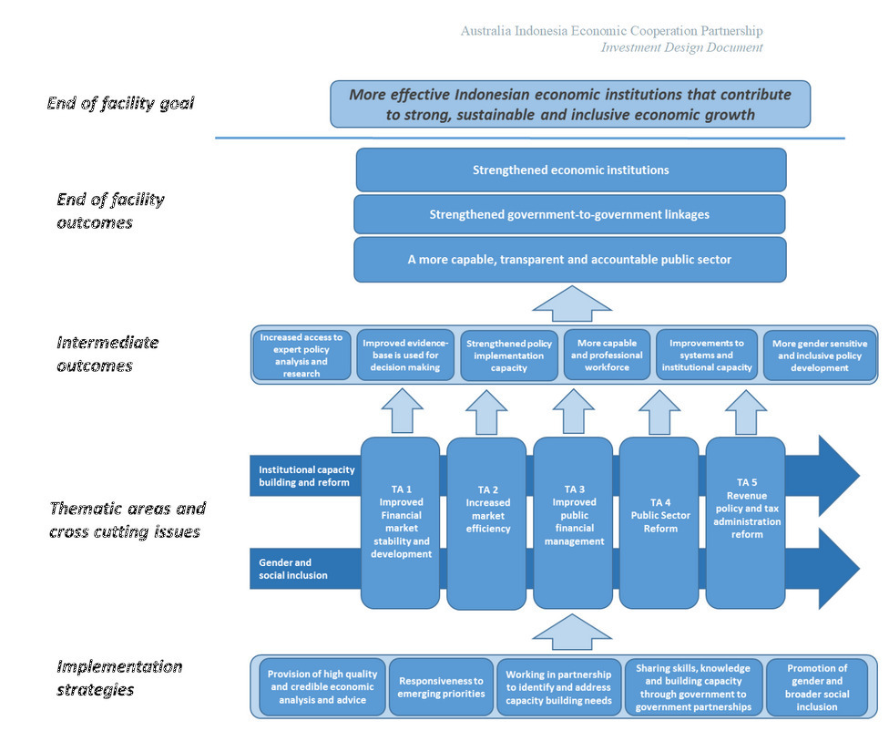
There is only one document that deals with the ToC that is the 2018 KPL Framework, including the concept of Cascading Logic. In the 2018 KPL Framework the ToC and how it is linked to facility and activity logic all based on assumptions is described as:
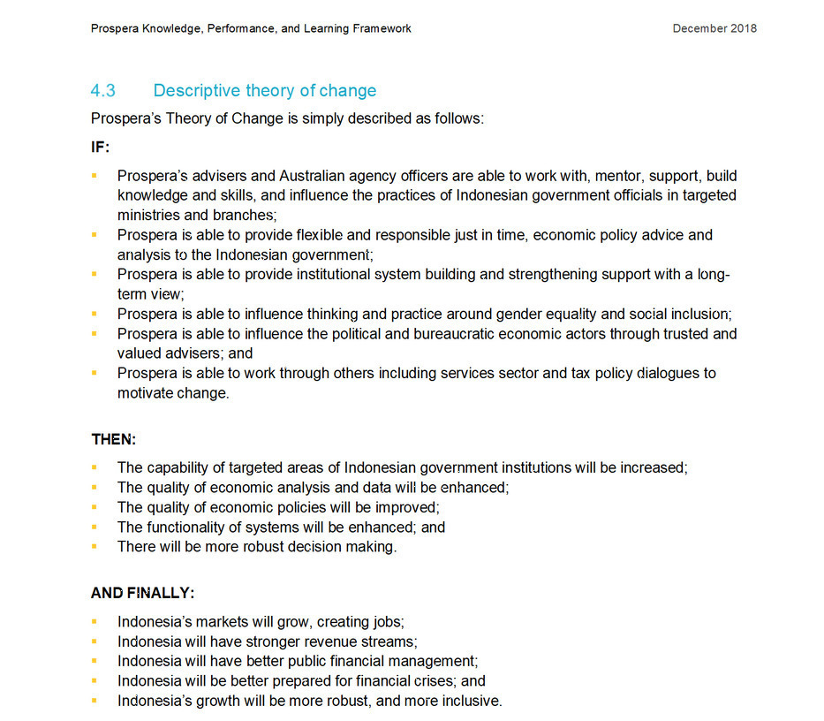

A ToC requires regular updates to reflect lessons learned from implementation failures, incorrect assumptions, and external shocks like COVID-19 or geopolitical shifts (e.g., companies leaving China). These changes necessitate revising both assumptions and the ToC itself—a critical process for maintaining evaluation rigor under DAC guidelines.
However, Prospera’s ToC has seen minimal updates since 2018, with only minor 2023 revisions (adding climate change and inclusive growth) and no substantive changes to core assumptions. The 2023 update merely restated the 2018 framework descriptively, failing to properly reassess underlying conditions. This stagnation risks non-compliance with DAC standards, potentially undermining the evaluation’s validity, attribution accuracy, and recommendation credibility. While limited insights may still emerge, findings must be treated cautiously with explicit caveats about these methodological gaps.

Theory of Change Updated in 2023 Report.
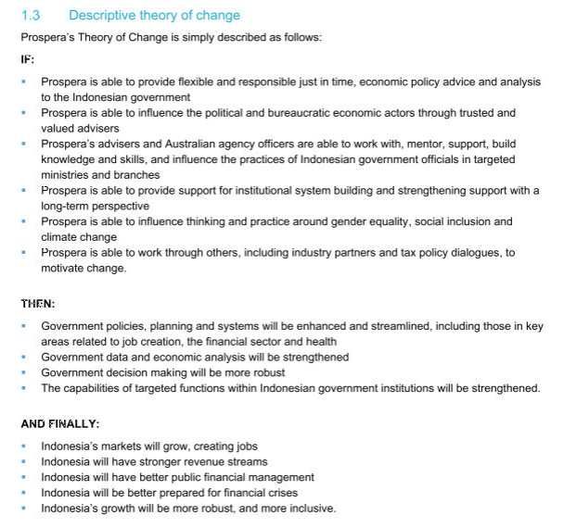

In a report published in December 2024, a new way of a ToC is applied in relation to one specific area of Women’s Economic Participation. The ToC is altered and tailored for this activity and Values and Guiding Principles are added to the ToC, see page 3 of the report. It is unclear if this proposed ToC that only focuses on one area was adopted by Prospera.
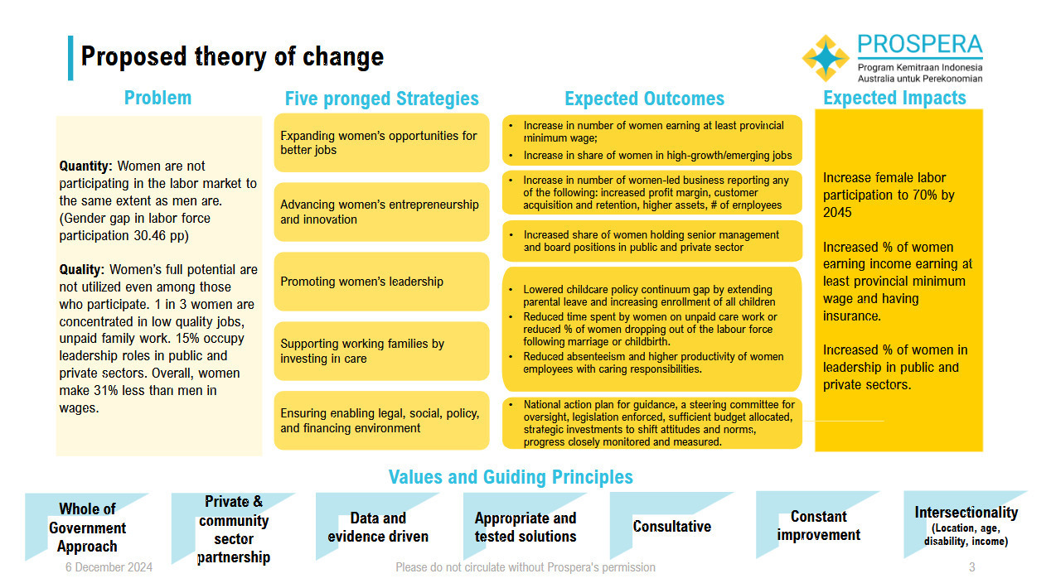

Program Logic in Prospera
Prospera mostly uses a Program logic to frame his activities. The framework frequently changes including structural changes such as in respond to Covid but also frequently in its detail, for example relating to whether it includes intermediate outcomes and the wording of outcome descriptors. Indicators, that would show whether the outcomes have been achieved, are not applied. This can be seen in the following diagrams, taken from Prospera documentation on the following pages. The frequent changes in the Program Logic, the different use of wording and concepts, and changes in levels has made it difficult for the evaluation team to use the Program Logic as a basis for assessing the program.

In the Program Logic in Component 1 KPL Framework 2018, there is no mention of activities and inputs, and it doesn’t include intermediate outcomes or indicators.
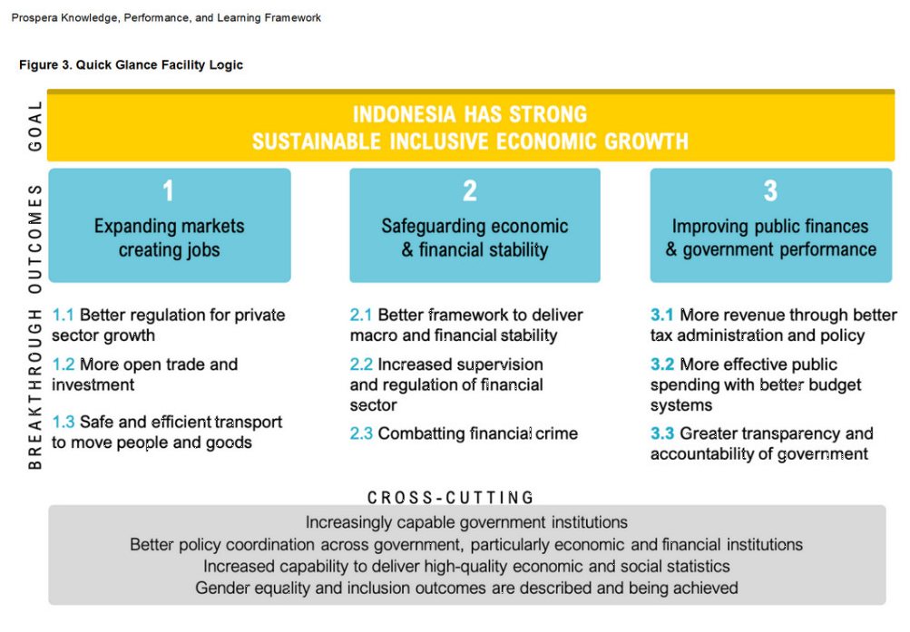

The Facility Logic in 2019 mentions activities and inputs but does not link them to specific outcomes. Intermediate outcomes are added as well as Breakthrough Outcomes.
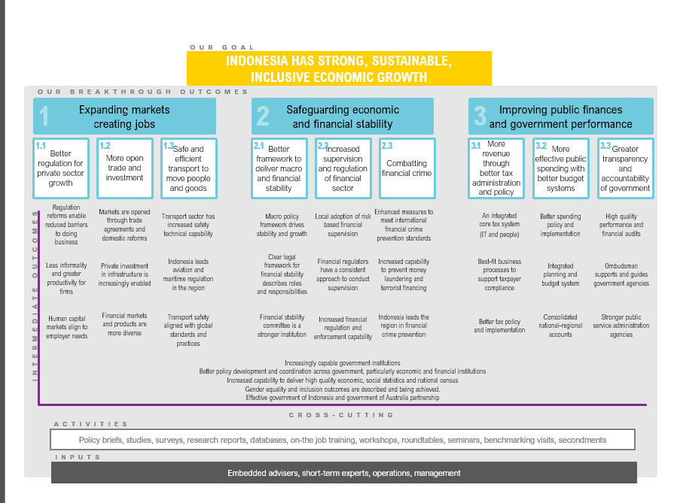

In the Prospera 2020 Annual Report July 2019 – June 2020 there are no mention of activities and inputs or intermediate outcomes.
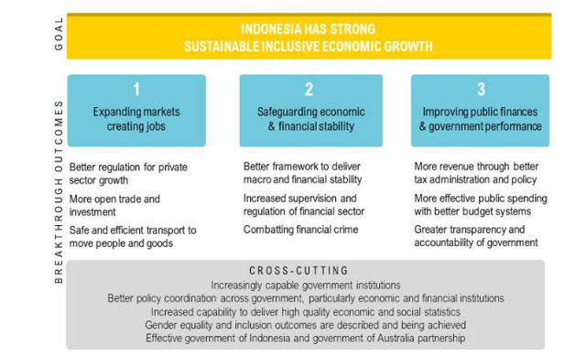

In December 2020, the board approved a new structure as response to COVID focus on stability. The breakthrough outcomes have changed, the intermediate outcomes omitted and no mention of activities and inputs.
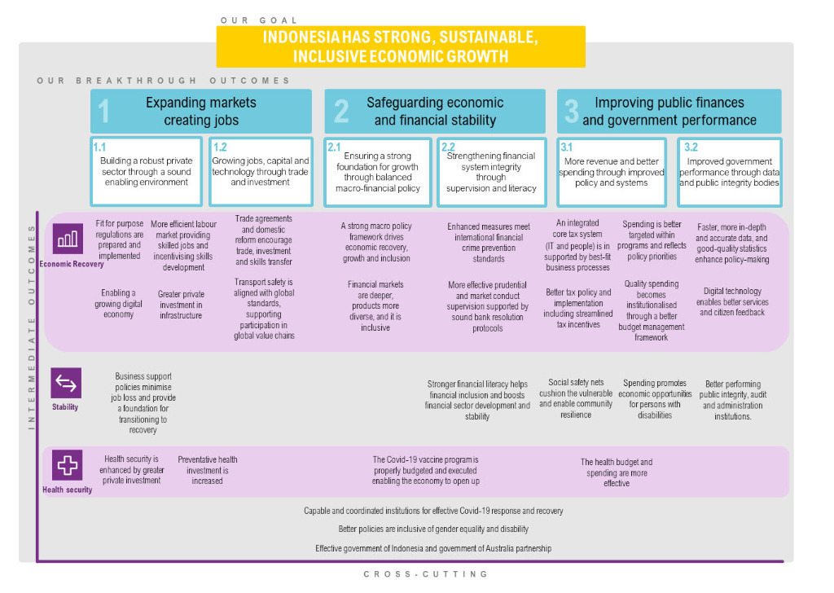

The 2020-2021 Workplan and Annual Report did not mention of activities and inputs.
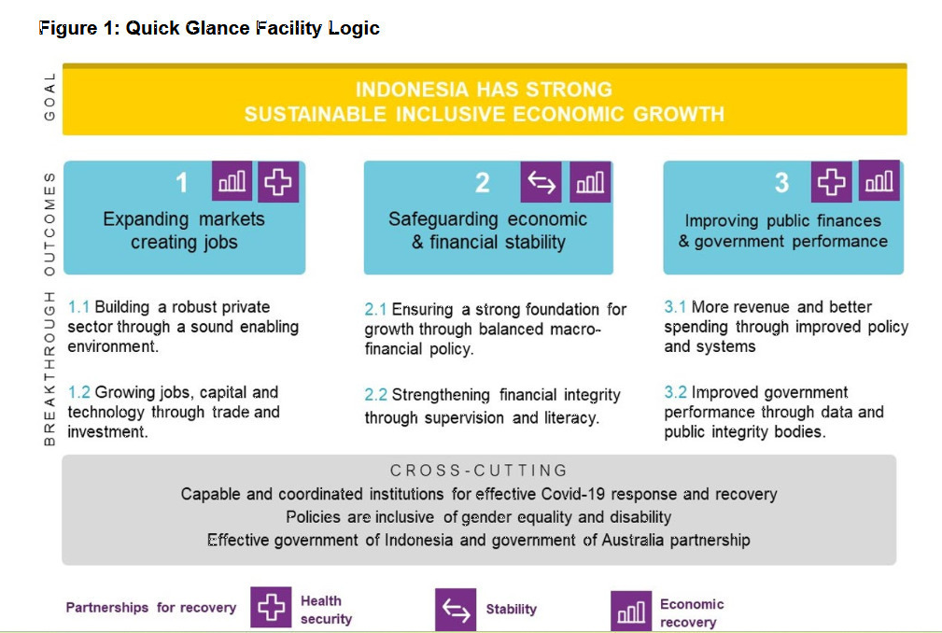

A report on 23 Nov 2023 did not mention of activities and inputs.
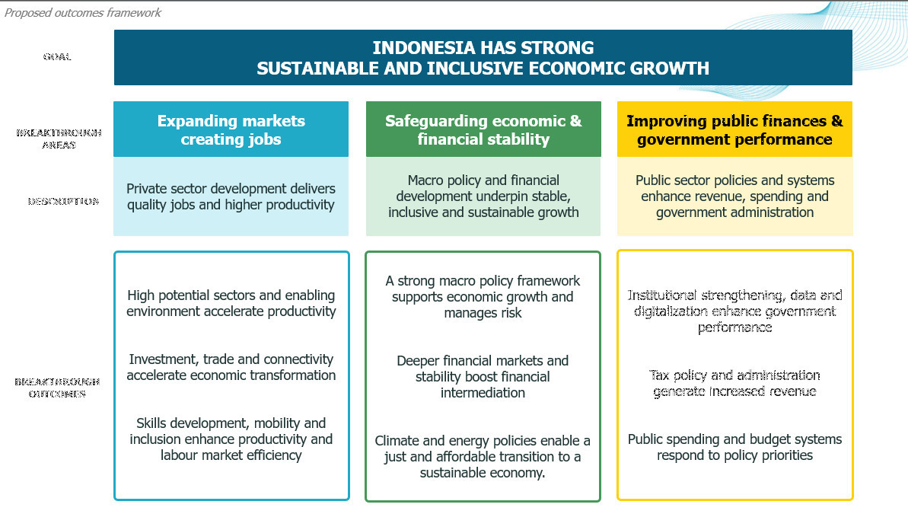

A report on 23 November 2023 (page 2) did not mention of activities and inputs.
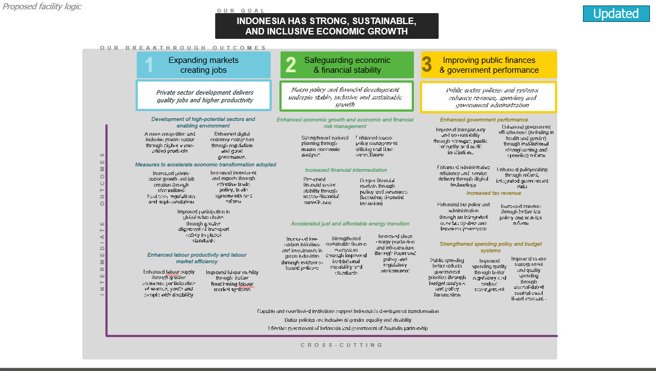

In the November 2023 report (KPL Addendum, p.6), there is cascading logic, an important aspect that was covered in the initial design documents and is now revisited (below is the BT 3 with an example). It links activities with milestones, intermediate outcomes and breakthrough outcomes.
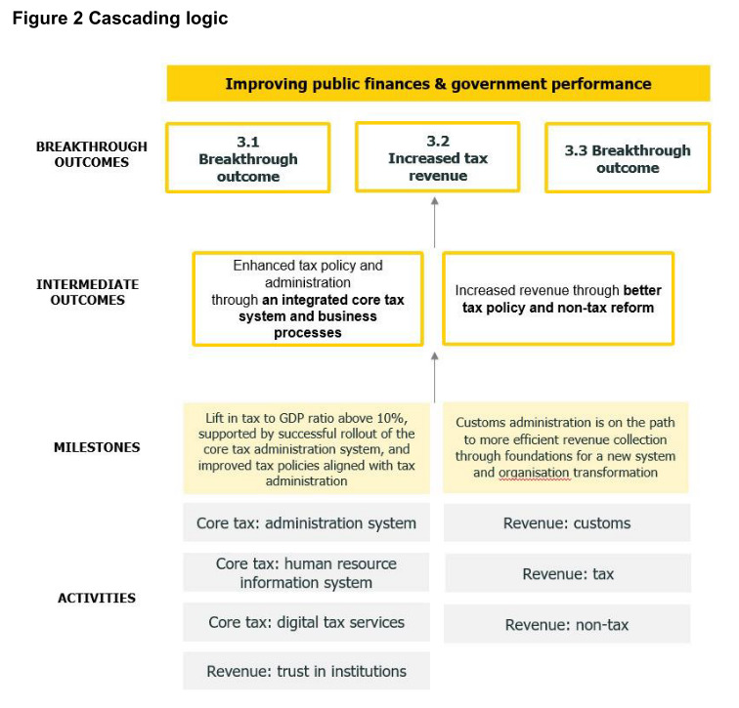

In the October 2024, Prospera added digital strategy & activity portfolio; there are no intermediate outcomes and no activities or inputs or cross cutting issues.
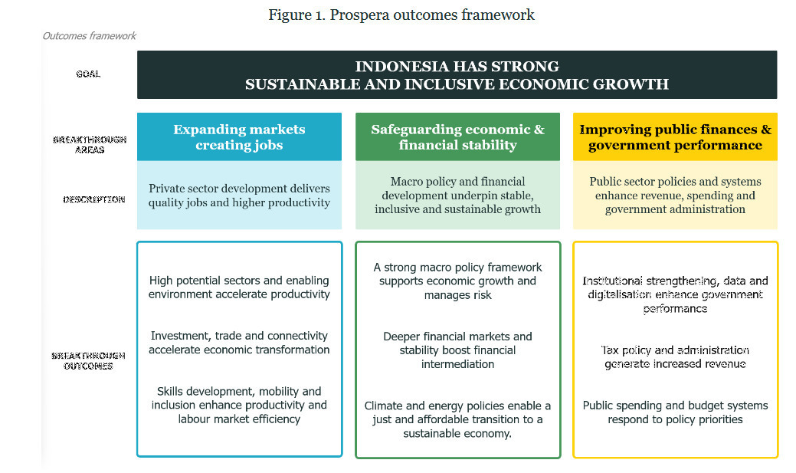

Annex 2: Methodology, Evaluation Questions, and Strength of Evidence Matrix

​​METHODOLOGY
The evaluation has employed a mixed-methods approach, combining desk review, secondary data analysis, primary data collection, and a case study approach to ensure a comprehensive assessment.
- Desk Review and Secondary Data Analysis: The team conducted an initial desk review of relevant documents, including project reports, assessments, reviews, and evaluations. This review identified key issues for further investigation through primary data collection that provided a foundation for assessing achievements, organisational arrangements, and procedures. Quantitative data previously collected by the project, such as the Mid-Term Review (MTR) survey and post-training evaluations, was also reviewed to inform the analysis of evaluation questions.
- Initial Consultation with the Project Team: The ET held an initial consultation with DFAT staff at the Australian Embassy in Jakarta to align objectives, scope, and key areas of focus.
- Key Informant Interviews (KIIs), Focus Group Discussions (FGDs), and Surveys.
- A qualitative approach was used for primary data collection, including KIIs and FGDs. Stratified purposeful sampling ensured diverse perspectives from all relevant stakeholder groups. Interview protocols for different stakeholder types are outlined in Annex 3. An online survey on partnership-building outcomes across APS-GoI collaborations was conducted by the ET, administered online. A list of interviews conducted is attached at Annex 4.
- Case Study Approach: Given the large number of activities across the three breakthrough outcome areas and sub-outcomes, the evaluation team adopted a case study approach to enable a deeper dive into specific outcomes and activities. Case studies were selected to reflect key aspects of the breakthrough areas and cross-cutting themes, ensuring manageability within the evaluation’s time and resource constraints. The case studies include:
Breakthrough Outcome 1: Expanding Markets, Creating Jobs
- Omnibus Law on Job Creation, OSS system, and underpinning regulations with the CMEA.
Breakthrough Outcome 2: Safeguarding Economic and Financial Stability
- Prospera contribution on education sector (cross-cutting with BT3) and growth narrative 2045.
Breakthrough Outcome 3: Improving Public Finance and Government Performance
- Directorate General of Taxation (DG Tax): Core Tax Administration System (CTAS).
- Support for integrating planning and budgeting systems (Krisna-Sakti integration) with Bappenas and the Ministry of Finance (MoF).
Cross Cutting:
- Support for the Digital Transformation and E-Government
- Improved government data collection and integration, leading to better policy outcomes (examples used COVID response and ABS and BPS collaboration)
The methodology for case studies involved intensive KIIs with advisers, counterparts, and other relevant stakeholders, a detailed review of the policy and regulatory context, and a desk review of project documents.
- Validation Workshop
Following stakeholder consultations, an online validation workshop was held with DFAT Jakarta and invited guests on the 5th of February 2025. The ET presented initial findings and gathered feedback from participants to refine its analysis.
- Data Analysis and Verification
Data from secondary sources, consultations, interviews, and surveys was analysed to address the evaluation questions. Content analysis, coding, and tallying of qualitative data was combined with quantitative data from secondary sources. This evidence-based approach ensured the evaluation report thoroughly addresses the evaluation questions and sub-questions.
- Utilisation of Key Findings and Results
The evaluation is grounded in a utilisation-focused approach, ensuring findings are presented in a way that maximises stakeholders’ ability to process, apply, and learn from the results. This has facilitated informed decision-making and continuous improvement.
An independent survey (see Annex 3 for more details) was conducted by the ET assessing the relationship between GoI and GoA based on joint activities that agencies between the two countries conducted or as part of Prospera’ activities.

​​EVALUATION QUESTIONS
Relevance and Validity of Design
Evaluation Question: How relevant and appropriate has Prospera’s strategy and modality been in promoting strong, sustainable and inclusive growth in Indonesian in the context of a bilateral partnership?
Sub-questions
To what extent is the project theory relevant and coherent as a model for supporting sustainable and inclusive growth in Indonesia in the context of a bilateral partnership?
How well aligned are Prospera activities to GoI partners’ requests, requirements and expectations while maintaining a coherent and strategic approach to supporting economic development?
How well has Prospera contributed to Australia’s bilateral partnership in Indonesia?
To what extent does the approach towards capacity building in component 1, 2, 3, and 5 of the Knowledge, Performance and Learning framework reflect the approach in the design document?
Effectiveness
Evaluation Question: To what extent can project implementation be considered to have been effective?
Sub-questions
What contribution has Prospera made to the achievement of its stated intermediate outcomes and BT outcomes (see Annex 1 Prospera’s Program Logic)? Have the contributions made by Prospera been in line with expectations as per the project design?
What aspects of Prospera design and implementation have helped or hindered the achievement of the BT outcomes? How effective have the delivery mechanisms been regarding achieving project outcomes?
How effective was the design and implementation of the activity cycle including the role of counterparts in proposal development?
How coherently have the different components of Prospera (i.e., Advisory teams, ‘Centres of excellence’, data analytics and Knowledge, Performance and Learning framework APS Partnerships, and Tim Asistensi) maximised potential synergies and added value to the achievement of the program outcomes?
To what extent has Prospera’s approach towards capacity building and knowledge transfer been effective?
What has Prospera contributed to policy analysis and its adoption in the Indonesian context? Has the approach taken been useful and effective?
To what extent has the approach to MEL on Prospera been effective in supporting learning and adaptive management on Prospera?
To what extent has Prospera achieved its hoped-for outcomes in relation to cross cutting issues such as GoI whole of government coordination and GoI and GoA partnerships?
To what extent has Prospera coordinated effectively and created synergies with other DFAT programs in Indonesia?
How effective has Prospera been in ensuring benefits from the investment are shared by women, girls, and people with disabilities?
Sustainability
Evaluation Question: What likelihood is there that benefits from Prospera will be sustainable?
Sub-questions
What contribution has Prospera made towards sustainable capability in GoI partners to achieve strong, sustainable and inclusive economic growth?
To what extent are GoI partners adopting and taking ownership of Prospera’s long term activities?
What is the likelihood of Prospera’s key outcomes being sustained by GoI stakeholders (for example, policies and regulations being implemented)?
Lessons learned
What lessons learned can be garnered from program implementation, in relation to areas such as implementation modality, sectoral selection, delivery mechanisms, cross cutting issues, approaches to partnerships, management, capacity building and MEL which could be useful for future DFAT interventions in economic governance in Indonesia and more broadly?
Recommendations
What are some key strategic and operational recommendations stemming from the evaluation pertaining to the design and implementation of a future phase of Prospera?
The Strength of Evidence Matrix below outlines the data collection methods that will be drawn upon and how different sources of information will combine to answer the evaluation questions and sub-questions.

STRENGTH OF EVIDENCE MATRIX
Evaluation Criteria | Evaluation Questions and Sub-Questions | Data collection methods | Data sources | Stakeholders/ Informants | Analysis and assessment
Relevant and validity of design | Question: How relevant and appropriate has Prospera’s strategy and modality been in promoting strong, sustainable and inclusive growth in Indonesian in the context of a bilateral partnership? | Document review; KIIs | Project Documents (See Annex 3)  Interviews | Designers of facility  Authors of the KPL component 1,2, and 3  APS representatives  DFAT staff  MTR Team Leader  Prospera LTAs  GoI counterpart staff | Qualitative;  Triangulation
 | SQ: How well aligned are Prospera activities to GOI partners’ requests, requirements and expectations while maintaining a coherent and strategic approach to supporting economic development? | Document review;  KIIs and  Secondary data (macro indicators); Case Studies | Project Documents (See Annex 3); Interviews and  survey results;  GoI data (documents relating to Prospera and statistics). | Designers of facility;  GoA agency reps;  GoI partners related to programs and activities. | Qualitative; Quantitative;  Triangulation.
 | SQ: How well has Prospera contributed to Australia’s bilateral partnership in Indonesia? | Document review;  KIIs; Case Studies | Project Documents (See Annex 3); Interviews  results. | Designers of facility  Authors of the KPL  APS representatives  DFAT staff  GoI counterpart senior representatives | Qualitative;  Triangulation.
 | SQ: To what extent does the approach towards capacity building in component 1, 2, 3, and 5 of the Knowledge, Performance and Learning framework reflect the approach in the design document? | Document review;  KIIs; Capacity Development and Partnership Quality Survey (CDPQS). | Project Documents (See Annex 3); Interviews and  survey results;  GoI data. | APS and GoI counterparts. | Qualitative;  Triangulation.
Effectiveness | Q: To what extent can project implementation be considered to have been effective? | Document review;  KIIs; Capacity Development and Partnership Quality Survey (CDPQS); Secondary data (macro indicators). | Project Documents; Interviews and  survey results;  GoI macro-indicator data. | Designers of facility  GoA partners  GoI partners related to programs and activities. | Qualitative; Quantitative;  Triangulation; Case Study.
 | SQ: What contribution has Prospera made to the achievement of its stated intermediate outcomes and breakthrough outcomes (see Annex A)? Have the contributions made by Prospera been in line with expectations as per the project design? | Document review; KIIs. | Project Documents; Interview results. | Designers of facility;  GoA partners;  GoI partners related to programs and activities. | Qualitative;  Triangulation; Case Study.
 | SQ: What aspects of Prospera design and implementation that have helped or hindered the achievement of the breakthrough outcomes?  How effective have the delivery mechanisms been regarding achieving project outcomes? How effective was the design and implementation of the activity cycle including the role of counterparts in proposal development? | Document review; KIIs. | Project Documents; Interview results. | Designers of facility;  GoA partners;  GoI partners related to programs and activities. | Qualitative; Quantitative;  Triangulation.
 | SQ: How coherently have the different components of Prospera (i.e., Advisory teams, ‘Centres of excellence’ data analytics and Knowledge, Performance and Learning framework APS Partnerships, and Tim Asistensi) maximised potential synergies and added value to the achievement of the program outcomes? | Document review; KIIs. | Project Documents; Interview results. | Designers of facility; Authors of the KPL; DFAT reps; APS reps. | Qualitative;  Triangulation.
 | SQ: To what extent has Prospera’s approach towards capacity building and knowledge transfer been effective? | Document review;  KIIs; Capacity Development and Partnership Quality Survey (CDPQS). | Project Documents; Interview results. | DFAT  GoA/ APS representative  GoI partners related to programs and activities | Qualitative; Quantitative;  Triangulation.
 | SQ: What has Prospera contributed to policy analysis and its adoption in the Indonesian context? Has the approach taken been useful and effective? | Document review; KIIs. | Project Documents; Interview results. | DFAT  GoA/ APS representative  GoI partners related to programs and activities | Qualitative; Quantitative;  Triangulation.
 | SQ: To what extent has the approach to MEL on Prospera been effective in supporting learning and adaptive management on Prospera? | Document review; KIIs. | Project Documents; Interview results. | DFAT  Authors of the KPL  DFAT  Prospera MEL adviser | Qualitative;  Triangulation.
 | SQ: To what extent has Prospera achieved its hoped-for outcomes in relation to cross cutting issues such as GoI whole of government coordination and GoI and GoA partnerships? | Document review; KIIs. | Project Documents; Interview results. | DFAT  GoA  GoI partners related to programs and activities. | Qualitative;  Triangulation.
 | To what extent has Prospera coordinated effectively and created synergies with other DFAT programs in Indonesia? | Document review;  KIIs; Capacity Development and Partnership Quality Survey (CDPQS). | Project Documents  Interviews and  survey results  GoI data (documents relating to Prospera, statistics, workshop/ training feedback) | DFAT  GoA  GoI partners related to programs and activities | Qualitative; Quantitative;  Triangulation.
 | SQ: How effective has Prospera been in ensuring benefits from the investment are shared by women, girls, and people with disabilities (considering all EOPOs as well as the GEDSI strategy)? | Document review;  KIIs; Capacity Development and Partnership Quality Survey (CDPQS). | Project Documents  Interviews and  survey results  GoI data | Designers of facility  GoA  GoI partners related to programs and activities. | Qualitative; Quantitative;  Triangulation.
Sustainability | Q: What likelihood is there that benefits from Prospera will be sustainable? | Document review;  KIIs; Capacity Development and Partnership Quality Survey (CDPQS). | Project Documents  Interviews and  survey results  GoI data. | Designers of facility  GoA  GoI partners related to programs and activities. | Qualitative; Quantitative;  Triangulation.
 | SQ: What contribution has Prospera made towards sustainable capability in GOI partners to achieve strong, sustainable and inclusive economic growth? | Document review;  KIIs; Capacity Development and Partnership Quality Survey (CDPQS). | Project Documents  Interviews and  survey results  GoI data. | Designers of facility  GoA  GoI partners related to programs and activities. | Qualitative; Quantitative;  Triangulation.
 | SQ: To what extent are GOI partners adopting and taking ownership of Prospera’s long term activities? | Document review;  KIIs; Capacity Development and Partnership Quality Survey (CDPQS). | Project Documents  Interviews and  survey results  GoI data. | Designers of facility  GoA  GoI partners related to programs and activities. | Qualitative; Quantitative;  Triangulation.
 | SQ: What is the likelihood of Prospera’s key outcomes being sustained by GOI stakeholders (for example, policies and regulations being implemented)? | Document review;  KIIs; Capacity Development and Partnership Quality Survey (CDPQS). | Project Documents  Interviews and  survey results | Designers of facility  GoA  GoI partners related to programs and activities. | Qualitative; Quantitative; Case Study;  Triangulation.
Lesson learnt | Q: What likelihood is there that benefits from Prospera will be sustainable? | Document review;  KIIs; Capacity Development and Partnership Quality Survey (CDPQS). | Project Documents  Interviews results. | Designers of facility  GoA  GoI partners related to programs and activities. | Qualitative; Quantitative; Case Study;  Triangulation.
Recommendations for a new phase | Q: What are some key strategic and operational recommendations stemming from the evaluation and foresight activities pertaining to the design and implementation of a future phase of Prospera. | Document review;  KIIs; Capacity Development and Partnership Quality Survey (CDPQS). | Project Documents  Interviews results. | Designers of facility  GoA/ APS representative  GoI partners related to programs and activities.  Prospera evaluation expert. | Qualitative; Quantitative; Case Study;  Triangulation.

Annex 3: Interview Protocol and Survey Instrument
Interview protocols for the GOI stakeholders
I. General Program Effectiveness and Strategic Alignment
- "As Prospera Board Member: How effective do you think Prospera has been in terms of selecting strategic interventions for support? Do you think Prospera has maintained focus well and selected useful interventions? What do you see as Prospera’s greatest achievement?"
- "In your view did Prospera align with GoI requests, requirements and expectations? Has Prospera taken a clear strategic approach according to project objectives?"
- "What do you think are the most important achievements of Prospera?"
- "What aspects of Prospera do you think could have been adjusted?"
- "Did Prospera fit well with other development partner interventions?"
- "As Deputy Minister, how responsive did you find Prospera to your requests for assistance? Did you feel that Prospera would respond to all requests or that there was a strategic focus to their selection of requests to respond to? Would you be able to provide any examples to illustrate your answer?"
II. Collaboration and Engagement
- "Collaboration: What collaboration/s did you have with Prospera?"
- "Effectiveness: During these collaborations, did Prospera engage effectively?"
- "Can you describe Prospera’s collaboration and support within [Specific Agency: BKF, KSSK, MoH]? (support can be briefs, drafting regulations, advice, training or workshops, etc). Have these been useful?"
- "Do you ([Agency]) also collaborate with APS? Give illustrations of the activities."
III. Capacity Building and Knowledge Transfer
- "To what extent has Prospera's approach towards capacity building and knowledge transfer been effective? Do you think Prospera has contributed to greater capability in Government? If so, how?"
- "Can you explain programs/activities with Prospera called [Specific Program: crisis simulation, banking stress test]? Have these been useful?"
IV. Specific Policy and Program Support
- "Can you talk about Prospera’s support for the (example: OSS System; the Omnibus bill on job creation; OECD accession; digital transformation strategy; and so on..)? What support has been provided with what modality (briefs, drafting regulations, advice, training or workshops)? Has it been useful? If so in what way? Was the support provided of high quality? How has it complemented support from other donors? Can you think of any ways it could have been done better?"
V. Strengths, Weaknesses, and Sustainability
- "What do you see as the key strengths and weaknesses of the program?"
- "Do you think the results of your collaborations with Prospera will have lasting impact?"
VI. GEDSI (Gender Equality, Disability, and Social Inclusion)
- "GEDSI: What has been Prospera’s approach to GEDSI? Was it effective?"
VII. Lessons Learned and Future Recommendations
- "Are there any lessons learned that it might be useful for the GoA to consider in planning a subsequent phase of Prospera?"

Survey questions – Prospera staff – Government of Indonesia (GoI)
Pertanyaan Survey – Staf Prospera – Pemerintah Indonesia

The following survey is intended to collect data to assist in the independent evaluation of the Prospera activity. The purpose of the survey is to gather information regarding APS (Australian Public Service) and Prospera activities supporting the GoI related to capacity building and relationship development.
Survey ini bertujuan untuk mengumpulkan data guna membantu evaluasi independen terhadap kegiatan Prospera. Fokus dari survey ini adalah kegiatan APS (Australian Public Service) dan Prospera yang mendukung Pemerintah Indonesia terkait dengan peningkatan kapasitas dan pengembangan hubungan antar-negara.

We aim to explore topics such as preparation, cross-cultural awareness and communication, understanding of operational context, modalities, ongoing connections, and other relevant matters.
Tim Evaluasi ingin mengeksplorasi topik-topik seperti persiapan, kesadaran dan komunikasi lintas budaya, pemahaman konteks operasional, modalitas, hubungan kedua negara yang sedang berlangsung, serta informasi lainnya yang relevan.

Your insights will contribute to a better understanding of important factors that impact on the effectiveness of capacity building, knowledge transfer and relationship building. This information can be used to improve approaches in these areas in future program designs for APS agency/Prospera support in Indonesia.
Pandangan Anda melalui survey ini akan memberikan kontribusi signifikan dalam upaya meningkatkan efektivitas program pengembangan kapasitas, transfer pengetahuan, dan penguatan hubungan kedua negara. Informasi yang diperoleh akan menjadi dasar bagi perbaikan program dukungan APS/Prospera di Indonesia di masa mendatang.

Participation in this survey is entirely voluntary, and all responses will remain anonymous.
Partisipasi pada survey ini sepenuhnya bersifat sukarela dan rahasia (anonymous).

Throughout the survey we use the term ‘activity/ies’ to refer to the work undertaken between yourself/your agency and the counterparts/counterpart agency. The work has involved many tasks including webinars, seminars, in-country visits, Centre of Excellence, advising, ongoing collaborations and secondments. For the purposes of the survey, the term ‘activity/ies’ refers to assignments in any of these areas.
Di sepanjang survey, kami menggunakan istilah 'kegiatan/aktivitas' untuk merujuk pada pekerjaan yang dilakukan antara Anda/instansi Anda dan mitra/instansi mitra (APS/Prospera). Pekerjaan ini dapat meliputi banyak hal, seperti: webinar, seminar, kunjungan ke luar negeri, Pusat Keunggulan (Centre of Excellence), konsultasi dan bantuan teknis (technical assistance), konsultasi dan penasihat teknis (technical advisory), kolaborasi yang sedang berlangsung, dan penempatan staf APS di instansi Anda. Untuk keperluan survey, istilah 'kegiatan' mengacu pada salah satu penugasan tersebut.

If you were involved in more than one activity under Prospera, please select one activity and answer the following questions in relation to that. At the end of the survey, you can repeat the survey for other activities.
Jika Anda terlibat pada lebih dari satu 'kegiatan' di bawah Prospera, pilihlah satu kegiatan dan jawablah pertanyaan-pertanyaan berikut ini. Di akhir survey, Anda dapat mengulangi survey untuk kegiatan lainnya.

- What was the total number of days support you received as part of Prospera?
Berapa lama (dalam hari) dukungan yang Anda terima pada kegiatan yang berhubungan dengan Prospera?
Choose an item.

- What was the type of support you received?
Apa jenis dukungan yang Anda peroleh?
Choose an item.

- What language was the support conducted in?
Bahasa apa yang digunakan untuk memberikan dukungan?
Choose an item.

- Were interpretation/translation services included?
Apakah terdapat layanan interpretasi/penerjemahan dalam kegiatan tersebut?
Choose an item.

- If the activity was conducted in English, how did this affect your learning?
Jika kegiatan dilakukan dalam Bahasa Inggris, bagaimana hal ini mempengaruhi pembelajaran Anda?
Choose an item.

- On a scale of 1 – 5 how culturally sensitive did you feel the APS staff who provided support were?
Pada skala 1 - 5, menurut Anda, seberapa peka terhadap budaya staf APS/Prospera ketika memberikan dukungan tersebut?

- How well did your Australian counterparts understand the way the Indonesian Government context works in your field?
Seberapa baik rekan-rekan staf APS/Prospera memahami konteks bagaimana cara kerja pada Pemerintah Indonesia di bidang Anda?

- How important do you think understanding the way the Indonesian Government context works was to be carrying out your assignment?
Menurut Anda, seberapa penting memahami konteks dan cara kerja Pemerintah Indonesia dalam melaksanakan tugas di bidang Anda?

- How important do you think understanding the Indonesian cultural context was to be carrying out your assignment?
Menurut Anda, seberapa penting memahami konteks budaya Indonesia dalam melaksanakan tugas di bidang Anda?
Choose an item.

- Did you work with pre-prepared material in your engagement?
Apakah Anda menerima materi yang telah dipersiapkan (bahan untuk dibahas/ didiskusikan) sebelum kegiatan berlangsung?
Yes – continue | Ya – lanjut ke pertanyaan selanjutnya
No – auto-skip to qn 14 | Tidak – langsung lanjut ke pertanyaan 14

- Before you began the activity, what was your knowledge of the material that you were to learn?
Bagaimana tingkat pengetahuan Anda tentang materi yang akan Anda pelajari/ dapatkan sebelum kegiatan berlangsung?
Choose an item.

- What information did you receive before the activity on what to expect and how to prepare?
Sebelum kegiatan, informasi apa yang Anda terima terkait dengan apa yang akan diterima, apa yang diharapkan, dan bagaimana mempersiapkan kegiatan tersebut?

- How suitable do you feel the material/content was that you worked with during the activity/s?
Menurut Anda, seberapa cocokkah materi/ konten yang Anda terima selama kegiatan berlangsung?
Choose an item.

- On a scale of 1-10, how relevant was the material to your work?
Pada skala 1-10, seberapa relevan penerapan materi tersebut pada pekerjaan Anda?

- Do you have any ideas on how the material could have been improved?
Apakah Anda memiliki saran untuk dapat meningkatkan relevansi dan efektivitas konten/materi tersebut?

- How well did the content of your learning accurately reflect a need in your workplace?
Seberapa baik dan akurat konten pembelajaran dari kegiatan tersebut dapat mencerminkan kebutuhan di instansi Anda?
Choose an item.

- Please outline an example of how the input from the APS/Prospera has changed your practice at work?
Berikan contoh bagaimana masukan dari APS/Prospera telah mengubah praktik Anda di tempat kerja?

- Do you feel the duration of the activity matched what was needed?
Apakah Anda merasa durasi kegiatan sesuai dengan yang dibutuhkan?
Choose an item.

- Choose the ways of learning that are most impactful for the activity you undertook (select the one that applies for each grouping):
Pilihlah cara belajar yang paling berdampak pada kegiatan Anda di lingkungan kerja (pilih salah satu untuk setiap pengelompokan):
In person v online | Secara tatap muka v daring/online
One on one v group | Secara individual v berkelompok
One off v ongoing | Sekali kegiatan v berkelanjutan

- Do you feel that your GoA (Government of Australia) counterpart also experienced learning through the activity/ies?
Apakah Anda merasa bahwa mitra Australia Anda juga mengalami pembelajaran melalui kegiatan tersebut?
Choose an item.

- How important did you perceive relationship – building between the GoI and GoA to be to your activity/ies?
Menurut Anda, seberapa penting Pemerintah Indonesia dan Pemerintah Australia menjalin hubungan melalui kegiatan tersebut?
Choose an item.

- To what extent have you maintained connections with the APS/Prospera staff or other participants in the activity since the support?
Sejauh mana Anda mempertahankan jejaring dengan staf APS/Prospera atau peserta lain dalam kegiatan tersebut setelah kegiatan/ dukungan selesai?
Choose an item.

- Rank the areas that you felt your work with Australian representatives allowed you to have the most impact by moving them up and down until you are satisfied, then pressing submit:
Beri peringkat pada bidang-bidang yang menurut Anda paling berdampak dengan menggesernya ke atas dan ke bawah hingga Anda puas, lalu tekan kirim:

Building relationships between GoI and GoA | Menjalin hubungan antara Pemerintah Indonesia dan Pemerintah Australia
Solving specific issues | Menyelesaikan hal/ permasalahan khusus
Co-learning | Pembelajaran bersama
Building the capacity of peers | Membangun kapasitas rekan kerja
Integrating new approaches into Indonesian systems | Mengintegrasikan pendekatan baru ke dalam sistem di Indonesia
Developing long term partnerships with colleagues | Mengembangkan kemitraan jangka panjang dengan kolega
Developing a long-term partnership between agencies | Mengembangkan kemitraan jangka panjang antar lembaga
Large scale reform | Reformasi skala besar

- Explain why you ranked them as you did:
Jelaskan mengapa Anda memberi peringkat seperti yang Anda lakukan!

- On a scale of 1-10, with 10 being the most effective, how effective was this activity in supporting you in building your capacity in your role?
Pada skala 1-10, dengan 10 sebagai yang paling efektif, seberapa efektifkah kegiatan tersebut dalam mendukung Anda membangun kapasitas dalam peran Anda?

- Please explain why you gave this score: Mohon jelaskan mengapa Anda memberikan nilai tersebut:

- As per the agreement between both governments, the project focussed on a variety of areas. Please score from 1-10, with 10 being the highest, how well the activity met the following areas:
Sesuai dengan kesepakatan antara pemerintah kedua negara, proyek ini (APS/Prospera) berfokus pada berbagai bidang. Beri nilai dari 1-10, dengan nilai tertinggi 10, seberapa baik kegiatan tersebut memenuhi bidang-bidang berikut:

- Technical assistance – 1-10 | Bantuan teknis – 1-10
- Capacity and institutional strengthening – 1-10 | Penguatan kapasitas dan kelembagaan – 1-10
- High quality analysis – 1-10 | Analisis berkualitas tinggi – 1-10
- Partnership building – 1-10 | Membangun kemitraan – 1-10

- What recommendations would you have for Australian government departments implementing activities among GoI ministries and agencies in the future?
Rekomendasi apa yang dapat Anda berikan untuk Departemen Pemerintah Australia yang mengimplementasikan kegiatan pada kementerian dan lembaga Pemerintah Indonesia di masa depan?

- Were you involved in another activity in this program. If you answer no, it will take you to the end of the survey, if you answer yes, it will return you to question 1.
Apakah Anda terlibat dalam kegiatan lain dalam program ini (APS/Prospera)? Jika Anda menjawab tidak, maka Anda akan dibawa ke akhir survey, jika Anda menjawab ya, maka Anda akan kembali ke pertanyaan 1.

OPTIONAL QUESTIONS – these questions are only for gathering data and can be filled in on an optional basis.
PERTANYAAN PILIHAN - pertanyaan-pertanyaan ini hanya untuk mengumpulkan data dan bersifat opsional.

- What is your age? | Berapakah usia Anda?
Choose an item.

- How many years’ experience do you have in your current role? | Berapa tahunkah pengalaman Anda pada jabatan yang ada duduki saat ini?
Choose an item.0-1, 2-4, 5+

- What is your gender: Female, Male | Apa identitas gender Anda? Laki-laki/Perempuan
Choose an item.

Annex 4: List of Interviews
No. | Name | Position | Date
1 | Adhi Saputro | Prospera | Head of BT2, Macroeconomy and Financial Stability | 26/11/2024
2 | Adi Budiarso & Team | GOI | Ministry of Finance, BKF | 10/12/2024
3 | Andi Muhardi | DFAT Jkt Finance Manager | 23/12/2024
4 | Angela Neumann & Angina | DFAT Proaktif Team | 11/12/2024
5 | Anisa, Lady & Team | DFAT Jkt | Prospera BT3 Team | 24/12/2024
6 | Astari Widiastomo | DFAT Jkt | Program Manager, BT2 Prospera | 9/12/2024
7 | Atika Amalia | Prospera | Revenue Team (Tax Policy), BT3 | 28/11/2024
8 | Basah Hernowo | GOI | ex-Direktur Bidang Pendanaan Pembangunan, Bappenas (Echelon 2) | 20/12/2024
9 | Bobby Nazief | GOI | MOF, Special Adviser to Minister, Bidang IT | 13/12/2024
10 | Catri Citraningistias, Ramot Aritongan & Team | DFAT Jkt | INKLUSI Team | 13/12/2024
11 | Celly Natalia | Prospera | Team Leader Financial Sector Policy, BT2.2 | 26/11/2024
12 | Chairul Saleh | GOI | CMEA, AsDep Manpower & Productivity (Echelon 2)
13 | Cindy Wiryakusuma & Team (1A) | Prospera | Deputy Director, Performance and Partnerships | 22/11/2024
14 | Cindy Wiryakusuma (1B) | Prospera | Deputy Director, Performance and Partnerships | 22/11/2024
15 | Cindy Wiryakusuma (Part 2) | Prospera | Deputy Director, Performance and Partnerships | 25/11/2024
16 | Darrian Collins, Michael Abboudante, Belle | ABS Team | 16/12/2024
17 | David Nellor | Prospera | Director | 15/11/2024
18 | Della Temenggung (Part-1) | Prospera | Deputy Director, Advisory and Policy | 19/11/2024
19 | Della Temenggung (Part-2) | Prospera | Deputy Director, Advisory and Policy | 20/11/2024
20 | DFAT Economic Governance Team | DFAT Jkt | BT1 and BT3 | 9/12/2024
21 | Edwin Manansang | GOI | CMEA, Asisten Deputi Bidang Digital Ekonomi (former), Senior Adviser to Minister | 10/12/2024
22 | Emily Edwards | DFAT | 23/12/2024
23 | Erwin Ginting | GOI | Dir. Portfolio & Debt Strategy, DJPPR, MOF (Echelon 2) | 12/12/2024
24 | Ferry Irawan | GOI | Deputi Bidang Makroekonomi dan Keuangan, CMEA (Echelon 1) | 11/12/2024
25 | Gary Deng | Prospera | Team Leader, Centre of Excellence Data Analytics | 28/11/2024
26 | Gavin Wyngaard & Nunik | Prospera | Chief of Operation & Deputy of Ops | 25/11/2024
27 | Grant Leader | ATO @DG Tax | 11/12/2024
28 | Halida & Team | DFAT Operation Team | 13/12/2024
29 | Hanny Kusananingtyas & Team | DFAT Investing in Women | 29/11/2024
30 | Ichsan Zulkarnaen | GOI | CMEA, AsDep Economy & Competitiveness | 11/12/2024
31 | Ilham Hadiana & Team | GOI | Bagian Kerjasama DJPK Kemenkeu | 13/12/2024
32 | Indrasworo Bagus Adhiyoso & Team | GOI | MOF, DG Budget Kesekretariatan | 23/12/2024
33 | Irma Marlina | GOI | MOF, BKF Senior Policy Analyst | 13/12/2024
34 | Irwan Sinaga | GOI | CMEA, AsDep Economic Cooperation America & Pacific (Echelon 2) | writing response
35 | Julia; A. Shauki; Widi | Prospera | BT1 Team (Head and Team Leaders) | 29/11/2024
36 | Kartika Juniwaty | Prospera | Team Leader, Centre of Excellence GEDSI | 28/11/2024
37 | Lestari Indah | GOI | ex CMEA (Echelon 2), Prospera Senior Adviser | 10/12/2024
38 | Malti Burrowes
39 | Melissa Wells | Former Prospera | Deputy Director, Performance & Partnership | 2/12/2024
40 | Netty Muharni | GOI | CMEA, Direktur Bidang Kerjasama Regional (Echelon 2) | 12/12/2024
41 | Nufransa Wira Sakti (Frans) | GOI | MOF, Staf Ahli Menteri Keuangan Bidang Pengawasan Pajak | 17/12/2024
42 | OJK: Pak Dewo & Pak Dedi & Team | GOI | OJK Kabid Kerjasama Internasional & Team | 12/12/2024
43 | Patrick Compau | Prospera | Contractor Representative, DT Global | 17/12/2024
44 | Paul Bartlett | KATALIS | 22/11/2024
45 | Perwita Sari | GOI | Senior Policy Analyst, KemenPan RB (Echelon 3) | 13/12/2024
46 | Prospera Senior Management Team | David Nellor, Cindy Wiryakusuma, Vipul Khosla | 12/12/2024
47 | Raksaka Mahi & Nadia Muhidin | Prospera | CMEA Hub & Policy and Strategy Unit (PSU) | 29/11/2024
48 | Reninta Fitriani | ABIP DFAT Team
49 | Riri Silalahi | DFAT Jkt SKALA Team | 28/11/2024
50 | Robert Kennedy | Former Prospera | Chief of Operation | 15/10/2024
51 | Roksana Khan | Prospera | Head of BT3, Public Sector Reform | 26/11/2024
52 | Ronald Mujur | GOI | Senior adviser for Ministry of Health | 10/12/2024
53 | Rullan Rinaldi & Daniel | Prospera | Spending Team, BT3 | 26/11/2024
54 | Sarah & Mima | APS Manager | 28/11/2024
55 | Tim Stapleton | DFAT Minister Counsellor, Economic Infrastructure and Investment (EII) | 9/12/2024
56 | Treasury Team (Emily & Janet) | Treasury Australia | 9/12/2024
57 | Vipul Khosla | Prospera | Head of KPL | M&E Adviser | 16/10/2024
58 | William Rowell | DFAT | 15/10/2024
59 | Yose Rizal Damuri | Founder, Indonesia Service Dialogue (ISD) | 23/01/2025

The evaluation team (ET) did not have access to a full list of detailed activities conducted by Prospera. It did not have detailed information regarding individual activities, neither did it had no access to the cost per activity. This impacted the selection of case studies as the team had no information regarding the size of an activity. It did not have access to the length of activities, or the use of subcontractors. The ET expected many documents to be ready at the start of the evaluation, this was not the case, much information had to be requested multiple times from Prospera.
Australia Indonesia Economic Cooperation Partnership (AIECO) Investment Design Document 2017
Prospera Knowledge, Performance and Learning Framework Component 1: Core Framework
Ibid
Prospera Annual Report & Workplan June 2018 - July 2019
Context monitoring was part of the proposals in 2018-2019 but after that the ET did not see evidence of context monitoring. It did not have access to detailed activity proposals after 2018-2019 except for the proposals by the APS. The APS proposals do provide good context monitoring.
APS partners receive budget directly from DFAT which is not reflected in the table.
The APS has three sources of funding: (1) is directly from the agency, (2) deploy support for staff from Australia, and (3) logistics support program (LSP). Prospera has visibility of the funds spent under (3) and (to some extent over 2), but none over (1). The LSP falls under Prospera. The amount is 11 million over the lifetime of the project up to December 2024 according to the Prospera finance/operations team. That amount does not include technical advisory work that may be conducted by APS staff and funded by a different part of the Prospera budget or by other Australian funding agencies.
Prospera Knowledge, Performance and Learning Framework Component 1: Core Framework, page 1 executive summary.
Prospera, KPL Framework Addendum – working paper November 2023.
Prospera Knowledge Performance and Learning Framework Component 5 – Sustainability strategy 2022–2026.
Lessons learned and recommendations are discussed in-depth in a separate report as per the agreement between DFAT and CARA Consulting Pty Ltd.
See https://one.oecd.org/document/DCD(2023)21/en/pdf accessed 7 April 2025
https://one.oecd.org/document/DCD(2023)21/en/pdf accessed 7 April 2025.
Prospera Jan - June 2023 Six Monthly Report
ibid.
The IDD specified that Australian Government officials deployed to Indonesia would receive training in capacity development techniques prior to departure to ensure that their support is developing key competencies to achieve sustained performance and improvement at the organisational and skills development level. On the adviser side, the IDD stated that the managing contractor would need to play an active role in ensuring that advisors are providing both technical assistance and capacity building expertise at the organisational and individual level. This would be facilitated by the recruitment of advisors with expertise and or experience in capacity building in developing countries and performance management processes that require capacity-building outcomes because of their work. see in green above using the letter from CMEA pointing out that the SA was not followed
Prospera, 2018, Public Sector Strategy: Strengthening the public sector in Indonesia to support strong sustainable and inclusive growth.
Ibid, page 12.
https://www.abnrlaw.com/news/omnibus-law-declared-conditionally-unconstitutional-what-exactly-does-it-mean
None of the subcontractors reported working with another subcontractor in their reporting, some did observe that that was crucial for the CTAS project when reflecting on their work. Some mentioned how Prospera assisted them in their negotiations with DG Tax in concluding contracts, “Prospera have been very helpful on the beginning of the project, especially on the signing of contract and Non-Disclosure Agreement (NDA) between DGT and (...). Prospera always accompanied us during the NDA discussions and helped us with providing solutions.” One subcontractor observed that, “(...) our company team has demonstrated strong commitment in engaging with DGT. We have been actively asking for information, initiating discussions and clarifications to DGT, (...) to further enrich the team’s understanding of the project. One major subcontractor complimented Prospera for having been very supportive, including when managing our contract and proceeding with our billing.” This was mentioned by many subcontractors, complimenting Prospera for speedy payment of their bills. No subcontractor addressed capacity building, institutional strengthening, or GEDSI matters. One major subcontractor who emphasised its focus on GEDSI addressed gender by stating in its completion report: “As long as the knowledge is documented and disseminated efficiently throughout the organisation, women or men can participate to create a better system.” Many subcontractors mentioned that they provided additional advice to DG Tax outside the scope of their ToR for future reference and then carefully suggested the role they could play in the additional improvements. For example, one major subcontractor wrote: “We have collected feedback and insights from DGT, and some of other areas outside of the scope of the project deemed as important factors by DGT.” One phrased it: “We have recommended DGT to further explore and assess security and capacity planning aspects in the long term, and to complement the testing process on infrastructure with system-wide vulnerability scanning and penetration testing. These initiatives will help DGT in making better decision on their new CTAS infrastructure.”
Prospera, 2018/2019 Annual Report.
Prospera, 2019/2020 Annual Report.
World Bank: Collaboration on fiscal relations and disaster risk management has improved government transparency and accountability. USAID: Joint initiatives on public service delivery and data mining have strengthened service delivery mechanisms. UNICEF and UNDP: Partnerships on child-focused programs and intergovernmental fiscal relations have supported sustainable economic growth and social development. ADB Institute: Collaboration on regional economic studies has provided valuable insights for policy improvements.
Investment Design Document, page 21.
As outlined in the excellent analysis of the key pillars for successful institutional strengthening and transformation (ibid, p.11). The 2023 KPL Framework Addendum – working paper Update to Outcomes Framework and Facility logic did not revise theses pillars. It did revise the high-level assumptions, but they did not affect the key pillars approach.
Brown RS. 2020 Rossi Award Lecture: The Evolving Art of Program Evaluation. Eval Rev. 2023 Apr;47(2):209-230. doi: 10.1177/0193841X221121241. Epub 2022 Aug 29. PMID: 36036541.
OECD (2021), Applying Evaluation Criteria Thoughtfully, OECD Publishing, Paris, https://doi.org/10.1787/543e84ed-en.
Prospera, 2024, Fostering women’s economic participation to realise Indonesia’s vision of inclusive and resilient growth, 6 December 2024.

