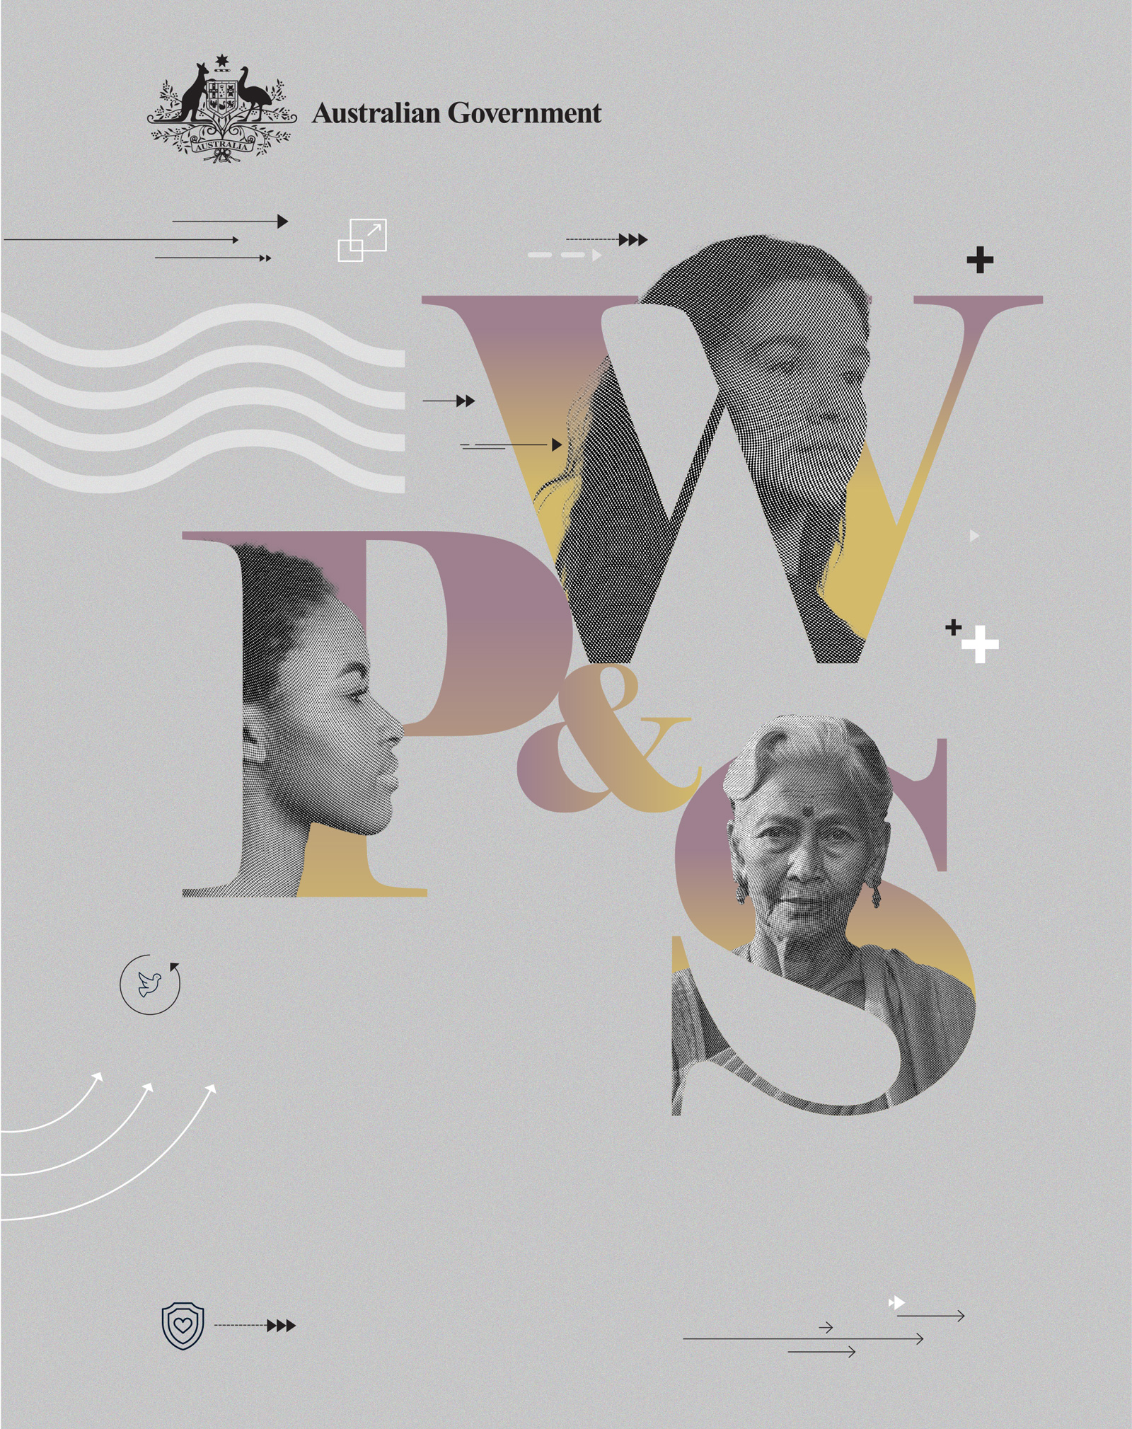

# AUSTRALIAN NATIONAL ACTION PLAN ON WOMEN, PEACE & SECURITY 2021–2031 | PROGRESS REPORT

**AUSTRALIAN NATIONAL ACTION PLAN ON WOMEN, PEACE & SECURITY 2021–2031 PROGRESS REPORT**

ISBN 978-1-74322-624-7 (PDF/Word/electronic)

Creative Commons

With the exception of the Commonwealth Coat of Arms and where otherwise noted, all material presented in this document is provided under a Creative Commons Attribution 3.0 Australia (creativecommons.org/licenses/by/3.0/au/) licence. The details of the relevant licence conditions are available on the Creative Commons website (accessible using the links provided), as is the full legal code for the CC BY 3.0 AU licence (<http://creativecommons.org/licenses/by/3.0/au/legalcode>).

The document should be attributed as:

Australian National Action Plan on Women, Peace and Security 2021-2031 Progress Report

**Contact**

Enquiries about this document should be directed to:

Department of Foreign Affairs and Trade, RG Casey Building, John McEwen Crescent,   
Barton ACT 0221 Australia

+61 2 6261 1111 (Phone)

Published 2024

## Foreword by the Secretary of the Department of Foreign Affairs and Trade

The Women, Peace and Security agenda is as important today as it was when the United Nations Security Council adopted the first of ten resolutions on the matter. As we head towards the 25th anniversary of United Nations Security Council Resolution 1325 in 2025, the global community faces continuing and new challenges. The climate crisis intersects with and exacerbates ongoing conflicts. The digital transformation is changing our societies, and bringing new arenas to the fore, including the governance of space. Such global challenges have gender equality impacts, and the Women, Peace and Security agenda is a powerful tool for identifying and addressing them.

We know that the Women, Peace and Security agenda is a shared commitment and that our goals will be achieved through collective, collaborative efforts. We recognise the indispensable role of civil society, including the Australian Civil Society Coalition for Women, Peace and Security, and the value their leadership, expertise and experiences bring in shaping actions and accountability in Australia, the Indo-Pacific region and beyond.

It is critical that governments, the UN system, civil society, the private sector, academia and the media work together. Women, Peace and Security is a priority for the security, stability and prosperity of us all. Together, we will continue to strive for a world in which diverse women and girls are leaders in peace and security processes, and their human rights are protected and promoted in all contexts.

Australia’s commitment to the Women, Peace and Security agenda is steadfast and enduring. Our National Action Plan on Women Peace and Security 2021-2031 is a ten-year strategy to realise gender equality and the human rights of women and girls in fragile and conflict-affected contexts. This progress report reflects the Government’s efforts in the first two years (2021-2023) of action to achieve these goals.

A close up photo of Jan Adams AO PSM, Secretary, Department of Foreign Affairs and Trade, looking at the camera smiling.


Jan Adams AO PSM

**Secretary, Department of Foreign Affairs and Trade**

## Contents

Foreword by the Secretary of the Department of Foreign Affairs and Trade 3

Contents 4

Introduction 5

Outcome 1: Support women’s and girls’ meaningful participation and needs in conflict prevention and peace processes 8

Outcome 2: Reduce sexual and gender-based violence 20

Outcome 3: Support resilience, crisis response, and security, law and justice sector efforts to meet the needs and rights of all women and girls 30

Outcome 4: Demonstrate leadership and accountability for the Women, Peace and Security agenda 39

List of Acronyms 49

Endnotes 51

Annex A: Examples of capacity strengthening activities, civil society engagement and Australian Government leadership during the reporting period 53

Annex B: Statements on the WPS agenda, sexual and gender-based violence and/or women’s participation that Australia led or sponsored during the 2021-2023 reporting period 56

Annex C: Australian Government WPS implementation plans 71

## Introduction

Gender equality is the number one predictor of peace – more so than a state’s wealth, level of democracy, or religious identity.[1] Gender inequality is also a strong predictor of civil war onset.[2] As at June 2023, the global gender gap is not expected to close for another 131 years.[3]

When peace and stability break down, existing gender inequalities are exacerbated, disproportionately impacting women and girls.[4] In settings where there is a lack of good governance, such challenges interact with political, social, and economic stresses to compound existing inequalities that threaten peace and security.

As the Women, Peace and Security (WPS) agenda enters its third decade, the protection of women’s and girls’ human rights, prevention of sexual and gender-based violence, and the full, equal and meaningful participation of women in peace and security processes have yet to be achieved. Contemporary challenges are changing the political and operational landscape across the world. Climate change is deemed “the single greatest threat to the livelihoods, security and wellbeing of the peoples of the Pacific”.[5]

Australia recognises that engagement with civil society, including women’s rights organisations and women’s human rights defenders, is essential for effective and efficient implementation of the WPS agenda, in the Pacific, Southeast Asia and internationally. Australia is committed to working as a global actor. In the context of increasing insecurity with climate change, and prolonged and intersecting conflicts and crises, Australia is working collaboratively with civil society, regional partners and the broader global community to mainstream WPS across foreign policy, defence, development, humanitarian and security work.

### Global Context

Women and girls have the right to participate in all areas of society. Yet, globally, discriminatory laws and practices that restrict women’s and girls’ access to public spaces, political voice and participation in all aspects of public life remain.[6] Women have a right to participate and lead in conflict prevention and peace processes, with their engagement improving outcomes before, during, and after conflict. Peace agreements with women negotiators and signatories are correlated with durable peace; contain a higher number of provisions aimed at political reform; have stronger linkages with women civil society groups; and have higher implementation rates, than those where women are absent.[7] Further, the participation of civil society groups, including women’s and girls’ rights organisations, makes a peace agreement 64 per cent less likely to fail.[8] Notwithstanding this evidence, the inclusion of gender provisions in peace agreements has yet to be standard practice. Of the almost two thousand peace agreements signed between 1990 and July 2021, only 21 per cent have provisions on women, girls, gender or sexual violence. During the first two years of Australia’s National Action Plan on Women Peace and Security 2021–2031, 32 per cent (9 out of 28) of new peace agreements had gender provisions.[9] Women’s participation and leadership references have also decreased in the reporting period. Of agreements between 1990 and June 2021, women constitute 42 per cent of mediators, witnesses and signatories in formal peace negotiations; 14 per cent of negotiators between 2015-2019; and 13 per cent of negotiators between 1992 and 2019.[10] Women’s exclusion from negotiation processes perpetuates their socio-political marginalisation and reduces the chances for political reform in favour of good governance and enduring peace.[11]

Violence against women and girls continues to be perpetrated, which is an abuse of human rights and hindrance to full and equal participation and leadership in society. During the reporting period, there was a small improvement in the number of countries that have national laws that criminalise sexual and gender-based violence. Across Southeast Asia and the Pacific, Myanmar remains the only country without such legislation.[12]

Sexual violence remains a tactic of war, torture, and terrorism, compounded by militarisation and the illicit proliferation of arms.[13] Since 2021, unconstitutional changes of government have reversed fragile progress on women’s and girls’ human rights. Politically active women, including women human rights defenders, are too often targeted with violence to deter their participation in decision-making processes and assuming leadership positions. The perpetration of violence against women and girls occurs both in material spaces and online. Eliminating sexual and gender-based violence, including technology-facilitated gender-based violence, is critical to women’s and girls’ participation and leadership in peace and stability processes and their full, equal and meaningful participation in society.

Supporting resilience, crisis response, and security, law and justice sector efforts to meet the needs and rights of all women and girls is foundational for peaceful, prosperous and stable societies. Across the world, access to services and institutions, including political, education, health and justice systems, is not equitable or safe for all persons. Structures and systems prevent or limit access for women and girls, especially for women and girls subjected to multiple and intersecting forms of discrimination. Globally, and as reported by the World Bank in 2023, only 14 economies had reached legal gender parity – meaning women and girls across 176 economies do not have the same legal rights as men and boys. Moreover, de jure equality has been lost in some countries, where legislative changes have stripped women and girls of rights and opportunities, including the freedom of movement and the ability to obtain paid work.[14]

### Australia’s National Action Plan on Women, Peace and Security 2021-2031

*Australia makes the most of the transformative potential of the Women, Peace and Security agenda by placing women’s meaningful participation at the centre of all our efforts to protect and promote women’s and girls’ human rights, prevent and resolve conflict, and establish enduring peace.*

Australia’s contribution to the Women, Peace and Security agenda is guided by the second, decade-long Australian National Action Plan on Women, Peace and Security 2021–2031, a whole-of-government strategy that is delivered through implementing departments’ and agencies’ programs that best contribute to achieving their mandated priorities and National Action Plan outcomes.

**PRINCIPLES**

* A ‘do no harm’ approach
* Gender mainstreaming
* A human rights-based approach
* Recognising and responding to diverse experiences

**OUTCOMES**

1. Supporting women’s meaningful participation and needs in peace processes
   1. Increasing women’s participation in conflict prevention
   2. Increasing women’s participation in all peace processes
2. Reducing sexual and gender-based violence
   1. Reducing harmful gender norms
   2. Increasing women and girls’ safety and security
   3. Increasing access to justice
3. Supporting resilience, crisis, and security, law and justice efforts to mee the needs and rights of all women and girls
   1. Security, law and justice responses
   2. Preventing and countering violent extremism
   3. Humanitarian action, stabilisation and disaster management
4. Demonstrating leadership and accountability for WPS
   1. Australia demonstrates global leadership
   2. Australia demonstrates accountability for results

***We will strengthen implementation by:***

* increasing women’s participation and leadership in the peace and security sector
* building knowledge and capabilities
* using evidence-based approaches
* strengthening our partnership with civil society

***Implementation plans are delivered by:***

* Department of Foreign Affairs and Trade
* Department of Defence
* Department of Home Affairs
* Australian Federal Police
* Australian Civil-Military Centre

Quick Facts

* As at June 2023, the global gender gap is not expected to close for another **131 years**
* Only **21 per cent** of the almost two thousand peace agreements signed between 1990 and July 2021, have provisions on women, girls, gender or sexual violence.
* Women and girls across **176 countries** do not have the same legal rights as men and boys

Embedded within Australia’s second National Action Plan is a monitoring and evaluation framework that is intended to tell a whole-of-government story about progress and achievements.[15] Implementing departments and agencies are guided by their own implementation plans, which capture specific outputs that contribute to each outcome.

The Australian Government will report progress regularly over the course of the National Action Plan and two independent reviews will be commissioned. The National Action Plan requires that an independent interim review be commissioned in July 2025 to consider the effectiveness of actions in meeting the National Action Plan’s medium-term outcomes. The Interim Review’s recommendations may change current outcomes, priorities and actions. In 2030, an independent final review will assess the National Action Plan’s effectiveness over its lifetime.

This first progress report presents case studies of implementation for the period July 2021 to June 2023. The report highlights the breadth of work being undertaken by the Implementing Partners in Australia and internationally. None of the work can be undertaken in silos: Implementing Partners work with civil society and governments in the Indo-Pacific region and beyond, as led and coordinated by local communities and partners. The case studies in this Progress Report share work undertaken and supported by Australian Implementing Partners in 24 countries, as well as regional and global initiatives. The case studies reflect a commitment to increased representation and capacity strengthening on WPS for Australian agencies, partners and stakeholders, encompassing governments, UN entities and international non-government organisations, multilateral and regional bodies, and civil society organisations.

## Outcome 1: Support women’s and girls’ meaningful participation and needs in conflict prevention and peace processes

This chapter outlines examples and case studies of Australia’s efforts to deliver on the first outcome of the National Action Plan: to support women’s and girls’ meaningful participation and needs in conflict prevention, peace and security processes. Specifically, the actions undertaken in the 2021-2023 reporting period aimed to:

* support women’s rights organisations to engage, participate and influence inclusive peace and security processes and political dialogues, at all levels;
* support existing community mobilisation — including the efforts of civil society coalitions, women’s rights organisations, youth organisations and human rights defenders — to advance gender equality, remove existing barriers to decision-making structures, and address gender-related barriers to social, economic and political rights;
* ensure conflict analysis and early warning systems are gender-responsive and that gender indicators are included to better monitor and respond to women and girls’ experiences of insecurity; and
* use Australia’s diplomatic leadership to advocate for women’s and girls’ participation in peace processes, reconciliation and stabilisation efforts.

The **Australian Department of Defence** focused on enhancing capacity through increased women’s participation and leadership across all defence force ranks and employment occupations; deploying more women on exercises, operations, humanitarian and disaster response missions; and the appointment of women to key engagement and representational roles.

The **Australian Federal Police** worked with partner law enforcement services to increase women’s meaningful participation and leadership through improved gender composition, policies and conditions for women in their services.

The **Department of Home Affairs** worked to strengthen Pacific women’s meaningful participation and leadership at all levels within customs administrations in support of more effective outcomes for operational procedures, global trade facilitation and national security.

The **Department of Foreign Affairs and Trade** supported women’s and girls’ participation and leadership in peace processes through international engagement, advocacy and funding of regional women peace mediator networks.

In the first two years of implementation, Australian Government agencies undertook a range of activities to increase the participation of women and girls in leadership, and to support women’s and girls’ meaningful participation and needs in conflict prevention and peace processes. This included work in Australia in Defence domestic operations to increase the representation of women in leadership roles, and capability development on gender equality and operations. All Implementing Partners engaged with international partners, regional organisations and partner governments to increase the meaningful participation and representation of women and girls in leadership roles. This included new and innovative initiatives, such as the establishment of the Cyber Fellowships and support for new regional coalitions of women peace mediators. It has also included sustaining the deep engagement Australia has with countries in the Indo-Pacific region in the law and justice sector, on policing and in customs administrations. The following case studies are examples of Australia’s actions to support women’s and girls’ full and equal participation and leadership, with a focus on the Asia-Pacific region.

### Supporting women’s and girls’ full and equal participation and leadership

Women’s full and equal participation and leadership in conflict resolution and peace processes is a founding pillar of the Women, Peace and Security agenda. Peace agreements signed by women delegates are correlated with durable peace; contain a higher number of provisions aimed at political reform; have stronger linkages with women civil society groups, and have higher implementation rates, than those where women are absent.

The second National Action Plan Monitoring and Evaluation Framework established indicators to track progress against the four outcomes, including on women’s and girls’ meaningful participation and needs in conflict prevention and peace processes.

While women have actively engaged in mediation processes at community levels, their inclusion is often overlooked when it comes to formal, ‘high-level’ peace initiatives. As reported in the Social Institutions and Gender Index for 2023, globally women’s civil liberties (Indicator 1.1 of the second National Action Plan Monitoring and Evaluation Framework) – measured as their access and participation and voice in the public and social spheres – remain restricted.[16] Similarly – and Indicator 1.2 of the second National Action Plan – ‘Open Government’, as measured in the World Justice Project Rule of Law Index, declined in 66 per cent of countries between 2016 and 2023. Accordingly, there are inadequacies in the adoption, administration, adjudication and enforcement of laws in terms of laws in terms of accessibility, fairness and efficiency, for the majority of the world’s peoples.[17] To address this exclusion, in recent years, national, regional, and global women mediator networks have been created and expanded to increase the representation of women in peace processes. In late 2022, DFAT established a partnership with the **Southeast Asia Women Peace Mediators** and supported the creation of the **Pacific Women Mediators Network**, facilitating the participation and leadership of women mediators and negotiators in conflict prevention and peace processes in both regions.

CASE STUDY: Southeast Asia Women Peace Mediators promoting regional mediation in Timor Leste

In February 2023, the **Southeast Asia Women Peace Mediators** (SEAWPM) visited Timor Leste to discuss opportunities to enhance regional mediation efforts. The SEAWPM met with Timor-Leste’s political leaders, Ministry for Foreign Affairs Director-General for ASEAN Affairs, Secretary of State for Equality and Inclusion, and academics and civil society leaders. The discussions covered the current context and regional mediation opportunities in Timor Leste, the 2023 parliamentary election, ASEAN membership and investing in training for Timorese civil servants on diplomacy and mediation.

The SEAWPM presented at a workshop on *Peer-to-Peer Learning Workshop on Mediation and Negotiation*, facilitated by UN Women Timor Leste and attended by more than 70 participants from civil society, government ministries, UN Women and the United Nations Development Programme. The SEAWPM’s participation helped strengthen the capacity of local mediators and provided an opportunity for networking and knowledge sharing across sectors.

The visit to Timor Leste and the engagement with political leaders demonstrated the growing recognition of SEAWPM’s contributions to regional conflict prevention and peacebuilding efforts, as well as the role of women mediators in promoting peace in Southeast Asia.

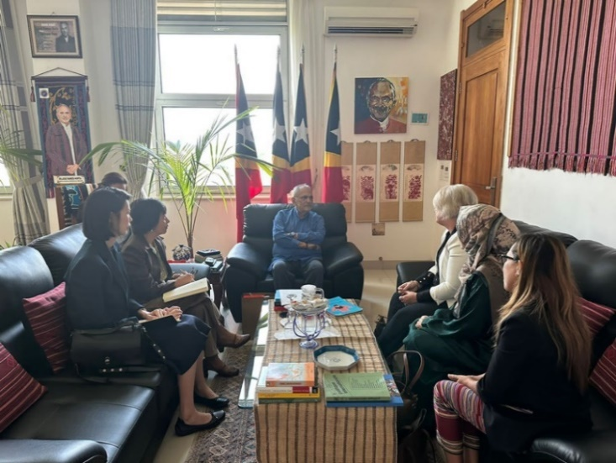 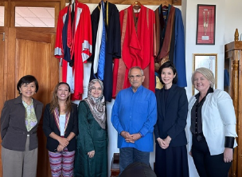  
 *SEAWPM in discussions in Timor Leste. Credit: SEAWPM*

**CASE STUDY: Launch of the Pacific Women Mediator’s Network**

The **Pacific Women Mediator’s Network** (PWMN), an initiative of the Global Partnership for the Prevention of Armed Conflict (GPPAC) in collaboration with Shifting the Power Coalition and ActionAid Australia, was launched in Fiji in June 2023.

Through a feminist peacebuilding approach, the PWMN works to strengthen the collective power, influence and leadership of diverse Pacific women to engage in conflict prevention and peace building. The PWMN also invests in leadership development for young Pacific women to support advocacy and action on WPS in the Pacific.

Capitalising on existing regional commitments to WPS and gender equality, the PWMN provides channels for women mediators to engage with national and regional actors and drives accountability on Pacific Island Forum Leaders’ commitments to gender equality.

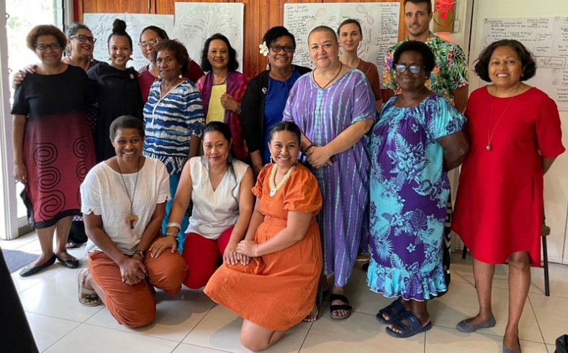

*The launch of the Pacific Women Peace Mediators. Credit: Pacific Women Mediators Network/GPPAC Pacific*

The Australian Federal Police worked with partner law enforcement services to increase women’s meaningful participation and leadership through improved gender composition, policies and conditions for women in their services.

The **Vanuatu-Australia Police and Justice Program** supported the Vanuatu Police Force to increase women’s representation within the police. This included supporting the development of the Diploma of Policing through a Vanuatu-based provider, with content tailored to enhance professional development opportunities for women. In 2021, 23 per cent (19 of 82) of new police recruits were women. In 2022, 36 per cent (18 of 50) of new recruits were women, exceeding the 30 percent target. As of June 2023, the overall representation of women in the Vanuatu Police Force had increased to 26 per cent.

In Timor-Leste, the **Timor-Leste Police Development Program (TLPDP)** worked with the Policia Nacionale Timor-Leste (PNTL) and UN Women to establish an independent PNTL Sexual Harassment Prevention Working Group to develop a workplace sexual harassment policy, associated training, reporting mechanism, and referral pathway. The TLPDP launched a 20-week women’s leadership pilot program designed to position women for promotion and scholarship opportunities. Five participants were subsequently selected to attend further leadership training in Australia and New Zealand.

In Vietnam, the Australian Federal Police hosted the 54th **Asia Region Law Enforcement Management Program**, in October 2022, focused on Utilising Forensic, Technical and Intelligence Capabilities. The Program was attended by participants from 28 participating countries, with women comprising 32 per cent of participants. An information-sharing and support network was created for participants, continuing engagement following the program.

The **Jakarta Centre for Law Enforcement Cooperation (JCLEC)** is an international law enforcement training institution, jointly operated by the Indonesian National Police (INP) and the Australian Federal Police, with bilateral and multilateral assistance from foreign countries and organisations. In November 2022, and in collaboration with the United Kingdom’s Foreign, Commonwealth and Development Office, a week-long Women’s Leadership Course was delivered to 21 women police officers from Indonesia (13 women), Malaysia (4 women), Bangladesh (2 women) and the Philippines (2 women). The program provided opportunities to build networks and formulate strategies to advance the participation and leadership of women in law enforcement.

The **Papua New Guinea-Australia Policing Program (PNG-APP)** worked with the Royal Papua New Guinea Constabulary (RPNGC), including support to training and development activities aimed at imparting information and skills in the investigating of gender-based violence, as well as targeted training opportunities for women RPNGC members. Women represent approximately 15 per cent of the police officers in the RPNGC, but have been, on average and since October 2022, 32 per cent of training course participants.

Between July 2021 and June 2022, the **Tonga Police** undertook several initiatives to raise awareness and promote leadership by women police officers, with support from the Australian Federal Police’s Families Free of Violence program. The FFOV program sponsored the 10th Annual Conference of the Tonga Police Women’s Advisory Network, with the theme of ‘Empowering Young Women of Today for the Future’. 107 police members attended the conference.

**CASE STUDY: Women in International Security and Cyberspace Fellowship**

The **Women in International Security and Cyberspace Fellowship** is a joint initiative of the governments of Australia, the United Kingdom, Canada, the Netherlands, New Zealand and the United States, launched in February 2020. The Fellowship promotes participation by women on international peace and security issues related to responsible state behaviour in cyberspace. During the reporting period, Australia supported Fellows from: Fiji, Indonesia, Laos, Malaysia, PNG, Philippines, Samoa, Thailand, Timor-Leste, Tonga, Tokelau, Tuvalu, Vanuatu, and Vietnam. The Fellowship has measurably increased women diplomats’ engagement in UN cyber processes; increased the number of Pacific voices represented in Open Ended Working Group negotiations; enabled greater priority placed upon mainstreaming gender in UN cyber processes; and increased the number of delegations with a woman with a speaking role; and the percentage of interventions made by women in the Open Ended Working Group.

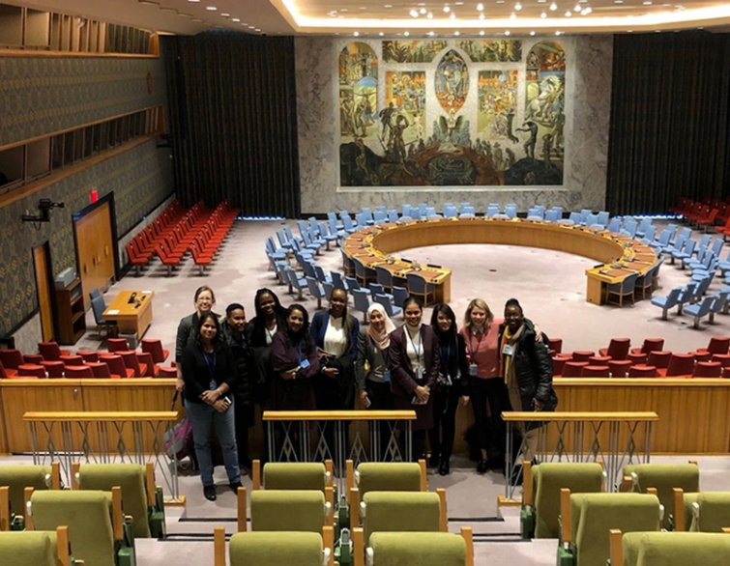

*Women in International Security and Cyberspace Fellowship project. Credit: DFAT*

The Australian Federal Police demonstrated its commitment to increasing women’s participation and leadership across all ranks and employment occupations through implementation of the **International Command Gender Strategy (2018-2024)**. Between July 2021 and June 2022, 28 per cent of all overseas members deployed by the Australian Federal Police were women, down from a high of 34 per cent in 2019. Efforts that began in 2021 to increase women’s representation among international deployees were hindered by the impacts of COVID-19. In December 2022, women comprised 24 per cent of long-term deployed members, a decrease of four per cent from 2021. Women comprised 21 per cent of short-term deployments. Cognisant of the need to increase numbers, the Australian Federal Police continues to implement strategies to reduce barriers to international deployments of women, including through sharing learnings, improving information relating to schooling and family life when deployed, and promoting internal recruitment opportunities.

The Defence **Gender, Peace and Security Mandate** focuses on enhancing capacity through increased women’s participation and leadership across all ranks and employment occupations, deploying more women on exercises, operations, humanitarian and disaster response missions, and supporting their appointment to key engagement and representational roles. All Australian Defence Force employment categories are open to women, including combat roles. As of July 2023, women represented 20.4 per cent of the Australian Defence Force, with the levels of representation being in 26.5 per cent in the Air Force, 24 per cent in the Navy, 15.2 per cent in the Army, and 47.7 per cent of Australian Public Service employees.[18] The Australian Defence Force continues to identify and remove structural and cultural barriers to women’s full participation, progression and leadership, and implements initiatives including leadership and mentoring, professional memberships, and Australian Government public sector programs. The Gender Advisor capability comprises Gender Advisors who are engaged on operational deployments, exercises and related activities, with the Australian Defence Force continuing to train and support Gender Focal Points to assist command teams in implementing the Gender, Peace and Security Mandate.

**Proportion of permanent Australian Defence Force women on deployment-2021-2022, by operation**[19]

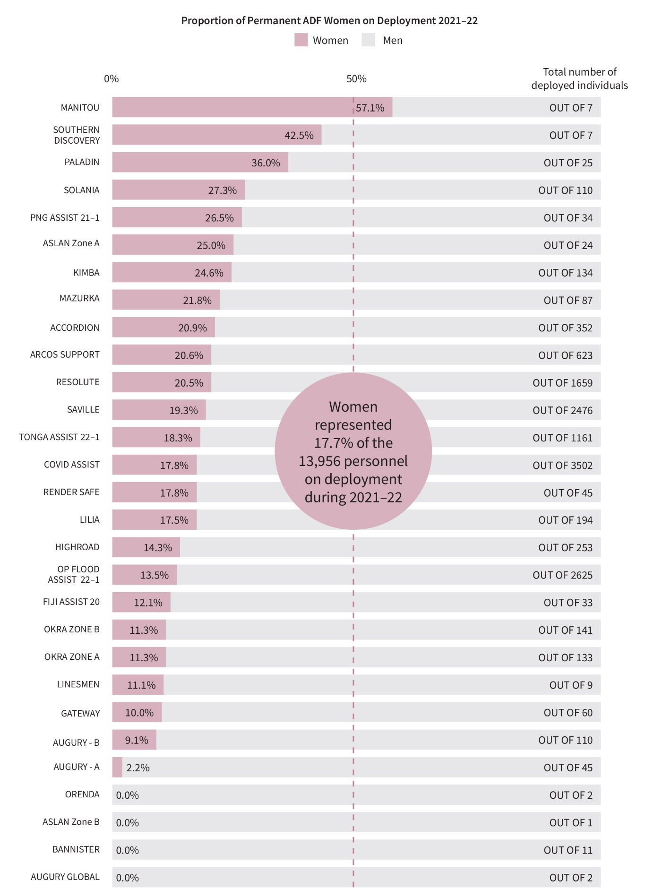

The ASEAN Women for Peace Registry (AWPR) is the ASEAN network of women leaders in peace action. ASEAN Member States have three representatives in the network, drawn from civil society, government, and academia. In July 2022, and with support of the **ASEAN-Australia Political Security Partnership** (APSP), a workshop was facilitated to develop AWPR’s priorities for WPS implementation. Recommendations were developed for action on WPS knowledge generation, pathways for WPS outreach, and inclusion of students and communities in peace and conflict prevention activities. Priority partners for dialogue to enhance the visibility and impact of AWPR’s work in the region were also identified. The forward agenda includes activities focused on supporting AWPR’s capacities for knowledge generation, communications on WPS, and institutional capacity strengthening.

**CASE STUDY: Pacific women keeping borders safe**

Women’s participation and leadership at all levels within customs administrations supports effective outcomes for operational procedures, global trade facilitation and national security. Yet only 37 per cent of the global customs workforce are women, and women only make up 26 per cent of senior roles and 17 per cent of heads of customs administrations.[20]

The **Pacific Women’s Professional Development Program (PWPDP)** is an initiative delivered by the Australian Border Force in partnership with the Oceania Customs Organisation and RMIT University’s Transnational Security Centre. The PWPDP provides an opportunity for women officers in Asia and the Pacific to advance their career pathways in their national customs administrations.

In 2023, a PWPDP Alumni Program was established. The Alumni Program provided an opportunity to strengthen the emerging network of women customs and border security officers and leaders across the Pacific. The Program’s 42 women participants from customs agencies across 16 Pacific Island countries completed the Alumni program over two weeks, comprising video conference sessions, leadership insight and coaching sessions. Participants reported enhanced confidence in public speaking, expanded repertoire of communication skills, greater confidence in their current roles, and increased motivation to pursue leadership opportunities.

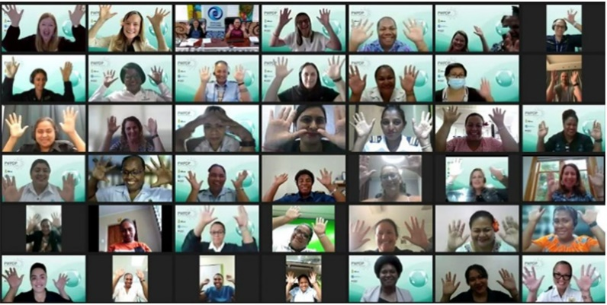

*The Pacific Women’s Professional Development Program’s 2023 Alumni Program participants. Credit: PWPDP Alumni Program*

Ms Nancy Oraka-Pomoso, from the Papua New Guinea Customs Service, was sponsored by the Department of Home Affairs to undertake a Graduate Certificate of Customs Administration at the Centre for Customs and Excise Studies (Charles Sturt University), and following this, was sponsored to undertake a Master in Customs Administration.

After graduating from the Master program in 2022, Ms Oraka-Pomoso was appointed as the Oceania Customs Organisation Head of Secretariat, commencing in early 2023. This was the first time both a woman and a Papua New Guinean had been appointed to the role.

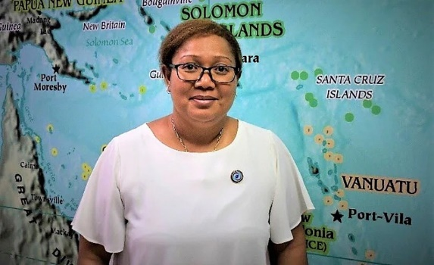

*The Pacific Women’s Professional Development Program’s 2023 Alumni Program participants. Credit: Ms Oraka-Pomoso/Department of Home Affairs*

Australian Border Force nominated Fiji Revenue and Customs Service Principal Customs Officer, Ms Akosita Valamalua for the *Excellence in Law Enforcement in the Pacific Region Award* at the 2023 Australasian Council of Women and Policing (ACWAP) award ceremony.

ACWAP is a group of women and men within police services, law enforcement agencies and the community who work together to improve the policing services provided to women; improve opportunities and outcomes for women within policing; and participate in the global network of women in policing.

The nomination recognised years of dedicated service, which helped Ms Valamalua earn recognition both locally and internationally. Ms Valamalua was also recognised by the World Customs Organization and accepted a multi-year contract with the World Customs Organization in Brussels.

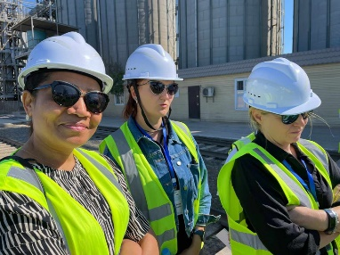 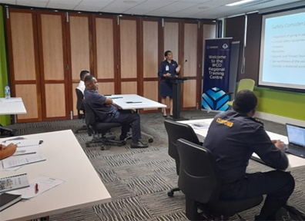

*Ms Akosita Valamalua, inspecting a port in Kazakhstan (left) and conducting a training workshop at the World Customs Organisation’s Regional Training Centre. Credit to Ms Akosita Valamalua/Department of Home Affairs*

In **Papua New Guinea**, women’s meaningful participation and leadership were supported through a range of peace-building initiatives.

In Southern Highlands Province, a 12-person Provincial Peace and Good Order Committee (PGOC) team conducted peace consultations and negotiations in the community, with the view to the restoration of peace and stability following tribal fighting and to enable basic services to return. In Hela, members of the law and justice community, including four women, engaged in strategic planning to discuss strategies for addressing the main law and justice challenges facing the province.

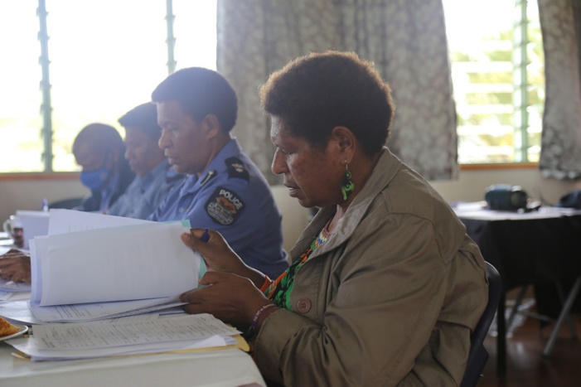

*Inspector Alice Arigo in Tari, Hela Province. Credit: Justice Services and Stability for Development (JSS4D) Program*

**Community Dispute Resolution Training** was held in Hanpan in February 2023 and attended by 95 (38 women) youth, women, and chief representatives from Hanpan and Elutupan wards of Haku Constituency (Autonomous Region of Bougainville). The training was part of efforts to address Sorcery Accusation Related Violence (SARV) following the SARV killings in early 2022. Activities included participants working together in groups and dialogue between young people and chiefs. While reflecting on learning outcomes from the course activities, chiefs spoke about how their actions had contributed to the disempowerment of certain community members, such as youth, especially in decision making.

In the Autonomous Region of Bougainville, disagreements over customary land boundaries are a source of tension and conflict. Joyce Miringka is the only women Magistrate who sits on the local land court. Through the **Local Land Court Mentoring Program** and the introduction of GPS technology, Magistrate Miringka addressed the backlog of land matters, which helped to reduce opportunities for simmering tensions to surface which may have led to conflict in and destabilisation of communities.

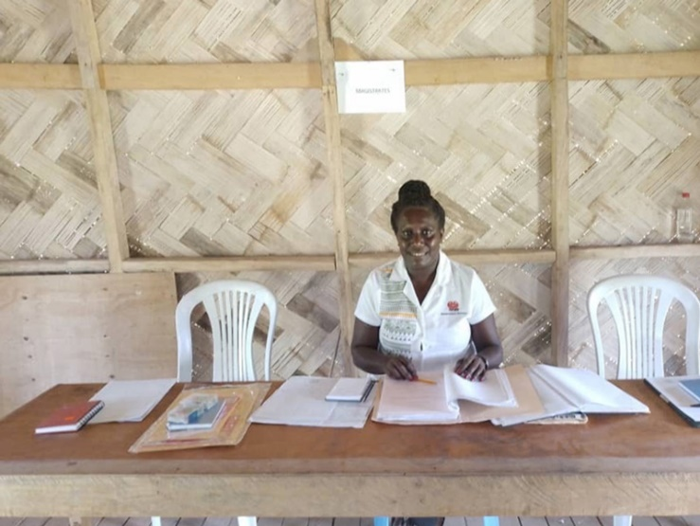

*Magistrate Miringka at a Local Land Court hearing in Central Bougainville. Credit: Justice Services and Stability for Development (JSS4D) Program*

In June 2023, the **Open-Ended Working Group on Through-Life Conventional Ammunition Management**, of which Australia is a member, agreed to a framework for conventional ammunition management. The framework recognised the need for the full, equal and meaningful participation of women in decision-making and implementation processes related to through-life conventional ammunition management. The framework encouraged the integration of gender into policy and practice to address the impacts of conventional ammunition on women, men, boys and girls. Australia also engaged with the UN Office for Disarmament Affairs on the Women Managing Ammunition Network (WoMA-Network), which was established under the UN SaferGuard programme to advance gender equality, increase the visibility of women in technical roles, and enhance women’s participation and leadership.

Australia is a founding member of the **Group of Friends for Women in Nuclear**, which promotes the representation and leadership of women in the International Atomic Energy Agency (IAEA) Secretariat. Members of the Group commit to improving the gender diversity of their own delegations to IAEA meetings, work with their domestic industries and within their governments to increase the number of women available for recruitment to the IAEA, and share good practices on policy and practical initiatives that advance gender equality.

To enhance Australia’s efforts to promote women’s and girls’ full and equal participation and leadership in conflict prevention and peace processes, Australia also invested in supporting women’s rights organisations and community mobilisation.

**CASE STUDY: Supporting women’s climate leadership**

Since 2017, DFAT partnered with the **Women’s Environment and Development Organization (WEDO)** to provide professional development and travel support to Pacific women delegates across 14 Pacific Small Island Developing States. WEDO hosted seven in-person Pacific regional workshops. The three and four-day workshops – five introductory and two advanced – provided training for 84 participants. Dozens of women also completed virtual training through two multi-week regional courses in 2021 and 2022. The majority of the participants were subsequently members of their Party delegations to United Nations Framework Convention on Climate Change sessions and sponsored to attend at least one negotiation session after their training.

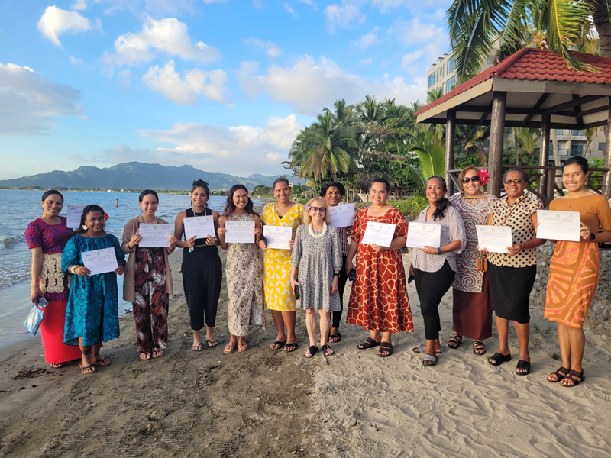

*Participants posing with their certificates following the Pacific Women Leaders Advanced Climate Negotiation Workshop, Fiji, May 2023. L to R: Nua Veilofia (Tonga); Ann Albert (FSM), Kirsten Maddison (Marshall Islands), Antonia Browne (Cook Islands), Mikayla Etpison (Palau), Mereani Nata (Fiji), Linda Siegele (Trainer), Eunice Dus (PNG), Takena Redfern (Kiribati), Phaedora Harris (Nauru), Vanda Faasoa Chan-Ting (SPREP), Rothina Noka (Vanuatu), Faatupu Simeti (Tuvalu). Credit: Sinéad Magner.*

Australia has supported the **Women’s Peace and Humanitarian Fund (WPHF)** since its establishment in 2016. A global pooled funding mechanism, the WPHF invests in the capacities of local women-led and women’s and girl’s rights organisations, supporting them to prevent conflict, end sexual and gender-based violence, respond to crises and emergencies, and seize peacebuilding opportunities. Within its mandate, the WPHF also focuses on climate security and disability inclusion. WPHF partners with disability civil society organisations, and both mainstreams disability inclusion, as well as supporting targeted initiatives to improve the lives of people, including women, living with disabilities.

Since 2016, the WPHF has supported more than 780 civil society organisations across 31 countries. DFAT’s funding to the WPHF in 2021 and 2022, for example, supported women civil society organisations in the Bangsamoro Autonomous Region in Muslim Mindanao (BARMM) in the Philippines to produce research to inform its National Action Plan on WPS (2023-2033) and the Bangsamoro Regional Action Plan (RAP) on WPS (2023-2033). The research included recommendations on youth, women-led early response and engagement of women mediators.

**CASE STUDY: Women community leaders working to prevent radicalisation and extremism**

In 2022, the Department of Foreign Affairs and Trade’s Office of Counter-Terrorism supported the Cairo International Center for Conflict Resolution, Peacekeeping and Peacebuilding (CCCPA) to deliver a five-day training, in Nigeria, on ***Enhancing the Role of Women Community Leaders in Preventing Radicalization and Extremism Leading to Terrorism****.* The training, held in Nigeria, brought together 27 women community leaders and influencers from diverse backgrounds and different local government areas across Borno State—including Borno State Ministry of Women Affairs & Social Development (MWASD), Social Cohesion Platforms, National Orientation Agency (NOA), the International Federation of Women Lawyers (FIDA) Nigeria, Women in the New Nigeria & Youth Empowerment Initiative (WINN), Nigeria Association of Women Journalists (NAWOJ/NUJ), Federal Ministry of Education, Bama Youth Development Initiative, and Bulumkutu Transit Center—and women community leaders and influencers from Gwoza, Chibok, Bama, and Jere.

The training aimed to empower women community leaders and strengthen their communities’ resilience against terrorism. Participants learnt to identify structural factors that can give rise to radicalisation and deepen their understanding of conflict and terrorism. Participants were also provided with information about the rules and ethics of war and peace in Islamic Sharia, tools to deconstruct extremist narratives, and guidance on how to formulate alternative narratives grounded in peaceful coexistence and tolerance, rooted in Islamic Sharia and community traditions. The training also imparted skills to support the prevention of radicalisation within the women’s communities, particularly among youth.

Participants acknowledged the value of discussing issues of conflict and terrorism in an all-women environment and in a mix of English and local languages. Participants requested follow-up courses, including for women journalists. The CCCPA noted that all participants were present for the duration of the course, which was deemed a significant achievement given the women’s community and domestic workloads.

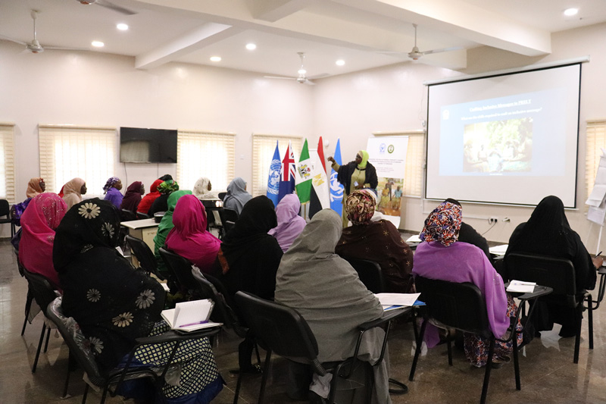

*CCCPA conducts its first in-person training for women community leaders on preventing radicalisation and extremism leading to terrorism. Credit: Cairo International Center for Conflict Resolution, Peacekeeping and Peacebuilding (CCCPA).*

During the reporting period, Australia was the third largest contributor to the **Elsie Initiative Fund**, a multilateral fund that supports the meaningful participation of uniformed women in peace operations. The support has included enhanced protection responses, including the prevention of and response to conflict-related sexual violence, promotion of human rights, and setting an example for women and girls to advocate for their rights and take on meaningful roles in the security sector and peace and political processes. In addition to supporting the Secretariat, Australia’s funding enabled 14 security institutions to undertake institutional assessments of barriers to women’s participation in peace operations; deployment of two gender-strong units—from Ghana and Senegal—with an average women’s representation of 18.3 per cent; and construction of gender-responsive accommodation and facilities for women peacekeepers in Lebanon.

The **Australia Assists** program funded an Australian official to work in the UN Office of the UN Special Envoy for Yemen (UNOSESGY), as the Senior Coordination Officer in the Principal Military Advisor section. Gender is a cross-cutting priority in UNOSESGY, which has a mandate for, and history of contributing to, WPS outcomes. As part of the official’s ceasefire implementation coordination role, they ensure women’s security needs in Yemen are included in ceasefire planning and concept development and that Parties adhere to their respective WPS obligations within the agreement. For example, in May 2022, the OSESGY engaged Yemeni women on multitrack peace process design and priorities. The consultations involved Yemeni women from academia, civil society, women’s organisations, and the private sector to gather views on the way forward for peace.

The Australian High Commission in Nicosia interacts with the UN’s Peacekeeping Mission in Cyprus (UNFICYP). The Cyprus Gender Advisory Team was formed in October 2009 to ensure gender equality is integrated into the peace negotiations and post-conflict peace building processes. During the reporting period, the Australian High Commission in Nicosia supported the Cyprus Gender Advisory Team to implement the ***Unifying Cyprus Women’s Voices for Social and Political Change***program in Northern Cyprus. This project focused on women-centred dialogue, training women community leaders to enhance their participation and contribution to policy reforms and advocacy as part of the Cyprus peace process.

This overview of examples and case studies highlights Australia’s breadth of engagement to promote the meaningful participation of women and girls in leadership and the WPS agenda during the reporting period. Across geographic regions, Australia‘s engagement enhanced women’s participation in international debates on countering violent extremism, climate change, national and regional security. Australia’s contribution is reflective of other advancements on women’s participation in conflict prevention and peace processes. For example, 32 percent (9 of 28) of peace agreements, encompassing the reporting period, contain provisions on women, girls, gender and/or sexual violence, up from 21 percent (412 of 1,959) of such agreements established between 1990 and July 2021; which is Indicator 1.2.1 in the second National Action Plan Monitoring and Evaluation Framework.[21]

## Outcome 2: Reduce sexual and gender-based violence

This chapter presents examples and case studies of Australia’s efforts, during the reporting period, to achieve the second outcome of the National Action Plan: to reduce sexual and gender-based violence including through efforts to address harmful gender norms, increase safety and security for women and girls, and increase access to justice. To achieve this objective, actions were designed to:

* support local efforts to challenge harmful gender norms and discriminatory practices and contribute to the evidence base of what works to change gender norms;
* strengthen local laws and institutions to protect human rights, including to protect against and respond to sexual and gender-based violence;
* work with personnel deployed to fragile and conflict-affected contexts on their responsibilities to affected populations to improve safety and security for women and girls;
* increase efforts to address the full range of rights violations that women and girls experience in fragile and conflict-affected contexts; and
* work at all levels to eliminate conflict-related sexual violence, including through support to the rules-based international order and established United Nations frameworks, as well as mechanisms agreed by Member States to protect and defend human rights.

The **Australian Defence Force** improved safety and security for women and girls in fragile, insecure and conflict-affected contexts and regions through the inclusion of gender perspectives in the planning and execution of military operations. Gender Advisors and Gender Focal Points may also be deployed to support operations and the application of a ‘Do No Harm’ approach when interacting with local populations.

The **Australian Federal Police** worked with partner law enforcement services to strengthen capacity to protect women’s and girls’ human rights, including through efforts to protect against and respond to sexual and gender-based violence.

The **Department of Home Affairs** improved safety and security for women and girls through implementation of expanded family violence provisions in migration legislation, programs addressing elements of violent extremism, and community cultural support.

The **Department of Foreign Affairs and Trade** mainstreamed efforts to reduce sexual and gender-based violence, including through international development and humanitarian assistance programs that support local efforts to change harmful gender norms, and the promotion of women’s and girls’ human rights in regional and multilateral fora.

During the 2021-2023 reporting period, Australia focused efforts in the Asia-Pacific region, undertaking a range of activities to challenge harmful gender norms, increase access to justice for survivors of sexual and gender-based violence, and prevent and respond to sexual and gender-based violence in conflict and crisis situations. This included taking action in both online and offline spaces, working with men and boys and religious leaders, countering trafficking and modern slavery, and targeting high-risk contexts, including prisons.

### Reducing harmful gender norms

Reducing harmful gender norms is central to reducing sexual and gender-based violence. Globally, and between 2019 and 2023, 66 countries have more inclusive social institutions in relation to gender (Indicator 2.1.2 of the second National Action Plan Monitoring and Evaluation Framework).[22] The other indicator (2.1.1) of reduction in harmful gender norms is the participation rate of youth and adults in formal and non-formal education and training in the previous 12 months. As reported by UNESCO, the percentages for females and males are similar, being 21.32 percent and 21.29 percent respectively.[23] During 2021-2023, Australian implementing agencies worked with a range of partners to support their efforts to reduce harmful gender norms. This included efforts with agencies in partner countries work with men and boys, as part of efforts to increase the overall impact of actions to combat sexual and gender-based violence.

In Tonga, **the Australian Federal Police’s Families Free of Violence (FFOV)** program supported initiatives to reduce harmful gender norms against LGBTQIA+ communities, including the Tonga Leiti Association’s Miss Galaxy Pageant week and the International Day Against Homophobia, Biphobia, Intersexism and Transphobia (IDAHOBIT) events at the Australian High Commission. The National Rugby League’s Voice Against Violence program was delivered to four secondary schools in July 2021, reaching 627 students. The program raised awareness of gender-based violence and the police’s role in preventing and responding to gender-based violence.

During 2021, the **Vanuatu-Australia Policing and Justice Program** delivered the 11-week *Be the Change* program, designed to safely engage police officers to address attitudes that perpetuate harmful, violent behaviours and promote transformational changes. The program was delivered to 42 men and women from the Vanuatu Police Force, including Sergeants and Senior Sergeants and some spouses. Participants emphasised the powerful, emotional impact of the program, with many having experienced violence as children or having been witness to family violence. In 2022, the program was expanded and delivered by World Vision Vanuatu.

**CASE STUDY: Engaging men and boys to change harmful gender norms in Cox’s Bazar**

Harmful gender norms continue to put women and girls in Rohingya camps and host communities in Cox’s Bazar at risk of sexual and gender-based violence. As part of events to mark the 2022 *16 Days of Activism against Gender Based Violence*, the Oxfam Gender team held a male engagement session with 34 men and adolescent boys on preventing and mitigating violence against women and girls in Cox’s Bazar. The men and boys undertook role playing exercises, with a particular focus on how to overcome community perceptions that intimate partner violence is a ‘personal matter’. One participant shared his perspective that violence only creates more violence: “If I behave badly towards my wife, my brother-in-law may think it is acceptable to beat my sister. Similarly, my son-in-law may be violent with my daughter. Then where does all this violence get us? We must stop violence against women in our homes for a peaceful community.”

Another participant said some of his friends started to engage in delinquent or anti-social behaviour because of a lack of anything better to do. “Joining Oxfam’s male groups gives me a chance to continue to learn and improve my education. So, I am doing something good rather than what I see some of my friends are doing.”

Both participants had been participating in the groups for over two years and agreed that violence against women and girls is less accepted now in their communities, but it continues to be an ongoing issue that requires more support to address on a wider scale. Each participant was supported to share anti-violence messages within their communities through small sessions with their friends, families and neighbours.

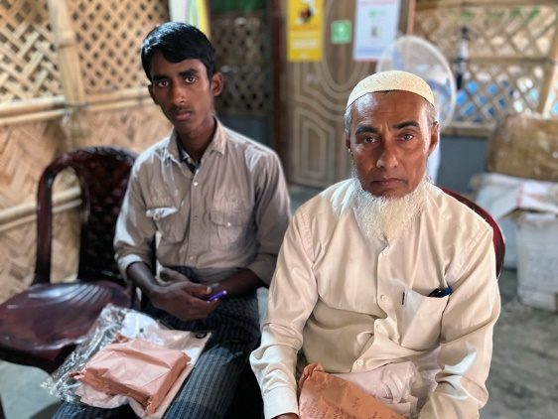 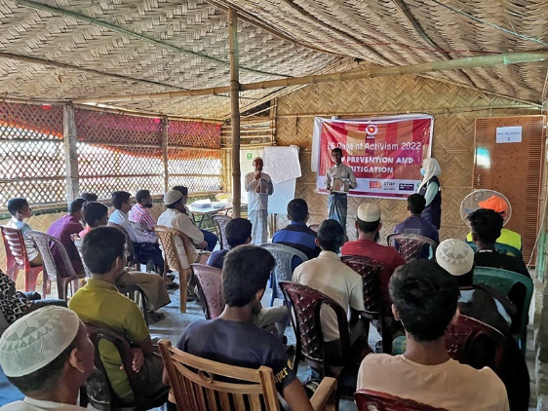

*Left: Both participants are proud to work on reducing sexual and gender-based violence in their community. Both men have participated in Oxfam’s male engagement group for two and a half years. Credit: Nargis Sultana/Oxfam Bangladesh*

*Right: Oxfam Gender Associate Nargis Sultana helps to train Rohingya male engagement group members on how to facilitate community sessions on preventing and mitigating sexual and gender-based violence. Credit: Oxfam Bangladesh.*

Since 2017, the Department of Home Affairs has worked in partnership with Deakin University on strengthening community resilience to violent extremism with the **South-East Asian Network of Civil Society Organisations (SEAN-CSO).** At the 2022 annual meeting, SEAN-CSO network members recognised the importance of promoting the Women, Peace and Security agenda, particularly in the post-COVID-19 context, and acknowledged the evidence that women play important roles in preventing violent extremism, but can also support extremist groups. Network members stated that it was crucial that there are more incentives for women to be agents for peace rather than violence. SEAN-CSO Network members also delivered six webinars during 2022–2023, including a session on the role of women in countering violent extremism in Southeast Asia.

With the **Australian Humanitarian Partnership’s** support in 2022, United Nations Population Fund engaged religious leaders and community activists to reduce harmful gender norms in Bangladesh. More than 420 religious leaders (417 men, 3 women), 1,500 community activists (450 men, 1,050 women), 1,020 community leaders (380 men, 640 women) and 23 institutional allies (four men, 19 women) joined the program to be sexual and gender-based violence change makers. Religious leaders used sermons to encourage prevention. One such leader explained: “We can play a significant role in preventing GBV. When we communicate through faith-based approaches, it will allow us to appropriately advocate for equal rights. With the increased knowledge, we understand what violence against women is and how balancing power in a couple’s life can make peace in the family.”

### Increasing safety and security for women and girls

Direct efforts to increase the safety and security of women and girls are essential both to prevent sexual and gender-based violence and to ensure that victim-survivors can access appropriate assistance. Australia’s efforts to increase safety and security for women and girls spanned a range of initiatives, from cyber safety and prison safety, to providing support services. The efforts were undertaken in a context of continuing perpetration of violence against women and girls. The proportion of ever-partnered women and girls, aged 15 years and older, subjected to physical, sexual or psychological violence but a current or former intimate partner in the 12 months preceding 2018, was 10 percent, rising to 26 percent in a lifetime (which is Indicator 2.1 of the second National Action Plan Monitoring and Evaluation Framework. The proportion of women and girls who have experienced non-partner sexual violence in their lifetime (Indicator 2.2) was estimated at six percent in 2018,[24] while the proportion of women aged 20-24 years who were married or in a union before age 18 was 21 percent.[25] Another measure of safety and security (and Indicator 2.2.1 for the second National Action Plan) is reporting feeling safe walking alone at night in the city or area where you live; which was reported by 70 percent of people surveyed, across 141 countries, by Gallup in 2022.[26]

**Cyber Safety Pasifika (CSP)** is an Australian Federal Police-led program delivered across 19 Pacific Island policing agencies. Cyber Safety Pasifika and WESNET, the Australian peak body for specialist women’s domestic and family violence services, collaborated to develop and deliver a *Combatting Technology Enabled Domestic Violence* training course. The training was co-designed with Pacific stakeholders, reviewed and endorsed by the Fijian and Tongan Women’s and Children’s Crisis Centres, and delivered to more than 250 front line women’s service workers and police officers from 16 Pacific Island countries. As a result, participants are now able to provide improved support services to women and children experiencing family and domestic violence perpetrated through technology.

Since 2017, the Department of Home Affairs has engaged the Global Center on Cooperative Security to deliver the **Countering Violent Extremism in Prisons (CVE-P)** program in Indonesia. The CVE-P Program provides training and technical assistance to Indonesian prison authorities to manage hardened violent extremists in custodial settings. Following consultation with Indonesian government agencies, civil society organisations and women prison staff, training gaps were identified for women prison staff managing prisoners associated with violent extremism. Existing CVE-P training modules were adapted to address the specific contexts in which women officers manage women violent extremist prisoners, and the issues that may influence women’s engagement in terrorism-related activities in Indonesia. The training program was piloted in 2023 to a group of 25 women prison officers in partnership with the Indonesian Directorate-General of Corrections.

In Fiji, Tonga and Vanuatu, DFAT’s **Cyber and Critical Tech Cooperation Program** supported Deakin University to improve understanding of the prevalence, nature, and impacts of technology-facilitated domestic and family violence, using the National Survey of Technology Abuse and Domestic Violence in Australia (WESNET) in a Pacific context. The program also worked with local domestic and family violence support organisations to enable improved identification, management and response to technology-facilitated domestic and family violence; and helped to enhance their understanding of and commitment to implementation of coordinated long-term strategies for addressing technology-facilitated domestic and family violence.

The **ASEAN-Australia Counter Trafficking Program (ASEAN-ACT)** is a 10-year partnership to support ASEAN Member States to implement and report on their obligations under the ASEAN Convention Against Trafficking in Persons, Especially Women and Children.[27] Several initiatives to eliminate sexual and gender-based violence were supported, including through a multi-year partnership with the ASEAN Commission on the Promotion and Protection of the Rights of Women and Children (ACWC). This partnership aimed to improve victim-survivor protection and just punishment of traffickers, by applying victim-survivor-centred and gender-responsive approaches to responding to and countering human trafficking. The partnership developed resources, including training materials, for frontline responders to safeguard the rights of victim-survivors of trafficking and ensure that counter trafficking actors are aware of, and committed to, doing no harm in the course of their work.

The deployment of **Gender Advisors and Gender Focal Points** on Australian Defence Force operations, exercises and planning groups is critical achievement of strategic military objectives and operational outcomes, and for ensuring the safety and security of women and girls.

The Australian Department of Defence continued to strengthen its networks across all levels, groups and services, training 41 Gender Advisors and 689 Gender Focal Points between July 2021 and June 2023, bringing the numbers of active serving Gender Advisors and Gender Focal Points to 332 and 990 respectively.

During 2021-2023, the Department of Defence contributed Gender Advisors to several military operations including Operation ASLAN (United Nations Mission in South Sudan, UNMISS); Operation HIGHROAD (Resolute Support Mission, Afghanistan); Operation ACCORDIAN (Middle East); and Operation INHERENT RESOLVE (Iraq). Gender Advisors and Gender Focal Points were also deployed on short-term operations, including Operation FIJI ASSIST, Operation COVID-19 ASSIST (Australia), Operation KIMBA (Papua New Guinea), Operation TONGA ASSIST, AFGHAN Non-Combatant Evacuation Operation, Operation VANUATU ASSIST and Operation FLOOD ASSIST (Australia).

A graphic of two pie charts showing Defence has a total of 332 Gender Advisors; 79 from the Navy, 130 from the Army, 11 from the Australian Public Service and 112 from the Air Force. 

The second pie chart shows Defence has a total of 990 Gender Focal Points; 248 from the Navy, 435 from the Army and 30 from the Australian Public Service and 277 from the Air Force. 

Defence’s Gender Focal Points are 55.5 per cent female, 0.5 per cent non-binary, and 44 per cent male. 

The Australian Government has expanded the **Family Violence Provisions** in migration legislation, which aim to ensure that visa applicants do not feel compelled to remain in violent relationships to be granted a permanent visa. The provisions allow certain visa applicants —primarily Partner Visa applicants—to be granted a permanent visa if their relationships have broken down and they have been subjected to domestic and family violence by the sponsoring partner or primary applicant. The provisions are implemented in partnership with the **Domestic and Family Violence Support (DFVS)** section of the Department of Home Affairs, which provides a centralised point of contact for domestic and family violence support service providers and assists temporary visa holders to understand and regularise their visa status. From July 2021 to May 2023, the DFVS section received 904 new case referrals (93 per cent from women) and undertook 260 stakeholder engagements.

The biennial **Exercise Polygon Wood** brings together the Australian Defence Force, the Australian Civil Military Centre, Department of Foreign Affairs and Trade, Australian Federal Police and International Committee of the Red Cross (ICRC) to practice a range of complex, high-end conflict scenarios. The 2021 iteration included exercising the establishment of a **Civil-military Operations Centre**. This enabled coordinated and consultative responses to complex civil scenarios that involved sexual and gender-based violence. This was a priority area for the co-ordination of humanitarian assistance to the population affected by conflict as well as assisting the military force’s understanding of other government agencies, non-government organisations (NGOs) and ICRC coordination, and security of internally displaced and transient-persons camps. A gender analysis was conducted and informed other government agencies and NGO planning and humanitarian assistance responses. For example, the provision of sex, age, and disability disaggregated data, together with an understanding of the societal familial structures and patterns of movement, identified matrilineal leadership for engagement for tailored assistance. This subsequently highlighted the need for increased security lighting and patrols at designated points within Internally Displaced People (IDP) camps. The gender analysis also identified the need for diverse and specialised health teams, the provision of safe zones for children, young people, unaccompanied minors, and attention to food distribution plans and timings to ensure women head of households were considered. Overall, the activity enhanced military staff understanding of the importance of gender, as well as of coordination with other government agencies, NGOs and the ICRC for the protection of persons in vulnerable situations resulting from conflict.

The Australian Federal Police’s Families Free of Violence program developed the **Tonga National Service Delivery Protocol for Responding to Cases of Gender-Based Violence** (SDP), which was officially endorsed on 16 September 2021. The SDP mandates service providers to work together and refer victim-survivors to the police, counselling and support services. Among the 19 signatories are organisations that provide services to people in vulnerable situations, people with disabilities and the LGBTQIA+ community. This provides a critical entry point to the referral system. Stakeholders reported that there are early indications that the Service Delivery Protocol has strengthened the referral pathway by increasing awareness among service providers of services available for victim-survivors.

As part of initiatives that assist migrants in Australia, the Department of Home Affairs supported **Community Liaison Officers** to enhance social cohesion by building relationships of trust and fostering a two-way information flow with a range of culturally and linguistically diverse communities. Community Liaison Officers engage with a range of stakeholders, including multicultural community leaders, faith-based groups, government and police representatives and domestic and family violence service providers which assists in increasing understanding of, and access to, domestic and family violence support. Community Liaison Officers help ensure key government messaging, in-language resources and contact details of relevant providers addressing domestic and family violence are accessible. Between July 2022 and April 2023, the Community Liaison Officer network undertook more than 400 engagements on domestic and family violence related matters. This was four times as many engagements than between July 2021 and June 2022.

**CASE STUDY: A protective KOMPASS for Ukrainian women moving through Europe**

KOMPASS is a new protection model designed and piloted by the Romanian, women-led organisation eLiberare and ActionAid, with the support of the **Australian Humanitarian Partnership**.[28] Using a network of partners, capacity strengthening for frontline responders and awareness raising, KOMPASS protected women and children from the risks of trafficking and supporting them in their journey across Romania or Europe.

By creating trusting relationships, women were better able to feel safe and disclose information, explained Loredana Urzica-Mirea, Executive Director of eLiberare: “There were women who disclosed abuse, and even women who were about to be recruited into trafficking - women who were offered jobs and accommodation by traffickers.”

Social media is used by the project to prevent, report and help. Telegram, YouTube and Instagram are used for searching for reliable information, looking for support and establishing new relationships, and are monitored and actioned by eLiberare for any suspicious activity. “One young Ukrainian mother found our channel, viewed the videos, and left us a comment reaching out for help to transit safely to Romania from Türkiye. There she had a high level of risk: a single mom with a 1-year-old child, traveling alone, with no contacts and she did not know any other languages.”

Involving women refugees as responders in this program is one of its success factors. “One of our responders [a Ukrainian woman] offered information and guided her to buy tickets and establish a plan for a safe journey to Romania. They put in place a check-in schedule that they both followed along the way. At each appointed stop, the woman confirmed she arrived safely.” This has helped meet the practical needs of people and engage them as participants in, and leaders of, the humanitarian response.

Over 2,500 women and their families have been supported through individual safety plans under KOMPASS, and more than 418,000 people have been alerted to risks and provided with reliable safety information through different channels.

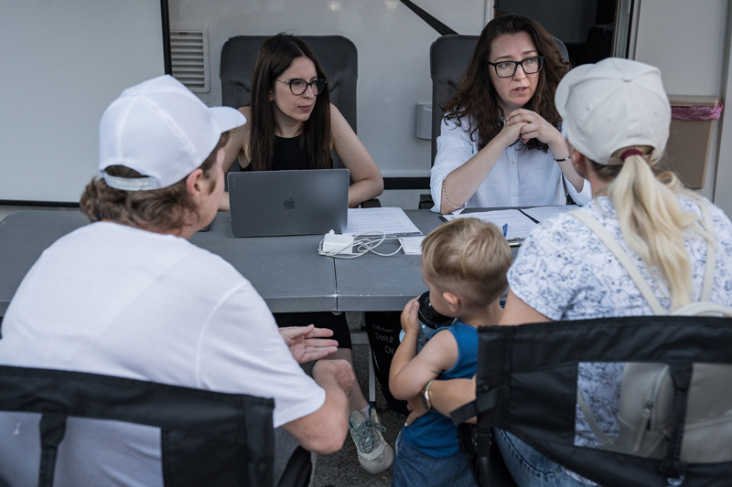

*Members of the eLiberare team hold a KOMPASS counselling session with Ukrainian refugees in Romania. KOMPASS is a new protection model designed and piloted by eLiberare, with the support of the Australian Government through the Australian Humanitarian Partnership, to protect Ukrainian refugee women and children from the risks of trafficking when moving through Europe. Credit: eLiberare*

### Increasing access to justice

To complement investments in reducing harmful gender norms, and increasing safety and security for women and girls, Australia worked with partner governments and other actors to support their efforts to improve access to justice for victim-survivors of sexual and gender-based violence. As the measure of access to justice for the second National Action Plan (Indicator 2.3.1), the number of countries that have national laws that criminalise sexual and gender-based violence increased from 158 to 162 (of 190) from 2021 to 2023. Yet, coverage is not universal, with 49 countries lacking specific laws on domestic violence, 45 on sexual harassment and 112 on marital rape.[29] In this global context, the Australian Federal Police worked with Pacific partner police agencies to increase access to justice through capacity-strengthening to prevent and respond to sexual and gender-based violence.

In Tonga, the Australian Federal Police’s **Families Free of Violence (FFOV)** Coordinator has been co-located in the Tonga Police Domestic Violence Unit since 2021, enabling ongoing coaching and mentoring of staff. To support operations, the FFOV purchased two vehicles, one each for the Domestic Violence Unit and the Tonga Police College Gender and Human Rights Unit. The FFOV also worked with the Domestic Violence Unit and local officers to equip and refurbish spaces dedicated to domestic and family violence responses at ‘Eua, Vava’u and Ha’apai police stations. In September 2021, the FFOV supported the launch of a domestic and family violence database, including the distribution of ICT equipment and roll-out of database training. The FFOV also supported improvements to data collection and management within the Tonga Women Affairs and Gender Equality Division of the Ministry for Internal Affairs.

In Papua New Guinea, the **PNG-Australia Policing Partnership (PNG-APP)** supported a refresh of the Sexual Offences Investigation Program. The program was delivered by the Royal Papua New Guinea Constabulary trainers, demonstrating strengthened capacity to deliver this training independent of the Australian Federal Police. The Australian Federal Police also provided mentoring to the Director of the Family and Sexual Violence Unit (FSVU) Directorate; and supported a Home Affairs-led initiative on human trafficking and modern slavery under Australia’s *International Engagement Strategy on Human Trafficking and Modern Slavery: Delivering in Partnership (2022)*. The PNG-APP funded training for Royal Papua New Guinea Constabulary members in the delivery of the United Nations Development Program (UNDP) sponsored Information Management System, a proposal from the Papua New Guinea National Strategy to *Prevent and Respond to Gender Based Violence 2016-2025* designed to improve referral pathways and information sharing.

In Vanuatu, the **Vanuatu-Australia Policing and Justice Partnership (VAPJP)** facilitated the signing of a Memorandum of Understanding between the Vanuatu Police Force and the Vanuatu Women’s Centre, detailing the duties and obligations of each organisation, in relation to Family Protection Orders. A dedicated Vanuatu Police Force unit was assigned to serve orders, resulting in an improvement in timeliness of Family Protection Orders being served. The Vanuatu Women’s Centre installed a Police Liaison Focal Point to work with Vanuatu Police Force’s Family Protection Unit, which led to improved case management, communication and collaboration.

In Samoa, the **Samoa-Australia Police Partnership (SAPP)** and the Pacific Community for Law Enforcement Cooperation developed a self-assessment on Gender and Family Harm for the Samoa Police Deputy Commissioner. The self-assessment helped to identify existing capabilities within Samoan policing in relation to legislative, policy and procedural frameworks for Gender and Family Harm. The SAPP also supported training for implementation of the Family Violence Policy in Savaii and Upolu, as well as for the Domestic Violence Unit. The training focused on the important role of police when attending incidents, ensuring that children, young people, and persons in vulnerable situations are protected.

In Indonesia, training and technical assistance was provided to the **Indonesian National Police’s Women and Child Protection Unit** to improve cyber investigations of child exploitation and sexual and gender-based violence offences. The Australian Federal Police facilitated the International People Smuggling Investigations Program, hosted at the Jakarta Centre for Law Enforcement Cooperation in Semarang, Indonesia. The course was designed to improve investigations into people smuggling and was attended by foreign law enforcement agencies in the Asia-Pacific Region, including from source and transit countries used by people smugglers.

**CASE STUDY: Gender audit of the Policia Nacionale Timor-Leste**

Through the first half of 2022, the Australian Federal Police’s International Command and **Timor Leste Police Development Program (TLPDP)** conducted a gender audit of the Policia Nacionale Timor-Leste to explore gender issues within the organisation.

The Gender Audit was conducted in all 14 districts of Timor Leste and reached around 1,300 Policia Nacionale Timor-Leste staff (31 per cent of the workforce) through an all-staff survey and qualitative data collection. The Gender Audit provided participants with an opportunity to share their beliefs, experiences and concerns about gender equality issues within the workplace. Staff members, especially from lower ranks, appreciated the opportunity to speak and be heard.

The Gender Audit presented recommendations to advance gender equality within the Policia Nacionale Timor-Leste. The findings and recommendations informed the development of a sexual harassment prevention policy; development of an updated Gender Strategy; and design of the next phase of TLPDP, covering 2023-2027.

The tools and resources developed during the Policia Nacionale Timor-Leste Gender Audit were converted into a generic International Command Gender Audit Toolkit for use in other Australian Federal Police partner law enforcement agencies.

Policia Nacionale Timor-Leste women commented that the Gender Audit process gave them an opportunity to raise their concerns. One women officer stated she had been waiting 20 years for such an opportunity.

In March 2023, the TLPDP Gender Advisor and a member of the Policia Nacionale Timor-Leste travelled to Cambodia to present on the process and the findings to the Cambodian National Police, at the Women in Policing Dialogue event.

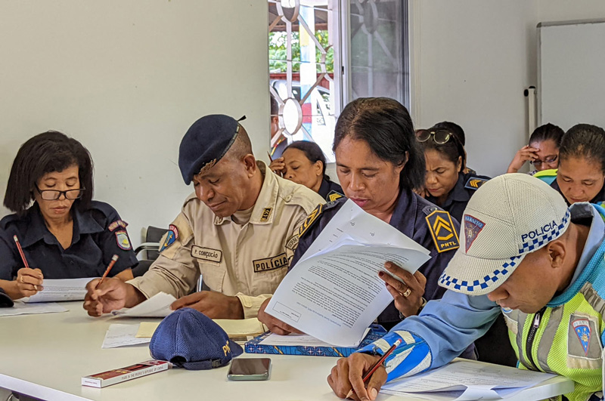

*Members of the National Police of Timor-Leste (Polísia Nasionál Timór Lorosa’e – PNTL) completing the Gender Audit all-staff survey in Covalima district. Credit: AFP member / TLPDP gender advisor Suzanne Preston*

The **Kiribati Women and Children Support Centre (KWCSC)** is an advocacy and crisis counselling service in Kiribati that provides holistic support to women and children who have experienced violence. KWCSC is the lead agency, on behalf of Kiribati civil society organisations, for reporting on the Convention on the Elimination of All Forms of Discrimination Against Women (CEDAW) and the Convention on the Rights of the Child (CRC). During 2022, the Australia Assists Program placed a volunteer with KWCSC to help strengthen the organisation’s capacity to report and advocate for improved legal outcomes for their clients. The project helped strengthen legal outcomes for both survivors of violence and judicial officers. All Kiribati court cases relating to violence against women and children now require Victim Impact Assessments. The information in the Victim Impact Assessments improved judicial officers’ understanding of the complex issues facing Kiribati women. The project has also helped to improve KWCSC’s reputation, trust and collaboration with government, law enforcement, community organisations and its clients.

A significant achievement for PNG-Australia Policing Partnership (PNG-APP) was the development of a **Gender Equity and Social Inclusion (GESI) Policy for Royal Papua New Guinea Constabulary**. In 2022, PNG-APP and the Royal Papua New Guinea Constabulary collaborated with other PNG government agencies to develop a training package to accompany the GESI Policy. PNG-APP champions the inclusion of women in leadership. The GESI policy notes that PNG National Public Service agencies should mainstream gender internally, including through appointments and promotions, career planning and development, training and induction, education, and organisational development. PNG-APP advisors across all portfolios are encouraged to integrate gender in training programs that are supported or sponsored by PNG-APP. The GESI policy was mainstreamed within the Detective Training Program and Prosecutions Qualifying Program.

Throughout 2022, the **Australian Embassy to the Federated States of Micronesia**, in partnership with the Department of Health and Social Affairs, delivered a series of workshops and training designed to improve access to justice for domestic and family violence survivors. Training on gender equality in the context of judicial decision-making was provided to justices and court staff from the Pohnpei Supreme Court. Following the training, the design of sentencing reports to the court were revised to, for example, ensure the holistic impacts and harm for women and children who have experienced sexual and gender-based violence and family violence are comprehensively captured and reflected in victim-survivor impact statements.

Workshops were delivered to the Micronesian Legal Services Corporation, exploring opportunities to improve service delivery for survivors of domestic and family violence. The Micronesian Legal Services Corporation has offices across Micronesia, including in Guam, Saipan, Palau and the Republic of the Marshall Islands, providing legal services for Micronesians with low economic status.

The workshops were attended by almost all employees of Micronesian Legal Services Corporation, encompassing program managers, legal secretaries and advocates. Following the workshops, the Micronesian Legal Services Corporation modified elements of its case management system and referral pathways to better support domestic and family violence survivors and clients. As one staff member noted: “requesting financial and demographic client data to determine eligibility is probably not the best way to start off talking with someone who has been experiencing domestic violence”. The Micronesian Legal Services Corporation’s Executive Director, Lee Pliscou, reflected: “Every week, I ask staff questions such as, what have we done to make it easier for domestic violence survivors to reach us?”

These case studies demonstrate the breadth and depth of Australia’s efforts to reduce sexual and gender-based violence with partner governments and other organisations in the Asia-Pacific region. Working with partners at multiple levels—from police and defence personnel to civil society and international organisations—enabled Australia to target sexual and gender-based violence in a holistic manner, making tangible contributions to the individuals and communities, as well as to the capacity of institutions to prevent and respond to sexual and gender-based violence.

## Outcome 3: Support resilience, crisis response, and security, law and justice sector efforts to meet the needs and rights of all women and girls

This chapter presents examples and case studies which demonstrate Australia’s actions against the third outcome of the National Action Plan: to support resilience, crisis response, and security, law and justice sector efforts to meet the needs and rights of all women and girls. Actions undertaken in this reporting period aimed to:

* apply gender-responsive approaches to all security, law and justice efforts, including through efforts to strengthen legislative frameworks to prevent crimes, particularly those with gender causes and consequences such as human trafficking;
* strengthen accountability and justice for human rights violations and abuses, including sexual and gender-based violence and mass atrocities;
* ensure stabilisation and recovery approaches meet the needs of women and girls for long-term sustainable livelihoods, including access to health, education, and economic opportunities;
* adopt a gender-responsive approach to resilience, relief and recovery in humanitarian action, and stabilisation, development and disaster management;
* support women’s leadership and participation in climate policy decision-making; and
* promote the leadership of women’s rights organisations, networks and coalitions, which are already investing in crisis response and sustainable disaster management, and encourage their leadership.

**The Australian Department of Defence** integrated gender, peace and security principles across the breadth and complexity of domestic operations and international engagement, including disaster and crisis responses.

The **Australian Federal Police** worked with partner law enforcement services to strengthen the capacities of partner police to apply gender-responsive approaches to security, law and justice efforts to prevent crimes, including those with gender causes and consequences.

The **Department of Home Affairs** worked to provide critical support to women and child refugees and asylum seekers in vulnerable situations, strengthen responses to trans-border issues, including human trafficking, and enhance gender-responsive customs administration initiatives and disaster responses.

The **Department of Foreign Affairs and Trade** integrated the Women, Peace and Security agenda across humanitarian, disaster response, resilience and climate adaptation and mitigation programs, and through international engagement and advocacy.

In the first two years of implementation, Australia took a global approach, supporting efforts across regions in response to emerging and continuing conflicts and crises. In 2021-22, Australia provided emergency assistance to 23.31 million women, men, girls and boys in conflict and crisis situations, increasing to 23.82 million in 2022-23 (Indicator 3.2.1 of the second National Action Plan Monitoring and Evaluation Framework). [30]The range and breadth of the following activities combined to support resilience, crisis response, and security, law and justice sector efforts to meet the needs and human rights of women and girls. Given the increasing frequency and severity of climate-induced crises, Australia also invested in knowledge sharing and capacity building on gender-responsive disaster risk reduction. For the first time, Australia deployed Australian Defence Force Gender Advisors domestically, which demonstrated the linkages between international and domestic approaches to gender-responsive crisis response.

These efforts occurred at a time when there was little global change in crisis, security, law and justice assistance that met the needs and rights of women and girls. The number of countries with laws and regulations restricting women’s ability to participate in society and the economy, relative to men, declined from 179 to 176, between 2021 and 2021 (Indicator 3.1 of the second National Action Plan Monitoring and Evaluation Framework).[31] Women and girls continue to be trafficked, and at high risk if in countries in conflict. In 2020, they constituted 60 percent of persons trafficked, and were subjected to greater violence by traffickers, than were men and boys (Indicator 3.1.1).[32] While maternal mortality declined by 34 percent globally between 2000 and 2020, that women and girls continue to die when giving birth, and at markedly higher rates in low-income countries (430, compared to 13, per 100,000 live births), indicates basic needs are not being met, and particularly in insecure contexts (Indicator 3.2).[33]

### Increasing access to security, law and justice responses

The following section provides examples of Australia’s investments in increased access to security, law and justice responses to meet the needs and rights of all women and girls. These case studies complemented the policing efforts to respond to sexual and gender-based violence outlined in the preceding chapter.

In partnership with The Asia Foundation, Australia supported women’s economic empowerment in the Bangsamoro Autonomous Region of Muslim Mindanao (BARMM) through the **Accelerate Women’s Entrepreneurship for Peace in Sulu** program. Through this program, 288 women directly affected by extremism—as former combatants, wives or family of former combatants, or as survivors of violent extremism—attended training and were provided with seed funding to support their small businesses. Participants learned how to improve the branding and marketing of their products and how to engage with the digital economy.

With support from the Australian Border Force, the **Oceania Customs Organisation Regional Gender Equality and Workplace Diversity Workshop** was delivered with the World Customs Organization and the New Zealand Customs Service from 27 to 30 June 2023. The workshop provided guidance and assistance to participants on how to design gender equality policies and strategies. The workshop was also designed to strengthen member organisational development, through building knowledge and awareness on gender equality and workplace diversity.

**CASE STUDY: Kitchen gardens and Green Networks empowering the women of Srebrenica and Tuzla**

In 2023, in Bosnia and Herzegovina, the Australian Embassy in Vienna supported the Snaga žene (“The power of woman”) project “Women’s empowerment – Green network”. Since 1999, Snaga žene has provided holistic support to women survivors of war atrocities across ethnically divided regions of Bosnia and Herzegovina, including psychological, social, medical, legal, and economic support. Many of the women survived wartime sexual and gender-based violence and continue to experience trauma associated with post-war political instability.

With the Embassy’s support, Snaga žene purchased kitchen garden seeds and equipment for 50 women in Srebrenica and Tuzla, providing opportunities for income generation and social integration.

One woman from Tuzla reflected: “A donated greenhouse and seed material mean a lot in my life. There, I am recovering physically and mentally. If I did not have the greenhouse, I wouldn’t know what I would do. Every morning I get up at five o’clock and go to the greenhouse. Very soon I will be picking tomatoes, cucumbers, and capsicums. I have a little petty cash tin for the money I get from selling to neighbours and friends. At the end, I will know how hard I have worked.”

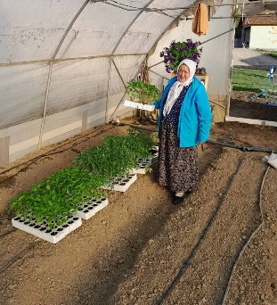 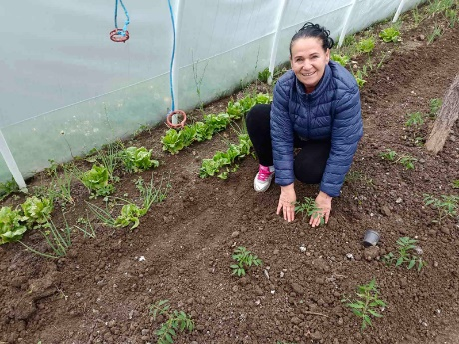

*Left: Mina O. from Srebrenica. Credit: The Association Snaga žene. Right: Nevresa M. from Tuzla. Credit: The Association Snaga žene*

Countering human trafficking is a priority for Timor-Leste. In 2021, the Timor-Leste Police Development Program engaged the Australian Federal Police’s Human Trafficking team to design a five-day face-to-face **Human Trafficking Investigators Program** (HTIP). Delivered in 2022 to Timor-Leste National Police investigators, Vulnerable Persons’ Unit (VPU) chiefs and immigration officers, the program provided participants with knowledge and skills to advance their expertise in areas critical to human trafficking investigations, legislation, investigative methodologies, multi-agency and international support, and victim-survivor liaison. The development and delivery of this training prepared the Policia Nacionale Timor-Leste to make intelligence-led policing decisions through enhanced processes to investigate HTIP and related sexual and gender-based violence offences.

Co-managed by Australia and Indonesia, the **Regional Support Office of the Bali Process** developed a comprehensive capacity-strengthening program to support and empower women within Bali Process Member States. The Bali Process Regional Support Office hosted eight training sessions and workshops from July 2022 to June 2023, which included sessions on the risks faced by women in the context of people smuggling, trafficking in persons and related transnational crime. The sessions helped raise awareness among communities, law enforcement agencies, and relevant stakeholders about specific risks and challenges faced by women, as well as imparted information on how to effectively identify and support women survivors. Participants reported increased knowledge and skills, and the training contributed to strengthened regional cooperation and information sharing.

The Department of Foreign Affairs and Trade partnered with Legal Action Worldwide on an initiative to establish a **Gender Justice Practitioner Hub**. Through collaboration, coordination and leveraging decades of experience at national and international levels, the Hub is intended to provide practical tools and assistance to practitioners to help strengthen gender justice efforts. In June 2023, Legal Action Worldwide facilitated the first regional meeting of experts in Beirut, Lebanon. Thirty-four practitioners, including representatives of civil society, academia, survivor groups and UN entities based in the Middle East and North Africa (including Lebanon, Syria, Palestine and Libya), participated in the discussion, including men, women and people of diverse sexual orientations and gender identities. There was recognition that, despite operating in different contexts, many of the obstacles faced are the same across countries and regions and that collaboration and coordination are critical to addressing the challenges. Participants underscored the need for safe spaces for practitioners engaged in gender justice to come together to discuss common issues and share advice and learnings.

### Humanitarian action, stabilisation and disaster management

Australia is committed to ensuring that all humanitarian action, stabilisation and disaster management efforts are gender responsive. The following case studies provide examples of our approach, which included targeted and mainstreamed gender equality investments.

During the aftermath of the Hunga Tonga-Hunga Ha’apai eruption, tsunami and subsequent COVID-19 outbreak, the **Australian Federal Police-led Families Free from Violence** (FFOV) program worked with the Tonga Police Force to ensure responses to the concurrent crises were gender-informed and responsive. This included, for example, the provision of dignity kits to women police officers to enable their continued participation and leadership. The Australian Federal Police’s FFOV advisor successfully advocated for the **Tonga Police National Domestic Violence Unit** to remain funded and operational, despite pressures to divert resources to the response operation. Damaged safe-space infrastructure and assets of the National Domestic Violence Unit, including vehicles and ICT equipment, were replaced by the FFOV program. As a result, women and their families in vulnerable situations were supported, including in relation to sexual and gender-based violence with the serving of Police Safety Orders and investigations. The FFOV program provided funding for 25 trauma counsellors to support the community, with more than 90 per cent of users of the service being women and leitis (gender-diverse people).

In January 2022, the Australian Government partnered with **Gender and Disaster Australia** to deliver online and in-person training and resources to more than 1,000 disaster responders across Australia to strengthen capacities on the gender equality impacts of disasters. Seventy employees from the National Emergency Management Agency, part of the Department of Home Affairs’ Portfolio, and eight Queensland Reconstruction Authority employees, completed the training, increasing their understanding of gender and its relevance to the lives of women, men, girls, boys and LGBTQIA+ peoples who experience disasters, and how to develop evidence-based strategies to facilitate equitable responses in and after disasters, as well as ensure the safety of women and children.

In Myanmar, Australia’s partnership with the United Nations Population Fund supported sexual and reproductive health and rights through the **Women and Girls First Programme**. The Programme provided maternity care, family planning, comprehensive sexuality education, and health services for sexual and gender-based violence survivors, along with HIV counselling, to more than ten thousand individuals, mostly women. The **World Food Programme** is another humanitarian partner for Australia in Myanmar, providing food and cash assistance to persons in need. Women’s participation in resilience-building project committees is supported so that they can influence decision-making. Training on finance and digital literacy was provided to over 12,000 women. This resulted in 79 per cent of the women participants in Yangon making decisions independently on how to use the assistance they received, a 15 per cent increase from 2021.

In Indonesia, the Department of Home Affairs supported the delivery of the **ASPIRASI Shelter Project**. Translating to ‘Aspiration’, the project supported women and child refugees and asylum seekers, including those who were unaccompanied, through physical protection safeguards (including shelter and security), access to health services (including psychological and mental health support), access to education and vocational training, and a weekly subsistence allowance. Since its inception in 2016, the project has supported more than 70 at-risk refugee and asylum seeker women and girls, including sexual and gender-based violence survivors, persons without shelter, and unaccompanied elderly persons.

**CASE STUDY: Australian Defence Force Gender Advisor deployed for the first time in Australia**

Operation COVID-19 Assist was the Australian Defence Force contribution to the whole-of-government response to the COVID-19 pandemic, supporting operations including mandatory state and territory hotel quarantine programs, emergency response planning assistance, frontline COVID-19 testing and support at testing facilities, contact tracing and logistics.

To support the integration of gender across planning and operations, an Australian Defence Force Gender Advisor was deployed to the Defence COVID-19 Command Taskforce. This was the first time a Gender Advisor had been deployed in Australia.

Online training was developed for deploying Australian Defence Force members, providing information on reporting responsibilities in relation to sexual and gender-based violence. Several tools were developed to assist Australian Defence Force members undertake their duties. Technical assistance was also provided to neighbouring countries to enhance their responses and provide further opportunities for embedding gender in regional COVID-19 responses.

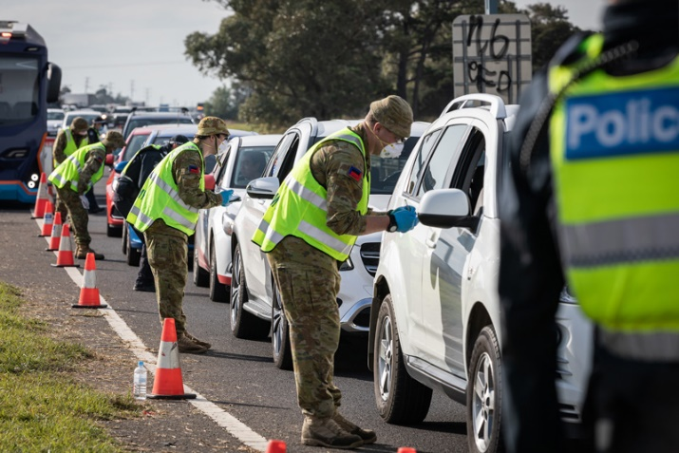

*Australian Army Reservists from 5th/6th Battalion Royal Victoria Regiment work with Victorian Police Officers at the Little River Police vehicle checkpoint in Victoria in support of Op COVID 19 Assist. Credit: Defence Image Gallery. Photographer: LAC John Solomon*

In the Indo-Pacific, sexual and reproductive health and rights inequities were exacerbated by the COVID-19 pandemic, as strained health systems diverted resources and disrupted the delivery of sexual and reproductive health services. The **Indo-Pacific Sexual and Reproductive Health and Rights COVID-19 Response** (SRHR COVID-19 Surge) provided a focused intervention across the Indo-Pacific to support service providers and technical specialists to help address unmet need for sexual and reproductive health services. The SRHR COVID-19 Surge investment was delivered in 22 countries in Asia and the Pacific by the United Nations Children’s Fund, United Nations Population Fund, Marie Stopes International Asia-Pacific and the International Planned Parenthood Federation. It improved access to quality information and services on family planning, preventing and treating sexually transmitted diseases, and maternal and newborn health. The program also strengthened family planning supply chain systems and data quality to improve public health responses.

In partnership with CARE Australia, the Department of Home Affairs facilitated the **Improving Protection and Resilience for Refugees and Jordanians Affected by the Syrian Crisis** (PEERS) project, providing emergency assistance and safe spaces for individuals and communities in vulnerable situations in Jordan. The project has operated in phases, with the third phase working with women and girls in refugee and host communities, providing access to information, services, emergency financial assistance for shelter, and psychosocial activities.

Supported by Australia since 2016, UN Women’s **Making Every Woman and Girl Count** program aims to increase the availability of accurate information on gender equality and women’s and girls’ human rights to inform policy and decision-making. Through its public-private initiative, the production, accessibility and use of gender statistics has improved understanding of the gender equality impacts of conflict and instability. The series of factsheets produced on Afghanistan have documented the evolving and declining human rights situation for women and girls.

The Australian Department of Defence integrated gender in the 2021 **Non-Combat Evacuation Operation in Afghanistan**, the largest humanitarian airlift operation in recent history. As the Taliban moved across Afghanistan, the Australian Defence Force, in coordination with the Department of Foreign Affairs and Trade and the Department of Home Affairs, flew 32 missions to evacuate over 4,100 men, women and children from the Hamid Karzai International Airport, Kabul. Australia brought in food, water and basic shelter to Kabul International Airport during the evacuation operation. Evacuees transitioned through Australia’s main logistic hub, providing temporary facilities to accommodate, feed and provide medical care for evacuees before moving to Australia. The needs of women, men, girls and boys were considered during the planning and execution of this operation. Families were kept together in sleeping quarters and separate accommodation was available for unaccompanied women. Medical facilities were deployed to respond to the needs of women, including pregnant women, and children, and sufficient lighting was placed around toilet areas in consideration of safety. Following the conclusion of the operation, interviews were conducted with deployed personnel. Their reflections highlighted how understanding and responding to gender enhanced operational effectiveness, including in relation to the selection of personnel for a mission; the skills and logistics required, and the management of the welfare of all people, including deployed personnel.

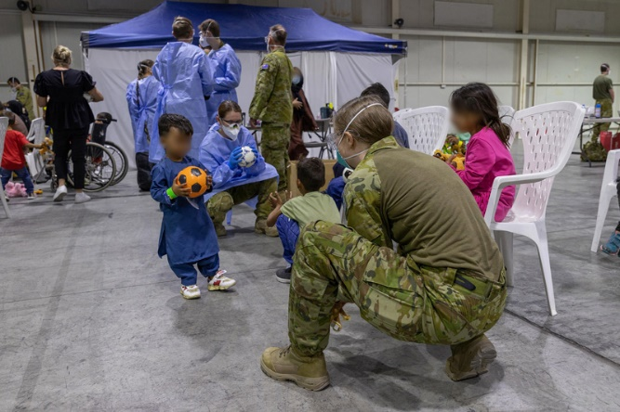 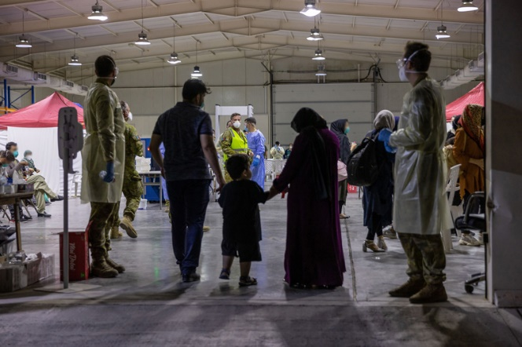

*Left: Australian Defence Force members play with children inside the evacuee handling centre at Australia’s main operating base in the Middle East. (This image has been digitally altered - privacy). Credit: LACW Jacqueline Forrester*

*Right: Evacuees enter the evacuee handling centre at Australia’s main operating base in the Middle East, following their evacuation from Kabul, Afghanistan. (This image has been digitally manipulated). Credit: LACW Jacqueline Forrester*

**CASE STUDY: Advocating for gender-transformative policy at the Asia Pacific Minister Conference on Disaster Risk Reduction**

Australia welcomed more than 2,000 delegates representing government, civil society, academia, the private sector, and local communities from over 40 Asia-Pacific countries to Brisbane for the 2022 **Asia-Pacific Ministerial Conference on Disaster Risk Reduction**. Hosted in partnership with the United Nations Office for Disaster Risk Reduction (UNDRR), the conference was an opportunity for delegates to review efforts to prevent new and existing disaster risks, to identify the priorities to be scaled up to advance disaster prevention and risk mitigation in the Asia-Pacific region, and to make actionable commitments against the Sendai Framework for Disaster Risk Reduction 2015-2030.

The Conference highlighted the importance of prioritising inclusive, gender-transformative and universally accessible disaster risk reduction, and the need for intersectional approaches that recognise and seek to overcome inequalities and marginalisation that can exacerbate individuals’ risk and reduce the resilience of communities.

A joint statement on leaving no one behind was delivered by the United Nations Population Fund, the International Planned Parenthood Federation, the International Federation of Red Cross and Red Crescent Societies and CARE, on reducing sexual and gender-based violence and increasing access to sexual and reproductive health services in emergencies.

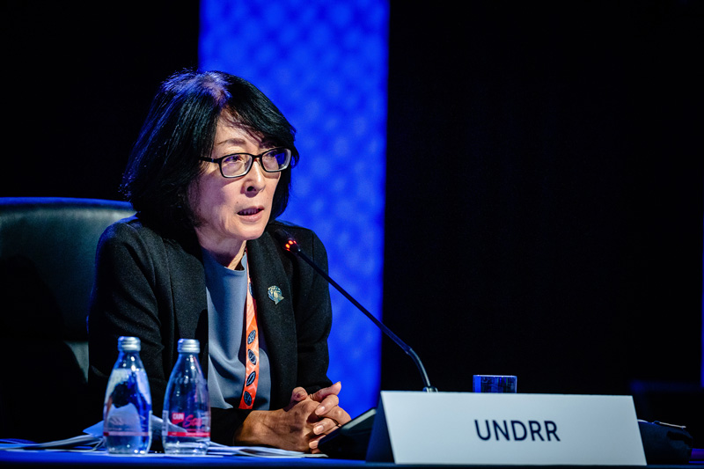

*Ms Mami MIZUTORI, Special Representative of the UN Secretary-General (SRSG) for Disaster Risk Reduction speaking at Asia-Pacific Ministerial Conference on Disaster Risk Reduction. Credit: Patrick Hamilton - APMCDRR 22 – Flickr*

Australia has partnered with UN Women on the **Women’s Resilience to Disasters Programme**, launched in four Pacific countries: Fiji, Kiribati, Vanuatu and Solomon Islands. The aim of the program is to strengthen the resilience of the lives and livelihoods of women and girls to disasters, including climate-related disasters and pandemics, as well as to contribute to sustainable, secure, and prosperous communities. Country-driven and locally owned action focuses on local priorities, with regional and global elements fostering enabling environments for women’s agency, leadership, coordination, knowledge exchange and advocacy. At a regional level, the Women’s Resilience to Disasters Programme provides the Fiji’s National Disaster Management Office advice on the inclusion of questions on sexual orientation and gender identity in data collection to support informed preparedness and recovery policies and plans. The Gender in Humanitarian Action Training of Trainers in Solomon Islands supports trainers on gender-responsive disaster preparedness, relief and recovery. It does this by enabling the trainers to transfer the knowledge and skills they acquire to other relevant stakeholders.

**CASE STUDY: Supporting women’s leadership in disaster risk reduction**

The Women’s International Network on Disaster Risk Reduction (WIN DRR) is supported by the United Nations Office for Disaster Risk Reduction and the Australian Government to promote and support women’s leadership in Disaster Risk Reduction in the Asia Pacific region. The aim of WIN DRR is for women to attain leadership positions, strengthening their roles in decision-making in disaster risk reduction in Asia Pacific. There are four components to the program:

i. building the evidence base—by commissioning research on women’s decision-making in disaster risk reduction, documenting good practices and case studies, and disseminating them widely;

ii. strengthening leadership capacities—by providing professional development opportunities and leadership training, and mentorship and peer-to-peer support programs for women working in disaster risk reduction;

iii. recognising women’s achievements—by supporting women’s participation in disaster risk reduction conferences and events, and presenting annual awards for women’s leadership; and

iv. supporting institutions to enhance women’s leadership—by supporting institutions working on disaster risk reduction to adopt strategies and policies to help reduce the barriers women face in advancing their careers, and enhance women’s leadership.

Since inception, WIN DRR has been a platform for improving women’s leadership skills and their roles in disaster risk reduction decision-making. As part of the ongoing Midterm Review of the Sendai Framework, United Nations Office for Disaster Risk Reduction worked with UN Women and United Nations Population Fund to advance gender equality and women’s empowerment, including through the Gender Guidance to Member States on a Gender Responsive Midterm. The United Nations Office for Disaster Risk Reduction also undertook thematic studies, interviews and profiles of women actors in disaster risk reduction in Asia and the Pacific as part of the WIN DRR priorities.

WIN DRR delivered training to almost 100 women leaders, including from Small Island Developing States in the Pacific and Southeast Asia, through the United Nations Institute for Training and Research-led Women’s Leadership in Tsunami based Disaster Risk Reduction training programme, and over 50 leaders on gender-responsive disaster risk reduction, as part of the All India Disaster Mitigation Institute training programme: **Intersectionality Approach for Securing Women’s Livelihoods, Food and Nutrition Security Towards Disaster Resilience Building**.

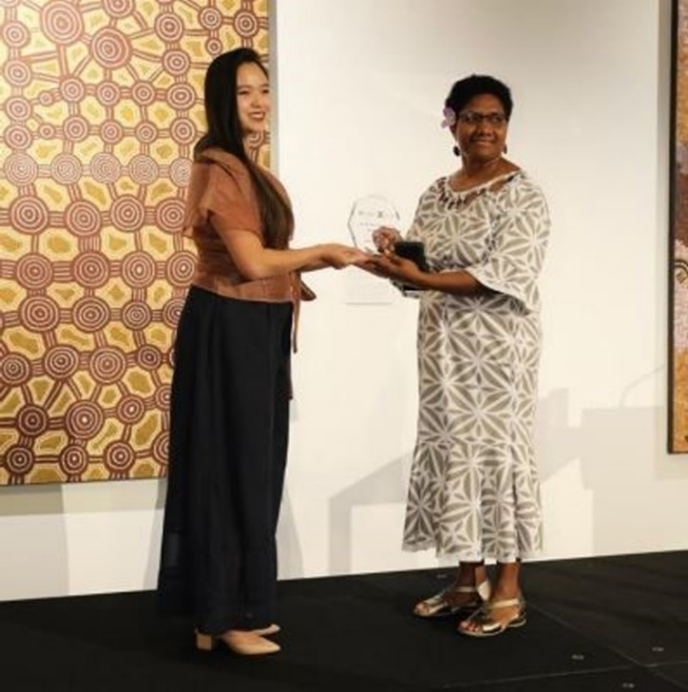

*SM Prime Assistant Vice President presents Dr Esline Garaebiti, Director General of the Ministry of Climate Change Adaptation, Meteorology, Geo-Hazards, Environment, Energy and Disaster Management in Vanuatu, with the 2022 award. Credit: Fiji NDMO*

Australia has a dedicated refugee visa program which provides protection to women and their dependents who have been subjected to harassment, persecution, abuse or victimisation on the basis of gender. Established in 1989, the **Woman at Risk Visa** has been granted on more than 25,900 occasions. The **Vulnerable Women and Children** classification captures women and their dependents who are granted another subclass of humanitarian visa and are unaccompanied by a male applicant. From July 2021 to June 2023, 2,883 offshore visas were granted under the Vulnerable Women and Children classification, comprising 31 nationalities, with the top five countries of citizenship being Afghanistan, Democratic Republic of the Congo, Iraq, Syria and Ethiopia. Consistent with Australia’s Humanitarian Program target of no less than 50 per cent women, women comprised 50.2 per cent of the 2021–2022 program and 51.2 per cent of the 2022–2023 program. The Humanitarian Settlement Program provided settlement support, including Specialised and Intensive Services for women and children with complex needs, including torture and trauma counselling through the Program of Assistance for Survivors of Torture and Trauma.

These examples demonstrate the breadth and depth of Australia’s engagement across different types of crises and geographical regions. Having engaged in practical initiatives at the grassroots, regional and international levels, as well as investing in knowledge building and sharing activities, Australia made positive contributions to meeting the needs of women and girls in crisis situations, as well as upholding women’s and girls’ human rights.

## Outcome 4: Demonstrate leadership and accountability for the Women, Peace and Security agenda

Australia is a global leader of the Women, Peace and Security agenda and advocates, supports and undertakes actions across the four pillars of participation, conflict prevention, protection of rights, and relief and recovery. Australia recognises the role of civil society, including women’s rights organisations and women’s human rights defenders, and values their leadership, expertise, insights, and experiences in implementation of the Women, Peace and Security (WPS) agenda.

This chapter provides a series of examples and case studies which demonstrate Australia’s efforts during the reporting period to provide global leadership, be accountable for and harmonise efforts to implement the Women, Peace and Security agenda internationally. The Australian Government actions aimed to:

* support women’s rights organisations and networks to represent and lead discussion on international peace, security and stability, and human rights frameworks that strengthen international norms;
* cooperate with other countries, and in multilateral fora, to advance the Women, Peace and Security agenda, fully utilising Australia’s diplomatic network, including by supporting women’s organisations and peace networks to share good practice;
* embed gender-sensitive conflict analysis to implement National Action Plan priorities;
* increase women’s participation and leadership in Australia’s security sector and diplomatic corps;
* build capacity in Australia, and our region, to implement the Women, Peace and Security agenda; and
* raise awareness of, and encourage compliance with International Humanitarian Law, International Human Rights Law, and strengthen connections between Women, Peace and Security and human rights mechanisms.

The **Australian Department of Defence** provided regional leadership via support to inclusive conflict prevention, conflict resolution, peace processes and post-conflict state reconstruction.

The **Australian Civil-Military Centre** supported engagement between government and civil society on the Women, Peace and Security agenda, including through its support for the Australian Civil Society Coalition for Women, Peace and Security.

The **Australian Federal Police** promoted gender-responsive policing by mainstreaming gender across its operations.

The **Department of Home Affairs** and the Australian Border Force contributed to social cohesion, the protection of Australia’s sovereignty and the integrity of borders, the resilience of national infrastructure, national security arrangements, as well as countering foreign interference and counter-terrorism.

The **Department of Foreign Affairs and Trade** engaged Australia’s diplomatic network in regional and multilateral fora to promote the Women, Peace and Security agenda.

In the 2021-2023 period of implementation, Australia’s international leadership on WPS focused on eradicating conflict-related sexual violence, advocating for gender-responsive climate action, and promoting and protecting the human rights of women and girls. Australia invested in partnerships and capacity building, and provided targeted funding to support full implementation of the Women, Peace and Security agenda. Examples of capacity strengthening activities, civil society engagement and Australian Government leadership, during the reporting period, are listed in Annex A.

### International Engagement and Advocacy

Australia’s international engagement and advocacy contributed to the global advancement of the WPS agenda. Australia’s engagements spanned multilateral, regional and bilateral fora. The following case studies provide a snapshot of these efforts. Examples of statements on the WPS agenda, sexual and gender-based violence and/or women’s participation that Australia led or sponsored during the 2021-2023 reporting period are listed in Annex B.

**CASE STUDY: Preventing sexual violence in conflict**

Australia is steadfast in supporting survivors of sexual violence and ending all forms of sexual and gender-based violence.

In 2022, Australia reaffirmed its commitment to preventing sexual violence in conflict. At the Ministerial-level Conference on Preventing Sexual Violence in Conflict Initiative, convened by the United Kingdom, Australia’s national statement reaffirmed commitment to sustained support for transformative global, regional and local initiatives. This commitment is reflected in Australia’s funding to the Women, Peace and Humanitarian Fund, women mediator networks, the work of women’s and girls’ human rights organisations, and mechanisms that deliver gender justice.

Australia is a founding member of the International Alliance on Preventing Sexual Violence in Conflict and the Call to Action on Protection from Gender-Based Violence in Emergencies; has joined the WPS and Humanitarian Action Compact, and encourages use of the Murad Code.

Australia advocated for the prevention of conflict-related sexual violence, including in UN Security Council Open Debates, and has zero tolerance for sexual exploitation, abuse and harassment in all contexts, operations and missions. Australia held regular discussions with other countries, including on the possible use and coordination of sanctions to address conflict-related sexual violence.

Australia also recognises that gender-responsive security sectors, along with greater numbers of women in strategic positions within defence and security institutions, will contribute to preventing conflict-related sexual violence. In 2022, the Australian Defence Force deployed an Australian Defence Force Gender Advisor to the United Nations Mission in South Sudan; and, in Timor Leste, the Australian Government provides funding for the Timor Leste Police Development Program to train Gender Advisors for the Policia Nacional Timor-Leste.

**CASE STUDY: Gender-responsive climate action**

At the 27th Conference of the Parties in 2023 (COP27), Australia demonstrated its prioritisation of gender-responsive climate action and gender balance in climate decision-making. The Australian Pavilion provided an inclusive and welcoming hub for Australians to engage in discussions and profile individuals experiencing the impacts of climate change, particularly First Nations Australians, women and youth. A Pacific Women Negotiators Breakfast was hosted by Assistant Minister for Climate Change and Energy and the Senator the Hon Jenny McAllister. An event was hosted by Water for Women to discuss equitable access to water resources as critical for a climate-resilient future. Australia contributed to discussions on the Mid-Term Review of the United Nations Framework Convention on Climate Change Gender Action Plan. The Australian delegation at COP27 was comprised of 57 per cent women and led by a woman Head of Delegation.

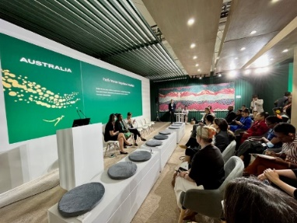*Senator Hon Jenny McAllister with Pacific women delegates at the Australian Pavilion at COP27. Credit: Department of Climate Change, Energy, the Environment and Water*

Australia’s **Ambassador for Gender Equality** leads Australia’s international advocacy, public diplomacy, and outreach in support of Australian Government gender equality policies and programs, including to end sexual and gender-based violence; eliminate all forms of discrimination against women and girls, and persons of diverse gender identities; ensure access to adequate education and health (including sexual and reproductive health) services; enhance the participation of women in decision-making and leadership; and implement the Women Peace and Security agenda.

During the reporting period, and for the second National Action Plan Monitoring and Evaluation Framework indicators 4.2 and 4.1.2, Australia led public statements on WPS in multilateral fora on ending sexual and gender-based violence and promoting women’s participation and leadership. For example, the Ambassador for Gender Equality, Stephanie Copus Campbell, delivered Australia’s national statement at the UN Security Council Open Debate on Women Peace and Security on 7 March 2023, and advocated for accelerated action on WPS in various other multilateral fora, including the Commission on the Status of Women, at the 2023 Women Deliver Conference in Kigali, Rwanda, as well as at bilateral and regional engagements.

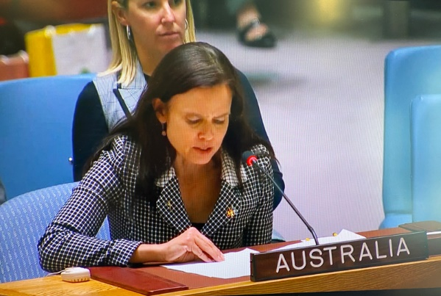

*Australia’s Ambassador for Gender Equality reads a National Statement at the annual Open Debate on Women, Peace and Security at the UN Security Council on International Women’s Day, 8 March 2023. Credit: DFAT*

Australia’s other thematic ambassadors also support international advocacy and engagement on WPS, including the Ambassadors for Human Rights; Arms Control and Counter-Proliferation; Climate Change; to Counter Modern Slavery, People Smuggling and Human Trafficking; and for First Nations People.

**CASE STUDY: Inaugural appointment of Australia’s Ambassador for Human Rights**

In December 2022, the Australian Government appointed an Ambassador for Human Rights, to restore Australia’s leadership on human rights around the world. The role of Ambassador for Human Rights was established to support Australia’s efforts to uphold human rights, including through support for the UN human rights architecture and international law. The Ambassador for Human Rights works to advance rights and protections for, *inter alia*, people living with disabilities, ethnic and religious minorities and LGBTQIA+ individuals. The first incumbent is Ms Bronte Moules.

**CASE STUDY: Advancing the WPS agenda at the 53rd regular session of the Human Rights Council**

At the 53rd regular session of the Human Rights Council, Australia demonstrated its ongoing commitment to the WPS agenda. The Australian delegation, led by the Ambassador for Human Rights, delivered three national statements on issues relevant to the WPS agenda, as well as joint statements with Canada, New Zealand, Mexico, and Member States (see Annex for full list).

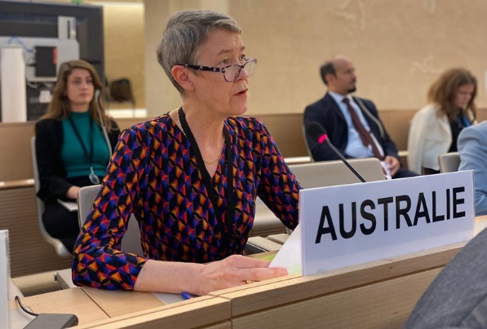

*Australia’s inaugural Ambassador for Human Rights, Bronte Moules, at Human Rights Council 53. Credit: DFAT/Deb Livermore*

In December 2021, Australia established a thematic **autonomous human rights sanctions framework** to target serious human rights abuses and violations. Sanctions are one of a suite of measures the Government uses to respond to egregious human rights situations. Under the legislation, human rights sanctions may be imposed if the Minister for Foreign Affairs is satisfied that a person or entity has been engaged in, responsible for, or complicit in an act that constitutes a serious violation or a serious abuse of a person’s right to (i) life; (ii) not to be subjected to cruel, inhuman or degrading treatment or punishment; (iii) not to be held in slavery or servitude; or (iv) not to be required to perform forced or compulsory labour. Prior to making listings, the Minister for Foreign Affairs is required to obtain the agreement of the Attorney-General and consult any other relevant Ministers. Between July 2021 and June 2023, the Australian Government imposed three successive tranches of human rights sanctions on Iranian persons and entities in response to the situation in Iran; on 10 December 2022, 1 February 2023, and 20 March 2023. In total during the 2021-2023 reporting period, the Government sanctioned 36 persons and 17 entities for their involvement in the oppression of women and girls and the violent crackdowns on protestors in Iran.

Australia is committed to working with the ASEAN Member States to support a peaceful, stable, resilient and prosperous region and advance shared commitment to the WPS agenda under the ASEAN-Australia Plan of Action to Implement ASEAN-Australia Strategic Partnership (2020-2024). In 2023, at the **WPS High Level Dialogue**, Australia, along with the governments of Canada, Norway, the United Kingdom, and the United States, as well as UN Women, pledged to strengthen cooperation with ASEAN in ASEAN-led implementation of the Regional Plan of Action on Women, Peace and Security. By signing the pledge, Australia affirmed its commitment to the principles and objectives outlined in the ASEAN WPS Regional Plan of Action, and strengthened its commitment to supporting ASEAN in its coordination, reporting, monitoring and evaluation, as well as fostering a culture of knowledge sharing, learning and leadership.

In November 2021, Australia and Vietnam co-hosted the second **ASEAN-Australia WPS Dialogue**, attended by both countries’ Ministers for Foreign Affairs. The theme of the Dialogue was ‘Women, Peace and Security: Progressing Implementation on the Road to Recovery from COVID-19’. The Dialogue provided a platform for advocacy on gender equality, to explore how WPS principles can help to identify the gender equality impacts of the COVID-19 pandemic, and inform gender-responsive recovery efforts. More than 130 participants participated in the Dialogue, including representatives of the ASEAN Secretariat, Canada, the United States, and international and non-governmental organisations, civil society, research institutes and associations from Australia and Vietnam.

The Australian Federal Police’s **Police Advisor to the UN in New York** promotes gender-responsive policing in multilateral fora. In 2021, the Police Advisor led negotiations for the delegation of Canada, Australia and New Zealand on ‘Conduct’ in the UN General Assembly Special Committee on Peacekeeping Operations Report, successfully negotiating inclusion of language on sexual harassment, in the Report. In partnership with UN Women, the United Nations Office on Drugs and Crime (UNODC) and the International Association of Women Police (IAWP), Australia supported the development of the *Handbook on Gender-Responsive Police Services for Women and Girls Subject to Violence*, launched in 2021. The Handbook provides practical, peer-to-peer guidance for police to enable gender-responsive action on violence against women and girls.

The 190 States Parties to the Treaty on the Non-Proliferation of Nuclear Weapons (NPT) meet every five years to advance disarmament and non-proliferation objectives. At the tenth **NPT Review Conference**  in August 2022, Australia’s gender-balanced co-leadership provided a visible demonstration of our commitment to gender equality and inclusion on nuclear issues. The delegation led efforts to advance the full, equal and meaningful participation and leadership of women in implementation and review of the Treaty. Our delegation was praised for its active, constructive engagement, which included modelling a gender equality inclusive approach to nuclear non-proliferation.

The **Nordic Centre for Gender in Military Operations** is an international Military Organisation established in 2012. The NATO-affiliated centre of excellence provides education, training and gender expertise in military operations. The Nordic Centre’s goal is to assist partner countries’ defence organisations through enhancing capabilities through gender-responsive military operations and organisations. In 2022, the Department of Defence Director of Gender, Peace and Security, visited the Nordic Centre to negotiate a non-NATO ‘Participating Nation’ status arrangement. The agreement enables the Australian Defence Force to access learning, education and good practices in gender-responsive military operations, and facilitate a reciprocal exchange of expertise, curricula, instructors and ‘think tank’ outputs.

### Capabilities and Partnerships

Advancing the Women, Peace and Security agenda is a collective responsibility. In recognition of this collective responsibility, and the historical and contemporary role of civil society in bringing attention to the human rights of women and girls in conflict and post-conflict situations, Australia prioritised partnerships and capability development to enhance collective impact. Between July 2021 and June 2022, 28 percent (111) of Australian Federal Police international deployees were women, reducing to 25 percent (43) in June 2023.

**Gender and rank disaggregated deployment data for the Department of Defence for the reporting period (1 July 2021 - 30 June 2023)**[34]

|  |  |  |  |  |  |
| --- | --- | --- | --- | --- | --- |
| **Rank** | **Total number deployed** | **Number of women deployed** | **Number of men deployed** | **% of women deployed** | **% of men deployed** |
| Defence  APS | 24 | 12 | 12 | 50.0 | 50.0 |
| E00 | 4 | 1 | 3 | 25.0 | 75.0 |
| E01 | 745 | 186 | 559 | 25.0 | 75.0 |
| E02 | 2,776 | 591 | 2,185 | 21.3 | 78.7 |
| E03 | 7,163 | 1,273 | 5,890 | 17.8 | 82.2 |
| E04 | 775 | 102 | 673 | 13.2 | 86.8 |
| E05 | 3,233 | 508 | 2,725 | 15.7 | 84.3 |
| E06 | 1,495 | 167 | 1,328 | 11.2 | 88.8 |
| E07 | 1 |  | 1 | 0.0 | 100.0 |
| E08 | 807 | 72 | 735 | 8.9 | 91.1 |
| E09 | 265 | 17 | 248 | 6.4 | 93.6 |
| E51 | 2 |  | 2 | 0.0 | 100.0 |
| O00 | 140 | 36 | 104 | 25.7 | 74.3 |
| O01 | 209 | 37 | 172 | 17.7 | 82.3 |
| O02 | 1,071 | 264 | 807 | 24.6 | 75.4 |
| O03 | 1,593 | 307 | 1,286 | 19.3 | 80.7 |
| O04 | 714 | 102 | 612 | 14.3 | 85.7 |
| O05 | 187 | 21 | 166 | 11.2 | 88.8 |
| O06 | 30 | 2 | 28 | 6.7 | 93.3 |
| O07 | 8 |  | 8 | 0.0 | 100.0 |
| O08 | 1 |  | 1 | 0.0 | 100.0 |
| Total | 21,243 | 3,698 | 17,545 | 17.4 | 82.6 |

**Department of Defence Gender Focal Points and Operation Gender Advisors trained between   
July 2021 and March 2023**

|  |  |
| --- | --- |
| 41 Gender Advisers | 689 Gender Focal Points |
| Army 15 | Army 310 |
| Navy 9 | Navy 179 |
| Air Force 14 | Air Force 171 |
| APS 3 | APS 29 |

**CASE STUDY: Indo-Pacific Endeavour**

The Department of Defence strengthens regional Gender, Peace and Security (Defence use Gender, Peace and Security as an alternate to Women, Peace and Security) capacity through dedicated activities, including the Indo-Pacific Endeavour. The Indo-Pacific Endeavour is the Department of Defence flagship regional engagement activity aimed at strengthening relationships and whole-of-government partnerships. Activities are conducted in Southeast Asia and the Northeast Indian Ocean, with maritime and fly-in/fly-out elements. The activities bring together personnel from across the Australian military and government.

Gender, Peace and Security featured in the Indo-Pacific Endeavour in 2021 and 2022. In 2022, the Indo-Pacific Endeavour was conducted between September and November, covering 14 countries in Southeast Asia and the Northern Indian Ocean, deploying a dedicated Amphibious Task Group and involving approximately 1,800 personnel.

The 2022 Indo-Pacific Endeavour sustained and enhanced existing Gender, Peace and Security relationships with regional counterparts and fostered new relationships with countries such as Laos and Brunei. More than 20 Gender, Peace and Security activities were undertaken across 13 countries, delivering education, training and networking opportunities to over 500 people. Activities included military-to-military interactions, and participation of government and non-government organisations.

In 2022, HMAS *Stalwart* hosted a visit of a small group of women from the Timor-Leste Defence Force and National Police Force. The event was held at Tibar Wharf in Dili and included a damage control demonstration, boat work and ship tour followed by a networking activity and discussions. The engagement highlighted women in non-traditional and leadership roles in the Royal Australian Navy and provided an opportunity for the Timorese women to be involved in different aspects of naval operations. The activity was also designed to support person-to-person links between the Australian Defence Force and Timorese military and police personnel and facilitate open conversations on the challenges facing women in security organisations.

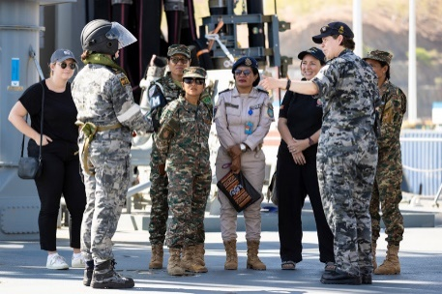 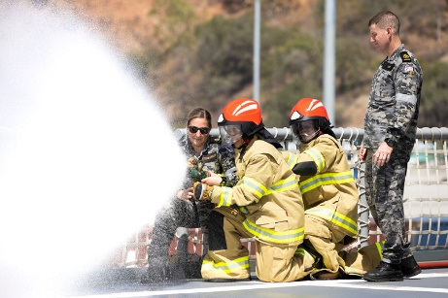 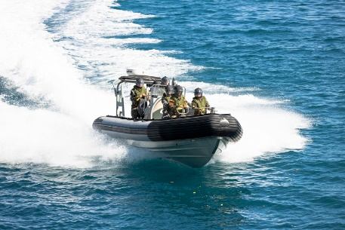

*Left: Executive Officer HMAS Stalwart, Lieutenant Commander Jemma Southern (right), speaks with members of the Timor-Leste Police Maritime Unit and Timor-Leste Armed Forces during a Gender, Peace and Security engagement as a part of Indo-Pacific Endeavour 2022. Credit: POIS Jake Badior*

*Centre: Royal Australian Navy sailors Leading Seaman Maritime Personnel Operator Ellen Storie-Gregory (left) and Petty Officer Physical Training Instructor Matt Vaisey (right) observe members of the Timor-Leste Armed Forces during a Gender, Peace and Security engagement as a part of Indo-Pacific Endeavour 2022 in Dili, Timor-Leste. Credit: POIS Jake Badior*

*Right: Members of the Timor-Leste Maritime Police Unit and Timor-Leste Armed Forces on-board a Rigid Hull Inflatable Boat during a Gender, Peace and Security engagement as a part of Indo-Pacific Endeavour 2022 in Dili, Timor-Leste. Credit: POIS Jake Badior*

*Australia’s Framework for Civil Society-Government Engagement on Women, Peace and Security* articulates civil society and government collaboration on the WPS agenda, including through implementation of Australia’s National Action Plan on Women, Peace and Security 2021-2031. From July 2021 to June 2023, seven engagements were held in collaboration with the Australian WPS Civil Society Coalition (the Coalition), supported by the National Action Plan Implementing Partners. The Coalition provided briefing to the WPS Inter-Departmental Committee, including on its work to increase the profile of the WPS agenda and facilitate dialogue with women from Indigenous, migrant, refugee and diaspora communities in Australia. Australia also invested in civil society partnerships to implement the WPS agenda, including through support to regional women peace mediator networks in Southeast Asia and the Pacific.

In 2016, a Memorandum of Understanding between the Department of Defence and UN Women formalised support for a UN Women-Australian Defence Force position in New York, with a ten-year commitment. The role supports the UN Peace and Security Section with UN system-wide WPS coordination. The position is the only military technical specialist within UN Women, providing a unique opportunity to influence and drive accountability on peacekeeping policy and gender equality.

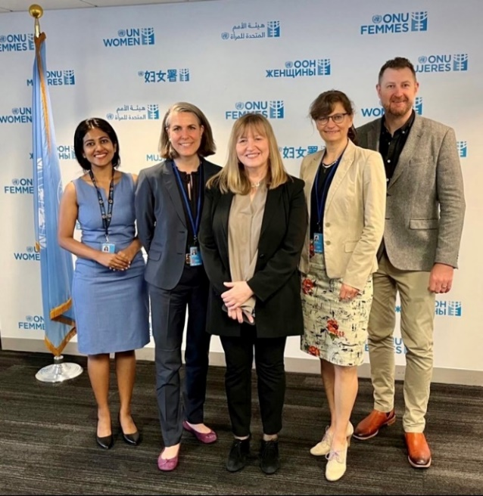

*From left to right: Ms. Arpita Varghese, Policy Specialist for Humanitarian Affairs, UN WOMEN; Dr. Astrid Irrgang, Executive Director, German Center for International Peace Operations; Ms. Paivi Kannisto, Chief of the Peace, Security and Resilience Section, UN WOMEN; Dr. Annika S. Hansen, Head of Analysis, German Center for International Peace Operations; CMDR Tyson Nicholas, Strategic Military Advisor, UN Women. Commander Tyson Nicholas, Royal Australian Navy, is the fourth seconded Strategic Military Advisor in the role.*

To enhance whole-of-government WPS capabilities, the Australian Government facilitated capacity-strengthening activities, including e-courses, briefings, in-person training, exchange of good practices, development and dissemination of guidance, and engagement with WPS specialists.

The Australian Civil-Military Centre, in collaboration with the Australian Council for International Development (ACFID), released a revised edition of the **Same Space, Different Mandates** publication to address evolving challenges, including WPS considerations, for civil-military cooperation brought about by the COVID-19 pandemic, climate change and conflict.[35] The *Same Space, Different Mandates* publication acknowledges the varied impacts of armed conflict and disasters on the lives of women, men, girls and boys, and how addressing gender inequalities supports effectiveness of responses to crisis. ‘*Same Space, Different Mandates*’ advocates for productive relationships, dialogue and constructive civil-military-police engagement. The publication highlights the complexities, challenges, limitations, and opportunities of engagement between civil-military-police stakeholders and shares considerations for working with civil society and promoting locally led responses, which have demonstrated improved outcomes for women and girls.

### Humanitarian and Development Assistance

Australia’s leadership and accountability for the Women, Peace and Security Agenda is demonstrated in the policy and programming commitments implemented in Australia’s international development assistance program.

In support of Australia’s commitment to gender equality, the Department of Foreign Affairs and Trade re-established the 80 per cent performance target for gender equality and introduced a mandatory requirement for new Official Development Assistance (ODA) investments valued at or above AU$3 million to include a gender equality objective. These commitments apply to investments delivered in fragile and conflict-affected countries.

**CASE STUDY: Multi-year investment in WPS**

The Department of Foreign Affairs and Trade has established multi-year partnerships to support implementation of the WPS agenda. The **Women, Peace and Humanitarian Fund (WPHF)** is a UN multi-partner trust fund which finances women’s participation, leadership, inclusion and empowerment in humanitarian responses and peace and security settings. Australia was a founding donor and supporter for the WPHF. Australia supports **UN Women** in implementation of its Regional Framework Towards Peaceful, Inclusive Societies: Advancing the Women, Peace and Security Agenda in the Asia Pacific Region. The Regional Framework addresses priority WPS issues and emerging trends in the Asia-Pacific region, including through provision of (i) technical support to governments to develop, implement and review national action plans and the ASEAN Regional Plan of Action on WPS (ii) research, data and tools on WPS; (iii) technical and financial support to civil society organisations to implement the WPS agenda; and (iv) capacity strengthening and networking opportunities for women’s and girls’ human rights organisations to advance WPS. **ActionAid Australia** supports the establishment of a Pacific Women Mediators Network, and strengthened civil society engagement on WPS in Asia-Pacific and the Great Lakes region in Africa. Collaboration with the **Centre for Peace and Conflict Studies** involves support to the Southeast Asian Network of Women Peace Mediators. The Centre for Peace and Conflict Studies is a well-established regional organization with experience implementing conflict transformation and peace process facilitation and is the secretariat of the Southeast Asian Network of Women Peace Mediators. **Legal Action Worldwide** is investigating the feasibility of establishing an international Gender Justice Practitioner Hub, which will support and connect practitioners involved in securing gender justice for international crimes.

Providing international leadership and advocacy to support the implementation of the WPS agenda continued to be a priority for Australia. This overview of examples is a snapshot of the advocacy, partnerships and financing committed to achieve this objective. Together the efforts had a tangible impact in safeguarding gender equality norms internationally and enabling women in partner countries to benefit from and provide leadership for the WPS agenda. Further information on the departmental and agency implementation plans is available through the website links provided in Annex C.

**Examples of Australian Department of Defence Gender Focal Points and Gender Advisors engagement**

| Activity | General Description |
| --- | --- |
| Regional Presence Deployments | Gender mainstreamed in planning |
| Exercise Cope North 21,22 Series | Gender mainstreamed in planning, deployed Gender Advisors (GENADs) and Gender Focal Points (GFPs). |
| Exercise Polygon Wood | One Gender Advisor appointed to the Intelligence Cell; one Gender Advisor provided planning advice and one Gender Focal Point deployed to Headquarters. |
| Indo Pacific Endeavour (IPE) 21 | GPS Directorate and HQJOC (Headquarters Joint Operations Command) GENADs contributed to planning and handed over to the deployed GENAD embarked HMAS Canberra, with three additional GPS trained members in the Task Group. |
| Exercise Combined Command Post Training 21-2 | One GENAD deployed with the Australian contingent reporting to the United Nations Command Deputy Chief of Staff for delivery of GPS into the activity. |
| Exercise Kakadu 22 | One GENAD and three GFPs included in activity. |
| Exercise Vital Prospect 22 | Three GENADs across HQJOC, Maritime Component Command, and Air and Space Operations Centre supported by 29 GENADs/GFPs across the network. |
| Rim of the Pacific | One GENAD and three GFPs included in activity. |
| Exercise Ulchi Freedom Shield 22 | One GENAD at the United Nations Command, Republic of Korea. |
| Indo Pacific Endeavour (IPE) 22 | Two dedicated GPS Directorate APS personnel planned for engagement with 14 countries, supported in co-planning and final execution by IPE 22 GENAD appointed to the Combined Task Unit CTU 635.7.6 and assisted by 14 other ADF and APS personnel for the direct delivery of GPS activities. GPS Directorate and HQJOC GENADs contributed to planning and handed over to the deployed GENAD embarked HMAS Canberra, with three additional GPS trained members in the Task Group. |
| Fleet Certification Period 2022+ | One GENAD consulted for macro scripting to integrate GPS into exercise design, the preparation of start state documents including country gender assessments and products to inform the development of the Joint Intelligence Preparation of the Operating Environment (JIPOE)/ human terrain. |
| Joint War Fighting Series (JWS-22) | HQJOC GENAD and Navy Fleet GENAD support to the J7 Branch of HQJOC for the development of the Joint War Fighting Series (JWS-22) exercise design and Master Scenario Event List development. |
| Exercise Balikatan 22,23 Series | One GENAD deployed on exercise and one GENAD attended Ex Balikatan 23 planning conferences. |
| Pacific Partnership 22 | Team of six GENADs and GFPs to USNS Mercy to plan and execute GPS activities. |
| 2 (AS) DIV Civil Military Operations (CIMIC) Course 22 | Developed participants skills and knowledge to integrate GPS considerations into Operation Orders. |
| Sea Power Conference GPS Stand May 22 | Staffed by GPS Directorate and six Navy GENADs/GFPs. Conference included Panel Discussions on Gender, Peace and Security in Maritime Operations, including Senior Leadership Group representation, and a Women in Defence Industry panel. |
| Land Forces International Land Defence Exposition Oct 22 | Land Forces 2022 was Australia’s largest defence industry exhibition, with 20 000 attendees. GENADs and GFPs ran an information booth to support increased awareness of GPS in the land domain and engaged with representatives from Australian, regional, and international defence and industry bodies. |
| Australian International Aerospace and Defence Exposition (AIA 23) GPS Stand | Staffed by 16 Air Force members and one APS from the Directorate of GPS. |
| Exercise Talisman Sabre 23 | GENAD deployed on exercise. |
| Exercise Mobility Guardian 23 | GENAD discussions with Air Force Lead Planner underway. |
| Indo Pacific Endeavour (IPE) 23 | GPS Directorate discussions and planning underway with HQJOC GPS Advisor input. |

## List of Acronyms

| Acronym | Description |
| --- | --- |
| ABF | Australian Border Force |
| ACMC | Australian Civil-Military Centre |
| ADF | Australian Defence Force |
| AFP | Australian Federal Police |
| APS | Australian Public Service |
| ASEAN | Association of Southeast Asian Nations |
| DFAT | Department of Foreign Affairs and Trade |
| GENAD | Gender Advisor – a specialist who provides advice to commanders and senior staff for the planning, execution and assessment of military operations (a Defence training program) |
| GFP | Gender Focal Point |
| GPS | Gender, Peace and Security. Defence use GPS as an alternative to WPS. In 2020, Chief of the Defence Force and the Secretary of the Department of Defence approved the nomenclature change in Defence from Women, Peace and Security to Gender, Peace and Security. |
| Home Affairs | Department of Home Affairs |
| HRC | Human Rights Council |
| IAEA | International Atomic Energy Agency |
| IPE | Indo-Pacific Endeavour (Defence lead operation) |
| LGBTQIA+ | People or communities of diverse sexual orientation, gender identity, gender expression and sex characteristics |
| MIKTA | A diverse and cross-regional grouping of powers that brings together Mexico, Indonesia, the Republic of Korea (ROK), Türkiye and Australia. |
| MTO | Medium-Term Outcome |
| NATO | North Atlantic Treaty Organization |
| NGO | Non-Government Organisation |
| OECD | Organisation for Economic Co-operation and Development |
| OEWG | Open-Ended Working Group |
| PSIDS | Pacific Small Island Developing States |
| PSVI | Preventing Sexual Violence in Conflict Initiative |
| SGBV | Sexual and Gender-Based Violence (inclusive of GBV – Gender-Based Violence and Sexual Violence) |
| SIGI | Social Institutions and Gender Index |
| SOGI | Sexual Orientation and Gender Identity |
| SRHR | Sexual Reproductive Health Rights |
| STEM | Science, Technology, Engineering and Mathematics |
| UN | United Nations |
| UN ECOSOC | United Nations Economic and Social Council |
| UNGA | United Nations General Assembly |
| UN ROAP | United Nations Regional Office for Asia and the Pacific |
| UNDP | United Nations Development Program |
| UNDRR | United Nations Office for Disaster Risk Reduction |
| UNFCCC | United Nations Framework Convention on Climate Change |
| UNFPA | United Nations Population Fund |
| UNSC | United Nations Security Council |

## Endnotes

## Annex A: Examples of capacity strengthening activities, civil society engagement and Australian Government leadership during the reporting period

| **#** | **Event Type** | **Title** | **Date** | **Hosted by** | **Attended by** |
| --- | --- | --- | --- | --- | --- |
| 1 | Policy | Women, Peace and Security Focal Point Network - Fifth Capital Level Meeting | 6-9 June 2023 | Washington D.C USA | WPS Focal Points Network Members |
| 2 | Civil Society Engagement | Civil Society engagement with Australian Government | 23 May 2023 | Australian Civil-Military Centre and Civil Society | WPS Focal Points Network Members |
| 3 | Policy | Diversity at the Frontier: Gender Equality in Space | 13 April 2023 | Australian National University with assistance from DFAT funding | Public |
| 4 | Policy | Launch of the “Regional Framework Towards Peaceful and Inclusive Societies: Advancing the Women, Peace and Security Agenda and Inclusive Governance in the Asia-Pacific Region” (2023-2027) | 4 April 2023 | UN Women | Ambassador for Gender Equality and Civil Society organisations and other stakeholders |
| 5 | Policy | Launch of Same Space – Different Mandates | 30 March 2023 | Australian Civil-Military Centre | Government, academia and civil society |
| 6 | Government Coordination | WPS Inter-Departmental Committee | 29 March 2023 | DFAT | Government Implementing Partners |
| 7 | Training | Women, Peace and Security Workshops - National Security College | 21 March 2023 | Australian National University - National Security College | Whole-of-government |
| 8 | Policy | Commission of the Status of Women 67 WPS Civil Society Side Event | 10 March 2023 | Australian Civil-Society on WPS | Ambassador for Gender Equality and Civil Society representatives |
| 9 | Training | Women, Peace and Security Workshops - National Security College | 28 February 2023 | Australian National University - National Security College | Whole-of-government |
| 10 | Government Coordination | WPS Working Group | 22 February 2023 | DFAT | Government Implementing Partners |
| 11 | Policy | Intervention at official launch of the ASEAN Regional Plan of Action | 5 December 2022 | ASEAN Post | Public |
| 12 | Policy | Preventing Sexual Violence in Conflict Initiative Conference | 28-29 November 2022 | United Kingdom | Public |
| 13 | Capacity Building | Women, Peace and Security Futures Workshop | 23 November 2022 | Australian National University - National Security College | Whole-of-government – Senior Executive Service |
| 14 | Civil Society Engagement | Australian Government - Civil Society Networking Engagement | 17 November 2022 | Australian Civil-Military Centre | Civil Society Representatives and Government |
| 15 | Training | Women, Peace and Security Workshops - National Security College | 3 November 2022 | Australian National University - National Security College | DFAT |
| 16 | Policy | Ambassador for Women and Girls keynote 'Advancing the Women, Peace and Security agenda in the Indo-Pacific' | 31 October 2022 | Western Sydney University/North Atlantic Treaty Organization | Public |
| 17 | Capacity Building | WPS Government-Practitioner Workshop | 28 September 2022 | DFAT | Civil Society, Academia, Government |
| 18 | Government Coordination | WPS Inter-Departmental Committee | 31 August 2022 | DFAT | Government Implementing Partners |
| 19 | Government Coordination | WPS Working Group | 27 July 2022 | DFAT | Government Implementing Partners |
| 20 | Civil Society Engagement | Australian Government - Civil Society meeting: Myanmar | 27 May 2022 | DFAT and Civil-Society | Closed Door |
| 21 | Policy | Women, Peace and Security Focal Point Network - Fourth Capital Level Meeting | 19 May 2022 | Geneva - Switzerland | WPS Focal Points Network Members |
| 22 | Government Coordination | WPS Inter-Departmental Committee | 30 March 2022 | DFAT | Government Implementing Partners |
| 23 | Civil Society Engagement | Framework for Civil Society - Government Engagement | 30 March 2022 | Australian Civil-Military Centre | Civil Society Representatives |
| 24 | Policy | Australian Strategic Policy Institute / North Atlantic Treaty Organization Ambassador's Event: “Women, Peace and Security – Reflections on Afghanistan” | 9 March 2022 | DFAT | Public |
| 25 | Government Coordination | WPS Working Group | 23 February 2022 | DFAT | Government Implementing Partners |
| 26 | Capacity Building | Indo-Pacific Endeavour 2022 - Bangladesh, Laos, Cambodia, Viet Nam Philippines, Sri Lanka, India, Singapore, Indonesia. Brunei, Timor-Leste | 2022 | Australian Defence Force – Whole-of-government | Foreign military and civil society representatives |
| 27 | Civil Society Engagement | Australian Government - Civil Society meeting: Afghanistan | 9 December 2021 | DFAT and Civil-Society | Closed Door |
| 28 | Civil Society Engagement | Inaugural Australian Government - Civil Society meeting | 12 November 2021 | DFAT | Civil-Society representatives and Implementing Partners |
| 29 | Policy | ASEAN- Australian second Dialogue on WPS | 9 November 2021 | Australia and Vietnam | The diplomatic corps, United Nations agencies, civil society organisations, academics and other stakeholders |
| 30 | Policy | Women Peace and Security side event - Asia Europe Meeting (ASEM) | 13 October 2021 | Cambodia | Message of solidarity by Australian Government Women, Peace and Security Focal Point |
| 31 | Policy | Women, Peace and Security side event co-hosted with US Ambassador to the United Nations | 20 September 2021 | Minister Payne | The diplomatic corps, United Nations agencies, civil society organisations, academics and other stakeholders |
| 32 | Government Coordination | WPS Inter-Departmental Committee | 11 August 2021 | DFAT | Government Implementing Partners |
| 33 | Government Coordination | WPS Inter-Departmental Committee | 21 April 2021 | DFAT | Government Implementing Partners |
| 34 | Capacity Building | Indo-Pacific Endeavour 2021 – Cambodia, Philippines, Indonesia, Vietnam, Thailand | 2021 | Australian Defence Force – Whole-of-government | Foreign military and civil society representatives |
| 35 | Member | Women, Peace and Security - Humanitarian Action Compact |  | member from 2022 |  |
| 36 | Member | International Alliance Preventing Sexual Violence in Conflict (previously Champions Network) |  | member from 2023 |  |
| 37 | Member | Women, Peace and Security Focal Point Network |  | founding member - 2016 |  |
| 38 | Member | Call to Action on Protection from Gender Based Violence in Emergencies |  | member since 2013 |  |

## Annex B: Statements on the WPS agenda, sexual and gender-based violence and/or women’s participation that Australia led or sponsored during the 2021-2023 reporting period

| **#** | **Forum** | **Description** | **Date** | **Delivered by** | **Link** | **Indicator** |
| --- | --- | --- | --- | --- | --- | --- |
| 1 | Human Rights Council 53 | Annual discussion on human rights on women: Panel 1 on 'Gender-based violence against women and girls in public and political life' | 30 June 2023 | Malaysia-Australia Joint Statement | <https://www.dfat.gov.au/international-relations/53rd-session-human-rights-council> | 4.1.2 |
| 2 | United Nations General Assembly | Responsibility to Protect and the Prevention of Genocide, War Crimes, Ethnic Cleansing and Crimes against Humanity | 26 June 2023 | Joint Statement | <https://www.globalr2p.org/resources/gof-2023-r2p-debate-statement/> | 4.1.2 |
| 3 | Human Rights Council 53 | Interactive Dialogue with the Special Rapporteur on Violence Against Women and Girls | 22 June 2023 | Australia | <https://www.dfat.gov.au/international-relations/interactive-dialogue-working-group-discrimination-against-women-and-girls> | 4.1.2 |
| 4 | Human Rights Council 53 | Joint Statement on “Femicides and Human Rights”: Interactive Dialogue with the Special Rapporteur on Violence against Women and Girls | 22 June 2023 | Cross regional group - 69 countries | <https://www.dfat.gov.au/international-relations/53rd-session-human-rights-council> | 4.1.2 |
| 5 | Human Rights Council 53 | Enhanced Interactive Dialogue on Afghanistan (with Special Rapporteur and Working Group on discrimination against women and girls) | 19 June 2023 | Australia | <https://www.dfat.gov.au/international-relations/53rd-session-human-rights-council> | 4.1.2 |
| 6 | Human Rights Council 53 | Enhanced Interactive Dialogue on the situation of women and girls in Afghanistan | 19 June 2023 | EU-led statement has been joined by more than 55 countries | <https://www.dfat.gov.au/international-relations/53rd-session-human-rights-council> | 4.1.2 |
| 7 | Australia-U.S. Strategic Dialogue on Gender Equality | Joint Statement on the Australia-U.S. Strategic Dialogue on Gender Equality | 12-13 June 2023 | Joint Statement | <https://www.dfat.gov.au/news/media-release/joint-statement-australia-us-strategic-dialogue-gender-equality> | 4.2 |
| 8 | United Nations Security Council | United Nations Security Council Arria-Formula Meeting on Cyber Attacks on Critical Infrastructure | 23 May 2023 | Australia | <https://unny.mission.gov.au/unny/230525_UNSC_Arria_Cyber_Attacks_Critical_Infrastructure.html> | 4.2 |
| 9 | United Nations Security Council | United Nations Security Council Arria-formula Meeting on: Addressing the Abduction and Deportation of Children During Armed Conflict: Concrete Steps for Accountability and Prevention | 28 April 2023 | Australia | <https://unny.mission.gov.au/unny/230428_UNSC_Arria_Meeting_Addressing_Abduction_Deportation_Children_During_Armed_Conflict.html> | 4.1.2 |
| 10 | United Nations Security Council | Statement to the United Nations Security Council Open Debate on Sexual Violence in Conflict | 13 April 2023 | Australia | <https://unny.mission.gov.au/unny/220413_Statement_UN_Security_Council_Open_Debate_Sexual_Violence_in_Conflict.html> | 4.2 |
| 11 | Commission on Population and Development 56 | United Nations: Fifty-Sixth Commission on Population and Development: General Debate | 10 April 2023 | Australia | <https://unny.mission.gov.au/unny/230410_UN_56th_Commission_Population_Development_General_Debate.html> | 4.1.2 |
| 12 | United Nations Security Council | United Nations: Fifty-Sixth Commission on Population and Development: General Debate | 10 April 2023 | Australia | <https://unny.mission.gov.au/unny/230410_UN_56th_Commission_Population_Development_General_Debate.html> | 4.1.2 |
| 13 | Human Rights Council 52 | National Statement during the Enhanced Interactive Dialogue on the Oral Updates on the Democratic Republic of Congo | 31 March 2023 | Australia | <https://www.dfat.gov.au/international-relations/national-statement-during-enhanced-interactive-dialogue-oral-updates-democratic-republic-congo-31-march-2023> | 4.1.2 |
| 14 | United Nations Security Council | Briefing of the General Assembly by the Special Envoy of the Secretary General on Myanmar | 26 March 2023 | Australia | <https://unny.mission.gov.au/unny/230316_Briefing_of_UNGA_Special_Envoy_of_SG_Myanmar.html> | 4.2 |
| 15 | Human Rights Council 52 | National Statement during the Interactive Dialogue with the International Commission of Human Rights Experts on Ethiopia | 21 March 2023 | Australia | <https://www.dfat.gov.au/international-relations/national-statement-during-interactive-dialogue-international-commission-human-rights-experts-ethiopia-21-march-2023> | 4.1.2 |
| 16 | Human Rights Council 52 | National Statement during the Commission of Inquiry on the Syrian Arab Republic | 21 March 2023 | Australia | <https://www.dfat.gov.au/international-relations/national-statement-during-commission-inquiry-syrian-arab-republic-21-march-2023> | 4.1.2 |
| 17 | Human Rights Council 52 | National Statement during the Interactive Dialogue with the Special Rapporteur on the situation of Human Rights in Myanmar, Mr Tom Andrews | 20 March 2023 | Australia | <https://www.dfat.gov.au/international-relations/national-statement-during-interactive-dialogue-special-rapporteur-situation-human-rights-myanmar-mr-tom-andrews-20-march-2023> | 4.1.2 |
| 18 | Human Rights Council 52 | National Statement during the Interactive Dialogue with the Commission of Inquiry on Ukraine | 20 March 2023 | Australia | <https://www.dfat.gov.au/international-relations/national-statement-during-interactive-dialogue-commission-inquiry-ukraine-20-march-2023> | 4.1.2 |
| 19 | Human Rights Council 52 | National Statement during the Interactive Dialogue with the Special Rapporteur on the Islamic Republic of Iran | 20 March 2023 | Australia | <https://www.dfat.gov.au/international-relations/national-statement-during-interactive-dialogue-special-rapporteur-islamic-republic-iran-20-march-2023> | 4.1.2 |
| 20 | United Nations Security Council | United Nations Security Council Arria-formula meeting: The Situation of Human Rights in the Democratic People's Republic of Korea | 17 March 2023 | Australia on behalf of Canada, Australia and New Zealand | <https://unny.mission.gov.au/unny/230317_UNSC_Arria-formula_Situation_Human_Rights_DPRK.html> | 4.1.2 |
| 21 | 66th Commission on the Status of Women | Group of Friends for the Elimination of Violence against Women and Girls | 16 March 2023 | European Commissioner for International Partnerships, Argentina and Namibia | <https://estatements.unmeetings.org/estatements/31.0070/20210316/CRjDT5faIqxw/usNrjcx6eFMl_en.pdf> | 4.1.2 |
| 22 | United Nations Security Council | Open debate on Women, Peace and Security: Towards the 25th Anniversary | 7 March 2023 | Ambassador for Gender Equality | <https://unny.mission.gov.au/unny/230307_UNSC_Open_Debate_Women_Peace_Security_Towards_25th_Anniversary_Resolution_1325.html> | 4.2 |
| 23 | United Nations Security Council | Open Debate on WPS: Towards the 25th Anniversary of Resolution 1325 | 7 March 2023 | Canada on behalf of Group of Friends of Women, Peace and Security | <https://www.norway.no/en/missions/un/statements/security-council/sc-2023/sc-wps---group-of-friends-statement/> | 4.2 |
| 24 | Human Rights Council 52 | National Statement during the Enhanced Interactive Dialogue on the Commission of Inquiry Report on South Sudan | 6 March 2023 | Australia | <https://www.dfat.gov.au/international-relations/national-statement-during-enhanced-interactive-dialogue-commission-inquiry-report-south-sudan-6-march-2023> | 4.1.2 |
| 25 | Human Rights Council 52 | National Statement during the Interactive Dialogue with the Special Rapporteur on the Situation of human rights in Afghanistan | 6 March 2023 | Australia | <https://www.dfat.gov.au/international-relations/national-statement-during-interactive-dialogue-special-rapporteur-situation-human-rights-afghanistan-6-march-2023> | 4.1.2 |
| 26 | Human Rights Council 52 | National Statement during the Enhanced Interactive Dialogue with the Special Rapporteur on Human Rights in Eritrea | 3 March 2023 | Australia | <https://www.dfat.gov.au/international-relations/national-statement-during-enhanced-interactive-dialogue-special-rapporteur-human-rights-eritrea-3-march-2023> | 4.1.2 |
| 27 | Special Committee on Peacekeeping Operations | Statement on Behalf of Canada, Australia and New Zealand | 21 February 2023 | Australia on behalf of Canada, Australia and New Zealand | <https://unny.mission.gov.au/unny/230221_Special_Committee_Peacekeeping_Operations_CANZ_Statement.html> | 4.2 |
| 28 | United Nations Security Council | 8th International Day of Women and Girls in Science Assembly United Nations Headquarters | 10 February 2023 | Australia | <https://unny.mission.gov.au/unny/230210_8th_International_Day_Women_Girls_Science_Assembly_UN_HQ.html> | 4.1.2 |
| 29 | United Nations Security Council | Open Debate on Women, Peace and Security: Protecting participation - addressing violence targeting women in peace and security processes | 26 January 2023 | Group of Friends of Women, Peace and Security | <https://unny.mission.gov.au/unny/230126_UNSC_Open_Debate_Peacebuilding_Sustaining_Peace.html> | 4.2 |
| 30 | United Nations Security Council | Open debate of the Security Council on "Peacebuilding and sustaining peace: Investment in people to enhance resilience against complex challenges" | 26 January 2023 | Australia | <https://unny.mission.gov.au/unny/230126_UNSC_Open_Debate_Peacebuilding_Sustaining_Peace.html> | 4.2 |
| 31 | United Nations Security Council | United Nations Economic and Social Council (ECOSOC) Meeting: Proposal to remove Iran from the Commission on the Status of Women | 14 December 2022 | Australia | <https://unny.mission.gov.au/unny/221214_UN_ECOSOC_Proposal_to_remove_Iran_from_Commission_on_Status_of_Women.html> | 4.1.2 |
| 32 | United Kingdom-hosted Preventing Sexual Violence Initiative Conference | International Ministerial Conference on Preventing Sexual Violence in Conflict Initiative 2022: national commitments | 29 November 2022 | Australia | <https://www.gov.uk/government/publications/conflict-related-sexual-violence-political-declaration-at-the-2022-preventing-sexual-violence-in-conflict-initiative-conference/international-ministerial-conference-on-preventing-sexual-violence-in-conflict-initiative-2022-national-commitments> | 4.2 |
| 33 | United Kingdom-hosted Preventing Sexual Violence Initiative Conference | Conflict-related sexual violence: political declaration at the 2022 Preventing Sexual Violence in Conflict Initiative conference | 29 November 2022 | United Kingdom led more than 50 countries and the United Nations | <https://www.gov.uk/government/publications/conflict-related-sexual-violence-political-declaration-at-the-2022-preventing-sexual-violence-in-conflict-initiative-conference/preventing-sexual-violence-in-conflict-initiative-psvi-conference-2022-a-political-declaration-on-conflict-related-sexual-violence> | 4.2 |
| 34 | United Nations General Assembly | United Nations General Assembly Item 34: The situation in Afghanistan: report of the Secretary General | 10 November 2022 | Australia | <https://unny.mission.gov.au/unny/221110_UNGA_Situation_in_Afghanistan_report_of_Secretary_General.html> | 4.1.2 |
| 35 | Universal Periodic Review Working Group – 41st Session | Universal Periodic Review of Indonesia, Statement by Australia | 9 November 2022 | Australia | <https://www.dfat.gov.au/international-relations/themes/human-rights/universal-periodic-review/41st-session-universal-periodic-review/universal-periodic-review-indonesia-statement-australia-9-november-2022> | 4.1.2 |
| 36 | United Nations 3rd Committee | United Nations Third Committee Report of the United Nations High Commissioner for Refugees | 2 November 2022 | Australia | <https://unny.mission.gov.au/unny/221102_3C_UNHCR_Dialogue.html> | 4.1.2 |
| 37 | United Nations General Assembly | United Nations General Assembly Plenary Debate on the Report of the International Criminal Court | 31 October 2022 | Australia | <https://unny.mission.gov.au/unny/221031_UNGA_Plenary_Debate_Report_ICC.html> | 4.1.2 |
| 38 | United Nations Security Council | United Nations Security Council Open Debate on Women, Peace and Security | 20 October 2022 | Canada on behalf of Group of Friends of Women, Peace and Security | <https://www.international.gc.ca/world-monde/international_relations-relations_internationales/un-onu/statements-declarations/2022-10-28-women-64-femmes.aspx?lang=eng> | 4.2 |
| 39 | United Nations Security Council | United Nations Security Council Open Debate on Women, Peace and Security | 20 October 2022 | Australia | <https://www.dfat.gov.au/international-relations/open-debate-women-peace-and-security> | 4.2 |
| 40 | United Nations Security Council | United Nations Security Council Open Debate on Women, Peace and Security | 20 October 2022 | delivered by the Group of Friends of the Responsibility to Protect | <https://www.globalr2p.org/resources/statement-delivered-on-behalf-of-gof-r2p-unsc-wps-debate-2022/> | 4.2 |
| 41 | Human Rights Council 51 | Interactive Dialogue with the Independent Expert on Somalia | 5 October 2022 | Australia | <https://www.dfat.gov.au/international-relations/interactive-dialogue-independent-expert-somalia-5-october-2022> | 4.2 |
| 42 | Human Rights Council 51 | Interactive Dialogue with Special Rapporteur on the situation of human rights in Cambodia | 5 October 2022 | Australia | <https://www.dfat.gov.au/international-relations/interactive-dialogue-special-rapporteur-situation-human-rights-cambodia-5-october-2022> | 4.1.2 |
| 43 | Human Rights Council 51 | Gender barriers to Freedom of Opinion and Expression | 20 September 2022 | Australia led Canada, Australia and New Zealand statement | <https://www.dfat.gov.au/international-relations/themes/human-rights/hrc-statements/51st-session-human-rights-councils/gender-barriers-freedom-opinion-and-expression-aus-led-canz> | 4.1.2 |
| 44 | Human Rights Council 51 | Interactive Dialogue with the Independent International Commission of Inquiry on Ukraine | 20 September 2022 | Australia | <https://www.dfat.gov.au/international-relations/interactive-dialogue-independent-international-commission-inquiry-ukraine-23-september-2022> | 4.1.2 |
| 45 | Human Rights Council 51 | Interactive Dialogue with the Commission of Inquiry on the Syrian Arab Republic | 20 September 2022 | Australia | <https://www.dfat.gov.au/international-relations/interactive-dialogue-commission-inquiry-syrian-arab-republic-22-september-2022> | 4.1.2 |
| 46 | Human Rights Council 51 | Interactive Dialogue on the International Commission of Human Rights Experts on Ethiopia | 20 September 2022 | Australia | <https://www.dfat.gov.au/international-relations/interactive-dialogue-international-commission-human-rights-experts-ethiopia-22-september-2022> | 4.1.2 |
| 47 | Human Rights Council 51 | Statement on Equal Participation in Political and Public Affairs | 20 September 2022 | Australia | <https://www.dfat.gov.au/international-relations/themes/human-rights/hrc-statements/51st-session-human-rights-councils/statement-equal-participation-political-and-public-affairs> | 4.1.2 |
| 48 | United Nations Security Council | Statement of the Group of Friends for the Elimination of Violence Against Women and Girls | 2 September 2022 | Statement delivered on behalf of the Group of Friends for the Elimination of Violence Against Women and Girls by the European Union Delegation | <https://unny.mission.gov.au/unny/220906_Statement_of_the_Group_of_Friends_for_the_Elimination_of_Violence_Against_Women_and_Girls.html> | 4.1.2 |
| 49 | United Nations Security Council | United Nations Security Council: Children and Armed Conflict Annual Open Debate 2022 | 19 July 2022 | Australia | <https://unny.mission.gov.au/unny/220719_UN_Security_Council_Children_and_Armed_Conflict_Annual_Open_Debate_2022.html> | 4.1.2 |
| 50 | Human Rights Council 50 | National Statement during the Urgent Debate on the Situation of Human Rights for Women and Girls in Afghanistan | 1 July 2022 | Australia | <https://www.dfat.gov.au/international-relations/national-statement-during-urgent-debate-situation-human-rights-women-and-girls-afghanistan-1-july-2022> | 4.1.2 |
| 51 | Human Rights Council 50 | Conflict during the Interactive dialogue with the Independent International Commission of Inquiry of the Syrian Arab Republic | 29 June 2022 | Geneva Group of Friends on Children and Armed Conflict | <https://www.dfat.gov.au/international-relations/themes/human-rights/hrc-statements/50th-session-human-rights-council/joint-statement-group-friends-children-armed-conflict-during-interactive-dialogue-independent-international-commission-inquiry-syrian-arab-republic-29-june-2022> | 4.1.2 |
| 52 | Human Rights Council 50 | National Statement during the Interactive Dialogue on the oral update of the Commission of Inquiry on the Syrian Arab Republic | 29 June 2022 | Australia | <https://www.dfat.gov.au/international-relations/national-statement-during-interactive-dialogue-oral-update-commission-inquiry-syrian-arab-republic-29-june-2022> | 4.1.2 |
| 53 | Human Rights Council 50 | National Statement during the Annual Discussion on Women’s Rights: Panel 1: Exploring the nexus between climate change and violence against women and girls through a human rights lens | 27 June 2022 | Australia | <https://www.dfat.gov.au/international-relations/themes/human-rights/hrc-statements/50th-session-human-rights-council/national-statement-during-annual-discussion-womens-rights-panel-1-exploring-nexus-between-climate-change-and-violence-against-women-and-girls-through-human-right> | 4.1.2 |
| 54 | Human Rights Council 50 | Canada, Australia and New Zealand Joint Statement during the Annual Discussion on Women’s Rights | 27 June 2022 | New Zealand on behalf of Canada, Australia and New Zealand | <https://www.dfat.gov.au/international-relations/canz-joint-statement-during-annual-discussion-womens-rights-27-june-2022> | 4.1.2 |
| 55 | Human Rights Council 50 | MIKTA Joint Statement during the Annual full-day discussion on the human rights of women, Panel 1: Exploring the nexus between climate change and violence against women and girls through a human rights lens | 27 June 2022 | MIKTA | <https://www.dfat.gov.au/international-relations/mikta-joint-statement-during-annual-full-day-discussion-human-rights-women-panel-1-exploring-nexus-between-climate-change-and-violence-against-women-and-girls-through-human-rights-lens-27-june-2022> | 4.1.2 |
| 56 | Human Rights Council 50 | Joint Statement delivered during Interactive Dialogue with the Special Rapporteur on the right of everyone to enjoyment of highest attainable standard of physical and mental health by Uruguay on behalf of Group of Friends of the Sexual Orientation and Gender Identity mandate | 20 June 2022 | Sexual Orientation and Gender Identity Group of Friends | <https://www.dfat.gov.au/international-relations/themes/human-rights/hrc-statements/joint-statement-delivered-during-interactive-dialogue-special-rapporteur-right-everyone-enjoyment-highest-attainable-standard-physical-and-mental-health-uruguay-behalf-group-friends-sogi-mandate> | 4.1.2 |
| 57 | Human Rights Council 50 | National Statement during the Interactive Dialogue with the Special Rapporteur on the independence of judges and lawyers | 20 June 2022 | Australia | <https://www.dfat.gov.au/international-relations/themes/human-rights/hrc-statements/50th-session-human-rights-council/national-statement-during-interactive-dialogue-special-rapporteur-independence-judges-and-lawyers-20-june-2022> | 4.1.2 |
| 58 | Human Rights Council 50 | Joint Statement delivered during Interactive Dialogue with the Special Rapporteur on violence against women, its causes and consequences by Luxembourg on behalf of the Group of Friends of the Responsibility to Protect | 20 June 2022 | Group of Friends of the Responsibility to Protect | <https://www.dfat.gov.au/international-relations/themes/human-rights/hrc-statements/50th-session-human-rights-council/joint-statement-delivered-during-interactive-dialogue-special-rapporteur-violence-against-women-causes-and-consequences-luxembourg> | 4.1.2 |
| 59 | Human Rights Council 50 | National Statement during the Interactive Dialogue with the Working Group on discrimination against women and girls | 17 June 2022 | Australia | <https://www.dfat.gov.au/international-relations/themes/human-rights/hrc-statements/50th-session-human-rights-council/international-relations/national-statement-during-interactive-dialogue-working-group-discrimination-against-women-and-girls-17-june-2022> | 4.2 |
| 60 | Human Rights Council 50 | National Statement during the Enhanced Interactive Dialogue on the High Commissioner’s Report on Sudan | 15 June 2022 | Australia | <https://www.dfat.gov.au/international-relations/themes/human-rights/hrc-statements/50th-session-human-rights-council/national-statement-during-enhanced-interactive-dialogue-high-commissioners-report-sudan-15-june-2022> | 4.1.2 |
| 61 | Human Rights Council 50 | National Statement during the Interactive Dialogue on the High Commissioner’s Update on Afghanistan | 15 June 2022 | Australia | <https://www.dfat.gov.au/international-relations/themes/human-rights/hrc-statements/50th-session-human-rights-council/national-statement-during-interactive-dialogue-high-commissioners-update-afghanistan-15-16-june-2022> | 4.1.2 |
| 62 | United Nations Security Council | United Nations Security Council Open Debate on the Role of Regional Organizations in Implementing Women, Peace and Security | 15 June 2022 | Group of Friends of Women, Peace and Security | <https://www.dfat.gov.au/sites/default/files/gof-statement-unsc-open-debate-regional-organizations-implementing-wps.pdf> | 4.2 |
| 63 | Human Rights Council 50 | Joint statement on behalf of 47 countries in the United Nations Human Rights Council on the human rights situation in China | 14 June 2022 | Netherlands on behalf of 47 countries | <https://www.dfat.gov.au/international-relations/joint-statement-behalf-47-countries-un-human-rights-council-human-rights-situation-china> | 4.1.2 |
| 64 | Human Rights Council 50 | National Statement during the Interactive Dialogue on the High Commissioner’s Annual Report | 14 June 2022 | Australia | <https://www.dfat.gov.au/international-relations/themes/human-rights/hrc-statements/50th-session-human-rights-council/national-statement-during-interactive-dialogue-high-commissioners-annual-report-14-june-2022> | 4.2 |
| 65 | Human Rights Council 50 | National Statement during the Interactive Dialogue on the Oral update by Special Rapporteur on Eritrea | 13 June 2022 | Australia | <https://www.dfat.gov.au/international-relations/themes/human-rights/hrc-statements/50th-session-human-rights-council/international-relations/national-statement-during-interactive-dialogue-oral-update-special-rapporteur-eritrea-13-june-2022> | 4.1.2 |
| 66 | United Nations Security Council | United Nations Security Council Open Debate on Protection of Civilians in Armed Conflict | 23 May 2022 | Group of Friends of the Protection of Civilians in Armed Conflict | <https://www.globalr2p.org/resources/statement-group-of-friends-unsc-open-debate-on-protection-of-civilians/> | 4.2 |
| 67 | Human Rights Council 34th Special Session | Joint Statement On behalf of the Group of Friends of Accountability following the Aggression against Ukraine | 12 May 2022 | Group of Friends of Accountability | <https://www.dfat.gov.au/international-relations/themes/human-rights/hrc-statements/34th-special-session-human-rights-council/joint-statement-behalf-group-friends-accountability-following-aggression-against-ukraine-12-may> | 4.1.2 |
| 68 | United Nations General Assembly | United Nations General Assembly: Statement on Interim oral update on the situation of human rights in the Syrian Arab Republic | 8 April 2022 | Australia | <https://unny.mission.gov.au/unny/220408_UNGA_Interim_Update_Situation_Human_Rights_Syria.html> | 4.1.2 |
| 69 | Human Rights Council 49 | Group of Friends of the Responsibility to Protect (Geneva) | 22 March 2022 | Group of Friends of the Responsibility to Protect (R2P) | <https://www.dfat.gov.au/international-relations/themes/human-rights/hrc-statements/49th-session-human-rights-council/group-friends-responsibility-protect-geneva-22-march-2022> | 4.1.2 |
| 70 | Human Rights Council 49 | Interactive Dialogue with the Independent International Commission of Inquiry on the Syrian Arab Republic | 18 March 2022 | Australia | <https://www.dfat.gov.au/international-relations/themes/human-rights/hrc-statements/49th-session-human-rights-council/interactive-dialogue-independent-international-commission-inquiry-syrian-arab-republic-18-march-2022> | 4.1.2 |
| 71 | Human Rights Council 49 | Interactive Dialogue with the Commission on Human Rights in South Sudan | 18 March 2022 | Australia | <https://www.dfat.gov.au/international-relations/themes/human-rights/hrc-statements/49th-session-human-rights-council/interactive-dialogue-commission-human-rights-south-sudan-18-march-2022> | 4.1.2 |
| 72 | Human Rights Council 49 | Interactive Dialogue with the Special Rapporteur on Iran | 17 March 2022 | Australia | <https://www.dfat.gov.au/international-relations/themes/human-rights/hrc-statements/49th-session-human-rights-council/interactive-dialogue-special-rapporteur-iran-17-march-2022> | 4.1.2 |
| 73 | 66th Commission on the Status of Women | Australian National Statement to the 66th session of the Commission on the Status of Women | 16 March 2022 | Minister Payne - Minister for Foreign Affairs and Minister for Women | <https://unny.mission.gov.au/unny/220316_Australian_National_Statement_66th_Session_Commission_Status_of_Women.html> | 4.1.2 |
| 74 | 66th Commission on the Status of Women | Pacific Islands Forum Statement | 16 March 2023 | Delivered Fiji on behalf of the Pacific Islands Forum | <https://www.forumsec.org/2022/03/16/csw66pac/> | 4.1.2 |
| 75 | 66th Commission on the Status of Women | Joint statement on women and girls in Ukraine - 66th Session of the Commission on the Status of Women | 15 March 2022 | Joint Statement | <https://unny.mission.gov.au/unny/220315_Joint_Statement_Women_Girls_Ukraine_66th_Session_Commission_Status_of_Women.html> | 4.2 |
| 76 | 66th Commission on the Status of Women | Lesbian, Gay, Bisexual, Transexual and Intersex (LGBTI) Core Group joint statement to the 66th session of the Commission on the Status of Women | 14 March 2022 | Statement delivered by Belgium on behalf of the Member States of the Lesbian, Gay, Bisexual, Transexual and Intersex (LGBTI) Core Group. | <https://unny.mission.gov.au/unny/220314_LGBTI_Core_Group_Statement_66th_Session_Commission_Status_of_Women.html> | 4.1.2 |
| 77 | 66th Commission on the Status of Women | Mexico, Indonesia, Republic of Korea, Türkiye and Australia (MIKTA) Joint Statement to the 66th Session of the Commission on the Status of Women | 14 March 2022 | Mexico, Indonesia, Republic of Korea, Türkiye and Australia (MIKTA) | <https://unny.mission.gov.au/unny/220314_MIKTA_Statement_66th_Commission_Status_of_Women.html> | 4.1.2 |
| 78 | United Nations Security Council | United Nations Security Council Open Debate on Advancing the women, peace and security agenda through partnerships: Women’s economic inclusion and participation as a key to building peace | 8 March 2022 | Group of Friends of Women, Peace and Security | <https://www.government.is/diplomatic-missions/embassy-article/2022/03/08/Group-of-Friends-of-Women-Peace-and-Security-at-the-Open-Debate-of-the-UN-Security-Council-on-Advancing-the-WPS-agenda-through-partnerships/> | 4.2 |
| 79 | Human Rights Council 49 | International Women's Day | 8 March 2022 | Joint Statement | <https://www.dfat.gov.au/international-relations/themes/human-rights/hrc-statements/49th-session-human-rights-council/international-womens-day-8-march-2022> | 4.1.2 |
| 80 | Human Rights Council 49 | Joint Statement on the Interactive Dialogue on the High Commissioner’s Report on Afghanistan | 7 March 2022 | Australia led joint statement | <https://www.dfat.gov.au/international-relations/themes/human-rights/hrc-statements/49th-session-human-rights-council/joint-statemeent-interactive-dialogue-high-commissioners-report-afghanistan-7-march-2022> | 4.1.2 |
| 81 | Human Rights Council 49 | Enhanced Interactive Dialogue on the High Commissioner’s Oral Update on Sudan | 7 March 2022 | Australia | <https://www.dfat.gov.au/international-relations/themes/human-rights/hrc-statements/49th-session-human-rights-council/enhanced-interactive-dialogue-high-commissioners-oral-update-sudan-7-march-2022> | 4.1.2 |
| 82 | Human Rights Council 49 | Interactive Dialogue on the High Commissioner’s Oral Update on Tigray (Ethiopia) | 4 March 2022 | Australia | <https://www.dfat.gov.au/international-relations/themes/human-rights/hrc-statements/49th-session-human-rights-council/interactive-dialogue-high-commissioners-oral-update-tigray-ethiopia-4-march-2022> | 4.1.2 |
| 83 | Human Rights Council 49 | Interactive Dialogue on the Oral update by Special Rapporteur on Eritrea | 4 March 2022 | Australia | <https://www.dfat.gov.au/international-relations/themes/human-rights/hrc-statements/49th-session-human-rights-council/interactive-dialogue-oral-update-special-rapporteur-eritrea-4-march-2022> | 4.1.2 |
| 84 | United Nations Security Council | Open Debate on Women, Peace and Security: Protecting participation - addressing violence targeting women in peace and security processes | 18 January 2022 | Human Rights/Conflict Prevention Caucus | <https://unny.mission.gov.au/unny/220118_UNSC_Open_Debate_on_Women_Peace_and_Security.html> | 4.2 |
| 85 | United Nations Security Council | Central Emergency Response Fund (CERF) High-Level Pledging Event | 8 December 2021 | Australia | <https://unny.mission.gov.au/unny/21_12_08_CERF_HL_PLEDGING_EVENT.html> | 4.1.2 |
| 86 | United Nations Security Council | United Nations Security Council Open Debate on Women, Peace and Security | 21 October 2021 | Australia | <https://www.dfat.gov.au/international-relations/unsc-open-debate-women-peace-and-security-21-october-2021> | 4.2 |
| 87 | United Nations Security Council | Mexico, Indonesia, Republic of Korea, Türkiye and Australia (MIKTA) Countries Joint Statement at the United Nations Security Council Open Debate on Women, Peace and Security | 21 October 2021 | Mexico, Indonesia, Republic of Korea, Türkiye and Australia (MIKTA) | <https://www.dfat.gov.au/international-relations/mikta-countries-joint-statement-unsc-open-debate-women-peace-and-security-21-october-2021> | 4.2 |
| 88 | UNGA | Australian Statement for Interactive Dialogue with the Special Rapporteur on violence against women | 5 October 2021 | Australia | <https://www.dfat.gov.au/international-relations/themes/human-rights/unga-third-committee-statements/76th-session/australian-statement-interactive-dialogue-special-rapporteur-violence-against-women-5-october-2021> | 4.1.2 |
| 89 | Human Rights Council 48 | Australian statement for the Enhanced Interactive Dialogue on the Commission on Human Rights in South Sudan | 23 September 2021 | Australia | <https://www.dfat.gov.au/international-relations/themes/human-rights/hrc-statements/48th-session-human-rights-council/australian-statement-enhanced-interactive-dialogue-commission-human-rights-south-sudan-23-september-2021> | 4.1.2 |
| 90 | Human Rights Council 48 | Joint Statement on the Importance of Care in the Human Rights Arena led by Argentina and Mexico | 22 September 2021 | Argentina and Mexico on behalf of multiple countries | <https://www.dfat.gov.au/international-relations/themes/human-rights/hrc-statements/48th-session-human-rights-council/joint-statement-importance-care-human-rights-arena-led-argentina-and-mexico-22-september-2021> | 4.1.2 |
| 91 | Human Rights Council 48 | Joint Statement on Women, Peace and Diplomacy led by Israel, Bahrain, Morocco and the United Arab Emirates | 22 September 2021 | Joint Statement led by Israel, Bahrain, Morocco and the United Arab Emirates | <https://www.dfat.gov.au/international-relations/themes/human-rights/hrc-statements/48th-session-human-rights-council/joint-statement-women-peace-and-diplomacy-led-israel-bahrain-morocco-and-uae-22-september-2021> | 4.2 |
| 92 | Human Rights Council 48 | Australian Statement for the Interactive Dialogue on the analytical report of the HC on the current state of play of the mainstreaming of the human rights of women and girls in conflict and post-conflict situations | 17 September 2021 | Australia | <https://www.dfat.gov.au/international-relations/themes/human-rights/hrc-statements/48th-session-human-rights-council/national-statement-interactive-dialogue-analytical-report-hc-current-state-play-mainstreaming-human-rights-women-and-girls-conflict-and-post-conflict> | 4.2 |
| 93 | Human Rights Council 48 | joint Statement on Afghanistan by the Geneva Group of Friends on the Safety of Journalists in the Item 2 General Debate | 14 September 2021 | Geneva Group of Friends on the Safety of Journalists | <https://www.dfat.gov.au/international-relations/themes/human-rights/hrc-statements/48th-session-human-rights-council/joint-statement-on-afghanistan-by-the-geneva-group-of-friends-on-the-safety-of-journalists-in-the-item-2-general-debate-14-september-2021> | 4.1.2 |
| 94 | Human Rights Council 48 | Australian Statement for the Interactive Dialogue on the report of the Independent Investigative Mechanism for Myanmar | 13 September 2021 | Australia | <https://www.dfat.gov.au/international-relations/themes/human-rights/hrc-statements/48th-session-human-rights-council/national-statement-interactive-dialogue-report-independent-investigative-mechanism-myanmar-13-september-2021> | 4.1.2 |
| 95 | Human Rights Council 48 | Australian Statement for Item 2 - General debate | 13 September 2021 | Australia | <https://www.dfat.gov.au/international-relations/themes/human-rights/hrc-statements/48th-session-human-rights-council/human-rights-council-48th-session-item-2-general-debate-13-september-2021> | 4.1.2 |
| 96 | Human Rights Council 48 | Joint Statement led by the US on human rights in the Tigray Region of Ethiopia | 13 September 2021 | Led by United States on behalf of 44 countries | <https://www.dfat.gov.au/international-relations/themes/human-rights/hrc-statements/48th-session-human-rights-council/joint-statement-human-rights-tigray-region-ethiopia-delivered-during-high-commissioners-oral-update-13-september-2021> | 4.1.2 |
| 97 | Human Rights Council 48 | Joint statement on Afghanistan by the Asia Pacific Forum of National Human Rights Institutions | 13 September 2021 | Asia Pacific Forum of National Human Rights Institutions on behalf of our membership | <https://www.dfat.gov.au/international-relations/themes/human-rights/hrc-statements/48th-session-human-rights-council/joint-statement-afghanistan-asia-pacific-forum-national-human-rights-institutions-12-september-2021> | 4.1.2 |
| 98 | Human Rights Council 31st Special Session | National Statement on serious human rights concerns and the situation in Afghanistan | 24 August 2021 | Australia | <https://www.dfat.gov.au/international-relations/themes/human-rights/hrc-statements/31st-special-session-human-rights-council/national-statement-serious-human-rights-concerns-and-situation-afghanistan> | 4.1.2 |
| 99 | Human Rights Council 31st Special Session | Joint Statement on Afghanistan women’s and girls’ human rights | 24 August 2021 | Joint Statement led by Spain | <https://www.dfat.gov.au/international-relations/themes/human-rights/hrc-statements/31st-special-session-human-rights-council/joint-statement-afghanistan-womens-and-girls-human-rights-24-august-2021> | 4.1.2 |
| 100 | Human Rights Council 47 | National statement on Gender-Equal Socioeconomic Recovery from COVID-19 during the Annual Full-Day Discussion on the Human Rights of Women | 6 July 2021 | Australia | <https://www.dfat.gov.au/international-relations/themes/human-rights/hrc-statements/47th-session-human-rights-council/national-statement-gender-equal-socioeconomic-recovery-covid-19-during-annual-full-day-discussion-human-rights-women-6-july-2021> | 4.1.2 |
| 101 | Human Rights Council 47 | Joint Statement on Sexual and Reproductive Health and Rights during the Annual Full-Day Discussion on the Human Rights of Women | 6 July 2021 | Joint Statement | <https://www.dfat.gov.au/international-relations/themes/human-rights/hrc-statements/47th-session-human-rights-council/joint-statement-sexual-and-reproductive-health-and-rights-during-annual-full-day-discussion-human-rights-women-6-july-2021> | 4.1.2 |
| 102 | Human Rights Council 47 | Joint Statement on Women’s Economic Rights during the Annual Full-Day Discussion on the Human Rights of Women | 6 July 2021 | Joint Statement | <https://www.dfat.gov.au/international-relations/themes/human-rights/hrc-statements/47th-session-human-rights-council/joint-statement-womens-economic-rights-during-annual-full-day-discussion-human-rights-women-6-july-2021> | 4.1.2 |
| 103 | Human Rights Council 47 | Joint Statement on Violence Against Women and Girls with Disabilities during the Annual Full-Day Discussion on the Human Rights of Women by Mexico, Indonesia, Republic of Korea, Türkiye and Australia (MIKTA) | 5 July 2021 | Australia on behalf of Mexico, Indonesia, Republic of Korea, Türkiye and Australia (MIKTA) | <https://www.dfat.gov.au/international-relations/themes/human-rights/hrc-statements/47th-session-human-rights-council/joint-statement-violence-against-women-and-girls-disabilities-during-annual-full-day-discussion-human-rights-women-mikta-5-july-2021> | 4.1.2 |
| 104 | Human Rights Council 47 | National Statement during the Adoption of the Universal Periodic Review of Austria | 2 July 2021 | Australia | <https://www.dfat.gov.au/international-relations/themes/human-rights/hrc-statements/47th-session-human-rights-council/national-statement-during-adoption-universal-periodic-review-austria-8-july-2021> | 4.1.2 |
| 105 | Human Rights Council 47 | National Statement during the Adoption of the Universal Periodic Review of Austria | 2 July 2021 | Australia | <https://www.dfat.gov.au/international-relations/themes/human-rights/hrc-statements/47th-session-human-rights-council/national-statement-during-adoption-universal-periodic-review-austria-8-july-2021> | 4.1.2 |

## Annex C: Australian Government WPS implementation plans

**Department of Foreign Affairs and Trade**

<https://www.dfat.gov.au/publications/international-relations/dfat-implementation-plan-australias-national-action-plan-women-peace-and-security-2021-2031>

**Department of Defence**

<https://www.defence.gov.au/programs-initiatives/gender-peace-security-defence>

**Department of Home Affairs**

<https://www.homeaffairs.gov.au/commitments/files/women-peace-and-security-implementation-plan-2021-23.pdf>

**Australian Federal Police**

<https://www.afp.gov.au/sites/default/files/PDF/23082021-InternationalCommandGenderStrategy.pdf>

1. Does Gender Equality Lead to Peace? Fact Sheet Building on the Global Study on 1325 - <https://www.peacewomen.org/sites/default/files/Fact%20Sheet%20Gender%20Equality.pdf>
2. Women’s Participation in Peace Negotiations and the Durability of Peace, 2018 - <https://www.tandfonline.com/doi/full/10.1080/03050629.2018.1492386?src=recsys>
3. Global Gender Gap Report 2023 - <https://www.weforum.org/reports/global-gender-gap-report-2023/>
4. Australia recognises that women and girls are not a homogenous group, and neither are men and boys, and diverse and different identities intersect, overlap and compound to create specific inequalities and injustices.
5. Boe Declaration on Regional Security (2018) - <https://www.forumsec.org/2018/09/05/boe-declaration-on-regional-security/>
6. The biggest improvements toward gender equality in Southeast Asia on restricted civil liberties were in Cambodia, Myanmar and Thailand. ‘Civil Liberties’ indicator within Gender Institutions and Development Database – <https://stats.oecd.org/index.aspx?datasetcode=SIGI2023>
7. Women’s Participation in Peace Negotiations and the Durability of Peace, 2018 - <https://www.tandfonline.com/doi/full/10.1080/03050629.2018.1492386?src=recsys>
8. Anchoring The Peace: Civil Society Actors In Peace Accords and Durable Peace, 2012 -<https://www.tandfonline.com/doi/abs/10.1080/03050629.2012.659139?scroll=top&needAccess=true&journalCode=gini20>
9. Peace agreements with provisions pertaining to violence against women (including conflict-related sexual violence and gender-based violence) decreased slightly in the reporting period. Twenty-nine percent of agreements between 1990 and June 2021 (121 of 412) had provisions on violence against women, whereas 22 percent (2 of 9) of agreements during the reporting period (July 2021 to June 2023) had violence against women provisions, both of which were part of the Tigray process in Ethiopia. <https://www.peaceagreements.org/wsearch>
10. India (Assam) provided a quota for four percent women in a power sharing Council – 50 seats, 6 members (at least 2 women) to be chosen by the Governor. The Political (Declaration) Agreement in Sudan explicitly noted participation of ‘women and youth sectors’ alongside ‘national forces (political and civilian), military component, resistance committees, live revolution forces’ in the transition - <https://www.peaceagreements.org/view/2394/Political%20(Declaration)%20Agreement>
11. Women’s Participation in Peace Negotiations and the Durability of Peace, 2018 - <https://www.tandfonline.com/doi/full/10.1080/03050629.2018.1492386?src=recsys>
12. This legislation (PoVAW) has been under review in Myanmar and will reportedly be passed by the State Administrative Council. Sexual and gender-based violence by military actors is excluded from the proposed law.
13. Report of the Secretary-General on Conflict-Related Sexual Violence 2022 - <https://www.un.org/sexualviolenceinconflict/wp-content/uploads/2023/07/N2312781.pdf>
14. World Bank. *Women, Business and the Law 2023*. Washington, DC: World Bank. doi:10.1596/978-1-4648-1944-5. License: Creative Commons Attribution CC BY 3.0 IGO - <https://openknowledge.worldbank.org/server/api/core/bitstreams/e3f5880b-2fa2-4af3-8ef4-3c9469d60baf/content>
15. Australia’s National Action Plan on Women, Peace and Security (2021-2031) Monitoring and Evaluation Framework - <https://www.dfat.gov.au/publications/second-australian-national-action-plan-on-women-peace-and-security-2021-2031>
16. OECD Social Institutions & Gender Index, ‘Restricted Civil liberties’ dimension, [https://www.oecd.org/en/data/dashboards/so­cial-institutions-gender-index.html](https://www.oecd.org/en/data/dashboards/social-institutions-gender-index.html)
17. 2023 World Justice Project Rule of Law Index, https://worldjusticeproject.org/rule-of-law-index/

    https://smnewstl.com/grupu-mediador-husi-sudeste-aziatiku-sei-tulun-mediasaun-konflitu-iha-timor/

    https://www.youtube.com/live/AyLxDaz3MH0?feature=share (Timestamp - 36:50)
18. Defence Monthly Workforce Report, 1 July 2023 - <https://www.transparency.gov.au/annual-reports/department-defence/reporting-year/2021-22-44>
19. Defence Human Resource Data warehouse: <https://www.defence.gov.au/sites/default/files/2023-08/women-in-adf-2021-22.pdf>
20. 2021/22 World Customs Organisation Annual Report - https://www.wcoomd.org/en/about-us/what-is-the-wco/annual-reports.aspx
21. The University of Edinburgh PA-X Analytics Peace Agreements Database - <https://pax.peaceagreements.org/agreements/search/>
22. <https://www.oecd.org/en/data/dashboards/social-institutions-gender-index.html>
23. <https://uis.unesco.org/>
24. World Health Organization (2021). Violence against women prevalence estimates, 2018: global, regional and national prevalence estimates for intimate partner violence against women and global and regional prevalence estimates for non-partner sexual violence against women, Licence: CC BY-NC-SA 3.0 IGO - <https://www.who.int/publications/i/item/9789240022256>
25. <https://data.unicef.org/sdgs/>
26. <https://www.gallup.com/analytics/356963/gallup-global-law-and-order-report.aspx>
27. ASEAN–Australia Counter Trafficking - <https://www.aseanact.org/>
28. ActionAid and eLiberare are supported through the Australian Humanitarian Partnership’s Ukraine response, as part of the Plan International Australia consortium. Adapted from story developed by Carol García, Communications Coordinator, ActionAid.
29. <https://wbl.worldbank.org/en/wbl>
30. DFAT (Department of Foreign Affairs and Trade) (2024). Performance of Australian Development Cooperation Report 2022–23. Commonwealth of Australia; https://www.dfat.gov.au/publications/development/performance-of-australian-development-cooperation-report-2022-2023
31. World Bank (2024). Women, Business and the Law 2024. Washington, DC: World Bank. doi:10.1596/978-1-4648-2063-2. License: Creative Commons Attribution CC BY 3.0 IGO
32. UNODC, Global Report on Tracking in Persons 2022 (United Nations publication, Sales no.: E.23.IV.1) - <https://www.unodc.org/unodc/en/data-and-analysis/glotip.html>
33. World Health Organization, SDG Target 3.1 Maternal mortality, <https://www.who.int/data/gho/data/themes/topics/sdg-target-3-1-maternal-mortality>
34. Defence Human Resource Data warehouse: <https://www.defence.gov.au/sites/default/files/2023-08/women-in-adf-2021-22.pdf>
35. Same Space: Difference Mandates 2023 - [https://www.acmc.gov.au/resources/publications/same-space-different-mandates-2023-edition#:~:text=2023-,Same%20Space%20%E2%80%93%20Different%20Mandates%20aims%20to%20improve%20the%20collective%20understanding,international%20disasters%20and%20complex%20emergencies.](https://www.acmc.gov.au/resources/publications/same-space-different-mandates-2023-edition%23:~:text=2023-,Same%20Space%20%E2%80%93%20Different%20Mandates%20aims%20to%20improve%20the%20collective%20understanding,international%20disasters%20and%20complex%20emergencies.)