Productive futures
Module length: 5 x 60 minutes

Summary
This module explores agricultural partnerships formed between Australia and the countries in the Asia-Pacific region. It focuses on the innovative solutions that are developed by these partnerships to meet Goal 2 of the United Nations (UN) Sustainable Development Goals, which is to achieve zero hunger. Students will investigate how partnerships involving local communities, scientific research and modern technologies are improving farmers’ productivity and mitigating the impacts of climate change within the region. Students can explore a range of case studies and consider how these agricultural ideas could be led locally and managed sustainably to improve food security.
This resource promotes student agency by fostering opportunities where students can work as a team and pitch their own idea for an agricultural partnership. During this activity they will follow a design thinking process to develop a prototype. Students will practise social competencies such as collaboration, negotiation, critical thinking, leadership, mutual respect and problem-solving. Students are encouraged to take action and think strategically within the timeframe for each activity.

Success criteria
At the end of this module, students should be able to:
- understand how Australia and its regional partners work together to advance the United Nations Sustainable Development Goals
- explain the importance of sharing scientific research and technology to improve food security
- adopt a design thinking approach and an entrepreneurial mindset while working collaboratively in a team to develop a pitch
or proposal.

Organising ideas
The organising ideas are global relationships, global responsibilities and global futures. These reflect the Australian Government’s aims to build genuine partnerships to jointly tackle global challenges, protect international rules, promote Australia’s international interests, and sustain a peaceful and prosperous future that keeps our region stable.
© Ness Kerton/Department of Foreign Affairs and Trade

Prior knowledge
i
n
e
r
a
p
e
/
s
m
- A basic understanding of the role of the United Nations.
- Knowledge of how environments are changing due to climate change.
- An understanding of the term ‘geospatial technologies’ and possible examples of how it is used.

Key terminology

adaptation
agriculture
business pitch
climate resilience
competitive advantage
food security
infrastructure
innovation
mitigate
productivity
prototype
salinity

Further resources
This module encourages the use of a design thinking process. To learn more about this process, visit Digital Technologies Hub: Design thinking.

Curriculum links
The table below lists the Australian curriculum V9 content descriptions explicitly addressed in this module. This module provides an opportunity for an interdisciplinary project, incorporating many learning areas.

Geography

Biomes and food security
Year 9: the distribution and characteristics of biomes as regions with distinctive climates, soils, vegetation and productivity AC9HG9K01
Year 9: the effects on environments of human alteration of biomes to produce food, industrial materials and fibres AC9HG9K02
Year 9: the environmental, economic and technological factors that impact agricultural productivity, in Australia and a country in Asia AC9HG9K03
Year 9: challenges to sustainable food production and food security in Australia and appropriate management strategies AC9HG9K04

HASS skills
Year 9: collect, represent and compare data and information from primary research methods, including fieldwork and secondary research materials, using geospatial technologies and digital tools as appropriate AC9HG9S02
Year 9: evaluate geographical data and information to make generalisations and predictions, explain patterns and trends and infer relationships AC9HG9S03
Year 9: evaluate data and information to justify conclusions AC9HG9S04
Year 9: develop and evaluate strategies using environmental, economic or social criteria; recommend a strategy and explain the predicted impacts AC9HG9S05
Year 9: create descriptions, explanations and responses, using geographical knowledge and geographical tools as appropriate, and concepts and terms that incorporate and acknowledge research findings AC9HG9S06
Science

Science as a human endeavour
Year 9: investigate how advances in technologies enable advances in science, and how science has contributed to developments in technologies and engineering AC9S9H02
Year 9: analyse the key factors that contribute to science knowledge and practices being adopted more broadly by society AC9S9H03
Year 9: examine how the values and needs of society influence the focus of scientific research AC9S9H04

Design Technologies

Technologies and society
Years 9 and 10: analyse how people in design and technologies occupations consider ethical, security and sustainability factors to innovate and improve products, services and environments AC9TDE10K01
Years 9 and 10: analyse the impact of innovation, enterprise and emerging technologies on designed solutions for global preferred futures AC9TDE10K02

Food and fibre production
Years 9 and 10: analyse and make judgements on the ethical, secure and sustainable production and marketing of food and fibre enterprises AC9TDE10K04

Skills
Years 9 and 10: analyse needs or opportunities for designing; develop design briefs; and investigate, analyse and select materials, systems, components, tools and equipment to create designed solutions AC9TDE10P01
Years 9 and 10: apply innovation and enterprise skills to generate, test, iterate and communicate design ideas, processes and solutions, including using digital tools AC9TDE10P02
Years 9 and 10: develop design criteria independently including sustainability to evaluate design ideas, processes and solutions AC9TDE10P04

Economics and Business

Knowledge and understanding
Years 9 and 10: processes that businesses use to create and maintain competitive advantage, including the role of entrepreneurs AC9HE9K04
Years 9 and 10: processes that businesses use to manage the workforce and improve productivity, including the role of entrepreneurs AC9HE10K05

General capabilities
Critical and Creative Thinking: This module emphasises inquiry skills and creativity. Students are required to connect or adapt complex ideas based on unfamiliar situations and then propose innovative solutions or strategies following the design thinking process.
Intercultural Understanding: Students will need to consider unfamiliar cultural contexts and appreciate the values, practices and perspectives of other cultures.
Personal and Social Capability: Empathy and community awareness are important aspects of this unit. Students will practise social management skills during one activity where teamwork and collaboration will be necessary in order to make decisions, delegate actions and develop a business pitch.

Cross-curriculum priorities
Asia and Australia’s Engagement with Asia: As this module has a global focus, students will research topics or examples of the Australian Government’s development programs that involve partners in the Asia-Pacific region. Global education clearly emphasises the interdependent nature of relationships and the importance of developing mutual understanding and accepting diversity.
Sustainability: This module explores many of the organising ideas within this priority. Students will gain an understanding of sustainable development and the interdependence of social, economic and environmental factors. Students will be challenged to consider sustainable futures when pitching an innovative agricultural technology.

How are global partnerships improving agricultural productivity?
Learning intentions | Materials
- To describe the role of the United Nations in establishing a global community.  - To outline how a global community can improve people's lives. | - PowerPoint: Productive futures (slides 1–6)  - Worksheet: Sustainable agriculture  - Animation: What is a partnership? (secondary version 3 min)  - Video: Vietnam’s soil saviours
Introduction (5–10 min)
- Present students with a dilemma facing various nations within the Asia-Pacific region.
Imagine you are a farmer and your low-lying fields are now affected by increasing sea level rise, which brings too much salt into the soil, impacting plant growth. There is also less rainfall than before, causing a shortage in freshwater supply. What would you do? What does that mean for you?
This dilemma does not have an easy solution. Students may struggle to know what action to take. It may assist to work through a flowchart of the problems as a starting point.
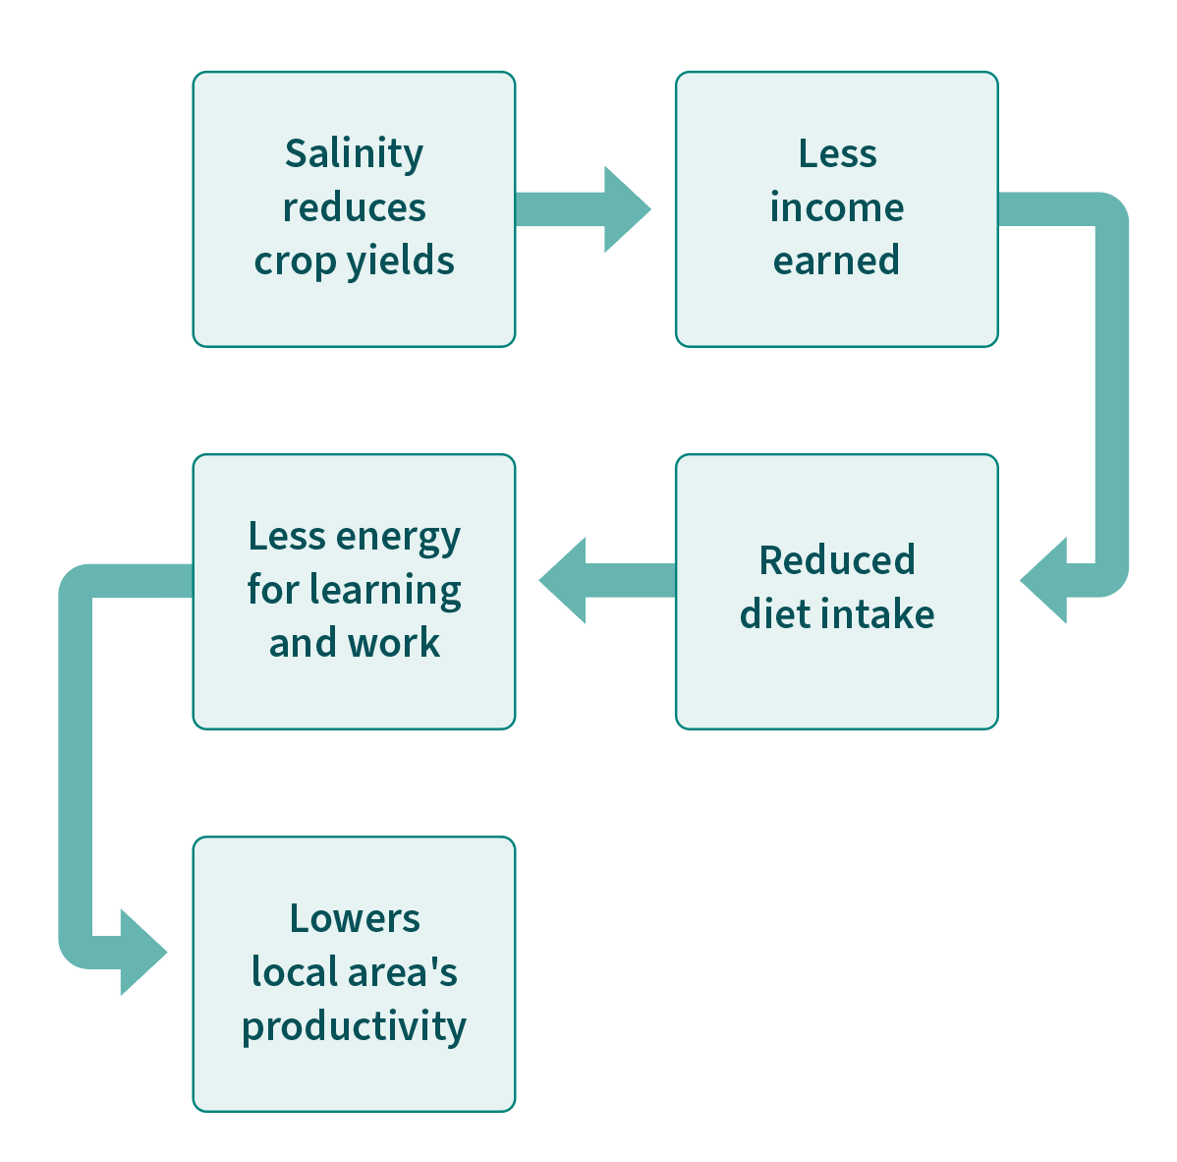
- Ask students to discuss with the students next to them what they would do. After two minutes of discussion, check to see if any groups have some ideas to share. They may not, but reassure them that real-world problems are often complex. Explain to the class that by breaking it down, the dilemma can become more manageable. Scaffold it further into two key questions. You may need to define the two words shown in bold.
- How could the farmer mitigate or prevent the sea water intrusion?
- How could the farmer adapt their water usage during dry periods?
- Allow the groups a further two minutes to come up with ideas and have them share. They may still find this dilemma challenging; however, the task provides a great segue into introducing this module and what they will learn.
- Use the Productive futures PowerPoint slides 1 and 2 to outline the learning intentions. Explain that the following lessons will explore Australia’s partnerships with other countries to design innovative solutions that address farming and food supply, ensuring these are climate resilient.

Guided instruction (15 min)
- Provide students with access to the Sustainable agriculture worksheet.
- Show students the animation: What is a partnership? to provide an overview of the aims for working with other countries. Decide on a definition of ‘sustainable development’ and write it on the worksheet under Activity 1.
- Use slides 3–5 of the Productive futures PowerPoint to introduce to students the importance of food supply globally. Students will need to add notes from slide 4 to their worksheet and can read more about the targets listed on slide 5 on their worksheet.
Note: The UN targets may introduce many new words to students. Some are listed in the teacher overview as key terminology. It is suggested to check student understanding of these words when completing Activity 1 and throughout the module. Creating a glossary is an optional activity.

Case study investigation (30 min)
- Begin Activity 2 by showing students a short video (slide 6) from the ABC’s Beyond Awesome series, ‘Vietnam’s soil saviours’ (5 min 30 sec). This video can also be accessed through the ABC iview website.
Gradual release of responsibility: You may wish to pause the video after one minute and work through Question 1 on the worksheet, modelling the process for the class and asking for input. After watching the remainder of the video, encourage students to compose their own answers to Questions 2–6. Students may need to make inferences to answer some questions. The information under Activity 1 and suggested article links in Activity 2 will assist them.

Learning review (5–10 min)
- Ask students to list in pairs all the groups or people (stakeholders) involved in this project and what skills or knowledge they brought to the project. The aim of this question is to emphasise the need for cooperation between farmers, governments, universities, scientists and businesses when working towards achieving sustainable development.
- Referring to the learning intentions, ask students how these stakeholders could evaluate whether their input has provided a local solution aimed towards Goal 2: Zero Hunger. What would be their success criteria? What data or feedback could they collect, and when, for how long and from who?
- Inform students that in the next lesson they will be individually conducting a similar investigation into another innovation.

Sustainable agriculture

Activity 1: Global goals to establish food security
Define sustainable development:

Goal 2 of the United Nations (UN) Sustainable Development Goals is Zero Hunger. According to the UN, this goal is supporting ‘sustainable agriculture, empowering small farmers, promoting gender equality, ending rural poverty, ensuring healthy lifestyles, tackling climate change’. The Zero Hunger Challenge calls for 5 achievements, list them here
1)
2)
3)
4)

Specific targets relevant to this module
Target 2.3 – by 2030, double the agricultural productivity and incomes of small-scale food producers …
Target 2.4 – by 2030, ensure sustainable food production systems and implement resilient agricultural practices that increase productivity and production:
- help maintain ecosystems
- strengthen capacity for adaptation to climate change
- progressively improve land and soil quality.
Target 2a – increase investment, including through enhanced international cooperation, in rural infrastructure, agricultural research and technology development.
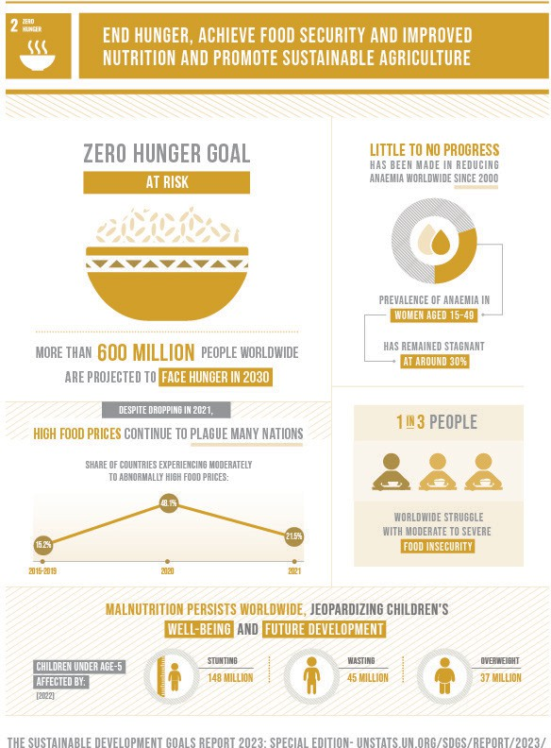
The Sustainable Development Goals Report 2023: Special Edition
© 2023 United Nations

Activity 2: Vietnam’s chameleon card
Watch the Beyond Awesome video ‘Vietnam’s soil saviours’ (5 min 30 sec) and then complete the questions about this innovation.

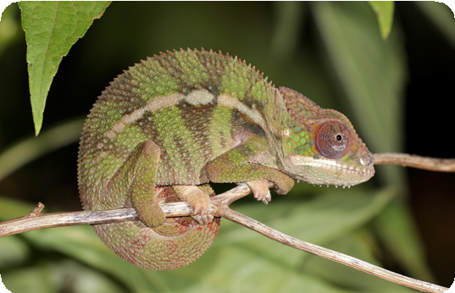
Charles J Sharp/Sharp Photography via Wikimedia Commons, CC BY-SA 4.0
- What concerns face Vietnam’s farmers? Relate your reasons to the subheadings below:
- Environmental and climate challenges:

- Unsustainable agricultural practices:

- Social challenges (food supply, diet):

- What can the chameleon card help produce or maintain?

The following two articles may assist further with the following questions:
- Turning water into food – ACIAR
- Chameleon soil water sensor – CSIRO
- How is the chameleon card working towards Target 2.4?

- Explain how the chameleon card is an example of Target 2a?

- What connection exists between Australia and Vietnam regarding this innovation?

- Could the chameleon card help local farmers achieve Target 2.3? Explain why or why not.

Extension task
- Research how farmers could overcome potential barriers to using the chameleon card (listed below). Some case study articles are provided under Useful sources to assist with researching.
- Costs
- Training
- Gender norms
- Connectivity and accessibility
- What is the global significance if Australia can successfully scale up this solution?
Useful sources (articles) to read:
- A journey to impact – Virtual Irrigation Academy
- Water research in Africa wins European development award – ACIAR
- Transforming smallholder irrigation in southern Africa – ACIAR
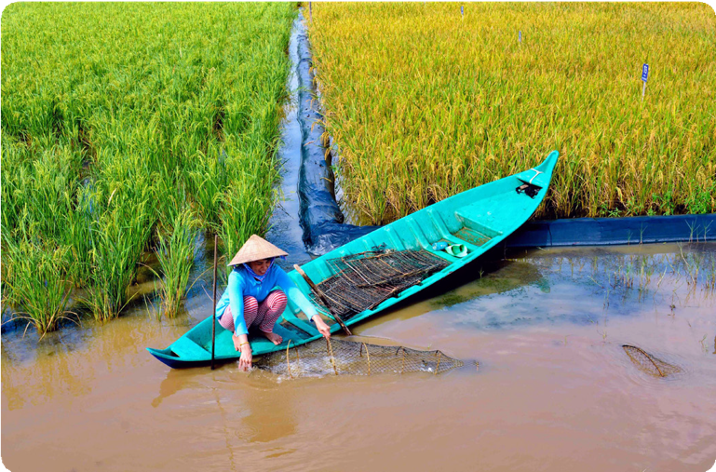
An Australian partnership program researched a new design for rice-shrimp farming systems that were more profitable and adaptable to environmental changes such as high salinity in pond soil and water quality.
© Research Institute for Aquaculture No 2 (RIA 2)/Department of Foreign Affairs and Trade

Why are agricultural innovation projects best led by local communities?
Learning intentions | Materials
- To explain the environmental and human-induced challenges that can impact productivity and food security.  - To evaluate the role of local communities in sustaining new agricultural innovations. | - Worksheet: Global partnerships, local solutions

Introduction (10 min)
- Prompt students’ prior understanding by presenting the following three questions to the class, and asking students to include in their responses tangible and intangible examples based on the Vietnam ‘soil saviours’ case study from Lesson 1.
- How do local farmers and communities contribute to an innovation partnership?
- How does the Australian Government contribute to an innovation partnership?
- Ultimately, what must happen next to ensure the solution is long lasting and effective, meeting the UN’s sustainable development targets?
- Depending on what responses you receive from students, scaffold student thinking towards the importance of locally led projects to ensure maximum reach across communities and increased credibility.
- Outline the learning intentions for this lesson.

Independent research (40 min)
- Using the Global partnerships, local solutions worksheet, students can choose another case study of an Australian Government partnership with a country in the Asia-Pacific region. Explain that the chameleon card example from Lesson 1 provides a model for how to approach this new case study.
Differentiation: The innovations and range of research sources listed in the table in the Global partnerships, local solutions worksheet cater to different abilities.
- Aglime for soil health: video Fiji Sugar: A systemic change story (watch first 10 min)
- Foodcubes to support diets: video Kiribati – Food security (2 min); provides a good overview.
For students seeking a challenge or extension, you might suggest they explore:
- higher altitude coffee: requires synthesis skills to connect information to questions
- honey and beekeeping: provides many sources raising issues to do with beekeeping, as well as opportunity for further research within the ACIAR website.

Learning review (10 min)
As the class will likely be researching a range of different agricultural innovations or practices, it is important for students to share their learning. In relation to the learning intention, ask each student to share one strategy they devised for Question 9 on the Global partnerships, local solutions worksheet on how locals could lead the agricultural innovation or practice that was researched.

Further learning opportunities
This module lends itself to possible interdisciplinary learning activities that fall under Design or Digital Technologies, Health and Science. These can include running experiments, creating sustainable gardening products or coding sensors to conduct testing of soil conditions. Such ideas can be used as part of a school garden initiative or to put together a design brief for one of the many agricultural products investigated in this unit. Suggestions include:
- Create a wicking bed, like a Foodcube:
- Learn how to create a small scale wicking bed: Junior Landcare: Making a small wicking bed
- Watch how to create a large-scale do-it-yourself wicking bed: Gardening Australia: DIY garden projects
- Watch how an industrially designed wicking bed is made: How to make a Foodcube.
- Test for salinity or conduct an experiment on how salt affects plant growth:
- Find out the effect of saltwater in plants' growth.
- Design a fair test for salinity in soils using data logging equipment with a sensor probe.
- Code a microbit based on pH or moisture conditions using the relevant sensor.
- Create a design brief for a new agricultural product that uses sustainable products. See Lesson 3 for an example of a product pitched on Shark Tank US called the tree T PEE.

Global partnerships, local solutions
From the table below, choose another innovation program to study. These programs all involve Australian Government partnerships that are building sustainable agricultural practices and tackling issues due to:
- environmental factors, such as increasing pests and disease in warmer temperatures, higher altitude farming, salinity, drought
- human factors, such as overuse of land reducing soil quality, lack of crop rotation, monocropping, overwatering or heavy use of chemicals, lack of pest control.
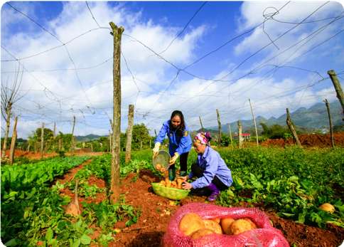
© Northern Mountainous Agriculture & Forestry Science Research Institute (NOMAFSI)/Department of Foreign Affairs and Trade
Innovation | Location | Useful sources of information
Liquid compost | Fiji | Article: Organic alternative to chemical fertiliser – The Fiji Times Report: Inclusion story – Cultivating local organic solutions in Fiji
Higher altitude coffee | Timor-Leste | Report: Climate change and the competitiveness of Timor-Leste’s coffee  Article: Taking Timor-Leste’s unique coffee global: Australia’s Business Partnerships Platform announces new partnership
Foodcubes to support diets | Kiribati, Tuvalu | Website: Atoll Food Futures | Live & Learn  Article/audio: New agriculture systems to help grow food on Pacific sandy atolls – ABC Pacific  Video (2 min): Kiribati – Food security  Animation (48 sec): Food futures
Aglime for soil health | Fiji | Video (watch first 10 min): Fiji Sugar: A systemic change story
Protecting bananas from disease | Indonesia, Philippines and Laos | Summary: An Integrated Management Response to the spread of Fusarium wilt of banana in South-East Asia – ACIAR  Article: Protecting livelihoods from Fusarium wilt in Southeast Asia and Australia – ACIAR
Honey and beekeeping | Papua New Guinea | Video (3 min 20 sec): Increasing the productivity and profitability of smallholder beekeeping enterprises in PNG and Fiji  Summary: Strengthening beekeeping industries for improved production and livelihoods in Fiji, PNG and Solomon Islands – ACIAR  Article: Pacific biosecurity program to protect Australian and local bees from killer pests – ABC News

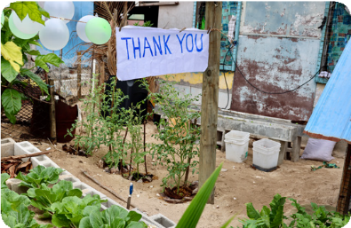
© Department of Foreign Affairs and Trade, CC BY

Name of agricultural innovation:
- Describe the agricultural innovation or program:

- Location:

- Why was the innovation required in the location outlined above? Relate your reasons to the subheadings
that apply:
Environmental and climate challenges
Unsustainable agricultural practices
Social challenges (food supply, diet)
- What resource, food or fibre can the innovation help produce or maintain?

- How is the innovation working towards Target 2.4?

- Explain how the innovation is an example of Target 2a.

- What interconnection exists with Australia in developing this innovation?

- Could the innovation help local farmers achieve Target 2.3?

- Outline three strategies that locals could lead to expand the use of this innovation.

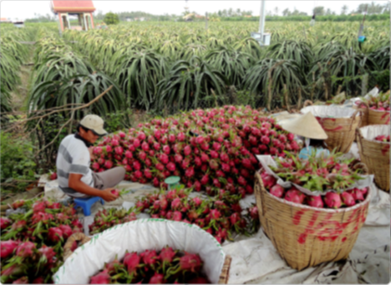
© ACIAR/Department of Foreign Affairs and Trade, CC BY

How is modern technology assisting sustainable food production?
Learning intentions | Materials
- To describe the technological innovations that are making food production more sustainable.  - To propose how the use of a modern technology could assist countries to reach food security. | - PowerPoint: Productive futures (slides 7–15)  - Worksheet: Modern farming technology proposal  - Video: Jasberry rice innovation Neil Dejkraisak, Thailand  - Video (Optional): The Sharks take an emotional trip to the farm  - Butcher’s paper  - Sticky notes  - Printed A3 posters: Design thinking in context Years 9–10

Introduction (5–7 min)
In this lesson students will work together to propose a future partnership program. Connections to prior learning are recommended in order to build a sense of purpose for the activity.
- Outline the learning intentions for this lesson using the Productive futures PowerPoint (slide 8) and then ask: What is meant by the term food security? Create a mind map of student responses.
- What are the goals and targets set by the UN in order to achieve global food security?
- Look again at the Zero Hunger infographic (slide 9) and ask students to summarise, in pairs, four challenges facing Goal 2.
- Show students the UN infographic on climate action (slide 10), and ask them to recall how temperature had an impact on the case studies they researched in Lesson 2. Students should relate the impact of increased temperature to an increase in pests and disease, heavier rainfall events, longer droughts, a need to grow crops at higher altitude, for example. Prompt if necessary.

Group task: Design thinking process
For this task, it is suggested that students work in groups of three. Ideally within these groups, students will have studied different case studies in Lesson 2, so the group has a diverse knowledge base.
- Introduce students to the types of innovation project partnerships established between the Australian Government and other countries. Slide 11 provides an example agricultural research project that describes the modern use of technology in Vietnam. Click on the linked CSIRO article on slide 11 and discuss the stakeholders involved.
- Provide access to the Modern farming technology proposal worksheet. Introduce the scenario (on slide 12) and then discuss the design thinking process. It may be useful for each group to refer to printed A3 copies of the Digital Technologies Hub Design Thinking in context Year 9–10 posters during the process. To showcase what an entrepreneur can do, you may wish to show students the following video (4 min): Jasberry rice innovation Neil Dejkraisak, Thailand.
- Allow each group 25 minutes to work through Activity 1: Understand the technology on their worksheet, which covers two steps of the design thinking process: empathise and define. This activity involves the following.
- To build their understanding of modern technologies, students will delegate and read through a few videos or articles provided in the table. Suggested time: 10 minutes.
- Groups are to share what technologies they found interesting and brainstorm how they could assist local communities.
- Students should complete the empathise and define tasks, considering a country where their chosen technology could be applied, based on their research in Lesson 2.
Keeping to a time limit will ensure student focus is optimal and collaborative.
- Students work on the ideate, prototype and test phase outlined under Activity 2: Implementing the technology. They will need to consider the questions about design, and fill in the worksheet. Allow 30–40 minutes.
- Optional: If time is available, students could complete a guided instruction activity explaining how to write a SWOT analysis. SWOT stands for Strengths, Weaknesses, Opportunities and Threats. SWOT analysis is an assessment tool that businesses use when undertaking a new project. Working through a model example of a SWOT analysis could be included within this lesson module. For more information, the following Australian Government business community website may assist: Do a SWOT analysis.

Group task: Creating a pitch
Students will develop a short pitch for how they would apply their innovative technology prototype. The type of pitch, delivery, length and class time assigned to complete and/or present the task are all at your discretion.
- Read through Activity 3: Creating a pitch on the Modern technology proposal worksheet as a class and allow students time to clarify the requirements. Depending on lesson time available, each pitch could range from 1–3 minutes and allow for an extra minute of audience questions.
- Optional: If time is available, scaffold this task by providing an example of how to create an effective business pitch. The following video outlines an innovative agricultural solution that was pitched on the television show Shark Tank (US version; 5 min 30 sec): The Sharks take an emotional trip to the farm.
- Play the video on Slide 13. The video shows a 3-minute pitch (with 90 seconds of Shark Tank questions)
- Ask students to identify as a class the following elements of the pitch and the design considerations outlined in the video
Elements of a pitch
- What problem are you solving?
- How does it work?
- Who is your target user?
- What will be your competitive advantage? Unique or different?
- Customer response: is it valuable?
- Anecdote (encourages empathy)
- Why do you need an investment? Outline the future.

Design considerations outlined in the video
- Sustainability of design
- How does this solution compare to past designs or ideas?
- What professional skills, labour, time and/or knowledge are required?
- Life cycle of product (durability of material, re-use or single use)
- Ethics (impacts on environment, culture)
- Scalability
Assessment: There is opportunity to assess each group’s pitch and to collect their worksheet answers. These tasks relate to the skills and knowledge across all the curriculum elements listed in the teacher overview. As part of this assessment, students could be asked: What’s the one factor that most determines whether an agricultural innovation scales and lasts? In their responses, they might pick from a list, such as local ownership, locally led design and implementation, market incentives, finance, enabling policy, extension services, reliable data, maintenance/ logistics or gender inclusion.

Learning review (20 min)
This first review activity asks for students to reflect on the following success criteria for the module:
- Adopt a design thinking approach and entrepreneurial mindset while working collaboratively in a team to develop a pitch or proposal.
Once the group pitches have been presented or submitted, students should individually reflect on the design thinking process and their pitch. This could be completed through a self-assessment questionnaire or a simple PMI (plusses, minuses, interesting) chart. To assist student reflection, share the prompts on slide 14:
- What skills underpin an entrepreneurial mindset? How would you rate yourself on these?
- What tasks did you enjoy and/or consider challenging during the design thinking process?
- What social skills are your strengths and what could you develop further?

Module wrap-up
The final review activity addresses the following module success criteria:
- Understand how the Australian Government’s regional partnerships are working towards achieving the United Nations Sustainable Development Goals.
- Appreciate the importance of sharing scientific research and technology to improve food security.
Using slide 15, ask students to discuss as a class whether they believe the Asia-Pacific region could reach zero hunger by 2030, based on the inquiries they have completed.
Ask students to consider which agricultural innovation, strategy, technology or combination will be most influential in achieving food security by 2030.

Modern farming technology proposal
Partnerships are driving agricultural advancements within our region with an aim to boost sustainable practice. This CSIRO article outlines one example: Australian–Vietnamese collaborations advance agricultural innovation.
Scenario: The Australian Government wishes to partner with a country in the Asia-Pacific to conduct research
on the use and effectiveness of modern technological innovations for local agricultural practices. This partnership could involve government departments, technology experts or scientists, entrepreneurs (such as yourself) or universities, and most importantly it must include local communities and agricultural businesses.
As a team of entrepreneurs, you need to develop an idea using the design thinking process. You will then make
a pitch, seeking investment from a panel of stakeholders to conduct your innovative research.

Activity 1: Understand the technology
To assist your proposal, you will follow the stages of design thinking. To begin, it is important to explore the innovations available to you and brainstorm how they might apply to a particular community. From this you should be able to empathise and define the challenge.
- Delegate the listed topics in the table below among the group. Spend a short time reviewing each video or article, ready to share with your group.
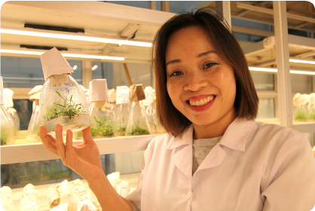
© ACIAR/Department of Foreign Affairs and Trade, CC BY
Innovation | Useful sources of information
Drones | Video (2 min 30 sec): How drones are helping farmers herd cattle in Australia  Video (4 min 40 sec): Monitoring crop health with drones
Robots | Video (5 min): ABC Landline: Developing robotic farm machinery  Article: Farm robots ripping out weeds the old-fashioned way  Article: Australian farmers invest in robots, vehicles to combat worker shortage
Artificial intelligence | Video (14 min): AI in Agriculture: Artificial Intelligence transforming agriculture – ABC News  Article: Artificial intelligence helps Aussie farmers – ABC News  Article: Drones, machine learning, AI, and geo-locating pests and disease bolster farmers’ arsenal – ABC News
Cloning trees | Article with video (3 min 30 sec) embedded: Blazing a trail for women in tree breeding – ACIAR
Using GIS to track flood | Summary: Promoting sustainability of Pacific Island agricultural systems – ACIAR  Website: Livelihoods and Landscapes  Fiji case study: Detecting flooding in Fiji’s croplands – Climate Change AI
Using GIS to survey crops | Summary: Promoting sustainability of Pacific Island agricultural systems – ACIAR  Website: Livelihoods and Landscapes  Tonga case study: Livelihoods and Landscapes – Tonga Crop Survey

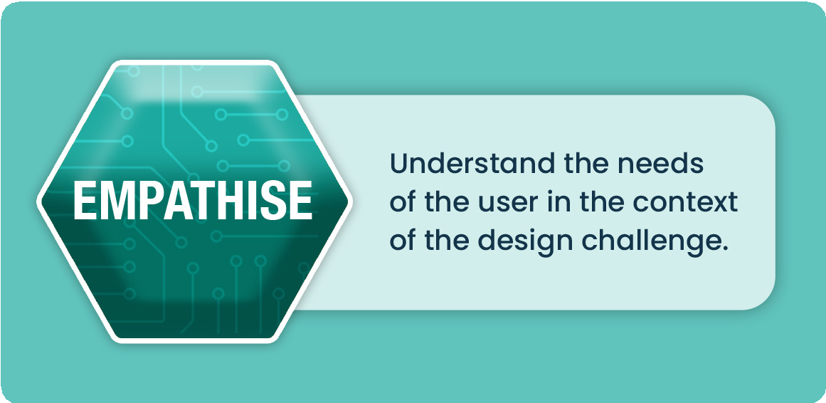
Visualise how a local community feels and thinks. What do they do and need?
Develop a user story:
As a <type of user> I want to <a goal> so that <reason for the goal or benefit>.

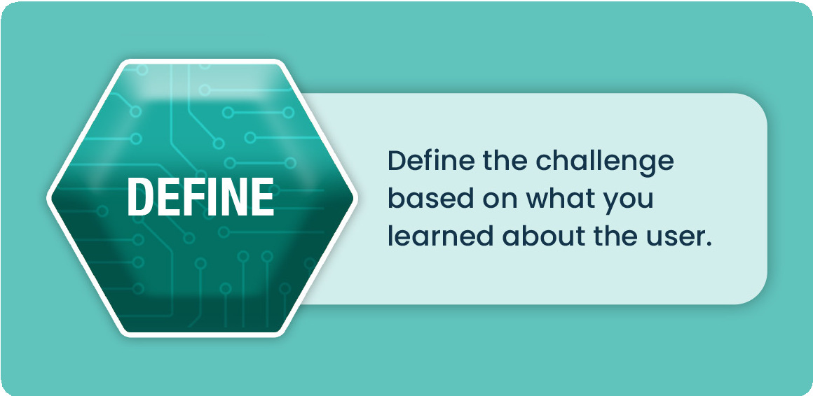
Define the problem clearly. Create a concise problem statement that addresses the core issue.


Activity 2: Implementing the technology

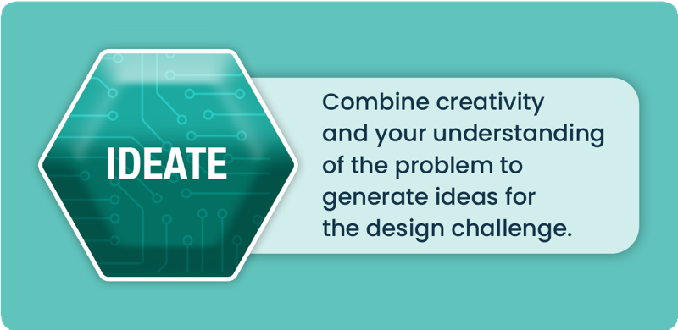
You could then use a SWOT analysis to assess your ideas and determine your competitive advantage.

Ideate:
Consider using sticky notes and butcher’s paper, or a digital application such as a miro board to brainstorm and map out all your ideas on the features of the technology and its potential use:
- how to apply it
- scale of the project
- durability
- local useability
- sustainability
- environmental considerations
- ethical considerations.

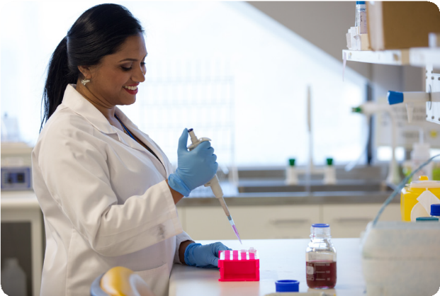
© Nathan Fulton/Department of Foreign Affairs and Trade, CC BY

Note-taking space:

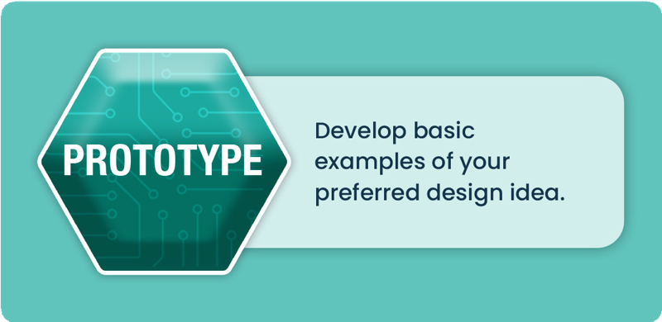

Prototype
Decide on how you would implement this technology for locals to lead. Develop an implementation plan or process; a visual diagram is beneficial. This is often called ‘paper prototyping’, where sketches are hand-drawn as a cheap and easy way to explore possibilities. Base your prototype on an example scenario to model the process within your chosen country. You may even decide to develop a model of the technology to demonstrate how it works.

Sketching space:

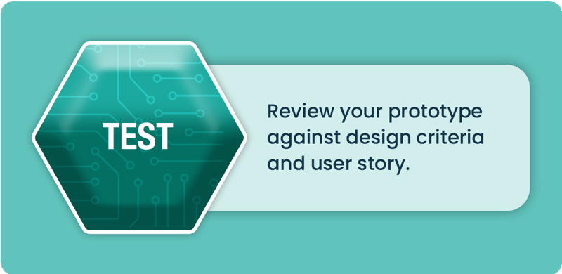

Test
Use the prototype to review and check the preferred design against the user story and design criteria to ensure it meets the design requirements. If elements do not satisfy the design requirements, revisit ideation stage. Answer the following questions, which will help you during Activity 3:
How could you test the technology? Think about the design criteria listed under ‘Ideate’.

What expertise or which professionals will be required to run this test?

How can you ensure the innovation becomes locally led? Consider the user story outlined in the ‘Define’ stage.

What feedback and data would you collect to assess the effectiveness of the technology and its use? Consider the time frame.

Activity 3: Creating a pitch
A pitch is a convincing and concise proposal that outlines a new product, service or idea with the aim of attracting potential customers, partners or investors who will help fund your innovation. Pitches can take many forms, such as written documents, expo demonstrations, formal face-to-face presentations, or informal conversations over a lunch or even during a ride in an elevator. For this reason, pitches can range in duration, with some as brief as 30 seconds. Following any pitch, you should expect there to be many questions about the product, target market, competitive advantage, business model, potential value and growth strategy.
A strong pitch instils confidence in its audience. Your audience should be able to see your innovation is worthwhile. Some tricks to achieving this include the following:
- Consider how you present yourself – what character traits do you want to showcase?
- Tell a story – describe a scenario and outline how your innovation fixed the issue.
- Focus on your uniqueness – how is your innovation different, exclusive, better? Think about your
- competitive advantage.
- Know the details – have you thought about the specifics? Be ready to answer questions.
- Show the roadmap – what is the potential for your innovation in the future? Suggest the journey
- and path to growth.
For this task, your teacher will determine the type of pitch and suitable length, plus any other requirements, such as visual aids, prototype sketches or demonstrations. The table below will assist your planning.

Elements of a pitch | Notes
- What problem are you solving?
- How does your innovation work?
- Who is your target user?
- What will be your competitive advantage? What makes your innovation unique or different?
- Expected customer response: is your innovation valuable? Include a story/anecdote to convey empathy.
- Why do you need an investment? Outline the future.

Potential questions you could be asked | Notes
- Scalability: can your innovation be mass produced?
- How does this solution compare to past methods or other ideas?
- What professional skills, labour, time or knowledge are required?
- Local usability: will locals adopt it?
- Life cycle of product (durable material, reusable or single use)
- Ethics (impacts on culture and people)
- Sustainability of design

