Sustainable agriculture

Activity 1: Global goals to establish food security
Define sustainable development:

Goal 2 of the United Nations (UN) Sustainable Development Goals is Zero Hunger. According to the UN, this goal is supporting ‘sustainable agriculture, empowering small farmers, promoting gender equality, ending rural poverty, ensuring healthy lifestyles, tackling climate change’. The Zero Hunger Challenge calls for 5 achievements, list them here
1)
2)
3)
4)

Specific targets relevant to this module
Target 2.3 – by 2030, double the agricultural productivity and incomes of small-scale food producers …
Target 2.4 – by 2030, ensure sustainable food production systems and implement resilient agricultural practices that increase productivity and production:
- help maintain ecosystems
- strengthen capacity for adaptation to climate change
- progressively improve land and soil quality.
Target 2a – increase investment, including through enhanced international cooperation, in rural infrastructure, agricultural research and technology development.
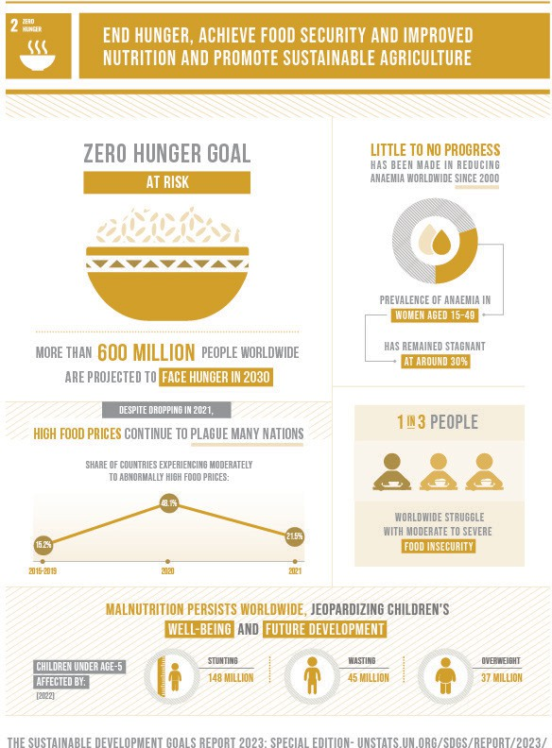
The Sustainable Development Goals Report 2023: Special Edition
© 2023 United Nations

Activity 2: Vietnam’s chameleon card
Watch the Beyond Awesome video ‘Vietnam’s soil saviours’ (5 min 30 sec) and then complete the questions about this innovation.

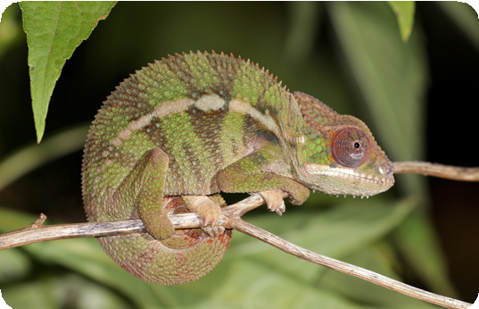
Charles J Sharp/Sharp Photography via Wikimedia Commons, CC BY-SA 4.0
- What concerns face Vietnam’s farmers? Relate your reasons to the subheadings below:
- Environmental and climate challenges:

- Unsustainable agricultural practices:

- Social challenges (food supply, diet):

- What can the chameleon card help produce or maintain?

The following two articles may assist further with the following questions:
- Turning water into food – ACIAR
- Chameleon soil water sensor – CSIRO
- How is the chameleon card working towards Target 2.4?

- Explain how the chameleon card is an example of Target 2a?

- What connection exists between Australia and Vietnam regarding this innovation?

- Could the chameleon card help local farmers achieve Target 2.3? Explain why or why not.

Extension task
- Research how farmers could overcome potential barriers to using the chameleon card (listed below). Some case study articles are provided under Useful sources to assist with researching.
- Costs
- Training
- Gender norms
- Connectivity and accessibility
- What is the global significance if Australia can successfully scale up this solution?
Useful sources:
- A journey to impact – Virtual Irrigation Academy
- Water research in Africa wins European development award – ACIAR
- Transforming smallholder irrigation in southern Africa – ACIAR
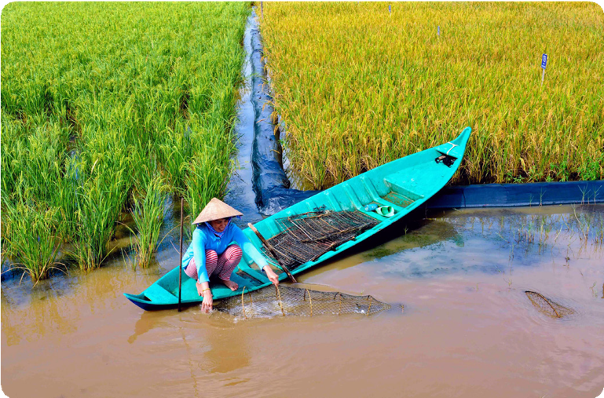
An Australian partnership program researched a new design for rice-shrimp farming systems that were more profitable and adaptable to environmental changes such as high salinity in pond soil and water quality.
© Research Institute for Aquaculture No 2 (RIA 2)/Department of Foreign Affairs and Trade

Global partnerships, local solutions
From the table below, choose another innovation program to study. These programs all involve Australian Government partnerships that are building sustainable agricultural practices and tackling issues due to:
- environmental factors, such as increasing pests and disease in warmer temperatures, higher altitude farming, salinity, drought
- human factors, such as overuse of land reducing soil quality, lack of crop rotation, monocropping, overwatering or heavy use of chemicals, lack of pest control.
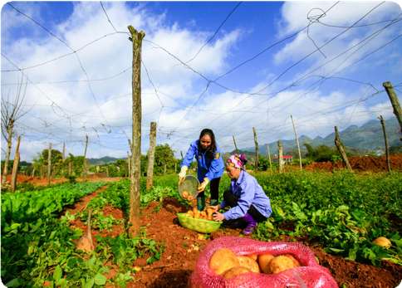
© Northern Mountainous Agriculture & Forestry Science Research Institute (NOMAFSI)/Department of Foreign Affairs and Trade
Innovation | Location | Useful sources of information
Liquid compost | Fiji | Article: Organic alternative to chemical fertiliser – The Fiji Times Report: Inclusion story – Cultivating local organic solutions in Fiji
Higher altitude coffee | Timor-Leste | Report: Climate change and the competitiveness of Timor-Leste’s coffee  Article: Taking Timor-Leste’s unique coffee global: Australia’s Business Partnerships Platform announces new partnership
Foodcubes to support diets | Kiribati, Tuvalu | Website: Atoll Food Futures | Live & Learn  Article/audio: New agriculture systems to help grow food on Pacific sandy atolls – ABC Pacific  Video (2 min): Kiribati – Food security  Animation (48 sec): Food futures
Aglime for soil health | Fiji | Video (watch first 10 min): Fiji Sugar: A systemic change story
Protecting bananas from disease | Indonesia, Philippines and Laos | Summary: An Integrated Management Response to the spread of Fusarium wilt of banana in South-East Asia – ACIAR  Article: Protecting livelihoods from Fusarium wilt in Southeast Asia and Australia – ACIAR
Honey and beekeeping | Papua New Guinea | Video (3 min 20 sec): Increasing the productivity and profitability of smallholder beekeeping enterprises in PNG and Fiji  Summary: Strengthening beekeeping industries for improved production and livelihoods in Fiji, PNG and Solomon Islands – ACIAR  Article: Pacific biosecurity program to protect Australian and local bees from killer pests – ABC News

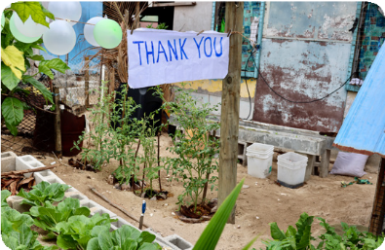
© Department of Foreign Affairs and Trade, CC BY

Name of agricultural innovation:
- Describe the agricultural innovation or program:

- Location:

- Why was the innovation required in the location outlined above? Relate your reasons to the subheadings
that apply:
Environmental and climate challenges
Unsustainable agricultural practices
Social challenges (food supply, diet)
- What resource, food or fibre can the innovation help produce or maintain?

- How is the innovation working towards Target 2.4?

- Explain how the innovation is an example of Target 2a.

- What interconnection exists with Australia in developing this innovation?

- Could the innovation help local farmers achieve Target 2.3?

- Outline three strategies that locals could lead to expand the use of this innovation.

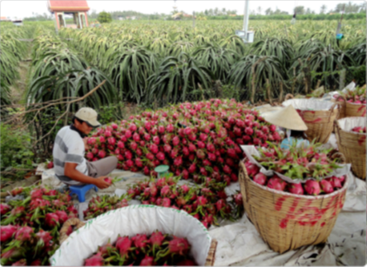
© ACIAR/Department of Foreign Affairs and Trade, CC BY

Modern farming technology proposal
Partnerships are driving agricultural advancements within our region with an aim to boost sustainable practice. This CSIRO article outlines one example: Australian–Vietnamese collaborations advance agricultural innovation.
Scenario: The Australian Government wishes to partner with a country in the Asia-Pacific to conduct research
on the use and effectiveness of modern technological innovations for local agricultural practices. This partnership could involve government departments, technology experts or scientists, entrepreneurs (such as yourself) or universities, and most importantly it must include local communities and agricultural businesses.
As a team of entrepreneurs, you need to develop an idea using the design thinking process. You will then make
a pitch, seeking investment from a panel of stakeholders to conduct your innovative research.

Activity 1: Understand the technology
To assist your proposal, you will follow the stages of design thinking. To begin, it is important to explore the innovations available to you and brainstorm how they might apply to a particular community. From this you should be able to empathise and define the challenge.
- Delegate the listed topics in the table below among the group. Spend a short time reviewing each video or article, ready to share with your group.
\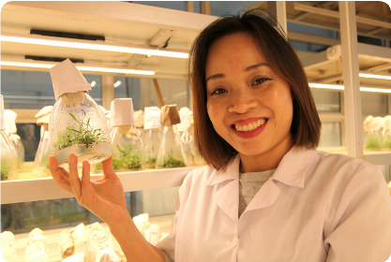
© ACIAR/Department of Foreign Affairs and Trade, CC BY
Innovation | Useful sources of information
Drones | Video (2 min 30 sec): How drones are helping farmers herd cattle in Australia  Video (4 min 40 sec): Monitoring crop health with drones
Robots | Video (5 min): ABC Landline: Developing robotic farm machinery  Article: Farm robots ripping out weeds the old-fashioned way  Article: Australian farmers invest in robots, vehicles to combat worker shortage
Artificial intelligence | Video (14 min): AI in Agriculture: Artificial Intelligence transforming agriculture – ABC News  Article: Artificial intelligence helps Aussie farmers – ABC News  Article: Drones, machine learning, AI, and geo-locating pests and disease bolster farmers’ arsenal – ABC News
Cloning trees | Article with video (3 min 30 sec) embedded: Blazing a trail for women in tree breeding – ACIAR
Using GIS to track flood | Summary: Promoting sustainability of Pacific Island agricultural systems – ACIAR  Website: Livelihoods and Landscapes  Fiji case study: Detecting flooding in Fiji’s croplands – Climate Change AI
Using GIS to survey crops | Summary: Promoting sustainability of Pacific Island agricultural systems – ACIAR  Website: Livelihoods and Landscapes  Tonga case study: Livelihoods and Landscapes – Tonga Crop Survey

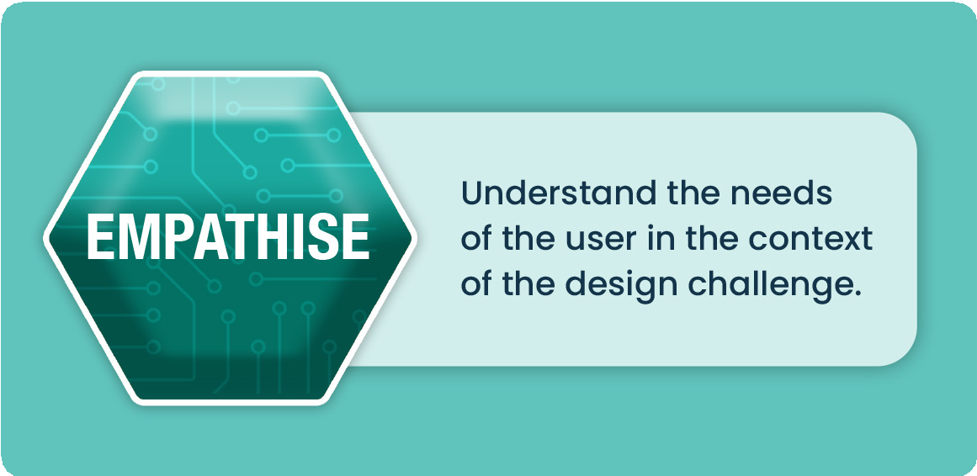
Visualise how a local community feels and thinks. What do they do and need?
Develop a user story:
As a <type of user> I want to <a goal> so that <reason for the goal or benefit>.


Define the problem clearly. Create a concise problem statement that addresses the core issue.


Activity 2: Implementing the technology

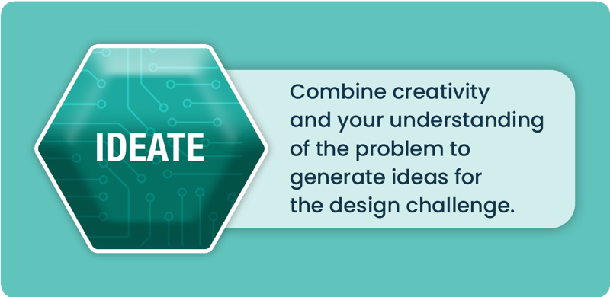
You could then use a SWOT analysis to assess your ideas and determine your competitive advantage.

Ideate:
Consider using sticky notes and butcher’s paper, or a digital application such as a miro board to brainstorm and map out all your ideas on the features of the technology and its potential use:
- how to apply it
- scale of the project
- durability
- local useability
- sustainability
- environmental considerations
- ethical considerations.

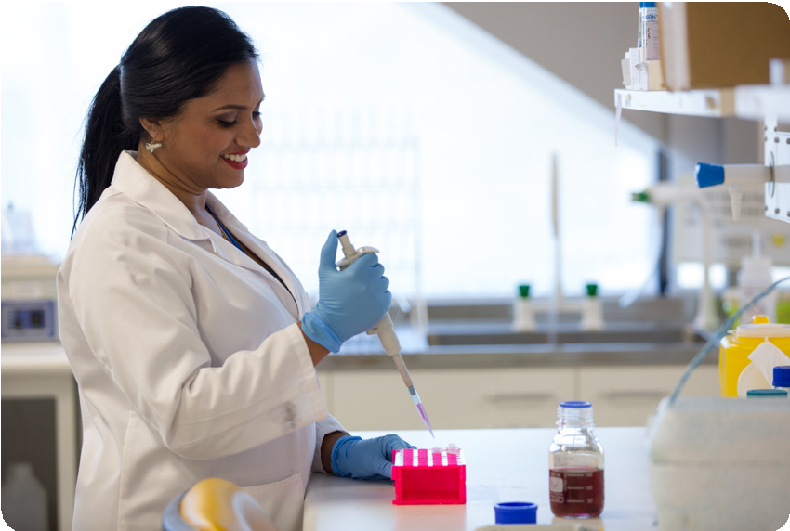
© Nathan Fulton/Department of Foreign Affairs and Trade, CC BY

Note-taking space:

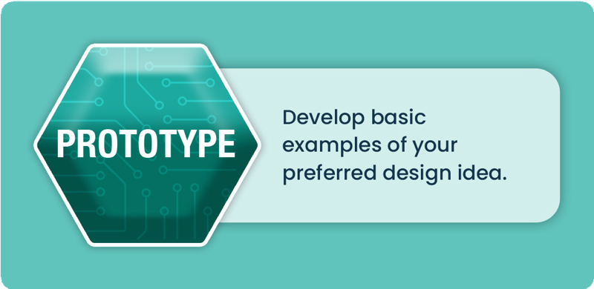

Prototype
Decide on how you would implement this technology for locals to lead. Develop an implementation plan or process; a visual diagram is beneficial. This is often called ‘paper prototyping’, where sketches are hand-drawn as a cheap and easy way to explore possibilities. Base your prototype on an example scenario to model the process within your chosen country. You may even decide to develop a model of the technology to demonstrate how it works.

Sketching space:

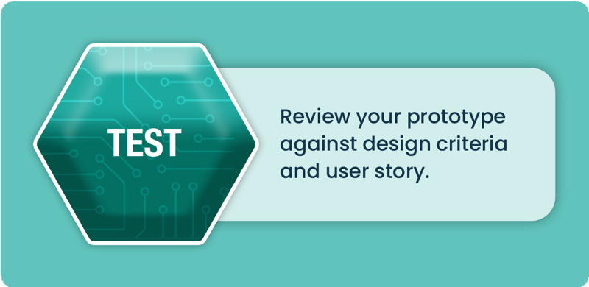

Test
Use the prototype to review and check the preferred design against the user story and design criteria to ensure it meets the design requirements. If elements do not satisfy the design requirements, revisit ideation stage. Answer the following questions, which will help you during Activity 3:
How could you test the technology? Think about the design criteria listed under ‘Ideate’.

What expertise or which professionals will be required to run this test?

How can you ensure the innovation becomes locally led? Consider the user story outlined in the ‘Define’ stage.

What feedback and data would you collect to assess the effectiveness of the technology and its use? Consider the time frame.

Activity 3: Creating a pitch
A pitch is a convincing and concise proposal that outlines a new product, service or idea with the aim of attracting potential customers, partners or investors who will help fund your innovation. Pitches can take many forms, such as written documents, expo demonstrations, formal face-to-face presentations, or informal conversations over a lunch or even during a ride in an elevator. For this reason, pitches can range in duration, with some as brief as 30 seconds. Following any pitch, you should expect there to be many questions about the product, target market, competitive advantage, business model, potential value and growth strategy.
A strong pitch instils confidence in its audience. Your audience should be able to see your innovation is worthwhile. Some tricks to achieving this include the following:
- Consider how you present yourself – what character traits do you want to showcase?
- Tell a story – describe a scenario and outline how your innovation fixed the issue.
- Focus on your uniqueness – how is your innovation different, exclusive, better? Think about your
- competitive advantage.
- Know the details – have you thought about the specifics? Be ready to answer questions.
- Show the roadmap – what is the potential for your innovation in the future? Suggest the journey
- and path to growth.
For this task, your teacher will determine the type of pitch and suitable length, plus any other requirements, such as visual aids, prototype sketches or demonstrations. The table below will assist your planning.

Elements of a pitch | Notes
- What problem are you solving?
- How does your innovation work?
- Who is your target user?
- What will be your competitive advantage? What makes your innovation unique or different?
- Expected customer response: is your innovation valuable? Include a story/anecdote to convey empathy.
- Why do you need an investment? Outline the future.

Potential questions you could be asked | Notes
- Scalability: can your innovation be mass produced?
- How does this solution compare to past methods or other ideas?
- What professional skills, labour, time or knowledge are required?
- Local usability: will locals adopt it?
- Life cycle of product (durable material, reusable or single use)
- Ethics (impacts on culture and people)
- Sustainability of design

