# Investment Design

|  |
| --- |
| **A: Investment Design Title** |
| **Start date: 01 May 2017 End Date: 30 June 2022** |
| **Total proposed funding allocation:** up to AUD 75 million |
| **Investment Concept (IC) approved by: Product Development Partnerships Fund, 2018-2022 IC Endorsed by AIC:** Yes/~~No/NA~~ |
| **Quality Assurance (QA) Completed: Yes. Independent Assessment** |
|  |

|  |
| --- |
| **B: Executive Summary** |

To continue making progress against emerging and longstanding global health threats like tuberculosis and malaria, there is a critical need for new drugs, vaccines, diagnostics, vector control tools and others (e.g. microbicides). However, there is a market failure for such products that target poverty related and neglected diseases. Because these diseases primarily affect people in some of the world’s poorest places, and due to the costs and risks of such research and development (R&D) traditionally being too high relative to the market potential, there is little commercial incentive for the private sector to develop these tools.

Product Development Partnerships (PDPs), are helping to address the void. The objective of the DFAT investment in PDPs, consistent with Australia’s Health Security Initiative for the Indo-Pacific strategic framework, is to accelerate access to new and effective tools. This is expected to eventually contribute towards reduced disease burden in Indo Pacific countries. The investment will address the need for cost-effective, new and adapted products for TB, malaria, and vector control more broadly, and to make them safely and effectively available to target populations. This investment is expected to achieve registration of at least a minimum new or modified products/regimens for patient use in the Indo Pacific region by 2022, and to ensure that availability-related dimensions of access (cost, geographic availability, stock, registrations in Indo Pacific) are achieved for those products that are ready for market. Targets to be established based on specific PDPs.

The PDP investment will take the form of direct, semi-restricted (in cases where the PDP does not have a sole disease focus on TB or malaria) or core funding to PDPs through a grant arrangement. Initial investment will cover up to 4 PDPs focused on the development of:

* Diagnostics and therapeutics for TB and malaria
* Vector control tools for malaria and other high burden mosquito borne diseases

Funding will consist of up to AUD 15m per year across up to 4 PDPs for an initial 3 year period. This will be followed by an external review of the initial three-year investment. Contingent on the findings of the review, PDPs will be eligible for a potential 2 year extension, for a total of 5 years (i.e. total investment over 5 years for up to 4 PDPs would be up to AUD 75m).

| **C: Analysis and Strategic Context** |
| --- |

Despite tremendous progress over the past decade, poverty-related and neglected diseases such as HIV/AIDS, tuberculosis (TB), malaria, and neglected tropical diseases still cause 6.7 million deaths and the loss of 354 million years of healthy and productive life in developing countries every year.[1] To continue to make progress against emerging and longstanding global health threats, new drugs, vaccines, diagnostics, vector control tools and others are vitally needed. These tools will be necessary to help end endemic health issues in low-resource settings. For most of the priority poverty related and neglected diseases, drug, vaccine, diagnostic and vector control technologies are imperfect and have limited use because of their toxicities, durations, inadequate efficacies, or because they do not prevent reinfection[2].

* For example, current approaches to preventing, diagnosing, and treating TB are inadequate. Today’s TB vaccine, which is more than 85 years old, provides limited protection for newborns and children and no protection against pulmonary TB in adults, which accounts for most of the worldwide disease burden. Today’s most commonly used TB diagnostic, sputum microscopy, is more than 100 years old, is labour intensive for health providers, requires special skills, and lacks sensitivity, detecting only half of all cases. Delay in proper diagnosis costs patients valuable time and money in receiving treatment. Finally, today’s TB drug regimen is more than 40 years old, must be taken for 6-9 months, assumes that a healthcare worker will supervise the full duration of treatment, and has significant side effects. The result is that many patients end treatment prematurely. Erratic or inconsistent treatment breeds drug resistant strains that increasingly are not susceptible to current medicines.
* In the case of malaria, the plasticity of the mosquito and the Plasmodium parasite has led to increasing resistance to medicines and insecticides. Resistance to artemisinin-based combination therapies (ACTs) has been detected in five countries in the Indo Pacific region. The spread of these strains to Africa or the Indian subcontinent could be catastrophic. In Africa, resistance has been detected against two or more insecticides in two-thirds of countries where malaria is endemic. Up to 80% of infections are asymptomatic, and *Plasmodium vivax* parasites remain dormant for months or even years after initial infection. Current field tests are not sensitive enough to pick up the low density of parasites in low-transmission areas. As transmission decreases, it is increasingly clustered in at-risk populations such as forest workers, who often migrate among job sites, taking the disease with them; or geographically resistant areas or “hotspots” such as swamps and other sources of stagnant water that serve as breeding sites[3]. The *Lancet* Commission on Investing for Health determined that if the right investments are made in scaling up existing health interventions and in developing new prevention, treatment, and surveillance tools, the world could achieve a “grand convergence” by 2035, with preventable deaths reaching universally low levels and economic benefits exceeding cost by a factor of 9–20[4]. Historically, LMICs that have aggressively adopted new tools have seen an additional 2%-per-year decline in child mortality rates compared with nonadopters5. However, adoption alone of new and existing tools with poor implementation will have little impact on disease transmission in the long term. The difficulty of maintaining major declines in disease following effective malaria control initiatives underscores the fragility of these successes[5].

Treating malaria and TB will require not only new approaches for scaling up existing strategies for treatment and prevention, but also novel tools to counter the growing threat of drug and insecticide resistance and better surveillance mechanisms to more efficiently target interventions to populations and areas of high risk.

The development problem to be addressed through this investment is a market failure for new drugs, vaccines, diagnostics, and other tools such as microbicides for neglected diseases. Because these diseases primarily affect people in some of the world’s poorest places, and due to the costs and risks of such research and development (R&D) traditionally being too high relative to the market potential, there is little commercial incentive for the private sector to develop these tools. Both the private and public sectors acknowledge that “a pure market mechanism generally does not work”[6] where such tools are involved, and new approaches have been needed.

To redress the imbalance in availability of these tools in developing countries, Product Development Partnerships (PDPs), generally non-profit organizations, use public and philanthropic funds to engage the pharmaceutical industry and academic research institutions to undertake R&D for diseases of the developing world that they would normally be unable or unwilling to pursue independently without additional incentives[7]. PDPs manage the multiple tasks of product development through this broad network of partnerships, towards the common objective of developing new health technology targeted to the needs of LMICs by developing much needed tools (medicines, diagnostics, vector control tools, etc.) to help curb challenges posed by such poverty-related and neglected diseases, including the emergence of drug resistance.

Unlike large pharmaceutical companies, PDPs tend not to undertake R&D, manufacturing, nor distribution in-house, but rather allocate resources to the most promising projects, provide technical insight, facilitate partner R&D and access activities and manage project portfolios to fulfil objectives. This “virtual R&D” structure also provides additional flexibility and lowers overhead costs, which frees up capital for other investments.

Most PDPs were established with the core mission of medical R&D. While this will continue to be the core mission of PDPs, as many of the projects in the PDP pipelines now enter Phase III clinical trials and beyond, there is increasing discussion of how best to ensure access and uptake of products as well[8]. This represents somewhat of a transition phase for PDPs, as they begin to also place greater emphasis on the importance of access/uptake of ready-for-market products, while still investing in new product development. As with other activities of PDPs, this can best be accomplished through partnerships, as well as building in-house expertise.

DFAT investment/contribution for PDPs can help catalyze this research for urgently needed health tools and to incentivize private sector engagement as the PDP model reduces the risks associated with investments in R&D to address key health security challenges in the Indo Pacific region, including TB and malaria by investing in best candidates (portfolio approach), working through smart partnerships, and managing the development process under the leadership of experts.

PDPs continue to represent a good option for donors wanting to invest in the development of products for diseases of the poor and enable risk-sharing with partners to address market failure. By investing in PDPs, DFAT is able to invest in a managed portfolio of research and development activities. Research and development activities have scientific oversight mechanisms (scientific advisory committees) that fast-track promising research while poor-performing projects are dropped from the portfolio. This helps contribute towards good value for money[9].

The evaluation of DFAT’s initial investment in PDPs (2013-2018) showed positive results with regards to investing in diagnostics and medicines for TB and malaria. The performance of the three core-funded PDPs was strong, having resulted in the registration of an agreed minimum number of products in the Indo Pacific region during the investment period. This builds on a strong track record for the PDP model of bringing products to market for poverty related and neglected diseases, relative to the status quo (see Annex 3).

DFAT investment in PDPs would help address a decline in R&D funding needed to address neglected diseases in LMICs:

* In 2015 (most recent data available), a reported USD$3,041m was invested in neglected disease R&D across various mechanisms, including PDPs. This represented a total funding decrease of $68m (-2.3%) for neglected disease R&D[10], marking the third consecutive year of declining funding, which has fallen in every year but one since 2009. This decline has been driven predominantly by declining public sector investment.
* Investment in TB remained essentially flat (up $2.4m, 0.5%), while funding for malaria declined (down $17m, -3.0%), although this followed a sharp increase in malaria funding in 2014. Non-disease-specific investment increased to $228m in 2015, with funding increasing by $43m (up 25%), following a sharp drop in 2014. Most of this increase was due to a jump in core funding – non-earmarked funds given to organisations working on multiple neglected diseases – which grew by $32m (up 38%) to $118m, the highest level recorded since the start of the G-Finder survey. More donors seem to be moving towards a core funding approach.
* Funding for platform technologies[11] increased by $11m (up 51%), which was essentially a return towards normal levels after a large drop in 2014. Almost three-quarters of all neglected disease R&D funding in 2015 was external investment in the form of grants ($2,202m, 72%). Three-quarters of this funding went directly to researchers and developers ($1,656m, 75% of external investment), $450m (20%) went to PDPs, and the remaining $96m (4.3%) was channeled through other non-PDP intermediary organisations[12]. Funding to PDPs fell (down $65m, -13%) after two years of increased investment, reflecting the highly cyclical nature of grant funding to PDPs, especially from the Gates Foundation.[13] While this represents a potential risk and is associated with projected budgetary shortfalls for funding the full scope of planned PDP activities, it also points to the need for continued public sector investment.

In summary PDPs are:

* Non-profit organisations that fund/support the development of appropriate and affordable innovative tools for populations affected by poverty-related and neglected diseases.
* Public health-driven and focused on patients’ needs in designing products for use in low- and middle-income countries (LMICs) with a high disease burden.
* Are working along the product development continuum from early discovery to product implementation (increasingly), covering specific research gaps or the full innovation cycle.
* Employing a portfolio approach to R&D to accelerate product development by pursuing multiple strategies for a disease area and allowing only the most promising products to move forward.
* Engaged as partners with academic and public research institutions, the private sector, governments, and civil society organisations, including partners in developing countries, stimulating R&D in developing countries and linking scientists across the North-South divide.

PDP Advantages:

* PDPs reduce industry and donor risks for investment in research in poverty-related and neglected diseases. Funding is spread across the portfolios to support broad product pipelines, allowing partners—including governments and private sector players—to contribute to the R&D enterprise without having to bear the entire cost and risk themselves.
* PDPs’ governance structures and professional portfolio management ensure programmes are conducted effectively and efficiently by reviewing projects as they progress through defined transition points.
* PDPs engaging in portfolio approaches have independent scientific-advisory boards, responsible for selection of projects and partners based on scientific merit/technical feasibility of developing the technology (including development of Technical Product Profiles). The degree to which the priority health needs of developing countries are addressed is also taken into consideration. Such a selection process is seen as a key advantage, cushioning donors from picking the funding winners/losers and placing that responsibility with those who have better information and expertise with which to make those decisions.
* Using this portfolio model, PDPs select winners and eliminate non-performers, thus ensuring that only the most promising candidates are accelerated through the development process.
* PDPs leverage resources from public and private sector partners, including co-financing of costly late-stage clinical trials, in kind contributions, and access to intellectual property.
* PDP agreements with industry foresee provisions to ensure affordable pricing and adequate levels of supply, and include provisions for technology transfer or access to intellectual property (e.g. licencing agreements)/

PDP Risks

* There is a risk that the medical products developed do not have the therapeutic efficacy required and are not a viable alternative to existing regimes. This is an accepted risk of medical product development. However PDPs by using a portfolio model carefully selected the most promising products to progress through clinical trials.
* Drug, vaccine and diagnostic development is lengthy and uncertain, leading to a need for stable long-term financing. The main identified risk associated with funding PDPs relates to funding sustainability (see funding trends described above) as most funding from the public sector and private foundations is relatively short term (between two and five years, while drug and vaccine development can take more than ten years). Nonetheless, public sector funding is critical for the sustainability of PDPs.
* As many of the projects in the PDP pipelines now enter Phase III clinical trials and beyond, the funding needs of most PDPs (including FIND, TB Alliance and MMV) are increasing in an exponential manner. Funding requirement projections provided by the PDPs funded in the initial DFAT investment expect shortfalls in the coming years.
* Researchers and developers continue to rely upon a small number of large funders, particularly the US Government (the US NIH especially) and the Gates Foundation. In 2015, nearly half of all PDPs received more than half their funding from the Gates Foundation. Gates Foundation will also be launching its own Medical Research Institute (MRI) with implications for the PDP landscape still being unclear. This needs to be closely monitored (see risks section for more).
* PDPs can deliver products, but the extent to which they can deliver health impact is only beginning to emerge. An increased focus on the various dimensions of access[14], and how best to facilitate uptake, is critical. A recent analysis[15] exploring the pathway from development to rollout of TB products, for example, found two “Valleys of Death”:
  + Between Development and Commercialization:
    - Insufficient evaluation in settings of intended use
    - Weak end-user involvement in product R&D (i.e. human centered design)
    - Misalignment in the product design and manufacturing process
  + Between Commercialization and Roll-out:
    - Lack of focus on demand-generation
    - Weak engagement of country decision-makers and stakeholders, including civil society and community
    - Lack of planning and resources for country adoption

PDPs, through various partnerships, are increasingly focusing on addressing such challenges. For example, FIND, in collaboration with the Stop TB Partnership, McGill International TB Centre, TB Proof, UNITAID and others recently launched the Accelerator for Impact (a4i)[16] in October 2016. a4i is a coordination platform of key partners and activities that focuses on the downstream end of the product development lifecycle and executes an efficient pathway to rapidly roll-out promising, new TB tools.  The platform’s mantra is: “bringing the *right* product, with the *right* performance, at the *right* cost and ensuring the *right* uptake, with the *right* implementation, for the *right* impact.”

PDP Achievements

* PDPs have helped to create the largest product development pipeline ever for drugs, vaccines, and diagnostic tools addressing global health needs. They have re-catalysed the development of global health tools.[17]
* Prior to the creation of PDPs, the neglected disease R&D pipeline was noticeably empty. A 2001 study estimated that only 1.1% of new drugs approved between 1975 and 1999 were for poverty-related and neglected diseases, though they represented 12% of the global disease burden[18] (See Annex 3 for more). Even today, only 1-2% of global spending on health R&D targets neglected diseases ($3.63b)[19].
* Globally, there are approximately 674 (as of end of 2016) products under, with just under half (321) of these in late-stage development[20]. As of October 2015, PDPs and other PPPs accounted for 58% of the global pipeline[21] (See Annex 4 for a more detailed breakdown), with 40% (192; 69 of which are for malaria and 36 for TB) falling specifically under PDPs[22]. Since 2000 (and up to end of 2016), 82 new global health technologies have been approved21.. Thus, they contribute to the World Health Organization’s (WHO) goals of preventing, eliminating, and eradicating several diseases, and to achieving the health-related targets in the Sustainable Development Goals (SDGs).
* With a focus on diseases that disproportionally affect developing countries, PDPs are committed to investing in research partnerships with and in these countries, and as they integrate partners from the North and South, they have made important contributions to building and sustaining capacity for health research (e.g. medical trials strengthening, systems, implementation, etc.). The organisations currently support research centres and scientists across Africa, Latin America, Asia, and the Pacific.

| **D: Investment Description** |
| --- |

Expected Outcome

The objective of the DFAT investment in PDPs, consistent with Australia’s Health Security Initiative for the Indo-Pacific strategic framework, is to accelerate access to new and effective tools. This is expected to eventually contribute towards reduced disease burden in Indo Pacific countries. The investment will address the need for cost-effective, new and adapted products for TB, malaria, and vector control for mosquito borne diseases more broadly, and to make them safely and effectively available to target populations. In accordance with the robust pipeline presented in Annex 4 (and upcoming updates to be released by Policy Cures Research in 2017) this investment is expected to achieve registration of a minimum number of new or modified products/regimens for patient use in the Indo Pacific region by 2022, and to ensure that availability-related dimensions of access (cost, geographic availability, stock, registrations in Indo Pacific) are achieved for those products that are ready for market. PDP specific targets to be established based on the each PDP’s proposal and pipeline.

The logic model developed for the investment (see Annex 1) represents a distilled set of outputs, outcomes and related indicators. This logic model was based on expert opinion, review of PDP Funders Group logic models, DFAT’s previous PDP design, and a literature review of publications that have explored various aspects of PDP monitoring and evaluation. It aims to be broad enough to cover multiple types of products, including medicines, diagnostics and vector control tools. Inevitably, there are differences in the types of indicators associated with each type of product, and examples of how indicators might be differentiated are included where applicable. The logic model is meant to serve as a guide and be a live tool that may be adapted as necessary. Adaptation and final specifications should ideally be done in consultation with selected PDPs.

As PDPs do not directly undertake R&D, but rather create the necessary partnerships to do so while being responsible for the overall management of bringing products to market for neglected diseases, so to are partnerships necessary for ensuring access. The logic model developed for this investment hopes to further support movement in this direction (already occurring to some degree, and continuously improving, with growing emphasis within PDPs3). By building a continuum of research and related activities (from development to implementation) around specific products, under the management of a single PDP, there are increased opportunities for integrated learning, cross-fertilization, coordination and full lifecycle management. This offers a potential comparative advantage to separately funded access activities, and may contribute to improved uptake/access of PDP products.

While there are still gaps PDPs are well positioned to determine how best to improve access and uptake of their products. Some PDPs are doing a good job of catalyzing product registration in and distribution to disease-endemic countries, through assuring comparatively low-cost products, and adopting products into national treatment guidelines (e.g. MMV).

However, PDPs need to improve broad, equitable access within countries (e.g. high distribution coverage in public and private sectors, availability for poor/vulnerable populations, and adoption by health providers and end-users). For example, leveraging its contribution to collaborations established during the product development process, FIND negotiates access strategies that guarantee sustained availability of high-quality tests at affordable prices for the public and non-profit private healthcare sectors. It does this through a laboratory support programme that provides an excellent opportunity to strengthen capacity for diagnosis of poverty related and neglected diseases by ensuring introduction, adaptation, and adoption of the most appropriate diagnostic technologies into an integrated laboratory network[23].

PDPs may need to clarify or redefine their access activities in relation to other global health partnerships[24] (e.g. Global Fund, UNITAID, Clinton Health Access Initiative, etc.) to ensure they are not duplicating efforts, and examine what partnerships/mechanisms would be best to establish to support access of their products.

In addition, it should be noted that access and delivery strategies for PDP products must be in line with the sovereign decision making authority of the various country health systems (e.g. what products are included in national treatment guidelines or drug formularies). Any national drug policy will broadly adhere to the following objectives:

* selection of reliable suppliers of relevant and high-quality products;
* procurement of the most cost-effective products in the right quantities;
* ensuring timely delivery;
* ensuring transparency in sourcing, pricing and the management of supplies;
* providing an early warning system for users about potential or actual problems in the supply chain which will affect the short-term or long-term availability of individual commodities.

PDPs must consider these factors within the context of their market access strategies, involving managers of country disease control programs in these discussions at an early stage to prevent policy decisions from adversely affecting their programs. PDPs do seem to be increasingly aware of such considerations, particularly as they incorporate access activities.

*Delivery Approach*

The PDP investment will take the form of direct funding to PDPs through a grant arrangement. Initial investment will cover up to 4 PDPs focused on the development of:

* Diagnostics and therapeutics for TB and malaria
* Vector control tools for malaria and other high burden mosquito borne diseases

Evaluation of the previous PDP investment found that core funding was the preferred option of PDPs with regard to funding support. This form of funding also seems to be the trend for other PDP donors. The flexibility provided to PDPs through DFAT’s core funding was seen to add significant value by allowing the PDPs to channel funds to high priority areas. Earmarked funding was seen to be more administratively burdensome, risking duplication and leaving gaps in PDP business plans. An expert group convened in 2012, prior to DFAT’s initial investment in PDPs, found that earmarking funding to PDPs can decrease or negate the advantage of the scientific oversight within the PDP model, as it can create perverse incentives to continue with projects or programs of research which are not performing well.

*Resources*

Financial

* Generally speaking, previous government funding has been given as unrestricted/core funding[25] grants that the PDPs can use as they choose, or semi-restricted to parts of the PDPs’ portfolio, but still with freedom for the PDPs to allocate resources between projects in this part of their portfolio. Under this investment, grants to the PDPs should consist of semi-restricted support, with funds being targeted solely at the TB and malaria focused activities of each selected PDP (in cases where the PDP has a disease focus of TB or malaria this will constitute core funding). The exception will be the vector control supported PDP, which will be core funding and support for vector control activities beyond malaria. Both malaria and TB have been identified as priority diseases within DFAT’s Health for Development Strategy and have strong linkages to the Health Security Initiative for the Indo-Pacific.
* Funding will consist of up to AUD 15m per year across up to 4 PDPs for an initial 3 year period. This will be followed by an external review of the initial three-year investment. Contingent on the findings of the review, PDPs will be eligible for a potential 2 year extension, for a total of 5 years (i.e. total investment over 5 years for up to 4 PDPs would be up to AUD 75m).
* Consideration could be given to a small allocation of additional funds to support M & E activities to measure results across the whole PDP investment .This could constitute a standalone PDP M & E or be integrated with the broader M & E of the RHSI.
* Allocations may not be equivalent across selected PDPs, and will be decided based on PDP pipelines, products in late stage development, time to impact, funding gaps, etc. (see Selection Criteria table below for example of factors to be considered).

Staffing

As identified in the end of investment evaluation for the original PDP investment, there is a need to have sufficient and appropriate staff to execute and strengthen DFAT’s partnership with PDPs. The relationship between DFAT and the 3 previously funded PDPs has moved from a traditional grants management approach to one of a collaborative partnership. Continuing to build on this momentum requires specific skill sets, which are particularly relevant given the highly technical nature of work pursued by PDPs.

Given the potential for Australia to play a greater leadership role in the PDP space internationally, and particularly within the Indo Pacific region, at least one program manager, plus regular and engaged oversight from a senior DFAT official (recommended to lead in meetings), should be continuously engaged under this investment.

| **E: Implementation Arrangements** |
| --- |

*Management and Governance Recommendations and Structure*

Based on evaluation of DFAT’s initial investment in PDPs (2013-2018), DFAT should retain responsibility to manage grants as an integral part of their health security investment and as a part of a broader suite of investments to achieve accelerated access to new and effective tools. The new phase of this investment should be managed by DFAT‘s Centre for Health Security and should be fully integrated and contribute to the overall development goal of Australia’s Health Security Initiative for the Indo-Pacific. Details about DFAT’s staffing resources and reporting responsibilities are provided under Section D above.

* Roles and Responsibilities of PDPs
  + PDPs fund and/or manage product research, development, and in many cases access activities for drugs, diagnostics, and vector control tools.
  + PDPs will provide accurate and timely reporting as per the established schedule
  + PDPs will monitor and manage risks (e.g. maintain a risk management framework)
* Roles and Responsibilities of DFAT
  + DFAT will coordinate the SAC, which will help select the PDPs to be funded under this investment
  + DFAT will provide funding as per the determined schedule
  + DFAT will manage grants to PDPs
  + DFAT will provide timely feedback on reports and correspondence with PDPs
  + DFAT will provide appropriate oversight of the investment
  + DFAT will monitor risks and escalate as necessary
  + DFAT will play increased leadership role on the PDP Funders Group (see below)

The PFG is an informal network of public and private organizations providing financial support to one or more PDPs developing new health technologies.  The PFG provides a forum where those responsible for managing an institution’s PDP investments can:

* share information and experiences to make better informed funding decisions;
* identify areas where it would be beneficial for funders to work together in a coordinated manner.

The PFG also works to increase the overall resource base for R&D funding for neglected diseases, and more specifically to increase the funding available for PDPs.

DFAT should continue to participate in, and strategically increase its leadership role in, the PDP Funders Group (PFG). DFID has chaired the PFG for a number of years and is seeking to share this leadership role. DFAT is well placed to play this role, particularly to drive related progress in the Indo Pacific. As DFAT seeks to play a greater role in the PDP space under the Health Security Initiative for the Indo-Pacific, the PFG presents a good opportunity to expand DFAT’s credibility and role (despite relatively smaller funding levels).

The PFG meets by phone or in person approximately 10 times per year. Members in addition to DFAT (as of 2014) include:

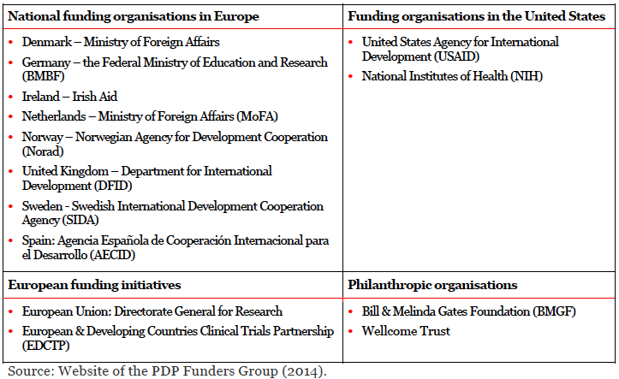 Source: Technopolis Group. Review of the PDP Fund (2011-2014)

The evaluation of DFAT’s 2013-2018 PDP investment with regard to its management and governance arrangements recommended that DFAT undertakes a much more strategic, proactive and engaged role with donor governments and other donors in the PFG in order to improve the effectiveness of the investment. This is consistent with the current trajectory, and moves from a traditional grants management relationship, to a more collaborative and participatory one. This can be achieved through engagement of a DFAT senior staff member as a focal point for PFG, actively participating at in-person PFG meeting(s) and PFG monthly calls together with support of the program manager. This will help bolster Australia’s growing role in the PDP space.

In addition to that, DFAT’s senior staff member, together with program manager, should engage in regular calls with selected PDPs and as required with relevant key partners and contractors with special focus on Indo Pacific, including the private sector.

DFAT staff should meet with PDP representatives in person on an annual basis, including further engagement of PDPs with Australian policy makers (e.g. see previous presentation to senate standing committee).

This approach to management and governance could help DFAT ensure greater alignment between DFAT’s investment and other PFG members’ investments, alignment in prioritization of the most relevant products and R&D activities, improved monitoring of performance, and better risk sharing. Furthermore, playing a greater leadership role on the PFG may allow DFAT to play a greater role in improving alignment of PDPs’ diagnostic and therapeutic portfolios for TB and malaria, resulting in more coordinated and accelerated development, fast-tracked WHO and / or national regulatory approvals and market access of new diagnostics and treatments.

For example, the PDP investment should be well integrated and seek coordination with other investments under the Health Security Initiative for the Indo-Pacific (e.g. partnership with Therapeutic Goods Administration (TGA) to build capacity in the South East Asia and Pacific regulatory authorities, initially by supporting activities under the Regional Regulatory Partnership (RRP) for Malaria Elimination under APLMA), as well as other DFAT investments outside of Health Security Initiative for the Indo-Pacific (e.g. bilateral investments in access side programs).

Representatives from academia, industry (pharma, biotech, diagnostics, vector control), Ministry of Health or regulatory authority representatives from “beneficiary” countries in the Indo Pacific, other PDP donors, as well as regional malaria and TB-related networks (e.g. Asia Pacific Leaders Malaria Alliance, Stop TB Partnership, Asia Pacific Malaria Elimination Network's Vector Control Working Group) will also be engaged as part of the investment, specifically as part of DFAT’s management approach (e.g. partnership with PDPs, facilitating coordinated approaches, influencing new investments, helping to shape related policies within the region). This work will help link to DFAT’s strategies under the Health Security Initiative for the Indo-Pacific (e.g. Australian leadership promoting policy dialogue on regional health security priorities; Develop networks and people-to-people linkages, sharing expertise between Australians and organisations in the region)

DFAT should consider appropriate ways to manage the resources of the investment to meet its strategic needs/interests. One approach would be to establish dialogue and reporting lines between the assigned program manager and senior official under the newly appointed Ambassador for Regional Health Security. The Ambassador could also undertake a role to represent DFAT at regional meetings which DFAT may initiate and organize to substantially advance regulatory processes, align development and accelerate access of products in PDPs’ portfolio (and related products or services supported by other DFAT investment) to populations in need. These meetings may bring together, in a focused and strategic way, partner governments, development and implementing partners, including the private sector, to address TB and malaria challenges and/or other health security challenges in Asia-Pacific. In this way, DFAT can leverage its funding to PDPs and use its influence in the region to promote dialogue, influence new investments, progress relevant policies, and maximize the potential of the PDP investment.

The selected PDPs should provide reports on an annual basis to DFAT, based on the new M&E framework. Additionally, selected PDPs should provide financial audit results, annual reports, and common PFG reporting requirements to DFAT on an annual basis. DFAT should maintain an option for any additional audits they may wish to secure from PDPs. DFAT leadership involved in the PFG should also aim to maximize coordination, alignment and harmonization of PDP-related M&E and reporting activities amongst donors so as to avoid duplication of efforts. Through the PFG, PDPs have established a shared annual reporting format which includes the PDPs own performance frameworks. Some donors, such as DFID have used the PDPs performance frameworks to populate their own logic models.  DFAT receives the harmonised report from the PDPs they fund, and the recommended logic model for this investment has taken these logic models into consideration.

*Implementation Plan*

To identify successful PDP grantees, DFAT could put out an open call for proposals under a proposed competitive grants program. The competition should be open to all PDPs with a focus on appropriate technologies for the Indo Pacific, including:

* Diagnostics and therapeutics for TB and malaria
* Vector control tools for malaria and high burden mosquito borne diseases

The selection panel described below would help facilitate this process.

Core funding may be provided for up to 4 PDPs upon selection and completion of grant negotiations/signature.

*Selection panel*

Given the scientific, financial and ethical considerations in investing in medical research through PDPs, and the depth of expertise and resourcing necessary to assess PDPs, it is proposed that DFAT’s grant process for this investment require the establishment of an ad-hoc expert Scientific Advisory Committee (SAC) for the purpose of PDP selection.

The SAC would be responsible for providing advice to assist with the selection of the PDPs under this investment’s requests for proposals (RFP) process, by applying scientific, technical, medical/clinical, and public health expertise, including knowledge of current and emerging issues related to PDPs, in their evaluation of proposals received. In addition to the initial proposal review and selection, the SAC could be convened on an annual basis at minimum, or at key reporting intervals to assist with monitoring, to review PDP reports, and provide DFAT with analysis and feedback on PDP performance. A sample framework for potential selection criteria for the PDPs to be selected under this investment is provided below.

The SAC would be convened and chaired by DFAT. .

Selection of SAC representatives should be designed to ensure requisite expertise and experience, and a variety of perspectives, promoting diversity and inclusiveness. Membership of the SAC as a whole should cover various areas of expertise, knowledge, and perspectives to the degree possible.

As a condition of appointment to the SAC, potential members will be required sign an "Affiliations and Interests Declaration Form". Such a form may be used to disclose to the selection committee any circumstances that may place, or be seen to place the member in a real, apparent, or potential conflict of interest.

While the previous investment (2013-2018) decision was able to “piggy-back” on an open call process already in place by the UK Department for International Development (DFID), and was deemed to have provided economies of scale and been an efficient and collaborative approach, the timing under the current investment was not aligned to allow for a similar process.

*Sample Selection Criteria*

. Alignment with the developed logic model for this investment, and the investment criteria for the Health Security Initiative for the Indo-Pacific should be noted. These considerations would need to be addressed by PDPs within the RFP process.

|  |  |  |
| --- | --- | --- |
| Selection Criteria | Description | Approximate Weighting (%) |
| PDP focus on:   * Diagnostics and therapeutics for TB and malaria * Vector control tools for malaria and high burden mosquito borne diseases |  | **Yes**/No  (if ‘Yes’, Continue) |
| Product pipeline (high-impact/late stage) | * Demonstrate overview of pipeline diagnostic and therapeutic products for TB and/or malaria, and/or vector control products for high burden mosquito borne diseases, with potential for high impact on target disease,   + provide detailed information on pipeline products in terms of development stage, clinical / diagnostic indications, risks, benefits and probability of impact on health (modelled DALYs, lives saved, etc.), poverty, and security, as well as projected timelines for each product. * Describe pipeline product/s that will be ready for registration in the next 3-5 years, including relevant milestones or requirements for development. * Describe pipeline products with particular relevance to targeted diseases in the Indo Pacific region, * Demonstrate compliance with global good clinical practice standards where relevant to particular products. | 40% |
| Contribution to access | Demonstrate contribution to access – where access is defined as availability and affordability of products – including extent of access-enabling initiatives and partnerships, where appropriate to the partnership model and/or product.   * These could include, but are not limited to, registering products for compassionate access schemes, understanding appropriate regulatory pathways, reducing time to registration of products, ensuring affordability to target markets, market analysis, and appropriate partnerships for regulation, procurement and distribution (where relevant?),…. | 10% |
| Achievements | Track record of registration of new TB, malaria and vector control products (medicines, diagnostics, vector control tools) to market in the previous 5-10 years. | 10% |
| Governance & Financial Management | Demonstrate organisational capacity to deliver against PDP strategy and objectives. Provide evidence of leadership, governance and management procedures of the PDP, including gender and disability breakdown of employees. PDPs should demonstrate appropriate risk management, and consideration of ethical issues, PDPs should demonstrate they have adequate financial management systems in place, including independent audits; | 10% |
| Gender and disability-sensitive research and capacity building focused activities in Indo Pacific | Demonstrate operational research and capacity building activities relevant to particular products, such as product trials or field studies which contribute to capacity building in research in countries in the Indo Pacific region. Able to provide evidence of contribution to gender-sensitive and social inclusive capacity building activities. | 10% |
| Budget | Demonstrate available funds, existing funding gaps, diversity of funding sources, provide breakdown of current funders. And proposed/projected allocation of core spending, | 10% |
| Partnerships | Demonstrate ongoing and appropriate engagement with key global health partners including multilateral institutes, academia, country governments, industry (e.g. manufacturing, distribution, implementation partners), Include detailed information on partnerships:   * + In the Indo Pacific region including specific mention of research institution partnerships in Australia   + Private sector partnerships   + Explicit nature of partnerships to be described. | 10% |

*Procurement Arrangements*

PDP services will be procured through an open and competitive request for aid grant proposals. The request for proposals will be advertised on the DFAT website. All PDPs with a focus on appropriate technologies for the Indo Pacific will be eligible to apply. Appropriate technologies include:

* Diagnostics and therapeutics for TB and malaria
* Vector control tools for malaria and high burden mosquito borne diseases

The SAC will assess and rank PDP proposals and make recommendations to DFAT about which PDPs to fund and for how much.

Semi-restricted or core funding of $15 - $20 million per PDP will be provided for up to 4 PDPs for an initial 3 year period. Specific allocations to successful PDPs will depend on proposals and pipeline and individual PDPs may receive differing amounts. Funding will be via aid grants, paid in annual tranches to successfully selected PDPs.

Following a review in year 3, it is proposed that an additional $25 million is allocated across performing PDPs, with specific top up funding amounts to be determined by the review.

*Monitoring and Evaluation (M&E)*

DFAT could consider a greater role for the SAC described in the Implementation Plan section above. The SAC could contribute to performance monitoring and agility in financing decisions. For example, after the initial 3 years, and based on performance of the PDPs during this initial investment period, the SAC could advise on the continuation (i.e. go-no-go), as well as the “top-up” levels, for the funded PDPs. This would serve as a form of performance-based funding prior to the potential 2-year extension for the selected PDPs.

The investment’s performance measurement framework, including outputs, outcomes, suggested indicators and their sources, as well as related assumptions/notes is in Annex 2.

The goal of the investment is to improve disease management through PDP technologies. This should be achieved through an intermediate outcome of increased access to PDP technologies.

Thus, by the end of the investment, stakeholders should be able to answer the question of whether the investment has helped to improve availability of new PDP technologies for TB, malaria, and potentially vector control for diseases other than malaria, particularly within the Indo Pacific region.

The investment’s M&E framework should be reviewed with each selected PDP to determine what indicators are already routinely collected by the PDPs, and what may require additional resources/efforts. It is expected that most of the suggested indicators, particularly up to the immediate/end of investment outcome level will be obtainable by the PDPs. In some instances, DFAT may wish to commission specific studies, or explore ways of incorporating into data collection activities associated with implementation/access related research being undertaken by PDPs. The indicators proposed will be of relevance to PDPs, and if not already being collected, are expected to strengthen their performance measurement activities/reporting.

PDPs should be encouraged to strengthen their performance measurement with regard to availability and access level indicators, without placing overly burdensome reporting requirements on them. Most PDPs seem to be moving in this direction, and should be encouraged to do so. DFAT is well positioned to support this transition.

DFAT may consider commissioning specific studies to acquire information on the greater integration with DFAT programs outside of the PDP investment and within the Health Security Initiative for the Indo-Pacific. For example, DFAT could explore whether operational research associated with bilateral TB or malaria programs operating in a recipient country (e.g. PNG, Indonesia) could incorporate any of the proposed indicators.

Examples of proposed indicators which may not be immediately available and require additional efforts by PDPs (as multiple PDP products have only recently begun to hit markets) may include[26]:

* Proportion of end-users (e.g. health professionals, patients, lab techs, medicine seller; may vary in public vs. private system) who find the product/tool affordable
* Proportion of eligible patients/at risk population who have geographic access (e.g. availability of product within 5-10km of household) to product/tool
* Proportion of eligible outlets in target area with stock of product on day of visit; total number of stock-out days of product in the previous month (avg. across sampled facilities)

In some instances, rather than commissioning specific studies to acquire such data, it may also be possible to cite external studies focused on the products being produced by PDPs, or the full suite of essential treatment/diagnostic options available to target populations (e.g. based on National TB/Malaria Treatment Guidelines or accredited laboratories). Donors and other PDP stakeholders should be encouraged to coordinate and harmonize their M&E efforts in this regard. The PFG should be used as the basis for ensuring this coordination.

The PDPs should report against the proposed template at least once a year, notifying DFAT where data is not yet available. It may be that for some of the indicators (as above), there are only limited opportunities to collect such data. These indicators may therefore only be reported against once towards the end of the investment or during a mid-term review.

A review commissioned by the PFG in 2007 suggested a new performance measurement framework with four areas of performance—R&D to commercialization, organizational strengths, enabling environments, and health impact—provided a structure, reflecting the challenging reality of PDPs’ efforts to bring new technologies to bear, and aimed to allow for disease/product versatility and individual PDP customization. The framework presents multiple options for consideration of what types of indicators may be useful across key PDP performance areas and the innovation life-cycle. As the report rightfully suggested, performance metrics need to be identified to match the specific objectives of each PDP. Referring to that framework[27], which also provides operational/process metrics, may be useful if supplementing the proposed logic model.

Another analysis [28], noted:

“One important point to keep in mind when trying to develop a common assessment framework for PDPs is the following central question: How should and can the performance of individual PDPs be assessed in a way that encourages:

* increases in funding overall;
* greater collaboration between PDPs;
* the best possible products;
* the best possible care for the end-users of these products.

The idea is not to develop a restrictive and punitive set of metrics or to develop a league table of PDPs, but rather to create a dialogue between the PDPs, donors and the global health community more broadly to ensure the best possible use of scarce resources.”

*Sustainability*

The outcomes of this PDP investment are expected to be self-sustaining beyond DFAT’s investment. The research and development associated with the medicines, diagnostics and vector control tools will be available and last well beyond the lifespan of the investment. With an increasing emphasis on access and uptake, PDPs are also working closely with industry to ensure sustainable business models built on market-based approaches (beyond the R&D).

Donor support is at the heart of the PDP model, thus, in reference to the broader approach, it would be unlikely to be sustainable in the absence of donor funding in the near term. That said, as a type of pooled funding mechanism, and assuming sufficiently diversified funding sources (see selection criteria), individual PDPs would be expected to continue if DFAT funding were to suddenly stop, albeit with challenges to the PDP.

As well as the direct focus on new products, most PDPs are also working to build capacity – to conduct related research in LMICs, and within the health systems that will make their products available.

For example, PDPs may collaborate with in-country partners to develop candidates in their pipelines, make direct investments to strengthen infrastructure in the communities where they work (including development of clinical trial sites), or work with regulators and health providers to ensure quality control and adequate training. Some PDPs are even focusing on how they can best leverage their connectivity enabled diagnostic devices, imbedded (currently or in the future) throughout LMIC health systems, to strengthen surveillance (e.g. resistance monitoring), health management information systems (HMIS), and other data automation.

*Gender Equality*

In developing countries, women and children are uniquely impacted by TB. TB is among the five leading causes of death, in low-income countries, among women of reproductive age and among adult women aged 20–59 years[29]. As a disease closely associated with poverty, TB poses a particular risk to women, killing almost half a million women each year[30]. Among pregnant women, TB is one of the leading causes of maternal mortality and pregnancy related complications[31]. Furthermore, pregnant women with TB have a high risk of transmitting TB peri- or postnatally. In 2009, there were approximately 10 million children orphaned as a result of TB deaths among parents[32]. While men are more likely to have latent TB infection, women are more likely to progress from infection to active disease[33], and poor women are less likely to receive diagnostic and treatment services[34].

Malaria in pregnancy is the most common yet preventable cause of maternal and perinatal morbidity and mortality in sub-Saharan Africa. Around 125 million pregnancies are at risk of malaria every year, and up to 200,000 babies and 10,000 mothers die as a consequence. WHO recommendations for the control of malaria in pregnancy are largely based on the situation in Africa, but strategies in the Asia-Pacific region are complicated by heterogeneous transmission settings, coexistence of multidrug-resistant Plasmodium falciparum and Plasmodium vivax parasites, and different vectors[35].

Malaria in pregnancy in the Asia-Paciﬁc region contrasts with that in Africa because many women are at risk in highly heterogeneous transmission settings. Irrespective of the number of children they have had, most pregnant women have little or no background immunity to malaria, so each infection is potentially fatal to mothers or fetuses. Prevention and treatment are complicated by different vectors, multidrug-resistant parasites (P. falciparum and P. vivax) and suboptimal dosing of antimalarials, such as artemether-lumefantrine. P. vivax can relapse throughout pregnancy when primaquine is contraindicated. The reduced birthweight of ﬁrst-born babies is similar to that recorded in Africa, but effects of symptomatic malaria in pregnancy (maternal death, miscarriage, stillbirth, or premature labour) seem to be more prominent in the Asia-Paciﬁc region38. Although malaria control and the introduction of artemisinin-based combination therapies in the general population has resulted in a substantial decline in prevalence of malaria, further efforts are needed from the national malaria control programmes and donors, because every infection in pregnancy is detrimental to mother and baby, with repercussions in infancy and childhood.

New antimalarial medicines that are well tolerated in pregnancy are urgently needed for both treatment and protection. Accordingly, PDPs focused on products for malaria are prioritizing the development of medicines and diagnostics to diagnose, treat and prevent malaria in women. For example:

* To protect pregnant women at risk of malaria, WHO recommends intermittent preventive treatment in pregnancy (IPTp) with sulfadoxine-pyrimethamine (SP). Today, IPTp coverage is very low – only 24% of pregnant women in sub-Saharan Africa receive the minimum dosing.[36] In addition, SP might one day lose its chemopreventive efficacy to drug resistance.
* MMV is developing a new combination therapy to improve the health of pregnant mothers and babies containing a fixed-dose combination of azithromycin and chloroquine (AZCQ), two drugs which are known to be well tolerated even in the first few weeks of pregnancy, when the baby is most vulnerable.
* Eurartesim (DHA-PQP) - investigators are considering its use as a potential chemoprotection option during pregnancy and as a drug for use in elimination campaigns;
* Highly sensitive RDT - detection of sub-microscopic infections in pregnant women

In the face of cultural gender biases in access to healthcare, PDPs also have projects aimed at ensuring equal access to gender responsive health services and health education, including for female caregivers and community healthcare workers.

To ensure gender effects are understood and taken into account when developing better products, efforts are made to include female patients in clinical trials as early as possible.

For most PDPs, specific enrolment numbers and gender breakdown are collected as a matter of standard operating procedure and gender analysis is done for all trials.

PDPs also regularly consider and report on how they are making research investments gender sensitive from a leadership/researcher/principal investigator perspective by providing a gender analysis of the research teams/leadership teams funded by the PDP.

*Disability Inclusiveness*

Within the call for proposals, PDPs will be asked to provide information (hiring practices related to people with disabilities, researchers in network with disabilities, proportion of product users with disability, etc.) on how they address disability inclusiveness within the PDP, as well as through the partnerships they develop

Studies have demonstrated that various barriers to accessing TB services for people with disabilities occur along the pathway to seeking health care, from contextual, social and individual factors influencing health seeking behaviour, to the encounter with health services, diagnosis and completion of treatment.[37] While barriers identified also apply to the general population these studies argue that the general access problems in a poor context have greater negative impact on vulnerable groups, such as individuals with disability, and that disability-specific barriers contribute to increase barriers to access health and TB services. Furthermore, health services assessed in the cited study were shown not to have equipment and sufficient competence to serve people with disabilities who needed TB screening and treatment.

A WHO priority is to enable populations to remain healthy, active and independent for as long as possible. Achieving the aforementioned goals requires early diagnosis, prevention and treatment of prevalent diseases (e.g., TB and malaria), reduction of their risk factors, managing disability, and delaying, managing, and preventing functional or cognitive decline. Creating socially supportive and inclusive environments whilst reducing inequities are essential in this. Health technologies (diagnostics, medicines, vector control tools) are indispensable tools to help achieve these goals

Estimates of the burden of disease in terms of disability-adjusted life years (DALYs) lost due to illness and death are 50 million for malaria and 65 million for TB (2013).

*Private Sector*

In the absence of an effective market and resulting lack of financial incentives to private sector investment, there has been limited private sector engagement and restricted innovation in the field of global health R&D technologies.

The PDP model has changed that, by partnering with the private sector to leverage expertise and skills. As a form of public-private partnership, PDPs incentivize and lower the risk associated with industry involvement with poverty related and neglected disease products. Under the PDP model, the private sector is able to contribute to the neglected disease R&D enterprise without having to bear the entire cost and risk themselves.

The extent of private sector engagement varies. Whereas some PDPs work closely with a number of pharmaceutical and biotech companies (e.g. through licensing agreements on compounds, or joint product development), others have more limited interactions with industry partners (e.g. for product manufacturing only).

PDPs are also a way for private companies to strengthen their brand and penetrate new markets.

PDPs leverage resources from private (and public) sector partners, including co-financing of costly late-stage clinical trials, infrastructure, in kind contributions, and access to intellectual property.

Private sector players outside of the pharmaceutical sector, such as Australia’s Newcrest Mining and Exxon Mobil, are also engaged with PDPs (i.e. MMV in this instance) in malaria elimination program (e.g. in Lihir Province, PNG), national advocacy and program support.

PDPs (e.g. TB Alliance) are also in the process of developing unique commercial strategies to garner competition and create a vibrant generic market for products (i.e. TB drugs), driving down prices.

*Risk Management Plan*

Specific examples of risks under this investment include (see Risk Register- Annex 5 - for more):

* Financial – Funding gaps; Lack of funding source diversity (e.g. BMGF funding as proportion of funds); Austerity and competing priorities drive OECD countries to reduce support for PDPs; if there is a significant switch from core funding to earmarked funding which may disrupt operational/financial model;
* Inherent risks associated with medical R&D (i.e. negative drug related events leading to reputational damage and withdrawal of support); process may or may not result in development of new and effective products.
* Launch and future directions of BMGF MRI. Initially will only focus on (1) therapeutics and vaccines for TB; (2) vaccines for malaria; and (3) vaccines for enteric and diarrheal diseases. But expansion plans and strategic direction as yet unknown.
* Development of further resistance to antimalarials and TB drugs.
* Industry support and engagement is not adequate; incentives not strong enough.
* Lack or limited/insufficient focus on access by PDPs and PDP stakeholders (including donors).
* Inadequate staffing and management from DFAT could mean not fully capitalizing on the investment.

Many of the risks identified can be mitigated through regular review of PDP processed:

* Selected PDPs should have a well-defined risk management strategy (see Governance section under proposed selection criteria), including a comprehensive risk register. The registers should be updated annually by management and reviewed by the Board annually as part of the Annual Plan discussions. DFAT (potentially through the SAC) should also review these registers on at least an annual basis. The Registers should cover discovery & preclinical, clinical & access, targeted diseases, mini-portfolios, business development, operations, regional offices, advocacy, fundraising, reputational risk, & financial. Identified risks should be matched with mitigation strategies.
* Other PDP risk management tools should include:
  + Internal control and audit processes;
  + Internal policies (e.g. conflict of interest, anti-corruption);
  + R&D guidelines, compliant with international standards and local regulations;
  + Internal Quality Assurance (QA) function; and
  + Insurance (including liability insurance for clinical trials)

Ad hoc risk reviews may take place if a particular risk emerges, with a clear pathway through management to the Board (if necessary), and to DFAT (where relevant).

*Safeguards*

The only safeguard issue that may pose a risk relates to child protection. Given that PDPs in the areas of interest under this investment include a focus on research and development of products for children, there is an inherent risk related to involvement of children as research subjects and potential adverse outcomes related to products under development (e.g. medicines). This is a risk that goes beyond children, and applies to all research subjects involved in clinical trials.

Some examples include:

Medicines for Malaria Venture:

* OZ439 is on track to potentially replace artemisinin and become a part of the much-needed one-dose cure for malaria. Currently in the product development stage, the next step for this new drug candidate is to get efficacy data in children.

TB Alliance:

* TB Alliance has ongoing and planned research on TB drugs in children (as well as pregnant women and HIV patients). These include studies that assess safety and tolerability, efficacy, optimal dosage and pharmacokinetics among these populations as well as drug-drug interaction studies to ensure optimal co-treatment is possible. For example, nearly 30 countries are currently in the process of introducing the new fixed-dose combinations that were registered under DFAT’s last investment in PDPs.
* Kenya is the first to roll-out the improved treatments on a national basis, while other countries are using the medicines in pilot projects to inform further scale up. In addition, other ongoing and future work includes:
  + Introducing child-friendly formulations of single-dose TB drugs (ethambutol and pyrazinamide) to improve the toolkit for childhood TB
  + Introducing child-friendly formulations of isoniazid, as part of a larger effort to prevent TB in vulnerable populations, including children under 5
  + Developing paediatric formulations of selected existing drugs to treat multi-drug resistant TB

With regard to the other safeguard issues, displacement and resettlement are not of concern under this investment, and PDPs should have a process in place to ensure the partners they work with are implementing environmentally responsible and sustainable business practices every day.

Please see Annex 5 for more information.

| **F: Annexes** |
| --- |

Annex 1: Draft Program Logic Model

Annex 2: Draft Performance Measurement Framework

Annex 3: Evidence of PDP Impact

Annex 4: Pipeline of Products for Poverty-related and Neglected Diseases

Annex 5: Risk and Safeguards Assessment

ANNEX 1: DRAFT LOGIC MODEL

|  |  |  |
| --- | --- | --- |
| **Timeline** | **Logic Flow Level** | **Expected Outcomes** |
| 2019 onward | **Goal/Ultimate Outcome/Impact**  **DRAFT** | Improved disease management through PDP technologies |
| 2018-2022 | **Intermediate Outcomes**  **DRAFT** | Increased access to PDP technologies |
| 2018-2022 | **Immediate/End of Program Outcomes** | Improved availability of new PDP technologies |
| 2018-2022 | **Outputs** | Robust Pipeline & Portfolio  Effective Partnerships  Contribution to accelerated access where appropriate and feasible |
| 2018-2022 | **PDP Role** | PDPs receive sufficient funding from diverse sources, and then fund and/or conduct product development activities for drugs, diagnostics, platforms and vector control tools |
| 2018-2022 | **Donor Role** | a DFAT convened Scientific Advisory Committee (SAC) recommends selection of PDPs with advice on funding allocations; DFAT manages grants and collaborative partnership with PDPs and other PDP stakeholders. |
| 2018 | **DFAT Inputs** | Up to $15M/yr across up to 4 PDPs for an initial 3 yr period, followed by a review and potential 2 year extension, for a total of 5 years (i.e. up to $75M).  Allocations may not be equivalent across selected PDPs, and will be decided based on PDP pipelines, products in late stage development, time to impact, funding gaps, etc.  Staff resourcing:  required skillsets  -at least one program manager, plus regular and engaged oversight from senior DFAT official (lead in meetings)  -technical background and experience in pharma/biotech/diagnostics/PDP  -experience working with stakeholders across multiple sectors including industry and researchers/academia  -health systems/integrated innovation lifecycle perspective  -Familiarity with global health product innovation processes (e.g. clinical trials, regulation, WHO processes, etc.) |

ANNEX 2 DRAFT PERFORMANCE MEASUREMENT FRAMEWORK

| **Logic Flow Level** | **Expected Outcomes** | **Sample Indicators** | **Sources** | **Assumptions/Notes** |
| --- | --- | --- | --- | --- |
| **Goal/Ultimate Outcome/Impact DRAFT** | Improved disease management through PDP technologies | Disease-Specific Incidence | World Malaria Report; Global TB Report; DHS, etc. |  |
| Disease-Specific Prevalence | World Malaria Report; Global TB Report; DHS, etc. |  |
| Disease-Specific Mortality | World Malaria Report; Global TB Report; DHS, etc. |  |
| Number of Lives Saved | Modelling studies (e.g. using LiST Tool), World Malaria Report/Global TB Report Mortality Reporting, Imperial College Impact Modelling |  |
| Number of countries in Indo Pacific reaching elimination phase | WHO surveillance data |  |
| **Intermediate Outcomes DRAFT** | Increased access to PDP technologies | Rational Use/Access Proportion of people using new product/tool who do so correctly | Commissioned studies; End-user surveys | Coverage indicators have been shown to lack specificity with regard to *how public health commodities/products are used, and whether they are used correctly.* For example, a coverage indicator that suggests 60% with a particular product may be less when considering whether the product is being used correctly (rational use). When considering access, this level of detail can be an important differentiator. |
| Improved User Satisfaction/Access Proportion of product-users who convey high satisfaction/Proportion of product-users who would use product the next time | Commissioned studies; End-user surveys | Both providers and patients constitute end-users |
| Improved Uptake/Access Estimated people cured per annum, based on introduction of novel medicines (and bioequivalent generics) (cumulative);   OR  Estimated people correctly diagnosed and put on treatment, based on introduction of novel diagnostic (cumulative) | Global Fund (GF) Price & Quality Reporting (PQR) database. Company-reported sales. Country procurement reporting. MIS surveys providing estimates of levels of correct case management (Tx of patients with confirmed infection) |  |
| Improved Coverage/Access Proportion of eligible patients/at risk population who use the product/tool | Commissioned studies; End-user/user-satisfaction surveys |  |
| **Immediate/End of Program Outcomes** | Improved availability of new PDP technologies | Cost/Access Proportion of end-users who find product/tool affordable | End-user/user-satisfaction surveys |  |
| Geographic/physical Availability/Access Proportion of eligible patients/at risk population who have access to product/tool (e.g. % of malaria suspects who have access to Malaria RDTs for febrile patients in target areas) | Procurement agency data; WHO surveillance data; Global RDT QC programme data |  |
| Geographic Availability/Access Number of disease endemic countries adopting new diagnostics/medicines/tools in their National Disease Control Programme Guidelines (disaggregated by disease and technology) | Country Disease Control Guidelines (TB, Malaria) |  |
| Physical Availability/Access Proportion of eligible outlets in target area with stock of product on day of visit  OR  Total number of stock-out days of product in the previous month (avg. across sampled facilities) | Facility/outlet records | Adequate forecasting   Facilities that carry products will vary by country system (e.g. public vs. private), and sampling strategy should be determined when establishing research/study methodology |
| Quality Assurance/Control  Number of complaints/product alerts (Reactive post-market surveillance)   OR  Proportion of lot verification testing with negative outcomes (proactive post-market surveillance) | Regulatory Authority Records; Manufacturer Records | National regulatory authorities and WHO play a role to collate complaints and ensure that manufacturers of WHO prequalified products are conducting post-market surveillance activities. Such data should theoretically be available. |
| Registration Number of successfully trialed new or modified products registered in countries in Indo Pacific (disaggregated by country, year and registration authority) | Country regulatory authorities; Manufacturer Records; PDP Records |  |
| Timeline Product time to registration  Product time to market | PDP Records | Measured against average times for equivalent products: e.g.avg. 10-15 yrs for drug; 6-7 yrs for diagnostic. |
| **Outputs** | Robust Pipeline & Portfolio | Number of treatments achieving WHO Prequal and/or Stringent Regulatory Authority (SRA) approval;   OR  Number of WHO (or recognized policy body) recommendations on new diagnostic technologies | PDP Annual Report/records;  WHO expert group and prequalification records/reports | This and the Robust Pipeline/Portfolio indicators below can also be consolidated into:   *Number and spread (pre-clinical, clinical, demonstration) of projects in development pipeline.*   Ongoing academic research and industry investment in new technology development will continue to yield fresh approaches. |
| Completion of late stage clinical trials for new and/or adapted product(s) within context of entire pipeline;   OR   Number of fit-for-purpose technologies completing all phases of the development process | PDP Records |  |
| Novel molecules entering human clinical trials (cumulative) | PDP Records |  |
| Number of New Chemical Entities (NCEs) recommended for inclusion in PDP portfolio as active project with clearly differentiated chemical series by Expert Scientific Advisory Committee (cumulative)  OR  Number of fit-for-purpose technologies recommended for inclusion in PDP portfolio as active project with clearly differentiated biomarker by ESAC | PDP Records; Target Product Profiles (TPPs) | For diagnostics - true innovation dependent on biomarker discovery  Significant number of NCEs and fit-for-purpose technologies at proof of concept phase. |
| Effective Partnerships | Number of agreements signed with partners following a due diligence process (by Type of Stakeholder - industry, academia, NGO, Government, etc. and Activity) | PDP Records | Includes Research Collaboration Agreements, Master Services Agreements, Clinical Trial Agreements, Material Transfer Agreements, Commercialization Agreements, Confidential Disclosure Agreements, etc. |
| Number of Australian Researchers/Institutions involved/supported by PDPs | PDP Records |  |
| Leadership & Management | TBC - leadership and leveraging funds |  |  |
| Contribution to accelerated access where appropriate and feasible | Number and type of operational/Implementation research or capacity building studies/projects | PDP Records | Weak health and laboratory systems hamper successful product uptake and rational use.  Country demand for capacity building continues to grow  Expanded access, sometimes called "compassionate use," is the use outside of a clinical trial of an investigational medical product. Regulatory authorities have procedures for obtaining access to human investigational drugs (including biologics) and medical devices in place.   E.g.'s of specific operational research/capacity building activities will vary by PDP and may include such areas as:   -Laboratories and /or testing sites strengthened (disaggregated data by disease and type of site and testing)  -Healthcare worker trainings on product (disaggregated by disease, trainee specialty and gender, and delivery method)  -Data generation/integration that informs the implementation/improvement of products produced by PDPs and in support of national health information systems (e.g. GeneXprt connectivity and automated HMIS integration; device & quality management; resistance monitoring & surveillance, etc.) |
| Number of product use cases (e.g. patient enrollment) granted on 'compassionate/expanded access' grounds | PDP Records; manufacturing/industry partner records |
| Number of countries in Indo Pacific provided with Technical Assistance related to adoption of new products | PDP Records |
| **PDP Role** | PDPs receive sufficient funding from diverse sources, and then fund and/or conduct product development activities for drugs, diagnostics, platforms and vector control tools |  |  | process indicators at this level may consist of:   # of sources of funding for PDP   % of funding from biggest funder for PDP |
| **Donor Role** | A DFAT convened Scientific Advisory Committee (SAC) recommends selection of PDPs with advice on funding allocations; DFAT manages grants and collaborative partnership with PDPs and other PDP stakeholders. |  |  |  |
| **DFAT Inputs** | Up to $15M/yr across up to 4 PDPs for an initial 3 yr period, followed by a review and potential 2 year extension, for a total of 5 years (i.e. up to $75M).   Allocations may not be equivalent across selected PDPs, and will be decided based on PDP pipelines, products in late stage development, time to impact, funding gaps, etc.  Staff resourcing:  required skillsets -at least one program manager, plus regular and engaged oversight from senior DFAT official (lead in meetings)   -technical background and experience in pharma/biotech/diagnostics/PDP   -experience working with stakeholders across multiple sectors including industry and researchers/academia  -health systems/integrated innovation lifecycle perspective  -Familiarity with global health product innovation processes (e.g. clinical trials, regulation, WHO processes, etc.) |  |  | Budget is approved   Staffing needs are met |
|

**Annex 3 – Evidence of PDP Impact**

An updated, in-depth, comparative analysis of impact across PDPs (to assess the PDP model/approach overall) is required, but was largely beyond the scope and timing of the evaluation associated with this investment design. Assessment of impact that was within scope can be found in the associated evaluation. Selected evidence from secondary sources is presented below.

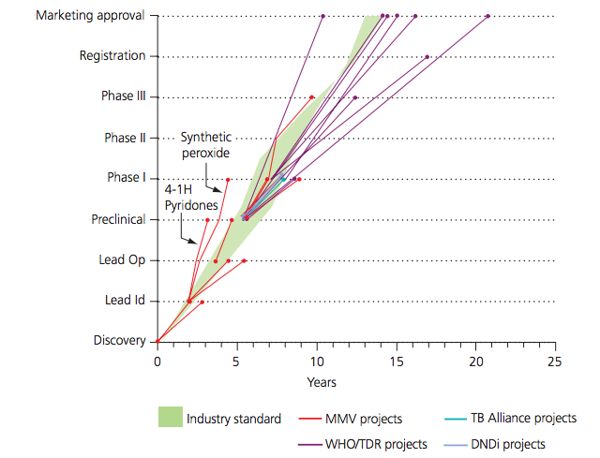

**Figure 1 – PDP Timelines**: *With the exception of WHO/TDR, PDP projects generally followed or exceeded standard industry timelines, with MMV being notably efficient. There appeared to be no correlation between speed of drug development and size of partner company, nor with the business model used (partnering or subcontracting), with the two fastest moving projects being synthetic peroxide and 4-(1H) pyridones. Factors associated with higher success were the PPP itself, and the level of resourcing for the individual project. For instance, the two most rapid projects were conducted by MMV, the PDP with the greatest funding and a high level of in-house industry skills, and both received additional funding from the BMGF to allow them to progress without restrictions as part of MMV’s ‘accelerated projects’ mini-portfolio. WHO/TDR’s slow performance, on the other hand, appears to reflect lack of funding (with one project on hold for several years) and lack of a primary drug-making focus, as well as structural issues and lack of in-house industry experience. A range of metrics, such as health value of the final products, level of innovation, development times and cost-efficiency were devised as part of the above analysis. Measurement of the various drug development approaches against the metrics showed that industry working alone and public groups working alone performed less well on these parameters versus PDPs. (*Source: Moran M et al. The New Landscape of Neglected Disease Drug Development. London. Wellcome Trust, London School of Economics and Political Science, 2005.

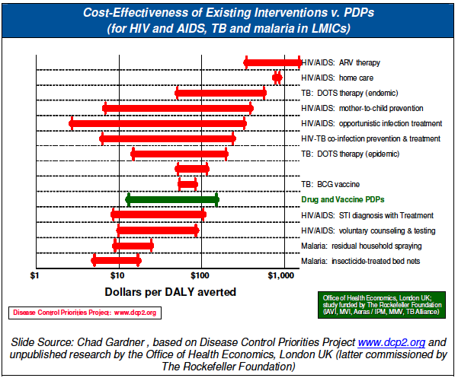

**Figure 2 – Cost Effectiveness of Existing Interventions vs. PDPs (for HIV/AIDS, TB, and malaria in LMICs):** *In a resource-scarce environment, one of the challenges for donors is justifying the need for investment in research to develop new technologies versus investment now in scaling up existing health technologies. New technologies are intended to be substantial improvements upon existing technologies, allowing higher uptake at lower cost of superior products in terms of quality, safety, effectiveness, etc. Even though their uptake is delayed versus uptake of existing technologies, on a cost per DALY basis, and assuming a long term horizon, investment in new technologies should compare favourably. Rockefeller-commissioned research (figure below) illustrates this; dollars per DALY averted for new PDP-developed technologies were well within the acceptable range of $15 to $120 and favourable in comparison to investment in existing technology scale-up. Thus it would seem that investment into new technology research is justified on cost-effectiveness grounds.*

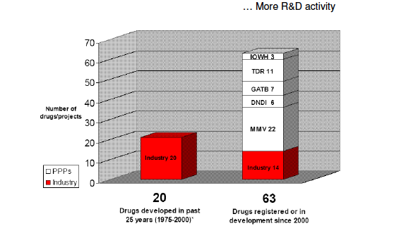

**Figure 3 - What has been the result of PD PPPs versus ‘pure’ industry participation in neglected disease R&D?:**  *There has been some empirical analysis to show that the PDP model is performing well, helping to justify it as an effective channel through which to support neglected disease product R&D. Wellcome Trust funded research led by Mary Moran – the Pharmaceutical R&D Policy Project - found that, within the drug sector, PDPs have been responsible for increased neglected disease R&D activity, increased effectiveness of that activity, and increased cost-efficiency of R&D activity. The figure above contrasts the pre and post PDP world (2000-2004), in terms of neglected disease drug R&D activity.*

*At standard attrition rates, it was projected that these projects would deliver 8 to 9 new neglected disease drugs between 2004 and 2009, as compared with the 13 new drugs developed for neglected diseases in 25 year period from 1975 to 2000. These projections were proven to be accurate.*

*(*Source: Moran M et al. The New Landscape of Neglected Disease Drug Development. London. Wellcome Trust, London School of Economics and Political Science, 2005.

**Annex 4 – Pipeline of Products for Poverty-Related & Neglected Diseases**

*This is the first comprehensive global picture of the neglected disease R&D pipeline since 2012. It looks at 34 of the 35 neglected diseases within the scope of G-FINDER survey (Ebola is not included), covering all product categories including vector control products, and all stages of research from early stage R&D through to product registration. The data is the result of a comprehensive review of the neglected disease R&D landscape conducted by Policy Cures in late 2015, and is presented as a snapshot of the pipeline as at October 2015. You can find a detailed explanation of the methodology behind this review and notes on the limitations of the data*[*here*](http://pipeline.policycuresresearch.org/#methodology_disclaimer)*.*

Note: On the pages that follow we list the **medicine and diagnostic** candidates for **TB and Malaria**, as well as all vector control candidates (across diseases). For more on the pipeline: http://pipeline.policycuresresearch.org/neglected-disease-product-pipeline-candidates-by-product-type/#drugs-pg3

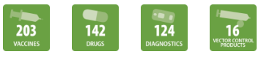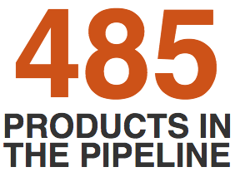

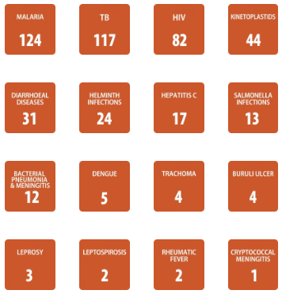

**PDP Specific Products for Malaria and TB:**

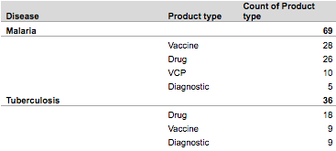

***PDPs specifically account for 56% of malaria products in the pipeline and 31% of TB products in the pipeline as of October 2015.***

**Source: Personal Communication with Policy Cures Research, September 2017.**

**MEDICINES - TB (51 Candidates)**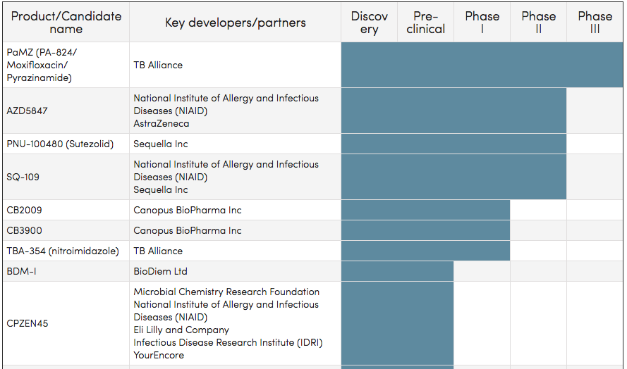

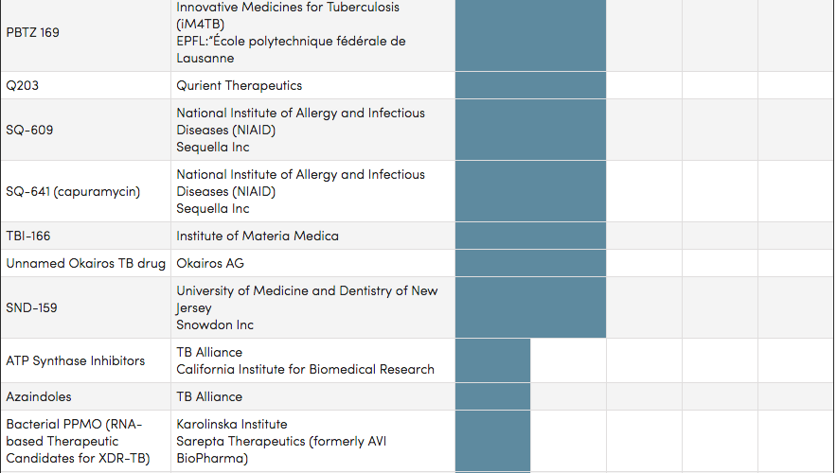

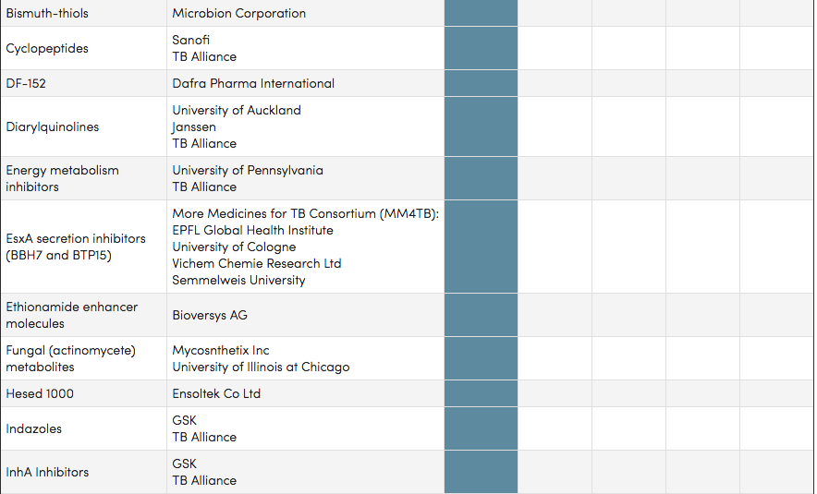

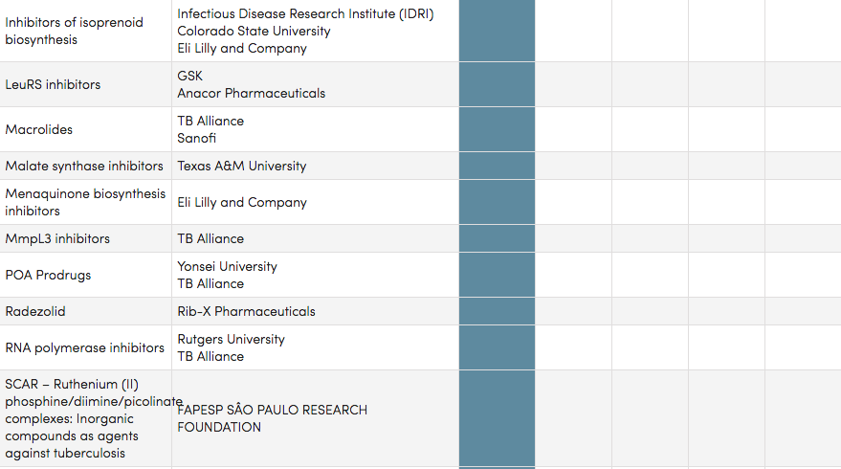

**Medicines - Malaria (45 Candidates)**

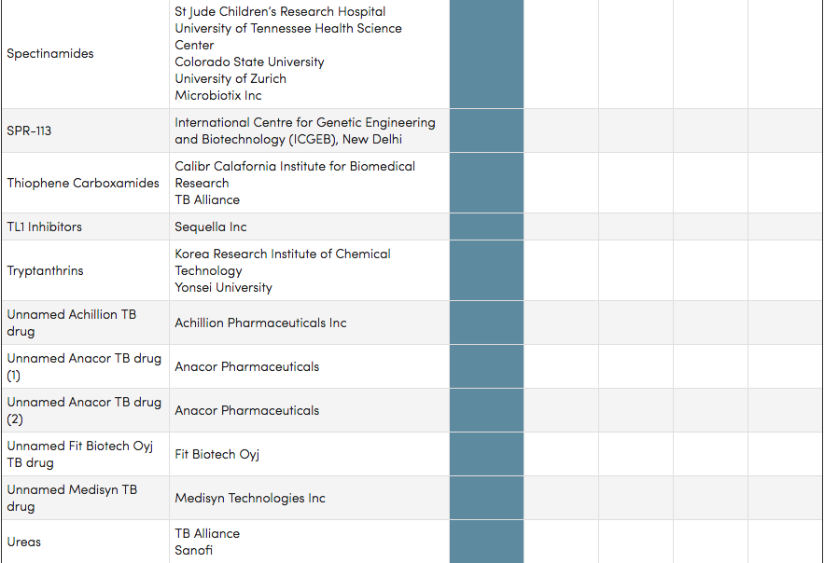

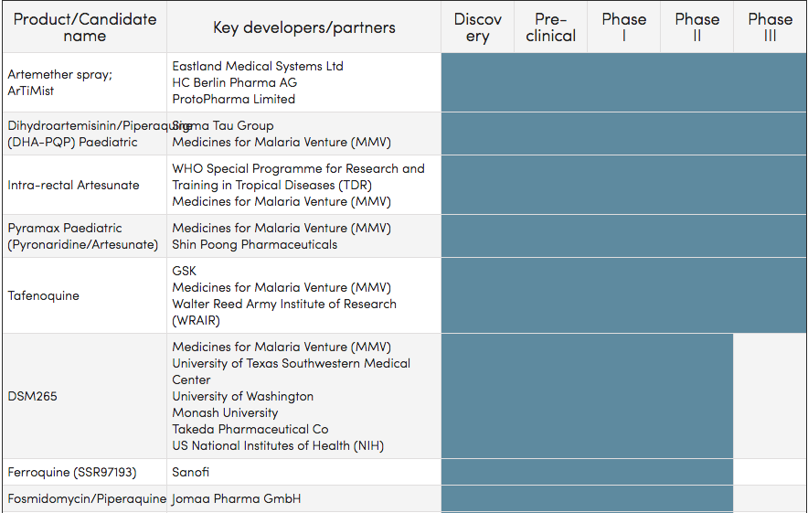

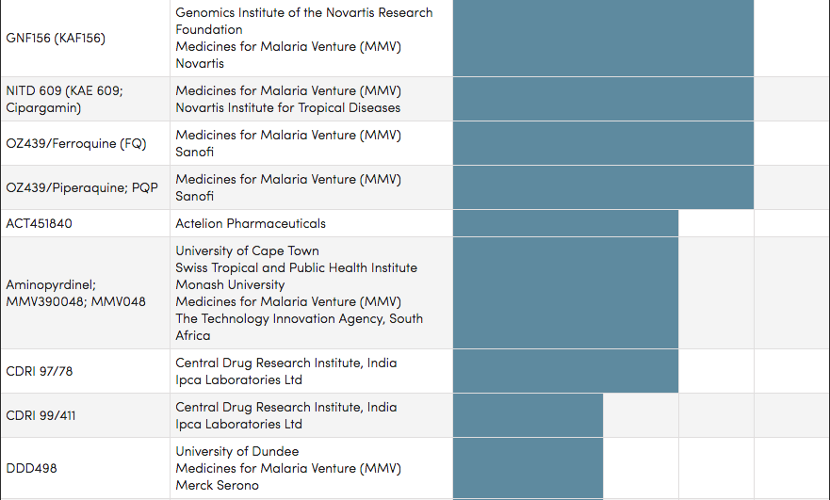

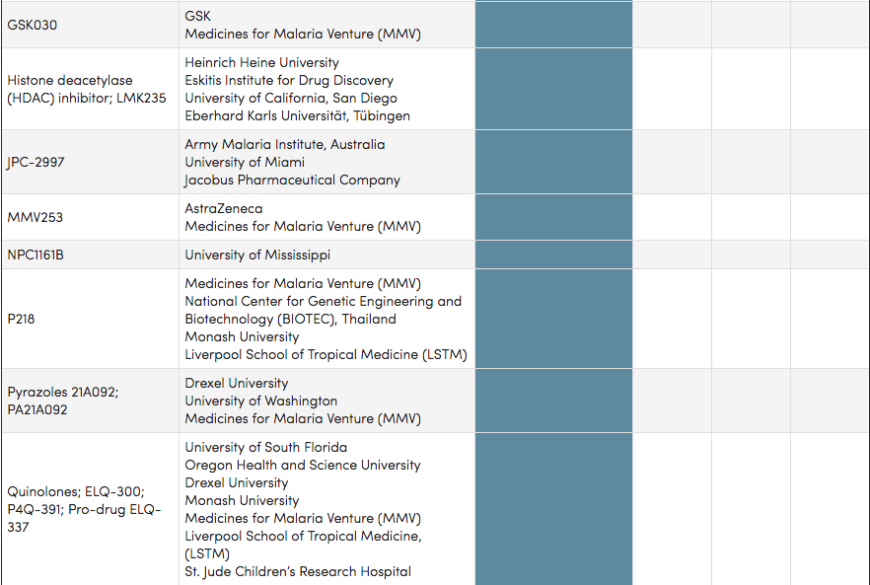

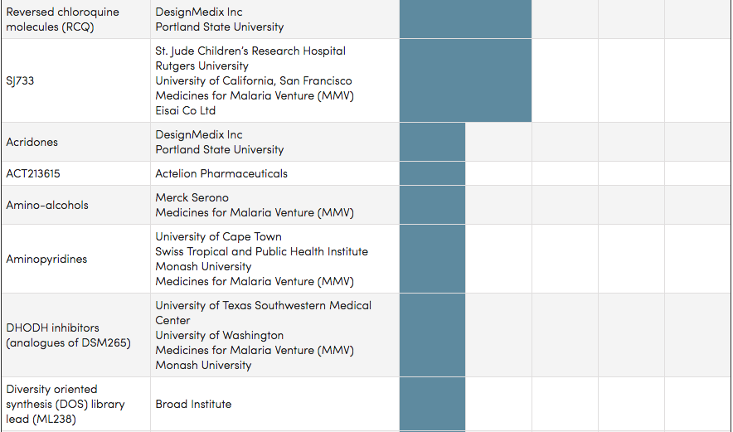

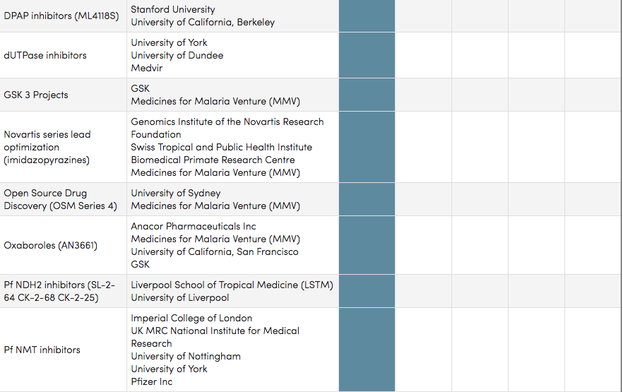

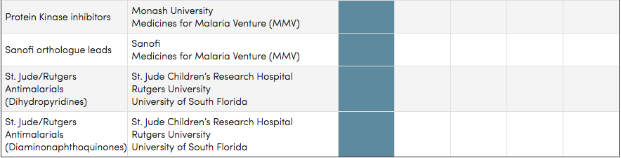

**DIAGNOSTICS – TB (42 Candidates)**

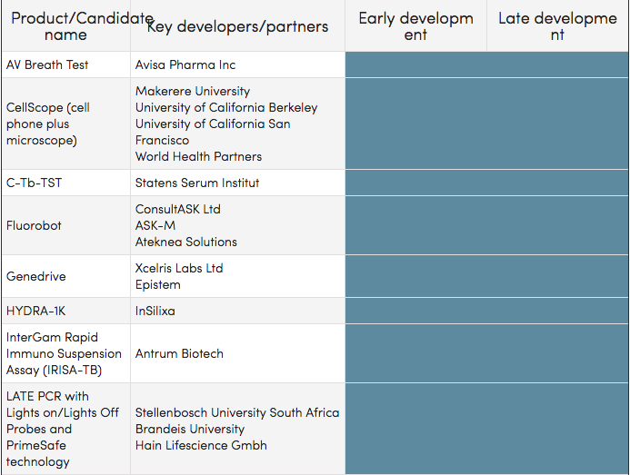

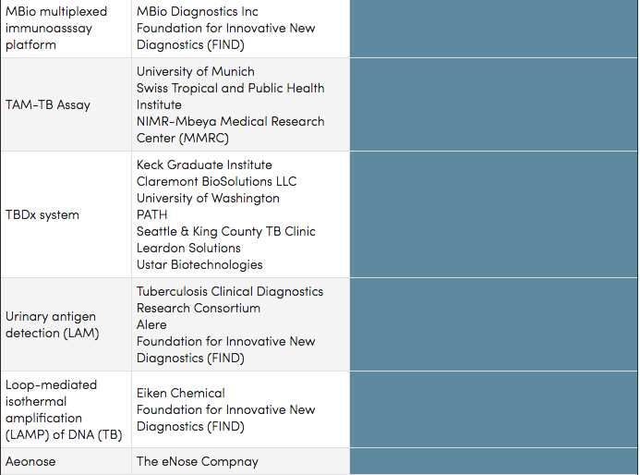

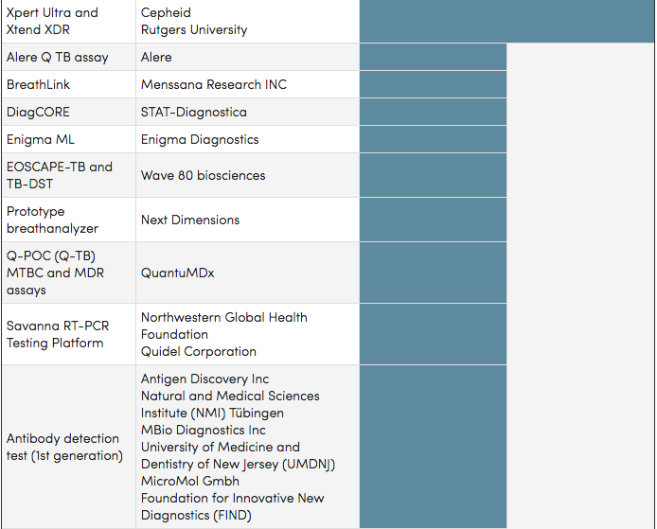

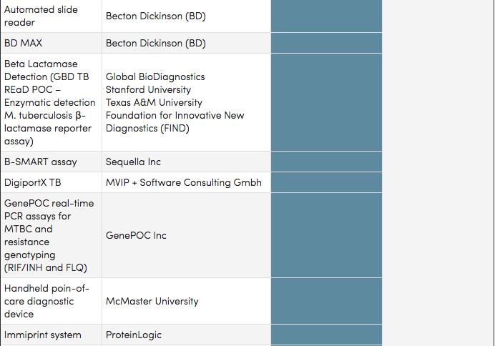

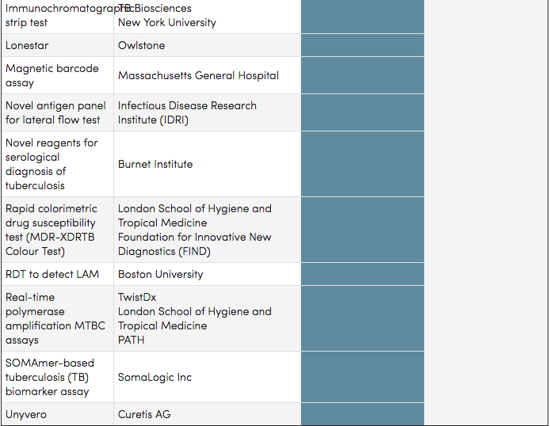

**DIAGNOSTICS – Malaria (28 Candidates)**

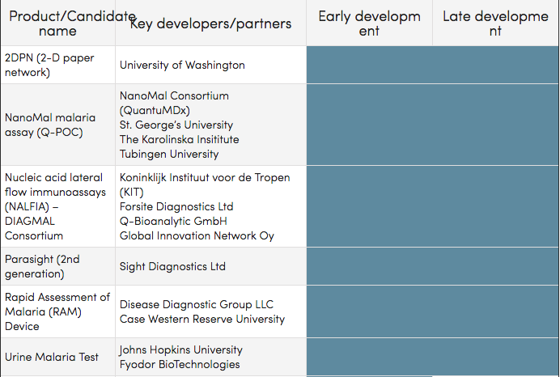

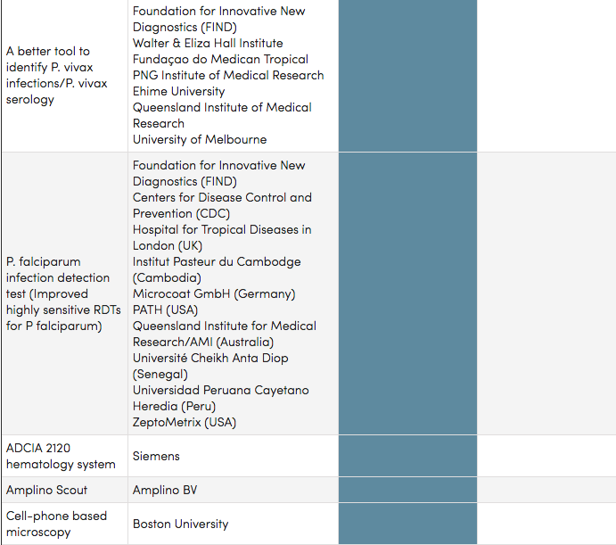

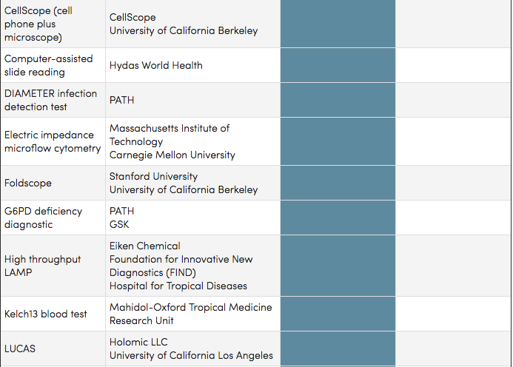

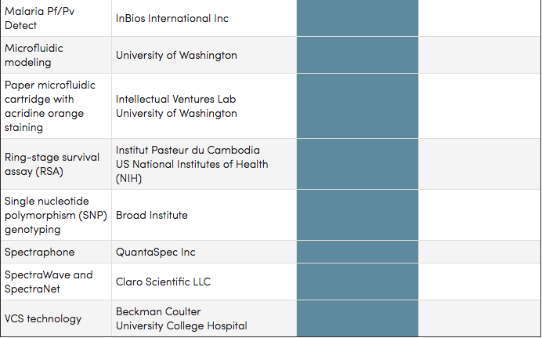

**VECTOR CONTROL – Malaria (12 Candidates)**

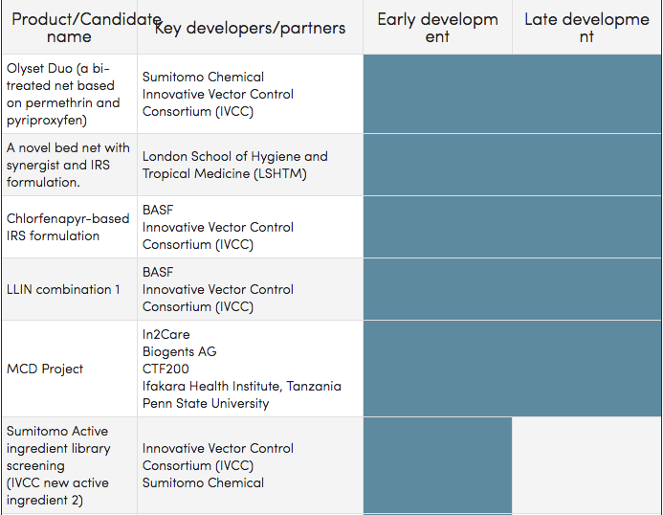

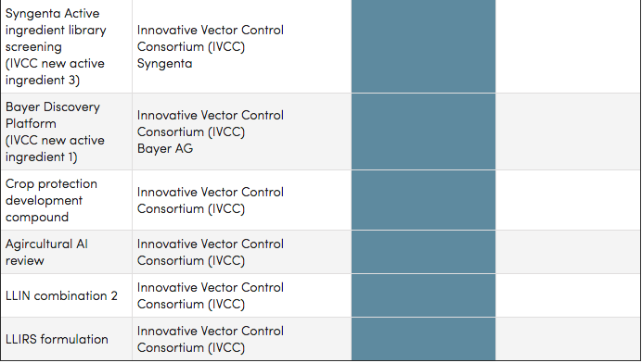

**VECTOR CONTROL – Dengue (2 Candidates) & Kinetoplastids -Sleeping Sickness (2 Candidates)**

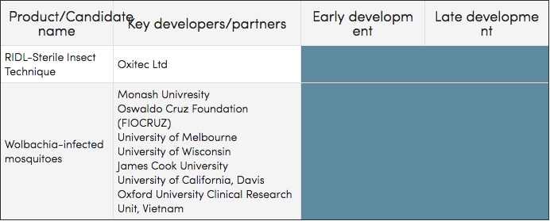

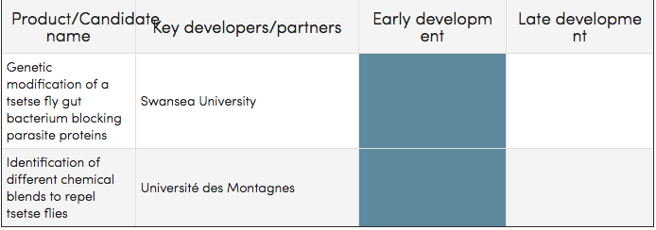

# Annex 5 Risk and safeguards assessment

#### Risk Assessment Tool

|  |  |  |  |
| --- | --- | --- | --- |
| **Value** | Likelihood | Consequence | Rating |
| 1. **Operating environment:** What factors in the operational or physical environment (political instability, security, poor governance, lack of essential infrastructure etc.) that might impact directly on achieving the objectives? |  |  |  |
| **Event/s**: Funding shortfalls due to a lack of investment in selected Product Development Partnerships (PDPs)  **Source**:Therapeutic and diagnostic development is lengthy and uncertain, leading to a need for stable long-term financing. The main identified risk associated with funding PDPs relates to funding sustainability as most funding to PDPs from public sector and private foundations is relatively short (between two and five years, while drug and vaccine development can take up more than 10 years).  In addition, ethical imperatives necessitate securing full funding for clinical trials before they begin. PDPs must identify and secure advanced funding commitments to progress such candidates through the pipeline (e.g. TB alliance’s BPaMZ and BPaL).  **Impact**: Full suite of PDP activities may not be supported, minimizing potential impact; may result in delays of critically needed new products for TB and malaria, or halting certain activities altogether. | Likely | Major | High |
| **Mitigation**  DFAT and other public funders should continue to support PDPs with long-term financing to ensure a steady stream of needed interventions for neglected infectious diseases. This funding should be mostly unrestricted or semi-restricted.  DFAT should encourage/support PDPs to seek diversity in their funding base to ensure they have the flexibility to set and follow their own strategy and not be driven by the requirements of a few larger donors.  Through proactive dialogue with their network of ongoing and new donors, PDPs should stress the critical importance of reliable, multi‐year funding commitments. DFAT, through the Partners Funding Group (PFG), may work with other donors to coordinate funding strategies, in collaboration with PDPs through various coalition approaches.  DFAT should also encourage PDPs to explore opportunities to predictably fund their development work and/or to offset R&D costs through innovative financing approaches, such as strategic management of their intellectual property and proprietary data assets for revenue generating purposes. | | | |
| **Event/s**: Investment does not result in new products to address poverty related and neglected diseases that have implications for health security in the region.  **Source**:An inherent risk within the PDP model, and R&D in general, is that the process may or may not result in viable/effective products; pipeline candidates might fail to advance through pipeline due to a variety of reasons, including adverse affects, instability, poor Target Product Profiles (TPPs), etc.  In addition, while evidence to date strongly suggests that early markers of treatment effect are highly predictive, the risk remains that assumptions based on findings from 2 week and 8 week studies prove unreliable in predicting Phase 3 results.  **Impact:** If the investment does not result in outcomes tax-payers could perceive this as wasted allocation of resources.  Unreliable prediction of future results and inappropriate advancement through pipeline. | Unlikely | Major | Medium |
| **Mitigation**  PDPs are essentially R&D organisations working on products that can take anywhere from 6-10 years, or more, to reach the market, so donor investment in PDPs must be viewed/accepted as a long-term (and risky) venture.  The portfolio approach of PDPs helps mitigate this challenge by focusing on multiple product candidates at once, only progressing the most promising candidates through the pipeline, while stopping pursuit of ineffective or less promising ones. The portfolio approach also increases the likelihood of overcoming the barriers to developing combination therapies, and decreases overall likelihood of failure. PDPs offer the public sector a way to invest in the development of the most promising selection of new interventions by sharing of risk and tapping into global networks, scientific and technical expertise, and various mechanisms (platform approaches, the screening of compound libraries for applicability against multiple diseases, selection of only the most promising candidates for later stage development, leveraging of finance and infrastructure from a range of different partners, etc.) that otherwise would not be available to them if they only funded projects on a bilateral basis.  To mitigate risks associated with predictive models, PDPs continuously evaluate the assumptions underlying them and seek to validate them through retrospective and prospective data analysis and feedback. To that end, PDPs may conduct assessments of their internal pharmacometric capacities, and based on those findings seek to bolster those capabilities internally.  DFAT could also communicate the importance of innovation in global health and the potential impacts, relay information on successful candidates and achievements to date (outcomes of last investment: e.g. paediatric fixed-dose combinations for TB; Pyramax tablets and granules for malaria; Eurartesim for malaria; highly sensitive rapid diagnostic test for malaria; etc.), educating the public on the R&D process, including its inherent risks and the potential pay offs. | | | |
| **Event/s**: External disasters  **Source**: A large portion PDP activities are conducted in high disease burden countries where the PDP may be exposed to risks such as political unrest, natural disaster, and even the potential for personal harm to staff and contractors (e.g. typhoon created several months’ delay when a shipment of drugs for a TB Alliance trial from India was ruined)  **Impact:** delays, harm to staff | Possible | Moderate | Medium |
| **Mitigation**  While it is difficult to control for such risks, DFAT should encourage PDPs to employ strategies to minimize the consequences of such events. These may include diversifying clinical trial networks to ensure that site difficulties in one location or region do not significantly impede the progress of the overall clinical program. Emergency protocols and backup measures should also be in place to minimize risk of personal harm and/or infrastructural damage in the case of complex emergency or natural disaster. | | | |
| **Event/s**: Exponentially greater costs as products reach stage III clinical trials and beyond resulting in greater budgetary needs; closely linked to risk “a” above.  **Source**: Product candidates reaching late stage clinical trials and shortfall of funding. The complexity, duration and scope of drug trials make such product development an extremely resource intensive endeavor.  **Impact**: The high cost of especially Phase 3 trials has been shown to be problematic and with current funding gaps will be stalled, delaying the confirmation and registration of critically needed new drugs and regimens for both TB and malaria. | Likely | Major | High |
| **Mitigation**  DFAT should encourage PDPs and be involved in mitigating this risk through advanced planning and effective relationship management geared at renewing and expanding funding partnerships with current donors. Donors, like DFAT, should continue to support PDPs and increase funding levels where possible. Simultaneously, through ongoing advocacy and outreach, PDPs should continue to aggressively pursue new bilateral, multilateral, and private funding sources and innovative financing options in order to close funding gaps. | | | |
| **Event/s**: Human Resources capacity challenges.   * DFAT fails to capitalize on the investment by taking a passive grants management approach * PDPs fail to attract and/or retain the talent needed to effectively execute their vision across different geographies   **Source**: Inadequate staffing and skillsets in place  **Impact**: Would pose a risk too overall effectiveness of PDPs and in the case of inadequate staffing within DFAT, the investment could fail to maximize its potential | Unlikely | Moderate | Medium |
| **Mitigation**  DFAT follows the proposed staffing recommendations.  PDPs engage in rigorous recruitment efforts, often with the assistance of regional and/or global search firms who understand the organization well and are able to align efforts with PDP needs. To ensure retention of its employees PDPs offer a stimulating environment, competitive compensation, and benefits packages. | | | |
| **Event/s**: Development of further resistance to antimalarials and TB drugs.  **Source**: Inappropriate/irrational drug use; failure to: prevent the spread of drug-resistant TB and malaria, adequately treat patients suffering from drug resistant forms of these diseases, failure to move the needle on eradication efforts. This is also why current investment in developing better tools for these diseases is so important.  **Impact**: Continued long term investment (i.e. even longer than might currently be required); worsened burden of illness. | Possible | Severe | High |
| **Mitigation**  By investing in new technologies/tools for global health, including for drug resistant TB and malaria, DFAT can help mitigate this risk. In addition, DFAT could invest in programs to educate the public and encourage adherence and rational use of medicines. | | | |
| 1. **Results:** How realistic are the objectives and can they be achieved within the timeframe? Are the objectives/results sustainable? Would the failure to achieve the results in the proposed timeframe, or at all, affect the targeted beneficiaries directly? |  |  |  |
| **Event/s**: Limited impact of products being developed  **Source**: A lack of focus on and expertise in ensuring availability and access limits the impact of products being developed.  **Impact**: Pending on what level of the proposed logic model DFAT chooses to assess up to (i.e. how the end of program outcome/objective is defined), the impact on the objective will, of course, vary. However, in general, if availability/access considerations are not adequately considered and addressed, products will fail to achieve their intended function. Challenges in this area may consist of products being unaffordable, end-users (e.g. patients, healthcare workers) not using the products, countries not adopting the products (where relevant), supply chain systems not getting products distributed to where they are needed, health system not having the capacity to leverage the product to inadequate capacity, training, or infrastructure, etc.  A recent DFID evaluation of PDPs found that: “Health impact is the ultimate priority of the donors and may be the fundamental mission of the PDPs, but their ability and responsibility to measure it is open to question.”[38]  If DFAT chooses to measure only up to the level of country registration of products, the risk (with reference to DFAT accountability) may be less, but the goal for investing in new products for poverty related and neglected diseases may not be met. | Unlikely | Severe | High |
| **Mitigation**  DFAT should encourage increased focus on access and support such activities of PDPs where possible. DFAT could consider allocating a small proportion of its funding for access related activities (a form of semi-restricted funding). | | | |
| **Event/s:** DFAT funds are not efficiently/effectively allocated and directed to the highest impact areas  **Source**: Inadequate selection processes and failure to recognise and respond to early warning signs of poor outcomes  **Impact**: Poor value-for-money of investment, program outcomes not achieved | Unlikely | Major | Medium |
| **Mitigation**  PDPs seem to have strong financial mechanisms and prioritization mechanisms in place (including Scientific Advisory Committees) to avoid this risk. DFAT should work closely and collaboratively with selected PDPs to track PDP allocation decisions and understand the choices being made. Through the PFG, donors should agree amongst themselves on the measures of impact and value for money, and to give clear guidance to PDPs where appropriate. | | | |
|  | | | |
| 1. **Safeguards** (see the checklist below)**:** Do any of the activities involved in this investment have the potential to cause harm relative to safeguard issues (child protection, displacement and resettlement and environmental protection)? |  |  |  |
| **Event/s**. Given that PDPs in the areas of interest under this investment include a focus on research and development of products for children, there is an inherent risk related to involvement of children as research subjects and potential adverse outcomes related to products under development (e.g. medicines). This is a risk that goes beyond children, and applies to all research subjects involved in clinical trials.  **Source**: A lack of adequate quality assurance standards or stringent research protocols.  **Impact:**  Reputational risk; adverse outcomes for patients | Unlikely | Major | Medium |
|  | | | |
| **Event:**  The development of medical products requires working with chemical compounds, some of which may be hazardous to eh environment.  Source: Production of pharmaceutical products in laboratories and manufacturing plants  Impact: Harmful chemicals may be released into surrounding land and waterways if not managed | Unlikely | Moderate | Low |
| **Mitigation**  Successful PDPs will be required to agree and comply with environmental safeguard clauses in the grant agreement. DFAT will only work with PDPs who partner with reputable pharmaceutical companies who have stringent policies on management of nay hazardous medical waste. Most have these in place already. | | | |
|  | | | |
|  | | | |
| 1. **Fraud/Fiduciary.** Are there any significant weaknesses which mean funds may not be used for intended purposes, not properly accounted for or do not achieve value for money? (Fraud Control and Anti-Corruption Strategies and Assessments of National Systems will assist in identifying significant risks.) |  |  |  |
| **Event/s** (what can happen): Funds provided to PDPs are misused or inappropriately managed  **Source**: Poor governance and financial management within the PDP or their implementing partner organisations  **Impact**: Depending on scale impact could be low to high | Unlikely | Low | Low |
| **Mitigation** – what (if known) can DFAT do to decrease the likelihood and/or consequence of the risk?  PDPs are entities which manage large sums of money from multiple partners who they are accountable to. PDP reporting include financial statements. PDPs will be required to demonstrate sound financial and governance systems including audit capacity as part of their proposals systems as part of the DFAT will reserve the right to conduct independent audits of PDPs if required. | | | |
| 1. **Reputation:** Could any of the risks, if they eventuated, cause damage to DFAT’s reputation? Could any aspect of implementation damage bilateral relations? |  |  |  |
| **a.**  Event/s: Reputational damage and/or withdrawal of support  **Source** : Adverse (e.g. negative drug-related) events related to products under development or products taken to market  **Impact:**  Reputational risk; adverse outcomes for patients | Unlikely | Minor | Low |
| **Mitigation**  DFAT should ensure PDPs have strong policies, protocols and guidelines in place for their research, including monitoring and reporting mechanisms. Most PDPs have these in place and have a track record of supporting high quality research (through partnerships). | | | |
| **b**  **Event:** There is a risk that through the open and competitive process currently funded PDPs do not receive funding. DFAT has already received unsolicited proposals from these PDPs and if these organisations are not successful, they may raise negative publicit**y.**  **Source:** Currently funded PDPs are not successful in obtaining funding through the open and competitive process.  **Impact:** This will have no impact on longer term results for the investment but may causes some impact for DFATs reputation |  |  |  |
| **Mitigation**  DFAT will proactively manage stakeholders by maintaining open dialogue and keeping partners informed. DFAT will conduct an open and transparent tender process with proposals being assessed based on merit by a team of experts. Unsuccessful PDPs will be given appropriate feedback. | | | |
| 1. **Partner relations:** Could a relationship breakdown occur with key partners or stakeholders and would this prevent the objectives/results from being achieved? Does the intended partner (if known) have the capacity to manage the risks involved with this investment? Could differing risk appetites affect the relationship? |  |  |  |
| **Event/s**: BMGFs new Medical Research Institute (MRI) decides to operate in the TB and malaria medicines and diagnostics space, or the vector control space.  **Source**: BMGF strategy shift  **Impact**: The establishment of the BMGF MRI has the potential to significantly influence the PDP landscape. Given that BMGF is a major funder of PDPs, accounting for a significant portion of many PDPs’ budgets, a decision by MRI to focus on similar areas to a selected PDP under the investment could lead to risk of funding shortfalls, competition for pipeline candidates, and in the worst case, the PDP not being able to sustain portfolio activities.  Current information is that the MRI will focus on efforts to accelerate translational research in three areas: (1) therapeutics and vaccines for tuberculosis; (2) vaccines for malaria; and (3) vaccines for enteric and diarrheal diseases. The only risk at this point, therefore, is in the overlapping interest area of therapeutics for TB. Future areas of focus are unknown. | Likely | Major | High |
| **Mitigation**  Plans for the MRI should be closely monitored through bilateral discussions with BMGF as well as through the PDP Funders Group (PFG) over the coming months, and consideration given to how their decisions will influence the options being considered by DFAT. Of particular focus should be the potential impact on PDPs focused on TB therapeutics (e.g. TB Alliance). Discussions with these PDPs should also be a priority, especially to get an understanding of their mitigation plans (e.g. focusing on partnership and leverage vs. competition), and funding strategies (i.e. diversification of sources). | | | |
| **Event/s**: Industry chooses not to actively engage with PDPs  **Source**: Not enough incentive for private sector participation  **Impact**: Los off expertise/skillsets/financial leverage and potentially weakened commercialization and scale-up strategy. | Possible | Major | High |
| **Mitigation**  DFAT should encourage PDPs to explore, or explore themselves (or through PFG), various incentives models being used to encourage private sector involvement in PDPs. PDPs should also be exploring innovative partnership models and platforms to involve the private sector (e.g. TB Alliances innovative commercialization strategy working with various generic producers, global business coalitions, advanced market commitments, etc.) | | | |
| 1. **Overall Risk Rating: (see Figure 1)** | High-risk | | |

#### Figure 1: Determining the risk rating for the Investment Concept

|  |  |  |  |  |  |
| --- | --- | --- | --- | --- | --- |
| **Likelihood** | **Consequences** | | | | |
| **Negligible** | **Minor** | **Moderate** | **Major** | **Severe** |
| **Almost Certain** | **Medium** | **Medium** | **High** | **Very High** | **Very High** |
| **Likely** | **Medium** | **Medium** | **High** | **High** | **Very High** |
| **Possible** | **Low** | **Medium** | **Medium** | **High** | **High** |
| **Unlikely** | **Low** | **Low** | **Medium** | **Medium** | **High** |
| **Rare** | **Low** | **Low** | **Medium** | **Medium** | **High** |

Safeguards Screening Checklist

|  |  |  |  |
| --- | --- | --- | --- |
|  | Yes | No | Not Sure |
| **Child protection**[39] |  |  |  |
| 1.1 Did the outcome of the child protection risk context assessment indicate a full assessment is required? [40] | X |  |  |
| 1.2 Is the investment likely to involve contact with or access to children (0-18 years old) due to the nature of the activity or the working environment? | X |  |  |
| 1.3 Will the investment involve personnel working with children? | X |  |  |
| **Displacement and resettlement** |  |  |  |
| 2.1 Does the investment involve construction on: exclusion from: or repurposing of land that is occupied, accessed to generate livelihoods or of cultural or traditional importance? |  | X |  |
| 2.2 Does the investment’s success depend on other development activities that may involve construction on; exclusion from; or repurposing of land that is occupied, accessed to generate livelihoods; or of cultural or traditional importance? |  | X |  |
| 2.3 Does the investment involve planning for, advising on or designing the economic or physical displacement of people to make way for infrastructure development, disaster risk reduction or exclusion of the local population from land accessed to generate livelihoods? |  | X |  |
| **Environment** |  |  |  |
| 3.1 Will the investment support any of the following:   * + - * medium to large-scale infrastructure such as roads, bridges, railways, ports, infrastructure for energy generation; or       * development of irrigation and drainage, diversion of water; or       * land clearing, intensification of land use; or       * hazardous materials and wastes; or * activity in mining, energy, forestry, fisheries, water supply, urban development, transport, tourism or manufacturing sectors? |  | X |  |
| 3.2 Will the investment support any of the following:   * + - * small to medium scale infrastructure such as localised water supply and/or sanitation infrastructure; irrigation and drainage; rural electrification, rural roads; or       * construction/renovation/refurbishment/demolition of any building for example: schools, hospitals or public buildings; or * localised use of natural resources, including small-scale water diversion, agriculture, or other types of land-use change? |  | X |  |
| 3.3 Will the investment contribute to, directly or indirectly, or facilitate, activities such as those listed above, including through:   * + - * trust funds, procurement facilities; or       * co-financing contributions; or       * support for planning, change to regulatory frameworks, technical advice, training or; * applied research? |  | X |  |
| 3.4 Has an environmental review of the proposed investment already been, or will be completed by an implementing partner or donor? |  |  | X |
| 3.5 Does this investment need to meet any national environmental standards or requirements? |  | X |  |

1. Institute for Health Metrics and Evaluation (IHME). Global Burden of Disease Study 2015 (GBD 2015) Location Hierarchies. Seattle, United States: Institute for Health Metrics and Evaluation (IHME), 2017. Available from: http://www.healthdata.org/data-visualization/gbd-compare
2. Hotez PJ, Pecoul B (2010) "Manifesto" for advancing the control and elimination of neglected tropical diseases. PLoS Negl Trop Dis 4: e718. pmid:20520793
3. Hemingway J, Shretta R, Wells TNC, Bell D, Djimdé AA, Achee N, et al. (2016) Tools and Strategies for Malaria Control and Elimination: What Do We Need to Achieve a Grand Convergence in Malaria? PLoS Biol 14(3)
4. Jamison DT, Summers LH, Alleyne G, Arrow KJ, Berkley S, Binagwaho A, et al. Global health 2035: a world converging within a generation. Lancet. 2013;382(9908):1898–955.
5. Cohen JM, Smith DL, Cotter C, Ward A, Yamey G, Sabot OJ, et al. Malaria resurgence: a systematic review and assessment of its causes. Malar J. 2012;11:122. 
6. Buse K, Walt G. Global public–private partnerships: part 1 – a new development in health? Bulletin of the World Health Organization, 2000, 78(4):549–561.
7. Incentives for the development of poverty related and neglected disease technologies can be categorized into “push” and “pull” categories. “Push” funding policies aim to incentivize industry via reduced costs during the R&D stages, whereas “pull” mechanisms create incentives for private sector engagement by creating viable market demand. Push mechanisms pay for “effort” on the part of researchers, by underwriting the cost of that effort, while pull mechanisms pay for “results”. Donors supporting PDPs with direct grants would fall under the “push” category, while on the “pull” side, there have been increases in development assistance for health (e.g. USD $70B in 2000 to USD $142B in 2016). Much of this has been routed through global health institutions such as the Global Alliance for Vaccines and Immunisation (GAVI), the Global Fund for AIDS, TB and Malaria, and UNITAID. It is estimated that about 40% of Global Fund grants are used for health commodity purchase and a much higher percentage of GAVI and UNITAID funds are directed towards commodity purchase. These funds send “pull” signals to industry that a credible market exists, though the strength of these signals is limited because the financial amount is not pre-defined well in advance, donors are not legally obligated to honour their funding commitments, and the products, volumes and purchase price are not committed in advance. (Source: Grace C. & Kyle M. Comparative advantages of push and pull incentives for technology development. Global Forum Update on Research; 6: 147-151).
8. MMV’s mandate was revised to include facilitating access to new anti-malarials and address the goal of eradicating malaria; FIND recently hired a Chief Access Officer; TB Alliance has established a “Pathways to Patients” Framework and an Access Advisory Committee (AAC); PDPs are now actively engaged in developing access strategies and phase 4 studies
9. “When you look at how much has been spent and how many products, I mean, I think the latest is that something like 93 candidates are in development - that’s vaccines, drugs and diagnostics. And that number changes every day. Instead of reducing that number, we’ve seen ten times more than were in clinical testing 10 years ago. And even if you do the math and you say (US)$3 billion, for that many products, that’s very good value for money.” – Hannah Kettler, BMGF as quoted in: Kondro W. “The best or the worst” end up in product development partnerships. CMAJ : Canadian Medical Association Journal. 2010;182(17):E761-E762
10. G-Finder Report 2016. Available at: <http://www.policycuresresearch.org/g-finder-2016/>; All amounts are reported in US currency.
11. A platform technology is a group of enabling technologies that are used as a base on which other applications, processes or technologies are developed. They function as innovation catalysts, and facilitate the development of follow-on technologies. The GeneXpert,for example, is a multi-disease testing platform that dramatically simplifies molecular testing by fully integrating and automating the three processes required for real-time PCRbased molecular testing: sample preparation, amplification, and detection.
12. Intermediaries act as coordinating agencies, receiving funding from multiple sources and passing this on to researchers and developers (either directly or via PDPs). They may also perform research themselves (often operational research, or research into existing treatment regimens) or be involved in clinical trials of novel products being developed by other organisations. They also aim to accelerate neglected disease product development, but do so without managing a product portfolio of their own. Examples of non-PDP intermediaries include the European & Developing Countries Clinical Trials Partnership (EDCTP), Global Health Innovative Technology Fund (GHIT Fund), International Union Against TB and Lung Disease (The Union), and the Barcelona Institute for Global Health (ISGlobal). There are only a small number of intermediary organisations, and government funding (in particular) to intermediaries is usually very geographically-driven. For example, essentially all funding to intermediaries from the EU, the Swedish SIDA, the UK DFID and the UK MRC went to the EDCTP; USAID channelled its intermediary funding through The Union; the Japanese Government contributed to the GHIT Fund; and Spanish public sector organisations funded ISGlobal.
13. G-Finder Report 2016. Available at: http://www.policycuresresearch.org/g-finder-2016/
14. Ramchandani R. Emulating Commercial, Private-Sector Value-Chains to Improve Access to ORS and Zinc in Rural Zambia. Available at: https://jscholarship.library.jhu.edu/handle/1774.2/39229
15. Ditiu L & Boehme C. Crossing the Valleys of Death in TB: From Development to Roll -Out. Available at: http://gbchealth.org/crossing-the-valleys-of-death-in-tb-from-development-to-roll-out/
16. Note this is different from the TB Drug Accelerator Program; <http://www.stoptb.org/news/stories/2016/ns16_052.asp>; Ditiu L & Boehme C. Crossing the Valleys of Death in TB: From Development to Roll -Out. Available at: http://gbchealth.org/crossing-the-valleys-of-death-in-tb-from-development-to-roll-out/
17. Mahoney RT. Product Development Partnerships: Case studies of a new mechanism for health technology innovation. Health Research Policy and Systems. 2011;9:33; Malaria No More. Staying the Course: Malaria Research and Development in a Time of Economic Uncertainty (2011), Available at: <http://www.malariavaccine.org/files/RD-report-June2011.pdf> this report notes that the rise in malaria research funds had led to the largest pipeline ever of new drugs, vaccines, insecticides and diagnostics, of which PDPs accounted for over half. PDP Backgrounder. Achievements to Date. Available at: https://www.finddx.org/wp-content/uploads/2016/03/PDP_Brief_ENG_final_Sep_2014.pdf
18. . Trouiller P. et al. Drugs for neglected diseases: a failure of the market and a public health failure? Trop Med Int. Health. 2001;(11):945-51.
19. Chapman N, Abela-Oversteegen L, et al. Neglected Disease Research and Development: A Pivotal Moment for Global Health. G-FINDER | 2016. Sydney: Policy Cures; 2017. 
20. Global Health Technologies Coalition. Return on Innovation, 2017. Accessed at: http://www.ghtcoalition.org/pdf/Return-on-innovation-Why-global-health-R-D-is-a-smart-investment-for-the-United-States.pdf
21. Policy Cures. The Unrecognised Revolution in Global Health: Neglected Diseases Pipeline Report 2015. Available at: http://policycures.org/downloads/ND%20Pipeline%20Report%202015%20web.pdf
22. Personal Communication. Policy Cures Research. E-mail correspondence on 13/09/2017 with Vipul Chowdhary, Analyst.
23. Ndung'u JM, Bieler S, Roscigno G (2010) “Piggy-Backing” on Diagnostic Platforms Brings Hope to Neglected Diseases: The Case of Sleeping Sickness. PLoS Negl Trop Dis 4(5): e715
24. Independent Evaluation Group. The Medicines for Malaria Venture. Washington, DC: World Bank; 2008.
25. **Restricted funding** – The funds can only be used for a specific and named purpose and any changes to or reallocation of these funds has to have the prior approval of the funder. **Semi-restricted funding** – the funders restrict the use of their funds to specified diseases or patient/population groups, but the funded organisation can reallocate the funds between individual projects in order to target the resources at the most productive ones. **Unrestricted/Core funding** – The funded organisation has complete flexibility to allocate resources between projects and portfolios to ensure that resources are targeted at the most productive ones. However, while these definitions are generally agreed, their detailed interpretation may vary between PDPs and reported data may reflect these detailed differences in interpretation.
26. See Logic Model for sources and assumptions
27. http://www.fsg.org/downloads?file=5126&nid=4711&cmpn=70170000000HyCxAAK
28. Sunderam, L. (2008). Issues in assessing product development partnerships (PDPs) in Health Partnerships Review, Global Forum for Health Research. Available at: http://announcementsfiles.cohred.org/gfhr_pub/assoc/s14813e/s14813e.pdf
29. M. Temmerman, R. Khosla, L. Laski, Z. Mathews and L. Say. (2015). Women’s Health Priorities and Interventions: EWEC Technical Content Workstream Working Group on Women’s Health.
30. Global TB Report 2016. Avaailable at: http://www.who.int/tb/publications/global_report/en/
31. Mathad JS, Gupta A. **Tuberculosis in Pregnant and Postpartum Women: Epidemiology, Management, and Research Gaps.** [**Clin Infect Dis**](https://www.ncbi.nlm.nih.gov/pmc/articles/PMC3491857/)**. 2012 Dec 1; 55(11): 1532–1549.**
32. Diana M. Castañeda-Hernández and Alfonso J. Rodriguez-Morales (2013). Epidemiological Burden of Tuberculosis in Developing Countries, Current Topics in Public Health, Dr. Alfonso Rodriguez-Morales (Ed.), InTech, DOI: 10.5772/53363. Available from: https://www.intechopen.com/books/current-topics-in-public-health/epidemiological-burden-of-tuberculosis-in-developing-countries
33. Kim JY, Shakow, A, Castro A, Vande C, Farmer P. Tuberculosis Control: The Burden of TB: Social Burden. Available at: http://www.who.int/trade/distance_learning/gpgh/gpgh3/en/index5.html
34. World_Health_Organisation. Global tuberculosis report 2015 WHO/HTM/TB/201522 2015.
35. Rijken, Marcus & McGready, Rose & E Boel, Machteld & Poespoprodjo, Rini & Singh, Neeru & Syafruddin, Din & Rogerson, Stephen & Nosten, Francois. (2012). Malaria in pregnancy in the Asia-Pacific region. The Lancet infectious diseases. 12. 75-88.
36. van Eijk, A.M., et al., *Coverage of intermittent preventive treatment and insecticide-treated nets for the control of malaria during pregnancy in sub-Saharan Africa: a synthesis and meta-analysis of national survey data, 2009-11.* Lancet Infect Dis, 2013. 
37. Grut L, Sanudi L, Braathen SH, Jürgens T, Eide AH (2015) Access to Tuberculosis Services for Individuals with Disability in Rural Malawi, a Qualitative Study. PLoS ONE 10(4)
38. https://assets.publishing.service.gov.uk/media/57a0897140f0b649740000b0/Evaluation_of_the_Product_Development_Partnerships_funding_activities.pdf
39. Answers to these questions will need to be logged in Aid Works under the policy marker questions.
40. The Child Protection risk assessment guidance can be found on the intranet.