Engaging the pRivate Sector in development

Guidance note

February 2020

Contents

1. Overview 2

2. Principles 6

3. Partnerships 8

4. Cross-cutting themes 10

5. Risk 12

Annex 1: Minimum Concessionality Flowchart 15

Annex 2: dced DECISION-MAKING FLOWCHART TO DEMONSTRATING ADDITIONALITY 15

Annex 3: sIX STAGES OF THE PARTNERSHIP CYCLE 17

## Overview

Australia's aid policy requires all aid investments to explore innovative ways to promote private sector growth and/or to engage with the private sector to achieve development outcomes.

Business partnerships are critical to narrowing the annual US$2.5 trillion investment gap to achieve the Sustainable Development Goals by 2030. Partnerships support Australia’s commitments to the Sustainable Development Goals, particularly SDG 8 – [Decent work and economic growth](https://sustainabledevelopment.un.org/sdg8) and SDG 17 – [Partnerships for the Goals](https://sustainabledevelopment.un.org/sdg17)*.* Working more closely with business helps DFAT better understand what is happening in country, promotes economic growth, reduces poverty and transitions from aid relationships to economic partnerships with developing countries.

Private sector engagement will strengthen DFAT’s knowledge, capabilities, develop our culture and modernise our systems, embedding consistent approaches to partnership with business. It complements our existing engagements with governments and civil society and aligns with DFAT's Economic and Commercial Diplomacy Agenda, to amplify the impact of Australia's development assistance. Working in partnership with private sector provides opportunities for staff to leverage partner resources and networks, co-develop solutions, and proactively manage risks.

Engaging with the private sector can better support the Department to design and achieve its Aid Investment Plan (AIP) objectives and build an awareness of the private sector environment in-country. Including the private sector in the program planning and design phase of an investment allows DFAT to harness its unique resources, innovation, knowledge and connections, providing additional value to the Department. Innovative ideas, combined with DFAT’s networks and capabilities, can maximise the impact of investments. Engaging the private sector in concept, design, implementation and performance management provides the Department with additional delivery partners beyond traditional partners, presenting value for money, effectiveness, opportunities for scale and new ways of working. The private sector is well suited to implementing particular types of development assistance investments where there is alignment with their core business objectives or areas where they have expertise.

This guidance note provides practical information and examples to assist DFAT staff to explore opportunities to work with the private sector. The aim is to enhance Australia’s economic and development outcomes as a result of our engagement with the private sector. In conjunction with the [Ministerial Statement on Engaging the Private Sector in Aid and Development](https://dfat.gov.au/news/news/Pages/engaging-the-private-sector-in-aid-and-development.aspx)and the[Operational Framework for Private Sector Engagement in Australia’s Aid Program](https://dfat.gov.au/about-us/publications/Pages/private-sector-engagement-in-australias-aid-program-operational-framework.aspx), this guidance note aims to embed consistent approaches to partnership with business for sustainable development outcomes in our national interest.

Key resources

The [Operational Framework for Private Sector Engagement](https://dfat.gov.au/about-us/publications/Pages/private-sector-engagement-in-australias-aid-program-operational-framework.aspx) in Australia’s Aid Program sets out how DFAT is strengthening its capabilities, developing a partnership culture and modernising systems to improve engagement with business. It complements our existing engagements with governments and civil society and aligns with DFAT's Economic and Commercial Diplomacy Agenda, to amplify the impact of Australia's development assistance.

Resources on approaches to private sector engagement, and supporting case studies providing lessons learned and best practice, can be found on the [Private Sector Engagement intranet page](http://dfatintranet.titan.satin.lo/external-engagement/private-sector-engagement/Pages/default.aspx).

### Private Sector Engagement

Private sector engagement (PSE) refers to working with commercial enterprises to achieve a particular development outcome[1]. These commercial entities include informal sector micro-enterprises (like farmers and street traders), start-ups and social enterprises, small and medium-sized enterprises, large locally-owned companies and multinational conglomerates, and investors, funds and intermediaries. PSE is an approach that DFAT can use to achieve increased development outcomes in both economic and human development. Engagement can range from dialogue to co-design, procurement to partnerships and can be led by DFAT, the private sector or co-created. Private sector engagement allows DFAT to gain better insights into the drivers and constraints facing business in the countries in which we work, allowing us to more effectively develop programs that drive private‑sector-led economic growth and address social issues.

Different stakeholders will have different motivations for working with each other but it is important that each stakeholder has complementary priorities and mutual beneficial outcomes, and invest in areas where they have a strategic advantage. The different types of engagement DFAT has with the private sector can be differentiated between **collaboration**, which is generally less formal in nature with lower levels of obligation and risk, and **partnership**, which involves more formal, written arrangements, and higher levels of structure and obligation. While collaborating and partnering are not necessarily sequential, experience suggests that partnerships often develop from earlier collaborations. Collaborations enable mutual sharing of objectives, priorities and capabilities, which can provide the foundations for a strong partnership. Partnership provides an on-going working relationship where contributions, risks and benefits are shared.

Table 1 provides examples of how DFAT engages with the private sector.

 Private Sector Engagement in practice – BPP in Vietnam

DFAT’s Business Partnerships Platform (BPP) is a multi-country program helping to accelerate Australia’s collaboration directly with businesses to address development challenges in our region. The BPP draws on the wealth of knowledge, ideas, capabilities and resources the private sector has to offer. Our partnerships create scalable shared value partnerships that advance economic and social conditions in developing countries.

In Vietnam approximately two-thirds of Vietnam’s 90 million people remain disconnected from the formal banking system due in large part to the high cost of operating bank branches in remote areas. Under the BPP, DFAT partnered with the Vietnam Bank for Social Policies (VBSP), The Asia Foundation (TAF) and MasterCard to roll out the first SMS service and a mobile banking platform for low income Vietnamese people. Digital technology is an enabler for economic development and growth and the partnership brought greater access to digital finance options for VBSP’s clients. By improving mobile banking technology and expanding its availability, the initiative reduced the cost of banking and provided VBSP clients with access to diversified services, such as SMS banking, increasing the bank’s competitiveness.

*For more information on the BPP see*: [www.thebpp.com.au](http://www.thebpp.com.au)*.*

### Private Sector Development

Private sector development programs are programs where DFAT is supporting the private sector to contribute to economic growth and reduce poverty and inequality in our partner countries. Private sector development falls into three main categories:

1. **Building better enabling environments for business**: including reforming business registration processes, implementing contract laws, establishing and strengthening institutions to provide support to business, economic governance reform, enabling businesses to access finance, and investments in infrastructure that is essential for private sector-led growth.
2. **Strengthening key markets and sectors that drive economic growth or poverty reduction:** activities that improve the function of specific markets by enhancing connectivity between different parts of the value chain (physical infrastructure or facilitating business to business connections), improving the information available to market players or supporting the development of new products and services to meet an unmet market.
3. **Maximising the development impact of individual businesses:** these activities involve engagement with specific businesses that are selected because of their important impact in a particular sector or economy, and their ability to transform markets and create broader development benefits. These types of programs may include the use of co-financing or matched-funding development projects to influence the way a business invests or undertakes their operations.

***What is the difference between Private Sector Development (PSD) and Private Sector Engagement (PSE):*** *PSD are the programs we design that support the growth of the private sector in our partner countries and PSE is the way we collaborate or partner with the private sector to achieve mutually beneficial outcomes; PSD is an outcome, while PSE is the approach.*

*Both PSD and PSE can be mutually reinforcing as we often collaborate or partner with the private sector to undertake private sector development. The Scaling Frontier Innovation (SFI) Program is an innovationXchange initiative supporting social enterprises to scale their development impact in the Asia-Pacific region. This program works with entrepreneurs and impact funds to deliver impact and build a functioning economic ecosystem. By supporting innovators who are delivering impact through market-based models, we can create opportunities for private sector capital to be invested in ways that contribute to development outcomes and help fill the SDG funding gap. SFI advocates for social entrepreneurship as an emerging approach to deliver development outcomes, maximising locally driven and contextually relevant solutions. For more information on SFI see:* [www.scalingfrontierinnovation.org](https://www.scalingfrontierinnovation.org/)*.*

**Table 1 - Private Sector Engagement Examples**

|  |  |  |  |
| --- | --- | --- | --- |
| **Private sector engagement approaches** | **Characteristics** | **Types of engagement** | **DFAT contributions** |
| **Knowledge and Information sharing**  Advance solutions by sharing new methods, tools and approaches. Addresses information asymmetries to promote private investment. | Low personnel costs  Builds and strengthens relationships and engages business on core business practices  Assists with accessing new networks and advocacy  Can have long time-horizons for impact but large-scale results are possible | Consultations between DFAT and businesses  Brokering business-to-business linkages through competitive facilities  Participation/funding for multi-stakeholder platforms, networks, events  Engaging businesses in strategic policy and programming processes | Vietnam Post collaborates with and supports the Australian Water Association to work with the Government of Vietnam and its water and sewage agency to improve water quality supply. |
| **Technical assistance**  Enable private sector actors to engage in development cooperation through support for project design. Improve operational capacities to meet development objectives or strengthen institutions/structures | High personnel costs  Often delivered through intermediaries (managing contractors or multilateral institutions) | Matching grants for feasibility studies  Funding/technical assistance for implementing shared value projects or after consultation with businesses | Through Investing in Women, DFAT is supporting the growth of the impact investing market to demonstrate the financial returns and development impact of investing in this way in the region |
| **Capacity development**  Improve private sector actors’ capacity to contribute to development results  Change or modify business operations | Personnel costs can be high  Requires a high level of technical expertise  Delivered through third party | Fund/implement training of company staff to help modify business operations and capacity-building intermediaries | The Scaling Frontier Innovation Incubators has built the capacity of more than 30 incubators and accelerators that work with enterprises across Asia and the Pacific. |
| **Finance**  Leverage private sector finance and investment  Support expansion of more and better business including through the promotion of business-to-business partnerships and inclusive business | High personnel costs  Normally delivered through intermediaries  Large-scale impacts are possible long-term  Can involve partnering with a diverse range of businesses from small to international | Matching grants/co‑funding programs that deliver development and commercial returns  Co-designed and resourced programs: collaborations to develop a product or value chain | Pacific RISE provides support to develop a market for impact investing in the Pacific, including assistance to SMEs to source financing. This is partnering supported by an intermediary. |

## Principles

Within DFAT there are two approaches to partnering with the private sector: **financial partnerships** and **collaborative (non-financial/less formal) partnerships**.

Donors have agreed to key guiding principles for working with the private sector[2]. These guiding principles manage risk, ensure value for money, and underpin well-designed private sector collaborations and partnerships.

Partnership requirements

All partnerships, financial and non-financial, should adhere to the principles of minimum concessionality, neutrality and sustainability. Additional principles apply to partnerships that involve the provision of financial or technical support to businesses, such as additionality and value for money[3].

### Crowding in and minimum concessionality

Support to the private sector should contribute to catalysing market development and the mobilisation of private sector resources. Financial support should be structured to encourage private investment that would otherwise have gone elsewhere or to bring in private investors that would otherwise not participate. Financial support should be provided at the minimum level necessary to induce private sector participation and should maximise the amount of private funding. Providing financial support that is greater than necessary to induce the intended investment can distort financial markets and subsidise private sector activity, representing an inefficient allocation of resources. See **Annex 1: Minimum Concessionality Flowchart** for additional information.

### Neutrality and reinforcing markets

Support should not provide one business with an unfair advantage over competitors. Further, it should minimise the risk of unduly distorting markets or crowding out new entrants into the market. The use of open, transparent bidding and tendering processes when selecting private sector partners can reinforce the operation of markets by placing all market participants on equal footing. Similarly, offering rolling application processes can ensure opportunities are available to a larger pool of private sector firms. In underdeveloped markets where there are a small number of private firms operating, it can be necessary to partner with a preferred firm. This should be done in a way that improves the operation of the market as a whole and encourages new entrants over time. The Development Finance Section is available to provide support on this topic.

### Sustainability

The partnership should have lasting development impacts and contribute towards the long-term commercial viability of the business or the relevant sector more broadly. There is an expectation that future investments in similar projects in a given sector will gradually require less financial support from the aid community and eventually none. However, depending on the context, commercial sustainability and independent commercial replication may only be achievable over time. It is important to maintain a high level of scrutiny of the commercial viability of private sector partners (such as through flexibility in responding to evolving markets, due diligence assessments and robust monitoring and evaluation), and reduce the level of support extended to repeat projects as market failures and other obstacles are reduced.

### Additionality

The principle of additionality must underpin all financial partnerships with the private sector: donors should not support activities that a business would have financed themselves and/or has the expertise to implement alone (see **Annex 2: DCED Decision-Making Flowchart** for detail on determining additionality). Additionality triggers investments that businesses would not make otherwise, or to make them occur more quickly, at a greater scale, or with stronger development outcomes. Blended finance can be used when a specific project cannot be funded on a commercial basis due to market failures or other factors. Blended finance is the strategic use of development funds to mobilise additional finance towards sustainable development in developing countries.

Key resources

The [Donor Committee for Enterprise Development](https://www.enterprise-development.org/) (DCED) is the leading agency on private sector development best practice. DFAT has endorsed the DCED standard for results measurement and is a member of the DCED. The committee has summarised key criteria into a decision-making flowchart to assist assessing additionality (**Annex 2**).

### Value for money

In achieving good value for money in working with the private sector, the expected benefits need to be higher than other possible approaches or partners. Typically, this means the achievement of a desired outcome at the best possible price, although not necessarily the lowest. Assessment of value for money is based on a balanced judgement of financial and non-financial factors relevant to the selection process for partners, such as opportunities for scale, reach and replication.

In addition to PSE-specific value for money, staff must also consider DFAT’s strategic objectives, including requirements under the Public Governance, Performance and Accountability Act (2013) and the Commonwealth Procurement Rules. Building on these requirements DFAT has developed eight [Value for Money Principles](https://dfat.gov.au/aid/who-we-work-with/value-for-money-principles/Pages/value-for-money-principles.aspx) to guide decision making and maximise the impact of its investments. We expect all our delivery partners to give effect to the principles and value for money performance is measured in our Aid Performance Framework.

|  |  |  |  |
| --- | --- | --- | --- |
| Economy | Efficiency | Effectiveness | Ethics |
| 1. Cost consciousness  2. Encouraging competition | 3. Evidence based decision making 4. Proportionality | 5. Performance and Risk Management 6. Results Focus 7. Experimentation and innovation | 8. Accountability and transparency |

*Source: DFAT Value for Money Principles*

 Case study: Carnival Cruises & DFAT in the Pacific

DFAT has pursued financial partnerships and non-financial partnerships for development outcomes. In 2013, DFAT signed a **non-financial partnership** with Carnival Cruises, [Cruising into a new future](https://dfat.gov.au/about-us/publications/Pages/pacific-carnival-partnership-cruising-into-a-new-future.aspx), for sustainable economic development in the Pacific. This partnership was the first corporate partnership in the Australian aid program, managed by the Pacific Division, and sought to increase the development impact of cruise tourism in the Pacific. Through principles based on mutual benefits and outcomes, the partnership combined partner resources, leveraged their investments and increased partner access to markets.

Carnival has an interest in the development of the communities that it visits: shore visits are essential to Carnival’s business model. Vibrant cultures and functioning economies improve the customer experience. Local community agreement is required for access to wharves, tourism sites and services. Carnival reinvests in communities through infrastructure and essential service provision, working with communities to develop products and services that will enrich the passengers’ experiences. Carnival regards this as core business, not corporate social responsibility.

Non-financial partnerships achieve greater outcomes when linked with other Australian aid programs. Collaboration with Carnival was enhanced by cooperation with the Pacific Partnership with the International Finance Cooperation (IFC), the Pacific Horticulture and Agriculture Market Access Program (PHAMA) and the Australian Pacific Technical College.

Outcomes from the non-financial partnership have included analysis on the impact of cruise tourism in the region, endorsement of local products, and initiatives to increase local spending by cruise passengers. Cruise tourism to the Pacific has been growing rapidly and is a growth sector in some Pacific countries. The partnership is helping Pacific nations translate this growth into development outcomes.

## Partnerships

### Developing partnerships

DFAT’s approach to working with the private sector is through partnerships. Building partnerships with the private sector may occur at any stage of the aid management cycle and take a variety of forms (for additional information on the six stages of the partnership cycle, refer to **Annex 3: Six Stages of the Partnership Cycle**).

 The Partnership Cycle

The partnership cycle provides a framework to ensure relationships and engagement between partners is equitable and of value to each partner, and supports stronger project implementation. Partnering using the partnership cycle helps to develop an understanding of, and mutual accountability to, the principles of equity, mutual benefit, diversity, openness and courage in collaboration. The partnership cycle has been developed for multi-stakeholder partnerships and aligns with the stages of the aid management cycle, focussing specifically on relationships and processes to support implementation. The cycle follows the relationship phases through *scoping and building*, *managing and maintaining*, *reviewing and revising,* and *sustaining outcomes or moving on/closure* (**Annex 3**).

Developing partnerships with the private sector has been tested through a number of DFAT programs, including the [Market Development Facility](http://marketdevelopmentfacility.org/) and the [Business Partnerships Platform](http://thebpp.com.au/), and appraisals demonstrate that successful partnerships exhibit three common elements:

1. Clear governance mechanisms enabling appropriate participation in decision-making
2. Disciplined approach to open communication among partners and with stakeholders
3. Approaches that balance the needs of individual partners with the objectives of the partnership.

Identifying opportunities for partnership can be instigated by DFAT or by the private sector, NGOs, and/or public sector bodies. Each partner brings resources and knowledge to achieve shared objectives that deliver both sustainable development and commercial outcomes.

Potential partnerships are assessed by their target outcomes, complementary partner priorities and values, and partner appropriateness.

**DFAT approaches to business**

* DFAT may approach private sector entities as collaborative or financial partners to achieve strategic development objectives. Reputational and financial risks must be considered in every engagement and where financial support is provided, partnerships must comply with the Public Governance, Performance and Accountability Act (2013) and the Commonwealth Procurement Guidelines.
* For financial partnerships, calls for partnership must be public and transparent and decided in an equitable manner. While there are minimum standards to adhere to, to attract interest from a broader range of businesses, a marketing campaign may be conducted (e.g. challenge funds or competitive processes as with the Business Partnerships Platform).
* In specific circumstances, where it is assessed that there is limited impact to the neutrality principle, strategic partnerships could be formed for advocacy and financial partnerships with identified individual businesses or private sector bodies to forward strategic development objectives (e.g. the DFAT partnership with Carnival Cruises, see Case Study pg. 7).

**Business approaches to DFAT**

* Businesses that have identified potential partnership opportunities with DFAT may contact DFAT via their own contacts and networks, through publicly available information, or via the Private Sector and Partnerships Section inbox ([privatesector@dfat.gov.au](mailto:privatesector@dfat.gov.au)).
* DFAT will make an initial assessment of the approach, taking into consideration its strategic development objectives, the value proposition and the principles above. The Private Sector and Partnerships Section will then connect the business with the relevant departmental area for further investigation regarding ongoing programming, or into discussions as part of the aid programming strategy cycle, as appropriate.

## Cross-cutting themes

The Foreign Policy White Paper identifies gender and disability as cross-cutting priorities in Australia’s international engagement in development. It is important to consider women’s empowerment and inclusive development in private sector partnerships.

### Gender Equality and Women’s Empowerment

While gender equality has an intrinsic value as a human right, it also acts as a catalyst for economic growth[4]. Equal access to resources and economic opportunities for women enhances productivity and economic growth[5]. Increased participation of women in the labour force is recognised as an important driver of national growth, with estimates that gender economic parity could add up to 26 per cent to the annual global GDP[6]. It is important that DFAT and its partners understand how gender impacts businesses, supply chains, customers and the workforce, to design and implement programs that can harness opportunities and demonstrate the business case for gender equality (while avoiding potential negative impacts on women and girls).

DFAT’s 2017 [Gender Equality and Women’s Empowerment Strategy](https://dfat.gov.au/about-us/publications/pages/gender-equality-and-womens-empowerment-strategy.aspx) highlights women’s economic participation as a driver of reduced poverty within communities and households and of inclusive and sustainable economic growth at a national level. Societies that better use the skills, talents and time of all members will more likely prosper.

The Government has set a target requiring that at least 80 per cent of investments, regardless of their objectives, will effectively address gender issues in their implementation. All private sector partnerships in the aid program must consider gender equality and women’s economic empowerment. Gender considerations can be addressed in partnerships by identifying how the initiative will impact women as consumers, producers, business owners and employees. With an in-depth gender and social inclusion analysis of the specific context, consider the initiative’s impact on women’s income and employment, as well as decision-making about that income, time use and sharing unpaid workload, skills development, occupational health and safety, safety from violence, and decision-making authority as a manager or business owner.

In showing positive impact on gender equality and women’s empowerment, partnerships are encouraged to:

* demonstrate that gender dynamics and the specific interests of women affected by the initiative have been assessed and taken into account in the initiative design
* promote women’s empowerment
* monitor and address potential negative and unintended impacts for women, such as increasing women’s workload and their exposure to gender-based violence.

**Case Study: Investing in Women**

Investing in Women (IW) supports Business Coalitions in Indonesia, the Philippines, Myanmar and Vietnam working with influential businesses to shift workplace culture, practices and policy barriers to achieve workplace gender equality (WGE).

There are substantial potential benefits for companies including increased staff motivation, better talent management, higher productivity and performance, and improved reputation. When IW began in 2016 there was little evidence in the region on the gains WGE can bring, and business leaders lacked confidence that they could convincingly promote the business case within their workplaces and to other private sector firms. IW supports the development of business cases through gathering and analysing data on firms’ priorities, policies, plans and actions – and on employee perceptions.

For example, staff retention is a core and measurable component of the business case. It is costly to replace staff, and women in particular need to be retained in order to improve the gender balance at senior levels (an important driver of business performance). IW studies with the Business Coalition member firms found that perceptions of pay fairness, access to leadership opportunities, working hours, and for women - the belief that their company would provide support in harassment cases, are factors that have statistically significant impacts on staff retention. Alongside this, IW has developed a staff turnover cost calculator that is being trialled with member firms so they have a clearer picture of how voluntary turnover impacts their bottom line. By staffing the Business Coalitions with HR expertise, developing their internal capacity and financial sustainability, and exposing them to global best practice in WGE, the Business Coalitions aim to become trusted advisors to the private sector in their national context.

For more information on the Investing in Women initiative, visit [www.investinginwomen.asia](https://investinginwomen.asia/our-work/workplace-gender-equality/).

### Disability-Inclusive development

The [Development for All Strategy](https://dfat.gov.au/about-us/publications/pages/development-for-all-2015-2020.aspx) states that development efforts that include and benefit people with disabilities are integral to achieving Australia’s development assistance policy objectives of promoting prosperity, reducing poverty and enhancing stability in our region. People with disabilities are the largest and most disadvantaged minority in the world. To be effective in reducing poverty, sustainable development must actively include and benefit people with disabilities.

Private sector partnerships are encouraged to improve the quality of life of people with disabilities through:

* enhancing participation and empowerment of people with disabilities, as contributors, leaders, decision makers, employees and customers
* reducing poverty among people with disabilities
* ensuring that design and development of infrastructure, information communications technologies, and facilities and services are accessible to all
* improving equality for people with disabilities in all areas of public life, including service provision, education and employment.

Disability-inclusive private sector engagement should consider disability as it intersects with gender: women and girls with disabilities are rarely included in programming on women’s leadership, women’s economic empowerment and ending violence against women, despite experiencing higher levels of discrimination and violence compared to their peers without disabilities.

Private sector partnerships can contribute to ensuring accessibility of infrastructure and relevance of applying DFAT’s [*Accessibility Design Guide*](https://dfat.gov.au/about-us/publications/Pages/accessibility-design-guide-universal-design-principles-for-australia-s-aid-program.aspx)*.* The Accessibility Design Guide provides reference and guidance to DFAT’s requirements for all partnerships, particularly those involving infrastructure investments.

 **Case Study: the Vanuatu Skills Partnership Program (VSPP)**

The Vanuatu Skills Partnership Program (VSPP) works with key productive sector departments to identify priority economic growth opportunities that can be maximised by targeted skills development. The partnership supports increased diversity and flexibility within the skills system and promote pathways for further education.

Improved accessibility of tourism products results in an increase in the number of visitors, including by those with disabilities, which contributes to business income. Following a visit by the Accessible Tourism Industry Coach, the Flower Garden & Water Music attraction in Santo levelled and smoothed the ground and entrances to bathrooms. As a result they received cruise ship visitors who use walking frames, and were able to access the attraction due to the changes.

Increasing their appeal to visitors with mobility impairments on cruise ship days has made participating businesses more competitive and attractive to their core market of cruise visitors.

The VSPP features key engagement points with private sector through its wider tourism sector support approach, including brokering relationships between local tourism operators and Disabled People’s Organisations.

## Risk

Engaging with the private sector provides significant opportunities to amplify the reach and impact of the Australian aid program. However, as with all partnerships, there are risks to manage, which may include:

* Reputational risks, through real or perceived conflicts of interest, or standards of conduct that do not align with the policy and legislative requirements of the Australian aid program.
* Misaligned interests or attitudes that compromise relationships and impact the ability to achieve objectives.
* Investment or fiduciary risks related to fraud, corruption, or poor partner performance.
* Relationship management risks that arise from a lack of direct control in direct private sector partnerships compared to traditional service delivery relationships.
* Safeguards and child protection risks; the DFAT [Preventing Sexual Exploitation, Abuse and Harassment (PSEAH) Policy](https://dfat.gov.au/international-relations/themes/preventing-sexual-exploitation-abuse-and-harassment/Pages/default.aspx) sets out expectations and requirements for all DFAT staff and delivery partners to manage SEAH risks and incidents.
* Project failure, despite strong planning, engagement and commitment, due to imperfect market assumptions
* Constraints to private sector/market growth in developing countries, such as access to finance, limited human capital, low resource base, poor infrastructure and vulnerability to external market shocks or natural disasters.

It is necessary to weigh the risks against the potential benefits and continuously re-assess risks/benefits and manage those risks instead of perceiving them as roadblocks to engaging with the private sector. Risks and appropriate mitigation actions can be identified and managed through a robust due diligence assessment, risk and safeguards assessment and in partnering discussions. As partnerships with private sector are often innovative, there will be failure in some cases. A risk appetite that allows for an appropriate level of failure is important. Some strategies for managing PSE risks are outlined in the below case study.

 Case study

Since its establishment, DFAT’s innovationXchange (iXc) has explored new ways of engaging with risk to encourage innovation. Below are some of the lessons the iXc has learned so far:

* Trial small – grow your team’s skills, use experiments and test where you can.
* Consider your investments and decisions from a portfolio perspective: balance your portfolio of activities between those where you embrace higher risk in return for higher potential return with those where you take a more conservative approach.
* Be clear about the costs and benefits of pursuing an opportunity, including the costs of not acting.
* Use new partnerships to bring in skills and experience as a means of broadening your ideas and minimising your risk exposure.
* Engage with private sector actors early in the concept and design stage to ensure aligned interests.
* A robust partnership approach and well-developed partnership agreement can help mitigate risks.

Before entering into a formal partnership, it is critical to conduct a due diligence assessment, as outlined in Chapter 7 of DFAT’s [Aid Programming Guide](https://dfat.gov.au/about-us/publications/Pages/aid-programming-guide.aspx). For potential private sector partners, DFAT’s [Due Diligence Framework](https://dfat.gov.au/about-us/publications/Pages/due-diligence-framework.aspx) identifies ten key risks that must be assessed and documented by the responsible DFAT officer – known as a [Baseline Plus assessment](http://dfatintranet.titan.satin.lo/managing-aid/other-aid-management-risk-policies/due-diligence/Pages/default.aspx)*.*

Mandatory requirements

[Baseline Plus Due Diligence Assessments](http://dfatintranet.titan.satin.lo/managing-aid/other-aid-management-risk-policies/due-diligence/Pages/default.aspx)require details on a private sector entity’s:

1. Entity Details 6. Counter Terrorism

2. Past Performance 7. Integrity Systems Check

3. Fraud Control 8. Child Protection

4. Anti-Corruption 9. Environmental Safeguards

5. Sanctions Lists 10. National Interest

### Safeguards

DFAT has expertise in environmental and social safeguards and can provide significant value-add to partnerships with the private sector. Working closely with the private sector to build solutions to development problems, utilising the Department’s and businesses expertise, leads to strong, sustainable projects.

* The [Environmental and Social Safeguard Operational Procedures](https://dfat.gov.au/aid/topics/aid-risk-management/Pages/environmental-and-social-safeguards.aspx)and guidance notes help staff manage safeguard requirements.
* DFAT’s [Preventing Sexual Exploitation, Abuse and Harassment Policy](https://dfat.gov.au/international-relations/themes/preventing-sexual-exploitation-abuse-and-harassment/Pages/default.aspx) sets out expectations and requirements for all DFAT staff and delivery partners to manage sexual exploitation, abuse and harassment risks and incidents. It applies to all DFAT staff and all DFAT partners, in Australia and overseas.
* DFAT-funded partners are required to act in accordance with DFAT’s [Child Protection Policy](https://dfat.gov.au/about-us/publications/Pages/child-protection-policy.aspx) to prevent child exploitation and abuse.
* The [Fraud Control Toolkit](https://dfat.gov.au/about-us/publications/Pages/fraud-control-toolkit-for-funding-recipients.aspx) provides ways of developing and implementing fraud control strategies that meet DFAT’s contractual requirements.

Key resources

For assistance or information on private sector engagement the [Private Sector Engagement intranet site](http://dfatintranet.titan.satin.lo/external-engagement/private-sector-engagement/Pages/default.aspx) provides useful resources, case studies and contacts. For specific support and advice, contact the Private Sector Development Section: [privatesector@dfat.gov.au](mailto:privatesector@dfat.gov.au).

The Private Sector Engagement Network circulates information, events and resources supporting private sector engagement. Join the network by emailing [privatesector@dfat.gov.au](mailto:privatesector@dfat.gov.au).

# 

# Annex 1: Minimum Concessionality Flowchart

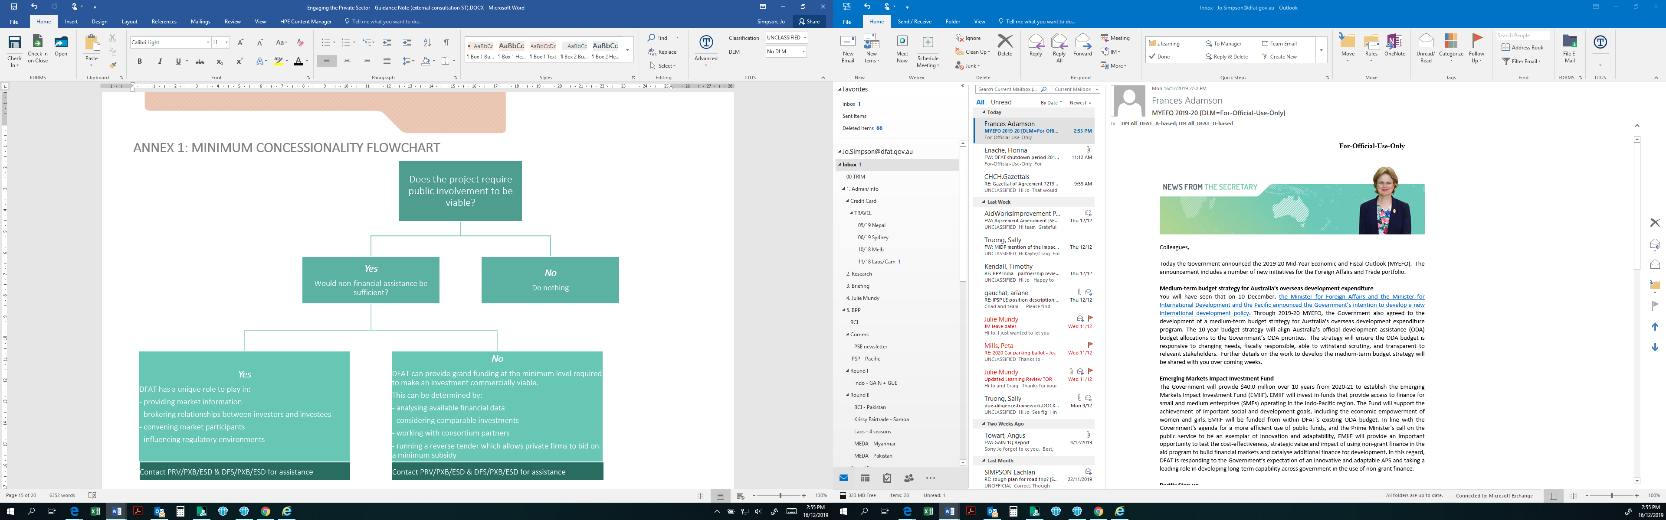

# Annex 2: dced DECISION-MAKING FLOWCHART TO DEMONSTRATING ADDITIONALITY[7]

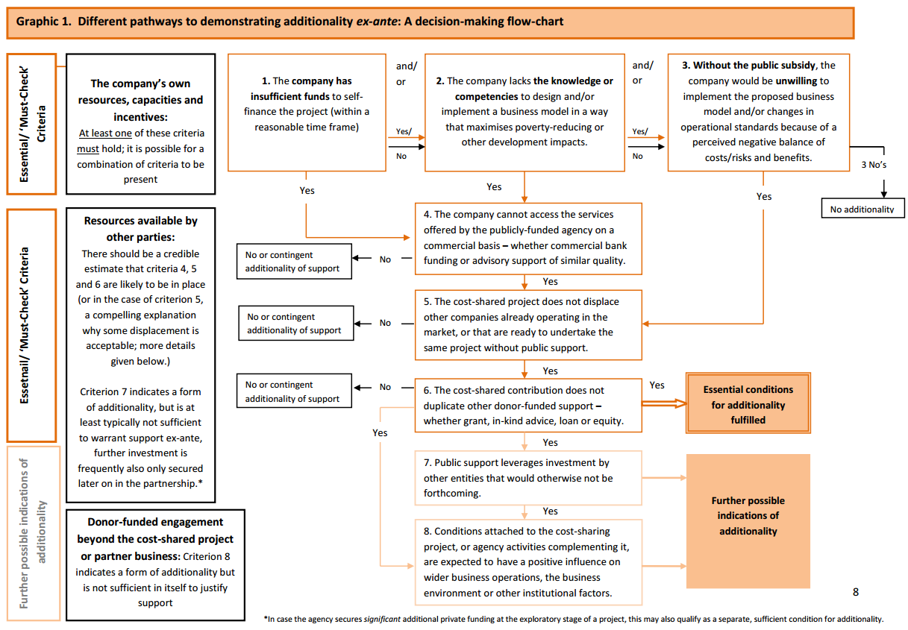

# Annex 3: sIX STAGES OF THE PARTNERSHIP CYCLE

### Setting the strategic framework

Identifying private sector partnership opportunities requires a strategic approach, beginning with a clear understanding of Australia’s development assistance program objectives and assessment of how private sector partners can contribute to meeting identified objectives. Private sector engagement should complement existing and planned aid investments.

In developing strategic documents, such as Aid Investment Plans, identifying key objectives and sectors where the private sector could add value enables potential roles for the private sector to be identified: consulting with key private sector entities that align with Australian development assistance priorities at an early stage enables DFAT to gain valuable market information. It is also the starting point for relationship building and seeds the potential for future engagement, collaboration and partnership. Figure 1outlines the stages and activities in the partnership cycle.

*Figure 1: Partnership Framework[8]*

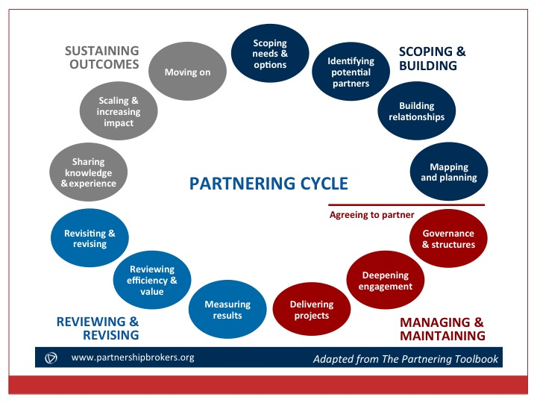

### Identifying and scoping partnerships

Identifying collaboration and financial partnership opportunities is an iterative process. Just as it is part of DFAT’s core business to maintain strategic relationships with governments and civil society organisations, regular, deliberate and ongoing engagement with private sector entities allows the Department to capitalise on opportunities and partners relevant to our development assistance program priorities.

The aid programming cycle guides the development of explicit objectives, to which the private sector can contribute and specific opportunities for working with the private sector are identified. The identification of partners is informed by understanding and articulating the problem to be addressed, including root causes and symptoms. This is particularly important in complex political environments where DFAT pursues development, trade and foreign policy objectives.[9]

A stakeholder analysis maps major stakeholders, including the private sector, and their potential role in supporting the realisation of strategic objectives. Good mapping helps build the contextual perspective that underpins strong private sector engagement, including understanding the expertise and influence of business actors, their role in the context within which they operate, the incentives that drive them, and their constraints. Consultations with private sector stakeholders during this phase also allows partners to scope out potential opportunities and build relationships.

Identification of a private sector partner can occur in two ways – where DFAT approaches businesses or a business seeks out DFAT.

### Building partnerships

When a potential private sector partner is identified, the responsible DFAT officers will conduct an in-depth partnership suitability assessment prior to proceeding to consider a formal partnership. Partnerships can be multi-stakeholder, involving civil society organisations, NGOs and academia if deemed valuable to achieving strategic development objectives. Each partner brings strengths to achieve shared objectives that deliver both sustainable development and commercial outcomes.

Assessments examine whether the partnership is viable by considering:

* the partnership’s potential to achieve targeted outcomes
* whether partners have complementary priorities and values
* partner appropriateness through due diligence and assessing commitment to transparency and responsible business (see section on Risk, pg. 13).

Partners then agree on the engagement approach, whether collaboration or partnership. This will determine the partnership governance structures. For example, a collaboration partnership does not require a formal partnership governance structure; rather it is built on joint and individual priorities and a commitment to an open and transparent relationship. Alternatively, a financial partnership has a formal documented governance structure with regular engagement points over the life of the investment. Collaboration partnerships may require formal documentation if the collaboration is high-level, extensive or will occur over a considerable period (for example a strategic partnership through a Memorandum of Understanding).

For extensive collaboration or financial partnerships, a joint meeting of all partners at the outset to discuss the following issues provide clarity, cements the partnership and underpins ongoing relationship maintenance and evaluation:

* objectives (joint and individual)
* guiding values and principles
* respective contributions (joint and individual)
* responsibilities and points of contact
* governance arrangements
* risks and risk management
* communication protocols
* reporting requirements
* success indicators
* process to resolve disagreements
* non-negotiable elements of the partnership
* duration of the partnership

Agreeing a formal non-binding record of the outcomes of the discussion is useful as a foundation on how partners will work together under the collaboration or financial partnership. The record can assist to work through future issues and to mitigate risks. A template for a discussion record can be found on the [Private Sector Engagement Intranet page](http://dfatintranet.titan.satin.lo/external-engagement/private-sector-engagement/Pages/engagement-resources.aspx).

### Managing and maintaining partnerships

Regular networking and communication between partners is critical to maintain a healthy partnership. Whether formal or informal, regular communication deepens relationships and builds rapport and trust between partners. Assigning a dedicated relationship manager to provide ongoing, consistent engagement with private sector partners will strengthen the partnership and enable early identification of issues requiring resolution.

A regular partnership health check[10] allows partners to reflect on the objectives and success indicators identified in the partnership discussions, ensuring that it is tracking well on delivering targeted outcomes, and allows resolution of any key issues that arise. Regular discussions can consider:

* What is working well? How do we do more of this?
* What should we do differently? What needs to change?
* How we can we derive more value-add from the partnership?
* What have we learnt? How do we transfer that knowledge to others?
* What are our options moving beyond the end of the funding cycle?

Regular health checks are particularly valuable for financial partnerships. At a minimum, plan a mid-point health check and a wrap-up meeting at the end of the investment. Maintain flexibility to allow for health checks at other intervals should the need arise to address specific issues over the course of the partnership.

### Reviewing and revising partnerships and outcomes

Allocating resources at the outset to measure and evaluate the achievements and quality of the partnership is key to ensure targeted outcomes are achieved and successful private sector partnerships are sustained.

The objectives, contributions and success indicators identified in the partnership discussions provide a solid foundation to measure and evaluate the success of the partnership.

For private sector financial partnerships, the [Development Committee for Enterprise Development (DCED) Standard for Results Measurement](https://www.enterprise-development.org/measuring-results-the-dced-standard/) can be useful. This framework outlines elements of a successful monitoring system based on proven good practices in private sector development. The DCED Standard also recommends an independent auditing process.

### Sustaining outcomes or moving on and closure

There is no ‘one size fits all’ approach for every partnership, and this is true of the closing or moving on stage of partnerships. A successful private sector partnership is characterised by sustained outcomes. It is useful to consider the exit/sustainability plan from the beginning of the partnership. After assessing results achieved from the partnership, a decision may be taken to:

1. **move on** – close the partnership if the investment has become self-sustaining
2. **innovate** – continue the partnership in a new form
3. **sustain** – invest additional resources to scale-up the activity to increase impact
4. **close** – end the partnership, capturing lessons learned for future partnerships

Where a decision is made to close the partnership, or to withdraw from it, it is critical to finalise the closing out processes, for example:

* Project sustainability – what aspects of the project will be sustained beyond the current partnership? Will some partners continue? For those withdrawing, how will their inputs during the early phase be acknowledged?
* Transfer of any physical resources
* Final reporting
* Reflection of lessons learned and how this can be shared and to whom
* Any outstanding Intellectual Property issues
* A communications plan to include public messaging about the partnership achievements
* Follow-on monitoring and evaluation to understand the longer-term impacts from the partnership

It is important that any closure processes also make time for identifying and celebrating the achievements and outcomes of the partnership.

1. See OECD definition on key terms and modalities for private sector engagement: <http://www.oecd.org/dac/peer-reviews/inventory-1-Private-Sector-Engagement-Terminology-and-Typology.pdf>
2. DCED Guiding Principles: <https://www.enterprise-development.org/dced-guidance/business-development-services-dced-guiding-principles/>
3. DFI Working Group on Blended Concessional Finance for Private Sector Projects, Summary Report, October 2017
4. Klugman, J & Tyson L. 2016, *A Call to Action for Gender Equality and Women’s Economic Empowerment,* United Nations High Level Panel on Women’s Economic Empowerment.
5. Klugman & Tyson 2016; 2011, World Development Report 2012 - Gender and Development, World Bank, Washington.
6. Woetzel et al., 2015
7. <https://www.enterprise-development.org/wp-content/uploads/DCED_DemonstratingAdditionality_OnePageSummary.pdf>
8. [www.partnershipbrokers.org](http://www.partnershipbrokers.org)
9. MercyCorp Private Sector Engagement Toolkit, <https://www.mercycorps.org/research-resources/private-sector-engagement-tool-kit>
10. A ***health check*** is a review and discussion of partnership progress, and often provides an opportunity to update partnership arrangements.