 | MARSHALLS ENERGY COMPANY, INC.

Request to the

Australian Agency for International Development (AusAID)

to fund a

METERING STRATEGY PROGRAM

for the

Marshall Islands Energy Corporation (MEC)

in the

REPUBLIC OF THE MARSHALL ISLANDS

1. BACKGROUND TO THE REQUEST
The Republic of the Marshall Islands (RMI) is a US-affiliated Western Pacific nation consisting of 28 atolls and with a total population of 96,000 people. The RMI has Micronesia’s second highest population density of 726 persons per square mile following Guam’s 771.  Apart from the small size of the market and extraordinary costs imposed by isolation, RMI possesses few resources, other than the Pacific Ocean, that are convertible to products and services to create jobs, income and the tax base the economy needs to provide and sustain an adequate standard of living. Furthermore, the educational system that normally produces a mix of semi-skilled and vocational to highly skilled workers has not been developed. | 
The Marshalls Energy Company, Inc. (MEC) is a semi-autonomous entity of the RMI government. The utility provides electric, water and wastewater utilities services to the Republic of the Marshall Islands in Majuro and in the outer islands. MEC relies on its revenues to meet the cost of generating and distributing electricity.
Recently MEC’s collections efforts have been challenged by a dwindling economy and the world wide economic downturn. The rate of delinquency by MEC’s customers has more than doubled with many customers resorting to dangerous and illegal means of obtaining electricity through bypassing meters and the use of long extension cords.
MEC has not been able to meet its maintenance and fuel costs in the last few years due to the high rate of delinquency. The Marshall Islands government has had to assist MEC with millions of dollars in funding at the expense of much needed infrastructure repairs and community improvement programs. MEC has had to in turn repay these financial advances back to the RMI Government over time and this has added to the financial strain upon MEC. Needless to say this is causing a regression in public services and infrastructure operations and maintenance for the community at large.
To prevent further deterioration of services and increases in costs, MEC intends to implement initiatives to curb customer delinquency. Foremost to this goal is to have all MEC customers pay for the electricity they use in advance which will then greatly improve the possibility of MEC becoming self-sustaining. This can be accomplished through a two-pronged approach:
- The installation of prepay meters to recover arrears from delinquent customers and to assist these customers to budget their electricity usage. Additionally this will reduce the demand for electricity generated that was previously uncollectable;
- The instigation of a meter calibration program to ensure that all customers are paying for exactly what they consume in way of electricity units.
To project the likely financial benefits of prepay metering to MEC and its customers; a study of the savings in energy consumption was made for a random sample of 350 prepay meter customers from the first 500 Majuro households to receive prepay meters. The study compared the average monthly energy consumption for these customers over 2009, and the customer’s average monthly consumption over the 6-month period since the first meter was installed in August 2010.
The results of the study are detailed in the following table.
Prepay Meter Customer Sample | Monthly Average kWh Usage 2009 (Debit Meter) | Monthly Average kWh Usage (Prepay Meter) | Monthly Average % kWh Savings (Prepay Meter)
350 | 659 kWh | 303 kWh | 54%
Based on the results of the study; energy consumption for each household fell by an average of 54% since having a prepay meter installed. Using the average residential tariff over the 6-month period of the study, this equates to an average saving per household of $122 per month.

From the customer’s perspective, every indication is that the prepay metering has proven itself to be a success, based upon the enthusiasm with which these meters have been received by customers and the number of customers on the waiting list for a prepay meter to be installed.

From MEC’s perspective, with every prepay meter installed, MEC will benefit from an incremental increase in cash flow, an incremental decrease in accounts receivable and an incremental drop in system demand.

However, there is another major benefit to MEC from the anticipated drop in customer energy demand resulting from the prepay metering program. Prior to the return to service in March 2011 of MEC’s most efficient generator, the Deutz #6 engine, the company’s operating regime was to run three generators during times of peak system demand and two generators during off-peak times. With the return to service of the Deutz #6 generator, only two machines are now necessary during peak demand periods and normally, only one machine is required during off-peak periods.

Operating one less generator to service the same system demand has resulted in considerably less diesel fuel being consumed and hence less expenditure on fuel. The demand threshold is so fine however, that any increase in system demand would return MEC to the operating regime of running three machines during peak periods and two during off-peak periods; such that it is very much in MEC’s financial interests to ensure that the system demand stays constant or reduces further.

Although the anticipated 54% drop in customer energy demand stemming from the prepayment metering program will result in a proportional drop in revenue for MEC; the drop in demand will ensure that the most fuel efficient operating regime for the company’s diesel generators is maintained.

Having experienced the benefits of prepay metering for the company and its customers, MEC is seeking grant funding from the Australian Agency for International Development (AusAID) to complete its prepay metering program in Majuro and the outer atolls of Jaluit and Wotje; and the associated meter calibration program.

This grant will greatly improve the collection efforts of MEC so that proper maintenance of the company’s generation and distribution infrastructure can occur; and that the government of the Marshall Islands is not further burdened with public debt brought on by a growing number of non-paying customers.

These initiatives will go a long way to assuring the future commercial viability of the Marshalls Energy Company.
2. STATEMENT OF THE PROBLEM
The Marshalls Energy Company (MEC) is fully dependent on fossil fuels to generate electricity for the people and businesses in the Marshall Islands. With the ever increasing cost of diesel fuel over recent years, the company has seen its accounts receivable increase drastically. Resulting from the high fuel prices and compounded with network technical and non-technical losses, MEC is facing a very significant deficit in funding with which to sustain its operations.
A study carried out in 2010 by KEMA into MEC’s generation and network losses has shown that MEC incurs some 14.5% in technical losses and some 12.4% in non-technical losses resulting from electricity theft and the non-payment of electricity bills. These losses are equivalent to thousands of dollars each month or millions of dollars of unrealized revenues each year. Additionally, there is some six million dollars in accounts receivables which remain uncollected.
These unrealized revenues result in a severe shortage of cash flow, and thus the lack of funds to purchase fuel and to carry out generation and network maintenance. This lack of cash flow with which to procure MEC’s full fuel requirements has become a serious problem that can only compound in the future. The lack of cash flow has contributed to a lack of critical maintenance, which can only result in generating plant and distribution network failures in the near future.
The lack of parts for generator maintenance only compounds the problem, as the utility has to run less efficient machines while the larger more fuel-efficient units are waiting for parts. Put simply, the more money spent on fuel the less money there is for maintenance.
Due to limited funding, the electrical switchgear and auxiliary equipment in the power plant are also in need of maintenance and the powerhouse building is in a state of disrepair. Continuing to skimp on maintenance will result in equipment failures and power rationing with a consequent reduction in sales and revenues.
MEC’s non-technical losses represent a significant amount of unrealized revenues that would otherwise be used to address the operations and maintenance issues. MEC’s financial viability therefore, is reliant on implementing a well thought-out meter maintenance and financial enhancement plan.
With the large and politically sensitive issues facing utility executives, it is not surprising that some matters, which were important in the past, are not receiving the same attention at present. However, revenues must continue to be brought in promptly, and the importance of revenue protection should not be overlooked as it controls the present and future prosperity of MEC.
The electricity revenue meter is the only tool the utility can use for revenue collection. Without the electricity meter, a utility cannot measure customer energy usage nor collect revenue. A revenue meter that under reports or over reports energy usage is a liability to MEC. Unfortunately, erroneous readings given by meters are not readily apparent, but require special testing tools to detect these errors.

Additionally, there are many incidences where customers have bypassed their meters. MEC’s revenue meters must be kept secure and protected from meter tampering. It therefore makes good financial sense for MEC to return to the basics and to monitor the financial affairs of the company, starting with the kilowatt-hour revenue meter.
MEC has identified the following areas as lacking and these areas must be addressed in order to improve the company’s current financial situation: -
1. The current total energy bills owing to MEC are around $6 million of which $2.3 - $3.0 million are greater than 120 days. The existing policy of disconnecting customers for non-payment of arrears has had very limited effect. Many customers once disconnected do not get reconnected or pay their arrears despite legal pursuit of the outstanding debt.
Terminating power services to these customers does cause hardship including health and education issues. So it is preferable to keep customers connected so long as these customers are paying something towards their arrears.
The work involved in collecting these debts is increasing due to the higher cost of electricity resulting from the worldwide increase in fuel prices. MEC bills for the full cost of the service it provides and outstanding arrears are collectable but must be made in increments.
In September 2010, MEC implemented a prepayment metering program which will allow/force customers to manage their electricity usage while steadily paying off arrears owing at a rate that will not place a larger financial burden on the customer. Prepay metering has proven to be very successful in many regional electricity supply utilities that have implemented the system, in that prepay meters allows customers owing arrears to continue to receive electricity services while at the same time paying off their arrears.
2. MEC does not have an ongoing meter maintenance initiative despite the revenue meter being the “cash register” for the company. Nor does MEC have a current operational meter maintenance program to assure that the revenue meters are regularly checked and calibrated if necessary. This procedure once adopted would assure that the MEC is not under-billing or over-billing any customer.
3. MEC does not have the necessary equipment for calibrating the 3-phase, kilowatt-hour revenue meters of its large commercial customers, nor a certified meter calibration technician to carry out this work. An accurate meter test-bench must be purchased and a meter calibrator must be trained and certified to operate this equipment.
4. Current transformers (CT’s) are used in large electrical installations and having faulty or the incorrect size of CT fitted can cause inaccurate meter readings. These losses can be magnified depending on the size of the electrical load being supplied. Every customer with CT metering should be inspected every 6-12 months.
5. There is at present, no comprehensive program for the training of MEC field staff or meter readers for detecting and reporting meter tampering.
3. SOLUTIONS
a. Prepay Meter Installations
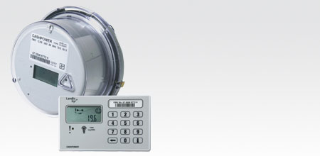 | Prepay meters have proved to be a very effective tool for improving revenue collection & cash flow in Pacific Island utilities. This system operates much like a prepay phone card where power is purchased from the utility and a code is entered into the electricity meter.  This effectively puts the control of the energy use in the hands of the customer. The customer friendly part of the meter is that MEC does not deny customers electricity services but gives customers the power to manage their usage, while reserving a portion of the payment to pay off their outstanding arrears.
MEC’s goal is to install prepay metering in all residential customer premises and single-phase commercial premises; with priority being given to customers with large arrears owing, bad paying customers, customers who live in hard to access locations or posing a vicious dog threat.

US Department of the Interior (DOI) funding of $600,000 was approved for the Marshall Islands for implementing a prepay metering program for Majuro which got underway in August 2010. DOI funding to MEC is spread out over three consecutive financial years. To date some 680 meters have been installed in the field, and on completion of this program, a total of 1,860 meters will have been installed under DOI funding. A further 350 prepay meters will be provided under the Japan Fund for Poverty Reduction (JFPR) program and will be installed in the Majuro system early 2012. Under JFPR funding, a scratch-card vending system was instigated in late 2011.
However, with a residential customer base of 3,300 customers in Majuro, as well as a further 500 meters needed to extend the program to the outer atolls of Jaluit, Wotje and Rongrong; a further 1590 meters will be required to complete the residential prepay metering program in the Marshall Islands. For the convenience of MEC’s customers and to ensure that customers have ready access to prepay electricity purchases at all times; MEC plans to install scratch-card vending machines at selected commercial outlets such as hotels and supermarkets for the vending of the company’s Powercards. On completion of this program, a program to convert all single-phase commercial customers to prepay metering will commence.
Recipients of the first 500 prepay meters under DOI funding were all voluntary customers, which MEC attributed to the positive publicity campaign appearing in the local press accompanying the rollout of the prepay metering program.

Prepay meters will improve customer relations, customer convenience and customer safety, and most importantly, with every prepay meter installed, MEC will benefit from an incremental increase in cash flow, an incremental decrease in accounts receivable and an incremental drop in system demand; such that the company in time will be in a position to maintain its power plants and distribution networks in a timely manner and return MEC to economic viability.

b. Three - Phase Meter Calibration Initiative

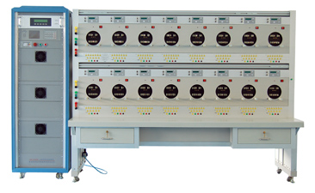 | The mainstay of any utility is the collected revenues and this mainstay cannot be achieved if the meters are not calibrated or secured from illegal customer activities.  Structured meter-testing will save MEC time and money and help offer improved customer service.
Under the initial setup of the Cashpower prepay vending system under DOI funding, portable calibration equipment was provided for on-site testing of prepay meters, and training of selected MEC staff in the use of the calibration equipment was carried out at this time.

As the traditional role of the MEC meter reader will be redefined towards meter installation inspections as more and more prepay meters are installed; it is planned to train meter readers in meter calibration techniques which will then form part of their routine meter inspections.

Although MEC is adequately equipped to carry out the testing of single-phase, prepay meters and has trained personal to carry out this work and to train others; the company at present does not possess a test-bench for testing the 3-phase kWh meters of its larger commercial customers or the expertise to operate such equipment.

By having a test-bench facility for testing and calibrating 3-phase, electronic type kWh revenue meters, meter accuracy will be guaranteed and hence MEC’s largest commercial customers will be billed for the actual electricity consumed.

Equally of importance is that by having staff properly trained in the use of this equipment, customers from small residential to large commercial will be assured that they are being billed correctly by MEC.

Hence, any purchase of a test-bench will entail the training on the part of the supplier of MEC staff in the use of the test-bench as an integral part of the supply contract.

4. MEC’S ANTICIPATED PLAN OF ACTION
a. Customer Installations Initiatives

To achieve the goals of MEC’s metering strategy program, MEC intends to: -

- Purchase a 3-phase kilowatt-hour test-bench to accurately test and calibrate the meters of MEC’s larger commercial customers;

- Physically check, test, calibrate and secure all large commercial customer meters, to ensure that these customers are being metered correctly and that the meter information matches the billing system records;

- Deploy two-meter calibration teams to carry out systematically a building-by-building inspection program to ensure the task is done expeditiously;

- Check buildings that are sub-metered to ensure that transformer loads match the total energy recorded by the combined metering;

- Check all current transformer (CT’s) installations to make sure that the CT’s match the meter they are connected to. The accuracy and type of CT’s will be inspected at this time;

- Fit CT cabinets with tamper proof locking devices that can only be opened by MEC;

- Replace all of the older electro-mechanical 3-phase kilowatt-hour revenue meters with the more accurate electronic meters;

- Carry out routinely in parallel with the inspection of commercial meters, on-site inspections and testing of residential prepay meters to ensure meter accuracy and that no bypassing of the meter has taken place; and

- Fit all meter installations with suitable sealing devices, and to enter the serial number of these meter seals into an appropriate database linking meter serial numbers, customer account numbers and meter seal numbers.

b. Community Consultation & Media Awareness Initiatives

Coinciding with the first rollout of prepay meters in Majuro, MEC provided customers with a simple-to-read, Q&A style booklet which provided valuable information covering all aspects of the management of prepay meters, together with energy conservation material readily available from the Energy Planning Office of the Ministry of Resources & Development.

For those customers who do not voluntarily register with MEC for a prepay meter, consultations are carried out in Marshallese generally along the following guidelines: -

- An initial consultation will be held with each household prior to the installation of the prepay meter. It is anticipated that any reservations disconnected customers may have will be dispelled once they are made aware that their households can be reconnected free-of-charge and that outstanding arrears owing to MEC can be repaid relatively ‘painlessly’ over a period of time.

- MEC’s meter installation team will then go through information booklet to ensure that the customer fully understands the operation of the prepay meter and the procedures to follow when purchasing units of electricity.

- Using the MRD brochures on household energy conservation which have been printed in both English and Marshallese; the team will go through the brochures explaining how the customer can make real cash savings by reducing electricity consumption.

- The offer will then be made to carry out an energy audit of the customer’s residence. With the customer’s consent, a list of all household electrical appliances will be compiled, correlating appliance rating and hours of operation to the cost of using the appliance. The resultant audit will provide a ready reference of those appliances which if used conservatively, will provide real savings in energy usage for the customer.

- The team will then install the prepayment meter in the customer’s residence and provide a practical demonstration of entering prepayment credit into the meter.

The following is an example of a Ministry of Resources and Development energy conservation message.

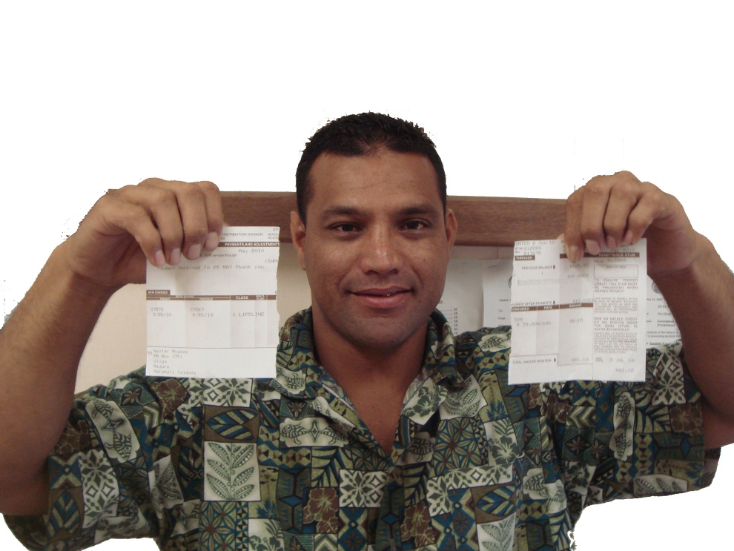
“JIDRIK oktak enaaj komman oktak KILLEP”
Kwobojak ke in “UNTAAK” ibben bill in jarom eo am?

Translation: Save Energy, Save Money.
Are you ready to “WRESTLE” with your electricity bill?
“SMALL changes that make a big difference”

5. ESTIMATED FUNDING
The estimated funding to carry out MEC’s meter strategy program is summarized in the following table: -

DESCRIPTION | QUANTITY | UNIT PRICE (AUD) CIF MAJURO | TOTAL (AUD) CIF MAJURO
Residential Prepay Meters | 1,590 | $286 | $454,740
Commercial Prepay Meters | 189 | $286 | $54,054
Card Vending Machines | 5 | $1,869.28 | $9,346.40
3-Phase Meter Test-bench | 1 | $47,292.80 | $47,292.80
 |  |  | $565,433.20
MEC’s prepay metering program commenced with the approval of counterpart funding amounting to $600,000 by the United States Department of the Interior (DOI) to the Marshall Islands in early 2010; with funds of $200,000 being disbursed over three consecutive financial years starting in FY2010.
A request for proposals was issued by MEC in February 2010 and following the closing of tenders, a contract was awarded to the only tender received from Arthur D Riley & Co. Limited of New Zealand (ADR). DOI funding in FY2010 saw the commissioning by ADR of the Cashpower prepay vending system and the installation of 500 prepays meters in Majuro by MEC.

MEC is locked into the Cashpower vending system such that all prepay meters required to complete the prepay metering program must be the Cashpower Jade meter, for which ADR is the sole regional supplier of this meter.

6. MEC’s CONTRIBUTION
Since MEC installed the first Cashpower prepay meter under training by ADR in August 2010, some 1,050 meters have been installed by the company. The installation of a Cashpower prepay meter involves the replacement of the existing revenue meter with the prepayment meter, the installation within the customer’s residence of a remote keypad and the wiring to connect the prepay meter to the remote keypad.
For the installation of the first 500 prepay meters provided under DOI funding, a dedicated team of MEC Distribution Department staff was assembled to carry out the work. Towards the end of the meter installations, MEC was installing prepay meters at the rate of 25 meters per working week.
MEC will continue to provide the manpower and miscellaneous items needed for installing prepay metering as the company’s contribution to the program until all 3,450 residential customer in Majuro, Jaluit and Wotje have prepay meters installed.

7. BENEFITS
It is anticipated that the following benefits will be derived from MEC’s Metering Strategy program:
- A steady increase in cash flow, a steady decrease in accounts receivable and a steady drop in system demand with the continuation of the prepay meter program;
- The lessening and eventual elimination of bad debt with the eventual completion of the prepay metering program;
- Customer reassurance that MEC is properly billing all customers for the actual electricity consumed;
- Improved MEC skill levels in a number of staff being adequately trained in kilowatt-hour revenue meter testing and calibrations;
- The identification, repair or replacement of malfunctioning meters in the field will ensure that all customers are being metered accurately and billed for their actual electricity consumption;
- With proper maintenance and calibration of meters, meter accuracy will be guaranteed, both for the protection of the customer and for MEC;
- The fitting of meter sealing devices will protect MEC’s “cash register”, the kilowatt-hour revenue meter, and eliminate fraudulent practices perpetrated by some of MEC’s customers;
- The training of meter readers to identify meter tampering in the field, and to increase the number of meter inspection teams will ensure all revenue meters are regularly checked;

- With much improved revenue collection, MEC can then properly address system technical losses by maintaining its power plants and embarking on network rehabilitation; and
- The government of the Marshall Islands will not be further burdened with public debt brought on by a growing number of non-paying MEC customers.

