- Philippine Red Cross Multi-Year Agreement (2020-2024)
Completion Review
27 July 2026

Report prepared by:
David Hale, Principal Consultant – Alinea International

Note: This report has been prepared by an Independent Review Team of Alinea International and reflects the views of the Review Team and does not necessarily represent the views of the Australian Government.

Contents
Executive Summary 4
Recommendations 7
Abbreviations 9
introduction 11
About the PRC MYA Program 11
Methodology 12
Safeguarding and Ethics 13
Data analysis and synthesis 13
Strengths and limitations 14
Limitations 14
Implications for interpreting findings 14
Overall Assessment of Evidence Quality 15
Relevance 16
Coherence 20
Effectiveness 21
Efficiency 24
Sustainability 25
Gender equality and disability inclusion 27
Localisation 29
Risk management 29
Financial ManAgement Review 31
ANNEX A: MYA Assistance summary 36
ANNEX B: CASE STUDY – SEVERE TROPICAL STORM KRISTINE 39
PRC Camarines Sur 39
Unprecedented flooding 39
Local coordination 39
Hot meals 40
Non-food items 40
Cash assistance 40
Lessons 41
ANNEX C: Data Analysis Rubric 42
Subdimensions under the evaluation criteria 42
Merit rating for subdimensions 43
Procedure of setting merit ratings for subdimensions 44

Executive Summary
This report contains the Independent Completion Review (ICR) and Financial Management Review (FMR) of the Australian Department of Foreign Affairs and Trade (DFAT) AUD 6.1 million multiyear prepositioning arrangement (MYA) with the Philippine Red Cross (PRC): “Responding to the Needs of the Most Vulnerable Population Affected by Disasters and Conflict through Emergency Relief and Cash Assistance”.
The review has two core objectives:
- assess impacts to inform potential future arrangements with PRC; and
- reassess areas for improvement, capacity building or support for consideration in potential future arrangements.
This review comprised engagement with 52 individuals in interviews (34 women), a document review, and thematic analysis. Overall, PRC was found to be an important and effective humanitarian partner for the Australian aid program. For potential future arrangements with PRC, consideration for continued support focused on pre-positioning and strategic systems strengthening is recommended. Key findings are summarised below.
The relevance of the MYA is assessed as ‘good’. The MYA was found to be highly relevant to DFAT’s investment priorities, largely meeting delivery expectations. While relatively small, the partnership is strategically significant project for the PRC, accounting for approximately 20% of NFIs distributed, and nearly 30% of cash assistance provided by PRC during this period. Assistance was well targeted and, while difficult to verify, appears to have generally reached those most in need. The delivery of the MYA was found to be largely consistent with the design of the agreement, though cash utilisation could have been higher.
The coherence of the agreement is assessed as ‘good’. The MYA investment demonstrably complemented broader system activities, leveraging the PRC’s unique role as a legally empowered government auxiliary. This pre-positioning enabled the PRC to deliver functions that could not be readily replicated by other actors. The MYA was also closely aligned with the priorities of the Philippine Government. Its emphasis on pre‑positioned stock complemented national preparedness strategies and supported requirements for rapid post-disaster response.
The effectiveness of the MYA is assessed as ‘adequate’. The MYA was effective in achieving intended outcomes, though some ongoing challenges remain in inventory management and cash distribution. PRC was particularly effective in augmenting the Philippine Government’s COVID-19 response. PRC was able to help alleviate the suffering of the most vulnerable population affected by disasters and emergencies, with over 10,000 families supported through the provision of non-food items (NFIs) and over 5,000 families receiving cash assistance. The utilisation of cash assistance was lower than expected, with some ongoing issues in distribution. 4,272 families received cash assistance, below the initial 5,000 target. PRC notes this was due to the changing value of assistance provided (increasing from Php 3,500 to Php 5,000 to remain consistent with GOP guidance).
PRC Chapter noted that distribution timing and locations were, on occasion, influenced by leadership preferences rather than assessed need, though this issue did not emerge as a recurring theme across the assessment. Approximately 40% of cash disbursed was to female headed households, according to PRC reporting. PRC appears to maintain a relatively sound internal MEL practice, that encourages a culture of continuous improvement. In Camarines Sur Province for example, this included post-action reviews, completion of a post-distribution monitoring report (surveying 398 respondents) and internal lesson exchanges facilitated through national headquarters. PRC has enhanced periodic reporting to better capture lessons and progress of cross-cutting issues. However, some reports have contained notable errors, and highlight the need for strengthened management systems.
The efficiency of delivery is assessed as ‘good’. PRC was largely efficient in the delivery of the MYA, with few issues arising in procurement or utilisation. PRC is however invariably too stretched to fully optimise program delivery. Resources are tight, and pressures are constant. Within this challenging operating environment, the MYA was broadly effective in its use of time, human, financial, and material resources.
The sustainability of MYA implementation is assessed as ‘adequate’. Sustainability was undoubtedly a challenge of this agreement. Assets procured for Covid responses have had limited utility post pandemic. Provision of humanitarian relief is inherently short-term, and some PRC systems and operations are over-capacity, and under-resourced. However, the broader Red Cross model offers a higher degree of sustainability than most humanitarian actors, underpinned by greater self-reliance, a large volunteer base, and strong integration within national systems.
The gender equality and disability inclusion achieved through the MYA is assessed as ‘less than adequate’. Gender equality was articulated as a priority in principle, but there is limited evidence of effective gender-responsive implementation. Constraints in gender analysis capacity, limited targeting informed by gender considerations, and inconsistent reporting of gender-disaggregated data reduced visibility and understanding of equality outcomes. Disability inclusion was partially implemented under the MYA, with evidence that people with disabilities were reached as beneficiaries, however, limited assessment data, reporting, and engagement constrained the ability to demonstrate a systematic or needs-responsive approach.
PRC interviewees indicated a good understanding of, and commitment to inclusive practice. But there is limited evidence of how needs were actually prioritised beyond targeting people living with visible disabilities and pregnant or lactating mothers. The MYA has targets in terms of the number of NFIs procured, but no clearly defined number or percentage of recipients from vulnerable groups that PRC and DFAT want to reach with this MYA.
Some safeguarding issues were identified in the distribution of NFIs and cash. In Camarines Sur, Post reported long delays in distribution. Additionally, a PRC Chapter noted that distribution timing and locations were, on one occasion, influenced by leadership preferences rather than assessed need, though this issue did not emerge as a recurring theme across the assessment
The localisation through the MYA is assessed as ‘good’. Localisation is a clear strength of the PRC MYA, with delivery strongly anchored in local leadership, decentralised decision making, and community level engagement through PRC’s extensive Chapter network.
The risk management of the MYA is assessed as ‘Less than adequate’. While PRC’s implementation of the MYA was informed by broader organisational risk management practices, PRC did not maintain a dedicated risk register specific to the MYA. While difficult to assess capacity in practice, PRC does appear to maintain an appropriate suite of safeguarding policies and reporting systems.
The financial management review ranged in assessments from ‘adequate’ to ‘less than adequate’. The PRC is well behind in its external auditing cycle, resulting from Covid-related delays and staff turnover. Independent audits are currently being undertaken to review activity across financial years dating back to 2019, according to interviewees with PRC, though no recommendations are yet available for consideration. These reviews will not explicitly focus on special project expenditure, such as MYA. PRC’s financial management policies are robust and consistent with DFAT’s due diligence expectations. However, some gaps have emerged in practice, particularly regarding delays in audits and weak inventory management. While gaps in PRC’s financial record keeping have been noted, there has been no reports of fraud or corruption identified through MYA funding, with procurement practices particularly strong. PRC appears to maintain effective fraud and corruption systems, but these are difficult to independently verify.
Case study lessons
The response to Severe Tropical Storm Kristine in 2024 underscored the unique responsibility and pressure placed on the Philippine Red Cross as a frontline, locally embedded responder. It also served as a reminder of the inherent complexity of disaster response in the Philippines, particularly the time required to accurately identify needs across geographically remote and marginalised communities.
The response highlighted:
- the ongoing challenge of balancing pre-positioning of NFIs with warehousing and logistics constraints; while pre-positioned stocks could have improved timeliness, maintaining sufficient and well-located storage remains difficult.
- the value of community-based processes in prioritising cash assistance, which helped manage expectations and reduce perceptions of bias.
- the importance of volunteer welfare and safeguarding, including protection from sexual exploitation, abuse and harassment (SEAH); while existing safeguarding measures were in place, there is scope to further strengthen volunteer knowledge, skills and confidence to proactively identify and respond to safeguarding risks during surge operations.

Recommendations
Relevance
- Continue to prioritise field Post-led monitoring missions to help verify effectiveness of targeting and appropriateness of support.
  - High priority / low indicative cost. Expenses can be absorbed within existing Post travel and oversight budgets

- Consider enhancing pre-positioning support through capability-focused investments (advisory, mentoring, organisational development), paired with technical support to scope and, if feasible, support implementation of the PRC’s warehouse expansion initiative
  - Medium priority / low-medium indicative cost. Cost for DFAT to scope likely to be modest, but actual support/feasibility/design may require additional funding, especially if capital planning involved
Coherence
- Consider appropriateness of including triggers and conditions for anticipatory action in future pre-positioning agreements.
  - High priority / low indicative cost. This would primarily require a design and negotiation adjustment; no significant upfront cost
Effectiveness
- PRC should prioritise finalising framework agreements with new Financial Services Providers (FSPs) alongside consideration of funding models, partner capacity, and procurement processes to strengthen cash for assistance programming.
  - High priority / low indicative cost. Agreements are low cost; addressing funding models / partner ecosystem may require modest design or advisory inputs
Sustainability
- Assess feasibility of repurposing or redeploying COVID-related assets that are no longer in active use, including through partnerships with government health facilities or other responders. Where continued use is not feasible, agreed asset reallocation should be considered in line with donor and organisational asset management requirements.
  - Medium priority / low indicative cost. Work will mainly require coordination, logistics, and partnership brokering rather than new funding
GEDSI
- PRC to define and propose the target number of beneficiaries through GEDSI analysis and disaggregated by sex, age and disability both in their proposal (concept note) and project reporting.
  - High priority / low-medium indicative cost. Scoping requires some analytical capacity and possibly MEL technical support, but can largely build on existing systems
Risk management
- PRC should formalise risk management of future agreements through a dedicated project risk register – including do no harm risks – that is updated and shared alongside periodic reporting cycles
  - High priority / low cost. Standard internal management practice; minimal additional cost
Financial
- PRC should prioritise the roll-out of its stock and inventory management, ensuring the inventory generates instantly the type of items, donors, and information on expiry dates.
  - High priority / low-medium cost. This process is likely to require ongoing testing and refinement

- Consider scheduling tranche payments conditional on completion of external, independent financial audits.
  - High priority / low cost. Recommendation will only require administrative/contractual change after appropriate negotiations

- Fund a dedicated Finance Officer within PRC to manage budgeting and financial reporting for DFAT agreements and consider funding external audit of future support
  - High priority / medium-high cost. Salary and audit costs will require dedicated budgetary allocation

- Request PRC to share key findings and recommendations from external audits with DFAT where appropriate
  - High priority / low cost. Process requirement only – no additional costs to consider.

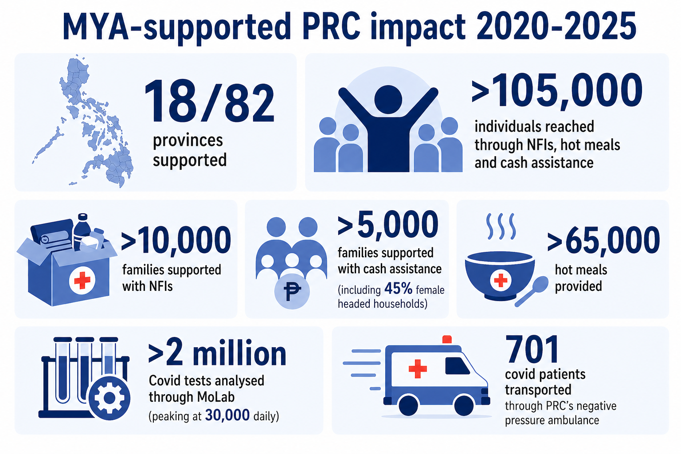
Figure 1. Summary of MYA supported PRC impact

Abbreviations

Acronym | Stands for
AUD | Australian Dollar
BAC | Bids and Awards Committee (of the PRC)
CfR | Cash for Relief
CWG | Cash Working Group
DFAT | Department of Foreign Affairs and Trade
DOH | Department of Health
DSWD | Department of Social Welfare and Development
FGD | Focus Group Discussion
FMR | Financial Management Review
FSP | Financial Service Provider
GOP | Government of the Philippines
HARD | Humanitarian Action and Disaster Resilience (Unit at Australian Embassy Manila)
HQ | Headquarters
HR | Human Resources
ICRC | International Committee of the Red Cross
IDP | International Development Policy
IFRC | International Federation of Red Cross and Red Crescent Societies
KII | Key Informant Interview
LGU | Local Government Unit
MEL | Monitoring, Evaluation and Learning
MoLab | Molecular Laboratory
MPCG | Multipurpose Cash Grant
MTR | Midterm Review
MYA | Multi-Year Agreement
NDRRMC | National Disaster Risk Reduction and Management Council
NFI | Non-Food Item
NGO | Non-Governmental Organization
OCHA | Office for the Coordination of Humanitarian Affairs (of the United Nations)
OECD-DAC | Organisation for Economic Cooperation and Development – Development Assistance Committee
PDM | Post distribution monitoring
PHP | Philippine Peso
PPE | Personal Protective Equipment
PRC | Philippine Red Cross
PSEAH | Protection from Sexual Exploitation, Abuse and Harassment
PWD | Person/People with Disability
SOP | Standard Operating Procedure
STK | Shelter Tool Kit
ToR | Terms of Reference

introduction
This report contains the Independent Completion Review (ICR) and Financial Management Review (FMR) of the Australian Department of Foreign Affairs and Trade (DFAT) AUD 6.1 million multiyear prepositioning arrangement (MYA) with the Philippine Red Cross (PRC). The review has two core objectives:
- assess impacts to inform potential future arrangements with PRC; and
- reassess areas for improvement, capacity building or support for consideration in potential future arrangements.
Alinea International was contracted to conduct the ICR and FMR of the PRC MYA project. The ICR is consistent with DFAT Design and MEL Standards and informed by the Organization for Economic Cooperation and Development – Development Assistance Committee (OECD-DAC) evaluation criteria and Australia’s key policy priorities. This includes reviewing the relevance, coherence, effectiveness, efficiency and sustainability of the MYA, alongside consideration of gender equality, disability and social inclusion, risk and financial management. The FMR approach is guided by the relevant chapters of DFAT’s Due Diligence Framework including chapters 4 (financial viability), 5 (Fiduciary Management), 7 (Value for Money), 8 (Fraud and Corruption Control), 10 (Integrity Systems), and 11 (Risk Management Processes).
The ICR and FMR covers the period of the PRC MYA implementation from March 2020 to December 2024. Consideration has been given to utilisation of leftover NFI stock and other assets after the MYA completion to fully assess effectiveness. Key findings in the report correspond to the Key Review Questions detailed in the Final Inception Report (submitted 27 February 2026).

About the PRC MYA Program
DFAT partnered with PRC from March 2020 to December 2024 under a AUD 6.1 million multi-year agreement to support disaster-affected families and (through an early contract amendment) to enhance COVID-19 response efforts. The program had two main components. Component 1 was a prepositioning arrangement to provide rapid relief through non-food items (NFIs) alongside cash assistance. Component 2 was a COVID-19 response, including support for laboratory testing, emergency care, and PPEs for healthcare workers. By December 2024, the project achieved a 100% fund utilisation rate, delivering aid to over 16,000 families and 64,295 individuals, and testing over 2 million COVID-19 samples.
The aims of the PRC MYA were to:
- Alleviate the suffering of the most vulnerable population affected by disasters and emergencies by quickly responding to their immediate needs and life-saving requirements through the provision of non-food items (NFIs) and cash.
- NFIs comprised of sleeping kits (blankets, plastic mat, and mosquito net); water, sanitation, and hygiene (WASH) sets (hygiene kit and jerry cans); shelter sets (tarpaulin and shelter tool kit); and health sets (mother and newborn kits) for 9,000 families.
- Unconditional multi-purpose cash assistance for emergency relief to 9,000 families (ranging from Php3,500 to Php5,000 per family) to be utilised for the purchase of basic needs/services such as food, cooking utensils, medicines, clothing, transportation.
- Procurement of a food truck (named “Bluey”) that will serve hot meals to people affected by emergencies (hot meals provided by PRC).
- Augment the Philippine Government’s COVID-19 response through the:
- Establishment of a molecular laboratory to increase the COVID testing capacity in the country
- Procurement of a negative pressure ambulance (named “Skippy”) to transport COVID-19 patients
- Provision of 1 million personal protective equipment (PPEs) for healthcare workers
A Mid-term Review (MTR) of the PRC MYA was undertaken and published, along with a DFAT Management Response, in 2023. The MTR assessed that the program was generally adequate with room for improvement regarding accuracy of stock inventories, monitoring and evaluation (M&E), timeliness, and low utilisation rate of prepositioned items.

Methodology
This ICR draws heavily on the MTR approach (and structure) to ensure consistency in comparison. Accordingly, the review employed a mixed-methods approach, with a higher prevalence of qualitative tools. This comprised a document review, consultations and thematic analysis. A purposive sampling strategy was used to maximise the value of information gathered against the time and opportunity cost associated with each interview. Purposive sampling considered the involvement of DFAT staff and partners that are broadly representatives.

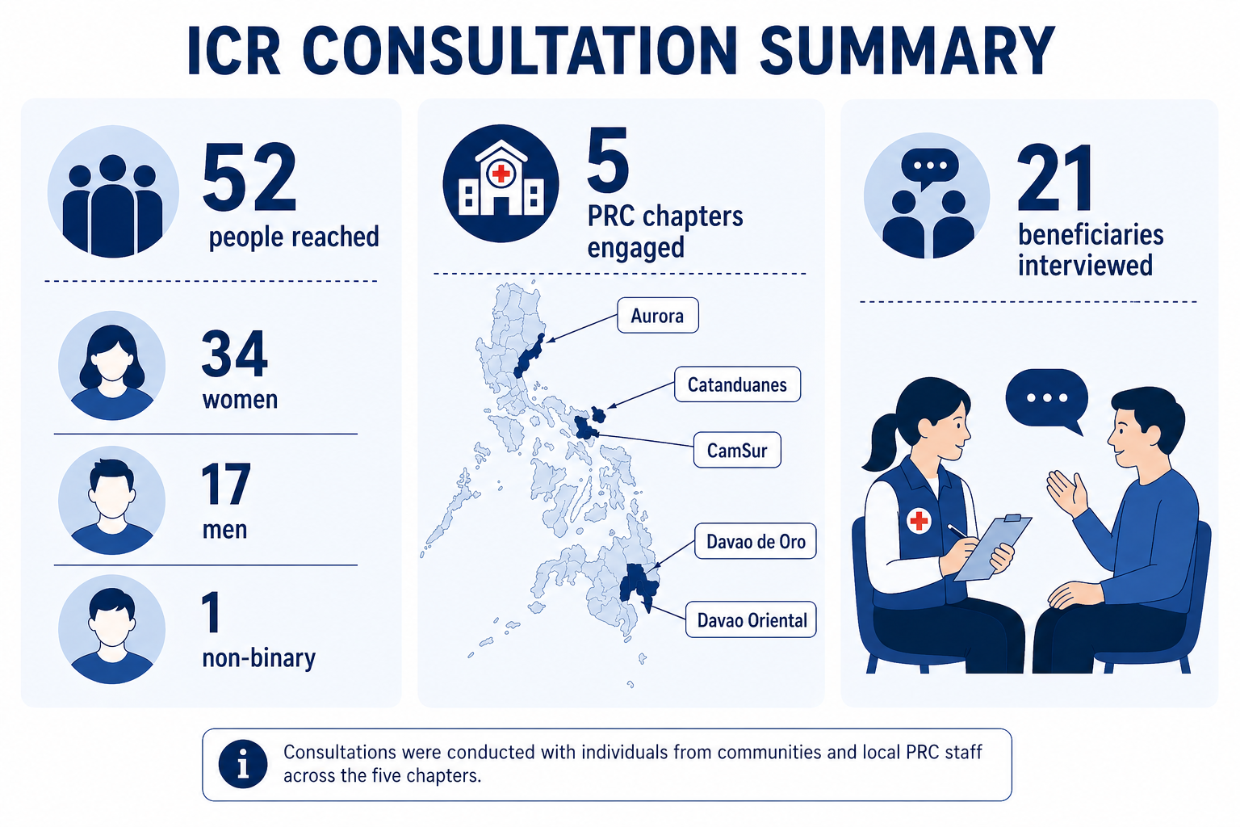
Figure 2. ICR Consultation Summary
A survey (using questions based on the MTR survey) was distributed to five PRC Chapters that distributed MYA-funded NFIs in 2024. Four out of five Chapters responded. The document review covered a wide range of materials, including Humanitarian Investment Monitoring Reports (HIMRs), annual reports, PRC policies, guidelines and SOPs, financial reports and post-distribution monitoring surveys (Camarines Sur, Aurora, Catanduanes and Davao de Oro).
Data collection for the review took place from March 2026 to April 2026. A debriefing on the data collection, along with an early overview of initial findings, was conducted on 17 April 2026.

Safeguarding and Ethics
The review was conducted in accordance with DFAT’s safeguarding and ethical standards, with the assumption that adult beneficiaries may have experienced trauma as a result of past disasters, regardless of whether this was explicitly disclosed. Engagement approaches were trauma-sensitive, voluntary, and designed to minimise the risk of re-distress. Participants were provided with clear (and translated) information about the purpose of the review, how data would be used, and their right to decline or withdraw at any time without consequence, and informed consent was obtained prior to participation. No children were engaged in this review. Confidentiality and anonymity were maintained throughout, and facilitators avoided intrusive or distressing lines of questioning. Safeguarding concerns identified during data collection were to be addressed through established reporting and referral procedures.

Data analysis and synthesis
Rubrics were used to assess overall performance against each review domain, detailed in Annex C. A rubric is a learning and evaluation tool that articulates the expectations for assignments and performance tasks by listing criteria, and for each criterion, describing levels of quality.
This rubric is an extension of the assessment framework used in the 2023 MYA to assist in consistency in assessment. Some alterations in sub-dimensions were applied to account for variances in review objectives and additional domains.
The synthesis process includes DFAT’s Final Aid Quality Check (FAQC) ratings matrix as seen in Table 1.
Ratings Matrix
No | Rating | Merit rating
6 | Very good | Satisfactory
5 | Good | Satisfactory
4 | Adequate | Satisfactory
3 | Less than adequate | Unsatisfactory
2 | Poor | Unsatisfactory
1 | Very poor | Unsatisfactory
Table 1: DFAT’s rating matrix for evaluation criteria (Source: FAQC)

Strengths and limitations
The quality of evidence supporting the conclusions in this review can be rated as moderate – sufficient for informed decision-making, but with some limitations.
Strengths
- Triangulated Sources: Conclusions draw from multiple data sources, including internal DFAT records, formal PRC reports and interviews from stakeholders across PRC, Government of Philippines and DFAT Post. This helps validate claims through diverse perspectives.
- Consistent Stakeholder Feedback: The interviewees provided repeated and corroborated evidence across most stakeholders about key themes such as:
  - Value of Covid components
  - Strength of local coordination mechanisms
  - Quality and relevance of NFI supplies
  - Challenges of timely distribution

Limitations
- Limited systematic feedback and uptake data: Many conclusions, particularly regarding overall effectiveness, draw on anecdotal evidence, stakeholder perceptions, and selected examples rather than comprehensive, systematically collected beneficiary feedback. Direct engagement with end users was limited, constraining the ability to robustly assess the extent to which activities translated into intended behavioural or institutional changes. Evidence collected from the MTR has been incorporated to assist in triangulating findings.
- Data gaps at outcomes level: While activity-level reporting has been relatively strong (including post-distribution monitoring), there is limited synthesis or analysis of higher-level outcomes in PRC reporting. As a result, the evaluation relies on partial evidence when assessing whether program outputs contributed to intended outcomes.
- Limited government validation: Time constraints for in-country fieldwork limited the evaluation team’s ability to engage local government stakeholders to verify PRC Chapter findings. Consequently, the analysis draws substantially on earlier consultations conducted during the MTR, which may not fully reflect current perspectives or changes over time.
- Limited representation from direct beneficiaries: Time constraints for in-country fieldwork also limited the evaluation team’s engagement with direct beneficiaries of MYA support. Substantive insights were available through PRC’s post-distribution monitoring surveys, and evidence from the MTR, but further validation with communities would have strengthened effectiveness and inclusion assessments.

Implications for interpreting findings
Given these limitations, some findings can only be partially assessed.
- Effectiveness assessments are indicative rather than conclusive, reflecting the balance of available evidence and stakeholder perspectives rather than comprehensive outcome verification.
- There is greater confidence in findings related to outputs and immediate results (e.g. delivery, reach, and implementation performance) than in higher-level outcomes (e.g. behavioural change, institutional strengthening, or sustained impact).
- Evidence of success should be understood as plausible and supported by triangulation across sources, but not systematically quantified or generalisable across all contexts.
- Where positive outcomes are identified, these should be interpreted as demonstrating contribution rather than attribution, given the absence of robust outcome-level data and counterfactual analysis.

Overall Assessment of Evidence Quality
Criterion | Rating | Explanation
Credibility | High | Based on official documents and stakeholder interviews
Representativeness | Moderate | Reasonable mix of stakeholders across PRC and DFAT, with some inputs from GoP. Lack of representation from people living with disabilities.
Triangulation | Moderate | Multiple data types used, but uptake and influence tracking is limited. Some data sources may be biased.
Outcome-level Evidence | Low-Moderate | Strong on outputs; anecdotal evidence for application and impact.
Data Quality/ Completeness | Moderate | Some data gaps, especially regarding risk management and budget decisions pre-2023.

Relevance
KRQ 1: What were DFAT’s expectations of the MYA investment in relation to its own priorities, needs and outcomes? How well were DFAT expectations articulated, implemented and met through the program?
Key finding 1.1: The MYA was highly relevant to DFAT’s investment priorities, largely meeting delivery expectations.
Sub dimension | Rating
Relevance of the MYA to DFAT’s priorities | Good
The MYA effectively served as a responsive, locally-led relief mechanism. The flexibility of the arrangement in responding to the Covid pandemic, the national reach of the PRC, and its mandated role as an auxiliary to the Government, were all important and consistent expectations underpinning the MYA. Unlike any other multilateral or NGO pre-positioning partner, PRC can respond to disasters immediately – and with a nationwide pool of volunteers – in collaboration with local government stakeholders, underscoring its relevance as an emergency relief partner.
Disaster response and recovery represent a core priority for DFAT and its partners in the Philippines, reflecting the country’s high exposure to climate-related shocks. As noted in the Australia-Philippines Development Partnership Plan (2024-2029), “during crises, we commit to supporting the humanitarian needs of affected populations in an inclusive, transparent and accountable manner to ensure we reach the most vulnerable”. From 2008 to 2023, more than 62 million disaster-related internal displacements were recorded in the Philippines, highlighting the persistent scale of vulnerability and the ongoing importance of prioritising relief efforts. These events, which often hit agriculture and infrastructure, reduce average household incomes and significantly hamper poverty reduction efforts, particularly for at risk individuals or those with limited access to social protection, and unequal access to decision‑making and economic opportunities. This reinforces the centrality of disaster-focused interventions within the MYA and their alignment with DFAT’s strategic objectives on resilience, GEDSI, and inclusive development.
The MYA was complementary within DFAT’s broader programming, which supports the Philippine Government (GOP) in responding to the humanitarian and early recovery needs of the most vulnerable people affected by disasters and conflict. The MYA sought to strengthen local capabilities to respond to disaster, explicitly as auxiliary support to the GOP. The MYA aligns with Australia’s International Development Policy (IDP), which prioritises locally led action and climate responsiveness. It is also aligned with the resilience pillar of DFAT’s Development Partnership Plan 2024-2029 with the Philippines. Moreover, the Covid component of the MYA was a clear and urgent priority between 2020-2022, strongly supporting the Australian Government’s Partnerships for Recovery: Australia’s COVID-19 Development Response.
The MYA was appropriately designed as a rapid response mechanism, with an intentionally narrow focus on post-disaster relief. More resilience building and safeguarding integrated within the relief components of the MYA could have strengthened the overall relevance of this specific investment. While not part of the original MYA design, anticipatory action has gained prominence in the Philippines, presenting opportunities to strengthen the MYA’s relief approach through more proactive and resilience-focused actions.

KRQ 2: How important was the support to the PRC?
Key finding 2.1: The MYA was a relatively small, but strategically significant project for the PRC.
Sub dimension | Rating
Relevance of the MYA to PRC  Importance of purchased vehicles – Food Truck and ambulance  Importance of molecular laboratory to COVID-19 management | Good  Adequate  Adequate
The PRC values its long-standing partnership with Australia, despite being one of around 30 project partners managed by PRC at the commencement of the MYA. The Covid-component investments were highlighted by numerous PRC interviewees as a critical investment. DFAT-funded NFIs were approximately 20% of total NFI stock during the MYA period although precise proportions fluctuate year-on-year. The utilisation rate largely verifies this estimate. Between 2020-2025, DFAT-funded supplies were approximately 22% of NFIs utilised by the PRC, and accounted for approximately 28% of cash grants provided to beneficiaries. Despite this, PRC does work with an array of partners, from red cross and red crescent societies to regional governments. According to interviewees, the MYA created a comparatively higher-administrative burden for the PRC, though some systems – such as concept note approvals for managing relief distribution – were valued and have been replicated as good practice. Concept notes were regarded by interviewees as strengthening transparency and accountability mechanisms, and encouraged more formal deployment targets.
The relatively limited urgency shown by PRC in pursuing a new MYA with DFAT likely reflects, in part, the organisation’s diversified funding base. While DFAT is still regarded as an essential partner according to interviews, its support complements other NFI donors. Legacy stocks procured under the MYA enabled PRC to continue supporting responses through 2025, which helps explain the pace at which discussions progressed. Evidence from both data and stakeholder discussions indicates that DFAT is regarded as an important and supportive partner within a wider ecosystem of PRC collaborators.
The enduring importance of PRC assets funded through the MYA is mixed. The urgency and need for both the molecular laboratory (MoLab) and negative pressure ambulance in 2020 was clear, as highlighted in the 2023 MTR. All consulted stakeholders agreed that the MoLab played an important role in the prevention of COVID-19 transmission, in particular by testing incoming international passengers at arrival and during quarantine. The lab processed more than two million tests, but its operations have been suspended since 2023. Similarly, the relevance of the negative pressure ambulance has largely subsided since the pandemic stabilised, though its importance at the time of peak transmissions was significant. By contrast, the ‘Bluey’ food truck has maintained its importance to PRC’s disaster response capability. While only one of over 30 food trucks in service with PRC, ‘Bluey’s’ high annual utilisation indicates the clear ongoing need and appreciation for hot meals in the immediate aftermath of a disaster (averaging approximately 17,000 meals annually between 2021-2024).

KRQ 3: How relevant was the assistance provided to affected communities?
Key finding 3.1: Assistance funded through the MYA was well targeted and, while difficult to verify, appears to have generally reached those most in need. Assistance was appropriate to community needs, though the utilisation of cash assistance could have been higher.
Sub dimension | Rating
Adequacy of needs analysis  Relevance of distributed goods to recipients  Appropriateness of cash distribution | Good  Very good  Adequate
PRC has a robust approach to identifying, understanding and verifying relief needs. Chapters interviewed for the ICR describe assessments processes consistent with the SOP for the geographical targeting of beneficiaries, prioritising the most affected and least served areas. While more time consuming, Chapter staff were able to reach more remote and – often cut-off – communities to assess needs. Verification of Local Government Unit (LGU)-provided household impact lists was an important step highlighted by Chapters, with Camarines Sur staff noting that over “200 volunteers were mobilised daily to speak to affected families” – identifying “many not on government lists”. The system to prioritise needs among Chapters engaged was more variable. While those with houses completely destroyed and pregnant women and those with newborns were consistently identified as priorities, there was less consistency in identifying people living with disabilities or the socio-economic vulnerability of families.
Non-food items distributed were almost always regarded as relevant for beneficiaries. From post distribution surveys conducted in Aurora, Camarines Sur, Catanduanes and Davao de Oro, 98% of respondents considered items to have been “very useful”. Items supplied through the agreement were generally considered to be of similar relevance and usefulness, with no clear indication that any particular items stood out as more valuable than others.
Cash for relief and multi-purpose cash grants were almost universally appreciated, but the triggers for distributing cash were not always clear. Between 2020-2024, MYA-funded cash assistance was distributed in three responses out of eight responses where NFIs were distributed through the MYA (37.5 per cent). PRC did distribute cash in four other responses but funded entirely by other movement partners. Across this period, MYA accounted for 28% of total PRC cash assistance distributed. The lower than expected use of cash for relief is, in part, explained by the higher prevalence of cash assistance among other partners (including LGUs). However, cash utilisation could be higher, particularly given how highly it has been appreciated in PDM reporting and PRC’s co-lead of the Cash Working Group.
Some issues in the targeting of beneficiaries and distribution of cash assistance remain. The MTR identified inconsistencies in establishing Barangay Response Committees (Barecoms) to help identify and prioritise cash assistance beneficiaries. However, in the two subsequent responses involving MYA-cash (Camarines Sur and Catanduanes), Barecoms were consistently established and, according to interviewees operated effectively in localising decision-making and supporting transparency. It is also important to recognise the ongoing risk of any perceived politicisation of cash assistance. The MTR found that the location and the Cash for Relief (CfR) modality was, according to interviewees, informed by a visit by PRC senior officials. Moreover, the MTR found “some PRC staff expressed the concern that necessary shortcuts to meet the date may have led to the inclusion of families that do not meet the selection criteria among the beneficiaries.” According to Post observations, some delays were also observed during distribution days at evacuation centres while awaiting attendance from PRC senior officials. While no adverse findings were identified in the targeting of beneficiaries in either Camarines Sur or Catanduanes, the use of independent Barecoms to facilitate this process should be continuously prioritised.
Recommendation 1: Continue to prioritise field Post-led observation missions to help verify effectiveness of targeting and appropriateness of support.
KRQ 4: The extent to which there are gaps between what the MYA was designed to deliver, and what it actually delivered?
Key finding 4.1: The delivery of the MYA was largely consistent with the design of the agreement, though cash utilisation could have been higher.
Sub dimension | Rating
Consistency of delivery against terms of agreement | Good
PRC was largely effective in delivering against the terms of the MYA, and collaboratively identified changes where appropriate. Procurement of both Covid-related assets and NFIs were as prescribed in the terms of the contract, with surplus funds re-directed to purchasing additional NFIs. The lower than expected utilisation of cash assistance was one potential gap in the program (as discussed in KRQ2). The reach of PRC’s NFI distribution was adequate, but accessibility remained a consistent challenge. Extending the number of locations NFIs were pre-positioned to increased coverage, though further localising pre-positioning hubs (as is currently being scoped by PRC), would further benefit the timely distribution of supplies.
Recommendation 2: Consider enhancing pre-positioning support through capability-focused investments (advisory, mentoring, organisational development), paired with technical support to scope and, if feasible, support implementation of the PRC’s warehouse expansion initiative
KRQ 5: Have the governance and management arrangements been fit for purpose?
Key finding 5.1: Governance arrangements were appropriate, and effectively utilised by both partners. Some management arrangements were probably overly prescriptive at times, but did support clear expectations and transparent processes.
Sub dimension | Rating
Appropriateness of governance arrangements  Appropriateness of management arrangements | Good  Adequate
Governance arrangements enabled both operational and strategic engagement, with no issues identified in the review. The technical team met consistently on a quarterly basis, aligned to the quarterly reporting cycle, to review progress, risks, and delivery matters. In addition, Principals met twice a year to provide strategic oversight, confirm priorities, and ensure alignment with agreed objectives.
Management arrangements were adequate but could be improved. The specificity of timeframes and approval processes contained in the MYA was largely valuable, particularly in supporting targeting for those most in need. However, some prescribed expectations were probably unrealistic in the most challenging and complex relief contexts. Accurate needs assessments are time intensive, particularly when trying to reach more remote communities. Logistical challenges associated with road closures often constrained PRC’s capacity to deliver assistance to where it was most needed.

Coherence
KRQ 6: How did the PRC MYA investment activities fit with the broader activities in the geography and sector?
Key finding 6.1: The MYA investment demonstrably complemented broader system activities, leveraging the PRC’s unique role as a legally empowered government auxiliary. This positioning enabled the PRC to deliver functions that could not be readily replicated by other actors, enhancing overall coherence, reach, and effectiveness
Sub dimension | Rating
The MYA complementing other relief efforts  Added value of MYA compared to other relief | Very good  Good
The PRC’s role is underpinned by a clear statutory mandate. Under The Philippines Red Cross Act (2009), the PRC is constituted as a legally empowered government auxiliary, authorised to act on behalf of government in overseeing, advising on, and supporting the proper management of public records. This legislative foundation confers formal authority, defines its functions and responsibilities, and provides the legal legitimacy that distinguishes the PRC from non-statutory partners operating in the same system. The PRC is a partner of the National Disaster Risk Reduction and Management Council, and is able to coordinate activities at all levels of government. As noted already, PRC has a wide network of Chapters and volunteers that can be rapidly mobilised – a far greater human resource pool than any other NGO. This is also supported through a surge capacity of trained staff from HQ and other Chapters that can be mobilised.
The MYA’s Covid components were highly complementary to national priorities. The MoLab was the largest of its kind in the Philippines, while the negative pressure ambulance was the first of its kind in the Philippines. Each asset, according to interviewees, were essential to support government counterparts and did not duplicate support from other donors.
MYA played an important role in empowering the PRC as an essential responder to disaster response. Over the duration of the MYA, UN agencies, such as OCHA, were increasingly constrained in their coordination and technical support capacity, further heightening the need of partners such as PRC. In this context, PRC Chapters also respond to more frequent, smaller-scale disasters such as localised flooding, fires and landslides. While the MYA is intended to support medium to large-scale events, the stock reserved under the MYA provides the PRC with assurance that surge capacity is available. This confidence, according to interviewees, enables the PRC to more readily deploy other pre-positioned stock for smaller-scale events, improving overall responsiveness and flexibility across different levels of need.
KRQ 7: To what extent was the intervention aligned with the needs, priorities, and expectations of key stakeholders, including the Philippine Government?
Key finding 7.1: The MYA was closely aligned with the priorities of the Philippine Government. Its emphasis on pre‑positioned stock complemented national preparedness strategies and supported rapid response requirements during periods of heightened uncertainty.
Sub dimension | Rating
Relevance of the MYA to the Philippine Government | Very good
As noted, the PRC is an important and mandated auxiliary to the Philippines Government. The MYA investment strategically aligns with an ever-increasing commitment to self-reliance. The Philippine Government is intentionally strengthening national and local disaster response capacity to reduce structural dependence on international assistance, particularly for routine and smaller-scale events. Since the passage of Republic Act 10121 (the DRRM Act) in 2010, the government has consistently shifted from a reactive, aid-dependent model toward state-led preparedness, anticipatory action, and resilience building. Interviews with DSWD underscored this priority, with significant investment in local pre-positioning and appreciation for the PRC’s work to complement such efforts.
Coordination between the PRC and Government is considered adequate at the national level, but particularly strong locally. Given the importance of relationships and informal networks in the operating environment, the PRC appears to maintain effective engagement with relevant government stakeholders. As a trusted auxiliary to government, the PRC's effectiveness depends in part on maintaining broad public confidence and demonstrating independence from partisan interests. In this context, the presence of current or former political affiliations among national or Chapter leadership warrants ongoing consideration, as perceptions of independence can influence credibility, trust and operational reach.
Anticipatory action (AA) was outside the scope of the MYA, but is becoming a more common modality to support local preparedness and resilience. The introduction of Republic Act No. 12287 marks a significant shift toward institutionalising AA in the Philippines. By creating a legal basis to declare a State of Imminent Disaster before impacts occur, authorities can now mobilise resources, pre-position relief, and initiate evacuations based on forecast risk rather than observed damage. As a Co-Chair of the AA Working Group, the PRC is focused on aligning more formally with government-led anticipatory measures while maintaining their auxiliary role.
Recommendation 3: Consider appropriateness of including triggers and conditions for anticipatory action in future pre-positioning agreements.

Effectiveness
KRQ 8: To what extent did the MYA investment achieve it’s intended outcomes and produce worthwhile results?
Key finding 8.1: The MYA was effective in achieving intended outcomes, though some ongoing challenges remain in inventory management and cash distribution.
Sub dimension | Rating
Delivering planned prepositioning outputs (including food truck) | Good
Speed of mobilising prepositioned items | Adequate
Delivering planned COVID-19 outputs | Very good
Delivery of cash assistance and compliance with CTP guidelines | Adequate
The overall effectiveness of the MYA is considered good, with sub-dimensions ranging from adequate to very good. The confidence of this assessment however been constrained by limited higher-level analysis in PRC reporting and limited systematic verification of outcome-level results. Findings have been extrapolated from the comprehensive MTR, with PRC responses throughout 2024 providing a baseline of evidence to compare against. The overall effectiveness was assessed against the aims of the PRC MYA. These were to:
- Alleviate the suffering of the most vulnerable population affected by disasters and emergencies by quickly responding to their immediate needs and life-saving requirements through the provision of non-food items (NFIs) and cash.
- Augment the Philippine Government’s COVID-19 response
PRC’s procurement of NFIs was effective and, although completed in fewer tranches than originally scheduled, items were almost certainly pre-positioned in a timely fashion. Following budget adjustments negotiated with DFAT in 2024, PRC were able to procure and preposition total of 6500 NFIs (exceeding the initial 4,500 target). Responding to Recommendation 6 from the MTR, warehouses stocking MYA stock was increased from two to eight warehouses (spanning all of PRC’s pre-positioning bases). While distribution of NFI stocks was limited in the first three years of the MYA, the multiple cyclone event in 2024 saw a high utilisation of MYA NFIs – accounting for over 40% of total PRC items distributed. The accuracy of stock numbers is difficult to verify, with challenges in stock inventory management considered in more detail in KRQ18. However, PRC did correct periodic inventory reporting at times, demonstrating a willingness to ensure accuracy where possible. And first-hand verification of warehousing processes during the MTR indicated that despite inventory challenges, stock was procured and distributed as advised by PRC.
Although PRC uses a detailed needs assessment approach, the decision-making regarding which stock is utilised from where is less clear. MYA stock was, according to interviewees, reserved for “highest need” communities, meaning NFIs were sometimes slower to reach beneficiaries. PRC noted that it understands the MYA should prioritise the most vulnerable communities, which are often more remote and generally less likely to access relief centres.
Despite logistical challenges, the mobilisation speed is still considered good. The PRC has demonstrated that goods can be distributed within the three weeks prescribed in the project proposal, but DFAT items are not necessarily among the first being delivered or distributed. GOP commitment to increase anticipatory action (AA), and PRC’s scoping of new warehousing locations both provide opportunities to strengthen the timely distribution of stock. Major deployments of MYA NFIs in Camarines Sur, Catanduanes and Cagayan were all within targets, according to interviews with PRC Chapters. The roll-out of a new management system, Oracle, should improve the effectiveness (and efficiency) of PRC’s inventory to better track and verify data, though the system has been delayed. The effectiveness of the ‘Bluey’ food truck was particularly high. ‘Bluey’ was used to deliver 68,268 hot meals in 10 different locations.
PRC was also highly effective in delivering on planned Covid-19 outputs. As noted, the MoLab tested more than two million samples accounting for 6% of total tested patients in the whole country, and a significant portion of non-paying patients, while more than 1 million pieces of PPE were distributed to front line workers. The negative pressure ambulance served 601 Covid patients and was regarded as an essential asset by PRC. While highly effective to support the government’s Covid response, the utilisation of the MoLab and ambulance has, unsurprisingly, diminished since (see Sustainability for further consideration of this).
The utilisation of cash assistance was lower than expected, with some ongoing issues in distribution. 4,272 families received cash assistance, below the initial 5,000 target. PRC notes this was due to the changing value of assistance provided (increasing from Php 3,500 to Php 5,000 to remain consistent with GOP guidance). The PRC process for cash beneficiary selection prescribes the conduct of a Community Assembly and normal practice is to establish a Barangay Response Committee (Barecom) to support the setting of beneficiary selection criteria and validation of the selected families. While neither barangay engaged during the MTR mentioned such activities, interviewees from Camarines Sur (including beneficiaries) and Catanduanes all detailed the establishment of Barecoms, suggesting good practice targeting. Cash distribution was challenging, with financial service providers (FSPs) engaged to manage on-site distribution. In each of the reviewed responses, PhilPost was the only FSP contracted to deliver this service, constraining PRC’s capacity for timely distribution.
Recommendation 4: PRC should prioritise finalising framework agreements with new Financial Services Providers (FSPs) alongside consideration of funding models, partner capacity, and procurement processes to strengthen cash for assistance programming
KRQ 9: In what ways did the MEL system provide evidence to support the findings?
Key finding 9.1: Despite improvements in periodic reporting, gaps remain in PRC’s MEL systems to provide adequate evidence to consider overall progress against outcomes.
Sub dimension | Rating
Adequacy of MEL systems and practice | Less than adequate
PRC provided regular reporting throughout the MYA, including quarterly and annual progress reports, stock inventories, and financial summaries. Consistent with the MTR, early reporting was largely output-focused, with limited documented analysis, reflection, or articulation of learning. While there was some evidence that reflection occurred through PRC–DFAT engagement and operational decision-making (e.g. reallocation of stock to more strategic locations), this was not systematically captured in reporting.
From 2023 onwards, there has been a noticeable improvement in the depth of reporting, with greater inclusion of analysis, reflection, and incorporation of lessons learned, as well as stronger attention to cross-cutting priorities such as GEDSI, climate, protection, and localisation. Overall reporting quality is assessed as sound; however, some inconsistencies remain, particularly in updated inventory records. Enhanced accuracy of reporting, and greater analysis in outcome-level assessments will be essential to strengthen MEL systems supporting MYA implementation.
Financial reporting has remained a persistent challenge, as also identified in the MTR (see Financial Management Review (FMR) for detail), affecting confidence in the accuracy and usability of financial data. Broader data management constraints noted in the MTR, including delays in document sharing, incomplete documentation trails, and limited capacity to analyse and synthesise available data, continue to affect the robustness and accessibility of evidence.
At the sub-national level, there is evidence of stronger MEL practice. For example, in Camarines Sur Province this included post-action reviews, post-distribution monitoring (PDM) surveys (covering 398 respondents), and internal lesson-sharing facilitated through national headquarters. More broadly, PRC demonstrates a positive learning culture, with after-action reviews and cross-Chapter exchanges periodically undertaken, according to interviewees. However, the extent to which these processes translate into systematic, organisation-wide learning and improved practice remains difficult to assess within this review. Persistent issues identified in the MTR across multiple PDMs (e.g. delays in timing, incomplete beneficiary lists, and documentation gaps) suggest that learning is not always consistently captured or operationalised.

Efficiency
KRQ 10: Did the PRC manage the implementation of funded activities well, including keeping to agreed delivery schedules?
Key finding 10.1: PRC was largely efficient in the delivery of the MYA, with few issues arising in procurement or utilisation.
Sub dimension | Rating
Delivering outputs as planned | Good
PRC achieved full utilisation of scheduled MYA funds and activities. As noted, NFI procurement was frontloaded rather than phased over each of the five years (and accounted for 49% of the total budget). While there were initial concerns regarding expiry of items, and warehousing capacity, the reduction of procurement cycles coordinated by the Bids and Awards Committee has enhanced efficiency. While more sophisticated inventory management systems are required to support warehousing larger stock (further explored in Effectiveness and the FMR), PRC recorded fully distributing NFIs purchased by 2025. Cash assistance was used more sparingly, but again, achieved full utilisation of its adjusted budget. Covid-related procurements were timely, and within projected budget allocations (with AUD 266,188 savings diverted to additional NFIs). Budget amendments were made in consultation with DFAT, and Post did not note any objections. The utilisation of the use of the food truck and MoLab (while operational) was relatively high. The value for money of the ambulance is less clear, with a daily average of approximately two patients over the duration of the MYA. Its size and operating costs have reduced its appeal in every-day use among the fleet of PRC ambulances.
While generally efficient, the timeliness of NFI delivery was in places affected by significant logistical constraints in hard-to-reach locations. In provinces such as Abra, delivery of some items took up to one month, reflecting the difficult operating environment rather than weaknesses in implementation. Access challenges included long travel times, river crossings, limited road infrastructure, and the need to adjust plans in response to emerging risks, including forecast tropical storms. While these delays reduced the speed of assistance reaching affected communities, they were largely unavoidable and consistent with the realities of last-mile delivery in remote and disaster-prone areas. PRC demonstrated persistence in progressing deliveries despite these constraints, prioritising safety and continuity over speed where necessary.
KRQ 11: To what extent did the PRC MYA make appropriate use of time, human, financial, and material resources efficiently in delivering the intended outcomes?
Key finding 11.1: PRC is invariably stretched to fully optimise program delivery. Resources are tight, and pressures are constant. Within this challenging operating environment, the MYA was broadly effective in its use of time, human, financial, and material resources.
Sub dimension | Rating
Appropriateness of resource use | Good

PRC is operating in a persistently challenging environment and is frequently stretched by the scale, frequency, and complexity of demands placed upon it. While the organisation has continued to deliver effectively under pressure, this operating context places strain on staff, systems, and processes and increases risks for partners. There is a need to prioritise strengthening core systems and organisational fundamentals, particularly in finance, logistics, and operational planning, to ensure sustainability, maintain performance, and reduce reliance on informal workarounds during periods of surge.
Despite these pressures, PRC made effective use of time, human, financial, and material resources. Efficiency broadly improved over time, particularly in the development of concept notes for DFAT approval related to NFI procurement, reflecting growing familiarity with processes and clearer internal coordination. This enabled faster mobilisation once needs were identified and approvals secured.
Management and administrative overheads associated with NFI pre-positioning were notably low, at approximately three per cent. However, there was insufficient support from PRC’s already stretched finance team, with the failure to recruit a dedicated finance officer a clear gap. Operational and administrative costs for the COVID-19 response component were higher, at around 17% of the budget. This reflects the urgency, complexity, and logistical intensity of pandemic response activities and is considered reasonable in the context of emergency health operations, rather than indicative of inefficiency.
Some inefficiencies were observed at the point of pre-positioning delivery. Planned in-person attendance by PRC leaders did, at times, delay distribution activities. While such involvement can be useful for visibility, accountability, and stakeholder engagement, it invariably affects the timing of planned activities and places undue burden on those in need, unnecessarily extending wait times in difficult circumstances, sometimes by hours. Ensuring that operational schedules are not dependent on leadership availability would help maintain delivery momentum while still enabling appropriate representational engagement.
PRC also experienced some challenges in managing budget efficiency due to fluctuations in foreign exchange rates. The MYA budget for non‑food items (NFIs) was prepared using an assumed exchange rate of PHP 35 per AUD; however, the average realised exchange rate over the implementation period was lower, at approximately PHP 32.84 per AUD. This variance reduced the total PHP value available for local procurement and required adjustments to planned quantities and allocations. While foreign exchange volatility is a common risk in international programs and largely outside PRC’s control, it had practical implications for efficiency by constraining purchasing power and necessitating periodic budget recalibration.

Sustainability
KRQ 12: What mechanisms and procedures were in place to ensure sustainability and longer-term impact under the MYA?
Key finding 12.1: The MYA demonstrates moderate sustainability, with strong alignment to local systems and capacity, but limited integration of response activities with longer-term resilience and recovery outcomes.

Sub dimension | Rating
Connectedness between implementation with longer-term considerations | Adequate
Strengthening local capacity | Less than adequate (though not a focus of MYA)
The MYA is appropriately designed as a rapid humanitarian response mechanism, and as such, opportunities to promote longer-term sustainability through programming are inherently constrained. Interventions largely prioritised the timely delivery of life-saving assistance, with limited explicit integration of recovery or development-oriented objectives. As a result, the connectedness between MYA-supported activities and longer-term resilience or livelihood recovery is partial but appropriate to its mandate.
There is some evidence of residual or extended benefits from relief inputs. NFI kits were widely regarded as high quality, with items such as tarpaulins and rigid jerry cans still in use nearly two years after distribution. However, these benefits primarily reflect durability of inputs rather than deliberate design for recovery pathways. Similarly, post-distribution monitoring indicates that cash assistance was overwhelmingly used to meet immediate needs (as was intended), with only limited evidence of use for livelihood recovery.
The MYA’s connectedness to longer-term outcomes is strengthened indirectly through its delivery model. By working through the PRC, a nationally embedded actor with formal auxiliary status and established links to government systems, the MYA supports continuity across the humanitarian–development spectrum. PRC’s parallel investments in disaster preparedness, including training and coordination with local government units (LGUs), provide an institutional bridge between response and longer-term resilience, even where these are not explicitly integrated within MYA activities. This model reinforces alignment with national systems and localisation objectives, ensuring that response efforts are not delivered in isolation from broader disaster risk management frameworks.
The MYA demonstrates strong performance in leveraging and reinforcing local capacity, reflecting both the appropriateness of its design and its delivery through PRC as a local, nationally mandated partner. PRC’s auxiliary status, extensive national footprint, and large volunteer base enable rapid mobilisation and sustained presence across emergency and non-emergency periods. This reduces reliance on external surge capacity and supports continuity of capability between responses.
However, the extent to which the MYA has systematically strengthened institutional capacity beyond operational is mixed. While not part of the scope of the MYA, institutional capacity building remains critical to addressing underlying system constraints and strengthening the sustainability of response efforts over time. Persistent structural challenges, particularly in financial management, end-to-end inventory systems, and data management, continue to constrain organisational efficiency and effectiveness. These include fragmentation across procurement, stock control, and financial systems, as well as ongoing difficulties in recruiting and retaining skilled finance personnel. While investments such as the Oracle system aim to address these gaps, it is too early to assess their impact.
MYA-funded assets have contributed positively to PRC’s long-term operational base. Vehicles such as Bluey and, to a lesser extent, Skippy remain in active use and support ongoing response capacity, although lifecycle costs (e.g. maintenance) were not incorporated into program design. The MoLab is however no longer used; molecular testing is expensive and is largely surplus to needs. Some of the equipment has been re-purposed according to interviewees and items such as freezers and refrigerators are secured and not in use.
Recommendation 5: Assess feasibility of repurposing or redeploying COVID related assets that are no longer in active use, including through partnerships with government health facilities or other responders. Where continued use is not feasible, agreed asset reallocation should be considered in line with donor and organisational asset management requirements.

Gender equality and disability inclusion
KRQ 13: How does the MYA contribute to gender equality?
Key finding 13.1: Gender equality was articulated as a priority in principle, but there is limited evidence of effective gender-responsive implementation. Constraints in gender analysis capacity, limited targeting informed by gender considerations, and inconsistent collection of gender-disaggregated data reduced visibility over equality outcomes.
Sub dimension | Rating
Supporting gender equality | Less than adequate
There is mixed evidence of PRC’s ability to target and support gender equality. Meaningful gender equality in cash and NFI distribution means assistance is designed and delivered in ways that reflect the different needs, roles, and risks faced by women, men, girls, and boys. This includes ensuring women and marginalised groups can safely access and control assistance, that distribution processes minimise risks of exclusion, exploitation, or harm, and that items provided respond to gender-specific needs such as dignity, caregiving, and accessibility. While Chapter staff interviewed demonstrated a consistent and firm commitment to reaching those most marginalised by disasters, the prioritisation methodology is unclear. There is a good understanding of the need for DFAT-funded stock to be reserved for the most marginalised, with Post indicating targeting was generally gender aware. The PRC notes, in its 2024 Annual Report that:
“Throughout COVID-19 response efforts and disaster relief operations, including interventions for Mindanao Flooding, Severe Tropical Storm Kristine, Multi-Cyclone Responses, and Typhoons Egay, Paeng, and Odette, PRC has systematically prioritized the needs of at-risk populations. This commitment is evident in emergency rescue operations, relief distribution activities, and post-distribution monitoring, where targeted measures are implemented to safeguard dignity, privacy, and protection of affected individuals.”
There is limited evidence of how needs were actually prioritised beyond targeting people living with visible disabilities and pregnant or lactating mothers. The MYA has targets in terms of the number of NFIs procured, but no clearly defined number or percentage of recipients from vulnerable groups that PRC and DFAT want to reach with this MYA. As noted in the MTR, the quarterly and annual reports do not include disaggregated data. External stakeholders (reportedly) highlighted that the PRC does not have the capacity, human or technically, to generate insights from the available data. Data collected from the CfR recipients is more elaborate, due to the Central Bank of the Philippines more stringent accountability requirements for FSPs to register beneficiaries, and apply the ‘Know your Client’ principle. Approximately 40% of cash disbursed was to “female headed households”, though it is unclear how that has been measured. There was evidence of considered inclusion of women and women’s rights groups in Barecoms however, indicating proactive representation in sample barangays.
Without more comprehensive sex-, age-, and disability-disaggregated (SADD) data, it is not possible to robustly assess how effectively assistance reached and benefited different population groups, particularly those who may face heightened vulnerability or barriers to access, such as women, children, older persons, people with disabilities, and other socially or economically excluded groups. This limits the ability to determine whether assistance was delivered equitably, whether specific needs were met, and whether any groups were systematically underserved. The absence of this data, and verifiable prioritisation approaches, means this sub-dimension cannot be assessed higher than ‘less than adequate’.
Some safeguarding issues were identified in the distribution of NFIs and cash. In Camarines Sur, Post reported long delays in distribution, while another PRC Chapter reported that distribution timing and locations was, on one occasion, influenced by leadership preferences rather than assessed need. Overall, the Chapters interviewed demonstrated a good understanding and general application of safeguarding practices, such as staffing welfare desks and scheduling distributions earlier in the day, but some gaps were evident in practice. However, post-distribution monitoring (PDM) data and interviews with a small sample of beneficiaries identified few safety concerns beyond the reported delays, suggesting that safeguarding risks were largely managed, albeit inconsistently.
Recommendation 6: PRC to define and propose the target number of beneficiaries through GEDSI analysis and disaggregated by sex, age and disability both in their proposal (concept note) and project reporting.

KRQ 14: How does the MYA contribute to disability inclusion?
Key finding 14.1: Disability inclusion was partially implemented under the MYA, with evidence that people with disabilities were reached as beneficiaries; however, limited assessment data, reporting, and engagement constrained the ability to demonstrate a systematic or needs-responsive approach.
Sub dimension | Rating
Supporting disability inclusion | Adequate
The is no documented data on the specific needs of persons with disabilities arising from assessments, nor evidence that persons with disabilities or organisations of persons with disabilities participated in MYA design or implementation. Available monitoring data indicated that approximately 8% of cash assistance recipients were identified as having a disability, suggesting inclusion in distributions, but without clarity on disability type, barriers faced, or whether assistance was appropriately adapted.
PRC advised that it collects disability-related information during household assessments to identify individuals with disabilities within affected families and uses this internally to inform response planning. Accessibility challenges, mobility constraints, and specific needs of persons with disabilities are reportedly considered when planning and implementing distributions, and that disability inclusion is integrated across assessment, planning, delivery, monitoring, and evaluation processes. However, this data was not made available for independent verification, and the absence of structured engagement with organisations of persons with disabilities and consistent reporting limits visibility over outcomes and the effectiveness of disability-inclusive practices in practice.
PRC’s COVID-19–related activities may have also indirectly supported disability inclusion, though this contribution was limited in scope. By strengthening testing and system capacity, the MoLab support likely contributed to broader access to COVID-19 testing, including for people with disabilities who face heightened health risks and barriers to care. However, as this support was not designed or targeted specifically for disability inclusion, its impact on outcomes for people with disabilities cannot be clearly demonstrated.

Localisation
KRQ 15: To what extent did the PRC MYA support locally led response capacity and decision-making
Key finding 15.1: Localisation is a clear strength of the PRC MYA, with delivery strongly anchored in local leadership, decentralised decision-making, and community-level engagement through PRC’s extensive Chapter network.
Sub dimension | Rating
Local Leadership and Decision-Making Authority | Good
PRC operates through a highly decentralised structure comprising 102 Chapters nationwide, enabling responses to be planned and delivered close to affected communities. Most Chapter staff interviewed progressed from volunteer roles, bringing deep local knowledge, trusted community relationships, and an understanding of local needs and dynamics. This structure supported faster contextual decision-making and reduced reliance on external surge capacity, strengthening locally led response. However, decisions on distribution amounts and targeting parameters are ultimately retained by national headquarters. One interviewee noted this limited alignment with Chapter-level recommendations and constrained responsiveness to local conditions, though this experience was not shared by other stakeholders.
At the community level, localisation was further reflected in the prioritisation of households for cash assistance, where community representation played a role in identifying and validating families most in need. This helped ensure assistance was contextually appropriate and perceived as legitimate, reinforcing trust and accountability.

Risk management
KRQ 16: Have the risks associated with the project been identified, included in the risk register, and effectively managed?
Key finding 16.1: While PRC’s implementation of the MYA was informed by broader organisational risk management practices, a dedicated risk register specific to the MYA was not developed.
Sub dimension | Rating
Risks appropriately identified and managed | Less than adequate
While PRC’s initial risk identification process was broadly appropriate, it did not develop its own risk register to track and continuously manage MYA-specific risks. In its proposal, PRC effectively identified ten key program risks; low quality of procured items, expiry of items, lost items, community and relations security, market risks, diversion of assistance, accountability fraud and corruptions risks of financial service provider (FSP), sexual and gender-based violence, child abuse and exploitation, security and safety risks for volunteers. Risks associated with do no harm – particularly arising from communal jealousies or frustrations – were not identified in the proposal. DFAT has maintained and updated an internal document assessing the level of risks of DFAT investments. The risks related to the MYA with PRC are incorporated in the register for the overall Response and Recovery Assistance to the Philippines (RRAP) investment, and include categories related to 1) the partners and 2) the Department’s and partners’ operational environment. The register is reviewed quarterly, or anytime when an emerging situation dictates a review. While PRC provided regular updates on emerging challenges and risks during periodic updates with DFAT, it has not maintained a stand-alone internal risk register.
Recommendation 7: PRC should formalise risk management of future agreements through a dedicated project risk register – including do no harm risks – that is updated and shared alongside periodic reporting cycles.
Despite this, PRC has demonstrated a reasonable capacity for managing the risks it identified for the MYA. As noted in the MTR, PRC has already passed a general vetting process to become a regular DFAT partner. PRC demonstrated it has the proper policies and checks and balances in place. The capacity and experience of its managing staff in Disaster Management Services (DMS) of the PRC is high, it maintains extensive policies on issues related to fraud, SEAH, child protection and provides regular refresher training to staff, it has developed a consistent and clear approvals process with DFAT prior to distributing assistance, and maintains a robust learning culture. Issues relating the financial and fraud risks are considered in the FMR section.
KRQ 17: What evidence was there that the partner’s safeguard capacity needs have been addressed, and reporting systems were in place, effective, and regularly reviewed?
Key finding 17.1: While difficult to assess capacity in practice, PRC does maintain an appropriate suite of safeguarding policies and reporting systems.
Sub dimension | Rating
Safeguard capacity | Adequate
As a National Society of the Red Cross and Red Crescent Movement, PRC is required to comply with IFRC safeguarding standards, including prevention of and response to SEAH, child safeguarding, and workplace harassment. These requirements are grounded in the IFRC Code of Conduct and the Movement’s zero-tolerance commitments to SEAH. PRC staff and volunteers are bound by codes of conduct that prohibit sexual exploitation, abuse and harassment, and require reporting of suspected misconduct. These norms align with IFRC and International Conference resolutions on SEAH
DFAT’s risk register includes a section on safeguards, with the overall risk rating of medium. This includes the medium risks of sexual exploitation or harassment during the implementation and contact with children. The PRC indicates that no incidents have been reported against the Child Protection Policy (CPP) and Preventing Sexual Exploitation, Abuse and Harassment (PSEAH). Hence, there is no evidence to assess the level of robustness or effectiveness of safeguarding measures.
PRC has adequate processes in place to receive and manage complaints, however it is difficult to assess effectiveness on the ground. Complaints are accepted through established channels and are handled through a clear referral and escalation pathway. At Chapter level, complaints are first received by a designated welfare officer, shared with the relevant taskforce, and elevated as appropriate to the Municipal Social Welfare and Development Office (MSWDO). At community level, all barangays have a Violence Against Women and Children (VAWC) desk, providing an accessible entry point for survivor support and referral. PRC commits to providing feedback to complainants and noted there has been appreciation for timely follow-up.
PRC is also strengthening its approach through a pilot initiative focused on SEAH in Albay Province, which aims to improve linkages between complainants and appropriate services. This includes training volunteers on referral pathways to ensure complaints are managed in a survivor-centred manner and directed to competent government and community service providers.

Financial ManAgement Review
KRQ 18: What financial management issues (if any) were identified by PRC, DFAT and/or the MTR? To what extent has progress has been made on recommendations?
Key finding 18.1: Limited substantive progress has been made to address concerns relating to stock and financial reporting, though PRC is working to address these issues.
Sub dimension | Rating
Progress to address concerns regarding financial management | Less than adequate
The MTR highlighted concerns regarding the accuracy and quality of PRC’s financial and stock records. Although PRC was found to have adequate procurement and policies in place for the overall management of resources, weaknesses were identified. According to the MTR, “The accuracy of financial reports has been the biggest challenge for DFAT. The reports are signed off by senior officials, but according to DFAT still contain errors.” Additionally, “the accuracy of stock records was still questioned internally by PRC”.
The MTR made two relevant observations to address these concerns.
- PRC to address immediately the weak stock and inventory management, ensuring the inventory generates instantly the type of items, donors, and information on expiry dates. DFAT is recommended to accompany the roll out of the new inventory management system with the commissioning of a physical count of stored items.
- PRC considered the general staffing to MYA as adequate, but prefers to have a designated finance officer. The challenges in financial reporting as found during the MTR is evidence of this weakness. The frequent submission of erratic financial reports which are endorsed by PRC senior officials indicates that PRC and DFAT have been unable to find structural solutions for the issue.
While some progress was made, these recommendations remained unresolved for the duration of the MYA. PRC agreed to recruit a designated finance officer to support the MYA, but the recruitment process was unsuccessful and was not re-visited. Staffing across the entire finance department remains a key challenge for PRC, with low staff retention due to relatively lower renumeration available for staff skilled in accounting and financial management. A stock and inventory management software (Oracle) was purchased by PRC. This also includes an accounting management system covering procurement and payroll. However as of this review (April 2026) was still in its testing phase after delays through 2025. Despite these challenges, PRC staff should be commended for maintaining operations and supporting implementation under difficult circumstances.
Recommendation 8: PRC should prioritise the roll-out of its stock and inventory management, ensuring the inventory generates instantly the type of items, donors, and information on expiry dates.
KRQ 19: What have been the audit outcomes and how have recommendations (if any) been implemented?
Key finding 19.1: The PRC is well behind in its external auditing cycle, resulting from Covid delays and staff turnover. Concurrent independent audits are being undertaken through 2026, though no recommendations are yet available for consideration.
Sub dimension | Rating
Status of external auditing | Less than adequate
The Philippine Red Cross is subject to independent external financial audits annually, however, full audited financial statements are not consistently published in the public domain, with financial transparency primarily provided through annual reports, donor reporting, and internal Movement accountability mechanisms. Internal audits are conducted annually, while at least two project-specific external audits have been undertaken in the past three years. The last annual report that the review team could find in the public domain was from 2021, though (Under Republic Act No. 10072) the PRC is required to submit an annual report, including its financial condition, to the President of the Philippines.
Independent external audits have not always been completed in a timely manner, with delays in finalisation extending back several years at present. These delays present a reputational and fiduciary risk, as current and complete audited financial information underpins confidence among government, donors, and partners. According to interviewees, PRC has (as of April 2026) engaged a KPMG International subsidiary to independently review this backlog, dating back to 2019.
Recommendation 9: Consider scheduling tranche payments conditional on completion of external, independent financial audits.
Recommendation 10: Fund a dedicated Finance Officer within PRC to manage budgeting and financial reporting for DFAT agreements and consider funding external audit of future support.
Recommendation 11: Request PRC to share key findings and recommendations from external audits with DFAT where appropriate.
KRQ 20: What are the gaps or weaknesses in PRC’s systems and processes vis-à-vis DFAT’s due diligence expectations?
Key finding 20.1: PRC’s financial management policies are robust and consistent with DFAT’s due diligence expectations. However, some gaps have emerged in practice, particularly regarding delays in external audits and weak inventory management.
Sub dimension | Rating
Compliance with DFAT due diligence expectations | Less than adequate
PRC demonstrates a decent foundation of financial management systems that broadly align with DFAT’s financial due diligence requirements. The PRC’s Finance Manual and Accounting Module are comprehensive and address core control elements, including approvals, segregation of duties, and fraud prevention. These policies are consistent with good practice and indicate a sound control framework. Recent financial transactions reviewed were appropriately recorded in the financial system, and cash is monitored and held in secure depositories, providing assurance over basic financial controls.
However, there are some limitations in how these controls are evidenced in practice. While the policies and processes are thorough, it is unclear how frequently these documents are updated and whether there is systematic onboarding of finance officers. Additionally, while financial reports are produced and formally signed off by both the Finance Director and Finance Analyst, providing a level of assurance that procedures have been applied, documentation largely reflects end-state outputs rather than the underlying process steps. As a result, there is limited visibility over how key controls (such as transaction approvals, cash monitoring, bank reconciliations, or asset management) are actioned within the system prior to report finalisation.
Most significantly (as noted above), delays in the completion and finalisation of independent external audits, extending back several years, represent a gap against DFAT expectations for timely, up-to-date assurance. While these delays do not, in themselves, suggest financial mismanagement, they reduce the availability of current audited financial information and create a residual fiduciary and reputational risk.
KRQ 21: To what extent has PRC managed Australian Government funds in ways that ensure value for money? What have been the opportunities and constraints?
Key finding 21.1: PRC has managed Australian Government funds in a manner that largely ensures value for money, particularly through leveraging its auxiliary role, existing infrastructure, and pre‑positioned capacity to deliver timely humanitarian outcomes.
Sub dimension | Rating
Value for money | Good
In the pre-positioning component, PRC’s use of established systems, warehousing, logistics networks, and trained volunteers enabled DFAT funding to be deployed without the need to create parallel delivery mechanisms. This reduced overheads and avoided duplication, supporting cost-effective use of resources. The MYA, in particular, supported economies of scale through pre-positioning and advance procurement, helping to stabilise costs in volatile operating conditions. Finance systems reviewed indicate that expenditure was largely recorded appropriately – despite some gaps in record-keeping – and subject to internal controls, supporting efficient fund management.
The COVID-related component of the MYA represented comparatively lower value for money over the longer term. PPE, the MoLab, and the negative pressure ambulance were essential during the acute phase of the pandemic; however, they have not translated into a sustained or broadly transferable capability beyond COVID-specific response needs. However, given the unique circumstances, immediate need and application of appropriate procurement processes, the overall rating for value for money is considered ‘Good’.
KRQ 22: Has MYA had any fraud or corruption identified / reported / investigated? What are the systems, policies, and procedures related to fraud and corruption control within PRC? Do these align with DFAT expectations?
Key finding 22.1: While gaps in PRC’s financial record keeping have been noted, there has been no reports of fraud or corruption identified through MYA funding. PRC appears to maintain effective fraud and corruption systems, but these are difficult to independently verify.
Sub dimension | Rating
Fraud and corruption systems | Adequate
There was no evidence of fraud or corruption associated with the MYA. PRC has established policies and procedures intended to prevent and detect fraud, and procurement processes reviewed under the MYA were conducted in accordance with these requirements. In particular, suppliers were identified through publicly advertised Requests for Quotation (RFQs), supporting transparency and competitive selection and reducing fraud and corruption risk.
Some weaknesses were identified in financial record-keeping and reconciliation. A small number of expenditure items were incorrectly reconciled, and a small, but significant portion of receipts for sampled expenses could not be provided to Post. These gaps were attributed to foreign exchanges variances, operational pressures associated with disaster response settings and the absence of a dedicated finance resource assigned specifically to the MYA. While these issues do not indicate fraudulent activity, they reduce the level of documentary assurance available and highlight vulnerabilities in financial control during high-tempo operations.
Being part of the Red Cross Red Crescent Movement provides important safeguards against fraud and corruption. The Movement operates under shared principles, codes of conduct, and minimum standards for integrity, including clear expectations around financial management, procurement, and accountability. These frameworks promote a strong culture of ethical behaviour and provide common reference points for fraud prevention and response across all National Societies. Although no instances of fraudulent activities were found in this review, some internal practices present potential risks, particularly in relation to perceptions around the delivery of cash assistance. While PRC targeting approaches were found to be appropriate, the presence of PRC senior officials at distribution sites may inadvertently heighten perceptions of politicisation.
KRQ 23: How does PRC identify and manage risk? Is this aligned with DFAT due diligence standards?
Key finding 23.1: PRC identified and managed key financial and fiduciary risks; however, limited reporting constrained verification of risk mitigation in practice.
Sub dimension | Rating
Risk management | Adequate
PRC identified a range of relevant financial and fiduciary risks at the outset of the project, reflecting a sound understanding of the operating context. Key risks included the quality of procured items, the potential for items to expire or be lost, market-related risks such as price fluctuations, and fraud and corruption risks associated with financial service providers used to deliver cash assistance. These risks are consistent with those typically encountered in large-scale humanitarian and disaster response operations.
Qualitative evidence suggests these risks were actively managed over the life of the project. Risk mitigation was discussed through verbal updates provided during quarterly reporting, and practical measures were implemented, including price monitoring to ensure cash transfer values remained appropriate in changing market conditions. Procurement and accountability arrangements were applied to manage risks related to goods and cash delivery, and no major issues were identified in relation to the risks originally flagged.
However, risk management relied largely on informal or verbal reporting, with limited written documentation to demonstrate how risks were systematically tracked, reviewed, and mitigated over time. In addition, political interference was not recognised as a potential risk despite the organisational context and leadership profile, nor was it actively managed through defined mitigation strategies.

ANNEX A: MYA Assistance summary
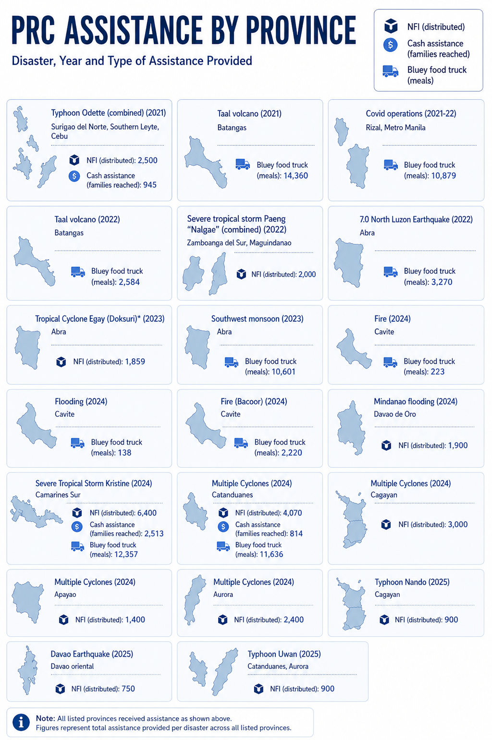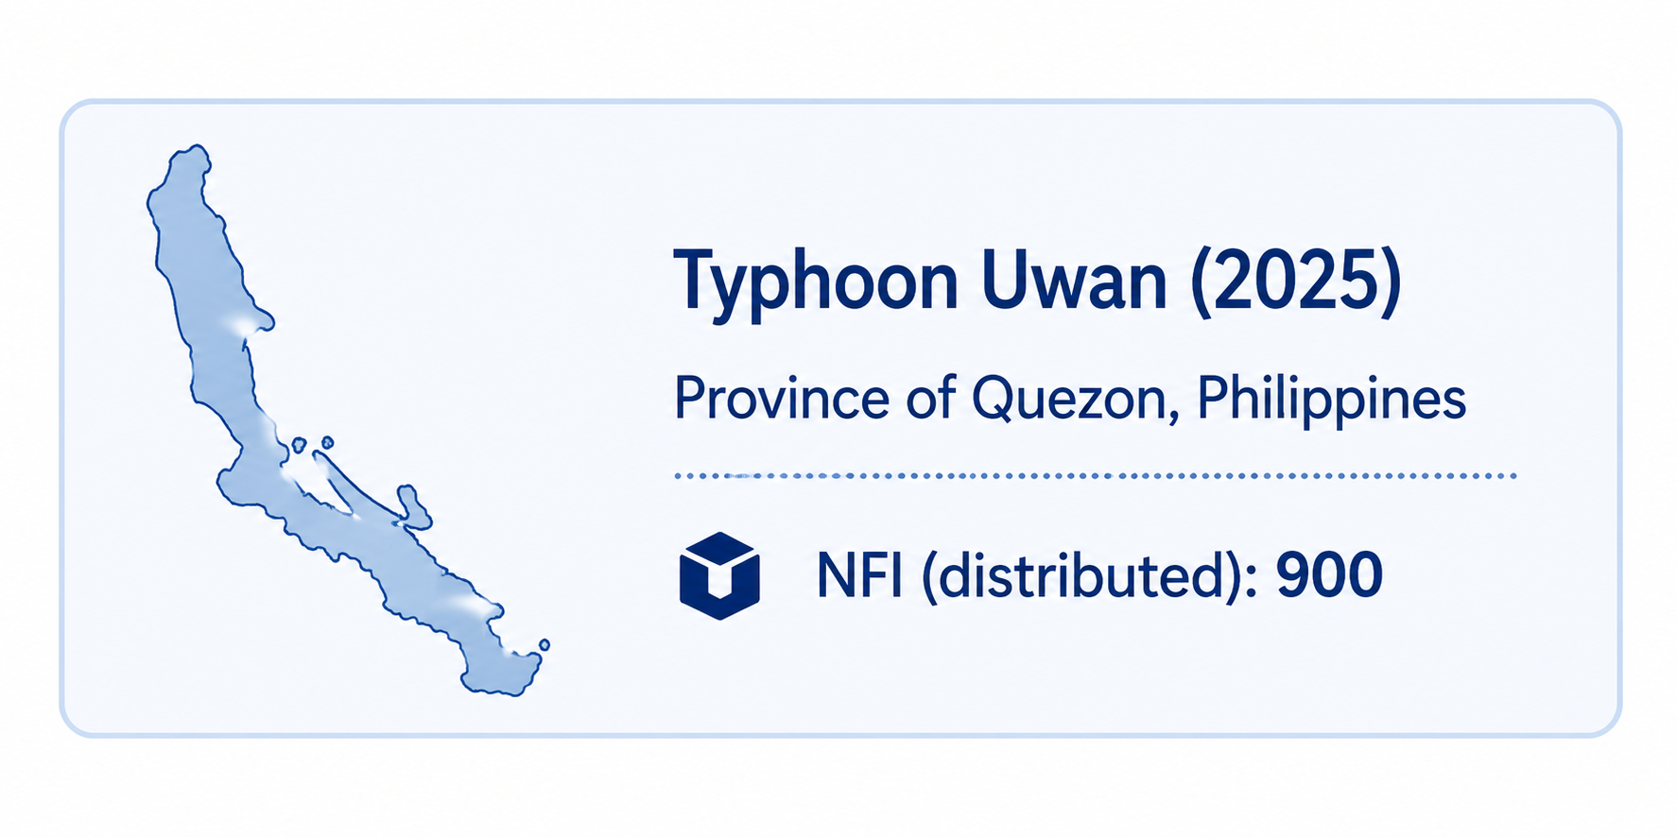

Disaster / response | Year | Province / location | NFI distributed | Cash assistance, families reached | Bluey food truck meals
Typhoon Odette | 2021 | Surigao del Norte | 2,000 | — | —
Typhoon Odette | 2021 | Southern Leyte | 500 | — | —
Typhoon Odette | 2021 | Cebu | — | 945 | —
Taal volcano | 2021 | Batangas | — | — | 14,360
COVID-19 operations | 2021–22 | Rizal and Metro Manila | — | — | 10,879
Taal volcano | 2022 | Batangas | — | — | 2,584
Severe Tropical Storm Paeng “Nalgae” | 2022 | Maguindanao | 1,200 | — | —
Severe Tropical Storm Paeng “Nalgae” | 2022 | Zamboanga del Sur | 800 | — | —
7.0 North Luzon Earthquake | 2022 | Abra | — | — | 3,270
Tropical Cyclone Egay “Duksuri” | 2023 | Abra | 1,859 | — | —
Southwest monsoon | 2023 | Abra | — | — | 10,601
Fire | 2024 | Cavite | — | — | 223
Flooding | 2024 | Cavite | — | — | 138
Fire, Bacoor | 2024 | Cavite | — | — | 2,220
Mindanao flooding | 2024 | Davao de Oro | 1,900 | — | —
Severe Tropical Storm Kristine | 2024 | Camarines Sur | 6,400 | 2,513 | 12,357
Multiple Cyclones | 2024 | Catanduanes | 4,070 | 814 | 11,636
Multiple Cyclones | 2024 | Cagayan | 3,000 | — | —
Multiple Cyclones | 2024 | Apayao | 1,400 | — | —
Multiple Cyclones | 2024 | Aurora | 2,400 | — | —
Typhoon Nando | 2025 | Cagayan | 900 | — | —
Davao Earthquake | 2025 | Davao Oriental | 750 | — | —
Typhoon Uwan | 2025 | Catanduanes and Aurora | 900 | — | —

ANNEX B: CASE STUDY – SEVERE TROPICAL STORM KRISTINE
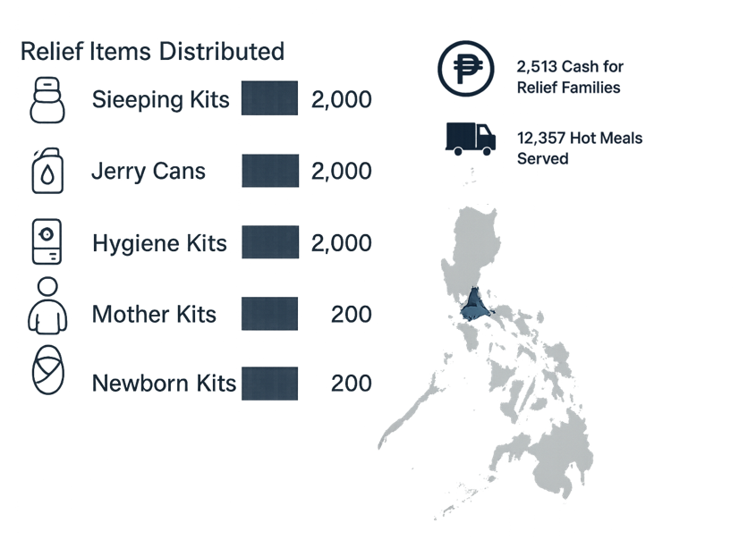
In 2024, six typhoons passed through the Philippines in less than a month, affecting over 12 million people. At its peak, thousands of displaced people were in evacuation centres or makeshift shelters, lacking essential non-food items (NFIs) such as sleeping mats and hygiene kits. Safe drinking water was scarce, sanitation facilities required urgent repairs and materials for rebuilding homes were in high demand.
The PRC response in Camarines Sur demonstrates the value of a flexible, locally led relief model, combining NFI distribution, cash-based assistance, and mobile food services to meet diverse and evolving needs following Severe Tropical Storm Kristine.

PRC Camarines Sur
PRC operates in all provinces nationwide, with 104 chapters and sub‑chapters reaching every region, including highly remote and disaster‑prone areas. PRC’s Camarines Sur (CamSur) Chapter is one of six in the Bicol Region, with eight regular staff and seven project staff (funded through the American Red Cross). Like most PRC chapters, its coverage is vast, supporting 1,063 barangays and over 2 million people. No other NGO in the Philippines has the reach, surge capacity, or legal mandate of PRC.

Unprecedented flooding
The first in the series of typhoons, Severe Tropical Storm Kristine made landfall on 24 October and triggered massive flooding and landslides severely affecting Regions 5, 4A and 2. According to OCHA, over 700,000 individuals were displaced, with 160 people killed and at least 135 injured.

“It washed away all of my possessions. Only my roof was left.”
- Female beneficiary interviewed for ICR

Local coordination
Within 12 hours of the typhoon crossing Camarines Sur, PRC staff were working alongside local government partners to develop needs assessments and prioritise support. Drawing on over 200 local volunteers – many of whom were trained in the immediate aftermath of the storm – PRC visited “up to 5,000” homes to verify government damage assessments, and provide recommendations to national headquarters. Efforts were hampered by flooding and damage to roads, making more remote communities extremely difficult to access, slowing the assessment process.

Hot meals
The ‘Bluey’ food truck was one of five deployed to provide immediate assistance to affected communities. PRC Camarines Sur used ‘Bluey’ to provide 12,357 hot meals at evacuation centres across the province. While not targeting within communities, the hot meals were considered essential.

“It gave people some nourishment and some hope”
- Camarines Sur PRC staff member

Non-food items
A week after Kristine struck, NFIs reached Naga City. As pre-positioning of NFIs was not feasible ahead of the storm, PRC enlisted government assistance to deploy stocks from its Cebu warehouse. This included over 10,000 items funded through the MYA, spanning hygiene kits, jerry cans and mother and newborn kits, provided to 2,000 families. Despite some delays in distributing supplies, all beneficiaries interviewed noted the NFIs provided from PRC were of high quality and greatly appreciated. Shelter supply kits were considered particularly important, while the mother and newborn kits provided essential assistance to parents. The PRC’s post distribution monitoring report surveyed 398 respondents, 150 of whom received NFIs. 100% of those surveyed were satisfied with the items received and 100% considered the items useful.
Response type | Total (families) | Total supplied from DFAT | DFAT % of total PRC response
Hygiene kit | 2,919 | 2000 | 69%
Jerry can | 3,394 | 2000 | 59%
Kitchen set | 994 |  | 0%
Sleeping kit | 2,940 | 2000 | 68%
Mother and newborn kit | 200 | 200 | 100%
Total NFI | 10,447 | 6,200 | 59%
Cash | 2,513 | 2,513 | 100%
Hot meals | 26,315 | 12,357 | 47%

Cash assistance
Reflecting PRC good practice, the Camarines Sur Chapter helped to establish Barangay Response Committees (Barecoms) across four municipalities to identify and prioritise families in need of multi-purpose cash grants. The Barecoms were well regarded in conversations with Barangay officials and community members in Milaor, and appeared broadly inclusive of different interests – including people living with disabilities. While harmonisation of standards across different Barecoms required support from PRC, the committees demonstrate PRC’s capacity to localise support and promote community agency. 5,000 pesos were distributed to 2,513 families each, consistent with standards from the Cash Working Group, though lower than some other stakeholders in the region. The cash assistance was undoubtedly significant, but made up only a small fraction of total cash relief – the World Food Programme for example supported 43,000 families with cash grants.
PRC MPCG assistance was distributed between 17-14 December – over six weeks after the initial impact. Despite the logistical challenges preventing earlier cash distribution, 98% of PDM respondents indicated cash had been beneficial to meet basic needs, with 36% using cash for food, and 25% for house repairs.
Despite effective targeting and communication with beneficiaries, some cash distribution monitored by Post was also impacted by delays, with one centre not commencing distribution until 4pm. The safeguarding risks of such delays are significant – particularly for pregnant women and young children – but PRC reportedly worked to ensure distribution was more efficient and respectful of families’ time in subsequent sessions.

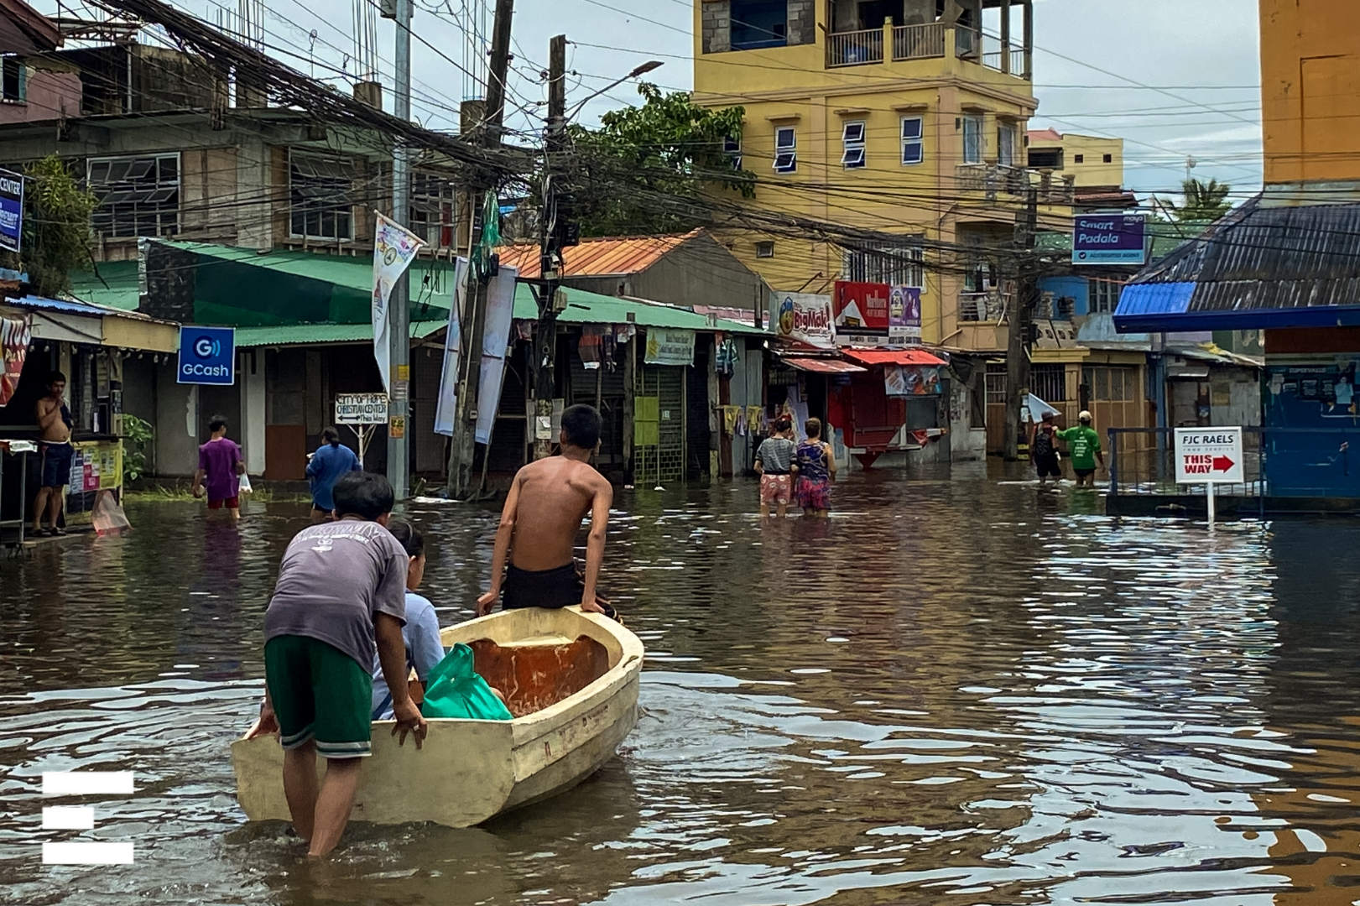
Lessons
The response to Severe Tropical Storm Kristine underscored the unique responsibility and pressure placed on the Philippine Red Cross as a frontline, locally embedded responder. It also served as a reminder of the inherent complexity of disaster response in the Philippines, particularly the time required to accurately identify needs across geographically remote and marginalised communities.
The response highlighted the ongoing challenge of balancing pre-positioning of NFIs with warehousing and logistics constraints; while pre-positioned stocks could have improved timeliness, maintaining sufficient and well-located storage remains difficult. The experience also reinforced the value of community-based processes in prioritising cash assistance, which helped manage expectations and reduce perceptions of bias.
Finally, the response emphasised the importance of volunteer welfare and safeguarding, including protection from sexual exploitation, abuse and harassment (SEAH). While existing safeguarding measures were in place, there is scope to further strengthen volunteer knowledge, skills and confidence to proactively identify and respond to safeguarding risks during surge operations.
ANNEX C: Data Analysis Rubric
The Review sought to build on the rubric developed for the MTR, to provide continuity and consistency where possible in analysis. Accordingly, a number of sub-dimensions were identified for each review domain, which were rated individually. The synthesis presented in this process will help to determine the merit (quality) ratings for these subdimensions, and consequently for each OECD criteria.
Sub-dimensions from the MTR were consolidated to minimise duplication, and additional sub-dimensions added for new areas of review (risk and financial management).
The following are presented:
- The subdimensions under each of the review criteria.
- Rubrics and procedures for determining merit ratings for each of the subdimensions. These are aligned with the six performance levels in DFAT’s Final Aid Quality Check (FAQC).
- The process to determine merit ratings for the performance for each of the criteria.
Consistent with the MTR, the matrix consists of the following 6 performance levels:
Score | Ratings Matrix | Merit rating
6 | Very good | Satisfactory
5 | Good | Satisfactory
4 | Adequate | Satisfactory
3 | Less than adequate | Unsatisfactory
2 | Poor | Unsatisfactory
1 | Very poor | Unsatisfactory

Subdimensions under the evaluation criteria
Criteria/KPP | Subdimension
Relevance | - Relevance of the MYA to DFAT’s priorities  - Relevance of the MYA to PRC  - Adequacy of needs analysis  - Consistency of delivery against terms of agreement  - Appropriateness of governance arrangements  - Appropriateness of management arrangements
Coherence | - The MYA complementing other relief efforts  - Added value of MYA compared to other relief  - Relevance of the MYA to the Philippine Government
Effectiveness | - Delivering planned prepositioning outputs (including food truck)  - Speed of mobilising prepositioned items  - Delivering planned COVID-19 outputs  - Delivery of cash assistance and compliance with CTP guidelines  - Adequacy of MEL systems and practice
Efficiency | - Delivering outputs as planned  - Appropriateness of resource use
Sustainability | - Enduring impact  - Institutional and systems sustainability  - Operational and asset sustainability
Gender Equality, disability and social inclusion | - Supporting gender equality  - Supporting disability inclusion  - Local Leadership and Decision Making Authority
Risk Management | - Risks appropriately identified and managed  - Safeguard capacity
Financial management | - Progress to address concerns regarding financial management  - Status of external auditing  - Compliance with DFAT due diligence expectations  - Value for money  - Fraud and corruption systems  - Financial risk management

Merit rating for subdimensions
The table below provides the merit rating for qualitative data.
Score | Merit Rating | Description
1 | Very good | Evidence of very strong performance; positive feedback from all consulted sources. No weaknesses were identified.
2 | Good | Evidence of a strong performance; predominantly positive comments. No weaknesses, or a few weaknesses without real consequences.
3 | Adequate | Evidence of noticeable positive performance; more than half of sources suggest a positive performance. Only a few weaknesses identified with serious impact on performance.
4 | Less than adequate | A mix of positive and negative comments. Inconsistent comments across the sources of information, and the different locations. Sources highlight a number of weaknesses with a serious impact on performance.
5 | Poor | Clear evidence of unsatisfactory performance. Findings are predominantly negative, or partial weak evidence. Many weaknesses are identified.
6 | Very poor | No positive evidence found, or predominantly weak evidence.

Procedure of setting merit ratings for subdimensions
This ICR draws heavily on the MTR approach (and structure) to ensure consistency in comparison.
For qualitative data only
- Review the data/evidence collected and assign the appropriate merit rating
For quantitative data only
- Compare the analysed data with the merit ratings and identify the associated merit rating
For quantitative and qualitative data
- Assign the merit ratings for quantitative data
- Assign the merit rating for qualitative data
- If they are the same, then that is the final merit rating
- If the qualitative merit rating is higher than that of the quantitative, then the overall merit rating will go up, but a maximum of 1 level.
- If the qualitative merit rating is lower than that of the quantitative, then the overall merit rating will go down, but a maximum of 1 level.

https://www.dfat.gov.au/about-us/publications/due-diligence-framework
Outcome 3 in the Australia-Philippines Development Partnership Plan (2024-2029)
IOM. 2024. Country Factsheet: The Philippines
UN OCHA. Global Humanitarian Overview. 2025. The Philippines

