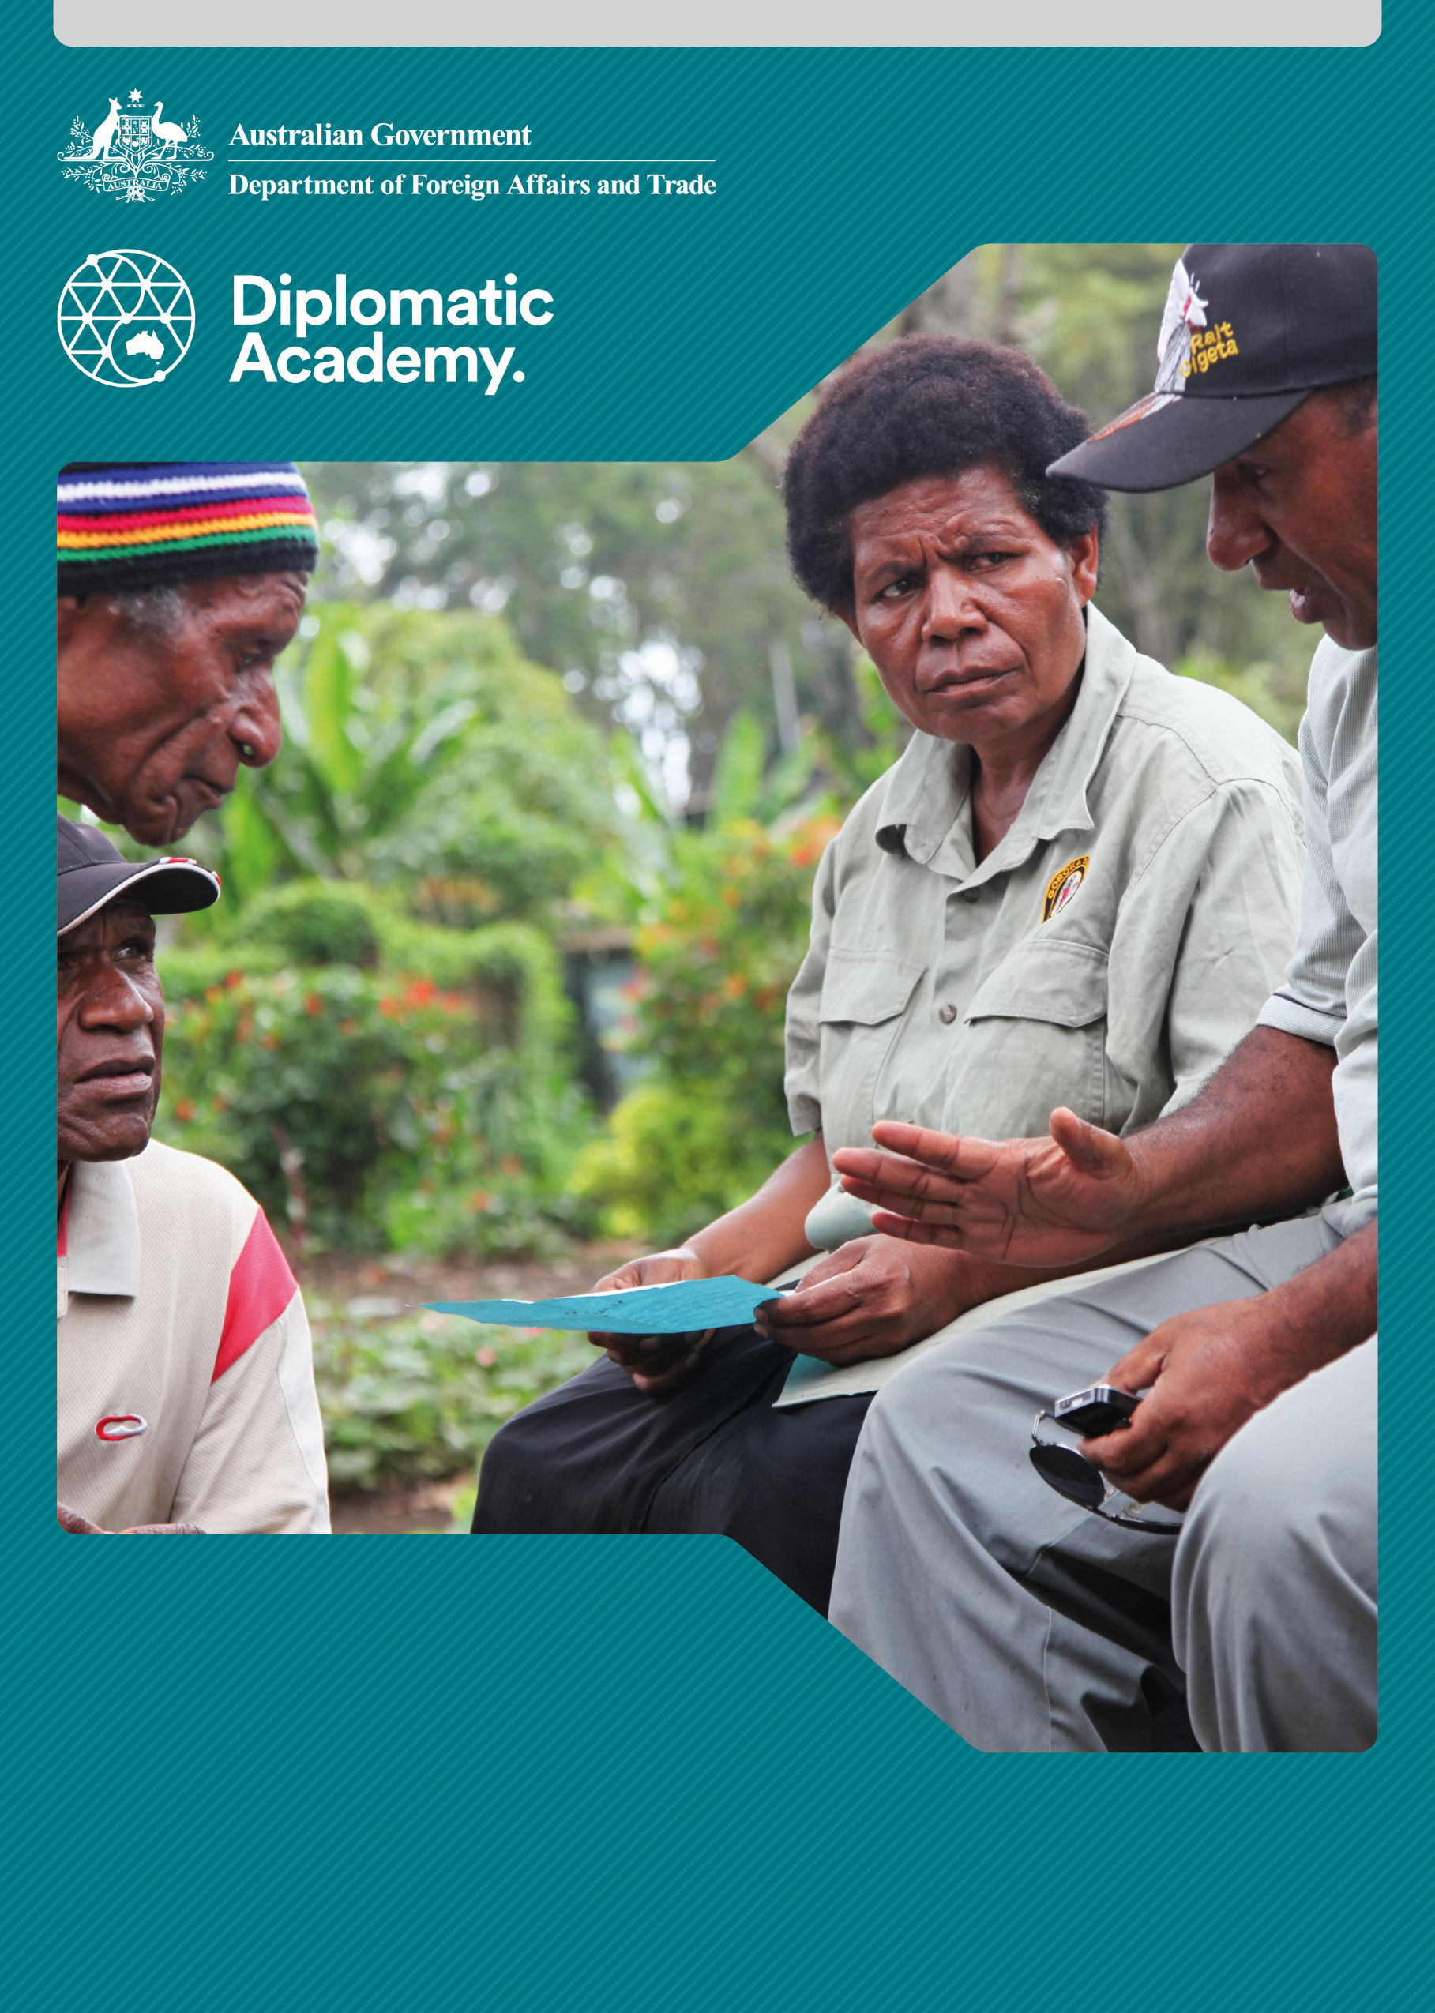

the role of key

stakeholders in education

and aid effectiveness principles

Practitioner Level

2018
Education Learning and Development Module
Education Learning and Development Module
CONTENTS

Acronyms 3
1 Introduction 4
2 The role of key stakeholders in education 4
3 In what ways can different stakeholders be involved? 10
4 Partnerships at the gobal, regional and country levels 14
5 Test your knowledge 18
References and links 21

Acronyms

ASPBAE The Asia South Pacific Association for Basic and Adult Education
DFAT Australian Government Department of Foreign Affairs and Trade
DFID Department for International Development (United Kingdom)
GCE Global Campaign for Education
GPE Global Partnership for Education
GTZ Deutsche Gesellschaft für Internationale Zusammenarbeit GmbH (Germany)
INEE Interagency Network on Education in Emergencies
INGO international non-government organisation
NGO non-government organisation
OECD Organisation for Economic Co-operation and Development
OECD-DAC OECD Development Assistance Committee
P4D Partnerships for Development
PEA political economy analysis
SDGs Sustainable Development Goals
UN United Nations
UNICEF United Nations Children’s Fund
USAID United States Agency for International Development

Introduction
The purpose of this module is to enhance the understanding of staff members who engage with international and domestic stakeholders and partners on aid effectiveness in education.
It is recommended that staff complete the Foundation level of the module The Role of Key Stakeholders in Education and Aid Effectiveness Principles as background information to this Practitioner level module.

The role of key stakeholders in education


Scenario
The Minister of Education has called a meeting of ‘all stakeholders’ to discuss the ways in which the recently approved national medium term strategy for education can be implemented. The Minister has insisted that the meeting should include ‘all the major multilaterals, bi-laterals, regional organisations, international and national NGOs and relevant local civil society organisations and interest groups’.
DFAT is the biggest development partner and has played a key role in supporting the government in developing the national medium term education strategy. The Secretary for Education has asked DFAT to help her plan for the meeting, and the follow up activities. Her letter includes the following: ‘We want to ensure that the key stakeholders are involved in the most appropriate way that maximises their comparative advantage and minimises conflicts of interest.’


An activity for you
Your supervisor asks you to represent DFAT at the preparatory meeting with the Director of Planning, and would like you to prepare a briefing note for the meeting. How will you determine who the key stakeholders are, their interests, likely influences and involvement?
The Foundation level module on The Role of Key Stakeholders in Education and Aid Effectiveness Principles provided an overview of the various different stakeholders in the education development arena. It offered some definitions of the different types of key stakeholders. In the scenario described above, you would be required to suggest in a briefing paper how the government might lead an exercise to:
- agree what ‘key stakeholders’ means (definition)
- who they are in this particular context (identification)
- what the particular interests of each stakeholder are (analysis)
determine how they should be involved in the process in the most efficient way (engagement).
Figure 1 – Four steps to stakeholder engagement
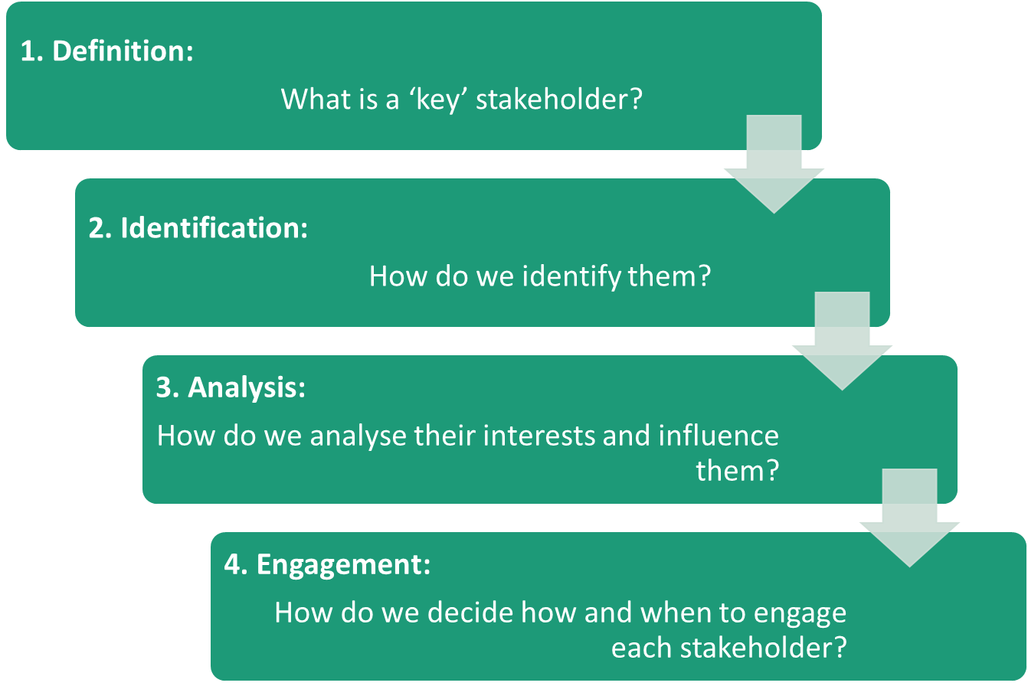
Example answer: Depending on the context, a range of different techniques can be used to identify stakeholders, such as:
- an analysis of documents
- commissioning a stakeholder survey
organising a planning session in which a small group begins to identify a list to answer the question: which people, groups or institutions will affect/be affected by the proposed activity.
Note: It is helpful to group the stakeholders according to categories such as ‘Private sector’, ‘Public sector’ and ‘Civil society’. This process will generate a ‘long list’ of stakeholders which will be an input for the next step of a stakeholder analysis.

How do we identify key stakeholders?
Techniques to identify key stakeholders range from commissioning researchers to conduct a formal stakeholder analysis to a simple brainstorming exercise among a core group in a preparatory meeting. For example, the World Bank commissioned a corporate consulting firm to undertake stakeholder analyses in two countries in South East Asia. They did this by using local agency staff and local consultants to prepare a paper that provided a basis for discussions and by holding a brainstorming meeting to identify the key stakeholders and suggest their interests.
Note: Another framework is suggested by the World Bank stakeholder analysis guidelines – a four-step process.
Source: World Bank 2016.

Political economy analysis
A high level, major sectoral reform program may qualify for a commissioned ‘political economy analysis’, which includes a stakeholder analysis. The United States Agency for International Development (USAID) provides a detailed description of USAID’s approach to applied political economy analysis. More common is an exercise conducted in workshops and brainstorming sessions, sometimes informed by reports on initial stakeholder consultations. At the local level, it may simply involve meetings with people who could influence a school level issue, such as improving attendance or attracting more qualified teachers to the school. The choice of specific technique will depend on the context, the issues and the resources (including time) available.
Source: USAID 2016.
Note: Political economy analysis (PEA) is something that calls for expert level engagement, and you may wish to seek further advice on this from your manager.
The range of stakeholders relevant to consider for analysis varies according to:
- the complexity of the reform area targeted
- the type of reform proposed
where the stakeholders are not organised, the incentive to include them.
Stakeholders can be of any form, size and capacity. In the Foundation level module, The Role of Key Stakeholders in Education and Aid Effectiveness Principles, the following categories of stakeholders were suggested:

Table 1 – Stakeholder analysis
Private sector stakeholders | Public sector stakeholders | Civil society stakeholders
Corporations and business | Ministers and advisors (executive) | Media
Individual business leaders | Public servants and government departments (bureaucracy) | Religious organisations
Professional bodies | Elected representatives (legislature) | Schools and universities
Individual business leaders | Courts (judiciary) | Social movements and advocacy groups
Financial institutions | Political parties | Trade unions
 | Local government/councils | National NGOs
 | Military | International NGOs
 | International bodies (World Bank, United Nations) | Parents and communities
They can also be categorised as individuals, organisations, or unorganised groups. Examples include:
- national or political actors (for example, legislators, governors)
- public sector agencies (for example, Ministries of Education and Finance, Public Service Commission)
- interest groups (for example, teacher unions, Chamber of Commerce, Independent Schools Association)
- commercial/private for-profit organisations (for example, textbook publishers, private schools, employer groups)
- non-profit, non-government organisations (NGOs) (for example, local and international NGOs, religious organisations, charities, foundations)
- civil society members (for example, community groups, village councils, parent/teacher associations)
- users/consumers (for example, students, parents/caregivers, community members)
international actors (for example, development partners).
Once there is agreement on the categories of stakeholders, it is helpful to develop a long list of all stakeholders, listing them under the agreed categories.
Key questions for this step in a stakeholder analysis can include:
- Who is directly responsible for key decisions affecting the issue?
- Who holds positions of responsibility in interested organisations?
- Who is influential over the issue (both thematic and geographic areas)?
- Who will be affected by related actions?
- Who will promote/support the related actions, provided that they are involved?
- Who will obstruct/hinder the related actions if they are not involved?
- Who has been involved in the area (thematic or geographic) in the past?
Who has not been involved up to now but should have been?
Source: World Wide Fund for Nature (WWF) 2005, Cross-cutting tool: Stakeholder analysis, p. 4.

How do we analyse the interests of key stakeholders and influence them?
The next step is to develop a shared understanding of:
- the stakeholders’ interests: what does each stakeholder stand to gain or lose by the implementation of the strategy?
- their influence: how much power does each stakeholder have to influence the process?
their level of access: what access to the process does each stakeholder have?
This last question is important because some groups or interests – for example, women and marginalised groups – can add value if they are helped to get organised or gain access to the process. It is not simply a matter of dealing with stakeholders who are already organised to engage in the process: it may be necessary to enable the participation of excluded groups.

An activity for you
For your country program or a developing country known to you, identify one stakeholder in each of the following categories and suggest how that line in the following table could be completed. The table outlines how the entries might look – please tailor this to your own example.
Stakeholder | Stake/ Mandate |  | Potential role in reform/ project or activity | Engagement status
 |  |  |  | Key actor | Marginalised
Actors and interests
List groups, organisations or individuals who could be affected by or who could influence the reform/project/ activity | What is at stake, what are the stakeholders’ interests, and what is the mandate of the stakeholder? |  | Could the stakeholder influence (for example, advance or prevent) the reform/project/ activity? | Is the involvement of the stakeholder vital (could it make or break the reform?) | Is the stakeholder well organised or represented, or usually excluded from  the process?
Stakeholder | Stake/ Mandate |  | Potential role in reform/ project or activity | Engagement status
 |  |  |  | Key actor | Marginalised
Multilateral Bank |  | Supports education at all levels. Its policies and activities directly contribute to overall programs for poverty reduction | Could provide Technical Adviser and loan support for major interventions | Yes | No presence in country

Private sector stakeholders
National Association of Private Schools | Represent interests of private school members in national policy discussions | Could influence some aspects of policy. Could add real value if on board | Yes | No, but some private schools not represented
National Chamber of Commerce and Industry | Ensure that education system helps develop learners with employable skills | Critical to some aspects of reform | Yes/No | No easy access to sector
Public sector stakeholders
Ministry of Finance | Responsible for ensuring most efficient distribution of resources across sectors to achieve national development objectives | Could support additional resources for sector if convinced of benefits | Yes | No
Education Ministry/ Department | Responsible for development of national policy; sets standards and monitors | Central leadership role | Yes | No
Civil society stakeholders
Women’s rights organisations | Represent women and promote gender equality | Could increase the voice of women and girls | Yes | Yes, not previously involved
Parents and communities | Key to supporting learning of children and to holding schools and teachers accountable for performance | Could play a strong role at grass-roots level | Yes | Yes
Disabled person’s organisation | Represent people with disabilities and promote equality of access and participation | Could increase the voice of people with disabilities | Yes | Yes, not previously involved

In what ways can different stakeholders be involved?

What is the stakeholder participation continuum?
It is helpful to bear in mind that there is a range of levels of participation, from simply keeping people informed, through various forms of consultation, to direct involvement in decision making. A stakeholder interests and influence analysis is used to reach decisions on which interests should be involved in which ways.
With their different interests, capacities, resources and potential roles, various stakeholders are not equally involved in the process. In approaching this decision of who should be involved and who should not, it is helpful to think in terms of a ‘participation continuum’:
- Level 1: Information – those who need to be kept informed of the process.
- Level 2: Consultation – those who should be involved in discussions.
Level 3: Decision making – those who must be involved in making decisions.

How do you decide how and when to engage each stakeholder?
There are many different approaches to this question. Most involve some version of the stakeholders and interests matrix illustrated in Figure 2 below.
Whatever approach is used, there are three essential steps in stakeholder analysis:
- Identifying the key stakeholders and their interests (positive or negative) in the issue.
- Assessing the influence, importance, and level of impact each stakeholder may have on the issue.
- Identifying how best to engage stakeholders.
Figure 2 shows the stakeholders and interests matrix that covers four quadrants from ‘more influence’ to ‘less influence’ and ‘less impacted upon’ to ‘more impacted upon’.
Figure 2: Stakeholders and interests matrix
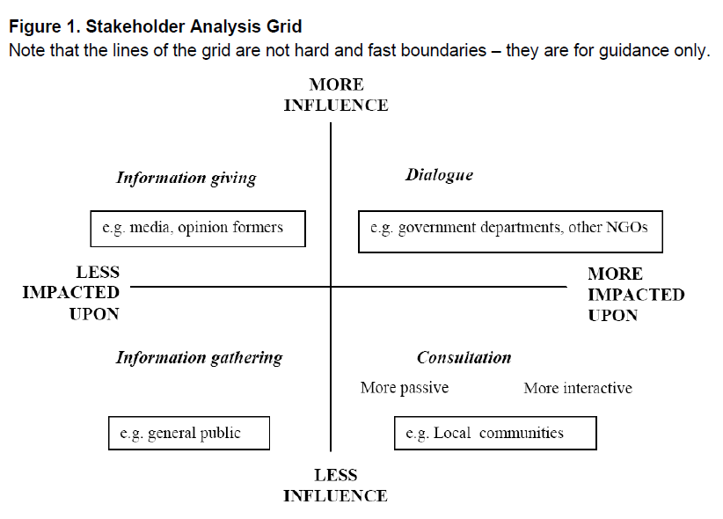
Source: World Wide Fund for Nature (WWF) 2005, Cross-cutting tool: Stakeholder analysis, p. 5.
An activity for you
Consider the scenario at the start of this module. Imagine you are in a stakeholder analysis workshop to agree on ways of engaging key stakeholders in the implementation of the new Medium Term National Education Strategy.
Using a country context that is familiar to you, identify and list different stakeholders for each of the following categories:
- international actors (for example, United Nations Children’s Fund (UNICEF))
- public sector agencies (for example, the Public Service Commission)
- commercial/private for-profit or non-profit organisations (for example, private schools)
- civil society members (for example, disability advocacy groups)
- users/consumers (for example, the National Students’ Union).
From your list of stakeholders, select one key stakeholder under each category. Using these key stakeholders identify where each one should be placed in the stakeholders and interests’ matrix (as above) – and why you have decided this.
Note: There are no correct or incorrect answers, but you should be able to explain why you placed a stakeholder where you did.


Case study: Zimbabwe stakeholder consultation
Following the economic and political crisis of 2008 in Zimbabwe, there was a recognition in government that the reconstruction of what had once been a very highly respected system was needed. For legitimacy, it was essential that there was popular acceptance of any changes introduced.
With support from the World Bank, the process of stakeholder consultation adopted was a politicians’ retreat to a three-day workshop. Here, in a relaxed but structured atmosphere, a level of trust and shared purpose was built. This was followed by a brainstorming session in which a long list of interest groups, individuals and (especially) marginalised groups was compiled. Through a stakeholder analysis process consensus was reached on how to group the stakeholders, and how to involve them in the national consultations on education.
In the consultation that followed, key interest groups such as teacher organisations, private sector representatives, churches and NGOs were involved in a range of different consultations. The resulting consultation, which took multi-stakeholder teams to every province and a selection of districts and villages, laid a foundation of trust and openness. This proved critical in the development of the Interim Education Strategy, and the five year sector plan that followed.

What other key lessons about stakeholder involvement have been learned from international experience?

Participatory or expert analysis?
Much depends on the issues and context, but even if consultants, or researchers are employed to do initial data gathering and provide some analysis, the exercise will have most value if key female and male stakeholders also participate in the analysis, and build consensus around who should be involved, and how.

Transparency or secrecy?
Some aspects of political economy analysis are sometimes undertaken in confidence. For this reason they are often led by experienced analysts. However, inclusive and transparent approaches tend to have more impact in the long term. The need for transparency must be balanced against practical considerations of time and resources.

Clarity on goals, or open discussion?
Successful participatory stakeholder analyses tend to start with clarifying the goals of the issue being investigated, which helps inform the selection of participants, and the way they are engaged.

Personal or institutional agendas?
It is important to differentiate between personal agendas (‘If I get this issue accepted I might be promoted’) and institutional agendas (‘The organised teaching profession that I represent expects the following…’). While some political economy analysis does consider personal interests and agendas, most stakeholder analyses focus on institutional or organisational agendas, since identification of personal agendas may be much more subjective.

Stakeholder analysis at the beginning, middle or the end?
Stakeholder analysis is generally important early in the policy development process, but can also add value as implementation progresses. Establishing an early precedent of stakeholder consultation makes it easier to engage stakeholders in different ways as implementation progresses.

How do we incorporate gender in stakeholder analysis?
Women and men have differing needs and development goals that need to be taken into account if an intervention is to be successful. If no gender differentiation takes place, any stakeholder analysis runs the risk of indirectly supporting existing role allocations and forms of discrimination against women and men. For example, if we only include those stakeholders who are already actively involved – such as Ministries of Education or teachers’ associations that are male dominated – the marginalisation of women may be indirectly reinforced.

An example of a gendered approach to stakeholder analysis
Taking gender into account requires commitment and effort. The links at the front of this module (USAID 2016, World Bank 2016) demonstrate the types of questions that need to be asked in a stakeholder analysis. The example below is taken from Tools for Stakeholder Analysis (GTZ, Germany) and applies a gendered approach to stakeholder analysis. A similar process could be used for other traditionally marginalised groups, such as people with disabilities and ethnic minority groups.
Source: USAID 2016, Draft Working Document: USAID Applied Political Economy Analysis (PEA) Field Guide; World Bank 2016, Stakeholder analysis, Social Analysis; Zimmermann & Maennling (GTZ) 2007.

Identifying key stakeholders
- Which stakeholders exert a major influence on gender equality as a result of their legitimacy, resources and connections?
- Which key stakeholders actively support gender equality?
- Which are sceptical or reject the idea altogether?

Stakeholder mapping
- Which stakeholders have expertise when it comes to gender equality in development?
- Which stakeholder relationships impede or promote gender equality in development?

Stakeholder profiles and strategic options
- Which capacities and alliances can be used and strengthened to promote gender equality?
- When choices are being made about strategic options, what needs to be done to ensure that gender awareness is promoted and the reform intervention promotes gender equality?

Power and power resources
- Which stakeholders are disadvantaged, excluded and marginalised on the basis of their gender by existing power relations?
- Which power resources need to be especially supported among women and men in order to promote gender equality?

Competencies and empowerment
- Which stakeholders have, on account of their gender role, neither access to nor control of resources and have very few basic competencies to enable them to articulate their interests?
- Which stakeholders have particular capacities in relation to gender equality that could be used in the context of the reform intervention?
- Which competencies need to be supported among these stakeholders (empowerment)?
- Which institutional rules and conditions need to be created so that gender equality in development can begin to take hold?

Partnerships at the gobal, regional and country levels

The Australian aid program’s choice of partnerships
The Australian aid program’s choice of partnerships is shaped largely by its commitment to aid and development effectiveness. This requires us to work with other development partners at the global, regional and country levels and to align DFAT’s interventions with the development strategies of partner countries. The Australian aid program is influenced by its commitment to global conventions, such as universal primary completion, gender equality and inclusion of minorities, marginalised communities and the disabled.
Choice of partners can be determined by comparative advantage. This means that the Australian aid program partners with those organisations that have strengths that complement those of the Australian aid program, so that it can focus on its own strengths.
The Australian aid program also bases its choice of partners by identifying the factors that are most likely to influence change, the ‘political drivers’ of change, and seeking to strengthen them.
Australian aid investments in better education outcomes in partner countries have the potential to deliver high returns against the objectives of Australian aid. Choice of partnerships is influenced by a commitment to identifying the mechanisms that will achieve the greatest possible impact.
This means strategies such as support for consultation processes, or institutional strengthening, or capacity building and information sharing.

What kind of partnerships does the Australian aid program participate in?

Global level partnerships
At the global level, Australia is engaged in a range of key organisations and partnerships. Some of the key ones are listed below, with links to background documents.
As indicated in the Foundation level module The Role of Key Stakeholders in Education and Aid Effectiveness Principles, Australia has been a leading partner in advocating for aid effectiveness. Australia has been actively involved in the aid effectiveness agenda from the Rome Declaration in 2003, through the Paris Declaration on Aid Effectiveness in 2005, the Accra Agenda for Action in 2008, and the Busan Declaration in 2011, and shaping the Sustainable Development Goals (SDGs) agenda.
Sources: Organisation for Economic Co-operation and Development (OECD) 2003; OECD 2005, 2008, OECD n.d.; OECD 2011; United Nations 2015.
The Australian Government has helped to shape the evolution of the agenda from a focus on development partner harmonisation through aid effectiveness, to global partnerships for effective development cooperation. This international process has been supported throughout by the Organisation for Economic and Cultural Development (OECD), of which Australia is a member.
- Organisation for Economic Cooperation and Development. As a member of the OECD, Australia participates in information sharing about its own education system performance. See the 2011 OECD report on Australian education, for an example of this.
- OECD Development Assistance Committee. Australia is a member of the OECD’s Development Assistance Committee (OECD-DAC), which, among other things, organises a peer review of Australia’s performance in aid effectiveness.
- The Australia–World Bank Partnership Framework. Australia is an active member of the World Bank and has entered a formal partnership framed by the Australia World Bank Partnership Framework.
- The Global Partnership for Education (GPE). Australia has been a member of the Global Partnership for Education since its inception as the Fast Track initiative. Established in 2002, the Global Partnership for Education is a multi-stakeholder partnership and funding platform that aims to strengthen education systems in developing countries in order to dramatically increase the number of children who are in school and learning. Members of the partnership mobilise and coordinate resources to support the achievement of goals identified and agreed in national education sector plans.
Sources: Santiago, Donaldson, Herman & Shewbridge 2011, Australian Agency for International Development (AusAID) and World Bank Group 2011.

Regional Partnerships
- The Asia South Pacific Association for Basic and Adult Education (ASPBAE). This is a regional association of more than 200 organisations and individuals of which Australia is a member. It works towards promoting quality education for all. It focuses on policy advocacy, leadership and capacity building, strategic partnerships and institutional capacity building.

Single Issue Partnerships
- All Children Reading: A Grand Challenge for Development is a multi-year initiative that seeks to improve early grade reading outcomes in low-resource settings. Key partners are USAID, the Australian aid program and World Vision.

International non-government organisations (INGOs)
The Australian aid program partners at the global level with a number of major INGOs. Two examples are World Vision and Save the Children International.
- World Vision’s goal is for children to attain functional literacy and numeracy and develop essential life skills by:
  - increasing children’s access to equitable and quality early childhood education and primary education, with special attention to girls
  - strengthening community involvement in education
  - fostering an enabling environment for learning through partnerships and advocacy with communities, governments, universities, development partners, and non-governmental organisations.
- Save the Children is Australia's leading independent emergency relief and development organisation for children. It is part of a global network of national member organisations that operate collectively as Save the Children International at country level.

Advocacy organisations
- Interagency Network on Education in Emergencies (INEE). The INEE is an open global network of individuals and representatives from NGOs, United Nations (UN) agencies, development partner agencies, governments, academic institutions, schools, and affected populations. These network members work together to ensure all persons have access to quality and safe education in emergencies and during post-crisis recovery. The network offers valuable support on a range of key policy issues that affect fragile and low capacity states.
- Global Campaign for Education (GCE). The GCE is a civil society movement. Its mission is to make sure that states act now to deliver the right of everyone to a free, quality public education.

National level partnerships
Pacific Partnerships for Development. At the national level, the Australian aid program’s principal relationship is with the partner government, and this partnership is usually captured in a partnerships agreement. In the Pacific, these are commonly known as Partnerships for Development (P4D). The P4D covers cooperation across all sectors, and usually includes an Education Schedule which spells out agreed priorities and targets. Read more about some examples of P4Ds:
- Pacific Partnerships for Development
- Kiribati–Australia Partnership for Development.
Sources: DFAT n.d.a; DFAT n.d.b.
Indonesia–Australia Economic Partnership: With Indonesia, Australia has moved away from a traditional donor-recipient aid model towards an ‘economic partnership’ that focuses on leveraging Indonesia’s own substantial resources. The economic partnership covers cooperation across a wide range of areas, but is focused on delivering development assistance that is aimed at improving the quality of Indonesia’s investments. Agreed priorities of the Australia’s aid program is set out in an Aid Investment Plan.
Source: DFAT n.d.d., Development assistance in Indonesia: Overview of Australia’s aid program to Indonesia.

Aid Investment Plan
In many regions, the Australian aid program agrees an Aid Investment Plan with the partner government, with the involvement of key stakeholders. These are provided on the DFAT website. In almost all cases, P4Ds and Aid Investment Plans contain commitments to work closely with other development partners, and to use, or align with, partner government systems as far as possible.
At the national level, the Australian aid program also works with the private sector, civil society organisations, national NGOs and other organised stakeholders. An important exercise when engaging in a country is to identify who the current and potential partners might be.
Source: DFAT n.d.c. Where we give aid.

Test your knowledge

Assessment questions
Answer the following questions by ticking ‘True’ or ‘False’. Once you have selected your answers to all the questions, turn the page to ‘The correct answers are...’ to check the accuracy of your answers.
Question 1
Key stakeholders are all the individuals, groups and institutions that could affect or be affected in any way by an intervention or change.
Is this statement true or false? □ True □ False

Question 2
Marginalised stakeholders are those who are not included in the stakeholder consultation.
Is this statement true or false? □ True □ False

Question 3
It is satisfactory to just keep some stakeholders informed about the changes being discussed, without involving them directly in decision making.
Is this statement true or false? □ True □ False

Question 4
The Australian aid program enters global and regional partnerships that will help it carry out projects at country and local level.
Is this statement true or false? □ True □ False

Question 5
The focus of Australia’s Pacific Partnerships for Development and Aid Investment Plans is on wider development objectives which may or may not include the education sector.
Is this statement true or false? □ True □ False

The correct answers are...

Question 1
Key stakeholders are all the individuals, groups and institutions that could affect or be affected in any way by an intervention or change.
This statement is false. ‘Key’ stakeholders are not all the individuals, groups and institutions. Rather, it is those whose interests are directly affected by an activity, or who have the power or influence to advance or stop an activity.

Question 2
Marginalised stakeholders are those who are not included in the stakeholder consultation.
This statement is false. Marginalised stakeholders are those who could benefit from or may be impacted by the intervention, but who are not organised or respected in a way that enables them to engage. Part of the Australian aid program’s commitment to inclusion means helping to ensure that marginalised stakeholders are supported to have a ‘voice’ in the consultations.

Question 3
It is satisfactory to just keep some stakeholders informed about the changes being discussed, without involving them directly in decision making.
This statement is true. Yes, some stakeholders do not need to be directly involved in the process. Often they do not expect, or have the knowledge and skills, to be involved directly in decisions, but still need to be kept informed of the proposed intervention so they do not obstruct it.

Question 4
The Australian aid program enters global and regional partnerships that will help it carry out projects at country and local level.
This statement is false. The Australian aid program’s engagement in global partnerships is a direct result of its commitment to aid effectiveness. Global partnerships help the Australian aid program’s work with other development partners, to achieve national, regional and international development objectives. These partnerships help the Australian aid program realise its commitment to global treaties, agreements and compacts.

Question 5
Australia’s Pacific Partnerships for Development and Aid Investment Plans focus is on wider development objectives which may or may not include the education sector.
This statement is true. Pacific Partnerships for Development and Aid Investment Plans are focused on agreed national development priorities, and do not necessarily include education. However, since the Australian aid program accords such high priority to education and human resource development, in practice, many Partnerships for Development and Country Strategies have a strong commitment to support the education sector.

References and links
All links retrieved July, 2018.
Australian Agency for International Development (AusAid) and World Bank Group 2011, Australia-World Bank Group Partnership Framework, http://dfat.gov.au/about-us/publications/Documents/ausaid-wb-partnership-framework-signed.pdf
Department of Foreign Affairs and Trade (DFAT) n.d.a , Pacific Partnerships for Development, http://dfat.gov.au/geo/pacific/development-assistance/partnerships/Pages/default.aspx
n.d.b, The Kiribati–Australia Partnership for Development, http://dfat.gov.au/geo/pacific/development-assistance/partnerships/Pages/kiribati.aspx
n.d.c. Where we give aid, http://dfat.gov.au/aid/where-we-give-aid/Pages/where-we-give-aid.aspx
n.d.d. Development assistance in Indonesia: Overview of Australia’s aid program to Indonesia, http://dfat.gov.au/geo/indonesia/development-assistance/Pages/development-assistance-in-indonesia.aspx
Organisation for Economic Co-operation and Development (OECD) n.d., The Accra Agenda for Action (AAA), http://www.oecd.org/development/effectiveness/45827311.pdf
2003, Rome Declaration on Harmonisation, https://www.oecd.org/dac/effectiveness/31451637.pdf
2005, 2008, The Paris Declaration on Aid Effectiveness and the Accra Agenda for Action Declaration, http://www.oecd.org/development/effectiveness/34428351.pdf
2011, Busan Partnership for Effective Development Cooperation, https://www.oecd.org/development/effectiveness/49650173.pdf
Santiago, P, Donaldson, G, Herman, J and Shewbridge, C 2011, OECD Reviews of evaluation and assessment in education: Australia, OECD, http://www.oecd.org/australia/48519807.pdf
United Nations 2015, The 2030 Agenda for Sustainable Development, Resolution adopted by the General Assembly on 25 September 2015, http://www.un.org/sustainabledevelopment/development-agenda/
USAID 2016, Draft working document: USAID applied political economy analysis (PEA) field guide, https://www.usaid.gov/sites/default/files/documents/2496/Applied%20PEA%20Field%20Guide%20and%20Framework%20Working%20Document%20041516.pdf
World Bank 2016, Stakeholder analysis, Social analysis, http://web.worldbank.org/WBSITE/EXTERNAL/TOPICS/EXTSOCIALDEV/0,,contentMDK:21233812~menuPK:3291499~pagePK:64168445~piPK:64168309~theSitePK:3177395~isCURL:Y~isCURL:Y,00.html
World Wide Fund for Nature (WWF) 2005, Cross cutting tool: Stakeholder analysis, p. 5, http://www.google.com.au/url?sa=t&rct=j&q=&esrc=s&source=web&cd=1&ved=0ahUKEwi69Iu3x43ZAhUKPrwKHZxRC3UQFggpMAA&url=http%3A%2F%2Fwww.panda.org%2Fstandards%2F1_4_stakeholder_analysis&usg=AOvVaw3HEFshtN6B3vYtkxNi-2YY
Zimmermann, A & Maennling, C 2007, Mainstreaming participation – Multi-stakeholder management: Tools for stakeholder analysis: 10 building blocks for designing participatory systems of cooperation, GTZ, http://www.fsnnetwork.org/sites/default/files/en-svmp-instrumente-akteuersanalyse.pdf
Learn more about…
- The World Bank interest analysis, found at: http://www1.worldbank.org/publicsector/anticorrupt/PoliticalEconomy/stakeholderanalysis.htm
- The World Health Organisation’s stakeholder analysis guidelines, found at: http://www.who.int/workforcealliance/knowledge/toolkit/33.pdf
- The Australian Government’s development policy, found at: http://dfat.gov.au/aid/Pages/australias-aid-program.aspx
- The Australia–World Bank Group Partnership Framework at this website: http://dfat.gov.au/about-us/publications/Pages/australia-world-bank-group-partnership-framework.aspx
- The Global Partnership for Education, found at: http://www.globalpartnership.org/about-us
- The All Children Reading: A Grand Challenge for Development program, found at: http://www.allchildrenreading.org/partners
- World Vision at this website: https://www.worldvision.org/our-work/education
- Save the Children International, found at: http://www.savethechildren.org/site/c.8rKLIXMGIpI4E/b.6153015/
- The Interagency Network on Education in Emergencies (INEE) , found at: http://www.ineesite.org/en/about
- The Pacific Partnerships for Economic Growth: Education, found at: http://dfat.gov.au/geo/pacific/development-assistance/Pages/education-pacific-regional.aspx
- The Department for International Development (DFID)’s Practice Paper on aligning with local priorities, found at:: http://www.gsdrc.org/docs/open/CON80.pdf
- The Strategy for Australia’s aid investments in education (2015–2020), found at: http://dfat.gov.au/about-us/publications/Pages/strategy-for-australias-aid-investments-in-education-2015-2020.aspx

