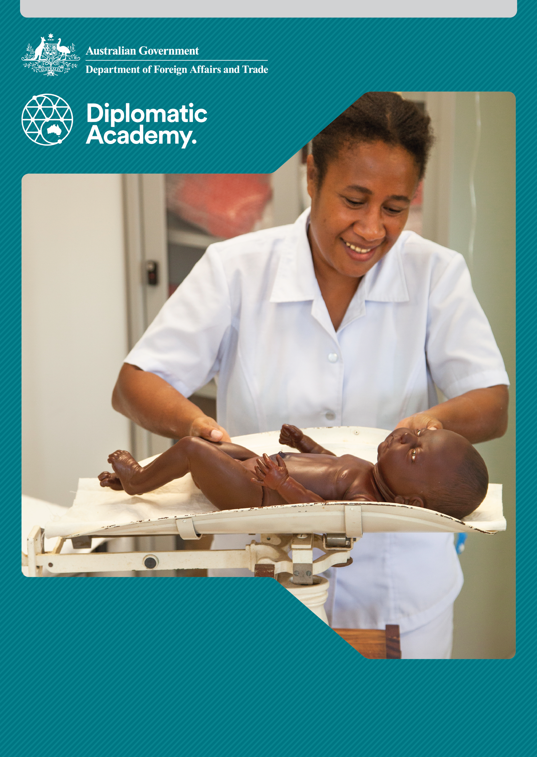

Education Learning and Development Module

**HIGHER EDUCATION**

Practitioner Level

2018

CONTENTS

Acronyms 3

1 Introduction 4

2 How does higher education link with TVET, secondary education, workforce planning and lifelong learning? 4

3 What are the investment options for higher education? 7

4 How is higher education financed? 13

5 How is higher education quality assured? 15

6 Sustainability and higher education 19

7 Test your knowledge 20

References and links 24

# Acronyms

ACIAR Australian Centre for International Agricultural Research

AAPS Australia Awards Pacific Scholarships

BAN-PT Indonesia’s National Accreditation Agency for Higher Education (Badan Akreditasi Nasional Perguruan Tinggi)

DFAT Australian Government Department of Foreign Affairs and Trade

FDI Foreign Direct Investment

DET Australian Government Department of Education and Training

INQAAHE [International Network for Quality Assurance Agencies in Higher Education](http://www.inqaahe.org/full-members-list)

NAAC [Indian National Assessment and Accreditation Council](http://www.naac.gov.in/)

OECD Organisation for Economic Cooperation and Development

PNG Papua New Guinea

R&D Research and development

QA quality assurance

SQA [Samoa Qualifications Authority](http://www.sqa.gov.ws/)

TAFE Technical and Further Education

TVET technical and vocational education and training

UGC University Grants Commission (Sri Lanka)

USP University of the South Pacific

# Introduction

This Practitioner level module is designed to ensure staff members who engage with and lead policy dialogue with international and domestic partners are informed about pathways through higher education and strategies for investing in and ensuring the quality of higher education.

It is recommended that staff complete the *Higher Education: Foundation level* module as background information to this *Practitioner level* module.

# How does higher education link with TVET, secondary education, workforce planning and lifelong learning?

## What do higher education, TVET, secondary education, workforce planning and lifelong learning mean?

In most developing countries ‘higher education’ refers to post-secondary education where a degree, diploma, or certificate is awarded at the end of study. In many countries higher education means university level education. In other countries the term ‘tertiary education’ is used, meaning any type of formal education program, short duration and long duration, available to those who have graduated from secondary school.

**Note**: For more information view the *Foundation level* module on *Higher Education*.

|  |
| --- |
| Technical and Vocational Education and Training  Technical and vocational education and training (TVET) refers to the study of technologies and related sciences, and the acquisition of practical skills, attitudes, understanding and knowledge relating to occupations in various sectors of economic and social life. TVET may or may not result in a degree, diploma, or certificate awarded at the end of study. In the Australian context, TVET includes Technical and Further Education (TAFE) based study, apprenticeships and non-award courses.  **Note:** For more information view the *Foundation level* module on *TVET*. |

|  |
| --- |
| Secondary education  Secondary education is the stage of education following primary education. Lower secondary (the initial 2 or 3 years) may form part of basic education. How much of secondary education is compulsory varies between countries.  **Note**: For more information view the *Foundation level* module on *Basic Education*.  Workforce planning  Workforce planning is a key component of a country’s employment and economic growth strategy. Higher education plays a critical role in the implementation of workforce plans.  Both established and emerging industries need women and men with appropriate skills at all levels. The public and private sectors of many developing countries experience skill shortages and skill mismatches. Vacancies for a wide range of professional and technical positions in areas such as health, education and the trades remain unfilled for long periods and can lead to service gaps, increased use of expatriate labour and/or wage pressures.  **Note**: For more information view the *Foundation level* module on *Higher Education.*  Lifelong learning  Lifelong learning is the ongoing, voluntary, and often self-motivated pursuit of knowledge for either personal or professional reasons. [The Sustainable Development Goal 4: Quality Education](http://www.undp.org/content/undp/en/home/sustainable-development-goals/goal-4-quality-education/targets/) emphasises the importance of providing access to quality education at all levels to promote lifelong learning.  Source: United Nations 2015b. |

## Higher education can provide a pathway from schooling to work

The last four decades have brought a major expansion of higher education in every region of the world, and women have been the principal beneficiaries in all regions.

Nonetheless there are many enduring challenges. In South Asia, the tertiary education system serves only 10 per cent of the population. In the Pacific the system serves less than 15 per cent of the population, and in some countries less than 5 per cent. This compares with OECD countries where, on average, 43 per cent of 25-34 year olds have completed tertiary education.

Young people leaving secondary school face major challenges in accessing decent work, especially young women. For many, the only employment options are in the informal sector. Higher education can provide a pathway from schooling into work, but such pathways are often very narrow with severe constraints on available places.

Source: Organisation for Economic Co-operation and Development (OECD) n.d., [OECD.Stat.](http://stats.oecd.org/)

### What does the informal sector of work consist of?

The informal sector of work consists of small-scale, self-employed activities (with or without hired workers), typically at a low level of organisation and technology, with the primary objective of generating employment and incomes. The activities are usually conducted without proper recognition from the authorities, and may escape the attention of the administrative machinery responsible for enforcing laws and regulations.

## Getting to the gate: access barriers to higher education institutions

In many developing countries a relatively small proportion of the youth population completes secondary education, because of school drop-outs at the primary and secondary levels.

Therefore, there is a cascading equity and access issue: you need to complete primary and then secondary education to be able to enter higher education. And simple completion of secondary is not enough – the competition for higher education places can be intense, especially for scholarships. Girls, ethnic minorities, people with disability, and rural and remote populations tend to face greater challenges in accessing and completing good quality secondary education, which in turn can block their access to higher education. Even in South Asia, where gains have been made to achieve near gender parity in upper secondary education, fewer girls transition to tertiary education.

For this reason, the Australian aid program’s investments in basic education can be viewed via a whole of sector perspective. ‘Australia will invest in better education outcomes for all children and youth across the Indo-Pacific region, to contribute to reduced poverty, sustainable economic growth, and enhanced stability’ (DFAT 2015). By supporting young people to complete basic education successfully, the Australian aid program helps them to be better placed to continue into upper secondary, and from there to TVET and higher education.

Source: UNESCO 2016, [Education for people and planet: Creating sustainable futures for all, Global Education Monitoring Report](http://unesdoc.unesco.org/images/0024/002457/245745e.pdf); DFAT 2015, [Strategy for Australia’s aid investments in education 2015-2020](http://dfat.gov.au/about-us/publications/Documents/strategy-for-australias-aid-investments-in-education-2015-2020.pdf), p. 2.

|  |
| --- |
| Should higher education stand alone?  Higher education should not stand alone. It is important to consider the sector alongside secondary education, TVET and lifelong learning. Many systems allow for multiple pathways through the education and training system, enabling, for instance, the movement of students between TVET and higher education institutions. Many countries are working towards an integrated tertiary education sector incorporating both higher education and TVET.  **Note:** For more information view the *Foundation level* module on *Education Pathways.* |

## Lifelong learning

Lifelong learning should be encouraged and opportunities created for suitably qualified people to access higher education programs throughout their adult lives.

Higher education participation should not just be seen as an immediately post-secondary school experience. So that people are able to adjust to the many and rapid changes taking place, higher education should be promoted as an opportunity and endeavour that people access as and when their vocational, professional and personal development needs and circumstances change throughout their lives.

# What are the investment options for higher education?

## What priority does development assistance give to higher education?

The priority given to higher education, relative to basic education, secondary education and TVET, has fluctuated widely over the past 50 years. Higher education, measured on a per-student basis, is expensive relative to primary and secondary education. Thus there are budget trade-offs related to investing in the various education sub-sectors.

Higher education investment reached a low point in the early 2000s as a result of arguments that the social rates of return for secondary and higher education in developing countries was substantially lower than the returns from primary education.

The adoption of the Millennium Development Goals and the focus on universal primary education reinforced this view. Analysis that is more recent indicates that as economies develop, rates of return change (for common-sense reasons) (Montenegro & Patrinos). As a greater proportion of people complete primary education – or beyond to secondary and tertiary – the education ‘premium’ moves upwards. While rates of return remain high at the primary and secondary levels, returns are higher for those able to complete tertiary studies, particularly for people living in growing economies. The [Sustainable Development Goals](http://www.undp.org/content/undp/en/home/sustainable-development-goals.html) now have targets related to higher education that focus on affordable and equal access to higher education and the provision of scholarships.

Source: Montenegro & Patrinos 2014, [Comparable estimates of returns to schooling around the world](http://documents.worldbank.org/curated/en/830831468147839247/Comparable-estimates-of-returns-to-schooling-around-the-worl); United Nations 2015a.

## Potential benefits of higher education

Table 1 – Potential economic and social benefits of higher education

|  |  |  |
| --- | --- | --- |
| **Benefits** | **Private** | **Public** |
| Economic | Higher salaries | Greater productivity |
| Better employment prospects | National and regional development |
| Higher savings | Reduced reliance on government financial support |
| Improved working conditions | Increased consumption |
| Personal and professional mobility | Increased potential for transformation from low-skill industrial to knowledge-based economy |
| Social | Better decision-making | Democratic participation; increased consensus; perception that society is based on fairness and opportunity for all citizens |
| Improved personal status | Social mobility |
| Increased educational opportunities | Improved basic and secondary education  Greater social cohesion and reduced crime rates |
| Healthier lifestyle and higher life expectancy | Improved health |

It is important to note that context is extremely important to any rate of return discussion. For example, if a person completes secondary education in a country where few complete primary, the personal rate of return on their additional educational ‘investment’ will tend to be high. However, if a person completes secondary education in a country where most learners achieve this and many have university qualifications, their rate of return (for example, in terms of the types of jobs they can access) will be more modest.

**Note**: For more information on education financing view the modules on *Education Financing and Modalities.*

## A comprehensive framework

Bloom, Channing and Chan have proposed a comprehensive framework for analysing the linkages between higher education and economic and social development.

Source: Bloom, Channing & Chan 2005, [Higher education and economic development in Africa](http://siteresources.worldbank.org/EDUCATION/Resources/278200-1099079877269/547664-1099079956815/HigherEd_Econ_Growth_Africa.pdf).

Figure 1 below illustrates potential benefits from investment in higher education.

Figure 1 – Potential benefits from investment in higher education

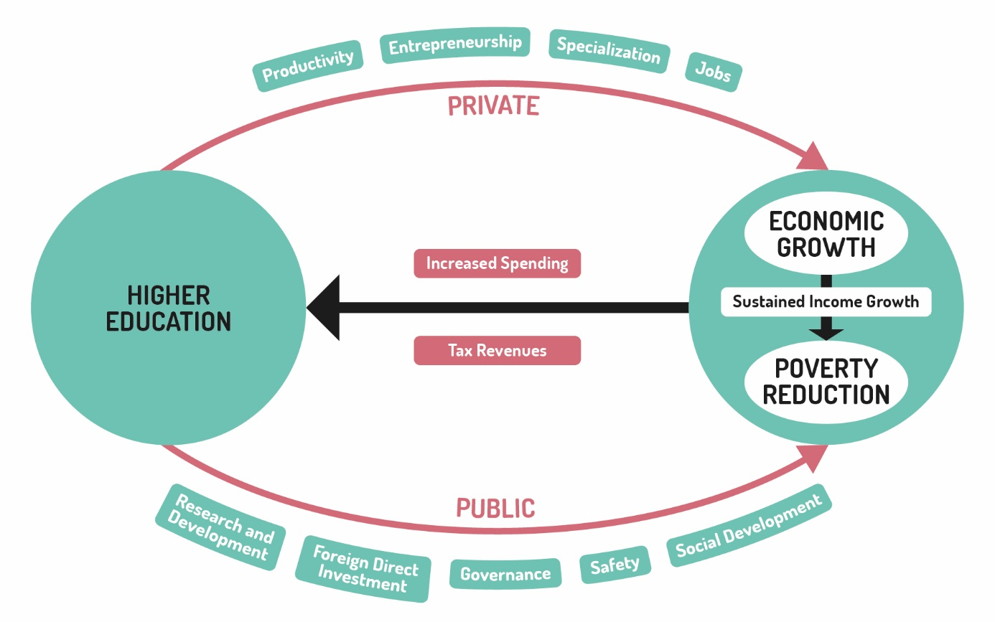

Source: Adapted from World Bank.2002, [Constructing knowledge societies: New challenges for tertiary education](http://siteresources.worldbank.org/INTAFRREGTOPTEIA/Resources/Constructing_Knowledge_Societies.pdf), p. 17.

However, it is important to underline that just investing in the expansion of higher education does not automatically generate the virtuous circle illustrated. Good governance, sensible macro-management and openness to trade are necessary to foster dynamic labour markets which can absorb growing numbers of university graduates.

## Higher education development and reform – some interventions

The types of interventions which can promote higher education development and reform are outlined in Table 2 and the sub paragraphs below.

Table 2 – Higher education development and reform interventions

|  |  |  |
| --- | --- | --- |
| **Strategic priority** | **Desired outcomes** | **Indicative interventions** |
| **Universal participation** | Access barriers removed so all children, including girls, children with disabilities, and other marginalised groups, can complete a full cycle of basic education | Finance and/or strengthen conditional grant schemes (for schools and/or students), targeted stipends, fee-relief approaches, and school feeding programs |
|  | Improve the safety of girls and boys on the way to and from school, such as by financing secure and supervised transportation |
|  | Support development of curricula that emphasise human rights, equity, and an understanding of peace and reconciliation |
| **Skills for prosperity** | Stable, well-regulated and adaptive higher education and training systems | Support reforms to higher education regulation, with a focus on quality assurance standards, provider accreditation, accountability and/or autonomy structures, and recognition of qualifications |
| Effective mechanisms for engaging employers in shaping training systems | Foster collaboration between universities, training providers, policy makers, regulatory entities and industry bodies |
| Clear pathways in and out of training, enabling second-chance entrants, skills upgrading, and lifelong learning | Innovate around industry engagement, such as establishing Industry Skill Councils, co-training approaches (for example, on-the-job training units or apprenticeships), industry co-financing opportunities, participatory curriculum review and labour market analyses |
| Sustainable financing models for tertiary education | Support flexible course delivery well suited to existing workers and persons with care-giving responsibilities, particularly women |

Source: DFAT 2015, [Strategy for Australia’s aid investments in education 2015-2020](http://dfat.gov.au/about-us/publications/Pages/strategy-for-australias-aid-investments-in-education-2015-2020.aspx).

### Support quality assurance in higher education

This may include supporting: the development of relevant legislation; the establishment or functioning of a national quality assurance agency; quality assurance mechanisms at the institutional level; government oversight and reporting functions; or stakeholder engagement with quality assurance systems (for example, transparency, accountability and stakeholder ‘voice’).

### Improved accountability mechanisms and transparency

For example, supporting the introduction of higher education management information systems at both the national and institutional levels, to support policy planning and reforms with effective monitoring and management tools.

**Note:** For more detailed information and discussion refer to Jamil Salmi’s reports for the World Bank.

Sources: Salmi [2009, The challenge of establishing world-class universities](http://siteresources.worldbank.org/EDUCATION/Resources/278200-1099079877269/547664-1099079956815/547670-1237305262556/WCU.pdf); World Bank Group 2002, [Constructing knowledge societies: New challenges for tertiary education](http://siteresources.worldbank.org/INTAFRREGTOPTEIA/Resources/Constructing_Knowledge_Societies.pdf).

### Scholarships

Targeted, merit-based scholarships can support the participation of young people typically excluded from higher education due to cost or structural barriers. While merit needs to be the overarching principle, scholarship schemes can have specific targets (for example, half of the scholarship places are to be allocated to eligible female applicants).

* Scholarships are an important form of assistance to higher education students.
* Indirectly (via student fees) scholarships are also an important source of funding for higher education institutions.
* In most developing countries scholarships are mostly funded by national government bodies and international development agencies. For example, scholarships to the University of the South Pacific (USP) are funded by the governments of USP member countries who sponsor their own citizens for undergraduate and postgraduate studies, and by development partners including the Australian aid program, New Zealand Government and the French Government.

The funders of scholarships can indirectly help to improve the quality of higher education programs by requiring institutions to demonstrate that they and their programs are quality assured and that their courses meet national, regional and/or international standards.

|  |
| --- |
| Case study: Australia Awards  **Australia Awards** bring Australian-government funded scholarships and fellowships together under one banner. They are funded by DFAT, the Department of Education and Training (DET), and the Australian Centre for International Agricultural Research (ACIAR) to provide educational, research and professional development opportunities.  [Australia Awards Scholarships (administered by DFAT)](http://dfat.gov.au/people-to-people/australia-awards/Pages/australia-awards-scholarships.aspx)  These scholarships contribute to the long-term objectives of developing countries to promote growth and stability. They equip recipients with the skills and knowledge to drive change and contribute to the economic and social development of their own countries. They provide opportunities for full-time undergraduate or postgraduate study at Australian institutions and are awarded each year to citizens of participating countries from Asia, the Pacific, Middle East and Africa.  [Australia Awards Fellowships (administered by DFAT)](http://dfat.gov.au/people-to-people/australia-awards/Pages/australia-awards-fellowships.aspx)  Fellowships provide opportunities for Fellows to undertake short-term study and professional development in Australia, they aim to:  strengthen partnerships and links between Australian organisations and partner organisations in developing countries, in support of Australia's economic diplomacy objectives; and  increase the capacity of developing countries to advance priority foreign affairs and development issues of shared interest at the country, sub regional and regional levels.  [Australia Awards Pacific Scholarships (administered by DFAT)](http://dfat.gov.au/people-to-people/australia-awards/Pages/australia-awards-pacific-scholarships-aaps.aspx)  Australia Awards Pacific Scholarships provide people from Pacific countries with opportunities to study at selected education institutions in the Pacific region. The purpose of the Australia Awards Pacific Scholarships is to give people the opportunity to gain and build the knowledge and skills to drive positive change, and influence their home country’s development.  [Australia Awards Fellowships (administered by ACIAR)](http://aciar.gov.au/article/australia-awards)  The two ACIAR Fellowships – the John Allwright Fellowship and the John Dillon Memorial Fellowship – are aimed at building capacity of agricultural research.  The John Allwright Fellowship is focused on postgraduate studies that are based on research work being carried out under a collaborative research project in which the awardee is engaged prior to taking up the award. The John Dillon Memorial Fellowship aims to develop leadership skills in the areas of agricultural research management, agricultural policy and/or extension technologies. This is achieved by providing exposure to Australian agriculture across a range of best-practice organisations involved in research, extension and/or policy making. |
| [Australia Awards Endeavour Scholarships and Fellowships](https://internationaleducation.gov.au/Endeavour%20program/Scholarships-and-Fellowships/Pages/default.aspx), and [Australia Awards Endeavour Mobility Grants](https://internationaleducation.gov.au/endeavour%20program/pages/endeavour-programs-landing.aspx)(administered by DET)  Australia Awards Endeavour Scholarships and Fellowships are funded by the Australian Government through DET and provide opportunities for citizens of the Asia Pacific, the Middle East, Europe and the Americas to undertake study, research and professional development in Australia. These awards are also available for Australians to undertake study, research and professional development abroad.  The objective of these scholarships is to provide high-quality learning opportunities to individuals of academic merit, contributing to Australia’s standing as a world-leader in education and research. They further aim to develop ongoing educational, research and professional linkages between individuals, organisations and countries and increase the productivity of Australians through an international study, research or professional development experience.  **Note:** You can read more about Australia Awards at: <http://australiaawards.gov.au>  Sources: [DFAT n.d.a, Australia Awards Scholarships](http://dfat.gov.au/people-to-people/australia-awards/Pages/australia-awards-scholarships.aspx); [DFAT n.d.b, Australia Awards Fellowships](ttp://dfat.gov.au/people-to-people/australia-awards/Pages/australia-awards-fellowships.aspx); [DFAT n.d.c, Australia Awards Pacific Scholarships](http://dfat.gov.au/people-to-people/australia-awards/Pages/australia-awards-pacific-scholarships-aaps.aspx); [Australian Centre for International Agricultural Research (ACIAR) n.d., Australia Awards](http://aciar.gov.au/article/australia-awards); [DET n.d., Australia Awards Endeavour Scholarship and Fellowship](https://internationaleducation.gov.au/Endeavour%20program/Scholarships-and-Fellowships/Pages/default.aspx). |

# How is higher education financed?

## Financing of higher education

Traditionally most higher education institutions have been funded by governments in the form of untied grants and on an input basis (such as number of courses offered or number of students enrolled).

## Funding based on performance

Bulk funding on the basis of a pre-approved number of student enrolments remains the norm, but the trend is to tie investment in higher education to performance and to meeting specified outcomes, such as:

* demand-led provision: investment in programs for which there is a demonstrated labour market demand
* number of graduates: with a focus on improving program completion rates
* number of graduates who get jobs or enrol in further study
* meeting annually agreed institutional key performance indicators: covering quality of programs, finances, governance, staff management and research outcomes
* institutional transparency and accountability: for example, by placing verified institutional performance information and quality reviews in the public domain.

### Performance-related mechanisms

The type and number of performance-related mechanisms need to be balanced against the capacity of higher education institutions to exercise institutional and academic autonomy. Two critical drivers that have an overarching effect on the capacity and performance outcomes of higher education institutions are governance and financing.

## Implementing reforms

International experience shows that the implementation of controversial higher education reforms has a higher probability of success when decision-makers take into account the social and political contexts of the reform environment**.**

Efforts need to be made to build a consensus among the various constituents of the higher education community, mobilise additional resources to provide tangible incentives in support of the reform, and think carefully about the timing and sequencing of reforms. Reform of the higher education sector is most feasible within a supportive policy environment in which all participants, both within and outside the education sector, are in fundamental agreement on the scope, pace, and direction of reform.

While having a political road map to guide the reform efforts is neither a magic formula nor a guarantee of success, ignoring potential opponents and failing to engage them in a dialogue about the proposed reforms is a recipe for failure.

## Developing countries’ experiences

In many developing countries, governance arrangements have not changed for many years. In the first instance, the main objective is to assist countries to put in place effective policy coordination bodies, and to find ways of granting sufficient autonomy to higher education institutions, at the same time introducing appropriate accountability mechanisms.

Secondly, development partners have sought to help countries enhance the mobilisation of resources for higher education, improve allocation mechanisms for the distribution of public resources, and seek more efficient ways of utilising available resources.

|  |
| --- |
| Case study: Review of Papua New Guinea’s university system  This review identified ways to strengthen PNG’s university system in order to enhance its capacity to produce quality graduates who will contribute to economic and social development. The review’s overall conclusions included the following:  **expansion** of the number of places in universities is desirable, since PNG is desperately short of skills for development. However, any expansion needs to be underpinned by clear and understood quality standards  the **quantity and quality of graduates is far short** of what is needed, due to inadequate resources and a range of governance and general service quality issues  rehabilitating, or replacing, run-down existing assets, and **restoration of quality, should precede** any investment in expansion  **no new funding** from government or development assistance sources should be allocated for additional enrolments to institutions which do not demonstrate steps towards and then measurable improvements in quality  it is **likely to take a decade** to raise quality to an extent that provides a sound base for rapid expansion  significant improvement in the quality of higher education graduates requires, in turn, **better qualified graduates from secondary schools**. That will take some time, even if investment is made now.  What was the main conclusion from the case study?  The critical importance of focusing on quality standards and quality assurance before making significant new investment in higher education institutions.  Source: Garnaut & Namaliu 2010, [Universities review: Report to Prime Ministers Somare and Rudd](https://dfat.gov.au/about-us/publications/Documents/png-universities-review.pdf). |

# How is higher education quality assured?

## What is quality assurance?

Quality Assurance (QA) is focused on ensuring that the educational and training services of an organisation:

* are being delivered efficiently and effectively
* are in line with the organisation’s published goals and objectives
* meet standards and/or criteria set by relevant external agencies

lead to quality outcomes that are valued by learners, including both women and men, and other stakeholders, including the labour market.

## How is higher education quality assured?

### Principles

Quality is best assured by those primarily responsible for providing the education and training services. Firstly the lecturers and administrators supporting the education and training; secondly the departments and faculties in which the lecturers and administrators work; thirdly the higher education institution’s managers; and fourthly, by government or independent QA agencies.

### Quality of learning and teaching

The most important activities are those that directly contribute to the quality of learning and teaching. Quality assurance activities should be focused on identifying ways to enhance learning and teaching. Information can be collected using a variety of mechanisms including: student satisfaction surveys; lecturer evaluations; course completion statistics; and graduate surveys. It is important that all data collected is disaggregated with regard to gender and disability.

### Internal quality assurance

The effectiveness of internal quality assurance activities needs to be regularly internally monitored, reviewed, evaluated and assessed. This may be done through self-assessments by individual departments or faculties, and through internal institutional evaluations, reviews and audits administered by a university’s quality assurance unit.

Evaluations, assessments, audits and reviews should be objective (based on evidence) underpinned by the collection of relevant data – ‘how do you know?’.

### External monitoring and evaluation

Regular monitoring and evaluation by an external national and/or international quality assurance agencyis necessary to provide assurance to students and stakeholders and to identify quality improvement opportunities, including gender equity.

|  |
| --- |
| Enhancing quality  Enhancing quality is a journey – confidence and trust can only be built over time.  Most higher education institutions in developing countries are near the start of the quality assurance journey. They are focused on compliance with regulations and are usually controlled by government agencies. Many institutions and higher education systems need assistance to develop and implement quality management systems and processes.  Over time the focus can shift towards improving effectiveness, and supporting improved outcomes for learners and the wider community. This will gradually lead to increasing trust in higher education institutions by learners, employers and other stakeholders.  External quality assurance agencies play a key role in helping each individual higher education institution make progress on its quality journey. |

## The role of higher education quality assurance agencies

**Quality assurance agencies must be independent of the institution to be assessed**. Their activities are discussed below.

### Registering new and existing higher education providers

Registration represents recognition given by an authority to an institution to deliver education and training programs. Registration represents an evaluation of the capability of the institution to provide and maintain a well organised, sound and stable learning environment.

### Program accreditation

Program accreditation represents a confirmation that an education and training program has met prescribed standards, and that it leads to a qualification approved by a recognised accrediting agency.

### Evaluations, reviews and quality audits of providers

An external evaluation and review process provides independent judgements about an institution’s performance and capability in delivering high quality education and training. A quality audit is a systematic and independent examination of an organisation’s processes, documents and records, to confirm alignment with identified quality standards. A quality audit seeks to confirm that a higher education institution’s activities are effective in delivering quality outcomes for learners and stakeholders.

### Benchmarking with universities in other countries

A range of university benchmarking mechanisms exists, both within nations and internationally. These are not without controversy, with the results often contested (particularly by those institutions that rank lower in the comparative tables). While not formal quality assurance, media-led university rankings can be very influential with decision-makers including parents.

**Higher education institutions need to be encouraged to engage with external quality assurance agencies, particularly those that work under their own act of parliament and are self-accrediting.**

This can be achieved through mechanisms such as:

* requiring all higher education institutions (both public and private) to demonstrate that they meet the national quality assurance agency’s minimum registration standards. This should apply both to existing institutions and to new institutions that are proposing to offer higher education in the future
* tying funding to quality assurance. For example, only providing government funding for the delivery of accredited education and training courses and programs that meet the standards and criteria set by the external quality assurance agency
* the provision of scholarships. For example, development partners only supporting students enrolling on accredited courses and programs
* the provision of quality assurance training for higher education institution staff
* facilitating national stakeholder meetings

using university staff on quality assurance panels.

## Most developing countries have quality assurance agencies

Information on developing countries’ quality assurance agencies can be found at:

* [International Network for Quality Assurance Agencies in Higher Education (INQAAHE)](http://www.inqaahe.org/full-members-list)

Examples of these agencies include:

* [Indonesia’s National Accreditation Agency for Higher Education](http://accreditation.org/accrediting-bodies/indonesia) (Badan Akreditasi Nasional Perguruan Tinggi), known as BAN-PT
* [Indian National Assessment and Accreditation Council](http://www.commonwealthgovernance.org/partners/national-assessment-and-accreditation-council-india/) (NAAC)
* [Samoa Qualifications Authority](http://www.sqa.gov.ws/) (SQA)
* [Timor-Leste National Agency for Academic Assessment and Accreditation](http://www.inqaahe.org/national-agency-academic-assessment-and-accreditation)
* [Tonga National Qualifications and Accreditation Board](http://www.tnqab.to/) (TNQAB)
* Sri Lanka [University Grants Commission](http://www.ugc.ac.lk/en/home/21-quality-assurance-and-accreditation.html)

Sources: International Network for Quality Assurance Agencies in Higher Education (INQAAHE) 2016; Accreditation.org n.d.; [Indian National Assessment and Accreditation Council](http://www.commonwealthgovernance.org/partners/national-assessment-and-accreditation-council-india/) (NAAC) 2018; Samoa Qualifications Authority (SQA) n.d.; Tonga National Qualifications and Accreditation Board ([TNQAB) 2018](http://www.tnqab.to/); University Grants Commission – Sri Lanka 2018.

|  |
| --- |
| Quality improvement takes time  Quality assurance activities should be designed and implemented to help higher education institutions:   * become more effective in their provision of education and training (not just comply with regulations) * focus on outcomes for their learners and the wider community (not just inputs such as systems and processes) * be able to manage themselves (with less external control) * be trusted by stakeholders (including governments, employers, communities, parents and development partners)   reduce the gender gap by identifying champions and institutional arrangements to promote and progress equity and inclusion. |

# Sustainability and higher education

## Program design features that can contribute to increased sustainability of higher education institutions

As with any Australian aid program investment, the design should be developed in close partnership with the beneficiary institution(s) and the relevant government agencies. Multiple ministries may have a stake, including the national authorities in charge of higher education, the Ministry of Finance and the Ministry of Economic Development (or equivalent). The private sector has a stake in higher education, as prospective employers and often as private providers of university level education and training. It is key to sustainability that planning for sub-sector contributions is undertaken in tandem with civil society, with government and with the private sector, and linked to local priorities and systems.

A focused and medium-term monitoring and evaluation framework, including agreed time-bound higher education targets, is an integral part of sustaining investments. Monitoring and evaluation frameworks should capture the full range of responsible parties, with specific objectives and targets spelled out for the higher education institutions, the QA agency, and Ministry of Education. According to the local context, the program partnership will need to strike an appropriate balance between the decentralisation of responsibilities to the institutional level, and central coordination.



# Test your knowledge

## Assessment questions

Answer the following questions by ticking ‘True’ or ‘False’. Once you have selected your answers to all the questions, turn the page to ‘The correct answers are...’ to check the accuracy of your answers.

Question 1

It is important to consider higher education alongside TVET to encourage the movement of students between TVET and higher education institutions.

Is this statement true or false? □ True □ False

Question 2

Providing more scholarships leads directly to better teaching in higher education institutions.

Is this statement true or false? □ True □ False

Question 3

The trend is to tie funding for higher education institutions to performance and meeting specified objectives.

Is this statement true or false? □ True □ False

Question 4

Quality is best assured by those primarily responsible for providing the education and training services.

Is this statement true or false? □ True □ False

Question 5

Establishing a national quality assurance agency automatically leads to enhanced quality of higher education provision.

Is this statement true or false? □ True □ False

Question 6

The sustainability of donor investment in higher education can be improved by addressing governance and management constraints at national and institutional levels

Is this statement true or false? □ True □ False



## The correct answers are...

Question 1

It is important to consider higher education alongside TVET to encourage the movement of students between TVET and higher education institutions.

**This statement is true.**

Question 2

Providing more scholarships leads directly to better teaching in higher education institutions.

**This statement is false.** Scholarships alone do not lead to better teaching in higher education. Targeted scholarships, focused on exposing recipients to high quality teaching can help –however, relevant, high quality curricula, teaching resources and facilities, properly structured education programs and effective quality control and improvement processes must also be in place.

Question 3

The trend is to tie funding for higher education institutions to performance and meeting specified objectives.

**This statement is true.**

Question 4

Quality is best assured by those primarily responsible for providing the education and training services.

**This statement is true.** Quality is best assured by those primarily responsible for providing the education and training services but externally validated QA is also an essential element. It is important for the providers to be open to voluntary QA by accreditation bodies.

Question 5

Establishing a national quality assurance agency automatically leads to enhanced quality of higher education provision.

**The statement is false.** Quality improvement in higher education takes time –such agencies can help to inform and oversee improvement decisions and actions, but they will almost always develop over time rather than immediately.

Question 6

The sustainability of donor investment in higher education can be improved by addressing governance and management constraints at national and institutional levels.

**The statement is true.**

# References and links

**All links retrieved July, 2018.**

Accreditation.org n.d., Indonesia’s National Accreditation Agency for Higher Education (Badan Akreditasi Nasional Perguruan Tinggi), <http://accreditation.org/accrediting-bodies/indonesia>

Australian Centre for International Agricultural Research (ACIAR) n.d., Australia Awards, <https://www.aciar.gov.au/Our-Research/Fellowships-Scholarships-and-Alumni>

Australian Government 2016, Australian Awards, <http://australiaawards.gov.au/Pages/default.aspx>

Bloom, D, Canning, D & Chan, K 2005, Higher Education and economic development in Africa, Harvard University, <http://siteresources.worldbank.org/EDUCATION/Resources/278200-1099079877269/547664-1099079956815/HigherEd_Econ_Growth_Africa.pdf>

Department of Education and Training (Australian Government), n.d., Australia Awards Endeavour Scholarships and Fellowship, <https://internationaleducation.gov.au/Endeavour%20program/Scholarships-and-Fellowships/Pages/default.aspx>

Department of Foreign Affairs and Trade (DFAT) n.d.a, Australia Awards Scholarships, <http://dfat.gov.au/people-to-people/australia-awards/Pages/australia-awards-scholarships.aspx>

n.d.b, Australia Awards Fellowships, <http://dfat.gov.au/people-to-people/australia-awards/Pages/australia-awards-fellowships.aspx>

n.d.c., Australia Awards Pacific Scholarships (AAPS), <http://dfat.gov.au/people-to-people/australia-awards/Pages/australia-awards-pacific-scholarships-aaps.aspx>

2015, Strategy for Australia’s aid investments in education 2015-2020, September, Commonwealth of Australia, <http://dfat.gov.au/about-us/publications/Documents/strategy-for-australias-aid-investments-in-education-2015-2020.pdf>

Garnaut, R & Namaliu, R 2010, PNG Universities review: Report to Prime Ministers Somare and Rudd, <https://dfat.gov.au/about-us/publications/Documents/png-universities-review.pdf>

Indian National Assessment and Accreditation Council (NAAC) 2018, <http://www.commonwealthgovernance.org/partners/national-assessment-and-accreditation-council-india/>

International Network for Quality Assurance Agencies in Higher Education (INQAAHE) 2016, Full members, <http://www.inqaahe.org/full-members-list>

Montenegro, C E.; Patrinos, H A 2014, Comparable estimates of returns to schooling around the world, Policy Research Working Paper no. WPS 7020. Washington, DC: World Bank Group, <http://documents.worldbank.org/curated/en/830831468147839247/Comparable-estimates-of-returns-to-schooling-around-the-world>

Organisation for Economic Co-operation and Development (OECD) n.d., OECD.Stat., <http://stats.oecd.org/>

Salmi, J 2009, The Challenge of Establishing World-Class Universities, <http://siteresources.worldbank.org/EDUCATION/Resources/278200-1099079877269/547664-1099079956815/547670-1237305262556/WCU.pdf>

Samoa Qualifications Authority (SQA) n.d., <http://www.sqa.gov.ws/>

Tonga National Qualifications and Accreditation Board 2018, <http://www.tnqab.to/>

UNESCO 2016, Education for people and planet: Creating sustainable futures for all, Global Education Monitoring Report, <http://unesdoc.unesco.org/images/0024/002457/245745e.pdf>

United Nations 2015a, Sustainable Development Goals, <http://www.un.org/sustainabledevelopment/sustainable-development-goals/>

2015b, Sustainable Development Goal 4: Quality education targets, <http://www.undp.org/content/undp/en/home/sustainable-development-goals/goal-4-quality-education/targets/>

University Grants Commission – Sri Lanka 2018, Quality assurance and accreditation, <http://www.ugc.ac.lk/en/home/21-quality-assurance-and-accreditation.html>

World Bank Group 2002, Constructing Knowledge Societies: New Challenges for Tertiary Education, <http://siteresources.worldbank.org/INTAFRREGTOPTEIA/Resources/Constructing_Knowledge_Societies.pdf>

Learn more about…

* *The informal sector, found at:* <http://www.ilo.org/asia/lang--en/index.htm>
* *UNESCO Atlas of Gender Equality, found at:* <http://www.unesco.org/new/fileadmin/MULTIMEDIA/HQ/ED/pdf/Atlas-chapter5-tertiary-education.pdf>
* *The OECD (2017) Education at a Glance, found at:* <http://www.oecd.org/education/education-at-a-glance-19991487.htm>
* *The EFA Global Monitoring Report, found at:*  <http://unesdoc.unesco.org/images/0021/002180/218003e.pdf>
* *The University of the South Pacific (USP) statistics, found at:* [www.usp.ac.fj](http://www.usp.ac.fj)
* *Constructing Knowledge Societies, found at:* <http://siteresources.worldbank.org/INTAFRREGTOPTEIA/Resources/Constructing_Knowledge_Societies.pdf>
* *University rankings, found at:* <http://www.topuniversities.com/university-rankings/>; <http://www.timeshighereducation.co.uk/world-university-rankings/>
* *A UNESCO resource toolkit for reducing the gender gap, found at:* <http://unesdoc.unesco.org/images/0025/002505/250567e.pdf>