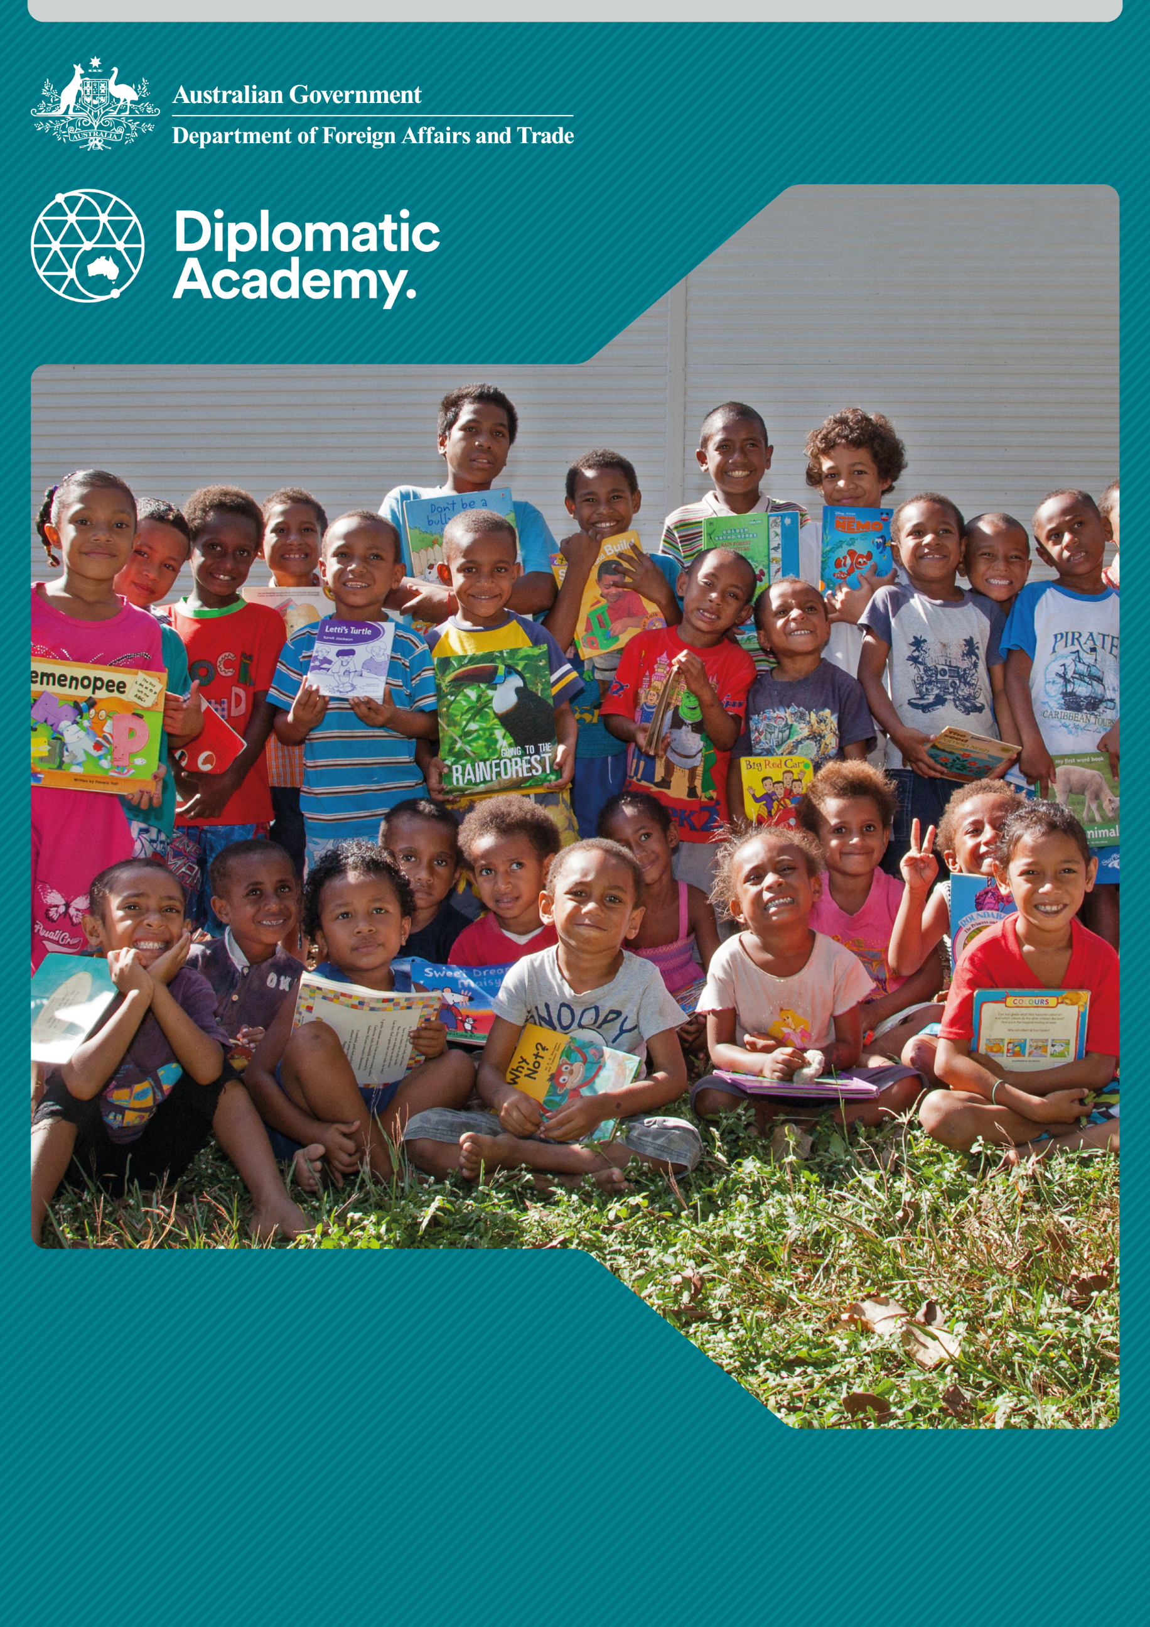
Education Learning and Development Module

EDUCATION
Infrastructure

Practitioner Level

2019

CONTENTS

Acronyms 3
1 Introduction 4
2 Identifying relevant data 4
3 Identifying cross-cutting and multi-sectoral considerations 6
4 Overseeing infrastructure projects 19
5 Management of education infrastructure delivery 22
6 Summary of key points 24
7 Test your knowledge 26
References and links 30

Acronyms
ACR Activity Completion Report
BEDP PNG Basic Education Development Program
BOM Boards of Management
CBC Community-based Contracting
EFMO Education Facilities Management Office
ICR Independent Completion Report
KEMIS Kiribati Education Management Information System
NGOs non-government organisations
P&C Parent and Citizens
PNG Papua New Guinea
RDI Network Research for Development Impact Network
SIMM School Infrastructure Management Manual
VIP Ventilated Improved Pit
WASH Water, Sanitation and Hygiene

Introduction
This practitioner level module is designed to ensure that staff members who engage with and lead policy dialogue on education infrastructure investments are informed about cross-cutting considerations, the phases involved in infrastructure projects and options for managing education infrastructure delivery.
It provides practitioner level knowledge to engage in this topic. It is recommended that all staff complete the Education Infrastructure: Foundation level module prior to undertaking the practitioner module.

Identifying relevant data

Which schools and education facilities would most benefit from funding support?
The Australian aid program and its various partners need to gather data to help determine which schools and education facilities would most benefit from Australian aid program support for infrastructure. This data will comprise:
- school infrastructure data
- census data
- sex-disaggregated evaluation data.
While existing infrastructure, engineering standards, contracting and finance will play an important role in determining how proposed infrastructure will be delivered, there are two key education criteria against which data should be assessed to establish what infrastructure should be delivered:
- demonstrated need
- improved access.

Demonstrated need
Infrastructure decisions cannot be made based on political opportunism and patronage: they need to be based on accurate infrastructure data. In many developing countries this type of data is in short supply and may be unreliable. The development of a reliable infrastructure database is fundamental for determining how large-scale construction programs are identified, where new schools are really needed and where schools require rehabilitation or expansion. The development and maintenance of this data is an important aspect of any education infrastructure project.

Case study: Data gathering in the Pacific
There are a number of the Australian aid program projects that are addressing the collection and dissemination of relevant education infrastructure data. Examples of infrastructure data includes number of classrooms and area of classroom space. Since 2005, the Kiribati Education Management Information System (KEMIS) requires Head Teachers to complete an annual school survey which includes infrastructure data. This is then stored on a database at the Ministry of Education.
The infrastructure data has been used by the Kiribati Education Improvement Program to prioritise and set budgets for the upgrading of schools from 2011-2020. The quality of the data is being continually verified and updated by the Ministry of Education Facilities Management Unit and Island Education Coordinators when they visit schools.
Similar databases, based on the KEMIS model, have been established in other Pacific countries.
Source: Melbourne Development Institute 2010.

Improved access
Most Ministries of Education have access to census data which will determine population growth in specific districts, and this combined with infrastructure data can be used to determine, for example, what numbers of classroom units are required to improve access.
Case study: Data gathering in Indonesia and Papua New Guinea
This is where construction programs do well and there is good evidence of success. In Indonesia under the Australia Indonesia Basic Education Program, 2,014 schools were constructed and 330,000 new places created. In PNG under the Basic Education Development Program (BEDP), 315 schools, most in rural areas and the remote parts of PNG, received new classrooms, teachers’ houses and Wash, Sanitation and Hygiene (WASH) facilities.
Sources: DFAT 2010a; DFAT 2010b.

The critical issue is the effective use of data for planning purposes. Improving access may mean a prioritisation of rural or remote areas, or providing good quality education infrastructure in urban slums. By understanding the current status and availability of education infrastructure, investments can be better targeted and resources used more efficiently. Involving civil society organisations in the prioritisation and design of investments can help ensure that the needs of marginalised groups are represented.

Identifying cross-cutting and multi-sectoral considerations
There are cross-cutting and multi-sectoral considerations that affect education infrastructure projects. The Australian aid program's staff members can play an important operational role in ensuring that they are integrated into the infrastructure planning and implementation cycle.
Ideally, staff members will be actively involved during the design phase to ensure cross-cutting and multi-sectoral considerations are accounted for in the design. Staff should attend at least some of the monthly construction site visits during the construction phase to monitor the effectiveness of cross-cutting and multi-sectoral initiatives.
Cross-cutting and multi-sectoral considerations include:
- inclusive education infrastructure (universally accessible, disable friendly infrastructure)
- WASH facilities that account for gender-specific needs
- national minimum infrastructure standards
- asset management and maintenance
- inspectorate functions
- community engagement and participation
- school-based management
- gender equality
- environmental standards
- disaster risk reduction.

Inclusive education infrastructure
Many people with a disability face difficulties using school buildings because of poorly designed and inaccessible infrastructure. This can prevent children with disabilities from going to school at all, and also blocks access to community members, teachers and other stakeholders with disabilities. To ensure infrastructure is accessible and inclusive of people with a disability, development partners and authorities should meaningfully engage with civil society groups, such as disabled people’s organisations, throughout the lifecycle of infrastructure investment. The Research for Development Impact Network (RDI Network) has developed seven key principles for implementing good practice and engaging civil society to delivery resilient, inclusive and sustainable infrastructure in the Pacific islands. Principle 6, ‘Create safe, inclusive and accessible infrastructure’, details strategies which promote disability inclusion in the Pacific.
Source: RDI Network 2020, Building together: Seven principles for engaging civil society to deliver resilient, inclusive and sustainable infrastructure in the Pacific islands.

The accessibility design guide
The Australian aid program's Accessibility Design Guide: Universal design principles for Australia's aid program aims to ensure that all of the Australian aid program's activities relating to the physical environment are accessible to persons with disabilities, and that the barriers to participation in social and economic life are minimised. Accessibility is viewed by the Australian aid program as a human rights issue and underpins every aspect of its approach to infrastructure development generally.
The Guidelines include an Education Annex which demonstrates how universal design principles can be incorporated into education infrastructure.
Source: AusAID 2013.


Accessibility Design Guide: Universal Design Principles for Australia’s Aid Program
The Australian aid program’s Accessibility Design Guide includes an Education Annex which notes that The World Report on Disability 2011 has reported that in low-income countries only 46 per cent of males with disability and 33 per cent of females with disability have completed primary school, compared with 56 per cent of males and 42 per cent of females without disability.
Inaccessible school buildings with poorly designed steps, tight entry ways, uneven paths, inaccessible toilets and poor natural lighting compound this problem. They make it even more difficult for students with disability to develop their potential and fully participate in school and the wider community. Physical barriers often prevent children with disability from attending school. Without an education, people with disability become even more disadvantaged, including socially and economically.
Sources: AusAID 2013; WHO and World Bank 2011.
The Accessibility Design Guide discusses inclusive education and describes in some detail accessibility initiatives that address:
- selecting a school site
- site planning
- building design, which accommodates considerations such as street to classroom accessibility and enabling children with low vision and blindness to sit with their back to a window (and not facing another window) to reduce the impact of sun glare
- creating an inclusive learning environment, which considers:
  - furniture type and room arrangement (e.g. to enable mobility, and access for wheelchairs)
  - general requirements to support flexible teaching and learning in classrooms
  - design of multipurpose rooms, science rooms and workshops
  - design of library resource centres
  - visual comfort—lighting, colours and signage
- hygiene, in particular accessible toilet and WASH facilities that take account of gender-specific needs
- school playground and physical education
- the cost of providing accessible schools for inclusive education (e.g. it may be cheaper to build an accessible school than it is to retrofit an existing school with accessibility features).

Case study: Disability inclusion in Indonesian schools
The Australian aid program supported improved access by children (and teachers) with disability to school through the Australia – Indonesia Basic Education Program.
All schools built under the program from 2008 (around 2,014) were required to provide access for people with disability. This included installing disabled toilets, handrails and ramps. The Government of Indonesia has since adopted these measures as construction standards for all new schools. The program also assisted the Government of Indonesia to issue a regulation on inclusive education, supporting schools to include and better meet the needs of students with disabilities.
Under the $500 million (2011-16) education partnership with Indonesia, Australia provided support through disability-inclusive education strategies.
This included the following aspects.
- Constructing or expanding an estimated 2000 schools, creating around 300,000 new places for children with disabilities by including disabled toilets, handrails and ramps.
- Developing a training system for all 293,000 of Indonesia’s school principals, school supervisors and district education officials in school planning, including disability-inclusive education strategies.
Source: DFAT 2010a.


An activity for you
What accessibility elements should be considered when turning an existing school into a barrier free environment?
To help you answer this question, refer to Annex F: Education of the Accessibility Design Guide, particularly sections 2 and 3.

Water, sanitation and hygiene facilities
Poor water resource management and inadequate sanitation is a major cause of poor health outcomes in developing countries. Investments in water and sanitation are a cost-effective measure to improve health and reduce the prevalence of diseases.
DFAT’s Health for Development Strategy 2015-2020 emphasises that “without continued attention to the strengthening of government and community capacity to maintain WASH systems, initial health gains are often not sustained”. Water and sanitation are also considered a fundamental aspect of economic infrastructure, which is reflected in the DFAT’s Strategy for Australia’s Investments in Economic Infrastructure.
The practical application of sustainable education infrastructure includes appropriate WASH facilities, targeting in particular:
- water supply
- sanitation
- hygiene.
Sources: DFAT 2015a; DFAT 2015b.

Water supply
A reliable and accessible supply of clean, drinkable water is a key component of a successful education infrastructure project that should not be overlooked or excluded due to budgetary constraints. Water supply is a major problem for many schools in developing countries. Where a piped water supply is not available, schools depend on water tanks, wells, bore holes, streams or students bringing bottled water to school. The diagram below shows a water harvesting system in Papua New Guinea (PNG).

Figure 1 - Diagram of a primary school classroom water harvesting system in PNG
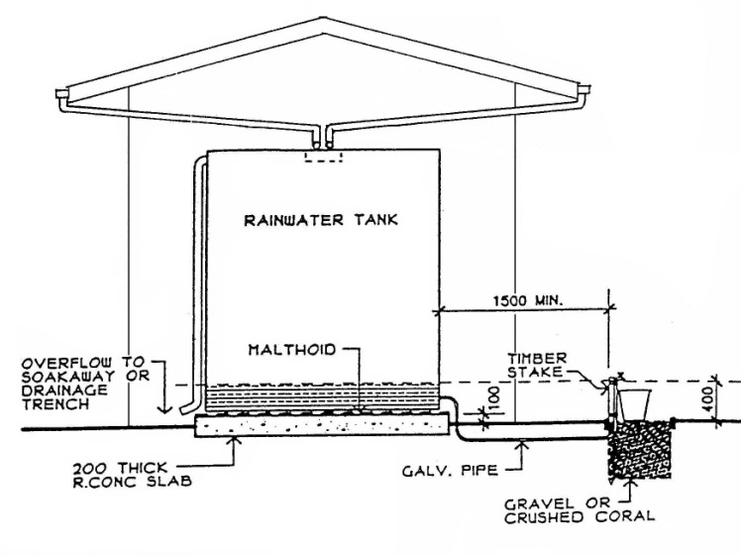
Source: Alexander & Lloyd Group.
Sometimes water from wells, boreholes or streams is contaminated or dries up. Often even piped water is unreliable and is not available for parts of the day or even for many weeks. The water strategy developed needs to take account of these constraints. It is not uncommon for schools to be closed during long dry spells or when the school’s water supplies are depleted or cut off. Therefore, the lack of a reliable water supply can quickly become an issue limiting access to education.

Sanitation
The location and type of toilets and sanitation blocks need to be considered very carefully, taking into account cultural considerations, health, security, privacy (particularly for female toilets), and accessibility for people with disabilities. Inadequate sanitation provision for the needs of maturing girls and boys can result in absenteeism or early dropout. The best type of toilet option for any school will depend on the availability of water at the school. The picture below and the diagram show a Ventilated Improved Pit (VIP) latrine in PNG.

Figure 2 - Diagram of a VIP latrine at a highlands school in PNG
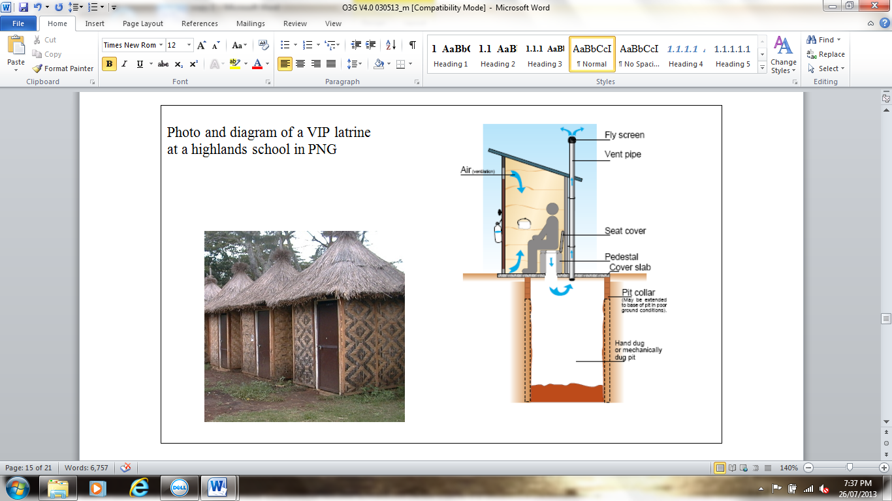
Source: Alexander & Lloyd Group.
Toilet options will be determined by the following factors:
- If there is a reliable 24 hour water supply, flushing toilets can be used.
- If there is no reliable water supply, VIP toilets are recommended.
- Where the school is next to the sea or a river, or there is a high water table, the VIP toilet pits need to be sealed.
Another toilet option is the use of composting toilets. However, these types of toilets can present risks of disease transmission if not properly maintained.

Hygiene
Hygiene is essential for all children. In communities where flush toilets and VIP toilets are not in common use, students will need to be trained in their use. Washing of hands after toilet use is very important and means that there needs to be a water supply close to all toilet facilities, even those that are not water dependent, such as VIP toilets.
Whatever toilets are used, the school must include routine cleaning as part of their day-to-day maintenance program and class teachers need to ensure toilet paper, soap and water are always available. Girls also need hygienic sanitary arrangements to manage menstruation safely and without embarrassment.
An activity for you
Think about your country program or a developing country known to you and answer the following question:
In an education infrastructure project, how can a WASH strategy take account of the following:
- Cultural awareness?
- Gender considerations surrounding sanitation and hygiene?
- Physical constraints of an unreliable water supply and waste management?
Check your answers.
Cultural awareness
- Work with local Non-Government Organisations (NGOs), WASH leaders, district/village leaders to raise awareness of WASH issues.
- Support the behaviour changes necessary to achieve a good approach to hygiene that is sustainable and will be maintained.
Gender considerations
- Female and male toilets should be in separate blocks, located in different areas of the school site.
- Toilets should be designed with safety in mind, both in terms of the materials used, and in site positioning (e.g. toilets should be discrete, but within school grounds and not overly far from other school buildings).
- Entrances to toilets should be screened from view by the general public.
Water supply and waste management
- If there is no reliable water supply, VIP toilets are recommended.
- New VIP toilets should be located at least 25 metres from a well, bore, creek or spring, and at least 50 metres from a coastal shoreline.
- On sloping ground, toilets should be located at a lower elevation than a ground water supply.
- On level ground, the area around toilets and the water supply should be mounded with earth.
- Locate hand washing facilities close to toilets.

National minimum standards
All school buildings need to be planned, designed and constructed to a minimum standard. Most developing countries have a National Building Code. Where they do not (e.g. Nauru) then appropriate alternative standards should be identified.
The purpose of the Building Code is to ensure that buildings have been properly designed and sensibly located to ensure the safety of the students and teachers, and to protect them from natural hazards such as earthquakes, floods, cyclones, landslides and bushfires.
For further information refer to the Education in Emergencies: Foundation and Practitioner level modules.

Rural and remote classrooms
In some rural and remote areas, classrooms are constructed from traditional materials. In these cases, the buildings need to be constructed to at least the same standard as the village buildings. It is preferable that one of the buildings is constructed to a national building standard so that it can be used as a secure storage area and a community ‘safe house’ in the event of violent conflicts or natural disasters.

National school infrastructure guidelines
Some countries, such as PNG, have developed national school infrastructure guidelines that all new and renovated buildings should be designed to.
Many national education departments will also have an Education Facilities Management Office (EFMO) whose role it is to support and monitor school infrastructure policy and development activities.

Asset management and maintenance
Asset management and maintenance involve planning and managing future infrastructure requirements and putting in place processes and budgets for the maintenance of existing infrastructure. It is a complex process, different in scope and nature from a construction process. Within a developmental context, infrastructure maintenance should consider maintenance at the system-wide, regional and school levels. Issues include areas of responsibility, funding, access to skilled tradespeople, and maintenance triggers, linked to the national minimum standards. Donors sometimes include ongoing maintenance as a legitimate target for funding.

Case study: A successful school maintenance project in PNG
The Australian aid program designed the Basic Education Development Program (BEDP) in PNG in 2002 with a separate building maintenance component. A School Infrastructure Management Manual (SIMM) was developed, to support the capacity of local communities to maintain their own schools. The SIMM was provided in pidgin and English, illustrated with attractive diagrams and photos.
BEDP developed a capacity building program to facilitate the introduction of the SIMM. The SIMM was distributed to over 3000 primary schools and has assisted with the planning and implementation of over PGK10 million in maintenance grants.
Source: Department of Education PNG, 2008.

Inspectorate functions
District Education Officers and School Inspectors can play an important role collecting infrastructure data for the national level EFMO and in the monitoring of education infrastructure standards. This can provide an important feedback loop, providing lessons learned for future education infrastructure projects.
However, in most developing countries this feedback loop is poorly developed or not established. In PNG under the BEDP, use of School Inspectors to collect data and monitor infrastructure and maintenance was frustrated by low morale and a lack of recurrent funding to allow School Inspectors to visit schools.
An activity for you
Think about your country program or a developing country known to you. List some strategies that could be implemented at a national level that would enable monitoring and inspection of education infrastructure.
Check your answers.
- Include inspection of infrastructure in School Inspector Duty Statements.
- Include a checklist of maintenance items to be inspected when School Inspectors visit schools. These checklists to be returned to the Ministry of Education Facilities Management Unit.
- Provide sufficient funding for logistics to enable School Inspectors to visit remote schools.

Community engagement and capacity building
In most developing countries in the Asia Pacific region, provincial and local level governments and communities have responsibility for maintaining education facilities. These authorities frequently have inadequate capacity to properly fulfil this role. Both financial and human resource capacity is required to plan and manage a school infrastructure program. This lack of financial and human resource capacity can be a major impediment to providing universal, quality and equitable education.
Donor funded community engagement and capacity building initiatives include:
- facilitating community engagement and capacity building with donor funded ‘seed’ grants
- building the capacity of national, provincial and district education personnel.
- building partnerships between education authorities and the school community.
These approaches are discussed below.

Facilitating community engagement and capacity building with donor funded ‘seed’ grants
National and provincial governments, donors, religious organisations, civil society and the private sector all provide funds for school infrastructure. However, the most reliable source of funding to school communities is from the school community itself.
There is strong evidence that a motivated community will provide significant inputs into the management and development of school infrastructure – in the form of voluntary labour, management and technical skills, building materials such as timber, and funding. Women can provide invaluable guidance to make schools safe and secure for girls, which has a positive impact for all children (and female teachers). Donor grants can provide seed funding to kick start community infrastructure initiatives. In addition, community-based construction and management approaches have shown to positively influence the ongoing maintenance of the infrastructure built, contributing to its sustainability beyond the life of the donor funded program.
Case study: Wallium primary school, Madang Province, PNG
In PNG, the BEDP provided a program of donor funded grants targeted at ‘deserving’ schools. Between PGK 30,000 and PGK 50,000 (AUD 15,000-25,000) was provided to over 200 schools to enable them to construct double classrooms and/or teacher staff housing. Communities contributed labour and local materials and used the grants to procure hardware materials.
This double classroom building and office at Wallium Primary School in Madang Province was built by the local community with a BEDP grant of PGK 37,5000 (AUD 17,000).
Source: Department of Education PNG, 2009.
Figure 3 – BEDP double classroom building and office in PNG
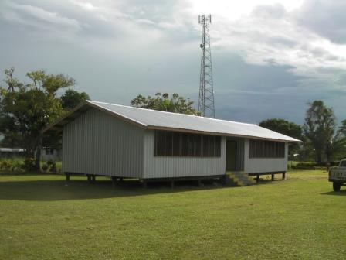

Source: Alexander & Lloyd Group.

Building capacity at national, provincial and district levels
In developing countries, administrative, communication and logistics difficulties place major constraints on the capacity of government officials to support local school communities in the implementation of infrastructure programs. Officials often do not have sufficient operating budgets to satisfactorily develop or manage networks between stakeholders or implement government programs.
In most developing countries there is a need to build capacity to support strategic planning, financial and program management and to ensure that women are represented in decision-making forums. Institutional strengthening programs funded by donors can help build this institutional capacity.

Building partnerships with the school community
The effective development and maintenance of school infrastructure is based on a partnership between the education authorities – teachers, district education agencies and School Inspectors – and the school community – parents, business people, elected officials and students. Where the school authorities and school community are actively working together, they are able to create a positive learning environment. Donors can provide financial support to community engagement programs aimed at facilitating and strengthening this partnership.
An activity for you
Think about your country program or a developing country known to you and answer the following question:
What could be used as assessment criteria to determine a ‘deserving’ school that would receive a donor ‘seed’ grant?
Check your answers.
Criteria can be grouped under four headings:
- Ownership: Community support, self-reliance, absence of land disputes, support from local Members of Parliament, community leadership, and involvement of local faith-based organisations.
- Disadvantage: Remoteness and inaccessibility, poor infrastructure condition, high student/teacher ratio, low access to services, poor socio-economic environment.
- Governance: School Committee working well and involving women as well as men, regular committee meetings and elections, good financial record keeping.
- Equity: Funding grants targeted to schools that have had limited or no grant funding, to enable an equitable distribution of resources. Communities will have varying levels of access to non-government funding (e.g. remittances or diaspora contributions; relationship with Rotary or faith-based fundraising groups) – this should be taken into consideration in the planning of grant allocations.
The criteria for selecting schools for support should consider all of the factors above, striving for equality of access and value for money.

Gender issues in infrastructure
Gender studies conducted in developing countries indicate that there are likely to be substantial constraints to the participation of women in education infrastructure projects. In many developing countries there are few women in leadership positions in the national, provincial or district education agencies, few women School Inspectors, Head Teachers or in-service coordinators, and few women on School Committees. This impacts understanding of the specific needs of girls and the level of motivation required to ensure gender needs are met.
Without women’s representation on School Committees, the needs of women teachers and female students are often not given adequate consideration. The ability of the School Committee to engage with the community and achieve an equitable partnership between the school and the community is diminished. Even when the Head Teacher is a woman and her staff all female, she may still find it difficult to have her views and recommendations respected by male-dominated construction processes and practices.
An example of the problems which this can lead to is the provision of toilets and sanitation blocks for women and girls. Women teachers and women’s groups often give priority to water and sanitation, but these items may be deprioritised by School Committees. The lack of adequate water and sanitation in schools has serious health implications, as well as being a major source of educational disadvantage for girls. This is particularly the case for girls undergoing puberty, who may be regularly absent from school due to the lack of basic water and sanitation facilities.
Gender considerations in the design of toilet facilities
For the design of toilet facilities specific gender equality provisions aimed at empowering women and girls include the following common sense features:
- Sufficient lighting to enable safe pedestrian passage between any associated buildings and the toilet facilities.
- Lighting should be sensitive to privacy issues.
- Sufficient area lighting to ensure that potential offenders are discouraged from offending behaviour against females.
- Sufficient lighting inside the toilet cubicles and common areas to enable night time usage.
- Easily recognised point of control for light switching and/or use of senor switching.
Case study: Kiribati Education Improvement Program
The construction industry is also traditionally a male-dominated industry. An example of a DFAT supported program that has supported the private sector to employ women in construction was the Kiribati Education Improvement Program. Women were involved in classroom rehabilitation projects in both the surveying, monitoring, project management and fabrication processes.
Source: Coffey n.d; DFAT 2016.

Studies show that infrastructure facilities are better maintained and used if both women and men are involved in choices about the type of service, technology, management and financing systems. Capacity building may be necessary, to ensure that costs and benefits are equitably shared. Where gender differences and inequalities are not taken into account there is an increased likelihood of program failures.

Case study: Building the capacity of women in PNG to manage infrastructure
Due to disparities in the participation of women and men in school Boards of Management (BOM), the PNG BEDP designed a specific program to address women’s participation in this education infrastructure program. This program identified local women who, with additional capacity building, would be able to take on membership and leadership roles in the Parent and Citizens (sometimes ‘Parent and Community’) Association (P&C) and the BOM.
The success of this program was evident in PNG's 2012 election where two of the three woman elected to national parliament, including the Governor of the Eastern Highlands Province, had actively participated in the BEDP capacity building program.
Source: Department of Education PNG, 2008.

Environmental standards
Infrastructure usually involve environmental risks. Education infrastructure funded through the Australian aid program legally is required to comply with local environmental regulations and the Australian Environment Protection and Biodiversity Conservation Act (1999). Aspects of the environment that must be considered as part of any Australian aid program investment are: ecosystems and their constituent parts, including people and communities; climate and natural systems and processes; natural and physical resources; qualities and characteristics of locations, places and areas; heritage values of places; and social, economic and cultural aspects of the above, including those related to indigenous peoples. DFAT’s Environmental and Social Safeguard Policy sets out the processes for identifying and assessing environmental impacts, and applying the safeguard policy.
Source: Australian Government 1999, DFAT 2015b, Strategy for Australia’s Aid Investments in Economic Infrastructure; DFAT 2019.

Disaster and climate resilience and risk reduction
The Asia Pacific region is one of the most disaster prone regions in the world. Poor planning and infrastructure development can expose people to increased disaster risk. Climate change (e.g. increased intensity and frequency of storms, fires, floods and drought) can impact on infrastructure. Assessments of potential impacts from disaster and climate change can help ensure education infrastructure is planned and developed to take into account and respond to these potential impacts. Examples of important actions that can be taken to mitigate risk include relocating infrastructure to less vulnerable locations and building more resilient infrastructure.
A common issue to be discussed with partner governments is the cost premium incurred with adopting sustainable and climate resilient building design standards. To ensure the desired lifespan and utility of Australian aid funded infrastructure a key consideration should always be the suitability of building design and material standards. It is often important to ensure a technical review of partner designs to check that sustainability and climate resilience design features are aligned with Australian Aid requirements.
For more information, refer to DFAT’s Climate and Disaster Risk Reduction Guidance Note.
Sources: DFAT 2015b, Strategy for Australia’s Aid Investments in Economic Infrastructure; DFAT 2018.

Overseeing infrastructure projects

The infrastructure planning and implementation cycle
As shown in the diagram below, the infrastructure planning and implementation cycle can be grouped into four main parts. Australian aid program staff are often involved in all four phases of the cycle, to ensure that infrastructure investments are developmentally sound, and technically appropriate.
In the following pages, the stages of the infrastructure planning and implementation cycle are discussed in further detail.

Figure 4 - A diagram of the infrastructure planning and implementation cycle

Phase 1: Feasibility and infrastructure brief
This is the first phase of the infrastructure cycle and is where development partners can play a critical role in determining what will and will not be funded and the quantum, quality, cost and timeline of the education infrastructure outcomes.
The intricacies of policy and politics that determine infrastructure priorities, allocation and expenditure are a complex issue and are beyond the scope of this learning module. However, agreeing with a partner government at an early stage the project/program objectives, priorities and budgets based on the partner government's stated policies and priorities will help limit political interference. Such agreement will also strengthen the relationship between the development partner and the education authorities responsible for implementing the project/program.
Objectives, priorities and budgets
These objectives, priorities and budgets can form part of the partnership agreements between the development partners and partner governments. Objectives can be targeted to achieve both educational outcomes (such as increased access and improved quality) and wider social outcomes (such as addressing urban drift or reducing conflict – the latter an objective of the Basic Education Assistance for Muslim Mindanao, Philippines). Development partner to partner government agreements must be clear and precise and address potential road blocks such as the level of partner government contribution and land issues.
What happens once agreement has been reached?
The first critical step required is for the development partner to agree with the partner government the parameters of an infrastructure investment. The larger context for this may be set by a partnership (e.g. Australia’s Education Partnership with Indonesia), program-based or sector-wide approach. The development partner and partner government then work through the general scope of what the infrastructure investment can support, with a focus on Government priorities. The ‘scope of services’ is essential because it defines the parameters of the project, specifically what is required and what the deliverables, outputs and outcomes will be.
When the scope and priorities are defined, infrastructure specialists are often invited in to work through what is feasible (i.e. realistic rather than aspirational) by conducting a feasibility assessment. This identifies the scope of services, costing, resource requirements, skills and labour requirements and availability, and the timeframe that it would reasonably take to complete the infrastructure requirements. A feasibility assessment also requires an assessment of the local conditions (e.g. climate, geography, community support) that could impact on the project. This assessment is usually in the form of a written report and usually specifies:
- predetermined infrastructure needs
- the best solution to meeting those needs
- any capacity constraints of the people who will provide the services
- due diligence that demonstrates that the potential investment it is legally, physically and socially compliant
- full costings for the whole life of the project
- the risks associated the project’s whole life cycle
- its affordability within the budget available.

Phase 2: Design phase
Following acceptance of the feasibility assessment (which, on bigger projects may include a Project Design Document, followed by a peer review) the services of an infrastructure company that specialises in the design and superintendence of education infrastructure will ordinarily be procured. Tendering may be domestic, international, or a combination of both. The services to be provided will have been determined in the ‘Scope of Services’ developed during the feasibility phase, and would normally include four stages:
- Inception Report
- Project Plan
- Design Development
- Detailed Design Report (incorporating construction documentation).
The design phase may be harmonised with other development partners, and needs to align with government systems.

Phase 3: Construction phase
Following approval of the detailed design report and confirmation that funding is available, the construction phase commences. The construction will usually involve the procurement of a construction contractor and a superintendent to manage the construction contract on behalf of government and development partners. Ideally the company superintending the works will be the same company that has been responsible for the design phase.
What does the construction phase entail?
The construction phase comprises three stages:
- Procurement of the construction contractor/s. The type of building contractor to be procured will have been determined in the tendering and contract strategy approved in the project plan. The tendering and contract strategy typically includes such statements as the Scope of Services, how the work to be done will be advertised to prospective contractors or who will be invited, selection criteria and their respective weightings in decision-making and selection, the selection panel and processes to be adopted, and the indicative timeframes. Critically, such a strategy needs to comply with any relevant supply and tender legislative requirements, such as the Commonwealth Procurement Rules.
- Construction. Once a building contractor/s has been procured, contracts are signed and the infrastructure is delivered in accordance with the construction documentation.
- Post construction. After the education infrastructure is completed there is normally a 12 month defects liability period where the builder will be responsible for repairing any defects and preparing an ‘Operating and Maintenance Manual’.
Source: Department of Finance 2019.

Phase 4: Monitoring and evaluation
Monitoring of the project will occur simultaneously with the construction phase for quality assurance purposes. Depending on the scale of the project, it may be appropriate to procure a third party construction inspection contractor to undertake independent monitoring of construction to verify results and ensure accountability for delivery.
While monitoring of the project will be on-going, an evaluation of the project is usually conducted at the end of the post construction stage to provide lessons learned that can feed back into the feasibility phase of future education infrastructure projects.
This usually will involve an Activity Completion Report (ACR) by the superintendent. For larger projects, the Australian aid program may also commission an Independent Completion Report (ICR). The lessons learned articulated in the ACR and ICR are made available to other staff members and contractors for the design of future education infrastructure projects.
Most of the input into the ’Infrastructure Planning and Implementation Cycle’ will be provided by infrastructure personnel both inside and outside of government. Capacity may vary, as government officials may have limited experience in the areas of infrastructure management, procurement, contract management or civil engineering. The provision of technical advisers is typical. Depending on the contracting method, local and/or international firms may be involved, with varying levels of expertise and experience.

Management of education infrastructure delivery

Infrastructure delivery
The most appropriate infrastructure delivery mechanism will be determined at the Feasibility and Infrastructure Brief phase of the infrastructure cycle.
The feasibility study explores both development partner-led managing contractor approaches and partner government arrangements. Alignment with partner government systems supports ownership and accountability, but fiduciary risks will need to be carefully considered.

Approaches commonly used by development partners and partner governments
Normally a prerequisite for the development partner agreeing to the partner government implementing the project/program is for the development partner to commission an assessment of the partner government's fiduciary risk profile and the ability of its procurement systems to satisfy the development partner’s procurement requirements.
Three typical construction approaches
Three types of construction approaches that are commonly used by both development partners and partner governments to support education infrastructure in the Asia Pacific region are:
- Conventional Construction Approach
- Managing Contractor Approach
- Community-based Contracting (CBC).
Conventional Construction Approach
The Conventional Construction Approach is often used for larger, more sophisticated projects such as the construction of a new, multi-storey secondary school (e.g. Nauru Secondary School) or a major building (e.g. the Samoan Ministry of Education, Sports and Culture). In the Conventional Construction Approach, a single building contractor with demonstrated financial and technical capability is contracted, and is responsible for the construction of the facilities. This is the conventional form of contracting adopted in most industrialised countries, including Australia.
Managing Contractor Approach
The Managing Contractor Approach can be a cost effective construction methodology for distributed infrastructure projects, particularly where the construction may be based on standard designs. An example is the construction or renovation of primary school infrastructure (e.g. the Philippines Classroom Construction program) and larger projects that can be broken down into manageable components (e.g. the Vanuatu Secondary School Extension Project). The Managing Contractor may sub-contract to local building contractors. Building materials are typically procured as a separate supply sub-contract either as kitset buildings or materials from a hardware merchant.
This approach enables sub-contracting to local builders, and can include the employment of community members as unskilled or semi-skilled labourers.
Characteristics include:
- use of local labour
- funds for construction stay within the local economy
- start-up funding is required to procure materials.
Community-based Contracting (CBC)
CBC is a well-established methodology for the construction and rehabilitation of rural schools, pioneered by the World Bank, in which the school community itself is responsible for delivering its own infrastructure. CBC has the advantage of enhancing school planning and management capacity, and increasing the school community's understanding of the infrastructure's scope and budget, good practice procurement and financial management. CBC can support: greater ownership, inclusion, participation of women, accountability, and sustainability.
CBC is the purest form of school based management related to education infrastructure delivery. It works particularly well for remote and rural schools where there are considerable logistical constraints. Examples include the School Reconstruction Project in West Sumatra and West Java.
Characteristics of CBC include the following elements:
- Under CBC, the School Committee or Council is the building contractor. As such, ownership of and responsibility for the school infrastructure tends to be greater.
- Under CBC there is potential to save money, through voluntary contributions of land, labour and materials by the local community.
- Under CBC any savings go back into the school and any profits remain in the local economy.
- Risk of non-performance under CBC is higher as the contracting arrangement is not as stringent.
- Greater investment is required by the development partner in providing capacity building for school committees to ensure that they are well equipped to manage the process.

Summary of key points
- An understanding of the infrastructure planning and implementation cycle is critical to ensuring the competent management of large scale infrastructure projects by the Australian aid program.
- The Australian aid program and its various partners need to identify and/or gather data to help determine which schools and education facilities would most benefit from support. This data comprises school infrastructure data, census data and sex-disaggregated evaluation data. Engaging with civil society organisations in the prioritisation and design of infrastructure, can ensure the needs of marginalised groups are represented.
- Both development partner-led managing contractor and partner government implementation approaches should be investigated as possible project/program arrangements.
- Cross-cutting and multi-sectoral considerations are an important part of the decision-making, planning and investment process that determines what and where education infrastructure is to be delivered. The Australian aid program can play an important role in this process.
- Many people with a disability have difficulty using school buildings because of badly designed and inaccessible infrastructure. To ensure infrastructure is accessible and inclusive of people with a disability, development partners and authorities should meaningfully engage with civil society groups. The Australian aid program’s Accessibility Design Guide: Universal design principles for Australia’s aid program includes an Education Annex which addresses school accessibility issues.
Sources: RDI Network 2020; AusAID 2013.
- An effective, gender-appropriate WASH strategy needs to be a key component of any education infrastructure program.
- All school buildings need to be planned, designed and constructed to a minimum standard. This minimum standard will be determined by building codes and the local environment.
- Asset management and maintenance is a complex process, different in scope and nature from a construction process.
- Within a development context, infrastructure maintenance should be a separate activity and donors should consider ongoing maintenance as a legitimate target for funding.
- District Education Officers and School Inspectors can play an important role collecting infrastructure data and in the monitoring of education infrastructure.
- In most developing countries in the Asia Pacific region, provincial and local level governments have responsibility for maintaining education facilities, together with local communities, but often have limited capacity to properly fulfil this role.
- Donor funded community engagement and capacity building initiatives which can build financial and human resource capacity include: (1) Facilitating community engagement and capacity building with donor funded ‘seed’ grants; (2) Building the capacity of national, provincial and district education personnel, and (3) Building partnerships between education authorities and the school community.
- Gender analysis in many developing countries has indicated that there are likely to be substantial constraints to the participation of women in education infrastructure projects.



Test your knowledge

Assessment questions
Answer the following questions by ticking ‘True’ or ‘False’. Once you have selected your answers to all the questions, turn the page to ‘The correct answers are...’ to check the accuracy of your answers.

Question 1
In education infrastructure design, it is important to consider cross-cutting and multi-sectoral factors.
Is this statement true or false? □ True □ False

Question 2
It is essential that every school has a piped water supply as this is the only way to ensure a safe and reliable water supply.
Is this statement true or false? □ True □ False

Question 3
All education infrastructure constructed using Australian aid resources needs to be designed and built to Australian standards.
Is this statement true or false? □ True □ False

Question 4
Asset management and the maintenance of education infrastructure should be viewed as a separate activity from the construction process.
Is this statement true or false? □ True □ False

Question 5
Donor funded infrastructure and maintenance grants can provide seed funding to kick start community infrastructure initiatives.
Is this statement true or false? □ True □ False

Question 6
Community-based Contracting (CBC) is a high risk activity and is not recommended for education infrastructure projects.
Is this statement true or false? □ True □ False

The correct answers are...

Question 1
In education infrastructure design, it is important to consider cross-cutting and multi-sectoral factors.
This statement is true.

Question 2
It is essential that every school has a piped water supply as this is the only way to ensure a safe and reliable water supply
This statement is false. In many areas a piped water supply is not feasible. Rain water tanks, wells, boreholes and springs are all practical alternatives. Sometimes, however, water from wells, boreholes or streams is contaminated or dries up. Piped water may be unreliable or may not be available for parts of the day or for weeks at a time. The water and sanitation strategy developed needs to take account of all these constraints.

Question 3
All education infrastructure constructed using Australian aid resources needs to be designed and built to Australian standards.
This statement is false. Education infrastructure does not require Australian design and building standards. Many Australian standards are not appropriate in developing country contexts. For example, Australian fire protection measures will include sophisticated technology which may not be available in many countries. Where possible and appropriate, the partner government National Building Code should be used. Where available, partner government Education Infrastructure Policies Guidelines should also be adhered to.

Question 4
Asset management and the maintenance of education infrastructure should be viewed as a separate activity from the construction process.
This statement is true.

Question 5
Donor funded infrastructure and maintenance grants can provide seed funding to kick start community infrastructure initiatives.
This statement is true.

Question 6
Community-based Contracting (CBC) is a high risk activity and is not recommended for education infrastructure projects.
This statement is false. Community-based contracting is no more risky than other models but has different risks to be managed. In general terms, a CBC model requires relatively more intense management and supervisory inputs, particularly in the early establishment phase. However, it is also a suitable model for building local community ownership of and engagement with education infrastructure. Communities involved in school construction are more likely to engage in regular maintenance of buildings that they feel ownership of.

References and links
All links retrieved July 2020
Alexander & Lloyd Group, http://www.alexanderandlloyd.com.au/profile
AusAID 2013, Accessibility Design Guide: Universal design principles for Australia’s aid program, https://www.dfat.gov.au/about-us/publications/Pages/accessibility-design-guide-universal-design-principles-for-australia-s-aid-program
Australian Government 1999, Environment Protection and Biodiversity Conservation Act 1999, https://www.legislation.gov.au/Details/C2019C00275
Coffey n.d., Kiribati Education Improvement Program Phase III, Building sustainable schools in Kiribati: Supporting women’s skills and livelihoods.
Department of Education PNG 2008, School Infrastructure Management Manual for Elementary, Community and Primary Schools. http://www.education.gov.pg/TISER/documents/schools/capacity-building/school-infrastructure-management-flipchart-for-elementary-community-primary-schools.pdf
2009, Universal Basic Education Plan 2010 – 2019, Achieving Universal Education for a Better Future. http://www.education.gov.pg/quicklinks/documents/ube-plan-2010-2019.pdf.
Department of Finance 2019, Commonwealth Procurement Rules, https://www.finance.gov.au/government/procurement/commonwealth-procurement-rules
DFAT 2010a, Australia Indonesia Basic Education Program (AIBEP), Independent Completion Report, https://www.dfat.gov.au/about-us/publications/Pages/australia-indonesia-basic-education-program-independent-completion-report-may-2010
2010b, Australia Support for Basic and Secondary Education in Papua New Guinea 2010 – 2015, https://www.dfat.gov.au/sites/default/files/png-education-strategy.pdf
DFAT 2015a, Health for Development Strategy 2015-2020, http://dfat.gov.au/about-us/publications/Documents/health-for-development-strategy-2015-2020.PDF
2015b, Strategy for Australia’s Aid Investments in Economic Infrastructure, https://www.dfat.gov.au/sites/default/files/economic-infrastructure-development-strategy.pdf
2016, Kiribati Education Improvement Program (KEIP) Phase III Investment Design Document, https://www.dfat.gov.au/sites/default/files/kiribati-education-improvement-program-phase3-design-doc.pdf
2018, Climate and Disaster Risk Reduction – Guidance Note, https://dfat.gov.au/about-us/publications/Pages/disaster-risk-reduction-and-climate-change-guidance-note.aspx
2019, Environmental and Social Safeguard Policy, https://www.dfat.gov.au/about-us/publications/Pages/environmental-social-safeguard-policy
Melbourne Development Institute 2010, Review of the Kiribati Education Management Information System (KEMIS), http://ozdev.yolasite.com/resources/KEMIS%20Review%20-%202010%20.pdf
RDI Network 2020, Building together: Seven principles for engaging civil society to deliver resilient, inclusive and sustainable infrastructure in the Pacific Islands, https://rdinetwork.org.au/wp-content/uploads/2016/12/RDINetwork_2020_BuildingTogether_S.pdf
WHO and World Bank 2011, World Report on Disability, https://www.who.int/disabilities/world_report/2011/en/
Learn more about…
- The Strategy for Australia’s Aid Investments in Education: 2015-2020, found at, https://www.dfat.gov.au/about-us/publications/Pages/strategy-for-australias-aid-investments-in-education-2015-2020
- The Australian aid program’s Disability Inclusive Development Strategy, Development for All: 2015-2020, found at, https://www.dfat.gov.au/about-us/publications/Pages/development-for-all-2015-2020
- Improving accessibility to schools at this website, found at, http://nda.ie/nda-files/Improving-the-Accessibility-of-Schools1.pdf
- Community-based Contracting approaches, found at, http://documents.worldbank.org/curated/en/925141468182373908/Community-based-contracting-a-review-of-stakeholder-experience
- The World Bank’s School Construction Strategies, found at, https://openknowledge.worldbank.org/bitstream/handle/10986/2637/488980PUB0prim101Official0Use0Only1.pdf?sequence=1
- Guidelines on improving accessibility of schools, found at, ttps://www.globaldisabilityrightsnow.org/sites/default/files/related-files/335/Access%20-%20Improving%20accessibility%20of%20schools_Sri%20Lanka.pdf

