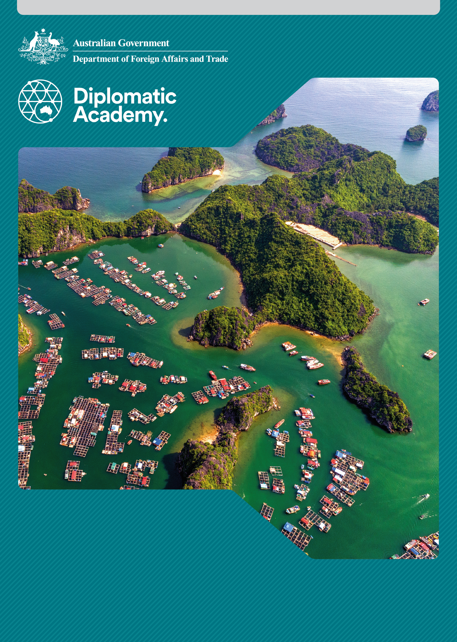
Education Learning and Development Module

country or region-specific analysis

Practitioner Level

2018

CONTENTS

Acronyms 3
1 Introduction 4
2 Making difficult choices: prioritising education 4
3 Identifying priorities using authoritatve and timely data 7
4 Determining education priorities in aid programs 11
5 Test your knowledge 15
References and links 19

Acronyms

DFAT Department of Foreign Affairs and Trade
EMIS Education Management Information System
MICS Multiple Indicator Cluster Survey
NER Net Enrolment Rate
ODA Official Development Assistance
OECD-DAC Organization for Economic Development’s Development Assistance Committee
SDG Sustainable Development Goals
SDP Strategic Development Plan (Timor-Leste)
UNESCO United Nations Educational, Scientific and Cultural Organization
VEMIS Vanuatu Education Management Information System

Introduction
This Practitioner level module is designed to ensure staff members are informed about how to engage in education sector prioritisation processes, including drawing on sources of evidence and data.
It is recommended that staff complete the Country of Region Specific Analysis: Foundation level module as background information to this Practitioner level module.

Making difficult choices: prioritising education

Prioritising education – or not?
Governments prioritise the sectors in which they are going to invest. They determine the balance between national investment in public services and in productive activities such as agriculture, industry, and technology. Within the public service portfolio, trade-offs must be agreed and synergies sought across education, health, water and sanitation, and other community level services.
The processes by which these difficult choices are made (and change over time) are context specific. They reflect in large part the diverse nature of the countries with which the Australian aid program interacts: the age profile of a country's population; its levels and distribution of income; its economic status; political ideologies and interests; and, policy and planning priorities.
The politics of development policy and resource allocations are key determinants of country priorities. Political economy analysis and the drivers for change literature make this clear. Technical analysis and planning also play a significant role.


Case study: Timor-Leste Strategic Development Plan
The Timor-Leste Strategic Development Plan 2011-2030 (SDP) sets a vision for becoming a middle-income country by 2030. It’s objectives include:
- a prosperous society with adequate food, shelter and clothing for all people
- a literate, knowledgeable and skilled population
- people living long, productive lives
- people actively participating in economic, social and political development, promoting social equality and national unity
- people no longer living in isolation with good roads, transport, electricity and communications in all towns and villages
- production and employment increasing in all sectors (agriculture, fisheries and forestry)
- rising living standards for all Timorese.
Source: Republica Democratica Timor-Leste 2011, Timor-Leste Strategic Development Plan.
The SDP translates this vision into three broad development priorities:
- social capital
- infrastructure development
- economic development.
Each of these three areas is shown on the following table:
Table 1 – Three Pillars of Development: Timor-Leste
Social Capital | Infrastructure Development | Economic Development
Education and training | Roads and bridges | Rural development
Health | Water and sanitation | Agriculture
Social inclusion | Electricity | Petroleum
Environment | Seaports and Airports | Tourism
Culture and heritage | Telecommunications | Private sector investment
The SDP elaborates each development priority within short (2010-2015), medium (2016-2020) and long term (2021-2030) frameworks; and situates their development within wider policies of security, defence, external relations, justice, and good governance.
Source: Republica Democratica Timor-Leste 2011, Timor-Leste Strategic Development Plan 2011-2030.

How was the program funded?
To fund this program, it was assumed in 2010 that growth in agriculture, small scale industry and private investment in oil and gas would result in a fall in the proportion of government expenditure as private sector activity expands. It was assumed further that the economy would grow by over 11 per cent to 2020, but falling to eight per cent after 2020.
The Government of Timor-Leste had to translate its vision and broad areas of priority into annual budget allocations. For education, this policy and budget prioritisation was done in the context of a fall in the share of education expenditure (as a percentage of total government expenditure) from 22 per cent to nine per cent between 2004 and 2010.
What can we learn from this example?
This case study demonstrates that education sector priorities are determined in the context of:
- national development strategies that cross all sectoral boundaries
- national and sector budgets
- short, medium and long-term planning
- aspirational goals and practical realities.


An activity for you
Think of a developing country you know well.
What are the main influences in determining the priority that is accorded to education?
Try to think of three factors which promote, and three which constrain the priority given to education.
Some examples of common factors that promote or constrain the prioritisation of the education sector are:
- political commitment to education as both a human right and a driver of economic development (promote)
- strong and vocal advocacy for education across the nation (promote)
- leadership by the Ministry of Education to argue its case with Ministries of Planning and Finance (promote)
- the ability of a Ministry of Education to demonstrate real progress in access, learning outcomes and equity drawing on authoritative and timely data (promote)
- strong support and prioritisation of education by development agencies, in support of the country’s education sector plan (promote)
- clear demand from employers for literate, skilled and knowledgeable youth graduating from school and skills development programs (promote)
- support from the Ministry of Finance or the Ministry of Planning (promote)
- historical emphasis on physical infrastructure projects, such as roads and ports (constraint)
- a country is recovering from civil unrest or natural disaster, and the government does not feel it is the 'right time' to prioritise education investments (constraint).

Identifying priorities using authoritatve and timely data

Education systems require good data
If rational and evidence-based decisions are to be taken, timely and reliable sex-disaggregated data are required in all sectors and sub-sectors of government.
Education systems require good data on all aspects of the system: students, teachers, buildings, water and sanitation, learning materials, learning outcomes, enrolment, attendance, transition, and other factors. Without data, the sensible prioritisation of needs and investments cannot be made.
- Policy making and planning will be ill-informed.
- Accountability to citizens will be difficult.
- Assessing the performance of education institutions and the learning achievements of female and male students will not be possible.

Collecting sex-disaggregated data
Most countries have Education Management Information Systems (EMIS) designed to collect, quality assure, analyse and make available a broad range of educational data, much of it collected annually using a school census. This is known as administrative data.
Although an EMIS may be present, in many developing countries it is poorly used. Often data is:
- incomplete, poorly defined, not sex-disaggregated, and not easily comparable year on year
- not disaggregated by other equity measures, such as socio-economic status, disability, remote/rural/urban, and ethnicity
- finalised/quality assured too late to influence planning, budget and management decision making
- difficult to access in user friendly formats
- limited in its use and availability to a small cadre of officials (limited transparency)
- often applied inconsistently across the education system so that it is not possible to observe all education pathways within one EMIS.

An activity for you
As a way of assessing the relative availability of education data, please complete the following table for six priority countries of the Australian aid program. For each country access the latest UNESCO Global Education Monitoring Report.
In the columns provided, indicate the latest year for which primary net enrolment rate data is provided (or not at all). It is important to note that the absence of data in a document like the Global Education Monitoring Report does not mean that countries do not have data. The absence of data held by the UNESCO Institute for Statistics does suggest weak or partial national systems of data collection and analysis.
Note: For more information on the statistics used, see the Monitoring and Evaluation: Foundation level module.
Primary Net Enrolment Rate (NER) data
Country | Last year for which internationally quality assured data is available for NER | Primary NER (%)/year | Estimated based on previous year data
For example | 2015 | 89 | Based on 2009 data
Fiji

Indonesia

Lao PDR

Philippines

Papua New Guinea
Timor-Leste

The importance of education management information systems (EMIS)
There is inevitably a time lag between when data is collected and when it is available for use. At best, some baseline data (e.g. number of schools, teachers and students) can be available within months of its collection. More sophisticated analysis will require longer.
In many countries development partners, including the Australian aid program, assist ministries of education to establish and sustain sound EMIS given the importance of robust data for education priority-setting.

Case study: The Vanuatu education management information system (VEMIS)
In Vanuatu, the Australian aid program supported the establishment of the Vanuatu Education Management Information System (VEMIS), which was later upgraded to Open VEMIS.
Open VEMIS is a fully functional information system that operates a systematic process of collection, storage, analysis and dissemination of basic data, statistics and indicators to support education planning and management. The system assigns a unique identifier to students within the education system, and then tracks their achievement through their primary and secondary school journey. The system is used for early childhood education, primary and secondary education. In time, the Government of Vanuatu will explore the incorporation of post-secondary education and training data within Open VEMIS.
Source: Vanuatu Ministry Education and Training n.d., Open VEMIS

Household surveys
Other sources of data that educational policy makers and planners can access are household surveys. These are surveys of a sample of households or families which are representative of the population. Household surveys are an important source of socio-economic data. Key indicators to inform and monitor development policies are often derived from such surveys.
Household surveys include such items as household-level income and expenditure, and often school attendance by children. School attendance information may indicate lower levels of school participation than that recorded in, for example, school enrolment data.

Multiple indicator cluster surveys (MICS)
The UNICEF-supported Multiple Indicator Cluster Survey (MICS) is a major source of national and global development data. MICS are a form of household survey which provides information on a range of indicators in the areas of health, education, child protection and HIV/AIDS. MICS findings are used extensively as a basis for policy decisions and program interventions.

An activity for you
Getting into the MICS
See if there is a MICS report (or other household survey) for your country program or a developing country that you know well.
To do this you will need to first watch the short video on understanding and using the UNICEF MICS. Once you have done this, access this link about MICS and search for your country of interest. Answer the following questions.
- What conclusions does the data present for education?
- What priorities are identified that may not emerge from EMIS systems and administrative data?
Source: UNICEF MICS

Analysing data at a regional level
Region-specific analysis shows us how a geographic region is making progress or achieving its goals. A country can compare its own progress against the broader region, and regions themselves can be compared with others.

An activity for you
To better understand region-specific analyses, access the UNESCO Institute for Statistics Policy Paper Reducing global poverty through universal primary and secondary education.
Read the Policy Paper, and then examine Table 1 ‘Out-of-school rates and numbers by Sustainable Development Goal (SDG) region.’ The figure shows totals of out-of-school children in 2015 in the different regions of the world. Answer the following questions from the diagram:
- Which two regions have the highest percentage of children and young people out-of-school?
- Which region has the highest percentage of out-of-school lower secondary youth?
- Which region has the greatest number of out-of-school girls?
Source: UNESCO Institute for Statistics 2017, Policy paper 32: Reducing global poverty through universal primary and secondary education

Determining education priorities in aid programs

Agencies make choices like governments
In many respects, the Australian aid program and other development agencies make similar choices to national governments. How much weight is to be placed on a sector such as education relative to investments in other sectors and activities? Within which country programs should education sector partnerships be prioritised?
Within country specific education portfolios further decisions are required about where the emphasis should lie: in early childhood development; in basic education; in skills development; meeting the needs of the poorest girls and boys in the poorest areas, irrespective of sub-sector; and/or building up the tertiary sector?
Different agencies arrive at different priorities for historical, political and technical reasons. The Australian aid program determines education partnership priorities based on the DFAT Strategy for Australia’s aid investments in education 2015–2020, and the specific challenges and opportunities identified in each context. Country-level education sector investment plans can be used to articulate activities against an Aid Investment Plan developed by DFAT.
For example, Figures 1 and 2 below provide data for five Organisation for Economic Co-operation and Development’s Development Assistance Committee (OECD-DAC) countries in 2015. Figure 1 shows how important education is within the overall aid budget. Figure 2 indicates the priority that is given to basic education within the total aid allocation to education.
Figure 1. Share of direct aid to education in sector allocable official development assistance (ODA) (%, 2015)
% Share of education in
sector-allocable ODA

Figure 2. Share of basic education in total aid to education (%, 2015)
% Share of basic education in total
aid to education
Source: Table 2, UNESCO Global Education Monitoring Report 2017/18, pp.410-411

An activity for you
Refer to Figures 1 and 2 above. What can we conclude from the figures?
Examples:
France allocates almost one quarter of its aid budget to education but spends modestly (8 per cent) on basic education. France spends much of its budget on scholarships in middle income countries.
USA spends a small percentage of its aid budget on education but over 75 per cent of what it does spend is devoted to basic education.
In 2015, Australia allocated 15 per cent of 'sector allocable aid' to education and spent about 65 per cent of that on basic education.
Note: this inference is made from Figure 1 and Figure 2 for 2015. DFAT reports aid allocation annually which means you can access more current figures from the DFAT website.

An activity for you
The Australian aid program's country posts are increasingly developing medium to long term investments in education. This requires a process of careful consultation, analysis and design that draws on a range of data and evidence.
The table below itemises a selection of the sources of data and information that are useful in compiling an education sector investment plan. Score each item a ranking of 1 to 5 (1 = low, 5 = high) depending on the level of influence that the source material has in the development of the education sector investment plan in your country program or for a developing country that is known to you. List any additional sources not mentioned.
Once you have completed the exercise, what conclusions do you draw about what matters most in making program investment judgements (e.g. Australia-generated material vs. partner government sources?)

Source material | Marks 1-5
Foreign Policy White Paper
DFAT education strategy
Australian aid program strategies (other than education)
DFAT policy documents
Topic specific reports and reviews
Education program and project evaluations
Monitoring and evaluation reports from other country programs
Lessons learned from recent projects in country
Situational analyses
Gender analyses
Poverty analyses
Comparative research
Investigation of potential synergy across sectors
Political economy analyses
Consultations with other agencies
Consultation with partner government and its ministries
EMIS and household survey data
Partner government development and education strategies
Partner government budgets and accounts
Independent studies
Dialogue with civil society organisations
Others?

Test your knowledge

Assessment questions
Answer the following questions by ticking ‘True’ or ‘False’. Once you have selected your answers to all the questions, turn the page to ‘The correct answers are...’ to check the accuracy of your answers.

Question 1
The biggest line item in education budgets is typically the (recurrent) salaries of those who work in the sector.
Is this statement true or false? □ True □ False

Question 2
The ability of a Ministry of Education to demonstrate real progress in access, learning outcomes and equity is a key influence in determining the priority that is accorded to education budgets.
Is this statement true or false? □ True □ False

Question 3
Education systems are able to make good decisions and prioritise in the absence of good data.
Is this statement true or false? □ True □ False

Question 4
Multiple Indicator Cluster Surveys (MICS) are a major source of national and global development data.
Is this statement true or false? □ True □ False

Question 5
The Australian aid program tends to focus on short term investments in education.
Is this statement true or false? □ True □ False



The correct answers are...

Question 1
The biggest line item in education budgets is typically the (recurrent) salaries of those who work in the sector.
This statement is true.

Question 2
The ability of a Ministry of Education to demonstrate real progress in access, learning outcomes and equity is a key influence in determining the priority that is accorded to education budgets.
This statement is true

Question 3
Education systems are able to make good decisions and prioritise in the absence of good data.
This statement is false. Accurate, comprehensive and timely data are critical to effective decision making. Robust data is needed to determine and plan for the number and distributions of schools, student demographics, teacher deployment, building infrastructure and maintenance, water and sanitation needs, learning materials, learning outcomes, enrolment, attendance, transition, inter alia. Without good quality data, evidence-based prioritisation of needs and investments cannot be made.

Question 4
Multiple Indicator Cluster Surveys (MICS) are a major source of national and global development data.
This statement is true.

Question 5
The Australian aid program tends to focus on short term investments in education.
This statement is false. Investments in education tend to focus on medium to long term strategies of support.

References and links
All links retrieved December, 2018
DFAT 2015, Strategy for Australia’s aid investments in education 2015–2020, Canberra, https://dfat.gov.au/about-us/publications/Documents/strategy-for-australias-aid-investments-in-education-2015-2020.pdf
Government of Timor Leste 2011, Timor-Leste Strategic Development Plan 2011 – 2030, Dili, https://www.adb.org/sites/default/files/linked-documents/cobp-tim-2014-2016-sd-02.pdf
UNESCO Institute of Statistics 2013, Schooling for Millions of Children Jeopardised by Reductions in Aid, Montreal, https://unesdoc.unesco.org/ark:/48223/pf0000221129
2017, Policy Paper 32: Reducing global poverty through universal primary and secondary education, Montreal, http://uis.unesco.org/sites/default/files/documents/reducing-global-poverty-through-universal-primary-secondary-education.pdf
UNESCO 2018, Accountability in education: meeting our commitments, Global Education Monitoring Report 2017/18, Paris, https://unesdoc.unesco.org/ark:/48223/pf0000259338
UNICEF 2010, Understanding MICS, YouTube, https://www.youtube.com/watch?v=BskK2PoS41U
UNICEF 2019, Multiple Indicator Cluster Surveys (MICS), http://mics.unicef.org/
Vanuatu Ministry of education and Training n.d., OPEN VEMIS, http://www.openvemis.gov.vu/Misc/About.aspx

Learn more about…
- The Timor Leste Strategic Development Plan (2011-2030), found at, http://timor-leste.gov.tl/wp-content/uploads/2011/07/Timor-Leste-Strategic-Plan-2011-20301.pdf
- The UNESCO Institute of Statistics, found at, http://www.uis.unesco.org/Pages/default.aspx
- The World Bank’s Education Statistics, found at, http://datatopics.worldbank.org/education/
- UNESCO’s Global Monitoring Report, found at, http://en.unesco.org/gem-report/
- Education in the Pacific including PADDLE, found at, http://www.paddle.usp.ac.fj/
DFAT Aid Programming Guide, found at, http://dfat.gov.au/about-us/publications/Documents/aid-programming-guide.pdf

