DEPARTMENT OF FOREIGN AFFAIRS AND TRADE

PORTRAITS
&
MIRRORS

EXHIBITION

A HISTORY OF AUSTRALIA’S FIRST
WOMEN HEADS OF MISSIONS AND POSTS
aROUND THE WORLD

jUly 2024 EDITION
ATRIUM RG CASEY
BARTON CANBERRA

INTRODUCTION
Australian women of the Department of Foreign Affairs and Trade have made a major contribution to advancing and protecting Australia’s national interests overseas.
Located in DFAT’s RG Casey Building in Canberra, the Portraits & Mirrors Exhibition builds on a 2019 Mirror Challenge set up by the United Kingdom’s Foreign and Commonwealth Office (now the Foreign, Commonwealth and Development Office). The Australian women featured in the DFAT Exhibition are the first appointed to Australian Head of Mission, Head of Post or thematic Ambassador roles. They are exemplars of determination and courage, paving the way for Australia’s women diplomats today and into the future.
The mirrors reflect the missions, posts or thematic roles where we have not yet had a woman Ambassador. As women commence in these roles the mirrors will be replaced with their portraits. Until then, let this exhibition inspire more DFAT officers, to aim higher and seek to represent Australia at the highest levels overseas.

Hon. Dame Annabelle Rankin DBE

High Commissioner to New Zealand

1971–1974
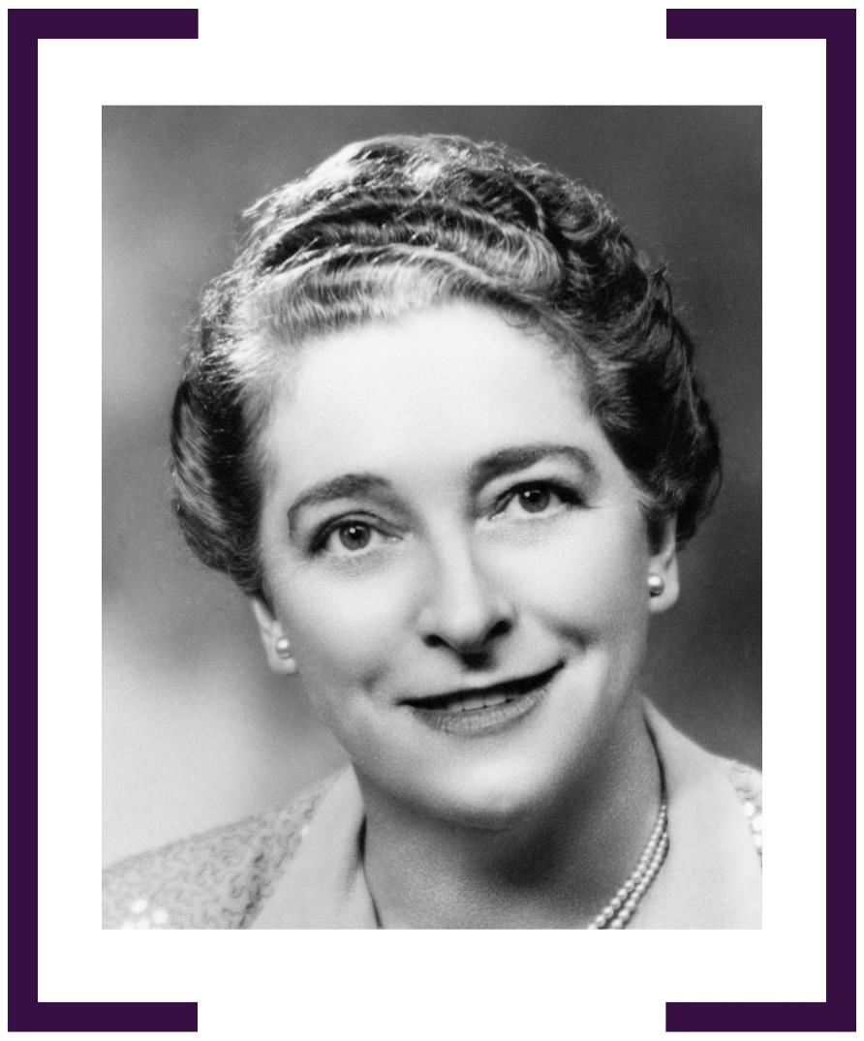

RUTH DOBSON OBE

AMBASSADOR TO DENMARK 1974–1978

AMBASSADOR TO IRELAND 1978–1981
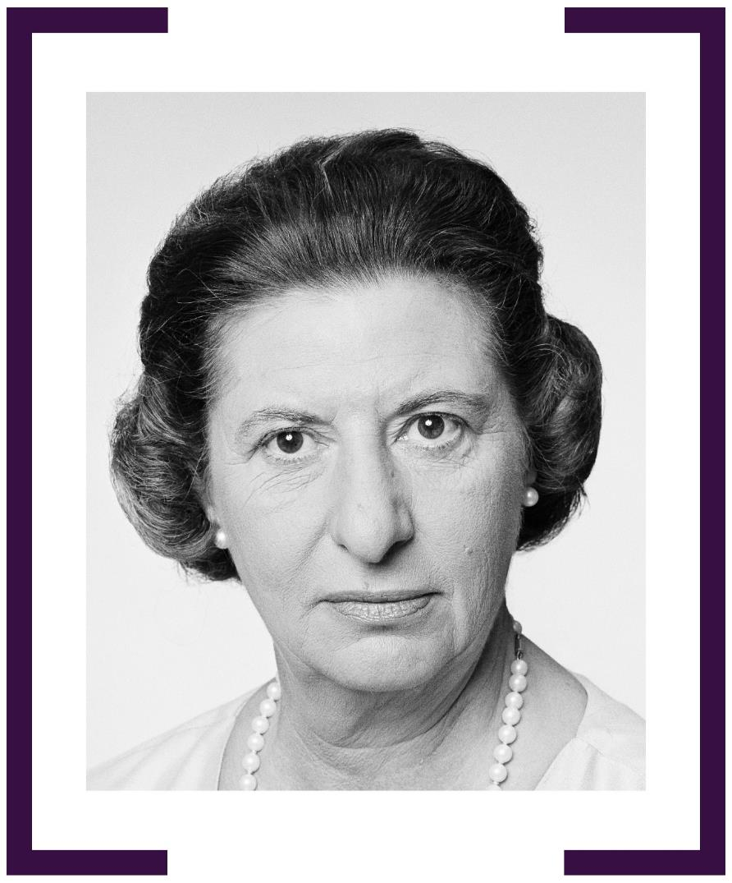

MARIS KING MBE

HIGH COMMISSIONER TO NAURU 1977–1979

HIGH COMMISSIONER TO TONGA 1980–1984
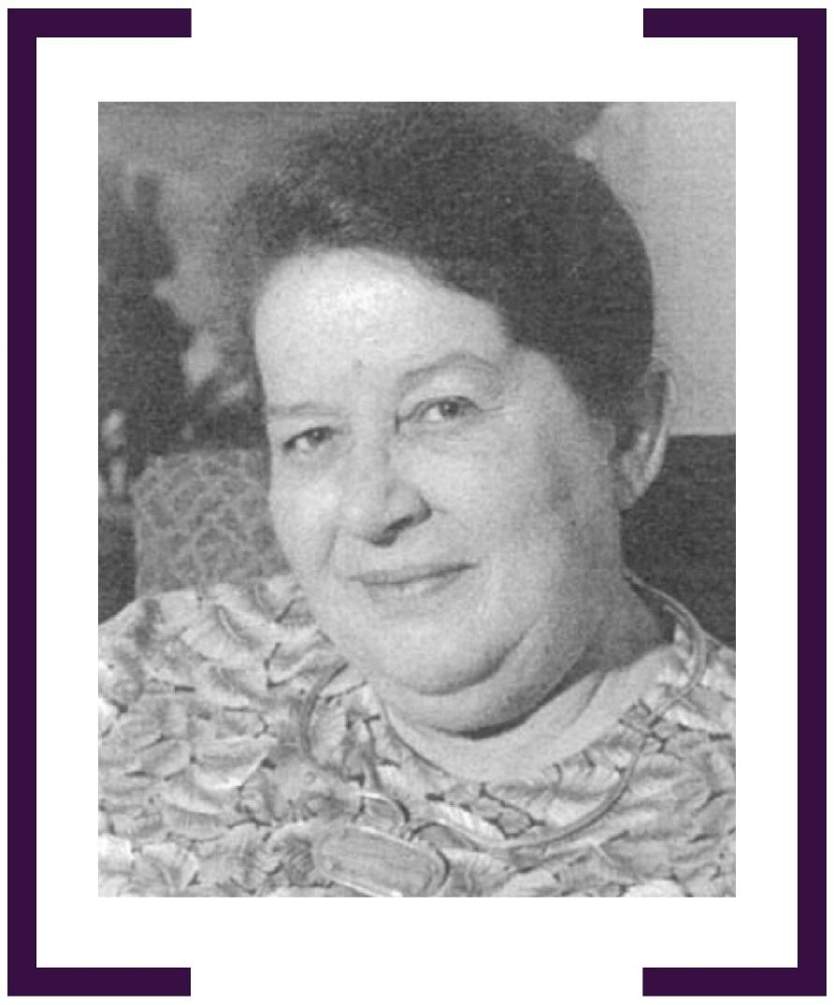

MARY McPHERSON

HIGH COMMISSIONER TO CYPRUS 1982–1985
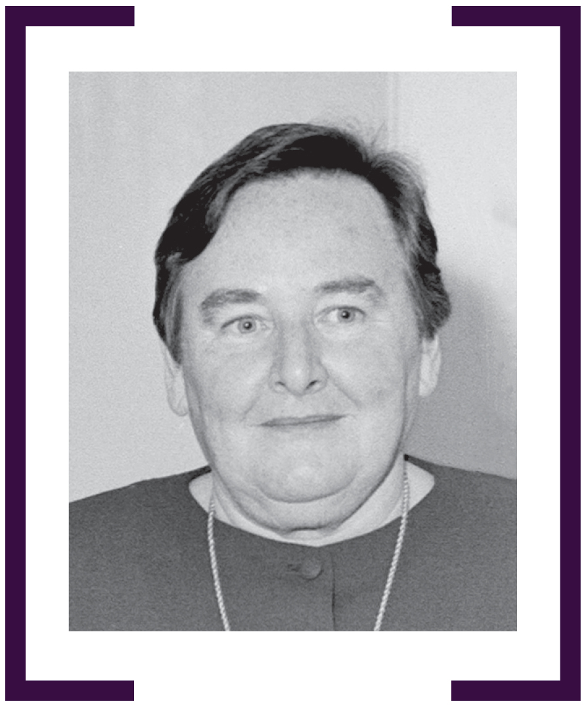

E. JOAN NORWOOD

HIGH COMMISSIONER TO VANUATU 1983–1985
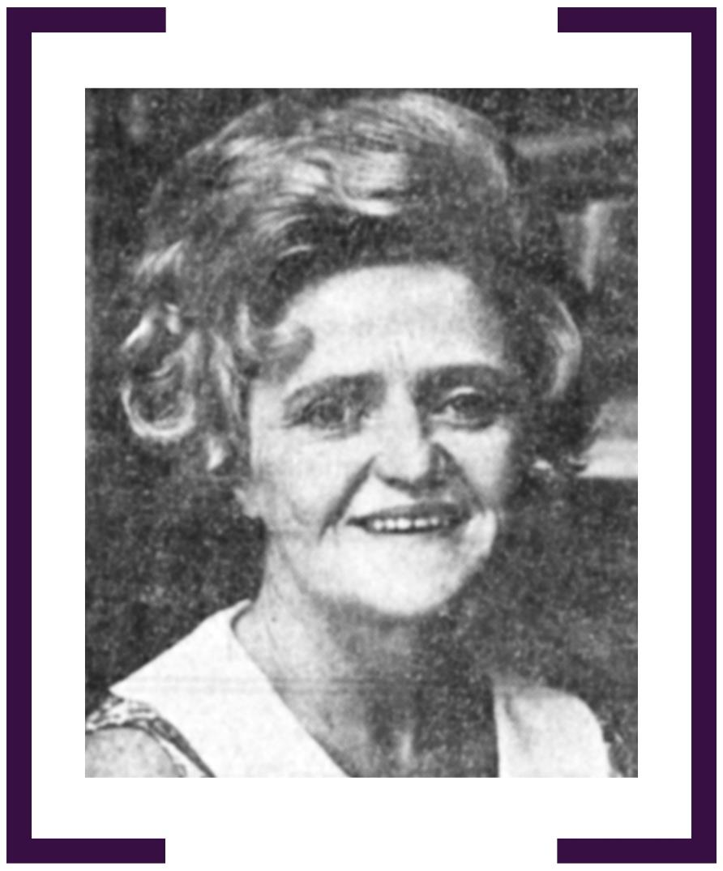

M. ROSALEEN McGOVERN PSM

AMBASSADOR TO SWEDEN 1983–1988

HIGH COMMISSIONER TO SINGAPORE 1988–1990
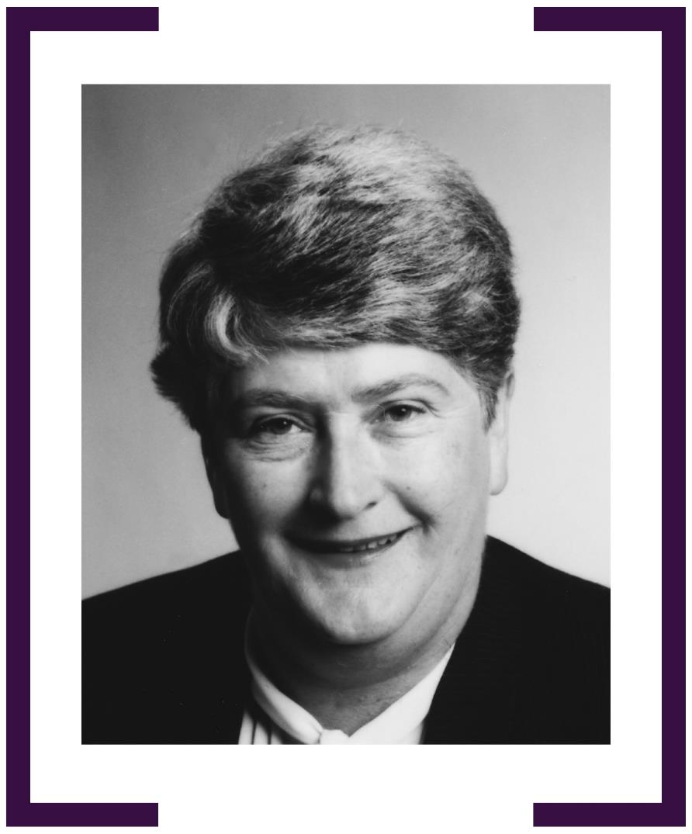

THE HON. PENELOPE WENSLEY AC
CONSUL-GENERAL, HONG KONG 1986–1989
AMBASSADOR FOR THE ENVIRONMENT 1992–1996
AMBASSADOR & PERMANENT REPRESENTATIVE TO THE UN, GENEVA 1993–1996
AMBASSADOR & PERMANENT REPRESENTATIVE TO THE UN, NEW YORK 1997–2001
HIGH COMMISSIONER TO INDIA 2001–2004
AMBASSADOR TO FRANCE 2005–2008
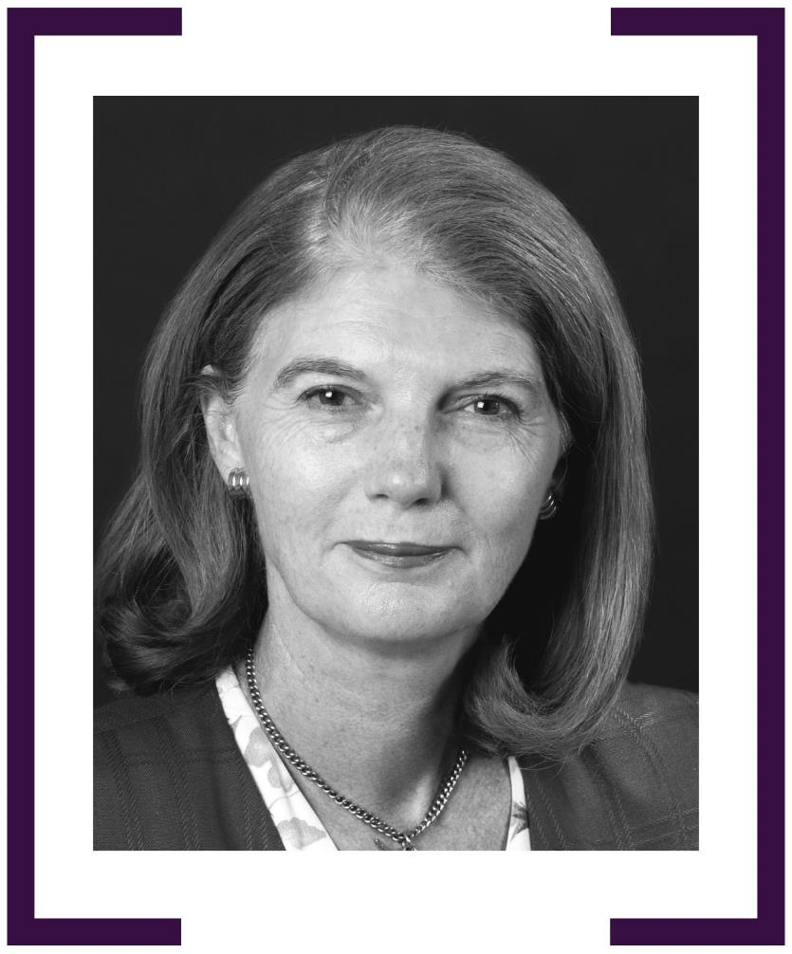

DIANE JOHNSTONE AM

AMBASSADOR TO NEPAL

1986–1989
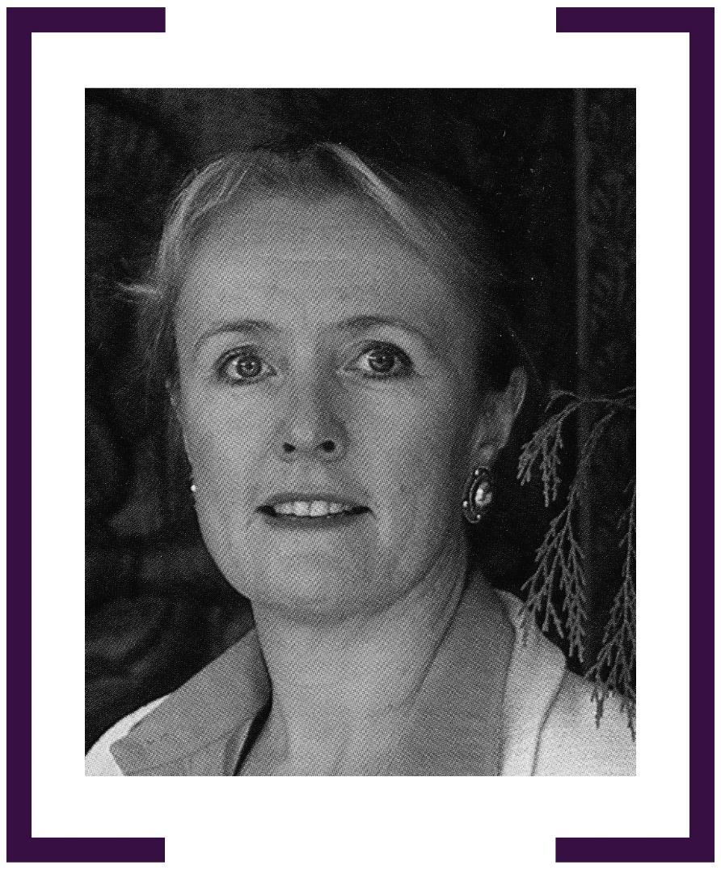

SUSAN BOYD am

HIGH COMMISSIONER TO BANGLADESH 1986–1989

AMBASSADOR To THE SOCIALIST REPUBLIC OF VIETNAM
1994–1998

HIGH COMMISSIONER TO FIJI 1999–2003
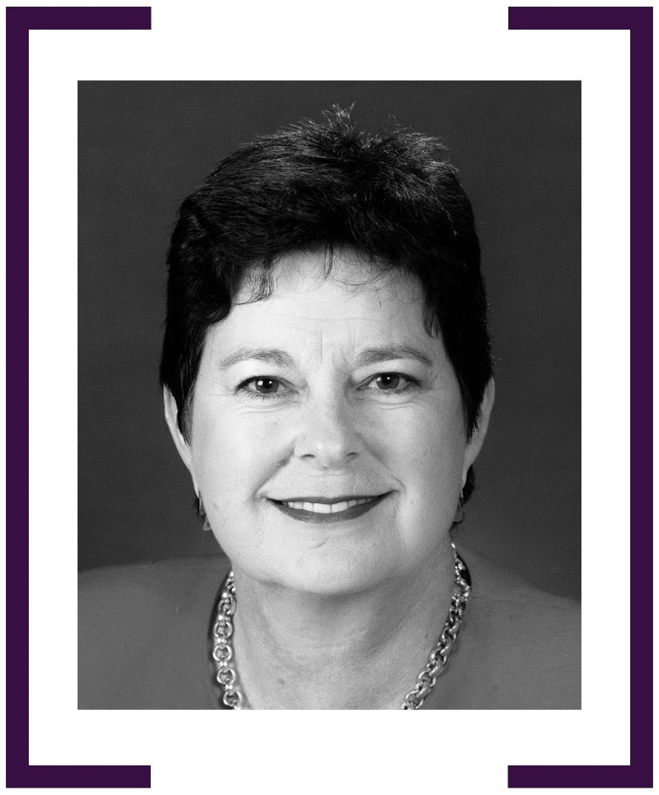

TONIA SHAND AM

HIGH COMMISSIONER TO SRI LANKA 1988–1993
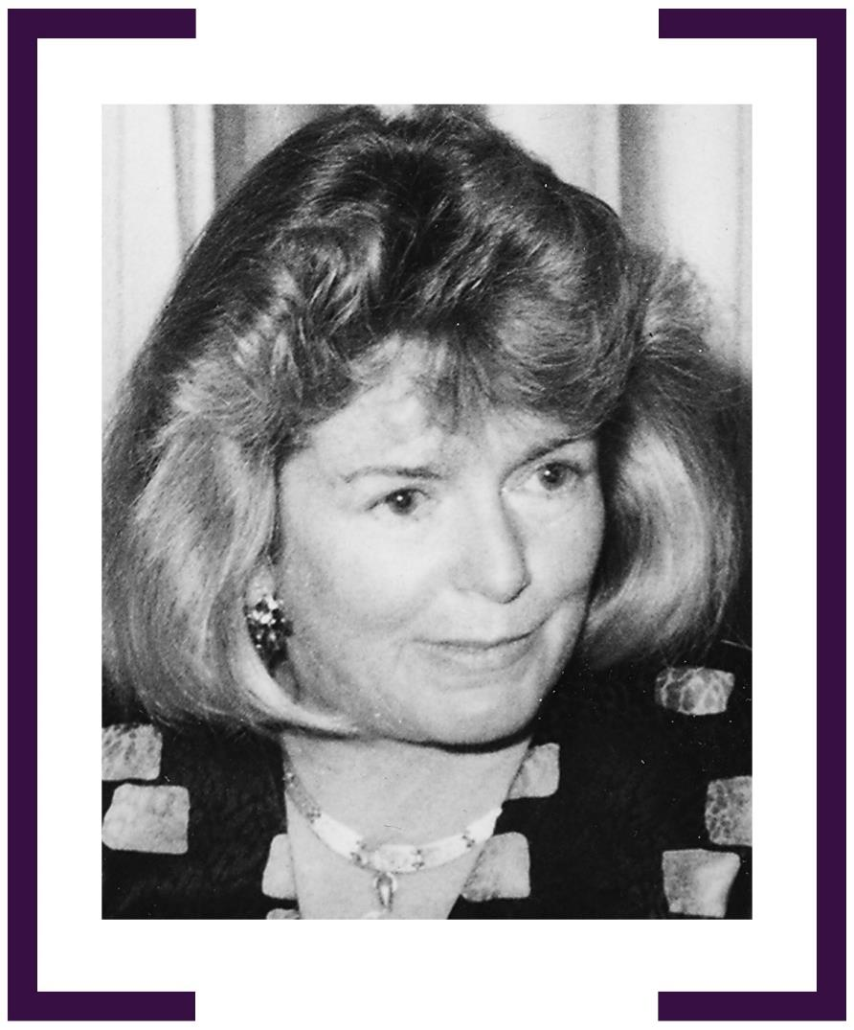

STEPHANIe DALY

CONSUL-GENERAL, BOMBAY (NOW MUMBAI) 1989–1992
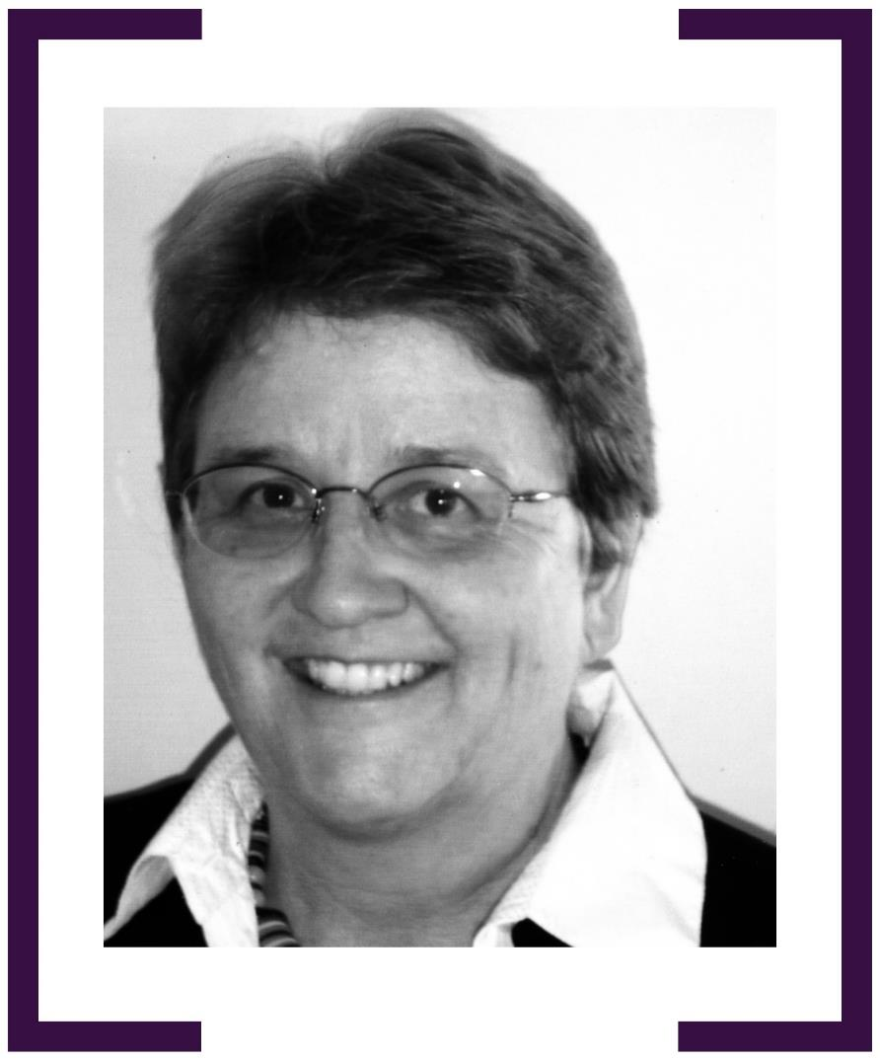

VICTORIa OWEN

AMBASSADOR TO SYRIA 1990–1992

AMBASSADOR TO EGYPT 1998–2002
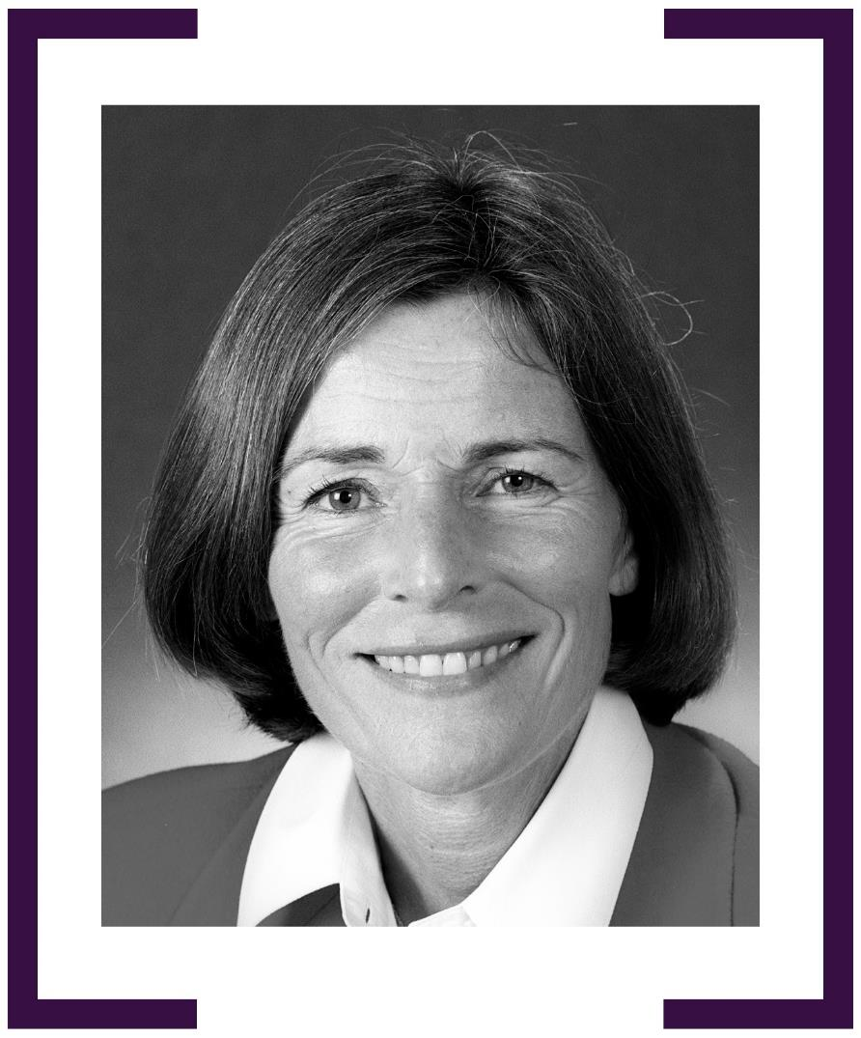

RUTH PEARCE

HIGH COMMISSIONER TO SOLOMON ISLANDS 1992–1994

AMBASSADOR TO THE RUSSIAN FEDERATION 1999–2002

AMBASSADOR TO the PHILIPPINES 2002–2005
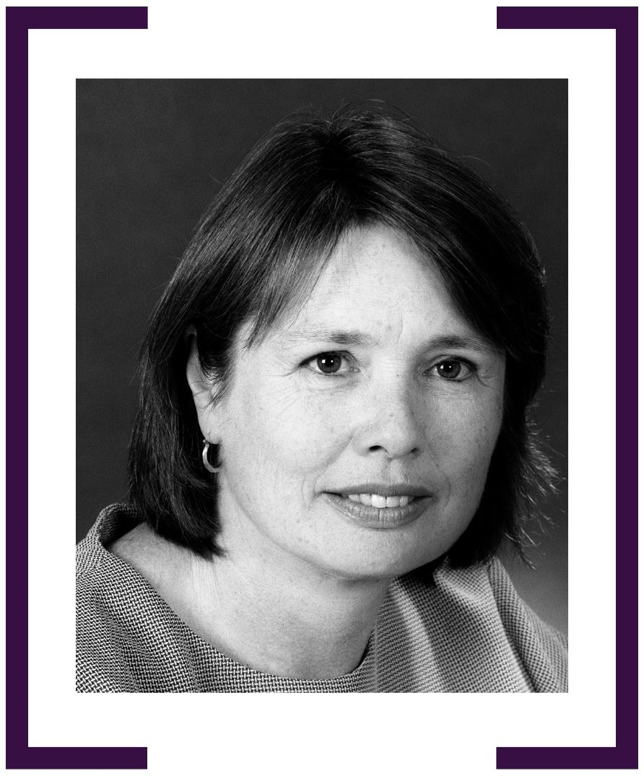

MARY McCARTER

HIGH COMMISSIONER TO MAURITIUS 1993–1997
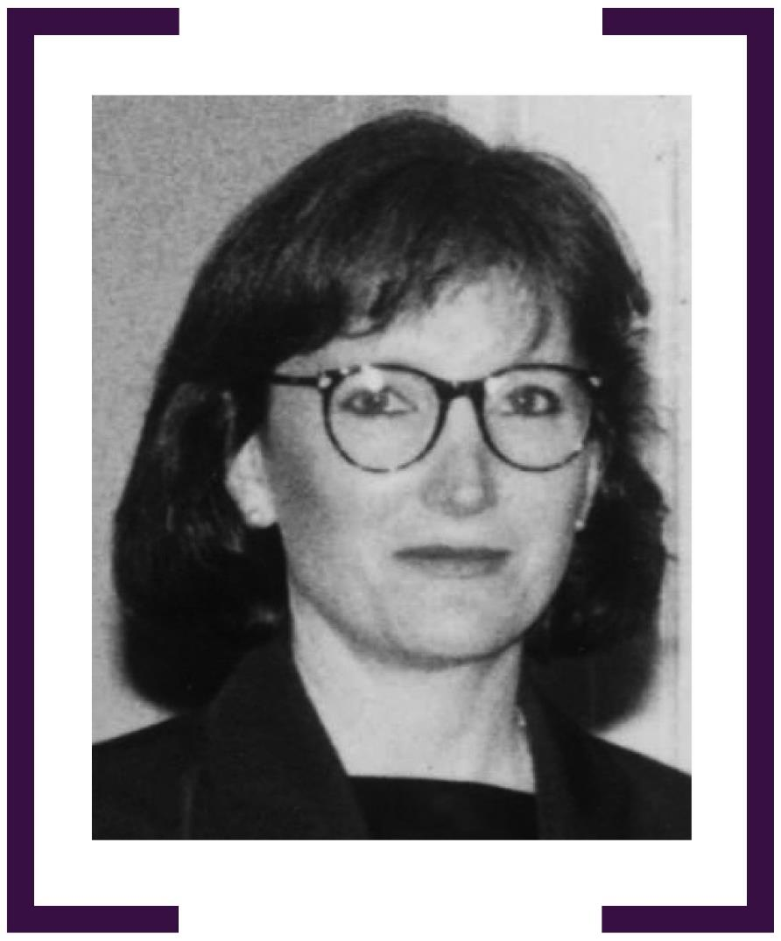

MERRY WICKES

AMBASSADOR TO JORDAN 1995–1998
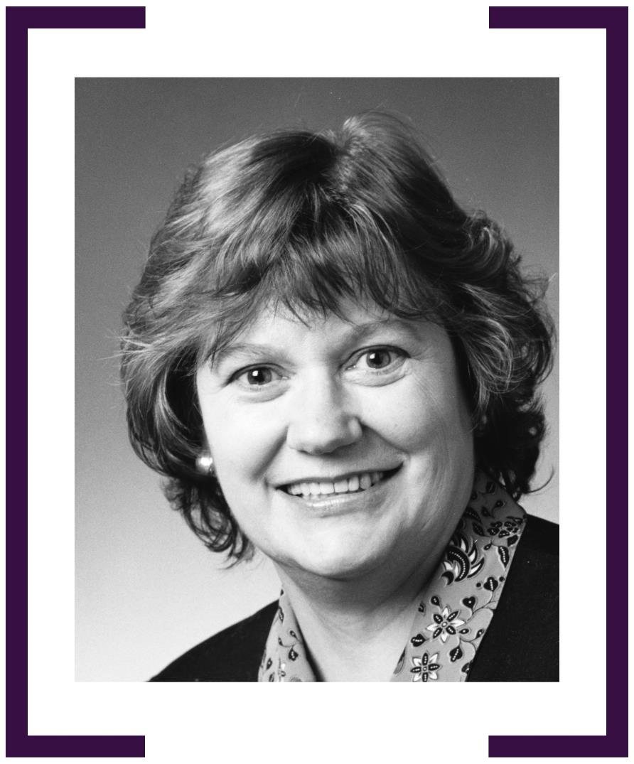

ZENA ARMSTRONG

CONSUL-GENERAL, GUANGZHOU 1996–1999
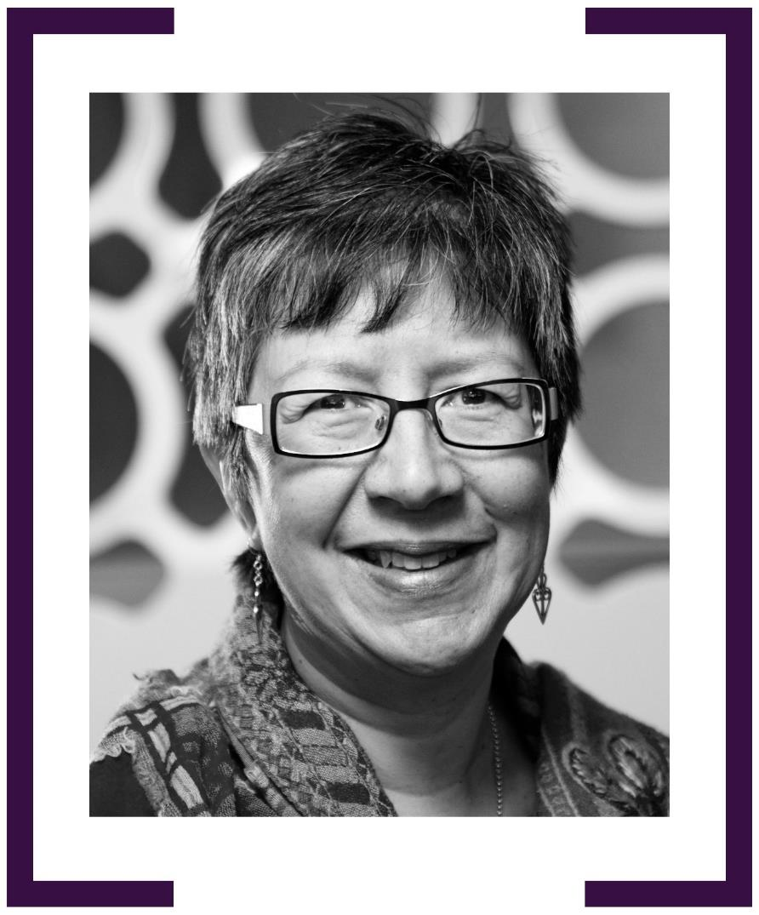

LISA FILIPETTO am

CONSUL-GENERAL, HO CHI MINH CITY 1997–2001

HIGH COMMISSIONER TO KENYA 2007–2010

AMBASSADOR TO ETHIOPIA 2010–2014
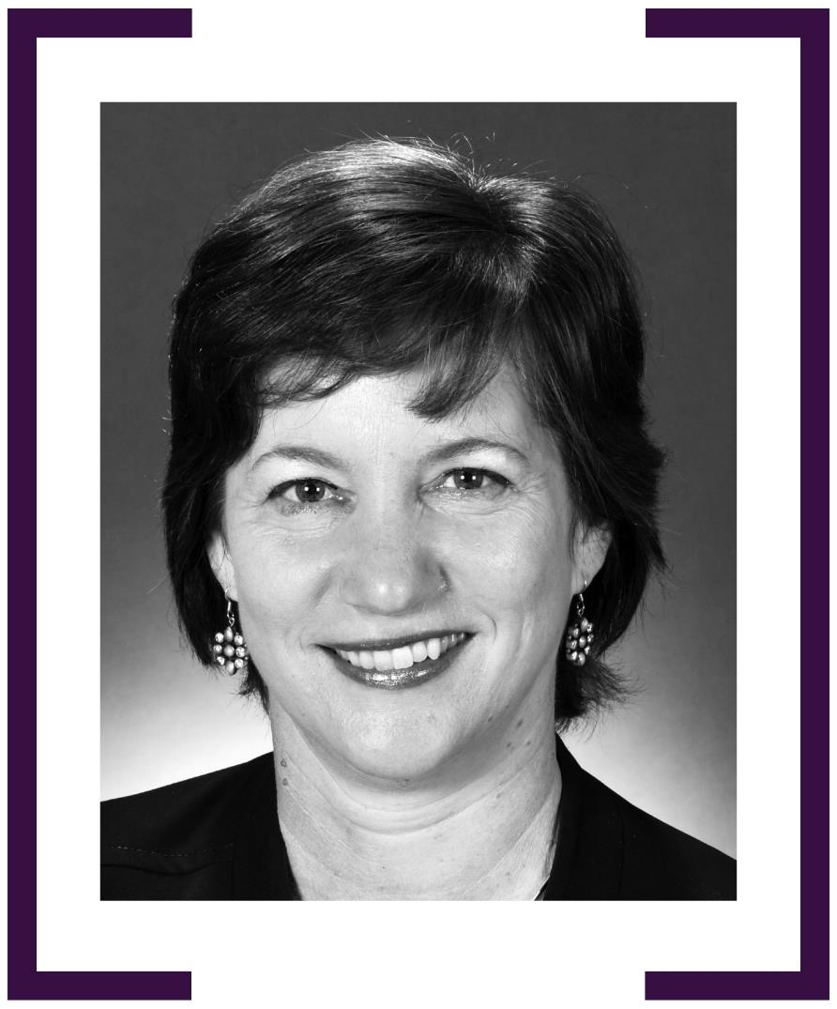

LYNDALL McLEAN AM

AMBASSADOR TO BURMA (NOW MYANMAR) 1997–2000
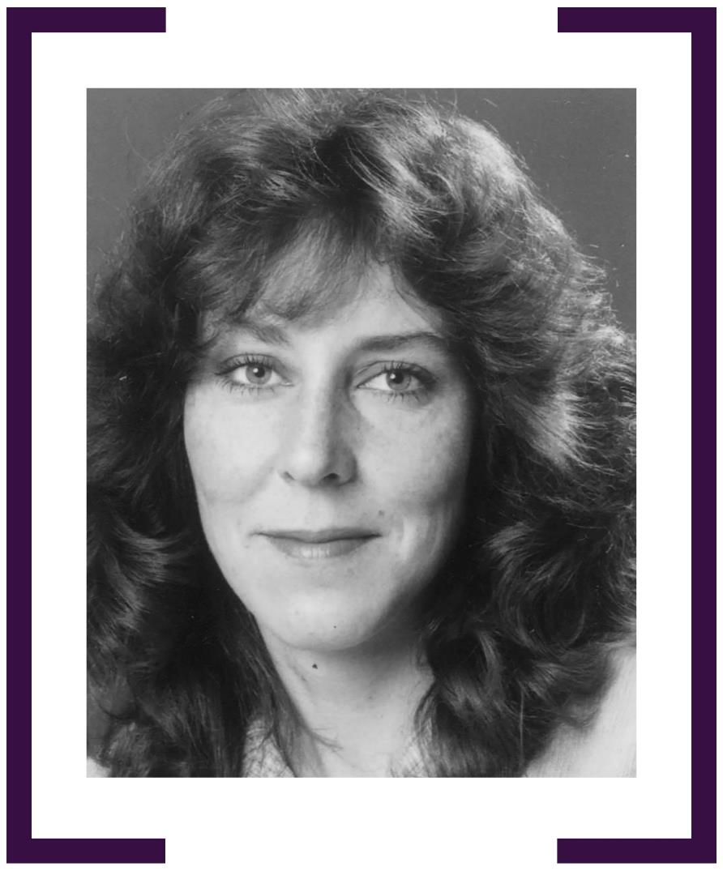

SUSAN TANNER

AMBASSADOR TO CHILE 1997–1999

AMBASSADOR TO SPAIN 2003–2006
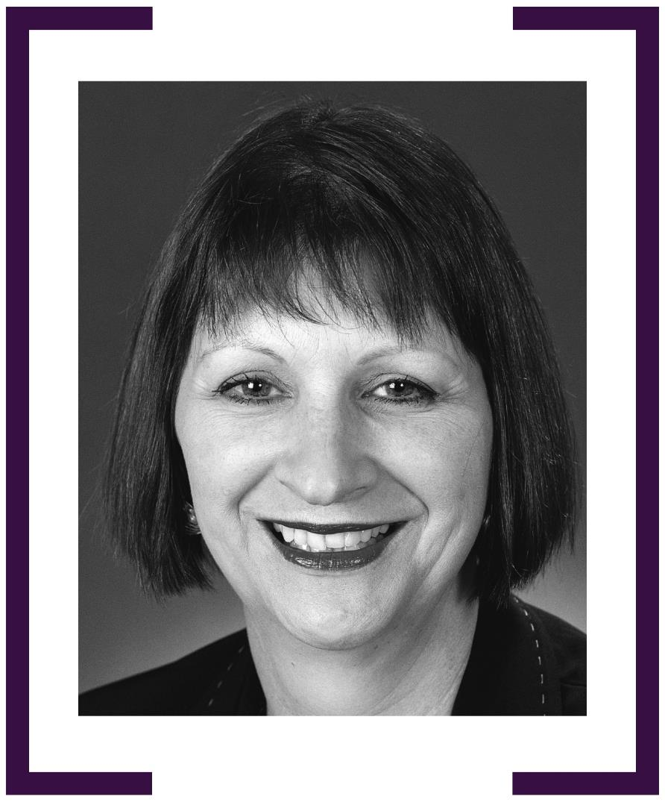

KARINA CAMPBELL

AMBASSADOR TO LAOS 1997–2000
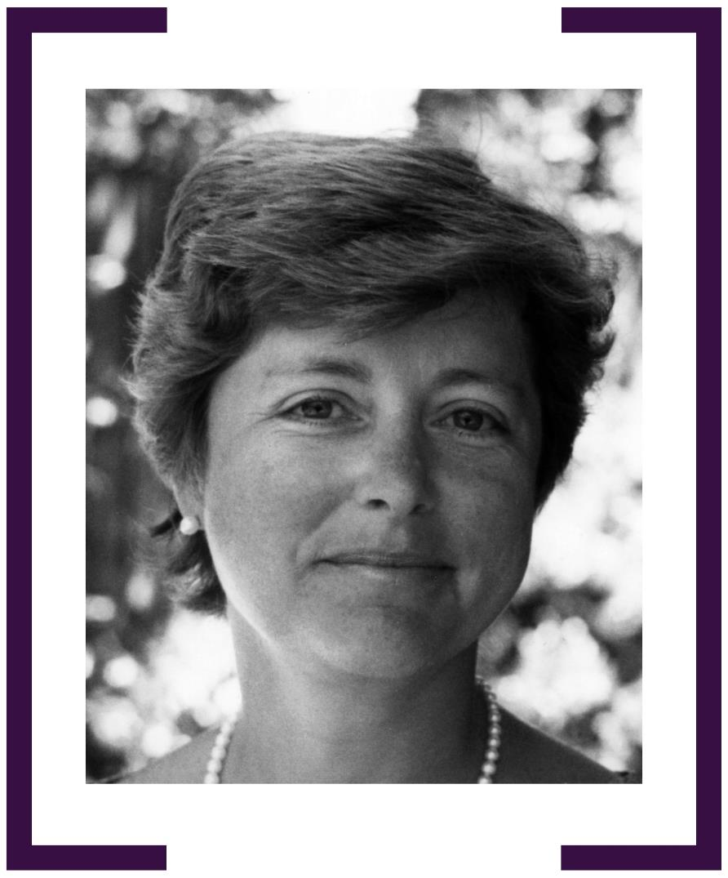

JOANNA HEWITT AO

AMBASSADOR FOR APEC 1998–2000

AMBASSADOR TO BELGIUM, THE EU & NATO 2000–2003
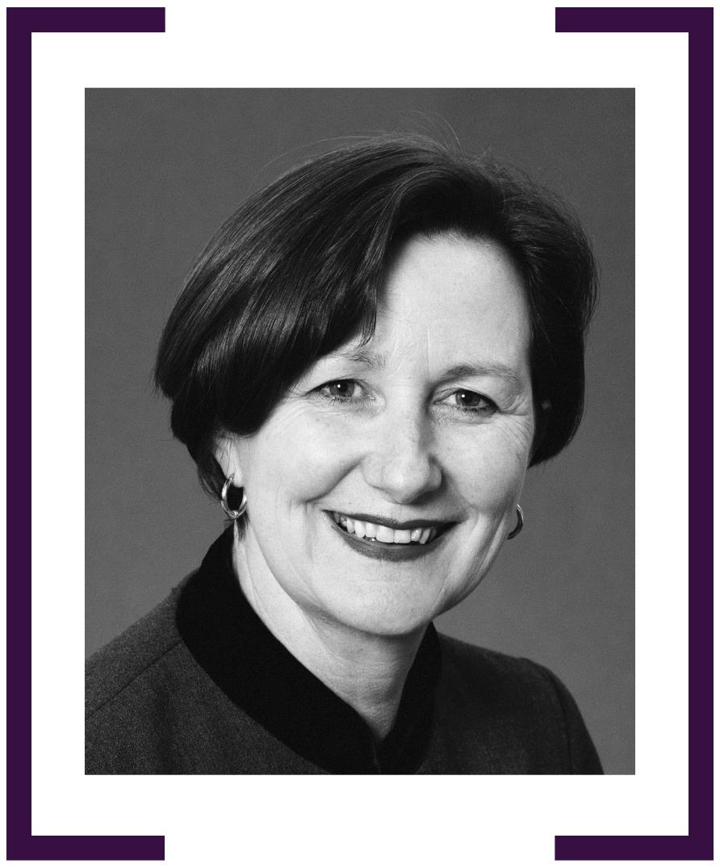

MARTINE LETTS

AMBASSADOR TO ARGENTINA 1998–2000
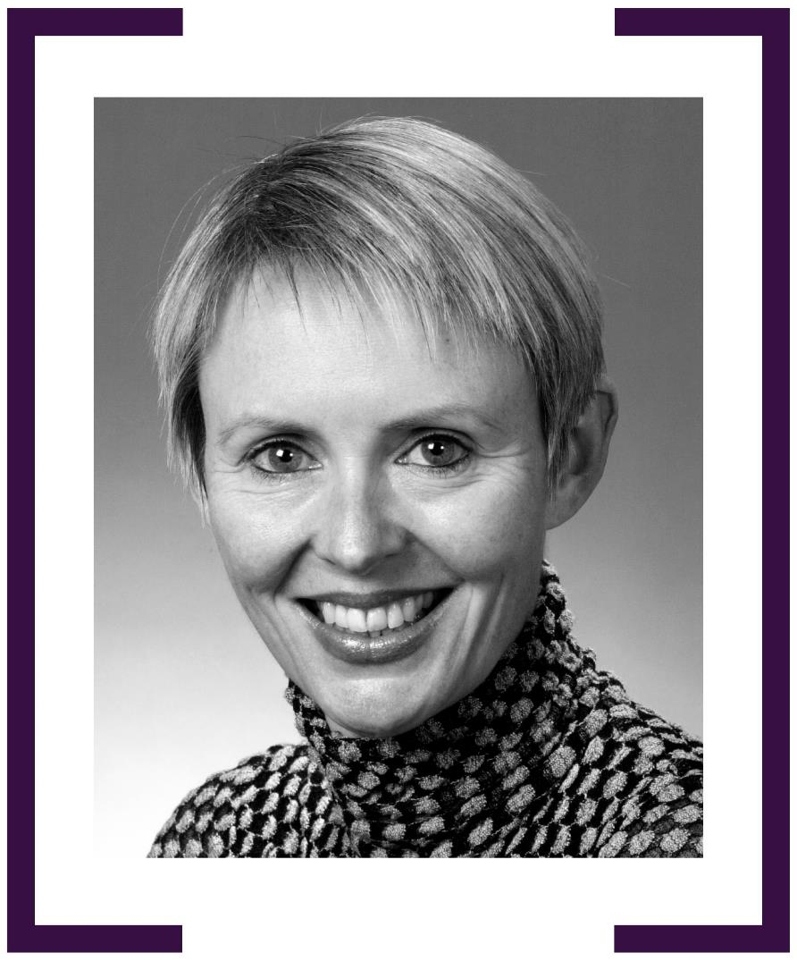

SALLY MANSFIELD

CONSUL-GENERAL, NOUMEA 1998–2001
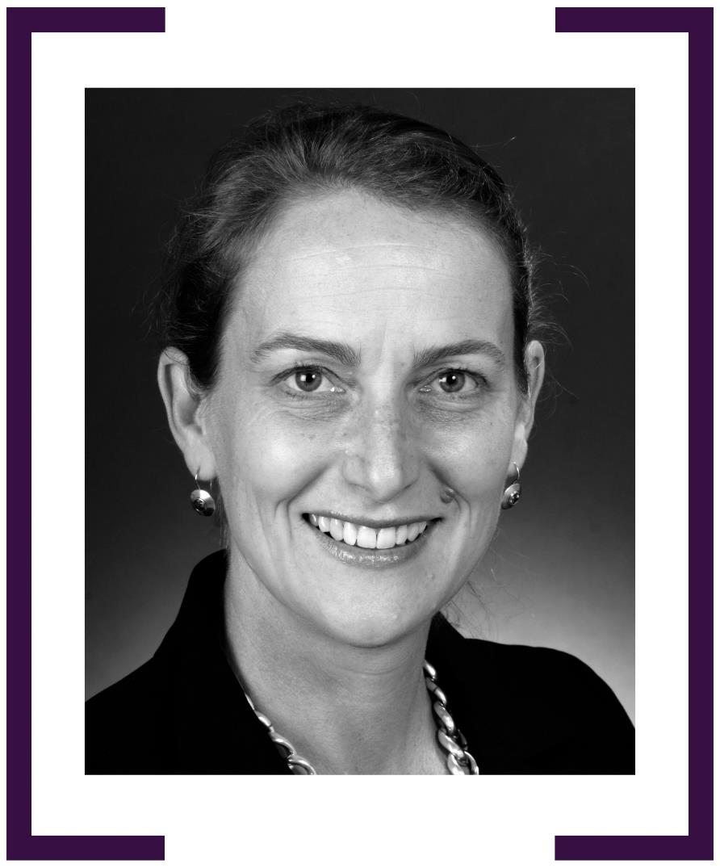

DENISE FISHER

HIGH COMMISSIONER TO ZIMBABWE 1998–2001
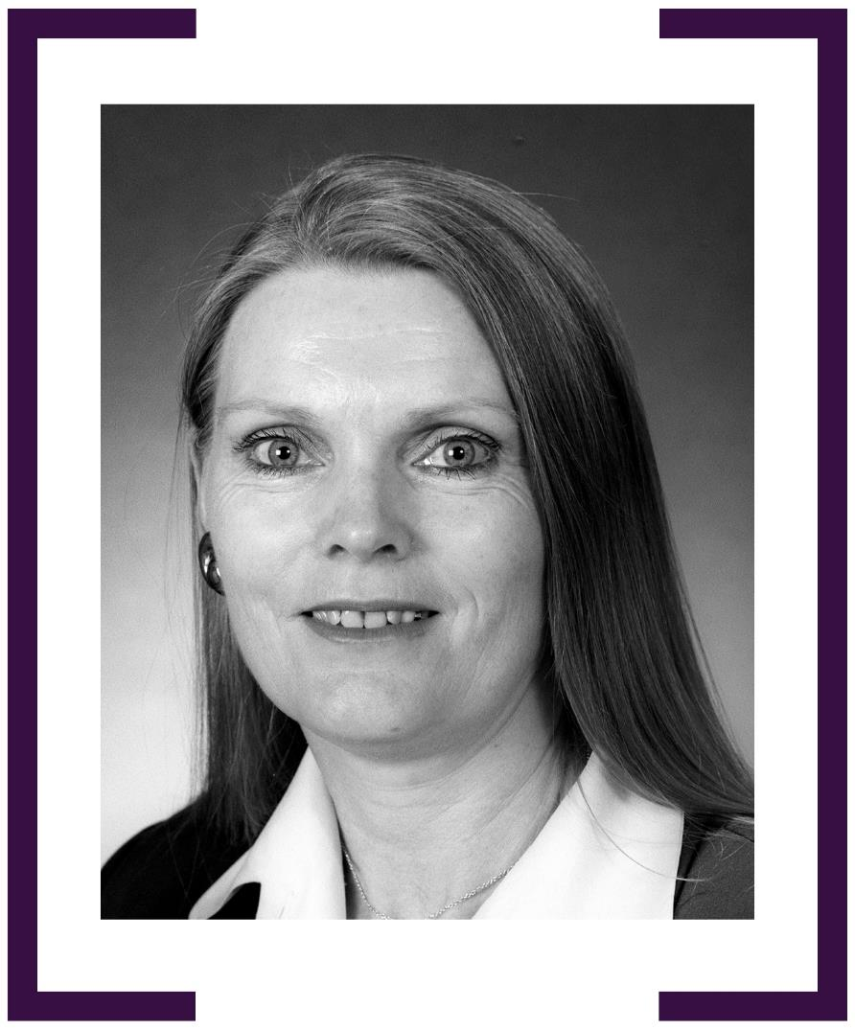

MARGARET ADAMSON

CONSUL-GENERAL, BERLIN 1993–1996

AMBASSADOR TO POLAND 1998–2002
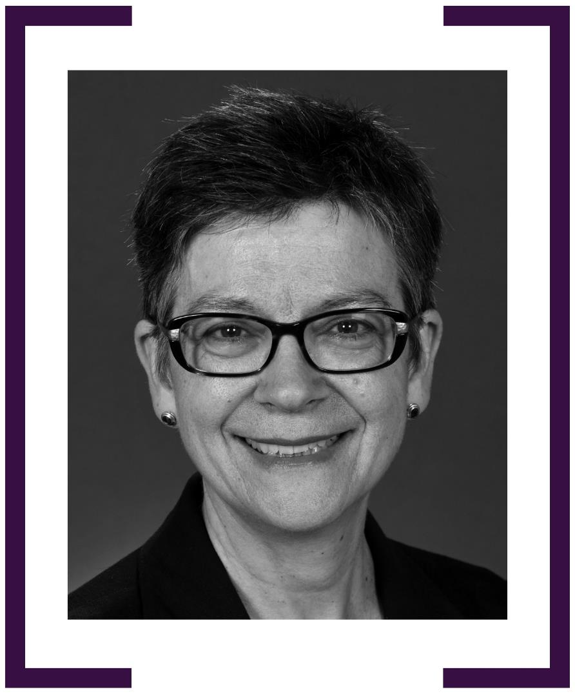

JANET GARDINER

AMBASSADOR TO PORTUGAL 2000–2003
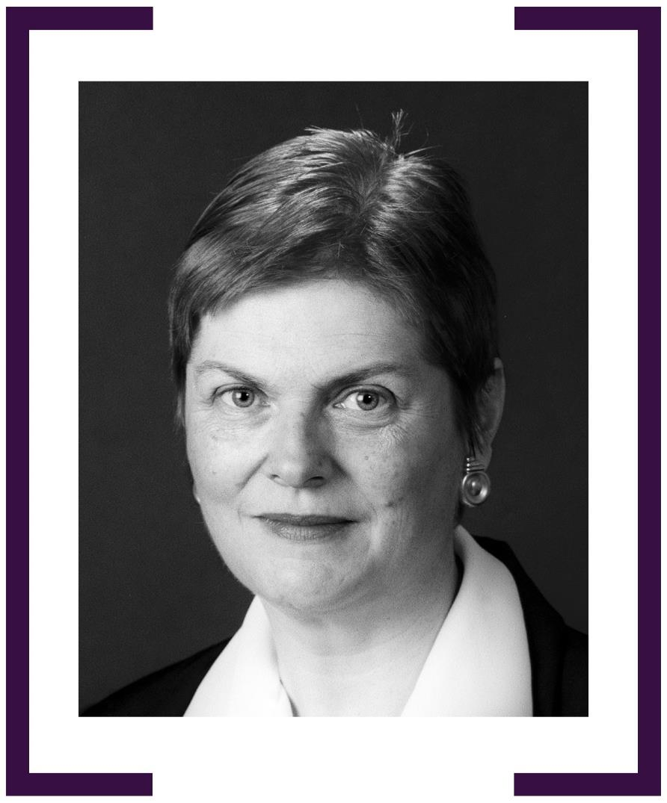

LOUISE HAND PSM

AMBASSADOR TO THE KINGDOM OF CAMBODIA 2000–2003

HIGH COMMISSIONER TO CANADA 2012–2015
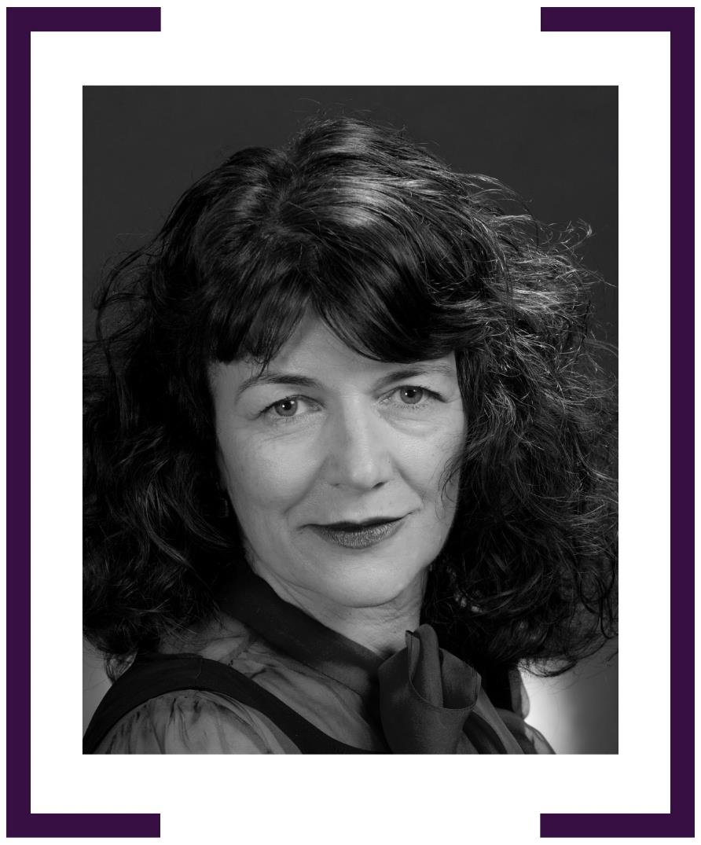

PENELOPE RICHARDS

CONSUL-GENERAL, SHANGHAI 2001–2002
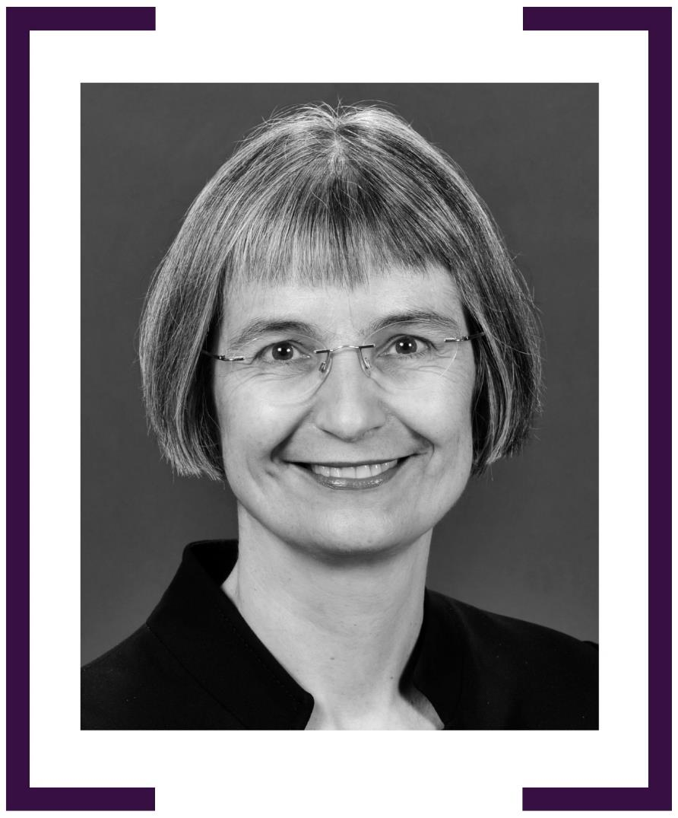

FRANCES ADAMSON ac

REPRESENTATIVE, TAIPEI 2001–2005

AMBASSADOR TO THE PEOPLE’S REPUBLIC OF CHINA
2011–2015
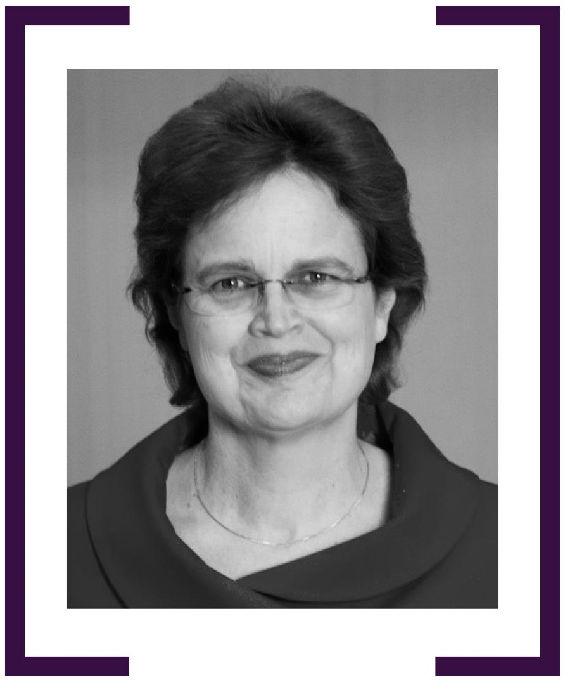

STEPHANIE SHWABSKY

AMBASSADOR TO LEBANON 2002–2006
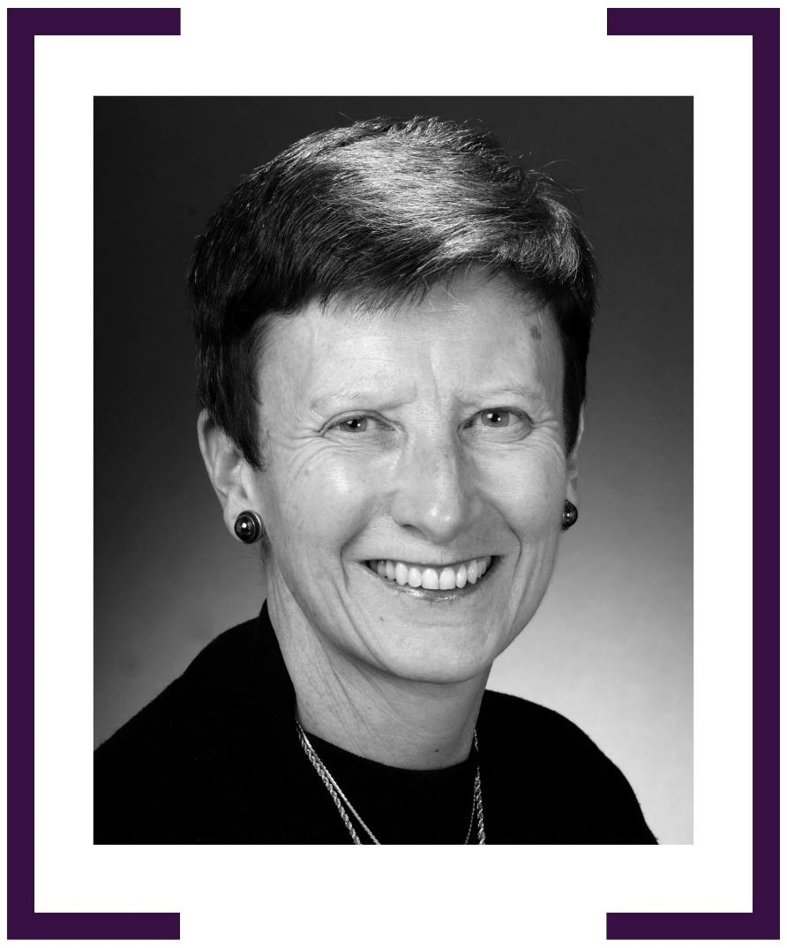

CAROLINE MILLAR

AMBASSADOR FOR PEOPLE SMUGGLING
& HUMAN TRAFFICKING 2003–2005
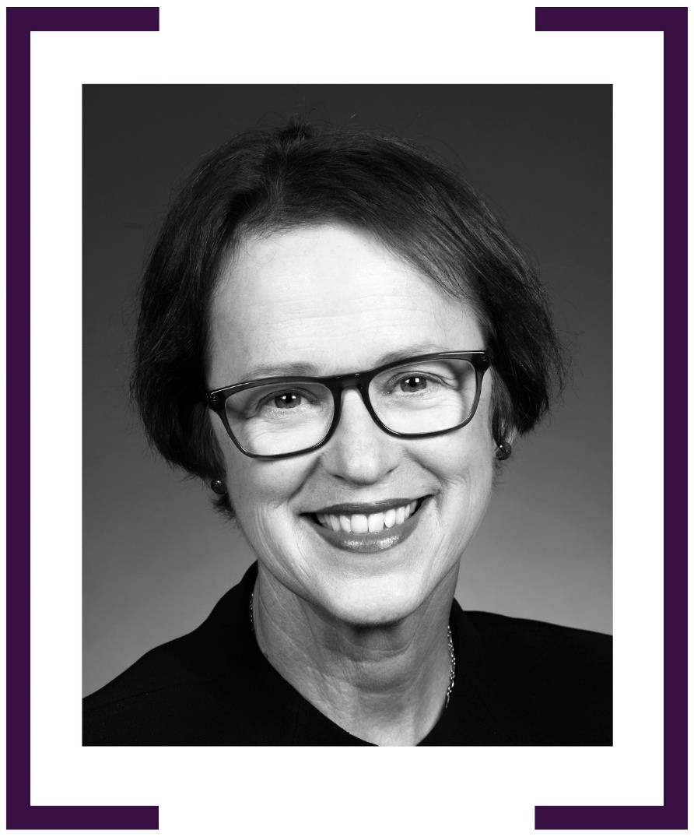

PAMELA FAYLE AM

AMBASSADOR TO THE FEDERAL REPUBLIC OF GERMANY
2003–2006
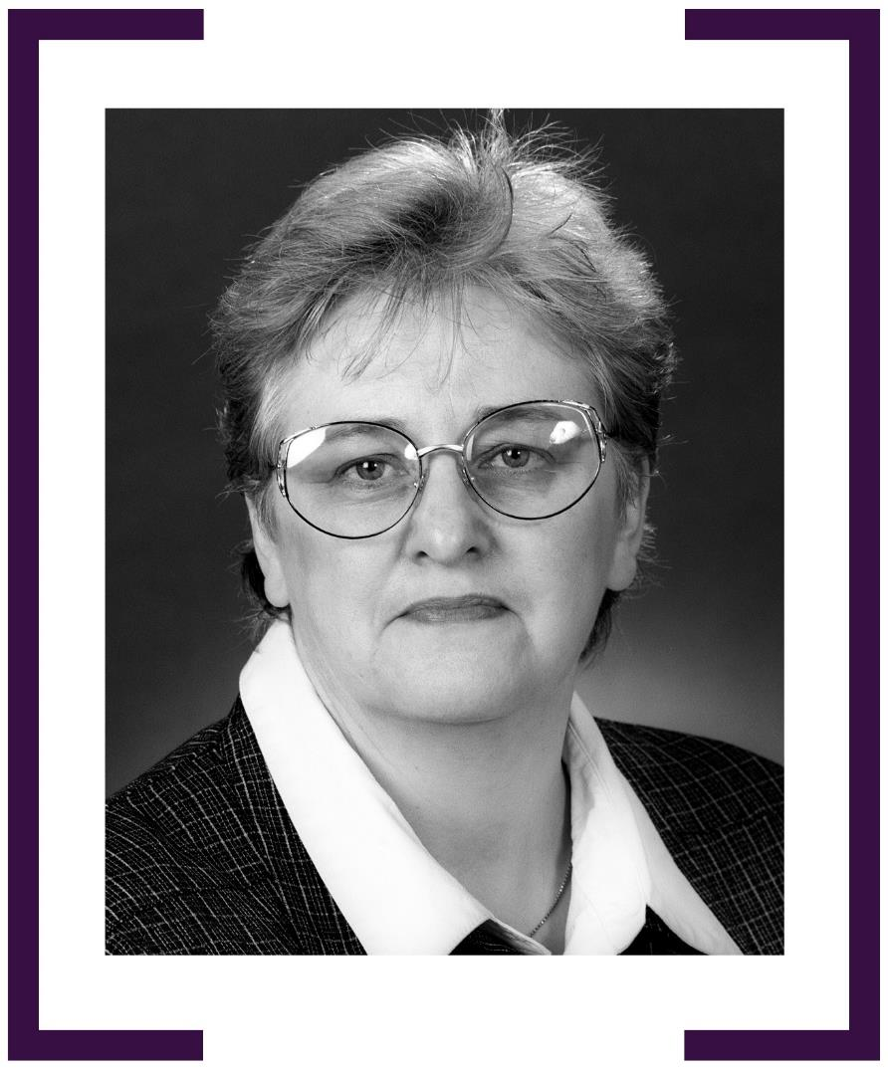

Jane Madden

Ambassador & Permanent Delegate to UNESCO 2003–2007
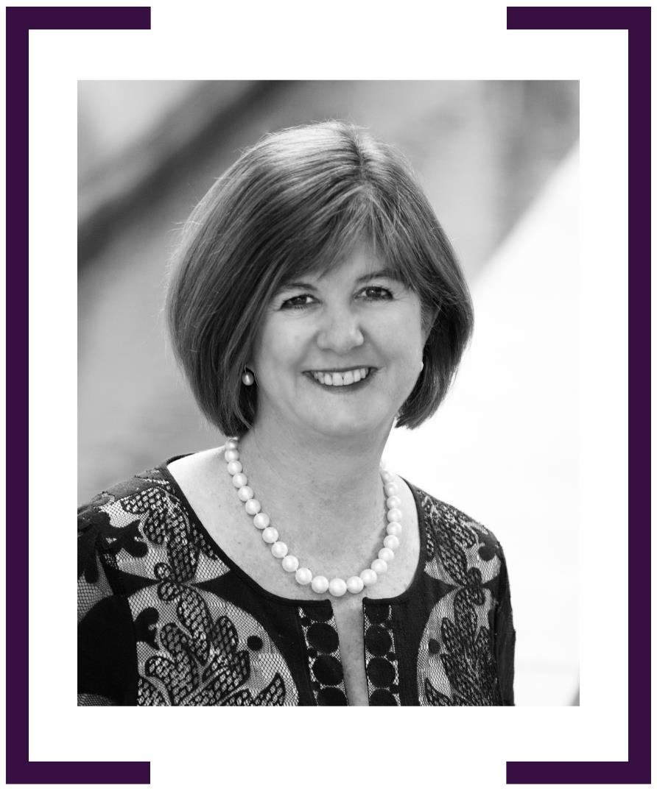

DEBORAH STOKES

AMBASSADOR TO AUSTRIA & PERMANENT REPRESENTATIVE TO THE UN, VIENNA 2003–2006

HIGH COMMISSIONER TO PAPUA NEW GUINEA 2013–2015
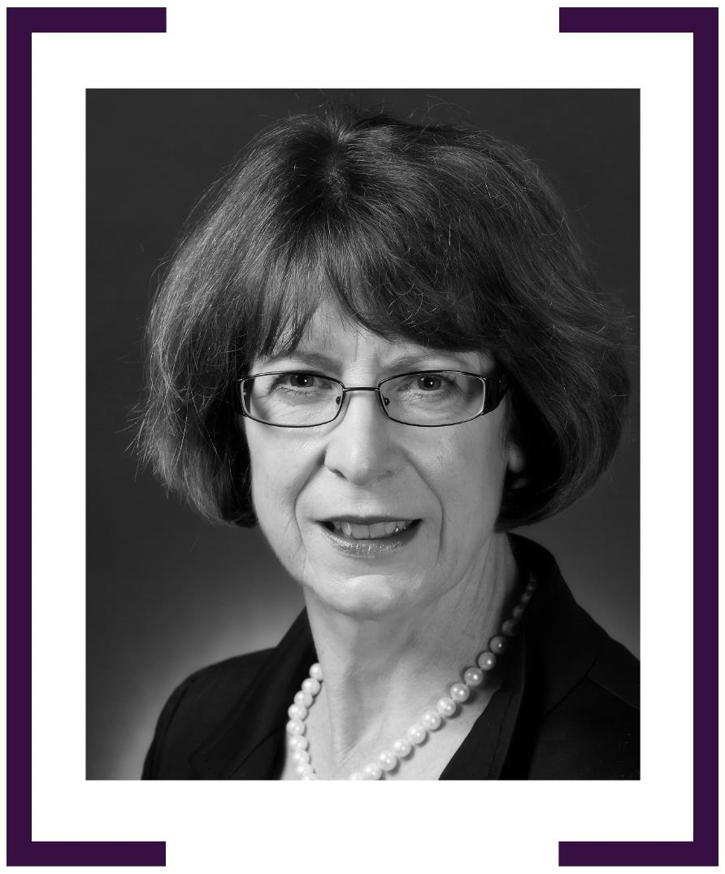

ANNA GEORGE

AMBASSADOR TO CROATIA 2003–2006
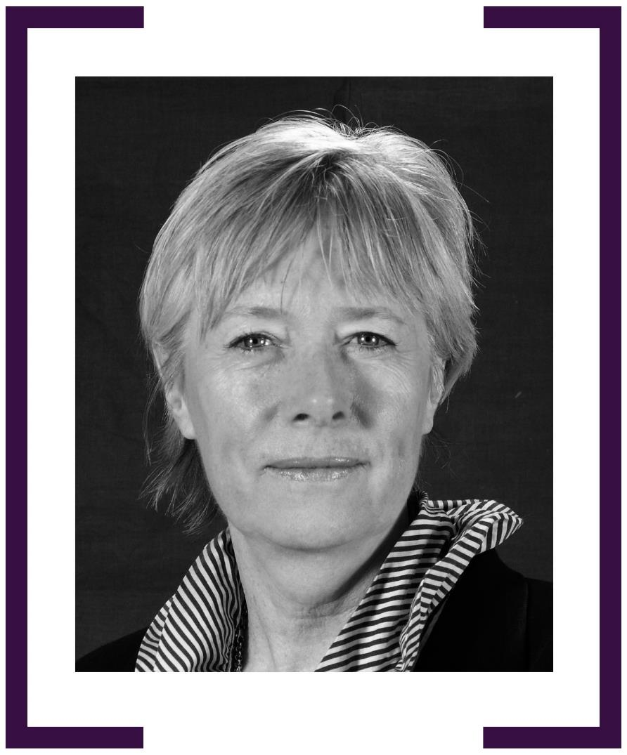

JEAN DUNN PSM

AMBASSADOR TO TURKEY 2004–2007
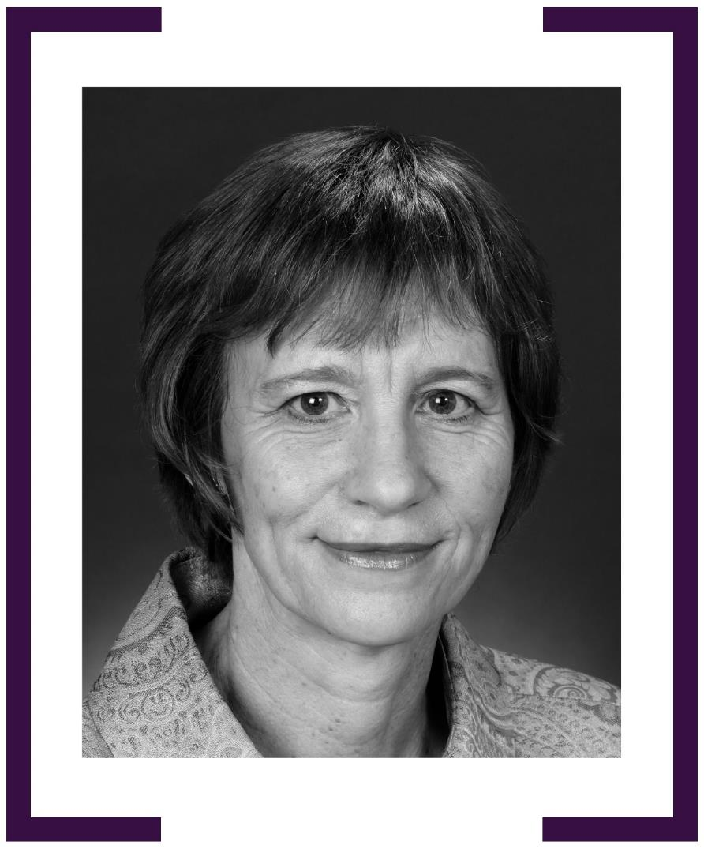

CORINNE TOMKINSON

AMBASSADOR TO FEDERATED STATES OF MICRONESIA
2004–2007
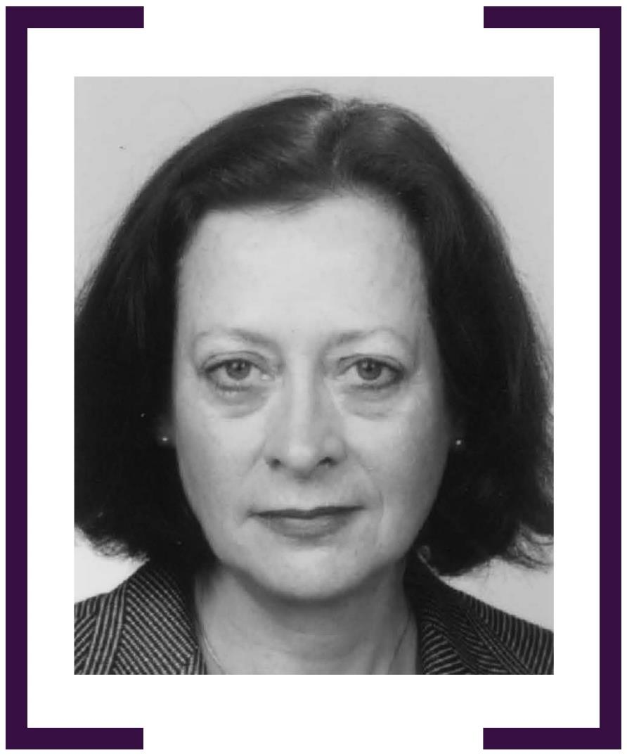

MARGARET TWOMEY AM

AMBASSADOR TO TIMOR-LESTE 2004–2008
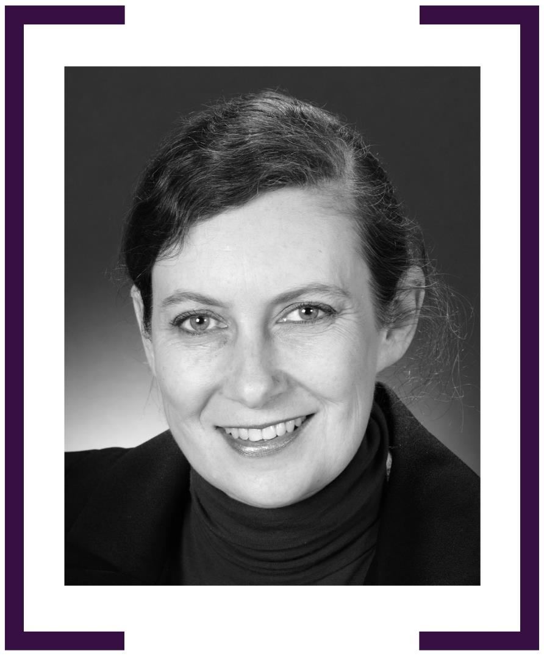

ZORICA McCARTHY

HIGH COMMISSIONER TO PAKISTAN 2004–2009
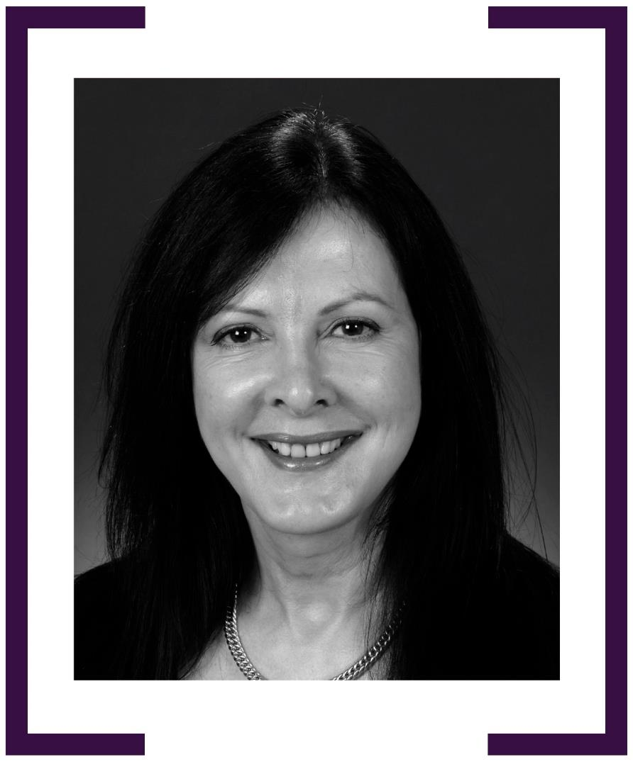

VERONIQUE INGRAM PSM

AMBASSADOR & PERMANENT REPRESENTATIVE TO THE OECD, PARIS 2005–2008
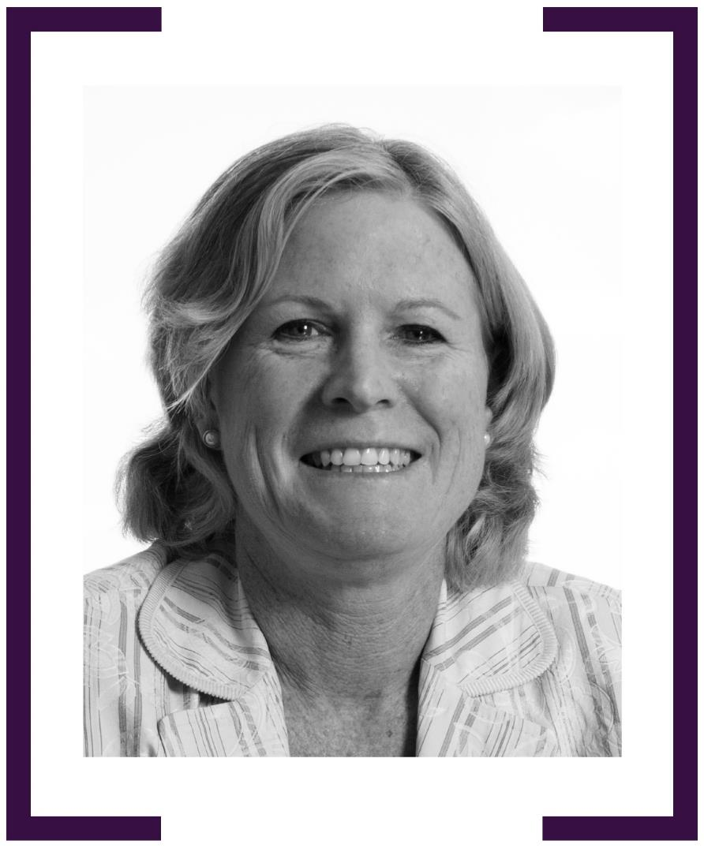

RUTH ADLER

HIGH COMMISSIONER TO BRUNEI 2006–2009
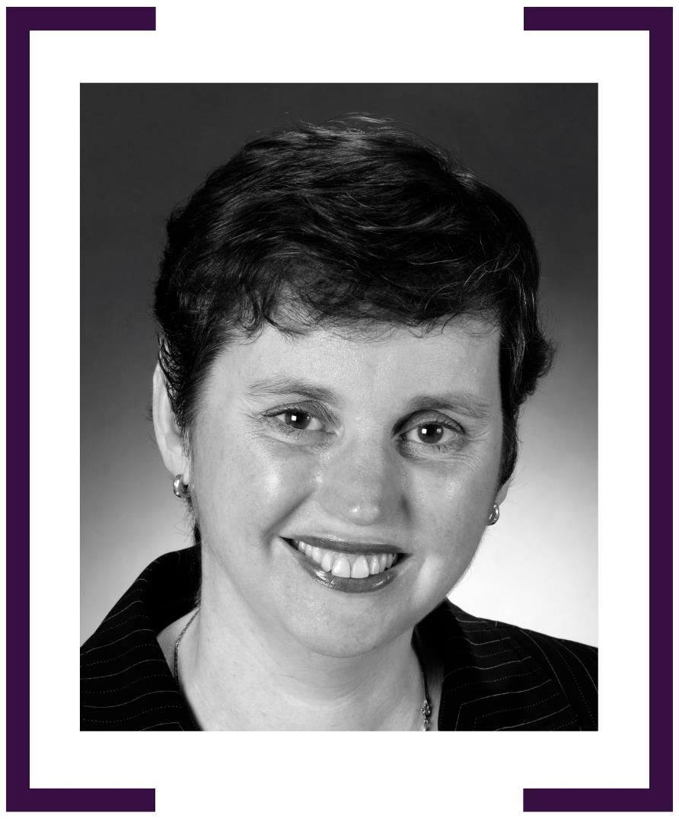
ANNE QUINANE

HIGH COMMISSIONER TO KIRIBATI 2006–2009

HIGH COMMISSIONER TO MALTA 2009–2012
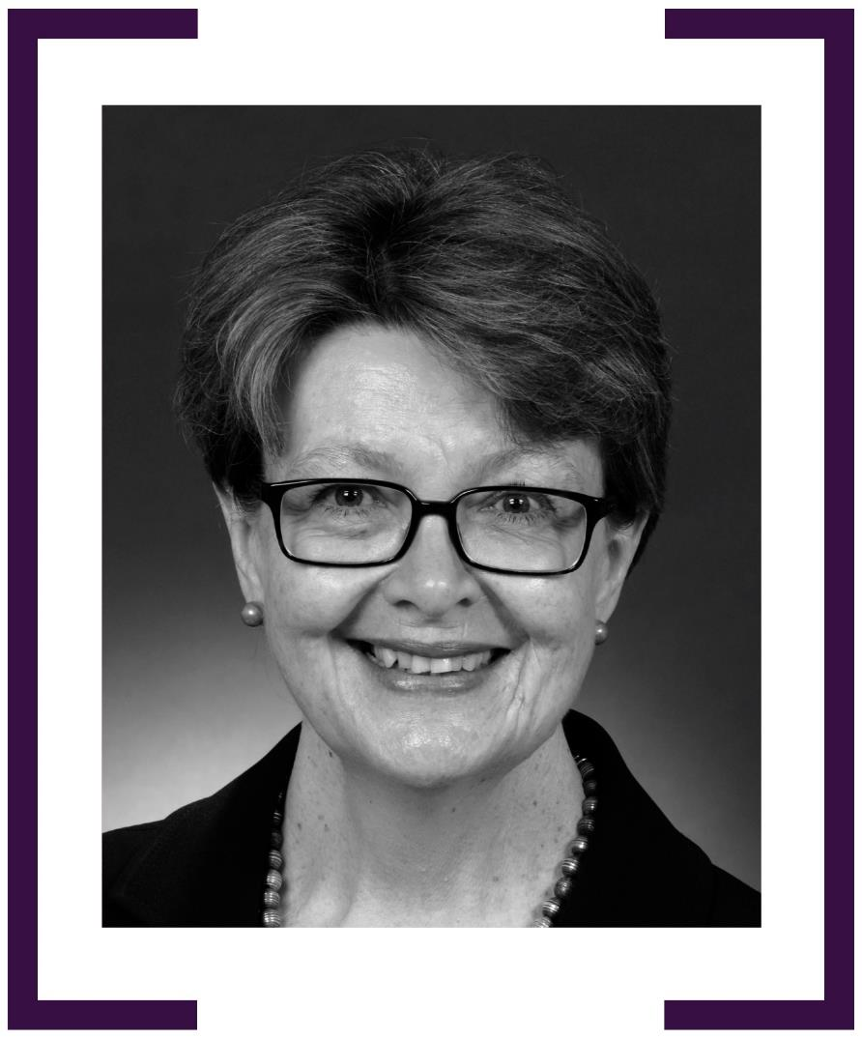

Annmaree O’Keeffe AM

Ambassador for HIV/AIDS 2006–2007
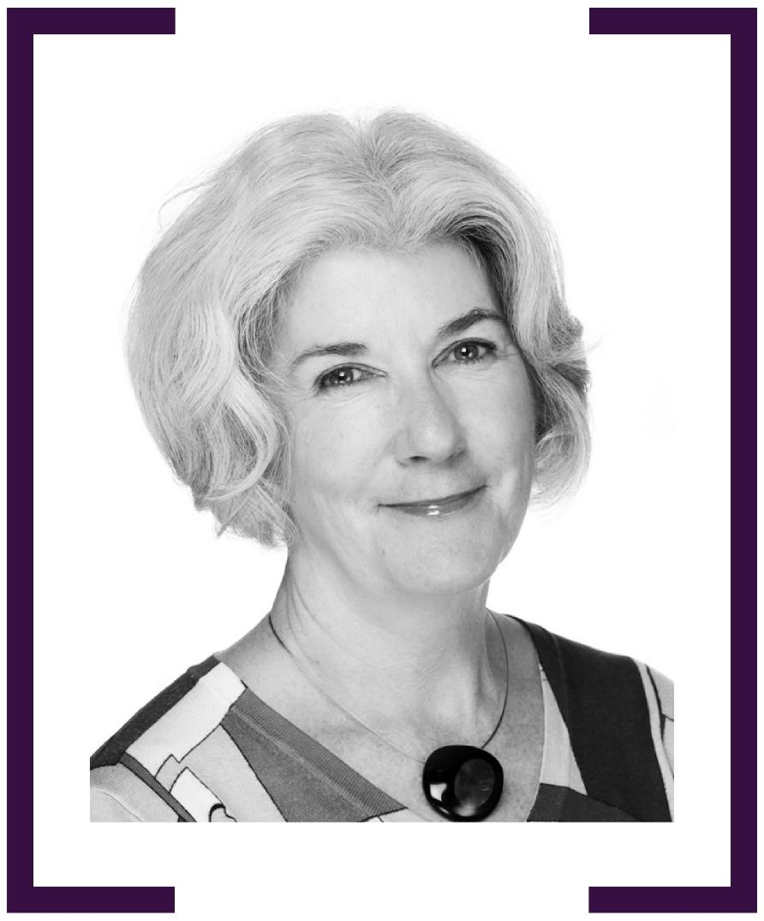

CLARE BIRGIN

AMBASSADOR TO HUNGARY 2004–2007

AMBASSADOR TO THE REPUBLIC OF SERBIA 2007–2010
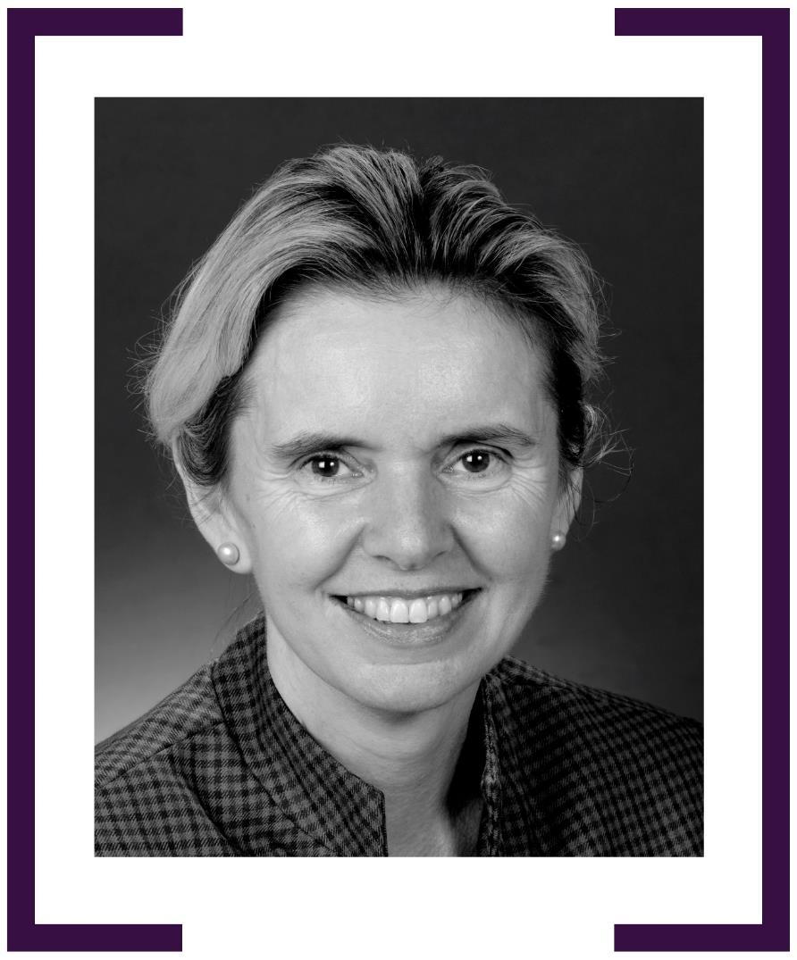

THE HON. AMANDA VANSTONE AO

AMBASSADOR TO ITALY 2007–2010
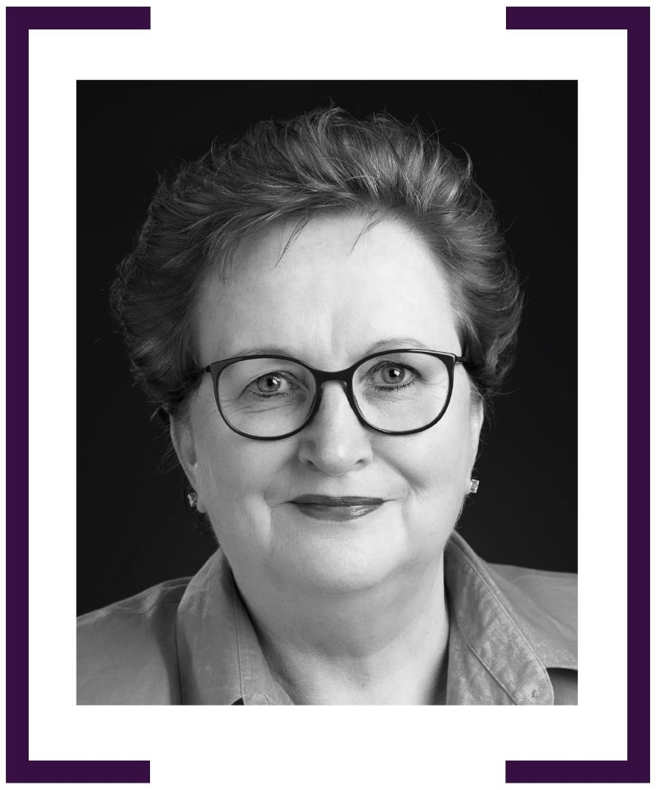

PENNY WILLIAMS PSM

HIGH COMMISSIONER TO MALAYSIA 2007–2010

GLOBAL AMBASSADOR FOR WOMEN & GIRLS 2011–2013

Ambassador to Indonesia 2021–current
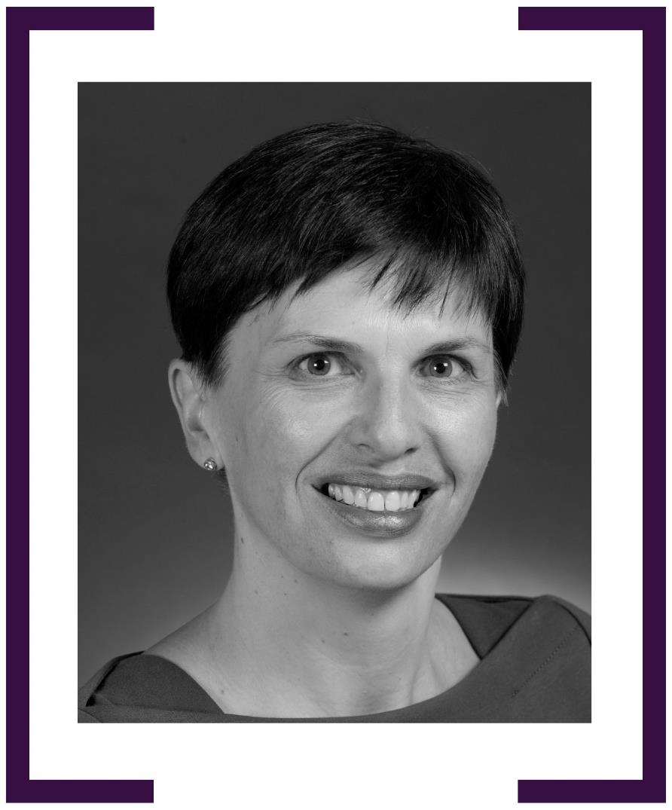

ANN HARRAP

HIGH COMMISSIONER TO SOUTH AFRICA 2008–2013
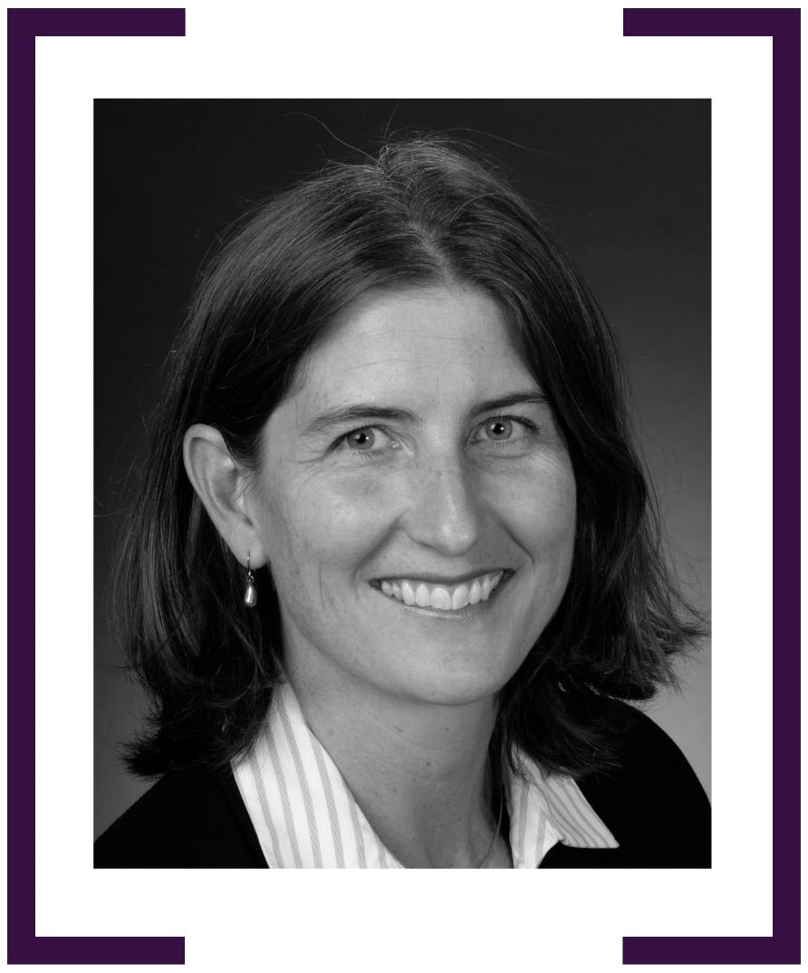

ELIZABETH SCHICK

CONSUL-GENERAL, CHICAGO 2008–2011
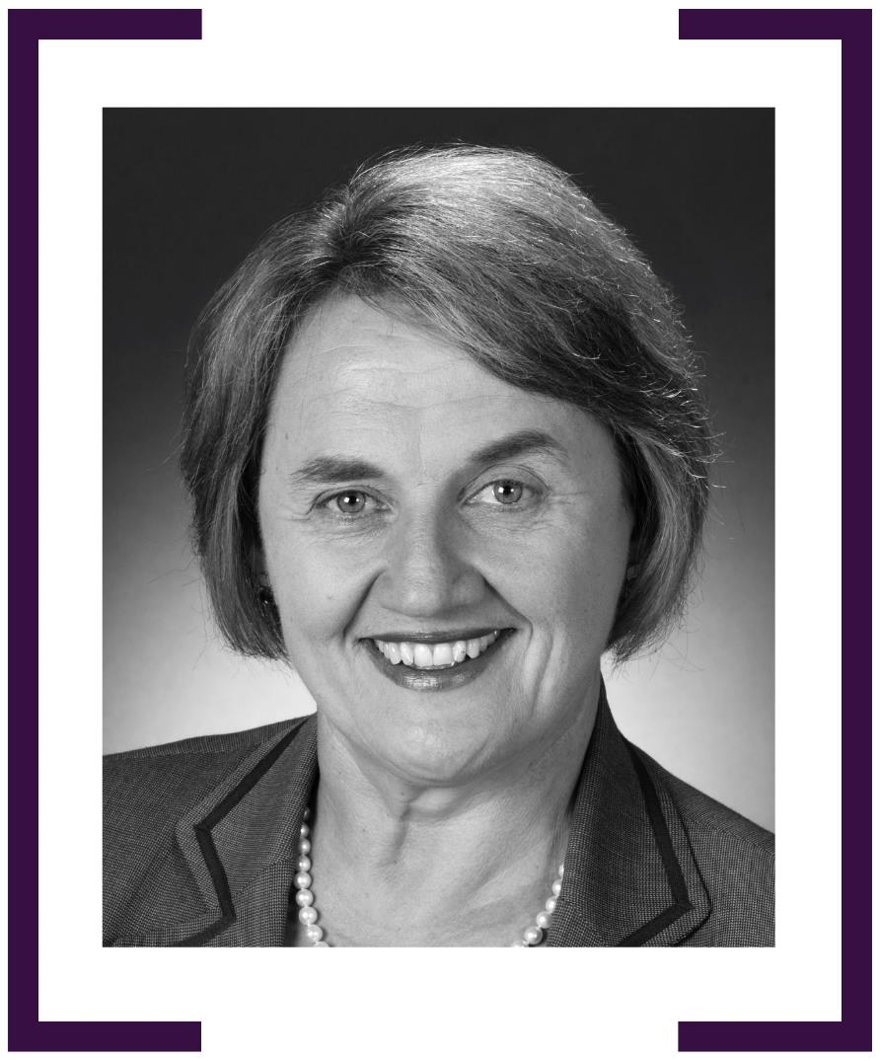

GILLIAN BIRD PSM

AMBASSADOR TO ASEAN 2008–2013
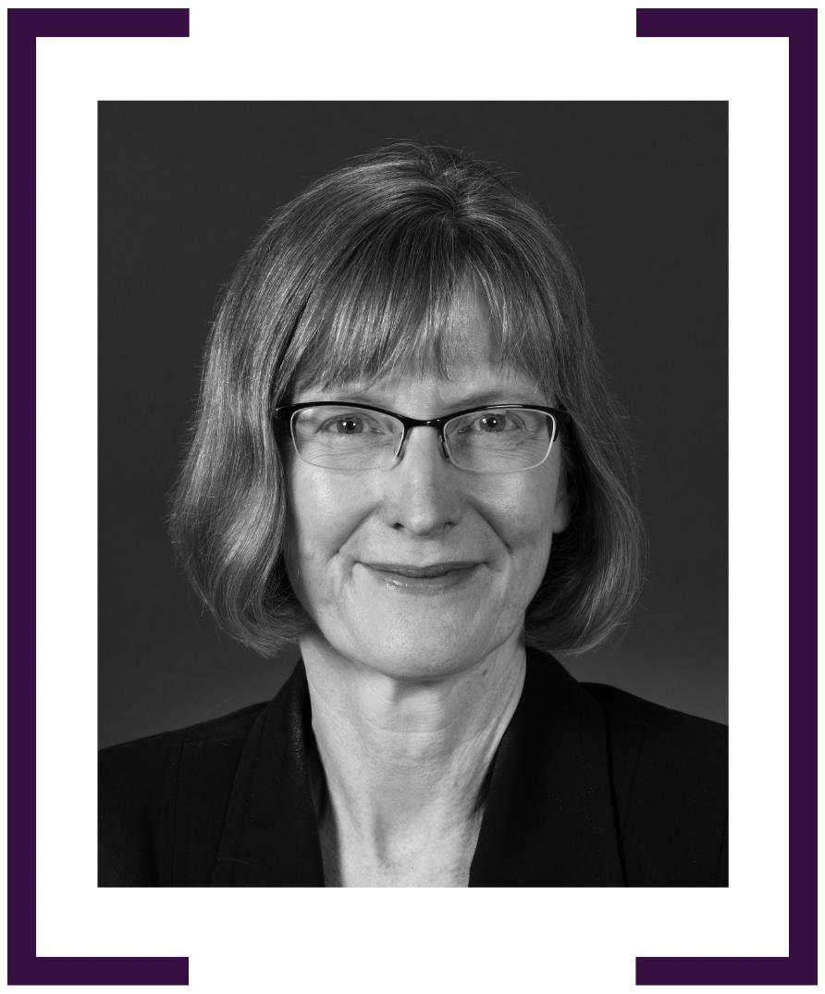

KATRINA COOPER

AMBASSADOR TO MEXICO 2008–2012
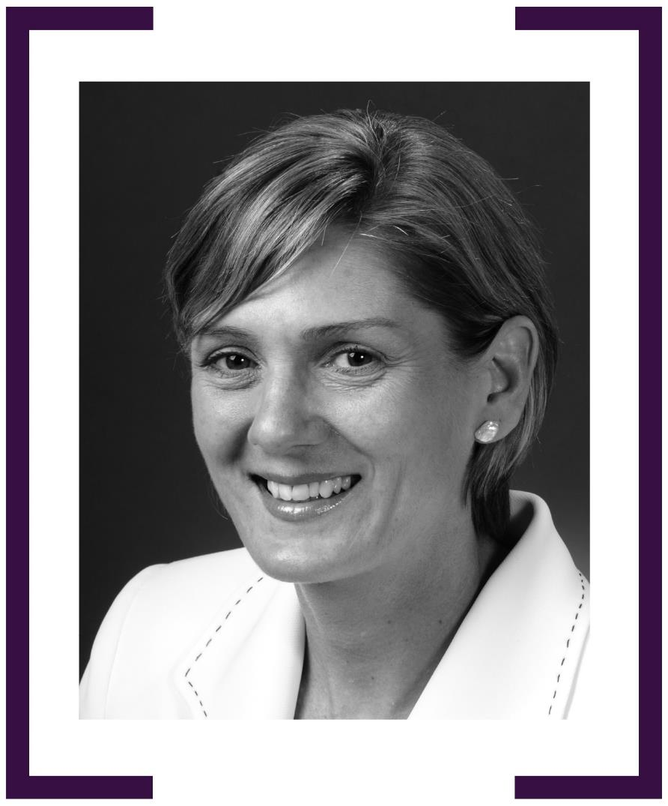

LYDIA MORTON

AMBASSADOR TO THE NETHERLANDS
& PERMANENT REPRESENTATIVE TO THE ORGANISATION
FOR THE PROHIBITION OF CHEMICAL WEAPONS, THE HAGUE 2008–2011
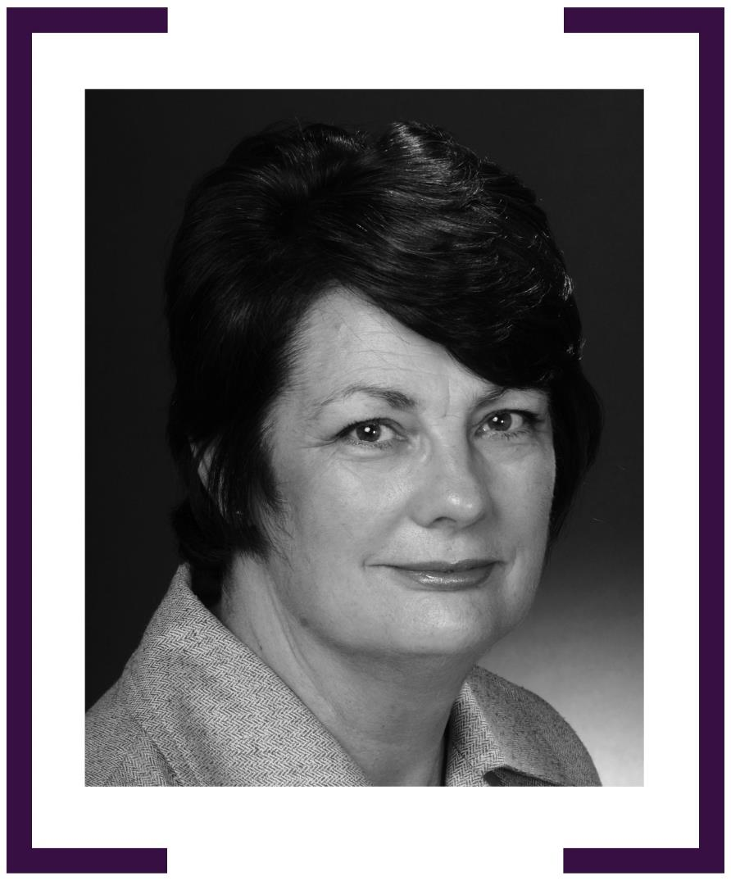

ANDREA FAULKNER psm

AMBASSADOR TO ISRAEL 2010–2013
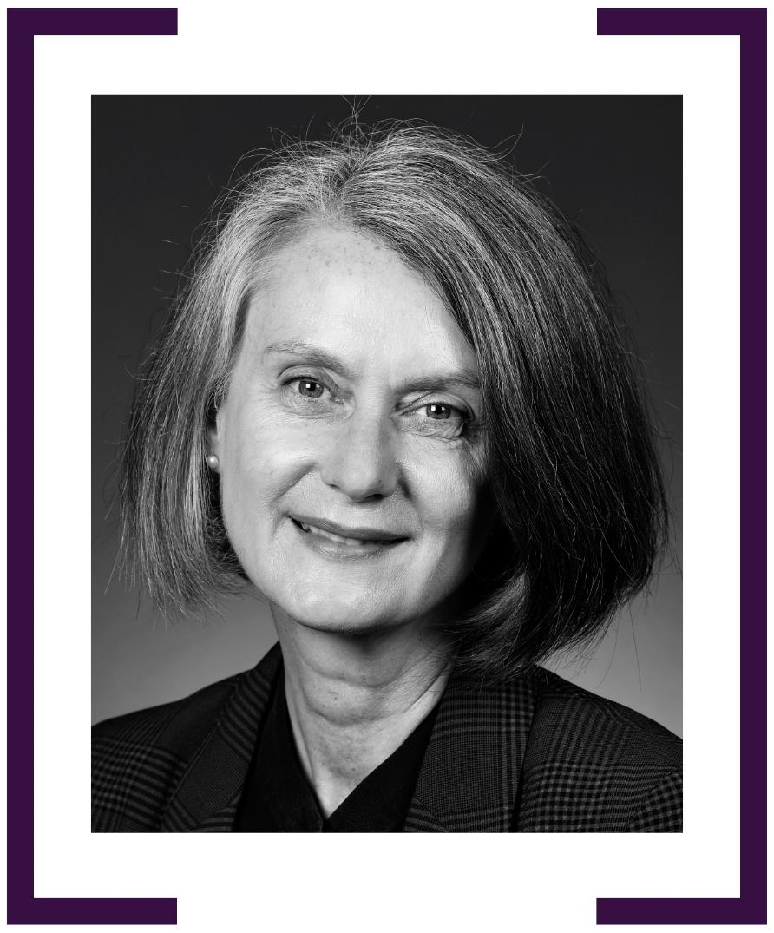

JENNY polyxeni BLOOMFIELD

AMBASSADOR TO GREECE 2011–2014
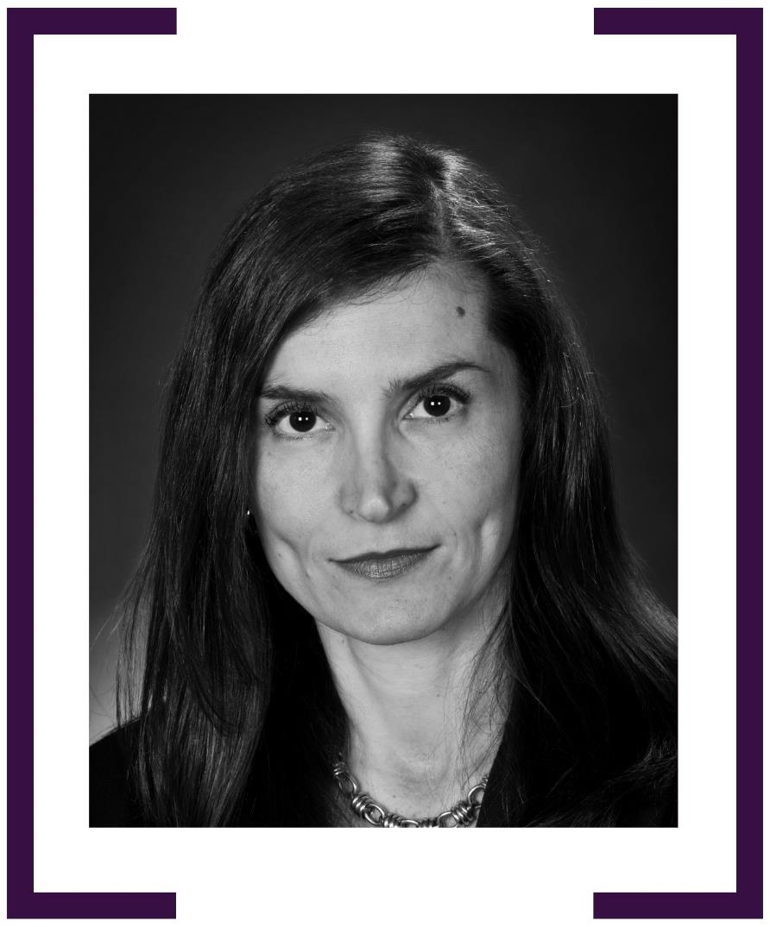

LYNDALL SACHS PSM

AMBASSADOR TO IRAQ 2011–2015

AMBASSADOR TO IRAN 2019–2024
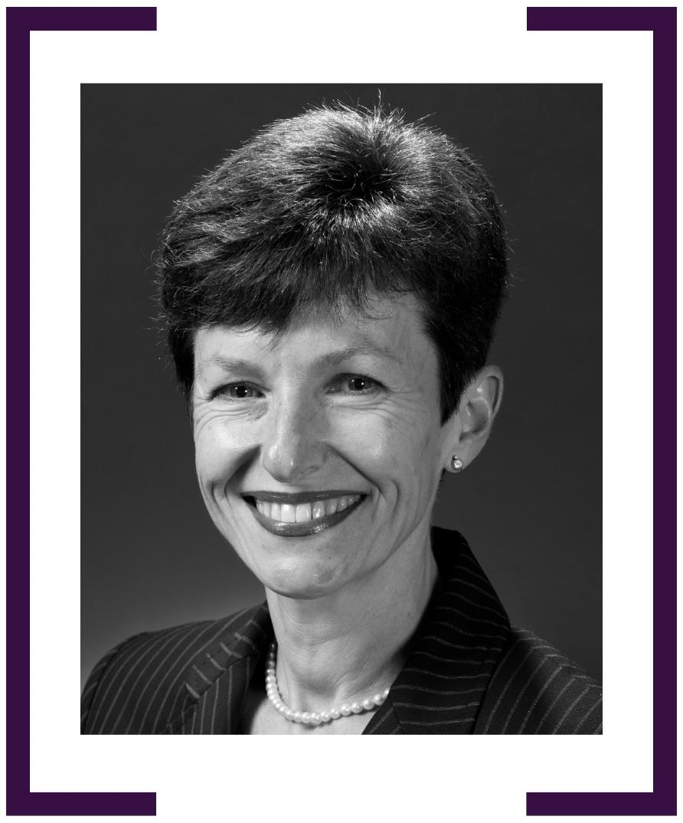

KAREN LANYON

CONSUL-GENERAL, LOS ANGELES 2012–2015
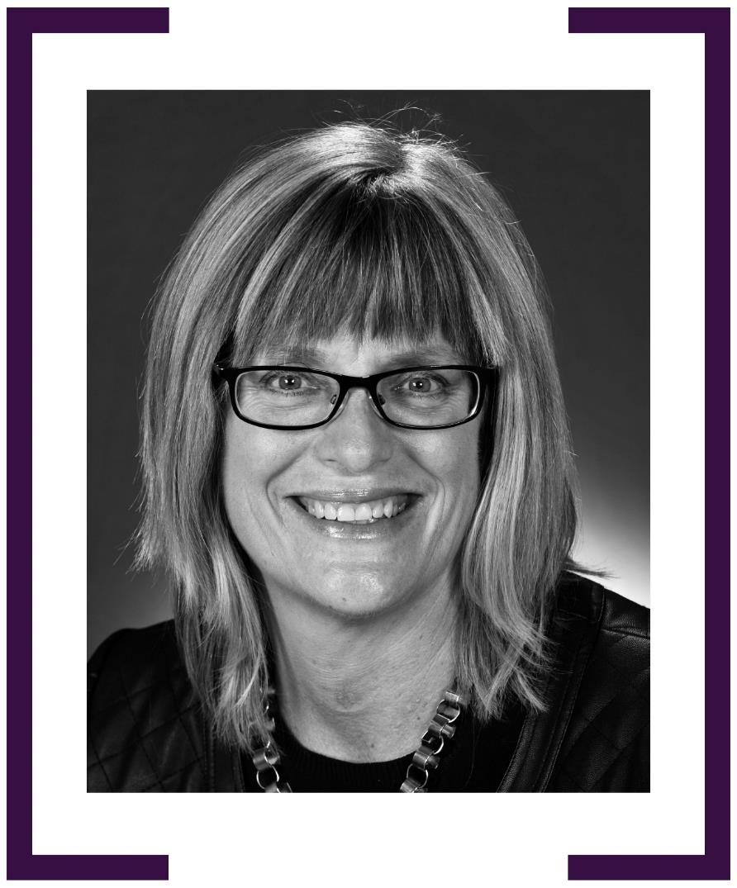

JOANNA ADAMSON

HIGH COMMISSIONER TO GHANA 2013–2015
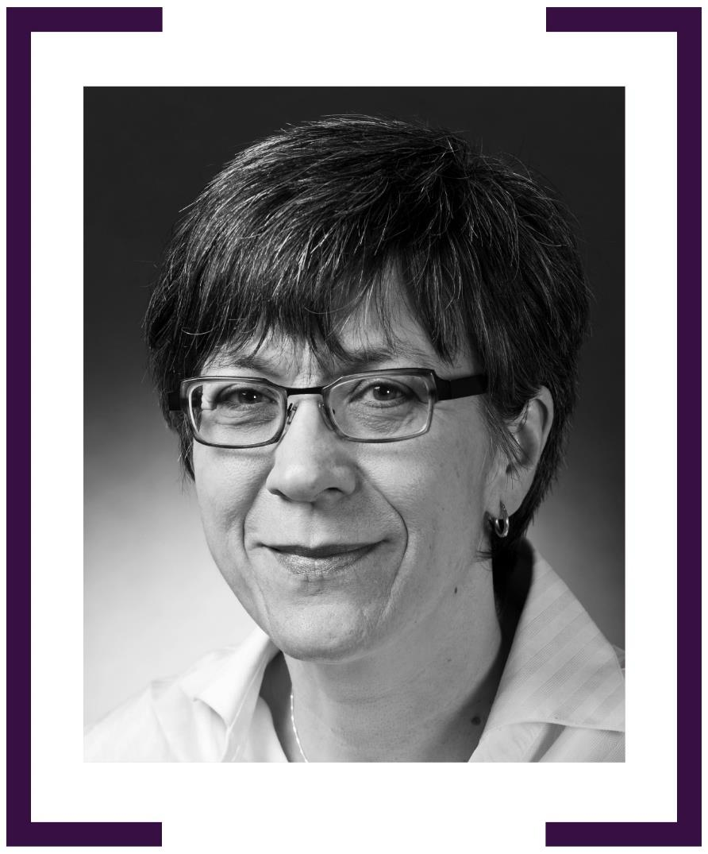

NANCY GORDON

CONSUL-GENERAL, CHENGDU 2013–2017
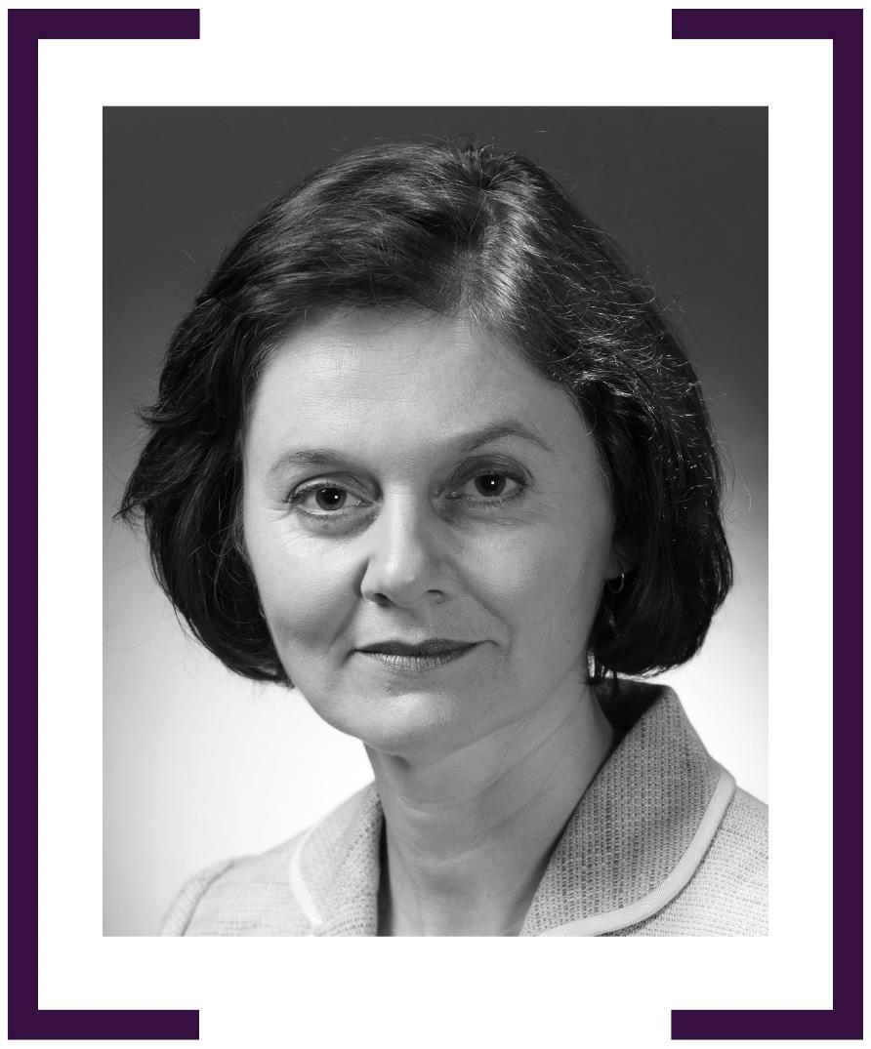

MAJELL HIND AM

CONSUL-GENERAL, BALI 2014–2015
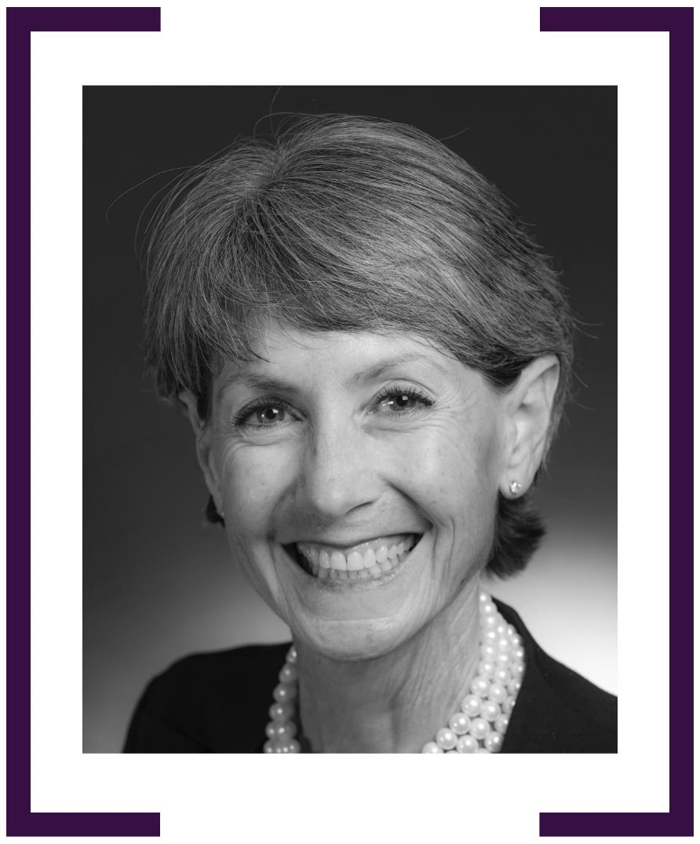

SUSAN LANGFORD

HIGH COMMISSIONER TO SAMOA 2014–2018
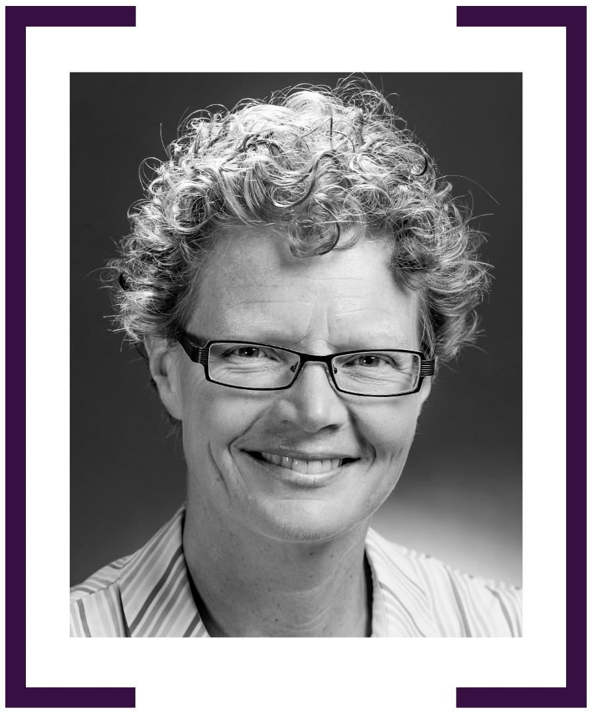

MELISSA HITCHMAN

AMBASSADOR TO THE HOLY SEE 2016–2019
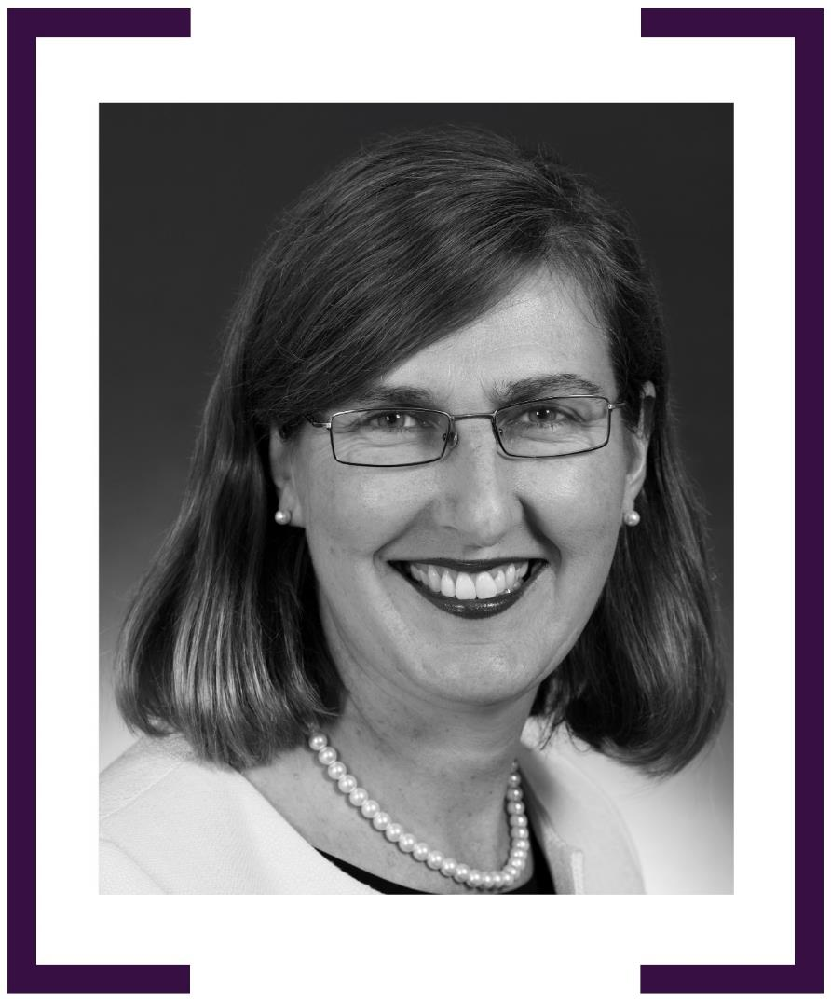

FRANCEs LISSON PSM

AMBASSADOR & PERMANENT REPRESENTATIVE TO THE WTO, GENEVA 2017–2020
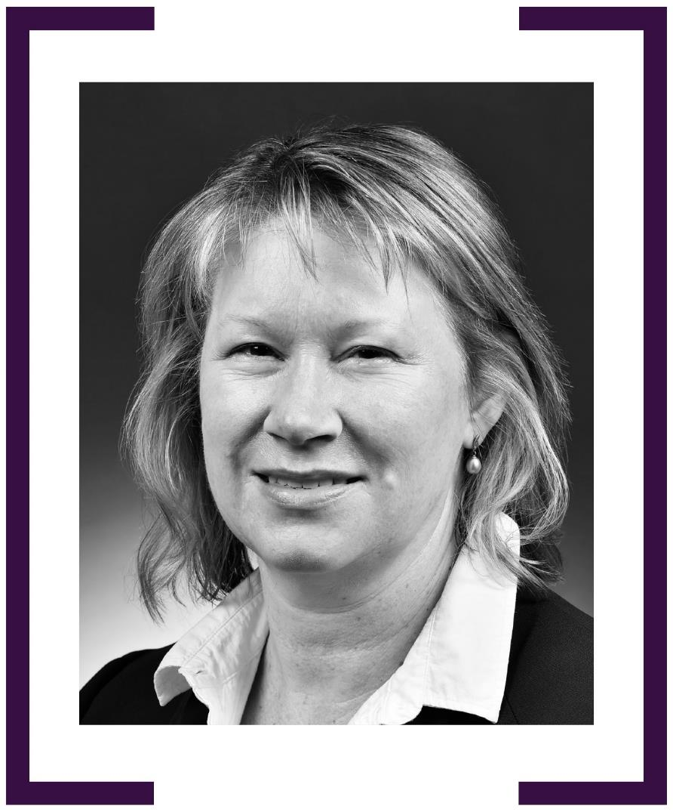

SOPHIE DAVIES

AMBASSADOR TO COLOMBIA 2017–2020

AMBASSADOR TO BRAZIL 2023–CURRENT
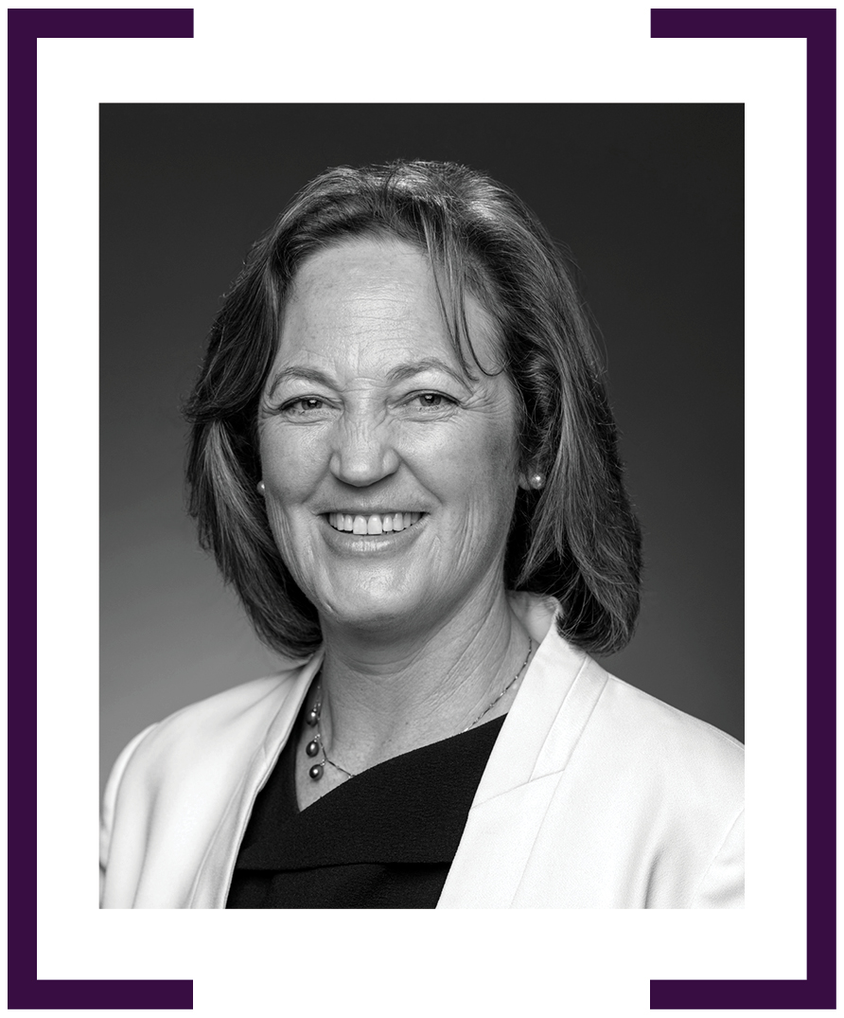

BERENICE OWEN-JONES

AMBASSADOR TO MOROCCO 2017–2020
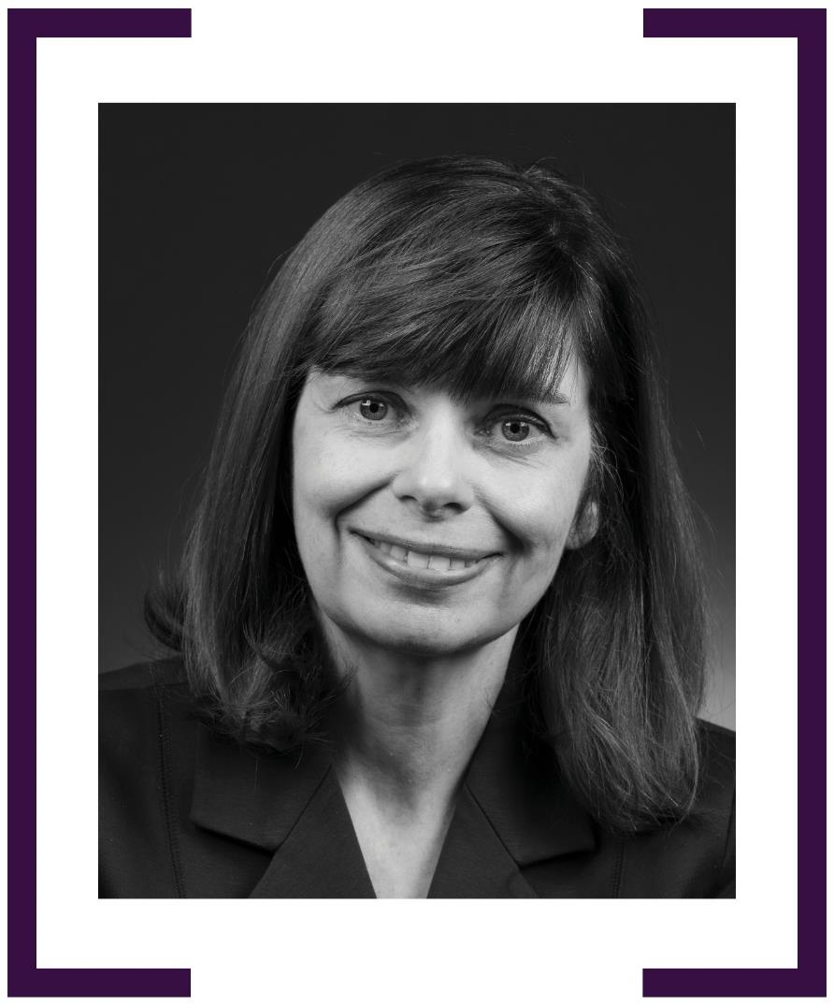

MELISSA O’ROURKE

AMBASSADOR TO UKRAINE 2017–2020
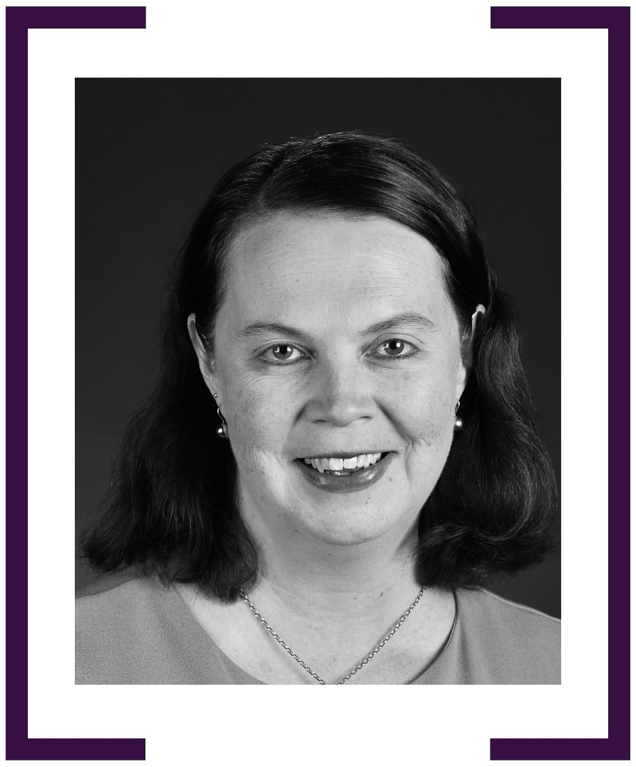

DIANA NELSON

AMBASSADOR TO PERU 2018–2021
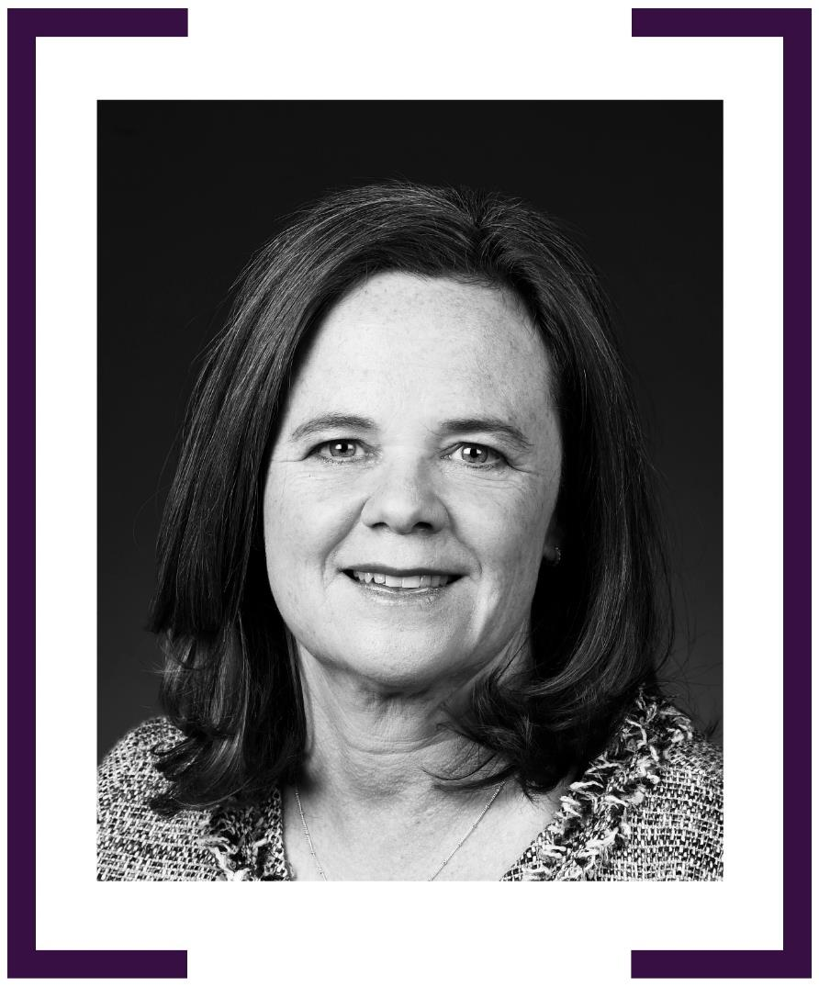

KARYN MURRAY

HIGH COMMISSIONER TO TUVALU 2018–2021
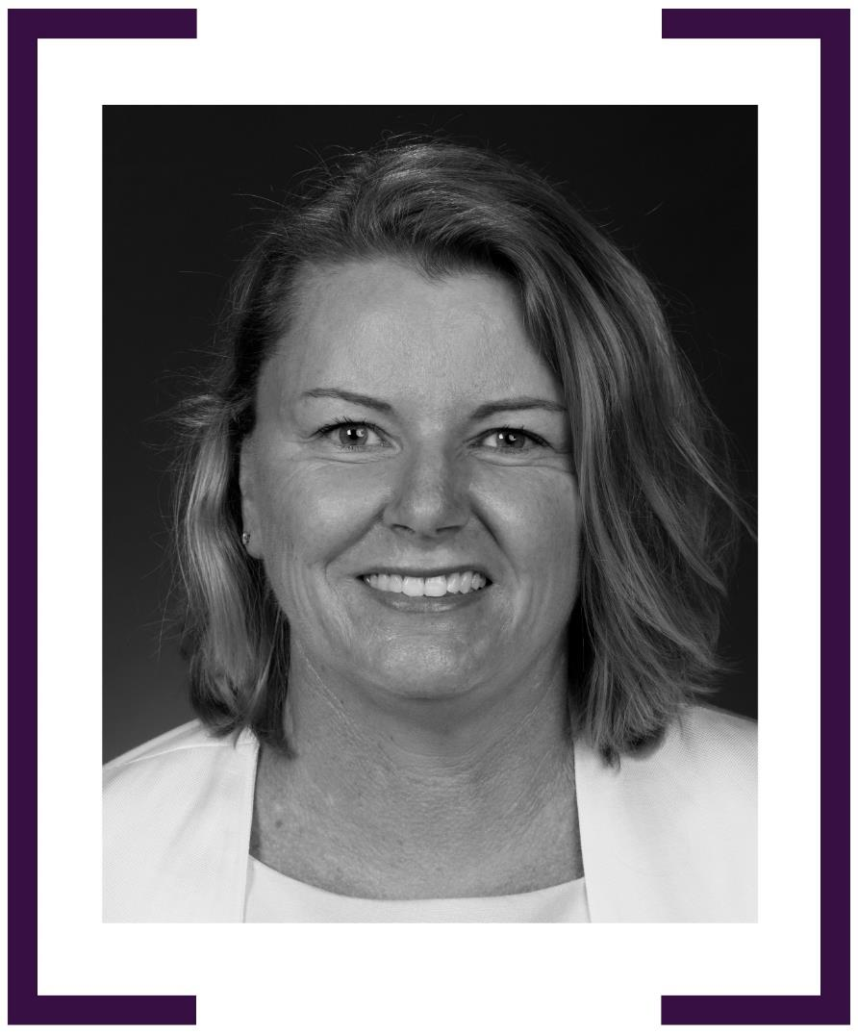

SUSAN GRACE

CONSUL-GENERAL, CHENNAI 2018–2020
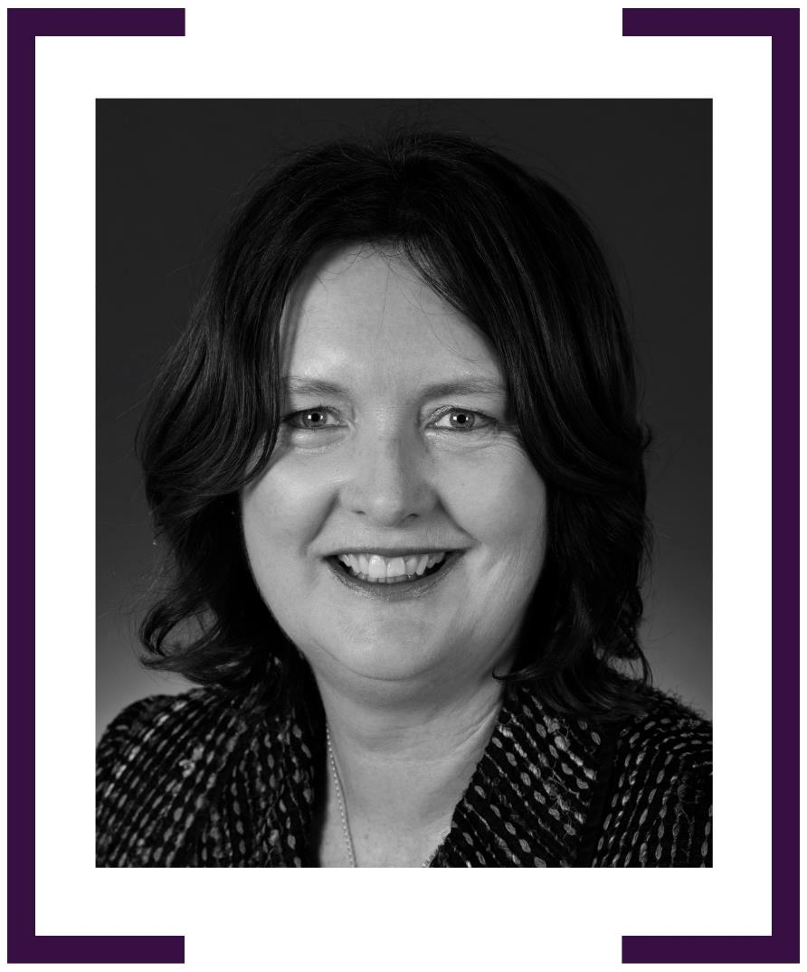

JEFFIE KAINE

CONSUL-GENERAL, ISTANBUL 2018–2021
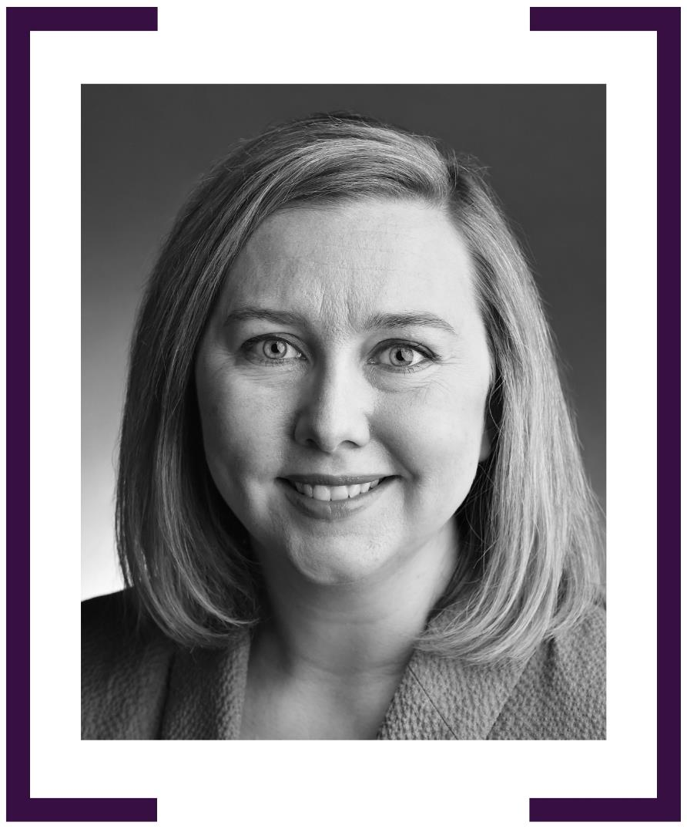

JANE HARDY

CONSUL-GENERAL, HONOLULU 2018–2021
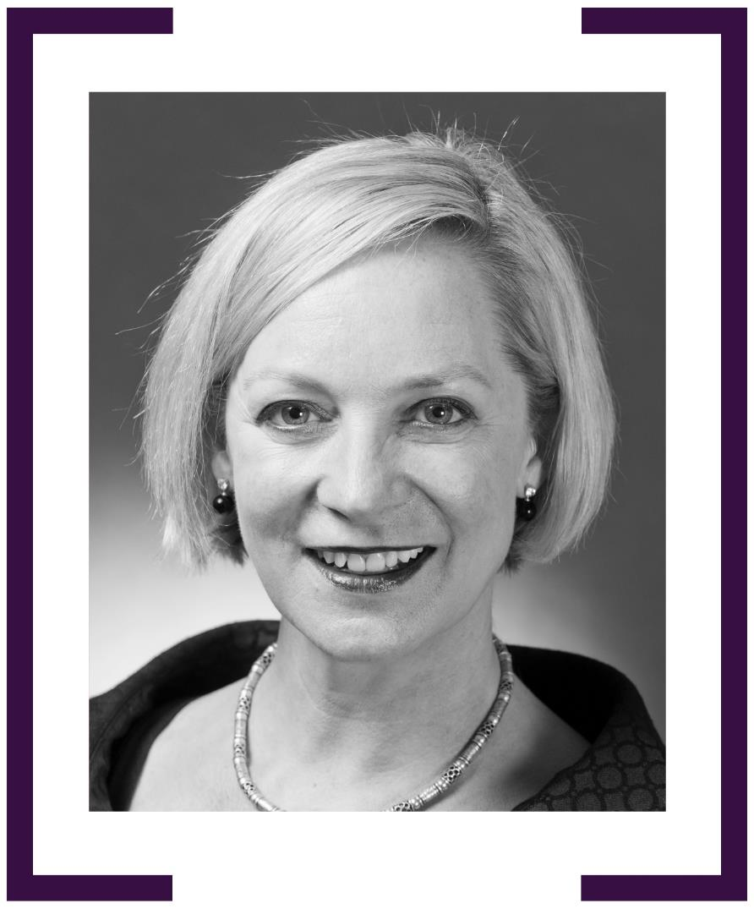

NICOLA GORDON-SMITH

AMBASSADOR TO AFGHANISTAN 2018–2019
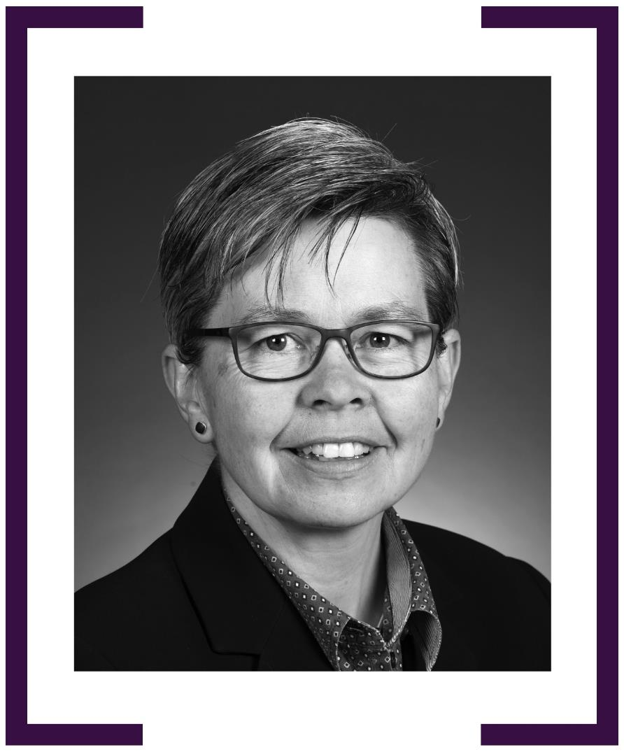

KERIN AYYALARAJU

AMBASSADOR TO ESTONIA 2018–2021
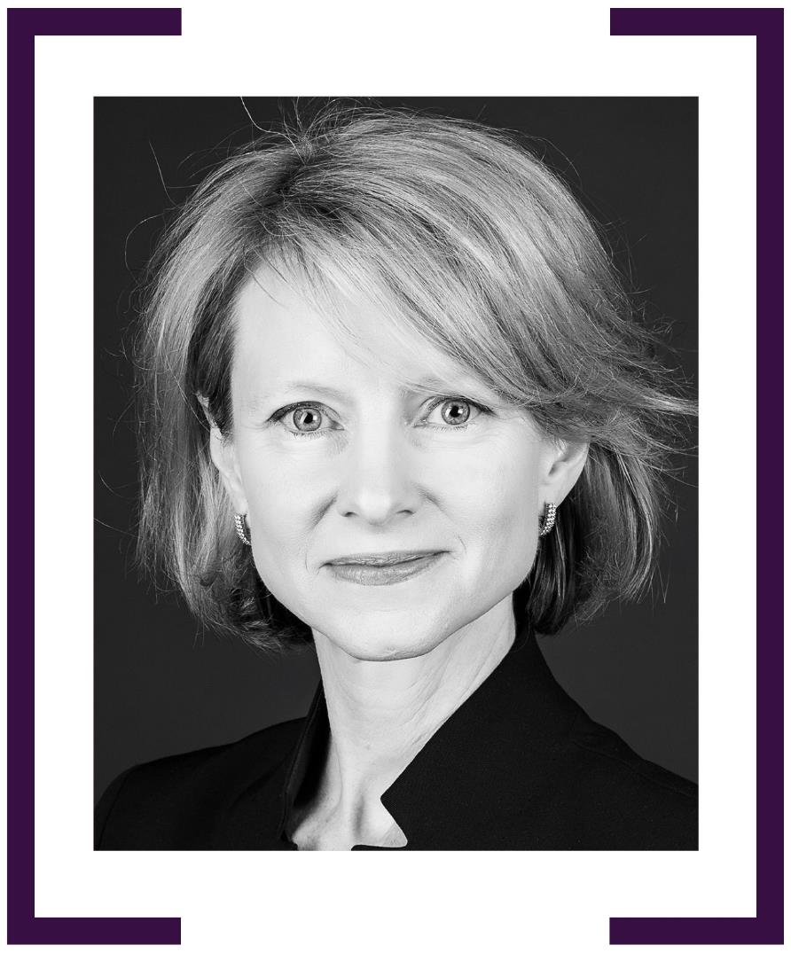

CLAIRE IRELAND

HIGH COMMISSIONER TO NIGERIA 2019–2020


HEIDI VENAMORE PSM

AMBASSADOR TO UNITED ARAB EMIRATES 2019–2024
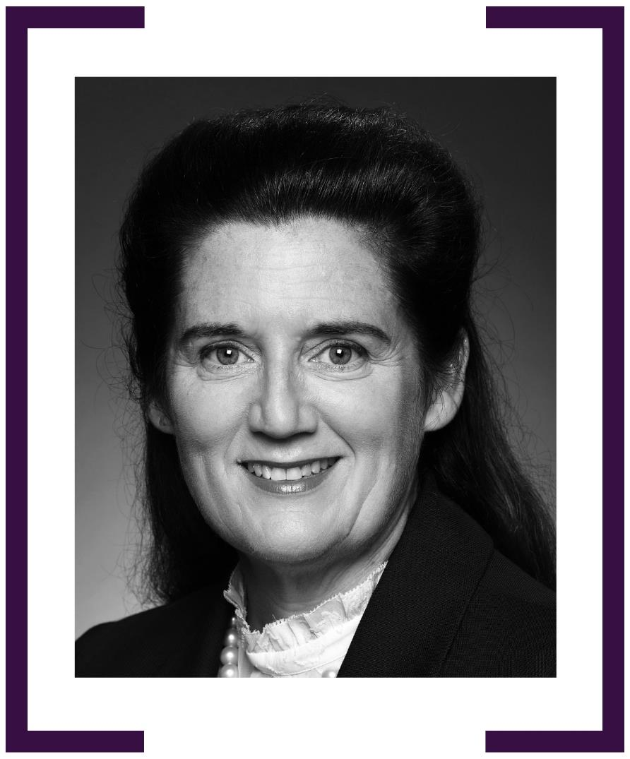

AMANDA GORELY

AMBASSADOR FOR ARMS CONTROL & COUNTER-PROLIFERATION 2019–2022
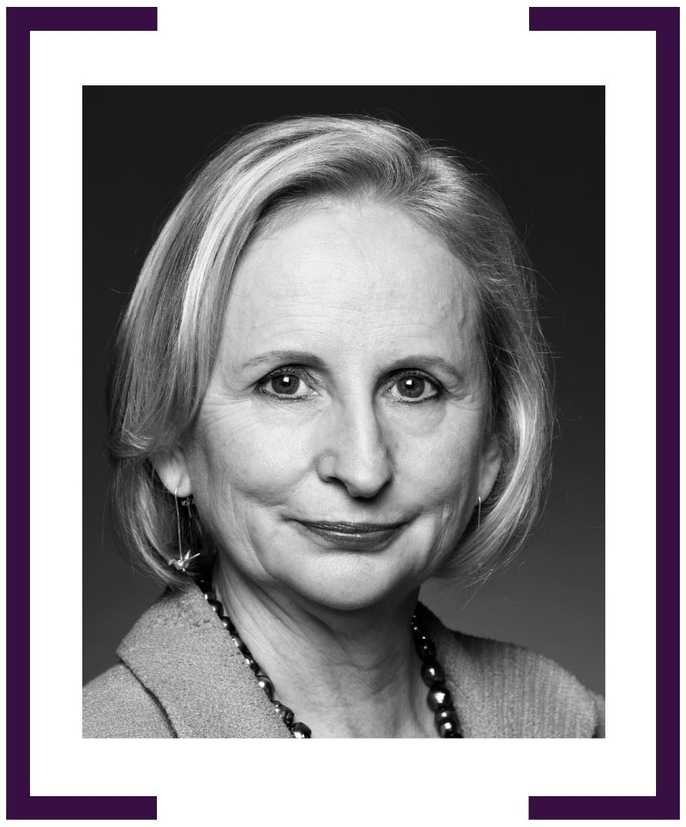

RICHELLE TURNER

AMBASSADOR TO PALAU 2020–CURRENT
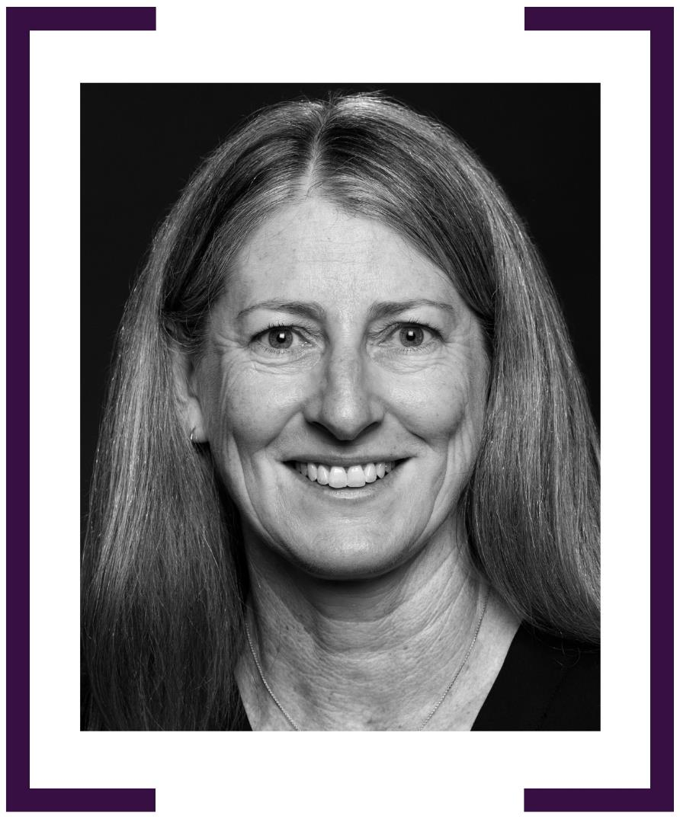
STEPHANIE WILLIAMS psm

AMBASSADOR FOR REGIONAL HEALTH SECURITY
2020–2023
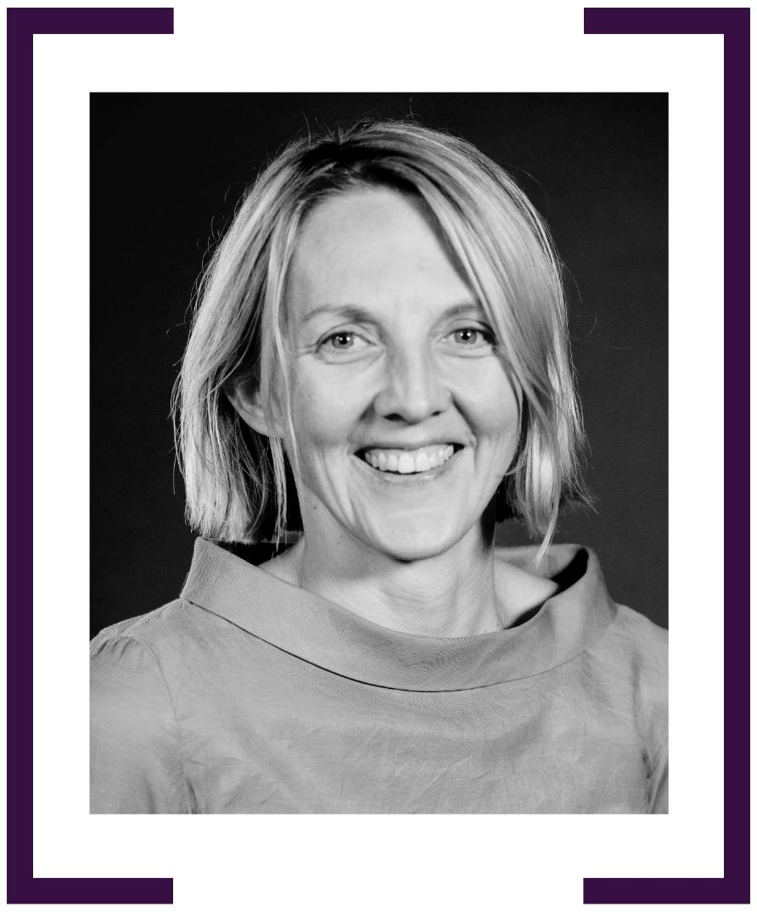

JULIE-ANN GUIVARRA

FIRST INDIGENOUS FEMALE HEAD OF MISSION
(AMBASSADOR TO SPAIN 2018–2020)

AMBASSADOR FOR GENDER EQUALITY 2020–2021
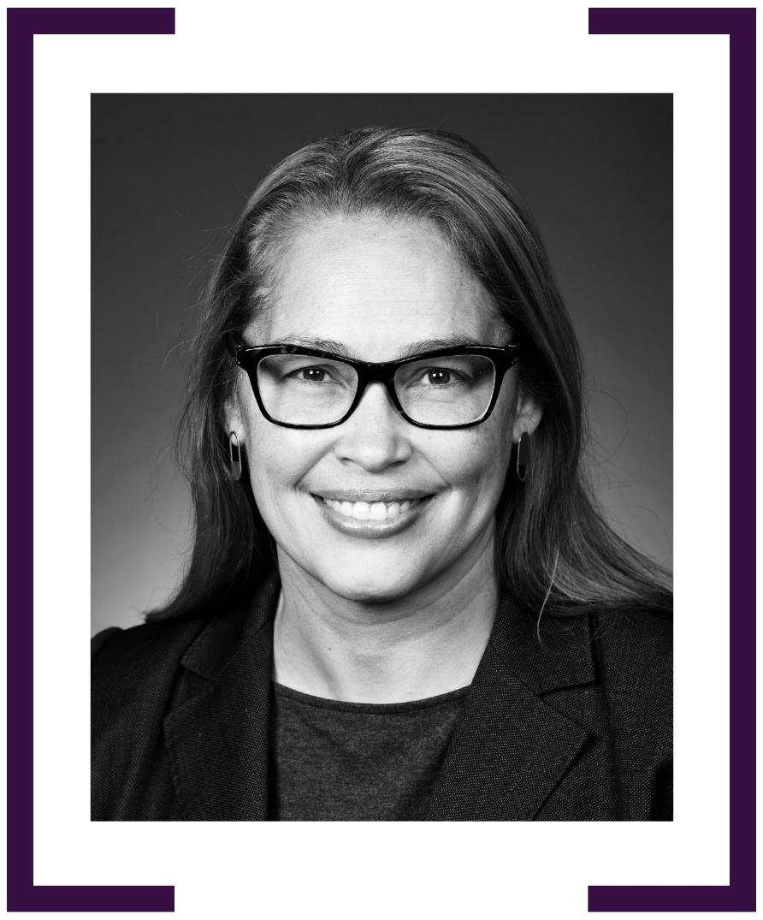

BRONWYN ROBBINS

CONSUL-GENERAL, MAKASSAR 2020–2023
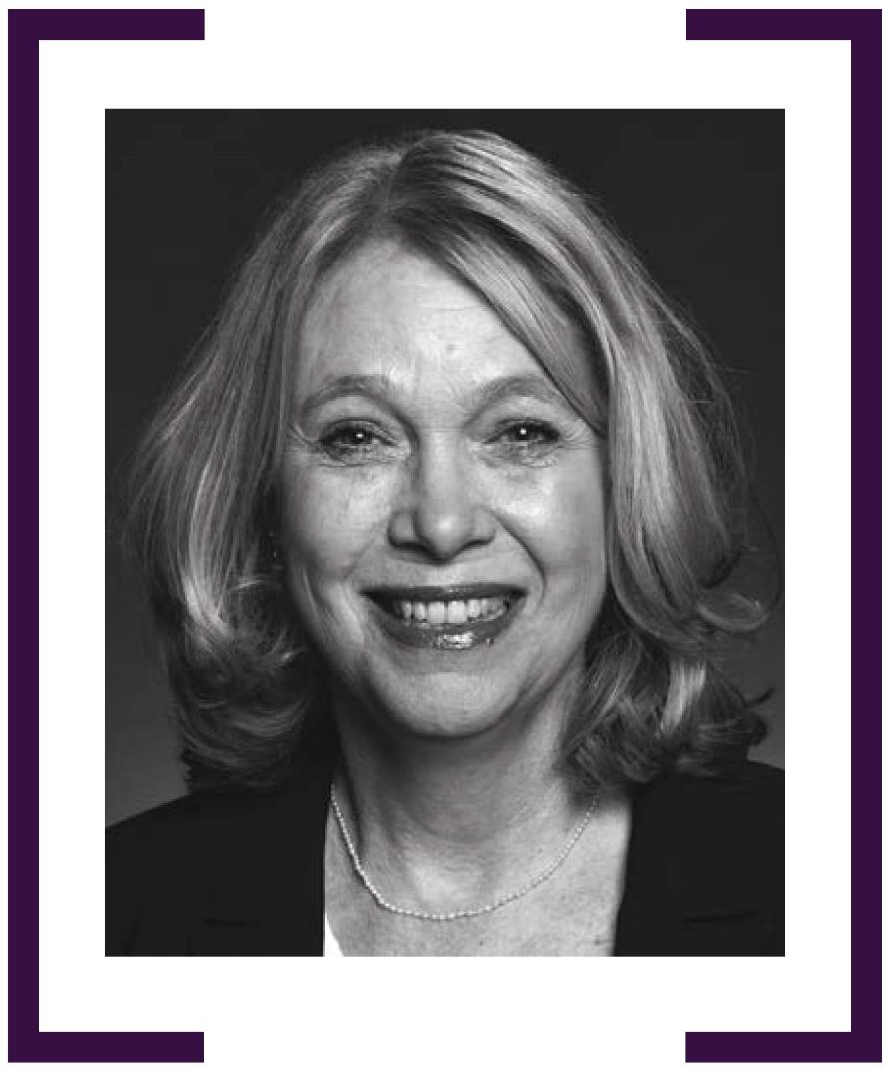

Catherine Raper

Ambassador to the Republic of Korea 2020–2024
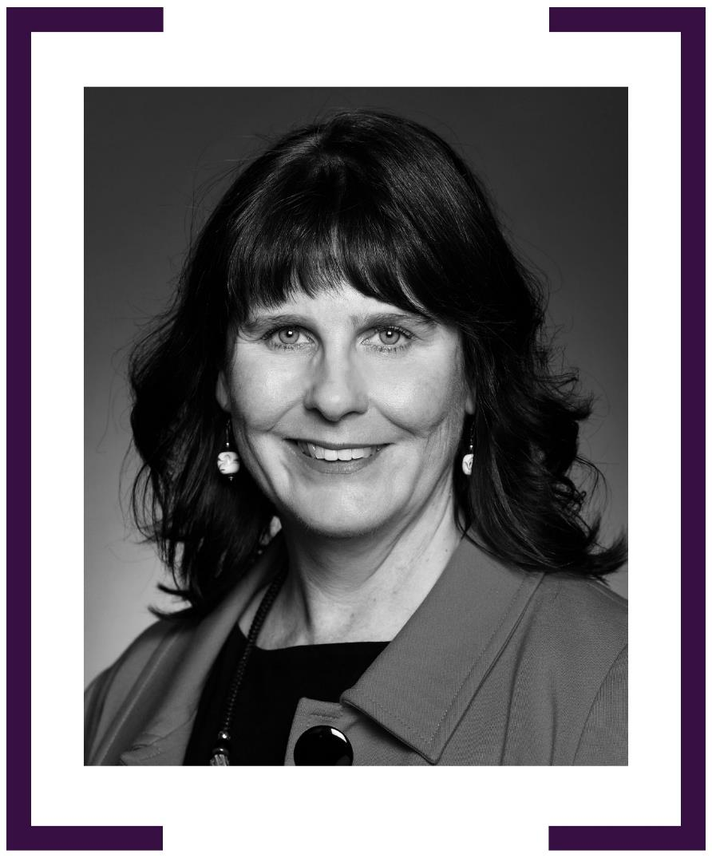

Jan Adams AO PSM

Ambassador to Japan 2020–2022
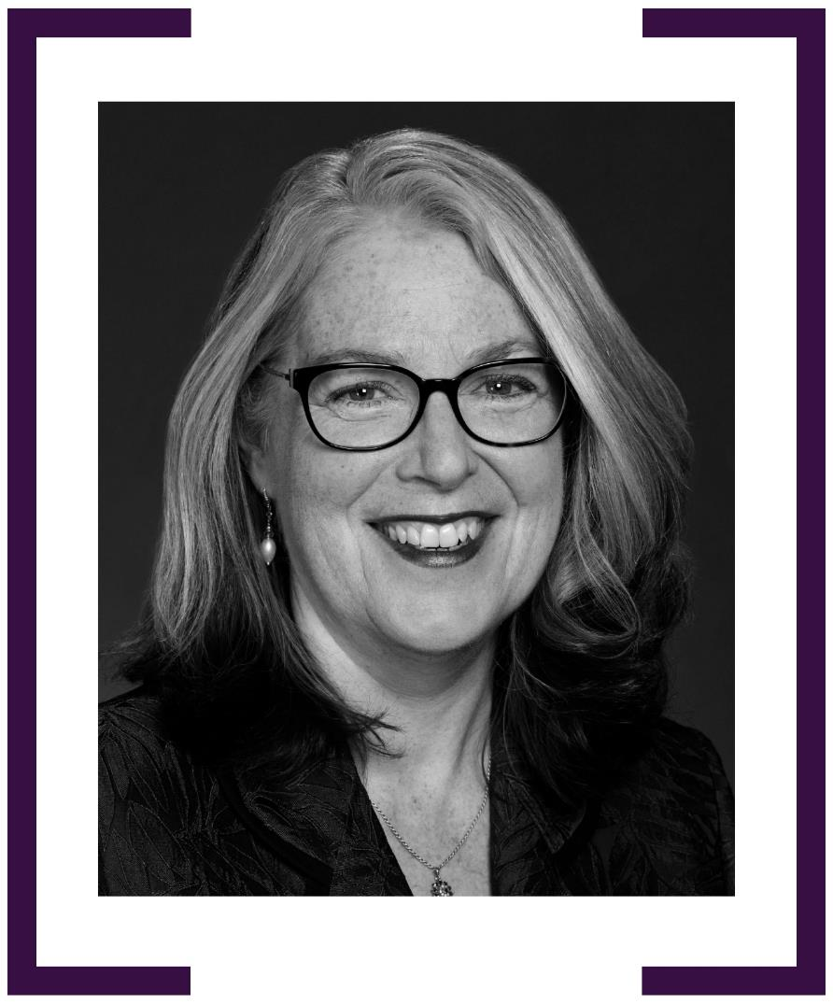

Susan Allen

High Commissioner to Niue 2020–2021
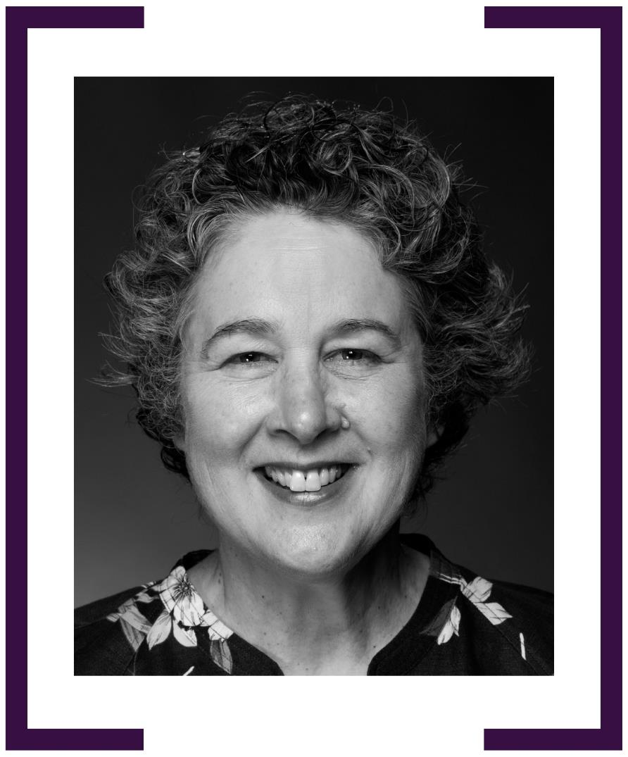
ROWAN AINSWORTH

Consul-General, Kolkata 2021–2024
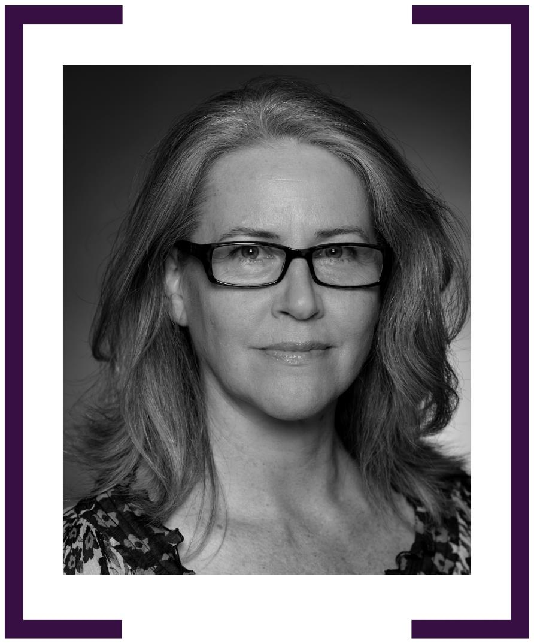
Claire Scott

Consul-General, Papeete 2021–2023


FIONA HOGGART

CONSUL-GENERAL, SURABAYA 2022–2024
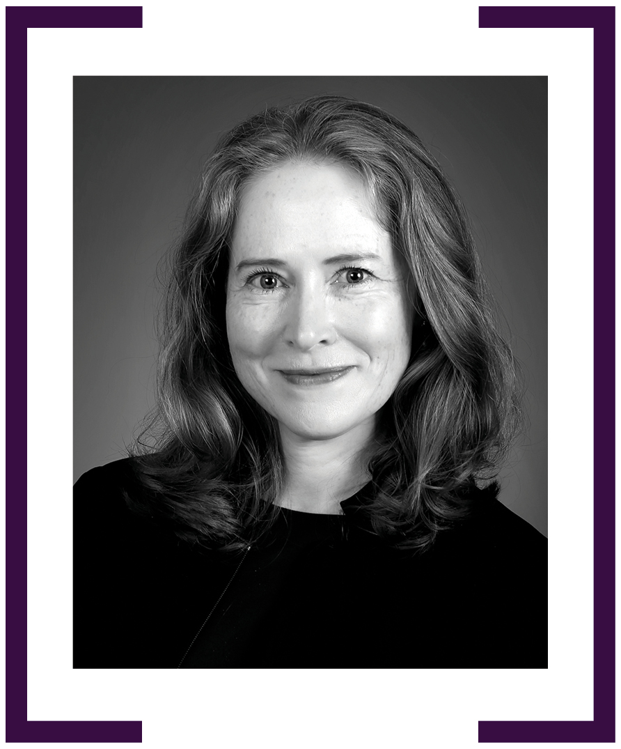

ANGELA MACDONALD psm

AMBASSADOR TO THAILAND 2022–CURRENT
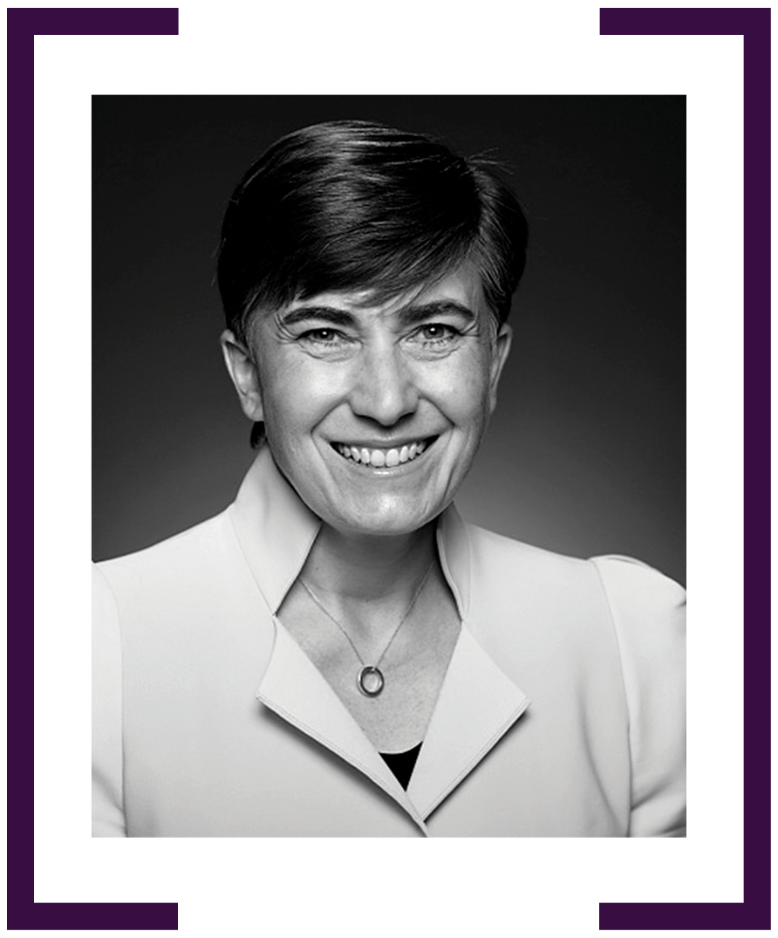

KATIE SMITH

AMBASSADOR TO MONGOLIA 2022–CURRENT
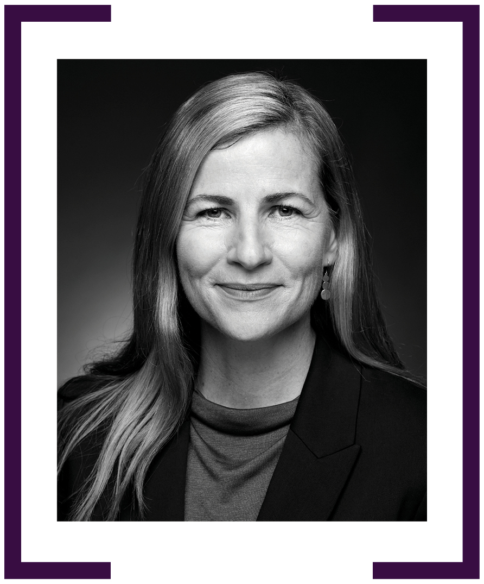

MELISSA KELLY

AMBASSADOR TO KUWAIT 2022–CURRENT
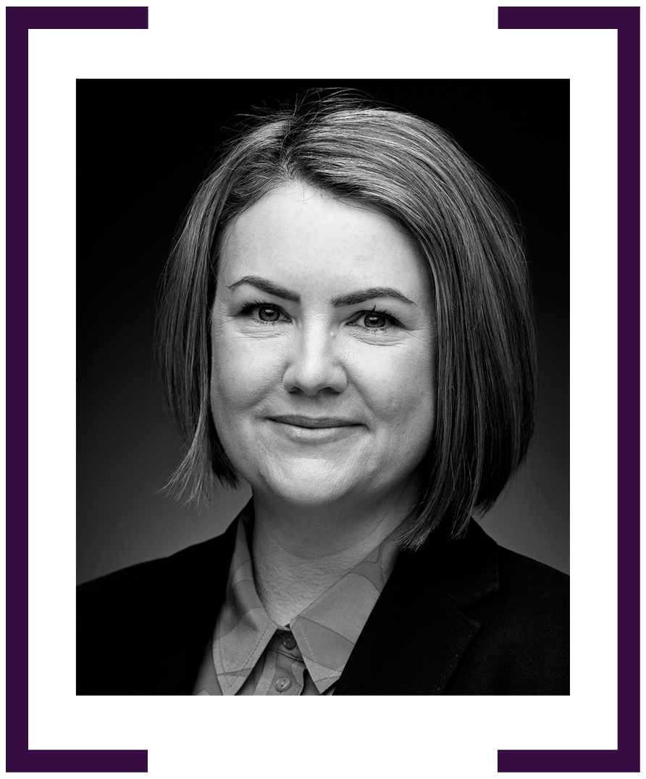

PHOEBE SMITH

HIGH COMMISSIONER TO COOK ISLANDS 2023–CURRENT
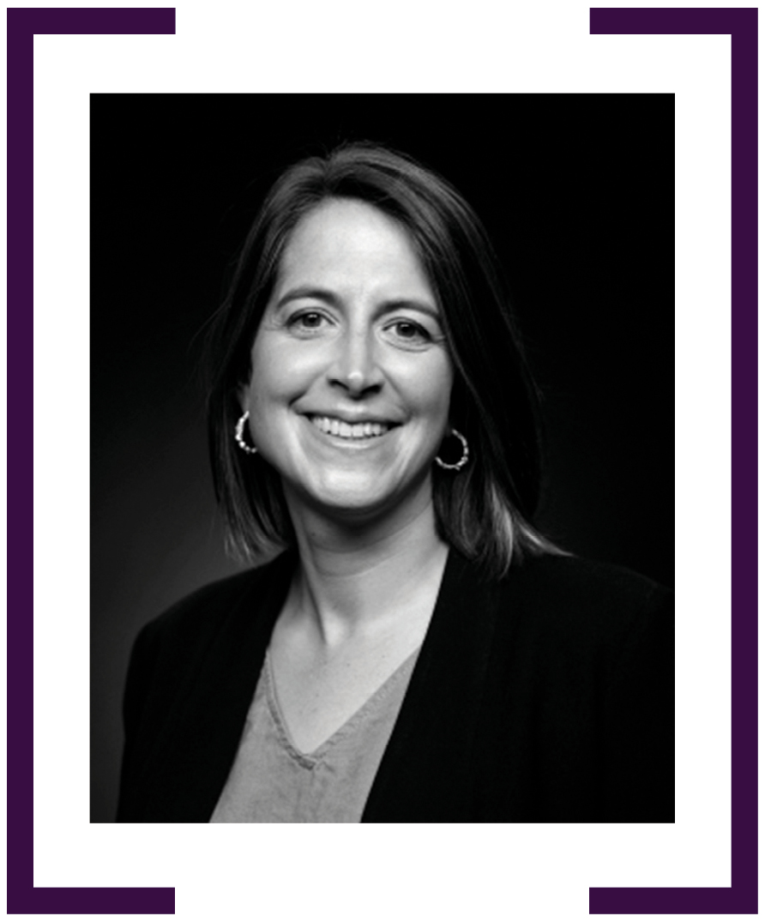

HEATHER RIDOUT ao

CONSUL-GENERAL, NEW YORK 2023–CURRENT
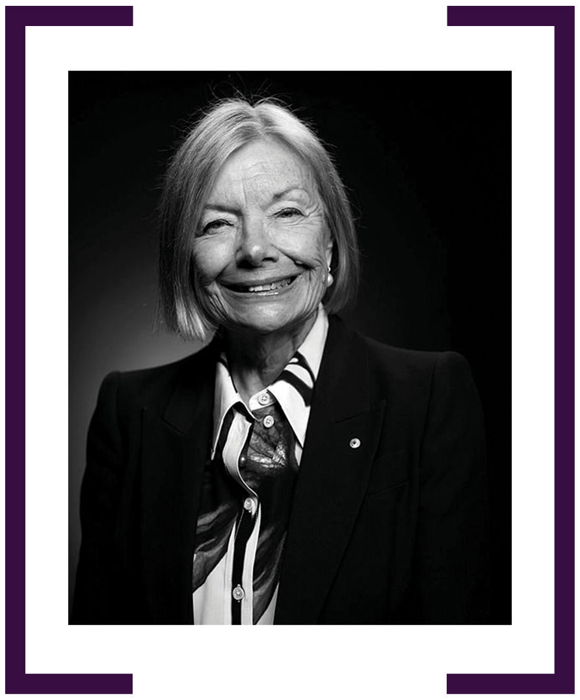

HILARY McGEACHY

CONSUL-GENERAL, BENGALURU 2023–CURRENT
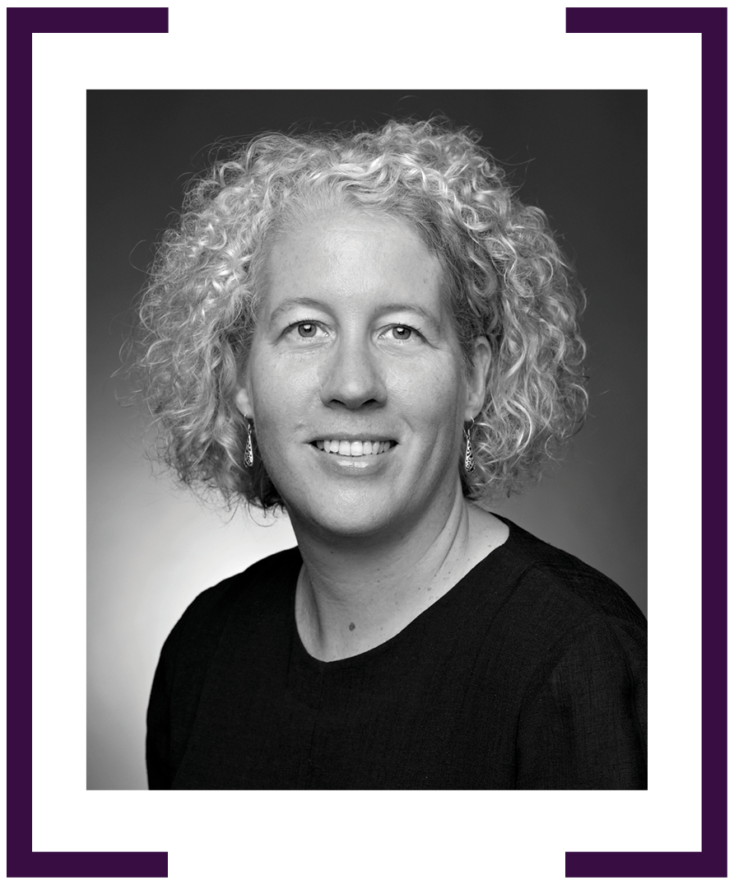

ELIZABETH DAY

AMBASSADOR TO SWITZERLAND 2023–CURRENT
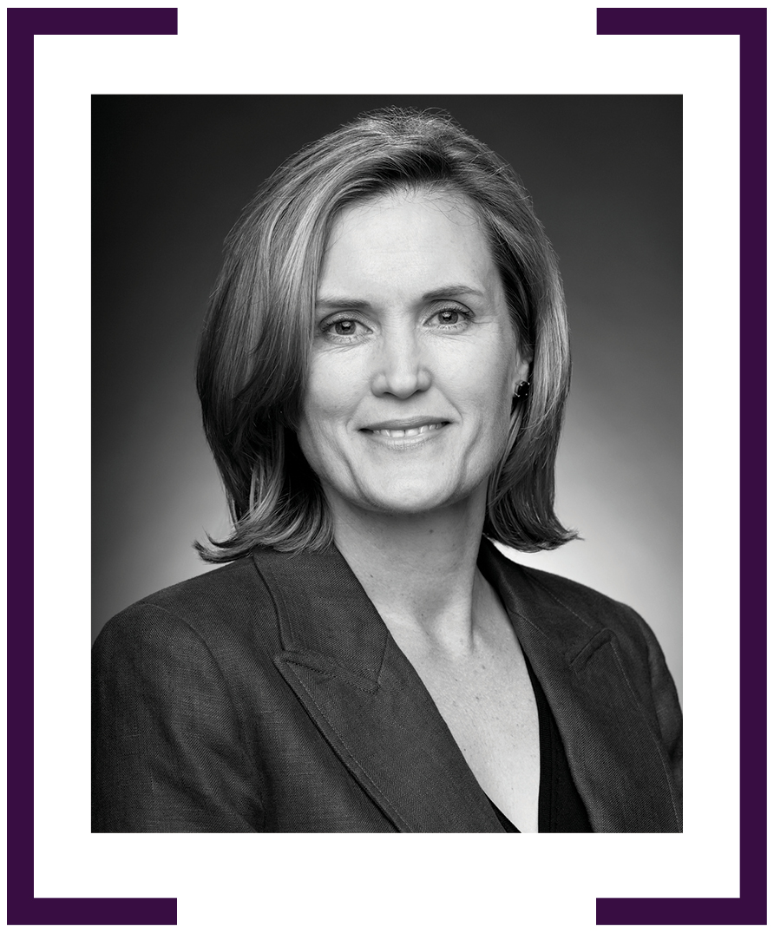

SONYA KOPPE

HIGH COMMISSIONER TO TRINIDAD AND TOBAGO
2023–CURRENT
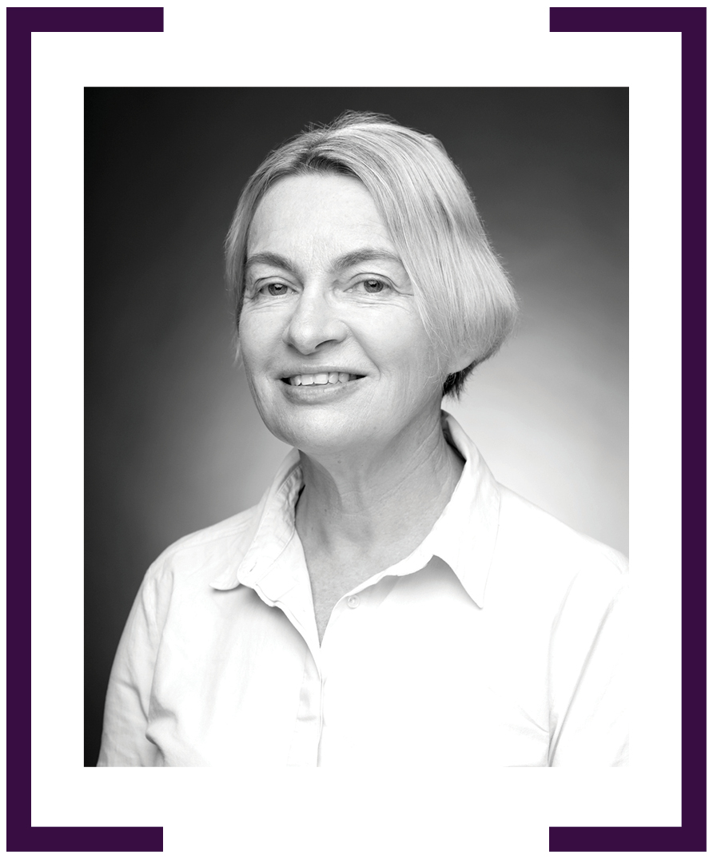

BRONTE MOULES

AMBASSADOR FOR HUMAN RIGHTS 2023–CURRENT
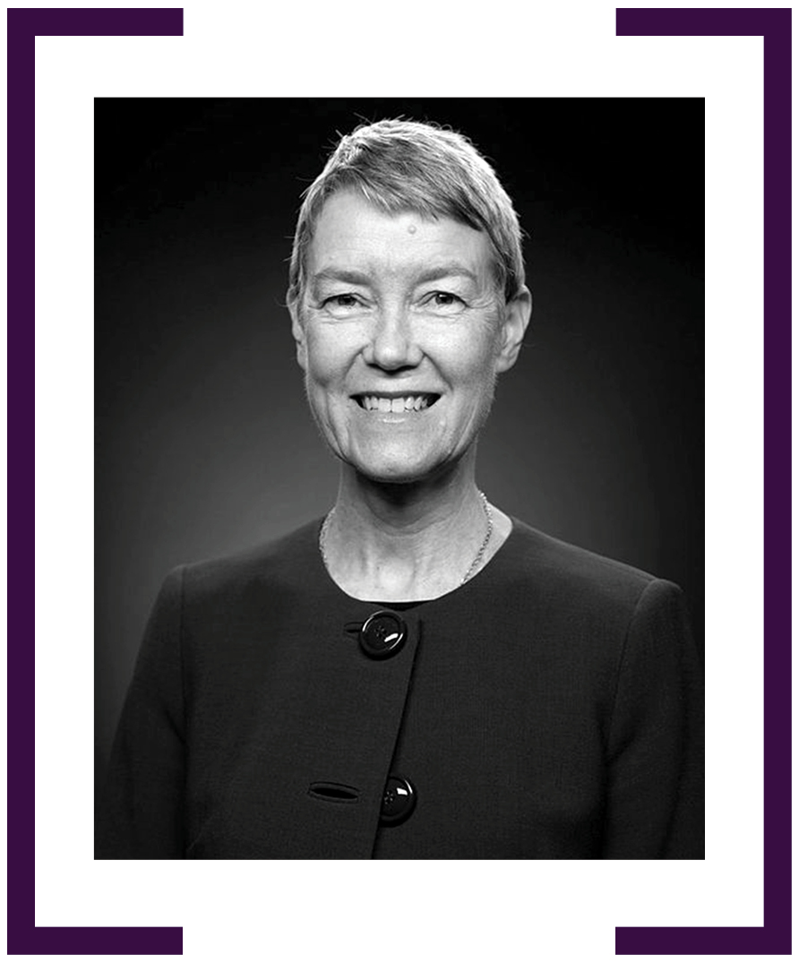

KIRSTEN FLETCHER

CONSUL-GENERAL, PHUKET 2023–CURRENT
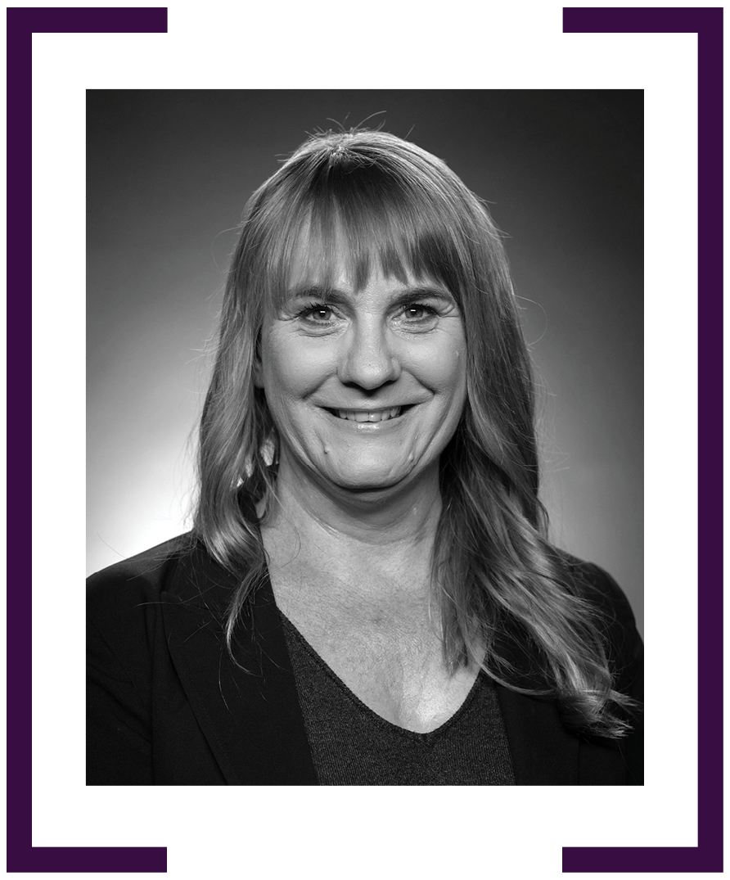

THIS COULD BE YOU

CONSUL-GENERAL, LAE

high commissioner to republic of maldives

AMBASSADOR TO QATAR

Ambassador to the Republic of
the Marshall Islands

AMBASSADOR TO SAUDI ARABIA

CONSUL-GENERAL, SHENYANG

HIGH COMMISSIONER TO THE UNITED KINGDOM OF
GREAT BRITAIN and NORTHERN IRELAND

AMBASSADOR TO THE UNITED STATES OF AMERICA

AMBASSADOR FOR COUNTER-TERRORISM

AMBASSADOR FOR CYBER AFFAIRS and critical technology

AMBASSADOR FOR FIRST NATIONS PEOPLE

