Political economy Analysis and adaptive Management
  - GOOD PRACTICE NOTE
Political economy analysis provides a valuable evidence-base to inform the design of DFAT programs, and to help manage them adaptively.
The purpose of this Good Practice Note is to assist DFAT to plan, commission, undertake and use political economy analysis and deliver politically-informed investments and policy dialogues. This note signposts how staff can integrate such analysis into the development management cycle, as an ongoing iterative process.
Understanding the political contexts in which we work is critical to informing DFAT’s policy work and improving development effectiveness. In recognition of this, DFAT’s systems and processes are increasingly recommending that programs undertake political economy analysis as part of the development of investment concepts and designs. Political economy analysis can be done alongside or as part of other analytical work (e.g. poverty analysis, growth diagnostics, gender analysis) to give a greater understanding of context, including barriers to change, institutional constraints and how power and decision-making is exercised. The inclusion of gender is particularly important and enables DFAT to undertake stronger analysis to better understand power and resource distribution.
This note covers:
- What is political economy analysis and when is it useful
- What should be the focus of the analysis
- The main elements of the analysis (including contextual factors and stakeholders)
- How to draw operational implications (pathways of change and intervention strategies)
- What is working politically and adaptive management
- Planning and implementing the approach in DFAT
- DFAT resources
- Further web-based resources
Each section includes key questions to consider, and concrete illustrations.

- Introduction
  - what is political economy analysis?
Applied political economy analysis (PEA) is a set of concepts, questions and tools that can help diplomats, development professionals and local reformers better understand the contexts in which they operate and make informed policy and investment decisions. It allows us to go ‘under the surface of things’ and explore how power and politics maintain the status quo and block change, or on the contrary enable change to happen. As a result, DFAT staff can make evidence-based judgements on how Australia should support its partners to achieve shared objectives, such as a flourishing private sector or the elimination of gender-based violence.
This updated guidance note draws on 20 years of collective experience across the international development community. One major lesson is that good analysis on its own is never enough; the insights gained about what may be a realistic DFAT strategy/program and the risks to be managed need to shape how DFAT and its implementers operate on a day-to-day basis. In other words, DFAT needs to ‘think and work politically’, making sure its programs are flexible and adaptive.
There are many applied PEA tools, which provide advice on how to think and work politically in a specific context. In practice they all cover three main steps:
Figure 1: The Policy Practice/ODI framework
- What is the problem or issue DFAT would like to address?

- Why does it happen, by looking at the dynamic interaction between:
  - Foundations/structures
  - Formal and informal institutions
  - Actors/stakeholders

- How can the problem be addressed by DFAT?
  - What are realistic pathways of change?
  - What are technically sound and politically feasible interventions?
  - How can DFAT embed politically-informed approaches?

  - WHy is applied POLITICAL ECONOMY ANALYSIS useful?

For development activities to achieve sustainable results, they need to be both technically sound and politically feasible. This is because development is a political process – sustainable, locally-legitimate institutions emerge over time through local political processes. In the past, donors have tended to emphasise technical fixes without due consideration of the political realities. They have also tended to focus on formal institutions and structures rather than human agency and informal institutions.
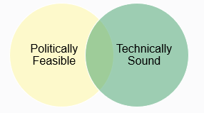

PEA enables us to better understand the political, economic, and social processes promoting or blocking change. A PEA prompts us to ask ‘why is the situation like it is?’, ‘how does change really happen’ or ‘why is change not happening?’ It requires us to consider ‘who wins and who loses out’, and what the losers may do to block reform. Box 1 provides an example of what politically-informed programs can achieve.
PEA tools assist us to design and implement policy engagement and development investments that have achievable objectives, and which are more likely to achieve results because they are appropriate to the context. By integrating PEA into the development management cycle, as an ongoing, iterative process, program staff and partners can track changing actors, interests and power relations throughout implementation, manage risks, and seize opportunities as they arise.
Box 1: The Coalitions for Change (CfC) Program in the Philippines
Since 2012, this Asia Foundation program has supported a wide range of coalitions working in many different policy domains, such as land governance, education, or conflict resolution.
These coalitions and networks combine ‘reform champions’ in government and civil society, such as political operators, advocacy campaigners, government insiders, who also draw on evidence from academics or policy experts. Coalitions are sometimes informal; and at other times they are directly linked to government initiatives. They act as ‘development entrepreneurs’: they explore problems, test solutions, try again with different tactics. They face delays, disappointments, but also successes. They target technically sound and politically feasible initiatives, aiming to make a lasting change by institutionalizing new practices in government, such as:
- changing how property titles are registered in a way that significantly increased property security (this short video explains how the policy reform was identified and pushed forward);
- assisting in the passage of excise tax reform legislation which produced significant new streams of revenue earmarked for public health care, and some evidence of reduced cigarette consumption;
- analysing the complex sources of school congestion; exploring, experimenting, and then institutionalizing solutions with the Department of Education.
Source: Sidel, J, and Faustino, J (2019) Thinking and Working Politically in Development: Coalitions for Change in the Philippines. Pasig City: The Asia Foundation. You can find the program webpage here.
- What is the problem?
  - What is the focus of the analysis?
Once DFAT decides that a PEA is required, staff need to determine the focus of the analysis. What are the main questions to design, implement or monitor in a realistic way a strategy or development investment?
- Applied PEA are most useful when they focus on a particular problem or issue that DFAT would like to address. This could be understanding why medicine and textbooks do not reach clinics and schools, or how to protect the civic space for civil society and the media.
- Sometimes, DFAT will benefit from an analysis of a sector such as health or education.
The selected problem should not just be technical (e.g. how to build a road?); instead DFAT needs to explore the deep reasons it has come about and persists (e.g. who benefits from the road? why is it of poor quality?).
  - What is the level of Analysis?
PEAs are relevant whether DFAT works at global, regional, national, or local levels. PEAs will reveal the interplay of power relations, institutions, interests, ideas and incentives at, and between, these levels:
- Global: how to agree and implement international treaties, such as on climate change or human rights? How do national or sub-national factors influence these agreements? What about the influence of multinational companies (e.g. mining) or non-state networks (e.g. human rights defenders)?
- Regional: what is blocking regional trade across Asia or the Pacific? What is causing instability in the Middle East? For example, the European Centre for Development Policy Management (ECDPM) has written about the politics of regional integration in Africa.
- Country: what are the main political, economic, and social features of a country? How do they explain why poverty or conflict persist? In this note, we draw on Timor-Leste to illustrate a country level PEA.
- Sub-national or local: why are women and girls or migrants more at risk of violence in a particular city, district, or border area? For example, this report from The Asia Foundation looks at why the local government level recovery after the earthquake in Nepal was lacklustre.
When DFAT staff undertake a PEA, the analysis will need to move between problems/issues and levels to identify whether the possible interventions align with Australia’s national interest considerations. It is helpful to have undertaken a broad national PEA to then explore a specific sector or policy issue.
Box 2: Understanding how states responded to COVID-19
During 2020-2022 governments responded sometimes very differently to the pandemic. Many introduced measures that previously appeared unconscionable, such as lockdowns or mandatory vaccinations. An applied PEA can help DFAT understand if COVID-19 policies are both technically sound and politically feasible, or what resistance they may face – by looking at local, national, and global factors beyond health policy choices.
In Bangladesh, despite improved state capacity and political incentives to manage the pandemic well, societal forces proved stronger. To maintain its legitimacy, the state had to tolerate rule-breaking by the poorest who needed to work. And it could not enforce its authority over local political elites to deliver relief programs.
Source: Ali, T et al (2021) The moral and political economy of the pandemic in Bangladesh: Weak states and strong societies during COVID-19 World Development, Elsevier, vol. 137(C).

- analysing POLITICAL ECONOMY PROBLEMS
  - The framework of analysis
Over the last 20 years, many tools and frameworks have been developed to help foreign affairs ministries or development agencies unpack a political economy problem. At their core, they all consider three sets of factors:
- Structures (or foundational factors): The more enduring specifics of the context that change slowly, such as global influences, natural resource endowment, demographic shifts, historical legacies, social-cultural factors, and technological progress.
- Institutions (or ‘rules of the game’): the local laws, conventions and traditions that shape human behaviour. Informal institutions (e.g. patronage systems, norms, and values as well as local world views) are just as important as formal institutions (e.g. economic markets; electoral laws and practices). They are not static and are often the focus of aid interventions. (Institutions are not the same are organizations - see below).
- Actors: Individuals, organizations, or coalitions from the public, private or civil society sectors. Their interests, motivations, networks, and influence shift over time. Their behaviour can be thought of as ‘the games within the rules’. They are influenced by institutions and in turn can modify them.
Bringing together structures, institutions, and actors, it becomes possible to understand why problems occur or persist. They may be due to poor coordination (because of a lack of trust), difficult collective action (because material interests or ideas/ideology pull actors in different directions), unequal access to information or deliberate misinformation, or leaders’ commitments that are not credible.
  - Exploring Contextual factors

Key questions to identify relevant structural/foundational factors will focus on the long lasting or slowly changing features influencing the sector/issue/level that you are analysing:
- What are the main natural resources and climate change trends?
- What are demographic trends?
- What is the structure of the economy and society?
- What are historical legacies (colonialism, wars/conflicts)?
- What are geo-strategic influences?
- What are the relevant dimensions of Australia’s past and present involvement?

Key questions to identify relevant institutional factors will need to be tailored but could include:
- What are formal rules, such as Constitution and laws? Are they widely respected?
- What are informal rules, social norms, values? Are they widely respected?
- How well aligned (or not) are formal and informal institutions?
- What are the key ideas about how the world works or why things should be as they are?
- What are the incentives that shape the behaviour of key players given these rules and ideas?
- How do gender and other norms influence who has access to power and resources?

Some key political economy concepts can guide your analysis, to avoid simply writing a description of a country or sector. The focus should be on who has power, who is excluded from power and why.
- As a shorthand, an elite bargain or political settlement refer to processes and agreements about how power is used and distributed.
- Political patronage and clientelism exist in some form in most societies; political patrons reward their supporters (‘clients’) through material benefits such as jobs, contracts or scholarships or backing for social and cultural agendas in what are unequal relationships.
- Economic rents are often the focus of elite deals and fund patronage networks. They are the extra ‘income’ that can be generated when controlling a resource in limited supply (e.g. oil, gas, or other natural resources; economic monopolies; award of public contracts, etc).

Box 2 provides an example from Timor-Leste to illustrate these concepts.
Box 2: Timor-Leste’s changing elite bargains
Politics in Timor-Leste is still dominated by the generation of leaders who fought for its independence. One elite group is constituted by the Revolutionary Front for an Independent East Timor (FRETILIN) which declared independence following the withdrawal of Portugal 1975 before Indonesia invaded the country. Another elite group is centred around Xanana Gusmão, a former FRETILIN leader and Commander-in-Chief of the National Liberation Armed Forces of Timor-Leste, who united different resistance factions and remains widely respected.
These leaders use their access to state power not only to implement their vision for a sovereign Timor-Leste but also to reward their supporters and thereby consolidate their power. Timor-Leste was fiscally constrained and aid dependent after its 2002 independence referendum. The government could not deliver a ‘independence dividend’ to its population and favoured some groups with contracts and jobs. This led to violent clashes between factions of the security forces which belonged to different patronage networks in 2006, prompting Australia and others to intervene militarily. The elite bargain changed following the discovery of oil and gas, which funded a fivefold increase in public spending. This benefited not only the government’s supporters but also potential spoilers, though, for example, expanded social protection schemes for those who had felt excluded – such as veterans of the resistance struggle, those from the western region, or disaffected military. In other words, oil and gas constitute the ‘economic rents’ on which Timor-Leste’s political stability is built.
Source: The Policy Practice independent analysis

  - exploring actors and power relations

Successful change is locally-led: it is driven by domestic actors. As a result, DFAT, as an external actor, needs to understand what motivates local actors. It can draw on a range of tools and frameworks to identify the most relevant stakeholders for a DFAT investment design and with whom to maintain ongoing relationships during policy discussions or investment implementation.
Key questions include:
- Who is most powerful? Who is less powerful?
- What is the basis of their power (e.g. gender, financial resources, ethnicity, religious status, patronage systems)?
- What motivates them (e.g. institutional rules, incentives such as status, material interests, ideas)?
- What’s their interest in the issue/problem being explored (e.g. could it threaten their interests or on the contrary could it enhance their status)?
- Which groups have the capacity to act and make their voices heard? What issues are the groups organising around (e.g. gender equality)? How could they collaborate in new ways?
The Everyday Political Analysis framework is a great way to quickly conduct analysis of stakeholders at your desk or through team discussions to make politically-informed decisions. It consists of two steps:
- Step 1 understanding interests: what makes people tick?
- Step 2 understanding change: what space and capacity do people have to effect change?
(See Figure 3 on the next page, which you could pin to your wall next to your computer!)
A stakeholder mapping can be done as a team exercise to map who has power in a specific context and who has influence over an issue of interest. On that basis, DFAT can draw conclusions about who to work with and how, in particular how to engage with domestic actors, promote coalitions or target influencing efforts.
Figure 2 is an example from OXFAM training material.
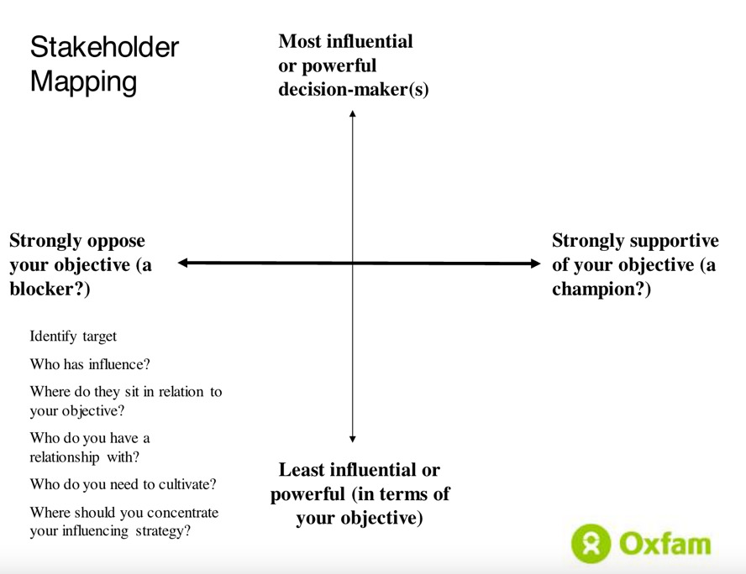
Figure 2 Stakeholder mapping
Source: Green, D (2019) How can we improve the way we move from analysing power to designing change strategies? From Poverty to Power, OXFAM blog, July
By placing stakeholders in four quadrants (high interest/high influence; low interest/high influence; low interest; low influence; high interest, low influence) you can start to identify who is likely to block your objective and who is likely to champion it. Potential alliances become quickly visible.
This mapping will be an iterative process as you identify new contextual factors and relevant actors. It is important to think hard about who you might have excluded from your initial analysis (e.g. women’s groups, less visible brokers such as wealthy businessmen, religious leaders).
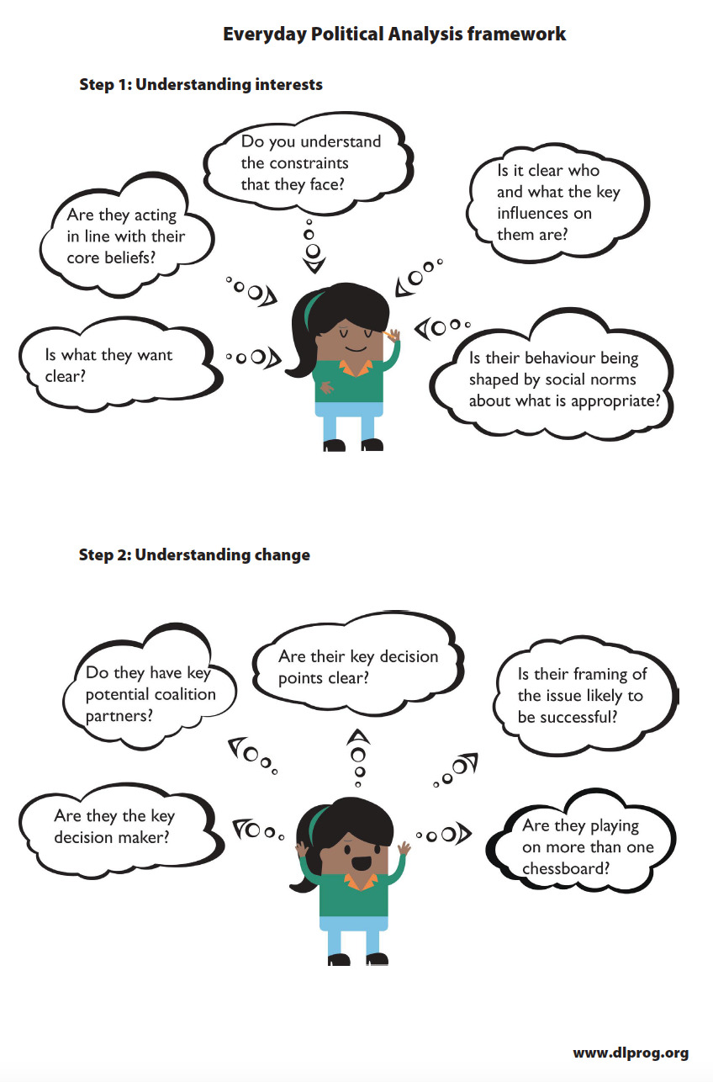
Figure 3 Everyday political analysis – two steps
Source: Hudson, D, Marquette, H and Waldock, S (2016) Everyday Political Analysis, Development Leadership Program

PEA frameworks initially focused on who has power and deals between elites, and PEA reports were often gender-blind. Recent PEAs frameworks make us explore who is excluded from power, and why. The gendered politics iceberg (Figure 4) illustrates which parts of the context are visible, and which ones are hidden – and should be proactively explored.
Inclusive, gender-sensitive PEAs adopt participative approaches and consider:
- How do the foundational factors affect different groups? For example, are demographic trends contributing to youth being excluded from the formal labour market?
- How do the rules of the game affect different groups? For example, do laws give equal rights to women and men? How do gender norms and patriarchal systems exclude women from decision making?
- How do the interests and influences of key actors affect other groups? For example, which minority ethnic, religious or language groups have been able to make alliances with more powerful groups? Why might this be sustained?
- What are realistic inclusive change pathways? Under which scenarios and how might excluded groups gain more influence in the sector or around the issue you are exploring?
- How could DFAT diplomatic dialogue or development investments empower excluded groups to claim their rights? How could they avoid re-enforcing exclusionary processes (e.g. male-dominated peace negotiations or humanitarian aid delivery)?
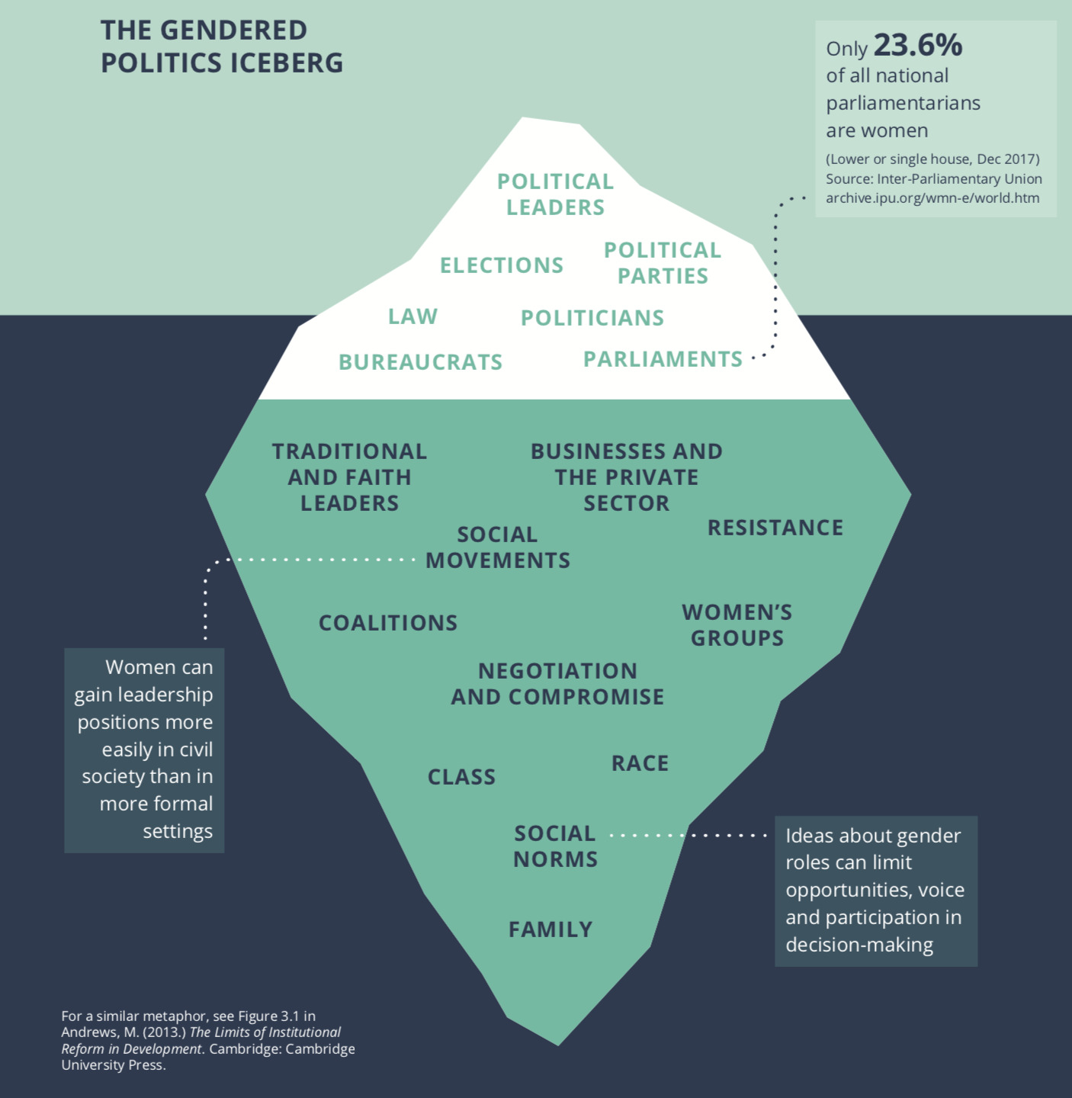
Figure 4 Gender and political economy
Source: Derbyshire, H et al (2018) Politically Informed, Gender Aware Programming: Five Lessons From Practice, Developmental Leadership Program
  - synthesis
Once potentially relevant structures/foundations, institutions and actors have been identified, it is essential to synthesise them into a manageable set of propositions that answer your PEA questions/issues. Otherwise, there is a danger that a PEA becomes a long descriptive report which is never used! These propositions could be presented in a PowerPoint presentation which then serves as a basis for team discussion, for example. The synthesis should cover:
- What are the political economy factors, or clusters of factors, that appear most powerful in explaining the problem(s) of concern?
- Which of these seem critical to future outcomes, in the sense that, as well as having a large impact, they are potentially susceptible to change within a given timescale?

Box 2 continues the Timor-Leste illustrative case study, illustrating what a synthesis could cover.
Box 2: Why is the private sector underdeveloped in Timor-Leste?
A synthesis could for example highlight the following:
- The preponderance of oil and gas in the (male-dominated) political settlement: political incentives are focused on capturing and redistributing rents from oil and gas, rather than investing in economic diversification (economic interests); this policy also demonstrates Timor-Leste hard-fought independence (idea/ideology).
- Other structural/foundational factors: small size of the country (1 million population); cost of export (island with expensive connections); poor quality of land; low levels of education
- Formal institutional factors: unclear property rights, complicated business registration, limited access to finance
- Informal institutional factors: gender norms weaken opportunities for women-owned businesses; traditional values/respect for ‘big men’ limits willingness to challenge resistance leaders on economic policy
- Events/shocks: the government’s response to the COVID-19 pandemic has further increased the role of the state in the economy and businesses’ dependence on government subsidies and social protection schemes

- Operational implications
  - Pathway of change
Before identifying what DFAT could do to respond to a specific problem through policy dialogue or an investment, it is crucial to understand if change could realistically happen without DFAT’s involvement.
A pathway of change is an explanation of how change can happen given a particular starting point and desired outcome. Key questions include:
- What is the initial situation?
- What is the desired outcome?
- What are the blockages and opportunities identified in the synthesis?
- How might foundational factors change? e.g. youth bulge, pandemic
- How might formal or informal institutions change? e.g. new market rules
- How might actors’ incentives change? e.g. a new coordination structure
Some of these changes are likely to happen without any external intervention.

Box 3 continues the Timor-Leste illustrative case study, illustrating questions to develop plausible pathways of change.
Box 3: What are plausible pathways of change for private sector development in Timor-Leste?
Plausible pathways could include the following elements:
- Oil and gas resources are fully depleted: would this challenge the political settlement and starve the state of resources to fund public services and issue contracts/jobs to supporters? What might the elite do?
- A new generation of leaders: with enough time since independence and multiplied education opportunities, will a new generation of leaders emerge?
- New framing of the debate: instead of presenting economic diversification as the opposition to reliance on oil and gas, could the terms of the debate change?
- Private sector actors organise themselves: how could incentives and perceptions of interests change between private sector actors, so they identify mutually beneficial arrangements to coordinate their actions?
- Post-COVID opportunities: as the government can no longer afford the recovery subsidies provided to the private sector, could this be an entry point?

4.2 Identifying interventions
You are now ready to identify how DFAT could respond to a specific problem through an investment or policy dialogue. Questions include:
- Should DFAT engage at all? There may be no plausible pathway to support, or none that would be appropriate for DFAT given Australia’s interests and capacity in that region/country.
- How can DFAT influence domestic actors in the identified pathways who already working on this objective and either seek to understand and amplify or at least not undermine them? (e.g. through policy dialogue, technical assistance, training, facilitation, etc). Test ideas with a stakeholder mapping.
- What are the risks and assumptions linked to the selected pathway DFAT wants to influence?
- How should DFAT structure its investment to have most influence? (e.g. grant to a multilateral agency or local organisation, commercial contract, twinning with an Australian body)
- How can DFAT work with other external actors to coordinate international support?
- Does DFAT have the commitment, resources, and staff capacity to oversee the investment and manage risks?

Box 4 continues the Timor-Leste illustrative case study, illustrating politically informed strategies.
Box 4: What are realistic investments for private sector development in Timor-Leste?
Realistic interventions can be based on the plausible pathways of change, and the identification of whether and how DFAT could play a role to support domestic change processes. In our example, they could include:
- Reliance on oil and gas resources: given the political sensitivities around oil and gas exploitation, it might be more appropriate for DFAT / Australia not to engage on this agenda, even though it is a fundamental factor.
- A new generation of leaders and evidence-based debates: DFAT could provide grants to civil society or media to create new spaces for public debates, support to parliamentarians, funding academic opportunities, framed in terms of economic diversification.
- Private sector actors organise themselves: grants to private sector organisations, such as chamber of commerce or sectoral associations, including women-led businesses, could help overcome some collective action challenges.
- Post-COVID opportunities may arise: technical assistance, if requested by the Prime Minister or economic ministry to develop and implement new economic recovery policies, may be politically acceptable (whereas outside of a crisis, it might have been rejected or ignored).

  - Theories of change and theories of action
Once the PEA analysis, design choices and defined interventions have been completed, it is important to carry through this analysis into the development of investment concept notes and design documents and annual quality checks. In particular, logframes and results frameworks should include the following theory of change logic:
- If DFAT invests in these interventions …
- Then the programs will deliver these results …
- Because our applied PEA suggests that the forces for change outweigh the forces blocking the change we have identified in our realistic pathway of change.

A theory of action will complement your theory of change. It is operational and describes how a program is designed and set up to deliver these results (see this TetraTech brief).

Table 1 Inferred theory of change in Timor-Leste’s economic development program
Area of work | “If … then” | “Because” (assumptions)
Economic policy | Support for capacity in economic ministries will help ensure evidence is used for economic policymaking because … | The political economy analysis provides evidence for the following assumptions which make the interventions realistic e.g.:  There is a genuine desire to improve performance from the leadership.  There is an ability to absorb the technical assistance and make the necessary changes.  Changes in the external environment will not derail the reforms.  Sub-sector specific assumptions about which change is politically feasible AND technically sound.
Aviation | Support for capacity in Timor-Leste’s civil aviation authority will make aviation safer because …
Business licensing | Improving the licensing process will encourage more businesses to set up because …
Access to finance | Creating a platform for agent banking will provide finance for farmers and small business because …
‘Other Voices’ | Building civil society capacity to analyse current economic policies will help to shape the overall direction of economic policy because …
Source: Piron, LH et al (2020) Independent review of the DFAT Governance for Development Program in Timor-Leste

- working politically and Adaptive management
‘Working politically’ involves integrating analysis and interventions through continuous, flexible adaptation in response to the political context to achieve the desired long-term development goals.
Adaptive management is about using PEA and other evidence to continuously adapt programs in response to changes in a context and what has been learned about what works. This will maximise the program’s relevance and its effectiveness given the unpredictability and complexity of the real world in which DFAT policy dialogues and development investments operate. It takes place at three levels (see Figure 5):
- Adaptive governance: DFAT creates an authorizing environment for programs to be tailored to their context, support locally-led change, and reflect, learn, and adapt (e.g. start small, change direction).
- Adaptive programming: program implementers manage staff and budget and facilitate reporting on progress and sharing insights between the front-line and DFAT for politically-informed decisions.
- Adaptive delivery: front-line staff have the skills and space to build relationships with local partners.
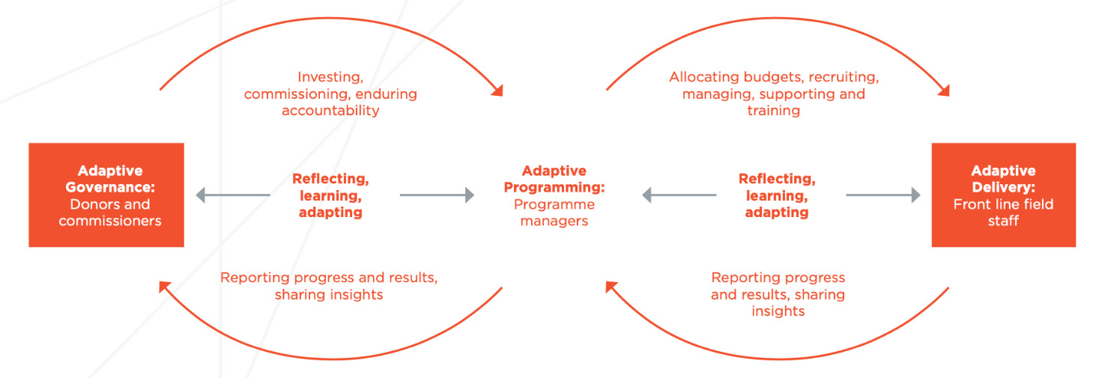
Figure 5 Adaptive governance, programming, and delivery
Source: Teskey, G and Tyrrel, L (2021) Implementing adaptive management: A front-line effort Is there an emerging practice? Abt Associates

Politically-informed programs and adaptive management can be challenging. They depend on:
- Trust and a shared understanding of the problem that the program will address, and a shared commitment between funders and implementers that the program will work in this way.
- Flexibility in program management so decisions can be taken in response to changes in the context and what is learned – e.g. reallocating budgets or adjusting objectives, rather than sticking to blueprints.
- Recruiting and managing staff with soft skills to support local partners and creating a learning organizational culture (e.g. where managed risks can be taken, and assumptions regularly tested) delivering politically-informed DFAT investments.
Box 5 below provides an example of a skills sector program, the Vanuatu Skills Partnership, which was able to work in a politically-informed and adaptive manner and contributed to Vanuatu’s economic development.

Box 5: Politically-smart and adaptive Vanuatu Skills Partnership
The Australian government has supported skills development in Vanuatu (2005-2021, AUD$ 42 million) through an approach which became politically-informed and adaptive. Based on its deep understanding of the country and sector, DFAT reoriented the program, which was initially focused on traditional technical and vocational education and training, towards a demand-driven, skills system better linked to Vanuatu’s economic opportunities. Over the course of four phases, the Vanuatu Skills Partnership program has:
- Contributed to local economic development and livelihoods as a result of its approach;
- Provided flexible support which empowered local actors to develop a broader understanding of the sector, as skills development linked to economic opportunities in both the formal and informal economy (rather than more narrowly technical training for the formal sector);
- Delivered skills training and business development mentoring approaches which suited local needs, establishing Provincial Skills Centres which responded to local demand, for example for tourism development. This was a ‘small bet’ or calculated experimentation to try a new province-based approach;
- Used the Provincial Skills Centres as a network for local governments, private sector, and local communities to form coalitions and support national sector reforms which met their economic interests - an approach that was iterative between local and national levels (e.g. provincial pilot initiatives informed national change);
- Through its reputation for high performance and professional project management, built trust and political legitimacy, which enabled the Vanuatu Skills Partnership to participate in reform debates. For example, monitoring and evaluation was undertaken by local program staff in a way that was accessible for local stakeholders, such as provincial officials who could use the data to prepare their plans and demonstrate the success of local initiatives to national actors;
- Supported the implementation of major institutional reforms, on the back of this political support, such as transferring responsibility for skills to the Ministry of Education and Training, linking skills development to tertiary education; and
- Institutionalised the program, by transitioning from a donor-driven approach to a skills development system within Vanuatu structures. For example, the program leadership is now part of the Ministry of Education and Training and the Provincial Skills Centres are part of the Ministry’s tertiary education directorate.
- The Australian High Commission’s sustained commitment to this new way of working was critical to achieving these results. It maintained the right degree of involvement with the program. In particular, the Vanuatu Skills Partnership relied on national staff program leadership, well informed and politically-savvy technical experts, and by phase four, a managing contractor who provided back-office support to facilitate the local senior management group.
Source: Barbara, J (2019) Thinking and working politically in the Vanuatu skills sector: supporting local leadership and building a political constituency for change Vanuatu Skills Partnership

- Thinking and working politically in DFAT
Applied PEA is useful at every stage in DFAT’s investment cycle management. DFAT staff need to think daily about political economy factors, not just through one-off reports.
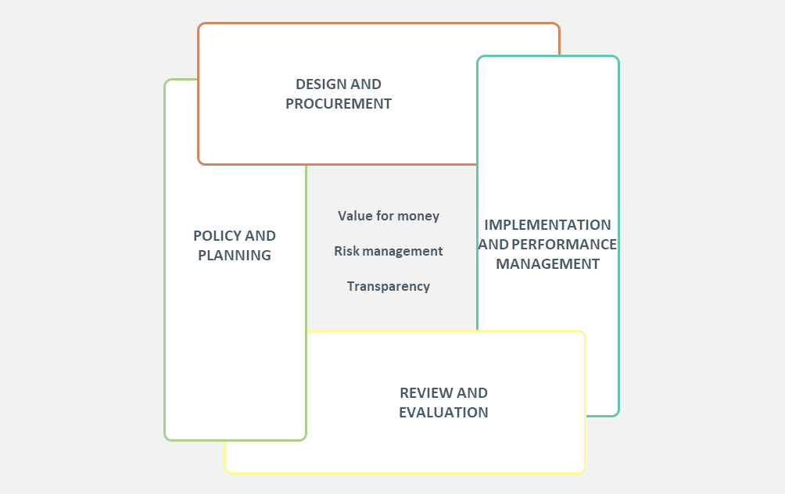
Figure 6 Development program management cycle
Source: DFAT
DFAT’s development program and country analyses: Applied PEA is one element of DFAT’s preparation of its broad strategies. It can be either integrated as part of, or undertaken to complement, DFAT analysis on poverty, gender and social inclusion, governance, climate change and economics. It is particularly useful in fragile and conflict-affected contexts. A PEA provides an understanding of the broader factors that hinder a country’s development or contribute to conflict. Open access examples of country-level PEAs can be found on here.
DFAT’s investment concept notes and investment design: Applied PEA can be an input into DFAT decisions on whether or not to enter a sector or to design a program, what realistic objectives to set, and which partners to prioritise. This is because it makes explicit some of the deep-seated factors that may make a reform highly risky, but with a high return, or unlikely to make progress, even with Australian assistance. PEA insights can also make a difference in the choice of development instrument (e.g. to give a grant or issue a contract, and the skills needed in the implementation team). In 2019, the second phase of the Philippines Coalitions for Change won DFAT’s International Development Design Award. The award commends quality program designs and good practices amongst Australia’s development programs.
Implementation and performance management: DFAT investments should consider political economy factors on an ongoing basis, so they can adjust when there are new developments (e.g. elections lead to a new government, oil is discovered, etc) which create new opportunities or new risks. DFAT programs should adopt ‘adaptive management’ principles throughout the investment cycle. (See section 5 above).
Monitoring, evaluation and learning (MEL): MEL should not be separate from implementation, as adaptive programs are designed to learn and adjust on an ongoing basis. Independent reviews and evaluations can be required by DFAT at important decision points; they benefit from a PEA perspective to assess if interventions are still relevant and have adopted the most effective approaches to partnerships. This 2020 independent review of the DFAT Governance for Development Program in Timor-Leste was based on a PEA and assessed the program’s ability to think and work politically.
There is no one way of commissioning, undertaking and using a PEA in DFAT. In practice, a combination of an in-depth analysis and regular ways of updating and making use of the analysis will be appropriate.
- In-depth PEAs may be useful when DFAT engages in a new country or sector or needs to review its approach because the context has radically changed. A mixed team of DFAT staff and external experts (local experts, technical specialists) will be needed. DFAT locally-engaged staff have particular relevant insights and networks. Gender specialists, political scientists and economists can provide complementary perspectives. If a PEA team is only composed of external experts, it may not sufficiently understand DFAT needs and internal dynamics to draw operational conclusions.
- Quality PEAs, whether light-touch or in-depth, share some characteristics: they need to be targeted around a specific issue, search for answers to deep seated problems and rely on evidence from a range of sources (such as documents or interviews with informants from a range of backgrounds). Triangulation across data sources is critical; otherwise DFAT may take decisions based on incomplete or biased information. In the post COVID-19 context, remote PEAs may be the only option, with teams split between locations and a team leader acting as an overall convener and facilitator.
- Embedding PEA in DFAT and implementers’ program management is another option. It requires identifying critical moments when PEA insights will be useful to steer an investment. They can be much lighter touch, such as team discussions (using DLP’s Everyday Political Analysis approach) or set piece ‘pause and reflect’ sessions (using TAF’s strategy testing framework, for example).
- Building local partners capacity to undertake PEA and think & work politically could become a DFAT program objective in itself. This can include capacity development programs for civil society partners or policy makers, so they develop the mindsets and coalitions to address local challenges on an ongoing basis, beyond the lifetime of a DFAT investment. The UK government worked in this way in Sudan through a 2014-2018 British Council program, prior to the revolution, when there was little scope to influence government policy. The Kulana Liltanmia Programme trained civil society activists in different analytical approaches, including PEA, to promote peaceful problem-solving at the local level.
Terms of Reference (ToRs) should be drafted even if the analysis will primarily be conducted in-house, in order to be clear on the objective, resources and process. This USAID checklist is also useful. ToRs should cover:

Background: Do you want to undertake a specific PEA or integrate PEA thinking into broader analysis work?
Objectives: What is the specific purpose of the PEA? What level of analysis is appropriate (macro, sector, issue-specific)?
Scope: How can you find out what you need to know? Where are the information gaps? How participatory will the process be?
Duration and Phasing: Is the length of the process proportionate? is timing and internal ownership/commitment right to ensure findings are acted upon?
The Team: What mix of skills and expertise is required? will the PEA be undertaken internally, externally or a mix?
Reporting and Utilisation: Who is the primary audience? How and whom will findings (which can be sensitive) be shared? Has a clear process for integrating the analysis been identified?

- Further support

The following organisations can provide guidance and training:
- The Asia Foundation organises training on Development Entrepreneurship.
- Online political economy in action training is offered by The Policy Practice / ODI.
- Harvard University Building State Capacity supports policy makers in problem-driven, iterative programs.
- The Thinking and Working Politically Community of Practice organises events and shares resources to disseminate lessons.
- For additional resources, please check The Policy Practice online library which is regularly updated.

DFAT welcomes feedback on the usefulness of this guidance as part of their continuing efforts to improve the quality of their advice. If you have any comments or feedback about this Guideline, please contact Governance@dfat.gov.au. The team would also welcome examples of case studies of applied PEA in practice and examples of the impact of politically-informed and adaptive management approaches.

- Additional resources

Introduction to applied PEAs
UK Department for International Development (DFID) (2009) Political Economy Analysis How To Note. One of the first PEA guidance notes, it has stood the test of time and provides a menu of tools and advice on processes.
United States Agency for International Development (2018) Thinking and Working Politically Through Applied Political Economy Analysis is complemented by additional practical web-based resources. This includes a useful long list of contextual questions DFAT staff can select from to draft ToRs.

Political economy concepts
National School of Government International (2017) Beginners Guide to PEA explains the concept of elite bargains and political settlements, and why these matter for international assistance.
World Bank (2017) World Development Report 2017: Governance and the Law. Washington, DC: World Bank. This report explores unequal power relations, elite capture and clientelism, and how external actors can try to shift incentives through elite bargains and citizens engagement.

Resources for problem-based PEAs
Fritz, V, Levy, B and Ort, R (2014) Problem-Driven Political Economy Analysis: The World Bank’s Experience. Directions in Development. Washington, DC: World Bank.
Saamji, S et al (2018) Problem-Driven Iterative Adaptation: A DIY Approach to Solving Complex Problems Building State Capability, Center for International Development, Harvard University. It offers tools to unpack a problem; also found in different languages and with additional material on this webpage: toolkit on problem-driven, iterative adaptation.
The Asia Foundation’s Development Entrepreneurs an iterative process that supports local actors to work collectively to find technically sound and politically possible reforms.

Resources for sectoral PEAs
Lane, C and Martinko, D (2018) The Use of Political Economy Analysis in Health System Strengthening Washington DC: USAID/Health Finance and Governance
Denny, L (2016) Using political economy analysis in conflict security and justice programmes ODI: London
Making Markets Work for the Poor is a framework to analyse whether the voices of the poor and government capacity and accountability are not obstructed or distorted by vested interests, poor information, or weak institutions.
Frøystad, M, Heggstad, K, and Fjeldstad, O-H (2010) Linking procurement and political economy: a guide Washington DC: World Bank Institute and DFID
WaterAid (2015) Political Economy Analysis Toolkit WaterAid
Worker, J and Palmer, N (2021) A Guide to Assessing the Political Economy of Domestic Climate Change Governance Working Paper, World Resources Institute

Resources for regional PEAs
Byiers, B, and Vanheukelom, J (2016) How To Note: Doing Regional Development Differently Maastricht:ECDPM

Resources for understanding stakeholders
Hudson, D, Marquette, H and Waldock, S (2016) Everyday Political Analysis Developmental Leadership Program
Green, D (2019) How can we improve the way we move from analysing power to designing change strategies? From Poverty to Power, OXFAM blog, July
Network Analysis maps the webs of relationships within a society, including power, prestige, and authority to create a power profile.
Christian Aid / Social Development Direct (2021) Gender, Inclusion, Power & Politics Toolkit - Part Two- Toolkit. A comprehensive set of tools and practical advice to design participative processes, such as workshops.

Resources for inclusive PEAs
Christian Aid / Social Development Direct (2021) Gender, Inclusion, Power & Politics Toolkit - Part One - Guide. A comprehensive guide to integrate gender and inclusion into PEAs.
Derbyshire, H et al (2018) Politically Informed, Gender Aware Programming: Five Lessons From Practice Developmental Leadership Program
Haines, R and O’Neil, T (2018) Putting gender in political economy analysis: Why it matters and how to do it Practitioners’ Guidance Note Briefings, Gender and Development Network
OECD (2020) Politically informed approaches to working on gender equality in fragile and conflict-affected contexts OECD Development Policy Papers no32, September, OECD: Paris
Sida (2013) Power analysis: a practical guide
Resources to develop pathways of change and interventions
DFAT’s Aid Programming Guide
TetraTech (no date) What is a theory of action

Adaptive management resources
Lonsdale, J and Pruden, M (2022) Guidance note: Practical introduction to adaptive management DT Global
Teskey, G and Tyrrel, L (2021) Implementing adaptive management: A front-line effort Is there an emerging practice? Abt Associates
Christie, A et al (2018) Six ways to tell if a programme is really ‘doing development differently’ BEAM Exchange, blog post
Ladner, D (2015) Strategy Testing: an innovative approach to monitoring highly flexible aid programmes Working Politically In Practice Series no3, The Asia Foundation. This is a monitoring system developed to track programs that are addressing complex development problems through a highly iterative, adaptive ‘searching’ approach.

This guidance draws on DFAT experiences and approaches developed and tested by DFID, ODI, The Policy Practice, World Bank, The Asia Foundation, the Developmental Leadership Program, Abt Associates and other organisations. It was updated in 2022 by Laure-Hélène Piron, drawing on The Policy Practice/ODI training material and experiences, and delivered through the Abt Associates-managed Governance Helpdesk.
A more comprehensive definition of a political settlement is ‘the formal and informal processes, agreements, and practices that help consolidate politics, rather than violence, as a means for dealing with disagreements about interests, ideas and the distribution and use of power’ (Laws, E and Leftwich, A (2014) Political Settlements, Developmental Leadership Program Concept Brief no1, page 1).

