

. 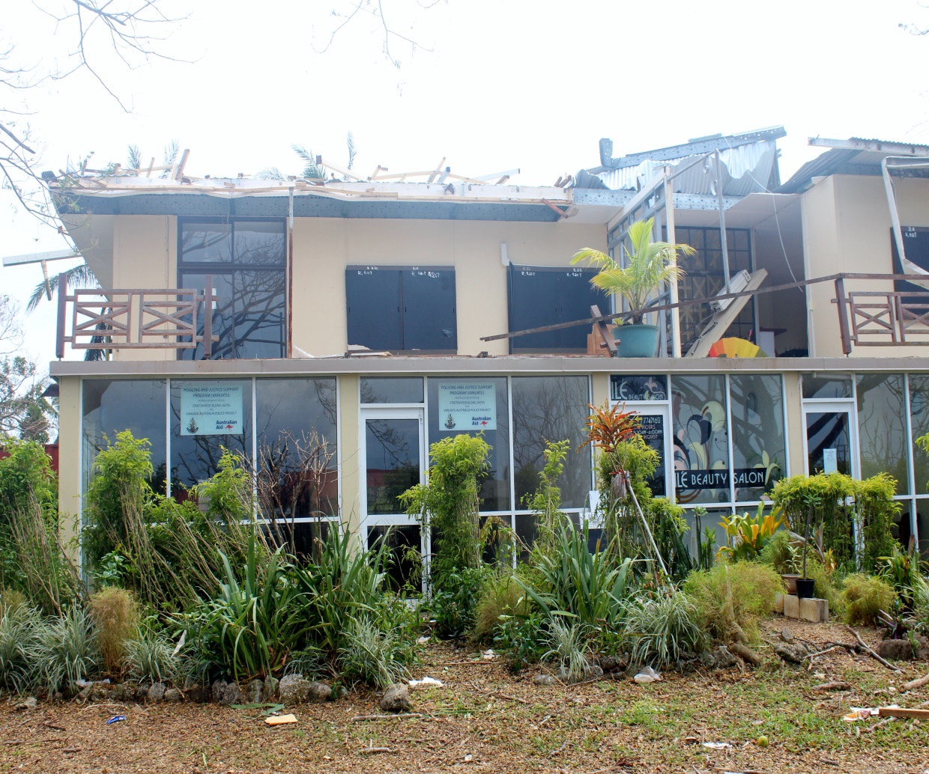

Vanuatu Law and Justice Partnership
Stretem Rod Blong Jastis
part of
Policing and Justice Support Program (Vanuatu)

Stage Two Progress Report – January to June 2015
Submitted 17 July 2015

Contents

Contents 2
Annexes 3
Tables 3
Acronyms 5
Executive Summary 6
1. Context 10
a) Maintaining relevance of the program 10
b) Context impacting on achievement of outcomes or implementation 10
c) Impact of program on context 15
2. Progress Towards End-of-Program-Outcomes 17
a) Defining Outcomes for the Program 17
b) Summary of Key Achievements 20
32
c) Key factors that account for the degree of progress towards outcomes 32
d) Implications for achieving end-of-program-outcomes 37
e) Variations to Workplan 37
f) Gender 40
g) Areas of strategic focus for this reporting period 42
h) Lessons 44
3. Reach & coverage of outputs during Reporting Period 46
4. Adequacy of Progress 49
a) Against the Workplan: On time 49
b) Adequacy of inputs to meet end-of-program-outcomes 49
c) Against Budget 49
5. Effectiveness and Efficiency of Management Systems 51
a) Workplan 51
b) Financial Management Systems 51
c) Monitoring and Evaluation 52
d) Risk Management 57
e) Staffing and human resource management 58
f) Special Management issues related to Grants Facility 61
6. Overall conclusion 65

Annexes

Annex 1 | Sector Perception Survey, June 2015
Annex 2 | Agenda and attendance lists for HOAG meetings on 1 April and 24 June 2015
Annex 3 | Indicators from Business Plans included in the Sector Monitoring & Evaluation Framework
Annex 4 | Case and Data Management of January 2015
Annex 5 | Vanuatu Law Commission Report (2012-May 2015), Progressive report on SRBJ support to Vanuatu Law Commission.
Annex 6 | Save the Children Child Protection Program Phase II – Six monthly Program report and annexes to that report (annexes on request)
Annex 7 | SRBJ Grants Review (subject to amendment post DFAT comments) and Management Response
Annex 8 | Update on minor delays reported on in the July-Dec 2014 Progress report
Annex 9 | PJSPV Gender Strategy 2015 (approved May)
Annex 10 | PJSPV Draft Gender Strategy Implementation Plan
Annex 11 | Update on the initiatives for strengthening gender since the July-Dec 2014 Progress Report
Annex 12 | Policing & Justice Support Program (Vanuatu) PJSPV Monitoring and Evaluation Update Report, January to June 2015
Annex 13 | Risk Matrix
Annex 14  Annex 15 | End of financial year finance summary  Program audit recommendations

Tables

Table A | Intermediate and end-of-program outcomes
Table B | Summary of achievements
Table C | Reach and Coverage of Outputs
Table D | Staffing and Human Resources
Table E | Grants approved during reporting period

Acronyms
ADR | Annual Development Report
CDLA | Capacity Development & Leadership Adviser
CDMA | Case & Data Management Adviser
CLE | Continuing Legal Education
CP | Child Protection
DFAT | Australian Department of Foreign Affairs and Trade
DWA | Department of Women’s Affairs
DSSPAC | Department of Strategic Sector Planning and Aid Coordination
GoA | Government of Australia
GoV | Government of Vanuatu
GRM | GRM International Pty Ltd
HRM | Human Resource Management
HOAG | Heads of Agency Group
IPAM | Institute of Public Administration and Management
JCSSS | Justice and Community Services Sector Strategy
JSC | Judicial Services Commission
LSIP | Law Student Internship Program
LTA | Long Term Adviser
M&E | Monitoring and Evaluation
MEF | Monitoring and Evaluation Framework
MEP | Monitoring and Evaluation Plan
MJCS | Ministry of Justice and Community Services
MNCC | Malvatumauri National Council of Chiefs
NDMO | National Disaster Management Office
NZ | New Zealand Government
OGCIO | GoV Office of the Chief Information Officer
PAA | Priority Action Agenda
PJSPV | Policing and Justice Support Program (Vanuatu)
PLAS | Planning Long Acting Short
PMG | Partnership Management Group
PMF | Public Financial Management
PMO | Prime Minister’s Office
PPO | Public Prosecutor’s Office
PSC | Public Service Commission
PSO | Public Solicitor’s Office
SCV | Save the Children Vanuatu
SLO | State Law Office
SPD | State Prosecutions Department
SRBJ | Stretem Rod Blong Jastis Partnership
TA | Technical Advisers
TOR | Terms of Reference
UNICEF | United Nations Children’s Fund
USP | University of the South Pacific
VAPP | Vanuatu Australia Police Program
VLC | Vanuatu Law Commission
VLJP | Vanuatu Law and Justice Partnership
VNSO | Vanuatu National Statistics Office
VPF | Vanuatu Police Force
WPL | Work Place Learning

Executive Summary

This six monthly progress report for Stretem Rod Blong Jastis (SRBJ), a part of the Policing and Justice Support Program Vanuatu (PJSPV), covers the period from 1 January to 30 June 2015. In the middle of that reporting period Vanuatu was hit, particularly in the East and South, by the devastating category 5 Tropical Cyclone Pam. The cyclone had a significant impact on our counterparts and on the sector, and on the context generally from causing personal trauma at the individual level, through to the macro-economic impacts on the national economy.
Whilst the program was cognisant of and sensitive to the very significant impacts of the cyclone on the people and the country as a whole, the impact on the program was not overwhelming. That is, counterparts did not call for the program to be entirely re-designed or re-prioritised or halted. Instead, the clear message from the Ministry of Justice and Community Services (MJCS), the Judiciary and other key stakeholders across the sector was that the program should assist where asked but otherwise continue as planned. The program was able to do so by supporting some immediate post Cyclone Pam infrastructure and information, communication and technology needs where requested to do so (recognising that there would also be other avenues of development partner support as a result of the cyclone). This response of the sector and the program’s stakeholders was representative of the fortitude and the resilience of the people of Vanuatu (no less those of the policing, justice and community services sector). The resounding response was to meet the immediate humanitarian needs of the country but otherwise pick up the pieces and continue with “business as usual” as soon as feasibly possible.
This demonstrated convincingly that the program is believed to be relevant and appropriate to the needs of the sector.
The cyclone undoubtedly contributed to delay in the implementation of outputs across the program with a hiatus in activity for a period of four to six weeks. This delay, however is unlikely to threaten the achievement of intermediate or end-of-program outcomes for SRBJ. Delay in some areas resulting from a number of factors in addition to the cyclone, may reduce the extent of progress made on end-of-program outcomes and the sustainability of outcomes but not their achievement per se.
The program has expanded with the recruitment of additional advisers envisaged in the design (Human Resource Management (HRM) adviser, Public Financial Management (PFM) Adviser and Workplace Learning (WPL) Adviser). This will allow for stronger implementation of the multidisciplinary and multifaceted Justice and Community Services Capacity Development Strategy, particularly with respect to support for the target functional groups across the sector - finance officers, human resource officers (or those with finance or human resource function respectively) and lawyers or quasi legal officers - as well as projects of institutional strengthening, for example of the MJCS.
Monitoring and evaluation of progress and outcomes of the program has been strengthened with the implementation of the Monitoring and Evaluation Plan (MEP) designed during the first six months of Stage 2 of the program. The first Baseline Assessment and Report has been completed; the findings of the Grants Review have been integrated into the management of the Grants Facility; the recommendations of the Law Student Internship Program Review are being implemented; the outcomes of the Sector Perception Survey have been shared with the Heads of Agency Group (HOAG) in June as part of a conversation about sector coordination and collaboration; the evaluation of women’s professional participation in the Vanuatu Police Force (VPF) has commenced; and the program is preparing for evaluations of case and data management support and capacity development in the next reporting period (July and August respectively). The Human Resource Management (HRM) adviser and Public Financial Management (PFM) adviser have commenced establishment of baseline with respect to the indicators relevant to their areas of practice. This together with regular meetings of the team, structured conversations and six monthly reporting has assisted in developing stronger qualitative and quantitative evidence for management decisions regarding the progress of the program and the overall assessment of contribution.
SRBJ has made progress in all areas in which it intended to focus strategically over this reporting period including strengthening gender; strengthening systems and processes; considering resourcing of component 3; consolidating links between MJCS and Prime Minister’s Office (PMO) M&E officers and units; reviewing and improving the management of the Grants Facility and increasing the focus on sustainability. Areas identified for attention with respect to sustainability in the last reporting period have all improved (albeit to varying degrees) over the last six months as well. This must continue to be a strong focus over the remainder of the program to ensure that positive changes are embedded wherever there is opportunity to do so.
Overall, SRBJ has made good progress towards end-of-program outcomes given the impact of the cyclone on the sector and other inhibitors to progress.
Highlights for the reporting period include:
- The Capacity Development and Leadership Adviser (CDLA), Public Solicitor’s Office (PSO) Adviser and State Prosecutions Department (SPD) Adviser collaborated well with the barrister trainers of the Victorian Bar to develop and deliver a legal advocacy course, building on the last one in December 2014. The course was specifically tailored to the legal and contextual environment in which the lawyers of Vanuatu operate. The Victorian Bar: “Legal advocacy in the criminal and civil jurisdictions” of 24-26 June 2015 had greater participation than a similar course run in December and was supported by members of the judiciary for the first time in the life of the program. This was the product of a very effective collaborative process by the team and the external service provider.
- Completion of the MJCS Sector Annual Report 2014 with an increase in contributions from eight agencies last year to ten this year. Completion of Budget Narratives Standard Guideline and sector consultations support to Business Planning & Budget Narratives. These achievements required significant effort and dedication of MJCS officers with varying levels of support from agencies in the sector, but exemplify the kind of service that the MJCS might be able to provide to the sector in more consistent and robust ways into the future.
- The Manager of the Community Legal Centre and Coordinator of the Law Clinic course arrived at USP during this reporting period allowing for the Law Clinic course to recommence after two years. Plans to bring the Internship Program into the Law Clinic Course have now been formally raised with agreement for trialling in semester two of 2015. This will offer a pathway to greater sustainability for the Law Student Internship Program.
- Significant progress has been made in the closure of dormant files at the PSO as a result of this being expressly endorsed by the Public Solicitor and supported by the Adviser. This is a step towards achieving case and data accuracy in that office and perhaps to supporting more systems and process reforms in the future.
- Case and data management progress:
  - The world’s believed to be the largest legal information services company, Lexis Nexis, (who won the Government Tender) will be providing the judiciary with its new Court Management System. This is currently in the implementation stage and scheduled to “go live” on computers of court staff in October 2015. Significant progress has been made during this reporting period including Lexis Nexis visiting the Courts in February 2015 to undertake detailed “requirements gathering” with court staff.
  - Lexis Nexis also won the tender for the State Law Office’s (SLO) case management system, which is also scheduled to “go live” on SLO computers in October 2015. Lexis Nexis visited SLO in May to undertake detailed “requirements gathering” with SLO staff.
  - The engagement with staff and the sponsors (Chief Registrar and Solicitor General) has been excellent, particularly in terms of reviewing requirements, attending working group sessions, and providing pragmatic feedback. In parallel, Lexis Nexis technical staff, have been wonderfully supported by Office of the Government Chief Information Officer (OGCIO) personnel and have installed the base software on servers at OGCIO, in readiness for commencement of the systems later in the year.
- Progress in the program-supported research related to conflict resolution (violence against women (Malekula) and youth at conflict with the law (Blacksands)) has been expanded, is significant and present exciting opportunities for future use:
  - The engagement of other sector stakeholders in the research itself, including researchers from the Vanuatu Law Commission; staff and affiliates of CARE; and the Vanuatu Women’s Centre; and the Judiciary will potentially extend the impact of the research.
  - The use of smart phone technology (SMAP/FieldTask) is also of particular interest to the Vanuatu Law Commission who may try to use it in future law reviews, and it may provide a more efficient support to ongoing monitoring and evaluation of programming activities in the sector.

  - The engagement of other SRBJ and sector assets around the development of the Authorised Persons database for Department of Women’s Affairs (DWA) has also represented another ‘technological’ highlight and represents an example of effective cross program collaboration.
  - The set of research instruments is close to completion and the research that will be carried out in July and August will offer a significant ‘look in’ to dispute resolution, and experiences of dispute resolution, across state and non-state justice processes and institutions.
  - The research has already generated interest from the Courts, civil society such as Wan Smol Bag, Vanuatu Australia Police Project (VAPP) colleagues, and from the Vanuatu Law Commission (VLC).
  - The findings will be of interest across the sector and should offer a nuanced and complex view of how problems are dealt with and experienced at the community level, particularly by women and young people.

Continuing Challenges over the reporting periodThere have been, of course, challenges and opportunities during this period but some, challenges (other than the impact of Cyclone Pam) have included continued political fluidity; mixed leadership; sensitivity of the work and bilateral relationship and capacity of partners to drive development even where there is the apparent intention to do so.

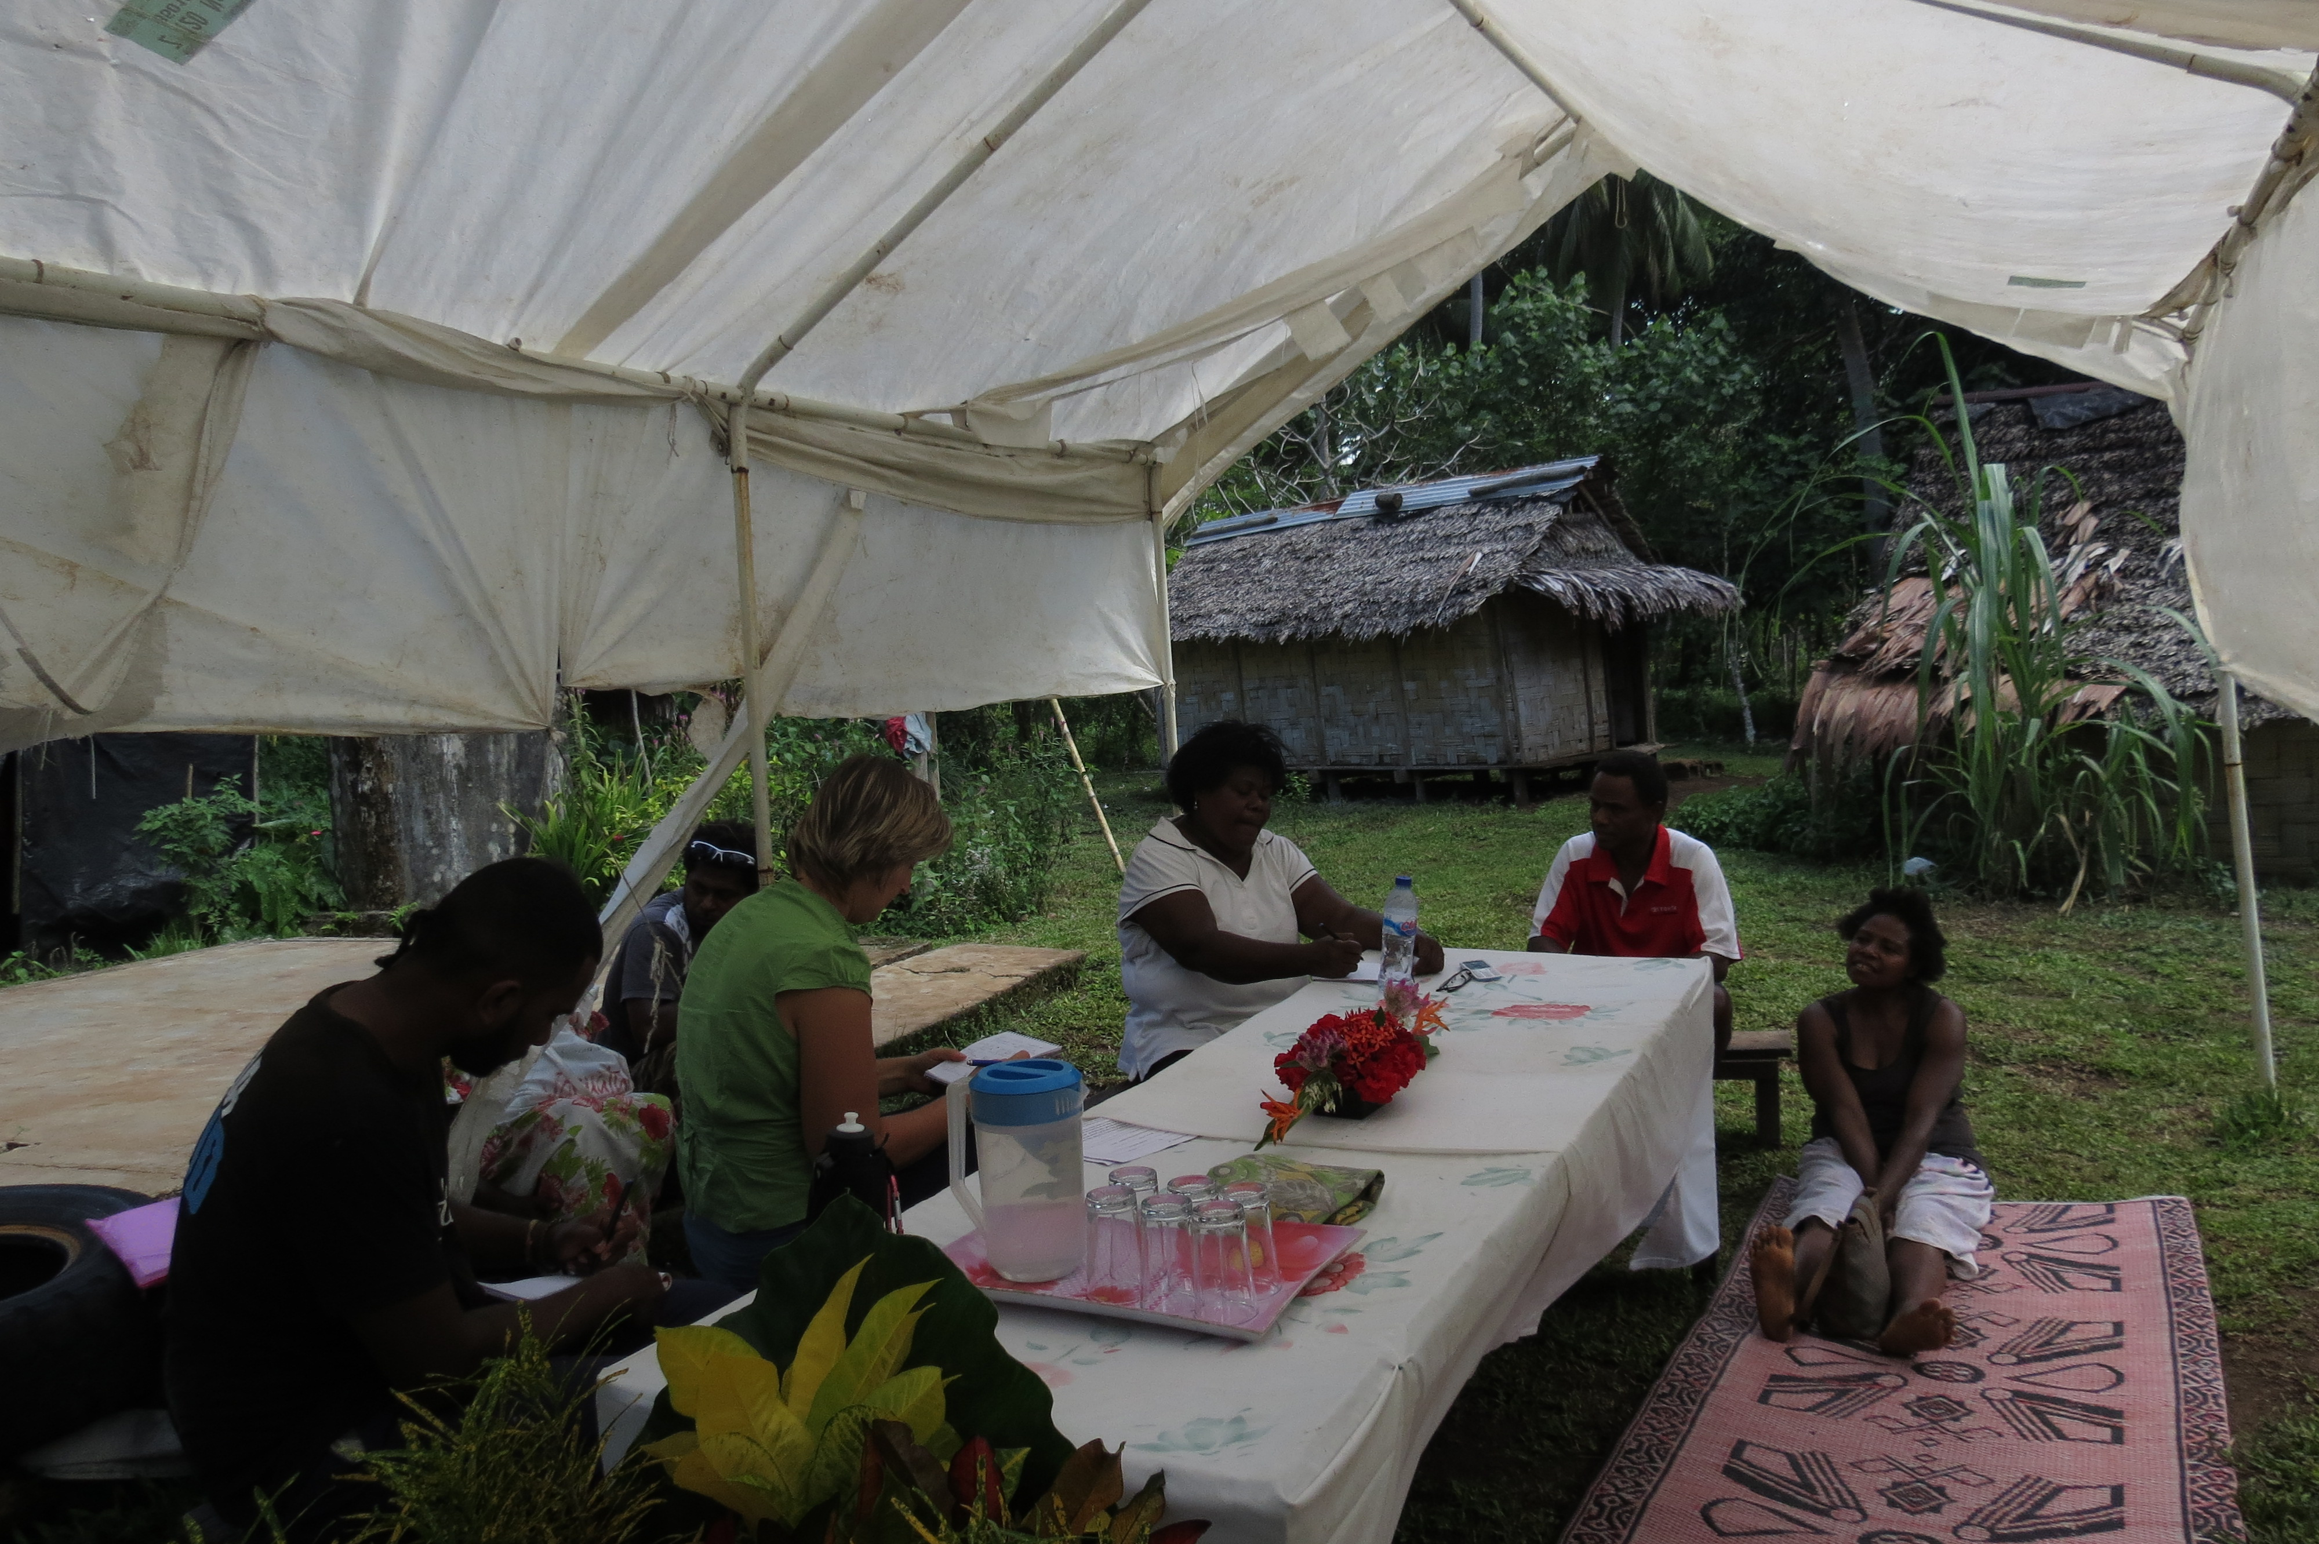Photo: DWA team working in Santo in preparation for the Family Protection Act pilots.

Context

This report is intended to build on the Stage 1 Completion Report which provides a stand-alone summary of the progress of SRBJ to the end of Stage 1 (30 June 2014) and the first progress report for Stage 2 which covered July to December 2014. Accordingly, reporting on context or on Lessons Learned for example, is intended to highlight new or changing factors rather than to repeat ones that have been reported on previously, except where stated. Context and lessons learned from Stage 1 are assumed or alluded to in brief and will not be reported on again in Progress Reports of Stage 2 of SRBJ. Constraints and inhibiting factors, opportunities and challenges, and strategic directions are updated since the previous reporting period.

Maintaining relevance of the program
The focus and end-of-program-outcomes continue to remain relevant to the needs and context in Vanuatu. However, the approach taken to achieve these end-of-program-outcomes needs to remain flexible to reflect changes in the context, increased understanding of the relevant issues, and response to identified challenges (this is dealt with in more detail in section 2e – Variation to the Workplan). That is, the approach to how the outcomes are to be best achieved remains flexible and responsive while the outcomes themselves have continued to remain appropriate and relevant.

This appropriateness and relevance of the focus of the program was confirmed by the Heads of Agencies and Institutions when they met at the Heads of Agency Group (HOAG) meeting after Tropical Cyclone Pam on 1 April. In the immediate aftermath of the destruction of the cyclone, the program sought some direction from stakeholders as to whether and to what degree it should maintain its current approach and end-of-program outcomes or if these should be reviewed and amended. The very strong response both by participants at the HOAG meeting in April, and during subsequent consultations with stakeholders across the sector, was that while the program would need to be cognisant of the circumstances and conditions under which the sector was now operating and use the Grant Facility to focus on immediate post-Cyclone Pam needs in the short term, the program as designed and approved, should continue. For example, those agencies with very stringent timelines under contract with foreign service providers where default would result in significant delay or cost, elected to continue to commit to those timelines without any significant change to what had been planned pre Cyclone Pam. This commitment and fortitude demonstrated a real strength of resolve across the sector.

Context impacting on achievement of outcomes or implementation
The nature, breadth of purview and complexity of the policing, justice and community service sector is described in some detail in section 2a of the SRBJ Completion Report Stage 1 – July 2014 (Stage 1 Completion Report) and that description continues to accurately represent the sector in which the program operates.

Constraints
The constraints identified in the Stage 1 Completion Report (1-5 summarised below) continue to represent the overarching constraints for the program:
- Fluidity of the political context; there have been two Ministers of Justice and Community Services in this reporting period and there are cases pending in the Supreme Court against politicians. In addition, there continues to be frequent changing of appointments to positions within the senior ranks of the VPF as a result of internal factions and political alignments.
- Leadership is both an asset and a constraint across the sector and the Government of Vanuatu (GoV) more broadly.
- Inherent sensitivity of work in this sector and the bilateral relationship; demonstrated, for example, by media coverage of the possibility of an expatriate Police Commissioner for Vanuatu Police Force (VPF) and the rhetoric of sovereignty by the National Disaster Management Office (NDMO) post Cyclone Pam.
- Politics of aid are inherent in this work and must be trodden carefully on a daily basis. This requires the constant balancing act between ensuring the ownership and direction of the counterparts whilst facilitating skills transfer and support. This becomes increasingly difficult where staff fill positions but do not have the requisite skills, experience and at times, interest.
- Retention of lawyers within the public sector; whilst this six months has not seen as many resignations of lawyers from the public sector, the attraction of the private sector remains and the program will focus in a multidimensional way to strengthen the capacity of the public sector to retain lawyers once admitted.
Additional constraints noted over this reporting period include:
- Impact of Cyclone Pam on 13 March: The impact of Cyclone Pam on PJSPV has been multifaceted and after four months is continuing and is not easy to quantify. Some of the immediate impacts on program and sector are identified below:
  - The building in which the program office was located had its roof blown off. The landlord determined to fully renovate the building and so the program made a decision to relocate rapidly to new premises to minimise the impact on service delivery to the sector. SRBJ was formally relocated to new office premises opposite Au Bon Marché, Nambatu on 18 March 2015. However, it took some time for it to be fully functional again with a robust internet connection; reliable power and plumbing which had some short term impact on efficiency.
  - All short term international program staff were evacuated and long term international program staff were offered some time outside of Vanuatu after the cyclone. Staff across the program needed to attend to personal matters at home to re-establish their houses and utilities to their houses after the cyclone.
  - Staff and agencies across the sector similarly had to respond to challenges at home (such as, destruction of homes; lack of supply of utilities; shortage of affordable fresh produce; support to additional family members; and relocation) as well as damage to office buildings; supply of utilities and damage to technology and communications. In particular, in Port Vila the SPD and PSO had small but manageable structural damage; the PPO and the Judiciary also had some structural damage; the SLO had the roof of its archive room blown away and resultant damage to archives and the USP Campus in Port Vila was badly damaged. In Tanna, the PSO and Court House were very badly damaged. Other court houses suffered some damage and the program supported urgent information technology and infrastructure needs through its Grant Facility where applications were made to it. VPF headquarters and Port Vila Police Station also suffered some structural and electrical damage which is being supported by VAPP. However, as a consequence of relatively little justice and community services infrastructure (when compared with health and education sectors, for example) across Vanuatu, the infrastructure impact on public buildings for the sector was relatively contained.
  - Counterparts across the sector were heavily involved in the emergency effort over the first two months or more after the cyclone (for example; the Director General, Disability Desk, Child Desk, DWA staff and others) which meant that they were not available for the usual core work of the sector which was entirely appropriate and to be expected. The Director General, for instance, spent three weeks in Pentecost supporting the distribution of relief and was frequently called on by the NDMO in his role as chair of the Infrastructure Cluster Group.
  - In terms of the implementation of the Workplan for SRBJ specifically, the cyclone probably resulted in an average of 4-6 weeks delay across the program and a three month focus by the Grant Facility on urgent post Cyclone Pam needs of the sector. The cyclone also provided greater impetus for the implementation of the Infrastructure Needs Assessment for the whole policing, justice and community services sector.
- MJCS Capacity: it was anticipated that at this stage of the program there would be greater strength demonstrated by the MJCS as an institution, including;
  - Greater demonstrable understanding of the MJCS’s reform agenda and therefore greater drive and support for achievement of progress to end of 2016;
  - Greater human capacity as a result of the recruitment of four additional positions for the Corporate Services Unit of the MJCS – none of which at the time of reporting have been recruited.
  - More proactive management style, which is working to an agreed vision, rather than only responding to demands on it. Some small progress in this direction has been trialled through the initiation of more regular operational meetings convened by the MJCS Executive Officer, and intended to enable better operational coordination of Ministry staff. The practice is far from institutionalised, although some benefits have been noted – largely related to greater levels of awareness and accountability amongst staff; picking up on opportunities for improved coordination; and staff feeling more valued for the contributions they are making.
- Capacity for DWA to drive the Family Protection Act pilots: during the previous reporting period, SRBJ agreed to provide support to DWA to pilot the appointment of “Authorised Persons” (APs) and “Registered Counsellors” in agreed sites. The piloting was fundamentally the work of the DWA. Technical support has been and was to have continued to have been provided to DWA by the program. DWA allocated two officers to support this piloting; one was also the driver and therefore was not consistently available to support the work and now has been reassigned elsewhere. The other officer was not transparently recruited and appears unable to offer the skills needed to support the practical requirements of implementation of a pilot. The issue has been raised with the Director, DWA who has agreed to respond appropriately to the program’s concerns in this regard. The capacity to drive this work will have a considerable impact on how and if it should be progressed.

Opportunities
Leadership in certain areas continues to be a key opportunity within the sector.
Other key opportunities referred to in the last progress report from which the program has benefited this reporting period include:
- Collaboration & communication between agencies and individuals has increased around issues of mutual concern or benefit; for example:
  - Improvement of investigations files sent to SPD
  - Communication related to court circuits
  - Attendance and contribution at HOAG meetings and to the sector newsletter
The Sector Perception Survey (Annex 1) whilst it only had a response rate of 54% provided some indicative findings that support the view that, “there is extensive interaction between agencies in the sector. Agencies liaise on sector priorities but are more likely to support collaboration which focuses on their own objectives.” In addition, the Sector Perception Survey found that, “[T]here is a strong support for collaboration and information sharing across the sector but not necessarily a great understanding of what this entails to be effective.” The outcomes of the survey therefore seem to suggest that there is fertile ground for strengthening communication and collaboration across the sector.
- “Increased engagement of DWA with the program through a direct request for support for mapping, piloting and implementation of aspects of the Family Protection Act 2008 and for support in the development of a National Gender Strategy. This provides an opportunity for strengthened work of the program with respect to both gender more broadly and violence against women more specifically, although partnership with GoV can also be challenging and convoluted.” Whilst working with GoV can be challenging as outlined in section 1b)(i) above, it remains the best way to ensure the sustainability, particularly when supporting the implementation of a key legislative responsibility of the GoV. Additionally, while a donor program could implement the pilot, building of institutional knowledge and skills where they should ultimately reside is vital even if sometimes more circuitous. This remains the program’s preferred approach. However, stronger capacity is required at DWA for the piloting to commence and be at all effective given the sensitivity and complexity of the work.
- Increased focus by the GoV on seeking external support for the Public Prosecutor’s Office (PPO) provides a potential opportunity to strengthen the sector as a whole. The GoV has made progress, albeit slow, in the recruitment of an expatriate Public Prosecutor. At the time of reporting the Instrument of Appointment has been signed by the Prime Minister; and a draft contract has been developed with conditions that have been negotiated with the selected candidate. The draft contract is currently with the Judicial Services Commission (JSC) for comment and with the SLO for approval before it can be executed by the selected candidate. The Director General believes the Public Prosecutor will be in Vanuatu in the third quarter of 2015. It is anticipated that this endeavour will have a very significant positive impact on both the PPO and the criminal justice system.
During the reporting period a new acting Public Prosecutor was appointed which has resulted in increased collaboration with the SPD and greater progress in the management of both physical files and file records for that office in preparation for the use of a case tracking system. The capacity of the PPO however remains extremely low. There are junior lawyers who have little or no support in the carriage of their cases and no depth of middle to senior lawyers to provide such support. There are still frequent non-attendances at court by that office although the PSO has noted fewer crises emanating from the PPO during this reporting period. At the time of writing, the JSC was advertising the position of acting Public Prosecutor again for the interim until the expatriate Public Prosecutor commences.
- Recruitment of a Finance Officer to MJCS has increased capacity of the Ministry with respect to financial oversight and support to the sector, and alleviated some of the burden of transactional work on the Executive Officer of the MJCS as anticipated in January. It has also meant that the PFM Adviser can work with the Executive Officer, Finance Officer and another officer in the MJCS.
- The Monitoring Officer has signed a contract of employment with the MJCS to commence on return from her maternity leave at the beginning of October 2015. SRBJ will continue to top up the Monitoring Officer’s salary to its current level to the end of the program in December 2016. The Monitoring Officer will on her return to the office take on additional duties related to systems support working with the Case and Data Management Adviser (this is discussed in more detail in section 2(e)(ii) below). This is a significant achievement given budget and human resource constraints within the MJCS in terms of the sustainability of the Monitoring Officer position as well as systems support for the sector.
- The New Zealand Government (NZ) remains an active development partner within the sector providing support to the Department of Corrections, the Judiciary and the VPF. Support to these three institutions continues to be collaborative and well harmonised with the sector-wide approach of SRBJ. NZ has been more strongly engaged in the sector than the previous reporting period, in that:
  - PPDVP has had a longer-term presence in Vanuatu this reporting period and was able to collaborate well with stakeholders. PPDVP supported the drafting and approval of a new Family Violence Policy; Standard Operating Procedures (SOP) for Family Violence Prevention and Response and a comprehensive Family Violence Training Package. VAPP and SRBJ will be able to continue to provide support to the implementation of the SOP and Policy, which is well aligned with the end of program outcomes for SRBJ.
  - NZ has strengthened its support for the Department of Corrections, which will also allow for areas of mutual support. These have already been discussed with respect to capacity development for the Department of Corrections and also with respect to the support for the implementation of a Document Management System under the OGCIO’s whole-of-government approach with the provider, Saperion. This is proposed for funding by SRBJ.
  - Justice Harrop, funded by the NZ Government, gave a presentation to the participants of the Victorian Bar’s Legal Advocacy Course in June. He provided some comments to the barristers about some of the issues that they see in court from the perspective of the bench and attended the closing ceremony in support of the course. This is the first time since the commencement of SRBJ that the judiciary has engaged actively in this way in a capacity development initiative for lawyers.

Impact of program on context
The program does not have any specifically targeted mechanism for measuring unexpected effects on context, although management and advisers are asked to reflect on this periodically.
Unexpected effects noted during this reporting period are:
- Support for the renovations of the Public Prosecutor’s Office, the Ombudsman’s Office and the Supreme Court Registry resulted in an increased appetite across the board for infrastructure improvements which is not intended to be a particular focus of the program. SRBJ has responded to this by proposing support for a sector wide infrastructure needs assessment which would allow for a more strategic approach to responding to infrastructure needs. This is in line with one of the JCSS strategies; is the focus of the Infrastructure Working Group and has been taken up by the MJCS as an appropriate approach.
This reporting period the PMG has developed terms of reference for a Police, Justice and Community Services working group to do the national infrastructure assessments for the sector which can then be assessed and costed by an adviser to be funded by the program. The adviser will be recruited once the sector working group has been appointed. The infrastructure needs have naturally been compounded by Cyclone Pam. An appropriately scaled and costed sector-wide infrastructure plan would be of significant benefit for GoV and development partner planning for the sector over the next five years.
- The last progress report noted that the presence of the program has in recent times altered the dynamic of the HOAG meetings which are generally convened by the MJCS on a quarterly (or more frequent) basis. The program responded to this observation by ensuring that whilst it attends HOAG meetings as an observer and to contribute to discussions, as appropriate, it does not make presentations or participate as such at those meetings. This has vastly improved the consultation and participation at the meetings by the Heads of Agency and two participants made comments after the HOAG meeting on 1 April to the effect that it was the best HOAG meeting yet.
- An additional observation arising from the last HOAG meeting on 24 June was the widespread influence that the program is having in driving initiatives across the sector. Stage 2 of SRBJ was intended to be the stage of the program where the implementation of initiatives that had been planned and designed during Stage 1, became more intensive across the board and were implemented at various overlapping levels. However, it was noticeable that those initiatives with SRBJ support were moving forward, whereas those without were making little or no progress. Whilst it was good to see the Heads of Agency supporting SRBJ, it did emphasise the need for the program to concern itself in a very concerted way about strengthening sustainability and embedding the changes wherever possible. Sustainability is one of the issues which as a team the program has agreed to consider and discuss on a regular basis at PJSPV meetings. The intention is to ensure that where opportunities arise to strengthen sustainability the program takes advantage of them to minimise over reliance on the program as it approaches end of 2016.
Contextual matters that pose a risk to the program are included in section 5d – Risk Management.

Progress Towards End-of-Program-Outcomes

Defining Outcomes for the Program
PJSPV whilst being an integrated program, continues to be made up of two sub-programs; one focussing on justice and community services and one focussing on police, but with many shared and mutually supportive target outcomes. The SRBJ, Stage 2, planned outcomes - both end-of-the-program and intermediate – are as set out below:

Component 1:
End-of-Program-Outcome  Networks within the VPF, justice and community services agencies influence positive change | Intermediate Outcome 1.1  VPF, MJCS, the judiciary, PSO, PPO, VLC, SLO, DCS, SPD and DWA are collaborating and sharing information more effectively to progress shared goals
Intermediate Outcome 1.2
VPF, MJCS, the judiciary, PSO, PPO, VLC, SLO, DCS, SPD and DWA are monitoring their progress
Intermediate Outcomes 1.3:
VPF, MJCS, the Judiciary, PSO, PPO, VLC, SLO, DCS, SPD and DWA communicate more effectively and consistently with the community and the rest of the government
Intermediate Outcomes 1.4:
VPF, the Judiciary, PSO, PPO, and SLO make coordinated reductions in delays within the formal justice system.
Intermediate Outcomes 1.5:
VPF and MJCS are better able to manage their finances
Component 2:
End-of-Program Outcome:  The VPF and justice and community services agencies demonstrate improved service delivery to women, children and youth. | Intermediate Outcome 2.1:  PSO, SPD, PPO, VLC, SLO develop and implement effective workforce planning and HR development strategy
Intermediate Outcome 2.2:
Women's professional participation in the JCSS and VPF is enhanced
Intermediate Outcome 2.6:
Work systems and practices in targeted agencies are strengthened and contribute to demonstrable improvements in service delivery
Component 3:
End-of-Program-Outcomes:  - The VPF and justice and community services agencies use evidence to support improved responses to the needs of women, children, and youth  - The VPF and justice and community services agencies implement targeted initiatives that deliver better services to women, children, and youth | Intermediate Outcome 3.1:  Decisions about appropriate interface between police, formal justice and kastom, in relation to working with women, children and youth, informed by evidence based research.
Intermediate Outcome 3.2:
Government and non-government partners are supported to implement agreed programming on child protection
Intermediate Outcome 3.3 (a)
The network of institutions and practices supporting women experiencing family violence is extended and strengthened.
Intermediate Outcome 3.3 (b)
Targeted justice sector agencies as well as local level actors are responding more effectively and consistently to women experiencing family violence
Intermediate Outcome 3.4
Targeted justice sector agencies and the Blacksands community
representatives respond more effectively, appropriately and collaboratively to juvenile justice issues in the pilot location
Table A: Intermediate and end-of-program outcomes

The consequences of the cyclone for SRBJ are described in section 1(b) and should be considered in terms of additional challenges for progress of the program. Notwithstanding these realities, the progress towards achieving outcomes is for the most part on track with manageable delay in the delivery of outputs that are being overcome by concentrated effort in most areas. This is discussed in more detail in section 2(d) and (e). None of the delay at this point threatens achievement of intermediate and end-of-program outcomes although it may have an income on the depth and sustainability of those achievements at the end of 2016.

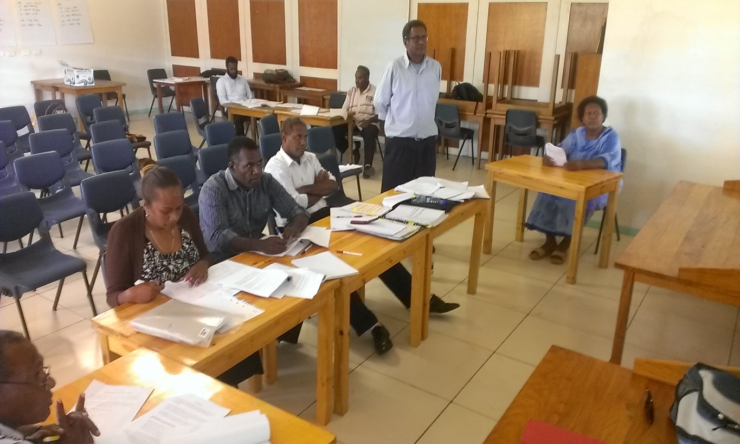
Photo: Lawyers from the sector practice their court skills during advocacy training supported by the Victorian Bar Association

Summary of Key Achievements
A summary of key achievements against intermediate outcomes for the reporting period January to June 2015 is set out in the table below:
Component 1: End-of-Program-Outcome
Networks within the VPF, justice and community services agencies influence positive change
Intermediate outcome 1.1  VPF, MJCS, the judiciary, PSO, PPO, VLC, SLO, DCS, SPD and DWA are collaborating and sharing information more effectively to progress shared goals | - HOAG meetings were held on 1 April and 24 June during the reporting period and showed a significant increase in participation and engagement than the one in December 2014 and have been held quarterly as planned during the reporting period. Agenda and attendance lists for the two meetings are attached in Annex 2  - Indications from the Sector Perception Survey (Annex 1) are that collaboration and communication is good across the sector in areas of mutual need, responsibility or benefit and is valued by the sector with desire for strengthened communications.
Intermediate outcome 1.2  VPF, MJCS, the judiciary, PSO, PPO, VLC, SLO, DCS, SPD and DWA are monitoring their progress | Monitoring  - The justice and community services sector (JCS) now has an achievable sector-wide monitoring and evaluation plan which after a significant period of consultation was presented to the HOAG and approved at the meeting on 15 December 2014. It was circulated to HOAG for comments again in January 2015. The Monitoring Officer has also increasingly sought to align indicators for the M&E Framework to core agency activities, where relevant, for the first time.  - Where feasible, agencies that can collect data on an indicator this year, will collect it and report on it in the Annual report for 2015. An example is Strategy 5: Human Rights indicator 5.2 increased alignment between domestic laws and relevant international human rights treaties. Data to service this indicator will be collected by the Vanuatu Law Commission and reported on in 2015.  - Currently the indicators set out in Annex 3 have been included in business plans of the agencies shown in that annex which provides a small baseline for what is happening in relation to the data sources that have been proposed in the JCSSS MEF but also is indicative of: (a) increasing alignment of agency business plans with the JCSSS; and (b) also increasing awareness and willingness to collect information relevant to the progress of those indicators.  Reporting  - The MJCS received 10 out of 13 Agency reports from the Sector, which was the target for this year’s annual reporting. Last year the MJCS received 8 out of 12 Annual Reports from the Sector. This year the PPO, the PSO and the Judiciary did not provide reports for submission in the MJCS annual report although summaries against these agencies indicators in the PAA and the PLAS are included in the report.  Business Planning and Budget Narrative for 2016  - Based on the verbal requirements of the PMO’s M&E Unit, the MO developed a Standard Guide on Developing Budget Narratives (which PMO approved) and sent it out to the 15 Sector agencies to support the development of Budget Narratives.  - The MJCS Finance and Monitoring staff have consulted with 14 and supported more than six agencies including, CLMO, VLC, MCC, Disability Desk, DWA and DCS in business planning and development of budget narratives.  2014 COM Decisions  - In 2014, the Ministry had 17 COM Decisions approved for implementation. A total of 52% of the 2014 COM Decisions were implemented in 2014 and will continue to be implemented in 2015.
Intermediate Outcomes 1.3:  VPF, MJCS, the Judiciary, PSO, PPO, VLC, SLO, DCS, SPD and DWA communicate more effectively and consistently with the community and the rest of the government | - Use of the MJCS website as a source of basic sector information, whilst it went down in May, increased again in June and has generally been trending upwards. From January 2015, the unique visitors to the site has been increasing from 246 in January, peaking at 531 unique visitors in April then declining to 432 visitors in May and then increasing slowly again in June 2015.  - The JCSS Newsletter was published in January 2015, March 2015 (Feb & Mar edition), April and May. The MJCS Administrative Assistant is increasingly doing this work under the oversight of the Monitoring Officer. To date, there have been 28 contributing agencies and 184 recipients of the JCSS newsletter representing 33 different agencies within the sector. Additional contributors since December 2014, include, TVET, Care International, NZ Corrections Partnership, Save the Children and Vanuatu Society for Disabled People (VSDP).  - In January 2014, the MJCS submitted an application to Scopeglobal for volunteer support for the development of a sector wide MJCS Communication Strategy. MJCS approved a candidate in early May. Whilst the Australian Volunteer program experienced significant budget cuts it is hoped that this recruitment is significantly advanced so as not to be effected. We have been informed that the likely commencement date is August 2015.
Intermediate Outcomes 1.4:  VPF, the Judiciary, PSO, PPO, SPD and SLO make coordinated reductions in delays within the formal justice system. | The focus of the support for this work to date is on strengthening and improving upon systems so that there can be an accurate understanding of timeliness across the sector (see Annex 4). Focusing on some core “justice” offices the program is tracking case visibility, clearance rates, timeliness, backlog and attendance where applicable. The definitions of those terms vary depending on the mandate of the office and there have been small improvements although the primary focus is at this point is still on ensuring reliable data. The six monthly M&E Update Report provides some definitions of these terms The achievements for this reporting period include:  - System implementation for the Courts Case Management System, which will support the Supreme, Magistrates’ and Island Courts.  - System implementation for the State Law Office for a Case Management System.  - Preparation at PPO for use of a Case Tracking System like the one at the SPD.  - Introduction of the Rapid Charge System within the police will increase efficiency of the police process.  - Finalisation of tender documents for the Police Information Management System for the VPF.  - Development by OGCIO of a database to support the DWA’s FPA piloting work.  - Development of a database for CLMO to manage its land matters.  - Preparation by Department of Corrections to make an application for a Document Management System which would be part of the OGCIO’s whole-of-government approach to document management using Saperion.  At present there are pocket s of reduction of delay (for example, time taken to draft charges at SPD; time taken to handle correspondence within SLO) but there is not yet a coordinated reduction in delay. The process requires full implementation and institutionalisation of systems and targeted management responses based on the data to reduce unnecessary delays and therefore a longer horizon.
Intermediate Outcomes 1.5:  VPF and MJCS are better able to manage their finances | Activities to support financial management have included:  - Budget Narrative Consultations for 2016 budget with Sector Agencies that sought to align indicators of the MEF to core agency activities where relevant for the first time.  - Design of a Financial Skills Assessment Tool for use across the sector to assess current capacity & financial skills as well as organisational financial management maturity to be able to implement relevant PFM Assessment recommendations.  - Review of the 2013 AusAID-funded Assessment of the law and Justice Sector and Vanuatu Police Force Public Financial Management Systems, Vanuatu, June 2013 (PFM Assessment) and recommendations are being prioritised in consultation with key stakeholders.  - A prioritisation matrix for assessing outstanding debts for VPF has been designed and implemented by CSU, VPF for their outstanding payments from 2013 to determine priority for payment in the next 6 months or for including in the budget for 2016 decisions.
Component 2: End-of-Program Outcome:
The VPF and justice and community services agencies demonstrate improved service delivery to women, children and youth.
Intermediate Outcome 2.1:  PSO, PPO, VLC, SLO and SPD develop and implement effective workforce planning and HR development strategy | - MOU between Solomon Islands IPAM and VIPAM & PSC has been approved by SLO after having been approved by the Council of Ministers during the first quarter of the year. The MOU is on track for final signing in third quarter this year. Pending agreement with all parties, next areas of capacity development support under the MOU will be:  - Training and facilitation skills development (for trainers, supervisors, manager technical specialists) (3rd quarter 2015)  - Leadership development (including funding an exchange arrangement for a VIPAM officer to spend time working with SI IPAM’s Leadership Development Unit) (3rd – 4th quarter 2015)  - Supervisor development (4th quarter 2015)  - WPL and HRM Advisers have commenced their work with first inputs completed and work plans developed to pick up on and progress initiatives in support of capacity development.  Job related skills (Level 1)  - Discussions with local provider (AMC) are underway to confirm plans for delivery of Personal Management Skills across the sector in August to October 2015  - Coaching and mentoring training is progressing supported by the WPL Adviser.  Professional/ technical sub-groups (Level 2):  - Lawyers/quasi legal:  - Completion of next stage of capacity development of lawyers and prosecutors through the “Legal Advocacy in the Criminal and Civil Jurisdictions” supported by Victorian Bar, 24-26 June, supported by CDLA, SPD and PSO Advisers. There were 32 Graduates (from 43 nominees) from SLO, PPO, PSO, SPD, Vanuatu Women’s Centre (VWC).  - The program is in initial stages of liaising with Pacific Ombudsman’s Alliance (Commonwealth Ombudsman’s office) to secure technical skills development for administrative investigations for Ombudsman’s office, Lands Ombudsman, officers at Professional Standards Unit VPF.  - Finance officers  - WPL and PFM Advisors are progressing the financial capacity development strategy, with coach training of Ministry of Finance and Economic Management (MFEM) trainers provided by WPL Adviser in May 2015.  - A process and tools to assess current 2015 capacity and financial skills and Organisational Financial Management maturity as needed to implement PFM recommendations, has been prepared for implementation to establish a capacity development strategy.  - Consultations commenced between MJCS Executive Officer, VPF Director CSU, VAPP Coordinator, PFM Adviser and SRBJ Partnership Coordinator, to prioritise recommendations of PFM Assessment and review current financial processes.  - Observation of current systems and processes and staff capacity, and associated risks for use of government systems by development partners is underway by PFM Adviser.  - The PFM Adviser as provided technical advice and informal mentoring of finance officers in VPF and MJCS to support daily management of financial and related issues.  - Human resource officers  - WPL Adviser delivered coach training to HR officers across the sector as part of their ongoing capacity development (19 graduates, 12 women, 7 men)  - A draft consolidated HR plan for sector developed, documenting key directional and priority elements has been developed for consultation.  - HRO networking operates within the sector as well as across the public service, and arrangements are being made for energizing HRO meetings at both levels through a focus on identified HR issues e.g. HR Planning in sector, HR strategy for public service.  - Consultations conducted with key stakeholders on salary review project expectations and planning and to develop and explore methodology for legal salary review, and assist information gathering.  - Support provided and planned for VPF PGO and HR Procedures Review process  - Work underway with key counterparts on initial capacity building.  Level 3: Agency:  - Development of leadership capacity through finalisation of the design and implementation of the Women in Leadership Mentoring program. Approval to proceed was granted by HOAG on 24 June. Initial training of around 90 women to be completed in July, with additional training to be provided to additional women in August.  - Agreement secured for PPO to be the next agency to be supported through team-based institutional strengthening. To be progressed in third quarter 2015 when it is anticipated that the new Public Prosecutor will be appointed.  Level 4: Cross sector:  - Support provided for JCSSS review process undertaken with MJCS to assess and recommend next steps for implementation of 8 sector strategies. Review results were subsequently presented to HOAG in June by DG where there was agreement that MJCS should provide a discussion paper with recommendations for each strategy for consideration, comment and approval by the HOAG.
Intermediate Outcome 2.2:  Women's professional participation in the JCSS and VPF is enhanced | - The draft consolidated Human Resources plan for the sector will take into account supporting and enhancing the professional participation of women in the sector.  - Women in Leadership Mentoring Program will support the capacity development of women in their various roles to enhance women’s participation in leadership across the sector.  - The program has been supporting the VPF WAN to develop a detailed activity plan to be endorsed by Acting Commissioner of Police. The activity plan forms the basis of development support to be offered in PJSPV to develop capacity in key areas of need, and enhance the participation of women in a broader range of policing and leadership roles, including community policing.  - The program has just had an evaluation of its support for enhancing the professional participation of women in the police force. The evaluation report is expected to be completed after this reporting period, likely August 2015. The evaluation is likely to have some clear areas where VAPP and SRBJ support can be focused to enhance female participation in the VPF.
Intermediate Outcome 2.6:  Work systems and practices in targeted agencies are strengthened and contribute to demonstrable improvements in service delivery | Systems improvement for service delivery  - Stage 1 assessment (Mid 2014) and repeat assessment Jan 2015 of CDMA (see Annex 4) provides good overview of capacity for systems to currently support enhanced service delivery.  PSO  - A new lawyer was recruited in the Port Vila office, bringing the total number of PSO lawyers to 11. This is the highest number of lawyers ever employed by PSO. The new lawyer is both female and francophone, so there are now 8 male lawyers and 3 female lawyers. The new lawyers are always inducted with and share the office with the adviser.  - PSO Adviser has continued to assist legal officers with files and legal issues as they arise, including preparing written advices and observing court cases; preparing and presenting training sessions on legal topics, with materials distributed to provincial lawyers; and has also supported training opportunities including Victorian Bar Legal Advocacy Course in country training, including developing materials for the civil component of that course.  - Competence of PSO lawyers continues to improve as demonstrated by:  - PSO Court of Appeal work was again impressive during the reporting period and there were some good ‘wins’ in other Supreme Court cases.  - A senior counterpart prepared the first draft of her submissions for Court of Appeal. In previous appeals the adviser had prepared the first draft of appeal submissions for this lawyer. The appeal was successful and the Court adopted the submissions made by the PSO lawyer.  - Junior lawyers have conducted several major SC trials during the reporting period and achieved success in several important civil cases.  - In one Supreme Court case, the adviser encouraged a PSO lawyer to successfully investigate an alibi defence for a woman charged with the homicide of a baby. Two alibi witnesses were located overseas. Witness statements and photographic evidence were obtained which established the innocence of the client. An expert medical report was also obtained which suggested the baby died of natural causes, and was not in fact murdered. The homicide charge was eventually withdrawn.  - Systems and processes: during the reporting period the Public Solicitor agreed to the PSO dealing with the large number of open but dormant files for the first time which will allow the office, once complete, to have a much better understanding of its workload, carriage by lawyer and throughput.  - The PSO has around 3000 open files and these are now being individually reviewed with a view to closing old files. In February 2015 there were 834 open criminal files. This number has been reduced to 748. It is expected that the final number of open criminal files should be less than 500, and this should be achieved in the next reporting period. There has been good collaboration with the CDMA on this work and it is hoped that Court master lists will greatly assist with the closure of PSO files over the next 12 months. There seems to be a genuine awareness and support for this work which is a substantial change in the attitude of the lawyers in large part a result of the existing relationship of trust in the adviser.  - An amended retainer agreement with clients will mitigate against having this build-up of dormant files as lawyers will be able to close files opened in 2015 and beyond without notifying clients where the client fails to contact the office for six months or more.  SPD  - The Adviser has continued to provide support and encouragement to the OIC of SPD to focus on service delivery; continued mentoring, guidance and in-house training for staff within the SPD in Port Vila and the provinces on litigation, case management and investigative matters; as well as implementation of the SPD Domestic Violence and Juvenile Justice Policy which is included in the State Prosecutors Manual. With an increased emphasis on individual mentoring he is having greater impact in the view of the Adviser with better two-way discussion on challenging issues.  - Support has also been provided for closer collaboration with the PPO and some assistance to junior prosecutors within that office.  - Competence and service delivery: During 2014 it took approximately 67 days to draft charge/s for 75% of cases. In the first half of 2015 it took approximately 36 days to draft charge/s for 75% of cases (Source, SPCTS 22/6/2015). This represents a significant reduction in the time it takes from when a file has been delivered to the SPD, for the matter to be ready for prosecution for those files that have been entered into the system. The OIC is currently working closely with the Chief Magistrate to reduce the Preliminary Inquiry backlog.  - Systems and processes: Developed a “Remand Check List” in conjunction with the former AFP investigators adviser and the OIC of SPD. The check list provides a step-by-step process that should be followed by investigators before they make a decision to remand an offender. This initiative should increase the chances of a successful prosecution at court and also reduce the number of instances where an offender can claim to have been unlawfully imprisoned by police, reducing the possibility of civil action being initiated against the state for this type of occurrence.  LSIP  - In the period of January to June 2015, the LSIP has reached its 2nd year of being in operation, and this has meant that four intakes of Law Student Interns have been conducted and completed, allowing 60 Law Students Interns to complete the Program. Of these 60 Law Student Interns, about a quarter who are Ni-Vanuatu have graduated and have entered into the work force and employed in either government law offices, private law firms, statutory bodies and also civil society organisations.  - LSIP has helped make law graduates from USP more visible to employers and institutions in the sector. LSIP is definitely a pathway between a tertiary institution and the sector. This pathway never existed formally in the past and the advent of LSIP has been welcomed by institutions in the sector.  - The perception of the interns is that the placement has improved their ability to perform their roles effectively.  - .
Component 3: End-of-Program-Outcomes:
- The VPF and justice and community services agencies use evidence to support improved responses to the needs of women, children, and youth
- The VPF and justice and community services agencies implement targeted initiatives that deliver better services to women, children, and youth
Intermediate Outcome 3.1:  Decisions about appropriate interface between police, formal justice and kastom, in relation to working with women, children and youth, informed by evidence based research. | Malekula Research and Pilot  - The research instruments are nearly complete and are broader in scope than originally anticipated. The research instruments consist of household survey questionnaire with over 150 questions that will be administered to more than 750 randomly selected women and men on Malekula; focus group guides that will be administered to approximately 6 to 10 groups of women and men on Malekula. As well a nearly 200 question survey will be administered to between 50 and 75 chiefs and community leaders involved in managing conflict at the community level. Focus groups will also be held with 6 to 10 groups of chiefs and community leaders. In the formal justice sector, key individuals will also be interviewed using semi-structured interviews (Magistrate, some Island Court Justices, State Prosecutor/s) and there is a dedicated survey instrument for police as well (police at Lakatoro, Lamap, and Southwest Bay will be interviewed). In addition to this, case mapping will be carried out with between 6 to 10 women in Malekula, to help to provide more nuanced case study style information. These research instruments have been shared strategically with stakeholders across the sector (for comments and input), and have also been shared with a researcher at the Australian National University.  - The Vanuatu National Statistics Office has supported the proportionate random sampling process for Malekula and Blacksands. On Malekula 38 villages will be visited with 10 women, 10 men and two community leaders interviewed in each. Individuals at the village level will be identified through a process of random selection as well. In Blacksands, between 500 and 600 youth (half male, half female) will be interviewed between the ages of 15 to 25. The Malekula research will be carried out in a three to four week period, over two trips in the last two weeks of July and the first two weeks of August. The Blacksands research will be completed over the last two weeks of August.  - A team of ten researchers (six women and four men) have been selected for Malekula, including two of the Legal Researchers from the Vanuatu Law Commission a staff member from CARE and two affiliates of the Vanuatu Women’s Centre. Six to eight of these researchers will help to carry out the Blacksands research, which will take place after the Malekula research.  DWA FPA Pilot  - The community of Paunangisu in North Efate was mapped in February and March, and interviews held with a variety of community members and leaders. Two potential APs were selected – one man and one woman. Unfortunately the chief did not initially agree to endorse one of the two APs (the woman), and we were in the process of returning to the community for further discussions with the chief when Cyclone Pam struck.  - Two DWA staff and the TA travelled to Santo for one week in April. In Santo the process for selection of APs was different in that existing networks were used to identify potential APs. Three areas were selected for AP piloting based on advice from local partners such as the FPU, and areas where there were existing resources. A potential Registered Counsellor was also identified in South Santo.  - On the Santo trip in particular a number of potential challenges and issues were identified relating to the complexity of the role of AP, and the need for much more careful training and a very well thought through handbook.  VLC  - The program was asked to continue to fund two senior legal researcher posts for VLC and the Partnership Management Group (PMG) agreed to do so on certain conditions which have not been completed. However, VLC did provide its first ever progress report to the program covering the period 2012 to 2015 (attached in Annex 5) as required and is now working with the CDLA to develop an approach for more sustainable capacity development for that institution which was another condition for further funding.  - VLC has been continuing to produce review papers on a number of key areas; a number of which have now been tabled in parliament. In 2014 The Water Supply Bill and Water Resources Management Bill were tabled in parliament. Recently the 2015 Dangerous Drugs Act was tabled before parliament  - In 2013 the VLC with the use of assistance of interns developed a database of outdated laws of Vanuatu that require review.  - VLC is focusing on ways to strengthened its financial independence including requiring line agencies to pay for reports. Development partners and GoV should encourage relevant TA to work with the VLC whenever possible rather than with line agencies if drafting legislation or legislative policy.
Intermediate Outcome 3.2:  Government and non-government partners are supported to implement agreed programming on child protection | - SRBJ provides a significant grant to Save the Children Vanuatu (SCV) to implement its Child Protection Program in support of the GoV priorities working with GoV, communities and key stakeholders. SCV provides a separate report for that program which is attached in Annex 6. It should be noted that the Child Protection Program was halted for 10 weeks (11 March till 19 May) by agreement whilst SCV provided significant support to the immediate humanitarian needs of children in Vanuatu after the impact of Cyclone Pam. This naturally has resulted in delay in the achievement of progress on the Child Protection Program and a revision of the dates for key milestones.  - The Highlights in brief of that program over the reporting period include:  - Development of an implementation plan, M&E mechanism and review of a risk matrix  - Selection of the pilot communities in Santo and Ambae for the implementation of the Child Protection Pilots  - Completion of a community mapping exercise and a KAP survey in the four target communities  - Meetings with relevant partners to coordinate activities and planning  - Support for the GoV Child Desk Officer to effectively coordinate regular meetings  - Support to the NCPWG to finalise a terms of reference and a workplan.  - Some of the learning and tools developed in the post Cyclone humanitarian phase may be relevant for use in the Child Protection Program
Intermediate Outcome 3.3 (a)  The network of institutions and practices supporting women experiencing family violence is extended and strengthened. | DWA Pilot  - While the preparations are complete for a National Family Protection Task Force meeting it has not yet been organised by DWA.  - Communities in North Efate and in Santo have been visited, and meetings have been held with stakeholders in every location.  - There seems to be consistent support for the role of the AP at community level (to the extent that people can fully understand the potential offered by the position) and a clearly identified need. As well, the need for stronger collaboration and support from key partners has become even clearer through the selection of potential APs on Santo.  - This learning will inform all that is done going forward, and hopefully stakeholders such as the VWC, Local Area Councils, and the VPF will play an even greater role in the piloting as a result.
Intermediate Outcome 3.3 (b)  Targeted justice sector agencies as well as local level actors are responding more effectively and consistently to women experiencing family violence | DWA Pilot  - The implementation of the pilot will continually seek to identify possibilities for engaging in closer, more collaborative partnerships with other key stakeholders – including VWC - and progressing these relationships.
Intermediate Outcomes 3.4: Targeted justice sector agencies and the Blacksands community representatives respond more effectively, appropriately and collaboratively to juvenile justice issues in the pilot location | None yet.
Table B: Summary of Key Achievements

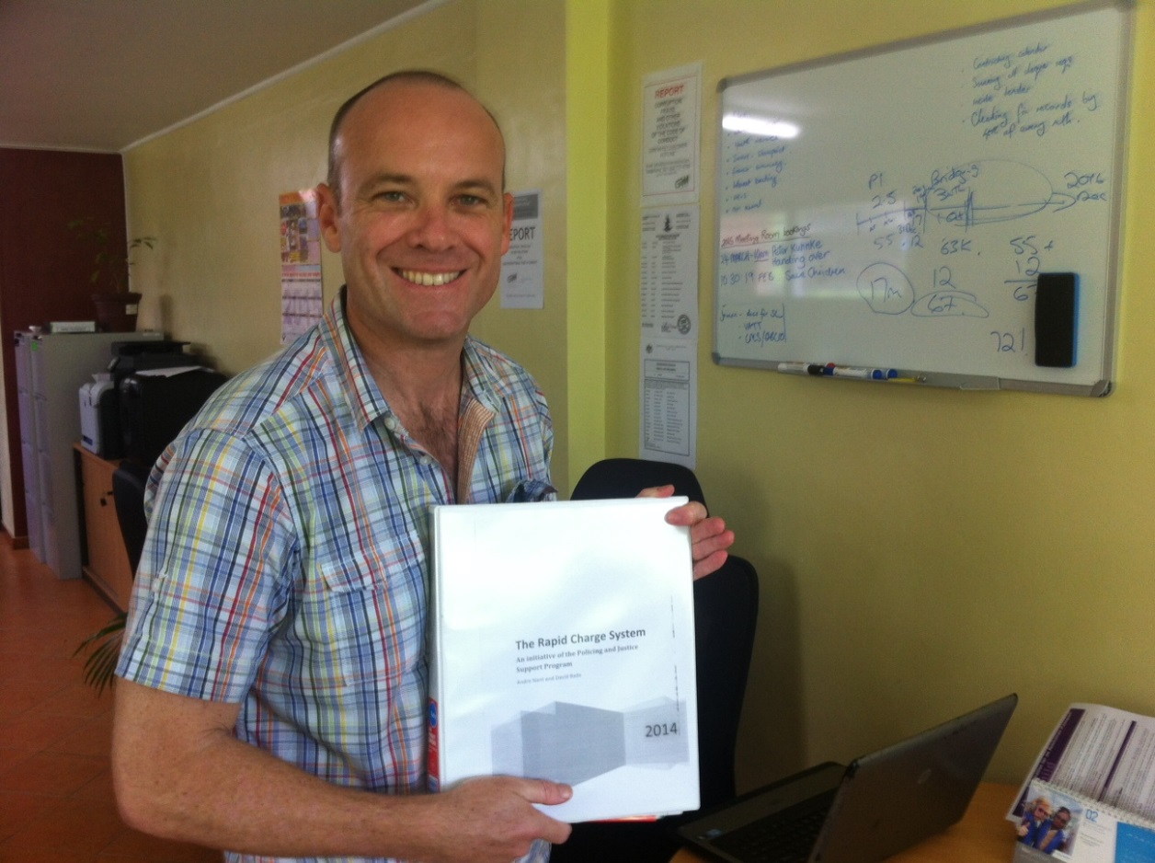
Photo: SPD Adviser David Bade displays training materials relating to the newly developed Rapid Charge System, an initiative which involved both VAPP and Stretem Rod Blong Jastis Advisers working closely together.

Key factors that account for the degree of progress towards outcomes
The key factors below are those that have directly impacted on the delivery of the program rather than those broader contextual factors outlined in section 1 that are part of the overall operating environment.
Key factors to which the program attributed the level of progress for the first six months were noted in the previous progress report to end of December and are repeated in brief below as they continue you to be pertinent to the progress:

Enabling
- Strength of the Team.
- Relationships with counterparts across the sector, Department of Foreign Affairs and Trade, Australia (DFAT) and other development partners.
- Flexibility and responsiveness: A close management relationship with DFAT and collocation of strategic resources and individuals across the sector has allowed the program to respond to dynamic circumstances and in some instances to take advantage of opportunities and evidence of local momentum for change.
- Continuation: Stage 2 of SRBJ generally represents a continuation, consolidation and refinement of the direction of many of the initiatives in Stage 1 of the program. The nature of the program is now well understood and supported by counterparts across the sector in Port Vila. This was something noted by one of the new short term advisers, “development of good will and trust over the preceding years by SRBJ and advisers. This has definitely laid fertile ground on which to work.”
- Leadership: The support and drive of some leaders has assisted in the maintenance of the momentum of initiatives within the program.
- Responding to a key practical need: Where interventions respond to a clear practical need and fill an existing vacuum this has contributed to robust up take of an initiative; for example the Monitoring Officer’s support for reporting and monitoring; the CDMA’s support for incremental improvements across the sector
- Demonstrable small benefits have maintained support for initiatives such as the systems improvements but also the support for planning, budget narratives and reporting.
- Enthusiasm: Junior and intermediate lawyers have been enthusiastic in seeking advice from advisers. This has continued with increased participation in the Legal Advocacy Course in June 2015 since December 2014.
- External reinforcement: Both the SPD and PSO advisers noted the benefit of having external respected reinforcement of their advice through the advocacy skills training that was provided by the Victorian Bar.
- Government momentum and support in some key areas.
- Strengthened monitoring and evaluation support to the program and to the sector has continued over this reporting period with the implementation of a number of key evaluative pieces including; the Grants Review (Annex 7 which is discussed in more detail in section 5(f)); the Sector Perception Survey (Annex 1 discussed in more detail in section 2(b)); Law Student Internship Program Desk Review; and the commencement, but not completion, of an evaluation of women’s professional participation in the VPF.
- Good coordination of interventions: Working and thinking systemically, and acknowledging that many different development activities that are well coordinated and integrated yield improvements. For example, the Victorian Bar Legal Advocacy Course which was stronger and more relevant than the course delivered in December last year. This requires significant investment of management time and the cooperation of the team.

New enabling factors over this report period

- Capacity of the Public Prosecutor’s Office has increased slightly with the appointment of a new acting Public Prosecutor that has resulted in strengthened and more effective collaboration with SPD and police as well as greater progress with file management in the PPO over this reporting period. A new female prosecutor has been appointed and there may be an opportunity for the SPD Adviser to provide some additional technical support to her. Technical legal skills and office management within that office still require significant support. This represents a slight shift within an agency whose capacity otherwise remains extremely low which impacts on the sector beyond that agency.

- Express willingness by the Public Solicitor to embrace incremental systems change within the PSO which has allowed significant progress in this area during the reporting period.
- The integration of the two subprograms (SRBJ and VAPP) has allowed for greater accessibility of the civilian advisers to the VPF since the commencement of Stage 2 and this has only increased since the last reporting period with growing capacity development, human resource development, public financial management and monitoring and evaluation support to the VPF over this period.
- During this reporting period an entirely new VAPP team has been appointed by AFP to manage the program. The team is more effectively managed and works more collaboratively and positively with SRBJ across the entire spectrum of the program’s interventions. This represents an opportunity for the integrated Policing and Justice Support Program in strengthening its potential outcome at the end of the program. It has been noted by advisers across the program in areas of management, monitoring and evaluation, capacity development, case and data management, finance and the thematic work related to women, children and youth.
- The re-opening of the Law Clinic and the recruitment of a Director for the Law Clinic provides a key opportunity for progressing the integration of the LSIP with the Law Clinic as one component for the assessment of that course. This will have a significant impact on the ongoing sustainability of the program. It is hoped that this will be trialled in the second semester of 2015.

Key factors identified in January 2015 that inhibited progress over the first six months of the program are noted and updated below to the extent that they are continuing:

Inhibiting
- MJCS capacity is low and it remains unable to fulfil expectations with respect to service delivery to the sector. Its manner of operating at all levels is responsive rather than proactive or strategic. Recruitment processes in which there is shared interest with the program have not best practice and have been very slow.
- DWA capacity to drive the implementation of the FPA pilots remains low and is further hampered by the lack of collaboration over the reporting period of key implementing partners such the Vanuatu Women’s Centre (VWC) on the implementation of those pilots at the national level.
- Political fluidity, whilst part of the overall context, also has a significant direct impact on the priorities of the program that have been agreed with the GoV. The expansion of the permitted number of Ministerial staff without a corresponding increase in the budget means that the entire cabinet budget for MJCS is committed to payroll and any other activities of the Minister or his staff, official or non-official, are sought with varying degrees of pressure from the corporate or other areas of the MJCS budget. This results in a significant impost on the capacity of the MJCS to fulfil its mandate to the sector and the community as well as limiting its ability to comply with the approved budget. In the period post Cyclone Pam, with all of the significant additional burdens on GoV as a result, the then Minister and two others spent two weeks in Thailand ostensibly visiting that United Development Bank of the Pacific which was opening an office there.
In addition, at times the influence of Ministers is in direct opposition to aspects of the program development in partnership with the MJCS to strengthen the sector such as supporting the MJCS to strengthen the PPO.
- Challenges working with GoV: Working closely with government poses its own challenges in terms of the human resources and capacity as well as financial resources. This has been a factor this reporting period particularly with respect to the MJCS and DWA.
- Lack of direction for the JCSSS: the program has provided updates, suggestions and papers with respect to the status of each of the strategies under the JCSSS as well as information regarding activities that have been undertaken across the sector that are aligned with those strategies. A key part of SRBJ’s support to the sector relates to supporting the JCSSS by whatever mechanism the GoV partners determine is most effective for them at this juncture. Proposals provided to the HOAG for the way forward for each strategy by the MJCS were at times unclear, top-down, and experienced as non-consultative. Consequently, it was agreed at the most recent HOAG that the MJCS should provide a discussion paper to the HOAG outlining the status and recommended approach for each sector strategy for consideration, comment and approval by the HOAG.
- Capacity of the Magistrates’ Court: There has been little change in the capacity of the Magistrates’ Court and still little success by the program in the provision of any significant support to the Magistracy. This is a result of the Chief Justice’s desire to prioritise the superior court within the Judiciary. Given the focus of the program on enhancing outcomes for women, children and youth and the fact that 80% of criminal matters within the formal system are dealt with by the Magistrates’ Court, this is disappointing. The program has approved small post Pam assistance to the Magistrates’ Court, continues to support Case and Data Management in that court and does receive some participants from the Magistrates’ Court for cross sector capacity development opportunities, however there has been no other support specifically targeted at that court.
The first plea date for the Magistrates’ Court this year was scheduled very late; for March and then as a consequence of Cyclone Pam was postponed until April. This resulted in significant backlog at SPD.
An additional inhibiting factors that has been noted over this reporting period is:
- Challenge of translating new systems into service delivery outcomes: the program is making significant investment in the improvement of case and data management across the sector as well as in systems procurement. The intention of this support is to provide information and understanding that will contribute to improvements in case visibility, timeliness, clearance rates, reduction in unacceptable backlog and attendance rates. It is also intended that improved case and data management and systems will trigger improvements in the monitoring and evaluation of progress for managers.
There is a reaction and acknowledgment by managers or heads of agencies when data reveals low clearance rates; workload or pending imbalances but so far this has not been significantly translated into improved timeliness or changes in approaches to work to actively target the concern. It is hoped that this will increasingly occur over the life of the program with encouragement and support. The question of “why this has not happened” has not been asked in all cases as yet, although some areas where timeliness should be enhanced pose significant challenges for the justice sector. For example, it is clear to the judiciary that significant resources and time are wasted as a result of the number of adjournments of cases before they are finally disposed of by the courts. While the courts certainly have a role to play in reducing the number of adjournments, the courts capacity to do this is significantly hampered by the fact that the legal profession are relatively unregulated in Vanuatu. The question has not been asked more across the board as the program is still focusing on the implementation of systems and the improvement of the quality of data so that it can be relied on to make management decisions of this type.
For example, there is a need to do a file stocktake and improve the accuracy of data within the SPD’s Tracking System but this has not significantly progressed. The staff claim that there are insufficient computers but there is also no accountability for completion of this work and as a consequence seems not to be prioritised.
- Implementation of policy and implementation planning support to the Child Desk has been delayed over a year since it was first approved by the PMG under a grant. The grant funds advisory support for the development of a child protection policy and national child policy for the Child Desk. This has been delayed for a number of reasons including on the basis of workload of the previous Child Desk Officer; other priorities of that officer; and then recruitment of a Child Desk officer to fulfil that role whilst the previous incumbent goes overseas on scholarship. MJCS has now contracted a staff member to the Child Desk Officer role and will be receiving support from SCV and UNICEF for staffing. The program is informed that the MJCS is now in a position to progress this assistance and that there will be three officers at the MJCS to work with the adviser. This work is intended to provide direction to GoV and NGOs operating in this field.
Systemic issues within the legal sector that hamper service delivery improvements identified last progress report in the main continue. With additional comments, these issues include:
- A practice has arisen within the legal profession for numerous attendances (usually conferences) and adjournments of court cases which increase delay and cost for users. The courts conducted an adjournment survey over the beginning of the year which supported anecdotal evidence of numerous attendances by parties to conclude cases. The number of results collected did not make the survey extremely reliable for the Magistrates’ Court but for the Supreme Court it was considered sufficient to provide a baseline. The courts are currently considering if they would like to redo the survey and thereafter access assistance from other courts (such as the Federal Court of Australia) in strengthening their approach to judicial management of cases.
- Continued delay in the admission to practice of lawyers within the public offices. This can sometimes take up to three years.
- An ineffective law society, which means that there is no provision or oversight of continuing legal education. Over the reporting period this has deteriorated further with the resignation and non-replacement of the President of the Law Society. The program is not aware of any activities that have been conducted for the benefit of the legal profession over the reporting period by the Law Society;
- Little or no disciplinary action taken with respect to unethical or fraudulent behaviour of the legal profession.
- Significant numbers of prosecutions that do not proceed for want of prosecution or as a result of dismissal in the Magistrates’ Court, which requires further investigation.
- There is some early evidence of the practice of light sentencing in domestic violence cases and sexual assaults by a number of judicial officers.

- Ongoing concerns about equity, impartiality and interference in decisions about recruitment, and access to development and promotional opportunities.

Implications for achieving end-of-program-outcomes
The key inhibiting factors outlined in section 2c) above are unlikely at this stage to prevent the achievement of the end-of-program-outcomes but they do certainly have the potential to impact on the speed of progress to the end of program outcomes and level of achievement by end of 2016. That is, there may be improvements in service to women, children and youth but the gains may be greater if some of the inhibiting factors could be reduced, mitigated or removed.
Similarly delay identified in section 4a in the progress of the delivery of outputs against the Workplan are at this stage not likely to delay progress towards achieving interim or end-of-program outcomes although interventions in component 3 may not be as advanced as hoped by the end of the program.

Variations to Workplan
The three most significant changes to the nature of the key activities proposed in the PJSPV SRBJ 18-month Workplan July 2014 to December 2015 (the Workplan) are listed below. These variations during this reporting period, made with the approval of DFAT, result from a recognition that a mechanism is not effective in driving progress; greater understanding of need and sustainability requirements; and the expansion of scope of an intervention and delay in preparation.

Support for the JCSSS working groups
Under the Workplan it was intended that integrated support be provided to the JCSSS Working Groups (including technical, secretariat, facilitative, research and capacity development with the ability for working groups to access technical assistance of the SRBJ team as needed). The lack of momentum around the working groups mechanism to support the implementation of the JCSSS requires a reconsideration of the mechanism. There has been no clear direction provided by sector leaders in this regard yet.
The first half of 2015 was to have been used to develop an approach for advancing the JCSSS that has clear MJCS and HOAG support and ownership.
At the HOAG meeting in December 2014 the issue of the progress of the JCSSS was raised but without clarity or resolution. Since then Cyclone Pam meant that key counterparts were occupied with other priorities and there has been some further delay. Program, MJCS and DFAT staff spent some significant time re-assessing inherent progress across the sector and developing possible ways forward for each strategy that could be put to the HOAG for consultation and ultimately approval. The possible ways forward were not presented to the HOAG in the way that was in line with what was previously discussed, and an agreed way forward was not approved at the June HOAG meeting.
In the last progress report, SRBJ observed that it may be more appropriate given where the agencies are currently focusing their energy and attention, to drive the strategies at an institutional level; that is, that the sector agree a shared plan for each strategy but that activities intended to support that strategy fall within the responsibilities of individual agencies’ business plans to drive and support in situations where there is not already an effective mechanism to support the particular strategy.
This was discussed at the last HOAG in June and left for further consideration. So at this time there is still no clear agreed direction for the implementation of the strategies and therefore no clear direction for the nature of program support to this work. It was suggested and agreed that the MJCS would provide a discussion paper with a proposed way forward for each strategy to the HOAG so that they could be considered, commented on and approved. This will be developed prior to the next HOAG meeting in September.
There has been progress made across the sector with respect to each of the eight strategies despite the fact that the working group mechanisms were not used. This progress can be harnessed to good effect with achievable plans for progress to end of 2016. At this stage the program assesses that effective outcomes can be achieved for half or more of the strategies over the remainder of the program.

Recruitment of a case and data management counterpart
Whilst recruitment of a counterpart for the CDMA was not in the original design for SRBJ, the necessity for this position became apparent during the first six months of Stage 2 of SRBJ. The justification for this position is twofold: first to ensure that there is local skill and expertise for systems implementation based on the requirements of the sector; and second, given the intensive period of implementation of new systems over the remainder of the program, to ensure progress between the in-country visits of the CDMA.
During this reporting period the program advertised twice for a local counterpart to work with the CDMA. The position was advertised and after the second round of advertisements there were six candidates, one of whom was the MJCS Monitoring Officer who was interested in integrating this work with her monitoring responsibilities.
After exploring the feasibility of this approach both with the CDMA (in terms of timing of Monitoring Officer’s availability and support) and with the Monitoring Officer (in terms of her workload), the program made a recommendation to the PMG that the program proceed on this basis. The synergy between the monitoring work and the data is persuasive, as was the sustainability of having this responsibility housed on a more permanent basis within the MJCS to support the sector in systems reform. It should be noted that the lack of a local support person for systems within the justice and community services sector is a marked difference from other sectors such as health and education. The feasibility of this approach will be tested on the return of the Monitoring Officer from her maternity leave.
This issue has been resolved in a stronger way than anticipated during this reporting period whilst there has been some delay in identifying the proposed incumbent, it will greatly assist the implementation of the Case and Data Management Roadmap for the sector.

Research for the Malekula and Blacksands pilots, Component 3
There has been some delay in the commencement of the research intended to underpin the piloting work in Malekula and Blacksands.
The delay has resulted from:
  - The provision of support to the DWA with respect to its Family Protection Act 2008 pilots which had not previously been planned for and delayed the commencement of detailed planning for the Malekula and Blacksands research and pilots as anticipated by several months.
  - The increased scope of the research work from an intensive piece in three locales (as was intended at the time of the drafting of the original design in 2013) to a larger, Malekula wide research mapping how conflicts are currently managed across all avenues with a more intensive investigation of disputes that relate to violence against women.
  - Thereafter it made sense for the research in Blacksands to follow the same methodology as that of Malekula but with a more intensive investigation of issues concerning youth, conflict and access to justice. Thus the two pieces are related and Blacksands will follow sequentially after the Malekula work.
  - The research approach is based on that of a World Bank funded piece of research in Solomon Islands for the Justice for the Poor program called, “Justice Delivered Locally” and some of the propositions posed in Miranda Forsyth’s article, “Spinning the Conflict Management Web in Vanuatu”. SRBJ intended to use the research instruments of the World Bank as a starting place for the development of appropriate instruments for Vanuatu given good development practice of not reinventing something that has already been developed. After a long period of seeking copies of those instruments from current and former staff and researchers in New York, Vanuatu, Solomon Islands, Canberra and Sydney it came clear that they did not exist. This resulted in some delay.
  - As a consequence the adviser developed the instruments for this piece of research based on a number of other relevant instruments but drawing from and adapting them. This work was therefore more time-consuming than anticipated.
  - Cyclone Pam caused some delay on progress as did some unexpected personal leave taken by the adviser.
  - Identification and recruitment of researchers to participate in both pieces given the expanded scope of both research pieces added to the time taken.
It is anticipated that the research results will be of more widespread interest and benefit across the sector than those in the design of the program and additionally more scale-able. Both pieces will be completed in September of this year which will allow for the planning and implementation of interventions for a year of the program if not slightly more. This delay may mean that the outcome of those interventions will not have progressed as far as anticipated and achievement of any change will be nascent but the advantage is that the research will have a broader base for future use by stakeholders.

Update on minor delays from last reporting period

Minor delays in the delivery of outputs listed in the last progress report which have been progressed as anticipated over this reporting period are set out in Annex 8 with comments on their current status.

Minor delays this reporting period

Minor delays in the delivery of outputs against the Workplan for this reporting period include:

- Institutional strengthening of MJCS delayed as a result of slow recruitment of positions to the MJCS and delay in recruitment of TA.
- Delay in the Gender Implementation workshop with the PJSPV team.
- Implementation of the SCV Child Protection Program has been delayed about three months overall (due in part to Cyclone Pam but also other factors).
- Difficulties in confirming arrangements with a local provider for learning and development services under Level 1, job-related skills development under the JCSS Capacity Development Strategy.
- Delays in implementation of planned legal practice mentoring (proposed to pilot in SLO), while options are explored including possible support through Victorian Bar.

Gender

Gender Strategy
The Gender Strategy for the program has been finalised and approved (Annex 9). The Gender Strategy is intended to be very practical and focused on this specific program. It provides some general principles for gender sensitive development aid; guidance for implementation and practical checklists for the key areas of intervention by the program.

Ways in which the program has contributed to gender equality or empowerment
The program has supported gender in the following ways over the reporting period:
- Supporting the DWA with respect to the piloting of Authorised Persons and Registered Counsellors under the Family Protection Act 2008 in selected sites. The program at the request of the DWA assisted in mapping communities; reporting on the findings of the mapping; developing an appropriate approach for identification of people for these positions. Supporting an effective mechanism for strengthening the protection of women when experiencing family violence would be significant in the context of Vanuatu.
- Supporting a female MJCS colleague to learn how to maintain the MJCS website and support her continuing role in this work. It is also proposed that when the communications volunteer arrives she will work closely with this officer.
- The MJCS newsletter has allowed the VWC to provide monthly news regarding their ongoing work through an easily accessible mechanism to the justice and community services sector.
- Significant PSO continuing legal education is being provided to the (now) three female lawyers in that office and it is they who seek advice most of the nine lawyers at the PSO. The most recently recruited lawyer for the PSO is a woman and shares an office with the adviser to ensure good skills support at the start of her recruitment to the office.
- A substantial proportion of the PSO case load provides support to female clients in the areas of child maintenance, divorce and employment.
- Providing better statistical information to analyse cases that are relevant to gender inequality (although it currently remains a very manual process across the formal sector). The CDMA is proposing to have a meeting with key stakeholders to determine with clarity what information would be of benefit to those stakeholder in an effort to support their availability in the next reporting period.
- Facilitating a collaborative design process for the Women in Leadership Mentoring Program. The mentoring program has been approved by the HOAG will be launched in July, but the design engaged a sub-group of women from across the sector to develop the structure and principles that will guide the way the mentoring program works. It will be open to all women across the sector.
- Continuing support to the Women’s Advisory Network (WAN) of the VPF to develop a plan for the implementation of their two key strategic priorities (being increasing access to human resource development and increasing participation in community policing). The evaluation into the participation of women in the VPF will also provide recommendations for the PJSPV for strengthening the participation of women in the VPF. It is anticipated that the evaluation report will be finalised in late July or early August.
- A significant proportion of the on the job training and provision of technical advice for public financial management has been conducted with the women in the financial roles in the MJCS, agencies and the VPF, Corporate Services Unit (CSU). As a female adviser, there have been some advantages in gaining trust and building relationships, especially in the male dominated area of VPF
- Support for the development of the National Gender Policy for the DWA and GoV which is progressing slowly towards finalisation. The M&E needed to monitor workplans that fall under the strategy was also supported by SRBJ.
- Encouragement by the program of a gender balance in recruitment as an approach to more effective service delivery including of legal services.

Strengthening gender
Pursuant to the development of the Gender Strategy for the PJSPV, the team has been collaborating on the development of a Gender Implementation Plan as a way to strengthen the gender awareness and support across the program in a more proactive and programmatic way. The Implementation Plan is in draft (see Annex 10) and it was intended that the first team workshop to support the commencement of the Implementation Plan would be in May of this year.
There has been delay with its implementation as a result of Cyclone Pam and general workload, whilst as noted above there has been cross program support for women offered by the program. It is proposed that the next team meeting, which will commence the Gender Implementation Plan more formally, will be at the beginning of August.
The previous progress report for July-Dec 2014 listed ways in which the program could strengthen its support for women, in addition to already programmed interventions. These have almost all been progressed, as shown in the updates of Annex 11.

Areas of strategic focus for this reporting period
Areas forecast for management and strategic focus over the this reporting period were:
- Strengthening the program’s mainstreaming of gender across program management and implementation. This will be achieved through embedding of the PJSPV Gender Strategy; identification of strengthened support for gender that can be provided in each area of practice and the development of consistent understanding and clear messaging with respect to gender in the context of Vanuatu. Advisers are more overtly identifying ways in which to strengthen support for gender in all their areas of work, as can be seen from Annex 11. However, this needs to be harnessed, supported and more strategically reinforced with programmatic implementation of the Gender Implementation Plan over the next reporting period.
- Strengthening the focus on institutional systems, processes, management and administration to increasingly embed capacity development and strengthen the sustainability of outcomes, particularly with respect to SPD and PSO where there has been significant investment in capacity by the program. Good progress has been made in the PSO over this reporting period with a slowdown in progress at the SPD.
- Continuing cognisance of the necessity of preserving sufficient resourcing for component 3 initiatives. This is required to preserve the strategic vision of the design of the program and was clearly articulated in the SRBJ Draft design. There has been an increase in the investment in component 3 over this reporting period which is likely to continue to the end of the program as implementation escalates.
- Strengthen the links between the sector Monitoring Officers (MJCS and VPF) and the M&E Unit, PMO through involvement in the M&E capacity development initiatives for the sector to strengthen the sustainability and consistency of messaging and requirements with respect to M&E.
The MJCS has requested approval for closer collaboration with the PMO’s Monitoring Officer who primarily liaises with the Justice and Community Services Sector. This has been very positively received by the Head of DSSPAC and has paved the way for closer work by the two offices. It is the intention of the program to include that officer in capacity development initiatives, where possible, and to strengthen collaboration around key deliverables required by the PMO. This has progressed well over the reporting period with the PMO adopting a reporting template developed by the MJCS Monitoring Officer. Links between the MJCS and VPF officers have not yet been strongly developed as the VPF Monitoring Officer has only recently been appointed and the MJCS Monitoring Officer is now on maternity leave. The PJSPV Monitoring and Evaluation Adviser has been providing significant support to the VPF Monitoring Officer since appointment during this reporting period. This will continue over the next reporting period.
- Strengthen effectiveness of grants facility: during this reporting period the Grants Facility was reviewed by the Quality Assurance and Technical Adviser, providing baseline for the facility and recommendations for strengthening the way it is managed (see Annex 7). The program has responded to and supports nearly all of the recommendations in full and is implementing those recommendations. The management response to those recommendations is also provided in Annex 7.
- Sustainability: over this reporting period and to the end of the program there will be an increased emphasis on the sustainability of support and identifying opportunities for strengthening sustainability where they arise. This is a cross cutting concern that will be raised at each PJSPV team meeting. It will also be considered and reported on in each six-monthly M&E report. Where interventions are not sustainable the program intends to be clear about this and have justification for the approach being taken. Where there are opportunities for strengthening sustainability the program will endeavour to support those.

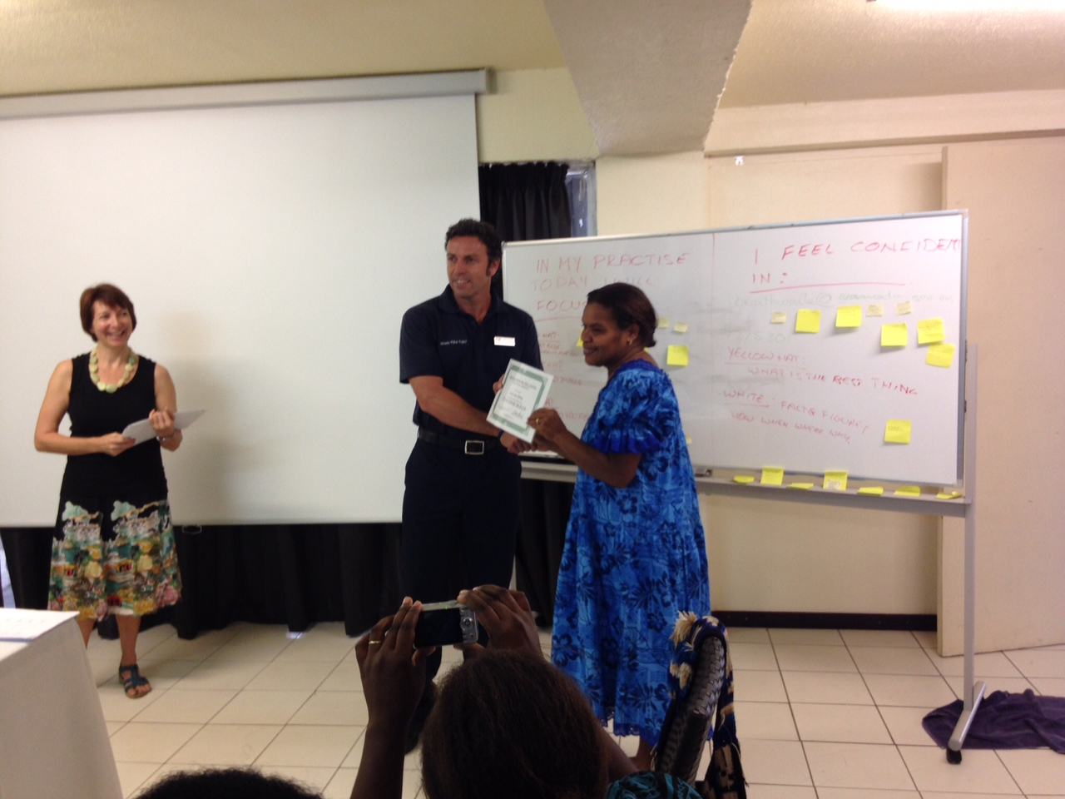
Photo: Natalie David, Partnership Coordinator, Stretem Rod Blong Jastis, and John Connoley, VAPP Adviser, Investigations and Community engagement award certificates at the conclusion of the Coaching for HR Officers Course.

Lessons
The requirements of close integration and coordination of effort and collaboration with the expansion of activity and complexity of the program continues to be very important and perhaps even more noticeable with the arrival of additional cross sector advisers whose fields of support are overlapping and mutually supportive.

New lessons learned during this reporting period include:

- The scale of the research and piloting work under component 3 has expanded and may require additional administrative, logistical and oversight support. This will be assisted by integrated support for the Blacksands research with VAPP which has already been discussed. Strengthened administrative support from SRBJ is also important, which it is hoped will be possible with the re-recruitment of administrative support for SRBJ.

- The Capacity Development Strategy is ambitious and is linked to many other elements of the program. For example, achieving systemic benefits that translate into agency and sector level performance improvements consistent with end-of-program-outcomes, requires the effective balance between training and workplace application. In addition, the Justice and Community Services Capacity Development Strategy has a significant amount of interdependence in the activities of a range of advisers including the CDL, PFM, HRM, WPL and the CDM Advisers. With many key adviser roles now in place, there is has been a noticeable shift in activity and action. However it is also revealing occasional challenges and risks; opportunities for synergy that are missed; actions taken without broader consultation; assumptions made that impact on the activities of others; and the potential of ‘adviser overload’ for key counterparts and groups. Everyone has their own terms of reference to complete but the management of the risks of the expanded team makes coordination and collaboration as a normative practice even more important.
- The difficulties in securing suitable local providers for training and development, and concern about sustainability and long term access to training intellectual property, has led to a change of direction. Later in 2015 it is planned to contract one or more local consultants to design and deliver specialised training. They will do so by working alongside VIPAM (and Police College where relevant) and a key part of the TOR will be how best to support VIPAM/ Police College to be capable of offering the course through their own resources.

Reach & coverage of outputs during Reporting Period
The table C below is provides some (albeit approximate) indication of number, reach and coverage for key outputs over this reporting period.
Component 1 | Outputs | Number & Reach | Coverage
Component 1 | MJCS website & newsletter | MJCS website: traffic shows that from January 2015, the unique visitors to the site has been on the increase, from 246 in January, peaking at 531 unique visitors in April then declining to 432 visitors in May and increasing slowly again in June 2015.  MJCS Newsletter: there are 28 contributing agencies and 184 recipients of the JCSS newsletter representing 33 different agencies within the sector. Additional contributors since December 2014, include, TVET, Care International, NZ Corrections Project, Save the Children and VSDP. | Public Sector employees across Vanuatu who have internet access  Sector NGOs with email access
Component 1 | M&E plan for sector & M&E Support | 15 Heads of Agency within formal sector | Port Vila
Component 1 | Annual reporting | 10 Agency Heads and Managers (10 out of 13 Agency provided contributions for the MJCS Annual Report (this is an increase d 8 out of 12 Annual Reports from the Sector last year) | Port Vila
Component 1 | Case & Data Management support | 6 policing and justice sector agencies (heads of unit and those responsible for information) which is made up of 9 public servants (of which 1 is female) | Port Vila and some provincial centres (Tanna, Santo, Malekula)
Component 1 | Financial officers mentored and supported to develop more cogent budget narratives | 2 officers at MJCS 4 officers at VPF (2 male 4 female) | Port Vila
Component 1 | Readiness of financial management systems and processes for use by SRBJ | 2 officers for MJCS, 1 officer in Justice agency, 6 officers in VPF CSU  (3 male, 6 female) | Port Vila
Component 1 | VPF Outstanding bills prioritisation matrix | 2 officers VPF – 2 female | Port Vila
Component 1 | Monthly planning tool for Commanders | So far 1 officer VPF , Male  (Potential distribution 20+ yet to occur) | Port Vila  (eventual distribution to the provinces)
Component 1 | Mandated financial responsibilities Summary | 3 officers for MJCS, 6 officers in VPF CSU  (5 male, 4 female) | Port Vila

Component 2 | Coaching Skills development for MFEM Officers | 7 Finance Officers from MFEM (4 Female)  2 Finance Officers from MJCS (1 Female) | Port Vila
Component 2 | Coaching Skills development for Officers with HR functions | 19 Public Servants from 10 Agencies (12 Female, 7 Male) | Port Vila
Component 2 | Civil and Criminal Legal Advocacy Skills Training | 32 graduates (7 female, 25 male) of 43 nominees from PSO, PPO, SPD, SLO and VWC for the three-day course. | Port Vila (Shefa), Penama, Sanma, Malampa and Tafea Provinces
Component 2 | SPD systems improvements | 8 prosecutors (1 female) | Port Vila and Sanma Province
Component 2 | Investigations systems improvements | 8 SPD prosecutors (1 female) | Port Vila
Component 2 | SPD CLE | 8 SPD prosecutors (1 female, 7 male) for in-house support  33 VPF staff (of which 9 were female) for the Rapid Charge System Training  22 VPF staff (of which 4 were female) for the outer province training using the SPD Manual. | Port Vila and provincial centres
Component 2 | PSO CLE | 11 PSO defence lawyers (of which 3 are female) | Port Vila and Santo, but lawyers also tour to other provinces so reach broader  Port Vila and provincial centres
Component 2 | LSIP | 17 law students (10 female, 7 male, 3 Ni-Vanuatu) | Pacific Region (40% non ni Vanuatu) and Port Vila
Component 2 | Human Resource Management skills through:  1) HR Planning workshop (1-day)  2) Defining HR priorities and initiatives (1:1 support) | Officers from CLMO, DCS, MJCS, SLO, Judiciary, VLC, PSO, PPO (8 female, 5 male)  VPF (1 female) and MJCS (1 male) | Port Vila
Component 2 | Financial Management skills | 3 officers for MJCS, 6 officers in VPF CSU  (5 male, 4 female) – On the job training in financial and office skills | Port Vila

Component 3 | Outputs | Number & Reach | Coverage
Component 3 | SCV
Component 3 | Research | Research is being scoped. Consultations occurred during reporting period. | Port Vila (incl Blacksands) and Malekula
Component 3 | DWA FPA support | Mapping and research occurred during reporting period | South Santo, Efate (Port Vila) and perhaps Tanna

The program is incrementally increasing the number of people that it reaches across the sector each reporting period to include heads of agencies, office managers, finance officers, human resource managers, lawyers, prosecutors, data entry staff, women within the police force, the police executive, the police CSU, key sector NGOs (Wan Smol Bag, Vanuatu Women’s Centre, Vanuatu Society for Disabled People). Whilst the coverage remains predominantly in Port Vila, there have been increases in support beyond Port Vila in terms of capacity building, in particular, where staff are brought in from the provinces for sector wide initiatives or supported through agency supported initiatives to go out to the provinces. The work to support women experiencing family based violence will also increase reach out of Port Vila (to include Malekula, Santo and rural Efate).

Adequacy of Progress

Against the Workplan: On time
Greater detail of the delays and variation to the Workplan are described in the section 2e, Variations to Workplan.
Overall the program is being delivered well (75-80%) in accordance with the timing described in the Workplan.
There has been a delay of four to six weeks as a minimum across the entire program as a result of Cyclone Pam.
There has been delay in the progress of the JCSSS likely as a result of a mechanism that was insufficiently supported and a process that was insufficiently led. Support for the JCSSS is delayed until there is sufficient direction for the program to know how best to support this initiative. It is anticipated that this will occur over the next six months and that there will some rationalisation of the strategies that are to be prioritised over the life of the JCSSS.
The initiating research for Malekula and Blacksands has been delayed as a result of a number of factors, the most important of which is the decision for an appropriate expansion in its scope which will make the outcome more robust and more widely useable.
The overall progress of delivery of outputs and progress towards interim outcomes for the first twelve months of Stage 2 is adequate and generally on time though the delay may have an impact in some areas on the strength and depth of the program outcomes.

Adequacy of inputs to meet end-of-program-outcomes
The inputs in Stage 2 of the program are adequate to meet end-of-program-outcomes.
The aspect of the program that has had significant expansion is the research in Malekula particularly. At the time when the program was designed it was contemplated that there would be concentrated research in approximately 2-3 communities. Since then in the preparation of the research and as a consequence of discussion with the DFAT Evaluation Capacity Building Program and others, it was agreed, with approval of DFAT, that the research would be more scale-able and more useful both to the program and to other stakeholders if it was a piece of research that was broader and could make some statistically sound findings at least for Malekula as a whole. The research also no longer looked only at the experience of women but rather at how conflicts more generally are managed at the community level with a more concentrated focus on the experience of women.
As a consequence, the interventions that could be programmed to respond to the findings of the research could be broader and require more resources than are currently budgeted for this component. This could be managed in a staged or iterative way tailored to the capacity of the program and strengthened wherever possible through close collaboration with others.
Nevertheless, the end-of-program-outcomes for component 3 are focused around building on an evidence base to improve the responsiveness of the sector and to target appropriate interventions for women, children and youth. The size and delay caused in preparing the larger piece of research is unlikely to impact on the achievement of those outcomes though it will be important to ensure sufficient inputs and budget to make measurable progress in this area.

Against Budget
Financial management remains an area of close collaboration between DFAT and Stretem Rod Blong Jastis. While this reporting period is from January through June 2015, now that the Australian financial year has been completed it is appropriate to make some comment about the annual budget. After discussion between the program and DFAT, the program was careful to provide invoicing at the end of the financial year which provided 100% execution of budget in the current financial year and a supplementary invoice which attributed any additional costs into the financial year 2015/2016. Annex 14 summarises the financial position of the program this financial year.
The budget has progressed well in all areas with the program generally underspending on themes with the exception of operational costs and program activity costs. The increase in operational expenditure is attributed to the costs incurred during re-establishment of the office post Cyclone Pam.
Additional expenditure (as per the below table) was also incurred through Program Activity Costs. After approval was granted by DFAT, underspends throughout the program were allocated to Program Activity Costs. This is seen as a positive outcome for the justice sector as funding is utilised for demand driven activity purposes rather than administration or staffing.
The Program will continue to liaise closely with DFAT about financial management and it is perceived that the provision of the monthly financial summary remains critical to keeping program finances clear in the minds of leaders both within the program and from a DFAT perspective.

Effectiveness and Efficiency of Management Systems

Workplan
The strategic direction of the PJSPV Design and the Workplan remain appropriate and relevant (see section 1a – Continuing Relevance). Changes in planned inputs and outputs are being or have been made with the approval of DFAT, (see section 2e – Variations to Plan) none of which alter the likely achievement of end-of-program-outcomes or the strategic direction of the program.
Some work carried out by the team in addition to the Workplan includes:
- Legal Salary Review (HRM Adviser and M&E Adviser)
- Assistance to the program in the recruitment of law student researchers for PJSPV research in Malekula and Blacksands (LSIP Administrator)
- Assistance with the recruitment of part time data entry officers for SLO to restore archives post Cyclone Pam (LSIP Administrator)
- Mentoring and assistance to junior prosecutor in PPO (SPD Adviser)
- Input into the VPF Family Violence Policy and SOPs (SPD Adviser)
- Support for the development of two funding applications for DWA (VAW pilot adviser)
- Participation and contribution to the Gender Policy and Strategy work of DWA (VAW pilot adviser)
- Compilation of data on status of women within the sector (WPL Adviser, MO)
- Advice to PPO prosecutor in Santo (PSO Adviser)
- Review of VPF revenue (PFM Adviser)
- Advice to MJCS with respect to recruitment of expatriate Public Prosecutor (management).
- Ad hoc speaking notes, briefing notes, agenda, presentations for MJCS (management).
- Recruitment and budget assistance to CLMO (management)

Financial Management Systems
The program’s financial management systems were audited by local firm Law Partners during late 2014 and early 2015. The findings and management response to the audit can be seen at Annex 15. While the audit did not uncover anything unexpected, recommendations which related to effective procurement were noteworthy for the program. The program also requested advice be given about managing financial advances for staff travelling to the provinces (a particular issue for the policing side of the program). However the recommended approach, which advocated for the program to send staff to accompany every acquittable expenditure was not seen as either practical or a value for money approach. The program continues to manage payments to staff travelling to the provinces extremely closely. The program places controls on these staff to acquit funds as soon as possible after travel, it also seeks clear receipting even where no receipts are generally given (eg for travel in taxis/buses). This is an area the program continues to manage closely.

Engagement with the VAPP has undoubtedly added complexity to financial management within the program. Two cashbooks are now developed on a monthly basis and the VAPP itself carries two petty cash floats; one for emergency operations (limit vt500,000) and one for basic office consumables (limit vt20,000). Similarly, the high volume and operational nature of expenditure through the VPF carries with it high demands on staff of the program. Undertaking due diligence and ensuring transparent and accountable practices throughout the program is a challenge with a small staff. It could be argued that the program should become stricter on partners who take time to acquit funds or have weaker procurement justifications. Capacity development remains at the heart of the program and therefore while the program pushes for good practice from partners, there is a high level of sensitivity to the constraints experienced by Agencies.

All financial management remains in line with the operations manual and with contractual requirements.

Monitoring and Evaluation
PJSPV is providing a six monthly M&E report intended to draw conclusions about the status of monitoring and evaluation for the program. The first of such reports is the Policing & Justice Support Program (Vanuatu) PJSPV Monitoring and Evaluation Update Report, January to June 2015, (M&E Update Report) in Annex 12.
The M&E Adviser is scheduled to come back to Vanuatu at the end of August to work with both SRBJ and VAPP to review the MEP. The review of the MEP was planned to take place after about one year of implementation. The focus of this review is; to review and potentially refine indicators based on what is now known and what can be measured; consider the evaluations completed to date and review and refine what is planned in terms of evaluations and surveys to the end of program; and take stock of any indicators for which there is currently no baseline to consider how and when baseline will be gathered. Some rewording and refining of indicators has already been identified in preparation of this process.
This review of the MEP will include developing and improving on definitions for indicators; developing technical sheets where needed; removing and rewording some indicators, where appropriate; removing and or refining the focus of future evaluations and surveys; focusing attention on indicators without baseline and developing an approach for ensuring baseline where there is not yet one

Strengthened M&E support for the integrated program
The model of a senior M&E Specialist and an M&E Adviser has continued very effectively in its support of the program M&E over this reporting period. The M&E Specialist will conduct the Capacity Development Evaluation in August and has given notice of his resignation from the program once that is completed. Models for continued robust M&E support for the program are currently being investigated noting that the remainder of the program requires effective implementation of the MEP and less conceptual M&E design work.

Monitoring & Evaluation Plan
The Monitoring and Evaluation Plan (MEP) developed in the first six months of Stage 2 provides an approach to tracking the progress and effectiveness of PJSPV with the assumption that activity completion or outputs are monitored by the program managers through other mechanisms. The MEP is instead focussed on contribution to the achievement of interim and end-of-program-outcomes. The MEP was approved last reporting period for implementation whilst recognising that it may be ambitious in some aspects.
The MEP is being implemented as designed with some slippage of dates for the evaluation pieces resulting from the hiatus post Cyclone Pam, workload of the program and availability of the evaluators.
In accordance with the MEP, between January and June 2015, the program has:
- Continued to conduct structured conversations with advisers and team members every three months (a reduction from the proposed monthly conversations).
- For SRBJ Advisers, continued use of the revised six monthly reporting template. The new reporting template is more focused on evidence and strategic analysis.
- All SRBJ advisers report on their work six monthly; VAPP reports to the International Deployment Group (IDG) of the Australian Federal Police (AFP) six monthly. The six monthly time periods for VAPP and SRBJ are the same.
- PJSPV reports to DFAT on progress six monthly.
- Completed a Baseline Study for all PJSPV indicators. This highlighted the indicators that needed to be focused on to obtain baseline and provided a starting place for measuring PJPSV progress and performance
- Obtained baseline for some of the indicators that did not have a baseline at the time of the Baseline Study.
- Completed a desk review of the LSIP, with recommendations considered and now being integrated.
- Supported the completion of a Sector Perception Survey finalised in June this year; the findings of which has been shared with the HOAG and MJCS for consideration. Some targeted follow-up will be useful in the subsequent reporting period.
- Completed a review of the SRBJ Grants Facility with a management response and integration of most of the recommendations in the way in which the Grants Facility is now managed.
- Provided support to the newly appointed VPF Monitoring and Evaluation Officer. Support has focused on the development of an M&E Framework for VPF.
- Enhanced engagement between the PJSPV M&E team and VAPP Advisors.
- Commenced an evaluation of the participation of women in the VPF which will be concluded in August.

The key findings of the first six monthly M&E Update Report are:
- The MEP is being implemented as designed, though with some delays in commencement of evaluations due both to Cyclone Pam and availability of some evaluators;
- Advisers are generally satisfied with the PJSPV M&E approach, though with some recommended adjustments to the evaluations planned;
- While it is too early to draw conclusions about the sustainability of PJSPV, important steps are being taken by the program to ensure sustainability of support. Further, advisers are generally cognisant of the importance of sustainability and the need to provide support in sustainable ways;
- SRBJ and VAPP advisers are increasingly familiar with and perhaps also supportive of PJSPV M&E ways of working. This includes the advisers taking ownership/responsibility for collecting data for the indicators relating to their work, and working collaboratively with the M&E team to participate in the analysis of that data;
- At the time of the Baseline Study, baseline data existed only for 13 of 35 SRBJ indicators and for 9 of 40 VAPP indicators. Now 17 of 35 SRBJ indicators have a baseline and 15 of 40 VAPP indicators. This is an important improvement though further work will be needed over the subsequent reporting period to establish baseline;
- At the time of the Baseline Study, VAPP was found to be less well positioned than SRBJ to report on contribution. Now SRBJ and VAPP are fairly equally well positioned to report on contribution, due largely to the commitment and hard work of VAPP Advisers, and their willingness to engage with the PJSPV M&E Adviser;
- It was only possible to measure progress for a limited number of indicators. Greater emphasis will be needed for this in the next reporting period;
- Nevertheless, PJSPV is positioned to report more rigorously in ensuing reports, with suitable methodologies either in progress or in development. This is the case in all three components, across Networks, Case & Data Management, Capacity Development, and Services to Women, Children and Youth. However, some indicators need further defining and development of methodologies to allow their measurement –this should be a priority for the M&E team over the next reporting period;
- Point 8 (above) is evidence of an increasing alignment of M&E with strategy, and increasing integration of M&E into the operations of advisers, with them actively considering how to monitor outputs and outcomes, and reflecting on and reporting results on the basis of evidence.
- Implementation of the JCSS M&E Framework has not received the same level of attention as the PJSPV M&E Framework. For example, a number of the performance indicators do not currently have a baseline nor any strategy for establishing a baseline.

Baseline
When the Baseline Study was completed, baseline data did not exist for a number of indicators (that is, 13 of 35 for SRBJ). In many cases neither quantitative nor qualitative data was available on which to base the narrative.
Accordingly, a significant focus of the M&E Update Report is on establishing a baseline for those indicators currently without a baseline by: (1) developing or confirming the strategy and timeframe for establishing a baseline where none exists; (2) expanding on the explanatory narrative for the indicator, to strengthen tracking of change or progress against the indicator; and (3) tracking progress against indicators.
The section on, “Analysis of PJSPV Performance Indicators”, commencing on page 15 of the M&E Update Report provides a systematic assessment of the current status of each of the indicators. Of course this assessment could only be made for those indicators that had a baseline established previously, so that any change could be measured. The table below (Table 19, extracted from the M&E Update Report, p 61) provides a snapshot of the current position of SRBJ indicators:
Indicator | Progress in last period (Jan – June 2015)
S1.1.1: Increase in attendance rates at cross-sector meetings (HOAG; Task Forces; Working Groups) | Made progress
S1.1.6: Program activity contributes to increased cross-sector communication and collaboration | Made progress
S1.2.1: Extent of progress in the development and use of Justice & Community Service agency systems and processes supporting M&E | Made progress
S.1.3.1: A sector communications strategy improves communication across and beyond the sector | No change
S1.4.2: Management decisions are increasingly based on information drawn from the C&DMS | No change
S1.4.3: The extent of contribution of the Case and Data Management System (C&DMS) to improving the delivery of services in justice and community services | No data
S1.5.2: Increase in GoV funding to the JCSS | Indicator removed
S2.1.1: Number of law and justice officials trained disaggregated by agency and gender | Made progress
S2.1.3 Staff trained consider that training has improved their ability to perform their roles effectively | No data
S2.1.5: The extent to which capacity development initiatives have led to increased capacity in justice and community services | No data
S2.2.1: Increase in percentage of women in the JCSS | No data
S2.2.2: Increasing percentage of women in leadership roles in the JCSS | No change
S3.3.1: Number of women survivors of violence who receive services including counselling | Made progress
3.3.3: Evidence of how conflicts are managed and experienced at the community level is gathered to inform targeted interventions | No change

Measuring Sustainability
To enhance SRBJ sustainability, there has been progress in a range of areas, including:
- Progressing the recruitment of a Ni-Vanuatu Partnership Coordinator to allow for a supported handover of the leadership of the program to a local person ensuring that the skills and knowledge developed to date to support the law and justice and community service sector in Vanuatu remains in Vanuatu.
- Development of a State Prosecutors Manual and Office of the Public Solicitor Lawyer Handbook by Advisers in State Prosecutions Department (SPD) and the Public Solicitor’s Office (PSO). The manuals are used in training and will remain as a legal resource and guide for both organisations after Advisers have completed their assignments.
- Integration of the LSIP into the law clinic course: this will be trialled in Semester two 2015 so in the next reporting period SRBJ will have a better sense of its feasibility.
- A stronger focus on systems, processes, policies and case management to strengthen the sustainability of the capacity development work within institutions, primarily PSO and SPD but other agencies as well. There has been noticeable progress in this area at the PSO.
- Strengthening relationship with PMO’s M&E Unit to enhance consistency of messaging and approach. There is an agreement for greater collaboration between MJCS, VPF and PMO’s M&E unit in reporting, planning, monitoring, messaging for the sector and capacity development.
- Recruitment of the positions within the corporate services part of the MJCS: the Performance Coordinator, Policy Officer and Capacity Development Coordinator have been advertised and are being actively recruited.
- The new HR Management Adviser, Public Financial Management Adviser and Workplace Learning Adviser roles will provide additional needed support for the integrated approach to capacity development envisaged by the Justice and Community Services Sector Capacity Development Strategy. It will also be essential to engage in 2015 with the new MJCS recruits to support the MJCS hub to build sustainable capacity in organisational improvement.
- A sector counterpart has been identified for the CDMA which is hoped will provide a sustainable model for systems support and ongoing improvements for the sector.
- Incorporation of sustainability criteria into the Grants Facility and constantly reinforcing best practice in the financial and procurement practises associated with the implementation of grants as a basis for supporting increased efficiency and sustainability within the agencies of the sector.
- It will be essential to engage in 2015 with the new MJCS recruits to support the MJCS hub to build sustainable capacity in organisational improvement.
- Continued use of partner GoV financial systems with respect to the ICT support for the sector supports greater sustainability that the parallel funding that continues to be necessary in other areas of the program.

Risk Management
There are risks to all development programs in Vanuatu given the complexity and fluidity of the operating environment. Many of these risks are a given and are beyond the scope of the program to control, such as political instability and changing macroeconomic conditions. The approach to these high level risks that are outside of the scope of the program are to be vigilant in monitoring shifts in the operating environment so as to be able to mitigate negative impacts through a flexible and responsive approach to risk identification and management.
The management of risk is a continuous part of the approach to implementation in that all SRBJ team members are aware and raise risks that impact on their particular areas of intervention regularly. These are often discussed at team meetings in an effort to identify appropriate risk mitigation strategies. Integral to this attentiveness to risk is a solid and effective tripartite relationship between SRBJ (PJSPV), DFAT and the GoV. This open and effective relationship has allowed for the identification and analysis of risks as they arise and a collaborative approach to the management of those risks. Collocation of SRBJ staff within agencies, within the MJCS and in the future within VPF strengthens not only the relationships but also the ability to observe likely risks to the program first hand.
Whilst integration and alignment strengthen sustainability and capacity and are generally good development practice, it has an additional benefit with respect to risk. It moderates against risks being perceived as those of the program alone to be borne and managed by the program; but rather spreads the responsibility for risk more widely to those who feel ownership and commitment in its intended objectives.
In addition to these general approaches to the management of risk, SRBJ has a risk management table which is reviewed every six months - and has been reviewed as part of the preparation of this report (see Annex 13). All amendments to that table are shown in blue.
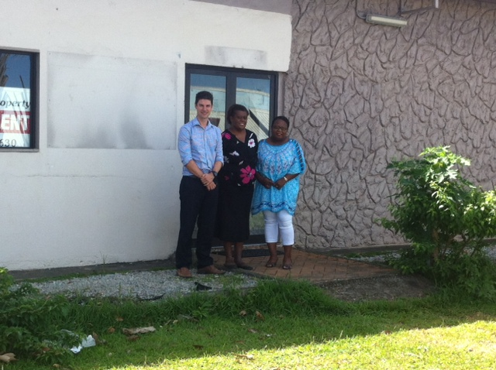
Photo: Rob Nicol, Jill Makikon and Joanna Garae outside the temporary Stretem Rod Blong Jastis Office

Staffing and human resource management
The staffing complement for the program during the period is summarised in the Table D below.
Long Term Advisers | Name
Partnership Coordinator | Natalie David
Deputy Partnership Coordinator | Rob Nicol
Adviser to the Public Solicitor’s Office | Stephen Barlow
State Prosecutions and Community Services Adviser | David Bade
Capacity Development and Leadership Adviser (50% Justice and 50% police) | Vicki Vaartjes
Public Financial Management Adviser (50% Justice and 50% police) | Sue Morrison
Short Term Advisers | Name
M&E Specialist | Stephen Miller
M&E Adviser | Nicole Dicker
Case and Data Management Adviser | Tony Lansdell
Quality & Technical Adviser | Sally Low
Workplace Learning Adviser | Jo Anne Braithwaite
Gender Adviser | Kate Morioka
HRM Adviser | Malcolm Bell
Locally Engaged Advisers | Name
Senior Finance and Administration Officer (VAPP) | Clare Moloney
Finance and Administration Officer (VAPP) | Mary Kalmet
Administration/Finance Officer | Joanna Garae
Administration Assistance | Jill Makikon
Monitoring Officer | Josianna Jackson
Law Student Internship Program Administrator | Arthur Faerua
Technical Adviser (PJSPV Community Justice Pilots) | Heidi Tyedmers
Technical Adviser to DWA | Heidi Tyedmers

Human Resource Management Issues associated with Cyclone Pam

As this report describes, Cyclone Pam had large impacts across the program and Vanuatu. Similarly, advisers who are engaged under the program were thrown into difficult personal and professional circumstances. The program supported advisers and staff by using non-reimbursable funds to assist in preparedness prior to the cyclone including procurement of torches, additional water, extra phone credit and other items specific to the needs of all staff. After the cyclone, the program gave further non-reimbursable funds to support its locally engaged staff to restore their personal damaged physical infrastructure.

From a contracting perspective, there was a short hiatus to programming, however based on the circumstances surrounding Pam, DFAT supported the continuation of salaries during this period.

Several short term advisers were evacuated before the cyclone, and their timings for return were delayed. This was perhaps the most difficult human resources impact, however all advisers were understanding of the circumstance.

Engagements and Contracting Changes over the Period

The program has engaged a number of new staff over the reporting period. The engagement terms have also changed for some staff. The following recruitments were made for the program:

- Partnership Coordinator position status

The program has commenced recruitment of a Ni-Vanuatu citizen to the Partnership Coordinator role in accordance with the Workplan. Whilst a little delayed, also as a result of Cyclone Pam, interviews and selection are likely to occur during the next reporting period allowing for sufficient time for support of that incumbent into the role before the end of the program.

- Public Financial Management Adviser

An open recruitment process was conducted to engage the Public Financial Management (PFM) Adviser. After a shortlisting was undertaken by GRM Brisbane and confirmed by a panel, three candidates were interviewed. The interview panel consisted of: Mark Bebe (Director General, Ministry of Justice and Community Services), Helen Corrigan (Senior Program Manager, Law and Justice, Australian Department of Foreign Affairs and Trade), Natalie David (Partnership Coordinator, Stretem Rod Blong Jastis). The panel conducted interviews over skype, and then the preferred candidate, Ms Sue Morrison, attended a second interview in person in Port Vila which also allowed the Director General of Justice, a VPF representative and the Senior Program Manager from the Department of Foreign Affairs and Trade to interview Ms Morrison.

Ms Morrison was confirmed as the preferred candidate and engaged by the program. She arrived in Port Vila on 29 April 2015 and is contracted as a long term adviser until the end of the calendar year. Ms Morrison is engaged to work between VAPP and the Justice component of the program at a 50/50 ratio.

- Human Resources Management Adviser

An open recruitment process was conducted to engage the Human Resources Management (HRM) Adviser. After a shortlisting was undertaken by GRM Brisbane and confirmed by a panel, three candidates were interviewed. The interview panel consisted of: Mark Bebe (Director General, Ministry of Justice and Community Services), Natalie David (Partnership Coordinator, Stretem Rod Blong Jastis) and Vicki Vaartjes (Capacity and Leadership Adviser, Stretem Rod Blong Jastis). The panel conducted interviews over skype, and then the preferred candidate, Mr Malcolm Bell, attended a second interview in person in Port Vila which again allowed the Director General of Justice, a VPF representative and the Senior Program Manager from the Department of Foreign Affairs and Trade to interview Mr Bell.

Mr Bell was confirmed as the preferred candidate and engaged by the Program. Mr Bell commenced with the program on 1 June 2015. Mr Bell is engaged as a short term adviser for 100 days which are anticipated to be finalised before the end of the calendar year. Mr Bell is engaged to work between the VAPP and the Justice component of the program at a 50/50 ratio.

- Workplace Learning Adviser

An open recruitment process was conducted to engage the Workplace Adviser (HRM Adviser). After a shortlisting was undertaken by GRM Brisbane and was confirmed by a panel. The panel consisted of: Vicki Vaartjes, Capacity and Leadership Adviser; Amy Savage, Project Manager, GRM International; and Charles McGregor, Recruitment Specialist, GRM International. Two candidates were interviewed. The Panel, for reasons of value for money (Vicki Vaartjes was travelling in Australia at the time, and all candidates and panel members were also in Australia), conducted interviews in Brisbane.

The preferred candidate was Jo Anne Braithwaite, it was not deemed necessary to bring the adviser to Vanuatu for further interviews due to the number of inputs for her engagement. Ms Braithwaite was engaged for 60 days to be concluded before September 2015.

- Gender Adviser

Ms Kate Morioka was engaged by the program to support the development of a Gender Policy (Vanuatu National Gender Equality Policy 2015-2019) for the Department of Women’s Affairs pursuant to a grant application by DWA. Ms Morioka concluded her contract on 8 March 2015 and the Gender Policy is currently moving towards approval by the Council of Ministers in consultations between DWA and PMO. The DWA is also progressing its annual plan, which falls under the Gender Policy.

- Access to Justice Piloting Adviser

Ms Heidi Tyedmers was engaged on 16 February 2015 to undertake work surrounding the program’s pilot of providing a multi-faceted response to gender based violence. As part of the same contract Ms Tyedmers was also engaged to support piloting of Registered Counsellors and Authorised Persons to grant family protection orders to victims of gender based violence in communities.

Ms Tyedmers was engaged previously as the Child Protection Evaluation Specialist. This role involved a rigorous selection process. Ms Tyedmers has offered the highest level of service and quality of output to the program during her past engagement. Based on her skills and experience, the Program developed a justification for the direct engagement of Ms Tyedmers, this was approved by DFAT and Ms Tyedmers was engaged for 2.8 days per week until December 2015.

- Monitoring and Evaluation Specialist

Mr Stephen Miller tendered his resignation as Monitoring and Evaluation Specialist to the Partnership Coordinator in May 2015. Mr Miller leaves after conducting nearly a year of short term inputs with the project. Mr Miller supported the development of the M & E Framework. The program is currently assessing future M & E resourcing needs, particularly how senior M & E inputs will be managed. Recruitment and staffing for this position will be resolved during the next reporting period.

- Capacity and Leadership Adviser

The Capacity and Leadership Adviser changed from short term to long term inputs in May 2015. Ms Vicki Vaartjes will be engaged in a full time capacity until December 2015.

Special Management issues related to Grants Facility

Grants Review of Stretem Rod Blong Jastis Grants Facility

Key Findings from the Review

This report does not summarise the findings of the Review, the full report for the Grants Review document can be found at Annex 7. There were two aspects of the review which were particularly useful and noteworthy, the first being information relating to categorising where the funding was going, secondly several recommendations it is felt will strengthen the grants facility once implemented.

Overall the review made some comment on effectiveness, to which it deemed over 50% of the grants scored 2.5/3 (or above) , as contributing to Agency and Sector outcomes. This figure underlines the fact that the Facility remains extremely relevant to the needs of the sector.

Interestingly, 60% of grants were directed towards funding activities impacting service delivery. While SRBJ remains a capacity development focussed program, the clear need for the sector is for support of an operational nature. This repeatedly is the theme of requests for grants. Often Agencies have difficulty meeting their core operational responsibilities and the program becomes a strong support to assist in the achievement of service delivery outputs. The next highest thematic areas were infrastructure and information management which, the reporting equates to 13% of grants expenditure, and operating costs, which equate to 9% of costs.

Similarly useful information was given analysing the geographical spread of grants:
- Twenty-six of 51 grants ($783,905) have been for activities or expenditure solely in Port Vila.
- Agencies or individuals from all six provincial capitals have received resources from, or participated in, activities funded by the Grants Facility.

From the above analysis it is clear that the grants remains geographically centred around Port Vila, however this is reflective of the reach of the formal justice sector and increasing reach of the program over time. At the same time, the program must continue to consider how it may support a more equitable reach both of the justice system but also of donor funding through grants.

In relation to the beneficiaries of the grants facility.
- NGOs and civil society groups, have received 62% of the total value of $2,893,827.
- The remaining 38% has gone to state justice agencies.
- State justice agencies have received the highest number of grants being 44 of a total of 52.
It is clear from above funding continues to be spread relatively evenly across non-government actors and Government of Vanuatu.

While the grants review was effective in succinctly capturing many of the issues associated with the facility, it did not provide any revelations but did provide baseline. The program constantly strives to increase effectiveness and had already embarked on a series of reforms to the facility prior to the Grants review. The Review was nonetheless useful for its confirmation that the grants facility is relatively effective under the current programming paradigm, and can continue to make an impact across the sector. At the same time the facility will be further strengthened with implementation of recommendations.

Management Response to Grants Review

The management response to the grants review can be seen at Annex 7. All recommendations of the review were agreed, with the exception of a recommendation that SRBJ seek ‘suitably qualified teams’ to be engaged to manage grant activities (on behalf of grantees). It is difficult to ensure, particularly as the grants facility seeks to capacity develop partners, that partners will have adequate skills and experience to manage funds to a high degree. The program must manage the risk associated with expenditure carefully and works more closely with partners it considers to be a high risk.

The Program was particularly interested in, and has started reforming approaches taking into account the following recommendations:
- Recommendation: That SRBJ consider simplifying the application form.
  - Application forms have been developed by the evaluator and these will be sent out to partners in the future.
  - Originally, the application form was designed in such a way that it reflected the DSSPAC forms of the Government of Vanuatu. However these forms are overly complicated and don’t provide a clear budget template which breaks down all different costs.
- Recommendation: That SRBJ and the PMG consider more flexible reporting requirements, according to the nature and budget of the activity. For very simple activities such as one-off purchase of consumables, a financial report should be sufficient. For others, an end of activity feedback and assessment meeting between SRBJ and the grantee could replace the requirement for a narrative report.
  - Receiving reporting has been a particular challenge for the program, and despite constant promptings, the program has not received adequate reports from its partners. The recommendation of a post grant interview is likely to be much more effective from a monitoring and evaluation perspective
- Recommendation: That the PMG retains the right to make out-of-cycle grants in exceptional and urgent situations. Such decisions should be well documented and justified.
  - The program has been striving to include grant intakes so that there is greater range of grants and the best grants are selected. However there is a clear need to remain flexible and responsive to the needs of the sector.

Capacity development and common issues which persist since the review

The Deputy Partnership Coordinator, who manages the grants facility as one of the core functions of his work, is looking to undertake small targeted capacity development of key staff across the sector who engage with the grants facility. Recent engagements with the Supreme Court, combined with ongoing engagement across the sector reflect that procurement and financial management practices remain at very low levels. The core skills requiring capacity development which facilitate effective grants management by partners (as opposed to technical skills required for effective programming) can be summarised below:
- Financial management
- Procurement practice
- HR management
- Report writing
Procurement practice in particular is of concern. It is often difficult to receive required numbers of quotes, or if quotes are received they are not for items with the same specifications. Motivations surrounding a push to undertake targeted capacity development of partners engaging in the grants facility are twofold; firstly this will allow for high level compliance by the program with Australian Government rules; secondly, an improvement in activity management in these areas by partners will have positive impacts on government management practice and better outcomes for any given activity. Additional and targeted training and ongoing support to the sector should improve the quality of these areas.

Grants Facility January – June 2015

Table E below shows the grants that were approved and implemented during the reporting period:
Grants January to June 2015

Customary Lands Management Office (CLMO) Support Grant | GA038
Description: This wide reaching grant is intended to support scanning and cataloguing customary land cases. It is also intended to support a legal paper to be developed relating to the implementation of the new Customary Lands Management Act.
Vanuatu Society for People’s with a Disability (VSDP) Early Intervention and Community Based Rehabilitation (CBR)– Later amended to post Cyclone Pam assessment and CBR | GA046
Description: Post Cyclone Pam program for VSDP changed from Early Intervention, to focus on conducting an analysis of needs after the cyclone. The program continued its core programming for Community Based Rehabilitation during this time.
Department of Women’s Affairs Registered Counsellor and Authorised Persons piloting | GA047
Description: This grant was developed to pilot identifying individuals who could serve family protection orders on victims of domestic violence.
Supreme Court Video conferencing | GA048
Description: Video conferencing facilities in both Port Vila and Santo will allow the Supreme Court to conduct trials and meetings across provinces without travel, reducing the cost and imposition of travel.
SLO Case Management System | GA049
Description: Development of a simple management system for case work within the office.
SPD Provincial Operations Manual Training | GA050
Description: Training conducted about the updated office operations manual.
PPO roof repairs | GA051
Description: Post Cyclone Pam repairs to the roof of the PPO.
State Law Office (SLO) Archives repair | GA052
Description: Post Cyclone Pam replacement of the roof of the SLO Archives space.
VSDP Temporary Office Space | GA053
VSDP office was destroyed during the cyclone, temporary office space has been supported while VSDP seeks costs for repair.
Magistrates and Island court ICT procurement | GA054
Description: Computers at the Magistrates Court required replacement prior to Cyclone Pam to enhance service delivery within the office. Several computers were destroyed at the Island Court during Cyclone Pam.
Island Court roofing repair | GA055
Description: Repair of roofing after Cyclone Pam

The grants facility continues to be a core activity of the program. The most problematic grant during this period relates to the CLMO. A significant grant was given to this office. Outcomes, acquittals and reporting are extremely limited. Difficulties associated with engaging with CLMO reflect the low capacity of this office. Apart from the CLMO Grant, the Program has not had any major exceptional issues of implementation during the reporting period, noting the issues discussed during the grants review section above.
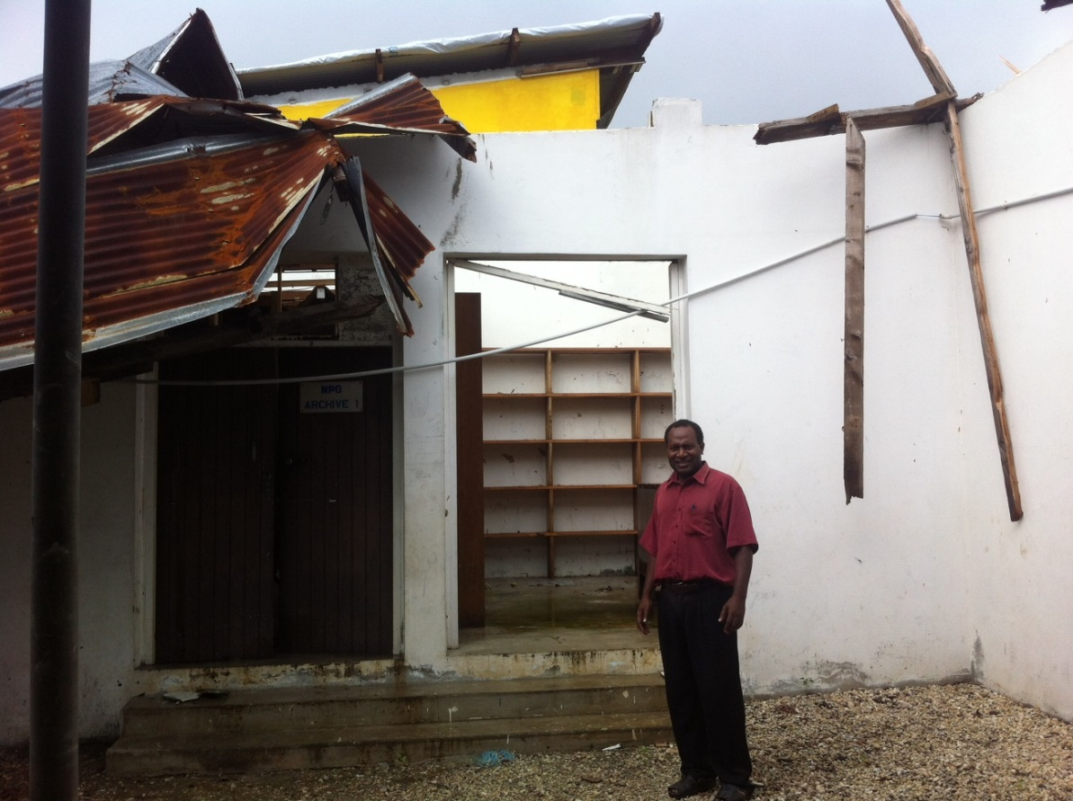
Photo: Mr Jack Semeno, Corporate Services Manager, State Law Office, inspects damage to the State Law Office’s Archives after cyclone Pam.

Overall conclusion

SRBJ has made effective progress against its Workplan over the first six months of 2015 under the integrated PJSPV particularly in the light of the impact of Cyclone Pam on staff, the program, counterparts and the sector.
There has been delay in the delivery of a number of outputs; some as a result of Cyclone Pam, some as a result of both the capacity of the program and the counterparts to engage with multiple advisers; some due to lack of clear direction for support and some resulting from approved expansion in the scope of the planned work. Many of the delays identified in the previous reporting period are being well progressed and in some cases overcome (see Annex 8).
Overall, the program anticipates that there will still be demonstrable progress towards outcomes by the end of the program but that the progress towards outcomes may not, in some areas, be as far or as embedded as had been envisaged at the outset. This may be the case with respect to the interventions under component 3 but the concomitant benefit intended by the more in-depth research is that it will be of greater use to more agencies and development partners and ultimately more scale-able than was originally envisaged.
The SRBJ team as a whole is focused more intensively on progress towards intermediate and end-of-program outcomes; strengthening the sustainability of support in their areas of practice; and strengthening support for gender equity across the program as it moves into its final two years of implementation.
Collaboration and the sharing of information, knowledge and learning must be increasingly supported to ensure the consistency and a holistic approach envisaged by the program design. This becomes increasingly complex and increasingly important with additional advisers working across the sector with multiple points of intersection and areas of mutual support and benefit.
The MEP is supporting effort with respect to ensuring that the work is monitored and evaluated and management adjustments are made wherever appropriate. There was baseline for 13 of the 35 SRBJ indicators at the time of the completion of the Baseline report in April and there has been progress made in the assessment of baseline on some of the 22 indicators that require it now that additional advisers are available to make those assessments. This will provide a reliable base for measuring the contribution of the program as it progresses.
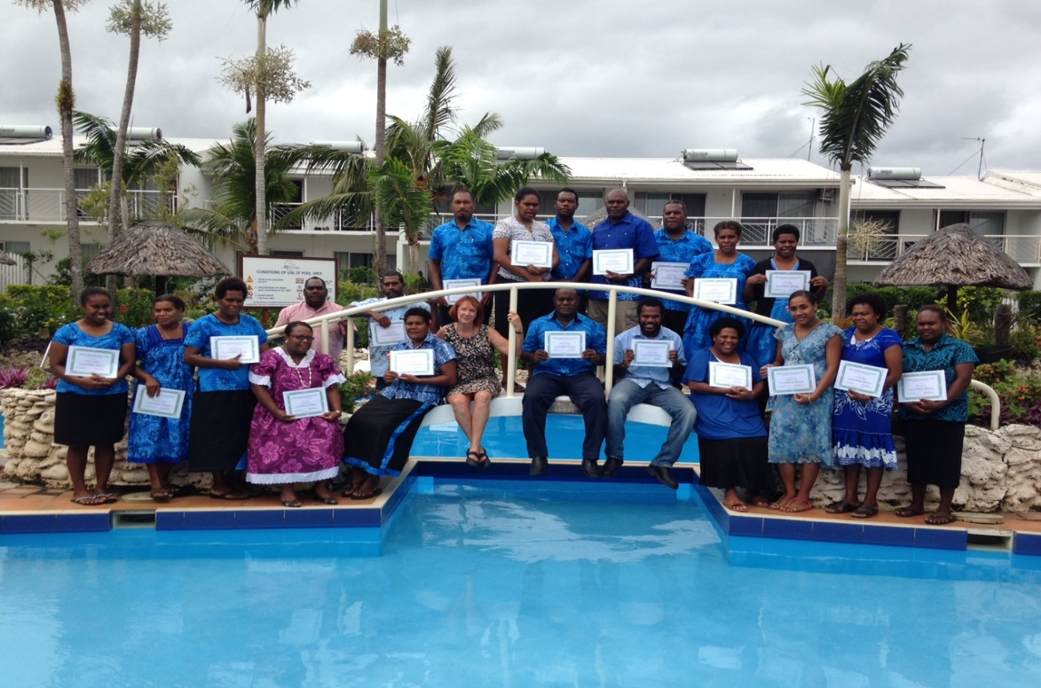
Photo: Jo-Anne Braithwaite, Workplace Learning Adviser with attendees of the coaching and mentoring skills course at the Melanesian in May 2015

This included repairs to the Public Prosecutors Office in Port Vila, repairs to the Supreme Court Registry in Port Vila and ITC equipment for the Magistrates’ courts in Tanna and Tongoa; repairs to the roof of the State Law Office archive room and support for the scanning of all documents damaged as a consequence of the cyclone.
For example, the CD&L Adviser was out of the country for a longer period as a result of the cyclone and the implementation of the capacity development strategy was delayed a little; the Save the Children Child Protection Program Phase 2 was halted for a period of 3 months; the LSIP program stopped whilst students left the country; negotiations ceased with potential service providers for foundational skills; and translation of the SPD Manual ceased for a period.
See page 37 of the July – December 2014 SRBJ Progress Report.
Although the program continues to consider if this needs to be increased in terms of human resources to facilitate the research, in particular.
See page 50 of the July – December 2014 SRBJ Progress Report.
Inhibiting factors in the context and to the program itself are provided in greater detail in sections 1(b) and 2(c).
In December 2014 the intermediate course had 25 lawyers and prosecutors (4 female) and the advanced course had 17 lawyers and prosecutors (3 female) from Port Vila, Sanma, Penama and Malampa. In June 2015 the Civil and Criminal course had 32 graduates (7 female) of 43 nominees from Port Vila (Shefa), Penama, Sanma, Malampa and Tafea Provinces. The second course in June 2015 had greater participation by the SLO as a result of express support by the Attorney General and less court listings.
LexisNexis® is a leading global provider of content-enabled workflow solutions designed specifically for professionals in the legal, risk management, corporate, government, law enforcement, accounting, and academic markets. LexisNexis originally pioneered online information with its Lexis® and Nexis® services. LexisNexis is part of RELX Group and serves customers in more than 100 countries with more than 15,000 employees worldwide.
Appreciation to Karae Vurobaravu and CDMA
See Section 1(b) p12-16 below for greater detail
Heads of Agency Group meeting, Melanesian Hotel, 1 April 2016.
OGCIO and Judiciary for example with respect to their implementation of the Court Case Management System but also the SLO committing to similar deadlines under its Case Management System procurement contract.
This is articulated in more detail pp 21-22 of the Completion Report July 2014
Minister Alfred Carlot for the majority of the reporting period, Minister Hosea Nevu for three days. Just after the reporting period Minister Dunston Hilton was appointed and is the current incumbent. Cases in the Supreme Court against politicians have an impact on the sector when there is a change of government as occurred recently and those being prosecuted return to government.
Approaches to mitigate against this issue include support for the legal salary review, human resource management support, capacity development for lawyers; leadership support and the law student internship program.
Observations as described by MJCS Executive Officer
See p22 of the Stage 1 Completion Report
See p8 of the SRBJ July-December 2014 Progress Report
For example, sharing of court calendar and budget; coordination between SPD and PPO.
See p5 Executive Summary, Sector Perception Survey 2015
See p5 Executive Summary, Sector Perception Survey 2015
This was the assessment made at the beginning of 2015 and it has proven to be thus.
Since the reporting period the new Public Prosecutor supported by the British and Vanuatu Governments was appointed at the end of August 2015.
The precipitous re-advertisement of the position rather than the extension of the current incumbent is likely related to the Bribery Case against Members of Parliament that is being heard by the Supreme Court of the Republic of Vanuatu relisted for 14 July 2015.
Impetus for greater engagement with the lawyers and prosecutors during this course may have resulted from discussions about the results of the adjournment survey that the courts have conducted and lack of engagement with the Victorian Bar legal advocacy course in December 2014.
Directors of DWA and Department of Corrections.
This paragraph is a discussion about the achievement of outcomes rather than about adequate progress in the delivery of the initiative as planned (see p6 DFAT IET and Pacific Branches ECB Program: Guidance to Implementation Partners on Progress reporting (2014 Update).
Courts, PSO, SPD, PPO, Corrections, SLO and VPF
See p29 and following. Since completion of this Progress Report this is also developed further in the Case and Data Management Evaluation Report where the evaluator develops definitions for each of the agencies.
Levels referred to here are consistent with those used in the Justice and Community Services Sector Capacity Development Strategy
Impressive on the basis that the PSO lawyer: after discussions with the PSO adviser identified a case as suitable for appeal; prepared the first written submission; worked closely with the adviser to finalise written submissions; presented clear and persuasive submissions during the appeal hearing; responded directly to questions from the judges in the hearing; was congratulated by von Doussa J on the quality of the submissions; won the appeal; achieved an excellent outcome for her client; and established useful guidelines for evidence in criminal trial.
This data should however be tempered by the fact that there are a significant number of cases that are as yet unassigned and so are not included in this data which impacts on the overall accuracy of this statistic.
As they now work across the whole PJSPV - more specifically, the Capacity Development and Leadership Adviser, the Case and Data Management Adviser and the SPD Adviser at the time of the first progress report and now also the Workplace Learning Adviser, the Public Financial Management Adviser and the Human Resource Management Adviser.
As indicatively recognized by heads of agency across the sector in the Sector Perception Survey 2015, see p5
One from cabinet staff and one from MFEM
Relates to indicator S1.4.1
The results are not available without approval of the Chief Justice and are not currently sufficient to be reliable. The Judiciary is considering repeating the exercise.
By the adviser and key representatives of the Supreme Court
After a manual review done in December 2014 by the CDM Adviser
see page 15 of the PJSPV SRBJ Workplan July 2014 – December 2015
Matthew Allen, Sinclair Dinnen, Daniel Evans and Rebecca Monson, Justice Delivered Locally – Systems, Challenges and Innovations in Solomon Islands, Research Report August 2013, J4P, The World Bank.
Miranda Forsyth, Spinning a Conflict Management Web in Vanuatu: Creating and Strengthening Links between State and Non-State Legal Institutions (2011) 63 Journal of Legal Pluralism and Unofficial Law 179-205
Other those encompassed in the three significant variations above.
The program is seeing if it might be possible to extract the numbers or percentage of cases that support female clients in these types of matters in the future.
See p 37 of the SRBJ July-December 2014 Progress Report
The format the Monitoring Officer, MJCS used in reporting against the PAA and PLAS indicators in the MJCS Annual Report has been used by the PMO Monitoring Officer to gather information across the agencies she is required to assist (i.e. Good Governance Sector (including Justice & Police) and the Primary Sector)
It should be noted that SRBJ has received further comments just before this report was finalized for further refinement of the Grants Review 2015, accordingly the version attached in Annex 6 remains in draft form until finalized.
The Grants Facility is discussed in more detail in Section 5(f).
See p30 of the last SRBJ progress report for July-December 2014
These are in addition to the high level lessons learned identified in the Stage 1 Completion Report Section 2e)
For greater detail of outputs refer to the Table in section 2b headed Summary of Key Achievements
For example, S1.5.2 Increase in use of government systems by development partners – has been identified for amendment by the PFM adviser to “Increase in use of government systems by the program.”
See table 1, page 10 and following of the M&E Update Report (Annex 12) for the amended evaluation schedule.
See p6 M&E Update Report Annex 12
M&E Update Report
See page 14 of the SRBJ Workplan 1 July – 31 December 2015

