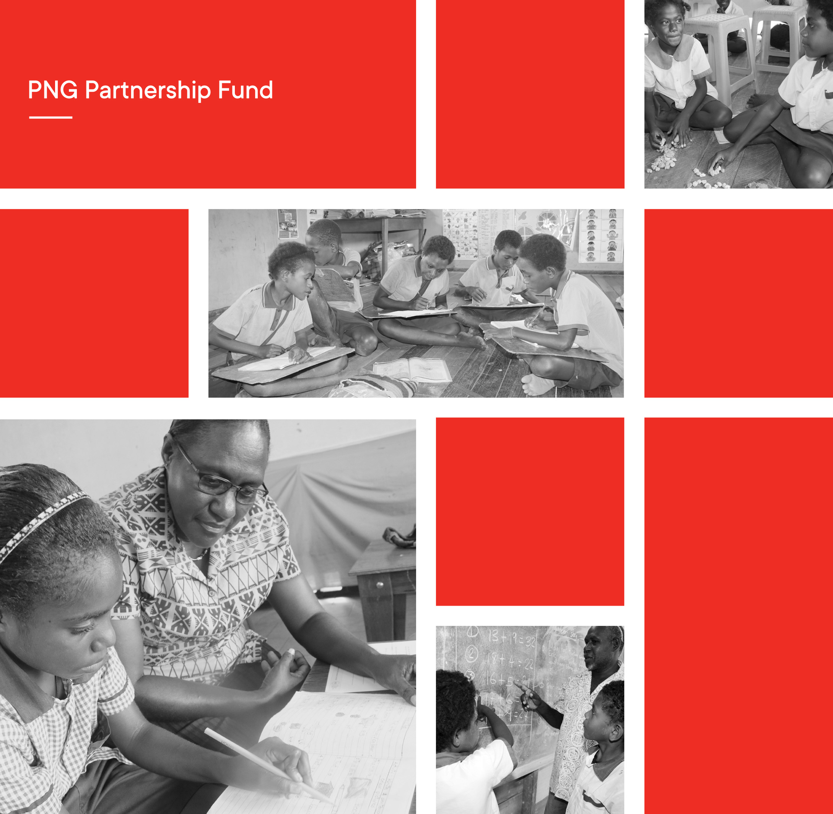

Papua New Guinea Partnership Fund

Education Program Completion Report
July 2017 to January 2022

Document Version Control
Ver. | Date | Originated by | Approved by | Comments
1 | 14.02.2022 | J. Waffi & C. Johnston | Phillippe Allen | Draft submission
2 | 01.03.2022 | J. Waffi & C. Johnston | Phillippe Allen | Revised based on DFAT feedback
3 | 30.03.2022 | C. Johnston | Geoff Scahill | Final draft submission
4 | 04.04.2022 | C. Johnston | Geoff Scahill | Final submission

Contents
Contents ii
Abbreviations and Acronyms i
Figures and Tables 2
1. Executive Summary 3
2. Key achievements 8
3. Introduction 13
3.1. Elementary Education in PNG 13
3.2. The PPF (Education) Program 14
3.3. PPF Theory of Change 15
3.4. Implementing context 16
3.5. Governance arrangements 20
4. Investment Performance 23
4.1. Effectiveness 23
4.2. Efficiency 30
4.3. Value for Money 31
4.4. Gender, Disability, ands Social Inclusion (GEDSI) 32
4.5. Relevance 42
4.6. Monitoring and Evaluation 43
4.7. Sustainability 47
4.8. Public Diplomacy 51
4.9. Other Issues 53
5. Past Reviews 56
6. Challenges and Lessons Learned 58
6.1. Challenges 58
6.2. Lesson Learned 60
7. Recommendations for Future support to elementary education in png 63
7.1. Ongoing Consolidation of Achievements 63
7.2. For Future programs 65

Abbreviations and Acronyms

DFAT Australian High Commission
AMS Abt PNG Management Services
ARoB Autonomous Region of Bougainville
AUD Australian dollar
CARE CARE International in PNG/Australia
CIMC Consultative Implementation and
Monitoring Council
CLP Community Leadership Program
CSEP Comprehensive Strategic and Economic
Partnership
CV4GE Community for Girls Education
DFAT Department of Foreign Affairs and Trade
DOE Department of Education
DRR Disaster Risk Reduction
EC Education Cluster
ECCE Early Childhood Care and Education
ECE Early Childhood Education
EERRP Education in Emergencies Response and
Recovery Plan
EHP Eastern Highlands Province
EiE Education in Emergencies
ESP East Sepik Province
FODE Flexible and Open Distance Education
GEDSI Gender Equity, Disability and Social Inclusion
GESI Gender Equity and Social Inclusion
GoPNG Government of Papua New Guinea
GPE Global Partnership for Education
HDMES Human Development Monitoring and
Evaluation Service
IEC Information Education Communication
IEP Individual Education Plan
IERC Inclusive Education Resource Centre
LFA Library for All
M&E Monitoring & evaluation
MEP Monitoring Evaluation Plan
MOU Memorandum of Understanding
NCD National Capital District
MTR Mid-Term Review
NGO Non-government organisation
NOC National Oversight Committee
PAF Performance Assessment Framework
PAGP PNG-Australia Governance Facility
PEA Provincial Education Authority
PDOE Provincial Department of Education
PD&C Public Diplomacy and Communications plan
PGK Papua New Guinea Kina
PKS Pikinini Kisim Save Project
PNGEI PNG Education Institute
PPF PNG Partnership Fund
PSS Psychosocial support
QTAG Quality Technical Advisory Group
RISE Rapidly Improving Standards in Elementary
Project
Save Save the Children in Papua New Guinea
SBC Standards Based Curriculum
SBoM School Board of Management
SLIP School Learning Improvement Plan
T4E Together for Education Project
TETWG Teacher Education Technical Working Group
TIC Teacher in Charge
ToC Theory of Change
TT Teacher training
TWG Technical Working Group
UNICEF United Nations Children Fund
UoG University of Goroka
WaSH Water and Sanitation and Hygiene
WVA World Vision Australia

Figures and Tables
Figures:
Figure 1: PPF coverage in PNG 7
Figure 2: Positive associations with learning outcomes 9
Figure 3: Negative associations with learning outcomes 9
Figure 4: Proportion of students’ literacy scores by percentage at baseline and endline. 9
Figure 5: Proportion of students’ numeracy scores by percentage at baseline and endline. 10
Figure 6: Student scores in literacy subtests at baseline and endline 10
Figure 7: Student scores in numeracy subtests at baseline and endline 11
Figure 8: English comprehension and word problem scores at baseline and endline 11
Figure 9: Teachers in SBC English Training, Madang 2021 13
Figure 10: PPF Education Theory of Change 16
Figure 11: PNG PILNA results for Grade 3 and 5 in literacy and numeracy 17
Figure 12: Observed teacher competency areas for student engagement by treatment 24
Figure 13: Observed teacher competency areas for positive discipline by treatment 25
Figure 14: Discipline strategies reported by parents in CARE (left) and Save by treatment 27
Figure 15: Parents who report reading to their child in Save and CARE by treatment. 28
Figure 16: Caregivers gathering at Mair Elementary School Madang 2021 31
Figure 17: Teacher's ability to ensure equal participation of boys and girls by treatment. 33
Figure 18: Teacher’s ability to apply gender sensitive pedagogy by treatment. 34
Figure 19: Teacher’s ability to apply inclusion strategies in the class. 34
Figure 20: Provincial officers’ perception on girls’ treatment in elementary. 35
Figure 21: Provincial officers' perception on whether girls are as smart as boys in maths. 36
Figure 22: Male and female students scores in the addition subtest at baseline and endline. 37
Figure 23: Male and female students scores in the subtraction subtest at baseline and endline. 38
Figure 24: Male and female students scores in the comprehension subtest at baseline and endline. 38
Figure 25: PPF monitoring and evaluation system levels 43
Figure 26: PPF document flow 44
Figure 27: A teacher in Missingi Elementary, Madang, sharing insights from teaching training 46
Figure 28: A teacher at Missingi Elementary, Madang sharing insights from the teacher training 46
Figure 29: Public diplomacy products 52
Figure 30: Public diplomacy messaging between 2020-2021 52
Figure 31: Public diplomacy messaging between 2020-2021 52

Tables:
Table 1: Changes in teaching and learning as observed and reported by teachers and TICs 25
Table 2: Observed changes in classroom practice reported by TICs 26
Table 3: Action taken to address high absenteeism reported by TICs 26
Table 4: Actions parents are taking to support their children learn by project 28
Table 6: Gender differences noted in the midline synthesis 36
Table 7: Statistical power of midline student learning results for Save the Children 37

Executive Summary
The Papua New Guinea Partnership Fund (Education) program (PPF) has made a significant contribution to the elementary education sector since its inception in 2017. The $69.4 million program was funded by the Australian Department of Foreign Affairs and Trade (DFAT) between 2017-2022 to improve the coverage of quality basic services across Papua New Guinea (PNG) and achieve critical and sustainable outcomes at scale. Initially the program covered the sectors of governance, law and justice, health, and education, but the program scope was subsequently narrowed to support the priority sectors of health and education. The program was one of seven administered through the PNG Australia Governance Partnership (PAGP).
Up to early 2020, the PPF approach was focused on two related long-term outcomes: 1) Improved service delivery scope and reach, and 2) Transformative sector governance. From 2020, after both a Quality Technical Advisory Group (QTAG) review and an Independent Mid-Term Review (MTR) of the education component of the PPF program, it was adapted, introducing a program level Theory of Change (ToC) — establishing four long term outcomes (LTO) for the final two years of the program. These were:
- Teachers demonstrate improved practices.
- School learning environments are inclusive and enable student learning.
- Parents/caregivers demonstrate improved behaviour to enhance student learning and attendance.
- DOE is supported to strengthen early grades education in PNG.
These outcomes aligned with both PNG and Australia’s priorities for education and the Department of Education’s (DOE) National Education Plans for 2015-19, and 2020-2029.
While the program pivot in 2020 was significant, the collaboration and commitment among program stakeholders enabled it to occur effectively - transitioning the program to provide pandemic support for the education sector while enabling the grant projects to continue as much as practicable.
The program chose to achieve the LTOs through grants to reputable Non-Government Organisations (NGOs) that had an existing presence in PNG. Through a competitive selection process three consortia were selected to deliver their nominated projects across 10 provinces:
- World Vision and its partners delivering the Together for Education (T4E) project
- Save the Children and its partners delivering the Rapidly Improving Standards in Elementary (RISE) project, and
- CARE and its partners delivering the Pikinini Kisim Save (PKS) project.
The three projects contributed to long term outcomes, meeting and often exceeding, targets. Over the years, the program and supported projects have adapted to the changing environment, the needs of stakeholders, and responded to the learnings gained from program implementation.
The utilisation of grants was excellent for achieving quality results at the community level in schools. Having consortia of NGOs, universities, church education agencies, and government enabled projects to be designed and rigorously contested during implementation for optimum results.
Each NGO partner established close working relationships with their Provincial Divisions of Education (PDOE) and District Education Office (DEO) to jointly drive improvements to elementary education in each of the 10 provinces.
As a result of the changes made in 2020 following the MTR, the relationships between subnational governments and NGOs shifted and the consortia adopted a mentoring and coaching role while PDOE became the primary implementers of many PPF activities including: teacher training, teacher professional development and School Learning Improvement Plan (SLIP) training. The shift enabled program practices to be embedded within the departments and provide the foundation for future reform based around collaboration and partnership.
Each NGO partner in the consortium brought different strengths and areas of specialisation, for instance CARE’s partnership with the University of Goroka saw female teachers graduate with early childhood education diplomas. Save the Children’s partnership with Callan Services enabled a close relationship to be formed between elementary schools and Inclusive Education Resource Centres (IERCs), and for World Vision, their partnership with Consultative Implementation and Monitoring Council (CIMC) enabled rich learning to be generated from community-based monitoring of elementary schools.
NGO partners have also capitalised on their learnings by replicating successful approaches such as the Teacher Learning Circle (TLC), initiated by ChildFund and World Vision.
As most partners are PNG-based these relationships and learnings will continue to benefit PNG through the ongoing activities these NGOs undertake in-country.
Since 2017, 360,575 children (172,219 females) have benefitted from the program, 6,455 elementary teachers (2,990 females) have received training, 2,502 elementary schools and 1,035 early learning centres have received resources, and over 1000 literacy volunteers were trained and ran reading and maths clubs in many schools across the target provinces.
Furthermore, literacy and numeracy programs have been run for adults to be able to read to their children and/or assist with their homework, benefiting 1,290 parents (739 females). After awareness raising sessions, 144,230 parents (86,538 females) in the target provinces better appreciate the need to support their children’s development and are investing more time in their children’s learning and promoting girls’ education in their communities. These initiatives have achieved greater community ownership and understanding on the importance of early education for their children while also empowering the parents through increased literacy and numeracy skills.
Early grade book production has been a feature of PPF’s activities, and 236,725 printed reading books have been distributed, including titles with female protagonists and stories capturing the lives of children with disabilities. Over 2,280 digital library tablets, (the first 480 to be distributed containing 500 book titles and 1,800 containing 760 book titles) have been distributed to 57 elementary schools, and vernacular stories have been added to software on tablets - with over 2,500 users reading more than 270,000 book titles.
To support the evaluation of impact a baseline survey was undertaken in 2017, a midline in 2018 and an endline survey in 2021 (more information can be found pages 9-12). The results of these surveys have shown that the initiatives undertaken by each consortium has contributed to improved student learning outcomes and teaching practice. Students in the endline assessment scored on average 12 percentage points higher in comprehension than students from the same grade level in 2017 and 8 percentage points higher in subtraction and addition. There are now fewer students scoring below 20 percent on literacy and numeracy subtests. Compared to teachers that had not received training, PPF supported teachers performed on average 7 percentage points higher in classroom management and student engagement reflecting the specific pedagogical areas that were practiced repeatedly during teacher professional development activities.
Importantly, the program has achieved some significant gains in gender equity and social inclusion. Teaching modules promote inclusion, and communities have been engaged in sensitisation activities that have challenged the traditional ‘role’ of girls and the negative implications on their education. These gains have also been achieved for children with disabilities, challenging the cultural norms of exclusion. 2,595 elementary teachers (1399 females) and 78 District Inspectors (38 females) received training in gender and disability inclusive practices and learnt how to screen and assess children for disabilities, develop and implement individual education plans, and make referrals to disability support services. This has assisted the IERCs to reach beyond their current resource capability and support a much wider region.
School management and governance mechanisms have also been strengthened to better support teaching quality, student learning and gender and disability inclusion with 2,815 School Board members (707 females) trained in effective school management, and financial management. In addition, 551 SLIPs were developed with strategies addressing gender and disability inclusion with more than 50,000 parents/caregivers engaged in SLIP development.
Results show that since 2017, results in literacy and numeracy have improved across the 10 provinces targeted by PPF. The focus on foundational standards in elementary education has proved successful, presenting a positive trajectory and story to shape future policy and practice.
The program has, however, faced some challenges. For the most part, the program adapted to address the challenges once identified to facilitate ongoing delivery of the various grant initiatives. The key challenges identified in the initial two years of the program were around fostering collaboration and consistent ways of working amongst the program partners, key stakeholders, and consortia members. This also led to a diversion in data collection and reporting methodologies, which limited the level of aggregate analysis.
While overall the engagement with the lead NGO for each consortium was positive and achieved significant results in the 10 priority provinces, there were variation in performance amongst the three grantees. The performance of each was proportionate to the capability of the grant program manager and the commitment of senior management to achieving program outcomes. In the two phases of the program, targets were met or exceeded for most grant outputs, however the quality of reporting to PPF fluctuated resulting in delays of corporate milestones. This was particularly evident in the final months of the program when grantees were juggling the impact of COVID-19 lockdowns at the same time needing to complete the endline evaluation and close out activities. This contributed to underspending and delays in the final audit reports.
Accessibility into the communities across the 10 provinces was a challenge for the life of the program, often causing delays in timeframes and emphasising the importance of logistical planning to every activity for it to achieve success. The cultural variation between communities, additional levels of government, and range of stakeholders in each province also required each initiative to be customised for each area of delivery to maximise community engagement.
Another challenge was the inability of most teachers to identify children with disabilities. This combined with the limited geographical reach in each province of the IERC made supporting disability inclusion into schools a complex matter that would benefit from ongoing attention into the future.
Finally, the existing national challenges of high rates of student and teacher absenteeism, under-qualified teachers, limited teaching and learning resources, inadequate school infrastructure, and the early drop-out rate of children from schooling have been key areas the program has sought to address to achieve the LTOs. Even though boys and girls are both affected by these factors, girls experience significantly more disadvantage due to cultural factors. Important reforms in elementary education can only succeed if students attend class as this is essential for mastery of the foundational concepts needed for higher grades. Despite chronic absenteeism, positive change has occurred and continues in the elementary sector with results showing an improvement in literacy and numeracy since 2017 across the 10 provinces targeted by PPF.
When the COVID-19 pandemic entered PNG, PPF played a pivotal role in supporting DOE in the development and implementation of the Education in Emergencies Response and Recovery Plan (EERRP). PPF assisted DOE to secure $10 million towards the PNG response effort. PPF also leveraged the grants to provide DOE access and support to the NGO communities.
Based on PPF findings, the key recommendations for the DOE and development partners to consider are:
- Combating the chronic absenteeism of children should be made a priority for future education investments. Reforms to the quality of teaching, resources and the curriculum will have limited effect if this entrenched behaviour remains unchanged.
- Building on the success of PPF’s SBC Inservice training and post training support initiatives, opportunities exist to institutionalise continuous teacher professional development for early grade teachers.
- While continuous teacher professional development can contribute to improved teacher quality, if teachers are not motivated then their commitment level is low. Teacher motivation is closely associated with recognition, accreditation, and salary and benefits. Future education investments should recognise the role of volunteer teachers in the early grades and work towards supporting their registration and ensuring they are on payroll.
- Opportunities exist to continue to improve inclusive practices and strengthen initiatives that enhance student learning. There have been some notable successes in this area by PPF, which could be built upon.
- Future education investments must be aligned to DOE priorities including the NEP, work in partnership with DOE and PDOEs and be represented at education stakeholder forums to ensure uptake and expansion of proven and cost-effective practices.
Overall, the PPF program has evolved since its inception, adapting to lessons learned each year and to changing stakeholder priorities. In each stage of its delivery the PPF program has delivered the expected outcomes effectively through the model of working with large NGOs and local partners with existing expertise.
Relationships with DOE, Australian High Commission (AHC), grantees and other stakeholders have remained positive over the duration of the program. The consistent commitment to take a collaborative approach to achieve change has been successful as displayed through the significant results achieved since 2017.
There is no doubt that COVID-19 significantly impacted on the achievement of program outcomes. It impeded the delivery of all approved activities to varying degrees, but also generated the creation of innovative approaches to continue projects.
PPF has been a robust and effective mechanism for improving literacy and numeracy skills of girls and boys in the elementary sector within PNG.
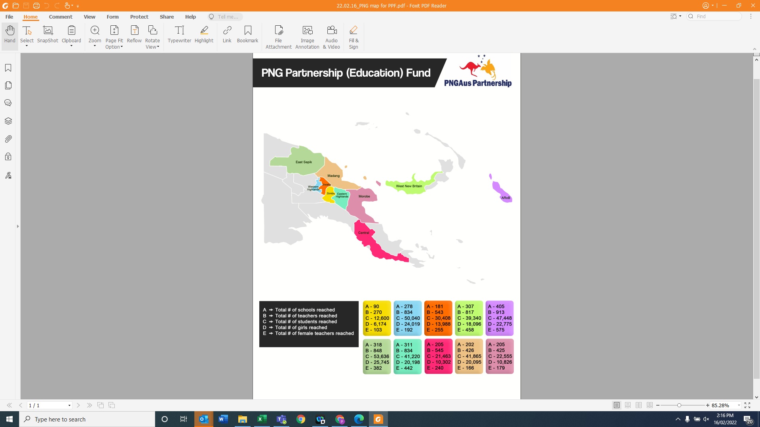
Figure 1: PPF coverage in PNG

Key achievements








The PPF program has partnered with government and non-government agencies to effectively progress reforms in the early grade sector in PNG. Key achievements include:
Teachers, school administrations and governing bodies are more aware of the need to create inclusive learning spaces for children and the importance of regular school attendance.
144,230 parents (86,538 females) in the target provinces better appreciate the need to support their children’s development and are investing more time in their children’s learning and promoting girls’ education in their communities.
The endorsement of the PPF developed Standards Based Curriculum (SBC) English and Mathematics Inservice training manuals for use across PNG by provincial divisions of education, PNG Education Institute, and teacher training colleges.
The Department of Education (DOE) can now continue approaches for ongoing teacher professional development, such as the teacher learning circles (TLCs).
Over 300 children with disabilities have been supported to access early grade education through individual education plans.
360,575 children (172,219 females) that benefited from the program will have opportunities for better education
outcomes to help them in the future.
2,502 elementary schools across 10 provinces and 1,035 early learning centres across three provinces are now better resourced to support effective teaching and learning activities
6,455 elementary teachers (2,990 females) are now better trained and equipped to deliver the SBC and provide an improved quality of education to early grade learners.

Positive associations with learning outcomes

Figure 2: Positive associations with learning outcomes
Students in Grade 1 who were served breakfast on the day of their assessments scored 3.6 percentage points higher on average, on the literacy test, than those students who did not. In Grade 2, students who ate a meal on the day of their assessment, scored on average, 4 percentage points higher on the literacy test than those who didn’t. Many positive drivers of learning outcomes were from outside the school environment.
Predictors of higher numeracy were parental support for math homework and leisure time spent with parents. For literacy, the best predictors of higher literacy were parental support in homework, mothers reading to their children and writing practice.
Negative associations with learning outcomes

Figure 3: Negative associations with learning outcomes
A significant correlation was found between student absenteeism and their test outcomes. Students in Grade 1, who missed at least one day of school in the week preceding the test, scored on average, 2.6 percentage points lower on the literacy test than those who did not miss any school. In Grade 2, those students who reported that they missed at least a day of school in the last week, scored on average 3.9 percentage points lower on the literacy test than those who didn’t miss any school.
For students in Grade 2, the strongest predictors of low numeracy were absenteeism, chewing buai, children needing to work at home, being bullied at home, learning difficulties in school and ill-health. All these findings control for district level fixed effects and asset ownership.
The graphs below highlight the changes in scores that children are now obtaining.
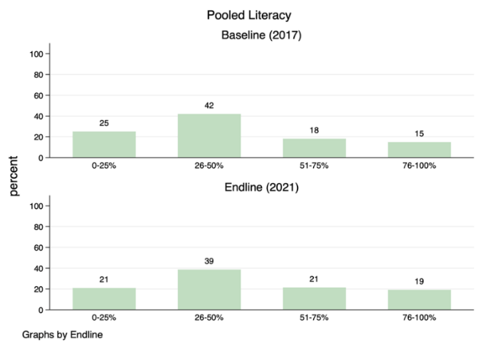
Figure 4: Proportion of students’ literacy scores by percentage at baseline and endline.
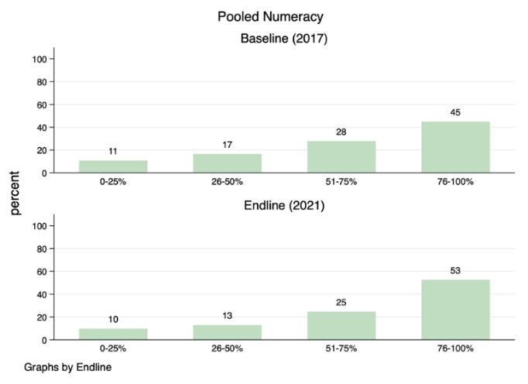
Figure 5: Proportion of students’ numeracy scores by percentage at baseline and endline.
A higher proportion of children are now scoring above 76 precent in literacy and numeracy compared to baseline and fewer children are scoring below 25 percent on the same assessments.
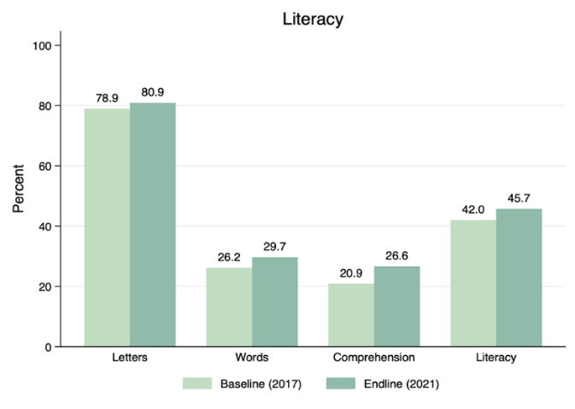
Figure 6: Student scores in literacy subtests at baseline and endline
In the graph above, we observe higher average scores in endline compared to baseline on all sub-tests for literacy. For literacy, comprehension has improved substantially (5.5 percentage points) which was a key area of focus. For numeracy, the most significant improvement was in addition and subtraction. This was a focus of the trainings.
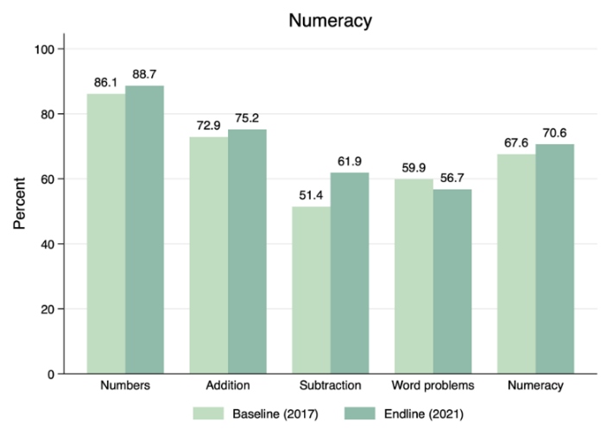
Figure 7: Student scores in numeracy subtests at baseline and endline
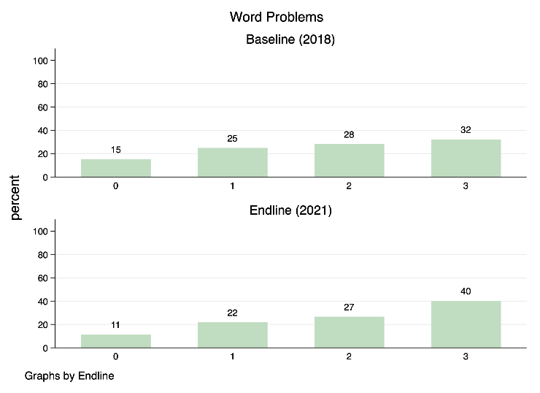
Comprehension results are presented below. It is evident that fewer children were unable to answer any questions and more children answered all the questions correctly. It is important to note that one in two Grade 1 and 2 students are still struggling to understand what they have read.
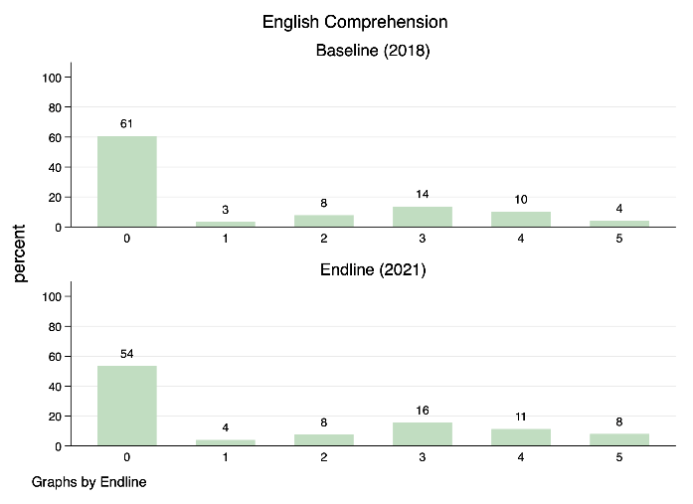
Figure 8: English comprehension and word problem scores at baseline and endline

Similarly, students’ ability to solve simple addition and subtraction word problems has improved.
The results confirm that the focus on reading strategies and solving addition and subtraction problems using concrete objects is relevant and appropriate to the learning needs of elementary children.

Baseline, Midline and Endline Assessments
PPF undertook the ambitious task of using student and teacher assessments to determine whether the program was effective. PPF utilized the Research Triangle Institute (RTI) International’s Early Grade Reading Assessment (EGRA) and Early Grade Mathematics Assessment EGMA) and a mirrored lesson observation instrument. Save the Children led the early work on adaptation and shared the tool with World Vision and CARE International to ensure complementarity. The tool was administered on three occasions: baseline, midline and endline.
In late 2017, the baseline was conducted with 5,589 Grade 1 students from 453 elementary schools were assessed in 10 provinces in PNG.
Key findings were that many E1 students were overage, absenteeism was widespread amongst teachers and students, repetition was high, a parent’s literacy and whether a child had participated in Early Childhood Education (ECE) were strong predictors of learning, 25 % of E1 students were comprehending a simple text, 35% of E1 students could answer the addition problems and only 15% of children could answer the subtraction problems.
In late 2018, a midline was conducted in T4E and RISE provinces to determine whether there had been a change in results after teacher training had been conducted. PKS began their project later, so was not ready to participate in the midline evaluation. The midline was conducted with 3,343 Grade 1 & 2 students from 276 elementary schools from 6 provinces in PNG.
Key findings were that intervention students performed 9 percentage points higher in reading comprehension than comparison students. Additionally, intervention students performed higher (up to 5 percentage points) in mathematics word problems and more E2 students could answer E2 addition and subtraction questions compared to E1’s attempts at baseline.
Positive associations to learning were similar to baseline: ECE attendance and a mother’s literacy but having reading books and reading at home was also a strong predictor of learning. Negative associations to learning were high absenteeism, repetition, and betel nut consumption.
In late 2021, the PPF endline was conducted with 3,577 Grade 1 and 2 students from 175 elementary schools in 9 provinces in PNG. Due to COVID-19 lockdowns, no data was collected from Eastern Highlands Province.
Key findings were that students in 2021 scored on average 12 percentage points higher in comprehension than students in 2017 and 8 percentage points higher in subtraction and addition. There were fewer students scoring below 20% on all literacy and numeracy subtests.
Positive associations with learning outcomes were nutrition related, parental support with homework and leisure time, and their reading habits. Negative associations to learning outcomes remained: absenteeism, betel nut consumption, bullying, and needing to work at home.
The results confirmed that focusing on reading strategies, solving addition and subtraction problems using concrete objects during teacher professional development was relevant and appropriate to the learning needs of elementary children in the PPF target provinces.

Introduction

Elementary Education in PNG
People are the foundation of every nation. Having appropriately skilled people is essential for PNG to grow its economy and provide better services to its people. Quality education should begin from the foundational years of schooling, which provides the basis for all future learning.
The quality of education in PNG was put under considerable strain when elementary schools were introduced in 1995. Grade 10 school leavers who would otherwise not have qualified for teachers’ colleges were given six weeks of training and sent into classrooms to teach six- to 10-year-old children. Many of these “teachers” had been out of school for decades and therefore struggled to understand their course materials. Follow-up visits by provincial elementary trainers also failed to reach every teacher limiting assessments of teaching and learning in elementary schools. A DOE capacity needs assessment reported concerns including increased enrolments and inadequate facilities and resources to cater for their needs; elementary teacher training; finance; staffing; inadequacy of visits by agency advisers; retention of female students and inadequate supplies of curriculum materials for student numbers.
Middle Ramu District TT1 participants in training
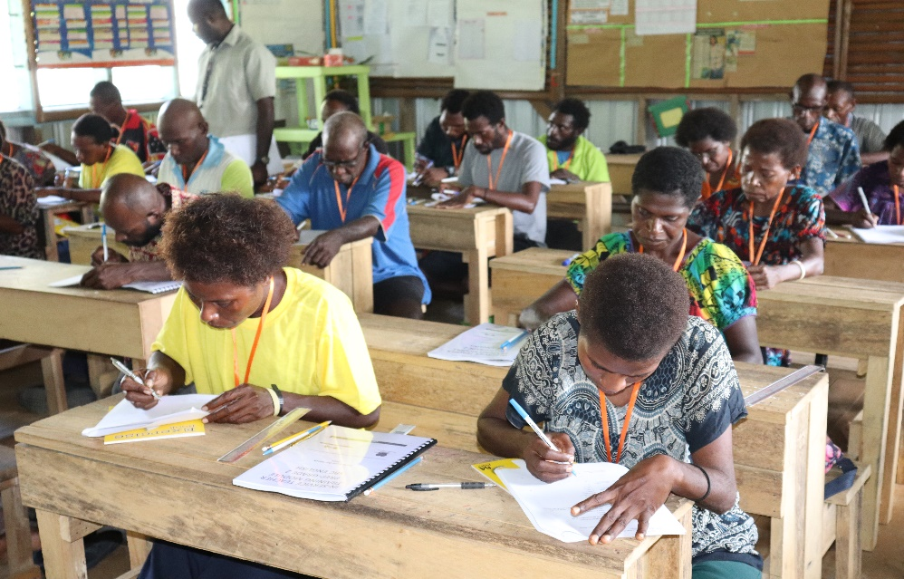
Figure 9: Teachers in SBC English Training, Madang 2021

Since 1995, significant education reforms have been implemented including the development of the Standards Based Curriculum (SBC), which has provided elementary teachers with clear standards for each grade level and curriculum guidance to support teaching and learning – including scripted lessons for English and Mathematics covering each day of the school calendar.
Teachers have welcomed this change but have continued to face challenges in their classrooms. Many rural schools have yet to receive the full suite of teaching and learning resources that complement the SBC or been orientated in its contents. Additionally, the low level of education of many elementary teachers has meant they face difficulty in comprehending the key concepts in the teaching guides, resulting in them skipping sections they fail to understand.
Furthermore, an estimated 50% of elementary teacher positions are filled by volunteers who rely on their community to maintain their livelihood. This lack of standardisation in education, training and reimbursement of teachers makes addressing issues, such as attendance, difficult.

The PPF (Education) Program
The PPF education program was established in 2017 to provide grants to support service delivery in the sectors of governance, law and justice, health, and agriculture. The scope of the program was subsequently narrowed to support the priority sectors of health and education.
The program aimed to improve the coverage of quality basic services across PNG and achieve critical and sustainable outcomes at scale. For education, the focus was on the foundation years of children’s learning as a strong predictor of success in later years of schooling. This focus aligned to the Australian Government’s Education and Leadership portfolio for PNG and was the main contributor to
Outcome 1: girls and boys in targeted provinces/schools have improved early grade literacy and numeracy.
The program aligned closely to the two iterations of the PNG government’s National Education Plan (2015-2019 and 2020-2029) targeting quality teaching and learning, local management and systems strengthening. The program built upon results and learning from previous successful interventions, and promoted the principles of scalability, innovation, and partnerships.
The PPF (Education) program had four main partners within GoPNG:
- Department of Education (DOE) – a formal MOU was signed with DOE and all grant recipients to formalise the objectives and roles and responsibilities of all key participants.
- Department of Higher Education, Research, Science and Technology (DHERST) – participated in the National Oversight Committee (NOC) as an observer and was a Member of the Teacher Education Technical Working Group (TWG). The department was an important stakeholder for decisions relating to the use of PPF developed SBC English and Mathematics Inservice training materials at pre-service teacher training institutions.
- Department of National Planning and Monitoring (DNPM) – was a member of the NOC and participated in PPF monitoring visits.
- Papua New Guinea Education Institute (PNGEI) was engaged as a member of the Teacher Education TWG and involved in discussions regarding the utilisation of PPF training resources for teacher upgrading programs and the primary teacher diploma course.
The program’s delivery modality was based around the provision of grants to reputable NGOs and consortia to enable the progression of education and health initiatives throughout the 10 priority provinces within PNG. Initially, the program began with a very ‘light’ touch, with all key responsibilities (MEL, GESI, public diplomacy etc) devolved to each grantee for management.
In education, PPF engaged three NGOs with significant in-country capacity and experience to support the DOE deliver quality services at sub-national levels in the elementary sector. Through a competitive grant funding mechanism, these consortia were selected to work with provincial and district education partners:
- World Vision and its partners ChildFund, Library for All, Consultative Implementation Monitoring Council and University of Canberra delivered the Together for Education (T4E) project in Madang, Morobe and Central
- Save the Children and its partners Callan Services and Summer Institute of Linguistics delivered the Rapidly Improving Standards in Elementary (RISE) project in Autonomous Region of Bougainville, East Sepik, and Eastern Highlands, and
- CARE International and its partners Adventist Development and Relief Agency, University of Goroka, Queensland University of Technology and Church Education Agencies delivered the Pikinini Kisim Save (PKS) project in Western Highlands, Simbu, Jiwaka and West New Britain.
By the end of its third year of operation the PPF program was acknowledged as a robust and effective mechanism for improving health and education outcomes for women, men, girls, and boys in PNG. The 2019 QTAG Report was positive on the achievements and management of PPF program at that time.
While the devolved management approach worked well, the 2019 Mid-Term Review (MTR) identified that key stakeholders saw benefits in the program having greater involvement in grantee project core functions such as MEL, GESI and public diplomacy. This resulted in the development of core policy documents, tools, and frameworks by PPF to support consistency in approach, comparison between grants, and for grantees to share learnings from their respective projects. These changes were applied from 2020 and provided the program with greater information and influence.
As a result of these reforms (and the onset of COVID-19) the PPF can be divided into two phases:
- Phase 1 (2017-2020) focused on capacity development through three projects that held full responsibility for all aspects of delivery.
- Phase 2 (2020-2022) focused on sustainability and moved the program into a greater leadership role in the management of MEL, GESI and public diplomacy. The COVID-19 pandemic also began at this time, resulting in the program taking a leading role in coordinating consortia adaptation of their projects, and fostering greater collaboration between the consortia and DOE.
In October 2020, the health component of PPF was successfully transitioned into the PNG Australia Transition to Health (PATH) program.

PPF Theory of Change
Through a consultative process with government partners, PPF developed a Theory of Change (ToC) that states that if we improve teacher practices and strengthen the inclusive learning environments in school as well as improve parents’ capacity to support their child’s learning and work with government to imbed good practices in teacher education institutes and policy, then improvements in student learning can be sustained beyond the life of the program.
This will be possible if the importance of early grade education as a foundation to life-long learning is retained as a priority of the government and the wider education community. This is more likely if the PPF program is adaptive and responsive to the COVID-19 pandemic and strengthens cooperation and collaboration with the DOE, provincial division of education and the education cluster within PNG through joint efforts to deliver the PNG EERRP.
The PPF Education program identified four long term outcomes (LTO) for the program. These were:
- Teachers demonstrate improved practices
- School learning environments are inclusive and enable student learning
- Parents/caregivers demonstrate improved behaviour to enhance student learning and attendance
- The education system is supported to strengthen early grades education in PNG.
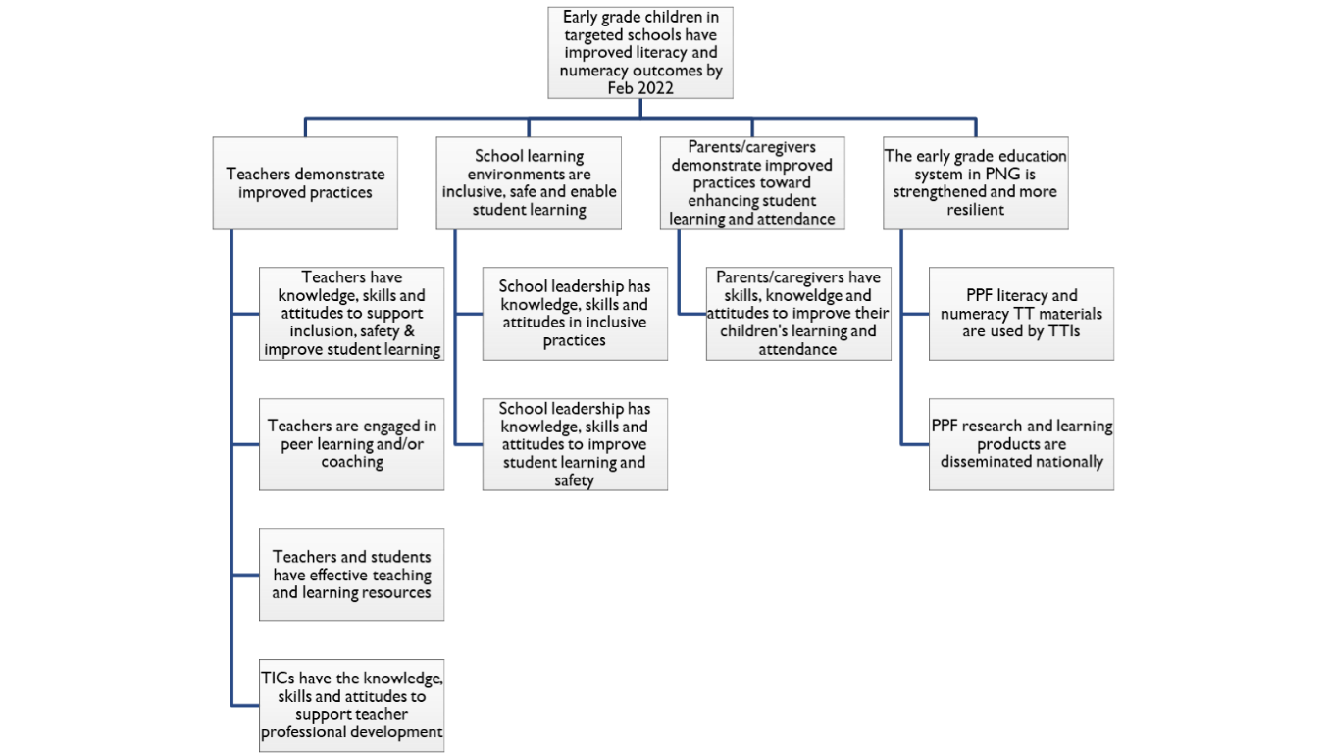
Figure 10: PPF Education Theory of Change
Effective teaching and learning lie at the heart of the PPF program. PPF’s core focus in developing elementary teacher competency to know their subject, teach the SBC effectively, support student learning needs and apply inclusive teaching practices has been a priority for all projects.
School systems throughout the world acknowledge that the quality of teaching is the most critical in-school factor impacting student outcomes. Each grantee placed emphasis on working with their provincial education counterparts in developing an effective teacher professional development system that supported elementary/early grade teachers.
A copy of the PPF Theory of Change can be found in the PPF PCR supporting Annex document.

Implementing context
Across PNG, education access and retention remain troublesome areas. For children in school, daily attendance is low, resulting in low literacy and numeracy levels that exacerbate students’ progress in primary and secondary school. Coupled with limited qualified teachers, insufficient infrastructure, limited and inadequate teaching and learning resources, low parent, and community involvement in children’s education, very few young adults are educated to a level where they can contribute to the economy beyond manual-based jobs.
When PPF began in 2017 the PNG elementary sector was struggling to meet the demand for high quality teaching and learning. Less than 50 percent of the elementary teaching workforce were qualified and very few had received training in the new SBC. Many lacked teaching and learning resources, especially resources that promote reading.
In previous early grade reading assessments, children’s critical pre-reading skills were two years behind the curriculum target and students took five years to attain the reading skill required in the first-grade curriculum. The studies have also shown that girls’ performance in literacy was slightly higher than boys. Despite this slight difference, the results were not statistically significant and so the variation observed cannot be considered representative of girls and boys in PNG. In relation to mathematics, for most of their education journey, girls perform slightly lower than boys.
The DOE took part in the Pacific Islands Literacy and Numeracy Assessment (PILNA) in 2013, 2015 and 2018. PILNA assesses children in Grade 3/4 & 5/6. In 2018, girls in Grade 3 and Grade 5 performed slightly higher than boys in literacy with the reverse for numeracy.
Figure 11: PNG PILNA results for Grade 3 and 5 in literacy and numeracy
Only 38.3 percent of boys and girls met the minimum proficiency in literacy in Grade 3, compared to 51 percent by Grade 5. This was also the trend in 2015.
Importantly, 61.7% of Grade 3 students were not meeting expected literacy standards in Grade 3.
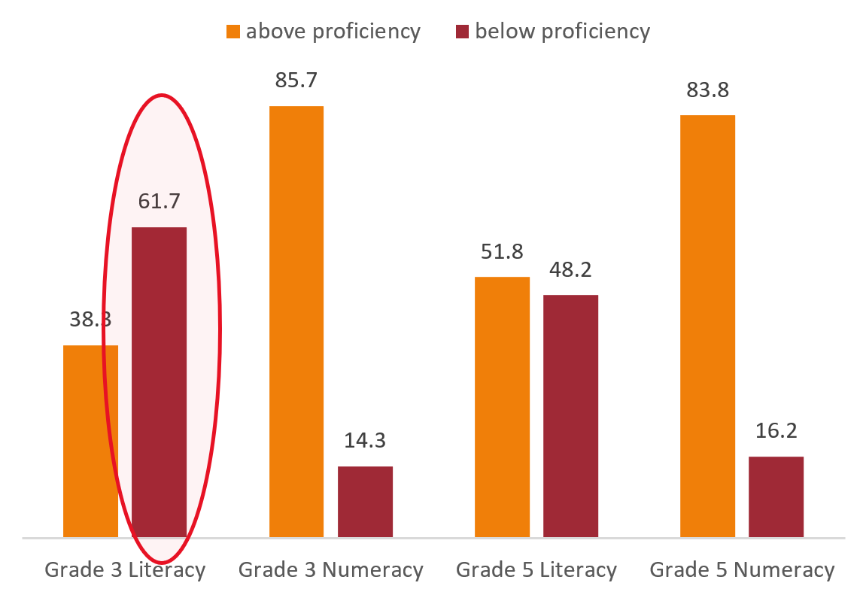
While students begin to catch up in primary school, there is a strong indication that their elementary education has not prepared them for primary education, especially in English which is the language of instruction.
Figure 11: PNG PILNA results for Grade 3 and 5 in literacy and numeracy

Although enrolment rates are high in the first year of formal education and the rate of girl’s enrolment has grown faster than boys over the past two decades, transition and completion rates remain stubbornly low and widen as children progress through school.
In PNG, boys and girls results in literacy and numeracy assessments show equivalency in primary and secondary assessments. Although due to low transition, it is likely that lower performing girls are not visible in assessment data, as they have already dropped out. The most significant loss in transition from one year to the next occurs from Grade 8 to 9 (primary to lower secondary), where only 61 percent of boys and 57 percent of girls’ transition.
Gender equity is near achievement in elementary and primary schooling as the Gender Parity Index (GPI) is close to 1, but this is not the case in secondary education, where the GPI remains less than 0.8. At key transition points between Grade 2 and Grade 3, Grade 8 and 9 and from Grade 10 and 11, significant declines are most prominent and is one of the reasons for the push to change the education structure to 1:6:6 and remove the Year 8 and Year 10 examinations as a requirement for transition.
There are many reasons reported for low attendance and retention in PNG. According to the DOE (2016) these include an insufficient number of schools to meet the school age population, long travel distances for children to travel to school, overcrowding with high student-teacher ratios, an inability of families to pay for school expenses and fees, a lack of community and family understanding of the role and importance of education, tribal fights, and natural disasters.
High teacher absenteeism, under-qualified teachers, limited teaching and learning resources, and inadequate school infrastructure, have all contributed to an inadequate learning environment where children drop out of school early. Even though boys and girls are both affected by these factors, girls experience significantly more disadvantage.
In more recent analysis by the DOE, several external factors were highlighted to explain gender differences in relation to retention, including cultural traditions and attitudes towards female education, especially in patrilineal cultures and areas with high rates of early marriage, adolescent pregnancy, and polygamy; and poverty which means female students are needed for domestic duties or subsidence farming, or families having limited resources to support a daughter’s education.
Whilst many elementary teachers have received some orientation to the new SBC, few have received extensive training on how to use the teaching resources effectively and many schools do not have a complete set of resources.
Insufficient curriculum materials, a lack of quality age-appropriate reading materials to support children’s early-grade literacy learning, and poor-quality school infrastructure, including teacher housing and classrooms, remain significant barriers to quality education provision in elementary.
The proportion of trained teachers at all education levels remains low due to limited access to formal education, low matriculation rates, and a rapidly expanding education system that has led to significant teacher shortfalls, particularly with the introduction of elementary. This has resulted in the mass recruitment of underqualified teachers.
Only 50 percent of elementary teachers are qualified, and community volunteer teachers are often used to fill teacher shortages. These volunteer teachers are not paid by the DOE and therefore rely on community contributions or livelihood activities for their income. This has contributed to low motivation and high absenteeism in teachers within the elementary sector.
DFAT’s new education program, PNG Partnerships for Improving Education (PIE), will build on the successes and achievements of PPF. PPF’s work, especially regarding teacher professional development, has emerged as a promising practice for future adaptation and development by the DOE.

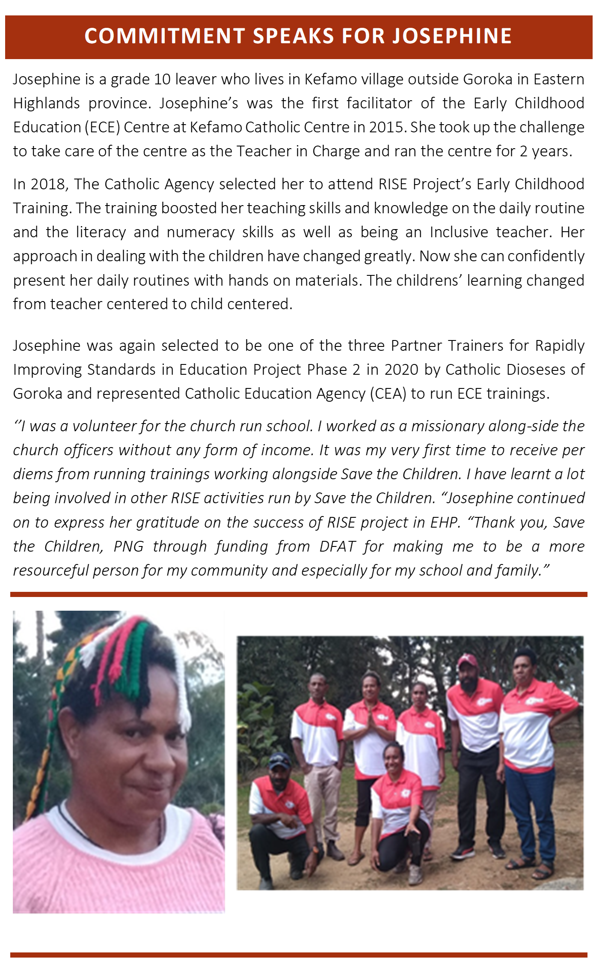
Figure 12

Governance arrangements
The PPF program established and maintained comprehensive governance mechanisms to maximise results through a transparent and collaborative approach.
In the first two years, when PPF Education and Health were combined each consortium established their own steering committees, and most provinces established sub-national committees with the PDOE to oversee project implementation. While these were effective at a project and subnational level, strategic engagement with the DOE and DFAT was limited to bilateral negotiations and, at the start at least, this constrained PPF’s progress.
By mid-2019, PPF, DFAT and DOE committed to establish an overarching governance structure. A Memorandum of Understanding (MoU) that formalised the roles and responsibilities of the three lead NGOs (CARE International, World Vision and Save the Children), DOE, and the PPF program. The establishment of the NOC followed in late 2019, providing critical strategic oversight and direction to the program. Since this time, five National Oversight Committee meetings have been held.
The NOC approved Teacher Education and Research and Learning Technical Working Groups (TWG) further enhanced partnership, coordination, and collaboration among the key PPF stakeholders and importantly with DOE. The two TWGs facilitated effective partnership with government and productive engagement regarding the strategic direction of the program especially as it related to teacher education and research and learning to generate evidence in support of resource allocation and strengthened and/or new government policy.
The grantees were also active in the EERRP response, enabling these meetings to serve as updates on COVID-19 response activities that were harmonised with PPF activities as part of the program’s adaption.
In addition to consortium steering committees established to provide oversight of the projects, the lead NGO also maintained project-level committees at the provincial level with government counterparts, PDOE and district education office stakeholders. These committees were pivotal for planning project activities, collectively reviewing progress and planning for response activities regarding school closures and openings during the COVID-19 pandemic.
At the program management level, PPF held bi-monthly meetings with grant recipients to ensure activities stayed on track and complied with government expectations. There were periods during the pandemic when additional grantee coordination meetings were convened to keep abreast of the COVID-19 context for each project. This was an important risk management measure that helped both PPF and DFAT retain awareness of the challenges and mitigation strategies being employed or considered to support activity completion.
These meetings ensured that when travel restrictions and school closures disrupted the implementation of activities, other office-based activities continued, enabling project teams to return when possible. Weekly catch-up meetings were also instituted with grantees to monitor context challenges over the endline evaluation period, and from January 2022, weekly grant closure meetings were convened with each grantee.
Outside of the regular meetings, special meetings were also called with the grantees to discuss and deal with specific issues of concern. These included opportunistic theft of assets, work plans, budgets, and for fraud related matters. Other meetings of note were around the six-monthly progress reports where PPF provided feedback to the grantees to support continued improvements in the quality of report submissions.
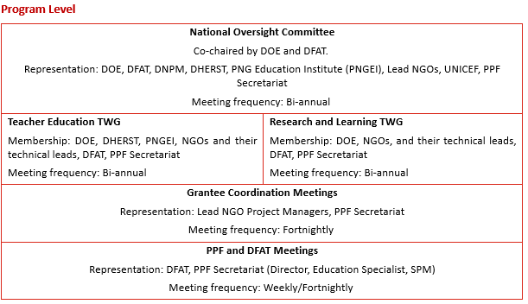
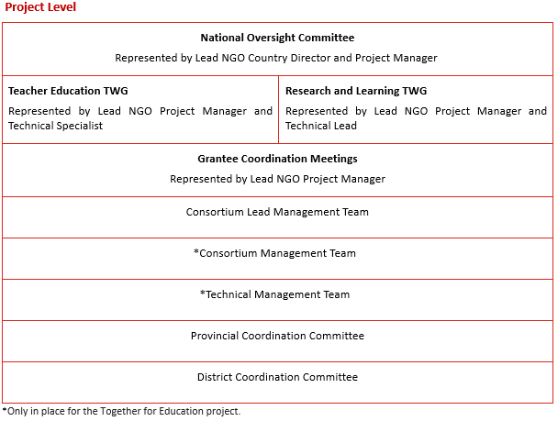

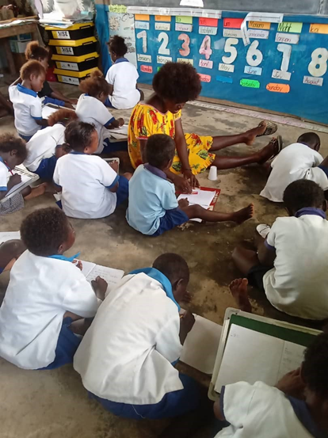
A LIGHT SHINING AT LONOHAN, BOUGAINVILLE
Glenda Rangata is the Teacher in Charge at Hahopuse Elementary School in Lonahan Buka, Autonomous Region of Bougainville. She’s been teaching E2 for over ten years.
Glenda has taken part in several RISE in-service trainings since 2020 and speaks very highly of the trainings.
“The SBC English and Mathematics trainings I received has enabled me to teach child centred lessons using the strategies and manipulatives. By using the strategies and the manipulatives, I’ve seen students are enjoying the lessons very much.
Students can count and draw shapes using sticks and stones. They can blend sounds into words, and they are beginning to read confidently” said Glenda.
Hahopuse Elementary School has been actively involved in the Reading Club and Caregiver activities under the leadership of Glenda.
When the primary school students saw the activities happening at the elementary school, they expressed interest and asked to join as many are slow readers.
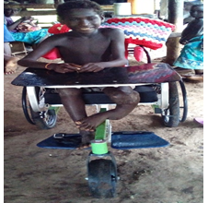
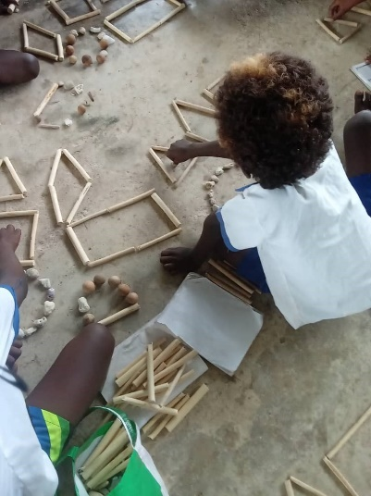
Word spread in the community and many more children from the primary school joined the Reading Club.
Glenda’s husband Christy is also a teacher in the nearby primary school and supports his wife in advocating for the Reading Clubs.
They see children improving and learning from attending the club and reading books.
The training provided has also had an impact on for those with a disability in the community:
“The Home Learning and Inclusive education training has helped me to assist Augustine. Augustine is a child with physical disability and faces challenges coming to school. With the wheelchair provided by Save the Children, Augustine is constantly coming to school to learn” said Glenda.

Investment Performance
The PPF program has achieved significant results since its inception. The delivery model selected for PPF was excellent for achieving quality results in schools within the 10 priority provinces. Having consortia of NGOs, universities, churches, and government enabled projects to be designed and rigorously contested during implementation.
Each NGO partner established close working relationships with the PDOE and district education office to jointly drive improvements moving to a mentoring and coaching role over the years with PDOE the primary implementers of many PPF activities, including teacher training, teacher professional development and SLIP training.
Significant learnings were obtained over the life of the program, with initiatives and governance measures adapting and refining as a result. The commitment to achieving results and collaborative approach taken by all stakeholders resulted in grantees meeting or exceeding their delivery goals each year. Progress did slow considerably because of the COVID-19 pandemic, as stakeholders, partners, delivery providers and schools were impacted. However, the program and its members pivoted quickly to revise their programs and provide support to the government of PNG to respond sub nationally.
Each NGO partner in the consortium brought different strengths and areas of specialisation. As most partners are PNG-based these relationships and learnings will continue to benefit PNG through the ongoing activities these NGOs undertake in-country.

Effectiveness
The PPF program used evidence informed practices to improve children's engagement in reading and foundational mathematics in elementary education. The baseline, midline and endline surveys along with the PILSNA tests provided independent assessments on program progress, while feedback from DOE, DHERST, DNPM, PDOE and other key stakeholders were integrated into program adaption initiatives.
The PPF program also capitalised on the reach, quality focus and partnership approach NGOs brought at the sub-national level and created mechanisms for national government oversight and direction. The program remained resolute in its focus on student learning and teaching practice, while using research and learning to inform program improvement. By undertaking the above approach, PPF ensured initiatives were as effective as possible and kept evolving as lessons were learned or the environment changed.
The PPF program has successfully progressed against its four LTOs. Key evidence and examples of how the program has improved effectiveness in elementary education within the 10 provinces include:

LTO 1: Teachers demonstrate improved practices
Enhanced teachers’ capacity to deliver SBC English and Mathematics lessons for early grade learners was achieved through training, the provision of core teaching and learning resources and other teacher support such as teacher learning circles and coaching and mentoring. Highlights include:
- 6,455 elementary teachers (2,990 females) had at least 100 hours of in-service training in SBC English and Mathematics teaching and learning strategies.
- More than 3,000 elementary teachers received a set of core teaching and learning materials and 236,725 printed reading books were distributed to schools.
- 2,280 digital library tablets, 480 containing 500 book titles and 1,800 containing 760 book titles were distributed to 57 elementary schools.
- Vernacular stories were added to SIL’s Bloom Reader software and the Talking Library App with over 2,500 users reading over 270,000 book titles and more than 2 million pages.
- 2,595 elementary teachers (1399 females) and 78 District Inspectors (38 female) were trained in Gender Equity, Disability, and Social Inclusion (GEDSI) practices and learnt how to screen and assess children for disabilities, develop and implement individual education plans, and make referrals to IERCs.
- 45 IERC teachers and Early Childhood Care and Education (ECCE) facilitators were trained in a specialised early intervention learning kit – ‘Reach and Match’.
- 951 elementary education educators/facilitators (617 females) were trained in the draft DOE ECCE guidelines, emergent literacy and maths circles and school readiness.
These outputs have contributed to improvements in teacher performance shown in the data collected from lesson observations at endline. Compared with teachers who were not trained under the PPF program, teachers performed 7 percentage points higher in classroom management and student engagement. These composite indicators emphasize specific pedagogical areas that are practiced repeatedly during teacher professional development activities (training, teacher learning circles and coaching).
The graphs capture indicators measured in the lesson observation. They show that teachers supported through PPF have performed higher than teachers who did not receive training by PPF.
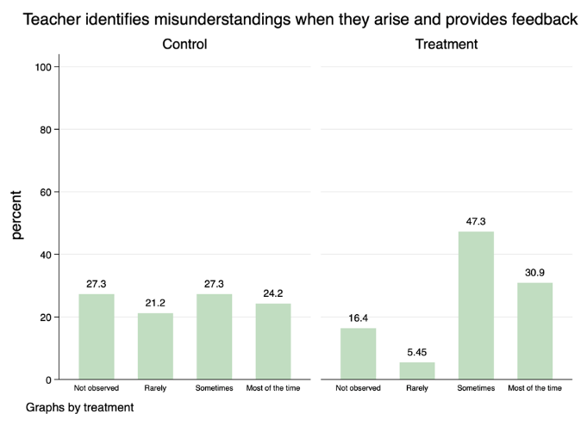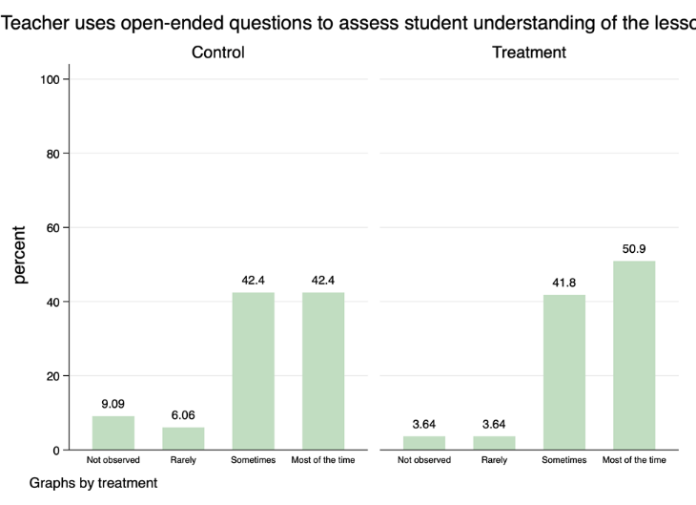
Figure 13: Observed teacher competency areas for student engagement by treatment

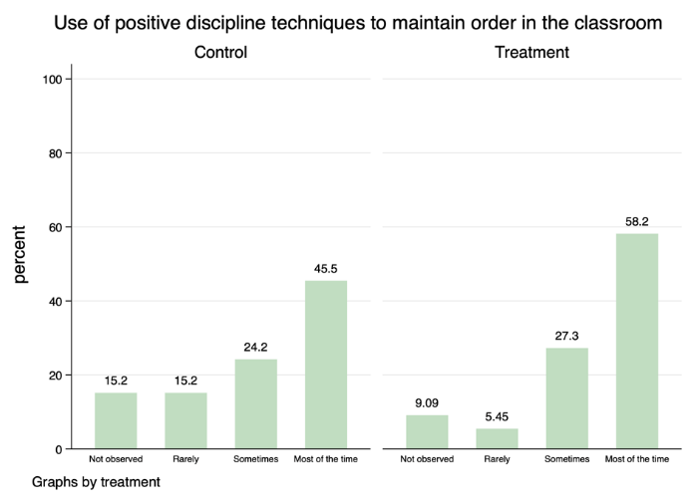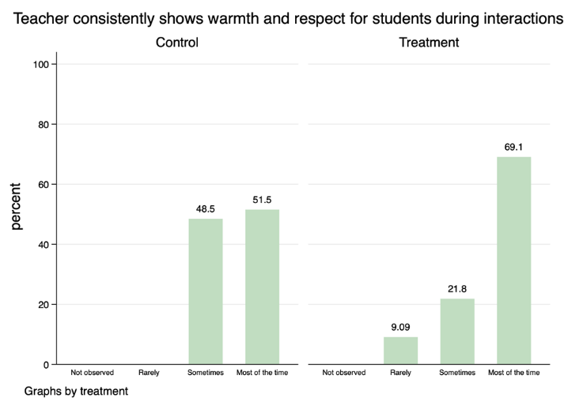
Figure 14: Observed teacher competency areas for positive discipline by treatment
Regarding results in the Monitoring and Evaluation Plan (MEP), all projects have seen improvements when analysed against the baseline and the targets set. This is captured in the MEP table below.
Indicator | Results |  |  | Baseline/  targets
 | Care | Save the Children | World Vision
% of teachers implementing specific instructional practices introduced in the professional development program | 69.09 | 84.62 | 85.45 | N/A  70% (T)
% of teachers who have received feedback following lesson observation from TIC or coach/mentor in the past 6 months | 45.45 | 57.69 | 65.45 | N/A  50% (T)
% of teachers who have a set of core teaching and learning materials | 63.64 | 88.46 | 92.73 | 28% (B)
% classrooms observed with appropriate reading materials for students | 56.36 | 76.92 | 78.18 | 63% (B)
Table 1: Changes in teaching practices reported by teachers and TICs
The results are variable across the NGO projects although similarities exist between Save the Children and World Vision’s results. Both projects have surpassed baseline/targets, especially in the core teaching and learning resources provided to teachers.
World Vision placed considerable effort in this area after their baseline results showed very few elementary teachers had received the core set of SBC materials, and many did not have reading books to promote a culture of reading. All NGOs promoted reading in the classroom and supported extracurricular activities such as reading clubs, which were first established by Save the Children and then developed also in the World Vision project.
World Vision partnered with Library for All who were pivotal in providing culturally relevant graded readers and storybooks for classrooms supported under the PPF program. After recognising the quality of LFA readers and storybooks, Save the Children and CARE included LFA books in their classroom library kids distributed to schools.
If compared with baseline when the project first began – previously teachers received NO feedback and NO lesson observations from a TIC or coach/mentor. Today, most teachers (56 percent) receive coaching support and 80 percent of teachers have core teaching and learning materials.

LTO 2: School learning environments are inclusive, safe and enable student learning
School management and governance mechanisms were strengthened to better support teaching quality, student learning and GEDSI, through the following actions:
- 2,815 (target 2026) School Board members (707 females) trained on effective school management to support student learning and inclusive practices to support student learning
- 551 (target 306) SLIPs were developed with strategies addressing gender and disability inclusion
- 221 (target 70) approved SLIPs completed 50 percent of planned annual activities addressing inclusive practices
- More than 50,000 parents/caregivers were engaged in SLIP development
- More than 30 school boards generated resources locally for SLIP implementation.
The PPF program engaged school management on issues impacting student learning. In the endline assessment, TICs were asked about the changes they had observed in classrooms. The table below highlights the observed changes in the NGO projects.
Changes | CARE | Save the Children | World Vision
Students seem more engaged in activities | 80.9% | 95% | 82.45%
Students are reading more | 76.35% | 91.65% | 82.45%
Classrooms are more decorated with print and numbers | 52.75% | 70% | 69.05%
There is more group work and fun | 47.75% | 78.35% | 46.45%
Students have started borrowing books and have started to borrow from the library | 10% | 73.35% | 43.15%
Student attendance has increased | 28.65% | 60% | 30.95%
Table 2: Observed changes in classroom practice reported by TICs
These observations validate the findings from the lesson observations of greater student engagement and reading in the classroom. Across the three projects, TICs frequently reported that students were more engaged in activities, they were reading more, the classrooms were more decorated with print and numbers and there was more group work.
In Save the Children’s project, many TICs reported that students had started to borrow books from the school library. Interestingly, changes in student attendance were not a change reported by many TICs except for TICs in Save the Children’s project. Save the Children placed considerable effort on attendance in their back-to-school campaigns, IEC materials, and in their messaging to parents and teachers. In Phase 2, Save the Children also placed emphasis on establishing and supporting simple classroom libraries that may have influenced the changes in student reading.
Exploring responses to high absenteeism, TICs were asked whether the schools had taken any action to address absenteeism.
 | CARE | Save the Children | World Vision
Schools which had taken actions to address high absenteeism | 55.17% of 856 schools | 50% of 1034 schools | 71.05% of 612 schools
Table 3: Action taken to address high absenteeism reported by TICs
Over half the TICs reported their schools had taken action to address absenteeism, which is a significant improvement on baseline results that showed very few schools were addressing absenteeism.
Positive actions taken by schools included daily records of student absences that were reported to the TICs for follow up when students were absent for several days, a sign in and out book for teachers, and reporting to inspectors when a teacher was absent for more than 20 days, conducting staff meetings on a regular basis, and school activities that promoted school as fun and engaging.
One third of schools are now practicing inclusive practices and promoting student learning as reported by the TICs. This indicator measured the type of activities undertaken by the school, for instance whether the school accepted children with disabilities to enrol, whether the school had established a partnership with the IERCs and included whether the school had taken action to promote girls’ education.
TICs also reported other actions taken to promote inclusion such as extracurricular activities to promote social connection, establishing classroom and school rules, conducting awareness with parents, and submitting requests to Callan for devices such as walking sticks and sign language support. To promote learning, TICs reported some classrooms established peer learning by assigning proficient students with students that required more support, formed reading clubs and greater reading activities in class.

LTO 3: Parents/caregivers demonstrate improved behaviour to enhance student learning and attendance
Through the PPF program parents have become more engaged in their child’s learning as evidenced by the results captured at endline:
- 144,230 parents (86,538 females) in the target provinces better appreciate the need to support their children’s development and are investing more time in their children’s learning and promoting girls’ education in their communities.
- In RISE and T4E project sites, over 1000 trained community literacy volunteers established and ran reading and maths clubs in their communities.
PPF was strongly focused on messaging to parents about home learning, reading to their child regularly, ensuring they attended school every day and participated in school activities. The program also shared key messages linked to nurturing and supporting children’s social emotional wellbeing.
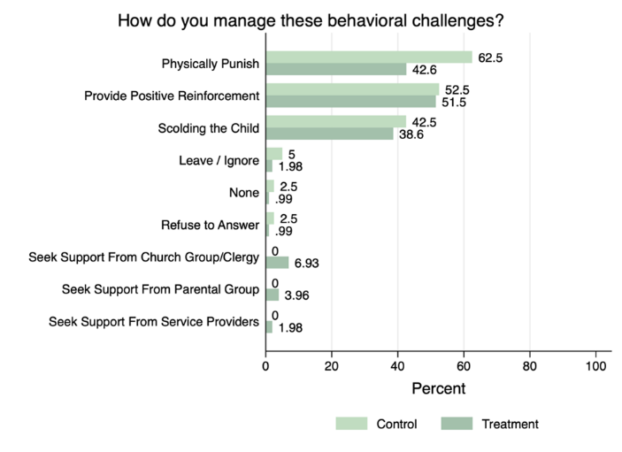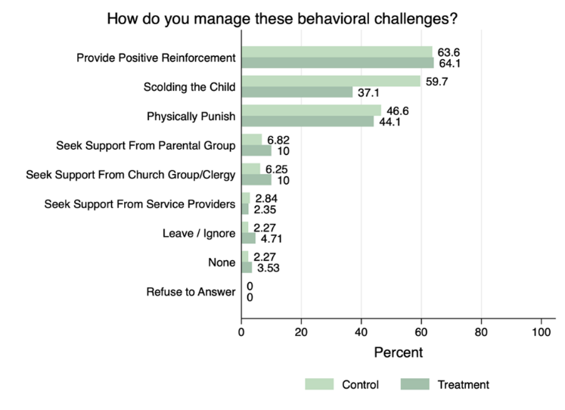
Figure 15: Discipline strategies reported by parents in CARE (left) and Save by treatment
The first graph is CARE’s, the second, Save the Children. In both examples, parents NOT involved in the PPF program were more likely (46.6 percent CARE, 62.5 percent Save the Children) than parents involved in the PPF program (44.1 percent CARE, 42.6 percent) to physically punish their children to manage behavioural challenges. Parents NOT involved in the PPF program were also more likely (59.7 percent CARE, 42.5 percent Save the Children) than PPF supported parents (37.1 percent CARE, 38.6 percent Save the Children) to scold their child. This positive shift suggests that the messages relayed through supported parental workshops have translated to shifts in practice.
In addition, parents involved in the PPF program were more likely to be engaged in reading with their child.
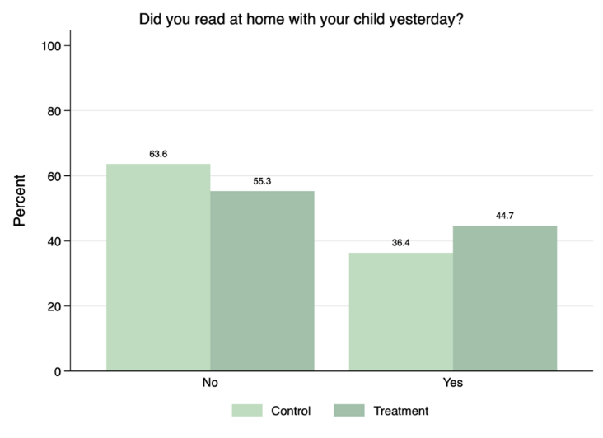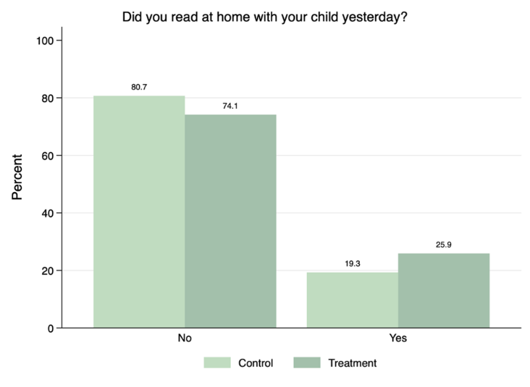
Figure 16: Parents who report reading to their child in Save and CARE by treatment.
In Save the Children’s project (left graph), 45 percent of treatment parents reported reading to their child yesterday, compared to 36 percent of control parents. This compared to 60 percent of treatment parents from World Vision’s project and 35 percent of treatment parents from CARE’s project (right graph).
Over half of parents engaged in the PPF program reported helping their child read and to help with maths homework. 57 percent of treatment parents reported counting with their child and helping solve maths problems compared to 51 percent of control parents.
This correlates with the analysis of baseline and endline results that show parents have increased the activities undertaken to support home learning. Additional comparisons have been captured in the table below.
Indicator | Results |  |  | Baseline/  targets
 | CARE | Save the Children | World Vision
Supplementary: % early grade students who attend at least 4 days of school in the previous week | 43.28 | 60.61 | 46.15 | 46.69% (B)
% parents with a positive attitude toward regular school attendance | 100 | 100 | 98.08 | 99.5 (B)
% parents/caregivers who participate in at least 3 actions to support quality education for children in the past fortnight | 78.61 | 78.03 | 51.92 | 31% (B)  50 % (T)
% of parents with positive attitude towards a) girls' education and b) children with disability | 89.55 | 90.15 | 96.15 | 22% (B) 50% (T)
Table 4: Actions parents are taking to support their children learn by project

LTO 4: The education system is supported to strengthen early grades education in PNG
The focus in this outcome was on strengthening two aspects of the national system: teacher professional development for elementary teachers and building an evidence base about effective responses to learning gaps in the early grades. PPF established the two TWGs on these areas with the engagement of DOE, and has achieved the following:
- A fully endorsed training package for elementary teachers focused on teaching SBC English and Mathematics (facilitators guide, participant workbook, pre and post training assessments and certificates). The training program has been transferred to PNGEI and DOE for ongoing work in elementary conversion and revisions to the primary teaching diploma course.
- Two promising practices (SLIP training and TLCs) were showcased during monitoring visits, presented at the research workshops, and handed over to the DOE for internal planning.
- Endorsed baseline and midline studies including presentations of key research studies, namely:
  - IDELA baseline assessment (RISE): A study of 1198 Early Childhood Education (ECE) NOC children from 86 ECE centres in ARoB, EHP and ESP using the International Development Early Learning Assessment (IDELA) tool that measured children’s emergent literacy and numeracy skills, social emotional and motor development to establish baseline for the RISE project.
  - Early Childhood Education (RISE) Impact Report – A study that investigated the effectiveness of the training program rolled out to ECE facilitators.
  - Sharing Literacy with Bloom Reader (RISE) – Findings from the distribution of the Bloom Reader reading app and digital library in 650 communities.
  - Disability Mapping Report (RISE) - This report is a synthesis of research and learning gathered in the first phase of the RISE project and included an analysis of changes to access, participation, and support for children with disabilities in ECCE and elementary education due to RISE interventions.
  - Reach and Match® Learning Kit – Impact Report (RISE) - This report is a synthesis of research and learning gathered from the Reach and Match® pilot and includes an analysis of changes to children’s participation and learning outcomes from inclusive play activities using Reach and Match® in IERCs and ECE centres.
  - SLIP (T4E) - This report documents the experiences of the Child Fund in their support to schools for SLIP development highlighting the progress made and the areas of improvement in both policy and practice.
  - Gender Synthesis Report (RISE) – The report studied the gender dimensions that emerged from in-depth interviews with parents and students that informed further analysis in the RISE program drawing on data collected in the baseline and midline assessments.
  - Teacher Learning Circles (T4E) – The report and additional resources provided guidance on the structure and curriculum used for TLCs.
  - Adult Literacy (PKS) – A study of the impact of ADRA’s Adult Literacy program on parental behaviour.

Efficiency
The PPF program modality of delivery to outsource program funds to reputable NGOs/consortia to complete selected projects within PNG has been successful. This devolution of delivery limited the amount of direct control the program had over implementation, but also permitted grant recipients to utilise their expertise to respond to challenges quickly and achieve results.
Overall, each of the grant recipients delivered their services more efficiently than the PPF program could have achieved without significant staffing resources. The existing connections, reach and expertise within each NGO enabled deeper engagement across the 10 target provinces in the elementary education sector, and supported alignment with DOE.
Furthermore, the PPF team was able to build NGO capability and improve performance in all ongoing activities within PNG. Areas that received development support included financial management, assets management, the need for tighter controls to prevent or minimise the occurrence of fraudulent activities, techniques to collect and manage data, and report writing. Additionally, support was provided by the PNG-Australia Governance Facility (PAGP) facility GESI and Communications specialists to the NGOs at no cost.
Each grant had different foci for supporting elementary education in their target provinces and managed the required governance structures internally. Reports were provided regularly to the PPF program and bi-monthly meetings held on progress.
The PPF team managing the grants were able to identify strengths and weaknesses within, and between, each consortium – sharing practices from the stronger performing organisations to strengthen the capacity of others. Lessons from managing PPF grants were also shared with other programs within the PAGP Facility, improving the efficiency obtained from PPF more broadly.
This modality of investment was found to be highly efficient in the delegation of functions from the program, enabling a smaller staff profile that focused on oversight rather than delivery. This also reduced the amount of guidance required from DFAT and DOE and provided the opportunity to establish connections between government and NGOs for collective action, which became essential in responding to the COVID-19 crisis.
Utilising grants for program delivery demonstrated the trust in each consortium and provided them with the flexibility and autonomy to respond to events as needed. However, this approach reduced the level of authority the program had contractually to enforce specific initiatives or governance mechanisms beyond the detail provided in each grant agreement. While this caused some difficulties at various times the strong partnership and collaborative approach taken by all members enabled the PPF team to oversight the program successfully.
It is worth noting the significant value to PPF of being part of a Facility model, and of sharing resources with the Education Support Services (ESS) program. Through being part of the PAGP Facility structure the program was able to access specialist support in MERL, GESI, Communications, HR, IT, Finance, travel, legal, procurement, security, and transport. To have a similar level of resource support would have more than doubled the PPF staffing ratio and required the acquisition of additional assets (such as vehicles). PPF was also able to learn from other programs to improve its management systems, processes, tools, and templates.
Parents and Caregivers gather at Mair Elementary school, Madang Province
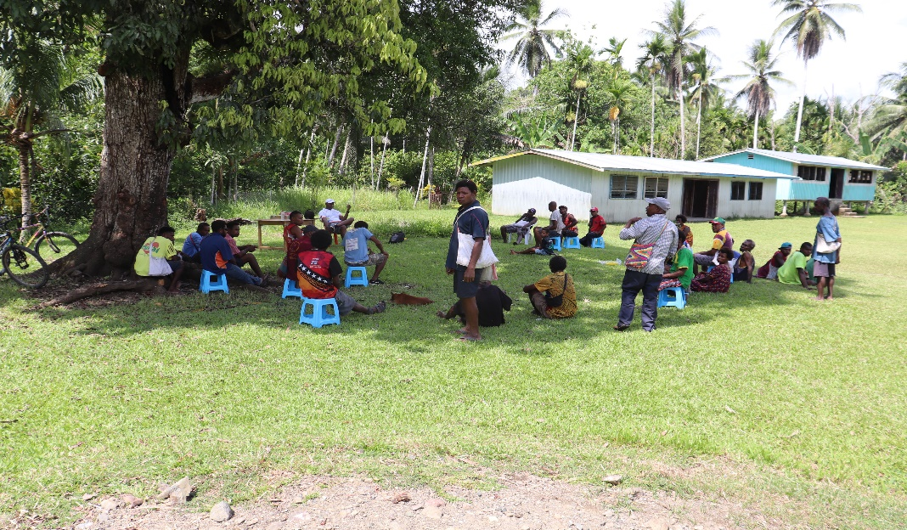
Figure 17: Caregivers gathering at Mair Elementary School Madang 2021

Figure 5: Photo of parents and caregivers gathering at Mair Elementary School, Madang

Sharing resources with the ESS program also gave the PPF education program access to the embedded advisers within the DOE and DHERST. These advisers were able to provide advice when PPF grant initiatives aligned with broader departmental reforms, help build relationships for the program, and secure appointments. They also provided pertinent information to the program that would not otherwise have been obtained due to the traditional siloed structure of PPF governance. This access reduced the level of effort required to identify and progress viable initiatives with DOE.

Value for Money
Value for money (VfM) has been a key performance indicator for consortia, and a required area for reporting by each lead grantee throughout the life of the program.
The MTR found that:
- activities and outputs were procured and delivered on time in line with VfM principles. It found that implementation arrangements were harmonised where possible with relevant provincial and district education activities such as joint monitoring/supervision visits and that all education grantees had implemented a wide range of activities with many beneficiaries in a short space of time, indicating they had been efficient in achieving outputs.
- efficiencies were gained through the consortia approach, including increased geographical coverage, sharing of reading resources, M&E expertise, and training resources. While the grants worked in relative isolation initially the introduction of regular grant coordination meetings resulted in closer cooperation and enhanced efficiency.
Additionally, PPF promoted value for money outcomes and the efficient use of resources through:
- facilitated cross-engagement between grant consortium, enabling: the utilisation of expertise and existing resources for program delivery, knowledge sharing, identification of best practice and the sharing of resources where applicable.
- providing guidance documents and supporting tools to support grantees to collect, analyse and report on their activities in a way which could be compared at the aggregate program-level.
- facilitated closer engagement between NGOs and the government, helping to build relationships that will be sustained beyond the life of the program while also developing a model of trialling initiatives which, if successful, are then integrated into policy.
- having a lower staffing footprint from utilising a grant approach than what would have been required to directly deliver a program across 10 provinces.
- Provided guidance on improved ways to manage HR, finances, and assets to support grantees.
- Undertook joint monitoring visits that included program, DOE, DFAT and subnational government representatives – maximising the benefits obtained from the trips collectively and individually (see page 41 for more information).
- Many PPF Secretariat activities were required to be implemented using a remote model from 2020 onwards. While this limited some activities it also resulted in significant cost-savings as workshops, partner and client meetings, and engagement with GoPNG partners took place virtually.
COVID-19 integration: With the onset of the COVID-19 pandemic in 2020, the PPF Secretariat managed a rapid reallocation of Phase 1 resources to support response activities. In the second half of 2020, grantees integrated COVID-19 messaging into existing programming and continued to refine delivery approaches into 2021 for maximum efficiency in program delivery.
For example, the RISE project integrated COVID-19 information into Module one training manuals and caregiver workshop flipbooks that targeted school Board Chairs, TICs, teachers, and parents/caregivers. Book categories selected for reading club and classroom library book banks included Health and WASH related COVID-19 prevention topics. The RISE project also distributed awareness raising and awareness materials in locations that would not otherwise receive materials prepared for distribution in EERRP target districts.
Challenges associated with the COVID-19 pandemic increased innovation and creativity in programming. Many activities which were previously delivered face to face were implemented successfully using a remote model.

Gender, Disability, ands Social Inclusion (GEDSI)
Since program inception, the PPF program has sought to mainstream GEDSI through all its grant management and programmatic functions. The inclusion of GEDSI was a requirement of each grant, and in Phase 1 each consortium had independence in how they chose to address this key issue. While each consortium undertook activities and complied with grant requirements, the independence provided to design their own approach resulted in a diversity in design, implementation and analysis that made it difficult for PPF to analyse information, especially at the combined program level.
To address this, and in response to the MTR, the program hosted a workshop with all partners to explore their approach to GEDSI in their projects. In addition, the GESI unit within the PAGP Facility also undertook an analysis that highlighted the status of GEDSI mainstreaming across the education program.
As a result of this consultation, in May 2021, a PPF Gender Equity, Disability, and Social Inclusion (GEDSI) Action Plan was developed and implemented fully. The plan outlined the actions for the remainder of the program to strengthen data collection, analysis, and reporting of GEDSI outcomes and lessons learned.

Consortia projects
The grants with each consortia required that GEDSI be integrated throughout all activities but did not specify any budget allocations. However, GEDSI activities were integral to all interventions undertaken by the three projects and was mainstreamed in all levels of the projects, along with specific interventions to improve gender equality and improve girls’ inclusion.
In training:
- The PKS project delivered multi-day, GEDSI training to all its staff to ensure everyone had a clear understanding for effective implementation through all stages of program delivery. The PKS team also worked in collaboration with Callan services specialized staff to deliver training sessions on disability inclusion. Callan services provided training to teachers, school boards and community members in areas such as identifying persons with special needs, basic applications of community-based rehabilitation and home care, and referral pathways for quality services in care.
- The RISE project mitigated the risks of women's involvement in project activities through initiatives such as ensuring teacher trainings were held in districts closer to their home to reduce travel and maintain communication with their spouses. Baby carers and children under the age of two were allowed to accompany their mothers to training.
- The T4E project held a particular design focus to support and promote female teachers’ participation, enhance women's voices, and legitimize women as leaders in the education space. The project deliberately encouraged female participation in project activities as much as possible in community awareness sessions and group discussions. While project staff carefully facilitated women's voices and advocate for women representatives.
As a result of this participation female teachers have assumed leadership roles in their communities. There has been an increase in the number of female teachers appointed as TIC, and in all three provinces women have been elected to school board leadership positions, for the first time.
Results of training:
Based on lessons observed during the endline evaluation, moderate change is evident in teachers’ approach to gender and disability inclusion. In CARE’s program areas, teachers who received the training were more likely (in 60 percent of observations) to ensure equal participation of boys and girls. By comparison, this was only evident in 50 percent of the observations.
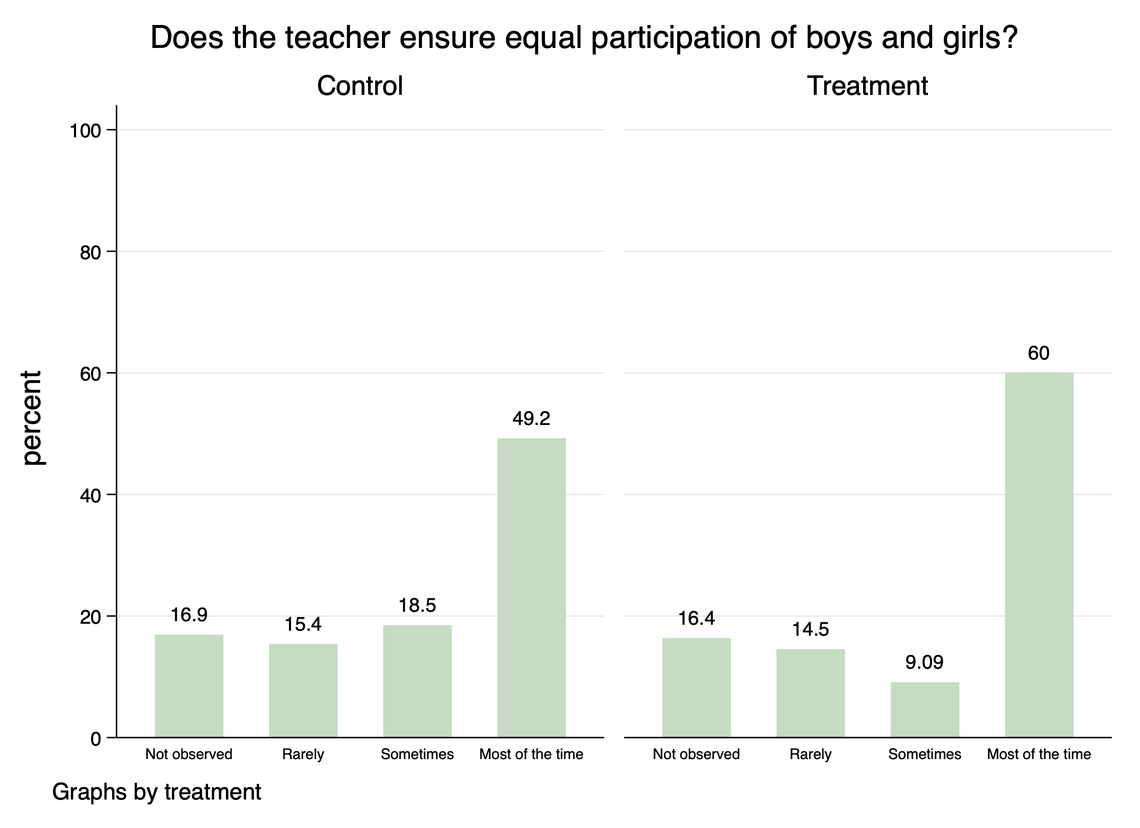
Figure 18: Teacher's ability to ensure equal participation of boys and girls by treatment.
In World Vision’s program areas, teachers who had received training were more likely (41.8 percent of observations) to apply gender sensitive pedagogy and avoid gender discrimination compared to teachers who had not participated in PPF training.
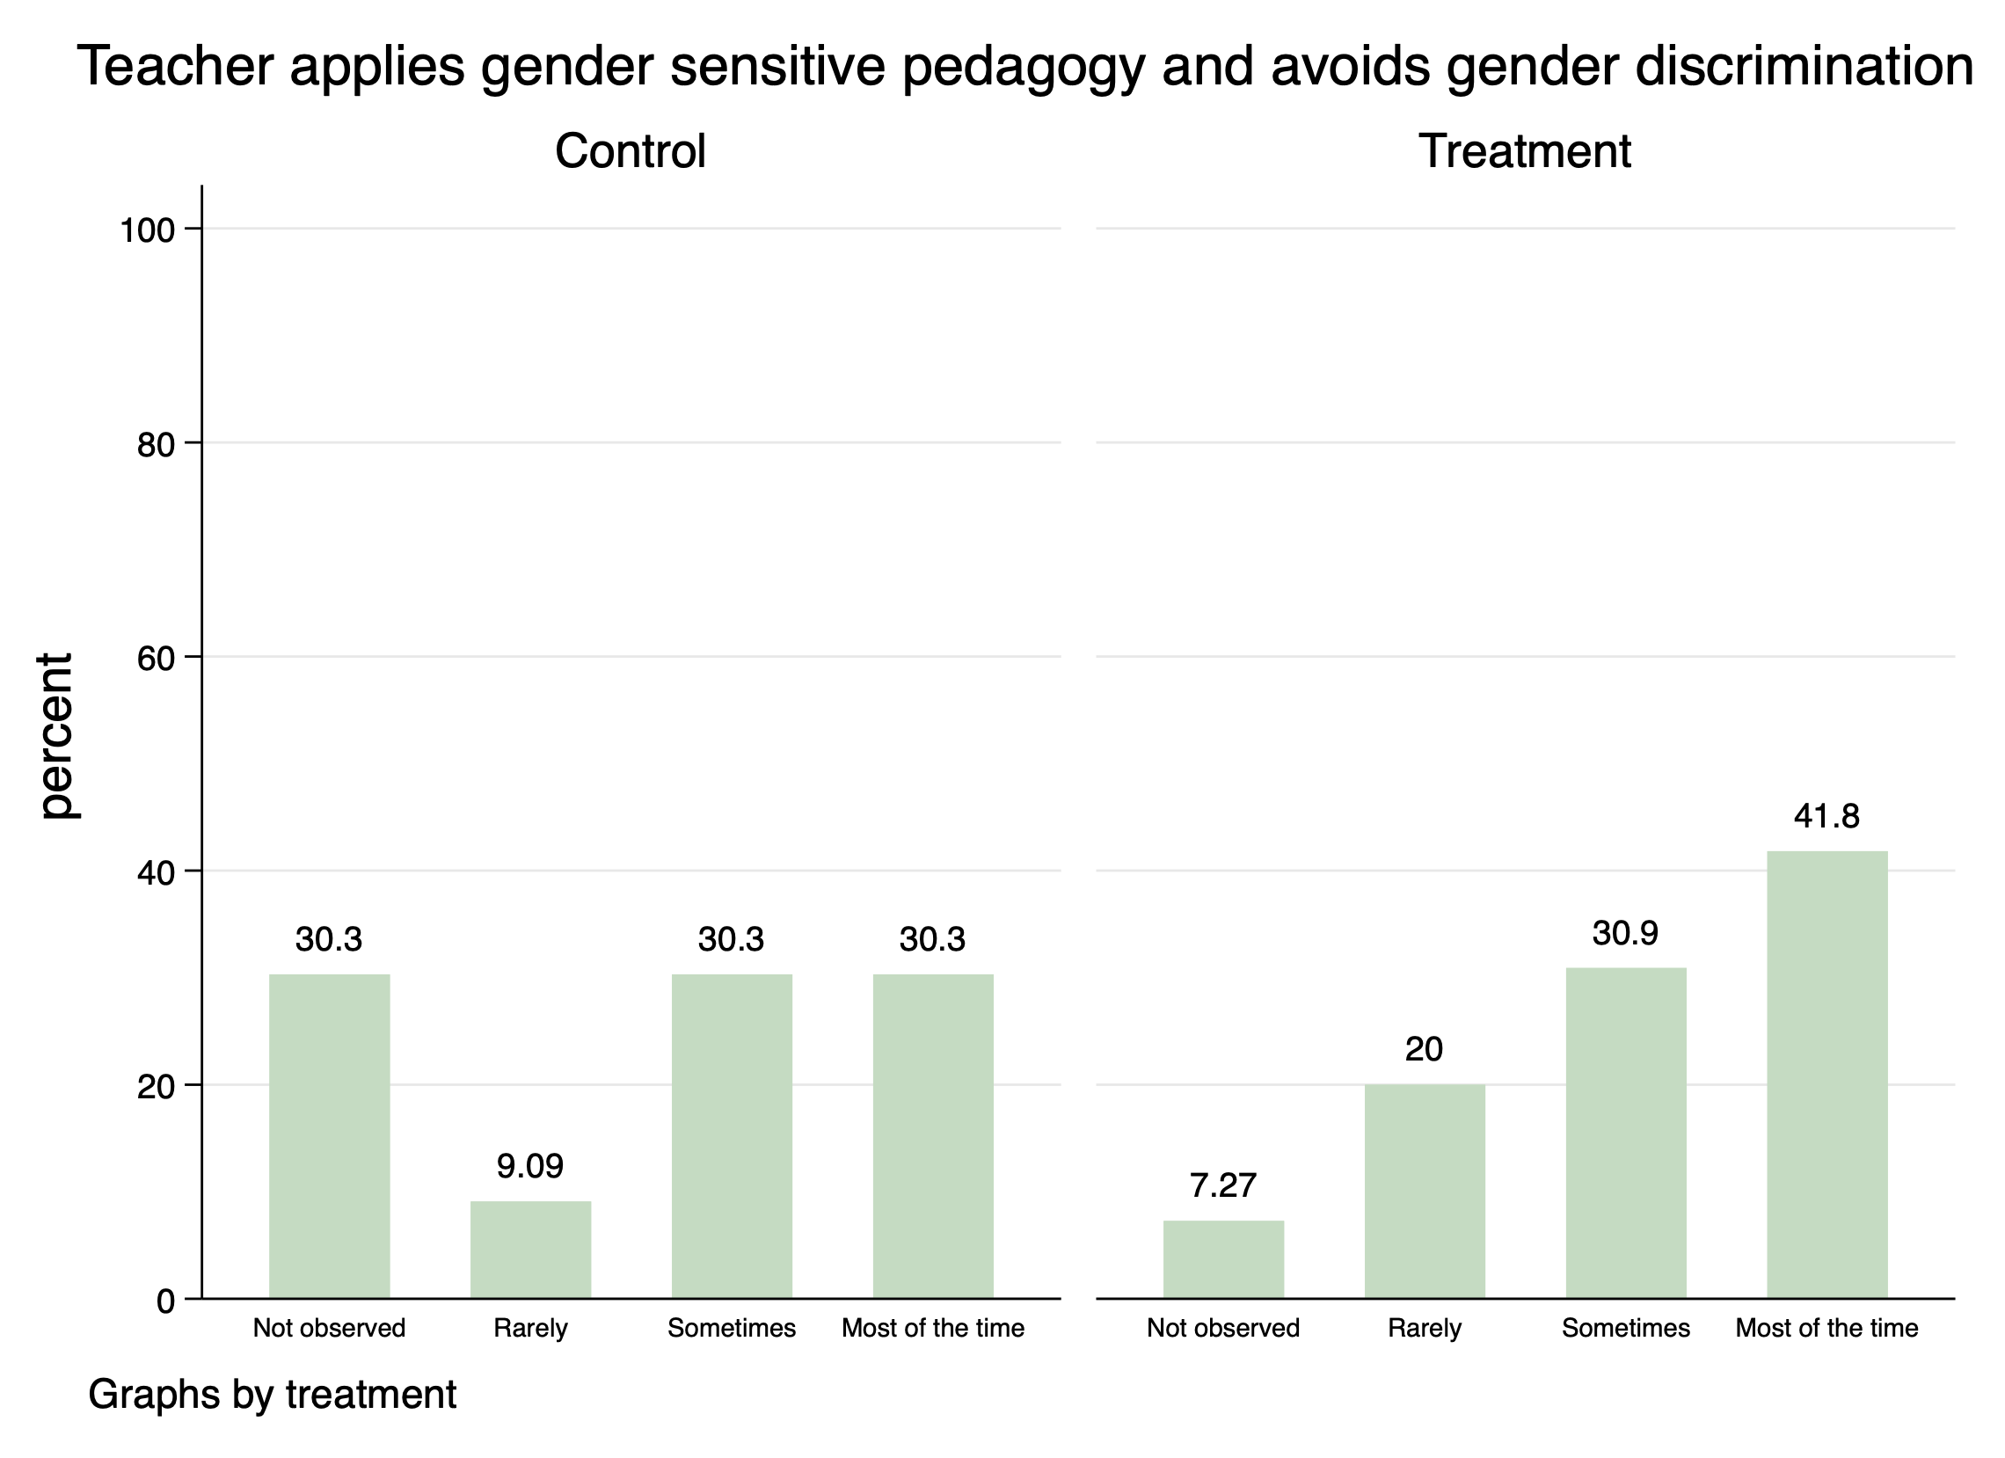
Figure 19: Teacher’s ability to apply gender sensitive pedagogy by treatment.
In Save the Children’s program areas, teachers who had received training were more likely (23.1 percent compared to 10 percent) to apply inclusion strategies to support different learners in the class.
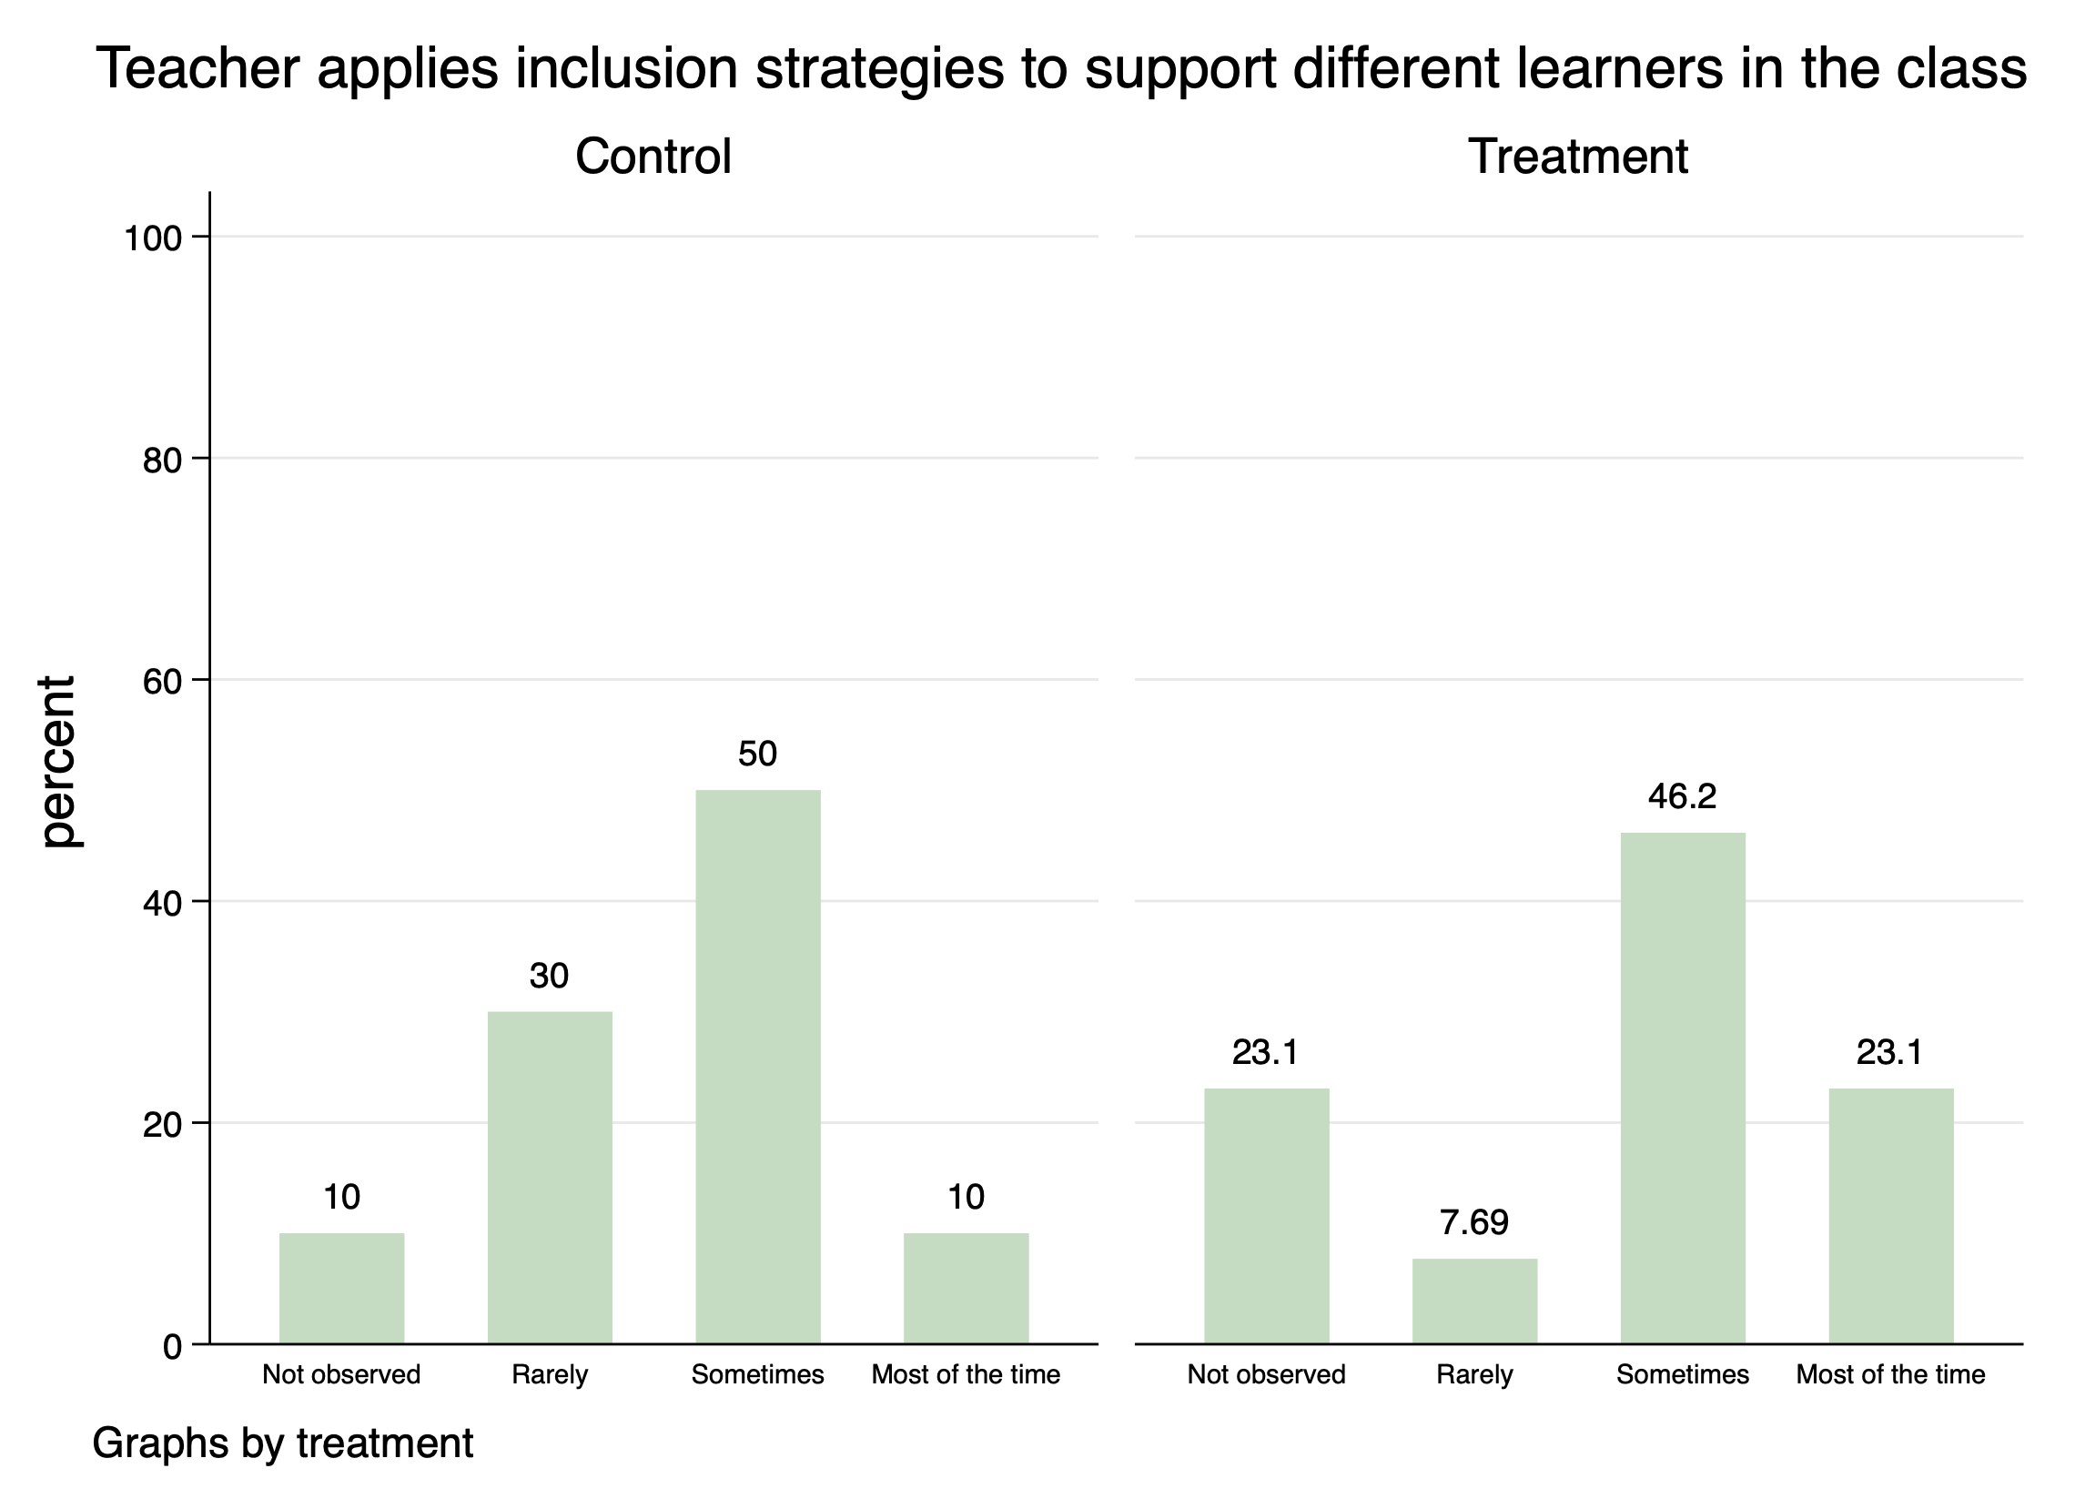
Figure 20: Teacher’s ability to apply inclusion strategies in the class.
The results reflect a positive trend but also highlight that more needs to be done to improve the learning environment for girls and children with disabilities. The progress regarding support to children with disabilities is perhaps symptomatic of the challenges faced by teachers in identifying and then supporting children with disabilities in the classroom. Whilst teachers, especially in CARE’s project and Save the Children’s project received specialist training from Callan Services, the improvements are moderate.
In resources developed:
- The RISE English and maths learning manuals provided teachers with lessons to encourage more child-centred and gender sensitive pedagogy. The manuals have group activities to ensure equal participation by both girls and boys. In addition, teachers have been encouraged to establish a leadership system where both boys and girls elect a class or vice-captain, giving both genders the opportunity for either role. This has enabled greater girls’ participation in decision making in their own classroom.
- The Digital Library collection developed by T4E was carefully curated to showcase stories that were culturally appropriate and engaging, as well as socially responsible and female empowering. 67 percent of the stories were written by women, and 32 percent of the collection showcased women and girls in lead roles. Several books showcase illustrations that incorporate characters with wheelchairs, amputations, or wearing glasses. The Digital Library also enables those with eyesight disabilities to alter the text size.
- T4E also developed educational playing cards, posters, drama shows and videos that depicted GEDSI principles.
School management and accountability:
- Through the T4E project, School Community Accountability Agreement’s (SCAA) were developed by teachers, school boards, youth, parents and in some instances with Ward Councillors/Committees to collaborate and take responsibility for the education of their children and to promote child protection and GEDSI. All 30 CIMC intervention schools formulated SCAAs that incorporated GEDSI commitments from the various stakeholders, and their implementation was monitored by SLIP committees, or in their absence CIMC organized community governance groups.
- Through the PKS project, inclusion of GEDSI content in school management training and support resulted in 65 percent of schools integrating some aspects into their SLIP documents.
- Through the RISE project sessions were delivered to teachers that raised awareness of gender biases and guided teachers to identify and make modifications to lessons for children with disabilities. Additionally, teachers received supportive supervision, visits, and monitoring where lesson observations and feedback sessions were conducted. From 2020-2021, school Boards and TICs received training in GEDSI.
Changes in perception of education officers:
A number of questions were asked to provincial and district education officers at baseline and at endline about their perception regarding gender and disability inclusion. The results reflect a moderate shift in perception with more officers (62.5 percent compared to 60.4 percent at baseline) strongly agreeing that girls should be treated the same as boys in elementary.
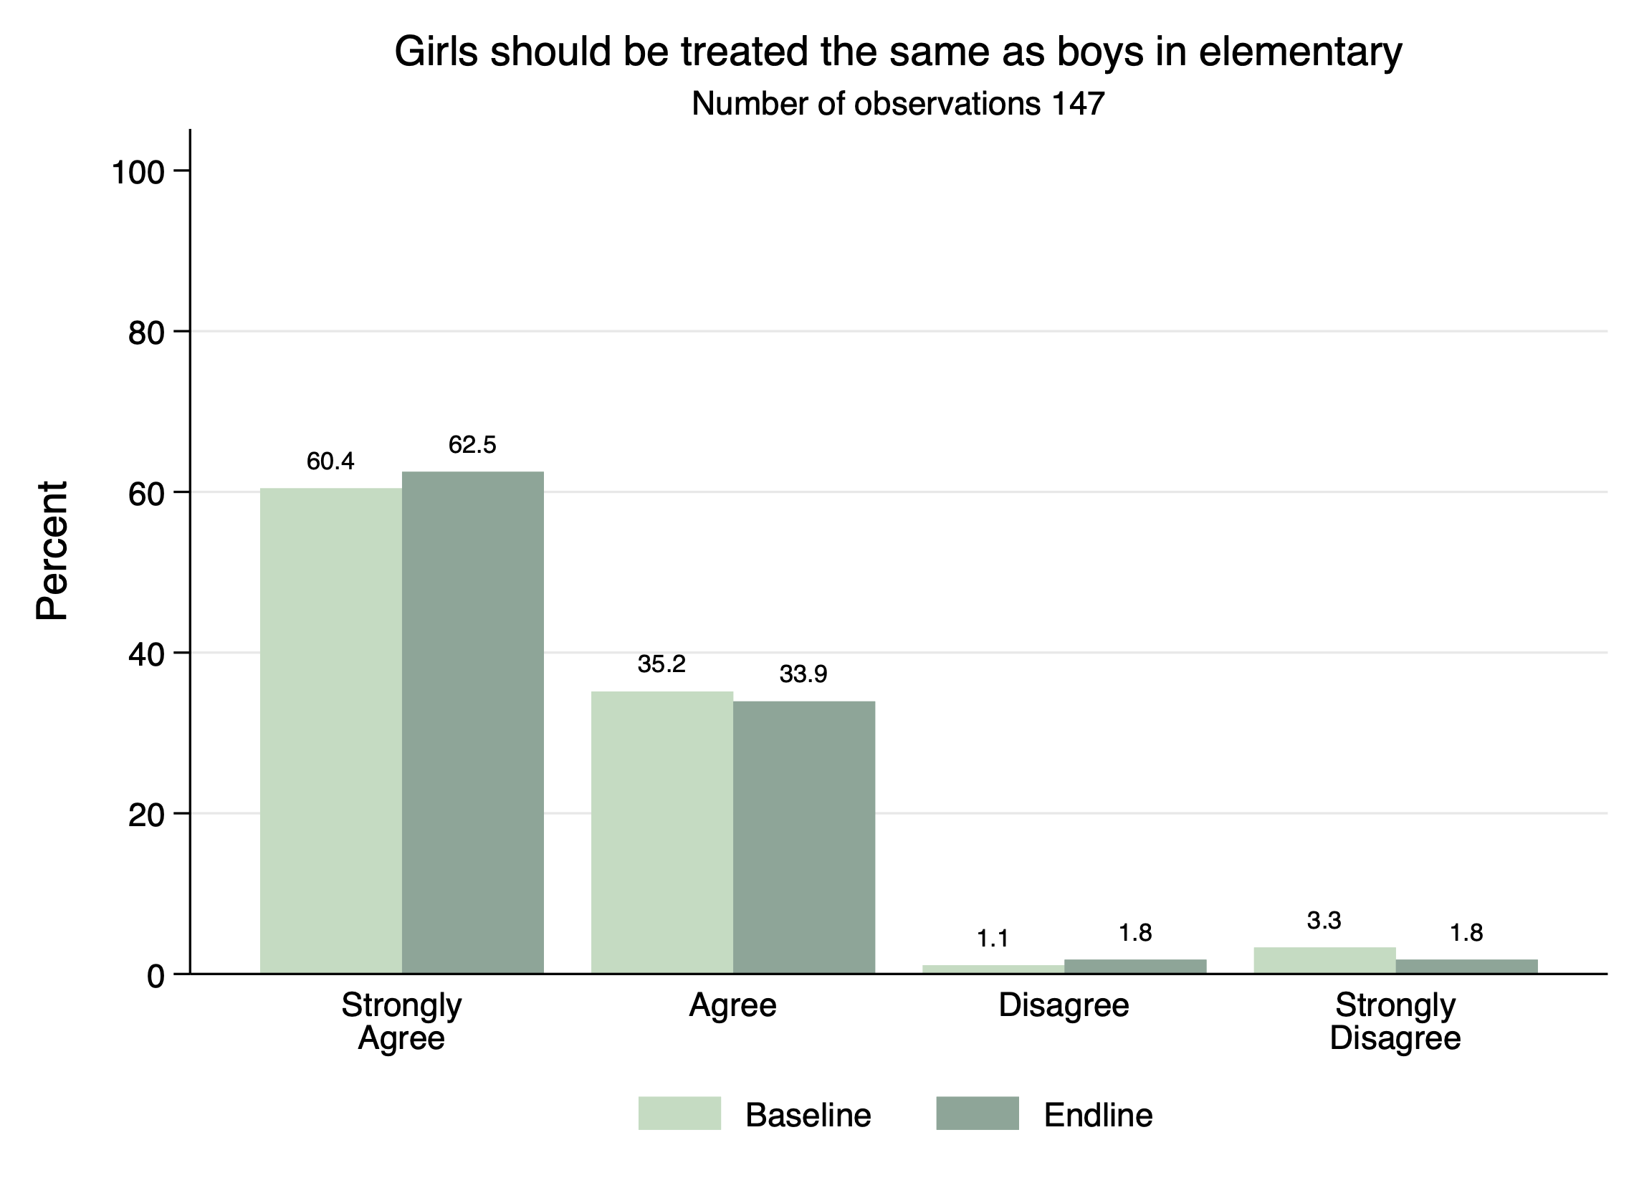
Figure 21: Provincial officers’ perception on girls’ treatment in elementary.
When asked the question – “Are girls as smart as boys in maths?”, provincial officers strongly agreed or agreed at baseline. The trend suggests that provincial officers are perhaps more doubtful at endline than baseline with 16.1 percent of officers disagreeing with this statement compared to 15.4 percent at baseline.
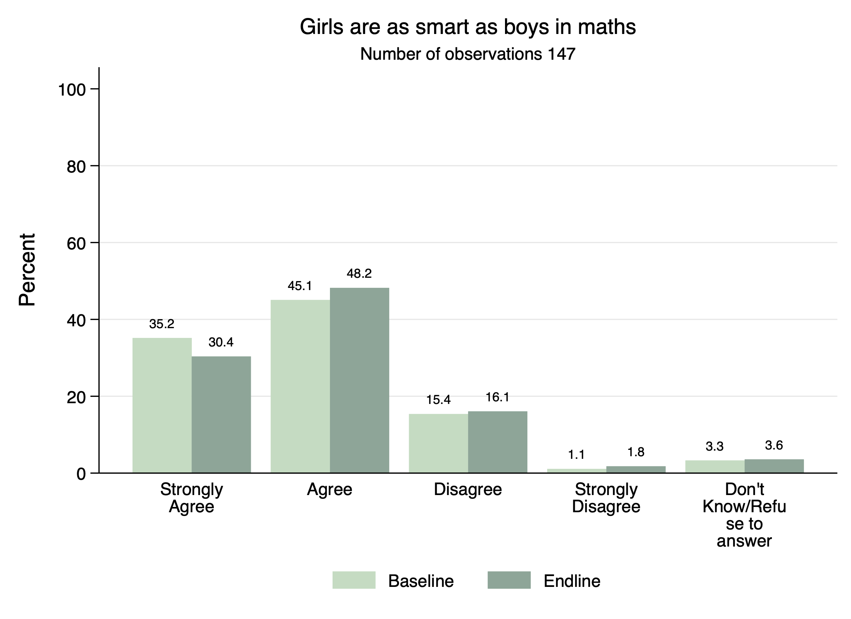
Figure 22: Provincial officers' perception on whether girls are as smart as boys in maths.
Historically girls have performed lower than boys in PILNA numeracy assessments although the differences are less evident today. In the PPF elementary baseline, across all provinces there were no statistical differences between boys’ and girls’ literacy and numeracy results in Grade 1. In subtest items such as comprehension, a few provinces noted differences. For instance, in Jiwaka, Simbu, WHP and WNB the proportion of non-readers was similar between boys and girls although when looking at students who could read, boys tended to perform above girls in reading comprehension. This was not significant nor a trend in other provinces.
At midline, RISE and T4E undertook an assessment of E2 students. This was carried out just one year after the project began. It is evident at the time that by E2, gender differences had emerged between boys and girls, particularly in relation to numeracy. Save the Children found that boys scored higher than girls in overall numeracy and in shape recognition, in particular.
 | Summary of key midline findings on gender dimensions
1 | Boys tend to score higher in overall numeracy compared to girls
2 | Boys are more likely to miss school days compared to girls
3 | Save the Children found that the intervention is having a positive effect on girls’ acquisition of foundational numeracy skills and overall literacy and numeracy
4 | World Vision found that the intervention is having a positive effect on boy’s reading comprehension
5 | Girls are more likely to chew betel nut than boys
Table 5: Gender differences noted in the midline synthesis
There were statistically significant differences between boys and girls in relation to numeracy skip patterns of two and five, addition and word problems with boys scoring up to 4 percentage points higher than girls. Girls were more likely than boys to know the 26 letters of the alphabet but, on average, both boys and girls tended to answer 25 of the letters correctly.
In Save the Children’s study, it was evident that while girls are not performing as well as boys in numeracy, the gains they had made in relation to literacy and numeracy since baseline and as a result of the intervention were statistically significant.
Impact of the intervention on girls’ overall scores and numeracy | Literacy and Numeracy | Literacy | Numeracy
Control scores | 53.7%*** | 40.6%*** | 67.2%***
Percentage point increase for intervention | 4.5* | 4.0 | 5.1**
Table 6: Statistical power of midline student learning results for Save the Children
In World Vision’s study the results were different. This study found that the intervention was having a positive effect on boys in many items such as English comprehension, letter identification, overall literacy, and overall literacy and numeracy.
At the time this suggested that there were variations in intervention effect across the provinces. In Save’s study for instance, notable gender differences were evident in the ARoB and ESP but not in EHP.
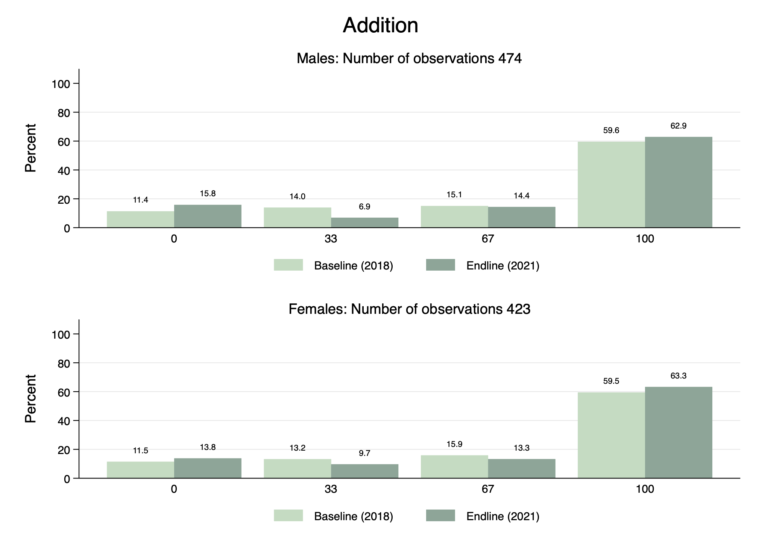
The endline study highlighted the gains made by boys and girls in E1 compared to original baseline scores. Comparing the results between Save the Children and World Vision, the trend is similar – a higher proportion of girls compared to boys are scoring 100% in the addition and subtraction sub-test.
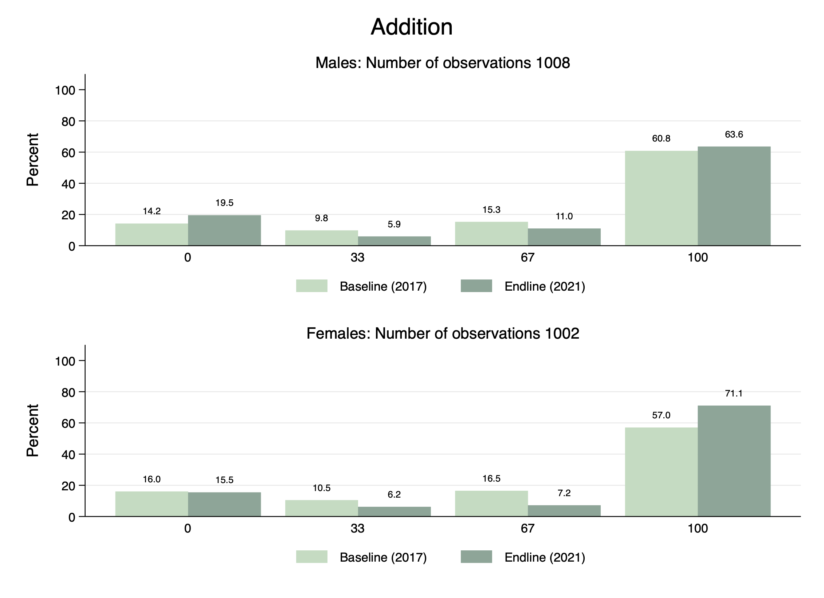
Figure 23: Male and female students scores in the addition subtest at baseline and endline.
The graph on the left is Save the Children’s. In this graph, it shows that at baseline, 61 percent of boys compared to 57 percent of girls obtained full marks in the addition subtest. By endline, this percentage had increased to 64 for boys and 71 percent for girls. It indicated that the gains made by girls were substantially higher than boys. World Vision’s results are similar, but the gains are much smaller.
In subtraction the results are similar. A higher proportion of E1 girls in 2021 are able to answer all the subtraction questions compared to E1 girls in 2017 and this result is higher than boys, who show gains between baseline and endline but much smaller.
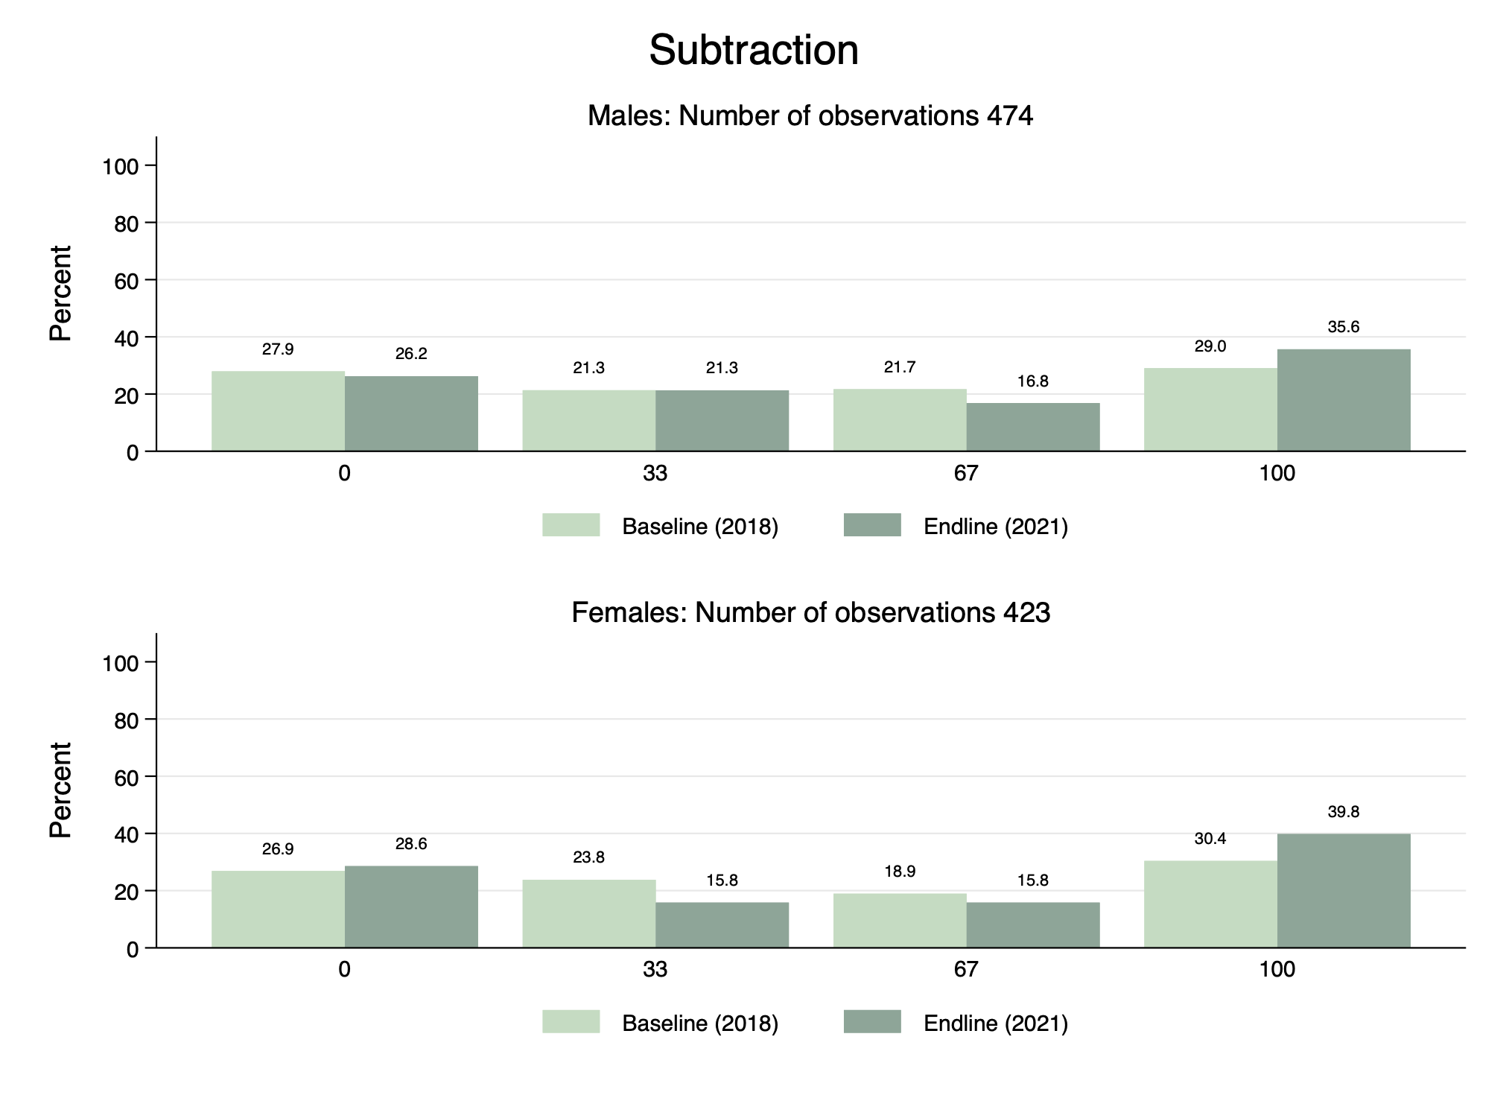
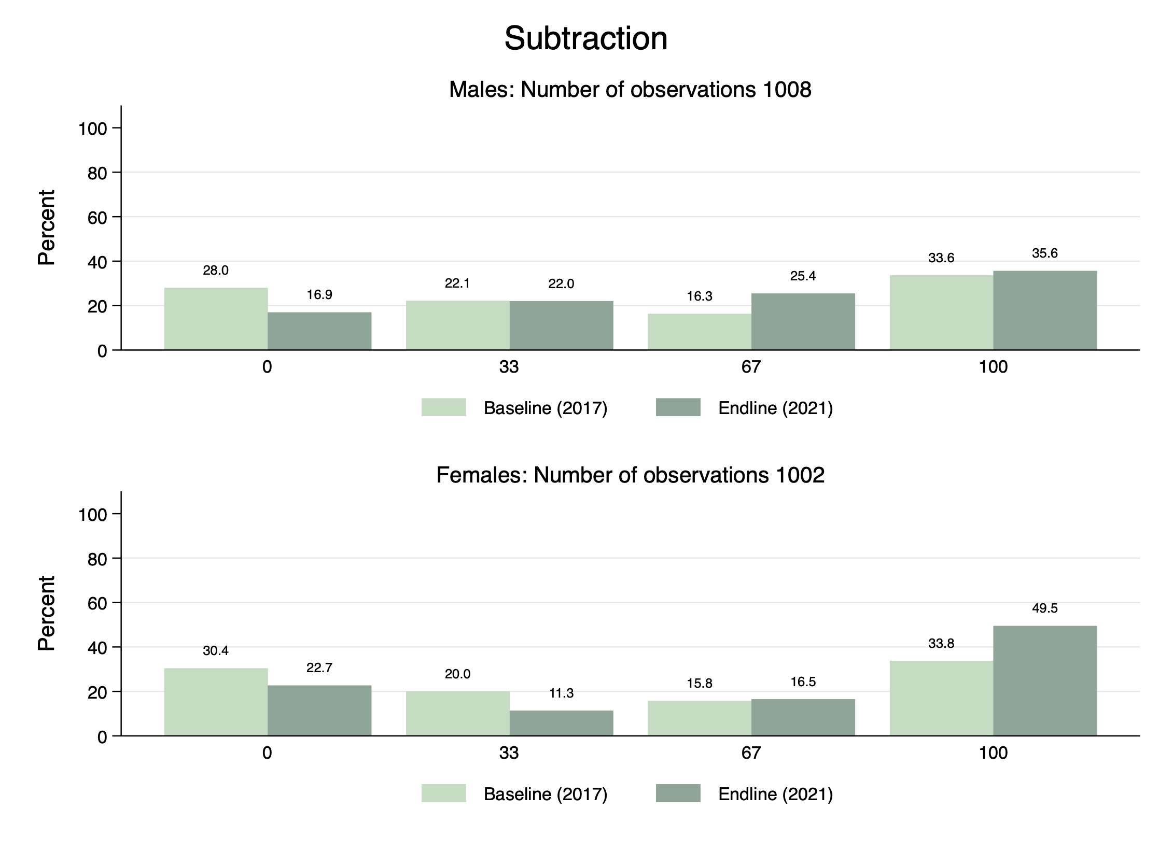
Figure 24: Male and female students scores in the subtraction subtest at baseline and endline.
These observations were also evident in the comprehension subtest, but the gains were small compared with the baseline scores for male and female students.
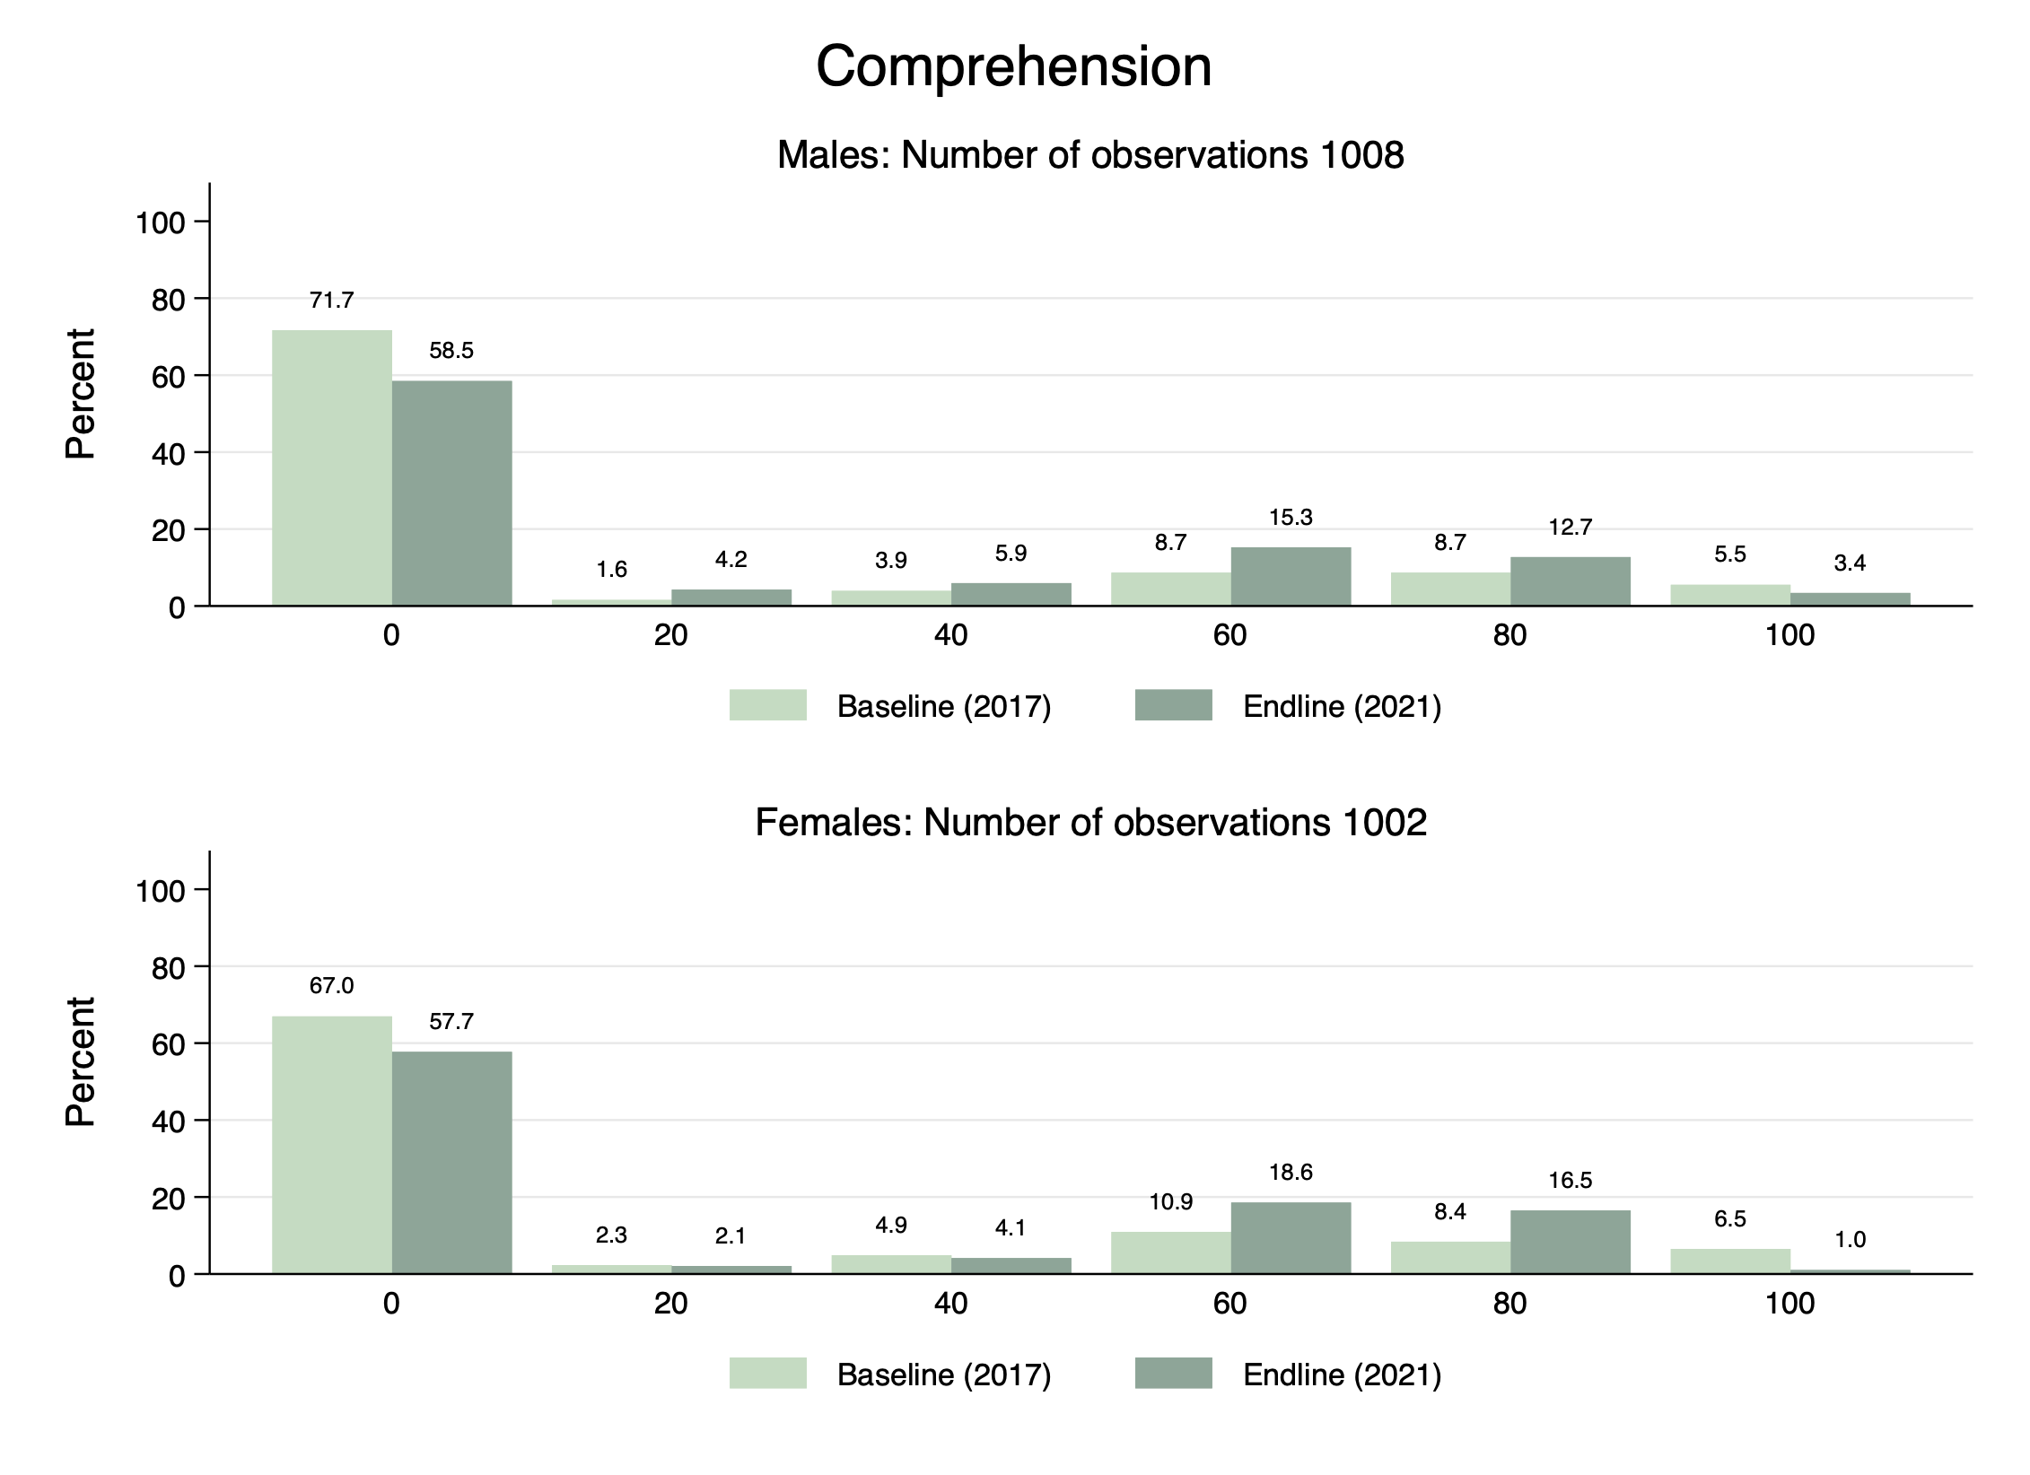
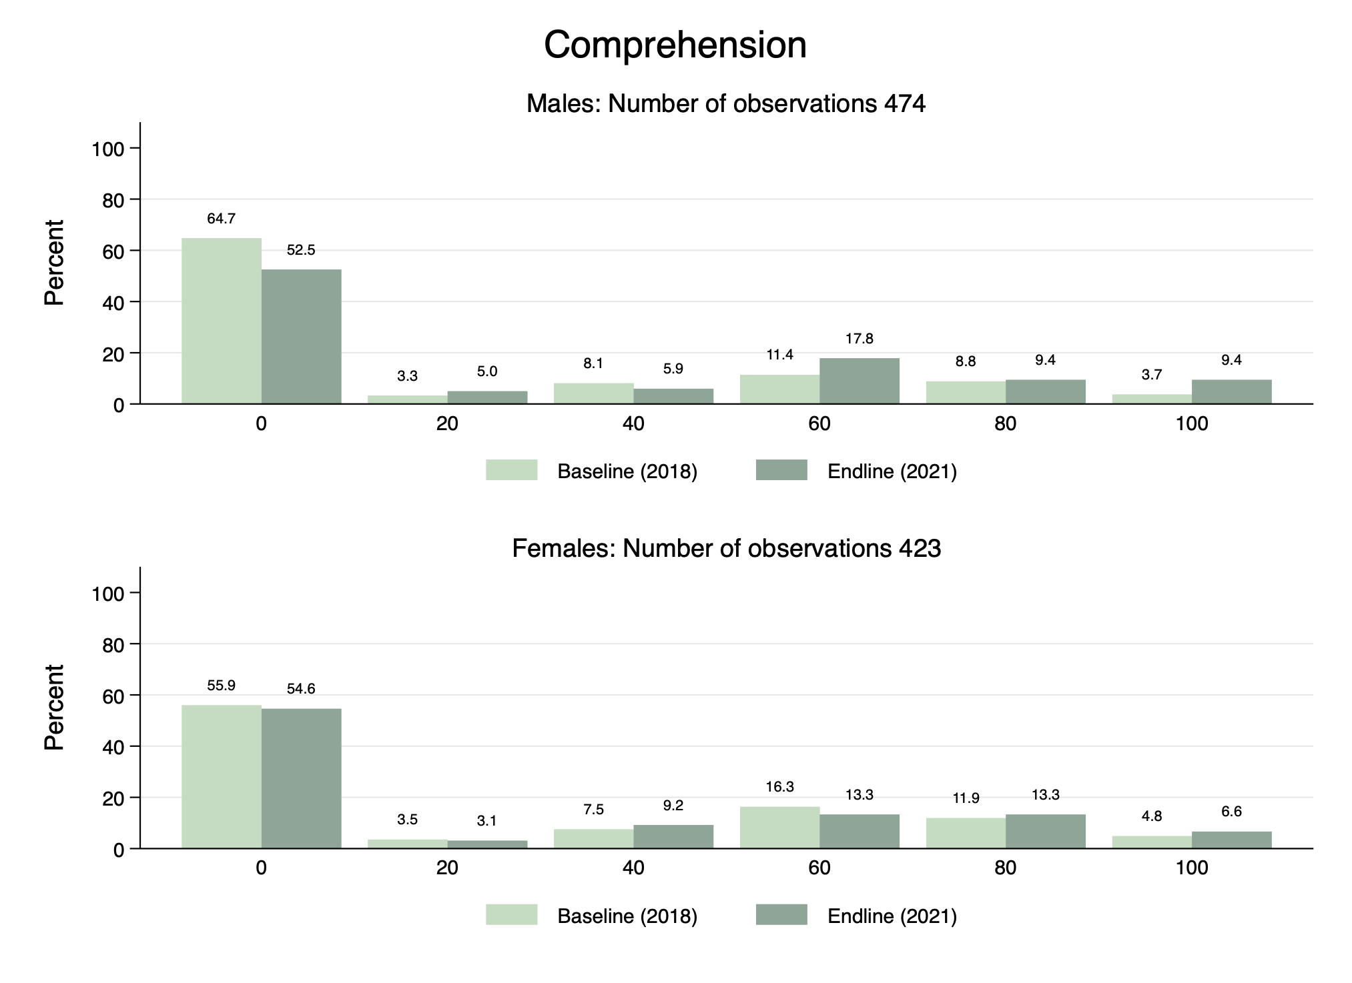
Figure 25: Male and female students scores in the comprehension subtest at baseline and endline.
In the two graphs above, it is evident that a smaller proportion of male and female students are unable to answer one of the comprehension questions compared to baseline and a higher proportion of male and female students are answering three or more questions correctly. The distinction between males and females is less evident than it was for addition and subtraction.
There was also inconsistency across the provinces limiting an overall trend being developed. Further study may be required to determine whether provincial differences remain significant or not. Due to the small sample taken at endline as a consequence of COVID-19, provincial results were too small to be representative.
The PPF results justify in many ways the perceptions held by provincial and district officers but also suggests that further work is needed to address perceptions that may judge girls in a particular way and therefore limit their potential.
Community initiatives:
- A significant initiative within PKS was the Community Voice for Girls Education and Adult Literacy (CV4GE) designed to gain community commitment to improve the learning environment for girls and boys, and to advocate for girls’ education. It aimed to challenge gendered social norms and build community voice to increase girls’ enrolment retention and regular attendance at elementary school. This was implemented in nine locations across the four selected provinces, with 938 parents and community members (549 females) trained to influence social norms and advocate for girls’ education.
CV4GE was effective in changing negative social norms, has reduced barriers to girls’ education and increased both girls’ and boys’ retention in school. Many parents who participated lowered their household expectations and responsibilities for girls (chores) and demonstrated increased understanding of children's rights and their responsibilities as parents.
This has led to increased encouragement for girls to attend school and ongoing support for their learning. There was also some indication that the barrier of girls’ mobility and safety had also been reduced linked to parents’ commitment to enabling education and supporting girls.
- The Adult Literacy initiatives through the PKS project were highly effective to support parents’ ability to read and write - to inspire positive action towards girls’ education, their children completing homework, and reading at home. The adult literacy program was implemented in eight locations in the four provinces and evidence has found it to have improved girls’ retention in school.
The most cited reason was a change in mindset to value both girls’ and boys’ education more equally. Further, the parents gained skills to generate income, which was highly appreciated by the communities. Some women also reported increased confidence and greater respect from their family and community linked to their improved literacy and numeracy skills.
Disability
- The RISE project undertook a baseline analysis of the access participation and support for children with disabilities in elementary education across their target provinces. Findings suggested there are more children with disabilities in elementary schools than indicated by enrolment data, with a figure of at least 13.2 percent. The original qualitative mapping exercise identified a fear of teasing and safety concerns as major reasons why parents were reluctant to send their children with disabilities to school.
The school environment has an impact on children's learning particularly for children with disabilities. The RISE project provided specific outreach and training sessions on identification and provision of support for children with disabilities by the Inclusive Education Outreach offices, in coordination with IERCS in each province. The identification and screening visits at schools was unprecedented and important to better understand the true distribution of children with disabilities in PNG, including the context these children must learn in, and what specialized support was required.
Teachers received training to support students with disabilities through the development of an Individual Education Plan (IEP). However, the end line evaluation reported only 30 percent of children with disabilities had an IEP, confirming the result of the initial disability study that indicated improvement in teachers’ awareness and knowledge on inclusive education did not directly correspond to improved practices.
The screening and identification of children with disabilities was followed up with some provision of support to enable learning. This included things such as specialized assessments, or assistive devices such as hearing aids, glasses, crutches, and wheelchairs. End line results showed that 31.25 percent of targeted schools had improved practices to enable inclusion in student learning.
- In T4E disability biases were challenged through initiatives such as local drama, picture playing cards and conversations in awareness training. Parents were encouraged to take a more empowering lens to view boys and girls with disabilities as able-bodied and as right holders capable of achieving as much as others. This was also strengthened through the school leadership training that challenged TICs and school Boards to address accessibility issues.
End results
Some key findings from the three projects included:
- In the RISE project, end line results showed that 100 percent of parents had positive attitudes towards regular school attendance and 90 percent of parents had positive attitudes towards girls’ education and education for children with disabilities.
- In the T4E project, results from observation at the end line evaluation indicated that 42 percent of teachers who were trained applied gender sensitive pedagogy and avoided gender discrimination compared to 30 percent of control schools. This included equal participation of boys and girls in class activities, mixed seating arrangements, boys and girls working together in and out of the classroom on learning activities, and equal materials provided to boys and girls for class activities. Girls’ attendance in school has also increased.
- In the PKS project, the inclusion of GEDSI content in teacher training resulted in 83 percent of teachers demonstrating evidence of using positive gender inclusive approaches to classroom management and more teachers reported the use of GEDSI inclusive teaching strategies in their classrooms.

MEN CAN BECOME STRONG ADVOCATES FOR GIRLS’ EDUCATION IF INFORMED APPROPRIATELY
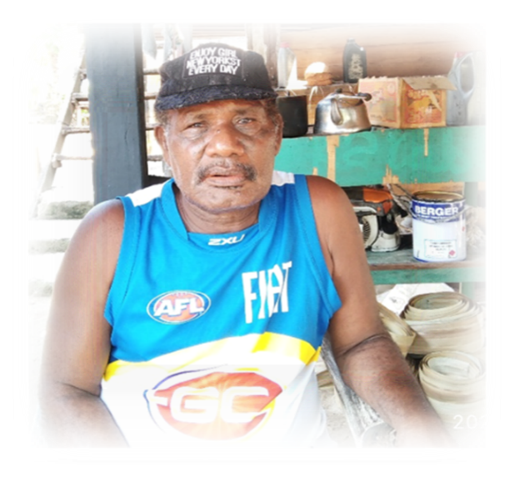
Anton Garile, a village Chief from Moputu in West New Britain Province was a participant of the Community Voice for Girls Eduaction (CV4GE) pilot training that took place in his community.
After the training, Anton made a pledge to break through some gender based cultural norms in his village.
Moputu and other villages in the Kaliai and Kove Local Level Government area have very strong customs and men are considered very important in the community.
“I worked closely with the Ward Development Committee and the Seventh Day Adventist Church Leaders to change the mindset of people in areas of changing cultural norms and practices that has been part of our life.”
“The CV4GE training enabled many young men to see women’s role differently and they advocated for change. The main discussion was around the existence of the hausboi, as this is the place that promote cultural norms and practices,” said Anton.
With support from other community advocates, the pastor, and CV4GE trainees, Anton convinced the village elders to change some traditional practices. A Community Action Plan (CAP) was developed to help educate and sustain the community to support their children continue education, including:
- ‘Hausboi’ (sacred spirit house) is no longer restricted to women.
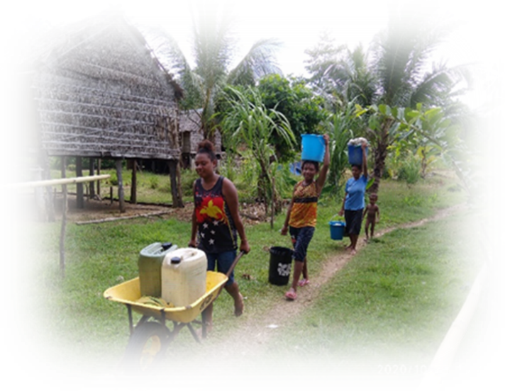
- Men come out of the hausboi for food rather than wait for women to bring it.
- Food is shared among families, and the village assists members with their cultural obligations (‘kastom wok’) by bringing food and ‘pram’ (shell money).
- Parents spend most of their time preparing for ‘kastom wok’ then preparing for school fees. Anton initiated a village calendar as follows:
- October – March: Preparations for School.
- April – September: Prepare for ‘Kastom wok’.
- Youth are encouraged to help anyone that has gardening or other heavy work.
More reforms are planned as part of the CAP, to reduce more barriers to their children’s education.
The community have decided to start up a community library in the village to provide easy reading access for the children and parents. There are also plans to build a library.
“I thank and praise God and thank ADRA for choosing Moputu village to conduct such activities that is having a positive impact on us,” said Anton. “I also extend my acknowledgement to CARE International and the Papua New Guinea- Australia Partnership for funding such programs.”

Relevance
The Comprehensive Strategic and Economic Partnership (CSEP) between PNG and Australia provides an enduring and overarching framework for deepening bilateral cooperation across security, trade and investment, governance, development cooperation, health, education, gender equality, climate change, people-to-people, and institutional links, underpinned by a commitment to achieving concrete outcomes by 2030.
The objectives and priorities for PNG in education are articulated in their National Education Plans 2015-19 and 2020-29. To support PNG, achieve these ambitions and meet the Australian Governments Education and Leadership Outcome 1: girls and boys in targeted provinces/schools have improved early grade literacy and numeracy, the four Long Term Outcomes (LTO) of the PPF were established.
PPF aimed to improve the coverage of quality basic services across PNG and achieve critical and sustainable outcomes at scale with the focus on the foundation years of children’s learning. Historically, the GoPNG has been unable to adequately support a national elementary education system. NGOs assist in service delivery, broadening the reach of services to citizens. PPF has worked with both DOE and NGOs to build teaching capacity and improve the quality of elementary education services across the country.
The three consortiums funded through PPF have supported the objectives of both nations. The lead NGOs held a strong presence within PNG and were able to access their existing networks to implement their projects, at a regional level in the 10 provinces. The PPF program has also been successful at sharing learnings and innovations between each consortium, benefitting PNG more widely.
This modality of delivery also enabled the program to foster strong linkages between the lead NGOs and the DOE, supporting the development and buy in of government officials on the respective projects. Fostering closer collaboration and a level of formalisation to the engagement between the parties has enabled successful initiatives to be integrated into the national education system for the benefit of all PNG students.
Through the program, thousands of teachers are now able to better deliver English and Mathematics lessons. The PPF developed SBC English and Mathematics Inservice training manuals can be used by any elementary teacher in PNG, and schools are better resourced to support effective teaching and learning activities. Furthermore, teachers, school administrations, and governing bodies are more aware of the need to create inclusive learning spaces for children. Parents from target provinces have a better appreciation of the need to support their children’s learning and development and many parents are now able to read and write to better support their children’s development.
The COVID-19 pandemic had significant implications for communities, teachers, students, DOE, and grantees. Planned activities were reduced or slowed considerably, while new initiatives were quickly generated to deal with the unprecedented situation. The program was able to respond quickly to the new environment, working closely with DOE and the lead grantees to adopt innovative ways to continue to support elementary education across the 10 provinces. PPF’s response to COVID gave effect to Prime Minister Marape’s call for donors to re-engineer their development investments to help manage the impacts of the pandemic.
The pandemic has progressed DOE engagement with NGOs and communities at a more rapid pace than was originally expected, creating a framework for a more integrated approach to elementary education services within PNG.
The new Education program design has identified ongoing support for several of the above success areas, which will enable the further embedment and expansion of early education initiatives across PNG.
In summary, the PPF program has retained relevance over the years through engaging closely with key stakeholders and being responsive to feedback and new requirements. It has supported grant recipients to deliver real results at the community level across PNG, leveraging existing connections and systems while fostering greater collaboration and integration between the public system and organisations and the non-profit/community sector.

Monitoring and Evaluation
The monitoring and evaluation (M&E) system encompassing the MERL framework, data repository, NGO grantee Monitoring Evaluation Plans (MEPs), donor reporting, joint monitoring visits, reflection and learning events including the Independent MTR provided a rich source of information that informed decision making at the individual project level, at the PPF program level, and provided valuable learning on current and emerging policy challenges and concerns. It produced information that was shared with PDOE to inform local prioritisation and to schools to support their school improvement planning.

The PPF monitoring and evaluation system was underpinned by a Monitoring Evaluation Research and Learning (MERL) Results Framework and described in the Monitoring and Evaluation Plan (MEP).
The system was designed at two levels – a program level and a project level.
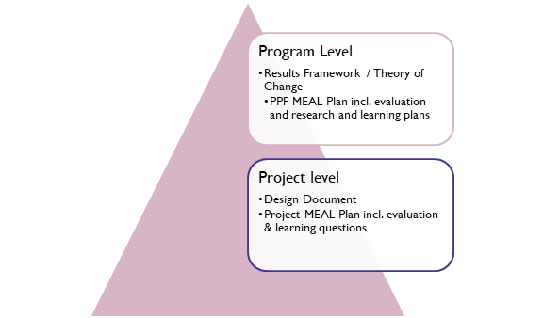
Figure 26: PPF monitoring and evaluation system levels
At the Program Level, PPF has a high-level Theory of Change, that summarises the PPF strategy and pathways of change PPF aimed to achieve. There were core pathways and approaches (which PPF expected all projects to follow closely) and flexible pathways and approaches (which PPF expected projects to adapt based on their context, the interests of stakeholders and their expertise and capacity). Outcomes were standardised and presented in the results framework. Most outcomes were measured during discreet baseline and endline activity points whereas outputs relied on project data routinely collected during monitoring activities and reported by NGO grantees.
PFF provided some uniform tools for outcome measurement and provided guidance and scope in the form of an Evaluation Plan for the baseline and endline evaluation. PPF oversaw the baseline for Outcome 3 & 4 and the endline evaluation. The NGO grantees were required to develop their data collection schedule based on a random sample of schools and administer data collection in their localities.
PPF provided quality assurance, training for enumerators, and provided the headline data sets for NGO grantees to analyse for their completion reports. Specific research studies were produced based on the interests and objectives of the Research and Learning TWG, established with the DOE to oversee all research and learning activities. The PPF MEP was informed by DFAT M&E standards.
At the project level, NGO partners reported on the PPF program outcomes and outputs as well as:
- PPF core outcome indicators that were relevant to their project
- Flexible outcomes, indicators and questions that were unique to the project
- Reflection and learning for project improvement
- Building knowledge to generate new insights and evidence that could influence policy and practice.
At the program level, features of M&E included data flow and management, program monitoring, program evaluation, and quality assurance. A copy of the key documents mentioned above can be found in the Annex document that supports this Completion report.

Data flow and management
PPF established a robust system for sharing information between stakeholders through its reporting and governance mechanisms, ensuring reporting aligned to the contractual requirements established by DFAT and program M&E standards.
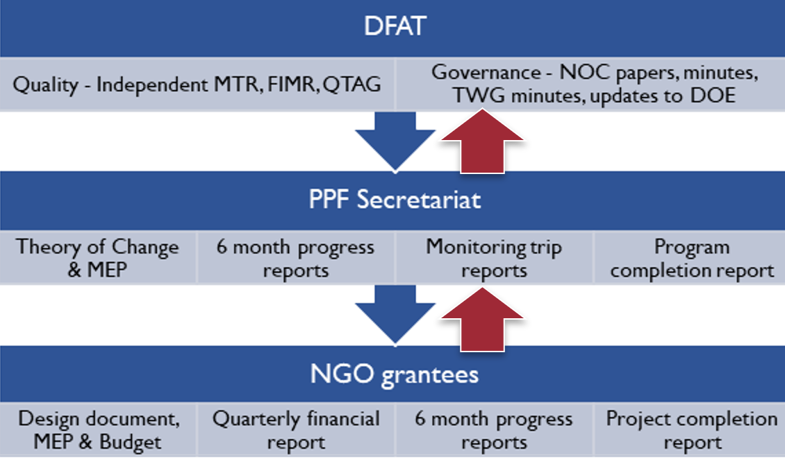
Figure 27: PPF document flow
Each NGO grantee produced core project documents such as a design document, M&E plan, and budget. These were used to periodically report on progress, captured in 6-month reports and quarterly financial reports.
The PPF Secretariat convened fortnightly meetings with NGO grantees to discuss implementation challenges, work achievements and future priorities. These meetings were pivotal during the COVID-19 pandemic when there were frequent changes to the operating context.
For the first two years of implementation, PPF relied on 6-monthly reflection meetings to share outcomes of monitoring visits, updates about new or updated standards/requirements and to address implementation challenges. Whilst this was a valuable mechanism, the restrictions placed on gatherings during the COVID-19 pandemic limited these opportunities from 2020 onwards.
The PPF Secretariat prepared core program documents to guide NGO grantee projects. These were the ToC and the MEP. Every six months, PPF provided a report of consolidated consortia results with a summary of Secretariat activities (including communications and public diplomacy, monitoring, GESI capacity building and risk management).
Based on consortia self-assessments and quality checks of results reported, PPF made assessments on the likelihood of grantees achieving their expected targets. The program identified areas where adjustments or improvements were needed for grantees to resolve. These assessments formed the basis of discussions for each project and provided a mechanism for feedback and reflection on the quality of work being undertaken.
The joint monitoring visits were also important opportunities for assessing progress, undertaking joint reflection, and learning, regarding project challenges and the obstacles facing the elementary education sector in PNG.

Data Repository
The PPF data repository provided a rich dataset for the program, including disaggregated data on schools, teachers and students reached by the program. Data spans the implementation period from 2018 – 2021 and has been captured for each grantee.

The PPF Secretariat maintained a data repository for the duration of the program. In the first phase of the project, it kept information on key results by individual NGO grantees. With no uniform program level results framework, challenges were experienced aggregating data and basic information (such as the number of teachers trained) as each NGO defined their indicators differently.
For example, some NGOs counted a teacher trained only if they attended all sessions throughout the year, while another counted if only one session was attended. This was also the case with refresher training. This misalignment of data collection was rectified after the MTR recommended that ‘PPF develop an integrated program logic and results framework to guide future activities.
The data repository was subsequently revised to match the Framework and ensure that data was captured in a uniform manner. Key indicators included: 360,575 students reached (disaggregated by gender, province, and district), 6455 teachers reached (disaggregated by gender, province, and district), and 2502 schools reached (disaggregated by province and district).
PPF also validated 2018 and 2019 data to ensure consistency in measurement across the years. This work provided PPF with confidence in the aggregated data obtained from NGO grantees. The PPF program results framework was updated in 2022 reflecting aggregated results across the program and a copy can be found in the Annex document that supports this Completion report.

Joint Monitoring Trips
Joint monitoring trips were an important feature of PPF’s engagement with the DOE, DNPM and DFAT. They provided an opportunity for reflection, learning, and sharing in relation to successes, challenges, and opportunities for strengthening effectiveness and sustainability of activities funded through the program. PPF visited 9 of the 10 target provinces at least once during the program.

The PPF joint monitoring visits were an important mechanism for the DOE, DNPM, DFAT, PPF Secretariat, and NGO staff to observe teachers and students in the classroom, speak with TICs, provincial and district education stakeholders, parents, and community leaders about the benefits of the program and challenges they faced.
The monitoring visits also provided a unique opportunity for the NGOs and PPF team to build relationships with DFAT, DOE, and DNPM. For DOE, DNPM, and DFAT staff, the monitoring visits also provided the opportunity to learn how individual projects engaged with local government stakeholders, and how each province and/or district planned to continue the work when the project ended. A key factor for their success was the ability to converse directly with PDOEs and district education officers.
Finally, the joint monitoring visits captured recommendations that were shared with NGOs to inform adaptations to their projects. These recommendations also informed actions at the program level to improve program performance.
Apart from program effectiveness monitoring, these visits provided an opportunity for DOE and DFAT to undertake separate monitoring and quality assurance processes, and to better appreciate the realities of implementing education policies across different parts of the country.
In the final PPF Monitoring trip, a senior DOE staff member commented on the high quality of the monitoring trips. Additionally, when reflecting on the improved pre-briefing session the PPF Secretariat conducted with GoPNG and DFAT officials before trips in 2021, a DNPM staff member commented on the high level of rigour in the processes and approach, which facilitated the active participation of GoPNG officials.
Another DNPM staff member was pleased to note the impact and innovative approaches introduced by the T4E project. On a monitoring visit he participated in, he commented that it was clear the PPF program was making a significant impact to beneficiaries.
Donatus Egimi - E2 Teacher Missingi Elementary School - Middle Ramu during TT1
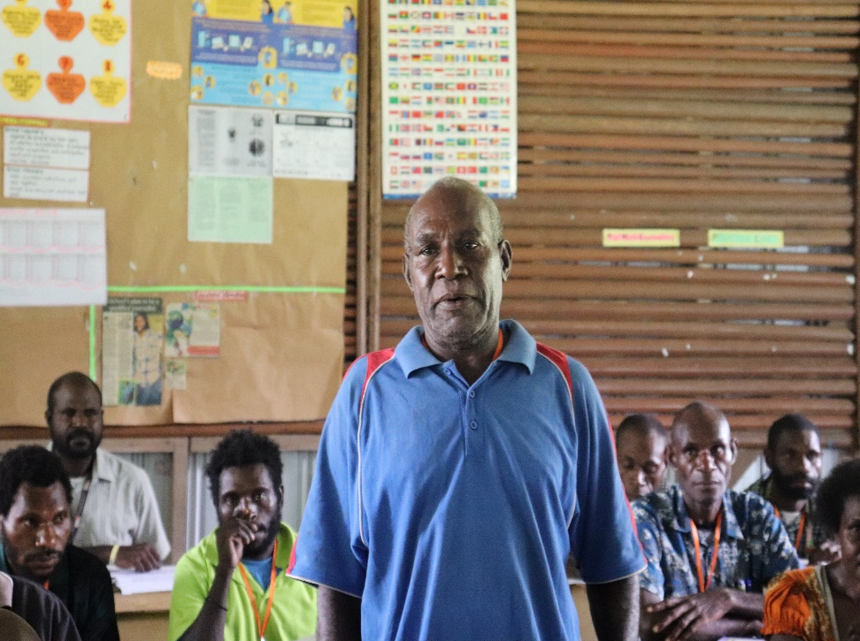
Figure 28: A teacher in Missingi Elementary, Madang, sharing insights from teaching training

Figure 29: A teacher at Missingi Elementary, Madang sharing insights from the teacher training

Overall, 12 monitoring trips were undertaken in all target provinces except for Simbu with representatives from the PPF Secretariat, DOE and DFAT. From 2020, monitoring schedules were significantly impacted by COVID-19 travel restrictions and lockdowns.
Several recommendations over the four-year implementation period that resulted in significant adaptions to the program included:
- The need to reconceptualise the governance structure away from individual NGO steering committees to a joint program level committee, NOC.
- The need to ensure teachers performance was adequately monitored. This informed the development of detailed lesson observation forms which were used by partner trainers, TICs, and others responsible for supporting teachers.
- The need to ensure training materials were socialised and endorsed by the DOE. This informed the move by PPF to establish a teacher education technical working group with DOE to oversee the consolidation and approval of all teaching and learning resources.
- The need to establish post training support for teachers so that they could practice the new skills they learnt in training. Each NGO established their own method for doing this based on the local context and were informed by PPF’s guidance on good practices in continuous teacher professional development. The establishment of TLCs in the second phase of the program was a direct response to monitoring feedback provided to NGOs in 2019.
In 2020, when the PPF program approach was standardised, all monitoring tools were updated to reflect this change. Further details about the monitoring visits along with the supporting tools used can be found in the Annex document that supports this Completion report.

Sustainability
Sustainability has been at the heart of PPF (Education) program’s ToC. It has been a primary focus since the beginning of 2020, when the PPF (Education) program consolidated its program approach, developed a unified MEP, and established mechanisms for enhanced partnership with the DOE through the TWGs. The objective of these changes was to strengthen sustainability outcomes and embed improved practices within the DOE at national and subnational levels.
In the first phase of the program, sustainability was pursued by individual NGO consortia at the sub-national level with PDOE and school administration and focused primarily on capacity development. In the second phase, the focus shifted to system strengthening. A significant portion of the achievements of the PPF program have now become embedded in rural schools, education institutions, NGOs engaged in education, and the national system through the DOE, DHERST, and PNGEI.
Sustainability was tabled as a topic at the 3rd PPF NOC. It was agreed at this discussion that an ‘Out of Session’ meeting be held to consider how to take forward a sustainability agenda for PPF. This meeting was held in May 2021 and a sustainability brief was tabled including a proposed Sustainability Action Plan. Progress on this Action Plan was shared for discussion at the 4th and 5th meetings of the NOC, ensuring members of the NOC were engaged in directing the priorities of PPF regarding sustainability.
The focus on sustainability has emerged over time and been informed by the TWGs and joint monitoring visits between DOE, DFAT and PPF where opportunities for reflection and learning were generated. Practices in teacher professional development have emerged as the most promising for sustainability. The SBC Teacher Training and school-based teacher support such as teacher learning circles have been the topics of sustainability discussion with DOE, PNGEI and DHERST in the final months of the program.
To summarise PPF’s approach, the ToC states that if teacher practices are improved, the inclusive learning environments in school are strengthened, parents’ capacity to support their child’s learning is improved, in collaboration with government to imbed good practices in teacher education institutes and policy, then improvements in student learning can be sustained beyond the life of the program.
The PPF (Education) program has worked to achieve sustainability at the national level in three ways:
- Endorsement of PPF’s SBC training manuals by the DOE Board of Students will enable this resource to be used across the country for national and provincial Inservice teacher training programs.
- Receiving commitment by PNGEI to institutionalise the training materials for two programs: the elementary teacher conversion program and the primary diploma course. DHERST has provided its commitment to support PNGEI’s submission to have the course materials accredited.
- Providing research and learning products that can inform policy and practice change. Many issues have surfaced from PPF’s learning agenda that will be taken forward as priorities for action in future education programs, such as chronic absenteeism, the link between teacher and student attendance, and the positive and negative associations to learning outcomes in the early grades. Some of the program’s research and learning products can be found in the supporting Annex document.
At the provincial and district level, sustainability has been achieved in the following ways:
- A cadre of provincial elementary trainers (under the provincial education authority) who have received specialized training and coaching in delivering SBC English and Mathematics teacher training, will be able to deliver the training on their own in future years. This capacity will be available in the 10-target province of PPF; Autonomous Region of Bougainville, East Sepik, Eastern Highlands, Morobe, Madang, Central, West New Britain, Jiwaka, Western Highlands and Simbu. A list of resource teachers and provincial trainers have been shared with the DOE as they are interested to draw on this capacity in future programs.
- A cadre of provincial and district officers (under the provincial education authority) who have received specialized training in follow up coaching, including lesson observation, will be able to provide supportive supervision during school visits on their own in future years.
- A documented mechanism of follow up support through teacher learning circles (TLCs) that is endorsed/affirmed by DOE as an effective strategy to boost elementary teacher competency. DOE has received a comprehensive guidance note and resources of the TLC methodology and are interested to pursue further pilots of this in the future education program.
At the school level, sustainability has been achieved in the following ways:
- Stronger school leadership regarding Teachers in Charge and School Boards of Management, many of whom will have received specialized leadership and management training and have increased capacity to develop their school improvement plans (SLIPs) and support quality improvements in the school. This will be evident in 1736 elementary schools that have been reached through the PPF program.
- More competent teachers who feel confident delivering the SBC English and Mathematics curriculum after receiving over 100 hours of professional development training in SBC English, Mathematics, gender, and disability inclusion. This will be evident in over 6,000 elementary teachers that have been reached through the PPF program.
- More engaged parents who not only understand the importance of education, (some of whom have also participated in the PKS Adult Literacy Program), but also the importance of regular school attendance and establishing a conducive home learning environment but can act on this understanding in their practices.
Notwithstanding the significant progress made toward sustainability, several challenges remain.
- Whilst PDOE have expressed a keen interest to replicate the teacher professional development approaches PPF have piloted, they are concerned about ongoing resourcing and human resource capacity. Whilst there are several outstanding elementary trainers and resource teachers identified through the PPF program, they do need further mentoring and coaching to become proficient in training/providing expert advice on early grade literacy and numeracy teaching.
- Whilst there is a commitment by PNGEI to use the materials for the elementary conversion program and the primary diploma, ongoing technical advice may be needed to ensure the content is correctly translated to new courses and programs. It will also be necessary for each course to be piloted and assessed prior to further expansion.
The key guidance documents that have informed PPF’s sustainability agenda can be found in the Annex document that supports this Completion report.
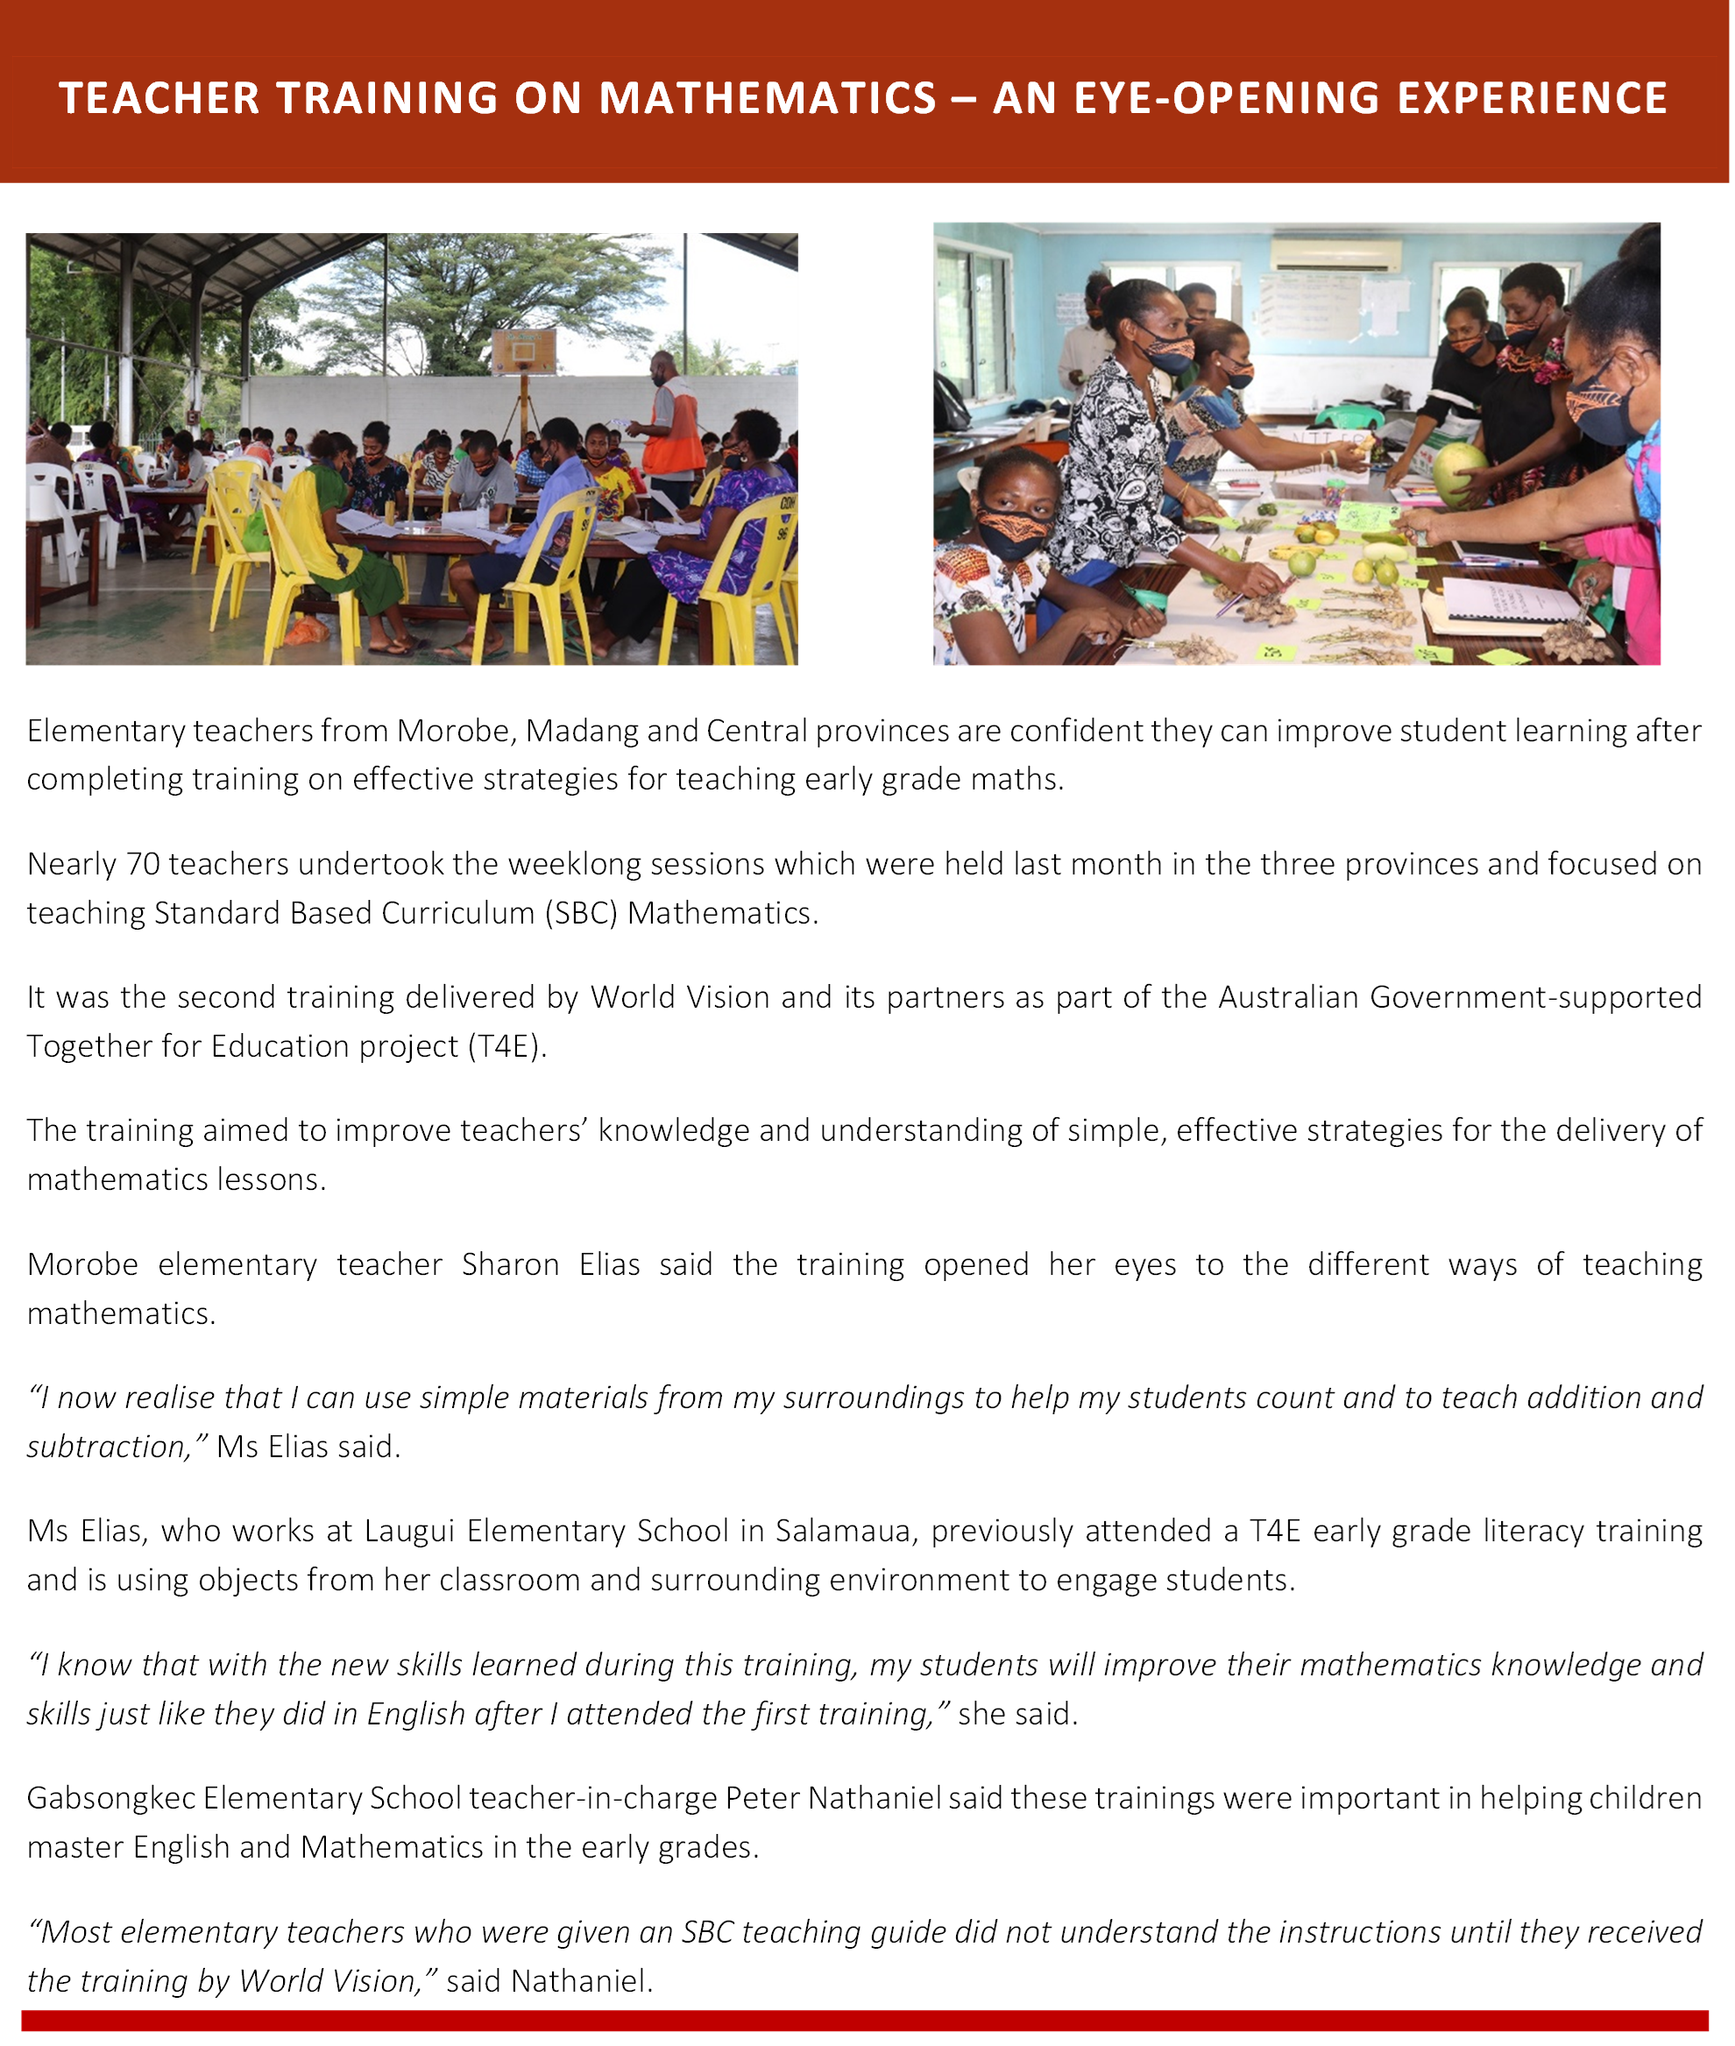

Public Diplomacy
When PPF began, NGO leads were responsible for developing and implementing communication plans for their projects. PPF program approval was not required for their public diplomacy activities, which were shared with the PPF program in regular reports. Significant activities were advised in the regular engagement meetings and permitted PPF or DFAT involvement if desired.
However, this separate approach resulted in separate branding and messaging. In 2018, a communications officer was recruited to support PPF across the education programs and the health portfolio that was later novated to PATH. This role was created to work closely with grantees to align branding, messaging, and public diplomacy content with a broader PPF communications strategy and DFAT expectations. From 2019, the PPF Secretariat utilised a quarterly communications work plan to generate public diplomacy content, but NGOs struggled to produce public diplomacy content with the consistency, quality and quantity anticipated.
At the onset of the COVID-19 pandemic in 2020 responsibility for communications shifted to the PAGP Communications Unit which provided part-time support to PPF while also working across five other programs. Learning from the inefficiencies and inconsistencies of the previous approaches, the decision was made to develop a program level communications and public diplomacy plan.
The PPF Public Diplomacy and Communications (PD&C) Plan emphasised timely and impact-focussed public diplomacy products. An editorial calendar, an important part of the PPF PD&PC plan, was developed in consultation with the NGOs. Additionally, to further improve the quality of content prepared by the NGOs, PPF also developed and shared a Public Diplomacy Guidance document in 2021.
Responsibility for producing content to be distributed in commemoration of specific international days was divided among the grantees. Clear timelines were given to allow for quality assurance and DFAT clearance before publication. Standard messaging for products was developed for each consortium and consistently used. The PD&C Plan was in place from August 2020 – December 2021 with 74 percent of the editorial calendar targets met. Unmet targets mostly related to products that would have been nice (TV and factsheets for social media) to develop if there was capacity and data to do so.
Throughout the life of the PPF education program, 226 media items were published or broadcasted. On average 56 items were prepared per annum with 68 generated in 2020. Newspaper was the most popular medium followed by social media and online news.
Some notable examples which demonstrated the impact and performance of the program included:
- Back to School campaign advertising in 2021 in support of the EERRP
- T4E project radio interview on the popular FM100 Talk Back Show
Annually, the program published media items to commemorate:
- International Day for Education
- International Women’s Day
- International Literacy Day
- World Teachers Day
- International Day of the Girl Child
- World Children’s’ Day
- International Day of Persons with Disabilities

Figure 30: Public diplomacy products

Figure 31: Public diplomacy messaging between 2020-2021
In terms of messaging, 90 percent of public diplomacy materials referred to the Australian Government and or PNG-Australia Partnership – a result of the quality assurance provided by the PPF and PAGP communications teams.
More than 80 percent had a thematic link to DFAT GEDSI priorities: enhancing women’s voice in decision-making, leadership, and peacebuilding; promoting women’s economic empowerment; and ending violence against women and girls. GEDSI was strongly represented because of its full integration into individual grant project designs and delivery approaches.

Figure 32: Public diplomacy messaging between 2020-2021

Other Issues

Program Pivot to COVID-19
The PPF Education program pivoted quickly to respond to the COVID-19 pandemic and the emergency response priorities of the government. PPE was quickly secured, and NGOs drew on their international footprint to quickly mobilise resources to support elementary schools adapt to the ‘new normal’.
Information, Education, Communication (IEC) materials and awareness activities on handwashing and safe hygiene were developed and rolled out to elementary schools quickly. The work undertaken by PPF in relation to IEC has positively impacted the entire school system with resources being made available on the DOE website.

Private Sector
PPF did not have extensive partnerships with the private sector as the program was focused on strengthening the government education system through NGO consortia who engaged civil society and not-for-profits to complement the work done by government. PPF did not focus on infrastructure or refurbishment which would have attracted more engagement with the private sector. Instead, emphasis was on teaching and learning and capacity development at the school level. However, there were a few engagements on note.
The provision of early grade readers and story books was an objective in all NGO consortia projects following the baseline that revealed the absence of culturally appropriate reading materials for elementary students.
Through a partnership with Library for All in the T4E project, local writers and illustrators were engaged in story writing workshops in 2018, which led to the production of over 500 titles. Illustrations were added promoting local cultural with images from children’s daily lives so they could connect to the stories. Distribution of hard and digital copies of titles were distributed to target schools in the 10 provinces following interest expressed by the PKS and RISE projects to increase the availability of culturally appropriate reading resources for elementary students. The partnership provided a boost to local writers, printing companies, illustrators, and distribution outlets where books are stored and distributed to schools after orders have been placed.
Additionally, a partnership with Bilum Books under the T4E project provided an important avenue for this schoolbook publishing company, which launched in 2016 to expand its reach into elementary schools across 3 of the 10 PPF target provinces. The publishing company has a long association with Papua New Guinea and a deep respect and affection for the country and its people. Their teacher guides and student workbooks are based on the SBC and endorsed for use in PNG. They provide a valuable complement to the government’s own teaching resources and feedback from teachers has highlighted their effectiveness. Through the partnership, printing companies and distribution outlets have also benefited from the partnership with Bilum Books.

Innovation
The PPF program has trialled a range of innovations to address the challenges facing elementary education in PNG. The most notable have been:
E-learning: The T4E and RISE projects piloted e-learning, which included the digitisation of early grade readers, the provision of digital software and hardware for elementary classrooms complemented by training and supervision from LFA and Summer Institute of Linguistics who provided the technology solution.
RISE completed a report documenting the pilot and its utilisation of the Bloom Reader. Results have indicated it has been effective in supporting children’s reading proficiency and as a complementary resource for teachers, parents, and students. Similarly, LFA completed a report into the Spark Kits and expanded the program in 2020 and 2021.
Reach and Match: Save the Children piloted the use of Reach and Match, an innovative play-based learning kit that stimulates play through multisensory tiles and mats in several IERCs and ECE centres across the country. Results from research into the use of this learning kit indicate its applicability in IERC and ECE learning contexts to stimulate play-based learning for children with disabilities. Improvements in letter and number identification were found in children who were assessed before and after the pilot study.
Teacher Learning Circle: ChildFund developed and piloted the Teacher Learning Circle (TLC) model for ongoing teacher professional development in the Rigo and Kairuku districts of Central province in the second half of 2020. In 2021, the TLC was rolled out to Madang and Morobe provinces. The TLC promotes routine ongoing professional development for teachers at the school and cluster levels.
TLCs are led by trained resource teachers and provide an excellent mechanism for teachers in remote rural Papua New Guinea to undertake low or no cost professional development support. TLC resource teachers are provided a TLC Manual and menu of 20 topics to help them in the conduct of TLCs. These topics are sufficient for two years of school-based professional development. Resource teachers were also provided tablets with pre-loaded videos to aid the TLC delivery.
School and Community Accountability Agreements: With leadership from the Consultative Implementation Monitoring Council (CIMC), the T4E project worked with SBOMs, TICs, and community members to set up Local Governance Committees whose responsibility is to oversee the implementation of School and Community Accountability Agreements (SCAAs). The SCAA is a tool to support improved student attendance at school, and learning.
While its effectiveness is yet to be measured, strong parental support is a positive indication of its relevance. Over the life of the program, more than 10,000 parents and caregivers across 44 schools were provided critical information on child protection, GEDSI, the importance of education, and important actions they can implement to support their children’s learning and attendance in school.
Cohort approach to teacher training: With the challenges brought about by school closures and other COVID-19 restrictions, CARE implemented a cohort modality for teacher training. Through this approach, schools remained open during the term and teachers took turns going away for training. CARE found this to be a successful approach to conducting training over non-school holiday periods as the teachers that remained covered for those who went first and vice versa.
Jumbo playing cards: The T4E project developed playing cards to use for their parental engagement program. Each playing card has different pictures and messages that stimulate discussion in the family about various topics including the importance of parental involvement in a child’s education, the importance of eating a balanced meal, having a good night’s rest before school, keeping clean, and COVID-19.

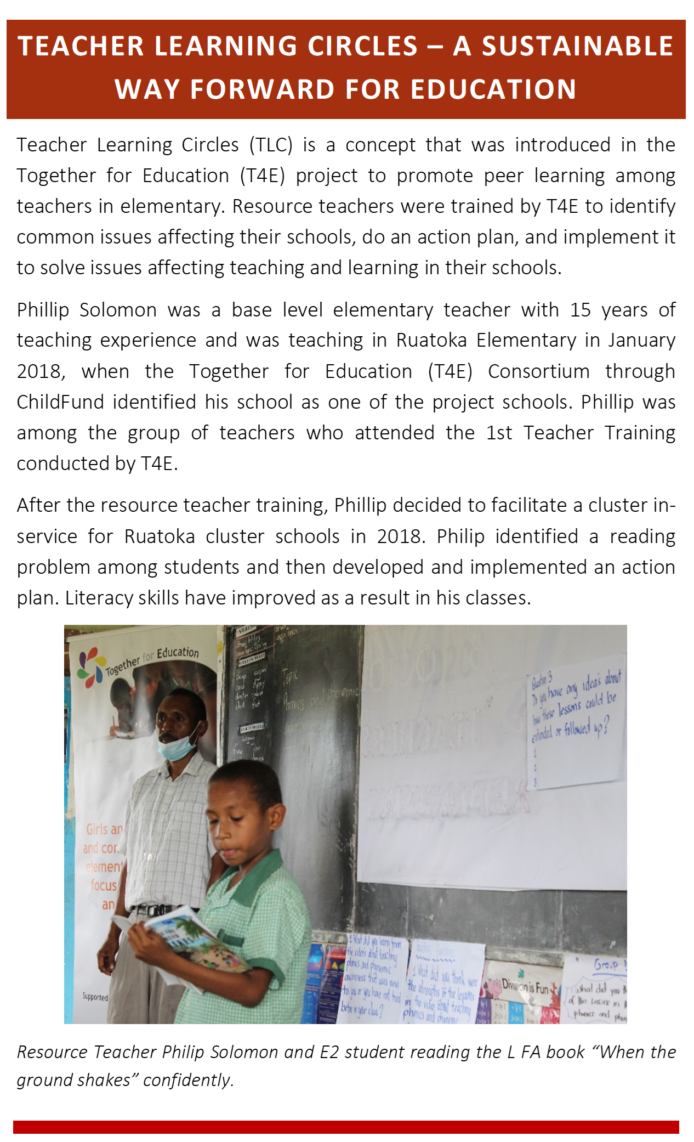

Past Reviews
In 2019, PPF received a QTAG review and an Independent Mid-Term Review, which was undertaken by Human Development Monitoring and Evaluation Services (HDMES).
The Review examined the overall effectiveness of the PPF (Education) program grants in contributing to improving literacy and numeracy skills of girls and boys in the early years of school (elementary) in PNG. To do so, the review looked at the effectiveness and efficiency of the three PPF grants, and their progress towards sustainable outcomes by contributing to basic education policies and planning in PNG.
The PPF Independent MTR made a range of recommendations all of which were adopted by the program following consultation with key stakeholders:
- Under the Australian Government’s guidance, the PPF Secretariat facilitated a collaborative process to engage key stakeholders culminating in the Theory of Change workshop in February 2020 that included a comprehensive problem analysis drawing on project progress, impact evaluation findings from the three grantees and MTR findings. The DOE and DNPM were involved in the workshop from teacher education, curriculum development, inclusive education, and donor coordination divisions.
- Theory of Change workshops were held at the national and sub-national level. The workshops involved stakeholders in developing a coordinated and well-integrated program logic that would lead to sustainable results. Additionally, in March 2020, the PPF Secretariat facilitated a remote workshop with NGO partners focused on Monitoring, Evaluation, Accountability and Learning (MEAL). Participants considered the key evaluation and learning questions (ELQ) and key performance indicators for the integrated program. The MEAL plan was finalised and approved by June 2020.
- A special (exception) meeting was held in May 2020 to consider the proposed program approach and seek endorsement from the NOC on the direction of the program for the extension period including the mechanism for DOE engagement in research, learning and teacher education priorities. The program approach was endorsed at the NOC meeting, including the technical working group mechanism.
- Institutional engagement was strengthened through the National Oversight Committee, Technical working groups, joint monitoring visits, and through promoting a one-team, partnership approach with the government. The technical working groups have been a major vehicle for collaboration with DOE, and DHERST and PNGEI, regarding teacher education.
- The research and learning workshops established by the associated working group, were forums for sharing research findings and discussing the implications on policy and practice in the education sector. Whilst only two of the three planned workshops could be held due to the impacts of COVID-19 on DOE, they were an effective mechanism for policy dialogue and provided a vehicle to advance papers through to Top Management Team (TMT) for approval. Using this mechanism, the program was able to advance the following reports through to the TMT for approval:
  - PNG Disability Mapping Synthesis Report, RISE
  - PNG Reach and Match Impact Report, RISE
  - PNG ECE IDELA Report, RISE
  - PNG Sharing Literacy through Bloom Reader Final Report, RISE
  - PNG Gender Synthesis Report, RISE
- Under the guidance of the Australian Government, the PPF Secretariat used the R&L TWG mechanism to develop a comprehensive evaluation plan building on the initial objectives established when the theory of change and MEP were finalised. The Research and Learning TWG were involved in the technical review of the draft plan and DOE were especially engaged in providing guidance for notifications to PDOE and district officers, ethics, survey reviews and consideration of how the findings would be taken forward by DOE. The DOE endorsed the plan which was later approved by DFAT.
- To improve cost and program effectiveness, PPF undertook the following:
  - The standardisation of teacher training materials reduced cost, improved consistency and coherence and ensured quality
  - The standardisation of tools and processes for baseline and endline
  - The standardisation of IEC materials (part of the COVID-19 response) to promote hygiene messages
- The Australian Government expanded the role and function of the PPF Secretariat to advance the establishment of two technical working groups in partnership with DOE that are governed under the NOC, and in the management and coordination of the baseline and endline studies which were undertaken across the program. It was also considered important to increase the amount of joint monitoring activity from one to two visits per NGO grantee per year. The later was not realised due to COVID restrictions.
- With guidance from the Australian Government, the PPF Secretariat worked with the three grantees to consolidate interventions over the extension phase with a core focus on student learning outcomes and teacher professional development and priority toward sustainability and inclusion. This built on the strengths and opportunities emerging from the first phase of the PPF program. PPF expanded to some new schools in the same provinces but retained others from the first phase that required further support.
Programmatically, PPF moved to finalise Phase 1 activities and prepare to commence Phase 2 implementation in July 2020. The Phase 2 Education program commenced in July 2020 with a consolidated program ToC and MEP, which all PPF education NGO partners adopted.
This collective approach to align the M&E framework was a significant improvement to the program design and cleared the way for a comprehensive evaluation across all program implementation in the final two years of the program.
However, the COVID-19 pandemic required the program and grant recipients to quickly adapt to the new operating environment. In response to the changing context, Phase 1 closeout activities (which occurred during Jan-June 2020) were adapted to support COVID-19 priorities, and Phase 2 designs were revised to integrate COVID-19 responsive programming options.
The move to align with COVID-19 response and recovery was subtle, increasing resilience to existing programming and adding COVID-19 recovery activities as necessary, while maintaining an overall commitment to improving the coverage of quality basic services across PNG and achieving critical sustainable outcomes.

Challenges and Lessons Learned
The PPF program faced several challenges between 2017 and 2021. All were proactively responded to, and the program adapted in collaboration with partners and stakeholders. Each challenge, or issue faced, resulted in learnings for the program, grantees, partners, and stakeholders which resulted in improved practices and greater efficiency or effectiveness for the program.

Challenges
Following is a summary of some of the key challenges faced by the program over its duration.
Level of devolution of responsibilities to lead grantees: Initially the requirements for managing MEL, finances, assets, GEDSI and communications was devolved entirely to each lead grantee to manage as part of their grant obligations. While each consortia developed their own quality processes the approach utilised differed sufficiently to make the collation of information at the program level difficult. This was especially true with GEDSI where the lack of guidance and frameworks/parameters to collect, analyse and properly report on GEDSI related data resulted in not all achievements made being well reported.
This gap was addressed in 2021 with the introduction of the GEDSI Action Plan, as well as the establishment of a PPF Handbook and Operations Manual that provided clear guidance within grant agreements around: asset management and disposal; the difference between assets vs. consumables; assets vs. resources for distribution to schools; the need for fraud policies and systems; and data collection and reporting requirements.
Importance of collaboration and clear processes: Initially the communication processes between PPF, DFAT and DOE were challenging due to unclear processes regarding engagement. The lessons learned captured in the mid-term review paved the way for the PPF Secretariat to adopt a more collaborative approach in the cross-grantee learning and enabling culture to deliver results and in transforming governance at the national and sub-national level. The establishment of the NOC, TWGs and cross grant collaboration meetings addressed this challenge and led to a united, agile response when the COVID-19 pandemic arrived in 2020.
Staff retention and ability to operate effectively: Within the grantees and the PPF program retaining quality staff at the points of program review (early 2020) and closure (2022) has been a challenge. In 2020, World Vision reported that the T4E project experienced significant loss of staff before the extension phase was confirmed, Save the Children reported an overspend to pay for consultants to undertake responsibilities that would normally be completed by full time staff, and the PKS project lost its MEL officers in Western Highlands and West New Britain.
Additionally, COVID-19 travel restrictions and extensive approval times presented a barrier to the in-country participation of the Education Specialist and Enhanced Education Unit Director. The staff turnover impacted the corporate knowledge present within each organisation and the speed with which responses could be provided. DOE staff were also impacted heavily from COVID-19, which made progressing TWGs and implementation plans difficult. This impact was also felt across the provinces and within schools.
Undertaking remote delivery at the subnational level: Due to COVID-19 disruptions, PPF experienced implementation delays. While some projects were able to achieve most activity implementation others needed to delay some activities, especially training. The key learning has been that a fully remote capacity building approach is not effective for conveying technical/complex concepts, and if face-to-face delivery is not possible, then a blended approach would be the most effective.
In some instances, the inability of the provincial government to provide promised manpower delayed implementation or resulted in resources being reallocated. For example, CARE experienced challenges in the delivery of low-cost WaSH facilities in Simbu province. While CARE procured materials and provided the technical specialists, the provincial government authorities were supposed to supply labour to implement the projects. Delayed organisation of manpower to support the projects delayed implementation. As a result, some materials were reallocated to 15 schools in Jiwaka province.
COVID-19: Disruptions caused by COVID-19 had the greatest impact on human resources, activity delivery, outputs, and outcomes. The impacts of COVID-19 were felt for the duration of 2020 and 2021 when the second phase of the program was implemented. Frequent travel restrictions, intermittent school closures, provincial lockdowns and two states of emergencies impacting the schooling of all elementary students in PNG. Findings from the EERRP baseline showed that ECE and elementary students were disproportionately affected by school closures with the highest levels of low attendance, repetition and withdrawals reported from these groups.
The PPF program had to pivot to ensure school communities received accurate information about the COVID-19 virus and could take preventative measures and implement the new normal guidelines to protect elementary students. It was also critical to act so that students could attend school regularly when it was safe to do so.
Whilst learning losses are evident across the school sector, the actions taken by PPF to provide PPE and hygiene kits, simple WaSH facilities and COVID-19 awareness raising sessions helped to ensure the impacts of COVID-19 were minimal. In the final stages of the program, PPF used underspending to purchase and distribute home learning packs for elementary students in Eastern Highlands, Western Highlands, Simbu and Jiwaka provinces.
As the nature of schooling in PNG shifted to respond to the COVID-19 pandemic, the PPF program pivoted toward supporting the DOE deliver the EERRP. In response to localised outbreaks and nation-wide lockdowns, the program adjusted by changing its implementation schedule and sometimes the modality of delivery. Some of the teacher training was rescheduled and changed to a cluster-based model to limit large gatherings of teachers.
Furthermore, in support to the response and recovery plan several activities were added to the PPF program, including:
- Developing home learning packs for ECE and Elementary school age children in collaboration with the curriculum development division.
- Developing booster program packs for ECE and Elementary school age children for when students return to school after extended periods of lockdown.
- Developing IEC materials for back-to-school campaigns and COVID-19 safety measures for students, parents and teachers which were rolled out nationally.
- Conducting hygiene and health promotion and awareness during monitoring visits to schools.
- Integrating COVID-19 protocols in all professional development activities with teachers.
- Supporting low-cost WaSH in schools and promoting the integration of WaSH and school disaster preparedness planning in SLIPs.
- Engaging as an active participant in the Education Cluster.
The PPF model adapted and responded to the short-term impacts of COVID-19 at the same time maintained its long-term strategic focus on quality teaching and learning. A key focus of this approach was in strengthening coordination and collaboration with the DOE, the Education Cluster (EC) and other development partners so that collective response and recovery efforts were maximised, and student learning could be maintained during periods of education disruption.
PPF developed the Expression of Interest mechanism which was approved by the DOE EERRP taskforce, and which enabled NGOs and civil society organisations to present proposals to the DOE on how they would support the government deliver the EERRP.
PPF grantees, World Vision, ChildFund and Save the Children were successful applicants and subsequently became responsible for developing key knowledge products including the WaSH initiative, PSS program for teachers and students, home learning packs, booster guides for teachers and disaster risk management in SLIPs. This enabled PPF to also be a delivery mechanism for some of the EERRP products.
PPF continued to support this enterprise by offering timely and quality technical advice. The PPF Education specialist for instance developed the home learning packs and booster programs for ECE and elementary students following initial drafting by the DOE. PPF also developed the IEC materials used for the back-to-school campaign in early 2021 and which were later circulated to other Pacific Island countries by UNICEF to use in their back-to-school campaigns due to the relevance of the messages and design to the context.
Pivoting has enabled PPF to be flexible to the changing context and to be available to the DOE to support the many challenges they faced with a national emergency of such scale that disrupted all aspects of the education system.
Utilisation of skills and knowledge: From limited lesson observations conducted as part of PPF monitoring visits, not all teachers were able to effectively utilise the knowledge and skills gained through Inservice training activities. This inability could be attributed to limited follow-up visits to the schools to enable more effective coaching and mentoring exercises, or the level of education of the teacher — with some able to grasp and apply the new learning better than others.
Identification of children with disabilities: Teachers’ inability to identify children with disabilities, especially children with learning impairments and other physiological incapacities is a barrier to disability inclusion.
Limited or no skills and knowledge on effectively distinguishing students with learning difficulties from others in the class means that teachers are unable to conduct proper analysis on the effectiveness of their teaching approaches, and their students' learning in class. Knowing how to easily identify children with disabilities across the full spectrum is important as there may be other students who need the teacher's attention, but their disabilities are not easily detected and diagnosed by the teachers.
Budgeting with context in mind: For all three grantees, the challenges faced with accessibility highlighted how crucial budget provision for transport is to projects of this nature. Without sufficient budget allocation for transport and logistics, security for trips into high-risk areas could not be sufficiently accommodated.

Lesson Learned
The PPF program learned a significant amount over its duration. Each grant consortia grew through their respective programs, adjusting program activities and establishing relationships that evolved over time. DOE and more recently PNGEI and DHERST have gained greater understanding and appreciation of the challenges in addressing quality teaching and learning in rural and remote PNG. The COVID-19 pandemic accentuated many of these challenges and yet surfaced opportunities for greater partnership with government and non-government agencies to support quality improvements in the early grades.
While at times significantly challenging, the lessons learned by communities, teachers and government, the grant recipients and within the program all contributed to a program that provided high quality, efficient outcomes that will last beyond this program.
Several important lessons learned that may inform future education initiatives in the early grades are:
Low-cost accessible technologies are important. PPF tested and trialled several technology interventions in schools. Technology remains a high commodity item that few have access to in rural remote PNG. There were cases where these technologies were exploited and misused. The importance of ensuring that technologies are suitable for low resource contexts is critical as is producing substitute copies in print.
SMS blasts are of limited benefit for awareness raising. PPF faced significant challenges in reaching the population on broad based communication regarding the importance of education. While it was easy to use SMS blasts and the messages could reach masses of people, PPF found that SMS blasts do not effectively raise awareness to inspire action. On the contrary, theatre performances and videos that can be shown in public places were more effective in the PNG context.
Assumptions regarding gender dimensions may need to be challenged. PPF found that whilst gender dimensions were observed in classroom observations and parental attitudes toward girls and boys appears symptomatic of the social norms and power dynamics that exist in PNG society, it is not true that girls are behind boys in terms of literacy and numeracy outcomes. It is often assumed that this is the case, but in the early grades at least, it is not.
Adults are often reluctant to promote behaviour change in children when it encroaches on their sensibilities and their own behaviours. A case in point would be children’s consumption of betel nut. Whilst parents have been engaged in understanding that there are negative consequences when children consume betel nut, they appear to justify their lack of action because of betel nut’s association with cultural tradition.
When a system does not focus on reading with meaning in the early grades, it may lead to an adult population that continue to need support in comprehending meaning in text. PPF found that in teacher training, many teachers needed support to comprehend the instructional guidance laid out in the teacher guides and training manuals. It is important not to assume that adults, even teachers can read with understanding.

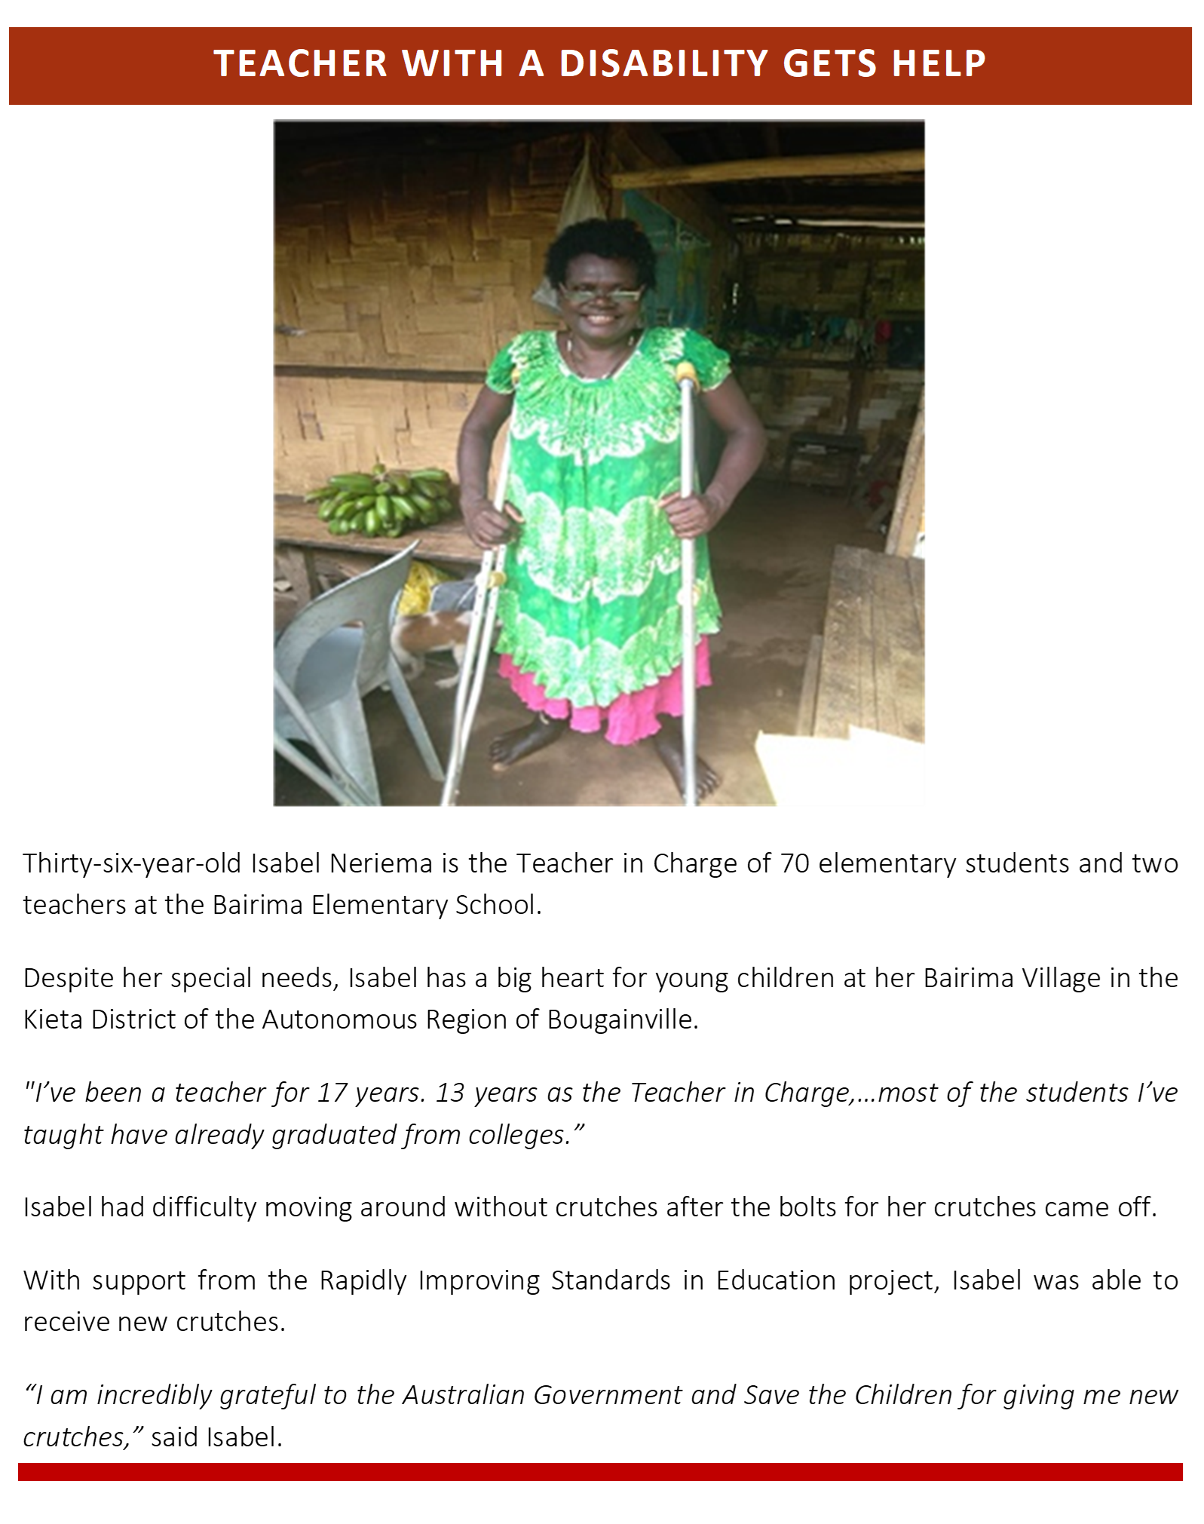

Recommendations for Future support to elementary education in png
Recommendations for providing ongoing support to elementary education in PNG fall into two areas – continuation of focus on key priority areas for improving elementary education within PNG, and enhancements for future programs.

Ongoing Consolidation of Achievements
There are several considerations and recommendations that the DOE, DHERST, DNPM and development partners might consider in planning future education investments in the early grades:
- Focusing initiative to combat the chronic absenteeism of children. Reforms to the quality of teaching, resources and the curriculum will have limited effect if this entrenched behaviour remains unchanged. 1:6:6 may be of assistance; however, the following is suggested:
  - Regular attendance tracking of teachers and students at the school level, including the reward of positive behaviour rather than a focus on punitive actions.
  - Each school learning improvement plan captures absenteeism as a priority.
  - National campaigns and IEC messages that target teachers, parents and students are undertaken backed by the government.
- Standardisation of the requirement for ongoing teacher professional development nationally through:
  - Each year 10 days of teacher professional development be institutionalised and resourced. A suite of professional development activities be offered covering subject matter specialisations and important teaching and learning pedagogy.
  - Resources are committed to support the teacher education divisional work plan that will see the roll out of SBC English and Mathematics Inservice Teacher Training program across the country.
  - Two promising practices trialled in PPF (Teacher Learning Circles and Coaching and Mentoring by head-teachers/resource teachers) be further strengthened through a multisectoral working group chaired by the teacher education division in DOE with representation from teacher training institutes, DHERST, PNGEI, PDOE trainers, and teachers.
  - The PPF developed Inservice teacher training manual be adapted for use in the two-year Early Childhood Education (ECE) diploma course and elementary teacher upgrade training led by PNGEI. The program will require further refinement and accreditation for national uptake.
  - In the future PNGEI be encouraged to include teacher training colleges in their work on upgrading teachers. Flexible and Open Distance Education (FODE) could also be included to support the inclusion of teachers in remote and hard to reach schools.
  - Reforms in teacher professional development must be underpinned by a competency framework that defines the proficiencies required at various levels of the education system. Incorporating consultation and engagement with teachers at all levels will be necessary to ensure the competencies developed are suited to the conditions of teachers in schools across rural and remote PNG.
  - The inspectorate plays a critical role in monitoring quality teaching yet often lacks the tools to do this work well. PPF has developed a suite of instruments that can support inspectorate visits undertake classroom observations and coaching and mentoring guidance that could help strengthen their feedback to teachers.
- Fostering teacher motivation and commitment. There is a lot to unpack in the evidence, but teacher motivation and commitment depend on a teacher management system that supports teachers’ wellbeing. PPF recommends:
  - That DOE continues to investigate payroll concerns, especially for teachers in the lower grades as it is evident that this is contributing to teacher absenteeism.
  - Continuous teacher professional development will go a long way to support teacher wellbeing but having leaders at the school level who can instruct, and guide teachers will be a critical ingredient. Developing an Instructional Leadership program for new and emerging school leaders (teachers in charge, head teachers and principals) that equip them with skills to support their teachers could go a long way to sustain achievements in teacher professional development.
- Improving inclusive practices at Schools.
  - More work is required to strengthen gender and disability inclusion in the early grades to ensure children with disabilities can access and participate in mainstream schools through the support of Inclusive Education Resource Centres (IERC). The value of outreach disability support workers visiting schools, supporting teachers to undertake screening tests, and work with parents and teachers on inclusive education plans cannot be understated. Appropriate resourcing to these vital workers will be required to realise the aspirations of the Inclusive Education unit within the DOE.
  - Gender dimensions are subtle yet pervasive in the early grades. Girls go unnoticed and whilst their results are comparable to boys, the lack of encouragement they receive may be contributing to early drop out in the higher grades. There is important and emerging work on gender transformative pedagogy which DOE should consider taking forward in future Inservice teacher training programs.
- Supporting initiatives that improve student learning
  - Children need culturally appropriate relevant reading materials if they are to become proficient readers. PPF through its partnership with Library for All has developed over 500 books and early grade readers for children in PNG which should be exploited in future programs. Classroom libraries have an important place in all schools in PNG.
  - Many schools developed extra curricula activities that supported children’s reading such as reading clubs. PPF has developed curriculum and course guidance for schools to replicate this model. PPF has found that the more children read, the better their literacy scores will be.
- Strengthening the partnerships between NGOs and government. Establishing mechanisms for effective partnership are critical and should be established during the inception phase of programs. The technical working groups established to oversee research and learning, and teacher education proved appropriate and ensured accountability to partnership principles and shared ownership.
- Greater dissemination to the sector and interested stakeholders of activities and their impact. Similar to other large donor funded initiatives in education, such as the GPE funded BEST program and EERRP, PPF should have provided regular updates and reports to the Local Education Group to promote harmonisation and foster collaboration and partnership amongst stakeholders working to support education in PNG.

For Future programs
Looking towards future investments in elementary education the program would recommend the following:
- Retain a grants-based model of delivery
- The benefits to the program in value for money, efficiency and sustainability is significant
- Grant consortia members gain capacity while delivering services that may last beyond the program.
- The relationships and networks established amongst the stakeholders within the elementary education system is far beyond what a traditional aid program (responsible for delivery) could achieve.
- Ensure the grants are robust and staff responsible for management are well trained.
- In addition, provide initial grant orientation workshops and regular refreshers for grantees and sub-grantees.
- Consortia arrangements were successful in obtaining breadth, diversity in expertise and assurance for responsible management of funds.
  - However, it is recommended that additional requirements be placed on the International NGOs to work more closely with local NGOs and churches who could continue to be a resource to the government in their localities after the International NGOs had left.
  - Additionally, fostering greater connections between the NGOs at the national and provincial level to support collaborative decision-making for government policies should be encouraged.
- Enable the grantee governing the grants to provide co-financing to community projects that support inclusive learning environments and improved quality of learning for students.
  - Reporting on these investments could be part of a quarterly governance meeting, where the lead NGOs of the various consortia attended.
- Involvement of PNG departments prior to implementation.
  - It is essential DOE and DHERST understand the nuances of the various challenges, and proposed initiatives, for improving elementary education within PNG. Only with detailed understanding can they amend the system to facilitate better outcomes and make successful initiatives national practice, allocating resources appropriately.
  - To support this, it is recommended that future grants require consortia members to present delivery approaches and models to DOE before rolling out, report on implementation, any lessons learned and improvements along the way.
- GEDSI. Despite GEDSI having a strong focus in all grantee programs (such as the girls’ education initiative of PKS or the work that RISE undertook with IERCs), there were no guidance or frameworks provided at inception to collect and analyse data and properly report on GEDSI outcomes. This lack of guidance resulted in grantees failing to collect the appropriate information to report to the detail desired on notable GEDSI achievements.
  - A GEDSI strategy, framework and supporting tools for collection and analysis developed at the start of the program would make a significant difference in this important area.
  - Additionally, the program found the technical support provided by the PAGP central GEDSI team invaluable to improving grant performance in this area. Having some expert resource available for grant consortia moving forward is recommended.
  - Consideration could be given towards specifying a specific portion of the grant funds to this area. However, differentiating between GEDSI and non-GEDSI initiatives might be difficult if activities are mainstreamed in all activities.
- Any online training be supplemented by a training specialist available to answer questions and help embed the knowledge taught. Online training could be linked to specialist visits to maximise their impact. These visits can provide an ongoing mentoring platform for teachers more widely moving forward.
- GoPNG commitment at the departmental officer level. In several instances, government officials initially committed to co-contribute on projects in target locations, and then subsequently retracted their commitment.
  - It is essential there is a champion for the program at the Deputy Secretary level in each partner agency, and the Secretary and Minister agree to provide co-contributions within their budget capability.
  - If possible, including support for this program into the Secretary’s workplan to his/her Minister would be a welcome step for greater accountability and commitment.

T4E project implemented in Central, Madang, and Morobe provinces by World Vision, ChildFund, University of Canberra, and the Consultative Implementation and Monitoring Council; RISE project implemented in the Autonomous Bougainville Region, East Sepik, and Eastern Highlands provinces by Save the Children, Summer Institute of Linguistics, Callan National Services Unit, and the Autonomous Bougainville Government; PKS project implemented in Jiwaka, Simbu, Western Highlands, and West New Britain provinces by CARE, Adventist Development and Relief Agency, University of Goroka, and Queensland University of Technology.
PPF T4E, RISE and PKS baseline assessments carried out in 2017 and 2018.
Divine Word University and Voluntary Service Overseas PNG (2012) Capacity Needs Analysis of the PNG National Education System. Madang. Divine Word University.
World Vision (2017) Together for Education Baseline Assessment. Papua New Guinea Partnership Fund.
Save the Children (2018) Rapidly Improving Standards in Elementary Midline Assessment. Port Moresby. Papua New Guinea Partnership Fund.
Divine Word University and Voluntary Service Overseas PNG (2012). Capacity Development Plan for the National Education System. Madang: Divine Word University.
World Vision (2017) Together for Education Baseline Assessment. Port Moresby. Papua New Guinea Partnership Fund.
Machuca-Sierra, M., de Silva, S. & Williams, B. (2011) Madang EGRA Baseline Assessment Report. Port Moresby: Department of Education, Papua New Guinea.
Macdonald & Vul. (2018). A Randomized Evaluation of a Low-Cost and Highly Scripted Teaching Method to Improve Basic Early Grade Reading in Papua New Guinea: Policy Research Working Paper 8427. World Bank Group Education Global Practice.
ACER. (2019). Papua New Guinea Pacific Islands Literacy and Numeracy Assessment (PILNA) 2018 Results. Suva: Australian Council for Educational Research.
NDOE. (2016). National Education Plan Quality Learning for all 2015 - 2019. Port Moresby: National Department of Education, Papua New Guinea.
ADB. (2012). Papua New Guinea: Critical Development Constraints. Mandayulong City, Philippines: Asia Developmnent Bank.
NDOE. (2018). Education Sector Plan Implementation Grant & Multiplier: Boosting Education Standards Together in PNG (BEST PNG_ Program.)
Smith & Simoncini. (2018). Literacy, Numeracy and School Survey: Baseline Report. Port Moresby: World Vision International in Papua new Guinea.
t statistics in parentheses * p < 0.05, ** p < 0.01, *** p < 0.001. This is the statistical power of the finding.

