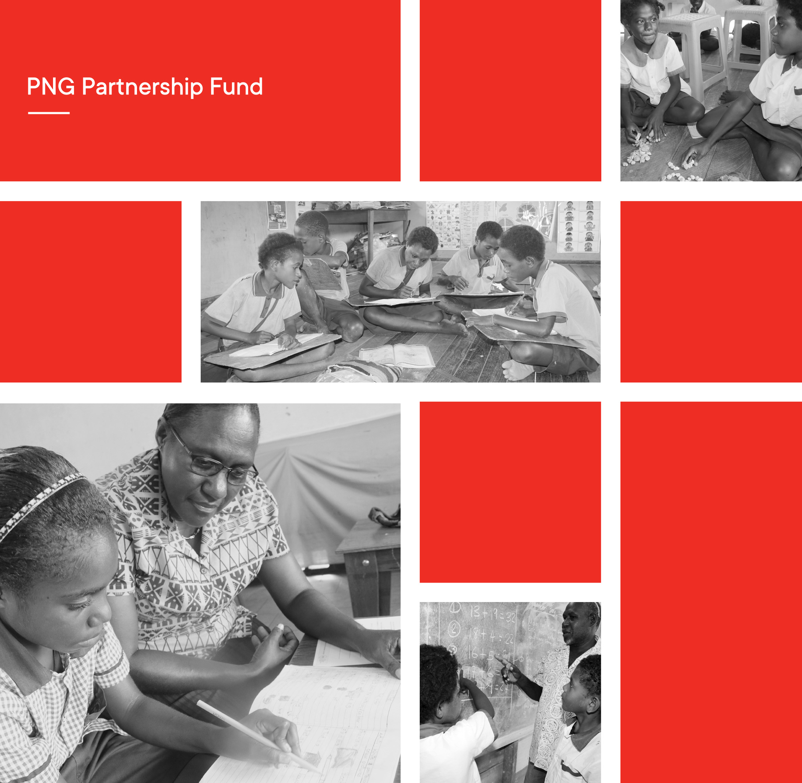

Papua New Guinea Partnership Fund

Education Program Completion Report

ANNEX DOCUMENT July 2017 to January 2022

Document Version Control

|  |  |  |  |  |
| --- | --- | --- | --- | --- |
| Ver. | Date | Originated by | Approved by | Comments |
| 1 | 01.03.2022 | J. Waffi & C. Johnston | Phillippe Allen | Draft submission |
| 2 | 04.04.2022 | C. Johnston | Geoff Scahill | Final submission |

# Contents

## PPF Summary documents

1. **Key Performance Indicators**
2. **Key Program Beneficiary Data**
3. **PPF Evaluation Snapshot**
4. **COVID-19 Response Data**
5. **PPF Program Financial summary**
6. **NGO performance**
7. **PPF Program Risk Register**

## Key Program documents

1. **PPF Theory of Change**
2. **PPF Monitoring Evaluation Research and Learning (MERL) Results Framework**
3. **PPF Monitoring Tools for Consortia**
4. **PPF Monitoring Visits**

## Research documents

1. **Evaluation Plan for the baseline and endline evaluation**
2. **Teacher Education and Research & Learning TWG workplan and status**
3. **List of PPF Research and Learning products**

1.1 PPF Summary Documents

1. PPF Key Performance Indicators
2. PPF Key Program Beneficiary Data
3. PPF Evaluation Snapshot
4. COVID-19 Response Data
5. PPF Key Performance Indicators

**Table depicting program performance indicator reporting by project and program overall.
**

**Table depicting program performance indicator reporting by project and program overall.
**

Table depicting program performance indicator reporting by project and program overall.


Table depicting program performance indicator reporting by project and program overall.


|  |  |
| --- | --- |
| Key |  |
|  | Data not available - Together for Education Project |
|  | Data not available - Rapidly Improving Standards in Elementary Project |
|  | Data not available - Pikinini Kisim Save Project |
|  | In the absence of baseline data, we have used figures from synthetic schools collected through the PPF endline survey |

**A special note for the two goal level indicators:** Endline results for CARE are for E2 students. Only 11 E1 students were assessed making the sample too small to use.

1. PPF Key Program Beneficiary Data

**Elementary Education**

|  |  |  |  |  |  |  |  |  |
| --- | --- | --- | --- | --- | --- | --- | --- | --- |
| Province | Schools reached | % of schools reached across target districts | Teachers reached | Female teachers reached | Students reached | Girls reached | Parents/caregivers reached | Female parents/caregivers reached |
| PKS | 856 | 76.8 | 2464 | 1007 | 132,388 | 62277 | 52,955 | 31,773 |
| RISE | 1034 | 78.3 | 2595 | 1399 | 142,304 | 68718 | 56,922 | 34,153 |
| T4E | 612 | 69.9 | 1396 | 584 | 85,883 | 41224 | 34,353 | 20,612 |
| **TOTAL** | **2502** | **75.6%** | **6455** | **2990** | **360,575** | **172219** | **144,230** | **86,538** |

**Please ensure beneficiaries are counted once only.

**Early Childhood Education**

|  |  |  |  |
| --- | --- | --- | --- |
|  | Total | Female | Male |
| Schools | 225 |  |  |
| Students | 10545 | 5544 | 5001 |
| Teachers | 1214 | 948 | 266 |
| Parents/Caregivers | 3514 | 2017 | 1497 |

1. PPF Evaluation Snapshot

The PPF program has partnered with government and non-government agencies to effectively progress reforms in the early education sector in PNG which now includes early childhood education and the early grades of primary. Key achievements include:

* The endorsement of the PPF developed Standards Based Curriculum (SBC) English and Mathematics Inservice training manuals for use across Papua New Guinea by provincial divisions of education (PDOE), Papua New Guinea Education Institute (PNGEI) and teacher training colleges.
* 6,455 elementary teachers are now better trained and equipped to deliver the SBC and an improved quality of education to early grade learners
* 2,502 elementary schools across 10 provinces and 1,035 early learning centres across three provinces are now better resourced to support effective teaching and learning activities
* 360,575 children that benefited from the program will go on to become the next generation of leaders in their communities, provinces, and the country.
* Over 300 children with disabilities that have been supported to access early grade education through individual education plans (IEPs).
* Department of Education (DOE) can now continue developing and systematising approaches for ongoing teacher professional development such as the Teacher Learning Circles (TLCs).
* The teachers, school administrations, and governing bodies are more aware of the need to create inclusive learning spaces for children and the importance of regular school attendance and making sure this is captured in School Learning Improvement Plans (SLIPs).
* Many parents in the target provinces now have a better appreciation of the need to support their children’s learning and development and are investing more time in their children’s learning.

**Positive associations with learning outcomes**

* Breakfast/good nutrition
* Parental support with homework
* Mothers’ reading to their children
* Leisure time with parents

Students in Grade 1 who were served breakfast on the day of their assessments scored 3.6 percentage points higher on average, on the literacy test, than their counterparts who did not eat a meal on the day. In Grade 2, students who ate a meal on the day of their assessment, scored on average, 4 percentage points higher on the literacy test than those who didn’t. Many positive drivers of learning outcomes were from outside the school environment. Predictors of higher numeracy were parental support for maths homework and leisure time spent with parents. For literacy, the best predictors of higher literacy were parental support in homework, mothers reading to their children and writing practice.

**Negative associations with learning outcomes**

* Absenteeism
* Chewing betel nut/buai
* Being bullied at school
* Needing to work at home and study

Another significant correlation was found between student absenteeism and their test outcomes; students in Grade 1, who missed *at least one day* of school in the week preceding the test, scored on average, 2.6 percentage points lower on the literacy test than those who did not miss any school. In Grade 2, those students who reported that they missed *at least* a day of school in the last week, scored on average 3.9 percentage points lower on the literacy test than those who did not miss any school. For students in Grade 2, the strongest predictors of low numeracy were absenteeism, chewing buai, children needing to work at home, being bullied at home, learning difficulties in school and ill-health. All these findings control for district level fixed effects and asset ownership.

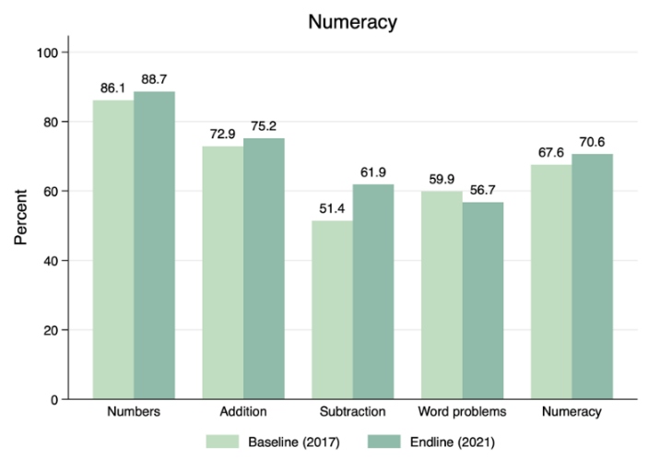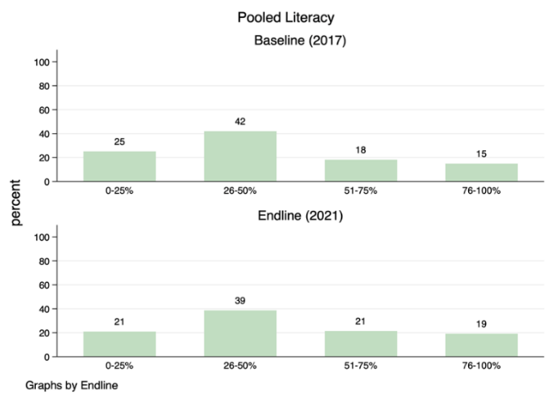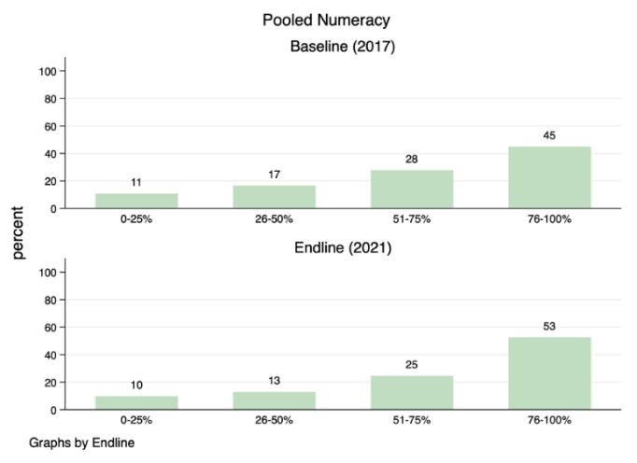The graphs below highlight the changes in scores that children are now obtaining.

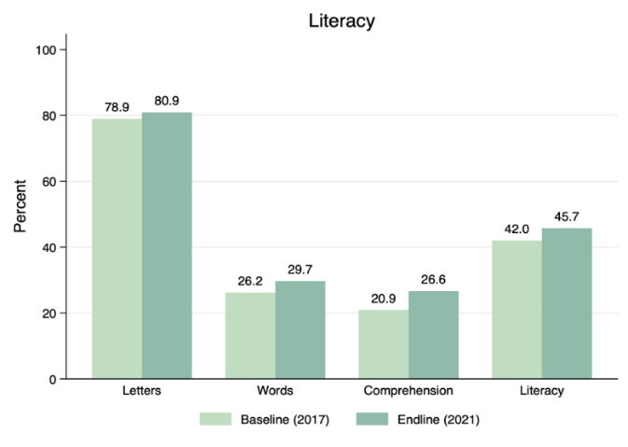A higher proportion of children are now scoring above 76 precent in literacy and numeracy compared to baseline and fewer children are scoring below 25 percent on the same assessments.

In the graph above, we observe higher average scores in endline compared to baseline on all sub-tests for literacy. For literacy, comprehension has improved substantially (5.5 percentage points) which was a key area of focus. For numeracy, the most significant improvement was in addition and subtraction. This was a focus of the trainings.

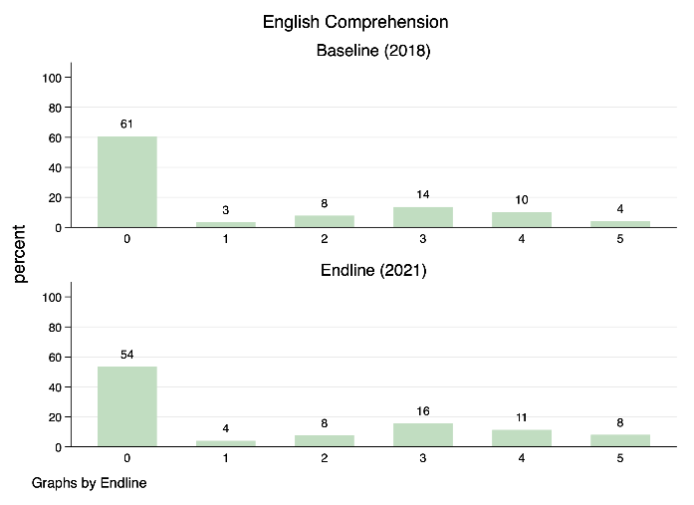Comprehension results are presented below. It is evident that fewer children were unable to answer any questions and more children answered all the questions correctly. It is important to note that one in two Grade 1 and 2 students are still struggling to understand what they have read.

Similarly, students’ ability to solve simple addition and subtraction word problems has improved.

The results confirm that the focus on reading strategies and solving addition and subtraction problems using concrete objects is relevant and appropriate to the learning needs of elementary children in PNG.

1. COVID-19 response data

**COVID-19 Annexes**

The PPF contributed to intermediate outcomes 1.1, 2.2, 2.4, and 2.5. Below are output results for various activities implemented between March 2020 and January 2022.

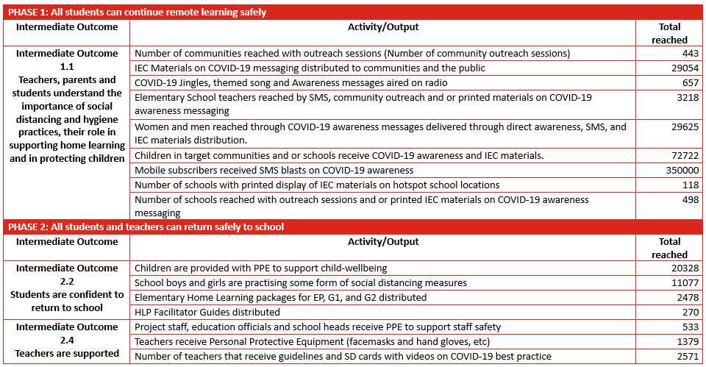

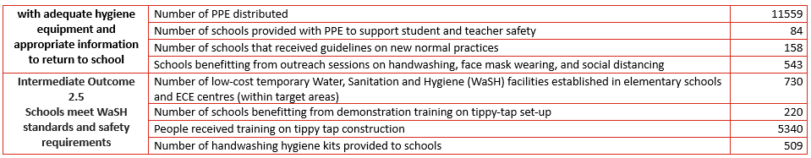

1.2 Key PPF Program Documents

1. PPF Theory of Change
2. PPF Monitoring Evaluation Research and Learning (MERL) Results Framework
3. PPF Monitoring Tools for Consortia
4. PPF Monitoring Visits
5. PPF Theory of Change

## PNG Partnership fund’s response to COVID-19 - A blended approach

### Introduction

At the time of finalising the Papua New Guinea Partnership Fund (PPF) Theory of Change (TOC), the COVID-19 pandemic began to spread throughout Asia, increasing fears of its impact in the Pacific. By the end of March 2020, the PNG government had issued a State of Emergency and the country went into lockdown. School closures commenced on 6 April and while students were requested to return to school on 4 May many provincial education authorities have delayed students returning to school to allow time for school facilities and staff to prepare adequately.

The PNG government has been developing its response capability and all sectors have been required to repurpose and redefine priorities. Within the education sector, the Education Cluster, led by the National Department of Education (NDoE) and including the Australian High Commission (AHC), PPF and PPF NGO consortia partners, has developed the *COVID-19 Education Emergency Response and Recovery Plan* (EERRP, 4 May 2020). The plan is based on a rapid assessment undertaken between 22 April and 1 May of the impact of COVID-19 on the national education system. Key findings included:

1) The majority of schools in PNG face significant barriers to delivering remote learning, including very limited access for students in the home to basic learning materials and technology (radio, mobile phones, television or internet);

2) Schools had limited resources, which will present a challenge to delivering quality education, including booster learning programs, for students on return to school; and

3) Many schools are experiencing additional challenges for students as a result of school closures and the COVID-19 response, including a lack of access to accurate information about COVID-19, safety and protection issues, lack of supervision at home, and limited access to WASH facilities.

The goal of the *COVID-19* EERRP is ‘to sustain learning and inclusion during and after the COVID-19 pandemic’. The NDoE will implement a phased approach to respond to and recover from the COVID-19 pandemic that includes all students continuing their education through safe remote learning (Phase 1), all students and teachers returning safely to school (Phase 2), all students safe and learning (Phase 3), and, the education system is more resilient to future disruption (Phase 4).

As the nature of schooling in PNG shifts to a ‘new normal’, the program approach which underpins PPF will adapt and respond accordingly and will pivot to support the NDoE to deliver on the EERRP. Depending on the phase of the response and the status of localised outbreaks, certain aspects of the program approach will be adapted in the short term. For instance, face-to-face training in the first 6 months of the program may shift to distance learning or cluster-based modalities. Furthermore, in support of the response and recovery plan a number of activities may be added to the PPF program, including 1) remote learning packs which are aligned to the syllabus will be prepared alongside other student learning resources in cases of extended school closures; 2) hygiene and health promotion will be integrated into everyday teaching and learning activities; 3) teacher mentoring and coaching will be extended to include psychosocial support (PSS) for teachers who have been impacted by COVID-19; 4) school leadership training and support will integrate WASH in schools and SLIP support will include school disaster preparedness planning; 5) parent support will be expanded to cover health and hygiene promotion and approaches to support children’s learning at home; and 6) support to the national education system will be extended to cover relevant remote learning and booster program resources generated for the elementary sector.

The PPF Blended model will both adapt and respond to the shorter-term COVID-19 impacts and maintain a strategic focus on quality teaching and learning in the longer-term. A key focus of this approach will be to strengthen coordination and collaboration with the NDoE, the Education Cluster (EC) and other development partners so that collective response and recovery efforts are maximised and student learning can be maintained through this period of significant disruption.

This model operationalises the humanitarian development nexus in that it responds to the immediate COVID-19 pandemic crisis while simultaneously increasing inclusive governance, strengthening local capacities and promoting shared outcomes so that the progress towards longer-term development goals is not eroded or compromised both during the initial humanitarian response and during the post COVID-19 pandemic recovery period. The PPF program TOC provided below therefore retains its longer-term strategic focus on quality teaching and learning, while integrating specific components that adapt and respond to the current COVID-19 pandemic and supporting the PNG government’s EERRP in relation ECE and elementary. These components are highlighted under each TOC pathway (see COVID-19 adaption and response in blue text) for easy reference.

### Background to the PPF

The PPF was established in March 2017 through the PNG Australia Partnership and is implemented by Abt PNG on behalf of the Australian Government. The PPF is a grant mechanism that was established to attract, identify and incentivise high performing government and non-government organisations, including consortia, to deliver longer-term projects that maximise value for money. The purpose of the grants is to expand the reach and coverage of interventions, initially in health and education, that have the potential to deliver results at scale. The PPF features a range of approaches to support human development projects. These are:

* Encouraging innovative approaches that focus on achieving results;
* Using a competitive funding and application process, with the best proposals selected to achieve sustainable results;
* Creating partnerships between different stakeholders, each with their own strengths and skills to contribute to achieving results; and,
* Enabling large-scale interventions with extensive and substantive reach in service delivery using Australia’s aid funds.

Currently PPF includes three consortia grants in the education sector. These are:

* Care Australia (CARE): Pikinini Kisim Save (PKS) Project
* Save the Children (SC): Rapidly Improving Standards in Elementary Education (RISE) Project
* World Vision (WV): Together for Education (T4E) Project

The Education consortia are an integral part of the Department of Foreign Aid and Trade (DFAT)’s Education and Leadership portfolio for PNG and is the main contributor to Outcome 1: girls and boys in targeted provinces/schools have improved early grade literacy and numeracy. The Education consortia projects have been working with the NDoE and respective provincial authorities to improve literacy and numeracy in the early grades of school. The grants align with the 2015 – 2019 national education plan’s focus areas of teachers and teaching, learning, local management and systems strengthening. The geographic implementation of the grants covers 10 of 22 provinces and 31 of 89 districts in PNG. During the first two years of implementation, over 1,400 elementary schools and more than 3,000 elementary teachers received training and resources from the program.[1]

### A description of the pathways of change

The TOC has identified four pathways for sustaining improvements in early grade student’s learning outcomes in targeted schools. In understanding the four pathways, it’s important to note the following:

* Effective teaching and learning lie at the heart of the PPF program. PPF’s core focus in developing elementary teacher competency to know their subject, teach the SBC effectively, support student learning needs and apply inclusive teaching practices remains a priority action in Phase II. School systems throughout the world acknowledge that the quality of teaching is the most critical in-school factor impacting student outcomes[2]. It is therefore expected that each grantee will place emphasis on working with their provincial education counterparts in developing an effective teacher professional development system that supports elementary/early grade teachers.
* These are not standalone pathways; making connections between the pathways is an essential element to achieving sustained improvements in student learning.
* The fourth pathway focuses on PPF’s partnership with NDoE and is directly relevant to the program. Whilst projects will benefit from this partnership and will be expected to engage actively in the work of the technical working groups, this pathway is not expected to be captured in consortia project plans.

The PPF theory states that if we improve teacher practices and strengthen the inclusive learning environments in school as well as improve parents’ capacity to support their child’s learning and work with government to imbed good practices in teacher education institutes and policy, then improvements in student learning can be sustained beyond the life of the program. This will be possible if the importance of early grade education as a foundation to life-long learning is retained as a priority of government and the wider education community. This is more likely if the PPF program is adaptive and responsive to the COVID-19 pandemic and strengthens cooperation and collaboration with the NDoE, provincial education authorities and the education cluster within PNG through joint efforts to deliver the PNG EERRP.

### Pillar/Outcome 1 - Teacher quality

**Teachers demonstrate improved practices**

In order for improvements to be made to teaching practices, teachers must have knowledge and skills in what to teach and how to teach. Teachers develop this knowledge and skills through high quality in-service training. Teachers must then practice building their skills through school based professional learning opportunities that are supported by competent teachers in charge (TICs) who know how to model effective practice and mentor teachers. Teachers also need teaching and learning resources to assist instructional practices and stimulate student learning.

This approach is grounded in evidence of what constitutes an effective teacher professional learning approach. Across the body of global literature, effective professional development is always connected to practice; focused on the teaching and learning of specific academic content; is connected to the school community and builds strong working relationships among teachers.[3] PPF’s professional development approach will include at least 100 hours of high-quality in-service teacher training. Several reviews of professional development note that in-service training is effective if it: focuses on classroom application, is practice driven, is based on teachers’ needs, focused on problems of pedagogy and content that are evident in specific schools, provide consistent guidance over a long period of time and is regularly monitored and evaluated[4].

Teacher in-service training will also build on lessons learned in Phase 1 and focus on teaching strategies that enable students to learn the SBC. In Phase II, teacher training materials will be standardised across the program for consistency, quality assurance and alignment to the government’s teacher education standards. Through partnership formation with relevant teacher colleges, the provincial education authority and colleges will become increasingly capable of delivering the training independently while shadowed by NGO partners during the first year of the extension. Whilst cascade training will be used, preference will be given to localise training provision and school-based training opportunities to mitigate the weaknesses of cascade training.[5]

The high-quality teacher training will be reinforced through school based professional learning that provides opportunities for teachers to engage in reflective practice such as classroom observation and feedback, teacher learning circles, cluster reflection workshops and mentoring sessions with the TICs. This draws on evidence that the most effective professional learning approaches are primarily school-based, school managed, focused on improving teaching practice[6] and involve discussions with peers and opportunities to apply new learning and skills in the classroom.[7] Drawing on the lessons learned in Phase 1, school-based activities will provide opportunities for teachers to reflect on their teaching practice in a structured manner. In these sessions, teachers will receive feedback from their mentors, share strategies with other teachers and model/demonstrate new skills in practice.

In order for teachers to have opportunities to practice their skills at school through peer learning and mentoring, mentors will need to be capacitated to support teachers. In most instances, this is likely to be the TIC, (as they are in charge of elementary schools and generally oversee the 2-3 other teachers in the school) or the most experienced staff member. In some cases, it may be resource teachers who are identified by schools and district officers in a cluster of schools. According to evidence, school based professional development, in the form of mentors, is often regarded as effective[8] although in low resource contexts, effective mentors are often difficult to identify and professionally support. Many reviews of effective TPD point to the importance of available quality trainers and mentors and that mentoring is especially important in contexts where practicing teachers have little or no formal teacher training[9]. It is likely that mentoring will be more effective if TICs are equipped with skills targeted in training, including early grade literacy and numeracy to support SBC delivery, gender and disability inclusion strategies and positive discipline/classroom management. TICs will receive additional training and tools in mentoring and coaching and will learn how to undertake lesson observations and feedback sessions in a constructive manner with early grade teachers. To support the wellbeing of teachers, TICs will be supported to champion quality teaching in the school community. Depending on the circumstances of the school, this might be overseeing the teaching and learning component of the SLIP or developing strategies to address poor attendance. This is in response to the evidence that strong leadership at school level is probably the most important school-based factor in promoting and facilitating teacher in-school professional learning[10]. This acknowledges the shift in discourse away from understanding school principals as managers and administrators to conceptions of their work as leaders of learning for students and teaching staff.

To complement the in-service teacher training and school based professional development, teachers will need access to quality teaching and learning resources that are aligned to the curriculum and learning needs of the students so that teachers can use the SBC effectively to improve student learning. A strong feature of Phase 1 was the provision of effective teaching and learning resources, particularly levelled readers for children, storybooks and supplementary teaching guides to support SBC delivery. Evidence highlights the many benefits of teaching resources, such as helping learners improve reading comprehension skills, illustrating or reinforcing a skill or concept, differentiating instruction and relieving anxiety or boredom by presenting information in a new and exciting way.[11] Whether instructional goals originate from curriculum documents, students’ expressed interests, or a mixture of both, students are more likely to achieve the goals if teachers draw on a wide variety of resources. Based on evidence gathered in Phase 1 and more broadly in education policy, learning resources can support student learning when the following criteria are met: 1) they align with the expected student learning outcomes and standards described in the SBC, 2) they meet the learning needs of students, 3) are age appropriate, 4) they contain words, images, behaviours and themes used in the resources have contextual relevance, and 5) they are interesting to students. Building on the success in Phase 1, the program will improve the availability, enhance the quality and were possible standardise the use of effective teaching and learning materials across target schools.

**COVID-19 adaption and response**

In response to the COVID-19 pandemic, a distance learning modality for the delivery of in-service teacher training may be required. The previous Certificate Elementary Teaching (CET) included self-instructional modules so many teachers would be familiar with this approach. At minimum, contingency planning for this will be undertaken and will include a focus on more frequent cluster based and school-based training options supported by Resource Teachers (RTs) and district and provincial trainers supported by the program. In-service teacher training will integrate COVID-19 responsive health and hygiene promotion and *WaSH in Schools* topics so that schools are safe, and teachers are supported to implement safety and hygiene measures to promote student and teacher health.

As the COVID-19 pandemic evolves in PNG, there may be periods of school closure that necessitate the delivery of remote learning. Hence, training and supporting teachers to develop and implement remote learning strategies so that teachers can provide the necessary support to their students and families may be a focus of initial in-service teacher training if prioritised in the EERR implementation plan. The provision of teaching and learning resources will also be expanded / repurposed to support remote teaching and learning if school closures are extended / re-introduced. This may include student and teacher packs and resources for booster programs that are being developed as part of the response plan to recover lost instructional hours and learning gaps upon students’ return to school.

The response plan highlights the need for PSS to teachers in response to the additional stresses, fear and challenges they face due to COVID-19 and their role in implementing the education response plan. PSS will be integrated into TIC and RT training so that TICs/RTs have the capacity to provide school-based PSS to teachers impacted by COVID-19. The PSS training will be gender conscious and female TICs/School Counsellors will be promoted so that female teachers can access PSS from female mentors when needed.

### Pillar/Outcome 2 - Inclusive learning environments

**Schools are inclusive learning environments that improve student learning**

So that teachers and students perform at their best, school learning environments will need to improve. PPF envisages improvements in the way schools adopt inclusive practices and focus on student learning. Based on research, school factors account for 5-10% of the variance in student learning. Hatti (2013) finds that school leadership is the strongest school factor because of the influence leaders have on defining the climate of the school[12]. In elementary schools in PNG, school leadership broadly constitutes the TIC as well as the leadership of the School Board of Management (SBOM), which usually include persons of influence in community. Research suggests that when school leaders create a climate of safety to learn and focus attention on all student’s learning then the effect on learning is trickled through these attributes[13]. Given that over 35% of the reasons for poor student attendance is due to school factors[14] and that poor attendance is likely influencing slower than expected results, a focus on school leadership is critical. PPF’s hypothesis is that if schools are inclusive learning spaces, then all children will want to come to school each day ready to learn, teachers will be encouraged to attend each day and teach well, and schools will be open every day according to government requirements. This will be possible if school leaders and persons of influence in the school community have the appropriate knowledge, skills and attitudes and understand the key factors that influence student learning. This will be achieved through targeted training and coaching of school leaders in how to enact government policies on disability and gender inclusion and behaviour management so that all children feel safe and included in the school environment. Training will also focus on how school leaders can support teachers in establishing activities that promote student learning, such as complementary reading and maths clubs and scheduled reading within the daily schedule.

**COVID-19 adaption and response**

School leaders will be targeted for additional training and support in response to the COVID-19 pandemic and in alignment with the EERR implementation plan, which is likely to initially prioritise school level support. As critical influences in creating a climate of safety, inclusion and focus on learning, school leaders will be trained and supported to 1) improve / maintain adequate WaSH facilities; 2) provide PPS for teachers and students as required; 3) orientate and implement booster programs if needed; 4) include school disaster preparedness planning within SLIPs, and 5) supporting learning from home if/when necessary.

### Pillar/Outcome 3 - Parents and Caregivers

**Parents/caregivers demonstrate improved behaviour to enhance student learning and attendance**

To acknowledge home and school factors that influence student learning, positive engagement with parents will be fostered. According to Hatti (2003), home factors account for 5-10% of the variance effects on student learning and are related to the levels of expectation, encouragement and support? received by parents or caregivers[15]. Whilst efforts to improvement parental engagement experienced difficulties in Phase 1, the positive effects on student learning when parents encouraged reading at home cannot be ignored. There is an established link between the home learning environment at all ages and children’s performance at school. For instance, for young children, promoting shared book reading and playing with letters and numbers, are both linked to improved outcomes.[16] Parental engagement will focus on promoting two important issues; home learning and regular school attendance. PPF will utilise evidence on parental behaviour change toward education to inform actions undertaken with parents and define communication strategies that are appropriate to the PNG context and that have been tested in PNG previously and shown to have positive effect. For instance, text messaging with parents[17], teacher-parent discussions and individualised letters to parents on attendance[18] will be further tested and refined. Rather than engaging parents in attending intensive workshops, emphasis will be on the provision of instructional materials and resources that are accessible to parents with low literacy levels and guide parents to read in a more interactive way and prompt longer and more frequent conversations with their children[19]. Communication strategies will focus on facts and tips and be informed by an understanding of the families’ home life[20] Effective partnership with parents is likely to be supported by several school level initiatives, including a TIC who prioritises parental engagement and ensures that it is integrated into school routines and a communication plan for working with parents that is informed by an understanding of families’ lives.

**COVID-19 adaption and response**

Parent/caregiver engagement and confidence will be instrumental to not only ensuring that children are supported to learn at home during school closures but also to ensuring that children return to school and attend regularly once schools reopen. There are fears that there will be an increase in both girls and boys dropping out of school as a result of periodic school closures and the economic fallout from COVID-19 as girls assume care responsibilities at home and pressure on boys to contribute to the family income increase. It is anticipated that regular school attendance, which is a significant issue in PNG, will be further compromised as a result of COVID-19 as it is likely that parents, who lack access to accurately and timely information about COVID-19, will harbour safety concerns for their children and will be more risk adverse in deciding when to allow their children to return to and regularly attend school. Hence, parent/caregiver engagement will be expanded, and the communication strategy initially focused on providing parents/caregivers with critical information relevant to the COVID-19 pandemic and their children’s safety and education. To this end, the communication strategy will include key health messages developed and endorsed by the National Department of Health (NDOH) communications cluster, COVID-19 health and hygiene promotion, information on remote learning content and teaching methods and when appropriate return to school messaging.

### Pillar/Outcome 4 - Collaboration with NDoE

**NDoE is supported to strengthen early grade education in PNG**

Improvements in student learning cannot be sustained without a strong partnership with NDOE to take forward the opportunity to advance the quality of teacher education in teacher colleges and evidence-based policy development. At a program level, PPF will work with NDoE to establish several technical working groups. One technical working group will oversee the standardisation of teacher training materials produced in Phase 1, the endorsement process from the Board of Studies and subsequent collaboration with Papua New Guinea Education Institute (PNGEI) so that the resources can be used for in-service TT programs managed by PNGEI and provincial teacher colleges. In this collaboration, PPF will engage closely with the teacher education division within NDoE. Additionally, PPF will establish a second technical working group that will oversee research studies and products which are produced under the program, ensuring that the evidence gathered and utilised will align with the priorities and reform agenda of the government in relation to teacher education and student learning in PNG. PPF will cooperate with the research division within NDoE to ensure research and learning follows expected standards and protocols.

**COVID-19 adaption and response**

As a result of the COVID-19 pandemic response there has been a significant increase in coordination and collaboration between the NDOE, NDOH and the Education Cluster to address important gaps in education service provision in PNG, including school WaSH facilities and health promotion in schools. The PPF program will capitalise on the current momentum for increased collaboration to bring evidence on key issues, such as the negative impact of betel nut consumption on children’s learning, and the importance of WaSH to the fore for joint action. Furthermore, opportunities for new partnerships between members of the PPF consortia and key education stakeholders are being pursued that will increase the PPF programs engagement within the elementary sector. This includes a potential new partnership between PPF and UNICEF through the PNG government’s current application to the Global Partnership for Education (GPE) *COVID-19 Accelerated Funding Window for Emergency Response,* which would allow for further collaboration between PPF and UNICEF on the new PNG ECCD curriculum. Finally, the technical working group which will be established by the PPF could include research and learning from the COVID-19 response to inform decision making on future emergencies impacting the education sector in support of building the resilience of the PNG education system to future disruptions.

### Underlying principles

The PPF program is founded on the following principles which drive forward the ambition and belief that sustained improvements can be made in early grade children’s learning outcomes when done in partnership with government and community.

* **Sustainability:** When the benefits of the PPF program continue after Australia’s funding has ceased, with due account of partner government systems and stakeholder ownership.
* **Partnership:** The relationship between the Australian government, the PNG government and NGOs where all partners engage in the relationship to seek a common outcome of maximising learning and development outcomes for children.
* **Inclusion:** The Framework for Action (Salamanca) defines inclusion as a reform that supports and welcomes diversity among all learners. Its aims are to eliminate social exclusion that is a consequence of responses to diversity in race, social class, ethnicity, religion, gender and ability.
* **Innovation:** The process of making changes to something established by introducing something new. It applies to radical or incremental changes to products, processes or services. In the context of PPF, the program has introduced digital technologies for classroom teaching and eBooks through tablets. The program also has developed innovative ways to stimulate local book production in PNG using social media to engage PNG writers and illustrators.
* **Evidence:** The PPF program has placed emphasis on being informed by evidence and building new evidence on what factors improve early grade student learning in PNG. The projects to date have been rigorously evaluated in experimental evaluations and this emphasis on rigorous evaluation will continue during Phase 2.
* **Learning:** PPF places importance on learning from the knowledge and skills of key stakeholders at the school, district, provincial and national level so as to develop and/or adapt program strategies that effectively improve early grade learning among all of PNG’s children.
* **Responsiveness:** The PPF program is responsive and adaptive so as to effectively respond to disasters within PNG when they strike, contributing to building an education system within PNG that is resilient to future crisis.

### Critical success factors

* Partnership with TTIs, PDoE and district education officers, schools and community
* Closer collaboration and joint work with NDoE – particularly through the establishment of the TWG mechanism

### Assumptions

* The importance of early grade education as a foundation to life-long learning is retained as a priority of government and the wider education community
* Parents are strongly influencing children’s attendance patterns
* Parents will have the time and interest to engage and support their children’s learning
* Economic hardship does not negate efforts to promote children’s return to school and their regular school attendance
* Term breaks remain a viable training period for teachers
* Teacher mentors are able to be identified at the school or cluster level to support school based TPD
* Teachers will have time and interest to participate in peer-learning opportunities
* If teachers are more supported in their professional development, they will be more motivated to come to school every day irrespective of the tenuousness of their job in the transition to 1:6:6
* If high quality and culturally relevant books are available, children will be inquisitive and eager to learn to read

**COVID-19 specific assumptions**

* The NDOE remains committed to working with PPF and the education cluster to deliver the COVID-19 EERRP
* The COVID-19 pandemic does not overwhelm PNG to the point that all government, donor and NGO resources are pivoted away from education
* The ensuing economic fallout from the COVID-19 pandemic does not decimate both the financial and human resources within the education sector and does not prevent children from returning to school and regularly attending once schools reopen

1. PPF Monitoring Evaluation Research and Learning (MERL) Results Framework

PPF Phase 11 RESULTS FRAMEWORK - Pivoting to respond to COVID-19 impacts

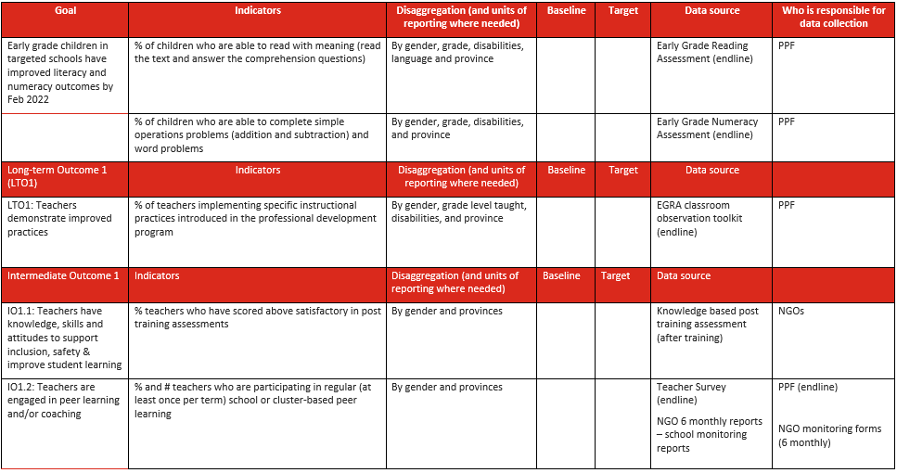

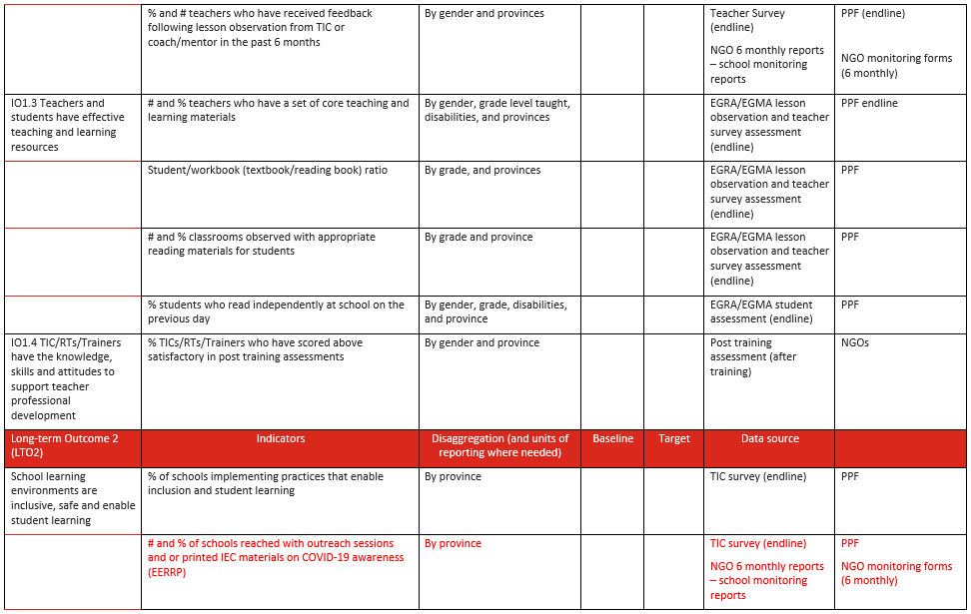

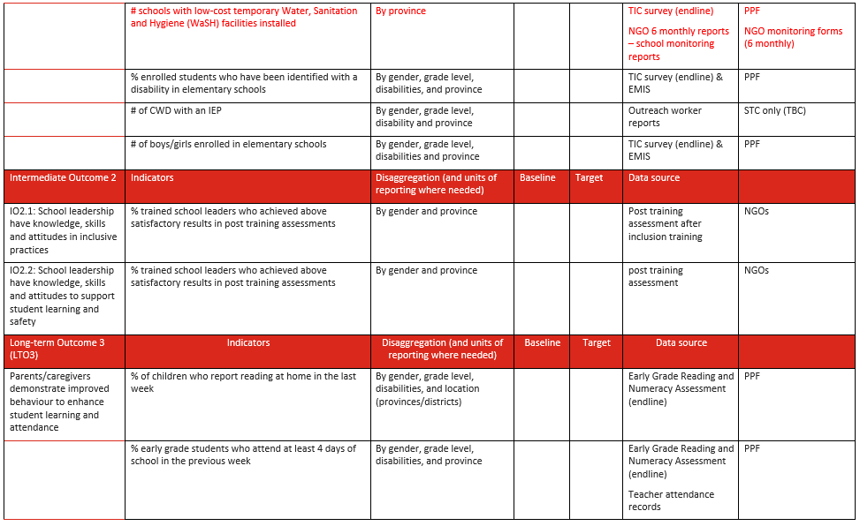

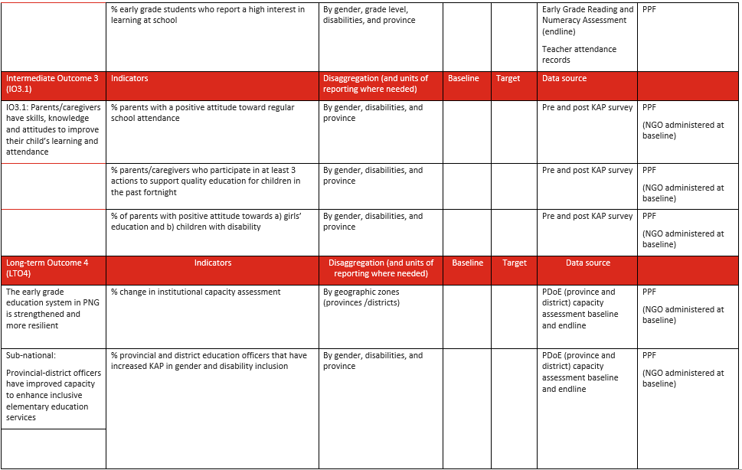

1. PPF Monitoring Tools for Consortia

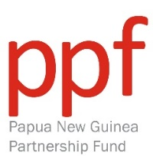**MONITORING TRIP REPORT**

|  |  |
| --- | --- |
| Grant partner |  |
| Consortium partner |  |
| Target Provinces |  |
| Province visited |  |
| Districts visited |  |
| Team members | * xxxx |
| Dates | xxxx |
| Purpose in ToR (As per the respective thematic areas in the Grantee’s Monitoring and Evaluation Plan) | * xxxx |

**Summary of key findings (As per the respective Thematic areas of Grantee’s MEP reflected in the ToR)**

xxxx

**Introduction**

xxxx

**Summary of activities (As per the ToR)**

xxxx

**Challenges (if any)**

xxxx

**Recommendations based on key findings**

xxxx

**Annex:** Schedule of visit

**PROVINCIAL MONITORING/REVIEW TRIP CHECKLIST**

**BEFORE VISIT -** Activities to be done **at least two weeks prior to the departure date** of the visit.

1. Confirm date of visit as reflected in the program MELF calendar.  (Tick box); ___SS__ (Initial of person responsible)
2. Do Terms of Reference and share with AHC and grant partner. ; _____
3. Share TORs with key objectives / questions with provinces and facilities to be visited. ; _____
4. Coordinate with DFAT for an AHC staff and GoPNG rep to go on the trip. ; _____
5. Finalise visit schedule in coordination with grantee reps and share with grant partner and AHC. ; _____
6. Finalise: Airfares; accommodation ; incidentals  hire cars ; security; ; _____
7. Organise an officer from Abt Communications team to come on the trip (if necessary). ; _____
8. Borrow camera from Abt Communications team (if necessary). ; _____
9. Make copies of visit schedule and photo consent forms where necessary. ; _____
10. Send photo consent forms to grantees to organise themselves for photo shots during field visits.
11. Remind grantees and facilities to be visited that patient confidentiality and privacy should be respected at all times and review teams should not be taken into patient doctor consultations. ; _____
12. Get security briefing on province visited from Abt Security team if necessary. ; _____

**ON TRAVEL DAY -** Activities to be done **on the day of departure and arrival**.

1. Pick up tickets and hotel reservation (Purchase Order) from the travel team. ; _____
2. Check in at the airport as least 2 hours prior to departure. ; _____
3. Hold onto boarding pass catalogue for acquittal purposes. ; _____
4. Confirm security personnel with hire cars are on ground waiting at the airport for pick up. ; _____
5. Present hotel reservations (Purchase Order) and do booking of rooms at hotels. ; _____

**DURING VISIT -** Activities to be done **during** **the visit**.

1. Carry out schedule of activities accordingly and on time. ; _____
2. Clarify with grantees that sensitivity of clients and service delivery has to be maintained at all times. ; _____
3. Get consent on relevant people for photo shots and stories. ; _____
4. Have team briefing and at end of each team recap meeting to contribute ideas towards final recommendations and reporting. ; _____

**AFTER VISIT -** Activities to be **done after the visit.**

1. Draft provincial visit report and share with grantees for input and clarification. ; _____
2. Compile final review report and share with AHC, relevant GoPNG department and grant partners. ;
3. Do presentation of findings to AHC, relevant GoPNG department and grantee reps, if necessary. ;
4. Present boarding passes to Abt travel team to do acquittals for the trip. ; _____

Please adhere to this schedule to help plan and manage monitoring/review trips successfully

|  |
| --- |
| **TERMS OF REFERENCE FOR MONITORING VISITS** |
| **Grant partner to visit:** |
| **Province/s to visit:** |
| **District/s to visit:** |
| **Date of visit:** |
| **Name/s of participants visiting:**  **Table** |
| **Background of visit.**  xxxx  **Purpose of trip. (As per the respective Thematic areas in the Grantee’s MEP. Monitoring report to be based on these)**   * xxxx * xxxx |
| **Activities to be done during the visit.**   * xxxx * xxxx   **Activities to be done after the visit. (Tick box)**  Compile report of findings and share with AHC, GoPNG and grant partners  Present findings with AHC, GoPNG and grant partners  Others. State here: ______________________________________________ |

-----------------------------------------------

GEOFF SCAHILL

**GENERAL MANAGER -ABT ASSOCIATES PNG**

-----------------------------------------------

**TEAM LEADER/SENIOR EDUCATION SPECIALIST**

**INTERNAL AMS CLEARENCE PROCESS (Tick box)**

|  |
| --- |
| AMS LOGISTICS ARRANGEMENTS COMPLETED  AMS SECURITY ARRANGEMENTS COMPLETED |
|  |

**MONITORING TRIP – LESSON OBSERVATION**

Table


|  |  |  |  |  |
| --- | --- | --- | --- | --- |
| Area | Indicator | Yes | No | Comment |
| 1. Opening the lesson | Evidence of …   * lesson objectives shared with students * check on prior knowledge * engaging students in the topic |  |  |  |
| 2. Use of teaching and learning resources | Evidence of   * Use of SBC scripted lesson * use of SBC teaching resources (flashcards, Shell books, etc.) * use of own teaching aids (word cards, etc.) |  |  |  |
| 3. If English | Evidence of   * Connecting students to the meaning of the text * use of questioning before, during and after story-time or reading * individual, pair or shared reading activity * individual, pair or group work to complete tasks * Use of literacy games/strategies to support student learning * student writing activity |  |  |  |
| 4. If Maths | Evidence of   * use of manipulatives * use of lines or grouping strategy to solve addition and subtraction problems * individual, pair or shared maths activity * use of maths games to support student learning * student writing activity |  |  |  |
| 5. Inclusion & classroom management | Evidence of   * use of positive discipline – * evidence of effective classroom management * differentiation to encourage all students to participate & learn * fair treatment of boys and girls and encouraging and supporting girls and boys to engage actively |  |  |  |
| 5. Assessing students understanding | Evidence of   * checking student’s understanding * evidence of checking whether objectives have been met |  |  |  |
| 6. Closing a lesson | Evidence of   * recap & feedback to students * evidence of next lesson topic |  |  |  |
| 7. Feedback | 1. Two Positives/strengths of the lesson  2. One recommendation for improvement |  |  |  |

**Brief interview with the teacher before giving feedback**

|  |  |
| --- | --- |
| Years of service |  |
| **Years of teaching at the school** |  |
| **Highest qualification** |  |
| **Training received in the past 2 years** |  |

**MONITORING TRIP – TEACHER LEARNING CIRCLE OBSERVATION**

Table


|  |  |  |  |  |
| --- | --- | --- | --- | --- |
| Observation | Comments | Yes | No | Comment |
| 1. Opening the TLC | Evidence of:   * TLC objectives shared with teachers * a clear structure to the TLC session * reflection on experiences teaching/challenges teachers have faced in the classroom |  |  |  |
| 2. Use of teaching and learning resources | Evidence of:   * use of visual teaching aids * use of SBC teaching and learning resources/readers/workbooks |  |  |  |
| 3. Topic | Evidence of:   * connecting the SBC lesson to a literacy and numeracy strategy/technique or literacy and numeracy game * problem solving – e.g. teachers express difficulty in an area and the group discusses ways to address the problem * teachers are given time to practice a new or improve strategy or skill * group work or pair work to complete tasks |  |  |  |
| 4. Facilitation by resource teachers/trainers | Evidence of   * facilitators have good understanding of literacy and numeracy strategies that support SBC English and Mathematics * equal treatment of male and female teachers * encouragement and support to all teachers throughout the lesson |  |  |  |
| 5. Assessing teachers understanding | Evidence of:   * checking teacher’s understanding * checking whether objectives of the session have been met |  |  |  |
| 6. Closing the TLC | Evidence of:   * recap & feedback to teachers * actions to be taken/agreements made |  |  |  |
| 7. Feedback | 1. Two Positives/strengths of the teacher learning circle  2. One recommendation for improvement |  |  |  |

1. PPF Monitoring Visits

**MONITORING VISITS UNDERTAKEN**

|  |  |  |
| --- | --- | --- |
| Year | Province | Project |
| **2018** | Eastern Highlands  Autonomous Region of Bougainville  Central  Morobe | Save the Children – RISE  Save the Children – RISE  World Vision – T4E  World Vision – T4E |
| **2019** | Madang  Jiwaka and Western Highlands  East Sepik | World Vision – T4E  CARE – PKS  Save the Children |
| **2020** | Central (Rigo and Kairuku) X 2  Bougainville | World Vision – T4E  ARoB |
| **2021** | West New Britain  Morobe | CARE – PKS  World Vision – T4E |

Eight officers from DOE and DNPM were able to join PPF monitoring visits. DOE officers were required to participate in field monitoring visits as a requirement of the *PPF Memorandum of Understanding* signed on the 25th of November 2020.

**NB:** PKS project sites were not visited in 2018 as they did not begin implementation until 2019 following baseline and community entry activities in 2018.

**DOE/DNPM offices who joined the visits**

|  |  |  |
| --- | --- | --- |
| Year | Officer name | Position at the time |
| **2018** | Peter Kants | First Secretary, Policy and Research |
| **2019** | Colette Modogai  Philippa Darius x2  Regina Mabia | Officer, Teacher Education Division  Officer, Curriculum Development Division  Director, Aid Coordination |
| **2020** | Michael Mera  Regina Mabia | Director, Elementary Teacher Training, Teacher Education  Director, Aid Coordination |
| **2021** | Michael Mera  Randall Manapangkec  Regina Mabia  Andrew Ape  James Ruru | Director, Elementary Teacher Training, Teacher Education Officer, Aid Coordination Branch  Director, Aid Coordination  Training & Development Officer, ECE  Principal Aid Coordinator, National Department of Planning and Monitoring (DNPM) |

1.3 PPF Research Documents

1. Evaluation Plan for the baseline and endline evaluation
2. Teacher Education and Research & Learning TWG workplan and status
3. List of PPF Research and Learning products
4. Evaluation Plan for the baseline and endline evaluation

# **Contents**

Contents 1

Abbreviations and Acronyms i

1. INTRODUCTION i

1.1. BACKGROUND AND CONTEXT TO THE ACTIVITY i

1.2. EVALUATION PURPOSE ii

1.3. EVALUATION SCOPE iii

1.4. EVALUATION QUESTIONS iii

2. Evaluation Design viii

2.1. INFORMATION COLLECTION ix

3. Evaluation Schedule x

4. Evaluation Stakeholders xi

5. Other Considerations in the Evaluation xiii

5.1. ETHICAL CONSIDERATIONS xiii

5.2. LIMITATIONS, RISKS AND CONSTRAINTS xiii

6. Appendices:

6.1. PPF THEORY OF CHANGE

6.2. PPF PROGRAM LOGIC

6.3. PPF DATA ANALYSIS MATRIX

Abbreviations and Acronyms

|  |
| --- |
| AHC Australian High Commission |
| AMS Abt PNG Management Services |
| ARoB Autonomous Region of Bougainville |
| AUD Australian dollar |
| CARE CARE International in Papua New Guinea/Australia |
| CIMC Consultative Implementation and Monitoring Council |
| CLP Community Leadership Program |
| CV4GE Citizen’s Voice for Girls Education |
| DFAT Department of Foreign Affairs and Trade |
| DOE Department of Education |
| DRR Disaster Risk Reduction |
| EC Education Cluster |
| ECCE Early Childhood Care and Education |
| ECE Early Childhood Education |
| EERRP Education in Emergencies Response and Recovery Plan |
| EHP Eastern Highlands Province |
| EiE Education in Emergencies |
| ESP East Sepik Province |
| FIMR Final Investment Monitoring Report |
| GESI Gender Equality and Social Inclusion |
| GoPNG Government of Papua New Guinea |
| GPE Global Partnership for Education |
| HDMES Human Development Monitoring and Evaluation Service |
| IEC Information Education Communication |
| IERC Inclusive Education Resource Centre |
| LFA Library For All |
| M&E Monitoring & evaluation |
| MEP Monitoring Evaluation Plan |
| MOU Memorandum of Understanding |
| NCD National Capital District |
| NDoE National Department of Education |
| NGO Non-government organisation |
| PAF Performance Assessment Framework |
| PEA Provincial Education Authority |
| PDoE Provincial Department of Education |
| PGK Papua New Guinea Kina |
| PKS Pikinini Kisim Save Project |
| PNGEI PNG Education Institute |
| PPF PNG Partnership Fund |
| PSS Psychosocial support |
| QTAG Quality Technical Advisory Group |
| RISE Rapidly Improving Standards in Elementary Project |
| Save Save the Children in Papua New Guinea |
| SBC Standards Based Curriculum |
| SBoM School Board of Management |
| SLIP School Learning Improvement Plan |
| T4E Together for Education Project |
| TETWG Teacher Education Technical Working Group |
| ToC Theory of Change |
| TT Teacher training |
| UNICEF United Nations Children Fund |
| UoG University of Goroka |
| WaSH Water and Sanitation and Hygiene |
| WVA World Vision Australia |

# INTRODUCTION

## BACKGROUND AND CONTEXT TO THE ACTIVITY

Since 2017, the Papua New Guinea Partnership Fund (PPF) Education program has enabled over 184,000 children to receive reading resources and support in the classroom, and over 5,000 teachers from more than 1,400 elementary schools to be trained. By 2022, the program aims to reach 236,716 elementary school aged children from 1,736 elementary schools and train 6,048 (49% female) elementary teachers in foundational literacy and numeracy to support delivery of the English and Mathematics School Based Curriculum (SBC).

The program has been delivered by three non-government organisation (NGO) consortia.

* + - World Vision and its partners Child Fund, Library for All, Consultative Implementation Monitoring Council and University of Canberra are delivering the Together for Education project in Madang, Morobe and Central,
    - Save the Children and its partners Callan Services and Summer Institute of Linguistics are delivering the Rapidly Improving Standards in Elementary project in East Sepik, Autonomous Region of Bougainville, and Eastern Highlands Province, and
    - CARE International and its partners Adventist Development Relief Agency, University of Goroka, Queensland University of Technology and Church Education Agencies are delivering the Pikinini Kisim Save project in Western Highlands Province, Simbu, Jiwaka and West New Britain.

For the years 2018 and 2019, NGO grantee partners delivered individual consortia programs, each aimed at improving the quality of teaching and learning in elementary schools. An initial baseline assessment was carried out between 2017-2018 of students and teachers that would benefit from the program. Two grantee programs, Together for Education (T4E) led by World Vision and Rapidly Improving Standards of Elementary (RISE) led by Save the Children undertook a midline assessment in 2019 to identify whether any improvements in student learning outcomes in English and Mathematics and teacher competency in teaching English and Mathematics was evident. The baseline and midline assessments utilised the Early Grade Reading Assessment (EGRA) and Early Grade Numeracy Assessment (EGMA) instruments. These were versioned carefully to ensure they were culturally appropriate and aligned to the SBC. These same instruments will be used in this evaluation.

Following an Independent Mid-Term Review (MTR) carried out in November 2019, a uniformed program approach was adopted in early 2020 for the duration of the program. NGO grantee partners have delivered a set of interventions aligned to the PPF program approach which is captured in the PPF Theory of Change (ToC) (Annex A). PPF has a uniform Monitoring and Evaluation Plan (MEP) approved in early 2020 for which this evaluation is framed.

The PPF Education ToC identified four long term outcomes for the final two years of the program. These are:

* Teachers demonstrate improved practices
* School learning environments are inclusive and enable student learning
* Parents/caregivers demonstrate improved behaviour to enhance student learning and attendance
* NDoE is supported to strengthen early grades education in PNG

PPF is being implemented at a time when significant reform is underway in the education sector and the country is battling the COVID-19 pandemic. Several factors have influenced the direction of the PPF program. These are:

* The National Department of Education (NDoE) new National Education Plan (NEP) 2020-2029. This plan focuses on two initiatives which directly impact the elementary sector.
  + The 1:6:6 structural reform which assigns previous Elementary 1 (E1) and Elementary 2 (E2) grades to primary schools (Grade 1 and Grade 2) and frames Elementary Prep (EP) as part of Early Childhood Care and Education (ECCE).
  + The approval and launch of NDOE’s first ECCE policy will pave the way for a more regulated early childhood sector in the future.

These two reforms are major shifts that will change the nature of early grade education in the country. The evaluation will illustrate the extent to which PPF has adjusted to these reforms and played a role in advocating for greater investment and support to ECCE through its participation on the ECE taskforce in 2019 and its role in piloting the ECCE draft curriculum.

Since 2020, the most significant external influence on PPF’s program has been the COVID-19 pandemic which began to impact the country in early 2020. PPF quickly pivoted to support the government’s attempts to control the spread of the virus, in particular its support to the DoE’s Education in Emergency Response and Recovery Plan (EERRP).

The evaluation plan has been designed collaboratively with NGOs when the MEP was developed in early 2020 and updated in 2021 to confirm evaluation questions, scope and ensure that the evaluation adhered to Department of Foreign Affairs and Trade (DFAT) Monitoring and Evaluation (M&E) standards, Final Investment Monitoring Report (FIMR) criteria and program learning priorities.

The primary audience for the evaluation will be the PNG Government, the Australian Government and development partners who are supporting education service provision and system strengthening in PNG.

The findings of the evaluation will be used:

1. To inform and promote effective policy and practices that may lead to improvements in elementary students learning outcomes in PNG.
2. To inform future investments in early grade literacy and numeracy policy and practice in PNG.
3. To document key lessons learned to inform future investments and policy dialogues.
4. To inform wider policy dialogue concerning inclusive quality early grade education to a range of national and international education stakeholders, donors, academic institutions, and education networks.
5. To provide evidence and lessons learned to inform DFAT’s FIMR.

## EVALUATION PURPOSE

The evaluation aims to:

1. Assess the relevance of the PPF education program to the needs of early grade learners (in selected elementary schools in 10 provinces of PNG) and to the education priorities of the education department.
2. Determine what impact the program had on children’s learning outcomes in literacy and numeracy
3. Assess the effectiveness of the approaches used to achieve the long-term program outcomes.
4. Determine whether the PPF education program demonstrated value for money principles.
5. Assess how the program has focused on capacity development and systems strengthening to ensure ownership and enhance sustainability outcomes.
6. Assess how the program generated evidence and learning and used this to enhance policy dialogue in PNG.

## EVALUATION SCOPE

The evaluation will be conducted between October – December 2021 covering the 10 PPF provinces - West New Britain, Jiwaka, Simbu, Western Highlands, Morobe, Madang, Central, East Sepik, Eastern Highlands and the Autonomous Region of Bougainville.

A representative sample of intervention schools from each grantee project and a synthetic sample[21] of elementary schools that did not participate in the PPF program. Student assessments and lesson observations will be conducted in this sample. These schools will be chosen using a propensity score matching algorithm[22] and will mirror the recipient schools in all criteria (number of students, rural/urban status etc.). The interventions schools will be shared with RED (DoE) to agree on the best approach to assign the synthetic sample for the evaluation. DoE has its own categorisation and disaggregation of schools into different localities which will assist in choosing schools using the propensity score matching algorithm.

The evaluation will be conducted with various stakeholders including national, provincial and district education officials, teachers, volunteers[23], students and parents. The evaluation will target:

* **Elementary schools:** 240 (80 schools per grantee, 120 intervention schools and 120 comparison schools)[24]
* **Elementary teachers:** 480 (E1 and E2 teachers from 240 schools)[25]
* **Elementary students:** 4,800 (2,400 boys and 2,400 girls)- 5 E1 girls, 5 E1 boys, 5 E2 girls, 5 E2 boys per school
* **Teachers in-charge:** 120 (Intervention schools only)
* **Parents**: based on baseline study undertaken of Outcome 3 in late 2020
* **District and provincial officers:** based on baseline study undertaken of Outcome 4 in late 2020

## EVALUATION QUESTIONS

The key evaluation and learning questions have been informed by DFAT’s M&E Standard’s document and the Organisation for Economic Co-operation and Development (OECD) Development Assistance Committee’s (DAC) six principles for evaluation. A small number of high-level key evaluation questions relate to specific information needs of stakeholders, including DFAT’s information needs about the investment.

Specific questions address quality of implementation; progress toward end-of-program outcomes (including gender equality and social inclusion outcomes); the causal mechanisms that link interventions with intended outcomes; and important positive or negative unintended outcomes.

In the table below, methods are identified for each of the evaluation questions. The main evaluation questions (numbered questions below) will be answered in each of the NGO grantee evaluations. Sub-questions are included to guide analysis.

Questions that are relevant to the FIMR are highlighted in red below. Please note that gender, disability, and social inclusion will be reflected in analysis of all long-term outcomes of the PPF program.

The Data Analysis annex document provides specific detail on Effectiveness (Outcome and Output level), Impact (Goal level) and Sustainability (Outcome 4 specifically). Evidence to support responses to these questions will be sourced from indicator measurements of the PPF program logic.

Table



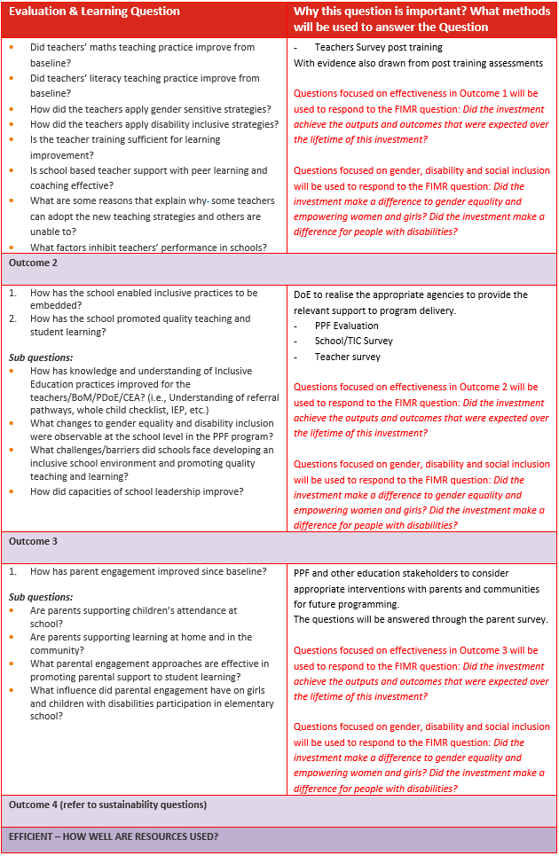

Table



# Evaluation Design

The endline evaluation will be considered a mixed methods impact evaluation. It will attempt to isolate the impact of the program’s interventions on program level outcomes from other influencing factors such as the COVID pandemic by comparing the results of program level outcomes of the group that received the program’s intervention with a group that did not receive the program’s interventions.

The evaluation will follow an experimental design as much as is possible noting that baseline data exists for the treatment group only. Multivariate analysis[26] will be used to isolate variables that have influenced results.

Additionally, the evaluation will compare E1 baseline student results with E1 endline student results to identify changes in literacy and numeracy since PPF began in 2018. This will be an important analysis for the MEP. The endline assessment for E1 will mirror the baseline to perform an accurate comparison. The study will be cross-sectional rather than cohort to mirror the baseline and midline studies undertaken by PPF. The cross-sectional approach will allow the evaluation to assess how a population of schools and a population of teachers and students within these schools are changing due to an intervention. The schools and students will be randomly selected from within the population of schools and students receiving the intervention to ensure representativeness. This will allow us to generalize changes that can be attributed to the student and teacher population.

All long-term outcomes will be measured through this evaluation to populate results in the program MEP and individual MEPs of the grantees. The project provides benefits at the provincial level in relation to capacity development, the district level in relation to teacher training and at the school level in relation to supply of books and materials, the establishment of interventions such as reading clubs, the support to SBOMs and parent engagement activities. All these areas are within the scope of this evaluation.

|  |  |  |
| --- | --- | --- |
|  | Quantitative | Qualitative |
| E1 and E2 Students  (20 students per school - equal # boys and girls and equal # students per grade 1 and 2)[27] | Adapted EGRA/EGMA assessment including biodata survey | Focus group discussions (should be considered based on grantee evaluation plan) |
| E1 and E2 Teachers  (2 teachers pref. 1 male and 1 female – 1 per grade 1 and 2)[28] | Adapted EGRA/EGMA lesson observation including post observation survey with E1 and E2 teachers | - |
| TICs in charge of elementary schools  (1 TIC per intervention school) | Survey integrated with EGRA/EGMA tools and collected post student and teacher assessments | - |
| SBOM | - | Focus group discussion (should be considered based on grantee evaluation plan) |
| Trainers | - | Key Informant Interviews (KII)s (should be considered based on grantee evaluation plan) |
| Parents | Knowledge Attitudes and Practices (KAP) survey (baseline and endline) | Focus group discussion (should be considered based on grantee evaluation plan) |
| Provincial/District officers | KAP survey (baseline and endline) | KII (should be considered based on grantee evaluation plan)[29] |

## INFORMATION COLLECTION

The evaluation is utilising a variety of methods, captured through mixed methods (quantitative and qualitative surveys and interviews) as detailed in the table above. This will be complemented by existing data from grantee MEPs which has captured progress concerning:

* teacher/TIC/SBOM knowledge and skills captured in post training assessments
* teacher practices captured in monitoring visits where TLCs and coaching activities were documented
* changes that have taken place at the school level captured from school visit forms as part of regular monitoring

The **data analysis sheet** from the MEP is attached as an **Annex** to this plan. This responds to questions concerning:

* student learning outcomes
* teacher competency
* inclusive school practices
* parental engagement
* provincial and district capacity
* gender and disability inclusion markers

# Evaluation Schedule

|  |  |  |
| --- | --- | --- |
| **Activity** | **Responsibility** | **Month** |
| 1. Complete the evaluation plan including sampling methodology. | PPF Sec., Evaluation consultant and NGOs | June-July |
| 1. Present the evaluation plan for endorsement at R&L TWG | PPF Sec. | August |
| 1. Version the EGRA/EGMA instrument for a harmonized assessment of Elementary I and Elementary II students (in close coordination with the PPF secretariat and the NGOs) | PPF Sec. and Evaluation consultant | August |
| 1. Finalise the sample for students, teachers, parents incl. districts and schools and communicate this to NGOs. | Evaluation consultant and NGOs | August |
| 1. Upload forms on KOBO forms including checks for revisions to baseline instruments (e.g., provincial officer and parent surveys) | PPF Sec. and Evaluation consultant | September |
| 1. Conduct enumerator training | PPF Sec. and Evaluation consultant | September |
| 1. Monitor and ensure quality data collection. | PPF Sec. and Evaluation consultant | October-November |
| 1. Data cleaning and the production of headline data sets (overall for PPF) and individually for the NGOs including contributions to the NGO evaluation reports and PPF’s completion report. | PPF Sec. and Evaluation consultant | December |
| 1. Validation of Findings Workshop | PPF Sec, RED | December |
| 1. Finalise evaluation reports for the (Program and Project Completion reports) | PPF Sec., NGOs, and DOE | Jan-Feb 2022 |

# Evaluation Stakeholders

This table shows the stakeholders and outlines their interest in the evaluation and their expected involvement.

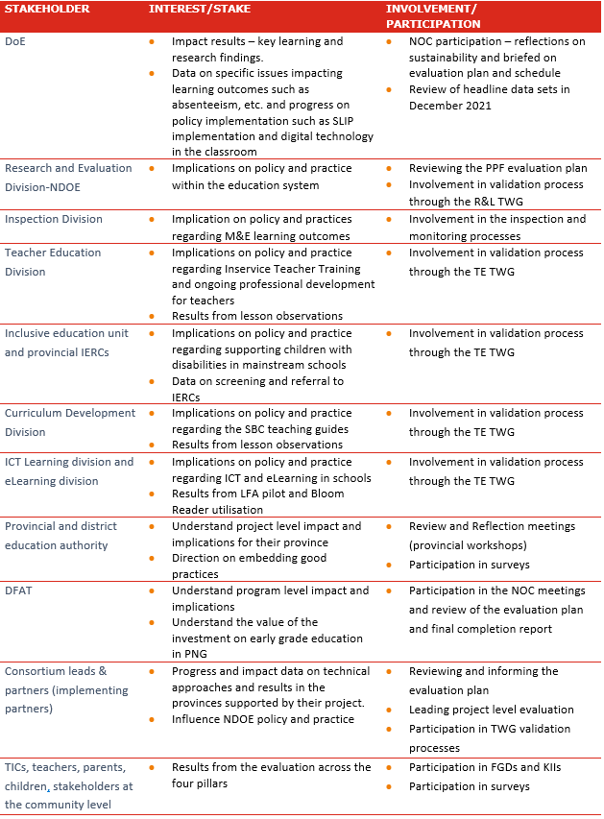

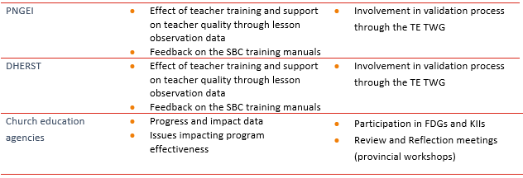

# Other Considerations in the Evaluation

## ETHICAL CONSIDERATIONS

The following ethical considerations will be applied to the evaluation process and planning.

The Research and Learning technical working group with membership from NDOE, NGO partners and DFAT will consider these steps and advice on additional requirements as needed.

All participants involved in the evaluation will be fully informed as to the evaluation purpose, how the information they provide will be used, and their rights regarding information they provide. This will be communicated in written form on the individual consent forms as well as communicated verbally in advance of any data collection being undertaken.

Signed consent will be requirement for all interviews and surveys and parental consent will be required in advance of the student assessments. These forms will be made available in Tok Pisin and English to ensure parents understand the purpose of the evaluation and how their children’s identities will be protected.

Child protection and safeguarding plus Code of Conduct orientation will be provided to ALL enumerators and staff involved in data collection. This will be initially provided as part of the training and complemented by NGO partner processes and requirements. ALL enumerators will need to sign child protection and code of conduct forms prior to training.

Confidentiality will be ensured through the following measures:

* No names of informants will be included in the body of the report
* Participants will be asked at the start of the interviews if they consent to their names being included in an appendix listing evaluation participants.

Gender, disability and cultural considerations will be agreed upon per NGO partner and actioned as part of their quality assurance measures. At minimum, a balance of male and female enumerators will be used, and lesson observations will be taken by one male and one female enumerator to reduce gender bias. The applicability of males interviewing boys will be carefully considered. Regarding disability, specific questions are asked concerning disability as part of the teacher survey and student assessment items have been carefully constructed to ensure children with disability can complete the assessment e.g., use of visual tools. Training of enumerators will consider additional adaptations to administration based on the needs identified.

## LIMITATIONS, RISKS AND CONSTRAINTS

List potential or actual risks, limitations and constraints (e.g., around methodology, evaluation process), their likely effect on the evaluation and how they will be managed/mitigated.

|  |  |  |
| --- | --- | --- |
| **Risk/limitation/constraint** | **Likely effect on evaluation** | **How this will be managed/mitigated** |
| Covid outbreak in data collection sites | Alters data collection schedule and possible change of sites | Have a large backup sample available |
| Unrest in villages limit access to schools in some localities | Alters data collection schedule and possible change of sites | Have a large backup sample available |
| Schools are closed upon arrival for data collection | Alters data collection schedule and possible change of sites | Advanced communication to schools.  Ensure the data collection schedule does not encroach on the end of term activities.  Have a large backup sample available |
| Small number of students present at the one school at the time of data collection | Uneven gender and sample group to produce a representative sample | Advanced communication to schools.  Provide a list of back up schools to ensure sample is reached. |
| Natural shocks and weather events limit access to schools in some localities | Alters data collection schedule and reduces sample | Have a large backup sample available |

## CONTINGENCY PLANNING

Considering the evolving COVID-19 pandemic and the outlook of higher inflections because of the DELTA strain, PPF has developed a contingency plan in case schools are closed or travel restrictions are imposed. The key changes envisaged would be:

* A reduction in the scope of the evaluation removing student-based assessments and lesson observations from the suite of tools to be administered in the evaluation.
* Methods of data collection would change to phone or online surveys. NGOs are practised using phone interviews for monitoring activities and district and provincial education officers use phone interviews for the EERRP so are familiar with this method.
* Some modification to the tools would be required to ensure the tool design is suitable for administration over the phone.
* Enumerator training would be adjusted, and schedules developed that would enable the following to be administered over the phone.
  + Teacher in charge surveys
  + Teacher interviews
  + Parent interviews
  + District and provincial officer interviews
* We would utilise monitoring data on lesson observations and student assessment data where this exists. Term based assessments are carried out in elementary, so we will endeavour to make use of these in the evaluation, if required.
* Develop a set of limitations that would capture the adjustments that have been made and the limitations that are presented in the reduced scope.

1. Teacher Education and Research & Learning TWG workplan and status

**ENGLISH SBC ELEMENTARY TEACHER TRAINING MANUAL**

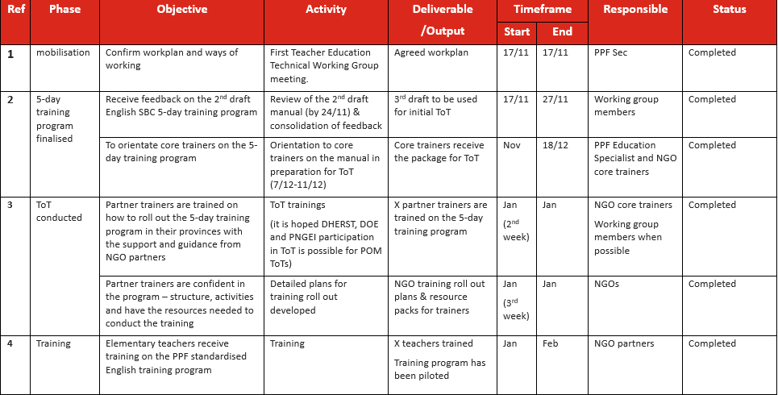

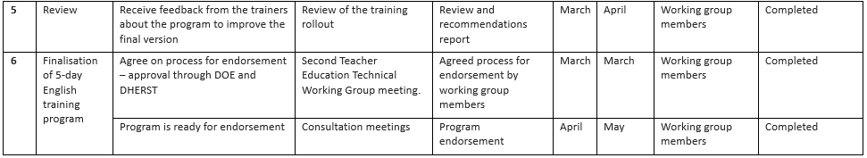

**MATHEMATICS SBC ELEMENTARY TEACHER TRAINING MANUAL**

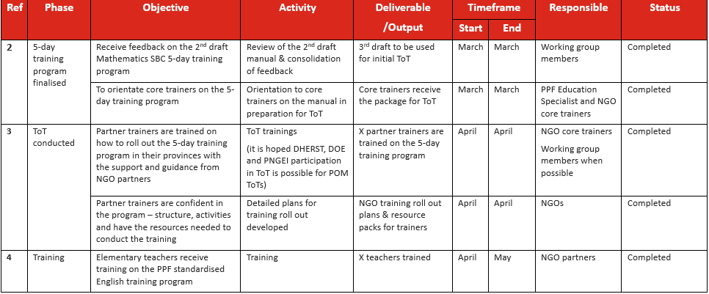

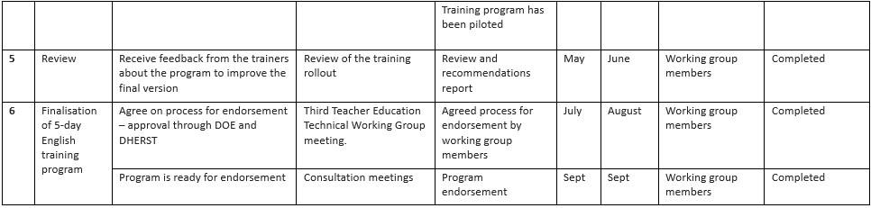

PPF Research and Learning Technical Working Group Work Plan

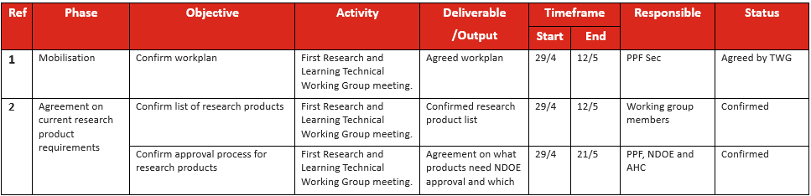

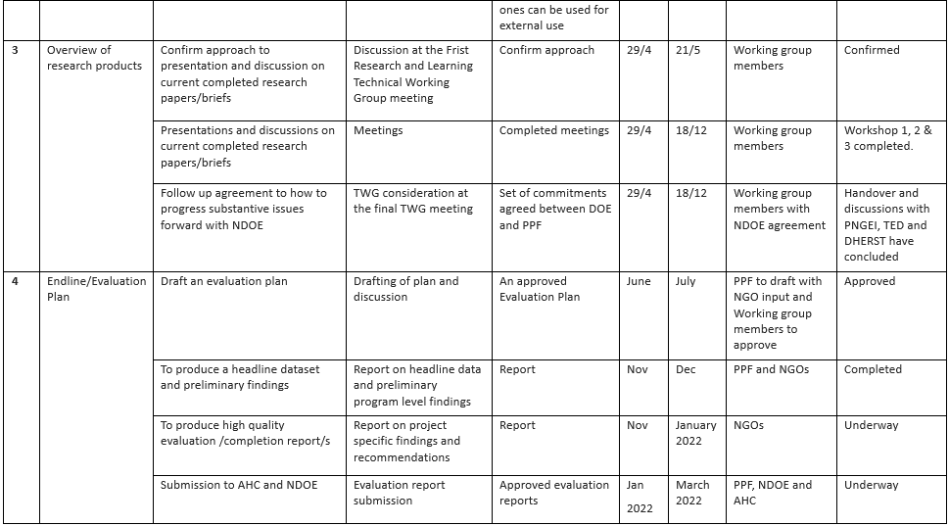

1. List of PPF Research and Learning products

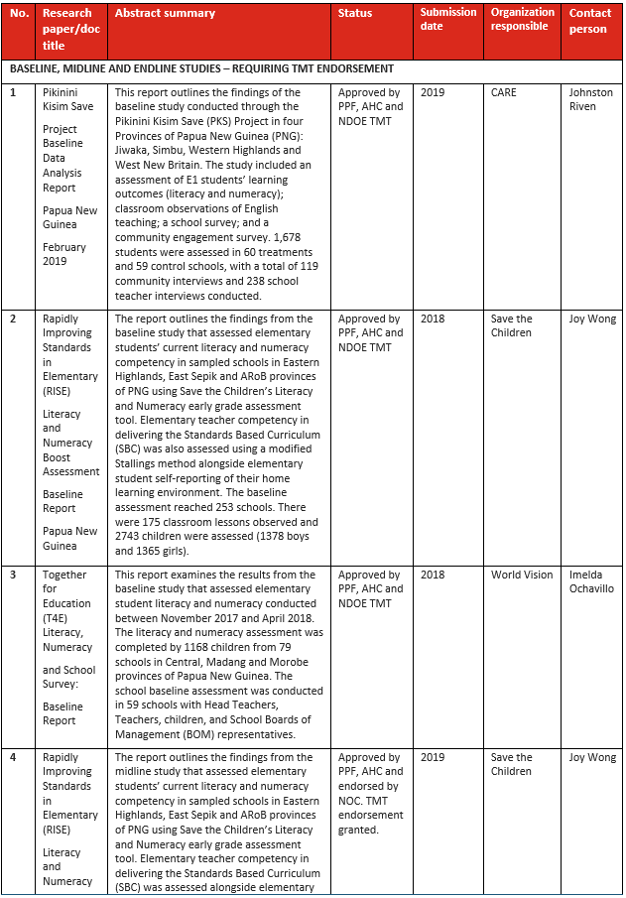

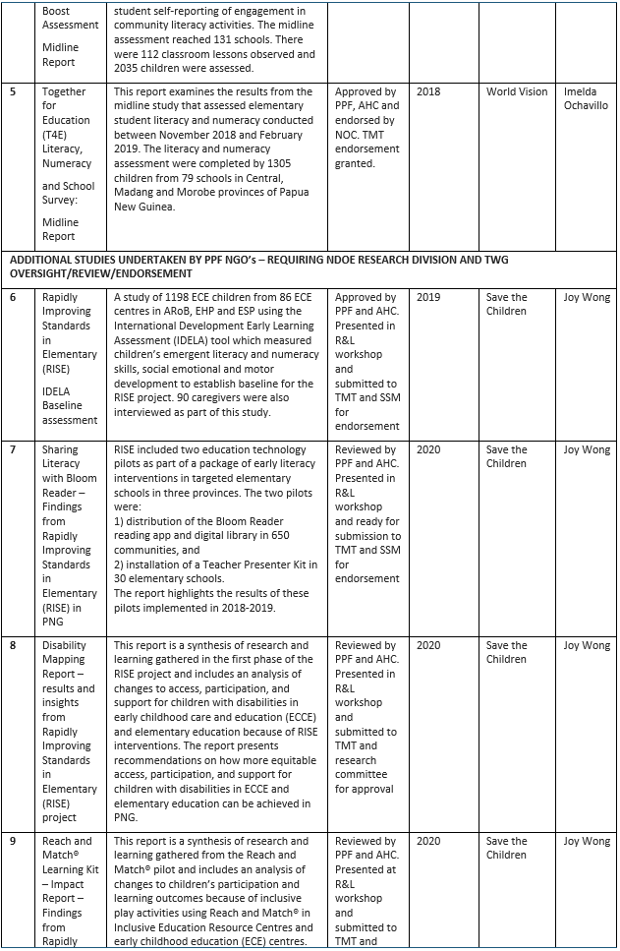

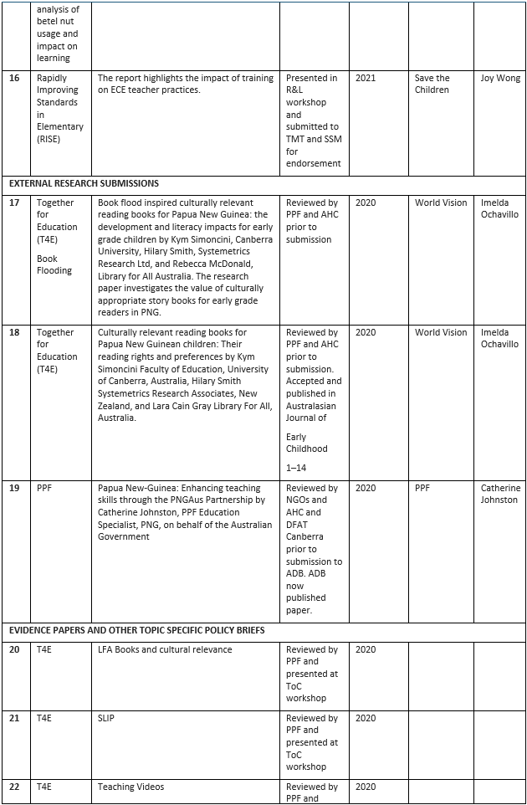

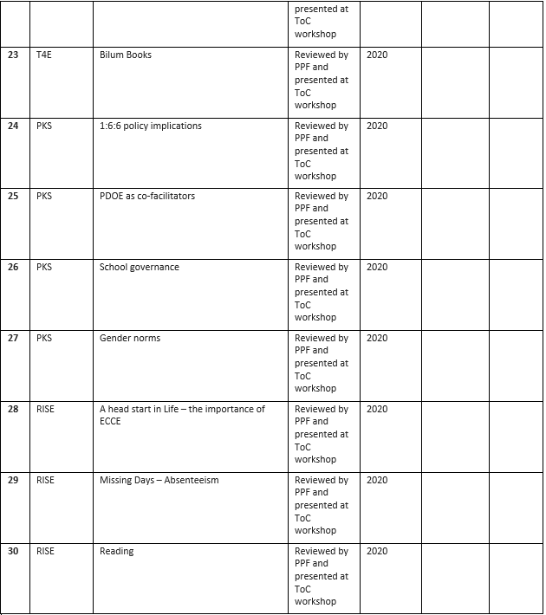

1. Totals were calculated based on information in the most recent Six-Monthly Progress Reports (June 2019) of the three projects.
2. Darling-Hammond, 2000, Hattie, 2008; Organisation for Economic Co-operation and Development OECD, 2005, Rockoff, 2004, Rowe, 2003, Timperley and Alton-Lee, 2008. Also cited in World Bank. (2012). System Approach for Better Education Results (SABER): what matters most in teacher policies? A framework for building a more effective teaching profession. Washington, DC, World Bank.
3. Darling-Hammond et al. 2009, Professional learning in the learning profession: A status report on teacher development in the United States and abroad. National Staff Development Council: Dallas
4. Sayed 2009; Schwille et al., 2007
5. Orr et al. (2013)
6. Cole 2012, p. 7
7. Orr et al. (2013)
8. Barrett et al. 2007
9. Naylor & Sayed, 2014
10. Naylor & Sayed, 2014
11. <https://internationalteacherstraining.com/blog/need-of-teaching-aids/>
12. Hatti, 2013
13. Hatti, 2013
14. Save the Children (2019) RISE Midline Report – taken from analysis of school related items selected combined with analysis of ‘other responses’
15. Hatti, 2003
16. Smees, R. and Sammons, P. (2017) What role does the home learning environment play in supporting good child development in the early years and positive outcomes in later life? London: Action for Children
17. Miller, S., Davison, J., Yohanis, J., Sloan, S., Gildea, A. and Thurston, A. (2016) ‘Texting Parents: Evaluation Report and Executive Summary’, London: EEF
18. Rogers, T. and Feller, A. (2018) ‘Reducing Student Absences at Scale by Targeting Parents’ Misbeliefs’, Nature Human Behaviour, DOI: 10.1038/ s41562-018-0328-1.
19. Whitehurst, G. J., Falco, F. L., Lonigan, C. J., Fischel, J. E., DeBaryshe,B. D., Valdez‑Menchaca, M. C. and Caulfield, M. (1988) ‘Accelerating language development through picture book reading’, Developmental Psychology, 24, pp. 552–559.
20. Cortes, K. E., Fricke, H., Loeb, S. and Song, D. S. (2018) ‘Too Little or Too Much? Actionable Advice in an Early-Childhood Text Messaging Experiment’ (No. w24827), National Bureau of Economic Research.
21. A synthetic sample is a sample of schools that have been generated using a scientific algorithm that ensures compatibility with the schools that have received the intervention.
22. Propensity score matching is a statistical method used to reduce selection bias and improve internal validity. It is an approach that is used when randomised trials are infeasible or unethical, or when researchers need to assess treatment or causal effects from data sources where a counterfactual (the object used as a comparison) must be constructed.
23. Volunteers were used extensively in the PPF program. It is a broad term that captures the unpaid work of various facilitators involved – e.g., reading club volunteers and adult literacy volunteers.
24. To collect sufficient data from the LFA pilot, a sample of LFA implementation schools (Central: 5, Madang: 20, Morobe: 20) will be included. It is highly likely that we will not be able to identify a matched synthetic sample due to coverage of the intervention in some provinces, e.g., ARoB. A solution will be proposed to tackle this once the sample is produced.
25. Multigrade teaching will be captured in the lesson observation and teacher survey and analysis will analyse the results considering this variable.
26. Multivariate analysis is a statistical method that assigns factors such as socio-economic background, gender, a mother’s literacy and determines whether these factors influence the results. e.g., it will help us answer questions such as – does a mother’s literacy influence student results? Does a child’s gender influence results?
27. If there are less than 5 girls and/or 5 boys per grade in each school, backup schools will be used to ensure the sample is reached. No more than 5 girls and 5 boys from each grade will be assessed.
28. In the instance that two teachers are not available in each school, the backup schools will be used to meet the required sample.
29. It is expected that KII and FGD tools are developed by NGOs as part of their evaluation planning and per their program approach as they will be specific to the project they implemented. All tools will be reviewed by PPF in advance of data collection.