Annexes to the PNDS Investment Design Summary

Contents

Annex 1: PNDS Program Operations Manual 2

Annex 2: Interim Australian support to PNDS 3

Annex 3: Lessons Learned 5

Annex 4: Effectiveness of CDD – International Evidence 12

Annex 5: PNDSSP Theory of Change 15

Annex 6: Indicative Outline of PNDS M&E System 16

Annex 7: PNDS Governance Structure 19

Annex 8: PNDS Organisational Charts 20

Annex 9: Draft implementation Schedule 21

Annex 10: Risk Matrix 35

# Annex 1: PNDS Program Operations Manual

Additional

**The Government of Timor-Leste’s** **Program Operations Manual[1] is the key document governing the design and implementation of PNDS**. All detail regarding design and implementation of PNDS should be sought, first and foremost from the Program Operations Manual. This is a comprehensive document covering a full range of issues, including:

1. **Background**: regulatory framework; PNDS objectives and key performance indicators; gender and social inclusions; guiding principles; code of conduct.
2. **Community Grants Funding and Management**: national budget allocations; menu of allowable and non-allowable activity types; disbursement triggers for suku grants; management of suku bank accounts; procurement policy and processes; cash management procedures; reporting requirements; monitoring and audit activities.
3. **Program Management Structure and Actors**: program management structure and roles and responsibilities of national, district, sub-district, suku actors.
4. **Program Cycle:** capacity building; program cycle steps; engineering and technical issues.
5. **Monitoring and Evaluation Framework**: community monitoring and accountability; Government monitoring and oversight; reporting and management information system; evaluation framework; complaints handling.

***Please find the PNDS Operations Manual attached in full in a separate PDF Document. It can also be accessed at*** [*http://aid.dfat.gov.au/Publications/Pages/pnds-operations-manual.aspx*](http://aid.dfat.gov.au/Publications/Pages/pnds-operations-manual.aspx)

# Annex 2: Interim Australian support to PNDS

In 2012 and 2013, Australia is providing international and national personnel and logistical support to assist with the preparation of the policies and laws covering PNDS, the development of the Program Operations Manual, establishing the Secretariat to oversee the design and implementation of the program and embedding corporate systems for program planning and management, training of program personnel, development of M&E systems and the implementation of a field test of the program in 30 sukus.

Australia is working closely with GoTL on a bilateral level, providing support through the services of a managing contractor[2] and is also facilitating other development partners’ contributions to PNDS. The total value of Australia’s support 2012-13 and 2013-14 is approximately $14.5 million. We note that GoTL’s plans and management for PNDS will continue to emerge during 2013. This will require flexibility from Australia to respond and adapt our support. Australia will continue to monitor and support GoTL’s preparations throughout 2013, with a view to ensuring we are confident in the program’s ability to deliver on its objectives in an effective and efficient way. With that caveat, by the end of 2013 Australia anticipates having achieved the following in support of GoTL’s PNDS.

**Design**: *assisted whole-of-Timorese government coordination and the development of a Program Operations Manual (Manual) by the Technical Working Group.* The Manual sets out the operations and accountability procedures for the cycle of community planning, funding and project implementation. A Decree Law, capturing the main operational features of the Manual and the roles and responsibilities of all parties involved in PNDS was approved by the Council of Ministers in April 2013 and is awaiting promulgation by the President to allow the implementation of the program. The Manual will be revised in late 2013 to take into account lessons learned during the mid-year field test in 30 sukus. The Technical Working Group will continue to provide regular line-ministry inputs into the development of PNDS and make decisions on key design and operational issues. Delivery approaches for Australia’s support to this work are the placement of expert personnel (AusAID and contracted staff) in the PNDS Secretariat as well as sustained bilateral engagement at high-level and officials-level.

**Management**: *supported GoTL to develop the corporate plans and broader systems needed to sustain PNDS.* These include strengthening human resource management in MAE, recruiting additional MAE staff to run PNDS, and, with the CSC, developing and putting in place a recruitment strategy for around 350 trained facilitators who will be recruited as civil servants. It also includes developing a transparent financial disbursement system in close cooperation with MOF. A complaints handling mechanism will also be designed. Delivery approaches are ongoing policy engagement with MAE, MOF and CSC in cooperation with Australia’s Governance for Development Program and the placement of expert personnel.

**Training**: *delivered three training programs* (social facilitation, financial management and technical design, based on the program steps set out in the Manual) to around four hundred men and women. About 350 trainees will be recruited by the Civil Service Commission as social, technical and financial facilitators, based at sub-district and district levels, to work with communities. MAE Officers will also be trained in the use of a PNDS Management Information System (MIS). Training will have been developed and delivered by Australian‑funded experts working in cooperation with local training providers and the Ministry of Finance. Work is underway to have these programs accredited in future under the (national training accreditation framework

**Monitoring and evaluation**: s*upported GoTL to develop a monitoring and evaluation system for PNDS*, including the MIS. Initial work carried out to monitor the field test, establish a data baseline for the program and understand key issues associated with community involvement. This work is likely to draw in The Asia Foundation, World Bank and local NGOs as partners as well as using personnel placed in the Secretariat.

**Implementation of field test**: *supported GoTL to run a field test of the PNDS process* in about 30 sukus by providing design support, training a small group of additional Field Test facilitators on the Program Operations Manual, and monitoring the process and outcomes. Delivery approaches will be training, input of expert personnel placed in the PNDS Secretariat and engagement of civil society partners in monitoring social and technical outcomes, as well as bilateral engagement to consider revisions to the PNDS Manual, based on field test results.

*For more detail on Australia’s current support to PNDS see the Draft Implementation Schedule below at Annex 7.*

# Annex 3: Lessons Learned

In the preparation of this Investment Design, Australia conducted a literature review of previous Community Based Development and Community Driven Development in Timor-Leste. The following lessons were drawn from this literature review.

#### Participation and Inclusion

The lessons learned exercise found that broad community participation is one of the key pre-conditions for effective implementation of community based and community driven development in Timor-Leste. As evidenced in lessons below, community participation is key to ensuring projects respond to actual community needs and are thus accessible, utilised and maintained.

Women’s participation in community driven and based development programs in Timor-Leste has been uneven. Even where participation at community meetings is strong, evidence suggests that decision-making remains primarily in the hands of men, notably with *suku* chiefs and customary leaders. According to TAF (2012), in some suku, while women attend meetings, their contributions are often ignored, as one research respondent noted: “they [women] have a very strong voice, but it’s just the same because people don’t listen to them” [3] The **Local Development Program** (**PDL)** identified a range of reasons for women‘s low attendance, including lack of advance funds for transportation, time away from home, and lack of compensation for meeting attendance.

In the **Community Empowerment Program (CEP)**, community participation was highly varied, depending on facilitator skills, the power of the Chefe Suku and the nature of the project[4]. Even where participation was strong however, the scope of the communities’ choice of projects was restricted to market-based infrastructure - despite other priorities being identified during community consultations. This undermined the relevance and local ownership of infrastructure constructed through the program.

In the **Decentralised Development Program (PDD)**, communities had minimal involvement in identification of PDD projects which were prepared by line Ministries, and with no local processes for prioritisation, consultation and planning required for other stages of project implementation. The Asia Foundation (TAF) study into community experiences of decentralised development[5] in Timor-Leste found that due to lack of community involvement, PDD is regularly described as reflecting elite, national interests, and being particularly vulnerable to “political interests from the top”[6] – which affected the utility and sustainability of infrastructure built through PDD.

The **PDL** contained a much greater emphasis on community participation in the process of identifying and prioritising project proposals. In the study described above, TAF found that nearly all research respondents stated a preference for the PDL over PDD process[7], describing it as ʻbottom-upʼ rather than ʻtop-downʼ[8].

According to TAF, the **Suku Development Plan** (**PDS)[9]** planning process was undermined by weak participation at the aldeia level. Participation at this level proved difficult to achieve due to weak participatory approaches, other priorities for community members time, and the fact that, in some cases, only those with privileged links to chefe aldeia were able to join[10]. The resulting PDS is therefore not always reflective of the development needs of the entire suku community.

Australian experience from **BESIK** shows that, with time and targeted effort, it is possible to improve women’s participation in community decision-making and resource use. For example, of the water user groups established by BESIK, 72 per cent of groups and community leaders reported that women and men made joint decisions compared with only 37 per cent prior to the project. [11] However, AusAID‘s sectoral survey (2009) concluded that, traditional gender attitudes continued to dominate and impede opportunities for women to participate in building, maintenance and leadership roles.‖

According to a World Bank review of community based infrastructure projects in Timor-Leste, successful methods to strengthen women‘s participation include training women facilitators, holding separate women‘s meetings, including quotas on the number of women for projects to proceed, and holding meetings at a time when many women can attend[12]. International experience confirms that high-performing facilitators can often be the difference between districts’ levels of success and buy-in to the program, promoting active participation rather than just attendance. Well trained facilitators are also more adept at engaging women and marginalised groups in the participatory process, encouraging them to speak up and influence project planning.[13]

**Lesson:** The work of trained, motivated sub-district facilitators will be essential for program success. There is a strong need to support adequate community involvement in planning sessions through the provision of clear guidelines for facilitating community participatory planning and/or providing some external support, and recognizing the time, effort and attention that is needed to carry out participatory community planning.

* Australia will support efforts to ensure that improved participation is an explicit objective of PNDS work and to track it.
* As described in the PNDS Investment Design Summary, a significant portion of Australia’s investment will be directed to training and ongoing support of facilitators.

#### Project prioritisation process

Community prioritisation of priorities and projects has been identified as a key weakness of community based and community driven development programs in Timor-Leste[14]. According to TAF (2012) in both **PDL** and **PDD**, rather than voting on the merits of a particular proposal, people voted for good speakers and lobbyists or on personal or political interests rather than broader community interest. The TAF study found that this has directly impacted the relevance and utility of infrastructure built[15].

According to the World Bank **CEP** Project Assessment Performance Report, the ability of communities to identify development needs and make decisions was limited because inadequate attention was given to the capacity of community members to do so.

**Lesson 1:** Specific measures should be put in place to encourage project prioritisation based on the merit and utility of proposals.

* PNDS has established measurable criteria through which council members can assess different proposals, in order to help participants make evidence-based decisions.

**Lesson 2**: Community capacity to prioritise projects based on development need and merit should be explicitly built and monitored.

* PNDS is prioritising training for facilitators to enable them to support communities to make evidence-based decisions. In particular, the technical and financial facilitators will support communities identify technical construction and cost implications of each proposal to better inform their decision making The PNDS field team will be a key monitoring tool regarding the project prioritisation process.

#### Sustainability and effectiveness of Infrastructure

Literature studied for this lessons learned exercise highlighted the need for broad community participation to ensure infrastructure is relevant, effective and sustainable. For infrastructure to be effective it is vital that there are no social or local environmental factors which would impact the completion or sustainability of infrastructure, such as conflict over the use of land or the effect of local weather conditions.

According to the World Bank **CEP** Project Assessment Performance Report, sustainability and suitability of infrastructure built through CEP was affected because communities often saw CEP as a source of aid or income rather than an investment to manage to improve development in the future. This often resulted in infrastructure which did not meet the priority needs of the community[16]. However, a larger problem was that the suku councils were not in a strong position to commit to the types of infrastructure that were often the highest priority in the first place, due to the lack of policies and structures at the national government level necessary to allow for development of infrastructure in areas such as health and education.

According to TAF (2012), the lack of involvement of community members or beneficiary groups in both **PDD** and **PDL** has had a significant impact on the extent to which projects were appropriate, usable and sustainable[17]. As one research respondent noted:

“*this project, all planning…and design came from the national level. But after they finished, the community did not want to use it because it was not relevant to what they needed*”[18].

Maintenance of infrastructure was a key weakness that was identified by many interviewees for both PDD and PDL projects in the above TAF research. This included: unrealistic expectations of the communities economic capacity to undertake maintenance; dissent over who was responsible for maintenance; lack of ownership felt by communities on ownership of infrastructure; maintenance arrangements which had overly simplistic understandings of community – and assumed community could be “scaled up” to include maintenance for infrastructure[19].

Drawing in Australia’s experience in **BESIK**, Government-led community consultation processes embedded in BESIK’s Community Action Planning process help to foster participation, inclusion and ownership of projects. The process, led by sub-district facilitators trained by BESIK, was given credibility by the understanding by communities that facilitators were trusted government officers in permanent roles.[20]

**Lesson 1:** Basic village infrastructure is more likely to be used and maintained when it is developed through a participatory, community based process.

* the PNDS Program Operations Manual establishes a range of mechanisms to support participation of the broadest possible base within communities in decision-making.
* In the first four years of PNDS, Australia will fund extra costs required to help ensure the quality of the program. Our funding demonstrates our commitment as GoTL’s partner.

**Lesson 2**: Appropriate technical standards help communities maintain village-level infrastructure.[21]

* the PNDS Program Operations Manual establishes technical standards to help communities build and maintain infrastructure. Technical facilitators will be trained to assist communities to understand operations and maintenance requirements.

#### Leadership and understanding of local context

According to the World Bank (2012), the most important factor in the success of the community councils and development projects was the leadership abilities of the council leader. In places where he was able to motivate the community members and work with them, levels of participation remained high. Suku Councils require a lot of training and support over a long timeframe to develop capacities that enable them to facilitate and manage suku level development. Quota system for women‘s representation was effective, though greater training and support is required to overcome traditional attitudes and maintain the levels of women‘s involvement.

In the case of **CEP**, numerous reviews agree that too little credence was given to traditional notions of leadership and authority in village-level decision making25. Village chiefs and resistance networks were explicitly excluded from membership on CEP councils in an attempt to mitigate the possibility of elite capture. However, according to the World Bank’s evaluation of CEP, the decision not to include the elders of the village in the project was a fundamental miscalculation[22]. The report states that pre-existing authorities had a genuine local legitimacy that the CEP councils never acquired and without which were ineffective. In addition, district staff were under-resourced relative to community teams and their decision making power was undermined.

In addition, literacy was a requirement to be a member of the village council, which sidelined many traditional authorities and many women in particular. An anthropological study of CEP[23] showed that CEP councils were not seen to hold authority as the actors were seen as too young – with age a key determinant of authority in Timorese communities. According to the World Bank (2012) the CEP misread the cultural context - in which conflict resolution and political decision making is vested in traditional and hereditary leaders. Council members did not receive payment during CEP, against their expectations, providing a further barrier to effective governance.

PDL recognised that sukuchiefs, who are the interface between communities and the state, are overburdened and could benefit from more training. PDL successfully strengthened the role of suku councils as enablers of development and helped suku council members, district administrators and technical staff build advocacy, lobbying, negotiation and facilitation skills.

**Lesson:** Program leadership that draws on traditional community structures and cultural contexts enhances community participation and ownership.

* The PNDS operational structure sets out roles and responsibilities at the community level to build on the traditional leadership of Suku Councils[24], with additional mechanisms for broader community involvement to support oversight, inclusive participation and capacity building opportunities.

#### Provision of Credit

According to the WB review of CEP, the credit component of CEP was highly unsuccessful. The WB review of CEP reveals that there was considerable advice from peer reviewers against including the micro-credit component based on past experience. The absence of microfinance institutions at the time to support a credit component contributed to its failure. The lack of transparency around the distribution of the credit allowed elite capture of benefits.

* PNDS does not include a credit component.

#### Management oversight and accountability

The Lessons Learned exercise found that a lack of accountability mechanisms – such as community financial monitoring or complains handling mechanisms can significantly weaken the sense of community ownership that is critical to a CDD or CBD approach. The exercise found that complaint mechanisms need to be clear and include downward communication back to the complainant as to the action take as a result of their complaint. Traditional leaders need to be engaged by the democratically elected councils to support local development.

According to the World Bank **CEP** Project Assessment Performance Report, procurement rules were not well understood by communities and there was a general lack of transparency and fiduciary compliance. The World Bank determined that monitoring financial management at the community level is a very difficult task.

According to TAF (2012), common across both **PDL** and **PDD** was a weakness in complaints mechanisms and monitoring frameworks[25].

**Lesson:** Accountability mechanisms are imperative: facilitate information flows to the communities; and promote social accountability, including through grievance mechanisms and community-based M&E.

An effective Complaints Handling System (CHS) is critical for building trust and strengthening governance. Its effectiveness rests on the different PNDS actors' good understanding of rights and responsibilities, and a clear understanding of processes.

* Australia is supporting the Ministry of State Administration to design and manage the PNDS complaints handling mechanism as a key pillar for accountability and sustainability. The mechanism will operate at national and district/sub-district levels and will involve mechanisms to improve communication and dispute resolution.

#### Who implements projects

TAF (2012) found that at the sukulevel, there was a strongly-expressed preference for communities to carry out the work, as it was thought they had better incentives to ensure high quality, more sustainable results. However, district officials pointed out the greater difficulty they had experienced in monitoring and applying sanctions to community groups: while it is relatively easy to blacklist companies who do not perform good-quality work, it is much more difficult to sanction community groups who did not carry out the project to a good standard[26].

**Lesson 1**: When community members are involved in the implementation, monitoring and evaluation of their projects builds a sense of ownership and increases the sustainability of projects.

* PNDS will be a community driven development project, with communities driving all stages of the project cycle.

PNDS Facilitators will assist communities consider technical implementation issues during the project prioritisation process.

**Lesson 2**: Appropriate monitoring is required to ensure projects are being implemented effectively.

* The *Field Support Team* expected to be on the roads for approximately three quarters of their time. As described in *Section 4, What will Australia Fund* (p39), the success of CDD programs is heavily dependent on skilled and effective facilitators to support participation, planning, decision-making and implementation.
* The *Field Support Team* will undertake extensive and ongoing field visits and report back to management on key findings – positive and negative. This will allow management to make decisions and respond to issues as they emerge. The field team will verify data in reports, document successes, identify major problems, and channel local voices, allowing local input into program management and problem-solving. They will provide an external cross checks verification processes to mitigate risks such as fraud, environment degradation and elite capture.

#### Monitoring and Evaluation

Strong monitoring and evaluation systems, both at the Government level and the support program level, are critical in allowing CDD programs to learn, adapt to the local context and be modified over time. They are also important where government monitoring and evaluation of service delivery is poor generally, and CDD programs are piloting new systems to better inform planning and delivery of government policy.

According to the World CEP Project Assessment Performance Report, monitoring was largely confined to tracking inputs and outputs and could not report on overall project objectives. Even in monitoring inputs and outputs, there were significant weaknesses. The completion report shows that some basic output indicators identified by the project were not monitored, for example number of committees formed.

**Lesson**: there is a strong need to have a system to track project inputs, outputs, and outcomes and also provide information about the adaptations needed in project design to ensure that the project objectives and activities are in keeping with the emerging institutional context and the absorptive capacity of the country

* The Program Operations Manual provides a mechanism for accountability and annual activity evaluation;
* The Management Information System which Australia is helping to design will provide a foundation for good management of fiduciary risks, it provides a reliable evidence for impact assessments and ensuring good stories where they are can be found and then told
* The monitoring and evaluation plan which Australia is helping to design will include baseline and assessment studies on a regular interval.

# Annex 4: Effectiveness of CDD – International Evidence

International evidence shows that CDD programs are effective at achieving increased social and economic benefits. CDD has been shown to deliver results more quickly where governments and donors have few tools to reach poor people directly, particularly in countries affected by conflict. We note that CDD approaches aspire to a range of broader development objectives including social capital, cohesion and empowerment. We note that international experience shows limited evidence that CDD programs contribute to these broader development objectives, or to measure and attribute such outcomes to the program. It will be important to have realistic expectations of the ability of PNDS to achieve the less measurable development objectives.

**Internationally, CDD programs have been shown to improve living standards** in communities where local institutions (governments or markets) have had a poor track record of service delivery. A recent World Bank meta-evaluation of its CDD programs around the world found generally positive evidence across programs for increased household living standards and welfare, poverty targeting and increased access to services.[27] The evaluation found that evidence is generally strong across CDD programs for positive impacts on access to and use of services, especially in health, education and drinking water. For example, completed subprojects as part of the Senegal National Rural Infrastructure Program (PNIR) “significantly increased access to clean water and health facilities and improved the nutritional status of children… Moreover, the project had effects in areas that did not have completed projects; simply residing in a PNIR-eligible area brought statistically significant benefits in terms of child health, perhaps because of spillovers from neighbouring villages that receive completed projects.”[28] The Philippines KALAHI-CIDSS program has had a positive impact on accessibility with a 6 per cent increase in the proportion of households whose house was accessible all year by road.[29]

Impact evaluations such as one conducted by the Abdul Latif Jameel Poverty Action Lab in Sierra Leone[30] have indicated that villages participating in CDD programs have had more and higher quality public goods than comparison areas, and additional market activity and economic gains, with minimal leakage of project resources.

**CDD has been highly relevant in fragile and conflict-affected states.** In Afghanistan, the National Solidarity Project (NSP) commenced in 2003 as an effort to reach poor rural communities where insurgency and opium production was growing. Since its inception, over 21,000 community development councils have been established, reaching 70% of Afghanistan’s villages and improving small scale infrastructure including water systems and roads. NSP has increased the government’s visibility and perceived legitimacy with rural communities, which is critical in a fragile setting[31].

**CDD has been shown to be a good value‑for-money approach to building and maintaining infrastructure.** Studies of many World Bank CDD programs show that infrastructure programs implemented locally cost significantly less than similar small-scale projects delivered by government[32]. Projects have proven to be largely cost-effective and quicker to implement than equivalent government works. Community control is intended to ensure that the allocation of resources is responsive to needs, that public goods are built to a good quality, maintained and used, and that the risk of corruption is lower than in other types of programs[33]. A three-country study of CDD (Philippines, Indonesia and Burkina Faso) found that in Indonesia, evidence shows that the Kecamantan Development Project (KDP) suggests that community implementation of infrastructure costs on average 56 per cent less than infrastructure provided through local government contracts[34].

**CDD can help to build inclusive governance, and encourages participation and accountability at the local level, engaging the poor and marginalised groups**.[35] Specific rules and methods have been developed to facilitate participation. In Indonesia, these include rules governing the participation of women at all stages of the project planning and implementation process and transparency mechanisms such as public information disclosure on village noticeboards, grievance handling mechanisms and community monitoring, including through civil society organisations (CSOs). Such tools are central to the vision of inclusiveness, transparency and accountability of Indonesia’s CDD programs.[36]

**There is limited evidence on the ability of a CDD program to change community norms to an extent that women and other disenfranchised members of a community may experience an improvement in their decision-making power outside of the project**[37]. It will be important to have realistic expectations on the quality of community empowerment, particularly in the early years of PNDS. Australia will support efforts to ensure that improved participation is an explicit objective of PNDS work and to track it.

**Overall, there is a limited evidence base for the theory that, through communities working together using a CDD approach, a project can build trust, networks, and collective action**. Some international experience shows that CDD can build political capital for governments by ensuring that funds reach communities on a predictable basis.[38] An evaluation of the Philippines KALAHI-CIDSS program reported, over a seven year period of project interventions, “increased levels of trust within project communities and increased memberships in organisations. The evaluation showed a 12.3 percentage point increase in the proportion of respondents indicating that most people in their village can be trusted, as well as a smaller but still positive impact on trust in local officials and in national officials.”[39]

While changes brought about in government-citizen links have been noticeable within the domain of some projects, there is insufficient evidence for sustained contribution to stronger community association and local governance beyond the programs themselves. Similarly, more research and evidence is required to understand the impacts of CDD programs in conflict or post-conflict environments, especially given the large injection of funds a program like PNDS will make into communities. As noted above, CDD approaches have been effective mechanisms for delivering funds and access to services in post-conflict environments where government capacity is weak or non‑existent. The World Bank meta-evaluation found some evidence for positive contributions of CDD programs to helping overcome conflict in the Philippines and Indonesia, helping redress grievances and building community mechanisms for mediating conflict.[40] A lack of explicit measurement of such impacts and the short timeframe for many CDD programs has made it difficult to assess longer-term impacts on social capital and governance. Through its M&E support, Australia can support research over a long time frame on the impacts of PNDS on association and trust in communities and towards national and sub-national levels of governance, as well as impacts on creating, worsening or helping resolve conflict.

# Annex 5: PNDS Theory of Change

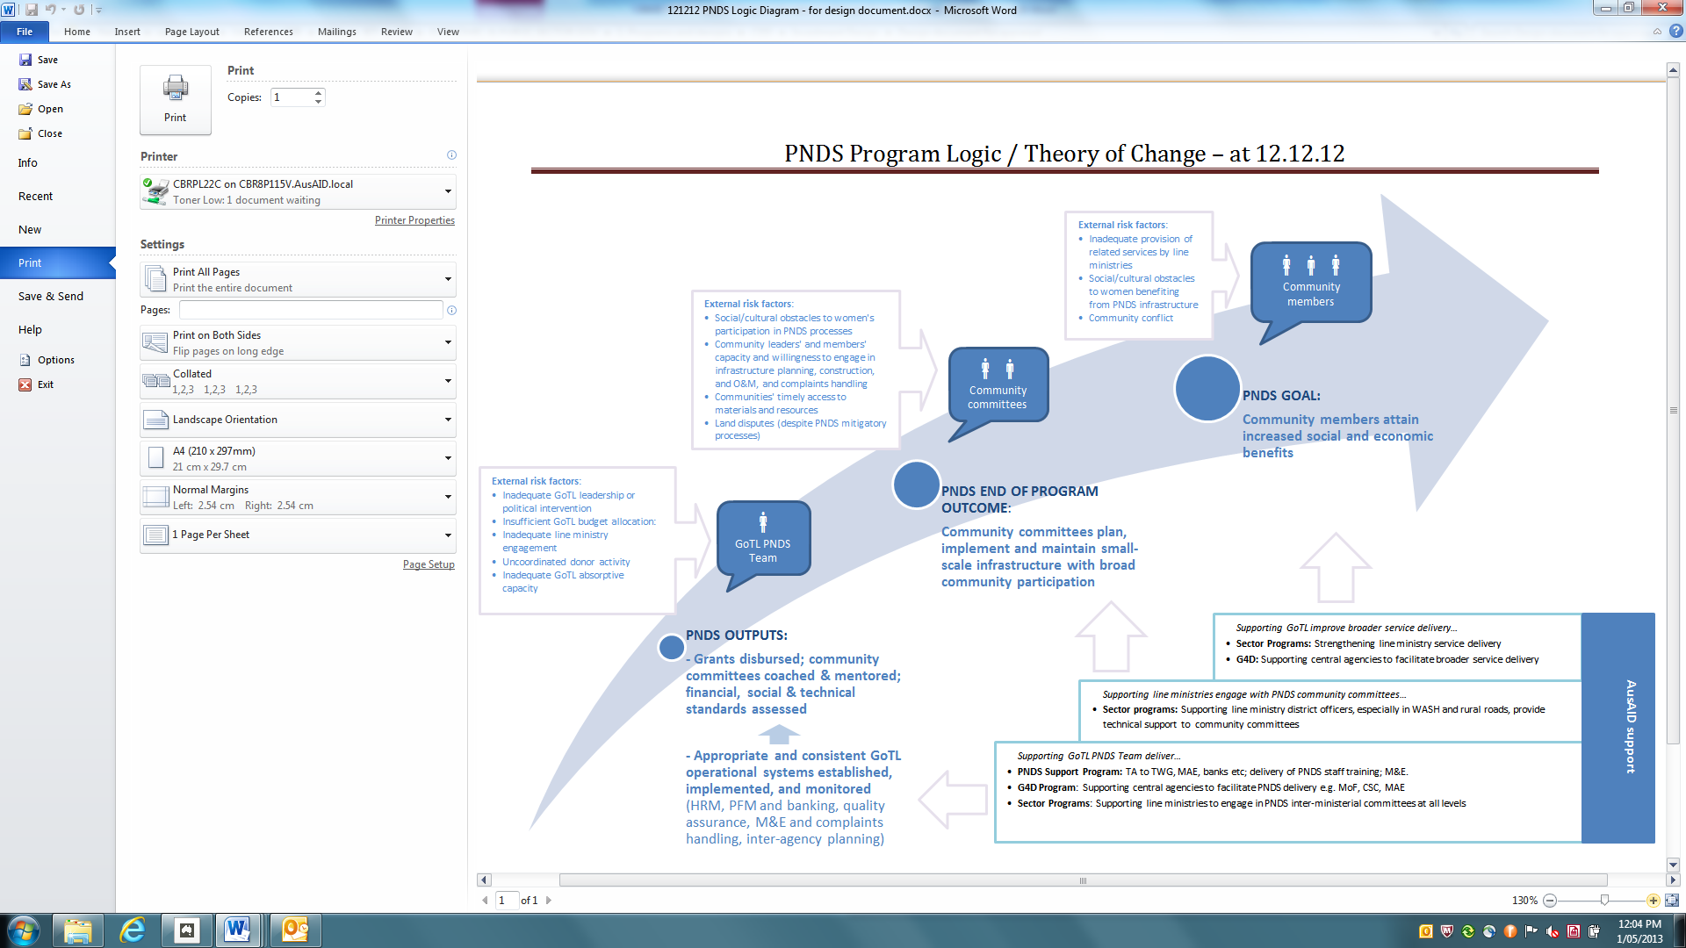

# Annex 6: Indicative Outline of PNDS M&E System

|  |  |  |  |  |
| --- | --- | --- | --- | --- |
| Overarching M&E questions | M&E sub-questions | Methods for answering questions | How answers will be used | Next steps |
| Are Timorese people’s circumstances improving? | How are poverty, suku governance etc. changing in PNDS communities and households?  *[specific dimensions of interest yet to be agreed. Could include range of social, governance and econ benefits accruing from employment, infrastructure (access to market, consumption), and participation in process (social cohesion, conflict, mgmt. skills, trust in govt, women’s participation]* | Mixed methods study [secondary data analysis, quant survey, qual methods TBD] | Technical working group and DFAT **reporting** on ongoing relevance of PNDS | * Agree on impact dimensions that GoTL/GoA want to track (M&E workshop?) drawing on POM, PNDSSP design * Based on above, scope available secondary data * Design and conduct baseline |
| To what extent is PNDS causing these changes? | * Return on investment studies * Qual methods: contribution analysis a. for more immediate effects eg access to clean water; and b. in sukus not receiving non-PNDS support? | TWG and DFAT **reporting** on overall merit of PNDS | * Agree on methods for answering this sub-question – mixed method design? |
| What unintended impacts is PNDS having?  Why?  *[high risk negative impacts to be agreed – the PNDSSP risk matrix proposes some]* | * TAF qualitative monitoring (field test) * Complaints Handling * Field Support Teams | TWG **improvement** to POM, facilitator prof dvlpt etc. | * Agree on key unintended consequences to focus on (M&E workshop?) |
| Are community-based PNDS structures functioning appropriately? | * Are communities following process as expected (financial, social)? [including O&M] * Are infrastructure design, construction and O&M meeting technical standards? * What is the reach of employment opps and infrastructure being delivered? Is it on time? * Why/why not? * Is process appropriate/valued? * Do communities understand it? * Why/why not?   *[see more detailed questions in field test M&E framework]* | * MIS forms * Field Support Teams * TAF qualitative monitoring (field test) * Complaints Handling Mechanism * Technical Audit? | * TWG **improvement** to POM, facilitator prof dvlpt etc. * **Lessons** for GoTL, donors, international CDD etc. | * Field Test M&E * Review field test, and agree to key evaluation questions for Field Support Team and TAF monitoring team. |
| How is quality of process and infrastructure influenced by ‘design variations’? | Special studies? (drawing on data from methods above). | * TWG **improvement** to POM, facilitator prof dvlpt etc. * **Lessons** for GoTL, donors, international CDD etc. | * Agree on any design variations * Design methods |
| How does the quality of infrastructure (construction, maintenance) and perceived value of process compare to non-PNDS funding? | Special studies? (drawing on data from methods above; and secondary data eg PDD, CEP, PDL analysis). | * TWG and DFAT **reporting** on overall merit of PNDS * **Lessons** for GoTL, donors, international CDD etc. | * Agree on dimensions that GoTL/ GoA want to assess, and what they want to compare PNDS to; * Based on above, scope existing data for baseline |
| Are PNDS operating systems working? | * Are facilitators following process? * Is the quality of facilitator mentoring, QA etc adequate? Why/Why not? | * MIS forms * Field Support Teams * TAF qualitative monitoring (field test) | * TWG **improvement** to POM, facilitator prof dvlpt etc. | * Review field test, and agree to key evaluation questions for Field Support Team and TAF monitoring team. |
| * Are PNDS subsystems working as expected at sub/district and national levels? (PFM, HRM, M&E and Complaints Handling, Inter-Ministry Planning Coordination and Oversight) * Why? Why not? | * MIS forms /other existing MAE/MoF data eg FreeBalance, HR data etc.? * Interviews (by MRG/MTR?) with key informants at sub/district and national levels e.g. MoF/MAE staff? | * TWG **improvement** to system design * Australian **improvement** of support? | * Agree through Contractor Annual Plan on ‘desired outcomes’ for each subsystem. Reflect in PNDSSP design. * Define MIS indicators for each subsystem with relevant LTA / PNDS Secretariat staff * Quality assure Manuals for each subsystem esp. alignment with GoTL systems |
| * To what extent is PNDS establishing systems and building capacities for future sub-national governance? * To what extent is PNDS influencing other existing service delivery systems e.g. line ministries? Are PNDS structures being used for other thematic programming? | * MRG/MTR * G4D Program M&E? | * TWG **improvement** of systems to promote broader preparedness for deconcentration? * **Lessons** for deconcentration? | * Clarify dimensions/questions of interest in M&E Workshop? |
| Is PNDS sub/district and national staff capacity to implement the PNDS system adequately improving? Why? Why not? | * Self-assessment with LTAs based on agreed Capacity Development plans | * Staff/advisors ongoing **improvement** of CD activities | * Agree on approach to CD M&E in PNDSSP Design * Progressively phase in CD plans for each subsystem through implementation |
| Are PNDS supporting systems providing value? | Are managing contractors’ key outputs adequate?  If not why not?  Is the balance between CD and substitution appropriate?  Are CD needs being monitored? Is technical support being adapted to any changes in capacity? | * Output indicator monitoring * Self-assessment with counterparts based on agreed CD plans * Other MC quality assurance * MRG | * MC **improvement** of support and **reporting** to DFAT and TWG * DFAT internal **reporting** and MC performance assessment | * Identification of key outputs in Contractor 13/14 Annual Plan – specification of expected reach, coverage quality etc. and QA processes * Development of further methods for QA once M&E expertise available * As above re CD M&E |
| Are WB, TAF (other NGOs?) providing adequate outputs? Is balance between CD and substitution appropriate? | To be proposed in concept notes | WB, TAF, others’ **improvement** of support | * Development, appraisal, approval of TAF, WB concept notes |

# Annex 7: PNDS Governance Structure

**Inter-Ministerial Commission**

Strategic Oversight

*Minister of Finance*

*Minister of State Administration*

**Ministry of State Administration**

**PNDS Secretariat**

Management, funding and monitoring of PNDS

**District Administrations**

Coordination, monitoring and technical support

**Sub-District Administrations**

Social, financial and technical facilitation

**Sucos**

Implementation of PNDS grants

**Technical Working Group**

PNDS coordination between

line ministries.

**Ministry of Finance**

Disbursement of funds to MAE

Financial oversight

**Other Development Partners**

Support activities (e.g. evaluations, impact studies, community surveys)

*World Bank*

*The Asia Foundation*

**Contractor**

**PNDS Support Program**

Technical Assistance for Ministry of State Administration

Training of program personnel

Logistical support for PNDS personnel

**Strategic and policy engagement**

*Head AusAID Timor-Leste*

**Technical Advisory Group**

Independent monitoring

**PNDS Support Program**

Management of PNDS support

*Head PNDS Secretariat*

*AusAID Program Director*

*Contractor Operations Manager*

# Annex 8: PNDS Organisational Charts

#### Senior Manager Reporting Relationships

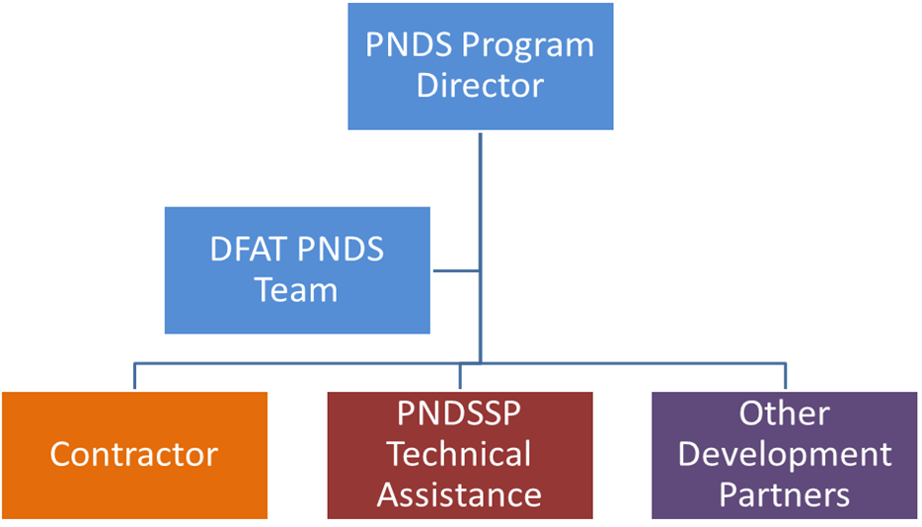

#### Adviser Team in the PNDS Secretariat

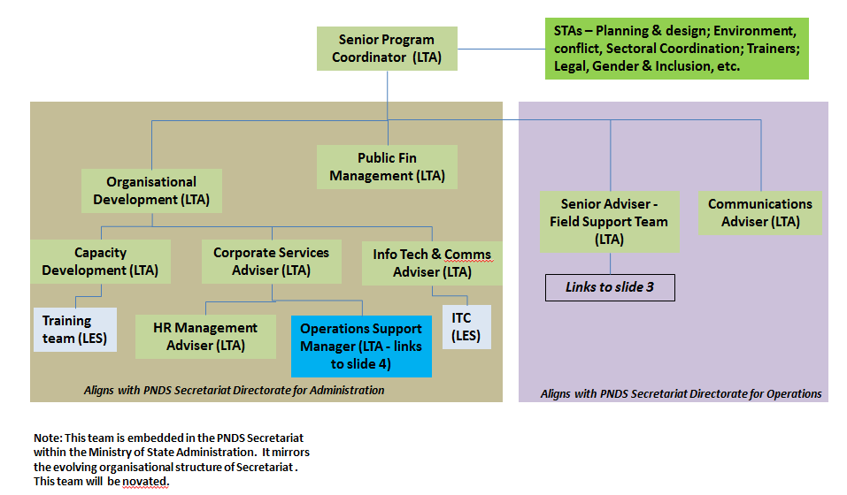

#### Field Support Team

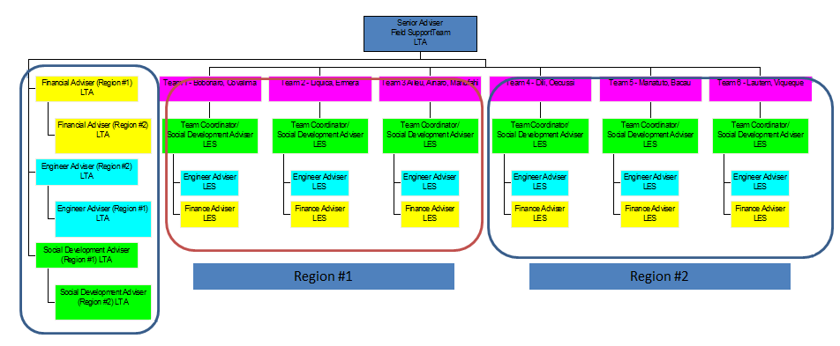

#### Managing Contractor Team

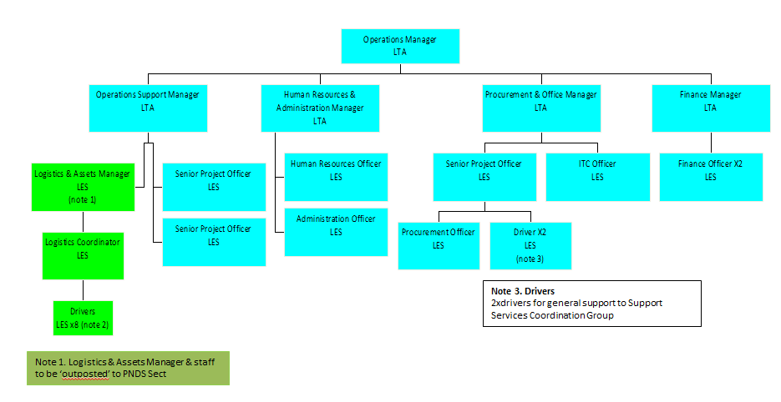

# Annex 9: Draft implementation Schedule

This Implementation Schedule is a rolling work plan that outlines the shared vision of GoTL and GoA on the scope of work necessary to deliver PNDS, and the respective contributions, roles and responsibilities of each party in delivering an effective program. This Implementation Schedule can be used by both parties to develop their individual work plans, and to frame the delivery of their respective contributions.

###### Status and approval process

This Implementation Schedule is a **draft*,*** which will continue to be developed collaboratively between GoA and GoTL, with input from other parties including the interim Managing Contractor, and key advisers in the Secretariat. GoTL has not yet had the opportunity to include their commitments in this version of the document, and neither has the Managing Contractor. However, GoTL has clearly outlined their priorities and timetable in seeking Australian support, and this is included in this version of the schedule.

Agreeing on priorities is important (hence the “priorities” column) so that agreement can be reached on support within budget and other resourcing constraints for each party. Also, where parties need to consider support on a case-by-case basis, a set of processes or principles will be outlined for making such decisions (hence the “principles / process” column).

A final version will be presented to the Technical Working Group, and once approved, will guide implementation. The IS will be revised each six months, and resubmitted to the TWG for comment and final approval.

###### What this implementation schedule does not include

The draft implementation plan is what GoTL and GoA need to jointly deliver for PNDS implementation. This does not include all of the other tasks that all parties need to undertake to deliver on the commitments outlined in this document. For example, MAE will need to continue to deliver their GoTL corporate responsibilities above and beyond PNDS. Australia needs to go through a tender and mobilisation process to procure a Managing Contractor to deliver many of the commitments. This Managing Contractor will also need to undertake a series of activities to deliver such things as technical assistance, including recruitment, mobilisation, performance management, pay, logistics, accommodation, transport, IT, and security arrangements. These sorts of tasks need to be captured in agency / organisational work plans rather than in this Implementation Schedule.

| **Ensure high level political commitment and support** | | | | | |
| --- | --- | --- | --- | --- | --- |
| **DELIVERABLES** | **TASKS** | **PROPOSED AUSTRALIAN SUPPORT** | **PROPOSED GoTL SUPPORT** | **PRINCIPLES / PROCESS** | **PRIORITY** |
| * 1. Understand all key stakeholders and engage with them effectively | Undertake stakeholder mapping exercise and develop comprehensive stakeholder engagement strategy for PNDS | LTA – Comms  Management capacity development building for PNDS Sect team |  |  | HIGH |
| Invest in effective engagement with relevant stakeholders formally and informally as appropriate and required | As above |  |  |  |
| Understand emerging issues and initiatives in other agencies and review / adapt PNDS accordingly | As above |  |  |  |
| Disseminate appropriate updates / information on PNDS regularly and seek feedback from relevant stakeholders | LTA - Comms |  |  | HIGH |
| Maintain close working relationship between GoTL and GoA to guide support & ensure we can deliver PNDS effectively  Periodic review of partnership & support | Program Director (overall coordination of Australian support)  Senior Officer (targeted specialist advice & representing Australia); Six-monthly review of implementation strategy; periodic partnership discussion; Weekly meetings PNDSSP & Secretariat. |  | Close, ongoing bilateral engagement and frank discussion will support the partnership |  |
| * 1. Support coordination and communication between PNDS parties at national and sub-national levels | Inter-Ministerial coordination at the national level via TWG | LTA – SPC;  Australian direct support; |  |  | HIGH |
| PNDS program coordination between national and sub-national level and between sectors via District Coordinators | Field Team |  |  |  |
| Support Line Ministries to help their national and sub-national staff and stakeholders work effectively with PNDS | Australian sector programs  Field Team |  |  |  |
| * 1. Garner necessary political commitment, program approvals, budget support, etc. | Regularly engage with key decision-making agencies – PMO, Council of Ministers, MoF, ADN, etc. to ensure PNDS is included in significant decisions |  |  |  |  |
| Ensure effective work plans are developed for PNDS as a basis for outlining program scope and needs | LTA - SPC |  |  | HIGH |
| Develop and maintain accurate budget plans for PNDS as a basis for budget request, and provide timely and accurate financial reports to Finance | LTA – SPC / PFM  Development of MIS  Management capacity development for key Secretariat staff |  |  | HIGH |
| Develop and have approve all relevant legal / regulations for PNDS | LTA – Legal (through GfD) |  |  | HIGH |
| Provide accurate and relevant reporting to agencies as required – MoF, PMO, etc. | LTA – SPC / PFM |  |  |  |
| * 1. Manage risks effectively | Develop and periodically revise a risk management framework | LTA – SPC, OA |  |  | HIGH |
| Track and manage risks as they arise | LTA – SPC, OA |  |  |  |
| Identify and monitor conflict risks; work with relevant stakeholders to reduce and mitigate conflict. | Partnerships with TAF and local NGOs (tbd); |  |  |  |
| * 1. Communicate and advocate for the program | Work proactively with key stakeholders (within Government and non-government actors) to ensure they understand the program. Provide avenues for their input to improve the program. | LTA – Comms |  |  | HIGH |
| Provide translation services as needed (for communities and partners); | LTA – Comms |  |  |  |
| Printing and publication of reports and materials, development and management of website, posters, briefings, etc. | LTA – Comms  Website and graphics? |  |  |  |

| **Produce and continue to improve program design** | | | | | |
| --- | --- | --- | --- | --- | --- |
| **DELIVERABLES** | **TASKS** | **PROPOSED AUSTRALIAN SUPPORT** | **PROPOSED GoTL SUPPORT** | **PRINCIPLES / PROCESS** | **PRIORITY** |
| * 1. The Program Operations Manual with reference to cross cutting issues such as gender and inclusion, social cohesion, environment | Design the POM | LTA and STA – include SPC, PFM, QA, Gender, Environment, Social Cohesion, M&E, MIS, |  |  | HIGH |
| Publish / print and disseminate POM through community socialisations and stakeholder engagement strategy | LTA - Comms |  |  |  |
| Test the POM through Field Trial and 2014 activity cycle | LTA and STA as above, as well as Field Test Team |  |  |  |
| Continue to ensure POM and guidance is in line with evolving Minimum Service Standards for infrastructure, sub national governance structures and public financial management reforms |  |  |  |  |
| * 1. Related guidance and handbooks (e.g. Financial management) | Design and trial field guidance for Financial management | LTA and STA |  |  | HIGH |
| Design / adapt field guidance for Technical facilitators including publication of “Good and Bad Construction” | LTA and STA |  |  |  |
| Design / adapt field guidance for community planning and mobilisation (Social, MIS, CHS, sub-national coordination) |  |  |  |  |
| Updating training curriculum | Training Team (MC) |  |  | HIGH |
| Publish / print and disseminate field guidance | Australia to fund / manage the publishing / printing of guidance? |  |  |  |
|  | Test guidance and handbooks through Field Trial and 2014 activity cycle |  |  |  |  |
|  | Continue to ensure that guidance and handbooks are in line with evolving reforms to public financial system, Minimum Service Standards for infrastructure and sub national governance reforms such as the formation of municipalities |  |  |  |  |
| * 1. Necessary regulations for operational purposes (e.g. for spending, procurement, etc.) | Develop and gain approval for necessary regulations. | LTA – include SPC, Ops Adviser, PFM, QA, Legal Adviser |  |  |  |
|  |  |  |  |  |
| * 1. Continual improvement of design (including through special reviews and studies) | Continue to improve the POM – two monthly learning forums - and ensure updates are reflected in revised training modules | LTA and STA – include SPC, PFM, QA, Gender, Environment, Social Cohesion, M&E, MIS, |  |  | HIGH |
| Special studies – see section on monitoring. Socialise design changes with all stakeholders and ensure political support |  |  |  |  |

| **Establish and maintain institutional mechanism for program delivery** | | | | | |
| --- | --- | --- | --- | --- | --- |
| **DELIVERABLES** | **TASKS** | **PROPOSED AUSTRALIAN SUPPORT** | **PROPOSED GoTL SUPPORT** | **PRINCIPLES / PROCESS** | **PRIORITY** |
| * 1. Inter-Ministerial commission and Technical Working Group | Develop Terms of Reference for IMC / TWG members, and formalize through Decree / Diploma. Establish working Groups within TWG for key program areas | TA – OA Legal, SPC |  | Australia does not pay salaries or per diems / honoraria for Civil servants |  |
| Plan and support undertaking of regular and ad hoc TWG meetings | LTA – SPC, |  |  |  |
| * 1. PNDS Secretariat | Develop Org Structure and TORs for the Secretariat, and formalize through Decree / Diploma | LTA – SPC / OA |  |  | HIGH |
| Develop and revise Secretariat work plans, and manage implementation of the work plan | LTA –SPC, OA |  |  |  |
| Ensure effective budgeting and financial management within Secretariat including setting up of FreeBalance system, procurement processes, petty cash, etc. | LTA – OA, PFM, |  | Australia does not pay Secretariat running costs; will transition out of current support. | HIGH |
| Ensure National Secretariat office and district offices have clear operating procedures for all aspects of office management |  |  |  | HIGH |
| Ensure National Secretariat office and district offices are fitted out, equipped and maintained – buildings and furniture | LTA – OA, Procurement |  | Australia has supported Secretariat fit out; transition out |  |
| Ensure National Secretariat office and district offices have functioning IT and comms systems | LTA – IT – can assist with specifications |  | GoTL purchase & maintenance |  |
| Develop systems to manage assets in accordance with GoTL policy and train staff, including vehicles, IT, office supplies, etc. | LTA – OA / Procurement |  | Australia does not provide admin offices – focus is on capacity development |  |
| Establish record keeping systems | LTA – OA  MIS support |  |  |  |
| * 1. Sub-national arrangements including district and sub-district coordinators and facilitators | Recruit, contract, train and assess Sub District and District trainees – social, technical, financial | Training program (3 streams SDF, DCs, MIS) – Contractor / new MC with local training partners and venues. New starter and refresher training. |  | High quality training essential to program quality | HIGH |
| Recruit, contract, and induct successful trainees to become Sub District and District Facilitators and Coordinators as Civil Servants | Senior Officer, OA  LTA/STA – HRM?  Capacity building for MAE/Secretariat staff  GfD – Support to CSC |  | Recruiting and employing PNDS employees consistent with CSC guidelines; performance management; building Ministry capacity on HRM. | HIGH |
| Recruit, contract, and induct Other District and Sub-District staff (MIS) | Senior Officer, OA  LTA/STA – HRM?  Capacity building for MAE/Secretariat staff  GfD – Support to CSC |  | Recruiting and employing PNDS employees consistent with CSC guidelines; performance management; building Ministry capacity on HRM. | HIGH |
| * 1. PNDS national staff have capacity to manage program | Learning and development opportunities for staff, linked to ToR / performance management | Identify key positions for professional development support  LTA – OA, SPC, Senior Officer |  |  |  |
| * 1. Other program support mechanisms (Contractor, TAF, World Bank, etc.) | Establish mechanism for delivering TA and other logistical support to PNDS (Australian funded managing contractor) | PNDSSP design and open tender (6-9 months to tender and mobilise).  BNCTL support? - tbd |  | GfD supports broader Ministries CB; PNDS program focused on PNDS; need cohesion between the two programs. |  |
| Establish World Bank Trust Fund to access specialist TA such as in M&E, MIS, CHS, baseline surveys, etc. | Australia-World Bank Country Trust Fund  Specific budget & staffing in Bank for PNDS (tbd) |  |  |  |
| Develop / formalize partnership with TAF for review / monitoring role | Australia-TAF Partnership agreement  Specific budget & staffing in TAF for PNDS |  |  |  |
| Develop partnerships with local NGOs to support community planning and monitoring (tbd) | Through Managing Contractor or TAF |  | Using the expertise of different partners to provide practical & political support PNDS |  |
| Sub contracts and capacity building of training centres, including accreditation of courses and alignment with National Skills Framework | Through Managing Contractor / Training Team / Procurement |  |  |  |

| **Support the implementation of key program activities** | | | | | |
| --- | --- | --- | --- | --- | --- |
| **DELIVERABLES** | **TASKS** | **PROPOSED AUSTRALIAN SUPPORT** | **PROPOSED GoTL SUPPORT** | **PRINCIPLES / PROCESS** | **PRIORITY** |
| * 1. Field Test 2013 | Design and plan field test, develop budget for field test, and support management | LTA – SPC, PFM, Senior Officer |  |  | HIGH |
| Recruit and train team for implementing Field Test 2013 including Sub District and District Facilitators, District Coordinators | LTA – Senior Officer, SPC,  Training team |  |  | HIGH |
| Undertake socialisation activities in field test areas | Logistical support - Contractor |  |  |  |
| Mobilize Field Test Team to 5 Districts / 30 Suku | STA – 4 Field Test advisers (Social, Financial, Engineering)  Logistical & IT support to TA - Contractor |  |  |  |
| Ensure for Field Test Team have access to essential goods and equipment, including POM, handbooks, operational funding (e.g. to carry out socialisation, elections, training, reporting, etc.) | STA field test team;  Some support with materials - Contractor |  | Operational funds come from GoTL; Australia doesn’t pay GoTL staff salaries or per diems. |  |
| Ensure banking and disbursement arrangements and process are in place to disburse operational funds and tranches of Block Grants (including safes in each Suko) (Liaison with BNCTL) | LTA – PFM, Legal Adviser, Senior Officer  Installation of safes – assistance with specifications - Contractor |  | POM guidelines | HIGH |
| Ensure that Field Test Team are paid relevant salaries and allowances in a timely and transparent manner | STA – OA to support process |  |  |  |
| Provide technical support and monitoring of Field Test Team | STA – Field Test advisers x4 |  |  |  |
| Ensure lessons from field test are captured and fed into revised POM / guidance / PNDS processes | Fund Review of Field Test – M&E Adviser and TAF field teams; regular learning activities. |  |  | HIGH |
| * 1. Regular activity cycle – 2014 and beyond | Mobilize Sub District and District facilitators | STA/LTA – HRM?  Senior Officer | Salaries, per diems and allowances |  |  |
| Ensure for Sub District and District Facilitators have access to essential goods and equipment, including POM, guidance, operational funding (e.g. to carry out socialization, elections, training, reporting, etc.) | STA/LTA – HRM?  Senior Officer |  | Operational funds come from GoTL; Australia doesn’t pay GoTL staff salaries or per diems. |  |
| Provide refresher training & in-field mentoring for Sub District and District Facilitators and increasingly move towards government accreditation of Facilitator training and linking to the National Skills Framework | Training courses and mentoring – Contractor | Per diems | Australia does not fund per diems for public servants | HIGH |
| Ensure that Sub District and District facilitators are paid relevant salaries and allowances in a timely and transparent manner | STA/LTA – HRM, OA  Senior Officer |  |  |  |
| Provide high levels of technical support and monitoring of Sub District and District facilitators via field team (see below) |  |  |  | HIGH |
| Performance management of sub-District Facilitators and District teams via CSC or have this mandate delegated | LTA – HRM, Senior Officer |  |  | HIGH |
| Ensure banking and disbursement arrangements and process are in place to disburse operational funds and tranches of Block Grants (including safes in each Suku) | LTA – PFM, Senior Officer, STA – PFM Specialists |  |  | HIGH |
| Ensure lessons from each activity cycle and changing implementation environment (e.g. decentralization) are captured and fed into revised POM / guidance / PNDS processes | LTA – PD, SPC |  |  |  |
| Duty of care for facilitators – especially in the face of deteriorating security |  |  |  |  |
| * 1. Field support team | Develop a design / TORS for an independent Field Support Team | PSC, CDD Advisor |  |  | HIGH |
| Recruit and contract Field Support Team | HRM / Contractor |  |  | HIGH |
| Provide relevant training and induction to Field Support Team | HRM / Contractor |  |  | HIGH |
| Provide relevant logistical support – office space, IT, equipment, transport, etc. | HRM / Contractor |  |  | HIGH |
| Quality Assure the work of the Field Support Team and ensure that their observations and support is captured in continuous improvement of program | SPC, M&S, PFM, etc |  |  | HIGH |
| * 1. Other activity cycle related issues | PDID and links to planning cycles (Plannu Distritu Integrated) – sync by 2015. |  |  |  |  |
| Emerging line agency programs and coordinating with these |  |  |  |  |
| Sub-district Development committees – role and capacity development |  |  |  |  |
| EVAS – role and function, as well as capacity development |  |  |  |  |
| Role of the Chefe Suku |  |  |  |  |

| **Support monitoring and evaluation of the program content** | | | | | |
| --- | --- | --- | --- | --- | --- |
| **DELIVERABLES** | **TASKS** | **PROPOSED AUSTRALIAN SUPPORT** | **PROPOSED GoTL SUPPORT** | **PRINCIPLES / PROCESS** | **PRIORITY** |
| * 1. Overall M&E Framework – KPIs, outcomes, etc. | Develop / finalize an M&E Framework including program logic, hierarchy of objectives, KPIs, and outcome / output measures (workshop with Government) | STA – M&E,  World Bank (tbd) |  |  | HIGH |
| * 1. Review and data collection for Field Test 2013 | Develop and implement a Field Test Review | STA – M&E  Australian partnership with TAF  Logistical support from Contractor |  |  | HIGH |
| Facilitate monthly “learning forum” to ensure timely feedback from Field Test | As above |  |  | HIGH |
| Final Field Test Review report with clear recommendations on improvements to program processes and approach | As above |  |  | HIGH |
| * 1. Evaluation plan, including specialist studies and research | Develop an evaluation plan that will capture qualitative and special interest data needed for the M&E Framework.  Includes quality assurance / technical compliance of engineering works. | World Bank (tbd)  TBD |  |  | HIGH |
| Design and commission baselines study | World Bank (tbd) |  |  | HIGH |
| Design and commission other relevant studies in line with Evaluation plan | World Bank (tbd) |  |  | HIGH |
| * 1. Management of Information System (MIS) | Establish Working Group to design and oversee development of MIS that captures data required for M&E Framework, Evaluation Pan, and routine GoTL reporting | LTA - IT Adviser (Contractor) |  |  | HIGH |
| Build MIS (hardware and software) and embed in Secretariat and at District level |  |  |  | HIGH |
| Establishment of training and guidance on MIS including for sub-national stakeholders | Training MIS officers (Contractor) |  |  | HIGH |
| Determine role for MIS officers | Training MIS officers (Contractor)  Support their work |  |  | HIGH |
| Continue to monitor and support improvements in MIS | TBD |  |  | HIGH |
| * 1. Complaints handling system (CHS) | Establish Working Group to design and oversee development of CHS | STA/LTA – CHS / World Bank (tbd) |  |  | HIGH |
| Establishment of training and guidance on CHS including for sub-national stakeholders |  |  |  | HIGH |
| Continue to monitor and support improvements in CHS |  |  |  | HIGH |
| * 1. Auditing and fiduciary monitoring | Develop / design a system of internal and external auditing for the program at all levels |  |  |  | HIGH |
| * 1. Support Learning and Improvement | Use program evidence to discuss progress with key stakeholders and inform ongoing decisions/policy making | LTA – PD, SPC |  | Commitment to learning and improvement | HIGH |
| Cross village learning, support, and monitoring. Find stand out Suku and use these as models |  |  |  |  |
| Study tours to other CDD programs, participation in regional workshops, exchanges for others to visit Timor-Leste | Logistical support (tbd)  Contacts with other programs |  | TBD | HIGH |

| **Risk Event** | **Potential impacts** | **Risk Level** | | | **Risk Management Strategy (ie steps Australia is able to take to minimise the risk occurring and/or its impacts)** | **Residual**  **Risk** | | | **Responsibility within GoA or GoA-contracted program for Australia’s part in managing risks.** |
| --- | --- | --- | --- | --- | --- | --- | --- | --- | --- |
| **L** | **C** | **R** | **L** | **C** | **R** |  |
| ***Political risks*** | | | | | | | | | |
| Unrealistic expectations, prioritisation of political interests, political intervention in program operations. | PNDS implementation is interrupted or fails to meet the quality and compliance standards set out in the design, negatively affecting communities and harming GoTL and GoA reputations, or politicising GoA’s reputation. | Likely | Major | High | Australia will maintain its close relationships with GoTL officials (including the Prime Minister, Ministers for Finance and State Administration and with officials working on PNDS). Through these relationships, Australia will ensure we understand the political dynamics affecting PNDS and try to influence GoTL decision-making by providing practical and timely advice. | Possible | Moderate | High | Minister-Counsellor  PNDSSP Program Director |
| GoTL capacity is insufficient to implement PNDS. | MAE, MF, CSC and other Ministries unable to manage PNDS policy and resources (among other programs & responsibilities) leading to delays, inconsistent decision-making, poor human resource management and poor budget execution, affecting outcomes in communities, reputation at national, district & sub-district levels & GoTL’s commitment to PNDS. Any failure to allocate sufficient and predictable annual budget means program can’t be delivered. | Almost Certain | Moderate | High | Australia will provide technical assistance to the Ministries of State Administration and Finance (eg for human resource management) to support PNDS implementation. It will use M&E results to discuss with GoTL how to improve PNDS management. It will discuss these issues at a high-level (as per governance arrangements) and link with GoA’s broader interaction with GoTL on budget and development. | Likely | Moderate | High | Minister-Counsellor  PNDSSP Program Director  M&E coordinator |
| Ministry of Finance withdraws funding from PNDS if it is not satisfied with financial management or program quality | PNDS cannot be implemented and the benefits of Australia’s investment are compromised. | Possible | Major | High | Ongoing engagement with Ministry of Finance to ensure they are actively involved in the program during design and implementation, and that they appoint strong counterparts to work with other ministries. | Unlikely | Major | Moderate | Minister-Counsellor  Governance for Development team  PNDSSP Program Director |
| GoTL allocates insufficient annual resources to implement PNDS. | Allocation of insufficient recurrent and operational costs for PNDS through the budget means PNDS can’t be implemented effectively. | Likely | Moderate | High | High-level advocacy on the importance of investing sufficiently. Through support to the Technical Working Group / Secretariat and partnership with the Ministry of Finance, Australia will provide technical assistance to the Ministries of State Administration and Finance to support appropriate, evidence-based budget development. | Possible | Moderate | High | PNDSSP Program Director |
| Inter-ministerial coordination is poor and PNDS is seen by ministries as outside their mandates and/or as a threat to their resources & status. | At community level, the design and implementation of PNDS projects does not abide by relevant sectoral procedures or roles, resulting in duplication, poor quality projects, undermining of essential sectoral capacities, wasting funds or impairing PNDS reputation. At a policy level, ministries seek to undermine PNDS, or displace their own priorities to access PNDS resources. | Likely | Moderate | High | GoA will work with the TWG to ensure all PNDS guidelines fit with other, agreed sectoral processes (eg for construction & maintenance of water and sanitation infrastructure). Through the Technical Working Group/ Secretariat and other Australian sectoral programs, ensure ministries allocate resources for coordination with PNDS. PNDS facilitators will be trained to understand sectoral roles and guidelines and to work with sectoral staff at district &sub-district levels to ensure PNDS projects adhere to, or complement sectoral approaches. Australia will draw on its relationships across sectors to promote effective inter-ministerial communication coordination at a national and sub-district levels. Australia will monitor cross-sectoral interaction at community and high-levels. | Possible | Minor | Moderate | PNDSSP Program Director  Other DFAT sector staff  Training Manager  M&E coordinator |
| ***Operational risks*** | | | | | | | | | |
| Disbursement of grants to communities by government is delayed | Communities don’t receive grants on time or have to rush projects, due to delays created by, for example, slow budget approval by Parliament or slow financial processing. | Likely | Minor | Moderate | Through support to the PNDS Secretariat and TWG, Australia has supported GoTL to design a program with appropriate controls but as few bottlenecks as possible. Through bilateral engagement and the managing contractor, Australia will work with MAE and MF to implement the PNDS financial system and monitor bottlenecks. | Possible | Minor | Moderate | Program Director  GfD Ministry of Finance program |
| Program implementation is of a poor quality and/or delayed due to non-adherence to POM by operational staff or other factors. | Poor quality infrastructure projects are built, wasting money and creating risks to community safety and the environment. Maintenance is neglected or not agreed upon. The financial integrity of the program is compromised, leading to a loss of confidence and budget from GoTL and donors. Community participation is not broad-based and men and women experience negative social outcomes. | Possible | Moderate | High | Australia will train sub-district and district facilitators so that they understand adequately the program cycle and have adequate skills in social, technical and financial facilitation to ensure that standards are met and that maintenance arrangements are agreed and adhered to. Australia will provide refresher training and ongoing mentoring to ensure that facilitators’ capacity is improved over time. Australian-funded technical advisers will work with GoTL to monitor implementation and manage performance of facilitators. | Unlikely | Moderate | Low | PNDSSP Program Director  Training Manager  M&E coordinator |
| PNDS staff (facilitators and management staff) are insufficiently motivated to or capable of performing their jobs to a high quality and are poorly managed by Ministry of State Administration | Communities do not have adequate support, the program does not meet their expectations and there is social disruption or conflict. PNDS projects are of poor quality. Reputational harm to GoTL and GoA. PNDS staff may not receive their salaries and logistical support (phone credit, motorbikes/fuels etc) in a timely or consistent manner, impairing their ability to do their jobs. Staff drop out of the program over time, leaving gaps in quantity and experience of staff. | Likely | Moderate | High | GoA will work with GoTL to ensure there is adequate recurrent resourcing for operational needs; Australia will ensure training and mentoring provides adequate technical capacity and seek to motivate staff; Australia will work with GoTL to develop an HR policy and incentives for good performance. | Possible | Moderate | High | PNDSSP Program Director |

# Annex 10: Risk Matrix

|  |  |  |  |  |  |  |  |  |  |
| --- | --- | --- | --- | --- | --- | --- | --- | --- | --- |
| **Risk Event** | **Potential impacts** | **Risk Level** | | | **Risk Management Strategy (ie steps Australia is able to take to**  **minimise the risk occurring and/or its impacts)** | **Residual**  **Risk** | | | **Responsibility (within GoA or GoA-contracted program)** |
| L | C | R | L | C | R |
| Fraud related to GoTL-funded grants occurs in a significant number of sukus. Fraud related to Australian-funded training, grants or resourcing occurs. | Program funds are lost and PNDS benefits are distributed unevenly or unfairly within communities. Communities experience delays implementing projects while fraud cases are resolved. Reputation of PNDS within GoTL harmed and program compromised. Australia expends considerable resources dealing with fraud cases, may attract media attention and may reconsider its investment. | Possible | Moderate | High | The PNDS Operations Manual has in place measures for opening and using bank accounts, acquitting funds, and grievance handling. Assuming facilitators and community groups abide by rules, these will minimise the number and the impact of fraud cases. Serious fraud cases relating to community grants will be managed by the PNDS TWG with Australian input where needed. GoA has a zero tolerance policy on fraud and will manage suspected fraud in relation to its funding in accordance with GoA policy. | Possible | Minor | Moderate | PNDSSP Program Director |
| The National Bank of Timor-Leste is unable to support the opening and operation of the large number of suku accounts required for PNDS | Grants unable to be disbursed to communities in some areas; constrains further expansion of banking sector; money is stolen (possibly violently) during transfer to remote areas. | Possible | Moderate | High | Through ADB and bilateral engagement with MF, work with BNCTL to help prepare for PNDS. Look at possible links through Australia’s microfinance programs. Explore innovative opportunities to overcome constraints (eg extra petrol money to access a branch in another districts). | Possible | Minor | Mod | PNDSSP Program Director  Governance for Development Team |
| PNDS does not make an adequate contribution to poverty reduction and improving living standards in Timor-Leste in its first four years. | Villagers don’t derive real or sustained benefit from the Government’s investment in PNDS, or benefits are not shared broadly within communities; communities, Government and/or partners withdraw or reduce support from the program. | Likely | Major | High | GoTL and GoA need to establish clear expectations for what the program can and can’t deliver. Opportunities for increasing investment and service delivery in villages over time through PNDS, the broader decentralisation effort and line ministries is discussed by GoA and GoTL as part of ongoing bilateral engagement, annual high level discussions and is considered in specific evaluation reports. | Unlikely | Major | Moderate | PNDSSP Program Director |
| Women in Timorese communities do not have equitable involvement in PNDS decision-making, implementation or access to project benefits. | Timorese women marginalised from PNDS community decision-making. Community norms about women’s capacities and interests are not changed. Women’s social and economic welfare does not improve or declines because they don’t get a fair share of the benefits. Women face increased risks of personal violence due to their participation in planning, construction or use of infrastructure. Women are unable to use PNDS small-scale infrastructure to leverage other economic opportunities. | Likely | Moderate | High | The program operations manual includes rules for women’s participation in PNDS. Australia will train facilitators to ensure women’s involvement at key steps. As set out in PNDS M&E Plan, women’s participation will be monitored and evaluations conducted at key points which interrogate the positive and negative impacts of PNDS for Timorese women. Australia will fund TA in the Secretariat to support a focus on gender equality. Australia will raise the issue of gender equality in PNDS in its (annual / periodic governance) discussions with GoTL and seek to involve the Secretary of State for Promotion of Equality in PNDS management and monitoring. | Possible | Moderate | High | PNDSSP Program Director  M&E Adviser  Gender Equality Adviser? |
| Conflict is created or exacerbated in communities due to access to PNDS resources, inequitable decision-making or poor project implementation. | Individual community members are harmed; relationships within or between sukus are harmed; infrastructure is not completed, is destroyed or people are prevented from using it. Conflict over PNDS spills over to connect to existing or broader community conflicts, which may lead to larger impacts. Community leaders may be implicated in the conflict, or unable to prevent or stop it. | Likely | Major | High | Australia will train PNDS facilitators to work with communities during planning, decision-making and implementation to try to minimise conflict risks. Conflict risks and incidences will be monitored as part of the PNDS M&E Plan, including through partnership with local CSOs. | Likely | Moderate | High | PNDSSP Program Director |
| Disputes arise over use of land and other natural resources (e.g. water) on PNDS project locations. | Risk of conflict arising (particularly in urban areas) that will be difficult to resolve in an uncertain, or contested, policy and legal environment. Risk that infrastructure is vandalised. Project implementation is delayed as communities are unable to decide where to build infrastructure and how community members will access fairly the benefits. | Possible | Minor | Moderate | The Program Operations Manual requires that projects are built only on land that is uncontested. Facilitators should refer to resources (eg cadastral survey, community meetings) to ensure that this is the case and to help communities negotiate use of natural resources. Communities and facilitators will be trained in the use of the PNDS complaints mechanism. Australia will support GoTL to ensure complaints are resolved in a timely way. Australia will monitor the development of land policy and legislation in Timor to understand how it might affect implementation of PNDS and work with GoTL to minimise risks to PNDS success arising from uncertainty or from new policy and legislation. | Unlikely | Minor | Low | PNDSSP Program Director |
| Development partners (bilateral, multilateral, NGOs) establish parallel policies and programs and development efforts remain uncoordinated. | GoTL is pressured to fund or support multiple or conflicting efforts at community development and sectoral work. The community development effort continues to be fragmented, missing the benefits for sustainability and equity of a nation-wide, government funded program. Competing donors may criticise PNDS performance rather than assisting to improve it. | Possible | Minor | Moderate | As part of our ongoing engagement with GoTL and development partners, Australia will use policy discussion and funding opportunities to help build support of other partners to implement PNDS. For example, it will fund the World Bank to undertake M&E and fund civil society organisations to assist with local-level planning, conflict mediation and M&E. Australia will support GoTL to advocate for the combined efforts of donors, in accordance with the Busan agenda and G7+. | Possible | Negligible | Low | Minister-Counsellor  PNDSSP Program Director  PNDSSP program staff |
| The managing contractor does not deliver a high-quality support program or is unable to manage constructive relationship with GoTL. | Australia is unable to deliver the support it has committed to GoTL; Australia’s reputation is damaged; program outcomes are reduced because training and technical assistance is poorly delivered and monitored. | Unlikely | Moderate | Moderate | The Program Director will be contracted by GoA to oversee delivery of operations by a managing contractor. This will create an effective link between policy development and operations and ensure that GoA is central in policy and program management with GoTL. Austalia will allocate sufficient additional resources within the country program team to manage the contract and will actively monitor the MC’s performance. | Rare | Minor | Low | PNDSSP Program Director  PNDSSP program staff  MC Operations Manager  MC Head Quarter Contract manager |
| Program Director and DFAT management quality is inadequate to manage complex program with GoTL | PNDS suffers because Australian inputs are not sufficient to support implementation and evaluation of program. | Unlikely | Moderate | Moderate | Australia will invest in the selection process for the recruitment of the Program Director to ensure that the selected candidate has the skills, experience and understanding required to manage this program. Australia will assign staff with appropriate skills and experience to support the program in Dili and Canberra and continue to monitor direction of PNDS. | Rare | Moderate | Moderate | Minister-Counsellor  Governance for Development Director |

1. The Program Operations Manual is currently being field-tested and is likely to be updated following lessons learned during the field test.
2. Services are being provided by Cardno Emerging Markets, under the Interim Governance for Development contract.
3. The Asia Foundation and Irish Aid, “Community experiences of decentralised development in Timor-Leste”, 2012 p20
4. World Bank (2009) Community Based Development and Infrastructure in Timor-Leste: Past Experiences and Future Opportunities, p21
5. The Asia Foundation and Irish Aid, “Community experiences of decentralised development in Timor-Leste”, 2012, p4.
6. The Asia Foundation and Irish Aid, “Community experiences of decentralised development in Timor-Leste”, 2012p 18
7. TAF notes that an exception to this general agreement, however, was the sub district administrator of Baguia, who argued that the PDL process took too much time, when there were too many urgent development priorities that need to be addressed
8. The Asia Foundation and Irish Aid, “Community experiences of decentralised development in Timor-Leste”, p19
9. Through the PDS, suco councils have come up with one-year and five-year plans, identifying development priorities through conducting community meetings in each aldeia, and then prioritising them at the suco level.
10. The Asia Foundation and Irish Aid, “Community experiences of decentralised development in Timor-Leste”, 2012, p4.
11. BESIK Community Engagement Review May 2012
12. World Bank (2009) Community Based Development and Infrastructure in Timor-Leste: Past Experiences and Future Opportunities, p21
13. Governance and Social Development Resource Centre (2012) Helpdesk Research Report: PNPM/CDD in Indonesia, p7
14. The Asia Foundation (2012) “PNDS pre-design study”.
15. The Asia Foundation and Irish Aid (2012) “Community experiences of decentralised development in Timor-Leste”
16. World Bank (2006) CEP Project Assessment Performance Report
17. The Asia Foundation and Irish Aid (2012) “Community experiences of decentralised development in Timor-Leste” p 18
18. The Asia Foundation and Irish Aid (2012) “Community experiences of decentralised development in Timor-Leste” p18
19. The Asia Foundation and Irish Aid (2012) “Community experiences of decentralised development in Timor-Leste” p19
20. Crawford and Willetts (2012) BESIK Independent Completion Report, p28.
21. World Bank (2009) Community Based Development and Infrastructure in Timor-Leste: Past Experiences and Future Opportunities p31
22. World Bank (2006) CEP Project Assessment Performance Report
23. Ospina and Hohe in World bank XX p 20
24. A regulatory framework for chefes de suco and councils, including their funding, in now in place, which will give greater clarity to the form of interactions between suco councils and PNDS structures. In addition, literacy is not a requirement for election to suco councils.
25. The Asia Foundation and Irish Aid (2012) “Community experiences of decentralised development in Timor-Leste”
26. The Asia Foundation and Irish Aid (2012) “Community experiences of decentralised development in Timor-Leste”
27. Wong (2012) What Have Been the Impacts of World Bank Community-Driven Development Programs? World Bank, p v-vi
28. Wong (2012) What Have Been the Impacts of World Bank Community-Driven Development Programs? World Bank, p26
29. Wong (2012) What Have Been the Impacts of World Bank Community-Driven Development Programs? World Bank, p26
30. J-PAL (accessed August 2013) <http://www.povertyactionlab.org/evaluation/community-driven-development-sierra-leone>
31. World Bank (2009) Afghanistan National Solidarity Program summary, http://web.worldbank.org/WBSITE/EXTERNAL/TOPICS/EXTARD/EXTRURLIV/0,,contentMDK:22138469~menuPK:5120069~pagePK:64168445~piPK:64168309~theSitePK:5097010,00.htm
32. Wong (2012) What Have Been the Impacts of World Bank Community-Driven Development Programs? World Bank, 40
33. http://web.worldbank.org/WBSITE/EXTERNAL/TOPICS/EXTSOCIALDEVELOPMENT/EXTCDD/0,,contentMDK:23013609~menuPK:8820441~pagePK:210058~piPK:210062~theSitePK:430161,00.html
34. World Bank (2007)
35. Wong, S., & Guggenheim, S. (2005). Community-Driven Development: Decentralization’s Accountability Challenge. *East Asia Decentralizes: Making Local Government Work*, p257
36. Wong, S., & Guggenheim, S. (2005). Community-Driven Development: Decentralization’s Accountability Challenge. *East Asia Decentralizes: Making Local Government Work* p259.
37. Wong (2012) What Have Been the Impacts of World Bank Community-Driven Development Programs? World Bank, p44.
38. I.e. The program needs to be of long enough duration, with repeated funding rounds, to establish trust about the program in communities and to entrench the rules of operation.
39. Wong (2012) What Have Been the Impacts of World Bank Community-Driven Development Programs? World Bank, p30
40. Wong (2012) What Have Been the Impacts of World Bank Community-Driven Development Programs? World Bank, p33