Strengthening

Civil Society in Myanmar

Paung Ku Annual Report 2010/11

Contents

Introduction 3

Objective 1: To Build Capacity 8

Objective 2: To Improve Practice 16

Objective 3: To Facilitate Networking 21

Objective 4: To Enhance Advocacy 27

Civil Society Strengthening in 2012 32

Conclusion 35

Appendix 1: Paung Ku donors 36

Introduction

This year has been one of dramatic change in Myanmar.

Elections, the release of Aung San Suu Kyi, a new President, the meetings of a new Parliament, new economic policy and new media and social freedoms have led to the most significant political shift of the last twenty years, or even the last fifty years.

Yet the picture is still mixed. While many of these changes have been positive, in some other ways things have deteriorated, especially in the north and east of the country where conflict has returned.

The change has also been most noticeable in urban areas, especially in Yangon and Mandalay. In other places, particularly in many rural and remote communities, little has changed - with poverty, lack of services and isolation persisting as before.

In last year’s annual report *‘Strengthening Civil Society in Myanmar 2009/10’* we explored the overarching questions related Paung Ku’s goal. *What is civil society? What does a strong civil society look like? What opportunities are there in Myanmar for strengthening civil society?*

This year we look more closely at each of Paung Ku’s four objectives (below) and explore our progress toward them within the changing context of Myanmar.

Paung Ku objectives are

* To **Build Capacity** of Civil Society Organisations
* To **Improve Practice** of the International Development Community
* To **Facilitate Networking** within Civil Society for learning, sharing and influencing wider change
* To **Enhance Advocacy** of Civil Society to Policy Actors

Overview

**Capacity Building** of civil society organisations through grants, mentoring, monitoring, training and cross visits has continued and there is a growing number of stories of positive organisational change. There are still gaps in Paung Ku’s evaluation and documentation (as identified in the 2010 evaluation) but progress is being made and a wider range of lessons are emerging about capacity building in the Myanmar context.

**Networking** and **Advocacy** activities have seen the most significant change in the last year. Township level networks, issue based networks and regional connections have grown rapidly (partly as a result of changes in the overall country context) and Paung Ku has been well placed to add value to these. There are also examples emerging where Paung Ku support has contributed to national level policy change (see below under advocacy objective). While enhancing advocacy and facilitating networks are new objectives (since 2010) for Paung Ku, there are signs that they are progressing quickly.

Paung Ku’s objective to **Improve Practice** of the international development community has also generated some outcomes in the last year. However, this remains Paung Ku’s most under resourced objective and will need a significant increase in attention in the final year (2012) of this phase.

Paung Ku was designed to be flexible and responsive to the visions and plans of Myanmar civil society organisations. This has meant that the initiative has been well placed to support the increasingly diverse work of civil society over the last year.

But while this diversity has being a strength of Paung Ku, it has also presented challenges in clearly representing the initiative- especially in an aid world dominated by sectors or geographically focussed projects. Rather than having one story to tell, there are a hundred unique stories of different groups in different places with different issues working in different sectors. This report attempts to cluster these stories into different themes and under our different objectives but this does not do justice to the real diversity on the ground.

One way of understanding the work of Paung Ku on the ground is through the micro projects which were supported in the last year.

Overall, (and including the Cyclone Giri Response) over two hundred civil society organisations were supported through capacity building, networking and advocacy activities, with Paung Ku providing over USD 600,000 in small grants (with each small grant being an average of USD 3-4000)[1].

Grant were divided between general development projects (related to ‘learning by doing’ and capacity building under objective 1), networking grants (related to objective 3) and advocacy grants (related to objective 4).

Overall, there were a total of 107 grants (not including Cyclone Giri) given in 2010/11

* Objective 1: 86 grants for a wide range of CSO development projects
* Objective 3: 7 grants for networking projects
* Objective 4: 14 grants for advocacy projects

How this overall number of grants compares with previous years is illustrated in the below graph which shows Paung Ku’s financial support to civil society micro projects over the four years since its inception in late 2007.

Of those grants given for development initiatives there was enormous variety. For example,

* Around one quarter of the grants, and especially those in Ayeyawaddy, were used for rural infrastructure development including roads, electricity infrastructure and bridges.
* Over ten grants were given for livelihood activities, such as a rice bank project by *A Nain Myittashin* group in Kachin State.
* Five grants were given to local groups focussing on HIV care or prevention. This included Muslim Positive Group in Yangon, Phoenix Network in Myitkyina, Naung He village HIV prevention group in Kachin State.
* Seven grants were given for small scale relief activities following the Mandalay flood in October 2010 (see case study below).
* A number of grants also went to specific capacity building activities. This included grants to networks to run workshops, such as the Food Security Working Group’s ‘Land Tenure’ Workshop, Buddhist Youth Empowerment Program for a ‘Community Development Awareness’ Training and the newly formed Myanmar Organisational Development Network for a planning meeting.

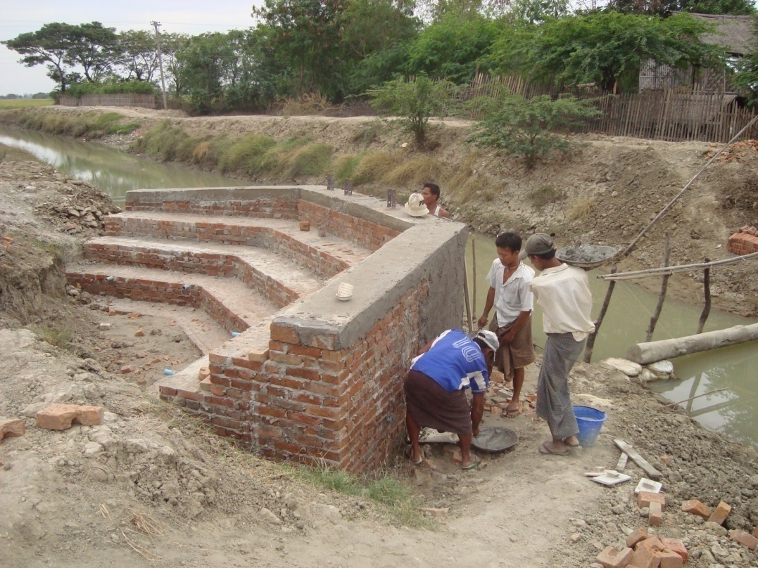A village bridge project supported by Paung Ku

In terms of geographic location, over half of Paung Ku non emergency grants were given in Yangon and Ayeyawaddy Divisions. The other grants were divided between Tanintharyi, Bago, Mandalay, Sagaing and Magway Divisions and Kachin and Shan states. The Cyclone Giri emergency response also meant that a large cluster (of 83 grants) went to Sittwe, Kyaukpyu and Myeboun townships in Rakhine state.

Perhaps the more critical geographical analysis is the relation between urban and rural grants. In 2009/10 almost all of Paung Ku grants were given to organisations based in rural communities. While the majority of grants are still given to rural groups, this year over twenty percent of support was to urban civil society organisations, especially those involved with advocacy and networking.

More widely, the Paung Ku consortium has been facing two key issues over the last year.

First is the tension between innovation and consolidation within Paung Ku. Paung Ku needs to have a creative focus on the core business of strengthening civil society. However, in order to have sustained impact and draw lessons to improve our practice, there also needs to be a level of consolidation in the way Paung Ku works, particularly in relation to documentation and evaluation. The 2010 evaluation highlighted this tension and it continues to present challenges to the initiative.

Second is the role of the consortium in Paung Ku. Originally, Paung Ku was a two person start up initiative which was completely dependent on a wider Consortium for its implementation and governance. But as the Paung Ku team has grown and developed its own implementation and leadership capacity over the last three years, the role of the consortium has become less clear. This is a problem. While it is often easier to rely on a discreet implementation team to achieve set objectives, the potential for synergies and wider impact is lost.

Objective 1 Build Capacity

Paung Ku grant systems are designed primarily to provide an opportunity for ‘learning by doing’. While the project outputs themselves are beneficial in a range of ways (improving livelihoods, health and education opportunities), Paung Ku is primarily aiming to increase capacity of organisations themselves, as well as building their role in networks and in advocacy. This combination of organisational capacity, networking, and increased voice are part of what Paung Ku has identified as being a ‘strong civil society’. Therefore, we are increasingly seeing these objectives as overlapping.

**Output 1.1**

**Expected output: 80 micro-projects funded, completed and evaluated by 60 civil society organizations each year.**

Achievement: 86 micro projects were funded to 75 CSOs (Cyclone Giri Response also funded 83 projects for 52 CSOs)

**Discussion**

2010/11 has seen a scale up in the numbers of grants given. Paung Ku gave as many non emergency grants this year as all of the three previous years combined.

However, while the capacity of Paung Ku to assess, disburse and monitor grants has increased, the evaluation at the end of 2010 highlighted that for building capacity, the quality of learning is the critical factor. The evaluation report described some gaps in the evaluation of individual micro projects. In many cases, CSOs themselves were not involved in a final evaluation of their projects.

In order to address this within the Paung Ku initiative, the indicator for Output 1.1 was changed to reflect evaluation (rather than grant disbursement) as the critical step in maximising capacity building.

Within the 2010/11 year, 49 projects funded under Objective 1 were completed. However, of these completed projects, only 27 had a clear end of project evaluation involving the CSO. In the coming year, in order to build a stronger understanding of the outcomes associated with the capacity building objective, all projects will need to be more rigorously evaluated.

Another area for improvement identified by the evaluation was the need for focussing more on repeat grants – where Paung Ku can be engaged with CSOs over a longer period of time. Overall of the 86 micro project grants given, less than 15 were repeat grants. Therefore, Paung Ku needs to continue to find ways to develop longer term relationships with CSOs.

**Output 1.2**

**Expected output: Mentoring programme completed with 40 grant-funded civil society organizations each year.**

Achievement: 73 CSOs received mentoring through 133 individual mentoring visits.

Average number of mentoring visits per CSO in 2010/11= 2

Number of CSOs which received more than 8 visits (ie completion of mentoring programme) = 8

**Discussion**

Mentoring has scaled up as an activity in 2010/11. Paung Ku employs five mentors and there were another 66 seconded mentors involved with the programme over the last year.

Together these mentors have reached over seventy CSOs around the country.

However, while Paung Ku has been able to mobilise a large number of mentors and there has been positive outcomes (see below in Capacity Building Outcome section), the evaluation highlighted two critical shortcomings.

First, the impact of mentoring will be related more to the depth of mentoring (through trust built up over a number of visits) rather than its breadth (number of organisations reached). While the breadth is impressive (73 CSOs receiving mentoring), in most cases the depth is not. For example, there was an average of only two mentoring visits per CSO.

Paung Ku’s experience has shown that it usually takes 4-5 visits to develop trust with an organisation and over eight visits to cover the basic organisational development areas in the mentoring design. Of the 73 CSOs reached, only eight organisations received these initial 8 visits. The difficulty of developing depth in the mentoring programme has been a long standing problem and in 2010/11 this continued.

Second, where mentoring is done there is limited documentation of lessons and outcomes. While there is some clear evidence of mentoring contributing to building capacity (see below in Outcome section) there could potentially be far wider learning and understanding of mentoring if documentation was better.

Part of the issue is the contribution of seconded mentors who – while motivated to be involved in Paung Ku mentoring – have other responsibilities, either to other agencies or to their own livelihoods. Therefore, seconded mentors are not easily able to give time or be held accountable to quality standards.

Paung Ku has responded to these challenges in the last year through trying to reduce the overall numbers of mentors (reducing ‘breadth’) in order to focus on the quality and depth of a smaller group. Paung Ku has also employed an international consultant to give periodic support to mentors in improving documentation and learning.

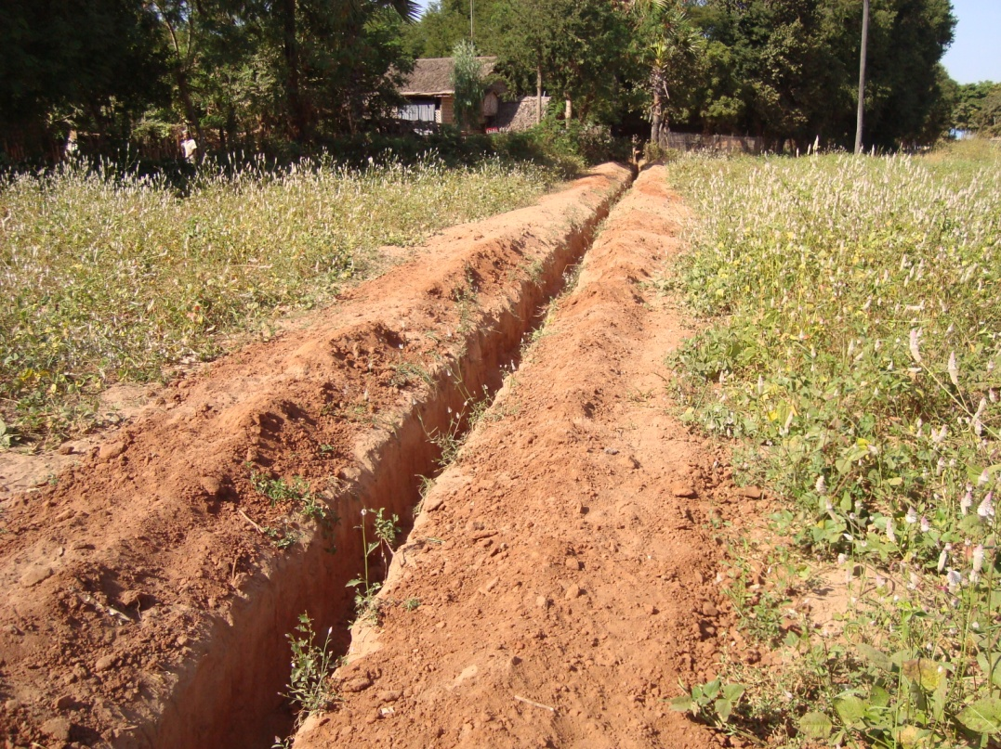A water project in Magway

**Output 1.3**

**Expected Output: Training delivered and cross visits facilitated for 60 civil society organizations each year.**

Achievement:

* Over 60 cross visits facilitated for 42 CSOs (nearly all in Ayeyawaddy Division)
* Workshops for 9 CSOs and 2 networks in ‘Grassroots Leadership Training’

**Capacity Building Outcomes**

In order to conceptualise changes in organisational capacity Paung Ku uses a model of capacity ‘to be’, ‘to do’ and ‘to relate’.

These areas are overlapping but help to distinguish between different aspects of capacity, for example in relation to project delivery, internal decision making and participation or relationships with authorities.

Organisational Capacity Model

To Be

To Do

To Relate

Through 2010/11 there are a number of examples where Paung Ku has been able to document capacity development within local organisations – related to capacity to be, to do and to relate. Direct attribution of this capacity development to Paung Ku is problematic as there are so many other factors influencing organisational change. Further, if Paung Ku has contributed to capacity development, it is not possible to track this through a common indicator across all groups. Therefore, Paung Ku analysis of outcomes is at this point based around case studies of individual CSOs.

Despite these caveats, the below examples are cases where Paung Ku has likely influenced change in capacity.

**Capacity ‘To Be’**

While grants for micro projects are by nature focussed on capacity ‘to do’ or to implement, the overlapping capacity ‘to be’ a well functioning organisation is also critical. Below are two examples where Paung Ku has contributed to capacity ‘to be’- related to group decision making processes.

Yaung Pin Tha- Paik Tan Group

*“Since the beginning, we have committees in Catholic, Baptist and Buddhist Culture and Social groups in the villages. The original proposal was developed by us, the Catholic groups in Nyaung Pin Tha village.*

*However, after meeting with Paung Ku staff, we learned that the project should be community based. Then we formed project implementing committee with all religious groups. In the process, we realised that the other two villages in our tract also in need as us. So, the committee covers not only our village but all the three villages, and roles and responsibilities of each of committee member rotate over committee term."*

Kyun Kalay Group

*“We had no previous experience of doing development programs, so when we started doing a project the activities were disorganised and difficult. Therefore, there were lots of needs in the area of project management. At that time, we didn’t have as much success in our project activities as we had hoped for. Within the organisation we also got disheartened. Some people didn’t want to keep going and we lost some of the unity we had in the group.*

*When the group was experiencing this, a mentor came from Paung Ku to meet with us.......We didn’t all meet with the mentor as a group. The leader couldn’t come because he had his own personal difficulties. The mentor met and talked with people who were free. He came and went three times. Then the fourth time, the mentor met with the whole group, including the leader. In this meeting we identified and discussed the current difficulties and problems. We also thought about possible ways to solve these. In order for the group to do this, we prioritised the needs and activities and planned accordingly.*

*This meeting was a crucial and important part of Kyun Kalay Village Social Organisation’s history. The meeting happened at a critical moment for the organization when we all felt like we were lost and weak. We were able to prepare and find solutions for the future based on outputs from that meeting.*

*Kyaun Kalay Village Social Organization has worked together with two mentors from Paung Ku for two years during 2009 and 2011 and has been able to strengthen our organizational capacity. When we reviewed our main activity model we identified our issues and thought about ways to solve them. Now when the mentor is not there, we now have the habit of identifying needs in the same way. Therefore, Paung Ku helped to increase the capacity of Kyun Kalay Village Social Organisation”.*

**Capacity ‘To Do’**

Much of Paung Ku’s monitoring and mentoring work focuses on capacity ‘to do’. Below are two examples from Mon State and Ayeyawaddy Division related to systems and strategic thinking.

Mon Youth Group

*"Our group is a township level youth group, consisting of representatives from 37 villages in Mudone township. Working with Paung Ku is our first experience of working with an NGO.*

*At the beginning, we proposed computers for capacity building of our youth group. However, after discussion with PK staff and we realised that computers will not building the rational thinking of youth. So, we changed our proposal to conduct a series of trainings, four modules for 7 days each, which covered basic leadership, financial and activity management, planning, monitoring, reporting, the causes of poverty and how can address them, gender, etc.*

*We also improved our bookkeeping and reporting skills right away because we needed to send our reports to Paung Ku. Our work is now systematic and we document everything systematically. Before, we never cared about documentation and filing after completion of the projects”.*

*A CBO in Ayeyawaddy Division*

*“You can see … how we are benefiting from strategic choice … in comparing with nearby villages, they are only able to accomplish one project… let’s say road renovation or bridge renovation… but in our case, we were able to maximize a grant into four projects.*

*First, we decided to apply for a generator to produce electricity for all households of our village. Then we collected electricity charge per household depending on utility, then we purchased a machine to use in harvesting. This is also generating for local development fund raising. Only after that we decided to do some road renovation from savings of these income generation activities.*

*This is all because of the mentor, before we submitted a fund application to Paung Ku, we tried to copy proposals of nearby villages. When the mentor saw this copying they discussed how can we maximize our resources, since they are limited. We have never forgotten this message”.*

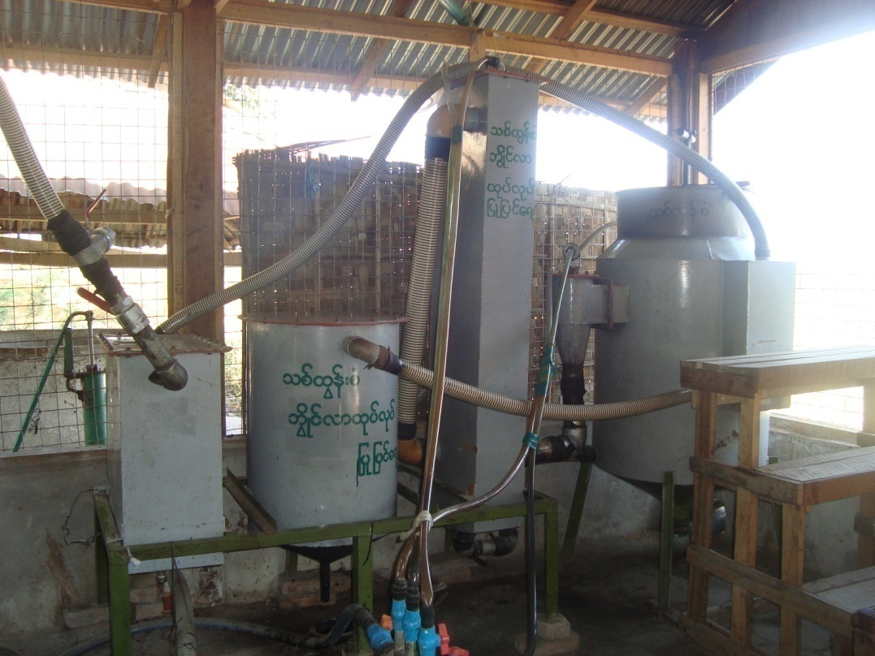A generator project by Paung Ku

**Capacity ‘To Relate’**

In the last year Paung Ku has also recognised the crucial part that external relationships play in organisational capacity in the Myanmar context. Especially at the village level many local groups are relatively isolated meaning that their opportunities for collective voice, learning and fundraising are limited. Below are examples where Paung Ku may have contributed to CSO capacity to relate.

Giri Emergency Response

*Many of the communities affected by Giri (especially those on islands) previously had very limited relationships outside of their village. The response to the cyclone brought a rapid increase in interaction with a range of external actors- from the government and religious organisations to local and international NGOs and other community based organisations in their area. For some local NGOs in Kyaukpyu and Myeboun it brought their first experience of interaction with national level and international organisations and their first experience of external funding.*

*Paung Ku explored change in capacity ‘to relate’ with a range of CSOs which had been supported in the Giri response. Overall, they stated that they had seen a substantial change in their external relationships. They felt that these relationships were important for several reasons.*

*First, through relationships with local and international NGOs, groups could gain both financial and technical resources. Second, better news and information – either through relating to authorities or to other groups - was seen to increase the capacity of groups to act. Finally, relationships with other local groups –especially those in neighbouring villages – were seen to be important in forming a collective response. Overall, while opportunities for building external links happens anyway during an emergency, groups felt that Paung Ku had played a key role in this capacity change.*

Ke Wan village

*Ke Wan community organisation in Mon State received a grant early in 2011 for building a bridge near their village centre. The project was the first of its kind that the group had undertaken. Paung Ku met regularly with the group to support them on a range of issues related to the project logistics, fund raising (some of the funds were raised within the community itself), labour and financial management. The bridge was completed in April 2011.*

*In the evaluation, the group reported that they had improved their skills in organisation and management- for example, having to develop systems to handle finances and source technical input from the township level. With Paung Ku’s facilitation, the group now also meets regularly with neighbouring village CBOs and they have plans to form a closer network in their village tract. The project also gave the opportunity for the group to interact in a positive way with the township government departments in identifying materials and technical assistance for the bridge construction. Through this, they reported that they now have more recognition from the authorities.*

*With more capacity to work together as a group and with improved external relationships - both with other civil society organisations and with the authorities- Paung Ku believes that over the longer term, Ke Wan community organisation can potentially contribute to a stronger civil society in their township.*

**Conclusion**

Despite some ongoing gaps in Paung Ku evaluation of micro projects and the ongoing challenges of seconding mentors, there is growing evidence that Paung Ku is contributing to building local organisation capacity.

In order to build on this, there will need to be more focus in the coming year on how capacity building can be monitored and understood more clearly. Case studies (as seen above) are useful in understanding capacity change but Paung Ku analysis should go further.

The capacity building objective of Paung Ku has received the most attention and investment over the last four years. We are seeing change, but more work needs to be done on how we capture this.

Objective 2 Improve Practice

Paung Ku seeks to improve practice through influencing culture within the international development community, through creating learning spaces and through promoting practical changes within NGOs, donors and the UN. Paung Ku also aims to facilitate mutually beneficial partnerships between local and international organisations. (Please note that through reflecting on how to better approach the Improve Practice objective, Paung Ku has adapted the output structure when compared to the original project log frame).

**Output 2.1**

**Awareness materials, learning spaces and reform mechanisms are created**

Paung Ku’s assumption is that most international agencies (UN agencies, INGO, donors) in Myanmar will need a range of things in place before they are able to make practical change in the way that they engage or work with civil society organisations (or the sector more widely).

Therefore, in order to facilitate change, Paung Ku will need to

* *Influence wider culture and attitudes* (agencies will usually not change unless there is a critical mass of other agencies and donors who also want to change)
* *Create new learning spaces* (agencies will usually not change unless they have a clear path forward which they know will work for them)
* *Facilitate practical reforms from ‘inside’ organisations* (agencies will usually not change unless they have specific support to put their new ideas into action)

Influencing wider culture and attitudes

In order to support a wide audience in Myanmar to engage with issues related to civil society, Paung Ku has continued with a range of activities.

The Paung Ku discussion Forum is an internet based blog and online discussion involving 120 development workers (50% expatriate, 50% Myanmar).There are weekly blogs, reviews of articles and discussions related to Myanmar civil society.

Paung Ku has completed three reflection/background papers in the last year. ‘Strengthening Civil Society in Myanmar 2009/10’ was an external document based around the 2009/10 annual report and released in October 2010. ‘Reflections on Cyclone Giri’ was written after the initial phase of the Giri response and released in November 2010. ‘Crossing the Hills – background on the Dawei Deep Sea Port Project’ was completed in September 2011 and will be released in the next two months.

Creating Learning Spaces

One key part of the Paung Ku initiative design was to have seconded mentors (from consortium or other agencies) take their lessons (about working with civil society) back into their own organisations. Paung Ku has sixty six seconded mentors of which 24 are from the Paung Ku consortium and 15 are from other agencies. There are some positive signs that this pathway for practice change is having some outcomes (see below).

The Paung Ku Advisory and Learning Group (ALG), made up of senior staff from the consortium agencies, runs forums for consortium member staff about civil society related issues. In the last year there have been two ALG Learning Forums attended by over 50 members of consortium looking at the role of media in Myanmar and civil society related donor policy (focussing on AusAID)

Paung Ku also facilitated a seminar for a Dawei Interest Group (of INGOs and LNGOs in Yangon) and presented the ‘Crossing the Hills’ background paper Paung Ku also, together with Oxfam and local NGO NAG held a ‘Good Governance’ workshop in July for local organisations interested in designing governance related projects.

Facilitating Practical Reform

One key area of focus for Paung Ku has been in improving institutional mechanisms for feedback to donors. This year the focus has been on the European Commission.

In June, Paung Ku supported 25 Myanmar CSOs in providing recommendations to the European Commission about the Good Governance programme. Then during the application period Paung Ku conducted research into LNGO and INGO experience of applying to European Commission Good Governance programme and produced a paper called ‘EC Good Governance: Is it Strengthening Civil Society?’ (which will be released soon).

**Output 2.2**

**Partnerships between CSOs and international organisations are facilitated**

In the last year Paung Ku field teams have sought to connect local organisations with possible alternate partners. For example, a local arts and media organisation was introduced and then invited to apply, to an international NGO. Meanwhile, several CBOs have submitted applications to, and been funded by embassy small grant schemes. It is hoped that this connection of civil society organisations to international ones will increase in the coming year and contribute to wider understanding of Myanmar civil society in the international community.

**Improving Practice Outcomes**

**Mentoring and Practice Change**

One key mechanism for practice change is the skills and perspectives that seconded mentors take back into their own organisations. Some mentors have reported that the perspectives gained through mentoring have changed the way they have worked, which in turn has had an impact on the success of their organisation at the local level. One example was a male staff member of an international NGO who was working on a microfinance project.

*“I work with an international organization and we provided support for microfinance activities in nineteen villages. I was responsible for 2 villages. As you know, we have guide lines for microfinance from our organization. I was interested to experiment with mentoring in my work so I used the [normal] guidelines and instructions provided by my organization for one village, and I used the system based on mentor facilitation with another village.*

*The village that I used mentoring with, felt like I was not that helping them. They always needed to find solutions by themselves. So it took longer for them to proceed compared to the other village. The other village was quite comfortably moving along the steps, following the guidelines and instructions from me.*

*Now, we have phased out from both villages. The group that I used mentoring approach with has left as the strongest in all aspects. The village that received guidelines and instructions from me were weak and I now feel sorry for them”.*

One unexpected outcome from the capacity building objective is related to changes in mentors themselves. One example is from a private teacher who was a member of a local organisation and then attended mentor training.

*“I am a private teacher and attended mentor training 2 years ago. I used to use the cane in teaching for those who failed to follow discipline or got poor scores in exams. This is normal practice for us. Sometimes I hit my students with a cane if they did not study hard - even to a point that blood came out.*

*After learning at the mentor training about questioning, to stimulate people to think for solutions, I experimented with that technique in my teaching. Our way of teaching is rote learning where we teachers give answers and they try to memorize the answers. I tried questioning to encouraging them to study and also in teaching subjects. The scores of the students were an average of 280 when I used punitive action with the cane and their scores went up to an average of 340 after my teaching method changed.*

*I have given up the habit of hitting with the cane for 2 years now and never use it any more”.*

**International NGOs, Embassies and Donors**

Paung Ku reports (as outlined above) have been used in guiding strategies of some international agencies. Norwegian People’s Aid (a Paung Ku consortium member) used sections of Paung Ku reflection papers on civil society and emergency response in drafting their global emergency strategy. Paung Ku *‘Strengthening Civil Society in Myanmar’* report from 2009/10 was used in strategic thinking and new programme frameworks for DFID and Save the Children

Meanwhile, the European Commission have made small changes to their application processes- translating guidelines into Burmese and are considering further changes such as improving questions and answer systems. These changes are likely directly related to Paung Ku’s support of civil society feedback.

In late 2010 Paung Ku facilitated a workshop involving embassy small grant staff and local organisations who had received funding or applied to embassies. A number of recommendations came out of the meeting – two of which were increasing the role of local staff in coordinating small grant schemes and developing partnerships for capacity building of local groups.

This year, the British Embassy employed a new local staff member to coordinate the small grants program. In the past the program has been managed directly by a foreigner.

Meanwhile, the US embassy has developed connections with the Capacity Building Initiative (CBI) – a local organisation- who they will fund to supply a range of tailored trainings to their grant recipients. These changes are not directly attributable to Paung Ku, but it is likely that Paung Ku’s role in facilitating a series of embassy workshops in 2010 had significant influence on this.

**Conclusion**

The Paung Ku team approach to improving practice has changed significantly over the last year.

Yet while we have some positive outcomes and improved thinking overall, this objective has had the least investment in terms of staff time and budget. In order to influence the international development community more widely there will need to be a substantial increase in focus on this objective.

Further, of all the objectives, this one is most dependent on a well functioning and engaged consortium of agencies. Greater ownership within the consortium would give much wider opportunities for collective learning and collective voice.

Objective 3Facilitate Networking

Paung Ku aims to facilitate civil society networking for learning, sharing and collectively influencing change. These networks are comprised of township CBO networks, issue based networks and international networks with other countries in the region.

**Output 3.1 Local, national and regional networks established and facilitated**

Overall Paung Ku has developed network connections with over one hundred civil society organisations and in the last 12 months gave 7 grants specifically for CSO networking activities.

Most of these CSOs (over 80) are connected to township level networks in Yangon and Ayeyawaddy Divisions. Other established networks are issue specific – for example, related to investment in Dawei or cyclone recovery and development in Kyaukpyu.

We will now look at the different types of networking

* Township level
* Issue focus networks
* International networks

Township level networks

One key development through 2010/11 has been the facilitation of a number of township level CBO networks. Between 2008 and 2010, in areas affected by Cyclone Nargis, Paung Ku funded hundreds of village level groups to do relief and recovery activities. With a wide range of grass roots civil society connections, Paung Ku was able to facilitate the development of new networks at the township level. Now six township networks have developed- in *Kyaiklat, Mawlamyinegyun*, *Bogale North* and *Bogale South* in Ayeyawaddy Division, and in *Kyauktan* and *Twante* townships in Yangon Division.

Paung Ku staff supported monthly meetings of the networks, providing some facilitation, particularly in exploring the vision of the different networks and supporting travel costs. Increasingly, mentors in these areas are taking a role of supporting networks rather than individual CSOs.

*Ayeyawaddy Division Networks*

In Ayeyawaddy Division, over 60 community based organisations are involved in the four areas (of North and South *Bogale*, *Kyaiklat* and *Mawlamyinegyun*) and over 20 new CBOs in those townships have joined the network over the last year. Over the last year a new system has also developed (with Paung Ku facilitation) where each CBO involved elects one representative who then joins in a ‘Zone Committee’ at the township level.

The Paung Ku Delta team has supported the Zone Committee over the last year to take on the main grant making functions in their area (see diagram below). With support from Paung Ku (both in covering costs and in staff time) the Zone Committee now does the assessment, monitoring and evaluation of the grants given in their township. CBOs in the respective townships now submit their proposals to the Zone Committee rather than to Paung Ku.

The Zone Committee also organises trainings for CBOs in the area and in the last year these trainings have covered topics on agriculture, land tenure law, environment and critical thinking. The Zone Committee has also invited members of the local media groups to join meetings and promote success stories from the network within the media. The interest of the Zone Committee is in promoting this kind of networking to other rural communities in Myanmar.

In order to get permission for the Zone Committee to hold large meetings in the township they needed to approach the township authorities. When asked about who the donor was to the Zone Committee, Paung Ku was able to use local NGO consortium member ECODEV to provide MoU coverage.

With this MoU coverage clear, the township level authorities gave support to the meetings. Paung Ku staff have also noticed that over the last year the township authorities have become more flexible and open (perhaps related to country wide changes).

***Ayeyawaddy Zone Committee Diagram***

CBO

CBO

CBO

CBO

CBO

**Zone Committee**

Representation  
Proposals

Project assessment  
Monitoring   
Training

Paung Ku Delta   
team

Township Authorities

ECODEV

Local media

MoU coverage

Support

Permission

Success   
stories

One challenge for these township networks and their zone committees is the question of representation. To what extent are the zone committee members truly representative of communities? This is particularly pertinent related to representation of women- who while present in the zone committees, only make up a small number of township level decision makers.

In the future, given the wide membership of these networks within townships, there is enormous potential for their township role to increase. This could be in relating to authorities and private sector, especially about issues of development. However, to do this effectively (especially in reducing poverty) would require more thinking about representation of minority voices.

*Yangon Division Networks*

Kyauktan Regional Development Group in Yangon Division which was established 18 months ago, received two grants this year (for a total of almost USD 15,000) from Paung Ku to establish rice banks for 15 groups in the Kyauktan area. The group aims to reduce vulnerability of community members by having a better system of storing rice after harvest.

Meanwhile the Golden Triangle Area Development Group in Twante Township was funded through one grant (approximately USD 10,000) to begin a livelihood project in seven villages.

Issue networks

One key example of facilitating issue based networking over the last year has been Paung Ku’s involvement in Dawei. There is now a group of nine local civil society organisations who are interested in exploring issues associated with the Dawei Special Economic Zone.

Dawei, in Tanintharyi Division, is the site of a new large scale development project - which will in time make it the largest deep sea port and industrial complex in South East Asia. The Dawei region will also become a Special Economic Zone – based on the model of Shenzhen in China’s south and Map Ta Phut in Thailand.

The project has four main components

* A deep sea port
* An industrial complex including petrochemical and other industries
* A highway linking Dawei to Thailand and ultimately to the planned East West economic corridor.
* Tourist infrastructure including hotels, resorts and recreational complexes.

Some key emerging issues of concern in these development projects are

* Low awareness amongst local population – despite the enormous scale of the new projects, villages that will be significantly affected still have very little knowledge about the proposed developments.
* Limited land registration and compensation – the new developments will involve up to 25,000 acres of land. Therefore, land rights and compensation are becoming significant issues.
* Few economic benefits for locals– it is likely that much of the employment opportunities and benefits associated with project will go to Thai workers (or workers from other investing countries) and the Myanmar government. It remains to be seen how the local economy and the Myanmar economy more broadly will benefit from this

Paung Ku is currently working with a range of local organisations in Dawei.

* At the community level, there will be twenty three villages that will be immediately affected by the deep sea port and industrial zone construction. Within three of these villages, local community mobilisation has begun and awareness raising activities.
* There is also a Dawei based local organisation of university graduates who began English teaching classes with local young people. They have also developed a partnership with a large Yangon based local organisations which focuses on education. In the future, together with their partner, they plan to expand their activities into supporting social enterprises, particularly related to raising skills and therefore employment opportunities for local people in the future.
* There are also a range of church based groups who are active in the area in community development. One group has plans to expand into supplying paralegal support for local people, particularly in relation to issues of land rights.
* A group of Dawei based academics with a background in archaeology have begun doing baseline social research in the areas that will be most affected by the developments. They also have connections to senior members of the new regional parliament (*hluttaw*). (See advocacy case study below)
* Another local group is focussed on the promotion of citizen journalism in Dawei. They have already made strong links with Yangon based journals which have begun running weekly stories on changes occurring in Dawei. They aim to increase these connections and media exposure of key issues both at the local level and in Yangon.
* *Dawei Free Funeral Service* and *Oxygen Donation Group* (which were both started by the same individual) have high standing within the Dawei community and have networks of thousands of volunteers and donors. The leadership involved with these groups have also started –on the advice of Thai based academics – a *Dawei Chamber of Commerce and Industry* (DCCI). This is designed to increase the influence of local voices (and particularly local economic interests) in the future Dawei Special Economic Zone Developments. Buddhist Pagoda Donation Groups – while not directly working on these issues- also have extensive networks (of up to thirty thousand people in the township) which can be accessed by groups such as the Free Funeral Service to gain wider links.

To this point Paung Ku has made connection with all of these groups (and their networks), funded projects with some groups and begun exploring potential roles in responding to Dawei economic developments.

One key challenge in this network is managing the approaches and strategies of different members. One critical area of discussion is related to the degree of engagement with power holders – and what level of cooperation is appropriate. Some groups opt for lower profile efforts, particularly focussing on protection for citizens, while others think that closer engagement with a range of stakeholders (including those private sector or government stakeholders that many would be uncomfortable with) will ultimately have more impact.

One possible area of concern for Paung Ku is whether we are increasing the risk to some local groups through their involvement in issue based networks- due to the raised level of attention that they may receive from authorities. This can be mitigated through ensuring that Paung Ku plays a facilitating role in networking rather than a leadership role. Leadership in these contexts best comes from actors from the local level.

Paung Ku also plans to convene a Yangon based group of donors and international organisations who may be able to provide resources for advocacy.

International networks

Over the last year Paung Ku has made some initial steps toward linking Myanmar networks together with key groups or networks in the region. The most significant connection made has been between the Dawei network and public policy groups in Bangkok and Map Ta Phut. It is hoped that there will be long term benefits for advocacy if groups in Dawei are able to build on lessons from Thailand.

Over the coming year Paung Ku is hoping to build connections to international networks such ASEAN people’s forum and networks involved in Engaged Buddhism.

**Networking Outcomes**

Overall, Paung Ku has played a key facilitation role with six township networks and three issue based networks (related to Dawei Special Economic Zone, Cyclone Giri recovery and Ayeyawaddy Watershed Management). Over 100 local organisations are involved in these networks.

One example of learning through networks came from connection between the Rakhine network (who had responded to Cyclone Giri) and local groups in the Delta who had been involved in the Nargis response. Rakhine groups reported that through this connection they had learnt more about how to engage with international agencies (previously they had few connections to the international community). Rakhine groups also said that the networks in the Delta- from local to township level – were far more developed and they saw potential for more cooperation and joint efforts between local groups in Rakhine.

Meanwhile, after meeting groups from Thailand Dawei based groups said that they came to understand more about the potential public dangers and negative consequences of developments like in Map Ta Phut in Thailand. They also felt that there is some urgency for them to more closely research the potential impact in their own area.

**Conclusion**

Networking only began as a Paung Ku objective 20 months ago. In that time there have been some significant achievements made in facilitating civil society networking- perhaps more achievements than were anticipated?

In the coming year this needs to be capitalised on in several ways. First, Paung Ku documentation around networking needs to improve. Second, Paung Ku needs to more closely explore what added value is there from the networks we are working with. Are they primarily related to mutual learning or are they more related to amplifying voice or other benefits? Beyond numbers and types of networks, what outcomes are we hoping for?

Objective 4 Enhance Advocacy

Over the last year Paung Ku has developed its new objective of enhancing advocacy of civil society with policy actors. This has taken the form of supporting civil society organisations in a advocating on a range of different issues, particularly related to corporate social responsibility and the environment. (Please note that as we have learnt more about advocacy the outputs related to this objective have changed to a format different from the original proposal).

**Output 4.1 CSO advocacy projects (including research, information dissemination, meetings with policy makers) funded, completed and monitored**

Paung Ku funded 14 advocacy micro projects in 2010/11.

Local level research activities were supported along with public talks, photo exhibitions, books and a media package. Below are three examples related to reforestation, services for the blind and land tenure.

*Reforestation in Sagaing Division*

In the period of King Mindon, Myanmar’s first sanctuary was established in Sagaing Division but over the last one hundred and fifty years- with little regulation- it has been steadily deforested and now only half of the original sanctuary remains. The sanctuary still contains some rare animal species (including the golden deer) but with the continued reduction in the area of the forest, these animals are now endangered.

Paung Ku funded an environmental group based in Mandalay who had a vision of reforesting the original sanctuary and working with local villages to protect the area from hunting and wood collection activities. The group has gained permission and cooperation from the Department of Forestry, worked with local communities and volunteers and also made connections with local media who have done several journal articles about the project. The project has the potential to bring together government, civil society, local communities and media in a cooperative project to protect a historic and environmentally important site.

*Improving services for the blind*

Paung Ku supported *Myanmar National Association of the Blind* (MNAB) (for a second grant) to collaborate with the Department of Social Welfare to develop a standard Braille system for Myanmar.

MNAB had previously participated –along with other organisations focussed on disability- in the drafting of Myanmar’s *National Plan of Action for Persons with Disability* (2010-2012). The group has also been active at a regional level in attending the Asia Pacific Regional Blind Union annual meeting.

Currently, there is no common system for Braille within Myanmar and many schools and blind associations are using a short hand systems invented over a hundred years ago. As a result there are significant challenges in communication between different blind support groups. The current two year plan of MNAB is to develop a standardised Myanmar Braille software system which can be used up to secondary school level, with the overall aim of increasing communication opportunities for visually impaired people in Myanmar. By working together with the Department of Social Welfare, this system could also become official national standard and be used in relevant government departments.

This example highlights current opportunities for engagement with Ministry level government representatives and collaboration in areas which will bring tangible benefits for vulnerable people.

*Land Tenure Policy*

In April, the Food Security Working Group in Yangon conducted a workshop on Land Tenure Policyin Myanmar. A range of differentstakeholders were involved and the workshop explored key issues facing upland farming communities, particularly related to food security and their land tenure. The working group is taking a leadership role in promoting dialogue on Land Tenure as a critically important issue for Myanmar society. The workshop report was widely distributed and Paung Ku supported a reprinting of the report due to high demand.

*Ayeyawaddy Watershed*

Through 2010/11 Paung Ku supported a range of organisations working on water issues in Myanmar. This included funding a local organisation to run an exhibition series on ‘Art for Watershed’, hold public talks in Yangon and Mandalay and make a media package to be sent to media, members of the *Hluttaw* and other relevant government officials. Paung Ku also supported other local organisations in preparing photo essays, holding public talks and linking with media.

**Output 4.2 Myanmar media promote issues and success stories of civil society activities**

A new role for Paung Ku in 2010/11 was related to promotion of issues and success stories in the Myanmar media. Paung Ku staff have developed wide links with local press, particularly private journals and have connected journalists with key stories. This has been particularly important in both the Dawei and Watershed issues. Paung Ku is exploring ways of better tracking contribution to media articles.

**Output 4.3 Civil society actors linked to policy allies (local and international) and policy makers.**

Another new role for Paung Ku has been in facilitating links between civil society groups and policy allies (eg academics) and policy makers.

For example, in June 2011 Paung Ku helped facilitate a group of Chinese academics to travel to Kyaukpyu in Rakhine to meet with local groups and gain more direct understanding of local views about Chinese investment. Meanwhile, in the Dawei archeological zone case study below, Paung Ku helped facilitate a visit of the Ministry of Culture to Dawei to meet with a key civil society group. This connection role of Paung Ku will likely increase in the future.

**Output 4.4 Case studies and learning about civil society advocacy in Myanmar are produced and disseminated**

One case study of policy change in Dawei township has been produced (see summary below).

**Advocacy outcomes**

Examples of influence on policy change or even policy practice are often difficult to demonstrate. The below example is a clear, and perhaps rare, example of how appropriate support to a small grassroots group can contribute to national level policy change.

*Dawei Archeological Zone*

DRA is a group of Dawei based academics who have been researching archaeological sites in the Dawei area for a number of years. The group’s leading members have a reputation in the community for trying to conserve Tanintharyi region cultural assets and they also have connections to senior members of the new regional Hluttaw. These relations to power holders are interpreted positively by some stakeholders but seen by others to be a risk.

DRA became concerned about the impact of the new Special Economic Zone on Dawei’s cultural assets and the DRA Director wrote an article in ‘7 Day News’ journal in April 2011 hoping to raise awareness in the local population about the issue. Then in May, DRA (with support from Paung Ku) undertook research on a range of potential impacts of the Dawei Special Economic Zone - particularly looking at affected archaeological sites.

The largest site is *Thagaya* which is an ancient Pyu capital west of Dawei. It is just 1.5 km from the proposed SEZ and therefore in danger of being impacted by the development. The city ruins stretch 1.6 km from east to west and 1.1km from north to south and include a moat, city wall and palace site.

After completing the research, DRA sent their findings (including a number of photos) to the Deputy Director of the Ministry of Culture U Than Zaw Oo with whom they had had previous contact. The Ministry of Culture responded positively to receiving the information and in August, DRA organised and facilitated a visit to Dawei for the Ministry of Culture Deputy Director, Assistant Director and Assistant Researcher.

The Ministry of Culture then submitted the issue to the high level Dawei SEZ Central Management Committee which is chaired by Vice President Sai Mauk Khan. At the end of August, the SEZ Central Management Committee convened a meeting with the Tanintharyi regional government, representatives from Italian Thai Development (the main company involved) and Archaeology Department officials to discuss the issue.

At the meeting,the decision was made to designate *Thagaya* as a special archaeological zone under the Cultural Heritage Protection Act.This was possible through using ‘loss of ancient items’ clause in Dawei SEZ law.

Prompted by Paung Ku staff, *Myanmar Times, Kumudra* and *7 Day News* journals have all run articles about the SEZ Committee decision to preserve the Thagaya area as a special archeological zone.

This was an example where a CSO took an issue from local level research to national level policy change. There were likely a range of other influences on the Ministry of Culture and the SEZ Committee. However, DRA’s research and contact to the Ministry of Culture was almost certainly the main catalyst for the SEZ Committee meeting.

Paung Ku’s role in this work was to provide small amounts of fast and flexible funding to an influential CSO and then support and monitor the project. Paung Ku also made use of connections to media and regional contacts to increase the profile of the issue. Also interesting to note is that it would not have been possible for Paung Ku to support this process without extensive local knowledge of Dawei and the connections of a key Paung Ku staff member.

**Conclusion**

Enhancing advocacy of civil society is a new objective for Paung Ku. However there has already been substantial progress in understanding how the objective may be reached. In particular through funding, use of media and connections to policy allies and policy makers.

There are two key considerations for Paung Ku related to the advocacy objective.

First is the tension between *enhancing* civil society advocacy as something external to Paung Ku (where we play a purely facilitating role)- and *doing* advocacy. Obviously, the initiative itself needs to focus on playing an external ‘enhancing’ role. However, it is also healthy that individuals in the Paung Ku initiative are themselves ‘civil society advocates’. We need both. But seeing the line between them is sometimes difficult.

Second is the overarching tension between innovation and consolidation. As the role of civil society in Myanmar changes quickly and opportunities arise, an innovative Paung Ku is extremely well placed to respond. However, consolidation of learning and strategy is also critical in order to be more effective (and minimise harm) in the future. This tension is healthy. And in order to move forward it is important to understand that it is not uniform across the team and consortium. In some areas Paung Ku needs to push innovation more, in others consolidation.

As the evaluation said, the ongoing monitoring of this creative tension will be crucial in the future of Paung Ku.

Civil Society Strengthening in 2012

As Paung Ku plans for the final year of its second phase (2010-12) there are several key considerations.

One is related to consolidation of existing activities, especially related to capacity building. There is a critical need to better evaluate micro projects and better understand how we measure capacity building.

Key questions also remain about the nature of Paung Ku itself. Should the initiative persist with an international and local NGO consortium structure? Or should Paung Ku begin a process of becoming a local entity? Or is it possible to be a combination of both? The Board and team will be exploring these issues in the coming months in order to have a clear plan over the coming year.

There are also four potential new areas of emphasis for 2011-12 based on Paung Ku’s analysis of the changing context in Myanmar.

*Civil Society and Emergencies*

Through the Cyclone Nargis, 2010 Mandalay floods and Cyclone Giri emergency responses Paung Ku has gained significant experience in the relief and recovery context. While much was achieved in these responses, the emergencies also exposed a lack of preparedness within Paung Ku

This area is seen as important in Paung Ku for two reasons. First, the Paung Ku relief approach has been to be rapid and effective in reaching large numbers of beneficiaries in a short period of time following disasters. This approach needs to be refined and then – if we are convinced of its effectiveness- promoted to other humanitarian actors for replication in the future.

Second, Paung Ku experience has shown that emergencies are a time of immense growth in civil society organisation activity and connectedness. Through humanitarian responses local organisations have opportunities to grow significantly in capacity and influence. Therefore, for longer term civil society strengthening it is beneficial for Paung Ku to be involved in emergency responses.

In response to this, Paung Ku plans to move forward with developing a small emergency team who can be first responders (from within the team) when there are emergencies and do research, consolidation of Paung Ku processes and wider influencing when they are not directly responding.

*Civil Society and the Media*

The dramatic changes in levels of media freedom this year have allowed a new public policy dialogue to take place in Myanmar, where citizens are more informed and more able to express opinions.

For most Myanmar citizens over the last four decades, discussions about policy have been necessarily hidden. While there are still some restrictions on Myanmar media, many policy areas are now open to public debate. And now through connection of civil society organisations to media, local groups can have a wider impact than before and start to mobilise more effective public debate around issues.

In the coming year Paung Ku will focus more on media analysis (eg which journals/media groups have what interests? And how is media content changing?) and build wider connections between civil society groups and networks and the media.

*Civil society and Investment*

Foreign direct investment in Myanmar is increasing dramatically.

In 2010, total foreign direct investment to Myanmar (largely from China, Hong Kong, Thailand and Korea) was conservatively estimated at 80-100 times the level of foreign development and humanitarian aid. This means that in order to stay relevant, aid agencies in Myanmar must find ways to amplify their impact through capacity building, policy advocacy and networking.

Paung Ku is planning a pilot project for 2012 focussing specifically on civil society role in influencing investment in Dawei and Kyaukpyu (the site of a new deep sea port and the beginning of the oil and gas pipeline and rail link to Yunnan). Paung Ku aims to pilot civil society capacity building, networking and advocacy activities and explore ways in which these activities can be scaled up.

*Civil society and International Aid*

Along with foreign investment, aid to Myanmar is also increasing.

However the Paung Ku objective to ‘improve practice’ of the international development community remains the initiative’s most underdeveloped. This is largely because since the beginning of the initiative, it has had relatively few resources devoted to it (a small portion of international advisor, director and other staff time).

The nature and quality of international aid will definitely play a role in the development of civil society in Myanmar. And this role (for better or worse) will increase dramatically if Western sanctions are dropped in the future and international donors and financial institutions (such as World Bank and ADB) scale up.

Yet at this point, there is virtually no other work being done on increasing the quality of aid. Therefore, there is a critical opportunity for Paung Ku to develop civil society’s capacity to advocate to donors (and international NGOs).

In the last year (2012) of Paung Ku’s phase 2 programme (2010-12), the Paung Ku team will increase its internal investment in the ‘improve practice’ objective (especially in more devoting more international and local staff time). Meanwhile, it is hoped that the Paung Ku consortium agencies themselves commit to a wider role related to this objective. With more staff time and a more involved consortium it is hoped that there will be more potential for influence.

Conclusion

The last year has seen unprecedented wider change in Myanmar.

Within Paung Ku as well, rapid progress has been made in a wide range of areas. The flexible and responsive nature of Paung Ku (which has been possible in part because of the flexibility and understanding of our key donors) has meant that the initiative has been extremely well placed to creatively take advantage of changes in the country.

Significant achievements have been made related to capacity building. The new objectives of networking and advocacy have progressed more quickly than expected. And there are a number of new opportunities arising for increasing impact in the future.

The last year has also presented a number of questions for Paung Ku about its own practice and future- as noted in this report. The ongoing success of the initiative will be dependent on how Paung Ku responds to these questions. And in particular whether the consortium and the team can respond to these together.

Appendix 1: Paung Ku Donors

Paung Ku had a range of donors for the non emergency programme in 2010/11, with AusAID as principal donor supporting approximately fifty percent of the total initiative. The other fifty percent was made up with contributions from Christian Aid, Misereor, Norwegian People’s Aid, Trocaire, Oxfam HK and Dan Church Aid. See below chart.

1. Please note that while the Cyclone Giri response made up a significant part of the last year’s activity, this report will focus primarily on the non emergency work of Paung Ku. Figures for the rest of the report will be related to non Giri grants only. The separate ‘Paung Ku Giri Response Final Report’ gives a detailed analysis of the Paung Ku’s humanitarian activities.