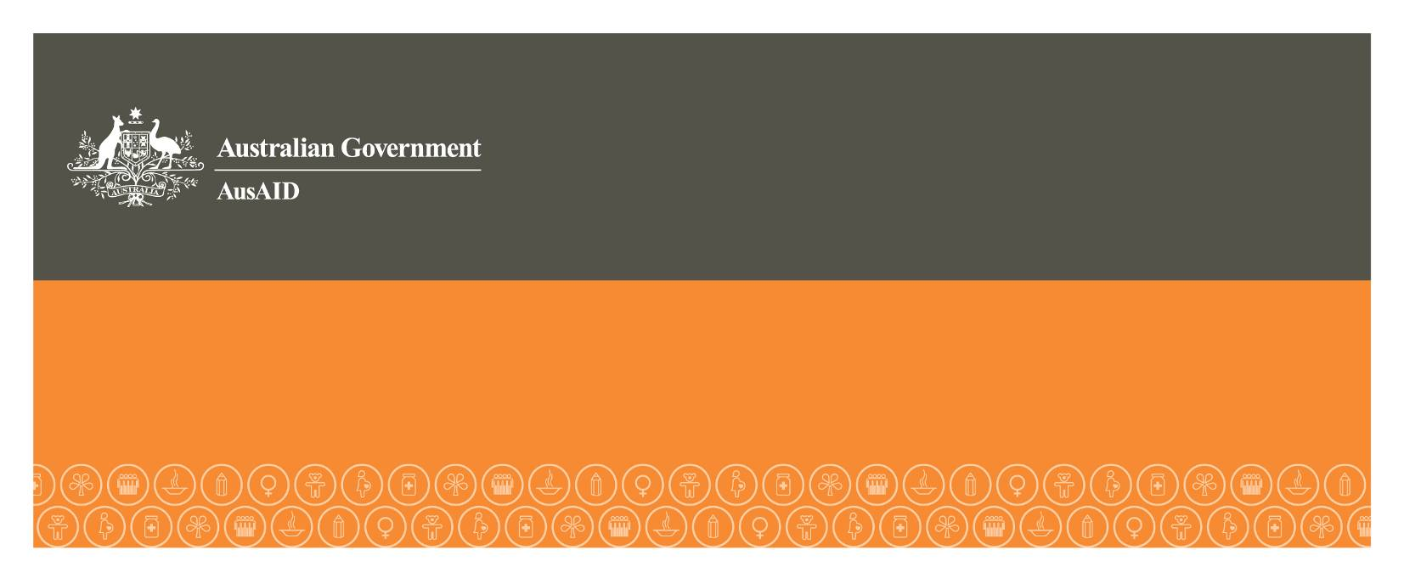
Philippines–Australia Public Financial Management Program (PFMP)
FACT SHEET

The Governments of Australia and the Philippines have agreed a long-term partnership to improve the efficiency, accountability and transparency of public fund use in the Philippines.
Australia through its international aid agency, AusAID, has committed A$30 million to the Philippines–Australia Public Financial Management Program (PFMP) over five years. The program commenced in October 2011.
The PFMP is assisting the Philippines Government to implement its Philippine PFM Reform Roadmap: Towards Improved Accountability and Transparency, 2011–2015. This comprehensive PFM reform agenda aims to clarify, simplify, improve and harmonize the financial management processes and information systems of the civil service in the Philippines.
Program Focus
The PFMP prioritises practical budgeting and expenditure management reforms that improve the basic building blocks for a modern PFM system. It is helping decision-makers to do their jobs efficiently, effectively and economically so that Filipinos benefit from improved delivery of goods and services.
Assistance is agreed annually and aims to achieve four strategic objectives:
- Objective 1: Increase the efficiency and effectiveness of the allocation, utilisation and reporting of budgeted funds by oversight agencies
- Objective 2: Improve PFM capability in select departments to enable more efficient utilisation and accountability of public funds for service delivery
- Objective 3: Generate more timely, reliable and accessible public expenditure management information
- Objective 4: Strengthen external oversight of public expenditure management linked to physical performance information.
A range of activities are funded to achieve these objectives: technical advisory assistance; capacity building (e.g. training, workshops and study tours); studies on specific reform topics; research grants; external oversight and monitoring; and co-financed initiatives with development partners.
Program Partners
The PFMP is coordinating assistance for national government reforms across oversight agencies, targeted spending departments, the legislature and civil society groups. It aims to build long-term capability and emphasises a whole-of-government effort to achieving lasting change.
The program works in collaboration with:
- Oversight agencies: the Department of Budget and Management (DBM), Department of Finance (DOF)–Bureau of Treasury (BTr) and Commission on Audit (COA) to advance institutional reforms
- Spending departments: the Departments of Education, Social Welfare and Development, and Public Works and Highways to improve their PFM capability. Other departments and agencies may receive assistance as needs emerge
- The legislature: the technical offices of the Congress to inform the public policy debate and improve capacity in budget oversight, if required
- Civil society: select civil society groups to build demand for change and engage constructively with the bureaucracy and legislature on budget transparency and expenditure monitoring
- Development partners: cooperation with development partners supporting implementation of the Philippine PFM Reform Roadmap.
Management
A Program Steering Committee provides strategic oversight to program planning and implementation and decides funding priorities year to year. It comprises senior officials from DBM, DOF–BTr, COA and AusAID, and aligns closely with the work of the Philippines’ PFM Committee. Meanwhile, the National Economic and Development Authority plays an advisory role to the program.
AusAID directly manages the PFMP and is supported by a contracted Service Provider, Coffey International Development, which is responsible for the day-to-day administration of the program.

