Annex 05 – Social development analysis to support the design of a future maternal and newborn health program in indonesia. permata

Executive summary
This report provides a social development analysis of maternal and newborn health issues to inform the design of Government of Australia’s (GOA)’s new maternal and newborn health (MNH) program, PERMATA. The overarching goal of the new program will be to assist the Government of Indonesia (GOI) to reduce maternal and neonatal deaths and childhood stunting. The program builds on the existing Australia-Indonesia Partnership for Maternal and Neonatal Health (AIPMNH), and will focus on districts in East Nusa Tengarra Province (NTT), Papua, West Papua, West Nusa Tenggara Province (NTB) and East Java.
The report is divided into five sections:
- A framework for analysing social development issues related to maternal and newborn health
- The evidence base on national disparities in MNH outcomes
- The institutional and governance context to MNH programming in Indonesia
- Key issues and analysis against each of the thematic areas of the social development framework
- Coordination with GOAs existing programs.
Social development framework for MNH
The study uses a five pronged framework for the analysis of social development concerns related to maternal and newborn health, these are: gender; social inclusion, access to MNH services, community empowerment, and voice and accountability.
National disparities in MNH outcomes
Drawing on evidence from the Indonesia Demographic and Health Survey (IDHS) the report presents data on the inequality of MNH outcomes between socio-economic groups and regions. Notably, neonatal mortality has plateaued since the IDHS 2007, and the 2012 data shows increasing disparity between wealth groups. While inequalities in the take up of some MNH services by poverty and mother’s education have decreased between the two surveys, the difference in institutional deliveries and postnatal care remains large with the poorest women and those without education lagging behind. The IDHS 2012 estimated maternal mortality ratio of 369 per 100,000 live births indicates that inadequate progress to reduce maternal deaths has been made over the past five years, and the MDG will not be met.
Stunting is increasingly concentrated among the poorest. National rates of stunting fell in the wealthiest quintile from 30% in 2007 to 24% in 2010, but increased in the poorest from 40% to 43% (Riskesdas, 2007 and 2010).
There are wide disparities in MNH outcomes and service coverage across the provinces of Indonesia with the worst outcomes tending towards the east of the country on the islands of Papua and West Papua, Nusa Tenggara and Maluku. Growing inequity between wealthy and poor populations is a key political concern for social stability. Within provinces and districts, inequalities in MNH outcomes according to wealth, mother’s education, and location of residence exist. This reinforces the need for context specific programming at the district level, according to the geographic context, and socio-economic conditions of the target group.
Institutional and governance context
The process of decentralisation in Indonesia has created an array of institutional and governance issues which affects the functioning of the health system, and the effectiveness of government agencies to work together to address underlying social determinants of health. The lack of clarity in functional assignment between levels of government has resulted in overlapping responsibilities and confusion and tension between them. Inter-sectoral coordination on health is less than optimal particularly on family planning despite its role in reducing maternal mortality and promoting women’s health. The capacity of provincial government to play a technical oversight and monitoring role has been weakened. Weak public financial management is a major concern across the country, which affects the availability and quality of health services and the motivation of health staff, and inevitably hurts the poorest and least influential worst.
Gender and MNH: policy
Government of Indonesia’s National Development Plan (2010-2015) includes gender as one of three cross-cutting issues to be addressed across all development sectors. Gender mainstreaming is compulsory for all national institutions, and local governments are required to establish gender working groups, and to formulate policies, programs and activities from a gender perspective in the local government medium term development plan (RPJMD), strategic plan (Renstra) and workplan (Renja) of local government work units (SKPD).
Beneath this overarching policy framework, gender mainstreaming in the health sector in practice appears formulaic. Misconceptions related to gender persist among health officials with gender often being equated with the delivery of services to women. Sector leadership on gender needs revitalising.
Nationally gender and reproductive health have a moral foundation rooted in Indonesia’s major religions, and patriarchy norms are deep seated in policies and programming. Women’s sexuality and reproduction is circumscribed to the confines of marriage, and issues such as adolescent sexual and reproductive health, safe abortion, premarital sex and childbirth outside of marriage are contentious and morally sensitive topics.
The decentralised governance system adds to the potential evaporation of national policies as district governments set their own priorities and approaches. In the area of safe delivery, some local governments have introduced regulations enforcing facility based deliveries and imposing fines on women that disobey. While this appears to have encouraged facility deliveries it also runs the risk of penalising innocent women who were unable to reach a facility in time for the delivery. Regulating facility deliveries also runs the risk of creating a false evidence base of extremely high institutional deliveries as health providers avoid capturing home deliveries in records. This leads to misinformed planning and service delivery, and the further neglect of populations that face the greatest difficulties in accessing services.
Gender and MNH: the health system
Gender gaps in the health system include the lack of routinely collected sex disaggregated data on utilisation of health care and very little information on sex-disaggregated mortality, morbidity or health risk factors.
Lack of data on the sex ratio of the health workforce is also a basic gap. Government of Australia’s Gender and Health Sector Assessment, 2010 found that women in the health sector face gender discrimination and bias through the lack of a decision-making voice, the lack of incentives to perform well, poor recognition for their work, and restricted access to proper training.
High levels of absenteeism – about 40% of the time -- and difficulties in filling and retaining health staff are common problems that have a serious impact on access to MNH and other primary level services. The dual practice system, which allows doctors to hold public and private sector jobs means that it is difficult to attract doctors to rural and remote posts where private sector demand is low.
Social inclusion and equity: GOI policy
The Ministry of Health’s Strategic Plan 2010–2014 refers to equity in terms of distribution and availability of health services and health resources, and has a value statement that states that ‘attaining the highest possible health degree for every person is one of the human rights that does not differentiate between ethnic groups, religion and social economic status.’ However the strategy does not include an analysis of health status and coverage by wealth/poverty, the barriers to access of poor and vulnerable populations or strategies for improving the health of the poorest or those living in remote or vulnerable situations. Likewise the draft National Action Plan for Maternal Mortality Reduction (2012) does not include an equity analysis of the groups or geographical areas where maternal mortality is higher and in need of an accelerated response. Commitment to address the underlying social determinants of health, including gender, appears to be missing in the policy frameworks that guide MNH.
Barriers to accessing MNH services
The barriers that women face in accessing MNH services and the additional hurdles that poor and vulnerable women and their families have to contend with are multiple and interconnected. We use a pathway approach to identify the constraints that women, and particularly those that are poor and vulnerable, have to contend with from the home, in the community, related to the journey, and at the point of service delivery.
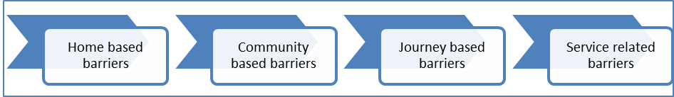
The framework shows how some thematic barriers, such as gender, financial, traditional and cultural beliefs, and lack of information appear at several points along the demand to supply pathway.
(a) Gender. Gender norms tend to define domestic tasks and child care as women’s responsibilities. Division of labour within the family often leaves women with heavy and physically demanding work burdens through to the end of pregnancy, impacting on their health and that of the baby. This is often reinforced by local beliefs that hard work towards the end of the pregnancy will strengthen women for an easier delivery. Women also often leave the facility early after delivery in order to get home to take care of older children putting their health and that of their newborn baby at risk.
Problems women face in accessing health services: IDHS asked women whether they faced specific problems in accessing health services for themselves when they are sick. The magnitude of the difficulties women face is much higher in Papua and West Papua than the other three provinces, with the biggest challenge reported in both being getting money for treatment. This is closely followed in Papua by the distance to a health facility and reflects the physical remoteness and scarcity of services.
Decision-making: Understanding how family control over resources and decision-making patterns are played out in local socio-cultural environments and affect access to health care is important for programming. In Papua, the decision-making process is complicated as both the husband’s and wife’s families have to be involved in deciding whether to seek care outside of the village, and once at a facility whether to accept the treatment being offered. This can be a major delaying factor at the time of an emergency.
Age at marriage: Social norms influence the age at which women get married and are an important correlate of maternal and child health and nutrition outcomes. In East Java, early marriage among girls is recognised to be a major social problem and determinant of MNH with reports that over 40% of women are married before they are twenty. This practice appears to be driven by religious and family pressures placed on girls to marry early, and the fact that only married women are permitted to migrate for work.
Women’s social solidarity: Social structures in some areas, such as on the island of Sumba (NTT) leave women without the space to come together and receive new information, dialogue with peers, and build solidarity and self-confidence. In contrast in the Highlands of Papua, women’s groups linked to the church tend to meet regularly. Even where women’s groups are functional, women are generally not involved in community level discussions and decisions. Village musrenbang tend to be male dominated and hardware oriented.
Gender issues on the supply side: affect women’s access to services. Facilities may be poorly staffed, poorly located and inadequately designed to cater to women’s basic needs such as functioning and accessible clean toilets, and screens for maintaining privacy. Service sites may not be sensitive to the needs of disabled women, and practitioners may lack the skills and knowledge to respond to their special maternal needs. Care may also lack the respect and compassion that fosters women’s confidence and trust, especially for particularly vulnerable women such as unmarried pregnant women, and those living with HIV.
(b) Financial: in the home and community, lack of awareness of health entitlements, including jamkesmas and jampersal, and lack of confidence that providers will not demand additional expenses results in considerable uncertainty in the household as to the affordability of services, particularly so for the poor and near-poor.
Ineffective targeting of jamkesmas leaves many poor and vulnerable people unprotected while many wealthier households receive benefits they are not entitled to. The World Bank Jamkesmas Health Fee Waiver Review (2012) found that jamkesmas coverage of the bottom 30% of the population ranges from between 39-50% while coverage of the top 60% ranges from 36% to 7%.
Even when covered by jampersal, providers are reported to continue to charge for ‘uncovered items’, such as the mattress cover of a bed, and drugs that are out of stock. Such accountability failures fuel public mistrust in health services, and uncertainty about the cost of care for families. Mistrust in health services is reportedly widespread in the Highlands of Papua. Moreover, given the non-functioning of puskesmas in some remote areas, the jampersal condition that hospital patients have a referral letter from a puskesmas, in effect disadvantages the most underserved.
Transportation: Cost of transport is not covered by any of the health protection schemes, and is often the most expensive cost that families have to cover, especially in remote areas.
(c) Traditional and cultural beliefs and customs affect family decision-making and gender norms, and maternal and child health practices, and are important determinants of maternal and early child health and undernutrition. They vary across ethnic, tribal and social groups and need to be understood as part of the socio-cultural domain of specific groups rather than generalised. For example, the strong importance of cultural festivities in parts of NTT, and preference for large families have significant implications on household poverty, and maternal and newborn health, and behaviour change campaigns need to be shaped accordingly.
Restrictions during pregnancy are common. Taboos related to pregnancy exist, in NTB, East Java and Papua women reported how they kept their pregnancy secret until their bellies visibly showed, with obvious implications for delayed antenatal care.
Malu or social shame or ‘shame culture’ hides away social issues and contributes to vulnerability and exclusion of those who have broken social codes, such as unmarried pregnant women. Stigma and shame attached to pregnancy outside of marriage feeds into the isolation of young, unmarried pregnant women and their lower take up of pregnancy care and institutional delivery, and increased risk of maternal mortality.
(d) Authoritative attitudes permeate the home, community organisation and decision-making, and the manner in which health services are delivered. This affects the level and form of interpersonal communication between the provider and user, and often leaves women uninformed of basic information on how they can promote their health, what they are entitled to, and why facility deliveries are beneficial.
(e) Remoteness and geography are major barriers to accessing services in some of the focal districts particularly in Papua and West Papua, where road and water access are often absent and villages can only be reached by foot or sometimes plane. Remoteness impacts on access to information, the distance to and costs in reaching services including time, the availability of transport, the availability of health personnel and medical supplies, and the cost of running health services. The low level of human development in poor remote areas also impacts the capacity to mobilise and train community facilitators and local people.
Tailored interventions to address the special challenges remote communities face in accessing services are often needed. Harmonising program interventions to maximise the use of limited local human resources and create linkages across development efforts also makes sense.
(f) Lack of information is a common theme among women, families, and communities. Weak knowledge of nutrition and family planning of midwives, as well as poor counselling and interpersonal communication adds to the information deficit. Existing behaviour change communication (BCC) approaches appear weak and underfunded. Breast milk substitutes are commonly promoted in health care facilities to both health care professionals and mothers.
Drawing on the national and international evidence base, it will be essential that the new program addresses key information gaps through empowering and participatory behaviour change approaches as well as traditional campaign ones. Provider knowledge and interpersonal communication skills also need to be strengthened for them to fulfil their role as key informers and influencers. As the new program expands to include family planning, informed choice will be a central issue and will reinforce the need to give greater attention to information dissemination and behaviour change communication.
(g) Poor availability and quality of care is a major barrier to access. Weaknesses in district health systems play out at the puskesmas level in terms of poor staff attendance, lack of operational funds, accountability deficits, and less than respectful and client-oriented care. In some districts, staff distribution is uneven leaving remote areas without staff and functioning primary level services. Security threats also persist and young female health workers are particularly vulnerable.
Language barrier: In Papua where the majority of midwives and doctors are not indigenous Papuans, communication is severely hindered because of language differences. This is a major barrier especially given local cultural norms that require extensive family consultation to decide on the course of medical action for a patient.
Community based services: The absence of a community based health and nutrition provider that is trained to provide information, counselling, treatment of common ailments, and referral leaves a gap in the health system especially in poor and underserved areas and districts, and particularly in remote areas. Evidence suggests that Posyandu are not a vehicle as currently structured and capacitated to fill the basic MNH information and service gap at community level in high burden areas.
Community empowerment
Desa Siaga is the government’s national program that seeks to mobilise the community to support MNH, prepare for each birth, monitor each pregnant women, and help enable her to access the pregnancy, delivery and post-partum care she needs regardless of her social and personal circumstances. In areas where AIPMNH is supporting Desa Siaga very positive results have been achieved and community ownership and advocacy and male involvement are strong. This has been a key factor for achieving support of the village head, and attracting local government funds. Desa Siaga as a vehicle for community mobilisation can also act as a platform for other community programs.
Desa Siaga appears to be a good model for what it is trying to achieve, reducing journey barriers and mobilising the community, particularly men, for MNH. Other interventions, such as participatory and reflective BCC will be necessary to tackle deeper gender based and cultural barriers in the home and community which affect MNH practices, and enable women and adolescents to have a greater voice in community structures and decision-making, and affect the social determinants of MNH.
Voice and accountability for MNH
During this assessment various examples of citizen voice and citizen driven accountability were identified. In addition to local demand side accountability efforts, national level research and advocacy has influenced policy decisions to move to facility based delivery, and demonstrated the weaknesses of health protection schemes in both targeting and reaching the right people, which has fed into the Government’s decision for universal health care. The regulated use of maternal and neonatal death audits with community representation although of mixed implementation quality has opened up the space for more demand led accountability tools.
Opportunity to test out the effectiveness of social accountability approaches for maternal and newborn health in the Indonesian context looks promising especially given public access to health information, the level of community mobilisation that has been achieved through Desa Siaga, and community readiness to monitor services and practices as in West Lombok under ACCESS. A stronger focus on voice and accountability for MNH also fits well with the Commission on Information and Accountability.
Coordination with GOA’s existing development programs
The report identifies a number of issues that need to be considered by GOA to determine the level and type of coordination it wants PERMATA to have with its other programs. The technical and programmatic issues and areas for coordination are relatively straightforward to identify. The challenge is creating the management and accountability systems to support coordination, and positioning coordination so that it is a positive and enabling approach in the governance and political economy context, and ensuring that coordination does not jeopardise achievement of outcomes.
PERMATA design and gender and equity strategy
The findings of the social development assessment informed the design of PERMATA and provided the basis for the development of a gender and equity strategy for the program; this is available as a separate document.

Contents

Acronyms i
1. Introduction 1
2. Social development analytical framework 2
3. Disparities in MNH outcomes in Indonesia 2
4. Institutional and governance context 10
5. Social development thematic evidence and analysis 11
5.1. Gender and maternal and newborn health: policies and health system 11
5.2. MNH, social inclusion and reaching poor and vulnerable populations: evidence and policy 15
5.3. Barriers to accessing MNH services 18
5.4. Community empowerment for MNH 25
5.5. Voice and accountability for MNH 28
6. Coordination with GOA’s existing development programs 29
Annex 1: Social development and health 32
Annex 2: MNH policies and regulations in Indonesia 35
Annex 3: Key MNH related programs for gender and social inclusion 36

Tables and figures
Table 1: Maternal and neonatal health indicators by province 8
Table 2: Problems women face in accessing health services when they are sick (IDHS 2012) 20
Table A1: Key social development lines of enquiry for health sector programs 34

Diagram 1: Social Development Analytical Framework 2
Diagram 2: Neonatal mortality by wealth 3
Diagram 3: Neonatal mortality by mother’s education 4
Diagram 4: Coverage along the continuum of care by wealth group, IDHS 2007 (extracted from Equity Investment Case, 2011) 4
Diagram 5: ANC and facility based delivery by mother’s education 6
Diagram 6: ANC, facility based delivery, postnatal visit by wealth 6
Diagram 7: Maternal health coverage by wealth 7
Diagram 8: Maternal health coverage by mother’s education 7
Diagram 9: Infant mortality rate in three districts of Papua 9
Diagram 10: Key barriers 19
Diagram 11: Barriers to accessing Maternal and newborn health services 28
Diagram 12: Complementarity of AIPMNH and other GOA demand side programs 30
Diagram 13: Degrees of coordination between programs 31

Table 1: Maternal and neonatal health indicators by province 8
Table 2: Problems women face in accessing health services when they are sick (IDHS 2012) 20
Table A1: Key social development lines of enquiry for health sector programs 34

Diagram 1: Social Development Analytical Framework 2
Diagram 2: Neonatal mortality by wealth 3
Diagram 3: Neonatal mortality by mother’s education 4
Diagram 4: Coverage along the continuum of care by wealth group, IDHS 2007 (extracted from Equity Investment Case, 2011) 4
Diagram 5: ANC and facility based delivery by mother’s education 6
Diagram 6: ANC, facility based delivery, postnatal visit by wealth 6
Diagram 7: Maternal health coverage by wealth 7
Diagram 8: Maternal health coverage by mother’s education 7
Diagram 9: Infant mortality rate in three districts of Papua 9
Diagram 10: Key barriers 19
Diagram 11: Barriers to accessing Maternal and newborn health services 28
Diagram 12: Complementarity of AIPMNH and other GOA demand side programs 30
Diagram 13: Degrees of coordination between programs 31

Acronyms

ACCESS Australian Community Development and Civil Society Strengthening Scheme
AIPD Australia–Indonesia Partnership for Decentralisation
AIPHSS Australia-Indonesia Partnership Health Systems Strengthening
AIPMNH Australia-Indonesia Partnership Maternal and Newborn Health
ANC Antenatal care
BAPPEDA Badan Perencanaan Pembangunan Daerah (subnational level national planning agency)
BKKBN Badan Koordinasi Keluarga Berencana Nasional
BPS Central Bureau of Statistics
DAK Dana Alokasi Khusus (Special Allocation Fund: government funds provided from line ministries to district governments)
GOA Government of Australia
GOI Government of Indonesia
GRPB Gender Responsive Planning and Budgeting
IDHS Indonesia Demographic and Health Survey
Jamkesda Jaminan Kesehatan Daerah (Basic Health Insurance for the Poor Program operated by district governments/ district health office)
Jamkesmas Jaminan Kesehatan Masyarakat (Basic Health Insurance for the Poor Program operated by the Ministry of Health)
Jampersal Jaminan Persalinan (Targeted funding for free maternity care operated by the Ministry of Health)
MAMPU GOA’s Empowering Indonesian Women for Poverty Reduction Program
MDGs Millennium Development Goals
MNH Maternal and newborn health
MMR Maternal mortality ratio
MSS Minimum Service Standards
MVA Medical vacuum aspiration
NMR Neonatal mortality ratio
NTB West Nusa Tengarra Province
NTT East Nusa Tengarra Province
PKK Pemberdayaan dan Kesejahteraan Keluarga – Family Empowerment and Welfare Movement
PNPM Generasi Program Nasional Pemberdayaan Masyarakat Generasi Sehat dan Cerdas (National Program for Community Empowerment)
Renja Rencana Kerja (Workplan)
Renstra Rencana Strategis (Strategic Plan)
RPJMN/D Rencana Pembangunan Jangka Menengah Nasional/Daerah (National/Province/District Development Plan)
SKPD Local government agencies
TBA Traditional Birth Attendant
UNFPA United Nations Population Fund
YAPKEMA Yayasan Pembangunan Kesejahteraan Masyarakat (Community Welfare Development Foundation)

- Introduction
This report provides a social development analysis of maternal and newborn health issues which are pertinent to the design of Government of Australia’s (GOA)’s new maternal and newborn health (MNH) program, PERMATA. The overarching goal of the new program will be to assist the Government of Indonesia (GOI) to reduce maternal and neonatal deaths and childhood stunting. The program will build on the existing Australia-Indonesia Partnership for Maternal and Neonatal Health (AIPMNH), which is currently being implemented in 14 of the 21 districts in Nusa Tenggara Timur (NTT), and will focus on districts in NTT, Papua, West Papua, West Nusa Tenggara Province (NTB) and East Java.
The new MNH program will ensure that the poorest have access to comprehensive, quality maternal and neonatal care, family planning services and a package of proven nutrition interventions. It will also focus on changing behaviours at the individual, household and community levels and encouraging women, their families and communities to place a greater priority on healthy pregnancies, safe deliveries and early childhood survival. GOA recognises that improving service delivery alone will not deliver better health and nutrition outcomes for women and children, programs need to address supply and demand side barriers together, and take into consideration gender and cultural factors that affect access to health services.
The existing AIPMNH provided a valuable lens to inform the social development analysis and draw lessons from. Insights from AIPMNH were supplemented by consultations within GOA’s Indonesia program, consultations with development partners, literature review, and exploratory visits to NTB, East Java, and Papua. A separate document builds on the analysis contained in this report and sets out the social development strategy for PERMATA.
There are five sections to this report. First we present a framework for analysing social development issues related to maternal and newborn health. Second, we review the evidence base of national disparities in MNH outcomes. Third, we discuss the institutional and governance context to MNH programming as this has important implications for how social development issues can be integrated into the new program. Fourth, using the social development analytical framework, key issues and analysis is discussed by thematic area. The final section articulates issues and points for GOA’s Indonesia development team to consider in defining the coordination of PERMATA with other GOA programs and those of Development Partners.

- Social development analytical framework
Social development is people-centred development. Social development is concerned with ensuring that women, the poorest, the excluded and vulnerable in society participate in, and benefit from development. Beneath this rather broad umbrella there is no common definition of the boundaries and approaches of social development in the field of international development. Social development is not a term commonly used by the GOI or for which GOA has a defined policy.
For health sector programs, social development concerns are centred on ensuring that women, the poor and other vulnerable groups are able to access and benefit from health sector developments. Social development cuts across the building blocks of the health system, and is as much concerned with demand as with supply side changes, systems development, and accountability and governance. See Annex 1 for a fuller discussion of social development lines of inquiry of health programs.
Diagram 1: Social Development Analytical Framework
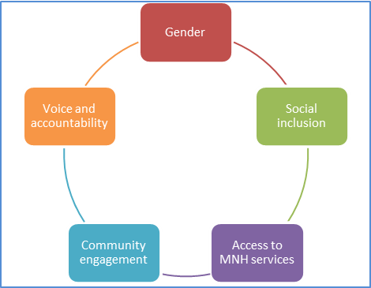
To frame our social development analysis of MNH in Indonesia, we have used a five pronged analytical framework: see diagram 1. This sits well with GOI’s and GOA’s priority focus on gender. It also incorporates attention to other social and geographical gaps, and by including attention to access to services resonates easily with health sector specialists. Community participation and empowerment is a well-recognised pillar of MNH programming and is embraced by GOI policy. Attention to issues of voice and accountability reflects good development practice and is a core theme of social development.
The new MNH program has equity or ‘closing the gap’ as an overriding goal which provides a high level entry point for promoting gender and social equity with GOI across MNH. As detailed in the following section, GOI has various policies to promote gender and equity, and using this language rather than ‘social development’ which is more allied to international development agencies, is likely to have greater traction and is recommended.

- Disparities in MNH outcomes in Indonesia
Indonesia’s maternal mortality ratio (MMR) declined from 390 in 1991 to 228 per 100,000 live births in 2007 (IDHS 2007). Recent census-based calculations suggest that the figure is higher at 260, and the IDHS 2012 estimate which, contrary to previous surveys includes maternal deaths of unmarried women, is still higher at 359. Large confidence intervals around the IDHS figures (322 to 132 in 2007; 478 to 239 in 2012) mean that the MMR may not have actually increased between the last two demographic and health surveys; but nevertheless the findings underscore the fact that inadequate progress has been made in reducing maternal mortality over the past five years. The MDG target of 102 by 2015 will not be met. Indonesia’s MMR is the highest in the region, and high for middle income countries. The lack of progress in reducing the maternal mortality ratio is particularly worrying given the increasing number of women having facility based deliveries - rising from 46.1% in 2007 to 63.2% in 2012 (IDHS 2007 and 2012 respectively) - and raises questions as to the quality of birthing care provided in facilities. While almost all women receive some antenatal care (ANC) during pregnancy – though this varies by province and district - the quality of care remains sub-optimal with only 60.2% of women in IDHS 2012 receiving at least two tetanus toxoid injections during their last pregnancy; increasing from 49.7% in IDHS 2007. Nationally, the two primary causes of maternal mortality are haemorrhage and eclampsia. The relative causes of maternal death vary by region, with for example, malaria and HIV reported to be important contributors in Papua.
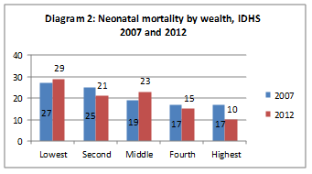
Diagram 2: Neonatal mortality by wealth

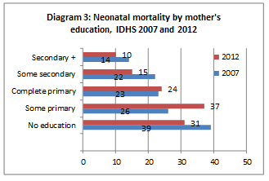
Diagram 3: Neonatal mortality by mother’s education

Linked to stagnation in maternal mortality is the plateauing of neonatal mortality at 19 per 1000 live births (IDHS 2012), the same aggregate level as found by IDHS 2007. Beneath this aggregate estimate, sharp differences in neonatal mortality are related to wealth and mother’s education; see diagrams 2 and 3.
The Indonesia Investment Case for Financing Equitable Progress Towards MDGs 4 and 5 in the Asia Pacific Region. Equity Report (2011) points out that the plateauing of neonatal mortality may partly be explained by weaknesses in coverage of facility deliveries, lack of good quality antenatal care, and poor breast feeding practices. Differences in facility based deliveries and ANC by wealth are notable in 2007 and shown in diagram 4 below, though early and exclusive breastfeeding is poor for all wealth groups. IDHS 2012 found that only 50.8% of babies in their first month of life were exclusively breastfed, tailing off to 27.1% by five months.
Diagram 4: Coverage along the continuum of care by wealth group, IDHS 2007 (extracted from Equity Investment Case, 2011)
The Equity Investment Case used IDHS 2007 data to assess inequities from neonatal through to child mortality, its key findings include:
- Wealth related inequality in mortality is large and does not show signs of converging.
- Disparities by wealth of key MNH service coverage.
- Neonatal and infant mortality more concentrated among the poor.
- Large gaps in mortality between island groups with the grouping of Papua, West Papua, Nusa Tenggara, Maluku performing particularly poorly.
- Low coverage of cost-effective interventions such as family planning, good post natal care practices, early and exclusive breastfeeding.
- High coverage of facility based deliveries in urban areas not translated into reduced neonatal mortality.
- Decentralisation has exacerbated inequalities in mortality rates and some provinces need support to governance, health systems and service improvements to enable better use of decentralised autonomy.
Socio-economic disparities: IDHS 2012 reaffirms the nature of the inequities found by the Equity Investment Case. Wealth related inequality in infant and child mortality remains large with the poorest significantly lagging behind other wealth groups. Infant and child mortality is also associated with mother’s education and place of residence with urban areas having lower mortality than rural areas.
In addition to the aggregate increase in use of MNH services between 2007 and 2012, there have been reductions in the disparities by wealth and mother’s education for some services. This includes a decline in the disparities in ANC by a skilled provider and facility based delivery, though the gap in facility based deliveries between women of different wealth and education status is still very large; see diagrams 5 and 6. The disparity between women receiving post natal care within two days of delivery by wealth has however increased between the two surveys as the poorest have been left out of the increase in use across all other wealth groups (see diagram 6).
Diagram 5: ANC and facility based delivery by mother’s education
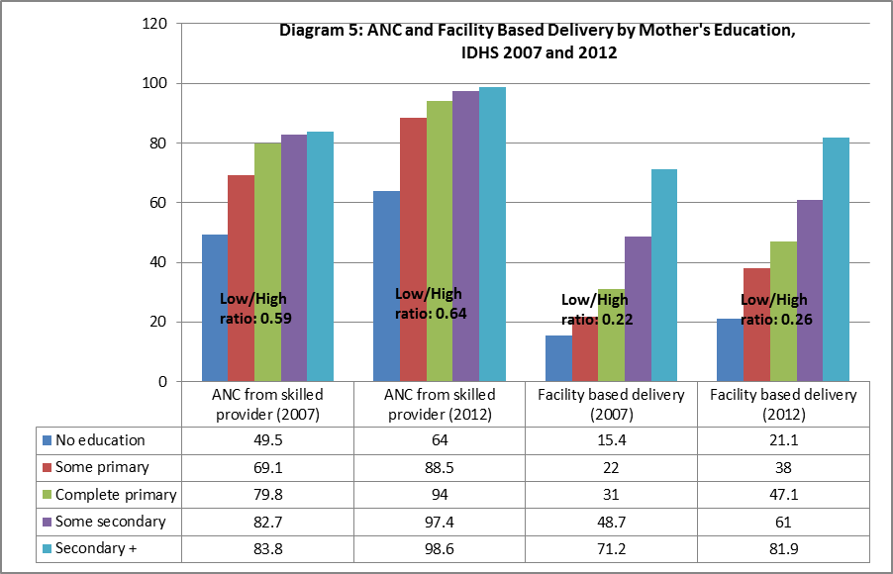
Diagram 6: ANC, facility based delivery, postnatal visit by wealth
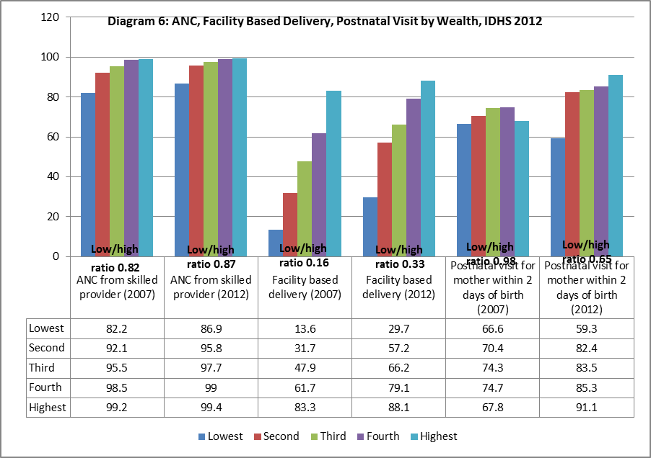
The two diagrams below which show the continuum of care plotted by wealth and mother’s education show how the disparities in coverage vary by individual services. While antenatal care is relatively equitable, the gap in institutional delivery by wealth and mother’s education is very wide and graduated. The differential in postnatal care coverage is less extreme than institutional deliveries, and less evenly spread across wealth and education groups with women who have no education particularly lagging. These diagrams illustrate that while the health system has been able to deliver ANC to the majority of pregnant women, the quality of ANC as shown by the provision of TT injections is inadequate for all, and the connection from ANC through to delivery and postnatal care is broken, with the poorest and least educated being the most neglected. Women with no education fare the worst of all on all four of the marker indicators.
Diagram 7: Maternal health coverage by wealth
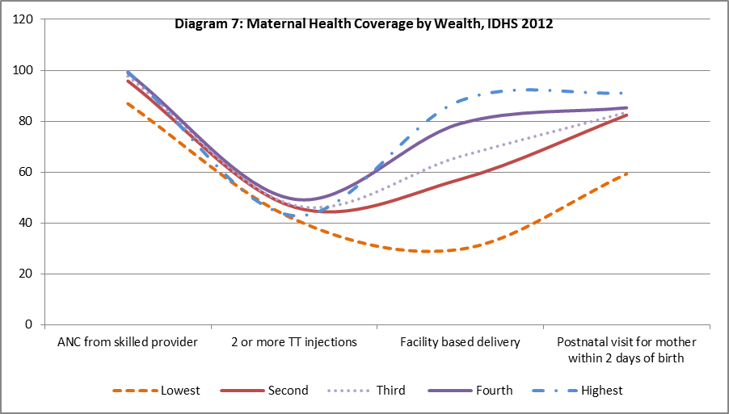
Diagram 8: Maternal health coverage by mother’s education
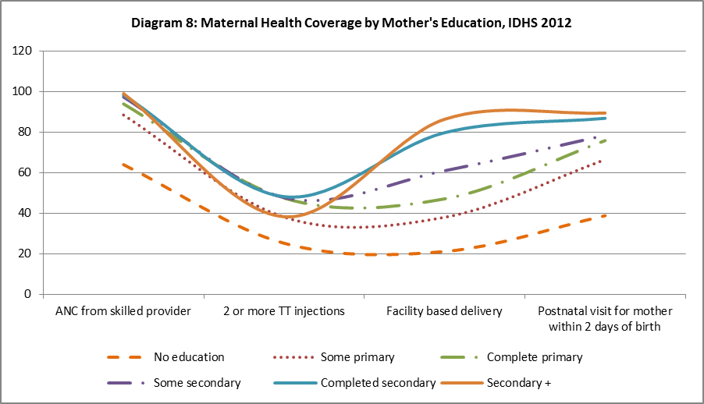
Provincial variation: There are wide disparities in MNH outcomes and service coverage across the provinces of Indonesia with the worst outcomes tending towards the east of the country in the islands of Papua and West Papua, Nusa Tenggara and Maluku. Growing inequity between wealthy and poor populations is a key political concern for social stability. The MMR in Nusa Tenggara Timur (NTT) (a rural province in Eastern Indonesia with 25% below the national poverty line) is an estimated 615 per 100,000 live births and NMR 26 per 1000 births compared to MMR of 290 per 100,000 and NMR of 14 per 1000 in East Java (2010 census).
More than one in three children under five are stunted (Riskesdas 2010) and more than 10% of babies are born underweight, with a nearly three times higher risk of newborn death (Titaley et al, 2008). Stunting is increasingly concentrated among the poorest. National rates of stunting fell in the wealthiest quintile from 30% in 2007 to 24% in 2010, but increased in the poorest from 40% to 43% (Riskesdas 2007 and 2010). However, the evidence as shown in Table 1 below suggests that the prevalence of stunting is not directly correlated with levels of poverty at province level with NTT having the highest level of stunting at 58% but Papua the highest levels of poverty at 31% living below the poverty line. Understanding the social determinants of stunting in different provinces will be important for ensuring design of the most cost-effective programming solutions.
High infant and child mortality and low coverage of MNH outcomes as well as poverty and human development indicators justify the selection of the four eastern provinces where geographical access is more challenging and health systems less developed. In contrast, East Java has better health outcomes overall but a number of districts which are performing much worse. The intention is that PERMATA will work in underserved districts of East Java to support local governments improve outcomes, and secondly to demonstrate models suited to health, demographic and socio-cultural contexts in Indonesia which are similar to East Java.
Table 1: Maternal and neonatal health indicators by province
Province | Poverty (% poor people) | Infant Mortality Rate, 2010 | Under 5 mortality (IDHS 2012) | Neonatal mortality (IDHS 2012) | ANC provided by a skilled provider (IDHS 2012) | Facility Based Deliveries % (IDHS 2012) | Stunting % (Riskesdas 2010) | CPR modern % (IDHS 2012)
East Java | 9.89 | 35 | 34 | 14 | 99 | 85 | 36 | 62
NTB | 18.02 | 72 | 75 | 33 | 98 | 75 | 48 | 55
NTT | 20.41 | 57 | 58 | 26 | 92 | 41 | 58 | 38
Papua | 30.66 | 36 | 115 | 27 | 58 | 27 | 28 | 19
West Papua | 27.04 | 41 | 109 | 35 | 86 | 38 | 49 | 41
Indonesia | 11.06 | 39 | 43 | 20 | 96 | 63 | 36 | 58

Disparities within geographical areas: Within provinces and districts, inequalities in MNH outcomes according to wealth, mother’s education, and location of residence exist. UNICEF’s MICS (2012) study which collected data from three Papua and three West Papua districts illustrates wide disparities in infant mortality by ethnicity, wealth, mother’s education and district: see diagram 9 below. This reinforces the need for context specific programming at the district level, according to the geographic context, and socio-economic conditions of the target group.
Diagram 9: Infant mortality rate in three districts of Papua
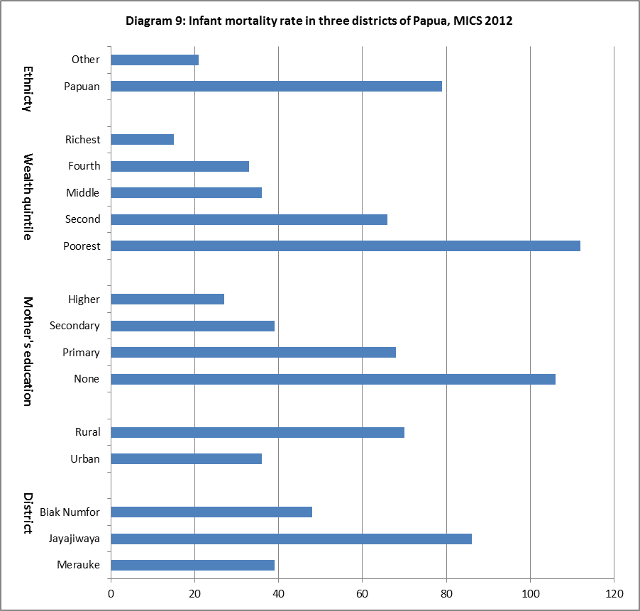
The IDHS 2012 will provide an important baseline for the new MNH program to measure changes in disparities by province, and by wealth, and mother’s education level at the national level. However, IDHS does not provide provincial level outcome data disaggregated by wealth or mother’s education; further analysis of IDHS to provide disaggregated provincial data may be possible though this will depend on sample size. Even with further analysis of IDHS data at provincial level, other data sources will be needed to measure the closing of the gaps in service coverage by district; by wealth and mother’s education; and provide evidence of impact on maternal and neonatal deaths disaggregated by wealth, mother’s education, and location of residence.

- Institutional and governance context
Decentralisation
Decentralisation has yet to deliver against expectations. Decentralisation of resources and authority has not been accompanied by decentralisation of functions and strengthened vertical accountability systems. The lack of clarity in functional assignment among central, provincial and district and city governments has resulted in overlapping responsibilities and confusion and tension between levels of government. Issues to highlight are a mismatch between national and regional priorities; the vulnerability of DAK (special allocation) funds to corruption and inefficiencies, and difficulties regions face in meeting nationally defined Minimum Service Standards (MSS).
The crowded development space at the local level involves a web of institutional and program structures that are brokered by key actors such as Bupati, Camat, Kepala Desa. The result is a number of overlapping programs with parallel facilitators and resource streams. There are at least five ministries involved in public health at the village level including the Ministry of Health, the Ministry of Religion, the Ministry of Home Affairs (through its involvement of the management of the PKK volunteers), the National Family Planning Coordination Board, and Ministry of Women Empowerment and Child Protection, as well as local government authorities and village level government. The claimed multiple ownership of posyandu by several ministries is one example of how institutional structures jockey for space and ownership of local resources. It will be important that the new MNH program is crafted so as not to further complicate or confuse lines of institutional responsibility for MNH at the local level while ensuring gender and equity concerns are upheld. This will be challenging given that gender and equity concerns are not naturally owned by the health department.

Weak inter-sectoral collaboration
MoH commitment to inter-sectoral collaboration to accelerate reduction in maternal and child mortality has been weak in practice. High unmet demand for family planning and stagnant maternal mortality reflect the need for a stronger family planning movement and the value of integrating family planning and health services to assure coverage, quality of care, and accurate reporting. In practice, tensions between agencies and local governments over budgets and responsibilities persist and family planning remains poorly integrated into the health system. This has implications for both integrated health and family planning programming and achieving gender and equity goals.

Weakness of provincial government
The role of the provincial government under decentralisation has been weakened. Human resources at provincial level are often weak, in part due to the central government regulation that transferred temporary contract workers to civil servant status regardless of merit. Shrinking discretionary provincial authority over centrally funded budget lines has left regional governments unable to cover their core functions. In the health sector, provincial departments of health have lost financial clout over districts, and the capacity to fulfil needed quality assurance functions.

Public financial management
Weak public financial management is a common concern across government. The multiple budget lines that districts and facilities have to manage are unwieldy and inefficient. Central resource distribution is poorly targeted to districts with the greatest needs, and resources often get trapped at the district level without percolating down to puskesmas and field based workers. Poorly enforced accountability further encourages the spread of a ‘skimming culture’ as power holders at all levels seek to siphon off resources for personal benefit. Such poor practices impact on the availability and quality of health services and the motivation of health staff, and inevitably hurt the poorest and least influential worst.

- Social development thematic evidence and analysis
This section of the report reviews MNH policies, services and systems, and family and community beliefs and practices against the analytical framework of gender, equity, access to services, community engagement, and voice and participation. See annex 3 for a description of the key government health programs that respond to MNH and gender and equity objectives, namely jamkesmas, jampersal, jamkespa, jamkesda, desa siaga, puskesmas reformasi, and posyandu.

  - Gender and maternal and newborn health: policies and health system
The policy framework for addressing gender inequality
It is internationally recognised that gender inequality and women’s lack of empowerment hinders economic development and poverty reduction. Australia has a strong commitment to reduce gender inequality and promote women’s empowerment through its aid program. Gender priorities for the health sector are set out by Australian Government to be improving access to maternal and reproductive health services, and mainstreaming gender into health systems and services. This strategy fits with the existing GOI policy framework for gender equality and women’s empowerment.
The GOI’s National Development Plan (2010-2015) includes gender as one of three cross-cutting issues to be addressed across all development sectors. Presidential Instruction 9/2000 made gender mainstreaming compulsory for all national institutions, and this has been reinforced by the Ministerial Regulation of the Ministry of Home Affairs No. 15/2008 which requires local governments to establish gender working groups, and for the head of the Development Planning Board (Bappeda) to act as a coordinator to formulate policies, programs and activities from a gender perspective in the local government medium term development plan (RPJMD), strategic plan (Renstra) and workplan (Renja) of local government work units (SKPD). The regulation divides responsibilities for gender mainstreaming between provincial and district level, and includes tools to assist with developing gender responsive policies, programs and activities such as Gender Responsive Planning and Budgeting (GRPB) and Gender Analysis Pathway. The Ministry of Home Affairs revised the regulation in 2011, and developed the current regulation No. 67/2011. The current national gender strategy requires all sectors to formulate a gender budget statement in the annual budget plan to ensure budgets incorporate gender responsive activities.

Gender and reproductive health policy in Indonesia
The GOI has a number of national policies and strategies to improve the health status of women and children, including maternal and newborn health. This includes the National Medium Term Development Plan (RPJMN 2010 –2014), the National Policy and Strategy on Reproductive Health, the National Action Plan for Maternal Mortality Reduction (2012-2015), and the Indonesian Family Planning Strategy: see Annex 2 for further discussion.
At the national level, gender and reproductive health have a moral foundation rooted in Indonesia’s major religions, and patriarchy norms are deep seated in policies and programming. Women’s sexuality and reproduction is circumscribed to the confines of marriage, and issues such as adolescent sexual and reproductive health, safe abortion, premarital sex and childbirth outside of marriage are contentious and morally sensitive topics. The rise of conservative Islamic movements is perceived by many to be closing the political and moral space for dialogue on reproductive and sexual health and gender. Efforts by UNFPA to dialogue with conservative religious leaders have been discouraging so far, and there is the view that fundamentalist thinking is growing in influence. The medicalization of female genital cutting is one example of how religious arguments are infiltrating the medical profession and becoming political mainstream. The decision of some medical schools to remove manual vacuum aspiration (MVA) training from obstetrics and gynaecology specialist education illustrates how religious beliefs are being used to curtail medical training. Reduction in the availability of MVA will impact on the availability of essential care to women who have had an incomplete spontaneous or induced abortion and place them at increased risk.
The Indonesian Constitution provides that “every person shall have the right to establish a family and to procreate based upon lawful marriage” (Article 28B(1)), but does not guarantee the rights of unmarried women and men to have children. Current laws prohibit the provision of government family planning services to unmarried men and women. Both the Population and Family Development Law (No. 52/2009) and the Health Law (No. 36/2009) state that access to sexual and reproductive health services may only be given to legally married couples. Such laws direct family planning service provision, and the attitudes and practices of health providers. In research undertaken by Amnesty International in 2010, health providers reported they do not provide contraception to unmarried couples, and district officials cited national laws and policies restricting access to contraception to unmarried couples. The legal framework neglects the sexual needs of young people who are seen as non-sexual, and runs contrary to their human rights.
Current laws and service delivery practices which restrict unmarried women and girls access to contraception increase their risk of unwanted pregnancy and sexually transmitted disease; this has additional implications in areas with raised HIV prevalence such as Papua and West Papua. The stigma of pregnancy outside of marriage has an impact on unmarried women’s and girls’ access to maternal health services, their acceptance in the home and school, and life choices.
A joint study by MOH and Provincial governments of West and East Nusa Tenggara (2009) reported:
“[P]regnant unmarried women attended no, or less, maternal health services including antenatal and [postnatal] care. It also showed unmarried women were more likely to deliver their babies at home and to be assisted by [traditional birth attendants].” (Amnesty International, 2010)
Abortion is illegal in Indonesia with the exception of when a doctor confirms a pregnancy is life-threatening to the mother, identifies genetic malformation, and in the case of rape. Professional counselling and husband’s consent are needed. Reliable data on the prevalence of abortion is not available, but estimates from a community based survey in 2000 suggest that about two million induced abortions occur each year many of them performed by untrained providers in unsanitary conditions. Women who seek abortions in urban clinic settings tend to be married and educated; the majority of urban clients seek care from a trained provider. A 2004 study found that a third of abortion clients at an urban clinic had experienced contraceptive failure. In contrast, in rural areas it is estimated that four-fifths of abortions are administered by a Traditional Birth Attendant (TBA). Nearly half of all induced abortions in Indonesia are thought to be provided by TBAs, traditional healers and masseurs.
It is estimated that 5-11% of maternal mortality in Indonesia is a result of unsafe abortion similar to WHO estimates of 14% for the region. The narrow legal limits of abortion in Indonesia and conservative attitudes of health workers towards abortion encourage women with unwanted pregnancies to seek unsafe abortions especially in rural areas. High unmet demand for family planning, estimated at 11% for the country in IDHS 2012 but varying by province with for example an unmet need of 24% in Papua, further compounds the issue. The gaps in the availability of safe and affordable reproductive health services to all women, especially unmarried women, and the risks this exposes them to, is a significant gender policy issue with maternal mortality implications.

Gender and health sector leadership
Since the commencement of Inpres 9/2000 on Gender Mainstreaming in National Development Planning and Programming, the Ministry of Health has been one of the State Ministry for Women’s Empowerment gender focal points. The Ministry of Health has a gender working group to accelerate gender mainstreaming, with focal points from the Planning Bureau, Maternal and Child Health and Community Health Unit. However, the vitality of this group has waned with the transfer of key staff and its potential to act as an engine for stimulating gender reforms needs revitalising. This may be an area for GOA’s Empowering Indonesia for Poverty Reduction Program (MAMPU) to promote women leadership.
The Ministry of Health’s gender mainstreaming strategy is formulaic and includes:
- assuring the implementation of gender mainstreaming at all levels of government;
- developing rigorous sex-disaggregated data;
- strengthening the legal basis of gender equality promotion in the Ministry’s work;
- implementing a gender-responsive plan and budget;
- raising gender awareness.
Specific gender-related activities to be carried out during this five-year development plan include a mix of women specific programs and gender training activities such as:
- delivering gender analysis training using the Gender Analysis Pathway model in all provinces;
- developing gender-related training modules such as gender responsive primary health services;
- including sex in the data base of ‘Kartu Menuju Sehat’ (health development card) for children under five;
- raising awareness to stop maternal mortality;
- promoting the anti-malaria program for pregnant women;
- increasing men’s participation in contraceptive use.
Despite the presence of national gender equality policies and institutionalised gender mainstreaming, levels of understanding of gender and health among officials in the health sector is low with gender often being equated with the delivery of services to women. There is a common misunderstanding regarding maternal and neonatal health, that gender is integrated into the program because 1) maternal and neonatal health focuses on women and children, and 2) midwives and nurses are mostly women. Stronger leadership and commitment to gender mainstreaming will be essential if the MOH is to play a more transformational role.
“Key leaders have shown limited understanding of the risks of not taking into account the underlying determinants of gender inequality, and the specific socioeconomic and cultural barriers that prevent women from accessing health care services. Education and knowledge sharing at this level are vital.” Rosalia Sciortino, 2012, “Sharpening the Sexual and Reproductive Health Component of Empowering Indonesian Women for Poverty Reduction (MAMPU) Program.”

Local interpretation and implementation of MNH policy: strengths and risks
Implementation of MNH policy is affected by the institutional structures, capacities and accountability of those in the health system, and its lawmakers. The decentralised governance system adds to the potential evaporation of national policies as district governments set their own priorities and approaches. For example, local regulations have been introduced in Aceh that restrict women’s mobility in the evening and run counter to national gender policies. In the area of safe delivery, some local governments have introduced regulations enforcing facility based deliveries and imposing fines on women that disobey. While this appears to have encouraged facility deliveries it also runs the risk of penalising innocent women who were unable to reach a facility in time for the delivery. Regulating facility deliveries also runs the risk of creating a false evidence base of extremely high institutional deliveries as health providers avoid capturing home deliveries in records. This leads to misinformed planning and service delivery, and the further neglect of populations that face the greatest difficulties in accessing services. In theory, local regulations that seek to protect women’s safety and well-being are framed so as to be consistent with national laws and policies but in practice, national and local policies and interpretations can be at odds with each other, and this can have negative consequences on women’s rights and well-being.
With the Government’s push towards increased use of long acting family planning methods care will be needed to ensure that women’s informed and voluntary choice of methods is upheld. Field evidence from a hospital in Papua suggests that provision of jampersal and jamkesmas for institutional delivery is being made conditional on acceptance of IUD. Such local interpretation of policy undermines women’s reproductive choice and public trust in the health system. Sensitive monitoring of the family planning component of the program through state and civil society channels to ensure choice and rights are maintained will be important, and may be an area for collaborative working with MAMPU.

Sex disaggregated data
There is a lack of sex disaggregated data on utilisation of health care and very little information on sex-disaggregated mortality, morbidity or health risk factors. The health management information system is fragmented, and decentralisation has further confused the division of reporting responsibilities. Basic data such as the sex of the government’s human resources for health are not available. Advocacy efforts for sex disaggregated data led by the State Ministry for Women’s Empowerment have had limited affect.
The lack of reliable population data collected through civic registration, birth certificate, marriage and divorce certificates, together with a high level of fraud and falsification of identification cards, also undermines health planning. Commonly people only obtain a birth certificate when they need it for school enrolment. IDHS 2007 found that the most commonly reported barrier to registering a birth is cost. The registration system needs strengthening if it is to reliably identify trends in populations, gender differences and future health needs across the country.

Gender and human resources for health
Lack of data on the sex ratio of the health workforce is a basic gap in the system. It is estimated that female doctors, midwifes, nurses, and volunteers form over half the total of health sector workers in Indonesia, and yet they generally lack decision-making powers. GOA’s “Gender and Health Sector Assessment, 2010” found that women in the health sector face gender discrimination and bias through the lack of a decision-making voice, the lack of incentives to perform well, poor recognition for their work, and restricted access to proper training. High levels of absenteeism – about 40% of the time - and difficulties in filling and retaining health staff are common problems which have a serious impact on access to MNH and other primary level services. The dual practice system which allows doctors to hold public and private sector jobs means that it is difficult to attract doctors to rural and remote posts where private sector demand is low.
GOA’s Health System Strengthening Program has a two pronged focus on human resources and health financing, and will be the primary vehicle for addressing gender inequalities in these health system building blocks. This is likely to include evidence generation and learning on the working conditions of female nurses, midwives, and doctors, and women’s participation in health leadership and decision-making.

Gender and health financing
Gender mainstreaming efforts have tended to focus on how to develop gender-responsive programs and integrate gender measures into budget formats. Gender budgeting in the health sector has not been put into practice. A gender analysis of health sector financing and of the forthcoming universal health coverage program is a priority need which AIPHSS should address.

Review of the AIPMNH gender mainstreaming approach
From our analysis, the AIPMNH did not integrate gender into its design and implementation. In the past two-to-three years, the program has given gender greater attention by bolting-on gender mainstreaming activities in focal districts. The result has been a missed opportunity to integrate gender into project activities, and to make gender a team-wide responsibility. Gender mainstreaming activities undertaken have produced varied results as they have attempted to follow government gender mainstreaming guidelines and tools across 40 SKPD in each district. In West Sumba, the process has been well accepted and internalised by the district government, and won a national award, but in most districts, less traction and ownership has resulted. While gender mainstreaming across local government is undoubtedly important, we believe that the priority focus of a MNH program is to ensure MNH systems and services are gender sensitive, and that women and girls and particularly poor and vulnerable women and girls, are empowered through access to information and decision-making to promote and protect their health. Gender mainstreaming should focus on MNH service delivery and the systems that support them rather than the more upstream and ambitious mainstreaming of gender across local government agencies for which a MNH program is less well placed than governance and institution building programs such as AIPD.

  - MNH, social inclusion and reaching poor and vulnerable populations: evidence and policy
Who are the poor and vulnerable?
Poverty: Indonesia has achieved mixed progress in reducing poverty since 1990 and achieving the Millennium Development Goal of eradicating poverty and hunger. While the number of people living on $1 a day has been more than halved from 20.6% in 1990 to 5.9% in 2008 (BPS and World Bank) other poverty indicators have been less successful. Progress in halving the number of people living below the poverty line is off track, and stood at 12.49% in 2011 (BPS, Susenas), 15.72% and 9.23% in rural and urban areas respectively. Progress in reducing child under-nutrition is on track.
At the national level there were approximately 29 million people living below the poverty line in 2010. In 2006, 49% of the population lived on less than $2 per day, the ‘near poor’ representing 108 million people. The World Bank suggests that ‘there is little that distinguishes the poor from the near-poor’. There is considerable movement in and out of poverty with half of poor households not being poor the year before, and four-fifths of next year’s poor originating from the bottom 40%. Inequality between households has been rising for the past decade.
Poverty rates vary across the country as do measures of human development, although evidence suggests that spatial inequality is declining. The four focal provinces of Papua (0.64), NTB (0.641), NTT (0.661) and West Papua (0.679) have the lowest HDI in the country; East Java is ranked towards the middle (0.703). Remoteness is a key contributor to poverty and a major barrier to accessing social services in the Indonesia archipelago and as in other countries impacts on health coverage and outcomes. Reaching women and children living in remote areas will need to be a key focus of efforts to reduce the MNH equity gap.
With MNH coverage correlated to wealth and mother’s education, poorer and less educated women and their children are particularly vulnerable to poor MNH outcomes. Women with no education have the lowest utilisation of MNH services. Understanding the linkages and manifestation of how poverty affects MNH is important for equitable programming.
Social exclusion: Gender and cultural norms put women at risk of being marginalised, and poor women face multiple levels of disadvantage. Unmarried women are particularly vulnerable to exclusion and lower take up of MNH services. Other groups of women that are marginalised and have greater difficulties in accessing health services include the disabled, settlers, and commercial sex workers. Indigenous groups face multiple barriers to accessing services including language and cultural barriers. Vulnerability and geographical and social exclusion reduces people’s access to health services and require tailored responses from the health system to help them overcome the barriers faced, be they of a cultural, social, financial or geographical nature.

Inequities in health financing and availability of services
World Bank (2012) estimates that out of pocket spending on health accounted for 38.25% of all health expenditure in January 2010; a decline from 44.71% in January 2004. In 2010, out-of-pocket spending made up 75% of all private expenditure reflecting the large proportion of private spending not covered by insurance. High levels of out of pocket spending are a barrier to accessing health care for the poor, and place the poor and near poor at risk of impoverishment. Catastrophic health expenditure has been declining, but 0.9% of the population still became impoverished as a result of health care costs in 2006; over two million people.
The Indonesia Public Expenditure Review (2007) found that public spending on health benefits richer groups more than the poor through subsidies on secondary care which accrue to wealthier quintiles. The Review found that 40% of public spending went to secondary hospitals of which 38% of the benefit was accrued by the wealthiest quintile and only 10% by the poorest. Poorer groups use significantly more primary level health services than hospital care and targeting greater resources to puskesmas and below will be key to improving the equitable use of public health funds and outcomes.
Government spending at district level is also ineffective in targeting resources to poorer and underserved districts. Deconcentrated central government expenditure which makes up a large share of total national health expenditures are not targeted to the poorest areas. Provincial and district revenue tend to be higher in better off areas. The result is lower per capita budget allocations for health in some of the poorest and neediest districts.
The low density of nurses and doctors per population compared to other middle income countries underpins fundamental gaps in coverage of health services especially in rural and remote areas. The uneven distribution of health personnel is fuelled by the tendency and legality of dual practice and the preference to be posted in urban areas. The lack of qualified, competent health providers in underserved areas is a major barrier to improving access to health care for women, the poor and vulnerable.

Equity in Government health and development policies
The Ministry of Health’s Strategic Plan 2010–2014 has four objectives:
- To increase the degree of public health through community empowerment, including both the private sector and civil society.
- To protect community health by insuring the availability of comprehensive, equal, quality and fair health efforts.
- To ensure the availability and equal distribution of health resources.
- To create good governance.
The strategy refers to equity in terms of distribution and availability of health services and health resources, and has a value statement that states that ‘attaining the highest possible health degree for every person is one of the human rights that does not differentiate between ethnic groups, religion and social economic status.’ However the strategy does not include an analysis of health status and coverage by wealth/poverty, the barriers to access of poor and vulnerable populations or strategies for improving the health of the poorest or those living in remote or vulnerable situations. Likewise the draft National Action Plan for Maternal Mortality Reduction (2012) does not include an equity analysis of the groups or geographical areas where maternal mortality is higher and in need of an accelerated response. The Action Plan lacks an equity lens, does not capture the socio-economic and cultural diversity in the country and the need for context specific and tailored responses to different MNH settings in Indonesia, or set any priority to target those areas where mortality ratios are very high. The lack of an equity dimension in the MDG targets themselves reinforce blanket approaches, and the tendency to report aggregate national achievements which mask social and geographical inequalities.
The Presidential Instruction No. 3, 2010 on an Equitable Development Program and the Roadmap to Accelerate Achievement of the MDGs emphasise the achievement of the health MDG targets and in particular the need to prioritise maternal health. There are, however, no specific references to ensuring that the poorest benefit from achievement of improved health outcomes.
Commitment to address the underlying social determinants of health, including gender, appears to be missing in the policy frameworks that guide MNH. The AIPHSS program is the natural place to promote greater attention to health equity broadly to influence policy, financing and programming. However, the new MNH program needs to integrate gender and equity into its design, implementation, monitoring and evaluation indicators and provide a learning site for improving MNH among poor and vulnerable populations, raising MNH coverage and outcomes in some of the most underserved areas of the country, and building the knowledge base and advocacy to address MNH inequity.

  - Barriers to accessing MNH services
There is considerable evidence of the barriers that women face in accessing MNH services and the additional hurdles that poor and vulnerable women and their families have to contend with. These barriers are multiple and interconnected. We use a pathway approach to identify the constraints that women, and particularly those that are poor and vulnerable, have to contend with from the home, in the community, related to the journey, and at the point of service delivery. Diagram 10 sets out the key barriers. This section of the report draws out key findings from the literature and from field visits in NTT, NTB, East Java, and Papua.
Diagram 10: Key barriers
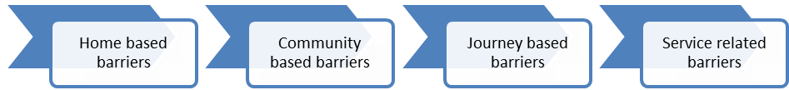
The framework shows how some thematic barriers, such as gender, financial, traditional and cultural beliefs, and lack of information appear at several points along the demand to supply pathway. The focus of AIPMNH has been on tackling service barriers, and those linked to the journey with limited attention to home and community based barriers. Independent reviews of maternal health programs in Indonesia suggest this is an area in need of greater attention.
(a) Gender: from the demand side, gendered social norms that affect decision making in the household are reinforced by community structures and practices. Gender norms tend to define domestic tasks and child care as women’s responsibilities. Division of labour within the family often leaves women with heavy and physically demanding work burdens through to the end of pregnancy, impacting on their health and that of the baby. This is often reinforced by local beliefs that hard work towards the end of the pregnancy will strengthen women for an easier delivery. Women also often leave the facility early after delivery in order to get home to take care of older children putting their health and that of their newborn baby at risk.
Gender norms also affect women’s control over household resources and their access to cash at the time of an emergency. The 2012 IDHS found that nationally, among women aged 15-49 who earn cash some 65% decide how that money is spent, and that 83% of women of the same age group report being involved in decisions about their health care. These are important indicators of women’s empowerment although the IDHS found that the strength of their association with health outcomes is weaker than expected.
Problems women face in accessing health services: IDHS also asked women whether they faced specific problems in accessing health services for themselves when they are sick. Table 2 below shows the range and magnitude of the problems across the five focal provinces. The magnitude of the difficulties women face is much higher in Papua and West Papua than the other three provinces, with the biggest challenge reported in both being getting money for treatment. This is closely followed in Papua by the distance to a health facility and reflects the physical remoteness and scarcity of services. While getting permission to go for treatment is not widely reported in East Java, NTB or NTT, 25% of women in West Papua and Papua consider getting permission a problem. Such findings underscore the diversity of the demand side scenarios in each of the provinces, and the need for context specific approaches to demand generation.

Table 2: Problems women face in accessing health services when they are sick (IDHS 2012)
Province | Getting permission to go for treatment | Getting money for treatment | Distance to health facility | Not wanting to go alone | At least one problem accessing health care | Number of women
East Java | 3.5 | 9.7 | 5.5 | 24.5 | 31.8 | 7,374
NTB | 5.0 | 16.0 | 9.0 | 12.9 | 25.7 | 997
NTT | 2.7 | 16.9 | 16.5 | 19.5 | 34.0 | 892
West Papua | 24.6 | 39.9 | 27.3 | 27.9 | 53.5 | 130
Papua | 24.9 | 57.8 | 50.5 | 26.8 | 64.0 | 527
National | 5.1 | 15.2 | 10.5 | 22.8 | 34.1 | 45,607

Decision-making: Understanding how family control over resources and decision-making patterns are played out in local socio-cultural environments and affect access to health care is important for programming. It was commonly reported in the field sites visited in NTT, NTB, East Java and Papua, that women need to seek family permission to leave the village and, though involved in decision-making about their health, lack the final say. In Papua, the decision-making process is complicated as both the husband’s and wife’s families have to be involved in deciding whether to seek care outside of the village, and once at a facility whether to accept the treatment being offered. This can be a major delaying factor at the time of an emergency. Staff at district and referral hospitals in Papua reported that this was often the cause of delayed action, with for example parents-in-law in a remote village in the Highlands needing to be consulted in deciding whether a woman has a caesarean section at a distant hospital.
Age at marriage: Social norms influence the age at which women get married and as the majority of women in Indonesia only start sexual activity once married, age of marriage is an important correlate of maternal and child health and nutrition outcomes. Age of marriage is important because younger women are at greater risk of maternal mortality, and delayed childbearing has benefits on child outcomes. The risks of stunting, diarrhoea, and anaemia diminish significantly as a woman delays her first birth through to age 27-29 years, regardless of socioeconomic status. Age of marriage is steadily increasing in Indonesia; the most recent IDHS (2012) found the median age of first marriage of ever-married women aged 25-49 is 20.1 years, increasing from 19.8 in 2007. This figure is lower in Papua at 19.6, as it is in East Java (19.5) and NTB (19.5).
In East Java, early marriage among girls is recognised to be a major social problem and determinant of MNH with estimates that over 40% of women are married before they are twenty. This practice appears to be driven by religious and family pressures placed on girls to marry early, and the fact that only married women are permitted to migrate for work.
Women’s social solidarity: Social structures in some areas, such as on the island of Sumba (NTT) leave women without the space to come together and receive new information, dialogue with peers, and build solidarity and self-confidence. In contrast in the Highlands of Papua, women’s groups linked to the church tend to meet regularly. The existence and capacity of women’s groups and networks which can act as a platform for empowering women varies across the focal provinces. Even where women’s groups are functional, women are generally not involved in community level discussions and decisions. Village musrenbang tend to be male dominated and hardware oriented. This translates into women typically not being aware of their entitlements, or having a say in the allocation of community resources in a way that will address women’s collective poverty.
Women lack voice
In Papua, community planning of PNPM Respek is dominated by village chiefs and elites and even if women are present in meetings they tend not to speak out and have little say in how funds are used or in accessing benefits. Elite capture translates into poor utilisation of infrastructure built with program funds. Where infrastructure has been built and achieved optimal utilisation user groups, such as women’s groups, have generally been involved in the planning process. The 15% allocation of PNPM Respek community funding to women’s activities are rarely secured by them.
(Sari Y.I., Rahman H., Manaf D.R.S, 2011, “Final Report: Evaluation of PNPM RESPEK: Village Infrastructure and Institutional Capacity”, Akatiga Centre for Social Analysis.)
Gender issues on the supply side: is linked to a range of issues which affect women’s access to services. Facilities may be poorly staffed and lack female staff to treat women who prefer a same-sex provider. Facilities may be poorly located so as to be accessible to women, and inadequately designed to cater to women’s basic needs such as functioning and accessible clean toilets, and screens for maintaining privacy. Service sites may not be sensitive to the needs of disabled women, and practitioners may lack the skills and knowledge to respond to their special maternal needs. Care may also lack the respect and compassion that fosters women’s confidence and trust, especially for particularly vulnerable women such as unmarried pregnant women, and those living with HIV.
(b) Financial: in the home and community, lack of awareness of health entitlements, including jamkesmas and jampersal, and lack of confidence that providers will not demand additional expenses results in considerable uncertainty in the household as to the affordability of services, particularly so for the poor and near-poor. IDHS 2007 found that women reported “getting money for treatment” the biggest problem they face in accessing health care. In 2012 this was surpassed at the national level by “not wanting to go alone”; though in Papua, West Papua and NTB access to money remained the biggest problem.
Less than half of the poorest 30% of the population receive Jamkesmas.
Ineffective targeting of jamkesmas leaves many poor and vulnerable people unprotected while many wealthier households receive benefits they are not entitled to. The World Bank Jamkesmas Health Fee Waiver Review (2012) found that jamkesmas coverage of the bottom 30% of the population ranges from between 39-50% while coverage of the top 60% ranges from 36% to 7%. Decentralised targeting of jamkesmas has reportedly added to targeting errors. World Bank reports that field researchers have found jamkesmas cardholders experiencing longer-than-normal delays in facilities because service providers needed to verify jamkesmas status or took long to provide a referral; this was also reported in all four provincial field studies. Discrimination in favour of regular paying patients has also been reported; as well as charges for covered medicines and services.
In all four of the field sites visited as part of this assessment, respondents reported that sometimes medicines and services are charged even though they should be covered by jamkesmas or jampersal; including caesarean section.
Jampersal covers the costs of pregnancy through to postpartum care at public and accredited private facilities for all women but reports from women in NTT district show that some women are unaware of jampersal, how to apply, and the benefits it offers them; UNICEF has found similar evidence. Often health providers choose not to share this information. Even when covered by jampersal, providers continue to charge women for ‘uncovered items’, such as the mattress cover of a bed, and drugs that are out of stock, and additional charges for those that are from outside of the sub-district (e.g. charges made for use of the local waiting home). Such accountability failures fuel public mistrust in health services, and uncertainty about the cost of care for families. Mistrust in health services is reportedly widespread in the Highlands of Papua. Moreover, given the non-functioning of puskesmas in some remote areas, the jampersal condition that hospital patients have a referral letter from a puskesmas, in effect disadvantages the most underserved.

In Papua, jamkespa, jamkesmas and jampersal are theoretically available at public health institutions. The reimbursable for delivery patients is more attractive from jamkespa but this is only offered to indigenous Papuans. Once jamkespa budget allocations have been exhausted or if a patient is not entitled to jamkespa, hospitals will seek coverage under jamkesmas if patients have the necessary identification. As a final source of health insurance, some hospitals will administer jampersal, but as the reimbursable is the lowest, some hospitals choose not to offer this. Jampersal also requires a referral letter from a puskesmas and where these are non-functional such as in the remote Highlands, this is difficult to avail.
The administrative burden for hospitals of administering three or more health insurance schemes, and the confusion and lack of awareness among the public of what each offers should be simplified with the introduction of universal health coverage but exactly who ends up benefitting and social exclusion will need close monitoring by the health system and civil society.
Transportation: Cost of transport is not covered by any of the health protection schemes, and is often the most expensive cost that families have to cover, especially in remote areas. The use of BOK to cover the referral transport costs from a lower to a higher level facility is available in some places. However, as the study team learned in Papua, these referral funds are typically neither publicised nor openly offered to those being referred; their ability to protect vulnerable women and children in need of referral services are therefore modest in their current form.
(c) Traditional and cultural beliefs and customs affect family decision-making and gender norms as discussed above, and maternal and child health practices, and are important determinants of maternal and early child health and undernutrition. They vary across ethnic, tribal and social groups and need to be understood as part of the socio-cultural domain of specific groups rather than generalised. For example, the strong importance of cultural festivities in parts of NTT, and preference for large families have significant implications on household poverty, and maternal and newborn health, and behaviour change campaigns need to be shaped accordingly.
Restrictions during pregnancy are common. In Papua and NTT we learned of food prohibitions during pregnancy; with eggs prohibited in NTT, and rice, tofu, and lentils in Papua. Taboos related to pregnancy were also documented, and women in NTB, East Java and Papua reported how they kept their pregnancy secret until their bellies visibly showed, with obvious implications for delayed antenatal care.
Trust in traditional birth attendants was reported in all the field sites visited. In Paniai District where the health service has scanty coverage in remote areas, the District Health Office has decided to train traditional birth attendants as a first line of care to pregnant and delivering women. Strengthening relationships of TBAs with the formal health system and building their capacities will need to be considered in accord with the different health system and social contexts in which the program will operate.
In Papua, there are cultural issues around giving and receiving blood. People do not want to give or receive blood from different tribes, and are reluctant to donate blood.
Positive and benign beliefs are a source to leverage for improving positive MNH behaviours and use of services. Harmful beliefs and practices, such as women and newborns put into “smoking huts” for 40 days post-delivery in NTT to cleanse the blood, and damaging dietary restrictions during pregnancy work against MNH, and need respectful multi-dimensional social mobilisation approaches to help reframe the behaviours they support. Across provinces, mothers-in-law are influential family figures, and field visits reported in several sites how they deterred breastfeeding. Indonesia’s poor record with early and exclusive breastfeeding, and the fact that women who have delivered in a health facility are more likely not to breastfeed illustrates the need for improved training of health providers, and regulation to prevent companies selling infant formula from accessing facilities.
Malu or social shame or ‘shame culture’ hides away social issues and contributes to vulnerability and exclusion of those who have broken social codes, such as unmarried pregnant women. Stigma and shame attached to pregnancy outside of marriage feeds into the isolation of young, unmarried pregnant women and their lower take up of pregnancy care and institutional delivery, and increased risk of maternal mortality. In West Lombok, one puskesmas reported undertaking “silent home visits” to unmarried pregnant women to provide antenatal care and encourage them to come for an institutional delivery; such practices illustrate the need for special provider attention to very vulnerable women.
Lack of access to reproductive health information and contraception for unmarried men and women places young people at risk of unwanted pregnancies. In NTB, NGOs supporting adolescent reproductive health information programs are campaigning for “new men” that share household and child care tasks and are involved in maternal and child health. Opportunities to link with other demand side programs, such as ACCESS and MAMPU, particularly in the areas of reproductive health will be essential for PERMATA to leverage local resources and stimulate action.
(d) Authoritative attitudes permeate the home, community organisation and decision-making, and the manner in which health services are delivered. Husbands and mothers-in-law, village leaders, and health providers are vested the authority to take decisions which impact on maternal and newborn health. This affects the level and form of interpersonal communication between the provider and user, and often leaves women uninformed of basic information on how they can promote their health, what they are entitled to, and why facility deliveries are beneficial. Local regulations that impose fines on women that don’t deliver in a facility while well-intentioned can end up penalising the most vulnerable that were unable to reach a facility in time. Similarly, the translation of national health financing policy so that jamkesmas and jampersal beneficiaries of institutional delivery funding are pressured into accepting IUDs, is another example of how authoritative attitudes can undermine choice and transparency.
(e) Remoteness and geography are major barriers to accessing services in some of the focal districts of PERMATA, particularly in Papua and West Papua, where road and water access are often absent and villages can only be reached by foot or sometimes plane. Remoteness impacts on access to information, the distance to and costs in reaching services including time, the availability of transport, the availability of health personnel and medical supplies, and the cost of running health services. The low level of human development in poor remote areas also impacts the capacity to mobilise and train community facilitators and local people.
Tailored interventions to address the special challenges remote communities face in accessing services are often needed. In AIPMNH, waiting homes are being experimented with, and Desa Siaga is mobilising and organising the community to be prepared with community based transport solutions, social funds, and support networks. Harmonising program interventions to maximise the use of limited local human resources and create linkages across development efforts also makes sense.
(f) Lack of information is a common theme among women, families, and communities both related to healthy maternal and child practices, nutrition, the impact of health and nutrition on outcomes, the importance and benefit of health service use, and entitlements.
Infant and child nutrition are poor and contribute to undernutrition early in life and increased risk of overnutrition later in life; the double burden of malnutrition. Only 42% of children less than six months are exclusively breastfed and 49% of babies are breastfed within one hour of birth; fewer when delivered by a doctor or midwife (48.6%) than by a traditional birth attendant (52.1%). (IDHS 2012)
Weak knowledge of nutrition and family planning of midwives, as well as poor counselling and interpersonal communication adds to the information deficit. Existing behaviour change communication (BCC) approaches appear weak and underfunded. Breast milk substitutes are commonly promoted in health care facilities to both health care professionals and mothers.
At the international level, community based approaches have demonstrated their effectiveness in raising awareness, changing family practices, and impacting on neonatal and maternal health outcomes. A Cochrane 2010 systematic review of clustered randomised and quasi-randomised controlled trials of the effectiveness of community-based intervention packages on maternal, perinatal and neonatal morbidities, mortality and health outcomes found an overall reduction of 24% of neonatal deaths.
Community delivery platforms include (i) group based approaches which provide education and support and mobilise the community, (ii) community mobilisation plus home visits by community health workers, (iii) home based care. The Cochrane review found “t(T)he most successful packages were those that emphasised involving family members through community support and advocacy groups and community mobilisation and education strategies, provision of care through trained community health workers (CHWs) via home visitation, and strengthened proper referrals for sick mothers and newborns.”
Randomised controlled trials of a participatory learning and action approach delivered through women’s groups have shown how maternal and neonatal mortality can be reduced in high burden environments through regular and structured group meetings over an 18-24 month period. Prost et al.’s 2013 meta-analysis found that exposure to a women’s group was associated with 37% reduction in maternal death and 23% reduction in new born deaths in Nepal, Bangladesh, India and Malawi. High coverage and participation of pregnant women is necessary for successful impact at mortality level. They recommend combining both the women’s group approach and home visits for maximum impact.
Drawing on the national and international evidence base, it will be essential that the new program addresses key information gaps through empowering and participatory BCC approaches as well as traditional campaign approaches. Provider knowledge and interpersonal communication skills also need to be strengthened for them to fulfil their role as key informers and influencers. As the new program expands to include family planning, informed choice will be a central issue and will reinforce the need to give greater attention to information dissemination and behaviour change communication.
(g) Poor availability and quality of care is a major barrier to access. Weaknesses in district health systems play out at the puskesmas level in terms of poor staff attendance, lack of operational funds, accountability deficits, and less than respectful and client-oriented care. In some districts, staff distribution is uneven leaving remote areas without staff and functioning primary level services. In Paniai in Papua, the district headquarters town has more midwives stationed in the hospital and puskesmas than the rest of the entire district. This is in part because staff use personal connections to avoid remote postings, and also because non-indigenous health workers lack the language skills and backgrounds to operate in remote areas. Security threats also persist and young women are particularly vulnerable. Related to weak human resource management is the sometimes inappropriate siting of health facilities driven by political influence or availability of donated land rather than population coverage and access.
Language barrier: In Papua where the majority of midwives and doctors are not indigenous Papuans, communication is severely hindered because of language differences. In Paniai District Hospital, only two out of 15 midwives and nine doctors speak the local language and they are relied upon to help communication between health staff and patients and their families. This is a major barrier especially given local cultural norms that require extensive family consultation to decide on the course of medical action for a patient.
Community based services: AIPMNH’s support to Puskesmas Reformasi is demonstrating how services can become more responsive and better quality, and how to strengthen community based service provision with support from Posyandu Reformasi.
In line with regional autonomy, posyandu have reduced in number and level of activity. The structure and functions are blurred, and community participation and ownership are almost absent. In general, service delivery at Posyandu remains weak with untrained cadres and lack of funding. (Mize, 2012, “The paradox of posyandu”, AusAID)
The absence of a community based health and nutrition provider that is trained to provide information, counselling, treatment of common ailments, and referral leaves a gap in the health system especially in poor and underserved areas and districts, and particularly in remote areas. The weaknesses of Posyandu are well spelled out in Lucy Mize’s “The paradox of Posyandu” report (2012). Evidence suggests that Posyandu are not a vehicle as currently structured and capacitated to fill the basic MNH information and service gap at community level in high burden areas. Other village actors with the potential to affect MNH practices, such as PKK and Cadre KB, are not felt to be functioning well. The PSF study found PKK to be largely not functioning. From our field visits we found Cadre KB have little supervision, receive limited training, and are not well coordinated with other actors. Tokoh agama and tokoh adat (religious and community leaders ) are generally not engaged in the area of MNH.
Proposals for PNPM Generasi to introduce a community health and nutrition facilitator as part of its stunting initiative are interesting, though for sustainability and institutional clarity it would seem better for such a facilitator to be linked to the health system rather than a community empowerment project. PERMATA will be well positioned to test out approaches to filling the information deficit, empowering women to use new information, and strengthening frontline delivery of MNH and related nutrition and family planning services at community level.

  - Community empowerment for MNH
Desa Siaga is the government’s national program that seeks to mobilise the community to support MNH, prepare for each birth, monitor each pregnant women, and help enable her to access the pregnancy, delivery and post-partum care she needs regardless of her social and personal circumstances. In areas where AIPMNH is supporting Desa Siaga very positive results have been achieved and community ownership and advocacy is strong. Male involvement in care of pregnant women and children is generally limited in Indonesia, and a major strength of Desa Siaga in AIPMNH areas is the strong male involvement which it has fostered. This has been beneficial for care of women and children in the home, and a key factor for achieving support of the village head, and attracting local government funds. Desa Siaga as a vehicle for community mobilisation can also act as a platform for other community programs. The green flags that are used to identify pregnant women are also used in disaster risk management programs to identify the most vulnerable in case of a disaster.
Experiences from the field in Papua suggest that Desa Siaga has had mixed results there, partly due to high community expectations that Desa Siaga will bear resources for local leaders, and insufficient tapping of the voluntary spirit that exists in many communities.
Desa Siaga is focused on addressing journey barriers, mobilising community support and monitoring pregnancies and births, and has leveraged local power structures to do so. This is a sensible approach but means that it has not been a vehicle for opening up space and building the agency of women and adolescents. The model in AIPMNH areas has tended to use existing decision making structures and a top-down mindset, this has fostered regulations for facility deliveries and punitive sanctions. While this has been successful it also has its limitations and potential risks of exclusion.
Desa Siaga appears to be a good model for what it is trying to achieve, reducing journey barriers and mobilising the community, particularly men, for MNH. Other interventions, such as participatory and reflective BCC will be necessary to tackle deeper gender based and cultural barriers in the home and community which affect MNH practices, and enable women and adolescents to have a greater voice in community structures and decision-making, and affect the social determinants of MNH.

Diagram 11: Barriers to accessing Maternal and newborn health services
Home |  | Community |  | Journey |  | Service
Gender | • Gendered decision making; permission seeking; and mobility restrictions  • Women's unequal relationships with husband and mothers-in-law  • Women lack voice  • Women's heavy work burdens  • Husbands lack of participation in domestic realm and childcare | Gender | • Stigma of pregnancy out of marriage  • Gender-based discrimination  • Women excluded from community decision-making and resources | Gender | • Women not involved in location of facilities; or negotiations for grants and purchase  • Permission required | Human resources | • Poor staff attendance  • Lack of HR; double burden of staff (clinical and admin)  • Shyness of users; prefer same sex personnel  • Lack of incentives for health workers and Posyandú cadres
 |  |  |  | Cost | • Lack of cash in hand  • High costs | Human resources
Gender |  | Elite capture | • Village elite dominate and capture community decision-making and resources
Gender |  | Attitudes | • Authoritarian attitudes and mind-set  • Lack of confidence in public health services | Geography | • Terrain; stretchers not functional in hilly areas  • Long distance  • No roads | Cost | • Charges for free services and medicine, under mattress, lack of funds
Cost | • Poverty  • Perceived unaffordability of health services |  |  |  |  | Financial | • No funds for pukesmas operational costs, restrictions on BOK (gas for ambulance)  • Poor use of budgets; gift to DHO; honorariums for non-participates; demotivates staff (skimming)
Cost | • Poverty  • Perceived unaffordability of health services | Traditional & cultural beliefs | • Cultural festivities are very important, poverty implications  • Traditional beliefs and practices are deeply set
Information | • Lack of information and knowledge: e.g. entitlements; healthy practices | Traditional & cultural beliefs |  | Transport | • Lack of transport  • Expensive | Quality | • Poor community based service delivery: Posyandú  • Lack of drugs and supplies; non-availability of jampersal drugs  • Buildings not women friendly  • Lack of information and counselling provided to users; e.g. HR cards  • Poor respect; shouting, cell phone use, social distance
Attitudes | • Lack of confidence in public health services  • Preference for traditional providers
Attitudes |  |  |  | Time | • Takes a long time to reach a health facility | Quality
Traditional & cultural beliefs | • Shame of pregnancy among unmarried women and social stigma  • Traditional and cultural beliefs that affect health care seeking e.g. 40 days post partum |  |  | Location of facility | • Poor siting, donated land, choice of cheap land, e.g. near cemetery, far away | Quality
 |  |  |  |  |  | Timing | • Inappropriate opening hours

  - Voice and accountability for MNH
During this assessment various examples of citizen voice and citizen driven accountability were identified which illustrate the potential for further strengthening of voice and accountability for MNH under the new program.
- In West Lombok, customary institutions have announced community regulations in favour of women’s and children’s health, “awiq-awiq”, with associated sanctions. For example, husbands are obliged to remind their pregnant wives and accompany them for antenatal care.
- Complaint centres have been established in nine areas of West Lombok with support from GOA’s ACCESS program, to oversee government funds, monitor the quality of puskesmas health services and manage community complaints.
- Desa Siaga in AIPMNH areas has articulated community voice and attracted political attention and leveraged financial allocations at the district level.
- Puskesmas Reformasi has opened up space for community participation in health facility management and influencing.
- Advocacy for gender has been a priority of the gender mainstreaming work, with some success, but the sustainability of these efforts now that the district gender coordinators have exited will be tested. Advocacy towards district parliaments, and district budget influencing and monitoring are areas to be exploited further.
- In the Highlands of Papua, local NGOs have been capacitating women to engage in, and claim resources earmarked for women under PNPM Respek. Achievements have been limited but there have been a few notable instances where women have spoken up and questioned Bupati in public forums.
In addition to local demand side accountability efforts, national level research and advocacy has influenced policy decisions to move to facility based delivery, and demonstrated the weaknesses of health protection schemes in both targeting and reaching the right people, which has fed into the Government’s decision for universal health care. The regulated use of maternal and neonatal death audits with community representation although of mixed implementation quality has opened up the space for more demand led accountability tools.
International experience with various forms of community monitoring of health services - social auditing, public hearings and citizen report cards - is showing encouraging results. In Uganda, community based monitoring led to increased service utilisation, nutritional improvements among infants, and reduced child deaths. Opportunity to test out the effectiveness of social accountability approaches for maternal and newborn health in the Indonesian context looks promising especially given public access to health information, the level of community mobilisation that has been achieved through Desa Siaga, and community readiness to monitor services and practices as in West Lombok. A stronger focus on voice and accountability for MNH also fits well with the Commission on Information and Accountability.
MAMPU provides a vehicle for promoting and supporting rights based advocacy for reproductive and maternal health. This will be particularly important given the closing moral and political space as discussed earlier. By virtue of the district and provincial relationships that the program will need to foster, the new MNH program will be well placed to provide and position internal advocacy and evidence for addressing MNH inequities, and this needs to be integrated into ways of working and objectives. Collaboration with other demand side programs such as ACCESS and PNPM Generasi offers scope for collaboration and synergy on citizen driven voice strengthening and activity.

- Coordination with GOA’s existing development programs
This section of the report aims to assist GOA in thinking through the level of coordination and integration it aims to achieve between the new MNH program and its existing portfolio.
At present, AIPMNH and several demand side programs complement each other in working towards improved MNH. Similarly, AIPMNH and AIPHSS have scope for considerable synergy. The diagram below illustrates how ACCESS, LOGICA and PNPM Generasi are active in promoting MNH at the community level and in improving quality of health services. The geographical overlap between the programs is however quite limited. In the design of the new MNH program the scope and objectives of coordination with other GOA programs needs to be clearly spelled out.
Diagram 12: Complementarity of AIPMNH and other GOA demand side programs
MNH
ACCESS
Influencing local plans and resourcing of MNH activities.
Complaint centres improving responsiveness and quality of puskesmas services.
LOGICA
PNPM
Generasi
Enabling and encouraging communities to prioritise resourcing of MNH and prepare for and respond to MNH events.
Determinants of MNH
Increasing community demand for resourcing MNH
Supporting government meet health minimum service
AIFDR
Mobilising communities, participatory mapping and identification of pregnant and other vulnerable women and children.
Strong gender and social inclusion lens.

In theory, coordination and even integration of programs is attractive. It can:
- expand the reach and inclusion of development gains;
- bring better value for money;
- widen the learning potential and level of influence;
- be good for public relations and marketing of development assistance;
- streamline implementation;
- simplify community engagement;
- eliminate poaching of local staff;
- facilitate better coherence of the myriad actors in a crowded development space.
In practice, as we see from the existing AIPMNH program coordination is challenging, even within the boundaries of one program. To help unpack what makes best sense for the new MNH program first we need to lay out what coordination and integration means.
There are different degrees of coordination ranging from collaboration to common management and accountability tools (see diagram 13).
Diagram 13: Degrees of coordination between programs
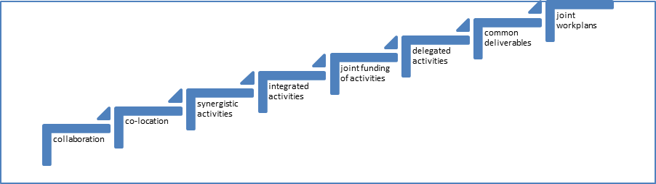
Looking across the health and social protection portfolio, there are several areas where coordination with the new MNH program would have benefit. Some examples are:
- ACCESS: targeting vulnerable groups in MNH program areas, raising demand, and supporting community monitoring and accountability for MNH services.
- PNPM Rural: identifying poor and vulnerable households and MNH targeting them.
- PNPM Peduli: targeting vulnerable and marginalised populations in MNH areas.
- PNPM Generasi: stunting initiative, MNH to support testing of different models in providing health and nutrition information.
- AIPHSS and MNH: sharing and rolling out systems strengthening initiatives around human resource management and development, health financing for MNH, and gender and equity in the health sector.
- MAMPU: supporting rights based advocacy for gender and MNH, women leadership development in health, and working with women’s networks.
- AIFDR: in common operational areas: sharing of geospatial and participatory mapping, identification of pregnant and other vulnerable women and children, strengthening of community planning and management structures and capacity, and promoting gender and social inclusion in district planning and coordination.
- AIPD: supporting district governance strengthening and gender mainstreaming in MNH districts.
Getting the best fit for the new program will depend on several factors that GOA’s Jakarta team will need to consider:
- The practical scope to coordinate in terms of time frames, geographical areas, contractual arrangements with existing management agencies.
- The trade-off between coordination and the risk that interdependence carries in not achieving outcome goals. Interdependent programs run the risk that no one program has sufficient control and coverage to achieve impact.
- Political economy implications and the potential gain or loss in influence over key government stakeholders at national, provincial and district level resulting from different degrees of coordination between programs.
- Assessment of the risks that by tying programs closely together a failing program may “contaminate” and bring another down.
- GOI willingness to forge closer coordination between programs given that this does not easily fit with government structures.
- Issue of attribution of results and the practicality of monitoring and evaluating outcomes, and how this affects GOA’s control of management agencies.
- The capacity, influence and commitment of existing programs and their management structures to work in a more coordinated and joined up way.
- Coordination is extremely time consuming and requires systems and protocols, and a management culture. This may not fit with the way management contracts are currently set-up or permit new programs to focus on achieving quick development wins in their first year.
- How can coordination be incentivised for the key actors that are essential to making a program work – GOA Jakarta based health and social protection team members; management agencies; GOI, district parliament, district government agencies and departments including Bappeda, health, PKK, women’s empowerment and child protection; field level agents including community management teams, facility management, community facilitators, village leaders, CSOs.
The technical and programmatic issues and areas for coordination are relatively straightforward to identify. The challenge is creating the management and accountability systems to support coordination, and positioning coordination so that it is a positive and enabling approach in the governance and political economy context, and ensuring that coordination does not jeopardise achievement of outcomes.
Annex 1: Social development and health

Social development is people-centred development. Social development is concerned with ensuring that women, the poorest, the excluded and vulnerable in society participate in, and benefit from development. Beneath this rather broad umbrella there is no common definition of the boundaries and approaches of social development in the field of international development. Social development is not a term commonly used by the GOI or for which GOA has a defined policy.
Definitions of social development among development agencies
For DFID, social development aims to ensure that all groups in society contribute to, benefit from and are empowered by processes of just, inclusive and sustainable change. It places importance on: the political and social dimensions to inequality and social exclusion; gender equality and women’s and girl’s empowerment and rights; working to achieve social inclusion and social empowerment; the needs and interests of the poor and excluded and promoting their voices and participation in development; strengthening accountability; and the realisation of human rights.
The World Bank’s social development strategy aims to empower the poor in the pursuit of poverty reduction by creating: (i) inclusive institutions that promote equal access to opportunities, and enable everyone to contribute to social and economic progress and share in its rewards; (ii) cohesive societies that enable women and men to work together to address common needs, overcome constraints and consider diverse interests; and (iii) accountable institutions which are transparent and respond to the public interest in an effective, efficient and fair way.
The Asian Development Bank defines social development as a cross-cutting approach to development that promotes policies and institutions in support of greater: (i) inclusiveness and equity in access to services, resources and opportunities; (ii) empowerment of poor and marginalized groups to participate in social, economic, and political life; (iii) security to cope with chronic or sudden risks, especially for the poor and marginalized groups.
For health sector programs, social development concerns are centred on ensuring that women, the poor and other vulnerable groups are able to access and benefit from health sector developments. Social development cuts across the building blocks of the health system, and is as much concerned with demand as with supply side changes, systems development, and accountability and governance.

Table A1: Key social development lines of enquiry for health sector programs
Health System Arena | Key Social Development Questions
Outcomes and impact | - Who is benefitting? Who is left out?  - Is access to and use of services increasing for women, the poor and excluded?
Community participation | - Are women, the poor and excluded informed to improve health behaviours and access services?  - Are women, the poor and excluded mobilised to improve health behaviours, increase use of services, and raise their voice for improved and more responsive service delivery?  - Are women, the poor and excluded empowered to use information and challenge harmful social norms to improve their, their families and community health?  - Are communities engaged in the planning, design and oversight of services, is this inclusive, functional and effective?
Services and programs | - Are services and programs appropriate and accessible to women, the poor and excluded?  - Are services affordable to women, the poor and excluded, and are social protection programs reaching vulnerable populations?  - Is the quality of service respectful to women, the poor and excluded? Is there any evidence of discrimination or social exclusion? Are services gender sensitive, culturally and religiously acceptable and women-friendly?
Health systems development | - Human resource management and development: are there sufficient and appropriate human resources to deliver accessible services to women, the poor and vulnerable populations. What are the strategies to retain health workers in rural and underdeveloped regions? What are the gender and human resource issues?  - Planning and Management: how are the needs and voices of women, the poor and vulnerable incorporated into planning and management processes? Has vulnerability mapping guided planning?  - Health financing: what are the sources of funding in the sector? How do funding mechanism address the need of the poor and other vulnerable groups, and how can health financing be made more progressive?  - Evidence: what is the evidence base for measuring access, utilisation, outcomes and impact disaggregated by poverty, gender, geographical area, ethnicity, religion and other vulnerability measures? What needs to be done to strengthen the evidence base to provide disaggregated data essential for planning and management, and policy making?
Rights and entitlements | - Rights and entitlements: what rights do the public have to health, nutrition, education, information, water and sanitation? What are existing entitlements to services, benefits and service quality, and are poor, excluded and vulnerable people aware of their entitlements and how to claim them; how can this be improved?  - What systems and mechanisms exist for the poor and excluded to hold providers (public, private, NGO) to account? Are they effective and how could they be strengthened?
Leadership and the policy environment | - Where is the institutional home in the government to address issues of equity and access, social inclusion, gender and women’s empowerment, and social accountability? Do the involved ministries clearly define their responsbilities for gender and social inclusion and are they integrated into their development plan?  - Gender inequality: does the political will exist to address gender inequality; is there an enabling policy environment and what are the key programs and interventions to affect change?  - What are the underlying social determinants of health and are they being addressed?  - Are policies and strategies gender and socially inclusive? Do policies address and respond to the interests and underlying problems, and include the voices, of the poor, excluded and vulnerable?

Annex 2: MNH policies and regulations in Indonesia

GoI’s commitment to increasing the health status of women and children is reflected in a range of strategies and plans:
- National Medium Term Development Plan (RPJMN 2010 –2014) includes reduction in infant mortality (IMR), maternal mortality (MMR) and childhood malnutrition as key health targets.
- National Action Plan for Maternal Mortality Reduction (2012-2015) aims to increase the coverage and quality of maternal health services, strengthen the role of local government and the private sector, and empower families and communities.
- The Indonesian family planning strategy aims to empower and motivate the community to build small and high quality families by improving the quality of family planning services, and increasing men’s participation. The strategy includes a commitment to increased financing and inclusion of family planning within universal health care coverage. Community participation and women’s empowerment are included.
- National Policy and Strategy on Reproductive Health focuses on strengthening the integration of reproductive health across all relevant sectors at the national, provincial and district/city levels.
Annex 3: Key MNH related programs for gender and social inclusion

Health financing to increase access of the poor
Jamkesmas
Jamkesmas has been implemented since January 2005 for the poor and the near poor to cover free primary health care services including maternity care at puskesmas and in-patient third class services in hospital. The scheme is based on the National Social Insurance law 40/2004. MoH has managed implementation since 2008. The fund is channelled from central to district/city through the social assistance mechanism and distributed to puskesmas and hospitals.
Jampersal
Jampersal is a financial guarantee that covers the costs of prenatal care, delivery assistance, postpartum care including family planning services, and newborn care. Jampersal has been implemented since January 2011 for all pregnant women who are not covered by any other maternity scheme. Jampersal aims to ensure access to maternity services performed by a physician or midwife, increase coverage of MNH services, and reduce the maternal mortality and infant mortality rates.
Jamkesda
In addition to jamkesmas and jampersal, various provincial (jamkesda) and local level health protection schemes have been introduced to enable access of the poor. In 2010, the Ministry of Health recorded that 33 provinces and 349 districts/cities had organized jamkesda.
Community mobilisation through Desa Siaga and alert villages
The concept of Desa Siaga was adopted by the Ministry of Health in 2006, its scope was broadened to cover a wide range of health-related challenges at community level beyond maternal and child health, including malnutrition, healthy lifestyles, sanitation, epidemiological surveillance and disaster preparedness. Desa Siaga is based on the idea that everyone – husbands, neighbours, community and religious leaders, midwives, and health facility personnel – play an important role in promoting birth preparedness and in responding to complications which might arise during pregnancy or delivery. Desa Siaga attempts to change the public mindset by making pregnancy a common concern rather than a private affair affecting only women, and impacts on community dynamics.
Improving health service quality and responsiveness through Puskesmas Reformasi
Puskesmas Reformasi aims to improve service quality and responsiveness by working in partnership with communities and external stakeholders. It includes three components: (i) community participation, (ii) improving puskesmas quality of care to public service standards, (iii) promoting empowerment and health development in the district through multi-party collaboration and partnerships.
Providing MNH services close to communities through Posyandu Revitalisation
Posyandu is a community-based health resource, managed and organized by and for the community. Institutionally positioned under the PKK, posyandu are the site of monthly clinics for children and pregnant women. Decrees No. 54/2007 and No. 19/2011 issued by the Ministry of Home Affairs set out the utilisation of posyandu as a basic social service unit and assign responsibility to Ministry of Health to support them. There are twenty additional laws that address the operation and purpose of a posyandu, with the most recent one being the Ministerial Decision from the Interior Minister, Number 140.05/292 which establishes a manual on the structure of the Desa Siaga/Posyandu Operational Working Group.
Posyandu provide integrated services for maternal and child health, including family planning, nutrition, immunisation and diarrheal control at the village level. Information provided at the posyandu is provided by cadres (volunteers) who have received varying levels of basic training in health and family planning; the volunteers are primarily drawn from the local PKK leadership.

HLSP Disclaimer

The Health Resource Facility (HRF) provides technical assistance and information to the Australian Government’s Australian Agency for International Development (AusAID). The Health Resource Facility is an Australian Government, AusAID funded initiative managed by Mott MacDonald Limited trading as HLSP in association with International Development Support Services Pty Ltd (IDSS), an Aurecon Company.
This report was produced by the Health Resource Facility, and does not necessarily represent the views or the policy of AusAID or the Commonwealth of Australia.
This document has been prepared for the titled project or named part thereof and should not be relied upon or used for any other project without an independent check being carried out as to its suitability and prior written authority of HLSP being obtained. HLSP accepts no responsibility or liability for the consequences of this document being used for a purpose other than the purposes for which it was commissioned. Any person other than the Commonwealth of Australia, its employees, agents and contractors using or relying on the document for such other purpose agrees, and will by such use or reliance be taken to confirm his agreement, to indemnify HLSP for all loss or damage resulting therefrom. HLSP accepts no responsibility or liability for this document to any party other than to the agency and agency representatives or person by whom it was commissioned.

GOA, 2013, draft Indonesia Health Delivery Strategy, 2014-2023.
This included visits, consultations and focus group discussions in Kupang, Ende District, and West Zumba District in NTT; Situbondu and Malang Municipalities in East Java; West Lombok Municipality in NTB; and Paniai and Nabire Districts and referral hospitals in Jayapura City in Papua. Participants included district officials, district hospital management, health providers, puskesmas reformasi members, posyandu cadres, family planning cadres, community level PNPM facilitators, community leaders, Desa Siaga networks, health facility users, and community men and women.
Separate field reports for Papua, NTB and East Java are available on request.
See “PERMATA Gender and Equity Strategy, 2013”.
Statistics Indonesia (Badan Pusat Statistik—BPS) and Macro International. 2008. Indonesia Demographic and Health Survey 2007. Calverton, Maryland, USA: BPS and Macro International.
Statistics Indonesia (Badan Pusat Statistik—BPS), National Population and Family Planning Board (BKKBN), and Kementerian Kesehatan (Kemenkes—MOH), and ICF International. 2013. Indonesia Demographic and Health Survey 2012. Jakarta, Indonesia: BPS, BKKBN, Kemenkes, and ICF International.
World Bank, DFID, Government of Indonesia, 2012, “Then She Died. Indonesia Maternal Health Assessment”.
Referred to as the Equity Investment Case from here on.
Diagram taken from the Indonesia Equity Investment Case (2011) as data used to construct the diagram is not available in the IDHS 2007 and must have been provided to the Investment Case team.
http://www.bps.go.id/eng/tab_sub/view.php?kat=1&tabel=1&daftar=1&id_subyek=23&notab=1, downloaded September 2012.
Decentralisation Support Facility, undated, “Functional Assignment in Indonesia: Policy Issues and Recommendations”.
Note, not all of the provincial or district/city government restructured the organisation in accordance with regulation No. 41/ 2007 and not all local governments established Cooperation Coordination Team according to circular letter No. 193/1709/SJ, 2008 from Ministry of Home affairs.
World Bank, 2012, World Development Report 2012: Gender Equality and Development.
AusAID, 2011, Promoting Opportunities for All. Gender Equality and Women’s Empowerment. Thematic Strategy (2011).
The other two cross cutting issues are sustainable development and governance.
Verbal communication with UNFPA.
Amnesty International, 2010, Left without a choice. Barriers to reproductive health in Indonesia.
Utomo B et al., 2001, “Incidence and Social-Psychological Aspects of Abortion in Indonesia: A Community-Based Survey in 10 Major Cities and 6 Districts, Year 2000”,Center for Health Research, University of Indonesia. Jakarta, Indonesia.
Hull et al, 2009.
Guttmacher Institute, 2008.
Widyantoro N and Lestari H, Counseling-Based Safe Termination of Unwanted Pregnancies, Jakarta, Indonesia: Women’s Health Foundation, 2004 (in Indonesian).
Amnesty International, 2011.
See Thomas D and Raintung A, October 2013, Social Development Assessment of PERMATA: Report of Field Visit to Papua, 15-20 September, 2013.
UNICEF, Gender and Poverty Study, 2008.
AusAID, 2010, “Gender and Health Sector Assessment, 2010” referenced in AusAID, 2011, “Australia Indonesia Partnership for Health Systems Strengthening 2011-2016. Program Design Document”.
Chaudhary et al., 2006, “Missing in Action: Teacher and Health Worker Absence in Developing Countries”, Journal of Economic Perspectives, Vol 20(1), pp 91-116.
Based on the population recorded in the census 2010 (232 million) and the MDG 2012 report of 12.49% living below the poverty line.
World Bank, Making the New Indonesia Work for the Poor (Overview), 2006.
World Bank, 2012, Protecting Poor and Vulnerable Households in Indonesia.
Wai Po, presentation at Indonesia Update 2013 – Regional Dynamics in a Decentralised Indonesia, 20-21 September, 2013, Australia National University.
UNDP, 2008, Human Development Report.
http://www.tradingeconomics.com/indonesia/out-of-pocket-health-expenditure-percent-of-total-expenditure-on-health-wb-data.html
http://www.tradingeconomics.com/indonesia/out-of-pocket-health-expenditure-percent-of-private-expenditure-on-health-wb-data.html
http://www.tradingeconomics.com/indonesia/out-of-pocket-health-expenditure-percent-of-private-expenditure-on-health-wb-data.html
World Bank, 2007, Public Expenditure Review. http://siteresources.worldbank.org/INTINDONESIA/Resources/226271-1168333550999/PER-4Health.pdf
Taken from AIPHSS.
See Thomas D and Raintung A, October 2013, Social Development Assessment of PERMATA: Report of Field Visit to Papua, 15-20 September, 2013; Yusran S and Raintung A, September 2013, Social Development Assessment of PERMATA: Report of Field Visit to East Java and Nusa Tengarra Barat.
Davies R, Makowiecka K, and Siti Nurul Qomariyah, June 2010, “Review of four maternal health programs in Indonesia between 2006 and 2010. (IMHEI, IMHI, SISKES, WCHPP). A synthesis of the findings of the Independent Monitoring and Evaluation Team (IMET).”
Finlay JE, Ozaltin E, Canning D. 2011. The association of maternal age with infant mortality, child anthropometric failure, diarrhoea and anaemia for first births: evidence from 55 low-and middle income-countries. BMJ Open 2: e000226.
Reported by district officials.
World Bank, 2012, Health Service Fee Waiver Review.
UNICEF Issue Briefs on Maternal and Child Health, 2012.
IDHS 2012.
Fuller Collins E. and E. Bahar, 2000. “To know shame. Malu and its Uses in Malay Societies”, Crossroads: An Interdisciplinary Journal of Southeast Asian Studies, 14(1):35-69.
PSF, 5/29/2013, “Health Institutions Study. Preliminary Findings” powerpoint. Referred to as the PSF study; World Bank Evaluation, 2012, Protecting Poor and Vulnerable Households in Indonesia.
Yulia Indrawati Sari Y.I., Hahman R., and Manaf D.R.S., 2011, “Final Report. Evaluation of PNPM RESPEK: Village infrastructure and institutional capacity”, Akatiga Centre for Social Analysis.
Centre for Health Policy and Management, Faculty of Medicine, Universitas Gadjah Mada and Faculty of Public Health, Universitas Airlangga and Faculty of Public Health, Universitas Nusa Cendana, 2013, “First Phase Report: Qualitative Study. Health Seeking Behaviour Study in East Java and East Nusa Tenggara Provinces”.
http://www.worldbank.org/content/dam/Worldbank/document/EAP/Indonesia/IEQ-Jul2013-Full%20report-English.pdf
Lassi ZS, Haider BA, Bhutta ZA, 2010, “Community-based intervention packages for reducing maternal and neonatal morbidity and mortality and improving neonatal outcomes (Review)”, The Cochrane Library 2010, Issue 11.
Lassi, Haider, Bhutta, 2010, pg 19.
Prost A., et al., 2013, “Women’s groups practising participatory and learning action to improve maternal and newborn health in low resource settings: a systematic review and meta analysis”, The Lancet, 381:1736-46.
Prost A., et al., 2013, “Women’s groups practising participatory and learning action to improve maternal and newborn health in low resource settings: a systematic review and meta analysis”, The Lancet, 381:1736-46.
Reported by Yayasan Pembangunan Kesejahteraan Masyarakat in Paniai District.
World Bank, 2009, Scaling up social accountability in World Bank Operations; DFID, 2007, Voice and Accountability Matters for Better Education and Health Services: A DFID Practice Paper.
Björkman Martina and Jakob Svensson, 2007, “Power to the People: Evidence from a Randomized Field Experiment of a Community-Based Monitoring Project in Uganda”, World Bank Policy Research Working Paper 4268.

