

# Performance of Australian Aid 2018-19

**October 2020**

ISSN 2204-9649 (Online)

ISBN 978-1-74322-490-8 (PDF format)

ISBN 978-1-74322-491-5 (Word format)

**Creative Commons**

With the exception of the Commonwealth Coat of Arms and where otherwise noted all material presented in this document is provided under a Creative Commons Attribution 3.0 Australia (creativecommons.org/licenses/by/3.0/au/) licence. The details of the relevant licence conditions are available on the Creative Commons website (accessible using the links provided) as is the full legal code for the CC BY 3.0 AU licence (<http://creativecommons.org/licenses/by/3.0/au/legalcode>).

The document should be attributed as: Commonwealth of Australia, DFAT, *Performance of Australian Aid 2018-19.*

**Contact**

Inquiries about this document should be directed to: Department of Foreign Affairs and Trade Public Diplomacy Branch

RG Casey Building John McEwen Crescent Barton ACT 0221 Australia

+61 2 6261 1111 (Phone) +61 2 6261 3111 (Fax)

Published by the Department of Foreign Affairs and Trade, 2020

## Table of Contents

Performance of Australian Aid 2018-19 1

Table of Contents 2

Introduction 3

Chapter 1 Performance against strategic targets 4

Target 4: Empowering women and girls 5

Target 7: Working with the most effective partners 8

Target 8: Ensuring value for money 8

Chapter 2 Country and regional program performance 9

Pacific 10

Southeast and East Asia 11

South and West Asia, Africa, the Middle East and other regions 12

Chapter 3 Multilateral performance 13

United Nations and Commonwealth organisations 14

Global education, health and environment funds 14

Other organisations 15

Chapter 4 Sector and thematic performance 15

Infrastructure, trade facilitation and international competitiveness 15

Agriculture, fisheries and water 16

Effective governance: policies, institutions and functioning economies 16

Education and Health 17

Building resilience: humanitarian assistance, disaster risk reduction and social protection 18

Disability-inclusive development 19

List of acronyms and abbreviations 20

## Introduction

As part of the 2014 performance framework for the Australian development program, Making Performance Count[1], the Government committed to publish an annual *Performance of Australian Aid* report. This is the sixth and final report under the 2014 framework and it summarises the performance of the Australian development program in 2018‑19. A detailed description of the approach to assessing performance is provided in earlier reports.[2]Statistical information on the development program, including expenditure, is available in *Australia’s Official Development Assistance: Statistical Summary 2018-19.[3]*

The Government’s *Partnerships for Recovery: Australia’s COVID-19 Development Response* policy was published in May 2020. A new performance system accompanied the policy[4].

This report is divided into four chapters and two annexes.

Chapter 1 reports on the 10 strategic targets under Making Performance Count, which provide the basis for assessing the performance of the development program as a whole in 2018-19.

Chapter 2 presents performance data for four regional groups: Pacific; Southeast and East Asia; South and West Asia; and Africa, the Middle East and other regions.

Chapter 3 summarises performance of multilateral development organisations.

Chapter 4 summarises performance data for the six investment priority areas under the 2014 development policy as well as disability inclusion.

The performance information in past reports was subject to a process of quality assurance by the Office of Development Effectiveness, under the supervision of DFAT’s Independent Evaluation Committee. With the shift of ODE functions to the Office of the Chief Economist in 2020, a different quality assurance process has been followed for the *Performance of Australian Aid 2018-19* report. The process remains risk based and included, but was not limited to:

* + - * Independent validation of ratings in Final Aid Quality Check reports (48 Final Aid Quality Checks were submitted in 2018-19)
      * Completion of independent evaluations of Australian development program investments (50 in 2019)
      * Review of the draft report by DFAT’s Aid Governance Board.

## Chapter 1 Performance against strategic targets

Making Performance Count identified 10 strategic targets to ensure the development program is well managed, achieving value for money and delivering on the key priorities outlined in the Government’s 2014 development policy: Australian aid: promoting prosperity, reducing poverty, enhancing stability. At the end of 2018-19, nine of the 10 targets had been achieved. The remaining target on gender equality has not been achieved. Progress against the 10 targets is summarised in Table 1 with additional analysis provided for targets 4, 7 and 8[5].

Table 1: Progress against the 10 strategic targets for the development program as at 30 June 2019

|  |  |
| --- | --- |
| **TARGET** | **PROGRESS** |
| **1**. Promoting prosperity: promote economic development by increasing Australia’s aid for trade[6] investments to 20 per cent of the aid budget by 2020 | **ACHIEVED:** The development program achieved this target ahead of schedule in 2016-17. Expenditure on aid for trade was $1.05b or 24 per cent of the aid budget in 2018-19. The largest share was to support investments that build productive capacity (51%), followed by economic infrastructure (45%) and trade policy and regulatory reform (4%). |
| **2.**  Engaging the private sector: all new investments will explore ways to promote private sector growth or engage the private sector in achieving development outcomes | **ACHIEVED:** In 2018-19,concept notes for new investments examined options for promotion of private sector growth and private sector engagement. |
| **3.** Reducing poverty: by September 2015, all country and regional programs have Aid Investment Plans that describe how Australia’s aid will promote economic growth in ways that provide pathways out of poverty | **ACHIEVED:** Aid Investment Plans have been developed for all major programs and were publicly released on DFAT’s website on 30 September 2015. Updates to Aid Investment Plan objectives and performance benchmarks were included in 2018-19 annual Aid Program Performance Reports. |
| **4.** Empowering women and girls: more than 80 per cent of investments, regardless of their objectives, will effectively address gender issues in their implementation | **NOT ACHIEVED:** In 2018-19, 77 per cent of investments effectively addressed gender. |
| **5.** Focusing on the Indo-Pacific region: increase the proportion of country program aid that is spent in the Indo-Pacific region to at least 90 per cent from 2014‑15 | **ACHIEVED:** This target has been achieved each year since 2014‑15. In 2018-19,92 per centof country programmable aid was spent in the Indo-Pacific. |
| **6.** Delivering on commitments: from July 2015, progress against mutual obligations agreed between Australia and its key partner governments and organisations will form part of program performance assessments | **ACHIEVED:** Since 2015, progress against mutual obligations and performance benchmarks have been reported in Aid Program Performance Reports. Out of a set of 184 performance benchmarks for 2018-19, 120 (65 per cent) were achieved and 53 (29 per cent) partly achieved. Eleven benchmarks (6 per cent) were either not achieved or could not be assessed due to unavailable data. |
| **7.** Working with the most effective partners: by July 2015, design and apply new systems to assess the performance of the aid program’s key delivery partners and ensure stronger links between performance and funding | **ACHIEVED:** In 2018-19, the three main delivery partner categories of commercial partners, NGOs and multilateral organisations were assessed as performing to an adequate level or better. |
| **8.** Ensuring value for money: deliver high standards of value for money in at least 85 per cent of aid investments. Where standards are not met and improvements are not achieved within a year, investments will be cancelled | **ACHIEVED**: For 2018-19, 93 per cent of aid investments were assessed as satisfactory for effectiveness and 89 per cent were assessed as satisfactory for efficiency. |
| **9**. Increasing consolidation: reduce the number of individual investments by 20 per cent by 2016-17 to focus efforts and reduce transaction costs | ACHIEVED: This target was achieved on 1 July 2016 when the number of individual investments had reduced by 23 per cent. As at 1 July 2019, the number of investments had reduced by 36 per cent[7] |
| **10**. Combatting corruption: develop and implement new fraud and anti-corruption strategies for all major country and regional programs by July 2015 | ACHIEVED: Fraud and anti-corruption strategies were put in place in 2015. Since then, the use of mandatory fraud clauses in all funding agreements, the design and delivery of fraud toolkits for DFAT staff and funding recipients, and the delivery of targeted training, have mainstreamed fraud and corruption risk management across all ODA operations. |

### Target 4: Empowering women and girls

More than 80 per cent of investments, regardless of their objectives, will effectively address gender issues in their implementation

Status: Not achieved

This strategic target measures effective mainstreaming of gender equality in Australia’s development program investments. It tracks the percentage of Australian investments that are effectively addressing gender equality issues during implementation, which is assessed through satisfactory or above ratings in the annual Aid Quality Check process.

Gender inequality undermines global prosperity, stability and security. Addressing gender inequality is essential to effective results from development efforts, humanitarian action, and responses to emergencies. Australia continues its efforts on ending violence against women and girls, advancing women’s economic empowerment and strengthening women’s leadership and their role in peace and security. We also continue to mainstream gender equality across our development program, to address the gender equality implications of the multi-faceted challenges facing the Indo-Pacific region. Gender mainstreaming approaches also work to ensure that our investments do not entrench or exacerbate gendered disadvantages and that Do No Harm principles are upheld in respect of women’s safety, voice and agency.

While performance in 2018-19 against the strategic target improved to 77 per cent, it is disappointing the target remains unmet. Analysis of the 86 underperforming investments shows that investments designed and implemented after the introduction of the target generally performed slightly better than older investments, except in the Pacific. However, there is no single characteristic that explains the continued shortfall. Rather, there continues to be an interplay of persistent challenges that relate to the need to factor gender equality into design and implementation, as well as our partnerships and the challenging settings where many of our investments are implemented. We will work urgently to identify solutions, including through redesign of our delivery mechanisms and programs. We are strongly committed to achieving better outcomes on gender equality through concrete management actions, including greater accountability of heads of missions, senior managers and implementing partners, ensuring that new investments are designed to deliver progress on gender equality, and making sure that staff are skilled and supported by expert advice. We also remain committed to the twin track approach of gender mainstreaming alongside gender-focused investments.

Figure 1: Gender performance by region, 2018-19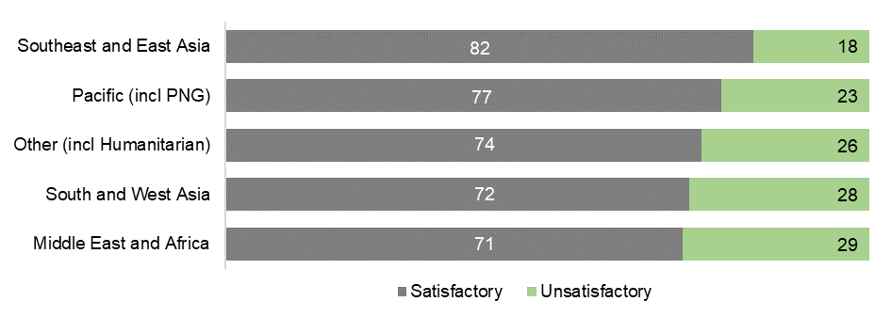

Performance across regions continues to be uneven. Southeast and East Asia investments generally continue to perform well against the Strategic Target. Performance on gender equality in the Middle East and Africa and in South and West Asia declined during 2018-19. Investments in the Pacific have continued to improve their performance on gender equality over the past two years, but there are still a number of underperforming investments. Underperformance in the Pacific is a function of challenges embedding gender equality in some regional organisations. Generally, some investments underperformed because of a lack of early consideration for gender equality, failure to integrate and support gender equality work into the larger organisation or program, or weak monitoring and evaluation that could not demonstrate gender performance. A heightened focus on the design process is successfully embedding gender in new investments across the development program. Ongoing attention to implementation and monitoring and evaluation is critical to further improve gender performance.

During 2018-19, DFAT continued to implement the high-level work plans that were initiated in 2017-18 and endorsed by the Department’s senior executive to improve gender equality performance. As part of these work plans, DFAT launched its refreshed internal gender equality training in mid-2019, and intensified its high-level engagement with key partners to outline expectations and advocate for priority actions, including resourcing for early and consistent deployment of gender technical expertise and improved monitoring and evaluation of progress on gender equality.

**Figure 2: Gender performance by investment priority area, 2018-19**

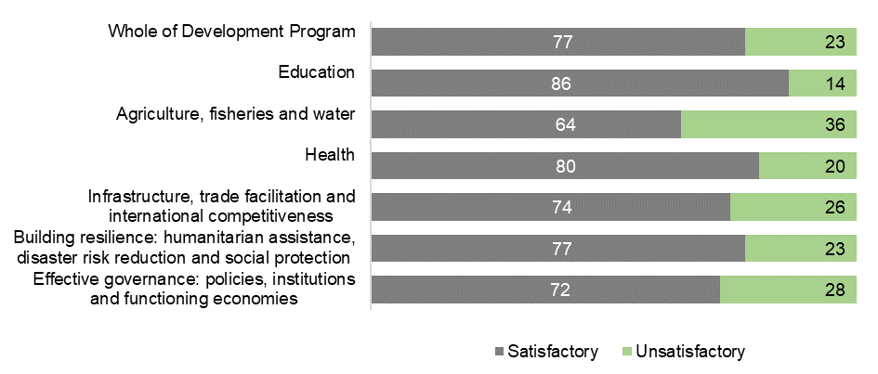

Investments in the education sector continued to perform very well on gender equality. The investment priority areas of effective governance and building resilience improved their performance but continue to face challenges with their implementing partners and when working on complex policy reform issues. These issues also account for the deterioration in performance of investments in the agriculture, fisheries and water sector. As the development program pivots further to focusing on settings where governance structures are weak and gender inequalities stark, these challenges are likely to be further accentuated.

Figure 3: DFAT ODA expenditure on gender equality, 2018-19

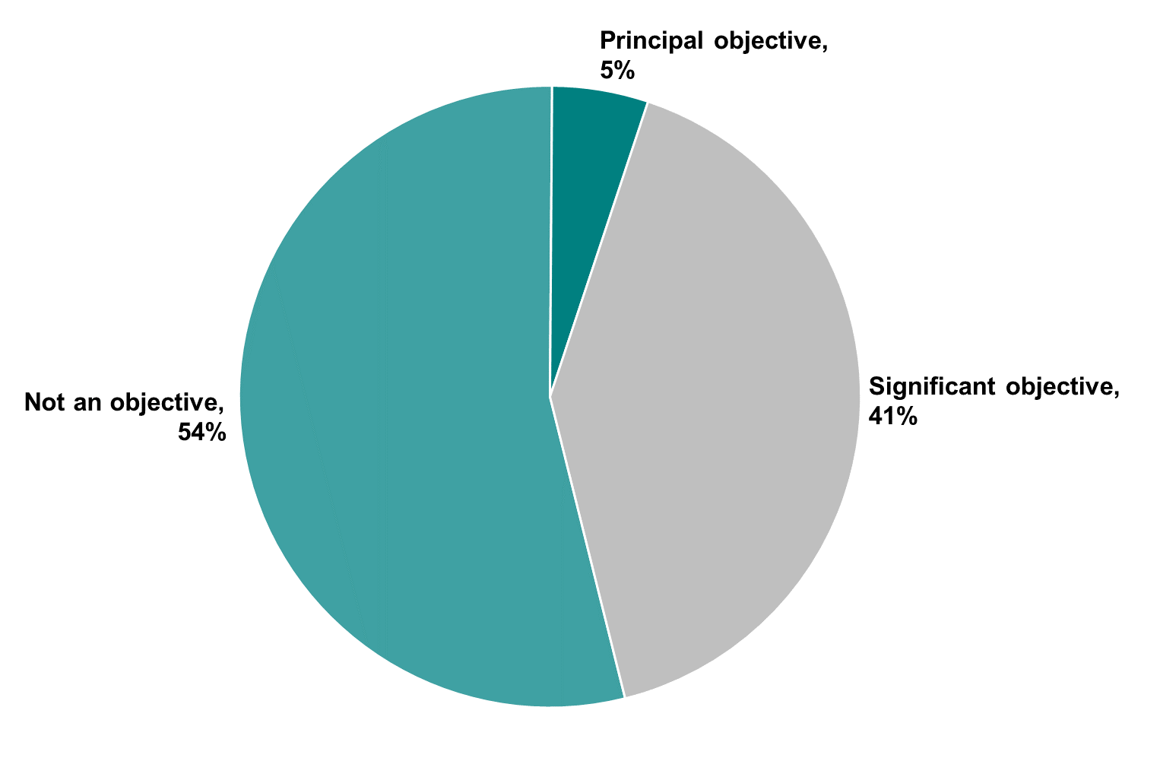

In 2018-19, Australia’s expenditure on investments that targeted gender equality as a principal or significant objective was $1.3 billion.[8] This amounts to 46 per cent of DFAT’s country, regional and global aid investments by value across a range of sectors (Figure 3). Investments where gender equality is integrated as a secondary (significant) objective continue to account for most of our expenditure towards gender equality.

In 2017-18, DFAT applied for the first time the OECD/DAC Minimum Recommended Criteria for gender-focused ODA expenditure reporting. This means that all ODA classified as contributing to gender equality has been carefully screened to confirm that is informed by gender analysis, aimed at narrowing gender equality gaps, tracks results for gender equality, and is managed on the basis of reducing unintended negative consequences for women and girls. As a result of this change in methodology, gender expenditure data for the past two years is not comparable with data for previous years.

### Target 7: Working with the most effective partners

By July 2015, design and apply new systems to assess the performance of the development program’s key delivery partners and ensure stronger links between performance and funding

Status: Achieved

Partner Performance Assessments (PPAs) review how well key implementing partners (commercial partners, multilateral organisations and NGOs) are delivering the services specified in funding agreements.

Table 2: PPA completed by delivery partner type, 2018-19



The results of PPA assessments (Table 3) indicate that the three main delivery partner categories are all performing to an adequate level or better. Over 95 per cent of assessments completed had ratings of adequate (4) or higher on a scale of 1 to 6

Table 3: Average PPA rating score by delivery partner type, 2018-19

### Target 8: Ensuring value for money

Deliver high standards of value for money in at least 85 per cent of aid investments. Where standards are not met and improvements are not achieved within a year, investments will be cancelled

Status: Achieved

This target was achieved in 2018-19 with 93 per cent of investments rated as satisfactory for effectiveness and 89 per cent of investments rated as satisfactory for efficiency.

DFAT applies value for money considerations across all development program management policies, practices and investments. Data to track progress towards this target is drawn from annual Aid Quality Checks. Investments rated as satisfactory against the efficiency and effectiveness criteria are considered to be delivering high standards of value for money.

Annual effectiveness outcomes have ranged between 87 per cent and 93 per cent since 2014-15 (Figure 4). Efficiency outcomes have ranged between 85 per cent and 89 per cent for the same period.

Figure 4: Percentage of investments with satisfactory ratings for efficiency and effectiveness,   
2014-15 to 2018-19

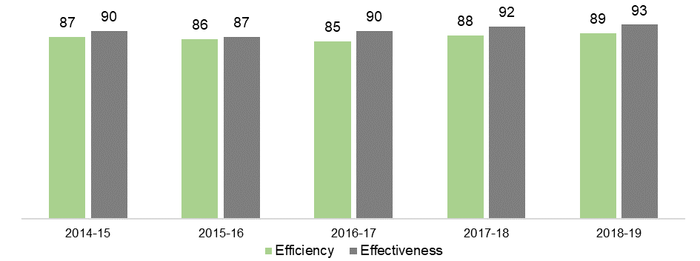

In 2018-19, the Office of Development Effectiveness validated the ratings of the 48 investments that completed Final AQCs. The outcome of this process resulted in the effectiveness ratings of 2 investments being changed from satisfactory to unsatisfactory and the efficiency ratings of six investments being changed from satisfactory to unsatisfactory. Figure 4 reflects these changed ratings.

This strategic target also requires the identification of underperforming investments based on unsatisfactory ratings for both effectiveness and efficiency criteria. In 2018-19, 10 investments were identified as Investments Requiring Improvement. If performance does not improve for each investment within 12 months, they are subject to cancellation. In 2017-18, 17 investments were identified as Investments Requiring Improvement. Of these 17 investments, one investment was again assessed in 2018-19 as unsatisfactory and has ended.

## Chapter 2 Country and regional program performance

This chapter summarises the performance of Australia’s country and regional development programs. It highlights performance trends for four regional groups: Pacific; Southeast and East Asia; South and West Asia; and Africa, the Middle East and other regions. For country and regional programs, performance is assessed each year and has been published in Aid Program Performance Reports (APPRs).[9] Assessments of performance made against program objectives contained in Aid Investment Plans for each country or regional program have been expressed as one of three ratings: progress towards objectives is on track; progress is less than expected; or progress is not on track.

Individual country and regional programs achieved significant results in 2018-19. These results have been published in APPRs and are not repeated in this report.

Figure 5: Progress against program objectives by region, 2018-19

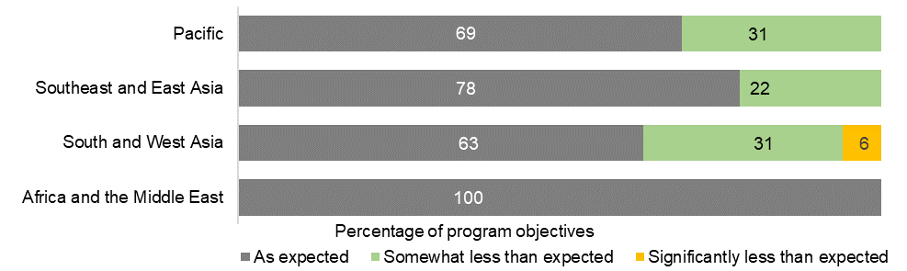

Performance benchmarks, together with other monitoring and evaluation indicators, have been used to assess progress against Aid Investment Plan objectives. Progress against each benchmark has been reported in APPRs. Progress against program objectives and benchmarks for individual country and regional programs is summarised by region below.[10] Performance against investment quality criteria is also summarised by region.[11]

### Pacific

In 2018-19, 69 per cent of Pacific country and regional program objectives were assessed as on track (Figure 5), reflecting the challenging operating environment in the Pacific. This outcome was higher than the five year average of 62 per cent. Pacific programs have identified management actions to improve program performance. These actions have been set out in country and regional APPRs.

Progress against performance benchmarks by Pacific programs was mixed, with 55 per cent of benchmarks achieved and 32 per cent partly achieved (Figure 6). Seven benchmarks (nine per cent) were not achieved.

Figure 6: Progress against performance benchmarks: Pacific, 2018-19

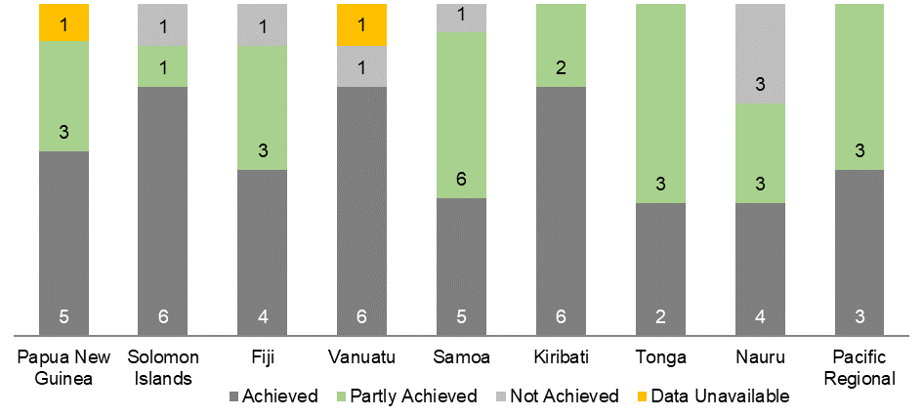

The ratings for Australia’s investment performance in the Pacific in 2018-19 exceeded the whole of development program outcome for efficiency and were marginally below the whole of program ratings for effectiveness (Figure 7). Effectiveness and efficiency ratings exceeded the five year averages of 89 per cent and 83 per cent respectively. Ratings for gender equality exceeded the five year average of 75 per cent.

Of the seven investments identified as requiring improvement in 2017-18, six improved performance or were completed in 2018-19. One investment was again assessed as unsatisfactory and has been closed. Three investments were identified as requiring improvement based on 2018-19 Aid Quality Check results and management action plans have been put in place for ongoing investments.

Figure 7: Investment performance: Pacific, 2018-19

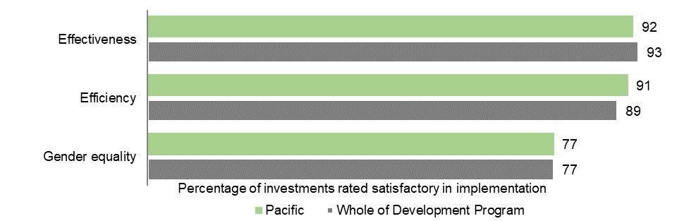

### Southeast and East Asia

Southeast and East Asia country and regional programs made good progress against program objectives with 78 per cent on track (Figure 5), higher than the five year average of 76 per cent. Southeast and East Asia programs have identified management actions to improve program performance. These actions are set out in country and regional APPRs.

For Southeast and East Asia, 70 per cent of performance benchmarks were achieved and 27 per cent were partly achieved (Figure 8). Two benchmarks (3 per cent) were not achieved.

Figure 8: Progress against performance benchmarks: Southeast and East Asia, 2018-19

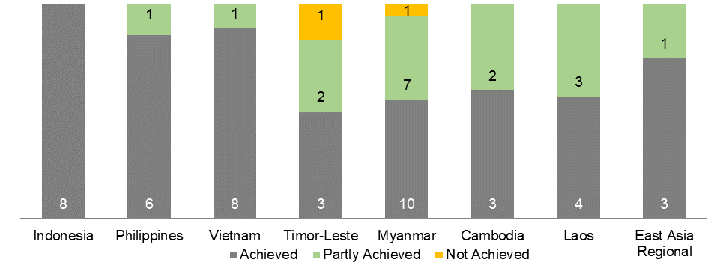

The ratings for Australia’s investment performance in Southeast and East Asia in 2018-19 exceeded the whole of development program outcome for gender equality but were lower than whole of program ratings for effectiveness and efficiency (Figure 9). Effectiveness ratings exceeded the five year average of 90 per cent with efficiency below the five year average of 88 per cent. Gender equality ratings equalled the five year average of 82 per cent. Of the four investments identified as requiring improvement in 2017-18, all improved performance or were completed in 2018-19. Three investments were identified as requiring improvement based on 2018-19 Aid Quality Check results and management action plans have been put in place for ongoing investments.

**Figure 9: Investment performance: Southeast and East Asia, 2018-19**

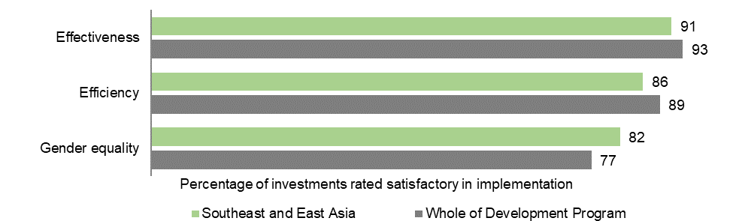

### South and West Asia, Africa, the Middle East and other regions

Sixty-three per cent of South and West Asia program objectives were assessed as on track in 2018-19 (Figure 5), below the five year average of 72 per cent. Sixty-seven per cent of performance benchmarks were achieved and 33 per cent partially achieved. Two investments were identified as requiring improving based on 2018-19 Aid Quality Check results and management action plans have been put in place for ongoing investments.

Figure 10: Progress against performance benchmarks: South and West Asia, Africa and the Middle East, 2018-19

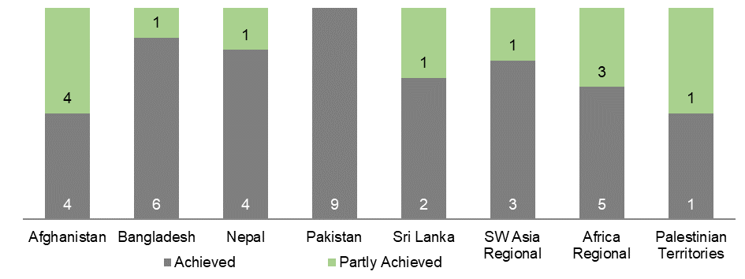

The ratings for Australia’s investment performance in South and West Asia were lower than whole of development program ratings for effectiveness, efficiency and gender equality (Figure 11). Effectiveness ratings equalled the five year average of 88 per cent with efficiency and gender equality ratings below five year averages of 87 and 78 per cent respectively.

The ratings for Australia’s investment performance in Africa and the Middle East were higher than whole of development program ratings for effectiveness and efficiency but lower for gender equality (Figure 11). Effectiveness and efficiency ratings were higher than the five year averages of 96 and 92 per cent respectively. Gender equality ratings were lower than the five year average of 77 per cent.

**Figure 11: Investment performance: South and West Asia, Africa and the Middle East, 2018-19**

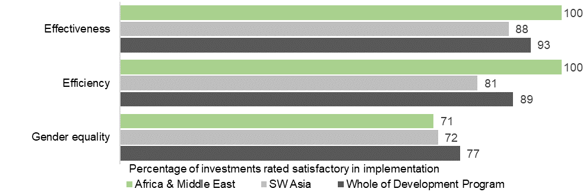

# 

## Chapter 3 Multilateral performance

Multilateral development organisations bring convening power, technical expertise, financial resources and an expansive footprint that extends the reach of our development program investments. Multilateral development organisations are central to the rules-based order, developing common norms and standards and supporting their implementation, providing a platform for debate, agreement and collective effort.

Australia is selective in its engagement with multilateral development organisations – we fund approximately 50 out of over 200 organisations. Australia’s engagement focuses on ensuring they are performing well and that their work aligns with the interests of the Indo-Pacific region and Australia. This includes focusing on ensuring the multilateral development system is relevant and is reforming to address the complex challenges we face. Australia’s priorities are delivering better performance from multilateral development organisations and achieving greater coherence across the system. We promote ongoing reform to ensure organisations are more efficient, results-oriented and responsive. We focus on how the organisations are delivering in our region, particularly in the Pacific.

In 2018-19, the Australian development program introduced a new assessment tool – the Multilateral Performance Report (MPR). These periodic reports replaced the previous 3-yearly Multilateral Performance Assessments. Performance data from this year’s MPRs are summarised below. In addition to the MPRs, DFAT will continue to draw on the assessments conducted on a rolling schedule by the Multilateral Organisation Performance Assessment Network (MOPAN).

Multilateral and regional development banks

The World Bank Group and Asian Development Bank are two of Australia’s largest development partners. They are trusted organisations who provide large-scale funding for quality-assured programs, backed by technical advice, social and environmental safeguards and assurances of debt sustainability. Their concessional and non-concessional loans enable countries in our region to make major investments that deliver long-term economic and social benefits, including in sustainable infrastructure, health and education.

Figure 12: Performance of Multilateral and Regional Banks, 2018-19

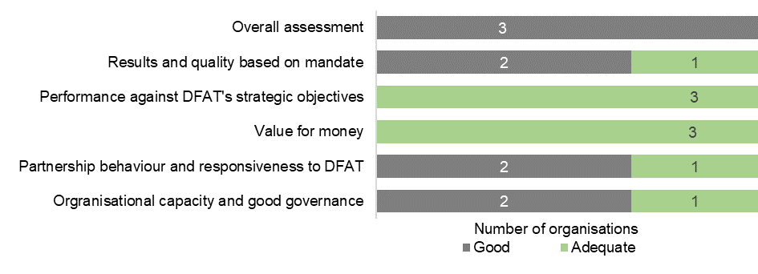

### United Nations and Commonwealth organisations

The United Nations development organisations have a range of critical mandates – from the development of norms and standards, to the delivery of essential services and humanitarian response, often in places where others cannot or will not operate. Australia concentrates our funding on those UN development organisations that have the most critical mandates. Through the Boards and Councils of UN development organisations, Australia prosecutes ongoing reform to improve their efficiency, effectiveness and ability to address our most pressing challenges.

Figure 13: Performance of UN and Commonwealth Organisations, 2018-19

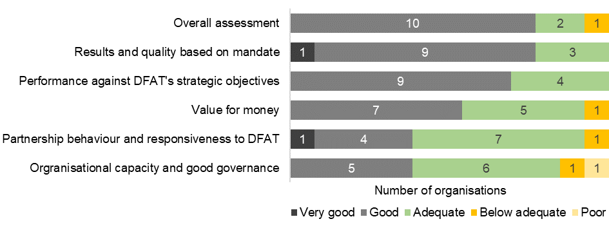

### Global education, health and environment funds

Australia supports a range of multilateral funds that target health, education and the environment. The Global Fund to Fight AIDS, Tuberculosis and Malaria and Gavi, the Vaccine Alliance are consistently rated by Australia and others as among the highest performing multilateral organisations. They achieve strong results against clear mandates and provide value for money for Australia.

Global Fund grants are continuing to help countries expand HIV treatment coverage, make progress towards malaria control or elimination, and achieve high treatment success rates for tuberculosis. These results are underpinned by strong operational and fiduciary management.

Gavi purchases life-saving vaccines on behalf of lower-income countries and uses its purchasing power to shape the global market. For example, between 2009 and 2020, Gavi achieved a 43 per cent price reduction for the pneumococcal conjugate vaccine by pooling demand, incentivising research and development, and manufacturing. This unique function can only be performed by a funder with the scale of Gavi.

Figure 14: Performance of Sectoral Funds, 2018-19

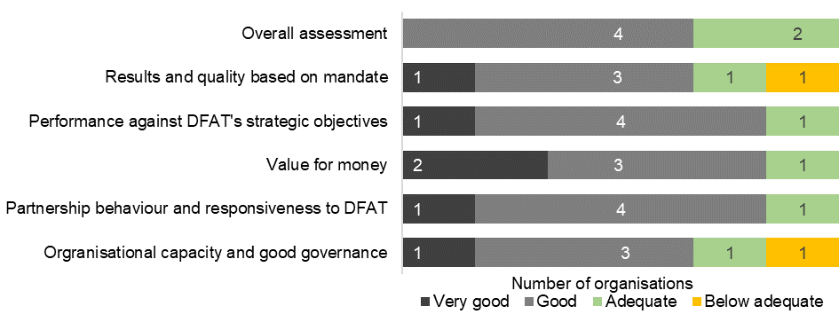

Australia is influential on the governing Boards and Committees of both the Global Fund and Gavi. We consistently advocate for the needs of our region and have successfully encouraged a more nuanced approach to eligibility for funding and ‘graduation’ thresholds. At USD1,580 per capita, Gavi has one of the lowest thresholds among multilateral development organisations for withdrawing financial support. In 2018-19, with Australian backing, Gavi approved a USD60 million package of exceptional support and a delayed transition period for PNG, and a USD8.5 million post-transition package for Timor-Leste.

### Other organisations

The International Committee of the Red Cross (ICRC) was highly rated across all criteria. It holds a unique role as the guardian of international humanitarian law and provides essential protection to civilians in armed conflict. ICRC seeks to prevent and respond to sexual violence in armed conflict. It also provides physical rehabilitation services for people with disabilities arising from conflict.

## Chapter 4 Sector and thematic performance

This chapter brings together performance data for the six priority areas of investment under the Australian Government’s 2014 development policy as well as disability-inclusive development.[12]

### Infrastructure, trade facilitation and international competitiveness

Investments in this sector were guided by the *Strategy for Investments in Economic Infrastructure*.[13] Australia’s work is aligned with the SDGs including Zero Hunger (SDG2), Affordable and Clean Energy (SDG7), Decent Work and Economic Growth (SDG8), Industry, Innovation and Infrastructure (SDG9), Sustainable Cities and Communities (SDG11), and Partnerships for the Goals (SDG17).

Figure 15: Infrastructure, trade facilitation and international competitiveness investment performance, 2018-19

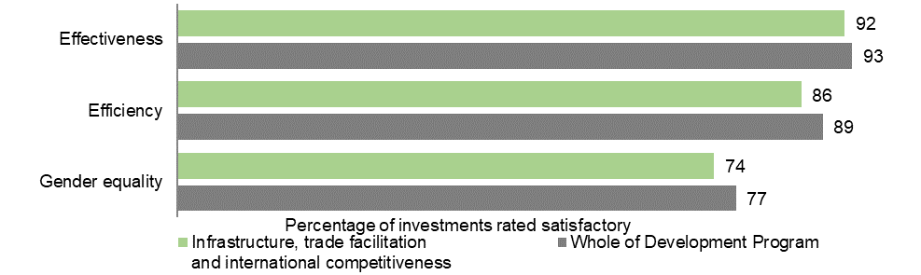

The ratings for Australia’s infrastructure and trade facilitation investment performance in 2018-19 were below whole of development program outcomes for effectiveness, efficiency and gender equality (Figure 15). However, ratings were on par with five year sector averages for efficiency and gender equality and marginally higher than the five year sector average for effectiveness of 91 per cent.

### Agriculture, fisheries and water

Australia’s development cooperation investments in agriculture, fisheries and water prioritise three key areas of engagement: strengthening markets; innovating for productivity and sustainable resource use; and policy, governance and reform. Australia’s investments are directly supporting several of the SDGs including No Poverty (SDG1), Zero Hunger (SDG2), Clean Water and Sanitation (SDG6), Responsible Consumption and Production (SDG12), Climate Action (SDG13), Life Below Water (SDG14), and Life on Land (SDG15).

Figure 16: Agriculture, fisheries and water investment performance, 2018-19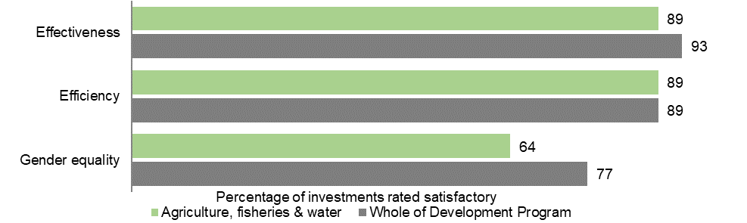

The ratings for Australia’s agriculture, fisheries and water investment performance in 2018-19 were below whole of development program outcomes for effectiveness and gender equality and on par for efficiency (Figure 16). Effectiveness and efficiency results were higher than five year sector averages of 83 per cent and 86 per cent respectively but gender equality outcomes were below the five year average of 72 per cent. In response, DFAT sourced additional technical expertise to support partners to improve performance.

### Effective governance: policies, institutions and functioning economies

DFAT’s governance work is guided by *Effective Governance: Strategy for Australia’s aid investments*.[14] Australia’s assistance has a direct impact on the SDGs Decent Work and Economic Growth (SDG8), Reduced Inequalities (SDG10), Peace, Justice and Strong Institutions (SDG16), and Partnerships for the Goals (SDG17).

Figure 17: Effective governance investment performance, 2018-19

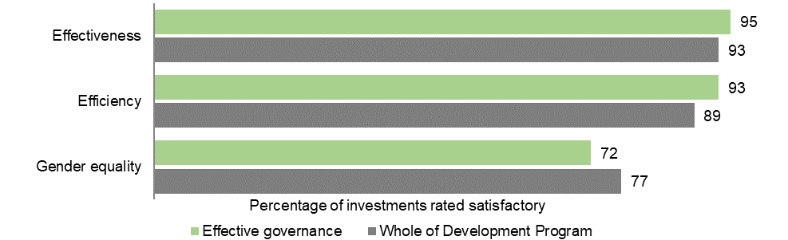

The ratings for Australia’s effective governance investments in 2018-19 were higher than whole of development program outcomes for effectiveness and efficiency but lower for gender equality (Figure 17). Technical support is being offered for investments where the overall settings are positive for achieving improved performance on gender equality. Effectiveness and efficiency results were higher than five year sector averages of 92 per cent and 89 per cent respectively and equal with the five year gender equality average of 72 per cent.

### Education and Health

Education

Australia’s investments in education are guided by the *Strategy for Australia’s aid investments in education, 2015–2020.[15]* Australian investments in education directly support SDG4 on Quality Education as well as contributing to the achievement of other SDGs, for example, Gender Equality (SDG5).

Figure 18: Education investment performance, 2018-19

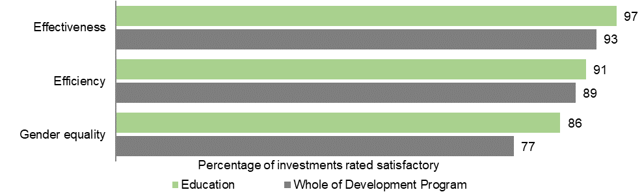

Overall, Australia’s education investments performed well in 2018-19. The percentage of investments meeting quality assessment criteria is higher than whole of development program results for effectiveness, efficiency and gender equality (Figure 18). The effectiveness result of 97 per cent was above the five year sector average of 92 per cent and the efficiency result was also above the five year sector average of 89 per cent. The gender result was below the five year sector average of 88 per cent.

Health

Australia’s investments in health are guided by the *Health for Development Strategy 2015-2020*.[16] The objectives of this strategy are twofold: to help build country-level systems and services that are responsive to people’s health needs and to strengthen regional preparedness and capacity to respond to emerging health threats. The strategy facilitates progress towards Universal Health Coverage and the corresponding Sustainable Development Goal 3: Health and Wellbeing for All.

Australia’s health investments performed well in 2018-19. The percentage of investments meeting quality assessment criteria is on par with or higher than whole of development program results for effectiveness, efficiency and gender equality (Figure 19). Effectiveness and efficiency outcomes were higher than five year averages of 90 per cent and 87 per cent respectively. The gender equality outcome of 80 per cent equalled the five year average.

**Figure 19: Health investment performance, 2018-19**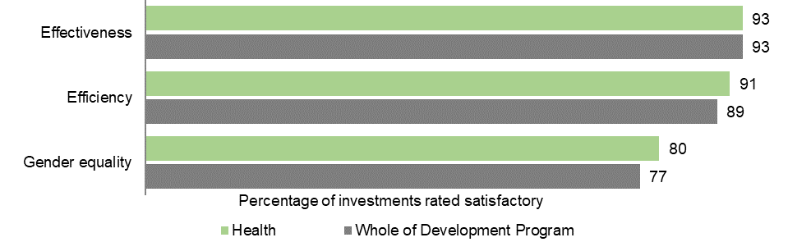

### Building resilience: humanitarian assistance, disaster risk reduction and social protection

Australia’s ‘building resilience’ investments deliver outcomes in support of a number of Sustainable Development Goals (SDG), including those relating to No Poverty (SDG1), Zero Hunger (SDG2), Good Health and Well-Being (SDG3), Reduced Inequalities (SDG10), Sustainable Cities and Communities (SDG11), and Climate Action (SDG13). Through these investments, Australia is meeting commitments made under the *Sendai Framework for Disaster Risk Reduction 2015-2030* to support our bilateral partners to limit economic and development losses and reduce the vulnerability of communities and institutions to natural hazards. Investments in these areas also support Australia’s commitments under the *Agenda for Humanity (2016)* and the *‘Grand Bargain’ (2016)* to save lives and protect human dignity through improved effectiveness and efficiency of humanitarian action.

Figure 20: Building resilience investment performance, 2018-19

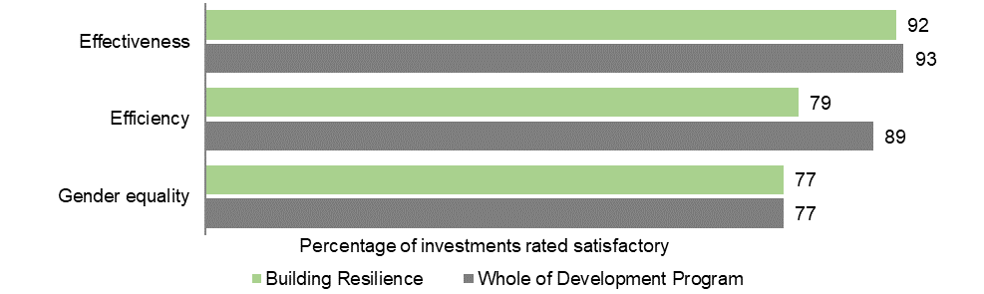

The ratings for Australia’s building resilience investments in 2018-19 were below whole of development program outcomes for effectiveness and efficiency and on par for gender equality (Figure 20). Sector ratings for effectiveness and gender equality were higher than five year sector averages of 91 per cent and 75 per cent respectively but lower than the five year average for efficiency of 87 per cent.

Building on the 2018 ODE evaluation of climate change in Australia’s development program, Australia continued its efforts to lift support for developing countries in tackling climate change during 2018-19. In line with the management responses to the evaluation, there has been ongoing work to integrate climate change considerations across the breadth of Australia’s aid investments. Australia’s climate finance support comprised 8.2 per cent of Australia’s total ODA expenditure for 2018-19, which represents an increase from 6.2 per cent 2016-17 and 6.6 per cent in 2017-18.

### 

### Disability-inclusive development

The Australian development program has had strategies to support disability-inclusive development since 2009. The “Development for All” strategies have aimed to improve the lives of people with disabilities by making Australian development assistance more disability-inclusive and having broader impacts through advocacy work. Advocacy to shape the policies and programs of bilateral, multilateral and other development agencies has the potential to deliver exponential benefits for people living with disability beyond what can be achieved by Australian development assistance. The percentage of investments rated satisfactory in 2018-19 for actively involving disabled peoples’ organisations (40 per cent) and identifying and addressing barriers to inclusion (45 per cent) were below whole of development program five year averages of 44 and 51 per cent respectively.

Figure 21: Disability-inclusion investment performance, 2018-19

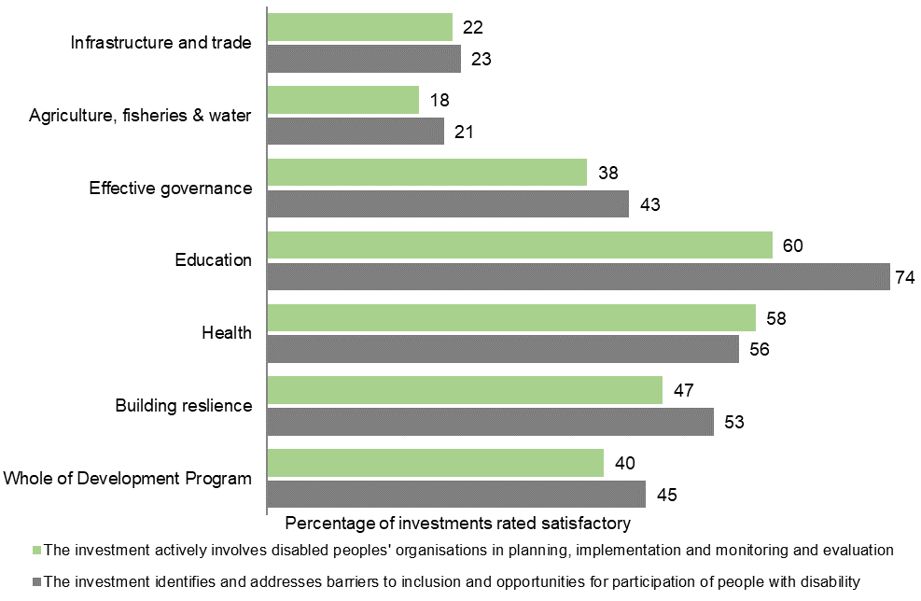

## List of acronyms and abbreviations

ADB Asian Development Bank

APPR Aid Program Performance Report

AQC Aid Quality Check

FAO Food and Agriculture Organization

GEF Gender Equality Fund

GEF Global Environment Facility

GPE Global Partnership for Education

IEC Independent Evaluation Committee

IFC International Finance Corporation

ILO International Labour Organization

IRI Investments Requiring Improvement

MPA Multilateral Performance Assessment

ODA Official Development Assistance

ODE Office of Development Effectiveness

PAA Performance of Australian Aid report

PPA Partner Performance Assessment

SDGs Sustainable Development Goals

UNDP United Nations Development Programme

UNHCR Office of the United Nations High Commissioner for Refugees

UNICEF United Nations Children’s Fund

UNISDR United Nations Office for Disaster Risk Reduction

UNFPA United Nations Population Fund

UNRWA United Nations Relief and Works Agency for Palestine Refugees

WBG World Bank Group

WFP World Food Program

WHO World Health Organization

WTO World Trade Organization

1. DFAT, Making Performance Count: enhancing the accountability and effectiveness of Australian aid (18 June 2014), available at <https://www.dfat.gov.au/about-us/publications/Pages/making-performance-count-enhancing-the-accountability-and-effectiveness-of-australian-aid>
2. For example, [Performance of Australian Aid 2017-18](https://www.dfat.gov.au/about-us/publications/Pages/performance-of-australian-aid-2017-18), pp 2 - 4
3. [Australia’s Official Development Assistance: *Statistical Summary 2018-19*](https://www.dfat.gov.au/about-us/publications/aid/statistical-summary-time-series-data/Pages/australias-official-development-assistance-statistical-summary-2018-19.aspx)
4. [Australia’s development program performance assessment](https://www.dfat.gov.au/aid/performance-assessment)
5. Updated information for all targets is included in Table 1. Full analysis of all targets is available in earlier [*Performance of Australian Aid* reports](https://www.dfat.gov.au/about-us/publications/Pages/performance-of-australian-aid-2017-18).
6. [Strategy for Australia’s Aid for Trade Investments](https://www.dfat.gov.au/sites/default/files/strategy-for-australias-aid-for-trade-investments.pdf), Supporting developing countries to trade and prosper, July 2015
7. Baseline dates from 1 July 2013.
8. This figure has been adjusted due to introduction of the 2016 OECD-DAC Minimum Requirements for the gender policy marker and is not comparable with figures reported in earlier years. This figure excludes core payments to multilateral organisations, departmental costs of running the development program and Australian ODA delivered by other Australian government agencies.
9. APPRs have been completed for country and regional programs of $15 million or greater. APPRs are available at <http://dfat.gov.au/about-us/publications/Pages/aid-program-performance-reports.aspx>.
10. For country and regional programs that publish aid program performance reports. There is not a straight line relationship between investment-level effectiveness results, achievement of performance benchmarks and whether program objectives are on track. This is because, for example, investments may be performing effectively and benchmarks met but progress against program objectives is assessed as less than expected because other actions were insufficient such as partner government budget allocations.
11. Reforms to the Aid Quality Check (AQC) system were introduced in 2018-19 to focus annual AQCs on continuous improvement and Final AQCs (prepared in the final year of an investment) on the extent to which outcomes were achieved. As such, annual AQCs focus on three quality criteria: effectiveness, efficiency and gender equality with Final AQCs considering these criteria as well as relevance, monitoring and evaluation and sustainability. The results published in Chapters 2 and 4 of this report cover effectiveness, efficiency and gender equality as the common criteria assessed across all AQC types.
12. Investment performance information included in Chapter 4 refers to DFAT-funded investments only. Performance data for the gender equality and empowering women and girls investment priority area is included under Strategic Target 4 in Chapter 1 of this report.
13. [Strategy for Investments in Economic Infrastructure](https://www.dfat.gov.au/about-us/publications/Pages/strategy-for-australias-investments-in-economic-infrastructure)
14. [Effective Governance: Strategy for Australia’s aid investments](https://www.dfat.gov.au/about-us/publications/Pages/effective-governance-strategy-for-australias-aid-investments)
15. [Strategy for Australia’s aid investments in education 2015-2020](https://www.dfat.gov.au/about-us/publications/Pages/strategy-for-australias-aid-investments-in-education-2015-2020)
16. [Health for Development Strategy 2015-2020](https://www.dfat.gov.au/about-us/publications/Pages/health-for-development-strategy-2015-2020)