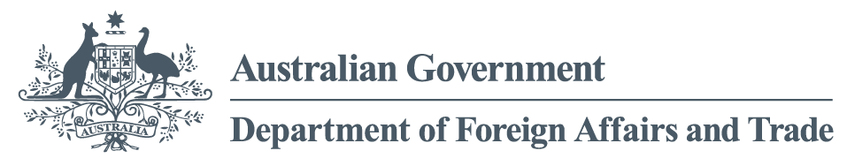

**Performance of Australian Aid 2017-18**

**April 2019**

ISSN 2204-6593 (Print)

ISSN 2204-9649 (Online)

ISBN 978-1-74322-486-1 (Book softcover)

ISBN 978-1-74322-487-8 (PDF format)

ISBN 978-1-74322-488-5 (Word format)

**Creative Commons**

With the exception of the Commonwealth Coat of Arms and where otherwise noted all material presented in this document is provided under a Creative Commons Attribution 3.0 Australia (creativecommons.org/licenses/by/3.0/au/) licence. The details of the relevant licence conditions are available on the Creative Commons website (accessible using the links provided) as is the full legal code for the CC BY 3.0 AU licence (<http://creativecommons.org/licenses/by/3.0/au/legalcode>).

The document should be attributed as: Commonwealth of Australia, DFAT, *Performance of Australian Aid 2017-18.*

**Contact**

Inquiries about this document should be directed to: Department of Foreign Affairs and Trade Public Diplomacy Branch

RG Casey Building John McEwen Crescent Barton ACT 0221 Australia

+61 2 6261 1111 (Phone) +61 2 6261 3111 (Fax)

Published by the Department of Foreign Affairs and Trade, 2019

# Table of Contents

Introduction 4

Outline of this report 4

Approach to assessing performance in the aid program 5

Transparency 8

Chapter 1 Performance against strategic targets 9

Target 1: Promoting prosperity 9

Target 2: Engaging the private sector 12

Target 4: Empowering women and girls 14

Target 7: Working with the most effective partners 18

Target 8: Ensuring value for money 19

Chapter 2 Country and regional program performance 21

Pacific 22

Southeast and East Asia 30

South and West Asia, Africa, the Middle East and Other Regions 38

Chapter 3 Global program performance 46

Multilateral Performance Assessments 47

Australian Non-Government Organisation Cooperation Program 48

Australian Volunteers Program 49

innovationXchange 50

Chapter 4 Sector and thematic performance 52

Infrastructure, trade facilitation and international competitiveness 53

Agriculture, fisheries and water 54

Effective governance: policies, institutions and functioning economies 55

Education and Health 56

Building resilience: humanitarian assistance, disaster risk reduction and social protection 62

Disability-inclusive Development 63

Annex A: Official Development Assistance delivered by other government agencies 68

The Treasury 68

Australian Centre for International Agricultural Research 68

Australian Federal Police 69

Department of Health 69

Department of Jobs and Small Business 70

Department of Agriculture and Water Resources 70

Department of Home Affairs 70

Attorney-General’s Department 70

Annex B: Assessment by Independent Evaluation Committee and the Office of Development Effectiveness 71

Foreword by Jim Adams, Chair of DFAT’s Independent Evaluation Committee 71

Statement by the Office of Development Effectiveness 72

Nature and scope of ODE/IEC assurance 73

List of acronyms and abbreviations 75

# Introduction

As part of the performance framework for the Australian aid program, Making Performance Count,[1] the Government committed to publish an annual Performance of Australian Aid report. This is the fifth report and it summarises the performance of the Australian aid program in 2017-18.

The Government’s aid policy, Australian aid: promoting prosperity, reducing poverty, enhancing stability,[2] affirms the purpose of the aid program as ‘promoting Australia’s national interests by contributing to sustainable economic growth and poverty reduction’. To achieve this, the aid program focuses on driving private sector growth and human development in the Indo-Pacific region through investments in six priority areas:

• Infrastructure, trade facilitation and international competitiveness

• Agriculture, fisheries and water

• Effective governance: policies, institutions and functioning economies

• Education and health

• Building resilience: humanitarian assistance, disaster risk reduction and social protection

• Gender equality and empowering women and girls.

The Foreign Policy White Paper, published in December 2017, highlighted that Australia’s development assistance program supports partner countries in their efforts to become more stable, prosperous and resilient. It confirmed that the objective of Australia’s development assistance is to reduce poverty and alleviate suffering as well as serving Australia’s national interests, magnifying the influence that Australia brings to bear on pressing regional and global problems, including efforts to meet the Sustainable Development Goals (SDGs).

Australia’s reporting on the aid program’s support for the SDGs occurs in different ways. Australia’s first Voluntary National Review on progress with the SDGs was published in June 2018.[3] The review includes discussion of Australia’s regional and global action to support partner countries to achieve the SDGs. Annual Aid Program Performance Reports for country and regional programs identify which SDGs are supported by individual country and regional program objectives. The *Performance of Australian Aid* report also identifies which SDGs are supported through investment priority areas.[4] New Aid Investment Plans, to be published in 2019-20, will outline how planned activities under country and regional program objectives contribute to the achievement of the SDGs.

## Outlineof this report

This report is divided into four chapters and two annexes.

Chapter 1 reports on the 10 strategic targets under Making Performance Count, which provide the basis for assessing the performance of the aid program as a whole.

Chapter 2 summarises the performance of country and regional aid programs. Analysis draws on a range of performance data from four regional groups: Pacific; Southeast and East Asia; South and West Asia; and Africa, the Middle East and other regions.

Chapter 3 reports on the multilateral performance assessment completed in 2017-18 for the Office of the United Nations High Commissioner for Refugees. The performance of the Australian NGO Cooperation Program, the Australian Volunteers Program and the innovationXchange is also summarised in this chapter.

Chapter 4 summarises performance data for the six investment priority areas under the aid policy as well as disability inclusion. For 2017-18, in addition to providing performance data for all investment priority areas, the Performance of Australian Aid report has focused in depth on two areas: education and disability inclusion. Other investment priority areas will be assessed in similar detail in subsequent reports.[5]

The report also includes a summary of the major activities and achievements of ODA appropriated to other Australian Government departments and agencies (Annex A). The performance information in this report is subject to a process of quality assurance and verification by the Office of Development Effectiveness (ODE), under the guidance of DFAT’s Independent Evaluation Committee (IEC). A description of this process and their assessment is set out in Annex B.

## Approach to assessing performance in the aid program

The analysis in this report draws on performance assessments undertaken at three levels of the aid program (refer Figure 1):

• whole of aid program level

• bilateral (country and regional) and global programs

• individual aid investments.

Performance assessments are completed by DFAT and subject to peer review and quality assurance. The performance of key aid delivery partners is also separately assessed.

At the whole of aid program level, alignment with the Government’s policy directions and progress against the 10 strategic targets in Making Performance Count are assessed and reported annually in Performance of Australian Aid reports.

At the program level, the approaches to performance assessment are tailored to the characteristics of different programs.

For country and regional aid programs, performance is assessed each year and published in Aid Program Performance Reports (APPRs). To ensure the assessments made are contested and robust, all APPRs are peer reviewed and approved by DFAT senior management. Judgements about performance are made against program objectives contained in Aid Investment Plans for each country or regional program, and expressed as one of three ratings: progress towards objectives is on track; progress is less than expected; or progress is not on track. APPRs also report on progress against program‑specific performance benchmarks and mutual obligations. In 2017-18, all 24 country and regional programs for which an APPR was required completed and published their APPRs on the DFAT website. In addition, APPRs were completed for the Australian NGO Cooperation Program and the innovationXchange.[6] The ODE also conducts an annual independent quality review of country and regional program APPRs. The ODE is currently reviewing APPRs published in 2018. Preliminary findings of this review have informed ODE’s quality assurance of this *Performance of Australian Aid* report as outlined in Annex B.

Each year, DFAT undertakes multilateral performance assessments for selected multilateral organisations receiving core funding from Australia. All major multilateral partners are assessed every four years. A summary of the multilateral performance assessment completed in 2017-18 for the Office of the United Nations High Commissioner for Refugees is included in Chapter 3. [7]

At the individual investment level, quality reporting is completed annually for all aid investments over $3 million. Through Aid Quality Checks (AQCs), each aid investment is rated as performing satisfactorily or unsatisfactorily on a six-point scale against six aid quality criteria.[8] In 2017-18, 353 AQCs were completed,[9] representing 100 per cent of eligible aid investments.[10] To ensure performance assessments in AQCs are robust and contestable, they are subject to peer moderation. The ODE also undertakes an annual spot check of the quality of AQCs.

DFAT prepares and publishes an annual Aid Evaluation Plan. The Plan identifies evaluations of individual aid investments undertaken by program areas as well as larger strategic evaluations undertaken by the ODE. Program areas identify evaluations based on their own priority information needs. To promote evaluation use and transparency, DFAT requires all evaluations to be published with a management response. In 2018, DFAT published 45 out of 48 (94 per cent) planned evaluations, of which 91 per cent had management responses. This continues the high level of publication and management response rates from 2017 (95 per cent of planned evaluations published, of which 95 per cent had management responses).

In 2018, ODE completed a review that assessed the quality of program evaluations identified in the DFAT Aid Evaluation Plan and completed in 2017. The review found that program evaluations continue to be a credible source of evidence for the aid program using modest consultant and financial resources. However, there is room for improvement. While the review found that 71 per cent of evaluations were of adequate or better quality, there has been a small decline in the overall quality of evaluations compared to previous reviews of 2012 and 2014 evaluations. In particular, attention is required to ensure that high value investments are evaluated effectively.

At the delivery partner level, Partner Performance Assessments review how well implementing partners are delivering the services specified in aid agreements. Implementing partners under each aid agreement valued over $3 million are rated as performing satisfactorily or unsatisfactorily on a six-point scale against five assessment criteria. In 2017-18, 90 per cent of eligible aid agreements were assessed.

Performance information generated at the individual aid investment level feeds into assessments of program performance, which in turn provides the basis for assessing the performance of the aid program as a whole. To ensure that DFAT’s reporting on the performance of Australian aid is rigorous, credible and supported by robust evidence, the ODE, under the guidance of the Independent Evaluation Committee, undertakes strategic evaluations of particular programs or thematic areas and provides independent oversight of departmental aid performance assessment systems. Evaluations undertaken by ODE, and published in 2018, are listed in Annex B.

One of the strategic evaluations completed by ODE in 2018 considered DFAT’s investment level monitoring systems,[11] with a focus on investments delivered through managing contractors. The evaluation found that these systems have been developed over time to support a performance culture that generates realistic and robust information on the performance of the aid program. However, the evaluation found that the quality of these systems could be improved. The evaluation found that Australian aid investments with higher-quality monitoring systems exhibit three distinct characteristics: systems are outcome focused, measuring and guiding progress towards achieving intended outcomes; systems and data are quality assured through the application of quality standards and contestability mechanisms; and systems use monitoring data well, serving different purposes and needs.

The evaluation recommended DFAT promote a consistent and robust approach to monitoring investment performance across the aid program supported by ongoing nurturing of a performance culture within DFAT and managing contractors. Other recommendations included checking of investment monitoring system quality during the investment inception phase and ensuring all investment managers have technical support to establish and oversee monitoring arrangements, especially for complex, technical and/or high-value investments. DFAT has accepted all of the evaluation’s recommendations and is now progressing initiatives that respond to the issues raised. These include actions to standardise monitoring requirements in commercial contracts and improve DFAT staff access to advice and support on investment level monitoring.

Figure 1: Performance assessment in the Australian aid program

How is the performance of the Australian aid program assessed?At what level is performance assessed? What is performance measured against? How is performance 
reported?Whole of aid program: 10 strategic targets
6 aid investment priority areas DFAT Annual Report Performance of Australian Aid Reportprograms:Country and regional aid programs
Global and other aid programsAid Investment Plan objectives, performance benchmarks and mutual obligations
Sustainable Development Goals
Program-specific performance frameworksAnnual Aid Program Performance Reports
Strategic evaluations by Office of Development Effectiveness
Multilateral Performance Assessments individual aid investments:Aid quality criteria: • Effectiveness• Efficiency• Gender• Relevance• Monitoring & evaluation• SustainabilityKey policy priorities:• Disability inclusion• Indigenous peoples• Climate change• Private sector engagement• Innovation in developmentAnnual Aid Quality Checks
Independent operational evaluationsKEY AID DELIVERY PARTNERS:5 assessment criteria • Lasting results & impact • Value for money• Collaboration, communication, responsiveness• Policy alignment, risk management, innovation• Effective personnelAnnual Partner Performance Assessments

## Transparency

The publication of an annual Performance of Australian Aid report forms part of the Government’s commitment to transparency and accountability in the management of the aid program. This commitment is included as part of the 2014 aid policy framework.

DFAT makes available, in an open and accessible format on its website, a substantial amount of information about the Australian aid program including policies, plans, results, evaluations, research, investment plans and aid fact sheets. Detailed statistical information on Australia’s aid program was published in May 2018 in the form of the Australian Aid Budget Summary for 2018-19 (“The Orange Book”). Additional statistical information is published during the year in The Australian Engagement with Developing Countries: Bilateral relationships at a glance and Australia’s International Development Assistance: Official Sector Statistical Summary.

DFAT continuously publishes new and updated policies, plans, results, evaluations and research on its website. This includes fact sheets that cover all country programs and major thematic areas are updated twice each year and published on the DFAT website. DFAT provides on its website aid information related to fraud control strategies, fraud losses and recoveries. In addition, DFAT uses the AusTender website (tenders.gov.au) to publish information on aid-related business opportunities, annual procurement plans, multi-use lists and contracts awarded.

Australia fully participates in the International Aid Transparency Initiative (IATI) and fulfils its aid reporting obligations to the OECD Development Assistance Committee. DFAT continued to increase its level of reporting to IATI in 2017-18 and will continue to engage with IATI in future.

# Chapter 1 Performance against strategic targets

Making Performance Count identified 10 strategic targets to ensure the aid program is well managed, achieving value for money and delivering on the key priorities outlined in the Government’s aid policy: Australian aid: promoting prosperity, reducing poverty, enhancing stability. At the end of 2017-18, 9 of the 10 targets had been achieved. The remaining target on gender equality has not yet been achieved. A review of the targets commenced in 2017-18. Progress against 9 of the 10 targets is summarised in Table 1 with additional analysis provided for targets 1, 2, 4, 7 and 8.[12]

## Target 1: Promoting prosperity

Promote economic development by increasing Australia’s aid for trade investments to 20 per cent of the aid budget by 2020

Status: Achieved

In 2017-18, Australia continued to surpass the aid for trade target. Expenditure on aid for trade was $897 million, or 22 per cent of Australia’s aid budget. Achieving the aid for trade target ahead of schedule is a reflection of Australia’s Foreign Policy White Paper commitment to use aid for trade as a mechanism for sustained economic growth and poverty reduction. Aid for trade also supports the White Paper goal of maintaining open and rules-based international trade and investment.

The largest share of Australia’s aid for trade expenditure in 2017-18 was to support investments that build productive capacity (see Figure 2).  This includes agriculture, fishing, small and medium enterprise development and women’s economic empowerment. This was followed by economic infrastructure (transport, energy and communications), and trade policy and regulatory reform (creating a competitive and market-based environment for trade).

Figure 2: Expenditure by aid for trade categories, 2017-18

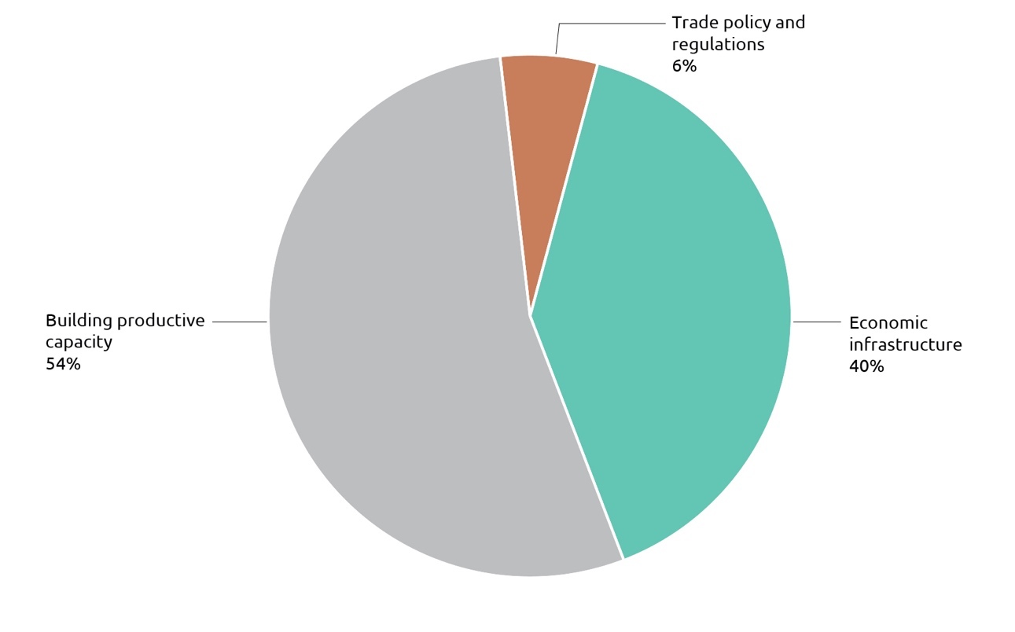

Table 1: Progress against the 10 strategic targets for the aid program as at 30 June 2018

| TARGET | PROGRESS |
| --- | --- |
| 1. Promoting prosperity: promote economic development by increasing Australia’s aid for trade investments to 20 per cent of the aid budget by 2020 | ACHIEVED: The aid program achieved this target ahead of schedule. Aid for trade accounted for 23.3 per cent of the aid budget in 2016-17 and 22 per cent in 2017-18 |
| 2. Engaging the private sector: all new investments will explore ways to promote private sector growth or engage the private sector in achieving development outcomes | ACHIEVED: In 2017-18, concept notes for new investments examined options for promotion of private sector growth and private sector engagement |
| 3. Reducing poverty: by September 2015, all country and regional programs have Aid Investment Plans that describe how Australia’s aid will promote economic growth in ways that provide pathways out of poverty | ACHIEVED: Aid Investment Plans have been developed for all major programs and were publicly released on DFAT’s website on 30 September 2015. Updates to AIP objectives are included in annual Aid Program Performance Reports |
| 4. Empowering women and girls: more than 80 per cent of investments, regardless of their objectives, will effectively address gender issues in their implementation | NOT YET ACHIEVED: In 2017-18, 75 per cent of investments effectively addressed gender |
| 5. Focusing on the Indo-Pacific region: increase the proportion of country program aid that is spent in the Indo-Pacific region to at least 90 per cent from 2014-15 | ACHIEVED: This target has been achieved each year since 2014-15. In 2017-18, 90.3 per cent of country programmable aid was spent in the Indo-Pacific |
| 6. Delivering on commitments: from July 2015, progress against mutual obligations agreed between Australia and its key partner governments and organisations will form part of program performance assessments | ACHIEVED: Since 2015, progress against mutual obligations and performance benchmarks have been reported in Aid Program Performance Reports. Out of a set of 180 performance benchmarks for 2017-18, 125 (70 per cent) were achieved and 38 (21 per cent) partly achieved. Seventeen benchmarks (9 per cent) were either not achieved or could not be assessed due to unavailable data |
| 7. Working with the most effective partners: by July 2015, design and apply new systems to assess the performance of the aid program’s key delivery partners and ensure stronger links between performance and funding | ACHIEVED: In 2017-18, the three main delivery partner categories of commercial partners, NGOs and multilateral organisations were assessed as performing to an adequate level or better |
| 8. Ensuring value for money: deliver high standards of value for money in at least 85 per cent of aid investments. Where standards are not met and improvements are not achieved within a year, investments will be cancelled | ACHIEVED: For 2017-18, 92 per cent of aid investments were assessed as satisfactory for effectiveness and 88 per cent were assessed as satisfactory for efficiency |
| 9. Increasing consolidation: reduce the number of individual investments by 20 per cent by 2016-17 to focus efforts and reduce transaction costs | ACHIEVED: This target was achieved on 1 July 2016 when the number of individual investments had reduced by 23 per cent. As at 1 July 2018, the number of aid investments had reduced by 32 per cent[13] |
| 10. Combatting corruption: develop and implement new fraud and anti-corruption strategies for all major country and regional programs by July 2015 | ACHIEVED: In September 2018, the department published a new Fraud Control Toolkit for Funding Recipients. The toolkit aims to build capacity and assist funding recipients to meet contractual obligations relating to controlling fraud and corruption. The review of Fraud and Anti-Corruption Strategies, which were developed in 2015, is continuing and will be completed in the second half of 2019 |

Australia’s aid for trade program is delivering meaningful results, for example:

• Promoting labour standards through better factory conditions: Australia’s partnership with the International Labour Organization’s Better Work Program is improving labour standards in factories that export garments and footwear. Australia’s investment is supporting 2 million workers across 1,400 factories in Indonesia, Cambodia, Vietnam and Bangladesh, about 80 per cent of whom are women.

An independent review of the program found that it has reduced the gender pay gap by 17 per cent in participating factories. Factory workers report higher morale, lower rates of abuse and exploitation, fewer instances of sexual harassment, and improved health and education outcomes for their children. At the same time, participating factories have increased their profitability by 25 per cent, driven by larger orders from buyers who have greater confidence in factory operations. The review also found that greater efforts are needed to increase female representation on worker-management committees and in supervisory positions in factories, and that more needs to be done with fashion brands and retailers to address the pressures put on supply chains by unpredictable and large orders, which adversely impact working hours and working conditions.

• Supporting engagement in the multilateral trading system: Australia is partnering with the World Bank to assist more than 45 developing countries reduce the time and costs to trade in line with the WTO Trade Facilitation Agreement. These developing countries have improved their trade policies and practices, making trade cheaper and more inclusive, and helping to improve incomes. For example, Bangladesh has reduced the time to trade at the Port of Chittagong by 23 per cent.

• Supporting disability inclusive development: Australia’s partnership with the World Intellectual Property Organization is giving practical effect to the Marrakesh Treaty to Facilitate Access to Published Works by Visually Impaired Persons and Persons with Print Disabilities.  The Treaty allows for copyright exceptions for books for the visually impaired. Our partnership led to the production of accessible books and reading devices that have benefited more than 35,000 visually impaired people in Bangladesh, Nepal and Sri Lanka.

• Supporting disadvantaged groups to trade: Through our Australian Awards: Women Trading Globally program, we are working with the Export Council of Australia to help women entrepreneurs develop their export capabilities. In addition to providing export training, the program connects participants to women exporters in Australia, and provides ongoing mentoring support. A recent graduate of the program was named 2018 Solomon Islands businesswoman of the year.

## Target 2: Engaging the private sector

All new investments will explore innovative ways to promote private sector growth or engage the private sector in achieving development outcomes

Status: Achieved

The aid program achieved this target in 2017-18, with all new investments exploring innovative ways to promote private sector growth or engage the private sector.

In August 2015, the Minister for Foreign Affairs released the Ministerial Statement on Engaging the Private Sector in Aid and Development – Creating Shared Value through Partnership. The Ministerial Statement built upon a broader policy platform articulating the role for Government in collaborating with the private sector to create sustainable solutions to tackle development challenges. The Statement was founded on the concept of shared value, which helped DFAT identify businesses that create economic value in ways that deliver sustainable social impact in developing countries.

The Strategy for Australia’s Aid Investments in Private Sector Development, the companion to the Ministerial Statement, was also released in 2015. The Strategy formalised the rationale, principles and approaches to improve the growth and inclusion of the private sector in Australia’s partner countries. Operational enhancements to the Department’s investment design and procurement systems mean all new investments are required to explore innovative ways to promote private sector growth or engage the private sector in achieving development outcomes.  These systems then capture and test private sector contributions to partnerships and the level of private sector engagement.

The Foreign Policy White Paper released in 2017 reiterated the Government’s commitment to engage the private sector as the primary source of growth, incomes and jobs. It recognised that by sharing assets, networks and expertise with business the impact of Australia’s development assistance will be increased.

Over the period since the release of the Foreign Policy White Paper, Statement and Strategy, the Government has made progress in delivering upon the policy intent, reflected in changes to the profile of the aid program to prioritise private sector-led development. The number and diversity of partnerships formed at corporate, country and investment levels and the value of private resources mobilised is satisfactory. In 2017-18, 69 per cent of monitored investments were assessed as engaging the private sector adequately or better. Of these investments, 86 per cent performed well on measures of effectiveness and efficiency.

In 2017-18, an internal stocktake examined DFAT’s private sector engagement efforts in meeting the objectives of the Statement. It found that while good progress had been made across a range of private sector programs, a more coherent and consistent approach to private sector engagement was required. It also found a number of factors preventing greater private sector engagement in DFAT including:

• a greater risk tolerance was required to overcome the current resistance to engage the private sector

• a lack of understanding of the role the private sector can play in development

• systems needed to be established to encourage relationship building with the private sector, to encourage further engagement beyond existing partnerships

• the majority of DFAT private sector engagement activity was through intermediaries.

The stocktake highlighted that more work is required to mainstream private sector engagement in the aid program, with a key focus required on building the capability of DFAT to engage with the private sector and in refining processes and systems to facilitate private sector partnerships.

Based on the findings of the stocktake, DFAT developed an operational framework to further strengthen DFAT culture, capability and systems to increase private sector engagement and provide more direction for staff on how to engage the private sector.

Through existing programs, DFAT has engaged the private sector in a number of ways to identify opportunities to collaborate and partner with business, and to work more innovatively with the private sector. While a number of engagements have translated into direct partnerships with DFAT, other programs have catalysed business to increase their engagement in developing environments and emerging markets, at global and local levels. For example, the innovationXchange’s Scaling Frontier Innovation program is supporting social enterprises to scale their development impact in the Asia-Pacific region. DFAT also supports the United Nations Global Compact Network of Australia (GCNA) to influence the global architecture for sustainable business. DFAT has worked closely with GCNA on the Voluntary National Review to showcase Australian business contributions to the Sustainable Development Goals.

In Cambodia, Australia’s Investing in Infrastructure (3i) program is helping to unlock and stimulate private investment in rural infrastructure. As of 2018, more than 70 Small and Medium Enterprises (SME) had received technical and financial assistance to expand clean water and electricity networks, leveraging additional private sector investment of over $33 million into quality infrastructure assets that are built to last. The program is also working with Cambodia’s main energy agencies to develop policies that allow for faster uptake of clean and environmentally sustainable energy.

DFAT is engaging the private sector in the Pacific to increase market opportunities and inclusive growth. The Pacific Regional Agricultural Market Access (PHAMA Plus) program is contributing to improved economic growth and improved rural livelihoods for people in six Pacific countries by increasing the value of agricultural and horticultural exports. The program works with private sector producers, processors and exporters (as well as national biosecurity agencies) to increase the quantity and quality of their agricultural, horticultural and cultural exports, including through maintaining and increasing market access. Support by PHAMA was instrumental in maintaining Solomon Islands market access to the EU for its tuna exports.

Staff with responsibility for economic diplomacy or trade have always interacted with private sector representatives as a means to represent Australia’s economic interests overseas. What is becoming more common is the integration of development objectives and the opportunity to mobilise Official Development Assistance to support DFAT’s broader work. For example, in Southeast Asia, Australia’s ASEAN and Mekong Program is funding the Mekong Business Initiative (MBI) implemented in partnership with the Asian Development Bank. MBI is successfully influencing the pace and quality of economic and private sector reform in the markets of Cambodia, Laos, Myanmar, and Vietnam (ASEAN-4) which continue to lag behind their more developed peers. Over the past four years MBI has successfully contributed to the creation or revision of 16 business and investment laws or regulations, developed multiple platforms for the private sector to directly influence government reform agendas, and unlocked millions of dollars in additional investment and finance for businesses in these markets. The program has facilitated business-to-business connections between these markets and Australia. In addition, the program has promoted opportunities for engagement with other Australian expertise especially in the fintech area, notably the Australian Securities and Investment Commission (ASIC), Austrade, and Fintech Australia.

| The BPP – Businesses and communities thriving together: Mobile banking for the poor in Vietnam |
| --- |
| DFAT partners with The Asia Foundation, the Vietnam Bank for Social Policies and MasterCard to improve digital financial services for low-income households in Vietnam.  Approximately two-thirds of Vietnam’s 90 million people remain disconnected from formal banking. For rural areas, the lack of affordable access to financial services is a major constraint to development. From 2016 to 2018, DFAT partnered with the Vietnam Bank for Social Policies (VBSP), The Asia Foundation (TAF) and MasterCard to establish the first mobile banking platform for low income Vietnamese under the Business Partnerships Platform (BPP). The BPP supports Australia’s collaboration with business and civil society to address development challenges.  The partnership exceeded planned targets, reaching 4.9 million clients (51 per cent women) across 63 branches using SMS notifications. Over the first phase of the initiative 90 per cent of customers said they highly valued the service and were interested in continuing to receive account information by SMS. By improving mobile banking technology and expanding its availability, the initiative reduced the cost of banking and provided the bank’s clients with access to diversified services, increasing the bank’s competitiveness over the longer-term.  From 2019-2021, DFAT will support a second phase with a key focus on financial inclusion and commercial viability. It will also support women’s economic empowerment, particularly women-led microenterprises, enhancing women’s knowledge and ICT skills and identifying the most effective approaches for responding to female customer’s needs.  DFAT funding: $500,000  Private sector funding: $735,556  Start date: September 2016  End date: September 2018  Beneficiaries to date: 4.9 million people |

## Target 4: Empowering women and girls

More than 80 per cent of investments, regardless of their objectives, will effectively address gender issues in their implementation

Status: Not yet achieved

This strategic target measures effective mainstreaming of gender equality in Australia’s aid investments. It tracks the percentage of Australian aid investments that are effectively addressing gender equality issues during implementation, which is assessed through satisfactory or above ratings in the annual Aid Quality Check process.

Addressing gender inequality is essential to effective development programming and humanitarian action. Many of the challenges facing Australia and our region – climate change, migration, humanitarian crises, the changing nature of work, and demographic challenges – have significant gender equality implications.

The development and implementation of gender-sensitive and inclusive responses is critical to finding sustainable solutions. DFAT’s ongoing focus on integrating gender equality across the aid program contributes to effective and sustainable responses. It also helps ensure that investments do not entrench gendered disadvantage in ways that compound women’s vulnerability to violence and exclusion.

With 2017–18 performance at 75 per cent the Strategic Target remains unmet. This was the first year since the introduction of the target in 2014 in which investments designed and implemented after the introduction of the target performed no better than older investments. Analysis of the 88 underperforming investments shows that there is no single characteristic that explains the continued shortfall. Rather, there is an interplay of persistent challenges that relate to attention to gender equality during design and implementation as well as our partnerships:

• limited choices of partners in some regions, and where we prioritise working with partner government

• insufficient resourcing by partners to translate high level commitments to gender equality into results on the ground

• settings that are fragile and conflict-affected and where capacity is generally low

• internal challenges around timely access to technical support on gender equality and prioritisation for ongoing implementation.

The gender target is challenging, given it needs to be met consistently across the life of an initiative. In practice, it has been difficult to ensure that conditions for good performance, in particular gender analysis, timely access to capacity and other resources, and appropriate prioritisation of gender equality during implementation, are consistently met across the aid program and at all points of implementation.

However, internal challenges do not account for the majority of investments with poor performance on gender equality. Other factors at play include limited capacity and commitment within delivery partners. This is particularly challenging when there is an imperative to work with a particular partner (such as when working through government systems) or when choice of partners is limited (such as when working in crisis and conflict-affected settings). In these instances, DFAT’s expectations on gender equality are not lower, and DFAT works to clarify our expectations, improve partner capacity, and push for greater leadership and accountability for gender equality results.

Figure 3: Gender performance by region, 2017-18

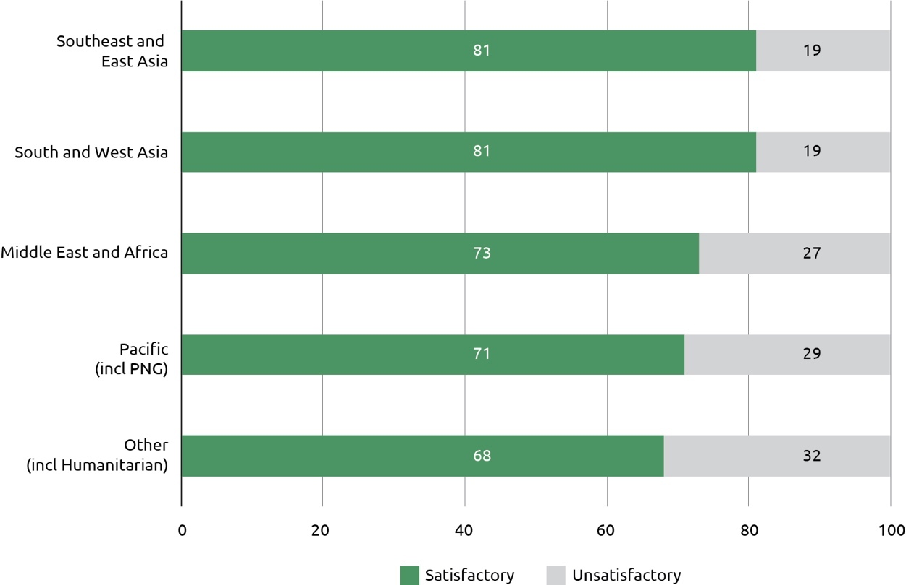

Performance continues to vary across the regions where we work. Aid investments in the Pacific have improved their performance on gender equality compared to 2016-17 but still face multiple challenges and account for a significant proportion of underperforming investments. Southeast and South and West Asia investments generally continue to perform well against the Strategic Target. Performance on gender equality in the Middle East and Africa declined during 2017-18.

In response to the 2017-18 data, DFAT in 2018 initiated a range of actions to improve gender equality performance. Chief amongst these was high-level work plans endorsed by the department’s senior management. These work plans set out systematic actions to improve performance on gender equality for new and existing investments. They include actions on capacity development, advocacy to influence policy and practice of implementing partners, and strengthening investment‑level monitoring and evaluation. Part of this is stronger, shared responses to underperforming investments that can be reasonably remedied. In addition, DFAT has undertaken a review and refresh of internal gender equality training (due for launch in mid-2019), and elevated discussions on expectations with key aid partners.

DFAT is applying the lessons from better performing investments: investments that explicitly articulate and design for gender equality objectives perform better on gender equality during implementation, compared to those that do not have gender equality as an objective. DFAT has therefore focused in 2018 on deploying additional, targeted gender expertise at the earliest stages of investment design to take maximum advantage and opportunity to deliberately articulate gender sensitive objectives. Several bilateral programs have contracted gender advisors, including in the Pacific. These actions will contribute to a greater likelihood of newly designed activities delivering on gender equality. Early visibility of pipeline aid investments has improved through DFAT’s redeveloped aid management system.

**Figure 4: Gender performance by investment priority area, 2017-18**

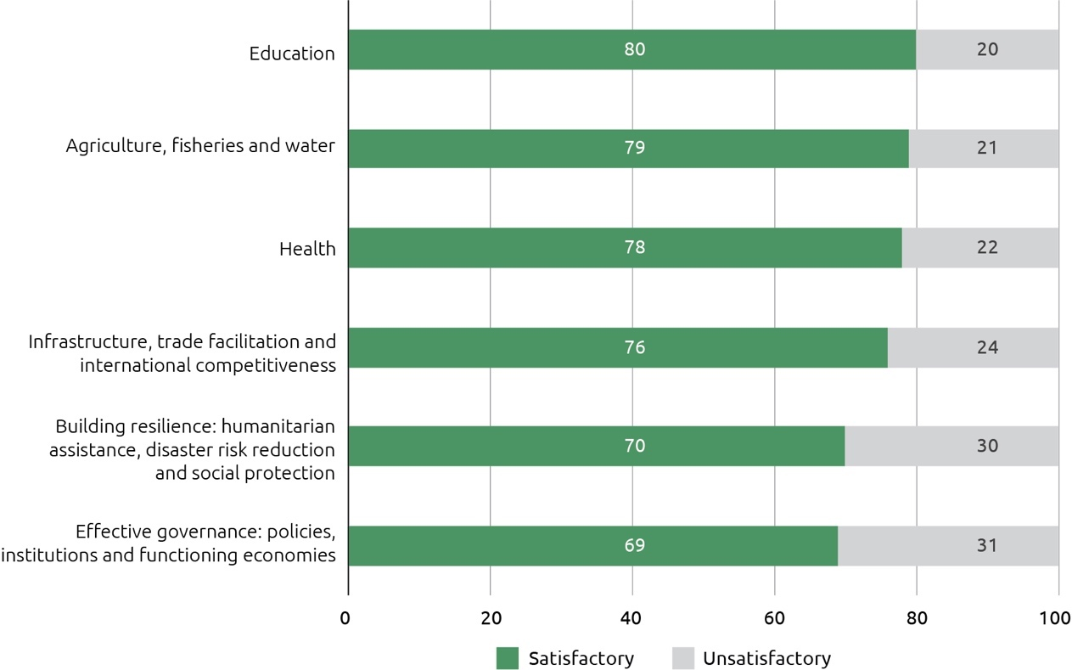

Investments in the priority areas of governance and building resilience continue to grapple with two significant challenges. The first is related to working with partner governments or other local partners whose capacity on gender equality issues is limited. The second relates to working on complex policy reform, often in settings where governance structures are weak, violence against women is endemic and links to human development are less obvious. A 2017 internal gender review of Pacific regional economic governance investments provided analysis and recommendations and contributed to improved gender equality results in 2017-18.

Figure 5: DFAT ODA expenditure on gender equality, 2017-18

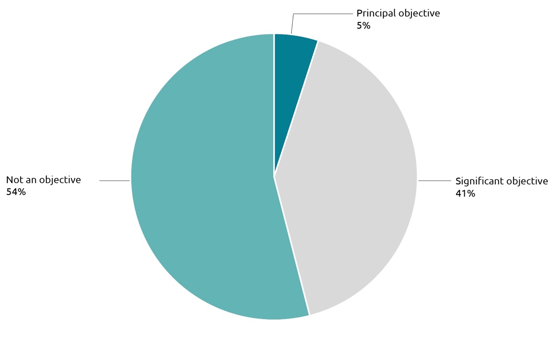

In 2017-18, Australia’s expenditure on investments that targeted gender equality as a principal or significant objective was $1.3 billion.[14] This amounts to 46 per cent of DFAT’s country, regional and global aid investments by value across a range of sectors (Figure 5). Investments where gender equality is integrated as a secondary (significant) objective account for the bulk of this expenditure.

In 2017-18, DFAT applied for the first time the OECD/DAC Minimum Recommended Criteria for gender-focused aid expenditure reporting. This means that all aid classified as contributing to gender equality has been carefully screened to confirm that is informed by gender analysis, aimed at narrowing gender equality gaps, tracks results for gender equality, and is managed on the basis of reducing unintended negative consequences for women and girls. As a result of this change in methodology, gender expenditure data for 2017-18 is not comparable with data for previous years.

DFAT’s Gender Equality Fund ($55 million in 2017-18) continued to invest in gender equality in support of DFAT’s three priority gender equality pillars, and in support of developing the global evidence base to drive improved gender equality programming. As well as supporting flagship programs *Investing In Women* and *Pacific Women Shaping Pacific Development*, the Gender Equality Fund influenced global partnerships to focus on the Indo-Pacific. The Fund also invests in technical support to help identify and implement the most effective strategies to tackle urgent gender inequality issues in the Indo-Pacific region. This included support for improved gender mainstreaming by key aid delivery partners in the Pacific, where challenges around violence against women and women’s leadership are among the greatest and access to gender expertise remains challenging.

A mid-term evaluation of the GEF-funded *Markets for Change* program in the Pacific found that it is progressing towards impact across the three target countries (Solomon Islands, Vanuatu and Fiji). [15] There is evidence the program has been effective in supporting women market vendor’s economic advancement, although more action is needed to enable women to control income and assets. There is also evidence of improved attitudes to gender equality across market vendors and government staff, particularly in Fiji.

## Target 7: Working with the most effective partners

By July 2015, design and apply new systems to assess the performance of the aid program’s key delivery partners and ensure stronger links between performance and funding

Status: Achieved

This target was first achieved in 2014-15 with the introduction of Partner Performance Assessments (PPAs); a strengthened Multilateral Performance Assessment process for multilateral organisations receiving core funding; reforms to systems for assessing performance under the Australia-NGO Cooperation program; and progress in linking performance to payments in aid agreements. Feedback on the PPA system in 2018 indicated that evidence-based performance discussions were valued by DFAT staff and commercial partners, with changed practices by partners when required following completion of PPAs.

In 2017-18, 77 per cent of total administered ODA was delivered through agreements with three main types of implementing partners: commercial partners, multilateral organisations and NGOs (Figure 6).

Figure 6: Total administered ODA by delivery partner type, 2017-18

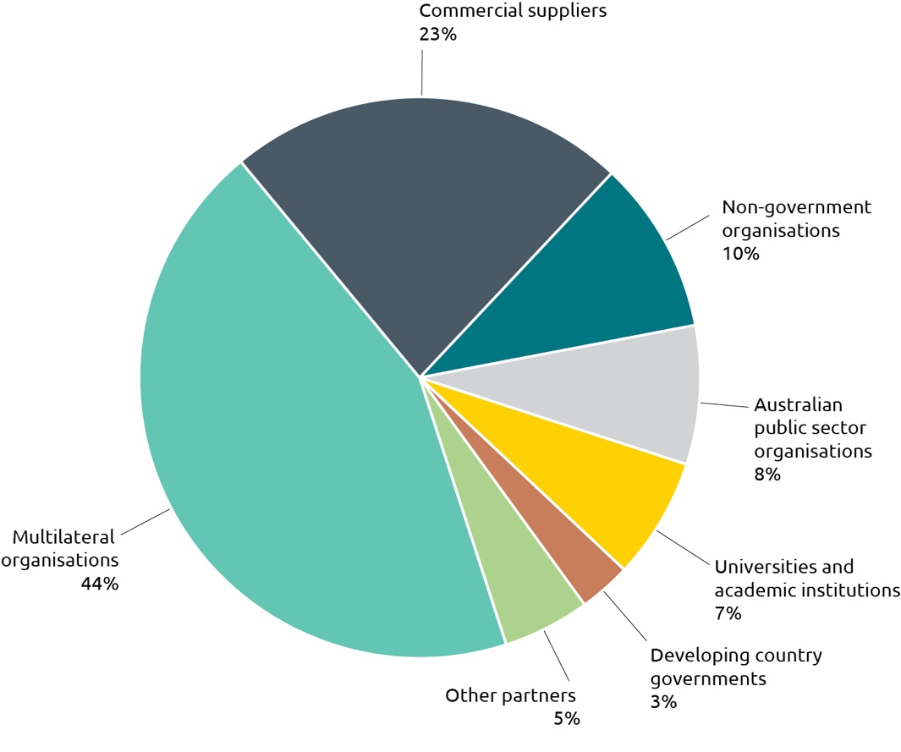

Partner Performance Assessments (PPAs) review how well key implementing partners (commercial partners, multilateral organisations and NGOs) are delivering the services specified in aid funding agreements. The focus is on the performance of the implementing partner, as distinct from the quality of the investment itself (which is assessed by the annual Aid Quality Checks). Assessments were completed for individual funding agreements valued at over $3 million except for core contributions to multilateral organisations.

Table 2: PPA completed by delivery partner type, 2017-18

| Partner type | Number of PPAs | Overall value of agreements assessed ($m) |
| --- | --- | --- |
| NGOs | 79 | $1,309 |
| Commercial suppliers | 95 | $3,082 |
| Multilateral Organisations | 129 | $1,942 |

The results (Table 3) indicate that the three main delivery partner categories are all performing to an adequate level or better. Over 94 per cent of assessments completed had ratings of adequate (4) or higher on a scale of 1 to 6.[16]

Table 3: Average PPA rating score by delivery partner type, 2017-18

| Commercial Partners | NGOs | Multilateral Organisations | Overall Partner Average Rating |
| --- | --- | --- | --- |
| 4.8 | 4.8 | 4.6 | 4.7 |

Agreements with commercial contractors are characterised by a high level of managerial direction and control by DFAT, whereas grant agreements with NGOs and multilateral organisations are partnership agreements where DFAT has agreed to fund investments over which partners have much greater autonomy in investment design and implementation. Australia’s investment in multilateral programs is often also made in collaboration with other donors, requiring greater degrees of compromise by all parties than is required in other arrangements. In addition, multilateral organisations operate under policies and procedures endorsed by boards (which include Australian representation) and these policies and procedures can be difficult to change quickly to meet Australia’s specific interests in individual countries (in contrast to the flexibility DFAT has when engaging commercial suppliers).

## Target 8: Ensuring value for money

Deliver high standards of value for money in at least 85 per cent of aid investments. Where standards are not met and improvements are not achieved within a year, investments will be cancelled

Status: Achieved

This target was achieved in 2017-18 with 92 per cent of investments rated as satisfactory for effectiveness and 88 per cent of investments rated as satisfactory for efficiency.

DFAT seeks to ensure that value for money considerations are applied across all aid management policies, practices and investments. Data to track progress towards this target is drawn from DFAT’s annual Aid Quality Checks. Investments rated as satisfactory against the efficiency and effectiveness criteria are considered to be delivering high standards of value for money.

Annual effectiveness outcomes have ranged between 86 per cent and 92 per cent since 2011-12 (Figure 7). The 2017-18 outcome of 92 per cent for effectiveness is the highest effectiveness result recorded since 2011-12. Efficiency outcomes continue to be rated higher than for 2013-14 and earlier years. The continuing trend of efficiency outcomes at 85 per cent or higher indicates that the overall efficiency of aid program investments has improved.

Figure 7: Percentage of aid investments with satisfactory ratings for efficiency and effectiveness, 2011-12 to 2017-18

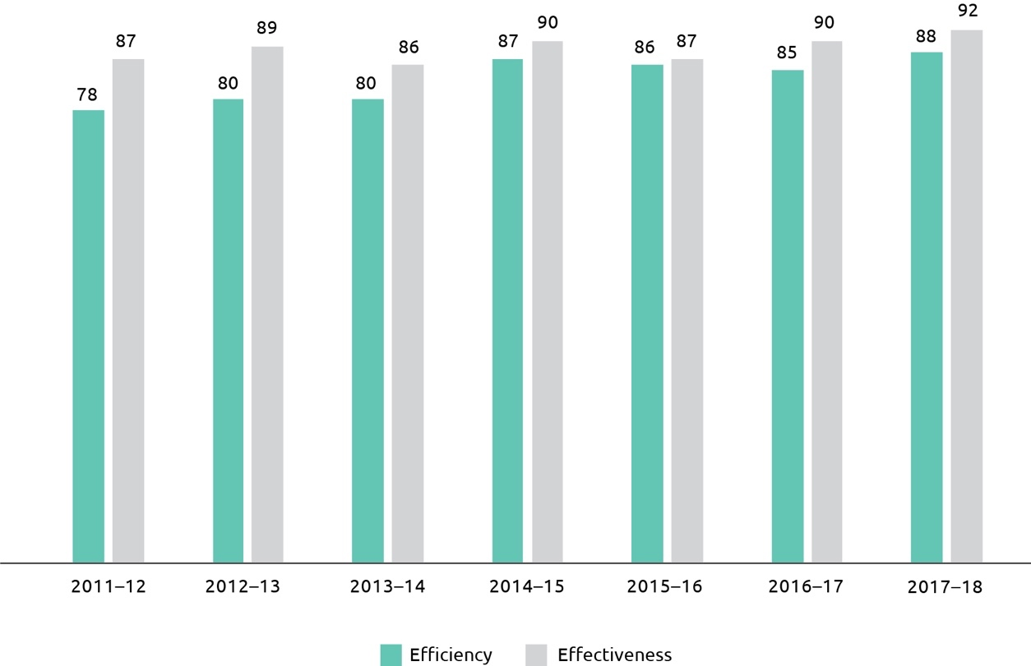

This strategic target also requires the identification of underperforming investments based on unsatisfactory ratings for both effectiveness and efficiency criteria. In 2017-18, 17 investments were identified as Investments Requiring Improvement. If performance does not improve for each investment within 12 months, they are subject to cancellation. In 2016-17, 25 investments were identified as Investments Requiring Improvement. Of these 25 investments, five investments were again assessed in 2017-18 as unsatisfactory. Four of these investments have been cancelled and the fifth is under review.

In 2018, DFAT commissioned an independent review into lessons learned from six large value facilities.[17] Facilities enable Australia to deliver aid results in rapidly changing environments. Activities are not specified at the outset but are chosen during implementation following analysis and consultation with partner governments. The review found facilities are a highly relevant model for effectively delivering Australian aid and are achieving results on the ground in a range of countries where we have larger aid programs.

The review identified a number of lessons to inform current, planned and future aid programs with a focus on internal systems and processes to support effectiveness and efficiency of facilities. DFAT accepts there is scope to further improve how facilities are designed and implemented and work is ongoing to improve the management of facilities to enhance their benefits. DFAT is implementing the review recommendations and has put in place a number of measures to enhance management of and support to facilities. These include improved quality assurance processes and the appointment of Senior Responsible Officers to selected facilities.

Aid delivered through facilities is subject to the same quality assurance, procurement and performance review processes as other aid programs. No facilities were identified as investments requiring improvement in the 2017-18 Aid Quality Check process. To continue to strengthen performance and evidence-based decision making, independent monitoring and evaluation will be introduced on an ongoing basis for all facilities. The ODE will undertake an evaluation of a selected set of facilities to be published in 2020.

# Chapter 2 Country and regional program performance

This chapter summarises the performance of Australia’s country and regional aid programs. It highlights key performance trends and areas for improvement, organised into four regional groups: Pacific; Southeast and East Asia; South and West Asia; and Africa, the Middle East and other regions. Individual country and regional programs achieved significant results in 2017-18. These results are available on DFAT’s website, and are not repeated in this report.[18]

For country and regional aid programs, performance is assessed each year and published in Aid Program Performance Reports.[19] Assessments of performance are made against program objectives contained in Aid Investment Plans for each country or regional program, and expressed as one of three ratings: progress towards objectives is on track; progress is less than expected; or progress is not on track.

Figure 8: Progress against program objectives by region, 2017-18

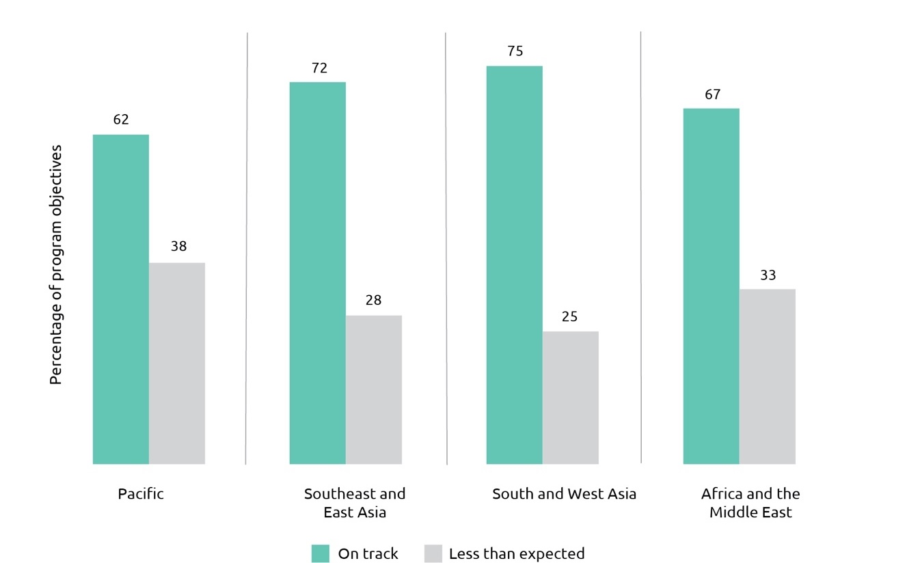

Performance benchmarks, together with other monitoring and evaluation indicators, are used to assess progress against Aid Investment Plan objectives. Progress against each benchmark is reported in Aid Program Performance Reports. Performance against objectives and benchmarks for individual country and regional programs is summarised by region below.[20]

## Pacific

With a population of approximately 10.2 million people scattered across hundreds of islands, many of them geographically isolated, the Pacific faces significant development challenges. The small and remote island states are characterised by limited natural resources, narrowly-based economies, long distances from major markets and vulnerability to natural disasters, including the effects of climate change. These factors constrain growth and often contribute to high levels of economic volatility. While Papua New Guinea faces its own unique challenges, including complex cultural dynamics, its young and growing population and significant endowment of natural resources provide significant growth potential.

Building on our longstanding commitment to the Pacific, Australia is taking its partnership with the region to a new level, including through a series of new initiatives to further promote economic development, grow people-to-people links and enhance security cooperation. Australia is working closely with Pacific partners to build a region that is secure, stable and sovereign. The 2017 Foreign Policy White Paper recognises this ‘step up’ as one of Australia’s highest foreign policy priorities. A dedicated **Office of the Pacific** in the Department of Foreign Affairs and Trade has been established to support implementation of these initiatives.

In 2017-18, four new Aid Partnership Arrangements were signed with Pacific governments, bringing the total number to eleven. These support a range of practical, mutually agreed measures to strengthen economic growth and resilience, enhance regional security cooperation, deepen people-to-people links, and support quality health and education outcomes in the region. During the reporting period, Australia also provided significant humanitarian and reconstruction assistance in responses to recent disasters such as Tropical Cyclone Gita in Tonga and the earthquake in the highlands of PNG.

Australia is the largest contributor of ODA to the Pacific. In 2017-18, 27.1 per cent of Australian ODA was allocated to the region. Assistance to PNG remained Australia’s largest program, accounting for 48.7 per cent of Pacific expenditure and 13.2 per cent of total Australian ODA.

Table 4: Total Australian ODA: Pacific, 2017-18

| **Country** | **2016-17** | **2017-18** |
| --- | --- | --- |
| **($m)** | **($m)** |
| Papua New Guinea | 549.9 | 539.4 |
| Solomon Islands | 155.2 | 141.8 |
| Fiji | 80.2 | 69.4 |
| Vanuatu | 66.1 | 72.3 |
| Samoa | 35.4 | 36.5 |
| Tonga | 28.1 | 37.2 |
| Kiribati | 28.7 | 29.9 |
| Nauru | 23.6 | 24.7 |
| North Pacific[21] | 10.7 | 9.6 |
| Tuvalu | 9.0 | 9.0 |
| Cook Islands | 3.9 | 3.6 |
| Niue and Tokelau | 4.3 | 3.1 |
| Pacific Regional[22] | 131.5 | 130.7 |
| Pacific Total | 1,126.7 | 1,107.2 |

Figure 9: Total Australian ODA by investment priority area: Pacific, 2017-18

Graph


Program quality

In 2017-18, 62 per cent of Pacific country and regional program objectives were assessed as on track (Figure 10), reflecting the challenging operating environment in the Pacific. The proportion of program objectives where progress was less than expected was 38 per cent. The performance of each country against program objectives is set out below. Pacific programs have identified management actions to improve program performance. These actions are set out in country and regional Aid Program Performance Reports.

Figure 10: Progress against program objectives: Pacific, 2017-18

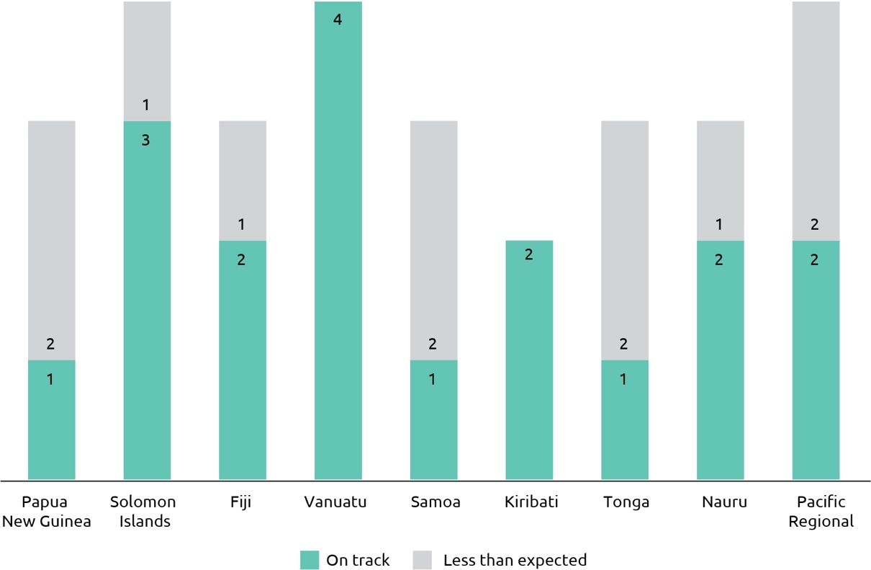

Progress against performance benchmarks by Pacific programs was mixed, with 56 per cent of benchmarks achieved and 28 per cent partly achieved (Figure 11). Nine benchmarks (12 per cent) were not achieved, four of which relate to performance in the Nauru program and three in the Fiji program. Benchmarks not met in the Fiji program included investment-level effectiveness targets for gender equality and disability-inclusion, which were new benchmarks introduced in 2017-18.

Figure 11: Progress against performance benchmarks: Pacific, 2017-18

~~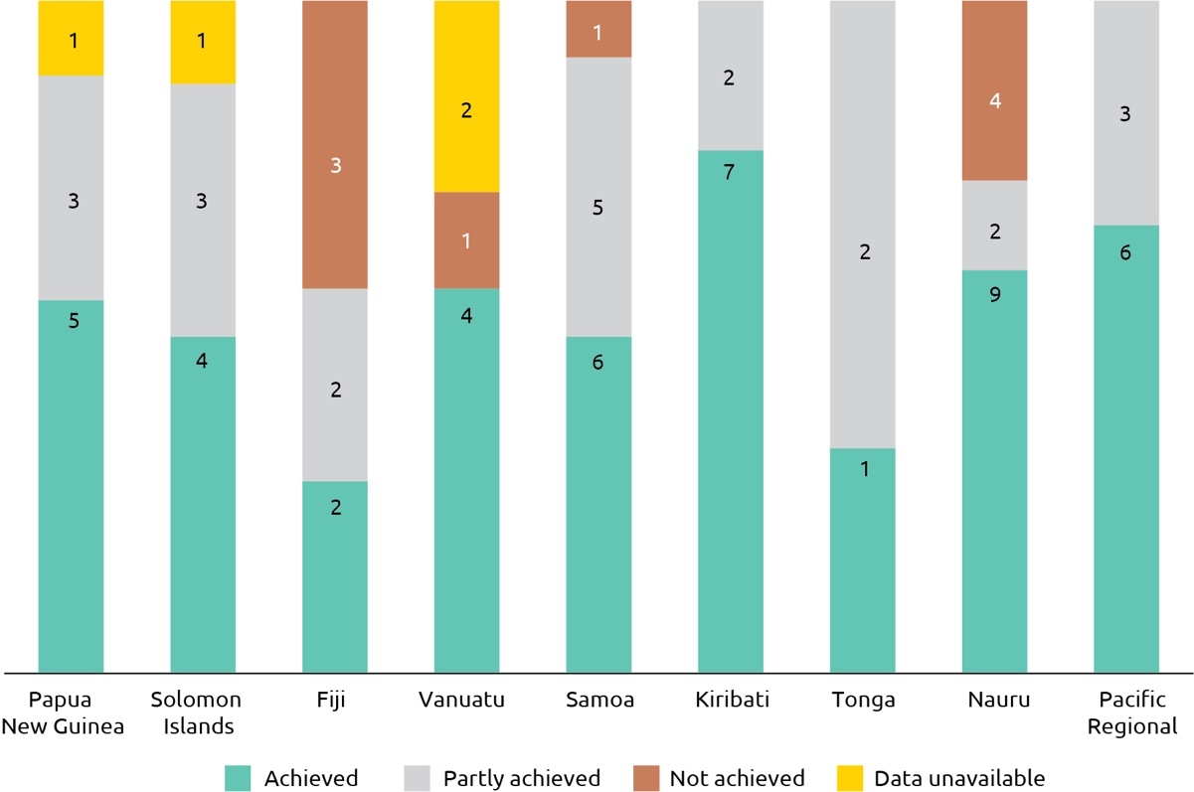~~

Figure 12: Aid investment performance: Pacific, 2017-18

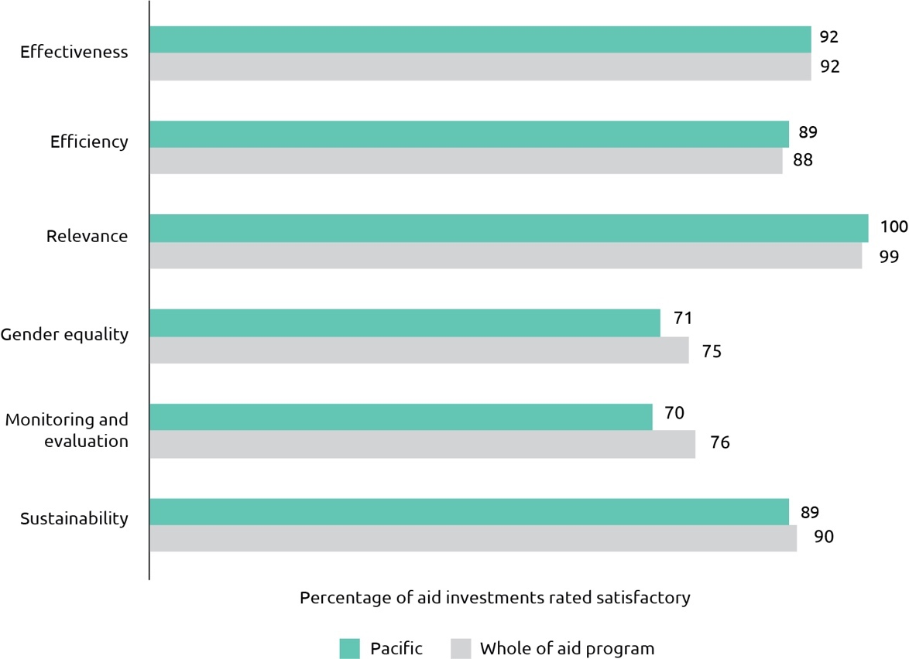

The results for Australia’s aid investments in the Pacific in 2017-18 exceeded the whole of aid program for efficiency and were on par with the whole of aid program results for effectiveness. Although at the margin, this is the first time Australia’s aid investments in the Pacific have exceeded whole of aid program results for efficiency and is also higher than the Pacific region’s five year average for efficiency of 80 per cent. While efficiency results for the Pacific were higher than in past years, it is too early to say if the long-term efficiency of Pacific programs has improved. Results for gender equality and monitoring and evaluation were higher than in 2016-17 but below the results for the aid program as a whole.

Of the 11 investments identified as requiring improvement in 2016-17, nine improved performance or were completed. Two investments were again assessed as unsatisfactory and have been closed. Seven investments were identified as requiring improvement based on 2017-18 Aid Quality Check results and management action plans have been put in place.

The objectives of Australian development cooperation in Papua New Guinea are *promoting effective governance*, *enabling economic growth* and *enhancing human development.* While progress towards *enabling economic growth* was rated on track in 2017-18, progress towards the other two objectives was less than expected.

Australia’s work to enable economic growth in PNG reflects a commitment to reducing poverty, promoting financial inclusion and lifting living standards. It includes investments in economic governance, private sector development and the transport sector. All three performance benchmarks for this objective – relating to the increased focus of the aid program on private sector led growth and aid for trade, increased access to financial services by the poor and sustained improvements in the national road network – were achieved. A key result was the Economic Governance and Inclusive Growth Partnership assisting the Government of PNG to increase its tax revenue by 315 million kina through clearing over 608,000 unlodged returns and increasing monthly lodgement rates by 44 per cent. Australian support to the International Finance Corporation’s Lighting Papua New Guinea project also saw over 1.2 million people benefit from high-quality solar recharging and lighting products. An Office of Development Effectiveness evaluation of the Transport Sector Support Program concluded that the program’s work to maintain PNG roads has had a major impact in improving the lives of ordinary citizens, but also found a need to sharpen focus in a number of areas.[23] In particular, the evaluation identified a need to sharpen the focus on policy, planning and delivery tasks that are critical to the funding and implementation of effective maintenance programs, and to develop and demonstrate life-cycle solutions to maintenance needs of selected corridors. DFAT has agreed (at least in part) to all recommendations, and their implementation is underway.

Australian support for better governance in PNG includes investments in decentralisation, public sector reform, electoral process, citizen participation and law and justice. Results from existing activities were largely on track against targets. Programs in Papua New Guinea made progress in addressing gender equality in 2017-18, and achieved the target of 80 per cent of investments effectively addressing gender equality and women’s empowerment. The Pacific Women program continues to perform strongly, and a number of projects under Pacific Women have been picked up and expanded by other sector programs. Examples from the law and justice sector include over 1,200 Village Courts and Land Mediators trained in delivering equitable and effective justice services and an estimated 65,000 people reached by awareness raising campaigns on legal rights and responsibilities. However, progress on new programs to support the PNG Government’s decentralisation agenda did not progress as quickly as planned due in part to delays caused by the 2017 National Election and the need for agreement on the strategy with the new Government. An independent evaluation of Australia’s assistance to Papua New Guinea’s 2017 national election found that although there were significant challenges to the effectiveness of Australia’s contribution, it was reasonable under difficult circumstances.[24] The evaluation will inform the design of Australia’s future electoral assistance.

Papua New Guinea’s economic and social development is heavily dependent on the health, education and skills of its population. While Australia’s support for enhancing human development has generated results, progress has been less than expected as the development of new programs was behind schedule in both health and education. In addition, progress was less than expected against performance benchmarks. The benchmark on improved school infrastructure, in particular, fell short of expectations due to unanticipated construction challenges in the Autonomous Region of Bougainville. Nevertheless, in 2017-18 Australian support enabled the training of 1,348 elementary teachers and 214 Community Literacy Volunteers, the launch of pilot electronic reading applications in 36 schools, and training 12,000 school administrators to efficiently manage and account for government funds. The extensive redevelopment of Arawa Hospital on Bougainville was completed, and six Community Health Posts were opened in three provinces, providing facilities for childbirth and other services. An independent evaluation of DFAT’s multilateral partnerships in the health sector of PNG highlighted some of the benefits and challenges of working in this way.[25] DFAT has accepted or partly accepted all of the evaluation’s recommendations to further strengthen the effectiveness of these partnerships and is taking or planning action in response.

For Solomon Islands, three of four aid program objectives were assessed as on track, relating to *supporting stability*, *enabling economic growth* and *enhancing human development*. The reporting period saw a notable change in cooperation in the justice and security sector, with the start of new programs supporting justice, governance and policing. Key achievements in education included the completion of 74 classrooms, the expansion of 13 schools, and continuing professional development for 1,440 teachers. In health, Australian funding to the Ministry of Health and Medical Services contributed to the delivery of a major policy reform, with cabinet approval of a policy setting out a pathway to achieve universal health coverage in the Solomon Islands. An independent review found that the program’s gender mainstreaming work was on track across all three areas of women’s leadership and decision-making, women’s economic empowerment and ending violence against women.[26] However, progress against the objective *more men and women able to earn a cash‑based income* was less than expected. Work under this objective scaled up over the period, including the launch of a new program to strengthen business and increased work on labour mobility, and progress indicators were on track. Nevertheless, the program’s overall assessment is that activities do not yet amount to a sustained contribution to the objective of improving incomes, especially rural incomes. In response, the program will strengthen monitoring to assess the collective impact of activities.

In **Fiji**, two of three program objectives – relating to *private sector development* and *human development* – were assessed as on track. A key result of Australia’s support for private sector development, through the DFAT-International Finance Corporation partnership with the Reserve Bank of Fiji, was Fiji’s issuance of the first sovereign Green Bond by a developing country to fund climate change mitigation and adaptation. A review of the Market Development Facility found it had built a solid reputation with businesses and government agencies and has potential for supporting long-term market-wide changes in Fiji’s economy that benefit poor women and men.[27] Similarly, an independent end of program evaluation of the Access to Quality Education Program, which operated from 2011-2017, found it to have been successful overall, highly relevant and effective across all areas of work.[28] Progress against the objective *Tropical Cyclone Winston Recovery* was less than expected. Work continued to deliver Australia’s $20 million package of support for longer-term recovery and reconstruction including repairing and rebuilding health and education facilities that suffered significant damage in Ra and Koro, and the rebuilding of economic infrastructure to improve livelihood opportunities for those affected by the cyclone, particularly women. However, while it was expected that all recovery work would be completed in early 2018, the program now estimates the remaining health and educational buildings to be completed and handed over to the Government of Fiji in 2019.

In Vanuatu, the aid program’s four objectives are *building resilient infrastructure and environment for economic opportunity, improving early education and essential health services, improving community safety and resilience* and *supporting cyclone recovery and reconstruction.* Progress against all four objectives was assessed as on track, with performance benchmarks for the last three objectives met, and strong performance of activities under the first objective despite failure to meet a benchmark. Key achievements in 2017-18 included maintenance and rehabilitation of 525 kilometres of rural roads, support for utility and revenue reforms to improve the operating context for private sector investment and training of over 100 health personnel, including medical interns, nurses and midwives. The Port Vila Urban Development Project, co-funded by Australia and the Asian Development Bank (ADB) and implemented by the Government of Vanuatu (GoV), was designated an Investment Requiring Improvement. While all programmed works were on track to be completed by the end of 2018, the impact of Tropical Cyclone Pam, foreign exchange losses and higher than anticipated design and construction costs hindered implementation and resulted in scope reductions and delays. A remediation plan has been developed to improve performance, including strengthened management oversight and resourcing by the ADB and the GoV’s Project Management Unit.

For the Samoa program, progress against the objective enabling economic growth was assessed as on track. In 2017-18, Australian support for the construction of the Tui-Samoa submarine cable, in cooperation with the ADB, World Bank and private investors, brought high-speed internet to Samoa, improving the enabling environment for business. Australian support for roads and bridges also continued, including the delivery of emergency ‘bailey’ bridges and design work on the new Maliolio Bridge and proposed improvements to Cross Island Road. Progress against the objectives progress health and education outcomes and *strengthen governance* was less than expected. While the Samoa program helped lift the quality of education and health services, including the replacement of key health buildings and medical equipment, progress against the objective’s performance benchmarks was mixed and a review of primary healthcare was delayed due to a restructure of the health sector. Work to strengthen governance included reviews of investment and tax policy, but there were delays in completing the construction of Samoa’s Parliament House and an assessment of national systems.

In Tonga, progress against the objective *skills development in support of economic opportunities for Tongan workers* was assessed as on track. The main performance benchmark of increasing the number of students trained and completed was met, as was the target for students and trainees in non-traditional gender fields. A 2018 mid-term review found that the program has contributed to strengthening coordination and planning in the country’s skills sector and a better national skills development network, but needs to improve internal management and performance monitoring to understand higher level impacts.[29] Progress against the objective *governance, economic and private sector development reforms* was less than expected. While a range of interventions achieved good outcomes, progress towards some reform actions under the Joint Policy Reform Matrix process was delayed, largely due to the extended period of political hiatus resulting from the dissolution of parliament in August 2017, together with significant damage and disruption caused by Tropical Cyclone Gita. Progress against the objective *a more effective, efficient and equitable health system* was also less than expected. While the main performance indicators relating to Tonga’s budgetary commitment to health and services for gestational diabetes screening were met and the partnership in the health sector is strong across a wide range of non-communicable disease prevention and treatment activities, there was slow progress on embedding systems improvements. A mid-term evaluation of the Tonga Health Systems Support Program will be conducted in 2018-19 to review progress and impact and support program improvements.

In Nauru, two of three program objectives relating to *public sector management* and *infrastructure* were assessed as on‑track. Australian-funded advisers supported a number of key financial management reforms, including improving annual budget preparation by moving to a Medium Term Economic Framework for 3-4 year expenditure planning. Australian funding of the position of Chief Executive Officer of the Nauru Utilities Corporation (NUC) has also delivered results, with subsidies to NUC reduced by $4 million in 2017, power outages decreased by 50 per cent in 2017 and electricity losses reduced from 48 per cent in 2014 to 36 per cent in 2017. Progress against the objective *supporting human development – education and health* was mixed. Work on education was assessed as on-track, reflecting the contribution made by the Australian-funded technical adviser to stronger performance by the program’s education investment. However, work on health was assessed as off-track, with activities and programs supported by Australia’s direct funding in previous years still significantly behind schedule. In response, Australia used the findings of a 2017 independent review of the *Nauru Improved Health Investment* to finalise the design for a new health sector investment, using primarily a project-based modality rather than direct funding as a means of improving program effectiveness.

For the Pacific Regional Program, two of four program objectives – *economic growth* and *empowering women and girls –* were assessed as on track with all performance benchmarks achieved. The program helped deliver improvements to the Pacific private sector enabling environment and aid-for-trade architecture, expand Australia’s labour mobility arrangements to increase employment opportunities for Pacific workers, and implement initiatives in fisheries and education. Key results included leveraging approximately $748 million in private sector investment ($150 million more than the 2017-18 benchmark) and increasing participation in the Seasonal Worker Program by 37 per cent. The regional element of the Pacific Women Shaping Pacific Development (Pacific Women), DFAT’s largest gender equality program, continues to effectively support implementation of commitments made in the 2012 Pacific Leaders Gender Equality Declaration. It is tracking as expected and is delivering against all outcomes, with women and girls increasingly claiming their rights and accessing resources in a range of contexts. However, there remains limited evidence of social norm change, and measuring this will be a focus of the six-year evaluation due in 2019. In its first five years, the initiative has seen 10,605 women take on leadership roles at the community, provincial and national level; 5,964 women access financial literacy training and financial services; and more than 526,000 people participate in community awareness sessions on violence against women.

Progress against the objective *effective regional institutions* was less than expected. While the 2017-18 benchmark that regional organisations have defined, clear and sensible priorities was largely achieved, challenges persist with sustainable financing and gender and disability integration amongst some organisations. Positive examples of progress in improving oversight of budgets and organisational effectiveness can be seen in two of Australia’s most important regional partners, the Pacific Islands Forum (PIF) and the Pacific Community (SPC). As a result of Australia and other members working closely with the Audit and Risk Committees of both organisations, both are now budgeting more effectively for results rather than against structure, helping to imbed internal controls and delivering greater accountability to members.

Progress against the objective *healthy and resilient communities* was also less than expected, with one performance benchmark achieved and two performance benchmarks partially achieved. While the number of Pacific island countries meeting the International Health Regulations (IHR) core capacities has been maintained (meeting the 2017-18 benchmark), not all of the 13 IHR core capacities were met. Climate change integration plans have been developed for eight Pacific bilateral programs (PNG, Solomon Islands, Vanuatu, Kiribati, Samoa, Fiji, Tonga, and Tuvalu), but these do not yet address disaster resilience. A key result relates to action on non-communicable diseases (NCDs). With Australian support, SPC has worked for the inclusion of NCDs on the agendas of key regional meetings (with a focus on childhood obesity) and enabled countries to take active steps to address underlying causes of NCDs. For example, SPC’s review of tax policy and legislation in six Pacific countries led to Nauru introducing a ban on sugary products and Republic of Marshall Islands increasing import duties on tobacco, alcohol and sugar-sweetened beverages.

## Southeast and East Asia

Southeast Asia is home to 8.6 per cent of the world’s population. That proportion is projected to remain similar through to 2025, by which time it will equate to a population of approximately 700 million people. Over a third of those will be living in Indonesia, while populations of Vietnam and the Philippines will exceed 100 million people.[30]

Economic growth for the region remains positive, accelerating to 5.2 per cent in 2017, up 0.5 percentage points from 2016. Strong domestic demand underpinned by spending on public infrastructure, foreign direct investment and household consumption is expected to support continued growth at this pace for the next two years.[31] All the countries of Southeast Asia have now achieved at least lower-middle income status (GNI per capita between USD996 and USD3,895) according to the World Bank’s classification of economies (for comparison, Australia’s GNI per capita is USD51,360).[32] Of Australia’s Southeast and East Asian development partners, some (such as Myanmar, Cambodia, and Timor-Leste) are at the lower end of the lower-middle income scale, while others (notably the Philippines and Indonesia) are closing in on upper-middle income status.

While manifesting differently in each country, the common challenge for all will be how to avoid the so-called ‘middle income trap’, given the factors that enabled the transition from low to middle income will not be sufficient to support a transition from middle to high income.[33] Many will also continue to experience persistent pockets of poverty, high inequality and vulnerability to income shocks.[34] Australia’s development cooperation will remain flexible and responsive to the changing needs of our partners in Southeast Asia as they navigate this transition.

In 2018, ODE completed an evaluation[35] that assessed how the aid program is positioned to support Australia’s economic partnerships with Asian middle-income countries, focused on Indonesia, Vietnam and the Southeast Asia Regional programs. The evaluation found Australia provides quality technical and analytical inputs to support reform-minded leaders and institutions to achieve policy reform, build institutional capacity and raise the quality of national development spending. Further, the evaluation found that there is a strong strategic and development case to continue providing development assistance to Asian middle-income countries, and that Australian assistance adds value by helping partner countries mobilise other resources and improve the quality of their spending.

Australian assistance is well regarded for being flexible, responsive, low-profile when necessary and committed to long-term reform objectives. The evaluation documented some impressive results. Furthermore, Australia has helped Indonesia introduce medium-term expenditure planning and improve alignment of planning and budgeting systems, including work to pilot new ways of financing local development projects. As a result an estimated AUD3.2 billion[36] in additional investment (national expenditure and multilateral development bank loans) was committed to programs designed or piloted by Australia.

Among the evaluation’s recommendations are that DFAT could better articulate the objectives of its economic partnerships to ensure messaging is consistent across aid, trade and diplomatic efforts. Also, that to support more ambitious partnerships, DFAT will need to adapt its systems and strengthen staff capabilities.

In 2017-18, 21.5 per cent of total Australian ODA was directed to Southeast and East Asia. Indonesia remained the largest recipient of Australian ODA in the region, representing 40.2 per cent of regional expenditure and 8.6 per cent of total Australian ODA.

Table 5: Total Australian ODA: Southeast and East Asia, 2017-18

| **Country** | **2016-17** | **2017-18** |
| --- | --- | --- |
| **($m)** | **($m)** |
| Indonesia | 364.3 | 352.2 |
| Timor-Leste | 92.7 | 95.8 |
| Cambodia | 91.8 | 91.0 |
| Vietnam | 92.2 | 86.3 |
| Philippines | 85.4 | 85.6 |
| Myanmar | 87.6 | 90.0 |
| Laos | 46.0 | 45.6 |
| Mongolia | 9.8 | 9.7 |
| Regional East Asia[37] | 20.5 | 19.9 |
| Southeast and East Asia Total | 890.5 | 876.2 |

Figure 13: Total Australian ODA by investment priority area: Southeast and East Asia, 2017-18

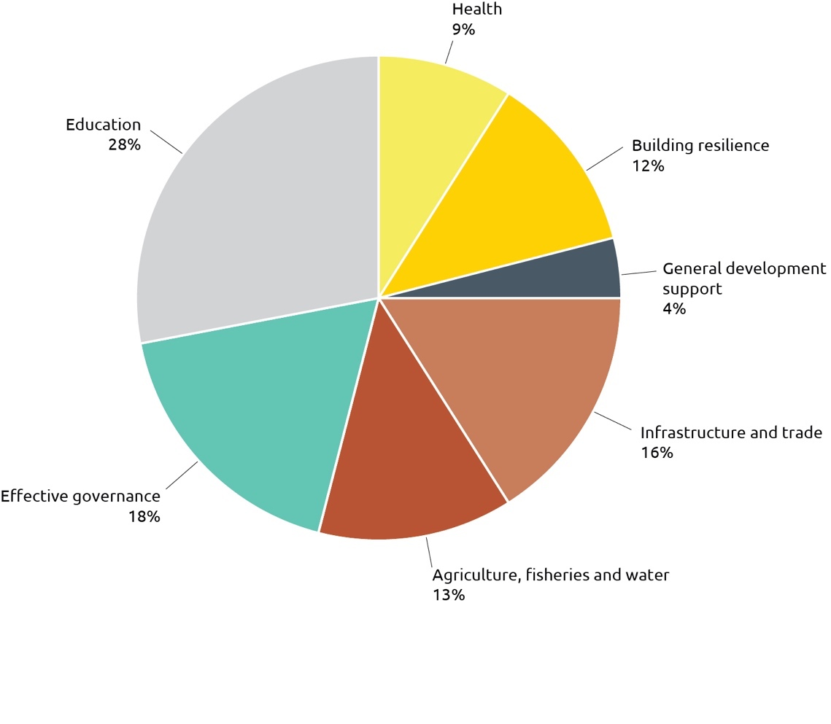

Program quality

Southeast and East Asian country and regional programs made good progress against objectives with 72 per cent on track (Figure 14). While no objectives were rated as off-track, progress against 28 per cent of objectives was assessed as less than expected. The performance of each country against program objectives is set out below. Southeast Asia programs have identified management actions to improve program performance. These actions are set out in country and regional Aid Program Performance Reports.

Figure 14: Progress against program objectives: Southeast and East Asia, 2017-18

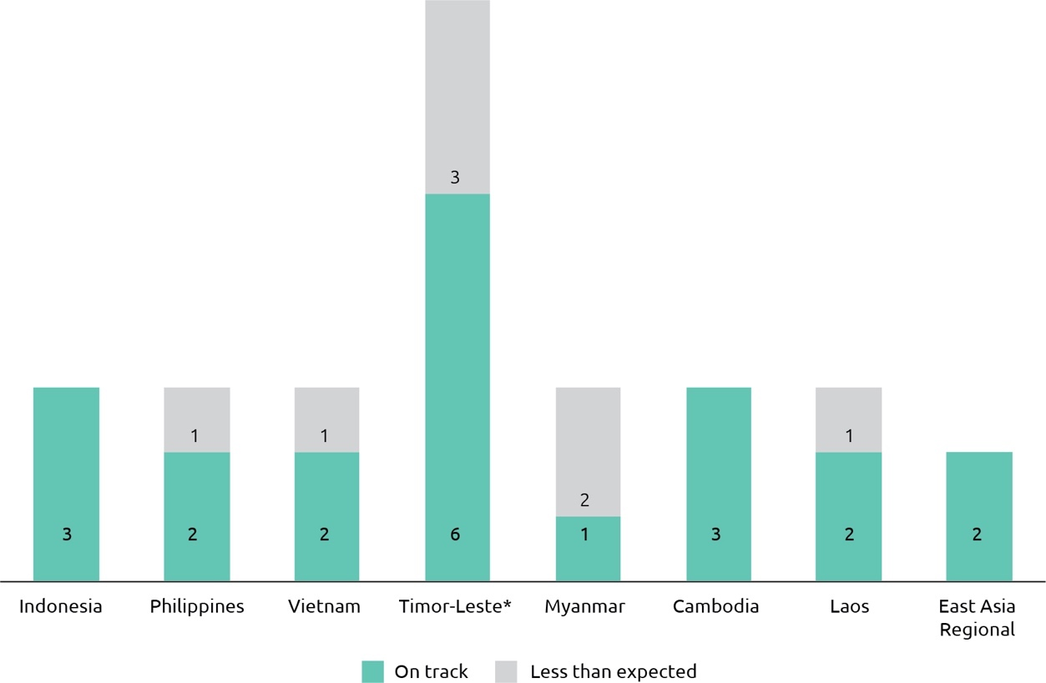

* In 2017-18, the Timor-Leste country program reported against program outcomes, which are typically greater in number than program objectives.

For Southeast and East Asia, 79 per cent of performance benchmarks were achieved and 18 per cent of benchmarks partly achieved (Figure 15).

Figure 15: Progress against performance benchmarks: Southeast and East Asia, 2017-18

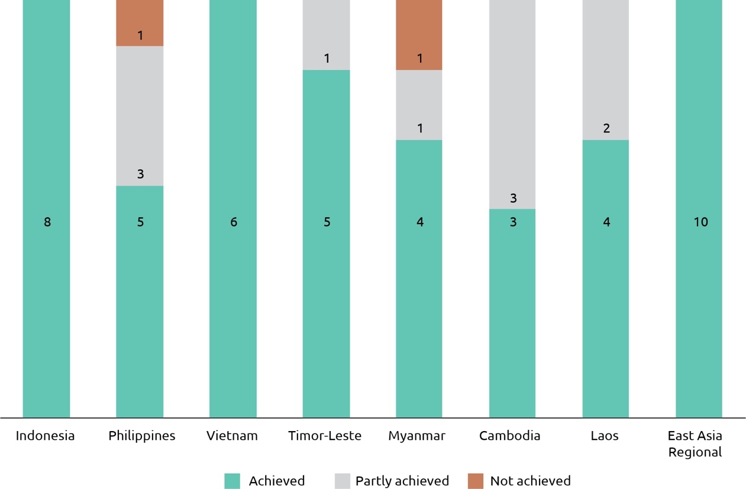

The performance of aid investments in Southeast and East Asia exceeded that of the aid program as a whole on all criteria (Figure 16) except for efficiency. Results for efficiency, gender equality and monitoring and evaluation were lower than in 2016-17 but generally consistent with five year averages. Of the four investments identified as requiring improvement in 2016-17, three improved performance and one was again assessed as unsatisfactory and is under review. Four investments were identified as requiring improvement based on 2017-18 Aid Quality Check results and management action plans have been put in place.

**Figure 16: Aid investment performance: Southeast and East Asia, 2017-18**

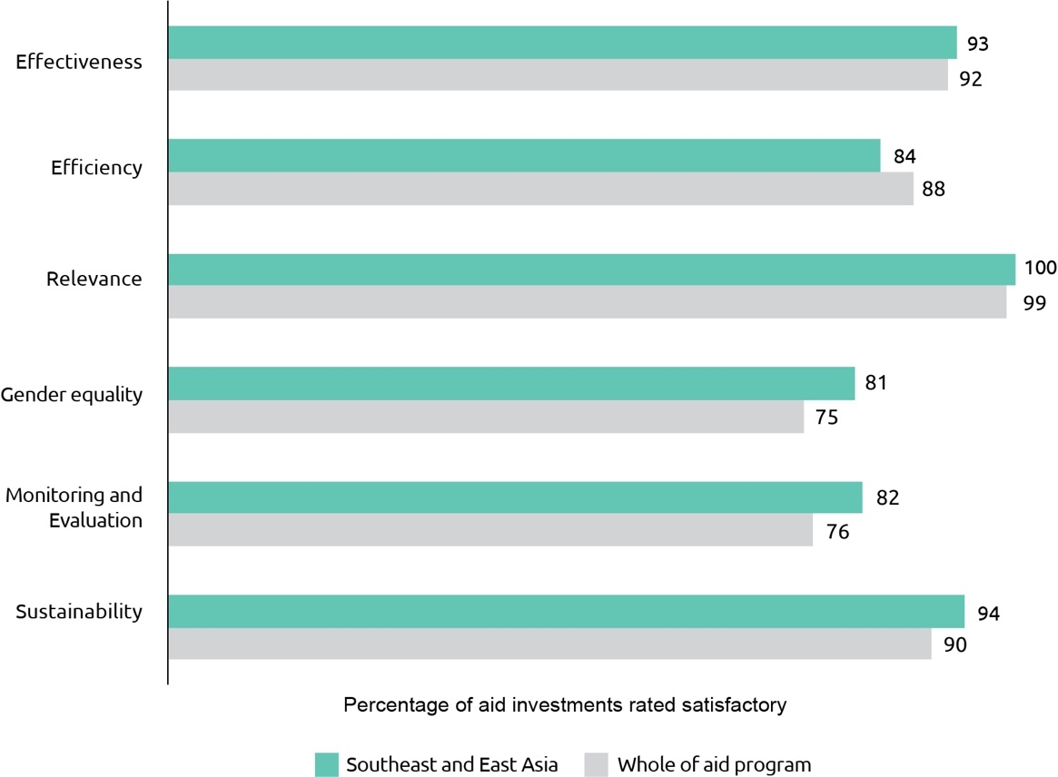

In **Indonesia**, the objectives of Australian development cooperation are *effective economic institutions and infrastructure*, *human development for a productive and healthy society* and *an inclusive society through effective governance*. Progress towards all three objectives was rated on track in 2017-18, including eight of the 11 outcomes that support their achievement.

Stronger economic institutions and better infrastructure are key enablers for economic growth. With Australia’s help, Indonesia has improved budget transparency, built a more open and competitive economy and taken the first steps towards modernising the tax system. Australia’s agricultural market program AIP-Rural partners with business to improve profits and in 2017-18 increased the incomes of an additional 104,534 farming households by an average of 191 per cent. Strong progress was also made on business climate reforms, with Indonesia improving 19 places in the 2018 World Bank’s Ease of Doing Business rankings. Australia’s contribution included assisting Indonesia’s economic agencies to make business licences cheaper, renewals easier and to improve investor protection.

There was steady progress in infrastructure, supporting Indonesia with high quality project preparation and attracting an additional AUD3.1 billion worth of infrastructure funding. However, delays in the rollout of a national performance-based road maintenance system (which would adopt Australia’s successful Provincial Road Improvement and Maintenance program model) meant that results in this outcome area were below expectations.

Australian support for this system is now contingent on the Indonesian Government providing an appropriate budget allocation in 2019. An independent evaluation of the *Multilateral Development Bank Infrastructure Assistance Program* found that overall the program was operating effectively but recommended, among other things, that specific operational‑level outcomes and outputs for trust fund activities should be identified and agreed at the outset.[38] The design for the new phase of the program will adopt the recommendations of the evaluation by establishing investment criteria to guide decision making as well as establishing a monitoring and evaluation framework with operational level outcomes and outputs.

Some of the most successful activities with Indonesia continue to be those where Australian funding is used to demonstrate new approaches, which Indonesia can then take to scale using its own financial resources. A standout example under Australia’s infrastructure assistance is the *Water and Sanitation Hibah Phase 2*, which is the first results‑based program in Indonesia to be replicated by the Indonesian Government. An independent review found the program’s effectiveness, sustainability and replicability to be good, and highlighted key strengths of the program as policy influence, strong participation of local governments and a significant increase in access to services.[39]

Investment in people – health, skills and knowledge – is an investment in economic growth. Australian advice in 2017-18 helped 1.2 million families to access a strengthened Non Cash Food Assistance Program, while assistance in collecting better information on the poorest 26.6 million households is supporting the Indonesian Government to target social protection support. The program has also implemented more than 14 pilot programs to improve teacher quality and children’s learning outcomes. For example, the *Innovation for Indonesia’s School Children* program (INOVASI) is supporting 12 pilots that were co-designed with local communities to identify local solutions to issues related to teaching and learning.

An inclusive and fair society, in which all citizens participate actively, is critical to strengthening Indonesia’s democracy and growing its economy. Through the KOMPAK program, Australia supported implementation of an improved formula for the allocation of Indonesia’s AUD9.3 billion Village Fund, meaning more funds will go to the poorest regions. An independent review of KOMPAK during 2017-18 found that the program remains highly relevant to Australian and Indonesian priorities, is generally effective and efficient and should be continued.[40]

Progress was less than expected in relation to the outcome area *marginalised groups can advocate for and access basic services* due to slow progress on implementation of the disability law and only modest increases in Indonesian Government funding to inclusive programs. To accelerate progress on the disability law Australian development programs will work with the Indonesia Government to assist in drafting the remaining three regulations needed for implementation. Progress in relation to the outcome *climate change impacts are lessened through better land management* was also below expectations due to delays in the establishment of a national landscape coordination mechanism, and because changes requested by the Indonesian Government to the program’s focus meant the original milestone of mobilising finance for peatland restoration was not achieved.

In the **Philippines**, two out of three program objectives – *building stronger institutions for transparent and accountable governance* and *improving conditions for peace and stability* – were assessed as on track. The Philippine Government decided not to proceed with the *Trade, Inclusive Growth and Economic Reform* (TIGER) program at the final approval stage in late 2017, leading to a gap in mobilising support for competition policy, economic reform, and trade policy, and is the primary reason the program objective *enhancing the foundations for economic growth* was not met. The program provided a timely humanitarian response to the Marawi conflict, including providing social services assistance to more than 250,000 displaced people and food assistance to 18,000 people, although the conflict also delayed implementation of some peace and stability activities in Mindanao. Australian-supported research, policy advocacy and technical support enabled the Philippine Department of Education to link Philippine professional standards for teachers with the national results-based performance management system, which will help increase the quality of teaching by tying teachers’ salary increments and promotions to performance against internationally-benchmarked quality standards. However, an independent review of the *Basic Education Sector Transformation* (BEST) program[41] found that while it had made a significant contribution to improvements in teaching quality and learning resources, it is yet to demonstrate widespread classroom-level improvements in teaching and learning. An independent completion review of the *Coalitions for Change* program recommended a further phase of the program on the basis that its approach of supporting multi-sectoral, formal and informal coalitions and networks to push for governance reforms is highly relevant, efficient and effective and should lead to sustained outcomes.[42]

In **Vietnam**, two out of three program objectives – relating to the *development and employment of a highly skilled workforce* and *promoting women’s economic empowerment, including ethnic minorities* – were assessed as on track. Three programs – the *Cao Lanh Bridge* construction project, the *Restructuring for a more Competitive Vietnam* (RCV) program, and the *Integrated Coastal Management Program* (ICMP) – were completed this year. The Cao Lanh Bridge is Australia’s largest aid investment in mainland Southeast Asia and is expected to have up to 170,000 daily users and connect five million people in the Mekong Delta with regional markets. Implementation of the non-scholarship components of the Aus4Skills initiative is progressing well following its launch in July 2017. A review of the action plan for the Australia in Vietnam Gender Equality Strategy, which commits Australia to addressing regulatory and societal barriers to women’s economic participation and to increasing women’s economic assets and leadership, found that 41 of 47 actions were ‘on track’. Progress towards the objective *enabling and engaging the private sector for development* was mixed, but ultimately less than expected. Some investments performed strongly against their benchmarks - for example, partnerships with the Australian Water Association and East Meets West Foundation helped provide over 20,000 rural poor with access to clean water, more than doubling the target for private sector water supply to rural population. However, other investments (Aus4 Water and Aus4Innovation) commenced more slowly than expected due to delays in design and Government of Vietnam approvals.

Overall, the **Timor-Leste** program performed well in 2017-18, with six out of nine outcome areas assessed as on track. Despite political change and uncertainty, long-term work on important policy reforms continued, such as public financial management reform under the *Governance for Development* program and development of a basic education curriculum on child-centred teaching practices under the Partnership for Human Development. Australian development programs also contributed to the creation of 2,155 new jobs (a significant result given the slowing Timor-Leste economy) and the generation of over USD400,000 of additional income for 3,480 people that benefited 13,804 household members (through the Market Development Facility). Australia continued to prioritise gender equality, with 100 per cent of programs rated as addressing gender effectively throughout 2017-18, and through the flagship EVAW program Nabilan, Australia worked to prevent violence against women by using best practice approaches aimed at changing gender norms, while also directly assisting 1,060 women and girls experiencing violence. Three outcomes – *more people participate in decision-making,* *improved governance at sub-national levels* and *increased rural incomes* require closer monitoring or more data to substantiate progress. While support for inclusive decision-making at the village level continued, political and budgetary impasse in Timor-Leste constrained work in this area through the *National Village Development Program Support Program (PNDS-SP)*. Subnational legislative reforms were delayed due to political uncertainty at the national level, which limited opportunities to strengthen municipal-level systems through engagement with and support for the decentralisation process. Australian development programs responded by continuing to improve subnational governance through sector specific interventions (such as water and roads), and by continuing with internal planning so to ensure readiness to support the decentralisation process once government policy is finalised and relevant government counterparts are in place.

The performance of Australian aid in **Myanmar** was mixed in 2017-18 as the operating environment became more challenging, particularly in light of the situation in Rakhine State. Core investments in education, rural livelihoods and humanitarian assistance met or exceeded performance targets. Key achievements included providing stipends to 46,605 disadvantaged students (53.6 per cent girls) to enable them to continue their education, and delivering humanitarian assistance to 397,772 people in Rakhine, Kachin, northern Shan and on the Thai border. However, while the objective relating to *enhancing human development* was assessed as remaining on track, the performance ratings of the other two objectives – *promoting peace and stability* and *promoting inclusive economic growth and government management* – were downgraded. In part this reflects the more challenging operating environment, but also the relative maturity of some investments and the expectation that results should be moving beyond outputs to intermediate or end-of-program outcomes. An independent evaluation of Australia’s humanitarian assistance to Myanmar between 2014 and 2017 found that it aligned well with the needs outlined in Myanmar’s Humanitarian Response Plans but recommended that Australia develop a multiyear humanitarian strategy to improve efficiency by enabling more targeted investment in fewer sectors and supporting humanitarian partners with multiyear planning.[43] In response, work is now underway to develop a multiyear humanitarian strategy for Myanmar that implements evaluation recommendations and responds to recent developments.

In **Cambodia** all three objectives were assessed as on track. Greater progress against the objective relating to *improved access to essential infrastructure* resulted from the continued strong performance of *Investing in Infrastructure* (3i) and better performance of the *Rural Roads Improvement Program Phase II* (RRIP2) in delivering connective infrastructure. For example, 3i has stimulated private sector investment that will see an additional 706,000 people (361,000 women) able to connect to reliable, affordable and safe piped water, and 152,000 people (78,000 women) benefit from a new, more reliable household energy connection. An independent Scalability Review of 3i found its performance compared very well to other similar programs elsewhere, concluded the program was on course to achieve its objectives and recommended that the program be scaled-up. Under the objective *increasing agricultural productivity and farmer incomes*, the *Cambodia Agriculture Value Chain Program Phase 2* and *Clearing for Results Phase 3* achieved good results, improving incomes for small holder farmers and exceeding targets for clearing land mine areas. Overall progress is also satisfactory against the objective *better health and education outcomes*, particularly due to the solid performance of Australia’s major investment, the *Health Equity and Quality Improvement Project*, despite some mixed results against the performance assessment framework indicators.

In **Laos**, two of three objectives – *improving Laos’ human resources through scholarships, training and organisational capacity building* and *a stronger trade regime and more competitive private sector* – were assessed as on track. The 2017 Laos Australia National Scholarships intake exceeded program targets (with awardees being 57 per cent women, 11 per cent living with disability and 72 per cent from ethnic minorities). Twenty-five village banks, providing financial services to 15,546 people (53 per cent women) were established. Performance against the objective *more disadvantaged boys and girls complete a quality basic education* was less than expected. A target for 381 ethnic students to commence training was partially achieved, with 364 enrolled. A target to write and pilot new grade two primary textbooks and teacher guides was achieved. However, a Mid-Term Review of the *Basic Education Quality and Access in Laos* (BEQUAL) program found that BEQUAL had drifted from its strategic aim, and that improvements to the program’s effectiveness and cohesion were required.[44] DFAT agreed to the majority of the MTR’s recommendations and has taken action in response, including establishing new organisational structures to support more bottom-up planning and decision making, more tailored support for targeted Provinces and Districts, and improved coordination with counterparts at the central and sub-national levels. Gender, disability and inclusiveness remain an important focus for Australian aid in Laos, with a new Gender and Disability Specialist recruited by the program in 2018 to help draft and implement a comprehensive Gender, Disability and Social Inclusion Strategy and Action Plan.

The ASEAN and Mekong program objectives – strengthening regional economic cooperation and inclusive growth and supporting regional responses to trafficking and the exploitation of migrant workers – were assessed as on track. All of the program’s ten performance benchmarks were achieved.

The ASEAN-Australia Development Cooperation Program Phase II (AADCP II) supports economic cooperation in ASEAN. This includes supporting greater connectivity across ASEAN such as feasibility studies to enhance electricity trading across the ASEAN Power Grid and the establishment of an ASEAN telecommunications single market. An independent review of AADCP II’s work on consumer protection found it had made a significant contribution to the work of consumer protection agencies in Indonesia, Philippines and Thailand.

The Greater Mekong Water Resources Program (GMWRP) helped to improve transboundary water governance in the Greater Mekong region. This included funding seminal research in support of sustainable regional and national water planning and hydropower development. An independent review of the ASEAN-Australia-New Zealand Free Trade Agreement Economic Cooperation Support Program (AECSP) found it was a significant driver of regional economic integration. This included facilitating easier and cheaper trademark protection for small to medium enterprises in ASEAN.

To strengthen regional responses to trafficking and the exploitation of migrant workers, the Australia-Asia Program to Combat Trafficking in Persons assisted 13 cross-border trafficking investigations, exceeding its 2017-18 target of five. TRIANGLE in ASEAN supported migrant resource centres in 33 locations, serving 25,933 migrant workers during 2017-18. Vulnerable workers were supported to safely migrate and seek employment opportunities and to remit their wages more securely and efficiently. A regional remittance cost comparison portal for migrant workers is expected to reduce the cost of remittances in ASEAN.

The forthcoming designs of new phases of key regional programs GMWRP, AACDPII and AECSP are opportunities to assess how the programs can continue to meet Australia’s strategic objectives in the ASEAN region.

## South and West Asia, Africa, the Middle East and Other Regions

South and West Asia

South and West Asia have the highest concentration of people living in poverty in the world. Despite remaining one of the fastest-growing regions, approximately half a billion people still live in extreme poverty. Many more, particularly women, live just above the poverty line. The region has the second highest regional Global Hunger Index and a very low Human Development Index. Furthermore, South and West Asian countries are poorly integrated despite common history, geography, culture and socioeconomics. This restricts the region’s potential growth and capacity to alleviate and lift people out of extreme poverty.[45] Overlapping crises such as natural disasters and forced displacement, exacerbated by climate change, threaten to erase hard-won development gains.

Even with its challenges, profound economic and social development throughout the region has reduced mortality rates and increased life expectancy. Over the past five decades, life expectancy has increased on average by approximately 30 years since 1960. Improvements are due to universal immunisation, improved sanitation, access to clean water and improved nutrition, and healthier lifestyles and education.[46] Steady economic growth in the region, especially in India, will increase opportunities for trade and investment and create the policy space for further supporting growth-promoting reform. Australia’s aid program has contributed to South and West Asia’s development, with a particular focus on promoting regional stability, economic growth and regional cooperation by addressing region-wide barriers to sustainable economic growth. In 2017-18, Australian ODA to South and West Asia was $361.5 million, representing 8.9 per cent of Australian ODA.

Table 6: Total Australian ODA: South and West Asia, 2017-18

| **Country** | **2016-17** | **2017-18** |
| --- | --- | --- |
| **($m)** | **($m)** |
| Afghanistan | 86.8 | 91.5 |
| Bangladesh | 58.6 | 114.0 |
| Pakistan | 53.6 | 53.3 |
| Nepal | 30.3 | 31.2 |
| Sri Lanka | 31.1 | 30.9 |
| Bhutan | 6.4 | 7.5 |
| Maldives | 3.7 | 3.3 |
| Regional South and West Asia | 22.0 | 29.7 |
| South and West Asia | 292.6 | 361.5 |

Figure 17: Total Australian ODA by investment priority area: South and West Asia, 2017-18

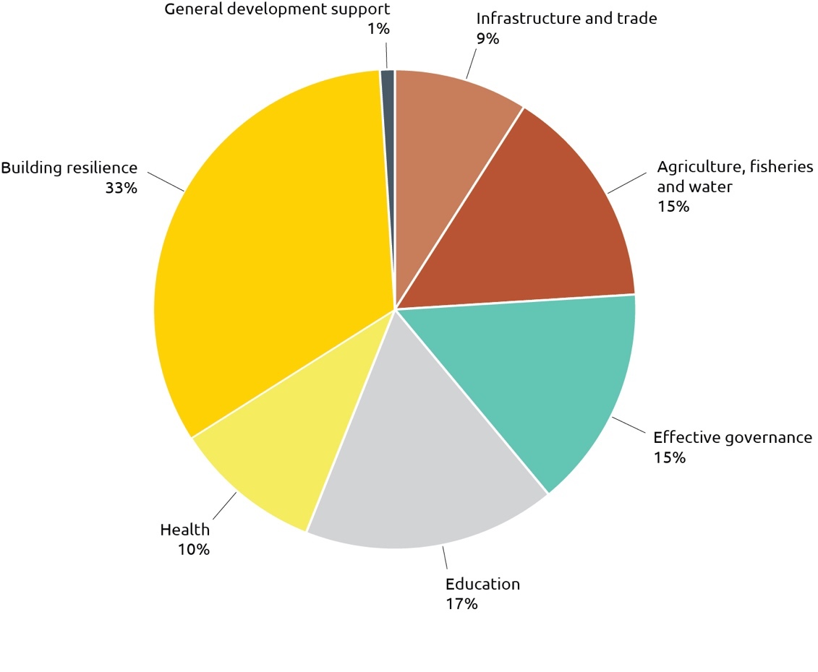

Africa, the Middle East and Other Regions

Sub-Saharan Africa is a diverse region with multiple development challenges. Of these challenges extreme poverty remains acute; the poor in Sub-Saharan Africa suffer from multiple deprivations more than any other region.[47] Extreme poverty is increasingly more concentrated there because of the region’s slower rates of growth, problems caused by conflict and weak institutions, and a lack of success in channelling growth into poverty reduction. Sub-Saharan Africa now accounts for most of the world’s poor, and unlike most of the rest of the world the total number of poor there is increasing. In short, extreme poverty is increasingly becoming a Sub-Saharan African problem.[48] Despite this key challenge, economic growth rebounded to 2.4 per cent in 2017, after slowing to its lowest level of 1.3 per cent in over two decades in 2016.[49] The rise reflects a modest recovery in Angola, Nigeria and South Africa – the region’s largest economies. Constraints that limit the region’s capacity to address development and economic challenges include skills shortages, poor enabling environments for business and governance, food insecurity, and low agricultural productivity, humanitarian crises, and gender and other inequalities. The Australian aid program contributed $174.5 million of development assistance in 2017-18, representing 4.3 per cent of Australian ODA, in sectors such as agriculture, human capacity development, extractives, promoting gender equality and humanitarian needs.

Significant development, economic and security challenges persist in the Middle East. The Palestinian Territories (consisting of the West Bank and Gaza Strip) remain one of the poorest regions in the Middle East. Economic growth continued to stall in both the West Bank and Gaza however conditions were most severe in Gaza with unemployment at 44 per cent. Over the last two decades, Gaza has undergone ‘de-development’, accompanied by a decline of real income per capita by a third since 1994.[50] Constraints to economic development include continued conflict and instability, restrictions on the movement of goods and people, and a lack of certainty over territorial borders and natural resources such as land and water. Approximately 42.5 per cent of the population of the Palestinian Territories are refugees. In 2017‑18, Australian development assistance to the Middle East and North Africa was $164.9 million, representing 4 per cent of Australian ODA. Australia provides humanitarian assistance in Syria, Jordan, Lebanon, Iraq and Yemen. Australia’s investment in these countries supports international efforts to meet the humanitarian needs of the most vulnerable including women, girls and people with disabilities, and to help communities become more resilient and stable.

Table 7: Total Australian ODA: Africa, Middle East and other regions, 2017-18

| **Region** | **2016-17** | **2017-18** |
| --- | --- | --- |
| **($m)** | **($m)** |
| Sub-Saharan Africa | 191.4 | 174.5 |
| Middle East and North Africa | 92.7 | 122.5 |
| Palestinian Territories | 42.7 | 42.4 |
| Latin America and the Caribbean | 13.6 | 8.9 |
| Total | 340.4 | 348.3 |

Figure 18: Total Australian ODA by investment priority area: Africa and the Middle East, 2017-18

graph


Program quality

Seventy-five per cent of South and West Asia program objectives were assessed as on track in 2017-18. Eighty-two per cent of performance benchmarks were achieved and 15 per cent of performance benchmarks were partially achieved. Four of the five investments identified as requiring improving in 2016-17 either improved their performance or were completed. The remaining investment was again identified as requiring improvement in 2017-18 and has been cancelled.

For Africa and the Middle East, 67 per cent of program objectives were assessed as on track. Progress was less than expected for two objectives in the Sub-Saharan Africa program. Seventy-five per cent of performance benchmarks for programs in Africa and Middle East were achieved.

Figure 19: Progress against program objectives: South and West Asia, Africa and the Middle East, 2017-18

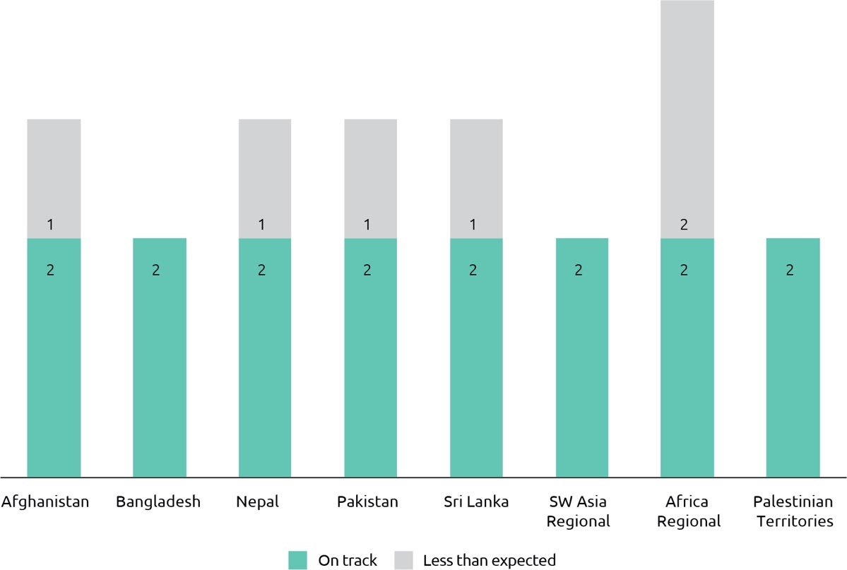

Figure 20: Progress against performance benchmarks: South and West Asia, Africa and the Middle East, 2017-18

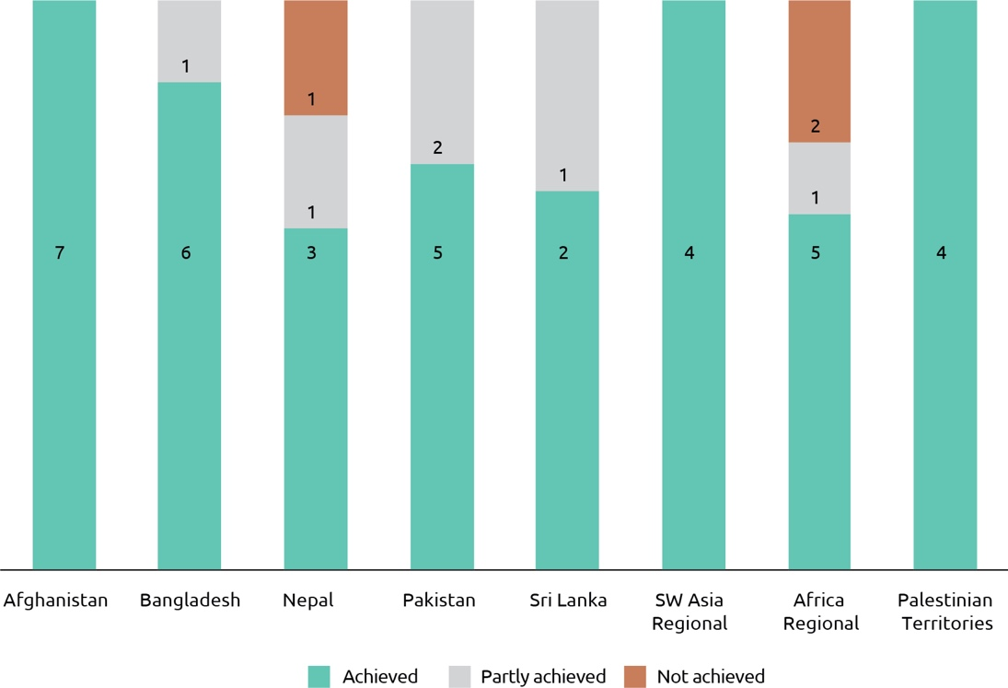

Australia’s aid investments in South and West Asia rated higher than the aid program as a whole for efficiency, gender equality and sustainability. Performance on gender equality continues to be comparatively strong. Overall performance was lower than the aid program as a whole for effectiveness and equal for monitoring and evaluation (Figure 21). For Africa and the Middle East, most investments were assessed as above whole of aid program results for aid quality assessment criteria except for gender equality and sustainability.

Figure 21: Aid investment performance: South and West Asia, Africa and the Middle East, 2017-18

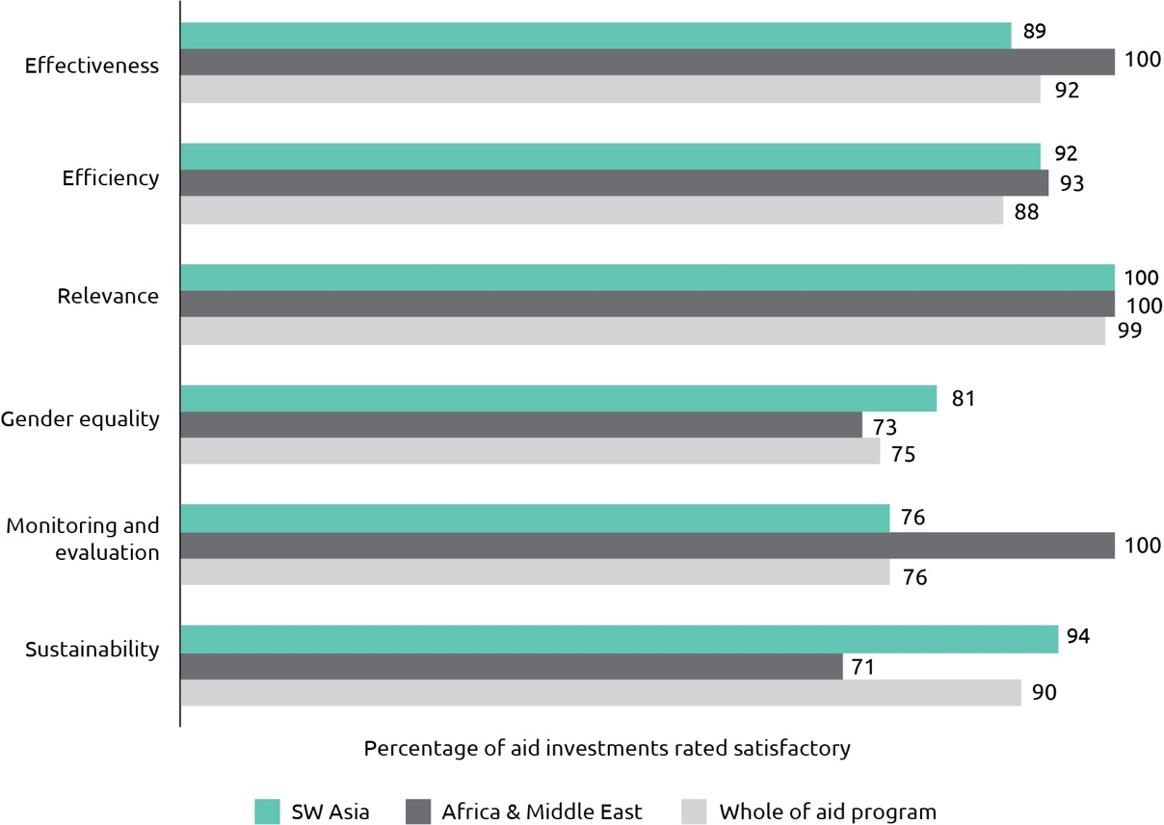

Overall, Australia’s aid program in **Afghanistan** has retained a good level of performance, against realistic expectations, despite the challenges inherent in Afghanistan’s security environment. The United Nations Assistance Mission to Afghanistan (UNAMA) considers Afghanistan to have returned to active conflict, and the resulting insecurity threatens to erode progress on institution building and stall reforms. Nevertheless, two of three program objectives – *empowering women and girls by addressing barriers to their social, political and economic participation*, and *building resilience and supporting at-risk populations, including through the delivery of humanitarian assistance* – remain on track. In 2017, Australian humanitarian assistance directly assisted approximately 483,650 of the most vulnerable returnees, displaced people and host community members, with a focus on women and children. Progress was less than expected with regard to the objective *supporting the Afghan Government to maintain economic growth and institute more effective and accountable governance*. While the aid program is structured in a way that makes it adaptable to contextual challenges, the underlying conflict has taken its toll on economic and institutional development and there are ongoing governance and reporting improvements required in the large trust funds supporting this objective.

In **Bangladesh**, performance in relation to the dual program objectives of *improving education access, equity, efficiency and learning outcomes* and *building resilience by reducing vulnerability and improving inclusion in the growing economy* was assessed as on track. Performance benchmarks related to Australia’s education support were met including increasing the proportion of competency based questions in Grade 5 exams, moving away from questions based on rote learning and memory. Australian assistance contributed to over 900,000 displaced Rohingya and members of the host community of Cox’s Bazar gaining access to food, shelter, clean drinking water, and safe spaces for women and children. An independent review of the World Food Programme’s (WFP) operations in Cox’s Bazar found that Australia’s willingness to allow its contribution to be used flexibly was a major contributor to efficiency. Australia’s flexibility and long standing partnerships enabled Australia to be one of the first responders to the new arrivals.

In **Nepal**, progress towards two of the three objectives - *creating economic opportunities for the poor through micro‑enterprise and job creation* and *building governance capacity, particularly at the sub-national level* – was assessed as on track. Results included the completion of the Micro-Enterprise Development Program Phase IV which achieved its target of assisting 73,000 micro-entrepreneurs to establish businesses (with 74 per cent being women). Progress against the objective *improving access to education* was less than expected, due to a shift in focus from supporting primary to tertiary education. Australia’s previous support to primary education ($34 million from 2009 to 2016) was through a USD4.4 billion World Bank-led primary education support program. Given the relatively small size of Australia’s contribution in 2017, and in the context of substantial existing international donor support to primary education, it was decided to consolidate bilateral education assistance in the Australia Awards program where a greater impact could be achieved.

Two of the three objectives of the **Pakistan** program – *generating sustainable inclusive growth and employment* and *investing in Pakistan’s people, with a focus on women and girls* – were assessed as on track. An independent evaluation of the economic growth portfolio found the program was reducing poverty and exclusion in Pakistan by unlocking constraints to sustainable and inclusive growth. Australia’s focus on agriculture and water resource management was appropriate, making good use of the skills, expertise and reputation Australia has in these sectors.[51] For the second successive year, Australia’s education, nutrition and ending violence against women investments all exceeded their targets, while performance on gender equality also improved, with all but one investment now assessed as satisfactorily addressing gender issues in implementation. Performance in relation to the objective *supporting stabilisation and resilience* was less than expected due to persistent challenges with implementation in the Federally Administered Tribal Areas (FATA) for two major investments as a result of weak government capacity and the challenging security situation. For example, the World Bank multi-donor trust fund investment has progressed well in two of the border provinces (Khyber Pakhtunkhwa and Balochistan) but was not able to start implementation in FATA within the reporting period. During the reporting period the decision was taken to merge FATA into Khyber Pakhtunkhwa in a bid to promote stability, but the decision has caused additional uncertainly and instability in the region in the short-term, affecting program performance.

In **Sri Lanka**, two of three objectives – *expanding economic opportunities for the poor* and *increasing gender equality* – were assessed as on track. Partnerships under the Market Development Facility are progressing well, with 145 full-time, long-term jobs created during the period January – November 2017. These jobs are better paid than average and most have been taken up by women, particularly in former conflict-affected areas in Sri Lanka’s north and east where there are few opportunities for formal employment. Progress towards the objective *supporting government to be more responsive to the needs of citizens and the private sector* was less than expected. Despite significant achievements, there have been delays in the establishment of key components of the Governance for Growth investment. In addition, an investment-level Monitoring, Evaluation and Learning (MEL) system is yet to be implemented, making it difficult to measure how well separate activities are collectively contributing to overall progress toward this objective.

Both objectives of the **South Asia Regional** program – *increased water, food and energy security to facilitate economic growth and improve the livelihoods of the poor and vulnerable (particularly women and girls)* and *increased regional connectivity through trade facilitation and infrastructure connectivity* – were assessed as on track. An independent evaluation of the World Bank-led South Asia Regional Trade Facilitation Program (SARTFP) and Infrastructure for Growth (IFG) program concluded that both are effective in delivering against their objectives.[52] Both SARTFP and IFG generated knowledge and analysis that is informing partner country policies in the areas of energy, transport and climate change. Under the Sustainable Development Investment Portfolio (SDIP2), progress was strong in integrated cross-border water management, conservation agriculture practices and increasing the knowledge base for water needs for agriculture and energy generation.

Two of the four objectives of the **Sub-Saharan Africa** program were assessed as on track. This includes *contributing to African leadership and human capacity development in areas of critical skills shortages*. In 2017-18, 495 professionals from government, civil society and the private sector received Australia Awards to undertake masters, short courses and fellowship study programs in Australia. The other objective on track is *responding appropriately to humanitarian crises in Africa through working with effective humanitarian partners and supporting advocacy efforts for effective international humanitarian action.* Australia provided humanitarian assistance in response to protracted crises in Somalia and South Sudan, reaching over 1,117,000 vulnerable people with life-saving assistance. Progress towards *enhancing agriculture’s contribution to sustainable and inclusive food security* was less than expected, due to a smaller number of poor women and men increasing their incomes (614,777) than the 2017 benchmark (812,200). Progress towards *empowering women and girls and improving gender equality outcomes* was also below expectations and the underperforming investments will close in 2018-19.

In the **Palestinian Territories**, both objectives – *improved public financial management and a more competitive agricultural economy in the Palestinian Territories* and *Palestinian refugees in the Palestinian Territories and across the region are able to access quality basic services* – were assessed as on track. Results included support for more than 1,100 farmers to adopt innovations in agriculture, leading to increased yields and profits through the Australian Middle East NGO Cooperation Agreement (AMENCA 3) and humanitarian assistance provided by UNRWA to over five million Palestinian refugees, primarily in the West Bank, Gaza and Syria. An independent risk management review of AMENCA 3 was undertaken in consideration of the high-risk environment arising from conflict and insecurity in the Palestinian Territories, and the risk of Australian funding supporting politically motivated violence. The review noted Australia’s strong measures to mitigate and manage the risk of financing terrorism and provided recommendations to strengthen further an already rigorous regime, which will be implemented in 2018-19.

# Chapter 3 Global program performance

In addition to country and regional programs, Australia’s aid funding is also provided through a number of global programs. This includes core funding[53] that is provided annually to multilateral development organisations. Australia’s contributions to these organisations, together with those from other donors, allow them to leverage additional resources into the Indo-Pacific region and pursue agreed priorities at a scale that would not be possible for Australia to achieve by itself. Australia’s membership of, and contributions to, multilateral organisations allow Australia to leverage those organisations’ finances, influence, technical expertise, convening power and role in setting global policy norms and standards. This serves to extend and deepen the impact of the Australian aid program.

Australia completes a rolling program of multilateral performance assessments for multilateral organisations receiving core development funding from the Australian Government.[54] Each multilateral organisation is assessed once in a four year cycle. In 2018, a multilateral performance assessment was completed for the Office of the United Nations High Commissioner for Refugees. This assessment confirmed that UNHCR is performing satisfactorily overall and its work aligns adequately with Australia’s priorities.

This chapter also reports on the performance of the Australian NGO Cooperation Program, the Australian Volunteers Program and the innovationXchange.

## Multilateral Performance Assessments

Office of the United Nations High Commissioner for Refugees

|  |
| --- |
| **Overview of performance[55]**   | Results and Impact | Adequate | Partnership Behaviour | Adequate | | --- | --- | --- | --- | | Relevance and Alignment | Good | Organisational Capacity | Good | | Value for Money | Adequate | Organisational Governance | Adequate |   **Summary of assessment**  Overall, UNHCR are a high performing humanitarian partner, continuing to deliver on their protection mandate in the face of unprecedented displacement and despite increasingly challenging operating contexts.  UNHCR has a unique mandate, undisputed humanitarian protection expertise and comparative advantage to address the immediate and longer-term needs of displacement contexts. Headline results for UNHCR operations globally in 2015 include: providing assistance and protection to 12.3 million refugees and 37.4 million IDPs; supporting 115,800 returnees; resettlement of 81,800 refugees; and, delivering 11,175 metric tons of core relief items and USD357 million through cash assistance.  UNHCR’s mandate specifies its non-political and humanitarian character. The 2014 MOPAN assessment considered UNHCR’s adherence to the humanitarian principles as ‘strong’. UNHCR effectively delivers on its protection leadership and coordination mandate, though challenges remain regarding coordination within the humanitarian system.  While UNHCR maintains large operations in the Indo-Pacific region, resourcing priority remains where the greatest need is, primarily in sub-Saharan Africa and the Middle East. Within the Indo-Pacific, UNHCR has operations in Afghanistan, Somalia, Pakistan, Myanmar and Bangladesh. UNHCR has been responsive to the evolving priorities of the Australian Aid Program, placing a greater focus on innovation, the private sector and gender equality. For example, UNHCR:  • achieved a 900 per cent increase in its private sector fundraising between 2006 and 2015  • pioneered the use of cash-based assistance and the use of credit cards, already coming close to achieving their 2016 Grand Bargain commitment to double cash-based interventions by 2020.  Recent operational reforms significantly reduced UNHCR’s Geneva footprint, with 96 per cent of costs now attributed to program delivery and support, and 87 per cent of staff field-based. UNHCR has gained efficiencies by nationalising offices and working directly with national partners, including a steady rise in partner funding allocated to national and local responders.  Areas for Continued Improvement  Despite continually challenging operational contexts, there is general satisfaction with UNHCR’s ability to achieve objectives in a cost-efficient manner, maintaining a 90 per cent implementation rate on funding received. However, according to the 2014 MOPAN assessment, UNHCR could do more to systematically collect and utilise lessons to enhance value for money, with UNHCR noting this and committing to improvement.  Areas for improvement in monitoring and reporting systems include reporting that: better links objectives, budget allocations, expenditure and results; highlights the value and impact of unearmarked funding; and, increases efforts to ensure the collection of data disaggregated by gender, age and disability status.  UNHCR’s leadership remains of exceptionally high quality. As one of a few UN agencies yet to sign the International Aid Transparency Initiative, UNHCR could strengthen and standardise its approach to transparency, including resource prioritisation at the country level. |

## Australian Non-Government Organisation Cooperation Program

The Australian NGO Cooperation Program (ANCP) is the Australian Government’s longest running and largest NGO program.  For over 40 years, the ANCP has provided annual grants to support locally-led and sustainable development. ANCP’s community-based development approach allows ANCP NGOs – and by extension Australia’s aid program – to be involved in long-term programming. In any given year, ANCP NGOs deliver around 450 projects in over 50 countries.

The ANCP model is unique. Consistent with the DFAT NGO Engagement Framework, the ANCP explicitly recognises NGOs’ organisational independence. This allows NGOs to implement their own programs and strategic priorities, consistent with the goals of the Australian aid program. ANCP NGOs must contribute their own funds, raised from the Australian community, to their ANCP projects. Matching funding against community contributions gives NGOs the flexibility to trial innovative approaches and address emerging development challenges. It also means the ANCP supports what the Australian public supports.

In addition, NGOs must undergo an upfront due diligence process known as accreditation prior to receiving ANCP funding. In 2017-18 there were 12 accreditation reviews: nine successful re-accreditations, two unscheduled upgrades (one successful, one withdrawn), and one new application for base accreditation which was unsuccessful. The ANCP had a $2.2 million budget increase in 2017-18 to $129.5 million. Of this, 99 per cent of the total budget allocation was granted to accredited Australian NGOs with less than one per cent ($700,000) used for program support costs including accreditation, monitoring, evaluation and learning activities.

The ANCP performed well against the Program’s three outcome areas in 2017-18:

Outcome 1: Effective and value for money programming

Outcome 2: A diversity of NGOs draw on funding and expertise from a range of sources

Outcome 3: Effective engagement with in-country partners

In 2017-18, 57 Australian NGOs worked with 1,820 implementing partners to deliver 455 projects in 54 countries; 87 per cent of project expenditure was in the Indo-Pacific. NGOs reached over 18 million people (55 per cent women and girls and 10 per cent people with disabilities) across a range of sectors including health (27 per cent), agriculture, fisheries & water (24 per cent), governance (17 per cent), education (13 per cent) and building resilience (12 per cent). Gender equality was addressed in 66 per cent of these projects, 42 per cent addressed disability inclusion, and 44 per cent involved engagement with the private sector.

ANCP NGOs exceeded the minimum 20 per cent match requirement to contribute one dollar of their own funds for every five dollars provided by DFAT. In 2017-18, NGOs contributed $32.4 million, exceeding the match requirement by 8 per cent. In addition, 106 projects (24 per cent) attracted funding from other sources to the value of $27.9 million. Key results from projects included:

• 11.7 million people benefitted from integrated community approaches to health and wellbeing (49.7 per cent women and girls, 0.5 per cent people with disabilities)

• 10.5 million people received increased access to essential medicines and health commodities including HIV treatment (49.5 per cent women and girls, 0.1 per cent people with disabilities)

• 2.9 million people increased hygiene practices (51 per cent women and girls and 0.2 per cent people with disabilities)

• 521,784 adults and children participated in preventative and awareness raising activities related to child protection (53.5 per cent women and girls and 1.2 per cent people with disabilities)

• 300,778 people were exposed to awareness raising campaigns/activities highlighting climate change and environmental issues (51.8 per cent women and girls and 1.3 per cent people with disabilities)

• 15,536 births were attended by a skilled birth attendant.

The ANCP Roles and Responsibilities policy was released to support Posts to contribute to the monitoring and evaluation of the ANCP, including hosting 15 NGO round tables.

## Australian Volunteers Program

The Australian Volunteers for International Development (AVID) program made an effective contribution to Australia’s aid program by sending skilled Australian volunteers to developing countries to deliver development outcomes and build people-to-people links. In January 2018, the program transitioned to the Australian Volunteers Program (AVP), capturing and applying AVID learning into the new program.

| AVID numbers at a glance |
| --- |
| • Duration: July 2011 to December 2017  • Volunteers: 5,274 of whom 65 per cent female and 18-29 year olds largest age group  • Partner organisations: 2,218 of whom 49 per cent NGOs, 28 per cent government, 11 per cent education institutions  • Footprint: 46 countries in the Pacific, Asia, Africa, South America and the Middle East  • Top five host countries: Indonesia, Cambodia, Vietnam, Fiji and Solomon Islands  • Assignment focus: community and social development, health, education and training, media and communications, management and human resources  • Total expenditure: $334 million |

Under AVID, strengthening local capacity – objective one – was achieved with 90 per cent of partner organisations reporting benefits from volunteers would continue, indicating the program promotes sustainable assignments and a capacity development approach. Locally-led and locally-driven capacity development is a guiding principle of the new program.

AVID promoted a positive perception of Australia in the Indo-Pacific – objective two – through a range of public diplomacy efforts in Australia and overseas. The Returned Australian Volunteer Network engaged 7,000 of 15,000 returned volunteers in the program and the aid program more broadly. AVP has a purposeful focus on connecting volunteers and communities across our region, and empowering returned volunteers to share their experiences in Australia and overseas.

A reform program to increase program efficiency and effectiveness began in 2014 in response to the AVID ODE Evaluation recommendations[56] and a reduced program budget. This resulted in streamlined in-country management arrangements and a smaller footprint from 46 to 26 counties. A central part of the new program design was a single contracting model for efficient delivery across 26 countries.

AVID’s Monitoring Evaluation and Learning (MEL) system focused more on program monitoring than evaluation and was designed to fit with partners’ MEL systems. A unified MEL is now in place in AVP, managed by one organisation, with a robust approach to measuring outcomes.

AVID had an intentional focus on disability inclusion. Overall, 1.2 per cent of volunteers had a disability and 14 per cent of volunteers supported Disabled People’s Organisations. This will be further enhanced under AVP by attracting a more diverse cohort of volunteers with disabilities, Indigenous Australians, and rural and regional Australians. Volunteers will also continue to contribute to strengthening diversity and inclusion in their overseas assignments.

After an extensive design and tender process, the AVI-led consortium was appointed as the managing contractor for an initial five-year period. From January to June 2018, three hundred and twenty volunteers were novated from AVID to AVP and more than two hundred volunteers were mobilised. A Global Program Strategy aligned with Foreign Policy White Paper priorities has been developed, along with a suite of strategies to guide the strategic direction of the program.

## innovationXchange

In 2017-18, the vision of the innovationXchange (iXc) was for Australia’s aid program to be a recognised leader in innovation, delivering new and cost-effective solutions to pressing development challenges to improve the lives of people in the Indo-Pacific region. In 2017-18, the iXc had four objectives to guide how it achieved this vision: *to support trialling innovations and building innovative capability at posts*; *to embrace new directions that complement existing program priorities*; *to encourage knowledge and resource transfer into the Indo-Pacific*; and, *to test and support Australia’s aid program to adopt innovative cross-cutting themes, approaches and tools*. As part of the iXc’s commitment to sharing information about innovative development solutions, the iXc completed a 2017-18 Aid Program Performance Report which assessed progress against these four objectives. The first three objectives were rated as on track. Progress against objective four was assessed as less than expected because it was not possible to determine the proportion of the bilateral aid budget dedicated to experimental practices, the performance indicator for this objective. Actions taken in 2017-18 should enable measurement of the resources dedicated to innovation across the aid program from 2018-19.

The iXc added 70 projects to its portfolio, and continued to support 26 projects creating a portfolio of 96, each bringing fresh solutions to the existing and emerging challenges in our region, and contributing towards 15 Sustainable Development Goals. Fifty-six new projects were winners from six open innovation challenges the iXc ran during 2017-18, which generated 2,292 new ideas for the aid program to draw upon. By June 2018, 13 countries in the Indo-Pacific region were operating five or more iXc-funded programs, building innovative capability at Posts. An innovative digital health program operating in six Pacific countries won the Institute for Public Administration Australia (ACT Division), Innovation Award for Digital and Data innovation in 2018.

Over 2017-18, the iXc broadened its focus, initiating work to strengthen innovation ecosystems and address the macro-economic impacts stemming from dramatic increases in the use of science, technology and innovation in our region. In Vietnam, the iXc co-funded a major program with Australia’s Embassy to help policy-makers use innovation to drive the country’s economic transformation.

Under objective two, the iXc used innovative practices and partnerships to address emerging policy issues, including technology. It explored how to give young people the skills to thrive in the digital age, how to use mobile technology in new socially oriented businesses and, how to enable children to get an education in emergencies. Despite this progress, an internal review identified the need to improve the integration of gender into DFAT’s innovation work and development outcomes for women driven by innovation.

A key goal when supporting innovation is to increase the impact of ideas with the most promise though scaling their use. Supporting innovators for development impact takes many forms, including advice on business, social impact, technical review, communications, and structuring and attracting different kinds of finance. This package - often called incubation or acceleration - involves much review and reflection, but not always independent evaluation, reflecting the needs and capacities of the emergent organisations. At the portfolio level, an independent review of the iXc in 2017-18 found our support had a positive impact, enabling 25 innovators to progress at least one stage along an internationally recognised pathway.

Independent review of the iXc’s challenge work highlighted how challenge design involves making key choices that affect the nature of their impact.[57] Broad challenge questions like that used in LAUNCH Food attract diverse ideas, building global knowledge. However, the spread of winners – excellent by themselves – makes it harder to build a portfolio that can have collective impact. The narrower questions set in the MIKTA, Blue Economy and MIT Solve challenges deliver cohorts that more easily benefit from group acceleration.

To deliver objective 3, the iXc successfully leveraged more finance into the region in support of innovative programs than it expended in 2017-18. Other strategies used to encourage knowledge and resource transfer into the region included strengthening DFAT’s partnership with the Global Innovation Fund through taking a seat on the Board. Engagement with the International Development Innovation Alliance helped iXc leadership both learn from their peers and raise the profile of innovation in the Indo-Pacific to attract partners and investors.

The iXc’s championing of innovation catalysed many parts of the aid program to experiment with innovative activity. In 2017-18, over 80 per cent of Aid Quality Checks reported using innovation. An independent review of program areas that had worked with the iXc found they attributed increases in their innovation culture and capability to the iXc, due to its expertise, co-funding and inherent appetite to embrace risk through experimentation.

The adoption by DFAT of a new Innovation Strategy in July 2018 provides the iXc with different objectives and priorities for the year 2018-19. The new objectives require adapting the role of the iXc so that it supports the whole of DFAT become an exemplar of innovative practice within Government, delivering impact and influence by embedding innovation practices. Over the next year, the iXc will transition away from a programmatic focus, whilst maximising the impact gained from existing investments by selecting the most promising innovations for scaling, improving focus on gender and, further evaluating programs and better communicating lessons and results.

# Chapter 4 Sector and thematic performance

This chapter brings together performance data for the six priority areas of investment under the Australian Government’s aid policy as well as disability-inclusive development.[58] In the 2016-17 report, in addition to providing performance data for all areas, health and governance were reviewed in depth. In the 2017-18 report, education and disability inclusive development have been considered in depth. Other investment priority areas will be assessed in similar detail in subsequent reports.

Figure 22 provides a breakdown of aid investments against investment priority areas in 2017-18. When compared to 2016‑17 figures, expenditure as a proportion of overall aid expenditure increased slightly for investments in health (up from 11 per cent to 13 per cent) and building resilience (up from 17 per cent to 18 per cent). Expenditure on agriculture, fisheries and water held steady at 9 per cent. Expenditure on infrastructure and trade, effective governance, education and general development support each decreased proportionally by one per cent.

Figure 22: ODA by investment priority area, 2017-18

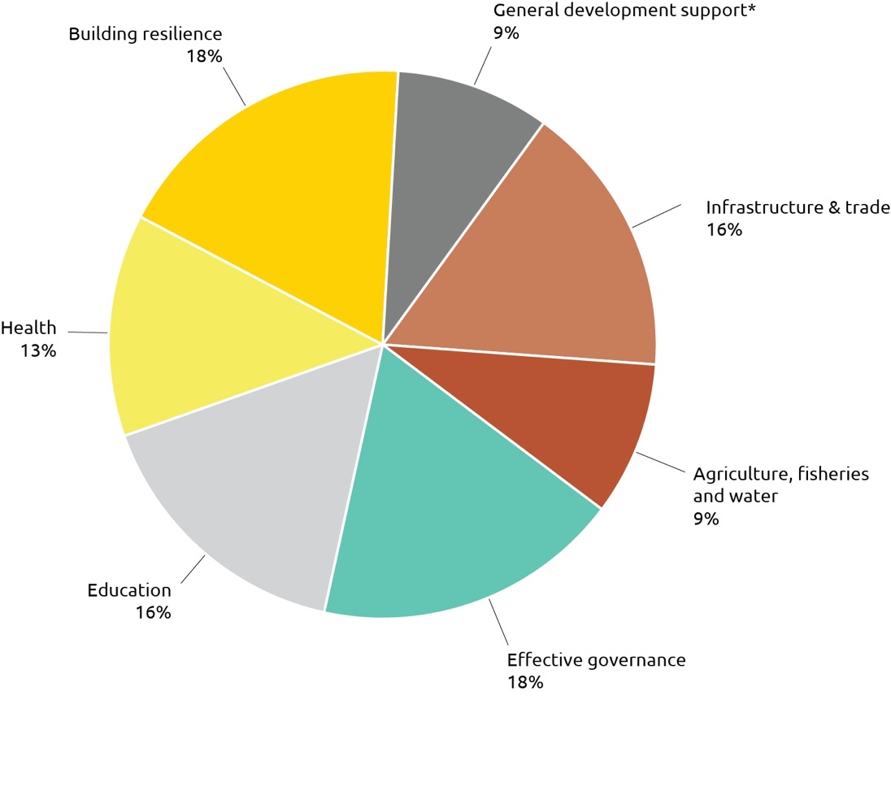

* ‘General development support’ includes action relating to debt, some research and scientific institutions and multisector development assistance that does not fall within other investment priorities.

## Infrastructure, trade facilitation and international competitiveness

Australia is committed to tackling infrastructure bottlenecks to help create the right conditions for sustainable economic growth and to enhance trade and investment opportunities across the region. Investments in this sector are guided by the Strategy for Investments in Economic Infrastructure. In 2017-18, Australia invested $670.1 million or 17 per cent of ODA in infrastructure, trade facilitation and international competitiveness. Australia’s work is strongly aligned with the SDGs including Zero Hunger (SDG2), Affordable and Clean Energy (SDG7), Decent Work and Economic Growth (SDG8), Industry, Innovation and Infrastructure (SDG9), Sustainable Cities and Communities (SDG11), and Partnerships for the Goals (SDG17).

Figure 23: Infrastructure, trade facilitation and international competitiveness investment performance, 2017-18

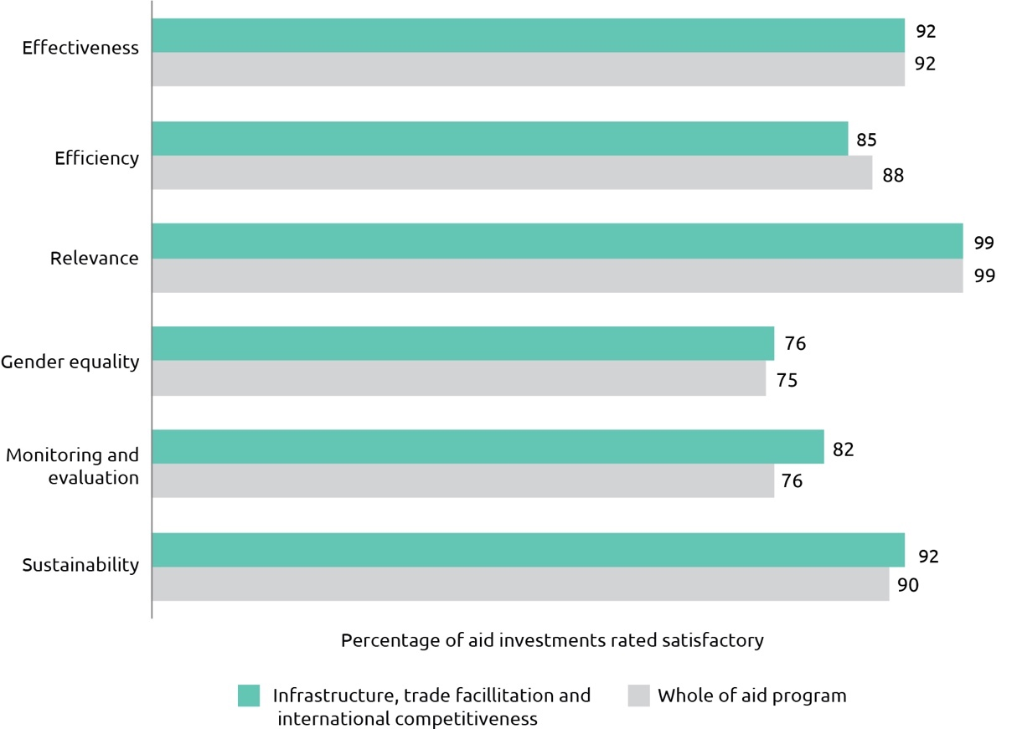

Australia’s infrastructure and trade facilitation assistance performed satisfactorily with all categories on par with or better than results for the aid program as a whole, except for efficiency. Results for effectiveness and efficiency were higher than 2016-17 figures. The effectiveness result of 92 per cent was higher than the five year average of 89 per cent. Results for gender equality decreased from 79 per cent in 2016-17 to 76 per cent in 2017-18 but remained higher than the five year average of 73 per cent.

In line with the government’s development, economic diplomacy and trade priorities, investments target: mobilising the private sector to finance and deliver infrastructure to meet the needs of the region;  improving access to infrastructure to facilitate private sector and human development and promote women’s participation and empowerment; and  promoting infrastructure to enhance trade and connectivity throughout the region.  Australia’s infrastructure investments in 2017-18 included the construction, rehabilitation or maintenance of over 4,000 kilometres of roads across the Indo-Pacific region.

A key result was strengthened capacity of the Philippine Government to develop and implement public-private infrastructure projects, enabling it to tender 17 infrastructure projects competitively and exceed its target by 13 per cent. Australian support also facilitated the reconstruction of four major bridges along the Kokoda and Northern Highways in Oro Province, PNG, that were destroyed by Cyclone Guba in 2007. In Cambodia, DFAT leveraged $6.3 million of private investment in power and water companies that will bring piped, treated water or reliable electricity to over 210,000 people in rural areas.  An efficiency review of the Private Infrastructure Development Group (PIDG), to which Australia is a donor, benchmarked its fees against benchmark fund fees published in a Deloitte quarterly report of credit funds, and found that the PIDG and its subsidiaries compared favourably with benchmark funds.

## Agriculture, fisheries and water

Optimising the potential of agriculture, fisheries and water for economic development, while ensuring sustainable use of resources for long-term prosperity, is one of the biggest challenges facing the Indo-Pacific. Australia is supporting agricultural productivity, sustainable fisheries management and water resource management, as well as addressing impediments that prevent producers linking effectively into domestic and international markets. Investments in this sector are guided by the Strategy for Australia’s aid investments in agriculture, fisheries and water. Australia’s investments are directly supporting several of the SDGs including No Poverty (SDG1), Zero Hunger (SDG2), Clean Water and Sanitation (SDG6), Responsible Consumption and Production (SDG12), Climate Action (SDG13), Life Below Water (SDG14), and Life on Land (SDG15). In 2017-18, Australia invested $361.8 million or nine per cent of ODA in the agriculture, fisheries and water sectors.

Figure 24: Agriculture, fisheries and water investment performance, 2017-18

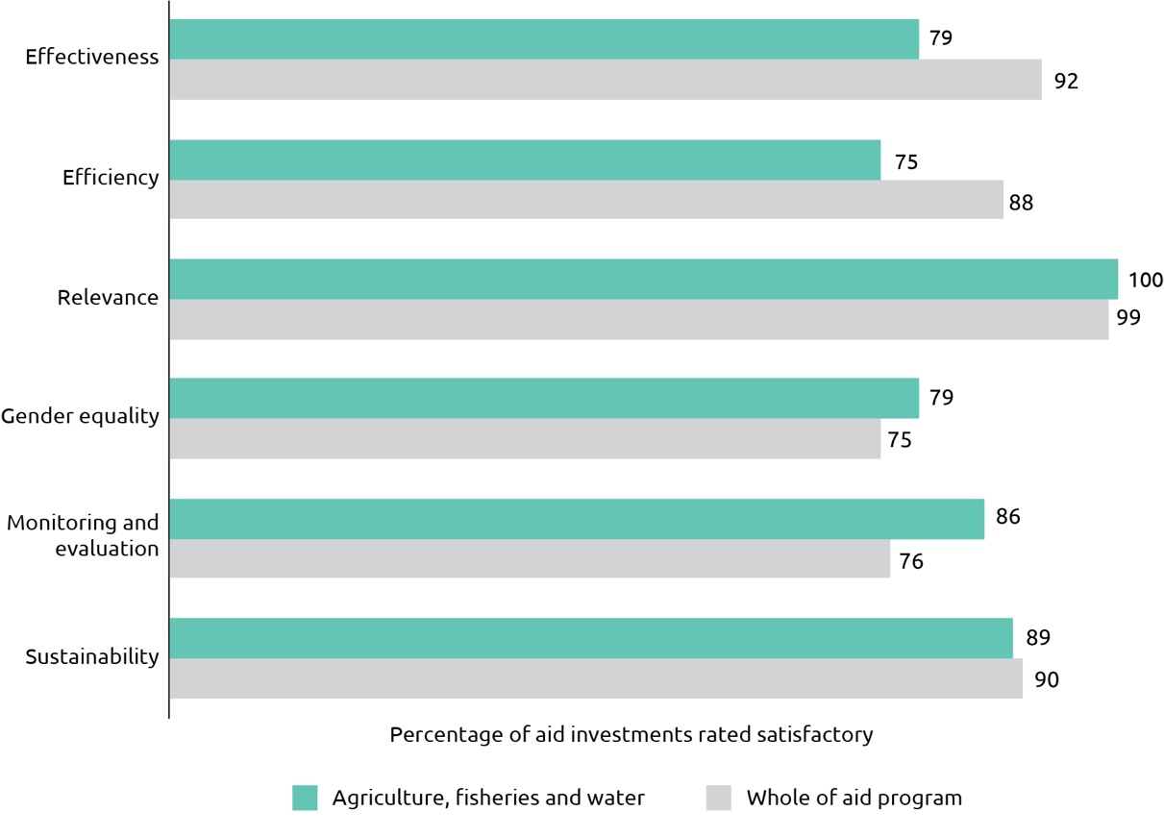

Australia’s agriculture, fisheries and water programs had mixed results in 2017-18. Results for gender equality and monitoring and evaluation were higher than whole of aid program results. However, effectiveness results were lower than in 2016-17 and lower than the five-year average of 83 per cent. Similarly, efficiency results were also lower than in 2016-17 and were also lower than the five year average of 87 per cent. Investments that were under-performing in both effectiveness and efficiency were designated as requiring improvement and remediation plans put in place. The remediation actions are being closely monitored and, where required, programs have been reoriented away from those activities which are not delivering the results originally anticipated.

Independent evaluations have also informed the approach to improving performance. An evaluation of the Private Sector Window of the Global Agriculture and Food Security Program, managed and implemented by the International Finance Corporation (IFC) found that the investment’s effectiveness was reduced by poor coordination with public sector investments. Alignment between private and public sector within the investment has now been improved which will result in a more efficient and effective investment.

Key achievements in 2017-18 included over 790,000 poor women and men adopting innovative agricultural and fisheries practices such as new growing techniques or improved crop varieties. An independent review of the Water for Sustainable Growth program was undertaken during the reporting period. The program has established the Australian Water Partnership (AWP) to facilitate the mobilisation of Australian water sector expertise to respond to the water management needs of developing countries in the Indo-Pacific and beyond. The review found that AWP adds unique value and should be continued, but that it also needs to strike a balance between being responsive to new opportunities and pursuing strategic larger engagements.

## Effective governance: policies, institutions and functioning economies

In 2017-18, Australia invested $743.7 million or 18 per cent of ODA to support more effective governance in partner countries, making governance the Australian aid program’s largest sector investment. DFAT’s governance work is guided by Effective Governance: Strategy for Australia’s aid investments. Australia’s assistance has a direct impact on the SDGs Decent Work and Economic Growth (SDG8), Reduced Inequalities (SDG10), Peace, Justice and Strong Institutions (SDG16), and Partnerships for the Goals (SDG17).

Figure 25: Effective governance investment performance, 2017-18

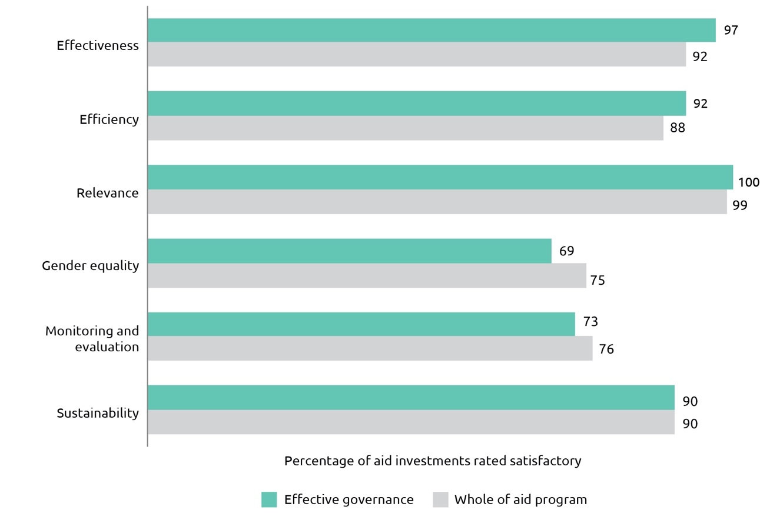

Overall, Australia’s investments in effective governance performed well on the majority of quality criteria in 2017-18, although results for gender equality[59] and monitoring and evaluation were again lower than results for the aid program as a whole. The effectiveness result was higher than in 2016-17 and higher than the five year average of 90 per cent.

Key results included: increasing transparency in government by supporting the implementation of freedom of information laws, including through the UN-Pacific Regional Anti-Corruption Program’s work in Vanuatu; supporting the delivery of elections in our region, at the request of partner governments including in Afghanistan, Timor-Leste, Papua New Guinea, Solomon Islands, Fiji and Tonga; and improving the quality of services for survivors of violence against women, for example, in Timor-Leste delivering more than 8000 instances of support for quality legal aid, medical support and examinations, emergency and long-term accommodation, counselling and rehabilitation services.

Australia’s governance programs are diverse, working with both government and civil society, across a broad range of economic and social policy issues. These programs support reforms in policies, laws, or institutions, and frequently rely on high quality technical expertise and knowledge products to influence the direction of change. The ODE evaluation *Investing in Regional Prosperity*,which assessed Australia’s economic partnerships in Asia, stated that ‘to be an effective partner on economic reform, DFAT needs to maintain relationships of trust with key individuals and institutions at the centre of governments’ and it found that ‘the flagship economic governance programs in Indonesia and Vietnam do this well.’ [60]

Furthermore, the evaluation affirmed the worth of Australia’s economic governance facilities which can offer a flexible package of research and analysis, technical advice, and capacity building across a range of economic and social policy areas. The governance facilities assessed in this evaluation were ‘proving to be effective’ at providing knowledge-based assistance. The evaluation also identified challenges to implementing effective economic governance facilities, including keeping the facilities aligned with Australia’s objectives and using resources strategically, and noted that they were less effective when they adopted a ‘train-and-equip’ approach, without paying attention to likely mechanisms for change. Peer‑to-peer partnerships between Australian government institutions and their regional counterparts were also found to be effective, but it has also been challenging to match skills of Australian partners with highest priority needs of counterpart institutions.

## Education and Health

Education

Education enables development; it contributes directly to poverty reduction, economic growth, reduced inequality and enhanced stability. Australia’s investments in education enable individuals, including women and girls and people with disabilities, to gain the skills they need to obtain work or go on to further study and to lead productive lives. Australia’s approach is outlined in the Strategy for Australia’s aid investments in education 2015-20. Australian investments in education directly support SDG4 on Quality Education as well as contributing to the achievement of other SDGs, for example, Gender Equality (SDG5). In 2017-18, Australia provided $643.4 million or 16 per cent of ODA to improve education outcomes.

Australia’s investments in education are guided by the *Strategy for Australia’s aid investments in education, 2015–2020*, which identifies four strategic priorities: Getting the foundations right (participating in Early Childhood Development); Learning for all (improving learning outcomes and improving the quality of education); Universal participation (with a particular focus on including girls and children with disabilities); and Skills for prosperity (improving access to high-quality, post-secondary education and training).

The Education Strategy is closely aligned with Sustainable Development Goal 4 – Inclusive and Equitable Quality Education for All – with investment choices firmly grounded in the economic, political and social contexts of Australia’s partner countries. In 2018, DFAT commissioned an independent mid-term review of the Education Strategy, to ensure that the strategy remains fit for purpose and to inform preparations for future strategic prioritisation. The mid-term review is expected to be published by July 2019.

In 2017-18, education investments achieved strong results including 881,935 additional girls and boys enrolled in school, 57,480 teachers trained and 4,662 women and men assisted to gain recognised post-secondary qualifications.

Australia is seen as a global beacon of education excellence. With over 550,000 students from 180 countries studying in Australia, education is Australia’s third largest source of export revenue. Australia Awards enable the next generation of global leaders in our region the opportunity to undertake study, research and professional development in Australia at Australian educational institutions. In 2017-18, 3,994 new Australian Awardees commenced their studies (55 per cent women; 3 per cent awarded to those who identify as living with a disability), and in 2017-18, DFAT financially supported more than 5,450 long-term awardees. Since 2012, successful Australia Award completion rates have averaged 95 per cent.

Australia is deeply committed to supporting the development of the Pacific through building its human capital. Australia Awards, support for the University of the South Pacific and partnership with the Pacific Community Education Quality and Assessment Program demonstrate DFAT’s focus on Pacific Islander education and skill development, associated with long-term partnerships and strengthened economic links. The third phase of the Australia Pacific Training Coalition (APTC3) was launched in 2018, solidifying our focus on high quality technical and vocational training connected to economic benefit. APTC3 represents an eight-year Australian commitment to collaborate with Pacific training institutions and industry, with a focus on increasing the quality, relevance and cost-effectiveness of Pacific partner TVET provision. Training targets domestic skills shortages and enables labour mobility within the Pacific and beyond. With more than 80 per cent of APTC graduates employed in their trained trade, APTC3 is a lynchpin of the Pacific Labour Scheme, driving regional prosperity through greater employment of Pacific Islanders and associated incomes and remittances to the region.

In 2017-18, Australia actively worked to ensure that children displaced by conflict, including those living in camps or host communities, are able to continue their education. Support included: a multi-year initiative enabling Syrian children to attend school in Lebanon and Jordan; a program to provide emergency education for displaced children in Rakhine State, Myanmar; and participation in the Education Cannot Wait Fund – which supports quality education for more than 650,000 children and youth across 14 crisis-affected countries. In security-challenged Afghanistan, we continued our established partnership with CARE Australia to fill gaps in the public education system and to open up the severely limited opportunities for girls to obtain an education.

Australia works with Indonesia to maximise its own resources to improve learning outcomes. During 2017-18 this included the activities of the ‘Innovation for Indonesia’s School Children (INOVASI)’ program. A series of innovative approaches to teaching and learning at the school level have been identified and analysed for their potential for transformative scale-up. In 2017-18, we implemented more than 14 pilot programs to improve teacher quality and children’s learning outcomes.

Throughout 2017-18, the Kiribati program strongly demonstrated the DFAT Education Strategy principles of responding to local priorities and engaging in policy dialogue and reform for greatest leverage. With support directed at improving education facilities and access rates, strengthening teacher development, enhancing school leadership, involving communities and working to improve participation rates, it is paying dividends. The percentage of students demonstrating performance at or better than the expected benchmark on the Pacific Islands Literacy and Numeracy Assessment (PILNA) in year 4 literacy climbed from 66 per cent in 2012 to 93 per cent in 2015 and in year 4 numeracy results climbed from 29 per cent to 73 per cent (PILNA 2018 results are yet to be released).

Australia continued to be a lead education partner in Myanmar in 2017-18. Using innovative incentives-based funding through the ‘Decentralising Funding to Schools Program’, we helped the government of Myanmar provide reliable and regular financing to schools and support school access for poor students. The program’s success attracted other donor funding and expanded the project scope to include teacher mentoring.

In Papua New Guinea, Australia is partnering with the government and Australian non-government organisations to trial fit for purpose approaches to teaching and learning within PNG’s decentralised education system. In 2017-18, the ‘Together for Education’ and ‘RISE PNG’ (Rapidly Improving Standards in Elementary) projects undertook sub-national pilots, and extensive consultations with the Government of PNG resulted in agreement of a multi-year partnership on education and leadership, with the objective of “supporting growth, stability and prosperity”.

Consistent with the DFAT Education Strategy, investments are tailored to local contexts, with careful assessment of financial and management systems. In 2017-18, education sector partnerships in the Philippines, Samoa, the Solomon Islands, Timor-Leste and Vanuatu were closely aligned with partner government priorities and systems.

Australia is a leading voice on good quality inclusive education for all, and global investments in 2017-18 complemented partnerships at the bilateral and regional levels. Australia worked with USAID and World Vision towards establishing a third phase of the innovative partnership, ‘All Children Reading’. Australia took a leading role in the operational evolution of the Global Partnership for Education, guiding the development of new financing mechanisms and design of the ground-breaking ‘Knowledge and Innovation Exchange’. The strategic partnership with the Australian Council for Educational Research’s Global Education Monitoring Centre entered a second phase in 2017-18, deepening the Centre’s respected role as a builder of global learning assessment standards, while providing high value technical assistance at the country and regional levels.

Figure 26: Education investment performance, 2017-18

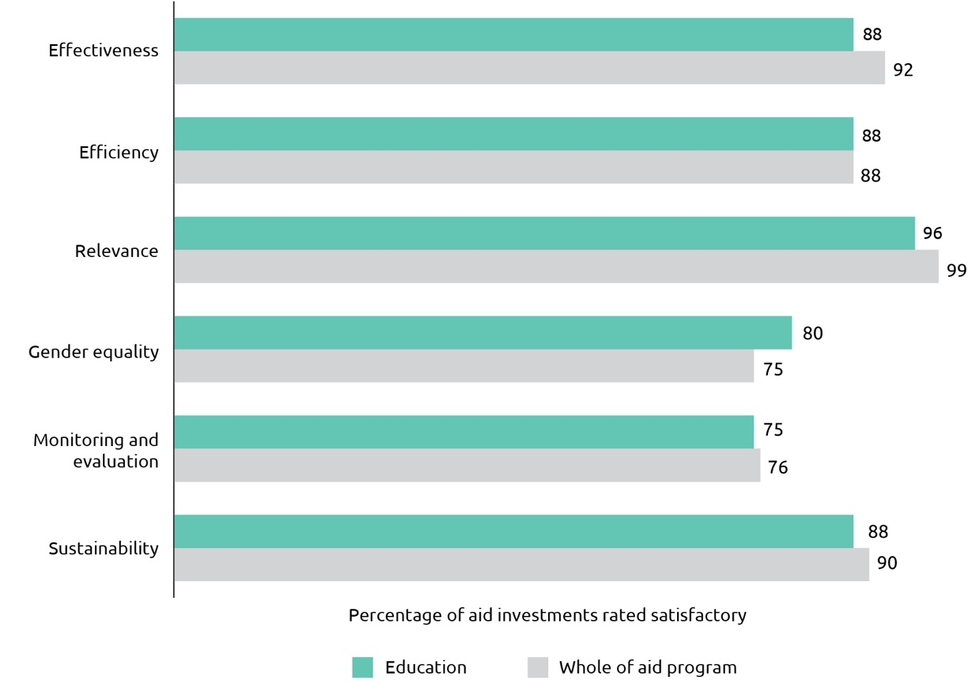

Overall, Australia’s education programs performed satisfactorily in 2017-18. The percentage of aid investments meeting quality assessment criteria is on par with or higher than whole-of-aid program results for efficiency and gender equality but lower for effectiveness, monitoring and evaluation and sustainability (Figure 26). The effectiveness result of 88 per cent is just below the five year average of 90 per cent for this investment priority area. A notable program effectiveness example in 2017-18 comes from the Fiji program, where an independent evaluation found the *Access to Quality Education Program* to be highly relevant and effective. Three education investments (in the Philippines, Papua New Guinea and Tuvalu) were identified as requiring improvement. Work is necessary to address a range of issues including: strategic clarity; monitoring, evaluation and analysis functions; partnership challenges; and systemic capacity. Remedial action is underway on all three investments.

Investments in education continued to perform well on gender equality and women’s empowerment. Many investments help partner governments achieve gender parity in enrolment and completion of basic education, and improve quality of education. Through the Basic Education Quality and Access in Lao PDR (BEQUAL) program, for example, we are assisting young women from ethnic minority groups to become teachers, with leadership and employment opportunities close to home (and providing much-needed female role models for young girls in remote communities). Australia also works to address barriers to schooling specific to girls. In Timor-Leste and Papua New Guinea we are working with adolescent girls to address reproductive and menstrual health, both areas that are critical to girls’ ability to be educated, healthy and empowered.

The global environment remains complex and the aid program is delivered in increasingly difficult environments. However, some of DFAT’s most highly rated education investments operate in the most challenging and complex of contexts. Investments in Afghanistan, Bangladesh and Pakistan received high gender equality Aid Quality Check ratings, demonstrating that it is possible to support gender equality in even the most challenging of environments.

DFAT Senior Education Specialist, Dr David Coleman, oversees policy and technical relationships in the education sector. His reflections on key international developments and challenges and how these relate to the performance of DFAT’s education portfolio in 2017-18 are provided below.

|  |
| --- |
| Australia’s Support for Education  There is a global consensus that strategic investment in human capital formation is vital to economic, societal and individual development. Good quality education and training is the essential and indispensable ingredient for building human capital.  In 2017 and 2018, a wide array of actors shone a light on education’s crucial role in three main areas: building the adaptive knowledge and skills that underpin shared economic prosperity; enabling social cohesion between countries and across cultures and; and empowering people of all ages and societies of every type to succeed in the fourth industrial age (e.g. robotics and automation, emergent artificial intelligence and the Internet of Things).  The G7 underlined the critical role of education in its 2017 Taormina Report, sub-titled “investing in education for mutual prosperity, peace and development”. The G20 gave priority to education opportunities at all levels, as captured in its 2018 Initiative for Early Childhood Development and its 2018 Education Declaration. The Declaration emphasises “the unique role of education as a key driver for sustainable development for all nations [and] recognises the need to place education at the centre of the global agenda”. The World Bank gave a principal focus to education and learning in its flagship 2018 and 2019 World Development Reports. In the Bank’s analysis of the changing nature of work, it concludes: “Investing in human capital is not just a concern for ministers of health and education; it should also be a top priority for heads of state and ministers of finance.” Peter Thomson OF, former President of the UN General Assembly and a Fijian national, dubbed education “the golden thread that runs through all 17 SDGs”.  In our aid program and international partnerships, Australia has long understood the connection between good quality education and training, economic development and social cohesion. The evidence of the costs and benefits are unequivocal. At the individual level, each additional year of schooling typically raises an individual’s earnings by 8–10 per cent, with larger increases for women. At the societal level, education and skills development shapes the economic trajectories of countries and regions. As the International Education Commission explained, “recent evidence shows that two growth scenarios – the ‘Latin American growth puzzle’ and the ‘East Asian miracle’ – are almost entirely explained by investment in learning and skills”.  For these reasons, the education sector has been and remains central to our aid and development partnerships across the breadth of the Indo-Pacific region. In 2017-18, education was an investment priority in 24 of 28 Aid Investment Plans. We play a leading role in international initiatives such as the Global Partnership for Education, the RISE consortium and Education Cannot Wait to strengthen the workings of education systems. Our actions in the Global Alliance to Monitor Learning, linked to partnerships with the Australian Council for Educational Research and the UNESCO Institute for Statistics, build a powerful evidence base of what is working, what is not, and why.  As a core principle of the DFAT Education Strategy, we prioritise building strong evidence to inform decisions by developing countries and their partners, so that scarce resources are directed to the education and training initiatives that will make the greatest difference. We understand the demands on time-poor decision-makers, and so our 2017 publication, ‘What Works Best in Education for Development: A Super Synthesis of the Evidence’, summarises to eight pages the findings of 700 rigorous studies. In 2014-15, the Office of Development Effectiveness (ODE) conducted an evaluation of Australia’s recent and current investments in teacher development. In response to ODE’s evaluation, Investing in Teachers,[61] which found almost no data on outcomes that could be attributed to DFAT’s teacher development investments, DFAT committed to support a multi-year study on teacher development investments in at least two countries. Evaluations are currently underway in Timor-Leste and Vanuatu. Consideration is being given to also undertaking an evaluation of the BEQUAL program in Laos. This study will provide much needed evidence on how to support system-level change from the classroom up.  We are focused on the connections between education, training and productive livelihoods. In 2018, the World Bank launched the Human Capital Project, “a global effort to accelerate more and better investments in people for greater equity and economic growth”. Findings are stark for the Indo-Pacific: the Human Capital Index score for East Asia and the Pacific is 0.61, signalling that the productivity for a child born today is 39 per cent below what could have been achieved with the availability of complete education (14 years of high-quality schooling by age 18) and full health. For South Asia, the Index score is 0.46, or 54 per cent below potential. This indicates that welcome moves towards middle income country status are far from realised, and that the elements of success are fundamentally multi-dimensional. The fourth pillar of the DFAT Education Strategy – Skills for Prosperity – is very deliberately not limited to employment, as we too define the ‘skills for prosperity’ in a broader, multi-dimensional way. This includes being a good parent, an active member of society, an informed citizen, as well as being an effective and skilled worker.  In our partnerships with fellow nations, therefore, we focus on adding value to the real challenges they face at this moment, in the context of longer-term planning and trends. For instance, we are keenly aware that infrastructure, the private sector and human resource development are inextricably linked. Infrastructure degrades without the ongoing resources and the technical skills to use and maintain the asset. The private sector cannot expand without appropriately skilled personnel and without core supporting infrastructure.  As such, our education partnerships in Southeast and East Asia and the Pacific celebrate the successes in school level access and retention and focus on the remaining challenges associated with learning outcomes. In Oceania, 22 per cent of children and adolescents are not achieving the expected minimum proficiency levels in reading. This rises to 31 per cent in Southeast and East Asia. In South Asia, our partners are addressing access, retention and system quality elements all at once, and we are targeting our efforts to support, for instance, school system reforms in Bangladesh and skills for growth initiatives in Sri Lanka. There too the learning challenges are great: for Central and South Asia, fully 81 per cent of children and adolescents do not demonstrate the expected minimum reading proficiency levels.  To be most effective in supporting education and training improvements, we remain vigilant to larger economic and societal trends. South Asia and Southeast and East Asia are highly susceptible to increased automation in manufacturing, and the concomitant impact on lower skilled jobs. The Pacific experiences the tyranny of distance from markets, and its economies of scale remain low. Each of these factors and trends point to one thing: the need for educated populations to innovate, to adapt and to prosper on their own terms. As stated in the Foreign Policy White Paper, “as developed countries and China age rapidly, populations in Africa and South Asia will soar. This could assist or constrain economic growth depending on how well governments handle education and training, health, employment and infrastructure”.  Australia has a role to play in strategic human development partnerships, tied to inclusive economic growth. We recognise the essential need for effective, well-targeted and transformative approaches to support learning from the earliest ages, onward to school and across the lifespan. DFAT could improve its partnership effectiveness by increasingly working across sectors, simultaneously addressing challenges in health, nutrition, education and overall well-being – this is particularly critical in early childhood. DFAT needs to remain an active education sector partner in middle income countries, where high standards of learning for all are far from achieved.  Looking forward, the most cost-effective and surest way for the Indo-Pacific region to adapt and succeed in the fourth industrial age is to have the broadest possible base of literate, numerate and critical thinking people, well equipped with the soft skills that are essential in our changing world. |

Health

In 2017-18, Australia invested $545.9 million or 13 per cent of ODA in health, including nutrition and water, sanitation and hygiene (WASH). Australia’s investment in health is guided by the Health for Development Strategy 2015-2020. The strategy has an overarching focus on building country-level health systems that meet immediate needs and prepare for and respond to emerging public health threats. The strategy enables progress towards Universal Health Coverage and the corresponding Sustainable Development Goal 3 – Health and Wellbeing for All.

Figure 27: Health investment performance, 2017-18

Graph


Overall, Australia’s health investments performed well in 2017-18 with all categories equal or better than results from 2016-17. The percentage of aid investments meeting quality assessment criteria is on par with or higher than whole-of-aid program results for effectiveness, efficiency, relevance, gender and sustainability but lower on monitoring and evaluation (Figure 27). The effectiveness result of 93 per cent is above the five-year average of 88 per cent for this investment priority area. The main challenge in monitoring and evaluation reflects in part the complex and long-term task of improving the underlying national health information systems required to produce reliable data.

In 2017-18, Australia’s health assistance delivered strong results. For example, our GAVI partnership supported the vaccination of over 2 million children globally. A key result of Australian support was that over 2017, the Global Fund to Fight AIDS, Tuberculosis (TB) and Malaria programs tested and treated 5 million people for TB, distributed 197 million insecticide-treated bed nets to prevent malaria, and supported 17.5 million people to access antiretroviral treatment for HIV. Australian funding has also increased access to safe water for over 1.4 million people and increased access to basic sanitation for over 1.9 million people. The Pacific Regional Health program supported the Royal Australasian College of Surgeons (RACS) to provide 35 Visiting Medical Teams to nine Pacific countries, conducting 1774 medical consultations, 564 operations, and training 375 health professionals.

Australian support for research and development for new treatments for major infectious diseases has led to more efficient and effective drugs being available across the region. Over 300 million paediatric anti-malarials have been delivered to 50 countries as well as 52.9 million vials of injectable anti-malarials for children. An independent evaluation of our Medical Research investment found that grants to Product Development Partnerships was an effective way to incentivise and engage industry and research institutions to develop tools to combat diseases that would otherwise be neglected.[62] However, it recommended that in future, DFAT should take a full innovation lifecycle approach and integrate support of product research and development with support for ensuring access to the products. To that end, the Centre for Health Security launched the Regulatory Strengthening Program in October 2018 in partnership with Australia’s Therapeutic Goods Administration, which aims to strengthen the capabilities of National Regulatory Authorities in the Indo-Pacific region to improve uptake of the new medical products.

## Building resilience: humanitarian assistance, disaster risk reduction and social protection

In 2017-18, Australia provided $740.1 million or 18 per cent of ODA in humanitarian assistance, disaster risk reduction, social protection and climate change investments.[63] During this period, 4,232,510 vulnerable women, men, girls and boys received Australian-funded life-saving assistance in crisis and conflict situations. Australia’s ‘building resilience’ investments deliver outcomes in support of a number of Sustainable Development Goals (SDG), including those relating to No Poverty (SDG1), Zero Hunger (SDG2), Good Health and Well-Being (SDG3), Reduced Inequalities (SDG10), Sustainable Cities and Communities (SDG11), and Climate Action (SDG13). Through these investments, Australia is meeting commitments made under the Sendai Framework for Disaster Risk Reduction 2015-2030 to support our bilateral partners to limit economic and development losses and reduce the vulnerability of communities and institutions to natural hazards. Investments in these areas also support Australia’s commitments under the Agenda for Humanity (2016) and the ‘Grand Bargain’ (2016) to save lives and protect human dignity through improved effectiveness and efficiency of humanitarian action.

Overall, Australia’s building resilience investments performed well in 2017-18 (Figure 28). The percentage of aid investments meeting quality assessment criteria was higher than whole-of-aid program results for efficiency, relevance and sustainability and slightly below for effectiveness. Performance against the gender equality criterion was slightly higher than in 2016-17, reflecting ongoing efforts to build capacity in this area. All humanitarian response investments were assessed as satisfactory or above against the ‘humanitarian protection’ criterion, i.e. the extent to which investments protect the safety, dignity and rights of affected people.

Australia also continued to work with countries in our region to build and expand their social protection systems, including to develop systems that are responsive to natural disasters and other emergencies. For example, in 2018 Australia helped the Government of Indonesia to expand the reach of its family assistance program from six million to 10 million of its poorest households and to commence a pilot cash transfer program for families with children under four years old in Papua province, to improve the health and economic resilience of vulnerable households. We also assisted the Government of Tonga to provide additional funds to the elderly and to people with a disability through their social protection system following Tropical Cyclone Gita. Our assistance has also helped to evaluate Fiji’s use of their social protection system to provide humanitarian top up payments following Tropical Cyclone Winston.

Figure 28: Building resilience investment performance, 2017-18

Graph


An evaluation of Australia’s climate change assistance,[64] undertaken by ODE, examined 26 climate change action investments valued at over $640 million, between 2006 and 2014 across a range of locations including Vietnam, Solomon Islands, Indonesia, the Philippines, PNG and the Pacific. The evaluation found the key characteristics of stronger performing investments included: longer investment timeframes (five years or longer); climate change risks are framed within the broader development goals of partner countries; and there is a balance of technical and development expertise in design and implementation. Recommendations included the need for DFAT to introduce an overarching strategy and implementation plan that articulates climate change goals and objectives for the aid program to inform its future climate change investments. A draft departmental strategy is being finalised and is expected to be released shortly.

During the 2017-18 reporting period, Australia published an independently led evaluation of our education sector response to Cyclone Winston in Fiji in February 2016.[65] Conducted in accordance with DFAT’s Aid Evaluation Policy, the review found that Australia’s humanitarian assistance was highly relevant, timely, effective and appropriate in the first six months. Australia’s rapid response reinforced national leadership allowing Fijian schools to reopen quickly. Evaluation findings helped inform the design phase of Australia’s new bilateral education program in Fiji. Australia’s experiences in responding to Cyclone Winston have also informed the establishment of a joint humanitarian monitoring and evaluation framework with New Zealand, which is being used to further strengthen responses to rapid onset disasters across the Pacific.

## Disability-inclusive Development

The Australian aid program has focussed on disability inclusion since the first ‘Development for All’ strategy, released in 2009. This donor strategy was the first of its type and informed Australia’s early leadership in disability-inclusive development. Following the release of the second ‘Development for All’ strategy in 2015, and a renewed global focus on inclusion catalysed by the ‘leave no one behind’ agenda of the SDGs, disability is affirmed in the 2017 Foreign Policy White paper as a cross-cutting priority for Australia’s international engagement on human rights, development assistance and humanitarian action.

Australia’s ‘Development for All 2015-2020, Strategy for strengthening disability-inclusive development in Australia’s aid program’ outlines support for people with disabilities in developing countries to improve their quality of life through enhanced rights and participation. The Strategy also focuses on improving the inclusion of a diverse range of people with disabilities, recognising that some groups within the disability community, particularly those who are deaf and people with psychosocial and/or intellectual disabilities are at heightened risk of marginalisation.

In 2017-18, Australia invested $12.5 million of ODA specifically in disability inclusion through a centralised disability budget. This centralised budget is used to partner with Disabled People’s Organisations (DPOs), improve the collection of disability data globally, and drive disability-inclusion reforms in the UN system and multilateral partners. For example, Australia’s support to UNICEF under the Rights, Education and Protection of Children program, has helped improve UNICEF’s disability-inclusive programming: now 90 per cent of UNICEF country offices provide support to children with disabilities, up from 19 per cent in 2014. This central allocation is in addition to activities to promote positive outcomes for people with disabilities within the broader aid program. For example, through the Civil Society WASH Fund, nearly 73,000 people with disabilities accessed improved WASH services. A 2018 Fund evaluation found projects that involved people with disabilities in all aspects of programming and implementation had the best disability inclusion outcomes.

The Office of Development Effectiveness has completed two strategic evaluations of Australia’s support for disability inclusive development. Now that these are completed, it is timely to focus on disability inclusive development in this report.

Published in December 2017,’Unfinished business: Evaluation of Australian advocacy for disability-inclusive development’[66] considered how Australia’s advocacy has shaped the policies and programs of bilateral, multilateral and other development agencies to ensure greater inclusion of people with disabilities. The evaluation found that Australia’s international advocacy for disability-inclusive development had been credible and effective. The combination of Australia’s leadership, partnerships with DPOs, and support for the development and use of disability data collection tools, worked effectively to influence major development and humanitarian frameworks, and the policies and programs of some multilateral organisations. For example, DFAT support for an independent evaluation of disability inclusion in the operations of UNDP led to disability-inclusive development being identified as a programing and policy priority within UNDP.  Further DFAT support has since catalysed the UN Special Rapporteur for Disability to conduct a system-wide review of inclusion within the UN.

In December 2018, ODE released ‘Development for All: Evaluation of progress made in strengthening disability inclusion in Australian aid[67] which examined how disability inclusion was being achieved in the aid program. The evaluation found that the Australian aid program has made good progress in strengthening disability inclusion in bilateral and regional development programs, humanitarian assistance and global programs. As a result of sustained strong support some partner DPOs are now high capacity organisations that are effective advocates and are informing development programs.  For example, DFAT’s support to the national DPO in Timor-Leste, has increased RHTO’s capacity to be recognised as a valued partner by government agencies, DFAT staff, and development implementing partners. In turn, working with DPOs, such as RHTO has helped build DFAT staff’s internal disability inclusion capability.

Disability is a cross-cutting priority for the aid program, and in the most recent annual performance and quality appraisals, approximately half of all aid expenditure was reported to be disability-inclusive and most high-value investments were found to be disability inclusive. While the percentage of investments rated disability-inclusive in the annual performance and quality process has declined for the last three years, the evaluation found evidence suggesting the declines largely stem from an increasing understanding of disability in DFAT, which has resulted in higher standards for ratings and more rigor being placed on assessments. As a result, declines in disability ratings do not accurately reflect overall progress made in strengthening disability inclusion across Australia’s aid program.

The Pacific regional and some country programs (notably Indonesia, Philippines, Timor-Leste, Cambodia, Vanuatu, Samoa and Kiribati) have made good progress in building disability inclusion. Disability inclusion is increasingly being mainstreamed in sectoral programs and inclusion is strong in Education, Governance and Health (Figure 29). Infrastructure and Agriculture, Fisheries and Water were noted as sectors where improvements can be made to ensure greater inclusion.

**Figure 29: Disability inclusion performance by investment priority area, 2017-18**

**Graph
**

Disability inclusion is relatively strong for the global programs reviewed and, for most, there is evidence that it is increasing. About 60 per cent of projects funded by the Australian NGO Cooperation Program reported having a disability focus. The proportion of Australia Award scholarships awarded to people with disabilities has been steadily increasing and is now about 4 per cent. In the Volunteer program the percentage of volunteers whose assignments are disability focused has increased to 18 per cent and 3 per cent of volunteers have disabilities. About 14 per cent of projects funded by the Direct Aid Program are disability inclusive and many of them focus on building the capacity of DPOs.

Approximately one third of Australia’s recent responses to humanitarian crises were rated as disability-inclusive in the annual performance and quality process. Partnership agreements for almost all of Australia’s main humanitarian partners have recently been renegotiated, embedding disability inclusion as a requirement. In recent humanitarian crises, more than half of Australia’s implementing partners carried out a disability analysis, mainstreamed disability inclusion and collected disability disaggregated data.

| Global Disability Trends  Approximately 15 per cent of the global population have some form of disability (one in seven or around one billion people).[68] Women with disabilities face compounding disadvantage, experiencing discrimination due to both their gender and disability.[69] Around 80 per cent of people with disabilities live in developing countries.[70] The numbers of people with disability globally are increasing for a number of reasons, including population growth, chronic health issues, medical advances, and an aging population,[71] meaning that people are living longer but with ongoing functional impairments.  The normative approaches to people with disabilities have evolved from disability being seen as a welfare and charity issue, to a human rights based approach, where disability is understood as one aspect of human diversity. This shift was reflected in 2006 with the adoption of the United Nations *Convention on the Rights of Persons with Disabilities* (CRPD) and the establishment of the United Nations Committee on the Rights of Persons with Disabilities. The 2030 Agenda is the first global development agenda that clearly includes persons with disabilities in a universal and ambitious plan of action to ensure that no one is left behind. The 2030 Agenda also reflects the rights based guiding principles of the CRPD. There is increasing recognition that the SDGs can only be achieved with the full participation of everyone, including people with disabilities and their representative organisations.  Recognising the need for development to be inclusive and reach those left behind, more donors and agencies are now actively supporting disability-inclusion. Australia was the first donor country to have a disability inclusion strategy. Others, such as the United Kingdom, are now developing and implementing their own strategies. Donors are interested in working collaboratively to maximise outcomes. A key mechanism for this is the Global Action on Disability Network (GLAD), which harnesses the collective voice, role and resources of bilateral and multilaterals donors as well as the private sector and foundations, to ensure that international development and humanitarian action includes and benefits people with disabilities. Australia has co-chaired GLAD with the DPO peak body International Disability Alliance since its inception in 2015 and in 2019 is transitioning this co-chair role to the UK DFID. GLAD is still in a formative stage and its thematic priorities of inclusive data, education, social protection and humanitarian action remain a focus for Australia’s engagement into the future.  Looking ahead  Despite the strong and increasing commitment by the international community towards disability inclusion, and an inclusive, accessible, and sustainable 2030 Development Agenda, people with disabilities continue to face significant challenges to their full inclusion and participation in society and development.  As reflected in the ‘United Nations Flagship Report on Disability and Development 2018’, a priority is to remove the fundamental barriers that exclude people with disabilities, including social isolation, stigma and discrimination, inadequate laws and protections, and the lack of accessibility in physical and virtual environments. These affect full inclusion and active participation in communities, including for people living with invisible disabilities such as poor mental health, psychosocial disabilities, neurological conditions, or physical challenges not obvious to others. Other barriers to participation may be more tangible. Global estimates are that more than one billion people need at least one assistive product, such as glasses, hearing aids, wheelchairs, communication aids, prostheses, or memory aids.  Yet, only one in 10 people have access to the products they need to participate.[72] Accessibility and the affordability of assistive products is a significant equity and human rights issue and another barrier to overcome. Australia is funding a WHO feasibility study into the procurement and distribution of assistive technologies and devices in the Pacific to identify options to overcoming geographic and fiscal barriers to accessing affordable, quality assistive devices.  A key challenge is mainstreaming disability inclusion into the policies and procedures of development partners and international institutions. At the 2018 ‘Conference of State Parties to the UN Convention on the Rights of Persons with Disabilities’, the United Nations Secretary General committed to making the United Nations system more disability-inclusive. A UN System Wide Disability Policy, Action Plan and Accountability Framework is expected in 2019. This is a significant commitment and a key enabler for the UN and the development sector more broadly to mainstream the Agenda 2030 challenge of ‘leaving no one behind’. Australia remains committed to mainstreaming disability-inclusion at all levels in development. We will continue to lobby for improved disability inclusion in our multilateral partners, including through our membership of GLAD, and support partner countries to strengthen their capacity to implement the CRPD and include people with disability in policies and procedures.  There is an urgent need to disaggregate data by disability for the purposes of monitoring the implementation of the CRPD and the SDGs. The ‘UN Flagship Report on Disability and Development 2018’ notes that the lack of data severely constrains the international community from monitoring the situation of children, youths and adults with disabilities.[73] Limited efforts to disaggregate data similarly constrains informed resource allocation and decision-making. This is slowly being addressed through increased capacity and the use of data tools like the Washington Group questions. Through partnerships with the Washington Group on Disability Statistics and UNICEF, Australia is funding the development and global application of the Washington Group short set of questions as a relatively simple, efficient and cost effective data tool to disaggregate data by disability. |
| --- |

# Annex A: Official Development Assistance delivered by other government agencies[74]

## The Treasury

(ODA expenditure $189.4 million)

Treasury supported international financial institutions that make contributions to development outcomes. In 2017-18 this included the payment of a previously agreed capital increase to the Asian Development Bank as well as a capital contribution to the Asian Infrastructure Investment Bank.

## Australian Centre for International Agricultural Research

(ODA expenditure $104.4 million)

As Australia’s specialist agricultural research-for-development agency, ACIAR actively contributed to the overall aid objectives by improving the productivity and profitability of agricultural systems in countries of the Indo–Pacific region. ACIAR supported economic and public diplomacy through improving agricultural competitiveness and sustainability, increasing value chain efficiency and effectiveness, alleviating regulatory impediments in relation to domestic and international markets and capacity building. ACIAR managed research partnerships in the areas of crops, livestock, fisheries, natural resources, forestry, and socio-economics and policy that generated new technologies and systems, innovation at the farm level, and greater capabilities in research and production.

A number of examples highlight ACIAR’s contribution.

• In the Philippines, reef restoration work with Southern Cross University is addressing the degradation and loss of coral reefs in northern Luzon. The method involves raising millions of coral larvae and then assisting their settlement into damaged reef areas using underwater enclosures or tents made of fine mesh. Mid-way through its term, the project has had spectacular results with coral larvae reared in the laboratory and subsequently stocked onto reefs surviving in large numbers.

• Nuts have long had huge potential to enhance nutrition of rural communities. In Papua New Guinea, the Transformative Agriculture and Enterprise Development Program (TADEP) project, co-funded with the Department of Foreign Affairs and Trade (DFAT) and in partnership with the University of the Sunshine Coast, has found new marketing opportunities in Port Moresby for Canarium (locally known as ‘galip’) nuts, the first indigenous nut commercialised in PNG.

• A strategic agribusiness approach to mango research and development created networks to collaborate with multiple Australian and key Asia–Pacific research, government and industry partners, connecting mango growers and markets across Indonesia, Pakistan, the Philippines and Vietnam.

• In Timor-Leste, ACIAR and the University of Queensland embarked on the second phase of a 10 year livestock strategy developed with the Timor-Leste Ministry of Agriculture and Fisheries, in which Australian and Indonesian scientists are helping with livestock research and training. The project aims to increase the income of smallholder crop–livestock farmers and market chain operators, and improve protein availability for the Timorese population, through more efficient, commercially-oriented cattle production and improved access to markets.

## Australian Federal Police

(ODA expenditure $52.0 million)

The Australian Federal Police (AFP) is the primary and preferred law enforcement partner of choice for a number of countries in the Indo-Pacific region. During 2017-18, AFP supported the Australian Government’s aid program to promote prosperity, reduce poverty and enhance stability in our region. AFP’s investments in effective policing services contribute to the aid program priorities of:

• effective governance: policies, institutions and functioning economies

• gender equality and empowering women and girls*.*

The Solomon Islands Police Development Program (SIPDP) commenced in July 2017, and is a continuation of Australia’s long-standing commitment to state-building in the Solomon Islands. The key distinction between SIPDP and previous iterations of AFP programming in Solomon Islands is the program’s emphasis on capability development. After the November 2017 vote of no confidence in the Solomon Islands Government there were no major outbreaks of violence or community unrest. This was in part due to the confidence in the Royal Solomon Islands Police Force (RSIPF) to ensure community safety and security. During this period SIPDP provided operational advice and guidance to RSIPF as well as supporting the Police Operations Centre to identify capability issues that the program could assist with in the future.

The Papua New Guinea-Australia Policing Partnership (PNG-APP) focused on assisting the Royal Papua New Guinea Constabulary (RPNGC) to deliver security arrangements for APEC. In the lead up to APEC Leaders Week, external stakeholders praised RPNGC efforts during the Rugby League World Cup and a number of high-level visits. The AFP maintained policing advisory support to strengthen the professionalism and accountability of the RPNGC.

Timor-Leste experienced a period of political uncertainty during 2017-18 with parliamentary elections held in July 2017 and May 2018. The election processes passed with only minor incidents reported; with *Policia Nacional de Timor-Leste* (PNTL) observed performing effectively to these situations. AFP, through the Timor-Leste Police Development Program, supported the PNTL in the lead up to and during the election processes.

In partnership with the Fiji Women’s Crisis Centre (FWCC), AFP delivered a Gender Advocacy Training Program to members of law enforcement agencies from Kiribati, Nauru, Samoa, Tonga, Tuvalu and Vanuatu. This program develops Gender Advocate to foster positive change in police attitudes towards gender inequality, human rights and the prevention of violence against women. By the end of the course, all newly graduated Gender Advocates developed action plans to assist their home-police forces to respond effectively to gender issues. The program is a valuable tool in building local police force’s capacity to respond effectively to gendered inequality and violence, and this has been demonstrated in Tonga with graduating advocates establishing a Gender Advocacy Group within the Tonga Police Force.

## Department of Health

(ODA expenditure $10.2 million)

The Department of Health’s contribution to official development assistance is primarily made through its assessed contribution to the World Health Organization (WHO). In the 2017-18 financial year the proportion of the assessed contribution used for official development assistance was $10.2 million.

Australia participates in regulatory, technical and policy exchanges through the WHO and the Western Pacific Regional Office of the WHO. This participation helps Australia consider new and innovative regulatory and policy approaches to help address system level and disease specific challenges within our region. Additionally, Australia’s membership to the WHO allows for participation in technical fora, and shaping of regional and global health priorities.

## Department of Jobs and Small Business

(ODA expenditure $10.3 million)

The Department of Jobs and Small Business provides an annual contribution to the International Labour Organization (ILO), a tripartite UN agency that sets labour standards, develops policies and devises programs promoting decent work for all women and men.

The Department continues to deliver the Seasonal Worker Programme, which contributes to the economic development of participating Pacific Island countries and Timor-Leste by providing opportunities for citizens of these countries to undertake seasonal work in Australia when demand for labour cannot be satisfied locally. The labour mobility program is a sustainable and direct way to help these countries develop economically. Participating countries include Fiji, Kiribati, Nauru, Papua New Guinea, Samoa, Solomon Islands, Timor-Leste, Tonga, Tuvalu and Vanuatu.

## Department of Agriculture and Water Resources

(ODA expenditure $7.0 million)

The Department of Agriculture and Water Resources provides Australia’s annual contribution to the United Nations Food and Agriculture Organization (FAO), part of which is ODA. The FAO seeks to raise levels of nutrition, improve agricultural productivity and food security, enable agricultural trade, better the lives of rural populations and contribute to the growth of the world economy. Australia, along with New Zealand, co-chairs the FAO South-West Pacific region. Australia works to ensure that the benefits of FAO membership such as agricultural, fisheries and forestry skills and knowledge sharing flow to Pacific Island nations.

Fifty-one per cent of the Department’s contribution to the FAO is deemed ODA, which equates to $6.9 million for the 2017‑18 financial year.

## Department of Home Affairs

(ODA expenditure $6.4 million)

Through International Policy Division, the Department of Home Affairs funded a range of activities to strengthen the migration and border management capabilities of our international partners in the Asia-Pacific, Middle East and Africa. Activities included strengthening border management and migration management capacity, supporting the voluntary return of displaced migrants, and providing care and management services to displaced populations. Activities were delivered directly by Home Affairs and through funding arrangements with non-government organisations and multilateral bodies.

Home Affairs delivered technical skills and English language skills training to countries primarily in the Asia-Pacific region to enhance the border management and security capability of foreign governments. Funding was provided to the International Organization for Migration, the United Nations High Commissioner for Refugees and other organisations to deliver a range of activities.

## Attorney-General’s Department

(ODA expenditure $1.2 million)

The Attorney-General’s Department (AGD) worked with Pacific Island countries to improve their capacity to develop, adopt, and implement legislation and policies, predominantly with respect to policing and criminal law. The AGD Pacific Law and Justice program has supported the development of legislative frameworks to combat cybercrime in a number of Pacific Island countries. AGD delivered training and mentoring to build policy development and law reform capacity in Pacific Island countries’ law and justice agencies including through its Pacific Policy Champions and Pacific Legal Policy Twinning Programs.

# Annex B: Assessment by Independent Evaluation Committee and the Office of Development Effectiveness

## Foreword by Jim Adams, Chair of DFAT’s Independent Evaluation Committee

I commend DFAT for delivering its fifth annual Performance of Australian Aid report (PAA).

The report reflects the department’s systematic monitoring of the performance of the DFAT component of Australia’s Overseas Development Assistance in 2017–18. Combined with the substantial body of other performance data on DFAT’s website, the PAA manifests Australia’s commitment and responsibility to track whether money is being spent in line with the Government policy objectives, is being managed well, and is producing value-for-money and results on the ground.

This Annex fulfils the responsibility of the Independent Evaluation Committee (IEC) and Office of Development Effectiveness (ODE) to review the performance statements in this PAA for appropriateness and accuracy.

Overall, the 2017-18 PAA presents an accurate review of DFAT aid performance. As in previous years, I am pleased to see it draw on a mix of qualitative and quantitative data from a wide range of aid management systems to tell a performance story. This performance story is succinctly and clearly presented, with a good balance between narrative text and facts and figures.

Australia’s aid performance management system is recognized as among global best practice, but this cannot be taken for granted. Going forward, DFAT needs to ensure that it not only has effective performance management systems, but also an associated performance culture which makes optimal use of the information coming out of those systems, to drive policy and program planning and implementation. Performance information, while crucially important, is not an end in itself but a means to the broader objective of an effective, efficient and accountable aid program.

I am therefore pleased to note that in 2018 DFAT completed an evaluation of its investment level monitoring systems. This evaluation found that that performance systems in DFAT, while strong, can continue to be strengthened and improved.

The Committee notes that the strategic targets have continued unchanged through 2017-18, despite the possibility they may be reset as acknowledged in the last PAA report. The current strategic targets have mostly been achieved and are hence in need of a refresh, if they are to continue to be relevant to driving improvements. It remains disappointing that the target relating to empowering women and girls is still unachieved.

Meeting its gender target has appropriately been a high priority for DFAT. During its last two meetings, IEC has engaged with the gender team on how to improve on the past record. IEC fully endorses the active and intensified efforts the gender team and operational staff are undertaking to ensure this target will be achieved in the near future. The IEC is also glad that increasing attention has been given to the measurement of student outcomes in evaluations of education programs, but notes that more action is needed.

There is little doubt that 2019 will be a big year for Australia’s aid program. The new Pacific initiatives will create both opportunities and challenges for performance management. It will be important while these new programs are being built, to maintain and extend the performance systems that already exist.

In conclusion the Committee is pleased to see ongoing efforts within DFAT to maintain and strengthen its aid management systems and the Committee looks forward to its continued role as a contributor to this.

Jim Adams   
Chair   
Independent Evaluation Committee

## Statement by the Office of Development Effectiveness

The following assessment fulfils the role of the Office of Development Effectiveness (ODE), under the supervision of DFAT’s Independent Evaluation Committee (IEC), to review the appropriateness and accuracy of the performance statements in the 2017-18 Performance of Australian Aid report (PAA).

This year’s report is succinct, clear, and utilises a wide range of performance data to present a clear statement about aid program performance. It presents a balance of both “good news” stories, and stories about where evaluations and reviews have identified issues for improvement.

As in previous years, this latest PAA draws on performance assessments arising from DFAT’s aid management systems. These systems include self-assessments at the investment and program level, which are peer reviewed and quality assured, and a large number of independent evaluations, some commissioned by program areas across DFAT and some undertaken by the ODE.

The department’s aid evaluation policy introduced in 2016-17 continues to provide a strong foundation for evaluative work. The 2018 DFAT aid evaluation plan included a total of 48 evaluations to be published in 2018: 43 program evaluations and five ODE strategic evaluations. Forty-five of the 48 evaluations (94 per cent) were published, of which 91 per cent had management responses. This maintains the strong publication and management response rates from 2017 (95 per cent of planned evaluations published, of which 95 per cent had management responses). ODE completed strategic evaluations on investment-level monitoring systems, climate change, disability inclusion, economic partnerships in Asia, and also completed a review of program evaluations (evaluations commissioned by program areas across DFAT) published in 2017.

Aid Quality Checks (AQCs) also remain a foundational component of DFAT’s aid management system. In 2018, 353 AQCs were completed for 358 aid investments (some AQCs covered more than one investment), with a total approved value of $12.7 billion. This represents 100 per cent compliance with the department’s AQC policy. The department also completed 26 Aid Program Performance Reports (APPRs) for country and regional programs. Many of these APPRs related to Aid Investment Plans (AIPs) which are nearing the end of their life. A new suite of AIPs will be rolled out beginning in 2019-20.

As in previous years, this ODE/IEC assessment of the PAA is based largely on our quality assurance of the AQC and APPR data that informs the PAA. The ODE has also reflected upon the findings of its independent evaluations, which assess Australian aid in the context of specific policy directions or development themes. A summary of the ODE evaluations published in 2018 is included at the end of this Annex.

Since 2008, ODE has carried out a spot-check of a sample of AQC reports to determine whether the AQC ratings provide a robust assessment of aid quality at the individual investment level.[75] ODE scrutinized 75 individual reports and generally, we found that AQC report quality, including the fundamental quality and use of evidence, continues to improve. While in 2017 ODE identified improvements over time, those gains largely reflected a reduction in the number of poor quality reports. AQCs completed in 2018 also included substantially more high quality reports. Program areas are to be commended for this improved result.

Also indicating the relative strength of the 2018 AQC assessments, ODE detected a statistically significant positive long-term trend in the robustness of effectiveness ratings (2010–2018). This matters, as it is arguably the core quality criterion in AQCs, and in recent years ODE has expressed concerns about the robustness of effectiveness ratings.

Notwithstanding these positives, systemic weaknesses remain. In particular, ODE is concerned about the quality of project‑level monitoring and evaluation (M&E) systems. Across the six quality criteria rated in AQCs, ratings for M&E (along with gender equality) have consistently been lowest, and 23 per cent of aid projects covered by 2018 AQCs reported unsatisfactory M&E system quality. ODE also found in 2018 that the scores awarded for M&E were less robust compared to other quality criteria, meaning an already relatively low aggregate score against this criterion should perhaps be lower. There was also a statistically significant decline in the robustness of sustainability ratings between 2017 and 2018.

Recognising this relative weakness in the department’s M&E systems, in 2018 ODE completed an important evaluation of DFAT’s investment-level monitoring systems. This evaluation found that four factors strongly determine the extent to which aid investments demonstrate better practice M&E: DFAT’s performance culture; DFAT’s ability to set and maintain clarity about aid investment objectives; DFAT’s demand for quality monitoring data and the systems required to generate this data; and managing contractor responsiveness to DFAT requirements. The department has accepted all the recommendations of this evaluation and is progressing initiatives to address the issues identified.

ODE also carries out an annual review of the department’s Aid Program Performance Reports (APPRs). In 2017-18, this review focused on nine APPRs in which ODE has identified substantive quality issues that warrant close scrutiny. ODE’s 2017-18 review also recognized that a key factor in APPR quality is the quality of Performance Assessment Frameworks (PAFs) and associated benchmarks, and that the majority of Aid Investment Plans (AIPs) and associated PAFs are nearing completion. ODE therefore focused on those APPRs in which there is greater scope to drive further change until the next suite of AIPs is rolled out from 2019-20.

Preliminary findings of this latest APPR review[76] suggest that there are inconsistencies in how APPRs are completed. Some APPRs articulate strong strategic intent, assess progress robustly, and shine a light on where things may require improvement. Others are not so strong across all three of these criteria. This lack of consistency reflects an ongoing need for the department to encourage a strong and unified performance culture. This is consistent with the findings of ODE’s evaluation of investment-level monitoring systems, mentioned above. A particular challenge is that APPRs for many programs need to serve multiple audiences, in that reporting on results of the aid program is not only important in itself, but also serves public diplomacy and communication purposes.

Taken together, and fully acknowledging the ongoing need to focus on areas of weakness, these findings provide sufficient confidence that the performance assessments in the PAA that draw on AQC and APPR assessments are sound.

In 2019, ODE looks forward to expanding its role into new areas of work. Following ODE’s 2017 Review of Program Evaluations, it has been agreed that ODE will from 2019 play a greater role in assisting program areas with their larger evaluations, to quality assure the process and ensure evaluations are as rigorous and relevant as possible. ODE also plans to quality assure all Final Aid Quality Checks (FAQCs) for the department’s aid investments from 2019 onwards. This represents a substantial increase in scope over ODE’s previous role in spot-checking a sample of AQCs, and will underpin the credibility of DFAT’s future performance reporting.

## Nature and scope of ODE/IEC assurance

Australia’s aid performance management policy, Making Performance Count, gives ODE the task of quality assuring and verifying the performance assessments made in annual Performance of Australian Aid reports. This approach meets the Public Governance, Performance and Accountability Act 2013 (PGPA Act) Rule section 17, which requires that Commonwealth entities’ audit committees review the appropriateness and accuracy of entity performance reporting. In the case of reporting on the performance of Official Development Assistance administered by DFAT, this function is undertaken by ODE in consultation with the DFAT Audit and Risk committee.

In line with modern management practice, ODE’s approach to this quality assurance role is risk based.

Our procedures include, but are not limited to:

• Assessment of the robustness of ratings within a sample of AQC reports (95 of the AQCs submitted in 2018)

• Detailed assessment of the quality of country and regional program APPRs (nine APPRs were targeted in 2018)

• Completion of in-depth evaluations of aspects of the Australian aid program (five in 2018).

Consequently, ODE does not check or verify the accuracy of every figure and every statement in the PAA. In particular, our approach does not allow us to attest to the accuracy of:

• Financial information and the quality or effectiveness of fraud and anti-corruption strategies

• Multilateral Performance Assessments and Partner Performance Assessments

• Estimates of aggregate development results

• Estimates of the extent or quality of private sector engagement, including performance under target 2

• Performance statements covering ODA appropriated to other agencies.

ODE Evaluations Published in 2018

|  |  |
| --- | --- |
| Climate Change Assistance | <https://dfat.gov.au/aid/how-we-measure-performance/ode/strategic-evaluations/Pages/climate-change-evaluation.aspx> |
| Disability-inclusive development | <https://dfat.gov.au/aid/how-we-measure-performance/ode/strategic-evaluations/Pages/development-for-all-evaluation.aspx> |
| Economic partnerships in Asia | <https://dfat.gov.au/aid/how-we-measure-performance/ode/strategic-evaluations/Pages/investing-in-regional-partnerships.aspx> |
| Quality review of 2017 program evaluations | <https://dfat.gov.au/aid/how-we-measure-performance/ode/strategic-evaluations/Pages/review-of-2017-program-evaluations.aspx> |
| Review of DFAT’s approach to investment-level monitoring | <https://dfat.gov.au/aid/how-we-measure-performance/ode/strategic-evaluations/Pages/evaluation-of-investment-level-monitoring-systems.aspx> |

# List of acronyms and abbreviations

ACIAR Australian Centre for International Agricultural Research

ADB Asian Development Bank

AEP Australian-Indonesia Education Partnership

AFP Australian Federal Police

AGD Attorney-General’s Department

AIPEG Australia Indonesia Partnership for Economic Governance

AMR Antimicrobial Resistance

ANCP Australian NGO Cooperation Program

APEC Asia-Pacific Economic Cooperation

APPR Aid Program Performance Report

AQC Aid Quality Check

ASEAN Association of Southeast Asian Nations

BEQUAL Basic Education Quality and Access in Laos

BRAC Building Resources Across Communities (Bangladesh-based development organisation)

CAVAC Cambodia Agricultural Value Chain

DAC Development Assistance Committee

DFID Department for International Development (UK)

DIBP Department of Immigration and Border Protection

FAO Food and Agriculture Organization

GAP Gender Action Plan

GBV Gender Based Violence

GDP Gross Domestic Product

GEF Gender Equality Fund

GEF Global Environment Facility

GfG Governance for Growth

GPE Global Partnership for Education

GPF Government Partnerships Fund

IEC Independent Evaluation Committee

IFC International Finance Corporation

ILO International Labour Organization

IRI Investments Requiring Improvement

ITU International Telecommunication Union

iXc innovationXchange

MoU Memorandum of Understanding

MPA Multilateral Performance Assessment

NGO Non-Government Organisation

ODA Official Development Assistance

ODE Office of Development Effectiveness

OECD Organisation for Economic Cooperation and Development

PAA Performance of Australian Aid report

PPA Partner Performance Assessment

PPP Public Private Partnership

SARTFP South Asia Trade Facilitation Program

SDG Sustainable Development Goal

STAR System for Transparent Allocation of Resources

UHC Universal Health Coverage

UNDP United Nations Development Programme

UNHCR Office of the United Nations High Commissioner for Refugees

UNICEF United Nations Children’s Fund

UNISDR United Nations Office for Disaster Risk Reduction

UNFPA United Nations Population Fund

UNRWA United Nations Relief and Works Agency for Palestine Refugees

WASH Water, Sanitation and Hygiene

WBG World Bank Group

WFP World Food Program

WHO World Health Organization

WTO World Trade Organization

1. DFAT, Making Performance Count: enhancing the accountability and effectiveness of Australian aid (18 June 2014), available at <https://dfat.gov.au/about-us/publications/Pages/making-performance-count-enhancing-the-accountability-and-effectiveness-of-australian-aid.aspx>.
2. DFAT, Australian aid: promoting prosperity, reducing poverty, enhancing stability (18 June 2014), available at <https://dfat.gov.au/about-us/publications/Pages/australian-aid-promoting-prosperity-reducing-poverty-enhancing-stability.aspx>.
3. Australian Government, Report on the Implementation of the Sustainable Development Goals (2018), available at <https://dfat.gov.au/aid/topics/development-issues/2030-agenda/Pages/sustainable-development-goals.aspx>.
4. See Chapter 4 of this report.
5. The health and governance investment priority areas were assessed in detail in the Performance of Australian Aid 2016-17 report. DFAT has initially focussed on areas where DFAT has principal and senior specialists [health, governance, education] or, in the case of disability inclusion, where there has been a significant evaluation published in the past 12 months. All investment priority areas will be assessed in detail over a three year period.
6. APPRs are available at <http://dfat.gov.au/about-us/publications/Pages/aid-program-performance-reports.aspx>.
7. Multilateral Performance Assessments are completed on a rolling cycle – assessments for other major multilateral agencies receiving core funding from Australia were completed in 2015, 2016, and 2017. The UNHCR was the last organisation to be assessed in the current cycle.
8. Ratings of 6 (very good), 5 (good) and 4 (adequate) are considered satisfactory ratings; ratings of 3 (less than adequate), 2 (poor) and 1 (very poor) are considered unsatisfactory.
9. These comprised 287 Aid Quality Checks, 52 Final Aid Quality Checks and 14 Humanitarian Aid Quality Checks.
10. Investment performance information included in this report refers to DFAT-funded investments only. Whole of aid program data on investment performance in Chapters 2 and 4 relates to DFAT-funded investments only.
11. Office of Development Effectiveness, DFAT, Evaluation of DFAT Investment Level Monitoring Systems (2018), available at <https://dfat.gov.au/aid/how-we-measure-performance/ode/strategic-evaluations/Pages/evaluation-of-investment-level-monitoring-systems.aspx>.
12. Updated information for all targets is included in Table 1. Additional analysis has been provided for targets 1, 2, 4, 7 and 8 reflecting that target 1 has a completion date of 2020, target 4 has not yet been achieved, and stocktakes and evaluations were completed in the reporting period for targets 2 and 8. Additional analysis has also been provided for target 7 reflecting ongoing public interest in information on delivery partners. Full analysis of targets 3, 5, 6, 9 and 10 is available in earlier Performance of Australian Aid reports.
13. Baseline dates from 1 July 2013.
14. This figure has been adjusted due to introduction of the 2016 OECD-DAC Minimum Requirements for the gender policy marker and is not comparable with figures reported in earlier years. This figure excludes core payments to multilateral organisations, departmental costs of running the aid program and Australian ODA delivered by other Australian government agencies.
15. ASSAI, UN Women Markets for Change Midterm Review Report (23 July 2018), available at <https://dfat.gov.au/about-us/publications/Pages/markets-for-change-independent-mid-term-review-2018.aspx>.
16. Ratings of 6 (very good), 5 (good) and 4 (adequate) are considered satisfactory ratings; ratings of 3 (less than adequate), 2 (poor) and 1 (very poor) are considered unsatisfactory.
17. Pieper, Lynne, Review of Selected DFAT Facilities – Independent Consultant Report to DFAT (May 2018), available at <https://dfat.gov.au/about-us/publications/Pages/independent-review-of-facilities-review-and-management-response.aspx>.
18. Country and regional fact sheets are available at <http://dfat.gov.au/aid/where-we-give-aid/Pages/where-we-give-aid.aspx>
19. APPRs are completed for country and regional programs of $15 million or greater. APPRs are available at <http://dfat.gov.au/about-us/publications/Pages/aid-program-performance-reports.aspx>.
20. For country and regional programs that publish aid program performance reports. There is not a straight line relationship between investment-level effectiveness results, achievement of performance benchmarks and whether program objectives are on track. This is because, for example, investments may be performing effectively and benchmarks met but progress against program objectives is assessed as less than expected because other actions were insufficient such as partner government budget allocations.
21. Includes Federated States of Micronesia, Republic of the Marshall Islands and the Republic of Palau.
22. Includes regional programs that cannot be disaggregated to a lower geographic level.
23. Office of Development Effectiveness, DFAT, Road Management in Papua New Guinea: An Evaluation of a Decade of Australian Support 2007-2017 (2018), available at <https://dfat.gov.au/aid/how-we-measure-performance/ode/strategic-evaluations/Pages/road-management-in-papua-new-guinea.aspx>.
24. DFAT, Independent Evaluation of Australia’s Electoral Assistance to Papua New Guinea 2015-2017 (2018), available at <https://dfat.gov.au/about-us/publications/Pages/evaluation-of-australias-electoral-assistance-to-papua-new-guinea-2015-2017.aspx>.
25. DFAT, Independent Evaluation of DFAT’s Multilateral Partnerships in the Health Sector of PNG and management response (2017), available at <https://dfat.gov.au/about-us/publications/Pages/papua-new-guinea-ind-eval-dfats-multilateral-partnerships-health-sector.aspx>.
26. DFAT, Independent Review of the Pacific Women Shaping Development Solomon Islands Country Plan 2013-2017 (2017), available at <https://dfat.gov.au/about-us/publications/Pages/review-of-the-pacific-women-shaping-pacific-development-pwspd-solomon-islands-country-plan-2013-2017.aspx>.
27. MDF Fiji Advisory Group Mission 6th–10th March 2018.
28. DFAT, Access to Quality Education Program End of Program Evaluation Report and Management Response (2018), available at <https://dfat.gov.au/about-us/publications/Pages/access-to-quality-education-program-end-of-program-evaluation-report-and-management-response.aspx>.
29. DFAT, Tonga Skills for Inclusive Economic Growth (Tonga Skills) Mid-Term Review (31 May 2018), available at <https://dfat.gov.au/about-us/publications/Pages/tonga-skills-for-inclusive-economic-growth-mid-term-review.aspx>.
30. Overseas Development Institute, Asia in 2025: Development Prospects and Challenges for Middle-Income Countries (September 2018) p. 13.
31. Asian Development Bank, Asian Development Outlook 2018: How Technology Affects Jobs (April 2018) p. xiii.
32. World Bank Country and Lending Groups, available at <https://datahelpdesk.worldbank.org/knowledgebase/articles/906519> (accessed 6 February 2019).
33. Asian Development Bank, Asia’s Middle Income Challenge: An Overview (November 2017) p. 1.
34. Overseas Development Institute, Asia in 2025: Development Prospects and Challenges for Middle-Income Countries (September 2018) p. 9.
35. Office of Development Effectiveness, DFAT, Investing in Regional Prosperity: Positioning the Aid Program to Support Australia’s Economic Partnerships in Asia (2018), available at [https://dfat.gov.au/aid/how-we-measure-performance/ode/strategic-evaluations/Pages/investing-in-regional-partnerships.aspx.](https://dfat.gov.au/aid/how-we-measure-performance/ode/strategic-evaluations/Pages/investing-in-regional-partnerships.aspx)
36. Note this figure is taken from the ODE evaluation and covers 2016-17. The total 2017-18 figure is AUD4.7 billion.
37. Includes regional programs that cannot be disaggregated to a lower geographic level and the ASEAN and Mekong program.
38. DFAT, Multilateral Development Bank Infrastructure Assistance Program (MDB-IAP) Independent evaluation and management response, (2018), available at <https://dfat.gov.au/about-us/publications/Pages/multilateral-development-bank-infrastructure-assistance-program-independent-evaluation.aspx>.
39. DFAT, Indonesia: Independent review of Water and Sanitation Hibah, (2018), available at <https://dfat.gov.au/about-us/publications/Pages/independent-review-of-water-and-sanitation-hibah.aspx>.
40. DFAT, KOMPAK Independent Progress Review and Management Response (2018) available at <https://dfat.gov.au/about-us/publications/Pages/kompak-independent-progress-review-and-management-response.aspx>.
41. DFAT, Philippines Basic Education Sector Transformation Program: Independent Program Review Report and Management Response (2018), available at <https://dfat.gov.au/about-us/publications/Pages/philippines-basic-education-sector-transformation-program-independent-program-review-report-and-management-response.aspx>.
42. DFAT, Philippines Coalitions for Change Independent Completion Report and management response (2018), available at <https://dfat.gov.au/about-us/publications/Pages/philippines-coalitions-for-change-independent-completion-report.aspx>.
43. DFAT, Review of Australia’s Humanitarian Assistance to Myanmar (December 2017), available at [https://dfat.gov.au/about-us/publications/Pages/review-of-australias-humanitarian-assistance-to-myanmar.aspx.](https://dfat.gov.au/about-us/publications/Pages/review-of-australias-humanitarian-assistance-to-myanmar.aspx)
44. Crawford, Paul et al, BEQUAL: MTR Report (August 2017), available at [https://dfat.gov.au/about-us/publications/Pages/laos-basic-educaton-quality-and-access-bequal-mtr.aspx.](https://dfat.gov.au/about-us/publications/Pages/laos-basic-educaton-quality-and-access-bequal-mtr.aspx)
45. Australian Centre for International Agricultural Research, South and West Asia (2018) available at <https://www.aciar.gov.au/Our-Regions/South-and-West-Asia-0>.
46. United Nations’ Economic and Social Commission for Asia and the Pacific, Key social development challenges in the Asia-Pacific region in the context of the 2030 Agenda for Sustainable Development (2018) pp. 2-3.
47. World Bank, Poverty and Shared Prosperity 2018: Piecing Together the Poverty Puzzle (2018) p. 13.
48. World Bank, Poverty and Shared Prosperity 2018: Piecing Together the Poverty Puzzle (2018) p. 2.
49. World Bank, Global Economic Prospects: Sub-Saharan Africa (2018) available at <https://www.worldbank.org/en/region/afr/brief/global-economic-prospects-sub-saharan-africa-2018>.
50. DFAT, Aid Program Performance Report 2017-18: Palestinian Territories (2018) p. 2.
51. Warner, Bob, Pakistan Economic Growth Portfolio Evaluation (12 November 2018), available at <https://dfat.gov.au/about-us/publications/Pages/pakistan-economic-growth-portfolio-evaluation-and-management-response.aspx>.
52. Abt Associates Australia, Independent Evaluation of the Infrastructure for Growth (IFG) and South Asia Regional Trade Facilitation (SARTFP) Programs (14 May 2018), available at <https://dfat.gov.au/about-us/publications/Pages/independent-eval-infrastructure-for-growth-south-asia-regional-trade-facilitation-programs.aspx>.
53. Core funding refers to financial support that covers basic ‘core’ operational and administrative costs of an organisation and is not earmarked to specific activities.
54. Multilateral Performance Assessments (MPAs) were completed in 2015 for Asian Development Bank, UNICEF, UNDP and WFP. Summary information is available in the Performance of Australian Aid 2014-15 report, pp. 54-56, available at <http://dfat.gov.au/about-us/publications/Pages/performance-of-australian-aid-2014-15.aspx>. MPAs were completed in 2016 for the World Bank Group, UNFPA, UNISDR, UNRWA, UN Women, WHO, and the Global Fund to Fight Aids, Tuberculosis and Malaria. Summary information is available in the Performance of Australian Aid 2015-16 report, pp. 43-51, available at <http://dfat.gov.au/about-us/publications/Pages/performance-of-australian-aid-2015-16.aspx>. MPAs were completed in 2017 for the Global Partnership for Education, Global Environment Facility and the Commonwealth Secretariat. Summary information is available in the Performance of Australian Aid 2016-17 report, pp. 48-50, available at <https://dfat.gov.au/about-us/publications/Pages/performance-of-australian-aid-2016-17.aspx>.
55. Multilateral Performance Assessments use a six-point rating scale to rate performance. Ratings of 6 (very good), 5 (good) and 4 (adequate) are considered satisfactory ratings; ratings of 3 (less than adequate), 2 (poor) and 1 (very poor) are considered unsatisfactory.
56. Office of Development Effectiveness, DFAT, Evaluation of the Australian Volunteers for International Development (AVID) program (January 2014), available at <https://dfat.gov.au/aid/how-we-measure-performance/ode/other-work/Pages/avid-evaluation-report.aspx>.
57. Information about the learnings from the LAUNCH Food challenge can be accessed at <https://www.r4d.org/blog/four-key-learnings-in-designing-innovation-accelerators/>.
58. Investment performance information included in Chapter 4 refers to DFAT-funded investments only. Performance data for the gender equality and empowering women and girls investment priority area is included under Strategic Target 4 in Chapter 1 of this report.
59. Refer discussion on gender equality on p 15 of this report.
60. Office of Development Effectiveness, DFAT, Investing in regional prosperity: Positioning the aid program to support Australia’s economic partnerships in Asia (October 2018), available at <https://dfat.gov.au/aid/how-we-measure-performance/ode/strategic-evaluations/Pages/investing-in-regional-partnerships.aspx>.
61. Office of Development Effectiveness, DFAT, Investing in teachers (December 2015), available at <https://dfat.gov.au/aid/how-we-measure-performance/ode/other-work/Pages/teacher-quality.aspx>.
62. Ramchandani, Rohit Dr, Bulc, Barbara, Final evaluation of Australia’s investment in Product Development Partnerships (2013-2018): Evaluation findings and options for future DFAT investment (November 2017), available at <https://dfat.gov.au/about-us/publications/Pages/final-evaluation-of-australias-investment-in-product-development-partnerships-2013-2018.aspx>.
63. The performance of climate change investments is included in this section, but climate change funding is spread across all investment priority areas.
64. Office of Development Effectiveness, DFAT, Investing in the future: Evaluation of Australia’s climate change assistance (2018), available at <https://dfat.gov.au/aid/how-we-measure-performance/ode/strategic-evaluations/Pages/climate-change-evaluation.aspx>.
65. DFAT, Tropical Cyclone Winston Education Response Evaluation (October 2017), available at <https://dfat.gov.au/about-us/publications/Pages/fiji-tc-winston-education-response-evaluation.aspx>.
66. Available at <https://dfat.gov.au/aid/how-we-measure-performance/ode/strategic-evaluations/pages/unfinished-business.aspx>.
67. Available at <https://dfat.gov.au/aid/how-we-measure-performance/ode/strategic-evaluations/pages/development-for-all-evaluation.aspx>.
68. UN Programme on Disability, Factsheet on Persons with Disabilities, available at <https://www.un.org/development/desa/disabilities/resources/factsheet-on-persons-with-disabilities.html> (accessed 17 December 2018).
69. Ibid.
70. Ibid.
71. Ibid.
72. World Health Organization, Factsheet on Assistive Technology (May 2018), available at <https://www.who.int/news-room/fact-sheets/detail/assistive-technology> (accessed 17 December 2018).
73. United Nations Department of Economic and Social Affairs, UN Flagship Report on Disability and Development 2018: Realization of the Sustainable Development Goals By, For and With Persons with Disabilities (2018).
74. Government agencies with ODA expenditure of AUD one million or greater are included.
75. ODE assesses ratings as robust if they are justified by the evidence and analysis in the AQC report, or justified by the evidence and analysis in the report combined with evidence from supplementary interviews with investment managers.
76. The review assessed three things: 1) the strategic clarity of the aid objectives; 2) the robustness of the progress assessments (against objectives): and 3) the utility of the management responses identified to address issues.