

**Performance of Australian Aid 2016-17**

**May 2018**

ISSN 2204-6593 (Print)

ISSN 2204-9649 (Online)

ISBN 978-1-74322-439-7 (Book softcover)

ISBN 978-1-74322-440-3 (PDF format)

ISBN 978-1-74322-441-0 (Word format)

**Creative Commons**

With the exception of the Commonwealth Coat of Arms and where otherwise noted all material presented in this document is provided under a Creative Commons Attribution 3.0 Australia (creativecommons.org/licenses/by/3.0/au/) licence. The details of the relevant licence conditions are available on the Creative Commons website (accessible using the links provided) as is the full legal code for the CC BY 3.0 AU licence (http://creativecommons.org/licenses/by/3.0/au/legalcode.

The document should be attributed as: Commonwealth of Australia, DFAT, Performance of Australian Aid 2016-17.

**Contact**

Inquiries about this document should be directed to: Department of Foreign Affairs and Trade Public Diplomacy Branch

RG Casey Building John McEwen Crescent Barton ACT 0221 Australia

**+61 2 6261 1111** (Phone) **+61 2 6261 3111** (Fax)

Published by the Department of Foreign Affairs and Trade, 2018

Table of Contents

Introduction 4

Outlineof this report 4

Approach to assessing performance in the aid program 5

Transparency 8

Chapter 1 Performance against strategic targets 9

Chapter 2 Country and regional program performance 24

Pacific 25

South-East and East Asia 31

South and West Asia, Africa, the Middle East and Other Regions 38

Chapter 3 Global program performance 46

Multilateral Performance Assessments 47

Australian Non-Government Organisation Cooperation Program 50

Chapter 4 Sector and thematic performance 51

Infrastructure, trade facilitation and international competitiveness 52

Agriculture, fisheries and water 53

Effective governance: policies, institutions and functioning economies 54

Education and Health 58

Building resilience: humanitarian assistance, disaster risk reduction and social protection 63

Disability-inclusive Development 64

Annex A: Official Development Assistance delivered by other government agencies 66

The Treasury 66

Australian Centre for International Agricultural Research 66

Australian Federal Police 67

Department of Health 67

Department of Jobs and Small Business 67

Department of Agriculture and Water Resources 68

Department of Immigration and Border Protection 68

Attorney-General’s Department 68

Department of Communications and the Arts 68

Annex B: Assessment by Independent Evaluation Committee and the Office of Development Effectiveness 69

Foreword by Jim Adams, Chair of DFAT’s Independent Evaluation Committee 69

Statement by the Office of Development Effectiveness 71

List of acronyms and abbreviations 74

Introduction

As part of the performance framework for the Australian aid program, Making Performance Count[1], the Government committed to publish an annual Performance of Australian Aid report. This is the fourth annual report and it summarises the performance of the Australian aid program in 2016-17.

The Government’s aid policy, Australian aid: promoting prosperity, reducing poverty, enhancing stability[2], affirms the purpose of the aid program as ‘promoting Australia’s national interests by contributing to sustainable economic growth and poverty reduction’. To achieve this, the aid program focuses on driving private sector and human development in the Indo-Pacific region through investments in six priority areas:

• Infrastructure, trade facilitation and international competitiveness;

• Agriculture, fisheries and water;

• Effective governance: policies, institutions and functioning economies;

• Education and health;

• Building resilience: humanitarian assistance, disaster risk reduction and social protection; and

• Gender equality and empowering women and girls.

The Foreign Policy White Paper, published in December 2017, highlighted that Australia’s development assistance program supports partner countries in their efforts to become more stable, prosperous and resilient. It confirmed that the objective of Australia’s development assistance is to reduce poverty and alleviate suffering as well as serving Australia’s national interests, magnifying the influence that Australia brings to bear on pressing regional and global problems, including efforts to meet the Sustainable Development Goals (SDGs).

A peer review of the Australian aid program was undertaken in 2017 by the Development Assistance Committee (DAC) of the Organisation for Economic Co-operation and Development (OECD).[3] The peer review presented an overall positive assessment of the aid program, including work on gender and performance. It also made a number of recommendations, including around aid volume, mainstreaming the environment and climate change, aligning the policy framework with the SDGs and DFAT’s aid capability. The peer review was published on 26 March 2018 and DFAT is considering each of the review’s recommendations in the context of ongoing efforts to strengthen the operation of the aid program.

DFAT continues to undertake a phased approach to reporting against the SDGs. In 2016-17, annual Aid Program Performance Reports for country and regional programs identified which SDGs were supported by individual country and regional program objectives. From 2017-18, new Aid Investment Plans will identify how planned activities under each country and regional program objective will contribute to the achievement of the SDGs.

Outlineof this report

This report is divided into four chapters and two annexes.

Chapter 1 reports on the ten strategic targets under Making Performance Count, which provide the basis for assessing the performance of the aid program as a whole.

Chapter 2 summarises the performance of country and regional aid programs. Analysis draws on a range of performance data from four regional groups: Pacific; South-East and East Asia; South and West Asia; and Africa, the Middle East and other regions.

Chapter 3 reports on multilateral performance assessments completed in 2017 for the Global Environment Facility, Global Partnership on Education and the Commonwealth Secretariat. The performance of the Australian NGO Cooperation Program is also summarised in this chapter.

Chapter 4 summarises performance data for the six priority areas of investment under the aid policy. In previous reports, the performance of all investment priority areas was assessed. For 2016-17, in addition to providing performance data for all areas, the Performance of Australian Aid report has focused in depth on two areas: health and governance. For these two areas, the views of DFAT’s principal specialists who oversee the portfolios have been sought. Other investment priority areas will be assessed in similar detail in subsequent reports.

The report also includes a summary of the major activities and achievements of ODA appropriated to other Australian Government departments and agencies (Annex A). The performance information in this report is subject to a process of quality assurance and verification by the Office of Development Effectiveness (ODE), under the guidance of DFAT’s Independent Evaluation Committee (IEC). A description of this process and their assessment is set out in Annex B.

Approach to assessing performance in the aid program

The analysis in this report draws on performance assessments undertaken at three levels of the aid program (refer Figure 1):

• whole of aid program level;

• bilateral (country and regional) and global programs; and

• individual aid investments.

The performance of key aid delivery partners is also separately assessed.

At the whole of aid program level, alignment with the Government’s policy directions and progress against the ten strategic targets in Making Performance Count are assessed and reported annually in Performance of Australian Aid reports.

At the program level, the approaches to performance assessment are tailored to the characteristics of different programs.

For country and regional aid programs, performance is assessed each year and published in Aid Program Performance Reports (APPRs). To ensure the assessments made are contested and robust, all APPRs are peer reviewed and approved by DFAT senior management. The ODE also conducts an annual independent quality review of APPRs. Judgements about performance are made against program objectives contained in Aid Investment Plans for each country or regional program, and expressed as one of three ratings: progress towards objectives is on track; progress is at risk (less than expected); or progress is not on track. APPRs also report on progress against program-specific performance benchmarks and mutual obligations. In 2016-17, all 26 programs for which an APPR was required completed and published their APPRs on the DFAT website.[4]

Each year, DFAT undertakes multilateral performance assessments for selected multilateral organisations receiving core funding from Australia. All major multilateral partners are assessed every three to four years. Summaries of multilateral performance assessments completed in 2017 for the Global Environment Facility, Global Partnership on Education and the Commonwealth Secretariat are included in Chapter 3.

At the individual investment level, quality reporting is completed annually for all aid investments over $3 million. Through Aid Quality Checks (AQCs), each aid investment is rated as performing satisfactorily or unsatisfactorily on a six-point scale against six aid quality criteria.[5] In 2016-17, 376 AQCs were completed[6], representing 100 per cent of eligible aid investments.[7] To ensure performance assessments in AQCs are robust and contestable, they are subject to peer moderation. The ODE also undertakes an annual spot check of the quality of AQCs.

A new evaluation policy was introduced in 2016-17. Under this policy, DFAT prepares and publishes an annual Aid Evaluation Plan that is reviewed and approved by the Secretary. The Plan identifies evaluations of individual aid investments prioritised by value, risk or profile as well as larger strategic evaluations undertaken by the ODE. Program areas are involved in identifying and prioritising evaluations. To promote evaluation use and transparency, DFAT provides management responses to all evaluations and these are published. In 2017, DFAT published 41 out of 43 (95 per cent) planned evaluations, including management responses. This compares to the end of 2016 and prior to the new evaluation policy, when only half of DFAT’s aid evaluations had management responses and only a third were published.

At the delivery partner level, Partner Performance Assessments review how well implementing partners are delivering the services specified in aid agreements. Implementing partners under each aid agreement valued over $3 million are rated as performing satisfactorily or unsatisfactorily on a six-point scale against five assessment criteria. In 2016-17, 84 per cent of eligible aid agreements were assessed.

Performance information generated at the individual aid investment level feeds into assessments of program performance, which in turn provides the basis for assessing the performance of the aid program as a whole. To ensure that DFAT’s reporting on the performance of Australian aid is rigorous, credible and supported by robust evidence, the ODE, under the guidance of the Independent Evaluation Committee, undertakes strategic evaluations of particular programs or thematic areas and provides independent oversight of departmental aid performance assessment systems. Evaluations undertaken by ODE, and published in 2017, are listed in Annex B.

Figure 1: Performance assessment in the Australian aid program

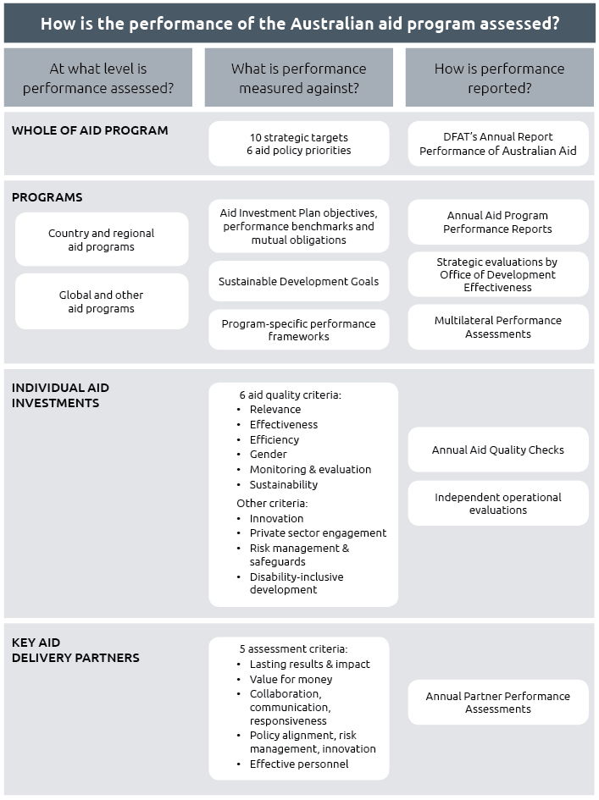

Transparency

The publication of an annual Performance of Australian Aid report forms part of the Government’s commitment to transparency and accountability in the management of the aid program. This commitment is included as part of the 2014 aid policy framework.

DFAT makes available, in an open and accessible format on its website, a substantial amount of information about the Australian aid program including policies, plans, results, evaluations, research, investment plans and aid fact sheets. Detailed statistical information on Australia’s aid program was published in May 2017 in the form of the Australian Aid Budget Summary for 2017-18 (“The Orange Book”). Additional statistical information is published during the year in The Australian Engagement with Developing Countries: Bilateral relationships at a glance and Australia’s International Development Assistance: Official Sector Statistical Summary.

In 2016-17, DFAT published over 300 new aid-related documents on its website. During the period, DFAT produced: 26 Aid Program Performance Reports; 58 independent program evaluations; and updated documents originally published in 2015-16. DFAT provided on its website aid information related to fraud control strategies, fraud losses and recoveries. In addition, DFAT used the AusTender website (tenders.gov.au) to publish information on aid-related business opportunities, annual procurement plans, multi-use lists and contracts awarded.

Australia fully participates in the International Aid Transparency Initiative (IATI) and fulfills its aid reporting obligations to the OECD Development Assistance Committee. DFAT has increased its level of reporting to IATI from 2015-16 to 2016-17 and will continue to engage with IATI in future.

The OECD-DAC peer review of Australia’s aid program (March 2018) states Australia ‘provides a strong level of transparency at the aggregate level in terms of policy statements, investment plans and input data reporting’. The report states that better availability of publications at the activity level will further improve transparency. DFAT recognises more can be done to improve public access to information and to communicate more effectively its development results, and plans to keep progressing this agenda. This includes strengthening regular, internal monitoring of the Department’s compliance with the Government’s transparency commitments.

Chapter 1   
Performance against strategic targets

Making Performance Count identified ten strategic targets to ensure the aid program is well managed, achieving value for money and delivering on the key priorities outlined in the Government’s aid policy: Australian aid: promoting prosperity, reducing poverty, enhancing stability.

At the end of 2016-17, nine of the ten targets had been achieved. The target on increasing aid for trade investments to 20 per cent of the aid budget by 2020 was achieved ahead of its target date. The remaining target on gender equality has not yet been achieved. With the release of the Foreign Policy White Paper and achievement of nine targets to date, a review of the targets is being undertaken.

Target 1: Promoting prosperity

Promote economic development by increasing Australia’s aid for trade investments to 20 per cent of the aid budget by 2020

Status: Achieved

The aid program achieved this target in 2016-17. Expenditure on aid for trade was $941 million or 23.3 per cent of Australia’s total ODA. This achievement is the culmination of strong progress towards the target since it was announced in 2014, when aid for trade was at 12.9 per cent.

Achieving the target ahead of schedule is a reflection of Australia’s strong commitment to aid for trade as a mechanism for sustained economic growth and poverty reduction – the 2017 Foreign Policy White Paper highlights that we will continue to use aid for trade to achieve these goals.

Our aid for trade has helped to deliver meaningful results, including for small businesses and women. For example:

• Reducing trade costs: We are working with the World Bank to help developing countries undertake trade facilitation reforms, such as streamlining customs procedures, in line with the WTO Agreement on Trade Facilitation (TFA). In Timor Leste, this work has reduced processing times at Dili Port from 16 to 9 days, which lowers the costs of trading, boosts links to global markets, and increases investment attractiveness, contributing to Timor Leste’s economic development.

• Financing trade in developing countries: We are working with the Asian Development Bank to help small and medium enterprises in developing countries access trade finance. In 2017, our support helped catalyse more than 3,500 trade finance transactions worth $4.5 billion in developing countries in the Indo-Pacific region. This involved more than 240 banks and supported 2,800 small and medium enterprises, allowing them to generate additional income by accessing global markets.

• Making trade more inclusive: We are helping Pacific Island countries to meet the import quarantine requirements of their key trading partners. Our support has helped Solomon Islands to maintain market access to Europe for their seafood exports, in an industry that supports more than 3,000 people. It has also helped cocoa exports, benefitting over 20,000 rural households in Solomon Islands, and 9,000 in Vanuatu, through increased incomes and improved livelihoods.

In 2016-17, the largest share of Australia’s aid for trade was directed towards building productive capacity, including in agriculture, fishing, small and medium enterprise development, and women’s economic empowerment (see Figure 2). This was followed by economic infrastructure (including in transport, energy and communications), and trade policy and regulatory reform (which is necessary to create an enabling environment for trade).

Figure 2: Expenditure by aid for trade categories, 2016-17  
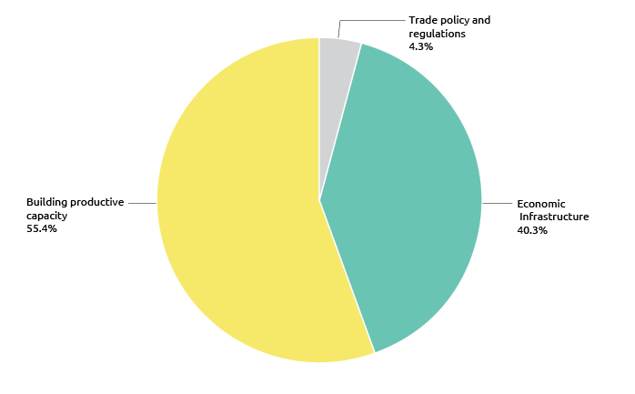

Target 2: Engaging the private sector

All new investments will explore innovative ways to promote private sector growth or engage the private sector in achieving development outcomes

Status: Achieved

The aid program achieved this target in 2016-17, with all new investments exploring innovative ways to promote private sector growth or engage the private sector.

In August 2015, the Minister for Foreign Affairs released the Ministerial Statement on Engaging the Private Sector in Aid and Development – Creating Shared Value through Partnership. The Ministerial Statement built upon a broader policy platform articulating the role for Government in collaborating with the private sector to create sustainable solutions to tackle development challenges. The Statement was founded on the concept of shared value, which helped DFAT identify businesses that create economic value in ways that deliver sustainable social impact in developing countries.

The Strategy for Australia’s Aid Investments in Private Sector Development, the companion to the Ministerial Statement, was also released in 2015. The Strategy formalised the rationale, principles and approaches to improve the growth and inclusion of the private sector in Australia’s partner countries. Operational enhancements to the Department’s investment design and procurement systems mean all new investments are required to explore innovative ways to promote private sector growth or engage the private sector in achieving development outcomes.  These systems then capture and test the extent to which investments promote private sector growth or engage the private sector.

In the two years since the release of the Statement and Strategy, the Government has made progress in delivering upon the policy intent, reflected in changes to the profile of the aid program to prioritise private sector-led development. The number and diversity of partnerships formed at corporate, country and investment levels and the value of private resources mobilised has increased. In 2016, nearly three quarters of monitored investments engaged with one or more private sector partners. This has occurred through the reorientation and mobilisation of both pre-existing and new investments to attract additional support and input from private sector partners, in addition to scaled up engagement with private sector partners.

DFAT has an increased capacity to engage with the private sector, through efforts to identify opportunities to collaborate and partner with business, and to work more innovatively with the private sector. Programs have been developed to catalyse business engagements in developing environments and emerging markets, at global and local levels. For example, DFAT supports the United Nations Global Compact to influence the global architecture for sustainable business, while programs such as the innovationXchange’s Scaling Frontier Innovation program is supporting social enterprises to scale their development impact in the Asia Pacific region.

DFAT posts engage with representatives from the private sector to inform and promote policy through peak bodies such as Chambers of Commerce and Business Councils, relevant industry associations, and employer groups. For example, in Hanoi, DFAT’s External Advisory Committee comprises prominent Australian and Vietnamese businesspeople, academics and technology experts, providing feedback on new ideas and on DFAT’s approach with business, community leaders and entrepreneurs. In Papua New Guinea, DFAT works with the Australia-Papua New Guinea Business Council including on tuberculosis and aid for trade; and, supports the Business Coalition for Women, comprising 60 businesses from the finance, hospitality, and extractive sectors. The purpose of this Coalition is to improve women’s leadership and safety to enable the development of more sustainable and profitable businesses.

At the investment level, engaging with private sector partners has been more straight-forward in some sectors than others. Investments categorised as infrastructure, trade facilitation and international competitiveness reported the highest number of engagements with private sector partners in 2016, with service delivery sectors (particularly education), reporting the lowest. The majority of this engagement is intended primarily to strengthen the private sector, for example, building better business-enabling environments, supporting growth in markets, and maximising the development impact of businesses. These are the key areas through which the aid program seeks to measure success as it engages in activities that focus on addressing market failures, identifying sector opportunities, establishing partnerships, capacity building, financing and service delivery.

We are working with the private sector in new ways. Staff with responsibility for economic diplomacy or trade have always interacted with private sector representatives as a means to represent Australia’s economic interests overseas. What is new is the integration of development objectives and the opportunity to mobilise Official Development Assistance to support DFAT’s work where a development objective is present. Modalities for private sector engagement are broadly categorised into new ways of investing funding, and new ways of working for staff with responsibility for development policy and programming. Examples include: knowledge and information sharing to identify new solutions to development challenges; policy dialogue to meet economic and development objectives through policy reform; technical assistance to assist private sector partners to engage in achieving development outcomes; capacity development to improve the private sector’s ability to achieve development results; and, financing through innovative mechanisms that encourage greater private sector investment in achieving development outcomes.

Exploring ways to support innovative financing mechanisms to encourage private sector investment has been a continued focus. Pacific RISE and Investing in Women both use an impact investing approach, while work continues in the development of an Emerging Markets Impact Investing Fund and a policy framework for innovative financing results. Some investments have developed ways to quantify the return on investment and funding leveraged on investment in the years to come.

Australia, with contributions from New Zealand, through its Pacific Partnership have helped the International Finance Corporation (IFC) to expand its regional presence. The Partnership combines advisory services with investments to generate private sector activity and economic growth in Pacific Island Countries. Much of IFC’s work is aimed at transforming the operating environment for the private sector in the Pacific. This includes building sustainable business environments, including through regulatory reform, eliminating discrimination, provide alternative dispute resolution and improving access to finance.

Despite solid progress on private sector engagement, there have been challenges in fully implementing this new way of working. There is a high level of awareness across DFAT of the importance of engaging the private sector to achieve development outcomes. However, there is not a consistent or broad-level of understanding of the global consensus, outlined in the 2030 Agenda on Sustainable Development, that private sector expertise and resources are key to realising development objectives. Also identified is the need for more coherent and consistent approaches in DFAT to engaging with the private sector, and for more detailed guidance and capability building for DFAT staff to ensure private sector engagement is mainstreamed across Australia’s policy agendas and development investments. To respond to these issues, work has started to explore ways to encourage a more strategic approach to working with the private sector, and to develop specific guidance for staff in developing private sector collaboration opportunities and partnerships.

| Engaging the Private Sector: The Business Partnerships Platform |
| --- |
| The Business Partnerships Platform (BPP) was launched in 2015 as the flagship investment in response to the Ministerial Statement. While the Statement acted as a call to business, the BPP was positioned as the mechanism. It was designed to leverage the presence and competitive advantage of the private sector in contributing to development impact through matched grant funding. The BPP was founded on the concept of shared value – that business can deliver sustainable social impact in developing countries while achieving commercial returns. The BPP supports engagement between NGOs and the private sector; and in three-way partnerships with DFAT. The platform currently brings together 40 private sector and NGO organisations across Asia, Africa and the Pacific in 19 partnerships, in Myanmar, Pakistan, Indonesia, Papua New Guinea, Vietnam, Nepal, Kenya, Bangladesh, Cambodia, Laos, Sri Lanka, Samoa and Vanuatu. In the first two rounds, the BPP has leveraged $14.32m in private sector funding, with the private sector contributing $1.87 for every $1 that the Australian Government contributes. The platform works across many sectors, including agribusiness, financial services, small enterprise development, off-grid energy, health, women’s economic empowerment, information technology, employment services and disability. |

| Engaging the Private Sector: Australia Awards |
| --- |
| The majority of Australia Awards programs reported they were engaging the private sector in achieving development outcomes. The Global Alumni Engagement Strategy, launched in 2016, identified opportunities for alumni to facilitate relationships between Australian companies and markets and partners in developing countries, and industry groups and representative bodies in partner countries, and DFAT. Formal Memoranda of Understanding have been developed or used to facilitate co-investment. In Papua New Guinea, Exxon Mobil and Newcrest have both co-funded awards under their respective MOUs with DFAT. In the Philippines, a three-way partnership between San Miguel Corporation (SMC), a local university (University of Santo Tomas) and Curtin University sees scholars complete one year at the local university, followed by an in-Australia award funded by DFAT. These scholars are then employed at the university or at SMC. |

| Engaging the Private Sector: The Pacific Partnership |
| --- |
| Signed in December 2012, the first Pacific Partnership leveraged the IFC’s expertise as a financier and facilitator of investment in major infrastructure to unlock private sector development through direct and consortium funding, guarantees for high risk ventures, and advisory services to Pacific governments.  DFAT’s $24 million investment helped generate:  a) USD572 million in foreign direct investment, including USD181.4 million investment by IFC;  b) improved access to infrastructure services for more than 1.6 million people through structuring public-private partnerships (PPPs);  c) private sector savings of USD45.7 million annually through business environment reform and Alternative Dispute Resolution (ADR) mechanisms; and  d) nearly USD232 million in financing to 2,485 Small and Medium Sized Enterprises, including 258 women-owned SMEs, and increased access to finance for more than 2 million individuals, including over 480,000 women. |

Target 3: Reducing poverty

By July 2015, all country and regional programs have Aid Investment Plans that describe how Australia’s aid will promote economic growth in ways that provide pathways out of poverty

Status: Achieved

Aid Investment Plans have been completed for all major country and regional programs.

Aid Investment Plans set out the direction for a country or regional program, and are designed to help ensure the most effective use of aid. They describe where, why and how Australian aid will be delivered and the expected results to be achieved. Aid Investment Plans are based on economic, political and social analysis that identifies the key constraints to economic growth, private sector development and poverty reduction. Drawing on this analysis, each individual Aid Investment Plan identifies a set of strategic objectives, priority aid sectors and specific aid investments to promote economic growth and poverty reduction.

Aid Investment Plans contain performance benchmarks and mutual obligations (see Strategic Target 6) tailored to the circumstances of each country or region. Performance against the strategic objectives in an Aid Investment Plan, as well as its performance benchmarks and mutual obligations, is reviewed annually through Aid Program Performance Reports.

Aid Investment Plans for all major country and regional programs, 25 in total, were published on the DFAT website on 30 September 2015. Though all Aid Investment Plans share a common commencement date, each have specific completion dates. Several aid investment plans will end in 2017-18 with successor plans under development.

Target 4: Empowering women and girls

More than 80 per cent of investments, regardless of their objectives, will effectively address gender issues in their implementation

Status: Not yet achieved

Efforts to progress gender equality and improve the lives of women and girls are a reflection of gender equality as a core Australian value and a foundation of Australia’s international engagement. Work in this area is underpinned by strong evidence that gender equality and women’s empowerment contribute to stability, security, and prosperity, as well as greater effectiveness of development efforts. DFAT’s Gender Equality and Women’s Empowerment Strategy, launched in 2016, directs us to promote gender equality through both stand-alone work to address binding constraints, and integration of gender equality considerations into all development work, regardless of its sector or objectives.

Target Four tracks the integration of gender equality throughout the aid program. It measures the percentage of Australian aid investments that are effectively addressing gender equality issues during implementation, which is assessed through satisfactory or above ratings in the annual Aid Quality Check process.

The performance target on gender equality is a reflection of the aid program’s global leadership in this area and is widely acknowledged by development partners as progressive and influential. For example, the 2018 DAC peer review recognises Australia’s approach to gender equality in the aid program as exemplary, and highlights its role as a champion “internationally, regionally and bilaterally. A dedicated strategy, performance targets, financial resources and political leadership underpin this commitment”.[8]

Meeting the target, however, remains challenging. During 2016-17, 77 per cent of aid investments effectively addressed gender equality in implementation, falling short of the target of 80 per cent (Figure 5). Progress towards the target was uneven across the aid program (Figure 3). Investments in the Pacific faced multiple challenges in addressing gender equality, and will require strong leadership to improve their gender performance. Investments in South East and East Asia, the Middle East and Africa performed well, while gender equality results from investments in South and West Asia were close to the 80 per cent target.

Figure 3: Gender performance by region, 2016-17  
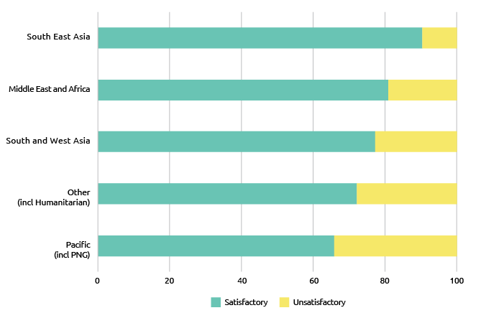

The aid program is still undergoing a transition to more gender-focused investments, which can be expected to lead to improved performance over time. The Department is still managing a tail of investments that did not adequately incorporate gender equality issues at design. Investments commencing in 2014 or later perform better on gender equality (82 per cent satisfactory) compared to those that commenced before (76 per cent satisfactory). While efforts are made to remediate lower performing activities, this is difficult and requires strong leadership. Results are expected to improve as aid investment managers are increasingly skilled and supported to manage for results on gender equality.

Figure 4: Gender performance by investment priority area, 2016-17  
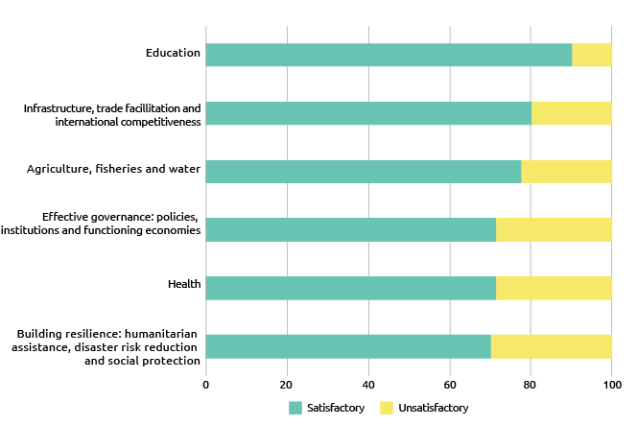

There is also a variable story by sector (Figure 4), pointing to technical challenges in gender-sensitive design and implementation.[9] In particular, the evidence suggests that it is more challenging to undertake gender analysis, develop gender informed designs and demonstrate tangible gender equality results in investments that work to improve systems rather than delivering direct benefits for people.

Across the board, there are consistent challenges ensuring commitments to gender equality made by our partners at headquarters level are translated into meaningful progress for women and girls. The Department is considering greater attention at senior management levels and stronger, mandatory responses to underperforming investments. Reaching the 80 per cent target will require strong linkages with existing senior management accountability structures.

The most direct indicator for meeting the target is the extent to which investments intend from the outset to address gender equality. Overall, investments with gender equality as a significant or principal objective continue to perform better on gender equality and a range of other aid criteria compared to those that do not have gender equality as an objective (Figure 5). The Department is therefore exploring ways to improve performance by strengthening gender-responsive forward-planning, Aid Investment Plans, and increasing dedicated aid expenditure towards gender equality objectives.

Figure 5: Gender equality: investment performance, 2016-17  
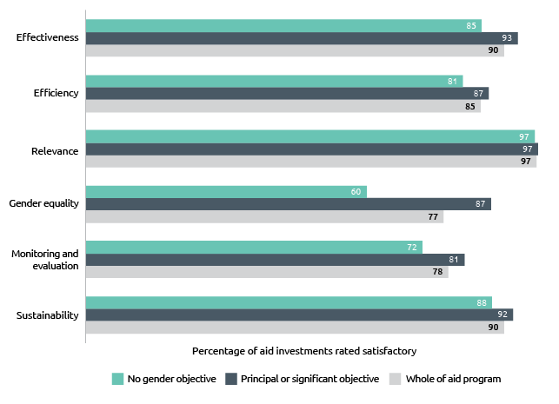

In 2016-17, Australia spent $2.07 billion on investments that targeted gender equality as a principal or significant objective. This amounts to 62 per cent of DFAT’s country, regional and global aid investments by value across a range of sectors (Figure 6). Most of this expenditure is through investments where gender equality is integrated as a secondary (significant) objective. Globally recognised key factors for effective performance on gender equality have been codified by OECD-DAC in Minimum Recommended Criteria for expenditure that is considered as targeting gender equality. From FY 2017-18 onwards DFAT will apply these Minimum Recommended Criteria for its aid expenditure reporting. This is part of our efforts to ensure aid investments are informed by gender analysis, take a Do No Harm approach, and address and measure progress towards gender equality where possible. The application of the new Criteria means figures concerning 2016-17 expenditure and prior years will not be comparable with later years.

DFAT’s $55 million Gender Equality Fund, established in 2015-16, includes activities to support new and innovative approaches that can accelerate effective gender integration across the aid program. This includes data collection to increase visibility and accountability in relation to gender equality gaps, standard setting for integration of strategies to end violence against women into priority sectors, and mainstreaming of gender equality considerations in private sector partnerships.

Figure 6: DFAT aid expenditure by gender objective, 2016-17  
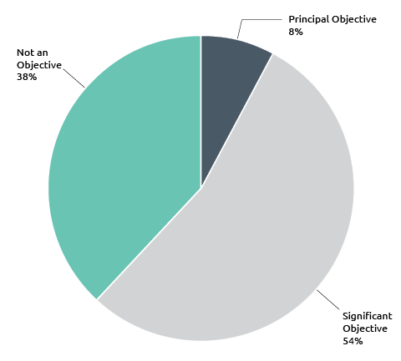

Key to robust gender integration in aid investments are strong leadership and the timely availability of gender specialist expertise and advice. In 2016-17, the Department continued to support utilisation of gender expertise, in particular during design of new investments. Gender specialists were instrumental to programs being deliberate during the design phase about the intention to achieve gender results, implementing a strong, evidence-based approach, and developing and implementing gender strategies at program and investment level. However, challenges exist in meeting demand, sequencing technical support and recruiting specialist gender support in fields such as economic reform, public financial management, and infrastructure.

DFAT continued to train staff in Australia and overseas through tailored capacity building activities. The approach to gender training is being refreshed to drive improved capacity development from mid-2018. To accelerate implementation of DFAT’s Gender Equality and Women’s Empowerment Strategy in humanitarian work, supplementary guidance has been provided for investment managers on how to progress gender equality through humanitarian and emergency investments. Additional guidance will be developed on how to achieve gender equality results in sectors where gender integration efforts are stagnating or relatively new, such as infrastructure.

Target 5: Focusing on the Indo-Pacific region

Increase the proportion of country program aid that is spent in the Indo-Pacific region to at least 90 per cent from 2014-15

Status: Achieved

This target was achieved in 2016-17, with 90.2 per cent of country attributable aid spent in the Indo-Pacific region.

This target ensures that the Australian aid program is focused on the region where Australia can and, as the Foreign Policy White Paper makes clear, must make the most difference. Stronger economic growth and stability in the Indo-Pacific region is directly in Australia’s interests.

This target measures the proportion of country attributable aid that is spent in countries in the Indo-Pacific region. This includes bilateral and regional aid expenditure, as well as some global and cross regional aid that can be attributed to countries in the Indo-Pacific region. For example, humanitarian assistance earmarked to particular countries is included in country attributable aid, but core funding to international humanitarian agencies and multilateral development agencies is not included.

Figure 7: Percentage of country attributable aid that is spent in the Indo-Pacific region  
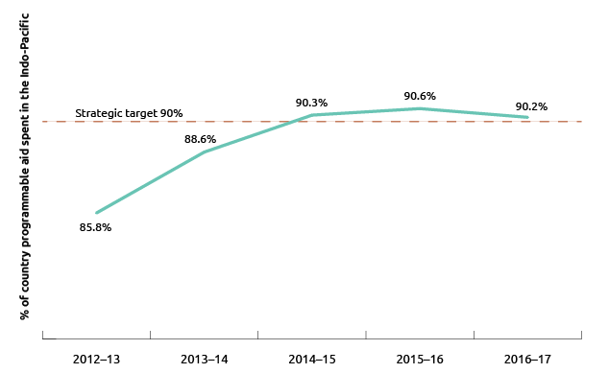

Target 6: Delivering on commitments

From July 2015, progress against mutual obligations agreed between Australia and its key partner governments and organisations will form part of program performance assessments

Status: Achieved

This target was first achieved in November 2015. Each year, progress against performance benchmarks and mutual obligations is published in Aid Program Performance Reports (available on the DFAT website). Aid Program Performance Reports for 2016-17 were published in September 2017.

Performance benchmarks and mutual obligations for all major country and regional programs are set out in Aid Investment Plans and Aid Program Performance Reports. For Pacific programs, mutual obligations are also included in Aid Partnerships completed during 2015-16. The most recent assessment of progress towards meeting benchmarks and mutual obligations are included in 2016-17 Aid Program Performance Reports.

Performance benchmarks assist with assessing progress against a country program’s objectives. A set of 171 performance benchmarks were reported for 2016-17. Figure 8 shows the progress against benchmarks for the six priority areas of the aid policy. Overall, 121 benchmarks were achieved, 44 were partly achieved and 6 were not achieved or could not be assessed. Chapter 2 reports on progress against performance benchmarks by region.

Figure 8: Performance benchmarks by investment priority area, 2016-17  
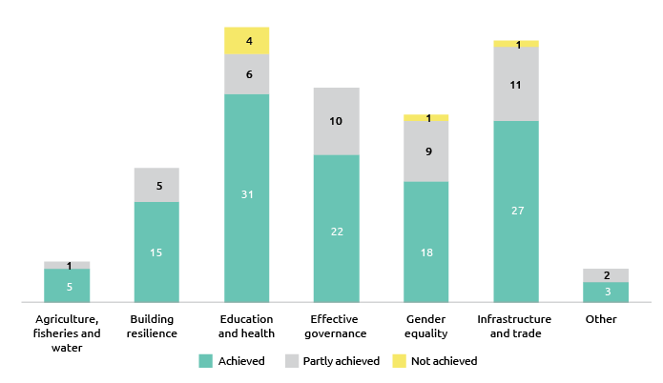

The stronger focus on mutual obligations under Making Performance Count builds on longstanding and widely accepted aid effectiveness principles. Both the 2005 Paris Declaration on Aid Effectiveness and 2011 Busan Partnership for Effective Development Cooperation emphasise ownership and mutual accountability as key principles for making aid more effective.

A broad range of mutual obligations is reported against in 2016-17 Aid Program Performance Reports. Australia’s obligations generally take the form of budget commitments, alignment of Aid Investment Plans with country priorities, and ways of working including responsiveness, flexibility and innovation.

Obligations for partner governments are derived from a range of sources. National development plans typically represent the overall framework for identifying commitments and assessing progress. These commitments vary and range from minimum sectoral budget allocations to specific legislative and policy reforms. For example, the Government of Solomon Islands committed to a target of 22 per cent recurrent budget funding for the education sector in 2016. This commitment was exceeded with 24 per cent allocated. Obligations are also derived from project specific commitments made by partner governments. For example, Cambodian Government funding of the Health Equity and Quality Improvement Project, originally estimated to be 54 per cent of total funding, exceeded expectations. In the first nine months of operation, the Cambodian national budget funded 64 per cent of program costs.

Target 7: Working with the most effective partners

By July 2015, design and apply new systems to assess the performance of the aid program’s key delivery partners and ensure stronger links between performance and funding

Status: Achieved

The target was achieved in 2014-15 with the introduction of Partner Performance Assessments; a strengthened Multilateral Performance Assessment process for multilateral organisations receiving core funding; reforms to systems for assessing performance under the Australia-NGO Cooperation program; and progress in linking performance to payments in aid agreements.

In 2016-17, 75 per cent of total administered ODA was delivered through agreements with three main types of implementing partners: commercial partners, multilateral organisations and NGOs (Figure 9).

Figure 9: Total administered ODA by delivery partner type, 2016-17  
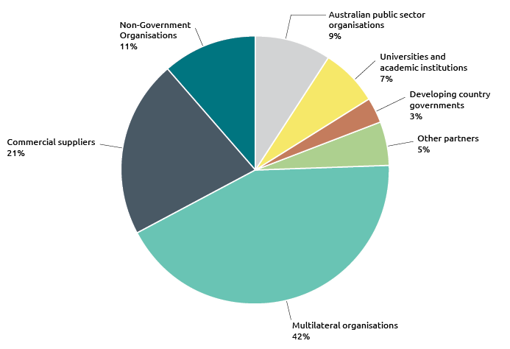

Partner Performance Assessments (PPAs) review how well key implementing partners (commercial partners, multilateral organisations and NGOs) are delivering the services specified in aid funding agreements. The focus is on the performance of the implementing partner, as distinct from the quality of the investment itself (which is assessed by the annual Aid Quality Checks). Assessments were completed for individual funding agreements valued at over $3 million except for core contributions to multilateral organisations.

Table 1: PPA completed by delivery partner type, 2016-17

| Partner type | Number of PPAs | Overall value of agreements assessed ($m) |
| --- | --- | --- |
| NGOs | 87 | $1,212 |
| Commercial suppliers | 90 | $4,012 |
| Multilateral Organisations | 128 | $2,581 |

The results (Table 2) indicate that the three main delivery partner categories are all performing to an adequate level or better. Over 94 per cent of assessments completed had ratings of adequate (4) or higher on a scale of 1 to 6.[10]

Table 2: Average PPA rating score by delivery partner type, 2016-17

| Commercial Partners | NGOs | Multilateral Organisations | Overall Partner Average Rating |
| --- | --- | --- | --- |
| 4.9 | 4.8 | 4.5 | 4.7 |

Commercial partners achieved the highest average PPA rating by delivery partner type. Agreements with commercial contractors are characterised by a high level of managerial direction and control by DFAT, whereas grant agreements with NGOs and multilateral organisations are partnership agreements where DFAT has agreed to fund investments over which partners have much greater autonomy in investment design and implementation. Australia’s investment in multilateral programs is often also made in collaboration with other donors, requiring greater degrees of compromise by all parties than is required in other arrangements. In addition, multilateral organisations operate under policies and procedures endorsed by boards (which include Australian representation) and these policies and procedures can be difficult to change quickly to meet Australia’s specific interests in individual countries (in contrast to the flexibility DFAT has when engaging commercial suppliers).

Target 8: Ensuring value for money

Deliver high standards of value for money in at least 85 per cent of aid investments. Where standards are not met and improvements are not achieved within a year, investments will be cancelled

Status: Achieved

This target was achieved in 2016-17 with 90 per cent of investments rated as satisfactory for effectiveness and 85 per cent of investments rated as satisfactory for efficiency.

DFAT seeks to ensure that value for money considerations are applied across all aid management policies, practices and investments. Data to track progress towards this target is drawn from DFAT’s annual Aid Quality Checks. Investments rated as satisfactory against the efficiency and effectiveness criteria are considered to be delivering high standards of value for money.

Figure 10: Percentage of aid investments with satisfactory ratings for efficiency and effectiveness, 2011-12 to 2016-17

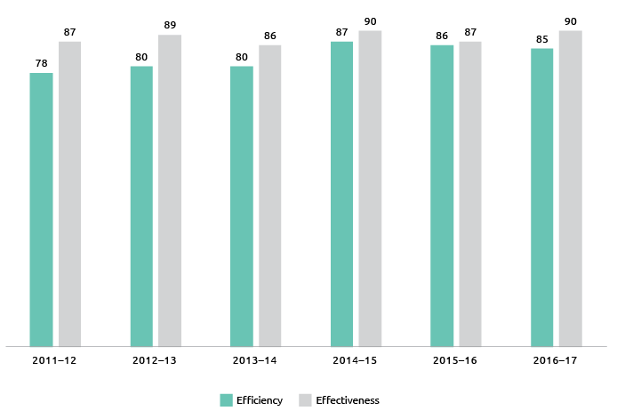

Annual effectiveness outcomes have ranged between 86 per cent and 90 per cent since 2011-12 (Figure 10). The 2016-17 outcome of 90 per cent for effectiveness is at the high end of the average outcome since 2011-12.

While efficiency outcomes were slightly lower than last year, they continue to be rated higher than for 2013-14 and earlier years. The continuing trend of efficiency outcomes at 85 per cent or higher indicates that the underlying efficiency of the overall aid program has improved. However, there continues to be marked differences between regions with the Pacific region efficiency outcomes rating 74 per cent compared to 92 per cent for South East and East Asia. This likely reflects more fluid operating environments in Pacific island countries.

This strategic target also requires the identification of underperforming investments based on unsatisfactory ratings for both effectiveness and efficiency criteria. In 2016-17, twenty-five underperforming investments were identified as Investments Requiring Improvement. If performance does not improve for each investment within 12 months, they are subject to cancellation. In 2015-16, twenty-one underperforming investments were identified as Investments Requiring Improvement. Of these twenty-one investments, five investments were again assessed in 2016-17 as unsatisfactory. Three of these investments have now ended, one was cancelled and the fifth is under review.

Target 9: Increasing consolidation

Reduce the number of individual investments by 20 per cent by 2016-17 to focus efforts and reduce transaction costs

Status: Achieved

This target was achieved on 1 July 2016 when the number of individual investments had reduced by 23 per cent.

Focusing on fewer, larger aid investments should improve the efficiency and effectiveness of Australia’s aid program. Consolidation can reduce the administrative burden on DFAT staff, partner governments and key delivery partners. However, these benefits may not always be achieved without careful management of aid investments, particularly multi-sector investments. Further analysis is being undertaken to better determine the effectiveness and efficiency of larger investments.

Figure 11: Progress on consolidation of aid investments

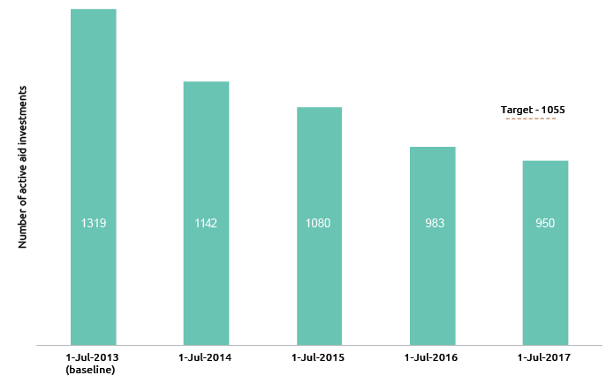

Target 10: Combatting corruption

Develop and implement new fraud control and anti-corruption strategies for all major country and regional programs by July 2015

Status: Achieved

Fraud and anti-corruption strategies are in place for all major country and regional programs.

These strategies identify risks and potential incidences of fraud and corruption relevant to the delivery of Australian aid. They detail the controls and measures adopted to safeguard Australian Government aid program funding, and actions and initiatives to support country efforts to combat fraud and corruption. A full review of all strategies is underway and is scheduled for completion by mid-2018. The Australian aid program is delivered in a particularly difficult set of country environments where fraud and corruption can be commonplace. The strategies complement the robust systems and procedures that are in place to protect public money and property from fraud and corruption.

Chapter 2   
Country and regional program performance

This chapter summarises the performance of Australia’s country and regional aid programs. Key performance trends and areas for improvement are highlighted for programs, organised into four regional groups: Pacific; South-East and East Asia; South and West Asia; and Africa, the Middle East and other regions. Individual country and regional programs achieved significant results in 2016-17. These results are available on DFAT’s website, and are not repeated in this report.[11]

For country and regional aid programs, performance is assessed each year and published in Aid Program Performance Reports.[12] Assessments of performance are made against program objectives contained in Aid Investment Plans for each country or regional program, and expressed as one of three ratings: progress towards objectives is on track; progress is at risk (less than expected); or progress is not on track.

Figure 12: Progress against program objectives by region, 2016-17  
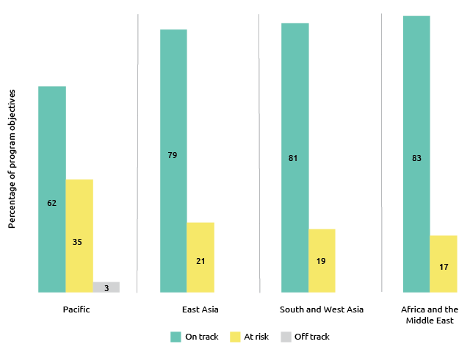

Performance benchmarks, together with other monitoring and evaluation indicators, are used to assess progress against Aid Investment Plan objectives. Progress against each benchmark is reported in Aid Program Performance Reports. Performance against objectives and benchmarks for individual country and regional programs is summarised by region below (see also the discussion of performance benchmarks under strategic target six in Chapter 1).

Pacific

The Pacific has a population of about 10.2 million people, spread across a diverse region made up of hundreds of islands, and scattered over an area equivalent to 15 per cent of the globe’s surface. Pacific island countries face a complex range of development challenges in this environment. Many countries in the region have economic growth rates that do not keep pace with population growth. Geographic isolation and small markets reduce international trade incentives, further curtailing economic growth. Narrow production bases and ongoing reliance on imported fuel expose the majority of Pacific island countries to commodity price fluctuations. Overfishing and environmental factors threaten the sustainability of fishery resources on which Pacific island economies and communities depend. Employment prospects are low. The formal private sector is typically small with significant informal economies. This high degree of informality reduces taxation revenue that would otherwise be available to increase government expenditure on health, education and other areas. Greater regional integration is necessary to leverage economies of scale.

Pacific island countries are particularly vulnerable to the effects of climate change, which exacerbate broader development challenges, heighten risks to livelihoods and food security, and compound security challenges. Four out of the ten most disaster prone countries in the world are in the Pacific (Vanuatu, Tonga, Solomon Islands, Papua New Guinea).[13] In February 2016 Tropical Cyclone Winston was particularly devastating, leaving 44 people dead and a damage bill of more than $2.5 billion.

Governance is a key development priority. Key governance issues include the building and maintenance of law and order, peace and stability, tackling corruption, and improving fiscal management. Stronger governance will contribute to a stable, secure and prosperous region, and support Pacific island countries to achieve improved development outcomes.[14] Governance programs receive the largest proportion of Australian ODA expenditure by investment priority area in the Pacific (Figure 13).

Australia is the largest contributor of ODA to the Pacific. In 2016-17, 27.9 per cent of Australian ODA was allocated to the region. PNG remained the largest recipient of Australian ODA in the region, representing 48.9 per cent of Pacific regional expenditure and 13.6 per cent of total Australian ODA.

Table 3: ODA by country program: Pacific, 2016-17

| Country Program | 2015–16 | 2016-17 |
| --- | --- | --- |
| ($m) | ($m) |
| Papua New Guinea | 534.3 | 549.9 |
| Solomon Islands | 172.6 | 155.2 |
| Fiji | 87.0 | 80.2 |
| Vanuatu | 65.6 | 66.1 |
| Samoa | 38.2 | 35.4 |
| Tonga | 31.7 | 28.1 |
| Kiribati | 29.3 | 28.7 |
| Nauru | 24.9 | 23.6 |
| North Pacific | 9.7 | 10.7 |
| Tuvalu | 8.7 | 9.0 |
| Cook Islands | 3.6 | 3.9 |
| Niue and Tokelau | 3.4 | 4.3 |
| Pacific Regional | 113.9 | 128.5 |
| Pacific Total | 1,122.9 | 1,123.7 |

Figure 13: Total Australian ODA by investment priority area: Pacific, 2016-17

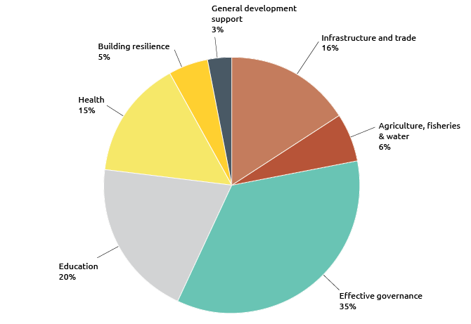

Program quality

In 2016-17, 62 per cent of Pacific country and regional program objectives were assessed as on track (Figure 14). The proportion of program objectives at risk (progress less than expected) was 35 per cent. One objective was assessed as off-track. The performance of each country against program objectives is set out below. Pacific programs have identified management actions to improve program performance. These actions are set out in country and regional Aid Program Performance Reports.

Figure 14: Progress against program objectives: Pacific, 2016-17

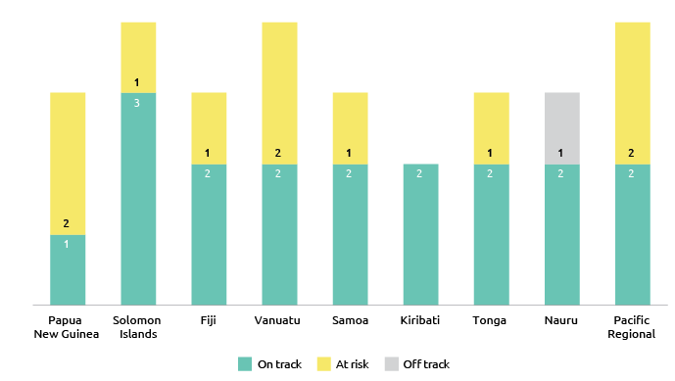

Progress against performance benchmarks by Pacific programs was mixed, with 59 per cent of benchmarks achieved and 32 per cent partly achieved. Six benchmarks (eight per cent) were not achieved, four of which relate to performance against the human development objective in the Nauru program.

Figure 15: Progress against performance benchmarks: Pacific, 2016-17

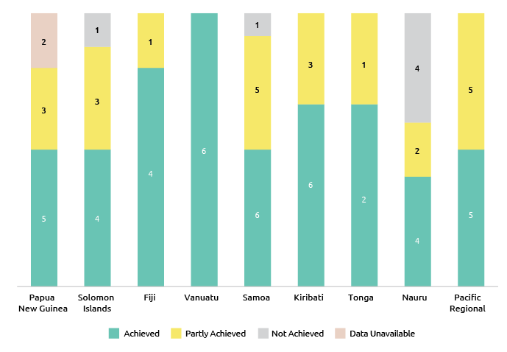

Australia’s individual aid investments in the Pacific rated lower on quality assessment criteria when compared to the aid program as a whole (Figure 16). Gender equality continues to be a particular challenge, requiring the gradual and systematic questioning of well-established and closely held social norms. Programs need to continue efforts on improving gender equality by ensuring women and girls are able to benefit from all Pacific aid investments. The Pacific continues to be a challenging environment for monitoring and evaluating aid investments, given host government capacity constraints and underdeveloped systems. Of the eight investments identified as requiring improvement in 2015-16, six have been completed. Of the two ongoing investments, one improved performance during 2016-17 and one was again assessed as unsatisfactory and is under review. Eleven investments were identified as requiring improvement based on 2016-17 Aid Quality Check results and management action plans have been put in place.

Figure 16: Aid investment performance: Pacific, 2016-17

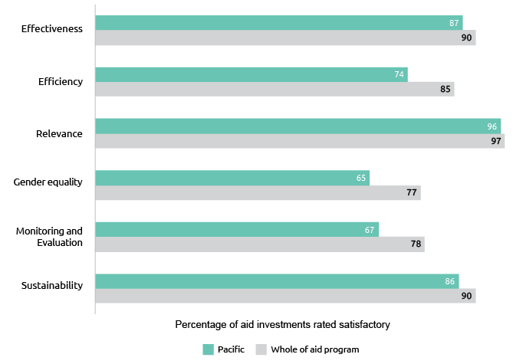

The Papua New Guinea program delivered a wide range of outputs in 2016-17. For example, over 760km of national priority roads were maintained and/or upgraded, construction of six major bridges was completed in Oro province, financial literacy training for approximately 46,000 people was delivered, the national election was supported, and construction of the first phase of redevelopment works at the Lae Angau Memorial Hospital including an operating theatre, 20 bed ward and new dental clinic was completed. Our support to Bougainville enhanced stability, improved service delivery and promoted economic activity.

One of three program objectives for PNG was assessed as on track. Under the objective enabling economic growth, progress was made in private sector development, economic governance and high impact infrastructure. Progress against the objective relating to promoting effective governance was assessed as less than expected due to delays in developing some governance programs and partial achievement of performance benchmarks. The target of 3,000 women and 4,000 men trained in core public service skills was partially achieved (6,301 trained) including through our investment in the Pacific Leaders and Governance Precinct. Data was not available on the benchmark relating to the number of survivors of violence receiving services. Australia will continue to work with the PNG Government to confirm the strategic priorities driving the aid program’s support for public sector leadership, as well as on achieving greater integration of gender and inclusion principles.

Progress against the PNG program objective enhancing human development was also assessed as less than expected, as outcomes in supporting health financing were below expectations and there were also weaknesses in monitoring and evaluation data, particularly in education. In response, Australia is developing a Sector Investment Plan that will establish a new education program with a robust monitoring and evaluation framework, as well as continuing to support the PNG Government to collect, analyse and use relevant education information to measure progress and inform policy development and implementation.

For Solomon Islands, three of four aid program objectives were assessed as on track, relating to supporting stability, an economic operating environment more attractive to business and enhancing human development. An independent review confirmed achievement of the majority of key indicators in the education sector program while an independent review found more mixed performance in the health sector with 73 per cent of targets achieved. Progress against the objective more men and women able to earn a cash-based income was less than expected. This is because although there are effective program activities underway they do not yet amount to a sustained contribution to the objective of improving incomes, particularly rural incomes. There is also still room to translate work on enabling economic growth into more cash-based income opportunities for men and women. This is despite a continued shift in bilateral expenditure towards enabling economic growth. A key priority in 2017-18 will be to better understand the barriers to women’s participation in the workforce. A comprehensive performance framework for the economic growth portfolio will be developed as well as improved information linkages between the private sector and Solomon Islands Government.

In Fiji, two of three program objectives were assessed as on track relating to private sector development and human development. Implementation of Australia’s $15 million Tropical Cyclone Winston response package was completed and substantial progress was made in delivering Australia’s $20 million recovery package. However, poor weather, difficulties accessing sites, shortages of building materials and some sub-standard initial building work resulted in delays in rebuilding a number of schools, a community health centre and a major municipal market. Time needed to deliver the recovery package was also underestimated. This contributed towards progress against the objective Tropical Cyclone Winston being assessed as less than expected at this stage of implementation. An independent evaluation of the response found that support to UNICEF and Save the Children as part of the response package helped to reopen schools and establish temporary learning spaces, introducing an element of stability in cyclone-affected communities and providing entry points for a wider array of disaster response services. However, the evaluation also found there was declining effectiveness over time as needs evolved and what were intended to be temporary measures (such as the use of tents as learning spaces) were still being used one year on from the cyclone.[15] In response, the program will implement agreed recommendations from the evaluation. Australia’s response to Cyclone Winston also built on lessons documented in a 2017 ODE evaluation of Australia’s response to Cyclone Pam, which hit Vanuatu in March 2015.[16] For example, in the Winston response DFAT ensured that AusMAT and funded NGOs worked with local partners and prioritised capacity building.

In Vanuatu, progress against the objectives building resilient infrastructure and environment for economic opportunity and improving community safety and resilience was assessed as on track. Progress against the objective improving early education and essential health services was rated as less than expected, reflecting mixed achievements by health investments. Health continues as a challenging and complex sector. While progress has been made, immunisation coverage, family planning and screening for non-communicable diseases are still areas of concern. Workforce shortages, particularly in rural areas, also remain a significant risk affecting aid posts, hospitals and dispensaries. Program investments in health, while individually highly relevant, are highly fragmented. Assessing the program is, as result, challenging. Design of a new phase of the health program, including a strengthened monitoring and evaluation framework, has commenced and will be implemented in 2018-19. This new design will also strengthen gender equality across health investments.

Progress against the objective supporting cyclone recovery and reconstruction was also less than expected. Delays in programming funds to meet risk and safeguard requirements has slowed implementation of investments and the large number of small procurements has slowed approvals through Vanuatu Government systems. Increased construction has also put pressure on the availability of building materials

and, in addition, infrastructure works are often in remote locations, presenting challenges for the supply and transport of materials. A remediation plan has been established to improve performance against this objective.

For the Samoa program, progress against the objectives enabling economic growth and strengthen governance was assessed as on track. Most performance benchmarks against these objectives were achieved. Progress against the objective progress health and education outcomes continued to be less than expected. In Samoa’s education sector, a review of the inclusive education program, found that while gains had been achieved, barriers to education exist, including teacher capacity, gender equality, mobility constraints, and parent perceptions. It was identified that future work in this area needs to focus more on professional development, coordination and reporting to demonstrate quantifiable outcomes. An analysis of lessons learnt will inform future education programs, particularly those focusing on children with disabilities. A review of the heath sector to identify actions to strengthen primary health care was put on hold pending a restructure of the sector.

In Tonga, two of three program objectives were assessed as on track. These related to governance and skills development. Performance benchmarks related to these objectives were achieved. Progress against the objective a more effective, efficient and equitable health system was less than expected reflecting partial achievement of benchmarks. While the main indicators of Tonga’s budgetary commitments to health have been met, the Essential Package of Services, which is an important aspect of achieving universal health coverage – remains under development. Reporting on performance against non-communicable diseases benchmarks was also delayed. In response, the program plans to strengthen reporting systems to enable better understanding of the impact of the health program and adapt activities to be more effective.

In Nauru, program objectives relating to public sector management and infrastructure were assessed as on-track. Progress in the health sector program under the supporting human development objective was assessed as off-track with activities significantly behind schedule. A remediation plan has been established to improve performance. Efforts will be focused on filling vacant health adviser positions and a redesign of health investments. Progress in the education sector program under the human development objective was also less than expected due to underperformance against regional education standards. Over 2017-18, the recruitment and mobilisation of an Education Adviser to support delivery of the Education Strategic Plan, as well as completion of the Learning Village, which will provide better access to tertiary education with a new university campus, is expected to lead to improved performance. Two reviews scheduled to be completed in 2018 are expected to generate recommendations aimed at improving performance of education investments.

For the Pacific Regional Program, two of four program objectives were assessed as on track. These objectives relate to economic growth and empowering women and girls. An independent mid-term review of the Pacific Financial Inclusion Program found five out of six end of program targets had been achieved and highlighted the program’s collaborative and holistic approach as important in increasing financial inclusion for low-income populations. An independent evaluation following four years of implementation of the ten-year Pacific Women Shaping Pacific Development program found positive views on its policy and cultural relevance. The evaluation found that that there was a need for the program to work with more balance between intended outcomes.[17] This means scaling up work in women’s economic empowerment and women’s leadership and decision making, selecting partnerships that can contribute to promoting the identity of the program and promoting Pacific leadership and ownership through a concerted strategy and in a consistent way.

Progress against the objective effective regional institutions was less than expected due to significant financial challenges faced by particular regional partners. These challenges have necessitated savings and delayed recruitment, financial reforms and prioritisation of work programs. In response, Australia is helping these organisations address their financial challenges by providing technical and other assistance.

Progress against the objective healthy and resilient communities was also less than expected. Pacific island countries are not using available climate science to ensure risk-informed development. This has implications for how resilient communities are when impacted by climate-related weather events. In health, the burden of non-communicable diseases is increasing, and communicable disease outbreaks are common. Unmet needs for family planning are high and in eight countries the adolescent birth rate is increasing. While there have been improvements across investments in the health sector, further work is required to strengthen coordination of these investments. In response, the program will enhance coherence between bilateral, regional and global investments through the rollout of a new Pacific Health Strategy (2018-30). Focus will also be given to strengthening regional health governance for issues that require regional collaboration as well as to scaling up assistance to make Pacific island country health systems more efficient through improved public financial management support.

South-East and East Asia

South-East Asia is a dynamic and diverse region, with extensive natural resources, a young population and diversified economy. It is one of the fastest-growing regions in the world, with economic growth forecast to be 5.2 per cent in 2018, up from 4.9 per cent in 2016 and 5.1 per cent in 2017.[18] With average growth of five per cent over the past 15 years, the region continues as one of the main drivers of global economic activity, anchored by the steady rise in domestic demand for goods and services, an improvement in exports and an expanding middle class.[19] This favourable economic outlook is also supported by accommodative monetary policy and expansionary fiscal stances across most countries.[20] Private investment is expected to remain the key driver of growth in the region.[21]

Notwithstanding this, South-East Asia faces several development challenges that need to be addressed to achieve its growth potential and to promote a more sustained and inclusive development path. Large numbers of people continue to live in poverty, and inequities persist, including a high degree of gender inequality. Women’s access to reliable maternal and neonatal facilities still needs to improve across South-East Asia. The region faces pressing social and environmental problems, including climate change. Economic institutions and governance remain vulnerable to economic shocks and with lagging productivity growth are preventing countries from fully leveraging global and regional economic opportunities.[22]

In 2016-17, 22.1 per cent of total Australian ODA was directed to South-East and East Asia. Indonesia remained the largest recipient of Australian ODA in the region, representing 40 per cent of regional expenditure and 8.9 per cent of total Australian ODA.

Table 4: Total Australian ODA by country program: South-East and East Asia, 2016-17

| Country Program | 2015–16 | 2016-17 |
| --- | --- | --- |
| ($m) | ($m) |
| Indonesia | 387.0 | 360.1 |
| Timor-Leste | 96.9 | 92.7 |
| Cambodia | 92.0 | 91.8 |
| Vietnam | 91.0 | 94.3 |
| Philippines | 85.6 | 87.5 |
| Myanmar | 84.5 | 87.6 |
| Laos | 44.6 | 40.8 |
| Mongolia | 10.2 | 9.8 |
| Regional East Asia[23] | 30.9 | 25.8 |
| East Asia Total | 922.7 | 890.5 |

Figure 17: Total ODA by investment priority area: South-East and East Asia, 2016-17

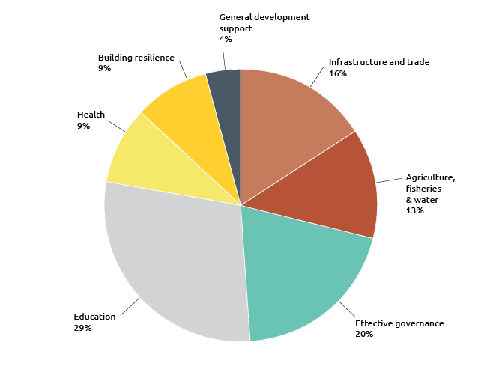

Program quality

South-East and East Asian country and regional programs made good progress against objectives with 79 per cent on track (Figure 18), higher than last year. While no objectives were rated as off-track, 21 per cent of objectives were assessed as at risk (progress less than expected). The performance of each country against program objectives is set out below. Progress against country and regional program performance benchmarks improved on last year with 74 per cent of performance benchmarks achieved and 24 per cent of benchmarks partly achieved.

Figure 18: Progress against program objectives: South-East and East Asia, 2016-17

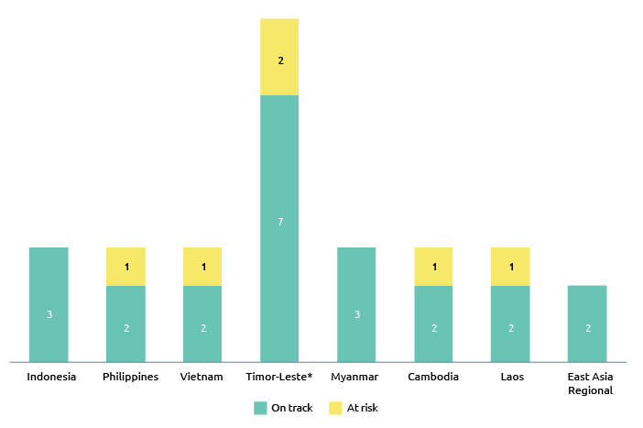

* In 2016-17, the Timor-Leste country program reported against program outcomes, which are typically greater in number than program objectives.

Figure 19: Progress against performance benchmarks: South-East and East Asia, 2016-17

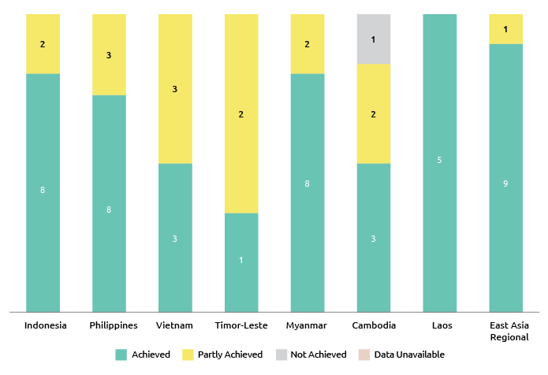

The performance of aid investments in South-East and East Asia exceeded that of the aid program as a whole on all criteria (Figure 20). Results for effectiveness, efficiency, gender equality, monitoring and evaluation, and sustainability were higher than last year. Not all country and regional programs achieved the gender equality strategic target and will be working to improve outcomes against this target in 2017-18. All five investments identified as requiring improvement in 2015-16 either improved their performance in 2016-17 or were completed. Four investments were identified as requiring improvement based on 2016-17 Aid Quality Check results and management action plans have been put in place for ongoing investments.

Figure 20: Aid investment performance: South-East and East Asia, 2016-17

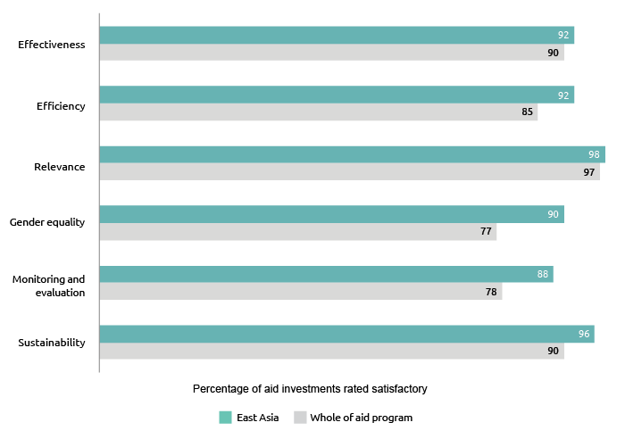

The three objectives of the Indonesia program were assessed as on track in 2016-17. These objectives related to economic institutions and infrastructure, human development, and governance. Many achievements made in 2016-17 related to the introduction of laws and regulations and the adoption of new ways to allocate government spending or systems that help people access government services. For example, Australia supported Indonesia to target electricity subsidies to the poorest 40 per cent of households, saving the Government of Indonesia an estimated $1.6 billion in 2017. Evaluation findings confirmed strong results from investments supporting Indonesia program objectives. For example, an independent evaluation of the Indonesia Infrastructure Initiative ($227.5 million; 2007-17) found it delivered high-quality technical assistance although whether reforms and innovations will be sustained is not yet clear in all cases.[24] An independent completion report for the Australia-Indonesia Education Partnership (AEP) found that it improved education access in many of Indonesia’s remotest areas, contributed to better school management and strategies to improve education quality in schools and madrasah (Islamic schools), and supported better quality dialogue and decision-making in important areas.[25] However, implementation of the AEP’s professional development component was delayed and did not deliver the full systemic improvements expected, and the AEP did not engage effectively with district governments to address education challenges. Lessons learned are being taken forward in new education programs.

The three Indonesia program objectives are underpinned by eleven outcome areas with eight outcome areas assessed as on track. Progress against the outcome area relating to more jobs and higher incomes was assessed as less than expected because while the target for increasing farm households’ incomes was exceeded, only modest progress was achieved on reforms that make it easier to invest and do business. In response, the program in 2017-18 will support Indonesia’s efforts to attract foreign investment and reduce barriers to business and trade by making it easier to register a business and obtain construction permits. Progress against the outcome area relating to improved literacy and numeracy for children was less than expected. In response, the program will develop models for teaching foundational literacy and numeracy, formative assessment and inclusive education which can be scaled up by government and expand the evaluation of KIAT Guru – a pilot program designed to improve education quality in remote areas by linking teacher performance to incentive payments – from 10 to 33 sub-districts. Progress against the outcome area relating to marginalised groups can advocate for and access basic services was less than expected because implementation of Indonesia’s new Disability Law was limited in 2016-17. In response, the program will advance Indonesia’s disability agenda by supporting the National Human Rights Action Plan. The program will also continue to fund disabled persons organisations working directly with government to implement the Disability Law and to make sure that progress against its implementation can be measured.

For the Philippines, two of three program objectives were assessed as on track. These related to governance and improving conditions for peace and stability. An independent evaluation of the Philippines-Australia Human Resources and Organisational Development Facility delivered in 2016-17 found that the investment had been effective in contributing to a more competent and efficient public service.[26] In relation to the improving conditions for peace and stability objective, a strategic review of the Building Sustainable Institutions and Communities in Bangsamoro investment found it had been effective at building constituencies in support of the peace process.[27] Progress against the objective related to enhancing the foundations for economic growth was less than expected, reflecting slower than anticipated progress on three benchmarks. Those benchmarks related to design and commencement of new infrastructure and trade programs as well as support for social protection reform.

In Vietnam, two of three program objectives were assessed as on track. These related to enabling and engaging the private sector for development and assisting the development and employment of a highly skilled workforce. Progress against the objective promoting women’s economic empowerment, including ethnic minorities was assessed as less than expected due to delays in Government of Vietnam approval of two flagship investments. Both investments propose an approach to implementation that requires flexibility in design, which presents challenges for compliance with the Government of Vietnam’s new Official Development Assistance approval and management requirements. Despite these challenges, there was good progress in advancing the necessary approvals. Lessons learned have informed the approach for the approval of other program investments.

In Timor-Leste, seven of nine program outcomes were assessed as on track. An independent mid-term review of Australia’s support for the Government of Timor-Leste’s National Program for Village Development found that it had contributed significantly to strengthened personnel capacity, establishment of robust government systems, monitoring and evaluation and gender and social inclusion.

For the outcomes more women and girls are safe and empowered, progress was assessed as less than expected due to delays in gender specific programming under the Partnership for Human Development. A review of the Ending Violence Against Women program highlighted the magnitude of the challenges involved to reduce violence against women. In response, the program will continue policy advocacy for increased funding for support services to survivors of violence, and will progress the rollout of gender-specific programming. For the outcome improved governance at subnational level, progress was also assessed as less than expected. This is because as the Government of Timor-Leste plans for decentralisation are still evolving, the program’s response has yet to be defined. In response, the program will continue to engage with the Government of Timor-Leste on the planned decentralisation process and consider how the aid program can best support this process.

For the Myanmar program, all objectives were assessed as on track. These objectives related to human development, peace and stability and economic growth and government management. Of the nine performance benchmarks, seven were achieved. The program exceeded the human development benchmark expand and strengthen government schools grants programs and reduce drop-outs and repetition of poor students. An independent review found that Australia’s humanitarian assistance to Myanmar has been effective in reaching over 500,000 people between 2014 and 2017. The review recommended Australia develop a multi-year strategy to guide funding for protracted crises. Progress towards the benchmark support government and non-state actors to effectively engage in negotiations and dialogue was partially achieved, with two of three targets met. Progress towards the performance benchmark strengthen public financial management systems and improved fiscal transparency was not fully achieved due to the late release of an extractive industry report.

In Cambodia, two of three objectives were assessed as on track. These related to increasing agricultural productivity and farmer incomes and better health and education outcomes. An independent evaluation of the first phase of the Cambodia Agricultural Value Chain program found that a deliberate ‘trial and learn’ approach led the program to pursue a small number of ‘complete’ irrigation schemes, which were more expensive to construct but were assessed to be sustainable operations in contrast to earlier models.[28] These schemes have the possibility of achieving a systematic impact across agriculture in Cambodia. The evaluation did identify some shortcomings in CAVAC’s monitoring systems, which made assessment of the adequacy of progress and impact difficult. Progress against the objective improving access to essential infrastructure remains as less than expected due to slower than expected progress in 2016 on a major multi-donor rural road improvement project. A remediation plan has been put in place.

In Laos, two of three objectives were assessed as on track. These relate to improving human resources and a stronger trade regime and more competitive private sector. Progress against the objective more disadvantaged girls and boys complete a quality basic education was assessed as less than expected. Despite some achievements against this objective, there were concerns about the design, scope and targeting of the Basic Education Quality and Access in Laos (BEQUAL) initiative. It has become clear that its design did not sufficiently acknowledge the institutional constraints and significant diversity across the country’s education sector. In response, a Mid Term Review of BEQUAL in 2017-18 will help articulate whether and how objectives and activities need to be modified to ensure BEQUAL achieves tangible impact in the most disadvantaged classrooms.

For the ASEAN and Mekong program, all objectives were assessed as on track. This includes enabling regional economic cooperation and inclusive growth and strengthening responses to trafficking and exploitation of migrant workers. Of its ten performance benchmarks, nine were achieved. An independent review of the Australia-Asia Program to Combat Trafficking in Persons found the program was delivering high quality capacity building work and had built valuable relationships with key institutions. The program is addressing three key challenges noted by the review: under-utilisation of national staff, the slow rate of program expenditure and an increased focus on victims. The benchmark, legal framework in place for pilot implementation of the Cross Border Transport Facilitation Agreement, was only partly achieved as only four of the six member states have signed onto the agreement. In response, the program will work with the remaining two members during 2017-18 so that pilot operations can commence.

South and West Asia, Africa, the Middle East and Other Regions

South and West Asia

South and West Asia has more than 400 million people still living in extreme poverty. Many more, particularly women and those working in the informal sector, live close to the poverty line and remain vulnerable to economic and environmental shocks. Limited availability of water supplies, increasing reliance on imported energy, the need to produce more food to feed a growing population, the emerging impacts of climate change and persistent gender and other inequalities, exacerbate this vulnerability and are key challenges for policymakers. Conflict and instability in West Asia serves as a further challenge to Australia effectively implementing its aid program. In what will continue to be a particularly challenging environment, Australia can respond to some of these challenges and improve the livelihoods of people in the region by sharing knowledge and technical expertise.

Even with its challenges, South and West Asia has significant potential for economic development. Steady economic growth in the region, especially in India, will increase opportunities for trade and investment, and create the policy space for further support growth-promoting reforms.

In 2016-17, Australian ODA to South and West Asia was $293 million, representing 7.3 per cent of Australian ODA.

Table 5: Total Australian ODA by country: South and West Asia, 2016-17

| Country Program | 2015–16 | 2016-17 |
| --- | --- | --- |
| ($m) | ($m) |
| Afghanistan | 88.1 | 86.8 |
| Bangladesh | 62.8 | 58.6 |
| Pakistan | 53.8 | 53.6 |
| Nepal | 35.2 | 30.3 |
| Sri Lanka | 29.2 | 31.1 |
| Bhutan | 9.2 | 6.4 |
| Maldives | 5.8 | 3.7 |
| Regional South and West Asia | 18.3 | 22.6 |
| South and West Asia | 302.5 | 293.2 |

Figure 21: Total ODA by investment priority area: South and West Asia, 2016-17

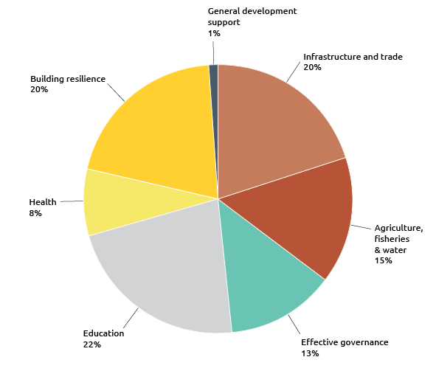

Africa, the Middle East and Other Regions

Sub-Saharan Africa is a diverse region with multiple development challenges. However, many of the key constraints to economic growth are shared across the continent, including skills shortages; poor enabling environments for business and governance; food insecurity and low agricultural productivities; humanitarian crises; gender and other inequalities. In 2016 economic growth was at its lowest in over two decades, as commodity exporters adjusted to lower commodity prices. South Africa and oil exporters account for most of the slowdown, while activity in non-resource intensive countries – agricultural exporters and commodity importers – generally remained robust.[29]

Significant development, economic and security challenges continue to exist in the Middle East. The Palestinian Territories (consisting of the West Bank and Gaza Strip) in particular is one of the poorest areas in the region. Constraints to economic development include continued conflict and instability, restrictions on the movement of goods and people, and a lack of certainty over territorial borders and natural resources such as land and water. Approximately 44 per cent of the population of the Palestinian Territories are refugees.

In 2016-17, Australian ODA to Africa, the Middle East and other regions was $340.4 million, representing 8.4 per cent of Australian ODA.

Table 6: Total ODA to Africa, Middle East and other regions, 2016-17

| Country Program | 2015–16 | 2016-17 |
| --- | --- | --- |
| ($m) | ($m) |
| Sub-Saharan Africa | 161.9 | 191.4 |
| Middle East and North Africa | 85.1 | 92.7 |
| Palestinian Territories | 43.3 | 42.7 |
| Latin America and the Caribbean | 13.3 | 13.6 |
| Total | 303.7 | 340.4 |

Figure 22: Total Australian ODA by investment priority area: Africa and the Middle East, 2016-17

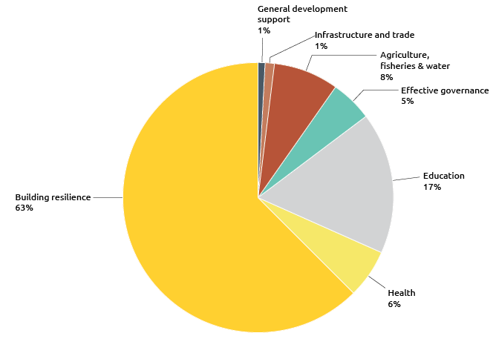

Program quality

Eighty-two per cent of South and West Asia program objectives were assessed as on track and no objectives were off track. Progress was less than expected against 18 per cent of objectives. Ninety per cent of performance benchmarks were achieved and 10 per cent of performance benchmarks were partially achieved. All four investments identified as requiring improvement in 2015-16 either improved their performance in 2016-17 or were completed. Five investments were identified as requiring improvement based on 2016-17 Aid Quality Check results and management action plans have been put in place for ongoing investments.

For Africa and the Middle East, 83 per cent of program objectives were assessed as on track. Progress was less than expected for one objective in the Sub-Saharan Africa Regional program. Sixty-four per cent of performance benchmarks were achieved and 27 per cent of performance benchmarks were partially achieved. Data was unavailable to assess performance on one (nine per cent) benchmark. No investments were identified as requiring improvement. The performance of each country against program objectives is set out below.

Figure 23: Progress against program objectives: South and West Asia, Africa and the Middle East, 2016-17

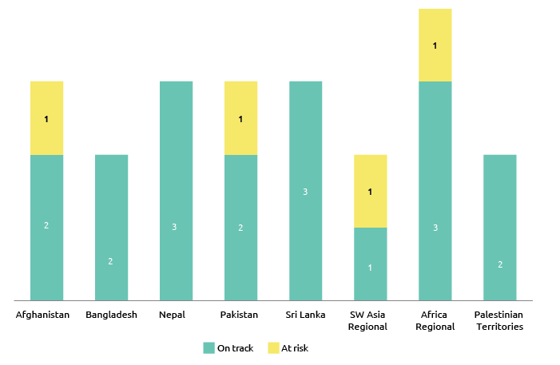

Figure 24: Progress against performance benchmarks: South and West Asia, Africa and the Middle East, 2016-17

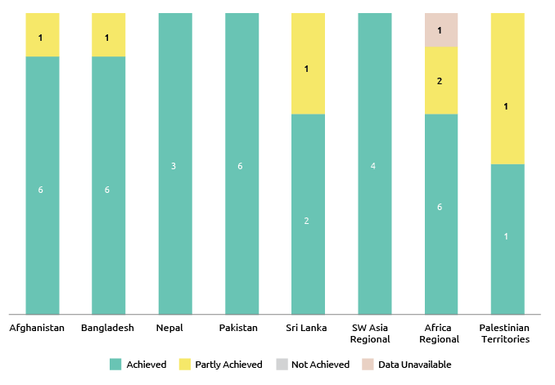

On various quality assessment criteria, Australia’s aid investments in South-West Asia performed in-line with, or fractionally lower than, the aid program as a whole (Figure 25). Performance on gender equality was assessed at 77 per cent, on par with the average across the aid program. This represents a significant achievement given the contextual challenges. For Africa and the Middle East, most investments were assessed as above the aid program average on aid quality assessment criteria reflecting that these programs consist of a small number of highly targeted investments. The exception was performance against the sustainability criterion. Programs need to continue efforts on ensuring the positive effects and impacts of their investments are ongoing to improve sustainability performance.

Figure 25: Aid investment performance: South and West Asia, Africa and the Middle East, 2016-17

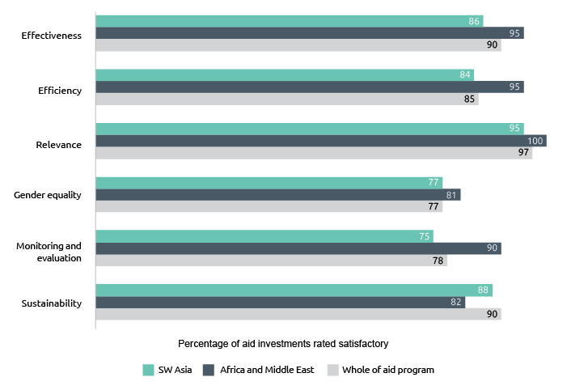

In Afghanistan, two of three program objectives were assessed as on track. These relate to empowering women and girls and building resilience and supporting at-risk populations. Progress towards supporting the Afghan Government to achieve economic growth and institute more effective and accountable governance was assessed as less than expected. Conflict in the country has had implications for Australia’s capacity to support the Afghan Government implement its state-building agenda. Government reform efforts have also been slow to establish and many large projects are in decline. Against this background, the program is limited in its ability to influence economic growth and effective governance despite achieving most performance benchmarks. In response, the program has decided to discontinue its Public Financial Management of Afghanistan investment, and has provided support to the Institute for State Effectiveness as an alternative means of supporting reform of Afghanistan’s public financial management and improving performance against this objective.

For the Bangladesh program, all objectives were assessed as on track. These relate to improving education and learning outcomes and building resilience. Support for the implementation of the Bangladesh Government’s National Security Strategy resulted in greater prioritisation of social protection by the Bangladesh Government in its annual budget. Six of seven performance benchmarks were achieved. The performance benchmark relating to number of women and their households able to access social transfers was partially achieved with 88,961 women-headed households supported to access social transfers through the Building Resources Across Communities (BRAC) and World Food Programme. This was below the target of 102,600 households due to a shortfall in entrants to a new phase of a BRAC program, with the start of a new phase and challenges with selection methodologies. These challenges with implementing a new approach are not anticipated to impact in the next reporting period.

In Nepal, all objectives were assessed as on track. These relate to expanding economic opportunities, governance and policy implementation and human development. An evaluation of the Build Back Safer Schools for All project found that it had contributed significantly to inclusive early recovery in education and in rebuilding new safer schools for all following the Nepal earthquakes in 2015.[30] Nepal’s transition to a federal structure will continue to impact on all investments. Whereas previously the program engaged with government at the central level, there will be opportunities to engage with local government in the new federal structure. Determining how best to engage with the new levels of government will continue to be a priority for the program.

In Pakistan, two of three objectives were assessed as on track. These relate to investing in people with a focus on women and girls and supporting stabilisation and resilience. An independent evaluation of the Pakistan Challenging Gender-based Violence (GBV) Program found that overall the GBV Program is progressing well against objectives with evidence of both attitudinal and behavioural change at the community level in targeted areas.[31] Progress towards the objective generating sustainable inclusive growth did not meet expectations due to performance being less than expected for an agricultural research program and a trade policy program. Remediation plans are in place to improve the performance of these two investments. The Pakistan program will continue to focus on improving gender equality performance and meeting the target of 80 per cent satisfactory gender ratings, and will build on the integration of disability inclusiveness and advocacy efforts.

For the Sri Lanka program, all three objectives were assessed as on track. These relate to economic opportunities for the poor, supporting government to be more responsive to the needs of citizens and the private sector, and increasing gender equality. An evaluation of the Community Forestry project, which supports the objective of economic opportunities for the poor, found that the project had contributed to increases in income for local poor men and women.[32] This was achieved through a combination of direct payments for labour work and diversification of household economic activities through the establishment of new micro enterprises and home gardens. Progress against the performance benchmark support government to be more responsive to the needs of citizens and the private sector was less than expected. Whilst the aid program has supported the government to respond to the needs of people and business, satisfaction ratings were mixed. In response, a revised performance benchmark better reflecting the program’s contribution has been developed to measure performance in future years.

Of the two objectives in the South Asia Regional aid program, performance against the objective of increased regional connectivity through trade facilitation and infrastructure connectivity was less than expected. Despite some good progress, implementation of the South Asia Trade Facilitation Program (SARTFP) was slower than anticipated. In response, the program will work closely with the World Bank to accelerate SARTFP activity implementation and development of pipeline activities. Progress against the objective related to increased water, food and energy security to facilitate economic growth and improve the livelihoods of the poor and vulnerable (particularly women and girls) was assessed as on track, as all performance benchmarks related to the objective were achieved. This assessment was supported by the 2016 annual review of the Sustainable Development Investment Portfolio which found that over 90 per cent of expected results were achieved or on track to being achieved.

In the Sub-Saharan Africa program, three of four objectives were assessed as on track. These relate to contributing to leadership and human capacity development, enhancing agriculture’s contribution to sustainable and inclusive economic food security, and responding appropriately to humanitarian crises. Progress against the objective empower women and girls and improve gender equality outcomes was assessed as less than expected. This was due to only partial achievement of benchmarks relating to satisfactory performance of investments against gender equality criteria and an incomplete set of gender strategies for all aid investments. In response, the program will focus on ensuring that all ongoing investments meet these benchmarks in 2017-18.

Progress in the Palestinian Territories for objectives relating to improved public financial management and a more competitive agricultural economy and access quality basic services was assessed as on track, reflecting the achievement of most performance benchmarks for a limited number of targeted investments. Progress towards the benchmark relating to education was only partially met, as the number of Grade 4 female students in UN Relief and Works Agency (UNRWA) schools performing at or above the expected level in mathematics declined by 1.1 per cent (to 34.1 per cent from a 2013 baseline of 35.2 per cent).

Chapter 3   
Global program performance

In addition to country and regional programs, Australia’s aid funding is also provided through a number of global programs. This includes core funding[33] that is provided annually to multilateral development organisations. Australia’s contributions to these organisations, together with those from other donors, allow them to leverage additional resources into the Indo-Pacific region and pursue agreed priorities at a scale that would not be possible for Australia to achieve by itself. Australia’s membership of, and contributions to, multilateral organisations allow Australia to leverage those organisations’ finances, influence, technical expertise, convening power and role in setting global policy norms and standards. This serves to extend and deepen the impact of the Australian aid program.

This chapter summarises the findings of assessments of multilateral organisations completed in 2017. Australia completes a rolling program of multilateral performance assessments for multilateral organisations receiving core development funding from the Australia Government.[34] In 2017, multilateral performance assessments were completed for the Global Environment Facility, Global Partnership on Education and the Commonwealth Secretariat These assessments confirmed these organisations are performing satisfactorily overall and their work aligns adequately with Australia’s priorities. This chapter also reports on the performance of the Australian NGO Cooperation Program.

Multilateral Performance Assessments

Global Partnership for Education

|  |
| --- |
| **Overview of performance[35]**   | Results and Impact | Adequate | Partnership Behaviour | Good | | --- | --- | --- | --- | | Relevance and Alignment | Good | Organisational Capacity | Good | | Value for Money | Adequate | Organisational Governance | Good |   **Summary of assessment**  The Global Partnership for Education (GPE) continues to perform well as a multilateral partner for Australia, demonstrating strong alignment with Australian aid policy priorities and an ongoing commitment to reform. GPE is particularly strong on collaboration, partnership behavior and stakeholder engagement. Its inclusive governance model helps ensure objectives and obligations are shared among its partners, including DFAT.  GPE’s needs-based funding model systematically gears financing allocations and activities toward the poorest (while also incentivising results, via results-based payments, and requiring an increased domestic education spend). Thirty per cent of GPE implementation grants went to the Indo-Pacific region in 2016.  Globally, the education sector continues to face challenges in sourcing data to monitor learning results. At present, it can be difficult to track, aggregate and link results directly to GPE’s work, and ensure governments have access to the data and information needed for good policy and planning. GPE is focused on filling the gaps and incentivising and supporting better data quality for developing country partners.  Australia has encouraged GPE to better institutionalise its approach to innovation, including by working with non-traditional development partners. While its overall objectives for private sector engagement are aligned with Australia’s objectives, implementing effective and strategic private sector engagement has been challenging for GPE (momentum is building among GPE’s stakeholders for this to improve).  GPE provides comparatively good value for money in Secretariat operational and management costs. Work is underway to ensure GPE’s in-country model is maximising the benefits of the partnership and delivering sustainable capacity development in-country. This includes greater differentiation in grant making requirements (based on grant size and risk), including for Pacific Island countries, which could help minimise transaction costs and help to maintain the primary focus on systems strengthening and results.  GPE’s new Financing and Funding Framework, to be rolled out from 2018, contains a series of promising new initiatives to better leverage GPE resources for education impact and fully realise its strategic vision. Australia will continue to work with GPE to ensure these and other reforms are fully operationalised. |

Global Environment Facility

|  |
| --- |
| **Overview of performance[36]**   | Results and Impact | Good | Partnership Behaviour | Adequate | | --- | --- | --- | --- | | Relevance and Alignment | Adequate | Organisational Capacity | Good | | Value for Money | Good | Organisational Governance | Good |   **Summary of assessment**  The Global Environment Facility (GEF) is a long-standing and trusted partner of the Australian Government that works to address the most challenging global environmental issues. Its current strategy (GEF 2020) shares a number of objectives with DFAT’s aid policy (Australian aid: promoting prosperity, reducing poverty, enhancing stability), including: contributing to poverty reduction and economic growth through investment in sustainable environmental management; leveraging external public and private sources of funding; and, supporting the needs of Small Island Developing States, including in the Pacific.  The MPA found that the GEF continues to deliver strong results to improve the global environment, and has been particularly effective in supporting climate change adaptation and mitigation activities. GEF has increased the number of projects covering multiple focal areas in recent years, which were found to address global environmental issues more holistically and create impact at scale.  GEF has a substantial portfolio of activities in the Indo-Pacific, and is delivering strong results in the region. In the indicative System for Transparent Allocation of Resources (STAR) allocations for GEF-6, countries in the Indo-Pacific region will receive US $918 million, or 39.3 per cent of total country allocations. GEF has a strong track-record of leveraging public and private sector resources to co-finance projects and has a co-financing ratio of 7.5 to 1 to GEF funding in GEF-6 to date. It has taken several steps to mainstream its private sector engagement in recent years, including launching a pilot program for the use of non-grant instruments.  Given the substantial progress it has made towards its targets and the Secretariat’s strong commitment to reducing management and operational costs, the GEF continues to represent value for money. The organisation has implemented initiatives in recent years to build capacities in cross-cutting areas such as results-based management, and has developed strong technical expertise across its focal areas and in its Scientific and Technical Advisory Panel (STAP). GEF is also served by a highly productive monitoring and evaluation unit – the Independent Evaluation Office (IEO).  As a large Partnership with an ambitious agenda and a wide range of different priorities, it is at times challenging for GEF to effectively reflect the priorities of all its members. The MPA found that the GEF could do more to strengthen the quality of its stakeholder engagement during the project development phase and in ongoing engagement with donor countries. The MPA also recognized the GEF’s institutional capacities could be strengthened to: promote gender equality and mainstreaming at corporate and project levels; support disability-inclusive development in its programming; analyse and improve operations in fragile states; and, enhance private sector engagement and expertise within the Secretariat. There is also scope to further align the GEF’s programming priorities with Australian aid objectives, particularly in regards to strengthening programmatic activities in the Indo-Pacific region, and enhancing complementarity and cohesion with other climate finance institutions, including the Green Climate Fund.  GEF is reviewing its policies on gender and stakeholder engagement to further strengthen its work in these priority areas. It is also working to enhance private sector engagement and expertise as a priority element of GEF-7. GEF has reaffirmed its commitment to close and continuing dialogue with Australia to achieve these goals. |

Commonwealth Secretariat

|  |
| --- |
| **Overview of performance[37]**   | Results and Impact | Adequate | Partnership Behaviour | Adequate | | --- | --- | --- | --- | | Relevance and Alignment | Adequate | Organisational Capacity | Less than Adequate | | Value for Money | Less than Adequate | Organisational Governance | Less than Adequate |   **Summary of assessment**  The Commonwealth Secretariat (ComSec) is the principal inter-governmental agency for the Commonwealth. Australia supports the Commonwealth to promote human rights, democratic norms and good governance.  The Multilateral Performance Assessment (MPA) gave ComSec ratings of 4 out of 6 on three assessment criteria: Results and Impact; Relevance and Alignment; and Partnership Behaviour; and 3 out of 6 on three criteria: Value for Money; Organisational Capacity; and Organisational Governance. Consistent with recent DFID evaluations, ComSec received an overall rating of adequate for the 2013-14 to 2016-17 period.  Three major factors affected ComSec’s ratings: ComSec is not primarily a development organisation, weakening its capacity to address some development criteria; disruption caused by leadership turnover, corporate restructure and budget cuts; and existing systemic issues that Australia expects ComSec to address in the next Strategic Plan period (2017-18 to 2020-21).  Australia will work with the UK to measure ComSec’s progress on resolving these issues – enhanced transparency; better value for money; and better results-based management and budgeting – using the performance agreement the UK concluded with ComSec in early 2017. ComSec must meet the performance criteria in the agreement to receive future tranches of DFID funding. It has so far qualified for the first three tranches of funding. Given this trajectory, and in the interests of avoiding administrative duplication and additional strain on ComSec’s resources, a separate agreement for Australian funding is not required at this stage.  Since Australia’s last major review of ComSec in 2012, the organisation has made good progress in reducing its number of ongoing projects – an important shift for the sustainability of its work program. Of the six outcomes from the 2013-14 to 2016-17 Strategic Plan – Democracy (Rule of Law); Public Institutions (Governance); Social Development; Youth; Pan-Commonwealth Development; and Development of Small and Vulnerable States – ComSec achieved the strongest results from its democracy, public institutions, youth and small states programs.  The MPA highlighted the value of ComSec’s election monitoring missions, demonstrated by an upsurge in demand, including from countries where the Commonwealth has not previously observed elections. ComSec made strong efforts to progress activities in the Indo-Pacific, including the deployment of specialised advisers to assist with legal and trade issues. ComSec continued to maintain and forge strong relationships with a range of development partners and international bodies, and to utilise its extensive networks to promote South-South and North-South cooperation. ComSec also made gains in areas such as results-based management; innovation; budget allocation and value for money mechanisms. |

Australian Non-Government Organisation Cooperation Program

The Australian Non-Government Organisation Cooperation Program (ANCP) recognises the unique strengths Australian NGOs bring to development activities and Australia’s overall efforts to reduce poverty.

Reflecting the contributions received from the Australian community, the footprint of the ANCP extends beyond the reach of Australia’s bilateral aid program. The 2015 Office of Development Effectiveness (ODE) Evaluation of the ANCP found that there is consistency between NGOs’ ANCP programming and the Australian aid program’s geographic and sectoral priorities. This continues to be the case in 2016-17.

In 2016-17, 54 Australian NGOs worked with 2,113 in-country partners to deliver 507 projects in 58 countries through the ANCP. NGOs worked in a range of sectors including education, health, water and sanitation, governance and economic development reaching 12.8 million people. Sixty-seven per cent of these projects addressed gender issues, 61 per cent of projects addressed disability inclusion and 45 per cent of projects involved engagement with the private sector. The ANCP budget allocation was $127.3 million in 2016-17, consistent with the allocation in 2015-16.

There are three interrelated outcome areas that ensure ANCP NGOs are positioned to deliver on the overarching ANCP goal: ‘through support to accredited Australian NGOs, improve the living standards and well-being of individuals and communities in developing countries.’

Outcome 1: Effective and value for money programming

Outcome 2: A diversity of NGOs draw on funding and expertise from a range of sources

Outcome 3: Effective engagement with in-country partners.

The ANCP Aid Program Performance Report assessed progress towards these three outcome areas as on track. In relation to effective and value for money programming, ANCP continues to provide value for money through the NGO match, use of local systems and capacity building of in-country staff, and effective results on the ground. ANCP NGOs must match 20 per cent or one dollar of their own funds for every five dollars that the program provides under the ANCP (1:5 match). In 2016-17, ANCP affiliated NGOs contributed $34.3 to ANCP projects, exceeding the matched funding requirement by seven per cent under this outcome area

In relation to progress towards a diversity of NGOs draw on funding and expertise from a range of sources, the flexible nature of the ANCP makes it ideal for leveraging additional funds from other sources (including international networks, donors and the private sector). In 2016-17, 379 projects (74 per cent) received funding from other sources to the value of $31.9 million.

The ANCP is continuing to work on implementing recommendations from the 2015 ODE evaluation, which included clarification of the role of DFAT Posts in the management of the program. In a November 2016 survey, 100 per cent of ANCP focal points at Posts supported the development of a policy document to guide Posts’ engagement with the program. ANCP is in the process of finalising the document and has begun informally guiding significantly increased engagement by Posts in the oversight of the ANCP.

Chapter 4   
Sector and thematic performance

This chapter brings together performance data for the six priority areas of investment under the Australian Government’s aid policy as well as disability-inclusive development.[38] In previous reports, the performance of all investment priority areas was assessed. For 2016-17, in addition to providing performance data for all areas, the Performance of Australian Aid report has focused in depth on two areas: health and governance. For these two areas, the views of DFAT’s principal specialists who oversee the portfolios has been sought. Other investment priority areas will be assessed in similar detail in subsequent reports.

Figure 26 provides a breakdown of aid investments against priority policy areas in 2016-17. When compared to 2015-16 figures, expenditure as a proportion of overall aid expenditure increased slightly for investments in infrastructure (up from 16 per cent to 17 per cent), agriculture, fisheries and water (up from eight per cent to nine per cent), and effective governance (up from 19 per cent to 20 per cent). Expenditure on effective governance captures work across a range of investments, including law and justice, anti-corruption, public financial management, leadership, and gender equality and women’s empowerment.

Expenditure in education held steady at 17 per cent. Expenditure in building resilience also remained steady at 16%. The largest difference was in health, where expenditure decreased as a proportion of the overall aid program from 14 per cent in 2015-16 to 11 per cent in 2016-17. This decrease was largely due to the changing priorities and nature of Australia’s engagement in several country programs in South-East and East Asia.

Figure 26: ODA by investment priority area, 2016-17

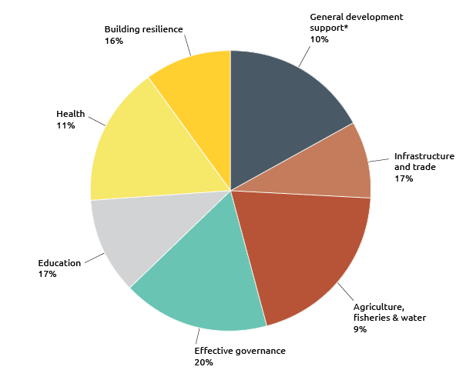

* ‘General development support’ includes action relating to debt, some research and scientific institutions and multisector development assistance that does not fall within other investment priorities.

Infrastructure, trade facilitation and international competitiveness

Australia is committed to tackling infrastructure bottlenecks to help create the right conditions for sustainable economic growth and to enhance trade and investment opportunities across the region. Investments in this sector are guided by the Strategy for Investments in Economic Infrastructure. In 2016-17, Australia invested $704 million or 17 per cent of ODA in infrastructure, trade facilitation and international competitiveness. Australia’s work is strongly aligned with the SDGs including Zero Hunger (SDG2), Affordable and Clean Energy (SDG7), Decent Work and Economic Growth (SDG8), Industry, Innovation and Infrastructure (SDG9), Sustainable Cities and Communities (SDG11), and Partnerships for the Goals (SDG17).

Figure 27: Infrastructure, trade facilitation and international competitiveness investment performance, 2016-17

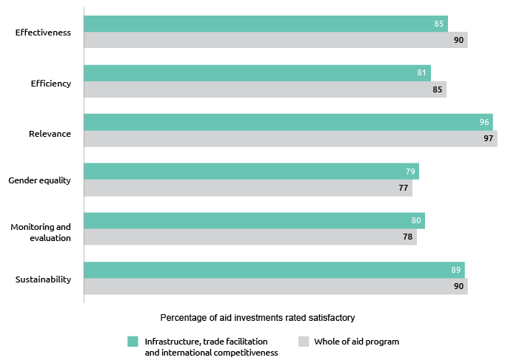

Australia’s infrastructure and trade facilitation assistance performed satisfactorily although results for effectiveness and efficiency were lower than the aid program average in 2016-17. The effectiveness result of 85 per cent was also lower than the four year average of 89 per cent. Results for gender equality improved from 76 per cent in 2015-16 to 79 per cent in 2016-17, just below the target of 80 per cent. Particular efforts were made to support analysis, design and strategy development, contributing to more effective gender integration.

Agriculture, fisheries and water

Optimising the potential of agriculture, fisheries and water for economic development, while ensuring sustainable use of resources for long-term prosperity, is one of the biggest challenges facing the Indo-Pacific. Australia is supporting agricultural productivity, sustainable fisheries management and water resource management, as well as addressing impediments that prevent producers linking effectively into domestic and international markets. Investments in this sector are guided by the Strategy for Australia’s aid investments in agriculture, fisheries and water. Australia’s investments are directly supporting several of the SDGs including No Poverty (SDG1), Zero Hunger (SDG2), Clean Water and Sanitation (SDG6), Responsible Consumption and Production (SDG12), Climate Action (SDG13), Life Below Water (SDG14), and Life on Land (SDG15). In 2016-17, Australia invested $350.3 million or nine per cent of ODA in the agriculture, fisheries and water sectors.

Figure 28: Agriculture, fisheries and water investment performance, 2016-17

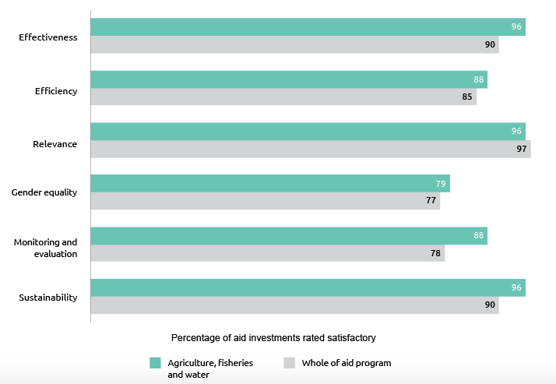

Overall, Australia’s agriculture, fisheries and water programs performed well in 2016-17. The percentage of aid investments meeting quality assessment criteria is on par with or higher than whole-of-aid program results (Figure 28). Effectiveness results improved compared to 2015-16 and exceeded the four year average of 84 per cent. Performance on gender equality improved compared to 2015-16. There is a very broad range of investments included in this investment priority area. It includes several that effectively support women’s economic empowerment and mobilise women’s leadership. However, it also includes investments that face significant challenges, such as partnering with regional and research organisations that lack gender strategies and expertise, and focusing on highly specialised agricultural research where identifying gender objectives can be difficult.

Effective governance: policies, institutions and functioning economies

In 2016-17, Australia invested $802.9 million or 20 per cent of ODA to support more effective governance in partner countries, making governance the Australian aid program’s largest sector investment. DFAT’s governance work is guided by Effective Governance: Strategy for Australia’s aid investments. Australia’s assistance has a direct impact on the SDGs Decent Work and Economic Growth (SDG8), Reduced Inequalities (SDG10), Peace, Justice and Strong Institutions (SDG16), and Partnerships for the Goals (SDG17).

Achievements in 2016-17 included:

• Providing logistics, policy and technical advice for the conduct of credible elections, including the 2017 elections in PNG

• Increasing transparency in government by supporting the implementation of freedom of information laws, including through the UN-Pacific Regional Anti-Corruption Program’s work in Vanuatu

• Conflict resolution and violence reduction through peace support programs in Myanmar, the Philippines and the Autonomous Region of Bougainville

• Providing the Government of Indonesia with research-based evidence to support better policy decision-making through the Knowledge Sector Initiative

• Contributing to global efforts to prevent the destructive and illegal trade in “conflict diamonds” through Australia’s chairmanship of the Kimberly Process in 2017.

Figure 29: Effective governance investment performance, 2016-17

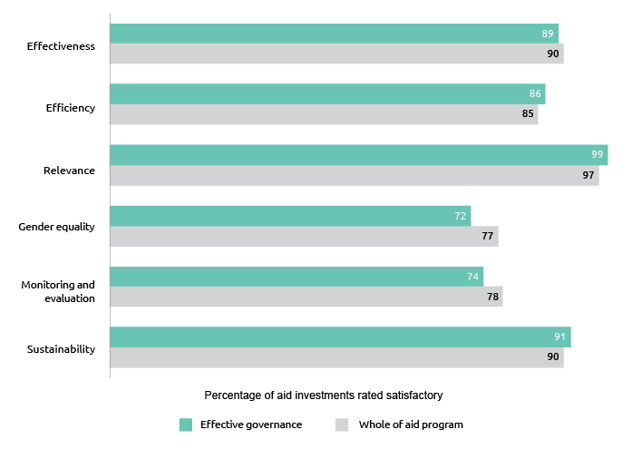

Overall, Australia’s investments in effective governance performed well in 2016-17, although results for gender equality and monitoring and evaluation were again lower than the aid program average. The effectiveness result of 89 per cent equals the four year average for this investment priority area. While law and justice investments generally did well on gender, investments working on public financial management, public sector reform, and economic governance experienced ongoing challenges in identifying and addressing gender dimensions.

A 2017 ODE evaluation of lessons from Australian electoral assistance considered 30 Australian-funded initiatives worth more than $135 million and spanning national elections in Afghanistan, Fiji, Indonesia, Myanmar, Papua New Guinea, Solomon Islands, Timor-Leste and Tonga.[39] The evaluation found that Australian assistance is well-regarded and has made a positive contribution to the quality of elections. It also identified ways in which future electoral assistance could be improved, such as by increasing attention to the wider governance and political environment in each country, longer-term planning, ensuring timely and inclusive assistance, and better harnessing Australia’s considerable expertise. DFAT is using the evaluation to inform more coordinated electoral assistance planning, strengthen guidance for program managers, and enhance cooperation with partners such as the Australian Electoral Commission.

DFAT appointed a new Principal Governance Specialist, Dr Sakuntala Akmeemana, in 2016 to oversee and guide work in the sector. Her reflections on key international developments and challenges and the performance of DFAT’s governance portfolio in 2016-17 are provided below.

|  |
| --- |
| Global trends in governance  Effective governance in our partner countries is an objective of Australia’s development assistance program and underlies its foreign policy ambitions for a secure, open and prosperous world, with a focus on the Indo-Pacific region. Indeed, over a fifth of the development assistance portfolio comprises programs aimed at improving state capability, accountability and inclusiveness – for developing and implementing policy, delivering public services, growing the economy and distributing public wealth – and changing the relationships between citizens and the state. Governance also underpins development effectiveness and programs in all other sectors, like education, health and infrastructure, and determines the extent to which they will achieve their objectives. Finally, addressing governance lies at the heart of dealing with fragility and conflict.  According to the Department’s Aid Quality Checks, governance investments have broadly plateaued in terms of effectiveness – performing just below average for the overall development assistance portfolio. Many of the best performing investments in the governance portfolio have adopted more politically informed, adaptive ways of working and demonstrating strong results. |
| Global trends, local practice  Globally, there have been fundamental shifts in thinking about governance and development over the last decade that have implications for both the areas we target in our programming and our ways of working. The good governance agenda” of the 1990s put forward a set of aspirations for how developing country institutions should look and function and a set of policy prescriptions for growth and development. Today, we have a much deeper understanding of the complexity of institutional change in our partner countries, and the centrality of power and politics in the development process. On my first day in the job, I chaired the Australian launch of the World Development Report 2017,  the World Bank’s flagship publication, which captures many of these insights. It highlights institutional change as a “long game”, a historical process that is often messy and asymmetric, and is dependent on local context. The process is incremental, with limited scope for great leaps forward, except at “critical junctures”.  Thus, our programming now has to be accompanied by a hard-nosed realism as to what may be possible and to identify and respond to transformative opportunities when they appear. The recognition that reform efforts must be driven by local constituencies raises a challenge to the international community to target policy experimentation to discover local solutions to development problems. We are making progress in incorporating a politically informed approach include locally based staff with good political intelligence, a preparedness to engage in a ‘low footprint’ manner in overtly political processes and a willingness to accept and learn from failure. Interventions need to be flexible and adapt quickly to changing dynamics.  DFAT is taking on the challenge both in the way it designs and implements development programs.  There are several programs in DFAT’s portfolio which were early examples– Coalitions for Change in the Philippines, and Vanuatu’s Governance for Growth (GfG) program ($52.3 million over 2007-16; up to $20 million 2017-21). The latter program has effectively used partnerships and informal mechanisms to support institutional and regulatory reform, central government policy and decision-making, including sensitive and contested reforms – the liberalisation of telecommunications, establishment of a utilities regulator and reform of revenue policy and administration.  A very different example is Program Peduli ($30.9 million from 2014-18), a partnership with the Government of Indonesia and civil society groups, who draw on local knowledge and networks to solve local problems in making government services and policies responsive to the needs of excluded groups. Operating in 21 provinces, it adopts an iterative approach to programming that is sensitive to the successes and failures of activities and the changing political and social context. In 2017, Peduli reached almost 8,000 marginalised people, helping more than 6,000 people receive legal identity documents in the form of marriage certificates, birth certificates and identity cards. The identity documents have enabled many of these beneficiaries to access public services and social assistance for the first time.  Another example is Program Nabilan in Timor-Leste (current phase 2018-22 $14 million), which works on reducing violence against women and girls in Timor-Leste. The Prime Minister of Timor-Leste has given his support to address this difficult issue, but it remains highly sensitive. Staff have developed an approach to policy dialogue that is informed by social and cultural sensitivities. They take a ‘low footprint’ approach, ensuring the process of changing harmful social norms is led by domestic leaders and organisations. One success has been in the adoption of judicial practices that protect victims and witnesses during trials.  Flexible investment modalities like facilities are good options for working in a more iterative and politically informed way. Facilities, when set up well, incentivise a feedback loop between learning and implementation so that the program learns and changes course to ultimately deliver better outcomes.  Increasingly, DFAT programs are introducing regular processes to consider changes in context and performance, and adjust the program accordingly. For instance, a monitoring and evaluation system assists Australia’s programs in Timor-Leste to undertake regular learning dialogues. The Coalitions for Change program uses a Partnership Strategic Panel to create a ‘learning loop’. Common to all of these processes is a willingness of staff and implementing partners to learn from experience, test their assumptions and try new strategies. However, with this opportunity come certain risks to mitigate. There is a robust internal discussion about the use of facilities, and a dialogue with managing contractors about learning on how we improve design and implementation. |
| Looking ahead  There remain opportunities to better link our governance programming to the potential development trajectories of our partners, dovetailing governance reform with domestic economic, social and political dynamics.   If local context is all important, our governance programming cannot be the same for small island states in the Pacific with small and geographically dispersed populations as they are with our populous Asian neighbours with a large urbanized middle class, strong civil society and a productivity-oriented private sector. Current analytical work suggests new models of economic development and public management in the former context. Our engagements in low income countries and lower middle income countries in the region may require addressing targeted capacity and institutional constraints when coalitions of stakeholders have strong incentives in supporting particular reforms. As countries become more capable and prosperous, and are no longer aid-dependent, there needs to be a shift to knowledge-based assistance to support reform, to help those countries make better use of their own development finance, and to think about how Australia can be a credible partner on key policy or institutional reform issues. This thinking needs to be front and centre of future integrated country strategies and Aid Investment Plans that guide choices for our development assistance.  We are also giving more attention to governance in sectoral programming, as core service delivery problems have their roots in the institutional and political economy context. We are working with colleagues in other sectors such as health (Indo-Pacific Health Security Centre), education (DFAT Education Conference) and water (Water for Women) to understand the political economy dimensions of reform in their sectors. What political and governance factors affect the delivery of public goods and services, including incentives and interests of key bureaucratic actors?   Which aspects of the policy environment hinder and enable reform?  What types of social, economic and political forces might facilitate change and what are the prospects of collective action?  Looking to the future, we need to be attuned to a shifting world order and new actors and potential partners in the development process. There are increasing concentrations of wealth, innovation, power and influence in actors which development assistance does not typically target:  cities, corporations, individuals and transnational movements.  We need to think more creatively about such engagements – for instance, the contemporary significance of cities as consequential actors on a global stage and pivotal to reaching the SDGs should not be overlooked, in a region with eight of the world’s ten mega-cities.  Finally, we need to better use our relationships with multilateral institutions and our research partnerships to tap into the vast learning that exists on governance and development.  DFAT is a major contributor to the World Bank and the Asian Development Bank, and has a wide range of research partnerships with international academic institutions that are at the forefront of knowledge about governance and development.  We need to use those partnerships more effectively to inform our aid programming and to leverage learning partnerships outside bilateral programming in order to inform our projects at critical points through the cycle. |

Education and Health

Education

Education enables development; it contributes directly to poverty reduction, economic growth, reduced inequality and enhanced stability. Australia’s investments in education enable individuals, including women and girls and people with disabilities, to gain the skills they need to obtain work or go on to further study and to lead productive lives. Australia’s approach is outlined in the Strategy for Australia’s aid investments in education 2015-20. Australian investments in education directly support SDG4 on Quality Education as well as contributing to the achievement of other SDGs, for example, Gender Equality (SDG5). In 2016-17, Australia provided $678.8 or 17 per cent of ODA to improve education outcomes.

Figure 30: Education investment performance, 2016-17

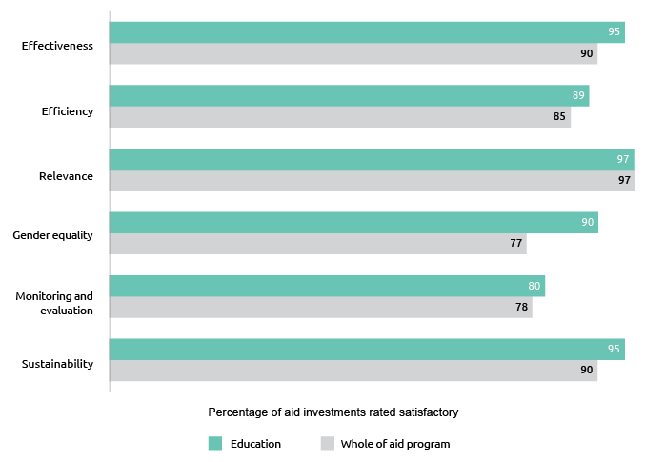

Overall, Australia’s education programs performed well in 2016-17. The percentage of aid investments meeting quality assessment criteria is on par with or higher than whole-of-aid program results (Figure 30). The effectiveness result of 95 per cent exceeds the four year average of 91 per cent for this investment priority area. Investments in education continued to perform well on gender equality and women’s empowerment. Many investments help partner governments achieve gender parity in enrolment and completion of basic education, and improve quality of education.

Health

In 2016-17, Australia invested $461.7 million or 11 per cent of ODA in health, including nutrition and water, sanitation and hygiene (WASH). Australia’s investment in health is guided by the Health for Development Strategy 2015-2020. The strategy has an overarching focus on building country-level health systems that meet immediate needs and prepare for and respond to emerging public health threats. Progress towards Universal Health Coverage and the corresponding Sustainable Development Goal 3 – Health and Wellbeing for All – are at the heart of the strategy. The strategy also recognises that good health is both an end in itself and a contributor to economic development.

In 2016-17, Australia’s health investments made a difference.  Australia committed $250 million from 2016-20 to Gavi, the vaccine alliance, and $220 million from 2017-19 to the Global Fund to fight AIDS, Tuberculosis and Malaria – the two global institutions financing the prevention and treatment of major diseases that disproportionately affect the poorest and most marginalised. In 2016, our support to the Global Fund helped to support the testing and treatment of an additional 2.3 million people for tuberculosis; the provision of antiretroviral therapy to an additional 1.8 million people; and the distribution of an additional 136 million bed nets to protect against malaria. In 2016, our assistance to Gavi helped to fund the vaccination of 62 million children worldwide, bringing the total number of children immunised with Gavi support to around 640 million. Through our role on the Global Fund Board, Australia helped ensure a strong profile of investment in the Indo-Pacific region for the 2017-19 replenishment period.

At a regional level, Australian aid is contributing to improved health security. In 2016-17, Australia provided nearly $4 million to the Medicines for Malaria Venture (MMV) and the Menzies School of Health Research to develop new drugs to fight malaria in the region. Through the work of MMV, the first new drug in more than 60 years to combat relapsing malaria (Plasmodium vivax) is on track to be registered by the Australian Therapeutic Goods Administration. To support the roll out of this new drug across the Indo-Pacific region, the Menzies School of Health Research and partners are progressing a new point-of-care diagnostic device to test for relapsing malaria. These new technologies have the potential to radically reduce the prevalence of malaria in our region.  Australian expertise is at the heart of these achievements with the MMV contributing almost $33 million to Australia-based malaria research between 1999 and 2016.

| A long term commitment to regional health security |
| --- |
| The Australian Government spent around $194 million between 2006 and 2015 helping countries in Asia and the Pacific combat emerging infectious diseases (EIDs) such as avian influenza, swine flu and rabies. A 2017 ODE evaluation of this work found that Australia has contributed to substantial improvements in surveillance and in the availability, timeliness and sharing of data on emerging infectious diseases across the region.[40] Whilst progress in addressing the human health risks posed by animals was more modest, Australian support did establish a regional disease control model for foot and mouth disease in South-East Asia. Lessons from these investments over this period have informed the development of the new $300 million Health Security Initiative for the Indo-Pacific region announced by the Foreign Minister in October 2017. |

The aid program supported the delivery of a range of essential health services in partner countries. In Cambodia, an innovative approach to contraceptive promotion for female garment factory workers (the initiative is known as “Chat!”) has successfully empowered women to prevent unplanned pregnancies. Chat! has more than doubled the rate of contraception use (from a baseline of 24.2% to 48%) and the use of reproductive health services (from 8.6% to 20%). In Pakistan, 129,558 eligible women and children in target districts received nutrition related services, well above the target of 77,970. This figure includes 39,723 women, 8,695 adolescent girls and 81,140 children including 40,613 boys and 40,527 girls. In Indonesia, through a range of Australian supported programs, 2.1 million women and children accessed health services helping 58,000 children reach a healthy weight.

Figure 31: Health investment performance, 2016-17

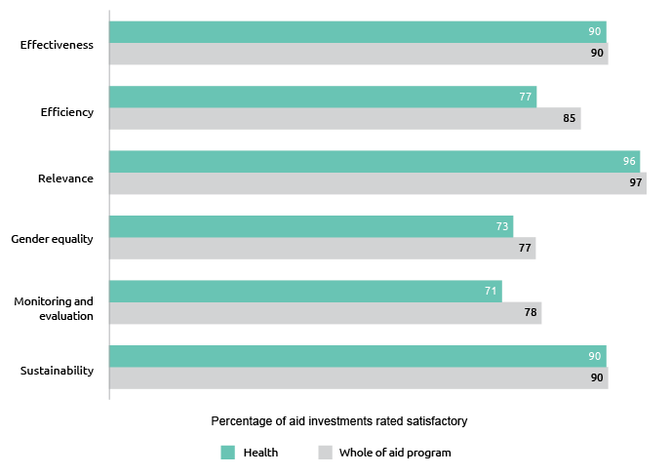

The percentage of aid investments meeting quality assessment criteria is on par with whole-of-aid program results for effectiveness and sustainability but lower on efficiency, monitoring and evaluation, and gender. (Figure 31). Overall, there was an increase in the assessed effectiveness and sustainability of Australian health investments from 2015-16. Improved sustainability is evidenced through the increased funding from partner governments for core health priorities. For example, in the Pacific, the Governments of Solomon Islands and Tonga both met or exceeded their health financing commitments. Efficiency results reflect variable capacity in partner governments leading to some implementation delays. In some Pacific programs, progress against health sector objectives fell short of expectations (PNG, Nauru, Samoa, Tonga, and Vanuatu) despite, in some cases, effective performance at the investment level (Samoa and Tonga).

Performance on gender equality declined below 80 per cent for the first time. Although many investments continue to help public health systems deliver services to women and girls, it has been difficult to address gender equality dimensions directly in areas such as health sector strengthening and health security. Strengthening monitoring and evaluation frameworks remains a priority.

DFAT appointed a new Principal Health Specialist, Dr Stephanie Williams, in May 2017 to oversee and guide work in the sector. Her reflections on key international developments and challenges and the performance of DFAT’s health portfolio in 2016-17 are provided below.

|  |
| --- |
| Global trends in health |
| Infectious diseases remain front and centre in global health. In 2016-17 outbreaks of Ebola, Marburg, pneumonic plague, cholera, and Zika reminded us of the importance of surveillance and response, emergency preparedness and public health leadership. The focus on health security has brought new resources, alliances and political will to outbreak planning and response – including Australia’s $300m Indo-Pacific Health Security Initiative. Antimicrobial resistance (AMR) – which could cause 10 million deaths a year by 2050 – has remained on the G2O and World Health Organization agendas, and is now the focus of a UN Interagency Coordination Group for AMR. Progress has stalled in malaria control and elimination[41], and is glacial against tuberculosis.[42] Closer to home, drug resistant tuberculosis remains prevalent in Papua New Guinea, while drug resistant malaria in the Greater Mekong Sub region threatens a resurgence of what was once the world’s biggest killer. |
| Universal health coverage (UHC) is a second notable global health ambition, championed by the WHO and reflected in the Sustainable Development Goals (SDGs). Country progress toward UHC requires domestic political support for health financing as well as service provision reforms. Several countries in the Indo-Pacific region have increased coverage of health services for poor and vulnerable populations, but out-of-pocket expenditures remain high, deterring health care access, and causing catastrophic health expenditures for individual and families.[43] Such health costs hinder inclusive growth, including in upper middle and middle income countries. A push toward UHC happens at a time when global development assistance for health is plateauing and in countries in our region declining. This decline is often faster than countries can mobilise increased domestic resources for health. One important consequence is a rise in out-of-pocket financing for health – felt most by the people least able to pay – as 70% of the world’s poor who live in middle-income-countries shoulder the burden of a premature transition from development assistance in health. |
| We also see continuation of a decades-long focus on “disease specific” efforts. Substantially more funding is earmarked for individual diseases or specific themes (e.g. maternal and child health, HIV/AIDS) than is channeled to broader health sector support.[44] Most philanthropic and key global funds are targeting specific diseases for reduction or elimination, and are introducing new technologies and performance incentives. Recent analysis of the financing flows of the ‘big four’ global health agencies – Gavi, the World Bank, the Global Fund and WHO – shows more discretionary funding and a reduction in more predictable core or longer-term funding; more defined multi-stakeholder governance rather than traditional government-centred representation and decision-making; and more money and initiatives for specific health issues rather than broader health systems.[45] |
| The 2017 Foreign Policy White Paper is informed by and acknowledges these trends in health for development. It recognises the importance of good health and strong and resilient health systems to support productive societies and economic growth, and also recognises that global cooperation is essential to guard against global health risks. If we are to implement the White Paper and meet the health-related SDGs, we need to actively manage the tension between support for health |
| systems and support for single health issues, such as diseases. Of course, we are one part of a global effort: USD37 billion is spent every year in development assistance for health, with Australia’s annual health spend being $460 million. |
| Challenges for the year ahead |
| Country ownership must remain at the forefront of health system development, and this requires a sustained commitment to country-led health system strengthening. Competing budgetary pressures have made this challenging, but we have a strong base and good track record especially in long running health programs in the Pacific. |
| Strong country ownership, however, is not sufficient to deliver global public goods in health such as epidemic and pandemic preparedness that reduce the risk of diseases crossing borders. The Indo-Pacific Health Security Initiative has been designed to generate precisely this targeted action across the region. The challenge is to deliver on the ambitious strategy, and find the intersections between country-led and vertical approaches in health security. Planned high-level scoping missions to understand country priorities, and develop strategic responses building on Australia’s institutional strengths, will provide a useful start. Follow-up efforts are also needed to combine forces with the other major actors in regional health security, including the multilateral institutions and the US government. |
| Beyond the new Health Security Initiative, we need to give more attention to the performance and flexibility of the multilateral institutions, including on specific health investments with development banks. We should remain clear eyed about the variable performance of multilateral institutions in health. The Health Equity Fund has performed strongly in Cambodia, while the regional (Greater Mekong Subregion) malaria elimination trust fund has room to improve. While the reasons are varied – and not always within the aid program’s control – health investments with multilateral banks can require significant resources, including our own staff time, to make them successful. |
| We will need to continue to use the aid program’s representation and influence in global health policy forums to benefit the region. Australia’s role on the Board of the Global Fund for AIDS, tuberculosis and malaria has helped ensure a strong profile of investment in the IndoPacific for the 2017-19 replenishment. Australia secured a new catalytic investment fund under the Fund that has increased the resources available to address drug resistant malaria and tuberculosis, and contributes to broader regional health security efforts. In 2016-17 we also championed, through the Gavi Board, tailored country support to help countries make the transition from Gavi funding towards fully self-financed vaccine programs. Looking forward, we will need to continue our advocacy for fair and sustainable transitions for countries in our region. |
| Finally, there is scope to better incorporate political economy considerations in health. Health is influenced by political, economic and social factors. In the past we have been comfortable with a narrow focus on technical outcome measures, such as counting health service utilisation, immunising kids and supervising births. These are essential, but our health investments must afford equal importance to addressing the political economy of health – understanding incentives, building institutions, and enabling leadership. Nowhere is this more important than in Papua New Guinea where there remain challenges in achieving results in the PNG health sector linked to our decades-long health program. While some service delivery and capacity substitution seems necessary, we now need to change ‘how’ we support the PNG health sector, cultivate PNG ownership and accountability, and work politically – addressing relevant factors outside the health system. As we do this, in PNG and across our country health programs, we will increase our chances of lasting and positive impact. |

Building resilience: humanitarian assistance, disaster risk reduction and social protection

In 2016-17, Australia provided $628.6 million or 16 per cent of ODA in humanitarian assistance, disaster risk reduction, social protection and climate change investments. Australian investments in these areas save lives, limit economic and development losses from natural and human-induced crises and reduce communities’ vulnerability to crises. Australia’s investments deliver outcomes in support of a number of Sustainable Development Goals (SDG), including those relating to No Poverty (SDG1), Zero Hunger (SDG2), Good Health and Well-Being (SDG3), Reduced Inequalities (SDG10), Sustainable Cities and Communities (SDG11), and Climate Action (SDG13). Through these investments, Australia is also meeting its commitments made under the Sendai Framework for Disaster Risk Reduction 2015-2030, the Agenda for Humanity (2016) and the ‘Grand Bargain’ (2016) to improve effectiveness and efficiency of humanitarian action. Australia responded to more than 20 humanitarian crises, providing life-saving assistance to 4,266,970 affected people.

Overall, Australia’s building resilience investments performed well in 2016-17. The percentage of aid investments meeting quality assessment criteria was higher than whole-of-aid program results for efficiency, equal for monitoring and evaluation and slightly below for effectiveness (Figure 32). Performance against the gender equality and empowering women criteria was disappointing. Australia has worked with partners and staff involved in humanitarian action to build gender capacity. Evidence of the benefits of these efforts, including the provision of sex-disaggregated data reporting, will take some time to become visible and support higher gender ratings. All humanitarian response investments were assessed as satisfactory or above against the humanitarian “Protection” criterion, i.e. the extent to which investments protect the safety, dignity and rights of affected people.

Figure 32: Building resilience investment performance, 2016-17

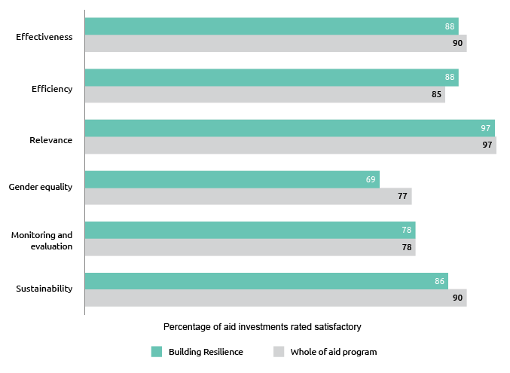

Disability-inclusive Development

The Australian aid program has had strategies to support disability-inclusive development since 2009. The ‘Development for All’ strategies have aimed to improve the lives of people with disabilities by making Australian development assistance more disability-inclusive and having broader impacts through advocacy work. Advocacy to shape the policies and programs of bilateral, multilateral and other development agencies has the potential to deliver exponential benefits for people living with disability above and beyond what can be achieved by Australian development assistance.

An ODE evaluation of the effectiveness and credibility of DFAT’s global advocacy for disability-inclusive development was completed in 2017.[46] It focused on advocacy work that has been the most significant, in terms of effort and funding:

• Advocacy in global policy processes

• Building the capacity of other advocates

• Improving data collection on disability

• Influencing partner agencies; and

• Building and working in coalitions.

The evaluation found that Australia is seen and valued as a leader in disability inclusion in the development process. Recent major global policy frameworks especially the World Humanitarian Summit outcome and the post 2030 Sustainable Development Goals have seen unprecedented recognition and inclusion of the needs of people with disability due in no small part to DFAT’s advocacy.  A hallmark of DFAT’s success has been the way it has modelled the principle ‘Nothing about us without us.’ DFAT’s support has helped build the capacity of Disabled Persons Organisations and facilitated their involvement in major policy and reform processes.

Annex A: Official Development Assistance delivered by other government agencies[47]

The Treasury

(ODA expenditure $207.3 million)

Treasury supported international financial institutions that make significant contributions to development outcomes. This included payments of previously agreed capital increases to the International Bank for Reconstruction and Development and to the Asian Development Bank (ADB), as well as contributions to the World Bank’s Global Infrastructure Facility and the ADB’s Asia Pacific Project Preparation Facility.

A range of agencies in the Treasury portfolio assisted in training officials and regulators in partner countries. These agencies include the Australian Securities and Investments Commission, the Australian Competition and Consumer Commission, and the Australian Bureau of Statistics.

Australian Centre for International Agricultural Research

(ODA expenditure $103 million)

As Australia’s specialist agricultural research-for-development agency, ACIAR actively contributed to the overall aid objectives by improving the productivity and profitability of agricultural systems in countries of the Indo–Pacific region. ACIAR supported economic and public diplomacy through improving agricultural competitiveness and sustainability, increasing value chain efficiency and effectiveness, alleviating regulatory impediments in relation to domestic and international markets and capacity building. ACIAR managed research partnerships in the areas of crops, livestock, fisheries, natural resources, forestry, and socioeconomics and policy which generated new technologies and systems, innovation at the farm level, and greater capabilities in research and production.

A number of examples highlight ACIAR’s contribution. In Vanuatu, researchers pinpointed substantial areas of underutilised land where, with support, agroforestry could succeed. In Fiji, Kiribati and Samoa, ACIAR research has helped to diversity seaweed industries. Cultured pearls are the Pacific region’s most valuable and highest priority aquaculture commodity. Pearl culture is compatible with traditional lifestyles and provides several opportunities for generating income. Research on pearl oyster mortality, and establishment of a giant clam hatchery, have helped Fiji to recover from the ravages of Cyclone Winston. Smallholder farming families are the backbone of food production in PNG. To provide support to these families through transition from subsistence practices into the cash economy, ACIAR has funded a Family Teams program, which has shown that men, women and youth working together as a family unit leads to more gender-equitable and effective farming practices, and these in turn result in improved family livelihoods. Galip nut is a marketable product with strong consumer demand and acceptance in PNG. ACIAR funding is helping to expand the domestic market, with the promise of also developing an export market.

Onions are one of the most important and profitable crops that smallholders can grow in Indonesia, but farmers risk harming themselves and their environment through excessive use of agri-chemicals. A clean seed system for onions grown in Java is leading to healthier, more productive onions. In the Philippines, smallholder farmers are learning how to reduce the impact of the highly destructive Fusarium wilt TR4 on banana yields by adopting disease control practices introduced through an ACIAR funded project. An ACIAR funded agroforestry project in north-western Vietnam is improving the livelihoods of smallholder farmers through higher income from produce, more fodder for livestock and better management resulting in less soil erosion. Also in north-west Vietnam, ACIAR projects are working with ethnic minorities including the Hmong people to improve the production and marketing of traditional green leafy vegetables, targeting the Hanoi market. Farmers (led by women) are now enjoying substantially better livelihoods, enabling them to send their children to school and university.

Australian Federal Police

(ODA expenditure $77.5 million)

The Australian Federal Police (AFP) is the primary and preferred law enforcement partner for a number of countries in the Indo-Pacific region. During 2016-2017, AFP support for effective policing services in the region primarily contributed to the aid program investment priorities of:

• effective governance: policies, institutions and functioning economies; and

• gender equality and empowering women and girls.

AFP supported the Policia Nacional de Timor-Leste (PNTL) to provide effective frontline services during election processes. External security observers noted the PNTL ‘demonstrated its capacity to provide security for communities across Timor-Leste... the election saw no major security incidents or disturbances to the peace. This is due to an increase in the professionalism and capacity of the PNTL.’ AFP support for the Royal Solomon Islands Police Force started transitioning from the Regional Assistance Mission to the Solomon Islands to a smaller and more targeted Solomon Islands Police Development Program (SIPDP). SIPDP focuses on community-level service delivery, as well as institutional capability. In Papua New Guinea the AFP prioritised supporting the Royal Papua New Guinea Constabulary (RPNGC) to develop critical police capabilities ahead of APEC 2018.

Regionally, the AFP continued to work in partnership with the Fiji Women’s Crisis Centre (FWCC) to deliver gender and human rights training to police officers. During 2016-2017, the AFP complemented investments in middle and junior officers with a focus on police leaders. The AFP and FWCC worked with police leaders to identify where they could positively influence gender equality within their organisations. Ongoing AFP capacity development support for Pacific Transnational Crime Units (TCUs) also led to an increase in our partner’s ability to contribute to regional disruptions. For example, 1.4 tonnes of cocaine was seized off the Australian coast in February 2017 as a result of a two year investigation that Pacific TCUs actively contributed to.

Department of Health

(ODA expenditure $11.2 million)

The Department of Health’s contribution to official development assistance is primarily made through its assessed contribution to the World Health Organization (WHO). This enables Australia to participate in the World Health Assembly and technical fora and shape regional and global health priorities.

Department of Jobs and Small Business

(ODA expenditure $8.4 million)

The Department of Jobs and Small Business provides an annual contribution to the International Labour Organization (ILO), a tripartite UN agency that sets labour standards, develops policies and devises programmes promoting decent work for all women and men. Additional funding in 2016-17 was provided to the ILO to prepare a research report and host a regional conference on the subject of Women and the Future of Work in Asia and the Pacific. Through this project, a detailed analysis will be conducted of the tools and policies needed to ensure women’s labour rights are upheld and they have access to an equal share of the region’s vast economic potential.

The Department also continued its delivery of the Seasonal Worker Programme, which contributes to the economic development of participating Pacific Island countries and Timor-Leste by providing opportunities for citizens of these countries to undertake seasonal work in Australia when demand cannot be satisfied locally. The program is a sustainable and direct way of delivering aid to disadvantaged countries in the region. Funding under this activity represents the Australian Fair Work Ombudsman’s efforts in monitoring the work standards of workers.

Department of Agriculture and Water Resources

(ODA expenditure $7 million)

The Department of Agriculture and Water Resources provides Australia’s annual contribution to the United Nations Food and Agriculture Organization (FAO), part of which is ODA. The FAO seeks to raise levels of nutrition, improve agricultural productivity and food security, enable agricultural trade, better the lives of rural populations and contribute to the growth of the world economy. Australia, along with New Zealand, co-chairs the FAO South-West Pacific region. Australia works to ensure that the benefits of FAO membership such as agricultural, fisheries and forestry skills and knowledge sharing flow to Pacific Island countries.

Department of Immigration and Border Protection

(ODA expenditure $3 million)

The Department of Immigration and Border Protection funded a range of activities in 2016-17 to strengthen the migration and border management capabilities of international partners in the Asia-Pacific, Middle East and Africa. Activities included supporting the voluntary return of displaced migrants, and providing care and management services to displaced populations. Activities were delivered directly by Immigration and Border Protection and through funding arrangements with nongovernment organisations and multilateral bodies.

The activities in 2016-17 included: core funding provided to the International Organization for Migration; funding to deliver support for return and reintegration assistance to approximately 10,000 refugees and displaced Afghan people returning to Afghanistan from neighbouring countries through the United Nations High Commissioner for Refugees; and emergency assistance to over 230,000 Syrian refugees in Jordan.

Attorney-General’s Department

(ODA expenditure $1.7 million)

The Attorney-General’s Department (AGD) worked with Pacific Island countries to improve capacity and technical expertise in law and justice agencies and to improve Pacific crime and policing legal frameworks and their implementation, including on forensics, policing, sex offences and cybercrime. AGD supported work through the Pacific Island Law Officers’ Network to address family and sexual violence, environmental crime and corruption and cybercrime, including a regional workshop on the use of electronic evidence. AGD delivered training and mentoring to build law reform capacity in Pacific Island countries’ law and justice agencies including through its Pacific Policy Champions and the Pacific Legal Policy Twinning Programs.

Department of Communications and the Arts

(ODA expenditure $1.1 million)

The Department of Communications and the Arts provides ODA to the International Telecommunication Union (ITU), the United Nations specialised agency responsible for international cooperation in the use of telecommunications and the radiofrequency spectrum. This ODA supports the ITU in its efforts to facilitate and enhance telecommunication and ICT development by offering, organizing and coordinating technical cooperation and assistance activities. A portion of the ODA we provide to the ITU is earmarked for technical assistance and capacity building activities in the Asia-Pacific region.

Annex B: Assessment by Independent Evaluation Committee and the Office of Development Effectiveness

Foreword by Jim Adams, Chair of DFAT’s Independent Evaluation Committee

I commend DFAT for delivering its fourth annual Performance of Australian Aid report (PAA). The report reflects the department’s systematic monitoring of the performance of the DFAT component of Australia’s Overseas Development Assistance in 2016-17. Combined with the substantial body of other performance data on DFAT’s website, the PAA manifests Australia’s commitment and responsibility to track whether money is being spent in line with the Government policy objectives, is being managed well, and is producing value-for-money and results on the ground.

This Annex fulfills the responsibility of the Independent Evaluation Committee (IEC) and Office of Development Effectiveness (ODE) to review the performance statements in this PAA for appropriateness and accuracy.

Overall, the 2016-17 PAA presents a fair assessment of DFAT aid performance. It appropriately emphasises the Australian aid program’s achievements throughout 2016-17, and reflects on key challenges. A mix of qualitative and quantitative data – generated by credible aid management systems – tells a cohesive performance story. It also draws on strategic and program evaluations of aid investments, consistent with the new aid evaluation policy which was introduced in 2016-17. I view the system as durable and fit-for purpose. This is echoed in the recent 2018 OECD/DAC Peer Review of the Australian Aid program, which refers to DFAT having a clearly articulated and comprehensive performance framework that examines performance at the strategic, program and individual investment levels (OECD, 2018).[48]

The IEC was pleased to see improvements in the quality and robustness of the performance assessments generated by the performance system in 2016-17, and in the previously low publication rate of evaluations from country and sectoral program areas. In the previous two years, the Committee had expressed concerns about these issues. As the following ODE statement shows, 2016-17 saw welcome progress in both these important areas. There is however, room for improvement, particularly in relation to how country programs articulate and report against overarching objectives.

By the end of 2016-17, nine of the Government’s ten strategic targets for the aid program had been achieved. These targets have been a useful means to drive institutional focus on development priorities, but now need to be revisited to ensure DFAT remains focused on relevant challenges. In this context, the IEC notes that a review of targets is being undertaken following the release of the Foreign Policy White Paper. Recognising that the existing strategic target relating to empowering women and girls has not yet been achieved, it will be important to maintain focus on and improve efforts to address gender issues in aid investments. The IEC would also like to see a stronger, more sophisticated conceptualization of value-for-money than the targets currently reflect.

The Committee also notes that aid investment performance is stronger in some regions and sectors than in others. This PAA has found that compared to other regions, progress against program objectives is not as strong in the Pacific, and that the performance of health investments is not as strong as for the aid program as a whole. Looking ahead, there will be opportunities for lessons from DFAT’s aid performance systems to inform how programs can be strengthened in these areas.

In conclusion, the prospect of a reset of strategic targets, combined with the application of the new Aid Evaluation Policy – which has already resulted in improvements in evaluation publication rates – presents an opportunity to further develop a culture of rigorous assessment, evidence-informed policymaking and commitment to transparency. The IEC looks forward to its continued role as an independent contributor to this.

Jim Adams   
Chair   
Independent Evaluation Committee

Statement by the Office of Development Effectiveness

The following assessment fulfils the role of the Office of Development Effectiveness (ODE), under the supervision of DFAT’s Independent Evaluation Committee (IEC), to review the appropriateness and accuracy of the performance statements in the 2016-17 Performance of Australian Aid report (PAA).

Overall, the PAA is a well-structured and cohesive document that draws on a substantial body of performance data to present a considered and frank statement about the performance of the Australian aid program. ODE recognizes the demonstrated commitment to a balanced presentation of the strengths and achievements of the Australian aid program in 2016-17, including areas in which progress has been less than aimed for and why. Importantly, the document also provides some examples of planned actions to improve performance. Efforts have been made this year to reduce the length of report with a view to improving its accessibility. This has in part been achieved through directing readers to details available in other DFAT publications. This is a sensible approach.

The performance assessments in the PAA are enabled by DFAT’s strong aid management policies. These policies articulate a system of regular performance assessments – largely peer reviewed self-assessments – that generate critical data, focus staff on core enablers of effective aid, and facilitate identification and management of challenges. The PAA also benefits from DFAT’s new evaluation policy introduced in 2016-17. Under this policy DFAT prepares and publishes an annual Aid Evaluation Plan. Further, to promote evaluation use and transparency, DFAT publishes management responses to all evaluations. Together with the oversight and quality assurance functions of ODE and the IEC, ODE considers these policies and processes to be comprehensive. The recent peer review of the Australian aid program by the OECD’s Development Assistance Committee reinforces this view, noting that DFAT’s “…aggregated reporting system is well oriented to ensure that performance information is used for overall direction, communications and accountability…” and that “…DFAT has a strong, independent evaluation system”. [49]

DFAT’s aid performance management system is built on two key mechanisms: Aid Quality Checks (AQCs) and Aid Program Performance Reports (APPRs). As detailed in the PAA, the 376 AQCs and 26 APPRs completed in 2016-17 represented 100% compliance with departmental requirements. These high compliance results are consistent with previous years’ results, and demonstrate the department’s investment in systematic oversight and assessment of the effectiveness of DFAT’s aid program.

As in previous years, this ODE/IEC assessment of the PAA is largely based on our quality assurance of the AQC and APPR data that informs the PAA. As a secondary source of data, we also draw on the work that ODE does through its independent evaluations, which assess Australian aid in the context of specific policy directions or development themes. A full description of the nature and scope of our assessment, as well as the ODE evaluations published in 2017, is provided below.

Since 2008, ODE has carried out a spot-check of a sample of AQC reports to determine whether the AQC ratings provide a robust assessment of aid quality.[50] ODE’s quality assurance of a statistically significant sample of 2016-17 AQC reports (96 in total) found that across the six AQC quality criteria, an average of 81 per cent of ratings were robust. Importantly, ODE found that overall AQC report quality improved significantly between 2016 and 2017, particularly in the use and quality of the evidence used to justify scores. This is welcome given the concerns ODE and IEC expressed in last year’s PAA response about a decline in how well evidence was used to justify performance claims.

Along with these improvements, ODE’s quality assurance also highlighted some ongoing weaknesses. In particular, the quality of aid investment monitoring and evaluation (M&E) systems remain stubbornly difficult to improve. In keeping with past years, in 2016-17 AQC scores on the M&E quality criteria were low compared to most other criteria. Our analysis also found that M&E scores were the least robust of all criteria, suggesting that an already relatively low aggregate score could in fact be lower. ODE remains concerned about staff capacity to recognise and reflect on what constitutes good quality M&E, as well as to work effectively with delivery partners to improve the quality of these systems. ODE is undertaking a detailed evaluation of project-level M&E systems in a bid to improve understanding of these issues, and to try and make inroads to improve this long-standing problem – a problem which is common among development agencies that take performance assessment seriously.[51]

ODE also undertook a quality review of a sample of APPRs from 2016-17, which covered the 12 largest country programs with annual aid budgets greater than $50 million. Preliminary findings of this review[52] suggest that the overall quality of APPRs has risen compared to 2015–16, and that aid performance reporting is becoming more clearly linked to management decision making. In particular, more APPRs are presenting a sound evidence base on which to demonstrate effectiveness – for example, by drawing on evaluation and review findings. ODE also found that the APPR quality of the two largest programs (Papua New Guinea and Indonesia) has improved.

However, ODE remains concerned that some programs still need to establish clearer strategic aid objectives and targets, and report more rigorously on whether expected progress has been achieved. This is particularly important given that Aid Investment Plans are now at their halfway point or near completion.

Taken together, and fully acknowledging the ongoing need to focus on areas of weakness, these findings give confidence that the performance assessments in the PAA that draw on AQC and APPR assessments are sound.

Evaluations of the aid program also make a valuable contribution to the department’s evidence base, and accountability claims. ODE and IEC had expressed concern over a number of years about the low publication rates of aid evaluations and their influence on management decisions. The DFAT Executive responded to this issue with a new Aid Evaluation Policy, which sought to improve the quality and publication rate of aid evaluations. This policy was released by the DFAT Secretary and endorsed by the IEC.[53] It has now been in place for a year and there are grounds for optimism about its impact. As part of the new policy, the first department-wide Aid Evaluation plan was published on the DFAT website in January 2017 which outlined the evaluations DFAT undertook to complete that year.[54] By the end of 2017 a 95% completion rate was achieved for publications against the plan[55], which is a big gain on the previous publication rate of 33 per cent. This represents a step-change improvement, from transparency, accountability and operational perspectives. ODE hopes that commensurate improvements in evaluation quality and utility accompany this much improved publication rate, and will complete a comprehensive review of evaluation quality later this year, to monitor and encourage this.

As always, there is more work to be done. While the 2018 OECD peer review praised Australia’s aid performance architecture, it also highlighted the need to better utilize the evidence that is generated by these systems. This points to the need to keep strengthening the accessibility of evidence, staff capability and willingness to systematically use it, and efforts by senior management to model and promote its value.

Nature and scope of ODE/IEC assurance

Australia’s aid performance management policy, Making Performance Count, gives ODE the task of quality assuring and verifying the performance assessments made in annual Performance of Australian Aid reports. This approach meets the Public Governance, Performance and Accountability Act 2013 (PGPA Act) Rule section 17, which requires that Commonwealth entities’ audit committees review the appropriateness and accuracy of entity performance reporting. In the case of reporting on the performance of Official Development Assistance administered by DFAT, this function is undertaken by ODE in consultation with the DFAT Audit and Risk committee.

In line with modern management practice, ODE’s approach to this quality assurance role is risk based.

Our procedures include, but are not limited to:

• Assessment of the robustness of ratings within a statistically significant sample of 96 AQC reports (26 per cent of the population of AQCs submitted in 2017)

• Detailed assessment of the quality of all 26 country and regional program APPRs completed in 2017, covering the 2015-16 financial year

• Completion of in-depth evaluations of aspects of the Australian aid program (six in 2017).

Consequently, ODE does not check or verify the accuracy of every figure and every statement in the PAA. In particular, our approach does not allow us to attest to the accuracy of:

• Financial information and the quality or effectiveness of fraud and anti-corruption strategies

• Multilateral Performance Assessments and Partner Performance Assessments

• Estimates of aggregate development results

• Estimates of the extent or quality of private sector engagement, including performance under target 2

• Performance statements covering ODA appropriated to other agencies.

ODE Evaluations Published in 2017

1. Humanitarian Assistance in the Pacific: The Effectiveness of Australia’s Response to Cyclone Pam (February)

<http://dfat.gov.au/aid/how-we-measure-performance/ode/other-work/Pages/evaluation-of-effectiveness-australias-response-cyclone-pam.aspx>

2. Investing in roads: Lessons from the Eastern Indonesia National Roads Improvement Program (March)

<http://dfat.gov.au/aid/how-we-measure-performance/ode/other-work/Pages/investing-in-roads-lessons-from-eastern-indonesia-national-roads-improvement-program.aspx>

3. Combatting Pandemics & Emerging Infectious Diseases (August)

<http://dfat.gov.au/aid/how-we-measure-performance/ode/strategic-evaluations/Pages/pandemics-and-emerging-infectious-diseases.aspx>

4. Cambodia Agricultural Value Chain (CAVAC) Phase One evaluation (December)

<http://dfat.gov.au/aid/how-we-measure-performance/ode/strategic-evaluations/Pages/cambodia-agricultural-value-chain-cavac-phase-one-evaluation.aspx>

5. Making it count: Lessons from Australian electoral assistance 2006–16 (December)

<http://dfat.gov.au/aid/how-we-measure-performance/ode/strategic-evaluations/Pages/making-it-count-lessons-from-australian-electoral-assistance-2006-16.aspx>

6. Unfinished business: Evaluation of Australian advocacy for disability-inclusive development (December)

<http://dfat.gov.au/aid/how-we-measure-performance/ode/strategic-evaluations/Pages/unfinished-business.aspx>

List of acronyms and abbreviations

ACIAR Australian Centre for International Agricultural Research

ADB Asian Development Bank

AEP Australian-Indonesia Education Partnership

AFP Australian Federal Police

AGD Attorney-General’s Department

AIPEG Australia Indonesia Partnership for Economic Governance

AMR Antimicrobial Resistance

ANCP Australian NGO Cooperation Program

APEC Asia-Pacific Economic Cooperation

APPR Aid Program Performance Report

AQC Aid Quality Check

ASEAN Association of Southeast Asian Nations

BEQUAL Basic Education Quality and Access in Laos

BRAC Building Resources Across Communities (Bangladesh-based development organisation)

CAVAC Cambodia Agricultural Value Chain

DAC Development Assistance Committee

DFID Department for International Development (UK)

DIBP Department of Immigration and Border Protection

FAO Food and Agriculture Organization

GAP Gender Action Plan

GBV Gender Based Violence

GDP Gross Domestic Product

GEF Gender Equality Fund

GEF Global Environment Facility

GfG Governance for Growth

GPE Global Partnership for Education

GPF Government Partnerships Fund

IEC Independent Evaluation Committee

IFC International Finance Corporation

ILO International Labour Organization

IRI Investments Requiring Improvement

ITU International Telecommunication Union

MoU Memorandum of Understanding

MPA Multilateral Performance Assessment

NGO Non-Government Organisation

ODA Official Development Assistance

ODE Office of Development Effectiveness

OECD Organisation for Economic Cooperation and Development

PAA Performance of Australian Aid report

PPA Partner Performance Assessment

PPP Public Private Partnership

SARTFP South Asia Trade Facilitation Program

SDG Sustainable Development Goal

STAR System for Transparent Allocation of Resources

UHC Universal Health Coverage

UNDP United Nations Development Programme

UNICEF United Nations Children’s Fund

UNISDR United Nations Office for Disaster Risk Reduction

UNFPA United Nations Population Fund

UNRWA United Nations Relief and Works Agency for Palestine Refugees

WASH Water, Sanitation and Hygiene

WBG World Bank Group

WFP World Food Program

WHO World Health Organization

WTO World Trade Organization

1. Making Performance Count: enhancing the accountability and effectiveness of Australian aid, DFAT, 18 June 2014, accessed at: <http://dfat.gov.au/about-us/publications/Pages/making-performance-count-enhancing-the-accountability-and-effectiveness-of-australian-aid.aspx>.
2. Australian aid: promoting prosperity, reducing poverty, enhancing stability, DFAT, 18 June 2014, accessed at: <http://dfat.gov.au/about-us/publications/Pages/australian-aid-promoting-prosperity-reducing-poverty-enhancing-stability.aspx>.
3. Review of the Development Cooperation Policies and Programmes of Australia, OECD, (2018).
4. These comprised twenty-one reports for country programs, four reports for regional programs and one report for the Australian NGO Cooperation Program (ANCP), which provides funding to accredited Australian NGOs.
5. Ratings of 6 (very good), 5 (good) and 4 (adequate) are considered satisfactory ratings; ratings of 3 (less than adequate), 2 (poor) and 1 (very poor) are considered unsatisfactory.
6. These comprised 289 Aid Quality Checks, 68 Final Aid Quality Checks and 19 Humanitarian Aid Quality Checks. 
7. Investment performance information included in this report refers to DFAT-funded investments only. Whole of aid program data on investment performance in Chapters 2 and 4 relates to DFAT-funded investments only.
8. Review of the Development Cooperation Policies and Programmes of Australia, OECD, (2018), p. 19.
9. Gender performance by investment priority area is discussed in Chapter 4 of this report.
10. Ratings of 6 (very good), 5 (good) and 4 (adequate) are considered satisfactory ratings; ratings of 3 (less than adequate), 2 (poor) and 1 (very poor) are considered unsatisfactory.
11. Country and regional fact sheets are available from <http://dfat.gov.au/aid/where-we-give-aid/Pages/where-we-give-aid.aspx>.
12. APPRs are completed for country and regional programs of $15 million or greater. APPRs are available at <http://dfat.gov.au/about-us/publications/Pages/aid-program-performance-reports.aspx>.
13. The World Risk Index (2016), accessed at <https://collections.unu.edu/eserv/UNU:5763/WorldRiskReport2016_small.pdf>.
14. Regional – Effective regional institutions (2018), accessed at [http://dfat.gov.au/geo/pacific/development-assistance/Pages/effective- governance-pacific-regional.aspx](http://dfat.gov.au/geo/pacific/development-assistance/Pages/effective-%20governance-pacific-regional.aspx).
15. For a copy of the evaluation, refer to Tropical Cyclone Winston Education Response Evaluation at <http://dfat.gov.au/about-us/publications/Documents/tropical-cyclone-winston-education-response-evaluation.docx>.
16. For a copy of the evaluation, refer to Cyclone Pam Humanitarian Assistance at http://dfat.gov.au/aid/how-we-measure-performance/ode/other-work/Pages/evaluation-of-effectiveness-australias-response-cyclone-pam.aspx.
17. For a copy of the evaluation, refer to Pacific Women Shaping Pacific Development: 3 year evaluation report and management response at <http://dfat.gov.au/about-us/publications/Pages/pacific-women-three-year-evaluation-report-mgt-resp.aspx>.
18. The World Bank in East Asia Pacific (2018), <http://www.worldbank.org/en/region/eap/overview>.
19. OECD, Active with Southeast Asia, (2017).
20. United Nations, World Economic Situation and Prospects 2018, (2018).
21. United Nations, World Economic Situation and Prospects 2018, (2018).
22. United Nations, Economic and Social Survey of Asia and the Pacific 2017, (2017).
23. The Regional East Asia program is made up of several programs, including the ASEAN and Mekong program.
24. For a copy of the evaluation and management response, refer to Indonesia Infrastructure Initiative Program: Impact Assessment Team Mission 3 Report and Management Response at <http://dfat.gov.au/about-us/publications/Pages/indonesia-indii-program-mission-3-report.aspx>.
25. For a copy of the completion report and management response, refer to Australia’s Education Partnership with Indonesia: Independent Completion Report and Management Response at <http://dfat.gov.au/about-us/publications/Pages/indonesia-education-partnership-completion-report.aspx>.
26. For a copy of the evaluation and management response, refer to Philippines Australia Human Resources and Organisational Development Facility: Evaluation Report and Management Response at <http://dfat.gov.au/about-us/publications/Pages/phillipines-human-resources-organisational-development-facility-evaluation-report.aspx>.
27. For a copy of the review and management response, refer to Australia’s Support for Peace in Mindanao: Strategic Review and Management Response at <http://dfat.gov.au/about-us/publications/Pages/philippines-strategic-review-of-australias-support-for-peace-in-mindanao.aspx>.
28. For a copy of the evaluation report, see Cambodia Agricultural Value Chain (CAVAC) Phase One evaluation at <http://dfat.gov.au/aid/how-we-measure-performance/ode/strategic-evaluations/Pages/cambodia-agricultural-value-chain-cavac-phase-one-evaluation.aspx>.
29. World Bank, Global Economic Prospects, (2017).
30. For a copy of the evaluation report, refer to Nepal Build Back Safer Schools for All project: final evaluation report at <http://dfat.gov.au/about-us/publications/Pages/nepal-build-safer-schools-for-all-evaluation-report.aspx.>
31. For a copy of the evaluation report and management response, refer to Challenging Gender-Based Violence in Pakistan Program: independent evaluation report and management response at <http://dfat.gov.au/about-us/publications/Pages/pakistan-challenging-gender-based-violence-evaluation-report-management-response.aspx>.
32. For a copy of the evaluation report, refer to Sri Lanka Community Forestry Program (SLCFP) at <http://dfat.gov.au/about-us/publications/Documents/sri-lanka-community-forestry-program-icr.pdf>.
33. Core funding refers to financial support that covers basic ‘core’ operational and administrative costs of an organisation and is not earmarked to specific activities.
34. Multilateral Performance Assessments (MPAs) were completed in 2015 for Asian Development Bank, UNICEF, UNDP and WFP. Summary information is available in the Performance of Australian Aid 2014-15, pp. 54-56 accessed at: <http://dfat.gov.au/about-us/publications/Pages/performance-of-australian-aid-2014-15.aspx>. MPAs were completed in 2016 for the World Bank Group, UNFPA, UNISDR, UNRWA, UN Women, WHO, and the Global Fund to Fight Aids, Tuberculosis and Malaria. Summary information is available in the Performance of Australian Aid report 2015-16, pp. 43-51 accessed at: <http://dfat.gov.au/about-us/publications/Pages/performance-of-australian-aid-2015-16.aspx>.
35. Multilateral Performance Assessments use a six-point rating scale to rate performance. Ratings of 6 (very good), 5 (good) and 4 (adequate) are considered satisfactory ratings; ratings of 3 (less than adequate), 2 (poor) and 1 (very poor) are considered unsatisfactory.
36. Multilateral Performance Assessments use a six-point rating scale to rate performance. Ratings of 6 (very good), 5 (good) and 4 (adequate) are considered satisfactory ratings; ratings of 3 (less than adequate), 2 (poor) and 1 (very poor) are considered unsatisfactory
37. Multilateral Performance Assessments use a six-point rating scale to rate performance. Ratings of 6 (very good), 5 (good) and 4 (adequate) are considered satisfactory ratings; ratings of 3 (less than adequate), 2 (poor) and 1 (very poor) are considered unsatisfactory.
38. Investment performance information included in Chapter 4 refers to DFAT-funded investments only. Performance data for the gender equality and empowering women and girls investment priority area is included under Strategic Target 4 in Chapter 1 of this report.
39. For a copy of the evaluation, refer to Making It Count: Lessons from Australian electoral assistance 2006-16 at <http://dfat.gov.au/aid/how-we-measure-performance/ode/strategic-evaluations/Pages/making-it-count-lessons-from-australian-electoral-assistance-2006-16.aspx>.
40. For a copy of the evaluation, refer to Evaluating a Decade of Australia’s Efforts to Combat Pandemics and Emerging Infectious Diseases in Asia and the Pacific 2006-2015: Are Health Systems Stronger? at <http://dfat.gov.au/aid/how-we-measure-performance/ode/strategic-evaluations/Documents/ode-peid-evaluation-final-report.docx.>
41. World Health Organization, World Malaria Report 2017, (2017).
42. World Health Organization, World Tuberculosis Report 2017, (2017).
43. Institute for Health Metrics and Evaluation (IHME). Financing Global Health 2016: Development Assistance, Public and Private Health Spending for the Pursuit of Universal Health Coverage. Seattle, WA: IHME, 2017.
44. Ibid.
45. Clinton, C et al. Who pays for cooperation in global health? A comparative analysis of WHO, the World Bank, the Global Fund to Fight HIV/AIDS, Tuberculosis and Malaria, and Gavi, the Vaccine Alliance The Lancet, Volume 390, Issue 10091, 324-332.
46. For a copy of the evaluation, refer to Unfinished business: Evaluation of Australian advocacy for disability-inclusive development at <http://dfat.gov.au/aid/how-we-measure-performance/ode/strategic-evaluations/Pages/unfinished-business.aspx>.
47. Government agencies with ODA expenditure of AUD one million or greater are included.
48. Review of the Development Cooperation Policies and Programmes of Australia, OECD, (2018).
49. Ibid., Executive Summary pp. 4-5.
50. ODE assesses ratings as robust if they are justified by the evidence and analysis in the AQC report, or justified by the evidence and analysis in the report combined with evidence from supplementary interviews with investment managers.
51. ODE also expressed this in our response to the 2015–16 PAA, referencing finding of the 2016 World Bank Report on self-evaluation systems (ROSES).
52. The review assessed three things: 1) the quality of the aid objectives; 2) the robustness of the progress assessments (against objectives): and 3) the quality of the management responses identified to address issues.
53. DFAT (2017), DFAT Aid Evaluation Policy, <http://dfat.gov.au/aid/how-we-measure-performance/ode/Documents/dfat-aid-evaluation-policy-nov-2016.pdf>.
54. DFAT (2017), 2017 Annual Aid Evaluation Plan, <http://dfat.gov.au/aid/how-we-measure-performance/ode/Pages/previous-annual-aid-evaluation-plans.aspx>.
55. By the end of 2017, 41 out of the 43 evaluations (95%) in the revised plan had been published – of the two outstanding evaluations, one was published in February 2018 and the other is expected to be published by the end of April 2018.