

Performance of Australian Aid   
2015–16  
May 2017

ISSN 2204-6593 (Print)   
ISSN 2204-9649 (Online)

ISBN 978-1-74322-389-5 (Book softcover)   
ISBN 978-1-74322-390-1 (PDF format)   
ISBN 978-1-74322-391-8 (Word format)

**Creative Commons**

With the exception of the Commonwealth Coat of Arms and where otherwise noted all material presented in this document is provided under a Creative Commons Attribution 3.0 Australia ([creativecommons.org/licenses/by/3.0/au](http://creativecommons.org/licenses/by/3.0/au)/) licence. The details of the relevant licence conditions are available on the Creative Commons website (accessible using the links provided) as is the full legal code for the CC BY 3.0 AU licence (<http://creativecommons.org/licenses/by/3.0/au/legalcode>).

The document should be attributed as: Commonwealth of Australia, DFAT, *Performance of Australian Aid 2015–16, May* *2017*.

**Contact**

Inquiries about this document should be directed to: Department of Foreign Affairs and Trade Public Diplomacy Branch, RG Casey Building John McEwen Crescent Barton ACT 0221 Australia

**+61 2 6261 1111** (Phone)   
**+61 2 6261 3111** (Fax)   
Published by the Department of Foreign Affairs and Trade, May 2017

Table of Contents

Executive Summary 3

Introduction 4

2030 Agenda for Sustainable Development 4

Outline of this report 5

Approach to assessing performance in the aid program 6

Transparency 8

Chapter 1 Performance against strategic targets 9

Chapter 2 Country and regional program performance 22

Pacific 23

South-East and East Asia 30

South and West Asia, Africa, the Middle East and Other Regions 39

Chapter 3 Global program performance 48

Development Banks and UN Funds 48

Australia Awards 57

Australian Non-Government Organisation Cooperation Program 58

Australian Volunteers for International Development Program 59

Chapter 4 Sector and thematic performance 61

Infrastructure, trade facilitation and international competitiveness 62

Agriculture, fisheries and water 67

Effective governance: policies, institutions and functioning economies 69

Education and Health 72

Building resilience: humanitarian assistance, disaster risk reduction and social protection 77

Gender equality and empowering women and girls 82

Disability-inclusive development 85

Innovation 87

Annex A: Official Development Assistance delivered by other government agencies 89

Annex B: Assessment by Independent Evaluation Committee and the Office of Development Effectiveness 92

List of acronyms and abbreviations 95

# Executive Summary

This report summarises the performance of the Australian aid program in 2015-16. It reviews progress with implementation of the Government’s policy and performance framework.

In 2015-16, new strategies for gender equality and women’s empowerment, economic infrastructure, aid for trade, private sector development, education, humanitarian assistance, social protection, and the Australia Awards program were released. Strategies are now in place to guide Australian aid investments for all priority investment areas. Aid Investment Plans for all major country and regional programs were released in September 2015, setting out the direction and expected results for each program. Internationally, in September 2015, Australia joined with other UN member states in committing to the 2030 Agenda for Sustainable Development.

Further progress was made in 2015-16 against the ten strategic targets set by the Government to assess the performance of the aid program as a whole. As at 1 July 2016, eight of the ten targets had been achieved with a further target on track to be achieved within the required timeframe. The aid program fell just short of meeting the remaining target on gender equality. Strategies are in place in order to meet the target in 2016-17. Progress against the full set of targets is reviewed in Chapter 1 of this report.

Overall, country and regional programs achieved solid results against the objectives set out in Aid Investment Plans. A majority of program objectives are on track to be achieved within expected timeframes and the majority of 2015‑16 performance benchmarks were achieved. However, progress varied within and between regions. A summary of country and regional aid program performance is presented in Chapter 2. Comprehensive assessments of individual program performance are contained in annual Aid Program Performance Reports, available on DFAT’s website.

Australia’s core funding to multilateral organisations and Australian non-government organisations contributed to a broad range of development results. Multilateral performance assessments for the Global Fund to Fight Aids, Tuberculosis and Malaria, United Nations Population Fund, United Nations Office for Disaster Risk Reduction, United Nations Relief and Works Agency for Palestine Refugees in the Near East, UN Women, World Health Organisation, and the World Bank Group were completed in 2016 and confirmed that these organisations are performing effectively. Summaries of these assessments, as well as the performance of other global programs including scholarships and volunteers are presented in Chapter 3.

Australian aid achieved strong results against the six priority investment areas outlined in the aid policy. Performance was strongest in the priority investment areas of infrastructure, trade facilitation and international competitiveness; effective governance; building resilience; and education and health. The agriculture, fisheries and water investment area comparatively underperformed in 2015-16. Improvements in this area are needed in relation to effectiveness and gender equality. Action is being taken to improve investment designs and to address gender equality issues in investment implementation. Performance by investment priority area and the aid program’s approach to innovation is discussed in Chapter 4.

# Introduction

As part of the performance framework for the Australian aid program, *Making Performance Count*[1]*,*the Government committed to publish an annual Performance of Australian Aid report. This third annual report summarises the performance of the Australian aid program in 2015-16.

The Government’s aid policy, *Australian aid: promoting prosperity, reducing poverty, enhancing stability*[2]*,*affirms the purpose of the aid program as ‘promoting Australia’s national interests by contributing to sustainable economic growth and poverty reduction’. To achieve this, the aid program focuses on driving private sector and human development in the Indo-Pacific region through investments in six priority areas:

• Infrastructure, trade facilitation and international competitiveness;

• Agriculture, fisheries and water;

• Effective governance: policies, institutions and functioning economies;

• Education and health;

• Building resilience: humanitarian assistance, disaster risk reduction and social protection; and

• Gender equality and empowering women and girls.

To articulate Australia’s areas of focus and the nature of engagement within each of these investment priorities, DFAT published a number of new sector and thematic strategies during 2015-16. The new strategies highlight key areas of focus, partners and delivery mechanisms in the areas of the private sector, aid for trade, economic infrastructure, education, gender equality and women’s empowerment, humanitarian assistance, and social protection. The changing nature of Australia’s engagement with individual countries and at a regional level was highlighted in Aid Investment Plans, published in September 2015.

With the comprehensive suite of strategic policy and performance frameworks in place, DFAT intensified the realignment of bilateral and regional aid investments with core policy priorities during the year. New opportunities to increase the aid for trade focus, strengthen engagement with the private sector, and support innovative solutions to major development challenges were identified. The Government also took further steps to promote gender equality and women’s empowerment, as well as disability-inclusive development at bilateral, regional and international levels.

The nature of Australia’s engagement in partner countries continued to shift to reflect the changing development needs across the region. Policy dialogue and new performance measures gave stronger emphasis to sustainable economic growth and poverty reduction efforts, and alternate financing options for service delivery.

Aid policy priorities informed Australia’s engagement with regional and global development institutions in 2015-16, and in major international events and subsequent commitments. These included the 2030 Agenda for Sustainable Development, the outcomes of the World Humanitarian Summit, and the 21st Conference of Parties to the UN Framework Convention on Climate Change.

The aid program continued to focus on delivering innovative solutions to development constraints including through the work of DFAT’s innovationXchange (iXc). The iXc is trialling new development approaches and technology and in 2015-16 experimented with four global challenges to source innovations: Pacific Humanitarian, Blue Economy, Google Impact Challenges, and LAUNCH Food. Progress with these initiatives is discussed in Chapter 4.

## 2030 Agenda for Sustainable Development

In September 2015, Australia’s Minister for Foreign Affairs joined leaders from all UN member states to agree the 2030 Agenda for Sustainable Development (the 2030 Agenda).

The 2030 Agenda builds on the Millennium Development Goals to establish a more contemporary and comprehensive framework for global development. The 2030 Agenda includes the 17 Sustainable Development Goals (SDGs) and the Addis Ababa Action Agenda on Financing for Development.

The 2030 Agenda has substantial buy-in and legitimacy as a result of over two years of consultation and negotiations involving UN member states, the private sector and civil society. It is a non-binding and universal roadmap for sustainable development, which addresses the social, economic and environmental aspects of development. Crucially, the Addis Ababa Action Agenda focuses on using all sources of finance for development including tax revenue, enhanced trade and private investment as well as Official Development Assistance (ODA).

The Australian Government has already done much to give effect to the 2030 Agenda, especially through the aid program. The Government will work to further support 2030 Agenda priorities, including gender, climate change, regional health security, and peace and governance, working with partner governments and organisations. Country ownership is a critical principle of the 2030 Agenda.

The 2030 Agenda is universal – meaning it applies to developed and developing countries. Australia’s commitment to the 2030 Agenda includes domestic implementation, by governments but also the private sector, civil society and academia. Work is underway to coordinate the Australian Government response to the 2030 Agenda, as is engagement with other partners such as NGOs and businesses.

Examples of how Australian aid has contributed to the 2030 Agenda during 2015-16 include:

### SDG 1 – (End poverty in all its forms everywhere)

Australia has been active in supporting the development of social protection systems in the Indo-Pacific region to protect against vulnerability, inequality and poverty. In 2015-16, Australia entered into a $92 million strategic partnership with BRAC and the UK Department for International Development to strengthen social protection in Bangladesh.

### SDG 3 – (Ensure healthy lives and promote well-being at all ages)

Australia’s aid program maintains a strong focus on health as set out in the Health for Development Strategy (2015‑2020). In 2016, Australia announced that it would commit a further $220 million to the Global Fund to Fight AIDS, Tuberculosis and Malaria.

### SDG 5 – (Achieve gender equality and empower all women and girls)

Australia has mainstreamed gender across the aid program and has set a target for 80 per cent of all aid investments to address effectively gender issues. To support this, a $50 million Gender Equality Fund has been established to accelerate support for gender equality in the Australian aid program.

### SDG 16 – (Promote peaceful and inclusive societies for sustainable development and provide access to justice for all)

Supporting good governance and the development of just, peaceful and inclusive societies is an important part of the 2030 Agenda. DFAT works with regional partners to achieve this, for example, through a contribution of $6.89 million over the 2016-19 period to Transparency International in the Indo-Pacific. Transparency International works to combat corruption and helps communities to strengthen transparency, accountability and integrity.

Australia has a number of initiatives which support the Addis Ababa Action Agenda. Australia has set a target that aid for trade will account for 20 per cent of the aid program by 2020. Australia has committed to doubling investments to support developing countries mobilise domestic resources, strengthen tax systems and promote good economic governance. Australia also established the Business Partnerships Platform to partner with the private sector and help deliver Australia’s aid program. This program matches funding from business for projects in developing countries with both a social and commercial return, while enabling businesses to benefit from DFAT’s convening abilities and knowledge of the national political and economic environment.

## Outline of this report

This report is divided into four chapters and two annexes.

Chapter 1 reports on the ten strategic targets under *Making Performance Count*, which provide the basis for assessing the performance of the aid program as a whole.

Chapter 2 summarises the performance of country and regional aid programs. The analysis draws on a selection of results from four regional groups: Pacific; South-East and East Asia; South and West Asia; and Africa, the Middle East and other regions.

Chapter 3 highlights results from major global programs including core funding to key multilateral development organisations and Australian NGOs. The performance of Australian scholarships and volunteer programs is also summarised in this chapter.

Chapter 4 assesses the performance of the Australian aid program across the six priority areas of investment under the aid policy as well as disability-inclusive development and innovation. A selection of aggregate development results for Australia’s aid in 2015-16 are also summarised here under relevant priority areas.

The report also includes a summary of the major activities and achievements of ODA appropriated to other Australian Government departments and agencies (Annex A).

The performance information in this report is subject to a process of quality assurance and verification by the Office of Development Effectiveness (ODE), under the guidance of DFAT’s Independent Evaluation Committee. A description of this process and their assessment is set out in Annex B.

## Approach to assessing performance in the aid program

The analysis in this report draws on performance assessments undertaken at three levels of the aid program (refer Figure 1):

• whole of aid program level;

• bilateral (country and regional) and global programs; and

• individual aid investments.

The performance of key aid delivery partners is also separately assessed.

At the **whole of aid program** level, alignment with the Government’s policy directions and progress against the ten strategic targets in *Making Performance Count* are assessed and reported annually in *Performance of Australian Aid* reports.

At the **program** level, the approaches to performance assessment are tailored to the characteristics of different programs.

For country and regional aid programs, performance is assessed each year and published in Aid Program Performance Reports (APPRs). To ensure the assessments made are contested and robust, all APPRs are peer reviewed and approved by DFAT senior management. The ODE also conducts an annual independent quality review of APPRs. Judgements about performance are made against program objectives contained in Aid Investment Plans for each country or regional program, and expressed as one of three ratings: progress towards objectives is on track; progress is at risk (less than expected); or progress is not on track. APPRs also report on progress against program-specific performance benchmarks and mutual obligations. In 2015-16, all 26 programs for which an APPR was required completed and published their APPRs on the DFAT website[3].

Each year, DFAT undertakes multilateral performance assessments for selected multilateral organisations receiving core funding from Australia. All major multilateral partners are assessed every 3-4 years. Summaries of multilateral performance assessments completed in 2016 for the Global Fund to Fight AIDS, Tuberculosis and Malaria, United Nations Population Fund, United Nations Office for Disaster Risk Reduction, United Nations Relief and Works Agency for Palestine Refugees in the Near East, UN Women, World Health Organisation, and the World Bank Group are included in Chapter 3.

At the individual **investment** level, quality reporting is completed annually for all aid investments over $3 million. Through Aid Quality Checks (AQCs), each aid investment is rated as performing satisfactorily or unsatisfactorily on a six-point scale against seven aid quality criteria[4]. In 2015-16, 432 AQCs were completed[5], representing 100 per cent of eligible aid investments[6]. To ensure performance assessments in AQCs are robust and contestable, they are subject to peer moderation. The ODE also undertakes an annual spot check of the quality of AQCs. During the reporting period, all aid investments with a budget of $10 million or higher were required to undergo an independent evaluation at least once in their lifetime.

Figure 1: Performance assessment in the Australian aid program

At what level is performance assessed?
What is performance measured against?
How is performance reported?
Whole of aid program
10 strategic targets
6 aid policy priorities  
DFAT’s Annual Report Performance of Australian Aid 
programs
Country and regional aid programs
Global and other aid programs
Aid investment plan objectives, performance benchmarks and mutual obligations
Program-specific performance frameworks
Annual Aid Program Performance Reports
Strategic evaluations by Office of Development Effectiveness
Multilateral Performance Assessments 
individual aid investments
7 aid quality criteria: 
• Relevance
• Effectiveness, including 
 disability inclusion
• Efficiency
• Monitoring & evaluation
• Sustainability
• Gender
• Risk management & 
 safeguards
Other criteria:
• Innovation
• Private sector 
 engagement

Annual Aid Quality Checks
Independent operational evaluations
KEY AID DELIVERY PARTNERS
5 assessment criteria: 
• Lasting results & impact 
• Value for money
• Collaboration, 
 communication, 
 responsiveness
• Policy alignment, risk 
 management, innovation
• Effective personnel

Annual Partner Performance Assessments


At the **delivery partner** level, Partner Performance Assessments review how well implementing partners are delivering the services specified in aid agreements. Implementing partners under each aid agreement valued over $3 million are rated as performing satisfactorily or unsatisfactorily on a six-point scale against five assessment criteria. In 2015–16, 96 per cent of eligible aid agreements were assessed.

Performance information generated at the individual aid investment level feeds into assessments of program performance, which in turn provides the basis for assessing the performance of the aid program as a whole. To ensure that DFAT’s reporting on the performance of Australian aid is rigorous, credible and supported by robust evidence, the ODE, under the guidance of the Independent Evaluation Committee, undertakes strategic evaluations of particular programs or thematic areas and provides independent oversight of departmental aid performance assessment systems. Evaluations undertaken by ODE, and published in 2016, are listed in Annex B.

A phased approach to implementation and reporting of the 2030 Agenda is underway, including further alignment of the aid program and performance reporting processes with the SDGs, which will enable more specific analysis of how the aid program is contributing to the 2030 Agenda over time.

## Transparency

The publication of an annual Performance of Australian Aid report forms part of the Government’s commitment to transparency and accountability in the management of the aid program. This commitment is included as part of the 2014 aid policy framework.

DFAT makes available, in an open and accessible format on its website, a substantial amount of information about the Australian aid program including policies, plans, results, evaluations, research, investment plans and aid fact sheets. Detailed statistical information on Australia’s engagement with developing countries was published in May 2016 in the form of *The Australian Aid Budget Summary for 2016-17* (“The Orange Book”) and during the year, *The Australian Engagement with Developing Countries. Part 1: Bilateral relationships at a glance* and *Part 2: Official Sector Statistical Summary 2014-15* (“The Green Book”). Both publications will be produced annually.

In 2015-16, DFAT published over 450 new aid-related documents on its website. During the period, DFAT produced: seven sector and thematic strategies (which are discussed in Chapter 4); 25 Aid Investment Plans; 26 Aid Program Performance Reports; and over 40 independent program evaluations. Improving evaluation publication rates continues to be a priority. The ODE also published six strategic evaluations during 2016. DFAT provided on its website aid information related to fraud control strategies, fraud losses and recoveries. In addition, DFAT used the AusTender website (tenders.gov.au) to publish information on aid-related business opportunities, annual procurement plans, multi-use lists and contracts awarded.

Australia fully participated in the International Aid Transparency Initiative fulfilling its aid reporting obligations to the OECD Development Assistance Committee. Nonetheless, DFAT recognises more can be done to improve public access to information and communicate more effectively aid development results, and plans to keep progressing this agenda. This includes strengthening regular, internal monitoring of the Department’s compliance with the Government’s transparency commitments.

# Chapter 1 Performance against strategic targets

*Making Performance Count* identified ten strategic targets to ensure the aid program is well managed, achieving value for money and delivering on the key priorities outlined in the Government’s aid policy: *Australian aid: promoting prosperity, reducing poverty, enhancing stability*.

In 2014-15, seven of the ten targets were achieved. Of the three that were not yet achieved, the target on increasing consolidation was met as scheduled in 2015-16. The target on increasing aid for trade investments to 20 per cent of the aid budget by 2020 is on track. The remaining target on gender equality is still to be achieved. The solid performance against the targets to date raises the issue of whether it is appropriate to set further targets. This issue will be further considered in 2017-18, and informed by broader strategic foreign policy discussions and considerations, including through the Foreign Policy White Paper process.

Target 1: Promoting prosperity

Promote economic development by increasing Australia’s aid for trade investments to 20 per cent of the aid budget by 2020

**Status: On track**

**The aid program is on track to meet this target within the required timeframe, consistent with the Australian aid policy’s strong emphasis on aid for trade. Estimated expenditure on aid for trade in 2015-16 represented $694 million or 17.3 per cent of Australia’s total ODA, up from 16.4 per cent in 2014-15. In 2016-17, Australia’s aid for trade expenditure is expected to reach $748 million or 19.5 per cent of Australia’s total aid budget.**

Figure 2: Aid for Trade expenditure as a percentage of total Australian ODA

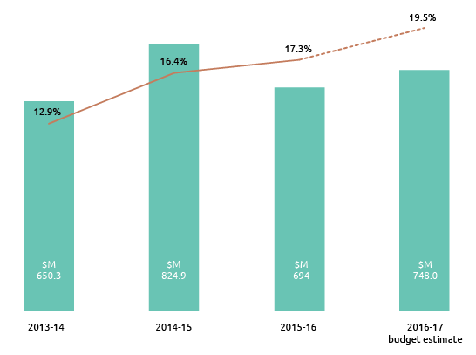

In 2015-16, the largest share of Australia’s aid for trade assistance was invested in infrastructure, including in transport, energy and communications (Figure 3). Other significant shares related to building productive capacity in agriculture and fisheries, and trade facilitation and trade policy. Further details on the aid for trade strategy and its implementation can be found in Chapter 4 of this report.

Figure 3: Aid for trade expenditure by investment area, 2015-16

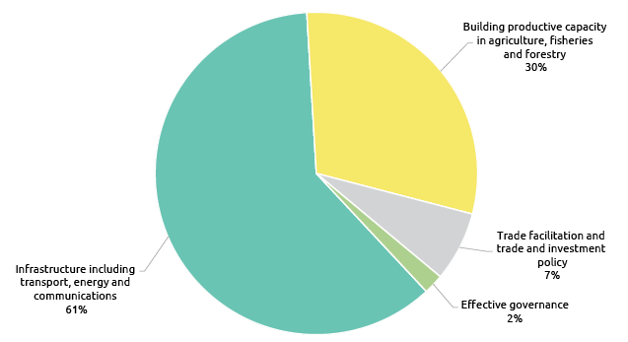

Target 2: Engaging the private sector

All new investments will explore innovative ways to promote private sector growth or engage the private sector in achieving development outcomes

**Status: Achieved**

**The aid program achieved this target in 2015-16, with all new investments exploring innovative ways to promote private sector growth or engage the private sector.**

In August 2015, the Minister for Foreign Affairs released the *Ministerial Statement on Engaging the Private Sector in Aid and Development*, inviting the private sector to collaborate with the aid program on creating sustainable solutions to tackle development challenges in the region. The Ministerial Statement adopted shared value as the framework for engaging the private sector, paving the way for DFAT to work with businesses that link financial returns and social impact, contributing to targeted and sustained poverty reduction.

The *Strategy for Australia’s Aid Investment in Private Sector Development*, the companion to the Ministerial Statement, was also released in 2015. The Strategy formalised the rationale, principles and approaches to improve the growth and inclusion of the private sector in Australia’s partner countries.

New initiatives were launched to accelerate the Government’s ability to collaborate with business and promote economic growth, including:

• The *Business Partnerships Platform* – a new flagship initiative that enables businesses and their partners to directly approach the Australian Government with proposals for new or redesigned initiatives that create new commercial opportunities whilst addressing specific aid objectives of the Australian Government. Round one of the Platform leveraged $9.7 million in private investment (against $3.3 million invested through the aid program)

– Ten partnerships selected from round one operate across seven countries (Myanmar, Vietnam, Pakistan, Nepal, Indonesia, PNG and Kenya), in a range of sectors including agribusiness, financial services, small enterprise development, off-grid energy, health and women’s economic empowerment. New partners have made it clear that the Business Partnerships Platform provides new opportunities to expand upon existing work and increase the reach of development outcomes.

• The *Pacific Readiness for Investing in Social Enterprises Facility (PacificRISE)* which will fund technical assistance for social enterprises based in or serving Pacific Island countries to make them ‘investment ready’ and work closely with impact investors to bring promising Pacific enterprises to their attention.

• A partnership with *Fairtrade* – providing links to retailers and supply chains, consistent with DFAT’s goal to create scalable partnerships with the private sector. The partnership has created sustainable commercial relationships between producers in the Indo-Pacific region and markets, while providing support to small producers and workers to help foster secure livelihoods.

• A partnership with the *United Nations Global Compact Network Australia* – supporting Australian businesses’ ability to contribute to sustainable development in the region, with a strong focus on the Sustainable Development Goals.

• A partnership with the *Shared Value Project* – the region’s peak body shaping the future of shared value in the Australian business community. The partnership promotes the development of shared value as a business practice in the Indo-Pacific.

• A partnership with the *Global Reporting Initiative* – supporting businesses improve their social and sustainability reporting and performance in Indonesia, the Philippines, Sri Lanka and Papua New Guinea.

• The Innovation Exchange Challenge Funds, such as the *Blue Economy Challenge and the Pacific Humanitarian Challenge*, bringing business ideas to the table to uncover innovations which transform how Australia delivers aid.

• The *LAUNCH Food* program run by the innovationXchange (iXc) to source, support and scale, supply or demand innovations that will impact people’s food choices for nutritional change. LAUNCH Food will add value to these innovative businesses by making available to the innovators the skills, experience and assets of major corporate players such as IKEA, Mars and Walmart. The iXc has committed to co-invest up to $5 million in the innovations. The partnerships will test new solutions to malnutrition, helping to reduce the number of stunted children and obese adults in the Indo-Pacific region through more nutritious food.

|  |
| --- |
| Engaging the Private Sector: Connecting communities to clean energy and the digital economy in Papua New Guinea  Through the Business Partnerships Platform, DFAT is partnering with Digicel to provide affordable solar energy solutions to off-grid households and small businesses in Papua New Guinea. The partnership leverages Digicel’s extensive logistic networks and distribution systems to scale up access to reliable solar products, allowing communities to more effectively and efficiently charge their mobile phones and access digital services via smart phones or computers. DFAT will support the partnership through its in-country knowledge of the business, political and regulatory environments and networks, and actively promote women’s economic empowerment. |

Target 3: Reducing poverty

By July 2015, all country and regional programs have Aid Investment Plans that describe how Australia’s aid will promote economic growth in ways that provide pathways out of poverty

**Status: Achieved**

**Aid Investment Plans have been completed for all major country and regional programs.**

Aid Investment Plans set out the direction for a country or regional program, and are designed to help ensure the most effective use of aid. They describe where, why and how Australian aid will be delivered and the expected results to be achieved. Aid Investment Plans are based on economic, political and social analysis that identifies the key constraints to economic growth, private sector development and poverty reduction. Drawing on this analysis, each individual Aid Investment Plan identifies a set of strategic objectives, priority aid sectors and specific aid investments to promote economic growth and poverty reduction.

Aid Investment Plans for all major country and regional programs, 25 in total, were published on the DFAT website on 30 September 2015. The deadline for the completion of Aid Investment Plans was extended from July 2015 to September 2015 to enable 2015-16 budget outcomes to be taken into account.

Aid Investment Plans contain performance benchmarks and mutual obligations (see strategic target 6) tailored to the circumstances of each country or region. Performance against the strategic objectives in an Aid Investment Plan, as well as its performance benchmarks and mutual obligations, is reviewed annually through Aid Program Performance Reports.

Target 4: Empowering women and girls

More than 80 per cent of investments, regardless of their objectives, will effectively address gender issues in their implementation

**Status: Not yet achieved**

Gender equality and empowering women and girls contributes to growth, development, stability and security. Ensuring equal opportunities, rights and responsibilities for women and men, girls and boys, in Australia and overseas, is in our national interest. Empowering women and girls is therefore one of the aid program’s six priority investment areas.

This target tracks the percentage of Australian aid investments that are rated ‘satisfactory’ or above for gender equality during their implementation. Performance data is drawn from DFAT’s annual Aid Quality Checks (AQCs). In 2015-16, 78 per cent of aid investments were rated as satisfactorily addressing gender equality during their implementation, falling short of the target of 80 per cent[7] (see Figure 4). This outcome was the same as for 2014-15. Analysis by the Office of Development Effectiveness suggests that the evidence given for gender ratings is robust.

Similar to previous years, performance on gender equality varied by investment priority area. Investments in the education and health sectors continue to perform well above the 80 per cent target, and saw further improvement. Gender equality results for investments in the building resilience priority investment area also improved, in part as a result of improved focus on opportunities to promote gender equality in humanitarian efforts.

Investments in the priority investment area of infrastructure, trade facilitation and international competitiveness also saw improved ratings compared to the previous year, increasing from an overall rating of 64 per cent satisfactory to 76 per cent. Improved attention to women’s roles in infrastructure design and construction, contributed to the improved ratings.

After improvement during 2014-15, investments in the agriculture, fisheries and water sector declined in their performance on gender equality. An increasing proportion of investments in this sector involve partnerships with private sector entities whose awareness of and ability to address gender inequalities in agriculture, fisheries and water still need strengthening. DFAT will need to focus on supporting this sector.

Ongoing changes in the aid portfolio should have a positive impact on gender performance, as investments that came to an end in 2015-16 on average had much lower gender performance ratings (67 per cent rated satisfactory) than current investments (82 per cent rated satisfactory). At the same time, DFAT made efforts to ensure that new investments were informed by gender analysis and were supported with gender expertise from their commencement.

Figure 4: Gender performance by investment priority area, 2015-16

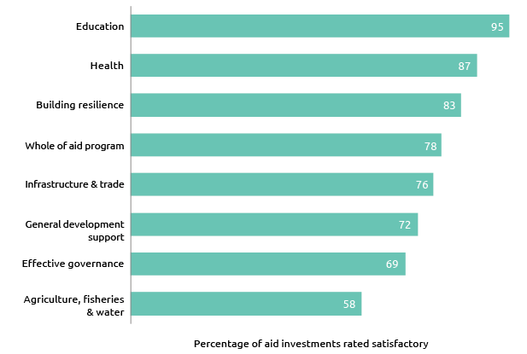

Other recent changes should lead to improvement in 2016-17. Implementation of the Strategy on Gender Equality and Women’s Empowerment, launched in February 2016, will be an important focus. Implementation of the strategy is being supported by further gender equality training for DFAT staff and partners. Support by gender specialists for the development and implementation of gender equality and women’s empowerment measures tailored to the sector and country and regional context will continue, as will assistance to develop gender action plans for country and regional programs.

|  |
| --- |
| The Empowering Indonesian Women for Poverty Reduction Program (MAMPU)  MAMPU is an example of a highly performing aid investment that specifically focuses on gender equality and women’s empowerment. The program aims to improve the welfare and socio-economic status of Indonesian women living in poverty. Working in a politically-informed way, MAMPU works closely with government, private sector, media and other stakeholders to analyse constraints, identify and test solutions, and use an evidence base to advocate for changes in policies and institutions.  An independent evaluation of Phase 1 of the program (2012–2016, approx. $53.5 million), which included a team member from the Office of Development Effectiveness, was finalised in 2016[8]. The evaluation found that MAMPU was performing strongly against its design objectives. For example,  the program influenced government services and policies to increase the access of poor women to rights, services and livelihoods. In 2015, the MAMPU partner organisation for female-headed households, PEKKA, successfully lobbied the Central Statistics Agency to improve data collection on female-headed households to better target social assistance. This improved access to social assistance will in turn improve these households’ economic circumstances. As at June 2016, the number of villages where MAMPU partners work is 1,600 across 26 provinces. More than 2,000 local groups have been established with membership of more than 50,000 women who are increasingly speaking out about the priorities that affect their lives, giving them greater influence in their local communities.  The independent evaluation found there was a strong case for MAMPU to proceed to a second phase. Phase 2 (2016–2020, approx. $60 million) will expand and deepen efforts with government, civil society, parliamentarians and the private sector to target improvements to selected policy and regulatory reforms that constrain progress on poverty reduction, particularly for women. The program will focus on five thematic areas where reform and working with coalitions would make a significant difference for poor women: increasing women’s access to jobs and removing workplace discrimination; improving women’s access to government programs for social protection; improving conditions for women’s overseas labour migration; strengthening women’s leadership for better health and reproductive rights; and strengthening women’s leadership to address violence against women.  The independent evaluation also found a number of areas where MAMPU could improve. At the time of the evaluation, the program did not adequately focus on people with disabilities and had not sufficiently demonstrated that it achieves value for money. Recommendations to improve such areas were accepted by DFAT’s Indonesia program. |

Target 5: Focusing on the Indo-Pacific region

Increase the proportion of country program aid that is spent in the Indo-Pacific region to at least 90 per cent from 2014-15

**Status: Achieved**

**This target was achieved in 2015-16, with 91.7 per cent of country attributable aid spent in the Indo-Pacific region, up from 90.4 per cent in 2014-15.**

This target ensures that the Australian aid program is focussing on the region where Australia can make the most difference. Stronger economic growth and stability in the Indo-Pacific region is directly in Australia’s interests.

This target measures the proportion of country attributable aid that is spent in countries in the Indo-Pacific region. This includes bilateral and regional aid expenditure, as well as some global and cross regional aid that can be attributed to countries in the Indo-Pacific region. For example, humanitarian assistance earmarked to particular countries is included in country attributable aid, but core funding to international humanitarian agencies and multilateral development agencies is not included.

Figure 5: Percentage of country attributable aid that is spent in the Indo-Pacific region  
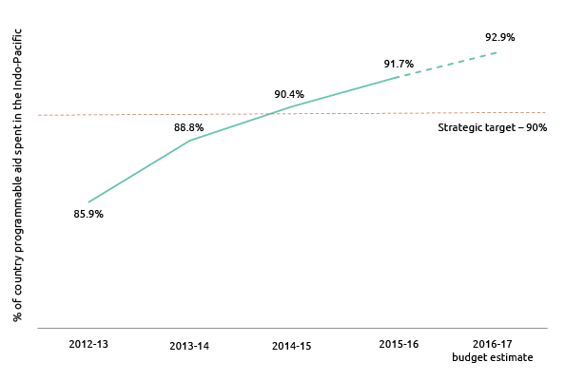

Target 6: Delivering on commitments

From July 2015, progress against mutual obligations agreed between Australia and its key partner governments and organisations will form part of program performance assessments

**Status: Achieved**

**This target was achieved in November 2015 with the publication of 2014-15 Aid Program Performance Reports on the DFAT website. Aid Program Performance Reports for 2015-16 were published in September 2016.**

Performance benchmarks and mutual obligations for all major country and regional programs are set out in Aid Investment Plans and Aid Program Performance Reports. For Pacific programs, mutual obligations are also included in Aid Partnerships completed during 2015-16. Progress towards meeting benchmarks and mutual obligations was assessed in 2015-16 Aid Program Performance Reports.

**Performance benchmarks** assist with assessing progress against a country program’s objectives. A set of 147 performance benchmarks were reported for 2015-16. Figure 6 shows the progress against benchmarks for the six priority areas of the aid policy. Overall, 106 benchmarks were achieved, 35 were partially achieved and six were not achieved. Chapter 2 reports on progress against performance benchmarks by region.

Figure 6: Performance benchmarks by investment priority area, 2015-16  
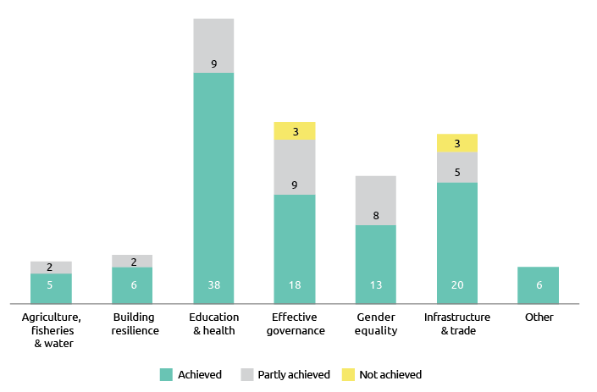

The stronger focus on mutual obligations under *Making Performance Count* builds on longstanding and widely accepted aid effectiveness principles. Both the 2005 *Paris Declaration on Aid Effectiveness and 2011 Busan Partnership for Effective Development Cooperation* highlight ownership and mutual accountability as key principles for making aid more effective.

A broad range of mutual obligations is reported against in 2015-16 Aid Program Performance Reports. Australia’s obligations generally take the form of budget commitments, alignment of Aid Investment Plans with country priorities, and ways of working including responsiveness, flexibility and innovation.

Obligations for partner governments are derived from a range of sources. National development plans typically represent the overall framework for identifying commitments and assessing progress. These commitments vary and range from minimum sectoral budget allocations to specific legislative and policy reforms. For example, the Solomon Islands Government allocated 23 per cent of its 2015 recurrent budget to education, exceeding the target of 22 per cent. It also contributed SBD58.5 million to the National Transport Fund in 2015, exceeding the target of SBD40 million. Australia ties 20 per cent of direct funding to the health sector in Solomon Islands to the achievement of jointly agreed performance milestones. In 2015-16, 63 per cent of performance milestones were achieved resulting in a performance payment of $1.76 million. One of the milestones achieved was the allocation of 12 per cent of the 2015 recurrent budget to the health sector, which exceeded the target of 10 per cent.

Target 7: Working with the most effective partners

By July 2015, design and apply new systems to assess the performance of the aid program’s key delivery partners and ensure stronger links between performance and funding

**Status: Achieved**

**The target was achieved in 2014-15 with the introduction of Partner Performance Assessments; a strengthened Multilateral Performance Assessment process for multilateral organisations receiving core funding; reforms to systems for assessing performance under the Australia-NGO Cooperation program; and progress in linking performance to payments in aid agreements.**

In 2015-16, Australia continued to refine the new systems introduced in 2014-15[9] to assess the performance of the aid program’s key delivery partners. Working with the most effective delivery partners helps ensure Australia’s aid investments are achieving value for money.

In 2015-16, 75 per cent of DFAT’s administered ODA was delivered through agreements with three main types of implementing partners: commercial partners, multilateral organisations and NGOs (Figure 7).

Partner Performance Assessments (PPAs) review how well key implementing partners (commercial partners, multilateral organisations and NGOs) are delivering the services specified in aid funding agreements. The focus is on the performance of the implementing partner, as distinct from the quality of the investment itself (which is assessed by the annual Aid Quality Checks).

Figure 7: DFAT administered ODA by delivery partner type, 2015-16

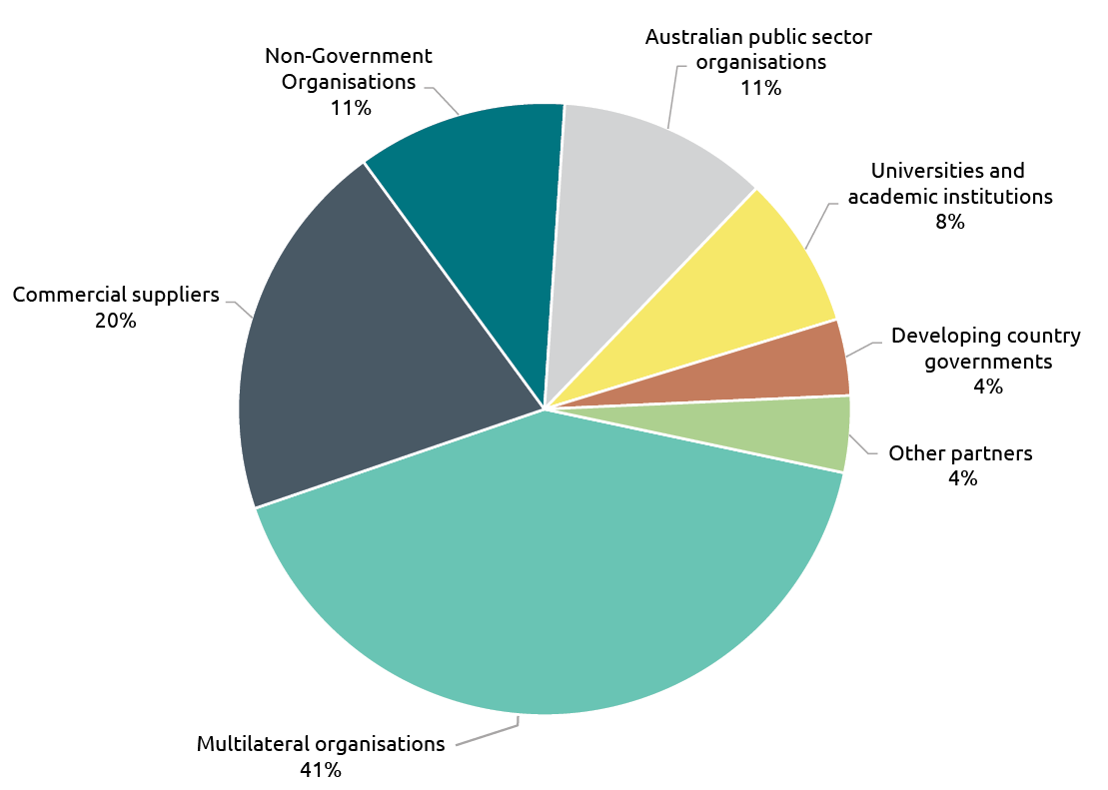

Assessments were completed for individual funding agreements valued at over $3 million except for core contributions to multilateral organisations.

Table 1: PPA completed by delivery partner type, 2015-16

|  |  |  |
| --- | --- | --- |
| **Partner type** | **Number of PPAs** | **Overall value of agreements assessed ($m)** |
| NGOs | 102 | $1,393 |
| Commercial suppliers | 85 | $4,038 |
| Multilateral Organisations | 131 | $2,559 |

The results (Table 2) indicate that the three main delivery partner categories are all performing to an adequate level or better. Over 94 per cent of assessments completed had ratings of adequate (4) or higher.

Table 2: Average PPA rating score by delivery partner type, 2015-16

|  |  |  |  |
| --- | --- | --- | --- |
| **Commercial Partners** | **NGOs** | **Multilateral Organisations** | **Overall Partner Average Rating** |
| 5.1 | 5.0 | 4.6 | 4.9 |

Commercial partners achieved the highest average PPA rating by delivery partner type. Agreements with commercial contractors are characterised by a high level of managerial direction and control by DFAT, whereas grant agreements with NGOs and multilateral organisations are partnership agreements where DFAT has agreed to fund investments over which partners have much greater autonomy in investment design and implementation. Australia’s investment in multilateral programs is often also made in collaboration with other donors, requiring greater degrees of compromise by all parties than is required in other arrangements. In addition, multilateral organisations operate under policies and procedures endorsed by boards (which include Australian representation) and these policies and procedures can be difficult to change quickly to meet Australia’s specific interests in individual countries (in contrast to the flexibility DFAT has when engaging commercial suppliers).

PPA information is used to inform tender evaluation and agreement award decisions. In addition, good progress has been made by DFAT in linking partner performance to payments in commercial agreements. In 2016, 100 per cent of complex aid tenders released and 100 per cent of complex aid contracts entered into by DFAT linked performance and payment (most commonly by linking a proportion of management fees to PPA scores).

Reforms to systems for assessing the performance of NGOs receiving funding through the Australian NGO Cooperation Program (ANCP) were introduced in 2014-15. Eleven NGOs in the ANCP with agreements over $3 million in value were assessed in April 2016. All NGOs satisfactorily met the performance criteria, which confirmed continued access to ANCP funding.

Multilateral performance assessments for multilateral organisations receiving core funding from the Australian aid program support and inform regular dialogue at headquarters level on key performance issues. Seven assessments were completed during 2016 and are summarised in Chapter 3 of this report.

Target 8: Ensuring value for money

Deliver high standards of value for money in at least 85 per cent of aid investments. Where standards are not met and improvements are not achieved within a year, investments will be cancelled

**Status: Achieved**

**This target was achieved in 2015-16 with 86 per cent of investments rated as satisfactory for efficiency and 87 per cent of investments rated as satisfactory for effectiveness.**

DFAT seeks to ensure that value for money considerations are applied across all aid management policies, practices and investments. Data to track progress towards this target is drawn from DFAT’s annual Aid Quality Checks. Investments rated as satisfactory against the efficiency and effectiveness criteria are considered to be delivering high standards of value for money. In 2015-16, 86 per cent of investments were rated as satisfactory for efficiency and 87 per cent of investments were rated as satisfactory for effectiveness.

Figure 8: Percentage of aid investments with satisfactory ratings for efficiency and effectiveness,   
2011-12 to 2015-16

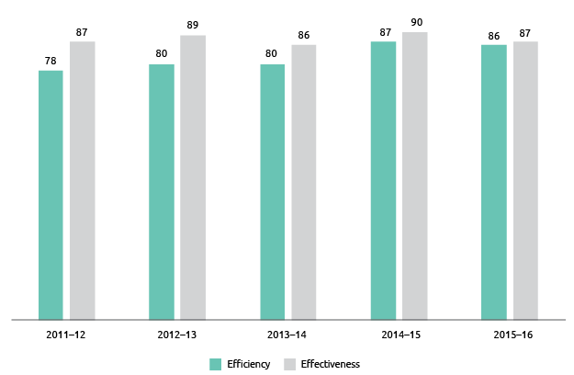

Annual effectiveness outcomes have ranged between 86 per cent and 90 per cent since 2011-12 (Figure 8). The 2015-16 outcome of 87 per cent for effectiveness is lower than last year but consistent with the average outcome since 2011-12. In the *Performance of Australian Aid 2014-15* report, ODE expressed concern that there were inconsistencies in the application of the Aid Quality Check ratings scale. In 2015-16, DFAT adjusted its quality reporting processes to address this issue.

Efficiency outcomes have been rated higher in the past two years than for 2013-14 and earlier years (Figure 8). It is too early to make a definitive judgement about whether the underlying efficiency of the overall aid program has permanently improved. While increases in efficiency ratings have been recorded across all regions compared to 2013-14 and earlier, the largest increase has occurred in South-East and East Asia. This reflects the shift of most South-East and East Asia programs towards economic partnerships, in recognition of their higher levels of development and comparatively less complex operating environments, both of which should facilitate more efficient programming. Another factor likely contributing to higher efficiency outcomes is increased consolidation of the aid program – this is discussed further under Target 9 below.

This strategic target also requires the identification of underperforming investments based on unsatisfactory ratings for both effectiveness and efficiency criteria. In 2015-16, twenty underperforming investments were identified as Investments Requiring Improvement. If performance does not improve within 12 months, investments will be cancelled. In 2014-15, 18 underperforming investments were identified as Investments Requiring Improvement. Of these 18 investments, four investments were again assessed in 2015-16 as unsatisfactory. Three of these investments have now been ended with the fourth under review.

In 2015-16, the department recorded 2,188 engagements of international advisers to support the delivery of the Australian aid program. All advisers were engaged in accordance with the Aid Adviser Remuneration Framework, which promotes the transparency of adviser remuneration and allowances based on professional discipline categories and job levels.

In 2015-16, the average remuneration (daily/monthly rates, applicable allowances and support costs) paid to long and short term advisers represented a 23.8 per cent and 35.2 per cent saving respectively, when compared to remuneration paid prior to the introduction of the framework in February 2011.

Target 9: Increasing consolidation

Reduce the number of individual investments by 20 per cent by 2016-17 to focus efforts and reduce transaction costs

**Status: Achieved**

**This target was achieved on 1 July 2016 when the number of individual investments had reduced by 23 per cent.**

Focusing on fewer, larger aid investments improves the efficiency and effectiveness of Australia’s aid program. Consolidation reduces the administrative burden on DFAT staff, partner governments and key delivery partners. Analysis conducted by the ODE also suggests that higher value investments perform better than lower value investments.

Figure 9: Progress on consolidation of aid investments

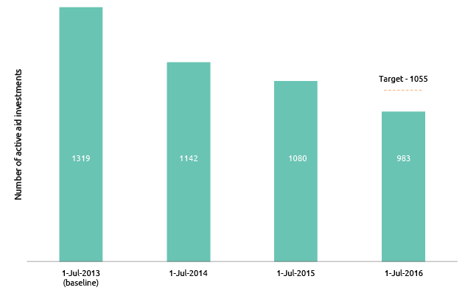

Table 3 presents further evidence of consolidation in DFAT’s aid administration over the three years from July 2013 to July 2016:

• the average size of aid investments has increased by more than 26 per cent

• the number of aid agreements (contracts and grant agreements) has decreased by 33 per cent

• the average size of agreements has increased by 90 per cent.

Table 3: Consolidation at the investment and agreement level

|  |  |  |  |  |
| --- | --- | --- | --- | --- |
| **Year** | **Investments** | **Average Investment Value** | **Agreements** | **Average Agreement Value** |
| July 2013 | 1319 | $20.3m | 3975 | $4.1m |
| July 2014 | 1142 | $22.8m | 3465 | $5.6m |
| July 2015 | 1080 | $24.4m | 2891 | $7.1m |
| July 2016 | 983 | $25.6m | 2661 | $7.8m |

Target 10: Combatting corruption

Develop and implement new fraud control and anti-corruption strategies for all major country and regional programs by July 2015

**Status: Achieved**

**Fraud and anti-corruption strategies are in place for all major country and regional programs.**

These strategies identify risks and potential incidences of fraud and corruption relevant to the delivery of Australian aid. They detail the controls and measures adopted to safeguard Australian Government aid program funding, and actions and initiatives to support country efforts to combat fraud and corruption. A full review of all strategies is scheduled for 2017.

# Chapter 2 Country and regional program performance

This chapter summarises the performance of Australia’s country and regional aid programs. Key performance trends, selected results and areas for improvement are highlighted for programs, organised into four regional groups: Pacific; South-East and East Asia; South and West Asia; and Africa, the Middle East and other regions.

For country and regional aid programs, performance is assessed each year and published in Aid Program Performance Reports (available on DFAT’s website[10]). Judgements about performance are made against program objectives contained in Aid Investment Plans for each country or regional program, and expressed as one of three ratings: progress towards objectives is on track; progress is at risk (less than expected); or progress is not on track. The 2015-16 reporting period is the first time all programs have reported against program objectives set out in Aid Investment Plans, which were finalised and published in September 2015.

Figure 10: Progress against program objectives by region, 2015-16

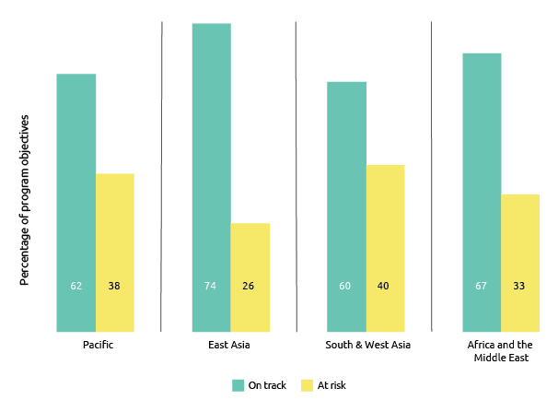

*No program objectives were rated as off track in 2015-16.

In 2015-16, performance benchmarks were identified for country and regional programs. Performance benchmarks, together with other monitoring and evaluation indicators, are used to assess progress against Aid Investment Plan objectives. Progress against each benchmark is reported in Aid Program Performance Reports (APPRs). Performance against objectives and benchmarks for individual country and regional programs is summarised by region below (see also discussion of performance benchmarks under strategic target six in Chapter 1).

## Pacific

### Context

The Pacific faces a range of development challenges. Recent lower economic growth from declining international commodity prices has added to the ongoing impact from narrow economies, high costs of service delivery, small and dispersed populations and vulnerability to natural disasters.

In much of the region, economic growth is not keeping pace with population growth. Adding to this challenge is rapid urbanisation. In Melanesian countries, this is particularly high. For example, in the Solomon Islands the urban population will double by 2032; in PNG it will double by 2030, reaching about two million people. Unplanned, rapid urbanisation and persistently low coverage of family planning risks increased poverty and adverse impacts on social and health issues.[11]

As Tropical Cyclone Winston demonstrated when it hit Fiji in early 2016, the Pacific is highly vulnerable to natural disasters which can include cyclones, flooding, droughts and earthquakes. Cyclone Winston affected approximately 540,000 people in Fiji and compromised the livelihoods of almost 60 per cent of the population. The ongoing recovery and reconstruction efforts required highlight the long-term impact of natural disasters and how they can compound existing social and economic challenges.

The Pacific is well behind on social and economic indicators. Progress towards meeting the Millennium Development Goals (MDGs) that finished in 2015 was disappointing and uneven across the region. Just two countries (Cook Islands and Niue) achieved all the MDGs with a number not reaching any of the MDGs. The majority managed to reduce child mortality and achieve universal primary education. However, few made gains in reducing poverty, improving maternal health, achieving gender equality and reducing violence against women.

In order to achieve the Sustainable Development Goals, ODA will remain necessary for most Pacific Island countries. Given the gaps in reporting of MDG targets, the need for accurate statistics is likely to remain and will require ongoing support from development partners.

Australia is the largest donor to the Pacific. In 2015-16, 28 per cent of total Australian ODA was directed to the Pacific, compared to 23 per cent in 2014-15 (Table 4). The PNG program accounted for 47 per cent of Australian aid to the Pacific.

Table 4: Total ODA by country program: Pacific, 2015–16

|  |  |  |
| --- | --- | --- |
| **Country Program** | **2014-15** | **2015–16** |
| **($m)** | **($m)** |
| Papua New Guinea | 527.5 | 536.7 |
| Solomon Islands | 189.1 | 172.6 |
| Fiji | 62.2 | 87.1 |
| Vanuatu | 114.4 | 65.6 |
| Samoa | 37.5 | 38.7 |
| Tonga | 29.9 | 32.4 |
| Kiribati | 30.2 | 29.3 |
| Nauru | 25.5 | 25.5 |
| North Pacific | 15.1 | 9.5 |
| Tuvalu | 11.2 | 8.7 |
| Cook Islands | 5.0 | 3.7 |
| Niue and Tokelau | 4.6 | 3.4 |
| Pacific Regional | 122.1 | 114.0 |
| **Pacific Total** | **1,174.3** | **1,127.4** |

Figure 11: Total ODA by investment priority area: Pacific, 2015–16

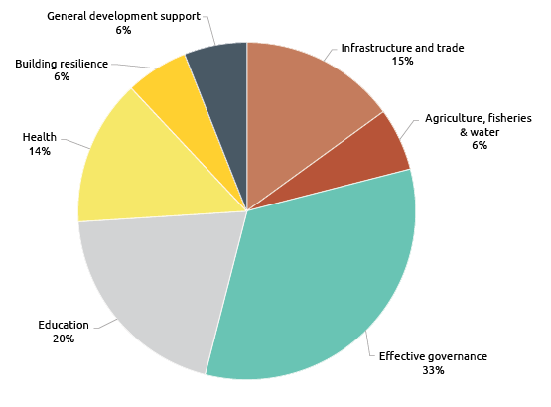

### Program quality

In 2015-16, 62 per cent of Pacific country and regional program objectives were assessed as on track (Figure 12). The proportion of program objectives at risk was 38 per cent. Nearly half of those objectives at risk are from the PNG program.

Figure 12: Progress against program objectives: Pacific, 2015–16

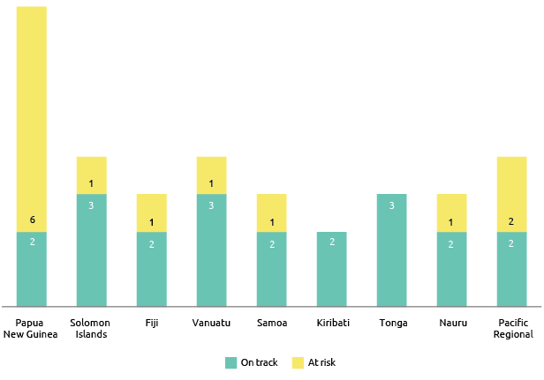

For **PNG**, two out of eight program outcome areas were assessed as on track (Figure 12). Program progress in *health* and *education* was assessed as less than expected because while programs have largely delivered intended outputs, these programs were not of a sufficient scale to impact on performance targets Australia and PNG share at the national level. Progress in *governance* was assessed as at risk because the results of a number of investments completed in 2015-16 fell short of original goals. Progress against the *gender equality* and *disability inclusive development* outcome areas was assessed as at risk reflecting the scope to leverage greater outcomes in these areas from Australia’s large mainstream investments.

In **Solomon Islands**, three of four program objectives were assessed as on track. Progress against the objective on *increased cash incomes* was rated as at risk as further Australian investment in market development is required to expand entrepreneurship and employment. In **Fiji**, progress against the *human development* objective was rated as at risk as some outcomes, particularly in the education sector, were not achieved due to the impacts of Cyclone Winston. In **Vanuatu**, progress against the Cyclone Pam *recovery* *and reconstruction* objective was rated as at risk as, while performance benchmarks were achieved, delivering the reconstruction program through government systems has meant that progressing recovery projects efficiently has been a challenge. In **Samoa**, progress against the *health and education objectives* was less than expected due to incomplete construction of some key infrastructure. In **Nauru**, the objective on strengthened provision of health and education services was rated as at risk due to the partial achievement of performance benchmarks related to the timely expenditure of budget support.

For the **Pacific Regional Program**, two out of the four program objectives were assessed as on track. The objective of *effective regional institutions* was rated as at risk reflecting the challenges faced by the Pacific Islands Forum Secretariat and the Pacific Community to prioritise their work in response to financial constraints. The objective related to *healthy and resilient communities* was also assessed as at risk; while health sector investments improved, the coherence of regional climate change investments requires further work.

Figure 13: Progress against performance benchmarks: Pacific, 2015–16

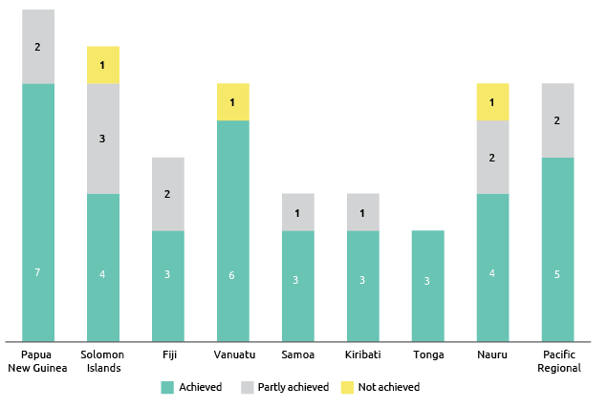

Progress against performance benchmarks by Pacific programs was positive, with 70 per cent of benchmarks achieved and 24 per cent partly achieved (Figure 13). Only three benchmarks (6 per cent) were not achieved.

Figure 14: Aid investment performance: Pacific, 2015–16

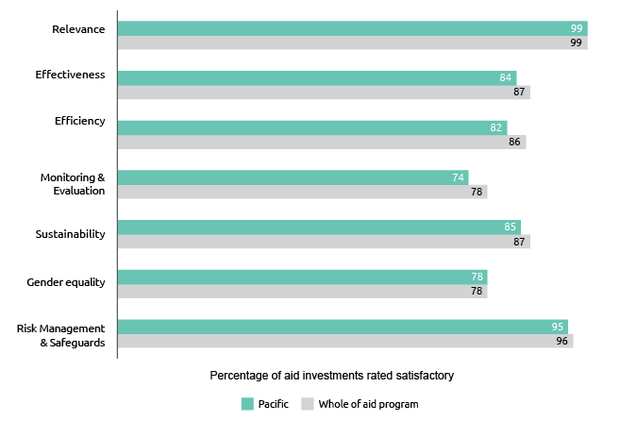

In 2015-16, Australia’s individual aid investments in the Pacific rated marginally lower on effectiveness, efficiency, monitoring and evaluation and sustainability quality assessment criteria than the aid program average (see Figure 14). Performance on gender equality was unchanged from 2014-15. Pacific programs need to maintain efforts on improving gender equality including by ensuring women and girls are able to benefit from all Pacific aid investments. Of the eight investments identified as requiring improvement in 2014-15, five improved their performance during 2015-16. Eight investments were identified as requiring improvement based on 2015-16 Aid Quality Check results and management action plans have been put in place.

Pacific programs have identified management actions to improve program performance and quality. These actions are set out in individual country and regional Aid Program Performance Reports.

### Performance by investment priority area

Investments to support economic growth through **infrastructure and trade facilitation** generally performed well in 2015-16. Targeted road maintenance in PNG, Solomon Islands, and Vanuatu contributed to economic growth and improved service delivery including in rural areas. In PNG, approximately 1,400 kilometres of the road network was maintained or upgraded exceeding the performance benchmark of 510 kilometres. In Solomon Islands, outsourcing of civil works created new opportunities for the local private sector. Labour-based roadworks provided 11,923 person months of employment, of which women took up 60 per cent.

Australian support for structural and regulatory reforms, in turn underpinned the growth of exports, investment and regional trade integration. For example, support to Solomon Islands Customs helped facilitate $44 million in exports and improved clearance efficiencies. Through the regional Private Sector Development Initiative, Fiji has received support for its State Owned Enterprise (SOE) reform agenda; Samoa received support for company law and registry reforms reducing the time it takes to form a company to a little over a day.

**Agriculture and fisheries** are key sectors for many island economies. Australia’s aid and technical support to the Forum Fisheries Agency (FFA) and the Fisheries, Aquaculture and Marine Ecosystems Division of the Pacific Community is critical for effective engagement in the complex management of offshore tuna stocks and provision of world-class stock assessments for offshore fisheries. The region significantly exceeded the benchmark for 2015-16 (US$264 million) for increasing revenue flowing to the FFA Pacific island member countries, with total Government revenues coming in at over US$350 million. Australia also supported 28 villages and 7,400 people in Kiribati, Vanuatu and Solomon Islands to strengthen inshore fisheries management for food security and livelihoods. In agriculture, the Pacific Horticultural and Agricultural Market Access Program (PHAMA) helped Pacific countries meet requirements associated with exporting primary agricultural products. PHAMA established the region’s first third party legality assurance system in the Solomon Islands for sawn timber, safeguarding several thousand jobs and $7 million in exports.

To support more **effective governance** in the Pacific, Australian assistance helped strengthen economic reforms, improve law and justice systems, build a more effective public sector and support organisational reform in Pacific regional organisations. Along with other donors, Australia supported specific reform programs in Samoa, Kiribati and Tonga. For example, Australia supported the introduction of a new Revenue Management System in Tonga, a revised policy on ownership performance and divestment of public bodies in Samoa, and the implementation of the Value Added Tax and an automated tax system in Kiribati. With the latter, provision of a tax adviser has contributed to an estimated 23 per cent increase in taxation revenue collection over the previous year.

|  |
| --- |
| ODE Evaluation of the SPC-Australia Partnership  The Office of Development Effectiveness (ODE) undertook the first mid-term Independent Evaluation of the Pacific Community (SPC) – Government of Australia Partnership Agreement in 2016, the first evaluation milestone in the ten year partnership which commenced in March 2014[12].  In their joint management response, DFAT and SPC welcomed the positive assessment of the Partnership which has increased predictable, flexible funding for SPC and contributed to its monitoring and evaluation and program planning strategies. The evaluation demonstrated the existence of strong working relationships between the SPC and the Australian Government built on a history of technical collaboration and shared experience. The report affirmed that DFAT remains a major development partner for SPC, is a leader in implementing internationally recognised donor practices and is a champion for the organisation’s change agenda.  DFAT and SPC appreciate that they can improve the effectiveness of the Partnership. There is scope to raise awareness of the Partnership across DFAT and the Australian Government and to support stronger strategic policy collaboration on key issues.  DFAT is committed to supporting the SPC reform and prioritisation agenda by providing tailored support on key issues, including financial management capability and gender equality. The Partnership can also benefit our relationships with other regional organisations and donors by encouraging all development players to work in an efficient, coordinated and consistent way. |

Australian assistance to the **law and justice sectors** in PNG, Solomon Islands and Vanuatu supports our shared interest in stability in those countries. In PNG, while law and justice programs are assessed as effective and efficient, overall progress has been rated as at risk because data from government agencies is not yet available to measure progress against many benchmarks. Australian assistance provided access to better standards of justice for more than one million PNG citizens by contributing to the training of more than 2,000 village court officials. Rollout of the Justice Information Management System in Solomon Islands continued and services across justice agencies were generally maintained. In Vanuatu, Australian support contributed to improved service delivery, including through an innovative new Rapid Charge System (RCS) for the police, which has reduced the time until charges are heard in court to 10 days (from 92 days in cases where RCS is not used); and improved processes for handling cases in the police Professional Standards Unit.

Australia’s investments in **education** in the Pacific delivered some significant results in 2015-16, although not all targets were met. In PNG, while progress has been slower than expected, there have been measurable gains in a year when PNG’s education funding was severely restricted by its budget deficit. Incremental improvements were seen in net enrolment rates and the gender parity index in schools. While an additional 133,000 girls and boys enrolled in school, this outcome fell short against the target of 155,000. Nevertheless, the basic net enrolment rate increased from 84.2 per cent in 2014 to 88.4 per cent. Gender parity increased marginally to 0.89. Australia provided 150 classrooms, 55 teachers’ houses and 57 ablution blocks to help meet the demand for school resources, exceeding the benchmark of 30 buildings.

While skills development to support economic opportunities for Tongan workers was assessed as ‘on track’, an evaluation of the education sector program found that program objectives were too ambitious for the timeframes, program implementation had made poor overall progress and there were expenditure delays. Tonga has agreed for Australia to transition out of the basic education sector and focus on vocational education and training.

While costly to deliver, services to remote and dispersed areas in Solomon Islands achieved good results. In 2015, more girls than ever before (5,500) started Junior Secondary School, 80 per cent of teachers are now trained (up from 50 per cent when Australia began investment in the sector in 2012) and learning outcomes have improved. Similarly, in Kiribati, where Australia works to improve standards in basic education in terms of quality and access, significant results have been achieved. This includes the 2015 Pacific Island Literacy and Numeracy Assessment results, which indicate that 93 per cent of Year 4 students performed at or above expected literacy levels (66 per cent in 2012) and 73 per cent at or above expected numeracy levels (29 per cent in 2012). The primary school Net Enrolment Rate increased from 82 per cent in 2011 to 99 per cent in 2015.

Australian investments in **health** yielded a number of measurable gains but for four out of the eight Pacific bilateral programs the health-related objectives were only partially met. The health sector program in Fiji temporarily diverted staff and resources to assist the emergency response to Cyclone Winston, including the establishment of three temporary health facilities. Under the Healthy Child Initiative, Fiji reached immunisation rates of 90 per cent for pneumococcal and rotavirus vaccines. An early study found the vaccines were already preventing pneumonia, pneumococcal sepsis and meningitis, along with a reduction in diarrhoea admissions to hospitals. Good results were achieved around the establishment of a set of Safe Motherhood national standards, and the prevention and management of non-communicable diseases.

An end of program evaluation into the six-year Fiji Health Sector Strengthening Program (FHSSP) concluded it effectively delivered its planned activities and its early and strategic approach to sustainability will ensure key activities will continue to be implemented beyond the program. However, in a valuable finding for the design of the new health program, the evaluation noted the FHSSP generally lacked adequate outcome and impact data on its interventions, making it difficult to assess program impact.

In PNG and Vanuatu, low levels of trained health workers impacted on the overall performance of the health sector. While Australian aid to PNG delivered newly qualified midwives, family planning and HIV testing for pregnant women, the national indicators for both worsened. Nearly 700 Papua New Guineans have graduated since 2013 with midwifery, nursing and community health work qualifications. In Vanuatu, the child mortality rate remained poor, although Australian support to strengthen routine immunisation for children has more than doubled the 33 per cent baseline target. Australian health support in Solomon Islands has helped reduce child mortality, the reduction in malaria remains on track and skilled birth attendant rates remained stable at 89 per cent.

Australia’s bilateral health investments were complemented by the Pacific regional health program which focussed on challenges that benefit from a regional approach. Australia helped strengthen regional health security and surveillance, provided core support to the College of Medicine, Nursing and Health Sciences at the Fiji National University which produced 613 graduates in 2015, and through the Royal Australasian College of Surgeons provided 46 specialist clinical service visits to nine countries which resulted in over 6,000 consultations. Three regional health investments in specialised clinical services and health workforce development were evaluated in November 2015 and have informed the design of a new phase of investment. While providing valuable medical interventions, the programs face challenges from weak health systems and limited guidance from regional institutions; these issues are prioritised in the new design.

Australia continued to support **disaster risk reduction** and build the resilience of communities in the Pacific. Cyclone Winston in Fiji dominated **humanitarian** assistance in 2015-16. Cyclone Winston affected approximately 540,000 people with Australia’s immediate assistance reaching over 200,000 people. An After Action Review of the Australian Government response found the systems were timely, effective and efficient. Responding to the needs of women and children and people living with disability was a focus of Australia’s emergency response. For example, Australia provided emergency repairs to 43 damaged schools which meant that children were only absent from school for one week. Reproductive health kits were distributed to women and dignity kits were distributed to women and children. Details of Australia’s response to Cyclone Winston can be found in the Fiji APPR. During 2015-16, Australia also worked closely with the Government of Vanuatu to allocate 65 per cent of the $35 million long-term recovery funds in response to the impacts of Cyclone Pam.

|  |
| --- |
| Pacific Regional Climate and Disaster Resilience  In 2015-16, the Pacific regional program provided $16 million to enhance climate and disaster resilience. Through ongoing support to the Australian Bureau of Meteorology, Australia continued to build the capacity of regional organisations and national meteorological services to provide weather and climate forecasting, to monitor sea levels and identify climate change impacts. Australia maintained support to the Secretariat of the Pacific Regional Environment Programme and continued to invest in building risk into community level planning through UNDP’s Pacific Risk Resilience Programme. Australia’s regional investment portfolio responded to the increasing importance of access to climate finance by funding a Climate Finance Readiness Program with five Pacific Island countries. The Pacific regional program also continued to work towards enabling available climate science to be used by decision-makers throughout the region by investing in upgrades to the Pacific Climate Change Portal. |

Working with governments and communities across the Pacific to achieve **gender equality and empower women and girls** is a priority for the Australian Government. *Pacific Women Shaping Pacific Development* is achieving positive results at both the regional and bilateral levels. In 2015-16, 9,320 women and girls accessed crisis support services (including counselling, health and justice services); 1,224 women and girls accessed financial information and services (including financial literacy training); 4,669 women and girls were supported to take on leadership roles (including women participating in market decision-making structures); 2,056 women had formal opportunities to share their ideas and learn from each other; and 692 men were actively engaged in promoting gender equality. Despite these gains, significant challenges remain in achieving gender equality in Pacific Island countries.

Australia continues to help with **disability-inclusive development** across the Pacific. Through the provision of financial support and training to the Pacific Disability Forum, there is an increased capacity within national Disabled People’s Organisations to engage with and influence national governments and other groups. In Samoa, a mobility device service provided 600 devices to 352 clients, meeting the performance benchmark. In PNG, health and education infrastructure included ramps and other design features to enable access for adults and children living with disability. The PNG program also increased access to disability support services for people with disabilities living in rural and remote areas through the delivery of assistive devices to 8,750 people (39 per cent women).

## South-East and East Asia

This section reports on Australia’s aid delivered through the ASEAN and Mekong program, East Asia regional program, and bilateral programs in Cambodia, Indonesia, Laos, Mongolia, Myanmar, Philippines, Timor-Leste and Vietnam. In 2015-16, 22.8 per cent of total Australian ODA was directed to South-East and East Asia. Total ODA to Indonesia comprises 42% of the $921.2 million spent in South-East and East Asia in 2015-16 (Table 5).

### Context

South-East and East Asia is a region of strategic importance to Australia which is experiencing increasingly complex security challenges and growing economic integration. South-East Asia remains one of the fastest growing regions in the world with aggregate growth in the ten ASEAN economies forecast to accelerate steadily from 4.4 per cent in 2015 to 4.8 per cent in 2017[13]. Australia’s two-way trade with ASEAN totalled over $96 billion in 2015, making ASEAN, collectively, Australia’s second largest trading partner.

However, economic performance has been uneven across this diverse region, and significant economic challenges remain. Large numbers of people continue to live in poverty, and inequities persist, including a high degree of gender inequality. Women’s access to reliable maternal and neonatal facilities, and safe homes and communities still needs to improve across South-East Asia. The region faces pressing development challenges, and social and environmental problems, including climate change. Economic institutions and governance remain weak, and with lagging productivity growth, are preventing countries from taking full advantage of global and regional economic opportunities.

Australia has re-focussed bilateral aid to respond to the region’s complex challenges, shifting to economic partnerships that support and stimulate economic growth, based on mutual accountability and shared objectives. Australia’s aid programs in Indonesia, Vietnam, and the Philippines aim to help these countries make the best use of their own considerable resources. Australia has a strong comparative advantage as an economic partner able to provide high-quality policy advice and expertise, working at the national and sub-national level.

Australia’s focus in the less developed countries in the region—Timor-Leste, Myanmar, Laos and Cambodia—has been on lifting their economic performance, with programs that aim to stimulate inclusive economic growth while supporting poverty reduction priorities. Across the region, Australia has worked to bolster the drivers of economic development and build resilience.

Australia continues to develop a strong relationship with ASEAN and through the East Asia Summit promotes a rules-based regional order advocating adherence to international norms. Australia has consolidated its ASEAN and Mekong program to focus on promoting economic development and combating human trafficking. Significant support has been provided to ASEAN’s economic integration agenda.

Australia has invested bilaterally in political security issues. For example, in partnership with Indonesia, as part of broader security and counter-terrorism efforts, Australia has worked with civil society organisations, government partners and research organisations to counter violent extremism. Efforts are more effective when led and delivered by local communities for communities.

Table 5: Total ODA by country program: South-East and East Asia, 2015–16

|  |  |  |
| --- | --- | --- |
| **Country Program** | **2014-15** | **2015–16** |
| **($m)** | **($m)** |
| Indonesia | 613.7 | 386.6 |
| Timor-Leste | 105.6 | 96.8 |
| Cambodia | 99.2 | 92.0 |
| Vietnam | 163.6 | 90.2 |
| Philippines | 144.5 | 85.7 |
| Myanmar | 102.5 | 84.2 |
| Laos | 64.2 | 50.1 |
| Mongolia | 17.0 | 10.2 |
| East Asia Regional | 40.9 | 25.4 |
| **East Asia Total** | **1,351.3** | **921.2** |

Figure 15: Total ODA by investment priority area: South-East and East Asia, 2015–16

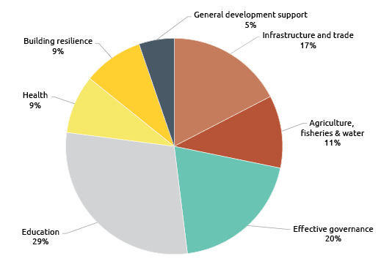

### Program quality

South-East and East Asian country and regional programs made good progress against objectives with 74 per cent on track (Figure 16). While no objectives were rated as off-track, 26 per cent of objectives were assessed as at risk (progress less than expected). Progress against country and regional program performance benchmarks was sound with 65 per cent of benchmarks achieved and a further 20 per cent partly achieved (Figure 17). For Indonesia, benchmarks were updated due to changes in the performance assessment framework as a result of reforms of several programs.

For **Indonesia**, eight out of nine program outcome areas were assessed as on track. Progress against the outcome related to *improved responsiveness of public institutions to community, especially to women* was assessed as less than expected as results from governance programs aimed at strengthening the inclusive nature of Indonesia’s reforms have yet to manifest. In **Timor-Leste**, five of nine outcome areas were assessed as on track. Progress against outcome areas on *rural roads maintenance* and *increased access to water supply and sanitation* were assessed as at risk due to uncertainties around Government of Timor-Leste’s future funding and human resource commitments. Progress against the outcome area related to *maternal health* was rated as at risk: while there were improvements in maternal and child health services and skills development of doctors, midwives and paramedics, management of the overall health portfolio was administratively burdensome limiting the program’s capacity to assess the appropriateness of sector investments. Progress against the outcome area on *improved economic development* *and delivery of services* was also rated as at risk. While the overall economic governance programs performed well, direct budget support from Australia for public financial management reform was assessed as unsatisfactory and subsequently terminated.

Figure 16: Progress against program objectives: South-East and East Asia, 2015–16

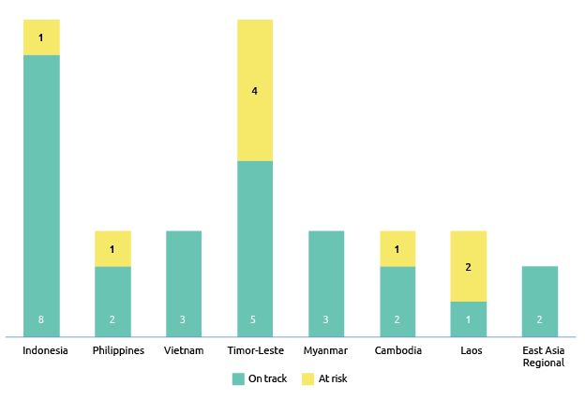

Two of three objectives were assessed as on track for the **Philippines** program. The objective on *enhancing the foundations for economic growth* was rated as at risk due to not meeting performance benchmarks for finalisation of aid for trade and infrastructure program designs. For the **Cambodia** program, two of three objectives were assessed as on track. The objective on *improving access to essential infrastructure* was assessed as at risk. While good progress was made on rural roads rehabilitation, performance benchmarks for electricity and water connections were not met due to delays in implementation of a new infrastructure program. Two of three objectives were assessed as at risk for the **Laos** program. This assessment reflected partial achievement of benchmarks on *improving human resource capacity* and mixed progress with outcomes under the objective on a *stronger trade regime and more competitive private sector.*

Figure 17: Progress against performance benchmarks: South-East and East Asia, 2015–16

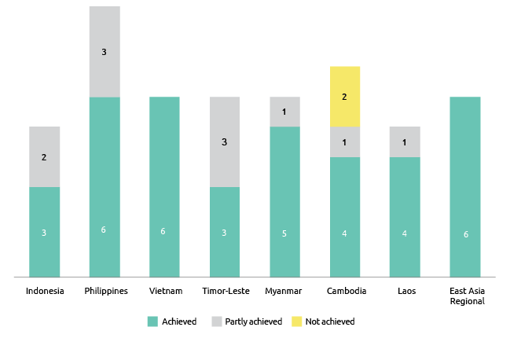

The performance of individual aid investments in South-East and East Asia was the same as the aid program as a whole on effectiveness criteria and higher for efficiency, monitoring and evaluation, gender equality and sustainability criteria (Figure 18). Performance on gender equality improved compared to last year although not all country and regional programs achieved the gender equality strategic target and will be working to improve outcomes against this target. All nine investments identified as requiring improvement in 2014-15 either improved their performance during 2015-16 or were completed. Four investments were identified as requiring improvement based on 2015-16 Aid Quality Check results and management action plans have been put in place for ongoing investments.

South-East and East Asia programs have identified management actions to improve program performance and quality. These actions are set out in individual country and regional Aid Program Performance Reports.

Figure 18: Aid investment performance: South-East and East Asia, 2015–16

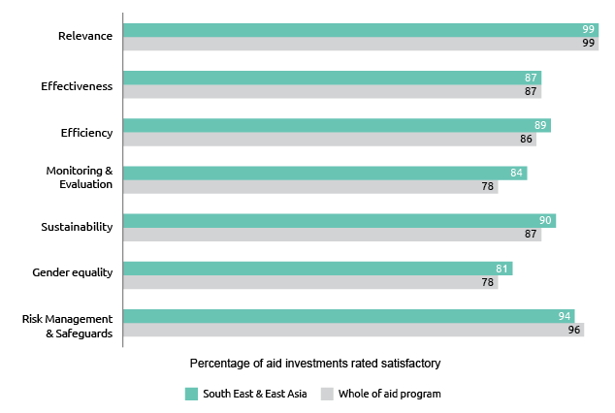

### Performance by investment priority area

Australian aid investments effectively supported economic development through **infrastructure, trade facilitation and international competitiveness.** In Indonesia, sustained economic growth has resulted in a rapid demand for electricity, but tariffs have not been sufficient to cover costs and mobilise the financing needed for new investments. Through a partnership between Australia and the World Bank, electricity subsidies were targeted to poor and vulnerable groups, and the state-owned energy company PLN, was incentivised to improve services. These reforms will reduce subsidies and enable PLN to meet the challenge of increasing electricity demand.

Improvements in road infrastructure in Indonesia, Philippines, Timor-Leste and Vietnam enabled better access to markets and services. In Vietnam, completion of the Mekong Delta Infrastructure Connectivity Project enabled construction of 231 kilometres of rural roads and 102 small bridges over the duration of the project, providing direct benefit to an estimated 316,000 people. Good progress continued to be made with construction of the Cao Lanh bridge which is now 66 per cent completed and slightly ahead of schedule. Poor households near the bridge site received support to improve their housing and income. In Timor-Leste, the Roads for Development program maintained 376 kilometres of roads and rehabilitated 27.9 kilometres of additional rural roads, exceeding its 2015-16 performance benchmark of 25 kilometres. To date, the program has provided over $635,000 in cash transfers to women through short-term employment opportunities.

After six years of implementation, the Philippines Provincial Road Management Facility was completed in June 2016. The program rehabilitated and maintained 628 kilometres of provincial roads and helped improve road management practices by local governments in 10 provinces. In 2015-16, the program leveraged $200 million in national budget funding for local road rehabilitation in 74 provinces. An independent review confirmed program achievements and identified areas where progress could have been better including with regard to the procurement system.

|  |
| --- |
| Eastern Indonesia National Roads Improvement Program  The Eastern Indonesia National Roads Improvement Program (EINRIP) finished in 2015-16 with completion of its final three road packages, bringing Australia’s overall support through this globally recognised program to $326 million. It delivered around 395 kilometres of roads and 1,300 metres of steel-fabricated bridges across nine provinces in eastern Indonesia and achieved national reforms in the areas of road design, construction supervision and project management. Indonesia is drawing on lessons learned through the program in developing its own new national roads program, scheduled to start in 2017. An ODE evaluation of EINRIP will be published in 2017. |

Australia continued to work with the ASEAN Secretariat and member countries to advance economic integration and support regional trade and competitiveness. Australia supported Laos, Myanmar and Cambodia to enact national competition law and establish competition authorities. Australia also contributed to the accession of Cambodia and Laos to the Madrid Protocol, an international trademark registration system intended to reduce the cost and complexity of doing business. Australia supported the ASEAN Secretariat to develop the ASEAN Connectivity Master Plan and improve labour mobility through ASEAN-wide mutual recognition arrangements in the tourism industry, including a common ASEAN tourism curriculum and training program.

In Laos, a mid-term review of the **Trade Development Facility** found that progress was being made across all components of the project. The Business Assistance Facility, a matching grants facility for Lao-based businesses implemented through the Trade Development Facility, performed strongly with 83 businesses issued grants to help increase their sales growth, exceeding Australia’s performance benchmark of 30. However, consultations undertaken as part of ODE’s evaluation of Australia’s trade facilitation assistance suggested that the political will in Laos for major reforms has declined since WTO accession and this was likely to impact on components of the Trade Development Facility project.

During 2015-16, Australia supported reforms in Indonesia, Vietnam, Timor-Leste and the Philippines aimed at **private sector development and increased competitiveness.** Australia supported the Indonesian Government to introduce major changes to its public private partnership policy to attract greater levels of private financing. In the Philippines, Australia is working with the Philippines Government to improve capacity to develop and implement public private partnership projects. In 2015-16, the performance benchmark of 14 projects competitively tendered was exceeded with 26 projects tendered and 12 projects awarded. In Timor-Leste, Australia supported the International Finance Corporation to improve business licensing processes, and the timeline to set up a business was reduced from 90 to nine days. Australia continued its support for policy reform in Vietnam. Supported by active diplomatic advocacy, the Restructuring for a More Competitive Vietnam project helped revise enterprise and investment laws, which led to the abolition of 3299 restrictive business conditions, and supported analysis to help identify inefficient regulations.

Australia’s **agriculture and fisheries** investments continued to support improved livelihoods in South-East Asia and East Asia. In Timor-Leste, the Seeds of Life program (co-funded with ACIAR) ended in 2016 having reached approximately 50 per cent (63,000) of rural households that adopted and routinely grew improved seed varieties, with 84 per cent reporting improved yields.

In Indonesia, the Promoting Rural Incomes through Support to Markets in Agriculture (PRISMA) program assisted 18,567 smallholder farmers (7,982 women) to increase their incomes by an average of 35 per cent in 2015 and the program is on track to achieve its target of benefiting 300,000 poor farmers by 2018. The ‘making markets work for the poor’ approach employed by PRISMA has a 30 per cent failure rate built in. Potential failure is part of doing business and informs decisions on when to scale up or cut interventions. For example, PRISMA decided to cease funding a fish cage farming project in East Java because it was assessed as having poor outreach and sustainability. After 18 months of implementation, PRISMA ended the project and identified lessons to inform future investments.

In Myanmar, Australian supported interventions focused on structural economic reforms in the agriculture sector and innovative partnerships with companies to connect smallholder farmers to commercial value chains. Through a program implemented by ACIAR, small-holder farmers in target areas achieved a 14 per cent increase in rice yields. In Cambodia, Australian support increased the productivity and incomes of smallholder farmers by strengthening market systems and irrigation infrastructure. About 19,000 households increased their agricultural productivity, equating to approximately 100,000 people having more food or a higher income. Also in Cambodia, land mines were cleared on 28 kms2 of contaminated land and 44 kms2 of cleared land was released which benefited over 80,000 people.

Australia has supported partner governments in the Philippines and Indonesia to implement their own **governance** reform agendas to improve the efficiency, accountability and transparency of public financial management. In the Philippines, Australia has promoted the formation of coalitions among civil society, the private sector and government to create platforms for dialogue to influence public policy. Results have included nearly doubling the total additional funding local governments and private sector companies provided to support local senior high schools, from $46 million in 2014 to $85.7 million in 2015. Not all reforms supported by the Coalitions for Change program in the Philippines were successful including improvement of the regulatory environment for public-private partnerships and amendments to the Disaster Risk Reduction law. Many of these failures were attributed to challenges around poor technical solutions or an unfeasible political climate, providing valuable lessons learned.

Enhancing the quality of government spending is an important focus of Australia’s program in Indonesia. Studies undertaken by two of our investments helped the Government of Indonesia identify that the spending of village funds in 2015 was not well targeted to local needs. Programs are now working with government partners to improve the national policy framework, including developing guidelines for communities to agree development priorities for village funds, and to strengthen reporting of fiscal transfers.

In Timor-Leste, Australia helped the Prime Minister’s Office to negotiate and agree program structures with 23 ministries and agencies, against which budgets have been allocated in 2017.  For the first time in Timor-Leste’s history, there is a direct link between government plans and budgets, and from 2017 it will be possible to track how much is being spent on specific services and policies.

In Cambodia, the criminal/community justice assistance program was completed after 19 years of implementation. An independent legacy review found the program had made significant achievements in prisons development including the establishment of a healthcare program within the correctional system and enabled senior officials to think differently about policing and crime prevention, although some program activities were poorly aligned with outcomes. The Australia-Indonesia Partnership for Justice helped design a small claims dispute settlement mechanism. In the first year, the majority of cases were settled within 58 days (improved from previous average of 450 days per case).

The Greater Mekong Water Resources Program facilitated research and capacity building in sustainable management of the region’s **water resources**. In Cambodia, this included supporting major irrigation reforms, which led to establishment of an ongoing budget mechanism to upgrade and rehabilitate 231 existing irrigation systems. Australia has formed a new partnership with the Government of Myanmar to take forward its substantial water reform agenda for the Irrawaddy and Salween rivers.

Australia’s support for **education** delivered results in Myanmar where Australia assisted with the delivery of school grants and stipends to 95 per cent of schools in 288 of Myanmar’s 330 townships. This exceeded the performance benchmark of 80 per cent of schools in 100 townships and benefited 9.3 million students. Stipends to reduce school dropout rates were provided to over 120,000 disadvantaged students (46 per cent girls), exceeding the performance benchmark of 18,000 students. The program’s monitoring system found that 97 per cent of children receiving stipends are staying in school. Australian support also helped train 12,115 teachers and 1,116 early childhood caregivers in remote community schools, benefiting an estimated 224,000 children in 2015-16.

In Indonesia, Australia reoriented our engagement away from building schools towards improving the quality of learning outcomes at the school level, including better education assessment. New programs build on Australia’s support for professional development to 7,200 school principals from 250 Indonesian districts (a total of 24,300 have been trained over the last two years). In Timor-Leste, Australia worked closely with the Ministry of Education to design and launch a Professional Learning and Mentoring Program for the nation’s teachers and school leaders as well as deliver new curriculum materials to 94 per cent of remote primary schools and 100 per cent of remote preschools.

In the Philippines, a large portion of Australian aid is devoted to working regionally, especially in Mindanao - home to a sizeable Muslim population. In 2015-16, Australia’s technical support helped implement 22 policies including for teacher development, national classroom systems assessments, indigenous people’s education, and senior high schools. Australia’s program has underpinned the education reform objective of expanding the ten-year secondary school system to include mandatory kindergarten and years 11 and 12 in the curriculum. A full 12-year education system will help to produce a well-educated population for a more productive workforce. Capacity building activities on the new curriculum were provided to 2,112 teachers, more than half of whom were female, and 87 classrooms were built in Bicol, the Visayas, the National Capital Region and Davao Region. In Mindanao, the program enabled 76,000 children who previously had no access to education to attend school, including more than 2,500 indigenous children.

The Australia Awards scholarships program is a core component of Australia’s South-East Asia programs. In the Philippines, it has been commended in an independent evaluation for establishing innovative Re-Entry Action Plans and mentoring processes to help scholars transition back into their professional environments and provide sustained benefits to their organisations. The program is supporting women’s leadership, with 53 per cent of females receiving a promotion on return from their scholarship. Vietnam Australia Awards were assessed as highly successful, with 93 per cent of alumni employed in positions relevant to their award skills after three years of returning, significantly exceeding our benchmark of 75 per cent.

After some 20 years of significant Australian assistance for Indonesia’s **health** sector, our major health programs completed their activities during 2015-16, leaving a legacy of improvements to health planning, maternal and child health, and prevention and treatment of HIV/AIDS. The Australian-Indonesian Partnership for Maternal and Child Health was instrumental in reducing maternal deaths in one of Indonesia’s poorest provinces, East Nusa Tenggara, by over 40 per cent since 2009. Australian support will transition to supporting health security and promoting nutrition. The focus in the final year has been on sustainability in systems improvement including developing a national health centre accreditation system. In Myanmar, the 3MDG fund delivered good results with 71,597 children under one (against a target of 78,875) immunised against tetanus, diphtheria, pertussis and hepatitis B. Nearly 160,000 suspected tuberculosis cases were screened – a doubling of numbers recorded in 2014. However, shifting performance targets have made it difficult to assess progress over time for this investment.

In Timor-Leste, Australia supported the innovative Liga Inan ‘Connecting Mums’ program which uses simple mobile phone technology to connect expectant mothers with community health workers to improve the likelihood of a healthy pregnancy, birth and post-natal period. An impact evaluation found that women in the program pilot sites were nearly twice as likely to have a skilled birth attendant and deliver at a health centre, seven times more likely to have a postpartum care visit and five times more likely to have their newborns receive a postnatal visit within two days of delivery.

In Indonesia, Australia’s investments helped improve service delivery outcomes in 275 districts across health, education and social protection. Over 18,000 service providers, including teachers and nurses, used their skills to deliver these improved services. Australia’s investments in urban and rural water and sanitation programs resulted in an additional 490,000 people from poor households (including 2,800 people with disabilities) gaining improved access to safe water and basic sanitation in 2,250 communities across Indonesia. As a result of these investments, the Indonesian Government allocated 500 billion rupiah (AUD$50 million) towards an output-based grants program that replicates Australia’s pilot program. In Vietnam, Australia financed 56,000 new water connections and provided an additional 111,000 households with hygienic latrines. End of program targets were achieved with 86 per cent of the rural population now having access to hygienic water, and 65 per cent of rural households with access to a hygienic latrine. Australia also began piloting new private sector led service delivery models for water and sanitation in Vietnam. The Rural Water Supply and Sanitation Program in Timor-Leste enabled 21,775 people to gain improved access to clean water or sanitation and hygiene behaviour change programs.

|  |
| --- |
| Health sector results in Cambodia  Australia’s health assistance in Cambodia achieved good results in 2015-16. These include:  • The ID Poor program expanded its reach to 100 per cent of rural communities, up from 95 per cent in 2014. This provided identification cards to poor Cambodians so that they can access subsidised health care and other social services.  • A mid-term review of Partnering to Save Lives found the program was on track and consistent with the priorities of the Australian and Cambodian governments. Training midwives in Cambodia’s remote North-Eastern provinces has helped improve the quality of reproductive, maternal and neonatal health services, doubling the percentage of midwives trained to 70 per cent in 2015-16. Also in the same region, the percentage of women delivering in a health facility with a skilled birth attendant increased from 39 per cent in 2014-15 to 44 per cent in 2015-16.  • Under the Second Health Sector Support Program, approximately three million vulnerable Cambodians, or about 20 per cent of the population, received access to a form of health insurance to access essential health services. Australia’s investment in 2015-16 contributed to expanding the Health Equity Fund system to 100 per cent of the country (up from 63 per cent in 2014). An independent completion review of this program will be completed in 2016-17. |

Australia continued to support interventions to **build resilience** in South-East and East Asia. A now complete project in Vietnam has increased women’s contribution and leadership in disaster risk management including by revising the disaster management law to incorporate gender equality and promoting the participation of the Vietnam Women’s Union in decision-making. In Indonesia, Australia has partnered with Geoscience Australia and the Indonesian Government since 2008 to increase the use of science and technology to support decision making in disaster risk management. While substantial progress has been made in the use of science and the development of disaster management tools, a review of this program found sustainability was a weakness, with Indonesian agencies still heavily dependent on Australian scientists and technology. This has been addressed in the new program, which has a stronger focus on sustainability and capacity-building. Australia provides support through several local partners, in particular the Indonesian Red Cross. During the 2015 fires, Australia deployed two fire-fighting aircraft and personnel to Sumatra, and stands ready to provide humanitarian assistance to respond to earthquakes, floods or fires.

Australia provided a range of **humanitarian** assistance during 2015-16. In the Philippines, Australia was the only bilateral partner requested by the Philippine Government to support its humanitarian response after Typhoons Melor and Koppu in late 2015. Emergency relief assistance (food, tarpaulins, family kits, hygiene/dignity kits, sexual and reproductive health kits) was made available to around 34,000 people affected by the typhoons. Australia also helped the Philippine Government to promote economic resilience in Metropolitan Manila by producing the first Earthquake Map Atlas. Australia responded to the El Nino drought in Timor-Leste by funding Australian NGO partners to provide emergency livelihoods, food security, risk reduction, health and hygiene and water management assistance to affected households.

In Myanmar, Australia provided humanitarian assistance, after Cyclone Komen and large-scale flooding, to over 372,000 women, men, girls and boys, exceeding the performance benchmark of 200,000. Australia supported UNICEF to address urgent protection and psychosocial needs in conflict-affected and displaced communities, reaching 70,510 girls and boys in Kachin, Rakhine and northern Shan states.

Australia continued to support **social protection** efforts in the Philippines through a conditional-cash transfers program. The program has lifted 1.5 million households out of poverty since 2012. In Indonesia, Australia supported the Vice President’s team for the Acceleration of Poverty Reduction to spearhead efforts in social protection reform. Australia assisted the Government of Indonesia to improve targeting of social protection programs, including by updating a unified database of almost 26 million households. The government used the database to better target conditional cash transfers to around 3.5 million very poor households, and 19 million poor school students in 2015.

Australia continued to make progress in improving **gender equality** in South-East and East Asia. Over the past two years in Indonesia, our analysis of opportunities and constraints to women’s economic empowerment has improved. The Australia Indonesia Partnership for Economic Governance (AIPEG) and the World Bank Partnership for Knowledge-Based Poverty Reduction (PKPR) trust fund have produced influential research and engaged policymakers on barriers to female labour force participation.

Through the regional Australia-Asia Program to Combat Trafficking in Persons (AAPTIP), Australia supported the drafting of the *ASEAN Convention Against Trafficking in Persons, Especially Women and Children (ACTIP),* signed in November 2015 by ASEAN Leaders. The Convention establishes a regional legal instrument that aims to prevent trafficking in persons, protect and assist victims and promote cooperation between ASEAN member states to achieve these objectives.

In Myanmar, Australia helped support women’s inclusion in the historic election in 2015. We supported local NGO, Yaung Chit Thit, to implement She Leads, a women’s leadership program training over 700 women to address the lack of women’s leadership in political and decision-making processes at all levels of state and society. The women provided voter education to over 50,000 people, and over 70 She Leads participants took on leadership roles in the election, including as candidates, observers, party agents or election officials.

Ending violence against women remains an important priority for the aid program in South-East and East Asia. In Cambodia, Australia’s funding provided shelter, counselling, legal aid and peer support services to 9,950 women and their families, an increase from 5,930 in 2014-15. The program successfully piloted prevention projects to reduce alcohol abuse and promote positive messaging about women in the media. The alcohol abuse intervention is likely to be scaled up next year.

In Indonesia, the Empowering Indonesian Women for Poverty Reduction program provided trauma counselling, legal assistance and referral services for 12,799 woman survivors of violence across 18 provinces in Indonesia. Over 5,000 women in Timor-Leste were provided legal support, medical treatment, shelter, counselling and life skills training. This includes services for 1,121 female survivors of violence, exceeding the performance benchmark of 1,000. Australia also supported the first national study into the prevalence of gender-based violence in Timor-Leste, which is informing advocacy, service delivery and the design of violence prevention programs.

Australia continued to work with partners to **improve conditions for peace and stability**. In the Philippines, Australia supported dialogue with the new Philippine Government, Congress and the Senate on the Bangsamoro Basic Law. The program developed communication strategies to counter anti-Muslim narratives; worked with key legislators and staff to raise awareness on the draft law; supported increased participation of women in the peace process; brought Moro Islamic Liberation Front representatives and legislators together; and supported the livelihoods of conflict-affected communities to shore up the peace process.

Efforts to improve **disability-inclusive development** in South-East and East Asia achieved results in 2015-16. In Cambodia, physical and community based rehabilitation services were provided to over 31,000 people with disability (28 per cent women). An independent evaluation in 2016 found the program played a crucial role helping the Cambodian Government establish 14 Disability Action Working Groups in line-ministries and 20 Disability Action Councils at the provincial level which now coordinate and monitor the implementation of the National Disability Strategic Plan. In Indonesia, Australia supported the General Election Network for Disability Access to develop a tool to help election administrators prepare and implement accessible elections. The tool was successfully piloted during the December 2015 regional elections, and will be used in the 2017 regional elections. In Myanmar, Australia supported disability inclusive polling stations at 18 locations in six states and regions. The Myanmar Union Election Commission provided ballot guides in braille and facilitated physical access to the polling booths.

## South and West Asia, Africa, the Middle East and Other Regions

### Context

#### South and West Asia

South and West Asia - home to a quarter of the world’s population - is the fastest growing region in the world. Absolute poverty, while declining, remains significant, and relative poverty is gradually increasing[14]. The region has achieved its strong economic performance despite exporting to low growth markets in Europe and the US, being poorly integrated, having low levels of foreign direct investment and high levels of public debt, and relying on remittances to balance out current account deficits. Its potential for greater, equitable growth, pulling millions more people out of poverty, is therefore enormous.

South and West Asia is important to Australia’s strategic and economic interests, and Australia continues to deepen security, economic and trade ties with the region. The aid program complements DFAT’s diplomatic, trade and investment expertise in building long-term economic partnerships that will help unlock the region’s potential to reduce poverty in a sustainable way. Australia also works with governments and non-government actors in the region to address economic and social disadvantage, gender inequality, violence against women and discrimination against people with a disability. As a region with a high vulnerability to natural disasters, the aid program provides timely humanitarian relief, with the response to the 2015 Nepal earthquakes being a highlight over the reporting period, and seeks to improve disaster preparedness.

Political uncertainty and security remain issues of concern. Afghanistan continues to be a high-risk operating environment that stifles economic activity and challenges aid delivery. Pakistan and Bangladesh face increased terrorism and security threats and are dealing with large numbers of displaced persons from neighbouring countries. Sri Lanka has renewed its focus on reconciliation and political and economic reform, with the goal of embedding a lasting peace.

Australia spent $302.7 million in South and West Asia in 2015-16, or 7.5 per cent of Australia’s total ODA. Of this, 68 per cent was spent in Afghanistan, Bangladesh and Pakistan (see Table 6).

Table 6: Total ODA by country program: South and West Asia, 2015–16

|  |  |  |
| --- | --- | --- |
| **Country Program** | **2014-15** | **2015–16** |
| **($m)** | **($m)** |
| Afghanistan | 139.9 | 88.1 |
| Bangladesh | 99.5 | 62.6 |
| Pakistan | 84.2 | 53.8 |
| Nepal | 58.0 | 35.2 |
| Sri Lanka | 42.8 | 28.6 |
| Bhutan | 12.8 | 9.2 |
| Maldives | 6.4 | 5.8 |
| South and West Asia Regional | 31.3 | 19.4 |
| **South and West Asia Total** | **474.9** | **302.7** |

Figure 19: Total ODA by investment priority area: South and West Asia, 2015-16

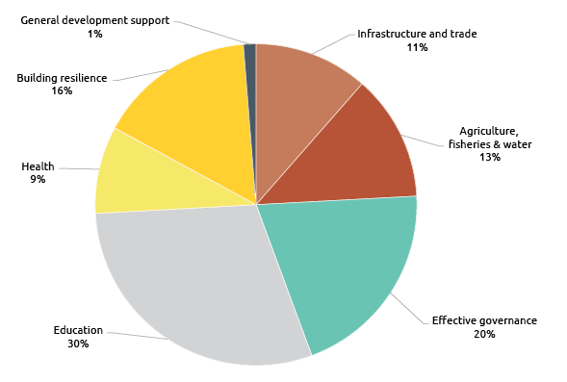

#### Africa, the Middle East and Other Regions

Slow economic activity and ongoing regional vulnerabilities contributed to the slow rate of poverty reduction in Africa. A combination of external and internal factors were responsible, including lower commodity prices, tightened borrowing conditions and in some countries political instability, corruption, conflict and insurgencies, drought and infrastructure constraints.[15] Overall, regional GDP per capita remained low in 2015 at 3.4 per cent, down from 4.6 per cent in 2014. This was the weakest annual growth rate since 2009[16].

Although poverty incidence has declined across Africa over recent decades, the number of poor Africans has increased due to population growth[17]. Poverty reduction has been slowest in fragile countries with rural areas remaining much poorer than cities. Seven of the ten most unequal countries in the world are in Africa, most of them in Southern Africa. Household survey data shows an increase in the number of extremely wealthy Africans is a major driver of inequality[18].

Significant development, security and economic challenges continue to exist in the Middle East. Almost 44 per cent of the Palestinian Territories’ population of 4.3 million are refugees. Constraints to development are particularly evident in Gaza, where extreme population density, heavy economic restrictions and repeated cycles of conflict have rendered half of its population dependent on food assistance to meet basic needs.

In 2015-16, Australian ODA to Africa, the Middle East and other regions was $305 million (Table 7).

Table 7: Total ODA to Africa, Middle East and other regions, 2015–16

|  |  |  |
| --- | --- | --- |
| **Country Program** | **2014-15** | **2015–16** |
| **($m)** | **($m)** |
| Sub-Saharan Africa | 268.6 | 163.3 |
| Middle East and North Africa | 49.9 | 85.1 |
| Palestinian Territories | 69.3 | 43.3 |
| Latin America and the Caribbean | 23.9 | 13.3 |
| **Total** | **411.7** | **305.0** |

Figure 20: Total ODA by investment priority area: Africa and the Middle East, 2015–16  
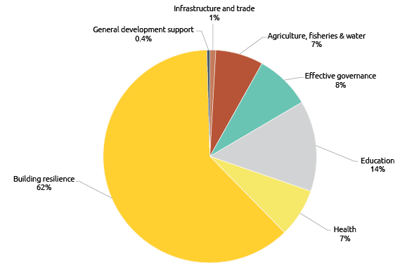

### Program quality

In the context of significant transition in program composition over the past year, 60 per cent of South and West Asia program objectives were assessed as on track and no objectives were rated as off track. Progress was less than expected against 40 per cent of objectives. Sixty per cent of performance benchmarks were achieved or partially achieved.

In **Afghanistan**, progress toward the *building resilience and supporting at-risk populations* objective was on track. However, heightened security and operational challenges placed progress toward the other two program objectives at risk, despite evidence of some positive outcomes at the individual investment level. Those objectives are *supporting the Afghan Government to achieve economic growth and institute more effective and accountable governance and empowering women and girls by addressing barriers to their social, political and economic participation.*

One of two program objectives was assessed as on track in **Pakistan**. While Australia saw good results from its education and gender-based violence investments, delays in implementing the nutrition investment in Khyber Pakhtunkhwa province adversely affected progress toward the program’s objective of *investing in people through health and education.*

For **Sri Lanka**, progress against two of three program objectives was assessed as being less than expected. Progress toward the *expand economic opportunities for the poor* objective was mixed over the past twelve months. Weaknesses in investment start-up have been resolved and improved results are expected over the next reporting period. Temporary delays in investment design also led to progress against the objective of *increase gender equality* to be less than expected.

For **Nepal**, two of three program objectives were assessed as on track. Progress against the objective related to *expand economic opportunities for the poor by promoting enterprise and job creation* was less than expected. While progress continued in micro-enterprise creation for the poor, limited success has been achieved to date with institutionalising and transitioning micro-enterprise development to Government of Nepal management.

Progress against objectives for the **Bangladesh** and **South Asia Regional** programs was assessed as on track.

Figure 21: Progress against program objectives: South and West Asia, Africa and the Middle East, 2015–16  
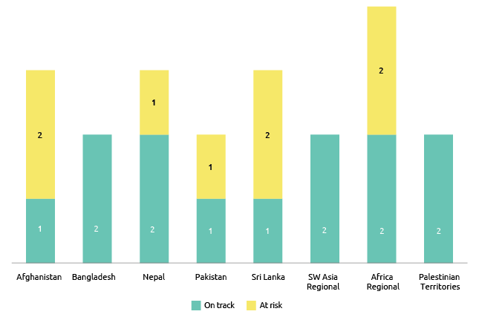

For **Sub-Saharan Africa**, two of four program objectives were assessed as on track. Progress was less than expected for the objectives relating to *enhance agriculture’s contribution to sustainable and inclusive economic growth and food security and empower women and girls and improve gender equality outcomes* due to mixed progress against performance benchmarks (Figure 22). A new Sub-Saharan African Gender Action Plan (GAP) has been introduced to support implementation of the Australian Government’s Gender Equality and Women’s Empowerment Strategy, along with GAP implementation plans at Australia’s seven Sub-Saharan Africa posts.

Progress against objectives for the **Palestinian Territories** program was assessed as on track, reflecting the achievement of the majority of performance benchmarks for a limited number of targeted investments.

Figure 22: Progress against performance benchmarks: South and West Asia, Africa and the Middle East, 2015–16

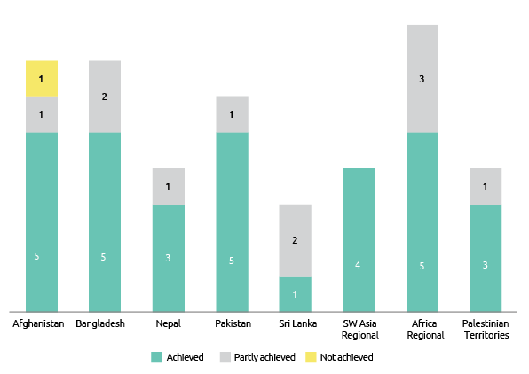

Figure 23: Aid investment performance: South and West Asia, Africa and the Middle East, 2015–16

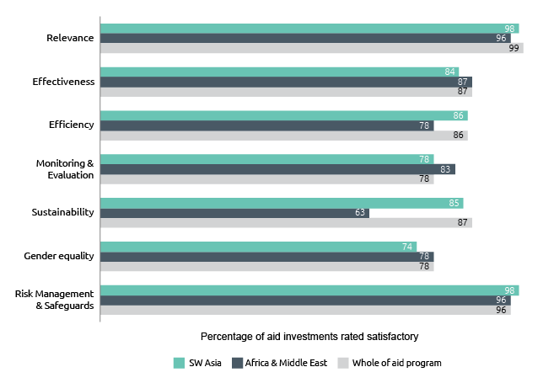

### Performance by investment priority area

Australia has supported rehabilitation of rural **infrastructure** in Uruzgan, Afghanistan since 2012 with two major investments completed in 2015-16. Achievements included providing flood protection for over 700 hectares of agricultural land benefitting over 1,800 families, improved access to arable land, 73 kilometres of road constructed and 151 kilometres of road maintained. However, these achievements were less than planned due to contractor performance, ongoing insecurity and flood damage experienced over the duration of the investments.

Australia’s partnership with the African Union’s New Partnership for Africa’s Development has improved the project management skills of public sector infrastructure project managers working on regional power and transport corridors in Eastern and Southern Africa. In addition, the partnership has resulted in the signing of a Memorandum of Understanding between Malawi and Zambia to connect their electricity grids and for South Sudan to meet the transport criteria for joining the East African Community.

Noteworthy contributions were made to Sub-Saharan Africa’s **agriculture** sector via the Australia Africa Community Engagement Scheme (AACES), which worked with ten Australian NGOs and their in-Africa partners across 11 African countries. Key results achieved included 36,750 poor men and women (24,323 females and 12,427 males) adopting innovative agricultural and fisheries practices and 15,101 poor men and women benefiting from increased incomes. AACES concluded in 2016 and an independent program review found that 817,933 people experienced improved agricultural productivity over the life of AACES (2011-2016)[19].

Poor men and women in Africa continued to gain improved access to markets and agricultural production through Australia’s support to the African Enterprise Challenge Fund (AECF), including an estimated 822,040 Zimbabweans who benefited from increased incomes. In addition, CSIRO’s partnership with Bioscience Eastern and Central Africa International Livestock Research Institute (BecA-ILRI) has generated the ability to detect and prevent aflatoxin (a highly carcinogenic substance) in maize crops and raise awareness among farmers and policy makers towards aflatoxin-free maize certification in Kenya. The project’s partnership with the Kenya Cereal Millers Association has the potential to reach over 10 million customers including the rural poor.

In South Asia, the aid program emphasises regional approaches in recognition that agriculture and water are cross-border concerns. The Regional South Asia Sustainable Development Investment Portfolio (SDIP) worked with seven delivery partners across the three major Himalayan river basins, to deliver initiatives aimed at increasing food, water and energy security. An independent review of the first phase of SDIP assessed the overall performance as good. It found clear evidence of the SDIP partners initiating substantial work programs that will contribute to the overall SDIP objective, and provided a platform for Australia to make a meaningful contribution to Basin management reform in the region. The review recommended that the second phase pay more rigorous attention to the content of partner activities and ensure clear alignment with the overall objectives of SDIP.

SDIP supported farm trials involving more than 15,000 farmers (one third women) across Bangladesh, India and Nepal developed water-efficient farming technologies and built capacity through training, crop modelling, machinery use, and business models for local small and medium enterprises and agricultural suppliers. As at 30 June 2016, around 28,000 male and 12,000 female farmers have adopted one or more of the trialled technologies.

In Pakistan, investments in agriculture and market development through a co-investment with the Food and Agriculture Organisation led to over 8,800 farmers increasing their incomes with 7,500 people (67 per cent women) being trained in advanced agricultural technologies and practices. In contrast, the final assessment of the Agricultural Sector Linkages Program concluded that the investment was unable to overcome the low participation of women in relevant value chains, reducing overall project impact.

**Governance** is an increasing focus of the aid program in South and West Asia. Despite contextual challenges, it has produced some promising results. In Sri Lanka, DFAT has been working closely with The Asia Foundation (TAF) in successfully piloting tools to improve sub-national governments’ legislation and policy-making, financial administration (including participatory budgeting) and accountability. These tools are now being implemented in 12 local authorities across Sri Lanka.

In support of more effective governance in Afghanistan, Australia’s Public Financial Management program aimed to improve budget execution in five line ministries: Agriculture; Economy; Education; Public Health; and Public Works. The program was completed in December 2015 and over the course of three years trained 3,837 people (550 female) in procurement, financial administration, reporting and planning across all 34 Afghan provinces. The program resulted in the increased functional capacity of civil servants and improvements to public financial management systems and processes. The program also addressed the need to increase women’s participation in the Afghan civil service, which remains extremely low, by incorporating computer and English training, and developing an internship program for women.

Support to the International Monetary Fund’s Managing Natural Resources Wealth Trust Fund helped legislative reform efforts in several African countries during 2015-16. For example, in Sierra Leone the Fund assisted with the approval of Public Financial Management legislation by Cabinet for submission to Parliament. The Fund has also supported capacity building in several countries including financial modelling capacity of the Inter-Ministry Mining Tax Unit in Mali; training staff on fiscal modelling and revenue forecasting for oil and gas in Ghana; and in Tanzania, the Fund helped build capacity in extractive industry risk assessments.

Australia’s support for Bangladesh’s primary **education** program helped improve the quality of education through a revised textbook curriculum, increased levels of competency based questions in school tests, improved teacher materials and increased access to quality basic education in areas where government schools are not operating. Australia’s partnership with BRAC assisted 470,075 students complete pre-primary and primary education, exceeding the program’s performance benchmark of 438,000.

In Nepal, more than 284,000 teachers received training in basic and secondary education of which approximately 34 per cent were women. The percentage of women teachers who received training is proportional to their representation across primary, secondary and basic education levels. Targets for assisting children (including those with a disability) to transition back to school following the earthquakes were achieved with 17,213 children assisted against a target of 17,000.

In Pakistan, education investments are overall achieving good results. This included 37,000 children (16,100 girls) supported to access quality education in Khyber Pakhtunkhwa (in a partnership with DFID) exceeding the target of 23,000 (10,000 girls). However, the school infrastructure component is two years behind schedule due to difficulties in government approvals and an increase in construction costs. As at June 2016, construction had started in 241 schools (against a target of 320 schools) with 87 schools completed. During 2016-17, progress is expected to improve now that the scope of construction has been agreed with the Government.

Australia has achieved good results in the **health** sector in the Palestinian Territories. With Australian funding, UNICEF completed the rehabilitation and construction of water, sanitation and hygiene facilities in 52 schools in Gaza (exceeding the target of 51 schools), having completed these facilities in all 40 targeted schools in the West Bank the previous year. Through these works, 30,412 children have benefited from improved access to drinking water, toilet and hand washing facilities. Despite ongoing regional insecurity, UNRWA instituted the holistic Family Health Team approach in 115 of its 117 health centres. Fewer daily medical consultations per doctor is one of the positive outcomes of the introduction of UNRWA’s approach, which helps to streamline doctors’ workloads and improve coverage and quality of comprehensive medical care. UNRWA’s Family Health Team approach also includes gender-based violence screening and counselling in its health centres.

Australia’s efforts to increase the capacity of governments in the Pakistan provinces of Balochistan and Khyber Pakhtunkhwa to address poor nutrition had mixed results. In Balochistan, over 304, 000 children aged 6-59 months were provided with Vitamin A supplementation, almost doubling the first year program target of 155,940. However, service delivery in Khyber Pakhtunkhwa has not commenced as a revised province-wide integrated health and nutrition development plan has not yet been approved. Through its Nutrition Trust Fund engagement and in direct discussion, Australia will continue to engage with the provincial government to advocate for approval of the health and nutrition plan.

In challenging circumstances, the aid program made some progress in promoting **gender equality** in South and West Asia, particularly in targeted gender programs. Australia’s Ending Violence against Women (EVAW) program in Pakistan continued to perform well in its second year. The program assisted 3,813 survivors of gender-based violence (against a target of 2,560) to access quality support including temporary safe housing, counselling, health and legal services and livelihood support. This is an increase of 33 per cent from 2014-15. In addition, 1045 police, judiciary, medical and legal officers were trained in handling gender based violence cases sensitively. However, institutionalising the sensitive handling of cases among the police and judiciary remains very challenging. The Afghanistan EVAW program also continued to perform well, almost doubling, for example, its target for training police and justice officials on gender-based violence case management and application of EVAW law. However, these gains remain fragile.

With Australia’s support, Oxfam Australia’s establishment of gender-based violence networks and help desks in the Northern and Eastern provinces of Sri Lanka has proven to be so successful that the model is set to be mainstreamed through the national health and legal systems.

Across Africa, Australia Awards continued to contribute to development outcomes through the actions of over 5,500 alumni, including advancing economic productivity and the promotion of democracy and human rights[20]. Approximately 46 per cent of scholarships were allocated to women, exceeding the performance benchmark of 45 per cent. This target is important given the male dominated nature of the priority sectors such as extractives, agricultural productivity and public policy. In 2015, targeted outreach to potential female candidates in countries where rates of female applicants were especially low was undertaken, utilising online tools to track application downloads and promotions data and enabling the revision of promotions strategies targeting women.

**Humanitarian** support to South Sudan, Somalia, the Democratic Republic of Congo and the Central African Republic provided life-saving assistance to 731,000 vulnerable men, women and children. In 2015-16, $29 million of Australia’s multilateral regular contribution to the World Food Programme (WFP) was allocated to African countries. In the Democratic Republic of Congo, Ethiopia, Malawi, Niger, Nigeria, Rwanda, South Sudan, Uganda and Zimbabwe this funding supported over 335,000 people. Food was delivered to victims of war, civil conflict and natural disaster, and communities helped to rebuild shattered lives. Australia also provided $5 million of emergency funding to the WFP for its operations under the South Sudan Regional Refugee Response plan, delivering food aid to 57,000 refugees in Kenya, Sudan and Uganda.

Australia’s humanitarian support to South Sudan in 2015 was delivered through the South Sudan Common Humanitarian Fund (CHF), managed by the UN Office for the Coordination of Humanitarian Affairs (OCHA). The CHF provided lifesaving support for 1.8 million people (Australia’s proportion of this was 133,200 people). The Fund’s protection activities assisted 635,000 vulnerable men, women and children including internally displaced peoples, host communities and people in counties with a high level of civilian casualties. It also assisted over 1 million people in and outside of protection of civilian sites with improved living conditions and delivery of services.

Australia’s $21.9 million in humanitarian assistance to Afghanistan and Pakistan in 2015-16 helped provide life‑saving assistance to over 7.1 million people in critical need. In 2015-16, Australian funding through OCHA to the Afghanistan Humanitarian Fund helped provide 3.4 million beneficiaries with basic shelter, food and health care. Australian support to the WFP in Afghanistan and Pakistan provided emergency food assistance and asset skills training to 3.5 million beneficiaries in Afghanistan and supported 102,000 internally displaced persons and returnees in the Federally Administered Tribal Areas in Pakistan.

Chapter 3   
Global program performance

In addition to country and regional programs, Australia’s aid funding is also provided through a number of global programs. This includes core funding[21] that is provided annually to multilateral development organisations such as the World Bank and UNICEF. Australia’s contributions to these organisations, together with those from other donors, allow them to leverage additional resources and pursue agreed priorities at a scale that would not be possible for Australia to achieve by itself. Australia’s membership of, and contributions to, multilateral organisations allow Australia to leverage their finances, influence, technical expertise, convening power and role in setting global policy norms and standards. All of this serves to extend and deepen the impact of the Australian aid program.

This chapter describes a selection of the results and achievements from Australia’s core funding to organisations that work across a number of sectors. Multilateral organisations and global funds with a specific sectoral or thematic focus are discussed in the context of the aid program’s sector and thematic performance in Chapter 4.

Australia completes a rolling program of multilateral performance assessments for multilateral organisations receiving core development funding from the Australia Government. In 2016, assessments were completed for the World Bank Group, UNFPA, UNISDR, UNRWA, UN Women, WHO, and the Global Fund to Fight Aids, Tuberculosis and Malaria[22]. The assessments confirmed these organisations are performing effectively and their work aligns well with Australia’s priorities. Summaries of these assessments are presented in this chapter.

This chapter also reports on the performance of the Australia Awards program, the funding provided to Australian NGOs under the Australian NGO Cooperation Program, and the Australian Volunteers for International Development Program.

## Development Banks and UN Funds

### World Bank Group

The World Bank Group (WBG) is Australia’s largest multilateral partner and is the world’s largest development organisation. Australia is the eleventh largest contributor to the World Bank’s International Development Association (IDA) and is represented on the Board of Governors and Board of Directors.

In 2015-16, Australia provided $222.4 million to the IDA – the WBG’s concessional lending arm that assists the world’s poorest countries. Australia also partners with the WBG on specific development programs which complement the objectives of Australia’s aid program. In 2015-16, Australia provided $185.8 million in non-core funding to the WBG for country or sector specific activities.

Australia and international donors consistently rate the WBG as one of the highest performing multilateral institutions. In 2016, Australia completed a Multilateral Performance Assessment of the WBG, which found that the WBG remains a strong and effective partner for Australia. Key strengths include engagement with the private sector; its position as a global leader in coordination, collaboration and knowledge sharing; effective systems and policies; and organisational governance including effective management of risk.

Australia’s core contributions to the WBG over the period 2013-14 to 2015-16 supported the World Bank Group to:

• provide health, nutrition, and population services to 319.2 million people;

• reach 59.1 million people in micro, small, and medium enterprises with financial services;

• provide 59.4 million people with access to an improved water source;

• provide 43.5 million people with access to improved sanitation facilities;

• expand conventional and renewable power generation by 47,343 and 25,173 gigawatt hours respectively;

• provide 75.2 million people with new or improved electricity services; and

• institutionalise disaster risk reduction as a national priority in 35 countries.

Australia’s membership of, and financial contributions to, WBG allows Australia to leverage WBG’s finances, influence, technical expertise, convening power and role in setting global policy norms and standards to extend the impact of the Australian aid program. Australia has used its influence to increase IDA allocations to countries in the Pacific. In the 2016 fiscal year, the World Bank approved US$7.5 billion for 41 projects in the East Asia and Pacific region, including US$5.2 billion in International Bank for Reconstruction and Development[23] loans and US$2.3 billion in IDA commitments.

In 2015-16, the WBG continued to work on and finalise a number of substantial reforms. Following a four-year review, the WBG Board approved a new procurement policy which, affecting some 1,600 projects, should significantly improve the conduct of WBG funded procurement. The WBG also finalised a new Gender Strategy, which aligns well with Australia’s priorities of enhancing women’s voice in decision-making, leadership and peace-building, women’s economic empowerment and ending violence against women and girls. The WBG also continued to work on revising and updating its environment and social safeguards policy, which will strengthen the protection of vulnerable groups and expedite project delivery by adopting a more risk based approach to implementation. Australia is actively engaging the WBG on the adequacy of its resourcing to implement these reforms in our region and across all elements of WBG operations.

|  |  |  |  |  |  |  |  |  |  |  |  |  |
| --- | --- | --- | --- | --- | --- | --- | --- | --- | --- | --- | --- | --- |
| Multilateral Performance Assessment: World Bank Group  Overview of performance[24]   |  |  |  |  | | --- | --- | --- | --- | | **Results and Impact** | Good | **Partnership Behaviour** | Good | | **Relevance and Alignment** | Good | **Organisational Capacity** | Good | | **Value for Money** | Good | **Organisational Governance** | Good |   Summary of assessment  The WBG[25] received strong ratings in the 2016 Multilateral Performance Assessment reflecting the alignment of its operations to Australian Government priorities; presence and reach in the Indo-Pacific region; strong policies and technical capacity; convening power and “platform” role in the provision of global public goods; and strong transparency and accountability mechanisms.  Generally, the WBG is delivering effective results although these vary across regions and sectors. The WBG has increased its focus on the needs of small states, and scaled-up engagement in Pacific Island countries. Achieving lasting results and sustainability in the Pacific can be further improved through strengthening staffing presence in-country, including senior staff and staff in fragile and conflict-affected states; improving data collection; increasing private sector engagement; and ensuring that gender equality policies are consistently implemented.  The WBG has undergone significant structural reforms to operate as “one World Bank”. These reforms have created 14 Global Practices organised according to technical expertise, and Cross-Cutting Solutions Areas, to facilitate the transfer of knowledge and expertise across sectors and regions more efficiently. The reforms have had a positive impact on some programs, although internal coordination and integration could be improved further – particularly between the World Bank and International Finance Corporation.  The WBG is well placed to continue to be a high performing development partner for Australia. Key strengths include organisational capacity and governance; robust risk management systems; appropriate use of partner government systems; and a highly collaborative approach at project and country level, including with other multilateral organisations. The WBG’s corporate systems and oversight are strong, but processes can be slow which can impact responsiveness and flexibility. Recent reforms to improve resource allocation, procurement and HR systems are expected to benefit operations, including in fragile and conflict-affected states. |

### Asian Development Bank

The Asian Development Bank (ADB) is Australia’s second largest multilateral partner. Australia is the fifth largest shareholder of the ADB and is represented on the ADB Board of Governors and Board of Directors.

In 2015–16, Australia contributed $124.9 million in core contributions to the ADB’s Asian Development Fund (ADF), the ADB’s concessional financing arm. Australia also provided approximately $59.7 million of non-core funding to the ADB over the same period for country or sector specific activities. Australia is the third largest non-core funder of technical assistance provided by the ADB.

The ADB strategic priorities align well with Australia’s in the Indo-Pacific region. The ADB is considered a high performing institution by Australia as reflected in the 2015 multilateral performance assessment of the ADB[26].

In 2015, Australia’s core funding to the ADB contributed to these results:

• provided 3,630 households with increased access to safe water;

• provided 4,070 households with increased access to improved sanitation;

• provided 740,960 students with new or improved educational facilities;

• constructed, rehabilitated or maintained 330 kilometres of roads; and

• provided 314,710 micro finance loans.

The ADB’s performance and compatibility with Australia’s aid program was acknowledged in February 2016, with ADB President, Takehiko Nakao invited to Australia as a Guest for Government by the former Minister for International Development and the Pacific, the Hon Steven Ciobo MP. During his visit, President Nakao and the Minister for Foreign Affairs, the Hon Julie Bishop MP signed the Partnership Framework on Development between the ADB and DFAT 2016-2020.

During 2015-16, the ADB has continued implementation of extensive corporate reforms, spanning human resources, procurement, and institutional structures that responded to the mid-term review of its Strategy 2020 corporate plan. These reforms, supported by Australia, will contribute to the ADB’s capacity to support the scale-up of its operations following the merger of its ADF and Ordinary Capital Resources from January 2017. Following these balance sheet reforms, ADB’s annual loan and grant approval capacity is projected to increase from US$16 billion in 2015 to US$20 billion in 2020.

In May 2016, donors agreed to the replenishment of the Asian Development Fund (ADF). Australia maintained its 11 per cent contribution share and position as the second largest donor to the ADF with a pledge of $468.54 million. Reflecting strong advocacy from Australia, this replenishment also introduced a minimum base allocation of US$6 million per year for Pacific countries eligible for concessional assistance, doubling the previous US$3 million annual base allocation.

Australia is working with the ADB to ensure increased in-country staff presence in Pacific countries to support the scale-up in financial resources and strengthen project implementation.

### UNICEF

Australia contributed $21.0 million in core funding to UNICEF in 2015-16, plus an additional $20.1 million through earmarked activities. In 2015, Australia’s core funding to UNICEF contributed to these results:

• providing 2.8 billion doses of vaccines that reached 45 per cent of the world’s children under age 5 in 95 countries;

• supplying 14.9 million children with learning materials and 348,000 classrooms with education materials. In 2015, 53 UNICEF country programmes made girls’ secondary education a priority;

• supporting the registration of more than 9.7 million births in 54 countries and treating 2.9 million children with severe acute malnutrition;

• assisting more than 5.7 million children at risk of, or withdrawn from, child labour in 30 countries and provided 3.1 million children with psychosocial support; and

• supplying 25.5 million people with safe drinking water, 23 million measles vaccinations to children and providing 7.5 million children with access to formal or non-formal basic education.

Australia signed a new, four-year Strategic Partnership Framework with UNICEF in 2016 that supports UNICEF’s core priorities, as set out in its Strategic Plan 2014-2017. The Strategic Partnership Framework sets out our shared commitment to assisting developing countries, working in Asia and the Pacific, and promoting a more effective UN system.

### UNDP

Australia contributed $12.7 million in core funding to UNDP in 2015-16, plus an additional $122.5 million through earmarked activities.

In 2015, Australia’s core funding to UNDP contributed to these results:

• assisting 18.6 million people (50 per cent women) benefit from improved livelihoods;

• creating 1.35 million new jobs (42 per cent for women);

• registering over 68 million new voters;

• enabling 2.1 million people (51 per cent women) gain access to legal aid services;

• establishing over 1,000 plans for disaster reduction and adaption; and

• improving access to energy for 2.5 million people.

Australia signed a new, four-year Strategic Partnership Framework with UNDP in 2016 that prioritises strengthening the UN Development System to deliver on the 2030 Agenda for Sustainable Development; building resilience through disaster risk reduction, humanitarian early recovery and peacebuilding; gender equality and disability inclusive development; and private sector engagement and innovation. The Strategic Partnership Framework also includes a Pacific Engagement Strategy that outlines mutual commitments by Australia and UNDP to improve UN performance in the Pacific.

### UNFPA

Australia contributed $9.24 million in core funding to UNFPA in 2015-16, plus an additional $8.7 million through earmarked activities.

|  |  |  |  |  |  |  |  |  |  |  |  |  |
| --- | --- | --- | --- | --- | --- | --- | --- | --- | --- | --- | --- | --- |
| Multilateral Performance Assessment: UNFPA  Overview of performance   |  |  |  |  | | --- | --- | --- | --- | | **Results and Impact** | Good | **Partnership Behaviour** | Good | | **Relevance and Alignment** | Good | **Organisational Capacity** | Good | | **Value for Money** | Good | **Organisational Governance** | Good |   Summary of assessment  UNFPA is a key partner of the Australian Government in working to strengthen sexual and reproductive health (SRH) rights in services in developing countries. Its objectives align well with DFAT’s Health for Development Strategy 2015-2020 which prioritises integrated health systems strengthening, including investing in maternal and newborn health and family planning.  It continues to lead effectively within the UN system both with respect to providing strong advocacy for improved SRH and delivering quality programs. UNFPA’s work in partnering with national governments to increase budget commitments for SRH underpins a sound focus on achieving sustainable improvements to services. The Multilateral Performance Assessment found UNFPA scored 5 out of 6 on all six assessment criteria: Results and Impact; Relevance and Alignment; Value for Money; Partnership Behaviour; Organisational Capacity; and Organisational Governance.  UNFPA generally achieves high impact development results at an institutional level and across programs globally. It has clarity of purpose and a mandate with a global reach; uses compelling evidence and analysis to advance SRH and gender equality issues at a global level; and purchases and distributes SRH commodities globally at competitive prices. UNFPA explicitly focuses on advancing gender equality, women’s and girls’ empowerment, and reproductive rights, including for the most vulnerable and marginalised women, adolescents and youth.  UNFPA was found to be strongly performing in effectively delivering assistance in humanitarian and emergency settings and remains a valued partner for the Australian aid program. Importantly, it has strengthened national disaster mitigation and response strategies and continues work to ensure key SRH commodities are available. This work makes an important contribution to saving lives during disasters.  In the Pacific, UNFPA has made some improvements to its operations in recent years although its human resources remain modest. More remains to be done to strengthen key SRH indicators, data collection and improve outcomes. Across the region, adolescent fertility rates and unmet need for modern family methods remains high. The planned 2016 evaluation of UNFPA’s Pacific Regional Operations will be an important mechanism for driving improved performance.  Since Australia’s last major review of UNFPA, the organisation has made good progress in improving its corporate management, increasing public reporting, strengthening human resource management and improving accountability for performance through the use of its global Integrated Results Framework. |

### United Nations Relief and Works Agency for Palestine Refugees in the Near East (UNRWA)

Australia contributed $19.3 million in core funding to UNRWA in 2015-16.

|  |  |  |  |  |  |  |  |  |  |  |  |  |
| --- | --- | --- | --- | --- | --- | --- | --- | --- | --- | --- | --- | --- |
| Multilateral Performance Assessment: UNRWA  Overview of performance   |  |  |  |  | | --- | --- | --- | --- | | **Results and Impact** | Good | **Partnership Behaviour** | Good | | **Relevance and Alignment** | Good | **Organisational Capacity** | Good | | **Value for Money** | Good | **Organisational Governance** | Adequate |   Summary of assessment  UNRWA plays a key role in maintaining a degree of social and economic stability in its five Field Areas of operation (Gaza, West Bank, Jordan, Lebanon and Syria) where some 5.6 million Palestine refugees live. It provides services in education, health care, relief and social services, microfinance, infrastructure and refugee camp improvement, emergency assistance and protection of refugees’ rights under international law. The deterioration of security, political and economic conditions has made refugees increasingly reliant on UNRWA for these services in recent years.  In 2014, Australia was the 10th largest donor to UNRWA and is represented on its Advisory Commission and its Sub-committee. The Multilateral Performance Assessment confirmed that UNRWA is delivering strong results under challenging circumstances.  The MPA found that UNRWA has a strong positive impact, delivering a good standard of basic public services in an efficient manner in comparison with other regional providers, and is an effective organisation delivering tangible outcomes for Palestine refugees. In 2014, results UNRWA achieved included over 9.5 million patient visits at UNRWA health centres, a vaccination rate of 99.3 per cent for infants aged 18 months, and over 493,000 children attending UNRWA’s 685 schools.  UNRWA’s operating environment has featured major conflicts in Gaza and Syria and the Agency has a strong record of rapid response to such emergencies. In the 2014 Gaza conflict, UNRWA supported the entire population of 1.28 million Palestine refugees through services including primary health care, emergency shelter and education for almost 240,000 students. In Syria in 2014, UNRWA continued education services to over 46,000 children, distributed food and essential items to over 100,000 families, and provided temporary accommodation to 13,000 displaced Palestine refugees.  UNRWA’s funding has not kept pace with increased demands due to increasing refugee numbers, continued conflict in the region and deepening poverty. UNRWA has instituted internal reforms to increase efficiency and effectiveness in service delivery, a program of expenditure cuts and broadening its donor base in response to repeated budget shortfalls in recent years. Australia is monitoring the impact of these reforms to see how they are implemented across UNRWA’s operations. Australia is working with UNRWA to increase its focus on gender, disability and sustained neutrality through the Harmonised Results Working Group, a group of donors leading on harmonised monitoring and reporting by UNRWA. |

### World Health Organisation (WHO)

Australia contributed $12.4 million in core funding to WHO in 2015-16.

|  |  |  |  |  |  |  |  |  |  |  |  |  |
| --- | --- | --- | --- | --- | --- | --- | --- | --- | --- | --- | --- | --- |
| Multilateral Performance Assessment: WHO  Overview of performance   |  |  |  |  | | --- | --- | --- | --- | | **Results and Impact** | Adequate | **Partnership Behaviour** | Adequate | | **Relevance and Alignment** | Adequate | **Organisational Capacity** | Less than Adequate | | **Value for Money** | Adequate | **Organisational Governance** | Adequate |   Summary of assessment  WHO is the directing and coordinating authority on international health within the United Nations system. WHO’s activities align closely with Australia’s Health for Development Strategy 2015-2020, and contribute to the Strategy’s two strategic outcomes.  WHO is an important partner in humanitarian emergencies as the lead for the UN Inter-Agency Standing Committee’s Global Health Cluster. In multiple humanitarian disasters in the region, WHO has demonstrated its effective leadership, coordination and capacity to deliver. However, this view must be balanced with its performance during the international response to the Ebola virus disease outbreak in West Africa in 2014.  This Multilateral Performance Assessment was conducted in 2015, immediate post-Ebola, and the ratings reflect that tumultuous period. The ‘adequate’ scores demonstrate that WHO has satisfied the criteria and has not failed in any major area. During this period the capacity of the organisation was assessed to be ‘less than adequate’ given the high global expectation of WHO’s role and performance, complexities of the Ebola outbreak, and resultant delays in progressing WHO’s reform agenda. Importantly, WHO has publicly acknowledged its shortcomings during the Ebola outbreak and has been proactive in accelerating essential reforms, particularly in organisational governance and capacity, and health emergency preparedness and response. Implementation of many elements of this reform agenda commenced in 2016, and this is expected to deliver stronger emergency response performance in the future.  WHO delivers technical expertise to countries in our region, assisting governments to build country-level health systems and services that are responsive to people’s health needs. WHO plays a lead role in supporting countries to prepare for, identify and respond to emerging diseases, as well as strengthening regional preparedness and capacity to respond to health threats. WHO has a long history of supporting countries in the Indo-Pacific region to strengthen health systems and disease surveillance. It has strong relationships with partner governments in the region, achieved through the provision of high quality technical input by WHO officers, often embedded in Ministries of Health. WHO is uniquely placed to provide this technical assistance to countries in the region. It is important to note that WHO’s technical and normative work supports other aid program investments, including the Global Fund to Fight AIDS, Tuberculosis and Malaria, UNAIDS and UNFPA. |

### United Nations Office for Disaster Risk Reduction (UNISDR)

Australia contributed $1.9 million in core funding to UNISDR in 2015-16.

|  |  |  |  |  |  |  |  |  |  |  |  |  |
| --- | --- | --- | --- | --- | --- | --- | --- | --- | --- | --- | --- | --- |
| Multilateral Performance Assessment: UNISDR  Overview of performance   |  |  |  |  | | --- | --- | --- | --- | | **Results and Impact** | Good | **Partnership Behaviour** | Good | | **Relevance and Alignment** | Good | **Organisational Capacity** | Adequate | | **Value for Money** | Good | **Organisational Governance** | Good |   Summary of assessment  UNISDR was established in 2000 to serve as the focal point within the UN system for the coordination of strategies and programs for natural disaster risk reduction (DRR). The bulk of Australia’s funding for UNISDR under our partnership agreement is allocated to support the work of their Asia-Pacific office.  The Multilateral Performance Assessment (MPA) confirmed that UNISDR is achieving results with clear evidence of impact across the full spectrum of UNISDR’s mandate. The Sendai Framework for Disaster Risk Reduction 2016-2030 (agreed in March 2015 and adopted by 185 UN member states) is a key result of UNISDR’s global DRR advocacy efforts. With the support of its partners, UNISDR positioned DRR as an essential element of the 2030 Agenda for Sustainable Development and the Paris Agreement. The MPA suggested better streamlining of reporting to minimise the burden on countries and maximise the value of countries’ inputs. UNISDR’s relevance and alignment with Australia’s priorities was assessed as strong, particularly the aid program’s strategic objective to build disaster resilience. UNISDR’s engagement with the private sector was also acknowledged as strong, together with their utilisation of innovative approaches and engagement in the Asia-Pacific to support risk-informed development. Internally, UNISDR’s work was assessed as effectively monitored and reported.  On partnership behaviour and contribution to wider multilateral system, UNISDR’s leadership of the UN family and broader global community on DRR was recognised and the importance of their role in overseeing implementation of the Sendai Framework – the global blueprint for DRR over the next fifteen years. UNISDR also rated well on value for money, with the MPA noting improvements adopted to better capture and utilise performance information, as well as UNISDR’s improved focus on evidence-based decision-making.  In terms of areas for improvement, the MPA noted that on organisational capacity UNISDR’s field presence is light relative to the number of countries they are seeking to service, and that while there is evidence staff have appropriate technical and sectoral expertise, there is room for improvement to build expertise. Under organisational governance, UNISDR was assessed as having adequate risk management systems in place and strong leadership, with the Special Representative to the UN Secretary General on DRR helping to build a prominent global profile for DRR. |

### UN Women

Australia contributed $8.2 million in core funding to UN Women in 2015-16.

|  |  |  |  |  |  |  |  |  |  |  |  |  |
| --- | --- | --- | --- | --- | --- | --- | --- | --- | --- | --- | --- | --- |
| Multilateral Performance Assessment: UN Women  Overview of performance   |  |  |  |  | | --- | --- | --- | --- | | **Results and Impact** | Good | **Partnership Behaviour** | Good | | **Relevance and Alignment** | Good | **Organisational Capacity** | Good | | **Value for Money** | Adequate | **Organisational Governance** | Good |   Summary of assessment  UN Women is a key partner for Australia. Its triple mandate of normative support, coordination and operational functions provides an effective platform for delivering results on gender equality and women’s empowerment. Its priorities align with Australia’s aid program and DFAT’s Gender Equality and Women’s Empowerment Strategy. It is an important partner in a number of country and regional programs as well as globally, where UN Women is well aligned with Australia’s advocacy activities. UN Women provides substantive support to intergovernmental bodies, in particular the Commission on the Status of Women, and engages with a broad range of other bodies, including the private sector  UN Women has performed solidly with regard to results and impact although performance of country offices between and within regions varies. This is demonstrated by regular performance evaluations of its work to ensure accountability, evidence-based decision-making, and the accomplishment of its strategic goals. It has a commitment to performance evaluation and strong accountability and audit processes. UN Women has reduced its management costs with adequate value for money processes in place. It operates in accordance with the UN System’s program management, anti-corruption and fraud prevention directives. UN Women undertakes regular audits of its program through the independent Office of Audit and Investigation.  UN Women is still a relatively new organisation within the UN system and continues to build its reputation for delivering transformative gender equality outcomes. UN Women faces the challenge of not receiving its target funding, this is in spite of having a very wide donor base. It has had to adjust to its current funding environment. It is operating in a crowded space, competing with other organisations with an interest in gender equality. One response has been its Flagship Programme Initiatives which are high-impact, scalable programs that aim to ensure UN Women is fit for purpose to deliver results and achieve its strategic plan. The initiatives provide it with access to high-quality, non-core funding to complement its core resources, which are critical for program delivery and future non-core funding development.  Australia values the good working relationship it has with UN Women, particularly the Regional Office for Asia and the Pacific. Australia is supportive of UN Women’s work with women with disabilities and encourages it to highlight those achievements. DFAT has also encouraged UN Women to improve its communications and better share its news and resources with stakeholders. |

### Global Fund to Fight Aids, Tuberculosis and Malaria (Global Fund)

Australia contributed $83 million in core funding to the Global Fund in 2015-16.

|  |  |  |  |  |  |  |  |  |  |  |  |  |
| --- | --- | --- | --- | --- | --- | --- | --- | --- | --- | --- | --- | --- |
| Multilateral Performance Assessment: Global Fund to Fight Aids, TB and Malaria  Overview of performance   |  |  |  |  | | --- | --- | --- | --- | | **Results and Impact** | Good | **Partnership Behaviour** | Good | | **Relevance and Alignment** | Good | **Organisational Capacity** | Good | | **Value for Money** | Good | **Organisational Governance** | Good |   Summary of assessment  The MPA confirmed the Global Fund is a strong, responsive development partner for Australia. Evidence of impact is robust. Global Fund-supported programs have saved over 20 million lives since 2002, including 10 million in the Indo-Pacific region. Between 2012 and 2015, Global Fund investments averted 146 million infections across the three diseases. The Global Fund makes a major contribution to regional health security, financing efforts to combat multi-drug resistant tuberculosis and artemisinin resistant malaria.  The MPA recognised the significant reforms undertaken by the Global Fund over its 2012-2016 Strategy period, including on fraud prevention and control. The Global Fund has also greatly improved its strategic leadership and governance, and made financing more predictable through a needs-based allocation methodology. Tensions within the Global Fund model remain. The need for strong fiduciary risk management can result in a reticence to use government systems. The need for robust data and reporting can often result in an administratively heavy approach. This is particularly evident in Pacific Island countries where the administrative workload of managing grants is high relative to their size. In 2016, the Fund began implementing a differentiated approach to grant management which will increase flexibility and reduce reporting requirements for smaller portfolios. Australia expects to see improvement in the efficiency of investments in our region.  The Global Fund’s counterpart financing requirements have helped increase domestic investment in health. The Global Fund is a world leader in mobilising private sector finance and expertise. The Global Fund works with private sector organisations such as Coca-Cola, Munich Re and Standard Bank to improve supply chains and help tailor approaches to risk and financial management.  Working with partners and pooling procurement, the Fund has driven down the price of key health commodities – reducing the price of insecticide-treated bed nets by 38 per cent since 2013, and of antiretroviral drugs by 25 per cent since 2014.  While the Global Fund has increased its investment in health systems in recent years, sustainability of the programs it supports remains a challenge. In April 2016, the Global Fund Board approved a Sustainability, Transition and Co-financing Policy to improve analysis and embed sustainability measures in all country grants. It also approved a Challenging Operating Environments Policy allowing it to work more flexibly in the most difficult contexts. The Global Fund’s 2017-22 Strategy has an intensified focus on building resilient and sustainable systems for health and on addressing gender inequality. The Global Fund’s long-term success in ending the epidemics will be critically dependent on these welcome policy initiatives being effectively operationalised. |

## Australia Awards

The Australia Awards are a whole-of-government initiative bringing together scholarships and fellowships offered by DFAT, the Department of Education and Training and ACIAR. The Australia Awards are a key pillar of the aid program, helping to meet the long-term human development needs of Australia’s developing country partners. In 2015–16, the aid program offered around 2,031 new Australia Awards to students in 56 countries with over 4,000 awardees in Australia at any one time. Seventy-seven per cent of Australia Awards recipients come from the Indo-Pacific region. The Australia Awards program expensed $328.9 million in 2015–16. Over 1,600 Australia Awards Scholarships awardees successfully completed their studies in 2015–16 (98 per cent success rate).

Figure 24: Australia Awards by region, 2016  
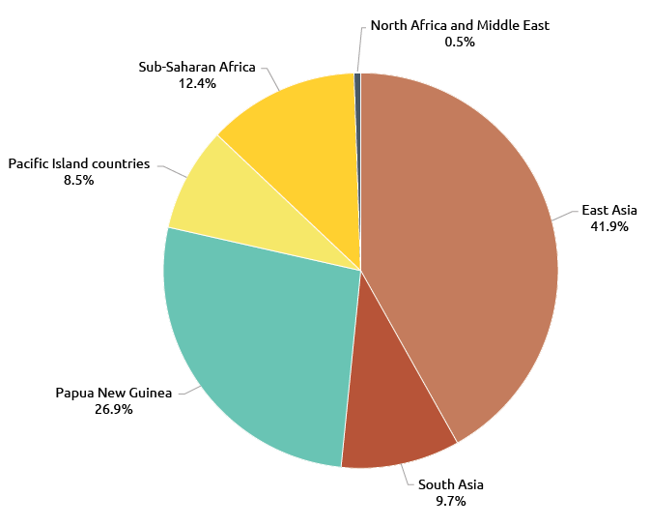

### Contributing to women’s advancement

The Australia Awards contribute strongly to women’s professional advancement. The opportunity to live and study in Australia for an extended period of time not only builds women’s technical skills and capabilities, but also develops personal skills and attributes critical to women exercising leadership[27]. For the 2016 Australia Awards scholarships round, 57 per cent of scholarships were offered to women.

### People-to-people links

The Australian Government has long recognised the importance of engagement with alumni and people-to-people links. In 2015-16, DFAT helped strengthen alumni relations through the provision of $597,000 in grants to more than 45 posts. This will complement the people-to-people links established through the Government’s New Colombo Plan.

DFAT continues to track the development contributions made by alumni and the linkages they maintain with Australia. DFAT has designed and launched the Global Tracer Facility. The facility will streamline future tracer studies across the global Australia Awards program.

## Australian Non-Government Organisation Cooperation Program

The Australian Non-Government Organisation Cooperation Program (ANCP) recognises the unique strengths Australian NGOs bring to development activities and Australia’s overall efforts to reduce poverty. In 2015-16, 54 Australian NGOs worked with 2,818 in-country partners to deliver 588 projects in 58 countries. ANCP NGOs worked in a range of sectors including education, health, water and sanitation, governance and economic development reaching 15.3 million people. Eighty-seven per cent of these projects addressed gender issues, 67 per cent of projects addressed disability inclusion and 44 per cent of projects involved engagement with the private sector. The ANCP budget allocation was $127.3 million in 2015-16, a 5 per cent reduction from $134 million in 2014-15.

Key ANCP results in 2015-16 included:

• 5.6 million people with increased access to essential medicines and health commodities including HIV treatment (50 per cent female, 0.8 per cent people with disabilities);

• 1.3 million poor people with increased access to financial services (72 per cent female, 0.1 per cent people with disabilities);

• 1.2 million people provided with prevention services excluding HIV/AIDS and STD (53 per cent female, 14 per cent people with disabilities);

• 1 million people with increased knowledge of hygiene practices (54 per cent female, 0.7 per cent people with disabilities);

• 970,000 people exposed to awareness raising campaigns/activities in communities highlighting issues of violence against women including harmful cultural practices (60 per cent female, 0.7 per cent people with disabilities); and

• over 960,000 indigenous beneficiaries of ANCP projects.

In March 2016, the ANCP Thematic Review on Gender Equality and Women’s Empowerment was published. It identified opportunities to better target gender equality in the ANCP and was the driver for the Australian NGO Gender Action Platform (GAP) launched in September 2016. The GAP aims to enhance gender equality outcomes in developing countries through the delivery of innovative or transformational NGO projects and increased collaboration on gender equality development challenges between NGOs and DFAT.

The 2015 Office of Development Effectiveness evaluation of the ANCP noted areas for improvement and DFAT agreed to undertake all recommendations proposed.[28] During 2015-16, the performance assessment framework and program logic were developed as well as the staged implementation of a new simplified funding model and a more efficient contracting approach. Also under development is a comprehensive communications strategy that will cover internal and external communication and a strategy for post engagement.

Australian NGOs must undergo a rigorous up-front accreditation process which assesses the organisational capacity, operational systems and development approaches of Australian NGOs. Each NGO is reaccredited every five years in order to continue to receive funding ensuring that DFAT is investing in effective partners. In 2015-16, there were 12 accreditation reviews: 10 reaccreditations and two new applications, of which one was successful.

## Australian Volunteers for International Development Program

In 2015-16, Australian Volunteers for International Development (AVID) continued to deliver a program with strong development and public diplomacy outcomes in 29 countries in the Indo-Pacific. A total of 1,345 Australians volunteered their time, energy and expertise to work for 883 host organisations including 778 continuing assignments and 567 new assignments. The total AVID budget allocation in 2015-16 was $47.8 million, a 15.5 per cent reduction from $56.6 million in 2014-15.

In 2015-16, 93 per cent of volunteers were placed in Asia and the Pacific, with Indonesia, Cambodia, Fiji, Solomon Islands and Vietnam receiving the highest number. Volunteers worked to support Australian and partner government country priorities with 95 per cent of new assignments aligned with Aid Investment Plans. In support of the aid program’s thematic priorities, 10 per cent of volunteer assignments had a primary focus on gender equality, 15 per cent of assignments focused on disability inclusion and 25 per cent of assignments engaged with the private sector.

The AVID program contributed to the achievement of the Government’s public diplomacy objectives. Volunteers promote a positive perception of Australia in the region, and promote a positive perception of the aid program domestically. The Returned Australian Volunteer Network (RAVN) was launched in 2015 to recognise the ongoing contribution of returned Australian volunteers to the Australian aid program. RAVN provides networking, engagement and professional development opportunities for around 13,000 returned volunteers. By December 2016, more than 7,000 returned volunteers had joined the network.

AVID underwent significant changes to deliver an effective program in 2015-16. Changes were made to in-country management arrangements with a move to a single AVID delivery partner operating in 27 of the 29 countries, with the exception of Indonesia and Fiji. The AVID program in Bangladesh was closed in late 2015 due increased security concerns for volunteers.

AVID underwent significant changes to deliver an effective program in 2015-16. In response to a recommendation by ODE’s 2014 evaluation of AVID[29], changes were made to in-country management arrangements with a move to a single AVID delivery partner operating in 27 of the 29 countries, with the exception of Indonesia and Fiji. The AVID program in Bangladesh was closed in late 2015 due increased security concerns for volunteers.

# Chapter 4 Sector and thematic performance

This chapter brings together performance information for the six priority areas of investment under the Australian Government’s aid policy[30]. Results against these areas in specific country and regional programs are summarised in Chapter 2: Country and regional program performance. This chapter also includes performance information on disability-inclusive development and innovation.

DFAT published a further seven sector and thematic strategies in 2015-16: the Gender Equality and Women’s Empowerment Strategy, Strategy for Australia’s Aid Investments in Social Protection, Strategy for Australia’s Aid Investments in Private Sector Development, Strategy for Australia’s Aid Investments in Education, Strategy for Investments in Economic Infrastructure, Strategy for Australia’s Aid for Trade Investments, and the Humanitarian Strategy. Strategies inform investment decisions, strengthen effectiveness of programming and promote coherence across the aid program. Progress against sector and thematic strategies is reviewed annually and contributes to the analysis in this chapter, which also draws on country and regional Aid Program Performance Reports, and relevant sector and thematic evaluations.

Figure 25 provides the breakdown of aid investments against priority policy areas in 2015–16. When compared to 2014-15 figures, expenditure increased slightly for investments in governance (up from 17 per cent to 18 per cent of overall aid expenditure) and building resilience (up from 15 per cent to 16 per cent). Expenditure on Effective Governance captures work across a range of investments, including law and justice, anti-corruption, public financial management, leadership, and gender equality and women’s empowerment.

Expenditure held steady for the agriculture, fisheries and water, and infrastructure and trade investment priority areas. Health expenditure decreased from the last financial year (from 17 per cent to 14 per cent).The largest difference was in education, where expenditure decreased as a proportion of the overall aid program from 22 per cent in 2014-15 to 17 per cent in 2015-16. These decreases were largely due to the changing priorities and nature of Australia’s engagement in several country programs in South-East and East Asia.

Figure 25: ODA by investment priority area, 2015-16  
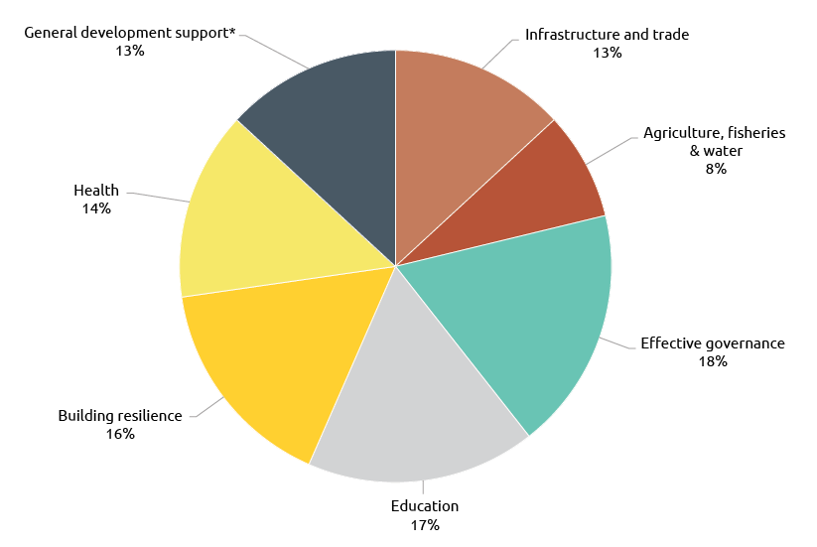

*\* ‘General development support’ includes action relating to debt, some research and scientific institutions and multisector development assistance that does not fall within other investment priorities.*

Overall, 2015-16 saw strong performance across sectors and thematic areas. Significant proportions of investments in most priority areas were rated as effective, particularly in infrastructure, trade facilitation and international competitiveness (91 per cent); effective governance (90 per cent); building resilience (90 per cent) and education and health (89 per cent and 83 per cent respectively). Further information on sector and thematic performance is detailed below.

## Infrastructure, trade facilitation and international competitiveness

In 2015-16, Australia invested $538 million or 13 per cent of ODA in infrastructure, trade facilitation and international competitiveness. Australian investments addressing infrastructure gaps and facilitating trade are essential elements of the aid program’s focus on sustainable economic growth and poverty reduction, and support the development of the private sector in the Indo-Pacific region.

New strategies, released in 2015, guide Australia’s aid for trade investments, investments in economic infrastructure, and engagement with the private sector. Applying the priorities set out in these strategies ensures new investments align with Australian aid policy objectives and broader Australian interests, are well-planned, innovative, engage with the most effective partners – including to leverage other financing flows for the region, manage risks, and address cross-cutting issues such as gender equality and governance. Australia’s work is strongly aligned with the SDGs including Affordable and Clean Energy (SDG7), Decent Work and Economic Growth (SDG8), Industry, Innovation and Infrastructure (SDG9) and Sustainable Cities and Communities (SDG11).

Infrastructure enables the movement of people and goods and provides access to local and global markets, as well as health, education, water, energy and communications services. Without adequate infrastructure, countries are unable to fulfil their economic potential and the benefits of growth do not reach poorer and more remote areas. Encouraging open markets, helping to facilitate trade and increasing the productivity of key sectors are also important ways in which Australia is helping countries to increase job opportunities, particularly for women, and boost economic growth. Figure 26 shows the areas of Australia’s infrastructure expenditure in 2015-16.

Figure 26: Infrastructure, trade facilitation and international competitiveness areas of expenditure, 2015-16  
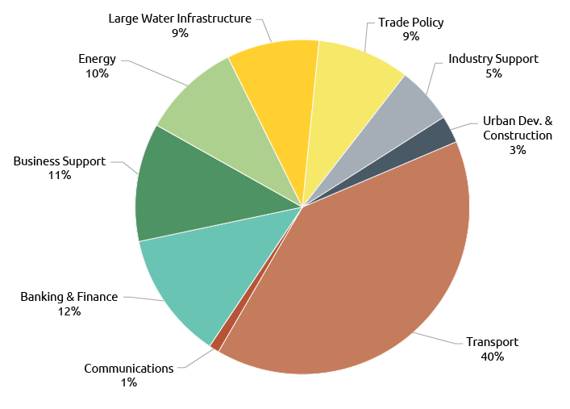

By addressing key constraints to infrastructure financing and delivery across the region, Australia is helping bridge the estimated US$8 trillion gap in infrastructure funding needed by 2020. Building on major new initiatives announced in 2014-15, Australia’s aid program is working with partners to develop investment pipelines to address the serious infrastructure shortfalls constraining trade and growth.

Australia is contributing AUD$25 million to the Global Infrastructure Facility which has 33 separate infrastructure projects under development globally, with over a third of these in East Asia and the Pacific. In 2015-16, Australia announced its contribution of $10 million to a complementary initiative with the Asian Development Bank, the Asia-Pacific Project Preparation Facility, which has helped expand the portfolio of projects in the Pacific under active consideration. These facilities are expanding the number of ‘bankable’ projects in the region to draw in much needed international private finance that will address the infrastructure gap.

This project preparation work is underpinned by Australia’s continued long-term support for the Public Private Infrastructure Advisory Facility (PPIAF) ($2 million in 2015-16), a global facility led by the World Bank targeting government reforms to increase private sector financing and delivery of infrastructure in developing countries. In 2015-16, Australia successfully secured the establishment of a PPIAF office in Singapore to help expand PPIAF’s services in the Asia-Pacific region.

As the Chair of the Private Infrastructure Development Group (PIDG) in 2016, Australia has helped expand its footprint in the Asian region. The PIDG uses donor funds to leverage private financing into priority infrastructure projects in developing countries and emerging economies. Continued support for the subsidiary InfraCo Asia Development has seen a steady pipeline of investments develop across the region, with ongoing project development of hydro-electricity projects in Nepal, Vietnam and the Philippines, a waste to energy project in Sri Lanka and a series of wind farms in Pakistan (see box below). In 2015-16, Australia made its first contribution to a second PIDG subsidiary company, GuarantCo, which provides local currency guarantees to shore up domestic debt and equity financing for infrastructure projects. Australia’s investment in GuarantCo is enabling its establishment of an office in Singapore, co-located with InfraCo Asia Development, to better service the Asian region. Australia’s total contribution to the PIDG in 2015-16 was $10 million.

Figure 27: Infrastructure, trade facilitation and international competitiveness investment performance, 2015-16  
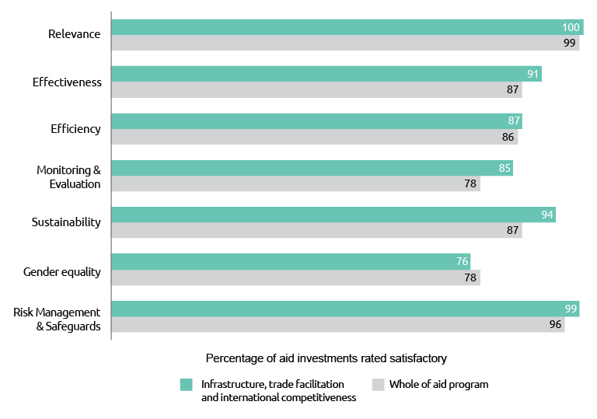

|  |
| --- |
| Private investment in wind energy bringing electricity to Sindh Province in Pakistan  Pakistan has a shortfall of more than 5,000MW in its power generation capacity. With demand increasing, customers can lose power for up to 18 hours a day. Recent studies suggest that the impact on business and industry in Pakistan is equivalent to a loss of around two per cent of the country’s annual GDP. The Government of Pakistan has developed an enabling environment for private sector involvement in the energy sector. However, the country remains reliant upon expensive, polluting oil and diesel power plants. The Government is keen to explore the country’s renewable energy resource to provide more customers with access to affordable, sustainable power. The 50MW Gul Ahmed facility will increase Pakistan’s fuel security, providing an additional source of power to address the country’s ever-increasing demand for electricity.  InfraCo Asia, a PIDG subsidiary company financed by the United Kingdom, Switzerland and Australia, invested US$7.9m in the development of Gul Ahmed and worked alongside a local sponsor, Gul Ahmed Energy, to develop a robust, internationally recognised structure for the project. Through a joint venture with a separate PIDG subsidiary, InfraCo Asia was able to provide a further US$7m in equity to reach financial close. The two investments combined leveraged an additional US$119.4m; US$69.2m of this was local private sector capital, kick-starting domestic private investment in Pakistan’s renewables sector.  By delivering a clean, secure source of additional energy to Pakistan’s national grid, Gul Ahmed will provide more people, in more regions, with reliable energy to support economic growth and social development. Gul Ahmed will benefit 354,000 people and reduce Pakistan’s reliance upon expensive fuel imports, cutting the country’s carbon emissions by 93,800 tonnes per annum. Designed to minimise adverse impacts on existing communities, the project also included the construction of a potable water supply and a local school in which boys and girls are being taught together for the first time. The project has significant scope for replication, promoting future involvement of the private sector in developing Pakistan’s renewable energy potential.  Source: Private Infrastructure Development Group (PIDG), www.pidg.org |

An evaluation by the Office of Development Effectiveness (ODE)[31], released in May 2016, assessed the effectiveness of Australia’s recent investments supporting trade facilitation and regional trade agreements to find out how Australia’s investments may be better targeted in the future. The evaluation found that DFAT investments in trade facilitation have been effective in addressing capacity issues, have the potential to make significant impacts on poverty reduction, and contain many elements of good global practice. Australia’s trade facilitation investments were found to have assisted partner countries in Asia and the Pacific to better integrate with regional and global economies. Overall, the investments have been effective in addressing capacity issues across a diverse range of areas, with the flexibility in designs enabling programs to be responsive and well-targeted.

Nonetheless, the ODE evaluation identified a number of improvements that can be made, including a stronger focus on promoting gender equality and women’s economic empowerment. DFAT acknowledges that aid for trade investments have historically performed poorly on incorporation of gender considerations. This is a common issue across other donor programs due to an historical lack of expertise in the area. The department is making significant progress in the intersection of aid for trade and gender, and exploring good practice and lessons learnt, including opportunities to incentivise partners (partner government agencies and aid program deliverers) and donors to undertake practical steps to address gender inequalities. The Aid for Trade Strategy highlights women’s economic empowerment as a priority area for aid for trade investments. The Strategy aims to incorporate a gender equality objective in every aid for trade investment to help ensure that Australia’s aid for trade target can be achieved simultaneously with the target on gender equality. Recent aid for trade investments have strengthened their gender considerations, and some include a specific focus on women’s economic empowerment.

Overall, investments in the infrastructure, trade facilitation and international competitiveness investment priority had performance results higher than the whole-of-aid program average for all quality criteria with the exception of gender equality (Figure 27). While lower than the aid program average, performance on gender equality improved with the proportion of investments rated as satisfactory or above rising from 64 per cent in 2014-15 to 76 per cent in 2015-16.

|  |
| --- |
| Australia’s approach to aid for trade  Australia’s aid policy puts a strong emphasis on aid for trade. Aid for trade helps developing countries address internal constraints to trade, including regulations, infrastructure and workforce skills. Trade is crucial to creating an enabling environment for economic growth and development. No country has achieved high and lasting growth without participating in international trade. The OECD and WTO estimate that one dollar of aid for trade investment is associated with an increase of eight dollars in additional exports[32].  The Strategy for Australia’s Aid for Trade Investments was released in July 2015 and encourages innovation, including by partnering with the private sector and promoting market-based solutions. Australia’s aid for trade priorities include trade and investment policy and trade facilitation, global value chains, infrastructure, private sector development, economic empowerment of women, knowledge and skills development, agriculture, and services.  As outlined in Chapter 1, the Australian Government has set itself a target of increasing aid for trade expenditure to 20 per cent of Australia’s aid budget by 2020. The target positions Australia as a key provider of aid for trade in line with other major donors. Australia is on track to meet this target — in 2015-16 estimated expenditure on aid for trade represented 17.3 per cent of Australia’s Official Development Assistance, up from 16.4 per cent in 2014-15.  Aid for trade supports the aid program’s key objectives of reducing poverty and lifting living standards through sustainable economic growth. The role of trade as an engine for economic growth and poverty alleviation is recognised by the global development community — aid for trade is embedded in the UN Sustainable Development Goals.  Australia categorises its aid for trade investments under the broad headings of trade policy and regulations, economic infrastructure, and building the capacity of the private sector. This is in line with the OECD’s definition, which is also followed by other major donors.  Australia’s aid for trade investments are made through multilateral, regional and bilateral channels. The bulk of aid for trade funding is provided through bilateral country and regional programs. Australia’s multilateral aid for trade flagship, the Global Trade Integration Facility (GTIF) is designed to support multilateral and regional investments that help developing countries in the region to participate in global trade. Examples of Australia’s aid for trade investments under the GTIF include:  • building the capacity of 600 women entrepreneurs in the Pacific (Papua New Guinea, Vanuatu and Samoa) to establish womens export co-operative associations to help access to new international and regional markets for selling their products (e.g. the Bilum Export Promotion Association in Papua New Guinea)  • partnering with the World Intellectual Property Organization and local civil society actors, to provide educational and reading materials in accessible formats, such as braille, audio and large print to the visually impaired and blind in Bangladesh and Sri Lanka. A project in Bangladesh, for example, is training a local organisation to produce accessible educational materials in Bengali, and teaching blind students to use reading devices; and  • supporting the International Labour Organization to expand the Better Work Programme in Indonesia, Cambodia, Vietnam and Bangladesh. The Better Work Programme helps improve labour standards and reduce gender discrimination in garment factories in developing countries, in partnership with the private sector. |

## Agriculture, fisheries and water

In 2015-16, Australia invested an estimated $305.7 million or 7.6 per cent of ODA in the agriculture, fisheries and water sectors to help improve food security and sustainable use of resources in the IndoPacific region. Figure 28 shows the areas of expenditure for this investment priority in 2015-16.

Figure 28: Agriculture, fisheries and water areas of expenditure, 2015-16

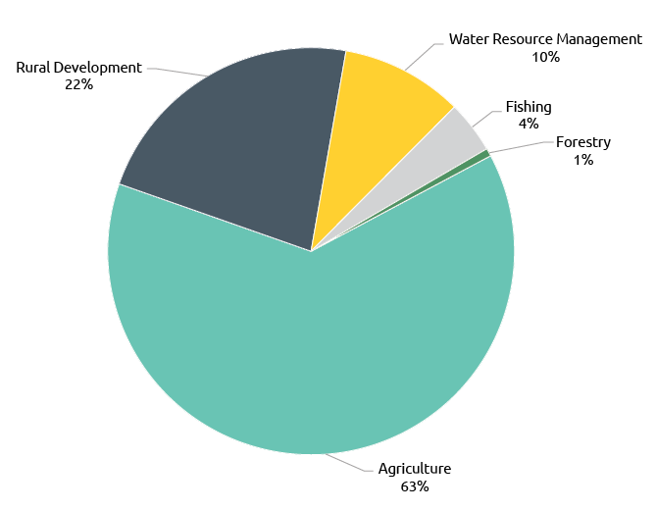

In line with the Australian Government’s *Strategy for Australia’s aid investments in agriculture, fisheries and water* (released in February 2015), investments in these sectors aim to strengthen markets, innovate for productivity and sustainable resource use, and promote effective policy, governance and reform among Australia’s developing country partners.

These sectors make a major contribution to sustainable economic growth and poverty reduction efforts in the region. Australia’s assistance is directly supporting several of the SDGs including Zero Hunger (SDG2), Clean Water and Sanitation (SDG6), Life Below Water (SDG14) and Life on Land (SDG15).

With support from the Australian aid program in 2015-16, over 443,000 poor men and women (at least 54 per cent women) adopted innovative agricultural and fisheries practices. Across the region, 1.3 million women and men (at least 79 per cent women) have increased access to financial services, and over 589,000 women and men (at least 60 per cent women) have increased incomes as result of Australia’s aid investments in these sectors.

During 2015-16, to give practical effect to the strategy, Australia pursued a diverse portfolio of global, regional and country-level investments. At the global level, Australia assumed the chairing role in September 2015 for AgResults. This innovative G20 initiative is driving private sector-led agricultural development, research and delivery for smallholder farmers by rewarding businesses for achieving development results, such as low-cost on-farm storage. At the regional level, in collaboration with the World Economic Forum and the ASEAN Secretariat, Australia continued its support for the fledgling agribusiness partnership platform, ‘Grow Asia’. Results include the establishment of 36 new commodity value chain initiatives across five countries, benefiting almost 500,000 smallholder farmers.

At the country level, through a number of its existing agricultural investments, Australia worked closely with the private sector and research organisations, including through the Australian Centre for International Agricultural Research (ACIAR), to help small-scale farmers and entrepreneurs, particularly women, to improve productivity and access markets. A mid-term review of the multi-country Market Development Facility (MDF) in late 2015 recommended that this program be extended into a second phase (commencing in mid-2017) based on its strong results to date. Since its launch in 2011, MDF has generated additional incomes that have benefited over 42,000 poor men and women.

In fisheries, Australian core funding for the key regional fisheries organisations in the Pacific – the Pacific Islands Forum Fisheries Agency and the Secretariat of the Pacific Community – support multi-year strategies to safeguard tuna resources and increase economic returns to Pacific Island countries. Australia invested around $15 million in the sector in 2015-16. This funding includes support to improve community-based fishery management and aquaculture in a number of Pacific Island countries, to improve food security and ensure long-term sustainability. Australian support is also assisting Pacific Island countries to implement the Niue Treaty Subsidiary Arrangement, which will help combat illegal fishing and improve legal and governance arrangements. 

|  |
| --- |
| Australian Centre for International Agricultural Research (ACIAR)  ACIAR’s bilateral investments contribute to improved livelihoods, economic growth and trade in partner countries. For example:  In Myanmar, the MYRice project is seeking to improve rice productivity through introducing better agronomy, modern rice varieties and improving post-harvest management of rice for better quality. Through the project’s work, improved post-harvest practices has reduced yield losses by 10 per cent.  In PNG, the Transformative Agriculture and Enterprise Development Program (TADEP) is pursuing five new impact-focused research for development projects centred on economic development opportunities associated with the production of a range of agricultural commodities. TADEP, with active private-sector involvement, focuses on opportunities to scale up successful ACIAR innovations over larger areas and for more people. Its aim is to achieve increased employment and incomes in rural areas and enhanced rural–urban supply chains, with a particular focus on the empowerment of women. |

During 2015-16 Australia advanced its partnerships in river basin management across Asia - notably in the Indus, Ganges, Brahmaputra, Ayeyarwady, Salween, Mekong and Red river regions. These contributions to water-food-energy-environment security and sustainable economic development are principally delivered through the multi-partner DFAT Greater Mekong Water Resources Program and the South Asia Sustainable Development Investment Portfolio. The Australian Water Partnership advanced its collaboration with the National Water Resources Committee in Myanmar on planning for the Ayeyarwady River basin, and with the Ministry of Water Resources in India to improve weather forecasting and water management and is boosting engagement in China and the Pacific and cooperation with ADB and the World Bank.

Overall, the aid performance results recorded for Australia’s investments in the Agriculture, fisheries and water priority area highlighted the need for strong improvements. In the 2015-16 Aid Quality Checks, investments in agriculture, fisheries and water scored below the aid program average for all but one (monitoring and evaluation) of the seven performance criteria (Figure 29). This is at odds with the 2014-15 performance results, which were above the aid program average for four of the seven criteria.  Of particular concern was the gender equality scores for 2015-16, which was 20 percentage points below the aid program average.

To address these results, strategies to empower women to overcome barriers to their participation in the agriculture, fisheries and water sectors are being included in new investment designs. In 2016-17, DFAT expects improved outcomes as several poor-performing initiatives will be closing during that year. In addition, it is anticipated that a new operational guidance note, issued in September 2015, will help support program managers to more effectively address gender equality issues in agricultural investment design and implementation. Regarding the other segments of the portfolio that are under-performing, attention is being given to improving investment designs and monitoring and evaluation systems.

Figure 29: Agriculture, fisheries and water investment performance, 2015-16  
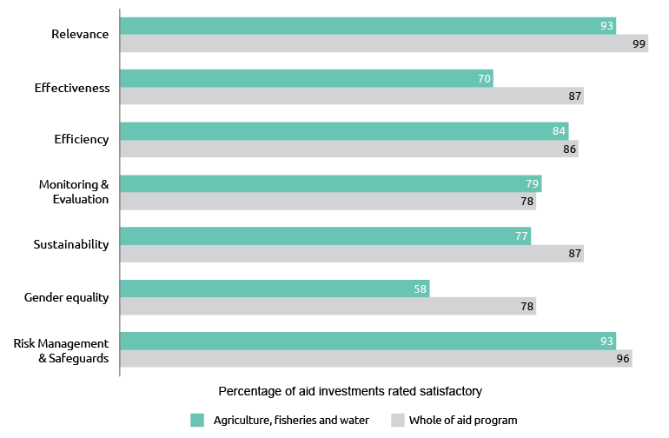

## Effective governance: policies, institutions and functioning economies

In 2015-16, Australia invested $744 million or 18 per cent of ODA to support more effective governance in partner countries, making governance the Australian aid program’s largest sector investment. Figure 30 shows the areas of expenditure under this investment priority in 2015-16.

Figure 30: Effective governance areas of expenditure, 2015-16  
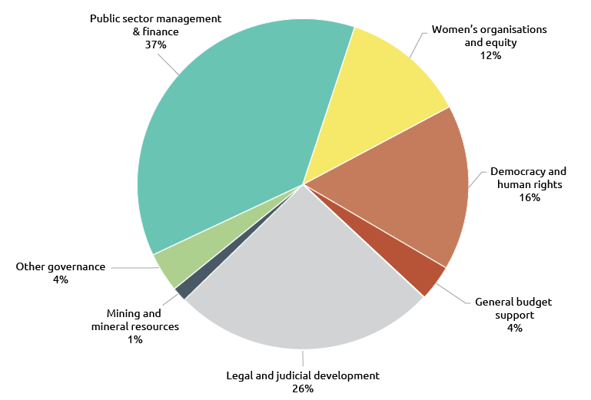

Australia’s investments aim to strengthen the effectiveness of governments and civil society, identify and support measures that promote gender equality and empower women and girls, strengthen the rule of law, enhance anti-corruption measures, foster peace and address the causes of conflict, and improve the effectiveness and transparency of government expenditure and public financial management. These are all key factors that contribute to sustainable economic growth and poverty reduction.

Of Australia’s largest fifteen bilateral aid partners, ten are fragile or affected by conflict. As a result, much of Australia’s aid is delivered in contexts where governance challenges are acute and where there is potential for development gains to be reversed by conflict, uncertain politics and weak institutions. Australia’s approach in such areas is to be sensitive to the underlying drivers of fragility in the specific political and economic contexts of the countries where Australia provides assistance.

DFAT’s strategy for the sector, *Effective Governance: Strategy for Australia’s aid investments*, guides Australia’s approach to building institutions that promote stability, support inclusive economic growth and poverty reduction, and strengthen gender equality and women’s empowerment (which is also the subject of a dedicated DFAT strategy). As the strategy highlights, partnerships between Australian organisations and their counterparts in developing countries are a very effective way of building relationships and strengthening partner government capacity.

Working with partner countries to achieve effective governance will help them to achieve a wide range of development objectives, including in relation to the SDGs and securing additional financing for development. Australian assistance will have a direct impact on the SDGs of Reduced Inequalities (SDG10) and Peace, Justice and Strong Institutions (SDG16).

In 2015-16, Australia supported improvements in the performance of the public sector in Pacific Island countries, including through training for public servants and broader technical assistance. As part of the Pacific Leadership and Governance Precinct in Papua New Guinea, Australia helped train over 6,600 public servants in core public service skills. In Timor-Leste, Australian support contributed to better budget planning across 23 ministries, commitments to increase the number of women leaders and persons with a disability across the public service, and new systems to develop and implement economic policy.

Several major anti-corruption investments in 2015-16 also achieved very strong results against this strategic priority. The Australian Government supported the PNG Government to deliver a suite of laws to criminalise corrupt conduct, better manage public assets and establish a functional Financial Intelligence Unit. As a result of these reforms, in June 2016 the Paris-based Financial Action Task Force removed PNG from its ‘grey list’ of countries considered to have weak measures to combat money laundering and terrorism financing. In addition, the Australian Transaction Reports and Analysis Centre’s support for its Indonesian counterpart contributed to Indonesia’s removal from the Financial Action Task Force ‘black list’.

In Indonesia, the Australian National Audit Office helped the Indonesian Audit Board to transition from cash to accrual accounting and the Australian Treasury supported the creation of a tax oversight authority to increase Indonesia’s low current rate of tax collection. In Timor-Leste, the Australian Bureau of Statistics helped support the national statistics office run the 2015 census by itself for the first time.

Australia supported the delivery of law and justice services by improving professional skills and deepening institutional relationships between organisations in the region and relevant Australian public sector organisations. In 2015-16, Australian support delivered training to over 15,000 police and law and justice officials (3,950 women). In Solomon Islands, Australian support for the justice sector continued to result in improved public perceptions of the quality of justice services, with 73 per cent of people surveyed reporting an improvement over the previous two years.

The DFAT Effective Governance strategy recognises the importance of supporting more responsive and accountable government, and access to justice and economic opportunities for marginalised groups, including women and people with a disability. In Indonesia, Australia supported a network of disabled peoples’ organisations to advocate for a new disability law, passed in March 2016, which moves Indonesia away from thinking about disability as a medical or ‘charity’ issue and towards it being a rights issue. In both Solomon Islands and Indonesia, Australian assistance continues to address the impact of violence against women, providing trauma counselling, legal assistance and referral services for 12,799 woman survivors of violence across Indonesia, and assisting the passage of a Family Protection Act in Solomon Islands that explicitly criminalises domestic violence for the first time.

In South-East and East Asia, Australia’s governance investments are focused on providing technical assistance and expertise where it aligns with partner government efforts to promote inclusive economic growth, deliver more accountable governance and improve the investment climate. In Indonesia, Australia funded analysis that underpinned 13 economic policy packages announced by the Indonesian Government, as well as advice resulting in the expansion of the number of business sectors open to foreign investment. In the Philippines, Australian assistance supported the creation of the Philippine Competition Commission to ensure efficient and fair market competition.

Overall, Australia’s investments in effective governance performed well in 2015-16, although results against monitoring and evaluation, sustainability and gender equality criteria were lower than the aid program average (Figure 31). Australia’s governance work is inherently complex in nature, and involves support to often highly contested reform processes in challenging contexts. The governance portfolio is also particularly diverse in terms of investment scale and scope, reflecting the fact that Australia’s activities are carefully tailored and adapted to local, in many cases fragile and conflict-affected contexts. These factors help to explain why, as in previous years, monitoring and evaluation, addressing gender equality objectives and sustainability remain a challenge across DFAT’s governance portfolio.

Increasingly, international evidence and learning on aid effectiveness points towards the need for more flexible, adaptive and politically-informed approaches to aid investment design and implementation. While the Effective Governance Strategy, operational guidance and training currently reflect best practice in terms of incorporating these approaches, much work still needs to be done to ensure major aid investments translate these principles into practice. To that end, DFAT will continue to invest in governance-related capabilities and further strengthen operational collaboration between governance and gender equality expertise and programming.

These efforts will also help to ensure that Australia’s strategic approach remains aligned with emerging priorities, including DFAT’s approach to SDG 16. Concurrently, DFAT will produce new guidance on development approaches to countering violent extremism, conducting conflict analysis, and programming in fragile and conflict-affected contexts

Figure 31: Effective governance investment performance, 2015-16  
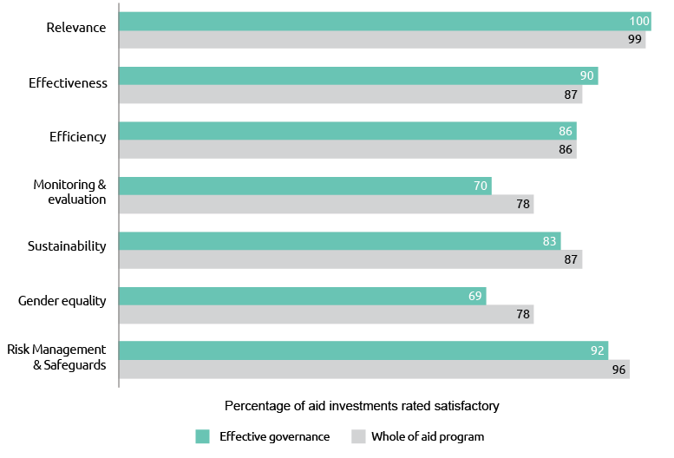

|  |
| --- |
| Governance for Growth in Vanuatu: Adapting and Responding  Increasingly, international evidence suggests that approaches to delivering aid that understand local politics in partner countries, work closely with partner governments, and respond quickly to changed circumstances are likely to have a greater development impact.  The DFAT Governance for Growth (GfG) program in Vanuatu operates in just this way. Recent events in Vanuatu, including a new reformist government and the 2015 cyclone changed the political and economic environment. GfG, co-located with the Vanuatu Prime Minister’s Office was well-placed to respond with reforms that were prioritised by government as well as being appropriate and realistic in a challenging environment.  In 2015-16, GfG helped deliver the rollout of a Universal Access Program that increased telecommunications access in rural areas. So far it has supported the school internet lab program which has opened in 17 schools, covering 4,326 students, of which 2,074 are girls.  GfG also supported the roll-out of a National Bank of Vanuatu mobile banking program. Designed with a focus on financial inclusion of women, this has resulted in almost 3,500 women participating in financial literacy training, over 3,000 women opening new bank accounts, and disbursement of micro-loans worth $1.2 million to poor women.  These reforms were possible because the Australian aid program was responsive to opportunities and the political context. |

## Education and Health

In 2015-16, Australia provided over $1.2 billion or 31 per cent of ODA to improve education and health outcomes, particularly in the Indo-Pacific region. Accessible and good quality education and health care and services are vital to save lives, lift people out of poverty, and enable everyone to participate fully in society and the economy.

During the year, DFAT continued the transition away from the use of Australian bilateral aid funding for the direct delivery of services in a number of partner countries, with a subsequent decrease in expenditure on school and health infrastructure and supplies. Most bilateral investments shifted focus towards sector training, systems and policy reforms, and mobilising partner government financing. Several country program teams reduced health and education spending to prioritise investments in support of other aid policy priorities such as infrastructure and governance, and given the ability of partner governments to access other funding sources for service delivery.

Australia continued to fund, and engage on policy issues, with major global and regional financing, research, and innovation programs in these sectors. Australia also provided targeted support for girls’ education and women’s health.

Australian investments in health and education outcomes directly support the SDGs of Good Health and Well-being (SDG3), Quality Education (SDG4) and Gender Equality (SDG5), and make an important contribution to the achievement of other SDGs.

### Education

Of the total expenditure for this investment priority, Australia provided $698 million or 17 per cent of ODA to support improvements in education in the region (including through Australia Awards scholarships, covered in Chapter 3). Figure 32 shows areas of Australia’s education expenditure in 2015-16.

Figure 32: Education areas of expenditure, 2015-16  
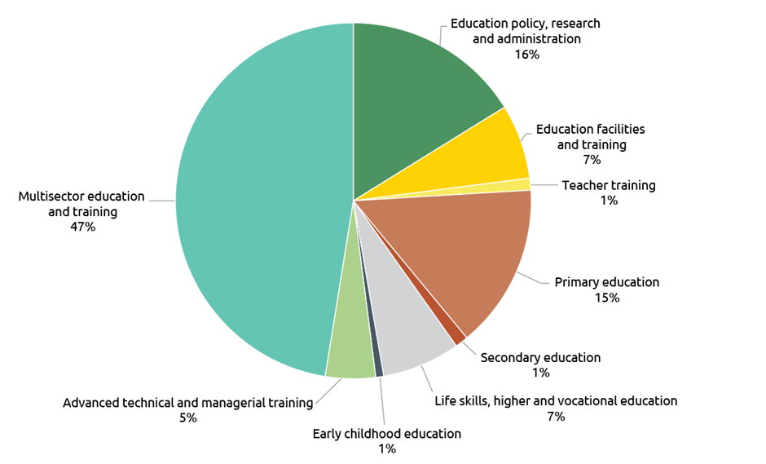

In September 2015, the Australian Government launched the Strategy for Aid Investments in Education 2015-2020, which prioritises the following areas for support:

• investing in early childhood care and development, which has been shown to deliver high returns, particularly for the poorest and most marginalised children;

• investing in quality at all levels of the education system, because it is what students know and can do that matters for poverty reduction and economic growth.

• prioritising equity, with a particular focus on gender and disability inclusiveness, because fairer education systems are also the most effective; and

• aligning education and skills with labour market needs, through investing in relevant and high-quality secondary and post-secondary education.

Australia’s education strategy promotes the use of innovative approaches and partnerships, including with the private sector and multilateral organisations. In 2015, Australia’s $26 million funding through the Global Partnership for Education (GPE) - which assists 62 countries - helped 7.2 million children, including 3.4 million girls, to enrol in school. To help improve the quality of education globally, Australian support to the GPE helped provide 29.7 million additional textbooks and learning materials, build (or rehabilitate) 3,554 classrooms, and train 38,541 teachers.

In 2015-16, Australian funding through regional and bilateral education programs also delivered strong results against the strategy. Australia’s support enabled over 1.1 million girls and boys to enrol in schools across the Indo-Pacific region. Recognising the strong link between access to quality education and national growth rates, Australian funds trained approximately 136,000 teachers. With Australia’s support, almost 5,700 women and men across the region gained post-secondary qualifications, with programs demonstrating strong links to labour market needs.

To improve evidence on education performance, DFAT’s partnerships with Pacific Island countries, the Australian Centre for Global Education Monitoring, and UNESCO’s Institute for Statistics, led to stronger statistical systems across the region, more effective data collection, analysis and dissemination. In Bangladesh, with Australia’s assistance, the 2015-16 annual school census was completed on time for the first time, enabling efficient reporting and planning. In Nepal, Australia supported specific data collection to improve services for children living with disabilities.

In Fiji, Australia’s assistance for 85 schools in remote and/or socially disadvantaged communities allowed 50 per cent of year 4 students to achieve above the national average in literacy, and 54 per cent in numeracy (up from 37 per cent and 39 per cent respectively in 2012). In the Philippines, Australia supported the shift to an expanded school system by improving teacher development and helping with classroom infrastructure, and supported national assessments to deliver stronger high school graduates for tertiary level education. Australian assistance increased access to education for children affected by conflict living in Lebanon, Jordan and on the Thai-Myanmar border.

Overall, Australia’s education programs performed well in 2015-16. The percentage of aid investments meeting quality assessment criteria is on par with or higher than whole-of-aid program results (Figure 33).

Across the education portfolio, program performance on gender equality continued to rate highly at 95 per cent. Innovative initiatives in Laos, the Philippines, Myanmar and Nepal increased opportunities for marginalised girls to attend school, and for female teachers and principals to receive targeted support. Programs in Pakistan, Bangladesh and across the Pacific, demonstrated progress in making schools more affordable and supportive of girls’ needs.

However, despite the good progress, DFAT’s education Community of Practice identified areas where more could be done to help marginalised girls get into and stay in school. DFAT will develop new guidance to help programs accelerate opportunities for marginalised girls to access education.

|  |
| --- |
| Vanuatu TVET Program delivers impressive results  Vanuatu’s Technical Vocational Education and Training (TVET) program facilitates skills development that links directly to provincial economic development. With Australian assistance, TVET Centres have opened in four provinces to train women and men in key skills for sectors that contribute to economic growth. The Vanuatu Government has committed funding, and the centres have contributed to significant tourism benefits. For instance, 77 local operators now meet Vanuatu Tourism Operator Minimum Standards.  An independent evaluation in 2015 verified the program’s impact in transforming the TVET sub-sector. The program’s success factors have included adopting a value-chain approach linking the formal and informal economies, values-based leadership and local empowerment, supported by minimal expatriate staff; and an adaptive, flexible approach including ‘at location’ training able to support marginalised groups. |

Recognising the central role of teachers in improving the quality of education, in 2015-16 ODE completed a major review into the relationship between Australian assistance for teacher development and the expected outcomes of improved teacher effectiveness and student learning[33]. The Investing in Teachers evaluation identified that Australian education programming understands and responds well to contextual challenges. However, the evaluation identified that there was almost no data available on outcomes that could be attributed to DFAT’s teacher development investments. Recognising this weakness, DFAT’s management response to the evaluation has committed to champion teachers across its portfolio of work; and to improve monitoring and evaluation of the outcomes of specific teacher development investments. In 2016-17, DFAT will ensure ODE’s Investing in Teachers evaluation informs all new education designs and mid-term reviews and will commence work on at least two long-term studies on the effectiveness of investments in teacher development.

Figure 33: Education and health investment performance, 2015-16  
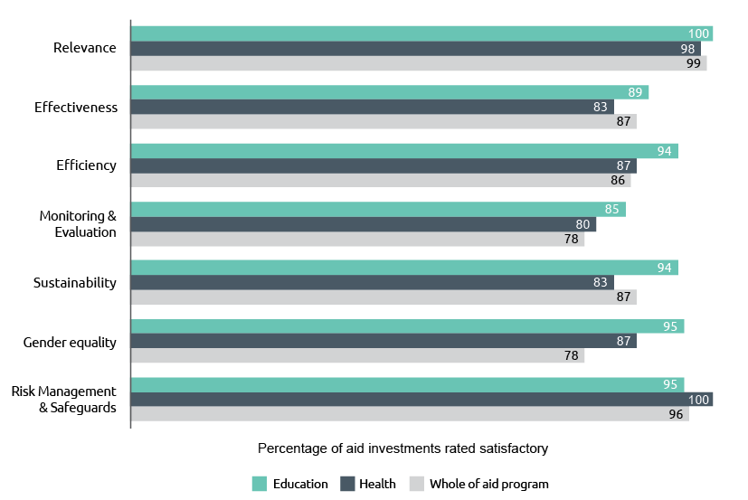

### Health

In 2015-16, Australia invested $565.3 million or 14 per cent of ODA in health, including in basic water, sanitation and hygiene (WASH) through global, regional and bilateral mechanisms. Figure 34 shows areas of Australia’s health expenditure in 2015-16.

Health investments under the aid program are guided by the Health for Development Strategy 2015-2020. The strategy focuses on health systems strengthening to ensure services respond to people’s health needs; and to strengthen regional preparedness and capacity to respond to emerging health threats.

In 2015-16, Australia’s health assistance continued to deliver strong results, including the vaccination of 2.8 million children globally, increased access to safe water for over 1.79 million people and increased access to basic sanitation for over 1.77 million people. DFAT continued to explore innovative approaches to deliver improved health outcomes. For example, Timor-Leste’s nutrition pilot, ‘Hamutuk’ (meaning ‘together’), a $3 million program from 2015-19 jointly funded by DFAT’s innovationXchange is using targeted messaging through mobile and wireless platforms to monitor and change nutrition behaviours.

Figure 34: Health areas of expenditure, 2015-16  
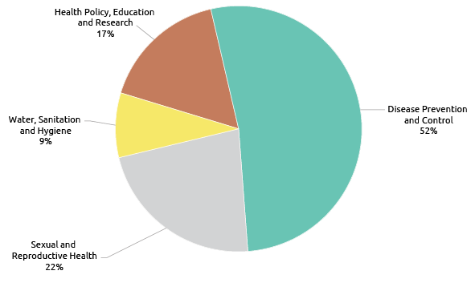

Funding continues to be channelled through global health partners, including the Global Fund to Fight AIDS, Tuberculosis and Malaria (the Global Fund); Gavi, the Vaccine Alliance; World Health Organization; UNFPA; UNAIDS; and the World Bank. Australia contributed $60 million of its $250 million 2016-20 pledge to Gavi in 2015-16, contributing to the immunisation of 65 million children globally, saving an estimated 900,000 lives. Australia contributed $85 million of its $200 million 2014-16 pledge to the Global Fund in 2015-16, helping to provide antiretroviral therapy for 1.1 million people with HIV/AIDS, treat 1.9 million people with TB and distribute 111 million bed nets to help prevent malaria, saving an estimated 3 million lives.

Health and medical research continues to be an investment priority with significant progress being made under three Product Development Partnerships (PDPs) that focus on high burden diseases in the Indo-Pacific region, specifically tuberculosis (TB) and malaria. The PDPs’ global public-private partnerships structure enables Australia to innovatively pool and leverage funding with other donor governments and philanthropic foundations for research and development in diseases that lack commercial value. Through this leveraging, Australia is able to multiply its investment impact – for example, for every US$1 invested in the Medicines for Malaria Venture, there is an investment impact of US$3.50. The PDPs recognised Australia’s leading edge in malaria and TB research, and have been actively engaging Australian researchers’ expertise over the last ten years in the development of advanced diagnostics, drugs and treatments. Collectively, these research activities will help lead to new and improved therapies to fight major disease challenges globally as well as in the region.

|  |
| --- |
| Product Development Partnerships (PDP)  Australia’s investment in PDP is supporting the introduction of the first-ever child-friendly paediatric formulated TB treatment by TB Alliance, and its partners. Prior to December 2015, there was no standard TB treatment for children. Paediatric treatment was estimated based on standard adult measure, resulting in crushed pills and inaccurate dosage. The new paediatric treatment is properly dosed and comes in various fruit flavours, dissolved in a glass of water, to be taken once a day for six months. At the country level, DFAT is supporting Papua New Guinea to pilot the introduction of this product at Port Moresby General Hospital ahead of a planned national roll-out. |

Regional health security is a priority for Australia’s aid program. Australia is working in partnership with country governments and regional organisations to improve surveillance and combat emerging threats, including the Zika virus. For example, Australia’s contribution to the World Health Organization Zika Virus Action Plan for the Pacific (announced in early 2016) supported a coordinated regional response including technical guidance, public messages and the provision of commodities. Australia also supported the Asia Pacific Leaders’ Malaria Alliance (APLMA) which secured leaders’ endorsement of a roadmap to elimination of malaria by 2030 - including by addressing malaria drug resistance. With support from Australia, APLMA hosted the inaugural Asia Pacific Malaria Week in Bangkok (May 2016) which brought together key stakeholders to progress the 2030 malaria elimination goal.

Lessons learned from these programs will inform the implementation of the Australian Government’s Regional Health Security Initiative, announced in July 2016. It will support partnerships and research with academia, medical institutions and the private sector to address priority health security challenges and improve health outcomes in the region.

Overall, Australia’s investments in health performed well in 2015-16 although results against effectiveness and sustainability criteria were lower than the aid program average. The ODE evaluation of the management arrangements for the Civil Society Water Sanitation and Hygiene Fund found that the Fund was working well and supporting civil society organisations to implement high quality WASH projects[34]. The Fund performed strongly in knowledge and learning, and the monitoring and evaluation process was pushing civil society organisations to go further on gender and disability inclusion in their programs. The evaluation recommended that for the next phase, the Fund’s management costs need to be justified.

Ensuring health programs are financed and managed sustainably remains a core challenge for partner governments, especially in the Indo Pacific region, where the economic growth of some countries has put them above the threshold to receive global health financing and support. To address this, and in partnership with the World Bank Group, DFAT has established a Multi-Donor Trust Fund (MDTF) to support countries in the region through this transition period. This is helping to strengthen the institutional and financial arrangements which underpin their health systems, routine immunisation systems, and regional health security. DFAT will invest $52 million in the MDTF from 2015 to 2019, and additional resources have been leveraged from partners such as the Bill and Melinda Gates Foundation and Gavi.

## Building resilience: humanitarian assistance, disaster risk reduction and social protection

In 2015–16, Australia provided an estimated $654.6 million or 16 per cent of ODA in humanitarian assistance, disaster risk reduction, social protection and climate change investments. Figure 35 shows areas of expenditure under this investment priority in 2015-16.

Figure 35: Building resilience areas of expenditure, 2015-16  
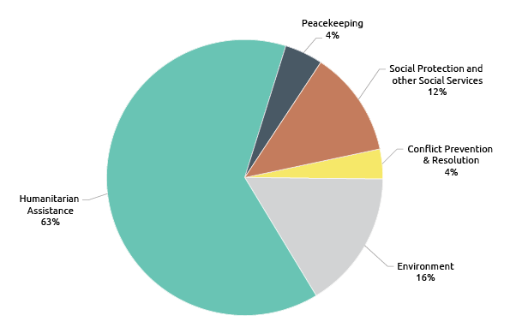

Australian investments in these areas save lives, limit economic and development losses and reduce vulnerability to crises. Australia’s investments also support the delivery of a range of international goals, including (but not limited to) the SDGs of No Poverty (SDG1), Zero Hunger (SDG2), Good Health and Well-Being (SDG3), Reduced Inequalities (SDG10) and Climate Action (SDG13).

### Humanitarian assistance

The year was a pivotal one for Australia’s humanitarian reform agenda, with the launch of Australia’s Humanitarian Strategy and leadership at the World Humanitarian Summit in May 2016. Together with the Strategy launch at the Summit, Australia championed the strengthening of protection mechanisms, elevating the role of women in decision making, improving disability inclusion, and promoting innovation in humanitarian response. Together with humanitarian partners, Australia also committed to the Grand Bargain – an agreement to increase efficiency and effectiveness in the humanitarian system via measures such as increased support to local responders, multi-year predictable financing, reduced earmarking of funds and increased use of cash-based assistance.

The Humanitarian Strategy reflects many of these commitments, including tailored humanitarian support for the Pacific and building disaster resilience through nationally-led responses. The Strategy also builds upon gender as a priority in the Government’s aid policy, committing 80 per cent of investments to effectively address gender issues, with particular attention to sexual and reproductive health in emergencies.

Australia provided an estimated $329 million in life-saving humanitarian assistance in response to more than 20 humanitarian crises, including severe flooding in Myanmar (September 2015), Tropical Cyclone Winston in Fiji (February 2016), the impacts of the El Nino drought across the Pacific and Africa, and provided support for the 11 million people displaced by the Syria and South Sudan crises in 2015-16. Diagram 1 highlights the range of assistance provided to Fiji, the country hardest hit by Tropical Cyclone Winston in early 2016.

Australia maintains a range of deployable capabilities to effectively respond to rapid onset and protracted crises. DFAT’s Crisis Response Team, for example, was deployed to Fiji within 36 hours of Tropical Cyclone Winston in February 2016 to coordinate one of Australia’s largest civil-military responses to a humanitarian crisis overseas.

The Australian Civilian Corps (ACC) mechanism deploys technical experts rapidly overseas during a crisis for six to twelve months. In 2015-16, there were 41 ACC deployments (30 new deployments and 11 on-going). DFAT maintains an ACC stand-by roster over the Pacific cyclone season and, since 2013, ACC specialists have been prepositioned across National Disaster Management Offices in the Pacific to provide support ahead of the Pacific cyclone season. It enables relationship building outside of a crisis and improves the specialists’ ability to support disaster response and recovery efforts. This fulfils the commitment made by Australia’s Foreign Minister at the Pacific Island Forum Foreign Ministers’ Meeting in July 2015 that the ACC would enhance the preparedness of Pacific Island countries ahead of each cyclone season.

DFAT’s prepositioning of emergency relief supplies in the Asia-Pacific region enabled prompt delivery of 520 tonnes of life saving supplies to assist more than 200,000 vulnerable people in 2015-16. DFAT’s support also played a critical role in restoring access to health facilities in Fiji. Australia’s $15 million in humanitarian assistance was delivered in accordance with the Government of Fiji’s priorities and in close coordination with other humanitarian partners. This close cooperation continues with Australia’s $20 million package of longer-term recovery and reconstruction assistance to Fiji.

Diagram 1: Australia’s response to help Fiji recover from Tropical Cyclone Winston  
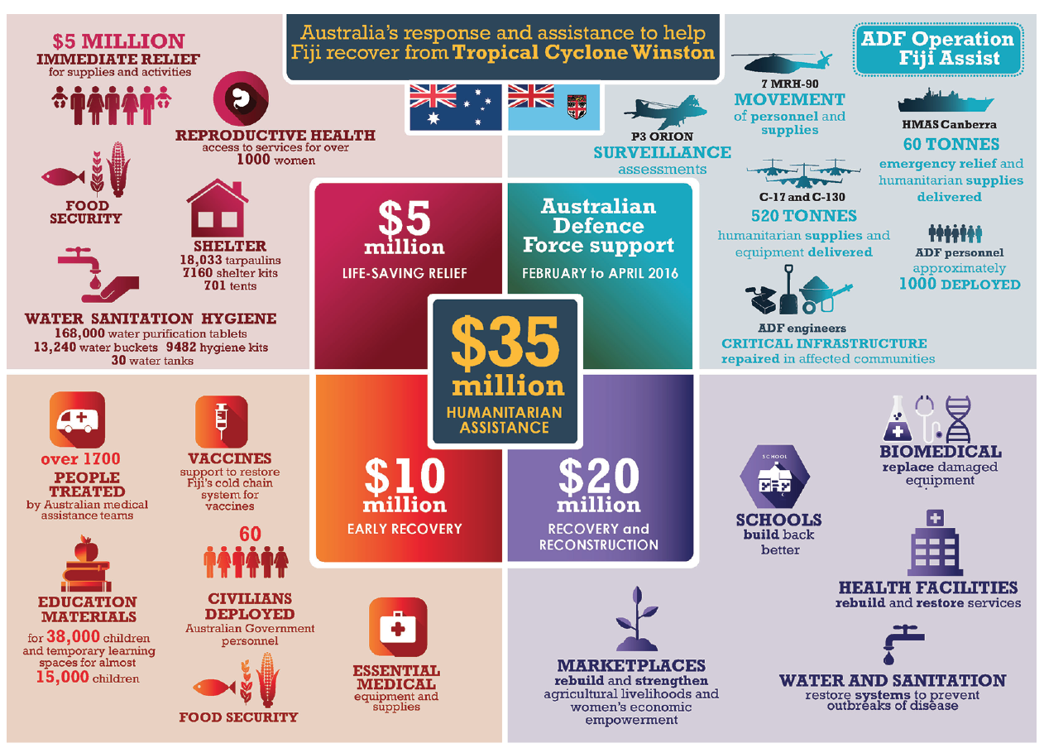

During 2015-16, the aid program continued to improve assessment of the quality and performance of humanitarian investments. Australia undertook independent reviews of the Humanitarian Partnership Agreement with Australian NGOs (July 2015), the partnership with RedR Australia (December 2015) and arrangements for the ACC (April 2016). The review of the partnership with RedR found that the mechanism has significantly supported Australia’s humanitarian responses globally. The review of the ACC found that specialists have played an important role in providing critical response, coordination and logistical support in emergencies, and is an important mechanism through which Australia can support Pacific countries deal with the impacts of climate change and natural disasters. Findings from the reviews of the DFAT-RedR partnership and ACC are being used to help strengthen the Australian Government’s deployable civilian capabilities. A forthcoming review by ODE of the assistance provided to Vanuatu in the wake of Cyclone Pam provides further impetus to efforts to strengthen responses to rapid onset crises in the Pacific.

|  |
| --- |
| Innovation: The Pacific Humanitarian Challenge  The Pacific Humanitarian Challenge was launched in November 2015, calling on innovators, entrepreneurs, designers, NGOs and academics to think of innovative ways to improve humanitarian action in the Pacific. Five winners were announced in May 2016 and share the $2 million for pilot projects in the Pacific. These five winning ideas will help communities, government and humanitarian agencies improve communications during a crisis, get relief to people more quickly and help the people of the Pacific to recover after a disaster. Throughout 2017, the teams will be piloting and implementing their ideas in the region. The website *pacifichumanitarianchallenge.org* provides further information. |

### Disaster Risk Reduction and Climate Action

The Indo-Pacific accounts for around 75 per cent of global fatalities from natural disasters. In 2015-16, Australia worked with regional partners to build disaster resilience through activities such as hazard and risk mapping, evacuation plans and livelihood diversification. These activities strengthened the ability of governments, businesses and communities to better respond to, and recover from, natural disasters. This support continued Australia’s commitment to accelerate implementation of the Sendai Framework for Disaster Risk Reduction 2015–2030.

Australia also provided financial, technological and capacity-building support to developing countries to reduce greenhouse-gas emissions and adapt to climate change.

Australia’s support for other countries to tackle climate change demonstrates its commitment to supporting the Paris Agreement on Climate Change, reached at the 21st Conference of the Parties (COP21) in Paris (November-December 2015). At COP21 Australia committed to spend $1 billion over five years to build climate resilience and reduce emissions. To meet this commitment Australia is integrating climate finance and action across the development assistance program. All geographic and thematic development assistance programs will be considering ways to better integrate climate change into their activities, supported by improved guidance.

Australia has continued to play a leading role in shaping international climate policy and drawing attention to the particular vulnerability of the region. Australia’s active leadership as Co-Chair of the Green Climate Fund and advocacy as a Board member has also assisted the Pacific to secure approval of US$165 million in funding from the Green Climate Fund for five projects to address resilience and disaster risk reduction in the Cook Islands, Fiji, Samoa, Tuvalu and Vanuatu. Australia has also assisted Pacific Island countries to develop a Green Climate Fund Pacific Roadmap that outlines potential climate change project proposals for Green Climate Fund support to 2018.

Australia directed $258 million towards climate action activities through the aid program, including a significant contribution to the Green Climate Fund ($60 million in 2015-16 from a four-year commitment of $200 million between 2014-15 and 2017-18). Through Australia’s US$12.4 million partnership with the Global Environment Facility’s Small Grants Programme, adaptation grants are assisting communities across 42 countries, most of which are Small Island Developing States, to reduce their vulnerability to the impacts of climate change and its variability.

From 2017 onwards, DFAT Annual Quality Checks include reporting on the management of risks as well as positive, resilience building action on climate change and disasters within all DFAT aid initiatives, not just those designated as ‘building resilience.’ In 2017, ODE will undertake a major evaluation of Australia’s climate change assistance. The evaluation will offer specific operational lessons on successfully incorporating climate change into design and implementation by assessing the performance of a number of past and current climate change investments with a focus on effectiveness, sustainability and value for money. The findings of the evaluation will be used to communicate with program areas about how to consider and incorporate climate change in their initiatives.

### Social Protection

Recognising the important role of social protection in building the resilience and creating livelihood opportunities, Australia provided $71.3 million in assistance in this area in 2015-16.

Australia’s approach involves leveraging partner governments’ own funding to improve social protection for the poor and vulnerable, contributing to human development, reduced vulnerability and economic growth outcomes. In 2015-16, this enabled an additional 317,933 poor people to receive cash, food and other transfers.

In September 2015, Australia launched a new Strategy for Australia’s Aid Investments in Social Protection. This Strategy aims to improve the coverage of social protection in the Indo-Pacific, improve the quality of social protection systems, and enhance partner governments’ ability to make their own informed choices.

In line with the strategy on social protection on assisting the poor and vulnerable, the Australian Government is working with stakeholders in the Pacific on shock responsive social protection programs. Australia is deepening the research on how social protection systems can be used for disaster response to decrease the level of hardship experienced by vulnerable populations during natural disasters and how social protection can assist speed up the recovery process. The Australian Government is also building knowledge and experience on how social protection programs can link with sustainable employment and is bringing together developing countries from across the globe to discuss this priority issue and learn from each other.

In 2015-16, social protection investments continued to be highly gender inclusive, with more than 100,000 additional poor women receiving transfers. Investments supported innovation, for example assisting the Government of Indonesia to test a new system for the distribution of social protection payments. In addition, the Australian Government commissioned the World Bank to undertake an impact assessment of the Fiji Government’s additional transfers, made by its programs, to the poor and vulnerable in response to Tropical Cyclone Winston.

Despite this progress social protection coverage in the region remains low. Identifying and reaching the poor with effective social protection programs is a challenge for many countries. Australia is working closely with partner governments on these programs to facilitate greater inclusion of the poor.

Figure 36: Building resilience investment performance, 2015-16  
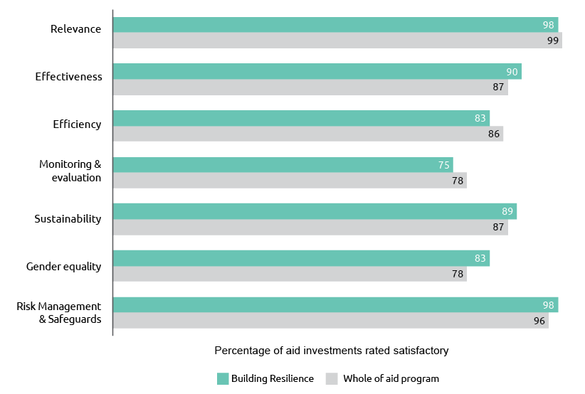

## Gender equality and empowering women and girls

In 2015-16, Australia spent $2.02 billion on investments that targeted gender equality as a principal or significant objective, reflecting in large part the Department’s efforts to integrate gender equality objectives across the aid program (and in support of SDG 5). This equals 55 per cent of DFAT’s country, regional and global aid investments by value across a range of sectors.

The *Gender Equality and Women’s Empowerment Strateg*y, launched by Australia’s Foreign Minister in February 2016, outlines how gender equality and women’s empowerment are at the core of Australia’s foreign policy, economic diplomacy and aid work.

The Strategy directs investments in three priority areas where there are persistent challenges to gender equality and where progress has been slow: enhancing women’s voice in decision-making, leadership and peace-building; promoting women’s economic empowerment; and ending violence against women and girls. The Strategy outlines Australia’s twin-track approach. Track one defines gender equality and women’s empowerment as a discrete strategic priority investment area for the aid program, leading to measures specifically designed to tackle gender inequalities where they are particularly challenging or where progress has been slow. Track two integrates gender equality effectively in all aid investments, regardless of the sector or focus.

In 2015-16, Australia continued to work closely with UN Women whose reach supported Australia’s ability to engage in policy dialogue and provide development assistance in the Indo-Pacific region and globally. For example, Australia supported the joint UN global program Essential Services Package for Women and Girls Subject to Violence, phase two of the joint UN regional program Partners for Prevention, and the UN Women regional program Leveraging Technical Tools which supported the development and use of studies in the region that outlined the costs to economies of violence against women, and responses to this violence. In November 2015, the Foreign Minister announced an additional $6 million of funding over three years to the Global Trust Fund to End Violence against Women, which is administered by UN Women.

Australia’s Ambassador for Women and Girls is an international advocate for gender equality and works to ensure it is a central focus of Australia’s diplomatic and development efforts. Dr Sharman Stone was appointed as Australia’s third Ambassador for Women and Girls in late 2016. In her term, the previous Ambassador Natasha Stott Despoja visited 31 different countries to participate in bilateral, regional and multilateral events. This included 12 visits to Pacific Island countries, reflecting the priority given to her engagement with Australia’s Pacific partners. In May 2016, she led Australia’s engagement at gender-related events at the World Humanitarian Summit in Istanbul, to ensure a strong focus on women in humanitarian settings.

In the 2015-16 budget, the Australian Government established a $50 million Gender Equality Fund (GEF) to strengthen gender equality and women’s economic empowerment in the Indo-Pacific region. The Fund supports innovative new investments both inside and outside DFAT, as well as global investments. It plays an important role in reshaping Australia’s development program to drive stronger gender equality performance and results.

Supported by the GEF, and as part of Australia’s increased focus on women’s economic empowerment through private sector engagement, Australia commenced the Investing in Women Initiative ($46 million, 2015-19). This is a new four-year program that aims to improve women’s economic participation, build markets for women, and through innovative approaches to aid, influence the private and public sector environment to promote women’s economic empowerment.

In 2015-16, the GEF also supported efforts at improving the global production and use of gender statistics, in the recognition of the need to invest substantially in monitoring of progress on the ambitious gender equality objectives of the 2030 Agenda for Sustainable Development. Australia’s support for UN Women’s flagship program on better gender statistics, ‘Making every woman and girl count’, will enable partner governments, international agencies and other actors to support the enabling environment for, production of and accessibility of gender statistics to better inform policy and investment. DFAT also recognises that to measure the relationship between gender and poverty, poverty must be measured at an individual level, rather than only at household level. Australia’s support will help to refine and disseminate the Individual Deprivation Measure, a new poverty measurement tool developed in Australia that collects data from individuals across 15 key economic and social dimensions, and can be disaggregated by sex, age, disability, and other characteristics.

In addition, the GEF contributed to improved articulation of gender equality objectives in the creation of shared value through DFAT’s Business Partnerships Platform, ensuring that all ten proposals supported in the first round will identify strategies to advance women’s economic empowerment, and implement gender equality measures as they proceed.

Figure 37: Aid expenditure with a gender-targeted objective, 2015-16  
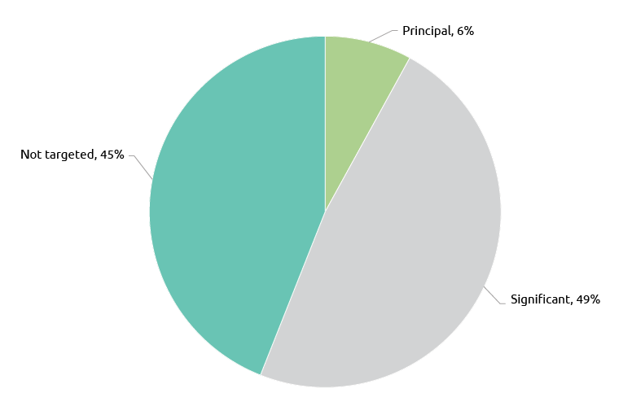

Figure 38 shows investments that identified gender equality as an objective at commencement continued to have higher performance ratings on gender equality as well as on effectiveness, efficiency and monitoring and evaluation quality criteria, compared to investments that do not have gender equality as an objective. This clear link between early consideration of gender equality and effective promotion of gender equality during implementation underscores the importance of gender analysis and gender expertise during investment design.

Figure 38: Gender equality: investment performance, 2015-16  
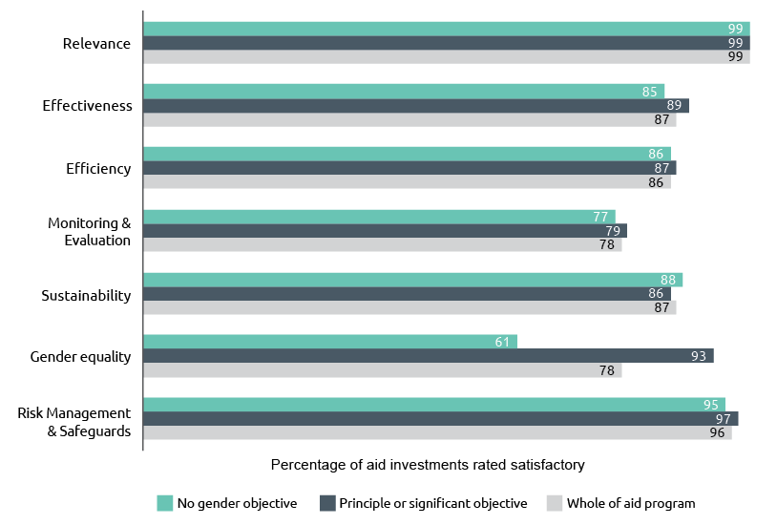

Further analysis of gender performance information can be found in the discussion of strategic target 4 of the aid program performance framework in Chapter 1.

## Disability-inclusive development

In 2015-16, DFAT continued its work to advocate for and include people as participants in, and beneficiaries of, development programs in the Indo-Pacific region. Outreach within DFAT and with DFAT’s delivery partners through 2015-16 supported a stronger awareness of, and compliance with, Australia’s strategy for disability-inclusive development in the aid program: Development for All 2015-2020. DFAT progressed its twin-track approach with a range of investments designed specifically to benefit people with disabilities complemented by efforts to mainstream disability-inclusion across all aid investments.

People with disabilities are referenced in five of the SDGs and six specific targets, covering equal and accessible education; inclusive economic growth and employment; accessible cities, water resources, and transport; and social, economic and political inclusion for people with disabilities.

As in previous years, Australia played a key role in supporting disability rights at international forums such as the Conference of States Parties to the UN Convention on the Rights of Persons with Disabilities (CRPD). In December 2015, the UK Government and the International Disability Alliance (IDA) launched the Global Action on Disability (GLAD) Network which aims to share expertise, coordinate actions, and raise the profile of disability across a broader range of organisations contributing to international development efforts.

Reflecting its international reputation as a strong proponent of disability-inclusive development, Australia (represented by DFAT) accepted the role of GLAD co-chair for 2016. In collaboration with permanent co-chair IDA, achievements to-date include promoting GLAD globally, attracting diverse membership, and facilitating agreement among members on its structure, membership and immediate priorities.

To support the disaggregation of data by disability status, DFAT is investing globally in strengthening disability statistics collection and analysis. This will inform better planning and assessments of how the aid program can support people with disabilities to participate in, and benefit from, development efforts on an equal basis with others. In 2015-16, Australia’s disability data partnerships with UN Statistical Division, UNICEF, and the UN Washington Group on Disability Statistics delivered training and online resources for partners including national statistics offices in the region.

Efforts continued in 2015-16 to improve DFAT’s ability to measure and report on the implementation of disability-inclusive development across the aid program. ODE commenced a strategic evaluation of disability-inclusive development to inform actions to strengthen outcomes for people with disabilities through the aid program in future years. The first phase, due for completion in March 2017, will inform efforts to improve robustness and reliability of disability-inclusion performance measures over time.

Figure 39: Disability-inclusion investment performance by investment priority area, 2015-16  
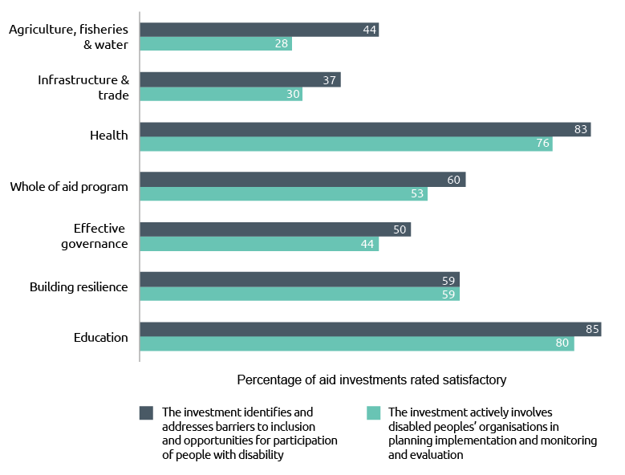

While important progress has been made, there is considerable room for improvement in the aid program’s performance on disability inclusion. In 2015-16, just over half (55 per cent) of all assessed aid investments rate themselves as performing satisfactorily or better on disability inclusion. Human development investments such as education and health perform best, with economic development investments lagging.

In partnership with its technical partner CBM Australia, DFAT continued to provide technical assistance to program managers to integrate disability considerations at all stages of the program cycle. In 2015-16, disability-inclusive development training was provided to DFAT staff and implementing partners in ten countries in the region. This support will be extended in 2016-17 to further support staff skills in the area of disability-inclusion.

In addition, DFAT selected seven aid investments across a range of sectors to receive additional funding and technical assistance to enhance disability-inclusiveness through the Disability-Inclusive Development Fund. This Fund, launched in March 2016, aims to provide catalytic support to strengthen inclusion of people with disabilities in aid investments, and generate and share evidence and lessons.

A number of other measures, including improving internal guidance for staff on assessing investments for disability-inclusion opportunities and requirements, technical outreach to contractors, and increased engagement with international partners to improve their own work in this area, will be undertaken to lift performance on this important cross-cutting issue.

## Innovation

DFAT’s innovationXchange (iXc) was launched in March 2015 to catalyse further innovation in the Australian aid program. This year, using three core tools of **experimenting**, **partnering**, and **learning**, the iXc has significantly expanded the depth and breadth of its portfolio. The iXc is trialling new development approaches and technology, through piloting, and adapting to achieve adoption.

Experimenting
Testing business models, technology & ways of delivering assistance
We support a portfolio of innovative programs & initiatives to service development priorities
Partnering
Linking collaborators & investors with knowledge & opportunity
We engage stakeholders in new ways through strategic partnerships, brokering both finance & expertise
Learning
Sharing lessons from our success & our failure
We exchange knowledge  & ideas to solve problems  & inform the future direction of work

**Experimenting** is about finding and testing new ways of providing development assistance that deliver greater impact, cost‑effectiveness or address new issues. This year the iXc experimented with four global challenges to source innovations and further the department’s objectives: the Pacific Humanitarian, Blue Economy, and Google Impact Challenges, and LAUNCH Food. As a result, five humanitarian innovations are being piloted in the Pacific, including Firetail, a drone that takes aerial images of disaster areas to improve response planning. LAUNCH Food was publicised using an innovative social media campaign and received nearly 300 applications from 74 countries. Twelve high-potential innovations that address malnutrition are being supported, including a Pacific Islands Food Revolution led by world renowned chef Rob Oliver that includes multimedia communications and a televised cooking competition. The Google Impact Challenge coupled the technological expertise of Google and development expertise in DFAT to identify its winners, including the Lafaek Water Project that will support 20 young people form a social enterprise that treats and sells drinking water to communities in Timor-Leste. To stimulate economic development in the Indo-Pacific region, Australia is supporting innovators to develop sustainable and viable development approaches by accessing equity and debt through our investment in the Global Innovation Fund. The iXc is also developing a program to enhance social entrepreneurship and impact investing in South East Asia. To date, the iXc has invested in 11 programs (such as the challenges) which are generating a pipeline of innovations, seven innovative projects, and is supporting 59 innovations in total.

To help encourage creativity in DFAT, iXc ran Ideas 2.0, a competition to stimulate new thinking and cross–departmental collaboration on five strategic policy issues. Progress is also being made on three Ideas 1.0 winners: “No Win No Fee” to trial a cost-effective approach to raising tax revenues in a neighbouring country; “The Last Taboo” exploring the challenge of providing women and girls access to affordable and effective menstrual hygiene products; and “the Digital Passport” is being advanced.

This year iXc’s **partnering** has become extensive, both strategically to frame challenges (e.g. with USAID, LAUNCH, Google, CSIRO and WWF), and operationally to deliver programs (e.g. with ConservationXlabs, SecondMuse, Monash University, and XPRIZE). Our partnership with Impact Investing Australia and UTS has helped scope a program to support social innovators.

To ensure we learn, capture and share our experiences, **learning** activities have expanded. A partnership with USAID and KOICA has delivered the Global Innovation Exchange, an online platform to connect innovators and funding opportunities around the world, as well as share lessons learned. We have built an interactive map to share case studies on innovative investments across the entire aid program. AQC analysis shows that in 2015-16, 63 per cent of aid investments applied innovative programming such as adopting new technologies and nearly half of all investments applied a new approach to aid delivery (Figure 40). Investments in aid for trade related areas showed the strongest performance on innovation. Some examples of innovation across the aid program include:

• Using prototyping and non-traditional partnering to codify traditional regulations that support gender-sensitive village development planning, land ownership, and conflict resolution;

• Crowd-sourcing and providing free disaster information, enabling first-responders to verify/reply to incidents and decision-makers to respond to the public’s needs;

• Piloting mobile money where providers issue e-money to a network of agents who provide real money to villagers – a model set to empower village banks;

• Collaborating with non-traditional partners to train ‘soy doctors’ to champion good agricultural practice, resulting in a 30 per cent increase in yield during the last harvest, despite the El Nino;

• An automated mobile phone system allowing health workers to regularly contact pregnant women, to facilitate antenatal, safe delivery and postnatal care.

Figure 40: Innovation investment performance by investment priority area, 2015-16  
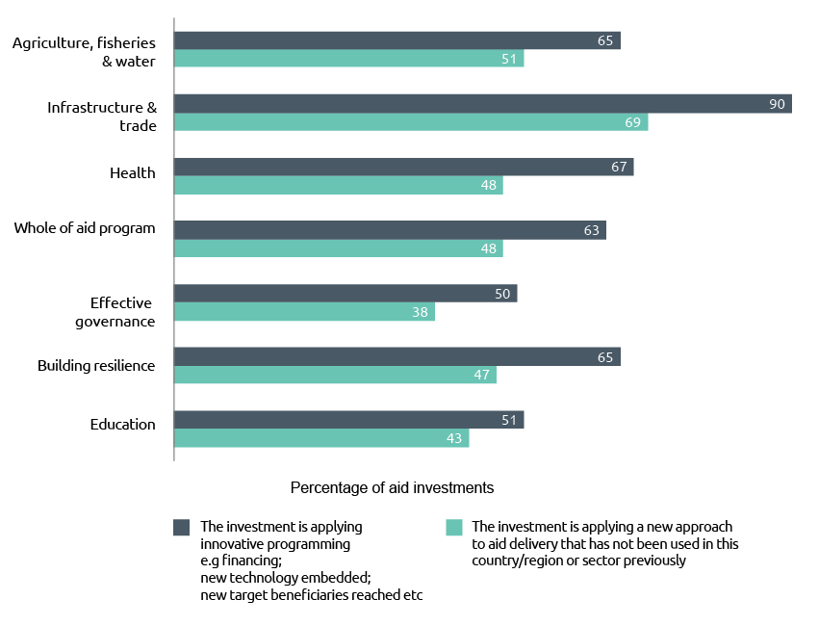

# Annex A: Official Development Assistance delivered by other government agencies

Australian Federal Police

### ODA expenditure in 2015-16: $100.4 million

In 2015-16, Australian Federal Police (AFP) programs maintained their commitment to the capacity development of partner police agencies in the Pacific Region. AFP continued to advocate and encourage an increased regional focus on combatting Transnational Serious and Organised Crime (TSOC) particularly through the Pacific Transnational Crime Network (PTCN) which has expanded its reach during this time. The PTCN was established in 2002 to enable the coordinated exchange of intelligence in support of efforts to combat transnational crime in the Pacific, and now has a presence in 16 member countries and manages 24 Transnational Crime Units (TCUs). In 2015-16, American Samoa, Tuvalu and Nauru became members of the PTCN and, under AFP support and guidance, established their own TCUs. Also during the period, the PTCN capability was extended in Vanuatu (Santo), Kiribati (Kiritimati Island) and Papua New Guinea (Madang), where additional TCUs were established.

In addition to the PTCN and its increased focus on TSOC, AFP police capacity development programs continued to provide support to partner police agencies to enable the delivery of legitimate, responsive and accountable policing in support of effective rule of law.

Police Capacity Development Programs in 2015-16 included:

• Papua New Guinea Australia Policing Partnership (PNG-APP) continued to provide support to the Royal Papua New Guinea Constabulary (RPNGC) to develop and enhance their community policing capabilities as well as increasing focus on RPNGC planning and preparation for the upcoming Asia-Pacific Economic Cooperation (APEC) summit in 2018;

• The Regional Assistance Mission to the Solomon Islands (RAMSI) continued to support the development of a credible policing capability throughout the Solomon Islands;

• Pacific Police Development Program supported community policing and investigative development programs in Nauru, Samoa and Tonga;

• Pacific Police Development Program – Regional continued their police capacity development work with partner police forces in Kiribati, Tuvalu, Cook Islands, Republic of Marshall Islands, Fiji, Niue, Palau and the Federated States of Micronesia;

• The Timor-Leste Police Development Program continued a focus on enhancing the capability of front-line policing services of the Policia Nacional de Timor-Leste;

• The Vanuatu – Australia Police Partnership (VAPP) focusses on professionalising the Vanuatu Police Force and operates in conjunction within the broader DFAT Law & Justice program

Australian Centre for International Agricultural Research (ACIAR)

### ODA expenditure in 2015-16: $91.1 million

As Australia’s specialist agricultural research-for-development agency, ACIAR actively contributed to the overall aid objectives by improving the productivity and profitability of agricultural systems in countries of the Indo–Pacific region. ACIAR supported economic and public diplomacy through improving agricultural competitiveness and sustainability, increasing value chain efficiency and effectiveness, alleviating regulatory impediments in relation to domestic and international markets and capacity building. ACIAR managed research partnerships in the areas of crops, livestock and fisheries, natural resources and forestry, and socioeconomics and policy which generated new technologies and systems, innovation at the farm level, and greater capabilities in research and production.

A number of examples highlight ACIAR’s contribution. In Timor-Leste, a collaborative activity involving scientists from Indonesia has introduced better forages and tree legumes for smallholder cattle, following the lessons of successful implementation in similar dryland areas in Indonesia. The introduction of versatile multicrop planters and conservation agriculture technologies in Bangladesh has led to higher crop yields and profit compared with the traditional system. An ACIAR project is turning the stems of old, non-productive coconut palms in Pacific Island countries into a high-value product cocoveneer. This product has the potential to bring benefits along the supply chain from coastal communities who own the plantations, to timber mills, furniture makers, retailers and exporters.  In Myanmar, the ACIAR project MyRice has demonstrated approaches to improving rice productivity through introducing better agronomy, modern rice varieties and improving post-harvest management of rice to improve quality. Best practices post-harvest reduced physical losses by 10–13 per cent. In Tanzania, women have been trained as community vaccinators to protect village chickens from the devastating Newcastle disease. Since the introduction of vaccination and the associated increase in the consumption of poultry and eggs, maternal and child health is improving, with height-for-age Z-scores of children from households owning chickens significantly higher than those from households without chickens.

Treasury

### ODA expenditure in 2015-16: $58.2 million

Treasury supported international financial institutions that make significant contributions to development outcomes. This included payments of previously agreed capital increases to the International Bank for Reconstruction and Development and to the Asian Development Bank (ADB), as well as contributions to the World Bank’s Global Infrastructure Facility and the ADB’s Asia Pacific Project Preparation Facility.

A range of agencies in the Treasury portfolio assisted in training officials and regulators in partner countries. These agencies include the Australian Securities and Investments Commission, the Australian Competition and Consumer Commission, and the Australian Bureau of Statistics.

Department of Health

### ODA expenditure in 2015-16: $7.0 million

The Department of Health’s contribution to official development assistance is primarily made through its contribution to the World Health Organization (WHO). The Department’s annual assessed contribution to the WHO enables Australia to participate in the World Health Assembly and technical fora and shape regional and global health priorities.

Department of Immigration and Border Protection

### ODA expenditure in 2015-16: $0.8 million

The Department of Immigration and Border Protection (DIBP) funded a range of activities to strengthen the migration and border management capabilities of partners in the Asia-Pacific and Middle East. Activities included strengthening border management and migration management capacity, supporting the voluntary return of displaced migrants, and providing care and management services to displaced populations. Activities were delivered directly by DIBP and through funding arrangements with nongovernment organisations and multilateral bodies. The types of activities funded by DIBP in 2015-16 are represented by the following examples.

DIBP delivered border management and English language skills training to over 2000 people in over 47 countries, primarily in the Asia-Pacific, to enhance the capability of foreign governments’ border management and security. Funding was provided to the International Organization for Migration, the United Nations High Commissioner for Refugees and other organisations to deliver a range of activities globally. These activities included emergency assistance to up to 35,000 people displaced by conflict in Syria and Iraq, health insurance to over 50,000 Afghan refugees in Iran and upgrades to over 50,000 identity cards for asylum seekers and refugees in Malaysia.

Department of Defence

### ODA expenditure in 2015-16: $4.9 million

The Australian Defence Force responded to the devastation brought by Tropical Cyclone Winston to Fiji in February 2016 through Operation Fiji Assist 2016. More than 1000 soldiers, sailors and aircrew deployed during the operation, providing humanitarian supplies and significantly assisting the recovery process in the wake of the Category 5 cyclone.

Department of Agriculture

### ODA expenditure in 2015-16: $3.6 million

The Department of Agriculture and Water Resources provides an annual contribution to the United Nations Food and Agriculture Organization (FAO) as a component of Australia’s membership fees. The FAO seeks to raise levels of nutrition, improve agricultural productivity and food security, better the lives of rural populations and contribute to the growth of the world economy. Australia, along with New Zealand, co-chairs the FAO South-West Pacific region. Australia works to ensure that the benefits of FAO membership such as agricultural, fisheries and forestry skills and knowledge sharing flow to Pacific Island nations.

Attorney-General’s Department

### ODA expenditure in 2015-16: $1.2 million

The Attorney-General’s Department (AGD) worked with regional partner countries including Indonesia, Vietnam, Pakistan, and Pacific Island countries, to: develop and improve capacity and technical expertise in law and justice agencies; help combat organised crime and corruption; strengthen legal frameworks on terrorism and transnational crime, including people smuggling and human trafficking; and improve Pacific domestic crime and policing legal frameworks and their implementation.

As part of AGD’s work through the Bali Process on People Smuggling, Trafficking in Persons and Related Transnational Crime, AGD co-chaired the second annual meeting of the Working Group on Trafficking in Persons, and a regional Bali Process ‘Follow the Money’ Forum, highlighting the benefits of using anti-money laundering tools and techniques to support investigation and prosecution of human trafficking cases. AGD also led the establishment of a Working Group on Trafficking in Persons and development of Policy Guides on Identifying and Protecting Victims of Trafficking in Persons to strengthen the regional response to combat people smuggling and human trafficking. In Indonesia, AGD has built on previous work supporting the passage and implementation of stronger laws to combat people smuggling, money laundering, terrorism and terrorism financing.

In the Pacific, AGD developed with Pacific Island countries to develop model forensics provisions to provide a legal framework to increase technical law enforcement capacity in the region, supported work through the Pacific Island Law Officers’ Network to address cybercrime and family and sexual violence, worked with several Pacific Island countries on various law reform and policy projects, assisted other Pacific Island countries to implement new legal frameworks and continued to deliver training and mentoring to build law reform capacity in Pacific Island countries’ law and justice agencies. This included continuing its Pacific Policy Champions and the Pacific Legal Policy Twinning Programs.

Department of Communications and the Arts

### ODA expenditure in 2015-16: $1.1 million

The Department of Communications and the Arts provided Australia’s annual contribution of $6.8 million to the International Telecommunication Union (ITU), the United Nations specialised agency responsible for international cooperation in the use of telecommunications and radio frequency spectrum.

Approximately $1.1 million of the annual contribution was ODA, which supported the ITU’s global activities to enhance telecommunication and ICT development.

Department of Finance

### ODA expenditure in 2015-16: $1million

The Department of Finance (Finance) supports whole-of-Australian-government international activities, through deployments, in-country workshops, hosting international delegations and capacity building. This involves developing, implementing, and managing activities that build strong partnerships and promote good governance in the Indo-Pacific region. In 2015-16, Finance worked with central agency counterparts in partner countries of Indonesia and Solomon Islands to improve public sector governance, budget processes, government asset management and public financial management. In March 2016, Finance ceased its in-country activities in Papua New Guinea, but continues to support collaboration through two PNG nationals participating in Finance’s graduate program each year.

# Annex B: Assessment by Independent Evaluation Committee and the Office of Development Effectiveness

Foreword by Chair of the Independent Evaluation Committee

The 2016 Performance of Australian Aid Report provides a good summary of the effectiveness of the  Australian aid program and progress against the Government’s policy objectives. This reflects DFAT’s well–established and effective performance management system.  In my experience working with a number of international development agencies, I judge Australia’s aid performance management system as among global best practice.

This year’s report shows again the continued strong performance against the Government’s ten strategic targets for the aid program.

Going forward, DFAT management will need to consciously provide close oversight of its performance management system so it can continue to operate at a high level. In particular, programs need to be clearer on what success looks like and to make better use of evidence to assess progress. Implementing this will depend on the quality of monitoring and evaluation systems, which have remained stubbornly difficult to improve over a number of years. The IEC applauds the new DFAT Aid Evaluation Policy released by the DFAT Secretary to improve the quality and transparency of aid evaluations, but the challenge now is to implement this consistently across the program.

The Independent Evaluation Committee encourages DFAT management to provide the necessary leadership and incentives to achieve consistent implementation, and to invest in the skills and capabilities of staff to underpin a rigorous approach to performance management. The Independent Evaluation  Committee continues to support a culture of constructive debate and contestability over performance results, and is pleased to keep playing its role in this process.

**Jim Adams   
Chair   
Independent Evaluation Committee**

Office of Development Effectiveness

The following assessment fulfils the role of the Office of Development Effectiveness (ODE), under the supervision of the Independent Evaluation Committee (IEC), to quality assure and verify the assessments made in the 2015–16 Performance of Australian Aid report (PAA).

The PAA is a well-structured document that uses available evidence to present a thoughtful and credible statement about the performance of the Australian aid program. The continued commitment to transparency demonstrated by the production of this annual report is commendable, as is its well-balanced coverage on performance. The PAA recognises achievements as well as challenges— a notable improvement on previous PAA reports.

DFAT’s strong aid performance management policies underpin the report. These articulate a system of regular performance assessments that generate critical data, focus staff on core enablers of effective aid, and facilitate timely management of challenges. Together with the oversight and quality assurance functions of ODE and the IEC, ODE considers these policies and processes to be comprehensive.

The ODE/IEC assessment of the performance information in this year’s PAA largely draws from our annual quality assurance of Aid Quality Checks (AQCs) and Aid Program Performance Reports (APPRs), as further described below. In addition, independent ODE evaluations provide insights into aid program performance in terms of key policy directions, and specific development themes and sectors. The end of this annex provides details on the nature and scope of our assessment, as well as the ODE evaluations published in 2016.

The bedrock of DFAT’s aid performance management system remains the annual AQCs, which report on the performance of individual aid projects. Some 432 projects underwent AQCs in 2016, covering

$2 billion of 2015–16 aid expenditure. The other main mechanism is Aid Program Performance Reports (APPRs), through which country and regional programs report on performance against broader program level objectives. Last year, 26 APPRs were completed.

These AQC and APPR completion rates represent full compliance with departmental requirements and provide a wealth of performance information on the aid program. There are however, some areas that DFAT needs to address to safeguard the ongoing integrity and value of the performance management system. These challenges, many of which are common among development agencies that take performance seriously[35], are discussed in the following paragraphs.

The performance narrative in the PAA, including reporting against a number of strategic targets, relies heavily on AQC ratings. ODE’s spot-check of a statistically significant random sample of 2015–16 AQCs (32% of all AQCs[36]) confirmed that AQCs continue to be a robust and integral part of DFAT’s aid performance management system. We found that across the six AQC quality criteria[37], an average of 82 per cent of ratings were robust assessments of aid quality—that is, the ratings were sufficiently justified by evidence. This is broadly consistent with previous spot-checks. Our analysis also suggests that the robustness of gender equality ratings has improved over the last three years. Traditionally among the least robust of the AQC quality criteria, the recent improvements in the robustness of gender equality ratings have coincided with strong and sustained engagement by DFAT’s gender experts in the AQC process.

On the other hand, the spot-check found a decline in the robustness of effectiveness ratings. Our analysis suggests that compared to previous years, the 2015–16 AQC reports were less clear on the link between outputs (e.g. number of teachers trained), and the outcomes that projects ultimately aim to achieve (e.g. improved student learning). Without this link, and without evidence of outputs and emerging outcomes it is not straightforward to explain and justify the basis for effectiveness ratings, and for ODE to verify that they are reasonable. We consider this is part of a recent decline in how well evidence is used in AQC reports to justify performance claims. The department has recently released new AQC guidance and templates with a stronger focus on effectiveness and the use of evidence, which should improve this situation. Beyond guidance and templates, there is a continuing need to support staff in the task of monitoring and assessing performance.

Linked to the challenge of assessing effectiveness is the quality of project monitoring and evaluation (M&E) systems. As in previous years, reported performance on M&E in 2015–16 AQCs was weaker than performance against all other AQC quality criteria. In ODE’s assessment of the previous PAA, we noted that the percentage of M&E ratings in 2014–15 AQCs assessed as robust in the spot-check, represented a decline from the robustness of M&E ratings in previous years. This percentage was unchanged in the latest spot-check indicating a continued need to improve M&E capacity within the aid program. ODE plans to investigate project-level M&E systems in detail as part of its 2017 quality assurance work.

The 2015-16 APPR quality review was the first opportunity for ODE to assess the quality of APPRs against the objectives and performance benchmarks set in the new Aid Investment Plans. The review found that close to two-thirds of 2015-16 APPRs were of good quality, with the remaining APPRs assessed to be of more limited quality. Some APPRs suffered from a lack of specificity about, and/or provided insufficient evidence to justify ratings. In these cases, it was more difficult to judge progress and verify performance ratings. ODE recognises that this is a challenging area to get right and notes both that programs are actively working to get this right and that APPRs will face the continuing dilemma of having to summarize large volumes of information and perspectives on country programs.

Independent evaluations continued to play an important role in building evidence and informing the effectiveness of the aid program. In general, evaluations published by ODE in 2016 reaffirmed that the aid program is well managed. We were also pleased with the level of commitment within the department to learn from evidence generated through these evaluations. The recent ‘Review of Uptake of ODE Recommendations’, which considered 11 evaluations published in 2014 and 2015, found that all recommendations from the evaluations were being implemented by the department. Further, the number of recommendations classified as ‘fully implemented’ has increased over time, indicating continuous efforts to improve aid activities based on evaluation recommendations.

The use of other DFAT evaluations appears to be improving. Seventy-two program evaluations (which are separate from ODE evaluations and usually focused on single projects) were completed by program areas in 2015–16 , which is a commendable effort. To date, two-thirds of these evaluations are publically available—a higher rate of publication than in previous years. However, there is still more to do to improve evaluation publication, which supports transparency and provides assurance that evidence generated by evaluations is used in decision-making.

Demonstrating DFAT’s commitment to transparency, the DFAT Secretary released a new DFAT Aid Evaluation Policy in November 2016. ODE expects the new policy—which aims to enhance the impact, quality and relevance of evaluations, and specifies strong senior management oversight—will increase evaluation use and publication.

ODE’s work continues to highlight the importance of prioritising performance management and evidence-based decision-making, and that the department needs to foster the capabilities required to support good practice in these areas. ODE looks forward to its ongoing involvement in progressing this agenda.

### Nature and scope of ODE/IEC assurance

Australia’s aid performance management policy, Making Performance Count, gives ODE the task of quality assuring and verifying the performance assessments made in the annual Performance of Australian Aid Report. This approach meets the Public Governance, Performance and Accountability Act 2013 (PGPA Act) Rule section 17, which requires that Commonwealth entities’ audit committees review the appropriateness and accuracy of entity performance reporting. In the case of reporting on the performance of Official Development Assistance administered by DFAT, this function is undertaken by ODE in consultation with the DFAT Audit and Risk committee.

In line with modern management practice, ODE’s approach to this quality assurance role is risk based.

Our procedures include, but are not limited to:

• Assessment of the robustness of ratings within a statistically significant random sample of 121 AQC reports (approximately 32 per cent of the population)

• Detailed assessment of the quality of all 26 country and regional program APPRs completed in 2016, covering the 2015-16 financial year

• Completion of in-depth evaluations of aspects of the Australian aid program (six in 2016)

Consequently, ODE does not check or verify the accuracy of every figure and every statement in the PAA. In particular, our approach does not allow us to attest to the accuracy of:

• Financial information and the quality or effectiveness of fraud and anti-corruption strategies

• Multilateral performance assessments and partner performance assessments

• Agency estimates of aggregate development results

• Estimates of the extent of private sector engagement, including performance under target 2

• Performance statements covering ODA appropriated to other agencies

ODE Evaluations Published in 2016

1. Evaluation of the management arrangements for the Civil Society Water, Sanitation and Hygiene Fund (December)

2. Evaluation of the partnership between the Pacific Community (SPC) and the Government of Australia (September)

3. Review of Operational Evaluations completed in 2014 (July)

4. Investing in Teachers (May)

5. Independent verification of the Empowering Indonesia Women for Poverty Reduction program (MAMPU) (May)

6. Gearing up for Trade (May)

# List of acronyms and abbreviations

AACES Australia African Community Engagement Scheme

ACC Australian Civilian Corps

ACEF African Enterprise Challenge Fund

ACIAR Australian Centre for International Agricultural Research

ACTIP ASEAN Convention Against Trafficking in Persons

ADB Asian Development Bank

ADF Asian Development Fund (of the ADB)

AFP Australian Federal Police

AGD Attorney-General’s Department

AIPEG Australia Indonesia Partnership for Economic Governance

ANCP Australian NGO Cooperation Program

APEC Asia-Pacific Economic Cooperation

APLMA Asia Pacific Leaders’ Malaria Alliance

APPR Aid Program Performance Report

APTC Australian Pacific Training College

AQC Aid Quality Check

ASEAN Association of Southeast Asian Nations

AUSTRAC Australian Transaction Reports and Analysis Centre

AVID Australian Volunteers for International Development Program

AWP Australian Water Partnership

BRAC Bangladesh-based development organization

CHF Common Humanitarian Fund

CRPD UN Convention on the Rights of Persons with Disabilities

CSIRO Commonwealth Scientific and Industrial Research Organisation

DFAT Department of Foreign Affairs and Trade

DFID Department for International Development (UK)

DIBP Department of Immigration and Border Protection

DRR Disaster Risk Reduction

EVAW Ending Violence Against Women

FAO Food and Agriculture Organization

FFA Forum Fisheries Agency

FHSSP Fiji Health Sector Strengthening Program

GAVI Global Alliance for Vaccines and Immunizations

GAP Gender Action Plan

GDP Gross Domestic Product

GEF Gender Equality Fund

GFATM Global Fund to Fight AIDS, Tuberculosis and Malaria (the Global Fund)

GfG Governance for Growth

GLAD Global Action on Disability

GPE Global Partnership for Education

GPF Government Partnerships Fund

GTIF Global Trade Integration Facility

ICSID International Centre for Settlement of Investment Disputes (of the WBG)

IDA International Development Association (of the WBG)

IEC Independent Evaluation Committee

ILO International Labour Organization

IRI Investments Requiring Improvement

ITU International Telecommunication Union

iXc innovationXchange

KOICA Korean International Cooperation Agency

M&E Monitoring and Evaluation

MAMPU Empowering Indonesian Women for Poverty Reduction Program

MDF Market Development Facility

MDG Millennium Development Goal

MDTF Multi-Donor Trust Fund

MIGA Multilateral Investment Guarantee Agency (of the WBG)

MPA Multilateral Performance Assessment

MW Megawatt

NATO North Atlantic Treaty Organization

NGO Non-Government Organisation

OCHA Office for the Coordination of Humanitarian Affairs (UN)

ODA Official Development Assistance

ODE Office of Development Effectiveness

OECD Organisation for Economic Cooperation and Development

PAA Performance of Australian Aid report

PDP Product Development Partnerships

PHAMA Pacific Horticultural and Agricultural Market Access Program

PIDG Private Infrastructure Development Group

PKPR Partnership for Knowledge-Based Reduction

PNG Papua New Guinea

PPA Partner Performance Assessment

PPIAF Public Private Infrastructure Advisory Facility

PPP Public Private Partnership

PTCN Pacific Transnational Crime Network

PWSPD Pacific Women Shaping Pacific Development

RAMSI Regional Assistance Mission to Solomon Islands

RAVN Returned Australian Volunteer Network

RCS Rapid Change System

RPNGC Royal Papua New Guinea Constabulary

SDIP Sustainable Development Investment Portfolio

SDG Sustainable Development Goal

SIG Solomon Islands Government

SOE State Owned Enterprise

SPC Secretariat of the Pacific Community

SRH Sexual Reproductive Health

TADEP Transformative Agriculture and Enterprise Development Program

TAF The Asia Foundation

TB Tuberculosis

TCU Transnational Crime Unit

TSOC Transnational Serious and Organised Crime

TVET Technical and Vocational Education and Training

UNAIDS Joint United Nations Programme on HIV/AIDS

UNESCO United Nations Educational, Scientific and Cultural Organization

UNDP United Nations Development Programme

UNDS United Nations Development System

UNICEF United Nations Children’s Fund

UNISDR United Nations Office for Disaster Risk Reduction

UNFPA United Nations Population Fund

UNRWA United Nations Relief and Works Agency for Palestine Refugees

VAPP Vanuatu-Australia Police Partnership

WASH Water, Sanitation and Hygiene

WBG World Bank Group

WFP World Food Program

WHO World Health Organization

WTO World Trade Organization

WWF World Wildlife Fund

1. *Making Performance Count: enhancing the accountability and effectiveness of Australian aid*, Department of Foreign Affairs and Trade, 18 June 2014, accessed at: <http://dfat.gov.au/about-us/publications/Pages/making-performance-count-enhancing-the-accountability-and-effectiveness-of-australian-aid.aspx>
2. *Australian aid: promoting prosperity, reducing poverty, enhancing stability*, Department of Foreign Affairs and Trade, 18 June 2014, accessed at: <http://dfat.gov.au/about-us/publications/Pages/australian-aid-promoting-prosperity-reducing-poverty-enhancing-stability.aspx>
3. These comprised twenty-one reports for country programs, four reports for regional programs and one report for the Australian NGO Cooperation Program (ANCP), which provides funding to accredited Australian NGOs
4. Ratings of 6 (very good), 5 (good) and 4 (adequate) are considered satisfactory ratings; ratings of 3 (less than adequate),   
   2 (poor) and 1 (very poor) are considered unsatisfactory.
5. These comprised 311 Aid Quality Checks, 104 Final Aid Quality Checks and 17 Humanitarian Aid Quality Checks. 
6. Investment performance information included in this report refers to DFAT-funded investments only. Whole of aid program data on investment performance in Chapters 2 and 4 relates to DFAT-funded investments only.
7. Gender specialists took part in the moderation of 304 Aid Quality Checks, out of a total of 432 checks completed, amounting to 70.5 per cent. This helped to ensure the robustness of the improved gender ratings and generate more realistic baseline performance data for many programs.
8. MAMPU Phase 1 evaluation: <http://dfat.gov.au/about-us/publications/Pages/indonesia-mampu-verification-report-man-resp.aspx>
9. These systems are described in DFAT’s *Performance of Australian Aid 2014-15* report (accessed at: <http://dfat.gov.au/about-us/publications/Pages/performance-of-australian-aid-2014-15.aspx>) 
10. Available at: <http://dfat.gov.au/about-us/publications/Pages/aid-program-performance-reports.aspx> 
11. *Pacific Urbanisation: Changing Times; State, Society and Governance in Melanesia*, Meg Keen and Julien Barbara, Australian National University, 2015, accessed at: <http://ssgm.bellschool.anu.edu.au/experts-publications/publications/4122/pacific-urbanisation-changing-times> 
12. Evaluation of the partnership between the Pacific Community (SPC) and the Government of Australia, DFAT’s Office of Development Effectiveness, 5 September 2016, accessed at: [http://dfat.gov.au/aid/how-we-measure-performance /ode/other-work/Pages/evaluation-of-the-secretariat-of-the-pacific-community-government-of-australia-partnership-final-report.aspx](http://dfat.gov.au/aid/how-we-measure-performance%20/ode/other-work/Pages/evaluation-of-the-secretariat-of-the-pacific-community-government-of-australia-partnership-final-report.aspx)
13. *Asian Development Outlook 2016*, Asia’s potential growth, Asian Development Bank, March 2016, accessed at:   
    <https://www.adb.org/publications/asian-development-outlook-2016-asia-potential-growth>
14. South Asia’s Turn: Policies to Boost Competitiveness and Create the Next Export Powerhouse, Gladys Lopez-Acevedo,   
    Denis Medvedev and Vincent Palmade, World Bank Group, October 2016, p. ix.
15. *Poverty in a Rising Africa: Africa Poverty Report*, World Bank, March 2016, accessed at: <http://www.worldbank.org/en/region/afr/publication/poverty-rising-africa-poverty-report>
16. *Global Economic Prospects: Spillovers Amid Weak Growth*, World Bank, January 2016, p. 153, accessed at:   
    <https://openknowledge.worldbank.org/handle/10986/23435>
17. Ibid.
18. Ibid.
19. Collectively, AACES activities impacted more than 2.3 million women and marginalised people across the 11 countries as found at: <http://dfat.gov.au/about-us/publications/Documents/aaces-program-review-2011-2016.pdf>
20. Australian higher education scholarships as tools for international development and diplomacy in Africa, Seye Abimbola, Rose Amazan, Pavle Vizintin, Leanne Howie, Robert Cumming & Joel Negin, 2016, Australian Journal of International Affairs, vol. 70, issue 2, pp105-120.
21. Core funding refers to financial support that covers basic ‘core’ operational and administrative costs of an organisation and is not earmarked to specific activities.
22. Multilateral Performance Assessments were completed in 2015 for Asian Development Bank, UNICEF, UNDP and WFP and summary information is available in the Performance of Australian Aid 2014-15, p54-56 accessed at: <http://dfat.gov.au/about-us/publications/Pages/performance-of-australian-aid-2014-15.aspx>
23. The IBRD is the WBG’s non-concessional public lending arm, providing middle income and creditworthy lower income developing countries with financial resources, knowledge and technical services, and strategic advice.
24. Multilateral Performance Assessments use a six-point rating scale to rate performance. Ratings of 6 (very good), 5 (good) and 4 (adequate) are considered satisfactory ratings; ratings of 3 (less than adequate), 2 (poor) and 1 (very poor) are considered unsatisfactory.
25. Australia’s engagement with three of the World Bank Group’s five “arms” – the International Bank for Reconstruction and Development, the International Development Association (together known as “The World Bank”), and the International Finance Corporation – formed the basis of the 2015-16 Multilateral Performance Assessment. Australia does not currently have significant engagement with the other two arms of the WBG – the Multilateral Investment Guarantee Agency (MIGA) and the International Centre for Settlement of Investment Disputes (ICSID).
26. *ADB Multilateral Performance Assessment summary*, Performance of Australian Aid 2014-15, 8 February 2016, p53, accessed at: <http://dfat.gov.au/about-us/publications/Pages/performance-of-australian-aid-2014-15.aspx>
27. *Building Women’s Leadership: the Contribution of Australia Awards Scholarships*, DFAT’s Office of Development   
    Effectiveness, 16 December 2015, accessed at: <http://dfat.gov.au/aid/how-we-measure-performance/ode/other-work/Pages/evaluation-of-the-contribution-of-australia-awards-to-womens-leadership.aspx>
28. *Evaluation of the Australian NGO Cooperation Program*, DFAT’s Office of Development Effectiveness, 11 August 2015, accessed at: <http://dfat.gov.au/aid/how-we-measure-performance/ode/other-work/Pages/evaluation-of-the-australian-ngo-cooperation-program.aspx>
29. ODE 2014 evaluation of AVID accessed at: <http://dfat.gov.au/aid/how-we-measure-performance/ode/other-work/Pages/avid-evaluation-report.aspx>
30. Investment performance information included in Chapter 4 refers to DFAT-funded investments only.
31. ‘Gearing for Trade: Australia’s support for trade facilitation programs: <http://dfat.gov.au/aid/how-we-measure-performance/ode/odepublications/Pages/gearing-up-for-trade.aspx>.
32. Organisation for Economic Co-operation and Development and World Trade Organization, 2013, Aid for Trade at a Glance 2013: Connecting Value Chains: <https://www.wto.org/english/res_e/booksp_e/aid4trade13_e.pdf>
33. *Teacher development*, DFAT’s Office of Development Effectiveness, 20 May 2016, accessed at: <http://dfat.gov.au/aid/how-we-measure-performance/ode/other-work/Pages/teacher-quality.aspx>
34. *Evaluation of the management arrangements for the Civil Society Water, Sanitation and Hygiene Fund,* DFAT’s Office of Development Effectiveness, 21 December 2016’ accessed at: <http://dfat.gov.au/aid/how-we-measure-performance/ode/other-work/Pages/evaluation-of-the-management-arrangements-for-the-civil-society-water-sanitation-and-hygiene-fund.aspx>
35. E.g. see World Bank (2016), *Report on self-evaluation systems* (ROSES); accessed at <http://documents.worldbank.org/curated/en/home>
36. In a small number of cases, a single AQC assesses the performance of more than one project; this figure refers to 32 per cent of unique AQCs completed.
37. Relevance, effectiveness, efficiency, sustainability, gender equality, and monitoring and evaluation.