Performance Assessment Note
Social protection

May 2016

Introduction
Social protection is identified as one of the six priorities for the Australian aid program, as part of its focus on building resilience. It refers to programs that address risk, vulnerability, inequality and poverty through a system of transfers to people in cash or in kind. It has three core functions: 1) protection of the poor from the worst impacts of poverty, 2) prevention against income shocks and drops in well-being, 3) promotion of opportunities and livelihoods.
Social protection systems and programs are mentioned throughout this Performance Assessment Note (PAN). Social protection systems refer to the approach used for the coordination and integration of the policy with the programs and the administration of the system. Conversely, social protection programs refer to the individual investments put in place to assist the poor and the most vulnerable such as: children, women, the elderly and the people living with a disability.
This PAN provides guidance and resources for designing monitoring and evaluation (M&E) arrangements for investments in social protection. It provides a menu of indicators and evaluative questions for DFAT staff and aid program implementing partners to draw upon.
This PAN can contribute to gathering reporting data on the Aggregate Development Results indicator which is used across the aid program to collect data on social protection. Furthermore, this PAN contains a number of indicators which could be used for reporting under the Sustainable Development Goals (SDGs).

Program Logic
Australia’s investment in social protection is about leverage. It seeks to help improve partner government systems to more effectively distribute their own funds.
The overall objective of the social protection strategy is to contribute to the wider aid program’s focus on economic growth and poverty reduction. It will do so through the pursuit of the strategic objectives, including:
- Improve social protection coverage in the Indo-Pacific
- Improve the quality of social protection systems
To achieve these objectives, priority areas of engagement will be in two broad areas:
- Refining and developing social protection systems
- Strengthening partner government and other stakeholders’ knowledge and their capacity on social protection to enhance their ability to make their informed choices about social protection options

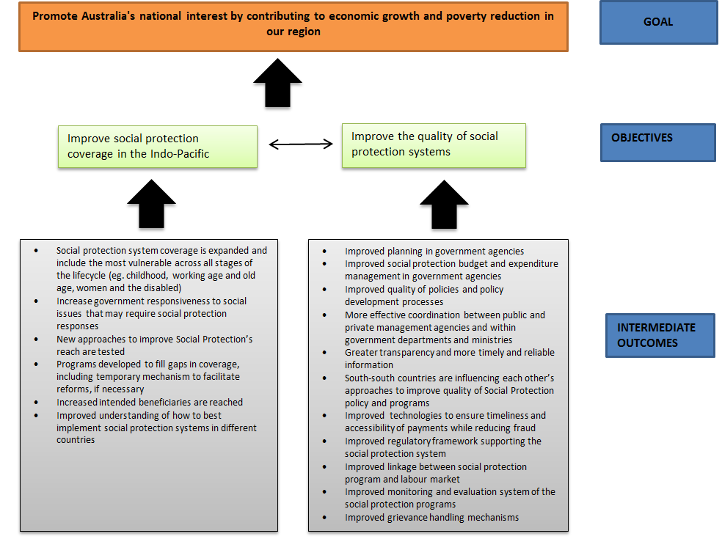
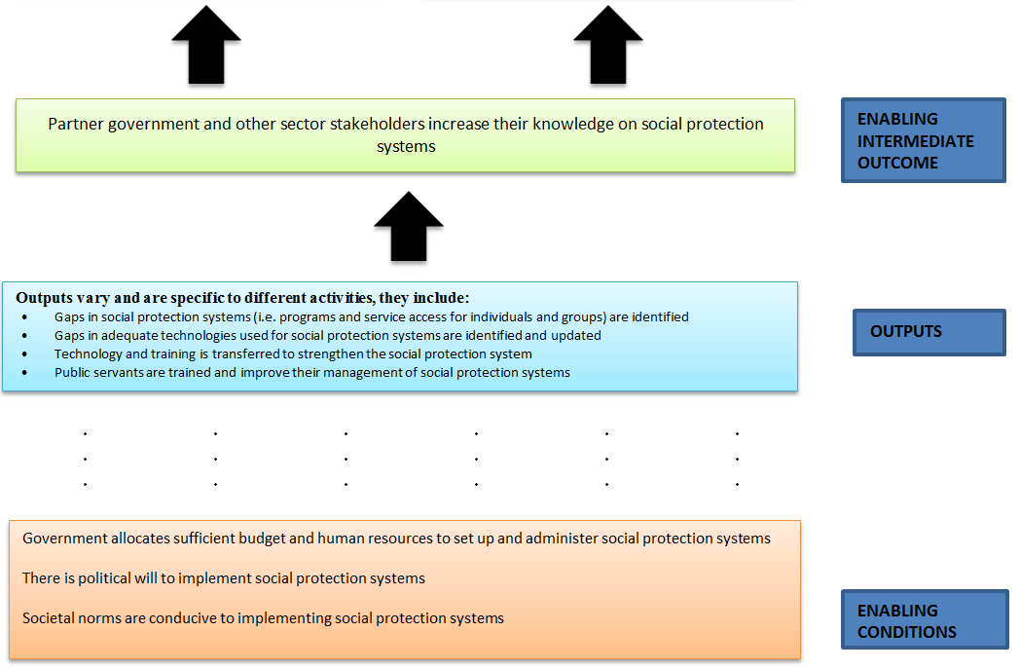
Social protection systems are complex and there might be times when progress cannot be directly attributed to Australia’s investment. As a result this should be reflected in each program’s individual M&E Framework. Where DFAT provides funding that leads to a result that would not have occurred without that funding, regardless of the partner government contribution, the result can be fully attributed to DFAT. Where an investment is funded by other parties in addition to DFAT – such as partner governments, other donors, multilateral organisations or other Australian Government agencies and the result would have occurred without DFAT funding, just to a lesser extend – the results should reflect a pro-rata share of DFAT’s funding relative to the overall funding.
How and when would you use this PAN?
This PAN provides a suite of indicators and performance questions, which seek to measure the strategic objectives of the strategy. The menu is not intended to be comprehensive (and should not preclude use of other context-relevant indicators beyond those presented here), but to provide suggestions of the breadth of areas that may warrant measurement.
It is most likely program areas would use this document during investment design processes. It may also be useful in the development of performance assessment frameworks for countries or regions.
The PAN should be read in conjunction with the Strategy for Australia’s aid investments in Social protection (http://dfat.gov.au/about-us/publications/Pages/strategy-for-australias-aid-investments-in-social-protection.aspx) and DFAT’s monitoring and evaluation standards (http://dfatintranet.titan.satin.lo/managing-aid/aid-programming-guide/Pages/aid-program-monitoring-and-evaluation-standards.aSocial protectionx).
Program areas and relevant M&E social protection specialists can draw from the range of indicators and performance questions listed in the sections below. In many cases new indicators or performance questions will need to be formulated that are relevant to the social protection specific investment and context, however the menu should provide a prompt for key areas for consideration.
When designing the M&E plan, program areas should:
- Develop indicators and performance questions that suit the context and program. The choice of indicators will be informed by the nature of the problem the investment is addressing, what solutions have been identified, and what data can practically be collected or that is already being collected by partner governments and/or other donors
- Consider use of the bolded indicator on social protection (known as the Aggregate Development Results indicator) which is used across the aid program to collect data on social protection
- Appropriately combine quantitative and qualitative data
- To the extent possible, include indicators and performance questions that reflect changes for ultimate beneficiaries
- Consider attribution of the areas measured to DFAT’s investments
- Where possible, select indicators with an existing and credible baseline
- Frequently test assumptions and feedback lessons to inform and adjust investments to ensure intermediate changes support long-term results
In addition, various indicators in the menu should be disaggregated as appropriate, across dimensions of:
- Women, men, girls, boys and older persons
- Socio-economic levels
- Disadvantaged and vulnerable groups such as minorities, people living with a disability, ethnic minorities
- Location, urban, peri-urban, rural

Evaluation Questions
Program areas can undertake evaluations to assess the impact and progress of social protection systems in Australia’s aid. The following questions provide a useful starting point for assessing the strategic impact of aid on social protection systems:
- Have DFAT’s aid investments in social protection systems brought positive outcomes for the poor and vulnerable (such as elderly, sick, people living with a disability, etc.)?
- Have DFAT’s aid investments in social protection systems brought positive outcomes for girls and boys?
- Have DFAT’s aid investments in social protection systems increased the incomes and improved the livelihoods for poor and vulnerable men and women?
- Have these aid investments impacted gender relations positively?
- Have DFAT’s aid investments in social protection systems or programs increased the partner government abilities to clearly articulate, promote and set up a national agenda for social protection systems, including the budget?
- Have these aid investments been effectively and efficiently implemented and are they achieving their intended impacts at the individual program level?
- Are DFAT’s aid investments likely to continue without the involvement of DFAT?

Menu of Indicators
The following section outlines some of the indicators that can be considered, when program areas are monitoring progress of aid investments in social protection. They are tailored to the strategic objectives of the strategy and include aid outcomes, outcome indicators, aid outputs, output indicators and assumptions in the program logic.
DFAT staff and aid program implementing partners can draw from this range of indicators and performance questions when designing investments. In many cases, the social protection indicators or questions used will change to reflect the social protection investment and context. This menu gives a breadth of ideas to prompt areas for consideration.
When selecting indicators, consider how the data and information will be collected, and how it will enable attribution of impact to DFAT’s aid investments.
OBJECTIVE 1: Improve social protection coverage in the Indo-Pacific

Examples of Outcome indicators
- Number of additional women and men able to access social transfers (such as cash or in kind transfers including food) (sex-disaggregated). Aggregate Development Results indicator
- Number and percentage of eligible (?) population having access to social protection programs
- Number and percentage of poorest people accessing social protection programs
- Percentage of eligible population covered by social protection systems in individual countries in the Indo-Pacific region, composed of the following:
- percentage of older persons receiving a pension;
- percentage of households with children receiving child support;
- percentage of working age persons without jobs receiving support;
- percentage of persons with disabilities receiving benefits;
- percentage of women receiving maternity benefits at child birth;
- percentage of workers covered against occupational injury; and
- percentage of poor and vulnerable people receiving benefits.
- Number of new social protection programs established in the Indo-Pacific region
- Percentage of in year financial contribution to the program from domestic revenue sources
- Number of additional women able to access free or affordable childcare to enable them to participate in productive work
- Number of social protection programs using new approaches undertaken
Examples of Output indicators
Quantitative
- Number of pilot test using new approaches undertaken
- Number of program staff trained in the policy formulation of social protection programs
Qualitative
- What evidence suggests that social protection programs have reduced differences in access for disadvantaged groups, including HIV positive people, ethnic minorities or other groups
- Research outlining the various social protection programs alternatives such as health, labour, etc, available
- Positive change and discourse in south-south social protection investment decisions for; policy, strategy and programs
- Description of programs/communication strategies in place to inform on the benefits to women and men from social protection systems
- Details of social protection training and advice programs in place for women and men to protect them in informal jobs and other vulnerable occupations

OBJECTIVE 2: Improve the quality of social protection systems

Examples of Outcome indicators
- Number and proportion of beneficiaries of social protection programs who are not intended beneficiaries
- Percentage of payments disbursed from the payment service provider on time
- Percentage of benefits going to each quintile relative to the total benefits going to the population
- Percentage of benefits going to the poorest relative to the total benefits going to the population
- Percentage of population receiving access to no social protection programs or percentage of beneficiaries receiving access to one or more social protection programs
- Total transfer received by all beneficiaries in a quintile as a share of the total welfare of beneficiaries in that quintile
- Average amount of cash transfer as a proportion of:
- average wage
- minimum wage, or
- GDP per capita.
- Average transfer amount among program beneficiaries
- Number of social protection programs with functioning grievance redress mechanisms
- Number of complaints:
- registered through the grievance mechanism
- actioned
- completed
- Percentage reduction in the poverty gap obtained for each $1 social protection in social protection systems
Examples of Output indicators
Quantitative
- Number of program staff trained in the maintenance of social protection systems
- Number of monitoring and evaluation events (eg. training and visits) held
- Number of program changes made due to monitoring, evaluation and research knowledge
- Ratio of program administrative cost to transfer allocation
- Number of knowledge events (eg. South-South) held
- Number of private sector partners involved in social protection service delivery
Qualitative
- Provision of assistance:
- to set up a monitoring and evaluation framework for social protection programs
- to develop a well-functioning management information systems and registries
- to implement a grievance system
- Research on how to use social protection system to respond to a crisis
- Research and evidence on payment systems that assure adequate regularity and predictability for beneficiary payments

INTERMEDIATE ENABLING OUTCOME : Partner government and other sector stakeholders increase their knowledge on social protection systems
Examples of Outcome indicators
- Relevant government institutions have defined institutional arrangements, operational structures, and monitoring for managing social protection systems
- Number of government and private stakeholders (NGOs, development partners or private institutions) with increased awareness of social protections systems
- Percentage change in proportion of national (or subnational) budget allocated to social protection systems
- Public sector expenditures on social protection systems as a percentage of national (or subnational) budget
- Number of policies that are based on research and evidence
- Number of new policies or strategies and/or regulatory frameworks developed that promote and include social protection programs
- New or updated policies and strategies and/or regulatory frameworks developed that reflect equality of access in social protection systems
Examples of output indicators
Quantitative
- Number and percentage of agencies (note which ones) that commission research to inform policy
- Number of research projects commissioned by government agencies
- Number of public servants participating in DFAT initiated workshops/events
- Increased interactions and requests for expert panel assistance
- Number of research documents produced on social protection programs on the Indo-Pacific’s region
- Number of individuals or groups participating in DFAT initiated workshops/events
Qualitative
- How have government systems been strengthened in terms of planning, budgeting, expenditure management, procurement, or monitoring for managing social protection systems?
- What evidence suggests that there have been improvements in the clarity of roles and responsibilities (and funding to meet relevant mandates) at different levels of government (national and subnational) to effectively manage social protection systems?
- What evidence exist that DFAT knowledge collaboration events and research have led to policy changes in social protection systems?

Global data sources
The following websites provide access to indicators on social protection that can be considered by program areas:
- World Bank: ASOCIAL PROTECTIONIRE – The Atlas of Social protection (Indicators of Resilience and Equity) http://data.worldbank.org/data-catalog/atlas_social_protection

- Inter-Agency Social protection Assessments (ISOCIAL PROTECTIONA) – Core Diagnostic Instrument (CODI). ISOCIAL PROTECTIONA is a unified set of definitions, assessment tools and outcome metrics to enable a country to assess its social protection system. Countries can use CODI to systematically take stock of their social protection provisions, assess their social protection systems and identify ways to improve system performance. Further information on ISOCIAL PROTECTIONA
http://www.social-protection.org/gimi/gess/ShowWiki.action?wiki.wikiId=2361

Refer to DFAT’s Aggregate Development Results Technical Note for inclusions and exclusions.

