

Project Completion Report

- PROJECT DETAILS
AUSAID AGREEMENT NO.: C061506
TODAY’S DATE: 31st July 2012
ACTIVITY TITLE: Tourist Jungle Trail - Peleliu Island

NAME OF IMPLEMENTING ORGANISATION: Cleared Ground Demining
ACTIVITY MANAGER DETAILS: Cassandra McKeown
cassandra.mckeown@clearedground.org
+680 345 1221 / 778 8042

TOTAL SGS AMOUNT APPROVED: USD 49,173:80
TOTAL SGS FUNDS EXPENDED: USD 48,895.48
Local Contribution: USD 146,000:00
Other Donors: USD 0
TOTAL: USD 194,895.48

- ACTIVITY FINAL REPORT

Start Date: 1st May 2012
End Date: 30th June 2012
The project commenced as scheduled on 1st May and concluded on 30th June 2012, with all activities taking place as and when planned. CGD has been operating in Palau since 2009, and was able to ‘hit the road running’ having all relevant Government agreements and permits in place, as well its local team fully equipped and ready to go. No specific milestones had been highlighted in the proposal due to the short duration of this clearance project.

Inputs & Outputs
A key input to this project was the local Palauan team of seven individuals, including two women, who have been capacity trained by CGD over the last 2.5 years. Other key inputs include the CGD equipment donated in kind to the project to be utilised by the team, such as two CGD vehicles and four metal detectors, GPS, laptops etc. The short duration of this project and the funding thresholds would not have allowed for procurement of such vital equipment.

The key output to this project was the trail extension that was created, with the outcome that the tourist experience to Peleliu and its WWII battlefield has been enhanced by a longer and safer trail. Subsidiary outputs include the trail markers as described more below, significant pieces of ordnance emptied of explosive (FFE – free from explosive) and left by CGD on the trail in their original positions, as well the plastic maps for tour companies and the new trail entrance sign as also described in more detail below.

The outcomes of this project are discussed in more detail in the Section 3 discussion of achievement of objectives, and include the enhanced and safer tourism experience, as well greater access to hunting grounds for the local community.
Key Activities

- Design & Set Up
The trail was designed following input from local stakeholders such as the Peleliu State Government, the Peleliu Rangers, Tour Guides, the local population and WWII historians. The trail design and route selection needed to ensure that the tourist experience would be one that interested all potential visitors both young and old, and from any nation. Therefore, it was important to make the trail extension accessible, informative, and enjoyable.

Encompassed within the trail are a number of key natural locations such as an outlook at the entrance to Hells Pocket, deep limestone sink holes, caves, and firing positions at key strategic natural points. The trail was also designed to incorporate significant artefacts such as the Japanese fighter pilot’s seat thought to have been ejected, as well as an equipment maintenance area with tools etc, helmets, canteens and bottles, and FFE ordnance in original positions.

At the outset of the project on 3 May 2012, a delegation from AusAid Canberra and Pohnpei who were visiting Palau for the annual Partnership Talks, was able to include a visit to Peleliu. Although the CGD team was still in the initial set-up phase as outlined below, the delegation was able to meet the team and have the route of the extension explained to them.
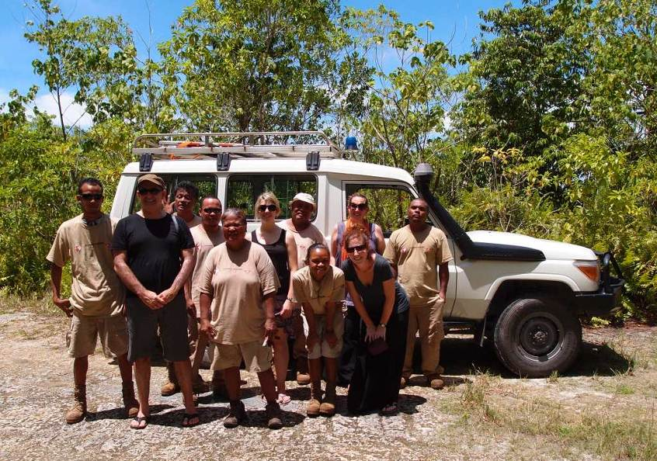
Photo 1: AusAID Delegation meet team & visit trail – May 2012

- BAC (Battle Area Clearance)
The first step of battle area clearance is to set out the area to be cleared with pegs and string. The standard clearance lane in mine action is 1 metre wide, however in this case as the cleared area is 2.8 metres wide, two lanes of 1.4m width were cleared. The direction of the lane followed the design as discussed above. As well a Control Point was set up for the location of the Paramedic and safety vehicle, at a distance that ensures the Medic would be safe in the case of an accidental detonation, but at the same time close enough to respond quickly in case someone is injured. Test pits are also set up to test the functionality and calibration of the metal detectors before operations commence.

A second stage of BAC is to remove vegetation for both access to the lane and for visual sighting of ERW on the ground. In order to maintain the sense of the battlefield as the soldiers would have experienced it, CGD is conscious not to conduct major vegetation removal, and hence designs the trail around significant vegetation such as large trees.

To ensure that the jungle trail removed all ERW that was within the boundaries of the route that the trail took, the actual clearance itself was broken down into two phases, the first phase being the surface visual clearance with the teams moving systematically down sections of the trail, marking with small wooden marker discs ordnance discovered. Under IMAS (International Mine Action Standards) workers must not be grouped together in case of accidental detonation, and are thus evenly spread out at 25m distances, but again within a close distance to the control point where the Paramedic is based.

The local team do not yet have sufficient EOD training to analyse and safely remove ERW located, hence the expatriate EOD Technician moves amongst the team to examine and remove ordnance located. The exact location of every piece of ordnance is logged by GPS and recorded according to international Mine Action formats. Ordnance removed from the trail items are placed in a sandbagged holding pit, for removal to the demolitions range at the end of each day by the EOD Technician. Again safety is paramount, and only the EOD Technician travels in the vehicle with the ordnance, whilst the rest of the team and the Paramedic travel at a safe distance behind in the second vehicle.

After some brief refresher training in the use of the mine detectors, the next phase was the sub-surface instrument assisted search, whereby the local searchers again move systematically down the lanes. When their detector indicates a suspect item of ERW, a small wooden disc is placed on the spot, and then at 5 meter intervals all marked locations are further investigated. The searchers do not fully excavate the item, but rather when ERW has been found, the expatriate EOD Technician conducts further excavation and investigation.
Again ordnance is collected and stored as per the visual clearance phase above.

- Quality Assurance
All clearance activities were conducted in accordance with International Mine Action Standards, including 100% QA (Quality Assurance) of the whole length of the trail by the expatriate EOD Technician, to ensure the team removed all ordnance.

- Marking
Following ERW sub surface clearance operations the trail was marked with small red and white circular concrete markers. The markers are consistent with international best practice for marking minefields, and are designed so that they are laid every 5metres on either side of the trail with the white portion facing inwards and the red facing outwards, so the visitor then walks between the white trail that has been cleared. The concrete markers are 150mm in diameter and 250mm high. CGD’s local team fabricated the markers, starting with making the mouldings for the pouring of the concrete.

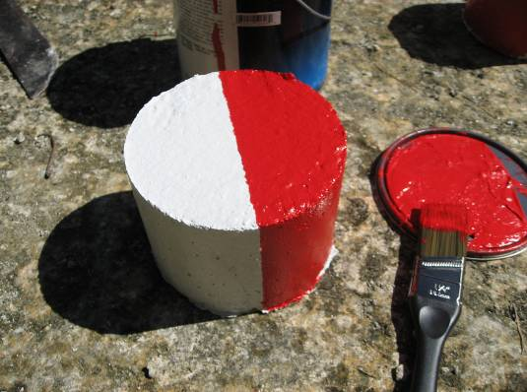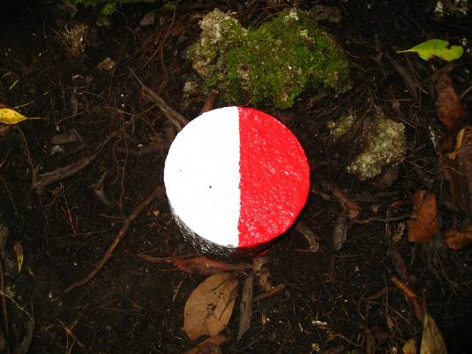
Photos 2: The concrete markers that line the tourist jungle trail.

The original sign to the trail was modified to include the contribution from the Australian Government, and is currently being reprinted on a waterproof surface and will be re-erected at the start to the trail when finished.

- Demolitions
Due to the short duration of this project and the relative small numbers of ordnance located and removed, demolitions did not take place during the period of this project, but rather ordnance was stored at CGD’s secure storage facility, awaiting future bulk demolition when a critical mass of ordnance has been collected. As explained in the project proposal, bulk demolitions ensure sufficient temperatures can be achieved for the environmental purpose of burning off dangerous explosive gases, as well to minimise disruption to the community that closing off access to parts of the island for safety purposes during demolitions entails.

- Tour Guide Familiarisation
In addition to laying permanent markers along the trail, the project provided basic familiarisation training, as well waterproof maps and narratives to the tour guides both from Peleliu and also guides from the major tour companies in Koror State. CGD sent photos of the Governor of Peleliu inspecting the final stages of the trail to national newspapers, to increase publicity of the trail extension amongst tour guides and the public at large. Please see attached media article in Annex 3.

- Emergency Tasks
The CGD Explosive Ordnance Disposal (EOD) Team was required to deal with nine emergency tasks during the timeframe of this project. An emergency task is defined as a task whereby the population is directly affected by an item of ERW that is posing an immediate threat to the community. Please see Annex 2 for more details of the items collected. It had been assumed from previous experience that there would be at most 2 Emergency Callouts per month, hence 4 in total, therefore this target was more than doubled.

Many of the Emergency Tasks took place on Peleliu, which is not surprising as Peleliu is Palau’s most ERW contaminated site due to the majority of the war’s land battles taking place there. The first emergency task in Peleliu was initiated following a report from a fisherman who had come across a 105mm high explosive projectile on the outer reef in the South of Peleliu State.

A significant emergency task was initiated following a report by a landowner / small holding farmer who had excavated a projectile whilst extending his tapioca growing area. Of particular importance is that the site is located directly adjacent to the main water supply tank in Meyuns, Koror State. Sub-surface investigations by the CGD team located a total of 32 items of ERW near to this major supply of water for Palau’s most populous (10,000 people) State. Two other emergency tasks in Koror concerned significant holdings of unstable WWII ammunition, in one case some 1,053 SAA held by a member of the public and in another case 254 SAA found in the grounds of the National Hospital.

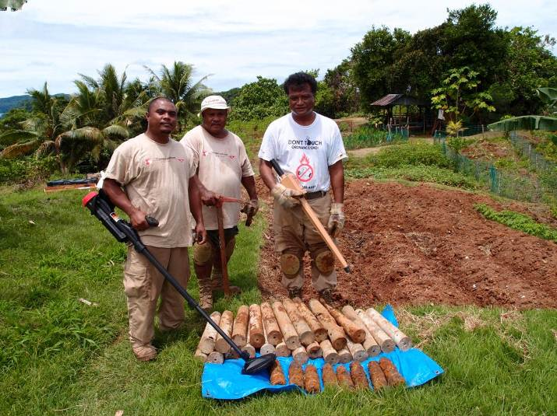
Photo 3: Emergency Task #: KOR 082 the removal of 32 items of ERW, adjacent to the main water supply tank in Koror State.

3. ACTIVITY ANALYSIS AND CONCLUSIONS

Project Achievements versus Objectives

- Project Purpose
The purpose of this project was to extend the existing tourist jungle trail to give greater access to the key area of Peleliu’s battle site, and further develop tourism opportunities on the island, at the same time reducing the threat of ERW to the community.

- Project Objectives
There were two main objectives to this project:

- To extend the existing adventure jungle trail, so that tourists can have greater safe access to the key battle site.
- To increase the safety of the community.

- Quantitative Achievements
Attached at Annex 1 to this report is the detailed ERW data of the ordnance located and removed both surface and sub-surface during clearance of the Jungle Trail extension. In total 752 items of ERW weighing 606.32kgs were removed, which is an astonishing amount of ERW to still be remaining on a small section of a battlefield that took place some 66 years previously. Furthermore the clearance located and removed 4,192 pieces of metallic fragmentation. The project target for items to be located and removed was 250 items, hence the team tripled the target set.
Annex 2 details the items located and removed during the nine emergency tasks. To summarise, 1,354 items of ERW weighing 374.5kgs were located and removed during the nine Emergency spot tasks.

As a result of both the creation of the battle field trail extension and the emergency callouts occurring during the project duration, in total 2,106 items weighing just under one tonne were removed.

- Achievements of Objective 1: To extend the existing adventure jungle trail, so that tourists can have greater safe access to the key battle site.
The existing jungle trail prior to this grant was 680m long, and through this grant has now been extended some 300 meters to a total distance just short of 1km. Prior to the trail and extension, tourists would wander ad hoc through the battlefield which is the most highly ERW contaminated area on Peleliu island, whereas now they are guided safely through this historically significant area. The extension has added approximately another 30 to 45 minutes of hiking to the trail, although the project target of 400m was not met. The likelihood of Objective 2 not being fully met if the number of expected items of ERW under Objective 1 exceeded expectations, was raised in the project proposal. The unexpectedly high level of metal fragmentation also hampered this meterage target, as discussed below in the Strengths & Weaknesses Section.

The trail now incorporates the highly significant area of Death Valley where many American troops fell, as they were not aware that Japanese forces were hidden in caves and positions along the valley. Death Valley is also very significant to Japanese tourists as it leads down through Hells Pocket to the Last Command Post, where Japanese High Command held out to the very end before giving the suicide order to the decimated troops remaining. Access to WWII artefacts, such as the ejected pilot’s seat, has also increased, as detailed above in the section discussing the design of the trail.

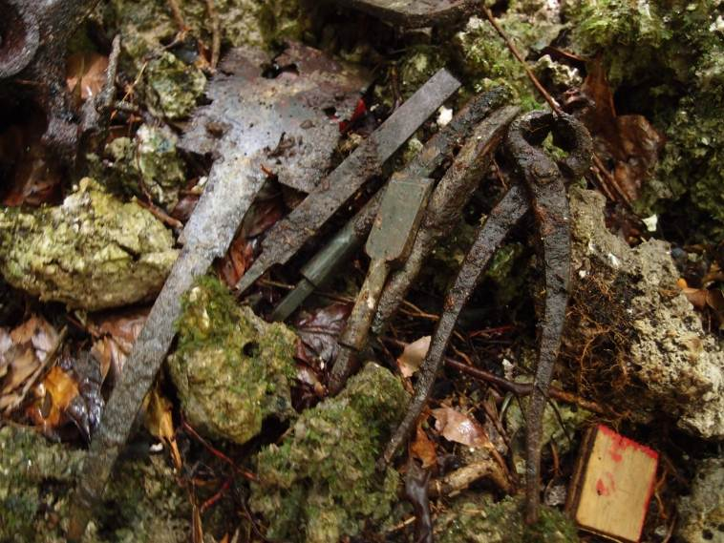
Photo 4: WWII artefacts located on the trail include this tool set

Feedback from all of the tour companies, tour guides and visitors has been extremely positive with tour companies saying that ‘the extension of the trail has given them a greater opportunity to show tourists the battlefield’. Tourists themselves have also commented that they are grateful for the work of Cleared Ground and AusAID in improving their experience and allowing them to first-hand experience the battlefield and to see numerous WWII artefacts still in-situ. Japanese tour guides have commented to CGD that the trail now provides access to older tourists who previously would not have been able to access parts of the battlefield such as Death Valley. This is important as it is now 68 years since the war, and families who make pilgrimages to the sites where their loved ones fought or fell are themselves getting older.

- Achievements of Objective 2. To increase the safety of the community.
A significant change in the community has been the increased safety that this project has brought to the community of Peleliu. The removal of such a large number of ERW as detailed above and of such a significant concentration per any international standard, has undoubtedly increased the human security of the Peleliu population as a whole. Firstly the removal of the ordnance on the trail prevents those items accidentally detonating and injuring members of the community, for example those engaged in traditional food gathering such as fruit bats and land crabs, in this favourite area of Peleliu known for its bats due to the surrounding cave systems. Unemployment is estimated at 82% on Peleliu, and many people on Peleliu live a subsistence lifestyle, relying on such food gathering.

Of particular importance was the location and removal of a Japanese Anti- Personnel landmine. AP landmines are an insidious weapon which are buried, and can be detonated in a manner of ways including by an individual treading on the unseen item. Today the production and use of AP mines are banned by over 160 countries under the Mine Ban Treaty. However, CGD does come across mines that appear to have been part of ordnance stored in the Peleliu cave systems. This location of this landmine suggests it was part of such a store of mines, rather than part of a formation laid under the soil.

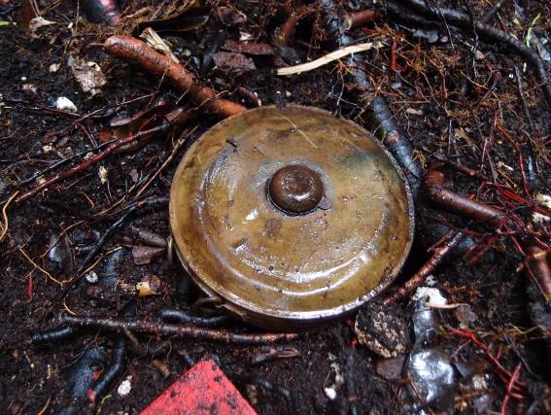
Photo 5: Type 93 Japanese Anti Personnel landmine located during trail clearance

The majority of post-conflict ERW clearance taking place globally deals with ordnance that is relatively new, when compared to the WWII ordnance found across the Pacific. The age of the ordnance found in the Pacific is unique and compounds the threat to the community, as the explosives can become destabilised over time and with exposure to the elements. Please see the below photo which shows how the rusting through of the munitions casing can leave raw explosives exposed.

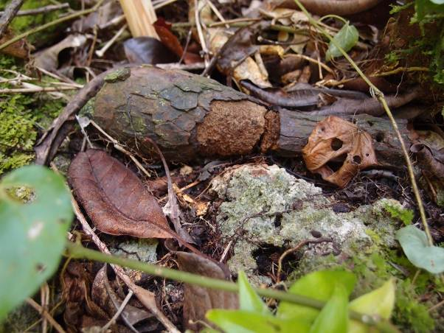
Photo 6: A deteriorating USA mortar with corroded outer case exposes high explosives to the elements.
It is known that local fisherman sometimes use WWII explosives for explosive fishing purposes. Aside from the potential risk to the fishermen, the practice is highly detrimental to the fish and reef life, as well the industries they support such as scuba diving and tuna fishing which are critical to Palau’s economy.

Finally the presence of the explosive substances as described above, pose the additional threat to the community of chemical pollutants leaching into the soil, water table and food chain. Peleliu Island has an incidence of thyroid cancer almost three times greater than Palau’s other fifteen States, however no research has ever been done to investigate a possible link.

Beneficiaries
The benefits to Peleliu’s tourists and communities have already been elaborated on above.

However it is also hoped that the enhanced and safer tourism experience will also benefit the small economy of Peleliu by bringing additional tourists. Tourism is Palau’s most important economic sector, representing 60% of its GDP, whilst WWII and diving tourism are Peleliu’s only real industries. An accident to a tourist caused by ERW could have devastating consequences both nationally and at Peleliu State level. A particular aim of extending the trail is to encourage tourists to stay overnight on Peleliu island, rather than take just a day tour from Koror which has been the norm. It is difficult to measure if the recent extension is contributing yet to an increase in overnight stays on Peleliu, but hopefully hotel stay data gathered by the State may eventually support this. It is also hoped that a broader range of tourists will visit, to include those wishing to hike rather than just history enthusiasts.

- Local Team
Key beneficiaries of this project are the seven local members of CGD’s BAC team, who through this project have been able to continue their capacity building in mine action skills such as survey, identification of ERW, BAC techniques, radio communications etc. It should be noted that 28.6% of the local team are female, as it is important to CGD that women benefit equally from such capacity building. CGD is keen to capacity build in a range of skills, and skills such as how to properly mix concrete for the trail markers, are additional transferable skills that the team can utilise in the future when Palau has been cleared of all ERW.

- Human Remains
Whilst unearthing ordnance located by the metal detectors, the team also located 7 bone fragments in various locations. Agreed procedure is for CGD to report these to the Palau Bureau of Arts and Culture who inform both the Government of USA and Japan. MIA (Missing in Action) teams from both Japan and USA are now scheduled to visit the sites of these remains. The CGD team reburies the human remains and takes GPS co-ordinates, in order to prevent the heinous looting of such artefacts.

The location of human remains is not an objective of CGD’s clearance operations, and these additional beneficiaries were unforeseen at the outset of the project activities. However these findings can bring some closure to international Governments still seeking MIA, and allow these remains to finally return to their homelands after 68 years.

Sustainability
The removal and destruction of ERW is a permanent solution to the threats they pose, and hence the impact is sustainable.

As discussed in the project proposal, the trail is self-maintaining, in terms of the regular foot traffic of the tourists keeps down the vegetation regrowth. As well experience has shown that in the last year there was only one occasion when a tree had to be removed from across the trail, and this was done in collaboration with the State Government which has workers responsible for maintaining the vegetation around Peleliu’s historic sites. The funding of these State workers is reasonably sustainable, as the purchase price of the land permits that all tourists to Peleliu must buy fund these activities.

Strengths & Weaknesses

During the project proposal preparations the only potential problem that was predicted was the potential that existing landowners might possibly request a fee for tourists to walk the trail. Cleared Ground is pleased to announce that this has not been the case, and CGD believes it remains unlikely as the Government is already charging tourists a land permit fee on entry to Peleliu, and it will not want to see fee duplication jeopardise tourism flows.

The biggest challenge to this project was the amount of metallic fragmentation that was located sub-surface once operations moved in-depth into Death Valley. In total 4,192 pieces were located over the 300 meters of the trail, which was a significantly higher occurrence than experienced in the original creation of the trail. Historic research tells of the ferocity of the battle in areas such as Death Valley, and the amounts of shrapnel and other fragmentations provide testimony to this. The high level of metallic contamination resulted in increased investigative excavations by the team, to ensure that the signal given by the detector was not ERW. Subsequently due to the increase in excavations the project started to fall behind schedule, and the solution to this was to increase daily working hours by 1.5hrs to ensure that the jungle trail was completed to the high standards set, and also on time whilst remaining in budget.

Lessons Learned
As this was an extension to the trail, the majority of lessons learned had been learned previously, for example the fabrication of trail markers was a good activity to put aside for days when heavy rains made clearance in the jungle hazardous.

Another lessons learned from previously, although unfortunately re-emphasised during this project, was that the team should take care in rainy conditions that they are not in the vicinity of Palau’s infamous Poison Tree also known as Tong. A team member who had forgotten to wear their work gloves, unfortunately unknowingly made contact with a poison tree and suffered the very painful blistering that the tree inflicts.

Environment
As per the project proposal, there are only positive environmental impacts from this project. CGD holds relevant environmental permits from Palau’s EQPB (Environmental Quality Protection Board) for its operations, and harmful explosives chemicals that are leaking into the environment have been removed under this project.

*********
Annex 1

STATISTICS OF ITEMS COLLECTED DURING JUNGLE TRAIL CLEARANCE

State | Task # | Item | Nomeclature | Country | Qty | NEQ kgs | Total NEQ kgs | Ind Weight | Total Weight
Peleliu | CGD/001 | Cartridge Case | M18 75mm | USA | 9 | 0.00 | 0.000 | 1.10 | 9.9
Peleliu | CGD/001 | Cartridge Case | 37mm | USA | 1 | 0.00 | 0.00 | 0.36 | 0.36
Peleliu | CGD/001 | Cartridge Case | 40mm | Japan | 1 | 0.00 | 0.000 | 0.40 | 0.4
Peleliu | CGD/001 | Demolition Charge | 2lb | USA | 2 | 0.91 | 1.820 | 0.91 | 1.82
Peleliu | CGD/001 | Fuse | Various | Various | 50 | 0.00 | 0.000 | 0.15 | 7.5
Peleliu | CGD/001 | Hand Grenade | M42 Smoke | USA | 1 | 0.00 | 0.000 | 0.50 | 0.5
Peleliu | CGD/001 | Hand Grenade | Smoke Candle | Japan | 1 | 0.05 | 0.050 | 1.00 | 1.0
Peleliu | CGD/001 | Hand Grenade | Type 91 HE Fragmentation | Japan | 1 | 0.065 | 0.065 | 0.53 | 0.532
Peleliu | CGD/001 | AP Landmine | Type 93 HE Blast | Japan | 1 | 0.91 | 0.907 | 1.364 | 1.364
Peleliu | CGD/001 | Mortar | Type 89 50mm HE 'Knee' | Japan | 110 | 0.15 | 16.500 | 0.73 | 80.3
Peleliu | CGD/001 | Mortar | M49A2 60mm HE Frag | USA | 21 | 0.23 | 4.767 | 1.24 | 26.04
Peleliu | CGD/001 | Mortar | 60mm Illuminating | USA | 54 | 0.03 | 1.620 | 1.50 | 81
Peleliu | CGD/001 | Mortar | 60mm Spigot Only | USA | 75 | 0.00 | 0.000 | 0.20 | 15
Peleliu | CGD/001 | Mortar | 81mm HE | USA | 3 | 0.73 | 2.190 | 5.10 | 15.3
Peleliu | CGD/001 | Mortar | 81mm Type 94 HE | Japan | 9 | 0.73 | 6.570 | 5.10 | 45.9
Peleliu | CGD/001 | Mortar | 81mm Type 97 HE | Japan | 1 | 0.73 | 0.730 | 5.10 | 5.1
Peleliu | CGD/001 | Mortar | 81mm Spigot Only | USA | 12 | 0.00 | 0.000 | 0.50 | 6
Peleliu | CGD/001 | Projectile | 0.5' Calibre Cannon | USA | 10 | 0.00 | 0.000 | 0.14 | 1.375
Peleliu | CGD/001 | Projectile | 105mm Base Only | USA | 1 | 0.00 | 0.000 | 0.70 | 0.7
Peleliu | CGD/001 | Projectile | 105mm Type 91 Long Nose | Japan | 1 | 2.30 | 2.300 | 15.90 | 15.9
Peleliu | CGD/001 | Projectile | 20mm Type 97 HE | Japan | 4 | 0.05 | 0.188 | 0.1195 | 0.478
Peleliu | CGD/001 | Projectile | 37mm HE | USA | 1 | 0.10 | 0.100 | 1.00 | 1
Peleliu | CGD/001 | Projectile | 40mm Mk3 HE | USA | 4 | 0.07 | 0.280 | 0.90 | 3.6
Peleliu | CGD/001 | Projectile | 5'' Mk 35 Naval HE Fragmentation | USA | 2 | 7.25 | 14.500 | 25.08 | 50.16
Peleliu | CGD/001 | Projectile | 75mm Type 94 HE Frag | Japan | 5 | 0.81 | 4.050 | 6.02 | 30.1
Peleliu | CGD/001 | Projectile | 8'' Common Mk 14 | USA | 1 | 4.96 | 4.960 | 118.18 | 118.18
Peleliu | CGD/001 | Rifle Grenade | M69A1 HE | USA | 3 | 0.56 | 1.680 | 1.12 | 3.36
Peleliu | CGD/001 | Rocket | 2.36 Inch HEAT | USA | 10 | 1.02 | 10.200 | 1.70 | 17
Peleliu | CGD/001 | SAA | 0.3'' Calibre | USA | 94 | 0.00 | 0.000 | 0.18 | 16.92
Peleliu | CGD/001 | SAA | 0.45'' Calibre | USA | 3 | 0.00 | 0.000 | 0.01 | 0.03
Peleliu | CGD/001 | SAA | 6.5mm | Japan | 34 | 0.00 | 0.000 | 0.18 | 6.12
Peleliu | CGD/001 | SAA | 7.7mm | Japan | 226 | 0.00 | 0.000 | 0.18 | 40.68
Peleliu | CGD/001 | Weapon | Rifle, Bolt Action | Unknown | 1 | 0.00 | 0.000 | 2.70 | 2.7
 |  |  |  |  | 752 | items |  |  | 606.32 kgs

Annex 2

STATISTICS OF EMERGENCY TASKS CONDUCTED

Date | State | Task # | Item | Nomeclature | Country | Qty | NEQ kgs | Total NEQ | Ind Weight | Total Weight | Open / Closed | Location Type
5/11/2012 | Peleliu | 413 | Projectile | 105mm Type 91 Long Nose | Japan | 1 | 2.30 | 2.30 | 15.90 | 15.9 | Closed | Beach
5/12/2012 | Koror | 82 | Projectile | 75mm Type 94 HE Frag | Japan | 8 | 0.81 | 6.48 | 6.02 | 48.16 | Closed | Agricultural
5/12/2012 | Koror | 82 | Cartridge Case | 75mm c/w primary cartridge | Japan | 24 | 0.01 | 0.24 | 1.30 | 31.2 | Closed | Agricultural
5/18/2012 | Koror | 83 | SAA | 7.7mm | Japan | 1,053 | 0.00 | 0.00 | 0.18 | 189.54 | Closed | Residential
6/6/2012 | Peleliu | 414 | Projectile | 75mm Type 1 Armour Piercing | Japan | 1 | 0.05 | 0.053 | 6.56 | 6.56 | Closed | Historical
6/7/2012 | Peleliu | 415 | Mortar | 81mm Type 97 HE | Japan | 1 | 0.73 | 0.730 | 5.10 | 5.1 | Closed | Historical
6/7/2012 | Peleliu | 416 | Hand Grenade | Incendiary | USA | 1 | 0.10 | 0.100 | 0.70 | 0.7 | Closed | Historical
6/7/2012 | Peleliu | 417 | Mortar | M49A2 60mm HE Frag | USA | 1 | 0.23 | 0.227 | 1.24 | 1.24 | Closed | Historical
6/7/2012 | Peleliu | 417 | Mortar | Type 89 50mm HE 'Knee' | Japan | 2 | 0.15 | 0.300 | 0.73 | 1.46 | Closed | Historical
6/8/2012 | Peleliu | 418 | Mortar | Type 89 50mm HE 'Knee' | Japan | 1 | 0.15 | 0.150 | 0.73 | 0.73 | Closed | Historical
6/8/2012 | Peleliu | 418 | Mortar | 81mm Type 94 HE | Japan | 5 | 0.73 | 3.650 | 5.10 | 25.5 | Closed | Historical
6/8/2012 | Peleliu | 418 | Rocket | 2.36 Inch HEAT | USA | 1 | 1.02 | 1.020 | 1.70 | 1.7 | Closed | Historical
6/8/2012 | Peleliu | 418 | Rocket | 2.36 Inch Motor Only | USA | 1 | 0.00 | 0.000 | 1.00 | 1 | Closed | Historical
6/18/2012 | Koror | 84 | SAA | 7.7mm | Japan | 254 | 0.00 | 0.000 | 0.18 | 45.72 | Closed | Underwater
 |  |  |  |  |  | 1,354 | items |  |  | 374.51 | kgs

Annex 3
Tia Belau Newspaper Article

