|  |
| --- |
|  |

WBG_Horizontal-RGB-web_smaller

Pakistan: Trade and Investment Policy Program (P-TIPP)

**April 6, 2015**

|  |
| --- |
| **Proposed Implementing Partner/s:** The lead administrator for the funding for PTIPP is the World Bank Group; the main executing units within the Bank are the South Asia Regional Integration Unit (SACRI) and Trade and Competitiveness Global Practice (T&C GP). The principle partner within Pakistan will be the Ministry of Commerce and the Federal Board of Revenue. |
| **Proposed start date and timeframe:** May 2015 to May 2018 (36 months) |
| **Proposed funding allocation :** AUD 9.9 million |

This document has a restricted distribution and may be used by recipients only in the performance of their official duties. Its contents may not otherwise be disclosed without World Bank authorization.

**Program Delivery Team**

Program Director, SACRI Salman Zaheer

Country Director, Pakistan Rachid Benmessaoud

Program Manager/Team Leader Haroon Sharif

Lead Economist, SACRI Sanjay Kathuria

Senior Gender Specialist Saba Gul Khattak

Operations Analyst Amena Raja

Program Assistant Huma Shaikh

**Partnership for South Asia (PFSA) Trust Fund Management**

PFSA Program Manager Nickolette Bowyer

PFSA Coordinator Laurent Durix

**Global Practice Leads**

Program Leader, T&C Gabi George Afram

TTL Wagah Border Project Amjad Bashir

TTL Subnational Trade Kamran Akbar

Contents

[1 Program Context 5](#_Toc415151243)

[2 Program Objectives and Outcomes 11](#_Toc415151244)

[3 Program Partnerships 13](#_Toc415151245)

[4 Indicative Funding Matrix and 2015 Projections 14](#_Toc415151246)

[5 Program Interventions 17](#_Toc415151247)

[5.1 Component 1: Supporting the Regional Trade Policy Framework 17](#_Toc415151248)

[5.2 Component 2: Strengthening Institutional Capacity for Trade 20](#_Toc415151249)

[5.3 Component 3: Regional Projects 21](#_Toc415151250)

[5.4 Cross Cutting Interventions 23](#_Toc415151251)

[5.4.1 Trade and Gender 23](#_Toc415151252)

[5.4.2 Trade Policy Communication Strategy 27](#_Toc415151253)

[6 Implementation Arrangements 30](#_Toc415151254)

[7 Political Economy Risk Assessment 34](#_Toc415151255)

[8 Results Framework 40](#_Toc415151256)

[9 Annexures 45](#_Toc415151257)

[9.1 Letter from EAD (Government of Pakistan) to the World Bank 46](#_Toc415151258)

[9.2 Letter from Federal Board of Revenue for Border Project Program 49](#_Toc415151259)

[9.3 Notification of Steering Committee 51](#_Toc415151260)

[9.4 MoC Team Members 52](#_Toc415151261)

[9.5 Pakistan Afghanistan Joint Business Forum 54](#_Toc415151262)

[9.6 Trade Policy Inputs 56](#_Toc415151263)

[9.7 Gender and Trade Inputs 56](#_Toc415151264)

[9.8 Strategic Communications Inputs 56](#_Toc415151265)

[9.9 Strategic Projects 56](#_Toc415151266)

[9.10 Proposed Implementation Arrangements 56](#_Toc415151267)

[9.11 Sample Operations Manual 56](#_Toc415151268)

[9.12 Minutes of the Finance/ADB Steering Committee on Land Borders 56](#_Toc415151269)

[9.13 Minutes of Joint FBR/WBG/ABD Mission to Wagah 56](#_Toc415151270)

# Program Context

Pakistan remains among the least regionally integrated countries in South Asia – with limited connectivity with India, Afghanistan and Central Asia. Given the positive changes in geo-political and economic dynamics in the region, the country’s political leadership desires enhanced trade and investment volumes with neighbouring economies as a policy priority. The prospects for South Asian regional connectivity with Western and Central Asian economies have gained significant momentum over the past few years. This is partly driven by the continued economic stagnation in traditional OECD countries, and partly due to a renewed emphasis on accelerating economic growth, political stability and prosperity by the newly elected governments in South Asian countries, especially in Afghanistan. There have been a number of concrete steps that augur well for enhanced economic cooperation in South and Central Asia. The new government in Afghanistan has shown its strong resolve towards increasing economic ties with Pakistan, as well as promoting Afghanistan as a safe transit country. Afghanistan and Pakistan have started a structured dialogue on economic cooperation, which is being institutionalized through a Joint Economic Council headed by the two Finance Ministers. Trade relations are taking a centre stage in these joint initiatives and Pakistan’s Ministry of Commerce has established a Regional Trade Unit to develop and implement regional trade policies and reforms.

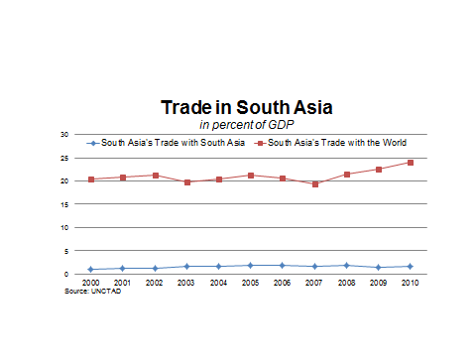

**Figure 1: Trade in South Asia as a Percentage of GDP**

Source: UNCTAD

In the rest of the region, India, Bangladesh, Nepal, Bhutan and Central Asian states have enhanced their economic ties through strengthened transport and energy links. Electricity trade is playing a transformational role in redefining regional connectivity and economic cooperation. Central Asia South Asia transmission line, CASA-1000, is becoming a reality as the World Bank-led consortium has arranged 80% of project financing. The project will bring clean hydro power from the Kyrgyz Republic and Tajikistan to Pakistan and Afghanistan. Bhutan is already exporting hydroelectric power to India and discussions are underway for cooperation between India and Nepal to develop the latter’s hydropower potential, eventually leading to electricity exports to both India and Bangladesh. Most recently, SAARC countries have signed a SAARC Framework Agreement for Energy Cooperation (Electricity) in November 2014. Pakistan and India are also engaged in a technical level dialogue on power interconnection. Sustaining this positive trend in regional economic relations will, however, be highly dependent on the degree to which the region’s two largest countries – India and Pakistan – are able to move past historical tensions and build on recent developments to forge durable economic ties for the medium- to longer term.

In comparison to other regions, South Asia clearly lags behind in leveraging the huge potential of geographical proximity, its large market size and resources (see table below). Countries like Pakistan, India and Afghanistan need higher levels of sustained economic growth to create employment for the large numbers of youth due to enter the labour force. Larger volumes of regional trade and investment will positively contribute to achieving this goal.

|  |  |  |  |
| --- | --- | --- | --- |
| **Table 1: Trade as Percentage of GDP** | | | |
|  | **1980** | **2000** | **2011** |
| East Asia (developing only) | 33.6 | 66.6 | 68.9 |
| South East Asia | 57.6 | 107.2 | 116.1 |
| **South Asia** | **16.3** | **29.4** | **52.7** |
| Europe | 53.3 | 71,3 | 82.6 |
| Source: IMF, Direction of Trade Statistics, 2011 and World Economic Outlook | | | |

Pakistan’s exports seem to have levelled off at US$24/25 billion stagnating in recent years[[1]](#footnote-1) and continue to lag behind those of other countries in the South Asian region. Many of the reasons affecting its competitiveness are internal in nature including macro-economic instability, restrictive trade regime (see figure 2 and 3 below), political uncertainty, and internal security challenges. The figures below explain erosion of Pakistan’s trade competitiveness over the years in comparison to similar economies.

**Figure 2: Pakistan’s global market share – exports**

Source: Int’l Trade Statistics database, WTO

**Figure 3: Estimated Overall Trade Restrictiveness Index, selected countries**

Note: Green highlights some of Pakistan’s main competitors. Base year is 2007, and 2002 for Pakistan

Source: Pakistan Policy Note 2: Reinvigorating the Agenda for

Open Trade. World Bank, 2013

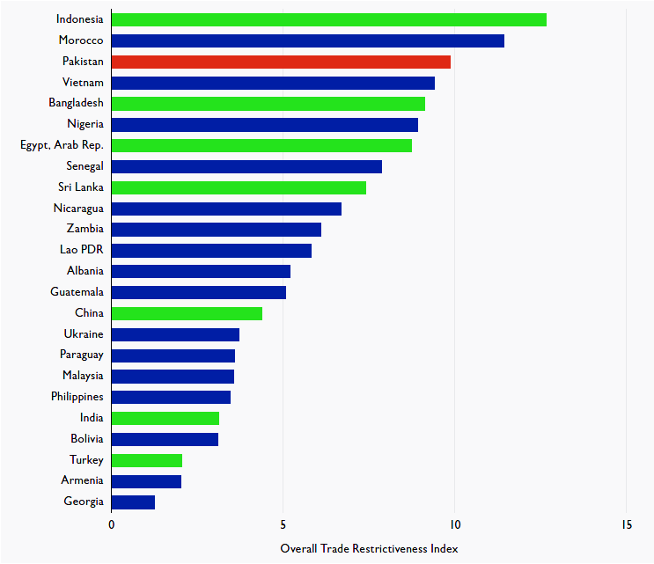

Pakistan’s new growth ‘Vision 2025’ highlights long term trade within its “neighbourhood”, i.e., within South Asia (especially India and Afghanistan) as well as with China, ASEAN and Central and Western Asia. This will be a key priority of its approach towards accelerating exports and revival of overall economic growth.

*Inter alia*, the government’s focus on increased trade and investment within the region is aimed at: offsetting stagnating demand for Pakistani exports from its traditional OECD partners; better exploiting Pakistan’s strategic location as a regional hub connecting the markets of South and Central Asia and the Middle East; and, bolstering efforts to improve prospects for regional political stability – and its associated peace dividend. Keeping in mind the complexities of relationships among countries, the recent openings may have to be supported through bi-lateral or sub-regional initiatives.

Pakistan’s federal Ministry of Commerce (MoC) is spearheading national efforts to promote and bolster exports and trade and has already made some important strides on regional economic cooperation agenda. It is currently in the process of developing its Medium Term Strategic Trade Policy (2015-2018), which will have a major focus on regional trade. Progress has been made in facilitating physical trade links with China and with Afghanistan and the MoC is keen to move forward with similar links to the rest of Asia. Moreover, the MoC, with the urging of the domestic private sector, is giving high priority to the modernization and rationalization of the overall policy and institutional environment for promoting regional trade and investment.

In this context, the Pakistan Trade and Investment Policy Program (PTIPP) will support the Government in developing and implementing a medium-term Regional Trade Strategy for Pakistan. To ensure timely implementation of the new policy, the Program will assist required institutional reforms within the Ministry[[2]](#footnote-2) and its associated outfits to better regulate trade flows and to improve the ease of doing business indicators. Components one and two of the program will provide high quality technical advice for setting the medium term policy priorities and will help in developing better implementation methodologies and business processes with the ministry. A series of policy, institutional and trade facilitation reforms have been identified to achieve this ambitious goal. A much stronger coordination mechanism will be required within the government ministries and provinces to ensure timely implementation of these reforms.

The existing border infrastructure remains insufficient and requires significant improvement to facilitate higher volumes of trade. Responding to the government’s request, WBG is working on improving business processes at the Wagah border to support trade facilitation[[3]](#footnote-3). The Government is keen to replicate this model at other border posts, especially those alongside Afghanistan. To move this agenda forward in a manner consistent with international good practices, the Government has requested the World Bank Group (WBG) to provide sustained support for policy, regulatory and institutional reform as well as for trade facilitation while incorporating an inclusive agenda vis a vis gender. The activities included in the PTIPP are intended to provide this requested support over a period of three years (FYs15-18). This initiative will also help the provincial governments seeking ways to support cross border trade by opening up the tourism and agriculture sectors cooperation. Due to historic and proximity reasons, sub-national level trade relations will be critical for building confidence of private sector to venture into larger investment transactions.

**The case for regional trade, sustained inclusive growth and poverty reduction:** It is well established that trade promotes growth and growth reduces poverty. As illustrated below, India and Pakistan have shown a steady progress in bringing down levels of absolute poverty over the past three decades. However, sustained level of growth in the range of 7% will be required to maintain this trend and more importantly for creation of jobs for large number of youth entering the labor market every year. Approximately half the population of Pakistan is below the age of 30 and looking for decent employment. Sustained regional cooperation has the potential to improve Pakistan’s GDP growth roughly by 2 percent per year, ensure energy security, help create viable transit corridors, and contribute to overall stability in the region. The opportunity cost of Pakistan’s isolation in terms of trade and investment linkages with neighboring economies remains very high.

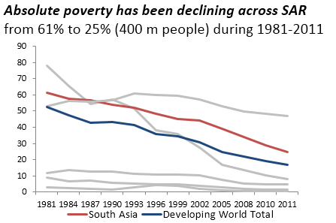

**Figure 4:** Absolute Poverty has been declining across SAR from 61% to 25% during 1981-2011

Source: Povcalnet

Despite the deterioration of macroeconomic situation due to the political turmoil and the floods in fall 2014, Pakistan’s the economy has been heading to the right direction with improvements, helped by prudent monetary and fiscal policies, strong capital and financial inflows, robust remittances, and lower international oil prices. Higher external inflows and a large fiscal adjustment has significantly reduced government’s budgetary requirements from the banking system, thereby facilitating credit availability for the private sector. GDP growth is gradually picking up and time is good to introduce policy reforms to create incentives for increasing trade volumes. Pakistan’s private sector remains stagnant and unless the country harnesses the potential of private sector by creating an enabling environment, moving up on the export ladder would remain a pipe dream.

*The key challenge in Pakistan is to ensure equitable redistribution of growth among all regions, income levels and women. The negligible levels[[4]](#footnote-4) of women’s presence and share in trade make their inclusion a challenge. However, given the government’s sensitivity to gender issues[[5]](#footnote-5), and within the overarching context of trade policy development and implementation, both the World Bank and GoP have aligned gender inclusion within the major components of this proposal. Specifically, the PTIPP envisages providing systematic and sustainable inclusion of women in trade at the policy and institutional levels and has included a stand-alone gender component (section 6). Making a separate gender component ensures that this element is neither diluted nor overshadowed by the primary focus of P-TIPP: to increase Pakistan’s trade volume within the region. Therefore, instead of highlighting gender integration repeatedly, specific indicators related to gender have been integrated within the results framework and the gender component is in sync with the focus and sub components of the proposed program. Depending upon the success and buy-in of women entrepreneurs, a separate gender focused project or a more in-depth phase 2 program can be developed at a later date.*

# Program Objectives and Outcomes

The overall objective of the P-TIPP is ***to support Pakistan’s efforts to increase regional trade and investment, with a special focus on strengthening links to other Asian countries***. This initiative will support Pakistan’s policy and institutional structure to significantly increase regional trade volumes by the end of the program. This would be accomplished through implementation of a focused advisory services program with knowledge generation and technical support aimed at: (a) improving the overall policy, regulatory and institutional frameworks for regional (and global) trade in goods and services; (b) directly strengthening trade and investment links between Pakistan and her neighbors leading to increased economic integration in the region as a whole; (c) and improve the quality of trade facilitation in terms of reducing time, cost and documentation for cargo clearance at border posts. With the overall objectives of enhancing economic growth, the program will also seek to develop entrepreneurship opportunities for women and youth.

The specific outcomes to be achieved by the end of the P-TIPP are as:

* ***Adoption and implementation of a comprehensive medium-term regional trade strategy*** underpinned by high-quality analysis and judged to be in line with international good practice
* ***Provide Technical Advice on regulatory and institutional improvements (in the MoC, associated institutions and border posts)*** to ensure alignment with the trade strategy and increased efficiency of business processes.
* ***Reduce time, cost and documentation required to process exports/imports through key border posts with substantial increase in the volume of goods traded*** as a result of WBG support for reform of regulations and business processes at selected border posts and improvements in the quality of infrastructure and trade facilitation[[6]](#footnote-6).
* ***Supporting the Government of Punjab in a phased manner to assess the potential of regional tourism with an aim to open up trade and livelihood opportunities in the province, as well as act to as a tool to tap the investment potential of the South Asian diaspora.*** This activity will also lead to knowledge exchanges, increased people to people interaction between India and Pakistan and creation of jobs and entrepreneurial opportunities inrural areas.

The overall program will benefit from two strategic cross cutting interventions ensuring inclusion of women in trade and wider ownership of program interventions through a targeted communication strategy.

**Considerable flexibility will be necessary during implementation of the PTIPP in order to ensure responsiveness to emerging needs and allocation of program resources to areas of greatest momentum.** The indicative budget in section 4 outlines the needs of the MoC identified in a series of consultations with the design team and with the World Bank held up to December 1, 2015.

# Program Partnerships

* **Ministry of Commerce (MoC):** A core unit has been set up within the MoC to liaise with the Trust Fund (TF) Team and provide support for TF activities. The core unit includes an Additional Secretary and Deputy Secretary. Two additional team members, a program coordinator and a research associate, may be financed through the TA program for the additional support required by the Ministry Unit[[7]](#footnote-7).
* **Federal Board of Revenue (FBR)**: the key counterpart for border-posts related technical assistance activities is the Ministry of Finance’s Federal Board of Revenue. The program teams (regional and global) will engage directly with the FBR on reform proposals and their validation, and support FBR in implementation of a reform action plan and agree on an appropriate timeline. A high level steering committee chaired by the Finance Minister has been overseeing progress over border post development including the establishment of the new land port authority[[8]](#footnote-8)
* **Provincial Governments:** The Government of GoPb has established a Program Steering Committee (PSC) to oversee technical assistance for the Punjab component. The World Bank task team is engaged with the GoPb’s PSC on the design of this component, while ensuring that the core unit in the Ministry of Commerce will be kept updated and informed via a coordination meeting to be held on a quarterly basis. The government of Khyber Pakhtunkhwa has also recently set subnational cooperation with Afghanistan as a key economic growth priority.
* **Private Sector Partnership Forums:** A Pakistan India Joint BusinessForum, formally recognized by the two Governments consists of 30 leading businessmen. The Forum plays a central role in identifying priority areas for enhancing regional trade, as well as acting as a vehicle for implementation and risk management. It is currently being expanded into a regional business forum to include Pakistan’s Western neighbours. The names for the Pakistan and Afghanistan members have been finalized in January 2015[[9]](#footnote-9).These forums will receive knowledge support through P-TIPP

# Indicative Funding Matrix and 2015 Projections

**Indicative Funding Matrix**

|  |  |
| --- | --- |
| **Component** | **Allocation (AUS$ mn)** |
| 1. Regional Trade Policy | 3.51 |
| 2. Institutional Strengthening | 1 |
| 3. Regional projects (3.6 + 0.8) | 4.4 |
| TF Management | 0.99 |
| ***Total*** | **9.9** |

**Disbursement Schedule (By Year)**

|  |  |
| --- | --- |
| **Year** | **Amount (in AUS$ mn)** |
| **2015** | **3.5** |
| **2016** | **5** |
| **2017** | **1.4** |
| **Total** | **9.9** |

**Projections for 2015 (January to December)**

**Component 1: Trade Policy Work**

|  |  |  |
| --- | --- | --- |
| Evidence based research | A series of studies as identified by the Ministry of Commerce and experts as inputs for year one of the program. These include a competitiveness scan, SME and Service sector studies and market access strategy work | 400,000 |
| Communications | A series of policy input events and two regional conferences as starting points for the trade policy work with be held. | 350,000 |
| Market Access Strategy | Based on inputs from the Ministry of Commerce, the year one strategy work will include identification of opportunities and challenges in two priority markets, Afghanistan, Central Asia and ASEAN. A unit will be set up to identify opportunities and create a roadmap for economic cooperation | 150,000 |
| Gender and Trade | Initial studies and communications events | 300,000 |
| *Subtotal* |  | *1,400,000* |

**Component 2: Institutional review**

|  |  |  |
| --- | --- | --- |
| Institutional Needs Assessment conducted and implementation plan for capacity augmentation developed | A 6 month review of the MoC is held and recommendations shared for implementation | 300,000 |
| Assessments of supporting institutions (PITAD, TDAP, etc) | TDAP, NTC, PITAD, TDRO, EDF assessed | 100,000 |
| Change Management Communication |  | 100,000 |
| *Subtotal* |  | *500,000* |

**Component 3: Strategic Projects**

|  |  |  |
| --- | --- | --- |
| Wagah Border trade facilitation |  | 800,000 |
| Subnational Initiatives for Regional Trade |  | 300,000 |
| *Subtotal* |  | *1,100,000* |

**Indicative Funding for 2015 by Component**

|  |  |
| --- | --- |
| Component 1 | 1,400,000 |
| Component 2 | 500,000 |
| Component 3 | 1,100,000 |
| TF Management | 500,000 |
| **TOTAL[[10]](#footnote-10)** | **3,500,000** |

# Program Interventions[[11]](#footnote-11)

***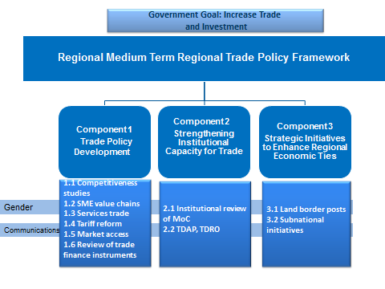***

**Figure 5:** PTIPP Interventions

The project will be implemented with a phased approach where year one will focus on analytical exercises aimed at enhancing sector level knowledge and year two onwards will focus on the integration and implementations of key actionable policy recommendations - with an emphasis on women’s inclusion in trade.

## Component 1: Supporting the Regional Trade Policy Framework*[[12]](#footnote-12)*

Recognizing that macroeconomic stability and acceleration in economic growth requires a sustained increase in exports, the Prime Minister of Pakistan has asked the Ministry of Commerce (MoC) to lead an initiative to double the volume of exports by 2018. MoC is positioning itself to launch a major effort to develop a strategic framework aimed at exploiting regional trade opportunities for meeting this objective. Pakistan’s trade growth is expected to remain slow due to a prolonged economic stagnation in its traditional export markets of Europe and the USA. Meanwhile the dynamic regional demographics of younger consumers in Asian economies are opening up new markets for Pakistani products. Asia’s new dynamics have created a historical moment to accelerate regional integration. The South Asia Region’s inability to open up trade and economic cooperation with its neighbors remains a binding constraint to healthy rates of growth. Policy shifts towards regional trade in Pakistan will not only break this barrier, but will also create niches in the growing regional value chains and supply chains for goods and services.

To assist the MoC in meeting this goal, the World Bank Group aims to develop an evidence-based **medium term regional trade strategy** through the PTIPP. The regional trade framework will reformulate the trade policy to create a shift towards the emerging regional economies of ASEAN, China, SAARC, GCC, CARs and Afghanistan. It will also ensure that gender issues are addressed systematically, in contrast to the past when gender issues were inadequately conceptualized. The regional trade framework will be developed in public-private knowledge partnerships with independent policy think-tanks with extensive participation with the industry. PTIPP will implement a comprehensive communications strategy to build consensus for the proposed interventions and secure an approval from the cabinet for implementation of the regional trade framework.

The regional trade policy framework will be informed by the following evidence-based analytical input as requested by the MoC:

* + - ***Product competitiveness studies*** will be developed with a focus on key business sectors. In the first ongoing phase funded by DFID, studies on textiles and automobile are underway. In phase two, these and other priority sectoral studies will be extended into case studies for regional value chain development which allow for new areas and niches of specialization that had previously not been considered feasible.
    - *A* ***small and medium enterprise (SME) strategy***will be developed focused on export-oriented SME sub-sectors with the aim to enhance their integration into regional value chains.Comprehensive and engendered interventions will be designed to support and nurture SMEs including access to financing, participation in international fairs and trade facilitations to boost exports to the region.
    - ***A Strategy for the Services Sector:*** As focus has to date been on industrial sectors, the PTIPP willaim to enhance services exports in the region and create new niches in the value chain for services. Improvements in e-commerce and communications technology have brought new areas like services (software production, consultancy, accountancy services, banking etc.) into the regional trade framework. As the industrial and service sectors of the more developed countries in the region shift to higher value-added and skill intensive sub-sectors, space is opening up for the kinds of services that a country like Pakistan can offer**.**
    - ***A review of existing interventions for trade promotion.*** A *tariff rationalization plan* will be developed in the light of regional benchmarks to enhance trade and consumer welfare while minimizing revenue loss and impact on the domestic industry. The tariff rationalization exercise will enable policy makers to build consensus to develop a tariff reform plan that would enhance exports and consumer welfare while minimizing revenue loss and impact on the local industry. Another intervention will be to conduct a *critical assessment of export promotion schemes* in the light of regional best practices. This includes freight subsidies, exports rebates, trade development fund etc. The study will identify existing discrepancies and shortcomings and propose amendments to export schemes.
    - *A* ***regional market access strategy***will be developed to create a road map for enhanced market access to identified markets for Pakistan’s exports as well as for negotiation of new Free Trade Agreements with emerging Asian economies. A comprehensive review of existing FTAs and Preferential Trade Agreements (PTAs) will also be conducted to assess their impact and usefulness. A template will be developed for future agreements and to identify amendments in existing FTAs and PTAs for further negotiations.
    - In addition to putting in a new, more open policy framework for regional trade, the Pakistan Government is seeking ways to support regional trade through better access to financing for exporters and importers of Pakistan’s products. **Trade financing gaps** are identified as key barriers to trade between Pakistan, Afghanistan and Central Asian countries. This component does not directly fall under the purview of MoC and will have to be coordinated with the state Bank of Pakistan and leading financial institutions. The Government is seeking expert advice from the WBG to explore the option of establishing a formal mechanism to mobilize trade financing and recommend a future trade financing architecture.

## Component 2: Strengthening Institutional Capacity for Trade*[[13]](#footnote-13)*

In addition to developing the regional trade strategy, the PTIPP through this component will provide assistance to identify and operationalize MoC institutional reforms needed to ensure effective strategy/policy implementation. In undertaking this task due attention will be paid to successful international institutional models, especially those adopted by the ASEAN member countries to boost international trade. The specific interventions will include;

**Institutional review of trade policy implementation in Pakistan:**

* Drawing on the lessons learnt from previous efforts and to learn from the experiences of successful countries like Malaysia, Thailand, Indonesia and Vietnam, the Ministry has decided to implement an Institutional Review to assess its capability in line of the best practices in Asia. This six months exercise will make concrete recommendations to the Ministry for incorporating desired changes in rules and structures for implementation of the new regional trade framework. In addition the review will critically examine the coordination mechanisms within government ministries and practical way forward to reduce fragmentation. Initially the program will support establishment of a Unit to focus on enhancing trade with ASEAN, India, Afghanistan and Central Asia. This Unit will closely coordinate with the Prime Minister’s Secretariat, Ministry of Finance, Ministry of Foreign Affairs, other economic ministries and the provinces.
* In addition, assessments of attached relevant departments will be conducted. These will include an assessment of the *Trade Development Authority of Pakistan* (TDAP) to review its role and effectiveness with a particular focus on its structure, capacity to work with private sector and ability to connect businesses in the region. The existing TDAP women’s wing will also be assessed to identify gaps and opportunities in its pro-women initiatives. Efforts will be made to identify opportunities to strengthen the *National Tariff Commission (NTC*), effectively the MoC’s front line vis a vis domestic producers on a range of complex trade issues. A strong NTC will be a critical player in ensuring smooth implementation of a new, more open trade policy, and the growing trade volumes that the new policy can be expected to engender. The MoC has already undertaken initiated some effort to strengthen the capabilities of the NTC to perform its functions effectively starting with the drafting of an appropriate legislation. This exercise will span over 2015-2016 as this will require regulatory and administrative changes. As part of the effort to successfully implement new trade policies this component of the PTIPP would support strengthening of the newly established *Trade Dispute Regulatory Authority (TDRO)*. The Government has requested help for developing a detailed work plan for TDRO and links to local courts, and stakeholder consultations.

*Strengthening the WTO Cell* at the Ministry of Commerce to ensure timely compliance to various agreements, timelines and commitments signed by Pakistan. Pakistan as a WTO member state can potentially support neighbouring economies in becoming WTO compliant.

## Component 3: Regional Projects[[14]](#footnote-14)

Component 3 will support two strategic projects aimed specifically at establishing closer economic ties between Pakistan and its immediate neighbours.

* ***Border Post Development:*** starting at theWagah Border post situated at distance of + 25km from the major cities of Lahore in Pakistan and Amritsar in India and could potentially be the busiest border crossing in South Asia. This project will build on and expand on existing FBR approved activities that are being implemented by the former IFC Advisory Services Investment Climate MENA team at Wagah, now part of the T&C GP. WBG support under this component will involve a comprehensive approach -- ranging from support on macro level policy and institutional issues (e.g., regulatory and visa policies etc.) that would lead to more trade through Wagah, to more focused support involving: (1) simplification and harmonization of procedures and documentation required to trade at Wagah; (2) automation at Wagah border to reduce the need for manual paper based procedures and 3) promote public-private dialogue at various levels In addition, emphasis will be placed on promoting a vigorous public-private dialogue to ensure adequate consideration of the views of end users. The work that will be conducted at Wagah is being viewed by the FBR and MOC as a first phase in a broader border management program that could be supported in the future by the WBG and other development partners. Support for Wagah is also being provided by ADB and USAID and all WBG support under P-TIPP will be closely coordinated with these agencies through a high level Government Steering Group (which will set overall direction for Wagah development), joint missions[[15]](#footnote-15) by all external partners and a shared results framework. The Government is very keen to start similar work on border posts between Pakistan and Afghanistan.
* The Provincial Government of Punjab has signed a Memorandum of Understanding (MoU) with the Indian Punjab to initiate economic cooperation and increase people to people exchange. The MoU prioritizes tourism, energy and agriculture sectors to be the entry points for opening up wider trade and economic cooperation. This is a strategic opportunity to exploit the potential of trade in a market of over 150 million people residing in the two Punjab provinces (India and Pakistan) supplemented by a very influential diaspora in the USA, Canada, UK and East Asia.

Several international studies and empirical analysis show the correlation between international trade and travel indicating a need to realize the potential of tourism growth and economic expansion[[16]](#footnote-16). There lies an untapped opportunity in the context of Pakistan and in particular the economic potential from enhancing tourism to heritage sites. Key highlights from the studies show:

* The Sikh population around the world is 26 million (approx) and out of which 85% hold an Indian Nationality. It is estimated that 15% of the population resides in the UK, Canada and the US.
* According to data, a total of 9300 Sikh tourists visited Pakistan in 2013 of which 7500 were Indian Sikhs and 1800 were the Diaspora Sikhs. Studies and surveys indicate that 73% of the population in Indian Punjab is keen to visit the heritage sites and if Pakistan can attract even 1 % of the 22.1 million Indian Sikhs, it will translate into approximately 2,00,000 visitors a year.
* The largest opportunity of growth however remains with the diaspora Sikhs and an opportunity to attract as their spending patterns are much higher, duration of stay much longer and visa facilitation is slightly easier.

This strategic project supports the Government of Punjab’s regional cooperation initiatives through the assessments required to design a project to promote regional tourism and knowledge exchanges. As currently envisaged, the initiative will use cultural/heritage tourism as the entry point, with subsequent phases involving trade potential in other sectors. The chief areas of focus with regard to cultural and heritage tourism – which has the potential to attract about 1 million visitors annually -- include planning for: (i) development of tourism sites; (ii) ways and means to attract private sector investment for tourist infrastructure and services; (iii) tourism to visit ancestral homes of people who migrated to either side during partition in 1947. To facilitate implementation, support will also be provided for exchanges of knowledge to enable learning from similar tourism experiences in the region (e.g., the Buddha circuit spanning India and Nepal) and implementation of stakeholder consultations involving government representatives of both Punjabs, tour operators, heritage site management committees and business representatives. Areas for cooperation that are likely to be included in later phases of the initiative include human development (especially skills training), agriculture (with a focus on water resource management), and rural energy. Synergies with relevant SAARC and educational forums can also be explored at this stage. The program may also identify further opportunities for skills development with a focus on women in the tourism/hospitality sector.

## Cross Cutting Interventions

The program has two cross-cutting interventions: gender and strategic communications which will be addressed through a twin-track approach to gender mainstreaming, and a comprehensive internal and external communication strategy to strengthen information, knowledge sharing and stakeholder coordination. Both gender and the trade policy communication complement one another to ensure delivery of the program components.

5.4.1 Trade and Gender[[17]](#footnote-17)

There is scant information on women in trade. The low presence and visibility of women in trade in South Asia in general and Pakistan in particular reflects the economic context of their workforce participation. Women account for 52 percent of Pakistan’s population, yet the total female labor force participation is 21.5% according to the Labor Force Survey (LFS), 2012-13. Only 3 percent of women are involved in economic activities in the formal sector, according to the Federal Bureau of Statistics. 15% of women in the workforce are self-employed of which 61% are in services related to crop and livestock and 21% in manufacture of wearing apparel. The bulk of them are home-based workers according to the LFS 2012. Only 6% of these are entrepreneurs (31,000), of whom 12.5 thousand (0.1%) are employers.

Self-employed women are not categorized as entrepreneurs and hence are not eligible to access formal financing. A majority of women entrepreneurs are involved in traditional sectors like textiles and garments, health and education services, handicrafts and beauty industry/ aesthetics. Most of them are primarily catering to the market within the same district and far fewer have outreach to markets within the country, let alone the region.

The obstructions to their participation in trade include lack of access to technology, financial resources and information; low levels of savings or means of investment; and structural barriers such as lower levels of education and mobility, early marriages, and cultural constraints on working outside homes, social interaction and risk averse conditioning. Despite prohibitive barriers, recent evidence indicates a slight change in that a slowly growing number of women are entering services industries in tandem with an enabling environment indicated by for example, a lowering in fertility rates, improved education outcomes and the introduction of a range of pro-women laws.

The program will address gender through a twin-track approach which aims to:

1. Ensure that gender is **mainstreamed** through the three components of the program as a cross-cutting theme.

The objective of mainstreaming is to facilitate women entrepreneur’s access to regional markets in selected sectors through gender responsive policy frameworks and strengthening institutions

1. Undertake **targeted activities to facilitate women’s economic participation** by strengthening the base of women entrepreneurs as a resource pool in Pakistan.

The objective of targeted activities is to support existing regional networks to enhance the influence, networks and skill base of women entrepreneurs

**Mainstreaming across the three components of the TIPP**

**Component One: Regional Trade Policy Framework**

A series of evidence based inputs for the inclusion of a chapter on gender equality in the trade framework will be prepared. Several analytical pieces will be completed during the first phase/year of the program including a probe on sectors in which women have a competitive advantage shall be conducted alongside an assessment of women’s access to trade financing and a review of successful institutional initiatives in the region. Subsequent analysis or policy relevant research will be endorsed by the Program Steering Committee. These research policy papers may include but are not limited to:

* Mapping of domestic and regional women entrepreneurs and identifying existing and/or new sectors where women can be facilitated. Identifying regional best practices and innovative approaches.
* Identification of priority sectors for enhancing participation of Pakistani women entrepreneurs in regional trade. The research could also identify possible incentives, such as fiscal concessions and/or priority lending for organizations employing a high percentage of women in senior managerial positions.
* Recommendations for overcoming practical barriers such as male dominated public spaces and offices, mobility and outreach; financial literacy; knowledge of trade bureaucracy and other related gaps.

Subsequent to these studies, a series of recommendations to change the regulatory framework can be made to facilitate female entrepreneurship in regional trade. Linkages to enhance women’s access to regional opportunities will be established through networking, experience-sharing conferences, and the communication strategy.

**Component Two: Strengthening Institutional Capacity**

There seem to be multiple incongruent attempts at promoting women’s economic inclusion with no internal institutional cohesion.[[18]](#footnote-18) A two-pronged approach is proposed over the life of the program: first to streamline existing institutional structures, and second, to connect these institutions with similar institutions in the region. This shall be done in a phased manner with much of the work on evaluation completed during the first year, and ensuring that buy-in from government and private sector for increasing regional linkages for gender responsive trade is in place by or before the end of the second year.

Gender will be mainstreamed by strengthening the capacity of the regional trade unit at the Ministry of Commerce by inclusion of a gender focus section/unit that could bring together the policy/research findings, have links with institutions that cater to women, and effectively integrate recommendations into the communication strategy.

**Component Three: Strategic Projects**

As part of the Wagah border strategic project, the team will mobilise leading female entrepreneurs trading with India and facilitate the development of a Women Entrepreneurs Network for Easing Trade (WE-NET). As well as supporting women to better organize their voice on bilateral trade facilitation at the border, the group will identify and address specific challenges women face while dealing with cargo clearance at the Wagah border. Around 10% of the total budget for this project will be allocated to WE-NET related activities.

Support will be provided to the Government of Punjab to incorporate gender sensitivity in initiatives to open up trade and livelihood opportunities through promoting cultural and religious tourism within the region. An inclusive range of activities such as a gender responsive visa regime, community-led tourism and heritage conservation in conjunction with entrepreneurship opportunities for men and women shall be part of this component. Horizontal and vertical linkages for women in the local job market due to increased tourism as well as eco-friendly tourism shall constitute a special focus.

**Gender and Communications**

A regional conference on women’s economic empowerment with a focus on entrepreneurship and trade in the region will be held during the second year of the program. The purpose is to bring all stakeholders and potential partners and experts on a platform, to share experiences and strengthen the constituency of support for women’s economic empowerment. The research that is conducted will be presented at the proposed conference. Other regional research institutions such as IDRC’s South Asia Office can be involved in this initiative along with women’s chambers, universities/institutions that actively support women entrepreneurs. Policy makers, practitioners and research community will be invited. Women’s organizations that promote women’s economic enterprises will also be included such as SEWA, BRAC, HomeNet South Asia etc.

* Discussions based on research and policy papers in the electronic media. Some TV anchors on business channels can be approached in this connection.
* Regional dialogues/networking among specific sectors where women have a presence and/or advantage.

Ensuring that the regional bureaucracies responsible for policy implementation are consistently cognizant of gender gaps in regional trade and that these issues are addressed in their meetings.

**Targeted activities to facilitate women’s economic participation by strengthening the base of women entrepreneurs as a resource pool in Pakistan**

Building on the analytical work undertaken under Components One and Two of the TIPP, the program will undertake targeted activities to support women entrepreneurs. Target activities will build on lessons learned through previous initiatives (see Annex 9.7) and will be determined through an independent review (including by a gender and trade expert) at the end of Phase/Year One of the TIPP, when the findings of analytical work are available. Activities may include:

* Evaluation of potential of existing infrastructure that is meant to be pro-women, such as the First Women’s Bank, TDAP, EXIM Bank and SMEDA and identifying gaps for strengthening their pro women initiatives.[[19]](#footnote-19)
* Evaluation of Women’s Chambers and their role in regional trade. Assessment of gaps and practical recommendations for strengthening their role.
* Connecting/promoting existing province level initiatives with regional trade initiatives that can include links with venture support groups, access to finance.
* Networking among women centered trade institutions in the region and possibly in the neighbouring regions.
* As a pilot initiative, a public or private sector institution can undertake targeted interventions for promoting a small group of women traders through meetings with international buyers. This form of ‘angel investment’ would yield contacts and focused interactions.

### Trade Policy Communication Strategy [[20]](#footnote-20)

A strategic communications initiative will be developed to address internal and external communications gaps to mitigate political economy risks and to build wider ownership of this reform. It will focus on robust communication strategies to improve coordination within the government, consultations with stakeholders, dissemination of findings of studies, and a series of conferences to promote Pakistan’s economic cooperation narrative.

Communications is often seen by government agencies as the job of advertising agencies, or public relations firms — in most cases, it is seen as the role of the Ministry of Information. This flawed view of communications is a driver of not only a failure to communicate effectively, but more centrally a failure to achieve stated objectives. It can only be done properly when it is interwoven into the various core functions of the organization. The very failure to implement key trade related reforms leading to increased competitiveness for wider market access is linked to the absence of a strategic and effective communications strategy. Good, effective communications are central to Ministry of Commerce’s aim to deliver a doubling of Pakistani exports by 2018.

The trade promotion function and related reforms suffer from very high levels of horizontal incoherence and fragmentation in Pakistan. The range of ministries associated with exports at the federal government level alone include the Ministries of Commerce, Industries, Foreign Affairs, Finance, Security Establishment, Science and Technology, Industries, Textile, IT, Federal Board of Revenue and the Board of Investment. The incoherence with which exports-related government organizations and government positions have proliferated is both caused by and a source of the deeper problem within government. The implications of this are not only writ large across the spectrum of export related functions, but also specific to the Ministry of Commerce. Members of the Commerce Group of the federal civil service are not provided with the training or skills needed to compete globally, nor are they given the institutional cover by their Ministry to engage and lead export-related conversations within and beyond the national borders. This has had a corrosive impact on the Ministry’s ability to assert its leadership on many fronts, most importantly on shaping the narrative of economic growth and exports in particular, both in the domestic Pakistani imagination, and across the international markets Pakistan seeks to export to.

The MOC, as a federal government body sitting at the confluence of a wide variety of functions, requires stronger communication for clarity on institutional and organizational dimensions. Those in positions of leadership at the Ministry, including the Federal Minister, State Minister, the Secretary, Additional Secretaries, and other senior officers, require a clear and unimpeded map of the array of relationships and linkages necessary for the Ministry to operate effectively.

Similarly, but to a lesser extent, the Ministry’s communications function needs to be seen as a whole of ministry effort that does not require large infusions of outside skill sets. Some outside help will no doubt be of great benefit to the ministry, but this should be treated as a temporary fix. The longer term solution to both the challenge of coordination, and the challenge of communication – i.e. shaping the trade & commerce story and telling it, is to develop these functions as intimate elements of the Commerce Group’s skillsets.

This program will support the MoC in this regard through a dedicated communications advisor to the Ministry for designing and implementing a focused communication initiative (year 1). As the process of institutional evaluation and strengthening progresses, the program will contribute towards the harmonization and streamlining of the communications function as an integral operational part of the MoC. This will require a redefinition of existing jobs and posts to reflect the urgent need for both vertical and horizontal coordination within government and the urgent need for improved communication within Pakistan and beyond.

**Internal and External Communications**

For the Ministry of Commerce, there are two kinds of internal communications it needs to be conscious of. The first is the deep inside communications, within the Ministry itself, while the second is the intra-departmental, intra-ministerial communications it conducts. In the first instance, the driver of communication needs to be the Minister, his/her advisory staff, and the Secretary of the Ministry of Commerce. This is classical top down communication that is meant to cohere and unite the narrative within the ministry. In the second instance, the communication cannot be top-down, it needs to be collaborative and consultative, but with a clear eye to the specific objectives with which the Ministry is engaging with other ministries and departments. As illustrated below, the Ministry intends to have at least one designated officer that is responsible for communication with each department and/or ministry and/or other government agency.

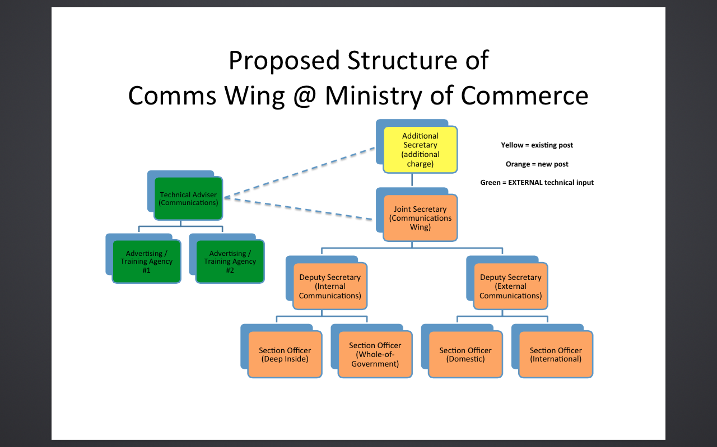

**Figure 4:** *The above diagram envisages a long term future crosscutting structure for reorganizing the Ministry for improved communications and coordination with internal and external audiences*

Just as there are two internal or inward focused types of communications for the Ministry of Commerce, there are also two external types of communications. The first is outward-facing communications that addresses domestic audiences (such as private sector) —which is about selling the exports narrative, and protecting it from various sources of vested interest. The second is outward-facing communications that addresses international audiences, principally the markets Pakistan seeks to expand into, but also markets where it already exists, or where it currently does not, but may seek to in the future.

The program funded communication advisor will assist the Ministry in developing a comprehensive communications strategy with the following overarching goals:

* Training of C&T Group officers in internal & external communications
* Communications strategy for a “Pro-Exports” narrative at the national level
* Communications plans for “Regional Trade Frameworks”
* Fully functional suite of MoC social media instruments, with at least 25,000 Twitter followers & 50,000 Facebook likes.

# Implementation Arrangements

The Australian Department of Foreign Affairs and Trade (DFAT) will contribute to its existing Australian umbrella Trust Fund to the World Bank for the South Asia Region (PFSA) to finance PTIPP activities. The World Bank Group, as administrator of the Trust Fund, will establish and maintain appropriate records and accounts to identify the contributions to this hybrid-executed[[21]](#footnote-21) trust fund and the commitments to be financed out of the contributions. The Trust Fund will incorporate the T&C GP executed component of the Technical Assistance program (principally from the Wagah program), to be disbursed through a child account.

The P-TIPP TF will follow the pre-existing governance arrangements outlined in the trust fund. In addition, a coordination/advisory mechanism with the Ministry of Commerce in Pakistan will be set in place to enhance communication between government, donor and WBG[[22]](#footnote-22). This mechanism will take the form of a Steering Committee (PSC) to provide policy guidance and direction for the implementation of these components. The Council, chaired by the Minister of Commerce, would include senior representatives of relevant Ministries, the private sector (e.g., the PIBJF, FPCCI), WBG and DFAT. The PSC will provide inputs for prioritizing the sequencing of P-TIPP actions and guide its outputs, and provide strategic communications support for the program. This group has already been notified by the PSC and currently includes membership from the Ministry of Foreign Affairs, WBG, DFAT and the PIJBF[[23]](#footnote-23).

The program will also fund a Regional Trade Unit at the Ministry of Commerce, which will assist the MoC in developing priorities and terms of reference for the studies to be conducted. The program will fund 3 of the researchers in the unit (the MoC will assign team members as well), who will be responsible for collating study findings into policy briefs, liaising with private sector and relevant stakeholders, and work with similar units in other countries as well.

**Figure 5: Regional Trade Unit**

Day to day management of the Trust Fund will be undertaken by two program Task Team Leaders (TTL) and a series of senior Trade and Competitiveness program leaders and experts to be assigned. The TTL will be supported by a Trade Consultant, Communications Specialist and Operations Analyst. Monitoring and evaluation, program management and oversight (including reporting, quality control, etc) will be undertaken from the TF Management fee.

The Ministry of Commerce will provide space for the relevant consultants on the program. A 5 person task team, led by an Additional Secretary, has also been assigned to for interventions related to P-TIPP[[24]](#footnote-24). The team members will include focal points for each relevant intervention and study, and take a lead role in designing Terms of Reference, consultations and the adoption/implementation of program recommendations.

The project will be monitored at multiple levels:

* **Regular monitoring reports** will be prepared to capture progress on a regular basis. Formats for these reports will be developed in collaboration with the Ministry of Commerce and other relevant stakeholders and endorsed by the project Steering Committee.
* **Yearly assessments** will be conducted to identify to identify project progress. Most project indicators capture process interventions that are aimed at contributing towards outcomes. Yearly assessments will aim at identifying whether process achievements to date are aligned to the proposed outcomes.
* An Independent Review will be undertaken in month 16 to review and make recommendations on the volume and focus of funding to each component of the TIPP, to set a program of gender and trade activities on the basis of the first year of analytical work, and to assess the business case for the Punjab cultural tourism strategic project to determine whether it merits funding under the TIPP. The review will also feed into the Bank’s comprehensive Mid Term Review to be held at 18 months.
* **Mid-term Review** of the project, as is standard for all World Bank Group projects, will seek to i) address implementation issues; ii) track progress towards development objectives; and, iii) recommend any changes to project design and/or implementation modalities.

**Third Party Monitoring and Validation** will be used to independently monitor the impact of the project: whether the capacity development and institutional strengthening initiatives have achieved their objectives specifically assessing the project’s contribution towards gender mainstreaming and pace of implementation of reform initiatives.

* The **Program Steering Committee** will provide regular updates on program progress (the PSC aims to meet quarterly in the first year and bi-annually year 2 onwards). Annual financial and progress reports will be provided to DFAT on the progress of implementation and results achieved through the TIPP, including an assessment against the indicators listed in the Results Framework, an outline of implementation challenges – including relating to gender, risks management and lessons learned - will also be shared as per the TF reporting requirements outlined in the Administration Agreement.

**Donor Coordination and Complementarities**

The first phase of the program (including design phase) was funded from existing Department for International Development, UK (DFID) funding to the SACRI Pakistan unit of the Regional Trade Program. Pakistan specific interventions included the development of a series of policy papers on regional energy and trade and investment – the trade related interventions include sectoral research papers (textile, automobile), dialogues on emerging opportunities and strengthening the capacity of the Ministry of Commerce for regional trade. The Bank has engaged heavily with diverse groups of stakeholders including the private sector as well as strategic experts and the Ministry of Commerce. The trade related interventions opened space for debate on longer term interventions to enhance Pakistan’s capacity for trade in Asia. The current phase of the program is part funded by DFID, including the first few months of the Regional Trade Unit, dialogue with private sector, initial forays into market access and regional trade strategy work. The Bank has also developed a road map for the preparation of a medium term regional trade strategy with the Ministry of Commerce with DFID funding, which has been used in the design of the longer term engagement with the Ministry of Commerce.

The Asian Development Bank hosts the Secretariat for Central Asia Regional Economic Cooperation program (CAREC), consisting of 11 countries including Pakistan, and Afghanistan. In Pakistan, the program focus is on road connectivity and improving the infrastructure of key border posts. P-TIPP will maintain strategic linkages to CAREC through a Government of Pakistan Steering Committee that is headed by the Finance Minister.

USAID Trade Project (2009-2014) aimed at increasing bilateral and regional trade with Pakistan’s neighbors through the implementation of trade and transit agreements, reduction of anti-export bias in trade policy, improved customs processes, border improvements, and trade facilitation measures. Its second phase is currently under design. WBG will be coordinating with the design team to ensure complementarity.

The European Commission’s Trade Related Technical Assistance (TRTA) program was implemented in a joint management mode with UNIDO under the overall guidance of the EC Delegation to Pakistan.  The program focused on trade policy capacity building, export development through improvement of quality infrastructure and strengthening of intellectual property rights.

WBG organizes a quarterly meeting of a Donor Coordination Group which includes bilateral and multilateral partners working on regional energy and trade issues. The group meets to share its own efforts and experiences, as well as upcoming and ongoing work to prevent overlaps and to help align interventions. Donor group members include representatives from DFAT, DFID, ADB, USAID, EU, JICA, and others.

# Political Economy Risk Assessment

Pakistan is going through a political, institutional and social transition. Nawaz Sharif became Prime Minister in May 2013 through a simple parliamentary majority and currently faces multiple political, security and institutional challenges. Over the past one year, the internal political dynamics have clearly changed with a strong resistance from Pakistan Tehrik-e-Insaaf (PTI) and the pressure from security establishment to have a stronger resolve against terrorism. As a result, the balance of power on foreign relations with India, Afghanistan and the United States have drifted towards the security establishment having more say than before. There has been an ongoing tension between the civil and military leadership on opening up trade with India in absence of a composite dialogue which includes territorial disputes between the two countries. This is amply demonstrated by the recent cross border firing from both sides. The lack of credible institutional communication between the civil and military leadership is likely to slow down the momentum for developing stronger trade and investment ties between India and Pakistan. However, the overall narrative among stakeholders in the public domain remains supportive on regional economic cooperation including India.

The foreign and strategic policy towards Afghanistan is showing consensus and convergence of thinking between the civil and military leadership and both Governments are likely to strengthen trade, transit and investment related economic ties in the near future. Stability in Afghanistan is critical for Pakistan’s efforts to curb extremism and militancy, especially when the military has initiated a major offensive against the militants near the Pakistan and Afghanistan borders. Following President Ghani’s visit to Islamabad in October 2014, a structured engagement between the two countries is evolving with a clear focus on economic cooperation. The key challenge is to translate this momentum in to a few realistic and transformational initiatives like CASA-1000 power transmission project which is showing good progress.

The Central Asian economies also welcome Pakistan’s leadership on economic connectivity as the country can offer excellent transit routes to several landlocked economies of west and central Asia. A key element is the focus on development of Balochistan as a stable trade hub through Gawadar port. Tajikistan, Pakistan and Afghanistan have already agreed to sign preferential trade agreement and an expanded transit trade agreement. Transport connectivity is also being discussed as part of the CAREC initiative as well as in the bi-lateral context of Pakistan and Afghanistan. Successful implementation of CASA-1000 will give further confidence to these countries to leverage their economic potential with Pakistan. In the medium term, China, Iran and Turkey are expected to play an influential role in carving strategic and economic alliances on the western side of Pakistan.

On the domestic political front, the Government still enjoys support from the major opposition Party (Pakistan People’s Party) and other key political allies for urgent measures to improve law and order. The fragmentation in policy making and governance system may be further deepened as the ruling party’s control will only be limited to the Punjab province with PPP (and MQM) running Sindh, PTI in Khyber Pakhtunkhawa and a coalition in Balochistan. This will lead to frustrations at the federal level due to a widening trust deficit in the federation and stark differences in policy priorities and governance styles among political parties.

Despite the continued support from PPP and smaller parties in the parliament, the Government’s capability to evolve political consensus on key policies, reforms and economic initiatives will be strongly hampered because of deep rooted **political vested interests**. Unless the Government shows flexibility to deal with the ongoing crisis, the possibility of key structural reforms like building big dams, privatization, power sector governance and improved law and order seems to be slowing down in the coming months.

The protests led by PTI in 2014 have managed to mobilize young urban middle class including a large number of women demanding their social, economic and other basic rights. The extensive media coverage of their voice has clearly increased the space and pressure for wide ranging reforms in the coming years. The political parties are clearly struggling to find ways for better service delivery and economic revival to meet rising expectations and awareness among the masses. The traditional politics of patronage and populist interventions is clearly being challenged.

The key institutions in Pakistan including the parliament, judiciary and military are continuously struggling to capture their span of power and operational space. Over the past few years, a shared though slightly fluid understanding about their constitutional role, independence and coordination has also emerged among these institutions. However, sustainability of this institutional space will mainly depend on their capacity to deliver equitable and efficient services to the people. There is a clear demand to fill the **knowledge gaps** and bring innovation in **institutional reforms.** However, this process will have to be led by the Pakistani stakeholders and will take some years.

World Bank’s 5 years Country Assistance Framework focuses on diversified range of development assistance consisting of policy reforms, powers sector development, regional economic cooperation, and investments in health and education. Keeping in mind the **transition and state of flux** mentioned above, implementation of these programs will require deeper understanding of political economy and mitigation strategies through a much wider engagement with stakeholders in the private space. This could be done directly or by building strong ties with **proxy institutions** and influential individuals. The IMF program is likely to get setbacks but might not be totally derailed. The Government’s ability to pick battles for structural reforms will be seriously tested and may lead to a focus on stabilization and short term populist policies in the near future. On regional trade and economic cooperation, the Bank is taking the following approach.

1. Trade with India: The Bank will mainly focus on one flagship infrastructure project – Power transmission line. Investments are needed to fill trade related knowledge gaps, policy formulation and improving technocratic capability. Private sector engagement and participation will be the key to enhance economic cooperation between the two largest markets in South Asia.
2. Pakistan-Afghanistan and Central Asia: Timing is ripe to align support to build economic corridors as a tool for peace, stability and economic prosperity. P-TIPP will have to work with multiple stakeholders to get economic projects going. However, there is very weak body of knowledge at the moment to develop meaningful economic projects (transit trade, investments in infrastructure, water resources, mineral/natural resources etc.).
3. Continued and wider engagement with organized private sector and strategic institutions working on foreign policy, economic growth, regional conflicts etc.

**Political scenarios and approach**

1. Weaker government with short term focus and limited convening power to build consensus for reforms.
2. Possibility of an early election and political parties getting in to an election mode. There will be a huge pressure on politicians to deliver major reforms as the demand is rising from urban middle class. This will lead to medium term opportunities for economic and governance reforms.
3. In both cases; a) if PML-N Government continues with the help of allies or b) new elections, the political set up is likely to remain less strong in the overall power structure. It is critical for development partners and investors to suggest innovative institutional mechanisms for ensuring implementation of economic policies and regional projects of national consensus. This will require a major restructuring of the centralized decision making process currently in practice.
4. Provincial and local government engagement will become more important for development programs. Development partners will have to play a role in ensuring institutional harmony for sustainability of interventions.
5. New development partnerships with bi-lateral countries and private sector will be critical.

**Risks and Mitigation**

|  |  |  |  |
| --- | --- | --- | --- |
| **Risk** | **Likelihood** | **Impact** | **Mitigation** |
| Operating Environment 1: Client | | | |
| *Intergovernmental Coordination:* While MoC’s political and technocratic buy in for this program is strong, the implementation of regional trade policy is dependent upon several other ministries/departments of state. This dependence may dilute the implementation capacity of the client.  *Low capacity* of the client to implement transformational change.  *Frequent changes* in MoC staff will also slow down program activities. | Moderate/High | High | WBG will maintain a close engagement with the Ministry of Commerce, Ministry of Foreign Affairs and the Ministry of Finance and its implementing partners through the life of the program. The involvement of influential private sector leaders will be a key tool in mitigating this risk. The Program will help to design an effective communications strategy at different levels, which will engage opinion leaders and other behavior influencers to increase the likelihood that interventions are supported. |
| Operating Environment 2: Macroeconomic Risks | | | |
| Over the past two years, under the IMF program, Pakistan’s macroeconomic stability has significantly improved. Both the monetary and fiscal targets have been brought under the agreed threshold. The inflation and lending rates are also declining. This has led to a marginal increase in GDP growth and will have a positive impact on regional trade. *The key macroeconomic risks include prioritized allocation of budgets to security and energy sector and the uncertain availability of adequate trade financing.* The ongoing tensions between stability and growth reduces space for trade incentives. | Moderate | High | Budget Space: A strong demand from the region as well as from the private sector will ensure budgetary allocations required from trade infrastructure.  Trade Financing: The program will devise means of ensuring market based trade financing instruments and required guarantees to provide incentives to investors.  A continued engagement with the relevant Ministries (Finance, FBR) will be maintained. |
| Operating Environment 3: Political Stability | | | |
| *Political stability in Pakistan and a few neighboring economies remains fragile and subject to shocks*. While consensus on regional trade policy exists, the implementation of that policy is subject to overall political stability, given the ongoing security focus.  Increased tensions, in the region, especially India-Pakistan, limit program success  Continuation of strong political will to implement trade policy reforms amid pressures from deep rooted *patronage based relationship* between state functionaries and private sector  Possible deterioration in government’s *ability to evolve consensus* on key economic reforms including regional trade. | High  High  Moderate | High  Moderate  Moderate/High | The capacity of the Ministry of Commerce is strengthened, for example through dedicated units embedded in the Ministry. At a program level risks will be mitigated by being selective and focusing on initiatives where there is clear client demand and ownership. The WBG’s ongoing efforts to expand the constituency for regional cooperation in South Asia by building sub-regional cooperation networks across borders.  Dissemination of credible evidence based research and exposure to economies that have progressed through reforms. Inclusive and transparent governance mechanisms to deal with vested interests.  Continuous engagement with various stakeholders to build consensus will be maintained. |
| Governance | | | |
| *The current institutional, organizational, and management structures for policy development, consensus building and implementation remain weak*. | High | High | The program will work on institutional strengthening and innovative models of delivery including private public knowledge partnership. |
| *Fragmentation* and lack of coordination within the government | Moderate/High | Moderate/High | Under the project, overall oversight of PTIPP activities will lie with the Program Steering Committee. The committee will provide a platform for coordination, strategic vision, oversight, technical guidance and monitoring. |
| Fraud and Corruption: (Recipient Executed Components) | | | |
| Likelihood of fraud and corruption in procurement. Weak client capacity to implement. | Moderate | Low | The Bank will conduct a Procurement and Financial Management Assessment to examine implementation agencies capacity for execution. The program will strengthen FM and procurement capacity for any Recipient-executed portion, which will provide stronger internal financial management and controls. A Procurement Operations Manual will be shared to streamline procedures for preventing any irregularities. |
| Program Risks | | | |
| *Design complexity*: The program involves high level buy-in, and involves multiple institutions and stakeholders | Moderate | Moderate | Bank will work closely with stakeholders to ensure feasibility and sustainability of the proposed interventions. A strong strategic communications platform will be required to ensure consensus building and addressing key structural barriers.  The program will work to improve the coordination mechanisms within the government’s institutional structure.  Interventions will be designed to respond in a flexible and tactical manner |
| *Enabling environment* for Gender related reforms is weak. | Moderate | Moderate | WBG will work strategically to identify and connect women entrepreneurs with the regional market. |
| *PTIPP research is not used*, resulting in the project not delivering concrete outcomes | Low/ Moderate | High | The WBG will engage with government and private sector stakeholders, and multi- and bi-lateral external partners to build awareness of, and support for the policy agenda emerging from the research. The WBG will use recommendations from the studies conducted, and also build the capacity of government entities for gender mainstreaming. |
| Safeguards | | | |
| The Subnational Punjab component examines opportunities in enhancing economic and cultural tourism between the Punjabs. It does not include development of tourism sites or any form of construction. | Low | Low | Program Safeguards related to Environment, Physical Cultural Resources and Involuntary Resettlement are triggered where construction works are involved. This is not the case in this program. |
| As the program is policy oriented, it is not expected to involve contact with or access to children. | Low | Low |
| The project is not expected to have any civil works, and hence there are no adverse environmental issues expected. | Low | Low |

# Results Framework

|  |  |  |  |  |  |  |  |  |  |  |  |  |  |  |
| --- | --- | --- | --- | --- | --- | --- | --- | --- | --- | --- | --- | --- | --- | --- |
| **Project Development Objective (PDO):**  The overall objective of the PTIPP is to support Pakistan in strengthening/increasing its capacity to promote regional trade and investment, with a special focus on strengthening links to other South Asian countries. | | | | | | | | | | | | | | |
| **PDO Level Results Indicators\*** | **Core** | **Unit of Measure** | | **Baseline** | **Cumulative Target Values\*\*** | | | **Frequency** | | | **Data Source/**  **Methodology** | | **Responsibility for Data Collection** | |
| **YR 1** | **YR 2** | **YR 3** |
| **Indicator One**: Evidence-based medium term regional trade framework developed and adopted contributing to enhanced regional trade. |  | Number/ process | | 0 | Research studies to inform the regional trade framework identified and prepared | Regional trade framework developed and approved with a specific chapter on gender and trade  Action plan developed for implementation of regional trade framework, activities to promote gender and trade | Regional trade framework implemented | End of project | | | End of project assessment | | M&E teams based in Ministry of Commerce Project Management Unit | |
| **Indicator Two**: Enhanced institutional effectiveness of Ministry of Commerce (MoC) |  | Number/ process | | TBC | - | Institutional needs assessment completed and recommendations implemented | Evidence that TIPP activities have increased institutional effectiveness | Annually | | | Annual progress reports  Assessment of institutional effectiveness? | | M&E teams based in Ministry of Commerce Project Management Unit | |
| **Indicator Three**: Reduced time taken to process transactions at Border Post |  | Number/ process | | TBC | - | Reduced time taken for cross-border trade | Policies and procedures adopted | Annually | | | Annual progress reports | | M&E teams based in Ministry of Commerce Project Management Unit | |
| **Indicator Four:** Potential forlivelihoods promotion in Punjab as a result of cross border trade |  | Number | | 0 | Livelihoods possibilities identified through analytical exercises with an inclusion lens on women | If the business case for the Punjab cultural tourism component is endorsed, results for targeted livelihoods promotion initiatives will be introduced into this results framework | | Quarterly | | | Quarterly progress reports | | M&E teams based in Ministry of Commerce Project Management Unit | |
| **INTERMEDIATE RESULTS** | | | | | | | | | | | | | | |
| **Intermediate Result (Component One):** Trade policy developed and implementation plan finalized | | | | | | | | | | | | | | |
| *Intermediate Result indicator One*: Analytical exercises for Regional Trade Framework Approved |  | Number | 0 | | TORs developed | # Studies completed specifically highlighting barriers to trade and knowledge | Recommendations incorporated into the regional trade framework and approved and implemented | | Annually | | | Annual progress reports | | M&E teams based in Ministry of Commerce Project Management Unit |
| *Intermediate Result Indicator Two :* Reviews of existing measured for export promotion completed |  | Process | 0 | | Reviews completed | Stakeholder consensus developed | Key recommendations approved and implemented by Government (adequate changes in legislative framework/policy recommended) | | | Annually | | Annual progress reports | M&E teams based in Ministry of Commerce and project Management Unit | |
| *Gender indicator Three:* At least 4 studies completed on female entrepreneurship, mapping of institutions working on women’s issues and sectors where women have competitive advantage |  | Process | 0 | | Studies completed | Studies disseminated and validated in consultation with relevant stakeholders | Recommendations specifically pertaining to gender mainstreaming incorporated within Trade Framework. | | Annually | | | Annual progress reports | | M&E teams based in Ministry of Commerce and project Management Unit |
| *Intermediate Result indicator Four*: Strategic communications plan developed and implemented |  | Number/process | 0 | |  | Strategic communications plan developed | Strategic communications plan implemented (including regional events for experience sharing on women’s economic empowerment) | | End of project | | | End of project assessment | | M&E teams based in Ministry of Commerce Project Management Unit |
| **Intermediate Result (Component Two):** Institutional capacity for trade strengthened | | | | | | | | | | | | | | |
| *Intermediate Result indicator One*: Institutional Needs Assessment (INA) for Ministry of Commerce completed, approved and capacity augmentation plan developed |  | Process | 0 | | Institutional review of trade policy implementation capacity completed aligned to regional best practices | Draft report prepared for INA | INA developed and implementation plan for capacity augmentation developed with inclusion of specific recommendations for gender mainstreaming | | End of project | | | End of project assessment | | M&E teams based in Ministry of Commerce Project Management Unit |
| *Intermediate Result indicator Two*: Capacity of Centre for Trade Dispute Resolution developed |  | Process | 0 | | - | Feasibility and workplan developed for strengthening Centre for Trade Dispute Resolution | Capacity of Centre for Trade Dispute Resolution developed | | Annually | | | Annual progress reports | | M&E teams based in Ministry of Commerce Project Management Unit |
| **Indicator Result (Component Three):** Strategic initiatives developed to enhance regional economic ties | | | | | | | | | | | | | | |
| *Intermediate Result Indicator One:* Institutional effectiveness of Border posts enhanced |  | Process | TBC | | Framework developed to enhance institutional effectiveness | Recommendations for institutional effectiveness developed with specific guidance on capacity building of Customs officials | Recommendations for institutional effectiveness implemented with specific guidance on capacity building of Customs officials | | Annually | | | Annual progress reports | | M&E teams based in Ministry of Commerce Project Management Unit |
| *Intermediate Result Indicator Two:* Clearance time at border posts reduced |  | Process | TBC | | Mapping completed to identify existing procedures including i) reduction in average number of days to comply with business regulations; and, ii) reduction in documents to trade with India through Wagah. | | i) Reduction in average number of days to comply with business regulations reduced by 15 % (from 20 – 17, on average for exports and imports); and, ii) reduction in documents to trade with India through Wagah from 18 percent (11 to 9). | | Bi-annually | | | Bi-annual progress reports | | M&E teams based in Ministry of Commerce Project Management Unit |
| *Intermediate Result Indicator Three:* Analytical exercises completed to identify potential for cross-border trade |  | Process | 0 | | XX studies completed identifying scope for cross border trade and implications for women | Plan developed and implemented to promote cross-border trade and livelihoods promotion – including a results framework | | | Bi-annually | | | Bi-annual progress reports | | M&E teams based in Ministry of Commerce Project Management Unit |

Annexures

*Relevant Requests, Documentation from Client*

* Letter from EAD (Government of Pakistan)
* Letter from FBR
* PSC Notification
* MoC Team for P-TIPP
* Pakistan Afghanistan Joint Business Forum
* Minutes of Meetings on Land Ports

*Team Inputs for Program Design*

* Trade Policy, Shahid Kardar
* Gender and Trade, Dr. Khalida Ghaus
* Communications, Mosharraf Zaidi
* Strategic Projects
* Proposed Implementation Arrangements
* Sample Operations Manual

## Letter from EAD (Government of Pakistan) to the World Bank

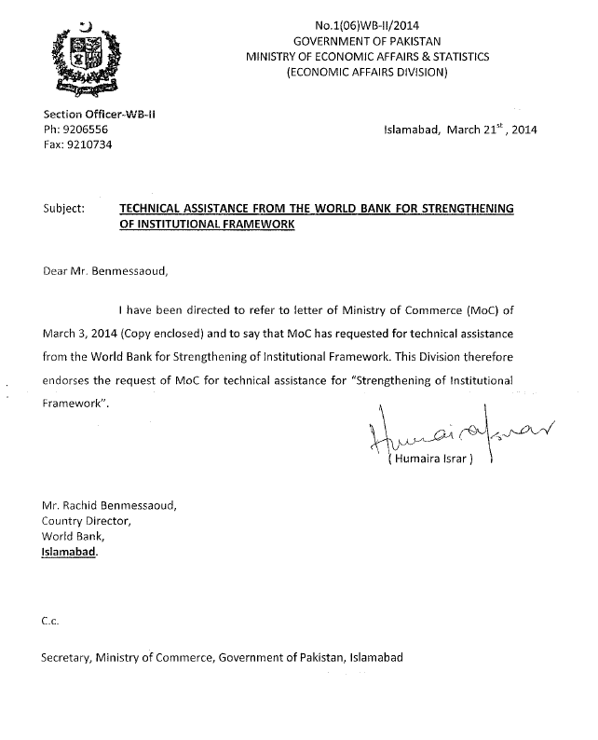

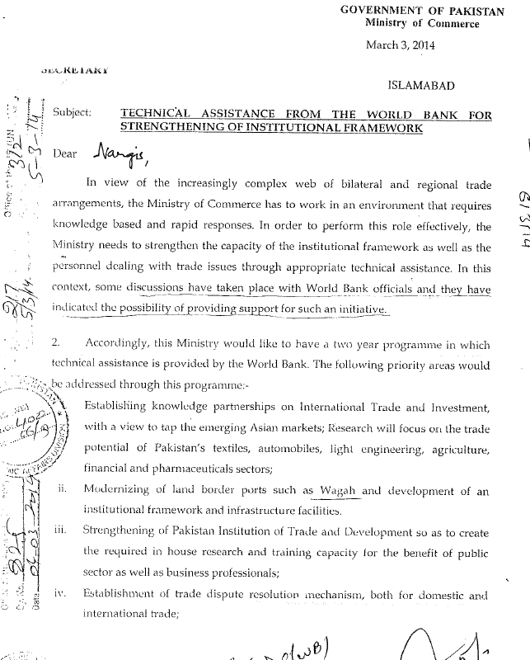

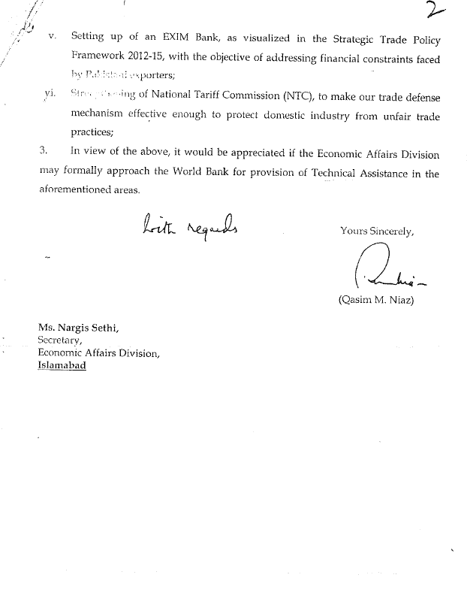

## Letter from Federal Board of Revenue for Border Project Program

**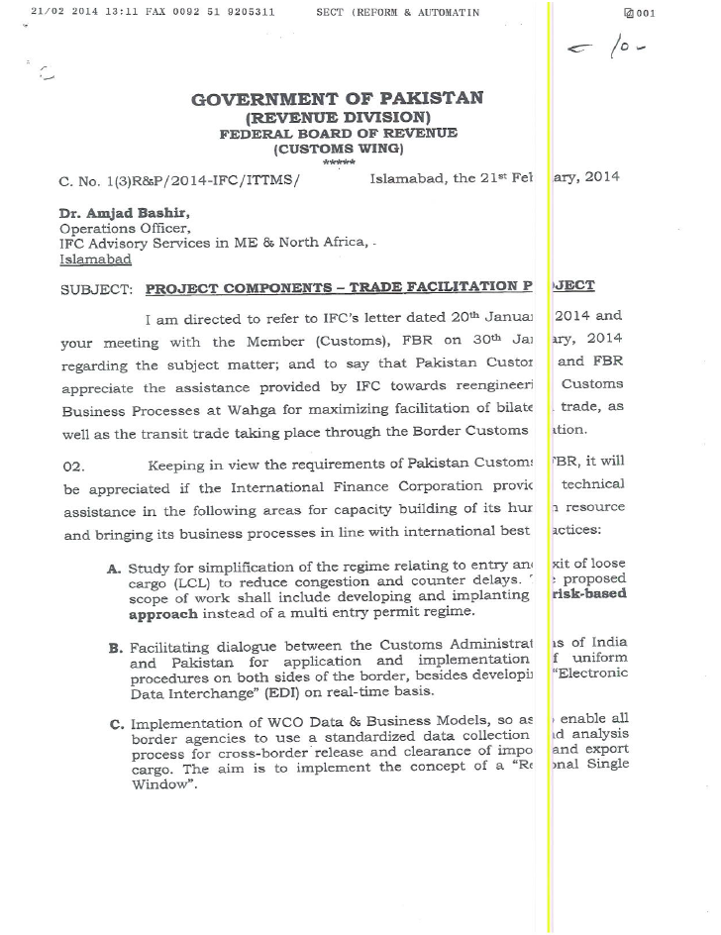**

**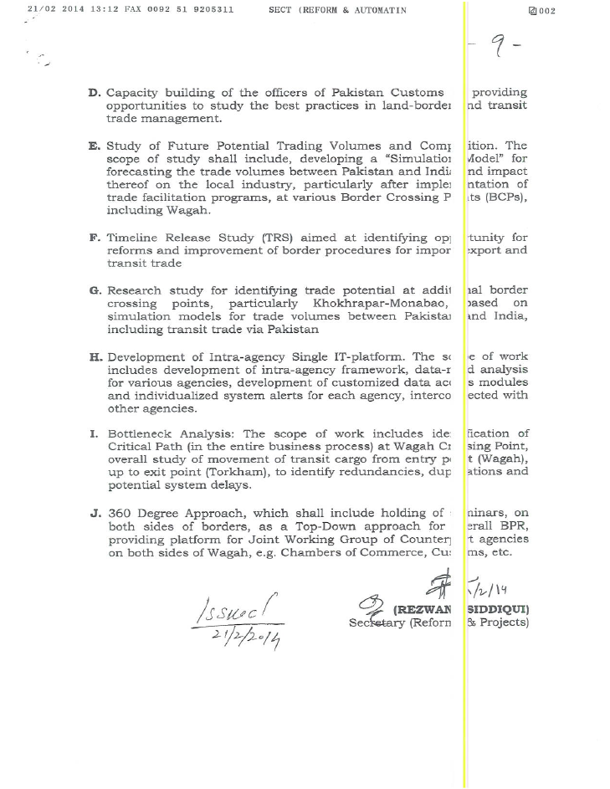**

## Notification of Steering Committee

## MoC Team Members[[25]](#footnote-25)

## Pakistan Afghanistan Joint Business Forum

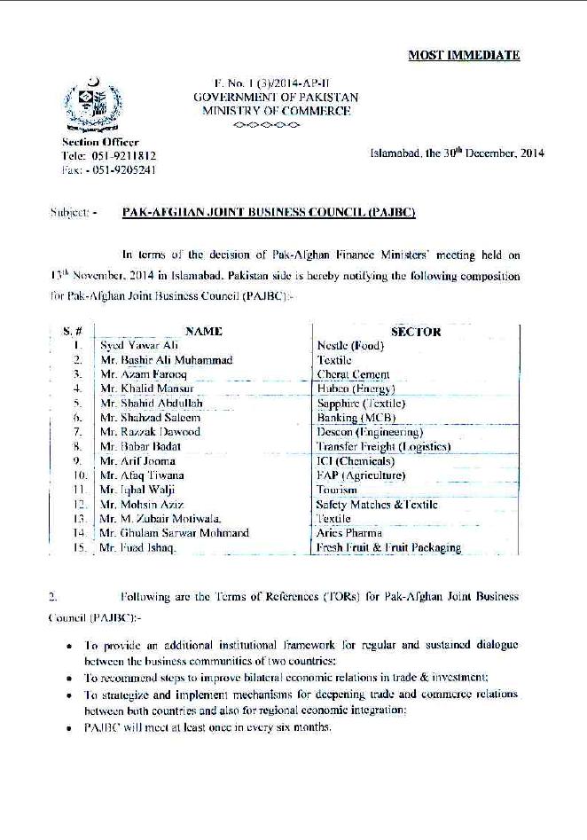

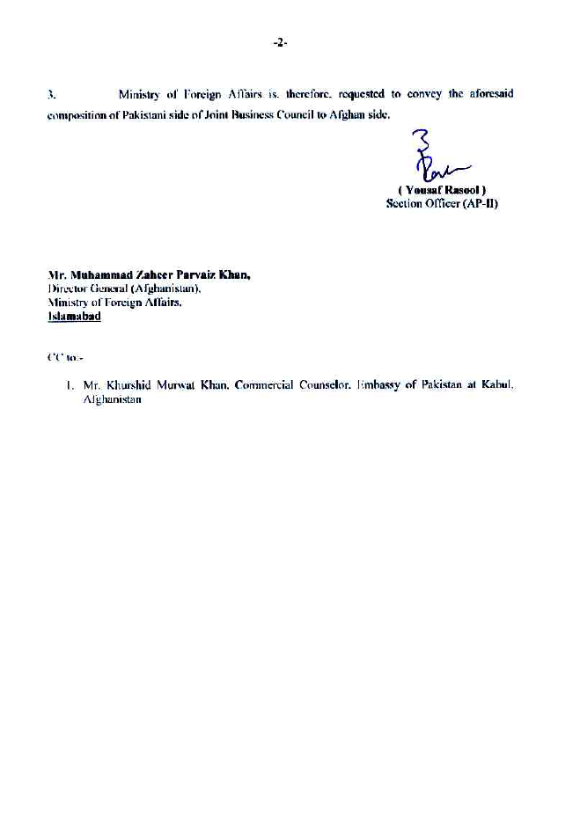

## Trade Policy Inputs

Design document inputs compiled by Shahid Kardar. The views reflected within are the consultants, after a series of consultations with area experts, Ministry of Commerce and private sector representatives. Attached separately.

## Gender and Trade Inputs

Design document inputs compiled by Dr. Khalida Ghaus. The views reflected within are the consultant’s, after a series of consultations with gender experts, WBG focal points, Ministry of Commerce and private sector representatives. Attached separately.

## Strategic Communications Inputs

Design document inputs compiled by Mosharraf Zaidi. The views reflected within are the consultants, after a series of consultations with area experts, and Ministry of Commerce. Attached separately.

## Strategic Projects

Part I: Wagah Border Project

Part II: Two Punjab Program

Attached separately

## Proposed Implementation Arrangements

Terms of reference PSC and Regional Trade Unit

## Sample Operations Manual

## Minutes of the Finance/ADB Steering Committee on Land Borders

## Minutes of Joint FBR/WBG/ABD Mission to Wagah

1. Pakistan’s exports grew at a healthy rate of just under 6.5% per annum between 2004/05 and 2013/14 peaking at US$25.4 billion in 2010/11 [↑](#footnote-ref-1)
2. Annex 9.1: Letter from the Government of Pakistan/Economic Affairs Division dated March 21, 2014. [↑](#footnote-ref-2)
3. Asian Development Bank is currently working to improve the physical infrastructure at the Wagah border [↑](#footnote-ref-3)
4. Only 3 percent of women are involved in economic activities in the formal sector, according to the Federal Bureau of Statistics. Pakistan is ranked at 141/142 on the World Economic Forum’s Global Gender Gap index and is placed at 94 out of 102 countries on the Social Institutions and Gender gap Index with a SIGI value 0.30127 in 2014. [↑](#footnote-ref-4)
5. The Vision 2025 also emphasizes gender equality and women’s economic empowerment: ‘To increase women’s participation in decision making, affirmative action will be taken in all public spheres. Women will be protected from harassment at work through strict enforcement of the legislation. Economic empowerment of women through ensuring access to education and enterprise shall be promoted.’ (Pakistan Vision 2025, Page 38) [↑](#footnote-ref-5)
6. ADB is working on improving infrastructure at three border posts including Wagha, Torkhum, Chaman. WBG will contribute towards improving ease of doing business at border-posts. [↑](#footnote-ref-6)
7. See Annex 9.4 [↑](#footnote-ref-7)
8. Minutes attached in Annex 9.12 [↑](#footnote-ref-8)
9. See Annex 9.5 [↑](#footnote-ref-9)
10. As per TF agreement between DFAT and WBG. [↑](#footnote-ref-10)
11. A detailed description for each component can be found in Annexures 9.6-9.9. These include design document inputs from a team consisting of a Trade Policy expert, a communications expert and a gender team. [↑](#footnote-ref-11)
12. This section is based on findings from a consultant hired by WBG to examine trade policy interventions. Please see Annex 9.6 for further details [↑](#footnote-ref-12)
13. This section is based on findings from a consultant hired by WBG to examine trade policy interventions. Please see Annex 9.6 for further details [↑](#footnote-ref-13)
14. Please see Annex 9.9 for further details. [↑](#footnote-ref-14)
15. T&C team conducted a joint mission to Wagah, in October 2014, with ADB along with senior FBR officials. [↑](#footnote-ref-15)
16. Kulendran, N. and K. Wilson (2000) Is There a Relationship between International Trade and International Travel? Applied Economics 32, 1001–1009 [↑](#footnote-ref-16)
17. This section is based on findings from a consultant hired by WBG to develop a gender strategy. Please see Annex 9.7 for further details [↑](#footnote-ref-17)
18. Please see Annex 9.7, section 2 that describes select initiatives taken by GoP, SAARC, USAID and EU for greater integration of women in business and trade. [↑](#footnote-ref-18)
19. Ibid [↑](#footnote-ref-19)
20. This section is based on findings from a consultant hired by DFAT to develop a communications plan with the MoC. This plan has been approved by the Minister for Commerce. Please see Annex 9.8 for further details [↑](#footnote-ref-20)
21. The program is mainly Bank executed with some selected interventions to be executed by the Moc as their capacity improves. [↑](#footnote-ref-21)
22. See Annex 9.10 [↑](#footnote-ref-22)
23. Annex 9.5 [↑](#footnote-ref-23)
24. Annex 9.4 [↑](#footnote-ref-24)
25. Mr. Maken has since been replaced by Ms. Robina Athar. [↑](#footnote-ref-25)