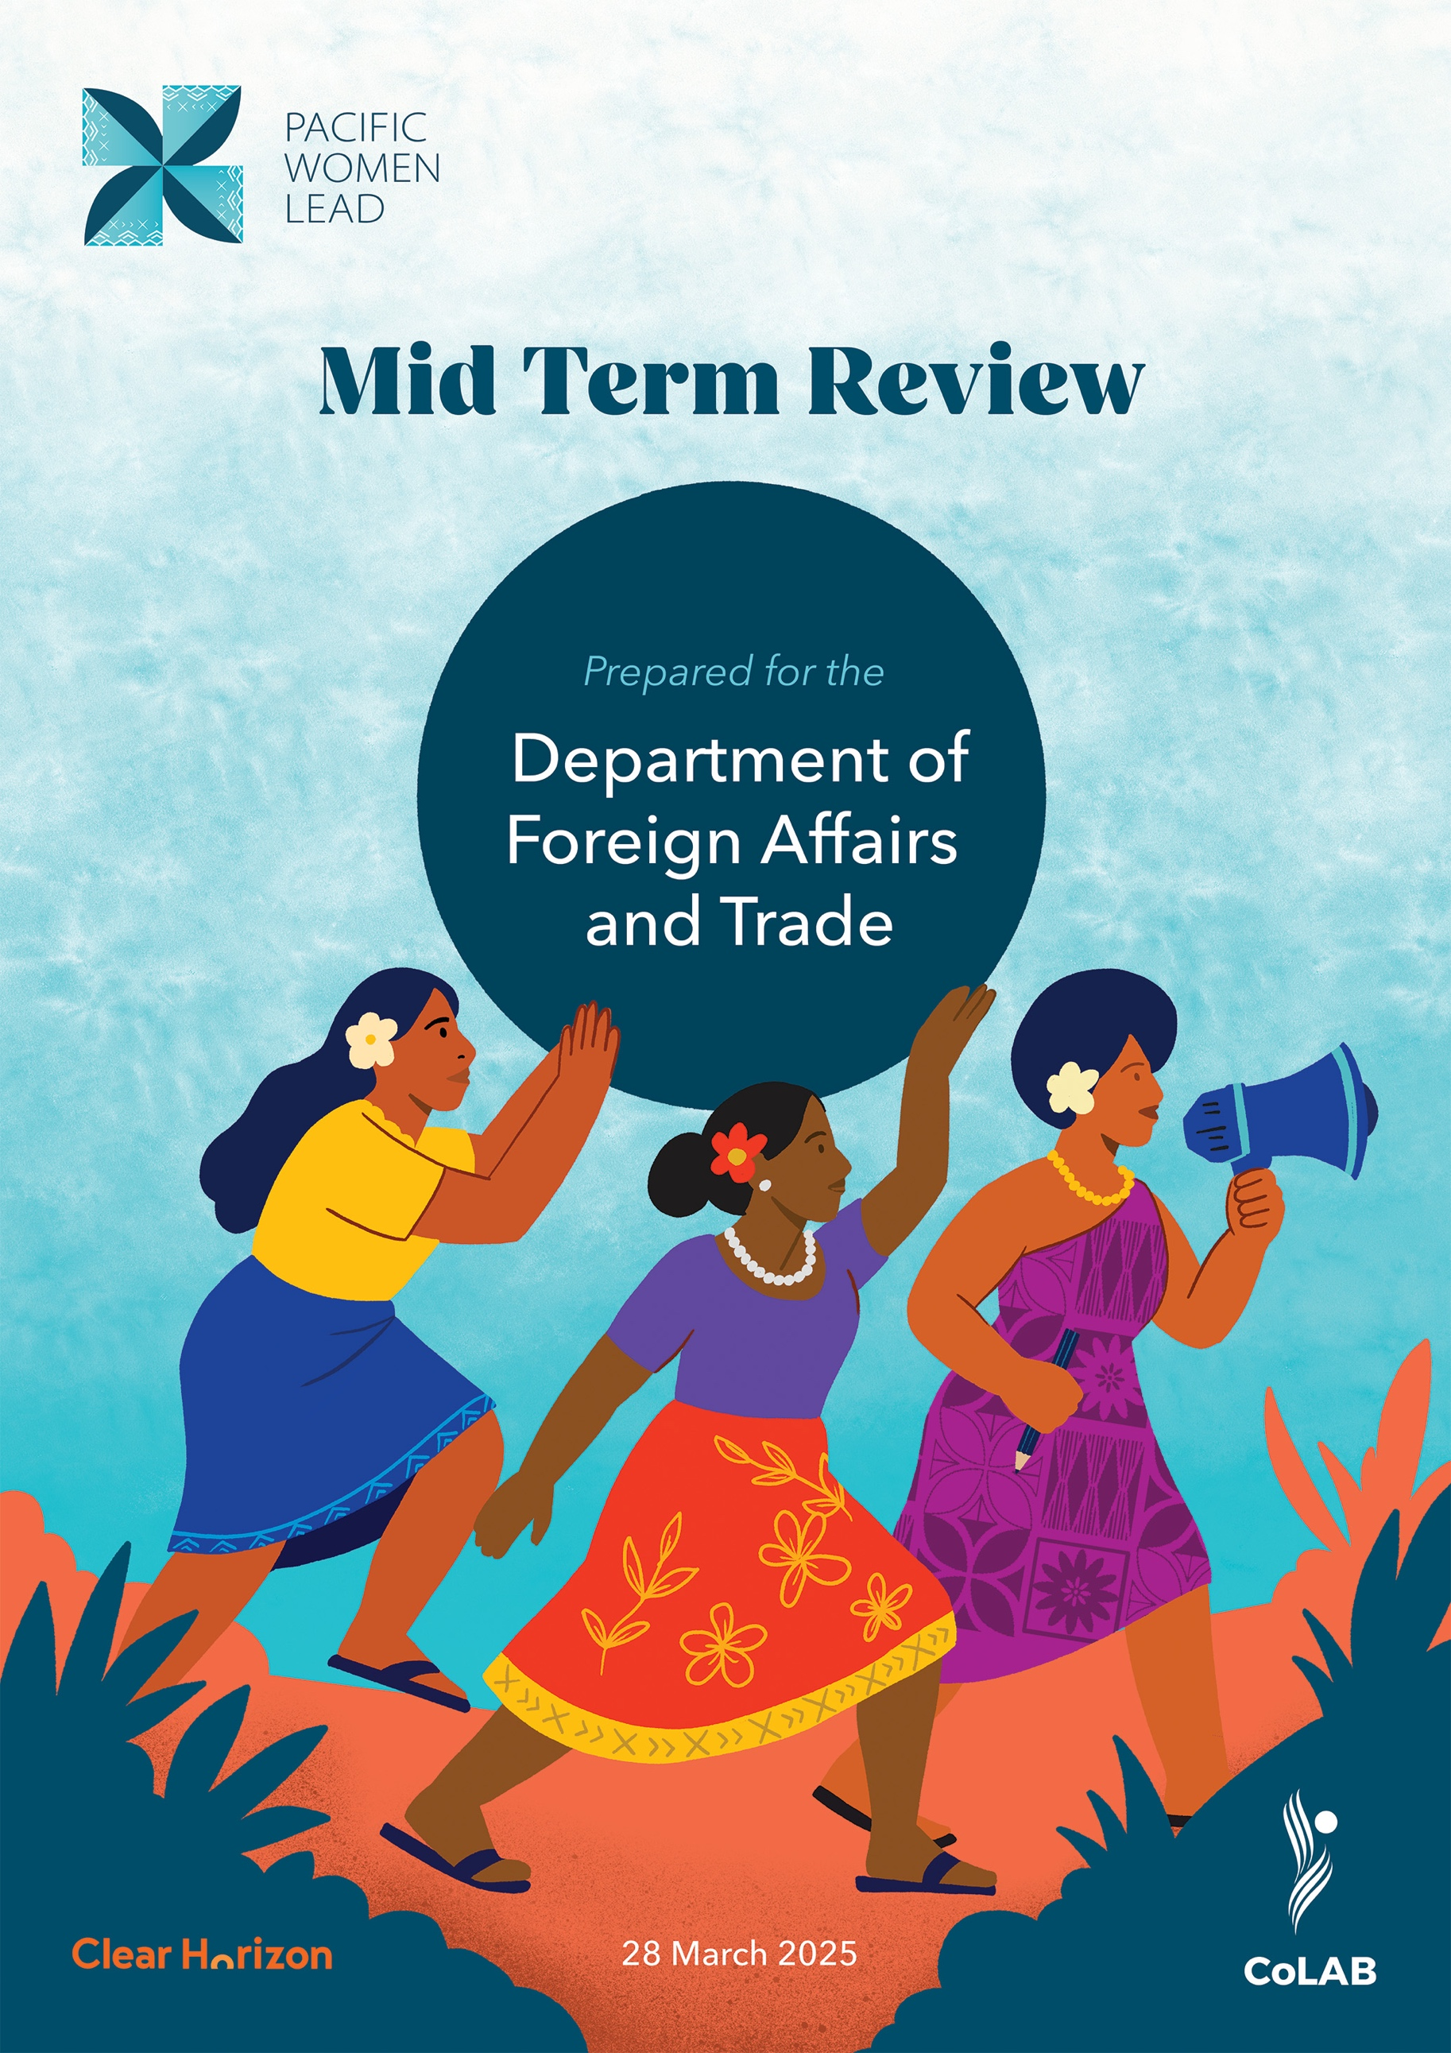

Contents

Executive summary 4

Introduction 4

Overall MTR finding 5

MTR findings against key review questions 5

Recommendations 8

1. Introduction 9

2. overAll finding 12

3. FINDINGS – EFFECTIVENESS 13

4. Findings – Relevance 46

5. Findings – Efficiency 49

6. Findings – Cross cutting 52

7. Recommendations 55

Appendix A PWL Program Logic 57

Appendix B MTR Methodology 59

Appendix C Data sources 62

Appendix D Acronyms 64

Appendix E PWL component summary 66

List of Figures

Figure 1. PWL Portfolio Components 9

Figure 2. Kakala Framework 11

Figure 3. Gender at Work Framework 43

List of Tables

Table 1. Overview of grant making and wrap-around support 28

Table 2. Women’s Funds within the PWL modality 33

Table 3. Overview of DFAT bilateral grants for gender-targeted programs 35

Table 4. Overview of technical assistance delivered by large UN programs 41

Table 5. Summary of data sources for this review 60

Disclaimer

This document has been produced with information from the Australian Department of Foreign Affairs and Trade (DFAT), Pacific Women Lead Enabling Service (PWLES) and partners supplied to Clear Horizon and CoLAB, including results charts and impact stories. While we make every effort to ensure the accuracy of the information contained in this report, any judgements as to suitability of the information for the client’s purposes are the client’s responsibility. Clear Horizon extends no warranties and assumes no responsibility as to the suitability of this information or for the consequences of its use.

Executive summary

Introduction

About the portfolio

Pacific Women Lead (PWL) is a portfolio of regional investments aimed at advancing gender equality across the Pacific. DFAT has invested AUD170 million to support PWL achieve its goals during the five-year period between 2021-2026. PWL aims to build upon the successes of its predecessor, Pacific Women Shaping Pacific Development (PWSPD), in advancing gender equality across the Pacific.

The goal of PWL is for Pacific women and girls, in all their diversity, to be safe and equitably share in resources, opportunities and decision-making with men and boys.  The program works across three thematic outcome areas with seven end of program outcomes (EOPOs) clustered under these outcome areas:

* Women’s Leadership Promoted: women and girl’s voices, Pacific feminist civil society
* Women’s Rights Realised: Sexual and reproductive health and rights (SRHR), women’s safety, and women’s economic empowerment (WEE)
* Pacific ownership and regional effectiveness: Pacific ownership, and gender mainstreaming.

To maintain its commitment to Pacific-led and intersectional programming, PWL operates as a whole-of-portfolio modality with five main components serving diverse but interconnected functions and strategies. These components are the Pacific Community (SPC), DFAT regional and bilateral programs, Women’s Funds, Pacific Women Lead Enabling Services (PWLES), and the PWL Governance Board.

Objective of the review

This mid-term review (MTR) is a standard requirement for large DFAT development programs. The purpose of this review is to:

* assess the PWL modalities across the whole of portfolio, identify achievements and challenges
* make recommendations to guide program implementation to June 2026 and the next phase of PWL
* extract learnings about key drivers of transformational change for gender equality across the Pacific to inform the next program phase.

This review covers the first half of the program and sought to develop findings related to the effectiveness, efficiency, relevance of PWL's approach to achieving desired outcomes, and the extent to which the program has supported integration of gender, disability inclusion and climate change into partner strategies and outcomes.

The review team reviewed internal PWL documents, conducted 41 consultations with more than 100 individual partners, facilitated and took notes at the PWL Annual Reflection and Analysis Workshop (ARAW), and incorporated findings from a parallel Pacific Women Lead at SPC-specific MTR. The team also conducted validation workshops with key stakeholders and the PWL Governance Board, and tested the key recommendations with representatives from PWLES, SPC and DFAT.

Overall MTR finding

This MTR concludes that at this point in implementation, the PWL modality is a fit-for-purpose, highly relevant, and effective approach to accelerating and consolidating regional gender equality efforts, distinguished by its Pacific-led, collaborative and adaptive design that reflects the complexity of advancing gender equality across the region. By uniting diverse stakeholders, including governments, civil society organisations, regional bodies and donors, PWL enacts principles of collective impact, intentionally builds relationships, and fosters strategic learning, which is central to addressing systemic and complex social change. This learning-by-doing methodology enables open discussion and iterative adaptation, allowing evidence, experiences, knowledge gaps and challenges to be shared and addressed.

For DFAT, PWL addresses long-standing gaps in regional coordination and visibility, aligning directly with Australia’s International Gender Equality Strategy, International Disability Equity and Rights Strategy, and Locally Led Development Guidance Note by embedding Pacific leadership, collective learning, and mainstreaming equity and inclusion. The backbone function provided by PWLES is pivotal for maintaining momentum, facilitating collaboration, brokering relationships, and supporting robust monitoring, evaluation, and adaptation; thus, adequate and flexible resourcing of PWLES is critical to sustaining and scaling the modality’s effectiveness, ensuring continued relevance, and safeguarding the significant gains achieved in the regional gender equality architecture and ecosystem.

MTR findings against key review questions

### Effectiveness

How does PWL design and delivery align with principles of Pacific led programming?

While not a KRQ as agreed in the MTR terms of reference, this became an emergent and priority question bringing together a key thread between KRQ2 (regarding Pacific ownership), and KRQ3 (regarding transformational change).

PWL demonstrates commitment to Pacific-led programming by strategically partnering with SPC as a lead implementing partner, establishing a Pacific-led PWL Governance Board, drawing on leadership and networks of the Women’s Funds to contribute to PWL outcomes and creating mechanisms that explicitly centre Pacific voices and decision-making. The program's approach provides a promising model for reimagining development programming with genuine regional leadership and partnership. While challenges remain, through the cooperation and collaboration with DFAT Canberra and Suva Post, PWL has laid critical groundwork for a more equitable, context-responsive approach to gender equality that yields power to Pacific partners to define and drive their own gender equality priorities in line with regional frameworks.

KRQ1: To what extent is there progress in the area of: women’s rights realised – women’s safety?

The evidence suggests that PWL efforts to date **are targeted, relevant, and effective – contributing to satisfactory progress towards the end of project outcomes (EOPO).** Nevertheless, evidence of social norms change has been minimal, presenting a critical opportunity to deepen focus on addressing social barriers to ensure that availability of services leads to greater uptake of services. More evidence of progress is expected for the second half of the program given many partners received funds shortly before this review.

KRQ1: To what extent is there progress in the area of: women’s rights realised – sexual and reproductive health?

**There is strong evidence of improved availability and delivery of services provided by health sectors across the Pacific as well as effective efforts to address social norms that limit access to services by diverse women and girls. T**here is minimal evidence to suggest any noticeable shifts in social norms to allow for greater access to services.Overall**, satisfactory progress has been made towards the EOPO.** More evidence of progress is expected for the second half of the program given many partners received funds shortly before this review.

KRQ1: To what extent is there progress in the area of: women’s rights realised – women’s economic empowerment?

**Partner efforts have achieved satisfactory progress towards this EOPO. However, the MTR team would encourage deeper reflection on whether the proportion of investment on WEE is sufficient to achieve scaled and sustained progress in this area.** Furthermore, there is minimal evidence of social norms change and of do no harm approaches being incorporated into programming, as suggested by the formative situational analysis. More evidence of progress is expected for the second half of the program given many partners received funds shortly before this review.

KRQ1: To what extent is there progress in the area of: women’s leadership promoted – feminist leadership?

The formative situational analysis describes difficulties with defining the feminist movement, and there was recognition during the 2024 ARAW of the possibility that using the label ‘feminist’ could unintentionally leave out women’s organisations that are doing progressive, rights-based work but may not use the term ‘feminist’ to describe themselves. Nevertheless, based on evidence from partners supporting this EOPO, the MTR team has found strong evidence that PWL has amplified Pacific feminist civil society at the regional, national, and local levels. PWL has contributed to convenings and attendance at key forums, local activism for women’s rights organisations in at least eight countries, and supported better connections between partners. More evidence of progress is expected for the second half of the program given many partners received funds shortly before this review.

KRQ1: To what extent is there progress in the area of: women’s leadership promoted – women and girl’s voice?

**There is strong evidence that PWL has improved representation of women and girls in regional convenings in which partners have direct influence, with some evidence in shifts in social norms to improve representation more widely.** More evidence of progress is expected for the second half of the program given many partners received funds shortly before this review.

KRQ2: To what extent is there progress in the areas of: Pacific ownership and regional effectiveness?

**The design of PWL positions SPC as leading implementation on Outcome 3 and with primary responsibility over resourcing and facilitating collaboration with PIFS. The MTR found strong evidence that PWL partners, particularly SPC, are contributing towards gender equality convenings and frameworks at the regional level. There is less evidence that Pacific governments are mainstreaming gender through their sector programs and policies, which is expected at this early stage of the program given the time required for mainstreaming and policy change.**

KRQ1b. How well are program strategies working to achieve outcomes?

PWL's four core strategies – grant making with wrap-around support, convenings, technical support, and portfolio-level monitoring, evaluation and learning (MEL) – have collectively demonstrated effectiveness in advancing gender equality across the Pacific region. The grant making approach has successfully mobilised 78 diverse implementing partners, though challenges persist with five distinct grant makers creating duplication and administrative burdens. Convenings have proven critical for gender mainstreaming and women's rights advancement, bringing together diverse stakeholders and enabling valuable knowledge sharing. Technical support has strengthened institutional capacity and policy development, while portfolio-level MEL has become an essential driver of Pacific stakeholders' ownership of evidence and strategic direction through mechanisms like the ARAW.

KRQ3. What are key opportunities and barriers for the PWL program to achieve transformational change?

This review highlighted considerable work done against all four quadrants of the Gender at Work framework. Partners have undertaken a wide range of activities to shift harmful social norms, though there is limited evidence of change at this stage. PWL is also supporting a number of initiatives aimed at influencing formal rules and policies, and there is scope to further strengthen this work. However, the absence of formal coordination mechanisms at the country level has reduced the visibility and collective impact of these efforts, both of which are necessary for transformative change.

### **Relevance**

KRQ4. How relevant is the whole of portfolio modality and the five components to addressing gender inequality across the Pacific region?

**PWL remains a critical investment into addressing Pacific gender inequality particularly due to the changing global, regional and national contexts in which the program operates.** **The modality and the five components are well-suited for tackling the deeply rooted issue of gender inequality across the Pacific because it acknowledges the need for a sustained, long-term investment and approach. The components have demonstrated appropriate levels of adaptation to contextual shifts and learnings, assisted by evidence produced by the MEL system and various coordination efforts. PWL has furthermore fostered alignment with existing international gender equality priorities and frameworks through its active engagement in international forums, strategic partnerships with global organisations, and consistent efforts to promote regional perspectives and leadership in global discussions.**

### **Efficiency**

KRQ5. To what extent are PWL components efficiently supporting delivery of outcomes?

PWL components demonstrate strong alignment with DFAT's efficiency principles through evidence-based decision making and proportionality, with efficiency particularly evident in dynamic and relational aspects including leadership by outstanding women with deep Pacific feminist connections, strategic knowledge transfer from Pacific Women Shaping Pacific Development, and a robust whole-of-portfolio MEL system. Despite managing a complex mandate across all five components that includes regional scaling, thematic deepening, and enabling Pacific ownership pathways, the program could benefit from increased coordination and trust between components to establish more cohesive working methods and enhance information sharing—improvements that would further strengthen the already proportional approach to delivering outcomes across the Pacific.

### Cross-cutting

KRQ6. How well is the program integrating GEDSI and climate change?

PWL demonstrates strong integration of disability inclusion and intersectional gender equality through systematic approaches, targeted funding, and strategic partnerships. The program works directly with Pacific organisations of persons with disabilities (OPDs) and SOGIESC-focused organisations, and benefits from the leadership and insights of people with lived experience through representation on its Governance Board. A dedicated Disability Working Group also provides advice to the Governance Board, helping to ensure inclusive and responsive decision-making. Progress on broader social inclusion is evident in PWL’s support to SOGIESC communities through regional networks and public events, though further work is needed to address social norms that continue to create barriers for girls and adolescents. Climate change integration remains moderate, with current efforts primarily relying on technical support rather than dedicated funding. The second half of the program offers opportunities to develop a program-wide climate strategy and deepen partnerships with climate-focused organisations.

Recommendations

For remainder of current phase (until end of June 2026)

1. Improve coordination between PWL components to enhance efficiency and effectiveness.
2. Strengthen the strategic value of the PWL Governance Board.
3. Ensure continuity and minimise disruptions in SPC grants.
4. Develop a PWL climate change strategy to integrate climate change considerations across PWL programming.
5. Ensure continuity of PWLES’ support.

For the next phase (from July 2026)

1. Maintain Pacific-led ownership as a core principle of PWL and cross-cutting driver of impact.
2. Refine PWL’s funding and support mechanisms based on program strengths and demand.
3. Strengthen national-level and sub-regional level engagement to drive transformational change.
4. Update the PWL program logic to reflect key lessons and strategic priorities.

# Introduction

About Pacific Women Lead

Pacific Women Lead (PWL) is a comprehensive initiative funded by the Australian Government's Department of Foreign Affairs and Trade (DFAT), investing AUD170 million between 2021-2026 to advance gender equality across the Pacific region. The AUD170 million figure refers to the core components of the program. The total value of investments contributing to PWL outcomes are however, higher, as it includes aligned and complementary gender equality initiatives, including multilateral programming and flexible funding mechanisms such as the Pacific Women’s Funds. These additional DFAT investments are integrated into the broader PWL platform but may not be captured in the headline program value.

Building on its predecessor program, Pacific Women Shaping Pacific Development (PWSPD), PWL aims to deepen Australian Aid's impact by focusing on collective regional progress alongside country-specific achievements.

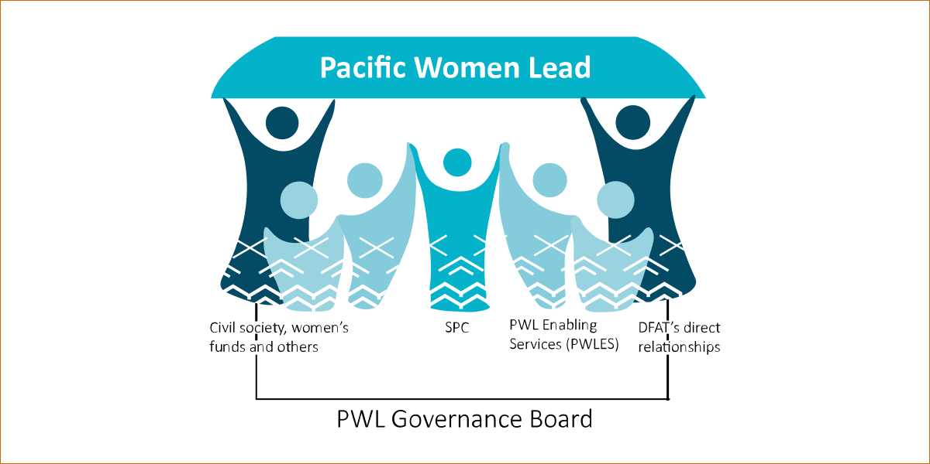

Figure 1. PWL Portfolio Components (Source: PWLES)

PWL emphasises transformational change by addressing harmful social and cultural norms that impede sustainable progress, while implementing a Pacific-led, responsive, flexible, and intersectional approach. PWL is particularly committed to achieving equitable outcomes for women and girls in all their diversity across the Pacific. PWL is implemented as a whole of portfolio modality with five main complementary components (Figure 1). Each component serves a unique but interconnected function:

* **The Pacific Community (SPC)** (AUD68 million), a scientific and technical organisation owned and governed by 22 Pacific Island members, serves as the lead implementing partner for the PWL program, providing technical support, convening stakeholders, and managing regional initiatives while supporting gender equality efforts.
* DFAT supports three independent **Pacific Women’s Funds** (AUD9.1 million) through the Amplify Invest Reach (AIR) investment: Women’s Fund Fiji (WFF), Urgent Action Fund Asia and the Pacific (UAF A&P), and the newly established Pacific Feminist Fund (PFF). These funds reach women’s rights organisations and human rights defenders in the Pacific, have been designed as flexible and responsive funding mechanisms, and are closely engaged with, and contribute to outcomes of Pacific Women Lead.
* **The Pacific Women Lead Enabling Services (PWLES),** managed by DT Global Asia Pacific with AUD32 million, provides comprehensive portfolio support through monitoring, evaluation, program management, communications, partnership brokering, and technical assurance, while directly managing the Balance of Power program and previously overseeing the We Rise Coalition.
* DFAT Canberra and Suva Posts manage **regional gender programs** totalling AUD103 million, encompassing multi-country initiatives with UN Women, UNFPA, and UNICEF that represent over 40% of PWL funding and support critical regional gender equality efforts. DFAT post-managed **bilateral programs** maintain design and delivery autonomy while aligning with PWL goals, including targeted grants to crisis centres in Fiji, Kiribati, and Tonga, and supporting the We Rise Coalition.
* The **PWL Governance Board** provides strategic oversight and advisory support for gender equality implementation, directly managing AUD5 million in discretionary funding while guiding the mainstreaming of gender initiatives across Australia's bilateral programs in the Pacific, with secretariat support from SPC.

For further detail on each component, see Appendix E.

The goal of PWL is for Pacific women and girls, in all their diversity, to be safe and equitably share in resources, opportunities and decision-making with men and boys. In working towards this, the program works across three thematic outcome areas: **Women’s Leadership Promoted, Women’s Rights Realised and Pacific Ownership and Regional Effectiveness**. See Appendix A for the PWL Program Logic. PWL’s components are focused on achieving these outcomes through across various strategies:

* **Grant making** in thematic areas of leadership, health, women’s economic empowerment and safety.
* **Convening** and collective action that supports genuine partnerships and strategies for change in social norms and gender equality outcomes.
* **Technical support**, training, and advice to support greater gender mainstreaming and gender equality outcomes for Pacific governments and development partner sector programs.
* **Collaborative portfolio-level MEL**, including sense-making spaces to inform PWL decision-making.

About this mid-term review

The PWL mid-term review (MTR), conducted from July to November 2024, evaluates the PWL’s portfolio of investments aimed at advancing gender equality across the Pacific. The review examines PWL through six key review questions.

**Effectiveness**

1. To what extent is there evidence of progress in the areas of: Women and girls’ leadership and Women’s rights realised?
2. To what extent is there evidence of progress in the area of: Pacific ownership and effectiveness of regional gender equality efforts?
3. What are key opportunities and barriers for the PWL program to achieve transformational change?

**Relevance**

1. How relevant is the whole of portfolio modality and the five components to addressing gender inequality across the Pacific region?

**Efficiency**

1. To what extent are PWL components efficiently supporting delivery of outcomes?

**Cross-cutting**

1. How well is the program integrating GEDSI and climate change?

The findings form the core of the analysis and are followed by recommendations for improvement. The MTR’s approach was guided by the Kakala Framework (Figure 2), which emphasises both meaningful stakeholder inclusion and valuable outputs. The approach also incorporated good practices from feminist and disability inclusive evaluation theory and ensured alignment with DFAT’s standards. See Appendix B for detail.

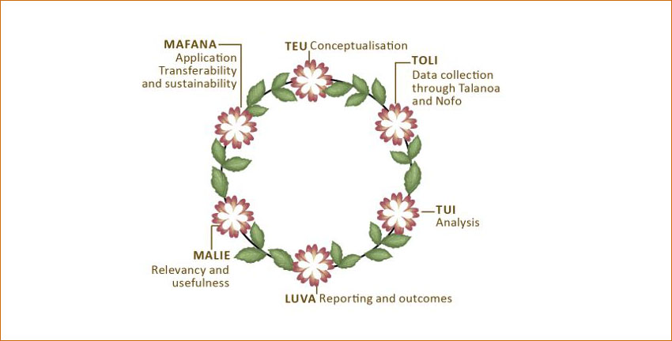

Figure 2. Kakala Framework (Source: SPC)

Limitations and considerations in reading this report

The MTR provides an imbalanced analysis across program components, with a more in-depth focus on SPC, PWLES, and the PWL Governance Board, which were prioritised due to their strategic importance and because other components have or will be undertaking separate evaluation processes. This approach influenced stakeholder selection and research methodology, resulting in fewer interviews for Women's Funds and DFAT programs, with findings instead derived from leadership consultations, the 2024 PWL Annual Reflection and Analysis Workshop, and validation workshop feedback. Despite efforts to facilitate inclusive discussions, power dynamics in focus groups and limited pre-validation engagement with draft findings may have affected participation and responses.

# Overall finding

This MTR concludes that at this point in implementation, the PWL modality is a fit-for-purpose, highly relevant, and effective approach to accelerating and consolidating regional gender equality efforts, distinguished by its Pacific-led, collaborative and adaptive design that reflects the complexity of advancing gender equality across the region. By uniting diverse stakeholders, including governments, civil society organisations, regional bodies and donors, PWL enacts principles of collective impact, intentionally builds relationships, and fosters strategic learning, which is central to addressing systemic and complex social change. This learning-by-doing methodology enables open discussion and iterative adaptation, allowing evidence, experiences, knowledge gaps and challenges to be shared and addressed.

For DFAT, PWL addresses long-standing gaps in regional coordination and visibility, aligning directly with Australia’s International Gender Equality Strategy, International Disability Equity and Rights Strategy, and Locally Led Development Guidance Note by embedding Pacific leadership, collective learning, and mainstreaming equity and inclusion. The backbone function provided by PWLES is pivotal for maintaining momentum, facilitating collaboration, brokering relationships, and supporting robust monitoring, evaluation, and adaptation; thus, adequate and flexible resourcing of PWLES is critical to sustaining and scaling the modality’s effectiveness, ensuring continued relevance, and safeguarding the significant gains achieved in the regional gender equality architecture and ecosystem.

# Findings – Effectiveness

How does PWL design and delivery align with principles of Pacific led programming?

While not a KRQ as agreed in the MTR terms of reference, this became an emergent and priority question bringing together a key thread between KRQ2 (regarding Pacific ownership), and KRQ3 (regarding transformational change).

PWL demonstrates commitment to Pacific-led programming by strategically partnering with SPC as a lead implementing partner, establishing a Pacific-led PWL Governance Board, drawing on leadership of the Women’s Funds and creating mechanisms that explicitly centre Pacific voices and decision-making. The program's approach provides a promising model for reimagining development programming with genuine regional leadership and partnership. While challenges remain, through the cooperation and collaboration with DFAT Canberra and Suva Post, PWL has laid critical groundwork for a more equitable, context-responsive approach to gender equality that yields power to Pacific partners to define and drive their own gender equality priorities in line with regional frameworks.

The foundations for Pacific-led principles are firmly embedded in Pacific Women Lead's design and operational strategies, representing a transformative approach that reimagines traditional donor-driven models. The program prioritises Pacific women in leading direction, defining challenges, and driving strategic approaches, emphasising learning and adaptation over rigid performance metrics. PWL's design effectively orchestrates five components to provide efficient and relevant strategies addressing diverse gender equality programming needs across the region, with varying degrees of alignment to Pacific-led principles across these components.

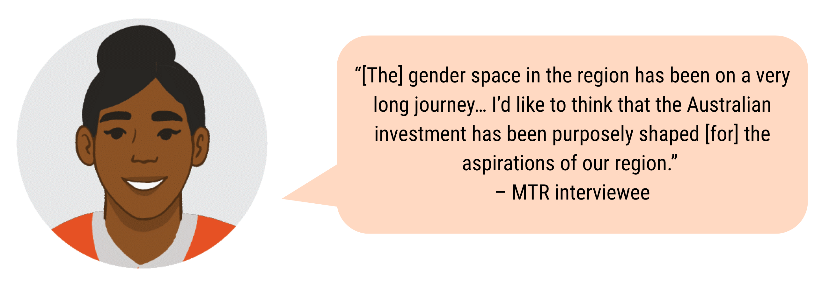

**DFAT Canberra and Suva Post**

DFAT Canberra and Suva Posts play a dual role as PWL’s donor as well as an implementing component, with direct funding and capacity support to various regional gender projects. As the donor, DFAT Canberra is operating through a unique investment model that is based on trusted and flexible *partnerships* with Pacific organisations. The uniqueness of this approach across DFAT investments has fostered careful balancing between conventional levels of investment accountability with the desire to yield ownership of strategic priorities and implementation to Pacific partners.

SPC

The nomination of SPC as the lead implementing partner represents a pivotal moment, fundamentally shifting from an Australian-managed program to a Pacific-led initiative.

This change leveraged SPC's strengths as a Council of Regional Organisations of the Pacific (CROP) agency, including its broader technical capabilities and strong convening power, enabling more comprehensive regional approaches and stronger policy influence. This move establishes a strong foundation for Pacific leadership across the program as evidenced through multiple reinforcing elements:

* SPC's structure as a Pacific-led organisation, mandated by 22 Pacific Island Countries and Territories and predominantly staffed by Pacific peoples, provides an inherent foundation for Pacific ownership. This is further strengthened by Pacific Islander staff in key leadership positions for PWL investments at SPC.
* The establishment of the Gender Equality Flagship marks a strategic shift in SPC's approach, aligning with the 2050 Strategy for the Blue Pacific Continent. Whilst still in a formative phase, the Flagship is intended to provide an overarching framework that will drive and support sustained engagement beyond funding cycles, connecting critical resources and capabilities to address entrenched inequality. PWL is the anchor investment for the Gender Equality Flagship.
* The creation and positioning of the Principal Strategic Lead - Pacific Women and Girls within SPC's Senior Leadership Team has elevated gender equality work across the organisation and across the region. The positioning and influence of this role has been strengthened as of October 2024 to encompass strategic oversight of PWL. The position demonstrates Pacific leadership in action – setting the foundations for transformational change, increasingly providing strategic oversight of gender equality efforts at SPC and ensuring gender equality is elevated as a priority both within and external to SPC.

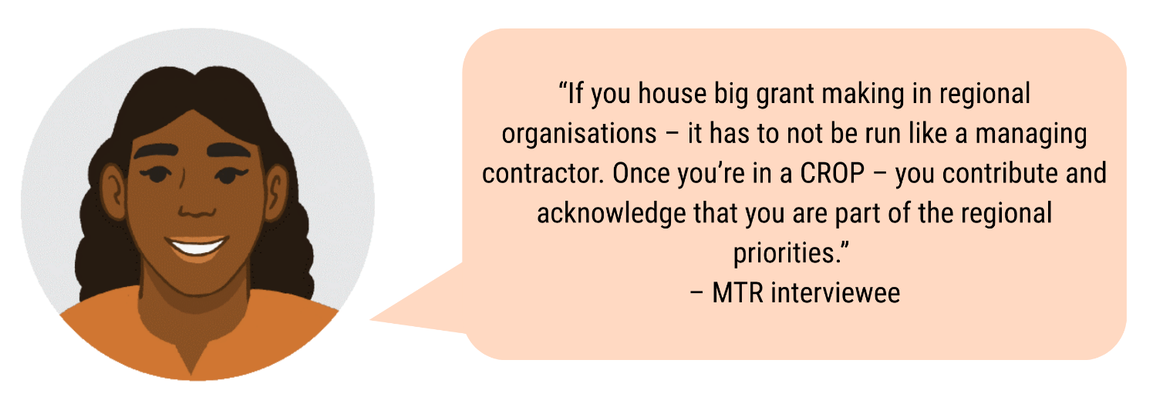

While the shift from a managing contractor modality to SPC was a significant step towards enabling greater Pacific ownership, there is a sense that this is an area that still requires careful thinking and work. Many interviews within SPC and outside SPC reflected perceptions that Pacific ownership has yet to be fully realised. These sentiments reflect an unintended outcome for PWL, with stakeholders wanting to explore further the contours of what Pacific ownership means and how it is enacted through the program.

**Spotlight: Transition to SPC as a key implementing partner**

The transition of Pacific Women Lead into the Secretariat of the Pacific Community involved significant complexity, transferring an established team, novated partnerships, and substantial resources amidst post-COVID adjustments and SPC's internal organisational changes. The design phase failed to adequately consider fundamental differences between a managing contractor and intergovernmental organisation, necessitating substantial two-way learning and operational adjustments, particularly in grants management. This created extended timeframes while SPC balanced "external pressures" and "high expectations" to become immediately operational within systems designed to reduce risk and protect member states' investments, which resulted in reduced flexibility and longer implementation timelines.

This transition demanded fundamental shifts in mental models and working approaches for all parties involved, with the transitioning team needing to move away from a managing contractor mindset while DFAT adapted to working with an intergovernmental organisation. The experience highlights the importance of viewing the 2022-2026 funding period as a formative learning phase, recognising that institutional change requires ongoing adaptation, relationship-building, and patience. While initial challenges created significant implementation barriers, careful attention to team composition, relationship building, and strengthening internal systems has established a foundation for Pacific-owned gender equality efforts.

**PWLES**

PWLES represents a nuanced approach to addressing the complex challenges of development work in the Pacific, particularly around principles of Pacific ownership. The PWL Formative Situational Analysis highlighted critical tensions in donor-led development, noting that local participants often feel marginalised, disconnected from their original motivations, and essentially pushed into implementing foreign agendas while being left with no voice in their own countries. What distinguishes PWLES is its intentional effort to break from these traditional patterns.

The program has been widely recognised by stakeholders for moving beyond mere development buzzwords like "locally led" and actively working to create meaningful Pacific-led partnerships. This is largely attributed to the team's leadership, particularly the Team Leader who has strong, trusted relationships across the region, the strong pairing of Pacific and non-Pacific MEL professionals and a principled approach across the team that prioritises nurturing relationships and amplifying Pacific voices and priorities.

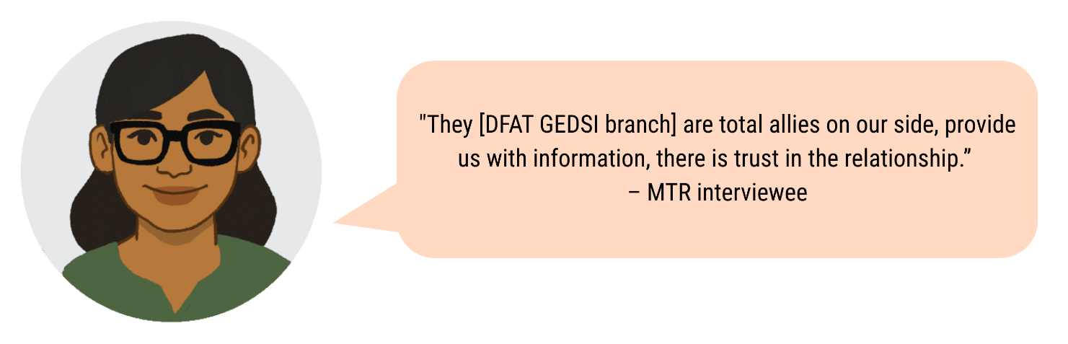

PWLES’ link to a managing contractor has supported efficient workstreams, but it’s arguably their capabilities and strong local relationships that have contributed to high degrees of effectiveness and trust across partners. Unlike many development initiatives that impose dominant external worldviews, PWLES has managed to strike an important balance - working collaboratively with DFAT while simultaneously amplifying and prioritising Pacific-led principles. A poignant sentiment from the PWL Formative Situational Analysis captures the core challenge: true structural change requires genuinely accepting that Pacific worldviews have equal value, not just paying lip service to local ownership. In this context, PWLES emerges as a promising model that actively challenges the traditional power dynamics in international development work, importantly enabled by the managing contractor DT Global and DFAT.

PWL Governance Board

The PWL Governance Board demonstrates strong alignment with Pacific-led programming principles in its design but faces significant implementation challenges that limit implementation in line with these principles. The Board represents a deliberate shift from the previous program's advisory-only model to one intended to enhance Pacific ownership through meaningful decision-making authority.



Its composition strongly supports Pacific ownership with 11 highly credentialed Pacific practitioners representing diverse sub-regions, countries, and communities, including disability, LGBTQIA+, youth, and North Pacific perspectives. This diversity has successfully brought attention to historically overlooked issues and led to dedicated Youth and Disability Working Groups, while enabling nuanced discussions that acknowledge the varied gender equality contexts across the Pacific.

Board members recognise that their diversity is critical to providing nuanced advisory support to the program as “*standard gender equality work doesn’t apply universally across the Pacific.”*

Despite these design strengths, the intention for the Board to have decision-making authority over key program components proved unrealistic. Existing institutional governance arrangements made this level of oversight inappropriate and unfeasible. In practice, the Board’s role has been limited to managing discretionary funds and providing advisory input to DFAT and some PWL partners. Operational challenges further constrain its effectiveness, including poor attendance at bi-annual meetings, problematic power dynamics with numerous observers from SPC and DFAT sometimes outnumbering Board members, members feeling constrained in speaking freely due to funding dependencies, and insufficient understanding of the program's structure.

While the Board represents an important step toward Pacific ownership through its diverse composition and ambitious design, its actual ability to exercise meaningful ownership remains limited by structural, operational, and capacity constraints. Addressing these issues—particularly meeting attendance and power dynamics—presents a key opportunity to strengthen Pacific-led principles by creating an environment where Pacific voices can more confidently shape program direction.



Women’s Funds

PWL’s design states that the Women’s Funds are *“critical to enable Pacific women’s leadership and to deliver broad-reaching support to women and women’s organisations across the region’’*. It further emphasised the importance of protecting the independence of the Women’s Funds, *“for whom maintaining their own autonomy is critical’’*. Support for Women’s Funds through AIR involves a Partnering Agreement between DFAT and Women’s Funds governing ways of working and individual grant agreements are held directly between DFAT and each of the funds: Urgent Action Fund (UAF) Asia & Pacific, Women’s Fund Fiji (WFF); and the Pacific Feminist Fund (PFF).

For the most part, this autonomy has been maintained across the funds, and the Women’s Funds enjoys a positive and mutually beneficial partnership with DFAT. Stakeholders from the Women’s Funds spoke appreciatively of their engagement with DFAT. They talked about the partnership agreement and the level of flexibility it affords. One stakeholder offered, “*Conversations with DFAT Canberra are more peer-to-peer rather than donor–grantee.*” Another stakeholder appreciated the patience, flexibility, and trust provided to PFF during its early inception stages: “*DFAT understands that PFF is new and is trying to understand its own rhythm of working.*” This approach has enabled the Women’s Funds to maintain their autonomy while benefiting from DFAT's support.

One area of slight frustration discussed by Women’s Funds stakeholders relates to the Women’s Funds reporting requirements, as DFAT’s timelines are out of sync with the Funds’ grantee reporting periods and tend to highlight quantitative over qualitative indicators of progress: ''Grantee reports come in around January and that is the time Amplify-Invest-Reach (AIR) is already compiling our collective reports. We’d appreciate some attention from DFAT in re-looking at these timelines… We’d like to commit more time to organisational learning and reflection… [and] spend some time to talk about this and how else we can assess impact.'' - MTR interviewee.

**Spotlight: The Formation and implementation of PFF is a key step towards Pacific Ownership and Effectiveness**

All AIR partners played a critical role in supporting the establishment of the Pacific Feminist Fund (PFF), enabling it to participate in key regional spaces, meetings, and events where it can engage directly with donors, advocate for Pacific feminist priorities, and access funding. PFF are strengthening their institutional capacity and positioning themselves as a sustainable, reliable source of support for feminist organisations and movements in the Pacific. Examples of institutional building efforts include a comprehensive due diligence assessment, setting up governance structures and processes, establishing financial and operational policies and procedures, implementing a grant making strategy and resource mobilisation strategy, and providing wrap-around support within its granting mechanism.

“The origins and beginnings of an independent fund that is mandated by the Pacific women’s and feminist movement is political. It means that we are first and foremost accountable to the movement. The presence of the home-grown Women’s Funds in the Pacific, that are situated and led within the Pacific movement is important. In 2017, the establishment of the Women’s Funds Fiji and Urgent Action Fund Asia and Pacific was hugely celebrated. And now we have the Pacific Feminist Fund. Now with the launch of the Pacific Feminist Fund in 2023, a new fierce and bold feminist fund. It’s groundbreaking!”

The formation of PFF reflects how AIR has incubated Pacific-led leadership and institution-building, creating new infrastructure that is now influencing the broader Pacific Women Lead platform. By amplifying Pacific women’s voices and leadership in regional decision-making spaces, PFF and other AIR partners are contributing to PWL’s vision of Pacific-owned and locally led gender equality efforts. (Impact Story)

Partnership brokering

PWL established partnership brokering services through two contracted brokers managed by PWLES to strengthen working relationships between program components. While PWL's foundational documents recognise this as a key mechanism for program effectiveness - with annual partnership health checks integrated into the MEL Framework between SPC, DFAT and PWLES - implementation experiences have been mixed. Three facilitated sessions have occurred to date: an initial ways-of-working session between SPC, DFAT and PWLES; a follow-up Partnership Health Check among these same components in 2023; and an internal SPC session between Pacific Women Lead at SPC and the Women in Leadership Programme. However, stakeholders reported that some sessions led to misunderstandings and tensions, with scepticism about their value despite commitment to collaboration. This may partly stem from timing issues, as the initial session occurred before components fully understood their respective scopes and mandates. The partnership brokers themselves noted that their function was not effectively embedded into the program structure, with components viewing brokering as an *"on-request"* service for addressing specific partnership issues rather than an integrated program function supporting strategic coordination. While PWLES cannot mandate the use of these services, opportunities exist to better socialise and facilitate access to brokering across all components. Partnership brokering represents a potentially transformative approach to operationalising Pacific ownership by moving beyond traditional transactional development models toward creating intentional, adaptive spaces for collaborative learning and relationship-building. This approach, when properly implemented, could address complex power dynamics and enable gender equality efforts that are genuinely responsive to Pacific cultural contexts and epistemologies of connection.

KRQ1: To what extent is there progress in the area of: women’s rights realised – women’s safety?

PWL efforts to date **are targeted, relevant, and effectively contributing to satisfactory progress towards the end of program outcome (EOPO).** ARAW 2024 attendees rated progress towards this outcome as ‘less than expected’ to ‘as expected’, justified by a perspective that PWL should heighten focus on the expansion of crisis centres in countries where they do not currently exist. Nevertheless, evidence of social norms change has been minimal, presenting a critical opportunity to deepen focus on addressing social barriers to ensure that availability of services results and in greater uptake of services. More evidence of progress is expected for the second half of the program given many partners received funds shortly before this review.

Key achievements

* **40 projects** with a primary focus on this outcome.
* **AUD71m** committed to this outcome.
* **83,923** services provided, including health, counselling and access to justice.
* **699** police and other law and justice officials received training.
* The inaugural eSafety Symposium, hosted by SPC with Australia's eSafety Commissioner, the University of the South Pacific, and PIFS, marked **a significant milestone in addressing technology-facilitated gender-based violence**, followed by in-country training in Solomon Islands, Fiji, and Tonga.
* **Improved coordination of services across the region:** In Papua New Guinea, Voice for Change secured maintenance payments for survivors through advocacy; In Solomon Islands, the Family Support Centre strengthened coordination between service providers; In Samoa, the Talanoa Toolkit reached over 30,000 people, with six pilot villages adopting it as part of Family Safety Committees.
* **Expanded reach of crisis centres**, with the Crisis Centres in Tonga and Fiji reporting increased clients from remote regions. They also **play a crucial role in increasing awareness and engagement**, with Women United Together Marshall Islands receiving extended speaking time at the Annual Local Government Conference and Tongen Inepwineu Counselling Centre engaged at the Pafeng Leadership Conference, demonstrating growing community interest in addressing gender-based violence.
* **Projects show promising results in changing behaviours:** Equal Playing Field's Safe Schools program in PNG and CARE Vanuatu's Laef Blo Mi project have led to observable changes in boys' behaviours; Male advocacy training with male leaders in Vanuatu has contributed to increased reporting of sexual abuse; Malampa Counselling Centre is seeing more girls coming forward about sexual abuse.
* **Prevention infrastructure has been strengthened in several countries** through the championing of ending violence against women and girls by various stakeholders: Faith leaders, sport stakeholders, community members, CSOs, and key government ministries engaged in Fiji, Tonga, Kiribati, and Samoa.

Intermediate outcome 1: Pacific Government, civil-society and private sector provide access to quality support services for diverse women and girls.

There is significant evidence of progress toward Pacific government, civil society, and private sector providing access to quality support services for diverse women and girls, with notable advancements in addressing new forms of violence, enhancing stakeholder collaboration, improving service coordination, and increasing access for rural and remote populations.

Intermediate outcome 2: Pacific Government, civil-society and private sector and communities work to address social norms that contribute to diverse women and girls’ experience of violence

There is modest evidence of progress toward Pacific government, civil society, private sector and communities working to address social norms that contribute to diverse women and girls' experience of violence. PWL supported a limited number of partners in this area, and evidence suggests limited progress at national or regional scales, though some promising localised initiatives exist. Engaging boys and men remains an area needing continued attention.

KRQ1: To what extent is there progress in the area of: women’s rights realised – sexual and reproductive health?

**There is strong evidence of improved availability and delivery of services provided by health sectors across the Pacific as well as effective efforts to address social norms that limit access to services by diverse women and girls. T**here is minimal evidence to suggest any noticeable shifts in social norms to allow for greater access to services.Overall**, satisfactory progress has been made towards the EOPO.** ARAW 2024 attendees rated progress towards this outcome as ‘as expected’ based on evidence of achievements and challenges across the portfolio. More evidence of progress is expected for the second half of the program given many partners received funds shortly before this review.

Key achievements

* **5 projects** with a primary focus on this outcome.
* **AUD47m** committed to this outcome.
* **406,547** couples protected for a full 12-month period.
* **84,774** unplanned pregnancies averted through the correct use of modern contraceptives.
* **23,694** students received Family Life Education (FLE) and Comprehensive Sexuality Education (CSE).
* **200,432** SRH services provided.
* **Evidence of progress in law and policy.** Including decriminalisation of homosexuality in Cook Islands, integration of SRHR language in policies, and research on abortion access in Solomon Islands.
* **Healthcare capacity strengthening.** Training programs across 6 countries, with Samoa and Tonga achieving 100% facility coverage with trained staff, and several countries revising midwifery curricula to international standards.
* **SGBV response improvement.** Establishment of the SGBV Pacific Champions Community of Practice, training of 19 participants, and development of standardised protocols.
* **Clinical services enhancement:** Including Tuvalu reaching the World Health Organisation target of 70% of the population screened for cervical cancer.
* **Educational Initiatives**: Family life education and Comprehensive Sexuality Education (CSE) programs have reached 23,694 students across the Federated States of Micronesia (FSM), Kiribati, Samoa, and Vanuatu. Additionally, out-of-school CSE training has been implemented in seven countries (Fiji, FSM, Kiribati, Marshall Islands, Solomon Islands, Vanuatu, and Tonga). One partner study in the Solomon Islands showed that targeted radio spots led to a 94% increase in the likelihood of listeners to use SRH services.
* **Pacific Girl Program**: This initiative has created safe spaces for conversations about SRHR, empowering girls to seek information and care, and helping dismantle stigma. Pacific Girl partners work with parents and caregivers to address misconceptions about SRHR education and encourage family support, helping normalise SRHR conversations in communities where they were previously taboo.

Intermediate outcome 1: Health sectors across the Pacific provide quality and inclusive SRHR services

There is strong evidence of progress in Pacific health sectors providing quality and inclusive SRHR services across multiple areas, including policy advancements, improvements in healthcare capacity, improvements in sexual and gender-based violence response (SGBV) and enhancement of clinical services.

Intermediate outcome 2: Pacific Governments, civil society, private sector and communities work to address social norms that limit diverse women and adolescent girls’ access to SRHR

There has been notable progress in addressing social norms that limit diverse women and adolescent girls' access to SRHR in the Pacific region. Evidence demonstrates that coordinated educational, media and community-based approaches are effectively beginning to shift social norms around SRHR. However, the work is also ongoing, with partner reporting highlighting that this is a long-term process, and that myths and misconceptions remain prevalent due to the lack of open discussion in homes, schools and communities.

KRQ1: To what extent is there progress in the area of: women’s rights realised – women’s economic empowerment?

**Partner efforts have achieved satisfactory progress towards this EOPO.** ARAW 2024 attendees rated progress towards this outcome as ‘as expected’ based on evidence of achievements and challenges across the portfolio. The MTR agrees with this rating, with the caveat that more attention is needed on social norms change and application of a do no harm lens. **However, the MTR team encourage deeper reflection on whether the proportion of investment on WEE is sufficient to achieve scaled and sustained progress in this area.** Furthermore, there is minimal evidence of social norms change and of do no harm approaches being incorporated into programming, as suggested by the formative situational analysis. More evidence of progress is expected for the second half of the program given many partners received funds shortly before this review.

Key achievements

* **AUD18m** committed to this outcome.
* **19 projects** with a primary focus on this outcome.
* **24,824** financial and business development services delivered to women, including training in finance and business, supporting women to access financial services and products, creating market opportunities for women to sell their products, and establishing savings clubs.
* **Markets for Change (M4C) program**: UN Women's M4C program has improved socioeconomic stability for women vendors across four Pacific nations through finance and business training. Over 700 rural women in Fiji and Vanuatu reported improved economic security, with 40% of Fijian participants gaining greater financial decision-making agency.
* **Strategic initiatives and partnerships**: Various programs have expanded access to information and business development opportunities, including SPC-facilitated WEE roundtables, the 3rd Regional Conference for Pacific Women in Maritime, market business fairs in Fiji, and Rise Beyond the Reef's market partnerships.
* **Environmental sustainability integration**: Several initiatives have integrated environmental sustainability with women's economic opportunities, including M4C's disaster management plans and vendor training, Women's Fund Fiji's climate-resilient projects, Naitasiri Women in Dairy Group's sustainability practices, and University of the South Pacific's Circular Economy models enabling income from recycled materials.

Intermediate outcome 1: Pacific Government, civil society and private sector provide quality, equitable, and inclusive economic opportunities for diverse women

There is moderate evidence of progress toward providing quality, equitable, and inclusive economic opportunities for diverse women through civil society initiatives and government engagement. There is evidence of progress in supporting women market vendors, developing strategic partnerships, and creating climate-resilient economic opportunities but less evidence of how programs have concretely benefited women with disabilities or gender-diverse women, suggesting an area requiring greater attention and targeted approaches.

Intermediate Outcome 2: Pacific Governments, civil society, private sector, and communities work to address social norms that limit diverse women’s economic empowerment

Evidence suggests limited progress in addressing social norms restricting women's economic empowerment across the Pacific. Partner reports acknowledge minimal advancement in changing gender norms, with few documented contributions from governments, civil society, or private sector. Promising developments include SPC's Pacific People Advancing Change program and the North Bougainville economic empowerment pilot, which has shown early positive results in family dynamics. While these initiatives suggest potential pathways forward, they remain small in scale, indicating substantial work is still needed to transform entrenched social norms limiting women's economic participation.

KRQ1: To what extent is there progress in the area of: women’s leadership promoted – feminist leadership?

The formative situational analysis describes difficulties with defining the feminist movement, and there was recognition during the 2024 ARAW of the possibility of feminist labels unintentionally excluding progressive women’s organisations led by feminist leaders. Nevertheless, based on evidence from partners supporting this EOPO, the MTR team has found strong evidence that PWL has amplified Pacific feminist civil society at the regional, national, and local levels. ARAW 2024 attendees similarly rated progress towards this outcome as ‘as expected’. PWL has contributed to convenings and attendance at key forums, local activism for women’s rights organisations in at least eight countries, and supported better connections between partners. More evidence of progress is expected for the second half of the program given many partners received funds shortly before this review.

Key achievements

* **AUD53m** committed to this outcome.
* **6 projects** with a primary focus on this outcome.
* **2,029** women and girls supported to participate in civil society and intergovernmental forums.
* **Financial sustainability and recognition**: Women's Funds have diversified funding sources, with WFF reducing DFAT reliance from 100% to 45% and PFF receiving only 19% from DFAT. This diversification signals growing recognition, while collaborative approaches have leveraged additional resources.
* **Regional and international representation**: Pacific feminist civil society organisations (CSOs) have gained visibility through participation in key national, regional and international forums including the Pacific Feminist Forum, Commission on the Status of Women (CSW), Women Deliver, Triennial Conference of Pacific Women, Pacific Islands Forum Women Leaders Meeting (PIFWLM), Pacific Regional Disability Conference, Women of the Wave (WOW). Their collective advocacy has ensured Pacific priorities like climate change and gender justice gained prominence globally.
* **Expert recognition**: The Fiji Women's Rights Movement has become a recognised expert on gender equality consulted for policy input, while organisations like Voice for Change and FemLINKpacific drive social change through feminist advocacy and community engagement.
* **Leadership in disaster response**: The Shifting the Power Coalition has documented women's emerging leadership in disaster contexts.
* **Inclusive movement building and connectivity**: The We Rise Coalition has strengthened connectivity through national forums in 11 countries that have localised feminist practice, created first-time convening spaces, offered safe havens during political unrest, and fostered regional connections through grassroots approaches. Progress toward more inclusive movement-building is evident, such as PFF's collaboration with DIVA for Equality to develop LGBTQIA+ grants to support marginalised communities
* **Strategic network expansion**: The UAF Asia & Pacific and PFF have invested in building their networks, and scoping missions to the North Pacific as the focus of first-round grants.

Intermediate outcome 1: Recognition and amplification of the leadership of Pacific feminist civil society

There is evidence of significant progress in recognising and amplifying Pacific feminist civil society leadership with progress particularly evident in financial sustainability, international representation, policy influence, and community-level leadership, principally in disaster response contexts.

Intermediate outcome 2: The Pacific Feminist Movement has grown in depth, is better connected, and their expertise is drawn upon by Pacific partners

There is evidence of significant progress in growing and connecting the Pacific Feminist Movement and increasing recognition of its expertise. Continued attention to increasing young women's leadership and representation in feminist spaces, measuring how international advocacy efforts translate into tangible local outcomes, and developing more diverse partnerships through strategic mapping of feminist and human rights organisations at both national and regional levels will be important for sustaining momentum.

KRQ1: To what extent is there progress in the area of: women’s leadership promoted – women and girl’s voice?

**There is strong evidence that PWL has improved representation of women and girls in regional convenings in which partners have direct influence, with some evidence in shifts in social norms to improve representation more widely.** ARAW 2024 attendees rated progress towards this outcome as: ‘less than expected’ to ‘as expected’. More evidence of progress is expected for the second half of the program given many partners received funds shortly before this review.

Key achievements

* **27 projects** with a primary focus on this outcome.
* **AUD46m** committed to this outcome.
* **10,003** diversewomen and girls supported to take on leadership roles.
* **108,681** people participated in sessions on gender issues and women’s equal rights.
* **Increased advocacy and representation**. More women and girls are engaging in national, regional, and international advocacy. Women with disabilities are gaining visibility, particularly in civil society leadership at regional and global levels. The Republic of Marshall Islands (RMI) Women’s Forum and FSM Women’s Conference provided new convening spaces for women’s mobilisation in the North Pacific.
* **Political and governance leadership**. The Solomon Islands National Cabinet approved temporary special measures to enhance women’s political representation. There is evidence of increased support for women to contest elections in Samoa and Fiji and more women are taking leadership roles in the private sector and on boards, particularly in Tonga and Samoa.
* **Youth leadership.** The Pacific Girl program has empowered adolescent girls to advocate for their needs, including at the PIFWLM and the Pacific Feminist Forum. Establishment of the Pacific Girl Reference Group ensures that adolescent girls co-design program strategies and events. Over 14 national, regional, and global convenings provided platforms for youth to discuss climate change, youth agency, and GBV. In Vanuatu, participants reported increased confidence and took on school leadership roles.
* **Sector-specific progress.** UN Women’s Disaster Resilience program advanced gender and disability-inclusive priorities in disaster risk reduction policies; the M4C program strengthened women’s leadership in market sectors; the Pacific Women Sports Administration Program increased women's leadership in sports administration; the Talitha Project successfully advocated for the Tonga Rugby Union to amend its bylaws, granting women full voting rights; and the Lakapi Samoa's "Get into Rugby Plus" initiative increased female participation in rugby.
* **Sustained gender equality advocacy**. The Balance of Power (BOP) program influenced gender equality work across the Pacific and the Women’s Rights Action Movement in Solomon Islands secured a major policy win despite challenges including funding cuts and COVID-19.

Intermediate outcome 1: Women and girls in all their diversity take on and practice their leadership skills in decision-making spaces (including household, community, business, sporting, local, national, regional and global spheres).

There is significant progress in women's and girls' leadership across the Pacific, with increased participation in national, regional, and international advocacy supported by various programs. More women are taking on leadership roles in decision-making spaces, including the private sector, boards, and politics, particularly in Tonga, Samoa, Fiji, and Solomon Islands. This growing representation highlights a positive shift toward greater inclusion and influence for women and girls in leadership at all levels.

Intermediate outcome 2: Pacific Governments, civil-society, private sector and communities work to tackle social norms that limit diverse women and girls’ leadership opportunities at all levels.

There is notable progress in shifting social norms limiting women’s and girls’ leadership, particularly through media advocacy, community engagement, and structural reforms. Progress in shifting gender norms is evident through media advocacy, community engagement, and structural reforms. While gains are visible, sustained efforts are needed for lasting impact.

KRQ2: To what extent is there progress in the areas of: Pacific ownership and regional effectiveness?

**The MTR found strong evidence that PWL partners, particularly SPC, are contributing towards gender equality convenings and frameworks at the regional level. The design of PWL positions SPC as leading implementation on Outcome 3 and with primary responsibility over resourcing and facilitating collaboration with PIFS. There is less evidence that Pacific governments are mainstreaming gender through their sector programs and policies, which is expected at this early stage of the program given the time required for mainstreaming and policy change.**

Key achievements

* **Increased collaboration between SPC and PIFS.** Strengthened partnership between key regional organisations, creating a more cohesive approach to gender equality initiatives across the Pacific.
* **Joint regional meetings.** The joint convening of the 15th Triennial Conference, 8th Ministers for Women Meetings, and 3rd Pacific Islands Forum Women Leaders Meeting created important platforms for regional gender policy dialogue and coordination.
* **Inaugural PWL ARAW 2023.** This event brought diverse stakeholders together to collaborate on gender equality efforts, enhancing regional coordination.
* **Principal Strategic Lead – Pacific Women and Girls (SPC).** Strategic leadership enabled gender equality principles to be incorporated into the work of other CROP agencies including SPREP and FFA.
* **Technical support for CEDAW reporting.** SPC’s assistance to the Fiji Government strengthened national capacity to meet international reporting obligations on women’s rights.
* **Regional GBV Counselling Framework development.** Creation of a standardised approach to addressing GBV across the region, improving service quality and consistency.
* **Support to Vanuatu CSOs on Universal Periodic Review.** Enhanced civil society participation in human rights mechanisms, ensuring gender perspectives were represented in international reporting.
* **"Remarkable collaborative strength" at CSW67.** Regional partners pooled resources and expertise across SPC, PIFS, Pacific governments and CSOs, resulting in significant advocacy wins.
* **Stronger gender equality language in global forums**. Successfully negotiated to include Pacific-specific concerns such as maritime areas, island vulnerabilities, and TFGBV in international agreements.
* **2050 Strategy for the Blue Pacific Continent**. Integrated gender equality throughout this major regional framework, ensuring gender considerations in long-term regional planning.
* **Revitalised Pacific Leaders Gender Equality Declaration (PLGED)**. Established PLGED as the official Gender Equality and Social Inclusion Framework for regional strategy, elevating its importance.
* **Micronesian Gender Equality Framework**. Support for this pioneering sub-regional coordination that integrates gender equality across multiple sectors including energy, health, tourism, and transportation, addressing specific sub-regional needs.

Intermediate outcome 1: Pacific Governments and development partners are mainstreaming gender through sector programs

There is substantial evidence of progress towards Pacific governments and development partners mainstreaming gender through sector programs. Pacific countries have made concrete progress in gender mainstreaming at the national level. FSM, Tuvalu, Palau, and Tonga have benefited from technical advisors placed in government ministries who have provided gender-related technical support. These advisors have contributed to developing strategic plans like FSM's Social Affairs Strategic Development Plan and Tuvalu's Gender Equity Policy, as well as reviewing key national documents such as FSM's National Disaster Preparedness Plan and Tuvalu's National Disability Policy. The establishment of Tuvalu's National GBV Task Force stands as a direct outcome of this support.

The creation of the Micronesian Islands Forum Gender Equality Framework demonstrates progress in establishing sub-regional mechanisms for integrating gender equality across multiple sectors. At the regional level, gender equality has been mainstreamed into key strategic documents like the 2050 Strategy for the Blue Pacific Continent Implementation Plan and the revitalised Pacific Leaders Gender Equality Declaration (PLGED) endorsed by Pacific Islands Forum (PIFS) Leaders in 2023. This represents renewed high-level political commitment to gender mainstreaming. Support has extended to various CROP agencies including SPC, Secretariat of the Pacific Regional Environment Programme (SPREP), and the Pacific Island Forum Fisheries Agency (FFA), integrating gender perspectives beyond traditional gender-focused initiatives. Institutional mechanisms have been strengthened through SPC's Gender Community of Practice, Gender Equality Flagship, and the Principal Strategic Lead – Pacific Women and Girls position, which collectively integrate gender considerations internally while also amplifying gender priorities externally.

Quote: “[The] rationale for putting PWL at SPC is about… Pacific ownership. We have the mandate to work with Pacific Island country governments. [It] can also strengthen our relationships with civil society.”
– MTR interviewee

In the international arena, there is substantial evidence of gender mainstreaming in climate action, with SPC and PIFS supporting at least 10 Pacific Island countries, including Vanuatu, to incorporate gender equality perspectives in their International Court of Justice submissions. This highlights the impact of climate change on women in all their diversities. PIFS has also supported Pacific islands in integrating gender equality considerations into negotiations and 28th United Nations Climate Change Conference (COP28). These international engagements demonstrate how Pacific gender mainstreaming efforts are extending beyond regional boundaries to influence global policy discussions, particularly in climate action where Pacific nations are disproportionately affected and where women's experiences and needs require specific consideration.

Intermediate outcome 2: The PWL Governance Board and regional partners are collaborating and contributing to the Pacific region’s gender equality commitments

There is substantial evidence of regional partners collaborating and contributing to the Pacific region's gender equality commitments. Continued attention to strengthening these collaborations is critical moving forward as challenges remain in ensuring consistent high-level attention to gender priorities and revising the PWL Governance Board’s role in and contribution to these efforts. Despite notable successes in regional cooperation, the 15th Triennial Conference highlighted a critical disconnect between technical work and high-level policy outcomes, with gender-related issues absent from the PIFS Leaders Communiqué and did not receive proper attention from PIFS leaders, despite innovative co-convening with the PIFWLM and strong partnerships at the social policy level.

This highlights the ongoing need to strengthen formal mechanisms for ensuring gender priorities are mainstreamed into high-level regional decision-making processes. Additionally, consultations surfaced the importance of continuing to strengthen clarity of the regional gender equality architecture and finding more efficient ways to work together, suggesting a need for continued efforts to strengthen coordination and avoid duplication.

Additionally, "Pacific Ownership" remains the least understood PWL outcome area, as reflected in ARAW discussions, the Formative Situational Analysis, the PWL Progress Report, and MTR consultations While the PWL Investment Design Document (IDD) presents a formal, institutional approach focused on governance mechanisms, stakeholders emphasised the need for a more nuanced understanding that values local knowledge and leadership, considers power dynamics, meaningful engagement, and diversity. Tensions between governments and CSOs are evident in implementation, with CSOs often feeling excluded from government-led gender initiatives. Stakeholders consistently cautioned against treating Pacific Ownership as a tokenistic exercise and emphasised the importance of recognising the distinct priorities of different Pacific countries rather than applying homogeneous approaches to diverse contexts.

KRQ1b. How well are program strategies working to achieve outcomes?

PWL's four core strategies - grant making with wrap-around support, convenings, technical support, and portfolio-level MEL - have collectively demonstrated effectiveness in advancing gender equality across the Pacific region. The grant making approach has successfully mobilised 78 diverse implementing partners, though challenges persist with five distinct grant makers creating duplication and administrative burdens. Convenings have proven critical for gender mainstreaming and women's rights advancement, bringing together diverse stakeholders and enabling valuable knowledge sharing. Technical support has strengthened institutional capacity and policy development, while portfolio-level MEL has become an essential driver of Pacific stakeholders' ownership of evidence and strategic direction through mechanisms like the ARAW.

PWL has four core strategies: Grant making and wrap-around support, convenings, technical support and portfolio-level MEL.

**Grant making and wrap-around support:** Funds provided to partners for projects, programs, or core funding. SPC and the Women’s Funds have provided wrap-around support that extends this support and encompasses deep relationships, and a long-term approach based on the feminist principles of nurturing and care.

**Convenings:** Bringing together gender equality partners and stakeholders for the purpose of collaboration and learning. This includes convenings of exclusively PWL partners, convenings of broader gender equality stakeholders and support that enables partners to attend convenings (including financial support).

**Technical support:** Capability building, advice, and input for the purposes of learning, social norms change, and gender mainstreaming. This includes awareness raising for PWL partners and broader gender equality stakeholders. Building trusted relationships with partners is a key component.

**Portfolio level MEL:** Supporting coordinated MEL across all PWL components and partners, synthesising all progress reporting to allow for aggregated reporting, the shared sensemaking and learning through ARAW, and technical MEL support to partners.

While these four strategies are considered separately in this report, it is notable that most component leads preferred to weave them together through their partnerships. For example, many partners do not receive grants in isolation – these grantees are provided wrap-around support, technical support, and invitations to convenings. Similarly, components supporting convenings often provide funds and technical support to follow up key action items agreed to in these convenings. This preferred approach to weave together the different strategies is an insight into the deep partnerships that the Pacific component leads seek to develop and nurture.

Effectiveness of grant making and wrap-around support

PWL's strategy of grant making paired with comprehensive wrap-around support has effectively mobilised diverse actors working toward women's safety, SRH, economic empowerment, feminist leadership, and amplifying women's and girls' voices. This support extends beyond traditional grant maker-grantee relationships to encompass deep connections and long-term approaches grounded in feminist principles of nurturing and care. This MTR uses the term wrap-around support to refer to the wrap-around support offered by both the Women’s Funds and SPC, acknowledging that some Women’s Funds use the term ‘accompaniment’ to describe a similar practice. This approach has successfully engaged 78 implementing partners across local, national, and regional levels, including CSOs, Pacific member governments, CROP agencies, UN programs, private sector entities, and universities.

The effectiveness of this combined approach is particularly evident through SPC and Women's Funds, which have prioritised underserved areas like the North Pacific as well as Organisations of Persons with Disabilities (OPDs). Novated and early grantees are already demonstrating contributions to program goals, with disability inclusion effectively integrated through targeted projects, mainstreaming requirements, and mandatory monitoring of outreach to people with disabilities. As implementation progresses with recently awarded grants, substantially more progress is anticipated across women's safety, sexual and reproductive health, economic empowerment, feminist leadership, and amplifying women's and girls' voices.

While PWL's five distinct grant makers have made positive coordination efforts—such as SPC and DFAT harmonising reporting requirements, PWLES supporting DFAT Posts on GBV grants coordination, and PWLES and SPC aligning reporting templates and timelines—challenges persist. Several CSOs receive funds from multiple PWL components simultaneously, creating administrative burdens that divert resources from program delivery. As one interviewee noted, partners struggle with *"writing the report, and figuring out which work was for which donor. Even though it's all Australian money."* A Women's Funds interviewee highlighted the need for a *"formal mechanism to discuss grants and grant mechanism and how they all complement each other."*

Despite coordination improvements that have enhanced regional coverage and streamlined some reporting requirements, the risk of funding duplication remains high across the five grant makers, even when funds designated for different purposes flow to the same organisations. This suggests an opportunity to develop more streamlined, fit-for-purpose, and sustainable funding mechanisms, particularly for women's crisis centres across the region.

Table 1. Overview of grant making and wrap-around support

| Component | Grants and support |
| --- | --- |
| **SPC**  *AUD58 million* | Funds and wrap-around support to CSOs, member governments, CROP agencies, universities, and other organisations, for partner programs and core operations, convenings, and technical support. |
| **DFAT Bilateral/ regional**  *AUD103 million (regional)*  *AUD66 million (bilateral) (funds not included in PWL)* | Bilateral program fund to country-level partners including CSOs and governments.  Regional programs fund a range of partners including UN agencies, INGOs, national governments, CSOs, and faith-based organisations. |
| **Pacific Women’s Funds** *AUD9.1 million* | Flexible funds and wrap-around support to CSOs, for partner programs, convenings, and technical support. |
| **PWLES** *AUD32 million* | Funds to programs and technical advisors |
| **PWL Governance Board**  *AUD5 million* | Discretionary funds for partners (not yet disbursed) |

**Spotlight: Support for women’s crisis centres**

Women’s crisis centres deliver critical services and require ongoing, long-term and reliable funding to ensure continued provision of services and responsive funding to support short-term surge needs. Currently, women’s crisis centres receive funding from multiple PWL components – some long-term core funding, some short-term project-based funding, which creates an administrative burden and raised concerns about lack of absorbative capacity to take on multiple grants at once, particularly for short-term projects. The review found the lack of coordinated funding also hinders long-term planning, creates inconsistency and unintended gaps in funding – with some centres having been forced to cease operations when funding lapses.

*“Particularly GBV services, it is so risky to start them up and close them down repeatedly. When you talk about trust and safety, getting women to go somewhere like that is huge, and suddenly it disappears for three months. Support the continuity in services. Services are continually applying for funding every 12 months. I think that PWL should commit to long term funding for critical services.” (PWLES advisor)*

Women’s Funds and DFAT partners interviewed identified the need for a single partnership-led funding model for women’s crisis centres that would allow these centres to stay open, work strategically, and receive wrap-around support from a single source. These partners further expressed need for fit for purpose, sustainable, flexible and responsive funding for crisis centres delivered through a central source which hold the relationships, understand risks and can accordingly respond efficiently and effectively.

*“I think Women’s crisis centres have been missed. [The] Women’s Funds [and DFAT have] a brilliant way of working which is based on partnership principles. That model where we value them as partners, not as service providers needs to be adopted as a women’s crisis centres. They need the flexibility. We are going to continue to fund them, but they need to tell us what they need. We need to be a better partner to them.” (DFAT)*

SPC

SPC has successfully implemented a grant novation process, ensuring the seamless transition of seven projects from PWSPD and allowing partners to continue delivering essential services without interruption. With extensive guidance and wrap-around support from SPC, these projects have contributed significantly to positive outcomes for women and girls, including economic empowerment, strengthened gender-based violence support services, and increased agency for adolescent girls. Though expanding SPC grant making faced challenges in ensuring fit-for-purpose organisational policies and adequately resourced processes to support grant partners—leading to implementation delays and postponed outcomes from many CSO activities—SPC has responded with key reforms to policies and support structures, creating institutional benefits that extend beyond PWL grants to other SPC divisions. Current fund disbursement and early evidence suggest that SPC grant making will contribute substantially to outcomes in the program's second half, and that partners have valued SPC’s wrap-around support.

SPC grant making represents a comprehensive approach to advancing gender equality across the Pacific region. Grants have reached a range of:

* + - Actors, including Pacific Island country member governments (Stream A) and civil society organisations, faith-based organisations, and the private sector (Stream B).
    - Subregions, with eight projects in Melanesia, five in Micronesia, and four in Polynesia, alongside seven regional projects, reflecting broad reach across the Pacific.
    - Outcome areas, with grants for rights-based initiatives, particularly around safety (11 projects). WEE (four grants), SRHR (three grants), and women and girl’s leadership (eight grants).
    - Diverse peoples, with age-specific initiatives focused on both adolescent girls/young women (four projects) and children (three projects), and two projects focused on women with disabilities.
    - Sectors, engaging diverse partners across education, health, sports, faith-based organisations, and economic sectors. This comprehensive approach is further enhanced by the holistic nature of many projects, which often address multiple thematic areas simultaneously, recognising the interconnected nature of gender equality challenges.SPC also provided funds for conferences and forums, and for governments to deliver 16 days of activism and International Women’s Day activities in each country.

The PWL at SPC program implemented a process of grant novation to ensure the smooth transition of projects from Pacific Women Shaping Pacific Development to SPC. This process involved novating seven grants on 1 July 2022, covering projects in Chuuk (FSM), Fiji, RMI, Tonga, and Vanuatu. The primary goal of this novation process was to allow partners to continue delivering essential services and programs without interruption. To facilitate a seamless transition, the SPC provided extensive support to partners in understanding and complying with the new grant management processes at SPC. This support included: familiarising partners with SPC's specific requirements, programmatic expectations, and management structures; offering guidance and advice on grant workplans, budgets, and monitoring and evaluation plans; and conducting informative sessions on the grant novation signing process and the updated arrangements under SPC.

SPC's novated grants have delivered substantial positive outcomes for women and girls across the Pacific. The Chuuk Women's Council has economically empowered women while its Tongen Inepwineu Counselling Centre, along with Women United Together Marshall Islands' Weto in Mour project, have strengthened gender-based violence support services and improved case management reporting and referral pathways. CARE Australia's Laef Blo Mi, Vois Blo Mi program has increased adolescent girls' agency by establishing an Advisory Group and engaging boys in behaviour change, with the program now adopted into Vanuatu's national school curriculum. Similarly, the Talitha Project's My Body! My Rights initiative has improved community perceptions of girls' value, while Fiji Women's Rights Movement's Girls Arise program has built life skills and confidence among girls while raising the profile of girls' issues with decision-makers. The Pacific Girl MTR further confirmed notable progress in increasing adolescent girls' agency, particularly regarding SRHR.

SPC's new grant making approach under PWL encountered significant efficiency challenges that slowed progress toward program outcomes. SPC needed to adapt its existing systems to accommodate multi-year funding at an unprecedented scale while simultaneously implementing a new grants framework. What began as a proposal for 10 grants expanded to 40 in response to overwhelming demand (evidenced by 300 initial Expressions of Interest), creating substantial strain on SPC's institutional capacity. The grant management process, originally envisioned as a three-month cycle, extended beyond 18 months for many organisations. As one partner explained, it had *"been an enormously long process".* These delays created cascading impacts, with another partner noting that "*there is a downstream impact when funding is delayed... disappointment to participants and stakeholders, which can lead to reputational damage for partners."*

In response to these challenges, SPC demonstrated institutional adaptability by implementing key policy reforms and enhancing support structures. The organisation introduced a tiered granting system to accommodate varying organisational capacities, developed clearer financial reporting guidelines, and streamlined processes with improved templates. One team member highlighted the shift from requiring *"100% acquittals on everything"* to a more nuanced system that created *"fair provisions for INGOs and those that meet capabilities assessment and smaller CSOs."* SPC also implemented a multi-team approach integrating communications, finance, and program focal points to provide coordinated assistance to grantees. To address resourcing issues for managing the increased volume of grants, two additional positions were created in the centralised grants team with PWL funding.

Most SPC grants commenced at the end of this review period, with the inaugural grantee orientation successfully delivered in September 2024, marking a significant milestone for the program. Despite the procedural inefficiencies, SPC maintained a committed approach to partner care and adverse outcome mitigation, with one team member noting it required a *"whole of team effort to balance out the strain on personal relationships."* This dedication resonated strongly with most grant recipients, exemplified by one grantee's appreciation for the *"hand holding which we are grateful for and doesn't always happen."* The pre-award phase also demonstrated high engagement levels, with grantees actively participating in various SPC activities, including the Triennial and ARAW. The institutional improvements made in response to PWL challenges have benefited other SPC divisions as well, reflecting the organisation's commitment to continuous learning and enhancement of its grant management capabilities.

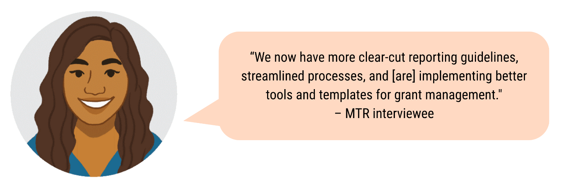

DFAT regional programs

DFAT regional grants have mobilised large UN agencies to deliver established programs in the Pacific, with five major programs accounting for over 40% of total PWL program funding. These initiatives align with the Women's Rights Realised and Women's Leadership Promoted outcomes and include United Nations Population Fund (UNFPA) Transformative Agenda (SRHR), UN Women Pacific Partnerships to End Violence Against Women and Girls, UN Women Women's Resilience to Disasters Program, UN Women M4C program (WEE), and United Nations Children’s Fund (UNICEF) Child Protection Program (women's safety). While these programs represent significant investment, evidence regarding UN agency performance and delivery was mixed. Agency reports document activities, but five partners from across the PWL portfolio suggested some agencies lacked capacity and were underdelivering.

Despite substantial funding allocation, the UN programs operate relatively disconnected from the rest of the PWL portfolio, with minimal collaboration between UN partners and other program components. Two Posts, PWLES Advisors, and Quality Technical Assurance Group (QTAG) staff reported having no visibility of regional programs and no clear mechanisms for collaboration with these partners. This sentiment was echoed by three regional partners who expressed feeling marginalised, with one noting*: "I feel we are on the margins, and we get invited once a year to these meetings [ARAW] and then we have to figure out what is happening."*

The geographical distribution of DFAT's five largest regional programs reveals a strong focus on Melanesia with limited coverage of other Pacific subregions. All five programs operate in the Solomon Islands and Vanuatu, and four operate in Fiji. Only two programs operate in four countries, while two others operate in up to nine countries. This concentration has led some partners, particularly in the North Pacific, to question why these regional programs aren't present in their countries, suggesting a need to reassess expectations and enhance monitoring to ensure appropriate scale and impact across the entire region.

Sports programs supported through DFAT regional funding have enabled 119 women to assume leadership roles in sports contexts, though evidence for assessing their effectiveness was limited. These organisations initially had minimal quality outcomes data, prompting PWLES to mobilise a QTAG advisor to strengthen their MEL capacity. Partners have reported improvements in outcomes reporting, which should provide more comprehensive evidence of program impacts by the end of the funding period.

Women’s Funds

The Women's Funds have emerged as an effective grant-making and wrap-around support mechanism for CSOs across the Pacific region. Their funding processes are notably faster and more accessible to small CSOs that may lack the institutional capacity to successfully apply to other grant makers, with the UAF Asia & Pacific providing urgent funding to individuals and organisations, and the WFF delivering core funding within relatively short timeframes. The PFF growing institutional capacity positions it well to provide grant funding to CSOs efficiently and at scale in the future, offering an alternative mechanism to fund CSOs quickly across the Pacific through a Pacific-owned organisation. Together, Women's Funds have engaged more than 194 women's organisations, groups, or coalitions, demonstrating significant reach and impact potential.

The Women's Funds have been particularly effective in reaching under-served areas where PWL coverage has been limited, especially feminist and women-led organisations in the North Pacific. PFF initiated its grant program in July 2024 with an invitation-based approach targeting feminist and women's organisations in small island states and territories. Additionally, the Women's Funds’ grant making strategy has supported North Pacific-based feminists to attend significant regional and global events such as the Asia Pacific Feminist Forum and the upcoming Association for Women's Rights in Development (AWID) Forum, expanding Pacific women's representation in international spaces.

Output data indicates the Women's Funds are on track to contribute to women's leadership promotion and rights realisation outcomes, supporting more than 2,700 women to participate in leadership training, providing financial and/or business development services to over 3,500 women, and delivering sessions on gender issues and women's equal rights to more than 8,000 women and 3,000 men. The Funds have also demonstrated a commitment to continuous improvement, engaging in research to better understand needs, challenges, and opportunities when lacking sufficient information about specific issues, regions, or communities. This proactive approach has helped the Funds design strategies and allocate resources that are responsive to on-the-ground realities, though outcomes from many CSO activities are still emerging.

Pacific Feminist Fund

PFF’s growing institutional capacity means it is well positioned to provide grant funding at much greater scale in the future. This provides a new mechanism to fund CSOs quickly, across the Pacific, by a Pacific-owned organisation. PFF was still in the establishment phase and had limited grant making experience at the time when PWL was designed. However, in the past two years PFF has undertaken several institutional building efforts and has delivered its first round of funding. Progress reports and consultations indicate these processes have proceeded well so far, and the final evaluation should provide more confidence about PFF’s capacity to deliver grants on a much greater scale.

PFF have reached new donors through the collective action of Amplify Invest Reach (AIR) partners and other Women’s Funds. Women’s Funds Asia connected PFF to the Foundation Chanel for a three-year grant. By linking and connecting, the AIR Partnership is demonstrating and fostering solidarity and amplifying the impact of gender equality movements.

Table 2. Women’s Funds within the PWL modality

| Women’s Funds | Reach | DFAT investment | Description |
| --- | --- | --- | --- |
| Urgent Action Fund Asia and Pacific (UAF A&P)  (2021-2025) | Pacific | AUD4.3 million | Rapid response and feminist fund that mobilises and distributes resources to women and non-binary human rights defenders, activists and their movements to continue their work. Grants are given to individuals and organisations whose funding needs are short-term and / or emergent. |
| Women’s Funds Fiji (WFF)  (2022-2025) | Fiji | AUD5.4 million | Funds and builds the capacity of women’s groups, organisations and networks in Fiji to expand and enhance work on gender justice and human rights. Grants are provided for direct, core funding in support of the organisation’s independence to decide how and where to use resources. |
| Pacific Feminist Fund (PFF)  (2023-2026) | Pacific | AUD1.2 million | The inaugural grants target small and smaller island states and territories through an invitation-based call to feminist and women’s organisations. |

PWLES

PWLES grants and wrap-around support has been effective and well received by partners. PWLES provides grants and wrap-around support to the BOP program, three programs in Tuvalu, and (until November 2024) the We Rise Coalition. PWLES grant management and support to these partners has been highly effective. Partners from BOP, We Rise Coalition, and the Long-Term Advisors (LTAs) were complementary about the grant management and timing, two-way communication, responsiveness and understanding. The BOP and PWLES teams share an office in Suva, which supports strong linkages and support where required. The effectiveness of PWLES’ support was such that other grantees – particularly under DFAT regional programs – have requested PWLES’ support.

Quote: “‘Working with PWLES: we appreciate their support. There is two-way communication, and they help ensure our program meets the contractual side.” 
– We Rise Coalition, MTR consultation

DT Global staff said that the design for PWLES, rather than SPC, to fund the BOP program worked well because the program’s political nature was more suited to a managing contractor rather than a regional organisation such as SPC: “*When PWL started, BOP advocated for it to remain under ES. As the ES contractor mechanism allowed the program to continue to be political’’ -* DT Global MTR interviewee.

PWL Governance Board

The PWL Governance Board's grant making processes have faced significant delays, preventing contribution to program outcomes during the MTR review period. With responsibility for distributing AUD 5 million in discretionary funding, the Board's Terms of Reference directed funds toward regional and multi-country initiatives or organisational coalitions, with an emphasis on innovation.

The Secretariat and Board also co-produced a Guidance Note to assist in grant direction. However, at the time of the MTR, no grants had been announced, making it not possible to determine the extent to which Board funding complements other component grant making or fills existing gaps.

Multiple factors were identified as contributing to these delays, including:

* The Board was not equipped to deliver a grant making process. The Board appointed SPC to manage the grants as part of the secretariat role but did not align the grant making process to SPC’s Stream A or B grant processes.
* The Board Secretariat did not provide enough information to support informed decision making.
* Board meetings are infrequent, and the Board members made limited use of out-of-session meetings to speed up the grant making process. Some Board members felt that the infrequency of meetings hindered their ability to direct funds towards emerging issues, as the board meets twice per year, but other partners noted that out-of-session meetings were available to speed up the process.
* The Board’s grant decisions triggered additional oversight to ensure transparency of the decision-making process, which contributed to the delays.

Furthermore, the review highlighted evidence of misaligned understanding regarding the funding's purpose. During the MTR, questions were raised about the appropriateness of Board members endorsing proposals linked to organisations with which they were affiliated. While these instances were managed within existing procedures, this wasn’t always publicly understood. Similarly, divergent views emerged regarding whether discretionary funding should be directed toward existing DFAT-supported programs, reflecting broader differences in opinion about how best to use these resources to drive innovation and progress gender equality across the region.

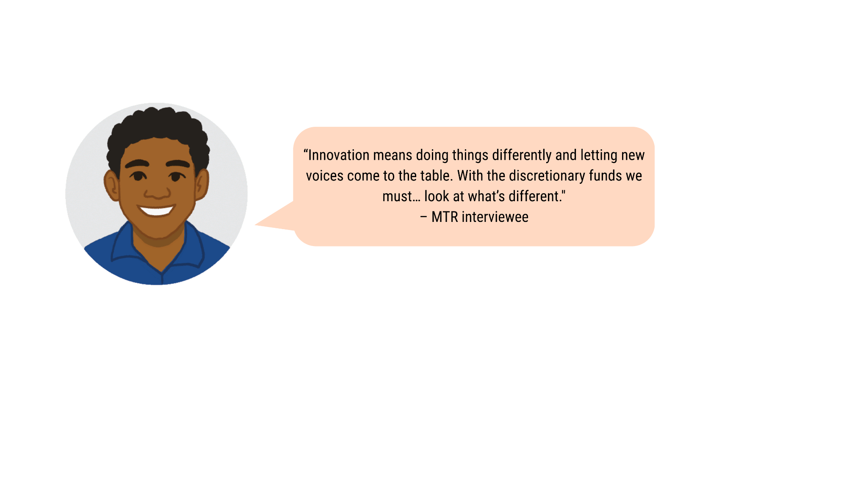

DFAT bilateral program

The DFAT bilateral gender-targeted grants contribute significantly to PWL outcomes, with more than AUD68 million (Table 3) allocated so far. Bilateral grants are focused on eight countries with the most funding for PNG Women Lead. Bilateral programs align well with the outcomes Women’s Rights Realised and Women’s Leadership Promoted, and several large programs have demonstrated significant reach. This review did not assess the effectiveness of all bilateral grants.

DFAT bilateral programs refer to gender targeted programs (not bilateral programs where gender inclusion is mainstreamed) funded and managed by DFAT Posts. DFAT bilateral gender-targeted programs are considered within PWL, although the grants are not counted under the PWL funding amount (AUD170 million). Data and reporting from DFAT’s bilateral programs contribute to PWL’s MEL system and PWL’s annual progress reporting. PWLES provides support to Posts upon request.

Bilateral programs demonstrate strong alignment with PWL outcomes focused on Women's Rights Realised and Women's Leadership Promoted, with 70% of grants targeting women's safety, 11% supporting women's economic empowerment, and 13% funding leadership initiatives.

While bilateral programs have reached over 135,000 people (with PNG Women Lead accounting for more than half of these outputs), most outcomes to date have come from novated programs that existed before PWL. Facility interviewees noted that these continued programs have progressed noticeably and delivered many activities. Although many Posts have developed Gender Country Plans to ensure coordination and inform future funding decisions, QTAG members, Advisors, and Facilities indicated it's too early to attribute outcomes to these plans.

Interviews with staff from three Posts suggested that many would have developed women's safety service programs regardless of PWL guidance, raising questions about the extent of PWL's influence on Post programming decisions.

Table 3. Overview of DFAT bilateral grants for gender-targeted programs (Source: PWLES database)

| Country | Projects | Grants (all AUD) |
| --- | --- | --- |
| Papua New Guinea | 17 | $28.3 million |
| Tonga | 9 | $9.1 million |
| Vanuatu | 2 | $9.1 million |
| Solomon Islands | 8 | $8.5 million |
| Fiji | 29 | $7.9 million |
| Samoa | 6 | $3.8 million |
| Kiribati | 7 | $2 million |
| Tuvalu | 3 | $0.1 million |
| **Total** | **81** | **$68.8 million** |

Bilateral funding to the North Pacific is limited. Just 3% of bilateral grants for gender programs went to the North Pacific (AUD0.1 million outside of Kiribati). Posts and Advisors in the North Pacific said there are limited funds and services available in the North Pacific for gender, and these governments generally relied on donor funds for programming and activities. SPC and the Women’s Funds’ strategies to focus on the North Pacific had the effect of complementarity by filling a gap in bilateral funding to this region.

Effectiveness of convenings

Convenings have been a critical strategy for gender mainstreaming, women's leadership, and women's rights advancement at regional and local levels. The evidence confirms these gatherings are both relevant and effective, enabling shared collaboration, learning, inclusion, and supporting transformational change. PWL has demonstrated commitment to diversity by bringing together a wide range of participants and presenters, including government ministries, CSOs, CROP agencies, women's funds, and representatives from disability, youth, and LGBTQIA+ communities. This inclusive approach promotes valuable linkages between key stakeholders and serves as a critical enabler of the program's effectiveness.

SPC

SPC was widely regarded throughout consultations as holding a unique convening power in the region, attributed to its mandate, geographical reach, reputation, and trusted relationships with member governments and CSOs. This unique position enables SPC to bring together diverse partners, fostering collaboration and knowledge sharing across the region. As one interviewee noted, *"SPC's ability to bring member governments together as well as CSOs from the PWL arm to talk about gender equality efforts in the region"* represents a key strength. With PWL funding support and the integration of the PWSPD team, SPC's convening role has been enhanced, with another interviewee observing that "*Requests are coming through knowing that PWL is [integrated] here."*

SPC has supported, hosted and contributed to critical conversations and convenings around gender equality in the region in line with gender mainstreaming, women’s leadership, and women’s rights realised. Examples include the three-day symposium on 'Safe and Equal Online Spaces' held in September 2023 in collaboration with Australia’s eSafety Commissioner, which brought together over 130 participants from various Pacific countries and organisations, support for the 15th Triennial Conference of Pacific Women and 8th Pacific Ministers for Women Meeting, 2nd Micronesian Ministers for Women Conference, 7th Pacific Regional Conference on Disability, 3rd Pacific Human Rights Conference on SOGIESC (sexual orientation, gender identify and expression, and sex characteristics), biannual WEE Roundtables, Women Deliver, and the Pacific Feminist Forum. The impact of SPC's convening role is evident in the outcomes of these gatherings. For instance, the 'Safe and Equal Online Spaces' symposium resulted in the development and endorsement of the region's first TFGBV Priorities Document, which has since been integrated into eSafety Commissioner’s TFGBV training for frontline workers in the Pacific and endorsed as a key regional priority by Pacific Ministers for Women at Triennial.

SPC contributed to collaborative women’s leadership initiatives such as collaborating with PIFS and the Pacific Islands Development Programme to establish the CROP WOW network, which fosters leadership among women employees in the CROP agencies. This network has inspired similar initiatives, and SPC’s engagement has strengthened understanding of gender mainstreaming practices across CROP institutions through sharing the experience of the Gender Equality Flagship. Internally, the SPC Gender COP has been pivotal in breaking down silos and enabling cross-divisional resource-sharing. SPC has also made strides in fostering internal advocacy for gender equality.

SPC has co-funded and co-convened the ARAW with PWLES. While the positive outcomes from ARAW are undeniable and were shared widely throughout consultations, it has led many partners to reflect on the need for strengthening national-level coordination in gender equality initiatives. SPC's mandate for responding to this need is by *"enabling rather than directing, with a clear transition plan towards national funding and ownership",* and only by request or invitation by a national government.

SPC is also credited by several interviewees as being able to create safe spaces for unpacking complex questions related to gender equality and culture in the Pacific context, for example during the technical panels on gender and culture at the Festival of Pacific Arts and Culture (FestPAC). This capability tool is particularly valuable given the region's diversity, contributing to inclusivity. SPC enhances connections between CSOs and governments, which can influence mindsets, policy agendas, and rhetoric. The organisation's approach *"Facilitating key discussions and using these to enhance connections between CSOs and Governments, and subsequently influence mindsets, policy agendas and rhetoric"* demonstrates its role in bridging the gap between civil society and governmental bodies.

PIFS

PIFS plays a crucial regional convening role for gender mainstreaming across the Pacific, with PWL providing support for several key initiatives. As custodian of the revitalised PLGED, PIFS convenes the PIFWLM and leads on the 2050 Strategy for the Blue Pacific Continent. PWL funding enables PIFS to organise the PIFWLM, the Pacific Regional Disability Conference, implement outcomes from these meetings, and engage at significant multilateral forums including the CSW, CEDAW, and the Conference of States Parties to the Convention on the Rights of Persons with Disabilities (CRPD). A notable achievement in 2024 was the first-ever co-convening of the Triennial Conference of Pacific Women and 8th Pacific Ministers for Women Meeting with the PIFWLM, as a partnership between SPC and PIFS. All of these activities contribute to PWL outcomes.

Despite these coordinated efforts, there was disappointment regarding the absence of gender-related outcomes in the PIFS Leaders Communiqué despite strong partnerships on gender equality at the social policy level, which failed to acknowledge the significant work accomplished at the Triennial, including health outcomes for women and girls. This omission occurred despite gender being reflected on the agenda in the previous two years and the endorsement of the revitalised PLGED in 2023.

While the efforts of SPC, the PIFS social policy team, and stakeholders were commendable, the lack of visibility of gender priorities in PIFS Leaders' communications suggests a need to reexamine how the program and key partners can better support the elevation of gender priorities through key forums, particularly through integration into the Leaders' agenda.

Women’s Funds

PFF also supported convening of Women Deliver 2023. As part of the Oceanic Pacific Organising Committee, PFF actively participated in the program development, identification of Pacific delegates and in drafting the outcomes documents for the two meetings that took place in Fiji and in Australia. This support was in collaboration with SPC’s Principal Strategic Lead – Pacific Women and Girls as co-chair of the Pacific Regional Convening Committee. This collaboration led toa cohesive set of messages that the Pacific delegates used to engage in the Women Deliver conference in Rwanda.

The Women’s Funds are supporting linking of Feminist activists across Pacific and Global platforms. For example, the Women’s Funds’ grant making strategy has supported Northern Pacific based feminists to attend the Asia Pacific Feminist Forum (Sept 2024) and the upcoming AWID Forum (Dec 2024). The inclusion of North Pacific based organisations in the partnership’s strategy enabled the Women’s Funds to find specific regional and global spaces to support the inclusion of northern based organisations.

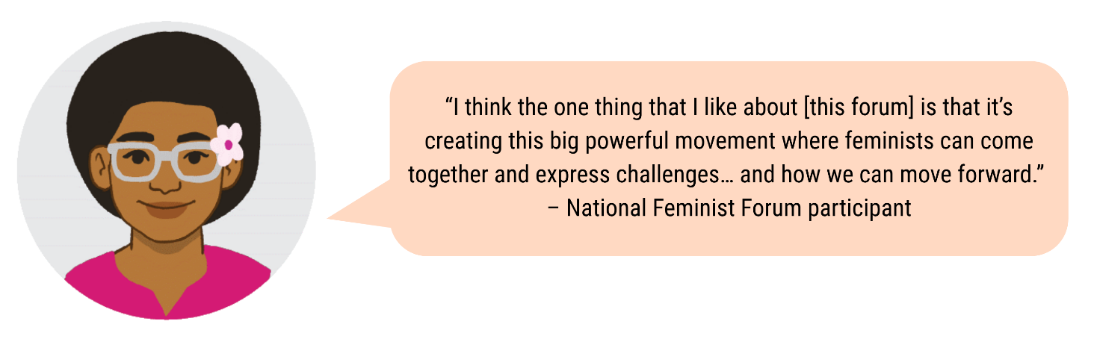

DFAT regional and bilateral programs

DFAT regional programs have supported a range of strategic convening efforts throughout the Pacific, enhancing coordination across different thematic areas. The UNFPA Transformative Agenda supported country SRHR committees and comprehensive sexual education steering committees in four countries, while the Pacific Partnership to End Violence Against Women and Girls (PPEVAWG) program delivered the Regional Services Symposium for women's crisis centres with over 100 representatives and coordinated emergency preparedness between services, CSOs, and national women's machineries in four countries. Additionally, the Women’s Resilience to Disasters (WRD) program convened a gender and social inclusion technical working group supporting the Framework for Resilient Development in the Pacific, and the M4C program facilitated convenings of market vendor associations, local councils, and governments at provincial and national levels in four countries.

While this review didn't specifically examine DFAT Posts' contributions to gender equality convenings at the national level, interviews revealed a notable example from Samoa, where the bilateral investment facility convened a roundtable meeting with the Ministry of Finance, key ministries, and CEOs to discuss Gender Equality, Disability and Social Inclusion (GEDSI) in the Samoan context. These convenings demonstrate DFAT's multilevel approach to facilitating dialogue and coordination on gender equality initiatives across the Pacific region.

Technical support and gender mainstreaming

Note that this focuses on technical support provided by the component leads (such as SPC’s support to member governments) and does not focus on partner technical support to Pacific communities (such as a SPC grantees’ technical support through their projects). Technical advice and support for gender mainstreaming across the Pacific has been highly effective through PWL components, with SPC, PIFS, PWLES, and DFAT programs all providing tailored assistance that has strengthened institutional capacity, supported policy development, and enhanced government engagement. The evidence demonstrates significant improvements in gender mainstreaming capabilities at both regional and national levels, with concrete examples of changed attitudes, policies, processes, and resourcing that respond to partners' specific needs. These coordinated efforts have embedded gender equality considerations in key regional frameworks and strengthened the capacity of Pacific Island country governments to contribute gender perspectives in decision-making processes.

**SPC**

Support for SPC gender mainstreaming

SPC has implemented comprehensive internal measures to improve technical capacity and mainstream gender across its organisational structure. Central to these efforts is the establishment of the Principal Strategic Lead – Pacific Women and Girls role and the SPC Gender Equality Flagship, which follows a two-pronged approach: internal institutional strengthening and gender equality initiatives across divisions to serve SPC members. As one staff member noted, SPC's tailored technical support approach is "*fit for purpose,"* building vital capabilities within the organisation with evidence of changes in attitudes, policies, processes, and resourcing to respond to partner needs.

Through PWL funding, SPC has strengthened its operational capacity for gender mainstreaming by supporting in part or in full over 50 positions across its programs, including advisors in the Maritime and Energy sectors. This support extends to policy and procedural enhancements, including the development of a tiered grant system with Protection from Sexual Exploitation, Abuse, and Harassment criteria to support safe partnerships. SPC has further invested in capability-building for its staff through CEDAW workshops and policy sessions. Intersectional inclusion is integral to SPC’s approach, with partnerships with the Pacific Youth Council and National Youth Council to elevate voices of adolescent girls and marginalised groups, such as SOGIESC and disability communities, and feeding through existing SPC initiatives such as Funding with Intent and Pacific Peoples Advancing Change.

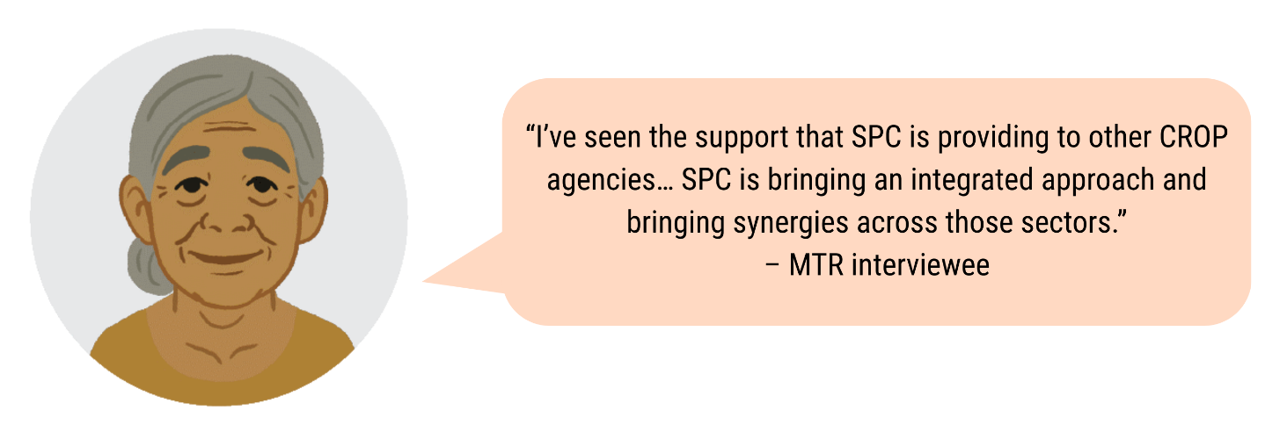

Technical advice and support to external stakeholders

SPC serves as the custodian of the Pacific Platform for Action for Gender Equality and Women's Human Rights (PPA), a critical roadmap for advancing gender equality in the Pacific. The PPA serves as a guiding framework for policy and actions in Pacific Island countries and territories, supporting the implementation of national, regional, and international commitments to gender equality. It provides a structure for prioritising strategic approaches and is reviewed and updated regularly to reflect the evolving needs of the region. This responsibility aligns with SPC's broader mandate to support regional gender equality goals and complements other significant frameworks including the Revitalised PLGED and the Sustainable Development Goals. SPC actively uses the PPA to benchmark progress through the Triennial Conference of Pacific Women and works with PIFS on collaborative reporting processes to implement the PLGED MEL Plan. This partnership approach has successfully increased engagement from CSOs and strengthened regional coordination on gender equality initiatives.

SPC provides essential support to Pacific national governments through relationship building, technical assistance, and targeted funding. Through Stream A grants, SPC works directly with member governments to understand their specific needs and tailor support accordingly. Notable examples include assisting governments with Beijing Platform for Action (BPA)+30 reporting and providing technical assistance for developing gender-responsive policies and legislation that promote women's human rights in alignment with key regional and international agreements. As one government interviewee emphasised, *"the PWL program's proportion that is sitting in SPC is purposeful. It has the most reach into government spaces."*

SPC’s comprehensive approach includes funding Country Focal Points for EVAWG in member governments, facilitating collaboration between communities and state governments to address gender-based violence. SPC has also significantly advanced gender research and data accessibility by transitioning over 300 datasets to the Pacific Data Hub and managing the Toksave Pacific Gender Resource portal. Additionally, SPC funds a gender statistics advisor who developed a gender dashboard aligned with the regional gender statistics roadmap, strengthening evidence-based decision-making across the region.

SPC facilitates national and regional engagement through supporting initiatives like the Ainikien Kora Forum in the Republic of Marshall Islands as they prepared to chair the 15th Triennial Conference in 2024, and regional learning exchanges on gender legislation including the CEDAW (Convention on the Elimination of All Forms of Discrimination Against Women) Learning Exchange and Regional Working Group on Family Protection Legislation. They also supported the 2nd Micronesian Ministers for Women Conference in Nauru under the theme 'Eõ Ngage - Eõ Yaran - Añ Towepo.' These efforts reinforce regional commitments and strengthen a collective approach while promoting integration across sectors. All interviewees from national governments reported responsive and efficient engagement at the national level.

PIFS

PIFS plays a critical role in providing technical support for gender mainstreaming in regional and national initiatives across the Pacific. As the custodian of the PLGED and convenor of the PIFWLM, PIFS leads on the 2050 Strategy for the Blue Pacific Continent while ensuring alignment of regional gender equality policy work. Their efforts have successfully mainstreamed gender equality and embedded social inclusion in both the 2050 Strategy and its Implementation Plan, while also aligning PPA with PLGED efforts. PIFS engages directly with Ministers for Women, who are instrumental in mainstreaming gender equality within their respective countries and has notably supported an increased number of male Ministers who now champion gender equality action throughout the region.

PWLES

PWLES has effectively supported gender mainstreaming through the QTAG and three embedded technical advisors. The LTAs have successfully targeted and responded to capacity gaps in Pacific Island country governments, providing ongoing technical support to Tuvalu and the FSM for both gender mainstreaming and targeted gender programming. This support has significantly enhanced local capacity, as evidenced by feedback from Tuvalu officials: *"Technical support is very helpful and the capacity building for the Gender Affairs Department in Government. Before [the support], when we were invited to meetings, we were just there to attend before, we didn't contribute because we did not understand but [the LTA] has helped us so much and now we are able to contribute and give gender perspectives."* Multiple partners acknowledged the need for increased support, noting the early stage of appreciation for gender mainstreaming objectives across Pacific ministries.

The QTAG has proven to be an effective mechanism for responding to technical support requests from diverse partners. Comprising 55 advisors and regularly updated to meet emerging needs, the QTAG complements SPC's capacity by providing independent technical advice to SPC and DFAT streams of PWL.

Since the program's inception, QTAG specialists have delivered over 43 projects in a timely manner, including Gender Country Plans for eight countries, GEDSI analysis and strategy work, gender mainstreaming training, annual work planning, technical support to governments, and assistance to sports program partners. All interviewed partners, including sports organisations, spoke positively about QTAG support and their engagements with the PWLES team. As noted in the DT Global Effectiveness review: *"The QTAG has been effectively managed, including having a dedicated coordinator who is supported by a GEDSI specialist. QTAG's implementation strategically embodies principles of collaboration, contextual appropriateness, and engagement, recognising the value of working with diverse experts to deliver culturally responsive and programmatically relevant support to partners across the Pacific."*

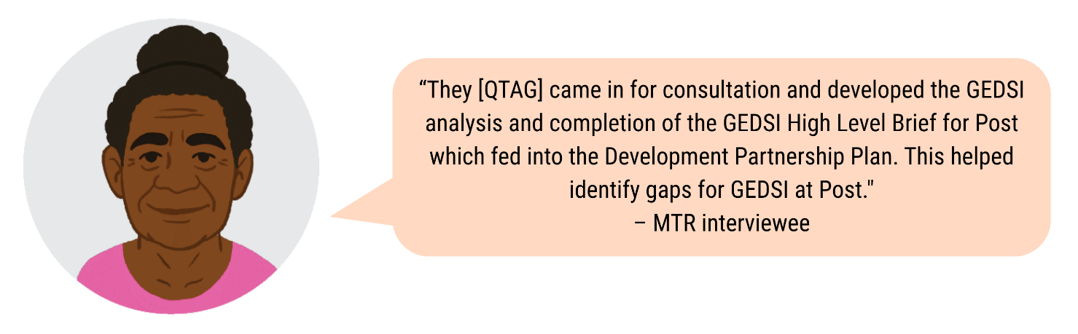

PWLES has demonstrated a commitment to increasing Pacific representation within the QTAG, aligning with the program's Pacific ownership outcome. Currently, 40% of QTAG members are Pacific Islanders, with PWLES actively working to increase this proportion. PWL has thoughtfully reflected on the challenges of increasing Pacific representation, recognising both the strategic need for Pacific insights and the practical difficulties faced by Pacific-based gender specialists when committing to short-term advisory engagements with irregular income. This intentional approach to improving representation has resonated with partners, with one Women's Funds partner reporting an increased likelihood of engaging the QTAG as a result of these efforts.

PWLES has evolved its approach to Pacific representation, moving away from the early design proposal of an *"emerging panel*" of Pacific specialists that they felt problematically *"designated Pacific-nationals as 'emerging' [and] did not reflect their extensive experience or cultural competence."* Instead, PWLES now includes professional development opportunities in Terms of References. Two Pacific QTAG members have acknowledged PWLES' contribution to their professional development, including opportunities to take leadership roles on projects, collaborate with QTAG staff for peer-to-peer learning, and participate in peer reviews. Additionally, PWLES has provided effective technical support to DFAT Posts through the QTAG, country briefs, and ongoing advice in response to specific requests, though it's worth noting that PWLES has no oversight on the extent to which Posts implement the Gender Country Plans.

DFAT bilateral and regional programs

Technical support for gender mainstreaming has been delivered through various DFAT channels with notable impact. There was moderate evidence of Posts delivering technical support. Two bilateral programs interviewed have provided training on gender mainstreaming for key government departments, and several Posts developed Gender Country Plans (GCP) which include support for mainstreaming gender at the country level. PWLES and SPC supported GCP development for some Posts. DFAT regional programs have delivered substantial technical advice to drive both service improvement and social norms change, including training, resources, and behaviour change communication that have demonstrated wide uptake and positive outcomes for service providers and communities (Table 4).

Additionally, the WRD program also supports gender mainstreaming within global UN systems, strengthening gender integration in DRR mechanisms such as UN system’s plan of action on DRR.

Table 4. Overview of technical assistance delivered by large UN programs

| Program | To service providers | Social norms change |
| --- | --- | --- |
| Transformative Agenda (UNFPA) | Develop and deliver training, service guidelines, and resources for health care workers and midwives in family planning. | Training for schoolteachers in family life education (FLE) and comprehensive sexuality education (CSE). Behaviour change communication, radio messaging, and strategies to engage influencers within communities around family planning. |
| Pacific Partnership to end violence against women and girls (UN Women) | Develop and deliver training for crisis centre service providers, domestic violence counsellors. Develop policies and decision-making processes for the Ministry of Education and schools on violence against women. | Social citizenship education, training, toolkits and community mobilisation including whole of school programs to address gender norms. |
| Women’s Resilience to Disasters (UN Women) | Targeted training for government, CSOs, businesses and community on early warning systems, resilient businesses, and inclusive disaster management. General resources including the global WRD Knowledge Hub. | Resources and training to support advocacy efforts. |
| Markets for Change (UN Women) | Capacity building and resources for market vendors. | - |

Women’s Funds

The Women’s Funds and their partners have advocated for and supported delivery of agreed commitments, such as the Fiji Ministry of Women’s National Action Plan. The Women’s Funds and partners have also engaged and advocated in select forums, including CSW and Women Deliver.

PWL Governance Board

The PWL Governance Board Terms of Reference indicated that the Board would *“Receive reporting on outcomes, share learning, provide advice”* to Women’s Funds, SPC, DFAT partnerships with UN agencies, and DFAT bilateral programs. The review found that the board has not issued any advice to partners in line with this intent.

Portfolio-level MEL

The Portfolio-level MEL system, designed in 2022 with input from over 60 stakeholders and refined in 2023, has become an essential driver of PWL stakeholders' ownership of evidence and strategic direction. The ARAW has supported Pacific ownership by authentically involving partners in shared sensemaking and generating recommendations that inform the program's future direction. This approach has streamlined reporting requirements for partners, enabling them to dedicate more time to project delivery while fostering learning, collaboration, and increased awareness of disability inclusion needs.

The system effectively integrates diverse data through component-specific templates into a comprehensive database, with critical support from PWLES and SPC ensuring high-quality inputs. The ARAW has grown from a small pilot in 2023 to engaging over 120 partners by 2024, establishing itself as a vital collaboration forum.

Concrete impacts include identifying North Pacific funding gaps in the 2023 ARAW, leading to increased attention from Women's Funds through the AIR partnership investment and targeted engagement processes; driving disability inclusion by requiring partners to measure and report on reach to people with disabilities and adopt inclusive tools like the Washington Group Short Set of questions. The Pacific-authored PWL Formative Situational Analysis exemplifies how portfolio MEL grounds evidence and strategic planning in Pacific knowledge and context.

Despite successes, some partners have noted areas for improvement, particularly regarding enhanced representation of contexts like Papua New Guinea, which has significant engagement across program streams including Women's Funds, government grants, CEDAW initiatives, and Pacific Girl partnerships. Overall, this responsive, collaborative approach has proven to be a powerful mechanism for advancing program objectives while maintaining Pacific ownership.

KRQ3. What are key opportunities and barriers for the PWL program to achieve transformational change?

This review highlighted considerable work done against all four quadrants of the Gender at Work framework. The most work has focused on improving capabilities and supporting resources. Partners have delivered lots of work to address social norms but there is limited evidence of social norms change at this stage. PWL is delivering many efforts to contribute to formal rules and policy efforts, and there are opportunities to further strengthen these efforts. In particular, the lack of formal country-level coordination has limited visibility and the collaborative impact necessary for transformative change.

PWL understands transformational change through the lens of the Gender at Work Framework by Rao and Kelleher (<https://genderatwork.org/analytical-framework/>), which identifies drivers and conditions for transformational change in gender equality and social inclusion. This framework highlights four interconnected areas: consciousness and capabilities, resources, informal norms and exclusionary practices, and formal rules and policies, as shown in Figure 3. PWL's central logic is that strategies targeting all four areas are necessary for achieving long-term, sustainable positive impacts on the lives of diverse women and girls in the Pacific. While PWL acknowledges the framework's usefulness, it advises against rigid application, instead suggesting it should inform the design of new activities and guide monitoring and evaluation efforts.

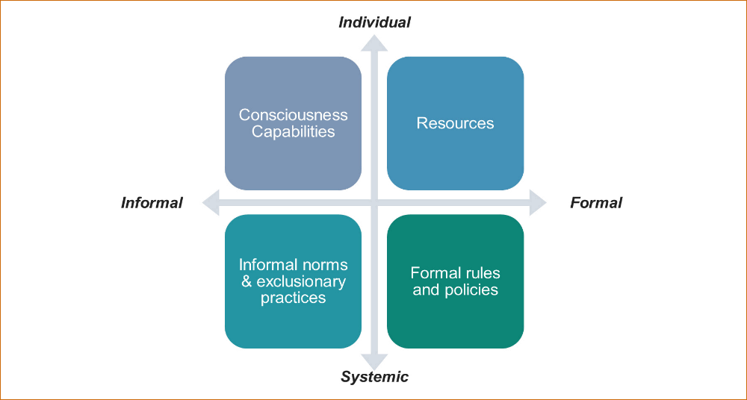

Figure 3. Gender at Work Framework (Source: PWL)

Key overarching barriers to transformational change

* **Lack of formal country-level coordination:** The absence of a dedicated mechanism for national coordination limits collaboration and visibility. This has led to fragmented efforts and duplication of gender equality initiatives.
* **Limited awareness among stakeholders:** Some DFAT Posts and partners are unaware of available country briefs and MEL dashboards. This has resulted in missed opportunities for leveraging existing data.
* **Need for a national convening body:** Ministries of Women and DFAT Posts may not have the capacity or intent to act as national coordinators for gender equality efforts. Without a clear convener, collaboration across sectors remains inconsistent.
* **Disconnection between regional and bilateral efforts:** DFAT regional partners and PWL initiatives operate in silos, reducing synergy. Improved coordination could enhance cross-country learning and program effectiveness.

Key overarching opportunities for transformational change

* **PWL should integrate into the broader gender equality ecosystem:** A holistic view beyond DFAT-funded initiatives is necessary for impact. Engaging with regional feminist movements and other donors can enhance program sustainability.
* **Need for national-level convening and coordination:** Strengthening local structures would enhance Pacific ownership and collaboration. For example, establishing national gender equality roundtables could facilitate better coordination.
* **Better alignment of regional and bilateral efforts:** Improved coordination between UN partners, SPC, and PIFS can enhance impact. This includes aligning regional programs with national action plans for gender equality.
* **Strengthening regional linkages:** Aligning with sub-regional mechanisms such as the Melanesian Spearhead Group (MSG) can provide further strategic direction. For instance, leveraging MSG networks to share best practices in gender-responsive budgeting could improve policy outcomes.

Summary of PWL work within each quadrant:

Consciousness and capabilities

PWL employs diverse strategies to enhance consciousness and capabilities in the gender equality field, including targeted training programs on leadership, advocacy, disability inclusion, and policy analysis. It has supported the development of a regional counselling framework for GBV, strengthening survivor-centred approaches. Through platforms like ARAW, PWL fosters continuous learning, collaboration, and evidence-based adaptation. Its initiatives have bolstered confidence and leadership among women and girls, raised awareness of key gender issues, and strengthened national women’s machineries in integrating gender perspectives into policies and programs. Additionally, PWL has been instrumental in building partnerships and networks that drive collective action for gender equality.

Access to resources

PWL strategically allocates resources to improve women's access to financial capital, healthcare, and economic opportunities, recognising these as essential for empowerment. It invests in expanding access to quality SRHR services, including contraception, safe abortion, maternal healthcare, and advocacy efforts. Additionally, PWL promotes women's economic empowerment by supporting entrepreneurship, financial inclusion, and access to decent work through training, mentoring, and financial support. However, delays in grant disbursement from SPC and the PWL Governance Board have hindered resource distribution to service providers in the program's early phase.

Social norms

PWL implements activities to challenge harmful social norms and promote inclusive practices, using strong evidence to guide change while authentically engaging with Pacific culture. Rather than viewing culture as a barrier, PWL harnesses its strengths to advance gender equality, as seen in events like the Ainikien Kora Forum in RMI. The program also supports disability inclusion through initiatives like Girls Arise, which fosters leadership among Deaf girls. While there is some evidence of social norms change, particularly in programs like Balance of Power and shifting attitudes toward SRHR services, inconsistent data collection and mixed findings highlight the need for clearer measurement frameworks.

Formal rules and policies

PWL employs multiple strategies to promote gender-responsive laws, policies, and institutional mechanisms, supporting national women's machineries through grants, technical assistance, and regional learning exchanges. The program also contributes to key gender equality forums and supports the implementation of gender policies, ensuring they translate into practice. PWL has played a role in policy advancements such as the Micronesian Gender Equality Framework and legal reforms in Vanuatu, Samoa, Solomon Islands, and Kiribati. However, weak accountability mechanisms and limited authority of national women’s machineries remain barriers to implementation, highlighting the need for stronger enforcement and improved MEL frameworks to track policy impact.

# Findings – Relevance

KRQ4. How relevant is the whole of portfolio modality and the five components to addressing gender inequality across the Pacific region?

**PWL remains a critical investment into addressing Pacific gender inequality particularly due to the changing global, regional and national contexts in which the program operates. The modality and the five components are well-suited for tackling the deeply rooted issue of gender inequality across the Pacific because it acknowledges the need for a sustained, long-term investment and approach. The components have demonstrated appropriate levels of adaptation to contextual shifts and learnings, assisted by evidence produced by the MEL system and various coordination efforts. PWL has furthermore fostered alignment with existing international gender equality priorities and frameworks through its active engagement in international forums, strategic partnerships with global organisations, and consistent efforts to promote regional perspectives and leadership in global discussions.**

PWLs response to the global, regional and national contexts in which it operates

The global context for PWL has undergone significant changes, with increased backlash against women's rights presenting substantial challenges. The PWL Formative Situational Analysis describes how gender equality is increasingly equated with a loss of Pacific identity and culture, contributing to reduced funding for progressive gender equality programming—with less than 1% of Organisation for Economic Cooperation and Development (<https://womensfundfiji.org/wp-content/uploads/2021/11/FULL-SCOPING-STUDY.pdf>). Implementation of gender-responsive laws and policies remains slow due to low political will and active resistance from senior decision-makers. Australia's continued support, particularly funding to civil society and women's government machineries via the Women's Funds and SPC, is crucial to challenge this backlash through locally directed strategies. Some Pacific countries are currently reviewing their policies through a gender lens, but they often lack baseline data or evidence for context-specific gender analysis. This gap emphasises the relevance of PWLES’s LTA and QTAG support to ensure sustainable and progressive policy reform.

National elections across multiple Pacific countries have resulted in persistently low levels of female participation in government, underscoring the continued need for women's leadership programs. In Fiji, the percentage of female parliamentarians decreased from 20% to 11% after recent elections, while in PNG, PWL supported two women in winning seats in the 118-seat Parliament. While a significant success for the program, the overwhelming minority position of women remains a challenge for gender equality policy reform and progress throughout the region, and challenges of leadership extend beyond official settings. The PWL Formative Situational Analysis on Pacific Ownership highlights the importance of broadening the program’s definition of women’s leadership to improve advocacy for gender equality at the sub-national or provincial as well as informal spaces in recognition of the diverse areas where women can occupy leadership roles.

The changing context further justifies continued investment in WEE, SRHR, and women's safety programs. Labor mobility initiatives like the Seasonal Worker Programme and Pacific Labour Scheme are adopting strategies to address gender disparities by diversifying beyond male-dominated industries, though these efforts introduce potential unintended consequences including family communication breakdowns and conflicts related to finances that have sometimes led to gender-based violence. Additionally, as noted in PWLES's 2023 annual report, while COVID-19 sparked examples of women's innovation and entrepreneurship, it also triggered *"profound changes and setbacks"* in gender equality, with increased rates of gender-based violence alongside decreased availability of health services.

Leveraging SPC’s relationship with participating governments as well as DFAT’s oversight of the Pacific Australia Labour Mobility scheme could help ensure that PWL gains deeper understanding of relevant issues to support women’s movement into non-traditional roles while protecting them from unintended harm.

Finally, the Pacific region faces ongoing risks from extreme weather events that disproportionately increase vulnerabilities for women and girls. These unpredictable incidents highlight the importance of the Women's Funds' ability to provide responsive, flexible, and emergency funding to CSOs supporting disaster response efforts. The likelihood of climate-related events across the Pacific underscores the need for PWL to develop a comprehensive climate resilience strategy and integrate climate change approaches throughout its programming to address the unique challenges faced by women and girls during environmental crises.

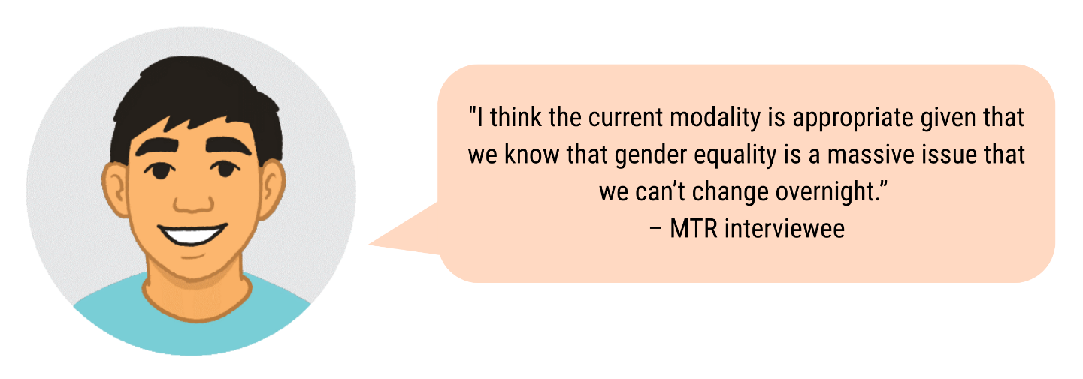

Alignment with international and regional context and priorities

PWL has fostered alignment with existing international gender equality priorities and frameworks. This commitment is demonstrated through its active engagement in international forums, strategic partnerships with global organisations, and consistent efforts to promote regional perspectives and leadership in global discussions. As discussed, SPC and others play a significant role in supporting Pacific governments to prepare for and effectively participate in the CSW. This support includes capacity building, increasing understanding of related international events like COP27, and providing technical and financial assistance to government delegations attending CSW sessions. Collaborative efforts between PWL, PIFS, Pacific governments, and CSOs during CSW67 led to the inclusion of language in the final outcome document that specifically addresses Pacific priorities. For example, the region successfully advocated for the inclusion of “maritime areas” and “islands” to highlight specific vulnerabilities faced by Pacific Island nations.

SPC also works with Pacific governments to fulfil their obligations under CEDAW. This includes organising a learning exchange with CEDAW committee members to strengthen the capacity of government officials in implementing CEDAW recommendations. This engagement underscores PWL at SPC’s dedication to supporting the implementation of international conventions and treaties at the regional level. Through these various engagements, SPC effectively bridges regional and international levels, ensuring Pacific voices contribute to global gender equality frameworks and agendas.

PWL has demonstrated alignment with and responsiveness to existing Pacific regional gender equality priorities and frameworks. PWL supports the implementation of major regional gender equality commitments, including the:

* 2050 Strategy Implementation Plan regional collective actions on gender equality
* Pacific Leaders' Gender Equality Declaration (PLGED)
* Pacific Platform for Action on Gender Equality and Women's Human Rights (PPA).

The program's focus on promoting women's leadership and advancing women's rights in safety, economic empowerment, and health directly corresponds with the priorities outlined in these regional commitments. Both the PLGED and PPA emphasise increasing women's participation in decision-making at all levels and commit to ending violence against women, improving women's economic opportunities, and addressing health issues. PWL's efforts to enhance the effectiveness of regional gender equality initiatives further support these commitments by strengthening regional action, backing key initiatives, and improving coordination among various stakeholders. This alignment ensures that PWL's work is supportive of the broader Pacific gender equality agenda.

PWL also aims to complement and enhance other regional gender equality initiatives. Crucially, PWL engages SPC as the key implementing partner and PIFS. These organisations play complementary but distinct roles in advancing gender equality in the region, with PIFS the custodian of the PLGED and SPC being the custodian of the PPA and convening the Triennial Conference of Women, which serves as the primary mechanism for monitoring progress outlined in the PPA. This contributes towards a continued strong strategic and operational alignment to regional priorities and complement of existing regional processes.

PWL also works alongside Women’s Funds, women’s rights organisations and crisis centres who are leading Pacific feminists and connected with the broader Pacific feminist movements, national women's machinery, international bodies such as the UN agencies, local women's organisations, and civil society as well as bilateral Australian investments in gender equality in Pacific countries. It supports mainstreaming of gender equality across development programs in all sectors and facilitates collaboration between civil society, government, and intergovernmental organisations. By taking this coordinated approach, PWL complements and strengthens overall regional efforts towards gender equality.

Quote: “PWL is a transformation from the previous program... It is looking at the priority needs of Pacific women… diversity is acknowledged but also the need to move in unison…”
– MTR interviewee

Long-term investment built on lessons from previous and current programs

The modality is well-suited for tackling the deeply rooted issue of gender inequality across the Pacific because it acknowledges the need for sustained long-term investment and approach. Gender equality is a complex challenge that cannot be resolved with short-term programs; it demands continuous, evolving efforts that adapt to the region's changing needs and challenges. PWL is built from the investments, lessons and learning of PWSPD, ensuring the modality is relevant to addressing the current context and gender inequality.

These lessons have resulted in the current modality comprised of five components that have been selected to serve diverse needs and sectors across the Pacific gender equality ecosystem. As discussed at length throughout this report, improvements in targeting, outreach and scope continue to evolve through coordinated efforts and entrenched evidence generating systems to ensure that learnings about underserviced areas or poorly performing sectors receive necessary support.

# Findings – Efficiency

KRQ5. To what extent are PWL components efficiently supporting delivery of outcomes?

PWL components demonstrate strong alignment with DFAT's efficiency principles through evidence-based decision making and proportionality, with efficiency particularly evident in dynamic and relational aspects including leadership by outstanding women with deep Pacific feminist connections, strategic knowledge transfer from PWSPD, and a robust whole-of-portfolio MEL system. Despite managing a complex mandate across all five components that includes regional scaling, thematic deepening, and enabling Pacific ownership pathways, the program could benefit from increased coordination and trust between components to establish more cohesive working methods and enhance information sharing—improvements that would further strengthen the already proportional approach to delivering outcomes across the Pacific.

Dynamic efficiency

Dynamic efficiency considers the extent to which a program is improving over time through processes related to adaptive management, innovation and learning. The MTR demonstrates significant learning and improvement in the PWL program at this mid-point, building on lessons from PWSPD. Key improvements include a deeper commitment to Pacific Ownership both in terms of its components as well as the regional coherence as a way to achieve transformational progress towards gender equality. Examples of this include shifting from a conventional MC-led model to a model which embraces partnerships with key Pacific organisations as well as the evolution to a PWL Governance Board which was intended to infuse strong Pacific influence over the program’s strategy and approach to achieving progress towards Pacific gender equality.

The MEL system has contributed significantly to PWL’s dynamic efficiency. MEL related data from each component is inputted into a PWLES-managed database and then summarised by the PWLES MEL team into results charts for stakeholders to review and validate during the ARAW. This evidence is used not only to assess progress towards outcomes but also supports identification of learnings about opportunities and gaps for further PWL focus. This evidence-based approach to learning contributed to increased targeted support to the North Pacific and greater disability inclusion. However, diverse reporting requirements across components cause some challenges for compiling evidence about programmatic effectiveness and opportunities for improvement. For example, CSO grantees spoke about the relative informality of the reporting requirements from the Women’s Funds. Bilateral programs report primarily on outreach and outputs whereas the regional programs provide significant detail about their broader programs, which provides an obscure understanding of PWL-specific influences.

Staff and members across various components supported the previous PWSPD program and brought extensive knowledge about the previous program, organisations and components. These individuals include the support unit staff that transferred to SPC, leadership of UAF-AP and PFF, two board members and one of the MEL staff in PWLES. The infusion of the support unit staff into SPC brought learnings about the program that have helped embed PWL into SPC. However, as discussed previously, challenges resulted from a lack of understanding about the operational differences between SPC and the Managing Contractor which previously ran the Support Unit that resulted in delays in grants distributed to CSOs.

Relational efficiency

Relational efficiency describes efficiencies that result from relationships that protect resources and reduce time and budgetary requirements due to the strength of networks, relationships and trust between parties. PWL represents a collaboration of outstanding women with deep connections, experience, and authority in the Pacific feminist space, forming the foundation of its success. Key figures like SPC's Principal Strategic Lead, who supported drafting the Micronesian Islands Forum Gender Equality Framework, and PWLES's team leader, with trusted relationships across SPC, have been instrumental to PWL's effectiveness. The Women's Funds leaders, respected figures in the Pacific Feminist Movement, further strengthen this collaborative foundation. Good communication and working relationships exist between SPC, PWLES, DFAT Canberra, and the Women's Funds through regular engagement pathways like the ARAW which facilitates portfolio-wide learning and informal communications. Collaborative efforts such as the Women's Funds and SPC working through Women Deliver demonstrate effective partnerships toward shared advocacy goals.

Despite these strengths, challenges in communication and cohesion persist across the program. Communications between the PWL Governance Board and other program components have been notably weak, as highlighted during stakeholder consultations. One focus group discussion participant noted, *"We have not had much engagement with the board."* Board members themselves acknowledge this issue, with one stating, "*We need a bit more visibility so people can understand the role of the Board, so people can demand accountability."* Similarly, DFAT UN regional programs remain comparatively disconnected from the rest of the PWL portfolio, with regional partners feeling marginalised, though they find value in ARAW attendance for networking and peer learning.

The wrap-around support provided by SPC, Women's Funds, and PWLES demonstrates relational efficiency through care-focused relationships that establish effective feedback loops between funders and partners. This approach has led to tangible improvements, with information about administrative burdens influencing streamlined grant reporting processes by SPC and PWLES, while UAF-AP updated grant application processes after identifying language barriers in their forms. The collaborative work has produced concrete results, such as connections made during the 2023 ARAW leading to SPC and UNFPA working together on programming to support adolescent girls. Though regional partners recommend additional mechanisms to facilitate intra-program connections, grantee interviewees generally support these intentional, if slower, ways of working as appropriate for contributing to deep, sustainable outcomes associated with transformational change.

**Spotlight: Integration of DFAT bilateral programs**

PWL's bilateral programs operate with substantial autonomy under direct DFAT post management and different managing contractors (including Tatua, TASP, and PNG PWL), creating ambiguity about their connection to the broader initiative and challenging program coherence. Despite integration efforts through PWLES-convened Communities of Practice and ARAW participation, the program would benefit from more direct engagement between bilateral stakeholders and other gender-focused actors within the same country contexts to enhance collaboration and coordination, potentially through country-level convenings.

Technical efficiency

Technical efficiency describes a state of maximising what is possible within a given level of resources or inputs. PWL operates with an ambitious five-year budget of AUD170 million across five components serving thirteen Pacific countries, pursuing three key outcomes while adhering to Pacific-led development principles.

Despite this scope, the program has managed several cost-intensive initiatives, including North Pacific engagement requiring two-day travel with overnight stays in Honolulu for FSM participants attending the ARAW, increased travel by Women's Funds stakeholders for regional outreach, support for organisations attending the Triennial Conference in Marshall Islands, and substantial funding and technical support from PWL at SPC to the RMI government for hosting the Ainikien Kora Forum (National Women's Forum). This included support to prepare RMI for their role, raise awareness and facilitate discussions about the outcomes and recommendations of the previous triennial, and prepare for the next.

The portfolio-wide MEL system has required significant investment to enable greater Pacific ownership, with extensive advisory and technical support from both PWLES and SPC, alongside a sizeable budget for the ARAW. High demand for these services resulted in PWLES reaching its funding ceiling, necessitating increased selectivity in partner support. As anticipated in the design, which acknowledged early inefficiencies due to "multiple sets of fixed costs to set up multiple arrangements," these challenges have been largely addressed through structural integration and improved systems, including SPC's significant internal reforms to enhance grant policies and processes. Interviewees generally supported this intentional, slower approach as appropriate for contributing to the deep, sustainable outcomes associated with transformational change.

Allocative efficiency

Allocative efficiency points to an appropriate mix of inputs and activities to meet programmatic needs and strategic objectives. PWL's diverse component outreach demonstrates high allocative efficiency with appropriate resource balance across its design. However, implementation has revealed key considerations for future funding rounds. The demand for MEL and gender technical advisory from PWLES and SPC exceeded expectations, with PWLES reaching funding limits that restrict partner support until 2026 and constrain innovation possibilities like country-level analyses. While grant making with wrap-around support has effectively advanced Women's Leadership and Women's Rights, evidence indicates a need for more flexible, multi-year core funding, and notably less funding was allocated to Women's Economic Empowerment compared to other objectives. Strengths-based adjustments have been made, with SPC and Women's Funds directing resources to fill gaps for smaller CSOs, including those in the under-served North Pacific.

The risk of funding duplication remains significant with five grant makers providing funds and setting administrative requirements, though coordination efforts have improved regional coverage and streamlined reporting. Despite these challenges, some CSOs still receive funding from multiple grant makers simultaneously. Convenings and technical advisory have proven particularly appropriate strategies, especially through SPC and PIFS given their regional mandate and networks, contributing to progress in gender equality frameworks, convenings, and mainstreaming at national and regional levels. UN agencies have similarly driven change at national and local levels, with all evidence from this review confirming that convenings and technical advice were effective approaches for advancing program objectives.

# Findings – Cross cutting

KRQ6. How well is the program integrating GEDSI and climate change?

PWL demonstrates strong integration of disability inclusion and intersectional gender equality through systematic approaches, targeted funding, and strategic partnerships, with disability and SOGIESC representation on its Governance Board contributing to more inclusive decision-making. Social inclusion shows good progress in supporting SOGIESC communities through networks and events, though more work is needed to address social norms that create barriers for girls and adolescents. Climate change integration remains moderate, relying primarily on technical support rather than dedicated funding, with opportunities in the second half of the program to develop a program-wide climate strategy and strengthen collaborations with climate-focused organisations.

Disability inclusion

PWL has systematically integrated disability inclusion across its operations through strategic investments and partnerships. The program strengthened disability-inclusive MEL systems by incorporating the Washington Group Short Set questions, developing the Disability Inclusion Guidance Note, and establishing a formal partnership with the Pacific Disability Forum (PDF) through MOUs with both PWLES and SPC. This collaboration produced significant outcomes including disability inclusion learning sessions at the 2023 and 2024 ARAWs, specialised staff training, improved data collection methods, and the development of SPC's Human Rights and Social Development (HRSD) Disability Inclusion Strategy. Collaboration with PDF's Women with Disability Network enabled tailored life skills training for women and girls with disabilities and increased their representation at events like the eSafety Symposium.

Grant partners have implemented targeted initiatives that meaningfully include women and girls with disabilities at the project level. The Fiji Women's Rights Movement's Girls Arise program partnered with deaf organisations to increase deaf girls' participation in advocacy forums and International Women’s Development Agency’s (IWDA) project collaborated with People with Disabilities Solomon Islands to enhance GBV service accessibility. Most PWL partners now routinely serve women and girls with disabilities within their mainstream projects, particularly in women's safety services where people with disabilities are overrepresented. Additionally, a PWLES Advisor provided support for developing disability policies and engagement strategies with OPDs in Tuvalu.

Regional collaborations have expanded disability inclusion efforts across the Pacific through strategic assessments and capacity building. UNFPA-commissioned needs assessments on women and young people with disabilities in Samoa, Fiji, and Vanuatu catalysed concrete actions, including training persons with disabilities as community-based SRHR officers. Urgent Action Fund Asia & Pacific is conducting a disability landscape mapping across the region to identify OPDs, understand their specific challenges, and determine appropriate support mechanisms to inform future granting approaches and engagement strategies with OPDs throughout the Pacific.

Key achievements

* **79** Pacific OPDs actively engaged in projects.
* **Integration of Washington Group Short Set questions in the MEL system**. Establishment of systematic measurement of disability inclusion across programs, enabling accurate tracking of needs and experiences of women and girls with disabilities.
* **Strategic partnership with PDF.** Formalised collaboration providing technical guidance that has strengthened disability inclusion through learning sessions, specialised training, and improved data collection methods.
* **Girls Arise program partnership with deaf organisations**. Increased deaf girls' participation in advocacy forums, including representation at the 51st Pacific Islands Forum Leaders Meeting.
* **Enhanced accessibility of GBV services in Solomon Islands**. Improved physical accessibility and created specialised materials in braille and Pijin for deaf clients at the Family Support Centre.
* **Regional needs assessments on women and young people with disabilities**. Catalysed concrete actions including training persons with disabilities as community-based SRHR officers who now co-lead outreach on disability rights.

Inclusion of women and girls in all their diversities

PWL has systematically integrated inclusion of diverse women and girls across its initiatives and funding approach, demonstrating significant progress in social inclusion. Partners routinely provide inclusive services through mainstream projects, particularly in women's safety services, while targeted initiatives like SPC's Pacific Girl, UNICEF's child protection program, and various awareness-raising projects address specific needs of young girls. The program has established an inclusive governance structure with diverse representation, including youth, disability, and SOGIESC advocates on the PWL Governance Board ensuring diverse perspectives inform program direction.

The Pacific Girl program exemplifies PWL's commitment to youth inclusion and has created pathways for girls' participation in national policy discussions and regional forums including the PIFWLM and PFF. Adolescent girl advisory groups established at the project level ensure youth voices directly influence programs, while SPC provides mentoring for the Pacific Girl Reference Group and provides PWL Youth Working Group members with capacity building in work planning, budgeting, reporting, and M&E. This commitment to youth leadership culminated in establishing a Youth Working Group in late 2023, chaired by the youth representative on the PWL Governance Board.

PWL has advanced SOGIESC inclusion through strategic civil society partnerships that leverage the flexibility of CSOs and Women's Funds to advocate independently from government mandates. Collaboration with the Pacific Sexual and Gender Diversity Network (PSGDN) and the Boutokaan Inaomataia ao Mauriia Binabinaine Association in Kiribati has supported critical events including the Pacific Human Rights Conference on SOGIESC and Fiji's Pride Parade. A notable achievement emerged from the PSGDN-led 3rd Pacific Human Rights Conference, where an SPC speaker's presentation on TFGBV led to its inclusion in the Regional Strategy on Ending Violence and Discrimination Against Pacific Islanders of diverse SOGIESC. The program's influence expanded through DIVA's learning sessions on SOGIESC and climate justice at the 2023 and 2024 ARAWs, while Women's Funds participation in ARAW 2023 resulted in UAF-AP awarding a grant to a foundation working with the SOGIESC community and people living with HIV. Despite these achievements, challenges remain in addressing social norms that create barriers for adolescent girls and in sharing evidence on effective transformative programming across the Pacific.

Key achievements

* **11,832** girls have participated in sessions on gender issues and women’s equal rights.
* **3,446** services have been provided to girls as survivors of violence.
* **93** girls have been supported to assume a leadership role at a community, provincial, or national level.
* **Diverse representation in governance.** Inclusion of youth, disability, and SOGIESC advocates on the PWL Governance Board positions diverse voices to influence program direction and decision-making, creating greater accountability to women and girls in all their diversities.
* **Pacific Girl’s youth empowerment approach.** Implementation of the "nothing about us without us" principle through adolescent girl advisory groups has created pathways for young women's meaningful participation in national policy discussions and regional forums, establishing a foundation for intergenerational leadership.
* **Strategic SOGIESC partnerships and advocacy**. Collaboration with the PSGDN and other organisations has strengthened SOGIESC inclusion, with concrete outcomes like the incorporation of TFGBV in regional strategies addressing discrimination against Pacific Islanders of diverse SOGIESC.
* **Mainstreaming inclusive services across partner programming**. Integration of services for diverse women and girls within mainstream projects, particularly in women's safety services, has helped normalise inclusion rather than treating it as separate or specialised programming.
* **Capacity building for youth leadership.** SPC's mentoring for the Pacific Girl Reference Group and PWL Youth Working Group members on work planning, budgeting, reporting, and M&E has built sustainable leadership capacity among young women, supporting their effective participation in decision-making spaces.

Climate change

PWL demonstrates moderate integration of climate considerations across its programming, primarily through technical support and collaborative efforts focused on gender-responsive approaches. PWL has developed climate change and disaster risk resilience tools which have been adopted by partners. Additionally, DFAT's support to the Women's Environment and Development Organisation has built capacity for National Gender and Climate Change Focal Points in the Pacific, while PWL funding for the Shifting the Power Coalition (StPC) has enabled crisis preparedness training for over 6,520 women across Samoa, Tonga, and Vanuatu. PWL has also supported collaborative work between disability and women's rights organisations to develop inclusive responses to humanitarian emergencies.

PWL's work addresses issues that natural disasters exacerbate, including increased violence against women, diminished economic opportunities, and interrupted health services. Many partners likely have disaster management planning in place, with PWLES and SPC positioned to provide additional support where needed. ARAW discussions have enhanced understanding of intersections between gender equality and climate resilience, as evidenced by support to the Kiribati Ministry of Women for consultations on their National Climate Change Policy. Gender mainstreaming in disaster resilience is also evident in CARE Vanuatu's work with the Department of Women's Affairs co-leading the Gender and Protection Cluster following the March 2023 cyclones, which amplified adolescent girls' voices in humanitarian spaces.

Despite these initiatives, PWL currently lacks a program-wide climate change integration strategy, though steps are being taken to address this gap through convening partner discussions and panels on gender program climate change integration. The StPC specifically addresses gender equality and climate change through the Pacific Owned Women-Led Early Warning and Resilience Systems project, recognising women's disproportionate vulnerability to climate impacts. Stakeholders acknowledge the need for stronger collaboration between PWL and climate-focused organisations like SPREP, with PWL establishing a two-year Gender Adviser role within SPREP to enhance connections. Opportunities exist through SPC's Gender Equality and Climate Change flagship projects to complement PWL interventions by providing technical support to partners accessing climate funding and facilitating knowledge sharing on gendered climate impacts.

Key achievements

* **Integration of gender into climate resilience initiatives**. PNG Women Lead has developed climate change and disaster risk resilience approaches and tools which have been adopted by partner projects; capacity building of Pacific National Gender and Climate Change Focal Points through Women’s Environment and Development Organisation (WEDO) collaboration.
* **Crisis preparedness training**. The StPC has delivered national crisis preparedness training to over 6,520 women across Samoa, Tonga, and Vanuatu, significantly strengthening women's leadership in disaster response and recovery efforts across the region.
* **Strategic collaboration between disability and women's rights organisations**. PWL has facilitated partnerships that develop inclusive responses to humanitarian emergencies, ensuring that disaster planning and response mechanisms address the specific needs of women with disabilities and other marginalised groups in climate-vulnerable communities.

# Recommendations

The MTR team proposes the following recommendations to support further progress towards outcomes for the remainder of the current phase (until end of June 2026) and the next phase (from July 2026).

For remainder of current phase (until end of June 2026)

1. **Improve coordination between PWL components to enhance efficiency and effectiveness**
   1. Initiate quarterly strategic convenings with component leads and key stakeholders, including SPC, PIFS, PWLES, Women’s Funds, DFAT and the PWL Governance Board. These convenings should:
      * provide a formal platform for high-level coordination, strategic planning, and oversight of the Whole of Program (WOP)
      * align with existing regional convenings organised by SPC and PIFS to ensure logistical efficiency
      * establish clear mechanisms within these quarterly strategic convenings for tracking and acting on key decisions made by component leads and key stakeholders to enhance effectiveness.
   2. Enhance the visibility and engagement of UN agency programs by:
      * inviting UN representatives to regular PWL convenings
      * establishing regular information-sharing mechanisms between UN agencies and other PWL components
      * mapping UN-funded initiatives alongside PWL grants to minimise duplication and identify collaboration opportunities.
2. **Strengthen the strategic value of the PWL Governance Board**
   1. Redesign the Board’s Terms of Reference (ToR) to clarify its role in:
      * providing strategic advice and oversight
      * strengthening communication channels with DFAT and program components
      * aligning with principles of Pacific-led programming and ownership.
   2. Revise the Secretariat’s role to ensure effective support for the Board, including:
      * reviewing its selection and management to align with the Board’s revised mandate
      * establishing clear performance expectations and accountability mechanisms.
3. **Ensure continuity and minimise disruptions in SPC grants by** signing a no cost extension to enable SPC grantees to implement their full contract budgets and developing a transition plan to bridge grants into the next phase.
4. **Develop a PWL climate change strategy to integrate climate change considerations across PWL programming to:**
   * + identify key entry points for climate change considerations across PWL programming
     + strengthen collaboration between PWL and climate-focused organisations
     + align the strategy with regional climate policies and funding mechanisms.
5. **Ensure continuity of PWLES’ support** byDFAT initiating a procurement process with an expanded scope of services to engage a PWL Enabling Services Contractor for the next phase of the PWL program. This will enable the PWL Enabling Services Contractor to sustain and expand technical advisory, MEL, and program management support for partners, ensuring the program continues to benefit from technical expertise and trusted relationships in the region.

For the next phase (from July 2026)

1. **Maintain Pacific-led ownership as a core principle of PWL and cross-cutting driver of impact**
   1. DFAT to continue supporting Pacific-owned programming by:
      * embedding lessons learned from this phase into future program design.
   2. Retain SPC as the key implementing partner, ensuring:
      * clearer alignment of expectations between SPC and DFAT
      * increased visibility and strategic positioning of the Gender Equality Flagship
      * strengthened grant management processes.
   3. Sustain and enhance PWLES’ MEL and technical advisory roles, ensuring:
      * PWLES team composition continues to demonstrate Pacific ownership in Phase II.
2. **Refine PWL’s funding and support mechanisms based on program strengths and demand**
   1. Increase funding to the Women’s Funds, in particular increasing funds to PFF to:
      * expand regional reach and flexible support for women’s CSOs
      * enhance flexibility in responding to emerging gender equality challenges.
   2. Focus SPC grants on areas of unique strategic value, ensuring:
      * prioritisation of national government partnerships and strategic CSO engagement
      * better alignment with SPC’s operational capacity and mandate.
   3. Expand and improve the coordination of technical advisory and MEL support by:
      * expanding PWLES’ role in MEL, advisory support, communications and program management, where required by DFAT bilateral posts
      * increasing funding for PWLES based on assessed demand
      * strengthening collaboration between SPC, PWLES, and UN agencies.
3. **Strengthen national-level and sub-regional level engagement to drive transformational change**
   1. Support national-level and sub-regional level coordination mechanisms for gender equality by:
      * identifying and reinforcing existing convenings rather than creating new ones
      * enhancing collaboration between SPC, UN agencies, PIFS and government bodies.
   2. Introduce national-level PWL outcomes reporting to:
      * improve visibility of country-level progress into regional reporting.
      * strengthen national-level coordination and collaboration between gender partners at the national-level.
4. **Update the PWL program logic to reflect key lessons and strategic priorities**
   1. Integrate Pacific-led programming and ownership as a cross-cutting driver of impact rather than a standalone outcome.
   2. Strengthen national and subregional coordination as a pathway to aligning regional and country-level priorities.
   3. Expand the regional programs WEE focus beyond women market vendors to include micro and medium-sized enterprises (SMEs). While the regional program has successfully supported women market vendors, there is an opportunity to broaden support to women-led micro and medium-sized enterprises (MSEs). Expanding the program’s focus will enhance economic opportunities for a wider range of women entrepreneurs, fostering greater financial independence and outcomes.
   4. Maintain the broad focus on quality health services while keeping SRHR as a priority area.

# Appendix A PWL Program Logic

**Goal:** Pacific Women and girls, in all their diversity, are safe and equitably share in resources, opportunities and decision making with men and boys.

| Thematic Outcome Areas | Women’s Leadership Promoted | Women’s Rights Realised | Partners are supported to increase pacific ownership and effectiveness of regional gender equality efforts |
| --- | --- | --- | --- |
| End of Program Outcomes (Year 5-6 of the program) | * More women and girls, in all their diversity, are respected, listened to and are influencing decision-making at all levels * The Pacific Feminist movement has grown in depth, is better connected, and their expertise is drawn upon by Pacific partners | * Diverse women and adolescent girls have improved access to quality health services, especially sexual and reproductive health * Diverse women have more equitable access to resilient economic opportunities, including increased voice in economic decision making * Violence against women and children is reduced and survivors of gender-based violence have access to quality support services, including in times of disasters | * Pacific Governments and development partners are implementing programs and policies that support gender equality * There is robust engagement, cooperation and mutual sharing between regional agencies and intergovernmental organisations to deliver on gender equality commitments |
| Intermediate Outcomes  (Year 2-4 of the program) | * Women and girls, in all their diversity, take on and practice their leadership skills in decision making spaces (household, communities, business, sporting, local, national, regional and global spheres) * Pacific Governments, civil society, private sector, and communities work to tackle social norms that limit diverse women and girls’ leadership opportunities at all levels * There is recognition and amplification of the leadership of Pacific feminist civil society | * Health sectors across the Pacific provide quality and inclusive SRHR services * Pacific Governments, civil society, private sector, and communities work to address social norms that limit diverse women and adolescent girls' access to SRHR services * Pacific Government, civil society and private sector provide quality equitable and inclusive economic opportunities for diverse women * Pacific Governments, civil society, private sector, and communities work to address social norms that limit diverse women’s economic empowerment * Pacific Government, civil society and private sector provide access to quality support services for diverse women and girls * Pacific Governments, civil society, private sector, and communities work to address social norms that contribute to diverse women and girls’ experience of violence | * Pacific Governments and development partners are mainstreaming gender through sector programs * The PWL Governance Board and regional partners are collaborating and contributing to the Pacific region’s gender equality commitments |
| Program outputs  (Year 1-2 of the program) | * PWL partners implement gender transformative projects that increase diverse women and girls' leadership opportunities and capabilities, and which address the norms and perceptions which limit those opportunities * Women’s Funds provide long-term and flexible funding to agendas set by the Pacific Feminist movement | * PWL partners implement transformative programs and projects to address diverse women’s priorities in SRHR * PWL partners implement gender transformative projects that address diverse women’s WEE priorities * PWL partners implement gender transformative programs and projects that address diverse women’s needs and priorities in safety | * Pacific Governments and development partners request and utilise support provided to build capacity in gender analysis and mainstreaming * There is effective collaboration between regional organisations on regional gender equality commitments |

**Strategies**

* Grant making in thematic areas of leadership, health (SRHR), women’s economic empowerment and safety
* Linking and learning and collective action that supports genuine partnerships and strategies for change in social norms and gender equally outcomes
* Technical support, training, coaching, and mentoring to support greater gender mainstreaming and gender equality outcomes for Pacific governments and development partner sector programs
* Collaborative portfolio-level monitoring, evaluation and learning sense-making spaces to inform PWL decision-making

# Appendix B MTR methodology

Purpose, scope and audience

This MTR is a standard requirement for large DFAT development programs. The review aims to:

* identify achievements and challenges in meeting End of Program Outcomes (EOPOs)
* provide recommendations for maximising impact over the remaining two years
* extract learnings about key drivers of transformational change for gender equality across the Pacific to inform the next program phase.

The review seeks to provide information for both primary audiences (DFAT, SPC, PWLES, PWL Governance Board, and implementing partners) who require evaluative information for decision-making, and secondary audiences (donors, NGOs, and other DFAT investments) who may benefit from the findings.

To achieve this, the MTR focuses on the following key review questions, as agreed in the MTR Plan and addressing all questions from the Terms of Reference (TOR) for this review:

1. To what extent is there evidence of progress in the areas of: Women and girls’ leadership and Women’s rights realised?
2. To what extent is there evidence of progress in the area of: Pacific ownership and effectiveness of regional gender equality efforts?
3. What are key opportunities and barriers for the PWL program to achieve transformational change?
4. How relevant is the whole of portfolio modality and the five components to addressing gender inequality across the Pacific region?
5. To what extent are PWL components efficiently supporting delivery of outcomes?

The MTR covers the whole portfolio, with particular focus on SPC, PWLES, and the PWL Governance Board. The review draws on a separate MTR report for Pacific Women Lead at SPC. Note that the MTR has an intentional focus on understanding program effectiveness, rather than impact, acknowledging the limited time that has lapsed since inception in 2021.

Methodology

The MTR’s methodological approach was guided by The Kakala Framework. This approach emphasises both meaningful stakeholder inclusion and valuable outputs. The MTR approach also incorporates good practices across feminist and disability inclusive research and evaluation and ensures alignment with DFAT’s standards for independent evaluation reports.

This evaluation report has drawn on the data sources summarised in Table 5. The review team conducted a review of internal PWL materials, 41 consultations with more than 100 individual partners, notes from interactive sessions at the PWL Annual Reflection and Analysis Workshop (ARAW), and findings from a parallel Pacific Women Lead at SPC-specific MTR.

The MTR team conducted thematic analysis of documents and consultation responses for each stakeholder group against the key review questions, through a systematic process that prioritised both technical rigour and cultural sensitivity. This analytical process culminated in a synthesis of findings against key questions, which were then validated through an online workshop with key partners to ensure collective interpretation and understanding of the results. The MTR team coordinated with the parallel Pacific Women Lead at SPC review to ensure shared sensemaking. The MTR team also tested the key recommendations with representatives from DFAT, SPC, and PWLES to gain feedback and refine the findings.

The MTR team used strength of evidence rubrics to gauge the quality and reliability of the data and information used to support findings. Strong evidence was required to have documented evidence, preferably from independent evaluation reports, which was triangulated by qualitative responses from different stakeholders who had direct experience and expertise in the topic. The team identified the areas of strong evidence against each intermediate outcome, and stated findings supported by strong evidence.

Table 5. Summary of data sources for this review

| Component/ data source | Description of data sources |
| --- | --- |
| **DFAT Staff** | * **15** DFAT Canberra staff consulted, including GEDSI Branch and program managers. |
| **DFAT bilateral** | * **11** people consulted from seven DFAT Posts, including three Posts in the North Pacific. * **4** staff consulted from three DFAT Facilities * Country briefs |
| **DFAT regional partners** | * **10** people consulted from DFAT regional partners, including PIFS, UN Women, and Sports Programs. * Evaluations and progress reports for regional programs. |
| **PWL Governance Board** | * **14** PWL Governance Board members consulted, including co-Chairs. * PWL Governance Board TOR and meeting minutes. |
| **SPC** | * **15** SPC staff consulted * (Also includes contributions from the **75** people consulted for the concurrent SPC MTR that informed this report, including 28 SPC staff) |
| **Women’s Funds** | * **8** people consulted from AIR partners * Partner progress reports |
| **PWLES** | * **23** people consulted, including eight PWLES and DT Global staff, eight QTAG advisors, three PWLES advisors, two partnership brokers, and representatives from DIVA for Equality (DIVA) and Pacific Disability Forum. * **9** people from regional programs, including We Rise and Balance of Power. * Key documents: Annual workplans, Quarterly reports, PPAs and country briefs. |
| **Grantees** | * Facilitated group discussions with grantees during the ARAW. |
| **All/ other** | * Key documents: PWL Formative Situational Analysis, program dashboard and design documents, impact stories and results charts, recommendations tracker and annual report. * Notes from MTR validation workshop |

Limitations and considerations in reading this report

The review encountered several key limitations that influenced data collection and analysis.

Methodological limitations had minimal impact on the review process, with only a small number of key partners remaining unreachable despite multiple and flexible consultation efforts. The team nevertheless ensured appropriate levels of representation from all stakeholder groups, bringing in alternative voices when the nominated stakeholder was unavailable.

A primary consideration in interpreting this report's findings is the imbalanced depth of analysis across program components. The MTR intentionally focuses more attention on SPC, PWLES and the PWL Governance Board in line with agreed MTR ToR and Plan, as an upcoming evaluation will explore the Women’s Funds in depth and separate previous evaluations explored the effectiveness of the UN programs supported under PWL’s regional program and bilateral programs supported by Posts. The focus on selected components influenced stakeholders selected for consultation and resulted in fewer interviews (particularly with grantees) directly related to the Women’s Funds and DFAT regional and bilateral programs. The findings on these components instead draw heavily from consultations with leadership and staff from the relevant components, observations and discussions during the 2024 ARAW, and feedback gathered from the validation workshops. The SPC component, having undertaken its own process-focused MTR, benefits from substantially more comprehensive data collection and analysis compared to other program areas. This results in a more thorough exploration of the SPC component's opportunities, challenges, strengths, and weaknesses, while other components may not be examined with the same level of detail.

Additionally, while the team made every effort to facilitate group conversations in a safe and inclusive way, power dynamics within focus group discussions and limited opportunity to engage with the draft findings prior to the validation workshops may have influenced participation levels and response content, which warrants consideration when interpreting the findings. The draft report was circulated to partners for written comments which were addressed prior to finalising this report.

# Appendix C Data sources

Documents reviewed

| Documents | No. Documents |
| --- | --- |
| Baseline assessments including Formative Situational Analysis | 8 |
| Investment design document | 1 |
| List of projects | 1 |
| Annual progress reports and recommendations tracker | 2 |
| PWLES Annual work plans | 6 |
| PWLES Partner Performance Assessments | 3 |
| PWLES MEL Plan | 1 |
| PWLES Quarterly Reports | 8 |
| Impact stories | 20 |
| Results charts | 8 |
| Whole of portfolio dashboard | 1 |
| Independent partner evaluations | 4 |
| DFAT regional, Women’s Funds progress reports | 11 |
| Governance Board Terms of reference | 1 |
| Governance Board Minutes | 3 |
| DFAT Guidance Notes | 3 |
| MEL Framework | 3 |
| Context | 4 |
| Country briefs | 12 |
| Knowledge products | 3 |
| Total | 103 |

Consultations

41 consultations were undertaken in support of the PWL MTR, involving 120 individuals across all stakeholder groups:

| Stakeholder Group | Number of people consulted |
| --- | --- |
| DFAT (Canberra, Bilateral, Regional, Posts) | 26 |
| PWL at SPC, and SPC staff | 15 |
| Governance Board | 14 |
| Regional Partners (PIFs, Sports Program, UN Women) | 10 |
| DT Global including PWLES | 9 |
| Amplify Invest Reach Partnership | 8 |
| QTAG Advisers | 8 |
| Grantees managed by PWLES | 8 |
| PWL Managing Contractors (TASP, Tautua, PNG Women Lead) | 7 |
| SPC Regional Programs (We Rise Coalition, Crisis Centre, Balance of Power) | 7 |
| PWLES Advisers | 4 |
| PWLES Partners (Diva for Equality and Pacific Disability Forum) | 2 |
| Partnership brokering | 2 |
| Total | 120 |

In addition to the above consultations, the PWL MTR team conducted consultations at the ARAW. This involved approximately 130 stakeholders, including significant representation from grant partners. This consultation process has been kept separate to the above summary in acknowledgement that some participants were part of both individual consultations, and the ARAW consultation process.

# Appendix D Acronyms

| Acronym | Definition |
| --- | --- |
| AIR | Amplify Invest Reach partnership |
| ARAW | Pacific Women Lead’s Annual Reflection and Analysis Workshop |
| AUD | Australian Dollar |
| AWID | Association for Women’s Rights in Development |
| BOP | Balance of Power |
| CEDAW | Convention on the Elimination of All Forms of Discrimination Against Women |
| COP28 | 28th United Nations Climate Change Conference |
| CROP | Council of Regional Organisations of the Pacific |
| CRPD | Convention on the Rights of Persons with Disabilities |
| CSE | Comprehensive Sexual Education |
| CSO | Civil Society Organisation |
| CSW | Commission on Status of Women |
| DFAT | Australian Government Department of Foreign Affairs and Trade |
| DRR | Disaster risk reduction |
| EOPO | End of Program Outcomes |
| EVAWG | Ending Violence Against Women and Girls |
| FestPAC | Festival of Pacific Arts and Culture |
| FFA | Pacific Island Forum Fisheries Agency |
| FLE | Family Life Education |
| FSM | Federated States of Micronesia |
| GBV | Gender Based Violence |
| GCP | Gender Country Plan |
| GEDSI | Gender Equity, Disability equity and Social Inclusion |
| HRSD | (SPC) Human Rights and Social Development |
| IDD | Investment Design Document |
| IWDA | International Women’s Development Agency |
| LGBTQIA+ | Lesbian, Gay, Bisexual, Transgender, Queer, Intersex, Asexual |
| LTA | Long Term Advisor |
| M4C | Markets for Change Program (UN) |
| MEL | Monitoring, Evaluation and Learning |
| MSG | Melanesian Spearhead Group |
| MTR | Mid Term Review |
| OECD | Organisation for Economic Co-operation and Development |
| OPD | Organisation of People with Disabilities |
| PDF | Pacific Disability Forum |
| PFF | Pacific Feminist Fund |
| PIFS | Pacific Islands Forum |
| PIFWLM | Pacific Islands Forum Women Leaders Meeting |
| PLGED | Pacific Leaders Gender Equality Declaration |
| PNG | Papua New Guinea |
| PPA | Pacific Platform for Action on Gender Equality and Women's Human Rights |
| PPEVAWG | Pacific Partnership to End Violence Against Women and Girls |
| PWL | Pacific Women Lead |
| PWLES | Pacific Women Lead Enabling Services |
| PWSPD | Pacific Women Shaping Pacific Development |
| QTAG | Quality Technical Assurance Group |
| RMI | Republic of the Marshall Islands |
| SGBV | Sexual and gender-based violence |
| SOGIESC | Sexual Orientation Gender Identify and Expression, and Sex Characteristics |
| SPC | The Pacific Community |
| SPREP | Secretariat of the Pacific Regional Environment Programme |
| SRH | Sexual and Reproductive Health |
| SRHR | Sexual and Reproductive Health and Rights |
| TFGBV | Technology Facilitated Gender Based Violence |
| TOR | Terms of Reference |
| UAF | Urgent Action Fund |
| UNFPA | United Nations Population Fund |
| UNICEF | United Nations Children's Fund |
| UPR | Universal Periodic Review |
| WEDO | Women’s Environment and Development Organisation |
| WEE | Women’s Economic Empowerment |
| WFF | Women’s Fund Fiji |
| WLP | Women’s Leadership Promoted |
| WOP | Whole of Portfolio |
| WOW | Women of the Wave |
| WRD | Women’s Resilience to Disasters |
| WRR | Women’s Rights Realised |

# Appendix E PWL component summary

SPC

The transition of PWL to SPC marks a pivotal moment in advancing Pacific ownership, fundamentally shifting from an Australian-managed program to a Pacific-led initiative. SPC, a scientific and technical organisation owned by 22 Pacific Island countries and territories, has been strategically positioned to manage AUD68 million of PWL funding, providing technical, convening, and funding support to government ministries, civil society, and partners. The organisation's Pacific-led structure, predominantly staffed by Pacific peoples, provides an inherent foundation for regional leadership, further strengthened by Pacific Islander staff in key leadership positions.

Central to SPC's transformation is the establishment of the Gender Equality Flagship, which aligns with the 2050 Strategy for the Blue Pacific Continent and aims to provide an overarching framework for sustained engagement beyond funding cycles. The creation of the Principal Strategic Lead - Pacific Women and Girls role within SPC's Senior Leadership Team has been particularly significant, elevating gender equality work across the organisation and the region. This strategic positioning demonstrates Pacific leadership in action, setting foundations for transformational change and ensuring gender equality remains a priority both internally and externally.

DFAT bilateral and regional programs

DFAT operates simultaneously as both donor and implementing partner through an innovative investment model that prioritises trusted, flexible partnerships with Pacific organisations. This approach carefully balances traditional accountability mechanisms with a deliberate strategy to transfer strategic ownership and implementation to Pacific partners, while navigating the nuanced intersections of development objectives and public diplomacy agendas.

Regional programs

DFAT Canberra and Suva Posts manage AUD103 million in regional gender initiatives, encompassing large-scale multi-country programs with organisations like UN Women, UNFPA, and UNICEF. These programs, which represent over 40% of PWL funding, include critical interventions such as Markets for Change, Pacific Partnership to End Violence Against Women and Girls, Resilience to Disaster programs, and UNICEF's Child Protection Program, with a direct grant to the Pacific Islands Forum to support regional gender equality, disability, and social inclusion policies.

Bilateral programs

DFAT's bilateral programs maintain design, delivery, and governance autonomy while aligning with PWL's overarching goals and outcomes. These programs, though not directly funded by PWL, contribute to the broader portfolio through reporting in the PWL MEL system and participate in ARAW. DFAT Canberra and Suva Posts also manage targeted grants to crisis centres in Fiji, Kiribati, and Tonga, and support initiatives like the We Rise Coalition.

Women’s Funds

The Pacific Women Lead (PWL) program supports three independent Pacific Women's Funds—Women's Fund Fiji, Urgent Action Fund Asia and the Pacific (UAF A&P), and the newly established Pacific Feminist Fund—with a strategic allocation of AUD9.1 million in partnership with DFAT's Amplify Invest Reach (AIR) program. These funds are critically designed to provide flexible, responsive financial and accompaniment support to women's rights organisations and human rights defenders across the Pacific region, targeting grassroots initiatives that often fall outside traditional bureaucratic funding platforms. The funds' design explicitly prioritises autonomy and equal partnership, with governance arrangements that protect their independence through strategic partnership agreements.

The Women's Funds represent a critical component of PWL, offering an innovative model of funding that centres local agency, supports feminist movements, and provides responsive financial resources to advance gender equality in the Pacific. By prioritising the autonomy of local organisations and maintaining a flexible, trust-based approach, these funds play a pivotal role in enabling Pacific women's leadership and delivering broad-reaching support across the region.

PWL Governance Board

The PWL Governance Board is a strategic body designed to enhance Pacific ownership of the program, comprising 11 highly credentialed Pacific practitioners and experts representing diverse sub-regions, countries, and communities, including perspectives from disability, LGBTQIA+, youth, and North Pacific contexts. With direct oversight of AUD5 million in discretionary funding, the Board is intended to provide strategic guidance to DFAT on mainstreaming gender equality through Australia's bilateral programs in the Pacific, with members selected to work collectively in supporting the goals and outcomes of Pacific Women Lead.

Marking a significant shift from its predecessor PWSPD, the Board represents a deliberate approach to centering Pacific leadership. Its members are chosen to hold positions based on their individual expertise, working not as representatives of specific organisations, but as collective advocates for the program's objectives. The Board receives secretariat support from SPC and includes three ex-officio members from SPC, DFAT, and the Pacific Islands Forum, further strengthening its regional collaborative approach and commitment to Pacific-led governance.

PWLES

PWLES, managed by DT Global Asia Pacific with a budget of AUD32 million, provides critical support across the PWL program through comprehensive enabling services. These include whole-of-portfolio MEL, program management, communications, support to DFAT Posts, partnership brokering, and technical advisory support via an independent QTAG, while also directly managing the Balance of Power program and the We Rise Coalition until March 2025.

What distinguishes PWLES is its intentional effort to create meaningful Pacific-led partnerships, characterised by a nuanced approach that prioritises local voices and relationships. The program has been widely recognized for moving beyond traditional development approaches, with a team leadership that includes a highly respected Pacifica Team leader and a strong pairing of Pacific and non-Pacific MEL professionals. By prioritising collaborative work, nurturing regional relationships, and amplifying Pacific priorities, PWLES has developed high levels of effectiveness and trust across partners, emerging as a promising model that challenges conventional power dynamics in international development work.