2019-20 pacific regional development program progress report

|  |  |
| --- | --- |
| **Program Budget** | **2019-20 Budget Estimate ($m)\*** |
| Bilateral | - |
| Regional | 180.2 |
| Global | 68.0 |
| Other Government Departments | 88.1 |
| **Total Australian ODA to Pacific Regional** | **336.4** |

*Actual expenditure is expected to be available in December 2020

Infrastructure and trade – 15%
Agriculture, fisheries and water – 16%
Governance – 20%
Education – 14%
Health – 6%
Building resilience – 27%
General development support – 2%
Due to rounding total percentage may not add up to 100 per cent


**COVID-19 Development Response**

Building on the **Pacific Step-up**, Australia quickly pivoted our Pacific regional development programs to respond to COVID-19. This enabled Australia to:

* Deliver $100 million in grant finance to nine Pacific countries and Timor-Leste. This package included budget supplementation for health economic responses to COVID-19 as well as support for the emerging needs of women and girls.
* Support regional organisations, including our work with other Pacific Islands Forum members to move critical goods and people through the *Pacific Humanitarian Pathway for COVID-19*, and support the Pacific Community (SPC) to bolster laboratories, critical care capacity and testing regimes across the Pacific.
* Deliver almost 10 tonnes of humanitarian supplies and return 600 Pacific islanders and Timorese home.
* Partner with multilateral banks to facilitate over US$140 million in loans and grants to the region to address the impacts of COVID-19.

**Other program highlights**

In 2019-20, Australia also delivered on a number of existing commitments to the Pacific by:

* Delivering crisis services to 21,223 women and children experiencing violence through local partnerships under the Pacific Women program.
* Completing the Coral Sea Cable System, which became operational in February 2020, and is now supporting faster and more reliable internet connection within the region.
* Completing the inaugural year of the Australian Infrastructure Financing Facility for the Pacific with financing progressing for the Solomon Islands’ Tina River Transmission System, Papua New Guinea’s Markham Valley Solar Project and Palau’s undersea cable.
* Exceeding our 2016 commitment to spend $300 million over four years to strengthen climate and disaster resilience in the Pacific.
* Partnering with 10 countries to exceed 1,000 worker mobilisations under the Pacific Labour Scheme, providing incomes, remittances and job skills for workers and their communities, and supporting regional Australia’s workforce needs.
* Graduating 1,306 students through the Australia Pacific Training Coalition.
* Supporting 2018 Boe Declaration on Regional Security implementation, including with the launch of the Australia Pacific Security College.
* Hosting Pacific education senior officials, and co-financing complementary Nauru scholarships, in the secondary schools scholarship program’s first year.
* Supporting over 150 Pacific athletes to compete at the Samoa Pacific Games through *PacificAus Sports*.

## Progress against 2019-20 performance indicators

| **title of strategic OBJECTIVE** | **Performance assessment framework indicator/benchmark** | **Brief summary of progress against indicator/benchmark** |
| --- | --- | --- |
| **Objective 1: Economic Growth**  - Collective action managing regional resources delivers economic benefits to Pacific governments.  - Australia Pacific Training Coalition (APTC) provides more Pacific islanders with internationally recognised qualifications.  - Aid program attracts new private sector investment that contributes to Pacific development outcomes. | **1.1** 5 per cent annual increase in revenue flowing to Forum Fisheries Agency (FFA) Pacific island member governments from offshore tuna fisheries  [draft Roadmap aim $475m by 2020-21].  **1.2** Additional 1000 Pacific islander graduates per year with internationally recognised qualifications in areas of demonstrated labour market demand.  **1.3** Private sector investment leveraged  [aim $660m / US$500m] | ~ Through collective action, FFA Pacific island member governments have achieved the 2020-21 roadmap target ahead of schedule. The annual value of access fees paid by foreign vessels to FFA members was approximately US$554m in 2018. We acknowledge the challenge in attribution for this benchmark. However, Australia’s core funding to FFA demonstrates a significant, ongoing contribution to members’ fisheries revenue by supporting the effective management and monitoring of regional fisheries. Our funding allows FFA to remain responsive to member needs, particularly for COVID-19.  ~ There were 1,306 Pacific island APTC graduates with internally recognised qualifications; over 39 per cent were female graduates. APTC has moved into new training areas in the care sector, partnered to strengthen local TVET institutions, and is providing training to enhance labour mobility pathways for Pacific Islanders in the region.  ~ Approximately $782.9m was leveraged in private sector investment. In reporting period, this comprised approximately: $22.5m, IFC partnership; $2.39m, Pacific Trade Invest (PTI) Australia; and $1.04m, Pacific Readiness for Investment and Social Enterprises. Through our IFC partnership: the Solomon Islands’ Tina River Hydropower project attracted US$10.01m in private equity and in-kind/ parallel contributions; and, the Vanuatu National Provident Fund committed to invest US$4m to construct a Vanuatu Sandalwood distillery. Of note, PTI Australia facilitated $26.5m in trade. |
| **Objective 2: Effective regional institutions - -** Collective ownership of regional organisations by Pacific island country members.  - Regional organisations have prioritised and consolidated programs focused on their comparative advantages | **2.1**Pacific island country members engaged in decision-making at Pacific regional organisation governing body meetings  [aim 60 per cent].  **2.2** Regional organisations have defined clear, sensible priorities for the organisation and the predicted budgets of regional organisations compare well to expected expenditure | ~ Regional organisations remained critical to driving regional collaboration and action on significant issues, including COVID-19. Over 80 per cent of Forum leaders were present at the 2019 Tuvalu Pacific Islands Forum. Minister level attendance ranged from 60-90 per cent at Forum meetings. Pacific island countries were well-represented at the Secretariat of the Regional Environment Programme (SPREP) Officials and Environment Ministers Meeting in September 2019.  ~ The Forum Secretariat, SPC, SPREP and FFA have all successfully pivoted to respond to COVID-19 while still maintaining momentum on their core priorities. The Forum Leaders invoked the Emergency Cooperation Mechanism under the 2000 Biketawa Declaration as the basis for establishing the Pacific Humanitarian Pathway on COVID-19. SPC is re-orienting to focus on the region’s recovery. The Forum also delivered agreement to develop the 2050 Strategy for the Blue Pacific Continent and endorsements of: the Boe Declaration Action Plan; concept and transitional arrangements for the proposed Pacific Resilience Facility; and the Kainaki II Declaration for Urgent Climate Change Action Now. SPC implemented its current strategic plan – focused on public health, education, |

| **title of strategic OBJECTIVE** | **Performance assessment framework indicator/benchmark** | **Brief summary of progress against indicator/benchmark** |
| --- | --- | --- |
|  |  | social development, human rights, statistics, climate change, disaster resilience, tuna fisheries and natural resources – and is now developing the new post-2021 strategic plan. SPREP’s work remains important to manage waste and invasive species, and address threats to biodiversity. FFA adopted their new Strategic Plan and Longline Strategy and implemented the Regional Monitoring, Control and Surveillance Strategy.  Pressure on the Forum’s budget continued in 2019, as general reserves were drawn-upon to meet the deficit. The Secretariat is working to ensure it remains equipped to meet its core priorities, including COVID-19 support. SPC is on track to expend its budget, and will be able to respond to COVID-19 issues. |
| **Objective 3: Health and resilient communities**  - Pacific island countries effectively manage global sources of climate finance.  - Collective action managing regional fisheries resources delivers economic benefits to Pacific countries.  - Pacific island government national surveillance systems effectively monitor outbreaks of infectious diseases | **3.1** Pacific governments are able to access and use information on climate change impacts in national planning  [Nine Pacific island country programs have commenced implementation of integration plans, as evidenced by the number of new investments addressing climate and other disaster risks and resilience].  **3.2** Pacific governments provide more resources (financial and human) to holistic community-based fisheries management approaches [ACIAR provides evidence of holistic community-based fisheries management approach in at least 3 countries]  **3.3** Aggregate IHR capacity (per cent) for the Pacific region as reported in States Parties Self-Assessment and Annual Reporting (SPAR)  [baseline is 52 per cent] | ~ Climate change and disaster resilience considerations are integrated into 172 bilateral and regional aid investments – benefiting 14 countries – through the *Australia Pacific Climate Partnership*. For instance, 14 meteorological services were supported to monitor, analyse and communicate information about climate and oceans; the Samoan Ministry of Health was supported to integrate climate and disaster resilience actions into their health system; and the PNG Government was supported to build roads and bridges that are more resilient to extreme weather. Australia also supported standalone investments, including: five Pacific governments to access global climate finance; and seven Pacific governments to manage and resource their response to climate change and geo-hazard challenges.  ~ The Community-Based Fisheries Management (CBFM) project is on track to achieve or exceed its targets. The independent mid-term review, undertaken in 2019, found that the project had achieved success in raising community-based fisheries management awareness, building capacity of national staff and empowering women and youth in decision-making. So far, the project has directly engaged 104 communities across Kiribati, Solomon Islands and Vanuatu. The project has facilitated the development of the first long-term coastal fisheries strategy in Vanuatu and Kiribati in 2019.  ~ At the time of reporting, this data is unavailable from the WHO or Pacific island countries. |
| **Objective 4: Empowering women and girls**  - Improved leadership opportunities for women in the Pacific. | **4.1** Number of women supported to take on leadership roles at the community, provincial and national level [target 6,000] | ~ In 2019-20, 4,828 women were supported to take on leadership roles, bringing the total number of women supported to 10,544. The Pacific Women regional initiatives supported 4,752 women; the *Shifting the Power Coalition* supported 25 young women to take on climate change leadership roles in their communities; 51 women completed the APTC’s Certificate IV in Leadership and Management course. In 2019, the *Pacific Girl and Balance of Power* directly engaged adolescent girls on participation and voice in political processes. |

ANNEX A: Program Quality

Investment Monitoring Report ratings

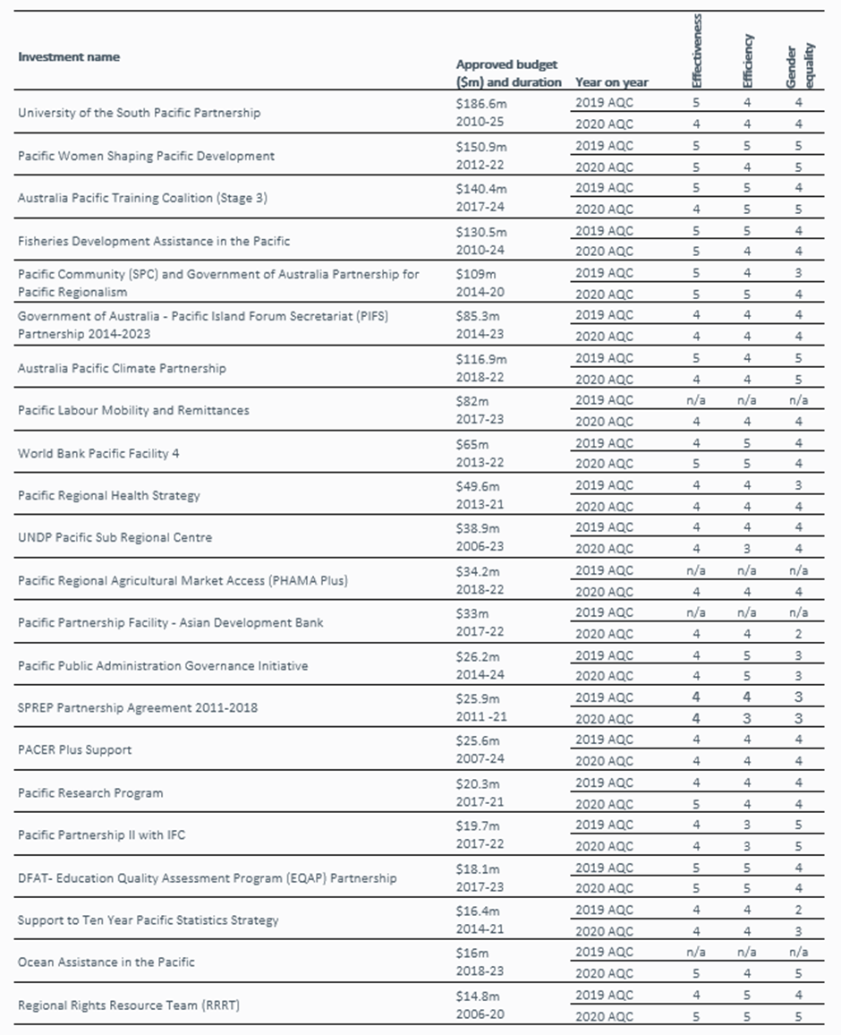

### Investment Monitoring Report ratings for 3 investments

### Final Investment Monitoring Report ratings

|  |  |  |  |  |  |  |  |
| --- | --- | --- | --- | --- | --- | --- | --- |
| Investment name | Approved budget ($m) and duration | Effectiveness | Efficiency | Gender equality | Relevance | Monitoring and Evaluation | Sustainability |
| Undersea Cables Project | $158.5m  2017-22 | 5 | 5 | 3 | 5 | 3 | 4 |
| UNDP Pacific Financial Inclusion Programme | $31.2m  2009-20 | 4 | 4 | 3 | 5 | 3 | 4 |
| Asia-Pacific Data for Development Initiative | $1.8m  2018-21 | 1 | 1 | 1 | 3 | 1 | 2 |

**Definitions of rating scale:**

Satisfactory (4, 5 and 6)

6 = Very good; satisfies criteria in all areas. 5 = Good; satisfies criteria in almost all areas.

4 = Adequate; on balance, satisfies criteria; does not fail in any major area.

Less than satisfactory (1, 2 and 3)

3 = Less than adequate; on balance does not satisfy criteria and/or fails in at least one major area.

2 = Poor; does not satisfy criteria in major areas. 1 = Very poor; does not satisfy criteria in many major area.