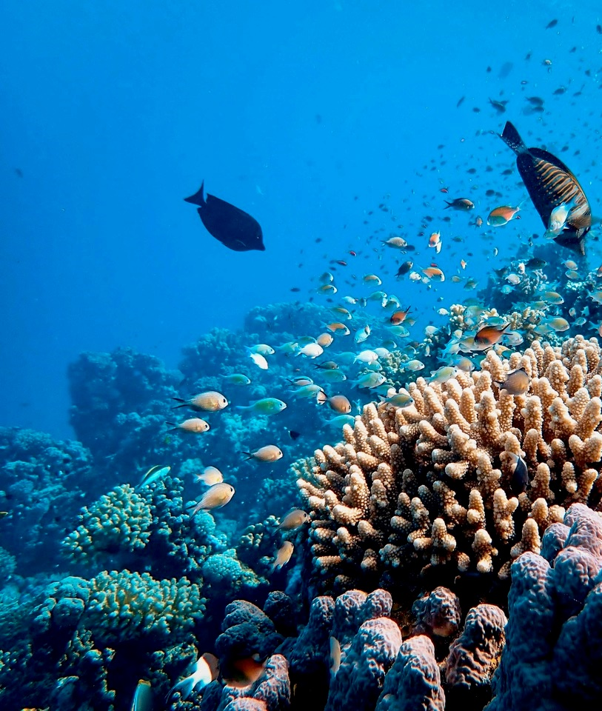

Department of Climate Change, Energy, the Environment and Water

Pacific Ocean Litter Project

Mid–term review and evaluation
  - Final Report
  - 29 November 2024


Contents
1 Executive Summary 5
1.1 Key findings 5
1.2 List of recommendations 6
2 Background and purpose 8
2.1 The Pacific Ocean Litter Project 8
2.2 Purpose and scope of the evaluation 10
3 Methodology 11
3.1 Evaluation criteria and questions 11
3.2 Data collection methods 11
4 Key findings 13
4.1 Overall findings 13
4.2 Compliance and governance 13
4.3 Relevance 18
4.4 Effectiveness 21
4.5 Efficiency 25
4.6 GEDSI 27
4.7 Sustainability 28
5 Case studies 32
5.1 Greening of the Pacific Games, Solomon Islands 32
5.2 Support for the ICN process 36
Appendix A POLP program logic framework 40
Appendix B List of documents 41
Appendix C List of stakeholders 43
Appendix D Participant information sheet 45
Appendix E Survey Instrument 47
Appendix F POLP governance structure 53
Appendix G Survey respondents’ profile 54
Appendix H Survey results 55
Appendix I Project Logic (written version) 59

List of tables and figures
Table 1 – POLP participating PICs 9
Table 2 – POLP key evaluation questions 11
Table 3 – POLP governance structure 14
Table 4 – Appropriateness of POLP’s focus on specific components 19
Table 5 – POLP implementation 22
Table 6 – Pacific involvement in the INC 36

Figure 1 – Appropriateness of POLP’s focus on specific components 19
Figure 2 – POLP implementation 23

List of acronyms and abbreviations

Acronym | Description
ACFID | Australian Council for International Development
AUD | Australian dollar
DCCEEW | Department of Climate Change, Energy, the Environment and Water
DFAT | Department of Foreign Affairs and Trade
EOPOs | End–of–project outcomes
GEDSI | Gender equality, disability and social inclusion
GSIC | (Solomon Islands) Government Services Integration Committee
IMR | Investment Monitoring Report
INC | International Negotiating Committee
MECDM | (Solomon Islands) Ministry of Environment, Climate Changer, Disaster Management and Meteorology
MEL | Monitoring, Evaluation and Learning
MERL | Monitoring, Evaluation, Reporting and Learning
MTR | Mid–term Review
LOA | Letter of Agreement
ODA | Official Development Assistance
OECD | Organisation for Economic Cooperation and Development
OECD–DAC | OECD Development Assistance Committee
PICs | Pacific island countries
PIM | Project Implementation Manager
PGOC | (Solomon Islands) Pacific Games Organising Committee
POG | POLP Oversight Group
POLP | Pacific Ocean Litter Project
PMU | Project Management Unit
PSIDS | Pacific Small Island Developing States
NPO | National Project Officer
ROU | Record of Understanding
SIG | Solomon Islands Government
SPREP | Secretariat of the Pacific Regional Environment Programme
SGGS | (Solomon Islands) Safe and Green Games Strategy
SUP | Single–use plastics
USD | US dollar
TOR | Terms of Reference
WMPC | SPREP’s Waste Management and Pollution Control team

Executive Summary
This mid–term review (MTR) was conducted to provide an assessment of the design, governance and implementation of the Pacific Ocean Litter Project (POLP). POLP is funded by the Australian Government for a total of AUD 16 million over the period 2019 to 2027. POLP supports Pacific island countries (PICs) to refuse, reduce and find alternatives to single–use plastics (SUP) to address plastic litter impacts on marine and coastal environments.
The evaluation assessed the POLP against six criteria – compliance / governance, relevance, efficiency, effectiveness, gender equality, disability and social inclusion (GEDSI) and sustainability. The evaluation methodology included review of relevant documents, stakeholder consultation and a brief survey.

Key findings
POLP is a direct response to an urgent and serious problem that has global, regional and national recognition and is a priority for the Australian Government. It complements other Australian regional and international commitments, initiatives and investments in the region.
POLP is a well–designed project with a clear rationale, realistic and achievable outcomes and logical, causal and sequential relationships between its activities and the outcomes it seeks. Planning, implementation and reporting is supported by comprehensive plans covering implementation, risk, communication and monitoring and evaluation.
However, progress in implementation has been hampered by COVID–19 impacts and the need to redesign the project and its approach to implementation, and as a result has experienced significant delays. Full implementation did not commence until 2023, and implementation in PICs was hampered by delays due to processes and capacity constraints in national governments, competing priorities such as national celebrations / holidays and challenges in recruiting and procuring resources to support on–ground activities. Is it worth noting here that at the time of evaluation, not all pilot PICs have started national activities under POLP. As Kiribati, PNG and Palau are yet to submit activity plans linked to their national priorities, it has been difficult to implement national activities in these countries.
While POLP has demonstrated measurable progress and results in implementation in recent years, particularly at the regional level, it faces several challenges in achieving its planned outcomes over the remaining three years of the project. POLP has a unique governance structure that reflects the funding and management roles of its three partners – the Department of Climate Change, Energy, the Environment and Water (DCCEEW), the Department of Foreign Affairs and Trade (DFAT) and the Secretariat of the Pacific Regional Environment Programme (SPREP). Aspects of the governance structure need to be updated, and roles and responsibilities clarified to streamline decision–making processes and avoid delays.
The project is directly relevant to the needs of the region and aligned with regional strategies and Australia’s development priorities. However, considerable activity in the region is related to POLP. These activities can benefit from improved coordination across donors and development partners to ensure coherence across programs and projects, avoid duplication and leverage resources.
POLP’s implementation of national activities has been delayed and POLP now needs to prioritise accelerating and supporting arrangements in PICs to facilitate on–ground activity.
The focus on GEDSI outcomes, and measuring and reporting GEDSI results, is an important element of POLP’s design and is embedded in the planning and delivery of activities. As the project’s implementation momentum grows, and more on–ground activities come online, the focus on GEDSI will expand and there are opportunities for POLP to enhance and strengthen the effectiveness of its approach to GEDSI, which will require specialist support.
Supporting the sustainability of POLP’s achievements will be particularly important in the delivery of national activities where capacity constraints and other challenges may limit the continuation of POLP outcomes beyond the life of the project. Consideration will also need to be given to how the POLP focus can be sustained as an ongoing component of SPREP’s waste management program after the current POLP term.

List of recommendations
The following recommendations are presented in relation to each of the review criteria.

Compliance and governance
Section 5.2 (Compliance and governance) discusses the key findings in relation to this criteria and the context and rationale for the following recommendations.
1 Ensure that DFAT’s and DCCEEW’s respective roles and responsibilities at the POLP Officer level are clear and reflect DCCEEW’s decision–making responsibilities for project implementation and decisions requiring referral to DFAT
2 Update the governance structure and roles to reflect oversight of the POLP PIM funding, DFAT’s current resourcing at the POLP Officer level and the Project Advisory Group’s role
3 Ensure that there are clear guidelines on the allocation of PMU resources for SPREP WMPC events and activities that benefit POLP’s implementation
4 Ensure that POLP’s approach to pilot country implementation continues to include appropriate processes, guidance and support to accommodate national governance arrangements (and limitations), including requirements and expectations for governance and reporting
5 Ensure that requirements and expectations for PIC data collection and reporting are formalised, and consider a common MEL platform for collecting and reporting PIC MEL data
6 Consider additional MEL expertise / support to strengthen the approach to MEL, including streamlining, aggregation of MEL results for similar activities in PICs, strengthening the measurement of GEDSI outcomes, improving the depth and quality of reports and focusing on long–term outcomes and impacts

Relevance
Section 5.3 (Relevance) discusses the key findings in relation to this criteria and the context and rationale for the following recommendations.
7 Consider establishing a more formal mechanism for coordination of donor activities through existing SPREP structures or using the reactivated technical advisory group with representation from other donor and development partners

Effectiveness
Section 5.4 (Effectiveness) discusses the key findings in relation to this criteria and the context and rationale for the following recommendations.
8 Continue to accelerate national implementation through a priority focus on finalising LOAs and consider enhancing the PMU’s technical capacity to provide on–ground support until NPOs are established
9 Ensure implementation in remaining PICs includes realistic timeframes, and support and capacity building to address the challenges in national implementation
10 Consider establishing a regional committee or ‘community of practice’ for PICs, with formal channels and processes for communication, information dissemination and collaboration

GEDSI
Section 5.6 (GEDSI) discusses the key findings in relation to this criteria and the context and rationale for the following recommendation.
11 Utilise specialist GEDSI expertise to strengthen POLP’s approach to GEDSI in implementing activities, collecting disaggregated data and measuring results

Sustainability
Section 5.7 (Sustainability) discusses the key findings in relation to this criteria and the context and rationale for the following recommendations.
12 Ensure the focus on national–level implementation addresses the key directions for sustainability that are identified in this report
13 For the future delivery of POLP, consider locating POLP’s focus as an integrated component of SPREP’s WMPC program

Background and purpose
POLP is funded by the Australian government for a total of AUD 16 million over the period 2019 to 2027. This MTR and evaluation was conducted to provide an assessment of POLP’s design, governance and implementation to date.

The Pacific Ocean Litter Project
Plastic litter is recognised as a significant threat to marine and coastal environments, which also impacts public health and the economic development of the Pacific region. The Australian Government is implementing POLP to directly address these issues by assisting PICs to refuse, reduce and find alternatives to SUP, such as plastic bottles and bags, take–away food containers, cutlery and straws.

Funding, implementation and management
POLP is funded through DFAT under Official Development Assistance (ODA) and administered by DCCEEW. The project is implemented by SPREP in collaboration with PICs.
The three project partners (DFAT, DCCEEW and SPREP) participate in a shared governance arrangement to support the management of the project. Accountability is provided through SPREP’s mid–year and annual reports to DCCEEW. This informs DCCEEW annual reports provided to DFAT, which in turn inform DFAT’s investment monitoring reports (IMRs).
POLP has been implemented in two phases, with some significant differences in each phase.

Phase 1 – 2019–2023
Initially, POLP was allocated funding of AUD 8 million until September 2023, however this was increased to AUD 16 million. Implementation was managed by an Australian Government Project Manager based in SPREP and supported by SPREP staff.
During 2020–2021, COVID–19 severely impacted the implementation of the project through restrictions on project activities and the subsequent recall of the project manager. In 2021, responsibility for implementation was transferred to SPREP with DCCEEW’s predecessor department continuing to administer the project. In late 2022, the project end date was extended at no cost to October 2024 and in early 2023 POLP was redesigned.

Phase 2 – 2023–2027
In May 2023, DFAT and DCCEEW entered into a new agreement for Phase 2 of POLP valued at AUD 10 million for the period August 2023 to September 2027, with DCCEEW administering the project and SPREP as the regional delivery partner.

Geographic scope
Fourteen PICs participate in POLP. Eight PICs expressed interest in participating as pilot countries, to implement activities through a national plan developed with national governments and supported by POLP National Project Officers (NPOs). These arrangements are at various stages of finalisation. As the Cooks Islands is no longer eligible to receive ODA, it participates in POLP through DFAT’s Regional Grants Program. Six PICs participate in POLP through ad hoc funding support. POLP pilot countries are listed in Table 1.
Table 1 – POLP participating PICs
Country | Category
Cook Islands | Pilot Country
Kiribati | Pilot Country
Niue | Pilot Country
Palau | Pilot Country
Papua New Guinea | Pilot Country
Samoa | Pilot Country
Solomon Islands | Pilot Country
Tuvalu | Pilot Country
Federated States of Micronesia | Other eligible country
Fiji | Other eligible country
Marshall Islands | Other eligible country
Nauru | Other eligible country
Tonga | Other eligible country
Vanuatu | Other eligible country

POLP’s goal and outcomes
POLP long term goal: Cleaner coastal environments for Pacific Island Countries.
POLP’s long–term goal is supported by the following five end–of–project outcomes (EOPOs).
- Measures, policies, or practical strategies to reduce single–use plastic are developed and provided to pilot countries
- Local and visiting consumers (women, men, girls and boys) are using less single–use plastics and more alternative products
- Target sectors, companies and businesses adopt plastic reduction measures
- Alternative products are identified for adoption
- SPREP, as the regional lead agency, has the capacity to coordinate the delivery of the Pacific Regional Action Plan – Marine Litter, 2018–2025
POLP’s long–term goal and five EOPOs are encapsulated in a program logic framework (Appendix A) that describes the project’s planned performance. The EOPOs also provide the framework for the approach to implementation of regional and national activities to achieve these outcomes, which underpin the investment design, implementation plan and monitoring, evaluation, reporting and learning (MERL) plan.

Purpose and scope of the evaluation
This MTR and evaluation is a requirement of the DFAT–DCCEEW agreement.

Purpose
The purpose of the MTR and evaluation is to provide an assessment of POLP design, governance and implementation in relation to the following six evaluation criteria.
- Compliance / governance
- Relevance
- Efficiency
- Effectiveness
- GEDSI
- Sustainability
While a mid–term review and an evaluation can have a different focus, the term evaluation will be used in this report.

Scope and limitations of the evaluation
The evaluation covers the period from the project’s commencement in March 2019 through to the end of June 2024 and covers two phases of POLP. As some characteristics of Phases 1 and 2 differ, these are considered in the approach to the evaluation.
POLP includes a range of activities delivered at both the regional and national level, covering diversity of activity types and PIC contexts. While these activities have informed the evaluation, the focus is on the project, rather than assessments of individual activities.
The scope of the evaluation is also defined by the above evaluation criteria. It should be noted that assessing the efficiency criteria, which usually refers to elements such as time and cost efficiency, will be limited to available data. It will not include a detailed cost analysis or benchmarking that are often used to measure efficiency.
As this evaluation has been conducted part–way through the project cycle, the outcomes focus is on progress towards achieving outcomes rather than achievement of the outcomes.

Methodology
This section outlines the evaluation methodology, including the evaluation questions, data collection methods and stakeholder consultations.

Evaluation criteria and questions
The evaluation criteria and related evaluation questions were used to guide the approach data collection, analysis and reporting. The criteria and questions are shown in Table 2.
Table 2 – POLP key evaluation questions
Criteria | Evaluation questions
Compliance / governance | KEQ 1 To what extent is POLP practising good governance across the project and complying with DFAT’s Design and Monitoring, Evaluation and Learning Standards?
Relevance | KEQ 2 How appropriate is the project design in supporting the priorities of Pacific Island countries to reduce the environmental, social, and economic impacts of marine plastic pollution?
Effectiveness | KEQ 3 How effective is POLP in achieving project outputs and outcomes?
Efficiency | KEQ 4 To what extent is POLP making the best use of resources and achieving value for money?
GEDSI | KEQ 5 How well is POLP supporting gender equality, disability and social inclusion?
Sustainability | KEQ 6 How well does the implementation of POLP support the continuation of POLP initiatives and outcomes beyond the life of the project?

Sub–questions were also developed to guide and prompt data collection, particularly stakeholder discussions.

Data collection methods
The primary methods for data collection were document review and analysis, stakeholder consultations and a brief online survey.

Document review
DCCEEW provided a range of relevant POLP documents which are listed in Appendix B, and included:
- the project design document and implementation, MERL and risk plans
- funding agreements and variations
- annual workplans and budgets
- annual SPREP, DCCEEW and DFAT reports.

Stakeholder consultations
Stakeholder consultations were conducted using a semi–structured interview format based on the evaluation questions. Stakeholders consulted for the evaluation are listed in Appendix C, and these were drawn from a range of stakeholder categories including:
- governance and management structure – delegate, POLP oversight group (POG) and administration team
- implementation team – SPREP project management unit (PMU)
- participating and eligible PICs
- development partners, networks and private sector organisations.
Prior to consultations, stakeholders received a participant information sheet which clarified:
- the purpose of the evaluation and the focus of the discussion
- that participation is voluntary and based on informed consent
- provisions for ensuring privacy and confidentiality.
The participant information sheet is attached as Appendix D.

Survey
A brief survey was administered to elicit quantifiable data and to extend the coverage to a wider group of stakeholders. The survey was hosted on the online platform Qualtrics and distributed to all PIC stakeholders, including those participating in the consultations. The survey instrument is included as Appendix E. Key findings of the survey are discussed in relation to the relevant evaluation criteria, and the full results and summaries of comments are included in Appendix H.

Case studies
The evaluation methodology included two case studies to explore the key features and learnings of a specific project activity. The two case studies are:
- greening of the Pacific Games (Solomon Islands)
- support to the Intergovernmental Negotiating Committee (INC) global treaty process.

Analysis and reporting
Data from all sources was analysed and synthesised against the evaluation criteria, which were used to structure the reporting of the evaluation’s findings.

Key findings
Key findings are discussed against each of the evaluation criteria in the following sections.

Overall findings
The need for POLP is well–supported globally, in the Pacific region, by individual PICs and the Australian government. It is a well–designed project with a clear rationale, realistic and achievable outcomes and logical, causal and sequential relationships between its activities and the outcomes it is seeking.
Planning, implementation and reporting are supported by comprehensive plans covering implementation, risk, communication and monitoring and evaluation. However, progress in implementation has been hampered by COVID–19 impacts and subsequent reorienting of the implementation arrangements through SPREP, the project design and associated plans, and challenges in establishing pilot country arrangements. Despite the support and buy–in of PICs, implementation faced delays and challenges resulting from local processes and timeframes, as well as capacity constraints, which has impacted finalising arrangements.
The following sections present the evaluation findings in relation to each evaluation criteria.

Compliance and governance

Key evaluation question
To what extent is POLP practicing good governance across the project and complying with DFAT’s Design and Monitoring, Evaluation and Learning Standards?

Compliance and accountability
POLP has a structured and comprehensive approach to ensuring accountability for the investment, which includes the following elements.
- Implementation guided by the investment design and implementation plans, and related risk, communication and MERL plans
- Preparation and approval of annual workplans and budgets
- Mid–year and annual reporting from SPREP to DCCEEW informing DCCEEW’s annual reporting to DFAT, which then informs DFAT’s annual IMRs
- Planning and coordination includes regular meetings between the three project partners as well as joint annual planning workshops
In addition, relevant policies and tools also guide POLP’s implementation, including the data collection tools and the POLP GEDSI Strategy.
The Activity Schedule with DFAT and DCCEEW and the Funding Agreement with DCCEEW and SPREP include the specific expectations of each party in meeting these accountability requirements.

Governance and management arrangements
The governance structure reflects the funding arrangements for POLP, which include:
- ODA funding from DFAT to DCCEEW for administration of the project
- funding from DCCEEW to SPREP for implementation of the project by the PMU
In addition, DFAT separately funds SPREP for the POLP Project Implementation Manager (PIM). The POLP Project Design outlines the POLP governance and management structure and is included in Appendix F. The structure includes four levels, and the key elements of each level are summarised in Table 3.
Table 3 – POLP governance structure
Element | Focus | Membership | Role
Delegates | Governance | DFAT SES 1  DCCEEW SES1 | High level strategic direction and alignment  Decision–making  Oversight of the Record of Understanding (ROU)
Project Oversight Group (POG) | Governance | DCCEEW Director (Chair)  DFAT Director  SPREP Director | Advise and support to delegates’ decision–making  Oversight of implementation, including quality, monitoring and evaluation  Appointments to advisory group
POLP Officers | Administration and implementation | DFAT project team, including two staff (as needed) | Oversight of investment and strategic direction  Project liaison with DCCEEW  Activity Schedule with DCCEEW
POLP Officers | Administration and implementation | DCCEEW project team, including two staff | POLP strategic direction, governance and administration  Liaison with and reporting to DFAT  Activity Schedule with DFAT  Funding Agreement with SPREP
POLP Officers | Administration and implementation | SPREP PMU, including PIM and three staff | Project implementation and regional coordination  Secretariat to governance and management meetings  Regional engagement  Funding Agreement with DCCEEW
Project Advisory Group | Governance | Experts from relevant sectors and disciplines | Advice on project strategy, quality and technical matters

Effectiveness of the governance arrangements
The governance structure has been designed as a fit–for–purpose mechanism for the unique context of POLP. While in general these arrangements have supported POLP’s implementation, the structure presents several challenges.
The governance structure reflects POLP’s unique funding arrangements. The POLP Officer level includes multiple decision–making levels and processes, and roles and responsibilities have needed clarification. DFAT’s current resourcing at this level of the structure has been scaled back to reflect DFAT’s approach to resourcing levels for its ODA investments, while DCCEEW has taken more carriage of strategic direction and decision-making for POLP administration. However, this has not been reflected in the governance structure and there is lack of clarity about what strategic funding decisions can be made by DCCEEW without consulting DFAT. Without clear roles and responsibilities, there has been an inconsistent approach and expectations about when DCCEEW should engage DFAT. This is being addressed by DCCEEW and DFAT so that decision-making is more streamlined and efficient.

Recommendation 1
Ensure that DFAT’s and DCCEEW’s respective roles and responsibilities at the POLP Officer level are clear and reflect DCCEEW’s decision–making responsibilities for project implementation and decisions requiring referral to DFAT
Related to this, DFAT’s reduced resourcing at the POLP Officer level is not reflected in the project design’s governance structure and may need to be reviewed and updated.
DFAT funds SPREP directly for the POLP PIM role and DCCEEW does not have visibility of this arrangement. As POLP’s implementation is dependent on and linked to the performance of this role, it is not clear in the governance arrangements how DFAT’s management of the PIM funding agreement interacts with DCCEEW’s management of the POLP funding agreement with SPREP. While it is not suggested that there needs to be a change in current reporting arrangements, there is a need for the Project Design’s governance structure to reflect the funding of the PIM role.
The governance structure provides for a Project Advisory Group which can provide value to POLP in terms of advice about technical matters, quality review, information and intelligence on future trends and opportunities, collaboration and sharing and links with other related projects and initiatives. Currently the group is not functioning. The role of a group such as this can also address issues identified in the next section in relation coordination of related donor and development partner programs and projects.

Recommendation 2
Update the governance structure and roles to reflect oversight of the POLP PIM funding, DFAT’s current resourcing at the POLP Officer level and the Project Advisory Group’s role
The PMU’s location within SPREP brings benefits and efficiencies such as back–office support and links to other related SPREP programs / projects. This also facilitates POLP’s role in supporting SPREP to coordinate the delivery of the regional marine litter action plan (POLP Outcome 5). The POLP implementation plan identifies specific Outcome 5 activities that POLP undertakes that supports SPREP’s role, and Outcomes 1 and 2 include support for regional events that contribute to POLP’s outcomes.
However, there is a risk that POLP’s focus and resources can be drawn into other SPREP programs and activities at a level that may diminish POLP’s focus and outcomes.
While some discretion may be required for the PMU to respond to unplanned or ad hoc opportunities that may be strategic, this needs to be aligned with POLP’s focus and resourcing and supported by decision-making criteria for participation. This has been addressed by developing specific guidance on the allocation of POLP resources to related SPREP events and can also be addressed by the WMPC Director’s membership of the POG. This needs to be a continued focus in POLP’s implementation planning and the POG’s monitoring and oversight.

Recommendation 3
Ensure that there are clear guidelines on the allocation of PMU resources for SPREP WMPC events and activities that benefit POLP’s implementation
While POLP has established governance arrangements at the project level, POLP national activities are implemented through national–level governance arrangements, where the context, approach and capacity may vary. This is evident in variations in PIC approaches and processes for establishing agreements with POLP, and for recruitment and procurement. As POLP’s governance arrangements do not have direct influence over national–level governance arrangements, POLP’s governance of the national elements of the project is limited to guidance and support provided to PICs. Participating PICs appreciated the PMU’s support in working with each PIC to adapt implementation to local governance requirements, although some stakeholders suggested that POLP’s guidance about national governance arrangements and processes for pilot PICs could be strengthened and formalised.

Recommendation 4
Ensure that POLP’s approach to pilot country implementation continues to include appropriate processes, guidance and support to accommodate national governance arrangements (and limitations), including requirements and expectations for governance and reporting

A programmatic approach
Currently POLP implementation sits with the SPREP WMPC program, which is appropriate for a start–up project. While this brings administrative advantages, it also requires close attention in planning and implementation to ensure that links between POLP and other WMPC projects are well–coordinated and leveraged, that there is coherence across projects and that resource allocations across projects are in line with resourcing budgets.
The Australian Government is currently reviewing the SPREP funding support mechanism under the Partnership Arrangement and considering moving to a more programmatic approach. For the next phase of POLP, and as the project matures, it may be more advantageous to deliver POLP as part of an integrated WPMC program. In this case, POLP’s funding arrangements, the respective roles and responsibilities of DFAT, DCCEEW and SPREP, and the associated governance structure, will need to be reviewed and revised.

Monitoring, evaluation and learning
The approach to monitoring, evaluation and learning (MEL) is underpinned by a comprehensive and detailed MEL framework and guidance on data collection tools that support reporting of POLP progress. The program logic framework is clear, and the MEL framework steps through the logic with measurable indicators that facilitate monitoring and assessment of progress.
However, as a project addressing five outcome areas through a range of activity types at both the regional and national level, data collection, monitoring and reporting is resource intensive as it is detailed and time–consuming.
The approach to monitoring and report includes the following dependencies.
- SPREP relies on PICs for the collection and reporting of national MEL data
- SPREP collects its own data and collates PIC data
- DCCEEW relies on the annual SPREP report for its annual report to DFAT
- DFAT relies on DCCEEW reports for its annual IMR report.
As a result, there is significant reliance on the timeliness, utility and quality of data and reports shared between all POLP partners. In relation to PICs, the requirements for collection and reporting of MEL data are adapted to local contexts and capacity, and PICs have identified the need for some formalisation and standardisation of local data collection and reporting requirements and tools.

Recommendation 5
Ensure that requirements and expectations for PIC data collection and reporting are formalised, and consider a common MEL platform for collecting and reporting PIC MEL data
POLP’s planned performance includes long–term outcomes that may now be difficult to achieve by 2027 given delays in the early stages of project implementation and challenges in establishing activities in pilot countries. As a result, measurement of these longer terms outcomes by 2027 may be limited to measurement of progress towards achievement of outcomes. In this case, the MEL framework provides the information needed to track and report progress.
The measurement of GEDSI outcomes is embedded in the MEL framework and POLP routinely collects and reports disaggregated GEDSI data, mainly in relation to participation and the visibility / voice of GEDSI populations in POLP activities. There are opportunities for measuring GEDSI outcomes beyond participation, which are discussed in the later section on GEDSI.
As POLP’s implementation progresses and expands to national implementation, the MEL task will become more demanding and complex, as the MEL data expands and includes challenges such as aggregation of data from like activities, a deeper assessment of GEDSI outcomes and a greater focus on long–term outcomes and impacts. Additional or enhanced MEL expertise can support POLP in addressing these challenges.

Recommendation 6
Consider additional MEL expertise / support to strengthen the approach to MEL, including streamlining, aggregation of MEL results for similar activities in PICs, strengthening the measurement of GEDSI outcomes, improving the depth and quality of reports and focusing on long–term outcomes and impacts

Relevance

Key evaluation question
How appropriate is the project design in supporting the priorities of Pacific Island countries to reduce the environmental, social, and economic impacts of marine plastic pollution?
POLP’s design sits within global, regional and national recognition of the scale and urgency of the consequence of SUPs and a commitment to action.

Strategic alignment
The project aligns with the priorities of the Australian government and is one of several initiatives that address marine litter, which are listed below.
- Membership of the ANZPAC Plastics Pact, which is an industry–led regional alliance focused on reducing plastic waste and pollution in the Pacific region.
- Participation, with PICs and other countries, in negotiations on a new global treaty to combat plastic pollution.
- Funding support to SPREP to build capacity and support Pacific island country preparations for, and participation in, negotiations for the treaty.
- Membership of the 17–nation High Level Panel for a Sustainable Ocean Economy
- Commitment to several related undertakings including the Commonwealth Clean Ocean Alliance, the United Nations Environment Programme's Clean Seas Campaign, the G20 Marine Litter Action Plan and Implementation Framework for Actions on Marine Plastic Litter and the Ellen MacArthur Foundation New Plastics Economy Global Commitment
POLP also aligns with and supports delivery of regional strategies such as the Cleaner Pacific 2025 – Pacific Regional Waste and Pollution Management Strategy 2016–2025 and the Marine Litter – Pacific Regional Action Plan 2018–2025. The project’s approach supports the approach advocated in the marine litter action plan, focusing on activities such as building the policy and regulatory environment, availability of alternatives to SUPs, awareness–raising and clean–up activities.
Survey respondents had very favourable views about the appropriateness and relevance of POLP – 92% of survey respondents agreed that POLP was relevant to the needs and priorities of Pacific countries and 96% of respondents agreed that the POLP objectives were appropriate. Respondents were also asked to rate the appropriateness of various components of the POLP approach – awareness and adoption, availability of alternative products, consumer awareness and measures and policies. The component with the highest rating was ‘measures and policies’ (96%) and the lowest was ‘availability of alternative products’ (84%), which included 8% or respondents who selected ‘Not sure / don’t know’. The support shown for upstream measures can provide guidance to POLP about the importance and appropriateness of these measures and value in continuing and strengthening POLP’s focus on promoting and supporting regulatory frameworks and compliance and enforcement arrangements. The results for all statements are illustrated in Table 4 and Figure 1.
Table 4 – Appropriateness of POLP’s focus on specific components
Statement | Disagree strongly | Disagree | Neutral | Agree | Agree strongly | Not sure / don’t know
Awareness and adoption of alternative products by target sectors and business | 0.0% | 0.0% | 8.0% | 44.0% | 48.0% | 0.0%
Availability of alternative products | 0.0% | 0.0% | 8.0% | 36.0% | 48.0% | 8.0%
Consumer awareness | 0.0% | 0.0% | 8.0% | 32.0% | 60.0% | 0.0%
Implementing measures, policies and strategies | 0.0% | 0.0% | 4.0% | 32.0% | 64.0% | 0.0%
Figure 1 – Appropriateness of POLP’s focus on specific components

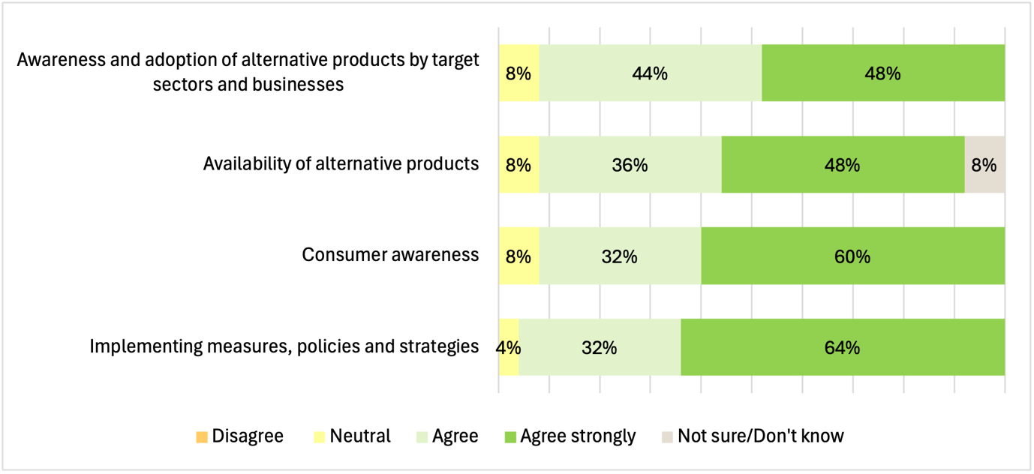

Relevance and appropriateness to PICs
POLP’s implementation addresses the specific needs and priorities of PICs. In implementing the national activities, the approach has been responsive and adaptive to individual contexts and capacities of participating PICs.

Comment from a PIC senior government officer
I think for us we've had so many projects in the area of waste management, but this project was the first to focus on plastics, and managing plastic wastes is one of the main issues that we try to tackle.
So, POLP has come at the right time. Its relevance to us can be seen during the Pacific Games, where we worked really hard to promote Plastic–free games.
No other project has supported our campaign against single–use plastics. So, POLP is really relevant to us.
While the focus on adaptation has been important in ensuring relevance and alignment, and building commitment, it has slowed progress in implementation. Feedback from PICs noted the value of the adaptive and responsive approach.
The approach to implementation is Pacific–led, and appropriate to and respectful of the contexts and culture of PICs and guided by SPREP’s Framework for Nature Conservation and Protected Areas in the Pacific Island Region 2014–2020.

Coherence with other related initiatives
Donors and development partners are supporting other initiatives in the Pacific region focused on marine litter and plastic waste in general, including:
- Pacific–EU Waste Management Program (PacWastePlus), EU / SPREP
- Sustainable Waste Actions in the Pacific (SWAP), Agence française de Development (AFD) / SPREP
- Japanese Technical Cooperation Project for Promotion of Regional Initiative on Solid Waste Management (J–PRISM), Japan International Cooperation Agency (JICA) / SPREP
- ANZPAC Plastics Pact.
The SPREP WMPC program includes the PacWastePlus and SWAP programs and other streams of work, as well as POLP.
In addition to POLP, the Australian government provides SPREP with annual core funding of AUD 4.3 million across all its programs, and funding for specific initiatives, such as AUD 729,000 from 2022–24 to support PIC preparations for treaty negotiations.
Together, all the initiatives related to plastic waste represent a busy agenda of projects and initiatives, with the potential for duplication and missed opportunities for integration and leveraging of resources and stakeholder networks. In addition, without effective coordination, the absorptive capacity of PICs may be stretched.

Comment from a PIC senior government officer
There are four projects with the same objectives as POLP that also look at marine pollution or plastic pollution. We have already started discussions with the German government on a project to start in 2025. We have also had an interest from the World Bank, also looking into plastic products that was to be implemented directly with the government. However, the Ministry were concerned and mindful of duplication, so we opted to channel the execution through SPREP so that there's better coordination of the similar projects.
Stakeholders consulted for the evaluation noted that there were informal mechanisms for sharing and coordination around donor activities and that generally coherence and compatibility were not problematic. However, in the stakeholder survey, only 64% of respondents agreed that ‘projects and activities of donors across the region are well–coordinated’. This is a low score relevant to other questions in the survey and includes 28% of respondents answering ’Neutral’ or ‘Not sure’/ Don’t know’.
The PMU is the logical focal point for coordination and sharing around donor activities and is positioning itself as the ‘go to’ place for plastic waste initiatives in the Pacific. The PMU has also ‘mapped’ the Pacific plastics landscape and identified the gaps in plastic initiatives in individual PICs and potential donor and development partners including:
- World Bank Group
- Deutsche Gesellschaft fuer Internationale Zusammenarbeit (GIZ)
- United Nations Environment Programme (UNEP) Global Project on Marine Litter (GPML)
The POLP PIM and WMPC program managers and advisers meet regularly to discuss integrated programming and streamlining activities, which provides opportunities to gather information on donor activities. SPREP’s strategic planning unit may also have the potential to fulfil a donor coordination role across SPREP programs. WMPC and POLP also engage regularly with donors through established forums and events, however approach to coordination may need to be more explicit and strategic and not rely on donor recognition of PMU’s role, and goodwill and professional courtesy in sharing information about proposed projects, plans and progress.
There is potential for coordination to be formalised through mechanisms such as regular donor and development partner meetings, as is currently used by SPREP in other areas (such as climate change) and by The Pacific Community (statistics). The PMU could explore opportunities with WMPC and SPREP to build on existing SPREP resources and mechanism for structured coordination. In the interim, POLP could consider broadening the role of the Project Advisory Group to include donor and development partners to provide this coordination focus.

Recommendation 7
Consider establishing a more formal mechanism for coordination of donor activities through existing SPREP structures or using the reactivated technical project advisory group with representation from other donor and development partners

Effectiveness

Key evaluation question
How effective is POLP in achieving project outputs and outcomes?
Delivery of POLP activities is underpinned by a comprehensive approach to planning. The implementation plan provides a practical roadmap for delivering POLP’s activities and is well–supported by related plans for MEL, risk, communications and GEDSI and associated tools and resources. Implementations is also supported by annual workplans and individual plans for regional activities and national activities.

Implementation progress
Project progress was severely impeded by COVID–19 impacts, changes to the project implementation management arrangements and revision of the project design. Because of this, it was not until 2023 that the project was able to fully transition from the design and planning phase to project implementation, having settled the design and management arrangements, fully resourced the PMU team and completed the implementation plan.
In addition, the project implementation plan relies on the completion of foundational activities to inform roll–out of other activities. These foundation activities include mapping and stocktaking exercises, feasibility studies, options analysis and other research. Given delays in the project implementation and the limited time now available to realise the project outcomes, consideration may need to be given to fast–tracking the foundational work through rapid analysis and leveraging the findings of existing research from other regional waste strategies and projects.
In the context of the delays experienced in the first phase of the project, there is a need to refocus project design and implementation, and the sequencing for some activities. POLP is making progress in achieving its outputs and intermediate outcomes, particularly for regional activities. However, national implementation has been slower than expected, and this is discussed in the next section. POLP’s reporting against the MERL plan provides useful information about the project’s progress and reports a number of measurable results across the five POLP outcomes.
The stakeholder survey included aspects of the implementation and delivery of the POLP. Survey respondents had favourable views about the implementation and delivery of POLP. Respondents were in strongest agreement about POLP contributing to its outcomes (92%) and lowest agreement about progress in implementation. The results for all statements are listed below and illustrated in Table 5 and Figure 2.
- The project is making a contribution to refusing, reducing and replacing SUPs (92%)
- Delivery of activities through SPREP is effective (76% agree)
- Implementation across the region is well–coordinated (68%)
- Information about implementation and progress is available (68%)
- Projects and activities of donors across the region are well–coordinated (64%)
- POLP is making good progress in implementing activities (64%)
The statements with lower levels of agreement include significant ‘Neutral’ and ‘Not / sure / Don’t know’ responses, whereas the high level of agreement about POLP contributing to its outcomes is unequivocal.
Table 5 – POLP implementation
Statement | Disagree strongly | Disagree | Neutral | Agree | Agree strongly | Not sure / don’t know
I receive or have access to adequate information about the project’s implementation and progress | 0.0% | 8.0% | 20.0% | 28.0% | 40.0% | 4.0%
The project is making, or has the potential to make, a contribution to refusing, reducing and replacing single-use plastics in the Pacific | 0.0% | 0.0% | 4.0% | 24.0% | 68.0% | 4.0%
The project is making good progress in implementing activities to support the project objectives | 0.0% | 4.0% | 20.0% | 36.0% | 28.0% | 12.0%
The delivery of project activities through the Secretariat of the Pacific regional Environment Programme (SPREP) is effective | 4.0% | 0.0% | 12.0% | 44.0% | 32.0% | 8.0%
This project and other projects implemented by donors and development partners focussing on ocean litter are well-coordinated | 0.0% | 8.0% | 16.0% | 32.0% | 32.0% | 12.0%
The implementation of the project across the region is well coordinated | 0.0% | 4.0% | 16.0% | 44.0% | 24.0% | 12.0%
Figure 2 – POLP implementation
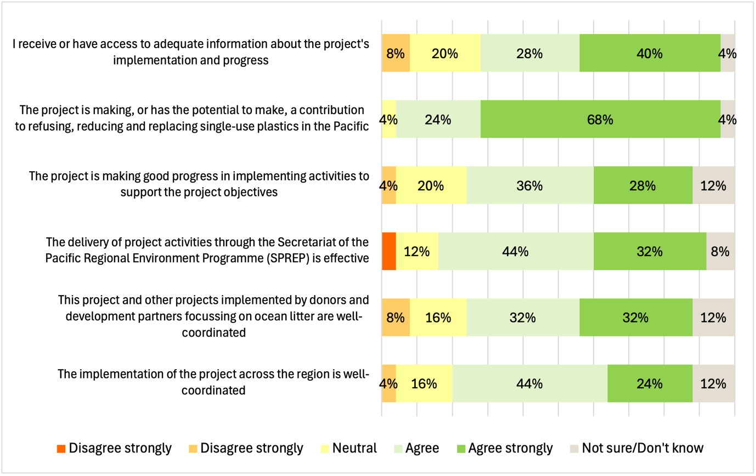

Challenges in national implementation
PICs face several challenges in implementation including processes and capacity constraints in national governments, logistical challenges, other competing priorities, availability of local expertise and specialist facilities and delays in recruiting NPOs.
PICs appreciated the flexible and adaptive approach to implementation planning and noted the importance of flexibility with timeframes.

Comment from a PIC senior government officer
Another challenge that will hinder our activities and efforts with POLP is having the right research capacity available to us, particularly with types of plastics alternatives, so that we don't have to start researching from scratch. Having the right information will be very beneficial in drafting and developing our regulations and legislations, right down to the implementation phase.
This observation validates POLP’s approach in undertaking three regional studies to develop foundational research to guide and inform PICs in developing appropriate national mechanisms and SUPs alternatives and substitutes.
Given the delays and challenges, the establishment of national activities is an urgent priority and needs to be accelerated. POLP’s regional results, growing brand and reputation and global and regional momentum around plastics provides a platform to support this. In addition, the experience of current PICs in establishing national activities that are relevant and responsive the local needs, priorities and capacities can be leveraged.
While the PMU has prioritised finalisation of implementation arrangements with each remaining PIC, including the LOA, delays in recruiting NPOs will have a significant impact on implementation progress, and there may be a need to boost the PMU’s technical capacity to provide on–ground assistance until NPOs are established.
There are opportunities for POLP to leverage PICs’ interest and momentum in implementing national activities through a ‘community of practice’ approach that focuses on disseminating information, promoting collaboration and sharing lessons, successes and best practices. This could support national implementation and provide opportunities for PICs to contribute their expertise and experience to support other PICs. The approach to establishing this process would supplement existing one-to-one communication between POLP and individual PICs and should reflect current resourcing and capacity within the PMU and PICs, and existing processes within SPREP.

Recommendation 8
Continue to accelerate national implementation through a priority focus on finalising LOAs and consider enhancing the PMU’s technical capacity to provide on–group support until NPOs are established

Recommendation 9
Ensure implementation in remaining PICs includes realistic timeframes, and support and capacity building to address the challenges in national implementation

Recommendation 10
Consider establishing a regional committee or ‘community of practice’ for PICs, with formal channels and processes for communication, information dissemination and collaboration

Efficiency

Key evaluation question
To what extent is POLP making the best use of resources and achieving value for money?
It should be noted that assessing the efficiency criteria, which usually refers to elements such as time and cost efficiency, is limited by available data. Assessment of POLP’s efficiency has not included a detailed cost analysis or benchmarking against established standards for resource utilisation, which are often used to measure efficiency. Our assessment of efficiency is high–level and generalised based on stakeholder feedback and our review of relevant documentation. It should also be noted that outside of the POLP governance and management, stakeholders have very limited visibility of the efficiency of the use of POLP resources.
Delays in POLP implementation have impacted both the operational and time efficiency of the project, and during Phase 1 these delays were largely outside of POLP’s control.

Operational efficiency
Operational efficiency is the consideration of how well resources are used during implementation and includes factors such as:
- budget underspend or overspend
- misallocation, reallocation or redirection of resources
- enhancing efficiency (cost savings)
- optimal procurement processes.
POLP works within a fixed budget, and through its governance structure, prepares and approves annual budgets based on workplans. Implementation is managed in accordance with the budget, expenditure is monitored and budget variations approved as required. Annual budgets are detailed and provide budget allocations against specific activities, which enables close monitoring and reallocation to address implementation delays or required changes or reprioritisation of effort. For 2023, the financial reporting against the approved budget shows an underspend of 36.5% – expenditure of USD 502,078 out of a total allocation of USD 1,374,294. This underspend reflects the delays and adjustments that characterised Phase 1 of POLP.
The implementation of POLP can take advantage of cost efficiencies that are not easily quantified. For example, the location of the PMU within SPREP provides opportunities for the PMU to leverage SPREP resources that enables efficient use of POLP resources, although it is also acknowledged that SPREP’s ‘back–office’ systems and processes can be inefficient. Opportunities for the PMU to access cost efficiencies in this way include:
- establishing the PMU through SPREP’s recruitment processes
- utilising SPREP’s corporate services such as travel and procurement
- operating under SPREP’s operational policy frameworks such as human resources, financial and risk management
- leveraging SPREP’s specialist and technical policy frameworks, expertise and resources
- utilising SPREP events for POLP engagement and communication
- operating POLP under SPREP’s organisational oversight.
While the 15% program management fee covers SPREP’s overhead costs for hosting the POLP PMU, it is likely that the efficiency benefits exceed this fee, particularly when compared to establishing the PMU as a stand–alone facility outside SPREP.
In a similar way, the approach to implementing national activities through national governments could provide some potential cost efficiencies, such as leveraging existing resources, processes and stakeholder networks, and be more efficient than if POLP worked alone in implementing these activities. However, the reality is that capacities in PICs in these areas is low, and the insertion of NPOs is a more efficient approach. Where there have been delays in establishing NPO positions, the PMU has been active in developing national plans and on–ground activities.
Feedback from PICs indicate that there have been opportunities to achieve efficiencies through leveraging other national activities or donor activities. However limited agency resources and capacity, availability of local expertise and facilities and challenges in recruitment, procurement and contractor management have led to inefficiencies.
The governance and management structure identified in the project design establishes the resource levels for the POLP Officers level. As mentioned previously, the current DFAT resource allocation has been reduced to reflect the management role of DCCEEW, and its role and responsibilities at this level, including decision–making needs to be clarified in the context of this resource allocation. The DCCEEW resource allocation at this level is larger than DFAT’s and reflects DCCEEW’s closer involvement in management of the POLP. An assessment of the efficient use of staff resources across the PMU, DCCEEW and DFAT is not possible without a detailed cost analysis and comparison against established benchmarks.

Time efficiency
Time efficiency relates to delivery of initiatives within the intended timeframe. Delays have been experienced at the whole–of–project level owing to COVID–19 impacts and the resulting reorientation of the project, and due to challenges in establishing national activities and recruiting POLP NPOs. However, these delays are not necessarily related to inefficiencies in planning or delivery. At the activity level, implementation is well–planned and appears to be efficient in terms of timeframes.
Time efficiency impacts also arise from the complex governance arrangements with multiple levels of decision–making and co–dependencies in reporting, which have been discussed elsewhere and can be addressed through clarification of roles and responsibilities.

GEDSI

Key evaluation question
How well is POLP supporting gender equality, disability and social inclusion?
GEDSI principles are embedded in the project design, implementation plan and MERL plan, and supported by POLP–specific GEDSI guidance to support implementation. The project collects GEDSI–disaggregated data on activities, particularly in relation to representation in engagement events, opportunities for hearing voices of GEDSI populations and some focus on inclusion opportunities for leadership roles and economic activities. Using the MERL plan, POLP routinely collects and monitors GEDSI.
As POLP has recently moved into full implementation, the amount of reporting on GEDSI outcomes is limited to date. GEDSI outcomes will become more evident as implementation moves from regional to national activities, and development of on–ground activities in PICs will provide opportunities to engage local GEDSI groups during community engagement to strengthen the GEDSI focus.
POLP is progressively strengthening its approach to GEDSI, through seeking advice from the DFAT GEDSI team and updating its MERL plan to include GEDSI –specific intermediate outcomes, in addition to including it as a cross–cutting outcome.
Effective reporting on GEDSI outcomes beyond participation is challenging, and even collecting accurate data on GEDSI characteristics at events can be difficult by observation and self–identification can be intrusive. GEDSI data collection and reporting presents several challenges, including those listed below.
- Integrating GEDSI data collection with activities, not just as an ‘add–on’
- Balancing the coverage of data collection across all GEDSI populations (currently the focus on gender is stronger than on disability and youth)
- Balancing the focus across all activities and outcomes that may have a GEDSI dimension – participation in engagement, input into design and delivery of activities and solutions, leadership roles, participating in livelihoods / economic benefits and any differential impacts on GEDSI populations
- Understanding barriers and enablers for GEDSI populations’ access to opportunities, and addressing these in activity design and implementation
- Measuring the intersectionality of GEDSI outcomes – for example the experience of people with intersecting GEDSI profiles, such older females, women with disabilities etc.
Feedback from PICs identified the need for a more explicit, integrated and deeper approach to GEDSI data collection and reporting. PICs cited the example where women’s groups have been provided opportunities to craft sustainable shopping bags and youth groups have been engaged in waste collection activities. However, it was acknowledged that this has been limited to traditional roles and to women and youth only and needs to be extended to people with disabilities and to new roles including leadership. There are challenges in sustaining artisan production of alternatives, which are discussed in the next section on sustainability.
Access to specialist GEDSI expertise is needed to strengthen POLP’s approach to GEDSI programming and reporting, including the challenges identified above. POLP’s approach to GEDSI can be strengthened through the following strategies.
- Provide GEDSI training to POLP staff and NPOs to strengthen the application of POLP’s GEDSI and Safeguarding Strategy and GEDSI Good Practice Menu
- Ensure that National Plans use an integrated approach to GEDSI
- Ensure that in addition to promoting and measuring participation and inclusion, POLP’s GEDSI approach also considers a deeper analysis including any negative or differential outcomes or impacts for GEDSI populations resulting from the changes in policy and practice (including an intersectional focus)
Given POLP’s interconnections with SPREP, strengthening the GEDSI focus may also be a focus for the Australian Government’s investment in SPREP more broadly, and there may be opportunities for POLP to leverage GEDSI expertise at this level.

Recommendation 11
Utilise specialist GEDSI expertise to strengthen POLP’s approach to GEDSI in implementing activities, collecting disaggregated data and measuring results

Sustainability

Key evaluation question
How well does the implementation of POLP support the continuation of POLP initiatives and outcomes beyond the life of the project?
A number of factors can contribute to the sustainability of the outcomes and benefits of POLP beyond the life of the project, which underpin POLP’s approach to implementation.

Imperative for action
There is recognition of the need for action on marine litter and SUPs at the global, regional and national levels. POLP’s rationale and design is grounded in this imperative, which extends beyond POLP and supports the sustainability of its results.

Buy–in and commitment

Comment from a PIC senior government officer
With the development of our regulations on plastics, the government will have to take ownership of it, and then full enforcement and implementation will follow. The government has invested in the sustainability of these initiatives. The proof that the government has really taken this seriously is that they have assigned a division to manage POLP and the issues related to waste.
Buy–in and commitment is required at all levels and POLP’s approach recognises and supports this. Challenges in implementing the national component of POLP stem partly from the effort and processes required to secure the necessary commitment of PICs, despite the PMU’s active engagement with PICs that expressed an interest in participating as pilot countries. Moving PICs from initial buy–in to commitment to a LOA takes time and has delayed implementation of national activities and the recruitment of NPOs. Securing commitment is a priority for the PMU, which has strengthened its engagement with PICs to progress this.
The POLP approach to national implementation through NPOs also addresses buy–in and commitment at the local level, which is critical to ensuring sustainability.

Mainstreaming initiatives
Sustainability of POLP outcomes can be achieved by mainstreaming the initiatives and changes it delivers. This includes new institutional arrangements established by POLP, such as the role performed by NPOs. For this role, and the changes it facilitates, to be sustainable beyond the life of POLP, it needs to be mainstreamed (and funded) by national governments. Without this there is the risk that continued development of POLP outcomes in PICs will be less than optimal after POLP.
Another institutional arrangement that should be mainstreamed to support sustainability is POLP itself. While its location within the SPREP WMPC program as a stand–alone project is appropriate for a time–limited project, sustainability of the POLP focus beyond POLP can be supported by its integration within the WMPC program.
The sustainability of POLP’s outcomes also depends on the continued availability of viable alternative product offerings, and this is a focus of POLP’s implementation plan. There is capacity in PICs for local production of alternative products, including artisan products, however, to be sustainable, support is needed to overcome competitive disadvantages compared to mass–produced and cheaper imports, through tariffs, import restrictions or other measures.

Enforced change
The changes achieved by POLP will be sustained by initiatives that support enforced changes, such as legislation and regulatory change, standards and certification and compliance and enforcement arrangements. PICs noted that enforcement of legislation involves cross–agency collaboration with ministries of Customs, Environment, Women and Youth and Education, for example. Effective local implementation will require a thorough understanding of the legislation and respective roles across these implementing agencies.
While POLP’s approach supports implementation by PICs through national activities, which should support sustainability, ultimately this will rely on the commitment and capacity of PICs to implement. Lasting change will also depend on PICs’ compliance and enforcement systems and capacities. This includes compliance and enforcement measures such as bans on single–use plastics, which may require additional or ongoing support for capacity building in national agencies responsible for enforcing bans.

Comment from a PIC senior government officer
The Ministry mandates the importation of goods, including plastic bags. That is something that is out of our Ministry’s control. So, our monitoring and enforcement really were to the end suppliers, which were the retailers. But then we also had challenges with limited personnel and there is a lack of vehicles for our team to monitor each and every supermarket that were distributing and using these plastic products.

Behaviour change
Achieving sustained behaviour change is central to the POLP outcomes, and POLP’s design and implementation is underpinned by a behaviour change focus that includes the elements discussed above as well as awareness raising, engagement and education. PICs noted that advocacy and behaviour change efforts would be more challenging in rural and remote communities but can be addressed with consistent civic education through radio and social media.

Comment from a PIC senior government officer
Regulation is a big achievement for us. We think it's because of POLP's flexibility and our ownership, which allows us to do it successfully. But we still need to take the campaign to our rural populations and remote communities. Doing that is a challenge at the moment but we can continue to work on it.
This feedback affirms the need for POLP to strengthen its focus on supporting PICs to strengthen regulatory frameworks and broaden engagement and inclusion with rural and remote communities.

Progress with sustainability
The slow pace of national implementation poses a risk to sustainability, as do capacity constraints and weaker national governance arrangements, which may require continued support to achieve and sustain outcomes.
It is too early to say whether POLP can achieve lasting and sustainable behaviour change, as this requires a longer timeframe to develop and measure, and there are clear risks that need to be managed, including PICs’ commitment and capacity and the sustainability of the NPO roles.
Without continued funding for POLP, SPREP’s capacity to sustain and develop the outcomes achieved by POLP may be limited without funding from other sources.

Key directions for sustainability
The review has identified several areas to strengthen POLP’s focus on supporting the sustainability of PIC national activities. For the remainder of the POLP term and for consideration in the design of the next phase of POLP, the focus on national–level implementation needs to address the following areas to support sustainability:
- supporting new or improved SUP regulations, and related compliance and enforcement mechanisms
- supporting the development of standards and certification arrangements
- engaging with local communities, including rural and remote communities
- supporting local producers to overcome competitive disadvantages to sustainable alternatives compared to mass–produced and cheaper imports (for example through tariffs and import restrictions)
- education and awareness activities
- capacity building required to support sustainability, such as strengthening national governance arrangements, developing local expertise, simplifying compliance arrangements and knowledge and skills transfer to local authorities and communities.

Recommendation 12
Ensure the focus on national–level implementation addresses the key directions for sustainability that are identified in this report

Recommendation 13
For the future delivery of POLP, consider locating POLP’s focus as an integrated component of SPREP’s WMPC program

Case studies

Greening of the Pacific Games, Solomon Islands
Solomon Islands' hosting of the 17th Pacific Games in 2023 provided an opportunity for the Solomon Islands Government (SIG) to implement an activity under POLP. The activity focused on promoting ‘Plastic–free games’ and sharing information about using non–plastic alternatives. The goal was to increase public awareness about the danger of plastic waste and encourage behaviours that lessen the use of single–use plastics.

Background
The activity had its roots in the 2019 Pacific Games in Samoa, which pioneered ‘green’ practices by banning single–use plastics and polystyrene. SPREP, which co–chaired the 2019 Greening of the Games committee, was invited by SIG to provide similar support for the 2023 Games. The Games took place in Honiara from November 19 to December 2, 2023.
SIG developed a Safe and Green Games Strategy (SGGS) to ensure the Games' environmental responsibility. Launched on March 3, 2023, and led by the Government Services Integration Committee (GSIC), this strategy was designed to coordinate efforts across stakeholders for a safe, eco–friendly event that leaves a positive environmental legacy for Honiara. An SGGS Taskforce was established to coordinate various activities before and during the Games.

Planning and coordination
SPREP’s assistance through POLP in delivering the SGGS strategy involved collaboration with several Solomon Islands entities, including the Ministry of Environment, Climate Change, Disaster Management, and Meteorology (MECDM) and the Pacific Games Organising Committee (PGOC). Key support areas focused on coordinating POLP activities through SPREP’s Waste Management and Pollution Control programme and the Pacific Climate Change Centre, with MECDM as the primary liaison.
Support from SPREP was guided by a strategic framework for coordination and integration across SPREP’s relevant programmes including Climate Change Resilience, Environmental Monitoring and Governance and Waste Management and Pollution Control (including POLP and other major projects). This supported both a holistic approach to planning and leveraging of support from across SPREP.
A Letter of Understanding between MECDM and SPREP confirmed the parties' roles and responsibilities, deliverables and USD 390,000 of POLP funding allocated between MECDM and SPREP.

Activities
Greening the Games involved a whole–of–community approach and adopted various activities before and during the Games, which are described below.

Single-use plastic regulation
Prior to the Games, Solomon Islands was the only Pacific country without a plastics regulation in place. Introduction of the national single-use plastic ban prior to the Games was not only an important foundation of the SGGS, it was also a significant achievement for the nation. The regulation, banning the importation, manufacture, supply and distribution of single-use plastics, was enacted in September 2023. Businesses were given a ‘grace period’ until 1 April 2024 to use up remaining stock purchased prior to the introduction of the ban.
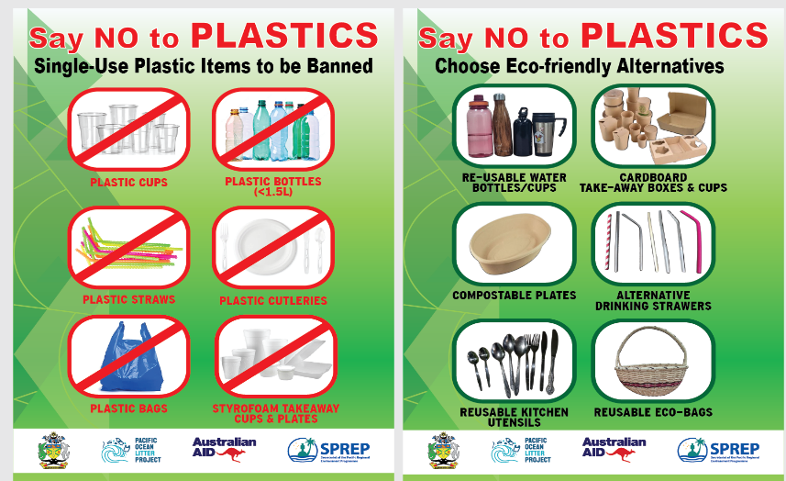
POLP’s contribution to MECDM included USD 90,000 to support the development and introduction of the regulation and an associated public awareness campaign.

Clean–up campaigns
The SGGS Taskforce organised Green Games advertising, marketing and outreach efforts, which complemented government–led clean–up campaigns involving public officials. The SGGS strategy was launched on 3rd March 2023 with a float parade followed by a major city clean–up on 4th March and a combined church service on Sunday, 5th March. These campaigns aimed to inspire local communities around Honiara to join in maintaining cleaner spaces, and the clean–up days had a meaningful impact on the city’s overall appearance.

Community awareness
Community awareness involved the following three key stakeholder groups and was coordinated by the SGGS Taskforce, with POLP support.
- All Honiara city councillors were encouraged to take a leading role in encouraging their ward residents to participate in all clean–up activities
- SIG rallied its ministries to kick off a weekly clean–up activity every Friday in designated zones within Honiara
- Churches, civil society groups, the private sector and schools encouraged their members to participate in the SGGS activities
SIG, through MECDM, engaged five youth interns (four female, one male) to support the initiative and activities associated with the new SUP regulation. Their role was to engage the business community in Honiara through awareness and consultation sessions and adherence to environmental regulations. This initiative strengthened the interns’ skills and MECDM’s outreach capacity and reached over 500 shopkeepers, including significant engagement with the local Chinese business community.

Media campaign
A robust outreach and awareness campaign developed by the POLP PMU in cooperation with MECDM included media channels such as TV, radio, social media, billboards, banners and print materials. The five interns who assisted in implementing these initiatives on the ground further supported this campaign.

Information booths
During the Games, an SGGS information booth at the main stadium, supported by the POLP PMU and MECDM interns, provided visitors with educational resources and encouraged environmentally responsible behaviour, including awareness about SUPs. Reusable water bottles and informational materials were distributed, reinforcing the importance of sustainable practices.

Provision of alternatives to plastics during the Games
POLP provided 3,000 reusable water bottles and 5,000 eco–friendly tote bags which were distributed throughout the Games. This, in conjunction with the SUP ban and extensive promotion with local businesses and the community, contributed to a lasting commitment to environmental responsibility among participants and spectators and the community more broadly.

Achievements
The Greening of the Games activity delivered a range of outputs that reached a large number of participants before and during the event, which included 10,000 people during the 14 days of the Games, as well as 707,000 Solomon Islanders as a result of the introduction of the national SUP ban. The distribution of reusable water bottles and eco–friendly tote bags during the Games would have avoided the use of large quantities of SUP during the Games and encouraged continued avoidance of SUPs after the Games, reinforced by the national SUP ban and public awareness campaign.
Given that the national SUP ban relates directly POLP’s long-term goal and EOPOs, it is a significant activity for POLP, both in terms of contribution to POLP’s outcomes and impacts as well guiding the approach to regulatory change in PICs.
While the PMU reports that its support to Games include a GEDSI focus, disaggregated data on the representation of GEDSI target groups in relevant activities has not been provided.
The event received positive feedback from visitors and officials, many noting Honiara’s clean appearance was a significant improvement. The collaboration fostered a successful model for eco–friendly event management that extended beyond the Games themselves.

Key learnings
While the SUP ban was a key foundation for the SGGS, the Games provided a focus on reducing plastic waste and therefore reinforced the ban, and in this way the two were mutually supportive.
The implementation of the SGGS was led by MECDM, with funding, advice and support from POLP and SPREP, and this proved to be an effective delivery model, in that MECDM was seen to ‘own’ the strategy and engage across national government agencies. However, the success of this approach was also due to the significant in-country support provided by the PMU to drive the project and provide technical and practical assistance. This support addressed a national capacity gap in the context of the short timeframe for implementation of the SUP ban.
While the PMU’s support for this project was instrumental, it may not have been an efficient use of resources, and it is not a model that could be applied across PICs given the extent of in-country support that was required. However, as the Games was a high-profile regional event, the intensive effort required of the PMU may have been offset by the opportunities it provided to raise POLP’s profile nationally and regionally. The capacity support required by MECDM also highlights the important role of NPOs in supporting the implementation of national activities and the need for realistic expectations of the in-county support that PICs will require.
The whole–of–community approach was based on extensive national and community consultation and engagement in planning and implementation, involved the community in activities and delivered a comprehensive public awareness campaign. This approach was an effective way for SGGS to build support, commitment and acceptance from a wide range of stakeholders.
As the national SUP ban had implications for businesses, the approach included close engagement and awareness activities with the business community to secure commitment. The provision of the ‘grace period’ for sale of remaining stock provided a flexible and responsive arrangement to help business manage the implications of the ban.
Another important learning was the critical importance of involving young people, as noted by SPREP’s project coordinator.
At the end of the day, the leadership has to change from our current generation to the youth, and I think these are the kind of activities that instil memories in the mindset of the young people and athletes.
Despite the effort put into engagement and public awareness, the PMU acknowledged that awareness and acceptance of the SUP ban was not complete among Games attendees and the business community, which highlights the need for a comprehensive and ongoing approach to engagement and communication.

Support for the ICN process

Background
Pacific countries face significant impacts from climate change and pollution, making it essential for them to participate in international processes that address these challenges. One key platform for this engagement is the Intergovernmental Negotiating Committee (INC) for a global treaty on plastics. In 2022, the UN Environment Assembly assigned the INC the responsibility of developing an internationally binding agreement to address plastic pollution in marine environments. The process includes five negotiation rounds, with the final session, INC–5, scheduled for 25 November to 1 December 2024, in Busan, South Korea. Fourteen Pacific nations are involved in these negotiations (Table 6).
Table 6 – Pacific involvement in the INC
Country
Cook Islands
Federated States of Micronesia
Fiji
Kiribati
Nauru
Niue
Palau
Papua New Guinea
Republic of the Marshall Islands
Samoa
Solomon Islands
Tonga
Tuvalu
Vanuatu

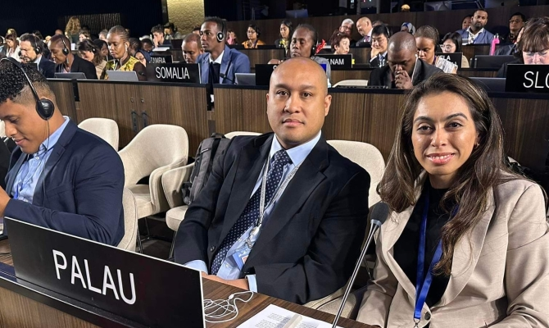
Source: https://www.sprep.org/news/pacific–sids–state–their–case–for–a–robust–and–ambitious–treaty–to–address–plastic–pollution

Activities
SPREP and POLP have supported PIC delegates in these INC negotiations with technical and legal advice and communications support through the following activities.

Pre–INC meetings and workshops
SPREP, supported by POLP, organised pre–INC meetings aimed at developing strategies and assisting the Chair of the Pacific Small Island Developing States (PSIDS) in leading coordination efforts. For example, in the lead–up to INC–3 in Kenya, PSIDS representatives convened to discuss key aspects of the zero draft of the plastic pollution treaty, focusing on potential areas of consensus for a regional position.

Providing capacity building trainings
Prior to INC–4 in Canada, SPREP also organised the ‘Empowering our Pacific Voice as Negotiators’ training program attended by the Cook Islands, Federated States of Micronesia, Fiji, Kiribati, Marshall Islands, Nauru, Niue, Palau, Papua New Guinea, Samoa, Solomon Islands, Tonga and Vanuatu. The one–day training is part of the Pacific Regional Preparatory Workshop for INC–4, facilitated with support from the Governments of Australia and New Zealand.

Assisting in the development of a negotiation strategy
The POLP PMU and the SPREP provided communication and engagement support to Pacific island countries, helping them address their single–use plastic priorities and strengthen their unified ‘One Pacific Voice’ at the INC.

Providing communication support
The POLP PMU developed comprehensive media and social media content before, during and after each INC session to raise regional awareness about the process and highlight the involvement of Pacific Islands.

Achievements
Ultimately, the success of this activity will be reflected in the outcome of INC–5 in late November 2024, in terms of the extent to which Pacific priorities are addressed in the final agreement. To date, the activity has been successful in strengthening the presence and visibility of Pacific island delegations and Pacific priorities at INC meetings through stronger profiling, bringing a deeper knowledge and understanding of Pacific plastic–related issues and achieving a greater emphasis on Pacific priorities within the INC.
In the INC process, Pacific island countries were able to provide substantial input to the draft text of the international legally binding instrument on plastic pollution to better reflect the specific needs and priorities of the Pacific region.
Further to the achievements for the region and PICs, POLP’s role in supporting the INC process had several benefits for POLP, including:
- raising POLP’s profile among participating PICs and delegates
- providing opportunities for POLP to build and strengthen relations with PICs and PIC delegates
- providing opportunities for the PMU to discuss and progress national implementation of POLP activities.
In addition, the extensive communications coverage provided by the PMU not only contributed to raising the profile of the INC process, it also assisted in raising POLP’s profile more broadly.
While the PMU reports that its support to the INC process included a GEDSI focus, disaggregated data on the representation of GEDSI target groups has not been provided.

Lessons learned
The contribution from the PMU to support and build the capacity of PIC delegates was seen as valuable, and instrumental in raising the profile of regional and national perspectives in the INC process. This support was able to leverage specialist expertise in the PMU to support the process, such as legal and communications input, and provided an example of POLP’s capability in delivering targeted, value-added support.
In this case, POLP was able provide support that strengthened the capacity of PIC participation in the INC process and highlighted the potential value of the strategic use of POLP resources for building national capacity for implementation of national activities, as a complement to the role of NPOs.
However, POLP’s support for the INC process also created the potential for PMU resources to be diverted from POLP’s other activities. Balancing this concern, POLP’s role in supporting the INC process had some benefits for POLP, which were discussed above. This support also relates directly to POLP’s long-term goals and EOPOs, particularly Outcome 5, which focuses on SPREP’s role in driving and leading action on marine litter.
The INC process illustrates the interconnectedness of POLP’s work with other SPREP waste– and plastics –related activities and events in the region, and the benefits of PMU’s location within SPREP. In addition, POLP’s work in specific activities are interconnected with its work in other POLP activities. As an example, the communications coverage of the INC process was successful in raising POLP’s profile more broadly.
The opportunities for PMU to represent POLP at other SPREP events is discussed elsewhere in this report, where the decision-making in relation to POLP’s participation in related activities, particularly ad hoc events, needs to balance the resources required with the potential benefits in the context of other priorities. This is an area of ongoing focus for POLP Officers and for POG and the approach to annual planning and the design of the next phase of POLP should reflect the opportunities and risks that flow from the interconnectedness within POLP activities and with related SPREP programmes.

- POLP program logic framework

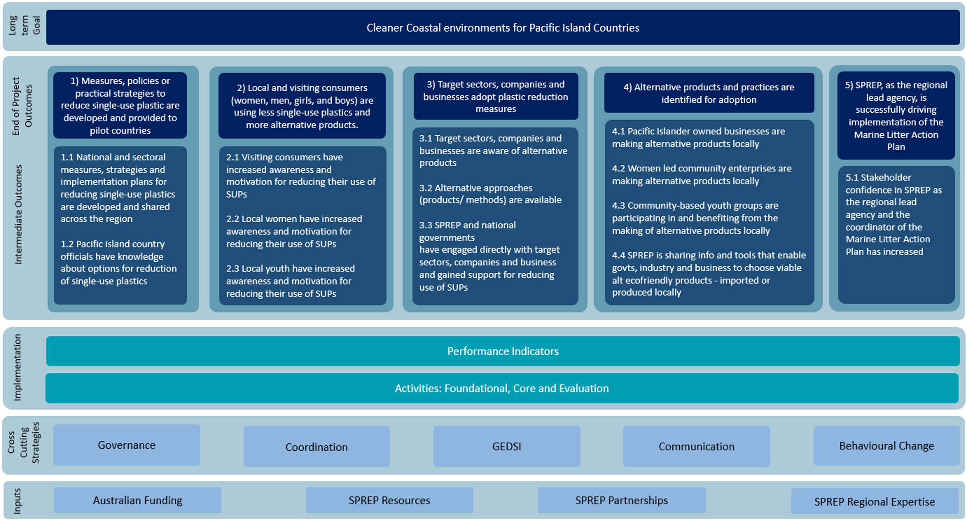
- List of documents

Document Category | Document
Project Design | POLP Project Design 2023
Implementation Plan | Implementation Plan 2023  Attachment A – Data Collection Plan  Attachment B – Implementation Tool  Attachment C – GEDSI Good Practice Menu  Attachment D – GESI and Safeguarding Strategy  Attachment G – National Implementation Plan Template  Attachment H – MERL Plan  Attachment J – POLP Risk Register  Attachment L – Communications plan  Monitoring and Reporting Toolkit
SPREP Annual Reports to DCCEEW | 2022 Annual Report  2023 Annual Report
DCCEEW Annual Reports to DFAT | 2020 Annual Report  2021 Annual Report  2022 Annual Report  2023 Annual Report
DFAT Investment Monitoring Reports | 2023 Investment Monitoring Report  2024 Investment Monitoring Report
Funding agreements | ROU No. 37602  Activity Schedule No. 41 to ROU No. 37602  Variation 1 to Activity Schedule No. 41  Variation 2 to Activity Schedule No. 41  Activity Schedule No. 44 to ROU No. 37602  DCCEEW–SPREP Funding agreement  Variation 1 to DCCEEW–SPREP Funding agreement  Variation 2 to DCCEEW–SPREP Funding agreement  Variation 2 to DCCEEW–SPREP Funding agreement – Schedule B  Variation 3 to DCCEEW–SPREP Funding agreement
Annual Planning Meetings | 2023 Annual Planning Meeting Outcomes Report
Annual Workplans | 20219–20 Annual Workplan  2022 Annual Workplan  2023 Annual Workplan  2024 Annual Workplan
Annual Budgets | 2022 Budget  2023 Budget  2024 Budget
Regional and National Policies | Australia’s International Development Policy 2023  Cleaner Pacific 2025 – Pacific Regional Waste and Pollution Management Strategy 2016–2025  Marine Litter – Pacific Regional Action Plan 2018–2025

- List of stakeholders

Organisation | Name and position
DCCEEW  Pacific and Regional Section | Nicole Coombe, Director (POLP Project Oversight Group)
Pacific and Regional Section | Melissa Masters, Assistant Director (POLP Project Administration)
Pacific and Regional Section | Kathryn McKenna, Senior Project Officer (POLP Project Administration)
DFAT  Pacific Climate Change Section | Claire Chivell, Director (POLP Project Oversight Group)
SPREP  Waste Management and Pollution Control Programme | Anthony (Tony) Talouli, Director Waste Management and Pollution Control (POLP Oversight Group)
POLP Project Management Unit | Andrea Volentras, Project Implementation Manager
POLP Project Management Unit | Dwayne Bentley, Project Coordinator
POLP Project Management Unit | Ngaire Ah Ching, Senior Project Officer (Budget and Procurement)
POLP Project Management Unit | Maryann Vaiula, Project Support Officer
Participating PICs  Cook Islands | Halatoa Fua, Director, National Environment Service (NES)
Cook Islands | Hayley Weeks, Environmental Partnerships Manager, NES
Palau | Kliu Basilius, Palau Environmental Quality Protection Board
Papua New Guinea | Veari Kula, POLP National Project Officer, Conservation and Environmental Protection Authority (CEPA)
Niue | Haden Talagi, Director, Department of Environment
Samoa | Katenia Rasch, Assistant CEO, Waste Management and Pollution Control Division, MNRE
Solomon Islands | Debra Kereseka, Deputy Director Environment, Environment and Conservation Division, MECDM
Solomon Islands | Wendy Beti, Principal Environment Officer, MECDM
Other eligible PICs  Tonga | Mafile'o Masi, Senior Environmentalist, MEIDECC
Development Partners Sustainable Waste Actions in the Pacific (SWAP), France | Julie Pillet, Technical Waste Project Coordinator, SWAP
GEF Islands | Joshua Sam, Hazardous Waste Management Adviser
Networks  Australian, New Zealand and Pacific Islands Plastics Pact (ANZPAC) – part of the Ellen MacArthur Foundation’s (EMF) global Plastics Pact Network | Angela Mayer, Senior ANZPAC Program Manager
Private Sector  Scientific Research Organisation of Samoa (SROS) | Annie Tuisuga, Manager, Environment and Renewable Energy Division

- Participant information sheet
Information for participants
You are invited to take part in an interview as part of the mid–term review and evaluation of the Pacific Ocean Litter Project (POLP).
Sustineo has been commissioned by the Australian Government Department of Climate Change, Energy, the Environment and Water (DCCEEW) to undertake the evaluation. The information below provides details about the evaluation and your potential contribution through the interview.

Evaluation purpose
The purpose of the evaluation is both formative and summative. As a formative evaluation it will inform the future implementation and management of the project by identifying lessons learned, particularly in terms of aspects of the project that worked well and areas that need to be improved. As a summative evaluation, it will assess the project’s progress in achieving its planned outcomes.

What does participation in the consultation entail?
The consultation will be conducted remotely and will seek your views on:
- the management and governance of the project
- the relevance of the project to the development needs of the region, individual PICs and Australia’s development priorities
- progress in achieving the project’s planned outcomes
- the efficient use of resources in delivering the project
- addressing gender equality, disability and social inclusion
- the likelihood that the benefits of the project will continue over the medium– and long–term.
The consultation will take about an hour. Should you wish to follow–up the discussion with clarification or further information you may provide this by email to the evaluation team.
With your consent, the interview will be recorded to ensure all information is captured for the analysis.

Confidentiality
Your answers and opinions will be treated in a strictly confidential manner. Any information that you provide that is used in the report will be de–identified and if it is used as a ‘quote’ in the report, it will not be attributed to you. The report will include a list of stakeholders consulted for the evaluation. If you do not wish to be included in this list, you may indicate this at the beginning of the consultation.

Use and storage of information
The information collected through the consultation will be used to create a report to submit to DCCEEW. Any information that you provide to us will be de–identified and stored in a secure password protected data storage system.

Voluntary participation and withdrawal
While we would greatly appreciate your participation in this consultation, it is entirely voluntary, and you may withdraw or decline to take part at any time. If you are uncomfortable with a question, you do not have to answer. You do not need to provide an explanation for your withdrawal. You may ask for questions or clarifications at any time.

Consent
As engagement with the consultation is voluntary, by participating in this consultation you provide your consent.
Thank you in advance for your participation in the evaluation. If you require further information or have any concerns or questions about the study, please contact us using the following information:
Douglas Smith, Evaluation Team Leader. Email: douglas.smith@sustineo.com.au

- Survey Instrument
Pacific Ocean Litter Project Stakeholder Survey
The Department of Climate Change, Energy the Environment and Water has commissioned Sustineo to undertake a mid-term review of the implementation of the Pacific Ocean Litter Project. As a stakeholder in the project, you are invited to complete this brief survey, which should take 10-15 minutes to complete. The review team is also conducting consultations with a selection of stakeholders and this survey will complement these consultations.
The survey is voluntary and completely anonymous and your identity will not be recorded or used in the review report.
If you have any questions about the survey you may contact the review team at douglas.smith@sustineo.com.au.

Respondent information
Please provide the following information about yourself.

What type of organisation do you represent?
¡ Pacific islands government agency
¡ Pacific Regional Body
¡ Donor or Development Partner
¡ Other industry, advocacy or non-government organisations
¡ Other type of organisation

What is your level of knowledge of the project?
¡ Directly involved in the planning or implementation of project activities
¡ Not directly involved but have a good knowledge of the project or its planned activities
¡ Limited knowledge of the project or its activities

The project in general
Please rate your agreement with the following elements of the project in general using the rating scale Disagree strongly, Disagree, Neutral, Agree, Agree strongly, Not sure or don’t know. You will have an opportunity to clarify your answers in the comments section at the end of this section.

¡ The project’s objective is appropriate (supporting actions to refuse, reduce or replace single use plastics in the Pacific).
The project focus on each of the following components is appropriate
¡ Implementing measures, policies and strategies
¡ Consumer awareness
¡ Availability of alternative products
¡ Awareness and adoption of alternative products by target sectors and businesses

¡ The project is relevant to the needs and priorities of Pacific countries
¡ The implementation of the project across the region is well–coordinated
¡ This project and other projects implemented by donors and development partners focussing on ocean litter are well–coordinated
¡ The delivery of project activities through the Secretariat of the Pacific Regional Environment Programme (SPREP) is effective
¡ The project is making, or has the potential to make, a contribution to refusing, reducing and replacing single–use plastics in the Pacific
¡ The project is making good progress in implementing activities to support the project objectives
¡ I receive or have access to adequate information about the project’s implementation and progress
Please provide comments is you wish to clarify any of the answers you gave in this section.

Project Activities
Do you have a close involvement with, or knowledge of, specific project activities? (Yes / No)
Please comment of the following aspects of the activity. If you have involvement in a number of activities, please focus on the one you have most involvement with.
- Name of the activity
- Key achievements of the activity
- Key challenges in implementing the activity
- Lessons learned that could improve the implementation of the activity

Comments
Do you have any comments about the design, implementation or value of the project?

- POLP governance structure

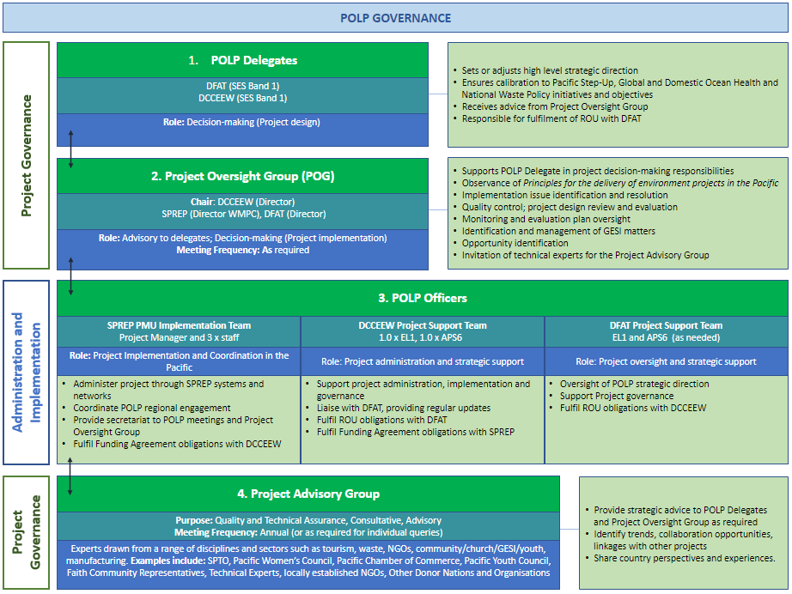
- Survey respondents’ profile

Category | Number | %
Total Responses | 28 | 100.0
Organisation  Pacific Islands country government agency | 12 | 43
Pacific Regional Body | 4 | 14
Donor or Development Partner | 4 | 14
Other industry, advocacy or non–government organisations | 2 | 7
Other type of organisation | 6 | 21
Level of knowledge about the project  Directly involved in the planning or implementation | 16 | 59
Not directly involved but has good knowledge | 7 | 26
Limited knowledge | 4 | 15
Level of knowledge about project activities  Has close involvement/knowledge | 19 | 76
Does not have close involvement/knowledge | 6 | 24

- Survey results

Agreement with survey statements

Criteria | Statement | % Agreed
Project Objective | The project's objective is appropriate | 96
Appropriateness of project’s focus on | Implementing measures, policies and strategies | 96
Appropriateness of project’s focus on | Consumer awareness | 92
Appropriateness of project’s focus on | Availability of alternative products | 84
Appropriateness of project’s focus on | Awareness and adoption of alternative products by target sectors and businesses | 92
Relevance | The project is relevant to the needs and priorities of Pacific countries | 92
Coordination | The implementation of the project across the region is well–coordinated | 68
Coordination | This project and other projects implemented by donors and development partners focussing on ocean litter are well–coordinated | 64
Effectiveness | The delivery of project activities through the Secretariat of the Pacific Regional Environment Programme (SPREP) is effective | 74
Effectiveness | The project is making, or has the potential to make, a contribution to refusing, reducing and replacing single–use plastics in the Pacific | 92
Implementation | The project is making good progress in implementing activities to support the project objectives | 64
Implementation | I receive or have access to adequate information about the project’s implementation and progress | 68

Summary of comments

Key themes

Delays in implementation
Project implementation experienced delays. For example, in the Cook Islands, despite positive reception, activities have yet to start due to prolonged due diligence, funding, and agreement–signing delays within SPREP. COVID–19 and recruitment challenges have further slowed progress.

Administrative and coordination Issues
SPREP faces administrative challenges in implementing projects across multiple small island states. Information dissemination to partners is slow. One participant who disagreed with the statement “’his project and other projects implemented by donors and development partners focusing on ocean litter are well–coordinated’ points to the fact that projects and activities by different donors are often done in isolation, suggesting the need for better collaboration and coordination.

Effectiveness and compliance
In the Solomon Islands, the project has shown effectiveness, with high compliance rates for the single–use plastic ban, indicating positive behavioural changes even in remote communities.

Focus on upstream measures
POLP’s emphasis on upstream measures complements other regional projects that focus on downstream measures, which avoids duplication but limits POLP’s ability to address all plastic waste priorities across Pacific Island Countries (PICs).

Project activities

Implementation activities that the respondents were involved in
- single–use plastic bans in Cook Islands, Solomon Islands and Tuvalu
- community outreach – beach clean–ups, school programs and street awareness in Honiara
- research on plastic alternatives – Samoa’s feasibility study on biodegradable plastic (PHA)
- development of Activity Plans and National Implementation Plans for Waste Management
- regional activities – Pacific Clean roundtable.
- coordination of pollution control within SPREP’s WMPC team.

Achievements of implementation of activities
- Awareness and education activities such as waste audits, produced awareness videos, and held education and outreach programs to inform the public about plastic pollution
- Regulatory actions such as a gazetted ban on specific SUPs in Solomon Islands, reducing their availability
- Behavioural changes including increased awareness and compliance among youth, women and businesses in Solomon Islands, especially leading up to the Pacific Games
- Community engagement activities including clean–up campaigns, training and outreach to promote sustainable behaviour in Honiara and other communities
- Internship and capacity building activities which established a POLP–funded graduate internship program, resulting in a NPO for ongoing efforts
- Research and feasibility studies conducted in areas such as the feasibility of biodegradable plastics in Samoa, producing recommendations for further action
- Coordination and partnerships which strengthened communication among sectors and stakeholders to address litter issues and share insights across the Pacific.
- Ban on specific plastics in Tuvalu which successfully banned eight SUP items with available alternatives

Challenges of implementation activities
- Procurement and funding delays resulting from issues such as the slow SPREP approval processes and lengthy internal payment procedures, which delated funding and project initiation
- Data collection challenges such as difficulties in engaging communities for long–term data collection, especially after funding ends and Issues with time constraints also affect the quality and comprehensiveness of data collected
- Logistics and remoteness impacted in organisation and delivery due to the remoteness of islands and limited transport options
- Capacity limitations in national environment ministries required intensive SPREP involvement to support implementation
- Compliance and enforcement challenges in enforcing the ban on single–use plastics, partly due to remote locations and limited resources
- Competing priorities and changes in partners led to delays in the delivery of activities
- Stakeholder resistance for example from importers who disagree with banning specific items
- Administration and communication Issues such as delays in obtaining necessary approvals and feedback from local departments, which impacted timelines

Lesson learned
- Community engagement during the through pilot projects, led by national or provincial authorities or NGOs, will improve local buy–in and sustainability
- Funding processes need to be streamlined to avoid delays and maintain alignment with national plans and stakeholder expectations
- Reporting needs to be timely and accurate to access funds and maintaining project momentum
- Capacity provided by NPOs needs to be in place early in the national implementation to drive project progress and improve in–country coordination
- Realistic expectations in implementation planning, including establishing achievable goals to manage expectations and focusing resources where success is most feasible
- Research timeframes should allow longer timelines for research activities to ensure robust and useful findings, especially for multi–country studies
- Private sector should be engaged and involved to improve data quality and stakeholder buy–in of outcomes
- Consistency in ongoing support and follow–up with local departments and collaboration with donors will enhance project effectiveness
- Flexible donor support will strengthen alignment of national activities with national policies and priorities

Final comments on POLP
- POLP is seen as impactful, well–designed, inclusive, sustainable and flexible.
- POLP builds local capacity and fosters strong partnerships, with potential long–term benefits for health, education and plastic waste reduction.
- COVID–19 and administrative issues have delayed implementation, but foundational work is largely complete
- POLP has emerged as a regional leader in plastics policy and supports global plastics treaty negotiations
- Project effectiveness could be improved by enhancing community engagement in awareness and clean–up activities
- Feedback suggests the need for clearer prioritisation of activities, streamlined governance and alignment of reporting timelines with Pacific Island realities
- Land–based initiatives could be linked with marine pollution monitoring
- Stakeholders are eager for full implementation and look forward to future impact

- Project Logic (written version)

Level | Details
Long term Goal | Cleaner Coastal environments for Pacific Island Countries
End of Project Outcomes | 1 Measures, policies or practical strategies to reduce single-use plastic are developed and provided to pilot countries  2 Local and visiting consumers (woman, men, girls, and boys) are using less single-use plastics and more alternative products  3 Target sectors, companies and businesses adopt plastic reduction measures  4 Alternative products and practices are identified for adoption  5 SPREP, as the regional lead agency, is successfully driving implementation of the Marine Litter Action Plan
Intermediate Outcomes | 1.1 National and sectoral measures, strategies and implementation plans for reducing single-use plastics are developed and shared across the region  1.2 Pacific Iland country officials have knowledge about options for reduction of single-use plastics  2.1 Visting consumers have increased and motivation for reducing their use of single-use plastics  2.2 Local women have increased awareness and motivation for reducing their use of single-use plastics  2.3 Local youth have increased awareness and motivation for reducing their use of single-use plastics  3.1 Target sectors, companies and businesses are aware of alternative products  3.2 Alternative approaches (products / methods) are available  3.3 SPREP and national governments have engaged directly with target sectors, companies and businesses and gained support for reducing the use of single-use plastics  4.1 Pacific Islander owned businesses are making alternative products locally  4.2 Women led community enterprises are use of single-use plastics  4.3 Community-based youth groups are participating in and benefiting from the making of alternative products locally  4.4 SPREP is sharing information and tools that enable governments, industry and businesses to choose viable alternative ecofriendly products – imported or produced locally  5.1 Stakeholder confidence in SPREP as the regional lead agency and the coordinator of the Marine Litter Action Plan has increased
Implementation | Performance Indicators  Activities: Foundational, Core and Evaluation
Cross Cutting Strategies | Governance  Coordination  GEDSI  Communication  Behavioural Change
Inputs | Australian Funding  SPREP Resources  SPREP Partnerships  SPREP Regional Expertise

Solomon Islands Government. 2023. Safe and Green Games to engage community–wide approach. https://solomons.gov.sb/safe–green–games–to–engage–community–wide–approach/
Gina Maka’a. 2023. ‘Empowering Pacific Athletes through Green Initiative Tree Planting’ In–depth Solomons. 1st December. https://indepthsolomons.com.sb/empowering–pacific–athletes–through–green–initiative–tree–planting/#google_vignette

