INFORMATION SESSION: PACIFIC HIGHER EDUCATION PARTNERSHIPS

Slide 1

Acknowledgement of Country:
I want to respectfully acknowledge the Ngunnawal people as traditional custodians of the land I am on and recognise any other people or families with connection to the lands of the ACT and region. I want to acknowledge and respect their continuing culture and the contribution they make to the life of this city and this region. I also acknowledge the Traditional Custodians of the various lands on which you all work today and any Aboriginal and Torres Strait Islander people on this call.

Slide 2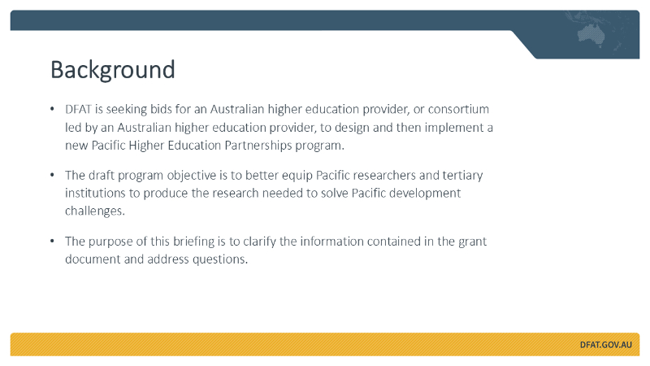
Thank you for your interest in this competitive grant opportunity, and for joining us at today’s applicant briefing.
The purpose of this session is to outline some of the information included in the grant documents, highlight key areas of focus under the new investment, and answer any new questions you may have.
You are welcome to begin posting questions in the Q&A space as I present, and I'll address them at the end.
DFAT is inviting bids from an Australian higher education partner – or a consortium led by one – to design and deliver a new Higher Education Partnerships Investment.
The draft program objective is to better equip Pacific researchers and tertiary institutions to produce the research needed to solve Pacific development challenges.

Slide 3
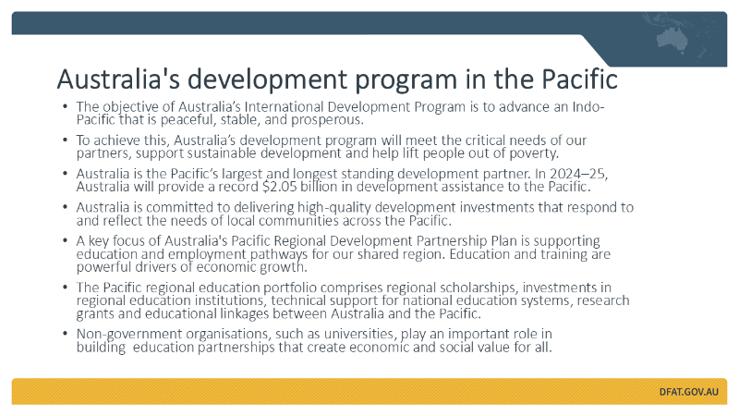
Australia’s development program aims to advance an Indo‑Pacific that is peaceful, stable, and prosperous.
To achieve this, we focus on meeting partners’ critical needs, supporting sustainable development, and lifting people out of poverty.
Australia is the Pacific’s largest and longest‑standing development partner. In 2024–25, we will provide a record $2.05 billion in development assistance to the Pacific.
We are committed to high‑quality investments that reflect local priorities. A key focus is education and employment pathways – powerful drivers of economic growth.
Non‑government organisations, including universities, play an important role in building education partnerships that create economic and social value.
Our key policy documents, including the Australian International Development Policy and the Pacific Regional Development Partnership Plan, can be found online and I encourage you to review them.

Slide 4
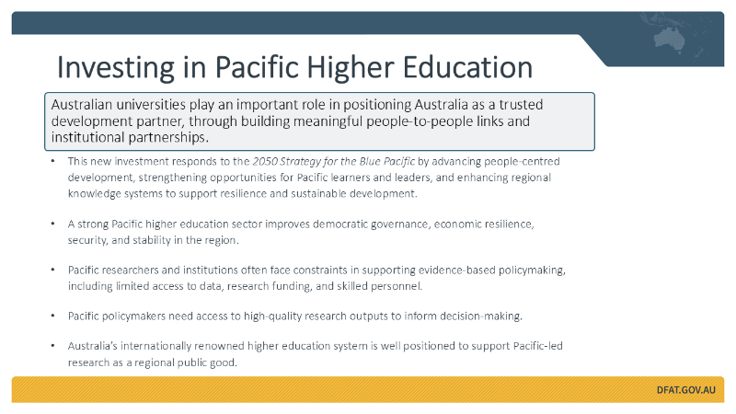
Why invest in Pacific higher education?
The 2050 Strategy for the Blue Pacific is the blueprint that informs Australia’s development program in the region. This new investment responds to the 2050 Strategy by focusing on people‑centred development, creating more opportunities for Pacific learners and leaders through inclusive education, and strengthening regional knowledge systems to build resilience and sustainable futures.
Australia values its partnerships with Pacific island nations. These relationships reflect deep historical ties and shared regional interests. Our future depends on a Pacific that is peaceful, prosperous, and stable.
A strong higher education sector in the Pacific is critical. It underpins democratic governance, economic resilience, security, and stability across the region.
Pacific researchers and institutions face real constraints – limited access to data, research funding, and skilled personnel. At the same time, policymakers need high‑quality research to make informed policy decisions.
Australia has an internationally renowned higher education system, with some of the best universities in the world. We believe the sector is well positioned to support Pacific‑led research as a regional public good, with the reputation and capability to help research inform policy challenges. This includes the important role universities and research institutes play in protecting freedom of speech and public debate.
We value the role that Australian universities and other research institutions can play in extending our bilateral and regional relationships beyond government, including building genuine institutional linkages and relationships with Pacific counterparts. The Australian government has made a commitment to the Pacific to be a responsive and reliable regional partner and this program seeks to recognise the important role Australian universities play as a development partner in the region.

Slide 5
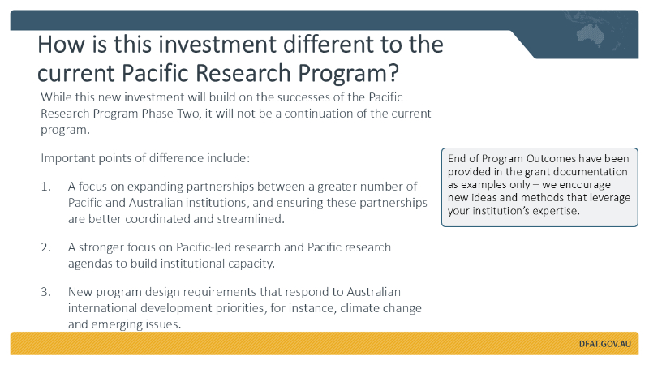
How is the investment different to the current Pacific Research Program?
This new investment builds on the successes of the Pacific Research Program (PRP), but it’s not a continuation. There are some important differences, informed by the recent Independent Evaluation of PRP Phase Two.
These include:
- Stronger emphasis on expanding and deepening institutional partnerships – bringing in more Pacific and Australian institutions and ensuring these partnerships are better coordinated.
- A greater focus on Pacific‑led research, research agendas and Pacific research methodologies that build capabilities in the region.
- The program will need to respond to Australia’s international development priorities, for example, climate change and emerging issues.
The Independent Evaluation can be found on the DFAT website. DFAT reserves the right to commission an independent evaluation of the Pacific Higher Education Partnerships Investment at any time.

Slide 6
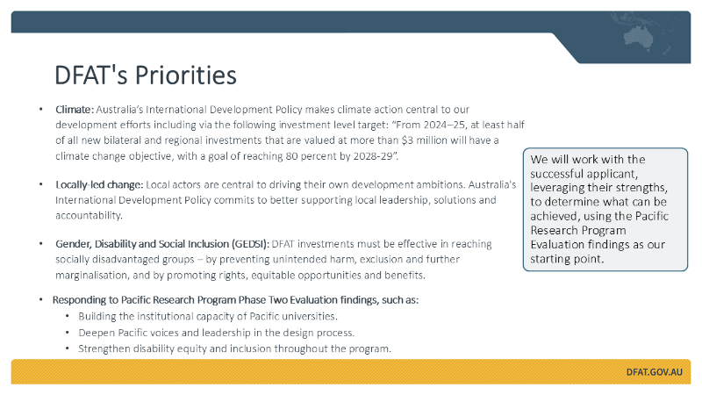
DFAT’s priorities
Our priorities for this investment include:
- Climate action: Climate action is central to Australia’s development efforts. This will be a mandatory part of the investment design.
- Localisation: Local actors are key to driving their own development ambitions. We’re committed to supporting local leadership, solutions, and accountability.
- Gender, Disability and Social Inclusion (GEDSI): All DFAT investments must effectively reach socially disadvantaged groups. This is another mandatory part of the investment design.
- Responding to Pacific Research Program Phase Two Evaluation findings, such as building the institutional capacity of Pacific universities, deepening Pacific voices and leadership in the design process, and strengthening disability equity and inclusion throughout the program.

Slide 7
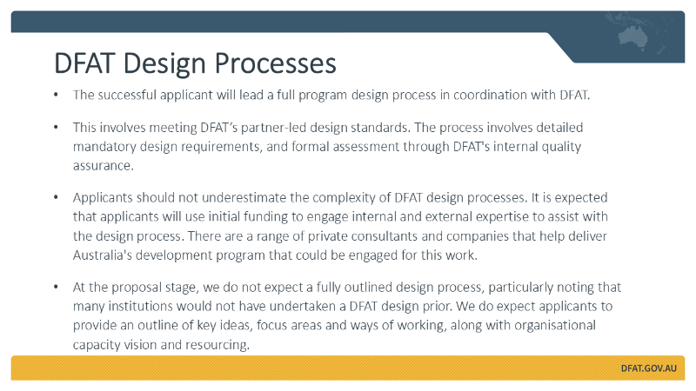
The successful applicant will lead a full program design process in coordination with DFAT.
This must meet DFAT’s partner‑led design standards, including mandatory requirements and formal quality assurance.
This process is complex, so please keep that in mind as you prepare your proposal.
I encourage you to review the DFAT Design and Monitoring, Evaluation and Learning Standards.
Initial funding is expected to be used to engage internal and external expertise. Private consultants and companies experienced in delivering Australia’s development program can be engaged.
We don’t expect a fully detailed design at the proposal stage, noting the length limits specified in the documents and noting many institutions may not have worked with DFAT funding before. What we do expect is an outline of your key ideas or offerings with respect to the objectives we have put forward, potential focus areas, and proposed ways of working, along with your vision for organisational capacity and resourcing.

Slide 8
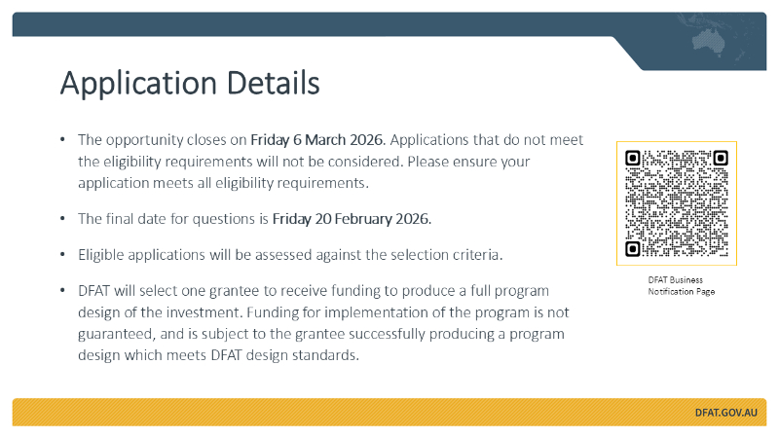
The opportunity closes on Friday 6 March 2026. Please ensure your application is submitted well before the deadline.
Applications that do not meet the eligibility requirements will not be considered. Please ensure your application meets all eligibility requirements (for instance, length, format requirements).
We recommend you pay close attention to the selection criteria, and their respective weighting.
DFAT will select one grantee to receive funding to produce a full program design for a new investment. Funding for implementation of the program is not guaranteed, and is subject to the grantee successfully producing a program design which meets DFAT design standards.

Slide 9
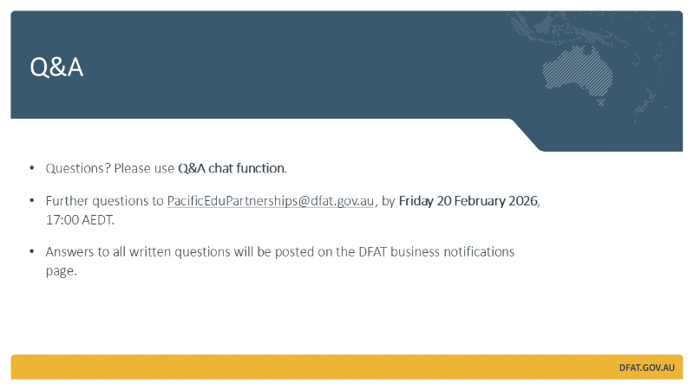

Question and answer
[Taken on notice during the information session – confirmed response provided below] Q1: Can this program fund activities linked to French territories?
A1: French Pacific territories are part of the Pacific family; as such, research projects that include French Pacific territories in scope are eligible under the grant. However, as territories of France, which is not ODA-eligible, direct flows of DFAT funding to institutions in French Pacific territories are not permissible under this investment. Lead institutions may decide to direct in-kind (non-financial) resources, whether financial or otherwise, to these institutions.
Q2: Does this project need to complement other initiatives in the region that are Australia-funded?
A2: It is not essential, but it is beneficial for proposals to demonstrate an understanding of other Australia‑funded initiatives in the Pacific and to outline any potential complementarity or synergies. If your institution is aware of relevant activities or investments and can identify opportunities to align or add value, this would strengthen your proposal. However, we would anticipate that more detailed exploration of these linkages would form part of a fuller design process.
Q3: Does DFAT expect applicants to have already established partnerships or a consortium that collectively addresses all priority areas at the time of submission, or is it acceptable for applicants to propose only the priority areas in which they have demonstrated capability, with DFAT facilitating consortium formation post-submission?
A3: Applicants may apply as individual institutions or as part of a consortium. We encourage all applicants to demonstrate their areas of comparative advantage or expertise as part of their EOI. While DFAT may engage in partnership alignment or consortium building during assessment or negotiation to ensure coverage of program priorities, applications that demonstrate sufficient breadth across proposed objectives will be viewed favourably.
Q4: Are there restrictions on types of organisations who can be recipients of funding as part of design or implementation phase?
A4: Eligibility to apply is limited to Australian higher education providers, or consortia led by an Australian higher education provider. Consortium members may include a range of organisation types, including non-Australian entities, provided they meet DFAT’s due diligence requirements, and any other requirements outlined in the Guidelines. The lead organisation is accountable to DFAT for the use of all funds and delivery of the program. This includes managing risks associated with consortium partners and any funding recipients.-Australian entities, provided they meet DFAT’s due diligence requirements
Q5: Are Letters of Intent expected to come from a whole organisation or the area of an organisation where we have our networks? E.g., Specific institutes / schools / centre
A5: While no formal rule applies, Letters of Intent should ideally come from the relevant part of the institution (such as the specific institute, school or centre) and be issued by the senior management of that area.
Q6: Are partnerships with Pacific institutions limited to higher education organisations or may we include other vocational institutions / industry, and community?
A6: There's no limitation on the type of consortium members, provided that the lead organisation is an Australian higher education provider.
Q7: The guidelines ask for CVs for 5 key proposed staff, are we allowed to name others within the application (but only provide biographies for the 5)
A7: Yes, it is fine to name others. CVs should not be provided for more than 5 critical staff.
[Taken on notice during the information session – confirmed response provided below] Q8: Is there anything to stop us intending to join a bid as a partner for a specific area (and providing a Letter of Intent to that effect), but also leading our own?
A8: DFAT is inviting bids from an Australian higher education partner – or a consortium led by one – to design and deliver a new Higher Education Partnerships Investment. Australian higher education partners wishing to participate by submitting a proposal must do so as either a consortium partner OR lead applicant (not both).
[Taken on notice during the information session – confirmed response provided below] Q9: Do partnerships in a consortium preclude those institutions from being a beneficiary of the program?
A9: Consortium members can be beneficiaries of the program where relevant. However, conflicts of interest (and how the lead entity proposes to manage and mitigate them) should be proactively addressed in the application. DFAT reserves the right to assess the risks associated with the proposal submitted.
Q10: As this grant requires a lot of advance work – when will the next round of funding be announced? Several years’ time?
A10: The grant is intended to operate over a four‑year period. Funding beyond this cycle is not guaranteed. Any future opportunities would be publicly advertised before a new funding round, and cycles will not overlap. It is therefore unlikely that another opportunity in this specific area will arise until the current four‑year cycle has concluded.
Additional information:
We acknowledge that this is a substantial proposal to prepare within a condensed timeframe. If stakeholders consider that the current deadline may affect their ability to submit a complete proposal, they may provide feedback on the timeline in the coming business days. While DFAT is not in a position to indicate whether any adjustment will be made, all feedback received will be considered. DFAT will not consider any requests beyond 20 February 2026.

Slide 10

Thank you for attending the applicant briefing today, and for your interest in this opportunity. If you have further questions, please reach out to pacificedupartnerships@dfat.gov.au by Friday 20 February 2026, 17:00 AEDT.

APPENDIX
Transcript of slide text.

Slide 1
Information Session
Pacific Higher Education Partnerships - Call for Proposals
Prepared by: Education Partnerships Section
Date: 6/02/2026

Slide 2
DFAT is seeking bids for an Australian higher education provider, or consortium led by an Australian higher education provider, to design and then implement a new Pacific Higher Education Partnerships program.
The draft program objective is to better equip Pacific researchers and tertiary institutions to produce the research needed to solve Pacific development challenges.
The purpose of this briefing is to clarify the information contained in the grant document and address questions.

Slide 3
Australia's development program in the Pacific
The objective of Australia’s International Development Program is to advance an Indo-Pacific that is peaceful, stable, and prosperous.
To achieve this, Australia’s development program will meet the critical needs of our partners, support sustainable development and help lift people out of poverty.
Australia is the Pacific’s largest and longest standing development partner. In 2024–25, Australia will provide a record $2.05 billion in development assistance to the Pacific.
Australia is committed to delivering high-quality development investments that respond to and reflect the needs of local communities across the Pacific.
A key focus of Australia's Pacific Regional Development Partnership Plan is supporting education and employment pathways for our shared region. Education and training are powerful drivers of economic growth.
The Pacific regional education portfolio comprises regional scholarships, investments in regional education institutions, technical support for national education systems, research grants and educational linkages between Australia and the Pacific.
Non-government organisations, such as universities, play an important role in building education partnerships that create economic and social value for all.

Slide 4
Investing in Pacific Higher Education
Australian universities play an important role in positioning Australia as a trusted development partner, through building meaningful people-to-people links and institutional partnerships.
This new investment responds to the 2050 Strategy for the Blue Pacific by advancing people-centred development, strengthening opportunities for Pacific learners and leaders, and enhancing regional knowledge systems to support resilience and sustainable development.
A strong Pacific higher education sector improves democratic governance, economic resilience, security, and stability in the region.
Pacific researchers and institutions often face constraints in supporting evidence-based policymaking, including limited access to data, research funding, and skilled personnel.
Pacific policymakers need access to high-quality research outputs to inform decision-making.
Australia’s internationally renowned higher education system is well positioned to support Pacific-led research as a regional public good.

Slide 5
How is this investment different to the current Pacific Research Program?
While this new investment will build on the successes of the Pacific Research Program Phase Two, it will not be a continuation of the current program.
Important points of difference include:
- A focus on expanding partnerships between a greater number of Pacific and Australian institutions, and ensuring these partnerships are better coordinated and streamlined.
- A stronger focus on Pacific-led research and Pacific research agendas to build institutional capacity.
- New program design requirements that respond to Australian international development priorities, for instance, climate change and emerging issues.
End of Program Outcomes have been provided in the grant documentation as examples only – we encourage new ideas and methods that leverage your institution’s expertise.

Slide 6
DFAT’s Priorities
Climate: Australia’s International Development Policy makes climate action central to our development efforts including via the following investment level target: “From 2024–25, at least half of all new bilateral and regional investments that are valued at more than $3 million will have a climate change objective, with a goal of reaching 80 percent by 2028-29”.
Locally-led change: Local actors are central to driving their own development ambitions. Australia's International Development Policy commits to better supporting local leadership, solutions and accountability.
Gender, Disability and Social Inclusion (GEDSI): DFAT investments must be effective in reaching socially disadvantaged groups – by preventing unintended harm, exclusion and further marginalisation, and by promoting rights, equitable opportunities and benefits.
Responding to Pacific Research Program Phase Two Evaluation findings, such as:
Building the institutional capacity of Pacific universities.
Deepen Pacific voices and leadership in the design process.
Strengthen disability equity and inclusion throughout the program.
We will work with the successful applicant, leveraging their strengths, to determine what can be achieved, using the Pacific Research Program Evaluation findings as our starting point.

Slide 7
DFAT Design Process
The successful applicant will lead a full program design process in coordination with DFAT.
This involves meeting DFAT’s partner-led design standards. The process involves detailed mandatory design requirements, and formal assessment through DFAT's internal quality assurance.
Applicants should not underestimate the complexity of DFAT design processes. It is expected that applicants will use initial funding to engage internal and external expertise to assist with the design process. There are a range of private consultants and companies that help deliver Australia's development program that could be engaged for this work.
At the proposal stage, we do not expect a fully outlined design process, particularly noting that many institutions would not have undertaken a DFAT design prior. We do expect applicants to provide an outline of key ideas, focus areas and ways of working, along with organisational capacity vision and resourcing.

Slide 8
Application Details
The opportunity closes on Friday 6 March 2026. Applications that do not meet the eligibility requirements will not be considered. Please ensure your application meets all eligibility requirements.
The final date for questions is Friday 20 February 2026.
Eligible applications will be assessed against the selection criteria.
DFAT will select one grantee to receive funding to produce a full program design of the investment. Funding for implementation of the program is not guaranteed, and is subject to the grantee successfully producing a program design which meets DFAT design standards.

Slide 9
Questions? Please use Q&A chat function.
Further questions to PacificEduPartnerships@dfat.gov.au, by Friday 20 February 2026, 17:00 AEDT.
Answers to all written questions will be posted on the DFAT business notifications page.

