PACIFIC FISCAL BUDGET SUPPORT 2020-2023  
EVALUATION REPORT

June 2024

# About us

About Equity eConomics

Equity Economics is a unique economics and social policy consulting firm working across the Asia Pacific region. We are deeply committed to more inclusive models of economic growth and ensuring vulnerable groups have a seat at the table in policy development.

We combine technical economic skills with policy expertise. We use evidence to inform and develop practical policy solutions. We work to address the persistent challenge of social and economic disadvantage.

About the Evaluation Team

The evaluation was led by Amanda Robbins and Gabrielle Stewart of Equity Economics. The team comprised James Batley, Katherine Dobson, Jonathan Gouy, Alice Kemble, Inge Stokkel and Melissa Wells. Additional analytical support was provided by the Equity Economics team including Dr Laura Bateman and Zachary Finch.

ACKNOWLEDGEMENT OF COUNTRY

We acknowledge Aboriginal and Torres Strait Islander peoples as the Traditional Owners of Country throughout Australia and their continuing connection to both their land and seas. We also pay our respects to Elders – past, present and emerging – and generations of Aboriginal and Torres Strait Islander peoples now and into the future.

CITE THIS REPORT AS

Equity Economics (2024), Pacific Fiscal Budget Support 2020-23 Evaluation

# Executive Summary

**Introduction**

**It is difficult to overstate the potential risk posed to the Pacific region’s economic outlook and social cohesion at the onset of the COVID-19 pandemic.** As the pandemic spread and borders closed, many Pacific Island countries (PICs) faced compounding risks associated with economies highly dependent on tourism, already strained government services, particularly health systems, diminishing access to finance, and the related potential for social unrest.

**The Pacific COVID-19 Fiscal Budget Support (FBS) package, which provided AUD498 million to Pacific Island countries and Timor-Leste between 2020 and 2023 was a key aspect of Australian support to the Pacific at this uncertain time.**

**The strategic intent of FBS was to contribute to a stable, prosperous, and secure Pacific in the wake of COVID-19 and enhance Australia’s relationships and reputation with PICs and Timor-Leste as an economic partner of choice.** It was a multi-country response, designed with a high degree of flexibility in terms of the size, timing, and type of funding to reflect the evolving and varied context across PICs.

**This evaluation was commissioned by DFAT in mid-2023 to assess the effectiveness, efficiency, sustainability, gender equality and disability inclusion of the FBS. It** considers the experience of implementation of FBS in 12 countries: Fiji, Papua New Guinea (PNG), Tonga, Samoa, Solomon Islands, Vanuatu, Kiribati, Federated States of Micronesia (FSM), Republic of the Marshall Islands (RMI), Nauru, Tuvalu and Timor-Leste

**Evaluation findings are based on a review of documentation, key informant interviews, and macroeconomic and budget analysis.** Over 85 interviews were undertaken with stakeholders from DFAT Desks, Posts, partner governments, NGO implementing partners, multilateral institutions, and academics. Two field visits to Fiji and Tonga took place in September 2023, and DFAT conducted in-person interviews in Kiribati on behalf of the Evaluation Team. Budget analysis drew on each country’s public budget papers. Macroeconomic analysis drew on the International Monetary Fund’s Global Forecast System (GFS) and World Economic Outlook (WEO) databases, as well as World Bank and Organisation for Economic Cooperation and Development (OECD) data.

**Key findings**

**The evaluation assessed FBS as effective, efficient and sustainable. Gender equality objectives were assessed as ‘adequate’ and disability equity objectives were assessed as ‘less than adequate’.**

**Effectiveness: There is strong evidence that FBS contributed to a stable, prosperous, and secure Pacific in the wake of the COVID-19 pandemic and enhanced Australia’s relationships and reputation with PICs as an economic partner of choice.** FBS contributed to stability by injecting budget support at a critical time for maintaining economic confidence and financial stability across the Pacific region. In some instances, significant economic and social reforms were achieved. The FBS opened opportunities for policy dialogue, particularly where there were existing bilateral reform agendas or when Australia had existing mechanisms to build upon. In terms of monitoring evaluation and learning (MEL), some credible information on outputs and outcomes was generated, and information was used for decision-making. At a country level, the package was ‘effective’ in seven of the 12 countries evaluated. Four countries demonstrated ‘adequate’ effectiveness. In one country, FBS was assessed as having been ‘very effective’.

**Efficiency: There is strong evidence that FBS made appropriate and efficient use of time and resources to achieve its EOPOs**. Most FBS allocations were channeled through partner governments and utilised existing relationships, programs and technical assistance – minimising overheads and operational resourcing and increasing the speed of disbursement of funds. Other findings related to efficiency include:

* The governance arrangements for FBS effectively balanced efficient decision-making with the size and risk of funding allocations across countries. They were highly flexible and uniquely DFAT-delivered, as opposed to other more expensive and time-consuming delivery models.
* FBS made efficient use of human resources, including drawing on existing technical assistance where available, and DFAT staff and specialists for the efficient achievement of intended outcomes, though staff were in many cases under considerable pressure.
* PICs were able to absorb FBS funding in most cases but there were several occasions, whether due to capacity constraints or rapidly changing circumstances, when implementation had to be delayed.
* Risk management policies and procedures were followed in relation to fiduciary and fraud risks but whether these policies and procedures were adequate could be considered further by DFAT.
* FBS assistance and funding was mostly harmonised and aligned with other donor and multilateral support.

At a country level, assessments of efficiency ranged from ‘adequate’ to ‘good’. FBS was ‘efficient/good’ in eight of the countries evaluated. Four countries performed ‘adequately’.

**Gender equality: There is sufficient evidence that FBS achieved adequate results for women and girls.** FBS supported governments to take action to maintain expenditure on essential services for women and girls (especially health and social protection, although education was mixed), earmark sectors or programs for attention (e.g. social protection in many countries, and preventing gender violence in Samoa), and, in limited countries, advance gender equality policy actions through budget support (Fiji is the standout). FBS reinforced gender-responsive elements of government PNDS in Timor-Leste, roads in Vanuatu and water and sanitation in Solomon Islands, supported by existing development programs. FBS also supported a small number of non-government entities to take action for gender equality such as UN Women in PNG supporting women traders to increase incomes and access to credit. The extent to which FBS made a difference to gender equality and empowering women and girls varied considerably by country, ranging from ‘poor’ to ‘very good’. Of the 10 countries for which evidence is available, performance on gender equality was assessed as ‘very good’ or ’good’ in two countries, ‘adequate’ in five countries and ’less than adequate’ or ‘poor’ in three countries.

**Disability equity: There is sufficient evidence that FBS performed less than adequately on including and meeting the needs of people with disabilities**. FBS had limited engagement with people with disabilities in FBS design, implementation, and monitoring, including a disability workplan (2021) with some outreach to people with disabilities through the Pacific Disability Forum and consultation with organisations of people with disabilities in select countries for the mid-term review and this evaluation. However, there was very little evidence of participation of people with disabilities in implementation at the country-level. FBS met only some needs of people with disabilities largely through social protection – this includes disability social protection payments (Fiji, Vanuatu, Timor-Leste, Tonga, Kiribati, Nauru) and disability-inclusive social protection policy updates (Fiji, Samoa). Among countries with general budget support, Kiribati and Fiji were the only countries to include disability-responsive policy triggers for social protection. In two-thirds of the nine countries for which an evaluative conclusion is available, performance on disability was ‘less than adequate’. In one-third of countries performance was ‘poor’.

Sustainability: There is strong evidence that the benefits in the investment outcome areas will endure. FBS commonly reflected partner government priorities. FBS worked through local systems and institutions, helped improve coordination among and between government and non-government institutions in some cases and boosted and enhanced existing Australian programs and reform efforts. FBS also strengthened sustainability at the beneficiary level- contributing to the ability of beneficiaries to cover basic needs during the pandemic. Many FBS funded reform measures are likely to have continuing, if not lasting, impacts. Given its design as a shock-response and its strategic intent to respond to the needs of vulnerable groups and fiscal gaps, the focus was not on broader sustainability goals though they were considered to some extent in design. Any future rollout of budget support will need to consider sustainability closely, and work with partner governments to clarify expectations and manage risks associated with unsustainable expenditures or changes in policy. At a country level, FBS outcomes are likely to be ‘sustainable’ in 10 countries, and ‘somewhat sustainable’ in two.

Recommendations and lessons

The evaluation of FBS identified a range of strengths and challenges associated with budget support. The following table and schematic outline a range of lessons learned and recommendations, based on the evaluation team’s analysis. It is important to note that these findings occurred in the context of the COVID-19 pandemic and the recommendations are pertinent to that context. Further analysis of budget support as a modality in other circumstances will be important to test these findings.

Lesson 1 Budget support provided a highly effective mechanism to support the region during a time of crisis, providing a fiscal injection at a critical time for economic confidence, opening policy dialogue and progress challenging policy reforms.

* Recommendation 1 Budget support should be considered as part of DFAT’s development toolkit where appropriate (see below).

Lesson 2 Budget support should only be provided in certain contexts. FBS demonstrated that support provided to incentivise adoption and implementation of PFM, social protection, and other reforms was effective when governments were already committed to those reforms. FBS also highlighted that outcomes were dependent on Post and partner government capacity to engage in policy dialogue and stronger partnerships.

* Recommendation 2 DFAT should carefully consider the following preconditions to guide budget support allocation decisions, alongside guidance provided in DFAT’s Budget Support Framework Document, published 2023.
  + Post capacity to implement budget support with DFAT Canberra support
  + Partner government commitment and capacity to engage with budget support, and to report and monitor (with DFAT if required).
  + Alignment with existing Australian investments, and
  + Alignment with multi-donor dialogues or other programs where appropriate.

Lesson 3 Effective management of FBS required well informed staff and a solid understanding of the political economy including the internal drivers, systems, political opportunities, risks and reform priorities.

* Recommendation 3 DFAT should build staff capability for budget support through:
  + Basic training on public financial management, risk and budget support for relevant Posted staff.
  + A better resourced PFM/macroeconomic unit within DFAT to support Posts manage and implement budget support and other related PFM reforms.
  + Investment in highly skilled local staff, who can play vital roles in budget support implementation and help overcome loss of knowledge through staff turnover.

Lesson 4 Both general budget support and earmarked budget support played important roles in FBS to support the budgets of the Pacific and vulnerable populations.

* Recommendation 4 DFAT should continue to support a mix of general budget support and earmarked support and results of their ongoing implementation should be monitored closely to gauge effectiveness in different contexts.

Lesson 5 Recent ANS and fiduciary risk assessments provided Posts with confidence in the modality of budget support even where it had not been used before, but more follow up was required. In terms of broader risks and mandatory social and environmental safeguards, there was a need to create greater accountability for Posts to improve compliance.

* Recommendation 5 DFAT should monitor fiduciary risks and broader risks more closely going forward. Assigning responsibility for activities to mitigate fiduciary risk at each Post is recommended. Maintenance of country-level risk and safeguard registers and regular political economy analyses should be considered.

Lesson 6 Posts with pre-existing programs and strong relationships with partner governments were better able to leverage the opportunity of FBS.

* Recommendation 6 DFAT should couple budget support with parallel support from other development programs and technical advice.

Lesson 7 Working with multilaterals through joint matrices is usually the preference of partner governments and collaboration should be encouraged where possible. However, FBS demonstrated that there were times when a joint approach was appropriate and there were times more progress could be achieved bilaterally.

* Recommendation 7 DFAT should work with multilaterals and other donors where they are already delivering budget support, noting there may be times when it is appropriate for Australia to unilaterally provide budget support.

Lesson 8 Clarity on the amount and timing of budget support is vital for planning purposes.

* **Recommendation 8** DFAT should implement budget support through multiyear commitments. Multiyear commitments would allow for greater forward planning, and it is recommended that more certainty is provided on the quantum of funds from year to year.

Lesson 9 - FBS achieved adequate results for gender equality by supporting governments to maintain (and in some cases enhance) expenditure on essential services and social protection, but could have gone further, especially in policy dialogue. Including and meeting the needs of people with disabilities was limited, except for some coverage in social protection.

* **Recommendation 9** - To support GEDSI outcomes, DFAT should undertake the following actions:
  + Further, broader consultation with women’s groups, government ministries for women, and people with disabilities and their organisations
  + Prioritising GEDSI in policy dialogue informed by Post mapping partner government policy commitments.
  + Risk monitoring regularly with measures to address GEDSI risks.
  + Data disaggregated by sex and disability proactively raised with government partners at the outset.
  + Program objective and/or narrative around targeting 'vulnerable groups' is replaced with 'women and girls, diverse genders, people with disabilities and other socially marginalised groups’ to prompt specific measures.
  + Earmarked/bilateral budget funding and technical assistance to support GEDSI outcomes explored, alongside strengthening policy dialogue with partner governments and multilaterals for advancing GEDSI.

Lesson 10 MEL data is vital for DFAT’s reporting on its own targets and achievement of program outcomes and could have been considered more closely in implementation.

* Recommendation 10 DFAT should implement stronger MEL requirements to continue to demonstrate the case for budget support and assess its contribution to desired outcomes. High quality country-level PAFs that are jointly agreed with partner governments are recommended for earmarked budget support. JPRMs can be effective mechanisms for general budget support but Posts need to be proactive in monitoring impacts on the ground.

Lesson 11 FBS required deep country knowledge and highlighted the critical role of Post leadership in budget support investment decisions. At the same time, the evaluation found that FBS being a multi-country program was an important factor in demonstrating Australia’s commitment to the region and in achieving the scale of investment needed to boost confidence and stability in the region during the crisis.

* **Recommendation 11** DFAT should keep open the options of designing and implementing budget support programs at both regional and bilateral levels.

**Based on the above key findings, lessons and recommendations, this evaluation discerns six success factors or ingredients that will help buttress budget support implementation in the Pacific going forward.** These are provided in the schematic below.

**Diagram1: Budget support: Key ingredients**

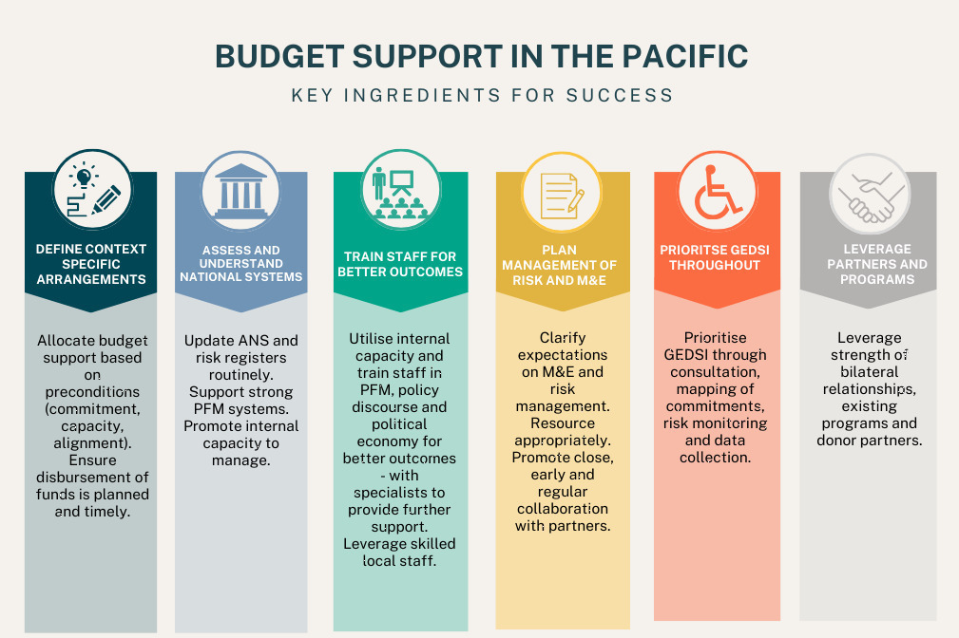

# Contents

[About us 2](#_Toc176880991)

[Executive Summary 3](#_Toc176880992)

[Contents 8](#_Toc176880993)

[Acronyms 9](#_Toc176880994)

[Introduction 11](#_Toc176880995)

[About the evaluation 12](#_Toc176880996)

[COVID-19 in the Pacific 13](#_Toc176880997)

[The Fiscal Budget Support (FBS) Package 17](#_Toc176880998)

[Evaluation findings 23](#_Toc176880999)

[1. Effectiveness 26](#_Toc176881000)

[2. EFFICIENCY 44](#_Toc176881001)

[3. GENDER EQUALITY 53](#_Toc176881002)

[4. DISABILITY EQUITY 57](#_Toc176881003)

[5. SUSTAINABILITY 59](#_Toc176881004)

[Recommendations 64](#_Toc176881005)

[Annexes 69](#_Toc176881006)

[Annex 1 Program Logic 69](#_Toc176881007)

[Annex 2 Evaluation Methodology 70](#_Toc176881008)

[Annex 3 FBS Investment Summary 75](#_Toc176881009)

[Annex 4 Rubric: Definitions 84](#_Toc176881010)

[Annex 5 Rubric: Summary of Findings 93](#_Toc176881011)

[Annex 6 Gender Equality: Detailed Results 107](#_Toc176881012)

[Annex 7 Social Protection: Detailed Discussion 114](#_Toc176881013)

[Annex 8 Consultations 117](#_Toc176881014)

[References 120](#_Toc176881015)

[Appendix 122](#_Toc176881016)

# Acronyms

Table 1. Acronyms

**Term Definition**

ADB Asian Development Bank

AML Anti-Money Laundering

ANS Assessment of National Systems

APTC Australia Pacific Training Coalition

AUD Australian Dollar

BDM-JF Bolsa da Mãe – Jerasaun Foun (Preparation for the New Generation)

CEFA Country Economic and Fiscal Assessment

COVID-19 Coronavirus Disease

CRPD Convention on the Rights of Persons with Disabilities

CSO Civil Society Organisation

DAC OECD Development Assistance Committee

DFA Direct Funding Agreement

DFAT Department of Foreign Affairs and Trade (Australian Government)

EOPO End-of-Program Outcome

EU European Union

FBS Fiscal Budget Support

FIMR Final Investment Monitoring Report

FMIS Financial Management Information Systems

FY Fiscal Year

GBS General Budget Support

GDP Gross Domestic Product

GEDSI Gender Equality, Disability and Social Inclusion

GFS Government Finance Statistics

GoF Government of Fiji

GoPNG Government of Papua New Guinea

GoTL Government of Timor-Leste

ICRC International Committee of the Red Cross

IDP Internally Displaced People

IFI International Financial Institution

IFC International Finance Corporation

IMF International Monetary Fund

JICA Japan International Cooperation Agency

JPAM Joint Policy Action Matrix

KEQ Key Evaluation Question

MEL Monitoring, Evaluation and Learning

MTR Mid Term Review

MIS Management Information Systems

MoF Ministry of Finance

NCD Non-Communicable Disease

NDoE National Department of Education

NGO Non-Government Organisation

NZD New Zealand Dollar

ODA Official Development Assistance

OECD Organisation for Economic Co-operation and Development

OPD Organisation for Persons with Disabilities

OTP Office of the Pacific

P4SP Partnerships for Social Protection

PHD Partnership for Human Development

PEFA Public Expenditure and Financial Accountability

PIC Pacific island country

PFM Public Financial Management

PNDS National Program for Village Development

PNG Papua New Guinea

SEFOPE National Directorate of Foreign Employment

SDG Sustainable Development Goal

SRP Strategic Review Panel

TA Technical Assistance

TSSP Transport Sector Support Program

UN United Nations

UN Women United Nations Entity for Gender Equality and the Empowerment of Women

USD United States Dollar

WASH Water, Sanitation, and Hygiene

WDI World Development Indictors

WEO World Economic Outlook

# Introduction

**It is difficult to overstate the potential risk posed to the Pacific region’s economic outlook and social cohesion at the onset of the COVID-19 pandemic.** As the pandemic spread and borders closed, many Pacific island countries (PICs) faced compounding risks associated with economies highly dependent on tourism, already strained government services, particularly health systems, diminishing access to finance, and the related potential for social unrest.

**Australia’s commitment to the Pacific region during the pandemic was significant and varied.** Australia supported its neighbors with COVID-19 vaccinations, testing kits and medical specialists. In addition to these efforts was the Pacific COVID-19 Fiscal Budget Support (FBS) program, which provided AUD498 million to PICs and Timor-Leste between 2020 and 2023.

**Direct budget support is defined by the OECD-DAC** **as ‘a method of financing a partner country’s budget through a transfer of resources from an external financing agency to the partner government’s national treasury.’ The funds transferred are managed in accordance with the recipient’s budgetary procedures.[[1]](#footnote-2)** Direct budget support (henceforth referred to as “budget support”) refers to both general budget support — funding allocated to a partner country’s consolidated revenue — and sector budget support which typically relates to a specific sector and when earmarked, requires an agreed expenditure plan and acquittals. Both forms of budget support are tied to policy reform.[[2]](#footnote-3) Both forms give the recipient government more control over the funds than other modalities.[[3]](#footnote-4) (See further discussion of these types of budget support in Section 1c).

**The objective of FBS was to help the Pacific and Timor-Leste mitigate the risk of fiscal crisis, maintain essential services, and protect the vulnerable through targeted and temporary support.** The original design proposed that FBS support nine countries over a two-year period (2020-21 to 2021-22) with AUD250 million delivered through existing multi-donor budget support mechanisms where they existed.[[4]](#footnote-5) The proposed delivery approach was for DFAT’s Economic Policy and Partnerships Section in the Office of the Pacific (OTP) in Canberra, supported by coordination between Pacific Bilateral and Operations and Development Divisions, to manage FBS in close collaboration with PIC and Timor-Leste Posts.[[5]](#footnote-6) The FBS was extended for a further one-year (2022-23) — providing an additional AUD225 million to assist PICs (including a further three countries[[6]](#footnote-7)) and Timor-Leste weather the economic impacts of COVID-19 and better position the region for recovery.[[7]](#footnote-8)

**The strategic intent of FBS was to contribute to a stable, prosperous, and secure Pacific in the wake of COVID-19 and enhance Australia’s relationships and reputation with PICs and Timor-Leste as an economic partner of choice.** TheFBS had two End of Program Outcomes (EOPOs) supported by six Intermediate Outcomes (see Annex 1 for a copy of the full Program Logic):

* **EOPO1: Inclusive economic recovery, and vulnerable people, are supported in eligible countries.**
* **EOPO2: Australian support helps to maximise development finance and shock contingencies to mitigate fiscal shortfalls resulting from the COVID-19 crisis.**

**Over the investment period 2020-23, FBS was directed to thirteen PICs and Timor-Leste.** Fiji was the largest recipient of funds, followed by Papua New Guinea (PNG) and Tonga. The FBS package also supported Timor-Leste, Solomon Islands, Vanuatu, Samoa, Kiribati, Nauru, Tuvalu, Republic of Marshall Islands (RMI), the Federated States of Micronesia (FSM) and Niue. The FBS was predominantly disbursed as earmarked budget support — comprising 60% of the total package — with the remainder disbursed as general budget support (36%) and a small number of program grants (4%).

**This report presents findings from the evaluation of the FBS package.**

## About the evaluation

**The evaluation was commissioned by DFAT in mid-2023 to assess the effectiveness, efficiency, sustainability gender equality and disability inclusion of the FBS.** The evaluation considers the experience of implementation of FBS in 12 countries in the Pacific and Timor-Leste: Fiji, PNG, Tonga, Samoa, Solomon Islands, Vanuatu, Kiribati, FSM, RMI, Nauru, Tuvalu and Timor-Leste.[[8]](#footnote-9)

**The evaluation is based on a review of documentation, key informant interviews, and macroeconomic and budget analysis.** Over 85 interviews were undertaken with stakeholders from DFAT Desks, Posts, partner governments, NGO implementing partners, multilateral institutions, and academics. Two field visits to Fiji and Tonga took place in September 2023, and DFAT conducted in-person interviews in Kiribati on behalf of the Evaluation Team. Macroeconomic analysis drew on the International Monetary Fund’s Global Forecast System (GFS) and World Economic Outlook (WEO) databases, as well as World Bank and Organisation for Economic Cooperation and Development (OECD) data.

**A detailed evaluation framework or rubric was developed to assess FBS’ overall performance and allow cross-country assessments against effectiveness, efficiency, gender equality, disability equity, and sustainability criteria (see Annex 4 for a copy of the complete rubric).**

**The final evaluation builds on the Mid Term Review (MTR) of FBS which was completed in 2022.** The MTR focused on the initial AUD269 million spent under the COVID-19 Response Package 2020-22 and found:

“…adequate evidence that the package contributed to a stable, prosperous, and secure Pacific. The package enabled the continuation of health and education services and income support to be provided to those deprived of their livelihoods. This contributed to defusing tensions that could have led to unrest and instability. Alongside this, other more targeted interventions under the package contributed to the protection of vulnerable people.”[[9]](#footnote-10)

**The Final Evaluation builds on the MTR in the following ways**:

* Extending qualitative primary data collection through in-person consultation in two countries and virtually with other government and partners.
* Further quantitative primary data collection including analysis of national budget data and incorporation of the final year of FBS funding.
* Further assessment of impact on beneficiaries through more recent program data and additional consultation with non-government stakeholders.
* A broadened Evaluation Team with expertise in macroeconomics; public financial management; social protection; primary services delivery; gender equality, disability and social inclusion (GEDSI); and monitoring, evaluation and learning (MEL).

**Tracking and measuring the impact of budget support is complex.**[[10]](#footnote-11) Budget support, by its nature, is funding transferred to partner government systems, making outcomes hard to track. While earmarked budget support is typically linked to spending in particular sectors, it is still fungible. Key informant interviews, macroeconomic and budget analysis, and program reporting have been used to inform this evaluation and address some of the limitations in tracking and measurement of budget support outcomes. Further discussion on the evaluation’s methodology is set out in detail at Annex 2.

## COVID-19 in the Pacific

**Already among the most remote countries in the world, PICS and Timor-Leste saw their economic links weakened with the onset of the COVID-19 pandemic with immediate cuts to tourism, and severe disruptions to international trade.** Many PICS were in weak fiscal positions even prior to the pandemic with several running successive budget deficits and limited cash reserves.[[11]](#footnote-12)The IMF anticipated that the COVID-19 pandemic would cut Pacific economies deeper than any other crisis previously experienced in the Pacific.[[12]](#footnote-13) It was anticipated that countries would risk a “lost decade” with the region facing its greatest economic contraction in four decades.[[13]](#footnote-14)

**In 2020, COVID-19 economic shocks were impacting government budgets, households and businesses.** Vulnerable people were particularly exposed to cuts. There were reports that governments were diverting health expenditure away from regular recurrent health priorities to reduce service delivery to meet the demands of managing   
COVID-19.[[14]](#footnote-15) The risk was high that economic and fiscal shocks precipitated by COVID-19 may heighten political instability and trigger security concerns. At the same time, there was also the risk that development gains would be set back, and existing development efforts significantly hampered by the economic and fiscal threats facing the Pacific at the time.[[15]](#footnote-16)

**The impact of COVID-19 across the Pacific region was highly varied.** In terms of economic impact, reliance on tourism and remittances made some PICs particularly exposed to closed borders and restricted movement. Travel restrictions also limited attendance at local markets and impacted local trade. Health care systems were strained with challenges in testing, treatment, vaccinations, and managing outbreaks. Schools were closed for several months in many countries. The Secretariat of the Pacific Community estimates 3,364 people died from COVID-19 over the 2020-23 period across the broader Pacific region.[[16]](#footnote-17)

**The impact on vulnerable people was most pronounced.** The economic fallout of closed borders and other restrictions had greater impacts on disadvantaged communities.[[17]](#footnote-18) The impact of the pandemic had disproportionate impacts on women and girls – increasing economic insecurity, rising levels of gender-based violence, and reduced access to essential health, education, justice, policy, and other social services. Changes to global food supply chains and drops in remittances posed significant challenges for women who are usually responsible for sourcing and preparing meals for their families and communities. Many women lost their jobs with the closure of local markets and also faced increased competition in food sales and increased cost of many foods.[[18]](#footnote-19) Research on the experience of people with disabilities during COVID-19 in Asia and the Pacific found that people with disabilities were disproportionally affected – experiencing poorer health outcomes, lower access to education, reduced services and support, low involvement in response planning, loss of income, and increased violence and abuse.[[19]](#footnote-20)

**While each country experienced the COVID-19 pandemic differently, overall GDP growth fell markedly in most PICs between 2019 and 2020** (see Figure 1). Travel restrictions impacted tourism and external trade, as well as markets, construction, and many kinds of economic activity. In Fiji alone, the loss in projected GDP was USD1.9 billion in 2022 (see Figure 2). Most PICs experienced a contraction in GDP of around 3%. Timor-Leste experienced significant economic contraction in 2020 driven by the pandemic, political uncertainty and the advent of Tropical Cyclone Seroja (in April 2021). Nauru maintained positive economic growth over the investment period with economic impacts largely offset by other income streams. Tonga’s economy grew marginally by 0.5% in 2020, before declining to -2.7% in 2021 and -2% in 2022.

**Figure 1: GDP % change, 2019-2020**

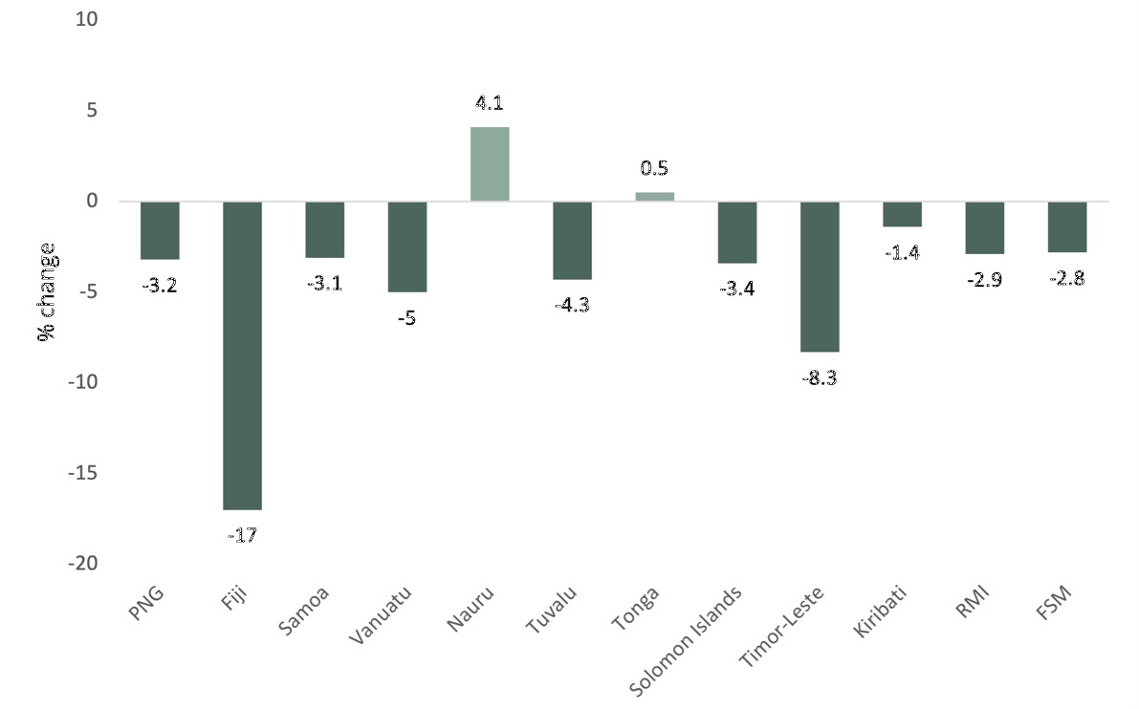

Source: IMF WEO, October 2023.

**Figure 2: Lost economic growth, Fiji - GDP projected vs actual, 2018-2024, USD billions**

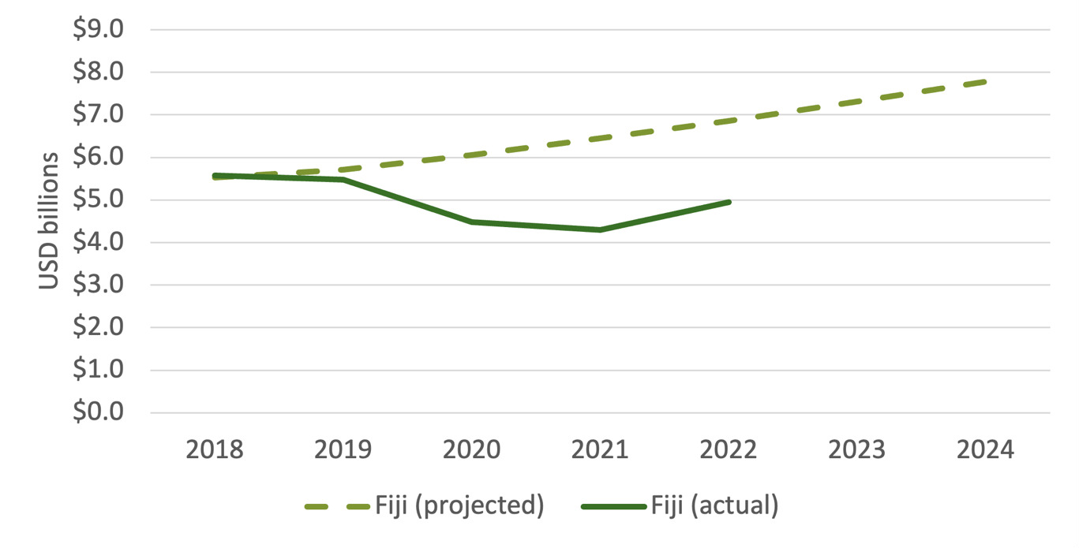

Source: IMF WEO 2019 (projected), 2023 (actual), current prices.

**The economic impact of COVID-19 was amplified for those countries highly dependent on tourism.** With border closures, tourism declined rapidly, with the greatest impacts felt in Fiji, Vanuatu, Samoa and Tonga (Figure 3). Tourism accounts for around 40% of GDP in Fiji[[20]](#footnote-21), 45% of GDP in Vanuatu[[21]](#footnote-22) and around 25% of GDP in Samoa and Tonga.[[22]](#footnote-23) Border closures had significant negative impacts on revenues and economic growth in these countries. In Vanuatu, lost projected economic growth was estimated at USD983.6 million in 2022 alone.[[23]](#footnote-24)

**Figure 3: International tourism arrivals, 2018-2022, Selected Countries**

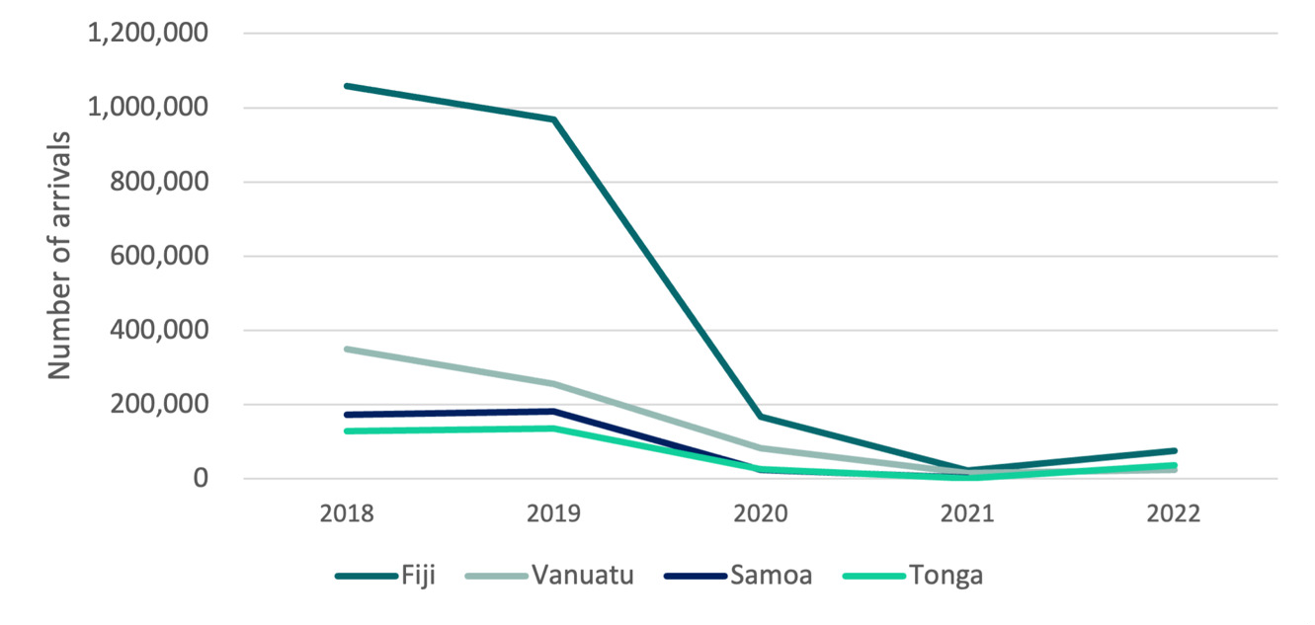

Source: National Statistics Agencies (Fiji, Vanuatu, Samoa and Tonga), 2023.

**Declining government revenues, combined with increased spending pressures related to managing the pandemic, led to widening budget deficits** (see Figures 4 to 7). In some cases, such as Timor-Leste, other factors (such as elections and change of government) led to major shortfalls in government spending – contributing to the depth of contractions. The ability of governments to fund essential services and development projects was at risk — a challenge FBS sought to address.[[24]](#footnote-25) The combined fiscal deficit for 10 PICs was expected to reach AUD5 billion in 2022, up from AUD2.3 billion in 2019.[[25]](#footnote-26)

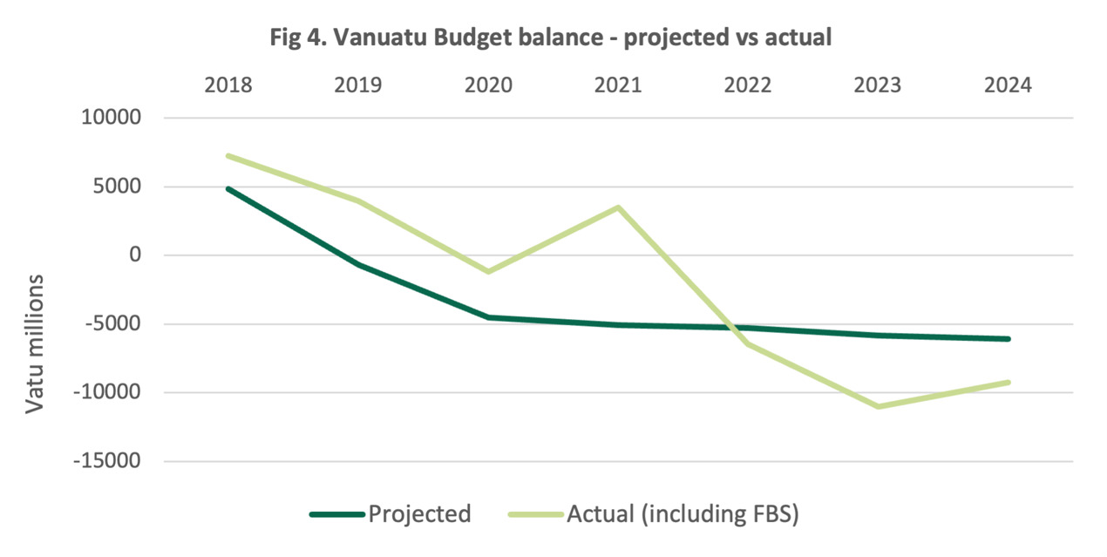

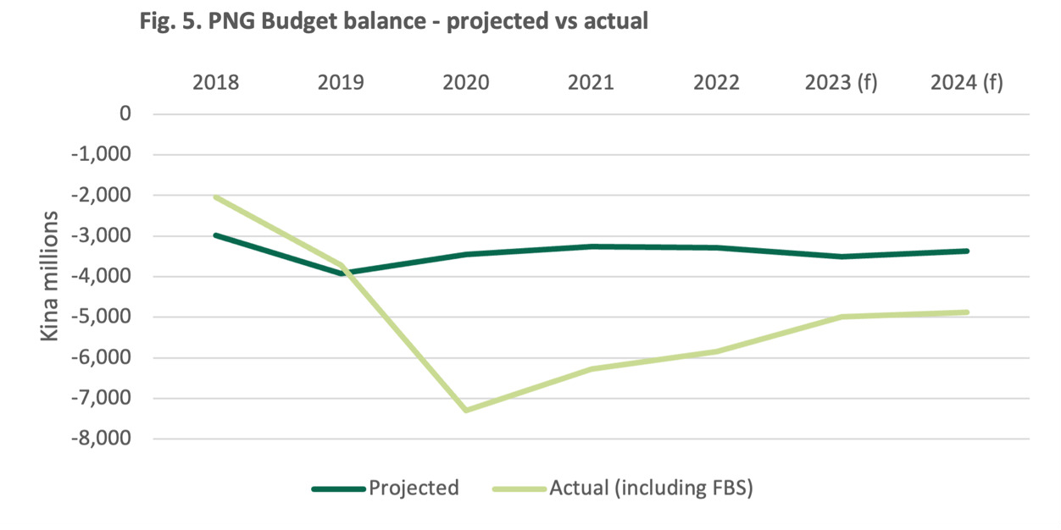

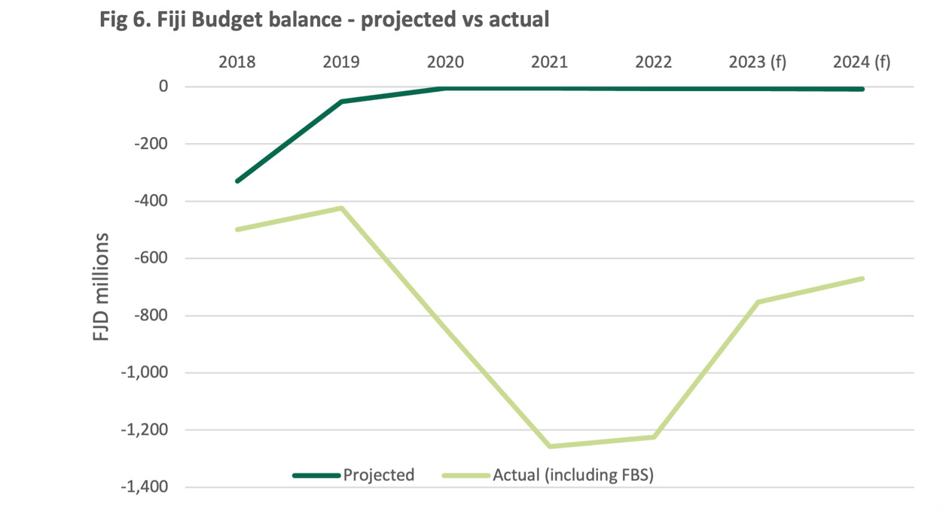

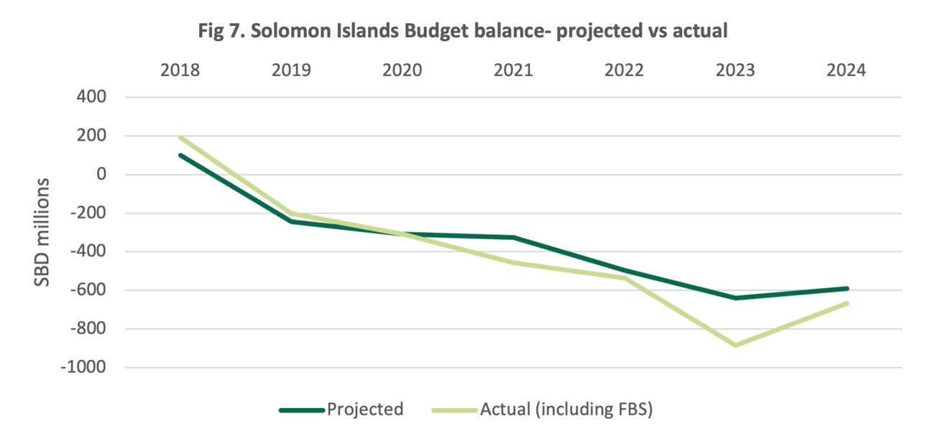

Source (Figures 4-7). : IMF WEO, projections are based on October 2019 WEO, actuals are based on October 2023 WEO. To undertake fiscal gap analysis, IMF WEO Budget balance projections from 2019 are compared to the actual data from IMF WEO 2023 to illustrate the fiscal impacts of COVID-19 on government budget balance sheets. The impact of FBS is illustrated by calculating the ‘actual’ budget balance minus the FBS value for a given year.

**Remittances remained a critical source of income to households for many PICs and Timor-Leste throughout the pandemic and, to the extent they were taxed directly or indirectly through spending, helped offset the widening fiscal gaps to some extent.** Remittances increased as a percentage of GDP in Fiji, Solomon Islands, Tonga and Samoa, noting this, in part, reflects a declining GDP denominator. Kiribati and RMI saw a decline in remittances as a percentage of GDP, increasing their revenue challenge (see Figure 8).

**Figure 8. Remittances as a % of GDP, 2018-2022, selected countries**

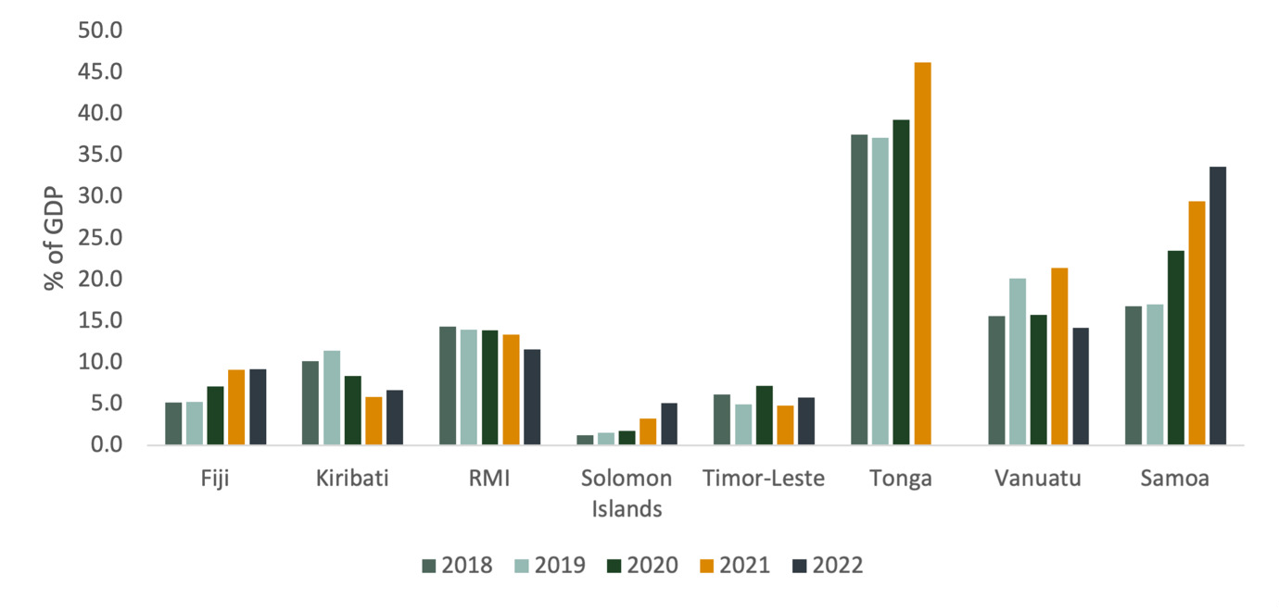

Source: World Bank, 2023.

**While COVID-19 impacted PICs and Timor-Leste in different ways and to varying degrees, all PICs and Timor-Leste faced high levels of uncertainty as to the potential economic and social impacts at the onset of the pandemic.** Similarly, as the pandemic progressed and countries entered a recovery phase, PICs faced a range of challenges, including natural disasters.

**Partner governments were severely stretched with managing an unprecedented pandemic with scarce resources.** At the same time, Australia’s diplomatic missions were under significant pressure with many staff being repatriated back to Canberra or working remotely in-country. Australia’s flagship COVID-19 development response, *Partnerships for Recovery[[26]](#footnote-27)* was simultaneously being rolled out with multifaceted activities targeted to each PIC— increasing the workload at many Pacific Posts. The staff and resources of implementing partners, such as managing contractors and NGOs, were also reduced in view of the uncertain context.

**In this highly uncertain and resource constrained context, FBS was designed to respond rapidly and flexibly to meet partner government needs.** The evaluation considers how FBS met that challenge.

## The Fiscal Budget Support (FBS) Package

**The FBS package provided AUD498 million over a three-year period (2020-2023) to PICs and Timor-‑Leste.** The package was a multi-country response to the pandemic, though it was designed with a high degree of flexibility in terms of the size, timing, and type of funding to reflect the unknown nature of the economic impact early in the pandemic, varying degrees of support required across PICs and each country’s context.

**FBS was originally intended as a two-year investment to provide support to nine Pacific Island countries (PNG, Solomon Islands, Vanuatu, Fiji, Samoa, Tonga, Kiribati, Nauru and Tuvalu) and Timor-Leste.** FBS was intended to use existing multi-donor general budget support mechanisms as the primary delivery modality (where they existed), with other modalities considered where budget support mechanisms were not appropriate. FBS was not intended to meet the full financing gaps facing PICs, but rather to work with International Financial Institutions (IFIs) and other partners to crowd in financing.[[27]](#footnote-28) A one -year extension to the package provided an additional AUD225 million in 2022-23 to assist the Pacific to better position the region for recovery and extend support to a further three countries: Niue, RMI and FSM. The design extension noted a desire for increased ambitions around policy dialogue and policy outcomes, noting the ongoing uncertainty and risk governments faced at the time.[[28]](#footnote-29)

**Funding allocation decisions were based on a range of criteria including need, existing partner government systems, resources at Post to manage, and existing programming supports. OTP economics, supported by the Office of the Chief Economist, developed an analytical and advisory work program to support funding allocation decisions.** Three main analytical products supported these decisions:

* A heat map – drawn from a quantitative dataset, drew together a variety of economic and fiscal indicators to inform allocation decisions.
* Country Economic and Fiscal Assessments (CEFAs) were prepared for the six largest PICs. The CEFAs rated economic, fiscal, and financing risks for each country to support Canberra-based assessments of current and future fiscal, economic, political and strategic risks.
* Fiduciary assessments over the course of the investment (2020-2023) were undertaken to identify where a new ANS was required as well as reviewing existing ANS’s in light of changes due to COVID-19 to identify gaps or out of date information.

**FBS was allocated to PICs and Timor-Leste through a variety of Direct Funding Arrangements (DFAs) or grants (see Annex 3).** Fiji was the largest recipient of FBS funds, followed by PNG and Tonga (see Figure 9).

**Figure 9: Total FBS by country, 2020-21 to 2022-23, AUD millions**

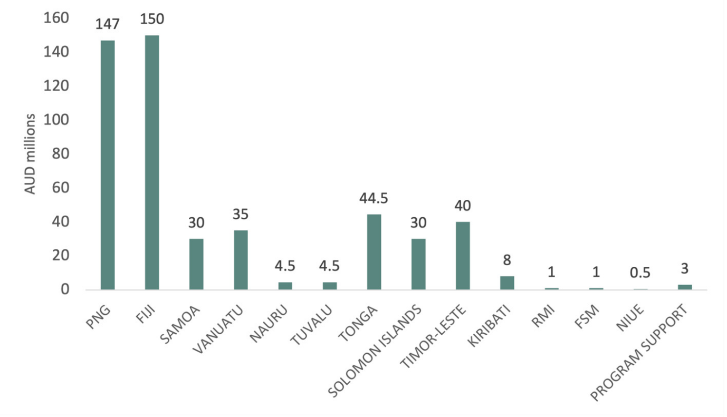Source: DFAT, 2023. Program Support discussed under Section 2 Efficiency.

On a per capita basis, the largest recipients of FBS were Tonga, Tuvalu and Nauru, and the smallest recipients were FSM, PNG and RMI (see Figure 10).

**Figure 10: FBS per capita, 2020-21 to 2022-23, AUD**

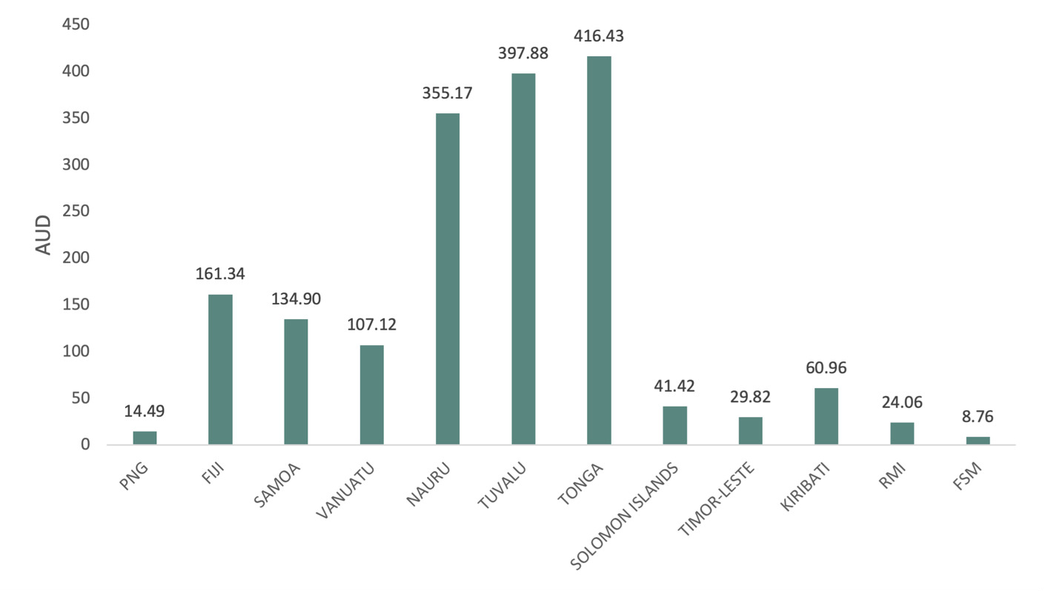

Source: DFAT, 2023.

As a share of GDP in 2020, FBS was highest in Tonga (at 6.3%), followed by Tuvalu (6%) and Kiribati (3.1%). It was lowest in FSM (0.2%), RMI (0.3%) and PNG (0.4%) (see Figure 11).

**Figure 11: FBS as a % of GDP in 2020**

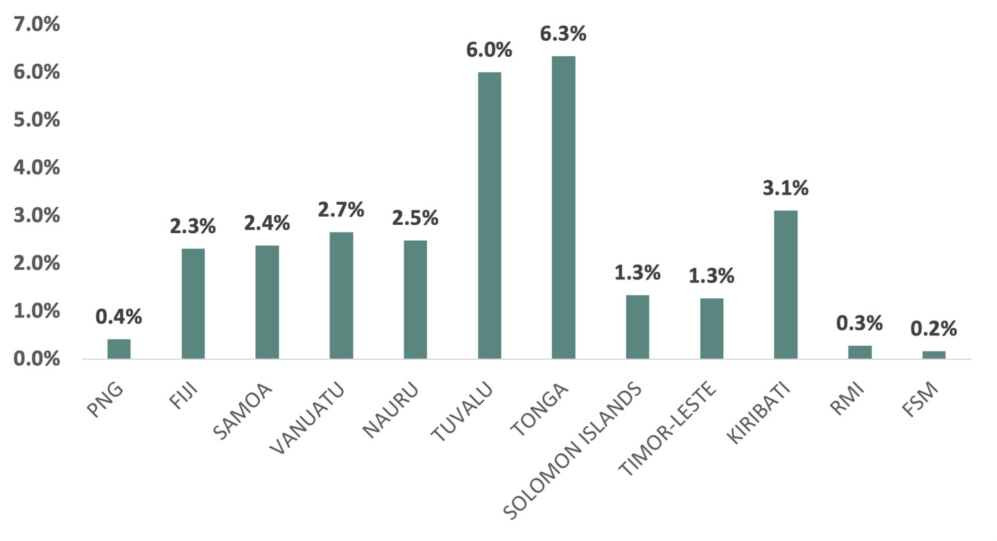

Source: DFAT, World Bank, 2023.

As a proportion of total revenue by country, FBS was highest in Samoa, Fiji and Tonga and lowest in PNG and Timor-Leste (see Figure 12).

**Figure 12: FBS as a % of total revenue, 2020-2022, selected countries**

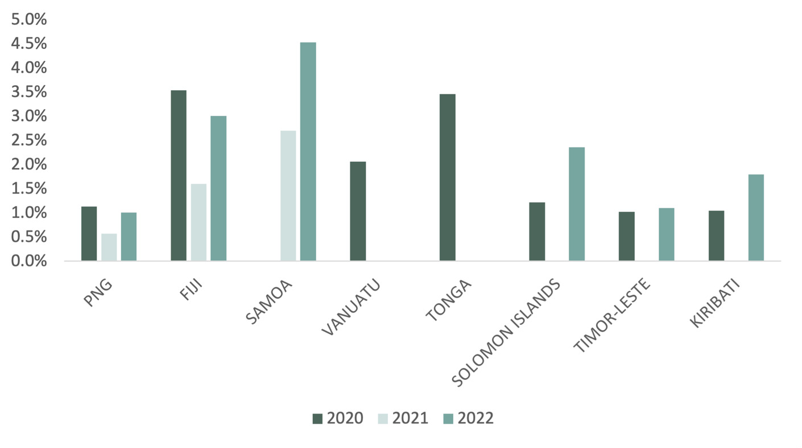

Source: DFAT, IMF GFS, 2023. Chart shows available country data

**In terms of timing, FBS allocations were highest in 2022-23 (at AUD225 million), followed closely by 2020‑21 (AUD194 million) and lowest in 2021-22 (at AUD80 million) (see Figure 13 by country).** This indicates that roughly a similar quantum of funds was spent during the recovery phase of the pandemic as in the initial crisis period.

**Figure 13: FBS by recipient country, by year, 2020-21 to 2022-23, AUD millions**

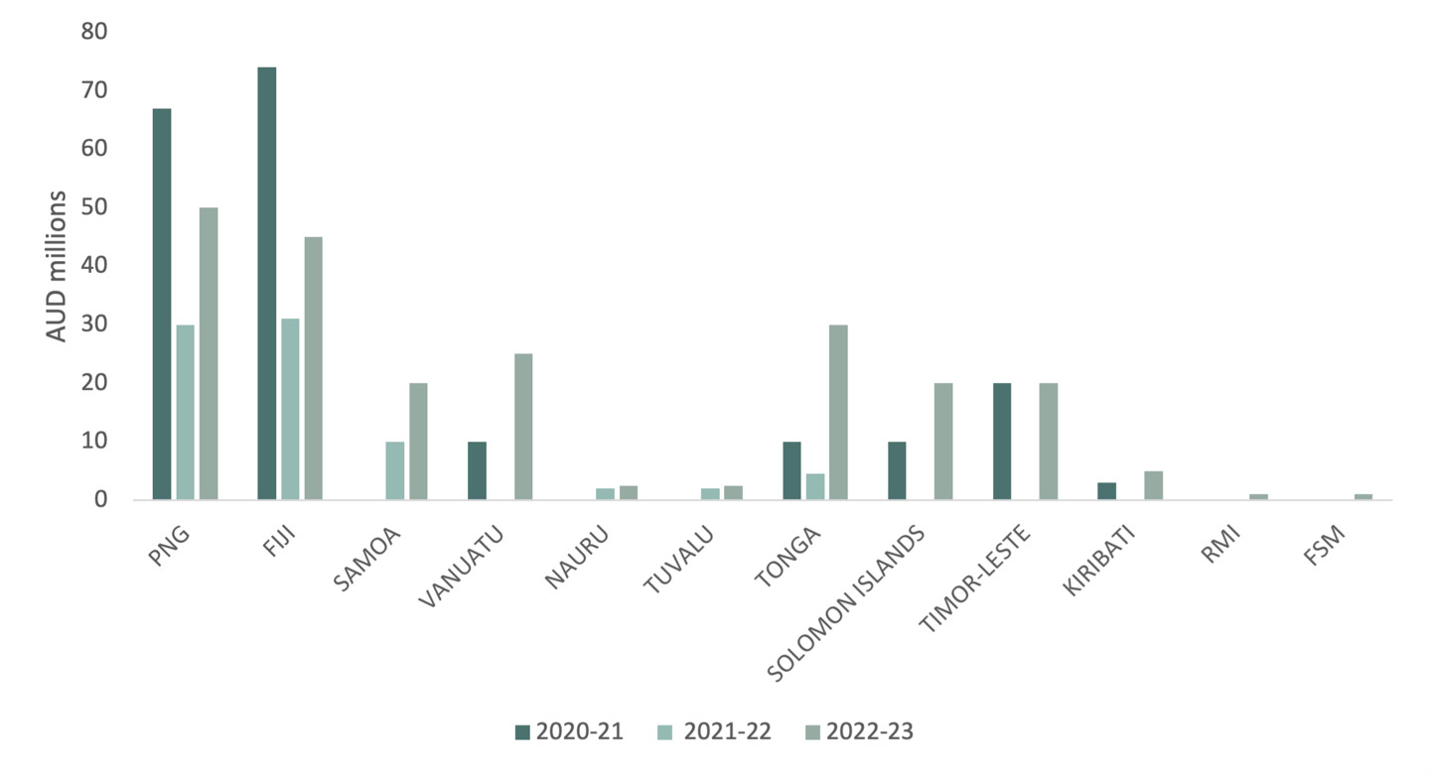

Source: DFAT, 2023.

**The FBS design anticipated that most of the package would be distributed as general budget support, whereas in implementation the majority was delivered as earmarked support. This was due to a range of reasons.** First, only five of the PICs had highly functional joint operations during the investment.[[29]](#footnote-30) Second, several countries did not have an up-to-date ANS. Third, earmarking enabled targeting of vulnerable groups or sectors.Earmarked support comprised 60% of funds, followed by general budget support (36%) and project support (4%) (see Figure 14). Earmarked FBS was distributed relatively evenly with key sectors for FBS being infrastructure (26%), health (16%), and education (8%). (Further discussion of the types of budget support, benefits, and the challenges of each type is covered in Section 1c.)

**Figure 14: FBS by type, %**

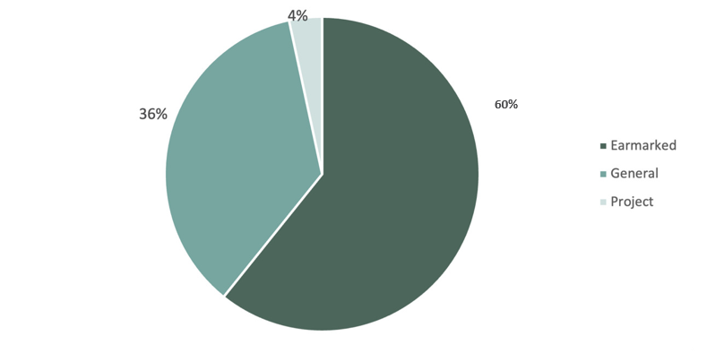

Source: DFAT, 2023.

**The FBS program constituted one component of total ODA flows from Australia and other development partners to PICs and Timor-Leste during the COVID-19 pandemic.** As a share of total global ODA, FBS was highest in Fiji (41.9% in 2020), Tonga (11.9% in 2020) and Vanuatu (10.3% in 2021) (see Figure 15).

**Figure 15: FBS as a % of total global ODA, 2020-2021, selected countries**

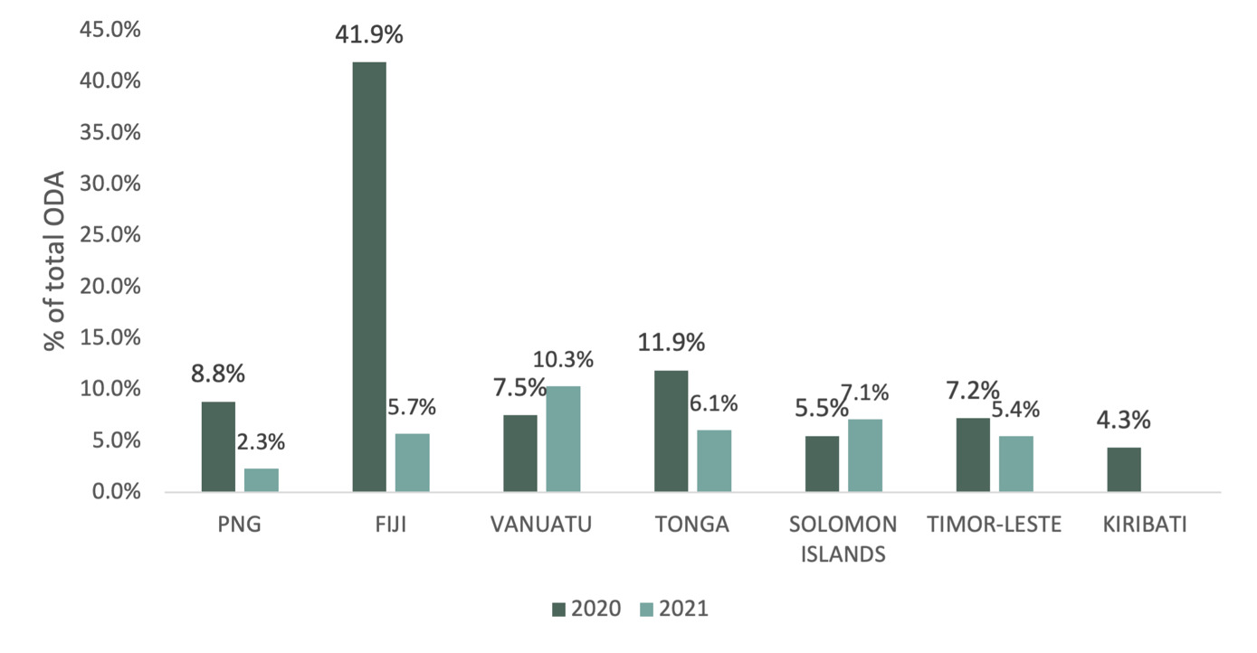

Source: DFAT, OECD DAC, 2023. Global ODA data from the OECD is recorded in a calendar year format, whereas FBS is recorded in FY format year and does not fully align.

**Australian ODA to PICSs and Timor-Leste increased during the pandemic.** Between 2019-20 and 2020-21, the greatest year-on-year increases in ODA were to Fiji (132%), Tonga (47%), Vanuatu (30%) and PNG (21%). Solomon Islands and Samoa received the smallest year-on-year increases. In 2022-23, ODA to PNG and Fiji decreased by 9% and 11% respectively, while ODA to Timor-Leste and the Solomon Islands increased by around 20%. See Figure 16.

**Figure 16: Australian ODA to PICs 2018-19 to 2022-23, AUD millions**

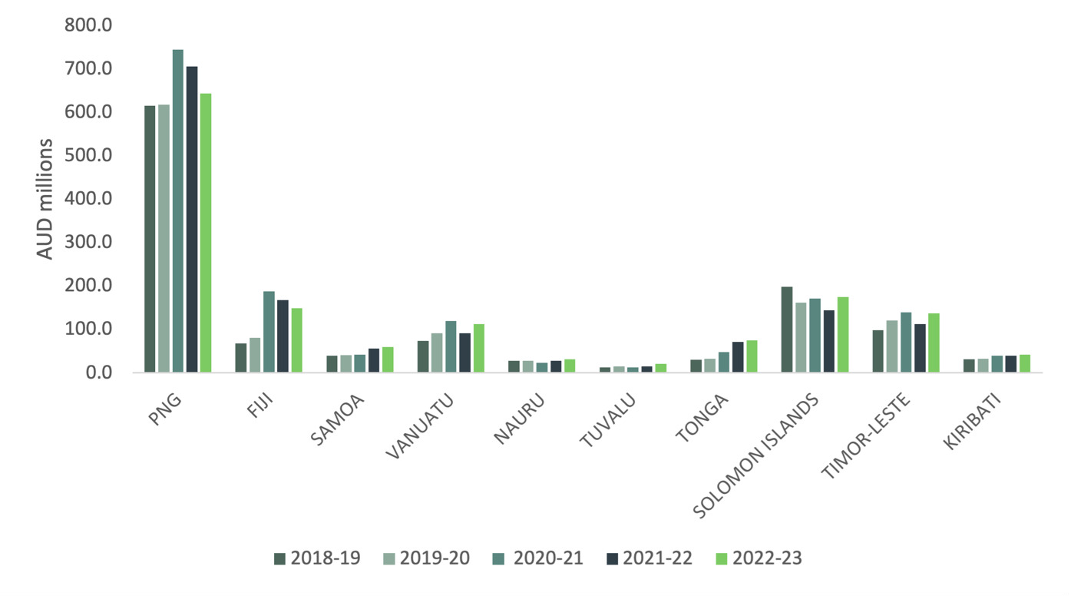

Source: DFAT ODA time series by partner country, 2024.

# Evaluation findings

**FBS contributed to a stable, prosperous and secure Pacific region, strengthening Australia’s position as an economic partner of choice during the COVID-19 pandemic.** Australia’s support provided a critical injection of funding, confidence, and support to the region at a critical time, augmenting the resilience of PIC and Timor-Leste economies and communities to weather the crisis. PIC economies were less impacted than initially projected and, for a range of reasons, came through the period better than anticipated. The extent to which stability in the Pacific post-pandemic is attributable to FBS is difficult to quantify. Further, the scale of FBS relative to the size of PIC economies meant that any fiscal contribution would be small, though important and in some cases, large relative to the realised shortfall in revenues. FBS clearly demonstrated Australia’s commitment to its neighbours and the region. FBS triggered a variety of opportunities to support PICs in important ways. The budget support modality, FBS’ flexibility to respond to emerging opportunities (such as social protection reform) and deliver funds where they were most needed contributed to FBS achieving its strategic objectives.

**This report seeks to provide an understanding of the ways, and the extent to which, FBS played a role in the realisation of the strategic objectives outlined above.** To do this, the evaluation assessed overall program performance between 2020 and 2023 against five key evaluation areas: effectiveness; efficiency; gender equality: disability equity; and sustainability. The FBS evaluation covered Fiji, PNG, Tonga, Timor-Leste, Vanuatu, Samoa, Solomon Islands, Kiribati, Nauru, Tuvalu, RMI and FSM. The Key Evaluation Questions (KEQs) (Table 2) informed data collection methods, sampling and analysis decisions, and were used as a basis for synthesizing data and structuring evaluative conclusions. Details of the methods used are provided in Annex 2 and assessment by KEQ, sub-KEQ and by country are provided in Annex 5. Overt references to performance assessments — ranging from 1: Very poor to 6: Very good — are used throughout this report, as are the assessments of the strength of available evidence — ranging from: 1: Weak evidence to 3: Strong evidence.

**The key findings include:**

**Effectiveness: There is strong evidence that FBS contributed to a stable, prosperous and secure Pacific in the wake of the COVID-19 pandemic and enhanced Australia’s relationships and reputation with PICs as an economic partner of choice.** FBS contributed to stability by injecting budget support at a critical time for maintaining economic confidence and financial stability across the Pacific region, with examples provided in Section 1.b. regarding EOPO2 (Fiscal Crisis Window). In some instances, significant economic and social reforms were achieved, contributing to a prosperous and secure Pacific, with examples presented in Section 1.b. against EOPO1 (Vulnerability and Economic Recovery Window). The FBS opened opportunities for policy dialogue, particularly where there were existing bilateral reform agendas or when Australia had existing mechanisms to build upon (see Section 1c). In terms of MEL, some credible information on outputs and outcomes was generated, and information was used for decision-making (see Section 1d). At a country level, the package was ‘effective’ in seven of the 12 countries evaluated. Four countries demonstrated ‘adequate’ effectiveness. In one country, FBS was assessed as having been ‘very effective’.[[30]](#footnote-31)

**Efficiency: There is strong evidence that FBS made appropriate and efficient use of time and resources to achieve its EOPOs.** Most FBS allocations were channelled through partner governments and utilised existing relationships, programs and technical assistance – minimising overheads and operational resourcing and increasing the speed of disbursement of funds.

* The governance arrangements for FBS effectively balanced efficient decision-making with the size and risk of funding allocations across countries. They were highly flexible and uniquely DFAT-delivered, as opposed to other more expensive and time-consuming delivery models.
* FBS made efficient use of human resources, including drawing on existing technical assistance where available, DFAT staff and specialists for the efficient achievement of intended outcomes, though staff were in some cases under considerable pressure (see Section 2a).
* PICs were able to absorb FBS funding in most cases but in many cases, whether due to capacity constraints or rapidly changing circumstances, implementation had to be delayed (see Section 2b).
* Risk management policies and procedures were followed in relation to fiduciary and fraud risks but whether these policies and procedures were adequate could be considered further by DFAT. Other safeguards received less attention (see Section 2c).
* FBS assistance and funding was mostly harmonised and aligned with other donor and multilateral support (see Section 2d).
* At a country level, assessments of efficiency ranged from ‘adequate’ to ‘good’. FBS was ‘efficient/good’ in eight of the countries evaluated. Four countries performed ‘adequately’.[[31]](#footnote-32)

**Gender equality: There is sufficient evidence that FBS achieved adequate results for women and girls.** FBS supported governments to take action to maintain expenditure on essential services for women and girls (especially health and social protection, although education was mixed), earmark sectors or programs for attention (e.g. social protection in many countries, and preventing gender violence in Samoa), and, in limited countries, advance gender equality policy actions through budget support (Fiji is the standout). FBS reinforced gender-responsive elements of government PNDS in Timor-Leste, roads in Vanuatu and water and sanitation in Solomon Islands, supported by existing development programs. FBS also supported a small number of non-government entities to take action for gender equality such as UN Women in PNG supporting women traders to increase incomes and access to credit. The extent to which FBS made a difference to gender equality and empowering women and girls varied considerably by country, ranging from ‘poor’ to ‘very good’. Of the 10 countries for which an evaluative conclusion is available, performance on gender equality was assessed as ‘very good’ or ’good’ in two countries, ‘adequate’ in five countries and ’less than adequate’ or ‘poor’ in three countries.[[32]](#footnote-33)

**Disability equity: There is sufficient evidence that FBS performed less than adequately on including and meeting the needs of people with disabilities.** FBS had limited engagement with people with disabilities in FBS design, implementation, and monitoring, including a disability workplan (2021), with some outreach to people with disabilities through the Pacific Disability Forum and consultation with organisations of people with disabilities in select countries for the mid-term review and this evaluation. However, there was very little evidence of participation of people with disabilities in implementation at the country-level. FBS met only some needs of people with disabilities largely through social protection – this includes disability social protection payments (Fiji, Vanuatu, Timor-Leste, Tonga, Kiribati, Nauru) and disability-inclusive social protection policy updates (Fiji, Samoa). Among countries with general budget support, Kiribati and Fiji were the only countries to include disability-responsive policy triggers for social protection. In two-thirds of the nine countries for which an evaluative conclusion is available, performance on disability was ‘less than adequate’. In one-third of countries performance was ‘poor’.[[33]](#footnote-34)

**Sustainability: There is strong evidence that the benefits in the investment outcome areas will endure. FBS commonly reflected partner government priorities.** FBS worked through local systems and institutions, helped improve coordination among and between government and non-government institutions in some cases and boosted and enhanced existing Australian programs and reform efforts. FBS also strengthened sustainability at the beneficiary level- contributing to the ability of beneficiaries to cover basic needs during the pandemic. Many FBS funded reform measures are likely to have continuing, if not lasting, impacts. Given its design as a shock-response and its strategic intent to respond to the needs of vulnerable groups and fiscal gaps, the focus was not on broader sustainability goals though they were considered to some extent in design. Any future rollout of budget support will need to consider sustainability closely, and work with partner governments to clarify expectations and manage risks associated with unsustainable expenditures or changes in policy. At a country level, FBS outcomes are likely to be ‘sustainable’ in 10 countries, and ‘somewhat sustainable’ in two.[[34]](#footnote-35)

**Key findings were made using KEQ aligned to evaluation rubrics, which drew on DFAT’s Final Investment Monitoring Report (FIMR) rating scale.** Assessments considered the strength of performance/outcomes against KEQs by country and the strength of evidence available, considering the number, type and strength of data sources and timeliness of available data. Evaluative judgements were made using cross-country analysis rubrics. Given the number of countries covered, the variety of FBS investments, number of data sources and volume of data, this was a critical analytical step. Table 2 provides an overview of FBS performance against each KEQ by charting the distribution or range of country-specific performance assessments alongside the mode (or most frequently occurring) assessment score across all countries This simplified summary indicates the overarching trend of performance across the twelve countries for which evaluative conclusions are available. It should be noted that performance assessments are not weighted by FBS investment size, and the available evidence basis for conclusions differs by country and KEQ. The strengths and limitations of this synthesis method are outlined in Annex 2 and FBS evaluation rubric definitions are presented in Annex 4. Further detail is provided in Annex 5, along with summaries of rubric KEQs, sub-KEQs conclusions by country.

**Table 2: Overview of FBS performance against KEQs**

|  | **KEQ** | **Distribution** | **Mode** |
| --- | --- | --- | --- |
| 1 | **Effectiveness:** How effective was the FBS over its lifetime? | Range: 4-6Range: 4-6 | **5. Good** |
| **2** | **Efficiency:** Did FBS make appropriate and efficient use of time and resources to achieve EOPOs? To what extent was risk managed, and FBS harmonised or aligned with other donor and multilateral support? | Range 4-5Range: 4-5 | **5. Good** |
| 3 | **Gender equality:** Did FBS make a difference to gender equality and empowering women and girls? | Range 2-6Range: 2-6 | **4. Adequate** |
| 4 | **Disability equity:** How well did FBS include and meet the needs of people with disabilities? | Range 2-3Range: 2-3 | **3.**  **Less than adequate** |
| 5 | **Sustainability: To what extent will the benefits in the investment’s outcome areas endure?** To what extent did FBS use and strengthen local systems and institutions? To what extent do partner governments demonstrate ownership of activities and policy changes supported by FBS? | Range 4-5Range: 4-5 | **5. Good** |

# 1. Effectiveness

###### How effective was FBS over its lifetime?

**Effectiveness*:* There is strong evidence that FBS was effective over its lifetime. It contributed to a stable, prosperous and secure Pacific in the wake of the COVID-19 pandemic and enhanced Australia’s relationships and reputation with PICs as an economic partner of choice. FBS contributed to stability by injecting budget support at a critical time for maintaining economic confidence and financial stability across the Pacific region, with examples provided in Section 1.b. regarding EOPO2 (Fiscal Crisis Window). In some instances, significant economic and social reforms were achieved, contributing to a prosperous and secure Pacific, with examples presented in Section 1.b. against EOPO1 (Vulnerability and Economic Recovery Window). The FBS opened opportunities for policy dialogue, particularly where there were existing bilateral reform agendas or when Australia had existing mechanisms to build upon (see Section 1c). In terms of MEL, some credible information on outputs and outcomes was generated, and information was used for decision-making (see Section 1d). At a country level, the package was ‘effective’ in seven of the 12 countries evaluated. Four countries demonstrated ‘adequate’ effectiveness. In one country, FBS was assessed as having been ‘very effective’.[[35]](#footnote-36)**

###### To what extent did FBS achieve its strategic intent of contributing to a stable, prosperous, and secure Pacific in the wake of COVID-19 and enhancing Australia’s relationships and reputation with PICs as an economic partner of choice? How satisfied were partner governments and/or other beneficiaries with FBS support and implementation?

**FBS achieved its strategic intent of contributing to a stable, prosperous, and secure Pacific in the wake of COVID-19 and enhancing Australia’s relationships and reputation. The extent to which it achieved its strategic intent was country dependent.** FBS was designed with significant flexibility — supporting PICs in multiple ways for different objectives — with various sectors supported by FBS(see Annex 3 for a summary of allocations by country and sector). It is clear from the design of FBS[[36]](#footnote-37) that EOPO2 was the intended focus of FBS with the original quantum of funds designated under the fiscal crisis window larger than funds under the vulnerability window. As the pandemic unfolded, and PICs in many cases were less impacted than projected and proving relatively resilient, it is appropriate that FBS transitioned to a recovery phase. In practice, this meant the majority of funds were earmarked and focused on sectoral support, and general budget support became a smaller focus (at 36% of total funds). The use of small grants (3%) in FSM and RMI (among others) reflected an assessment that budget support was not appropriate in those cases, and key informants indicated that the grants did achieve the strategic intent of a strengthened relationship with Australia.

**The FBS was effective in strengthening the quality of Australia’s relationships throughout the region over the investment period.** In all cases,FBS was appreciated by partner governments (albeit to varying degrees) and helped underscore Australia’s role as a reliable, dependable neighbour, particularly in times of need. This was most evident in the case of Fiji where budget support significantly enhanced Australia’s bilateral relationship. This was demonstrated through increased opportunities for policy dialogue across a range of important reform areas against which significant progress was made over three years. The FBS engagement in Fiji built on pre-existing policy engagement which lay the foundation for a shared push to progress policy dialogue and actions in key areas. Key informants also confirmed enhanced relationships, particularly in Tonga, Timor-Leste, Vanuatu, and Kiribati. Whether improved relationships will be enduring will only be known with time (see Section 5, Sustainability, for further discussion).

**Australia’s willingness to be locally led and deliver budget support was highly welcomed.** Many partner governments expressed their appreciation for budget support and welcomed Australia’s rapid response to this as their preferred delivery mechanism. In the words of Fiji’s Deputy Prime Minister and Minister for Finance, Strategic Planning, National Development and Statistics, the Hon. Biman Prasad, at the Australian National University’s 2023 Australasian Aid Conference:

“If development is not locally led – it most probably is not development. … Development support through national budgets is the surest way to ensure that development is nationally owned and locally led. This will allow Pacific governments and civil society to deepen their relationships as they become implementing partners for national programs, rather than for external development programs”.[[37]](#footnote-38)

**The FBS effectively built stronger relationships with most PIC Governments.** Partner governments confirmed FBS built trust and deepened relationships. For example, the Tongan Government expressed appreciation at the highest levels for Australia’s trust in their systems and highly valued FBS, which helped reduce fiscal shortfalls. Budget support in financial year 2022-23 prevented Tonga from experiencing a fiscal deficit (FBS in 2020-21 and 2021-22 may have reduced the deficit but support in FY 2022-23 ‘balanced the budget’). Whilst budget support has been a modality used by the Samoa bilateral development program since 2013, FBS affirmed to Samoa that Australia is committed to this modality, and to the Joint Policy Action Matrix (JPAM), and has confidence in Samoa’s governance arrangements and systems. In Timor-Leste, FBS helped strengthen Australia's relationship with the Ministry of Finance and facilitated vital bilateral conversations with senior leaders.

**The capacity of DFAT personnel greatly influenced the extent to which relationships were strengthened by FBS.** Where DFAT had substantial capacity (from an economic and social policy relationship perspective), FBS was able to be leveraged to effectively navigate and progress dialogue on challenging reforms. Where DFAT officers had sufficient depth of understanding of the political economy, economic and social policy priorities, and experience or oversight of government systems, its ability to foster well informed and effective budget support partnerships with governments was significant — with Fiji a case in point. In other cases, key informants saw FBS as a missed opportunity to strengthen relationships and progress reform, in particular in PNG where resources were already focused on budget support in the form of a major new lending agreement between Australia and the Government of PNG.

**The timing of FBS and alignment with government systems and priorities were important factors in strengthening relations**. Australia’s quick response at the onset of the COVID-19 pandemic, the quantum of FBS, and willingness to provide general budget support — something many PICs had been seeking for some time — contributed to stronger relationships with partners. In Tuvalu, for example, FBS followed soon after the opening of the Australian High Commission in Funafuti, reinforcing a willingness to work in partnership. In Vanuatu, the timing of the second tranche helped put funds through the JPAM process which had been gaining momentum over the previous 18 months.

**In some cases, FBS helped support working relationships at the officials-level, rather than senior levels.** In PNG for example, in the context of a very large existing development program, including a new program of lending by Australia, FBS was not necessarily regarded as a significant or new opportunity at the most senior levels of the PNG Government. In Solomon Islands, FBS was certainly appreciated at the public official level and by specific ministries such as the Ministry of Education, Human Resources and Development (MEHRD). It is less clear that FBS in Solomon Islands helped ‘open doors’ at the most senior levels of government.

**Country allocation decisions responded to a range of criteria (see Introduction for further detail).** Some countries were provided more funding based on a combination of perceived need, absorptive capacity, Post resourcing to support management, and existing programming. This responsive and adaptive decision making effectively supported – in most cases – timely disbursement of funds and support for vulnerable groups (see also section 2 Efficiency). There was a certain level of pragmatism and opportunism about allocation decisions which was appropriate given the emerging context of the pandemic. It is important to reiterate that funding allocations were made at a time of great uncertainty, and limited and stretched Post and partner government resources.

###### To what extent did the investment achieve its intended EOPOs?

###### EOPO 1 (Vulnerability and Economic Recovery Window) Inclusive economic recovery, and vulnerable people, are supported in eligible countries.

**There is strong evidence that FBS supported inclusive economic recovery and vulnerable people.** There is evidence of FBS supporting the maintenance of public expenditure throughout the pandemic. There are also examples of FBS earmarked funding supporting social protection systems, health and education systems, and economic recovery through tourism and transport sector and community infrastructure initiatives. Public expenditure was broadly maintained over the 2019-2021 period across PICs and Timor-Leste. Figure 17 shows the percentage change to total expenditure, year-on-year, with declines evident in RMI and FSM in 2020, and declines in Vanuatu and Solomon Islands in 2021. In Kiribati and Timor-Leste expenditure rose in 2021.

**Figure 17: Total expenditure, Year-on-Year % Change, 2019-2021**

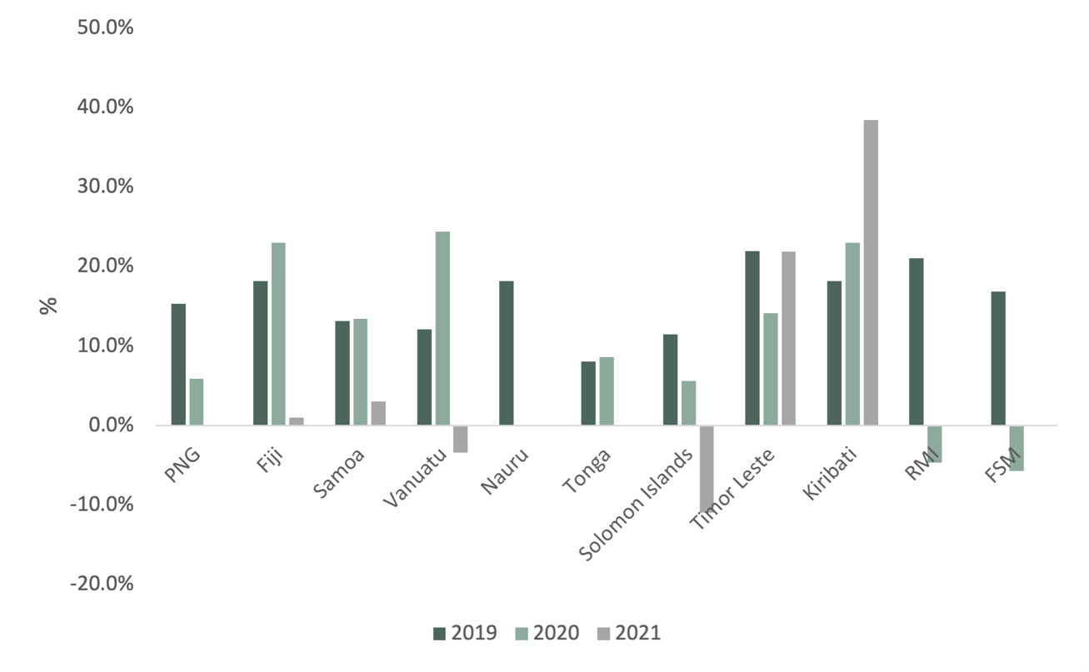

Source: IMF GFS, 2023, latest available data.

**FBS effectively supported existing social protection systems to provide ongoing or additional support to vulnerable people.** The FBS for social protection played an influential role in reaching vulnerable groups during the COVID-19 pandemic and supporting inclusive recovery — a major achievement of FBS over the period. Eight out of the 12 FBS countries evaluated utilised the funding to advance social protection. The FBS supported short-term social protection responses in countries where fiscal space was tight and funded the development of stronger social protection systems. Key informants confirmed that FBS also elevated policy dialogue on social protection, allowing Australia to engage with the priorities of government directly, responsively and with influence.

**Channelling FBS for crisis response through existing social protection systems was an effective approach to reaching the most vulnerable.** This approach built on DFAT’s previous experiences in channelling budget support for shock-response through national social protection programs in Fiji. A fiduciary risk assessment of the Ministry of Women, Children and Social Protection’s downstream PFM systems in Fiji meant Post was very clear on the risks and systems strengthening needs. This led to a budget support policy action in 2021-22 for a technical review of Fiji’s social assistance programs and a framework to guide development of an updated social protection management information system. In Fiji, Australia earmarked AUD20 million to support social protection payments in 2021, benefiting 125,372 people (13.6% of the population). In Tonga, top-ups were provided to approximately 5,500 recipients (5.5% of the total population) of existing schemes following a volcanic eruption and tsunami.

**The FBS also contributed to the expansion and/or establishment of social protection systems, including where reform progress had previously been slow or limited.** For example,support to ‑Timor-Leste's *Bolsa da Mae – Jerasaun Foun* (BdM-JF) program expanded women and children’s access to social protection, with 46,793 women and children enrolled in the program across seven municipalities, representing about 70% of the target population in these municipalities. It should be noted, however, that the Government of Timor-Leste has since cancelled the BdM-JF program in the context of a significant fiscal consolidation, with an 18% cut in expenditure in their 2024 Budget.[[38]](#footnote-39) (See Section 5. Sustainability for further discussion). In Kiribati, earmarked FBS went through the Economic Reform Taskforce and helped establish a new Social Protection Unit in the Ministry of Youth and Social Affairs to deliver on the Government’s social protection reform, through a new unemployment benefits scheme and existing elderly benefit scheme — estimated to have benefited approximately 61,000 people (also discussed further in Section 5. Sustainability). In PNG, the pandemic highlighted gaps in the social protection systems and FBS contributed to the design and development of a new child nutrition social protection program. In Vanuatu, where there was not an existing social protection program to support the most affected people, FBS provided a grant to Oxfam for cash transfers that benefited 25,435 people (further detail on social protection is provided at Annex 6 Social Protection).

**There is strong evidence that in most funded countries, FBS achieved its objective with respect to targeted service delivery, supporting the maintenance of funding, salaries and the ongoing operation of key services including clinics, hospitals, and schools.** Tuition fee subsidy programs in PNG and Vanuatu supported high school students to stay in school in the context of reduced economic activity. The FBS support for PNG public service salaries was also critical to maintaining services and stability. In the case of PNG, however, the scale of impact was reduced by the range of existing challenges in PNG’s health and education sectors, and allocation decisions were largely determined by absorptive capacity. In Solomon Islands, funding to the Solomon Islands Water Authority provided access to potable water for over 3,000 households (approximately 2.3% of the population)[[39]](#footnote-40) and funding to the Ministry of Education supported primary school grants across the country for school equipment to ensure that schools were able to stay open the entire year. In FSM 144 or approximately 1% of households, (assuming a household size of 8.6) benefited from the electrification grant.[[40]](#footnote-41)

**The following section summarises the impact of FBS on particular sectors.** The extent of evidence for different activities is highly variable by sector, activity and by country. This report provides the evidence as outlined in program reporting provided to the Evaluation Team which comprised financial acquittals, and some beneficiary/impact reporting. Intended results were not explicit and there was significant variability in the quality and scope of country level performance assessment frameworks with general indicators – not targets – provided to identify performance. In many cases, it was not possible to estimate the number of people benefiting from budget support. In PNG for example, earmarked funds to health services topped-up church health service salaries. An evaluation by M&E experts HDMES, funded by the PNG Post, identifies the number of clinics potentially supported by the funds, but does not identify the number of health workers supported or the number of potential beneficiaries of the health services provided. This level of detail would require more detailed M&E specifications, closer monitoring by Posts and stronger investment-wide systems for aggregated reporting. (See Section on M&E for further discussion).

##### FBS and education

**Education was the largest service sector under FBS in terms of the number of DFAs and dollar value.** FBS funded four DFAs related to education:

**PNG: AUD52 million to education and health in 2020-21 (AUD 30 million to education) and AUD30 million in 2021-22 (2 DFAs).** Funding supported the cost of the PNG Government Tuition Fee Subsidy Policy through the provision of the cost of government tuition for primary school children. It is estimated that over 1.1 million school students benefited from the fee support, though the exact impact is unclear in the context of declining expenditure on education and declining education standards. Some school closures were likely prevented.

**Vanuatu: AUD5 million in 2020-21. Funded subsidised school and other fees.** It is estimated that up to 26,000 secondary students in Vanuatu, of which 51% were girls in 2021, benefited from subsidised school fees – helping maintain enrolments.[[41]](#footnote-42) MoET statistics show that enrolments increased from 2020 to 2021.[[42]](#footnote-43)

**Solomon Islands: AUD4 million in 2020-21 Funding supported grants for schools’ basic operational costs, including education materials, administration, WASH facilities, minor repairs and transportation.** Key informants said that many schools would have only operated for six months if it were not for FBS grant support. No further reporting available.

Box 1 FBS and Education

##### FBS and health

**Health spending was a smaller proportion of the total earmarked FBS package.** This may have been because health was supported through other scaled up bilateral investments in support of COVID-19 prevention and treatment. FBS funded three DFAs related to health:

**PNG: AUD22 million to health in 2020-21.** The Christian Health Services and Catholic Church Health Service, through their members and dioceses, operate more than 50 per cent of rural health facilities in the country. Through its support for the payment of CHS and CCHS health worker salaries, Australia’s COVID-19 Response Package supported the ongoing operation of 746 health facilities in twenty-two provinces and 87 districts of PNG. These facilities include 17 District and Rural Hospitals, 129 Health Centres and Urban Clinics, 256 Health Sub-Centres and Community Health Posts and 344 Aid Posts and Day Clinics.[[43]](#footnote-44)

**Tonga: AUD30 million in 2022-23.** To date, the payment has supported an AUD300,000 upgrade of the obstetric ward of the main hospital in Nuku’alofa. Tonga’s first mammogram machine will also be purchased under the payment. With implementation until June 2025, it is expected that these funds will contribute to inclusive recovery and the protection of vulnerable people.

**Samoa: AUD5 million in 2021-22.** Funding primarily supported the provision of Wage Support for Clinical and Primary Health Care Staff.   (No further reporting available).

**Nauru** also received AUD4.5 million supporting food security and support to the health sector. (No further reporting available).

Box 2 FBS and Health

**Several FBS activities helped to stimulate stronger, more inclusive economic recovery in critical sectors though some could have been better targeted.**

* In Fiji, the support for the divestment program associated with the general budget support policy actions had a positive impact in bringing forward the partial sale of Energy Fiji.
* In Tonga, FBS provided cash support to 1,589 registered businesses and 57 tourism businesses with a demonstrated revenue loss as evidenced in tax statements and returns. In the early stage of the program over a quarter of the businesses were women-owned businesses, mainly in hospitality and tourism sectors. One-off wage subsidies of TOP1000 (for workers registered with the retirement benefits fund) were provided to 4,107 employees of small businesses, mostly in the services industry which reduced unemployment risks. In the early stages of the program, 45% of the recipient employees were women. Funds also supported the costs of renewal of 816 business licenses, reducing the costs of maintaining their business.
* In Timor-‑Leste, FBS for the National Program for Village Development (PNDS) provided community grants and top-up funds for 652 small-scale community infrastructure projects (as of September 2023) that supported local recovery efforts across the nation.
* In the Solomon Islands, FBS support helped keep the national airline (Solomon Airlines) afloat (which also cross-subsidised the domestic air transport sector).
* Support of AUD1.5 million was also provided to Vanuatu’s tourism sector to support tourism recovery.

**Some spending on infrastructure — in particular AUD50 million allocated to road maintenance in PNG in 2022-23, with funds yet to be disbursed from the PNG Department of Works and Implementation Trust Account —doesn’t appear to directly promote either EOPO**. With implementation slated for the future, it is unlikely that this activity will have a meaningful impact on pandemic-related recovery or vulnerable people. Similarly in Vanuatu, AUD4 million in funds for ‘Core Roads’ are not yet sitting with the appropriate Ministry (Infrastructure) but are currently sitting with the Ministry of Finance waiting on a budget appropriation in Parliament to have the funds correctly reallocated. These delays will reduce the effectiveness of the activity and impact on pandemic-related economic recovery (see Section 2.b for other instances of delayed disbursements impacting the efficiency of the investment).

**FBS general budget support also supported economic recovery.** Maintaining public spending would have had a large impact on maintaining private sector provision of goods and services, especially when many capital projects were put on hold due to pandemic-related travel restrictions. Stability achieved through general budget support funds enabled governments to move faster than otherwise into economic recovery and resilience measures. In Fiji for example, stability achieved through budget support enabled Fiji to take advantage of the tourism revival. In Samoa, $25 million of funds provided through general budget support created the stability required to facilitate economic recovery. Further, reforms through the JPAM related to debt, finance and tax reform will also assist Samoa to be able to move faster through recovery and provide a buffer against future shocks.  In Tonga, $5 million provided as general budget support also helped Tonga emerge from the economic impact of the pandemic. Most economies are now experiencing positive growth (see Figure 18). The World Bank predicts that most Pacific nations will recover their pre-pandemic GDP levels by 2024, with growth gradually stabilising to 3.3 per cent as the initial rebound from the pandemic subsides.[[44]](#footnote-45)

**Figure 18: GDP Growth in PICs and Timor-Leste, 2020 to 2024**

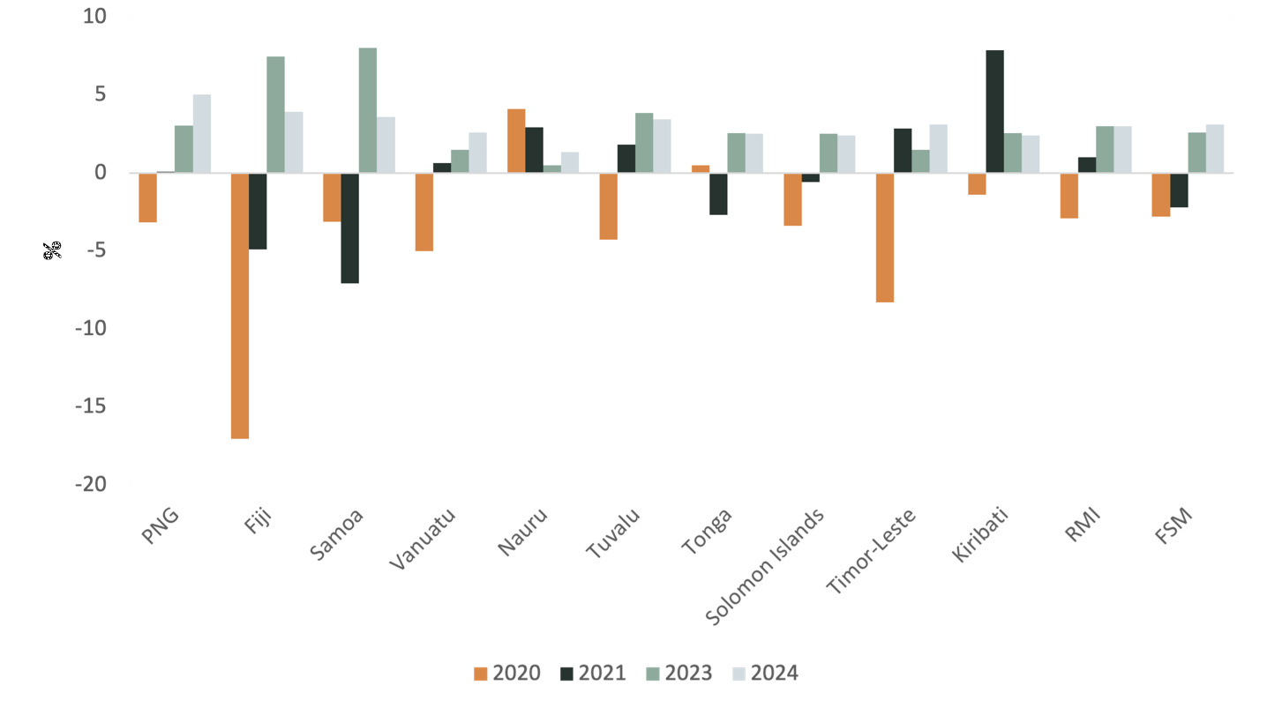

Source: IMF WEO October 2023. 2023 and 2024 values are estimates.

##### FBS and INFRASTRUCTURE

**Spending on infrastructure was a large component of earmarked FBS – comprising 17% of the investment, including:**

Large allocations to road funding, including:

* PNG: AUD50 million in 2022-23.
* Vanuatu: AUD4 million in 2022-23.

These initiatives are both new and funds are yet to be expended. As such there’s no data on outputs or outcomes.

Spending in the water and sanitation (WASH) sector was proportionally smaller. FBS funded four DFAs related to water, including to:

1. **Solomon Islands (AUD 5 million in 2020-21 to the Solomon Islands Water Authority). Solomon Islands Water Supply and Sanitation for Vulnerable Communities Project (WSSVCP).**

AUD5 million was provided in 2020-21 to the Solomon Islands Water Authority (SIWA) for basic water supply facilities through the Water Supply and Sanitation for Vulnerable Communities Project (WSSVCP).

Benefitting over 25,600 Solomon Islanders, the Project had 3 components: water availability, household connections and provincial water, sanitation and hygiene (WASH).

* Water availability: Upgrades were made to Rove, Kwaibala and Panatina settlements.
* Household connections: Access to water was provided to 3,172 new households (approximately 22,000 people). WSSVCP estimates this increased household income of USD270,000 per annum (assuming 3000 connections, 50% recovery, US$15 per household per month average bill).
* Provincial WASH: New handwashing stations at 24 churches in four towns (benefitting around 2,400 people); water supply improvements in Gizo town; WASH improvements at two hospitals; WASH improvements at 11 schools; (benefitting an estimated 1,100 students) two markets and one Christian Care

Centre (benefitting around 100 people). Four town wide hygiene promotion campaigns.

1. **RMI: 2022-23 AUD 1 million UNDP grant to provide water tanks and climate changes activities.**

Complementing Australia’s bilateral support, FBS funds will increase Australia’s contribution to install water tanks to an additional five atolls (Aur, Wotje, Mejit, Utrik and Malolelap), (from an original ten atolls) ensuring over 60 per cent of RMI’s outer atolls have rainwater harvesting and storage solutions. The additional funding is likely to benefit an estimated additional 2,100 beneficiaries over the initial 4,506 covered under the initial AUD2 million bilateral support. No program reporting was available at the time of evaluation to verify the number of households supported to date.

**3- Samoa: AUD 5million earmarked to health sector plus programs aimed at ending violence against women, WASH, promoting health and sports.**

With funding of SAT1.5 million, ADRA constructed 87 new shelters or toilets and showers for families in two regions. Although female-headed household was one criterion for beneficiary selection, disaggregated data were not reported. With funding of SAT500,000 Caritas distributed water tanks to 110 households across several locations in Samoa (sex-disaggregated data not available).

**4- Timor-Leste: with implementation still underway, AUD13.5 million in 2020-23 contributed to 652 water and other community infrastructure projects nationwide as of September 2023. (No further reporting available)**

Box 3 FBS and Infrastructure

###### EOPO2 (Fiscal Crisis Window) Australian support helps to maximise development finance and shock contingencies to mitigate fiscal shortfalls resulting from COVID-19 crisis).

**There is strong evidence that FBS helped to maximise development finance and shock contingencies to help mitigate fiscal shortfalls resulting from the COVID-19 crisis in some countries.** While FBS did not entirely ‘plug the gap’, it contributed by reducing the quantum of shortfalls and giving confidence to other donors to provide support at a critical time. Senior officials in partner governments and development partners said that FBS (coupled with other donor support) was critically important in preventing the economic shock from deepening into a social crisis — forestalling significant budget cuts and asset sales, both of which were under consideration in the early stages of the crisis.

**The clearest example of this was in Fiji where FBS contributed to Fiji avoiding the instability of a major currency devaluation by securing foreign currency inflow.** Further, FBS contributed to some extent to crowding in over AUD700 million in additional grants and concessional loans from Multilateral Development Banks and enabled Fiji to increase government borrowing to fund the national budget (see Figures 19 and 20). These outcomes were in part owing to Australia’s prior dialogue with the multilaterals to advocate for Fiji’s access to concessional IDA lending under the ‘small country exemption’ to enable the government to finance the deficit on manageable terms and ongoing dialogue with multilaterals about Fiji’s manageable debt sustainability risks”.

**Figure 19 Fiji Budget balance – projected vs actual vs actual less FBS, 2018-2024, FJD millions**

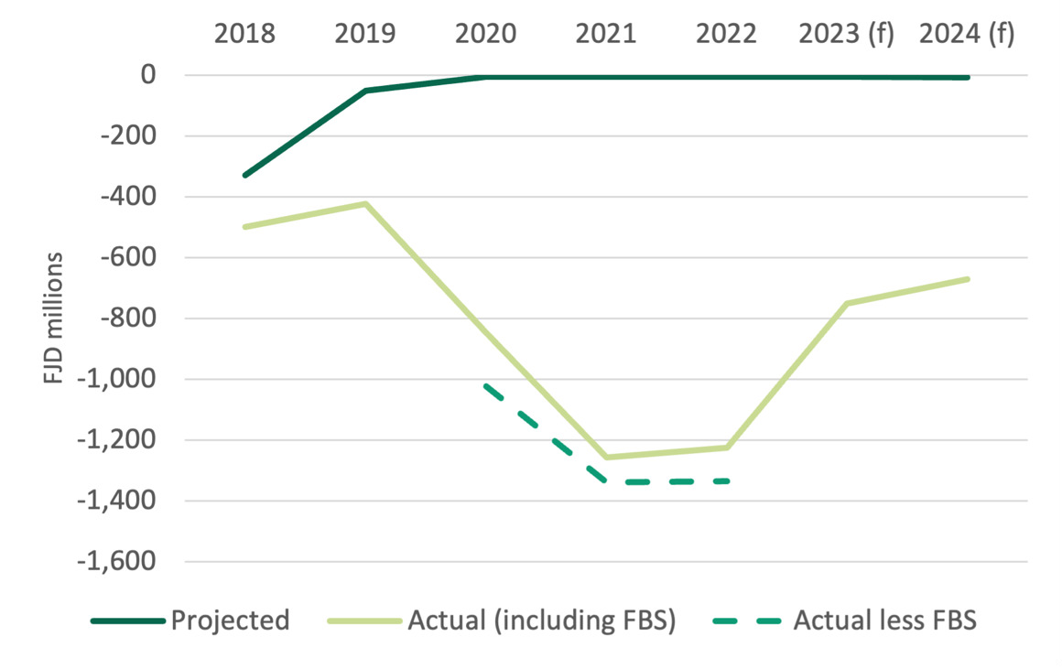

**Figure 20: Fiji donor ODA grants as a % of GDP, 2018-2021**

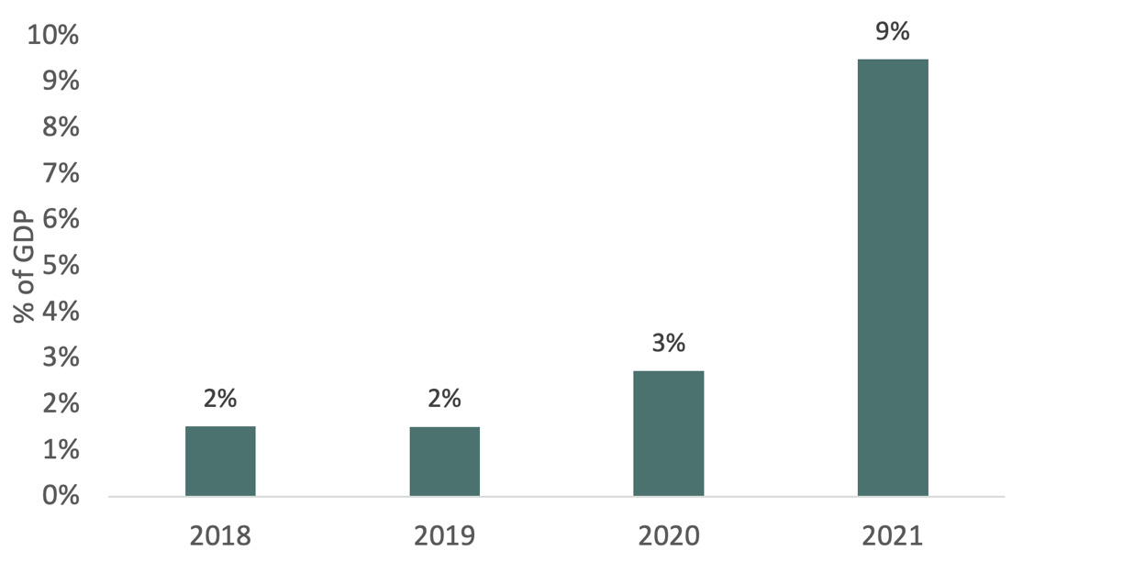

Source: OECD DAC, World Bank, 2023.

**In other PICs, FBS helped crowd in finance to the extent that Australia was able to provide momentum behind pre-existing or nascent economic donor forums.** In design, the intention was that FBS would crowd-in financing from IFIs and like-minded nations such as New Zealand, Japan, the United States and the United Kingdom.[[45]](#footnote-46) The review found evidence of close consultation and coordination with IFIs and other bilateral donors throughout the investment and across PICs. Greater leadership in joint policy matrices by Australia, spurred by FBS, helped garner support in a variety of PICs including (in addition to Fiji,) Vanuatu, Kiribati, Tonga and Samoa (see also Section 2d on coordination across development partners). It is evident that some donor partners increased their budget support to Pacific Island Countries and Timor Leste over the investment period. New Zealand for example increased budget support from USD3.2 million in 2019 to 72 million by 2021.[[46]](#footnote-47) FBS was likely a contributing factor to the crowding in of finance throughout the Pacific. Additional multilateral and other donor financing, together with Australia’s rapid and flexible FBS, helped avert the loss and damage of economic crisis Australia was most concerned about at the time of investment.

**In Tonga, FBS filled a critical fiscal gap with Australia providing a large amount of funding quickly following the onset of COVID-19 and two natural disasters.** As part of Tonga’s fiscal consolidation in 2022-23, some baseline budget allocations to ministries were reduced with some of their recurrent payments funded from FBS. The Ministry of Finance Budget Statement for 2023-24 stated that additional budget support received from Australia will “provide significant relief to the recurrent budget in terms of funding important projects related to improvements in public infrastructure, education and social services”.

**FBS also helped reduce the fiscal gap[[47]](#footnote-48) in PNG and Solomon Islands but the impact was less evident than compared to Fiji** (see Figures 21 and 22). This may have been because the total quantum of funds was small relative to Fiji.

**Figure 21: PNG Budget balance – projected vs actual vs actual less FBS – 2018-2024, PNG Kina millions**

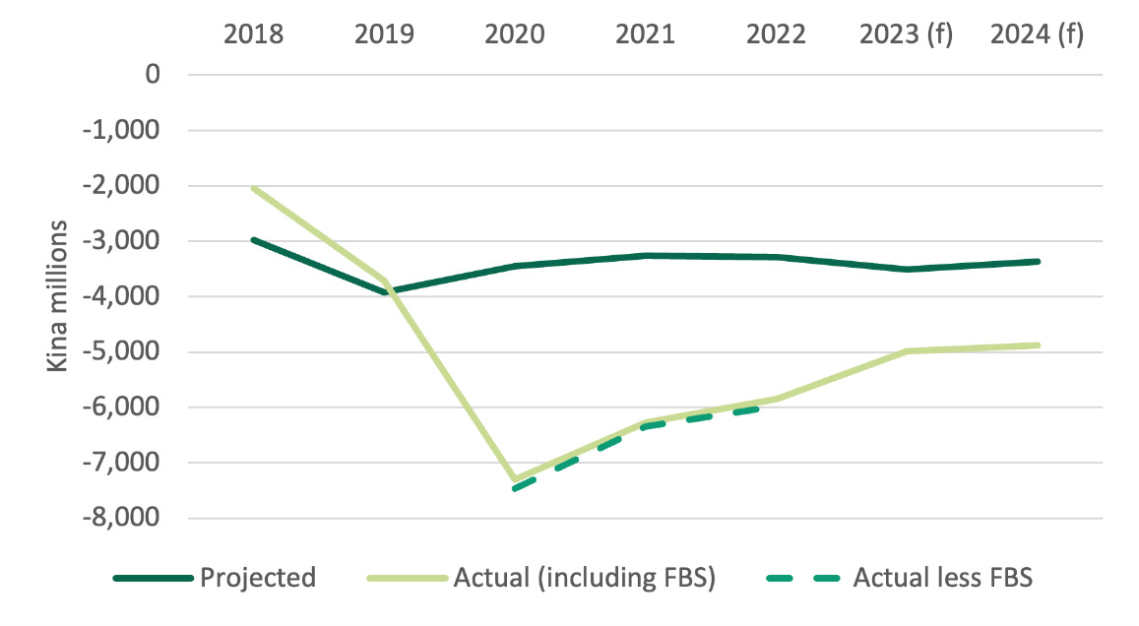

**Figure 22: Solomon Islands Budget Balance: projected vs actual vs actual less FBS, 2018-2024, SBD millions**

**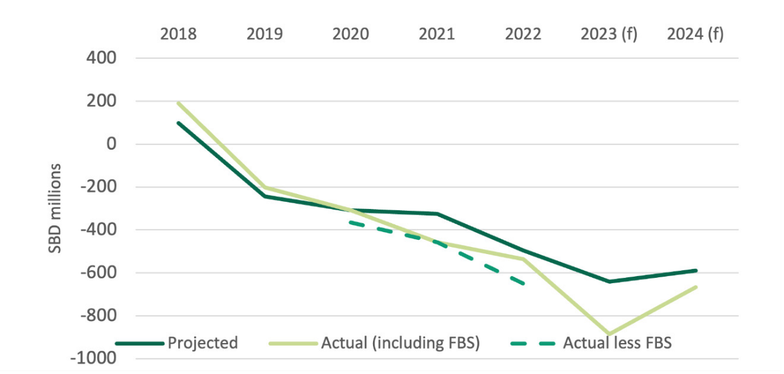**

Source: IMF WEO database, projections are based on 2019 data and actuals are based on 2023 data; DFAT, 2023.

**Evidence of fiscal impact was less evident in PICs where FBS was proportionately less.** In some of these cases, the economic impact of the pandemic on the economy was less severe as they were less exposed to the global market – Kiribati, Nauru, FSM, and Timor-Leste, for example, or projected revenue losses were less severe than anticipated at the onset of the pandemic (Samoa is a case in point). The scale of budget support also impacted its effectiveness.

###### To what extent, and in what ways, did budget support open up opportunities for policy dialogue and/or progress in participating countries, including in regard to macroeconomic management, Public Financial Management (PFM), social protection, GEDSI, economic reform or other priorities? How did budget support-generated policy dialogue vary across participating countries and sub-modalities (general vs earmarked; and budget support vs through multilateral banks) and for what reasons? Was the dialogue well-targeted? Was it aligned with PIC government priorities?

**There is strong evidence that FBS opened opportunities for policy dialogue.** Policy dialogue opportunities increased where there were existing bilateral reform agendas or when Australia had existing mechanisms to build on, such as bilateral programming or technical assistance, or when there was a well-coordinated joint policy matrix. Reform discussions were mostly had around PFM and economic reforms, but social protection was also progressed — less so GEDSI.  Policy dialogue was more evident in countries where disbursements were relatively larger, and relationships were already developed – such as in the case of Fiji, Samoa and Tonga - strengthened by the presence of technical advisors and ongoing DFAT programs.  In the case of PNG however, larger sums of budget support did not lead to an increase in policy dialogue- underscoring the importance of other factors such as the sectors chosen and constrained resources at Post to leverage FBS for dialogue purposes.

**FBS delivered as general budget support was effective at generating systemic reform.** The best examples of this were in Fiji, Samoa and Tonga where policy action processes generated robust economic dialogue and reform actions.

##### General Budget Support and policy reform

**In Fiji, FBS gave Australia a seat at the table to discuss reforms and wider issues.** An impressive 44 policy actions were undertaken over three years in the areas of finance, climate, social protection, gender equality, energy, and private sector. While some of these were already in progress, linking policy actions to budget support enabled several “sticky” reforms to pass, such as modernising the Financial Management Act, Fiji’s first medium-term debt management strategy, divestment of key state-owned enterprises (e.g. Fiji Energy) and updating the national payment system to take account of digitalisation.

**In Kiribati, Australia disbursed AUD 1 million from the Package in the form of general budget support in 2022 following an assessment by the ERT that Kiribati had made significant progress against the agreed key policy actions, as set out in the ERT matrix for 2022, including:**

* Policy action 2: commenced a competitive procurement process to select an IFMIS service provider
* Policy action 3: Investment Committee approved withdrawal procedures
* Policy action 4: Cabinet provided in-principle approval for the Income Tax Bill for submission to Parliament
* Policy action 5: GoK completed 50% of an internal audit process and MFED approved SOE monitoring
* Policy action 6: Ministry of Women, Youth, Sport and Social Affairs completed a roadmap for social protection
* Policy action 7: Approved Environment Act 2021
* Policy action 8: Cabinet approved Disaster Risk Management and Climate Change Regulations 2022; and planning for climate adaptation and mitigation.
* Policy action 9: Parliament approved the Financial Supervisory Authority of Kiribati Act 2021 and the Kiribati Financial Institutions Act 2021

**In Samoa, FBS helped promote additional policy dialogue between the two nations and with other development partners, both through the JPAM arrangements and in bilateral discussions (as noted by both the Samoan and Australian Governments in interviews).** Dialogue through the JPAM and bilateral discussions were seen as complementary. An example cited by Post was the Government of Samoa’s approach to debt management, where the FBS

discussions enabled confirmation that Samoa would not take on any more non-concessional loans. FBS support contributed to a range of policies and reforms that, while they are in their early stages of implementation, and evidence of their long-term effectiveness is still to be determined, will assist Samoa to be able to move faster through recovery and provide a buffer against future shocks. These include:

* The Finalised Medium-term Debt Strategy (2021-26), to support the Government’s spending, decision making and reform efforts in management of its economic recovery. Samoa has amongst the highest debt to GDP levels in the Pacific increasing government costs and vulnerability to shocks. The strategy puts in place mechanisms to draw down debt levels, reducing risks and vulnerability, and applies rigor, controls and conditions on new loans and government guarantees.
* The Finance Sector Plan, outlining priorities around Fiscal Resilience and Sustainability, Monetary and Financial Stability, Competitive and Sound Relationships with Foreign Markets and Robust Financial Report and Independent Scrutiny.
* The Disaster Risk Financing Policy.
* Tax reform, although this has been more limited than originally intended.

**In Tonga FBS provided the opportunity for Australia to be at the table with relevant ministries to discuss PFM and procurement.** Policy dialogue around budget support in Tonga leveraged existing Australian-funded technical assistance, for example, long-term advisers in the Ministry of Finance on PFM and procurement.   Several reform highlights included:

* Electronic sales registry contributing to VAT collections increasing by 20%.
* Disaster Risk Management Act – greater focus on disaster preparedness and governance arrangements.
* PFM – a forthcoming major update supported by Australia’s technical assistance to legislate key fiscal responsibility processes and place a numerical limit on the stock of government guaranteed debt. One objective is to support the government to have options, and not increase problematic borrowing.
* Pilot e-phytosanitary certification for adherence with biosecurity standards for export enabling lodgement and confirmation in a matter of hours rather than days.

Box 4: General budget support and policy reform

**FBS advanced social protection reform and system building, including in countries where reform had been slow or at an impasse prior to the pandemic.** Progress was notable in Timor-Leste during the investment period, although progress has subsequently reversed since January 2024 due to different funding priorities of the new Government. Combined with technical assistance (TA) through the Partnership for Human Development (PHD) and Partnerships for Social Protection (P4SP), FBS was instrumental in having the BdM-JF Decree Law approved that committed to national coverage of the reformed social protection scheme. Australia’s support to the program – providing funds to cover a substantial part of the transfers to women and children – provided the Timor-Leste Council of Ministers with the confidence to proceed and increase their own commitments.

**Social protection policy dialogue was also evident in Kiribati where FBS supported the establishment of a dedicated social protection unit in government to assist the government with their planned rollout and expansion of social protection.** In PNG, FBS enabled policy influence on social protection policy with the Department of Justice and Attorney General, Department of Health and the Department for Community Development and Religion, complemented by technical assistance from the World Bank. While PNG’s social protection payments are tiny by regional standards, FBS dialogue opened the door to the government considering a deeper system of social protection.  The new child nutrition grant that FBS has supported, co-financed with the World Bank and the Government of PNG, will increase social protection coverage in PNG.

**Both bilateral and joint policy processes were effective.** Their relative effectiveness was highly context-specific and indeed in Fiji, both types of processes worked well with the former generating more progress on specific bilateral objectives such as gender equality.

**Policy actions to progress GEDSI through general budget support were evident in a few countries.** In Fiji, FBS helped capitalise on reform momentum to progress gender equality including piloting and scaling gender-responsive budgeting and cabinet endorsement of guidance for early childhood services. In Samoa, a few policy actions were designed to specifically benefit women, including targets for women in the credit registry and national ID, and requirements for data disaggregated by sex and disability in the social protection database.

**In some cases, budget support generated additional and unexpected benefits.** For example, in Timor-Leste, FBS helped strengthen engagement with the Ministry of Finance – a relationship that had experienced difficulties for several years. It could also be said that progress in Fiji exceeded expectations, owing in part to the confluence of a range of external factors supporting the effectiveness of FBS. More broadly, it also built or strengthened DFAT capability in understanding partner government budgets and macroeconomic contexts and thus helped increase development effectiveness beyond the budget support sphere. Unintended negative consequences such as allegations of foreign interference by partner governments or misunderstandings over the short-term, one-off nature of budget support, could have exposed the Australian Government to adverse allegations but this was generally not the case.

**However, due to the nature of FBS meeting immediate essential needs, it did not lead to substantive policy dialogue of reforms across all PICs.** In Solomon Islands funds channelled to Solomon Airlines, the Water Authority, the Ministry of Education and the elections were focused on meeting immediate and essential needs and did not lend themselves to dialogue on reform discussions – although it has strengthened the relationship with these organisations as well as the Ministry of Finance to discuss future reform. In PNG whilst FBS facilitated some effective policy dialogue, this was limited by the much larger relative scale of budget support lending, the sectors chosen and constrained resources at Post to leverage FBS for dialogue purposes. Key informants noted that the rapid establishment of the steering committee with PNG was evidence of closer engagement driven by FBS. In terms of a broader economic dialogue, however, the scale of FBS meant that it did not precipitate more meaningful discussions.

##### **General Budget Support versus earmarked support**

**There are essentially two main types of budget support: general budget support and earmarked budget support.**

**DEFINITIONS**

* **General budget support**: Funds provided through general budget support are disbursed through the recipient government's own financial management system and are not earmarked for specific uses.[[48]](#footnote-49) There is usually a dialogue between development partners and government focusing on overall policy and budget priorities.
* **Earmarked support:** The focus is sector-specific.[[49]](#footnote-50) Funds may be earmarked to a sector expenditure plan, such as a health sector plan.[[50]](#footnote-51) They may be notionally or virtually earmarked (i.e., through an agreement to spend in an area but with no expenditure plan or acquittals or traceably/financially earmarked with agreements to spend with plans and acquittals to verify.[[51]](#footnote-52)[[52]](#footnote-53)

**These broader definitions are further defined by DFAT’s application of general budget support.** DFAT (and other donors involved in joint donor mechanisms with DFAT) require specific, agreed policy reform actions to be delivered as a condition for releasing general budget support funds. While the funds may go into the partner government system and specific Australian funds cannot be tracked, it is conditional on achievement of particular reforms. DFAT also requests that partner governments report on expenditure of general budget support funds (amount expended/unexpended).

**Both forms of budget support elevate certain risks, particularly fiduciary risks and other risks such as failure to achieve investment outcomes and damage to bilateral relationships.** DFAT’s approach to managing these risks includes assessments of national systems (ANS), and monitoring during investment implementation (also refer section 2c Risk). A well-designed PAF and ongoing policy dialogue around expenditure priorities can help reduce the risk of fungibility. Including some form of macro-fiscal targets, potentially complemented by sector level targets for priority sectors for GBS investments can also reduce these risks. Earmarking expenditures to higher-risk investments is another option.[[53]](#footnote-54)

**FISCAL BUDGET SUPPORT**

**FBS was distributed across three years with countries receiving disbursements at different times for different amounts, in different sectors.** Most funds (96%) went through partner government systems. Approximately 4% was channeled through development partners (such as ICRC, UN Women, World Bank, Oxfam) to support vulnerable people.

**In design, FBS was intended to be predominantly general budget support** with earmarked support used where general budget support was not appropriate.[[54]](#footnote-55)

**In implementation however, earmarked support was the main vehicle through which FBS funds were provided to PICs and Timor-Leste – comprising 60% of the total.** Earmarking gave Australia greater control over signaling where and how funds were spent and helped reduce the risk profile.

**Social protection reforms and support to health and education spending were backed by earmarked support (though general budget support also supported social protection reform in Samoa and Kiribati).** While earmarked support has inherent fiduciary risk (though less than general budget support), it was often mitigated by pre-existing programs and relationships in sectors where Australia already had visibility. In some cases, earmarked budget support was not a new departure for Australia, but FBS provided the opportunity to increase the scope and scale of support to particularly vulnerable sectors. Ongoing relationships allowed FBS to be transferred rapidly through government systems.

**Earmarked support was more impactful for supporting vulnerable groups in specific areas.** In Fiji, earmarked FBS supported nine months of regular social protection payments. In Vanuatu, earmarked education funding supported keeping high school students in school. In PNG, earmarked funds supported health worker salaries, thus helping maintain health services through the pandemic.

**General budget support comprised 36% of FBS over the three years, disbursed to six of the 12 countries evaluated.** These were Tuvalu (100% of FBS) Fiji (87% of FBS), Samoa (83% of FBS), Vanuatu (36% of FBS), Kiribati (13%) and Tonga (11%).[[55]](#footnote-56)

**General budget support was unanimously preferred by partner governments.** Samoa, for example, reiterated their preference for general budget support, indicating that earmarked support was more onerous in terms of monitoring and evaluation as well as the set up and development of systems.

**TAKEAWAYS**

**When tied to policy reform matrices, general budget support can boost reform momentum by backing policy commitments prioritised by Australia and/or supported by other development partners with funds.** General budget support delivered significant reform gains in Fiji and Samoa, particularly with respect to PFM and economic reforms. In those instances, it advanced bilateral relationships and established enduring policy changes. It also enabled Australia to have a stake in the whole partner government development agenda.

**The available evidence from FBS suggests that general budget support is better for achieving long-term reform and elevating policy dialogue. In some cases, general budget support can also be effective at achieving immediate change through policy reform matrices.** Policy influence can be harder however through multilateral processes, particularly where there are differences in prioritisation of reforms. Earmarking is better to support vulnerable groups as a crisis response or for supporting particular policy priorities. For both general and earmarked budget support, strong technical advice was needed to support implementation and FBS worked best where technical capability was strong.

Box 5 General Budget Support and Earmarked Support

The above discussion can be encapsulated in a decision tree to inform decisions on whether to provide budget support and if so, whether to provide general or earmarked support.

Diagram 2 provides a decision tree on when to provide general or ear marked budget support based on:
-Partner government commitment to reform  and alignment with Australian partnership and values
-Post capacity to implement budget support with DFAT Canberra support
-Partner government capacity to engage with budget support, report and monitor and absorb funds. 
-Alignment with existing Australian investments
-Alignment with multi-donor dialogues or other programs where appropriate.
-Degree of policy influence
-ANS up to date
-Risks manageable
**Diagram 2. General or earmarked budget support decision tree.**

###### To what extent did the MEL system generate credible information on outputs and outcomes that was used for management decision-making, learning and accountability purposes?

**There is strong evidence that some credible information on outputs and outcomes was generated however the quality of data collected across the package varied, both by country and by type of intervention.** At a regional and country level, there are some examples of FBS performance information being used for management decision-making and accountability purposes although the varying availability of timely, credible data – including data disaggregated by sex and disability status – restricted opportunities for data-based management decision-making, learning and accountability.

***MEL design:***

**In the design phase of FBS, there was a commitment to a simple, non-burdensome approach to monitoring both for partner governments and DFAT Posts. That light-touch MEL design was appropriate, particularly in the early years of FBS where the focus was on rapid response at the onset of COVID-19.** The investment’s MEL plan and arrangements were adequate and met key DFAT Monitoring and Evaluation Standards.[[56]](#footnote-57) An overarching Program Logic (see Annex 1) and Performance Assessment Framework (PAF) guided FBS MEL (Standard 5.2). End of Program Outcomes (EOPOs), Intermediate outcomes and outputs were clearly articulated. In most instances, performance targets were not specified which influenced the options for later performance monitoring and evaluation. MEL reporting requirements for partner governments and development partners were reflected in DFAs (Standard 5.15) albeit to varying levels of specificity across countries and specific arrangements. Diagram 3 provides an overview of the FBS MEL performance management system. The bold arrows indicate how the overarching Program Logic and PAF were incorporated into DFAs, as well as joint policy reform monitoring and other existing MEL arrangements. As detailed in the section below, throughout FBS programming there was less emphasis on ‘upward’ or aggregate MEL reporting and use, indicated by the light arrows.

**Diagram 3: FBS performance management system**

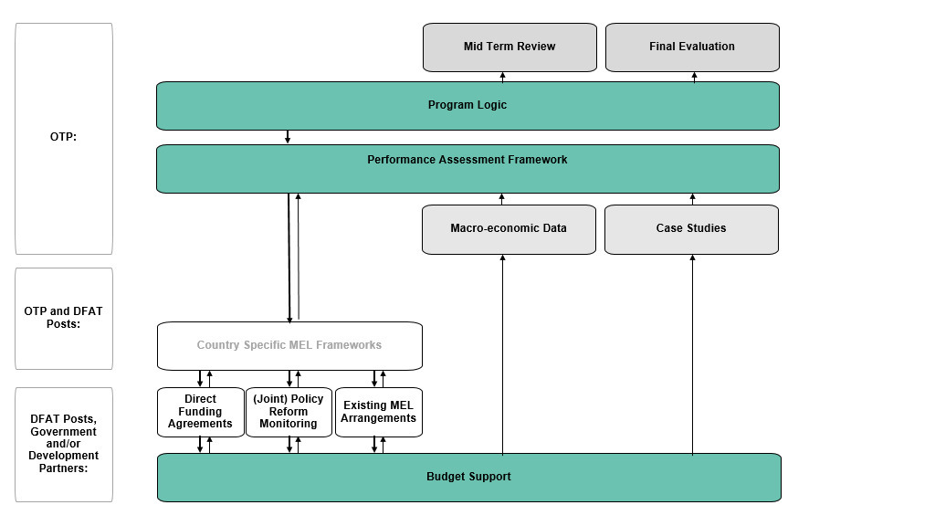

**Where FBS funding was channelled through existing development partner programs, existing program MEL frameworks and indicators were used**. FBS’ pragmatic approach to MEL was appreciated by many stakeholders and reflected the nature of the strategic design framework which was deliberately flexible and less prescriptive on MEL compared to some other DFAT investment designs given that FBS was a rapid COVID-19 response intervention and many Posts and partner governments were experiencing human resource constraints at the package’s onset. In some instances, plans for how budget support outcomes would be monitored were not adequately specified. This may have reflected different perceptions of what level of information was reasonable to request partner governments provide for accountability and learning purposes. The non-burdensome approach to monitoring was consistent with FBS’ preferential use of, and trust in, partner governments’ own systems and data sets (Standard 5.16).

***Data collection/collation:***

**The extent to which quality data on outputs and outcomes was generated across the package varied, both by country and by type of intervention. The MTR, final evaluation and select case studies were embraced as key opportunities to collect and consolidate data from a diversity of sources.** Across the package, monitoring (and later evaluation) efforts were focused on FBS expenditure and specified outputs and outcomes of inclusive economic recovery and support of people experiencing vulnerability (EOPO1); mitigation of shocks and fiscal shortfalls (EOPO 2); and – to a more limited extent – policy dialogue and action (Standard 5.8). Key means of collating data included Post-led financial/expenditure monitoring and outputs, and OTP-led budget statement monitoring and time-series macro-economic data analysis, select case studies, and an external MTR and final evaluation.

**DFAT Posts led routine monitoring of FBS, with agreed reporting arrangements for partner governments and development partners identified in DFAs (Standard 5.15).** The monitoring requirements outlined within those arrangements varied across DFAs – in some instances only financial reporting requirements were reflected, while in other instances qualitative and quantitative information on the use of FBS funds and explicit links to FBS outcomes were specified. In the context of a pandemic response, expectations were not always clearly set in advance with partner governments (and to an extent with Implementing Partners) about what reporting was required and/or those expectations evolved over time – meaning partner governments were not always set up or prepared to provide the required level of detail requested for monitoring or evaluation purposes. Turnover of DFAT staff at Post also led to differing expectations on what level of monitoring was sufficient.

**Progress against monitoring indicators was not always systematically collected or collated.** In some PICs, stakeholders from multiple Posts where there had been staff turnover expressed that there was not always sufficient, readily available data on how FBS funds were spent, or on the outcomes of the investment. Gender/sex or disability disaggregated data was not routinely or commonly collected. Across countries, quality reporting of progress against monitoring indicators tended to occur when FBS supported activities with pre-existing MEL frameworks. Similarly, joint policy and associated donor forums provided a structured assessment of progress on policy actions. Monitoring was also better supported where Posts set clear expectations with partner governments about reporting needs and actively followed up.

***Data use for decision making, accountability and learning:***

**At both a regional and country level, there is adequate evidence that FBS performance information informed management decision-making and was used for learning and accountability purposes.**

At a whole-of-package/regional level,an extensive MTR was commissioned and finalised in June 2022, andsomekey recommendations were actioned within the following 12 months. For example, there is evidence of:

* A greater investment in resource coordination and support functions (Recommendation 6) –including the recruitment of a dedicated MEL resource and continued provision of specialist advice for Posts through PRES coordinated support unit functions.
* Enhanced monitoring and evaluation of the multi-year FBS operation (Recommendation 2, 9 and 10) – including routine collation of data (Country Economic and Fiscal Analysis (CEFA)), case studies, a comprehensive final evaluation and initiating/continuing a series of regional learning calls.
* Continued technical advice and financial support for the progressive introduction and scale up of inclusive social protection in the region (Recommendation 14 and 15), and
* A greater investment in skills and resourcing to promote gender equality outcomes through budget support (Recommendation 3) – including through the utilisation of PRES gender advisors working on a gender strategy and inclusion of greater GEDSI analysis and planning.

**At a country or Post level, the varying availability of timely, credible information on outputs and outcomes meant opportunities for management decision-making, learning and accountability may have been lost. There are, however, a few notable examples of the use of FBS performance information for management decision making and learning.** Examples of strong MEL practice and use of FBS performance information for management decision making include:

* **Monitoring of policy actions being used to guide decisions about fund disbursement**: Suva Post summarised policy changes in a narrative document with supporting evidence which was relayed back to Canberra and informed policy actions for subsequent rounds. Clear assessments on progress of policy actions were reported and included in Disbursement Notes for later funding rounds.[[57]](#footnote-58) Evaluating the political economy for reform was also undertaken by Post – some areas were explored but ultimately determined not suitable for the list of policy actions.
* **Joint monitoring field visits:** In Timor-Leste, the FBS Steering Committee provided an effective mechanism for financial reporting and accountability processes and both governments undertook joint monitoring field visits. Steering Committee members (including MoF, Ministry of State Administration, MSSI stakeholders and Australia’s Head of Mission) were able to engage with communities and directly hear of their circumstances and experiences of the investment.

# 2. EFFICIENCY

###### DID FBS MAKE APPROPRIATE AND EFFICIENT USE OF TIME AND RESOURCES TO ACHIEVE EOPOS?

**Efficiency: There is strong evidence that FBS made appropriate and efficient use of time and resources to achieve its EOPOs. Most FBS allocations were channelled through partner governments and utilised existing relationships, programs and technical assistance – minimising overheads and operational resourcing and increasing the speed of disbursement of funds.**

* **The governance arrangements for FBS effectively balanced efficient decision-making with the size and risk of funding allocations across countries. They were highly flexible and uniquely DFAT-delivered, as opposed to other more expensive and time-consuming delivery models.**
* **FBS made efficient use of human resources, including drawing on existing technical assistance where available, DFAT staff and specialists for the efficient achievement of intended outcomes, though staff were in some cases under considerable pressure (see Section 2a).**
* **PICs were able to absorb FBS funding in most cases but in many cases, whether due to capacity constraints or rapidly changing circumstances, implementation had to be delayed (see Section 2b).**
* **Risk management policies and procedures were followed in relation to fiduciary and fraud risks but whether these policies and procedures were adequate could be considered further by DFAT. Other safeguards received less attention (see Section 2c).**
* **FBS assistance and funding was mostly harmonised and aligned with other donor and multilateral support (see Section 2d).**
* **At a country level, assessments of efficiency ranged from ‘adequate’ to ‘good’. FBS was ‘efficient/good’ in eight of the countries evaluated. Four countries performed ‘adequately’.[[58]](#footnote-59)**

###### How efficient were the FBS modalities in relation to the use of time and resources to achieve EOPOs? How well did management and governance arrangements function, including the internal structure and delivery approach (regional investment implemented through country-level activities/investments)?  How well did FBS make use of human resources, including technical assistance, DFAT staff and specialists for the efficient achievement of intended outcomes?

**FBS modalities across DFAT were efficient but additional funding could have supported delivery, particularly given the scale and complexity of the investment.** A Support Unit was funded out of the Package, procured through the Innovation Resource Facility (IRF and later through the Pacific Recovery Economic Support Program (PRES)). Initially, the Support Unit assisted the design and early implementation of FBS, working with EPS. Subsequently, the Support Unit supported OTP by providing tailored advice as requested by Posts and partner governments.[[59]](#footnote-60) By the final year of the investment, the Support Unit provided project management M&E, PFM and GEDSI expertise to support implementation.[[60]](#footnote-61) The initial design estimated the Support Unit would cost AUD2.57 million over one year (November 2020-November 2021). It is estimated that approximately $3.9 million was spent on PRES across 21/22 and 22/23, some of which supported FBS and some supported similar initiatives across DFAT programs. Approximately $2.4- $3 million was spent on technical advice to FBS. Although FBS was supported through existing staff and modalities, the Support Unit’s additional support was 0.6% of the total package spend – a very small amount relative to most DFAT programs (see also box 6). As described below, the imposts on Posts to implement FBS were significant and in several cases further funds could have supported stronger policy dialogue efforts, closer monitoring of risks and mandatory data collection and reporting. (Further discussion on resourcing provided in Section 2b).

**The governance arrangements for FBS effectively balanced efficient decision-making with the size and risk of funding allocations across countries.** The Aid Governance Board provided senior oversight for FBS. Advising the Board was the Strategic Review Panel (SRP) – composed of Assistant Secretary/Directors from across DFAT. The SRP had responsibility for providing strategic oversight and direction as well as supporting decisions on funding allocations. FBS also sought to prioritise partner government systems where possible – using general budget support or earmarked support to facilitate rapid disbursement of funds whilst minimising risk.[[61]](#footnote-62)

**Management and governance functions efficiently supported the internal structure and delivery approach.** The multi-country approach was able to make more effective use of technical capacity specialists such as economists, PFM experts, social protection specialists, GEDSI and MEL experts. Senior OTP management, leadership and strategic oversight was central to the effectiveness of FBS. At the same time, significant Desk and Post engagement significantly strengthened the potential for greater impact of FBS in implementation.

**The arrangements were highly flexible in terms of Post autonomy. They allowed additional specific governance arrangements at country level.** This provided opportunity for Posts to implement and manage as best befitting the context. For example, Timor-Leste and PNG had formal steering committees with the Ministry of Finance/Treasury. Fiji had close but not structured collaboration with the Ministry of Finance and other development partners. This level of flexibility was useful to not overburden partner governments in a time of crisis and reduced resources.

**The arrangements were highly flexible in terms of the type of budget support provided to each country and to each sector.** The FBS’ flexible approach enabled targeted and appropriate budget support pathways, suitable for different country and sector contexts. Other donors, by contrast, tended to employ a less flexible approach which can be less efficient from a risk management perspective. This flexible approach was built in at the design phase, where country allocations were determined by an array of criteria. These criteria helped determine the choice of funding amounts by country and by sector. (See also Introduction: The Fiscal Budget Support Package). It also meant that country allocations could respond to changing circumstances. FBS in Nauru responded to changing needs. While the disbursement of funds was delayed, this arguably improved the investment because it ensured that funds were directed to where they were needed. In Tuvalu, the initial DFA was subsequently amended to allow more time for disbursement (to 30 June 2022), to ensure appropriate use of funds in line with the intent of the DFA. Ongoing correspondence between Australia and Tuvalu led to an evolution of activities to best reflect the evolving needs of Tuvalu.

**Arrangements were also uniquely DFAT-dependent – with DFAT as the chief implementer (as opposed to managing contractors).** This provided the opportunity for Post staff to engage directly with ministries. By contrast, other aid modalities often rely more heavily on consultants and contracted personnel. It also enabled those Posts to engage with ministries on areas where there may not have been previous strong engagement and coordination (refer to Section 1c. Policy Dialogue). The capacity of Posts to engage directly with ministries was dependent on resources at Post. In PNG for example, resourcing limits did not facilitate optimal interaction. It was also dependent on resources of the partner government and their capacity to engage on what in some instances was a new modality. Fiji was resourced sufficiently to leverage the opportunities with a highly effective LES capable of managing much of the FBS load. (See Recommendations for discussion on training needs).

**There is strong evidence that FBS made efficient use of limited human resources, including TA, DFAT staff and specialists for the efficient achievement of intended outcomes.** Other development modalities across PICs were comparatively more resource intensive and such modalities were not viable at a time where many Post and program staff were being repatriated back to Australia. DFAT Canberra and Posts emphasised that there was no other modality that could have disbursed funds as quickly and with negligible overheads.

**Some informants indicated that FBS resourcing was too lean.** Significant pressure was placed on already-stretched Posts to roll out what was for some Posts a new modality, in pandemic conditions.Several Posts noted that because budget support was a new modality and FBS spanned a range of sectors, it required intensive support to get up and running. There were teething problems in terms of getting money in the right place and it was more human resource intensive than anticipated. This was exacerbated by tight timeframes for delivery. In Tonga the evaluation heard that more clarity on the objectives and intent of budget support would have been helpful. With many staff changes in DFAT, the perceived objectives of Australia’s budget support to Tonga were not always the same or clear. Clearer intent would have helped staff more proactively advance mutual objectives through regular bilateral policy dialogue and maximise opportunities.

**The timeframes for Australian Government budget decisions and internal DFAT allocation processes were constrained.** This created considerable pressure on Posts and OTP and also constrained funding options. The PNG case demonstrated that more time and resources were needed to manage budget support in a complex operating environment. More resources would have helped Post leverage the opportunity to increase dialogue on effective PFM and build relationships to support stronger monitoring of systems. More time and resources at the outset would have also supported the analysis of different options and better decision making on allocation. In Solomon Islands the evaluation team heard that while FBS supported the government in a few key areas, with more time to prepare and more time to roll out multi-year budget support, more could be made of the opportunity to leverage budget support for stronger outcomes.

**In the context of COVID, the initial assessment of the sectors supported by FBS was appropriately undertaken quickly.** Looking forward, additional resourcing would also help Post leverage the opportunity to increase dialogue on effective budget support and build relationships to support follow-through and monitoring. More time to consider the impacts and risks of investments will be important with any future rollout of budget support to ensure closer consideration of the impacts, both short and long term.

**Posts responded to this pressure by drawing on a range of Post-based or Canberra-based resources** – **OTP provided technical advice across the gamut of sectors.** Posts’ capability in PFM, social protection and budget support was also critical to managing budget support arrangements and required experienced staff. In Fiji, FBS implementation was led by a highly experienced Fiji national who brought together technical skills and a knowledge of the local decision-making and political context in a way that any A-based member of staff would have found difficult, if not impossible, to match. In Timor-Leste, Post put in place a dedicated FBS short term adviser and drew on TA through existing programs. Tonga was supported by resources from DFAT Canberra to help manage administrative processes. In Kiribati, technical experts from Canberra supported Post to participate in reform discussions.

**Some Posts reported that local capacity was sufficient, mainly where budget support was already part of the bilateral program or where FBS was a relatively small investment.** Post in Samoa reported that as budget support and engagement in the JPAM was already part of the bilateral program, it had sufficient technical capacity in place to support the responsibilities and objectives of FBS. Smaller posts such as FSM noted they leveraged long term and short-term Post resources to forge relationships with existing programs and other development partners to support implementation.

**While Posts were able to identify target sectors for support and to implement the package, constrained resources were most evident in follow-up monitoring and evaluation of FBS** (see Section 1d on M&E). Canberra M&E support was available to Posts but interaction between the M&E support and Posts was reportedly limited. For GEDSI, the constraint was more about prioritisation and a willingness to seek out and act upon advice. Peer review from Canberra in the early years, for example, motivated Fiji Post to strengthen gender equality and social protection. By 2022, FBS had a GEDSI adviser and capacity to draw down on surge panels for gender equality and disability inclusion. Several large posts also have GEDSI focal points and expertise within programs. There was a clear improvement in GEDSI analysis, but it is too early to tell impacts in many cases with implementation into 2024.

**Posts also drew on existing programs to help ensure the effectiveness of FBS funds spent**. In Fiji, over 2021-22 and 2022-23, Australia funded technical assistance for 70% of the policy actions either directly or indirectly from a variety of quarters including DFAT-funded initiatives such as P4SP, IMF capacity assistance (PFTAC) and World Bank-IFC operations. Similarly, the assessments and diagnostics through technical assistance programs enabled DFAT to engage constructively in policy dialogue.

**P4SP and other existing programs also provided significant support across the PICs and Timor-Leste to help support FBS-supported social protection system strengthening.** In Kiribati for instance, TA supported by P4SP helped establish a new Social Protection Unit in the Ministry of Youth and Social Affairs funded by the Package, with the adviser acting as the Director of the Unit – leading to significant improvements in the performance of Kiribati’s social protection program.  P4SP also supported Fiji to sustain improvements in the social protection sector including implementation of a new policy framework, operational reviews, and ongoing assistance. Other existing programs also supported FBS rollout such as Governance for Growth in Vanuatu; PHD, PARTISIPA, APTC and P4SP in Timor-Leste, and PFM programs in Samoa and Kiribati.

**In the absence of existing programs, budget support efficiency was compromised.** Timor-Leste’s labour mobility investment for example, lacked the large existing programs working with GoTL to support implementation and delays have occurred as a result. In Solomon Islands, funds channeled to sectors better supported by existing programs may have supported stronger outcomes or at the very least supported better reporting on outcomes. Visibility on the impact of support to Solomon Airlines for example, was limited. In Samoa, further technical support on social protection would have likely led to greater policy dialogue outcomes and provided different points of view for the Government of Samoa to consider. While the Samoan Social Protection Policy Framework was supported by the World Bank and was used by DFAT as a ‘trigger’ for its budget support, earlier technical involvement from DFAT’s social protection team and/or P4SP could have added more diverse perspectives to the policy development process to support the drafting of a well-informed and fit for purpose Social Protection Policy Framework.

**Budget support should also be considered in the context of existing programs, particularly where other support is of a significant scale**. In the case of PNG, the scale of FBS funds was small in comparison with the significant budget support lending delivered by Australia during the same period and small considering the size of Australia development programs in PNG, arguably limiting the potential relationship impact of direct budget support.

##### efficiency of fbs compared to other modalities

**Budget support has become an increasingly important instrument in the context of a partnership-based approach to development assistance.** Compared to traditional modes of aid delivery, it promises greater country ownership, reduced transaction costs, better donor coordination, scaling up of poverty reduction and potentially greater development effectiveness.[[62]](#footnote-63) It does however give rise to risks in terms of the use of funds by partner governments. It has garnered significant attention during the COVID-19 pandemic as a tool to support developing countries through a crisis.

**The evaluation finds that FBS was a particularly efficient aid modality, noting that it is unlikely that any other delivery mechanisms were feasible in the context of travel restrictions and lockdowns, nor could they have had the development impact of FBS in the COVID-19 context.** This was particularly true in the context of staff repatriations across Posts, NGOs and managing contractors.

Budget support ensures that 100% of funds are channeled into partner government systems. Aid programs delivered through managing contractor facilities spend 14% to 21% of expenditure on administration alone.[[63]](#footnote-64) In many cases, a large proportion of facility budgets are spent on technical advisor salaries which may be saved and spent in their home country. This was not the case with FBS.

**While budget support may require additional funds to provide technical support to partner governments and to strengthen partner government systems.** These funds that may have otherwise gone to managing contractor administration could instead be directed to improving partner government systems and capacity with longer-term benefits.

**The evaluation also finds that FBS was, in some contexts, a particularly effective capability strengthening modality, achieving commitment to significant and substantive reforms in some countries such as Fiji.** The quantum of reforms may not have been achieved through any other aid modality. This was because FBS supported partner government-led agendas by central agencies across a range of sectors and in joint operations supported by other donors.

**The evaluation also finds however that it is not an either/or scenario.** Australia’s bilateral programs significantly complemented FBS and on many occasions, FBS allocations were only successful due to existing bilateral operations. In Timor-Leste, for example, FBS was linked to the social protection work supported by the PHD program and P4SP, to PARTISIPA’s TA for PNDS, and APTC’s support to SEFOPE. In Kiribati the P4SP program supported the roll out of social protection and the AusP3 program provided PFM oversight of FMIS implementation. Strong ties with partner government ministries through Australia’s bilateral engagements in Vanuatu and Solomon Islands gave Australia confidence to earmark education funds during the pandemic even without significant on-the-ground oversight.

**The strategic and technical undertaking of budget support should not be underestimated. FBS was rolled out under lean management.**

Box 6 Efficiency of FBS

###### Were fund disbursements to partners timely, in relation to both plans/commitments and alignment with national budget processes? To what extent were participating PICs able to absorb FBS funding?

**FBS funds were disbursed quickly but fund disbursements to partners were not always timely in relation to plans and commitments and were not always aligned with national budget processes.** Most FBS allocations were channeled through partner governments where Australia had pre-existing relationships, programs and/or already provided technical assistance in those sectors. This increased the speed and ease at which funds could be disbursed.  In the context of significant uncertainty, limited on-the-ground resources, and rolling lockdowns, the pace at which funds were disbursed is commendable and demonstrates significant strategic capability to design and deliver. That said, the need for quick disbursement of FBS meant that not all funding was aligned with partner government budget cycles making it more difficult to factor into fiscal management. In Vanuatu for example, allocation under the Core Roads DFA did not align. As a result, funds are currently being held with the Ministry of Finance and a budget appropriation will need to be made to transfer the funds to the Ministry of Transport. Fiji also reported some challenges in the timing of Australia’s budget commitments. In practice, the year-on-year allocations under the Pacific FBS, and Australia’s federal election affecting the 2022-23 budget, meant that funds were not confirmed until later in the Fiji budget year. This also impacted the ability of Australia to link to ministry-level work plans and budgets as recommended by the Assessment of National Systems (ANS).  In PNG, the school grants were received well into the second half of the school year, and there were not systems in place early enough to ensure fiduciary risks had appropriate treatments, slowing down flows of funds to schools. The need for quick disbursement of Package budget support from Australia to the Government of Tonga meant that not all of the Package funding was aligned with the partner government budget cycle. Large in-year injections were very much welcomed but more challenging for the government to manage.

**There is strong evidence that the flexibility of FBS funding added to efficiency, with funding allocated according to annual plans with the opportunity for partner governments to carry over any underspent funds to the following year**. This multi-year budget flexibility was greatly appreciated by partner government stakeholders. It was important in Timor-Leste, where all programs supported by FBS saw implementation and spending delays due to a range of reasons, including the need to establish new systems, elections and a new government. In Tonga, budget support disbursements were quick and sufficient in reducing the budget deficit. Australia was also seen as a reliable partner with timely disbursement of JPRM-related funds (particularly in 2022 when the World Bank and Asian Development Bank (ADB) did not provide budget support).  This multi-year flexibility in expending funds is not usually an option (funds usually cannot be rolled over from one financial year to the next) yet it clearly allows for the accommodation of on-the-ground realities and likely helped achieve better outcomes than if there was a forced expenditure of funds by the end of each financial year. It also supports cash balances which are a critical priority to many PICs given their limited ability to borrow in the event of shocks. That said, whilst flexibility was useful, greater certainty may have also been desirable. Many Posts stated that greater multi-year certainty would have supported better funding decisions. For DFAT, there wasn’t flexibility on timing of disbursement. Funds had to be disbursed within the year they were allocated.

**There is adequate evidence that PICs were able to absorb FBS funding on the whole, but in many cases, implementation had to be delayed.** Due to the temporary nature of FBS, and capacity constraints in some PICs, some of the FBS allocations were greater than could be absorbed in one year and multi-year implementation arrangements were put in place (e.g., until the end of 2024). In several cases, implementation of FBS is still underway, indicating that FBS allocations could not be disbursed in the anticipated investment timeframe. For example, in PNG AUD50 million has been disbursed to the Transport Sector Support Program (TSSP) for road maintenance but implementation has not commenced. In Vanuatu, AUD4 million has been disbursed to support Core Roads but implementation is also yet to take place. General Budget Support funds of AUD12.5 million to Vanuatu were only disbursed recently. Tonga received AUD30 million in 2022-23 but so far only a small proportion (AUD0.3 million as of January 2024) has been spent with implementation anticipated through to June 2025. In Kiribati, AUD3 million provided to the Government of Kiribati as earmarked budget support for social protection in 2020-21 was not drawn on until 2023. In Nauru, the first tranche of FBS funds were delayed due to Nauru having sufficient funds to respond to the immediate impacts of COVID-19. In Solomon Islands a range of implementation challenges impacted the disbursement of funds including challenges facing school grant disbursements and school grant retirement issues. A small proportion of unspent funds in 2021 were rolled over in 2022 in response to other issues facing the education sector such as the November 2021 period of civil unrest. AUD 0.5 million remains unspent. In Tuvalu, due to a lack of absorptive capacity amidst an influx of donor funding, the initial DFA had to be amended to allow more time for disbursement. It is estimated that over $100 million of FBS is still yet to support specific activities on the ground.

###### To what extent were risk management policies and procedures (including in relation to fraud control and safeguards) followed?

**There was strong evidence that risk management policies and procedures were followed in relation to fiduciary and fraud risks, but other risks were not carefully considered.**

**At the design stage of FBS, risks were identified through a risk and safeguard tool and mitigation strategies were identified as part of the FBS Design Framework.** The design notes key risks including those related to insufficient funding; limited opportunities for policy dialogue; limited timeframes; allocation of funds; and insufficient crowding in. In terms of implementation risks, fiduciary risks and staffing risks were seen as critical challenges. Environmental and social safeguards were considered in the design noting that they would be addressed at the investment level using pre-existing screening tools and mitigation measures and where budget support was new.

**The design did not specify a significant increase in fiduciary risk monitoring**. The framework recognises that “in most cases there are existing risk mitigation measures in place following implementation of an ANS or through previous rounds of funding”. The key additional requirements detailed in the design include:

1. Using an exchange of letters to record how funds would be used
2. Seeking agreement to undertake post-crisis audits
3. Mobilising remote technical support from Canberra or engaging local technical assistance
4. Taking a country-by-country approach that acknowledged the very different risks faced within each country’s PFM systems.

**Upon implementation, risks and mitigation strategies were identified, agreed by Posts and OTP and considered by the SRP.** ANS and Fiduciary Checks were the main tools employed by DFAT to identify and manage fiduciary and fraud risks. Specialists were usually contracted either by Post or OTP to undertake fiduciary checks or update ANS. These assessments and checks took place in a timely fashion prior to fund allocation and disbursement and Posts welcomed these checks to support risk assessments. The review finds that these activities were carried out effectively at most Posts. (Refer Annex 5). In Fiji there was strong evidence that fiduciary risks were managed well – including through an ANS in 2020 and ANS Risk Register, plus a specific Fiduciary Risk Assessment of Top-up Payments through Government of Fiji Social Welfare Programs. Annual fiduciary checks were conducted by independent experts to ensure continued compliance and validate Post’s risk assessments. Risks associated with disbursing funds ahead of completion of policy actions or verification of social protection payments in some cases were mitigated by the prior ANS checks and subsequent reporting.

**Mitigation and treatment of recommendations, however, was not prioritised in an ongoing way.** Posts tended to see these checks as an end in themselves rather than a framework for ongoing monitoring and mitigation. These challenges speak to the broader issues faced by Posts regarding understanding and working with PFM systems and their intersection with risk – an issue taken up in the recommendations section of this report. These challenges also reflect the pandemic context and the lean operating environment at most Posts over the investment period. More careful consideration of risks is recommended to support budget support implementation in any future rollout.

**In the Design there was an expectation that “environment, resettlement, climate change, disaster resilience and child protection safeguards will be addressed at the investment level, using pre-existing screening tools and mitigation measures embedded within the aid investments that will be used to disburse Package financing”.** It was anticipated in the design that these types of risks would be minimal. While the design anticipated that certain risks would be considered on implementation, there is limited evidence of this taking place. Risks and environmental and social safeguards that were poorly considered include:

* external risks: risks that exist in the operating environment that may negatively impact on the operating environment such as natural disasters or security threats;
* political risks: risks to relationships with other development partners;
* social risks: risks that actions or funded activities may negatively impact on people – i.e. gender, children, vulnerable and disadvantaged persons;
* stakeholder risks: impacts on beneficiaries and the risk that beneficiaries may be inadvertently negatively impacted.

The expectation that environmental and social safeguards would be addressed using pre-existing tools and mitigation measures was not appropriate and further consideration should have been given to these risks upon implementation across the Posts. (Also see recommendations section for further discussion).

**Some Posts managed broader risks through new governance arrangements and clear communications.** In Timor-Leste, risks were managed through the FBS steering committee and the respective program management meetings and existing program risk registers. All Posts had to manage expectations to some degree with clear communication on the one-off nature of FBS as a COVID-19 response. In Vanuatu for example, posters were provided to schools to be clear that tuition fee subsidies would only be provided for a short time.

**Reducing the risk profile of partner government systems is another consideration of budget support.** Better outcomes were evident in countries where Australia had confidence in national systems such as Fiji and Samoa. Helping partner government to improve and strengthen PFM systems is another key component of DFAT’s development program that will help support any future rollout of budget support.

###### To what extent was FBS assistance and funding harmonised and aligned with other donors and multilateral support)?

**There is strong evidence that FBS assistance and funding was harmonised and aligned with other donor and multilateral support.** There are clear examples of cooperation through JPRM processes with multilaterals including ADB and World Bank such as in Tonga, Samoa and Fiji. In Tuvalu, through the World Bank policy reform matrix, development partners talked regularly about a shared set of reforms and combined budget support with technical assistance and other program efforts. There are also instances of collaboration with other donors such as New Zealand through joint matrices. In some instances, FBS helped to implement other donor partner objectives independently from the joint matrix process. In Kiribati, FBS funds supported implementation of a Financial Management Information System (FMIS) which had been progressed by ADB for several years.

**FBS also provided the opportunity for DFAT to play a larger and more hands-on role in joint donor activities.** Posts were generally well placed to identify reforms and draw on bilateral programs to support implementation.[[64]](#footnote-65) In Vanuatu FBS provided some momentum to get a Vanuatu joint donor approach off the ground. While it likely would have happened anyway, FBS provided some impetus. In Fiji, Australia was able to use its influence to identify gender-focused reform priorities in the reform matrix for the first time.

**FBS highlighted the need for closer consideration of where joint donor approaches should be pursued to leverage reform.** Further consideration is also required on how decisions around disbursements are made, and, where an inevitable outcome is that disbursements could and should be deferred if there is unsatisfactory progress on reforms. In Tonga, informants noted that the JPRM donor coordination platform weakened during COVID-19 with donors bilaterally progressing additional budget support. There is an intent to strengthen this multilateral platform, including with greater ownership by the Government of TongaJoint donor approaches were not universally used by FBS where they existed. In Solomon Islands for example, the joint donor approach was not functioning effectively at the time of FBS allocation and therefore a bilateral approach was taken.

**In Fiji, Australia used both multilateral and bilateral approaches.** This example demonstrated that Australia tended to have greater flexibility in reform actions progressed bilaterally. Australia was also willing to support implementation-orientated reforms (e.g. social protection operational review and a framework for climate change regulations). These reforms were critical to unlocking bottlenecks and setting the scene for more complex reforms in an evolving political economy. By contrast, the multilaterals tend to link their operations to legislated or regulatory policy changes.

**FBS also highlighted the importance of coordination with partners more generally.** In FSM, working with the Pacific Community and the EU, as well as FSM local authorities was critical to the successful, timely, delivery of the renewable energy project. In RMI, delivering support through the UNDP was an efficient mechanism for supporting the most vulnerable in the recovery phase, allowing timely disbursement.

# 3. GENDER EQUALITY

###### DID FBS MAKE A DIFFERENCE TO GENDER EQUALITY AND EMPOWERING WOMEN AND GIRLS?

***Gender equality:* There is evidence that FBS achieved adequate results for women and girls. FBS supported governments to take action to maintain expenditure on essential services for women and girls (especially health and social protection, although education was mixed), earmark sectors or programs for attention (e.g. social protection in many countries, and preventing gender violence in Samoa), and, in limited countries, advance gender equality policy actions through budget support (Fiji is the standout). FBS reinforced gender-responsive elements of government PNDS in Timor-Leste, roads in Vanuatu and water and sanitation in Solomon Islands, supported by existing development programs. FBS also supported a small number of non-government entities to take action for gender equality such as UN Women in PNG supporting women traders to increase incomes and access to credit. The extent to which FBS made a difference to gender equality and empowering women and girls varied considerably by country, ranging from ‘poor’ to ‘very good’. Of the 10 countries for which evidence is available, performance on gender equality was assessed as ‘very good’ or ’good’ in two countries, ‘adequate’ in five countries and ’less than adequate’ or ‘poor’ in three countries.[[65]](#footnote-66)**

**There is sufficient evidence that FBS adequately made a difference to gender equality and empowering women and girls.**

1. ***To what extent did FBS achieve intended results on gender equality and empowerment of women and girls?***

**There is sufficient evidence that FBS achieved adequate results for women and girls** by maintaining expenditure on essential services (especially health and social protection), earmarking sectors or programs for support (e.g. social protection or preventing gender violence in one case), and in limited countries, policy actions attached to general budget support (Fiji is the standout).

**COVID-19 was widely recognised as a setback to gender equality**.[[66]](#footnote-67) Women and girls were more vulnerable to COVID-19 socio-economic effects due to existing gender inequalities. This included loss of women’s jobs and incomes concentrated in COVID-19 affected services sectors, women’s increased care expectations (including assistance with remote learning), risk of girls permanently dropping out of school earlier, extra challenges in accessing essential maternal and sexual health services, and increased risk of gender-based violence associated with lockdowns and household income pressures.

**The FBS Gender Strategy 2021, set out intended results for women and girls as follows**[[67]](#footnote-68):

1. Women and girls’ access to essential services is maintained and enhanced.
2. Women and girls in targeted populations access and use social protection interventions.
3. Women’s incomes increase through support to the formal and informal sectors.
4. Women and girls benefit from government budget policies.

A fifth outcome, DFAT staff are enabled to advocate for gender-responsive economic policy measures, is covered by this evaluation in Annex 6.

**Although the FBS Gender Strategy was developed in the second year of implementation, the intended results resonated** with key informant interviews about the design of FBS and are used for this evaluation.[[68]](#footnote-69) The Gender Strategy was updated in 2022 ahead of the final year of funding. In the absence of a FBS Gender Strategy, an alternative would have been to use DFAT’s Gender Equality and Women’s Empowerment Strategy outcomes for all development initiatives (Enhancing women’s voice in decision-making and leadership, Promoting Women’s Economic Empowerment and Ending Violence Against Women and Girls). The FBS Gender Strategy results are more specific and tailored to the FBS context.

**There is strong evidence that services for women and girls were adequately protected in terms of expenditure.** Many government services are essential for women and girls – in the context of the COVID-19 pandemic and Australia’s budget support – this evaluation considers government expenditure on health, education, social protection. As discussed in Section 1b and shown in Annex 6, government expenditure on health was maintained in all countries and increased in a majority of countries in response to COVID-19. Expenditure on education (at a national level) increased in half of the countries and fell in others in 2020 and 2021. Expenditure on women, children and social protection was maintained in Fiji and Tonga, and increased in Timor-Leste, Samoa, Kiribati and Solomon Islands (but remained minimal in PNG and Vanuatu). Government expenditure on programs to address gender violence or disability support services is not readily available from national budget documents or other sources (e.g. IMF Government Financial Statistics).

**In addition, FBS effectively earmarked funding for services essential for women and girls in several countries.** Results included covering 4,803 PNG health worker salaries in 2021 to deliver services including antenatal care, sexual and reproductive health, in Vanuatu subsidizing school fees for 26,000 secondary students in 2021 (although sex-disaggregated data not reported) so benefits to girls uncertain), and in the Solomon Islands, grants supporting school operating costs in 2020-21 (again, sex disaggregated‑ data not available, so benefits to girls uncertain). Samoa was the only FBS country to earmark funding to government for gender-based violence support services, enabling the government to fund the Samoa Victim Support Unit to deliver counselling for survivors of violence, support for shelters, and advocacy with male role models and leaders over nine months in 2022-23.

**There is strong evidence that women and girls benefited from social protection linked to FBS.** In Fiji,FBS funded government social protection payments for nine months in 2020-21 went to 54% female recipients under the poverty benefit scheme, 57% female recipients of the care and protection allowance and 56% female recipients of the disability allowance.  In Vanuatu almost half (49%) of the FBS supported Oxfam cash transfers went to women. In Tonga, FBS enabled fiscal space for ongoing benefits to 58% female elderly benefit recipients and 54% female disability benefit recipients (although overall coverage of elderly and disability benefits is low). In PNG, the FBS supported design of a new child-nutrition allowance set up to empower women with grants allocated to individuals (mostly mothers) rather than household-level transfers. Similarly, in Timor-Leste, 97% of the FBS funded BdM-JF (next generation child grant) recipients were women.

**However, evidence is lacking about whether gender diverse groups benefited from essential services or social protection.** Evidence of the experience of people with diverse Sexual Orientations, Gender Identities and Expressions, and Sex Characteristics (SOGIESC) is extremely limited, as these groups are often invisible in data and access to services. In Fiji, none of the participants in a diverse SOGIESC focus group discussion had received funds through the Government of Fiji’s formal social protection schemes.[[69]](#footnote-70) Challenges to receiving support can include stigma and exclusion faced in dealing with government service providers.

**There is very limited evidence that FBS was effective in supporting women’s economic incomes.** In partthis reflects the overall FBS package which had less earmarking for private sector response and recovery compared to social sectors and infrastructure. Data on government COVID-19 stimulus packages and impact on women’s incomes is also not readily available. Nonetheless, in Tonga,two business recovery measures were earmarked by FBS. Under a business loss scheme, 28% of the 295 grants went to businesses owned by women, mainly in hospitality and tourism (with a further 27% to joint-owned businesses, and 45% to male-owned businesses). Under a wage subsidy scheme, 45% of the 402 eligible workers were women.  In Timor-Leste FBS enabled expansion of the PNDS which has targets for women’s labour participation.

**There is strong evidence of policies to benefit women and girls in Fiji, but few policies in other countries with general budget support.** In Fiji, policy reforms included piloting and scaling gender ‑responsive budgeting, cabinet endorsement of guidance for early childhood care services, a gender-responsive social assistance policy framework and technical review, and a National Action Plan to Prevent Violence Against All Women and Girls. In Tonga, under the current joint-policy matrix, three out of 18 policy actions address gender issues: gender inclusivity in disaster risk management, PFM, and social assistance policy. In Samoa, a few joint-policy actions contain targets for women (credit registry, national ID) and a requirement for the social protection database to be sex-disaggregated. There were no specific policies to advance gender equality evident in the general budget support operations of Kiribati, Tuvalu, and Vanuatu.

**GENDER EQUALITY in BUDGET SUPPORT**

A recurring theme of the evaluation has been to what extent gender equality can be addressed in budget support. This section briefly reviews the evidence on general budget support. Although only one-third of the FBS, general budget support will be a feature in Australia’s ongoing cooperation with the Pacific.

Globally, general budget support has evolved significantly over the past two decades. In a comprehensive roundup, Fardoust et al (2023) note that budget support operations have increasingly been focused on climate, social sectors and gender.

The share of World Bank budget support tagged for gender, for example, has increased from 24% in 2017 to 70% in 2021. The World Bank notes that budget support – known as Development Policy Operations (DPOs) – has served as an important instrument to facilitate coordinated policy actions toward gender equality and women’s empowerment. Rigorous gender analytical work to underpin DPOs have also helped to influence policy dialogue and inform reform efforts across the portfolio.

Budget support has been used in World Bank DPOs to promote economic opportunities for women, tackle negative impacts on female labour force participation, and fight gender-based violence and child marriage. Jobs and access to finance are the gender gap areas featured in most DPOs over the last two years.

In Fiji, Australia’s budget support over 2020-23 capitalised on reform momentum and prioritised supporting Government of Fiji’s commitments to gender equality. Policy reforms included piloting and scaling gender-responsive budgeting, cabinet endorsement of guidance for early childhood care services, a gender-responsive social assistance policy framework and technical review, and a National Action Plan to Prevent Violence Against All Women and Girls. Policy indicators also specify for data to be sex-disaggregated.

Fiji is a standout case, reflecting a combination of factors – Government of Fiji leadership, Australia’s prioritisation of gender equality (through DFAT Fiji Post), and donor technical assistance for gender policy development and implementation (including ADB and IMF on gender budgeting, World Bank/IFC on childcare, Australia on preventing gender violence and gender-responsive social assistance policy).

Australia’s review of gender in budget support across the Pacific finds that the extent of gender mainstreaming within the country (taken in broad terms to encompass government and community action for gender equality) affects how much traction can be gained through budget support. Clearly, this is a success factor but the quality of donor engagement in the policy dialogue matters too.

What is possible will vary in the country context, but steps can be taken to support the government agenda, especially when matched with technical assistance. For example, policy actions in Samoa’s budget support did not go as far as Fiji but include targets for inclusion of women in the credit registry and national ID. Both are important enablers for equal participation of women in economic and social life.

*Sources: World Bank (2022) Development Policy Retrospective 2021; Fardoust, Shahrokh et al (2023). Retooling Development Aid in the 21st Century: The Importance of Budget Support; Equity Economics (2024) Fiji Recovery and Resilience Budget Support Evaluation, DFAT OTP Economics (2022) Gender and Budget Support in the Pacific and Timor-Leste*

Box 7. Gender equality in budget support

1. ***To what extent did FBS support local partners to take action on gender equality?***

**There is strong evidence FBS effectively supported partner governments to take action on gender equality through funding essential services, expanding social protection, and policy changes in Fiji, but limited evidence elsewhere.** Examples of supporting partner governments to take action on their commitments to gender equality include earmarking health services and social protection, the design of gender-responsive social protection programs for women and children in Timor-Leste and PNG, and government funding NGO activities to address gender violence in Samoa.  FBS also reinforced gender-responsive elements of government programs for village infrastructure (PNDS) in Timor-Leste, roads in Vanuatu and water and sanitation in Solomon Islands, supported by existing development programs. For FBS support for the Government of Fiji to take action on gender equality, see section above.

**The FBS modality is to primarily work with partner governments, but there were a few examples of effectively supporting NGOs to take action on gender equality**. In the first two years, FBS supported a small number of NGOs directly through the vulnerability and economic crisis window. This was another avenue of reaching vulnerable groups in a crisis where normal systems were disrupted. In Vanuatu, Oxfam and NGO partners were supported to target social protection to women and girls, (in the absence of a government social protection system), in PNG, UN Women and Community Sector Organisation (CSO) partners were supported to empower women market vendors and also in PNG the ICRC was supported to deliver services including women’s health and sexual violence response.

**FBS could have gone further to support local partners to take action on gender equality, including through consultation on priorities.** After COVID-19 restrictions had eased, consultation with women’s ministries (or equivalent), women’s rights organisations and NGOs delivering services to women was a requirement of the 2022 design. With the exception of Fiji, there was no evidence this occurred. This was a missed opportunity to engage with local partners and connect on ways to take action for gender equality.

# 4. DISABILITY EQUITY

###### HOW WELL DID FBS INCLUDE AND MEET THE NEEDS OF PEOPLE WITH DISABILITIES?

***Disability equity:* There is sufficient evidence that FBS performed less than adequately on including and meeting the needs of people with disabilities. FBS had limited engagement with people with disabilities in FBS design, implementation, and monitoring, including a disability workplan (2021), with some outreach to people with disabilities through the Pacific Disability Forum and consultation with organisations of people with disabilities in select countries for the mid-term review and this evaluation. However, there was very little evidence of participation of people with disabilities in implementation at the country-level. FBS met only some needs of people with disabilities largely through social protection – this includes disability social protection payments (Fiji, Vanuatu, Timor-Leste, Tonga, Kiribati, Nauru) and disability-inclusive social protection policy updates (Fiji, Samoa). Among countries with general budget support, Kiribati and Fiji were the only countries to include disability-responsive policy triggers for social protection. In two-thirds of the nine countries for which an evaluative conclusion is available, performance on disability was ‘less than adequate’. In one-third of countries performance was ‘poor’.[[70]](#footnote-71)**

Expectations for disability inclusion in DFAT programs are set out in DFAT’s disability strategy and investment monitoring criteria: meaningful engagement with people with disabilities (and/or their organisations) across design, implementation and monitoring, good analysis of barriers to disability inclusion, and measures to overcome barriers to ensure requirements of people with disabilities.

1. ***To what extent were people with disabilities and/or organisations for people with disabilities actively involved in FBS?***

**There is adequate evidence that FBS was poor at actively involving people with disabilities and/or organisations** **for people with disabilities (OPDs).**  FBS had limited engagement with people with disabilities or their organisations in design and monitoring. Engagement included design of a disability workplan for the FBS in 2021, including consultation with Pacific Disability Forum (PDF), the MTR (interviews with two OPDs) and this evaluation (one roundtable with OPDs in Tonga, and an interview with PDF).  However, there was no evidence that the FBS disability workplan (2021) or a draft brief on disability inclusion options produced by DFAT’s disability-inclusion advisers were used in funding allocations. DFAT’s disability-inclusion advisers reported having little influence on budget support discussions. There is no evidence that Posts engaged directly with people with disabilities or OPDs in the implementation of the FBS. However, collaboration between the FBS GEDSI advisor, disability advocacy organisation, CBM, and DFAT’s Disability Inclusion staff in 2022-23 resulted in ‘Fast Fact’ briefs quantifying economic benefits of gender equality and disability inclusion members for each FBS country to support Posts advocacy in policy dialogue for the funding of GEDSI measures.

**There is some evidence that program or policy initiatives supported by FBS engaged with people with disabilities, facilitated by other DFAT programs.** Fiji’s social protection technical review (a policy trigger for budget support) engaged with people with disabilities, supported by P4SP. Similarly, in Timor-Leste Partnerships for Social Protection (P4SP) and Partnership for Human Development (PHD) were avenues for supporting participation of people with disabilities in the design of the social protection scheme (BdM-JF) and decision-making committees for the PNDS.

1. ***To what extent did people with disabilities benefit from FBS?***

**There is sufficient evidence that FBS met some needs of people with disabilities through social protection.** Although far from complete coverage, countries that did endeavor to support people with disabilities through FBS-linked social protection measures are set out in Table 3.

**Table 3: FBS and disability-inclusive social protection measures by country**

* **Fiji** - Australia’s earmarked funding supported 8,864 people living with a disability to access government allowances for nine months in 2021. In addition, two policy actions attached to general budget support were Fiji’s social protection policy framework (2021) which includes an intent to improve the disability certification mechanism, and a social assistance technical review (2023) which recommended ways to improve the functional assessment of people with disabilities.
* **Vanuatu** - FBS funded Oxfam’s Unblocked Cash initiative and supported 25,435 beneficiaries of which 41% were living with a disability (based on Washington Group criteria).
* **Tonga, Kiribati, Nauru** - FBS indirectly contributed fiscal space for disability allowance top-ups.
* **Kiribati**- A policy action attached to joint-donor budget support is for Kiribati to update social protection standard operating procedures for people with disability by 2024.
* **Samoa** - A policy indicator attached to joint-donor budget support is for 40% of Samoa’s social protection system data to disaggregate by disability by 2027.
* **Timor-Leste** - The FBS funded BdM-JF program (next generation child grant) provided an additional monthly payment to families with a child living with disability (although enrolment was relatively low).

**Beyond social protection, several program initiatives were designed to include households with people with disabilities,** includingthe water and sanitation project in Solomon Islands, and improved shelter and hygiene facilities in Samoa, but evidence on outcomes is lacking. In 2022-23 there was major improvement in terms of disability analysis, however there was insufficient evidence that this flowed through to improved practices and outcomes at the time of this evaluation.

**Including and meeting the needs of people with disabilities in a COVID-19 budget response goes beyond social protection.** People with disabilities were likely to have higher rates of COVID-19 infection and death, less access to healthcare and information, lack of involvement in response planning, loss of income, reduced access to disability services, increased gender-based violence and inaccessible remote learning.[[71]](#footnote-72) For women with disabilities, these challenges were compounded and intersected with increased care responsibilities.[[72]](#footnote-73) Acknowledging the modality of budget support and stretched partner government and DFAT resources in a crisis, what is reasonable in the circumstances could have included:

* **Policy dialogue** with partner governments to ensure funding for programs for people with disabilities was maintained in priority areas including health, education and disability support services.
* **Consultation** with people with disabilities and/or their organisations by DFAT Posts by 2022-23 to understand expenditure impacts, inform direct financing decisions, and bring this voice to policy dialogue with government.

# 5. SUSTAINABILITY

###### TO WHAT EXTENT WILL THE BENEFITS IN THE INVESTMENT OUTCOME AREAS ENDURE?

***Sustainability:* There is strong evidence that the benefits in the investment outcome areas will endure. FBS commonly reflected partner government priorities.FBS worked through local systems and institutions, helped improve coordination among and between government and non-government institutions in some cases and boosted and enhanced existing Australian programs and reform efforts. FBS also strengthened sustainability at the beneficiary level- contributing to the ability of beneficiaries to cover basic needs during the pandemic. Many FBS funded reform measures are likely to have continuing, if not lasting, impacts. Given its design as a shock-response and its strategic intent to respond to the needs of vulnerable groups and fiscal gaps, the focus was not on broader sustainability goals though they were considered to some extent in design. Any future rollout of budget support will need to consider sustainability closely, and work with partner governments to clarify expectations and manage risks associated with unsustainable expenditures or changes in policy. At a country level, FBS outcomes are likely to be ‘sustainable’ in 10 countries, and ‘somewhat sustainable’ in two.**

1. ***To what extent will the benefits in the investment’s outcome areas endure?***

**There is strong evidence that many of the benefits achieved by FBS will endure.** Budget support, by definition, works through partner government systems and thereby avoids many of the risks often associated with development such as duplicating government systems and failing to gain the support of local leaders and local ownership of investments.[[73]](#footnote-74) Even so, budget support cannot eliminate the issue of competing priorities *within* governing elites - ‘local ownership’ is not always a straightforward concept. While FBS was designed in the context of a crisis and the need for a rapid response, the adoption of budget support as a delivery mechanism has strengthened the potential for sustained benefits beyond the crisis in a range of ways:

* FBS worked predominantly through partner government budget systems, largely relying on existing institutions and coordination mechanisms, strengthening systems, institutions, mechanisms and being guided by partner government policies and priorities.
* FBS improved fiscal sustainability, helping governments to avoid the worst impacts of the crisis and support economic recovery.
* FBS also strengthened sustainability at the beneficiary level. It contributed to their ability to cover basic needs and avoid the spiral of deepening poverty, or of additional people falling into poverty.
* FBS supported enduring policy reform. Sustainability was strengthened through economic reforms (i.e. Fiji, Tonga and Samoa) and social protection reforms (i.e. Kiribati and Tuvalu) which are likely to endure long beyond the FBS and COVID-19 period.
* FBS strengthened multilateral processes with various economic reform matrices either strengthened through the period (Fiji, Tonga, Kiribati, Tuvalu, and Samoa) or established in the period (Vanuatu).

**FBS led to an increase in overall aid flows to PICS compared to what would have otherwise been anticipated**. Total Australian ODA to the Pacific increased over the investment period (see Figure 16). On average FBS comprised 15% of Australian ODA in 2020-21, 11% in 2021-22 and 19% in 2022-23. The country with the highest share of FBS as a proportion of ODA was Fiji in 2020-21 and 2021-22 and Samoa in 2022-23. This indicates that Australian programs were not cut to fund FBS but rather FBS represented an uptick in support over the period.

**FBS led to a number of policy reforms that are likely to be sustained.** In Fiji alone, FBS helped support an impressive 44 policy actions over the investment period. While many reforms had progressed from a technical perspective, linking policy actions to the budget support enabled several complex reforms to pass. Section 1c provides examples from Samoa, Tonga and Kiribati of a variety of policy reform commitments supported by FBS which are expected to continue. In Vanuatu, one of the programs supported by FBS will be continued and supported by the Government of Vanuatu. The MOET now co-funds the high school tuition subsidy and 50% of the exam fees. This suggests that the education allocation had a demonstrative effect on senior high school funding. This builds on a broader sustainability story in the sector with the Government of Vanuatu taking over funding of education from development partners over the years from early childhood, primary and junior secondary co-funding with donors.

**There are however, sustainability risks where sector budget support helps implement reform agendas when policies or governments change.** Ongoing review of the political economy is important to influence sustainability of reforms. The recent decision to reverse a key success of FBS in Timor-Leste – the BdM-JF program – demonstrates that all budget decisions are subject to reversal, particularly with changes in government. This is a risk for all development work and is not confined to FBS and does not reverse the benefit of this FBS investment in Timor-Leste during the pandemic. By the end of 2023, the BdM-JF program delivered benefits to 60,000 women and children, improving their circumstances and ability to respond to the crisis, ultimately improving their ability to participate in economic recovery, even if the program is not ongoing. Further, a range of lessons in the delivery of social protection systems in Timor-Leste have been learned and may inform future policy. Other FBS investments in social protection are having a sustained impact, including in Kiribati where FBS support is strengthening institutional capacity and systems (see Section 1b) with the potential to improve the fiscal sustainability of those policies.

**In some cases, it is too early to tell if strengthened relationships from FBS will be sustained.** FBS helped underscore Australia’s role as a reliable, dependable neighbour, particularly in times of need. This enhanced relationship is likely to have some enduring benefit, but relationships are subject to multiple influences and pressure points and are subject to change. Similarly, it is unclear that the increased opportunity for policy dialogue and engagement with partner governments seen during FBS will continue without ongoing budget support, or in the absence of a crisis context which gave additional impetus for policy reform in some PICs. Vanuatu Post noted that the signing of the FBS agreement with the Vanuatu Prime Minister garnered a lot of attention, but maintaining the uptick in positive support will remain an ongoing challenge. Whether improved relationships and dialogue will endure will only be known with time, but certainly the benefit of FBS in terms of strengthened relationships and opportunity for dialogue was widely acknowledged as enduring at the time of the evaluation interviews.

**There are risks to sustainability of broader programs of budget support looking forward.** Boosting the resources available to governments through budget support is arguably inherently unsustainable, where PICs become reliant on donors for ongoing funding for basic services. However, FBS was delivered as a one-off response to the COVID-19 pandemic. The range of investments were either temporary in nature or part of broader programs for which plans and future funding arrangements are in place, and are consequently assessed as sustainable. In Nauru while there are questions of whether reimbursing expenses incentivises increased expenditure that is sustainable, key informants considered it appropriate in the context of the COVID-19 crisis and Nauru’s particular context and system. Should budget support become an ongoing mechanism used as part of Australia’s development program, managing the risk of funding potential unsustainable expenditures will require careful management. For example, in Kiribati, where the IMF has expressed concerns over the sustainability of social spending, earmarked FBS went through the Economic Reform Taskforce and helped establish a new Social Protection Unit in the Ministry of Youth and Social Affairs, presenting an enduring mechanism for work on social protection and its sustainability.

**Greater predictability, even over three years, would probably have been very helpful for partner governments.** Maintaining levels of spending on existing programs creates fewer sustainability challenges than support for new initiatives resulting from shorter term upticks in revenues available for spending.

**The request for continuing budget support by PICs and Timor-Leste, does point to the longer-term challenge of ensuring sustainability of budget support.** The impacts of spending enabled by FBS may decline quickly if governments cannot continue to finance them.FBS provides some lessons in managing these risks, including: the need to strike the right balance between general budget support and earmarked support, the need for a deep understanding of a country’s fiscal position, political economy and sustainability, and the existence of complementary technical support and programs in areas of earmarked expenditure. Sustainability and raised expectations are issues relevant to all kinds of aid modalities. A key risk for DFAT in increasing use of budget support is the perception that budget support requires only ‘light touch’ management and that MEL, data/evidence collection, GEDSI, safeguards and reporting are ‘nice to have but not essential’. Pertinent to this evaluation is that FBS was a short-term measure designed to support vulnerable groups and fiscal gaps and hence, while fiscal sustainability is important to consider, it is much more relevant to decisions and implementation of budget support going forward. See recommendations for further discussion.

1. ***To what extent did FBS use and strengthen local systems and institutions?***

**There is strong evidence that FBS used and strengthened local systems and institutions.** In almost all cases (96%) FBS was channeled through government systems. In some cases, these systems were strengthened by TA supported by FBS or otherwise supported by existing programs.

**In a small number of cases, FBS was delivered outside of partner government systems.** In PNG AUD15 million in funds were channelled through existing implementing partners such as existing project partners (World Bank, UNFPA, ICRC). In RMI an AUD1 million grant was provided to UNDP for water tanks and climate-related infrastructure. In FSM an AUD1 million grant was provided to SPC for an electrification project. In Vanuatu an AUD3.8 million grant was provided to Oxfam to allow the program to continue funding cash transfers to vulnerable families. Whilst these grants were not envisaged in the original design of FBS they served the purpose of protecting the vulnerable using the most reliable implementing system at the time, which also supports the strategic intent of FBS, despite being less aligned with the budget support modality.

**There is strong evidence that FBS helped improve coordination amongst and between government and non-government institutions in some cases but not many.** In Samoa, building capability of NGOs to work with government in service provision was an opportunity for localisation and sustainability. The Samoa Victim Support Group, Caritas and ADRA reported that dialogue around FBS led to them receiving Government funding for the first time. In this case, FBS helped forge a link between NGOs and Government that was not previously there – to deliver programs that government could not deliver on its own. FBS supported Timor-Leste’s PNDS community-driven development program to reach national coverage, with the government now providing annual community grants to all villages across the country for community infrastructure projects.  Engagement with NGOs across the board however was more limited. (See recommendations for further discussion on the need for broader consultation).

**There is strong evidence that FBS boosted and enhanced existing Australian programs and reform efforts.** Success was most evident in cases where FBS funded or worked alongside bilaterally funded programs that provided the technical advice and programmatic scaffolding to support implementation. The combination of grant funding and technical assistance was viewed as an effective combination for Australia to advance mutual priorities, expand Government capacity and manage risk. Indeed, this way of working was regarded as Australia’s comparative advantage by some development partners. In Kiribati, implementation of a new Financial Management Information System (FMIS) had progressed only slowly prior to the pandemic, largely driven by the ADB and Australia. FBS funds helped catalyse FMIS implementation with a start date slated for January 2024 further supporting PFM reform and other shared priorities. In FSM, local leaders had undertaken a scoping study of priority islands for electrification and SPC had a related program in place. FBS funded implementation of the scoping plans, supported by SPC through an efficient and locally driven process which will likely be replicated elsewhere in FSM and has been highly regarded by both local and national leaders. In Vanuatu, the Governance for Growth (GFG) program will support PFM reform objectives under the new JPAM, with FBS funds. This will likely provide momentum behind GFG efforts to hasten the pace of reform. In Fiji, FBS also helped bilateral efforts to expedite policy and program reforms. In Timor-Leste, significant progress was made on social protection, although the new Government has since decided to reverse these reforms.

**FBS has contributed to stronger relationships with partner governments and opportunities exist for these relationships to be strengthened over time, including through budget support.**  While there is certainly an opportunity to continue to build on strengthened relationships, including through ongoing budget support, the pandemic provided a particular set of circumstances that offered the opportunity for Australia to tangibly show its support to its Pacific neighbours and Timor-Leste. Early indications may be positive, with partner governments continuing dialogues and governance processes established during the crisis into the recovery phase.  Even so, as noted above, bilateral relationships are determined by a wide range of factors: the relationship dividends garnered by FBS cannot simply be assumed to be enduring.  Nor is it possible to say that the same benefits would be achieved through any future program of budget support as it is not clear similar benefits would be achieved in an ongoing way.

1. ***To what extent do participating governments and other partners demonstrate ownership of activities/allocation decisions and policy/institutional changes supported by FBS?***

**There is strong evidence that FBS reflected partner government priorities and that where local ownership exists the benefits are more likely to be sustained.** In most countries, FBS responded to partner government priorities. In Vanuatu and Solomon Islands, FBS specifically responded to some of the key gaps identified by those partner governments. In Fiji, policy actions were led by Fiji Ministries - the Ministry of Finance (formerly Ministry of Economy), Reserve Bank and Ministry of Women, Children and Social Protection. Development partners may have presented ideas, but all reforms were areas in which Fiji policymakers wanted to make progress. This helped ensure leadership and momentum behind reform efforts. As a result, the benefits of FBS are likely to be sustained through policy changes and stronger systems.  In Tonga, expenditure of most FBS funds **has** been mutually agreed through Exchange of Letters, offering great ownership and flexibility by the Tongan government. However, informants noted the need for greater government ownership of joint policy actions through the multilateral process to make sure policy actions are demand driven and include a better understanding of the associated resource implications.

##### FBS and Locally Led Development

Australia’s International Development Policy, launched in August 2023, states among other things:

*‘We will support local leadership, solutions, and accountability, including by channeling funding to local actors. This includes providing direct financing to partner governments, particularly in the Pacific, facing fiscal distress.’[[74]](#footnote-75)*

FBS illustrates both the possibilities of locally-led development amongst PICs and the constraints that DFAT faces in seeking to implement this important policy commitment. Evidence from FBS shows that, in the right circumstances, budget support fulfils the promise of locally-led development. It does so because it uses local systems; because it draws on local expertise both within and beyond government; and because it is driven by the priorities and choices of partner governments. In short, it puts more power into the hands of the partner.

These characteristics were present, albeit to differing degrees, in FSB-funded programs around the region. As noted elsewhere in this report, the evaluation team found ample evidence of the positive dividends for bilateral relationships of this form of assistance. Fiji was one of the countries in which these outcomes were most fully realised. As such, it should not come as a surprise that this experience was reflected back to Australia in the words of Fiji’s Deputy Prime Minister and Minister for Finance, the Hon Biman Prasad, at the Australian National University’s 2023 Australasian Aid Conference:

*“...assistance must shift rapidly towards budget support. I am glad that Australia is moving in this direction and encourage it to take deeper steps in this direction.” (See another extract from the same speech, quoted above in section 1b). [[75]](#footnote-76)*

Prasad’s comments provide an authoritative endorsement of the approach of FBS, but they also seek to push the boundaries of Australian policy by pointing to a future in which budget support is seen not simply as a response to fiscal distress, but as the norm.

One aspect of local expertise that should not be ignored in the localisation equation is the extent to which DFAT’s own locally-engaged staff are drawn on and empowered in the development of budget support programming. This includes direct involvement in policy dialogue with partner governments, informing program design, implementation and evaluation. This undoubtedly raises a broader set of issues for DFAT in terms of personnel, post and possibly security management, but the FBS experience provides some valuable lessons that DFAT would do well to reflect on.

All that said, FBS encountered a range of constraints, both external and internal, which impacted the extent to which this form of assistance was able to deliver on the promise of locally-led development. These included situations where local systems were untested, inadequate or, at worst, could not be trusted; situations where there was a lack of leadership or consensus on a reform agenda or where FBS was seen simply as an opportunity for ad hoc measures; and situations where DFAT lacked the capacity or resources to engage in policy dialogue at a sufficiently sophisticated level. All this underlines that budget support, in and of itself, is not a straightforward shortcut to locally-led development.

Consultation beyond government to broader stakeholder groups including women’s organisations and disabled persons organisations is vital to ensure that budget support is truly locally led.

Box 8 FBS and Locally Led Development

# Recommendations

**The evaluation of FBS identifies a range of strengths and challenges associated with budget support**. It is important to emphasise that FBS occurred in the context of the COVID-19 pandemic and the recommendations of this evaluation are pertinent to that context. But this context, though unique and particularly challenging, was not the only crisis PICs were experiencing during the investment period. Some PICs were described during the evaluation as experiencing ‘rolling crisis’ – whether it be health, natural disaster, climate or economic instability - potentially making the lessons from FBS relevant in an ongoing way.

**On this basis, this section presents 11 lessons learned from the experience of FBS during the COVID-19 pandemic and 11 recommendations for budget support in the Pacific going forward.** These recommendations are supported by a schematic on the key ingredients for budget support success in the Pacific.

**Lesson 1: Budget support provided a highly effective mechanism to support the region during a period of crisis, providing a fiscal injection at a critical time for economic confidence, opening policy dialogue and progress challenging policy reforms.** Key informant interviews unanimously identified budget support as having opened opportunities for dialogue with partner governments. In several cases the policy dialogue contributed to policy reform momentum. In terms of PFM, FBS effectively shifted the dial on a range of economic reforms, particularly in Fiji including on GEDSI. In terms of social protection, FBS provided critical financial support that helped build partner government confidence and capacity in implementing social protection reforms across several PICs – leveraging existing bilateral efforts and mobilising regional technical expertise. FBS-enabled policy dialogue and funding not only helped strengthen PFM, social protection and other systems but also enabled DFAT to channel funds through these systems and respond to shocks in a timely and effective way – supporting nationally-led response efforts. As such, it is recommended that budget support be further incorporated, as appropriate, into DFAT’s development toolkit with further testing and evaluation required in more general (non-crisis) settings to assess if budget support is as effective in achieving policy reform and whether applying FBS lessons can enhance effectiveness in non-crisis settings. The potential for PFM reform and strengthening of government spending is significant and should be further explored in future applications of budget support in the Pacific.

**Recommendation 1. Budget support should be considered as part of DFAT’s development toolkit where appropriate.**

**Lesson 2: Budget support should only be provided in certain contexts.** FBS demonstrated that support provided to incentivise adoption and implementation of PFM, social protection, and other reforms was effective when governments were already committed to those reforms. FBS also highlighted that outcomes were dependent on Post and partner government capacity to engage in policy dialogue and stronger partnerships. Alignment with existing programs and multi-donor dialogues was also critical to success. These preconditions do not exist in all PICs in all sectors. Australia’s Pacific bilateral engagements do not lend themselves to the development of budget support as a modality across the board.

**Recommendation 2: DFAT should carefully consider the following preconditions to guide budget support allocation decisions alongside guidance provided in DFAT’s Budget Support Framework Document, published 2023.**

* Post capacity to implement budget support with DFAT Canberra support;
* Partner government commitment and capacity to engage with budget support, and to report and monitor (with DFAT if required);
* Alignment with existing Australian investments, and
* Alignment with multi-donor dialogues or other programs where appropriate.

**Lesson 3: Effective management of FBS required well informed staff and a solid understanding of the political economy including the internal drivers, systems, political opportunities, risks and reform priorities.** OTP expertise was vital to supporting the rollout of FBS. In the pandemic context, both Post and OTP resources were stretched, and more support may have led to better decisions on allocations, better leveraging of opportunities and closer monitoring of outcomes. The success of FBS was significantly augmented at Posts where staff had a deep understanding of the economic context and reform politics, alongside the capability to engage credibly with the government and other development partners in budget and policy discussions, all underpinned by an extensive set of relationships and networks, both personal and professional. In Fiji, skills at Post raised the ambition and success of the budget support operation. Any future budget support offering will need to be better supported by sufficient political, strategic, and technical resources in Canberra and at Posts. Risk management depends heavily on the quality of PFM systems and DFAT’s understanding and engagement with those systems. The pursuit of reforms indicated by ANS and the monitoring and evaluation of some budget support outcomes, as well as engagement with multilateral donors, requires a deeper understanding of PFM systems than Posts can generally support without further training or expertise.

**Recommendation 3. DFAT should build staff capability for budget support through:**

* Basic training on public financial management, risk and budget support for relevant Posted staff.
* A better resourced PFM/macroeconomic unit within DFAT to support Posts manage and implement budget support and other related PFM reforms.
* Investment in highly skilled local staff, who can play vital roles in budget support implementation and help overcome loss of knowledge through staff turnover.

**Lesson 4. Both general budget support and earmarked budget support played important roles in FBS to support the budgets of the Pacific and vulnerable populations.** General budget support in Fiji, Samoa and Tonga for example, helped plug fiscal gaps as well as provided the impetus for a wide range of economic and other reforms. Earmarked budget support – more commonly applied in FBS – had a greater focus on vulnerable groups: helping keep schools open in Solomon Islands, supporting school attendance in Vanuatu, paying health worker salaries in PNG and Samoa (see section 1b for additional examples and Annex 3 for further detail). It also helped achieve policy reform –progress on social protection system strengthening for example was best achieved through earmarked support where Australia had more policy influence.Both general budget support and earmarked support can succeed in achieving policy reforms. General budget support to joint operations with like-minded development partners has the benefit of pooling financial resources, information, and skill-sharing. It also reduces the burden on government partners with limited capacity.[[76]](#footnote-77) With respect to earmarked support, DFAT generally has more policy influence and plays a larger leadership role. It generally requires more work and also requires complementary work to strengthen government plans and budgets. General budget support is usually a partner government’s preferred modality.

**Recommendation** **4**. **DFAT should continue to support a mix of general budget support and earmarked support and results of their ongoing implementation should be monitored closely to gauge effectiveness in different contexts.**

**Lesson 5. Recent ANS and fiduciary risk assessments provided Posts with confidence in the modality of budget support even where it had not been used before but more follow up was required. In terms of broader risks and mandatory social and environmental safeguards, there was a need to create greater accountability for Posts and greater management oversight of these program implementation requirements to improve compliance.** Trust in national systems demonstrates Australia’s commitment to being strategic and economic partners (as opposed to development partners). The extent to which Australia can ‘trust’ partner government systems is determined by relationships, risk and mitigation processes and technical program alignment. Building up these enabling streams will help develop the environment for more effective budget support. Establishing stronger capability and clearer lines of responsibility for risk management at Posts will be important.

**Recommendation 5: DFAT should monitor fiduciary risks and broader risks pertaining to budget support more closely going forward. Assigning responsibility for activities to mitigate fiduciary risk at each Post is recommended. Maintenance of country-level risk and safeguard registers and regular political economy analyses should be considered.**

**Lesson 6:**  **Posts with pre-existing programs and strong relationships with partner governments were better able to leverage the opportunity of FBS**. Existing programs and established bilateral and joint policy dialogues provided important opportunities for rapid disbursement of funds, including through existing PFM and national social protection programs. Stronger PFM systems, supported by Australian PFM programs, strengthened budget support modality in implementation. The ability of FBS to leverage expertise from the DFAT social protection team, the P4SP regional program and bilateral programs was critical to support the strengthening of social protection systems and the implementation of practical reforms. Post use of GEDSI technical assistance, especially disability inclusion in country-level implementation, could have resulted in stronger outcomes. The combination of FBS and high-quality technical assistance supported quality outcomes and this capability was identified as a comparative advantage of Australia. Maintaining this mix of modalities is likely to be important to the future effectiveness of budget support, which has also proven complementary to program investments.

**Recommendation 6. DFAT should couple budget support with parallel support from other development programs and technical advice.**

**Lesson 7: Working with multilaterals through joint matrices is usually the preference of partner governments and collaboration should be encouraged where possible. However, FBS demonstrated that there were times when a joint approach was appropriate and there were times more progress could be achieved bilaterally.** Australia may have different priorities that may be better backed by bilateral processes. DFAT officials can bring a deep understanding of country context and be better able to identify mutual objectives with partner governments that can help to progress reforms. (For this to be appropriately leveraged see Recommendation 2).

**Recommendation 7. DFAT should work with multilaterals and other donors where they are already delivering budget support, noting there may be times when it is appropriate for Australia to unilaterally provide budget support.**

**Lesson 8: Clarity on the amount and timing of budget support is vital for planning purposes.**  Early confirmation of direct financing aligned with partner governments budget timelines is important for budget credibility and macroeconomic stability. Multi-year commitments would allow for greater forward planning and the opportunity to back more complex areas of reform, but would also be more time-intensive, hence requiring more human resource support.  Keeping to Australia’s budget commitments is vital so as not to weaken partner government systems. Timeliness of disbursement and allocation to partner governments is also important. This can be facilitated by additional economic resources, including the provision of timely macroeconomic analysis.

**Recommendation 8: DFAT should implement budget support through multiyear commitments. Multiyear commitments would allow for greater forward planning, and it is recommended that more certainty is provided on the quantum of funds from year to year.**

**Lesson 9. FBS achieved adequate results for gender equality by supporting governments to maintain (and in some cases enhance) expenditure on essential services and social protection, but could have gone further, especially in policy dialogue. Including and meeting the needs of people with disabilities was limited, except for some coverage in social protection.** Closer consideration of GEDSI outcomes is warranted given partner governments’ own commitments to gender equality and inclusion and the need for budget expenditure and technical assistance to deliver. Fiji is a clear example of how economic and fiscal parameters of budget support can be pursued alongside outcomes for citizens that come from gender equality actions such as a National Action Plan to End Violence Against All Women and Girls.

**Recommendation 9**: **To support GEDSI outcomes, the following actions by DFAT Posts are recommended:**

* **Consultation** with women’s groups, government ministries for women, and people with disabilities and their organisations at least annually to understand the impacts of budget support and bring these voices to policy dialogue with partner governments as appropriate.
* **Prioritising** GEDSI in policy dialogue, identifying initial steps if needed (e.g. sex-disaggregated data) which can grow into larger efforts over time. In many countries, greater ambition is possible, informed by Post mapping partner government policy commitments (including use of material already available such as GEDSI Fast Facts, and where relevant, country-level GEDSI strategies and focal points).
* **Risk monitoring** regularly with measures to address GEDSI risks (including failing to achieve GEDSI outcomes and/or causing harm).
* **Data disaggregated by sex and disability** proactively raised with government partners at the outset, and discussing ways to support this as necessary.
* **Program objective and/or narrative around targeting 'vulnerable groups' is replaced with** 'women and girls, diverse genders, people with disabilities and other socially marginalised groups’ to prompt specific measures.
* **Earmarked/bilateral** budget fundingand technical assistanceto support GEDSI outcomes explored, alongside strengthening policy dialogue with partner governments and multilaterals for advancing GEDSI.

**Lesson 10: M&E data is vital for DFAT’s reporting on its own targets and achievement of program outcomes and could have been considered more closely in implementation.** It is also important for learning and decision-making, for both partner governments and DFAT. In future budget support investments, clear and documented expectations of MEL requirements and established check-in/review points are recommended, noting that partner governments themselves have identified the need for better data to inform government decision-making. More attention towards data disaggregated by sex and disability, where relevant to budget support, is warranted to assess budget support impact. To improve data collection, reporting requirements should be bedded down from the start by Posts having more detailed and open conversations with partner governments on practical ways to collect data and to gain agreement on sharing of partner government data with DFAT, to assist DFAT with its own reporting and accountability requirements. Routine follow up and maintaining on-going communication on monitoring is also important and helps maintain relationships. Better specifying the purpose of, and intended audience, for indicators can further focus monitoring efforts and promote data use. Tracking of targeted policy reform areas and policy actions may be an area where a regional or cross-country approach to learning may be useful. An internal dashboard or knowledge bank where policy reform actions are briefly outlined and progress reported may help Posts across the Pacific as they assess the political economy for reform in their jurisdiction and could also be used to inform outcome evaluations of DFAT’s support of policy reform across the region. Information on what policy reforms have been put forward previously, what’s worked, what has been rejected and why is also likely to be useful for Posts too, particularly as staff change over time.

**Recommendation 10. DFAT should implement stronger MEL requirements to continue to demonstrate the case for budget support and assess its contribution to desired outcomes. High quality country-level PAFs that are jointly agreed with partner governments are recommended for earmarked budget support. JPRMs can be effective mechanisms for general budget support but Posts need to be proactive in monitoring impacts on the ground.**

**Lesson 11: FBS required deep country knowledge and highlighted the critical role of bilateral leadership in budget support investment decisions. At the same time, the evaluation found that FBS being a multi-country program was an important factor in demonstrating Australia’s commitment to the region and in achieving the scale of investment needed to boost confidence and stability in the region during the crisis.** It provided critical central capability through OTP for technical support and policy dialogue that would not be available under a purely bilateral program, and enabled lessons to be shared across the region. FBS has also delivered a model example for other PICs to consider, in the experience of Fiji. Maintaining a regional capability for budget support, combined with bilateral resourcing and deep engagement with Posts in design and delivery decisions, will best position budget support for success. It will also ensure broader lessons are learnt and shared across contexts.

**Recommendation 11: DFAT should keep open the options of designing and implementing budget support programs at both regional and bilateral levels.**

**Based on the key findings, lessons and recommendations, this evaluation discerns six success factors or ingredients, provided in the below schematic that will help support budget support implementation in the Pacific going forward.**

This image shows six key ingredients for budget support success in the Pacific.
1) Define context specific arrangements.
2) Assess and understand national systems.
3) Train staff for better outcomes.
4) Plan management of risk and M&E
5) Prioritise GEDSI throughout.
6) Leverage partners and programs.


# Annexes

## Annex 1 Program Logic

Figure 23 Program Logic Model

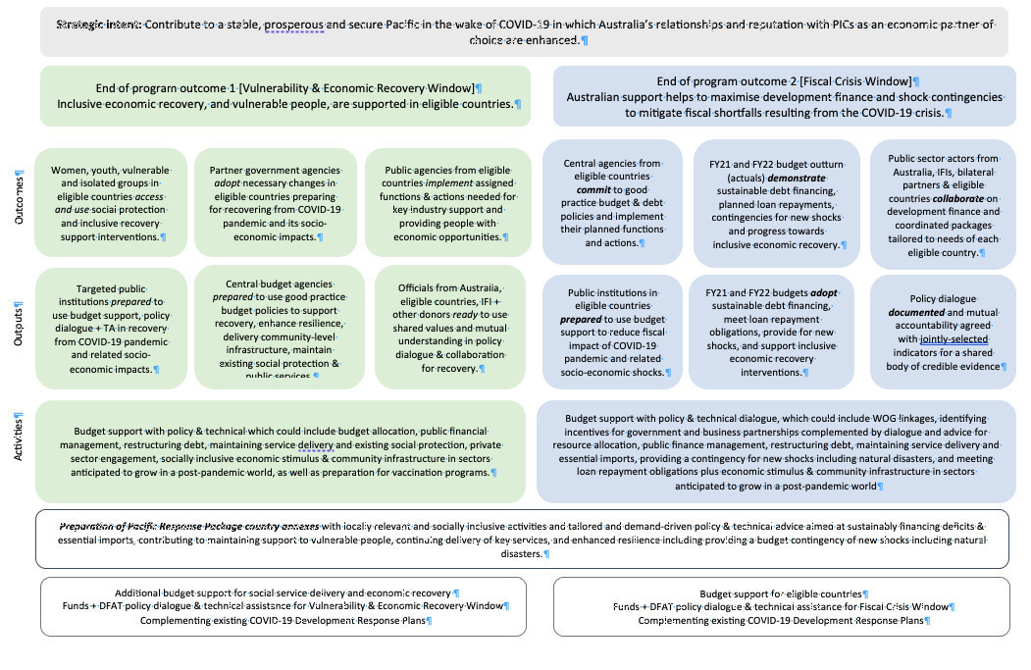

## Annex 2 Evaluation Methodology

The FBS evaluation assessed overall program performance (2020 – 2023) against Key Evaluation Questions (KEQs) related to effectiveness, efficiency, gender equality, disability equity, and sustainability. The KEQs and sub-KEQs informed data collection methods, sampling and analysis decisions, and were used as a basis for synthesizing data and structuring evaluative conclusions.

The KEQs and sub-KEQs that guided this evaluation were:

*Key evaluation questions and sub-questions*

**EFFECTIVENESS**

**1 How effective was the FBS over its lifetime?**

1aTo what extent did FBS achieve its strategic intent of: (a) contributing to a stable, prosperous, and secure Pacific in the wake of COVID-19 and (b) enhancing Australia’s relationships and reputation with PICs as an economic partner of choice?

How satisfied were partner governments and/or other beneficiaries with FBS support and implementation?

1b To what extent did the investment achieve its intended EOPOs?      
I. EOPO 1 (Vulnerability and Economic Recovery Window) Inclusive economic recovery, and vulnerable people, are supported in eligible countries.

II. EOPO2 (Fiscal Crisis Window) Australian support helps to maximize development finance and shock contingencies to mitigate fiscal shortfalls resulting from COVID-19 crisis).

1cTo what extent, and in what ways, did budget support open up opportunities for policy dialogue and/or progress in participating countries, including in regard to macroeconomic management, PFM, social protection, GEDI, economic reform or other priorities?    
How did budget support-generated policy dialogue vary across participating countries and sub-modalities (general vs earmarked; and DBS vs through multilateral banks) and for what reasons?  
 Was the dialogue well-targeted? Was it aligned with PIC government priorities?

1dTo what extent did the MEL system generate credible information on outputs and outcomes that was used for management decision-making, learning and accountability purposes?

**EFFICIENCY**

**2 Did FBS make appropriate and efficient use of time and resources to achieve EOPOs? To what extent was risk managed, and FBS harmonized or aligned with other donor and multilateral support?**

2aHow efficient were the FBS modalities in relation to the use of time and resources to achieve EOPOs?

(i)How well did management and governance arrangements function, including the internal structure and delivery approach as well as in-country arrangements?

(ii)How well did FBS make use of human resources, including technical assistance, DFAT staff and specialists for the efficient achievement of intended outcomes?

2b (i)Were fund disbursements to partners timely, in relation to both plans/commitments and alignment with national budget processes?

(ii)To what extent were participating PICs able to absorb FBS funding?

2cTo what extent were risk management policies and procedures (including in relation to fraud control and safeguards) followed?

2dTo what extent was FBS assistance and funding harmonized and aligned with other donor and multilateral support?

**GENDER EQUALITY**

**3 Did FBS make a difference to gender equality and empowering women and girls?**

3aTo what extent did FBS achieve intended results on gender equality and empowerment of women and girls?

3bTo what extent did FBS support local partners to take action on gender equality?

**DISABILITY EQUITY**

**4 How well did FBS include and meet the needs of people with disabilities?**

4aTo what extent were people with disabilities and/or disabled people’s organisations actively involved in FBS?

4bTo what extent did people with disabilities benefit from FBS?

**SUSTAINABILITY**

**5 To what extent will the benefits in the investment’s outcome areas endure?  To what extent did FBS use and strengthen local systems and institutions? To what extent do partner governments demonstrate ownership of activities and policy changes supported by FBS?**

5aTo what extent will the benefits in the investment’s outcome areas endure?

5bTo what extent did FBS use and strengthen local systems and institutions?

5cTo what extent do participating PIC governments and other partners demonstrate ownership of activities/allocation decisions and policy/institutional changes supported by FBS?

*Data collation and collection*

The evaluation used a mixed-methods approach that included the collation and review of primary and secondary qualitative and quantitative data, and the collection of primary qualitive data through key informant interviews:

* **Documents, reports and program documentation** were reviewed to understand project design and implementation across the PICs and Timor-Leste. Documents and data related to activities, outputs and outcomes were sourced from DFAT, partner governments and development partners.
* **Budget and macroeconomic data:** Budget and other macroeconomic data, provided by DFAT, multilaterals, and implementing partners, has been analysed to assess spend and impact over the 2020 –2023 period.
* **Household and private sector impact data:** Where available, other qualitative and quantitative data on health, education, gender and disability was identified and analysed to assess FBS impact on beneficiaries. Secondary data sources included partner governments’ and development partners’ activity monitoring and evaluation reports, national household surveys and business impact surveys.
* **Key informant interviews (KIIs)**: Semi-structured interviews were conducted to investigate strategic and operational issues related to program performance. In total, 85 interviews have been conducted with key stakeholders from DFAT, partner governments, implementing partners, community organizations, and peak bodies. Most consultations with stakeholders from Fiji, Tonga and Vanuatu were conducted face-to-face, while the remainder have been held remotely (usually via MS Teams). The technical quality of online interactions varied considerably and, on a few occasions, affected the quality and depth of the consultations.

**Multiple sources of information were available for each evaluation question, which positioned the team to credibly derive evaluative conclusions.**  At a country level, the strength of available evidence varied. The countries and specific KEQs for which information is weak is reflected within the rubric presented in Annex 5.

*Sampling*

**The FBS evaluation covered all countries supported by FBS, however countries and programs that received a higher proportion of overall FBS funding generally had a correspondingly greater focus in the evaluation. Much of the discussion and analysis for example, is focused on Fiji, Tonga and Timor-Leste which received a higher proportion of FBS funds.** PNG represents an exception to that, with the pragmatic sampling considerations outlined in Table 4 influencing the depth of qualitative information available to the Evaluation Team on the second largest recipient of FBS funds (see Figure 9). At a country-level, a *utilisation-focused, instrumental-use multiple case* sampling method was used. Selection of PICs for field visits and more in-depth, detailed qualitative inquiry was determined based on cases or countries where sufficient depth and detail of information was available to support robust identification of key factors to inform evaluative findings and recommendations on budget support (Patton, 2015). Case selection was determined by five factors, some purposive and some pragmatic (see Table 4).

**Table 4: Case selection criteria**

*Purposive criteria:*

* Nature of the FBS investment
* Size of the FBS investment
* Maturity of implementation

*Pragmatic criteria*

* Availability of stakeholders
* Political appropriateness of mission in late 2023.

Given the purposive and pragmatic criteria applied, the PICs selected for field visits and more in-depth, detailed qualitative inquiry are likely to represent leading – rather than typical – cases.

**Fiji was the largest recipient of the regional FBS package (45% of total funds).** A specific *Fiji Recovery and Resilience Budget Support 2020-23 Evaluation* was also conducted by the FBS evaluation team, with the final report finalized in January 2024. That evaluation covers all Australian budget support provided to Fiji from 2020 to 2023, which amounted to AUD 223.5 million. Two-thirds of those funds were from the Pacific FBS package and one-third from Fiji bilateral/regional funds. The Fiji-specific evaluation was intentionally aligned with the regional FBS evaluation and assessed program performance against the same KEQs. In addition, the Fiji evaluation also assessed effectiveness against Fiji specific objectives, and the extent to which climate change was addressed through budget support.

**At a key informant level, interview participants were selected using a purposive, group characteristic sampling approach.** Selection of key informants was based on:

1. Knowledge area: Each stakeholder interviewed had strong knowledge and expertise in at least one of the following domains: budget support, public finance management, policy dialogue, gender, disability equity, MEL or an understanding of the socio-political context, COVID-19 and other shocks and stressors in one or more focus countries, and
2. Varying depth of engagement with, and stakes in FBS: Stakeholders interviewed include a mix of DFAT, partner government, development partner, civil society, and peak bodies

**The sampling approach ensured the composition of interview participants**:

1. Provided credible, useful information and insightful perspectives to answer specified evaluation questions (Patton, 2015)
2. Represented a range of perspectives, including stakeholders responsible for delivering/implementing FBS, benefiting from FBS and external to the program, and
3. Supported the triangulation of findings and the Evaluation Team’s confidence in evaluative conclusions.

###### Analysis of economic, fiscal, social and ODA data

Quantitative data was collected from a wide variety of sources including the IMF World Economic Outlook (WEO) and Government Financial Systems (GFS) databases, OECD DAC database, World Bank Development Indicators database, Government budget papers, National Statistics Agencies and DFAT’s official ODA time-series data tables.

**The Evaluation Team faced considerable gaps in data** – primarily around timeliness of data rather than quality or access. The team had anticipated that more routine statistics would have been available from the M&E system designed for the package. The Evaluation Team’s approach was to tap into existing international databases. These also had their constraints. Lags in certain standard socio-economic, fiscal and ODA statistics were significant for certain statistics and countries. Aggregate ODA data for the package countries was only available up to 2021 in the OECD DAC database. The World Development Indicators (WDI) is key source for socio-economic data, which consolidates data from many sources, such as the World Bank, UN, and IMF. Socio-economic statistics are generally complete in WDI, but recent data is often late or incomplete. For example, while routine data on tourist arrivals is available for 2020 (and 2021 in some cases), whereas data in important areas like education (e.g. children out of school) were delayed, often by years.

**For fiscal data, the IMF GFS database is the primary source.** There remain many gaps in the completeness and timeliness of data that is provided to the IMF. For example, data by economic classification (or type, like salaries and goods and services), is available for all countries (except Tuvalu), but can be delayed (e.g. Timor-Leste and Tonga’s last year were 2021). Fiscal data on purpose of spending is reasonable but limited to a few countries (Kiribati, PNG, Samoa, and Solomon Islands). By sector – or levels of government, the situation is similar. Kiribati, Nauru, Samoa, and Timor-Leste provide general government sector data. This includes government fiscal statistics that consolidate central government data with lower levels of government like states, provinces, and local government. It is important that countries which transfer significant resources to lower levels of government (e.g. PNG sends around 40% of central government expenditures to the provinces) produce general government level reports. Not providing general government sector data significantly compromises the visibility of where money went. IMF WEO data was used to fill data gaps where data was not available in the IMF GFS database and to source projections of what was expected to occur in PIC and Timor-Leste in the absence of COVID-19. Budget balance, GDP and revenue projections sourced from the October 2019 WEO were compared to ‘actuals’ in the October 2023 WEO for this purpose.

**To undertake fiscal gap analysis, IMF WEO Budget balance projections from 2019 are compared to the actual data from IMF WEO 2023 to illustrate the fiscal impacts of COVID-19 on government budget balance sheets.** The impact of FBS is illustrated by calculating the ‘actual’ budget balance minus the FBS value for a given year.

*Data analysis and synthesis*

**Ongoing data analysis is informed by *interactive qualitative analysis***(Miles, Huberman and Saldaña, 2014)*)* and *framework matrix* methods (Better Evaluation, 2023), which provide pragmatic and flexible procedures for narrative-heavy data analysis (Hsieh & Shannon, 2005; Punch, 2009). Analysis of mixed-methods FBS evaluation data involved data preparation, collection, and transformation, followed by iterative data reduction, display and conclusion drawing and verification (Miles et al., 2014).

Analysis focused on intra- and inter-case (or FBS country) analysis and on generating clear answers to KEQs and sub-questions.

KEQ-aligned evaluation rubrics, that draw on the Final Investment Monitoring Report rating scale, were developed and used to assess the:

1. **strength of evidence available**: taking into account the number, type and strength of data sources and timeliness of available data, and
2. **strength of performance**/outcomesagainst KEQs.

**Those rubrics were used by the Evaluation Team to make considered and consistent preliminary assessments, to facilitate cross-case/country analysis and sense-making (including identify similarities and differences across countries) and to reach transparent, evaluative judgements**. The Evaluation Team’s joint reflection on rubrics means evaluative conclusions are likely to reflect the phenomenon being evaluated, based on available information, rather than differences in how Evaluation Team members approached performance assessments. Given the number of countries covered within the evaluation, mix of FBS modalities, number of data sources and volume of data this was a critical analytical step.

The FBS evaluation rubric definitions are presented in Annex 4. Evaluative conclusions on the strength of performance against each KEQ at country level are presented in Annex 5. Overt references to those performance assessments (ranging from 1: Very poor to 6: Very good) are used throughout this report, as are the assessments of the strength of available evidence (ranging from: 1: Weak evidence to 3: Strong evidence).

###### Ethics

All data has been held in confidence by the Evaluation Team and identifying information was not provided to DFAT. Consent was sought, and received, for all interviews. This included explaining to participants the interview's purpose and how the information they provided would be used as part of the evaluation. All information provided by key informants has been aggregated and presented in a de-identified manner.

###### Limitations

**The use of mixed-methods synthesis rubric with qualitative descriptions intentionally summarises performance to support cross-country comparisons but should be interpreted with care.**  Across the twelve countries for which rubric-based performance was evaluated, there were significant differences in country context, FBS investment size, disbursement timing and the nature of interventions funded. Rubric summaries indicate the overarching trend of performance across the twelve countries for which evaluative conclusions are available but are not weighted by FBS investment size. A further limitation is that the available evidence basis for conclusions differed by country and KEQ. (Details of the countries and specific KEQs for which information is weak are presented in Annex 5.) Finally, performance assessments were undertaken at a country-level, with assessments of distinct projects or intervention summarized into one performance assessment score per sub-KEQ. While the considerations informing performance assessments are outlined throughout this report, the functional ‘weighting’ of achievements across various initiatives within a country are not noted within rubric summaries which limits the dependability or replicability of conclusions.

**The Evaluation Team’s commitment to ensuring key informants’ identities were not revealed throughout this evaluation, meant that some insightful and descriptive information needed to be excluded from evaluation deliverables.** References to key informant sources have intentionally not been made to prevent participants being recognised, which may expose them to risk of harm (Gibbs, 2007).

**In some instances, access to key stakeholders was limited given other partner government priorities and political sensitivities. Reduced engagement by some partner governments limited available evidence, and in some instances made it difficult to triangulate analysis (particularly at a country or investment level).** The Evaluation Team took advice from DFAT on when and how to engage with partner governments, and when it was not appropriate or practical to meet with partner Governments consultations with DFAT, consulted with other available stakeholders and relied on available reporting.

**Reliance on available economic and programming data meant that trend analysis, and country-specific evidence was sometimes limited, as outlined above**. Data on gender equality and disability was not often available, which meant analysis could not occur. Where data gaps were identified, alternative primary or supplementary secondary data sources were used where available.

## Annex 3 FBS Investment Summary

The following table, provided by OTP to the review team, summarises the activities supported by FBS over the course of the review. Despite receiving funds under the investment, Niue is excluded from the review due to small size of funds.

Table 5. FBS Summary Table

| Country | Year | FBS $ | Agreement | Type | Description | Outputs and/or outcomes |
| --- | --- | --- | --- | --- | --- | --- |
| PNG | 20-21 | 52.0 | DFA | Earmarked | Education and health | FBS supported the cost of government tuition for primary school children and potentially benefited over 1 million school students though the exact impact is unclear in the context of declining expenditure on education and declining education standards. Funds were directed through the GoPNG’s 2021 Budget and Supplementary Budget and assigned to relevant budget lines.  The Christian Health Services and Catholic Church Health Service, through their members and dioceses, operate more than 50 per cent of rural health facilities in the country. Through its support for the payment of CHS and CCHS health worker salaries, FBS supported the ongoing operation of 746 health facilities in twenty-two provinces and 87 districts of PNG. These facilities include 17 District and Rural Hospitals, 129 Health Centres and Urban Clinics, 256 Health Sub-Centres and Community Health Posts and 344 Aid Posts and Day Clinics. |
| PNG | 20-21 | 6.0 | UN women Grant | Project | Market, Economic Recovery and Inclusion (MERI) Project. | The MERI program supported 12 major markets to stay open, and be COVID-19 safe, better-governed, and inclusive. This directly impacted the socio-economic resilience of 17,329 market vendors (3,812 men; 13,517 women), and indirectly benefited 64,854 people (18,159 men; 46,695 women) who used the markets daily.10 |
| PNG | 20-21 | 5.0 | World Bank Grant | Project | The World Bank’s Child Nutrition and Social Protection Program is supporting vulnerable communities deal with the impact of COVID-19 | FBS funded preparatory research, analysis, and proof of concept. Australia’s support helped expedite the pace of program development, supporting technical advice and the development of an operations manual for child nutrition. The program is still at early stages of system development with completion due by 2027. |
| PNG | 20-21 | 4.0 | ICRC Grant | Project | A grant to the International Committee of the Red Cross to support vulnerable people affected by conflict, sexual violence, and those deprived of their freedom, including detainees. The grant is serving the wider community through the establishment of health facilities and increasing the capacity of security officers on international policing standards and law enforcement. | Some notable outputs in 2022 included:   * dissemination sessions and key messages on humanitarian principles (this included 34 drama shows along with education materials which reached over 43,500 individuals, and 12 sessions on the consequences of sexual violence integrated with workshops on restraint during fighting which were conducted in Enga and Hela). * 694 households (4,164 individuals) affected by tribal conflict in Hela and IDPs in Mount Hagen received essential household items consisting of kitchen sets, shelter tool kits, and blankets, thereby supporting their capacity to cope with the consequences of the violence. |
| PNG | 21-22 | 30.0 | DFA (education) | Earmarked | Continuation of budget support for health and education services outlined above in 2020-21. | As above |
| PNG | 22-23 | 50.0 | PNG trust Fund (infra) | Earmarked | Funding will support road maintenance through an existing DFAT investment (Transport Sector Support Program). | Funds are yet to be disbursed from the DoWH Trust Account. It is too early to tell whether funding TSSP is an effective use of FBS though the likely impact on the PNG economy will be experienced several years from now and therefore not immediately responsive to the COVID-19 economic impact. |
| Fiji | 20-21 | 20.0 | DFA (social protection) | Earmarked | This funding provided social protection payments under the Poverty Benefit Scheme, the Care and Protection Allowance and the Disability Allowance | Australia’s investment substantially supported social protection. Following Tropical Cyclone Yasa, and at the same time as a major COVID-19 outbreak, Australia earmarked AUD 20 million to cover social protection payments under three of Fiji’s six social welfare programs for nine months in 2021. The three programs were the poverty benefit, disability allowance, and care and protection allowance (child grant). Together these programs benefited an estimated 125,372 people. This earmarking was an important priority, with respect to signaling, and was acknowledged as a positive move by the Government of Fiji and civil society. |
| Fiji | 20-21 | 54.0 | DFA | General | General budget support - Australia adopted World Bank-led policy actions | Australia’s budget support directly filled fiscal gaps, amounting to 6% of Fiji’s revenue on average in 2020-21 and 2021-22 and 4% of expenditure. |
| Fiji | 21-22 | 31.0 | DFA (extension of above) | General | General budget support - Australia adopted ADB-led policy actions, plus additional bilateral actions (e.g. early childhood care services guidance) | Australia’s budget support helped maximise development and other finance. There is adequate evidence that Australia contributed towards crowding in over AUD 700 million in additional grants and concessional loans from the multilateral development banks and enabled Fiji to increase government borrowing to fund the national budget. At a macroeconomic level, Australia’s grant funding contributed towards Fiji avoiding the instability of a major currency devaluation by securing foreign currency inflow, as shared by one senior government official. Fiji’s solid macroeconomic and debt management resulted in the IMF rating Fiji’s level of debt distress as ‘moderate’ in 2023 which is important for further borrowing. |
| Fiji | 22-23 | 45.0 | DFA | General | General budget support – Bilateral policy actions (no World Bank or ADB policy operations due to lending cycle and Fiji election) | An impressive 44 policy actions were undertaken over the past three years (see Annex 4). While many reforms had progressed from a technical perspective, linking policy actions to the budget support enabled several complex reforms to pass such as modernising the Financial Management Act, Fiji’s first medium-term debt management strategy, and updating the national payment system to take account of digitalisation. Other reforms may have occurred anyway, but the link to budget support made it happen within the year and improved the outcome through technical assistance (e.g. public enterprise transactions). In many areas, reforms were sequential, building on prior action such as a social assistance policy framework (2021) followed by a technical review of operations (2023). |
| Samoa | 21-22 | 5.0 | DFA | General | General budget support | General budget support under the multi-donor joint policy action matrix, including supporting government to develop a social protection framework and continue to pursue sustainable debt management practices. |
| Samoa | 21-22 | 5.0 | DFA | Earmarked | Earmarked for health sector plus NGO programs to end violence against women, supply shelter and clean water, promote health and sports. | FBS earmarked funding for the health sector and NGOs to protect the vulnerable In the health sector funding was to cover wages for clinical and primary health care staff, including nurses, midwives and healthcare/outreach services. Ministry of Health officials confirmed that the funding significantly helped cover staff salaries, especially overtime.  FBS also earmarked funding via the Ministry of Finance to be distributed to NGO programs to supply shelter and clean water, end violence against women, and promote health and sports to reduce non-communicable diseases. With funding of SAT1.5 million, ADRA constructed 87 new shelters or toilets and showers for families in two regions. Although female-headed household was one criterion for beneficiary selection, disaggregated data were not reported. With funding of SAT500,000 Caritas distributed water tanks to 110 households across several locations in Samoa. |
| Samoa | 22-23 | 20.0 | DFA | General | General budget support linked to key economic reforms to support recovery. | Reforms through the JPAM, included activities that are intended to assist in the stability and security of Samoa into the future, including:   * Finalised Medium-term Debt Strategy (2021-26), to support the Government’s spending, decision making and reform efforts in management of its economic recovery. * Finance Sector Plan, aligning the work of the GoS’s finance sector with the government’s overarching development policy, the Pathway for Development of Samoa. * The Disaster Risk Financing Policy. * Tax reform, although this has been more limited that originally intended.   Whilst these policies and reforms are in their early stages of implementation, and evidence of their long-term effectiveness is still to be determined, they assist Samoa to be able to move faster through recovery and provide a buffer against future shocks. |
| Vanuatu | 20-21 | 5.0 | DFA (education) | Earmarked | Funding to the Vanuatu Ministry of Education and Training (MOET) to provide secondary schools funding to partially alleviate the pressure of school fees to families of high school students. | FBS funding, together with additional funds from OTP underspends (totalling AUD8.8 million) helped subsidise school fees for over 26,00012 secondary students (Year 7-14) to help keep children in school. A proportion of these secondary students were also supported through subsidised tuition fees and exam fees (year 11-14) and partially supported boarding fees for students at secondary schools (years 7-14). A survey of principal’s ratings on the support packages’ usefulness, conducted for a report assessing the impact of COVID-19 on education in Vanuatu13 found that the boarding fee subsidy, exam fee subsidy and tuition fee subsidy were the 2nd, 3rd and 4th most useful interventions, behind the Vanuatu Australia Community School Grants (which targeted primary school students). |
| Vanuatu | 20-21 | 3.8 | Grant - Oxfam | Grant | Grant to Oxfam | The AUD3.8 million for social protection supported cash transfers to vulnerable households. Covering cash transfers from August 2020 to August 2022, the INGO Oxfam Unblocked Cash program reached a total of 24,100 beneficiaries from 4,719 households, exceeding a target of 22,141 recipients. Households used the cash transfer for basic needs such as food and water (62%), sanitation and hygiene (13%) and hardware materials (11%). Some of those cash transfers were also supported under other Australian Government funding. The funds were monthly e-cash transfers designed to be spent by households through local vendors on goods and services to provide a monthly predictable income as well as support economic activity within local communities. |
| Vanuatu | 20-21 | 1.2 | DFA (tourism) | Earmarked | This is funding the development and implementation of a Vanuatu tourism recovery-marketing plan. | Funds were channeled through Australia’s existing Governance for Growth program (GFG), which supported the Vanuatu Tourism Office with technical assistance, including through a partnership with Vanuatu’s Ministry of Tourism and Trade, under which the Tourism Office is a statutory body. At the direction of Government, this funding was earmarked to the offshore tourism marketing component of tourist recovery (i.e., getting Vanuatu back on people’s radar as a travel destination). Given Vanuatu remained COVID-19 free for a prolonged period, borders remained closed until June 2022, these funds were not used until mid-June 2022 onwards. Accordingly, they have had more of a prolonged impact on tourism marketing and recovery, rather than a rapid short-term impact. |
| Vanuatu | 22-23 | 5.0 | DFA | Earmarked | Trade and agricultural supply chain strengthening. | Implementation underway. Funding support to trade and agricultural supply chain strengthening and support for PACER plus, cybersecurity, banking, aviation, roads and other activities under the JPRM will help contribute to economic activity and reduce the fiscal deficit. |
| Vanuatu | 22-23 | 3.5 | DFA | Earmarked | Key issues of strategic Importance to the PM’s Office. | Implementation underway. It is hoped that FBS will incentivise action in the areas of aviation and banking/ AML-CTF. The goal of the FBS funds earmarked for these sectors is to (i) facilitate actions (e.g., some funds set aside to procure TA through the PMO DFA) and (ii) incentivize those actions through the aviation indicator, for example, under the JPRM. |
| Vanuatu | 22-23 | 4.0 | DFA | Earmarked | Core Roads Support. | Implementation underway. Funds are currently sitting with the Ministry of Finance rather than the target Ministry (Infrastructure) as a result. A budget appropriation in Parliament will now be required to have the funds correctly reallocated. |
| Vanuatu | 22-23 | 12.5 | DFA | General | General budget support. | General budget support (AUD12.8 million) linked to policy reform on public financial management, economic management and financial sector. A range of initiatives under a Joint Policy Reform Matrix (JPRM) with the aim to:   * Incentivise GoV to progress agreed economic, social and fiscal reforms (across a broad range of issues and progress indicators - PFM, anti-money laundering and counter-terrorist financing, state owned enterprises, finance sector and financial inclusion, aviation..); * Support GoV to recover from impacts of COVID-19 and recent natural disasters; and * Strengthen coordination and joint action (analysis, prioritisation, planning and implementation) on policy reform between GoV and partners |
| Nauru | 21-22 | 2.0 | DFA | Earmarked | The 2021-22 package supported connectivity/food security, quarantine costs and support to the health sector. | Funds supported the GoN ‘capture and contain’ COVID-19 strategy. This strategy prevented COVID-19 related death and illness and enabled Nauru to keep its borders open – vital for preserving food security and maintaining law and order. |
| Nauru | 22-23 | 2.5 | DFA | Earmarked | Funding will cover increased air freight costs that maintained critical food and health supplies during the pandemic. | The connectivity component of the FBS investment in Nauru aligned with the goal of reducing fiscal shock by minimising disruption to Nauru’s economy due to COVID-19. |
| Tuvalu | 2020-21 | 2.0 | DFA | General | Funding was provided as general budget support through a World Bank reform matrix. | This investment included direct financial assistance to Tuvalu citizens during the period of COVID-19 emergency, risk compensation for frontline officers involved in COVID-19 operations and government grants to the Development Bank of Tuvalu to assist with small to medium enterprises deal with the economic impacts of COVID-19. |
| Tuvalu | 22-23 | 2.5 | DFA | General | Funding will be provided as general budget support through a World Bank led reform matrix. | Forthcoming. |
| Solomon Islands | 20-21 | 5.0 | DFA | Earmarked | Provided water supply and basic facilities to vulnerable communities in urban and rural settings. | Water upgrades saw an additional 2.11 MLD additional water.. Households connections to six formal settlements and seven informal settlements providing water access to 22,000 people. Provincial wash achievements including handwashing stations at 24 churches, water supply improvements in Gizo Town, WASH improvements in 2 hospitals, 11 schools, 2 markets, one Christian Care Centre and four town wide Hygiene Promotion Campaiagne. |
| Solomon Islands | 20-21 | 4.0 | DFA | Earmarked | Helping keep schools open through funds for schools’ basic operational costs. | The impact of COVID-19 on the recurrent budget meant that budget cuts to education were estimated to be 12%7 including a significant reduction to basic education school grants. Education spending fell significantly in 2021 (see Figure 4). It is likely that many schools would have had to halve the number of months of education provided without additional support. |
| Solomon Islands | 20-21 | 1.0 | DFA | Earmarked | Assisting Solomon Airlines to meet essential training requirements for engineers and crew; purchase essential aircraft maintenance equipment; and undergo a remote IATA Operational Safety Audit. | A bankrupt or unlicensed airline would have had significant economic implications, thus contributing to the ongoing operation of Solomon Airlines helped ensure the airline could continue despite travel restrictions. Whilst borders were closed Solomon Airlines continued to fly cargo such as medicines and equipment as well as specialists or technical advisers needed for COVID-19 support. Australian support also helped support the continuation of domestic flights. FBS covered the USD 0.66 million ICAO audit as well as some domestic cargo support, training, and maintenance equipment. |
| Solomon Islands | 22-23 | 20.0 | DFA | Earmarked | Providing funding to support election preparation. | Funding will support Solomon Islands elections, due to take place in April 2024. Funding will be specifically linked to biometric voter registration, preparation, and polling activities.8 FBS will fund biometric voter registration which will support updating of the electoral role. Teams of trained electoral officials will travel to each province and undertake the registration of prospective voters and check the roll. FBS funds will also support training and equipping of electoral officers to operate during the election event (pre-polling, polling, counting etc). |
| Tonga | 20-21 | 5 | DFA | Earmarked | This program is alleviating the economic impact on businesses due to closed borders and health restrictions providing assistance to businesses that can demonstrate lost revenue due to COVID−19. | Provided cash support to 1,589 registered businesses and 57 tourism businesses with a demonstrated revenue loss as evidenced in tax statements and returns. In the early stage of the program over a quarter of the businesses were women-owned businesses, mainly in hospitality and tourism sectors. One-off wage subsidies of TOP1000 (for workers registered with the retirement benefits fund) were provided to 4,107 employees of small businesses, mostly in the services industry which reduced unemployment risks. In the early stages of the program, 45% of the recipient employees were women. Funds also supported the costs of renewal of 816 business licenses, reducing the costs of maintaining their business. |
| Tonga | 20-21 | 5 | DFA | General | In partnership with the World Bank, Australia’s budget support program is leveraging fiscal and public sector policy reform and enabling a focus on health sector effectiveness. | Fiscal budget support helped fill fiscal gaps in Tonga, emerging from the economic impact of the pandemic. The multilateral led JPRM was generally seen as an effective mechanism for advancing technical priorities and coordination. Several highlights included:   * Electronic sales registry contributing to VAT collections increasing by 20%. * Disaster Risk Management Act – greater focus on disaster preparedness and governance arrangements. * PFM – a forthcoming major update supported by Australia’s technical assistance to legislate key fiscal responsibility processes and place a numerical limit on the stock of government guaranteed debt. One objective is to support the government to have options, and not increase problematic borrowing. * Pilot e-phytosanitary certification for adherence with biosecurity standards for export enabling lodgement and confirmation in a matter of hours rather than days. |
| Tonga | 21-22 | 4.5 | DFA | Earmarked | Sector Budget support in response to the eruption of Hunga Tonga – Hunga Ha’apai volcano and subsequent tsunami. | Funds supported a social protection top-up as part of the government’s HTHH volcanic eruption and tsunami response. People on the disability and elderly social welfare schemes living in HTHH affected areas received a one-off additional payment of TOP200 in January 2021, which benefited 3647 people over 70 (of which 2112 (58%) were female and 1535 (42%) male)10 and approximately 1900 people with disabilities (1525 with ‘severe’ disabilities and 352 with ‘moderate’ disabilities). While impact information was not available, stakeholders shared anecdotal reports that cash support was used to meet basic needs of the family as well as church contributions, which form an important part of the social obligations in Tonga. They also shared that the additional payment provided dignity to the elderly and people with disabilities and allowed them to contribute to family expenses. This top-up built on a separate Australian budget support contribution for additional social protection payments to help older people and people with disabilities cope with the impacts of COVID-19. |
| Tonga | 22-23 | 30 | DFA | Earmarked | Health infrastructure | To date, the FY23 payment has supported an AUD300,000 upgrade of the obstetric ward of the Vaiola hospital, the main hospital in Nuku’Alofa, which will benefit mothers and children. Tonga’s first mammogram machine will also be purchased under the payment. Priorities under this budget support tranche include a strong focus on ensuring inclusive recovery and resilience building, including through reducing poverty and increasing the quality of social protection, supporting quality and affordable services and supporting critical infrastructure reconstruction and resilience building. With implementation until June 2025, it is expected that this budget support will contribute to inclusive recovery and the protection of vulnerable people. |
| Timor Leste | 20-21 | 20 | DFA | Earmarked | (13.5m) Funding supported the National Village Development Program that invested in new infrastructure projects.  (6.5m) Supported the establishment of a new cash transfer for pregnant women, young children and children with disabilities. | Timor-Leste: with implementation still underway, funds have contributed to 652 water and other community infrastructure projects nationwide as of September 2023.  The cash transfer program provided USD15/month to pregnant women, USD20/month for each child up to six years and an additional USD10/month for children with disabilities. Program implementation started in June 2022 and lasted until December. 20,917 women and children had received at least one payment between July 2022 and March 2023, representing about 65% of the total enrolled people. A post-payment survey showed that recipients used the money to buy nutritious food (particularly important as the stunting in Timor-Leste, at nearly 50%, is the highest in Southeast Asia and the fourth highest in the world). The program also motivated them to visit a health centre and to get civil registration documents, which will also enable access to other social and financial services. |
| Timor Leste | 22-23 | 20 | DFA/grant | Earmarked | Earmarked budget support: PNDS/MAE (PARTISIPA) (7 million)  Earmarked budget support: Labour Mobility & TVET/ Secretary of State for Vocational Training and Employment (SEFOPE) (Australian Pacific Training Coalition (APTC)) (1.3 million)  Earmarked budget support: BdM-JF /MSSI (Partnership for Human Development (PHD)) (10.5 million)  Project funding for impact evaluation of BdM-JF (Grant to The Asia Foundation) (1.2 million) | FBS for SEFOPE has not yet been implemented. In the last year of the Package, Australia provided direct funding to the Mobility and Technical and Vocational Education and Training initiative to increase opportunities for Timorese to be employed through the Pacific Australia Labour Mobility (PALM) scheme and to increase the development impact of returned PALM workers. While the then GoTL and Australia had agreed on budget support for a select number of activities in SEFOPE’s Annual Action Plan for 2023, the change of Government following the elections meant that this workplan needs to be renegotiated to ensure ownership of the workplan. The funding, disbursed in February 2023, currently sits with the MoF and will be allocated when agreement has been reached. Funds for social protection are still sitting with MoF and discussions on reallocation are underway. |
| Kiribati | 20-21 | 3.0 | DFA | Soft earmarked | Earmarked support for social protection reform | Delivered through the ERT, funds designed to help the GoK deliver on its social protection reform agenda. This earmarked budget support enabled Ministry of Women, Youth, Sport and Social Affairs (MWYSSA) to establish a dedicated Social Protection Unit (SPU) to strengthen the GoK’s administration of the senior citizens allowance and the SFU to ensure the right recipients received the right payments at the right time. |
| Kiribati | 22-23 | 1 | DFA | General | General budget support for the Kiribati COVID-19 Response Measures and Economic Reforms Program. | This was disbursed in December 2022 following a virtual Economic Reform Taskforce (ERT) mission where development partners agreed that the Government of Kiribati (GoK) had demonstrated sufficient policy actions for 2022 to trigger disbursement. |
| Kiribati | 22-23 | 4 | DFA | Earmarked | Implementation of a financial management information system. | Supported the Ministry of Finance and Economic Development (MFED) to rollout a new Financial Management Information System (FMIS). |
| RMI | 22-23 | 1.0 | Grant to UNDP | Project | UNDP to provide water tanks and climate change sustainability. | The funding was channelled to the Addressing Climate Vulnerability in the Water Sector in the Republic of the Marshall Islands (ACWA) project, a 7-year USD24.7 million (~AUD37 million) United Nations Development Programme (UNDP) initiative (2019-2026) supporting the Government of the RMI to adapt to increasing climate risks as they relate to water security and resilience. The additional funding increases the number of beneficiaries from the initial 4,506 to an additional 2,100 beneficiaries. |
| FSM | 22-23 | 1.0 | Grant to SPC | Project | SPC electrification project. | The grant was for New Electrification Connection for the Islands of Piis Paniu and Etten in the Chuuk Lagoon Islands in the Federated States of Micronesia. The agreement commenced 1 June 2023 and extends until 31 March 2025. FBS funds will support the provision of accessible electricity to all 144 households on two islands in the Chuuk Lagoon: the islands of Piis Paniu and Etten. |
| Niue \* not included in this evaluation | 22-23? | 0.5 | Trust Fund payment | N/A | Niue Intergenerational Trust Fund to support Niue’s financial stability and sustainability. | N/A |
| Technical Assistance | 2020-21 | 3.0 (approx) | PRES contract | TA | TA to support implementation of the program through risk and M&E inputs. | N/A |
| **Total** | N/A | **499** | N/A | N/A | N/A | N/A |

## Annex 4 Rubric: Definitions

The FBS evaluation assessed overall program performance (2020 – 2023) against KEQs related to effectiveness, efficiency, gender equality, disability equity, and sustainability. The KEQs informed data collection methods, sampling and analysis decisions, and were used as a basis for synthesising data and structuring evaluative conclusions.

KEQ-aligned evaluation rubrics, that draw on the Final Investment Monitoring Report rating scale, were developed and used to assess the:

a. strength of evidence available: taking into account the number, type and strength of data sources and timeliness of available data, and

b. strength of performance/outcomes against KEQs.

Those rubrics, together with narrative information, haven been used by the Evaluation Team to make to facilitate cross-country analysis and sense-making and to reach considered, consistent and transparent, evaluative judgements. Given the number of countries covered within the evaluation, mix of FBS modalities, number of data sources and volume of data this was a critical analytical step.

Evaluative conclusions on the strength of performance against each KEQ are presented in Annex 5. KEQ and sub-KEQ evaluative conclusions by country are also presented in Annex 5. Overt references to those performance assessments (ranging from 1: Very poor to 6: Very good) are used throughout this report, as are the assessments of the strength of available evidence (ranging from: 1: Weak evidence to 3: Strong evidence).

Table 6. Rubric A: How strong is the evidence?

| **1: Weak (limited) evidence** | **2: Adequate evidence** | **3:Strong evidence** |
| --- | --- | --- |
| Evidence is weak, comprised of non-validated assertions, personal opinions, and anecdotes.   *\*\*Weak evidence is not sufficient to rate an investment criterion as being 5: Good or Very good.* | Evidence is derived from a more limited range of sources, such as implementing agency reports, records of monitoring visits, or records of discussions with partners and other stakeholders. | Evidence is derived from multiple reliable sources, such as independent reviews/evaluations, quality assured monitoring data, implementing agency reports validated by monitoring trips, and independent research conducted in the sector. |

*Country-level evaluative conclusions are based on an average of sub-KEQs, and adjusted as needed to represent the Evaluation Team's overarching assessment of effectiveness. If weak evidence (Rubric A), Rubric B sub-KEQ rating cannot be a 5 or 6.*

Table 7. Rubric B: How strong is performance (outcomes) against key evaluation questions?

| **KEQ and**  **Sub-KEQ** | **Performance level and description** | **Performance level and description** | **Performance level and description** | **Performance level and description** | **Performance level and description** | **Performance level and description** |
| --- | --- | --- | --- | --- | --- | --- |
| **Performance level and description** | 1: Very poor | 2: Poor | 3: Less than adequate | 4: Adequate | 5: Good | 6: Very good |
| ***Effectiveness***  **1 How effective was the FBS over its lifetime?** | Very ineffective | Ineffective | Somewhat ineffective | Somewhat effective | Effective | Very effective |
| 1a (i) To what extent did FBS achieve its strategic intent of: (a) contributing to a stable, prosperous, and secure Pacific in the wake of COVID-19 and (b) enhancing Australia’s relationships and reputation with PICs as an economic partner of choice? | The investment did not meet any (either) of the intended strategic intents | The investment achieved neither of the intended strategic intents | The investment partially achieved one of the intended strategic intents | The investment achieved one of the intended strategic intents | The investment achieved both of the intended strategic intents  (at least in part) | The investment achieved all (both) of the intended strategic intents |
| 1a (ii) How satisfied were partner governments and/or other beneficiaries with FBS support and implementation? | There is dissatisfaction among partners or beneficiaries | There are very few examples of satisfaction among partners or beneficiaries | There are few examples of satisfaction among partners or beneficiaries | There is satisfaction among partners and beneficiaries | There are high levels of satisfaction among partners and beneficiaries | There are very high levels of satisfaction among government partners and beneficiaries |
| 1b (i) To what extent did the investment achieve its intended EOPOs?  I. EOPO 1 (Vulnerability and Economic Recovery Window) Inclusive economic recovery, and vulnerable people, are supported in eligible countries. | The investment impeded inclusive economic recovery and harmed people experiencing vulnerability | The investment had no impact on inclusive economic recovery and did not support people experiencing vulnerability | The investment had limited impact on inclusive economic recovery and on people experiencing vulnerability | The investment had some impact on inclusive economic recovery and supported people experiencing vulnerability to some extent | The investment supported inclusive economic recovery and people experiencing vulnerability | The investment significantly supported inclusive economic recovery and people experiencing vulnerability |
| 1b (ii) II. EOPO2 (Fiscal Crisis Window) Australian support helps to maximize development finance and shock contingencies to mitigate fiscal shortfalls resulting from COVID-19 crisis). | The investment impeded development finance and shock contingencies and failed to mitigate fiscal shortfalls | The investment had no impact on access to development finance and shock contingencies to mitigate fiscal shortfalls | The investment had limited impact on access to development finance and shock contingencies to mitigate fiscal shortfalls | The investment had some impact on development finance and shock contingencies mitigating fiscal shortfalls to some extent | The investment increased development finance and shock contingencies mitigating fiscal shortfalls | The investment significantly increased development finance and shock contingencies, significantly mitigating fiscal shortfalls |
| 1c To what extent, and in what ways, did budget support open up opportunities for policy dialogue and/or progress in participating countries, including in regard to macroeconomic management, PFM, social protection, GEDI, economic reform or other priorities?  How did budget support-generated policy dialogue vary across participating countries and sub-modalities (general vs earmarked; and DBS vs through multilateral banks) and for what reasons?  Was the dialogue well-targeted? Was it aligned with PIC government priorities? | Opportunities were lost for policy or partnership dialogue during the investment | Policy dialogue or partnerships were not used to support the achievement of the intended end-of-program outcomes | There are few examples demonstrating that policy dialogue or partnerships were used to support the achievement of the intended EOPOs | Policy dialogue or partnerships were used to partly influence the development agenda or support the achievement of end-of-program- outcomes and the program's strategic intent and were somewhat targeted | Policy dialogue or partnerships were used to effectively influence the development agenda and support the achievement of end-of-program outcomes and the program's strategic intent and were well targeted | Policy dialogue or partnerships were used to drive/shape the development agenda and support the achievement of all (both) end-of-program outcomes and the program's strategic intent and were very well targeted |
| 1d To what extent did the MEL system generate credible information on outputs and outcomes that was used for management decision-making, learning and accountability purposes?  MEL design, collection and use was assessed, with an average of those sub-themes presented as the Evaluation Team's overarching assessment of MEL effectiveness. | The investment had no M&E  arrangements | The investment’s M&E plan and arrangements met very few of DFAT’s M&E standards | The investment’s M&E plan and arrangements met few of DFAT’s M&E standards | The investment’s M&E plan and arrangements were adequate and met some of DFAT’s M&E standards | A good quality M&E plan and appropriate arrangements were in place, which met some/key DFAT’s M&E standards | A very good quality M&E plan and arrangements were in place, which met most of DFAT’s M&E standards |
| As above | No attention was given to collecting data on progress towards, and the  achievement of the agreed end-of-program outcome | The investment collected very little quality assured data on progress towards, and the achievement of the agreed end-of-program outcomes | The investment’s data on progress towards, and the achievement of agreed end-of-program outcomes was inaccurate or delayed | Some data on progress towards, and the achievement of at least some agreed end-of-program outcomes was collected and quality assured, with room for improvement in accuracy or focus | Good, quality assured, timely data on progress towards, and the achievement of agreed end-of-program outcomes was collected throughout the life of the investment | Very good, quality assured, timely data on progress towards, and the achievement of agreed end-of-program outcomes was collected throughout the life of the investment and shared with relevant stakeholders |
| As above | No attention was given to using performance information | The investment paid very little attention to the use of performance information to support basic management functions | There are few examples of the use of performance information for management decision making and that, overall, there was little attention to uses other than for reporting | The investment gave some attention to the use of performance information to support management decision making and learning | The investment sometimes used performance information to support management decision-making and learning | The investment used performance information to support management decision-making and learning |
| 1e How can future budget support programming, in particular in the PICS and Timor-Leste, be improved based on the findings on the effectiveness of the Pacific FBS program? | NA | NA | NA | NA | NA | NA |
| **KEQ and Sub-KEQ** | 1: Very poor | 2: Poor | 3: Less than adequate | 4: Adequate | 5: Good | 6: Very good |
| ***Efficiency***  2 Did FBS make appropriate and efficient use of time and resources to achieve EOPOs? To what extent was risk managed, and FBS harmonized or aligned with other donor and multilateral support? | Very ineffective | Ineffective | Somewhat ineffective | Somewhat effective | Effective | Very effective |
| 2a How efficient were the FBS modalities in relation to the use of time and resources to achieve EOPOs? | The modality was very inefficient. The investment made very poor use of time and resources | The modality was mostly inefficient. The investment made poor use  of time and resources | The modality was less efficient compared to alternatives. The investment made less than adequate use of time and resources in key areas | The modality was adequate, with room for improvement. The investment made appropriate use of time and resources in relation to at least one of the end-of-program outcomes | The modality was good, or mostly efficient. The investment made good use of available time and resources in relation to both end of-program outcomes | The modality was very good, or very efficient.  The investment made very good use of available time and resources in relation to all (both) end-of-program outcome |
| 2a (i) How well did management and governance arrangements function, including the internal structure and delivery approach as well as in-country arrangements? | The governance and management arrangements  were very poor | The governance and management arrangements were poor | The governance and management arrangements were not adequate | The governance and management arrangements were adequate, with room for improvement | The governance and management  arrangements were good, or  efficient overall | The governance and management arrangements  were very good, or very  efficient overall |
| 2a (ii) How well did FBS make use of human resources, including technical assistance, DFAT staff and specialists for the efficient achievement of intended outcomes? | DFAT staffing, skills, or experience levels were entirely inappropriate for achieving the intended end of- program outcomes | DFAT staffing, skills, or experience levels were inappropriate for achieving the intended end-of program outcomes | There were gaps within DFAT staffing, skills or  experience levels, which reduced efficiency and threatened implementation | There were gaps within DFAT staffing, skills or  experience levels, which reduced efficiency, but did  not threaten implementation | DFAT had appropriate staff, skills and experience levels for achieving both of the intended end-of-program outcomes (at least in part / to a reasonable extent) | DFAT had highly skilled and experienced staff for efficiently achieving all (both) of the intended end-of-program outcomes |
| 2b (i) Were fund disbursements to partners timely, in relation to both plans/commitments and alignment with national budget processes? | Funds were not dispersed | Funds were not disbursed in a timely manner and/or not aligned to national budget processes | Some funds were not disbursed in a timely manner and/or only partially aligned to national budget processes | Some funds were disbursed in a timely manner and aligned to national budget processes | Most funds were disbursed in a timely manner and aligned to national budget processes | All funds were disbursed in a timely manner and closely aligned to national budget processes |
| 2b (ii) To what extent were participating PICs able to absorb FBS funding? | Not able to absorb | Mostly unable to absorb | Some funds were not able to be absorbed | Most funds were able to be absorbed | All funds were able to be absorbed | All funds were able to be absorbed effectively |
| 2c To what extent were risk management policies and procedures (including in relation to fraud control and safeguards) followed? | Risk management policies and procedures were not established | Risk management policies and procedures were only partially established and not followed | Risk management policies and procedures were established but only partially followed | Risk management policies and procedures were established and mostly followed | Risk management policies and procedures were established and followed | Risk management policies and procedures were established and followed effectively |
| 2d To what extent was FBS assistance and funding harmonized and aligned with other donor and multilateral support? | The investment was not at all harmonized or aligned with other donors or partner governments’ systems | There were major  misalignments with other donors’ or partner government systems, which  created major inefficiencies | There was some misalignment with other donors or partner government systems, reducing efficiency in achieving intended end-of-program outcomes | There was some harmonization/alignment with other donors or partner government systems, supporting efficient  achievement of at least one of the intended end-of-program outcomes | The investment was mostly harmonized / aligned with other donors or partner government systems, supporting efficient achievement of both (or all applicable) intended end-of-program outcomes | The investment was completely harmonized / aligned with other donors or partner government systems, supporting the efficient achievement of all (both) end-of-program outcomes |
| 2e e. How can future budget support programming, in particular in the Pacific, be improved based on the findings on the efficiency of the Pacific FBS program? What (additional) DFAT capabilities are required for effective and efficient FBS management? | NA | NA | NA | NA | NA | NA |
| **KEQ and Sub-KEQ** | 1: Very poor | 2: Poor | 3: Less than adequate | 4: Adequate | 5: Good | 6: Very good |
| ***Gender Equality***  3. Did FBS make a difference to gender equality and empowering women and girls? | Very ineffective | Ineffective | Somewhat ineffective | Somewhat effective | Effective | Very effective |
| 3a To what extent did FBS achieve intended results on gender equality and empowerment of women and girls? | No difference made to gender equality, and/or women’s and girls’ empowerment | Very few intended results\* achieved on gender equality, and/or women’s and girls’ empowerment | Few intended results\* achieved on gender equality, and/or women’s and girls’ empowerment | Most intended results\* were achieved on gender equality and/or women’s and girls’ empowerment | Almost all intended results\* achieved on gender equality and/or women’s and girls’ empowerment | All of the intended results\* achieved on gender equality and/or women’s and girls’ empowerment |
| [Essential services] Women and girls access to essential services is maintained and enhanced | Major reduction in services essential for women and girls | Reduction in services essential for women and girls | Services essential for women and girls somewhat protected | Services essential for women and girls adequately protected | Services essential for women and girls maintained (and some enhanced) | Services essential to women and girls enhanced |
| [Social protection]  Women and girls have access to and use social protection interventions | No or very few women and girls accessed social protection | Very few women and girls accessed social protection | Few women and girls accessed social protection | Many women and girls accessed social protection | Almost all women and girls had access to social protection | All women and girls had access to social protection |
| [Incomes supported]  Women's incomes protected through funding to the formal and informal sector | No economic interventions to benefit women | Very few economic interventions to benefit women | Few economic interventions to benefit women | Several economic interventions to benefit women | Almost comprehensive economic interventions to benefit women | Comprehensive economic interventions to benefit women |
| [General budget policies] Women and girls benefit from government budget policies | No policy actions to benefit women and girls | Very few policy actions to benefit women and girls | Few policy actions to benefit women and girls | Many policy actions to benefit women and girls | Almost comprehensive policy agenda to benefit women and girls | Comprehensive policy agenda to benefit women and girls |
| [DFAT capability] DFAT staff are enabled to advocate for gender-responsive economic policy measures | No budget for gender expertise | Very little budget for gender expertise | Less than adequate budget for gender expertise | Adequate budget for gender expertise and some staff/partner requirements met | Budget to fund most of gender strategy and most staff/partner requirements met | Full budget for gender strategy and all staff/partner requirements met |
| [Strategy/Analysis] | No analysis or strategic approach for addressing gender equality and empowerment | Major gaps in gender analysis/approach and little progress in implementing gender strategy | Less than adequate gender analysis/strategic planning and progress implementing gender strategy | Adequate gender analysis/strategic planning and implementation of gender strategy | Good gender analysis/strategic planning and almost all gender strategy actions implemented | Robust gender analysis and all gender strategy actions implemented |
| [Risks] | No identification or monitoring of gender equality risks | Very few gender-risks mitigated and barriers to women participating or benefiting addressed | Few gender-risks mitigated and barriers to women participating or benefiting addressed | Some gender-risks mitigated and barriers to women participating or benefiting addressed | Almost all gender-risks mitigated and barriers to women participating or benefiting addressed | All gender-risks mitigated and barriers to women participating or benefiting addressed |
| [M&E] | No data available on gender equality or empowerment | Very little sex-disaggregated information or gender equality indicators and not acted upon | Little sex-disaggregated information or gender equality indicators and mostly not acted upon | Adequate sex-disaggregated data and gender equality indicators used to inform decisions | Comprehensive sex-disaggregated data and gender equality indicators used for improving almost all outcomes | Comprehensive sex-disaggregated data and gender equality indicators used for improving all outcomes |
| 3b To what extent did FBS support local partners to take action on gender equality? | Local partners not influenced on gender equality | Very few instances of local partners influenced on gender equality | Few instances of local partners influenced on gender equality | Improved awareness, capacity or ownership among local partners on gender equality | Local partners increasingly prioritize gender equality | Local partners take action on gender equality |
| 3c How can future programs using budget support modalities, in particular in the Pacific, be improved based on the findings with regard to gender equality outcomes in the Pacific FBS program? | NA | NA | NA | NA | NA | NA |
| **KEQ and Sub-KEQ** | 1: Very poor | 2: Poor | 3: Less than adequate | 4: Adequate | 5: Good | 6: Very good |
| **Disability Equity**  4 How well did FBS include and meet the needs of people with disabilities? | Very ineffective | Ineffective | Somewhat ineffective | Somewhat effective | Effective | Very effective |
| 4a To what extent were people with disabilities and/or disabled people’s organisations actively involved in FBS? | No engagement with people with disability (or their organisations)\* in design, implementation, M&E  *\*Including diverse gender perspectives, geographic locations and impairment types (mobility, sensory, psych-social, intellectual)* | Token engagement with people with disability (or their organisations)\* in design, implementation, M&E | Inadequate resources for meaningful participation with people with disability (or their organisations)\* in design, implementation, M&E | Adequate resources for meaningful engagement with people with disability (or their organisations)\* in some of design, implementation, M&E | Consistent resources to enable meaningful engagement of people with disability (or their organisations)\* across most of design, implementation, M&E | Comprehensive resources to enable significant engagement of people with disability (or their organisations)\* across all of design, implementation, M&E |
| 4b To what extent did people with disabilities benefit from FBS? | No identification of disability-inclusion barriers and measures to overcome them. | Very little analysis of barriers to disability inclusion or measures to overcome them. | Little analysis of barriers to disability inclusion or measures to overcome them. | Adequate analysis of barriers to disability inclusion and some requirements of people with disability were met. | Good analysis of barriers to disability inclusion and almost all requirements of people with disability were met. | Very good analysis of barriers to disability inclusion and all requirements of people with disability were met. |
| 4c How can future programs using budget support modalities, in particular in the Pacific, be improved based on the findings with regard to disability equity outcomes in the Pacific FBS program? | NA | NA | NA | NA | NA | NA |
| **KEQ and Sub-KEQ** | 1: Very poor | 2: Poor | 3: Less than adequate | 4: Adequate | 5: Good | 6: Very good |
| **Sustainability**  5 To what extent will the benefits in the investment’s outcome areas endure?  To what extent did FBS use and strengthen local systems and institutions? To what extent do partner governments demonstrate ownership of activities and policy changes supported by FBS? | Very ineffective | Ineffective | Somewhat ineffective | Somewhat effective | Effective | Very effective |
| 5a To what extent will the benefits in the investment’s outcome areas endure? | The benefits of the  investment are unlikely to endure in any end of investment outcome area | The benefits of the investment will endure in very few end of investment outcome areas | The benefits of the investment will endure in few end of investment outcome areas | The benefits of the investment will endure in some end of investment outcome areas | The benefits of the investment will endure in almost all end of investment outcome areas | The benefits of the investment  will endure in all end of  investment outcome areas |
| 5b To what extent did FBS use and strengthen local systems and institutions? | The investment used stand-alone systems that are unlikely to be sustained after the investment concluded | The investment made very little use of local systems or there was no strengthening of local institutions | The investment made little use of local systems or there was limited strengthening of local institutions | The investment made some use of local systems and local institutions, but there was room for improvement in the extent to which local capacity was strengthened | The investment made good use of local systems and the investment strengthened the capacity of local institutions in almost all end of investment outcome areas | The investment made very good use of local systems and the investment strengthened the capacity of local institutions in all end of investment outcome areas |
| 5c To what extent do participating PIC governments and other partners demonstrate ownership of activities/allocation decisions and policy/institutional changes supported by FBS? | The investment did not encourage ownership by partners and beneficiaries | Partner and beneficiary ownership were very weak, or occurred in very few end of investment outcome areas | Partner and beneficiary ownership were weak, or occurred in only a few end of investment outcome areas | The investment partners and beneficiaries have ownership in some end of investment outcome areas of the investment, but this could be stronger | There is a high level of  ownership of the investment  by partners and beneficiaries | There is a very high level of ownership of the investment by partners and beneficiaries |
| 5d How can future programs using budget support modalities, in particular in the Pacific, be improved based on the findings about sustainability in the Pacific FBS program? | NA | NA | NA | NA | NA | NA |

## Annex 5 Rubric: Summary of Findings

This Annex includes a summary of key evaluative findings including the range, mean and mode of country-specific evaluative conclusions for each KEQ and an equivalent summary at the sub-KEQ level. Rubric-based, evaluative conclusions for each country are presented at both a KEQ level and for each KEQ and sub-KEQ. Further details and explanatory notes are available in Annex 2.

Table 8: Summary of key evaluative findings including the range, mean and mode of country-specific evaluative conclusions (n=12)

|  | **KEQ** | **Min.** | **Max.** | **Mean** | **Mode** | **Distribution** | **Finding** |
| --- | --- | --- | --- | --- | --- | --- | --- |
| 1 | **Effectiveness:** How effective was the FBS over its lifetime? | **4** | **6** | **4.8** | **5** | Min 4, Max 5, Mode 5 | **There is strong evidence that FBS was effective across PICs and Timor-Leste**, in terms of the achievement of its strategic intent, End of Program Outcomes (EOPOs) and policy dialogue and reform, and levels of satisfaction among partner governments. At a country level, the package was *effective* in 7 (58%) of the 12 countries for which evidence is available. FBS performed *adequately* in 4 (33%) countries and was *very effective* in Fiji. |
| **2** | **Efficiency:** Did FBS make appropriate and efficient use of time and resources to achieve EOPOs? To what extent was risk managed, and FBS harmonized or aligned with other donor and multilateral support? | **4** | **5** | **4.7** | **5** | **Min 4, Max 5, Mode 5** | **There is strong evidence that FBS made appropriate and efficient use of time and resources to achieve EOPOs.** Most FBS allocations were channelled through partner governments and utilised existing relationships, programs and technical assistance. This increased the speed and ease at which funds could be disbursed, and minimised resources required to implement FBS. At a country level, assessments of efficiency ranged from *adequate* to *good*. FBS was *efficient/good* in 8 (67%) of the 12 countries. 4 (33%) countries performed *adequately*. |
| 3 | **Gender Equality:** Did FBS make a difference to gender equality and empowering women and girls? | **2** | **6** | **3.9** | **4** | Min 2, Max, 6, Mean 4. | **There is sufficient evidence that FBS achieved adequate results for women and girls by maintaining expenditure on essential services (especially health and social protection), earmarking sectors or programs for support, and in limited countries, policy actions attached to general budget support.** The extent to which FBS make a difference to gender equality and empowering women and girls varied considerably by country, ranging from *poor* to *very good*. Of the 10 countries for which an evaluative assessment is available, performance on gender equality was assessed as *very good* or *good* in 2 (20%) countries, *adequate* in 5 (50%) countries and *less than adequate* or *poor* in 3 countries (30%). |
| 4 | **Disability Equity:** How well did FBS include and meet the needs of people with disabilities? | **2** | **3** | **2.7** | **3** | Min 2, Max 3 Mean 3 | **There is sufficient evidence that FBS performed less than adequately on including and meeting the needs of people with disabilities.** FBS had limited engagement with people with disabilities in FBS design, implementation, and monitoring, including a disability workplan (2021), with some outreach to people with disabilities through the Pacific Disability Forum and consultation with organisations of people with disabilities in select countries for the mid-term review and this evaluation. However, there was very little evidence of participation of people with disabilities in implementation at the country-level. FBS met only some needs of people with disabilities largely through social protection – this includes disability social protection payments (Fiji, Vanuatu, Timor-Leste, Tonga, Kiribati, Nauru) and disability-inclusive social protection policy updates (Fiji, Samoa). Among countries with general budget support, Kiribati and Fiji were the only countries to include disability-responsive policy triggers for social protection. In two-thirds (6, 67%) of the nine countries for which an evaluative conclusion is available, performance on disability was *less than adequate*. In one-third (3, 33%) of countries performance was *poor*. |
| 5 | **Sustainability: To what extent will the benefits in the investment’s outcome areas endure?  To wha**t extent did FBS use and strengthen local systems and institutions? To what extent do partner governments demonstrate ownership of activities and policy changes supported by FBS? | **4** | **5** | **4.8** | **5** | Min 4, Max 5, Mean 5 | **There is strong evidence that FBS will be sustainable, with benefits in the investment’s outcome areas likely to endure in many cases.** FBS used and strengthened local systems and institutions, helped improve coordination amongst and between government and non-government institutions and boosted and enhanced existing Australian programs and reform efforts. FBS reflected partner government priorities, and where local ownership exists the benefits of FBS are more likely to be sustained. At a country level, FBS outcomes appear likely to be *sustainable* in 10 (83%) of the 12 countries for which an evaluative conclusion is available, and *somewhat sustainable* in 2 (17%) countries. |

[[1]](https://auc-word-edit.officeapps.live.com/we/wordeditorframe.aspx?ui=en%2DUS&rs=en%2DUS&wopisrc=https%3A%2F%2Fequityeconomics.sharepoint.com%2Fsites%2FEquityExternalSharing%2F_vti_bin%2Fwopi.ashx%2Ffiles%2Fc55d6fe6b303480db5e80d761fc1c711&wdenableroaming=1&mscc=0&hid=E1B902A1-3065-2000-D19F-3CB06A5C2050&wdorigin=Other&jsapi=1&jsapiver=v1&newsession=1&corrid=d75d682e-6b3d-4555-b9bc-d135cf9227af&usid=d75d682e-6b3d-4555-b9bc-d135cf9227af&sftc=1&cac=1&mtf=1&sfp=1&instantedit=1&wopicomplete=1&wdredirectionreason=Unified_SingleFlush&rct=Normal&ctp=LeastProtected#_ftnref1) The minimum, mean, mode and distribution charts exclude any countries for which evaluative conclusions for a specific KEQ were not available or not applicable.

Table 9: Country-specific evaluative conclusions for each KEQ, based on rubrics [[2]](https://auc-word-edit.officeapps.live.com/we/wordeditorframe.aspx?ui=en%2DUS&rs=en%2DUS&wopisrc=https%3A%2F%2Fequityeconomics.sharepoint.com%2Fsites%2FEquityExternalSharing%2F_vti_bin%2Fwopi.ashx%2Ffiles%2Fc55d6fe6b303480db5e80d761fc1c711&wdenableroaming=1&mscc=0&hid=E1B902A1-3065-2000-D19F-3CB06A5C2050&wdorigin=Other&jsapi=1&jsapiver=v1&newsession=1&corrid=d75d682e-6b3d-4555-b9bc-d135cf9227af&usid=d75d682e-6b3d-4555-b9bc-d135cf9227af&sftc=1&cac=1&mtf=1&sfp=1&instantedit=1&wopicomplete=1&wdredirectionreason=Unified_SingleFlush&rct=Normal&ctp=LeastProtected" \l "_ftnref2)

|  |  |  |  |  |  |  |  |  |  |  |  |  |  |
| --- | --- | --- | --- | --- | --- | --- | --- | --- | --- | --- | --- | --- | --- |
|  | **KEQ** | **Fiji** | **PNG** | **Tonga** | **Timor-Leste** | **Vanuatu** | **Samoa** | **Solomon Islands** | **Kiribati** | **Nauru** | **Tuvalu** | **RMI** | **FSM** |
| 1 | **Effectiveness** | 6: Very good | 4: Adequate | 5: Good | 5: Good | 5: Good | 5: Good | 4: Adequate | 5: Good | 4: Adequate | 5: Good | 5: Good | 4: Adequate |
| 2 | **Efficiency** | 5: Good | 4: Adequate | 4: Adequate | 5: Good | 5: Good | 5: Good | 4: Adequate | 5: Good | 5: Good | 4: Adequate | 5: Good | 5: Good |
| 3 | **Gender Equality** | 6: Very good | 4: Adequate | 4: Adequate | 5: Good | 4: Adequate | 4: Adequate | 4: Adequate | 3: Less than adequate | 3: Less than adequate | 2: Poor | Not available | Not available |
| 4 | **Disability Equity** | 3: Less than adequate | 2: Poor | 3: Less than adequate | 3: Less than adequate | 3: Less than adequate | 3: Less than adequate | 2. Poor | 3: Less than adequate | 2: Poor | Not available | Not available | Not available |
| 5 | **Sustainability** | 5: Good | 4: Adequate | 5: Good | 5: Good | 5: Good | 5: Good | 5: Good | 5: Good | 4: Adequate | 5: Good | 5: Good | 5: Good |

[[2]](https://auc-word-edit.officeapps.live.com/we/wordeditorframe.aspx?ui=en%2DUS&rs=en%2DUS&wopisrc=https%3A%2F%2Fequityeconomics.sharepoint.com%2Fsites%2FEquityExternalSharing%2F_vti_bin%2Fwopi.ashx%2Ffiles%2Fc55d6fe6b303480db5e80d761fc1c711&wdenableroaming=1&mscc=0&hid=E1B902A1-3065-2000-D19F-3CB06A5C2050&wdorigin=Other&jsapi=1&jsapiver=v1&newsession=1&corrid=d75d682e-6b3d-4555-b9bc-d135cf9227af&usid=d75d682e-6b3d-4555-b9bc-d135cf9227af&sftc=1&cac=1&mtf=1&sfp=1&instantedit=1&wopicomplete=1&wdredirectionreason=Unified_SingleFlush&rct=Normal&ctp=LeastProtected#_ftnref2) Countries are ordered based on FBS investment size (largest to smallest). Where a country assessment is based on weak/limited evidence that is indicated by a dotted red border.

Table 10: Summary of rubric-based evaluative conclusions for KEQs and sub-KEQs, including the range, mean and mode of country-specific conclusions

|  | **KEQ / Sub-KEQ theme** | **Min.** | **Max.** | **Mean** | **Mode** | **Distribution** | **Finding** |
| --- | --- | --- | --- | --- | --- | --- | --- |
| 1 | **Effectiveness:** How effective was the FBS over its lifetime? | **4** | **6** | **4.8** | **5** | Min 4, Max 6, Mean 5 | **There is strong evidence that FBS was effective across PICs and Timor-Leste, in terms of the achievement of its strategic intent, End of Program Outcomes (EOPOs) and policy dialogue and reform, and levels of satisfaction among partner governments.** At a country level, the package was *effective* in 7 (58%) of the 12 countries for which evidence is available. FBS performed *adequately* in 4 (33%) countries and was *very effective* in Fiji. |
| 1a  (i) | Achievement of strategic intent | 4 | 6 | 4.9 | **5** | Min 4, Max 6, Mean 5 | The strategic intent of FBS was achieved. FBS helped contribute to a stable, prosperous, and secure Pacific region in the wake of COVID-19. FBS played an important and direct role in enhancing the quality of Australia’s relationships throughout the region. In most (8, 73%) of the 11 countries for which an evaluative conclusion is available, FBS was *effective* in achieving its strategic intent. In Fiji, FBS's strategic intent was *very effectively* achieved. |
| 1a  (ii) | Satisfaction of partner governments / other beneficiaries | 4 | 6 | 5.3 | **6** | Min 4, Max, 6 Mean 6 | FBS was appreciated by all partner governments (to varying degrees) and helped underscore Australia’s role as a reliable, dependable neighbour, particularly in times of need. At a country level, partner governments in half (6, 50%) of the 12 countries for which an evaluative conclusion is available were *very satisfied* with FBS, 4 (33%) countries were *satisfied* and 2 (17%) countries described *adequate* levels of satisfaction. |
| 1b (i) | Achievement of EOPO 1: Inclusive economic recovery, and vulnerable people, are supported in eligible countries | 4 | 6 | 4.8 | **5** | Min 4, Max 6, Mean 5 | FBS effectively supported inclusive economic recovery and vulnerable people. EOPO 1 was achieved through support to social protection systems, health and education systems, and support to economic recovery through tourism and transport sector and community infrastructure initiatives. For three of the largest countries, PNG, Solomon Islands and Fiji, recurrent government spending in these areas held up, or at least did not fall by as much as revenues fell. FBS effectively supported existing social protection systems to provide ongoing or additional support to vulnerable people and supported the expansion of existing and new social protection systems. At a country level, 7 (58%) of the 12 countries for which an evaluative conclusion is available *effectively* achieved EOPO 1, 4 (33%) countries performed *adequately* and 1 (8%) country *very effectively* achieved EOPO 1. |
| 1b  (ii) | Achievement of EOPO 2: Australian support helps to maximize development finance and shock contingencies to mitigate fiscal shortfalls resulting from COVID-19 crisis | 4 | 6 | 5.0 | **5** | Min 4, Max, 6 Mean 5 | FBS helped to maximise development finance and shock contingencies to mitigate fiscal shortfalls resulting from the COVID-19 crisis, particularly in those countries where larger sums of FBS were disbursed under the Fiscal Crisis Window. EOPO 2 was not a focus of FBS in Timor-Leste, Solomon Islands, Tuvalu, RMI and FSM. In the 7 countries for which an evaluative conclusion is available, 3 (43%) countries *effectively* achieved EOPO 2, 2 (28.5%) countries – Fiji and Tonga – *very effectively* achieved EOPO 1 and 2 (28.5%) countries performed *adequately*. |
| 1c | Effectiveness of policy dialogue and actions | 4 | 6 | 4.8 | **5** | Min 4, Max 6, Mean 5 | FBS opened opportunities for policy dialogue and was effectively used. In some instances, significant economic and social reforms were achieved. Policy dialogue was more evident in countries where disbursements were larger and relationships already developed in those sectors, strengthened by the presence of technical advisors and ongoing DFAT programs. Both bilateral and joint policy processes were effective. At a country level, policy dialogue and action was *effective* in 6 (60%) of the 10 countries for which an evaluative conclusion is available. 3 (30%) countries performed *adequately* and in Fiji, policy dialogue was *very effective*. |
| 1d | Effectiveness of MEL | 3 | 5 | 4.1 | **4** | Min 3, Max 5, Mean 4 | Credible information on outputs and outcomes was generated by FBS, and in some instances that information was used for management decision-making, learning and accountability purposes. A simple, non-burdensome approach to monitoring was adopted. That light-touch MEL design was appropriate, particularly in the early years of FBS where the focus was on rapid response at the onset of COVID-19. The extent to which quality data on outputs and outcomes was generated across the package varied, both by country and by type of intervention. Progress against monitoring indicators was not always systematically collected or collated. At both a regional and country level, FBS performance information informed management decision-making and was used for learning and accountability purposes.  At a country level, in 9 (75%) of the 12 countries for which an evaluative conclusion is available MEL was *adequate*. 2 (17%) countries demonstrated *effective* MEL and in 1 country MEL was *less than adequate*. |
| **2** | **Efficiency:** Did FBS make appropriate and efficient use of time and resources to achieve EOPOs? To what extent was risk managed, and FBS harmonized or aligned with other donor and multilateral support? | **4** | **5** | **4.7** | **5** | **Min 4, Max 5, Mean 5** | **There is strong evidence that FBS made appropriate and efficient use of time and resources to achieve EOPOs.** Most FBS allocations were channelled through partner governments and utilised existing relationships, programs and technical assistance. This increased the speed and ease at which funds could be disbursed, and minimised resources required to implement FBS. At a country level, assessments of efficiency ranged from *adequate* to *good*. FBS was *efficient/good* in 8 (67%) of the 12 countries. 4 (33%) countries performed *adequately*. |
| 2a (i) | Functionality of management and governance arrangements | 4 | 5 | 4.8 | **5** | Min 4, Max 5, Mean 5 | FBS management and governance arrangements functioned efficiently. At a country level, arrangements functioned *efficiently* and effectively in 9 (75%) of the 12 countries for which an evaluative conclusion is available. In the remaining 3 (25%) countries, management and governance was *adequate*. |
| 2a (ii) | Effectiveness/efficiency of human resources | 4 | 6 | 4.7 | **5** | Min 4, Max 6, Mean 5 | FBS made efficient use of human resources, including technical assistance, DFAT staff and specialists for the efficient achievement of intended outcomes. At a country level, use of personnel/human resources was *efficient* and effective in half (6, 50%) of the 12 countries for which an evaluative conclusion is available. The 5 (42%) countries assessed as *adequate* experienced challenges in the sufficiency of Post resourcing. In Fiji, use of human resources was *very efficient* and effective. |
| 2b (i) | Timeliness of fund disbursements | 3 | 6 | 4.4 | **4** | Min 3, Max 6, Mean 4 | Fund disbursements to partners were not always timely in relation to plans and commitments and were not always well aligned with partner governments' budget processes. At a country level, evaluative assessments of the timeliness of FBS disbursements ranged from *somewhat inefficient* to *very efficient*. In 7 (58%) of the 12 countries for which an evaluative conclusion is available, performance was *somewhat efficient*. |
| 2b (ii) | PIC capacity to absorb funds | 3 | 6 | 4.4 | **4** | Min 3, Max 6, Mean 4 | PICs were able to absorb FBS funding in most cases. Due to the temporary nature of FBS, some of the FBS was greater than could be absorbed in one year and multi-year implementation arrangements were put in place. At a country level, evaluative assessments of absorbative capacity ranged from *somewhat inefficient* to *very efficient*. In 7 (58%) of the 12 countries for which an evaluative conclusion is available, absorption of FBS funding was *somewhat efficient*. |
| 2c | Effectiveness/efficiency of risk management policies and procedures | 3 | 5 | 4.4 | **5** | Min 3, Max 5, Mean 5 | Risk management policies and procedures were followed in relation to fiduciary and fraud risks, but other risks were not carefully considered. At the design stage of FBS, risks were identified through a risk and safeguard tool and key risks and mitigation strategies were identified as part of the FBS Design Framework. Upon implementation, risks and mitigation strategies were identified through individual Posts. Risks were managed in different ways across Posts. Some forms of risks were largely ignored. At a country level, risk management was *efficient/good* in half (6, 50%) of the 12 countries for which an evaluative conclusion is available. In 5 (42%) countries risk management was *adequate*, and in 1 country it was *less than adequate*. |
| 2d | Harmonization with multilateral / other donor support | 4 | 6 | 5.2 | **5** | Min 4, Max 6, Mean 5 | FBS assistance and funding was harmonised and aligned with other donor and multilateral support. FBS provided the opportunity for DFAT to play a larger and more hands-on role in joint donor activities. At a country level, harmonization was *efficient/good* in half (6, 50%) of the 12 countries for which an evaluative conclusion is available and *very efficient* in 4 (33%) countries. In 2 (17%) countries, harmonization with other donors was *adequate* though more limited. |
| 3 | **Gender Equality:** Did FBS make a difference to gender equality and empowering women and girls? | 2 | 6 | 3.9 | **4** | Min 2, Max 6, Mean 4 | **There is sufficient evidence that FBS achieved adequate results for women and girls by maintaining expenditure on essential services (especially health and social protection), earmarking sectors or programs for support, and in limited countries, policy actions attached to general budget support.** The extent to which FBS make a difference to gender equality and empowering women and girls varied considerably by country, ranging from *poor* to *very good*. Of the 10 countries for which an evaluative assessment is available, performance on gender equality was assessed as *very good* or *good* in 2 (20%) countries, *adequate* in 5 (50%) countries and *less than adequate* or *poor* in 3 countries (30%). |
| 3a | Achievement of intended results\* on gender equality and empowerment of women and girls | 3 | 6 | 4.1 | **4** | Min 3, Max 6, Mean 4 | Services for women and girls were adequately protected in terms of expenditure and women and girls benefited from social protection linked to FBS. However, there is very limited evidence that FBS was effective in supporting women’s economic incomes. Policy change to benefit women and girls was evident in Fiji, but few policies were progressed in other countries with general budget support. At a country level, achievement of intended results on gender equality ranged from *less than adequate* to *very good*. Of the 10 countries for which this sufficient data to reach an evaluative conclusion, 4 countries (40%) performed *adequately* - meaning most intended results were achieved on gender equality and/or women’s and girls’ empowerment. Performance was *less than adequate* in 3 countries (30%), *good* in 2 countries (20%) and *very good* in Fiji (10%). |
| 3b | Effectiveness of support to local partners to take action on gender equality | 2 | 5 | 3.2 | **3** | Min 2, Max 5, Mean 3 | The extent to which FBS supported partner governments to take action on gender equality through funding essential services and expanding social protection varied considerably by country – ranging from *poor* to *good*. Of the 10 countries for which there is sufficient data to reach an evaluative conclusion, 4 countries (40%) performed *poorly*, meaning there were very few instances of local partners being influenced on gender equality. Performance on supporting action for gender equality was *good* in 2 countries (20%), *adequate* in 2 countries (20%) and *less than adequate* in 2 countries (20%). |
| 4 | **Disability Equity:** How well did FBS include and meet the needs of people with disabilities? | 3 | 3 | 2.7 | **3** | Min 3, Max 3, Mean 3 | **There is sufficient evidence that FBS performed less than adequately on including and meeting the needs of people with disabilities.** FBS had limited engagement with people with disabilities in FBS design, implementation, and monitoring, including a disability workplan (2021), with some outreach to people with disabilities through the Pacific Disability Forum and consultation with organisations of people with disabilities in select countries for the mid-term review and this evaluation. However, there was very little evidence of participation of people with disabilities in implementation at the country-level. FBS met only some needs of people with disabilities largely through social protection – this includes disability social protection payments (Fiji, Vanuatu, Timor-Leste, Tonga, Kiribati, Nauru) and disability-inclusive social protection policy updates (Fiji, Samoa). Among countries with general budget support, Kiribati and Fiji were the only countries to include disability-responsive policy triggers for social protection. In two-thirds (6, 67%) of the nine countries for which an evaluative conclusion is available, performance on disability was *less than adequate*. In one-third (3, 33%) of countries performance was *poor*. |
| 4a | Extent of engagement with people with disabilities / OPDs | 1 | 2 | 1.7 | **2** | Min 1, Max 2, Mean 2 | FBS performed poorly at actively involving people with disabilities and/or organisations for people with disabilities (OPDs).FBS had limited engagement with people with disabilities in design, implementation, and monitoring. This included a disability workplan (2021), , with some outreach to people with disabilities through the Pacific Disability Forum, and consultation with organisations of people with disabilities in a select countries for the mid-term review and this evaluation. However, there was little evidence of participation of people with disabilities in implementation at the country-level. In a few instances, program or policy initiatives supported by FBS engaged with people with disabilities, facilitated by other DFAT programs. Of the 9 countries for which there is sufficient data to reach an evaluative conclusion, 6 (67%) countries performed *poorly* and 3 (33%) performed very *poorly*. |
| 4b | Extent to which people with disabilities / OPDs benefitted from FBS | 2 | 4 | 2.8 | **3** | Min 2, Max 4, Mean 3 | FBS performed less than adequately on meeting the needs of people with disabilities. FBS met some needs of people with disabilities largely through prioritising social protection, including disability social protection payments and disability-inclusive social protection policy updates. Evaluative conclusions for this sub-KEQ varied by country - ranging from *poor* to *adequate*. Of the 9 countries for which there is sufficient data to reach an evaluative conclusion, just over half of countries (5, 56%) performed *less than adequately* and 3 (33%) countries performed *poorly*. In Timor-Leste, needs of people with disability were *adequately* met by the investment through social protection (the BdM-JF program provided an additional monthly payment to families with a child living with disability) and village infrastructure, and in Fiji, Tonga, Vanuatu, Kiribati and Samoa, social protection efforts partially met needs of people with disabilities and contributed to a *less than adequate* assessment on the extent to which people with disabilities fully benefitted from FBS. |
| 5 | **Sustainability: To what extent will the benefits in the investment’s outcome areas endure?  To wha**t extent did FBS use and strengthen local systems and institutions? To what extent do partner governments demonstrate ownership of activities and policy changes supported by FBS? | 4 | 5 | 4.8 | **5** | Min 4, Max 5, Mean 5 | **There is strong evidence that FBS will be sustainable, with benefits in the investment’s outcome areas likely to endure in many cases.** FBS used and strengthened local systems and institutions, helped improve coordination amongst and between government and non-government institutions and boosted and enhanced existing Australian programs and reform efforts. FBS reflected partner government priorities, and where local ownership exists the benefits of FBS are more likely to be sustained. At a country level, FBS outcomes appear likely to be *sustainable* in 10 (83%) of the 12 countries for which an evaluative conclusion is available, and *somewhat sustainable* in 2 (17%) countries. |
| 5a | Endurance of benefits beyond funding period | 4 | 5 | 4.6 | **5** | Min 4, Max 5, Mean 5 | Some of the benefits of the FBS investment are likely to endure. At a country level, FBS appears likely to be *sustainable* in 7 (58%) of the 12 countries for which an evaluative conclusion is available, and *somewhat sustainable* in 5 (42%) countries. |
| 5b | Use and strengthening of local systems and institutions | 4 | 5 | 4.7 | **5** | Min 4, Max 5, Mean 5 | FBS used and strengthened local systems and institutions. FBS helped improve coordination amongst and between government and non-government institutions and boosted and enhanced existing Australian programs and reform efforts. At a country level, the use and strengthening of local systems and institutions was *good/sustainable* in two-thirds (8, 67%) of the 12 countries for which an evaluative conclusion is available, and *adequate/somewhat sustainable* in 4 (33%) countries. |
| 5c | Partner government and other stakeholders ownership of activities and policy changes | 4 | 6 | 4.9 | **5** | Min 4, Max 6, Mean 5 | FBS reflected partner government priorities. Where local ownership exists the benefits of FBS are more likely to be sustained. At a country level, partner government ownership was *good/sustainable* in most (9, 75%) of the 12 countries for which an evaluative conclusion is available, and *adequate/somewhat* sustainable in 2 (17%) countries. In Tonga, partner government ownership of FBS activities and policy changes was *very good/very sustainable*. |

Table 11 Country-specific evaluative conclusions for each KEQ and sub-KEQ, based on rubrics[[77]](#footnote-78)

|  | **KEQ & Sub-KEQ** | **Fiji** | **PNG** | **Tonga** | **Timor-Leste** | **Vanuatu** | **Samoa** | **Solomon Islands** | **Kiribati** | **Nauru** | **Tuvalu** | **RMI** | **FSM** |
| --- | --- | --- | --- | --- | --- | --- | --- | --- | --- | --- | --- | --- | --- |
| **1** | **Effectiveness** | **6: Very good** | **4: Adequate** | **5: Good** | **5: Good** | **5: Good** | **5: Good** | **4: Adequate** | **5: Good** | **4: Adequate** | **5: Good** | **5: Good** | **4: Adequate** |
| 1a  (i) | Achievement of strategic intent | 6: Very good | 4: Adequate | 5: Good | 5: Good | 5: Good | 5: Good | 4: Adequate | 5: Good | 5: Good | 5: Good | 5: Good | Not available |
| 1a  (ii) | Satisfaction of partner governments / other beneficiaries | 6: Very good | 4: Adequate | 6: Very good | 6: Very good | 5: Good | 6: Very good | 4: Adequate | 6: Very good | 5: Good | 6: Very good | 5: Good | 5: Good |
| 1b (i) | Achievement of EOPO 1 | 6: Very good | 5: Good | 4: Adequate | 5: Good | 5: Good | 4: Adequate | 5: Good | 5: Good | 4: Adequate | 5: Good | 5: Good | 4: Adequate |
| 1b (ii) | Achievement of EOPO 2 | 6: Very good | 5: Good | 6: Very good | Not applicable | 4: Adequate | 5: Good | Not applicable | 5: Good | 4: Adequate | Not applicable | Not applicable | Not applicable |
| 1c | Effectiveness of policy dialogue and actions | 6: Very good | 4: Adequate | 5: Good | 5: Good | 5: Good | 5: Good | 4: Adequate | 5: Good | 4: Adequate | 5: Good | Not applicable | Not applicable |
| 1d | Effectiveness of MEL | 5: Good | 4: Adequate | 4: Adequate | 5: Good | 4: Adequate | 4: Adequate | 4: Adequate | 4: Adequate | 4: Adequate | 3: Less than adequate | 4: Adequate | 4: Adequate |

|  | **KEQ & Sub-KEQ** | **Fiji** | **PNG** | **Tonga** | **Timor-Leste** | **Vanuatu** | **Samoa** | **Solomon Islands** | **Kiribati** | **Nauru** | **Tuvalu** | **RMI** | **FSM** |
| --- | --- | --- | --- | --- | --- | --- | --- | --- | --- | --- | --- | --- | --- |
| **2** | **Efficiency** | **5: Good** | **4: Adequate** | **4: Adequate** | **5: Good** | **5: Good** | **5: Good** | **4: Adequate** | **5: Good** | **5: Good** | **4: Adequate** | **5: Good** | **5: Good** |
| 2a (i) | Functionality of management and governance arrangements | 5: Good | 5: Good | 4: Adequate | 5: Good | 5: Good | 5: Good | 4: Adequate | 5: Good | 5: Good | 4: Adequate | 5: Good | 5: Good |
| 2a (ii) | Effectiveness/efficiency of human resources | 6: Very good | 4: Adequate | 4: Adequate | 5: Good | 5: Good | 5: Good | 4: Adequate | 4: Adequate | 5: Good | 4: Adequate | 5: Good | 5: Good |
| 2b (i) | Timeliness of fund disbursements | 5: Good | 4: Adequate | 5: Good | 3: Less than adequate | 4: Adequate | 4: Adequate | 4: Adequate | 4: Adequate | 4: Adequate | 4: Adequate | 6: Very good | 6: Very good |
| 2b (ii) | PIC capacity to absorb funds | 6: Very good | 4: Adequate | 4: Adequate | 4: Adequate | 4: Adequate | 5: Good | 4: Adequate | 3: Less than adequate | 4: Adequate | 4: Adequate | 6: Very good | 5: Good |
| 2c | Effectiveness/efficiency of risk management policies and procedures | 5: Good | 5: Good | 4: Adequate | 4: Adequate | 5: Good | 5: Good | 4: Adequate | 5: Good | 5: Good | 3: Less than adequate | 4: Adequate | 4: Adequate |
| 2d | Harmonization with multilateral / other donor support | 5: Good | 4: Adequate | 5: Good | 5: Good | 5: Good | 5: Good | 4: Adequate | 6: Very good | 5: Good | 6: Very good | 6: Very good | 6: Very good |

|  |  |  |  |  |  |  |  |  |  |  |  |  |  |
| --- | --- | --- | --- | --- | --- | --- | --- | --- | --- | --- | --- | --- | --- |
|  | **KEQ & Sub-KEQ** | **Fiji** | **PNG** | **Tonga** | **Timor-Leste** | **Vanuatu** | **Samoa** | **Solomon Islands** | **Kiribati** | **Nauru** | **Tuvalu** | **RMI** | **FSM** |
| **3** | **Gender equality** | **6: Very good** | **4: Adequate** | **4: Adequate** | **5: Good** | **4: Adequate** | **4: Adequate** | **4: Adequate** | **3: Less than adequate** | **3: Less than adequate** | **2: Poor** | **Not available** | **Not available** |
| 3a | Achievement of intended results\* on gender equality and empowerment | 6: Very good | 4: Adequate | 4: Adequate | 5: Good | 4: Adequate | 5: Good | 4: Adequate | 3: Less than adequate | 3: Less than adequate | 3: Less than adequate | Not available | Not applicable |
| 3b | Effectiveness of support to local partners to take action on gender equality | 5: Good | 4: Adequate | 3: Less than adequate | 5: Good | 2: Poor | 4: Adequate | 3: Less than adequate | 2: Poor | 2: Poor | 2: Poor | Not available | Not available |

|  |  |  |  |  |  |  |  |  |  |  |  |  |  |
| --- | --- | --- | --- | --- | --- | --- | --- | --- | --- | --- | --- | --- | --- |
|  | **KEQ & Sub-KEQ** | **Fiji** | **PNG** | **Tonga** | **Timor-Leste** | **Vanuatu** | **Samoa** | **Solomon Islands** | **Kiribati** | **Nauru** | **Tuvalu** | **RMI** | **FSM** |
| **4** | **Disability equity** | **3: Less than adequate** | **2: Poor** | **3: Less than adequate** | **3: Less than adequate** | **3: Less than adequate** | **3: Less than adequate** | **2: Poor** | **3: Less than adequate** | **2: Poor** | **Not available** | **Not available** | **Not available** |
| 4a | Extent of engagement with people with disabilities / OPDs | 2: Poor | **1: Very poor** | 2: Poor | 2: Poor | 2: Poor | 2: Poor | **1: Very poor** | 2: Poor | **1: Very poor** | Not available | Not available | Not available |
| 4b | Extent to which people with disabilities / OPDs benefitted from FBS | 3: Less than adequate | 2: Poor | 3: Less than adequate | 4: Adequate | 3: Less than adequate | 3: Less than adequate | 2: Poor | 3: Less than adequate | 2: Poor | Not available | Not available | Not available |

|  |  |  |  |  |  |  |  |  |  |  |  |  |  |
| --- | --- | --- | --- | --- | --- | --- | --- | --- | --- | --- | --- | --- | --- |
|  | **KEQ & Sub-KEQ** | **Fiji** | **PNG** | **Tonga** | **Timor-Leste** | **Vanuatu** | **Samoa** | **Solomon Islands** | **Kiribati** | **Nauru** | **Tuvalu** | **RMI** | **FSM** |
| **5** | **Sustainability** | **5: Good** | **4: Adequate** | **5: Good** | **5: Good** | **5: Good** | **5: Good** | **5: Good** | **5: Good** | **4: Adequate** | **5: Good** | **5: Good** | **5: Good** |
| 5a | Endurance of benefits beyond funding period | 5: Good | 4: Adequate | 5: Good | 4: Adequate | 5: Good | 5: Good | 4: Adequate | 4: Adequate | 4: Adequate | 5: Good | 5: Good | 5: Good |
| 5b | Use and strengthening of local systems and institutions | 5: Good | 4: Adequate | 5: Good | 5: Good | 5: Good | 5: Good | 5: Good | 5: Good | 4: Adequate | 5: Good | 4: Adequate | 4: Adequate |
| 5c | Partner government and other stakeholders ownership of activities and policy changes | 5: Good | 4: Adequate | 6: Very good | 5: Good | 4: Adequate | 5: Good | 5: Good | 5: Good | 5: Good | 5: Good | 5: Good | 5: Good |

## Annex 6 Gender Equality: Detailed Results

Figure 24 shows government expenditure on social sectors compared to pre-pandemic levels and overall budget expenditure, drawn from national budget documents[[78]](#footnote-79). Where possible, actual expenditure data is used (usually up to 2021), followed by budget estimates.

The charts show that government expenditure on health was maintained in all countries and increased in a majority in response to COVID-19. Expenditure on education (at national level) increased in half of the countries and fell in others in 2020 and 2021. Sex disaggregated data was not available so analysis assumes benefits to women and girls. Expenditure on women, children and social protection was maintained in Fiji and Tonga, and increased in Timor-Leste, Samoa, Kiribati and Solomon Islands (but remained minimal in PNG and Vanuatu). The evaluation team also analysed non-staff recurrent expenditure across social sectors as a measure of quality of spending and the same patterns emerged.

Government expenditure on programs to address gender violence or disability support services is not readily available from national budget documents or other sources (e.g. IMF Government Financial Statistics).

**Figure 24: Total budget spending by social sectors (health, education, social protection): Fiji**

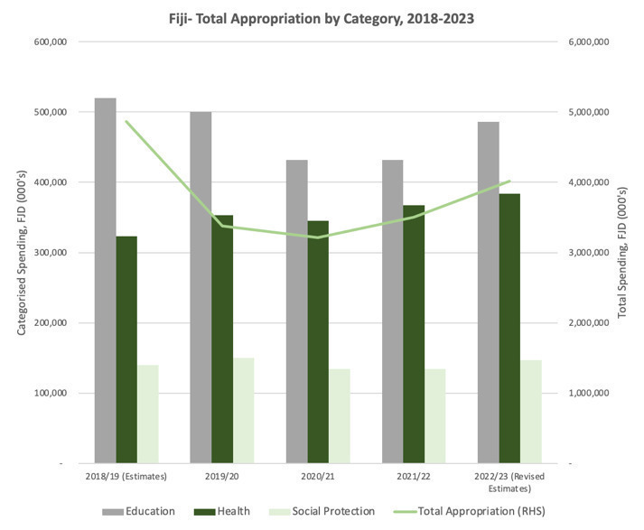

**Figure 25: Total budget spending by social sectors (health, education, social protection): Timor-Leste**

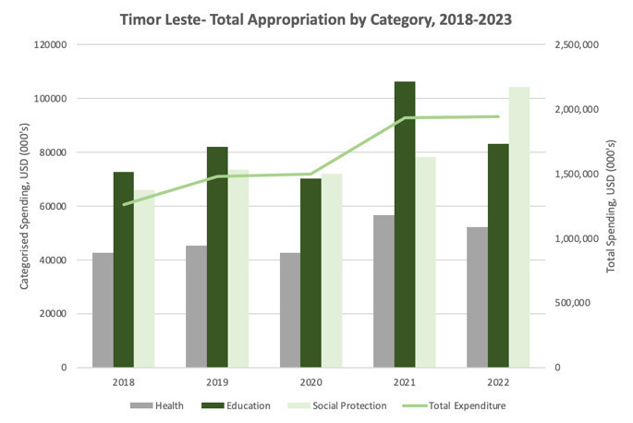

**Figure 26: Total budget spending by social sectors (health, education, social protection): Tonga**

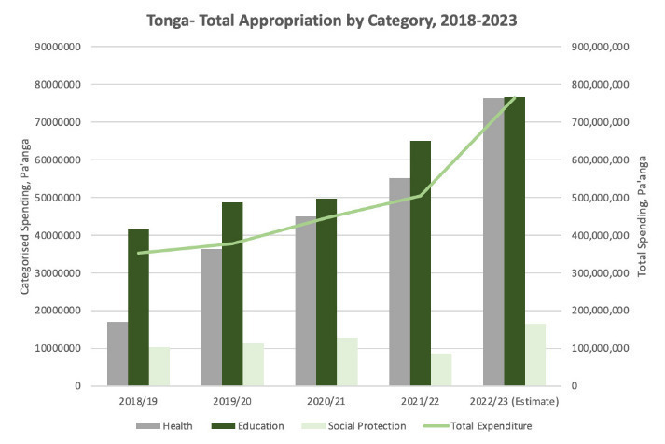

**Figure 27: Total budget spending by social sectors (health, education, social protection): PNG**

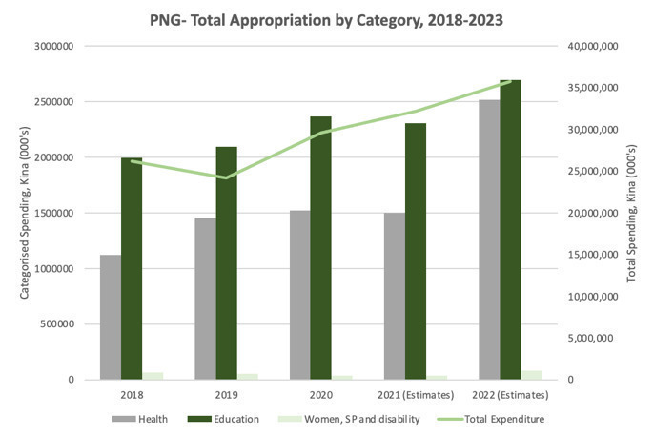

**Figure 28: Total budget spending by social sectors (health, education, social protection): Samoa**

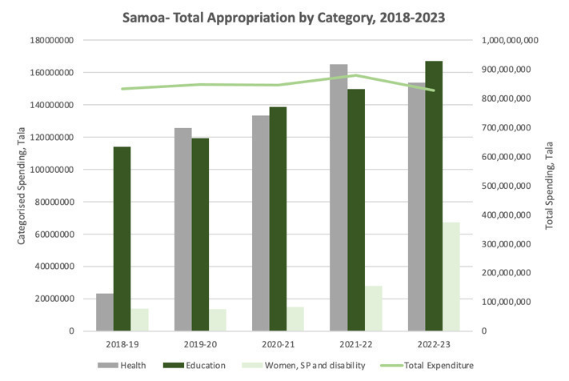

**Figure 29: Total budget spending by social sectors (health, education, social protection): Kiribati**

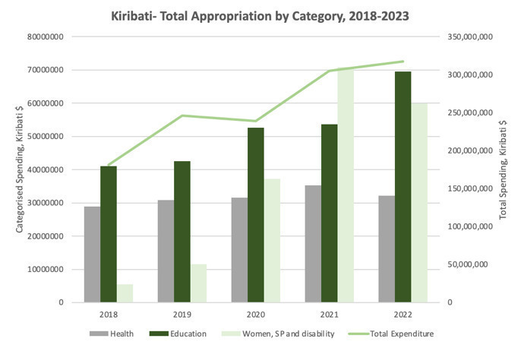

**Figure 30: Total budget spending by social sectors (health, education, social protection): Solomon Islands**

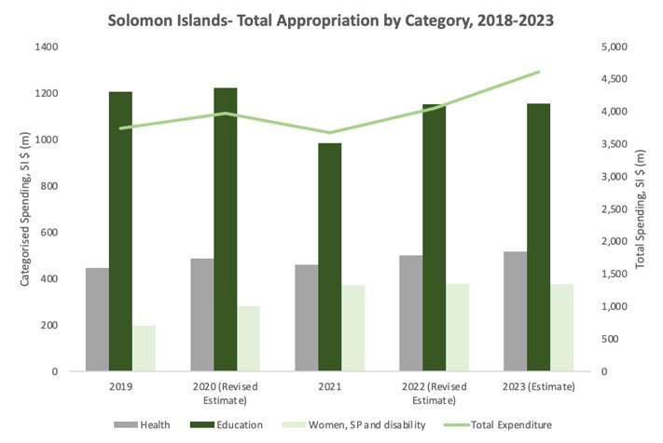

**Figure 31: Total budget spending by social sectors (health, education, social protection): Vanuatu**

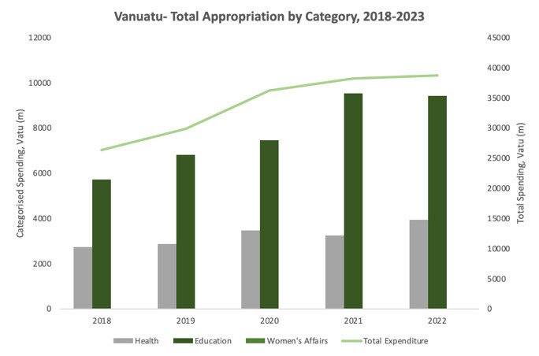

Source: National Government budget documents.

**Table 12: FBS and earmarked services essential for women and girls by country**

* **PNG** - In 2021, salaries for 3,290 Christian Health Service workers and 1,513 Catholic Church Health Service workers were funded to deliver services including antenatal care, sexual & reproductive health. FBS funds also covered the tuition fee subsidy for 9,260 secondary schools (1.1 million enrolments) in 2021, but sex-disaggregated data is not available. An ICRC community safety and support initiative benefited displaced households and victims of violence (sex disaggregated data not available), and healthcare services including vaccinations for almost 4,000 pregnant women and children and 3,000 antenatal visits.
* **RMI-**FBS granted additional funding to a UNDP water and sanitation project. The project is expected to benefit 7,630 women (18% of the total population) but it is too early to assess results.
* **Solomon Islands-** FBS earmarked funding for school operational costs supported schools to remain open for boys and girls (sex disaggregated data not available). A water and sanitation initiative supplied new connections to households (22,000 people – approximately 3% of the population), along with installing/upgrading water and sanitation facilities in community settings. The work program included six settlements in Honiara where a baseline survey indicated that 33% of women felt scared or unsafe collecting water.
* **Samoa-** FBS funding was earmarked for the health sector to cover wages for clinical and primary care staff (government reporting not yet available at the time of the evaluation). Samoa was the only FBS country to earmark funding to address gender violence, enabling the government to fund the Samoa Victim Support Group for the first time.
* **Tonga -** Australia leveraged relationships under its health program to encourage the Ministry of Health to secure financing for a vital upgrade to the obstetrics ward of Tonga’s main hospital (following several maternal deaths related to poor hygiene).
* **Vanuatu -** Australia’s earmarked education support helped subsidise school fees for 26,000 secondary students (approx. 8% of the total population) (sex-disaggregated data not reported).

**Table 13: FBS and social protection that benefited women and girls**

* **Fiji-** FBS funded government social protection payments for nine months in 2020‑21 went to 54% female recipients under the poverty benefit scheme, 57% female recipients of the care and protection allowance and 56 % female recipients of the disability allowance.
* **PNG** **-** The FBS supported design of a new child-nutrition allowance set up to empower women as individual recipients,
* **Kiribati-** General budget support contributed fiscal space for social protection schemes. In 2022, females accounted for 40% of disability allowance payments, 49 % of unemployment benefits, and 60% of over 60 age pensions.
* **Samoa -** General budget support contributed to social protection to households during the crisis but evidence on the extent to which women and girls benefited is lacking.
* **Timor-Leste**  **-** For the FBS funded BdM-JF (next generation) program, as of June 2023, 46,793 women and children were registered for the program in seven municipalities, representing about 70% of the target population. Of these, 44,459 women and children were successfully enrolled (7,466 pregnant women, 36,830 children under 6, including 163 children with disabilities). Reported data on children not sex‑disaggregated. Around 97% of recipients of allowances were women (pregnant women and mothers).
* **Tonga -** FBS enabled fiscal space for 58% female elderly benefit recipients and about 54 % female disability benefit recipients (although coverage is low). One in three households received some form of government assistance but evidence on the extent to which women and girls benefited is lacking.
* **Vanuatu -** Almost half (49%) of the Oxfam cash transfers went to women. Additionally, 87% of the market vendors and farmers registered to receive the electronic cash vouchers were women.

**Table 14: FBS supporting women’s incomes in the formal and informal sectors**

* **Fiji**  **-** One policy action was for the Reserve Bank to operate a working capital facility through licensed financial institutions.  Loans with a two-year interest free period were offered and for SMEs, the Reserve Bank gave a 50% guarantee. For women-led SMEs this was increased to 75% recognising that women may have less collateral to qualify for a loan.
* **Timor-Leste -** FBS enabled expansion of the PNDS which has around 40% of community management roles held by women and targets for women’s labour participation.
* **Tonga**  **-** Two business recovery measures were earmarked by FBS. Under a business loss scheme, 28% of the 295 grants went to businesses owned by women, mainly in hospitality and tourism (27% to joint-owned businesses, and 45% to male-‑owned businesses). Under the revised wage subsidy scheme, 45% of the 402 eligible workers were women.  By creating fiscal space, FBS also indirectly contributed to Tonga’s grants to 6,381 informal businesses, 70% of which were owned by women.

***DFAT’s enabling factors for promoting gender equality***

**This section considers DFAT’s enabling factors for advancing gender equality and women’s empowerment in investments**: analysis of gender equality gaps and opportunities substantially informs the investment; risks to gender equality are managed; there is a strategic approach to gender equality and it is implemented; the M&E system collects sex-disaggregated data and includes gender equality indicators; and there is sufficient budget and resources for gender equality[[79]](#footnote-80). Although these are not specific KEQs for this evaluation[[80]](#footnote-81), the enabling factors shed light on the extent to which gender equality and women’s empowerment was supported by institutional factors.

**In the first two years, the approach to gender equality was lighter with limited gender analysis, no evidence of consultation with women’s groups and some Posts emphasising gender more than others (e.g. Fiji)**. In part this reflects the operating context including COVID-19 restrictions, reduced staffing levels at Posts and the need to disburse funds quickly in a crisis situation. Nonetheless, several DFAT staff emphasised awareness of gender issues shaping allocations including the need to maintain services essential for women and girls. DFAT’s Principal Gender Advisor was also a member of the FBS Advisory Board – an important role for maintaining expectations of gender equality outcomes.

**There was a clear improvement in GEDSI analysis in 2022-23, including risks to gender equality.** By 2022-23 sufficient resources forgender equality included a dedicated FBS Gender Adviser, products such as GEDSI Fast Facts for each country and, for larger Posts, GEDSI focal points. However, it is not clear these resources shaped FBS funding allocations or practice at the time of this evaluation, and gender risks were not integrated into risk tools which largely focussed on fiduciary risks. This limited the opportunity for GEDSI analysis to influence allocations. The availability of GEDSI Fast Facts were not well known at Posts interviewed for this evaluation and will benefit from further promotion. In several countries, implementation will run into 2023-24 and it is too early to assess the impact of the GEDSI analysis.

**There is no evidence of DFAT consulting with women’s groups to inform funding allocations in the final year (except for Fiji), and limited consultation in implementation and M&E.** This was despite the 2022 FBS design specifying that at a minimum, each country should consult with the women’s ministry or equivalent, a key women’s rights NGO and the main organisation representing people with disabilities in-country.  The Gender Strategy was also updated (August 2022) and a consultation guide produced. There is some evidence of consultation with women’s groups in implementation through programs – for example P4SP consulted with a range of community groups to support the Timor-Leste next generation child grant program (BdM-JF), and Fiji social assistance policy framework and technical review. Similarly, limited consultation with women’s groups was conducted as part of evaluation (MTR and this evaluation). The lack of systematic consultation was a missed opportunity to understand if FBS was delivering intended benefits and adjusting the approach as necessary.

**The M&E system contained gender equality indicators but the quality of monitoring data available across the package was variable (see Section 1d on M&E), and often did not include sex disaggregated data.** In part thisreflected use of partner monitoring systems or data – for example, education enrolment data to support reporting against school subsidies in PNG and Vanuatu were not sex-disaggregated, nor was NGO reporting of water tanks in Samoa or ICRC reporting of sexual violence support in PNG. In other cases, sex-disaggregated data was available (and analysed in this evaluation), especially in social protection programs, and the business assistance program in Tonga. In gender budget support policy indicators, there were some good examples of specifying sex-disaggregated data (e.g. Samoa’s social protection database and national ID), but this was not systematic across policy matrices for all countries with general budget support. Collection and analysis of sex-disaggregated data remains a point for DFAT to emphasize with partners and to follow through with monitoring.

## Annex 7 Social Protection: Detailed Discussion

**FBS for social protection has played an influential role in reaching vulnerable groups during the COVID-19 pandemic and supporting inclusive recovery.** Eight out of the 13 countries supported through the FBS Package utilised the funding to advance social protection. FBS supported short-term social protection responses during the COVID-19 pandemic, notably in countries where fiscal space was tight, and funded the development of stronger social protection systems. FBS also elevated policy dialogue on social protection, allowing Australia in some countries to engage with the priorities of government directly, responsively and with influence.

**FBS ensured the continuity of social protection spending and funded additional social protection payments to support people in a time of crisis**. In some countries, FBS was channeled through existing social protection systems, which was an effective approach to reaching people, particularly those most vulnerable to falling (further) into poverty. This approach built on DFAT’s existing social protection sector risk assessments in these countries, as well as previous experience in supporting humanitarian responses through national social protection programs. In Fiji, FBS was critical to maintaining existing social protection payments when the Government was facing fiscal shortfalls and compounding impacts of COVID-19 and Tropical Cyclone Yasa. Australia earmarked AUD20 million in FBS to fund social protection payments through three of six existing schemes for nine months in 2021. These benefited an estimated 125,372 people, including 8,865 people with disabilities. More than half of the recipients were women, including 54% of the Poverty Benefit recipients, 57% of the care and protection allowance recipients, and 56% of the disability allowance recipients. In Tonga, FBS created fiscal space for additional social protection payments to approximately 5,500 recipients of existing schemes following the Hunga Tonga-Hunga Ha-apai volcanic eruption and tsunami in 2022. More than half of the recipients were female – 58% of the elderly benefit recipients and 54% of the disability benefit recipients. This approach built on earlier DFAT funding for social protection “top-ups” in response to TC Gita in 2018 and to COVID-19. In Vanuatu, in lieu of an existing social protection program, FBS provided a grant to AHP/Oxfam for its Unblocked Cash program, extending Oxfam’s cash transfer response to Tropical Cyclone Harold. The program provided cash transfers to 25,435 people, 49% of whom were women and about 5% people with disabilities. This supported food security - 78% of the supported vulnerable households were no longer considered food insecure by the end of the project. FBS also subsidised school tuition fees through partner government school grant programs, reducing the cost of children to attend school. In PNG, this potentially benefited over one million school students. In Vanuatu, subsidised school fees, exam fees and boarding fees benefited around 26,000 secondary school students.

**FBS supported the improvement of existing and establishment of new social protection schemes, leveraging or funding technical assistance to strengthen design and implementation.** FBS provided critical financial support that helped build partner government confidence and capacity in implementing social protection reforms. FBS was able to leverage existing bilateral efforts and mobilise regional technical expertise to strengthen social protection systems. In Timor-Leste, earmarked FBS supported the establishment of a reformed mother and child grant program, BdM-JF, complementing technical assistance from the Partnership from Human Development and the P4SP programs. This support expanded access of women and children to social protection in seven municipalities with 44,459 women and children successfully enrolled by June 2023 (7,466 pregnant women, 36,830 children under 6, including 163 children with disabilities. This represented about 70% of the target population in these municipalities. Post-payment surveys showed that benefit payments were utilised mostly to buy more nutritious food (98%). BdM-JF was reverted to the old BdM program by the new Government in January 2024. At closure BdM-JF had reached 60,000 women and children. Earmarked FBS in Kiribati, with technical assistance from P4SP, helped establish a new Social Protection Unit in the Ministry of Youth and Social Affairs to deliver on the Government’s social protection reform through a new unemployment benefits scheme and existing elderly benefit scheme – which benefited approximately 61,000 people. In PNG, COVID-19 highlighted gaps in the social protection system and FBS contributed to the design and development of a child nutrition and social protection program in collaboration with the World Bank – PNG’s first government-led social protection program.

**FBS leveraged and influenced social protection policy development.** FBS built on political momentum for SP reform. Multilateral bank-led joint policy actions, linked to general budget support, included social protection policy development in several countries. In Fiji, Tonga and Samoa, Australia’s general FBS leveraged these policy actions, which were achieved generally with technical assistance from multilateral agencies (notably the World Bank). Australia’s policy influence was greatest through bilateral dialogue. For example, in Fiji, building on the development of the Fiji’s Social Assistance Policy, Australia negotiated the inclusion of an operational review of Fiji’s social protection system by DFAT’s Partnerships for Social Protection program (P4SP) as a policy action. The operational review was an entry point for ongoing technical assistance by P4SP, including digitalisation of the social protection program databases. These efforts will contribute to a stronger system both on an ongoing basis and for shock response. In Samoa, general FBS leveraged the development of the Government of Samoa Social Protection Policy Framework to guide government efforts to strengthen its social protection system. Australia’s technical engagement in this process was limited. General FBS in Tonga supported the development of the National Social Protection Policy (2023-2033) with technical support from the World Bank. While DFAT and P4SP commented on the draft policy document, Australia’s policy influence with the multilateral institution was limited.

**FBS for social protection system strengthening was particularly effective when Posts drew on technical expertise from existing bilateral and regional programs**. Technical social protection expertise is critical for effective social protection engagement. The ability for FBS to leverage expertise from the DFAT social protection team, the P4SP regional program and bilateral programs was critical to support the strengthening of social protection systems and to implement practical reforms. The combination of FBS and high-quality technical assistance supported quality outcomes and this capability was identified as a comparative advantage of Australia. P4SP provided significant complementary support for social protection system strengthening, in particularly in Fiji, Kiribati and Timor-Leste. Other existing programs also supported FBS rollout such as GfG in Vanuatu; Partnership for Human Development in Timor-Leste, and PFM programs in Samoa and Kiribati. With regards to FBS for multilateral partner-led social protection efforts, it is important for DFAT Posts to bring in expertise in a timely manner to broaden social protection policy discussions with partner governments, and position Australia as a partner in this sector. This will ensure government stakeholders are well informed and able to determine social protection policy priorities best suited to their country context.

**FBS for social protection responses and system strengthening was mostly through (soft) earmarked budget support.** Earmarking budget support for social protection led to tangible results and served as important signaling of priorities. In Fiji, the government and civil society acknowledged this signaling as a positive approach. General budget support tied to joint policy actions enabled the development of national social protection policies, however these processes resulted in relatively limited opportunities for Australian policy influence.

**It is more efficient and effective to provide emergency cash transfers through existing social protection schemes than through the development of new programs.** Where new programs were established, it took time to reach people. Multi-year budget support, combined with technical assistance, could continue to support social protection system strengthening. This will not only strengthen essential social services, but also provide a ready platform for emergency response for partner governments and donors.

**FBS for social protection strengthened PFM.** ANS’ and social protection sector risk assessments informed how Australia could work with partner governments and provided confidence in the use of SP programs for shock response. Regular updating of these sector assessments is important to ensure risks continue to be managed and to support system improvements. For example, in Fiji, the assessment helped facilitate dialogue between both governments on opportunities for social protection system strengthening, which led to practical improvements to existing schemes such as the digitisation of program databases. In Timor-Leste and Kiribati, FBS policy dialogue and technical expertise enabled improvement in payment and reconciliation processes to ensure governments can deliver the right cash transfer to the right people at the right time.

**FBS for social protection supported gender equality and disability inclusion**. FBS provided cash transfers through existing disability benefit schemes (Fiji, Tonga, Kiribati) and funded the development of new or reformed schemes that specifically reached women or children with disabilities (PNG, Timor-Leste). FBS was also linked to joint donor policy actions that support disability-inclusive social protection. For example, in Kiribati a policy action seeks to update social protection standard operating procedures for people with disabilities by 2024 and in Samoa a policy indicator is for 40% of Samoa’s social protection system data to be disaggregated by disability by 2027.  A longer-term budget support package can play an influential role in strengthening gender-responsive and disability inclusive social protection policies and programs.

**FBS leveraged the COVID-19 triggered political impetus to utilise and improve social protection programs and systems. However, it is important to understand the evolving political economy of social protection in respective countries.** Budgets are political and reflect the priorities of the government of the day. While FBS supported government-led reforms and programs (with the exception of Vanuatu), the level of commitment to these reforms can change across Administrations. A change of Government in Timor-Leste, for example, has seen the drop in support for the BdM-JF program and the new Government will revert to the original Bolsa da Mae program. However, it is important to note that important results were achieved through BdM-JF in reducing negative coping strategies during a difficult time. BdM-JF post-payment surveys showed that the BdM-JF provided much needed support to meet basic needs and recipients used the money to buy more nutritious food. Particularly for children who were supported through the program in their first 1,000 days, this will have lasting positive impacts. The program had also motivated recipients to seek (maternal) health care and obtain civil registration documents, which will help them access other social services. There may also be an opportunity for improved operational processes to be adopted by the old program.

## Annex 8 Consultations

Table 15: Consultation date, organisation and attendees

| Date | organisation | ATTENDEES |
| --- | --- | --- |
| TUESDAY 29 AUGust | GEDSI Equality Unit | Elizabeth Cowan |
| TUESDAY 29 AUGust | Artificial Fiscal Intelligence | Vincent Ashcroft |
| WEDNESDAY 30 august | DFAT Samoa Desk | Rob Brink, Louise Ellerton, Trina Mohit, Christiarne Carroll, |
| THURSDAY 31 august | Design section | Kirsten Hawke |
| FRIDAY 1 September | Previous EPS Head | Matthew Harding |
| MONDAY 4 SEPTEMBER | Risk and PFM contractor | Peter Jensen |
| MONDAY 4 SEPTEMBER | Assistant Secretary of the Pacific Economic and Trade Branch | Andrew Cumpston |
| TUESDAY 5 SEPTEMBER | CBM | Cristy Gaskill |
| WEDNESDAY 6 SEPTEMBER | PRES | John Fargher |
| WEDNESDAY 6 SEPTEMBER | PRES | Bob Warner |
| THURSDAY 7 SEPTEMBER | Lead economist OTP Economics | Jono Pryke |
| TUESDAY 12 SEPTEMBER | OTP and FBS Program Manager | Angus Hinton |
| TUESDAY 12 SEPTEMBER | ADB | James M Webb, Matthew Hodge |
| WEDNESDAY 13 SEPTEMBER | The World Bank | TBC |
| FRIDAY 15 SEPTEMBER | RMI | Koji Kumamaru (UNDP), Caroline Reid (Head of Mission), Derek Taylor (Chare D’Affairs) |
| FRIDAY 22 SEPTEMBR | David Osborne | David Osborne |
| Tonga visit (11-15 September 2023) | Government of Tonga | Hon Tiofilusi Tiueti; Kilisitina Tuaimei’api; Saane Lolo; Sione Kioa; Sivoki Lavemaau; Makeleta Siliva; Semisi Faupula; Pisila Matafahi; Nick Lavemaau; Tatafu Moeaki; Tevita Tonga; Letisia Afu; Distaquaine Tuihalamaka; Lorraine Kauhenga and staff |
| Tonga visit (11-15 September 2023) | Tonga Community Sector | Betty Blake; Rhema Misa; Saane Faka’osifolau; Timote Solo; Siaosi Vaka; Unaloto Halafihi; Ofeina Leka |
| Tonga visit (11-15 September 2023) | Tonga Private Sector | Sam Vea |
| Tonga visit (11-15 September 2023) | Development partners | Matthew Howell; Olivia Philpott  Natalia Latu |
| Tonga visit (11-15 September 2023) | DFAT Post | Erin Gleeson; Shelly Thomson; Ofa Mafi |
| Fiji Visit  (25-29 SEptember 2023) | Government of Fiji | Shiri Gounder and staff; Filimone Waqabaca and staff, Faizul Ariff Ali, Eseta Nadakuitavuki and staff, Shavindra Nath, Sujeet Chand and staff, Kelera Ravono and staff, |
| Fiji Visit  (25-29 SEptember 2023) | Fiji Community sector | Vani Catanasiga, Laisa Vereti,, Nalini Singh |
| Fiji Visit  (25-29 SEptember 2023) | Fiji Private sector | Pradeep Patel |
| Fiji Visit  (25-29 SEptember 2023) | Development partners | Samir Jahjah Neil Saker, Demet Kaya, Tuimasi Radravu Ulu, Alex Shahryar-Davies, Ellen Claire Maynes, Felicity O'Neill, James Webb, Jacqueline Connell |
| Fiji Visit  (25-29 SEptember 2023) | DFAT (Fiji Post and Fiji Desk) | Stuart Watts, Andrew Shepherd, Susannah Hodson, Pranil Singh, Sheona McKenna, Emily Wilson, |
| TUESDAY 3 OCTOBER | Timor-Leste DFAT Counsellors , Timor-Leste | Rebecca Dodd, Rachel Jolly, Laura Ralph |
| TUESDAY 3 OCTOBER | Timor-Leste DFAT, PARTISIPA | Megan Kybert, Nina Soares , Lamberto Pinto |
| TUESDAY 3 OCTOBER | Timor-Leste DFAT Gender | Felicity Errington, Gizela de Carvalho, Getty da Silva Soares |
| TUESDAY 3 OCTOBER | Timor-Leste DFAT Labour Mobility | Penny Roberts, Ovania Mendonca |
| WEDNESDAY 4 OCT | PHD - BdM-JF | Therese Curran, Carmen Monteiro |
| WEDNESDAY 4 OCT | PARTISIPA - PNDS | Fiona Hamilton, Alvaro Ribeiro |
| WEDNESDAY 4 OCT | APTC - SEFOPE | Agostinho da Costa Cabral |
| Friday 6 October | FBS Gender Adviser | Fareeha Ibrahim |
| TUESDAY 10 OCTOBER | World Bank PNG | Ning Fu |
| THURSDAY 12 OCTOBER | DFAT Post PNG | Lara Andrews, Marlon Butler, Eric Ramond, Cailin Lucas |
| THURSDAY 12 OCTOBER | TSSP | Jack Buncle |
| TUESDAY 17 OCTOBER | DFAT Vanuatu Post and R4D2 | Paul Regnault |
| TUESDAY 17 OCTOBER | DFAT – Gender Equality Branch | Sarah Goulding |
| TUESDAY 17 OCTOBER | DFAT Post PNG | Diane Barclay |
| WEDNESDAY 18 OCTOBER | DFAT Post FSM | Jo Cowley |
| WEDNESDAY 18 OCTOBER | DFAT Development Effectiveness and Enabling Division | Andrew Egan, Matthew Fehre |
| THURSDAY 19 OCTOBER | DFAT Vanuatu Post | Stephanie Kimber, Yvette Andrews |
| THURSDAY 19 OCTOBER | DFAT Samoa Post, AS Samoa, Tonga, Niue | Greg Furness, Bella Taua’a , Kirsty McNeil |
| THURSDAY 19 OCTOBER | DFAT Vanuatu Post | Briscosley Kauh, Vanessa Balmasen |
| MONDAY 23 OCTOBER | DFAT Vanuatu Post | Heidi Bootle, Shannon Ryan |
| MONDAY 23 OCTOBER | Samoa MoF | Feagaimaleata Tafunai, Peresitene Kirifi |
| MONDAY 23 OCTOBER | Tonga MIA | Luisa Manuofetoa |
| MONDAY 23 OCTOBER | DFAT Solomon Islands Post | Sally-Anne Vincent, John Heaslip, Alison Purnell. |
| TUESDAY 24 OCTOBER | Samoa MoH | Gaualofa Matalavea, Tofilau Matthew Melesete Soonalole, , Feagaimaleata Tafuna - |
| TUESDAY 24 OCTOBER | Samoa Victim Support Group | Muliagatele Pepe Tevaga, Tafatoa Sam Fruean, Feagaimaleata Tafunai |
| TUESDAY 24 OCTOBER | DFAT Tuvalu and Nauru | Alex Langley, Brenton Garlick |
| TUESDAY 24 OCTOBER | Caritas Samoa | Feagaimaleata Tafunai, Peresitene.Kirifi |
| WEDNESDAY 25 OCTOBER | Solomon Airlines | Napolean Padabela, Frank Wickham |
| THURSDAY 26 OCTOBER | DFAT Canberra | Ally Bridges |
| THURSDAY 26 OCTOBER | DFAT OTP SES | Kirsty McNeil |
| FRIDAY 27 OCTOBER | VESP | Rebecca Pryor, David Letichevsky |
| TUESDAY 31OCTOBER | Solomon Water Authority | Ken Marshall, Scranvin Tongi, Michelle Maeleua, Unni Kesevan – |
| TUESDAY 7NOVEMBER | Vanuatu Ministry of Education and Training | John Gideon, Julia Whippy |
| TUESDAY 7NOVEMBER | Vanuatu Tourism Office | Adela Aru |
| WEDNESDAY 8NOVEMBER | Solomon Islands MEHRD | McGregor Richards |
| THURSDAY 9NOVEMBER | Nauru Post | Alex Langley, Rene Dube, Helen Cheney |

## References

This list of references contains the documents referenced in this report.

ANAO (2020) Value for Money in the Delivery of ODA through Facility Arrangements, April 2020, https://www.anao.gov.au/work/performance-audit/value-money-the-delivery-official-development-assistance-through-facility-arrangements

CBM Australia (2021) Evidence summary: Experiences of people with disabilities during COVID-19 in Asia and the Pacific, <https://www.cbm.org.au/wp-content/uploads/2021/12/Evidence-summary-Experiences-of-people-with-disabilities-during-COVID-19-in-Asia-and-the-Pacific-Infograph-Report.pdf>

DFAT (2019), Assessing and Using Partner Government Systems for Public Financial Management and Procurement

DFAT (2020) COVID-19 Response Package Design Framework

DFAT (2020) Partnerships for Recovery, https://www.dfat.gov.au/development/australias-development-program/partnerships-recovery-australias-covid-19-development-response

DFAT (2021) Development Program Progress Report, Vanuatu, Samoa, Tonga, 2021-2022.

DFAT (2021) Disability Inclusion In the DFAT Development Program Good Practice Note April 2021

DFAT (2022) Australia’s COVID-19 Response Package for the Pacific and Timor-Leste Independent Review

DFAT (2023) Design and Monitoring, Evaluation and Learning Standards, September 2023.

DFAT (2023) COVID-19 Fiscal and Budget Support Design Framework: One year extension

DFAT (2023) Australia’s International Development Policy, Canberra, August 2023

DFAT (2023), Budget Support Framework

Easy Asia Forum (2023) Beginning the repairs on Timor-Leste’s economy https://www.eastasiaforum.org/2023/12/18/beginning-the-repairs-on-timor-lestes-economy/ 18 December 2022

Edge Effect (2021) “We Don’t Do A Lot For Them Specifically”: A scoping report on gaps and opportunities for improving diverse SOGIESC inclusion in cash transfer and social protection programs, during the COVID-19 crisis and beyond.

HDMES (2022) DFAT COVID Response Package: Catholic and Christian Health Service Salaries, Monitoring Report August-October 2021

IMF (2002) cited in Pacific FBS Evaluation TOR

IMF (2021) Pacific Islands Monitor, Issue 15, October 2021, Asia and Pacific Department IMF.

IMF (2020), Pacific Islands Threatened by COVID-19, May 27, 2020 IMF Country Focus https://www.imf.org/en/News/Articles/2020/05/27/na-05272020-pacific-islands-threatened-by-covid-19

Koeberle, Walliser, and Stavreski (2006), Budget Support as More Effective Aid? Recent Experiences and Emerging Lessons, World Bank Books, <https://doi.org/10.1596/978-0-8213-6463-5>

Lowy Institute Rahaj, R. and Dayant, A. (2020) Avoiding a “lost decade” in the Pacific https://www.lowyinstitute.org/the-interpreter/avoiding-lost-decade-pacific

McKinsey & Company (2020) COVID-19 and Gender Equality, Countering the Regressive Effects

MOET (2021) Education Key Indicators https://moet.gov.vu/docs/statistics/00%202021%20Education%20Key%20Indicators%20EN\_2021.pdf

MOET (2022), MOET Statistical Report, https://moet.gov.vu/docs/press-releases/ministry/MoET%20Statistical%20Report%202022\_10\_2023.pdf

New Zealand Ministry of Foreign Affairs and Trade 2022, New Zealand Aid Programme, <https://d-portal.org/ctrack.html?reporting\_ref=NZ-1&sector\_code=51010#view=countries&year=2023>.

OECD-DAC (2006), Harmonizing Donor Practice for Effective Aid Delivery: Volume II – Budget Support, Sector-Wide Approaches and Capacity Development in Public Financial Management, OECD-DAC, Paris.

OECD (2014) Synthesis of Budget Support Evaluations https://www.oecd.org/derec/ec/BGD\_Budget-Support-Synthesis-Report-final.pdf

Pacific Community (2023), ‘Cumulated number of deaths due to COVID-19, COVID-19 cases in Pacific Island Countries and Territories’ [https://stats.pacificdata.org/vis?lc=en&df[ds]=SPC2&df[id]=DF\_COVID&df[ag]=SPC&df[vs]=1.0&dq=..DEATHS.&pd=2019%2C2023&ly[cl]=TIME\_PERIOD&ly[rw]=GEO\_PICT&to[TIME\_PERIOD]=false&lo=13](https://stats.pacificdata.org/vis?lc=en&df%5bds%5d=SPC2&df%5bid%5d=DF_COVID&df%5bag%5d=SPC&df%5bvs%5d=1.0&dq=..DEATHS.&pd=2019%2C2023&ly%5bcl%5d=TIME_PERIOD&ly%5brw%5d=GEO_PICT&to%5bTIME_PERIOD%5d=false&lo=13)

Pacific Environmental Data Portal (2021) A summary of Pacific Women’s Webinar on Women’s Economic Empowerment and COVID-19 https://pacific-data.sprep.org/dataset/summary-pacific-womens-webinar-womens-economic-empowerment-and-covid-19

Pacific Islands Forum (2021) Socio-Economic Impact Assessment of COVID-19 in the Pacific Regionhttps://www.forumsec.org/wp-content/uploads/2021/12/SEIA-Report.pdf

Pacific Women (2021) Pacific Women Shaping Pacific Development Thematic Brief: Gender and COVID-19 in the Pacific

United Nations (2021) COVID-19 could lead to a lost decade for development, in Financing for Sustainable Development Report 2021, https://www.un.org/en/desa/un-covid-19-could-lead-lost-decade-development

UN Women (2022) Experiences of women with disabilities in the Asia-Pacific region during COVID-19 <https://www.unwomen.org/sites/default/files/2022-01/Brief-Experiences-of-women-with-disabilities-in-the-Asia-Pacific-region-during-COVID-19-en_0.pdf> PIC-9 = Kiribati, Nauru, Republic of the Marshall Islands, Federated States of Micronesia, Palau, Samoa, Tonga, Tuvalu, and Vanuatu. https://documents1.worldbank.org/curated/en/099051523071042129/pdf/P17773407e134708c0a3470ad7579b7cedd.pdf

Warner (2022) Gender and Budget Support in the Pacific and Timor-Leste <https://www.dfat.gov.au/sites/default/files/gender-budget-support-pacific.pdf>

World Bank (2014) Poverty Profile of the Federated States of Micronesia: Based on the 2013-14 Household Income and Expenditure Survey. <https://documents1.worldbank.org/curated/en/629961528185586614/pdf/Poverty-profile-of-the-Federated-States-of-Micronesia-based-on-the-2013-14-household-income-and-expenditure-survey.pdf>

World Bank (2023) Raising Pasifika Strengthening Government Finances to Enhance Human Capital in the Pacific A Public Expenditure Review for Nine Pacific Island Countries Kiribati, Nauru, Republic of the Marshall Islands, Federated States of Micronesia, Palau, Samoa, Tonga, Tuvalu, and Vanuatu, <https://documents1.worldbank.org/curated/en/099051523071042129/pdf/P17773407e134708c0a3470ad7579b7cedd.pdf>

World Bank (2023) Pacific Recovery Picks Up Amid Uncertain Global Outlook, https://www.worldbank.org/en/news/press-release/2023/08/08/pacific-recovery-picks-up-amid-uncertain-global-outlook

World Economic Forum (2020) COVID-19 is the Biggest Setback to Gender Equality in a Decade

## Appendix

*Figure 1: GDP % change, 2019-2020*

Figure 1 outlines the change in Pacific Island Countries and Timor-Leste’s Gross Domestic Product (GDP) from 2019 to 2020 by percentage. Pacific Island Countries with a reduction in their GDP in this period included PNG (-3.2%), Fiji (-17%), Samoa (-3.1%), Vanuatu (-5%), Tuvalu (-4.3%), Solomon Islands (-3.4%), Timor-Leste (-8.3%), Kiribati (-1.4%), Republic of the Marshall Islands (-2.9%) and the Federated States of Micronesia (-2.8%). Pacific Island Countries that experienced GDP growth in this period were Nauru (+4.1%) and Tonga (+0.5%).

*Figure 2: Lost economic growth, Fiji – GDP projected vs actual, 2018-2024, USD billions*

In Figure 2, Fiji’s projected GDP across 2018-2024 is measured in two ways, projected and actual, in USD billions. Projected and actual GDP are the same in 2018 at $5.6 billion, following this the projected and actual figures separate, with projected GDP growing to $5.7 billion in 2019, $6.1 billion in 2020, $6.5 billion in 2021, $6.9 billion in 2022, $7.3 billion in 2023 and $7.8 billion in 2024. This is compared to actuals which remained steady in 2019 at $5.5 billion before decreasing in 2020 and 2021 to $4.5 billion and $4.3 billion respectively. GDP increased to $4.9 billion in 2022, however the figure highlights that in 2022 Fiji’s GDP was USD1.9 billion lower than projected prior to Covid-19.

*Figure 3: International tourism arrivals, 2018-2022, Selected Countries*

Figure 3 represents the number of international tourism arrivals that entered Fiji, Vanuatu, Samoa and Tonga from 2018 to 2022. Each country experienced a decline across this period. Fiji experienced the most significant decline of tourism arrivals with a drop from over one million arrivals in 2018, to 969,000 in 2019, 168,000 in 2020 and to 23,226 in 2021 before recovering to just 75,580 in 2022. Vanuatu experienced the second largest drop in tourism arrivals from 350,200 in 2018 to 256,000 in 2019, 82,400 in 2020 and 15,000 in 2021. Arrivals increased slightly to 25,000 in 2022. The figure depicts Samoa’s tourism arrivals decreasing over the period in a similar manner, with arrivals of just under 172,000 in 2018, which increased moderately in 2019 to 181,000 before decreasing to 23,900 in 2020 and to 2,600 in 2021. Data is not provided for 2022. Arrivals in Tonga were 128,734 in 2018 and increased slightly in 2019 to 136,059. Arrivals decreased in 2020 to 25,382 before decreasing further in 2021 to 1,903. Arrivals increased mildly in 2022 to 36,251.

*Figure 4: Vanuatu Budget balance – projected vs actual*

Figure 4 depicts the Vanuatu Budget balance, projected and actual figures for 2018 to 2024. The actual budget balance, including FBS was above the projected balance in every year until 2022, prior to actual dropping below projected balance through to 2024. Actual budget balance is estimated as follows: VUV7,225 million in 2018, VUV3,963 million in 2019, -1,180 million in 2020, VUV3,482 million in 2021, -VUV6,470 million in 2022 and updated forecasts of -VUV11,028 million in 2023 and -VUV9,256 million in 2024. This compares to projected with figures as follows: 2018 VUV4,823 million, -676 million in 2019, -4,512 million in 2020, -VUV5,055 in 2021, -VUV5,290 in 2022, -VUV5,814 million in 2023 and -6,095 million in 2024.

*Figure 5: PNG Budget balance – projected vs actual*

Figure 5 depicts the PNG budget balance, projected and actual, over the period 2018 to 2024. In 2018 the actual budget balance was above projected, with a deficit of 2,000 million Kina against a projected deficit of 3,000 Kina. In 2019, actual and projected were similar, both with a deficit around 4,000 million Kina. From 2020 a significant gap emerged between projected and actual budget balance, with projected balance always more positive than the actual balance. The projected deficit was between 3,000 and 4,000 million in every year between 2020 and 2024, whereas the actual deficit was more than 7,000 million in 2020 before improving to over 6,000 million in 2021, 6,000 million in 2022 and 5,000 million in 2023 and 2024 (forecast).

*Figure 6: Fiji Budget balance – projected vs actual*

Figure 6 depicts the IMF’s projected and actual budget balance for Fiji. The projected budget balance is significantly greater than the actual balance in every year from 2018 to 2024. The gap was smallest in 2018, with a projected deficit of FJD350 million, compared to an actual deficit of around FJD500 million. While the actual deficit improved somewhat in 2019 to just over FJD400 million, this was still below the projected deficit of around 50 million. The IMF projected that Fiji would be in budget balance every year between 2020 and 2024, however the actual budget balance was a deficit of FJD800 million in 2020, over FJD1,200 million in both 2021 and 2022 before improving to around FJD700 million in 2023 and FJD650 in 2024.

*Figure 7: Solomon Islands Budget balance – projected vs actual*

Figure 7 shows the IMF’s projected budget balance and the actual balance for Solomon Islands. Both projected and actual balance followed a similar trend in most years with the exception of 2023 when the actual balance came in well below the projected balance. In 2018, the actual budget balance was SBD200 million, against a projected balance of just over 100 million. In 2019 the actual balance was again slightly above the projection with a deficit of 200 million. In 2020, the projected and actual balance were equal, with a deficit of around 300 million. In 2021, the projected balance was above the actual, with a deficit of just under SBD400 million, in comparison with an actual deficit greater than 400 million. In 2022, the projected deficit of SBD500 million was again greater than the actual balance, but only marginally. In 2023, the projected deficit was just above 600 million, however the actual was closer to SBD900 million. This improved in 2024, with both the projected and actual deficit reducing to SBD600 million and SBD630 million respectively.

*Figure 8: Remittances as a % of GDP, 2018-2022, selected countries*

Figure 8 shows remittances as a percent of GDP over the period 2018-2022. The figures are shown in the table below.

|  |  |  |  |  |  |
| --- | --- | --- | --- | --- | --- |
| **Country** | **2018** | **2019** | **2020** | **2021** | **2022** |
| **Fiji** | 5.2 | 5.3 | 7.2 | 9.1 | 9.2 |
| **Kiribati** | 10.2 | 11.5 | 8.4 | 5.9 | 6.7 |
| **RMI** | 14.3 | 14.0 | 13.9 | 13.4 | 11.6 |
| **FSM** | 5.8 | 5.6 | 5.7 | 5.7 | 5.5 |
| **PNG** | 0.02 | 0.12 | 0.01 | 0.05 | 0.01 |
| **Solomon Islands** | 1.2 | 1.6 | 1.8 | 3.2 | 5.1 |
| **Timor-Leste** | 6.2 | 5.0 | 7.2 | 4.8 | 5.8 |
| **Tonga** | 37.5 | 37.2 | 39.3 | 46.2 | 0 |
| **Tuvalu** | 5.6 | 4.4 | 4.3 | 4.2 | 4.2 |
| **Vanuatu** | 15.6 | 20.2 | 15.8 | 21.4 | 14.2 |
| **Samoa** | 16.8 | 17.0 | 23.5 | 29.4 | 33.6 |

*Figure 9: Total FBS by country, 2020-21 to 2022-23, AUD millions*

Figure 9 depicts total FBS over the period 2020-21 to 2022-23 in millions of Australian dollars. Values were as follows: PNG $147 million, Fiji $150 million, Samoa $30 million, Vanuatu $35 million, Nauru $4.5 million, Tuvalu $4.5 million, Tonga $44.5 million, Solomon Islands $30 million, Timor-Leste $40 million, Kiribati $8 million, RMI $1 million, FSM $1 million, Niue $0.5 million and program support of $3 million.

*Figure 10: FBS per capita, 2020-21 to 2022-23, AUD*

Figure 10 outlines the FBS received by Timor-Leste and Pacific Island countries, per capita, between 2020-21 and 2022-23, in AUD. Values were as follows: Tonga $416.43, Tuvalu $397.88, Nauru $355.17, Fiji $161.34, Samoa $134.9, Vanuatu $107.12, Kiribati $60.96, Solomon Islands $41.42, Timor-Leste $29.82, Republic of the Marshal Islands $24.06, PNG $14.49, Federated States of Micronesia $8.76.

*Figure 11: FBS as a % of GDP in 2020*

Figure 11 outlines the FBS received by Timor-Leste and Pacific Island countries as a percentage of their Gross Domestic Product, in 2020. As a share of Gross Domestic Product, Tonga was the highest at 6.3%, followed by Tuvalu at 6%. The remaining values were as follows: Kiribati 3.1%, Vanuatu 2.7%, Nauru 2.5%, Samoa 2.4%, Fiji 2.3%, Solomon Islands 1.3%, Timor-Leste 1.3%, PNG 0.4%, Republic of Marshall Islands 0.3% and Federated States of Micronesia 0.2%.

*Figure 12: FBS as a % of total revenue, 2020-2022, selected countries*

Figure 12 highlights FBS as a percentage of total revenue for PNG, Fiji, Samoa, Vanuatu, Tonga, Solomon Islands, Timor-Leste and Kiribati, across the period 2020-2022. The data is provided in the following table, where available.

|  |  |  |  |
| --- | --- | --- | --- |
| **Country** | **2020** | **2021** | **2022** |
| **PNG** | 1.14% | 0.57% | 1.01% |
| **FIJI** | 3.54% | 1.61% | 3.01% |
| **SAMOA** | 0 | 2.70% | 4.54% |
| **VANUATU** | 2.06% | 0 | 0 |
| **TONGA** | 3.46% | 0 | 0 |
| **SOLOMON ISLANDS** | 1.22% | 0 | 2.36% |
| **TIMOR-LESTE** | 1.02% | 0 | 1.10% |
| **KIRIBATI** | 1.04% | 0 | 1.80% |

*Figure 13: FBS by recipient country, by year, 2020-21 to 2022-23, AUD millions*

Figure 13 depicts the value of FBS provided to recipient countries across each year from 2020 to 2023, in AUD millions. Across each year both PNG and Fiji were the largest recipients of FBS. In addition, PNG, Fiji and Tonga were the only recipient countries to receive FBS across each of 2020, 2021 and 2022. The data is presented in table format below.

|  |  |  |  |
| --- | --- | --- | --- |
| **Country** | **FBS 2020-21 (AUD m)** | **FBS 2021-22 (AUD m)** | **FBS 2022-23 (AUD m)** |
| **PNG** | 67 | 30 | 50 |
| **FIJI** | 74 | 31 | 45 |
| **SAMOA** | 0 | 10 | 20 |
| **VANUATU** | 10 | 0 | 25 |
| **NAURU** | 0 | 2 | 2.5 |
| **TUVALU** | 0 | 2 | 2.5 |
| **TONGA** | 10 | 4.5 | 30 |
| **SOLOMON ISLANDS** | 10 | 0 | 20 |
| **TIMOR-LESTE** | 20 | 0 | 20 |
| **KIRIBATI** | 3 | 0 | 5 |
| **RMI** | 0 | 0 | 1 |
| **FSM** | 0 | 0 | 1 |

*Figure 14: FBS by type, %*

Figure 14 breaks down how the FBS package was distributed. Earmarked support comprised of 60% of funds, followed by general budget support 36% and project support 4%.

*Figure 15: FBS as a % of total global ODA, 2020-2021, selected countries*

FBS as a percent of total global ODA in 2020 and 2021 for select countries is outlined in Figure 15. In 2020, FBS made up 8.8% of PNG’s ODA, 41.9% of Fiji’s, 7.5% of Vanuatu’s, 11.9% of Tonga’s, 5.5% of Solomon Islands’, 7.2% of Timor-Leste’s and 4.3% of Kiribati’s. In 2021, FBS made up 2.3% of PNG’s ODA, 5.7% of Fiji’s, 10.3% of Vanuatu’s, 6.1% of Tonga’s, 7.1% of Solomon Islands’ and 5.4% of Timor-Leste’s. Kiribati is undefined for 2021.

*Figure 16: Australian ODA to PICs 2018-19 to 2022-23, AUD millions*

Figure 16 depicts Australian ODA to selected Pacific Island Countries in each year from 2018 to 2023. In each year, PNG was the largest recipient. The greatest year-on-year increases in Australian ODA were to Fiji (132%), Tonga (47%), Vanuatu (30%) and PNG (21%). Solomon Islands and Samoa received the smallest year-on-year increases. In 2022-23, ODA to PNG and Fiji decreased by 9% and 11% respectively, while ODA to Timor-Leste and the Solomon Islands increased by around 20%.

| **Country** | **2018-19** | **2019-20** | **2020-21** | **2021-22** | **2022-23** |
| --- | --- | --- | --- | --- | --- |
| **PNG** | 616.5 | 618.9 | 745.8 | 706.1 | 643.9 |
| **FIJI** | 68.1 | 80.9 | 187.6 | 168.4 | 149.2 |
| **SAMOA** | 39.4 | 41.0 | 42.8 | 56.9 | 60.3 |
| **VANUATU** | 74.0 | 91.7 | 119.5 | 91.4 | 112.5 |
| **NAURU** | 28.0 | 28.6 | 24.0 | 28.0 | 31.9 |
| **TUVALU** | 12.4 | 14.9 | 13.3 | 14.9 | 21.3 |
| **TONGA** | 31.0 | 32.7 | 48.0 | 72.0 | 74.8 |
| **SOLOMON ISLANDS** | 198.2 | 161.7 | 171.5 | 144.8 | 175.1 |
| **TIMOR-LESTE** | 98.8 | 120.7 | 139.5 | 113.0 | 137.5 |
| **KIRIBATI** | 31.8 | 32.4 | 39.5 | 39.4 | 42.5 |

*Figure 17: Total expenditure, Year-on-Year % Change, 2019-2021*

Figure 17 highlights the percentage change to total expenditure, year-on-year from 2019 to 2021. In 2019, all countries increased their total expenditure. In 2020, the Republic of Marshall Islands (-4.7%) and the Federated States of Micronesia (-5.7%) decreased their total expenditure. In 2021, Vanuatu and Solomon Islands decreased their total expenditure, while all others increased. Below is the data that was used to generate Figure 17.

| **Country** | **2019** | **2020** | **2021** |
| --- | --- | --- | --- |
| **PNG** | 15.3% | 5.9% | 0 |
| **Fiji** | 18.2% | 23.0% | 1.0% |
| **Samoa** | 13.2% | 13.4% | 3.0% |
| **Vanuatu** | 12.1% | 24.4% | -3.4% |
| **Nauru** | 18.2% | 0 | 0 |
| **Tonga** | 8.1% | 8.6% | 0 |
| **Solomon Islands** | 11.5% | 5.6% | -11.0% |
| **Timor-Leste** | 22.0% | 14.1% | 21.9% |
| **Kiribati** | 18.2% | 23.0% | 38.4% |
| **RMI** | 21.0% | -4.7% | 0 |
| **FSM** | 16.8% | -5.7% | 0 |

*Figure 18: GDP Growth in PICs and Timor-Lest, 2020 to 2024*

Figure 18 illustrates the percentage change of GDP in Pacific Island countries and Timor-Lest across 2020 to 2024. In 2020, of the PICs included all but Nauru and Tonga experienced a decline in their GDP. Fiji’s GDP decreased the most by -17% then Timor-Leste with -8.3%. In 2021, Kiribati experienced the largest growth in GDP of 7.9%, while Samoa GDP shrunk by -7.1. In 2023 and 2024 all PICs and Timor-Leste experienced growth in their GDP. Below is the data that was used to generate Figure 18.

| **Country** | **2020** | **2021** | **2022** | **2023** | **2024** |
| --- | --- | --- | --- | --- | --- |
| **PNG** | -3.167 | 0.07 | 4.348 | 3.048 | 5.039 |
| **Fiji** | -17.04 | -4.881 | 20.016 | 7.459 | 3.913 |
| **Samoa** | -3.109 | -7.079 | -5.31 | 8.011 | 3.6 |
| **Vanuatu** | -4.992 | 0.648 | 1.85 | 1.484 | 2.614 |
| **Nauru** | 4.113 | 2.932 | 1.881 | 0.494 | 1.332 |
| **Tuvalu** | -4.275 | 1.804 | 0.677 | 3.853 | 3.457 |
| **Tonga** | 0.489 | -2.667 | -1.962 | 2.558 | 2.529 |
| **Solomon Islands** | -3.382 | -0.565 | -4.071 | 2.506 | 2.421 |
| **Timor-Leste** | -8.282 | 2.853 | 3.9 | 1.5 | 3.1 |
| **Kiribati** | -1.384 | 7.886 | 1.154 | 2.577 | 2.413 |
| **RMI** | -2.901 | 1.028 | -4.454 | 3 | 3 |
| **FSM** | -2.807 | -2.189 | -0.556 | 2.603 | 3.123 |

*Figure 19: Fiji Budget balance – projected vs actual vs actual less FBS, 2018-2024, FJD millions*

Figure 19 depicts the Fiji budget balance in FJD millions in three ways, projected, actual (including FBS) and actual less FBS, across the years 2018 to 2024. The projected budget balance was FJD-329 million in 2018 and reduced to FJD-7 million in 2024. The actual figures (including FBS) and actual less FBS are compared across 2020-2022. In 2020 actual less FBS was FJD-1,024 million, actual (including FBS) was FJD-847 million, a FJD176.86 million difference. In 2021, actual less FBS was FJD-1,339 million, actual (including FBS) was FJD-1,257, an 82.15 million difference. In 2022, actual less FBS was FJD-1,335 million and actual (including FBS) was FJD-1,225 million, a FJD109.8 million difference.

|  |  |  |  |  |  |  |  |
| --- | --- | --- | --- | --- | --- | --- | --- |
| **Country (FJD millions)** | **2018** | **2019** | **2020** | **2021** | **2022** | **2023 (f)** | **2024 (f)** |
| **Projected** | -329 | -52 | -5 | -5 | -6 | -6 | -7 |
| **Actual (including FBS)** | -499 | -423 | -847 | -1257 | -1225 | -752 | -671 |
| **Actual less FBS** | 0 | 0 | -1,024 | -1,339 | -1,335 | 0 | 0 |
| **Difference between actuals** | 0 | 0 | 176.86 | 82.15 | 109.80 | 0 | 0 |

*Figure 20: Fiji donor ODA grants as a % of GDP, 2018-2021*

Figure 20 presents Fiji donor ODA grants from 2018 to 2021 as a percentage of GDP. In 2018, ODA grants were equivalent to 2% of Fiji’s GDP, this remained steady in 2019 before increasing to 3% in 2020 and 9% in 2021.

*Figure 21: PNG Budget Balance – projected vs actual vs actual less FBS – 2018-2024, PNG Kina*

Figure 21 depicts PNG’s budget balance in Kina million in three ways, projected, actual (including FBS) and actual less FBS, across the years 2018 to 2024. The projected budget balance was Kina-2,976 million in 2018 and declined to its lowest point in 2024 of Kina-3,373 million. Actuals (including FBS) and actuals less FBS are compared across 2020-2022. In 2020, the actual balance less FBS was a deficit of Kina 7,465 million, whereas the actual balance including the FBS was a deficit of Kina7,305 million, a Kina160.13 million difference. In 2021, the actual balance less FBS would have been a deficit of 6,350 million Kina, whereas the actual balance including FBS was -6,270 million Kina, a 79.5 million Kina difference. In 2022, the actual balance less the FBS would have been -5,974 million Kina and the actual balance including the FBS was -5,852 million Kina, a 122 million Kina difference.

**PNG Kina millions**

|  |  |  |  |  |  |  |  |
| --- | --- | --- | --- | --- | --- | --- | --- |
| **Year** | **2018** | **2019** | **2020** | **2021** | **2022** | **2023 (f)** | **2024 (f)** |
| **Projected** | -2,976 | -3,923 | -3,457 | -3,259 | -3,282 | -3,512 | -3,373 |
| **Actual (including FBS)** | -2,048 | -3,715 | -7,305 | -6,270 | -5,852 | -4,985 | -4,877 |
| **Actual less FBS** | 0 | 0 | -7,465 | -6,350 | -5,974 | 0 | 0 |
| **FBS** | 0 | 0 | 160.13 | 79.5 | 122 | 0 | 0 |

*Figure 22: Solomon Islands Budget Balance: projected vs actual less FBS, 2018-2024, SBD*

Figure 22 depicts the Solomon Islands budget balance in SBD millions in three ways, projected, actual (including FBS) and actual less FBS, across the years 2018 to 2024. The projected budget balance was positive in 2018 with a surplus of SBD 99 million before gradually declining to its lowest point in 2023 reaching a deficit of SBD641 million. The actual balance including FBS and actual less FBS are compared across 2020-2022. In 2020 the actual balance less FBS would have been a deficit of SBD364.8 million, whereas the actual balance including FBS was SBD308 million, a SBD56.8 million difference. In 2021, both actuals were -458 million as no FBS was provided. In 2022, the actual balance less FBS would have been a deficit of SBD650 million, whereas the actual balance including FBS was SBD537 million, a 113 million difference.

|  |  |  |  |  |  |  |  |
| --- | --- | --- | --- | --- | --- | --- | --- |
| **Year** | **2018** | **2019** | **2020** | **2021** | **2022** | **2023 (f)** | **2024 (f)** |
| **Projected (Solomon Island dollars million)** | 99 | -244 | -309 | -325 | -496 | -641 | -590 |
| **Actual (including FBS)** | 191 | -202 | -308 | -458 | -537 | -885 | -667 |
| **Actual less FBS** | 0 | 0 | -364.8 | -458 | -650 | 0 | 0 |
| **FBS** | 0 | 0 | 56.8 | 0 | 113 | 0 | 0 |

*Figure 23: Program Logic Model*

Figure 23 outlines the Project Logic Model.

*Figure 24: Total budget spending by social sectors (health, education, social protection): Fiji*

Figure 24 presents Fiji’s budget spending on the social sectors of education, health and social protection across the years 2018 to 2023, in FJD. Below is the data used to generate Figure 24.

| **Total budget spending by social sectors** | **Estimates** | **Actual** | **Actual** | **Actual** | **Revised Estimate** |
| --- | --- | --- | --- | --- | --- |
| **Year** | **2018/19** | **2019/20** | **2020/21** | **2021/22** | **2022/23** |
| **Education** | 520,190 | 500,084 | 432,078 | 431,430 | 485,951 |
| **Health** | 323,313 | 353,110 | 345,204 | 367,276 | 383,533 |
| **Women, Children and Social Protection** | 140,243 | 150,439 | 134,650 | 134,602 | 146,837 |
| **Infrastructure** | 502,733 | 373,462 | 313,516 | 448,763 | 580,544 |
| **Total Social Spending** | 983,746 | 1,003,633 | 911,932 | 933,309 | 1,016,321 |
| **Social Spending (% Change)** | 0 | 2% | -9% | 2% | 9% |
| **Other Spending** | 0 | 2,374,051 | 2,297,294 | 2,569,775 | 2,995,660 |
| **Other Spending (% Change)** | 0 | 0 | -3.2% | 11.9% | 16.6% |
| **Aid** | 216602.5 | 23971.9 | 18933.7 | 88987.7 | 199849.9 |
| **Total Spending** | 4650545.9 | 3353712.5 | 3190293 | 3414095.7 | 3812130.3 |
| **Total Appropriation** | 0 | 3,377,684 | 3,209,227 | 3,503,083 | 4,011,980 |
| **Total Government Spending (% Change)** | 0 | 0 | -5.0% | 9.2% | 14.5% |

*Figure 25: Total budget spending by social sectors (health, education, social protection): Timor-Leste*

Figure 25 presents Timor-Leste’s budget spending on the social sectors of education, health and social protection across the years 2018 to 2023, in USD. In 2019, budget spending increased in health (+6%), education (+13%) and in social protection (+8%). In 2020, spending reversed with a decrease in spending on health (-6%) and education (-14%), while there was no change in social protection expenditure (0%). In 2021, spending increased on health (+33%), education +(51%) and reduced on social protection (-65%). Below is the data used to generate Figure 25.

| **Category** | **Figure** | **Revised Estimate (Assumed)** | **Revised Estimate (Assumed)** | **Revised Estimate (Assumed)** | **Revised Estimate (Assumed)** | **Estimate** |
| --- | --- | --- | --- | --- | --- | --- |
| **Category** | **Year** | **2018** | **2019** | **2020** | **2021** | **2022** |
| **Health** | Nominal | 42709 | 45371 | 42716 | 56768 | 52182 |
| **Education** | Nominal | 72727 | 81973 | 70245 | 106341 | 83192 |
| **Social Protection** | Nominal | 65922 | 73696 | 72053 | 78197 | 104248 |
| **Agriculture** | Nominal | 7016 | 14709 | 7265 | 29479 | 23592 |
| **Infrastructure** | Nominal | 144121 | 109033 | 161945 | 207229 | 246046 |
| **Other Spending** | Nominal | 929,083 | 1,157,218 | 1,142,819 | 1,455,398 | 1,434,640 |
| **Total Expenditure** | Nominal | 1,261,578 | 1,482,000 | 1,497,043 | 1,933,412 | 1943900 |
| **Health** | YoY % Change | 0 | 6% | -6% | 33% | -8% |
| **Education** | YoY % Change | 0 | 13% | -14% | 51% | -22% |
| **Women, SP and disability** | YoY % Change | 0 | 8% | 0% | -65% | 14% |
| **Agriculture** | YoY % Change | 0 | 110% | -51% | 306% | -20% |
| **Infrastructure** | YoY % Change | 0 | -24% | 49% | 28% | 19% |
| **Other Spending** | YoY % Change | 0 | 25% | -1% | 31% | 0% |
| **Total Expenditure** | YoY % Change | 0 | 17% | 1% | 29% | 1% |

*Figure 26: Total budget spending by social sectors (health, education, social protection): Tonga*

Figure 26 depicts Tonga’s budget spending across three social sectors, health, education and social protection from 2018 to 2023, in Tongan Pa’anga. Below is the data used to generate Figure 26. In 2020, spending on health (+106%), education (+17%) and social protection (+9%) increased.

| **Category** | **Figure Type** | **2018/19** | **2019/20** | **2020/21** | **2021/22** | **2022/23 (Estimate)** |
| --- | --- | --- | --- | --- | --- | --- |
| **Health** | Nominal | 17028918.5 | 36416378.6 | 45062152.6 | 55215327.6 | 76442603 |
| **Education** | Nominal | 41539895.05 | 48708108.52 | 49728129 | 64957429.14 | 76615911 |
| **Social Protection** | Nominal | 10421692.55 | 11344056.31 | 12770700.93 | 8659921.359 | 16549477 |
| **Agriculture** | Nominal | 9439482.767 | 9732168.132 | 8836331.369 | 11132910.33 | 12964550 |
| **Infrastructure** | Nominal | 29656100.48 | 34442851.88 | 21189769.77 | 34459394.29 | 71302243 |
| **Other Spending** | Nominal | 244,113,911 | 236,256,437 | 309,112,916 | 330,675,017 | 510,792,916 |
| **Total Expenditure** | Nominal | 352,200,000 | 376,900,000 | 446,700,000 | 505,100,000 | 764667700 |
| **Health** | YoY % Change | 0 | 106% | 21% | 19% | -28% |
| **Education** | YoY % Change | 0 | 17% | 2% | 31% | 18% |
| **Women, SP and disability** | YoY % Change | 0 | 9% | 13% | -32% | 91% |
| **Agriculture** | YoY % Change | 0 | 3% | -9% | 26% | 16% |
| **Infrastructure** | YoY % Change | 0 | 16% | -38% | 63% | 107% |
| **Other Spending** | YoY % Change | 0 | -3% | 31% | 7% | 54% |
| **Total Expenditure** | YoY % Change | 0 | 7% | 19% | 13% | 51% |

*Figure 27: Total budget spending by social sectors (health, education, social protection): PNG*

Figure 27 depicts PNG’s budget spending across three social sectors*,* health, education and social protection from 2018 to 2023, in Kina. Below is the data used to generate Figure 27.

|  |  |  |  |  |  |  |
| --- | --- | --- | --- | --- | --- | --- |
| **Category** | **Figure Type** | **2018** | **2019** | **2020** | **2021 (Estimates)** | **2022**  **(Estimates)** |
| **Health** | Nominal | 1124458.8 | 1458526.2 | 1522836 | 1498378.1 | 2519628.8 |
| **Education** | Nominal | 1993761.8 | 2093799.6 | 2366515.2 | 2309203 | 2693826.2 |
| **Women, SP and disability** | Nominal | 66899.9 | 53924.6 | 40522.2 | 37690 | 81582 |
| **Agriculture** | Nominal | 41056.4 | 45736.8 | 103427.5 | 57898.6 | 56893 |
| **Infrastructure** | Nominal | 47432789.5 | 739218.5 | 1395623.1 | 1730385 | 1544019.8 |
| **Other Spending** | Nominal | -24,450,066 | 19,771,694 | 24,184,476 | 26,545,845 | 28,873,250 |
| **Total Expenditure** | Nominal | 26,208,900 | 24,162,900 | 29,613,400 | 32,179,400 | 35,769,200.00 |
| **Health** | YoY % Change | 0 | 30% | 4% | -2% | 68% |
| **Education** | YoY % Change | 0 | 5% | 13% | -2% | 17% |
| **Women, SP and disability** | YoY % Change | 0 | -19% | -25% | -7% | 116% |
| **Agriculture** | YoY % Change | 0 | 11% | 126% | -44% | -2% |
| **Infrastructure** | YoY % Change | 0 | -98% | 89% | 24% | -11% |
| **Other Spending** | YoY % Change | 0 | -181% | 22% | 10% | 9% |
| **Total Expenditure** | YoY % Change | 0 | -8% | 23% | 9% | 11% |

*Figure 28: Total budget spending by social sectors (health, education, social protection): Samoa*

Figure 28 depicts Samoa’s budget spending across three social sectors*,* health, education and social protection from 2018 to 2023, in Tala. Below is the data used to generate Figure 28.

|  |  |  |  |  |  |  |
| --- | --- | --- | --- | --- | --- | --- |
| **Category** | **Figure Type** | **2018-19** | **2019-20** | **2020-21** | **2021-22** | **2022-23** |
| **Health** | Nominal | 23267596 | 125779268 | 133387132 | 164937661 | 153611969 |
| **Education** | Nominal | 113919094 | 119435108 | 138579543 | 149645620 | 167113697 |
| **Women, SP and disability** | Nominal | 14158691 | 13541586 | 15088838 | 28011773 | 67520856 |
| **Agriculture** | Nominal | 17658883 | 23564433 | 32782255 | 42082899 | 0 |
| **Infrastructure** | Nominal | 212375303 | 182114731 | 242791701 | 195534758 | 160723545 |
| **Other Spending** | Nominal | 451,120,433 | 383,064,874 | 283,370,531 | 298,887,289 | 278,629,933 |
| **Total Expenditure** | Nominal | 832,500,000 | 847,500,000 | 846,000,000 | 879,100,000 | 827,600,000 |
| **Health** | YoY % Change | 0 | 441% | 6% | 24% | -7% |
| **Education** | YoY % Change | 0 | 5% | 16% | 8% | 12% |
| **Women, SP and disability** | YoY % Change | 0 | -4% | 11% | 86% | 141% |
| **Agriculture** | YoY % Change | 0 | 33% | 39% | 28% | -100% |
| **Infrastructure** | YoY % Change | 0 | -14% | 33% | -19% | -18% |
| **Other Spending** | YoY % Change | 0 | -15% | -26% | 5% | -7% |
| **Total Expenditure** | YoY % Change | 0 | 2% | 0% | 4% | -6% |

*Figure 29: Total budget spending by social sectors (health, education, social protection): Kiribati*

Figure 29 depicts Kiribati’s budget spending across three social sectors*,* health, education and social protection from 2018 to 2023, in Kiribati dollars. Below is the data used to generate figure 29.

| **Category** | **Figure Type** | **2018** | **2019** | **2020** | **2021** | **2022 (estimate)** |
| --- | --- | --- | --- | --- | --- | --- |
| **Health** | Nominal | 28940937 | 30891781 | 31518671 | 35210770 | 32135750 |
| **Education** | Nominal | 41031045 | 42591494 | 52586416 | 53617988 | 69574605 |
| **Women, SP and disability** | Nominal | 5558302 | 11537900 | 37150085 | 70860760 | 59802902 |
| **Agriculture** | Nominal | 8159262 | 9179613 | 9758091 | 12549983 | 14822643 |
| **Infrastructure** | Nominal | 17458919 | 60050614 | 19984141 | 20919510 | 10698655 |
| **Other Spending** | Nominal | 79,786,808 | 91,606,692 | 88,133,180 | 111,730,590 | 130,110,055 |
| **Total Expenditure** | Nominal | 180,935,273 | 245,858,094 | 239,130,584 | 304,889,601 | 317,144,610 |
| **Health** | YoY % Change | 0 | 7% | 2% | 12% | -9% |
| **Education** | YoY % Change | 0 | 4% | 23% | 2% | 30% |
| **Women, SP and disability** | YoY % Change | 0 | 108% | 222% | 91% | -16% |
| **Agriculture** | YoY % Change | 0 | 13% | 6% | 29% | 18% |
| **Infrastructure** | YoY % Change | 0 | 244% | -67% | 5% | -49% |
| **Other Spending** | YoY % Change | 0 | 15% | -4% | 27% | 16% |
| **Total Expenditure** | YoY % Change | 0 | 36% | -3% | 27% | 4% |

*Figure 30: Total budget spending by social sectors (health, education, social protection): Solomon Islands*

Figure 30 depicts Solomon Islands’ budget spending across three social sectors*,* health, education and social protection from 2018 to 2023, in SB dollars. Below is the data used to generate Figure 30.

| **Category** | **Figure Type** | **2019** | **2020** | **2021** | **2022** | **2023** |
| --- | --- | --- | --- | --- | --- | --- |
| **Health** | Nominal | 445.1 | 486.0419 | 458.8 | 501.6 | 517.2 |
| **Education** | Nominal | 1204.7 | 1220.8 | 984.2 | 1151.7 | 1154.5 |
| **Women, SP and disability** | Nominal | 196.9 | 281.4 | 369.5 | 378 | 377.4 |
| **Agriculture** | Nominal | 0 | 0 | 0 | 0 | 0 |
| **Infrastructure** | Nominal | 156.3 | 145.5 | 149.2 | 195 | 166.9 |
| **Other Spending** | Nominal | 1,738 | 1,840 | 1,709 | 1,822 | 2,396 |
| **Total Expenditure** | Nominal | 3,741 | 3,974 | 3,671 | 4,049 | 4,611.9 |
| **Health** | YoY % Change | 0 | 9% | -6% | 9% | 3% |
| **Education** | YoY % Change | 0 | 1% | -19% | 17% | 0% |
| **Women, SP and disability** | YoY % Change | 0 | 43% | 31% | 2% | 0% |
| **Agriculture** | YoY % Change | 0 | 0 | 0 | 0 | 0 |
| **Infrastructure** | YoY % Change | 0 | -7% | 3% | 31% | -14% |
| **Other Spending** | YoY % Change | 0 | 6% | -7% | 7% | 31% |
| **Total Expenditure** | YoY % Change | 0 | 6% | -8% | 10% | 14% |

1. OECD-DAC (2006), Harmonizing Donor Practice for Effective Aid Delivery: Volume II – Budget Support, Sector-Wide Approaches and Capacity Development in Public Financial Management, OECD-DAC, Paris. The same definition is presented in OECD-DAC (2012). [↑](#footnote-ref-2)
2. Warner (2022) Gender and Budget Support in the Pacific and Timor-Leste https://www.dfat.gov.au/sites/default/files/gender-budget-support-pacific.pdf [↑](#footnote-ref-3)
3. DFAT (2023), Budget Support Framework [↑](#footnote-ref-4)
4. PNG, Fiji, Tonga, Samoa, Solomon Islands, Vanuatu, Kiribati, Nauru and Tuvalu [↑](#footnote-ref-5)
5. DFAT (2020) COVID-19 Response Package Design Framework [↑](#footnote-ref-6)
6. RMI, FSM and Niue [↑](#footnote-ref-7)
7. DFAT (2023) COVID-19 Fiscal and Budget Support Design Framework: One year extension [↑](#footnote-ref-8)
8. Niue received a small grant of AUD0.5 million under FBS. The grant has not been reviewed as part of this evaluation. [↑](#footnote-ref-9)
9. DFAT (2022) Australia’s COVID-19 Response Package for the Pacific and Timor-Leste Independent Review. [↑](#footnote-ref-10)
10. DFAT (2020) COVID-19 Response Package Design Framework. [↑](#footnote-ref-11)
11. DFAT (2020) COVID-19 Response Package Design Framework [↑](#footnote-ref-12)
12. IMF (2020), Pacific Islands Threatened by COVID-19, May 27, 2020 IMF Country Focus https://www.imf.org/en/News/Articles/2020/05/27/na-05272020-pacific-islands-threatened-by-covid-19 [↑](#footnote-ref-13)
13. Lowy Institute Rahaj, R. and Dayant, A. (2020) Avoiding a “lost decade” in the Pacific https://www.lowyinstitute.org/the-interpreter/avoiding-lost-decade-pacific [↑](#footnote-ref-14)
14. DFAT (2020) COVID-19 Response Package Design Framework [↑](#footnote-ref-15)
15. United Nations (2021) COVID-19 could lead to a lost decade for development, in Financing for Sustainable Development Report 2021, https://www.un.org/en/desa/un-covid-19-could-lead-lost-decade-development [↑](#footnote-ref-16)
16. Pacific Community (2023), ‘Cumulated number of deaths due to COVID-19, COVID-19 cases in Pacific Island Countries and Territories’ https://stats.pacificdata.org/vis?lc=en&df[ds]=SPC2&df[id]=DF\_COVID&df[ag]=SPC&df[vs]=1.0&dq=..DEATHS.&pd=2019%2C2023&ly[cl]=TIME\_PERIOD&ly[rw]=GEO\_PICT&to[TIME\_PERIOD]=false&lo=13 [↑](#footnote-ref-17)
17. Pacific Islands Forum (2021) Socio-Economic Impact Assessment of COVID-19 in the Pacific Regionhttps://www.forumsec.org/wp-content/uploads/2021/12/SEIA-Report.pdf [↑](#footnote-ref-18)
18. Pacific Environmental Data Portal (2021) A summary of Pacific Women’s Webinar on Women’s Economic Empowerment and COVID-19 https://pacific-data.sprep.org/dataset/summary-pacific-womens-webinar-womens-economic-empowerment-and-covid-19 [↑](#footnote-ref-19)
19. CBM Australia (2021) Evidence summary: Experiences of people with disabilities during COVID-19 in Asia and the Pacific, https://www.cbm.org.au/wp-content/uploads/2021/12/Evidence-summary-Experiences-of-people-with-disabilities-during-COVID-19-in-Asia-and-the-Pacific-Infograph-Report.pdf [↑](#footnote-ref-20)
20. World Bank (2023) Raising Pasifika Strengthening Government Finances to Enhance Human Capital in the Pacific A Public Expenditure Review for Nine Pacific Island Countries Kiribati, Nauru, Republic of the Marshall Islands, Federated States of Micronesia, Palau, Samoa, Tonga, Tuvalu, and Vanuatu, https://documents1.worldbank.org/curated/en/099051523071042129/pdf/P17773407e134708c0a3470ad7579b7cedd.pdf [↑](#footnote-ref-21)
21. [DFAT](https://www.dfat.gov.au/sites/default/files/2020-21-vanuatu-development-program-progress-report.pdf) (2021) Development Program Progress Report, Vanuatu, Samoa, Tonga, 2021-2022. [↑](#footnote-ref-22)
22. [DFAT](https://www.dfat.gov.au/sites/default/files/2020-21-vanuatu-development-program-progress-report.pdf) (2021) Development Program Progress Report, Vanuatu, Samoa, Tonga, 2021-2022. [↑](#footnote-ref-23)
23. Lost economic growth was estimated by comparing IMF WEO GDP projections from October 2019 to the values in October 2023 [↑](#footnote-ref-24)
24. IMF (2021), Pacific Islands Monitor, Issue 15, October 2021, Asia and Pacific Department IMF. [↑](#footnote-ref-25)
25. IMF (2002) cited in Pacific FBS Evaluation TOR [↑](#footnote-ref-26)
26. DFAT (2020) Partnerships for Recovery, https://www.dfat.gov.au/development/australias-development-program/partnerships-recovery-australias-covid-19-development-response [↑](#footnote-ref-27)
27. DFAT (2020) COVID-19 Response Package Design Framework. [↑](#footnote-ref-28)
28. DFAT (2023) COVID-19 Fiscal and Budget Support Design Framework: One Year Extension (2022-23). [↑](#footnote-ref-29)
29. These were Fiji, Samoa, Tonga, Kiribati and Tuvalu. Vanuatu’s joint policy matrix was developed toward the end of the investment. Solomon Islands joint policy operations were not highly functional at the time of the investment. [↑](#footnote-ref-30)
30. Performance was evaluated as *Very effective* in Fiji, *Effective* in Tonga, Timor-Leste, Vanuatu, Samoa, Kiribati, Tuvalu and RMI and *Adequate* in PNG, Solomon Islands, Nauru, and FSM. [↑](#footnote-ref-31)
31. Performance was evaluated as *Efficient or Good* in Fiji, Timor-Leste, Vanuatu, Samoa, Kiribati, Nauru, RMI and FSM and *Adequate* in PNG, Tonga, Solomon Islands and Tuvalu. [↑](#footnote-ref-32)
32. Performance on gender equality was evaluated as *Very good* in Fiji, *Good* in Timor-Leste, *Adequate* in PNG, Tonga, Vanuatu, Samoa and Solomon Islands, *Less than adequate* in Kiribati and Nauru, and *Poor* in Tuvalu. [↑](#footnote-ref-33)
33. Performance on disability equity was evaluated as *Less than adequate* in Fiji, Tonga, Timor-Leste, Vanuatu, Samoa and Kiribati and *Poor* in PNG, Solomon Islands and Narau. [↑](#footnote-ref-34)
34. Performance was evaluated as *Sustainable* in Fiji, Tonga, Timor-Leste, Vanuatu, Samoa, Solomon Islands, Kiribati, Tuvalu, RMI and FSM and *Somewhat sustainable* or *Adequate* in PNG and Nauru*.* [↑](#footnote-ref-35)
35. Performance was evaluated as *Very effective* in Fiji, *Effective* in Tonga, Timor-Leste, Vanuatu, Samoa, Kiribati, Tuvalu and RMI and *Adequate* in PNG, Solomon Islands, Nauru, and FSM. [↑](#footnote-ref-36)
36. DFAT 2020 COVID-19 Response Package Design Framework. [↑](#footnote-ref-37)
37. Honourable Professor Biman C Prasad, Fiji Minister for Finance, Strategic Planning, National Development and Statistics, Opening Address to the Australasian Aid and International Development Conference, Australian National University, Canberra, 6 December 2023. [↑](#footnote-ref-38)
38. Easy Asia Forum 2023, Beginning the repairs on Timor-Leste’s economy https://www.eastasiaforum.org/2023/12/18/beginning-the-repairs-on-timor-lestes-economy/ 18 December 2023 [↑](#footnote-ref-39)
39. Household size determined from Government of Solomon Islands, 2019, Solomon Islands 2019 Population and Housing Census National Report Vol 1 https://solomons.gov.sb/wp-content/uploads/2023/09/Solomon-Islands-2019-Population-and-Housing-Census\_National-Report-Vol-1.pdf [↑](#footnote-ref-40)
40. World Bank 2014, Poverty Profile of the Federated States of Micronesia: Based on the 2013-14 Household Income and Expenditure Survey. https://documents1.worldbank.org/curated/en/629961528185586614/pdf/Poverty-profile-of-the-Federated-States-of-Micronesia-based-on-the-2013-14-household-income-and-expenditure-survey.pdf [↑](#footnote-ref-41)
41. MOET 2021 Education Key Indicators https://moet.gov.vu/docs/statistics/00%202021%20Education%20Key%20Indicators%20EN\_2021.pdf [↑](#footnote-ref-42)
42. MOET 2022, MOET Statistical Report

    https://moet.gov.vu/docs/press-releases/ministry/MoET%20Statistical%20Report%202022\_10\_2023.pdf [↑](#footnote-ref-43)
43. HDMES (2022) DFAT COVID Response Package: Catholic and Christian Health Service Salaries, Monitoring Report August-October 2021 [↑](#footnote-ref-44)
44. World Bank (2023) Pacific Recovery Picks Up Amid Uncertain Global Outlook, https://www.worldbank.org/en/news/press-release/2023/08/08/pacific-recovery-picks-up-amid-uncertain-global-outlook [↑](#footnote-ref-45)
45. DFAT 2021, COVID-19 Response Package Design Framework. [↑](#footnote-ref-46)
46. New Zealand Ministry of Foreign Affairs and Trade 2022, New Zealand Aid Programme, <https://d-portal.org/ctrack.html?reporting\_ref=NZ-1&sector\_code=51010#view=countries&year=2023>. [↑](#footnote-ref-47)
47. To undertake fiscal gap analysis, IMF WEO Budget balance projections from 2019 are compared to the actual data from IMF WEO 2023 to illustrate the fiscal impacts of COVID-19 on government budget balance sheets. The impact of FBS is illustrated by calculating the ‘actual’ budget balance minus the FBS value for a given year. [↑](#footnote-ref-48)
48. OECD (2014) Synthesis of Budget Support Evaluations https://www.oecd.org/derec/ec/BGD\_Budget-Support-Synthesis-Report-final.pdf [↑](#footnote-ref-49)
49. Warner (2022) [↑](#footnote-ref-50)
50. DFAT (2023) Budget Framework [↑](#footnote-ref-51)
51. DFAT (2019), Assessing and Using Partner Government Systems for Public Financial Management and Procurement [↑](#footnote-ref-52)
52. The broader term “sector support” can also be used but DFAT’s preference is to use the term “earmarked support” in this context as all funds required acquittals and expenditure plans. [↑](#footnote-ref-53)
53. Ibid. [↑](#footnote-ref-54)
54. DFAT 2020 COVID-19 Response Package Design Framework [↑](#footnote-ref-55)
55. In Tonga, a further AUD34.5 million was “soft earmarked” where funds were allocated to specific programs without reform conditions attached. [↑](#footnote-ref-56)
56. DFAT (2023) Design and Monitoring, Evaluation and Learning Standards, September 2023. [↑](#footnote-ref-57)
57. DFAT, Disbursement Note – Fiji Sustainable Growth and Resilience Budget Support Program FY 2022-23. [↑](#footnote-ref-58)
58. Performance was evaluated as *Efficient or Good* in Fiji, Timor-Leste, Vanuatu, Samoa, Kiribati, Nauru, RMI and FSM and *Adequate* in PNG, Tonga, Solomon Islands and Tuvalu. [↑](#footnote-ref-59)
59. DFAT (2020) COVID\_19 Response Package Design Framework. [↑](#footnote-ref-60)
60. DFAT (2023) COVID-19 Fiscal and Budget Support Design Framework: One-Year Extension. [↑](#footnote-ref-61)
61. DFAT (2020) COVID-19 Response Package Design Framework. [↑](#footnote-ref-62)
62. Koeberle, Walliser, and Stavreski (2006), Budget Support as More Effective Aid? Recent Experiences and Emerging Lessons, World Bank Books, https://doi.org/10.1596/978-0-8213-6463-5 [↑](#footnote-ref-63)
63. ANAO (2020) Value for Money in the Delivery of ODA through Facility Arrangements, April 2020, https://www.anao.gov.au/work/performance-audit/value-money-the-delivery-official-development-assistance-through-facility-arrangements [↑](#footnote-ref-64)
64. Warner (2022) Gender and Budget Support in the Pacific and Timor-Leste https://www.dfat.gov.au/sites/default/files/gender-budget-support-pacific.pdf [↑](#footnote-ref-65)
65. Performance on gender equality was evaluated as *Very good* in Fiji, *Good* in Timor-Leste, *Adequate* in PNG, Tonga, Vanuatu, Samoa and Solomon Islands, *Less than adequate* in Kiribati and Nauru, and *Poor* in Tuvalu. [↑](#footnote-ref-66)
66. See for example, McKinsey & Company COVID-19 and Gender Equality, Countering the Regressive Effects (2020), World Economic Forum (2020) COVID-19 is the Biggest Setback to Gender Equality in a Decade, Pacific Women Shaping Pacific Development Thematic Brief: Gender and COVID-19 in the Pacific (2021). [↑](#footnote-ref-67)
67. The FBS Gender Strategy was updated in August 2022 – the gender targeted outcomes remain the same. [↑](#footnote-ref-68)
68. As outlined in the Evaluation Plan (August 2023). [↑](#footnote-ref-69)
69. Edge Effect (2021) “We Don’t Do A Lot For Them Specifically”: A scoping report on gaps and opportunities for improving diverse SOGIESC inclusion in cash transfer and social protection programs, during the COVID-19 crisis and beyond. [↑](#footnote-ref-70)
70. Performance on disability equity was evaluated as *Less than adequate* in Fiji, Tonga, Timor-Leste, Vanuatu, Samoa and Kiribati and *Poor* in PNG, Solomon Islands and Narau. [↑](#footnote-ref-71)
71. CBM (2021) Evidence Summary: Experiences of People with Disabilities During COVID-19 in Asia and the Pacific. [↑](#footnote-ref-72)
72. UN Women (2022) Experiences of women with disabilities in the Asia-Pacific region during COVID-19 https://www.unwomen.org/sites/default/files/2022-01/Brief-Experiences-of-women-with-disabilities-in-the-Asia-Pacific-region-during-COVID-19-en\_0.pdf [↑](#footnote-ref-73)
73. Some FBS funds did support programs, but this was the minority with 96% of funds channelled through partner government systems. [↑](#footnote-ref-74)
74. DFAT (2023), Australia’s International Development Policy, Canberra, August 2023. [↑](#footnote-ref-75)
75. Honourable Professor Biman C Prasad, Fiji Minister for Finance, Strategic Planning, National Development and Statistics, Opening Address to the Australasian Aid and International Development Conference, Australian National University, Canberra, 6 December 2023. [↑](#footnote-ref-76)
76. DFAT (2023) Budget Support Framework [↑](#footnote-ref-77)
77. Countries are ordered based on FBS investment size (largest to smallest). Where a country assessment is based on weak/limited evidence that is indicated by a dotted red border. [↑](#footnote-ref-78)
78. Note that total expenditure is not the same as services delivered for women and girls, but it is a broad indicator given the nature of budget support and available data in government budget documents. Where Australia’s support was earmarked for specific services, sex-disaggregated data are included if available. [↑](#footnote-ref-79)
79. DFAT Final Investment Monitoring Report Gender Equality Q2-5. Q1 and Q6 are KEQs in this evaluation. [↑](#footnote-ref-80)
80. Evaluation Plan (August 2023) [↑](#footnote-ref-81)