
Years 3–4

Our Indo-Pacific community
Module length: 3 x 60 minutes

Summary
In this module, students think critically and creatively about what it means to be part of a global community. Students learn about the geographical and cultural diversity of Australia’s closest international community, the Indo-Pacific. They are then introduced to the Indo-Pacific values of peace, stability and prosperity for all, and explore how these are supported through the partnership projects of Australia’s development program. Students create a proposal for a hypothetical partnership project. Through engaging with the activities and scenarios, students have opportunities to develop ethical skills and understandings that underpin global citizenship.

Success criteria
At the end of this module, students should be able to:
- identify some countries in the Indo-Pacific region
- give at least one reason why countries work together as a community
- give an example of a partnership project and explain why it might be put into action.

Organising ideas
The organising ideas of this module are global relationships and global responsibilities. These reflect the Australian Government’s goals to support a peaceful, stable and prosperous future for Australia and our region.

Prior knowledge
- Awareness that Australia is a country (a nation that rules itself).
- Knowledge of where they live in Australia (town, region, city, state) and where Australia is located on a globe.
- Appreciation of how people are connected across these scales.
- Understanding that a community is a group of people with something in common, and that people can belong to multiple communities.
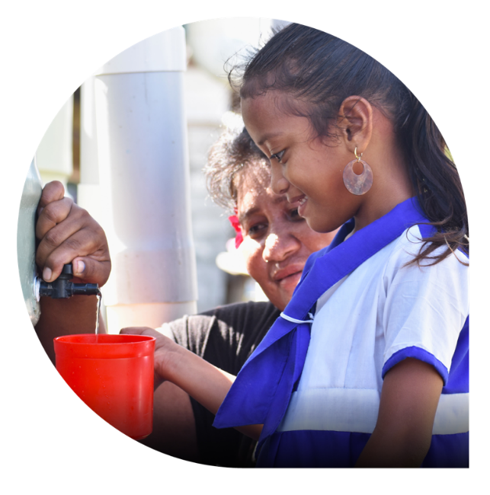
© ChildFund Kiribati/Department of Foreign Affairs and Trade, CC BY

Key terminology
t of Foreign Affairs and Trade, CC BY
n
e
m
t
r
a
p
e
D
/
s
e
m
l
o
H
m
i
J
©

archipelago
community
culture
development program
diversity
Indo-Pacific
natural resources
partnership projects
peace
prosperity
stable
values

Further resources
Teacher background information
- https://www.unesco.org/en/global-citizenshippeace-education/need-know
Student resources
These student resources are available on Scootle (www.scootle.edu.au). Log in and search for the codes:
- MapMaker: Free online mapping application with curated map content, created by National Geographic Society and Esri (Scootle A007127)
- Squiz the World!: Weekly audio excursion to a new country (A006219)
- Pacific culture areas map (Scootle A007270)
Books
- Macintosh, C. (2023). Islands of the Pacific. Cengage Australia.
- MacGregor, J. (2012–2020). Children of the Pacific series. Puriri Paddocks.

Curriculum links
The table below lists the Knowledge and understanding content descriptions explicitly addressed in this module. The module also provides opportunities to engage with the English curriculum and the Intercultural understanding capability.

HASS
Geography
Year 3: the locations of Australia’s neighbouring regions and countries AC9HS3K03
Civics and Citizenship
Year 3: why people participate within communities and how students can actively participate and contribute to communities AC9HS3K07
Year 4: diversity of cultural, religious and/or social groups to which they and others in the community belong, and their importance to identity AC9HS4K09
HASS skills
Year 3 and 4: locate, collect and record information and data from a range of sources, including annotated timelines and maps AC9HS3S02 AC9HS402
Year 3 and 4: interpret information and data displayed in different formats AC9HS3S03 AC9HS4S03
Year 3 and 4: draw conclusions based on analysis of information AC9HS3S05 AC9HS4S05
Year 3 and 4: propose actions or responses to an issue or challenge that consider possible effects of actions AC9HS3S06 AC9HS4S06
Year 3 and 4: present descriptions and explanations, using ideas from sources and relevant subject-specific terms AC9HS3S07 AC9HS4S07

General capabilities
Ethical Understanding: Students explore how values, rights and responsibilities and shared expectations influence responses and decision-making.
Creative and Critical Thinking: Students identify and examine relevant information and opinions from a range of sources, including visual information and digital sources. They condense and combine selected information related to the topic of study. They draw conclusions and make choices when completing tasks, using observation and prior knowledge to provide reasons and construct arguments for their choices.

Cross-curriculum priorities
Asia and Australia’s Engagement with Asia: Students learn that people of the Asia region are diverse in backgrounds, experiences, stories, religions, beliefs and perspectives. They explore Australia’s developing and deepening relationships with the peoples of Asia and how these influence mutual understandings and expressions of citizenship and culture nationally, regionally and globally.

What is the Indo-Pacific community?
Learning intention | Materials
To identify the nations that make up our Indo-Pacific community, find out about them, and share with others what we have learned. | - PowerPoint: Our Indo-Pacific community  - Worksheet: Our Indo-Pacific community  - 6 atlases or access to online maps  - Country fact files

Introduction (10 min)
- Share the learning intention for the lesson. Explain that these aims sit within larger aims of learning what it means to be part of our regional community, the Indo-Pacific.
- Ask students what they think a community is. Record a working definition that can be built on over the module. For example, a community is a group of people with something in common.
- Draw four concentric circles on a whiteboard. Elicit examples of communities from students. Ask students to locate the community examples in the model, using arrows to indicate if they cross boundaries.
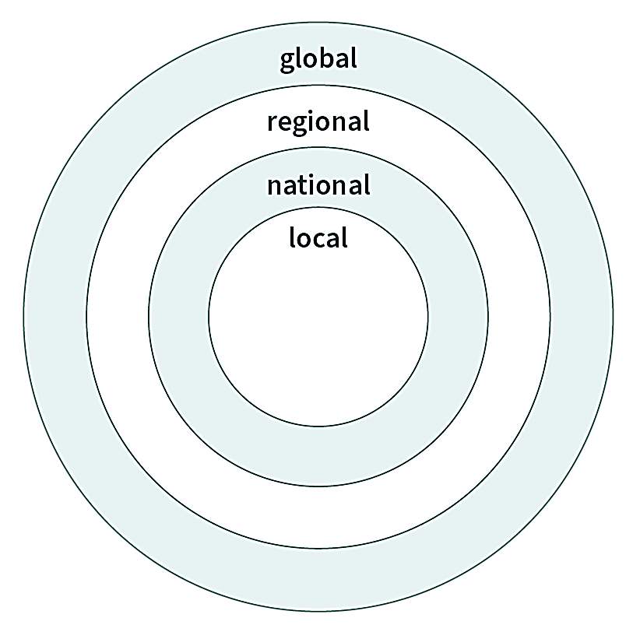
Hint: Students may not understand the term ‘regional’ or be able to think of any regional examples. This is fine at this point.
- Discuss multiple belongings – the idea that people can be part of many communities – and that these communities can ‘reach across’ the local and global.
Hint: Consider using familiar cultural communities to make the point.

Scaffolding geographical knowledge (20 min)
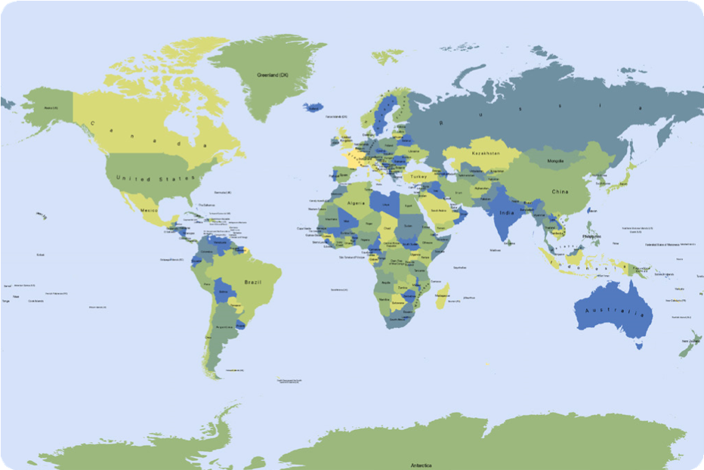
© Mapswire, CC BY 4.0
- Display the world map slide (Slide 2) from the Indo-Pacific community PowerPoint. Using a technique such as ‘thumbs up, thumbs down’, point at different regions and ask students if they think the region is in the Indo-Pacific region.
Hint: A suggested sequence is to point at the whole map (globe/world), northern hemisphere, southern hemisphere, western hemisphere (e.g. the Americas), eastern hemisphere (e.g. Africa, Europe and Australasia) and Australia. Use these terms when responding.
- Share the Indo-Pacific region map (Slide 3) from the Indo-Pacific community PowerPoint, and ask for ideas about its name (derived from the oceans surrounding the countries). Explain we also belong to other communities such as the Asia-Pacific and Commonwealth communities. The Indo-Pacific countries include our immediate neighbours, so are an important regional community.
- Hand out the worksheet, The Indo-Pacific community (1 per student), and explain that the countries are recognised by the Australian Government as countries in the Indo-Pacific community.
- Organise students into five teams and explain that their task is to find all the countries in their list. They can use atlases and/or online maps. The task can be run cooperatively, with the class working together to find all the countries in the community, or competitively, with the teams racing each other to complete the task.

Guided research (30 min)
- Explain to students that they will now do some research and learn about one of the 26 countries and then describe it to others.
- Allocate a country to each student (or student pair if support is required) and give them the matching Country fact file. Explain that they do not need to include all the information but should select some facts and extend them into full descriptive sentences, to create a short paragraph about the country in their workbooks.
Hint: Model the process with Australia. Explain terms on the Country fact files such as ‘prosperity’, ‘cultural’ and ‘natural resources’, and discuss the need to speak respectfully about countries.
- Students share completed descriptions in pairs or small groups. One method is for listeners to close their eyes and imagine the country as it is described to them.
Differentiation: This activity can be extended and adapted to suit classroom needs. For example, students could develop a script, and then record and share their presentations. Squiz the World! offers a useful model. Students may also want to find information elsewhere – some options are given in the ‘Further resources’ section.

Learning review (5–10 min)
- Call on students to share a country that ‘came alive’ for them through the descriptions.
- Ask students to explain something they learned about the Indo-Pacific community. Revisiting the concentric community circles and adding to the regional circle could also show how much they learned over the lesson.

Our Indo-Pacific community
The countries in the table below are Australia’s nearest neighbours from the Indo-Pacific community. Find and circle your team’s countries on the map.

Team 1 | Team 2 | Team 3 | Team 4 | Team 5
Cambodia | Kiribati | Nauru | Solomon Islands | Tonga
Cook Islands | Laos | Myanmar | Thailand | Indonesia
Fiji | Malaysia | Papua New Guinea | Niue | Palau
New Zealand – Aotearoa | Federated States of Micronesia | Samoa | Vietnam | Vanuatu
Tuvalu | Tokelau | Singapore | East Timor –Timor-Leste | Philippines
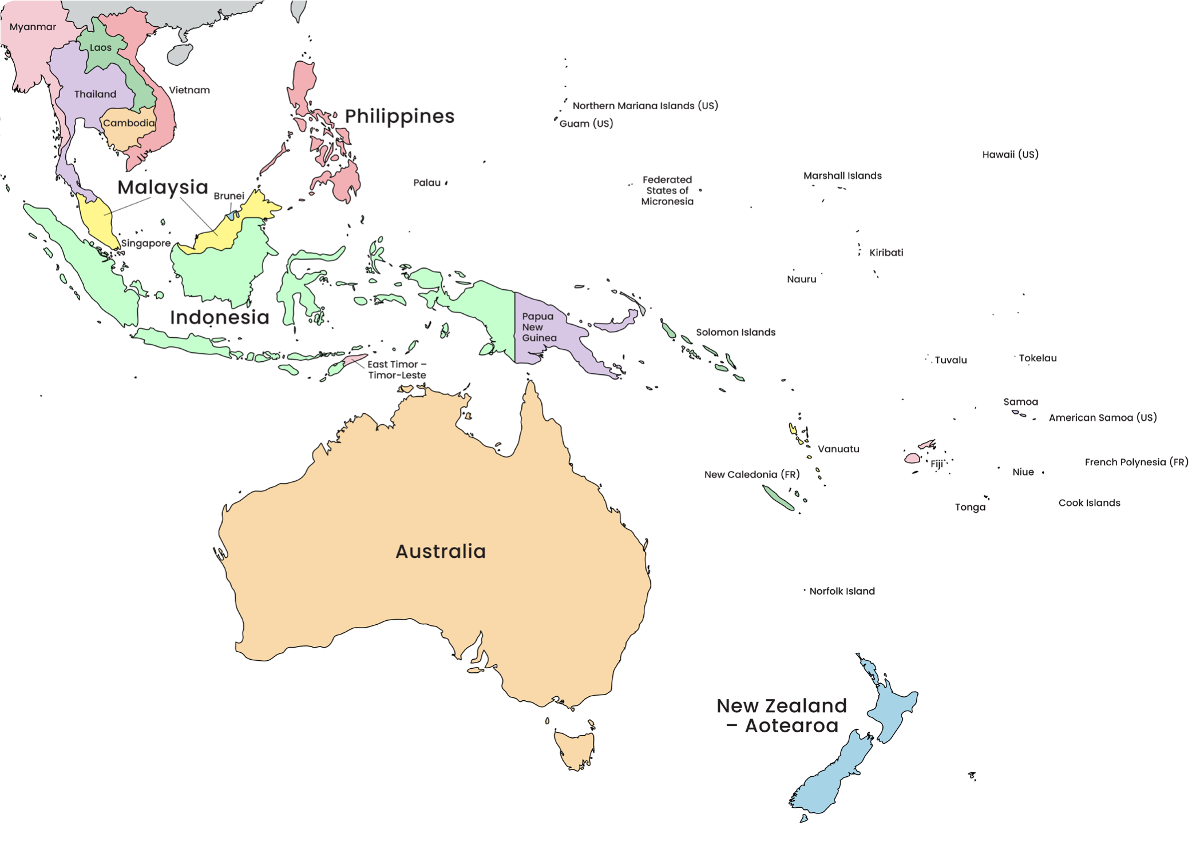
Adapted from: © VectorStock

What does it mean to be part of the Indo-Pacific community?
Learning intention | Materials
To learn about how communities work together in line with their values. | - Worksheet: Consequences chart  - Country fact files (from Lesson 1)

Introduction (15 min)
- Revisit the definition of community created in the previous lesson. Introduce the learning intentions of this lesson – to explore how and why the Indo-Pacific community works together in line with its values.
- Explain that communities are guided by sets of values (ways of being and doing) that involve rights and responsibilities. Use a community such as the school community to elicit ideas from students about its values and associated rights and responsibilities – for example, ‘Everyone has the right to feel safe at school, so we solve our problems without fighting.’
- Ask student groups to develop a role-play of a school or other community value. The class will guess what value it is.
- Make a list of the values discussed. Ask students which they think are also Australian values.
Hint: A list of Australia’s official values can be found via an internet search for ‘Australian values’ and ‘home affairs’. They include individual freedom within the law, democratic rule, respect, fairness, equality of opportunity for all, and compassion (care) for those in need.

Guided instruction (20–25 min)
- Explain that the Indo-Pacific community is also guided by a set of values. Develop an initial understanding of these terms: peaceful, stable, prosperous.

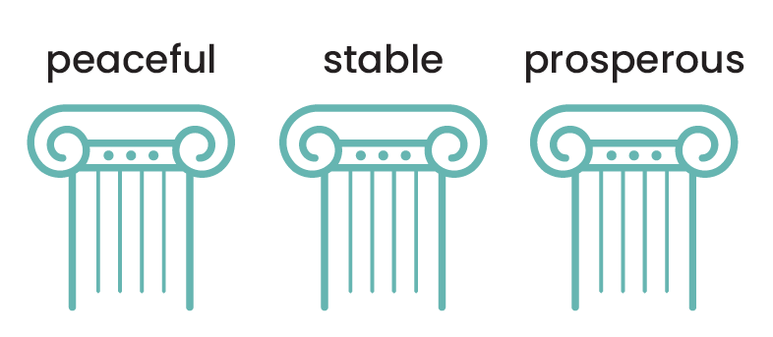
Hint: It may be useful to simplify these. For example, peaceful – safe/secure; stable – democratic/law-abiding; prosperous – comfortable/living well. Or combine them into a statement such as ‘it is important that everyone in the Indo-Pacific region is able to live safely and well in their community’.
- As a class, make a list (or draw a model) of the features of a peaceful, stable and prosperous community and elaborate on these features.For example, it has to have enough food for everyone (so people don’t go hungry), clean water (for healthy drinking), shops (and money to buy things with), sturdy houses (safe homes for people to live), good health care (so people stay healthy), police and laws (for safety), well-equipped schools (so all children can learn), and steady jobs for adults (to provide for themselves and their families).
- Explain that Australia is a peaceful, stable and prosperous country where people are safe and can live well.
Hint: It might be useful to draw out the role of government in addressing urgent needs – for example, food relief and emergency housing.
Note that some Indo-Pacific countries are not as prosperous (so there is not enough money to meet all the needs) and/or do not have the same levels of safety and security.
- Explore what it would be like to lack some of the features in the list compiled above. Use the graphic organiser on the Consequences chart worksheet to model the process in two directions. For example, 1. lack of clean water > might mean you get sick > then you can’t go to school and learn. 2. lack of clean water > adults must go and find clean water > this means they can’t go to work.
- Organise students into pairs and give each pair a copy of the worksheet. Allocate features to consider.
- Call on students to share their thinking.

Creative and critical thinking (15 min)
- Explain that Australia works with countries in the Indo-Pacific to help them stay or become peaceful, stable and prosperous (in line with Indo-Pacific and Australian values). One way to do this is through partnership programs (run by governments or through organisations such as World Vision) that involve Australians and Indo-Pacific communities working together to meet local needs.
- Watch the video ‘The Australian NGO Cooperation Program (ANCP)’ (Scootle A008025) and discuss what students noticed.
- Rewatch the video, pausing to make a list of some of the different partnership aims. Examples might include: opportunities for girls and women, climate action, nutritious food, trained heath workers, chances to learn, income for families and disability inclusion.

- Ask student pairs to use a Country fact file to identify and explain some areas where partnership programs could help communities be safe and live well. It might be useful to model the process and draw attention to the need to infer. For example, ‘In Papua New Guinea, there are a lot of volcano eruptions and earthquakes. This means they might need help when these happen, like getting food or rebuilding roads.’

Learning review (5 min)
- Call on students to explain the possible partnership programs they identified. Explain that they will explore these ideas further in the following lesson.
- Exit ticket – have students identify a value that they have connected with over the lesson.

Consequences chart
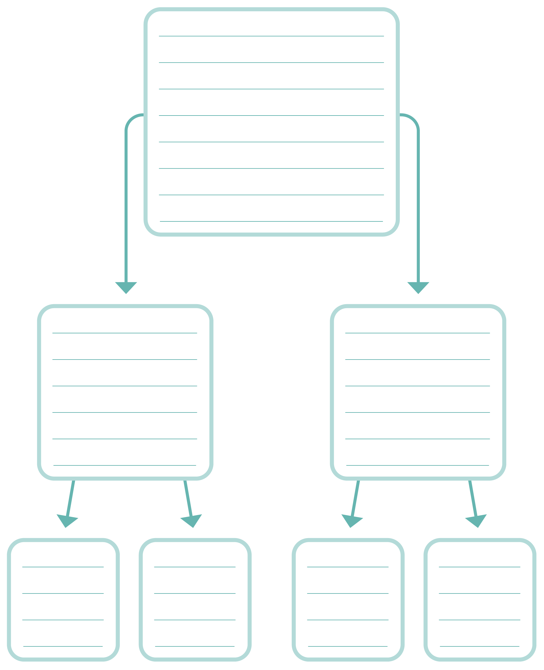

How can Australians contribute to Indo-Pacific communities?
Learning intentions | Materials
- To explore different ways that Australians contribute to Indo-Pacific communities through partnership projects.  - To develop plans for a partnership project and share this with others. | - Worksheet: Proposal planner  - Country fact files (from Lesson 1)

Introduction (5 min)
- Recap the previous lesson with students. Explain that in this lesson, they will learn more about how Australians contribute to an Indo-Pacific community. Students will work in small groups to develop a proposal for a partnership project.
Hint: For this activity it may be useful to focus on Pacific Island and/or low-income countries.

Guided research (15–20 min)
- Explain to students that they will look at some previous projects in detail and report back to the cla ss on what the project was, why it was needed, who was involved and in what ways, how it worked and with what equipment.
- Organise students into five groups and allocate a video to each group. Have students make notes in their workbooks about the key questions above as they watch. These videos can be found in Scootle (using the ID code), on iView or on YouTube:
- Video 1: Meet one of the first women to qualify
as a surfing instructor on Solomon Islands | ABC Australia [Scootle A008248]
- Video 2: ‘Sea Women of Melanesia’ fight to protect ‘Amazon’ of Pacific | Pandemic Warriors | ABC Australia [Scootle A008247]
- Video 3: PNG-Australia Partnership for Sports [Scootle A008024]
- Video 4: Fiji’s ping pong pioneer breaks down barriers for disabled people | Beyond Awesome | ABC Australia [Scootle A008246]
- Video 5: This Samoan circus is showcasing the magic of science | Pandemic Warriors | ABC Australia - YouTube [Scootle A008245]
Ask students to stop the video and ask for help if there are any difficult words or concepts. Explain that they are looking for the answers to the key questions and do not need to understand all details of the projects.
Hint: This section of the lesson provides opportunities to check for understanding of the task to come.

Collaborative development of ideas (25 min)
- Explain that students will work in their groups to develop a proposal for a (hypothetical) partnership project for the Australian Government to support. Tell them the projects will be selected on the strength of the proposals.
- Students use the graphic organiser on the Proposal planner worksheet to plan a partnership project. They then practise presenting their ‘pitch’. Encourage them to refer to the Country fact files to support their proposal.
- The project can be presented in different ways, for example, shared in class for feedback and refinement; presented and voted on; or reviewed by a panel of teachers/students.
- As students share their proposal, model drawing out the mutual obligations and benefits of the partnership projects and identifying the different roles and skills that make them work. For example, ‘I see, Australians provided ‘x’ resources and community members drew on their local expertise and language to…’

Learning review (10 min)
- Revisit the learning intentions and success criteria of the module.
- Each student creates an exit ticket that completes the statement ‘Two things I learned are… One thing I now want to learn is…’
- Have students share their statements.
- Ask students to reflect on the social and critical thinking skills they used in the tasks and make links with the values and terms introduced over the module. For example, ‘We worked collaboratively to build a picture of the Indo-Pacific region. It was like a partnership, with everyone doing their bit.’

Proposal planner
