Our global responsibilities
Module length: 3 x 60 minutes

Summary
This module explores contemporary global issues faced by current and future generations. Students will explore the cooperative and diplomatic processes that countries adhere to when working together on the world stage. Each lesson includes a focus on the legal responsibilities and development assistance that Australia provides as a prominent global actor and member of the United Nations. Students are encouraged to engage with the Australian Government’s Department of Foreign Affairs and Trade (DFAT) website to conduct research into Australia’s global engagement.
This module promotes student agency by fostering opportunities for students to plan a sustainable future as global citizens. Through the learning activities and scenarios in this resource, students will practise social competencies such as collaboration, negotiation, critical thinking, leadership, mutual respect and problem-solving. These are all vital skills to refine during the upper-secondary years as students prepare to enter the workforce and consider future career pathways. By maintaining a timeframe for each activity, students are encouraged to take action and interact with a diplomatic mindset.

Success criteria
At the end of this module, students should be able to:
- explain how Australia works cooperatively at a regional and global scale to improve human development
- describe the legal processes that Australia follows to uphold its global responsibility
- use teamwork and diplomacy skills to make decisions and design a proposal for a global development issue.

Organising ideas
The organising ideas are global relationships, global responsibilities and global futures. These reflect the Australian Government’s aims to build genuine partnerships that jointly tackle global challenges, protect international rules, promote Australia’s international interests, and sustain a peaceful and prosperous future to keep our region stable.
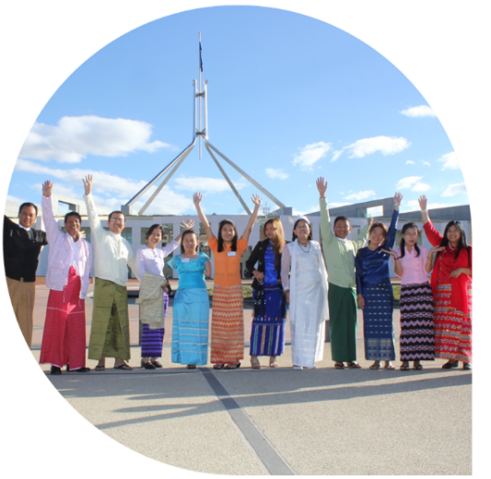
© Angus Braithwaite/Department
of Foreign Affairs and Trade

i
t of Foreign Affairs and Trade, CC BY
n
e
r
a
p
e
/
s
m

Prior knowledge
- An understanding of the United Nations.
- An understanding of international development programs.
- An awareness of the Asia-Pacific region.

Key terminology

convention
bilateral
diplomacy
international relations
legally binding
multilateral
state
treaty
unilateral
United Nations

At the end of this module, students should be able to:
- Explain how Australia works cooperatively at a regional and global scale to improve human development
- Describe the legal processes that Australia follows to uphold its global responsibility
- Use teamwork and diplomacy skills to make decisions and design a proposal for a global development issue.

Further resources
- Human rights treaties and international law in Australia – Rule of Law Education Centre
- Sustainable development goals for career education – myfuture

Curriculum links
The table below lists the Knowledge and understanding content descriptions explicitly addressed in this module. Most activities allow for student choice and, depending on the topic studied, students could engage with aspects of Geography, Digital Technologies and Science. There is an opportunity to expand this into an interdisciplinary project.

Civics and Citizenship

Government and democracy
Year 9: the legislative processes through which federal government policy is shaped, developed and implemented AC9HC9K02
Year 10: the Australian Government’s role and responsibilities at a regional and global level AC9HC10K02

Laws and citizens
Year 10: how Australia’s international legal obligations shape Australian law and government policies, including those relating to First Nations Australians, and the issues related to the application of these obligations AC9HC10K04

Citizenship, diversity and identity
Year 9: how and why individuals and groups, including community, religious and cultural groups, participate in and contribute to civic life in Australia and to global citizenship AC9HC9K05
Year 10: the challenges to and ways of sustaining a resilient democracy and a cohesive society in Australia and/or
in our region or globally AC9HC10K05

Skills
Year 9 and 10: locate, select and compare information, data and ideas from a range of sources AC9HC9S02
AC9HC10S02
Year 9 and 10: analyse information, data and ideas about political, legal or civic issues to identify and evaluate differences in perspectives and interpretations AC9HC9S03 AC9HC10S03
Year 10: evaluate the methods or strategies and outcomes related to making decisions about civic participation AC9HC10S04
Year 9 and 10: create descriptions, explanations and arguments using civics and citizenship knowledge, concepts and terms that incorporate evidence AC9HC9S05 AC9HC10S05

History

The globalising world (Year 10)
Year 10: causes and effects of the significant events and developments of the major global influences on Australia
in the post-Second World War period AC9HH10K16
Year 10: changing social, political, economic, cultural, environmental and technological conditions, and the causes of a major global influence in Australia AC9HH10K17
Year 10: the effects of global influences on Australia’s changing identity as a nation and its international relationships AC9HH10K19

General capabilities
Literacy: The knowledge and understandings in this module highlight the many legal dimensions that apply to global education. As such, literacy skills are widely used to define terms and introduce new concepts. Consider pointing out to students that the word ‘state’ is often used in global education. It refers to countries but is a more formally defined term used in international law. Students will commonly see this when researching. While students are not expected to explore any UN treaties, it may benefit them to see some examples of how such laws are written. This would highlight the importance of being precise when communicating laws. Teachers are encouraged to check student understanding of terminology throughout the module.
Intercultural Understanding: Students may question unfamiliar cultural contexts. Assisting them to use appropriate, respectful and considerate language when learning about other cultures will improve their ability to communicate without bias, stereotypes or prejudice.
Personal and Social Capability: Diplomacy is a key theme in this module and students will need to persevere and adapt to meet certain goals. Social management skills will be vital during one activity where teamwork and collaboration are needed to make decisions.

Cross-curriculum priorities
Asia and Australia’s Engagement with Asia: As this module has a global focus, students may research topics or examples of the Australian Government’s programs delivered by DFAT that involve partners in Asia. Overall, global education clearly emphasises the interdependent nature of relationships and the importance of developing mutual understanding and accepting diversity.
Sustainability: This module explores many of the organising ideas within this priority. Students will gain an understanding of sustainable political systems through learning about global diplomacy processes and agreements. By researching global themes, students will understand world views towards social justice and the environment. Finally, students will be challenged to consider sustainable futures when creating a treaty proposal.

How does Australia uphold its global responsibilities?
Learning intention | Materials
To understand how Australia works cooperatively with other countries and organisations to fulfill its legal and global responsibilities. | - Worksheet: Treaties and international relations including worked example  - PowerPoint: Our Global Responsibilities

Introduction (10 min)
Activate students’ prior knowledge and introduce the topic for these lessons. Focusing on definitions will develop students’ literacy.
- Conduct a Think-Pair-Share: ask students to discuss a possible definition for the word ‘treaty’. During the ‘share’ part of the activity, prompt students to think of some examples.
- Write the following words on the board: charter, convention, agreement, protocol. Ask students whether they have heard of these terms and, as a class, discuss their similarities. Is there a theme?
- Check students’ understanding of the phrase ‘legally binding’. Give a few examples of legally binding agreements, such as business contracts, mobile phone plans, privacy policies and rental agreements, and ask students for similarities between these. Ensure students understand that a legally binding document is an agreement of terms made between two parties that can be enforceable by law. Describing a scenario such as ‘What would happen if you didn’t pay your mobile phone plan?’ may help understanding. Then scale that idea to a business, national and global context.
- What implication might a legally binding agreement have on countries and their decision-making process regarding signing international agreements?
- Provide an overview of the lesson: students will be building their understanding of diplomacy and the role of the Australian Government. Reiterate the learning intention outlined above and provide context by summarising that students will be working in groups to propose a treaty in an upcoming lesson.

Guided Instruction: Defining new knowledge (15 min)
Give students access to the Treaties and international relations worksheet. Activity 1 introduces students to new knowledge using explicit instruction.
- Using the worksheet as a guide, explain the importance of the Vienna Convention of 1961 for establishing diplomacy. As a class, decide on a definition for the term ‘treaty’.
- Hint: There is opportunity here to expand this investigation of the Vienna Convention of 1961 into another lesson. That lesson would explore the historical context of global changes after WWII that led to the development of the UN and similar treaties being ratified. This aligns to the Year 10 History sub-strand: The globalising world.

- In Activity 1, Question 2, students are asked to research key terms to describe international cooperation. Ensure all students have a clear understanding of each word as they will be required in future lessons. To gauge understanding and spark discussion of current events, ask students how they may classify the G20 forums, AUKUS, free trade agreements between Australia and another country, and other examples that students may have heard about.

Scaffolding independent research (30 min)
- Hint: This activity has a time limit to replicate real-life scenarios where political briefings for diplomats may be required within the hour. Encourage this productivity in students.

Activity 2: Global development – the diplomatic work of DFAT allows students to independently research various ways the Australian Government fulfills its legal and global responsibilities, working cooperatively with other countries and non-government organisations to provide development assistance. Read through the activity and the four questions with students. There is also one extension question.
Gradual release of responsibility: Display the worked example in the Our global responsibilities PowerPoint to assist student understanding of how to complete the task. Read the worked example together. Inform students this is written to a high standard as an exemplar of the level of detail and reasoning required by diplomats. Check for student understanding of the meaning of terms. Words such as ‘exploitation’, ‘stigma’, ‘non-government organisation’, ‘rehabilitation’, ‘law enforcement’, ‘inclusion’ and ‘discrimination’ may need further explanation. In the worked example, these words are highlighted. You may wish to highlight others as well.
Scaffolding: Teachers are encouraged to demonstrate to students where they can find information using the DFAT website menu on the homepage, in particular the links on the International relations page. It may be useful to exemplify the research process for a topic as some themes require more investigation. All answers to the questions can be found on the DFAT website, so students should use this as their main source of information. They can clarify their findings further with other sources if required. The Beyond Awesome ABC series (link: https://iview.abc.net.au/show/beyond-awesome/series/1) provides videos between four and seven minutes long that may assist students looking for a case study example.

Learning review (5 min)
At the end of the lesson, ask students to share their research with two students who studied a different topic. They will answer the following prompts that align with the learning intentions and the organising ideas of global relationships, global responsibilities and global futures.
- Give an example of how Australia upholds its legal and global responsibilities.
- Give an example of how Australia is working cooperatively on an area of global development.
Further assessment opportunities could use the organising ideas and the Australian Government’s goals as potential success criteria.

Treaties and international relations

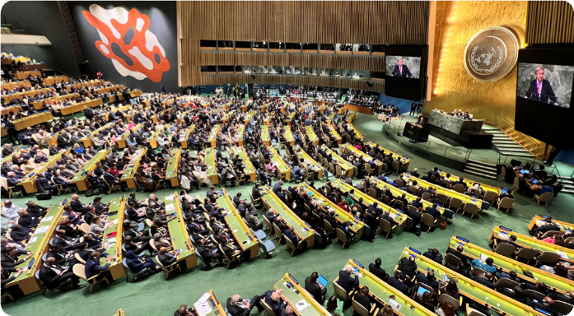
The UN headquarters are in New York City, USA. Representatives from 193 member countries discuss matters in this General Assembly building. All have equal representation.
© Nathan Fulton / Australian Department of Foreign Affairs and Trade, CC BY

Activity 1: Understanding diplomacy
The Vienna Convention of 1961 is an international treaty signed by 193 countries (states). It encourages cooperation between world governments through an agreed set of diplomatic principles. The Department of Foreign Affairs and Trade (DFAT) upholds the legal requirements of this treaty. Such agreements are often led by the United Nations, and can also be referred to as protocols, conventions or charters.
- As a class, define the term ‘treaty’ and explain what is meant by the phrase ‘legally binding’.

- ‘Diplomacy’ refers to the management, negotiation and collaboration of decision-makers, usually on a regional or global scale. In international relations, agreements and partnerships are often classified under three terms: bilateral, multilateral and unilateral.
Research the definition of each term and provide an example of each type of agreement:
Term | Agreement examples
Bilateral
Multilateral
Unilateral
- Australia’s global responsibilities are often formed in collaboration with other organisations or countries. Which two of the above agreements would Australia be adhering to and why?

Activity 2: Global development – the diplomatic work of DFAT
Australia’s international relations are managed by DFAT, which is responsible for issues of global security, human rights and development, environmental issues and trade. In this task you will learn more about the role of DFAT in one of the areas of global development listed below. All topics aim to improve economic, social or environmental living conditions around the world.
You are encouraged to use the DFAT website to conduct your initial research. Some topic links can be found on the International relations page of the DFAT website, or you can use the search function. For case study examples, the ABC series Beyond Awesome can be useful. Links to individual episodes are provided in the list below.

Topics | Beyond Awesome video links
Child protection and rights | Lao’s game changer
Environment and sea law | Plastic pollution warriors  Blue giant guardian
Education and workforce | Samoa’s geek girls
Climate change | Vietnam’s soil saviours
Rights of Indigenous Peoples or people with disability | Vanuatu’s resilience star  Fiji’s ping pong pioneer  PNG’s mobility maestro
Gender equality | Solomon Islands sea sisters
Once you’ve chosen a topic, research answers to the following questions:
- Identify any international treaties or multilateral agreements signed by Australia to do with the topic you chose.
- Provide examples of how these agreements are reflected in Australian legal policies and commitments.
- Outline an Australian Government development program or project that highlights how Australia is upholding its legal global responsibility. Include what type of cooperative agreement this is, using the terms from Activity 1.
- Hint: if there are no examples listed under your topic or sub-topics, try reading the latest news items on the DFAT website.
- What are some of the challenges and risks for DFAT when managing your topic on behalf of Australia?
- Extension: How does global connectedness both hinder and enhance the ability to manage your chosen topic?
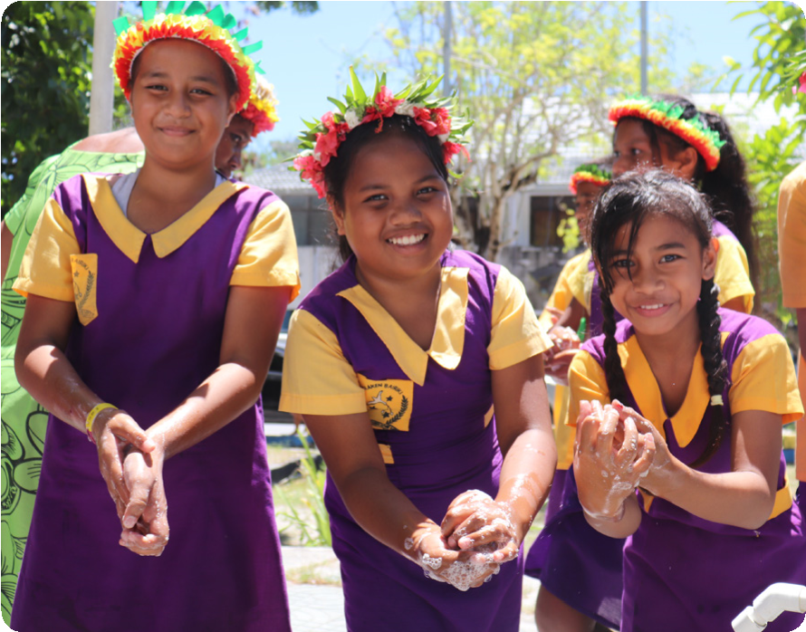
© UNICEF / Department of Foreign Affairs and Trade, CC BY

A high-level worked example
Area of global development:
Child protection and rights of people with a disability
- Identify any international treaties or multilateral agreements signed by Australia to do with the topic you chose.
United Nations Convention on the Rights of the Child (UNCRC)
- Provide examples of how these agreements are reflected in Australian legal policies and commitments.
- Australia was first to implement a policy to protect children from exploitation and abuse. The Australian Government has a zero-tolerance approach.
- Following the UNCRC, the Australian Government upholds that the primary consideration should always be what is in the best interests of the child.
- In Australia, the National Framework for Protecting Australia’s Children was endorsed in 2009. It outlines the standards for protecting and supporting children as agreed to in the UNCRC. The framework makes clear that ‘protecting children is everyone’s business’.
- Outline an Australian Government development program or project.
This example summarises information from the following link that was found through a DFAT website search: Strengthening protection and inclusion of children with disabilities in Laos.
Globally, children with a disability are more likely to suffer abuse and exploitation. In Laos, social stigma and a lack of specialised health services means that most children with a disability are kept at home. The Australian Government is working with the Lao Government and supported by the non-government organisation, UNICEF Australia to develop a model of care for these children. It is currently aimed at certain villages to reduce isolation and discrimination, and to assist families with health services such as rehabilitation exercises to improve quality of life and encourage their inclusion into a school. This is an example of a multilateral agreement between the Australian Government, Lao Government and non-government organisation UNICEF Australia.
- What are some of the challenges and risks for Australia?
The exploitation or abuse of children undermines a child’s right to grow up safely. When experiencing abuse, there is a risk that children may be traumatised and suffer long-term mental health issues. The Australian Government works to minimise exploitation and abuse by managing any risks that may be linked to its international development programs. They also ensure that responsibility of their zero-tolerance policy is shared with all partner organisations. DFAT provides guidance on how to immediately report concerns.
The growing challenge of online predatory or suspicious behaviour towards children has meant that Australia is part of a Virtual Global Taskforce. This is a multilateral agreement between 15 law enforcement agencies. Online criminal activity and child sexual abuse is borderless, making it impossible for any one country to combat it alone. The taskforce also works with other organisations to protect children online, across the globe.
- Extension: How does global connectedness both hinder and enhance the ability to manage your chosen topic?
Diplomacy between governments and the formation of legal agreements ensures there is universal acceptance regarding the rights and treatment of children, which then becomes more widely known to people throughout the world. This hopefully filters through into national and organisational standards. However, technology has enabled such connectedness that it is difficult to control or keep track of what methods are being used to abuse children. Furthermore, with large companies often spreading the production of goods and services across the globe, it allows avenues for child labour and exploitation to arise, often discreetly.

How does Australia cooperate on issues of global significance?
Learning intentions | Materials
- To understand how Australia forms decisions regarding international treaties.  - To practise diplomatic skills such as negotiation, compromise and critical thinking with respect for others. | - Worksheet: Proposal to negotiate a treaty

Introduction (10 min)
Steps 1 and 2 recap student learning from Lesson 1.
- Ask students to share their knowledge of various treaties or agreements that Australia has legally agreed to uphold.
- Tip: There is an Australian Treaties Database that you could explore with students to see the status and scope of treaties managed by the government.

- Outline the learning intentions for this lesson and establish a clear expectation for the behaviours students should display. You may be able to align this to your school’s values. Explain that during today’s lesson, students will be practising the skills of diplomacy by negotiating with their peers, ensuring respectful communication and teamwork are upheld, just like international diplomats would.

Group collaboration activity
This activity revolves around practising diplomacy. It allows students to formulate a proposal for an international treaty. These should be based on current areas of global development that are being raised or negotiated by the UN, listed in the table below. The table includes a regional multilateral example of development work being supported by Australia. Students can investigate these examples.
UN treaties under discussion or recently established | Australia’s regional programs
Global pandemics | Indo-Pacific Centre for Health Security
Cyber security | Cyber ASEAN
Climate resilience | REnew Pacific
Older people’s rights | Aged care expansion program – PALM
Ocean biodiversity | Pacific regional – fisheries assistance  Pacific Ocean Litter Project

In groups of four to six, students complete the following steps and document their findings in the Proposal to negotiate a treaty worksheet.
- Conduct some research into the selected UN treaty topic.
- Brainstorm some key considerations and possible terms for a treaty.
- Make notes about the possible implications for Australia and its regional development programs such as those suggested in the table.
This activity encourages students to problem-solve and employ diplomatic skills such as negotiation, strategic thinking and compromise, while displaying mutual respect at all times. It is suggested that setting a clear time limit (within two lessons) will ensure all students are challenged to work together to complete the activity. If working digitally, it is suggested that students use collaborative document editing to complete the task. You could have each group present their findings to the class in a future lesson.
Read the following fictitious scenario to the class. The second paragraph of the script is optional, depending on how you wish to set up the class and arrange groupings. You may have two groups study the same topic if there is a strong topic preference among students, or students could be randomly allocated.

Script
‘In the current global setting, it has come to the Australian Government’s attention that a number of treaties are being discussed by the United Nations. To assist the Minister of Foreign Affairs in deciding whether to enter a treaty negotiation, various government ministers are inviting experts to write a proposal explaining why Australia should consider signing a treaty on their selected global issue. As an expert [specify for yourself – from government, academia, non-profit or private sector], you will be responsible for collating your own research notes and then sharing your thoughts and ideas collaboratively as a committee to answer the proposal questions. You may need to delegate questions among your committee to ensure the proposal is completed within the tight deadline.
For the next [insert duration], you will each be allocated to a committee. These committees will investigate their area of global development and work together to brainstorm some key considerations for Australia and possible treaty terms. Each committee will put together a brief proposal using the template in the worksheet. Each committee will have [insert time] minutes to present their proposal in person to the Minister of Foreign Affairs [teacher] and then submit the document for closer review.’

Assessment
This activity has many opportunities for assessment:
- Peer or self-assessment: students reflect on their teamwork and understanding of global cooperation and the process of diplomacy.
- Formal boardroom debate: the activity could incorporate a formal committee meeting or debate situation, where every student is individually assessed. A Harkness teaching strategy could be employed. During this debate the class would jointly decide which treaty proposals should be prioritised. This would further encourage negotiation and compromise, giving students more exposure to the skills of diplomacy and governance.

Learning review (20 min)

Group work debrief
After such an activity it is important for students to reflect on the skills they employed while conducting their diplomatic discussions as a class and within their groups. Choose a reflection strategy and use any of the following questions to encourage a short debrief between students:
- What diplomatic skills do you believe you/your group excelled in?
- What challenges did you/your group face when practising diplomacy skills?
- Has this topic raised any thoughts or questions regarding international decision-making?
- What questions in the treaty proposal do you believe are most important?
- Acting diplomatically can often be considered an ‘art’.
- Why do you think this is?
- What other social skills do you think a diplomat may be confident in?
- How could you build on such skills?

Module wrap-up
Ask students to communicate (either verbally or written) their learning in relation to the organising ideas and the Australian Government’s aims. Listed below are potential prompts for a discussion or written reflection:
- How do global relationships and responsibilities protect Australians?
- What treaties do you believe will have the greatest impact on the future?
- Which is more important to you as an Australian, sustainability or prosperity?

Proposal to negotiate a treaty
Possible treaties for the Australian Government to consider:
UN treaties under discussion or recently established | Australia’s regional programs
Global pandemics | Indo-Pacific Centre for Health Security
Cyber security | Cyber ASEAN
Climate resilience | REnew Pacific
Older people’s rights | Aged care expansion program – PALM
Ocean biodiversity | Pacific regional – fisheries assistance  Pacific Ocean Litter Project
Agreement examples:
Term | Agreement examples
Expert committee members:
Treaty topic

Individual research notes:
Research the proposed or recently formulated UN treaty to understand what it might cover.

Stipulate the treaty terms:
Outline some possible terms to the treaty that the committee believe should be included.

Global cooperation:
List any data or evidence to outline how Australia is already providing development assistance to other countries on this topic. (The provided links to the regional programs could be helpful.)

Assess risks and advantages:
Would signing this treaty change international relations with any other countries or organisations?

Legal compliance:
Explain any reasons or scenarios where Australia may not be able to uphold this legally binding treaty.

National interest:
How does this treaty specifically assist Australia’s regional stability and prosperity?

Accountability:
Australia’s parliament scrutinises all decisions to sign a treaty before the country agrees to a legally-binding agreement. Forecast any questions or concerns that Parliament may raise regarding this treaty.

Future sustainability:
Predict how this treaty will bring changes and improvements to people globally.

