Treaties and international relations

Activity 1: Understanding diplomacy
The Vienna Convention of 1961 is an international treaty signed by 193 countries (states). It encourages cooperation between world governments through an agreed set of diplomatic principles. The Department of Foreign Affairs and Trade (DFAT) upholds the legal requirements of this treaty. Such agreements are often led by the United Nations, and can also be referred to as protocols, conventions or charters.
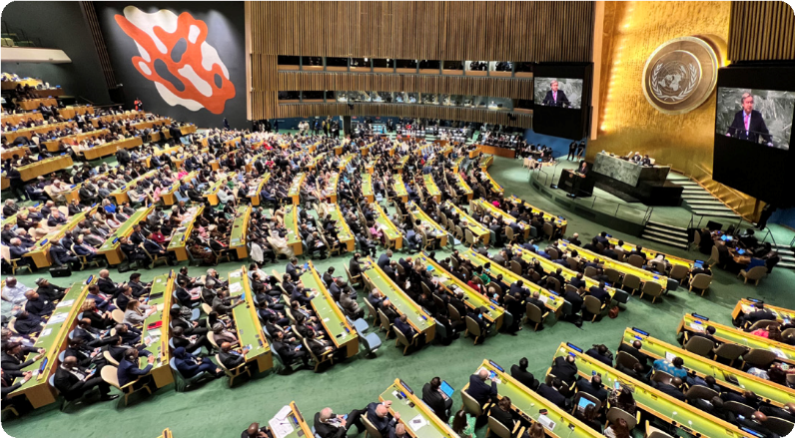
The UN headquarters are in New York City, USA. Representatives from 193 member countries discuss matters in this General Assembly building. All have equal representation.
© Nathan Fulton / Australian Department of Foreign Affairs and Trade, CC BY
- As a class, define the term ‘treaty’ and explain what is meant by the phrase ‘legally binding’.

- ‘Diplomacy’ refers to the management, negotiation and collaboration of decision-makers, usually on a regional or global scale. In international relations, agreements and partnerships are often classified under three terms: bilateral, multilateral and unilateral.
Research the definition of each term and provide an example of each type of agreement:
Term | Agreement examples
Bilateral
Multilateral
Unilateral
- Australia’s global responsibilities are often formed in collaboration with other organisations or countries. Which two of the above agreements would Australia be adhering to and why?

Activity 2: Global development – the diplomatic work of DFAT
Australia’s international relations are managed by DFAT, which is responsible for issues of global security, human rights and development, environmental issues and trade. In this task you will learn more about the role of DFAT in one of the areas of global development listed below. All topics aim to improve economic, social or environmental living conditions around the world.
You are encouraged to use the DFAT website to conduct your initial research. Some topic links can be found on the International relations page of the DFAT website, or you can use the search function. For case study examples, the ABC series Beyond Awesome can be useful. Links to individual episodes are provided in the list below.

Topics | Beyond Awesome video links
Child protection and rights | Lao’s game changer
Environment and sea law | Plastic pollution warriors  Blue giant guardian
Education and workforce | Samoa’s geek girls
Climate change | Vietnam’s soil saviours
Rights of Indigenous Peoples or people with disability | Vanuatu’s resilience star  Fiji’s ping pong pioneer  PNG’s mobility maestro
Gender equality | Solomon Islands sea sisters
Once you’ve chosen a topic, research answers to the following questions:
- Identify any international treaties or multilateral agreements signed by Australia to do with the topic you chose.
- Provide examples of how these agreements are reflected in Australian legal policies and commitments.
- Outline an Australian Government development program or project that highlights how Australia is upholding its legal global responsibility. Include what type of cooperative agreement this is, using the terms from Activity 1.
Hint: if there are no examples listed under your topic or sub-topics, try reading the latest news items on the DFAT website.
- What are some of the challenges and risks for DFAT when managing your topic on behalf of Australia?
- Extension: How does global connectedness both hinder and enhance the ability to manage your chosen topic?

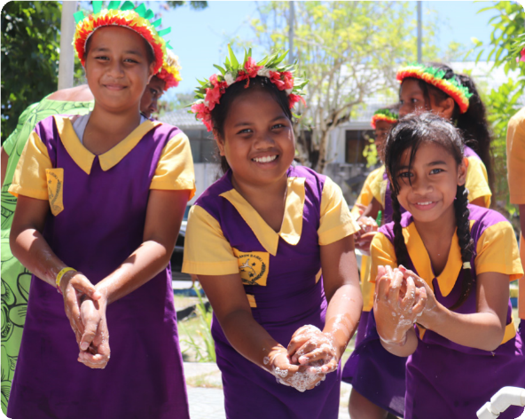
© UNICEF / Department of Foreign Affairs and Trade, CC BY

A high-level worked example
Area of global development:
Child protection and rights of people with a disability
- Identify any international treaties or multilateral agreements signed by Australia to do with the topic you chose.
United Nations Convention on the Rights of the Child (UNCRC)
- Provide examples of how these agreements are reflected in Australian legal policies and commitments.
- Australia was first to implement a policy to protect children from exploitation and abuse. The Australian Government has a zero-tolerance approach.
- Following the UNCRC, the Australian Government upholds that the primary consideration should always
be what is in the best interests of the child.
- In Australia, the National Framework for Protecting Australia’s Children was endorsed in 2009. It outlines
the standards for protecting and supporting children as agreed to in the UNCRC. The framework makes clear that ‘protecting children is everyone’s business’.
- Outline an Australian Government development program or project.
This example summarises information from the following link that was found through a DFAT website search: Strengthening protection and inclusion of children with disabilities in Laos.
Globally, children with a disability are more likely to suffer abuse and exploitation. In Laos, social stigma
and a lack of specialised health services means that most children with a disability are kept at home.
The Australian Government is working with the Lao Government and supported by the non-government organisation, UNICEF Australia to develop a model of care for these children. It is currently aimed at certain villages to reduce isolation and discrimination, and to assist families with health services such as rehabilitation exercises to improve quality of life and encourage their inclusion into a school. This is an example of a multilateral agreement between the Australian Government, Lao Government and non-government organisation UNICEF Australia.
- What are some of the challenges and risks for Australia?
The exploitation or abuse of children undermines a child’s right to grow up safely. When experiencing abuse, there is a risk that children may be traumatised and suffer long-term mental health issues. The Australian Government works to minimise exploitation and abuse by managing any risks that may be linked to its international development programs. They also ensure that responsibility of their zero-tolerance policy is shared with all partner organisations. DFAT provides guidance on how to immediately report concerns.
The growing challenge of online predatory or suspicious behaviour towards children has meant that Australia is part of a Virtual Global Taskforce. This is a multilateral agreement between 15 law enforcement agencies. Online criminal activity and child sexual abuse is borderless, making it impossible for any one country to combat it alone. The taskforce also works with other organisations to protect children online, across the globe.
- Extension: How does global connectedness both hinder and enhance the ability to manage your chosen topic?
Diplomacy between governments and the formation of legal agreements ensures there is universal acceptance regarding the rights and treatment of children, which then becomes more widely known to people throughout the world. This hopefully filters through into national and organisational standards. However, technology has enabled such connectedness that it is difficult to control or keep track of what methods are being used to abuse children. Furthermore, with large companies often spreading the production of goods and services across the globe, it allows avenues for child labour and exploitation to arise, often discreetly.

Proposal to negotiate a treaty
Possible treaties for the Australian Government to consider:
UN treaties under discussion or recently established | Australia’s regional programs
Global pandemics | Indo-Pacific Centre for Health Security
Cyber security | Cyber ASEAN
Climate resilience | REnew Pacific
Older people’s rights | Aged care expansion program – PALM
Ocean biodiversity | Pacific regional – fisheries assistance  Pacific Ocean Litter Project
Agreement examples:
Term | Agreement examples
Expert committee members:
Treaty topic

Individual research notes:
Research the proposed or recently formulated UN treaty to understand what it might cover.

Stipulate the treaty terms:
Outline some possible terms to the treaty that the committee believe should be included.

Global cooperation:
List any data or evidence to outline how Australia is already providing development assistance to other countries on this topic. (The provided links to the regional programs could be helpful.)

Assess risks and advantages:
Would signing this treaty change international relations with any other countries or organisations?

Legal compliance:
Explain any reasons or scenarios where Australia may not be able to uphold this legally binding treaty.

National interest:
How does this treaty specifically assist Australia’s regional stability and prosperity?

Accountability:
Australia’s parliament scrutinises all decisions to sign a treaty before the country agrees to a legally-binding agreement. Forecast any questions or concerns that Parliament may raise regarding this treaty.

Future sustainability:
Predict how this treaty will bring changes and improvements to people globally.

