ONE YEAR INTO THE PANDEMIC: SOCIOECONOMIC IMPACTS OF COVID-19 AND ACCESS TO SOCIAL PROTECTION FOR PEOPLE WITH DISABILITIES IN INDONESIA

Written By Sinta Satriana, Karishma Huda and Diah Hidayati
Contributions By Maliki, Annissa Sri Kusumawati, and Adhi Rachman Prana

April 2022

Direktorat Penanggulangan Kemiskinan dan Pemberdayaan Masyarakat,
Badan Perencanaan Pembangunan Nasional Republik Indonesia

ONE YEAR INTO THE PANDEMIC: SOCIOECONOMIC IMPACTS OF COVID-19 AND ACCESS TO SOCIAL PROTECTION FOR PEOPLE WITH DISABILITIES IN INDONESIA
Written By Sinta Satriana, Karishma Huda and Diah Hidayati
Contributions By Maliki, Annissa Sri Kusumawati, and Adhi Rachman Prana
This report presents findings from the second-round of a quantitative survey on COVID-19 Impacts on People with Disabilities in Indonesia. Data collection was led by the Organisation for People with Disabilities (OPD) Network for More Inclusive COVID-19 Response, with support from the Government of Indonesia through the Ministry of National Development Planning (Bappenas) and the Australian Government through two development cooperation programs, Towards a Strong and Prosperous Indonesian Society (MAHKOTA) and the Australia-Indonesia Partnership for Justice (AIPJ2).
Direktorat Penanggulangan Kemiskinan dan Pemberdayaan Masyarakat, Badan Perencanaan Pembangunan Nasional Republik Indonesia, with support from MAHKOTA
MAHKOTA (Towards A Strong and Prosperous Indonesian Society, 2015-2022) is an Australian Government-Funded Program supporting the Government of Indonesia (GoI) to improve its social protection system and to reduce poverty and inequality.

All rights reserved @2022 BAPPENAS RI
Support to this publication is provided by the Australian Government through the MAHKOTA Program.
The findings, interpretations and conclusions herein are those of the author(s) and do not necessarily reflect the views of the Government of Indonesia or the Government of Australia.
You are free to copy, distribute and transmit this work, for non-commercial purposes.
Suggested citation: Satriana, S., Huda, K., Hidayati, D., (2022), “One Year into the Pandemic: Socioeconomic Impacts of COVID-19 and Access to Social Protection for People with Disabilities in Indonesia,” MAHKOTA and AIPJ2 with support of the Australian Government, Jakarta: Indonesia
To request copies of this paper or for more information, please contact: ditpk@bappenas.go.id or mahkota.comms@mahkota.or.id

Foreword

Government Regulation Number 70 Year 2019 on Planning, Budgeting, and Evaluation mandates the Master Plan for People with Disabilities (RIPD) in realizing more inclusive development for People with Disabilities through the multidimensional 7 (seven) strategic objectives. The paradigm shift in Law 8/2016 has consequences that the affairs of People with Disabilities are not only related to social assistance, but also development on data collection, unhindered environmental infrastructure, access to justice and politics, habilitation and rehabilitation, access to jobs or businesses, educational services, and health insurance.
With the COVID-19 pandemic, the challenge in fulfilling the Rights of People with Disabilities is certainly a priority in the context of realizing inclusive development in Indonesia. Therefore, the study result of the socio-economic impact of COVID-19 on People with Disabilities is strategically implemented within a comprehensive and collaborative multi-sectoral planning and budgeting mitigation framework. The main findings of this social impact study has shown that the livelihoods of People with Disabilities were greatly affected due to COVID-19, including a decrease in income to termination of work rights, difficulties in meeting daily needs, and difficulties in accessing assistive devices services.
We hope that this study result, which has been successfully written with the support of DPO Network for More Inclusive COVID-19 Response, can be a reference for policy making by all decision makers. In the future, with various cross-sector collaboration efforts, People with Disabilities can be independent and inclusively participate in supporting economic transformation to achieve an advanced Indonesia.

Jakarta, April 2022

Maliki, ST, MSIE, Ph.D
Director of Poverty Alleviation and Community Empowerment
Ministry of National Development Planning/Bappenas

Content
Foreword iv
Acronyms and Abbreviations vii
Introduction and Approach of the Study 1
Profile of Respondents and the Barriers Faced by People with Disabilities 3
Changes in Employment and Income of People with Disabilities Through the COVID-19 Pandemic 8
COVID-19 Impacts on Access to Services for People with Disabilities 16
Access to Education for People with Disabilities During the Pandemic 19
Social Protection Coverage in the COVID-19 Pandemic 23
Conclusion 30
Recommendation 31
References 33
Annex 1 Program Bantuan Sosial dan Ketenagakerjaan Respons COVID-19 di Indonesia 35
Annex 2 Organisasi Penyandang Disabilitas yang Tergabung dalam Jaringan DPO untuk COVID-19 yang Lebih Responsif di Indonesia 37
Annex 3 Second Survey Questionnaire: Impact of the COVID-19 Pandemic on Persons with Disabilities 39

List of Figures and Table

Figure 1: Type of Disability reported by respondents 3
Figure 2: Ownership of Identification Documents 4
Figure 3: Ownership of Birth Certificate (by Age) 5
Figure 4: Labour Force Participation Rate Among Respondents (16 Years of Age and Above) (by Gender) 5
Figure 5: Employment Sector and Status 6
Figure 6: Education Attainment Among Respondents (18 Years of Age and Above) (by Type of Disability) 7
Figure 7: Workers Experiencing Changes in Their Jobs 8
Figure 8: Changes in Number of Workdays During the Pandemic 9
Figure 9: Changes in Number of Days Worked per Week 10
Figure 10: Monthly Income Range of Workers During the Pandemic 11
Figure 11: Income Level Before the Pandemic and in the Mar-Jun 2020 Period (by Gender) 12
Figure 12: Workers Experiencing Significant Income Reduction and Income Recovery by the End of the Survey Period 13
Figure 13: Difficulty Affording Necessities by Household Income Level (in January-March 2021) 14
Figure 14: Difficulty Affording Necessities and Income Reduction 14
Figure 15: Coping Strategies Among Respondents Who Faced Difficulty Affording Necessities 15
Figure 16: Level of Difficulty Accessing Services by People with Disabilities During the Pandemic 17
Figure 17: Reasons for Disruptions in Accessing Services During the Pandemic 17
Figure 18: Ownership of Assistive Devices Among Respondents Needed to Perform Daily Activities 18
Figure 19: Reasons for Not Owning or Using Assistive Device 18
Figure 20: Level of Difficulty Following Remote Learning Among Student Respondents (by Type of Disability) 20
Figure 21: Reasons for Difficulties in Following Remote Learning for Student Respondents 20
Figure 22: Use of Digital Learning Platforms Among Students with Disability 21
Figure 23: Changes in the Use of Digital Learning Platforms for Students (by Type of Disability) 21
Figure 24: Level of Difficulty Affording Tuition Fees and School Supplies 22
Figure 25: Level of Difficulty Engaging Learning Assistant 22
Figure 26: Number of Respondents Reporting Receipt of Government Social Protection Programs 24
Figure 27: Coverage of Main Government Social Protection Programs for People with Disabilities (July-December 2020) 25
Figure 28: Number of Respondent who Receive Regular Social Protection Programs (Various Periods) 27
Figure 29: Number of Respondent who Receive COVID-19 Social Protection Programs (in the period of March-June 2020 and July-December 2020) 27
Figure 30: Beneficiaries of Main Government Social Protection Programs by Income Level (March-June 2020) 28
Figure 31: Proportion of Workers With/Without Social Protection (by Income Change) 28

Table 1: Respondents Reporting Difficulty Affording Necessities (by Level of Difficulty) 13

Acronyms and Abbreviations

ASPD Asistensi Sosial Penyandang Disabilitas (Social Assistance for People with Disabilities)
Bappenas Badan Perencanaan Pembangunan Nasional (Ministry of National Development Planning, Indonesia)
BLT-DD Bantuan Langsung Tunai – Dana Desa (Unconditional Cash Transfer – Village Fund)
BPJS-TK Badan Penyelenggara Jaminan Sosial Ketenagakerjaan (Social Security Implementation Agency – Employment)
BBRVPD Balai Besar Rehabilitasi Vokasional Penyandang Disabilitas (National Vocational Rehabilitation Center for People with Disabilities)
BPNT Bantuan Pangan Nontunai (Noncash Food Assistance)
BST Bantuan Sosial Tunai (Cash Transfer)
CBR Community-based Rehabilitation
DTKS Data Terpadu Kesejahteraan Sosial (Integrated Social Welfare Database)
JKN Jaminan Kesehatan Nasional (National Health Insurance)
KIP Kartu Indonesia Pintar (Smart Indonesia Card)
KK Kartu Keluarga (Family Card)
KTP Kartu Tanda Penduduk (National Identity Card)
MoSA Ministry of Social Affairs
OPD Organisation of People with Disabilities
PKAKN Pusat Kajian Akuntabilitas Negara (Center for State Accountability Study)
PKH Program Keluarga Harapan (Family Hope Program)

Introduction and Approach of the Study

This analysis is part of a series of studies conducted on the impact of the COVID-19 crisis on people with disabilities in Indonesia and their access to social protection during the pandemic. It was preceded by: (i) a quantitative survey conducted in April 2020 looking at the initial impacts of COVID-19 and access to COVID-19 economic response programs; and (ii) qualitative research conducted in July-August 2020 which took a granular look at ways in which COVID-19 shaped the lives of people with disabilities and how they navigated access to social protection (pre- and post-COVID).
The series of surveys were designed and carried out collectively by the network of OPDs for Inclusive Covid-19 Response, with support from the Government of Indonesia (GOI) and Australian Government development cooperation programs. For reports of the study, see OPD Network for Inclusive COVID-19 Response (2020); Satriana (2020); and Satriana et.al. (2021).
This report is based on the second round of a quantitative survey conducted in February-March 2021 that assessed how people with disabilities have been faring nearly a year after the pandemic first impacted Indonesia. It followed the first round of the survey conducted in April 2020. While the general topics covered in the second round of the survey were similar to the first round, changes were made to the questions to adjust to the changing nature of the crisis and the ensuing need for new information.
Whereas the previous studies assessed the impacts experienced by people with disability in the early stage of the pandemic, this round of the survey attempts to deepen our understanding by capturing the different levels/severity of the impact of COVID-19 throughout different periods and how the situation had changed compared to before the pandemic. During the survey, respondents were asked to recall their situation in the following periods:
- Prior to March 2020, the pre-pandemic period.
- March-June 2020, the beginning of the pandemic when strict restrictions were put in place. Following the announcement of the pandemic in Indonesia in the beginning of March, the country implemented the disaster emergency status due to the COVID-19 pandemic (BNPB decision no.9A of 2020 and no.13A of 2020). Restrictions in this period include movement restrictions and suspension of some modes of transportation, as well as suspension/reduction of non-essential business operations which affected millions of workers across the country.
- July-December 2020, when some restrictions were relaxed with the implementation of “transitional restrictions” in some areas. The transition period meant that most businesses and public transportation were allowed to gradually resume operation with reduced capacity (Tempo, 2021)
- January-March 2021, the period closest to the survey. Some regulations on the COVID-19 response programmes were revised at the start of 2021 and while most COVID-19 response programmes continued in 2021, this was not well understood in the beginning of the year.
Some analyses shown in this report may include all four periods, while others exclude some periods for simplicity or data confidence purposes.
The survey used a combination of online questionnaire, phone interview and (in exceptional cases) face-to-face interviews, to ensure accessibility for respondents with different types of disabilities and those in areas with limited connectivity. The survey employed enumerators, who are members of local OPDs in each province, who were tasked to actively contact potential respondents and ensure respondent representation based on gender, age, and types of disability.
This survey, therefore, attempts to purposely target reasonable representation of all groups of people with disabilities. The survey had 1,597 respondents from 34 provinces. Twenty six percent of respondents responded to questions directly in the online platform, while the majority (74 per cent) used the help of enumerators by answering questions by phone or face-to-face interview. However, the survey is limited in the distribution within provinces, and rural dwellers tend to be underrepresented. Half of respondents are located in urban areas, 23 per cent in semi-urban areas and 27 per cent in rural areas.
This policy brief, produced by MAHKOTA, AIPJ2 and the Directorate for Poverty Alleviation and Community Development of Bappenas, focuses on selected aspects of the findings and accompanies the full report produced jointly by all organisations involved. For the full report or the survey findings and methodology, see OPD Network for Inclusive COVID-19 Response (forthcoming).

Profile of Respondents and the Barriers Faced by People with Disabilities

A total of 1,597 people with disabilities participated in the second quantitative survey. Of these 821 (51 per cent) were male, 775 (49 per cent) female and one respondent identified as other. Types of disability among respondents are summarised in Figure 1, noting that the biggest proportion (36 per cent) reported physical disability.
Sixty-eight per cent of respondents are between the ages of 18, 24 per cent are below the age of 18, and the remaining 8 per cent above 60 years of age.
Figure 1: Type of Disability reported by respondents
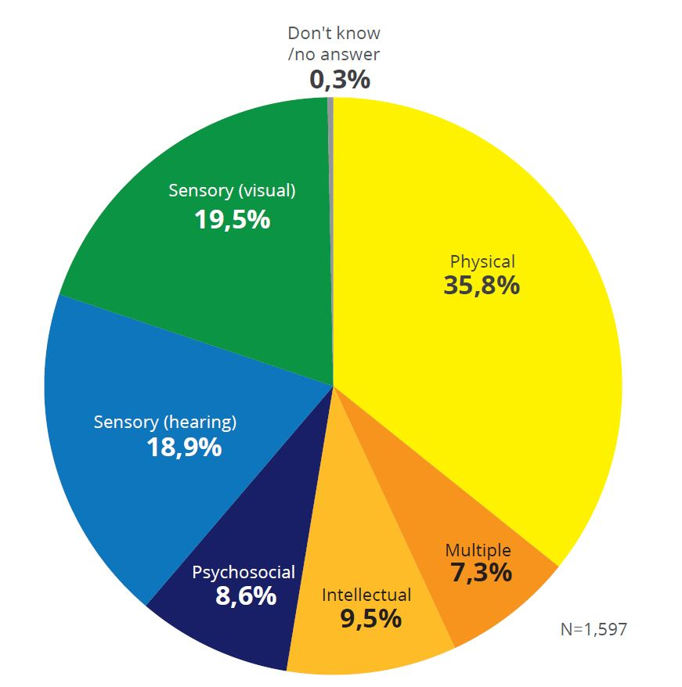

Ownership of identification documents such as the national identification card (Kartu Tanda Penduduk: KTP), family card (Kartu Keluarga: KK), and birth certificate among people with disabilities is low compared to the general population. KTP ownership is mandatory among Indonesian citizens who are above 17 years old and/or have been married. Around 86 per cent of survey respondents 18 years of age and over own a KTP‒significantly lower than the general population where KTP registry is recorded at 99 per cent (Figure 2). Birth certificate ownership among respondents is particularly low at 53 per cent and the lowest is among those above the age of 60 (12 per cent) (Figure 3). In the 0-17 years age group, 75.6 per cent of respondents own a birth certificate. Nevertheless, this is still significantly lower in comparison to the 93.5 per cent of Indonesian children who own birth certificates (MOHA, 2021).
Based on disability type, ownership of birth certificate was lowest among people with psychosocial disability and multiple disability. Since the national identity number is often a requirement for various services (ranging from health and education to asset ownership and banking services), the low ownership among people with disabilities may significantly reduce access to services for people with disabilities, who are already facing significant barriers.
Figure 2: Ownership of Identification Documents
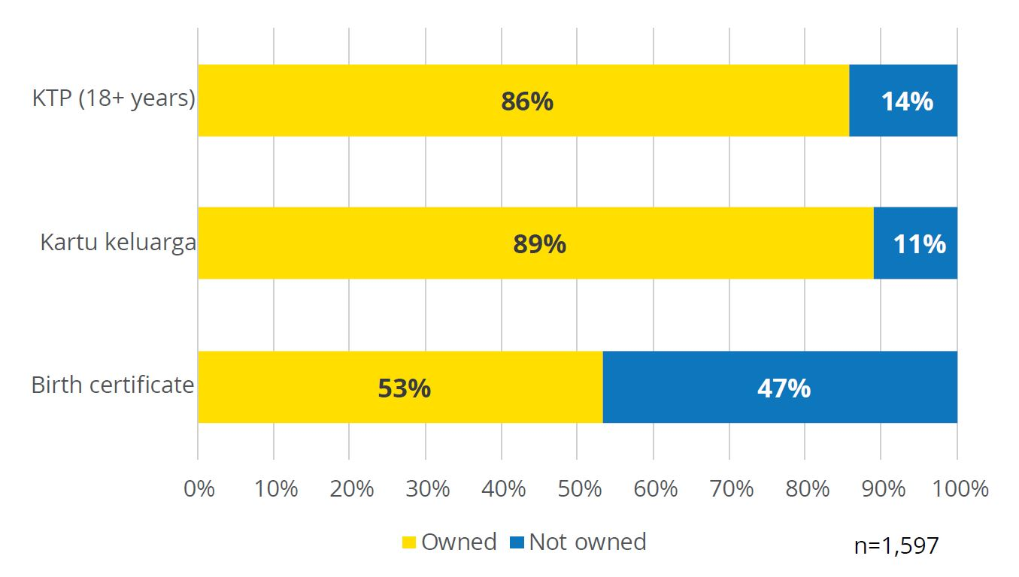
Figure 3: Ownership of Birth Certificate (by Age)
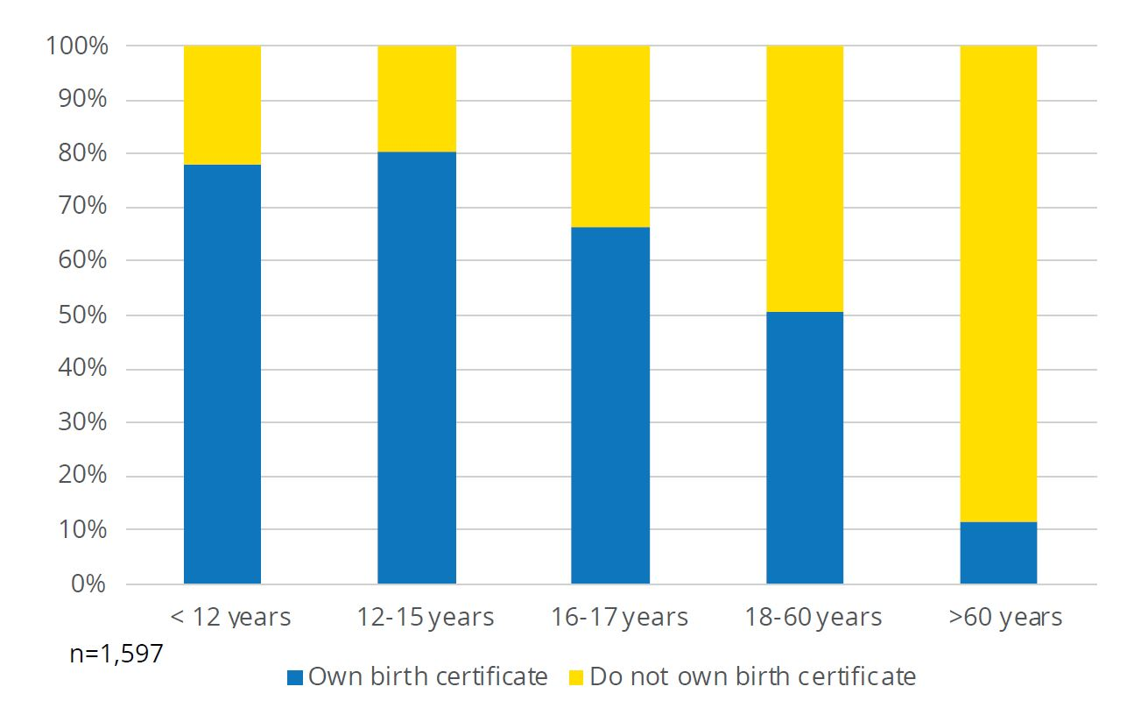
Labour force participation among working age respondents is very low, particularly among women. While the national labour force participation rate in February 2021 was 68 per cent (BPS 2021b), only 39 per cent of respondents reported being in work. The gender difference in labour force participation is also significant as only 30 per cent of female respondents reported being in work compared to 48 per cent among male respondents (Figure 4).
Figure 4: Labour Force Participation Rate Among Respondents (16 Years of Age and Above) (by Gender)
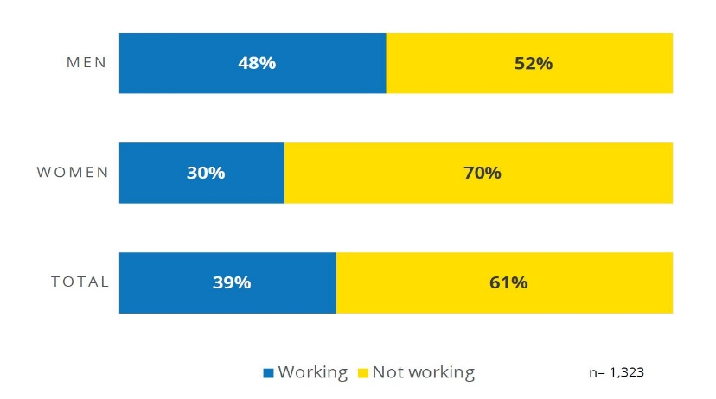
Among respondents who work, the vast majority (88.5 per cent) were in informal employment (Figure 5). These include owners of small businesses (44 per cent), casual labour (20 per cent), workers in the private sector without a fixed-term contract (19 per cent), volunteers (2 per cent) and other types of employment (4 per cent). The remaining 11 per cent of workers are in the formal sector, including government employees (5 per cent) and employees in the private sector with fixed-term contracts. Informal employment among people with disabilities comes with poor and irregular income. Furthermore, informal jobs do not provide social insurance or severance pay in case of unemployment, providing very little income security and little protection in times of crisis (Satriana et al., 2021).
Figure 5: Employment Sector and Status
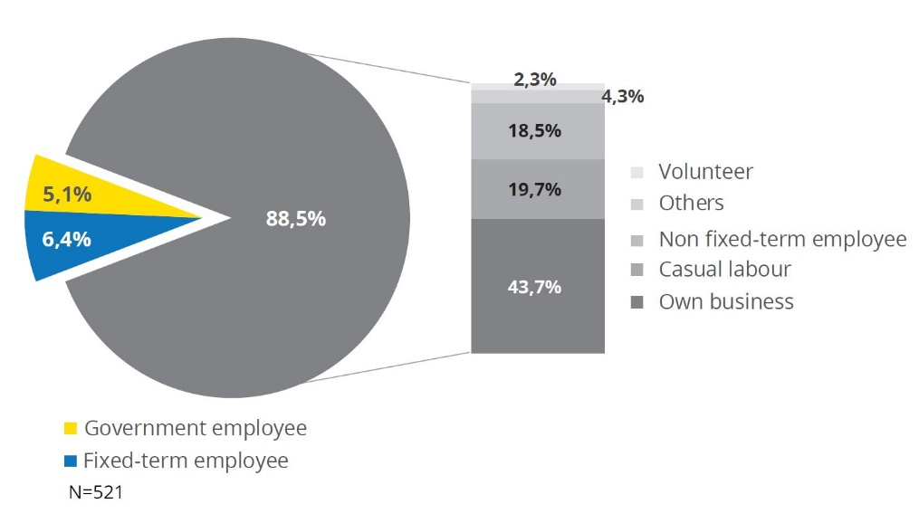
As expected, formal employment is strongly correlated with education level. Only two per cent of workers with a junior secondary school education or lower are in formal employment‒compared with 10 per cent among those with a senior secondary education and 29 per cent for those with a university education.
Given the low education attainment of people with disabilities, access to formal employment is not available for most respondents. According to Susenas (2019), 21 per cent of people with disabilities have never attended school compared with only 3 per cent among people without disabilities. In addition, only 10 per cent of people with disabilities have graduated from senior secondary school‒compared with 27 per cent for people without disabilities.
Respondents with psychosocial disability, intellectual disability, and multiple disabilities faced the most significant barriers to education. Figure 6 shows education attainment among respondents aged 18 and older. Fifty-two per cent and 68 per cent of respondents with psychosocial and multiple disabilities, respectively, had a primary education or no education at all.
As comparison, the figure was 25 and 28 per cent among respondents with hearing impairment and visual impairment respectively. Note that respondents of this survey appear to have a generally higher education level compared to the education level of people with disabilities in the national socioeconomic survey (Susenas). For instance, 2.8 per cent of people with disabilities in Susenas 2019 had higher education (BPS, 2019) compared to 12.5 percent in this survey. This is likely due to the method of our survey, which relied on internet and phone connection and with higher representation of urban dwellers (see methodology above) compared to the stratified sampling in Susenas.
Figure 6: Education Attainment Among Respondents (18 Years of Age and Above) (by Type of Disability)
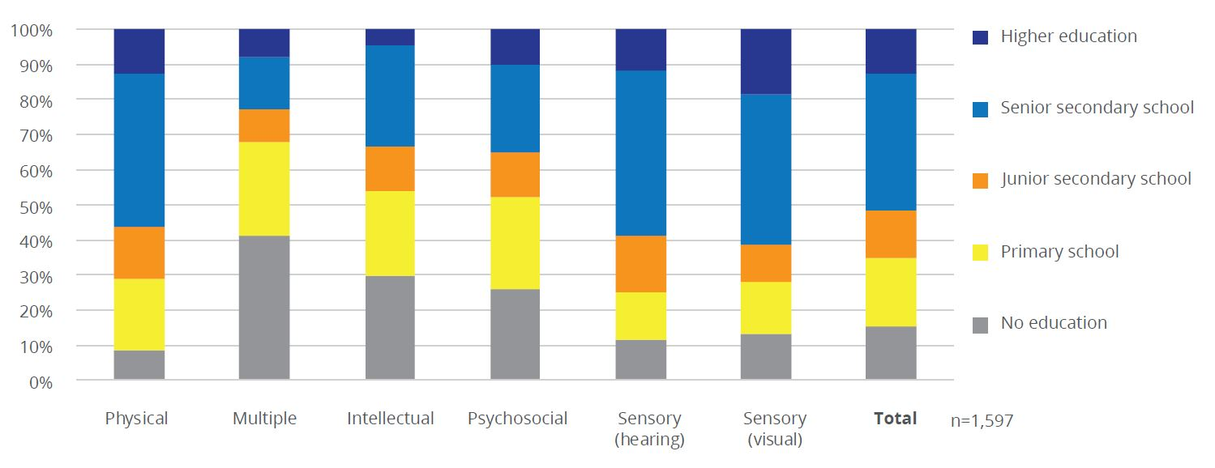

Changes in Employment and Income of People with Disabilities Through the COVID-19 Pandemic

As Figure 7 illustrates, 21 per cent of respondents who work reported that they have changed their jobs since they experienced the pandemic in March 2020. Of this 21 per cent, 15 per cent claimed to have changed their jobs for pandemic-related reasons such as bankruptcy, redundancies or lay-offs, furlough (indefinite unpaid leave), wage cuts, or having to close their place of business due to lock down. As to be expected, the rate of pandemic-related job changes was higher among informal workers (22 per cent of casual labourers changed jobs as compared to 7 per cent of employees with fixed-term contracts).

Figure 7: Workers Experiencing Changes in Their Jobs
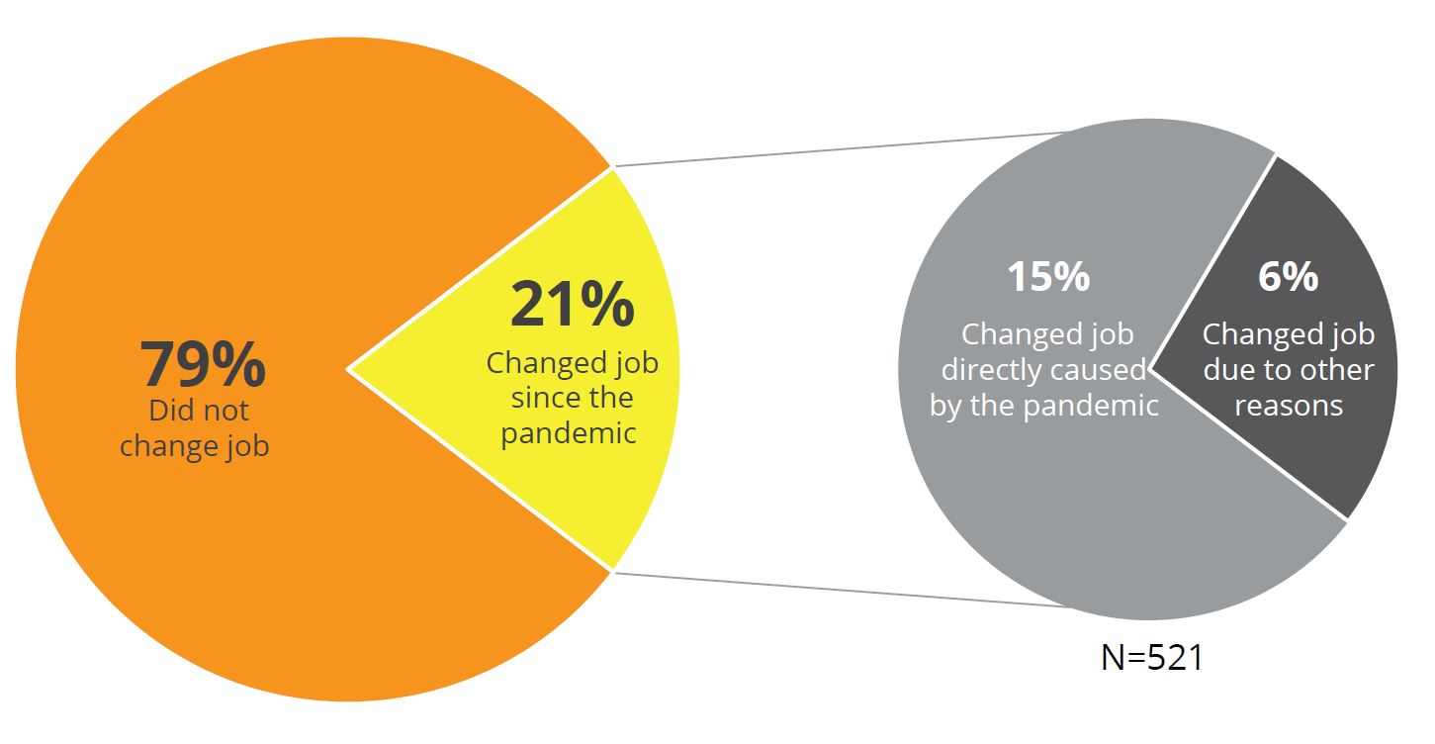
More than one-half (55 per cent) of workers experienced a reduction in the number of days worked during the pandemic (Figure 8). These are workers who reported a lower number of working days per week in at least one period since March 2020 compared to before the pandemic. By the time this survey was conducted (February-March 2021), only 16 per cent of workers had fully recovered the number of pre-pandemic workdays. Another 20 per cent of workers recovered some of their working days but still remained below the pre-pandemic level. The remaining 19 per cent of workers have not regained their pre-pandemic working days‒highlighting the long-term economic impacts the pandemic has had on their livelihoods.

Figure 8: Changes in Number of Workdays During the Pandemic
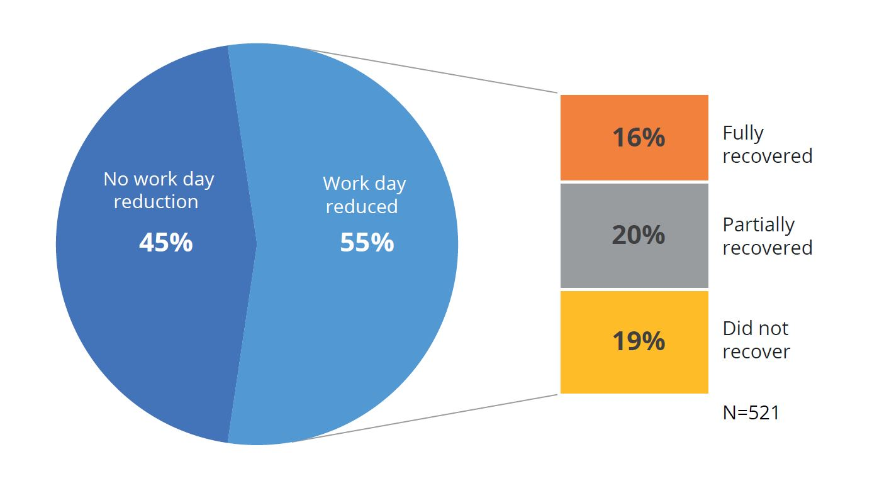

The most significant drop in work activities was seen in the period of March-June 2020, during the onset of the pandemic (Figure 9). The situation slowly improved in subsequent periods but was still far below the pre-pandemic level. While 92 per cent of workers worked full time/nearly full time (4-7 days per week) before the pandemic, this number dropped significantly to only 61 per cent in the March-June 2020 period. The figure increased to 63 per cent and 69 per cent in the July-December 2020 period and January-March 2021 period respectively (Figure 9).
Work reduction during the pandemic had caused many full-time workers to work part time. Respondents with part-time work (2-3 days per week) increased from 8 per cent before the pandemic to 21 per cent in March-June 2020. This continued to increase to 27 per cent through July-December 2020, before going back down to 21 per cent in the January-March 2021 period. These changes appear to be similar among men and women respondents. However, since more men work full time since before the pandemic, throughout the pandemic the proportion of men working full time continues to be higher compared to women (Figure 9). Thirteen per cent of respondents lost their employment (worked zero days per week) in at least one period during the pandemic. In the March-June 2020, period 17 per cent of workers worked between 0-1 day per week due to work reduction.
In the July-December 2020 the situation improved, with 10 per cent working 0-1 day per week, as some had gained more work. The figure then remains through the January-March 2021 period‒signifying a slow economic recovery over the course of the year. These trajectories reinforce the fact that, while economic activities are slowly recovering, respondents continue to experience significant economic impact compared to pre-pandemic levels.
Figure 9: Changes in Number of Days Worked per Week
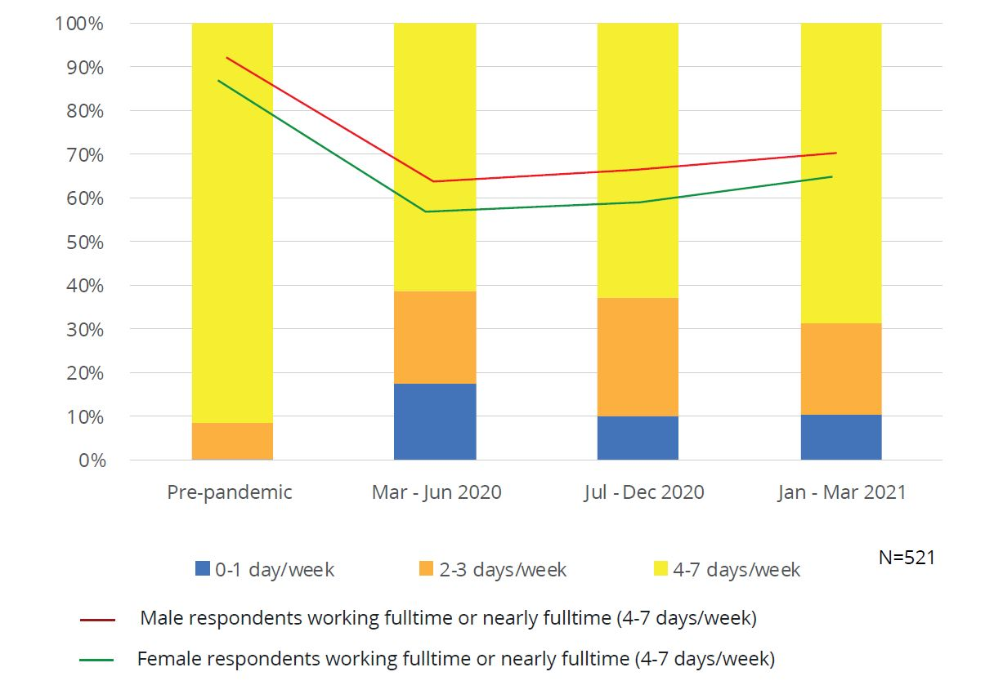

The survey attempted to track significant changes in respondents’ personal income (for those who work) and household income (for all respondents who are aware of, and willing to disclose, their household income). Incomes were asked in monthly averages for each of the following time periods: March-June 2020; July-December 2020; and January-March 2021. Monthly incomes are recorded as: (i) no income; (ii) <Rp 1 million per month; (iii) Rp1–2 million per month; (iv) Rp 2‒4 million per month; and (v) >Rp 4 million per month (Figure 10). Of 521 respondents who work, 494 reported their personal income. Household income was reported by 1,038 out of the total 1,597 respondents. Respondents are considered to have experienced a significant income reduction if their income in at least one period during the pandemic has dropped to a lower bracket compared to their pre-COVID income. Given the relatively wide income bracket options, the survey was only able to capture significant changes in income and smaller changes in income may have gone unobserved.
A significant income reduction was experienced by 37.3 per cent of workers at some point over the course of the pandemic, affecting informal workers more than formal workers (40 per cent and 19 per cent respectively). Within the informal sector, over 50 per cent of small business owners experienced significant income reduction. As shown in Figure 10, the biggest income decline was experienced in the period of March-June 2020, as the proportion of workers having no income or an income less than Rp 1 million per month increased from 28.3 per cent to 48.6 per cent.
In the same period, the proportion of workers earning more than Rp 1 million per month dropped from 71.6 per cent to 51.4 per cent in each income range. The situation improved slightly in the period of July-December 2020 for workers with no income with the proportion of these workers falling to 4.0 per cent before increasing again to 4.9 per cent in January-March 2021. By the end of the survey period in March 2021, the biggest income group was below Rp 1 million/month (44 per cent of respondents). Prior to the outbreak of the pandemic the biggest income group was earning Rp 1-2 million/month (34.2 per cent).
Figure 10: Monthly Income Range of Workers During the Pandemic
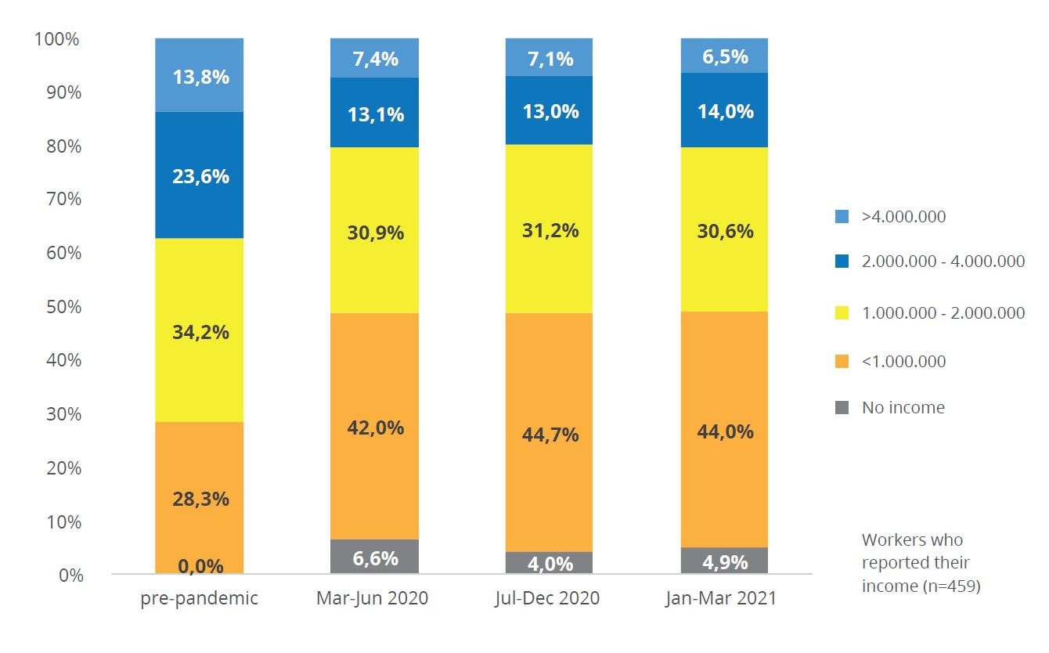
As shown in preceding studies (Satriana et. al. 2021; JPAL 2020), the impact of COVID-19 on the income of people with disabilities tends to be higher compared to people without disabilities due to the types of work involved.
The income effect appeared to be slightly higher among men than women respondents, with 38.5 per cent of men and 34.6 per cent of women experiencing significant income decline. Given the lower baseline income among female workers, however, women still ended up with a lower income during the pandemic.
Figure 11 shows that, before the pandemic, a smaller proportion of female workers earned more than Rp 2 million per month (30.7 per cent) compared to males (40.5 per cent). With the effect of the pandemic, in the period of March-June 2020, 19.9 per cent of female workers earned more than Rp 2 million per month compared to 20.4 per cent among their male counterparts.
Figure 11: Income Level Before the Pandemic and in the Mar-Jun 2020 Period (by Gender)

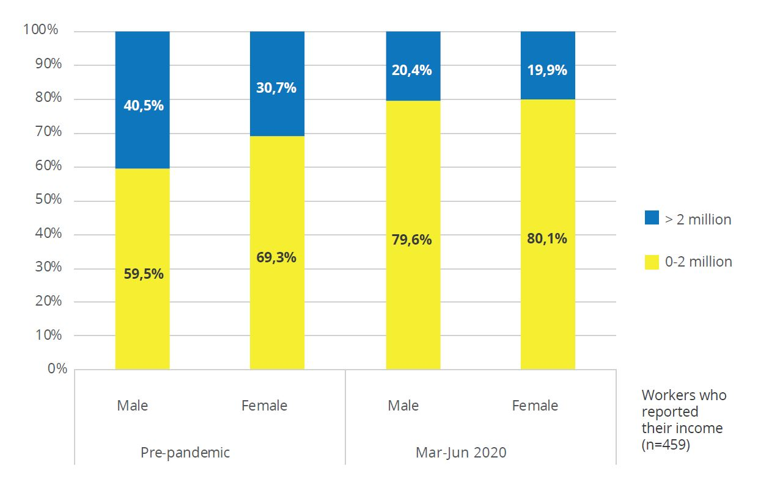
The income decline was significant, as only 16.4 per cent of those who experienced a decline (6.1 per cent of workers) had fully recovered their earnings by March 2021, and another 6.4 per cent (2.4 per cent of workers) had partly recovered their earnings (Figure 12). The remaining 77.2 per cent of those who experienced a decline in earnings (28.8 per cent of all workers) experienced a chronic income reduction that persisted into March 2021. Eight per cent of workers completely lost their income in at least one pandemic period and, as shown in Figure 12, nearly 5 per cent continued to have no income as of the January-March 2021 period.

Figure 12: Workers Experiencing Significant Income Reduction and Income Recovery by the End of the Survey Period

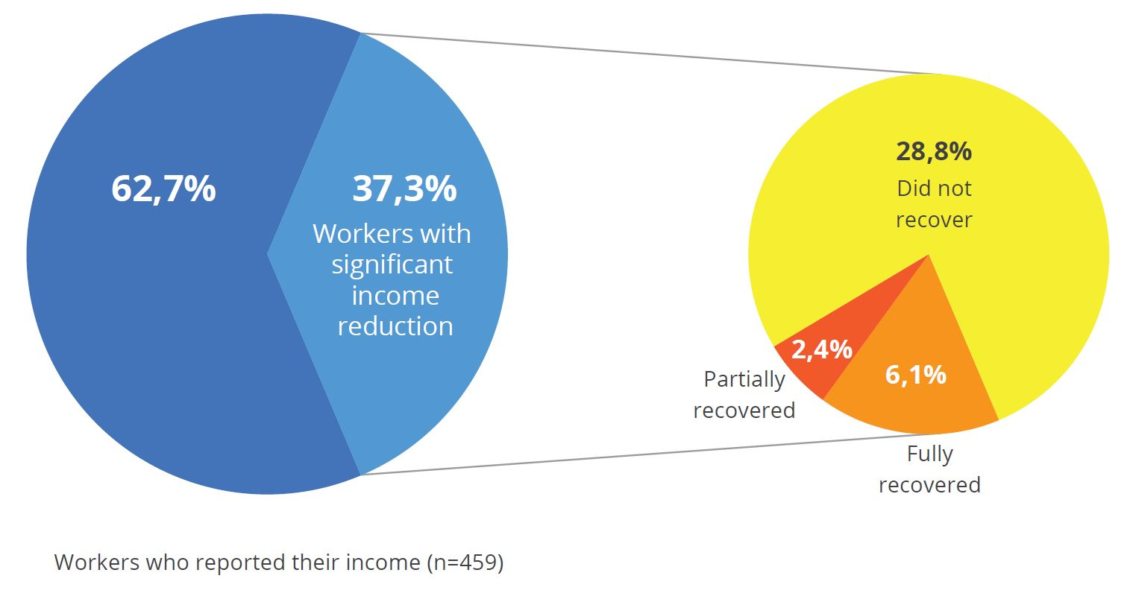

The majority of respondents (85.7 per cent) reported having some degree of difficulty affording basic necessities during the pandemic‒ranging from a little difficulty to not being able to afford necessities at all (Table 1). Such difficulty is associated with a loss in workdays and declines in income levels.
Table 1: Respondents Reporting Difficulty Affording Necessities (by Level of Difficulty)

Tingkat Kesulitan | n | %
Tidak ada kesulitan | 229 | 14,3%
Sedikit Kesulitan | 421 | 26,4%
Cukup Kesulitan | 470 | 29,4%
Banyak Kesulitan | 442 | 27,7%
Tidak mampu | 35 | 2,2%
Total | 1.597 | 100%

Respondents who self-reported household income below Rp 1 million per month had the most difficulty in affording basic necessities such as food and other daily expenses (Figure 13). As to be expected, more than 70 per cent of respondents who reported significant income reduction also reported having difficulties in affording basic necessities, but it is noteworthy that around 50 per cent of those who did not experience significant income reduction still experienced difficulties in affording basic necessities (Figure 14). This suggests that precarious economic conditions even extended to respondents who were lucky enough to maintain relatively stable income levels over the pandemic period (see Satriana, 2020). It is also important to note the higher costs of living borne by people with disabilities, combined with the already low pre-pandemic income level, which presents additional economic hardship in times of crisis and beyond (see Satriana et.al., 2021).

Figure 13: Difficulty Affording Necessities by Household Income Level (in January-March 2021)
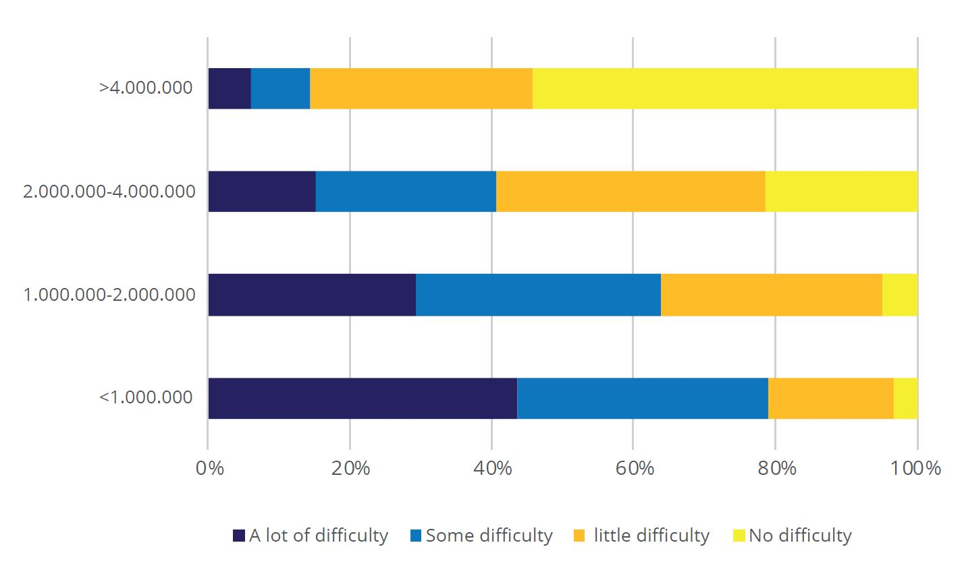
Figure 14: Difficulty Affording Necessities and Income Reduction
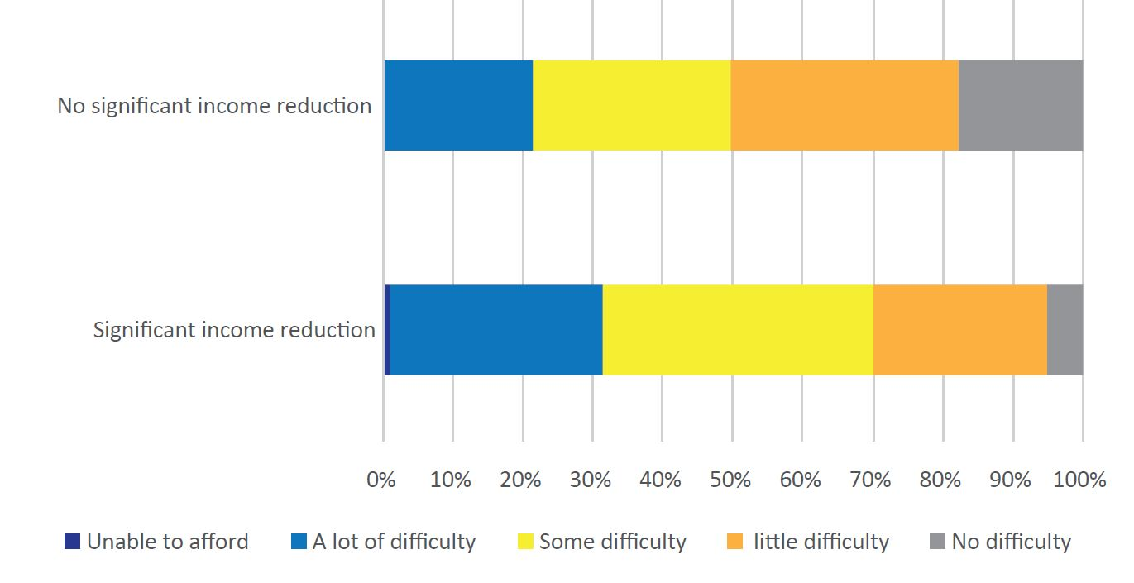

Respondents claimed that assistance from relatives, followed by assistance from the government, provided the most support in coping with these difficulties in affording necessities (Figure 15). Other common coping strategies include reducing consumption withdrawing savings, borrowing, and selling assets.
As addressed in more details in the previous qualitative study (Satriana, et.al., 2021), consumption reduction affects both general consumption such as food, as well as disability-specific expenditure such as therapy and special food supplements. While reducing consumption was a common coping mechanism among everyone who had difficulty in buying necessities, withdrawing savings was more common among those experiencing little difficulty.
This could be because those who experience a lot of difficulty in affording basic necessities are likely in worse financial situation and no longer had savings to draw on. Borrowing and selling assets were strategies used by a smaller number of respondents, mostly those having a lot of difficulties affording food, which show that these methods serve as the last resort. These findings are consistent with the results of our previous quantitative assessment.
Figure 15: Coping Strategies Among Respondents Who Faced Difficulty Affording Necessities
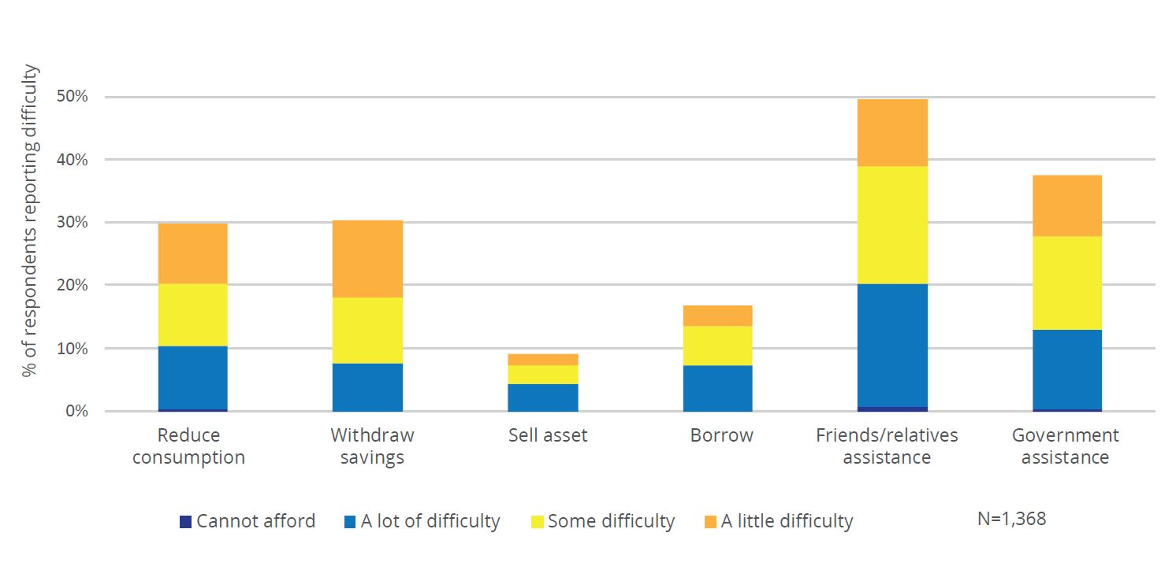

COVID-19 Impacts on Access to Services for People with Disabilities

Most respondents experienced service disruptions during the pandemic which further limited their access to health care, disability assistants, and assistive devices (Figure 16). Reasons for service interruptions include demand side (such as lower affordability as incomes decline) and supply-side factors (closure/limitation of health facilities, unavailability of disability assistants due to contact restrictions), as well as not being able to get help from other people due to physical distancing.
Among respondents who regularly use health services, more than 60 per cent experienced difficulties accessing health services during the pandemic. Around 7 per cent reported that they were not able to obtain any services at all (Figure 16). Around 10 per cent of respondents who regularly use health services reported that their health providers had to close or stop providing the services they need at some point during the pandemic (Figure 17).
Access to disability assistants has also been interrupted, as physical distancing requirements mean many assistants were no longer able or willing to work during the pandemic. Much of the work of disability assistants requires close contact with the people they work with‒putting both clients and assistants at risk of COVID-19 exposure. More than 65 per cent of respondents who need disability assistants reported that they experienced difficulties getting the service, with nearly 10 per cent reporting it was not possible at all (Figure 16). When asked about the reason for such difficulty, 19 per cent mentioned that the disability assistant stopped working due to the pandemic (Figure 17).

Figure 16: Level of Difficulty Accessing Services by People with Disabilities During the Pandemic
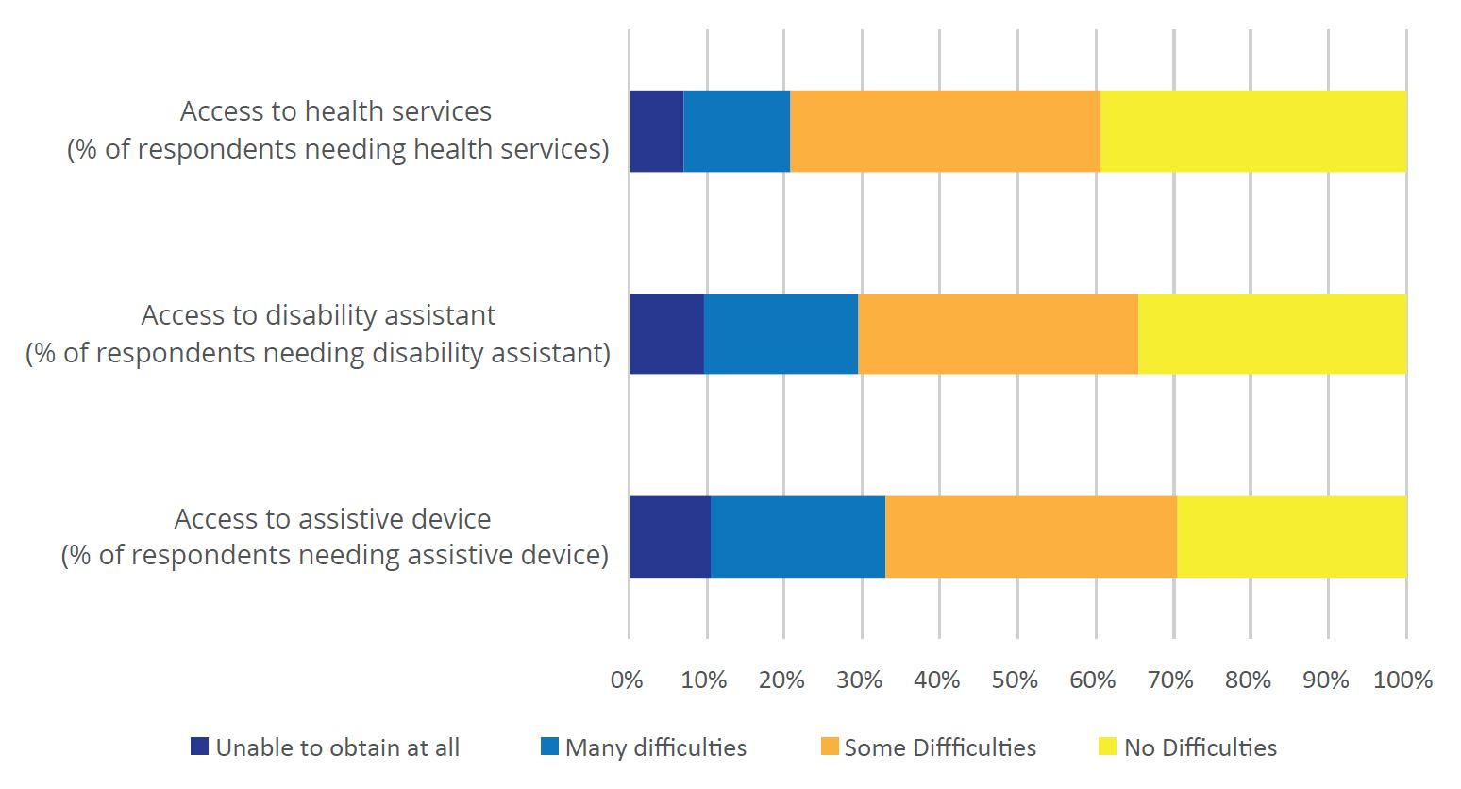
Figure 17: Reasons for Disruptions in Accessing Services During the Pandemic
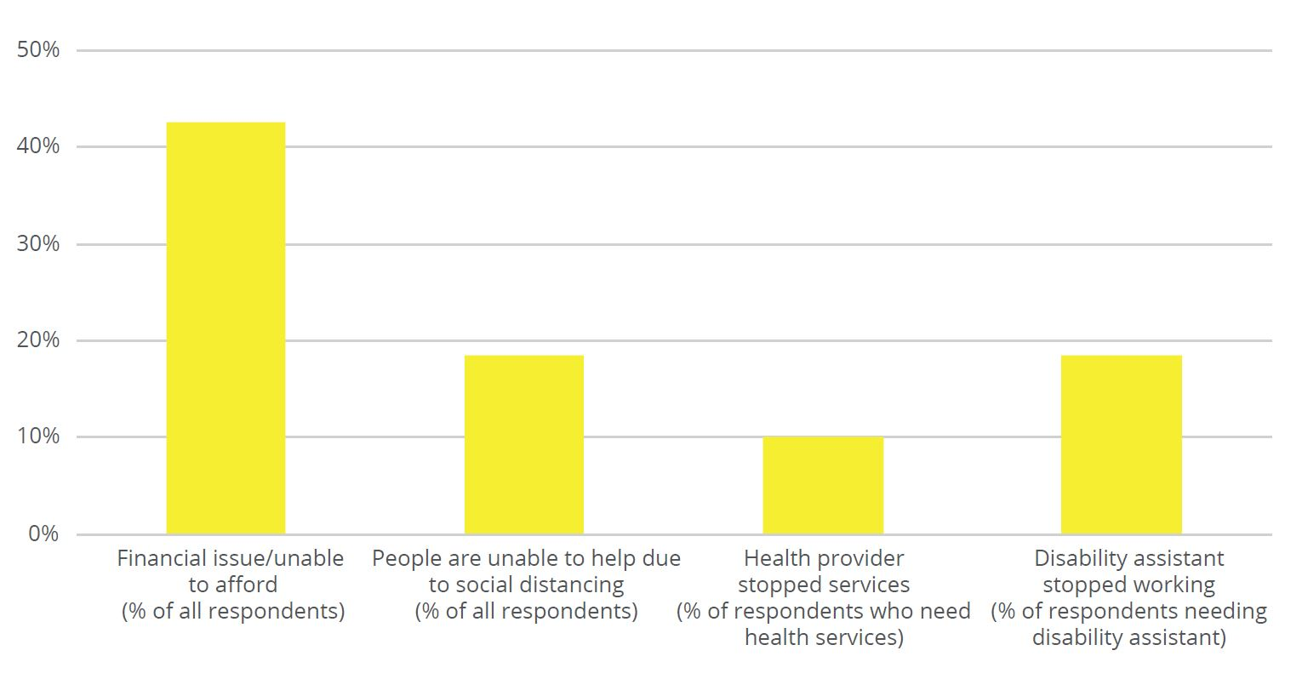

Access to assistive devices for people with disabilities had been limited even before the pandemic and appeared to worsen during the pandemic. Around one-half (50.5 per cent) of respondents reported that they need assistive devices to perform daily activities, however, many do not have the assistive device that they need and, therefore, cannot perform their daily activities optimally. For instance, 182 respondents need a wheelchair to perform daily activities, but only 124 respondents have access to a wheelchair (68 per cent).
Furthermore, only 35 per cent of respondents who need hearing aids have one. The number of people actually using the assistive devices they need is even smaller, as some respondents reported to own devices that are outdated, broken, or do not fit well (Figure 18).
The most common reason for not having an assistive device is lack of affordability and availability of the devices (even before the pandemic), a situation that has worsened during the pandemic. Forty-two per cent of respondents who need an assistive device said it is too expensive, and 12 percent mentioned that the device needed is not available in their area (Figure 19).
The limited access to assistive device has been further heightened by the pandemic as income dropped (thus affordability also dropped) and as discussed in Section 6 below, provision of assistive devices through social protection programs appeared to have been reduced during the pandemic due to interruptions in program activities.

Figure 18: Ownership of Assistive Devices Among Respondents Needed to Perform Daily Activities
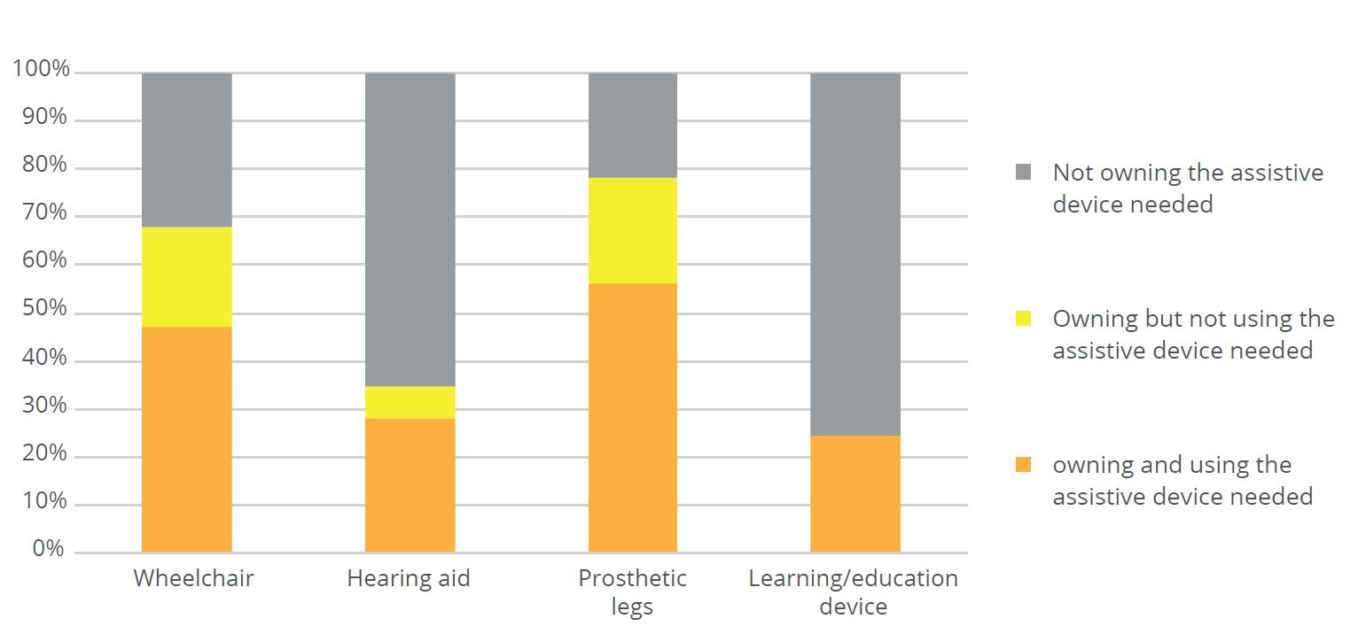
Figure 19: Reasons for Not Owning or Using Assistive Device
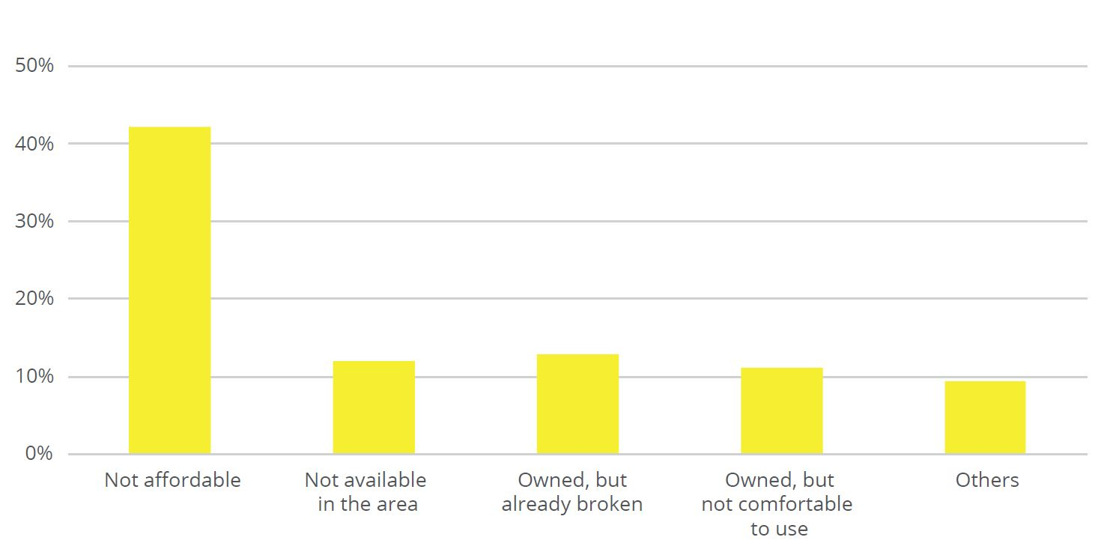

Access to Education for People with Disabilities During the Pandemic

The COVID-19 pandemic is disproportionately impacting students with disabilities who were already experiencing significant social and educational disadvantages before the pandemic (UNESCO 2020). Susenas 2020 data showed that 31 per cent of children with disabilities between the ages of 13 to 15 dropped out of school‒compared to only 7 per cent of children without a disability in the same age group (BPS 2020). Our survey confirmed that difficulties in participating in education during the pandemic are twofold: (i) issues related to the disability such as lack of accessibility for remote learning as well as unavailability of learning devices and learning assistants; and (ii) reduced affordability as their families are experiencing financial hardships due to the COVID-19 pandemic.
Remote learning mediums because of school closures have been challenging for many students with disabilities. By January-March 2021, one-half of student respondents had some difficulties, many difficulties, or were not able to follow online learning. Another 30 per cent reported having a little difficulty, and only 20 per cent reported not having difficulties. This figure remained consistent compared to the first quantitative survey in April 2020, where 20 per cent of students reporting no difficulties following remote learning (OPD Network for COVID-19 Response, 2020). Students with multiple disabilities found online learning most difficult, with nearly three-quarters reporting some difficulties, a lot of difficulties, or being unable to follow remote learning activities (Figure 20). Students with intellectual disability and those with hearing impairments were also reporting high level of difficulties, with more than half reporting some difficulties, a lot of difficulties, or being unable to follow remote learning activities. As previously shown in Figure 6, respondents with multiple disability and intellectual disability already face the most barriers to education even before the pandemic, so further disruptions in their participation in education will put them in a very disadvantaged situation. Students with physical disability and those with visual impairment appear to have been less impacted, although in both groups the proportion reporting some difficulties, many difficulties, and not being able to follow remote learning was still above 40 per cent.

Figure 20: Level of Difficulty Following Remote Learning Among Student Respondents (by Type of Disability)
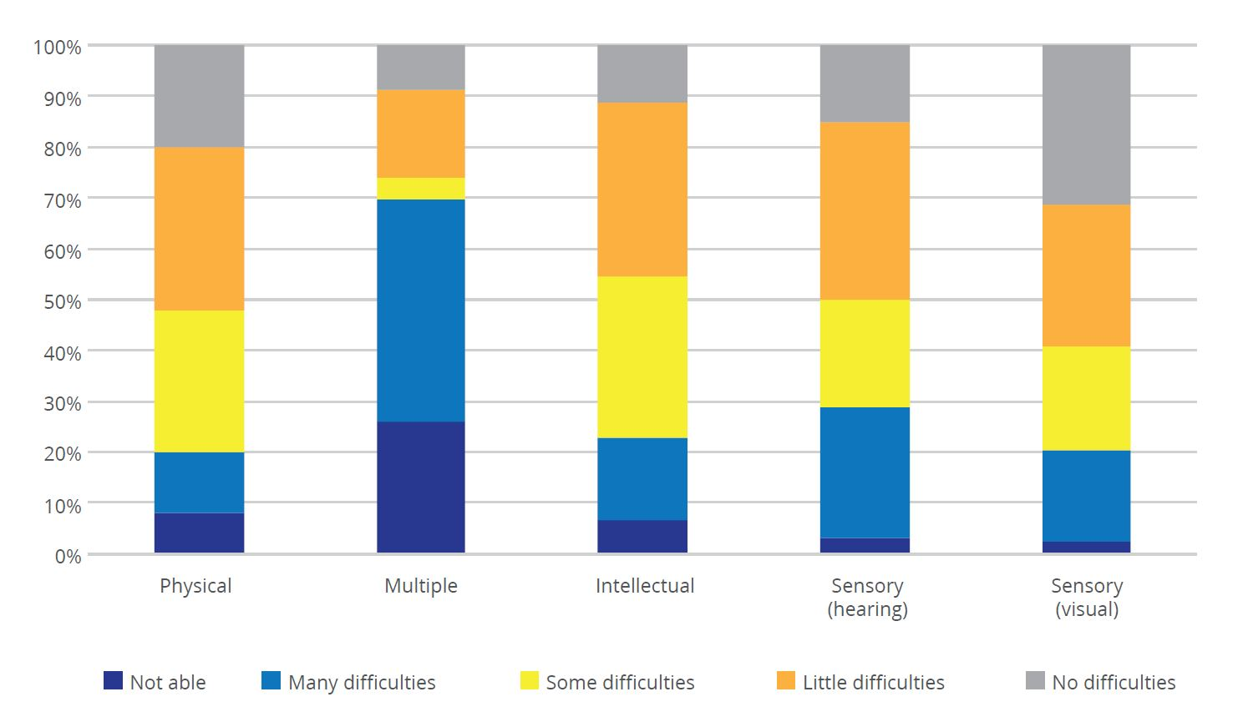

The biggest barriers to following remote learning, as shown in Figure 21, include limited equipment/technology (51 per cent), limited access to learning materials such as textbooks, online tutorials and video instructions (42 per cent) and difficulty understanding teachers’ presentation (41 per cent).
Figure 21: Reasons for Difficulties in Following Remote Learning for Student Respondents
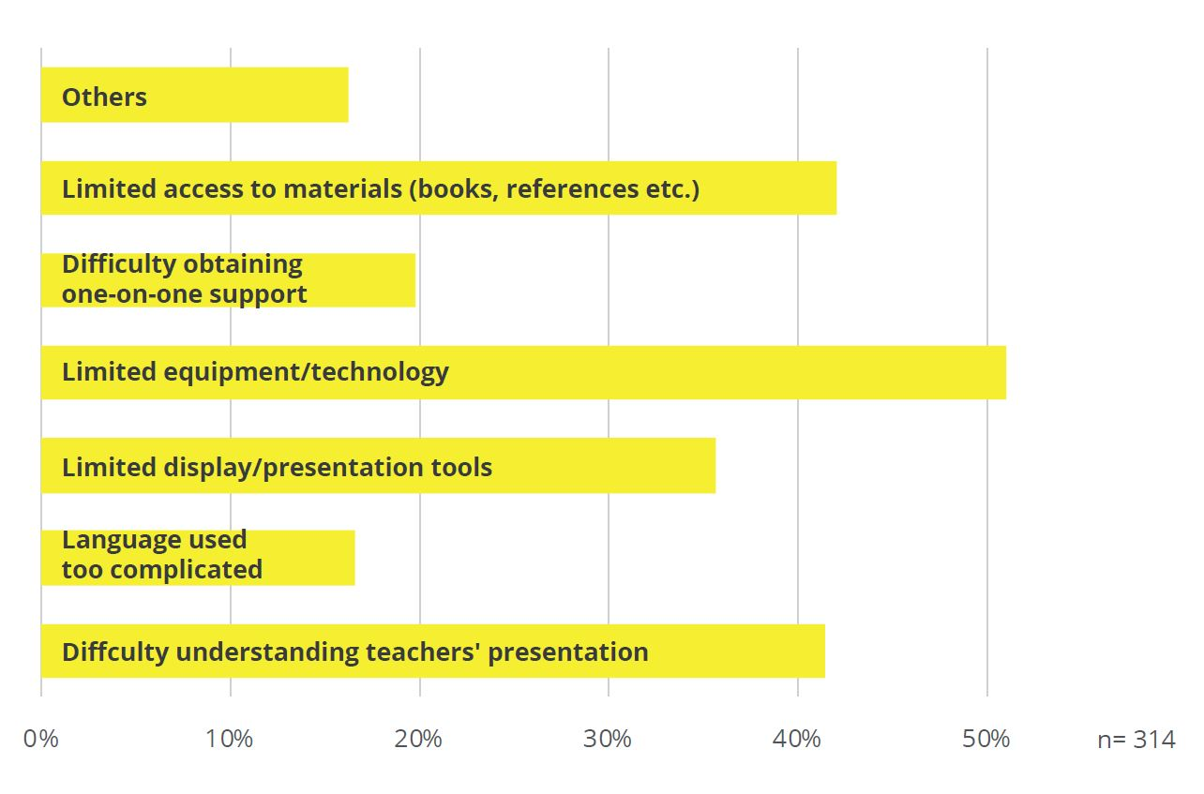
Although adoption of information and communication technology had generally increased since the start of the pandemic, students with disabilities are still facing multiple barriers and progress has not been equal across students with different types of disability. Figure 22 shows that the proportion of students who often or always used digital meeting platforms for education purposes increased from 15 per cent before the pandemic to around 40 per cent during the pandemic. While this shows progress, the figure also shows that by January-March 2021, 30 per cent of students with disability never used such technology for education activities and another 30 per cent used it only rarely. Progress in the use of digital communication is particularly slow among students with intellectual disability and multiple disability (Figure 23).

Figure 22: Use of Digital Learning Platforms Among Students with Disability
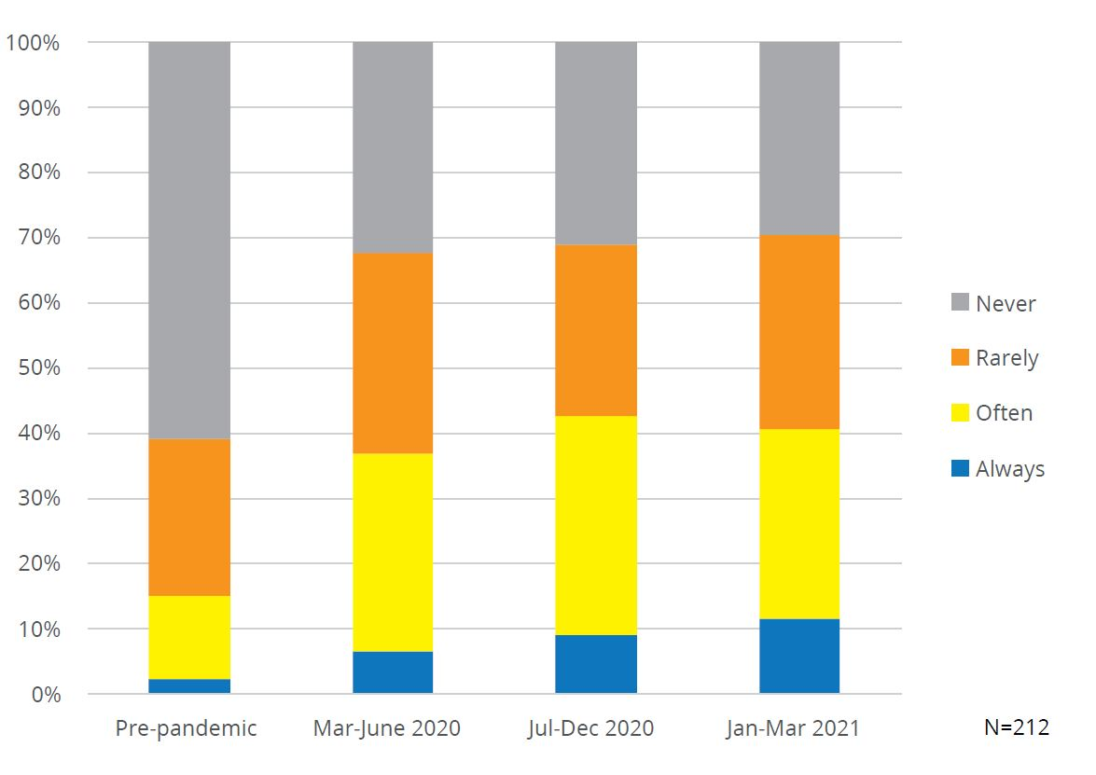
Figure 23: Changes in the Use of Digital Learning Platforms for Students (by Type of Disability)
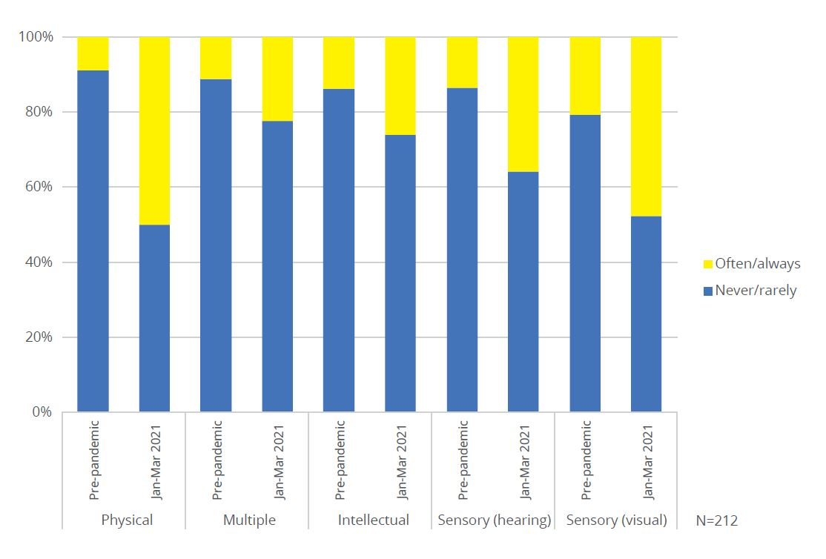
The pandemic has also worsened students’ access to education through economic hardship and unavailability of other services. From a monetary perspective, there has been an increase in the level of difficulties in affording tuition fees or school supplies since the pandemic (Figure 24). Furthermore, as a result of physical distancing and movement restrictions, students who need learning assistants to participate in education have found it more difficult to get such services (Figure 25).

Figure 24: Level of Difficulty Affording Tuition Fees and School Supplies
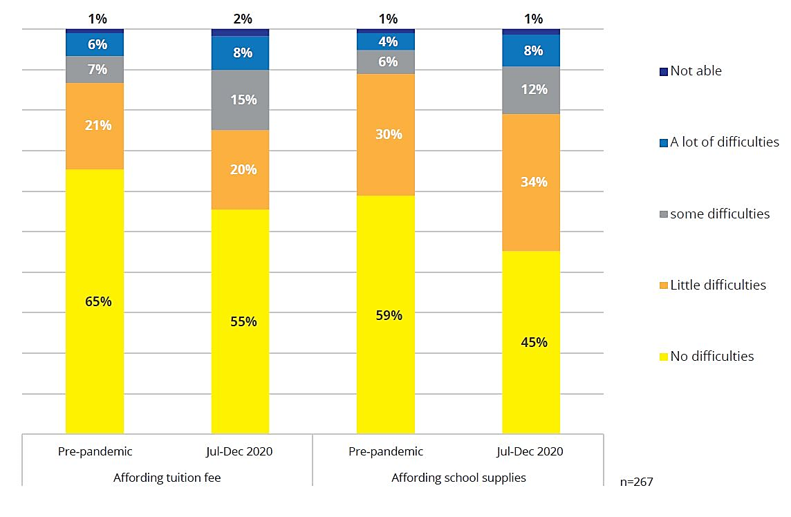
Figure 25: Level of Difficulty Engaging Learning Assistant
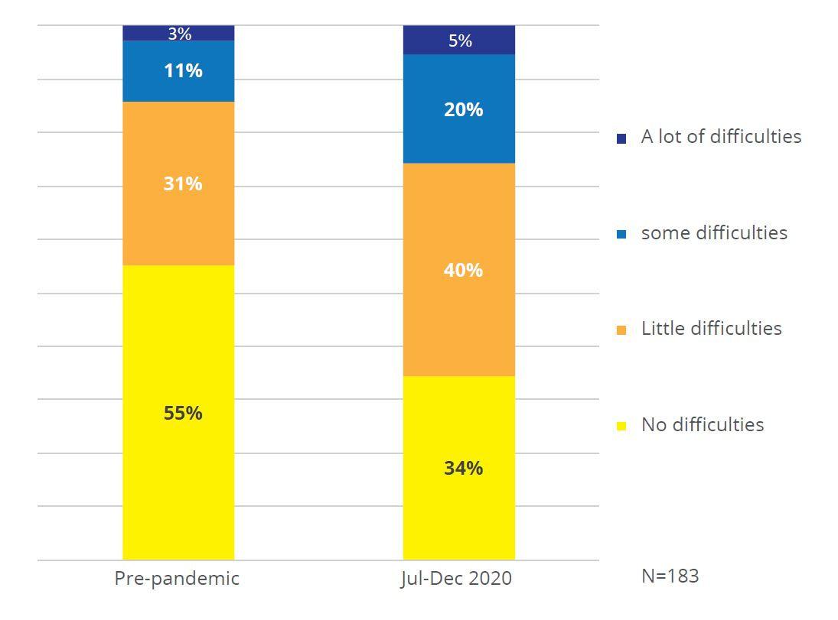

Social Protection Coverage in the COVID-19 Pandemic
Despite their high vulnerability, before the pandemic, people with disabilities in Indonesia have received little social protection from the national government. Prior to the pandemic, social protection programs targeted to people with disabilities covered only 5 per cent of people with severe disabilities, leaving the vast majority without protection. Regular social assistance for people with disabilities mainly consists of two cash transfer programs–Social Assistance for People with Disabilities (Asistensi Sosial Penyandang Disabilitas: ASPD), Family Hope Program (Program Keluarga Harapan: PKH), and social insurance schemes for workers under the Social Security Agency for Employment (Badan Penyelenggara Jaminan Sosial Ketenagakerjaan: BPJS-TK) Program. In addition to the limited coverage, the benefits received for people with disabilities are relatively low, particularly when given the extra costs related to disability (See Satriana et.al., 2021).
In response to the crisis, the national government introduced a set of COVID-19 social protection policies consisting of new programs as well as regular social protection programs that have been expanded vertically (with additional new beneficiaries) and horizontally (with top-up benefit amounts) during the COVID-19 crisis. The social assistance and employment programs that Indonesia has rolled out in response to the COVID-19 crisis (as of February 2021), is available in annex 1.
Social protection coverage for people with disabilities increased significantly with the implementation of COVID-19 social protection responses. While only 28 per cent of respondents reported receiving at least one of the main government social protection programs before the pandemic, the proportion increased to 48 per cent during the pandemic. The main government programs included in the survey are those listed in Figure 26. The periods of social protection receipt covered in this analysis are: (i) before the pandemic; (ii) March-June 2020; and (iii) July-December 2020.
Coverage of social protection programs had nearly doubled between the period before the pandemic and the period of July-December 2020. This is mainly due to the launch of new COVID-19 social protection programs including: (i) Cash Transfers (Bantuan Sosial Tunai: BST); (ii) Cash Transfers from the Village Fund (Bantuan Langsung Tunai - Dana Desa: BLT-DD); (iii) phone/internet subsidy for students; (iv) Prakerja job-seeker program; (v) wage subsidy for formal workers through the social insurance program Badan Penyelenggara Jaminan Sosial Ketenagakerjaan (BPJS-TK); (vi) small business subsidy; and (vii) credit payment deferral (Figure 26).
The rapid expansion of existing social protection programs also led to a significant increase of coverage among people with disabilities. These included the Program Sembako food voucher program (previously BPNT) and electricity subsidy which were previously available to a much smaller number of households in the Data Terpadu Kesejahteraan Sosial (DTKS) national poverty registry. Social protection coverage among respondents was highest in the period of July-December 2020. While most COVID-19 programs started in the period of March-June 2020, many of them gradually progressed only to reach their maximum target beneficiaries in the period of July-December 2020. Other programs, such as the BPJS-TK wage subsidy, only started in the period of July-December 2020.
Figure 26: Number of Respondents Reporting Receipt of Government Social Protection Programs
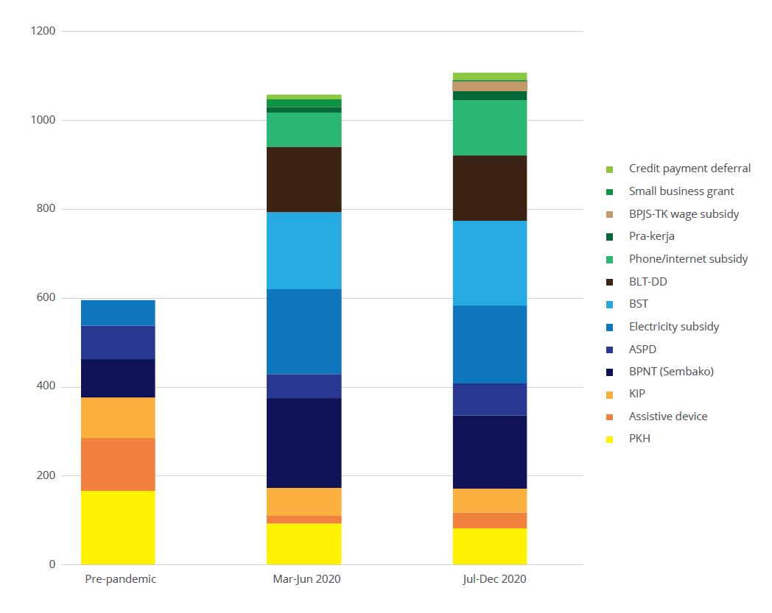

Programs with the highest coverage among people with disabilities during July-December 2020 include BST (12 per cent), electricity subsidy (11 per cent), and Program Sembako (10.3 per cent) (Figure 27). Prakerja, credit payment deferral, and small business grants provide the smallest coverage at 1.3 per cent, 1 per cent, and 0.2 per cent respectively. The composition of the biggest programs was slightly different from the programs’ coverage in the general population where Program Sembako has the biggest coverage of 20 million households, followed by the Family Hope Program (Program Keluarga Harapan: PKH) with 10 million households and BST with 9 million households.
As found in our previous qualitative study (Satriana et al. 2021), BST is likely to be higher among people with disabilities because it had a special allocation for people with disabilities by using the Ministry of Social Affairs’ (MoSA) disability registry (SIMPD). On the other hand, employment-related programs such as Prakerja, credit payment deferral, and small business grants had very low coverage among people with disabilities. Lower coverage may be partly explained by the low number of people with disabilities in the labour market. However, even among people with disabilities in the labour market, the programs are not well known as they lack an outreach and communication strategy to reach workers with disability (Satriana et al. 2021). Given the high proportion of workers with disabilities who run small businesses (see section 2 above), receipt of business supports during the pandemic has been low.

Figure 27: Coverage of Main Government Social Protection Programs for People with Disabilities (July-December 2020)
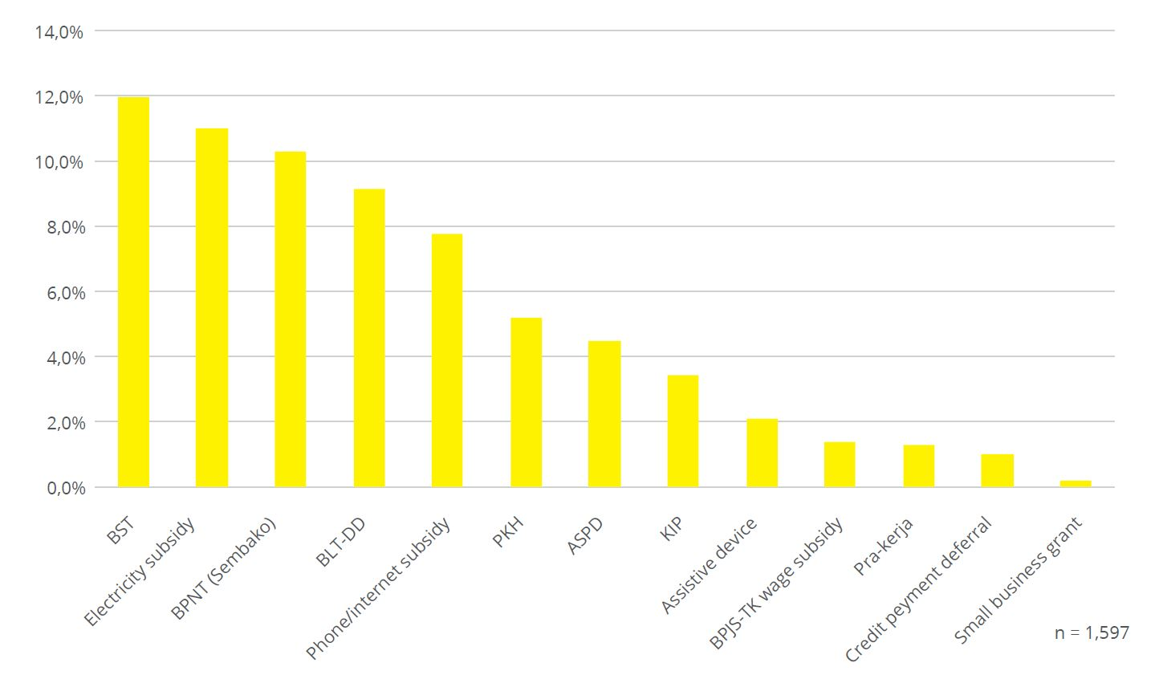
The number of beneficiaries of Program Sembako among respondents had more than doubled‒from 87 respondents (5.4 per cent) before the pandemic to 202 respondents (12.6 per cent) in the period of March to June 2020. Recipients of electricity subsidy had more than tripled from 57 respondents (3.6 per cent) to 191 respondents (12 per cent) in the same time frame (Figure 28).
Regular social protection programs for people with disabilities, however, has not increased in their coverage as much. These include PKH conditional cash transfer, ASPD cash transfer for people with disabilities, and provision of assistive device assistance from MoSA (Figure 28).
The number of respondents receiving assistive device assistance went down from 120 (8 per cent) before the pandemic to just 18 respondents (1 per cent) in March-June 2020 and 34 respondents (2 per cent) in July-December 2020. Assistive device provision was interrupted during the pandemic due to movement restriction, reduced contacts between social workers or staff of social welfare departments with people with disabilities, as well as reprioritisation of programs, as financial and human resources were redirected to support COVID-19 responses. Consistent with our findings, provision of assistive devices from MoSA in 2020 dropped to just over one-tenth of the provision in 2019.
Although PKH increased its overall number of beneficiaries during the pandemic, this expansion was not inclusive of elderly and people with a disability. The reduction of people with a disability benefiting from PKH can be partially explained by a government policy introduced at the beginning of 2020 that limited the number of elderly and people with disabilities to a maximum of one person per family. Prior to this policy revision, PKH families received an additional Rp 200,000 per month for each household member with a disability, with no caps in place. At the national level, this policy change has resulted in 6,641 fewer people with disabilities benefiting from PKH, or 6.1 per cent of PKH recipients in the disability category and 2,084,801 fewer elderly people or 65.6 per cent in the elderly category (PKAKN 2020).
ASPD did not experience an overall reduction in beneficiaries, but internal management and implementation issues caused significant fluctuations in the number of beneficiaries over the survey periods. While 75 respondents (5 per cent) reported to have received ASPD before the pandemic, the number went down to 54 respondents (3 per cent) for March-June 2020, and back to up to 72 respondents (5 per cent) in the July-December period (Figure 28). The fluctuation was due to changes in the program structure and disbursement mechanism in 2019-2020 that caused delays and disruptions in beneficiaries receiving their benefits. In 2019 ASPD was managed by the Directorate of Social Rehabilitation of People with Disabilities, and in 2020 this role shifted to the Center for Vocational Rehabilitation of People with Disabilities (BBRVBD) in Cibinong. The transition also entails changes in the data management system (MoSA 2019; MoSA 2020; TNP2K 2020). While the number of beneficiaries may have remained the same, these transition challenges resulted in transfers being unpredictable and unreliable during a difficult period.

Figure 28: Number of Respondent who Receive Regular Social Protection Programs (Various Periods)
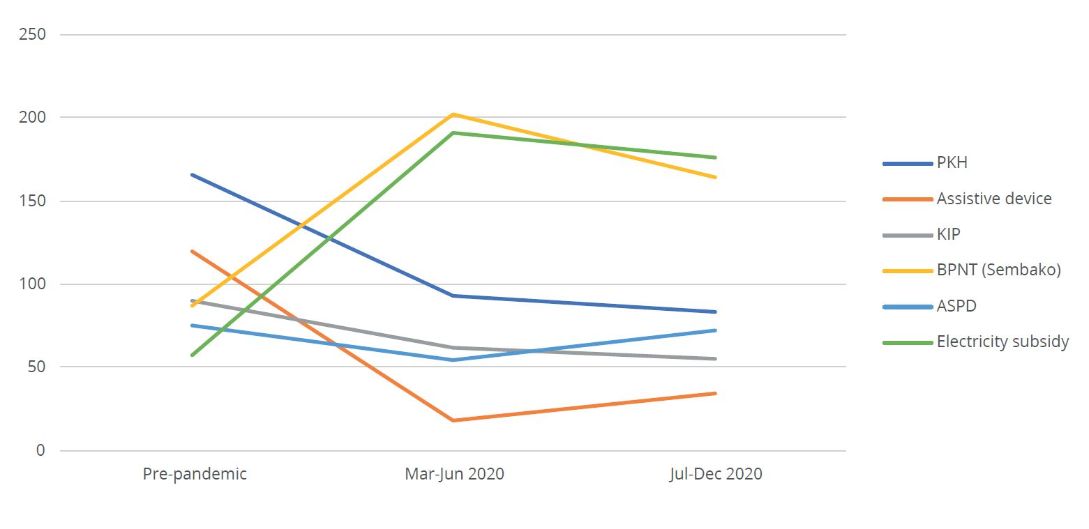
Figure 29: Number of Respondent who Receive COVID-19 Social Protection Programs (in the period of March-June 2020 and July-December 2020)
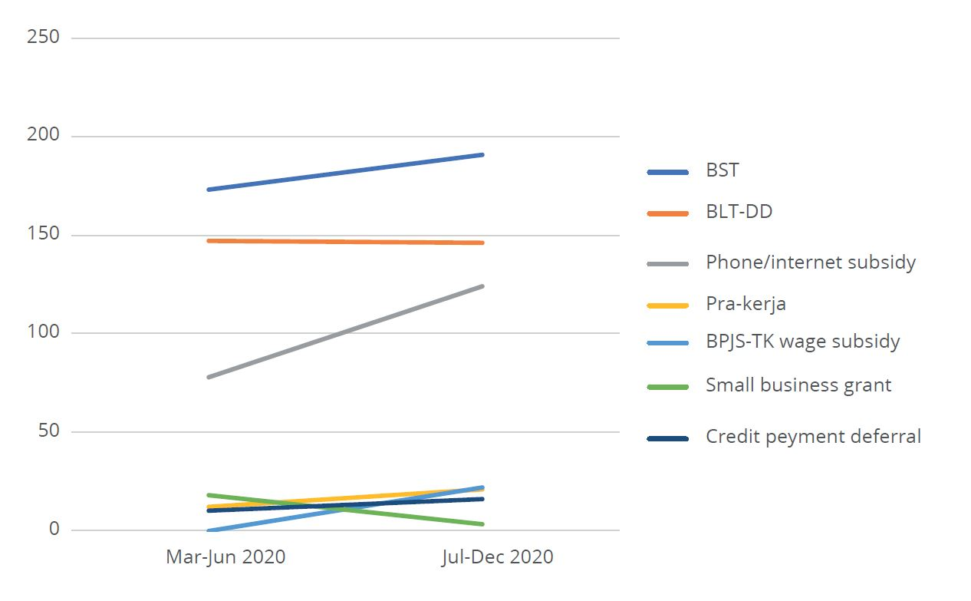

The main government social protection programs during the pandemic are more likely to be received by respondents with lower income level and respondents who experienced a significant income drop. Some 76 per cent of workers who had zero income in the period of March–June 2020 benefitted from at least one social protection program, compared to 44 per cent among those earning more than Rp 4 million per month in the same period (Figure 30). Similarly, workers who reported a significant income drop were more likely to benefit from at least one of the programs (at 68 per cent) compared to workers who did not report a significant income drop (53 per cent). This, however, implies there is still a notable gap among the poorest and those most economically affected by the crisis. With 68 per cent of workers who reported a significant income drop receiving, the remaining 32 per cent were without such assistance.

Figure 30: Beneficiaries of Main Government Social Protection Programs by Income Level (March-June 2020)
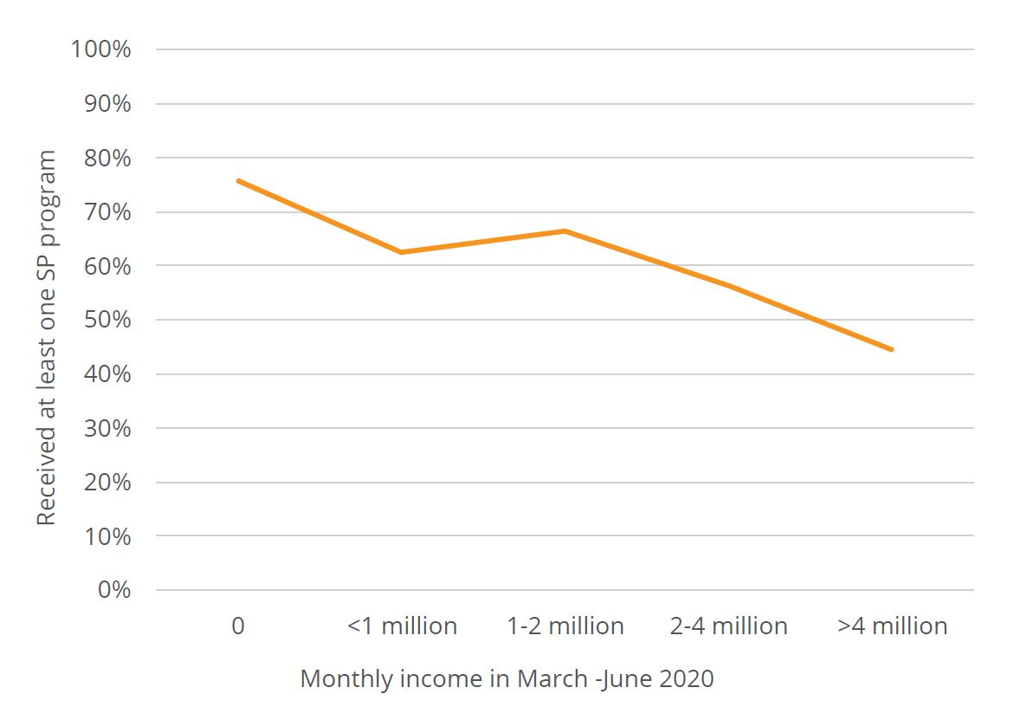
Figure 31: Proportion of Workers With/Without Social Protection (by Income Change)
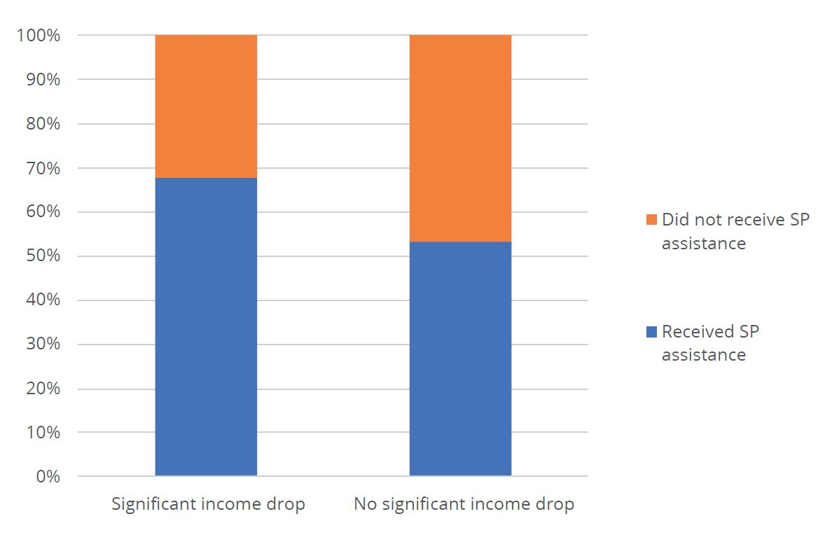
When beneficiaries experience benefit deductions, they very rarely file complaints through official channels. Thirty-six respondents, or around three per cent of those receiving social protection programs (both cash and in-kind assistance), received lower than the official amount of benefits. Some of them stated that the value or quality (especially of food assistance) received was lower than what was stated in the program. Another group had to pay costs at the time of disbursement for “transport or logistics cost”; “organisers’ fee”; “admin fee” or costs to have other people withdraw the benefit on their behalf. Almost all these respondents did not do anything about the situation even though some were shocked or very disappointed. Only one respondent officially reported the irregularity to the community leader (Ketua RT).

Conclusion

Most people with disabilities are engaged in informal employment and have experienced significant declines in income since the pandemic. Most survey respondents are engaged in casual labour and running small businesses. These income generating opportunities were severely impacted over the course of the past year, resulting in approximately 37 per cent of respondents experiencing a significant decline in income.
This economic decline has left 86 per cent of respondents with some degree of difficulty in purchasing basic needs. This highlights the critical role of social protection in enabling people with disabilities to stabilise their consumption and avoid precarious crisis-coping methods, such as withdrawing savings and reducing food consumption.
Limited access to health services, assistive devices, and disability assistants posed a considerable challenge for respondents during the pandemic. The closure of health facilities, social distancing restrictions, and reduced income have made access to critical support services even more difficult for people with disabilities.
Online learning (due to school closures) proved to be particularly challenging for most in-school respondents. Students with multiple disabilities, intellectual disabilities, and hearing impairments experienced the greatest difficulties. They attribute this to limited access to technological devices/internet, books and other study materials, and inability to understand teachers’ presentations.
Social protection coverage for people with disabilities increased significantly with the implementation of COVID-19 economic response programs. Since the pandemic, 48 per cent of respondents benefited from at least one of the main government social protection programs (as compared to only 28 per cent prior to the pandemic). Programs with the highest coverage among people with disabilities include BST (12 per cent), electricity subsidy (11 per cent) and Program Sembako (10.3 per cent). Coverage of other mainstream social protection programs (such as PKH and ASPD) declined or stagnated, however, over the course of the pandemic period.
Mainstream social protection programs were more likely to be received by respondents who experienced job loss, as well as those who experienced significant drops in their income (76 per cent and 68 per cent respectively). One-third (32 per cent) of workers who experienced economic decline over the pandemic period did not benefit from any access to social protection.
Grievance systems for social protection schemes are not adequately resourced. The three per cent of respondents who claimed to have been paid lower than the official amount of benefit level, or said they received in-kind support of inadequate quality, did not file official complaints.

Recommendation

The following recommendations are drawn from the learnings gathered in this study and the two preceding studies in the same series (see Satriana, 2020 and Satriana et al, 2021)
Recommendation 1: Strengthen access to formal employment and vocational training for people with disabilities
Given the precarious nature of informal employment, measures should be taken to improve access to formal sector jobs for people with disabilities. Providing adequate access to vocational training (with cash benefit to offset individuals for their time investment in gaining a new skill) with certification is urgently needed to help people re-enter into a post-COVID-19 economy.
Recommendation 2: Continue to expand community-based care to improve access to health services, and improve provision of assistive devices through the National Health Insurance scheme (Jaminan Kesehatan Nasional: JKN)
Given the breakdown in health care access because of the pandemic, it is critical to learn from CBR models to progressively develop a range of community rehabilitation services that provide support in the community in a flexible and responsive manner. With a functioning CBR, health care institutions can become more of a resource centre than primary provider. In addition, access to therapy and assistive devices should be made more accessible in the JKN package, including by reducing cost-sharing requirements.
Recommendation 3: Address barriers to remote learning for students with disabilities
In line with the Ministry of Education’s policies, all teachers should receive training and clear guidelines on how to support children with disabilities in remote learning environments. The ministry should also ensure, at the minimum, the availability of internet data, accessible technology (for example, learning applications that are accessible for different types of disability), as well as psychosocial support in remote learning contexts.
Recommendation 4: Strengthen social protection systems (especially access to cash transfer programs) for people with disabilities
The significant economic declines that respondents were faced with during the pandemic highlights the need for improved access to social protection for people with disabilities. This can be achieved through various strategies:
- For existing national programs such as ASPD and PKH, increase benefit levels and beneficiary coverage. For ASPD, this would require reverting to the 2019 benefit level of Rp 3.6 million per year. For PKH, an increase in the coverage of people with disabilities could be achieved by removing program limitations of only one person with a disability per household being entitled to the program.
- Strengthen outreach and communications campaigns for social protection programs so that people with disabilities are aware of the programs they are eligible for and how to enrol for them. This includes providing information that is more accessible for people with different types of disabilities. Engaging Organisations for People with Disabilities (OPDs) could make communication strategies much more effective.
- Introduce a new disability cash transfer for people with severe disability. This would help to meet the high costs of disability on a sustainable basis.
- Improve social protection grievance mechanisms so that beneficiaries have a safe and reliable channel to launch appeals and complaints and improve accessible information regarding these mechanisms. Aside from complaint mechanisms within individual programs, other platforms to channel complaints related to government programs are currently available at the national level including Ombudsman Republik Indonesia (ORI) and LAPOR. However, the survey did not find that these mechanisms were utilized by respondents who experienced deductions. There needs to be more socialization of these mechanisms, using more accessible means of communication for people with disabilities.

References

Badan Nasional Penanggulangan bencana (BNPB). 2020. Keputusan Kepala BNPB No. 9A tahun 2020 mengenai Penetapan status keadaan darurat bencana wabah penyakit akibat virus corona
BPS. 2020. Potret Pendidikan Indonesia: Statistik Pendidikan 2020 (A Portrait of Indonesian Education: Education Statistics 2020). Jakarta: BPS.
BPS. 2021a. BPS: 270,20 juta Penduduk Indonesia Hasil SP2020 (BPS: The Population Census of 2020 Determines Indonesia’s Population at 270.2 million). Jakarta: BPS.
BPS. 2021b. Februari 2021: Tingkat Pengangguran Terbuka (TPT) sebesar 6,26 persen. (February 2021: Open Unemployment Rate of 6.26 per cent). Jakarta: BPS.
J-PAL. 2020. “Online Survey on Economic Impact of Covid-19 in Indonesia: Results for People with Disabilities.” Microsoft PowerPoint. J-PAL Southeast Asia (J-PAL SEA).
Katadata. 2021. 99% Penduduk telah Melakukan Perekaman KTP Elektronik (99% of the Population Registered for an Electronic KTP).
Kompas. 2021. Kemendagri: Kepemilikan Akta Kelahiran Anak pada 2020 Capai 93,78 Persen. 9 Februari 2021. (Ministry of Home Affairs: Ownership of Birth Certificates by Children in 2020 Reaches 93.78 per cent).
MOHA. 2021. Jumlah Anak Usia 0 sampai 18 tahun yang Memiliki Akta Kelahiran Sudah Mencapai 93,53 persen (November 2020). Dirjen Dukcapil.
MoSA. 2019. Buku Saku Penyaluran Bantuan Sosial Nontunai ASPD 2019 (ASPD 2019 Non-cash Social Assistance Disbursement Pocketbook). Jakarta: MoSA.
MoSA. 2020. Petunjuk Pelaksanaan Bantuan Sosial Nontunai ASPD 2020 (ASPD 2020 Non-cash Social Assistance Implementation Guidelines). Jakarta: MoSA.
OPD Network for Inclusive COVID-19 Response. 2020. Yang Bergerak dan Yang Terdampak di Masa Pandemi: Suara Disabilitas dari Indonesia: Suara Disabilitas dari Indonesia: Laporan Asesmen Cepat Dampak Covid-19 bagi Penyandang Disabilitas (Those Affected and Impacted During the Pandemic: The Voice of People With Disabilities from Indonesia: Rapid Assessment Report on the Impact of Covid-19 for People With Disabilities).
Pusat Kajian Akuntabilitas Keuangan Negara (PKAKN) Badan Keahlian DPR RI (National Research Centre for Financial Accountability Expert Panel DPR RI). 2020. Akuntabilitas Pelaksanaan Program Keluarga Harapan (PKH) Komponen Kesejahteraan Sosial (Lanjut Usia Dan Disabilitas Berat) Di Indonesia (Accountability for the Implementation of the PKH Social Welfare Component (Elderly and People With Severe Disability in Indonesia).
Satriana, S. 2020. “Economic Impacts and Access to Social Protection during the COVID-19 Crisis: The Experiences of People with Disabilities in Indonesia.” Policy Brief 1, August 2020., Jakarta: MAHKOTA and KOMPAK with support of the Australian Government.
Satriana, S., K. Huda, N. Saadah, D. Hidayati, and A. Zulkarnaen. 2021. “Covid-19 Impacts on People with Disabilities in Indonesia: An In-Depth Look.” Jakarta: MAHKOTA and KOMPAK with support of the Australian Government.
TNP2K. 2020. Presentasi Pelaksanaan Bantuan Sosial Bagi Penyandang Disabilitas di Kementerian Sosial. (Presentation on the Implementation of Social Assistance for People with Disabilities at MoSA). Presentation. Unpublished. Jakarta: TNP2K.
United Nations Educational, Scientific and Cultural Organization (UNESCO). 2020. “Including learners with disabilities in Covid-19 education responses.” https://en.unesco.org/news/including-learners-disabilities-covid-19-education-responses

- Program Bantuan Sosial dan Ketenagakerjaan Respons COVID-19 di Indonesia
Program Name | Program Overview | Coverage | Benefits in 2020
Cash Transfer (Bantuan Sosial Tunai: BST) | A new unconditional cash transfer program introduced for eligible residents outside the Greater Jakarta region who have already registered in the social registry but are not recipients of PKH or Program Sembako. | 9 million households (HH) | IDR 600,000/month for 3 months, then IDR 300,000/month
Food transfer for Greater Jakarta residents (Bantuan Sosial Sembako: BSS) | A new in-kind food assistance for Greater Jakarta (Jabodetabek) residents, providing food assistance worth IDR 600,000 in April-June 2020, then Rp 300,000 since July 2020. In 2021 the program was converted to cash transfer. | 1.9 million HH | IDR 600,000/month for 3 months, then IDR 300,000/month
Electricity subsidy for households | Newly launched electricity fee waiver for all households subscribing to 450VA (24 million HH) and partial discounts for households subscribing to 900VA (7.2 million HH), starting in April 2020. | 31.2 million HH | Fee waiver and discounts on electricity use
Cash transfer funded from Village Funds (Bantuan Langsung Tunai Dana Desa: BLT-DD) | A new unconditional cash transfer funded from the village funds, for village residents affected by the crisis but are not registered in the social registry and are not recipients of other programs. Identification of beneficiaries is done through the community consultation forum. | 8 million HH | IDR 600,000/month for 3 months, then Rp 300,000/month
Program Sembako (previously BPNT)
Vertical and horizontal expansion | Program Sembako food assistance program (previously called BPNT), expanded from 15.2 to 20 million low-income households and the benefit level increased from IDR 150,000 to IDR 200,000 (33%) starting April 2020. | 20 million HH | IDR 200,000 per month
PKH
Vertical and horizontal extension | PKH conditional cash transfer expanded from 9.2 to 10 million beneficiary families and double the benefit level for 3 months (April-June 2020). | 10 million HH (800,000 new HH) | Increased benefits by 100% for 3 months
One-off cash top-up for Program Sembako recipients | A one-time unconditional cash transfer of IDR 500,000 was given in September 2020 to Program Sembako beneficiaries who are not receiving PKH. | 9 million HH | IDR 500,000 per HH
Rice for PKH beneficiaries | Additional benefit of 15kg rice/month provided to recipients of PKH program for three months. | 10 million HH | 15 kg of rice Aug-Oct 2020
Electricity subsidy for micro and small enterprises | Newly launched electricity fee waiver for micro/ultra-micro-enterprises subscribing to 450VA (501,000 enterprises) and partial discounts for certain businesses and industries subscribing to 900VA and 1,300VA (1.3 million enterprises). | 501,000 + 1.3 million enterprises | Fee waiver and discounts on electricity use
Cash for work (CFW) programs | The government allocates a total of Rp 16.9 trillion for CFW programs through various ministries and Village Fund projects.
 | More than 589,000 workers | Local daily wage

- Organisasi Penyandang Disabilitas yang Tergabung dalam Jaringan DPO untuk COVID-19 yang Lebih Responsif di Indonesia

- Advokasi inklusi disabilitas (AUDISI Foundation)
- Bandung Independent Living Center (BILiC)
- Center for Improving Qualified Activity in Life of People with Disabilities (CIQAL)
- Difabel Siaga Bencana (DIFAGANA) Kulon Progo
- Disability-Leprosy Advocacy Network
- Disabled Motorcycle Community (DMC) Jakarta
- Dewan Pengurus Cabang Persatuan Tuna Netra Indonesia (DPC PERTUNI) Kabupaten Wonogiri
- Dewan Pengurus Daerah Perkumpulan Penyandang Disabilitas Indonesia (DPD PPDI) Kalimantan Timur
- Dewan Pengurus Daerah Perkumpulan Penyandang Disabilitas Indonesia (DPD PPDI) Kalimantan Timur
- Kelompok Difabel Desa (KDD) Guyub Rukun
- Dewan Pengurus Pusat Persatuan Tuna Netra Indonesia (DPP PERTUNI)
- Dewan Pengurus Pusat Perkumpulan Penyandang Disabilitas Indonesia (DPP PPDI)
- Dewan Pembina Pusat Gerakan untuk Kesejahteraan Tunarungu Indonesia (DPP GERKATIN)
- Forum Komunikasi Difabel Cirebon
- Gerakan Advokasi Transformasi Disabilitas untuk Inklusi (Garamin) Nusa Tenggara Timur
- Gerakan Mandiri (GEMA) Difabel Mamuju
- Gerakan Advokasi Kesetaraan Difabel (Garda) Pati
- Dewan Pembina Daerah Gerakan untuk Kesejahteraan Tunarungu Indonesia (DPD GERKATIN) Sulawesi Tengah
- Human Rights Working Groups (HRWG)
- Himpunan Wanita Disabilitas Indonesia (HWDI) Kota Padang
- Himpunan Wanita Disabilitas Indonesia (HWDI) Maluku
- Himpunan Wanita Disabilitas Indonesia (HWDI) Maluku Utara
- Himpunan Wanita Disabilitas Indonesia (HWDI) NTB
- Himpunan Wanita Disabilitas Indonesia (HWDI) Sulawesi Selatan
- Himpunan Wanita Disabilitas Indonesia (HWDI) Sulawesi Tengah
- Himpunan Wanita Disabilitas Indonesia (HWDI) Sumatera Barat
- Ikatan Difabel Enrekang (IDE) Inklusi, Sulawesi Selatan
- Institut Inklusif Indonesia (I3)
- Jakarta Barrier Free Tourism (JBFT)
- Kampoeng Infinedua Peduli
- Perkumpulan Penyandang Disabilitas Indonesia (PPDI) Kabupaten Semarang
- Kelompok Difabel Desa (KDD) Cahaya Mandiri Desa Ngentakrejo, DIY
- Kelompok Difabel Desa (KDD) Desa Pandowan
- Kelompok Difabel Desa (KDD) Giripeni
- Kelompok Difabel Desa (KDD) Sindutan
- Kelas Volunteer Difabel Jombang
- Kelas Volunter Difabel Kepulauan Bangka Belitung
- Kelas Volunter Difabel Kepulauan Riau
- Komite Penyandang Disabilitas (KIPDA) Timor Tengah Selatan, Nusa Tenggara Timur
- Komunitas Young Voices Indonesia, Nanggroe Aceh Darussalam
- Koperasi Simpan Pinjam (KSP) Bank Difabel Ngaglik
- Lembaga Bantuan Hukum (LBH) Disabilitas Indonesia
- Lingkaran Demokrasi Indonesia (LiDI) Foundation Nusa Tenggara Barat
- Lembaga Penelitian dan Pengabdian Masyarakat (LP2M) Kota Padang
- NewsDifabel
- National Paralympic Committee Indonesia (NPCI) Kabupaten Tegal
- Organisasi Harapan Nusantara (OHANA)
- Organisasi Peserta Didik Intra Sekolah (OPDIS)
- Perhimpunan Dokter Spesialis Kedokteran Fisik dan Rehabilitasi (PERDOSRI)
- Perhimpunan Jiwa Sehat (PJS)
- Paguyuban Sehati Sukoharjo
- Persatuan Kusta Perjuangan Sulawesi Selatan
- Perkumpulan Penyandang Disabilitas Fisik Indonesia (PPDFI) Papua
- Perkumpulan Penyandang Disabilitas Indonesia (PPDI) Bengkulu
- Perkumpulan Penyandang Disabilitas Indonesia (PPDI) Kalimantan Barat
- Perkumpulan Penyandang Disabilitas Indonesia (PPDI) Padang
- Perkumpulan Penyandang Disabilitas Indonesia (PPDI) Sulawesi Tengah
- Forum Belarasa Difabel Nian Sikka (Forsadika) Maumere
- Pelopor Peduli Disabilitas Situbondo (PPDiS)
- Pusat Kajian dan Advokasi Inklusi (PUSKADIN)
- Pusat Layanan Juru Bahasa Isyarat
- Pusat Rehabilitasi Yayasan Kristen untuk Kesehatan Umum (YAKKUM)
- Pusat Studi Hukum dan Kebijakan Indonesia (PSHK)
- Pusat Studi Management Bencana (PSMB) Universitas Pembangunan Nasional
- Pusat Pemberdayaan Penyandang Disabilitas (Puspadi) Bali
- SAMMI Institut
- Sentra Advokasi Perempuan, Difabel dan Anak (SAPDA)
- Yayasan Semai Jiwa Amini (SEJIWA)
- Sasana Inklusi dan Gerakan Advokasi Difabel (SIGAB) Indonesia
- Severe and Profound Impairment Collective Empowerment (SPICE)
- UCP Roda Untuk Kemanusiaan (UCPRUK)
- Wahana Keluarga Cerebral Palsy (WKCP)
- Yayasan Nema Folok, Papua Barat
- Yayasan PerMata Bulukumba
- Yayasan Pergerakan Difabel Indonesia untuk Kesetaraan (PerDIK)
- Yayasan Wahana Inklusif Indonesia
- Pusat Rehabilitasi Bersumber Daya Masyarakat (PPRBM) Solo
- Jaringan Visi Solo Inklusi (JVSI)
- Jaringan Jawa Tengah Inklusi (Jangka Jati)
- Aliansi Rehabilitasi Berbasis Masyarakat (RBM) Indonesia
- Difabel Blora Mustika (DBM) Blora
- Difabel Slawi Mandiri (DSM) Slawi
- Gerakan Difabel Brebes Hebat (G-DEBAT) Brebes
- Forum Komunikasi Difabel Boyolali (FKDB) Boyolali
- Forum Buah Hati Intanpari, Sragen
- Forum Buah Hati Berseri, Solo
- Himpunan Wanita Disabilitas Indonesia (HWDI) Nusa Tenggara Timur
- Himpunan Wanita Disabilitas Indonesia (HWDI) Papua Barat
- Universitas Brawijaya – Australia-Indonesia Disability Research and Advocacy Network (AIDRAN)
- Universitas Negeri Yogyakarta
- Universitas Hasanuddin

- Second Survey Questionnaire: Impact of the COVID-19 Pandemic on Persons with Disabilities

Page 1 Gambaran Umum Survey

Salam sehat dan semangat

Bapak/Ibu/Saudara/I(selanjutnya disingkat B/I/S) yang terhormat, kami, Jaringan Organisasi Penyandang Disabilitas/Difabel Respon Covid Inklusif, saat ini melakukan survei gelombang kedua untuk mengetahui dampak pandemi covid-19 bagi difabel/penyandang disabilitas di Indonesia.

Untuk itu, kami mengundang B/I/S untuk mengisi jawaban atas pertanyaan dalam survei ini.
Survei ini bertujuan memetakan permasalahan dan kebutuhan penyandang disabilitas. Hasil survei ini akan digunakan sebagai dasar advokasi kepada pemerintah dan pihak lainnya untuk memastikan pemenuhan hak-hak penyandang disabilitas pada masa pandemi baik dalam penanganan maupun pemulihannya. Partisipasi B/I/S sangat kami butuhkan.

Dalam survei ini, kami menjunjung tinggi kerahasiaan dan keamanan data yang B/I/S berikan. Kami menggunakan prinsip anonimitas (tanpa nama) dan kerahasiaan informasi, yakni tidak menyebutkan nama B/I/S dalam penulisan laporan maupun dokumen lainnya. Kami sangat berharap B/I/S berkontribusi dalam menyuarakan pemenuhan kebutuhan difabel/penyandang disabilitas pada masa tanggap bencana Covid-19 ini. Pengharagaan setingg-tingginya kami sampaikan atas kesediaan B/I/S. Semoga kita semua selalu sehat dan semangat.

Utuk informasi lebih lanjut mengenai survei tahap ke-2 ini, hasil, serta pemanfaatan informasinya, B/I/S dapat menghubungi:
- Dr. Ishak Salim; Jaringaan DPO Respon Covid Inklusif; No. HP 08124106722/e-mail: isangkilang@gmail.com
- Haris Munandar; Koordinator Pendataan; SIGAB Indonesia; No HP 081802695133/e-mail: haris.munandar@sigab.or.id
- Rahmiatun Nur Khasanah; Asisten Koordinator Pendataan; SIGAB Indonesia; No. HP 089671869992/e-mail: rahmi.khasanah@sigab.or.id

Demikian, terima kasih atas kesediaannya.
Salam Tangguh, salam inklusi.

Atas nama Jaringan Organisasi Pemerhati Disabilitas/Difabel Indonesia

Catatan: * Pertanyaan wajib dijawab

Page 2 Halaman Persetujuan

Saya telah membaca dan memahami maksud dan tujuan serta mekanisme survei ini.

1.* Dengan ini saya menyatakan
□ Bersedia mengikuti survey ini >> Lanjut Page 3
□ Tidak bersedia mengikuti survey ini >> Lanjut Page 68

Page 3 Metode Pengisian Survei

2.* Apa metode yang B/I/S gunakan dalam mengisi survey ini?
□ Dengan enumerator >> Lanjut Page 4
□ Menjawab sendiri >> Lanjut Page 5

Page 4 Informasi Pendataan oleh Enumerator
3.* Kode Wilayah

□ Barat 01
□ Barat 02
□ Barat 03
□ Barat 04
□ Barat 05
□ Tengah 01
□ Tengah 02
□ Tengah 03
□ Tengah 04
□ Timur 01
□ Timur 02

4.* Nomer Responden
5.* Nama Enumerator:

6.* Apa metode wawancara yang digunakan dalam survei ini?
□ Tatap muka langsung dengan dengan hard copy
□ Tatap muka langsung dengan form online
□ Wawancara dengan telepon
□ Lainnya

7.* Mengapa anda menggunakan metode tersebut?

□ Terkendalan jaringan internet
□ Terkendala sinyal
□ Menghemat waktu dan tenaga
□ Pertanyaan lebih mudah disampaikan
□ Daerah sulit dijangkau
□ Lainnya (sebutkan)

Page 5 Pemberi Informasi
8.* Apakah B/I/S (menjawab sendiri/diwakilkan) dalam mengikuti survei ini?
□ Diwakilkan >> Lanjut Page 6
□ Menjawab sendiri >> Lanjut Page 8

Page 6 Identitas Pemberi Informasi
9.* Nama Pemberi informasi:
10.* Hubungan dengan responden:

□ Kakek/ Nenek
□ Orangtua
□ Anak/menantu
□ Saudara (kakak/adik/ipar)
□ Paman/bibi
□ Keponakan
□ Cucu
□ Teman
□ Lainnya (sebutkan)

11.* Apakah pemberi informasi tinggal serumah dengan responden?
□ Ya >> Lanjut Page 8
□ Tidak >> Lanjut Page 7

Page 7 Alamat Pemberi Informasi
12.* Alamat tempat tinggal pemberi informasi
Alamat :
Kota/Kabupaten :
Provinsi :

Page 8 Informasi Umum Responden
13.* Apakah B/I/S mengikuti survei jaringan OPD Respon Covid Inklusif yang pertama?
□ Ya
□ Tidak
□ Tidak Tahu

14.* a. Nama Lengkap Responden:
b. No. Telepon Responden:

15.* Jenis Kelamin

□ Laki-laki
□ Perempuan
□ Tidak bersedia menjawab
□ Lainnya

16.* Usia dan tahun lahir (pilih usia dan isikan tahun lahir B/I/S):

□ <12 tahun
□ 11-15 tahun
□ 16-17 tahun
□ 18-60 tahun
□ >60 tahun
□ Tahun lahir:

17.* Dokumen kependudukan yang dimiliki responden (boleh lebih dari 1 jawaban):

□ Kartu Tanda Penduduk (KTP)
□ Kartu Keluarga (KK)
□ Akta Kelahiran
□ Kartu Identitas Anak (KIA)
□ Tidak memiliki satu pun

18.* Status dalam keluarga:

□ Kepala keluarga
□ Suami/istri
□ Kakek/nenek
□ Orangtua
□ Anak/menantu
□ Saudara (kakak/adik/ipar)
□ Paman/bibi
□ Keponakan
□ Cucu
□ Lainnya (sebutkan)

19.* Status Pernikahan:

□ Menikah
□ Belum Menikah
□ Janda/Duda
□ Tidak Menikah

Page 9 Alamat Responden dan Status Tempat Tinggal
20.* | Provinsi

□ | Aceh | □ | Jawa Barat | □ | Kalimantan Barat
□ | Sumatera Utara | □ | D.I. Yogyakarta | □ | Kalimantan Selatan
□ | Riau | □ | Jawa Tengah | □ | Kalimantan Timur
□ | Sumatera Barat | □ | Jawa Timur | □ | Bali
□ | Jambi | □ | Sulawesi Barat | □ | NTT
□ | Sumatera Selatan | □ | Sulawesi Tengah | □ | NTB
□ | Bengkulu | □ | Gorontalo | □ | Maluku
□ | Lampung | □ | Sulawesi Utara | □ | Maluku Utara
□ | Kep Bangka Belitung | □ | Sulawesi Selatan | □ | Papua
□ | Kepulauan Riau | □ | Sulawesi Tenggara | □ | Papua Barat
□ | DKI Jakarta | □ | Kalimantan Utara
□ | Banten | □ | Kalimantan Tengah

21. Kabupaten/Kota :
22. Kecamatan :
23. Desa/Kelurahan :

24.* Kategori wilayah tempat tinggal responden
□ Perkotaan
□ Semi Perkotaan
□ Perdesaan/Pesisir (Agraris/Maritim)

25.* Status rumah atau tempat tinggal responden

□ Milik sendiri
□ Kontrak/sewa
□ Bebas sewa
□ Rumah dinas
□ Asrama/kost
□ Asrama Sekolah Luar Biasa
□ Panti Rehabilitasi
□ Panti Asuhan
□ Menumpang (keluarga/teman/tetangga, dsb)
□ Lainnya (sebutkan)

Page 10 Pendidikan dan Pekerjaan/Mata Pencaharian Responden

26.* Pendidikan terakhir responden

□ Tidak sekolah
□ SD/sederajat
□ SDLB
□ SMP/sederajat
□ SMPLB
□ SMA/sederajat
□ SMALB
□ Diploma (D1/D2/D3)
□ Sarjana/DIV
□ Master (S2)
□ Do

27.* Apakah B/I/S bekerja?
□ Ya >> Lanjut Page 11
□Tidak >> Lanjut Page 12
Page 11 Informasi Pekerjaan
28. Di sektor apa bidang pekerjaan B/I/S?

□ Pemerintahan
□ Peternakan
□ Keamanan
□Perdagangan
□ Transportasi
□ Media
□ Konveksi
□ Periklanan
□ Pendidikan
□ Kerajinan
□ Jasa Keuangan
□ Perbengkelan
□ Konstruksi/bangunan
□ Pariwisata
□ Kecantikan/perawatan diri
□ Olahan makanan
□ Pertambangan
□ Hiburan
□ Pertanian/perkebunan
□ Kesehatan
□ Olahraga
□ Perikanan
□ Kebugaran
□ Layanan Masyarakat/LSM/Organisasi Sosial Kemasyarakatan/Keagamaan
□ Lainnya (Sebutkan)

29.* Apa status ketenagekerjaan B/I/S?

□ PNS >> Lanjut Page 15
□ Karyawan Tetap >> Lanjut Page 15
□ Karyawan Tidak Tetap/Kontrak >>
Lanjut Page 15
□ Pekerja lepas/serabutan/buruh >>
Lanjut Page 15
□ Usaha mandiri/wirausaha >> Lanjut Page 15
□ Magang >> Lanjut Page 15
□ Sukarelawan >> Lanjut Page 15
□ Pensiunan >> Lanjut Page 15
□ Lainnya (Sebutkan)>> Lanjut Page 15

Page 12 Pemerolehan Biaya Hidup
30* Kenapa B/I/S tidak bekerja? (boleh lebih dari 1 jawaban)

□ Masih sekolah/kuliah
□ Masih usia anak
□ Masih Mencari pekerjaan sejak sebelum pandemik
□ Kehilangan pekerjaan akibat pandemik
□ Kesulitan bekerja/tidak mendapatkan pekerjaan karena disabilitas
□ Tidak bekerja sejak sebelum pandemik
□ Pensiun
□ Lainnya (sebutkan)

31.* Jika B/I/S tidak bekerja, dari mana B/I/S memperoleh biaya hidup?
□ Masih ditanggung orangtua/saudara/suami/istri/anak >> Lanjut Page 15
□ Bantuan >> Lanjut Page 13

Page 13 Bantuan
32. Siapa yang memberikan B/I/S bantuan untuk memenuhi kebutuhan hidup? (bisa lebih dari 1 jawaban)

□ Perorangan di luar keluarga
□ Institusi/organisasi swasta/keagamaan
□ Tetangga
□ Kerabat jauh
□ Teman
□ Lainnya (sebutkan)

33.* Apakah B/I/S mendapatkan bantuan dari pemerintah untuk memenuhi kebutuhan hidup?
□ Ya >> Lanjut Page 14
□ Tidak >> Lanjut Page 15

Page 14 Skema Bantuan Pemerintah
34.* Apa skema bantuan dari pemerintah yang B/I/S terima? (bisa lebih dari 1 jawaban)

□ BLT-DD (Bantuan Langsung Tunai Dana Desa)
□ ASPD (Asistensi Sosial Penyandang Disabilitas)
□ PKH (Program Keluarga Harapan)
□ BST (Bantuan Sembako Tunai)
□ Tidak tahu
□ Lainnya (sebutkan)

Page 15 Informasi Disabilitas Responden
35.* Jenis disabilitas secara umum yang dialami responden

□ Penyandang Disabilitas Fisik >> Lanjut Page 16
□ Penyandang Disabilitas Sensorik (Penglihatan) >> Lanjut Page 17
□ Penyandang Disabilitas Sensorik (Pendengaran) >> Lanjut Page 18
□ Penyandang Disabilitas Intelektual >> Lanjut Page 19
□ Penyandang Disabilitas Mental >> Lanjut Page 20
□ Penyandang Disabilitas ganda/multi >> Lanjut Page 21
□ Tidak Tahu >> Lanjut Page 21
□ Tidak bersedia menjawab >> Lanjut Page 22

Page 16 Disabilitas Fisik
36.* Jika B/I/S penyandang disabilitas fisik, apa B/I/S dapat melakukan hal-hal berikut?
□ Bergerak dengan alat bantu gerak secara mandiri >> Lanjut Page 22
□ Bergerak dengan alat bantu gerak dengan dibantu >> Lanjut Page 22
□ Bergerak tanpa alat bantu secara mandiri >> Lanjut Page 22
□ Tidak satupun jawaban di atas >> Lanjut Page 22
□ Lainnya (sebutkan) >> Lanjut Page 22

Page 17 Disabilias Sensorik Penglihatan
37.* Jika B/I/S penyandang disabilitas penglihatan, apa B/I/S dapat melakukan hal-hal berikut? (dapat memilih lebih dari 1)

□ Menulis dan membaca dengan huruf Braille Latin >> Lanjut Page 22
□ Menulis dan membaca dengan huruf Braille Arab/Alqur’an >> Lanjut Page 22
□ Menggunakan aplikasi pembaca layar HP >> Lanjut Page 22
□ Menggunakan aplikasi pembaca layar laptop >> Lanjut Page 22
□ Melakukan Orientasi Mobilitas (OM) >> Lanjut Page 22
□ Tidak satupun jawaban di atas >> Lanjut Page 22
□ Lainnya (Sebutkan) >> Lanjut Page 22

Page 18 Disabilitas Sensorik Pendengaran
38.* Jika B/I/S penyandang disabilitas pendengaran atau berbicara, apa B/I/S dapat melakukan hal-hal berikut? (dapat memilih lebih dari 1)

□ Menggunakan Bahasa Isyarat Indonesia (Bisindo) >> Lanjut Page 22
□ Menggunakan Sistem Isyarat Bahasa Indonesia (SIBI) >> Lanjut Page 22
□ Membaca gerak bibir >> Lanjut Page 22
□ Menulis dengan struktur Bahasa Indonesia baku >> Lanjut Page 22
□ Mendengar dengan alat bantu dengar >> Lanjut Page 22
□ Dapat mengucapkan kata/kalimat dengan baik >> Lanjut Page 22
□ Tidak satupun jawaban di atas >> Lanjut Page 22
□ Lainnya (sebutkan) >> Lanjut Page 22

Page 19 Disabilitas Intelektual
39.* Jika B/I/S penyandang disabilitas intelektual, apa B/I/S dapat melakukan hal-hal berikut? (dapat memilih lebih dari 1)

□ Membaca dan berhitung dengan lancar >> Lanjut Page 22
□ Membaca dan berhitung dengan terbatas >> Lanjut Page 22
□ Bersosialisasi dengan teman atau orang di sekitar >> Lanjut Page 22
□ Mengurus diri sendiri >> Lanjut Page 22
□ Tidak satupun jawaban di atas >> Lanjut Page 22
□ Lainnya (sebutkan) >> Lanjut Page 22

Page 20 Disabilitas mental/psikososial/kejiwaan
40.* Jika B/I/S penyandang mental/psikososial, apa B/I/S dapat melakukan hal-hal berikut? (dapat memilih lebih dari 1)

□ Mampu bersosialisasi >> Lanjut Page 22
□ Mampu mengendalikan emosi >> Lanjut Page 22
□ Mampu mengenali gejala Ketika akan kambuh >> Lanjut Page 22
□ Mampu mengatur konsumsi obat sendiri >> Lanjut Page 22
□ Tidak satupun jawaban di atas >> Lanjut Page 22
□ Lainnya (sebutkan) >> Lanjut Page 22

Page 21 Disabilitas yang Lain
41. Jelaskan dengan singkat keadaan B/I/S!

Page 22 Aktivitas Keseharian
42.* Apakah B/I/S dapat melakukan aktivitas sehari-hari? (makan, minum, memakai baju, ke toilet, dll)
□ Ya, tanpa bantuan
□ Ya, dengan sedikit bantuan
□ Ya, dengan banyak bantuan
□ Tidak bisa sama sekali

43.* Apakah kondisi disabilitas mempengaruhi B/I/S untuk melakukan aktivitas sehari-hari?

□ Tidak berpengaruh sama sekali
□ Sedikit berpengaruh
□ Cukup berpengaruh
□ Sangat berpengaruh

44.* Apakah B/I/S sering bepergian/beraktivitas di luar rumah?

□ Tidak pernah >> Lanjut Page 24
□ Jarang >> Lanjut Page 23
□ Sering >> Lanjut Page 23
□ Selalu >> Lanjut Page 23

Page 23 Cara Bepergian
45. Ketika bepergian/beraktivitas di luar rumah; biasanya B/I/S melakukannya dengan (boleh memilih lebih dari satu)

□ Berjalan kaki
□ Sepeda biasa
□ Sepeda modifikasi
□ Motor
□ Motor modifikasi
□ Mobil
□ Mobil modifikasi
□ Transportasi umum
□ Transportasi online

46. Dalam menggunakan sarana transportasi, posisi B/I/S sebagai
□ Pengendara (bisa lebih dari 1 jawaban)
□ Penumpang

Page 24 Alat Bantu
47.* Apakah B/I/S membutuhkan alat bantu untuk membantu aktivitas B/I/S sehari-hari?
□ Ya >> Lanjut Page 24
□ Tidak >> Lanjut Page 27

Page 25 Jenis Alat Bantu
48 Apa alat bantu yang B/I/S butuhkan, gunakan, dan miliki?

Jenis Alat Bantu | Membutuhkan | Memiliki | Tidak Memiliki | Menggunakan | Tidak Menggunakan
Kursi roda | □ | □ | □ | □ | □
Kruk | □ | □ | □ | □ | □
Kanadian | □ | □ | □ | □ | □
Tripot | □ | □ | □ | □ | □
Brace | □ | □ | □ | □ | □
Kaki palsu | □ | □ | □ | □ | □
Tangan palsu | □ | □ | □ | □ | □
Sepatu avo | □ | □ | □ | □ | □
Korset | □ | □ | □ | □ | □
Tongkat putih | □ | □ | □ | □ | □
Kacamata | □ | □ | □ | □ | □
Kaca pembesar (lup) | □ | □ | □ | □ | □
Magnifier | □ | □ | □ | □ | □
Screen reader | □ | □ | □ | □ | □
Alat bantu dengar | □ | □ | □ | □ | □
Implant koklea | □ | □ | □ | □ | □
Alat bantu belajar/Pendidikan | □ | □ | □ | □ | □
Lainnya | □ | □ | □ | □ | □

49. Jika B/I/S menjawab lainnya, apa nama alat bantu tersebut?

50. Apa yang menyebabkan B/I/S tidak memilikinya? (bisa menjawab lebih dari 1)

□ Harganya mahal
□ Alat bantu tidak tersedia di wilayah tempat tinggal
□ Alat bantu yang ada rusak
□ Alat bantu yang dimiliki tidak nyaman digunakan/dipakai
□ Lainnya (sebutkan)

Page 26 Kesehatan
51.* | Apa jenis disabilitas B/I/S secara spesifik?

□ | Amputasi kaki | □ | Netra total | □ | Bipolar
□ | Amputasi tangan | □ | Low vision | □ | Depresi
□ | Lumpuh layu/kaku | □ | Disabilitas rungu | □ | Anxietas/ kecemasan
□ | Paraplegi | □ | Disabilitas wicara | □ | Autis
□ | Cerebral Palsy (CP) | □ | Tuli | □ | Hiperaktif
□ | Akibat stroke | □ | Lambat belajar | □ | Rungu-wicara
□ | Akibat kusta | □ | Disabilitas grahita | □ | Netra-tuli
□ | Orang kecil | □ | Down syndrome | □ | Tidak bersedia menjawab
□ | Cedera tulang belakang (Spinal Cord Injuried/SCI) | □ | Skizofrenia | □ | Tidak tahu
□ | Lainnya (sebutkan)

52.* Apakah B/I/S memiliki penyakit menahun?
□ Ya >> Lanjut Page 27
□ Tidak >> Lanjut Page 28

Page 27 Informasi Kesehatan
53.* Apa penyakit menahun/kronis yang B/I/S derita? (boleh memilih lebih dari 1)

□ Asma
□ Paru-paru/Gangguan pernapasan yang lain
□ Jantung
□ Diabetes
□ Hipertensi
□ Tuberculosis (TB)
□ Lainnya (sebutkan, bisa lebih dari satu)…

Page 28 Jaminan Kesehatan
54.* Apakah B/I/S memiliki jaminan Kesehatan/asuransi kesehatan?
□ Ya >> Lanjut Page 29
□ Tidak >> Lanjut Page 3

Page 29 Jenis Jaminan Kesehatan
55. | Jaminan kesehatan apa yang B/I/S miliki dan bagaimana pembiayaannya?

Jenis Jaminan Kesehatan | Dibiayai sendiri / keluarga | Dibiayai pemerintah | Dibiayai kantor / tempat kerja
Asuransi kesehatan swasta | □ | □ | □
BPJS Kesehatan | □ | □ | □
BPJS Ketenagakerjaan | □ | □ | □
Asuransi ketenagakerjaan swasta | □ | □ | □

Page 30 Informasi Keluarga Responden
56. Rincian anggota keluarga B/I/S (orang):

Rincian anggota keluarga B/I/S (orang): | Tidak ada | 1 | 2 | 3 | 4 | 5 | 6 | >6
Laki-Laki <18 tahun | □ | □ | □ | □ | □ | □ | □ | □
Laki-laki 18-60 tahun | □ | □ | □ | □ | □ | □ | □ | □
Laki-laki >60 tahun | □ | □ | □ | □ | □ | □ | □ | □
Perempuan <18 tahun | □ | □ | □ | □ | □ | □ | □ | □
Perempuan 18-60 tahun | □ | □ | □ | □ | □ | □ | □ | □
Perempuan >60 tahun | □ | □ | □ | □ | □ | □ | □ | □
Lainnya <18 tahun | □ | □ | □ | □ | □ | □ | □ | □
Lainnya 18-60 tahun | □ | □ | □ | □ | □ | □ | □ | □
Lainnya >60 tahun | □ | □ | □ | □ | □ | □ | □ | □

57.* Selain B/I/S, apakah di dalam keluarga anda terdapat penyandang disabilitas yang lain?
□ Ya >> Lanjut Page 31
□ Tidak >> Lanjut Page 32

Page 31 Penyandang Disabilitas Lain dalam Keluarga
58. Selain B/I/S, apa di dalam keluarga B/I/S terdapat penyandang disabilitas lain:

Jenis disabilitas anggota keluarga | Tidak ada | 1 | 2 | 3 | 4 | 5 | 6 | >6
Penyandang Disabilitas Fisik | □ | □ | □ | □ | □ | □ | □ | □
Penyandang Disabilitas Sensorik Penglihatan | □ | □ | □ | □ | □ | □ | □ | □
Penyandang Disabilitas Sensorik Pendengaran | □ | □ | □ | □ | □ | □ | □ | □
Penyandand Disabilitas Intelektual | □ | □ | □ | □ | □ | □ | □ | □
Penyandang Disabilitas Mental | □ | □ | □ | □ | □ | □ | □ | □
Penyandang Disabilitas Ganda/Multi | □ | □ | □ | □ | □ | □ | □ | □

Page 32 Pengetahaun dan Jangkauan Responden terhadap Program Perlindungan Sosial
59. Bagaimana pengetahuan B/I/S terhadap informasi program perlindungan sosial yang ada di Indonesia yang ada sebelum pandemik?

Nama program | Tidak mengetahui sama sekali | Sedikit mengetahui | Cukup mengetahui | Banyak mengetahui | Sangat mengetahui
PKH (Program Keluarga Harapan) | □ | □ | □ | □ | □
BPNT (Bantuan Pangan Non Tunai) | □ | □ | □ | □ | □
Subsidi listrik | □ | □ | □ | □ | □
KIP (Kartu Indonesia Pintar) | □ | □ | □ | □ | □
Bantuan pihak swasta/ LSM/ lembaga sosial keagamaan | □ | □ | □ | □ | □
Bantuan alat bantu disabilitas | □ | □ | □ | □ | □
Kartu Indonesia Sehat (KIS)
ASPD (Asistensi Sosial Penyandang Disabilitas)/Bantuan Tunai untuk PD | □ | □ | □ | □ | □
Lainnya | □ | □ | □ | □ | □

60. Program perlindungan sosial yang B/I/S ketahui saat pandemik covid-19

Nama Program | Tidak mengetahui sama sekali | Sedikit mengetahui | Cukup mengetahui | Banyak mengetahui | Sangat mengetahui
BLT-DD (Bantuan Langsung Tunai Dana Desa) | □ | □ | □ | □ | □
BST -Kemensos (Bantuan Tunai) | □ | □ | □ | □ | □
Bantuan pulsa/data untuk pendidikan | □ | □ | □ | □ | □
Pra-kerja (Pelatihan dan Bantuan Tunai) | □ | □ | □ | □ | □
Bantuan pekerja melalui BPJS Ketenagakerjaan | □ | □ | □ | □ | □
Bantuan UMKM (Modal Usaha) | □ | □ | □ | □ | □
Penangguhan pembayaran cicilan UMKM | □ | □ | □ | □ | □
Lainnya | □ | □ | □ | □ | □

61.* Selain yang disebutkan di atas, apakah B/I/S mengetahui jenis bantuan lain?
□ Ya >> Lanjut Page 33
□ Ragu-ragu >> Lanjut Page 33
□ Tidak >> Lanjut Page 34

Page 33 Jenis Program Perlindungan Sosial yang Lain
62. Apa nama bantuan tersebut? (boleh memilih lebih dari 1)
63.* Dalam bentuk apa bantuan-bantuan tersebut? (dapat memilih lebih dari 1)
□ Uang
□ Barang
□ Lainnya (sebutkan)

64. Jika B/I/S menerima bantuan berupa barang, apa wujudnya? (Bisa memilih lebih dari 1 jawaban)
□ Sembako
□ Hygiene kits/alat kebersihan (sabun mandi, sampo, pembalut, dll)
□ Alat bantu mobilitas (kursi roda, kruk, tongkat, kacamata, dll)
□ Alat tulis
□ Lainnya (sebutkan)

65. Siapa/instansi mana yang memberikan bantuan tersebut? (bisa pilih lebih dari 1)

□ Pemerintah Provinsi
□ Pemerintah Kabupaten/kota
□ Pemerintah desa
□ Perusahaan
□ Lembaga Kesejahteraan Sosial (LKS)
□ Lembaga Swadaya Masyarakat
□ Organisasi Penyandang Disabilitas (OPD)
□ Tidak tahu
□ Lainnya

66 Apakah B/I/S mengetahui cara mengakses bantuan yang berasal dari:

Pemberi Bantuan | Tidak mengetahui sams sekali | Sedikit mengetahui | Cukup mengetahui | Banyak mengetahui | Sangat mengetahui
Pemerintah Provinsi | □ | □ | □ | □ | □
Pemerintah Kabupaten/kota | □ | □ | □ | □ | □
Pemerintah desa | □ | □ | □ | □ | □
Perusahaan | □ | □ | □ | □ | □
Lembaga Kesejahteraan Sosial (LKS) | □ | □ | □ | □ | □
Lembaga Swadaya Masyarakat | □ | □ | □ | □ | □
Organisasi Penyandang Disabilitas (OPD) | □ | □ | □ | □ | □
Lainnya | □ | □ | □ | □ | □

Page 34 Perolehan Informasi Program Perlindungan Sosial
67.* Dari mana B/I/S mendapatkan informasi bantuan-bantuan tersebut: (bisa memilih lebih dari 1 jawaban)
□ Pemeritah desa (RT/RW/kelurahan)
□ Tokoh Masyarakat/Agama
□ Pendamping/pekerja sosial
□ Organisasi Penyandang Disabilitas (OPD)
□ LSM
□ Televisi
□ Radio
□ Media sosial
□ Surat kabar
□ WA
□ Tetangga
□ Keluarga
□ Teman
□ Lainnya (sebutkan)

68.* Apakah B/I/S mengetahui cara mengakses bantuan berikut (yang ada sejak sebelum pandemik)

Program/Bantuan | Tidak mengetahui sama sekali | Sedikit mengetahui | Cukup mengetahui | Banyak mengetahui | Sangat mengetahui
PKH (Program Keluarga Harapan) | □ | □ | □ | □ | □
BPNT (Bantuan Pangan Non Tunai/sembako) | □ | □ | □ | □ | □
Subsidi listrik | □ | □ | □ | □ | □
KIP (Kartu Indonesia Pintar) | □ | □ | □ | □ | □
Bantuan pihak  swasta/LSM/lembaga  sosial keagamaan | □ | □ | □ | □ | □
Bantuan alat bantu disabilitas | □ | □ | □ | □ | □
Kartu Indonesia Sehat (KIS)
ASPD (Asistensi Sosial Penyandang Disabilitas)/Bantuan Tunai untuk PD | □ | □ | □ | □ | □

69.* Apakah B/I/S mengetahui cara mengakses bantuan berikut (yang ada sejak pandemik terjadi):

Program/Bantuan | Tidak mengetahui sama sekali | Sedikit mengetahui | Cukup mengetahui | Banyak mengetahui | Sangat mengetahui
BLT-DD (Bantuan Langsung Tunai Dana Desa) | □ | □ | □ | □ | □
BST -Kemensos (Bantuan Tunai) | □ | □ | □ | □ | □
Bantuan pulsa/data untuk pendidikan | □ | □ | □ | □ | □
Pra-kerja (Pelatihan dan Bantuan Tunai) | □ | □ | □ | □ | □
Bantuan pekerja melalui BPJS Ketenagakerjaan | □ | □ | □ | □ | □
Bantuan UMKM (Modal Usaha) | □ | □ | □ | □ | □
Penangguhan pembayaran cicilan UMKM | □ | □ | □ | □ | □

Page 35 Pengetahuan terhadap Covid-19
70.* Apa B/I/S mengetahui dan memahami hal-hal berikut (bisa menjawab lebih dari 1)

□ Virus Corona atau covid-19
□ Gejala penyakit covid-19
□ Cara penularan
□ Cara pencegahan
□ Cara pengobatan
□ Jaga jarak atau “social distancing”
□ Karantina mandiri di rumah
□ Karantina mandiri di rumah sakit
□ Normal baru atau “new normal”
□ Sistem rujukan bagi pasien covid-19
□ Alat Pelindung Diri (APD)
□ Tidak satupun mengetahui dan memahami tentang covid-19

71.* Sejauh apa pengetahuan dan pemahaman B/I/S atas covid-19?

Periode | Tidak mengetahui sama sekali | Sedikit mengetahui | Cukup mengetahui | Banyak mengetahui | Sangat mengetahui
Maret-Juni 2020 | □ | □ | □ | □ | □
Juli-Desember 2020 | □ | □ | □ | □ | □
Januari 2021-sekarang | □ | □ | □ | □ | □

Page 36 Kebiasaan dalam Melaksanakan Protokol Kesehatan
72.* Apa APD yang biasa B/I/S pakai atau gunakan sehari-hari (bisa menjawab lebih dari 1)

□ Masker
□ Sabun cuci tangan
□ Hand sanitizer
□ Face shield
□ Tidak satu pun
□ Lainnya (sebutkan)

73.* Seberapa sering B/I/S mematuhi protocol kesehatan dengan memakai APD di atas?

□ Selalu >> Lanjut Page 38
□ Sering >> Lanjut Page 38
□ Jarang >> Lanjut Page 37
□ Tidak pernah sama sekali >> Lanjut Page 37

Page 37 Alasan Tidak Melaksanakan Protokol Kesehatan
74.* Apa yang menyebabkan B/I/S tidak mematuhi protocol Kesehatan (memakai APD) (boleh menjawab lebih dari 1)?

□ Tidak memiliki
□ Biaya pembelian APD mahal
□ APD sulit didapat
□ Malas
□ Tidak percaya adanya covid-19
□ Tempat cuci tangang sulit dijangkai
□ Tidak pernah keluar rumah
□ Lainnya (sebutkan)

Page 38 Tes Deteksi Covid-19
75.* Apakah B/I/S pernah melakukan tes deteksi covid-19?
□ Ya >> Lanjut Page 39
□ Belum pernah >> Lanjut Page 40

Page 39 Tes Deteksi Covid-19 yang Sudah Dilakukan
76. Tes deteksi covid-19 yang sudah pernah B/I/S lakukan dan di mana melakukan tes tersebut (boleh menjawab lebih dari 1)?

Jenis Tes | Puskesmas | RSUD/RSUP | RSU | Klinik | Laboratorium | Tempat Lain (stasiun, bandar,dll)
Rapid tes | □ | □ | □ | □ | □ | □
Tes swab/PCR | □ | □ | □ | □ | □ | □
Rapid antigen | □ | □ | □ | □ | □ | □
Lainnya (sebutkan) | □ | □ | □ | □ | □ | □

Page 40 Vaksin
77* Apakah B/I/S mengetahui ketersediaan vaksin covid-19?

□ Tidak mengetahui sama sekali
□ Sedikit mengetahui
□ Cukup mengetahui
□ Banyak mengetahui
□ Sangat mengetahui

78.* Apakah B/I/S mengetahui cara memperoleh vaksin covid-19?

□ Tidak mengetahui sama sekali
□ Sedikit mengetahui
□ Cukup mengetahui
□ Banyak mengetahui
□ Sangat mengetahui

79.* Apakah B/I/S bersedia divaksin covid-19?
□ Bersedia >> Lanjut Page 42
□ Ragu-ragu >> Lanjut Page 41
□ Tidak bersedis >> Lanjut Page 41

Page 41 Alasan Tidak Bersedia Divaksin
80.* Apa yang menyebabkan B/I/S tidak bersedia/ragu-ragu untuk divaksin covid-19? (boleh menjawab lebih dari 1)

□ Informasi tersebut belum sampai
□ Polemik kehalalan vaksin covid-19
□ Takut efek samping vaksin covid-19
□ Tidak percaya adanya covid-19
□ Tidak percaya dengan vaksinasi (antivaksinasi)
□ Lainnya (sebutkan)

Page 42 Pengetahuan Teknologi Komunikasi
81. Apakah sejak sebelum pandemik B/I/S sudah memanfaatkan/menggunakan teknologi informasi komunikasi digital (WA, media sosial, berita online, meeting online, dll)
□ Ya >> Lanjut Page 43
□ Tidak >> Lanjut Page 44

Page 43 Penggunaan Media Komunikasi
82.* Seberapa sering B/I/S menggunakan WhatsApp (WA)

Periode | Selalu | Sering | Jarang | Tidak pernah
Sebelum pandemik | □ | □ | □ | □
Maret-Juni 2020 | □ | □ | □ | □
Juli-Desember 2020 | □ | □ | □ | □
Januari 2021-sekarang | □ | □ | □ | □

83.* Seberapa sering B/I/S menggunakan, mengakses, dan atau memanfaatkan Streaming youtube, FB live, IG live, dll?
Periode | Selalu | Sering | Jarang | Tidak pernah
Sebelum pandemik | □ | □ | □ | □
Maret-Juni 2020 | □ | □ | □ | □
Juli-Desember 2020 | □ | □ | □ | □
Januari 2021-sekarang | □ | □ | □ | □

84.* Seberapa sering B/I/S menggunakan, mengakses, dan atau memanfaatkan digital meeting platform (zoom, skype, webex, google classroom, Microsoft team, dll)?
Periode | Selalu | Sering | Jarang | Tidak pernah
Sebelum pandemik | □ | □ | □ | □
Maret-Juni 2020 | □ | □ | □ | □
Juli-Desember 2020 | □ | □ | □ | □
Januari 2021-sekarang | □ | □ | □ | □

85.* Untuk kegiatan apa, B/I/S menggunakan platform media digital di atas? (boleh menjawab lebih dari 1)

□ Rapat internal kantor
□ Rapat dengan Lembaga lain
□ Kegiatan belajar mengajar
□ Komunikasi pribadi
□ Hiburan
□ Seminar/workshop/pelatihan/diskusi
□ Mencari informasi
□ Jual beli
□ Lainnya (sebutkan)

86.* Apakah B/I/S menemukan kesulitan dalam menggunakan platform media digital tersebut?
□ Tidak ada kesulitan >> Lanjut Page 46
□ Sedikit kesulitan >> Lanjut Page 45
□ Banyak kesulitan >> Lanjut Page 45
□ Tidak bisa sama sekali >> Lanjut Page 45

Page 44 Kesulitan dalam Kegiatan Online/Menggunakan Platform Digital Online
87.* Jenis kesulitan apa yang B/I/S temui selama menggunakan platform media digital di atas? (boleh menjawab lebih dari 1)

□ Ketersediaan alat komunikasi (HP, laptop, computer, dll)
□ Ketersediaan jaringan internet
□ Aksesibilitas dalam media digital
□ Penguasaan teknologi informasi
□ Biaya pulsa/paket data/wifi
□ Lainnya (sebutkan)

Page 45 Dampak Diri
88.* Sejak terjadinya pandemi, apakah B/I/S merasakan gejala-gejala perubahan sikap / perilaku / perasaan sebagai berikut?

Kondisi yang dialami | Selalu | Sering | Jarang | Tidak pernah
Resah karena kondisi ekonomi | □ | □ | □ | □
Mudah marah | □ | □ | □ | □
Bingung/gelisah | □ | □ | □ | □
Bosan karena tidak keluar rumah | □ | □ | □ | □
Kondisi fisik menurun | □ | □ | □ | □
Kesehatan mental menurun | □ | □ | □ | □

89. Sejak pandemik, kesulitan apa yang B/I/S temui?

Bantuan | Tidak menggunakan/ melakukan/ membutuhkan | Tidak ada kesulitan | Sedikit kesulitan | Banyak kesulitan | Tidak bisa sama sekali
Memenuhi kebutuhan pokok | □ | □ | □ | □ | □
Mendapatkan pendamping disabilitas/ asisten | □ | □ | □ | □ | □
Mengakses transportasi umum/online | □ | □ | □ | □ | □
Menerapkan PHBS (Perilaku Hidup Bersih dan Sehat) | □ | □ | □ | □ | □
Mengakses transportasi umum/online | □ | □ | □ | □ | □
Mengakses layanan Kesehatan | □ | □ | □ | □ | □
Memperoleh alat bantu | □ | □ | □ | □ | □
Bekerja/belajar/sekolah/kuliah di rumah | □ | □ | □ | □ | □

90. Apa yang menyebabkan B/I/S kesulitan dalam mendapatkan/ mengakses/ menggunakan kebutuhan di atas? (boleh menjawab lebih dari 1)

□ Pendamping disabilitas/asisten tidak lagi bekerja
□ Layanan Kesehatan di rumah sakit berhenti
□ Orang enggan membantu karena harus melaksanakan jaga jarak
□ Transportasi umum berhenti beroperasi
□ Tempat cuci tangan sulit dijangkau
□ Menyesuaikan diri dengan perubahan offline ke online membutuhkan waktu
□ Tidak tersedia fasilitas yang memadai untuk bekerja/belajar saat di rumah
□ Lainnya (sebutkan)

91.* Kebutuhan pokok apa yang B/I/S butuhkan sejak sebelum pandemik? (boleh lebih dari 1 jawaban)

□ Pangan
□ Tempat tinggal
□ Komunikasi
□ Transportasi
□ Kesehatan
□ Pendidikan (biaya sekolah/guru pendamping)
□ Kebutuhan anak
□ Listrik dan air
□ Membeli APD
□ Alat bantu disabilitas
□ Terapis/konsultasi psikologis
□ Obat khusus
□ Tidak tahu

92.* Apakah B/I/S juga berpartisipasi aktif dalam kegiatan sosial kemasyarakatan dan keagamaan?
□ Ya >> Lanjut Page 46
□ Tidak >> Lanjut Page 47

Page 46 Kegiatan Sosial Kemasyarakatan dan Keagamaan
93.* Bagaimana partisipasi B/I/S dalam kegiatan sosial kemasyarakatan seperti menghadiri dasawisma/pertemuan RT/RW/Dusun/Desa, melayat, hajatan, kenduri, dll?

Periode | Tidak pernah hadir | Berhenti total | Kadang-kadang | Selalu hadir
Sebelum Pandemik | □ | □ | □ | □
Maret-JuniDesember 2020 | □ | □ | □ | □
Juli-Desember 2020 | □ | □ | □ | □
Januari 2021-sekarang | □ | □ | □ | □

94.* Bagaimana partisipasi B/I/S dalam kegiatan keagamaan untuk eribadah di tempat ibadah?

Periode | Tidak pernah hadir | Berhenti total | Kadang-kadang | Selalu hadir
Sebelum Pandemik | □ | □ | □ | □
Maret-Juni 2020 | □ | □ | □ | □
Juli-Desember 2020 | □ | □ | □ | □
Januari 2021-sekarang | □ | □ | □ | □

Page 47 Aktivitas Keseharian Sejak Sebelum Pandemik
95.* Apakah aktivitas utama sehari-hari B/I/S sejak sebelum pandemik?
□ Bekerja >> Lanjut Page 48
□ Belajar (anak sekolah/mahasiswa) >> Lanjut Page 51
□ Mengurus/mengatur rumah tangga >> Lanjut Page 52
□ Tidak satupun jawaban di atas >> Lanjut Page 52

Page 48 Dampak Ekonomi
96.* Apakah pekerjaan B/I/S saat ini sama dengan sebelum pandemik?
□ Ya >> Lanjut Page 50
□ Tidak >> Lanjut Page 49

Page 49 Perubahan Pekerjaan
97.* Apa yang menyebabkan pekerjaan B/I/S saat ini berubah?

□ PHK
□ Usaha sendiri bangkrut
□ Perusahaan bangkrut
□ Ingin mencoba usaha sendiri
□ Tawaran pekerjaan di tempat lain
□ Keluar karena ada perubahan upah dan atau jam kerja selama pandemik/Dirumahkan
□ Lainnya (sebutkan)

Page 50 Jam Kerja
98.* Berapa hari B/I/S bekerja dalam seminggu?

Periode | 0 | 1 hari | 2-3 hari | 4-5 hari | 6-7 hari
Sebelum Pandemik | □ | □ | □ | □ | □
Maret-Juni 2020 | □ | □ | □ | □ | □
Juli-Desember 2020 | □ | □ | □ | □ | □
Januari 2021-sekarang | □ | □ | □ | □ | □

99.* Berapa umlah rata-rata jam kerja B/I/S dalam seminggu?

Periode | 0 | <8 jam | 8-15 jam | 16-35 jam | >35 jam
Sebelum Pandemik | □ | □ | □ | □ | □
Maret-Juni 2020 | □ | □ | □ | □ | □
Juli-Desember 2020 | □ | □ | □ | □ | □
Januari 2021-sekarang | □ | □ | □ | □ | □

100.* Berapa penghasilan pribadi rata-rata B/I/S per bulan?

Periode | 0 | <1.000.000 | 1.000.000-2.000.000 | 2.000.000-4.000.000 | >4.000.000
Sebelum Pandemik | □ | □ | □ | □ | □
Maret-Juni 2020 | □ | □ | □ | □ | □
Juli-Desember 2020 | □ | □ | □ | □ | □
Januari 2021-sekarang | □ | □ | □ | □ | □

101.* Silahkan klik pilihan jawaban berikut untuk melanjutkan survei
□ >> Lanjut Page 53

Page 51 Dampak Pendidikan
102.* Bagaimana kondisi B/I/S dalam membayar biaya SPP/semester?

Periode | Tidak ada kesulitan | Sedikit kesulitan | Cukup kesulitan | Banyak kesulitan | Tidak bisa sama sekali
Sebelum Pandemik | □ | □ | □ | □ | □
Maret-Juni 2020 | □ | □ | □ | □ | □
Juli-Desember 2020 | □ | □ | □ | □ | □
Januari 2021-sekarang | □ | □ | □ | □ | □

103.* Bagaimana kondisi B/I/S dalam membayar/membeli perlengkapan sekolah (termasuk alat tulis)?

Periode | Tidak ada kesulitan | Sedikit kesulitan | Cukup kesulitan | Banyak kesulitan | Tidak bisa sama sekali
Sebelum Pandemik | □ | □ | □ | □ | □
Maret-Juni 2020 | □ | □ | □ | □ | □
Juli-Desember 2020 | □ | □ | □ | □ | □
Januari 2021-sekarang | □ | □ | □ | □ | □

104.* Bagaimana kondisi B/I/S untuk mendapatkan asisten/pendamping belajar?

Periode | Tidak ada kesulitan | Sedikit kesulitan | Cukup kesulitan | Banyak kesulitan | Tidak bisa sama sekali
Sebelum Pandemik | □ | □ | □ | □ | □
Maret-Juni 2020 | □ | □ | □ | □ | □
Juli-Desember 2020 | □ | □ | □ | □ | □
Januari 2021-sekarang | □ | □ | □ | □ | □

105.* Bagaimana kondisi B/I/S dalam mengikuti pembelajaran jarak jauh/online?

Periode | Tidak ada kesulitan | Sedikit kesulitan | Cukup kesulitan | Banyak kesulitan | Tidak bisa sama sekali
Sebelum Pandemik | □ | □ | □ | □ | □
Maret-Juni 2020 | □ | □ | □ | □ | □
Juli-Desember 2020 | □ | □ | □ | □ | □
Januari 2021-sekarang | □ | □ | □ | □ | □

106.* Dalam hal apa, B/I/S menemui kesulitan dalam mengikuti pembelajaran jarak jauh? (boleh lebih dari 1 jawaban)

□ Penyampaian materi guru/dosen kurang jelas
□ Bahasa yang digunakan terlalu kompleks
□ Keterbatasan alat peraga
□ Keterbatasan sarana prasarana pembelajaran jarak jauh
□ Mendapatkan guru pendamping untuk belajar mandiri
□ Kesulitan mengakses materi pembelajaran (buku pelajaran, buku referensi, dll
□ Lainnya (sebutkan)

107.* Apa yang B/I/S rasakan dengan perubahan kondisi kegiatan belajar mangajar yang B/I/S alami:

Periode | Jenuh | Membosankan | Biasa saja | Menambah semangat belajar
Pandemik periode Maret-Juni 2020 | □ | □ | □ | □
Pandemik periode Juli-Desember 2020 | □ | □ | □ | □
Januari 2021-sekarang | □ | □ | □ | □

Page 52 Pendapatan dan Pengeluaran Keluarga Tiap Bulan
108.* Berapa rata-rata pendapatan rumah tangga B/I/S per bulan?

Periode | Tidak tahu | 0 | <1.000.000 | 1.000.000-2.000.000 | 2.000.000-5.000.000 | >5.000.000
Sebelum Pandemik | □ | □ | □ | □ | □ | □
Maret-Juni 2020 | □ | □ | □ | □ | □ | □
Juli-Desember 2020 | □ | □ | □ | □ | □ | □
Januari 2021-sekarang | □ | □ | □ | □ | □ | □
109.* Berapa rata-rata pengeluaran rumah tangga B/I/S per bulan?

Periode | Tidak tahu | 0 | <1.000.000 | 1.000.000-2.000.000 | 2.000.000-5.000.000 | >5.000.000
Sebelum Pandemik | □ | □ | □ | □ | □ | □
Maret-Juni 2020 | □ | □ | □ | □ | □ | □
Juli-Desember 2020 | □ | □ | □ | □ | □ | □
Januari 2021-sekarang | □ | □ | □ | □ | □ | □

110.* Berapa rata-rata pengeluaran pribadi B/I/S per bulan?

Periode | Tidak tahu | 0 | <1.000.000 | 1.000.000-2.000.000 | 2.000.000-5.000.000 | >5.000.000
Sebelum Pandemik | □ | □ | □ | □ | □ | □
Maret-Juni 2020 | □ | □ | □ | □ | □ | □
Juli-Desember 2020 | □ | □ | □ | □ | □ | □
Januari 2021-sekarang | □ | □ | □ | □ | □ | □

Page 53 Pengeluaran Rata-rata Tiap Bulan untuk Memenuhi Kebutuhan Pokok
111. Berapa pengeluaran rata-rata keluarga per bulan untuk memenuhi kebutuhan pangan?

Periode | Tidak ada pengeluaran | Tidak tahu | <50.000 | 50.000-100.000 | 100.000-250.000 | 250.000-500.000 | >500.000
Sebelum Pandemik | □ | □ | □ | □ | □ | □ | □
Maret-Juni 2020 | □ | □ | □ | □ | □ | □ | □
Juli-Desember 2020 | □ | □ | □ | □ | □ | □ | □
Januari 2021-sekarang | □ | □ | □ | □ | □ | □ | □

112. Berapa pengeluaran rata-rata keluarga per bulan untuk memenuhi kebutuhan tempat tinggal?

Periode | Tidak ada pengeluaran | Tidak tahu | <50.000 | 50.000-100.000 | 100.000-250.000 | 250.000-500.000 | >500.000
Sebelum Pandemik | □ | □ | □ | □ | □ | □ | □
Maret-Juni 2020 | □ | □ | □ | □ | □ | □ | □
Juli-Desember 2020 | □ | □ | □ | □ | □ | □ | □
Januari 2021-sekarang | □ | □ | □ | □ | □ | □ | □

113. Berapa pengeluaran rata-rata keluarga per bulan untuk memenuhi kebutuhan komunikasi?

Periode | Tidak ada pengeluaran | Tidak tahu | <50.000 | 50.000-100.000 | 100.000-250.000 | 250.000-500.000 | >500.000
Sebelum Pandemik | □ | □ | □ | □ | □ | □ | □
Maret-Juni 2020 | □ | □ | □ | □ | □ | □ | □
Juli-Desember 2020 | □ | □ | □ | □ | □ | □ | □
Januari 2021-sekarang | □ | □ | □ | □ | □ | □ | □

114. Berapa pengeluaran rata-rata keluarga per bulan untuk memenuhi kebutuhan transportasi?

Periode | Tidak ada pengeluaran | Tidak tahu | <50.000 | 50.000-100.000 | 100.000-250.000 | 250.000-500.000 | >500.000
Sebelum Pandemik | □ | □ | □ | □ | □ | □ | □
Maret-Juni 2020 | □ | □ | □ | □ | □ | □ | □
Juli-Desember 2020 | □ | □ | □ | □ | □ | □ | □
Januari 2021-sekarang | □ | □ | □ | □ | □ | □ | □

115. Berapa pengeluaran rata-rata keluarga per bulan untuk memenuhi kebutuhan kesehatan

Periode | Tidak ada pengeluaran | Tidak tahu | <50.000 | 50.000-100.000 | 100.000-250.000 | 250.000-500.000 | >500.000
Sebelum Pandemik | □ | □ | □ | □ | □ | □ | □
Maret-Juni 2020 | □ | □ | □ | □ | □ | □ | □
Juli-Desember 2020 | □ | □ | □ | □ | □ | □ | □
Januari 2021-sekarang | □ | □ | □ | □ | □ | □ | □

116. Berapa pengeluaran rata-rata keluarga per bulan untuk memenuhi kebutuhan Pendidikan?

Periode | Tidak ada pengeluaran | Tidak tahu | <50.000 | 50.000-100.000 | 100.000-250.000 | 250.000-500.000 | >500.000
Sebelum Pandemik | □ | □ | □ | □ | □ | □ | □
Maret-Juni 2020 | □ | □ | □ | □ | □ | □ | □
Juli-Desember 2020 | □ | □ | □ | □ | □ | □ | □
Januari 2021-sekarang | □ | □ | □ | □ | □ | □ | □

117. Berapa pengeluaran rata-rata keluarga per bulan untuk memenuhi kebutuhan anak?

Periode | Tidak ada pengeluaran | Tidak tahu | <50.000 | 50.000-100.000 | 100.000-250.000 | 250.000-4500.000 | >500.000
Sebelum Pandemik | □ | □ | □ | □ | □ | □ | □
Maret-Juni 2020 | □ | □ | □ | □ | □ | □ | □
Juli-Desember 2020 | □ | □ | □ | □ | □ | □ | □
Januari 2021-sekarang | □ | □ | □ | □ | □ | □ | □

118. Berapa pengeluaran rata-rata keluarga per bulan untuk memenuhi kebutuhan listrik dan air?

Periode | Tidak ada pengeluaran | Tidak tahu | <50.000 | 50.000-100.000 | 100.000-250.000 | 250.000-500.000 | >500.000
Sebelum Pandemik | □ | □ | □ | □ | □ | □ | □
Maret-Juni 2020 | □ | □ | □ | □ | □ | □ | □
Juli-Desember 2020 | □ | □ | □ | □ | □ | □ | □
Januari 2021-sekarang | □ | □ | □ | □ | □ | □ | □

119. Berapa pengeluaran rata-rata keluarga per bulan untuk memenuhi membeli APD?

Periode | Tidak ada pengeluaran | Tidak tahu | <50.000 | 50.000-100.000 | 100.000-250.000 | 250.000-500.000 | >500.000
Sebelum Pandemik | □ | □ | □ | □ | □ | □ | □
Maret-Juni 2020 | □ | □ | □ | □ | □ | □ | □
Juli-Desember 2020 | □ | □ | □ | □ | □ | □ | □
Januari 2021-sekarang | □ | □ | □ | □ | □ | □ | □

120. Berapa pengeluaran rata-rata keluarga per bulan untuk memenuhi kebutuhan alat bantu disabilitas?

Periode | Tidak ada pengeluaran | Tidak tahu | <50.000 | 50.000-100.000 | 100.000-250.000 | 250.000-500.000 | >500.000
Sebelum Pandemik | □ | □ | □ | □ | □ | □ | □
Maret-Juni 2020 | □ | □ | □ | □ | □ | □ | □
Juli-Desember 2020 | □ | □ | □ | □ | □ | □ | □
Januari 2021-sekarang | □ | □ | □ | □ | □ | □ | □

121. Berapa pengeluaran rata-rata keluarga per bulan untuk memenuhi kebutuhan terapis?

Periode | Tidak ada pengeluaran | Tidak tahu | <50.000 | 50.000-100.000 | 100.000-250.000 | 250.000-500.000 | >500.000
Sebelum Pandemik | □ | □ | □ | □ | □ | □ | □
Maret-Juni 2020 | □ | □ | □ | □ | □ | □ | □
Juli-Desember 2020 | □ | □ | □ | □ | □ | □ | □
Januari 2021-sekarang | □ | □ | □ | □ | □ | □ | □

122. Berapa pengeluaran rata-rata keluarga per bulan untuk memenuhi kebutuhan obat khusus?

Periode | Tidak ada pengeluaran | Tidak tahu | <50.000 | 50.000-100.000 | 100.000-250.000 | 250.000-500.000 | >500.000
Sebelum Pandemik | □ | □ | □ | □ | □ | □ | □
Maret-Juni 2020 | □ | □ | □ | □ | □ | □ | □
Juli-Desember 2020 | □ | □ | □ | □ | □ | □ | □
Januari 2021-sekarang | □ | □ | □ | □ | □ | □ | □

123.* Secara umum, apakah B/I/S kesulitan ekonomi/keuangan untuk memenuhi kebutuhan pokok?

□ Tidak ada kesulitan >> Lanjut Page 55
□ Sedikit kesulitan >> Lanjut Page 54
□ Cukup kesulitan >> Lanjut Page 54
□ Banyak kesulitan >> Lanjut Page 54
□ Tidak bisa sama sekali >> Lanjut Page 54

Page 54 Upaya Mengatasi Kesulitan dalam Memenuhi Kebutuhan Pokok
124.* Bagaimana B/I/S mengatasi kesulitan tersebut? (boleh lebih dari 1 jawaban)

□ Mengurangi konsumsi
□ Menggunakan dana tabungan
□ Menjual barang/modal usaha
□ Berhutang
□ Menerima bantuan teman/ saudara
□ Meneriman bantuan pemerintah
□ Membuka usaha baru (online atau offline)
□ Tidak melakukan apapun
□ Lainnya (sebutkan)

Page 55 Hutang
125.* Apakah B/I/S memiliki tanggungan hutang sejak sebelum pandemik?
□ Ya >> Lanjut Page 56
□ Tidak >> Lanjut Page 58
□ Tidak bersedia menjawab >> Lanjut Page 58

Page 56 Informasi Hutang
126.* Berapa yang B/I/S keluarkan untuk membayar hutang dalam sebulan?

Periode | 0 | <50.000 | 50.000-100.000 | 100.000-250.000 | 250.000-500.000 | >500.000
Sebelum Pandemik | □ | □ | □ | □ | □ | □
Maret-Juni 2020 | □ | □ | □ | □ | □ | □
Juli-Desember 2020 | □ | □ | □ | □ | □ | □
Januari 2021-sekarang | □ | □ | □ | □ | □ | □

127.* Kepada siapa B/I/S membayar hutang/cicilan? (boleh memilih lebih dari 1)

□ Bank
□ Leasing (kredit motor/mobil)
□ Pinjaman online
□ Koperasi
□ Rentenir/Bank plecit
□ Teman/saudara
□ Warung/toko
□ Lainnya (sebutkan)

128.* Apakah B/I/S mengambil hutang baru sejak pandemik?
□ Ya >> Lanjut Page 57
□ Tidak >> Lanjut Page 58

Page 57 Informasi Hutang Baru
129.* Kepada siapa B/I/S membayar hutang/cicilan baru? (boleh memilih lebih dari 1)

□ Bank
□ Leasing (kredit motor/mobil)
□ Pinjaman online
□ Koperasi
□ Rentenir/Bank plecit
□ Teman/saudara
□ Warung/toko
□ Lainnya (sebutkan)

130.* Untuk keperluan apa, hutang B/I/S bertambah? (boleh lebih dari 1 jawaban)

□ Pangan
□ Tempat tinggal
□ Komunikasi
□ Transportasi
□ Kesehatan
□ Pendidikan (biaya sekolah/guru pendamping)
□ Kebutuhan anak
□ Listrik dan air
□ Membeli APD
□ Alat bantu disabilitas
□ Terapis/konsultasi psikologis
□ Obat khusus
□ Tidak tahu

Page 58 Keterjangkaun Penyandang Disabilitas atas Program Perlindungan Sosial
131.* Apakah B/I/S pernah mendapatkan bantuan program perlindungan sosial dari pemerintah/swasta?
□ Ya >> Lanjut Page 59
□ Tidak tahu >> Lanjut Page 59
□ Tidak >> Lanjut Page 61

Page 59 Jenis Program Perlindungan Sosial
132 Apakah jenis program perlindungan sosial yang B/I/S dapatkan sejak sebelum pandemik? (Sesuaikan pilihan jawaban sesuai dengan kondisi anda)

Nama Program | Sebelum pandemik | Maret-Juni 2020 | Juli-Desember 2020 | Januari 2021-sekarang
PKH (Program Keluarga Harapan) | □ | □ | □ | □
BPNT (Bantuan Pangan Non Tunai/Sembako) | □ | □ | □ | □
KIP (Kartu Indonesia Pintar) | □ | □ | □ | □
Subisdi listrik | □ | □ | □ | □
Bantuan pihak swasta/LSM | □ | □ | □ | □
Bantuan alat bantu | □ | □ | □ | □
ASPD (Asistensi Sosial Penyandang Disabilitas) | □ | □ | □ | □
Lainnya | □ | □ | □ | □

133. Jika B/I/S menjawab lainnya, sebut dan jelaskan nama program perlindungan sosial tersebut!

134. Apakah jenis program perlindungan sosial yang B/I/S dapatkan yang ada pada masa pandemik? (Sesuaikan pilihan jawaban sesuai dengan kondisi anda)

Nama Program | Maret-Juni 2020 | Juli-Desember 2020 | Januari 2021-sekarang
BLT-DD (Bantuan Langsung Tunai Dana Desa) | □ | □ | □
BST-Kemensos (Bantuan Tunai) | □ | □ | □
Bantuan pulsa/data untuk pendidikan | □ | □ | □
Pra-kerja (Pelatihan dan Bantuan Tunai) | □ | □ | □
Bantuan pekerja melalui BPJS Ketenagakerjaan | □ | □ | □
Bantuan UMKM (Modal Usaha) | □ | □ | □
Penangguhan biaya cicilam UMKM | □ | □ | □
Lainnya (sebutkan) | □ | □ | □

135. Jika B/I/S menjawab lainnya, sebut dan jelaskan nama program perlindungan sosial tersebut!

136*. Apakah terdapat pemotongan atas bantuan yang seharusnya B/I/S terima?
□ Ya >> Lanjut Page 60
□ Tidak >> Lanjut Page 62
□ Tidak tahu >> Lanjut Page 60

Page 60 Pemotongan Bantuan
137.* Jenis bantuan apa yang dipotong? (boleh menjawab lebih dari 1)?
□ Tunai/uang
□ Sembako
□ Lainnya (sebutkan)

138.* Apa bentuk potongan atau alasan pemotongan bantuan yang B/I/S temui? (boleh lebih dari 1 jawaban)

□ Transport panitia penyalur bantuan
□ Upah untuk biaya pengambilan
□ Harga di bawah standar
□ Jumlah barang yang diterima tidak sesuai dengan nilainya
□ Kualitas barang yang diterima di bawah standar
□ Lainnya (sebutkan)

139. Apa yang B/I/S lakukan Ketika mengetahui bantuan anda dipotongan? (Jelaskan dengan singkat)

140.* Untuk melanjutkan survei silangkan klik pilihan ini □ Keterlibatan dalam penanganan covid-19

Page 61 Penyebab Tidak Mendapatkan Bantuan
141.* Apa yang menyebabkan B/I/S tidak mendapatkan bantuan pemerintah? (boleh pilih lebih dari 1 jawaban)
□ Tidak terdata (tidak masuk dalam DTKS atau SIMPD)
□ Tidak memiliki kartu identitas
□ Tidak pernah mendapat iinformasi
□ Tidak tahu
□ Lainnya (sebutkan)

Page 62 Keterlibatan dalam Penanganan Covid-19
142*. Apakah B/I/S atau organisasi B/I/S terlibat dalam penanganan covid-19?
□ Ya >> Lanjut Page 63
□ Tidak >> Lanjut Page 65

Page 63 Kontribusi Penanganan Covid-19
143* Kontribusi seperti apa yang sudah B/I/S atau organisasi B/I/S lakukan dalam membantu penanganan covid-19? (boleh memilih lebih dari 1 jawaban)
□ Membuat APD (masker, hand sanitizer, dll)
□ Membuat KIE (komunikasi informasi dan edukasi) covid-19
□ Menulis berita difabel dan covid-19
□ Menggalang donasi publik
□ Memberikan penyuluhan Kesehatan dan motivasi kepada keluarga difabel
□ Lainnya (sebutkan)

144 Apakah B/I/S atau organisasi B/I/S bersedia dihubungi untuk memberikan informasi lebih lanjut atas kontribusi yang anda atau organisasi anda lakukan?
□ Ya >> Lanjut Page 64
□ Tidak >> Lanjut Page 65

Page 64 Kontak Person
145. Kontak Person
Organisasi:
Email B/I/S (jika ada):

Page 65 Terima Kasih
Terima kasih atas waktu B/I/S.

DIREKTORAT PENANGGULANGAN KEMISKINAN DAN PEMBERDAYAAN MASYARAKAT
KEMENTERIAN PPN/BAPPENAS

JL. HR. RASUNA SAID
WISMA BAKRI 2, LANTAI 7
JAKARTA SELATAN
TELP: (021)3915227
EMAIL: DITPK@BAPPENAS.GO.ID

The network consists of various OPDs across Indonesia, which were formed in a fluid and rapid manner to conduct a rapid survey of the impact of COVID-19 on people with disabilities in the early days of the pandemic. This network is not a formal coalition and does not have a formal structure, but has a common interest to ensure people with disabilities have access to social protection programs in the COVID-19 pandemic. A list of organisations involved in the studies is available in annex 2.
Including the Australian Government development cooperation programs working on working on social protection (MAHKOTA), access to justice (AIPJ2), decentralised governance (KOMPAK), and social inclusion (PEDULI).
For instance, analysis on receipt of social protection programs excludes the January-March 2021 period as it may not accurately represent provision of programs. By the time respondents participated in the survey, which can be any time between mid-February and early March, some program disbursements may not have been received (although they were in the pipeline) due to the short time frame and possible delays at the beginning of the year.
Respondents were asked the general type of disability (summarized in Figure 2-1) and more details on functioning (not included in this analysis. See questionnaire in annex xx for the complete questions
In 2020, according to the Ministry of Home Affairs, out of a target population of 194,332,413, 192,468,599 (99 per cent) have registered for a KTP (Katadata 2021). The population census of 2020 (BPS 2021a) also recorded 99 per cent of KTP registry.
Workers are categorised as having full recovery if, by the end of the survey period, their income had rebounded to the pre-pandemic level. Workers are categorised as having partial recovery of income if they have recovered some of their lost income, but it is still lower compared to the pre-pandemic level.
These workers had positive income before the pandemic but lost their income to Rp 0 in the period of Mar-Jun 2020.
The necessities listed in the questionnaire include food, accommodation, health care, education costs, communication, transportation, water and electricity, assistive device, therapy and disability-related medications.
Note that of disability assistants are not common among people in rural areas and those who are poor, even before the pandemic. The proportion of respondents who reported to need or use assistants (nearly half) is relatively high, which may reflect the high representation of urban dwellers in the survey.
Students with psychosocial disability were not included in this analysis due to the small number of respondents currently in school.
Students with psychosocial disability were not included in this analysis due to the small number of respondents in this category.
Some 1.8 per cent of the population is estimated to have severe disabilities based on the Sakernas survey 2016 (in ILO and LPEM FEB UI 2017)
Adding non-government assistance (from NGOs or corporations increases the proportion to 30 per cent and 51 per cent respectively.
While the questionnaire included the period between January 2021 and the time of responding to survey (can be any time between mid-February to early March), this period is not included here as the period is short and some program disbursement may not have been received although they were in the pipeline.
ASPD: Asistensi Sosial Penyandang Disabilitas (Social Assistance for People with Disabilities).
Information obtained through interviews with staff at MoSA and local social welfare departments.
The survey may have overestimated the number of PKH beneficiaries before the pandemic. Since the option to answer “received before the pandemic” was not limited to a certain period, this may include respondents whose families have received (but have exited) PKH long before the start of the pandemic. A similar pattern was found in KIP, where beneficiaries who are no longer students reported to have received the benefit at some point before the pandemic.

