Office of Development Effectiveness
ODE BRIEFS JUNE 2014

Quality of Australian aid operational evaluations
Independent evaluations are an essential part of the Australian aid performance management and reporting system. Good evaluations can inform the direction, design and management of the aid program. They also play an important accountability role, providing an independent perspective on the quality and results achieved through the Australian aid program.
Independent evaluations are undertaken at two levels in the department:
- The Office of Development Effectiveness (ODE) produces high-level evaluations of aid program policies, strategies and development themes. These are subject to oversight and endorsement by the Independent Evaluation Committee.
- Country and regional programs manage independent evaluations of individual aid investments. The vast bulk of DFAT’s independent evaluations are commissioned by the managers of discrete aid initiatives. These are termed ‘operational’ evaluations to distinguish them from ODE evaluations.
It is important to periodically take stock of the quality, credibility and utility of operational evaluations, to make sure the department is getting it right. The 87 operational evaluations managed by program areas and completed in 2012 were the subject of an ODE review. The review assessed the quality of the evaluations, considered underlying factors influencing evaluation quality and utility, and provided recommendations for improvement.

KEY FINDINGS
- The majority of evaluations are credible, and coverage of the aid program is satisfactory.
- The design of evaluations could be improved.
- Good evaluations require investment in funding, time and human resources.
- Capacity to effectively manage evaluations is stretched.
- Evaluations with a clear and immediate program management purpose are more likely to be adequately resourced and be of higher quality.
- The full report can be accessed at www.ode.dfat.gov.au

If the managers see the merit, they can get an awful lot out of an evaluation. But if they delegate the management of evaluations to junior staff who do not understand the scope of what is being achieved then the result is more likely a ‘box ticking’ exercise.
Senior manager

Tips for evaluation delegates and evaluation managers: maximizing evaluation quality
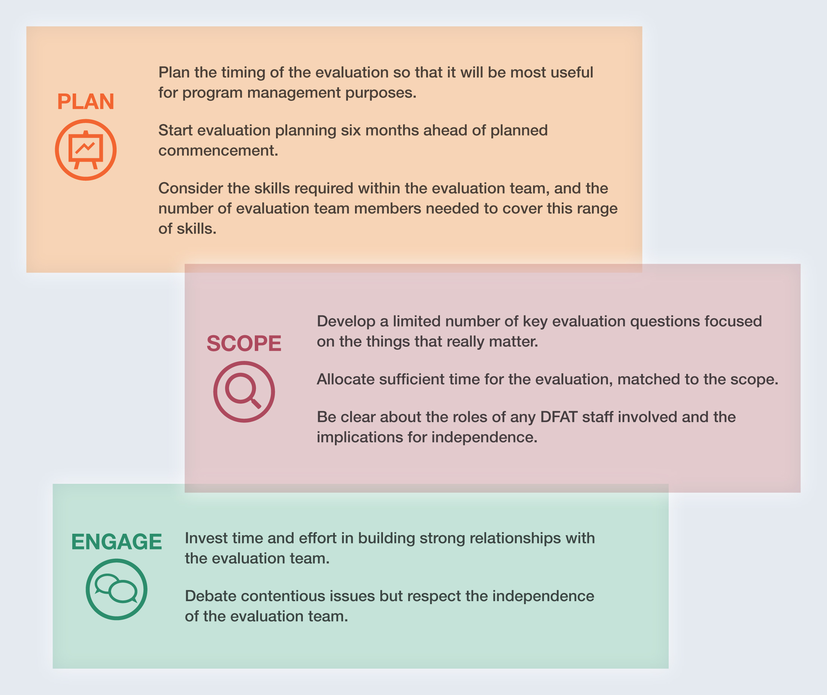

Good evaluations require investment in funding, time and human resources
The review found a positive correlation between evaluation quality and evaluation duration. The findings also suggest that evaluation quality is influenced by the level of resourcing provided. On average, more resources tended to be applied to evaluating larger initiatives and, up to a point, higher initiative value corresponded with better evaluation quality. While the evaluations of larger initiatives tended to be of disappointing quality, it is noted that many of these initiatives are complex and multifaceted and hence more challenging to evaluate.
The results of the quality review suggest that in general the optimum size of an evaluation team is three or four members. This enables key requirements to be covered such as evaluation expertise, sector and country knowledge and strong interpersonal communication skills. Larger teams are at risk of becoming unwieldy and difficult to manage.
The insights from interviews suggest that it is worthwhile for aid initiative managers to invest time and effort in building a strong relationship with the evaluation team. Involvement of Australian aid program staff in delivering an evaluation can have numerous benefits. But this involvement needs to be carefully defined in the evaluation plan so as not to compromise the independence of the evaluation.

The design of evaluations could be improved
The review found that most evaluations had a clear purpose but just over half did not assess the underlying logic of the intervention or had a weak assessment and/or did not adequately justify the evaluation methodology used. This in part reflects the absence of any specific guidelines requiring either an assessment of the underlying logic or a justification of methodology. It may also relate to the capacity of non-specialist staff to commission high-quality evaluations.
This finding suggests a need to focus greater support and quality assurance efforts at an early stage of an evaluation, specifically on terms of reference and evaluation plans.

RECOMMENDATION
DFAT should review arrangements (including responsibility and resourcing) for:
- evaluation planning at the program level, including the prioritisation and resourcing of evaluations
- support by dedicated evaluation staff for non-specialist evaluation managers, particularly for developing evaluation terms of reference and/or evaluation plans and for evaluating high-value investments.

MANAGEMENT RESPONSE
Agreed. The Government is committed to improving the effectiveness and efficiency of Australian aid, and has introduced a new performance framework which will see funding at all levels of the aid program linked to progress against rigorous targets and performance benchmarks. Independent evaluations are an important component of this strong focus on results and value for money.
The review findings have been used to inform the development of a new aid management architecture. This includes:
- explicit evaluation plans in country/regional aid investment plans and annual performance reports
- the creation of a unit within ODE which, alongside performance and quality managers, provides evaluation support across the department. An evaluation tracking database has been established to assist the targeting of support to evaluations of high value, high risk or otherwise strategically important investments.

Capacity to effectively manage evaluations is stretched
A central feature of the department’s evaluation policy is the mandatory evaluation of all significant initiatives. As a consequence, a large cohort of program staff are required to commission and manage evaluations as part of their normal program management duties. In recent years there have been significant efforts across the department to boost the capacity of non-specialist staff to help deliver high-quality evaluations. Nevertheless, realistic expectations need to be maintained as to the degree of evaluation expertise and knowledge these staff can or should acquire. Several interviewees indicated that, given the number of evaluations undertaken, the evaluation capacity within the department is stretched.
The issue of the number of mandatory evaluations is already being addressed:
- The department’s evaluation policy has already been revised to require only one evaluation during the lifetime of each aid initiative, reducing the number of mandatory operational evaluations by approximately half.
- From mid-2014 the minimum financial value of an aid initiative requiring mandatory evaluation will be raised to $10 million. This will reduce the number of evaluations by a further 42 per cent while still covering approximately 90 per cent of the dollar value of the aid program.

The key is how can we do better, by doing slightly less. Everyone wants to do more, but there is a real risk that this will sap the ability of posts to get value out of this. The more we mandate, the more we insist on templates, the less learning we’ll see. An evaluator comes in with external eyes and provides lots of learning. We need to make evaluations more focused, and make it easier for posts to do these.
Senior manager

Evaluations with a clear and immediate program management purpose are more likely to be adequately resourced and be of higher quality
Review findings indicate that evaluations undertaken during initiative implementation, as opposed to at or near completion, are more useful to aid managers and evaluators in terms of providing information and evidence to inform critical programming decisions such as whether to adjust or extend an investment.
Departmental evaluation guidelines set out expectations that all operational evaluations will assess initiative performance against a set of standard quality criteria (relevance, effectiveness, efficiency, sustainability, impact, and gender equality). The review found evidence that this can lead to an evaluation scope too ambitious to be realistic or appropriate, and on occasion this may negatively affect evaluation quality and utility.

Too many evaluations focus on the level of activities and outputs, and too few really confront the key strategic issues.
Consultant

Half of the evaluations did not attempt to assess the impact of the aid initiative. Where an assessment of impact was made, the assessment was often weak. The impact of an aid initiative is difficult to assess until well after its completion and typically relies on a robust monitoring and evaluation system being in place across the lifetime of the initiative.
Rigorous assessments of end-of-program outcomes and of impact are important to inform learning and to account for the results of public spending. Special arrangements for commissioning and resourcing evaluations designed to look at the impact of aid initiatives need to be considered, particularly for high-value investments and/or those that offer broader learning opportunities.

RECOMMENDATION
DFAT should make it explicit that the purpose of the evaluation guides the approach to that evaluation. Specifically:
- The timing of operational evaluations should remain flexible, with their scope and methodology purposefully designed to meet the specific information needs of program areas.
- Consideration should be given to commissioning impact evaluations, especially of high-value investments and/or those that offer broader learning opportunities.

MANAGEMENT RESPONSE
Agreed. This review has been particularly helpful in shaping the evolution of the department’s evaluation guidance. Specifically:
- Revised evaluation guidance will emphasise that an evaluation’s purpose should be the key guide to determining the overall evaluation approach.
- The department has raised the minimum value threshold for mandatory evaluations to encourage fewer, better quality evaluations.
- ODE will work with programs to identify areas where impact evaluation may be of strategic value. It is anticipated that this will result in ongoing collaboration between ODE and programs on a limited number of impact evaluations.

The majority of evaluations are credible and coverage of the aid program is satisfactory
The review found the overall credibility of the evidence and analysis in the evaluation reports to be satisfactory in 74 per cent of cases. Most evaluations satisfactorily assessed the relevance and effectiveness of the aid initiative, which indicates that operational evaluations are generally a robust source of evidence about the effectiveness of the Australian aid program.
Overall, the quality of evaluations managed wholly by Australian aid staff was found to be at least as good as that of joint evaluations led by partners, and this was generally achieved with fewer resources.
The initiatives evaluated were diverse in terms of value, sector and geographic region, and were found to be broadly representative of the overall Australian aid program.
About half of the completed operational evaluations were published. This represents a significant increase from previous publication rates, however there is room for improvement. There is also scope to improve the accessibility of published evaluations.

RECOMMENDATION
DFAT should monitor implementation of the policy requirement to publish all independent operational evaluations and should improve public access to them.
MANAGEMENT RESPONSE
Agreed. ODE will monitor and support the publication of completed evaluations. An online register with links to completed evaluations will be incorporated into ODE’s webpage.

WANT MORE INFORMATION?
Visit the ODE website at www.ode.dfat.gov.au for:
- departmental guideline ‘Manage an evaluation’
- good practice examples of evaluation terms of reference, plans and reports
- DFAT monitoring and evaluation standards.
- Or contact ODE at opeval@dfat.gov.au

OFFICE OF DEVELOPMENT EFFECTIVENESS
DFAT’s Office of Development Effectiveness (ODE) monitors the performance of the Australian aid program, evaluates its impact and contributes to international evidence and debate about aid and development effectiveness.

