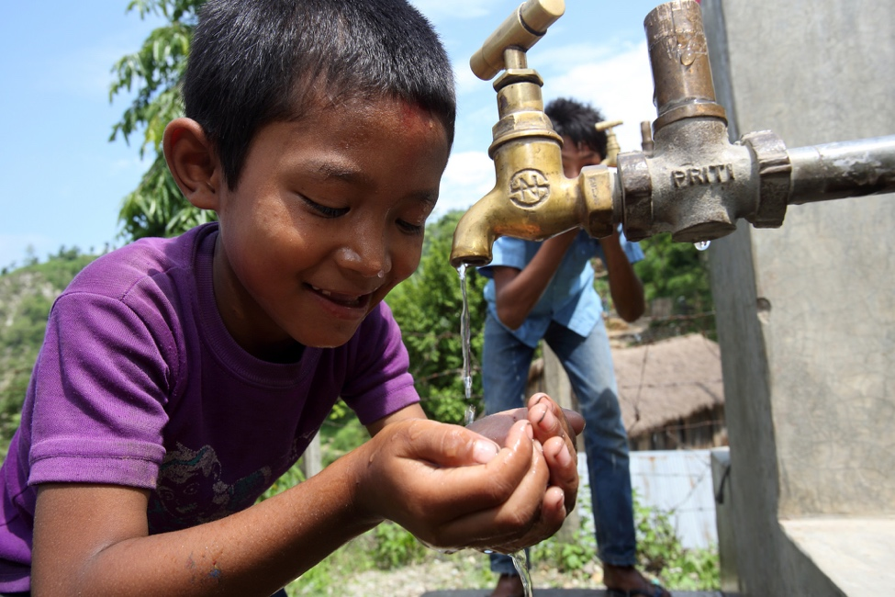Evaluation of the Civil Society Water, Sanitation & Hygiene Fund

Boy with access to drinking water in Nepal, 2013. Photo: DFAT.

## The Fund

The Civil Society Water, Sanitation and Hygiene (WASH) Fund seeks to sustainably improve WASH services for people who are vulnerable and poor. The Fund is a $103 million Australian Government investment (2013 – 2018) that supports 29 projects implemented by 13 civil society organisations (CSOs) in 19 countries across Asia, the Pacific and Africa.

By current forecasts, the Fund will directly benefit up to 3.6 million people by 2018.

The Fund aims to finance CSO projects that build local capacity so that improvements in WASH services can be maintained. Projects were selected through a competitive process open to Australian and international CSOs. DFAT oversees the Fund, and contracts support to manage the Fund, facilitate learning between CSOs, and to monitor and evaluate the Fund.

## ODE’s evaluation

An evaluation of the Fund by the Office of Development Effectiveness (ODE) examined two main questions:

* the Fund’s management arrangements and the extent to which these were appropriate, effective and efficient; and
* the appropriateness of the Fund’s CSO selection process.

Evaluating these two aspects will inform implementation for the remainder of the current Fund and the imminent design of the next fund (DFAT’s *Water for Women* initiative, announced on 29 September 2016).

In addition, this evaluation will be useful for DFAT program managers of other centrally-managed grant programs looking to strengthen their program’s monitoring and evaluation (M&E), internal learning, and risk-management of grantee selection.

Management arrangements for the Fund are summarised at **Figure 1.**

Figure 1: Fund management arrangements

DFAT’s Water, Sanitation and Hygiene Section (DFAT WSH)

* provides overall strategic oversight
* manages contracts with the 13 implementing CSOs
* manages contracts with the other members of the Fund management team: the Monitoring, Evaluation and Review Panel (MERP) and Fund Management Facility.

Monitoring, Evaluation and Review Panel (MERP)

* a three-member panel that supports the Fund’s M&E
* advises implementing CSOs on M&E
* puts into effect a Fund-wide M&E system.

Fund Management Facility

* led by a Fund Manager who supports fund management
* the Fund Manager is the Fund’s principal liaison point, for example, between the Fund and DFAT’s country program areas that engage with the Fund on an ‘opt-in’ basis
* the Knowledge and Learning Manager manages the Fund’s knowledge and learning component, collaborating with implementing CSOs, the MERP and local and international partners
* the Facility’s Program Coordinator provides logistical and other assistance, particularly around the Fund’s learning events.

## Fund management: strengths

ODE’s evaluation found that the Fund:

* places an emphasis on learning. The global and regional face-to-face events in particular have assisted CSOs to innovate and strive for continuous improvement;
* effectively integrates gender equality and disability inclusiveness in CSO projects. The Fund’s M&E system and practical advisory support have pushed CSOs to go further in these areas;
* effectively supports CSOs through the engagement of long-term M&E advisors; and
* provides flexibility to CSOs to adjust their projects to take account of new learning and changing conditions on the ground.

## Fund management: weaknesses

ODE found the Fund’s management arrangements are relatively high cost, when compared to other DFAT CSO grant funds. Therefore, for the Fund’s next phase, DFAT WSH should ensure that the Fund’s M&E system monitors the impact of the Fund’s management to ensure that costs can be justified.

## CSO selection: strengths & weaknesses

ODE found a number of good practices when selecting CSOs but also areas for significant improvement. Aspects to be commended included:

* the Fund’s inception phase, which was widely praised by Fund stakeholders. Successful CSOs participated in a three-month inception phase to further define their project designs. This inception phase made applying for grant funding less expensive for CSOs and improved CSO projects, including with respect to gender equality and disability inclusion; and
* the selection panel’s diverse expertise (combining WASH and CSO sector expertise).

The Fund selection process did not always   
result in the selection of appropriate projects.   
In assessing the CSO selection process, ODE   
found that:

* there was insufficient weight given to CSO’s past track-record and to a key criterion (the Fund’s ‘theory of change’); and
* the external selection panel member scored some criteria markedly differently to DFAT selection panel members (for example, criteria related to gender and social inclusion).

DFAT program areas managing competitive grant selection rounds should take account of these lessons.

## Recommendations

Based on these findings, ODE made six recommendations to improve the management of the Fund and, especially, to inform the design of the *Water for Women* initiative. These recommendations are summarised at **Figure 2.**

Strengthening the WASH enabling environment: Thrive Networks working in partnership with the Vietnamese government. Civil Society WASH Fund, 2014.   
Photo: Bruce Bailey.

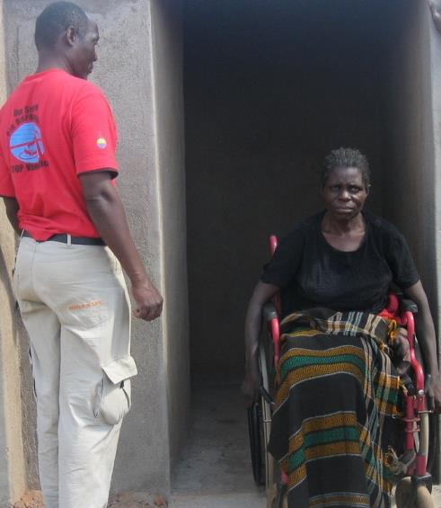

New toilets built to accommodate people using   
wheelchairs, 2011. Photo: AusAID.

Figure 2: Recommendations









FOR FUND MANAGEMENT IN THE NEXT PHASE:

Recommendation 1:

The Fund’s monitoring and evaluation system should include arrangements which ensure the Fund’s management costs can be justified.

Recommendation 2:

DFAT WSH should commit its resources to areas where it has the greatest value add, particularly strategic oversight (including for M&E and reporting), relationships with country programs and public diplomacy.

Recommendation 3:

The design team should consider a Fund-specific advisory or consultative group which includes all members of the Fund management team and Fund CSOs.

FOR FUTURE CSO SELECTION

Recommendation 4:

Consistency with the Fund’s intent and theory of change should be a heavily weighted criterion.

Recommendation 5:

CSO performance in the WASH sector and the current Fund should be explicitly taken into account.

Recommendation 6:

Panel members should have appropriate expertise (in WASH, gender equality and disability inclusiveness, and with CSOs).