

# OASIS 2025 Intake

## User guide for applicants

Department of Foreign Affairs and Trade

The R G Casey Building

John McEwen Crescent

Barton ACT 0221

Australia

Version: 5.11

Updated: January 2024

Websites:

[Participating Countries:](https://dfat.gov.au/people-to-people/australia-awards/Pages/participating-countries.aspx)

[Australia Awards Scholarships Policy Handbook](https://dfat.gov.au/about-us/publications/Pages/australia-awards-scholarships-policy-handbook.aspx)

[Australia Awards Pacific Scholarships Handbook](https://www.dfat.gov.au/about-us/publications/australia-awards-pacific-scholarships-policy-handbook)

[John Allwright Fellowships](https://www.aciar.gov.au/scholarships/john-allwright-fellowship)

[CRICOS](https://cricos.education.gov.au/)

**Table of Contents**

1. Introduction 1

2. Eligibility to apply 2

3. OASIS page elements 3

4. OASIS registration 5

5. Creating a new application 9

6. Application checklist 11

7. Completing an application 12

Section 1 – Personal Details 12

Section 2 - Contact Details 12

Section 3 - Spouse details 13

Section 4 - Children details 14

Section 5 - Emergency contact details 15

Section 6 - Previous scholarships 16

Section 7 - Scholarship applications 17

Section 8 - Proposed study program 18

Section 9 - Qualifications 22

Section 10 - English language details 23

Section 11 - Computer literacy details 24

Section 12 - Current employment 26

Section 13 - Previous employment 27

Section 14 - Supporting statement 28

Section 15 – Professional memberships 30

Section 16 – Communication 31

Section 17 – Documentary evidence 32

Section 18 - Declaration 33

8. Submitting your application 35

9. Submission Deadline 35

10.Making changes after submission 36

# 1. Introduction

The Australia Awards Scholarships are long term development awards administered by the Department of Foreign Affairs and Trade (DFAT). They aim to contribute to the long-term development needs of Australia’s partner countries in line with bilateral and regional agreements.

The Australia Awards Scholarships provide opportunities for people from developing countries to undertake full-time undergraduate or postgraduate study at participating Australian universities and Technical and Further Education (TAFE) institutions. Through study and research opportunities in Australia, the Australia Awards Scholarships develop the skills and knowledge of individuals to drive change and contribute to the development outcomes of their own country.

Australia Awards Scholarships recipients are required to return home for two years after they have completed their studies in order to contribute to the development of their country.

This User Guide is designed for people applying for an Australia Awards Scholarship. The Guide introduces applicants to the Online Australia Awards Scholarships Information System (OASIS) which is used to submit online Australia Awards Scholarship applications, and steps them through the application process.

**Online applications for the 2025 Intake of Australia Awards Scholarships will be open in OASIS on Thursday, 01 February 2024 and close at 11:59 Australian Eastern Standard Time (AEST) on Tuesday, 30 April 2024. Please be aware that not all eligible countries permit online applications**.

**! Attention !**

You must check the [Participating Country](https://dfat.gov.au/people-to-people/australia-awards/Pages/participating-countries.aspx) page for details on how to apply and read the [Australia Awards Scholarships Policy Handbook](https://dfat.gov.au/people-to-people/australia-awards/Pages/how-to-apply-for-an-australia-awards-scholarship.aspx) before submitting an application.

# 2. Eligibility to apply

**STOP !**

Are you eligible to apply for an Australia Award Scholarship?

Applicants for an Australia Awards Scholarship must meet all relevant eligibility requirements.

Participating Countries

Not all countries participate in the Australia Awards Scholarships program.

Before creating a new application, you must check the [Participating Country](https://dfat.gov.au/people-to-people/australia-awards/Pages/participating-countries.aspx) page on the DFAT website to confirm that your home country is a participating partner, and for details on how to apply.

Other Eligibility Requirements

All applicants must begin by reading the eligibility criteria set out in the [Australia Awards Scholarships Policy Handbook](https://dfat.gov.au/people-to-people/australia-awards/Pages/how-to-apply-for-an-australia-awards-scholarship.aspx) to apply for an Australia Awards Scholarship or the Australia Awards Pacific Scholarship Policy Handbook to apply for an Australia Awards Pacific Scholarship and [John Allwright Fellowships](https://www.aciar.gov.au/scholarships/john-allwright-fellowship)

The following are an example of some of the eligibility criteria:

* Residing in, being a citizen of, and applying from a participating partner country.
* Being a minimum of 18 years of age.
* Not currently serving military personnel.
* Not applying for a visa to live in Australia.

**! Attention !**

The [Australia Awards Scholarships Policy Handbook](https://dfat.gov.au/people-to-people/australia-awards/Pages/how-to-apply-for-an-australia-awards-scholarship.aspx) provides the guiding policy on the Australia Awards Scholarships and all applicants must be familiar with its provisions.

# 3. OASIS page elements

In order to use OASIS to create and submit your application for an Australia Awards Scholarship, there are some important elements of OASIS that you will need to be familiar with.

These elements are as follows:

Help Text

Each page of the application will begin with **Help Text**. The **Help Text** will contain additional information on how to complete the application page you are on. Some **Help Text** may also include links to various websites.

Here is an example of the **Help Text**:

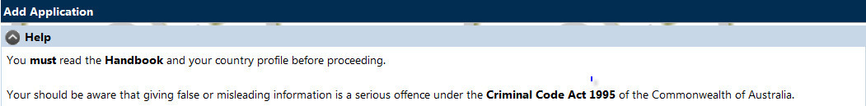

Error Messages

In addition to the **Help Text**, OASIS will display error messages. These error messages will appear in **Red** at the top of each page, directly below the help text if any of the required information has not been entered on the application page.

Some common error messages are as follows:

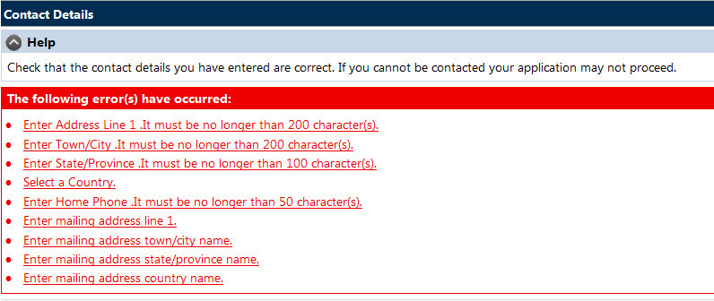

For example: this error message indicates all the mandatory fields on one page of the application have not been completed. If you see an error message like this, you will not be able to submit your application until you have completed all the necessary fields.

**! Attention !**

All fields that have an * next to them are **mandatory.** These fields must be completed.

Character Limits

‘Free text fields’ are fields or boxes, that form part of the OASIS application, and which allow you to enter additional information to support your application. These fields have **Character Limits.**

‘Characters’ include letters, spaces and punctuation marks.

It is important that you stay within the character limit as OASIS will not allow you to enter more than the limit. You will be not be able to complete and submit your application until you have removed the additional characters.

**! Attention !**

All information entered in free text fields must be clear, concise, relevant, and must not exceed the character limit.

# 4. OASIS registration

**STOP !**

It is recommended that OASIS be accessed using Edge or Chrome. Other browsers such as Safari and Opera are not supported and may not work as expected.

Before beginning an application for an Australia Awards Scholarship, applicants must request access to OASIS. The first step is to register in OASIS as this will enable you to logon, create and complete an application.

If you have submitted an application for a previous intake round you will already be registered in OASIS, and you will not need to register again.

If you cannot remember your password you will be able to reset your password by entering your email address, selecting Register New Account, and entering your answer to the ‘reminder question’. This will send a temporary password to your email address.

If you cannot reset your password please send an email to [enquiries.canberra@australiaawards.org](mailto:enquiries.canberra@australiaawards.org) to request a password reset.

To register and receive an OASIS password and logon for the first time, follow these steps:

1. Open your internet browser and navigate to <https://oasis.dfat.gov.au>. On the home page menu select **Logon/Register** and **Register New Account**.



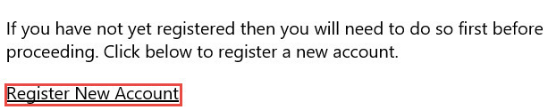

1. Complete the New User Registration screen and select **Save**.

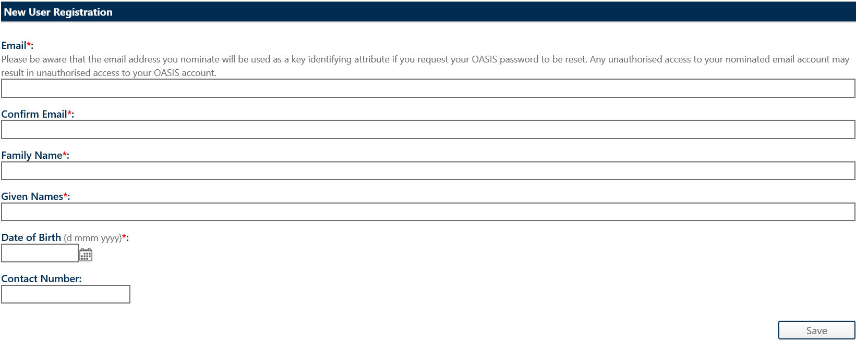

**! Attention !**

All fields that have an * next to them are **mandatory**.

These fields must be completed.

1. You will be redirected to the **Registration Confirmation** screen and an email will be sent to you containing a temporary password.

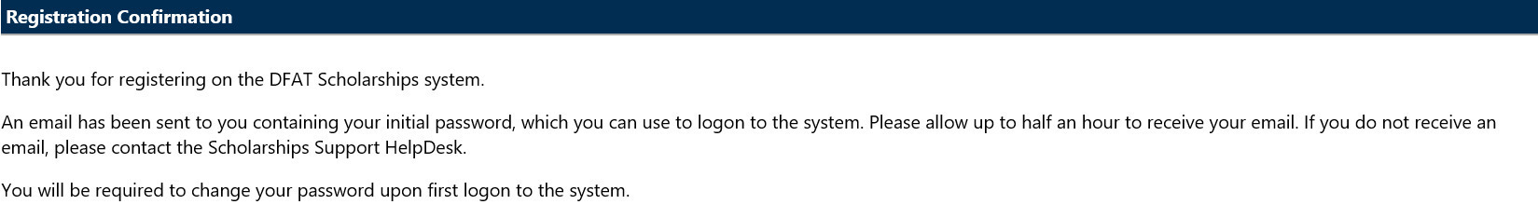

1. The following email will be sent containing a temporary password.

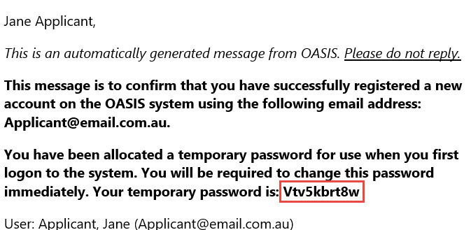

1. Return to OASIS <https://oasis.dfat.gov.au> and select **Logon / Register** again.
2. Enter the exact email address that you used to register. In the password field enter the temporary password you were sent and then select logon.

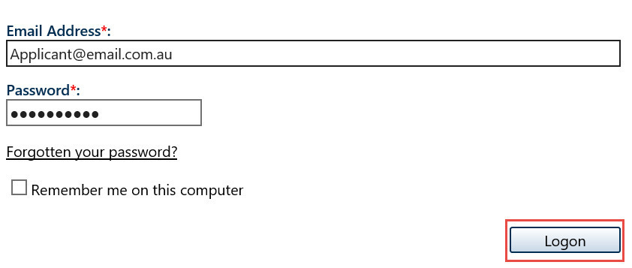

1. You will now be required to change your password.
2. Enter your temporary password in the **Old Password** field.

Create a new password and enter it in the **New Password** and **Confirm Password** fields and then select **Save**.

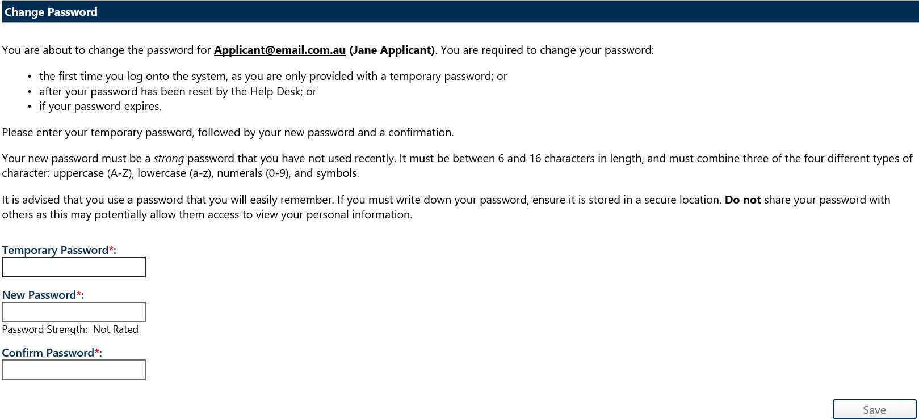

**! Attention !**

Your new password must be between 6 and 16 characters in length and must combine   
three of the four different types of character: uppercase (A-Z), lowercase (a-z),   
numerals (0-9) and symbols.

Now that you have registered on OASIS and created your password you will be able start your online application.

You do not need to start, finish and submit your application all at once; you can complete your application in stages over a period of time. However, you must remember to submit your application by the deadline on **30 April 2024**. It recommended that you submit your application prior to the deadline as OASIS will experience large traffic closer to the deadline and this may result in your application not being submitted.

**One Time Password (OTP)**

Once you have established your logon and password, each time you logon to OASIS you will receive notification of the One Time Password (OTP)

The OTP is automatically generated after existing credentials are entered and validated and will be sent to an email address registered to your account.

The OTP is a password that is used once and then expires.

The OTP will be valid for a period of time, if you fail to enter the OTP within this time period, you will be required to re-enter your credentials to obtain a new one.  Please remember to check your spam folders in case the email has been redirected.

An example of changes to the Logon screen in OASIS appear below:

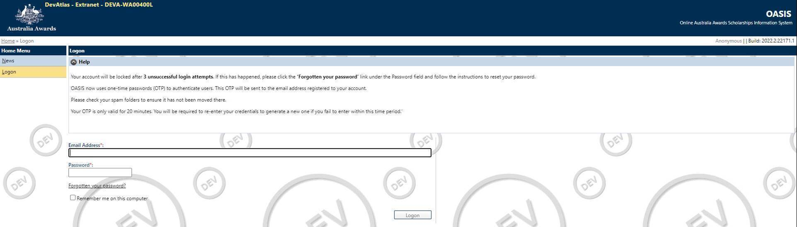

# 5. Creating a new application

**STOP !**

Not all participating country programs use OASIS to receive applications for the Australia Awards Scholarships. Don’t forget to check the [Participating Country](https://dfat.gov.au/people-to-people/australia-awards/Pages/participating-countries.aspx) profile **before** beginning an application in OASIS.

Once you have registered in OASIS, you can create a new online application by following the steps below.

1. Log on to OASIS.
2. Select Applications on the Home Menu.

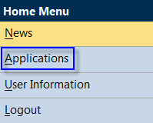

This will open the **Applications** screen.

1. Select **Create New Application**.

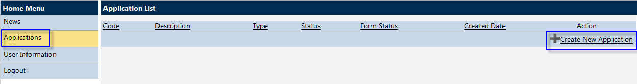

This will open the Add Application screen

1. Select the **Australia Awards Scholarships** from the drop down menu and then select **Next**. The Intake will be the automatic default to the current Intake. Select **Next** to continue, and the **Personal Details** screen will open.

~ continued on next page ~

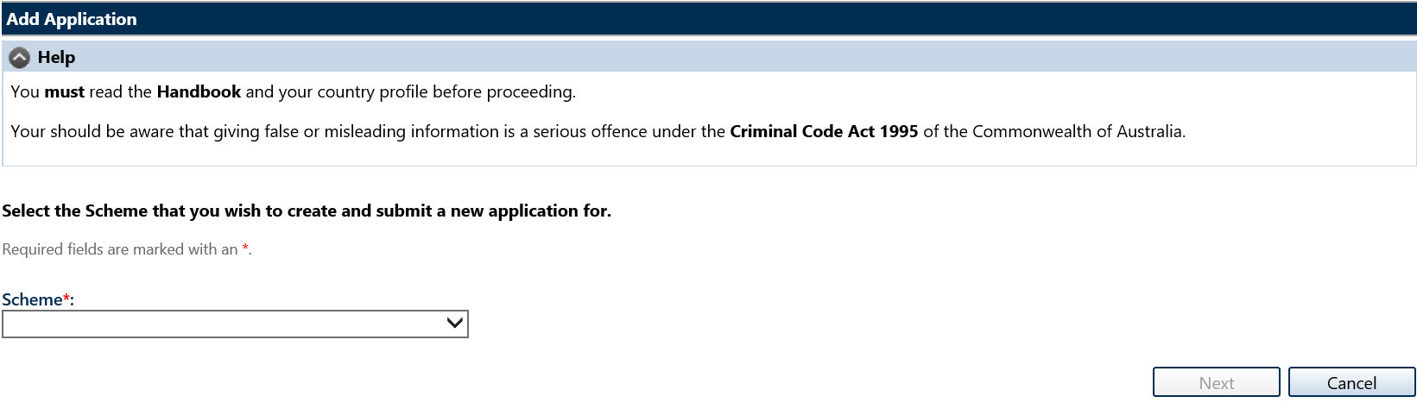

**! Attention !**

The options available in the Scheme drop-down list are: *Australia Awards Scholarships, Australia Awards Pacific Scholarships* and *ACIAR John Allwright Fellowship*. You must select Australia Awards Scholarships. [ACIAR John Allwright Fellowships](https://www.aciar.gov.au/scholarships/john-allwright-fellowship) are a different   
type of award, with different eligibility requirements and a different application process.

1. Complete the fields on the **Personal Details** screen.

Fields marked with an * are mandatory fields and must be completed before OASIS will allow you to move to the next screen.

Entering a passport number is not mandatory, however if you have entered a passport number you must also enter the date of issue and expiry date.

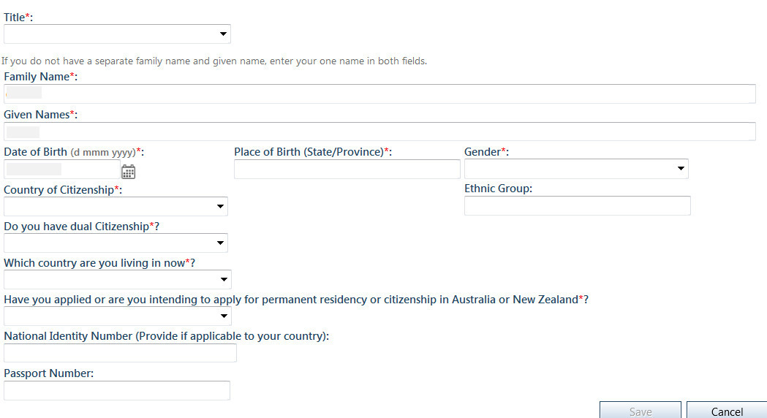

When you are finished completing the fields, select Save to create a record of your application and to continue.

**! Attention !**

At this point a record of your application has been created in OASIS, you can now logout and return to your application at a later time to continue.

# 6. Application checklist

Once you have entered and saved your personal details, OASIS will display a Checklist. This Checklist shows each of the remaining pages of the application and indicates which parts of the application are complete.

The Checklist will enable you to navigate within the draft application by selecting the section you would like to review, update or complete.

Here is an example of the Checklist:

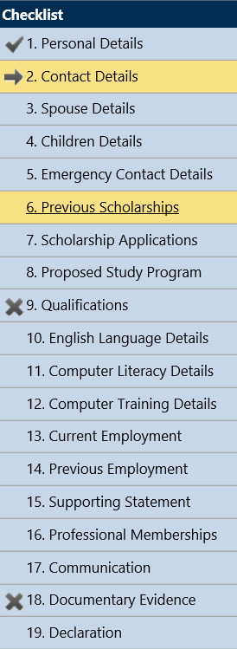

**Reading the Checklist**

The Checklist will indicate with a tick box symbol that a section of the application has been completed.

An cross box symbol will indicate that a section of the application is incomplete.

The forward arrow symbol will indicate a section you are in the process of completing.

**! Attention !**

Each section of the application must be completed with a tick box shown before your application can be submitted.

# 7. Completing an application

This section of the Guide will take you through the remaining steps you need to action to complete your application.

Each of these steps will allow you to complete one of the sections listed in the Checklist.

To check your progress, simply refer to the Checklist.

**STOP !**

Remember to select **Next** at the bottom of each page to save your information   
and move to the next screen.

## Section 1 – Personal Details

You have already completed Section 1 of the Checklist by entering your personal details when you created your new application.

## Section 2 - Contact Details

Use this section to enter your current residential address, phone and email details.

If your ‘Mailing Address’ is the same as your Residential Address, tick the box to confirm this. If not please enter your mailing address as well.

1. Complete these fields:

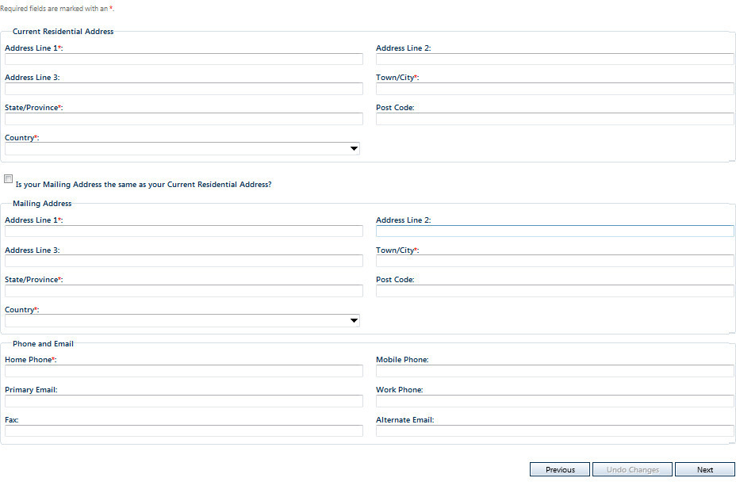

1. When you have finished, select Next to save your information and move to the next screen – Spouse Details.

**STOP !**

Please check that the contact details you entered are correct. If you cannot be contacted your application may not proceed.

## Section 3 - Spouse details

Use this section to enter the details of your spouse.

A spouse is a person you are married to, or in a de-facto relationship with.

If you have a spouse you should provide their details, even if they will not be accompanying you to Australia.

1a. If you do not have a spouse, select the Not Applicable checkbox.

***OR***

1b. If you do have a spouse, complete the fields with their details. If you enter a passport number you will be required to add the issue and expiry date of the passport.

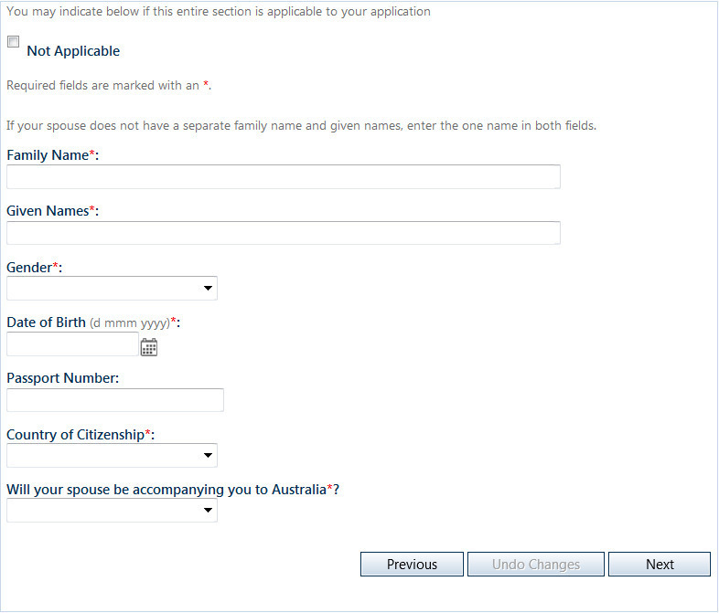

1. When you have completed **either** step 1a or 1b, select **Next** to save your information and move to the next screen – **Children Details**.

**! Attention !**

The Australia Awards Scholarship does not provide any financial support for   
accompanying dependants; spouse or children.

## Section 4 - Children details

Use this section to enter the details of your dependent children.

A dependent child is your or your spouse’s child or stepchild, who is under 18 years of age, and is not married or in a de-facto relationship.

You should provide details of all dependent children and indicate if they will join you in Australia.

1a. If you do not have any dependent children, select not applicable.

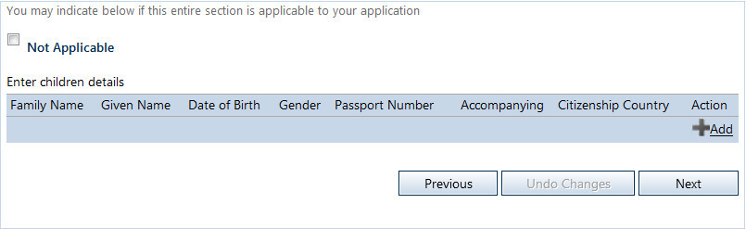

***OR***

1b. If you do have any dependent children, select the **+ Add** icon.

The **Add Children Details** screen will appear. Complete all the fields with your child’s details, then press **Save**.

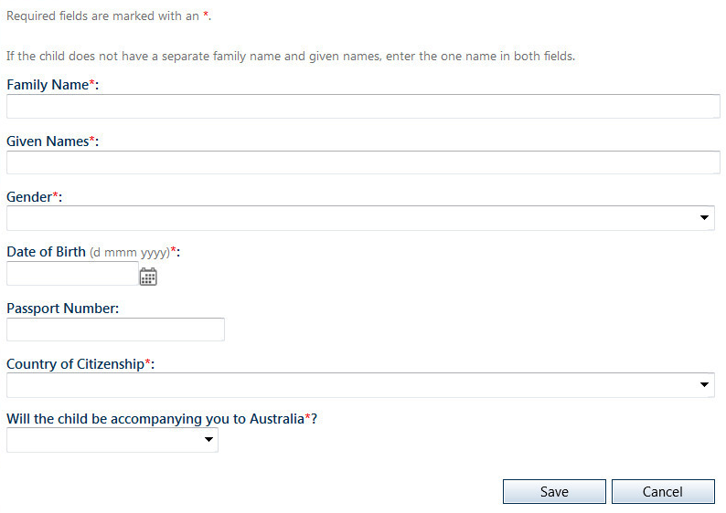

1. If you have more than one child you will need to enter each child’s details individually.

When you have entered the details of one child, select **Save** to save the information. Then repeat steps 1 and 2 to add the next child.

1. When you are finished adding all dependent children, select Next to save your information and move to the next screen – **Emergency Contact Details**.

**STOP !**

Don’t forget to indicate if you plan for your dependent children to join you in Australia.

## Section 5 - Emergency contact details

Use this section to enter the details of your emergency contact.

An emergency contact is a person that can be contacted in case of an emergency. This is often a relative or a friend.

1. Complete these fields:

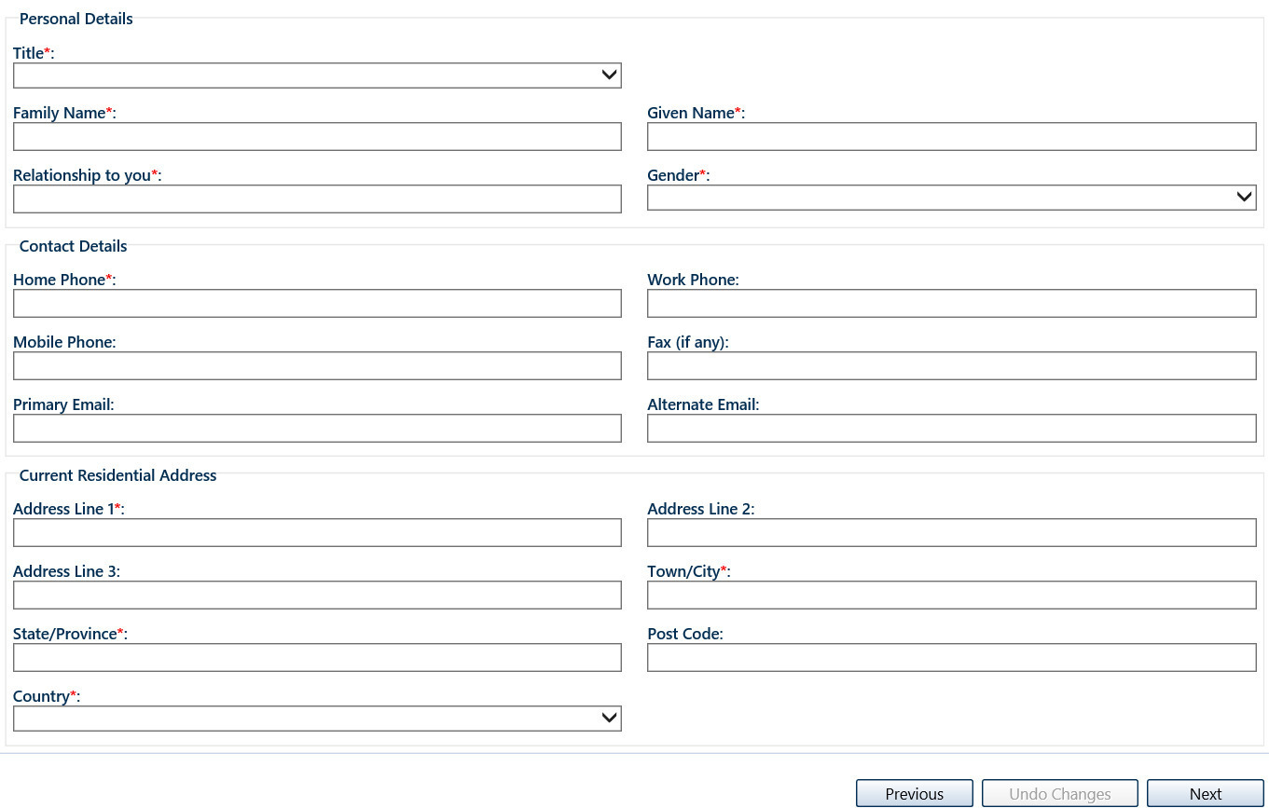

1. When you have finished, select **Next** to save your information and move to the next screen – **Previous Scholarships**.

## Section 6 - Previous scholarships

Use this section to enter details of any current or previous scholarships or fellowships that you have been awarded.

You should enter all post-secondary school scholarships or fellowships, undertaken in any country, in any field.

Entering this information will not have any effect on the outcome of your Australia Awards Scholarships application.

1a. If you have not been awarded a scholarship or fellowship before, select the ***Not Applicable*** checkbox.

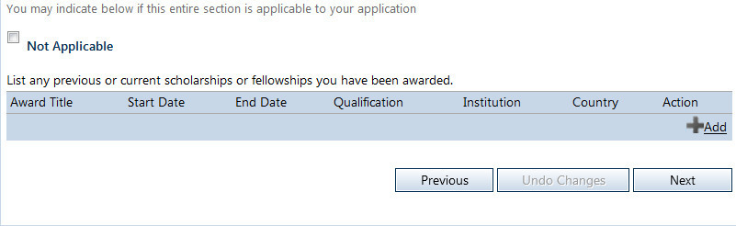

**OR**

1b. If you have been awarded a scholarship or fellowship previously, select +Add icon to bring up the **Add Previous Scholarship** screen.

If the scholarship did not lead to a formal qualification, enter **Not Applicable** in the qualification field.

Complete all the fields then press **Save**.

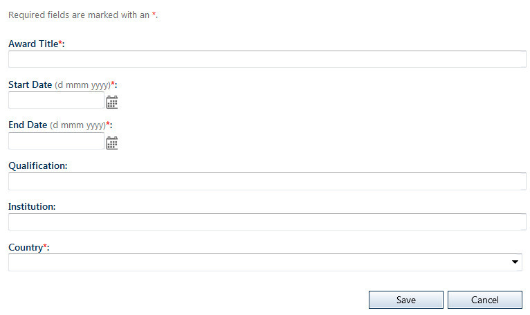

~*continued next page*~

1. If you have been awarded more than one scholarship or fellowship you will need to enter award individually.

When you have entered the details of one award, select Save to save the information. Then repeat steps 1 and 2 to add the next award.

1. When you have completed either step 1 or 2-3, select Next to save your information and move to the next screen – Scholarship Applications.

## Section 7 - Scholarship applications

Use this section to enter details of any other scholarships you are currently applying for and to indicate if you have previously applied for an Australia Awards Scholarship or any other scholarship offered by DFAT (formerly AusAID).

1. Complete these fields as required:

Screenshot of where to add
Details other scholarship applications

1. When you are finished, select Next to save your information and move to the next screen – Proposed Study Program.

**! Attention !**

Applying for more than one scholarship does not make you ineligible to apply for an Australia Awards Scholarship.

## Section 8 - Proposed study program

It is your responsibility as an applicant to research study options in Australia.

Use this section to indicate your proposed study program, i.e. the course you would like to study.

**STOP !**

Please select your proposed study program carefully. Please consider the information below before you add course preferences.

Please check that the contact details you entered are correct. If you cannot be contacted your application may not proceed

There are a number of factors that will impact on your choice of a study program.

Australia Awards Scholarships may be available for the following types/levels of courses:

* Vocational Education and Training (VET) courses
* Bachelor degree (undergraduate) courses
* Master degree courses
* Doctorate degree (PhD) programs

However, DFAT will only consider offering you an Australia Awards Scholarship if:

* your proposed course of study is in a “priority sector for your country” that will contribute to the development needs of your country, and
* the type/level of course is available for study by Australia Awards Scholarship recipients from your country.

Information on the priority development sectors and type/level of courses available can be found in your [Participating Country](https://dfat.gov.au/people-to-people/australia-awards/Pages/participating-countries.aspx) profile.

In addition, Australia Awards Scholarships are available only for courses that are listed on the Commonwealth Register of Institutions and Courses for Overseas Students ([CRICOS](http://cricos.education.gov.au/)) is the official Australian Government website that lists all Australian education providers that offer courses to people studying in Australia on student visas.

You must add two course preferences to your application. You are encouraged to choose courses at two different institutions.

1. To enter your course preferences, start by selecting the +Add icon on the Proposed Study Program screen.

Screenshot of how to 
Select course preferences

This will open the **Add Proposed Study Program** screen.

~continued on next page~

1. The **Add Proposed Study Program** screen looks like this. See the following pages for instructions to complete this screen.

Add proposed study program

Screenshot of 
Add proposed study program

Screenshot of 
Adding CRICOS course code

**! Attention !**

The CRICOS course code can be obtained in the Course Search section of the [CIRCOS Website](http://cricos.education.gov.au/). Each course on CRICOS has a number of codes; please ensure that you are copying the “course code”.

1. Adding a course

To add a course you will need to enter the CRICOS code.

Type the CRICOS code into the field and select the look up Search looking glass icon icon.

OASIS will then automatically enter the following information:

* Course Name
* Type of Study
* Level of Study
* Duration in Weeks
* Field of Study

You must select the Institution from the drop-down list.

You must also indicate if this is your first, second, or third preference.

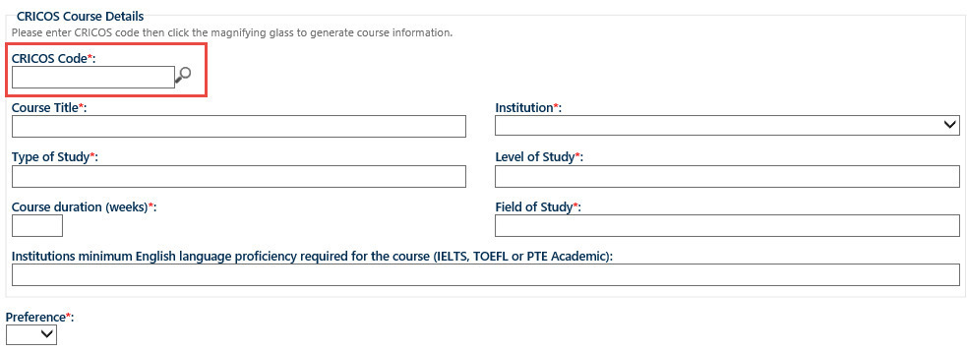

1. When you have entered the details of your course preference, select **Save**, to save the information. Then repeat steps 1, 2 and 3 to add another preference.
2. Research programs

If you have selected a research program (i.e. a PhD or a Masters by Research), in the Add Proposed Study Program screen you must also complete the questions relating to your research.

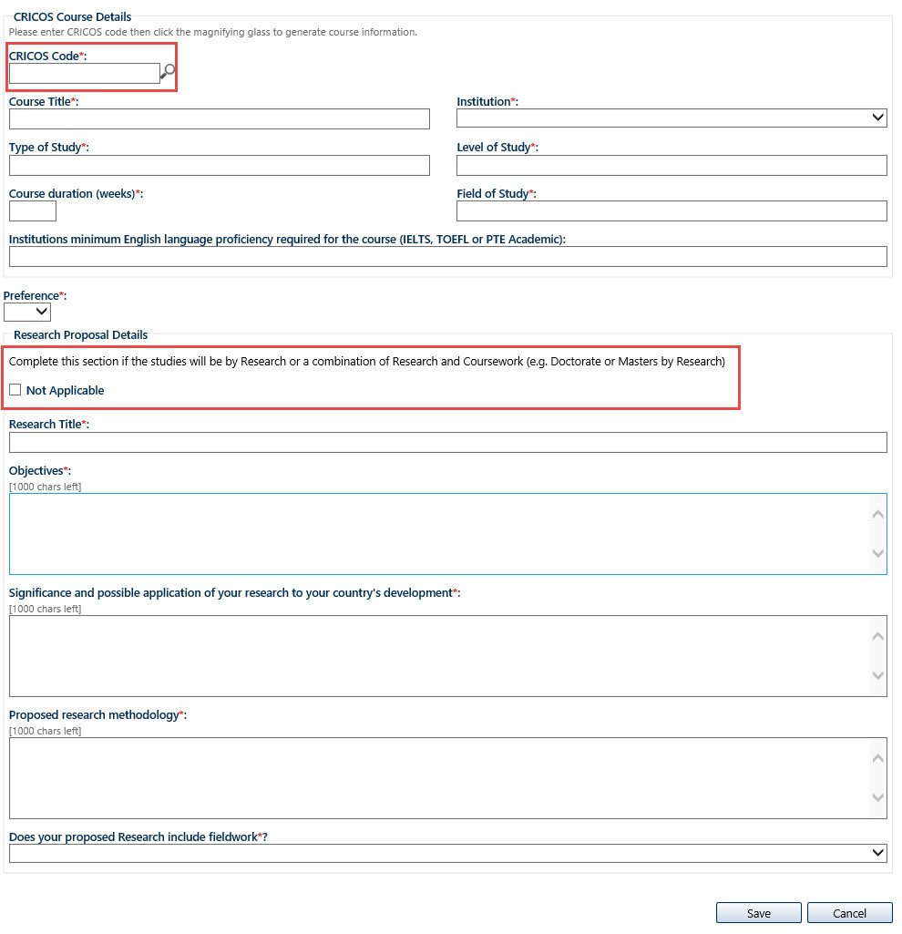

When you have entered the details of your research program, select **Save** to save the information.

1. When you are finished adding all course preferences (and research program details if required), select Next to save your information and move to the next screen – Qualifications.

## Section 9 - **Qualifications**

Use this section to record all your previous academic qualifications.

List all qualifications, complete or incomplete, by level of study starting with the highest.

You will need to enter each academic qualification one at a time.

If you have not completed your studies please list the expected completion date.

1. Select the **+Add** icon to open the **Add Qualifications** screen.

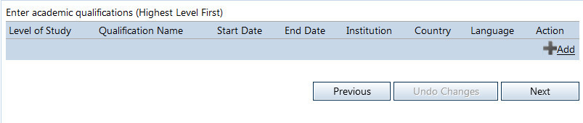

1. Enter the details of your academic qualifications.

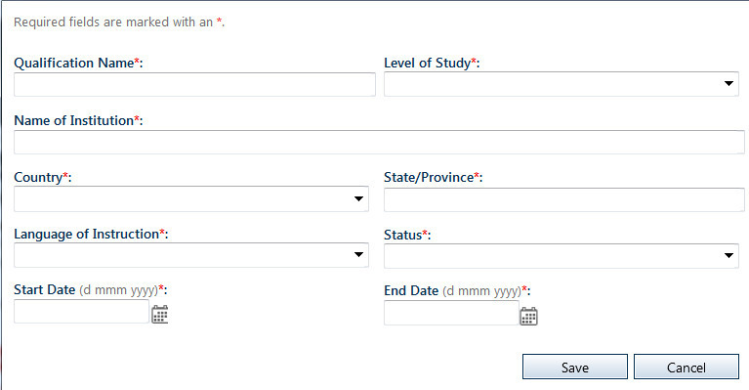

1. When you have entered the details of your academic qualification, select **Save** to save the information. Then repeat steps 1 and 2 to add another qualification.
2. When you are finished adding all of your academic qualifications, select **Next** to save your information and move to the next screen – **English Language Details**.

## Section 10 - English language details

Use this section to enter the details of your English language proficiency.

Awardees must meet the English language requirements of the Australia Awards Scholarships. Full details can be found in the [Australia Awards Scholarships Policy Handbook](https://dfat.gov.au/people-to-people/australia-awards/Pages/how-to-apply-for-an-australia-awards-scholarship.aspx).

DFAT will accept the following English Language test results: IELTS; TOEFL; PTE Academic.

This section allows you to enter information about your English language proficiency and to indicate if you have already taken an academic English language test.

1. Complete these fields:

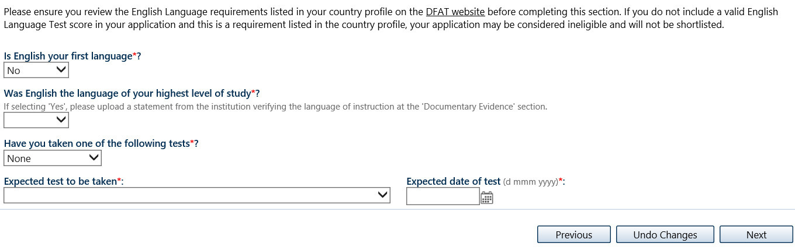

If you have taken an English language test you will be asked to enter your test

scores into the following fields.

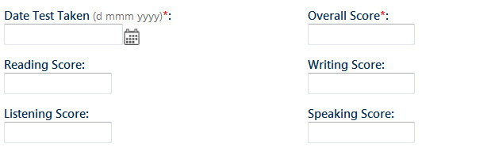

1. When you are finished, select **Next** to save your information and move to the next screen – **Computer Literacy Details**.

**! Attention !**

Please check the [Participating Country](https://dfat.gov.au/people-to-people/australia-awards/Pages/participating-countries.aspx) profile and the [Australia Awards Scholarships Policy Handbook](https://dfat.gov.au/about-us/publications/Pages/australia-awards-scholarships-policy-handbook.aspx), to make sure you are familiar with the requirements for English   
language testing.

## Section 11 - Computer literacy details

Use this section to enter details relating to your computer literacy.

Australian tertiary courses require a high degree of computer literacy. Completing this section of your application will assist Australian tertiary institutions to determine if you will require additional computer skills to undertake your proposed study program.

1. Complete these fields:

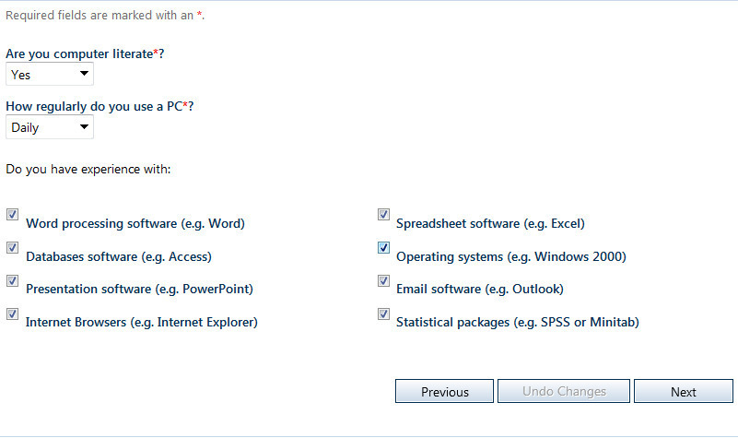

1. When you are finished, select **Next** to save your information and move to the next screen – **Computer Training Details**.
2. Complete these fields:



1. When you are finished, select **Next** to save your information and move to the next screen – **Computer Training Details**.
2. If you have undertaken formal computer courses select the +Add icon to open the **Add – Computer Training Details** screen.

Complete the fields.

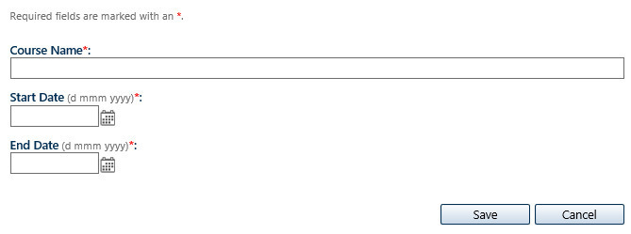

1. When you have entered the details of your computer training, select **Save** to save the information.

Repeat steps 1 and 2 to add any additional computer courses/training.

1. When you are finished, select **Next** to save your information and move to the next screen – **Current Employment**.

## Section 12 - Current employment

Use this section to enter details your current employment.

Information about your current employment helps DFAT to determine the development impact you would be likely to have after completing an Australia Awards Scholarship.

1. If you are not currently employed please select the Not Applicable checkbox.

***OR***

1. Complete the fields to record your current employment details.

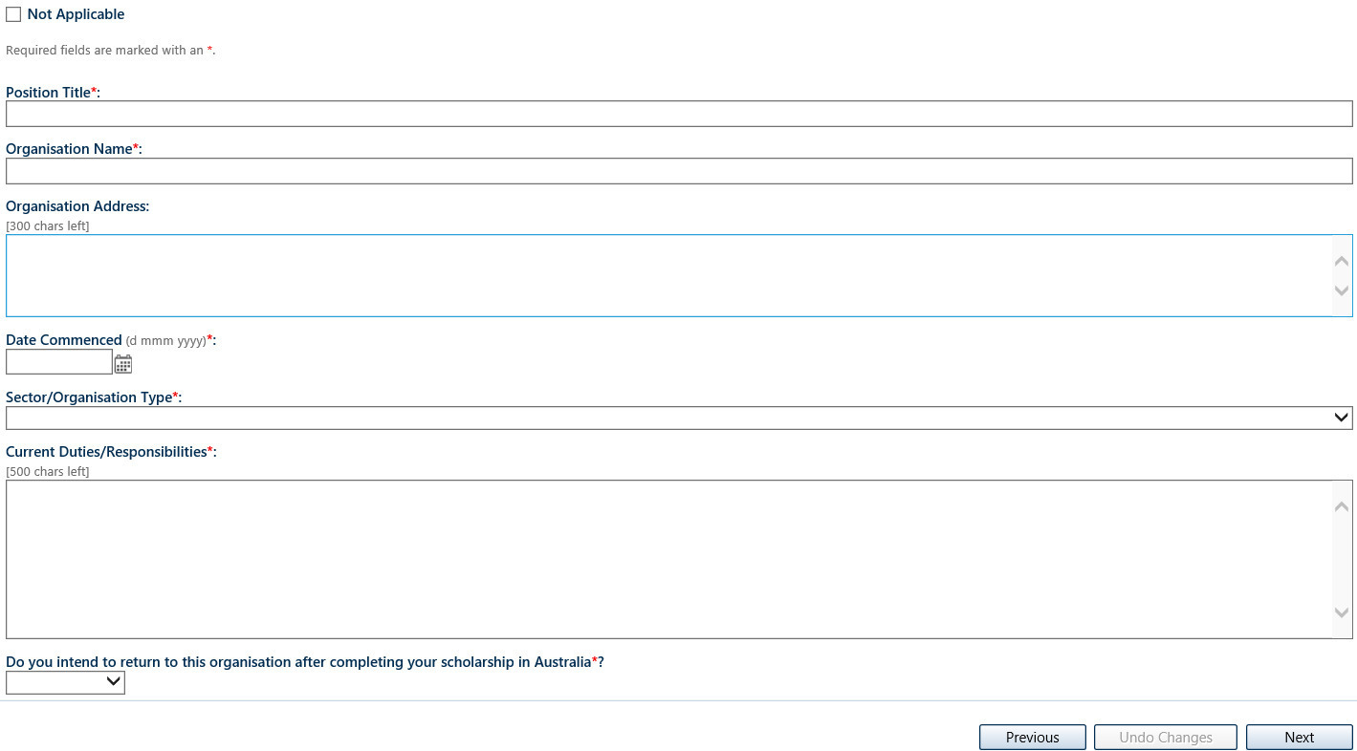3.

1. When you are finished, select **Next** to save your information and move to the next screen – **Previous Employment**.

**! Attention !**

Current employment may include work experience and voluntary work.

## Section 13 - Previous employment

Use this section to enter details of your previous employment.

Only provide details of previous employment that is relevant to your application. Employment history may include relevant work experience, community work and voluntary work.

1a. If you do not have a previous employment record, please select the not applicable checkbox.

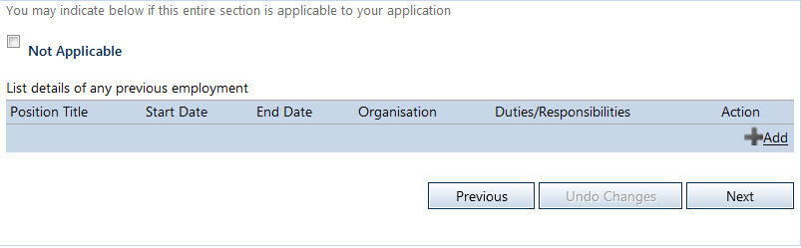

***OR***

1b. If you have previous employment records select the +Add icon to open the **Add – Previous Employment** screen.

Complete the fields.

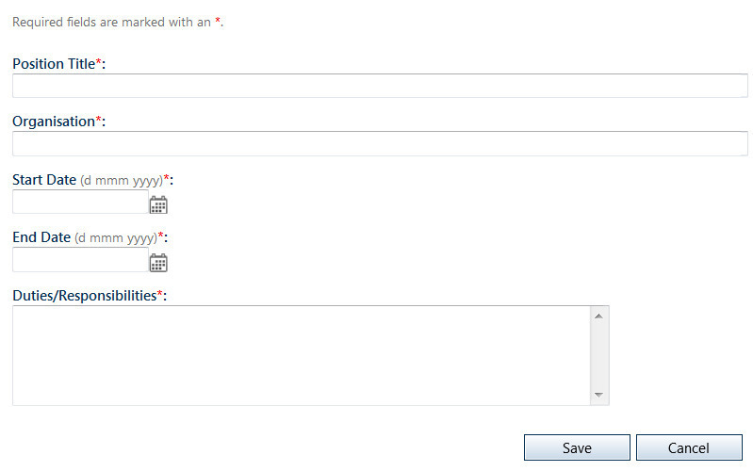

1. When you have entered the details of your previous employment, select **Save** to save the information.
2. Repeat steps 1b and 2 to add any additional previous employment.
3. When you are finished, select **Next** to save your information and move to the next screen – **Supporting Statements**.

## Section 14 - Supporting statement

Use this section to enter statements to support your application.

Please prepare your supporting statements carefully. Your answers will be considered by the Australia Awards Scholarships selection panel when shortlisting candidates for interview and when making a decision on the outcome of your application.

Please ensure that your supporting statements are clear, concise and relevant.

**! Attention !**

Each field has a character limit of 2000 characters; characters are defined as letters, spaces and punctuation marks. Any characters which exceed the limit may not visible to the selection panel and will not be included in your response.

1. Please complete these fields:

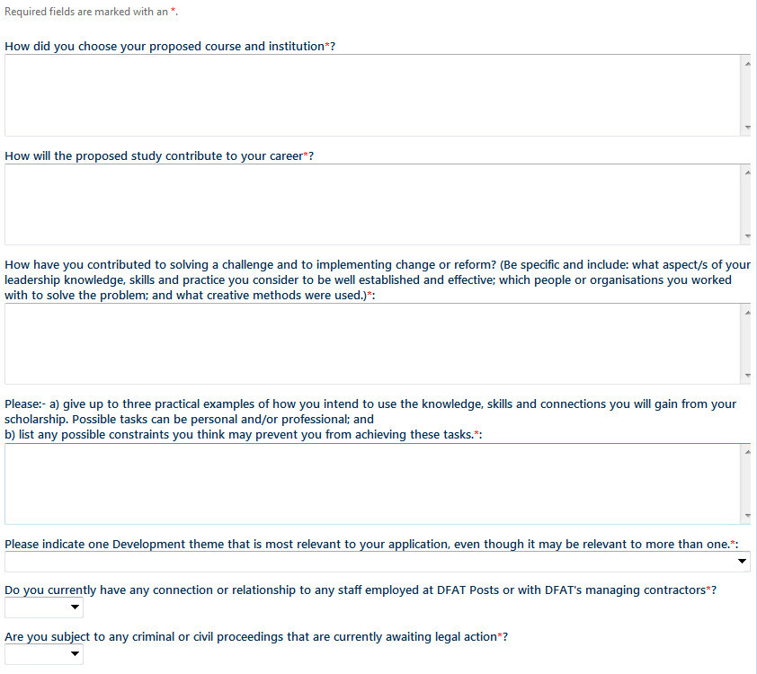

~continued on next page~

Disability status

This Supporting Statement Section also asks you to indicate if you are a person with disabilities.

**! Attention !**

Under Australian law, disability includes physical, intellectual, psychiatric, sensory, neurological, learning disabilities, physical disfigurement, and the presence in the body of disease-causing organisms. DFAT strongly encourages applications from people with disabilities and encourages applicants with disabilities to identify themselves. This information is bound by Australian privacy laws and will be disclosed only for the purpose   
of facilitating an accessible barrier-free learning environment. More information on support for applicants or awardees with disabilities can be found in the   
[Australian Awards Scholarships Policy Handbook.](https://www.dfat.gov.au/about-us/publications/australia-awards-scholarships-policy-handbook)

[Australia Awards Pacific Scholarships Policy Handbook](https://www.dfat.gov.au/about-us/publications/australia-awards-pacific-scholarships-policy-handbook)

1. Please use this box to indicate your disability status.



1. When you are finished all fields on the Supporting Statement screen, select **Next** to save your information and move to the next screen – **Professional Memberships**.

## Section 15 – Professional memberships

This is the section where you can tell DFAT about any professional memberships you have.

Only include memberships of relevant professional associations or voluntary organisations. This could include community, cultural, political, scientific, professional or educational organisations.

1a. If you do not have professional membership record, please select the not applicable checkbox.

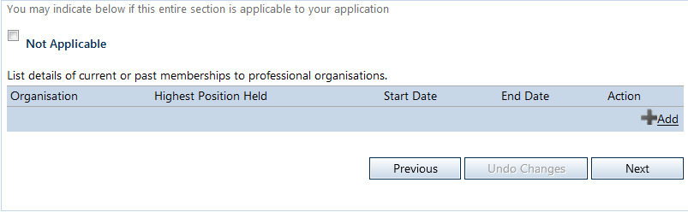

***OR***

1b. If you do have any current or past memberships to professional organisations select the +Add icon to open the **Add – Professional Memberships** screen.

Complete the fields and then press **Save**. Your information will appear as a list on the Professional Memberships screen.

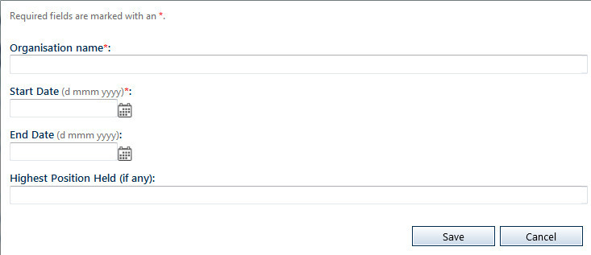

1. If you have more than one professional membership you will need to enter each one individually.

When you have entered the details of each professional membership, select Save to save the information. Then repeat steps 1 and 2 to add the next membership.

1. When you are finished, select **Next** to save your information and move to the next screen – **Communication**.

## Section 16 – Communication

Use this section to indicate where you first learnt of the Australia Awards.

This information is important because it helps DFAT ensure eligible candidates are aware of the Australia Awards Scholarships program.

1. Select an option from the drop-down list.

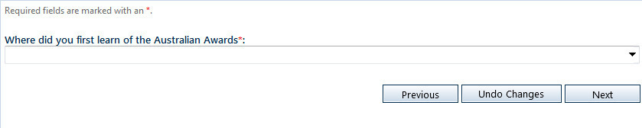

1. When you are finished, select **Next** to save your information and move to the next screen – **Documentary Evidence**.

## Section 17 – Documentary evidence

Use this section to upload all required documentary evidence.

In addition to the application form, Australia Awards Scholarship applicants are required to upload copies of a number of documents to support their application. Please read this screen carefully and ensure that you have uploaded all mandatory documents.

**STOP !**

Most documents will require certification before they are attached. Please refer to [Australia Awards Scholarships Policy Handbook](https://www.dfat.gov.au/about-us/publications/australia-awards-scholarships-policy-handbook) for guidance on certifying documents and the participating country profile to ensure that you have included all mandatory documents.

1. On the **Documentary Evidence** screen select the +Add icon.

The **Upload Document** screen will open.

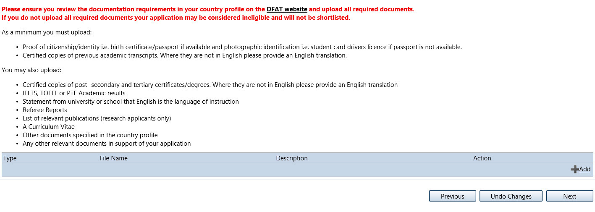

1. On the **Upload Document** screen select document type, add the description and upload the document and save.

Repeat these steps to upload additional document. All uploaded documents will appear as a list on the **Documentary Evidence** screen.

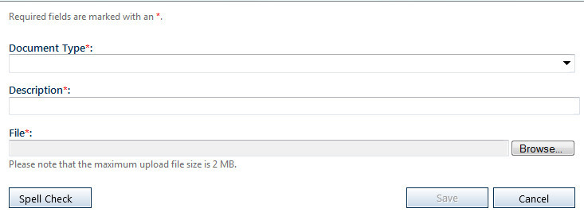

1. When you are finished, select **Next** to save your information and move to the next screen – **Declaration**.

**! Attention !**

There is a 2MB limit per document uploaded. OASIS will accept only the following documents types: .doc, .docx, rtf, .pdf, .gif, .jpeg, .jpg, .tiff, .png, .bmp, .txt.

## Section 18 - Declaration

Applicants for an Australia Awards Scholarship are required to declare that the contents of their application are true and correct, and to acknowledge that DFAT has the right to vary or reverse any decision regarding an Australia Awards Scholarship made on the basis of incorrect or incomplete information.

This section allows applicants to make that declaration.

1. Complete the Declaration and Acknowledgement section by reading the screen carefully and ticking the box. Then select Submit to complete and submit your application.

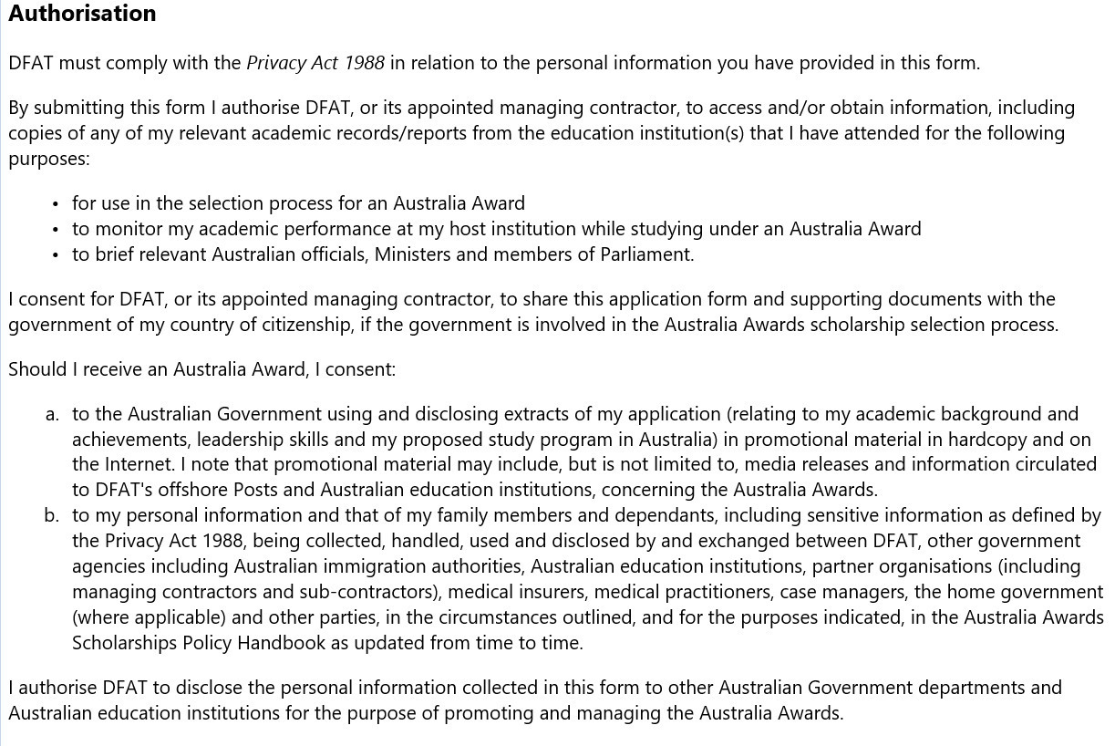

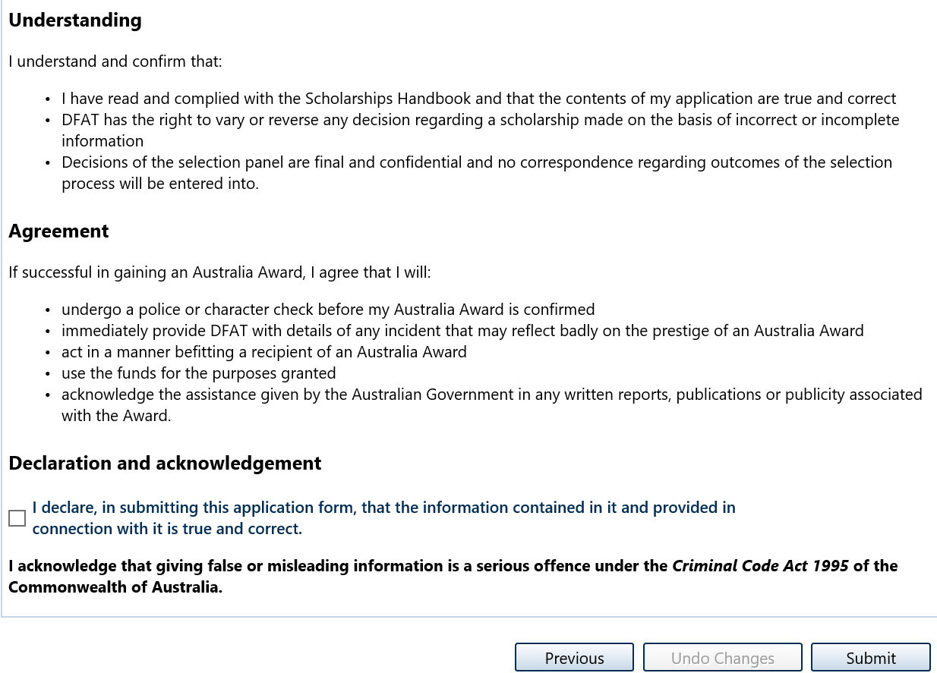

# 8. Submitting your application

Once you have pressed **Submit** on the **Declaration** screen you have completed all the tasks in the Application Checklist and submitted your application for consideration by DFAT.

## Submission Deadline

All online applications must be submitted in OASIS, with all relevant documents attached, by **midnight Australian Eastern Standard Time on 30 April 2024.**

OASIS will close to all applicants at that time. After this time applicants will no longer be able to view, edit or submit applications. There is no exception to this rule.

**! Attention !**

OASIS will become very busy in the few days before 30 April 2024. To avoid the possibility of not being able to submit your application we **strongly advise** applicants applying online to submit their applications well before the closing date. OASIS experiences peak usage in the days leading up to the closing date and applicants may experience delays.

# 9. Making changes after submission

All applications may be edited while they are in Draft before they have been submitted. In practice this means applicants can log in and out of OASIS and make changes to Draft applications at multiple times up until they have hit Submit on the Declaration screen.

Once an application has been submitted, it has to be un-submitted in order to make changes. Un-submitting allows applicants to edit and resubmit an amended application.

1. To un-submit your application; open your application in OASIS select

**Un-submit Application** on the **Application Menu**.

This will open the **Un-Submit Application** screen.

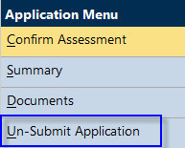

1. The **Un-Submit Application** screen will open with a verification confirming that the application is about to be recalled.

Select **Un-Submit** and the status of the application will change back to **Draft**.

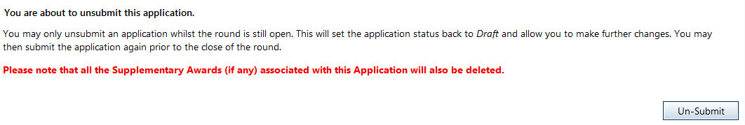

**STOP !**

Remember to re-submit your application when you have completed your changes  
and before the submission deadline **midnight Australia Easter Standard   
Time on 30 April 2024**.