Overseas Aid Gift Deduction Scheme 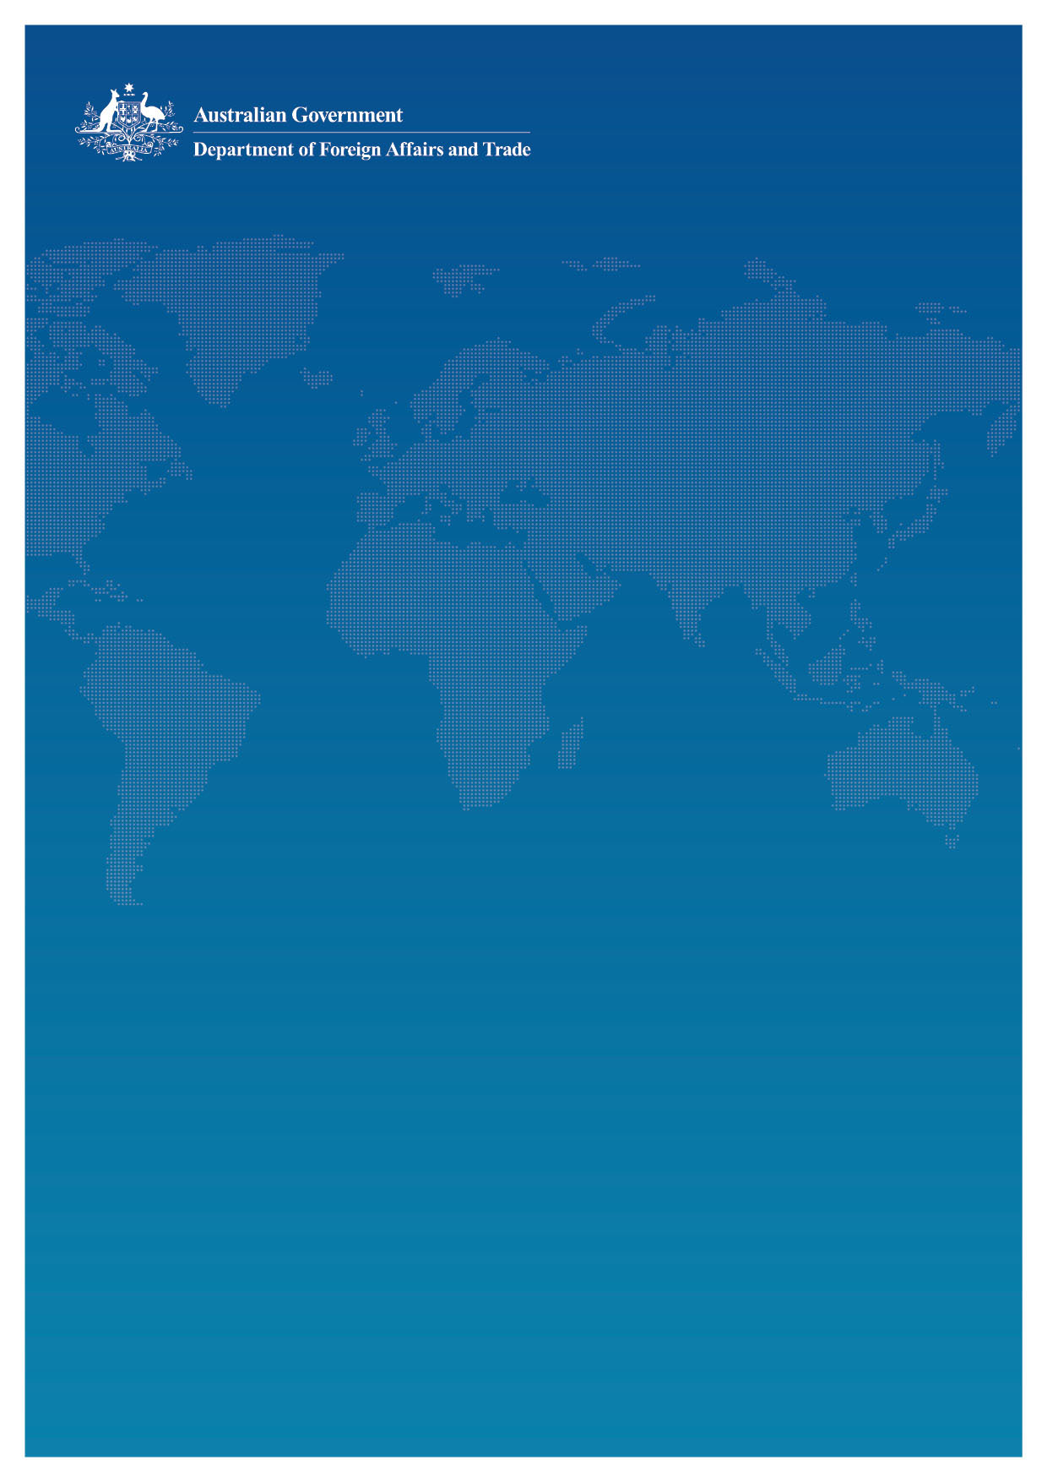

Frequently Asked Questions

February 2016

## Applying for the OAGDS

### Should our organisation apply for OAGDS?

The OAGDS allows organisations working on overseas aid activities to provide tax deductible receipts for donations to support these activities. As there is a high degree of risk in undertaking overseas development activities, the OAGDS seeks to ensure that organisations applying for OAGDS have good governance structures in place and a high standard of international development practice, based on their track record.

As such, not all organisations will be approved for OAGDS. If you are undertaking a one-off project, it may be more efficient to partner with another organisation that already has tax deductibility to deliver your project. Similarly, if your organisation is a fundraising arm for another international organisation, in some instances you may not be able to meet all of the OAGDS criteria. If you are unsure whether your organisation fits OAGDS, contact the OAGDS administrators about your application.

Depending on the type of overseas aid activities you are undertaking, you may wish to partner with, or contribute to, another overseas aid organisation rather than to seek your own deductible gift recipient (DGR) status. Justice Connect also publishes a useful guide to those considering entering into partnering arrangements: [www.nfplaw.org.au/not-profit-laws-new-auspicing-guide](http://www.nfplaw.org.au/not-profit-laws-new-auspicing-guide)

### Why should I apply for OAGDS when there are other ways of achieving tax deductibility?

There are different ways of obtaining deductible gift recipient (DGR) status but only the OAGDS is administered by DFAT. We advise you to seek advice as to what DGR may best suit your organisation and governance arrangements.

The OAGDS seeks to promote good governance and international development practice in overseas aid charities. Under the legislation, the Minister for Foreign Affairs ‘approves’ an organisation. For the Minister for Foreign Affairs to be confident in this approval, the organisation needs to meet the standard required by the eligibility criteria.

Aside from tax deductibility, obtaining OAGDS approval can have other benefits for your organisation. Past applicants have favourably commented on how the OAGDS process has strengthened the governance of their organisation. Many organisations use OAGDS criteria as a guide to good international development practice.

### How long does it take to get ‘approved organisation’ status under Step 1?

This step can take several months, depending on the quality and completeness of the application, the quality of evidence presented to support the application and the availability of assessors. DFAT engages independent development experts to assess the application. If there are areas of the application where there are gaps or not enough evidence is provided, the independent assessor will provide a preliminary report to the applicant, with the applicant given 30 days to address highlighted issues.

### When can an organisation offer tax deductibility for donations to its developing country relief fund?

Tax deductible receipts can only be offered after the Treasurer has gazetted the developing country relief fund, and can only be applied to donations received after the date of gazettal.

### I have received a letter from DFAT saying that the Minister for Foreign Affairs has declared my organisation an ‘approved organisation’ under the Overseas Aid Gift Deduction Scheme. Can my organisation now offer tax deductible receipts for donations for overseas aid activities?

No. You cannot issue tax deductible receipts until your developing country relief fund has been gazetted by the Treasurer. The Treasurer’s decision is independent of the Minister for Foreign Affairs’ decision, and there may be an interval of several months between their decisions.

### Can an organisation reapply for ‘approved organisation’ status under the OADGS should they not be successful?

Yes. An organisation can re-apply at any time. Where an organisation has been unsuccessful, a new full and complete application will be required and should only be submitted where the organisation is able to demonstrate that action has been taken to redress the areas the previous application did not satisfy. Please note that DFAT will not accept incomplete applications that merely address the criteria that the organisation did not satisfy initially.

## Meeting the OAGDS Criteria

### My organisation is currently partnering with another organisation with DGR status in order to issue tax deductible receipts. Will this affect our organisation’s ability to meet the eligibility criteria?

Some organisations choose to enter into partnerships with other Australian organisations for a variety of reasons such as capacity building, administrative efficiencies and the ability to offer tax deductible receipts to donors. For the purposes of OAGDS criteria, DFAT does not take a view on the various partnership arrangements an Australian organisation may make with another entity, as long as the applicant does not misrepresent their role in carrying out the activities used as evidence.

It is important that applicants to the OAGDS in these partnerships are able to clearly articulate the role they play in the projects used as evidence to demonstrate track record. DFAT seeks to establish that an organisation has the capacity to successfully carry out overseas aid activities.

## Continuing to Comply with the OAGDS

### What happens if the name, objectives, activities or governance of an ‘approved organisation’ changes after the developing country relief fund has been gazetted?

Where an organisation seeks to change its purpose or provisions in its constitution or equivalent document it should consult with DFAT about the possible impact of these changes on its ‘approved organisation’ status. Where significant changes are made to the organisation’s objectives, activities or governance, another assessment may be required.

Where an organisation seeks to change its name only, it must also seek advice from DFAT. If DFAT is satisfied that an organisation’s objectives and governance arrangements have not changed and that the renamed organisation is the same organisation as that declared an ‘approved organisation’ previously, DFAT does not require further notification and does not require further information.

### Can I change the name of the developing country relief fund?

Yes. When an organisation establishes a developing country relief fund, the ATO requires an undertaking in writing, or the inclusion of a clause in the constituent documents, that the ATO is to be notified of any changes to the fund’s constitution or other governing documents. Therefore, an organisation contemplating any changes to its developing country relief fund should therefore first contact the ATO.

Since the Treasurer declares by notice in the Commonwealth Government Gazette a fund to be a developing country relief fund, any change of name will require the Treasurer to reissue the notice in the new name and to revoke the old name.

### Can an organisation be reviewed after it has been declared an ‘approved organisation’ by the Minister for Foreign Affairs?

Yes. Once an organisation has been declared an ‘approved organisation’ by the Minister for Foreign Affairs and its developing country relief fund has been gazetted, it must operate that fund according to the rules and principles under which it was established. At any future date DFAT may request an organisation to provide information that demonstrates the organisation is operating in accordance with the OAGDS guidelines. DFAT will inform the organisation in writing of any such request. This is in addition to ACNC and ATO requirements.

## Developing Country List

### What happens when there are changes to the list of approved developing countries?

Tax deductible donations can only be applied to activities in a country which appears on the list of developing countries. Where a country is removed from the list by the Minister for Foreign Affairs, the organisation will no longer be able to apply those funds to projects within that country. Changes to the list take effect immediately. It is the responsibility of organisations to keep themselves informed of the up-to-date list.

The Minister for Foreign Affairs declares which countries are 'developing' for the purposes of the OAGDS. These countries are generally based on the OECD’s Development Assistance Committee list of aid recipients and may change from time to time.

The list of approved developing countries is available from: <http://www.dfat.gov.au/aid/who-we-work-with/ngos/Pages/list-of-developing-countries.aspx>