Project details:
Project Name: | Nepal Water for Health Project (“NEWAH project”)
Region(s): | Nepal
Implementing Partner(s): | NEWAH
AusAID project funding: | AU$3,000,000
Funding received to date | AU$3,000,000

Australian NGO contact details:
Australian NGO contact | Elly Barrett
Title | International Programs and Accountability Manager for South Asia and Africa
Organisation | WaterAid Australia
Phone number | 03 9872 1806 / 0403 333 375
Email | elly.barrett@wateraid.org.au
Fax | 03 9872 1132

Nepal Water for Health Program
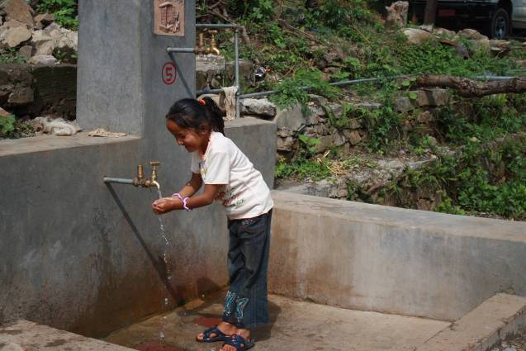
6 monthly update
(01 January - 30 June, 2011)
Submitted by WaterAid Australia
August 2011

Acronyms 4
1 Executive Summary 6
2 Objectives of the Program 7
3 Other key progress highlights (qualitative) 13
4 Financial Progress 13
5 Challenges arising 14
6 Mid Term Review recommendations and action plan 15
7 Key activities planned in the coming 6 months 17
Annex 1: Financial Report 17
Annex 2: Revised list of working areas (projects and VDCs) 18
Annex 3: Project progress photos 19
Annex 4: Case Studies 21
Annex 5. Hygiene Indicators developed in collaboration with district health office: Translated version 26

Acronyms
AUD Australian Dollar
AusAID Australian Agency for International Development
CLTS Community Led Total Sanitation
DDC District Development Committee
DPHO District Public Health Office
D-WASH-CC DDC level WASH Coordination Committee
ER Eastern Region
ERO Eastern Region Office
FEDWASUN Federation of Water and Sanitation Users Nepal
FWR Far Western Region
FWRO Far Western Region Office
MFWRO Mid and Far Western Region Office
MTR Mid Term Review
MWR Mid Western Region
NEWAH Nepal Water for Health
NGO Non-Government Organisation
ODF Open Defecation Free
PLHIV People living with HIV
PME Planning Monitoring and Evaluation
PRA Participatory Rural Appraisal
UC User Committee
VDC Village Development Committee
V-WASH-CC VDC level WASH Coordination Committee
WAAus WaterAid in Australia
WAN WaterAid in Nepal
WASH Water, Sanitation and Hygiene
WSUC Water and sanitation Users Committee

Executive Summary
WaterAid’s AU$3m AusAID funded Nepal Water for Health program (the NEWAH project) commenced in May 2010 and will be completed in December 2011. WaterAid has been managing this project through its office in Nepal and its national partner, Nepal Water for Health (NEWAH).

The project aims to increase WASH services in four districts (Udayapur, Siraha, Surket and Doti) across three regions (Eastern, Mid-Western and Far Western) of Nepal through a number of targeted interventions. This includes working with local civil society organisations, NGO and government partners to provide water services, as well as undertaking awareness and education programs focused on achieving improved and sustained sanitation and hygiene behaviour practices. A total of 30,200 poor people are expected to benefit from this project by December 2011 in targeted areas.

The reporting requirements set out in the project funding order specify the submission of an interim report in August 2010, a progress report in December 2011 and a final project report in May 2012. Following discussions with AusAID after the submission of the interim report in August 2010, WaterAid agreed to provide two additional six-monthly updates given the extended period of time between the first two reports. This report is the second six monthly update and covers the period from 01 January 2011 to 30 June 2011.

Significant progress has been made across the NEWAH program with a total of 65 projects currently in progress in varying stages of completion. Exchange rate gains resulting from the high Australian Dollar have made it possible to extend the project areas to an additional seven from the originally planned 58. Of the 65 project areas, 34 projects have now been completed and are being successfully managed by their respective communities. This has provided 16,000 additional people with access to safe water.

Sanitation has also significantly improved in the target communities with the delivery of the Community Led Total Sanitation (CLTS) approach. 57 communities have declared their communities as “Open Defecation Free” or “ODF communities” and 4 Village Development Committees (VDCs) have declared their VDCs as “ODF”.

In addition to the service delivery program, sector capacity building and improving sector governance activities have also being successfully implemented. All 10 local NGOs and district chapters of FEDWASUN (Federation of Water and Sanitation Users Nepal) have been actively participating in the capacity building program. Likewise, sector coordination and collaboration in WASH activities at regional and district level are in full swing. Multi-year strategic plan development for universal sanitation coverage at both districts has taken place with increasing momentum.

A Mid Term Review (MTR) of the NEWAH project was recently undertaken by an external review team and a report finalised in June 2011 and shared with all stakeholders including with AusAID. The MTR findings reported good progress towards achieving project implementation against targets noting major program success in the delivery of NEWAH’s sanitation promotion. It also noted the use of a sound implementation approach and that NEWAH’s gender and poverty approach has been particularly successful. The team suggested some very practical recommendations for improvement of the current program as well as a possible next phase program which WAN and NEWAH have discussed and responded to through the development of an action plan which is included in this report.

Regular progress updates and meetings have been held with AusAID Nepal, especially in relation to the possible next phase of the NEWAH program, mid-term review and upcoming Australian Ambassador’s visit to a project site. In addition to the regular project monitoring visits undertaken internally, WaterAid in Australia (WAAus) also undertook a monitoring visit in March 2010 and met with staff from AusAID Nepal, WAN and NEWAH.

WaterAid has received the full budget for the NEWAH project from AusAID and subsequently no
further tranches have been received or are scheduled for the remainder of the project.

Utilisation of project funds has been tracking well with projected expenditure for the reporting period
at 86%. Due to the high Australian dollar, significant exchange rate gains (AU$222,000) were incurred and subsequently directed back to the project, enabling the reach of the project to be extended. Budget utilisation is anticipated to remain on track for the remainder of the project in 2011. A detailed expenditure and budget table for this reporting period is included in Annex 1.

Objectives of the Program
The key objectives and anticipated results areas of the NEWAH project as set out in the project proposal are outlined below:
Objective - 1: To increase access of poor and excluded communities to a sustainable supply of safe and adequate water, and to ensure sustained improvements in the environmental sanitation and health status within these communities in at least 4 districts by December 2011
Result Area: Change in Access & Rights to WASH services for the un-served
Objective - 2: To improve the capacity of selected NGOs and Local Government Agencies (LGAs) to enable WASH services to be targeted at poor and excluded communities, delivered and monitored more effectively by December 2011
Result Area: Changes in Sector Capacity to achieve WASH
Objective - 3: To strengthen effective district level coordination mechanisms for efficient and pro-poor allocation of resources and implementation of WASH services in unserved areas by December 2011
Result Area: Changes in the Governance in relation to WASH Sector
Objective - 4: Involvement of women, men, girls and boys in all stages of WASH service delivery to strengthen their capacity and improvement of WASH governance at local level.
Result Area: Gender involvement in the provision of WASH services
Progress against objectives table:
Objective | Indicators | Progress
To increase access of poor and excluded communities to a sustainable supply of safe and adequate water, and to ensure sustained improvements in the environmental sanitation and health status within these communities in at least 4 districts by December 2011 | - 22,400 people in 55 targeted communities have access to safe and adequate drinking water  - VDC and communities operation and support mechanisms are in place to ensure water scheme remain functional  - 80% of beneficiaries are from poor & excluded groups  - 22,400 people have access to and use hygienic and appropriate sanitation services in targeted VDCs  - 100% of the targeted communities within VDCs reach and sustain No Open Defecation  - 80% of beneficiaries are from poor & excluded groups.  - 80% targeted communities have in place a community management system to maintain a healthy environment  - 70% of the beneficiaries adopted sustain improved hygiene behaviour practices in at least in three key hygiene indicators (hand-washing, management of human excreta, water & food hygiene) in targeted VDCs.  - Reduction in point prevalence rate of diarrhea by 20% respectively in targeted VDCs | - 65 rural communities identified in 21 target VDCs (16 ER communities and 49 MFWR communities) for WASH service delivery projects  - 30,200 people identified through field assessment data and socio-economic surveys of which 90% are poor and excluded.  - 65 Water and Sanitation Users Committees (WSUCs) established for implementation and management of the WASH projects.  - 34 (22 in MFWRO and 12 in ERO) of 65 WASH schemes completed and under the management of respective communities.  - 16,000 people have access to safe water as a result of the completion of the 34 WASH schemes.  - 31 remaining WASH schemes under construction.  - 57 communities have been declared as “Open Defecation Free” (ODF) through the delivery of Community Led Total Sanitation (CLTS) approach.  - 8 remaining project communities are in the process of declaring themselves ODF.  - 4 of 21 VDCs had been declared as “ODF VDCs”.  - Inclusive school latrine blocks with water supply facilities have been constructed at 23 of 29 schools and are being managed by the respective schools.  - 58 communities have received appropriate sanitation and safe hygiene practice awareness and training  - Appropriate sanitation and safe hygiene practice awareness training underway in remaining 7 communities
To improve the capacity of selected NGOs and Local Government Agencies (LGAs) to enable WaSH services to be targeted at poor and excluded communities, delivered and monitored more effectively by December 2011 | - NEWAH increase their knowledge on water quality mitigation, water resource management, climate change adaptation technologies and approaches  - NEWAH provide technical support on the delivery of drinking water and water resource management to local NGOs & LGAs beyond the focus VDCs in 4 districts  - Community based sanitation models are understood and promoted by all sector actors in 4 districts  - NEWAH provide technical support on sanitation promotion to VDCs, other local NGOs and LGAs beyond the focus VDCs in 4 districts  - NEWAH's Hygiene Promotion Team develops locally appropriate hygiene promotion programme addressing the specific needs of the targeted communities  - NEWAH provide technical support on hygiene promotion to CBOs, other local NGOs and LGAs in focus districts | - Identified 10 local NGOs and district chapters of FEDWASUN in Doti and Surkhet districts and assessed their capacity for WASH program delivery.  - Developed capacity building plan for 10 identified NGOs  - Developed and delivered training on NGO Organisational Management; Participatory Rural Appraisal (PRA) train-the-trainer facilitation; and CLTS sanitation promotion for 10 identified NGOs.  - As a result of the NGO capacity building activities ODF promotion campaigns have been initiated in 10 non-project VDCs by the participating NGOs.  - WASH project Water Quality & Water Safety Plan trainings have been delivered to the identified 10 Local NGOs and district FEDWASUNs  - V-WASH CCs established in all 21 project VDCs.  - V-WASH CCs have received training and support for planning and monitoring the WASH activities.  - Training on WASH project management, Gender and Social Inclusion delivered to all 58 WSUCs.  - Orientation training on CLTS approach delivered to all VDC secretaries in Doti and Surkhet districts to increase understanding and prioritisation of the sanitation budget in their respective VDC.  - As a result of this training VDC budget was allocated as an incentive for ODF communities.  - CLTS approach orientation delivered to VDC and District Development Committee (DDC) level political representatives, D-WASH-CC members and other agencies working in WASH sector who can influence and make decisions on budget allocation.
To strengthen effective district level coordination mechanisms for efficient and pro-poor allocation of resources and implementation of WASH services in unserved areas by December 2011 | - Sector coordination committees are established and functioning, addressing water resources in 4 focus districts by end of 2011  - District plans are developed and annually reviewed addressing drinking water issues for poor and un-served areas and improve local water governance  - Establishment of WASH coordination committee with defined roles and responsibilities on sanitation promotion in 4 focus districts  - WASH coordination committee influences district level inclusive planning processes and facilitates sectors monitoring towards sanitation targets  - WASH and Health Sector actors have planned joint District or VDC level activities to address key hygiene behavior changes in at least 3 of the targeted districts  - WASH and Health Sector actors have agreed indicators for monitoring adoption of hygiene practices in at least 3 of the targeted districts and jointly undertake a study on hygiene behavior practices in at least 1 district | - Organised national level and district level dissemination meeting(s) about the AusAID funded NEWAH program..  - Organised district level coordination and information sharing meetings to highlight the program deliverables in the areas of WASH service delivery, capacity building and governance improvement in the WASH sector.  - Revived the D-WASH-CCs in all 4 project districts and delivered technical and management support. Regular review meetings undertaken to discuss WASH plans and issues arising in the districts.  - Developed the VDC WASH profile of 4 VDCs in collaboration with V-WASH-CCs.  - Developed Doti and Surkhet district strategic WASH plans which articulate targets to declare districts as ODF by 2015  - Ongoing consultation and coordination with project area health posts and the District Public Health Office (DPHO) to identify the key hygiene behaviour needs to focus on in the health and hygiene program.  - Hygiene indicators developed in coordination with DWAS-CC and DPHO  - Budget Advocacy workshops conducted in Doti and Surket VDCs in collaboration with FEDWASUN.  - Consultation meetings and orientation workshops organised with FEDWASUN and Doti and Surkhet district journalists highlighting issues around WASH service delivery, budget allocation and utilisation, and focus areas for civil societies and media sector to address.  - In collaboration with the DPHO, a free health camp has been organized in a remote VDC of Doti district.  - SACOSAN IV, a declaration of commitment to sanitation and hygiene in South Asia by heads of delegation including Nepal, translated in Nepali language and disseminated at districts through D-WASH-CC
Involvement of women, men, girls and boys in all stages of WASH service delivery to strengthen their capacity and improvement of WASH governance at local level | - Gender and poverty (GAP) approach will be used at the programme and organizational level to address the exclusion of women and the poor in decision-making , training and other project-related benefits  - NEWAH will be utilizing the GAP approach throughout all its projects and organization, which includes interventions such as disaggregated data by sex, caste and ethnicity; affirmative action; gender awareness training; technical training for women; gender balanced water and sanitation users committees (WSUCs) | - 1846 people from the project area provided with gender and social inclusion training, of which 971 participants were female.  - 619 project users holding a position as WSUC members in 65 schemes, of which 312 members are female. 124 (almost 50% of female members) are holding key decision making positions within the WSUCs.  - 66 children’s clubs formed / revived in project communities. 597 child members of 66 children’s clubs have received training in children’s rights in WASH and sanitation and hygiene related training. 308 of the 597 participants were girls.  - 211 project area community members participated in sanitation mason training, of which 85 were female (40%).  - 192 project area community members participated in water supply systems care taker training, of which 77 were female (40%).  - 768 project area community members participated in community health volunteers training, of which 509 were female (66%).  - Training on Community Based Monitoring and Evaluation delivered to 659 project area community members, of which 321 were female (49%)

Other key progress highlights (qualitative)

  - After the program intervention in Doti and Surkhet, a movement in sanitation promotion and ODF campaigns was undertaken by sector stakeholders other than WAN and NEWAH. This was a result of the good coordination at district level and the sector capacity building undertaken along with replicable examples set by NEWAH in the field.
  - Sector coordination, capacity building of local NGOs, VDC secretaries, D-WASH-CC members and FEDWASUN have resulted the increased allocation of budget in sanitation at district and VDC level. Most importantly, VDC and DDC funds for sanitation are also being disbursed replicating the NEWAH model to incentivise communities once they have been declared ODF by communities themselves.
  - Local NGOs who participated in sector capacity training have since initiated community ODF campaigns and replicated the training they received in different VDCs using the knowledge and resources they had acquired. They have also since started seeking financial assistance from other agencies to scale-up their ODF campaigns more widely.
  - VDCs have taken a lead on ensuring the sustainability of ODF status through mainstreaming permanent and hygienic latrines. They have adopted a “Sanitation Identity Card” at the household level which captures the present latrine type (temporary or permanent) being used by households so that they can be monitored and encouraged to upgrade of latrines to more permanent ones.
  - Gender involvement in WASH activities has increased. Around 50 percent of WSUC members are now women and two WSUCs are lead entirely by women. Likewise, the representation of women in V-WASH-CCs, which is the VDC level mechanism and traditionally dominated by men, has increased, and is currently above 20%.
  - A People living with HIV (PLHIV) focused WASH initiative has commenced in Pachnali VDC in close coordination with the DPHO. This initiative has been launched in partnership with Laligurash Yakata Samaj, a member of the PLHIV group.

  - In preparation for a possible second phase of the NEWAH program, project identifications and technical survey activities have been completed.

Financial Progress
WaterAid has received the full budget for the NEWAH project from AusAID and subsequently no
further tranches have been received or are scheduled for the remainder of the project.
The initial approved NEWAH project budget was NRs. 192,000,000 (AU$3,000,000). This was calculated adopting the exchange rate of AU$1 to NRs. 64. However, at the time of the fund transfers the Australian dollar was significantly higher, resulting in exchange rate gains of NRs. 6,233,152 (approximately AU$222,393). The local currency budget has subsequently been revised to account for this and now totals NRs. 206,233,152. A higher exchange rate has been applied of NRs 68.4 to maintain the overall AUD budget at AU$3,000,000 reflecting the amount WaterAid has received from AusAID. Please see Annex 1 for more details.
Utilisation of project funds has been tracking well with projected expenditure for the reporting period
at 86% including the increased local currency funds. Budget utilisation is anticipated to remain on track for the remainder of the project in 2011. A detailed expenditure and budget analysis is included in Annex 1.
A snapshot of budget utilisation is shown in the table below:
 | Budget | Expenditure
Currency | Overall budget | Apr – Dec 2010 | Jan – June 2011 | Cumulative to June 2011
NRs | 206,233,152 | 103,163,891 | 73,762,145 | 176,926,037
AUD | 3,000,000 | 1,611,935 | 961,744 | 2,573,680
Budget utilisation rate ( %) |  | 50% | 36% | 86%

Challenges arising
The main challenge currently faced is that a possible second phase of the program has not yet been confirmed. This has a number of implications on planning, staff and other project resources.
The second phase of the program would ideally overlap with the current program which is due to conclude in December 2011 so that there is an immediate transition and minimal adverse impact to continuity, staff and other project resources. Where project work has been completed some field staff have been notified of their termination due to there being no confirmed continuation of project funding. NEWAH will continue to scale down their staff base as the current project draws to an end which may leave them without trained or experienced project staff to mobilise for the next phase of the program.
To prepare for the possibility of a phase two of the project, WAN and NEWAH have undertaken preliminary planning and technical survey works in coordination with district governments so to avoid any delay in the implementation of the possible second phase of the project. NEWAH, WAN and WaterAid Australia have also been in regular communication with AusAID in Nepal and in Canberra to discuss the possibility of the phase two project and to raise the issues of a gap in funding between the project periods.
In terms of staff retention, NEWAH is keeping both their current and former project staff fully updated on any further developments of the phase two program in the hope that they could be mobilized quickly if the second phase of the program is confirmed.
NEWAH is also keeping other project stakeholders abreast of developments regarding the possible phase two as there is great support and enthusiasm for the continuation of the program by the local government. Subsequently, DDCs have already identified the target VDCs for the next possible phase of the program but WaterAid is not yet in a position to confirm whether these VDCs are likely to receive support and / or provide an indication of timing.

Mid Term Review recommendations and action plan
A Mid Term Review of the NEWAH project was undertaken and report completed in June 2011. This review was conducted by external consultants selected by WAAus and WAN following extensive consultation including with AusAID. The TOR for this assignment was developed through joint consultation between WAAus and WAN and WAN provided a detailed orientation on the TOR to the consultants at the outset of the review.
The MTR TOR describes the following four purposes:
- to assess trends of progress related to project implementation against targets;
- to assess WAN’s and NEWAH’s success in delivering outputs and the relevance of the various approaches applied.
- to review lessons learned that can be shared.
- to make recommendations to improve the effectiveness of the project and set out benchmarks for future programming and direction.

The methodology adopted involved a desk top review, consultations with WASH sector agencies and an extensive field visit. Background reading included key sector, AusAID, WAAus, WAN and NEWAH documentation including administrative, financial and procurement procedures. Meetings were held with NEWAH program staff in Kathmandu, Nepalgunj, Surkhet and Doti and with line agencies, WASHCCs, local government and partner NGO staff in Surkhet and Doti. Additional meetings were held in Kathmandu with WaterAid’s program team, The World Bank, UNICEF and the Department of Water Supply and Sewerage (DWSS). AusAID’s Senior Program Manager participated in the MTR team on its visit to Far West Nepal and provided constructive inputs during interactions with WSUCs, V-WASHCCs and D-WASHCCs and sector agencies. He also advised on AusAID related development information.
The MTR findings reported satisfactory progress towards achieving project implementation against targets and noted that the use of a sound implementation approach, including NEWAH’s gender and poverty approach, was particularly successful. The team also suggested some very practical recommendations for improvement of the current program as well as a possible next phase program. Following are the key recommendations and action plan:

Major themes of recommendations | Action plan | Timeline
Research/study on hygiene behaviour: It has been recommended to conduct research on sustainability of hygiene behaviour in communities at the post-project stage. | Sustainability monitoring on hygiene behaviour in post-follow up monitoring will be included. An independent study will also be conducted. | April 2012
Collaboration with cross sector agencies: It has been advised to expand the collaboration with DEO, DHO and NHSP2 for the upgrading of toilet facilities in schools and health facilities to include the safe disposal of menstrual and medical wastes | The current level technical coordination and collaboration between NEWAH and the DEO and DOH will be scaled up. | Ongoing
Collaboration with D-WASH-CC and V-WASH-CC: It has been recommended to continue close collaboration as well strengthening to V-WASH-CC and D-WASH-CC. | The current level of coordination and collaboration will be continued and support will be provided to strengthening them as well. | Ongoing
Advocacy and Sector influencing: it has been recommended to increase the advocacy and influencing role and scaling up CLTS approach. | Advocacy and influencing work to attract increased funding in sector and uptake of CLTS will be given more focus | From August 2011 onwards
Procurement: It has been recommended for WAN to sit on NEWAH procurement committee along with external technical consultant. | WAN now has representation on NEWAH’s procurement committee | March 2011
Impact of gender training and effectiveness: It has been recommended to review the achievements of gender training. | Review of the achievements of gender related training planned. | Nov –Dec 2011
Research and documentation: To maximise the scale-up effect of the program, it has been recommended to carry out studies and document learnings. | Greater contribution will be made to the WASH evidence base through undertaking and documenting program research. | August 2011 onwards
Monitoring and support visits: It has been recommended to WAN to increase the technical support visits at field level. | WAN’s field level support visits are planned in the areas of programs, M&E and finance support. | July 2011 onwards

Key activities planned in the coming 6 months
- Construction activities in remaining 31 schemes are ongoing. Thus, completion of those projects is one of key activities in next six months.
- Documentation of case studies from field to be undertaken using an external consultant.
- Follow-up and management support will be provided to 34 completed schemes.
- V-WASH CC workshops at all 21 VDCs will be arranged to hand-over the projects in December 2011
- District level review and dissemination meeting(s) will be undertaken at Doti and Surkhet to discuss project outcomes
- Review meeting with local NGO partners and FEDWASUN will be organised to review and discuss the outcomes of sector capacity building initiatives
- Review and experience sharing workshop of women’s leadership from WSUCs and FEDWASUN will be conducted.
- Detail financial and program planning for next phase of program undertaken.
- Action plan in response to MTR recommendations implemented.

Annex 1: Financial Report
Please see attached Excel file

Annex 2: Revised list of working areas (projects and VDCs)
Region | District | VDC | Project name | Number of projects | Completed March 2011 | Completed April-June  2011 | Total completed June 2011
Eastern Region | Udayapur | Sirise | Sirise VDC Project | 3 | 3 |  | 3
Eastern Region | Udayapur | Rauta | Rauta VDC Project | 6 | 3 |  | 3
Eastern Region | Udayapur | Ename | Ename VDC Project | 3 | 2 |  | 2
Eastern Region | Siraha | Fulbariya | Fulbariya VDC Project | 1 | 1 |  | 1
Eastern Region | Siraha | Brahmangaugadhi | Brahmangaugadhi VDC Project | 3 | 3 |  | 3
Mid Western Region | Surkhet | Guthu | Guthu VDC Project | 3 | 1 | 1 | 2
Mid Western Region | Surkhet | Dasharathpur | Dasharathpur VDC Project | 3 | 1 | 1 | 2
Mid Western Region | Surkhet | Kunathari | Kunathari VDC Project | 2
Mid Western Region | Surkhet | Lekgaon | Lekgaon VDC Project | 2 | 1 | 1 | 2
Mid Western Region | Surkhet | Salkot | Salkot VDC Project | 8 |  | 4 | 4
Mid Western Region | Surkhet | Ghoreta | Ghoreta VDC Project | 1 | 1 |  | 1
Mid Western Region | Surkhet | Dahachaur | Dahachaur VDC Project | 1
Far Western Region | Doti | Banlek | Banlek VDC Project | 6 |  | 2 | 2
Far Western Region | Doti | Mudbhara | Mudbhara VDC Project | 1
Far Western Region | Doti | Latamandu | Latamandu VDC Project | 3 |  | 1 | 1
Far Western Region | Doti | Warpata | Warpata VDC Project | 5
Far Western Region | Doti | Dahakalikasthan | Dahakalikasthan VDC Project | 2
Far Western Region | Doti | Lamikhal | Lamikhal VDC Project | 3 | 2 | 1 | 3
Far Western Region | Doti | Pachnali | Pachnali VDC Project | 4 | 2 |  | 2
Far Western Region | Doti | Mannapakadi | Mannapakadi VDC Project | 3 |  | 2 | 2
Far Western Region | Doti | Ghangal | Ghangal Project | 2 |  | 1 | 1
Grand total |  | 21 VDCs | 26 Projects | 65 | 20 | 14 | 34

Annex 3: Project progress photos
Figure 1 Children fetching the water from tap stand constructed near to their house at Latamandu VDC of Doti District
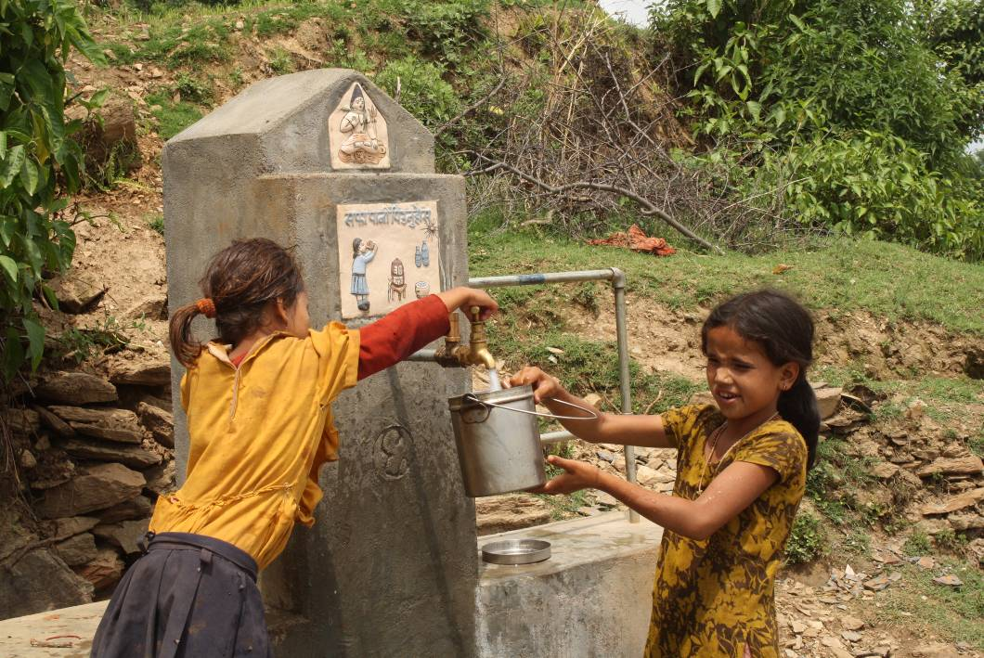
Figure 2 Project display board at Tokma village of Salkot VDC in Surkhet
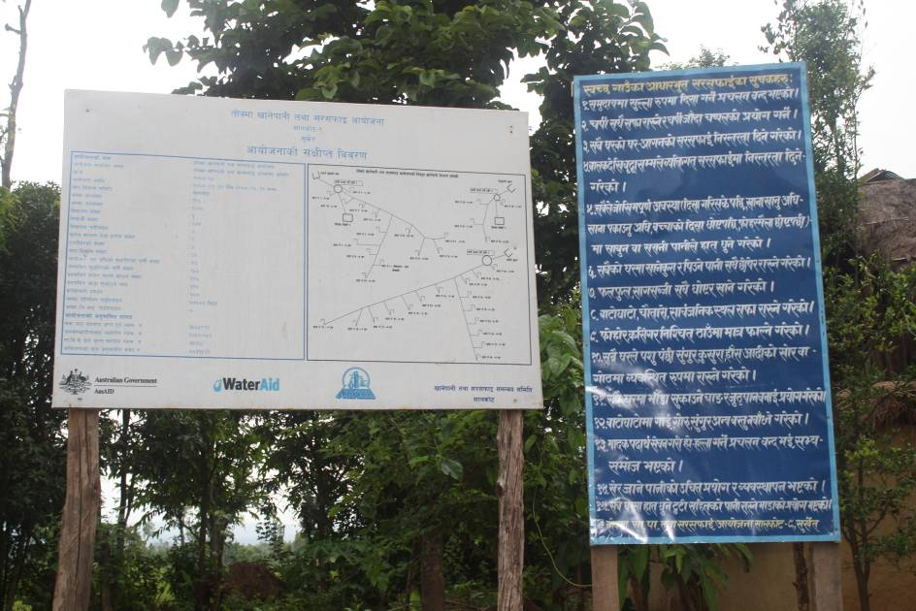
Figure 3 Women of Pachanali VDC of Doti District showing the commitment board of ODF VDC during ODF declaring ceremony
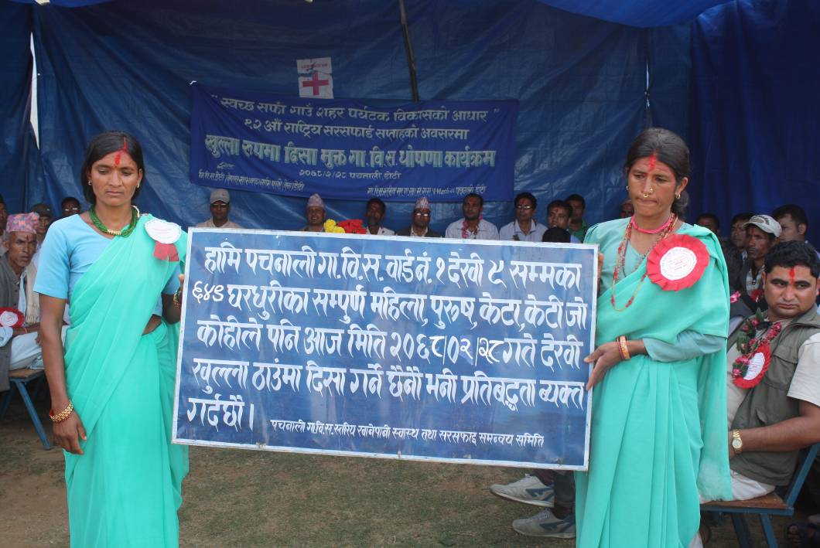

Annex 4: Case Studies
Buying water no more
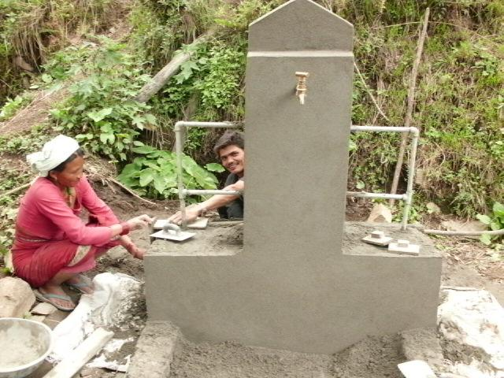
“Wealth is not enough to achieve benevolence, thinking and consciousness in a person; the kind of consciousness that helped to declare this area open defecation free,” says Prem Nepali, 28, from Doti district’s Ghangal VDC ward no. 8.
Woman working in construction activity
The VDC, predominately populated by indigenous people, remained untouched in terms of water and sanitation projects until Nepal Water for Health (NEWAH) introduced the Bagcheda Water, Sanitation and Hygiene (WASH) project on F.Y. 2010/11. The challenging land topography and dispersed settlement was the main reason behind its previous lack of WASH projects. After NEWAH studied the poor situation, they decided to support the area both technically and financially.
“Before, we had only one water point where we would queue for hours to get water. The water wasn’t worth drinking, but we had no alternatives,” shares Prem. He also says, “Being a working person, it was hard for me to waste hours just collecting water, so I used to buy a water bottle (20 litres container which cost Rs. 20). For a family of five people, 120 litres of water is required per day which costs Rs. 120 per day. This was hard for economically weak people like us.”
Now, joyfully he tells us that “There’s no need to buy water anymore!”
The VDC has already been declared open defecation free. People use toilets and fetch clean water from a tap just five minutes away from home. They are working on enlisting the village as a model community within the Doti district.
Nepali adds, “At first I was hesitant about making a toilet as I didn’t have sufficient cash, but in no time I built one and then there was a water tap installed nearby. Everyone is delighted to have Bacheda village clean, safe and healthy.”
Prema Shahi
Senior Health and sanitation facilitator
Date: June 2011

Dipak Bahadur Pun: Almost forgot his disability

Dipak is unable to use his legs, and yet his disability did not stop him from constructing a toilet in the middle of the forest at Patal Thapakhore village.
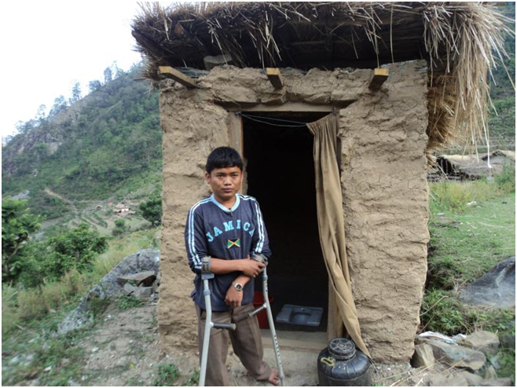
The village itself, located at Ghangal VDC ward no. 8, is a remote place with a poor community. Health and sanitation is merely a course for primary school students, while others in the community have never heard or thought about it. After Nepal Water for Health’s (NEWAH) support in conducting water, sanitation and hygiene projects, the village had a make-over. Dipak is an example of the changes made in the sanitation and hygiene area.
Dipak posing in front of his toilet
Dipak, though disabled, constructed a toilet on his own and was then able to use it. His determination and spirit inspired the whole community to join the campaign, and now there has been a magical change in the village. The use of safe water taps and clean toilets, as well as a special focus on individual and household cleanliness, has resulted in less susceptibility to water-borne diseases.
Dipak’s bold attempt has led to positive changes in the whole community, and so the Water and Sanitation Users’ Committee (WSUC) decided to provide a 126 meter pipe for his family that was used for kitchen gardening.
Dipak was present at the project completion contract signature meeting where he shared, “If NEWAH hadn’t supported us, I would have been openly defecating and crawling in the mud.” He then thanked the team and invited them to visit again.
Prepared by: Bhanubhakta Budhachhetri
Patal Thapakhore
Date: June 2011

Women strive for community development
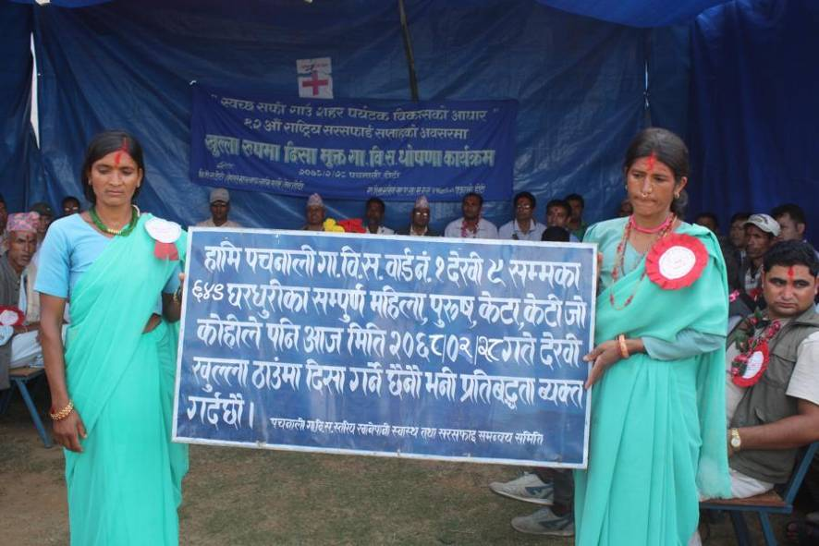
Contrary to the belief that women cannot contribute to development activities, the women’s group in Doti has been working effectively to help declare the VDC Open Defecation Free (ODF). Due to an absence of male members in the community, women have actively participated in every activity. The committee, comprising of seven female members, was chaired by Chandra Devi Malla.
Women holding a commitment board on the VDC open defecation free declaration day
Mrs. Chandra Devi Malla, a resident of Detada village at Pachnali VDC-8 in Doti and the Chairperson of the Village Development Committee Water, Sanitation and Hygiene Coordination Committee (VWASH-CC) says, “We have challenged the traditional perspective towards women’s abilities and have decided to declare this VDC Open Defecation Free with permanent toilets within three months”.
Mrs. Kalpana Malla, VWASH-CC Secretary and community health volunteer at Mata Nepal said, “Not only is the village clean, we have proved our worth to those who underestimated women”.
The “One house one toilet” slogan has been the basic theme for the women’s group. Earlier, during the faeces calculation, they realised that they were ingesting one kilogram of faeces annually which ultimately motivated them to construct toilets. They then consulted their husbands (who are mostly living abroad for employment) about having permanent toilets at their house.
Women participation is often more of a written policy than actual practice in Nepal, but this is a real example of women’s empowerment.
The project has been cordially handled with three-party agreement between Nepal Water for Health (NEWAH), Pachnali VWASH-CC and District Development Committee (DDC), Doti.
Sarala Rawal
Senior Health and Sanitation Facilitator
Date: June 2011

Transfromation in sanitation situation of Kimada village
Karna Balyar
Senior health facilitator
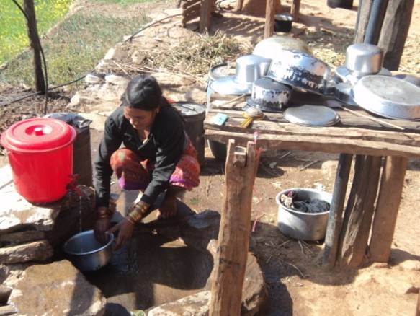
Kimada drinking water supply, sanitation and hygiene project is under implementation in Barpata VDC of Doti district with the support of NEWAH.
In BS 2067.8.13 the Kimada village has been able to make a significant decision to make unique decision. Now the people of Kimada village are enjoying the situation of dignity who do not have to defecate in open spaces. All the households have prepared their improved latrines for their families as an effective indicator of open defecation free village. They have been able challenge those did not expect to happen such significant changes in that village.
Although a year ago there was some support received from district development committee office for latrine construction @ Rs. 20,000.00 but no progress was achieved due to absence of effective triggering to people’s mind. The effectiveness of triggering exercise conducted by NEWAH staff has been instrumental to ignite the local people towards stopping the open defecation and given ways and direction for the construction and use of latrines. This has created opportunity to use the support received from DDC as well.
According to Bhoj Bahadur Kimadi, it has been amazing to see such significant change in people’s mind towards sanitation movement, against the previous situation of the village as he was not expecting such change would be possible. As a learning he perceives that money only is not everything but effective sensitization and realisation matter much to bring changes in the minds of people and society. He further mentions that now Kimada village even being a rural village is equipped with basic facilities of water and sanitation like better off places where everyone is happy.

User-friendly toilet adds joy
Nawaraj Subedi, Koiralachula Salkot

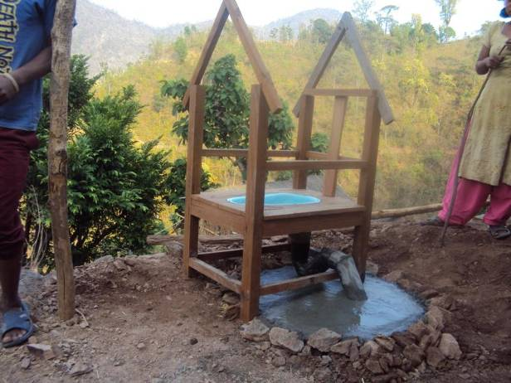
“Those troublesome days have passed. I don’t have to dispose off my daughter’s excreta anymore. Now we have a toilet where she can defecate,” expresses Tilsari Rana, a resident of Surkhet district’s Koiralachula village Salkot VDC-3.
Disable-friendly toilet under construction
Tilsara a mother of two daughters and a son takes care of all her children alone as her husband is working overseas.
When people in the community got motivated in building toilets, Tilsari also managed to build one. Despite having a new toilet, she was deeply concerned about how the open defecation free (ODF) campaign would help her 12 year old daughter Amrita who had been disabled since birth. The newly built toilet at home was not appropriate for Amrita and she was really worried that she still needs to continue collecting her daughter’s faeces.
She got some hope when NEWAH consulted with her to design a disable friendly toilet. A local carpenter constructed the new disable friendly toilet with locally available materials by fixing a pan to a chair along with a roof. The users committee also provided some monetary support to her from the reward money received by the community after the ODF declaration.
Finally, Tilsari got a big relief from her worries and she proudly says, “Now my Amrita can also use a toilet. This has improved our individual and household cleanliness and our life has become easier and comfortable.”
Man Bahadur Tarami, Chairperson of Koiralachula WASH Users Committee states, “The project has tried to be as socially inclusive as possible in providing its services to women, men, children, poor, elderly and differently abled people from all castes and classes in the community.”

Annex 5. Hygiene Indicators developed in collaboration with district health office: Translated version
District Health Office, Doti
Hygiene Indicators - “Endeavour to make a clean and healthy society”
- An end to open defecation practices in the community.
- Use of clean and hygienic toilets and use of slippers in the toilet.
- Hand washing practice using soap/ ash water at critical times (before/after eating meals, after toilet use, after cleaning children, before cooking or preparing meals, after touching dirt and before holding infants)
- Use of a vessel with spout for hand-washing
- Food covering practice followed by every household
- Continuation to personal hygiene (bathing, cutting nails, combing hair, cleaning face, washing clothes, cleaning private parts and also special attention to hygiene during menstrual and post-natal stage)
- Management of animal-shed away from home and also managing its waste in a proper way
- Improvement in the traditional practice of Chaupadi (keeping women away in sheds or separate place from the house during menstrual and post-pregnancy phase) and improvement in hygiene during such periods
- Household, the yard and its surroundings kept clean
- Solid waste disposal well managed in a specific place in public organisations (VDC, schools, health posts)
- Health institutions having maternity service centre with the provision for a placenta pit and its proper usage.
- Safe use and management of water from source to mouth
- Usage of rope, bamboo poles and wires for drying clothes
- Dirty, stale and rotten food not consumed
- Waste and excess water used for kitchen gardening
- Each and every household using dish drying rack and washing slab
- Infants below one year to have received complete vaccination and pregnant women a routine check-up at least four times, including other services.
- Public organizations (VDC, schools, health posts, etc) with user friendly toilets and water supply facilities. Also, availability of sanitary pads for girls during their menstrual period with specific area for its disposal
- Availability of maternity services from maternity health expert
- Kitchen area and kitchen utensils and materials kept clean and properly managed
- The drinking water properly stored and covered in a clean vessel.

