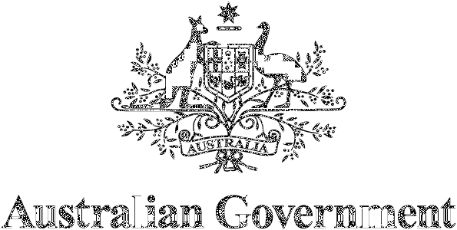


A New Roadmap
  - for Australia’s Economic Engagement with India

Acknowledgement of Country
The Australian Government acknowledges the Traditional Owners and Custodians of Country throughout Australia and acknowledges their continuing connection to land, waters and community. We pay our respects to the people, the cultures and the Elders past, present and emerging.
We also acknowledge that First Nations people are Australia’s first traders – from trading goods with Makassan seafarers in Indonesia for generations, to now exporting a range of services and goods, including native foods, art and design, cyber and clean energy solutions, to world markets. First Nations tourism businesses also highlight Australia’s unique visitor experience and celebrate the world’s oldest living continuous culture, both domestically and internationally. We recognise the unique and important contribution that First Nations businesses have made, and continue to make, to strengthening our economic ties with India.

ISBN: 978-1-74322-641-4 (print)
ISBN: 978-1-74322-642-1 (online)

Creative Commons
With the exception of the Commonwealth Coat of Arms, the Department of Foreign Affairs and Trade logo, photographs, images, signatures and where otherwise stated, this publication is provided under a Creative Commons Attribution-Non Commercial- No Derivatives 4.0 International (CC BY-NC-ND 4.0) licence. The licence terms are available at creativecommons.org/licenses/by-nc-nd/4.0. To the extent that copyright subsists in a third party, permission will be required from the third party to reuse the material.

Use of the Coat of Arms
The terms under which the Coat of Arms can be used are set out on the Department of the Prime Minister and Cabinet website at pmc.gov.au/honours-and-symbols/commonwealth-coat-arms.

Contact
Inquiries about the publication are welcome and should be directed to:
Director, India Economic Section, India Branch
Department of Foreign Affairs and Trade
RG Casey Building, John McEwen Crescent
Barton ACT 0221
Phone: 02 6261 1111
Email: IndiaEconomicRoadmap@dfat.gov.au

Table of Contents
Foreword: Minister for Foreign Affairs Senator the Hon Penny Wong 6
Foreword: Minister for Trade and Tourism Senator the Hon Don Farrell 7
Executive Summary 8
Action Plan – at a Glance 12
Growing and diversifying the Australia-India economic relationship 12
Accelerating efforts toward the Net Zero economy, including critical minerals 12
Boosting our education and skills partnership 13
Unlocking the potential in our agriculture partnership 13
Stepping up our science, technology and space cooperation 14
Deepening our tourism, creative economy and sporting connections 14
Delivering greater two-way investment 14
Introduction: Why Does India’s Economic Rise Matter? 16
The India Growth Story 19
India’s growth policies 20
Australia’s unique position 21
Energy and Net Zero transition 21
Skills development 21
High-quality goods and tourism 21
Indian-Australian communities 21
Supporters 22
The Role of Trade Agreements 23
ECTA – our first free trade agreement 23
CECA – unlocking the future 27
First Nations cooperation 30
Superhighways of Economic Growth – Sectors of Significant Potential 33
Clean Energy 34
Our opportunity – Future Made in Australia and Make in India 36
India-Australia Renewable Energy Partnership 37
Solar 38
Renewable hydrogen 39
Critical minerals 39
Green metals 40
Education and Skills 47
Building our education partnership together 48
Where the opportunities are 48
Powering research 49
People-to-people connections and mobility 52
Agribusiness 55
Building on Australia’s first free trade agreement with India 56
Grow in Australia, manufacture in India, export to the world 57
Making this happen 58
Boosting productivity through agritech 58
Tourism 63
Preparing for take-off! 63
Fulfilling potential 65
Major Economic Roads 72
Investment 73
Inbound 73
Outbound 74
Defence Industries 80
Technology and IT 82
India’s technology and IT ecosystem 82
Greenfields investment 84
Space 87
Collaboration opportunities 87
Sports, Culture and the Arts 91
Building our sporting connections 91
Culture and the arts 94
Resources and Mining Equipment, Technology and Services 99
Resources 99
Mining equipment, technology and services 100
Health 102
Indian-Australian Communities 104
The Role of States and Territories 107
Victoria 107
New South Wales 109
Queensland 111
South Australia 112
Western Australia 114
Tasmania 116
Northern Territory 117
Australian Capital Territory 118
Collaboration with states and territories 119
Annexes 120
List of submissions 120
Roadmap Taskforce 121

Foreword: Minister for Foreign Affairs Senator the Hon Penny Wong
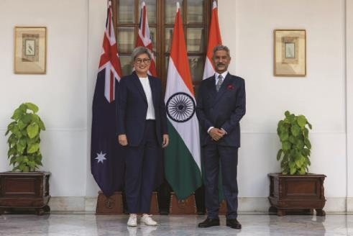
Senator the Hon Penny Wong, Minister for Foreign Affairs with her Indian counterpart, External Affairs Minister Dr S. Jaishankar in New Delhi, November 2023
At a time where strategic competition, climate change and economic disruption are reshaping our region, the Australia – India relationship has never been more consequential.
We have a shared interest and ambition for a region that is peaceful, stable and prosperous. Our deep ties through culture, economics, and people are stronger than ever. We are working together closely as Comprehensive Strategic Partners, through the Quad and in the multilateral system to secure the region we both want.
The modernisation and opening of India since the 1990s has been a remarkable transformation, and today it is the world’s fastest growing economy. As this story continues, India’s economic growth and demographic picture offer compelling opportunities for Australian jobs and economic prosperity.
It is incumbent on Australia to meet this moment. The Government has consulted across the nation to prepare A New Roadmap for Australia’s Economic Engagement with India, to identify opportunities and key sectors that have the potential to expand our economic partnership and diversify our trade and investment footprint.
Australia has the raw commodities and resources, and the skills and technologies, which India needs. Our resources can support India’s ambitious plans for its infrastructure, manufacturing and renewable energy – and our world-class universities can help train the next generation of India’s professionals.
That is because the momentum in this relationship, more than anything else, comes from our people. That includes the remarkable Australian-Indian community, our fastest growing diaspora and a source of deep friendship and connection between our nations. It includes the million-odd Indian tourists and students that come to Australia each year. I launched the Centre for Australia-India Relations in Parramatta in 2024 to serve as a centre of gravity for the people across Australia that support this important relationship. The Roadmap is the next step.

Foreword: Minister for Trade and Tourism Senator the Hon Don Farrell
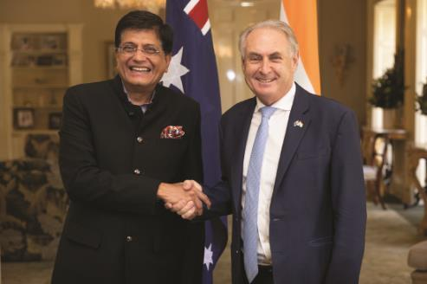
Senator the Hon Don Farrell, Minister for Trade and Tourism with his counterpart, Minister of Commerce and Industry, Hon Shri Piyush Goyal in Canberra, September 2024
Our Government is focused on helping Australians to prosper through greater trade and investment. India is vital to achieving that goal. It is not only the fastest growing major economy in the world, it is growing in a way that favours Australia. India wants to be a world leader in the production of clean energy and advanced manufacturing – and Australia is well positioned to partner with it, given our resources, critical minerals and expertise. India’s consumer class is interested in our education services, our tourism experiences and our premium agriculture. There are many other sectors primed for greater economic collaboration – like space, high-end technologies, resources, mining equipment and technology, sports, culture and the arts, health, and defence.
Our incredible Indian-Australian communities play a special role in driving greater economic engagement with India. We are lucky to have the insights and connections of these vibrant and dynamic Australians. They are a ‘living bridge’ between our two countries.
In preparing this Roadmap, we consulted widely across Australia and India. Those consultations underlined how far we have come since 2022. Major steps forward include the entry into force of Australia’s first free trade agreement with India, the opening of the Centre for Australia-India Relations, and the expansion of our diplomatic footprint in India.
But we know there are many more steps we can take together. This Roadmap identifies four focus sectors which show significant potential – clean energy, education and skills, agribusiness and technology, and tourism. It also looks at other prospective sectors alongside the opportunity offered by our important Indian-Australian communities and the role of state governments.
This Roadmap will help focus and accelerate our efforts to harness India’s growth and tap into the enormous trade and investment opportunities that will create the next generation of jobs for Australians.

Executive Summary
India is the world’s fastest growing major economy, with an average annual growth rate of 6.4 per cent for the past two decades. That’s impressive for any country – but for a country the size of India, it’s truly remarkable. To put it in context: India is adding the equivalent of the New Zealand economy to its national GDP each year. Now the fifth largest economy in the world, this rapid growth rate means India is projected to jump to third by 2030 – behind only the United States and China.
What this means for Australia is that we have a once-in-a-generation opportunity to benefit from – and contribute to – India’s growth story. Our economies are growing in ways that are complementary, and we have been hard at work to set the stage for success. In just the last two years, we have:
- Implemented our first-phase free trade agreement, the Australia-India Economic Cooperation and Trade Agreement (ECTA), By the end of 2025 Australian exporters to India will have saved around $2 billion in tariffs due to ECTA.
- Progressed the Australia-India Comprehensive Economic Cooperation Agreement (CECA) – a deeper, more comprehensive trade agreement that will build on ECTA’s foundations.
- Opened the Centre for Australia-India Relations to boost our work supporting the business community and Indian-Australian communities, including through the Centre’s Maitri Grants.
- Opened a new Consulate-General in Bengaluru, India’s tech hub and an economic driver of its booming south.
- Reinvigorated the CEO Forum to accelerate business-to-business direct engagement between Australia and India.
- Established the India-Australia Renewable Energy Partnership, which will facilitate ongoing cooperation on renewable energy and boost two-way investment.
- Announced the India-Australia Rooftop Solar Training Academy in India under the Renewable Energy Partnership, showcasing Australian rooftop solar expertise. The Academy will train 2,000 solar technicians and solar helpers in its first two years of operation, with a focus on women and young people.
- Signed a Migration and Mobility Partnership Arrangement to support and promote two-way migration and mobility.
These efforts are a great start. But the challenge we face now is to understand where and how to accelerate our efforts – to really harness the potential we see. Focusing our efforts on the sectors with the most potential will help us take the economic relationship to the next level. That’s why the heart of this Roadmap is a close look at four sectors of significant potential which we are confident will drive the economic relationship forward: clean energy; education and skills; agribusiness; and tourism.

- Superhighways of economic growth – sectors of significant potential
Clean energy
- A shared commitment to reach Net Zero.
- Well positioned to mutually support clean energy transition: India as a leading manufacturer of clean energy products and Australia’s abundant renewable energy potential, natural endowments and skilled workforces.
Education & Skills
- India has one of the youngest demographics of the world’s major economies – around two-thirds of all Indians are under 35.
- Australia is a tertiary education and skills partner of choice – Indian international students are Australia’s largest cohort after students from China.
- Australian providers are now exploring offering both in-person and online courses in India.
Agribusiness
- Exports of Australian premium agricultural products to India have increased 59 per cent since our first free trade agreement came into force.
- Increased market liberalisation in India and seasonal complementarity mean we can support India’s food security and help it meet demand from its growing consumer class.
Tourism
- Indian visitors contribute over $1.5 billion to Australia’s economy each year.
- Significant potential for further growth exists as India’s consumer class grows, flight links increase, and major events such as Olympics create new opportunities.
First, clean energy. Australia and India are each committed to Net Zero emissions policies and we are implementing domestic agendas to transition our economies. Getting there won’t be easy or fast, and no country can get there alone. Australia and India are well positioned to help with each other’s clean energy transition. India is positioning itself as a leading manufacturer of clean energy products. Australia has the skills and resources to be part of that transition – we have potential comparative advantages in some technologies and resources like critical minerals, green metals, and the potential to progress further downstream processing of materials. We are also a trusted, longstanding supplier of energy to India and will continue to be a supplier of choice in a way that reinforces our own renewable energy superpower ambitions. Australia is implementing programs to bolster our own clean energy manufacturing capabilities, which partnership and investment from India can help drive forward.
Second, education and skills. India is home to around one-fifth of the world’s youth. Every year, around 12 million young Indians are added to the working-age population. Many of them are looking to build their skills and attain a world-class tertiary qualification to improve their employment prospects. Thanks to our long-term investment in the education relationship, many young Indians will consider Australian universities as they think about their future options: excellent universities and a reputation for a vibrant and safe campus life add up to a great experience in Australia, and better employment prospects in India and beyond. Since 2018, new avenues of education collaboration have opened. Dual and joint degrees as well as twinning programs mean students in one country can experience education in the other. For example, two Australian universities are the first in the world to open campuses in India. That’s a major development – and we hope more will follow. At the same time, online offerings by Australian universities are expanding. Vocational education and training in India is another opportunity for Australian business.
Third, agribusiness. Australia produces enough food to feed around three times our population and much of it is premium grade. India is already one of the largest food markets in the world. It makes sense that we would look to each other. As India’s consumer class expands, demand for premium-grade food will accelerate. The gains that flow from our first free trade agreement mean that many Indians are now enjoying our lamb, seafood and almonds. India is also increasingly interested in our agricultural expertise and technology. As it looks to make its agricultural sector more efficient and sustainable, the Indian Government wants to produce more nutritious food with less energy, less water, less fertiliser and less land. Australia’s agriculture sector is one of the most efficient in the world, which makes us natural partners. We can cooperate with India to build its agriculture sector – estimated to be worth over $900 billion by 2030 – as we support India’s food security aims and improve the livelihoods of farmers.
Fourth, tourism. Indian visitors to Australia already contribute over $1.5 billion each year to the Australian economy. Indians were the first major cohort to return to, and then exceed, pre-pandemic levels of travel. There are more direct flights now than before the pandemic. It’s an area where we still see plenty of untapped potential – for example, the size of our Indian diaspora isn’t so different to the size of our Chinese diaspora, yet there are five times as many direct flights between China and Australia as there are between India and Australia. As India’s consumer class expands, more Indian tourists will want to visit friends and family in Australia. And when they do travel to Australia, they spend as much as any other travellers. That is good for our airlines, our hospitality and hotel industries, our tourism providers, and our retailers.
While we expect clean energy, education and skills, agribusiness, and tourism to be superhighways in building the economic relationship, we know there will be other major roads to success. Some sectors, like technology and IT, are cross-cutting. This Roadmap also highlights investment; defence industries; space; sports, culture and the arts; resources and mining equipment, technology, and services (METS); and health.
This Roadmap also draws attention to the role of our Indian-Australian communities. People are the lifeforce of any relationship. This is certainly the case for our relationship with India. Indian-Australian communities have become larger, more prominent and more vibrant – woven tightly into the fabric of our society. Australians of Indian heritage contribute strongly to our economy already, and this Roadmap also considers how we could further unleash their insights and dynamism, including through the Centre for Australia-India Relations and the CEO Forum.
Finally, we look at the critical work that Australian states and territories are doing to build the economic relationship. Most Australian states and territories now have active India-based trade commissioners, an integral part of Australia’s collective efforts in India. State and territory ministers have established close ties with their counterparts in Indian states, opening the door for business-to-business relations. But, as this Roadmap highlights, more could be done to ensure we are working together to build the relationship collaboratively.
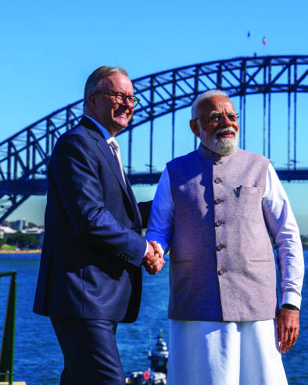
Image courtesy of the Prime Minister’s Office

Action Plan – at a Glance

Growing and diversifying the Australia-India economic relationship
- The Australia-India Business Exchange (AIBX) will accelerate business-to-business engagement and cooperation, with renewable energy as a priority sector.
- Implementing and promoting our first free trade agreement, the Australia-India Economic Cooperation and Trade Agreement (ECTA), will expand and diversify two-way trade as Australian and Indian businesses embrace its opportunities, particularly through new side letters on wine and on trade in organic goods.
- Concluding Australia’s next free trade agreement, a Comprehensive Economic Cooperation Agreement (CECA), would deliver commercially meaningful goods and services market access across key sectors – particularly in agriculture and manufactured goods to support a future made in Australia.
- A new Australia-India Trade and Investment Accelerator Fund (AI-TIAF) will support the implementation of our first free trade agreement, ECTA. The AI-TIAF will also complement negotiations towards our next free trade agreement, CECA – and help overcome regulatory impediments to two-way trade and investment.
- A reinvigorated Australia-India CEO Forum will provide a key business-to-business mechanism to accelerate commercial engagement and partner with governments to improve investment conditions and the business environment.
- A Centre for Australia-India Relations (CAIR) CEO and Director Network will harness the expertise of senior Indian-Australian businesspeople to promote understanding of contemporary India among their peers.
- Embedding First Nations perspectives in the Australia-India trade and economic relationship, including through funding a new dedicated First Nations Business Mission to India.
- Enhancing efforts to coordinate India-related trade and economic cooperation with Australian states and territories through ministerial and officials-level discussions with state and territory counterparts will ensure a whole-of-nation approach to the India economic opportunity.

Accelerating efforts toward the Net Zero economy, including critical minerals
- Delivering the India-Australia Renewable Energy Partnership will strengthen bilateral collaboration on Net Zero efforts, including by diversifying and decarbonising our clean energy supply chains across the region.
- Leveraging the India-Australia Green Steel Research Partnership will address the challenge of decarbonising the iron and steel value chain.
- The India-Australia Critical Minerals Research Partnership and the Critical Minerals Investment Partnership will strengthen supply chains, add value to Australian exports, expand the pipeline of investment-ready projects, and develop critical minerals technology.
- Business, including the CEO Forum, will drive cooperation in renewable energy including hydrogen and green steel.
- The India-Australia Minerals Scholar Network forges partnerships between our research institutions on green steel and critical minerals, including Net Zero technologies.
- The Austmine Global Mining Challenge – India facilitates Australian mining services companies to drive mining cooperation between Australia and India.
- The India-Australia Rapid Innovation and Startup Expansion (RISE) Accelerator is forging cross-border commercialisation of science and technology-led startups and small to medium-sized enterprises (SMEs).
- The International Hydrogen Research, Development and Demonstration Collaboration Program is accelerating the development of the hydrogen industry and bolsters trade and investment.
- The Green Hydrogen Taskforce will identify opportunities for Indian and Australian collaboration on green hydrogen production and deployment.

Boosting our education and skills partnership
- The Government will support universities to undertake joint research in sectors of mutual economic priority, with a focus on translating research into industry impact.
- The Maitri Scholarships and Fellowships Program support some of the best and brightest Indian students to study in Australia and will build ongoing exchanges between Australian and Indian think tanks to explore research into our shared future.
- The Maitri Grants program is designed to support research activities that build business capability and create opportunities for greater commercial collaboration.
- Fully implementing the Australian Government’s A Partnership for the Future: Australia’s Education Strategy for India including mutual recognition, transnational education and commercialisation of research.
- A renewed focus on leveraging and expanding alumni networks between Australia and India will facilitate knowledge transfer, innovation, and business networks.
- The Mobility Arrangement for Talented Early-professionals Scheme (MATES) is supporting Australia’s skills base by facilitating mutually beneficial knowledge and skills transfers in key sectors.
- Skills, qualifications and labour market mapping will strengthen vocational training opportunities and expand skills capabilities to ensure that workers can take advantage of India’s economic modernisation.
- Supporting Australian universities who wish to enter the Indian higher education sector and Australian vocational education and training providers in the Indian market will ensure Australian providers can explore and take up these opportunities.

Unlocking the potential in our agriculture partnership
- Promoting Australia’s agricultural products to India’s growing consumer class through support for Australian providers and states and territories, including at events and expos, will help gain greater market visibility for high-quality Australian products.
- Boosting agricultural market access to India through negotiations on our next free trade agreement, CECA, and resolving technical market access issues to unlock significant potential in our economic partnership.
- Increasing Trade in Organic Goods through our first free trade agreement, Australia and India will streamline arrangements for the export of organic products, unlocking a range of new opportunities for both Australian and Indian exporters.
- Boost our joint dialogue on wine, to ensure industry and government are cooperating on technical and regulatory topics related to the wine trade – including non-tariff barriers and research, development and extension opportunities.
- The Australian Centre for International Agricultural Research (ACIAR) has supported a program of collaborative research with India since 1983. Research focuses on reducing poverty, strengthening food security and supporting the management of natural resources. The Australian Centre for International Agricultural Research (ACIAR) will roll out the next generation of collaborative research with India. Research focuses strengthening food security, managing agricultural water, improved cropping systems, and breeding programs. ACIAR will explore a ‘next generation’ partnership with the Indian Council of Agricultural Research.
- Strengthening knowledge sharing and technology cooperation to promote farm productivity through research and private sector collaborations.

Stepping up our science, technology and space cooperation
- The Australia-India Strategic and Technology Policy Initiative (SATPI) will address shared Australia-India strategic and technology issues and interests, particularly in the Indo-Pacific region. This includes the funding of a flagship 1.5 Track Strategic Dialogue, to begin in 2025.
- The International Space Investment India Projects grants will expand collaboration on satellite communications, navigation systems, Earth observation and its applications, and big data analytics to support mutual policy priorities.
- Strengthening our partnership on civil space cooperation by encouraging greater collaboration between our respective commercial space sectors will foster new opportunity.
- The Australia-India Strategic Research Fund (AISRF) has invested over $100 million since 2006 to support research collaboration, and will continue to in wide-ranging priority areas such as agriculture, clean energy technologies and marine sciences.

Deepening our tourism, creative economy and sporting connections
- Encouraging additional direct flights and Indian companies’ investment in high-end Australian hotel developments will help scale up tourism.
- Stepping up efforts to promote Australia as a tourist destination in India, including through major sporting events, and engaging with Indian travel agents and influencers, will foster growth in tourist numbers.
- Engaging with tailored tourism campaigns centred around major sporting events, such as the 2024 launch of the ‘Summer of Cricket’ campaign, will help boost tourism flows into the future.
- Hosting ‘Australia Marketplace’ events in India every second year will help build business relationships in the tourism sector.
- Dedicate funding to support Australian sports businesses and peak bodies to engage with the Indian market as it expands, including in sports infrastructure, elite performance and sporting event management.
- Promoting tactical airfares and packages to visit Australia in collaboration with industry partners will help reduce the gap between consideration and travel.
- Regional dispersal initiatives will provide Indian travellers visiting friends and relatives in Australia with opportunities to take side trips to nearby regional attractions.
- The Maitri Grants program will support projects, events, exhibitions and professional exchanges in the visual and performing arts, literature, film and music sectors.
- The Australia-India Audiovisual Co-Production Agreement will provide projects in both countries with access to government funding – including grants, loans and tax offsets – with a view to building a flourishing pipeline of co-productions.

Delivering greater two-way investment
- Export Finance Australia (EFA) will enhance its efforts to deliver finance in the Indian market to support Australian exporters, infrastructure development and crowd in private investment. EFA will also boost investment cooperation on supply chain resilience, critical technologies, emerging technologies, climate, energy and infrastructure through its 2023 Memorandum of Cooperation with Quad export credit agency partners.
- Austrade and Invest India, India’s investment attraction agency, have signed a Memorandum of Understanding to support bilateral investment cooperation. CEO Forum to work with Austrade to strengthen this partnership with Industry.
- The Quad Climate Working Group and the Quad Clean Energy Supply Chain Diversification Program will drive collaboration with India and other Quad partners to support the clean energy workforce and build resilient supply chains.

Introduction: Why Does India’s Economic Rise Matter?
India is the world’s fastest growing major economy. Not only is it growing fast, but it is growing in a way that enhances our natural economic complementarity. There are enormous opportunities ahead if we can draw on our commercial, entrepreneurial and demographic strengths to accelerate our economic engagement.

India’s economic rise is also happening just as our geostrategic environment becomes more volatile. Our strategic interests are converging with India’s. This is becoming central to the way we engage each other. Our growing geopolitical alignment supports our economic partnership. We signed a Comprehensive Strategic Partnership in 2020. We are members of the Quad, the G20 and the Commonwealth. Our prime ministers meet each year. We are both working hard toward our shared vision for a peaceful, stable and prosperous Indo-Pacific. As neighbours, we see our neighbourhood – our region – in the same way. We share many of the same goals, and we are both focused on what needs to be done.
This Roadmap outlines how the Government intends to seize the opportunity that our relationship with India presents. We can’t do it alone – we’ll need the skills, energy and talent of Australia’s business community, the buy-in of our state and territory governments, and of course collaboration with India’s private and public sectors. We will also need the insights and drive of Australians of Indian heritage to turbocharge the economic potential of our two countries, including by bringing us together in boardrooms and classrooms around Australia.
This Roadmap breaks down the key opportunities in India’s economic rise, and sets out practical opportunities for Australia to be part of this growth. Our consultations have helped us identify key sectors where we believe Australia has clear strengths and complementarities with India, including in clean energy, education and skills, agribusiness and tourism. There are also other lines of effort where we can collaborate. Finally, we look at the role of the Indian-Australian communities and state and territory governments.
In preparing this Roadmap, we consulted widely. We met over 400 stakeholders from businesses, Indian-Australian communities, unions, state and territory governments and cultural organisations across every Australian state and territory and in India itself. We also received over 70 written submissions (a full list of submissions included at the end of this report). These inputs confirmed what we expected – a strong desire for closer economic engagement with India across the full spectrum of the Australian community – and built out the detail of the opportunities and challenges outlined in this Roadmap.
This Roadmap also builds on An India Economic Strategy to 2035, written by former Department of Foreign Affairs and Trade (DFAT) Secretary Peter Varghese AO, which independently reviewed the economic relationship and set out a long-term strategy. We have also drawn upon India’s Australia Economic Strategy by Ambassador Anil Wadhwa and the Confederation of Indian Industry, which we see as a complementary strategy.
- Why India matters – to Australia and the region
India’s fast-growing economy
India is the world’s fastest growing major economy, growing on average by 6.4 per cent annually for the last decade. By 2030 it is projected to be the third largest economy in the world, growing to US$6.8 trillion by 2030. Indian consumers, service providers and manufacturers will shape our region.
Highly complementary economies
Our natural commercial, entrepreneurial and demographic strengths create economic opportunities. India’s growing consumer class will create opportunities for Australian energy, services, agriculture and tourism sectors.
Strategic alignment
Working together to preserve a peaceful, stable and prosperous Indo-Pacific, including through regional groupings like the Quad and Indian Ocean Rim Association.
Neighbours
Australia is an Indian Ocean country. We share a region and an ocean, and a commitment to finding solutions to the challenges we face – in fields such as climate change, trade facilitation and maritime security.
People to people links
Harnessing economic opportunities through the insights of our talented communities – including the nearly one million Australians of Indian ancestry, and over 15,000 Australians currently living in India.

- A comprehensive stocktake
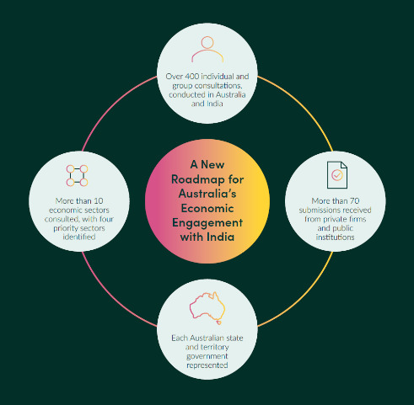

The India Growth Story
India’s growth is remarkable for its quantum, but also for the sustained nature of growth over time. The graph below compares India’s GDP rank over time. The infographic provides a comparison between the relative magnitudes of India’s GDP and that of other advanced economies and emerging market and developing economies. India is now set to overtake Germany and Japan on its way to becoming the world’s third largest economy by the end of the decade. This is a growth story we can’t ignore.
- GDP by rank
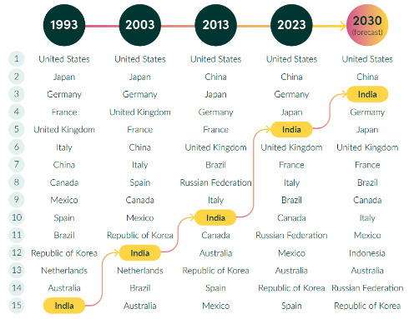
Source: International Monetary Fund (IMF), GDP current prices, World Economic Outlook, October 2024. DFAT forecast to 2030 utilised existing growth rate.
Two decades of high growth have created a new consumer class in India. One in three Indian citizens – around 432 million people – are estimated to have joined the consumer class, up from around one in 20 in 2005. Of these, around 45 million Indians have an advanced economy purchasing power annual household income of over $55,000. These are the people who will drive consumption of the products that matter to Australia. They will visit friends and family in Australia; buy our premium lamb; enter into joint ventures with our investors; need our critical minerals for their electric vehicles; build their cities with Australian green metals; and enrol in our universities. The opportunities are endless. With the right policies, Australia could tap into India’s economic growth for decades to come.

India’s growth policies
- India, Rest of Asia and Australia: working age as a percentage of total population
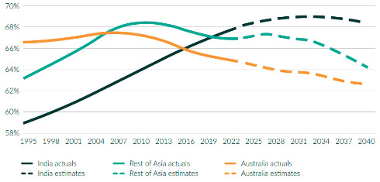
Source: United Nations, Working age % of total population, India, Data Portal, Population Division.
India aims to be a developed economy by 2047. To reach that goal, India will have to capitalise on its huge, young and working population. With 1.4 billion people, India has the largest population in the world. It is youthful, and likely to stay youthful for decades – 93 per cent of Indians are younger than 65. This means by 2052, India’s demographic old-age to working-age ratio is projected to be just 26.2 per cent, illustrating a comparatively large working-age population. But demographics are only favourable if you can make the most of them, and this is one of India’s biggest challenges. It needs to create a staggering 20 million jobs per year to reach the level of economic development to which it aspires.
Many of these new jobs will likely come from India’s growing services and high-end manufacturing sectors. Over the long term, productivity will be increasingly driven by the services sector. India’s goal is to channel as many as possible of the millions of Indians who enter the workforce each year into services or high-value manufacturing. To do this, it has incentivised investment in advanced manufacturing through the Make in India program. India wants to become a hub for electric vehicles and to develop other leading-edge sectors like solar photovoltaics and renewable hydrogen. India is one of the few economies with the scale necessary to become truly globally competitive in these sectors.
- India: GDP by sector
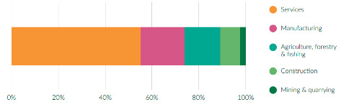
Source: Ministry of Statistics and Programme Implementation, National Accounts Statistics, Statement 1.6 – Gross value added by economic activity at current and constant prices, 2023.

Australia’s unique position
Australia and India are well positioned – perhaps uniquely well positioned – to work together for our mutual economic benefit. Australia has a lot of the inputs India needs to reach its economic goals, from critical minerals to high-end education.
Our first free trade agreement, the Economic Cooperation and Trade Agreement (ECTA), was a critical step forward in realising this potential. It is discussed more extensively in the next section. This agreement came into force in 2022 and means that, by value, over 85 per cent of Australian goods exported to India are now tariff free, rising to 90 per cent in 2026. In addition, 96 per cent of imports from India are now tariff free, rising to 100 per cent by 2026. This gives Australian exporters greater certainty and provides a springboard for further growth.

Energy and Net Zero transition
India’s economic rise, Net Zero targets, and massive energy demands will provide Australia with opportunities to expand into green energy exports, potentially including green metals and other supply chains – which we expect to be an important driver of the economic relationship. To meet its Net Zero ambitions, India needs expertise and technology in sectors like solar photovoltaics, green steel and hydrogen, as well as reliable suppliers of critical minerals. Australia is a natural partner for all these products – we have what India needs. We are also a trusted regional neighbour. Australia’s plan for a Future Made in Australia complements India’s flagship program, Make in India, and sets a strong foundation for us to work together and achieve Australia’s ambition to become a renewable energy superpower. The India-Australia Renewable Energy Partnership will capitalise on this opportunity and provide a framework for cooperation in this space.

Skills development
A major challenge for India will be to upskill its workforce to perform the jobs that its growing economy will require (for example, for high-end manufacturing). Australia’s higher education and vocational education and training providers are well positioned to work with India to help upskill its young workforce. Using innovative models, working with industry, and through virtual delivery of education and skills training for Indians, Australia can help bridge the skills gaps that India needs to meet its 2047 economic ambitions.

High-quality goods and tourism
As India’s consumer class expands and its incomes rise, more Indians will be interested in high-quality goods, like premium food and wine, or overseas tourism. This also plays to our strengths. We expect to export more high-quality agricultural produce to India, which, in turn, is accessing Australian markets in record quantities. We expect more Indian tourists to travel to Australia for a holiday or to catch up with friends and family. Surveys in India show that Australia is the third most desired tourist destination, but only the 10th most visited – a clear indication of the unfulfilled potential of this sector.

Indian-Australian communities
This brings us to the importance of our diverse Indian-Australian communities. Australians of Indian heritage form one of Australia’s largest and most diverse diaspora communities – nearly one million strong, and the fastest growing. Their contribution to Australia’s cultural fabric is immense, and that contribution has been further highlighted since the May 2024 opening of the Centre for Australia-India Relations headquarters in Parramatta, the heart of Sydney’s Indian-Australian community. The expertise, insights, networks, language skills, energy and entrepreneurial drive of these communities opens doors and helps Australia to walk through them.
- Australia: growth of Indian-Australian population
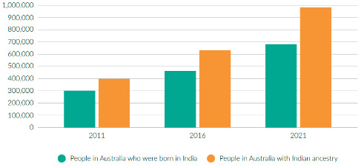
Source: Australian Bureau of Statistics (ABS), Australia’s Population by Country of Birth, June 2023, April 2024.


Indian diaspora event at Qudos Bank Arena during Prime Minister Modi’s visit to Australia, May 2023

Supporters
Beyond the Indian-Australian communities, there are many supporters and drivers of closer economic engagement. Organisations like the Centre for Australia-India Relations and the CEO Forum, supported by the Business Council of Australia and Confederation of Indian Industry, play a vital role in driving the relationship forward. Business chambers in both countries are also integral to the task of building stronger business ties. In Australia, the Australia India Business Council, the Australia India Chamber of Commerce and the India Australia Business & Community Alliance are well-established and critical supporters of the Australia-India economic partnership. In India, the Indo-Australian Chamber of Commerce is a major player.
For our future young leaders, one of the big successes in the annual calendar is the Australia India Youth Dialogue (AIYD). Its alumni now include ministers and business leaders in both countries. As the AIYD said in its Roadmap submission, engaging with, understanding and investing in the next generation of leaders in India and Australia is the surest way to realise the ambitions we have for the economic relationship.

The Role of Trade Agreements
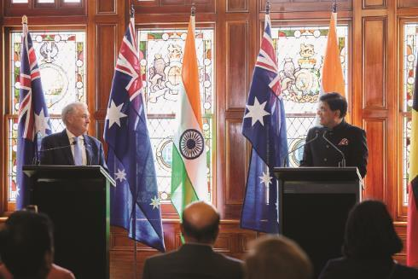
Senator the Hon Don Farrell, Minister for Trade and Tourism with his Indian counterpart, Minister for Commerce and Industry Hon Shri Piyush Goyal in Adelaide, September 2024
India’s trade policies reflect its broader aim of economic development, including increased employment. It views trade agreements as tools to increase exports, investment and employment. India uses various domestic policy tools to protect its own industries from perceived risks from international competition and to promote self-reliance. Trade agreements, however, allow India to play to its strengths, boosting its status as a trading nation and its overall prosperity.

ECTA – our first free trade agreement
Australia’s first free trade agreement with India, the Economic Cooperation and Trade Agreement (ECTA) was a critical step forward. It entered into force in December 2022. Before then, our trade with India had grown steadily to become our fourth largest goods and services export market, up from 15th in 1999. In the first year of the agreement, Australian exports to India grew by 35 per cent (excluding the price-volatile coal).
Overall, two-way trade was up 18 per cent (excluding coal and diesel). ECTA has also kickstarted a whole range of Australian agricultural exports to India, including cotton, nuts, and some fruit and vegetables. This agreement does more than just boost trade – it helps our industries take advantage of the complementary nature of our trade relationship, while giving Australian exporters greater certainty and priming them for further growth.
- Australia: agriculture exports to India
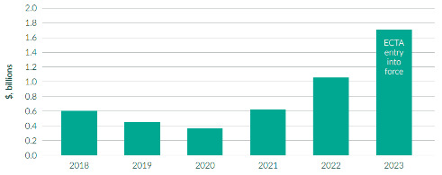
Source: Department of Foreign Affairs and Trade, Australia’s direction of goods and services trade – calendar years from 1989 to present, May 2024.

- Australia: goods and services trade with India
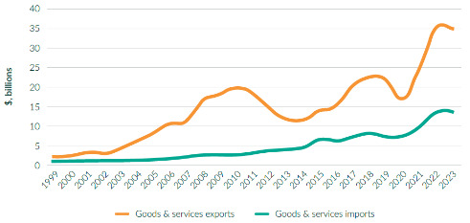
Source: Department of Foreign Affairs and Trade, Trade time series data, 2023.
Our first free trade agreement with India has energised bilateral trade across a range of sectors. Almost 200 Australian products have been exported to India for the first time, or reintroduced after a long absence. That includes avocados, fresh salmon, pine wood, rock lobsters, a range of chemicals and pharmaceuticals, electric motors and generators, astroturf and fibreglass.
- Up to 34,000 tonnes of Australian almonds can now enter India with a 50 per cent discount on Indian duties. In ECTA’s first year, Australian almond exports grew by 117 per cent.
- Mandarins and oranges can now be exported in volumes up to 13,700 tonnes attracting only half of the 30 per cent tariff. Exports grew by 159 per cent in 2023.
- India’s 30 per cent duty on avocados will be eliminated under ECTA by 2028.
- Under ECTA, Australian cotton producers can export up to 51,000 tonnes within a duty-free quota, avoiding the 10 per cent import tariff. The quota was fully utilised in 2023 and 2024. Australian cotton is used in a range of Indian textiles and apparel which can be re-exported to Australia, where Indian garments and carpets are eligible for duty-free treatment. It’s a great example of how Australian inputs can support Indian manufacturing.
Case Study
The Avolution’s Australian avocados bowl over Indian consumers
Australian avocados have found a new market in India, thanks to lower tariffs and rapid market access. ECTA reduced import tariffs on avocados to 25 per cent at the end of 2022, with tariffs on avocados to be eliminated by 2028. Another hurdle overcome was that initially, even with ECTA, Australia did not have technical market access for avocados. However, direct negotiations between Australian and Indian agencies saw market access granted in 2023.
One company to seize this opportunity is Queensland-based The Avolution, a leading exporter of Hass avocados. It ships over 150 containers of avocados per year to Asia and the Gulf region, including to India, where demand is rocketing. According to The Avolution’s CEO, Anthony Allen: ‘India could easily overtake Hong Kong as our biggest export market within two to three years. What’s more, we can sell into multiple sectors. Our markets span from the restaurant sector to delivery services. Most astonishing of all, we now have premium Australian avocados on traditional roadside stalls in India. The market potential is huge.’

Image courtesy of The Avolution

Case Study
Australian sheep meat finds new appetites in India
Australian lamb exporters now enjoy an advantage in India over their competitors, with tariffs on Australian sheepmeat reduced from 30 per cent to zero under ECTA. Combined with growing interest amongst Indian consumers in trying new types of food, increasing meat consumption, and an appetite for more premium products and dining experiences, Australian lamb is well positioned for continuing success.
Mulwarra Export Pty Limited is one of Australia’s premier meat and speciality food exporters. Based in Sydney, the company currently exports to more than 35 countries worldwide, and supplies a large percentage of Australia’s lamb exports to India. “ECTA has made our lamb much more competitive in Indian markets,” says Regional Manager, Sam Rodgers. “We have successfully started to diversify our sales into high-end retailers, as well as our already strong sales into high end restaurants. The tariff reductions are really helping us increase our volumes, with lower entry prices meaning we are far more competitive than other suppliers, like New Zealand”.
Given India’s growing population, rising consumer incomes and other demographic factors are increasing the overall demand for red meat, there are strong prospects for Australian exporters. “India is a massive market,” says Rodgers. “It’s also changing quickly. There’s a fast-growing middle class with more disposable income, so our addressable market keeps getting bigger”.
Australian industrial products exports have also grown.
- Exports of Australian wood and paper almost tripled in ECTA’s first year. Australian products are gaining a substantial price advantage over import competitors as India phases out its 20 per cent duty on Australian products.
- India’s 10 per cent tariff on Australian pharmaceuticals will be removed in stages. Already, exports of pharmaceuticals are up 188 per cent since ECTA entered into force.
- Australia’s world-leading cochlear implant will enter India duty free by 2028. In ECTA’s first year, cochlear exports rose 33 per cent.
- Many Australian exports have grown rapidly since ECTA came into force in 2022
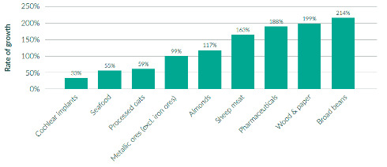
Source: Trade Data Monitor, September 2024.

Indian businesses are also taking advantage of improved access to the Australian market, providing cheaper prices on goods for Australian consumers. This trade agreement to date has resulted in total tariff savings of $315 million for Australian consumers in 2023. In the Agreement’s first year, Australian imports of Indian agricultural products grew 15 per cent. There has been notable growth in imports of Indian industrial products, including clothing and apparel, medicaments, telephone sets, cosmetics and perfumes, machinery and auto parts. By 2026, all Indian products entering Australia will be tariff free. Cheaper Indian inputs to Australian processed or manufactured goods lead to cheaper prices for Australian consumers.
AIBX
The Australia-India Business Exchange (AIBX) and associated programs have assisted Australian businesses achieve over 300 commercial outcomes valued at over $1 billion.
Through AIBX, Austrade provides a range of enhanced digital and group services and content tailored to the needs of businesses in high-prospect sectors. The program delivers two-way business missions targeted at Australian firms across five priority sectors: agrifood; critical and enabling technologies; defence, advanced manufacturing and space; education and skills; and the green economy.
AIBX also provides a platform for promoting ECTA to help Australian businesses benefit from improved market access and harness the significant economic opportunities in India.
The Australian Government has expanded AIBX in 2024, providing an additional $14.4 million in funding to help even more Australian businesses tap into growth opportunities in India and South Asia for the next four years.

CECA – unlocking the future

H.E Mr Philip Green OAM, Australia’s High Commissioner to India at a Chennai supermarket

Our next free trade agreement, the Comprehensive Economic Cooperation Agreement (CECA), aims to build on ECTA by expanding market-opening opportunities for business and industry in both countries. Expanded Indian market access for Australian goods – including agricultural market access – would deliver Indian consumers and businesses cheaper and more reliable sources of food and industrial inputs to support India’s thriving manufacturing, food processing and high-tech industries. Improved market access for Australian service suppliers would deliver greater certainty for those looking to export and invest in a range of services sectors. We also want to turbocharge bilateral cooperation in broader cross-cutting areas, enhancing outcomes in areas such as digital trade and government procurement.
CECA could leverage Australia’s agricultural expertise and technology to boost Indian farm productivity by raising output in agriculture, food processing and animal husbandry. This would support India’s goals to be a world leader in agricultural production and processing. India has taken a traditional approach to negotiating trade agreements in the past – so engaging on inclusive and sustainable trade represents a significant change in approach. India has been open to discussing First Nations peoples, labour, environment, and gender equality, which are priority considerations for trade negotiations. Officials have engaged in an extensive schedule of CECA negotiations following ECTA’s entry-into-force, with eight negotiating rounds to date and other engagements at a range of levels.
The first full round of trade negotiations following the Indian elections was held 19–22 August 2024 in Sydney. Minister Farrell and Indian Commerce Minister Goyal also discussed CECA during Minister Goyal´s visit to Australia (24–25 September 2024).

The multilateral trading system
Australia and India have much to gain by working closely in the World Trade Organization (WTO). Both Australia and India are driven by a shared commitment to the rule of law and a strong, open and rules-based global trading system. The WTO’s rules framework enhances transparency and market access for exporters and investors, providing a mechanism to enforce those rules for all WTO members, regardless of size or economic weight. Closer alignment between Australia and India in support of a strong and effective WTO would deepen our bilateral relationship and deliver on our shared interests in a stable region. Australia is determined to work with India to address the challenges facing the multilateral trading system through reform and modernisation, including fixing its dispute settlement system and driving cooperative rules-based efforts on shared economic priorities. At times our views on specific issues differ, but we should be on the same page, as committed multilateralists in support of the health and stability of our global institutions, particularly as the system encounters new pressures and strains. Australia will continue to work with India to promote rules and norms for international trade outcomes in other forums, including the G20.

The Indo-Pacific Economic Framework
Regional trade arrangements offer important practical benefits to Australian and Indian businesses by having one set of trade rules that apply to multiple markets. Australia and India are founding members of the Indo-Pacific Economic Framework (IPEF), which helps lift and align standards across the region.
Australia and India are signatories to three IPEF treaties: the IPEF Supply Chain Agreement, to better address modern supply chains challenges; the IPEF Clean Economy Agreement, to support the region’s transition to Net Zero; and the IPEF Fair Economy Agreement, to strengthen transparency and financial integrity and prevent corruption.
India and Australia work together through IPEF on addressing supply chain concentrations in identified areas such as such as semiconductors, chemicals, and critical minerals, and support private sector investment in sustainable infrastructure.

First Nations cooperation
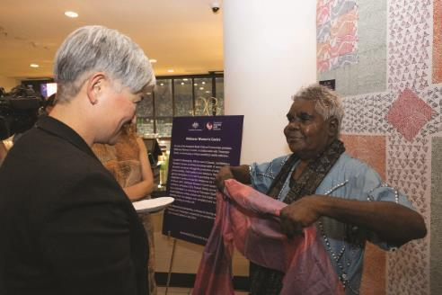
Senator the Hon Penny Wong, Minister for Foreign Affairs at the launch of the Centre for Australia-India Relations (CAIR), meeting with Bábbarra Women’s Centre, February 2024
Australia is committed to an international trade and investment agenda that drives economic growth for all Australians, including First Nations people and communities. The Government is working to ensure the interests of First Nations communities and businesses are integral to our engagements with India, drawing on our shared desire to celebrate and promote our rich cultural heritages.
Priority sectors are tourism, clean energy and the creative industries. As First Nations filmmakers increase their presence on and behind the camera, the Australia-India Audiovisual Co-production Agreement, ratified by both countries in 2023, can provide opportunities for our screen industries to collaborate more closely.
The Centre for Australia-India Relations is developing a First Nations strategy to embed Indigenous perspectives into the Centre’s work and activities. The Maitri Grants program supports First Nations people to develop innovative cultural collaborations, for example, between artists from the Bábbarra Women’s Centre in Arnhem Land and artisans from Tharangini Studios in Bengaluru (see case study).
The Centre has also supported the Eleanor Dark Foundation to deliver a project that builds understanding on the shared challenges faced by First Nations and Adivasi writers. It supported Monash University to deliver an ‘Ara-Thulu’ project to build a deeper understanding of the relationship between place and country among Indigenous peoples in Australia and India, with a public exhibition and performance in Melbourne. The Centre is also supporting Charles Darwin University to deliver a project that will be the first of its kind to engage and explore cultural connections between Indigenous peoples from northern Australia and southern India.
In 2025, the Government will send a dedicated First Nations Business Mission to India for the first time. A government-funded pilot project will support First Nations businesses looking to engage with India to establish valuable networks and commercial partnerships in the mining equipment, technology and services sector and in clean energy – both of which are ripe with opportunity. It will also promote the excellence, ideas and unique offerings of First Nations businesses to the Indian market. Austrade is supporting First Nations businesses to export products and services through its export programs globally.

Standards cooperation
Standards harmonisation promotes trade and investment by reducing or eliminating hidden barriers to trade that result from different standards requirements in different countries. Harmonising standards requirements reduces transaction costs for exporters by reducing the duplication of effort required to comply with differing standards regimes. It also gives businesses certainty and clarity about whether their exports will be allowed into another country. Harmonisation also allows exporters to produce for multiple markets operating under the same standards.
The Government is building on strong existing engagement between Australia and India’s standards bodies by funding Standards Australia to work in consultation with the Bureau of Indian Standards to map standards cooperation needs and gaps. This work will survey Australian and Indian businesses to see where alignment would be most beneficial, as well as developing a program to drive these outcomes bilaterally and multilaterally. It will directly respond to business need, complement the tariff reductions under our first free trade agreement, and build more momentum for finalising our next free trade agreement.
Action plan
The Australia-India Trade and Investment Accelerator Fund (AI-TIAF) will support small-scale projects and initiatives which promote industry uptake of our first free trade agreement, support ongoing negotiations for the next free trade agreement, and overcome policy and regulatory impediments to greater two-way trade and investment. The first tranche of AI-TIAF projects includes initiatives designed to strengthen partnerships between Australian peak agriculture industry and research bodies and their Indian counterparts; facilitate greater two-way business-to-business engagement on green energy supply chains; and enable market access and trade opportunities through developing an industry standards partnership.
Our first free trade agreement with India, ECTA, will continue to deliver benefits to Australians and Indians and support both countries’ goal: to diversify trade. Fully implemented, ECTA will save Australian exporters an estimated $2 billion through to 2025–26 through associated tariff elimination. Australians have already saved over $205 million in duties on goods imported from India since ECTA’s entry-into-force in December 2022. Further promotion of ECTA through regular trade and investment roadshows and other business outreach will amplify its benefits for Australian businesses. Indian and Australian governments will continue to advance with agreed ECTA-related commitments – such as work and holiday visas, wine and other agricultural trade cooperation activities, and the mutual recognition arrangements of organic goods – to deliver full benefit to both economies. Upcoming AI-TIAF initiatives include a suite of Austrade-managed India Trade and Investment Roadshows.
A Comprehensive Economic Cooperation Agreement (CECA) will build on ECTA’s market access gains, including through comprehensive outcomes in services, digital trade, investment, and agricultural goods market access for Australian and Indian businesses and consumers. CECA will continue the Government’s commitment to diversify and strengthen Australia’s key trade and investment relationships in the region. CECA will provide Australian businesses with more opportunities to benefit from India’s fast-growing economy, with a population of over 1.4 billion including a burgeoning middle class and a consumer market of over 400 million.
The Australia-India CEO Forum will remain a key business-to-business mechanism to accelerate commercial linkages and leverage the significant complementarities of the two economies by engaging with senior levels of the Australian and Indian governments on how to lift the economic relationship. Its five Joint Working Groups, will coordinate intersessional work on priority sectors for cooperation, including investment, Net Zero, digital economy, education and agriculture. The CEO Forum will continue to work with governments to improve investment conditions, accelerate cooperation, and improve ease of doing business in both Australia and India. It will also play an important ongoing role in building private sector awareness of, and support for, CECA.
The Australia-India Business Exchange (AIBX) will continue to boost the confidence and capability of businesses to grow and diversify bilateral trade and investment links. AIBX will deliver high-impact programs across priority sectors, additional trade and investment services, online resources, virtual events, and business missions. These are designed to deepen two-way business literacy and commercial outcomes across all priority sectors – international education, agrifood, energy and resources, infrastructure, health, defence capability and advanced technologies. The AIBX program will continue to provide a robust platform for promoting ECTA and supporting Australian businesses to take advantage of its improved market access and reduced tariffs. AIBX will also support CECA negotiators’ engagement with Australian and Indian businesses.
The Centre for Australia-India Relations’ CEO and Director Network will harness the expertise of Indian-Australian CEOs and board directors to enhance contemporary business awareness of India among their peers in the upper levels of Australian business. The Network will be a powerful representation of the role the Indian diaspora can play to assist Australian businesses to respond to India’s growth story. The Network will utilise understanding of both markets and deep connections across top ASX companies to help demystify India, build India literacy, and build commercial confidence to embrace opportunities through targeted high-level engagements and boardroom events arranged by the Centre.
An India First Nations Strategy will seek to increase, encourage and support First Nations participation in trade and investment opportunities with India. The strategy will look to encourage greater participation of First Nations businesses in trade missions to India, embed First Nations perspectives into the work of the Centre for Australia-India Relations, and explore support for First Nations businesses to export products and services through Austrade export facilitation programs.

Superhighways of Economic Growth – Sectors of Significant Potential


Clean Energy
India’s energy transition is a significant opportunity for Australian business. India’s appetite for energy – and especially clean energy – will expand in response to and will drive economic growth. India is already the third largest energy consumer globally after China and the United States. India’s primary energy consumption is forecast to grow by 44 per cent out to 2030.
It wants to become a major player in sectors key to the global shift to clean energy – such as solar, hydrogen, electric vehicles, battery manufacturing and green steel. India also wants to be a key link in stronger, more diverse and resilient global supply chains. Australia’s resources and our expertise make us an ideal partner for India to achieve these ambitions.

The Hon Tim Watts MP, Assistant Minister for Foreign Affairs attending a Smart Energy Council Roundtable, August 2024

- India energy generation capacity
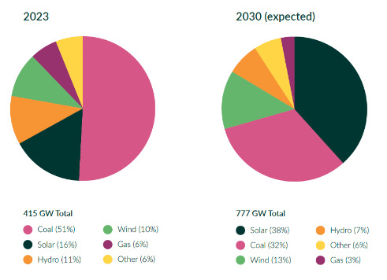
Source: Government of India Ministry of Power Central Electricity Authority (CEA).
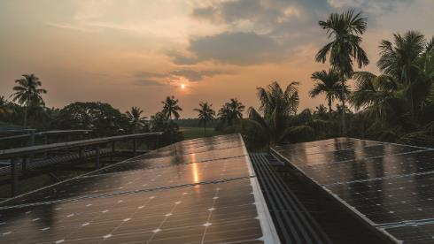

Our opportunity – Future Made in Australia and Make in India
Both Australia and India have policies designed to strengthen our economic security and resilience, titled Future Made in Australia and Make in India respectively.
The Australian Government has strong climate goals. It developed the Future Made in Australia plan to maximise the economic and industrial benefits of the Net Zero transition. Future Made in Australia seeks to attract and enable both global and domestic investment to help make Australia a renewable energy superpower and strengthen our economic security. The Australian Government is also establishing a new Front Door for investors with major, transformational proposals.
Case Study
Entura – sustainable pumped hydro
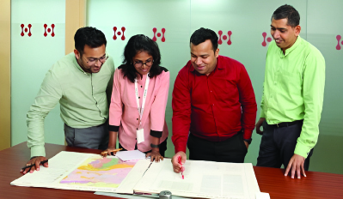
Image courtesy of Entura
Making a difference for environmentally friendly storage: Entura is the power and water consulting business of Hydro Tasmania. Since establishing a presence near New Delhi in 2006, it has provided expertise in planning, designing and maintaining clean energy and storage infrastructure to India. Entura has used its pumped hydro mapping and screening process to identify potential pumped hydro sites in India based on sustainability criteria (such as elephant corridors, tiger habitat, and cultural heritage sites).
This process has helped identify the most promising sites with minimal environmental impacts while maximising the potential for storing energy and balancing the power grid. It is an important step towards developing new pumped hydro to support India’s clean energy future.
The Front Door will provide bespoke concierge and regulatory facilitation services and play a central role in coordinating engagement and approvals across Government. Priority sectors under Future Made in Australia investments are renewable hydrogen, green metals, low carbon liquid fuels, processing critical minerals and clean energy manufacturing. Australia also has a potential role to play as an exporter of embedded renewable energy to India, leveraging our significant comparative advantages.
Similarly, the Indian Government is using its Make in India campaign to attract foreign investment and direct it towards critical and strategically important manufacturing sectors. India’s climate ambitions have grown – for example, its goal to generate half of its energy requirements from renewable energy by 2030. Make in India supports green industries like solar photovoltaics, batteries, electric vehicles and renewable hydrogen.
These two flagship agendas share an ambition to drive the development of clean energy industries to support the economic Net Zero transformation. They underline Australia and India’s natural economic complementarity and create a platform for both countries to develop regional and global clean energy supply chains of the future. India’s scale gives us the chance to move up the value chain in key products and exports to support India’s growing manufacturing ambitions.
Prospective areas of focus are specific upper- and mid-stream supply chains of critical minerals such as lithium, which would feed into India’s battery and electric vehicle manufacturing ambitions. Australia could provide input for clean energy technologies and green metals production. Australia can play a role also in supporting India’s growing photovoltaic solar panel manufacturing industry with vital inputs in the future – another area of opportunity.

India-Australia Renewable Energy Partnership
On 19 November 2024, Prime Ministers Albanese and Modi welcomed the launch of the elevated India-Australia Renewable Energy Partnership. The partnership outlines eight areas for cooperation: solar photovoltaics; solar supply chains; renewable hydrogen; energy storage; circular economy for renewable energy; two-way investment in renewable energy projects and allied areas; capacity building; and other areas of mutual interest.
Joint solar photovoltaics projects, in line with the recommendations of the India-Australia Solar Taskforce, are already underway and will continue under the Partnership. The India-Australia Green Hydrogen Taskforce Recommendation Report will inform the development of joint renewable hydrogen projects. Priorities for the other six areas will be detailed through a new 1.5 Track Strategic Dialogue which will explore and define areas for cooperation.
Practical activities underway include the establishment of an India-Australia Rooftop Solar Training Academy – a world-class solar skills training centre in India, showcasing Australian rooftop solar expertise. With a view to supporting India’s 2024 energy transition ambition of installing 10 million solar rooftops over the next three years, the Academy will train 2,000 solar technicians and solar helpers in its first two years of operation, with a focus on women and young people, and provide trainees with a pathway into the booming distributed solar sector in India, Australia and globally.

Solar
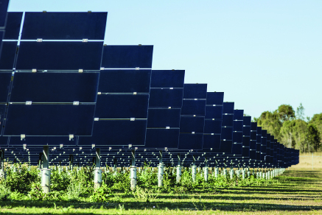
Image courtesy of Austrade
Solar sector cooperation will be an important element of the Renewable Energy Partnership. Australia is well placed to collaborate with India to fulfil its significant solar ambitions. Demand for electricity in India is expected to grow by 6 per cent annually to 2030 and the contribution from renewable sources like solar is expected to rise from 26 to 51 per cent in the same timeframe.
Australia is uniquely placed to support India’s commitment to roll out 10 million solar rooftops in the next three years, with our largest per capita solar deployment in the world. We will pursue partnerships in areas such as training – for the workforce skills we both need for the design, manufacture, installation and maintenance of solar rooftop panels – as well as the development of mutual capacity in digital enabling technologies and off-grid storage.
Building secure supply chains and sourcing polysilicon, a major input into solar photovoltaic manufacturing, will be central to achieving India’s solar manufacturing ambitions. Large Indian energy companies are looking for alternative sources of polysilicon. Australia’s Solar Sunshot program, launched in August 2024, focuses on supporting innovative solar photovoltaic manufacturing activities and enhancing resilience in domestic supply chains. With up to $1 billion of funding, Solar Sunshot supports local solar photovoltaic manufacturing innovation and feasibility studies, which could complement India’s broader solar manufacturing goals.

Case study
Powerledger – cutting electricity costs in India’s north
Australia’s Powerledger is making the energy market more efficient and lowering electricity prices for Indians: Powerledger has worked with north India’s Uttar Pradesh Government to pilot a platform that records transactions and stores them in an encrypted format. This improves the transparency and reliability of the data while simultaneously reducing transaction costs. Powerledger’s technology helps explain why the Uttar Pradesh Government can buy energy that is 43 per cent lower than the retail price. Following the pilot, the Uttar Pradesh Government legislated to make peer-to-peer trading mandatory for all utilities.
Powerledger says the success of the pilot will incentivise the uptake of distributed energy resources (such as locally produced solar power as opposed to power from a central source). This is part of Powerledger’s vision to help people access affordable electricity when they aren’t connected to an electricity grid. Powerledger’s work is another example of how Australian clean energy expertise and skills are making a difference in India.

Renewable hydrogen
Renewable hydrogen represents a major long-term opportunity. Through Future Made in Australia, Australia is starting to develop a large domestic renewable hydrogen industry. India is doing likewise. By 2050, India’s renewable hydrogen demand could reach 55 million tonnes each year, with imports potentially making up a significant contribution. Australia’s target to produce between 15 and 30 million tonnes of renewable hydrogen annually could place us in prime position to meet India’s decarbonisation needs. Under its National Green Hydrogen Mission, India has designated major ports in Gujarat, Odisha and Tamil Nadu as transport hubs for renewable hydrogen, green ammonia and green methanol. The India-Australia Green Hydrogen Taskforce is hard at work identifying opportunities to progress cooperation across technology co-development and manufacture, industrial uses of hydrogen, enabling infrastructure, skills and workforce development, and knowledge-sharing. Industry groups like the Smart Energy Council are working overtime to circulate and stimulate opportunities.

Critical minerals
The critical minerals sector is another example of where our goals and targets are aligned. Australia is well placed to seize the opportunities of India’s clean energy transition thanks to our rich geological reserves, expertise at extracting minerals and track record as a reliable producer and exporter of resources. The Australian Government’s Critical Minerals Strategy 2023–2030 sets out a vision to grow Australia’s critical minerals sector, including through international partnerships with countries like India and programs to encourage investment and the development of critical minerals projects. The Government is supporting research and development in the sector through the Australian Critical Minerals Research and Development Hub to address technical challenges and develop new intellectual property for critical minerals and rare earth processes. The Australian High Commission in New Delhi and our four Consulates-General in India are also working to connect Indian firms interested in Australian critical minerals with Australian counterparts.
Government priorities such as the Future Made in Australia plan could deliver further opportunities for Australia and India to develop stronger, more reliable and secure supply chains by helping more Australian companies move along the supply chain into refining and processing products like lithium hydroxide. That’s a key input India needs if it is to meet its ambitions for large-scale battery manufacturing. Other priority technologies, such as electrolysers for hydrogen production and semiconductors for solar photovoltaics, could open further opportunities for Australian critical minerals export and processing ambitions.
India wants to capitalise on the projected global demand for electric vehicles and become a prominent electric vehicle manufacturing hub. The Indian Government is putting significant resources behind its ambitions – for example, $10 billion to incentivise battery, electric vehicle and automotive manufacturing. To meet its own Net Zero targets, India wants most Indian drivers to be behind the wheel of an electric vehicle.
We are a leading producer and exporter of the minerals needed to make lithium-ion batteries. Our critical minerals – notably lithium – could be integral to India’s battery manufacturing plans. Australia has the potential to process critical minerals at a scale which could supply Indian companies planning to produce key battery components.
Australia cannot achieve its critical minerals objectives alone. We have established bilateral partnerships with India and others which will help build diverse, resilient and sustainable global supply chains. Foreign investment has always been critical to Australia’s prosperity. Government-to-government agreements can build investor confidence and help private sector partnerships to develop and scale up quickly.
Cooperation on critical minerals between Australia and India is supported by the Critical Minerals Investment Partnership. Investments under the Partnership will seek to build new supply chains underpinned by critical minerals processed in Australia. Working together, both the nations are committed to reducing emissions, guaranteeing energy security and diversifying global markets for critical minerals and clean technologies. The Partnership is underpinned by a Memorandum of Understanding (MoU) between Australia’s Department of Industry, Science and Resources and Khanij Bidesh India Limited (KABIL), an Indian joint venture company, signed in March 2022.
The India-Australia Critical Minerals Research Partnership is another government initiative supporting our common goals. Its research projects aim to strengthen supply chains, add value to Australian exports and work with India to commercialise CSIRO-owned critical minerals technology. These will contribute to diversified, resilient and responsible sources of critical minerals which could support new local jobs and industries for Australia and India. The four partnership projects span the supply chain from exploration, mineral processing, smelting and refining, and fabrication to design and manufacturing stages.

Green metals
Given India’s target of achieving Net Zero, some Indian steel manufacturers are looking at opportunities to lower the carbon intensity of their steelmaking and develop green steelmaking supply chains. India has a large established steelmaking industry and domestic steel demand will continue to grow. While Australia is currently predominantly focused on exporting iron ore, it is a highly prospective location for green iron and steelmaking in a world transitioning to Net Zero. There are opportunities for Australia and India to collaborate on green steelmaking technologies and pathways.
One of Australia’s key competitive advantages in this industry lies in the upstream end of the supply chain – we have abundant reserves of high-quality iron ore feedstock and a world-leading mining industry with established infrastructure and expertise.
Australia’s other comparative advantages include significant renewable energy resources, availability of land, a highly prospective hydrogen industry, strong research and innovation, and proximity to key markets in Asia. These factors make Australia an attractive location for green iron and steelmaking.
The India-Australia Green Steel Partnership (IAGSP) is a government initiative to support our shared decarbonisation goals. The IAGSP supports Indian and Australian researchers, industry and governments to deliver a range of research and development projects to accelerate the decarbonisation of the iron-steel value chain in India and Australia.
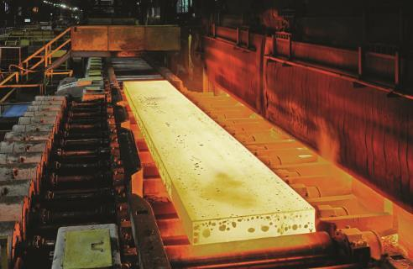

Case study
India-Australia Minerals Scholars Network
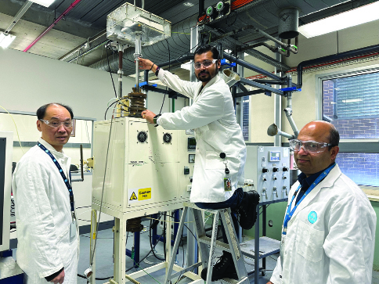
Image courtesy of CSIRO
Funded by the Australian Government, the India-Australia Minerals Scholars Network (part of the India Australia Minerals Partnerships in Green Steel and Critical Minerals) was launched in 2023 to develop a collaborative ecosystem of technical researchers in green steel and critical minerals across both nations. So far, 12 projects have been launched, five within green steel and seven within critical minerals. Two more are in the pipeline. Further projects are planned for the next couple of years, many in collaboration with higher education institutions throughout India.
Australia at India Energy Storage Week
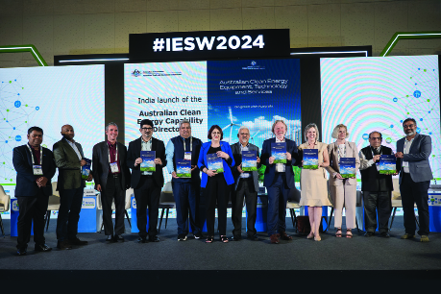
Image courtesy of Austrade
Australia supports our renewable energy companies participating in the annual India Energy Storage Week – India’s premier annual renewable energy summit. In 2024, the Australian High Commission and Austrade in India supported over 40 companies that spanned the full renewables sector from solar and critical minerals through to smart grid management.
The event helped Australian companies to launch into the Indian market, develop partnerships with Indian suppliers and learn from those Australian companies already established across India. As the largest country delegation, we provided India with a taste of what Australia has to offer.
Case study
Aligning innovation cultures for affordable, secure and reliable energy
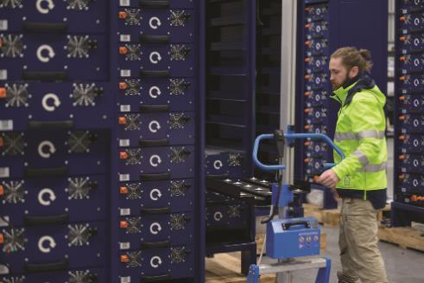
Image courtesy of Austrade
The Tata Consultancy Services (TCS) and the Australian Energy Market Operator (AEMO) are making the Australian energy market more efficient. The Five-Minute Settlement (5MS) Program helps smaller energy suppliers to be more efficient in storing energy in a battery and selling into the grid when prices are high.
The AEMO has partnered with TCS, a prominent Indian IT services, consulting and business solution company, to find solutions to power the 5MS Program. This is already creating a more efficient energy market in Australia with better outcomes for energy producers, distributors and consumers. This program lays the foundation for energy market reforms and accelerates environmental, social and governance, and Net Zero initiatives in Australia.

Action plan
When fully implemented, the India-Australia Renewable Energy Partnership (REP) will provide a structure to develop opportunities for two-way investment across renewable energy. The REP will explore emerging opportunities for collaboration with India across clean energy transition as Australia’s domestic capabilities mature and deepen under Future Made in Australia and identified alignment with key Indian priorities, including Make in India. We anticipate the Partnership will also enhance collaboration between Australia and India on shared interests in key international forums, including the Quad.
The India-Australia Green Steel Partnership will continue to work with Indian and Australian researchers, industry and government to deliver a range of projects that address the unique challenges associated with Indian and Australian iron ore in future low carbon steelmaking processes. Five projects are currently underway on a range of topics including raw material quality improvement, substitution of renewable energy into existing processes, direct reduced iron production from low grade ores, carbon capture and recycling, and single-step hydrogen reduction and smelting. The partnership will continue to contribute to securing the future of this important industry in a low carbon economy for the benefit of both nations.
The India-Australia Critical Minerals Research Partnership works with Indian and Australian researchers, industry and government to deliver projects that aim to unlock commercial benefits of commencing, improving and integrating Indian and Australian critical minerals value chains. Four projects have been funded with activities that span the supply chain, including exploration, mineral processing, metallisation and manufacturing. The partnership will continue to contribute to diversified, resilient and responsible supply chains – creating new jobs and industries for both Australia and India.
The Australia-India Critical Minerals Investment Partnership strengthens cooperation on the development of critical minerals projects and supply chains between Australia and India. Through the Partnership, the Australian Government is supporting due diligence work on Australian critical minerals projects to inform potential Indian Government investment. This would support Australia’s position as a trusted and reliable supplier of raw and unprocessed critical minerals to India and position India as a partner of choice for Australia – with its scale, market size and low-cost manufacturing.
The Australia-India CEO Forum is working with business and industry in India and Australia to propel our shared clean energy ambitions, drive investment opportunities and support our respective Future Made in Australia and Make in India agendas. The CEO Forum, including through the Energy, Resources, Net Zero and Critical Minerals Joint Working Group, is promoting knowledge, information and technology sharing and strengthening industry links.
The India-Australia Rapid Innovation and Startup Expansion (RISE) Accelerator facilitates and supports Indian and Australian startups and SMEs to commercialise within our science and technology sectors. The program integrates our startup and SME ecosystems with cross-country research, industry, corporate and investment communities. It helps develop supply and value chains and commercial relationships. Between November 2023 and June 2026, the RISE Accelerator will have supported the scaling of technologies in select climate and environment national challenges including in the agriculture, critical minerals and clean energy sectors.
The India-Australia Minerals Scholar Network strengthens green steel and critical minerals research capabilities and collaborations in support of the India-Australia Green Steel Partnership and India-Australia Critical Minerals Research Partnership. The network supports PhD sponsorships in both India and Australia and student/research exchanges. Partnering with India on capability development through the Scholar Network builds a pipeline of talent to meet the growing global demand for steel and critical minerals.
The CSIRO’s International Hydrogen RD&D Collaboration Program builds on the work of the India-Australia Renewable Hydrogen Taskforce by supporting joint research in mutual priority areas identified by the Taskforce and the RD&D Collaboration Program. The Program will support Australian early and mid-career hydrogen researchers to conduct joint research between Australian and Indian research institutions, with a focus on building a collaborative hydrogen industry research sector through co-development and commercialisation of new and innovative hydrogen technologies. CSIRO’s existing International Hydrogen RD&D Collaboration Program is a partnering initiative with 10 countries, including India.
The Quad Climate Working Group provides a unique opportunity to collaborate with India, alongside Japan and the United States, to support resilience and security during the energy transition for the Indo-Pacific region. During the Quad Leaders’ Summit 2023, the Working Group agreed on the Quad Statement of Principles on Clean Energy Supply Chains in the Indo-Pacific (the Principles) to contribute to the diversification of clean energy supply chains, support the clean energy workforce, and cooperate on interoperability of standards. The Quad Clean Energy Supply Chain Diversification Program, launched by the Australian Government on 15 November 2024, supports these Principles. The Program comprises $50 million in grants to fund feasibility studies and R&D projects to develop and diversify solar photovoltaic, hydrogen electrolyser and battery supply chains in the Indo-Pacific. Projects must be delivered jointly between Australian and Indo-Pacific organisations. Quad partner organisations – including Indian organisations – may also participate as additional project partners. We see India as an important partner in engaging across the Indo-Pacific on climate ambition, clean energy innovation and deployment, and adaptation and resilience under the Working Group.

Education and Skills

India is among the youngest of the world’s major economies. One in every five people under the age of 25 globally lives in India. One million Indians turn 18 every month. As those young people leave school and enter the workforce, they form the backbone of India’s economy – manufacturing electric vehicles, running IT firms, managing farms and building their country’s future.
India needs skilled people to support its economic ambitions. This creates enormous opportunities for Australia’s higher education and vocational education and training providers. There is a long and great tradition of Indians travelling to Australia to study, and a smaller but important cohort of Australian students seeking study experiences in India, including through the New Colombo Plan. Studying overseas generates understanding of each other’s countries and cultures, promotes business and tourism, and builds a cohort of Indians who know us well and want to engage with us.
Increasingly, however, Indian students can also access an Australian education experience without leaving home. Over the past 12 months, some of Australia’s world-class universities have set up shop in India, with Deakin University and the University of Wollongong the first foreign universities in the world to establish campuses in India, and others planning to establish some form of in-country presence. Students are enrolling, classes being run, and young Indians are enjoying Australia’s quality education without having to travel thousands of miles to get it. That is a win-win.
Partnerships between our institutions are similarly powerful. Australian and Indian institutions are joining forces to deliver qualifications that bring the best from each institution and make studying in two nations possible. New dual awards and twinning arrangements between some of the world’s leading universities are available in India for students who plan to have both Indian and Australian experiences, graduating with international experience for global careers. A recent example is the University of Melbourne partnering with three Indian universities to offer a new Bachelor of Science dual degree. The University of Technology Sydney’s Faculty of Engineering and Information Technology is also creating strong partnerships with Indian universities.
There are also green shoots in skills training, where Australian expertise can help India deliver its demographic dividend and improve productivity. Australia’s skills providers have a track record of delivering training that meets industry demands. This enables them to work to equip India’s young people with skills its economy needs.
Education and skills are a force multiplier for the entire relationship. Joint Australia-India projects in green energy, mining, agriculture or infrastructure are more likely to succeed when they have a built-in education and skills component. They are also more likely to lock in deeper and lasting cooperation. Indian firms frequently tell us they want Australia’s help in delivering the skills component of their business plans.

Building our education partnership together
The Australian Government has a plan to ensure Australia benefits from India’s growing youth population. A Partnership for the Future: Australia’s Education Strategy for India will ensure our education relationship delivers for both countries. It will strengthen ties between our universities and researchers, enhance our people-to-people links, and help Indians and Australians to be more job-ready. We want to improve what our education institutions offer India, diversify this offering, and solidify Australia’s position as India’s go-to partner for education.
In 2023, Australia and India signed the Mutual Recognition of Qualifications. It assists with mutual recognition of school, vocational education and training, and higher education qualifications. It will make it easier for students, researchers and academics from one country to study and work in the other. These mutual recognition agreements will help school leavers find employment, and professional bodies, such as for dentistry and teaching, can use this model to develop their own recognition arrangements. This will make our workforces more innovative and collaborative.

Where the opportunities are
As India adapts to meet the enormous demand for tertiary education in the country, Australian universities are seizing the opportunity. In 2024 Deakin University and the University of Wollongong established campuses in Gujarat International Finance Tec-City (GIFT City), an economic hub in the western state of Gujarat (see case study). Other Australian universities are planning to open campuses or establish a presence in other parts of India. Another positive development is new dual degrees and twinning arrangements: these provide students with diverse qualifications and boost their employment prospects. For example, the Birla Institute of Technology and Science and RMIT’s Higher Education Academy are collaborating to offer dual-degree undergraduate engineering programs and a dual PhD program. The Australia India Institute, with funding from the Australian Government, hosted a Skills Visitor Program to boost opportunities in Vocational Education and Training and for Australian and Indian experts to discuss future collaboration opportunities.

Powering research
Research collaboration between India and Australia is happening on many levels, in many areas against a backdrop of an over 5 fold increase in partnerships between Australian and Indian universities. The Australia-India Strategic Research Fund (AISRF) is the Australian Government’s largest fund dedicated to bilateral science collaboration. Since its establishment in 2006, the Australian Government has committed more than $100 million which, together with the Indian Government, has helped support over 370 joint activities, including collaborative research projects, fellowships and workshops. This has produced quality research on emerging economic sectors: agritech, quantum, biotech, water and renewable energy. The Australian and Indian governments will mark the 20th anniversary of the AISRF in 2026. The Indian Government-funded Scheme for Promotion of Academic and Research Collaboration (SPARC) is another program that pushes in the same direction. Phase III of SPARC will encourage research collaboration on rare earths, critical minerals, medtech and manufacturing.
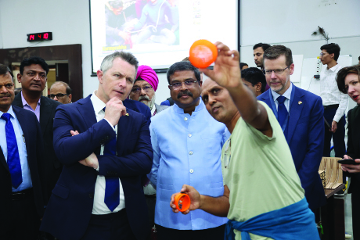
The Hon Jason Clare MP, Minister for Education with his counterpart, Minister of Education, Hon Dharmendra Pradhan in India, November 2023

Case study
International partnership builds training courses in India
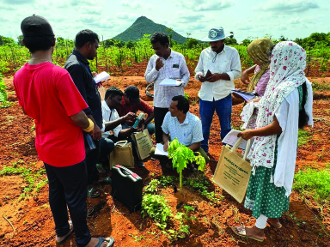
Image courtesy of the University of Adelaide
The Australian Government funded the University of Adelaide to bring together an international consortium of providers to establish five new agricultural VET courses in India, focusing on developing critical skills in areas such as digital agriculture, carbon farming and organic farming. The aim was to design and deliver pilot training products in partnership with the Australian international education sector and the Australian and Indian agriculture sectors – to meet India’s emerging agricultural skills needs and provide new market opportunities for Australian education providers.
This project has delivered a demand-driven set of future skills in Indian agriculture, building connections between Australian and Indian actors in agricultural Vocational Education and Training, as well as building a cohort of training providers who can deliver quality training to a wider stakeholder network.
The project identified future collaborative opportunities between India and Australia. These include dual certification, scaling of course implementation, business opportunities and research connections. This project also highlighted how micro credentials can offer flexible training options that benefit industries, particularly in online course delivery.

Case study
University of Wollongong and Deakin University campuses in GIFT City, Gujarat
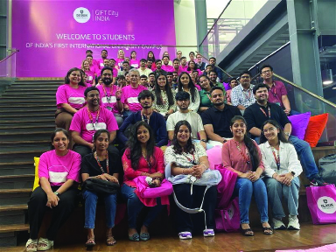
Image courtesy of Deakin University
Australia’s University of Wollongong and Deakin University were the first foreign universities to establish campuses in India at GIFT City. Wollongong has started by offering postgraduate courses in computing and financial technology, with plans to expand, including into undergraduate courses in information technology and business. Deakin University is offering postgraduate courses in cybersecurity and business analytics, before expanding to other degrees from the faculties of Science, Engineering and Built Environment, and Business and Law. A campus in India helps both these pioneering universities to engage more deeply with their Indian partners, understand their needs and offer targeted programs that will boost students’ employment prospects.

People-to-people connections and mobility
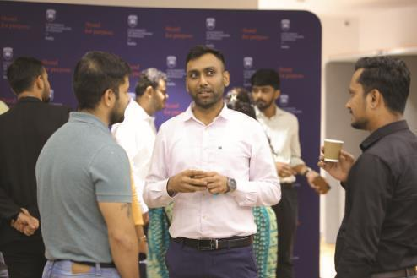
Image courtesy of the University of Wollongong
Enhancing outcomes for students, researchers and academics is crucial for strengthening the Australia-India education partnership. Australia’s Maitri Scholarships Program is an initiative of the Centre for Australia-India Relations. The Scholarships program is enabling some of India’s brightest STEM students to develop their skills in Australia. These kinds of programs connect young leaders and can smooth the way for future business and commercial engagement. In our consultations, we repeatedly heard from Indian businesses whose trade or investment efforts had begun with a connection or opportunity that had started with an experience as an Indian student in Australia, or vice versa.
On a larger scale, the Mobility Arrangement for Talented Early-professionals Scheme (MATES) will also facilitate mutually beneficial knowledge and skills transfer between Australia and India. Launched in December 2024, it will allow Indian university graduates and early career professionals to come to Australia and work in specific specialised fields such as renewable energy, mining, engineering, information technology, artificial intelligence, finance technology and agricultural technology.

Action plan
The Maitri Scholarships Program supports India’s top students to study at Australia’s world-class universities, with a priority on students undertaking postgraduate studies in STEM-related disciplines. The Maitri Scholarships Program will deepen educational links and connect scholars and alumni with Australian business to support greater economic ties between Australia and India. Recent Maitri Scholars have commenced projects on electric vehicle integration in the power system as a clean energy solution; soil behaviour during the installation of offshore wind turbine supporting foundations; pathways for converting carbon dioxide into ethylene to reduce reliance on fossil fuels; and the storage and transportation of renewable hydrogen for sustainable energy solutions.
The Maitri Fellowships Program builds institutional links and academic capacity in both countries, and enhances public discourse on our bilateral, economic and broader geostrategic relationships. Recent Maitri Fellows have undertaken projects designed to examine climate and security cooperation in the Indo-Pacific; threats to maritime trade between India and Australia; shared climate risks faced by Australia and India; and Australia-India cooperation in critical minerals and clean energy technology.
The Maitri Grants support research into new avenues for industry collaboration and opportunities to commercialise Australia’s technical capabilities with India. Recent Maitri grantees are undertaking projects to connect Australian energy transition researchers and startups with India’s manufacturing hubs; develop new commercial models for cooperation in semiconductor supply chains; pilot Australian cyber resilience technology for smart farming applications in India; and advance sustainable manufacturing and commercialisation of an innovative Australian additive manufacturing technology in India.
The Mobility Arrangement for Talented Early-professionals Scheme (MATES) will facilitate mutually beneficial knowledge and skills transfer between Australia and India. It allows Indian university graduates and early career professionals from specific fields such as renewable energy, mining, engineering, information and communication technology, artificial intelligence, financial technology, and agricultural technology to work temporarily in Australia. The scheme will also benefit Australian industry sectors and businesses by enhancing their access to some of India’s most talented graduates with in-demand knowledge and skills.
To fully implement A Partnership for the Future: Australia’s Education Strategy for India, the Australian Government continues to support Australian institutions looking to enter India, advocate for Indian regulatory settings that enable Australian institutions to contribute to India’s future skills needs and encourage further transnational education (TNE) investment from Australia. More TNE investment would offer new knowledge pathways and employment opportunities and aligns with India’s National Education Policy 2020 (NEP).
Through TNE partnerships, Australian institutions are already collaborating with Indian counterparts to offer joint degrees. Establishing mutual recognition of professional qualifications would set a foundation for Australian institutions to deliver qualifications based on mutually recognised professional standards. The Government would work with professional bodies to facilitate dialogues between professional bodies, establish pilot programs, and support regulatory harmonisation to facilitate professional mutual recognition.
The Government will map alumni expertise to Australia’s economic interests and work with alumni to support business activity. We will strengthen professional development programs and networking opportunities for alumni across our India network to help them stay connected and engaged with both countries.
The Government will invest in initiatives that support mutual critical skills needs and encourage industry growth and investment. By mapping Vocational Education and Training qualifications and/or occupational standards in mutual areas of critical need, such as cybersecurity, sustainability and agriculture, we will create commercial opportunities for Australian Registered Training Organisations to establish in-country partnerships and develop supplementary training units and/or transition to Australian Qualifications Framework delivery.
The Government will support an increase in the presence of Australian universities in the Indian tertiary education sector and explore and support opportunities for Australian Vocational Education and Training providers in the Indian market, including through partnership with Indian manufacturers and tech giants.

Agribusiness

Image courtesy of Austrade
Food is at the heart of any culture – but in India it holds a special place. The good news for Australia is that the way Indians celebrate and enjoy food is changing: with rising Indian purchasing power, palates and tastes are diversifying. As the array of food options has increased, Indians are spending more at restaurants, on food delivery apps, and at the supermarket.
Two examples stand out: the Indian food services market (dining out and ordering in) is expected to hit $200 billion a year by 2030, and India’s wedding industry has reached $100 billion and will grow by half again by the end of the decade.
All this presents real opportunity for Australian exporters, especially as a growing part of Indian society develops a taste for the premium produce that Australia excels at – Australian wines, avocados, rock lobster, lamb and sheep meat.
But the better news is that we expect the size of India’s market to keep growing as the country develops and purchasing power rises. The alcoholic beverage market in India, for example, is currently $82 billion and will reach $135 billion in 2030. Although much of that is whiskey and spirits, the market for beer and wine is also expanding. Another Australian advantage is that many of the products we do well are not produced in India in large volumes. Premium seafood is one example. Lamb is another. A lot of this produce is finding markets such as five-star hotels and high-end restaurants, which are found in megacities like Mumbai, New Delhi and Bengaluru.

Building on Australia’s first free trade agreement with India
The Economic Cooperation and Trade Agreement (ECTA), Australia’s first free trade agreement with India, is proof we are heading in the right direction on agriculture. Since the trade agreement’s entry into force in December 2022, we have seen export growth leap ahead in products like sheep meat, seafood, almonds and avocados. Avocados, in particular, were able to take advantage of phased tariff elimination thanks to the Department of Agriculture, Fisheries and Forestry’s work to secure technical market access. But the growth in agricultural trade is not just in food. Exports of cotton – a key input in India’s $270 billion textiles sector – as well as wood and paper product exports have also grown considerably.

Image courtesy of DFAT
Wine showcases how ECTA has created a foundation for cooperation in agriculture. ECTA allows Australian premium wine to enter the Indian market under reduced tariffs, providing our exporters with an entry point to build potential new, diversified revenue streams. Indian consumers have benefited from ECTA through access to quality Australian wine at lower prices. The Indian wine industry – which is small but growing fast – has also profited from the knowledge and technical expertise of bodies like Australian Grape & Wine, Wine Australia and the Australian Wine Research Institute, which have made Australia a world leader in viticulture. It’s another win-win for India and Australia.

Grow in Australia, manufacture in India, export to the world

Senator the Hon Tim Ayres, Assistant Minister for Trade meeting with Minister of Commerce and Industry, Hon Shri Piyush Goyal during his trip to India in 2023
Another prospective market for Australian produce is India’s enormous food processing and textiles industries. At the heart of these industries are Indian staples such as besan (chickpea flour), myriad breads, and apparel. Indian manufacturers want high-quality inputs for these goods, and Australia can provide them. Some of that is already happening: Australian lentils feature on Indian plates, and our wool provides warmth on cold nights and is even being woven into quality carpets for export to Australia. As India’s consumer class expands, consumption patterns will shift, and the demand in India for some fast-moving consumer goods (FMCG) – like food, meals, beverages, toiletries and cosmetics that Australia is good at producing – is likely to expand. A good example is whey powder, produced in Australia and used in dairy products like infant formula or protein powder for athletes. India’s per capita consumption of whey powder is currently a fraction of comparable countries but set to expand.
- India, fast moving consumer goods (FMCG) market
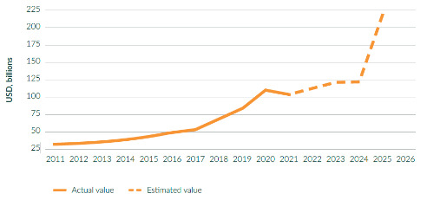
Source: Macrobond; DFAT calculations.

Australia also has advantages in agricultural exports, such as stability of supply and counter-seasonality. Apples and stone fruit are examples of counter-seasonal crops for which we are seeking improved market access through the Comprehensive Economic Cooperation Agreement, CECA.
Australian agricultural producers can also help India achieve its food security goals. For example, there is a strong link between climate change and food security. Australian expertise can directly assist Indian farmers transition to more climate-resilient and more sustainable production systems. Our counter-seasonal agricultural exports also boost India’s food security and help to stabilise its food prices.
The bottom line is that Australia is a trusted, reliable partner and well positioned to work with Indian producers to help them achieve food security goals, boost productivity, and make India’s food system more resilient.

Making this happen
Much of the opportunity in agriculture trade depends on securing better market access for Australian produce. This is a long-term goal. Around 70 per cent of Indian households and half of India’s labour force depend on farming for their livelihoods, so India’s agricultural sector is politically sensitive. The Indian Government’s core objectives for its agricultural sector – food security, food self-sufficiency and doubling income for farmers – are unlikely to change soon. We expect a good portion of India’s agriculture sector to remain protected through tariffs and subsidies for some time.
Gaining access and market share in India may be a long game, but it’s still worth playing for at least two reasons. First, the growth of India’s consumer class is substantial. This is increasing demand for agricultural, fisheries and forestry imports – sources of protein and exotic fruits and vegetables, but also natural fibre for textiles, and wood for the construction sector. Second, Australian exporters who are prepared to diversify and develop markets in India will be insuring themselves against the kinds of risks that have affected Australian exporters elsewhere.
- Indian Agricultural Consumption (2020 vs 2050)
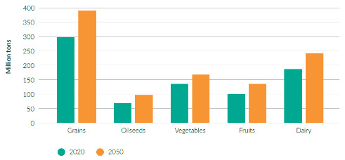
Source: Long-term Agrifood Demand in Asia: 2023 Revision, ABARES, Department of Agriculture, Fisheries and Forestry.

Boosting productivity through agritech
India’s agricultural sector is mostly comprised of small family farms with monthly incomes of about $180. Australia can contribute to India’s agriculture sector by improving efficiencies and uplifting skills through knowledge-sharing to build a more robust agriculture industry – it is one of the clearest examples across the entire relationship of a sector where Australia’s unique skills and experience are precisely what India needs.
One example is water management. In 2023, 20 Indian officials visited Australia to complete short courses on circular economy for water delivered by the University of Technology Sydney. The officials learned about Australian expertise in circular economy approaches, practices and technology. Another is the Australian wool industry which continues to provide valuable expertise to the Indian textiles sector. This includes cooperation on building pathways from the farmgate through to processing and manufacturing. The Indian Grain Storage Project, run by Pulses Australia, was a series of technical webinars aimed at sharing Australian best practice with Indian industry to optimise grain storage conditions and minimise storage loss. Another example, Rubicon Water, based in Melbourne, is working with its local Indian partner to modernise a major canal system in Karnataka.
Australia also has a longstanding track record of working in India on agricultural research. Since 1983, the Australian Centre for International Agriculture Research (ACIAR) has worked with the Indian Council of Agricultural Research to conduct research on climate-resilient seed, and on capacity development to support climate-resilient farming practices and additive cropping. The Australia-India Strategic Research Fund has also facilitated the development of higher-yield rice, chickpeas and wheat (staples of the Indian diet).
These channels for sharing knowledge and technology have made Indian and Australian farms more efficient, productive, and better prepared for the impact of climate change, water scarcity, flooding, pests and disease. They have brought together Indian and Australian farmers, scientists and businesspeople, laying a solid foundation for future commercial deals. These research connections help to familiarise the Indian agricultural sector with Australian exports and build confidence and trust in our respective systems.

Image courtesy of CSIRO
Case study
Western Sydney University to set up campus in India in 2025
Agriculture and education, two areas of Roadmap focus, are bearing fruit in India: Western Sydney University (WSU) is pursuing an excellent opportunity for knowledge partnership that matches India’s agricultural development ambitions with Australian know-how. The university is planning a ‘future tech’ agriculture campus which would leverage WSU’s reputation in India in protected cropping and intensive horticulture, and its strong relationships with the Indian Council of Agricultural Research and other State Agriculture Universities in India.
The campus would serve as a hub for future-focused agriculture research with partners throughout Asia. WSU aims to offer STEM education with a focus on agriculture and hopes to enrol around 1,000 students over the next five years. It will initially offer undergraduate programs focused on emerging technologies in agriculture, drawing on engineering, science, business and computer science. This will be a cutting-edge campus, also including courses on ‘agri-preneurship’ working with industry and startups in a ‘launchpad’ incubator.

Case study
Marquis Macadamias crack the Indian market
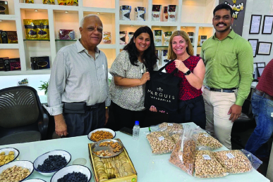
Image courtesy of Marquis Macadamias
Thanks to ECTA, Indian consumers are getting a taste for premium Australian macadamias, with the previous 30 per cent tariff for macadamias reduced to 17 per cent and then progressively to zero by 2028. The reduced import tariffs enabled Marquis Macadamias to send its first container shipment of macadamias to India in September 2023.
Australian macadamias can be an ingredient in foods ranging from confectionary to traditional Indian cuisine, salads, sauces, oil and nut milks. That also brings opportunity for Indian companies to add value by further processing products locally.

Case sudy
Helping Indian farmers with climate-smart agricultural production
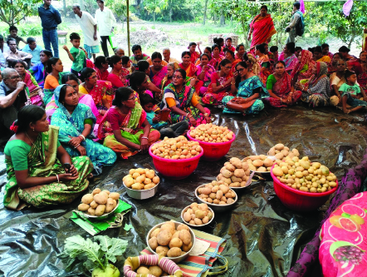
Image courtesy of CSIRO
With a large proportion of India’s population working in the agriculture sector, sharing Australian knowledge with small-scale farmers on climate-smart agricultural production has huge benefits for rural women, especially in the coastal zone of the Ganges Delta. The Ganges Delta is environmentally vulnerable, with higher-than-average incidence of poverty, food insecurity, and limited livelihood opportunities. Australia’s SciTech4Climate has engaged leading Australian scientists with a focus on climate change and science and technological advances. The project has trained 450 Indian farmers to leverage climate-smart technologies and zero tillage practices in two ecologically sensitive islands of the Indian Sundarbans in West Bengal. In these projects, over half the farmers were women, who were cultivating two crops simultaneously. Off-season vegetable production ensures a steady supply of vegetables for family consumption and cash income, enhancing the resilience of fragile farming systems and improving smallholder farmers’ livelihoods. It has increased the access of female farmers to new agricultural technologies as well as their knowledge, skill and confidence.

Case study
World Food India puts Australian produce on the table
The Department of Agriculture, Fisheries and Forestry supported a delegation of Australian agricultural peak body representatives to travel to New Delhi in September 2024 for the third iteration of the World Food India conference. World Food India put Australian businesses directly in contact with their Indian counterparts, including site visits and the facilitation of exchanges on technical issues, further strengthening our economic and commercial partnership. Australian businesses were able to demonstrate their value-add to India’s food manufacturing supply chains, including using Australian inputs in India’s food processing sector. Delegation visits such as World Food India are an important tool in strengthening our bilateral relationship and helping to accelerate wealth creation, skills transfer and mutually beneficial economic growth and diversification between Australia and India.
Action plan
Strengthening knowledge sharing and technology cooperation to promote farm productivity through research and private sector collaborations.
The Government will seek improved agricultural market access to India through the Comprehensive Economic Cooperation Agreement (CECA) negotiation process and work to remove non-tariff barriers to trade – including through Austrade’s efforts to help agribusinesses locate suppliers and partners in India and the Department of Agriculture, Fisheries and Forestry’s work to resolve sanitary and phytosanitary issues and other impediments.
The Government will promote Australia’s agricultural products to India’s growing consumer class through government support for Australian providers and states and territories at events such as wine and food expos and trade shows, showcasing Australian produce at government-hosted events, and through promotion on social media.

Tourism

Image courtesy of Tourism Australia
As India’s consumer class prospers, the number of Indians travelling overseas will continue to grow strongly. CAPA, an aviation consultancy, projects that 50 million Indians will travel abroad by 2030, making India the fastest growing outbound market in the world. Arrivals from India are expected to continue to grow strongly, reflecting India’s strong economic growth and population growth outlooks, as well as the large and growing Indian diaspora in Australia. According to McKinsey, Australia is India’s third most desired destination but only the 10th most visited by Indian travellers. Indian visitors are attracted to our exciting tourist experiences, friendly people, value for money offerings, the English language, a clean environment, relative proximity and of course our vibrant Indian-Australian communities.
Indian-Australian communities play a critical role in attracting the visiting friends and relatives (VFR) segment of the market. They help create a welcoming environment in Australia that suits Indian tastes – food, community links and events attract holiday makers. Indian families and friendship networks tend to be large and close, so we expect the VFR segment of the market to grow fastest, perhaps at an even faster rate than the Indian-Australian community itself. As the Indian-Australian population keeps growing strongly, a similarly strong growth trajectory is projected for Indian visits to Australia.

Preparing for take-off!
Before it was disrupted by the pandemic, the Indian leisure tourism market to Australia was thriving – between 2011 and 2019 it grew at an average annual rate of 17 per cent. The Indian market was one of the first to bounce back after the pandemic: arrivals from India increased by 30 per cent in 2023 to reach 395,600, which was 99 per cent of their pre-pandemic level. This was a much faster recovery than most other markets, and saw India move to Australia’s fifth largest source market in 2023. It is now one of Australia’s fastest growing tourist markets. Total trips from India for the year ending June 2024 reached 416,000 and arrivals from India are forecast to increase further in 2024, to reach 437,000 arrivals, which is 9 per cent higher than the pre-pandemic level. Total spending for the same period was up by 25 per cent, reaching $1.5 billion (with an average spend of around $6,000 per trip). The outlook for the Indian market is positive, reflecting population dynamics and rising household incomes in India, increasing interest in international travel among the Indian middle class, and the large Indian diaspora in Australia. By 2029, arrivals from India are expected to reach 618,200. This would see India retain its current ranking as Australia’s fifth largest visitor market.
There’s evidence to suggest we can build upon this strong growth. However, there is still work to be done before we reach our stretch goal of receiving 1.2 million visitors from India by 2035.
- Short-term visitor arrivals from India
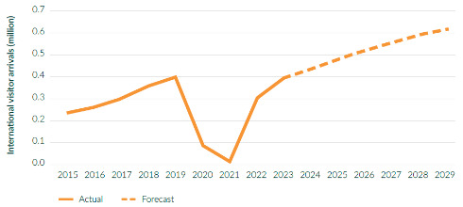
Source: Australian Bureau of Statistics (Overseas Arrivals and Departures); Tourism Research Australia forecasts.

- India market by main trip purpose
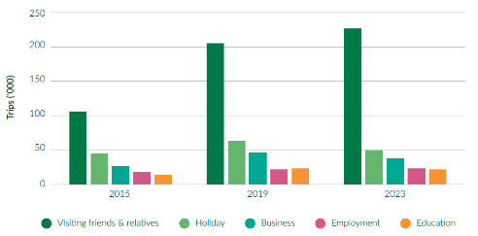
Source: Tourism Research Australia, International Visitor Survey 2015–2023.

Fulfilling potential
On the supply side, improving flight connectivity is the most important factor that will drive growth. Before the pandemic, there were only eight direct weekly flights between Australia and India. As of 2024, there are around 25 weekly flights, with Qantas and Air India ramping up direct services, and IndiGo establishing code sharing arrangements with Qantas. But there’s still plenty of unmet demand. The comparison with China is striking. The size of the community, migration flows, overseas students, even geographic proximity are roughly the same for China and India and yet there are five times as many direct flights between China and Australia than between India and Australia.
The Open Skies Agreement should help to improve flight connectivity. This treaty underlines the potential the Australian Government sees in Indian tourism – India is one of only seven countries with which we have such an agreement. It allows Indian and Australian airlines to offer an unlimited number of seats to six Indian cities and six Australian cities, which we anticipate Australian and Indian airlines to take up once their fleet capacity improves.
The benefits of direct flights can be seen by the 27 per cent growth in the India-New South Wales market in the two years following Air India’s launch of Delhi-Sydney flights.
The new Western Sydney International (Nancy-Bird Walton) Airport – expected to be operational from 2026 – will also help by increasing our capacity to receive flights from India. It will boost the visiting friends and relatives (VFR) and business segment of the market by facilitating travel between India and the 200,000-plus greater Sydney Indian-Australian community, a good proportion of whom live close to the site of the new airport in greater western Sydney.
In addition, we anticipate that capacity constraints in India will ease, gradually. India is the world’s fastest growing air travel market so it’s no surprise that demand for air travel has outpaced supply. A major constraint limiting the tourism growth from India is the number of planes operated by Indian airlines. The unfulfilled demand is huge. There are close to 40 airlines operating in India and, between them, they have 1,000 new planes on order to begin flying within the decade. The Australian High Commission in New Delhi is engaging deeply with airline CEOs and owners to prioritise new flights to Australia, including to new destinations.
India is a diversification focus country for the Government’s Austrade-led THRIVE 2030 strategy, which aims to increase the capabilities of industry to service increasing numbers of Indian visitors. Collaborations and co-funding with industry, such as through the Australian Tourism Export Council’s India Host Program, have seen around 250 tourism businesses build their India tourism capabilities since the program was rolled out in 2020.
Tourism Australia is working hard to boost demand from the Indian tourist market. Since 2022, Tourism Australia has leveraged prestigious events such as the ICC Men’s T20 World Cup, FIFA Women’s World Cup, Melbourne Food and Wine Festival and Australian Tourism Exchange with a public relations and international media hosting program.
Looking ahead, there are plenty of big events in Australia that are likely to attract a following in India, and we know from efforts to build campaigns around significant events like the Border-Gavaskar Trophy five-day Test cricket series (see box) that these can have a significant drawcard effect. There’s strong interest in other sports collaborations, and in Australia’s cultural and culinary scenes too. We know that enjoyment of food and drink, sightseeing and culture account for seven of the top 10 experiences appealing to Indian travellers, which will only grow in the lead up to the 2032 Brisbane Olympics.
Cricket Australia and the Centre for Australia-India Relations – a strategic partnership
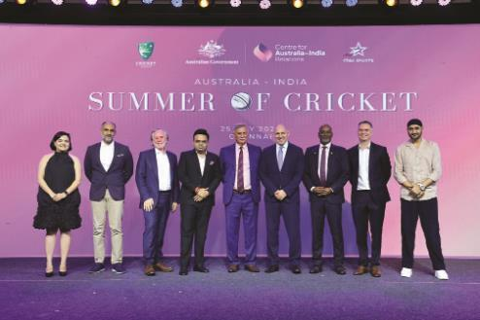
Image courtesy of Cricket Australia
The Centre for Australia-India Relations set up a taskforce with Cricket Australia to establish the Australia-India Cricket: Summer of Opportunity in 2024–25.
Australia-India series are amongst the most highly anticipated events in international cricket. The interest in the 2023 ICC Men’s Cricket World Cup final between Australia and India was huge – over 87 billion live viewing minutes. Building on this momentum, the men’s Border-Gavaskar Trophy series achieved the highest television viewership in history for a Test match series played in Australia. Together with the Australia-India Women’s One Day International matches, these series were great opportunities for Australia to leverage cricket’s vast popularity in India to engage with key Indian stakeholders, including business leaders, government representatives, fans, media and the local Indian community. This built on Cricket Australia’s Multicultural Action Plan which aims to engage the Indian diaspora and promote cricket as a means of fostering social cohesion and cultural exchange.

This new initiative comes after a broadcasting MoU was signed between Cricket Australia and the Board of Control for Cricket in India (BCCI) in November 2023, which was witnessed by Foreign Minister Wong.

Senator the Hon Penny Wong, Minister for Foreign Affairs in New Delhi, November 2023
The taskforce delivered tailored programs around the Summer of Cricket that included partnering with the Australian, state and territory governments and commercial partners to host trade events, business-to-business forums, and community engagement activities in both Australia and India.
We aim to build a lasting partnership between Australia and India. With cricket’s inclusion in the 2028 Los Angeles Olympics, its probable inclusion in the 2032 Brisbane Olympics, and its potential inclusion in the 2036 Olympics, for which India will bid, the taskforce sees significant scope for cricket to drive growth in the bilateral relationship.

Case study
A new direct route from Bengaluru – powering potential from India’s south

Image courtesy of Qantas
In September 2022, Qantas commenced flying between Bengaluru and Sydney, the first time the two cities had been connected non-stop. The Australian national carrier envisioned the opportunities arising from a Bengaluru connection, given the rising wealth and economic growth in southern Indian states. This, combined with the appeal of the new high-end Bengaluru airport, the growing Indian diaspora in Australia and the tourism appeal of both destinations, is resulting in unprecedented demand for two-way air travel. These drivers are not just seen in passengers on Qantas flights – overall Indian visitors to Australia have exceeded pre-pandemic levels.
Qantas sees this route as a successful addition to its services from Delhi to Melbourne and will operate additional flights from mid-December 2024 to late March 2025 to cater for strong demand. This will result in an additional 12,000 seats between the two cities over the four-month period.

Case study
Tourism Australia’s Aussie Specialist Program

Image courtesy of Tourism Australia
Tourism Australia’s Aussie Specialist Program (ASP) provides frontline travel sellers from around the globe with the knowledge and skills to best sell Australia. The training program, shared by eight state and territory tourism partners, is supported in India by an Aussie Specialist coordinator and trainer, and is delivered through a new digital platform.
Tourism Australia is using this program in India to train and develop a network of qualified local tourism retailers. This team has already trained over 1,800 agents in India in the last 12 months. To ensure Indian tourism demand trends are captured, the Aussie Specialist online platform is updated regularly, including recent refreshes of popular courses on food and drink, self-driving, and the youth market.

Case study
Australian tourism industry accessing the growing Indian market

Image courtesy of Foodie Trails
Melbourne-based Himanshi Munshaw Luhar, who migrated to Australia from Mumbai as an international student in 2005. She obtained a double master’s degree before embarking on a successful career in the Australian visitor economy. Driven by her love of Melbourne’s food and culture, she founded small business ‘Foodie Trails’ in 2009. It enables visitors to join food walking tours, festivals and events as a way to break down cultural barriers over a shared meal and experience Melbourne’s rich food heritage. More recently under the banner of ‘Culture Kite’, Himanshi is showing the Australian tourist industry how to access the growing Indian market and service Indian visitors through the Australian Tourism Export Council’s India Host Program, which she helped develop.
She says: ‘The local Indian community and their VFR guests are key to boosting regional tourism and spending. There’s immense potential for the Australian tourism industry to upskill their teams with cultural insights and market specifically to this diaspora.’
Action plan
Continue to encourage additional direct flights, including by working with state and territory governments, Indian and Australian carriers and Australian airports, and encourage Indian companies to invest in high-end Australian hotel developments.
Promote Australia as a tourist destination in India, including through major sporting events, hosting tourism journalist visits, engaging with Indian travel agents and influencers, and working closely with state and territory tourism agencies.
Investigate regional dispersal initiatives which could be targeted for Indian travellers visiting friends and relatives in Australia, to encourage more inbound travellers to see more of Australia.
Continue to build and establish business relationships through holding an ‘Australia Marketplace’ in India every second year.
Collaborate with key distribution and airline partners to promote tactical airfares and packages to visit Australia, aimed at reducing the gap between consideration and actual visitation.

Major Economic Roads


Investment
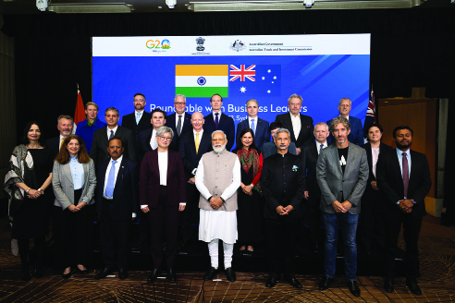
Senator the Hon Penny Wong, Minister for Foreign Affairs with her Indian Counterpart, Minister for External Affairs Dr S. Jaishankar and Indian Prime Minister Hon Narendra Modi at a Business Leaders Roundtable in Sydney, May 2023

Inbound
On the back of India’s robust economic growth, Indian investors are pursuing international partnerships and investment opportunities to grow their businesses and secure their supply chains. The Front Door will act as a central point of entry for investors to identify priority projects and provide those projects with coordinated regulatory and investment facilitation services. What draws them to Australia is clear economic complementarity in sectors like resources and clean energy, our alignment of values, low sovereign risk and commitment to the rule of law. In other words, our investment regime is both stable and transparent.
Total Indian investment in Australia stands at $47.3 billion. Portfolio investment is the largest share and has grown over the last decade. Looking ahead, we expect direct investment to increase. While most of India’s direct investments in Australia have been into traditional resources such as coal, as our economic ties diversify, investors are sizing up opportunities in new areas. For example, Indian investment in critical minerals is promising, as India’s demand for critical minerals is projected to climb significantly. Multiple Indian manufacturers are racing to build large battery manufacturing facilities which will have significant feedstock requirements for minerals Australia can competitively supply, such as lithium, nickel and graphite. Already, Coal India Limited is actively scouting for Australian investment opportunities to help secure access to the critical minerals that are essential for India’s development objectives. National Mineral Development Corporation, India’s largest producer of iron ore, built on its existing Australian investments to sign a lithium exploration pact in 2024 with Australia’s Hancock Prospecting.
Australia’s economic agencies in India are busy engaging investors to promote Australian opportunities, facilitate their interest and support business connections. Australian companies in critical minerals and energy storage are also increasingly looking to India for trade, technology and investment partnerships. In fact, Australia was the largest country delegation at India Energy Storage Week in New Delhi in July 2024.
Beyond clean energy and resources, two further areas of interest to Indian investors are IT services and tourism. On IT services, some of India’s giant IT companies are significant investors in Australia, enjoying a strong competitive position and share of the Australian market. Australia’s network of consulates in India’s south facilitate IT and tech investment in Australia – an engine of growth and innovation.
On tourism, major Indian investors, mindful of how fast India’s outbound aviation market is growing, want to capitalise on demand from wealthy Indians for premium tourist experiences in places like Australia. Investors are looking for opportunities in Australia in high-end hotel developments.
And there are other long-term Indian investors in Australia, such as the State Bank of India, which has had a branch in Sydney for over two decades, offering valuable banking services to Indian and Australian businesses.
Educating business: The Centre for Australia-India Relations CEO and Director Network
Australian businesses are sometimes uncertain about how to engage effectively in India or adjust business models for success. The Centre for Australia-India Relations aims to rectify this by developing India literacy in the Australian business community and helping it take advantage of the economic opportunities in India. To realise this ambition, it created the CEO and Director Network as the first initiative of its business engagement pillar.
The CEO and Director Network is an influential group of Indian-Australian senior executives and board directors with deep connections across top ASX companies. Members of the Network work with the Australian business community to build awareness of India as a market where Australian companies can make money and grow. Members provide advice and expertise to help the Centre develop compelling evidence-based programs to lift business literacy on India and to connect into the boardrooms of corporate Australia. The Network helps to demystify India by working with government agencies such as Austrade to build greater understanding in the Australian business community regarding the opportunities and challenges of doing business in India.

Outbound
Export Finance Australia (EFA) is currently exploring commercial financing opportunities in the Indian market. This is consistent with EFA’s mandate to provide finance that facilitates and encourages Australian export trade and overseas infrastructure development, noting the strategic importance of the Indian market to Australia. Supporting more Australian investment in India helps better link our business, supply chains, and opens opportunities for Australia’s exports to India in the future
Australian companies in India
Australia’s investment stock in India reached $22.2 billion in 2023. Some blue-chip Australian investors have been in India for decades, such as Macquarie (infrastructure and green economy), ANZ (finance), Linfox and Toll (logistics) and Leightons (construction and real estate). Most of our major banks have taken advantage of India’s rapidly growing talent and innovation pool, readily available venture capital funding, and sophisticated startup ecosystems to create ‘Global Capability Centres’. In the technology sector, Bengaluru has been Atlassian’s fastest growing research and development and talent location site since it opened for business in India in 2018. In the resources sector, Rio Tinto, BlueScope Steel and Orica have large operations in India. We expect there will be similar opportunities for leading Australian companies with the right partnerships or models for the Indian market.
- Australian investment in India
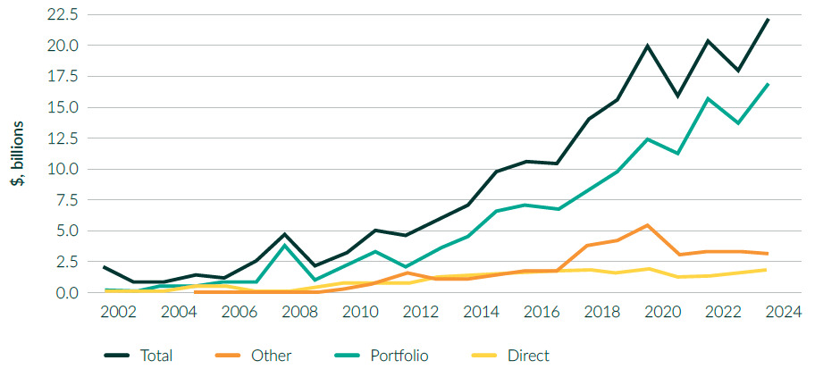
Source: Macrobond; DFAT calculations.

Case study
Retail innovation from India to Australia
Australia’s Wesfarmers launched the Anko Global Capability Centre (Anko GCC) in India in 2018. Anko GCC serves as the Global Capability Centre for Kmart and Target Australia, driving innovation and technology advancements.
Since its inception in 2018, Anko GCC has been at the forefront of retail transformation, growing to over 400 team members at its Bengaluru office. Anko GCC’s talented workforce brings a wealth of experience, pushing the boundaries of retail innovation, and the GCC is accelerating Kmart and Target’s strategic goals through top-tier capabilities in technology, data science, inventory, finance, and people and capability.

Case study
Macquarie invests in ChargeZone to help accelerate the growth of EV infrastructure and green mobility in India
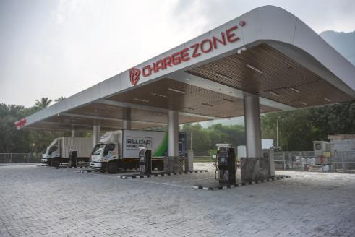
Image courtesy of Macquarie Group
Macquarie Capital acquired a stake in TecSo Charge Zone Limited (“ChargeZone”), one of the leading providers of fast-charging infrastructure in India.
Accelerating deployment of fast-charging infrastructure will help meet the Indian Government’s decarbonisation targets for the transport sector (30 per cent electrification of the country’s vehicles by 2030). Meeting the target will require a cumulative investment of over $260 billion in vehicle production and charging infrastructure.
Macquarie Capital’s investment will further support “ChargeZone” in increasing the network of fast-charging infrastructure across India.

Reflecting India’s growth prospects, Australian investment funds are more actively considering portfolio investment in India. One prominent example, AustralianSuper, is already an anchor investor in India’s National Investment and Infrastructure Fund (NIIF).
The Indian investment environment can be complex. Australian firms should do their due diligence, find good local partners, be aware of the resources and learning programs on the business environment in India (like those offered, for example, by Asialink) and be prepared to play a long game.
Both governments are working to facilitate greater levels of investment. From our side, the Australian Government has initiated several measures to encourage Indian investment in Australia, while also advocating for a more level playing field for taxes on inward investments into India comparable with other major partner countries. The Centre for Australia-India Relations is developing a program to build the knowledge base of Australia and India as strong investment destinations.
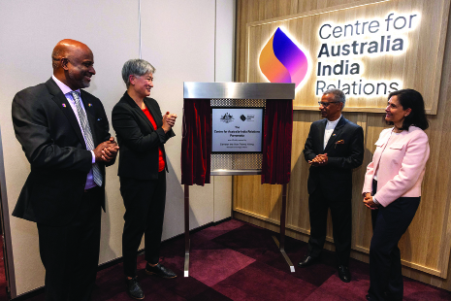
Senator the Hon Penny Wong, Minister for Foreign Affairs with Centre for Australia-India Relations CEO Tim Thomas, High Commissioner of India to Australia, H.E Gopal Baglay and Chair of the Advisory Board to the Centre, Ms Swati Dave

Australia-India CEO Forum
A big step forward – and one welcomed by the private sector – was the revitalisation of the Australia-India CEO Forum in 2023. The Forum is co-chaired by Macquarie Group CEO Shemara Wikramanayake and Mahindra Group CEO Dr Anish Shah. It draws in many key figures in the Australian and Indian business communities. It provides a platform for Australian and Indian business leaders to build commercial linkages, discuss opportunities across sectors, and work with governments to increase two-way trade and investment by enhancing investment conditions, accelerating cooperation, and improving the ease of doing business in both Australia and India.
Although the CEO Forum first met over a decade ago, it was refreshed by the Australian and Indian Governments in 2023 and provided with a dedicated secretariat by the Business Council of Australia (BCA) and the Confederation of Indian Industry (CII). The BCA and CII also play important roles managing the intersessional work of the CEO Forum’s Joint Working Groups for energy, resources, Net Zero and critical minerals; infrastructure, finance and investment; education, qualifications and standards; digital economy; and agritech.
The CEO Forum first met in its new format in Mumbai in March 2023 when Prime Minister Albanese led the most significant high-level Australian business delegation to visit India. The Forum underlined Australia’s commitment to closer economic ties. Prime Ministers Albanese and Modi encouraged Indian and Australian businesses to cultivate links, explore emerging economic and investment opportunities and leverage the significant complementarities of both economies. At the October 2024 CEO Forum meeting – held virtually – the Forum’s Joint Working Groups presented recommendations to ministers. As a next step, the BCA and CII will support businesses to take forward key recommendations in 2025 through a work plan that will be presented to government.
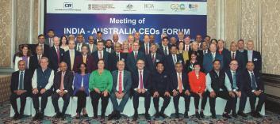
Australia-India CEO Forum, 2023. Image courtesy of Business Council Australia

Action plan
Australia’s economic agencies in India will engage investors to promote Australian opportunities, facilitate their interest and support business connections.
Export Finance Australia (EFA) will enhance its efforts to support further investment into the Indian market. EFA can provide loans, guarantees and insurance, and, in limited circumstances, equity investment, including in the growing Indian infrastructure sector. Through a greater focus on India, and ongoing project scoping and due diligence, EFA would look to increase its exposure in-market, helping India secure quality inbound investment. The Government’s National Interest Account may also be available to support infrastructure of strategic significance to the Government.
The Australian Government will continue to support institutional investors and firms seeking to invest in India, including through the work of EFA and Austrade’s collaboration with Invest India. Delegations under Austrade’s expanded Australia-India Business Exchange program will support increased India market understanding and exposure. The Centre for Australia-India Relations is standing up an initiative to improve business literacy for Australian corporates and institutions, whether investing in infrastructure-related projects or other areas of investment promise. The Government will explore options for providing Australian companies with additional investment support, capability and solutions in India.

Defence Industries

Image courtesy of the Prime Minister’s Office

Australia and India are top-tier security partners, a partnership that is being driven by increasing strategic convergence in the Indo-Pacific region.
India’s defence budget is around $125 billion a year. It is also diversifying towards Western suppliers and so, for Australia, this presents export opportunities – especially those that involve joint production, or the export of components for manufacture in India. Our National Defence Strategy recommends Australia expand its relationship and practical cooperation with India, including on defence industry cooperation.
Both the Australian and Indian governments are focused on building the strength of their respective sovereign industrial bases. Although our efforts to do this may not be naturally complementary, there will still be opportunities in this sector for greater economic engagement. Defence industry exporters are building from a low base, and should bear in mind that procurement processes can be protracted and require significant and long-term investment. Exporters also need to protect their intellectual property.
India’s streamlining of licensing requirements and foreign investment liberalisation are positive steps, but India’s focus on increasing domestic production may limit some opportunities. Joint ventures and partnerships between Australian and Indian companies are the most likely mechanisms for entry into the Indian market.

Deputy Prime Minister and Minister for Defence, the Hon Richard Marles MP and VADM David Johnston, AC, RAN, with Indian representatives. Courtesy of the Australian Department of Defence

Technology and IT

India’s technology and IT ecosystem
India has developed one of the largest and fastest moving technology and IT sectors in the world. The technology hub based around Bengaluru in Karnataka is a technology ecosystem worth well over $300 billion and is Asia’s biggest market for venture capital. It drives innovation across technology fields, from electric vehicles to artificial intelligence and quantum computing. In 2022, India ranked sixth globally in patent filings, with a 25 per cent growth in that year. And the OECD predicts India will produce 27 per cent of the world’s STEM graduates by 2030.
India’s growth is driven by a massive and expanding internal market for technology and IT – the number of online consumers in India is expected to be well over 400 million by 2027. Other nations looking to diversify their technology supply chains are investing in India and so India’s technology sector is booming. This has helped India’s remarkable rise in global innovation rankings from 81st in 2015 to 40th in 2023. The Australian Strategic Policy Institute’s latest Critical Technology Tracker found that India now ranks in the top five countries for 45 of 64 critical technologies, including technologies such as photovoltaics and advanced data analytics.
India’s large investments in digital public infrastructure serve as a major driver and enabler. India’s embrace of technologies such as digital signature, banking, and payment systems has expanded markets, fostered innovation and inclusivity and stimulated industry. Nearly half the world’s digital payments each day occur in India – reaching over 8 billion real-time payments each month. Other emerging technologies have expanded in India, including cybersecurity, blockchain, fintech, medtech and gaming. India has also made significant investments in uplifting cybersecurity capabilities.
The opening in 2023 of an Australian Consulate-General in Bengaluru is a force multiplier and clear statement of intent (see box). Meanwhile, our Australia-India Cyber and Critical Technology Partnership – established in 2020 and worth nearly $13 million – provides grants for Australian business to seize opportunities presented by India’s technology and IT sector. With four rounds complete, these grants are already hard at work supporting collaboration on cyber and critical technology issues, deepening institutional linkages, fostering policy exchanges, increasing our information sharing and raising awareness of opportunities – including to promote women in business. Our universities are also contributing – the University of Wollongong recently launched a Women Leaders in Fintech Scholarship to support female participation in India’s fast moving fintech sector.

The Australia India Innovation Network – worth $2.2 million out to 2025 – is one of Austrade’s priority initiatives aiming to increase the number of Australian technology companies accessing the rapidly growing digital sector in India. Austrade’s India Tech Export Catalyst (ITEC) program helps Australian SMEs prepare to enter the Indian market by advising on market entry strategies and facilitating introductions for potential partnerships through business missions and delegations to India. ITEC supported over 80 Australian deep tech (including agritech) companies going through the India immersion program and developing commercialisation pathways in India. ITEC also acts as a feeder to other India acceleration programs such as CSIRO’s RISE initiative.
The new Strategic and Technology Policy Initiative (SATPI) – established in 2024 and worth nearly $4 million – will help achieve Australia and India’s vision for a region that is peaceful, stable and prosperous. SATPI will fund innovative projects that address Australia and India’s shared strategic and technology challenges, including a flagship annual 1.5 Track Strategic Dialogue between Australia and India.
Australia’s presence in Bengaluru and southern India: a tech opportunity
In 2023, Australia opened its Consulate-General in Bengaluru to help our businesses connect in the heartland of India’s business innovation and space sectors.
This Consulate has already become a critical enabler of our economic engagement with India’s thriving south. The new Consulate-General enhanced our existing Austrade and Victoria and Queensland Government representative offices in Karnataka. Its role is to open the door for Australian businesses looking to engage with India’s booming digital economy and innovation ecosystem and to reinforce our growing links into the space sector. Its gives us a comparative advantage – Australia is one of just 11 countries with consulates in Bengaluru.
Many Australian firms are in Bengaluru to utilise the tech city’s Global Capability Centres and their local resources and expertise. The Consulate supports a strong Australian presence at the annual Bengaluru Tech Summit, ‘Asia’s biggest tech event’. Another area for focus is research and its links to commercial outcomes – critical for Australian tech companies with a presence in south India.
India’s space agency, the Indian Space Research Organisation, is also headquartered in Bengaluru and so the Consulate plays a role in driving our engagement in India’s growing space startup sector, including through leading Australian participation at events like the Bengaluru Space Expo (see next section: ‘Space’).

Greenfields investment
Indian technology and IT firms are increasingly important greenfield investors in Australia. Software and IT, services, communications and the financial services sectors are among the largest Indian investments in Australia. A good example is the Indian IT giant Infosys, present in Australia since 1999 and now employing over 5,000 people in Australia. Infosys has established innovation hubs in Sydney and Melbourne. Tata Consultancy Services (TCS), another Indian behemoth, launched its digital innovation centre, TCS Sydney Digital Garage, in 2022. TCS is also partnering with Macquarie University on the TCS GoZero Hub – a research and innovation centre – to guide Australian organisations towards Net Zero. Wipro (with around 2,000 employees in Australia) has also invested heavily. HCLTech, another large employer in Australia, has embraced our business culture by showing leadership on environmental, social and governance issues – for example, developing its own Reconciliation Action Plan and even supporting the National Museum of Australia’s Walking through a Songline exhibition in India. Finally, Zoho, a business software firm founded in Chennai, opened its Australian head office in Adelaide in 2022.
These investments are injecting capital into the Australian economy, creating jobs and bringing world-class technology and expertise through our doors. As the Future Made in Australia agenda begins operation, we’d expect more investments like these from India in Australia as our investment environment improves.
Case study
Infosys InStep program
Leveraging from India internship to Australia’s advantage: the Infosys InStep internship program has been recognised as a world-leading internship program. It offers university students from around the world, including many Australians, a unique opportunity to work in India for three months. Interns are based in Infosys’ expansive Bengaluru campus, where they work on a project of their choice under the mentorship of an experienced supervisor. Beyond their professional experience, interns also explore and immerse themselves in the rich culture of India. Infosys takes great pride in its Indian heritage.
Australian partner universities include Deakin University, RMIT, UNSW, Swinburne, Monash, Curtin, University of Canberra, and Macquarie University. InStep Australia collaborates closely with the Victorian Government on the Digital Jobs Program, which aims to create a new talent pool of skilled individuals to meet the increasing demand for digital expertise in Victorian businesses. Over the past few years, more than 20 New Colombo Plan interns have participated in this flagship program, significantly contributing to its success and broadening its impact.

Case study
RISE Accelerator Program supporting Indian and Australian startups and SMEs

Image courtesy of CSIRO
The RISE Accelerator program, co-designed and co-delivered by a close partnership between the CSIRO and Atal Innovation Mission (AIM), NITI Aayog, supports Indian and Australian startups and SMEs in expanding their innovative technology to Australia and India.
The accelerator program focuses on environmental and climate technologies, with each round seeing a cohort of 12 to 16 startups and SMEs addressing specific challenges and national priority areas – from the circular economy opportunity to clean energy and climate-smart agriculture.
Launched in 2023, startups and SMEs are being supported to navigate early steps in the new market; validate and adapt technologies for new market conditions; fast-track connections to the right partners; and build credibility to accelerate their technology in Australian and Indian ecosystems. CSIRO and AIM’s joint vision for the Program is knowledge exchange and collaboration within industry, science and technology innovation ecosystems.

Action plan
The Australia-India Strategic Research Fund (AISRF) will continue to support collaborative research projects between Indian and Australian researchers focused on evolving priority areas. Through 15 rounds so far, the AISRF has funded Australian recipients to work with Indian counterparts on 148 projects. Outcomes of Round 15 were announced in July 2024, supporting five collaborative projects including antimicrobial resistance, artificial intelligence and machine learning, new and renewable energy technologies, and urban mining and electronic waste recycling. Round 16 of the Fund is now open.
A new Australia-India Strategic and Technology Policy Initiative (SATPI) will fund activities which address common strategic and technology challenges and interests, particularly in the Indo-Pacific. SATPI will convene a flagship 1.5 Track Strategic Dialogue between Australia and India. Other funded activities will include aligned conferences, two-way exchange programs, in partnerships with the Asia Society short-term residencies, and research projects. SATPI complements the existing Australia-India Cyber and Critical Technology Partnership, which supports projects that advance our understanding of ethical frameworks, best practice and technical standards for cyber and critical technology to boost the responsible development and use of emerging technologies.

Space
India is justifiably proud of its achievements in space. In 2023, India became only the fourth country ever to land a lunar rover and the first near the moon’s south pole. Its national space program is one of the world’s oldest and most advanced. India’s future vision for space is also one of the world’s most ambitious – led by Prime Minister Modi, who also serves as Minister for Space. India released a new Space Policy in April 2023 which aims to unlock new opportunities for private sector companies. It is the platform for what has become the fastest growing space sector in the world, expected to grow by over $70 billion by 2032. The size and rapid growth of India’s space sector offers plenty of opportunities for Australian entities to contribute and collaborate – particularly in the commercial domain.
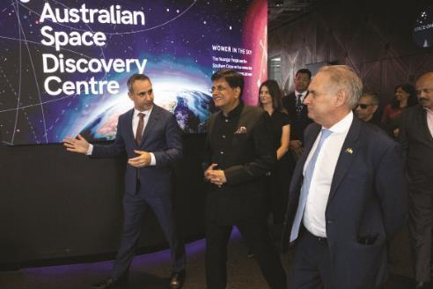
Senator the Hon Don Farrell, Minister for Trade and Tourism and Hon Shri Piyush Goyal, Minister of Commerce and Industry at the Australian Space Agency in Adelaide, September 2024

Collaboration opportunities
Australia’s space ecosystem has some significant strategic advantages, like a unique and clear view of the sky and a growing space talent base. Australia has a range of niche expertise in areas like robotics, launch services, ground station services, remote operations, communications and satellite tracking. This makes us a natural partner for India. These areas of expertise have, for example, enabled us to support India’s inspirational Gaganyaan Human Spaceflight Programme, a revolutionary $2 billion program led by India’s space agency, the Indian Space Research Organisation (ISRO), aiming to put India’s first astronauts into space within the next few years.
The recently updated space cooperation MoU between the Australian and Indian governments sets a launchpad for greater collaboration – not just between governments, but also in the private sector. Indian space sector startups have been incubated in Australia, and Australian startups have begun operations in India. Austrade and the Australian Space Agency (ASA) have led the way early in fostering business-to-business collaboration. Our new Bengaluru Consulate-General, located close to India’s space sector, has already made a difference to Australian companies seeking to collaborate in the space sector, according to the Space Industry Association of Australia.
The $21 million International Space Investment India (ISI India) program was launched in 2023 by Prime Ministers Modi and Albanese and is part of the Comprehensive Strategic Partnership between Australia and India. Managed by the ASA in the Australian Department of Industry, Science and Resources, the program has provided $18 million in targeted grants to three Australian organisations to conduct joint space projects and establish commercial partnerships with the Indian space sector. Each project aligns with agreed focus areas of strategic importance and includes Australian and Indian partners.
Case study
Helping India’s space ambitions take off
HEX20, an Adelaide-based satellite manufacturing company, opened its India office in May 2023. HEX20 in India has an exclusive focus on R&D partnerships and uses India’s state-of-the-art manufacturing facilities to develop next-generation small satellite systems enabling it to deliver innovative solutions globally. The Australian space industry presence in India demonstrates the growing collaboration between Australia and India in the space sector. Such collaboration not only fosters mutual economic growth, but also strengthens our participation in global space supply chains, and our mutually complementary aims across future space missions and applications.

Case study
Helping achieve low debris space
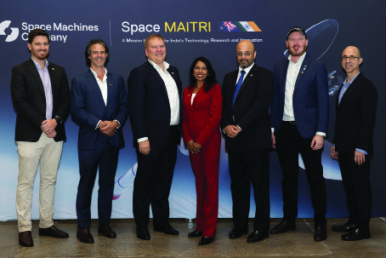
Image courtesy of Space Machines Company
The Mission for Australia-India Technology, Research and Innovation is an International Space Investment India (ISI India) initiative. Space Machines Company was awarded more than $8.5 million for its industry-led Australian-Indian mission on space debris management and progress toward a sustainable space future. It involves collaboration between 13 Australian and Indian organisations which will launch the largest Australian-made spacecraft into orbit from a NewSpace India Ltd (NSIL) Small Satellite Launch Vehicle (SSLV) in 2026.
It is the first dedicated SSLV launch agreement between Australia and India. This will uplift advanced manufacturing, artificial intelligence and sustainability technologies through Australian-Indian space sector cooperation and supply chain partnerships. It showcases strategic alignment between our two nations across space technology innovation, research and development.
The Quad Space Working Group is another opportunity for Australia. Alongside Japan and the United States, the Working Group is collaborating on ways to share satellite data to monitor and adapt to climate change and enhance disaster preparedness. The Working Group is also exploring how to share Earth observation data within the Indo-Pacific region to better manage the impact of extreme weather events and to support sustainable use of oceans and marine resources. We see great potential for Australia-India collaboration in space, especially around Earth observation for a range of purposes (agriculture, climate change, meteorology, situational awareness).
Australia participated in the annual Bengaluru Space Expo in 2024 as a Country Innovation Partner, where we showcased Australian capability, explored further commercial collaboration, and consolidated our support for India’s Gaganyaan program, leading to the subsequent signing of an agreement with ISRO on Capsule and Crew Recovery. ISRO’s development of Kulasekarapattinam as India’s second spaceport will potentially create opportunities for Australian companies, as the burgeoning commercial Australian spaceport industry will provide greater opportunity for Indian companies to access space. The ASA and ISRO are discussing the potential to collaborate on an Indian-led G20 satellite initiative to build a space mission for the G20 countries, addressing challenges such as climate change and natural disasters.
The bottom line is that Australia is poised to benefit from the many opportunities for collaboration. Our geography and our growing space talent base will lead to meaningful scientific opportunities. While the ISI India program demonstrates the potential of these opportunities on a small scale, we should encourage and aim to unlock greater reciprocal investment to fully realise the benefits to both of our space sectors.
Action plan
The International Space Investment India Projects grants will continue to bring together our respective space industries and R&D ecosystems to conduct joint space projects and collaborate on focus areas of strategic importance to both nations. The three projects funded to date include satellite debris mitigation, more accurate identification and reporting of greenhouse gas emissions, and a validation of a new Position, Navigation and Timing system. Separate to this program, Australia will provide tracking and ground-recovery support for India’s Gaganyaan program to launch crewed spacecraft into low Earth orbit. Both activities strongly signal a step-up in our bilateral space partnership.
Building upon the MoU between the Australian and Indian governments, the Government will continue to strengthen the partnership on civil space cooperation by encouraging greater collaboration between our respective commercial space sectors, including encouraging incubation of Australian startups in India through Austrade’s Australia India Innovation Network’s Tech Export Catalyst.

Sports, Culture and the Arts

Senator the Hon Penny Wong, Minister for Foreign Affairs with her Indian counterpart, Minister for External Affairs Dr S. Jaishankar in Sydney, February 2023

Building our sporting connections
Through our Sports Diplomacy 2030 strategy, Australia wants to build a shared sporting culture in the Indo-Pacific and beyond to boost trade, tourism and investment opportunities. Sports diplomacy is an excellent way for Australia to promote our values like gender equality, women’s empowerment and disability inclusion, as well as to engage with diaspora communities.
India will be a key partner in our sports diplomacy strategy. The obvious place to start is cricket, and our links are flourishing as Australian players and coaches remain in demand from the Indian domestic circuit, particularly the Indian Premier League (IPL). As just one example of the broader benefits: the 2020 ICC Women’s T20 World Cup culminated in a historic final between India and Australia at the MCG, attracting a crowd of over 86,000 spectators and making a significant impact on promoting female sport globally.
The 2024–25 Summer of Cricket opened the batting for the start of a two-year blockbuster period of Australia-India cricket, which includes a five-test men’s series, the Border-Gavaskar Trophy. The Centre for Australia-India Relations worked with Cricket Australia and our High Commission in New Delhi to develop a targeted program designed to catalyse business engagement and engage Indian-Australian communities (see box).
But the conversation shouldn’t end with cricket. Our MoU on Sports Cooperation, signed in 2023, provides a platform for engagement on the full range of sporting cooperation. Australia is helping build more connections with India through a sports management program for coaches and trainers, providing football coaching clinics for girls in vulnerable communities, and co-hosted a first of its kind Women in Sport International Conference focused on women’s participation, retention and performance in sports. And traditional Indian sports like kabaddi and kho-kho are increasingly popular in Australia.
When it comes to sports management, we’ve already made a significant contribution, with Australian firm Populous helping design the iconic Narendra Modi stadium in Ahmedabad. Our consultations with Indian-Australian communities and sporting bodies have shown there’s much more to be done, including on participation and inclusivity pathways, expanding connections between our sports bodies, and collaboration on talent development and sports tech.
Cricket may be the standout but India’s sports entrepreneurship is likely to expand to other sports and women’s leagues. During our consultations, we learned of promising or new collaborations in AFL, tennis and basketball. Australia’s strong results in the 2024 Olympics cemented India’s awareness of our reputation for sports management and our potential to help it become a sports heavyweight globally beyond its long-standing strengths in cricket, soccer, hockey, shooting and wrestling.
Case study
Canberra striking partnerships in Bengaluru

Image courtesy of Cricket ACT
In 2024, the University of Canberra (UC) and Cricket ACT sponsored a cricket tournament in Bengaluru to drive future students to Canberra. The tournament brought together six girls’ teams and eight boys’ teams for a four-day competition. It involved 10 schools from across the state focusing on women’s and men’s cricket. The goal was to bring in more schools and make it an annual tournament. UC and Cricket ACT have been working collaboratively to build relationships with contacts, such as the President of the Karnataka State Cricket Association (KSCA). This partnership has extended to other initiatives, such as UC bringing teams from India to its UC Cup in Canberra. Cricket ACT is finalising an MoU with KSCA to bring teams to Bengaluru.

Case study
Adelaide Giants step up to the plate

Image courtesy of the Adelaide Giants
As a country where sport is a major part of the culture, India represents a huge opportunity for Australian sporting institutions. The Adelaide Giants know this and are working to develop a deeper sporting link with India by developing a strategy that focuses on growing baseball in India as well as cultural and economic ties with South Australia.
Modelled off their successful international baseball academies in China and the Republic of Korea, the Giants aim to establish an exchange program to upskill both players and coaches in India locally and in Australia. They are also working with tourism bodies across South Australia to include baseball in tourism packages to capture the ever-growing inflow of Indian visitors to Australia. This work will contribute to strengthening people-to-people links through sports in Australia and India, growing economic opportunities in the complementary tourism industry, while also growing the pool of world-class baseball players in India.

Culture and the arts
Australia and India have thriving creative industries and established international reputations – especially in film, music, literature, the visual arts and the performing arts. India draws on its extraordinary civilisational history and its diversity of cultures and traditions, which inform its arts practice. Australia has acclaimed creative industries, diverse multicultural traditions – and the cultural heritage, traditional knowledge and cultural expressions of the oldest continuing cultures on the planet: First Nations people. There is a strong affinity between our two countries, and a growing interest in exploring ways to collaborate in culture and the arts, thanks in no small part to Australians of Indian heritage who are often the driving force behind greater cultural engagement.
The Centre for Australia-India Relations is well positioned to capitalise on this growing cultural affinity. One of the central pillars of the Centre’s work is the promotion of creative and cultural exchange. The Centre administers the Government’s Maitri Grants program which is building relationships between Australian and Indian artists, performers and cultural organisations. This includes supporting major Australian cultural organisations to engage Indian partners, supporting First Nations collaboration, and supporting small to medium-sized Australian cultural organisations.
Arts and cultural exchanges between Australia and India align with Australia’s National Cultural Policy – Revive: a place for every story, a story for every place, released in 2023. Through Revive, Australia supports activities which encourage exchanges and international collaboration on arts and culture. This includes delegations and exchanges of arts and culture leaders who are touring in India, support for festivals, and capacity building programs.
In addition, the Asia Pacific Arts Awards (APAA) recognise international cultural exchanges in the Asia Pacific. In a welcome signal, artist and scholar Priya Srinivasan received the 2024 APAA Impact Award for her work. Rooted in Indian classical dance, Srinivasan’s work shines a spotlight on the experiences of women from minority communities and brings together First Nations and Asian Australians.
Film and television are coming into focus as sectors for further cultural collaboration. We have a long history of connection through film. Mary Ann Evans, originally from Perth and best known as ‘Fearless Nadia’, rose to prominence in the 1930s as a stunt woman in Indian films after featuring in Hunterwali. Just recently, in September 2024, our Consulate-General in Mumbai partnered with Australia’s National Film and Sound Archive (NFSA) and India’s Film Heritage Foundation to deliver a training program on film conservation for almost 50 Indian conservators from state, private and museum archives. The 2017 Australian film Lion, which wove a cross-cultural story of identity and belonging across both countries, is another example of our shared stories and cooperation.
Case study
Australia – focus country at International Film Festival of India 2024

Image courtesy of Screen Australia
Film co-production – creating new links to make it happen: Screen Australia formally accepted an invitation from India’s National Film Development Corporation (NFDC) for Australia to be the ‘focus country’ at the Indian Government-sponsored International Film Festival of India (IFFI) held in Goa in November 2024.
Our focus country status translated into a dedicated ‘Australia day’ at the festival, for which Screen Australia developed a showcase of Australian films. Notable Australian film personalities (including prominent actors and directors) attended the red carpet opening of the festival to raise Australia’s prominence.
To advance the Co-production Agreement, Screen Australia facilitated an Australian presence at IFFI’s Film Bazaar. This included the hosting of panel discussions, producer ‘speed dating’ sessions and masterclasses with expert film technicians as well as support for a travelling delegation of Australian producers. Through these, we saw stronger relationships between the film industries in both countries – and a platform to explore co-production opportunities.

IABCA Awards Dinner at the Great Hall in the Australian Parliament House August 2024
India’s thriving film sector produces nearly 2,000 movies a year. Many Bollywood movies have already been shot in Australia – from song and dance routines in front of the Sydney Opera House, to action sequences set in the Queensland rainforest or the desert landscapes of the Northern Territory. Some examples include the critically acclaimed Dil Chahta Hai, and box office successes Chak De India!, Bhaag Milkha Bhaag, Salaam Namaste, and Singh is Kinng. Indian productions with content shot in Australia showcase talent and benefit the tourism industry by introducing Indian audiences to Australia’s people, landscapes and culture. Indian filmmakers are increasingly interested in Australia – in December 2023, Australia was the feature country of the Kolkata International Film Festival. In late 2024, Australia was the feature country of the prestigious International Film Festival of India (IFFI), held in Goa.
Australian audiences are increasingly interested in and appreciative of Indian films – the annual Indian Film Festival of Melbourne is the largest Indian film festival outside of India, and now in its 15th year. Indian Netflix series are increasingly popular in Australia, as are Indian singers, dancers and stand-up comedy.
Finally, the University of Melbourne’s newly opened Global Centre in Delhi will not only provide opportunities for education cooperation, but also for exchanges, including through symposia, forums and public programs which bring together Australian and Indian arts, cultural and creative industry representatives.
In sum, there are many strands, and much work that has been done. We’ll need to keep working to maximise the potential – and the Indian-Australian community will certainly continue to play a major part in forging our cultural links.
Case study
Sutr Santati – Stories of India Woven in Thread

Image courtesy of Museums Victoria
Sutr Santati – Stories of India Woven in Thread was an international exhibition brought together by Museums Victoria, in collaboration with India’s Abheraj Baldota Foundation. Curated by Lavina Baldota in 2023, Sutr Santati celebrated India’s rich textile heritage and ancient weaving traditions passed down through generations. Featuring 75 hand-woven tapestries created by prominent Indian artisans, the exhibition marked 75 years of Indian independence and showcased India’s cultural legacy, strengthening economic and cultural ties between India and Australia. It highlighted the potential of creative industries as a vital component of the bilateral economic relationship, fostering deeper cultural exchanges and enhancing mutual understanding.
Following Sutr Santati, new avenues of collaboration are being explored between Australian and Indian institutions, including fashion, design, tourism and education, generating ongoing opportunities for a dynamic and multifaceted economic partnership.

The Australia-India Co-production Agreement & ECTA
In 2023, the Governments of Australia and India ratified the Australia-India Audiovisual Co-production Agreement, which aims to foster more official co-productions, rather than our filmmakers simply filming in each other’s countries. It offers projects in both countries access to government funding, including through a mixture of grants, loans and tax offsets to incentivise collaboration between our industries, ultimately encouraging Indian-Australian co-productions and opportunities for creative exchange, industry investment and access to audiences.
The Economic Cooperation and Trade Agreement, ECTA, our first free trade agreement also contributes by improving access and fostering trust for suppliers and professionals in the culture and arts sector – which means they are guaranteed to receive the best treatment accorded by India to any future Free Trade Agreement partner – giving Australian providers confidence of future access.
Action plan
The Maitri Grants will continue to build partnerships between Australian and Indian creative industries by supporting projects, events, exhibitions and professional exchanges in the visual and performing arts, literature, film and music sectors. Recent Maitri Grants have supported an India Focus Showcase Program at South by Southwest Sydney to promote business opportunities in music, fashion, technology and gaming; and the Sydney-Dharamshala International Film Festival Exchange to deepen collaboration between Australian and Indian filmmakers.
Ratified by the Governments of Australia and India in 2023, the Australia-India Audiovisual Co-Production Agreement will incentivise collaboration between our creative industries, ultimately encouraging Indian-Australian official co-productions, and providing opportunities for creative exchange, industry investment and access to audiences.
Australia and India share a love of sport – particularly cricket, where our rivalry is becoming one of the greatest in the game. As a common language that cuts across all levels of society, cricket and sport more broadly represent an unparalleled opportunity for Australians to build rapport with Indian counterparts. The government will use major sport to facilitate business outcomes in a range of sectors and showcase Australia’s sports industry (including events management, sports infrastructure and sports technology). India’s own 2036 Olympic ambitions – coming after Brisbane 2032 – also present an opportunity for Australia to share experience and know-how.

Resources and Mining Equipment, Technology and Services

Resources
Resources are a mainstay of the bilateral economic relationship. Australian coal is used in India primarily for steel production, which India needs to keep its massive infrastructure building program on track. Metallurgical coal is Australia’s single largest exported product to India – worth $15 billion in 2023–24 – and it is likely to remain our largest single export product for the foreseeable future. But there are also big opportunities for Australian critical minerals, copper and iron ore, especially magnetite for green steel.
In the last decade alone, billions have been spent on India’s roads, ports, airports and railways – including nearly 55,000 km of national highway, which is five times the distance between Sydney and Delhi. In this time, India’s rail sector expanded by over 30,000 km – equal to Australia’s entire rail network. Already, India has the second largest steel sector in the world. But to meet its infrastructure goals, it will need to double steel production by 2030. Australia has an incredible opportunity to work with India to support its resources needs in a way that involves reducing its emissions, including through steel production here in Australia.
Case study
Austin Engineering and TATA Steel – a match made by Austmine
Austin Engineering is an innovative Perth-headquartered Australian company that designs and manufactures customised dump truck bodies, buckets, water tanks, tyre handlers and other ancillary products used in the mining industry. Austmine was approached by Indian multinational mining and industrial organisation, Tata Steel, to identify solutions to reduce the weight of its dump truck bodies. Austin Engineering designed and tested their dump truck bodies in collaboration with Tata Steel. Austin Engineering has now received a commercial contract for an initial set of dump truck bodies from Tata Steel, with significant scope for future expansion.
Our first free trade agreement, ECTA, was a step forward in increasing exports to India of Australian copper, zirconium and critical minerals such as manganese. However, this is just the beginning – with India’s economic ambitions, it will need a steady supply of minerals. There are a range of opportunities for Australia to provide a secure supply of the mineral resources integral to realising India’s economic and green technology ambitions, including iron ore, gold, and critical minerals such as lithium. This is another complementary economic opportunity for Australia, and our mining sector is well positioned to do this – it is experienced, capable and highly innovative in a world that wants growth and to reduce its carbon footprint and at the same time.

Mining equipment, technology and services
Australia is a world leader in mining equipment, technology and services (METS). Our miners, and the METS ecosystem built around them, are technically advanced and highly innovative. We are good at identifying resources and mining them efficiently and in large volumes, while maintaining safety and environmental, social and governance (ESG) standards.
This means our METS sector is another long-term area of mutual interest. India sees Australia as an experienced and reliable partner whose technologies and expertise will help its resources sector become more self-reliant and environmentally friendly as it transitions to Net Zero. To provide a concrete example: Indian companies are interested in Australian coking coal washing technology because it is cost efficient and provides a better yield than Indian coal, which has a high ash content.
Other areas of Australian METS expertise of interest to India include digital enablement; energy switching; electrification; circular economy (waste recovery); extraction technology (especially underground); and carbon storage and utilisation. A good case study is the Perth-headquartered Immersive Technologies, whose mining equipment simulator has improved operator skills in India, reducing equipment wear and tear, increasing safety and decreasing downtime.
The Government is supporting the METS sector in four ways. First, under ECTA, we negotiated the waiver of import duties, of around 7.5 per cent on average, on most METS equipment. This will open the market up further and remove red tape.
Second, we are supporting Austmine – Australia’s leading industry association for METS – with its $1 million Global Mining Challenge – India program to drive industry cooperation between Australia and India through a structured series of innovative projects, major events and market visits.
Third, in collaboration with Austrade, the NSW Government’s Going Global Export Program is running a series of workshops and business matching events for the METS sector.
And finally, Austrade continues to support the METS sector with events in India each year, like the International Mining Exhibition and the International Mining and Machinery Exhibition (attended by more than 60 Australian companies in 2024), as well as ongoing client servicing.

Case study
Global Mining Challenge – India
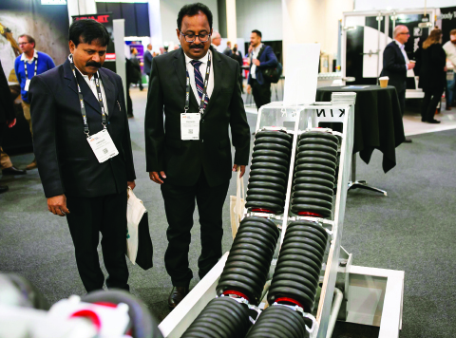
Image courtesy of Austmine
Austmine, the national industry body for the Australian METS sector, launched the Global Mining Challenge – India (GMCI) initiative in July 2022 to foster collaboration between our METS sector and India’s rapidly developing mining industry. Key activities include engaging with Indian mining organisations to scope operational challenges and apply Australian METS solutions; hosting major events such as the Australia-India Mining Innovation Summit, Meet the Miners Speed Networking and collaboration workshops; providing training programs to help Australian METS companies operate in India; and organising inwards and outbound delegations to connect Indian mining customers with the sector in Australia.
More than 200 METS companies have participated in program initiatives and over 60 Australian solutions have been identified for mining challenges. More than 10 METS companies have advanced with Indian market entry.
Action plan
The Austmine Global Mining Challenge – India (GMCI) will continue to facilitate Indian mining companies to benefit from Australian world-class mining services expertise and promote opportunities for Australian mining services companies to access this fast-growing market. The program will increase business relationships and strategic partnerships formed between Australian and Indian organisations and support implementation of innovative solutions across the value chain to drive operational performance of Indian mining projects. GMCI will also provide enhanced education and support for Australian METS companies to enter the Indian market.

Health

Image courtesy of Austrade
India is seeking to become an integral part of global health supply chains through its already strong pharmaceutical exports and its rapidly emerging medical devices and digital health services sectors.
India’s healthcare sector is growing at a phenomenal rate, and is expected to be valued at $917 billion by 2026, up from $556 billion in 2022. This growth will likely continue as Indian consumer spending power increases.
This growth presents significant opportunities for Australian business. Australian health digital service providers are well placed to expand into this market. Indian consumers are also looking for the latest medical technology which Australia can provide – for example, Australian medical device manufacturer Cochlear is already exporting significant quantities of its hearing implants. Importantly, India imports 70 to 80 per cent of its medical devices and demand is rising for high-value medical equipment. The scale of India’s market also provides these Australian firms with the opportunity to expand their operations. Closer to home, Australian consumers are already benefiting from access to India’s well-priced high-quality pharmaceuticals.
Indian and Australian health researchers are exploring opportunities for collaboration. For example, the University of Melbourne is working with the Public Health Foundation of India to address global health challenges. And in 2024, the Australia-India Strategic Research Fund backed projects to support the design of new anti-microbials and develop improved diagnostics to detect bacterial infections.
Case study
Bringing Australian diagnostic tech to India
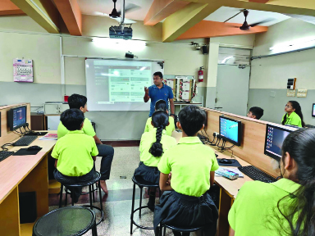
Image courtesy of The George Institute
The George Institute, an independent global medical research institute, has been operating in India since 2002. Its clever SMARThealth platform for disease detection, management and treatment is making a big difference on many fronts. This platform uses a mobile device-based clinical decision support system to help primary healthcare workers improve optimal preventive treatment in primary health care. It is building the capacity of health workers, and improving health outcomes for patients, often with chronic diseases. The George Institute is working with Indian primary health services and not-for-profit community organisations to maximise community health in less affluent communities across India, where health services are limited. Australian technological advances in medicine are making all the difference in India.

Indian-Australian Communities
Australian-Indian communities have immeasurably enriched Australian society. Indian-Australian businesspeople often lead the way in driving our bilateral economic ties with unique insights, expertise and entrepreneurial flair. The cultural contributions of Indian-Australians span everything from film festivals to food festivals. Diverse communities contribute respected leaders like WA Senator Varun Ghosh, NSW Treasurer Daniel Mookhey, NSW Supreme Court judge Hament Dhanji, and Professor Chennupati Jagadish AC, the head of the Australian Academy of Science. If anyone had any doubt about how deeply Indian-Australian communities have become a valued part of Australian society, the top three surnames registered by Cricket Australia are Singh, Smith and Patel (which augurs well for the future of Australian cricket).
There are almost a million people in Australia, or 4 per cent of the population, with Indian heritage. It’s the fastest growing segment of the population – since 2011 the number of Australians with Indian heritage has doubled. And they are diverse communities. They speak many languages, work in many fields, support many political parties and have many different interests. The biggest communities are in Victoria (about 40 per cent of Indian-Australians), followed by NSW (about 30 per cent), then Queensland, Western Australia and South Australia.
- Australia: Indian-heritage population by state
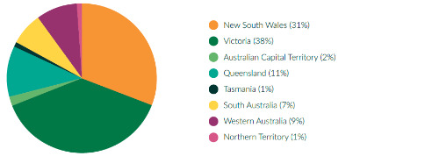
Source: Australian Bureau of Statistics (ABS), Australia’s Population by Country of Birth, June 2023, April 2024.

A key characteristic of Indian-Australian communities is their outsized economic contribution. Indian-Australians are on average younger, more educated, more likely to participate in the workforce, and have a higher income than the general Australian population. Indian-Australians are one of the most entrepreneurial segments of our population. Many have started businesses, which include anything and everything, from local restaurant franchises to high-end technology companies. Their connections into India, their skills – including language skills – and their insights help Australia to seize the opportunities presented by India’s economic rise. This is one reason why, when it comes to engaging India, we are lucky to have Indian-Australian communities.
- Australia: occupation of Indian-Australians
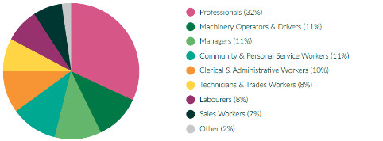
Source: Australian Bureau of Statistics (ABS), People in Australia who were born in India, 2021.


Indian diaspora event at Qudos Bank Arena during Prime Minister Modi’s visit to Australia, May 2023
The Centre for Australia-India Relations
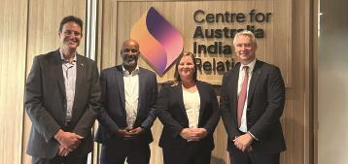
National Foundation for Australia-China Relations CEO Gary Cowan, Centre for Australia-India Relations CEO Tim Thomas, Deputy CEO National Foundation for Australia-China Relations Helen Horsington and DFAT NSW State Office Director Crispin Conroy AM at CAIR’s Parramatta office, July 2024.
To help engage Indian-Australian communities, the Government established the Centre for Australia-India Relations (CAIR) in 2023 with an allocation of $44.9 million over four years. The Centre works across all levels of government, industry, academia and civil society to strengthen engagement between Australia and India.
The Centre’s work is focused on four pillars:
- Building business engagement with India
- Promoting informed public debate
- Engaging Indian-Australian communities to support the bilateral relationship
- Deepening cultural connections and mutual understanding
The Centre is headquartered in Parramatta, Sydney. Its Parramatta office was opened in May 2024 by Senator the Hon Penny Wong, Minister for Foreign Affairs; Senator the Hon Don Farrell, Minister for Trade and Tourism, and leaders from the NSW Government.
The Centre is building India capability and literacy among the business community in Australia, as well as engaging with Indian-heritage communities in Australia. The Centre is especially prominent in supporting academic, business and cultural links with India through its flagship Maitri Grants, and its Scholarships and Fellowships program. Details of these are available on its website. It is also working innovatively with stakeholders to leverage Australia’s deep sporting links with India to drive greater economic opportunities.
The Centre is a resource for businesses and others with an interest in doing more with India, and its role will grow and develop further in future.

The Role of States and Territories

Victoria
Victoria is home to the largest Indian diaspora in Australia. According to the 2021 Census, over 258,000 Victorian residents were born in India and considerably more have Indian heritage. Many people in Victoria’s Indian community live in Dandenong – where the Little India Cultural Precinct has thrived since the 1990s – or suburbs in Melbourne’s inner west, like Werribee and Williamstown, where Indian-Australian communities make a huge economic contribution to the area, or even regional towns like Geelong, Ballarat and Bendigo.
Victoria’s growing Indian community has spearheaded the Indian Film Festival of Melbourne (IFFM), which celebrated its 15th year in 2024. The festival is the largest celebration of Indian cinema outside of India, drawing Indian movie stars and filmmakers to Melbourne and has become a highlight in Melbourne’s social calendar. In 2024, IFFM included the world premiere of ‘My Melbourne’, a feature of four stories made in collaboration between Australian creative filmmakers and acclaimed Indian directors Onir, Imtiaz Ali, Rima Das, and Kabir Khan.
To build on the relationship, in 2024 the Victorian Government launched Victoria’s India Strategy: Our Shared Future 2025–30, an updated five-year outlook to boost Victoria’s cooperation with India. Launched in India by Victorian Premier Hon Jacinta Allan MP in her first official trip as Premier, this strategy aims to do three things to foster a deep and genuine connection across Victoria and India’s economies and societies:
- strengthen connections for a meaningful and inclusive relationship
- enhance strategic economic cooperation for the mutual prosperity of India and Victoria
- deepen bilateral education, innovation and technology ties for a vibrant knowledge economy.
Following the pandemic, Indian tourism has bounced back strongly and while it helps to have the largest Indian-Australian community to draw in tourists from India visiting family and friends, Victoria’s world class sports scene is also a major attraction. As of September 2024, India was Victoria’s second largest source of international visitor expenditure ($590 million) and third largest source of international visitors (203,600).
Merchandise trade is strong – India is Victoria’s 11th largest trading partner with two-way trade valued at $3.67 billion in FY2023-24. Key exports include food and fibre, digital technology and education. India is emerging as an important market for Victoria in creative industries, sport, energy, health and life sciences, beauty, wellness and personal care and manufacturing.
Investment is particularly strong. Foreign direct investment accounted for 74 per cent of all Indian foreign direct investment into Australia in FY2022-23. Big Indian investors are major technology companies like Infosys, Sonata, Wipro, UST, Tata Consultancy Services and Tech Mahindra. Indian startups, like LeadSquared, JarvisAI and Fractal, are attracted by Victoria’s research and development culture and human capital. Beyond the technology sector, other big Indian investors in Victoria include the Firstsource, State Bank of India, Cipla, Lupin, Sun Pharma and Motherson.
More Indian students (over 40 per cent) choose Victoria to study than anywhere else in Australia. In 2023, India was Victoria’s largest source of international student enrolments with over 65,000 enrolments. Victorian universities and tertiary education providers have strong links with India, through transnational education partnerships, research, joint degrees, exchange programs, over 200 academic and research collaborations, two-way mobility and curriculum co-design and development. Further opportunities include increasing two-way student and academic mobility, extending research collaborations and strengthening alumni engagement.
Case study
Kookaburra Sport in India
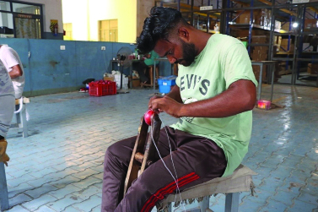
Image courtesy of Kookaburra Sport
Aussie brand growing its cricket ball manufacturing in India: Melbourne-based sports equipment and apparel company, Kookaburra Sport, is creating jobs in India as well as promoting Indian made products across global markets. Kookaburra Sport is an iconic Australian brand and was the first international cricket brand to have forayed into the Indian market, with nearly 300 retailers now selling Kookaburra cricket gear across the country.
The business has grown since it invested and opened a new manufacturing and warehousing facility in Meerut, Uttar Pradesh in 2014. Currently the company employs around 80 people and indirectly many more through sourcing and procuring goods from third party suppliers in India. Kookaburra Sport is a consumer of Indian leather and raw materials for making the balls. The balls are then sold in both domestic and international markets, so also boosting exports from India. The next step is a planned centralised distribution hub in India – so Kookaburra Sport will keep making in India.

New South Wales
Momentum is building in the relationship between New South Wales and India – the two-way trade and investment relationship is at a high point. Two-way NSW-India merchandise trade was $4.5 billion in 2023–24. Minerals and fuels – valued at $1.4 billion – was the most valuable merchandise export, but there were other areas of growth too. Education was NSW’s most valuable service export – in 2023 around 35,000 Indian students studied in NSW, making India its third largest source of international students. Tourism was strong too, and the number of visitors to NSW from India has now rebounded from the pandemic. But while trade is strong, there’s still plenty of room for growth – India is only NSW’s 13th largest trading partner.
NSW, and especially Sydney, has attracted a welcome share of Indian investment. Many big Indian technology companies – TCS, Infosys, Wipro, HCLTech and Tech Mahindra – have established operations in Sydney, working on emerging technologies like AI, machine learning and data science. Many big Indian technology companies are leveraging the high-end research and development happening in NSW universities. Indian-Australian communities in NSW are vibrant and growing fast. At 209,000, the community is second only to Victoria’s in size. The opening of the Centre for Australia-India Relations in Parramatta in May 2024 has been an important step in facilitating greater collaboration and engagement with India. The NSW Government has provided some initial financial support for the Centre.
Looking ahead, key priorities for NSW include attracting more high-quality investment into the state, especially in areas like technology, clean energy and critical minerals. The NSW Government is working to build India literacy amongst the business community and help it to capitalise on the Economic Cooperation and Trade Agreement (ECTA), especially in sectors such as agriculture, fisheries and forestry, mining equipment and tech services. Education and skills are another focus area. The University of Wollongong recently established a campus at India’s GIFT City in Gujarat, while other NSW education institutions are working on partnerships with top-tier Indian tertiary institutions like the prestigious Indian Institutes of Technology and Management.
NSW’s active trade and investment office in India in the financial hub of Mumbai gives assistance to NSW businesses interested in a future with India – and, like the other state trade and investment offices, it works closely with federal government representation throughout India at our High Commission in New Delhi and Consulates-General across the country.

Case study
iCodeNext

Image courtesy of iCodeNext
Helping Indian tech professionals: iCodeNext – a digital technological academy based in Sydney – successfully launched its Australian digital technology program in India in late 2022. Currently serving six states with over 10,000 students, iCodeNext is empowering young minds with cutting-edge skills in coding, robotics and AI. Through its innovative curriculum and hands-on learning approach, iCodeNext is shaping the next generation of tech leaders and innovators across the country.

Queensland
The Queensland Government is targeting India as a key market for trade and investment. India is already Queensland’s fourth largest trading partner and third largest export market. Major exports are coal, iron ore, fertilisers, textiles, and fruit and vegetables.
The goal over the next five to 10 years is to build on existing trade and investment strengths like mining, agribusiness, mining equipment, technology and services (METS), tourism and education, but also to diversify into newer sectors like clean energy, biomedical sciences and health, entertainment and sport. Australia’s engagement with India on sport will certainly grow as Brisbane prepares to host the 2032 Olympics. The introduction of direct flights from India to Brisbane would help to driver closer economic engagement between Queensland and India.
To reach these goals, the Queensland Government’s India Trade and Investment Strategy outlines four key strategic priorities:
- Growing Queensland’s presence and profile in India, including through establishing strong inter-governmental relations and enhanced marketing.
- Fostering relationships and connections, including through better aviation links.
- Developing India business capability, including through establishing a business advisory network.
- Investing for growth, including through the flagship India Growth Program.
The goal of the India Growth Program is to provide multi-year support to Queensland businesses seeking to expand into India by providing co-investment, training to become India-ready and export-ready, market development services and access to a peer support community. A key enabler of the Strategy is Trade and Investment Queensland’s office in Bengaluru and its recent expansion into Mumbai.
At around 72,000, Indian-Australian communities in Queensland comprise the third largest grouping in Australia, but one of the most visible – you’ll see them in full force at the Premier’s Annual Indian Community Reception, Brisbane’s Holi Festival or India Fest in Townsville.
Case study
Frosty Boy scooping up opportunities in India
Frosty Boy Australia, a leading Queensland-based manufacturer and supplier of dessert, beverage, savoury and wellness powder products is strengthening its international market exposure, opening a dedicated India office in 2013.
For Frosty Boy, their deep market research and understanding was their biggest strength. They wanted to make sure that their products and price points would work in India. Their strategy always remained agile and adaptable. The ‘on the ground’ experience and data, continues to be Frosty Boy’s secret ingredient of success.
The frozen dessert maker signed a deal with one of India’s largest coffee chains, to consolidate its presence in the Indian food industry.
The company recorded more than 200 per cent growth over the last two years in India, with an additional 30 per cent growth projected for the 2024–25 financial year.

South Australia
South Australia is prioritising its engagement with India in 2025, with Minister for Trade and Investment, Joe Szakacs, visiting Mumbai and Delhi in January (2025) to connect with key government officials, Indian investors and enterprises.
Last year (2024), the South Australian Government opened two trade and investment offices in Chennai, to cover the booming south, and Mumbai, to cover one of India’s most important business regions.
The offices, co-located with Austrade, facilitate trade and investment for South Australia in key sectors of economic growth, including critical technologies, renewable energy, food, wine, agribusiness, defence, space and education.
The South Australian Government’s in-market Directors supported Minister Szakacs’ first visit to India, which focused on renewable energy, with the Minister hosting key investors and industry members. Food, wine and agribusiness were also a focus, with the Minister visiting leading fresh produce, meat and seafood importers.
India is South Australia’s third largest merchandise export market, valued at almost $1 billion to the year ending December 2024. Food, wine and agribusiness exports hit $320.4 million, and India continues to be one of South Australia’s top market for lentils, valued at $246.9 million. India is South Australia’s fifth largest source of announced foreign direct investment.
India has been South Australia’s largest source market for international student enrolments since 2022, with 15,398 students enrolled with South Australian education providers, up five per cent on the previous year to 30 September 2024.
Students range from school students to PhD candidates and South Australia’s universities have a range of research and development partnerships, some of which are supported through the Australia-India Strategic Research Fund and initiatives such as the Australian Researcher Cooperation Hub India (ARCH-India).
India is also the largest source country for skilled migrants in South Australia, with nearly 45,000 people born in India, living in South Australia. The state’s international airport, Adelaide Airport, has plans to establish direct flights to Indian cities as part of its Network Vision.
The South Australian Government will continue to facilitate trade and investment growth with India, taking advantage of the Australia-India Comprehensive Economic Cooperation and Trade Agreement (AI-ECTA) to deepen economic ties and to provide further opportunities for South Australian and Indian businesses.

Ms Setu Sharma, Mr Sujit Jagirdar, Hon Joe Szakacs MP Minister for Trade and Investment, Mr Tim White, Mr Kamran Khan signed a non-disclosure agreement for a strategic partnership between the South Australian Government and T-Hub in New Delhi, India

Case study
Zoho establishes Australian headquarters in Adelaide
Zoho Corporation, a multinational technology company with deep roots in India, has established its new Australian headquarters in Adelaide, aiming to create 50 positions over the next few years.
Founded in 1996, Zoho employs more than 15,000 people globally and has more than 100 million users across its 55+ business apps, serving more than 700,000 businesses in 150 countries.
The company is working with a range of businesses across South Australia, including wineries, healthcare providers, NDIS providers, sporting clubs and energy companies.
Zoho complements the many and large Indian tech companies like TCS and Infosys which already have a growing place in Australia.
Zoho sees opportunities to establish its headquarters in Adelaide beyond financial growth – there’s positive feedback from a robust business ecosystem, government encouragement for extensive trade and innovation, vastly diverse communities that nurture each other, and a safe, welcoming lifestyle for its employees.
The company has offices across the world, including its development head office in Chennai, India.

Western Australia
The size and tempo of government and business delegations travelling between Western Australia and India underline the dynamism of the relationship. In 2022, then Deputy Premier and Minister of State Development, Jobs and Trade, Roger Cook MLA (now Premier), led an investment and trade mission of over 100 businesspeople across key sectors, including METS, education, energy, innovation, primary industries, tourism and creative industries. The goal was to build networks and leverage opportunities opened by ECTA. That trade and investment mission paved the way for subsequent Western Australian Government missions – in March 2023, June 2023, January 2024 and February 2024 – which have laid the foundation for closer economic engagement. To point to a few examples:
- In March 2023 advanced vanadium developer, Technology Metals Australia Ltd, entered into a Memorandum of Understanding with Indian steelmaker Tata Steel Ltd;
- Western Australian digital space company, Space Angel, has entered an MoU with Skyroot, an Indian aerospace company, focused on space technology collaboration; and
- Helped by ECTA, 1500kg of Western Rock Lobsters have been exported to India in the last year and Western Australian wine brands, including Vasse Felix, MadFish and Fishbone, are now available in select states in India.
Priority sectors for further engagement between Western Australia and India are renewable energy, primary industries, METS, space industries, health and medical life sciences, tourism and events, creative industries, and international education.
These sectors align with Diversify WA, the Western Australian Government’s economic development framework.
To strengthen its presence in India, the Western Australian Government operates investment and trade offices in Mumbai and Chennai. The Mumbai office focuses primarily on investment attraction, including innovation and talent development, with Mumbai the key city for talent attraction with the largest number of startups. The Mumbai office also manages engagement with primary industries and space industries. The Chennai office focuses on international education, energy, METS and health and medical life sciences.
Education is an important sector, with India being Western Australia’s largest source market for international students. All Western Australian universities have agreements with Indian institutions, which cover student mobility and research collaboration. In 2023, there were close to 12,000 Indian students enrolled in Western Australian education institutions.
Indian investment into Western Australia is also significant. Indian tech companies such as HCLTech and TCS have a strong presence and investment in the State as well as strategic partnerships with Western Australian power supply companies Synergy and Western Power. In 2023, Legacy Iron Ore, a Perth-based subsidiary of India’s National Mineral Development Corporation opened the Mount Celia gold mine in Western Australia. Thejo Engineering, an Indian METS company, has expanded with offices in Perth, Kalgoorlie and the Pilbara.

Case study
Hira Steel and GenOffGrid
Remote solar and batteries: Following participation in the India Energy Storage Week in July 2024, Hira Steel, an Indian steel company, and GenOffGrid, a Western Australian solar and battery system designer and installer, signed an MoU to build and operate large-scale remote solar/battery power stations in Northern Australia and the Kimberley. This connection was facilitated by Austrade and Invest and Trade Western Australia during an outbound delegation to India Energy Storage Week.

Tasmania
In 2023–24, Tasmania’s exports to India increased by 30 per cent to around $129 million. India is now a top 10 market for Tasmanian merchandise exports, with processed metals, wood and paper products the main items. Some of the rise is directly attributable to ECTA – for example, Tasmanian salmon exports to India have grown strongly under ECTA’s more favourable terms.
Looking ahead, the Tasmanian Trade Strategy 2019–2025 identifies India as a key market opportunity. The Tasmanian Government is planning a future trade mission to India, with a focus on three sectors: international education, resources and energy, and tourism. The education sector is particularly important – India is Tasmania’s largest source of international students. Critical minerals could be an area for future trade growth – Tasmania has easily accessible rich and high-grade mineral deposits and a Tasmanian Critical Minerals Strategy was released in November 2024. METS is another prospective sector, with several companies looking at selling mining equipment manufactured in Tasmania into Indian markets. Tasmania intends to participate in the next Australia Minerals promotional visit to India in 2025. A Tasmanian company – Muir Engineering – has sold cutting-edge anchoring systems to the Indian Coast Guard which, given India’s maritime ambitions, could lead to future growth.
As one of only five international Antarctic gateways, Tasmania is the home to globally recognised polar expertise which presents opportunities for future collaboration with the expanding Indian Antarctic Programme.
Case study
Tassal reels in success with India
Premium Tasmanian salmon is now available in India after Tassal took advantage of tariff cuts under ECTA to enter the market for the first time. The 30 per cent tariff that used to apply to fresh salmon fell to 26 per cent when ECTA entered into force on 29 December 2022 and will fall progressively until it is eliminated on 1 January 2028. So far, Tassal has exported around 30 tonnes of salmon to India. It wants to increase that amount to 100 tonnes by 2026.
India was the top Tassal aim in diversifying its markets, owing to India’s large population and growing middle class. When Tassal became aware that Australia and India were negotiating a trade agreement, it worked with Austrade to prepare for market entry. This led to an agreement with India’s leading importer of fresh salmon, ensuring that Tassal was ready to export when the trade agreement came into effect. The company flew its first shipment of salmon to India in April 2023 and has continued to export successfully to India ever since.

Northern Territory
Trade between India and the Northern Territory is modest but there is certainly potential for growth – the Northern Territory Government’s International Engagement Strategy identifies India as a priority country.
Current NT exports to India are focused on liquefied natural gas (LNG), resources, education and training, defence and maritime services. But the greatest medium-term opportunities lie in the energy and resources sectors, hydrogen production, and renewable energy. For example, the Northern Territory is rich in critical minerals such as lithium, manganese and nickel which could support India’s burgeoning electric vehicle market and ambitions to become an advanced manufacturing hub. This was a focus of the India visit in October 2023 of former Deputy Chief Minister Nicole Manison, which led to an MoU with the Kerala State Government.
The Northern Territory Government will look to facilitate travel to India for other delegations to build networks, find opportunities for further collaboration and identify potential investors in key areas like renewable energy and critical minerals. Indian investors have, for example, already invested in the Middle Arm Sustainable Development Precinct, a hub for low-emission energy and minerals processing. There is also scope to collaborate on hydrogen projects leveraging the Northern Territory’s massive solar resources. Developing downstream mineral processing facilities and promoting exploration applications could be mutually beneficial.
Case study
First Nations artists making an impact in India
In 2022 and 2023, the Centre for Australia-India Relations funded the Bábbarra Women’s Centre in Maningrida in the Northern Territory to collaborate with the Tharangini Studio in Bengaluru, working with emerging women artists specialising in textiles.
Artists from the Bábbarra Women’s Centre in the Northern Territory travelled to India, sharing traditional techniques and co-creating unique textiles after translating Bábbarra’s lino designs onto traditional Indian woodblocks and printing them on silks and cottons – a unique intercultural partnership between the Northern Territory’s West Arnhem Land and India’s Bengaluru, supported by the Centre for Australia-India Relations’ Maitri Grants.

Australian Capital Territory
Canberra’s International Engagement Strategy nominates India as a top target. The ACT’s focus is on attracting more tourism and international education activity from India, as well as supporting climate and sustainability and renewable energy activities. These priorities were high on the agenda of the ACT’s most recent trade mission to Mumbai and New Delhi in February 2024. The ACT Government also provides export support programs to businesses in key sectors such as education and research and renewable energy. Trade missions for economic relationship building have focused on Delhi, Mumbai and Bengaluru.
Recent successes include a February 2024 agreement between the University of Canberra and Cricket ACT To provide tailored, in-school programs to build skills of young cricketers throughout India. In July 2023, a new collaboration agreement was signed by the University of Canberra and Wipro to fund select PhD programs and boost employment opportunities for UC students. Skykraft, a Canberra-based company specialising in air traffic services delivered from space, is designing a launch adaptor system that deploys constellations of up to 30 satellites into low Earth orbit from low-cost rockets in conjunction with NewSpace India Limited. Through the Tidbinbilla–Canberra Deep Space Communication Complex, CSIRO is supporting Indian (ISRO) Missions (the tracking task is a collaboration between NASA and ISRO, with CSIRO as the delivery agent).
Case study
Sunrise CSP – new technology for Gujarat and beyond
Sunrise CSP, a Canberra-based solar thermal power company has commercialised its cutting-edge technology – the Big Dish – to provide sustainable energy solutions for the state of Gujarat’s Kailash Cancer Hospital and Research Centre. This technology can be used for large-scale heating and cooling for factories, commercial buildings and hospitals. It could even be an option to cool an entire city centre in one of India’s new Smart City developments from a single solar thermal Big Dish plant.
A deal signed in August 2023 (following an Austrade-led Australia-India Business Exchange trade mission to India) will make Sunrise CSP a partner of choice for Engineers India Ltd and central to its plans to scale up solar thermal power used in energy projects across the region.

Collaboration with states and territories
Maximising opportunities between Australia and India will rely on our states and territories working seamlessly with the Commonwealth in a whole-of-nation effort to promote Australia’s unique offerings. But there is still more we can do, as these summaries of the big role of the states and territories show well.
Austrade, DFAT, and the NSW and WA State Governments worked closely to bring Australia’s largest clean energy delegation to India Energy Storage Week (IESW) in New Delhi and Mumbai. The 60-member delegation from 41 Australian companies met with more than 200 Indian companies from 1–5 July 2024. The Australian Pavilion was the largest at IESW. The Pavilion showcased innovative Australian solutions across solar, energy storage, renewable hydrogen, circular economy, electric vehicles, energy manufacturing, critical minerals and smart grids.
The 2024 International Mining and Machinery Exhibition (IMME) highlighted the Commonwealth’s collaboration with New South Wales, Queensland, Western Australia, South Australia and Victoria, showcasing an impactful Australian Government and corporate presence. ‘Team Australia’ worked together to support 67 delegates from 46 companies to showcase METS solutions which can underwrite India’s aspirations to achieve greater productivity, enhanced safety and heightened environmental sustainability in its mining sector.
Action plan
Prioritise trade and economic cooperation with Australian states and territories to promote Australian goods and services in India, through ministerial coordination (Ministerial Council on Trade and Investment) and through close collaboration between state and territory representatives – especially trade and economic representatives on the ground in India, working with the Australian High Commission and Consulates-General.

Annexes

List of submissions
- AFTINET
- Alluvium
- Arrow Digital
- Asialink
- ATN Universities
- Australian Council of Trade Unions
- Australian Dairy Council & Dairy Australia
- Australian Academy of Technological Sciences and Engineering
- Australian Walnut Industry Association Inc.
- Australia India Institute
- Australian Nut Industry Council (ANIC)
- Australia India Youth Dialogue
- Australian Council of Trade Unions
- Baxter IP
- Business Council of Australia (BCA)
- Business Council for Sustainable Development Australia (BCSDA)
- Canegrowers
- Commonwealth Bank
- Cotton Australia
- CPC Analytics
- Cricket Australia
- CUTS International
- Deakin University
- Department of Industry, Tourism and Trade NT
- Endangered Heritage
- Entura
- Export Council Australia
- Faculty of Education, University of Melbourne
- Global Machinery Consultants
- GLO Sports
- Group of Eight
- H2Orizons
- HanRoy Iron Ore Projects Pty Ltd (HanRoy)
- HCL Tech
- Hort Innovation
- India Australia Business & Community Alliance
- Indian Crisis & Support Agency
- Independent Higher Education Australia (IHEA)
- Infosys
- Institute of Innovation, Science and Sustainability at Federation University
- Monash University Performing Arts Centre
- Monitoring and Evaluating Climate Change and Education (MECCE) Project
- Pistachio Growers Association Inc.
- Ramena
- School of Policy and Governance
- Smart Energy Council
- South Asian Research and Advocacy Hub at ANU
- Space Industry Association of Australia (SIAA)
- Stahmann Webster
- STIMULAI
- Summerfruit Australia
- Sustainative (First Nations business)
- The Academy of Indian Music, Ausfilm & University of Melbourne
- The Placing Company and VYTLS
- Thomas Cook
- Trade & Investment Queensland
- Tradewinds Consulting
- Universities Australia
- University of Melbourne
- UNSW
- University of Wollongong
- Vet Assess
- Wipro
- Young Sikh Professionals Network
[Note: 72 submissions were received; some asked not to be publicly mentioned.]

Roadmap Taskforce
Department of Foreign Affairs and Trade: Peter Truswell, Nigel Stanier, Shuchita Pota, Sarah Cheng, Jackson Barton, Yvette Crouch, Cindy Mititelu, Ashley Brosnan, Renita Arumugam, Jonathan Muir, Daniel Buckley, David Gottlieb, Medha Majumdar, James Yeomans, Brent Martin
CSIRO: May Liak
Australian Trade and Investment Commission: Nathan Webb

All dollar figures are in AUD, unless otherwise specified
Primary energy consumption measures a country’s total energy demand including the consumption of the energy sector itself, distribution of energy, and the final consumption by end users.
International Monetary Fund, Real GDP growth, annual per cent change, India, World Economic Outlook, April 2024.
Economist Intelligence Unit, 2024, Nominal GDP (US$), 2024. India is the world’s fifth-largest economy by nominal GDP but the third-largest by purchasing power parity (PPP).
International Labour Organization, India employment report 2024: Youth employment, education and skills, Institute for Human Development, 2024.
McKinsey & Company, How agtech is poised to transform India into a farming powerhouse, May 2023.
Tourism Australia, Tourism statistics: Aviation, 2024.
International Monetary Fund, Real GDP growth, annual per cent change, India, World Economic Outlook, April 2024.
People Research on India’s Consumer Economy (PRICE), The rise of India’s middle class: A force to reckon with, January 2023.
Krishan, S, Understanding India’s evolving middle classes, East Asia Forum, 21 May 2024.
Viksit Bharat@2047, https://iipe.ac.in/iipeviksitbharat@2047/.
Silver, L, Huang, C, Clancy, L, Key facts as India surpasses China as the world’s most populous country, Pew Research Centre, 9 February 2023.
International Labour Organization, India employment report 2024: Youth employment, education and skills, Institute for Human Development, 2024.
Trade time series data, DFAT https://www.dfat.gov.au/trade/trade-and-investment-data-information-and-publications/trade-statistics/trade-time-series-data
Australian Bureau of Statistics (ABS), International trade in goods, July 2024, 5 September 2024.
Australian Bureau of Statistics (ABS), International trade in goods, July 2024, 5 September 2024.
Australian Bureau of Statistics (ABS), International trade in goods, July 2024, 5 September 2024.
Trade Data Monitor, September 2024 https://tradedatamonitor.com/
DFAT analysis on Australian Bureau of Statistics trade in goods data.
Economist Intelligence Unit, Total gross domestic energy consumption (% of world), 2024. EIU, Solar/wind/other: Gross domestic energy consumption (% of world), 2024.
US Energy Information Administration, International Energy Outlook 2023, 11 October 2023.
Finighan, R, The New Energy Trade: Harnessing Australian renewables for global development, The Superpower Institute, 2024.
Government of India Ministry of Power, 500GW non fossil fuel target, 2024.
Department of Climate Change, Energy, the Environment and Water, National Hydrogen Strategy 2024.
Department of Education, A Partnership for the Future: Australia’s Education Strategy for India, 2023.
Mukherjee, A, Prakash Rao, A, Parashar Sarma, A, Bharti, N, Dugar, P. Developing principles for regulation of alcoholic beverages sector in India, Indian Council of Research on International Economic Relations, 2021.
Ministry of Agriculture & Farmers Welfare, Increase in income of farmers, 9 February 2024.
Tourism arrivals (i.e. leisure category, which includes holiday and visiting friends and relatives as purposes for travel) based on ABS arrivals from India (VFR and holiday only).
Tourism Research Australia, https://www.tra.gov.au/en/international/international-tourism-results, September 2024.
Tourism Australia, Tourism statistics: Aviation, 2024.
Trade and Investment Queensland Submission to A New Roadmap for Australia’s Economic Engagement with India, August 2024.
Australian Bureau of Statistics (ABS), International investment position, Australia, supplementary statistics, 2023, 1 May 2024.
Invest India, India’s EV Economy: The Future of Automotive Transportation, February 2023.
World Intellectual Property Organisation, World Intellectual Property Indicators 2024.
Organisation for Economic Co-operation and Development, Education at a glance 2015 – OECD indicators, 2015.
Startup Genome, Global startup ecosystem ranking 2023 (Top 30 + runners up), 2024.
Wong Leung, J, Robin, S, Cave, D, ASPI’s two-decade Critical Technology Tracker: The rewards of long-term research investment, Australian Strategic Policy Institute, August 2024.
Indian Space Research Organisation, Department of Space, 2023.
Australian Space Agency, Historic signing to see India launch largest Australian-made spacecraft, 27 June 2023.
Statista, Number of new film releases in India from 2017 to 2023, March 2024.
Trade and Statistical Pivot Tables, DFAT, Country and commodity pivot table 2006 to 2023.
India Brand Equity Foundation, Medical Devices Industry in India, August 2024.
Australian Bureau of Statistics (ABS), 2021 People in Victoria who were born in India, Census country of birth, QuickStats, Australian Bureau of Statistics (abs.gov.au), 2021 Census – Country of birth, accessed August 2024.
Australian Bureau of Statistics (ABS), 2021 Victoria, Census all persons, QuickStats, Australian Bureau of Statistics (abs.gov.au), 2021 Census – Victoria – Country of birth of parents, Country of birth of father, Country of birth of mother, accessed August 2024.
Australian Bureau of Statistics (ABS), 2021 Dandenong, Census all persons, QuickStats, Australian Bureau of Statistics (abs.gov.au), 2021 Census – Victoria – Dandenong – Ancestry, Country of birth of parents, Country of birth of father, Country of birth of mother, accessed August 2024.
Department of Foreign Affairs and Trade, DFAT state & territory pivot table, 2014–15 to 2023–24, August 2024.
Australian Trade and Investment Commission (Austrade), Education and data insights, 2024.
Department of Foreign Affairs and Trade, DFAT state & territory pivot table, 2014–15 to 2023–24, August 2024.
Australian Bureau of Statistics (ABS), Australia’s population by country of birth, June 2023.
Australian Trade and Investment Commission (Austrade), Education and Data Insights, 2024.
Department of Foreign Affairs and Trade, DFAT state & territory pivot table, 2014–15 to 2023–24, August 2024.

