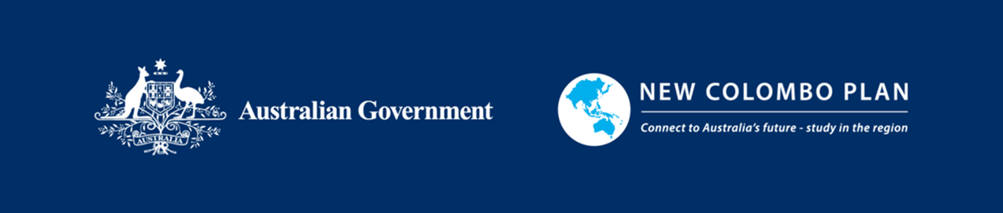
New Colombo Plan Semester and Mobility Programs
Media and Publication Guidelines

Sharing your experience of learning and engaging with your host location is an important part of your New Colombo Plan (NCP) Program. It can help increase awareness and understanding of the NCP in Australia and the Indo-Pacific. When publishing, speaking publicly or engaging with media – including local media in your host location, your own social media or Australian media – it is important that you abide by the following guidelines:

- Do not represent yourself as an employee of the Australian Government or the New Colombo Plan.
- When talking about your participation in the program, refer to yourself as a ‘New Colombo Plan Semester/Mobility Program or Project participant’ or ‘New Colombo Plan Semester/Mobility Grant recipient’, and after completion, as a ‘New Colombo Plan Alum.’
- Always acknowledge that the New Colombo Plan is an Australian Government initiative.
- While on program, do not comment on sensitive political, economic or social issues related to your host location or Australia, even if asked.
- Where possible, participate in promotional activities organised by DFAT or its approved contractors during and after your NCP program.
- Exercise sound judgement when invited to engage in media activities in your host location. If in any doubt, ask your university NCP Program Coordinator.
- While on program, inform your university NCP Program Coordinator before engaging in media activities or participating in interviews for Australian media outlets in Australia or overseas so the necessary approvals can be obtained.
- While on program, inform your university NCP Program Coordinator before authoring articles for third-party publication (e.g. in journals including online journals, your university newspaper or website) so the necessary approvals can be obtained.
- Ensure that photography and videography related to your NCP program for use in publications, online and provided to DFAT adheres to standards set out in DFAT’s Child Protection Policy, Child Protection Guidance Note on the Use of Images and Social Media and Protection from Sexual Exploitation, Abuse and Harassment Policy.
- You may maintain personal websites, blogs, vlogs and social media to share your experiences while participating in an NCP Program; however, the content you publish on these sites should in no way bring Australia, the Australian Government, the NCP, your institution, host location, host institution or host organisation into disrepute.
- On social media post stories that highlight your engagement with your Indo-Pacific host location; your personal, institutional and professional connections; and your study, work-based learning, internship, mentorship and leadership journey as an NCP Semester/Mobility Program participant. Tag these posts with the NCP handle on Instagram, Facebook and LinkedIn - @NewColomboPlan
- Always be mindful of the NCP Participant Code of Conduct and the expectations of your behaviour.
Tips for engaging on digital and social media
Before you engage on digital and social media, ask yourself:
- Could my comments or posted images cause anyone to lose confidence in my selection as an NCP Program participant?
- Are my comments or posted images consistent with how Australian and international communities expect NCP participants to operate and behave?
- Could my comments or posted images lower or undermine the reputation of the Australian Government, DFAT, the NCP, my institution, host location, host institution, host organisation or my own reputation? Could they damage bilateral or regional relationships?
- Are my comments lawful in Australia and overseas? For example, do they comply with anti-discrimination legislation, the Crimes Act, the Criminal Code and laws relating to defamation?
- Could my comments or posted images jeopardise my future employment?
- How appropriate are my comments or posted images in the social and political environment in which they will be made.

