New Colombo Plan Scholarship Program

Guide to Referee Reports in New Colombo Plan Online

(for Applicants and referees)

This guide aims to provide further information for Applicants, referees and Australian Universities regarding the referee report process for the New Colombo Plan (NCP) Scholarship Program using the online application system ‘New Colombo Plan Online’.

This guide should be read in conjunction with the NCP Scholarship Program Guidelines and Advice for Applicants available on [GrantConnect](https://www.grants.gov.au/Go/Show?GoUuid=df1447e3-783d-4307-bad5-89f7ecc6d593). It should also be read in conjunction with the Scholarship Application Guide, provided to all applicants and Australian Universities to provide guidance on using the NCP Online system to prepare and submit an application form, including referee reports (section 11 of the application form).

All capitalised terms used in this document have the meaning provided in the NCP Scholarship Program Guidelines. The NCP Scholarship Program Guidelines take priority to the extent of any inconsistency with this guide.

As part of an Application, **each Applicant is required to obtain two referee reports**, to be supplied as part of their application before the application closing date: **11.30pm Australian Eastern Standard Time (AEST) on 23 September 2025.** An application cannot be submitted without the referee reports.

Referee reports must be uploaded directly to NCP Online by referees, following the steps described in this document. Referee reports cannot be submitted by email or any other alternative method to that set out in this document.

When choosing a suitable referee, or before agreeing to be a referee, please note that a referee must be able to comment substantially on the applicant’s abilities and experience with respect to the Assessment Criteria as set out in the 2026 Scholarship Program Guidelines, and must hold a position that gives their comments credibility (e.g. a position in the Applicant’s university, workplace or community). At least **one** report must be prepared by an academic referee.

Screenshots of relevant sections of the NCP Online system contained in this guide may refer to information and dates from previous rounds. These are included as examples only and do not indicate dates for the NCP 2026 Scholarship Round.

If you experience any technical issues using the referee report functionality or have any questions, please contact the NCP Secretariat at [ncp.secretariat@dfat.gov.au.](mailto:ncp.secretariat@dfat.gov.au)

Application Form Functionality

The referee report process begins as each Applicant is completing their Application Form. Under *Section 11: Referee Details* of the Application Form, Applicants have the ability to add referees, which will automatically send, using the supplied email address, a link to the referee to complete the report.

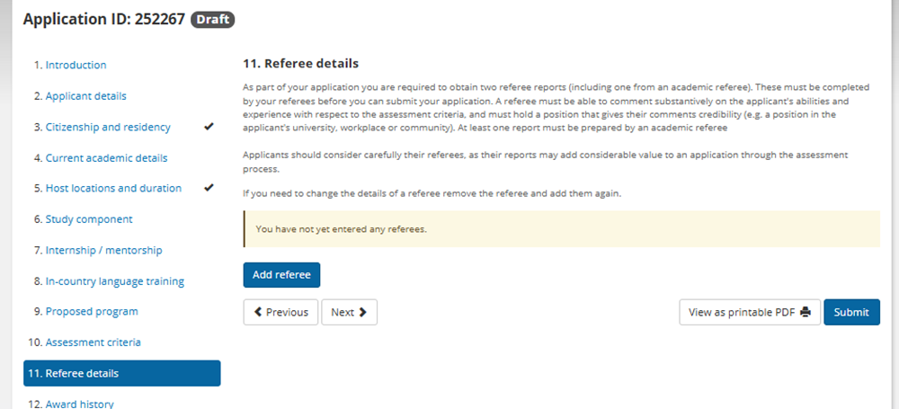

To begin the process, Applicants should select the blue ‘Add referee’ button under Section 11.



Applicants can then enter the details of their referees and designate each referee as either an academic or non-academic referee. Each Applicant must have at least **one** academic referee in order to submit their Application.

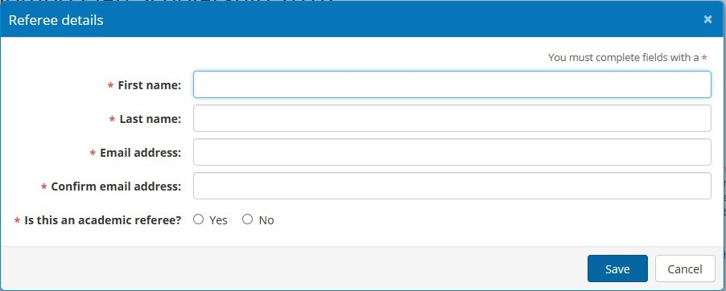

Once the Applicant has entered the referee details and selected the ‘Save’ button, they will receive the notification below advising that the referee will receive an email inviting them to complete a referee report and asking the Applicant to confirm they want to do this.

Selecting ‘OK’ will send the referee report to the referee. The status of the referee will appear as

‘Request sent’.

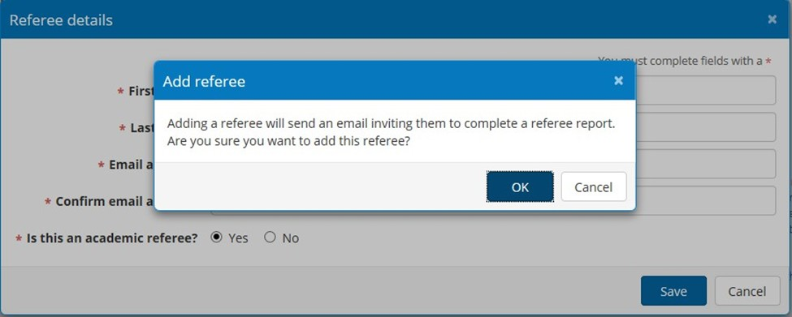

If the Applicant needs to change one of their referees, a referee request can be cancelled using the

‘Remove’ button.

If a referee has not received the referee request email, the Applicant can resend it using the

‘Resend’ button.

If the Applicant has mistakenly designated the referee as the wrong type (i.e. academic or non- academic), this can be changed using the ‘Edit’ button functionality.

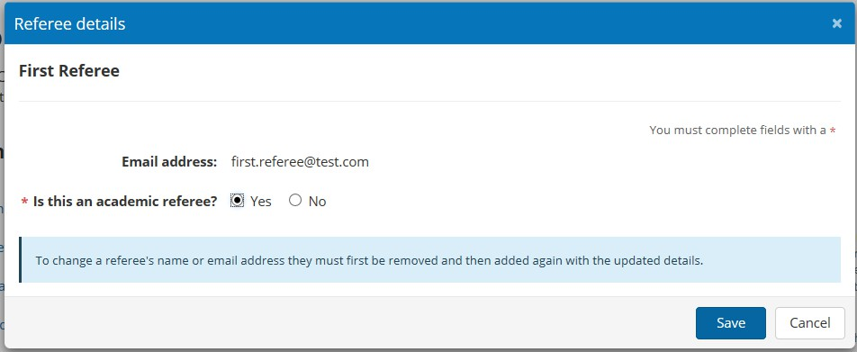

However, if an incorrect email address or name has been entered, the Applicant must create a new referee by removing and re-adding them using their correct details.

Please note that a referee may also edit their name through the referee report. If this occurs, the

Applicant will be notified via email to ensure the report is completed by the intended referee.

*Dear Applicant*

*Your referee for your 2036 New Colombo Plan Scholarship application updated their name details from First Referee to Initial*

*Referee.*

*Kind regards*

*New Colombo Plan Scholarships Team*

Once the referee has completed their report, the Applicant will be advised via email and the status of the report in the Application will change to ‘Complete’.

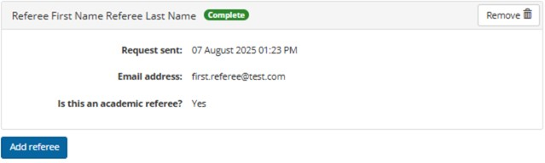

Referee Report Functionality

The referee will receive an email notifying them that the applicant has requested they provide a referee report for their NCP scholarship application. This will contain instructions on how to access NCP Online, including log-in details and a pass key. Once the referee has entered the pass key contained in their referee email, they will be logged in to their report. **The Applicant will not be able to view the referee report.** The report will be returned directly to the Department once it has been completed.

It is not necessary to complete the entire referee report in one session. The report will be saved each time the referee saves a completed section, allowing the referee to continue later.

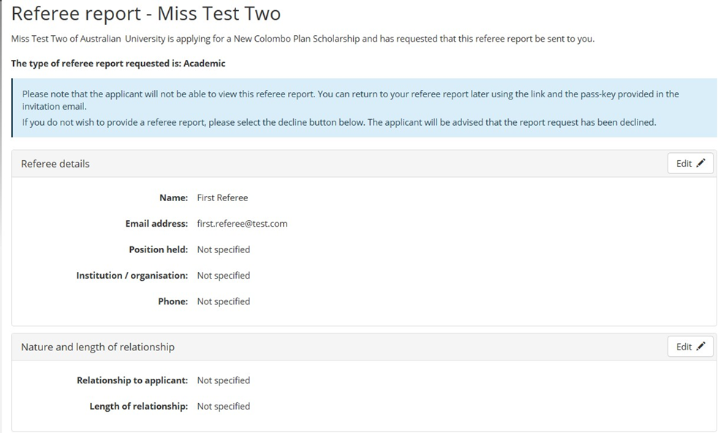

If the referee does not wish to provide a referee report, the request can be declined using the red

‘Decline to offer referee report’ button at the bottom of the report. If declining a request to be a referee, please do so as soon as practicable. The Applicant will be advised via email that the request has been declined and can add a new referee in their Application after removing the old referee.

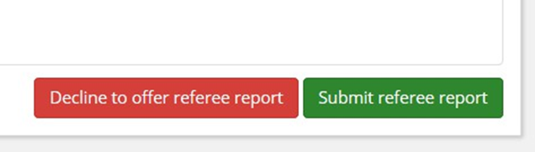

The referee is first requested to provide their personal information and the contact details in case further information is required during the Application assessment process. NOTE: If a referee is not willing to provide this information, they cannot be a referee.

The referee may also edit their name. If this occurs the Applicant will be notified via email to ensure the report is completed by the intended referee.

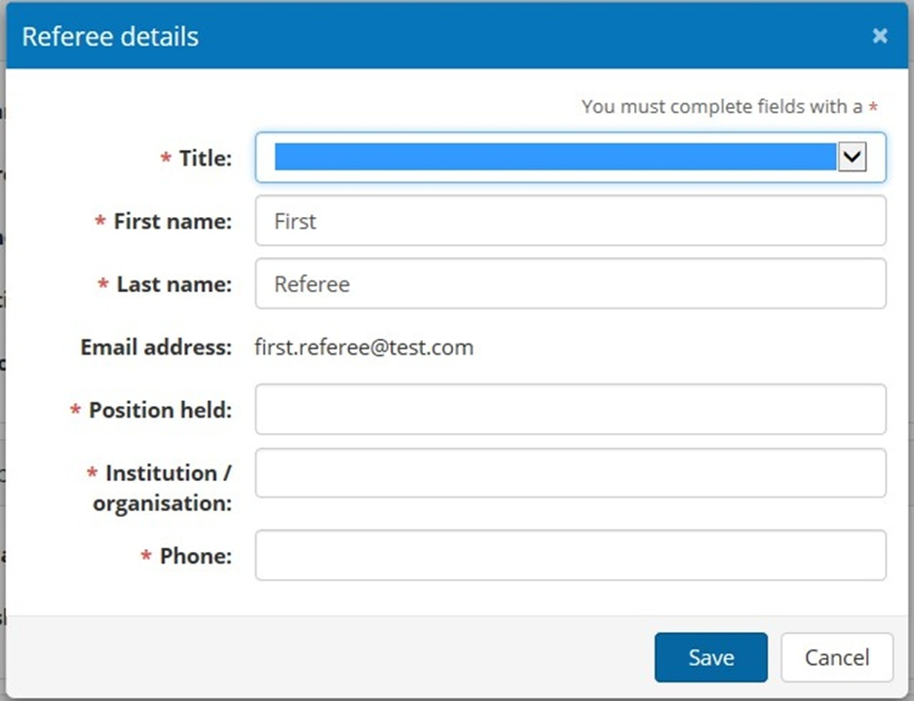

The referee must also provide details of the nature and length of their relationship to the Applicant.

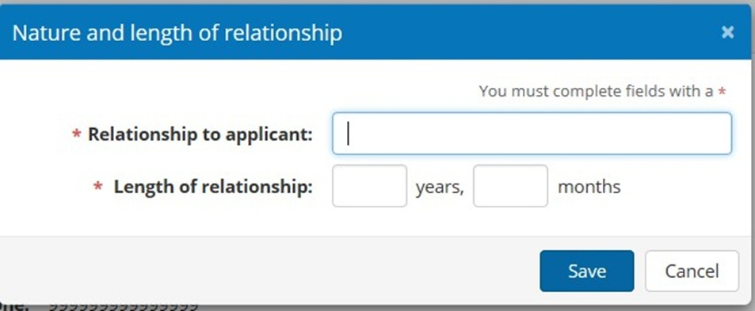

The referee is then asked to assess the Applicant against the same Selection Criteria specified in the NCP Scholarship Program Guidelines.

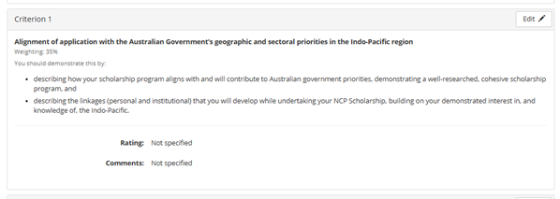

Referees may enter their rating and comments by selecting the ‘Edit’ button for each Selection Criterion. Comments are limited to 300 words.

Referees should give the Applicant a rating between A-E for each Section Criterion. However, if a referee feels they are unable to assess the Applicant in relation to a particular Selection Criterion, they have the option of selecting ‘NA’, as Not Assessed. Referees should still leave a comment as to why they have selected NA, rather than leaving the comment box empty.

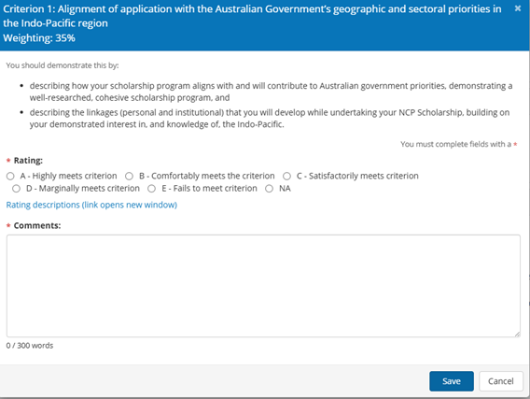

Once the referee has entered the ratings and comments for all four Section Criteria, the referee is to submit the report by selecting the green ‘Submit referee report’ button at the bottom of the referee report form.



Referees will then be presented with the Referee privacy notice, which outlines the New Colombo Plan Scholarship Program’s privacy policy regarding referees’ personal information. Once the referee indicates they have read and understood the privacy notice by ticking the box, they can submit the referee report using the blue ‘Submit’ button. A completion notice will be sent to the Applicant to advise that the referee report has been completed.

