

**New Colombo Plan Scholarship Program - 2018 Round**

**Guide to nominating students in New Colombo Plan Online**

The following guide aims to assist universities in submitting nominations for the 2018 round of the New Colombo Plan Scholarship Program using New Colombo Plan Online (NCP Online).

The scholarship nomination form will allow you to nominate up to 10 students from your university.

It is not necessary to complete the entire nomination form in one session. The form will be saved each time you add a nominee or manually save a completed section, allowing you to continue later.

You may withdraw your previous submission, edit and re-submit the form multiple times up until the end of the nomination period (11.59 pm AEST on 31 July 2017). The form as submitted at the end of the nomination period will be regarded as final.

If you experience any technical issues using the nomination form or have any questions, please contact the NCP Scholarships team at [ncp.scholarships@education.gov.au](mailto:ncp.scholarships@education.gov.au).

# Information required prior to completing the nomination form:

The following details about each student will be requested in the scholarship nomination form:

* Title
* Name
* Gender
* Date of birth
* Email
* Mobile phone
* Degree in which the nominee is enrolled
* Official Academic transcript
* Intended Host Location (where known)
* GPA Score

# Nomination Form – Home Page

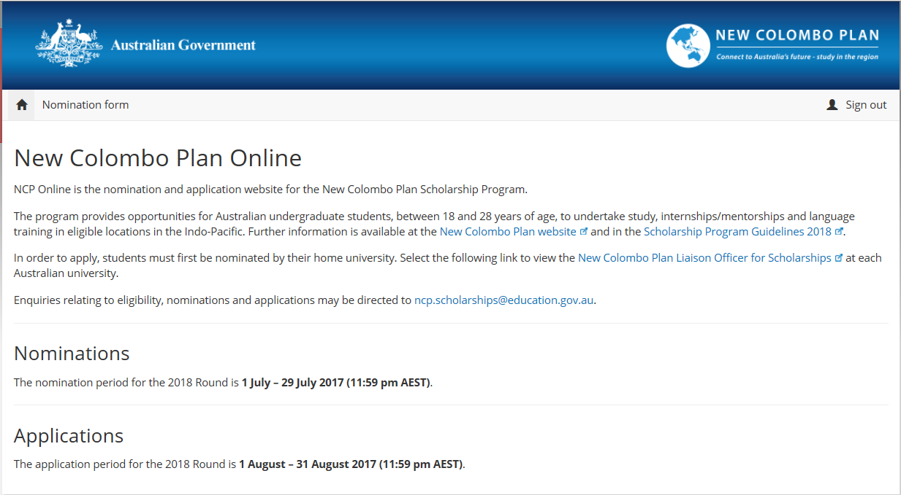

# Introduction Tab

You will be sent an email granting you access to NCP Online. Once you click on the link, you will be taken to New Colombo Plan Online. Enter the pass key contained in your email to access your university’s nomination form. The ‘Introduction’ tab contains a number of issues for universities to consider when making nominations, as well as the dates of the nomination period for reference.

You can print the nomination form at any stage during the nomination process.

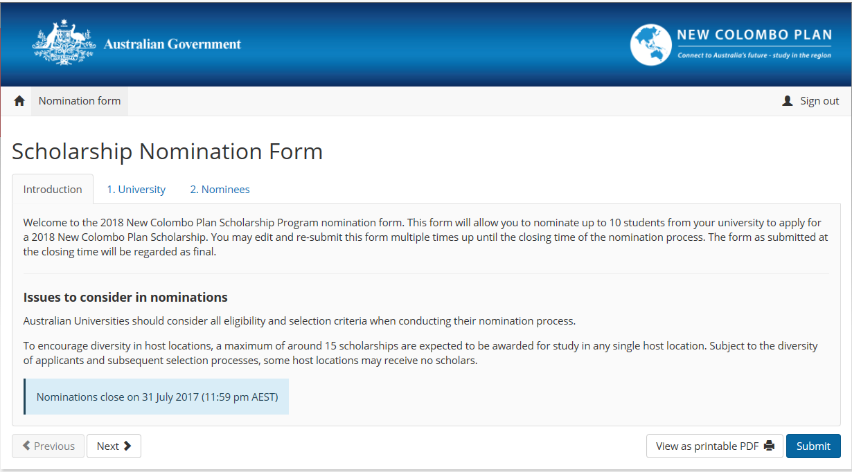

# University Tab

The ‘University’ tab lists the current New Colombo Plan Liaison Officers for Scholarships for your university and their contact details. If any of the information is out of date or incorrect please email the New Colombo Plan Scholarships team at [ncp.scholarships@education.gov.au](mailto:ncp.scholarships@education.gov.au) to have it amended.

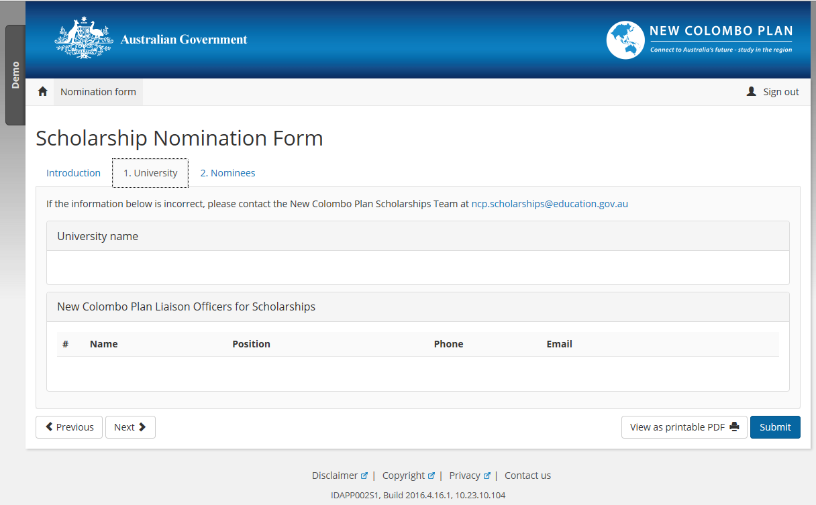

# Nominees Tab

The ‘Nominees’ tab allows you to enter nominee details. Clicking the blue ‘Add nominee’ button from the ‘Nominees’ tab will open up a dialogue box in which you can enter the student’s details. All mandatory fields are required in order to save the nominee details.

As it is an eligibility criterion of the New Colombo Plan Scholarship Program that all nominees must be between 18 and 28 (inclusive) years of age on 1 January 2018, the ‘add nominee’ dialogue box will not allow a student’s details to be saved if their birthdate falls outside this range.

If the nominee’s intended host location is known please select it from the list, otherwise leave the response as ‘Unknown’. The intended host location is indicative only. Each applicant is required to make a final determination of their host location as part of their application.

A new field has been added ‘Average Percentage Score for Completed Units’. This is the grading percentage average calculated from the nominee’s transcript. A minimum score of 70% is required. The ‘add nominee’ dialogue box will not allow a student’s details to be saved if the GPA is less than 70%.

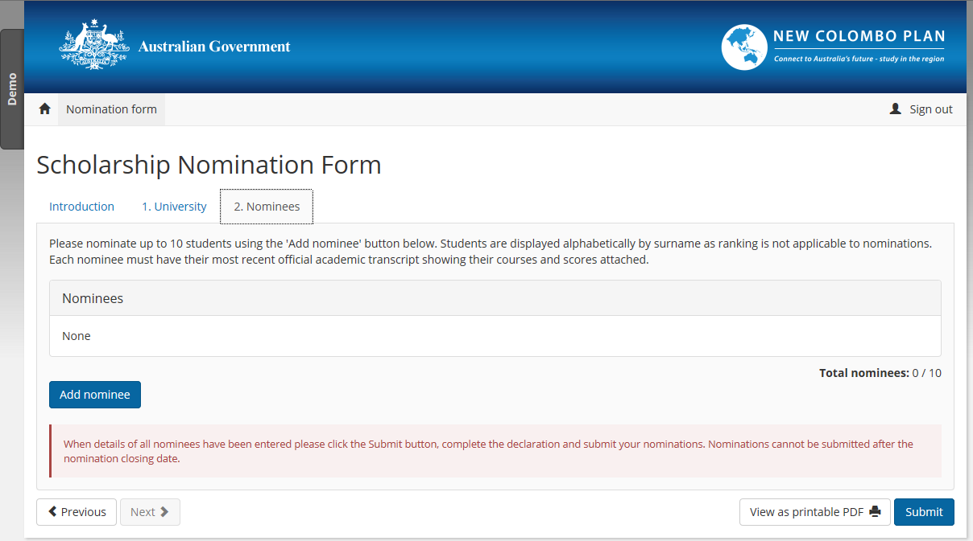

Nominee Window – Mandatory Fields

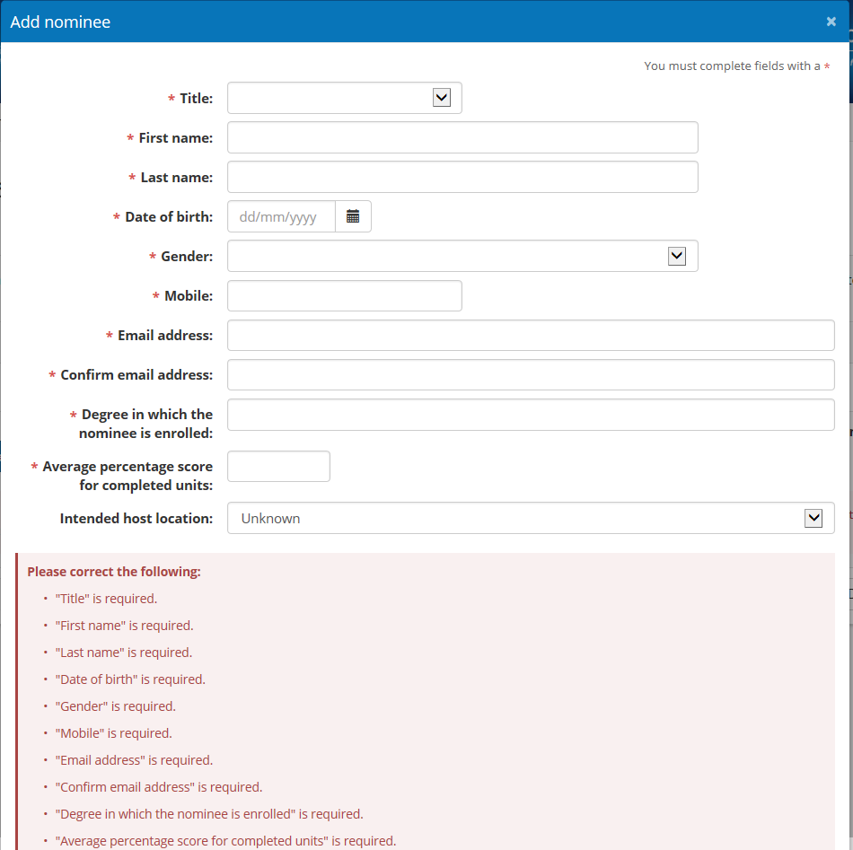

Nominees Tab- With a Nominee

The ‘Nominees’ tab will display all of the students, nominated by your university in alphabetical order. At least one nominee must be listed before the nomination form can be submitted. Official academic transcripts must also be attached for each nominee using the ‘Upload transcript’ button. You may attach multiple files to each nominee record, as appropriate.

Please note each nominee’s age will be displayed as at 1 January 2018, not the current date.

You may also edit nominee information or remove nominees.

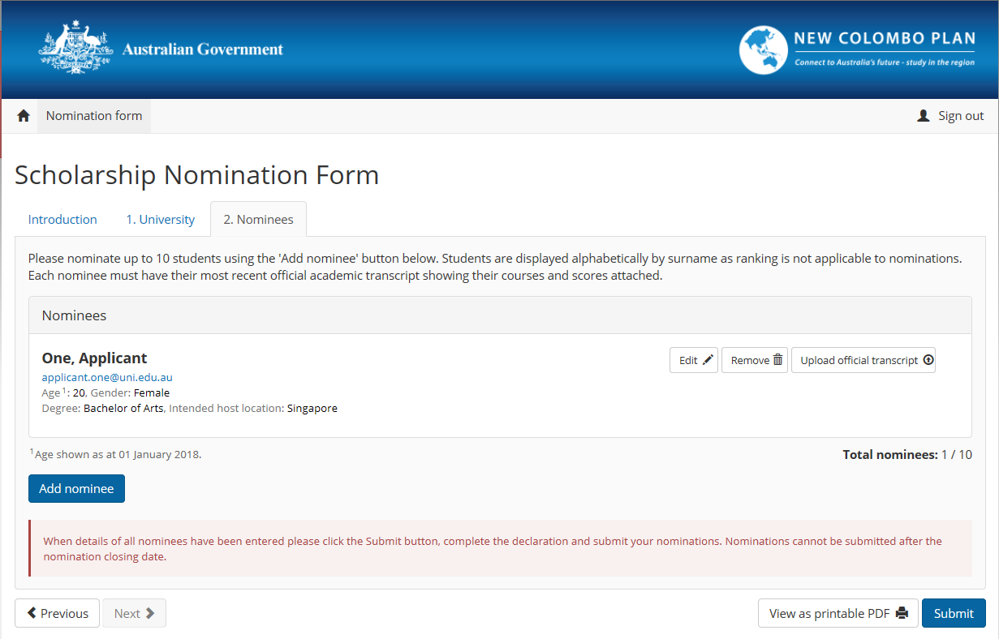

Nominees Tab- Upload Official Transcript Window

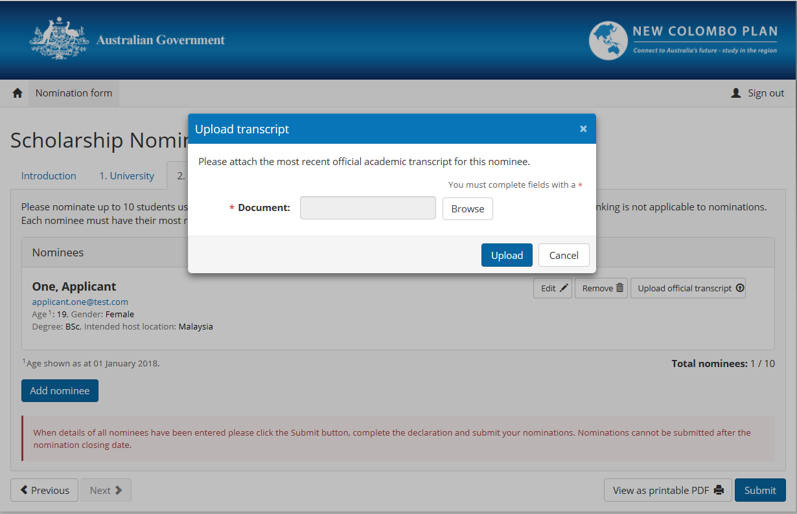

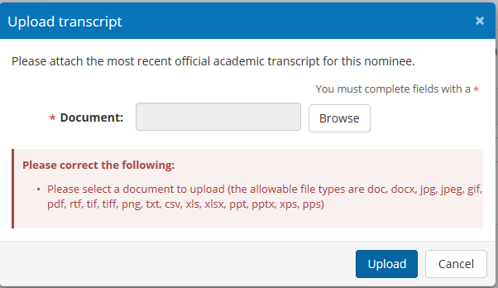

Nominee Tab – Official Transcript Required for Submission

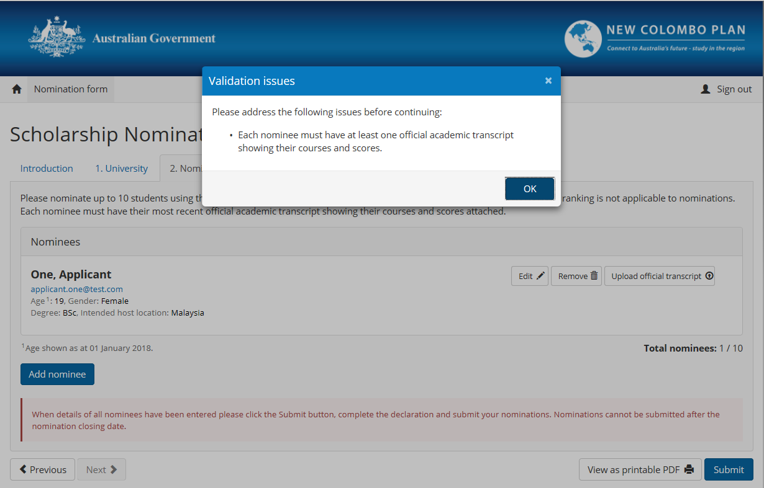

# Declaration

A ‘Declaration’ tab will appear once all information has been completed in the preceding tabs. Please read the declaration and linked privacy notice before proceeding. To submit the nomination form, the New Colombo Plan Liaison Officer for Scholarships must complete the declaration to confirm that: the students have been nominated by the university; certain eligibility criteria have been met; all nominees have undergone a police check within the last 12 months and nominees consent to their personal information being disclosed and; the privacy notice has been read and understood.

Once all the declaration boxes have been ticked, type your name and position and submit the nomination form. The person who submits the nomination form must be one of the New Colombo Plan Liaison Officers for Scholarships listed on the ‘University’ tab.

Once you submit the form an automated email will be sent to the New Colombo Plan Liaison Officer(s) for Scholarships at your university. This email acts as verification of your submission and will contain a PDF version of the submitted nomination form for your records.

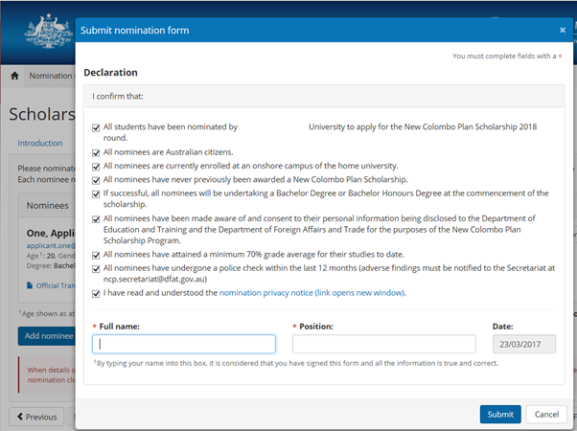

Declaration (not all declarations completed)

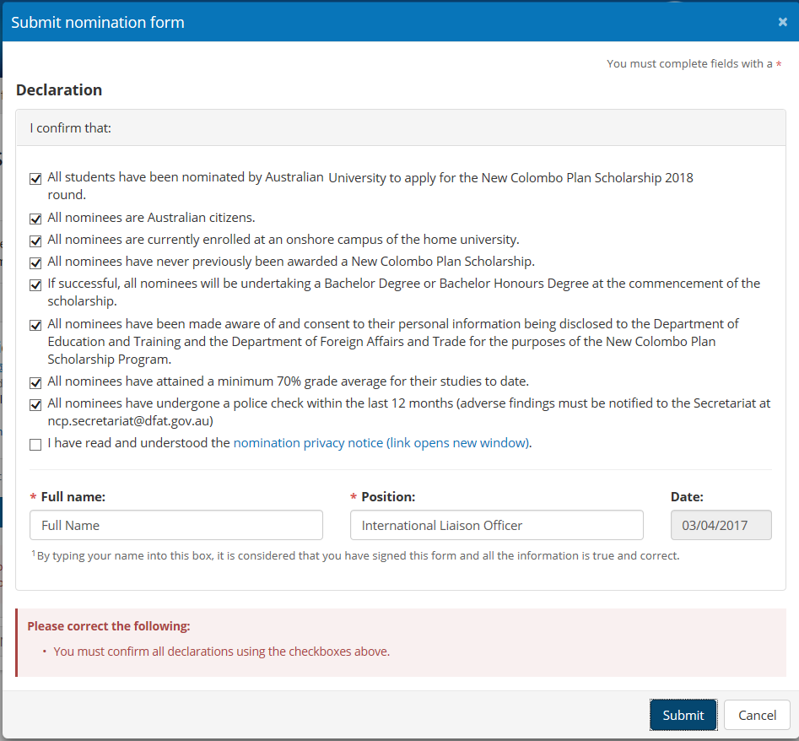

Declaration (mandatory fields)

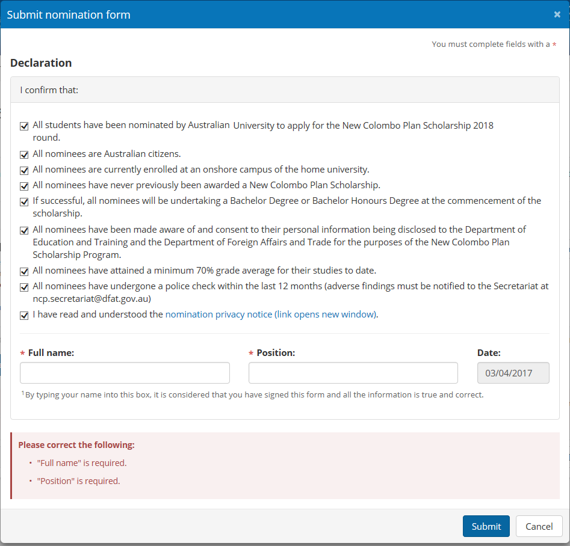

Declaration – Nomination Privacy Notice

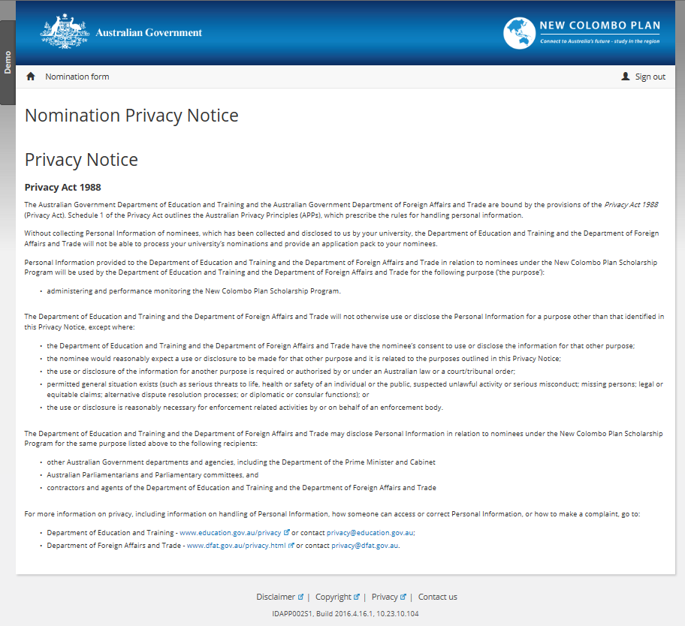

# Submission – Confirmation Window

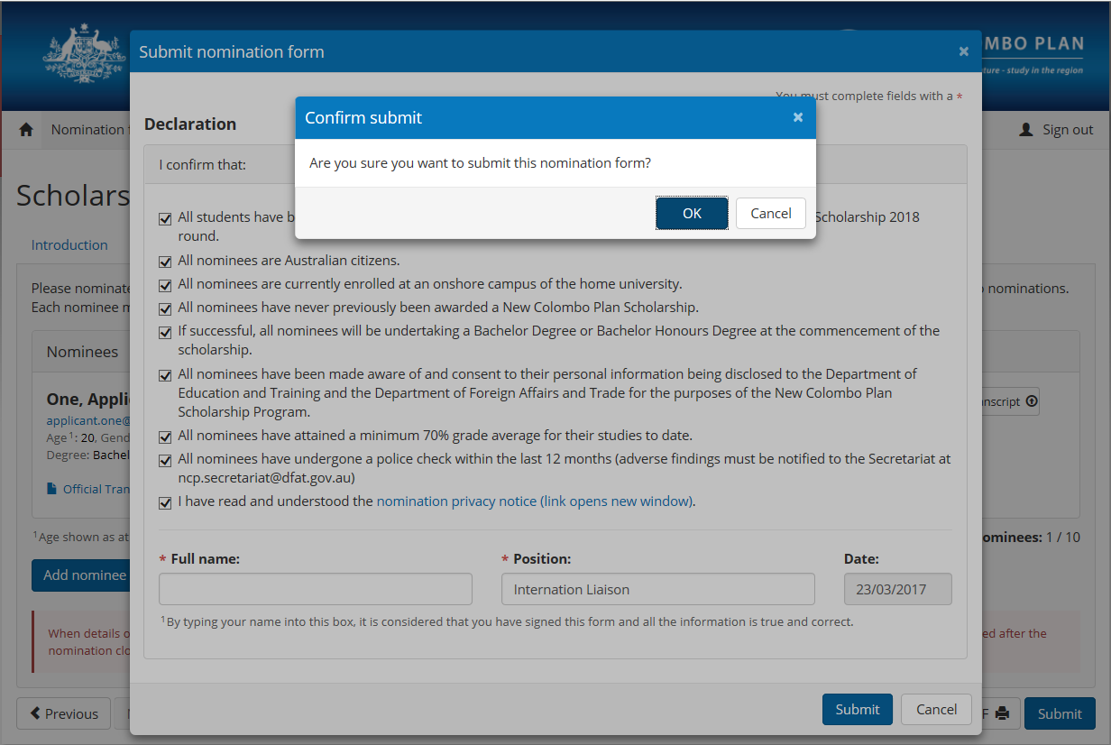

# Nomination Form Submitted – Confirmation Window

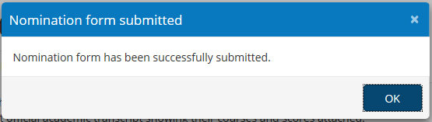

# Post-submission alterations

You may continue to access the nomination form using the pass key from your initial email for the duration of the nomination period. The most recent date of the form’s submission will be listed in a green text box on the ‘Introduction’ tab.

If you wish to edit the form or alter any of your university’s nominations, please withdraw the nomination form using the red ‘Withdraw nomination’ button. The data from your previous submission will still be visible, however you will be required to make a new declaration each time you resubmit the nomination form.

If you do withdraw your submission and resubmit a new one, please notify the New Colombo Plan Scholarship Team at [ncp.scholarships@education.gov.au](mailto:ncp.scholarships@education.gov.au).

# Introduction Tab (post submission)

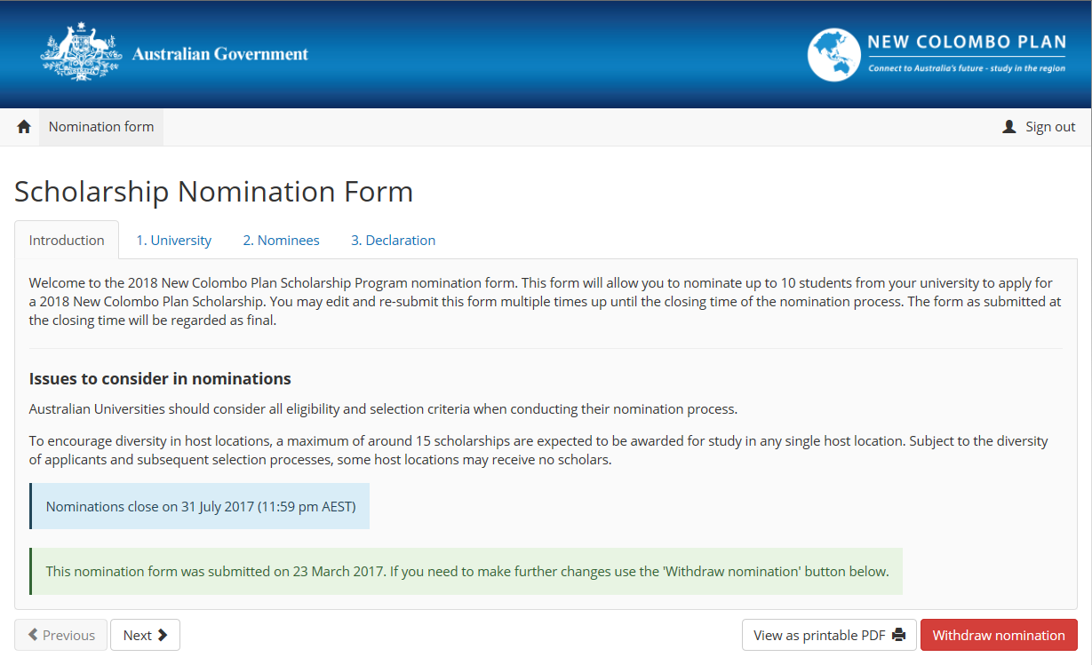

University Tab (post submission)

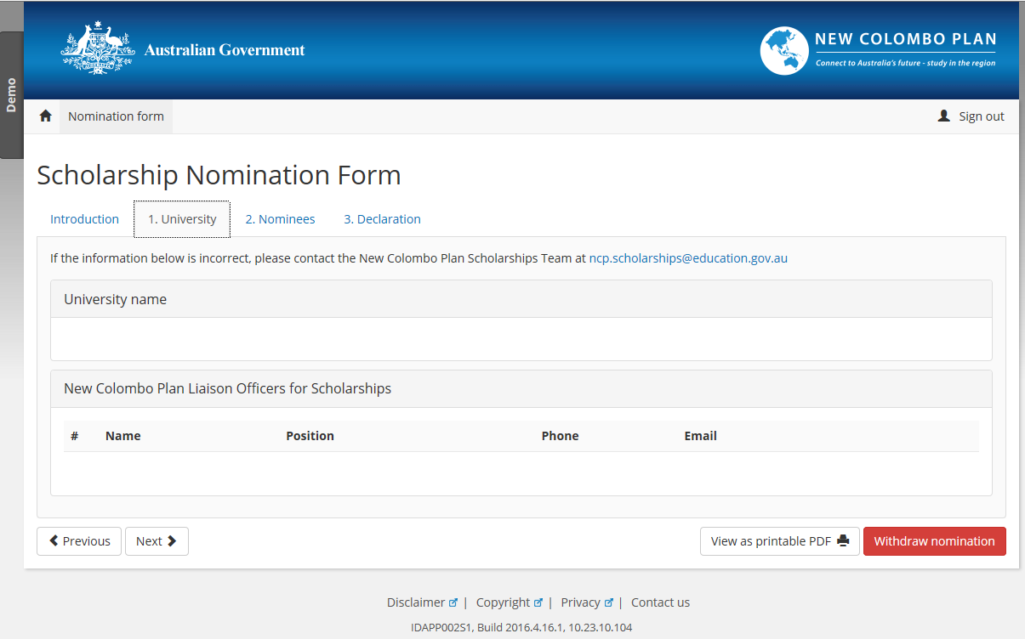

Nominees Tab (post submission)

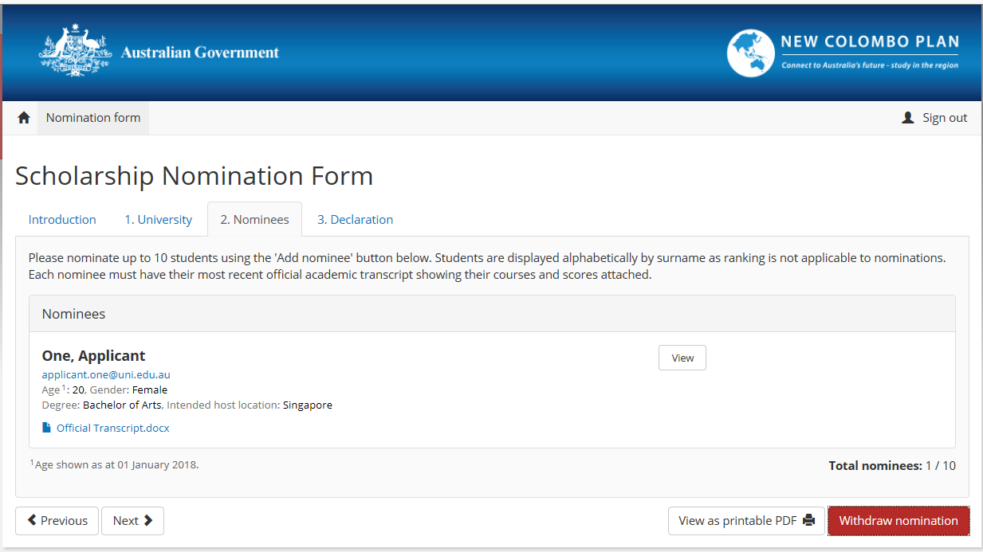

# Declaration Tab (post submission)

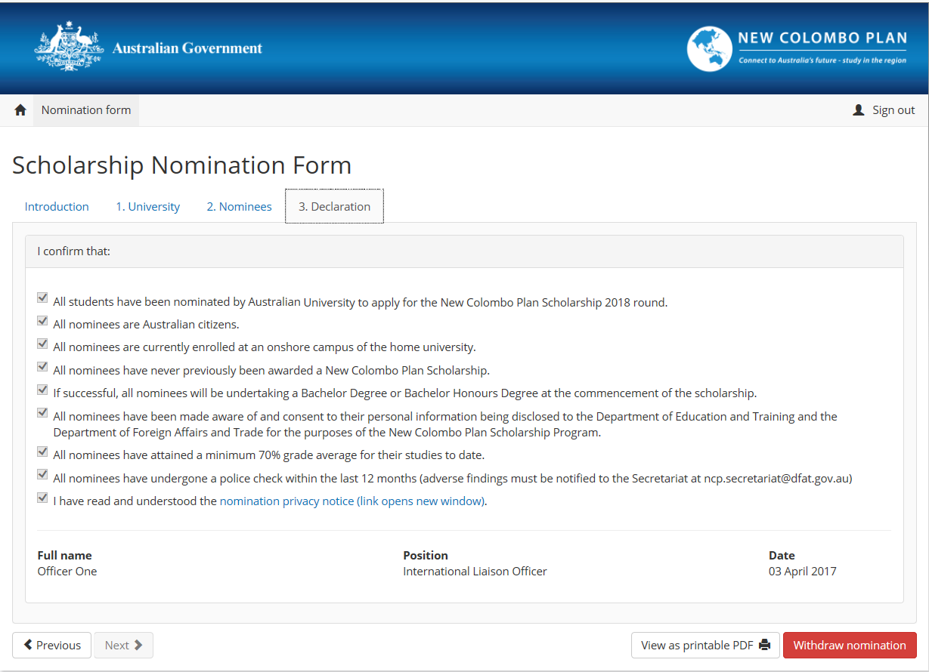

# Withdrawal Nomination – Confirmation Window

