National Adaptation Programme of Action 4 ( NAPA4) Progress report July - December 2012
Sixth Monthly Report
Ministry of Natural Resources and Environment (MNRE), Fire and Emergency Services Agency (FESA), Samoa Tourism Authority (STA)

Overview
NAPA4 is part of the Samoa-Australia Partnership for Development (the Partnership) which includes a priority outcome on climate change. The Partnership commits Samoa and Australia, initially, to work closely with other donors to ensure a coordinated approach to analysis, scoping and design of measures which meet Samoa’s interests to:
- Monitor the impacts of climate change on planning, water, forest fire, tourism, health, agriculture and food security;
- Develop adaptation measures for vulnerable communities, including coastal infrastructure and development of early warning systems;
- Improve Capacity Building.

Through these objectives the NAPA4 in its efforts to address climate change has some key achievements to highlight below;

- Twelve automatic rain gauges to be installed under this component is currently underway and will help improve the quality of the data available for climate monitoring, flood forecasting, climate early warning advisories and long-term climate change research. It is envisaged that the upgrade of the 12 rainfall observations sites will enhance capability of the Meteorology Division to monitor extensive rain storms events and possible floods as a result of tropical cyclones and severe weather and climate conditions;
- The Planning and Urban Management Agency’s (‘the Agency’)has been working towards the review and analysis of existing plans to reflect the current situations as well as future projections of population growth and development within the greater Apia Urban Area. The information and data values indicated within these documents will assist in highlighting the priority areas for the project as well as indicating direction of development and population growth to accommodate the needs and objectives of the Apia Spatial Plan (ASP);
- Work is still ongoing in monitoring and establishment of a ground water profile for these areas (Mulifanua, Leulumoega, Vaitele and Faleasiu) which provides baseline information for monitoring potential impacts of sea level rise on the ground water resources;
- The opening and operational of the Asau Rural Fire station has enabled the fire service to respond in a timely manner to address forest fires in this drought prone area. This is one of the main targets for this component under NAPA4 and has been successfully completed. Another key output is the Forest fire prevention Strategy which was developed in December 2012 and the initial draft is ready for comments;

- Under the Tourism Component all climate change projects are aligned to complement work addressed in the different projects. Hence the NAPA4 and NAPA 5 (GEF) projects are working closely to ensure the activities are not a duplication of each other. The NAPA5 will be implementing the Climate Change Tourism Strategy developed under the NAPA4, this is a significant achievement seeing partnership in different avenues to address climate change;

- One of the major outputs of this NAPA 4 Capacity component is the State of the Environment report and the Ministry's response actions which is the NEMs - the sector plan for environment. Significantly the past NEMS focused mainly on a thematic based issue but the new and improved NEMs will be focused on habitat based assessment which looks at the whole landscape. This is a great step in the Environment sector as all policy/strategy papers ( NAPA.NAP,NBSAP etc) will be streamlined into this sector plan.

Key significant achievements are provided in detail in the specific components of this report.

This report is a compilation of all priority areas under the NAPA4 and is submitted as part of its six monthly progress report to AusAid through the Ministry of Finance.

Component A - Climate Early Warning System, Meteorology Division, MNRE

Background

This report covers the period between July through to December 2012.
The Samoa-Australia Partnership for Development, National Adaptation Program of Action (NAPA 4) project is a project funded by the Australian Government with the aim to safeguard human development in Samoa from risks associated with climate change on planning, water resources, fire prevention and tourism sectors whilst simultaneously reducing greenhouse gases emissions across sectors. Component A of NAPA 4, is the Meteorology Component.

The overall outcome of this component is to enhance technical and organisational capabilities of the Meteorology Division (MD) of the Ministry of Natural Resources and Environment to monitor climate trends and provide monthly climate trends and provide monthly climate risk and early warning communications to planning, water, fire and tourism sectors to help augment existing Disaster Risk Reduction management processes.
The past six (6) months of the project period has been focussed on sector specific and community consultations. These sector consultations involved tourism, fire, planning, and water from the NAPA 4 project and finance, agriculture and health from the ICCRAHS/NAPA 1 project.
Technical installations, data collection and climate monitoring continues to improve and provide strong foundation for the information system expansion, and early waring dissemination to the NAPA 4 sectors (planning, fire, forest and water). Technical inspections are ongoing in all NAPA 4 rainfall observation sites, manual rainfall intensity monitoring equipment are in good working condition.
A total funding allocation of WST$784,308.40 was provided for this component for 2012-2013 period. WST$61,014.79 (7%) has been utilised. Tropical Cyclone Evan and other Tropical Depression has caused many delays in the implementation. Resources and staff have been occupied in Tropical Cyclone watch from the start of the tropical cyclone season in October, recovery efforts and technical assessments post tropical cyclone Evan.
Key Achievements
Output 1.1: Technical Installations, Climate Monitoring, Data Collection and Information System Expansion
The Meteorology Division is finalising the tender for the installation of the 12 automatic rain gauges to help improve the quality of the data available for climate monitoring, flood forecasting, climate early warning advisories and long-term climate change research. It is envisaged that the upgrade of the 12 rainfall observations sites will enhance capability of the Meteorology Division to monitor extensive rain storms events and possible floods as a result of tropical cyclones and severe weather and climate conditions.
In support of the above, Meteorology Division has worked with the Bureau of Meteorology to upgrade the Climate Database Management System called CLIDE (Climate Database for the Environment) in order to improve its functionalities and better retrieval of data and products for the provision of climate early warning reports. An example of these improvements in functionality is the availability of the wind rose report (see figure below), which is now one of the main features of the climate summary report. The wind rose is a method for graphically presenting wind strength and wind direction. The availability of the wind information is crucial in the management of forest resources, forest fire control, but also vital for tourism activities such as wind sports.
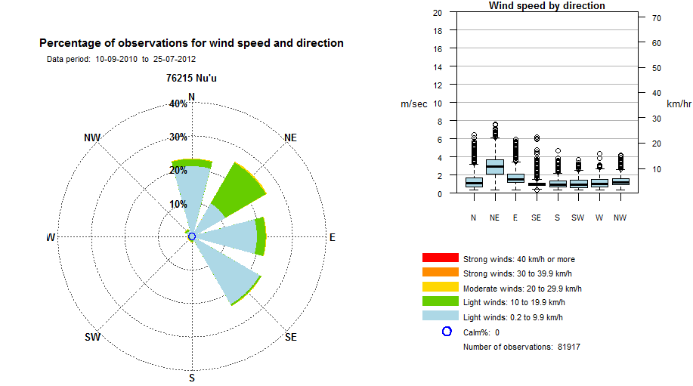
The monthly Climate Early Warning Reports, such as the Seasonal Rainfall Outlook, Drought Watch, El Nino Southern Oscillation and Climate Summary have been regularly provided to all NAPA 4 stakeholders during the reported period via email. The total number of recipients has grown from 56 from January to June 2012 period to more than 80 government officials, members of the disaster advisory committee (DAC), Civil Societies such as Bee Keepers Association, SUNGO, Women in Business Inc have accessed these bulletins.
Technical Inspections are ongoing and crucial in the upkeep of the rainfall measuring equipment across the country.
Output 2.2 Public Awareness and Consultations
The Meteorology Division has developed and launched its Current Climate of Samoa brochure last November, during the National Environment Week Celebrations. The brochure is a simplified (not too technical) version of the scientific assessment and new research on Climate Change in the Pacific. The aim of the brochure is to ensure all levels of society (different age groups) will be able to read and understand the findings of the scientific assessment conducted by the meteorological staff in collaboration with Australian scientists based at the Bureau of Meteorology and Commonwealth Scientific and Industrial Research Organisation. Understanding the developments in the climate system will empower Samoan communities to adapt to adverse implications of climate variability and long-term climate change.
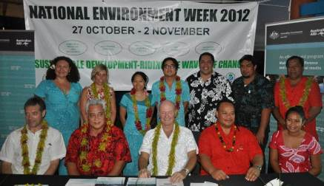
Figure 1: Launch of the “Current and Future Climate of Samoa” brochures, November 1, 2012

The brochure has been translated into Samoan language and more than 500 copies have been printed and released to the public. The launch was attended by at least 50 government officials, representatives from South Pacific Regional Environment Programme, United National Development Program, New Zealand High Commissioners Office, Australia Bureau of Meteorology, Commonwealth Scientific Institute of Research, and Staff from the Australian High Commission Office in Apia and the Media. Several articles of the launch was reported in the local media both on national television, newspaper and online.
The Meteorology Division have also conducted awareness raising activities of the project with communities, and promoting the new climate brochure. More than 500 people in rural communities have been consulted; most of the villagers expressed their appreciation of these initiatives and would like to see a continuation. A farmer from the Auala village through personal communication said his understanding of climate change issues has increased as result.
About 30% of all those consulted were females, majority of those that attended were male.
The Meteorology staff conducted consultation with the following communities:
- Tourism operators and stakeholders, Savaii Island, 25 September 2012
- Tourism operators and stakeholders, Upolu Island, 27 September 2012
- Falealupo village consultation, Savaii Island, 27 November 2012
- Asau village consultation, Savaii Island, 28 November 2012
- Auala village consultation, Savaii Island 29 November 2012
- Manase village consultation, Savaii Island, 30 November 2012
- Sapapalii village consultation, Savaii Island, 3 December 2012
- Faleseela village consultation, Upolu Island, 5 December 2012
- Falelatai, Manono and Apolima village consultation, Upolu Island 6 December 2012
- Fagaloa village consultations, Upolu Island 7 December 2012

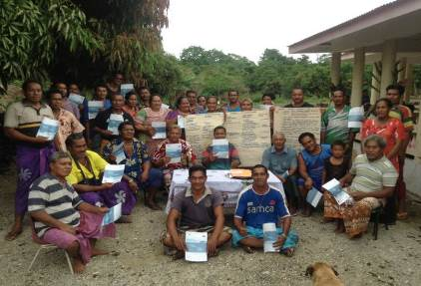
Figure 2: Village Consultation with Falealupo Village – Villagers holding up their Samoan version of the Current and Future Climate of Samoa brochure, November 27, 2012
The Meteorology Division is also supporting clean energy initiatives of the Government of Samoa through the Ministry of Natural Resources and Environment. The project vehicle, MNRE41 is now fully powered by environmentally friendly clean bio-diesel. This is to demonstrate to the public that we “walk the talk” and strong advocates to keeping the environment clean and reducing our greenhouse gas emissions and carbon footprint.
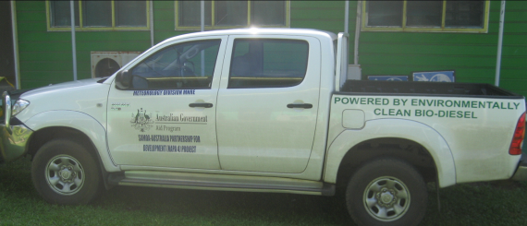
Output 1.3 Project Management Unit established
All materials and hardware procured to furnish project management unit, a projector screen was also funded from NAPA 4 fund for the awareness and village consultation activities.
- Issues and Challenges

2.1 Tropical Cyclone Watch
The arrival of the tropical cyclone season since October 2012, and the allocation of key staff to ‘cyclone watch’ roles have caused some delays in the delivery of project activities.

2.2 Tropical Cyclone Evan
Tropical Cyclone Evan (12-15 December 2012) also created significant unforeseen delays in the implementation.

2.3 Tailoring of Climate Early Warnings
Lack of research, comparable data from other sectors remains a challenge for the tailoring of sector specific climate early warnings.

2.4 Limited staff
The shortage of staff and the significant representation in the vast number Climate Change adaptation project committees, technical groups and activities has stretched resources and time.

Risk Management
  - Project Scope
The work plan has been amended to ensure postponed outcomes from last year are achieved and targets met within timeframe.

Work Plan FY2012/13
See Work plan attached. Note: ST$200,000 from the Meteorology Component of NAPA4 has been reallocated to fund the completion of the State of Environment Report (SOE).
NATIONAL ADAPTATION PROGRAMME OF ACTION
SAMOA AND AUSTRALIA PARTNERSHIP DEVELOMENT PROGRAMME
Ref | TASKS |  |  |  | ACTIVITY |  |  | SUB-ACTIVITIES | QUARTER 1 | QUARTER 2 | TOTAL | JUSTIFICATION/COMMENTS
COMPONENT A – CLIMATE EARLY WARNING, METEOROLOGY DIVISION, MNRE – 2012/2013
Outcome 1 - Enhance technical and organizational capacity to monitor climate trends and provide monthly climate trends and provide monthly climate risk and early warning communications to planning, water, fire and tourism sectors to help augment existing Disaster Risk Reduction management processes.
Output 1.1 - Technical Installations, data collection, climate monitoring and information system expansion.
1.1.1 | International Meteorology Consultant |  |  |  | Prepare and finalise TOR and contract |  |  |  |  |  |  | Completed
1.1.1 |  |  |  |  | Advertisements of tender, EOI, Assessment of Technical and Financial proposals |  |  |  | 1000 | 0 | 1000 | To ensure competition between suppliers and as per Tender Manual.
1.1.2 | Instrument upgrade of 12 automated rain gauges |  |  |  | Procurement of 12 sets of GPRS enabled, automatic rainfall monitoring stations at locations agreed by Met.Div (including power supplies, mounting hardware, and installation materials) |  |  |  | 258,890.93 | 0 | 258,890.93 | The installation of additional rainfall sites will improve understanding of the spatial variability of rainfall available to the CLEWS system enabling a more regionally targeted generation of products
1.1.3 | Technical maintenance and calibration visit of the 12 sites and train Met. Div staff. |  |  |  | Engage International consultant |  |  |  | 40,000 | 0 | 40,000 | Annual maintenance and calibration is a requirement of all meteorological instruments under the WMO standards
1.1.4 | Technical support to expand Climate Database and Communication |  |  |  |  |  |  |  | 44,486.82 | 0 | 44,486.82 | Ensure that the new auto-rain gauges are compatible with the automatic weather stations installed under the ICCRAHS (NAPA 1) project. Hiring a different supplier will create problems and may bring systems that are not compatible with existing equipment and infrastructure.
  Engage an Expert on Meteorological Equipment installation to supervise installation of a subset of the 12 Automatic Rain gauges and provide training to SMD staff to complete balance of sites.
1.1.5 | Install and upgrade telemetry system to archive rain gauge data via telemetry server to CliDE |  |  |  | Engage Telemetry Expert to commission upgraded rainfall stations and to upgrade FLOSYS communications server to include NEON-FLOSYS WEB based communications server and interface. |  |  |  | 24,046.93 | 0 | 24,046.93 | Upgrade of FLOSYS is needed considering the additional number of auto-rain sites to be put in by this component. Upgrade will ensure systems will be able to handle data traffic and avoid system failure.
1.1.5 |  |  |  |  | Travel and Accommodation for site installation and telemetry upgrade personnel |  |  |  | 19,967.54 | 0 | 19,967.54 | Travel and accommodation for overseas contractors and experts involved in the installation of the 12 auto rain gauges
1.1.6 | Install and commission NEON WEB enhancement to SMD Flosys communications server |  |  |  | Commission NEON Web enhancement to display data from rainfall and climate stations in near real time, including one-off software development licencing fee. |  |  |  | 53,676.18 | 0 | 53,676.18 | To improve data visualisation and display-part of enhancing climate products and services to its end users
1.1.7 | Construction of security fencing around the 12 new auto-rain gauges |  |  |  | Procurement of security fencing materials |  |  |  | 0 | 32,000.00 | 32,000 | To ensure security of project assets from illegal entry and from theft and damage from likely sources
1.1.7 |  |  |  |  | Fencing Contract for 12 newly established auto rain gauges |  |  |  | 0 | 35,000.00 | 35,000 | No capability in-house to undertake this task
1.1.7 |  |  |  |  | Caretaker allowance of 12 newly established auto-rain gauges @ $1200 per site |  |  |  | 0 | 14,400.00 | 14,400 | Ensure the security and well being and safety of project assets and installations in the field.
1.1.8 | Hire Expert to expand GIS Mapping of Climate Elements such as rainfall, temperature, winds etc to customised requirements of the sectors |  |  |  | Develop Climate GIS layers for sector planning, expand the GIS work undertake in ICCRAHS. Finalise GIS layers for Tourism, FESA and PUMA requirements. |  |  |  | 25,000.00 | 10,000.00 | 35,000 | Ensure the customisation of GIS climate layers to the needs of the sectors
1.1.9 | Hire Expert to develop Climate Services Application Services (CLIDEsc) from Climate Database for Tourism, PUMA, FESA and Forestry. |  |  |  |  |  |  |  | 8400 | 0 | 8400 | Expand CLEWS services and products to include NAPA sectors i.e Tourism, FESA, PUMA and Forestry.
1.1.  10 | Hire consultant to finalise State of the Environment Report |  |  |  | Consult relevant stakeholders SOE report |  |  |  | 0 | 100,000 | 100,000 | To ensure effective and timely communication of climate early warning services to meet sector needs
1.1.  11 | Hire consultant to develop Climate Early Warning Communication Strategy |  |  |  | Launch of CLEWS Communication Strategy |  |  |  | 0 | 5000 | 0 | To ensure effective and timely communication of climate early warning services to meet sector needs
1.1.  11 |  |  |  |  | Consultancy fees |  |  |  | 0 | 20,000 | 20,000
1.1.  12 | Spare manual rain gauge parts |  |  |  | Procure spare 5'' manual rain gauge to calibrate automated rain gauges |  |  |  | 5000 | 0 | 0
 |  |  |  |  |  |  |  | Sub-total | 480,468.4 | 216,400 | 696,868.4
Output 1.2 – Public Awareness and Education
1.2.1 |  | Development and Conduct public awareness on seasonal rainfall prediction and drought monitoring tools and reports |  |  |  | NAPA 4 Sector engagement workshop to introduce CLEWS products and services including GIS Mapping Tools for Planning |  |  | 3000 | 3000 | 6000 | Awareness raising of end users and stakeholders of the services from CLEWS and climate products
1.2.2 |  | Consultation workshops for Rainfall Observers |  |  |  | Consultation Workshop for Rainfall Observers and stakeholders in Upolu |  |  | 3000 | 0 | 3000 | Awareness workshops for technical staff and village-based operators in Upolu
 |  |  |  |  |  | Consultation Workshop for Rainfall Observers and stakeholders in Savaii |  |  | 3000 |  | 3000 | Awareness workshops for technical staff and village-based operators in Savaii
1.2.3 |  | Launch of Current and Future Climate of Samoa Report, Brochure and Awareness Materials |  |  |  |  |  |  | 0 | 0 | 0 | Completed
1.2.4 |  | Printing of education materials, tshirts, umbrellas, awareness information packages, brochures |  |  |  |  |  |  | 6000 | 0 | 6000 | Public awareness of the project
 |  |  |  |  |  |  | Sub-total |  | 15000 | 3000 | 18000
Output 1.3 – Project Management Unit established
1.3.1 |  | Quarterly site inspection to Upolu and Savaii to supervise progress of implementation |  |  |  | Accommodation, boat fares etc |  |  | 1500 | 1500 | 3000 | Ensure compliance with project schedule
1.3.2 |  | Acquire office equipment for project use; maintenance of office equipment |  |  |  | Office equipment, stationeries, consumables for office use |  |  | 0 | 0 | 0 | Completed
1.3.3 |  | Maintenance of office assets including the insurance of project vehicle, maintenance and servicing |  |  |  | Maintenance needs of Met Division Component |  |  | 2300 | 2300 | 4600 | Ensure project vehicle adhere to safety requirements for project staff to use. Long term use of asset
1.3.4 |  | Monitor & evaluate progress and prepare reports to the Steering committee on progress of implementation |  |  |  | Attend project steering committee meetings to discuss progress of implementation and addresses project related issues |  |  | 400 | 400 | 800
 |  |  |  |  |  |  | Sub-total |  | 4200 | 4200 | 8400
 |  |  |  |  |  |  | Grand Total |  |  | 723268.4 | 723,268.40

Appendix:
Pictures

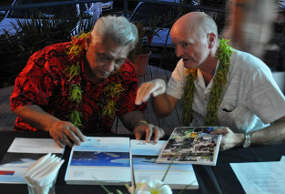
Figure 3: Hon. Faamoetauloa Taito Dr. Faale Tumaalii, Minister of Natural Resources and Environment and His Excellency Dr. Stephen Henninham, Australia High Commission to Samoa at the Official Launch of Samoa brochures, November 1, 2012
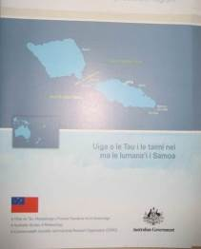

C Figure 4: The printed copies of the Samoa brochures, available in the Samoan language for local communities, November 1, 2012

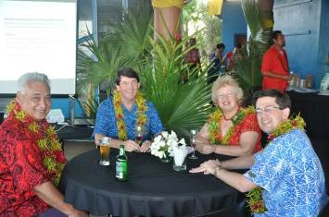

Figure 5: Launch of Climate brochures. Hon. Minister of Environment Faamoetauloa Taiti Dr. Faale accompanied by the NZ High Commissioner to Samoa, and the Representative of the US Embassy, November 1, 2012
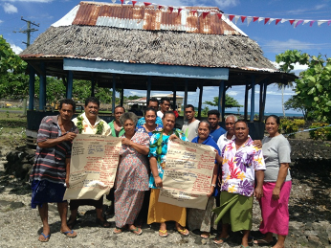

Figure 6: Group 2, Consultations with Asau Village, November 28, 2012
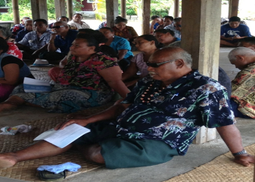

Figure 7: Papali’I a chief from Sapapalii village holding his copy of “Current and Future Climate of Samoa”, December 3, 2012

COMPONENT B - SURFACE WATER FLOODING, Planning and Urban Management Agency

Outcome 2 - Strengthen capacity of Samoa's planning sector to adapt to impacts of climate change.

Background

This progress report covers the period between July through to December 2012.

Samoa’s National Adaptation Program of Action - Framework 4 (NAPA 4) has identified long term solutions targeted towards land use planning and creating a comprehensive and integrated approach to addressing the built environment’s resilience to climate change.

NAPA 4 was adopted by the Government of Samoa in 2004 as part of a cross sectoral initiative to integrate planning, water resource management, forestry and tourism in addressing climate change adaptation.

The past six (6) months of the project period has been focussed on public consultations with the Apia population and stakeholders to canvass three two objectives:
- in trying to create awareness of the project and highlight how the outcomes of the project can benefit the urban population; and
- obtain feedback on the planning process, the urban issues and possible solutions.

The Category 3 Cyclone Evan struck Samoa 12-14 December 2012 and is still dealing with the recovery and damage, loss and needs assessments.

- Key Achievements
Output 2.1: Review of Project Documents
The Planning and Urban Management Agency’s (‘the Agency’) Strategic Planning Section has been working towards the review and analysis of Project Documents to reflect the current situations as well as future projections of population growth and development within the greater Apia Urban Area. The information and data values indicated within these documents will assist in highlighting the priority areas for the project as well as indicating direction of development and population growth to accommodate the needs and objectives of the Apia Spatial Plan (ASP).

Output 2.2 Public Consultations
The Agency has begun the first round of consultations with the following groups regarding the preparation of the Apia Spatial Plan:
- Village mayors (Sui o Nuu) of the Apia Urban Area (22 November 2012)
- Marketing during Environment Week (30 October 2012).
- Stakeholder community (28 November 2012).
- Executive members of the Chamber of Commerce (29 November 2012)
- Ministry of Natural Resources and Environment (12 December 2012)

The primary objectives of the consultations were to gauge perspective on the draft Apia Spatial Plan as well as to create public awareness of the project and its objectives.

Output 2.4 Education and Awareness Program
In creating awareness of the project, the Agency has procured promotional materials in the form of t-shirts which were distributed during the public consultations and used for Environment Week celebrations.
Output 2.5 Institutional Development Advisor
Pending finalisation of the Institutional Development Advisor Terms of Reference

- Issues and Challenges
  - Public Consultations
The initial phase of consultations has yet to be completed and has scheduled to continue over the next ten (10) weeks (ending March 2013). The challenge is to ensure reasonable attendance and generate interest and by-in. The next stage will target village level consultations.

Figure 1: Broad Level Spatial Analysis
Figure 1 illustrates the imagery we have been using to generate discussions on the issues. To improve the level of graphics the Agency is discussed with a Graphic Designer to assist the office to produce quality graphic imagery including the proposed precincts as a means to facilitate public consultation.
3.2 State of Emergency
Cyclone Evan (13-14 December 2012) and the recovery period has made significant unforeseen disruption. This has meant that public authorities have been focusing on damage, loss and needs assessments and the Agency is mindful of Government’s immediate priorities. The intent is to obtain a list of ongoing and planned pipeline urban investments so as to coordinate and integrate into the Spatial Plan.

It must be stated that the flash-flooding that occurred in the Vaisigano Catchment on Thursday December 13, 2012 caused a significant flood damages and loss to critical public infrastructure and community assets. The investigations carried out as a result of this project assisted greatly in the flood event assessment and in preparing draft interim reconstruction strategy (in progress).

3.3 ‘Urban’ definition
The consultations highlighted the need for clarity around defining the urban boundary. The reference to Apia as a city, township, urban centre, or Apia urban area often highlights the ambiguity that surrounds discussions of the intent of the Apia Spatial Plan. The process of urbanization has slowly overtime seen an economic expansion of activity that has also leaped over customary land and governance. To address this concern, the Agency is developing a Cabinet Submission aimed at receiving Cabinet Directive on how to define ‘urban’

Risk Management

  - Project Scope
The current workplan has been amended to accommodate the current situation and targeted outcomes to ensure that objectives are achieved and targets met.

Work Plan FY2012/13
See Work plan attached.

NATIONAL ADAPTATION PROGRAMME OF ACTION
SAMOA AND AUSTRALIA PARTNERSHIP DEVELOMENT PROGRAMME
Ref | TASKS |  |  |  | ACTIVITY | SUB-ACTIVITIES | QUARTER 1 | QUARTER 2 | TOTAL | JUSTIFICATION/COMMENTS
COMPONENT B - SURFACE WATER FLOODING, PUMA, MNRE – 2012/2013
Outcome 2 - Strengthen capacity of Samoa's planning sector to adapt to impacts of climate change
Output 2.1 - Project management office and support services established and maintain
1 | Maintenance of project management office |  |  |  |  | Stationery for project unit administration | 3,000.00 |  | 3,000.00 | Office stationery, equipment and others for maintaining project unit operations
 |  |  |  |  |  | Sub-total | 3,000.00 | - | 3,000.00
Output 2.2 - Spatial plan to incorporate climate change developed
2 |  | Revise draft and implement methodology to complete spatial plan for greater Apia |  |  | Set priorities to allow better coordination of urban policies and infrastructure developments | Preparation for Community/Stakeholder Consultations on developing the spatial plan |  | 5,000.00 | 5,000.00 | Continue wide consultation throughout to secure and maintain the support and co-operation of infrastructure providers, public authorities, etc in the implementation of the Spatial Plan.
3 |  | Revise vulnerability and adaptation assessment for urban flooding areas |  |  | Use existing vulnerability assessment tool to assess vulnerability levels of urban area to flooding | Community & Stakeholder workshop |  | 2,000.00 | 2,000.00 | Conducting a vulnerability assessment will identify zones in urban area and their level of vulnerability.
 |  |  |  |  |  |  | - | 7,000.00 | 7,000.00
Output 2.3 - Flood adaptation strategy 2012 - 2017 developed
4 |  | Review and Finalise Draft Flood Adaptation Strategy |  |  | Review and finalise hydraulic modeling of urban flooding to develop background information for the strategy | Community consultation on Strategy |  | 6,000.00 | 6,000.00 | Baseline information will include assumptions, constraints, and medium and long term aspirations to base strategy objectives, project actions, streamlining climate change information into standard operating procedures for development control, and guidelines for adaptation measures
 |  |  |  |  | Develop and streamline climate change information into development control standards and guidelines. | Prioritise and develop standards for adaptation measures.
 |  |  |  |  |  |  | - | 6,000.00 | 6,000.00
Output 2.4 - Education and awareness program on flooding and urban drainage issues developed and implemented
5 |  | Continue implementation of urban drainage education and awareness programme |  |  | Continue implementing education and awareness programmes on wide-drainage and on-site drainage issues | Reprinting t- shirts |  | 5,000.00 | 5,000.00 | Public education and awareness is critical to adapting to flooding caused by climate change.
 |  |  |  |  |  | media awareness (tv, radio, newspaper) | 5,000.00 | 5,000.00 | 10,000.00
 |  |  |  |  |  |  | 5,000.00 | 10,000.00 | 15,000.00
Output 2.5 - Quality planning tools and procedures to assist operations of the Planning and Urban Management Agency
6 |  |  | Procure an Institutional Development Advisor |  | Hire an Institutional Development Advisor | Finalise TOR for Institutional Specialist Carry out research on urban development issues in relation to climate change and increasing environmental pressures |  | 30,000.00 | 30,000.00 | Institutional Development Advisor will provide planning advise and undertake research to strengthen the capacity and enhance quality performance of the Planning and Urban Management Agency
 |  |  |  |  |  |  | - | 30,000.00 | 30,000.00
 |  |  |  |  |  | Grand Total | 8,000.00 | 53,000.00 | 61,000.00

Appendix: Pictures.
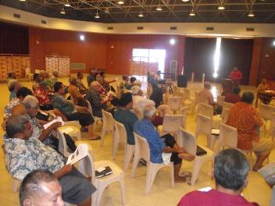
Figure 2: Consultations with Pulenuu, November 22, 2012

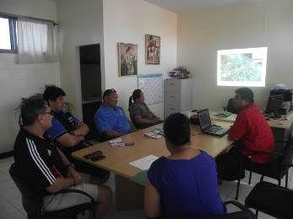

Figure 3: Consultations with the Chamber of Commerce Executives, November 29, 2012

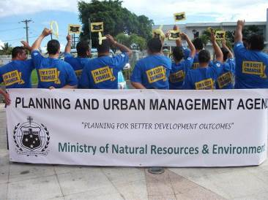
Figure 4: Environment Week publicity, Nov 2012

COMPONENT C - GROUND WATER, Water Resources Division

Outcome 3 - Establishing the capacity of Samoa's water resource managers and GIS planners to identify the impact of climate change on groundwater resources.

Background
This report is subject to as part of the six month reporting mechanisms by the NAPA steering committee. It is also a follow up to the recent January - July 2012 report. The past six (6) months of the project period has been focussed on the data collection, maintenance and monitoring of previous works as well sustaining climate change awareness campaign. The Water Resource Division especially the Hydrology Section assisted the works of the project. Such include;

- Monthly data collection from all monitoring borehole stations both funded by the NAPA & Water Sector Budget Support ;
- Assessment of abandoned boreholes for both Upolu and Savaii (SWA productions boreholes);
- Rehabilitation efforts for abandoned boreholes such as the STEC site at Mulifanua;
- Data collection from privately and commercially owned groundwater wells;
- Procurement of project vehicle, a specialized crane truck which currently assists the project drilling needs;
- Awareness programs in schools, career days, local communities, news paper and radio stations;
- Mainstreaming project goals and objectives with other climate related initiatives such as the University of the South Pacific European Union Global Climate Change Alliance Project Advisory Committee.

The Category 3 Cyclone Evan struck Samoa 12-14 December 2012 and is still dealing with the recovery and damage, loss and needs assessments.

- Key Achievements
2.1 Project Vehicle – Crane Truck Procurement and Handover Ceremony
The long awaited project vehicle has finally arrived. Delays have been largely due to the initial winning bidder inability to source the vehicle due to major changes within the motor vehicle industry especially in Japan after the Tsunami disaster. The third winning bidder is a New Zealand based company, Intracor Commodity Exports. The mentioned company won the bid and final inspections in New Zealand has confirmed that all crane specifications have been verified and complied as shown in Annex Figure 1.1 -1.4.

The handover ceremony was held on Thursday 18th October 2012 at the front court yard of the Tui Atua Tupua Tamasese Building as highlighted in Figure 1.5. It was attended by Cabinet Ministers, Diplomatic Corp, representatives of the Water Sector and members of the public. The program included;

- Welcoming Remarks by CEO - Taule’ale’ausumai Laavasa Malua
- Opening Prayer / Services – Rev. Kerisiano Soti (CCCS-Sogi)
- Keynote Address - MNRE Minister Hon.Faamoetauloa Lealaiauloto Taito Dr Faale Tumaalii
- Remarks and Keys Handover - Australian High Commissioner - Dr Stephen Henningham

It was a brief ceremony to acknowledge and accept the great assistance from the Government of Australia for Climate Change Adaptation partnership with the Government of Samoa (National Adaptation Program of Action 4).

The truck (Hyundai HD 75 model, 2012) with a heavy duty crane (up to 3.4 tons lifting capacity) was a long overdue component of the project due to previous supplier’s inability to procure it. After the National Tender process, Intracor Commodity from NZ won the bid. It costs NZD$147,352 or ST$282,915.84. It will be use by the Water Resources Division-Hydrology Section of the MNRE.

This new truck will assist with the heavy equipment transportation and the installation of our ground water stations. These stations will monitor salt water intrusion into our coastal spring as a result of sea level rise. It is now very safe for the staff to manually install these heavy equipments especially when we drill to depths of 100 meters below. Manually lowering and pulling up piezometers pipes and lifting heavy equipment for hours is quite a very unsafe practice.

- 2.2 Upolu and Savaii abandoned borehole inspection
Site inspection and data collection were also carried out in collaboration with the Samoa Water Authority. As the project awaits the procurement of new drilling equipments, the team embarked on assessing all confirmed abandoned boreholes for both Upolu and Savaii to collect information and assessed the conditions of each site. However, the majority of Savaii boreholes have been in poor conditions for any quality data to be collected. (Please refer to Figure 2.1 and attached Hydrology Report (both surface and ground water in the Appendix for more information).

However, the team managed to collect data from some abandoned boreholes in Upolu such as the Samoa Trust Estate Corporation at Mulifanua. The team is currently working in rehabilitating this site for data collection to assist in mapping localized ground water and to assess viability of water supply for the local community as shown in Figure 3.1

- 2.3 Data Capturing – Commercial and Private wells
Further to works as described in Section 2.2, the team also collected information from all commercialised and privately owned wells such as;

- GPS location;
- Bore depth and size specifications;
- Construction an installation details;
- Daily and annual extraction rate;
- Water pump information/capacities;

The above information will assist not only the project goals but also the Water Resources Division other roles in assessing groundwater mapping, localised ground water availability, recharged rates during wet and dry season and sea water intrusion as shown in Figure 4.1.
Furthermore, an attached summary of all monitoring boreholes data for the last six months in the Appendix section is attached for more clarification.

- 2.4 Public and School Awareness Program on Ground water and climate change
Educating the younger generation on the importance of groundwater and water catchment areas is significant to the sustainable development of this critical resource in the future. As such, vital information about climate change and ground water were put out during the Watershed Section school awareness program for students both in Upolu and Savaii as shown in Figure 6.1. Also, continuous contribution and active participation on newspaper articles such as the Samoa Observer Sunday issues and other media programs increases community awareness on the overall goal of this project.

Moreover public awareness programs such as talkback shows on both radios 2AP and Talofa FM as shown in Figure 5.1 were also carried out for 3 months on a fortnightly basis. Radio 2AP was used to target age group audience of 40 years or more and Talofa FM for the less than 40 years old. The program audience grew as more listeners participated on on-air forums and greater understanding by the public on project goals was acknowledged.

Awareness campaign was also carried during the Environment Week 2012. Nearby villages, schools and communities were targeted and all participants were given commemorative t-shirts as shown in Figure 7.1.

2.5 Drilling equipments procurement – ADG Australia
Figure 8.1 showed some of the vital drilling equipment for the continuation of the drilling program. Due to the large amount ordered, on time delivery and compatibility of the equipments, a single source supplier was sourced for the specialized equipments. ADG Australia won the bid and the equipments arrived late on January 16th 2013 due to Cyclone Evan’s aftermath effects. The equipments will sustained the drilling program towards the end of the year.

2.6 Others – Relief Response during and after Cyclone Evans
Among the main goals and objectives of the Project, assets funded under the project were also utilised for immediate and emergency relief works during and after the cyclone. As shown in Figure 9.1 the specialized not only assisted in the clearance of the town area, but also for relief distribution.
The AusAID funded crane truck together with the Samoa Water Authority were amongst the first to cart and distribute much needed water supplies to families during day, night and early morning hours.

Issues and Challenges
- Governance
- Finances - Funding assistance is needed for remaining projects objectives such as:
- National Ground Water Climate Change Adaptation Strategy 2013-2020”
- Implementation of the aforementioned strategies.
- Sustainability
- The importance of the project requires ample time to fully installed monitoring stations to determine future concrete and solid decisions by the Authorities. It is expected by 2015, the monitoring bore hole installations program will be completed and extensive information will be available to determine;
- Overall underground water capacity and quality;
- Recharge rates during wet and dry season;
- Yielding and extraction rates;
- Pumping rates, etc.
- Pollution

- Gender Equality
- There is a fair balance in terms of gender equity within the project. The technical and analyst staff members include balance number of both males and females. The nature of the drilling works involved heavy equipments hence the all males in the drilling team.
- The female staff in the hydrology team collected and analysed the data for updated reports.
- The active participation by village women committees in awareness programs, as well as the support of chiefs during drilling works is also noted.

- Risk Management
One of the major risks involved in this project is the lease of customary lands where monitoring stations are located. The normal process will take months for a lease to be executed. The works at one of the site had to be on hold for a few months as family members solved some internal issues regarding lease and land ownerships. Currently, the matter has been resolved and works continued and completed. The land lease process through proper channels is now in progress. Further delays are due to customary land owners in negotiation.

Annex
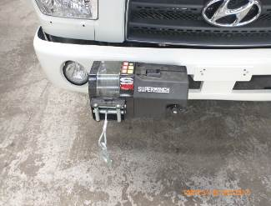
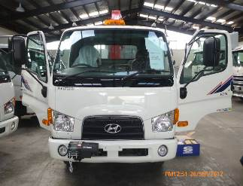
1. Crane truck
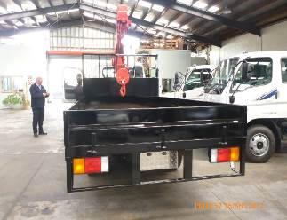
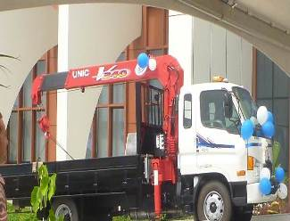
Figure 1.1: Auckland Inspection Figure 1.2: Auckland Inspection – specialised winch Figure 1.3: Auckland Inspection – tray and crane Figure 1.4: Handover Ceremony - Apia
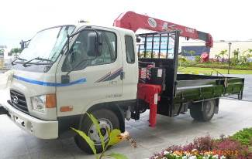
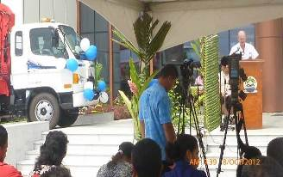
Figure 1.5: Keynote Address – Australian High Commissioner

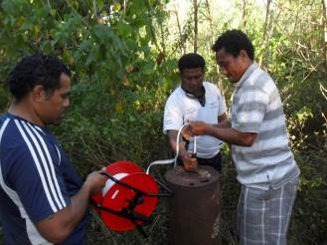
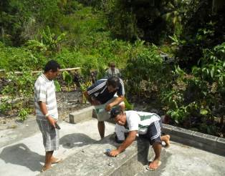
2. Savaii abandoned borehole – Site Investigation
Figure 2.1 Abandoned borehole – Asau site Figure 2.2 Sataua Site

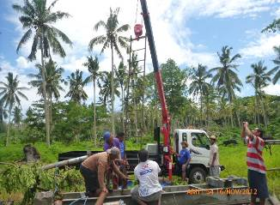
3. Upolu abandoned borehole – Site Investigation/rehabilitation
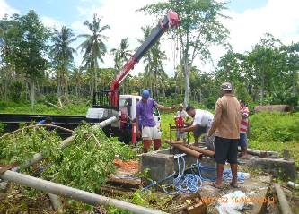
Figure 3.1 Mulifanua site (Samoa Trust Estate Corporation)

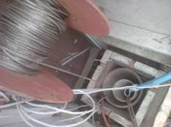
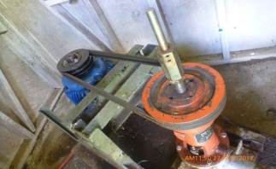
4. Data Capturing – Commercial and private wells
Figure 4.1 LDS Borehole Figure 4.1 Le Vai Company borehole Lotopa

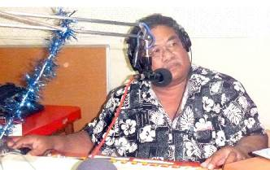
- Radio Awareness – Radio 2AP and Radio Polynesia Talofa FM

Figure 5.1 – Vaasiliega Iupati Lagaia – Radio 2AP Radio Host and Talk Show on Climate Change

- School Awareness – Climate Change and Hydrology
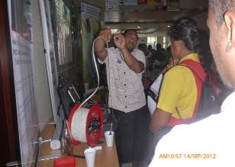
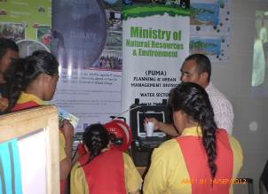
Figure 6.1. Staff demonstration ground water meters to very keen students

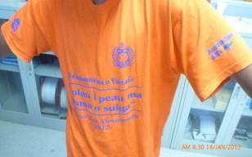
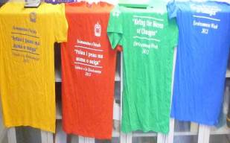
- Public Awareness Campaign – Environment Week 2012
Figure 7.1 – Community Awareness program – awareness t-shirts for all participants

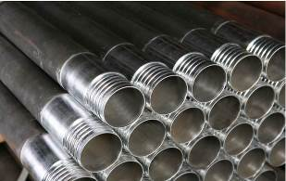

8. Procurement – Drilling Equipment from Australia

Figure 8.1 Drilling rods (3inch size) and Bentonite chips

9. Others – Cyclone Evans Relief works
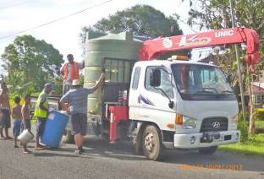
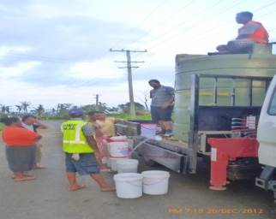
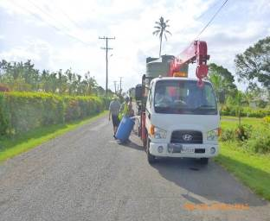
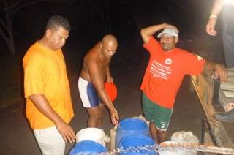
Figure 9.1 Relief works operation – water distribution to all affected families in the town area.

COMPONENT D - FOREST FIRE PREVENTION, FESA
Outcome 4:- Strengthen Samoa's fire prevention and suppression capacity to reduce the impact of climate change on native forests and forest plantations during drought periods.

Background
This progress report provides progress on work undertaken during the period of July to December 2012.

- Key Achievements
The achievements under the different outputs in the last six months are summarised below:

- Output 4.1: National Fire Strategy developed and implemented
A term of reference has been developed and a forest fire expert has been selected to lead the development of the forest fire prevention strategy. A memorandum of understanding is being drafted to set out the terms and conditions for the engagement of this expert to facilitate the development of the strategy including consultations and reporting.

The expert was in Samoa from 25th November to 6 December 2012 to undertake a physical study of Samoa’s forest cover and type. At the same time, critical data and information were collected and one-to-one consultations were conducted with FESA and MNRE (Forestry, Meteorology, Spatial Information and Disaster Management Divisions). An initial draft of the National Forest Fire Management Strategy has been completed and has been provided to FESA, DMO and Forestry for initial thoughts on the format and content.

The remaining works include one-to-one consultations with remaining critical agencies, community consultations, report drafting and finalization.

- Output 4.2: Public awareness on forest fire adaptation planned and implemented
Apart from forest fire prevention advertisements aired on television, a forest fire prevention page has been developed to be included in the 2013 yellow page hardcopy and website. This will be launched on the 30th of January 2013. Every family will be given a hard copy of this yellow pages book. The same information is now available online through the yellow pages website. The public can also text to the short code “933” to get information on what to do if an area is affected by a forest fire.

Fire danger indicators have been installed in the North West part of Savaii (one in Falealupo and one in Aopo) that is highly vulnerable to forest fires. The fire danger indicators are manually changed depending on the weather conditions from time to time and also the condition of the forest and vegetation. It provides a visual of the level of danger of the forest and vegetation in these locations to prevent the public from burning the vegetation or from causing any fires.

- Output 4.3: Forest fire prevention mechanisms
The Asau Rural Fire Station was officially opened on the 11th of October 2012. An official opening ceremony was held on this day to mark this achievement of this milestone. It was attended by Cabinet, Diplomatic Core, heads of partner government ministries and corporations, community representatives from the North West of Savaii as well as the private sector.

The Memorandum of Understanding (MoU) between FESA and MNRE to recognize its partnership in forest fire prevention was also signed during the official opening ceremony of the Asau Rural Fire Station. The MoU also cover the establishment of remaining fire stations within Forestry Division compounds in Maota and Togitogiga.

The station is now manned by two shifts comprised of four trained fire fighters. The FESA organizational structure now includes a structure for Asau Rural Fire Station and all personnel and operational costs are paid for from the FESA local budget.

The land to build the Maota Fire Station has been leveled and ready for the construction of this station. The design and the list of materials required to build this station have been completed. Request for bids was published on the newspaper inviting interested builders to submit bids to build the Maota Fire Station with the plan to start building in early January 2013. Unfortunately, Tropical Cyclone Evan occurred and required the project implementation team to provide response to the impacts of TC Evan. As a result, bid evaluation and selection of a builder has been delayed until the second week of February and therefore the completion of Maota Fire Station will also be delayed. The construction of the building at Maota is now planned to start in mid-February 2013 if weather permits as Samoa is still in its cyclone season.

Two x 38000 liters bladders have been procured by FESA using its local budget in addition to the existing forest fire prevention and suppression equipment procured under the project funds.

- Output 4.4: Volunteer forest fire systems established
The establishment of the volunteer forest fire fighters in the North West will be undertaken back to back with community consultations to inform the forest fire prevention strategy. The volunteers to support personnel capacity will be setup following the opening of remaining stations.

- Output 4.5: Forest fire prevention exercises conducted
Exercises for Asau Rural Fire Station will be conducted as part of the community consultation to inform the forest fire strategy. The same will be done following the opening of remaining stations.

- Output 4.6: Project management
The National Steering Committee conducted its inspection of the Asau Rural Fire Station during the official opening of the station.

The project team has conducted at least five visits to ensure that the staff, forest fire appliances and equipment are properly operated and kept. Two project team meetings were conducted with regular discussions and updates via email.

The same site visits also include monitoring of the progress of the construction of Maota Fire Station.

Issues and Challenges
- Governance
- None
- Finances
- Funding is sufficient to cover for the planned program. However, there might be an additional station to be built under the project in light of the request from the Government to build another station in Vaipouli to cater for both forest and structural fires in this populated area of Savaii.
- Sustainability
- The sustainability of activities completed under the project will require the Authority to include in its budget bids for the operational cost of stations and personnel. The Authority will also require more fire fighting appliances and equipment in the future to support the operation of the new fire stations.
- Gender Equality
- There are no issues pertaining to gender equality.

Risk Management
The risks identified in the progress report for January – June 2012 remains the same. However due to Tropical Cyclone Evan, the activities planned for early January 2013 needs to be re-scheduled. This is because the project team are also key personnel who play leading roles in coordinating and providing response to the impacts of TC Evan.

These changes are reflected in the work-plan for January – June 2013.

Work Plan (next 6months)
This work plan has been developed based on the following aspects:
- Order of priority and feasibility – the activities planned to implement within this six months are based on the fact that their completion is a pre-requisite to the other activities that will be implemented afterwards. For example, upon completion of the Asau Station, the fire fighters will be trained on forest fire prevention and suppression and also use of the forest fire suppression equipment and tools. Afterwards then the forest fire volunteers will then be selected and trained.
- Unforeseen circumstances such Tropical Cyclone Evan require the
Table 1: Work-plan for the next six months Jan – June 2013
ACTIVITIES | TASKS | Jan | Feb | Mar | Apr | May | Jun
Outcome 4.1 National forest fire prevention strategy developed
Develop the nation forest fire prevention strategy | - Negotiate with the CFA to identify specialists in forest fires to lead the development of the strategy in collaboration with FESA and DMO and consult NSC and MoF on the arrangements; and develop a ToR for the specialists to develop the strategy | Completed
 | - Develop the plan for the development of the strategy including consultations and one-to-one meeting schedules | Completed
 | - Conduct consultations and develop the draft strategy
 | - Present final strategy to NSC, finalize and submit to Cabinet for endorsement
Output 4.2 Public awareness on forest fire prevention planned and implemented
 | - Develop a documentary (est.15 minutes) on climate change impacts and forest fires.
 | - Community consultations for the development of the forest fire strategy to include awareness raising
Output 4.3: Forest fire prevention mechanisms developed and implemented
Construction of fire stations | - Completion of Asau station (including construction of new roof, installation of blinds, gate and siren) and official opening of the station | Completed
- Construction of Maota Station
- land preparation, design of station and costing of materials and labour and procurement of construction labour services to construct the station
- Construct Maota station
 | - Forest fire index – construct and install forest fire danger indicators for Maota and Togitogiga.
Output 4.4 Volunteer forest fire system established
Volunteer fire fighting systems | - Identify and consult 2 villages in North West part of Savaii e.g. Asau and Aopo to identify and establish forest fire volunteers teams
 | - Plan and conduct trainings for volunteer forest fire fighters
 | - Identify other villages to replicate the same initiative and include lessons learned from the pilot setup to improve
Output 4.5: Forest fire prevention exercises conducted
Implement forest fire prevention drills | - Develop a simulation schedule for Asau Station
 | - Plan including the development of simulation manual for planned simulations and conduct 2 simulations to test skills of trained Asau Station staff and the first two teams of volunteers from the first two pilot villages
Output 4.6: Project management
Project management | - Meeting of the technical team (FESA and DMO) – every fortnight
 | - Site visits – weekly visits to Savaii to supervise construction of Maota fire station
 | - Procurement of office equipment for the Maota Station

Table 2: Budget for the next six months from Aug 2012 – Jan 2013
ACTIVITIES | Particulars | Estimated Cost (SAT) | Total Estimated Cost (SAT) | Comments
Output 4.1: National forest fire prevention strategy developed
Develop the nation forest fire prevention strategy | - Cost of two personnel from Country Fire Authority Australia:  - Airfare – 2 x $2,200 return  - DSA to cover accommodation, meals and incidentals - $250 USD per day per person for an estimated period of 40 working days | $4,400.00  $22,000.00 | $26,400.00
 | - Community consultations:  - Sites: 4 consultations in Savaii, 2 in Upolu targeting only forest areas that are vulnerable  - Catering - $5000.00 per consultation  - Cultural costs per site (ava - $600.00, faaaloaloga - $1000.00)  - Transportation (ferry costs for vehicles and personnel including fuel)  - Savaii - $4,500.00  - Upolu - $1,500.00  - Accommodation for facilitators of about 10 people estimated @ $4500 per site consultation in Savaii only. Facilitators for Upolu consultations will commute | $30,000.00  $9600.00  $6,000.00  $18,000.00 | $63,600.00
 | - Printing and distribution of endorsed strategy  (Launch of the strategy can be done together with the opening of the Maota Station) estimated cost of printing including layout and design is $60 per strategy, total amount of strategies to print is 200 documents | $12,000.00 | $12,000.00
Sub-Total |  |  | $102,000.00
Output 4.2: Public awareness on forest fire prevention planned and implemented
 | - Develop a documentary (15 minutes) on climate change impacts and forest fires | $25,000.00 | $25,000.00
 | - Community consultations for the development of the forest fire strategy to include awareness raising | Included in the cost of community consultations to develop the strategy
Sub-Total |  |  | $25,000.00
Output 4.3: Forest fire prevention mechanisms implemented
- Construction of fire stations
 | - Construction of Maota Station  - design of station - FOC  - cost of materials - $93,000 per station  - Transportation of materials  - Labour - $50,000,00 per station | 0  $93,000.00  $16,000.00  $50,000.00 | $159,000.00
Specialized equipment | - Procurement of specialized equipment and fire index:  - 2 x bladders of 38,000 litres @$9,400.00  - 2 x buildings to house the bladders in selected sites within Asau Forestry plantations areas:  - 7 meters by 7 meters, height is about 1.5 meters high estimated cost per building is $12,000.00  - 3 x fire index to be constructed and installed at Maota and Togitogia Fire Stations and one at the Meteorology Office Mulinuu  - Bore hole at Asau  - 1 x borehole pump | $18,800.00  $24,000.00  $5,000.00  $12,000.00 | $59,000.00
Sub-Total |  |  | $218,000.00
Output 4.5: Forest fire prevention exercises conducted
Volunteer fire fighting systems | - Identify and consult 2 villages in North West part of Savaii e.g. Asau and Aopo to identify and establish forest fire volunteers teams (this will also be covered during the community consultations) | Cost covered in community consultations | 0
 | - Trainings for volunteer forest fire fighters:  - Catering for a maximum # of volunteers estimated at 40 people @ $20.00 Tala for all meals for 5 days  - Accommodation and meals for Trainers from Apia Fire Station $180.00 per person for two people  - Transportation to and from Savaii @$250 for one return trip | $4000.00  $1800.00  $250.00 | $6,050.00
Sub-Total |  |  | $6,050.00
Output 4.5: Forest fire prevention exercises conducted
Implement forest fire prevention drills | - Develop a simulation schedule for Asau Station | 0
 | - Plan including the development of simulation manual for planned simulations and conduct 2 simulations to test skills of trained Asau Station staff and the first two teams of volunteers from the first two pilot villages | $5,000.00 | $5,000.00
Sub-Total |  |  | $5000.00
Output 4.6: Project management
Project management | - Meeting of the technical team (FESA and DMO) – every fortnight | 0
 | - Site visits – weekly visits to Savaii to supervise construction of Maota fire station:  - 10 site visits @ $800 per site visit including transportation, accommodation and meal costs | $18,000.00 | $18,000.00
Sub-Total |  |  | $18,000.00
Total Budget |  |  | $374,050.00

COMPONENT E - Samoa Tourism Authority
Outcome 5: Capacity of Samoa's tourism resource managers and climate change task force strengthened to reduce the impact of climate change on tourism resources.

- Background
The Tourism Sector is the 9th priority sector on the list of Adaptation priorities which has been implemented under the Samoa – Australia Partnership for Development Programme project funded by the Government of Australia and is the fourth implementation of the National Adaptation Programme of Action. The Tourism Component is the 5th of 7 components under this AusAid – funded Programme.

The Tourism Component through this NAPA 4 programme tries to “increase the adaptive capacity and resilience of the tourism sector to the adverse impacts of climate change.” The leading implementing agency for the Tourism Component is the Samoa Tourism Authority which is the national tourism office and also the coordinating body for the tourism sector in its product development, destination marketing and research statistical programmes in Samoa.

The period reported, is July to December 2012.

It is very important to note that during this period, the Tourism component implemented by its Tourism Climate Change Project Unit had prioritized executing its GEF/LDCF Project Proposal for grant (PPG). This phase preceded the Project Implementation Framework (PIF) outlining the concepts around which the PPG phase will focus on. The project is titled “Enhancing the resilience of tourism – reliant communities to climate change risks.”

The Project proposal required detailed vulnerability assessments, site visits and inspections, consultations as well as reports of these activities. The full Project Document is the final product of this phase which also required reviews and commentaries from the various stakeholders involved. The project document after lengthy reviews by the PPG team and UN officials was submitted at the end of January 2013.

The PPG phase started in January 2012 with recruitment procedures for consultants and this position was finally filled in June 2012 concluding with the Project document submission to the UN headquarters as mentioned for approval of release of funds for project implementation. This is progress report covers the periods from July to December 2012.

- Key Achievements
As mentioned above, the six months reported had the tourism sector focusing mainly on the Proposal Preparation for Grant (PPG) Phase for the GEF/ LDCF Funding proposal. The following activities were completed for this full project proposal formulation which was made possible with the assistance of staff and resources from NAPA 4 and PPG phase budget as well the Samoa Tourism Authority’s local budget:

(i) Inception Report - STA
(ii) Vulnerability Assessments - USAID/ ADAPT Programme for Asia & the Pacific
(iii) Gender Report - USAID/ ADAPT Programme for Asia & the Pacific
(iv) Economic Report - USAID/ ADAPT Programme for Asia & the Pacific
(v) Project Document - GEF/LDCF
(vi) Consultation Report - STA

(i) Inception Report
An Inception Report was drawn to capture the existing information on the selected tourism operations and sites that will be covered under this Project. This information was collected through site visits and inspections done by the team involved inclusive of consultants recruited to draw up the Project document, coastal infrastructure specialist from USAID ADAPT Programme for Asia & the Pacific as well as UNDP & STA staff. The tourism operators were also introduced the project concept and its scope as well as gathering their views and experiences on the impacts and climate related threats they were experiencing.

(ii) Vulnerability Assessment
Through the UNDP, the assistance of the USAID ADAPT Programme for the Pacific enabled the recruitment of local consultants who were contracted to conduct a Vulnerability Assessment for selected tourism businesses in Savaii, Upolu and Manono. This assistance was well received given the limited budget allocated for the PPG phase which required a lot of information for the formulation of the Project document.

As part of the GEF proposal implementation framework (PIF), tourism development areas were selected with the main emphasis being to engage vulnerable coastal, small – scale beach fale and community owned tourism operations. This was due to the fact that the proposed budget of US$2million for this project will not be sufficient to cover all the tourism operations in Savaii, Upolu and Manono.

(iii) Gender Report
One of the key components of the Project proposal is the involvement and role of gender in climate change and tourism. A local consultant was contracted to formulate a report on the implications of climate change to gender. The technical assistance provided was paid by the USAID APADT Programme.
The role of the Tourism Climate Change Unit was in providing advice and guidance to the consultancy team as well as reviews and comments on the drafts of the gender report provided.

(iv) Consultation Report
This report was also submitted to capture the aims and results of the consultations that were held as part of the project proposal formulation.

(iv) Economic Report
An Economic Report was also completed as part of this PPG phase with the assistance of an international economist from USAID. This was done to give insight into the economic situation of the tourism operations involved as well as the most viable adaptation options. However, given the budget limitations of this project, the report will be used by STA as baseline information to source further assistance to help with implementation.

(v) Project Document
The main deliverable required for submission to the GEF responsible Agencies is a detailed project document which was paid under the PPG budget and the selected consultant who authored this document was also the team leader for the PPG team.

3. Proposed Activities 2013
(5.1) National Tourism Climate Change Adaptation Strategy for Samoa, 2012 – 2017
The Tourism Climate Change Project was able to officially launch the above document in August, 2012 with the following main areas of focus for the period, 2012 to 2017:
• Increase the resilience of the tourism sector to climate change impacts through the implementation of immediate adaptation measures.
• Enhance the resilience of tourist facilities and infrastructure including key resource supply (food, water, electricity) to the impacts of Climate Change.
• Increase the resilience of the tourism sector to the impacts of climate change through mainstreaming climate risks into tourism-related policy instruments.
• Strengthen human capacity to identify, analyse, implement, monitor and evaluate cost-effective mitigation and adaptation measures
• Raise awareness at the national, sector and community levels about the need to promote and support climate change adaptation measures.
• Develop sustainable financing mechanisms in support of tourism climate change adaptation actions nation-wide.

The Implementation plan for the NTCCASS outlines priority activities for the tourism sector which have a few being implemented as part of the Project proposal formulation for Tourism to GEF.

(5.2) Trainings, Education & Awareness
None of the trainings and awareness programmes were implemented due to the whole period following the official launch of the NTCCASS being dedicated to the urgent activities as mentioned above. However, there is a plan to implement training for EIA Processes awareness for the Planning & Development team of STA which is also the responsible team for product development and sector human resource development.

(5.3) Environmental standards developed
Environmental standards for tourism properties were also put on hold given the priorities as mentioned above.

(5.4) Information and Resources for Resource Room
The Tourism Climate Change Resource Room was officially opened together with the launching of the NTCCASS document in August 2012. At the moment, this room is mainly used for small meetings and consultants for their research. Posters and pamphlets of climate change related information are displayed in the Resource Room and more information is still being sought to make this room more resourceful for the tourism sector. The Meteorology Division of MNRE at the launch of the Climate Change Profiles for Samoa also donated copies of these vital documents for the Resource Room.

(5.5) Monitoring & Evaluation
This has yet to be implemented but attached also is a template formulated to keep track of what has been implemented through the GEF/LDCF funded project as part of the recent PPG phase implementation and the already existing NAPA 4 project.

(5.6) Project Administration
The Tourism Climate Change Project through its Project Coordinator will continue to work closely together with the leading implementing agency, MNRE with the rigorous support of STA and its Tourism Climate Change Taskforce which have been forefront in the activities mentioned above for the GEF funded project proposal for tourism. This has ensured that initiatives done and proposed are in line with the climate change adaptation efforts and activities Samoa is trying to achieve for all its priority sectors at the national level and at the operator level which the Taskforce members represent.

4. Challenges
The Tourism Climate Change Project unit faced major challenges during the six months reported. One of the major challenges is staffing, as there were no assistant staff pertaining to the unit which had to use the Planning & Development staff to assist the Project Coordinator for the activities which were required as part of the GEF funded project proposal. As a result, all of the planned activities for this period for NAPA 4 were not completed.
The other challenge is the unclear future on the actual duration of this NAPA 4 Project making it difficult to make concrete plans beyond 2013. However, with the GEF/LDCF funded project for tourism now awaiting implementation, this will sustain some of the activities that this NAPA 4 project has started.

5. CONCLUSION
With the approval of funds for proposal to GEF for tourism in the pipeline, the activities identified will be complementing the NTCCASS implementation plan. This follows on from the GEF/LDCF project focusing on small – scale tourism operations and tourism – reliant communities whilst the NAPA 4 had been able to identify all the baseline information required and its Implementation Plan as highlighted in the NTCCASS document. The project coordinator continues to be paid under NAPA 4 through AusAid and will continue with the assistance of STA staff and resources to implement priority activities at this
stage through the existing NAPA 4 and also its local budget.
COMPONENT F - Capacity Building Component
Outcome 6: Implementation of Capacity Building Priorities

Background
The Ministry of Natural Resources & Environment (MNRE) is currently conducting a review of the state of Samoa’s environment, to include the National Environment & Development Management Strategies ( NEMS, 1993 ) and prepare Samoa’s 3rd State of the Environment (SOE) Outlook Report. The SOE Review is scheduled to be completed in June 2013.
The consultancy work commenced in May 2012 with Tuaifaiva Sam Sesega as the Consultant and the work is being managed by the SOE Technical Working Group under the leadership of the ACEO Corporate Services Division.
Key work currently being undertaken include the initial assessment of Samoa’s SOE to produce the 3rd SOE Outlook Report for Samoa. The assessment also included the review of the NEMS (1993) in order to develop an updated environment management framework with a set of indicators for monitoring and reviewing of the state of the environment. This review was carried out mainly through a consultative process and regular briefings with the Technical Working Group.

( i ) Scope of Services
A. Review of the state of Samoa’s environment
- literature review and data collection on the state of the environment of Samoa
- finalise in consultation with MNRE set of indicators to guide the collection of data and information and assessment of states and trends of the environment under the DPSIR model.
- Analyse the information to reveal environmental trends at the national level ( guided under the Assessment Analytical Model of the DPSIR.
- Develop indicators to the most practical and relevant values for the current and future monitoring and review of Samoa’s SOE.
- Conduct consultations with relevant stakeholders to verify information and seek all stakeholders’ views on the information.
B. Prepare the 3rd State of the Environment Outlook Report for Samoa to reflect on the following.
- The current state of the environment
- Identification of environmental pressures and influences
- Impacts of these pressures on the current state
- Past and future trends in environmental quality
- Tracking of management performance
- Compliance with Multilateral-environmental agreements ( MEAs ).
C. Prepare a Summary Paper of the Review key findings and recommendations.
D. Update of the NEMS, 1993
- Review of the NEMS and evaluate effectiveness of policies developed and institutional arrangements.
- Draft a national integrated environmental management framework and present to the Steering Committee.
D. Capacity-building Activities
- Conduct consultations with MNRE on presentations for the SOE report

( ii ) Funding
Funds available under the NAPA (ST$104,000) is currently being utilized to cover 1st phase of the SOE Review. An additional ST$200.000 was approved by the CEO and secured under the Meteorology component to cover the 2nd phase of the review in November 2012(attached workplan and budget).
( iii ) Key Objectives:
- Enhance the capacities of national and local stakeholders at planning and implementing integrated environmental assessment ( IEA ) of Samoa's state of the environment;
- Strengthen institutional arrangements for regular monitoring and reviews of the state of the environment;
- Establish a minimal set of indicators and related dataset to monitor and review the major states and trends of the state of Samoa’s environment;
- Develop a clear understanding of the states and trends of Samoa’s environmental issues in the last twenty years;
- Develop a more streamline integrated SOE monitoring system that incorporates MEA and related national policy monitoring and planning requirements;
- Strengthen environmental information sharing among environmental stakeholders in the country; and
- Increase awareness and participation of the country’s population in state of the environmental assessment activities.

- Key Achievements
The overall major Outcomes from the review were evidenced in the following:
- Established a working team from MNRE in IEA mainstreaming for future SOE monitoring and planning;
- Datasets of indicators developed to provide assessment on the state of the environment and trends relating to different habitats;
- Updated the NEMs as Samoa's Response Actions to the SOE Review ( Environment Sector Plan ) established for annual monitoring of key issues of the state of Samoa’s environment;
- Samoa SOE Outlook Report draft and Summary Paper completed, including Report Cards;
- Key policy issues for improving the long term management of Samoa’s environment considered and mainstreamed into the country’s environment and development planning processes.
- Consultations conducted for stakeholders and schools.
- Strategic Integrated Approach promoted within the MNRE workplans.

Major Achievements
- 2 Consultations on the SOE Report Card (English & Samoan) with stakeholders and schools in Upolu (MNRE Newsletters).
- 3 Workshops conducted for the SOE Technical Group (Selecting Indicators, Application of the DPSIR Model, Mapping).
- Developed 6 Forest Maps, Mapping Exercise with Forestry Technical Group on Samoa forest cover, August - September 2012 ( and boundary established for habitat zones).
- Presentation at the SPREP Meeting in Noumea, New Caledonia, September 2012.
- SOE Outlook Report 2012 Draft - Peer review by MNRE, November 2012.
- Briefing & presentation by the Consultant on the Summary Paper and discussed comments from MNRE re SOE Draft Report, December 2012.
- Updated NEMS draft for MNRE review, December 2012.

- Issues and Challenges
- Governance - Institutional set-up designed to provide the overall monitoring for the review.
- No issues at hand and SOE Technical Working Group encouraged to maintain regular contact with Consultancy Services on update.
- Finances - Total of ST$104,000.00 was approved for the 1st phase of the SOE Review.
- An additional ST$200,000 was requested and approved by the CEO in November 2012 to cover the 2nd phase of the Review.
- The addition was vired from the Meteorology Component
- Sustainability -
- MNRE established the SOE Working Group to provide the back-stop support and capacity building activities to sustain the review exercise.
- Data collected for selected indicators were being validated and verified by MNRE staff to ensure credibility of information.
- Gender Equality- no issues on this component.

- Risk Management
(what are the risks identified and what has been updated in the RM)

Work Plan (January - June 2013)

Annexes
- Workplan/ Budget Jan July 2013
- SOE Summary Paper

AUSTRALIA & SAMOA PARTNERSHIP DEVELOPMENT PROGRAMME
PRIORITY OUTCOME 5: CAPACITY BUILDING COMPONENT
Implementation of Capacity Building Priorities – Work Plan for Oct 2012 – Mar/June 2013.
( Proposed New Allocation )
Samoa 2012 Environmental Outlook & Sector Plan ( SOE Review )
Summary Activity |  | Priority | Time Line |  |  | Lead Agency | Collaborating Agency | Financial Implication ($SAT211)
 |  | Priority | (start-end) |  |  | Lead Agency | Collaborating Agency | YEAR 1 (2012-2013)
 |  | Priority |  |  |  | Lead Agency | Collaborating Agency | Q3  (Actual Exp) |  |  | Q4 2012 |  |  |  |  |  |  |  |  | Q1/Q2 2013 |  | Comments
Task 1: S Review & Consultations on Samoa National State of the Environment Report & Environment Sector Plan

1.1 | National Consultations on SOE Review & IEA Process (4)  1. SOE Report for Samoa  2. Environment Sector Plan  ( Venue, materials, catering ) | 1 | Nov-Dec -Jan 2012/2013 |  | MNRE -CSD |  | MNRE + Steering Committee |  | 16,000 |  |  |  |  | 60,000 |  |  |  |  | 60,000 |  |  | 4 ( district /national ) workshops for Upolu & Savaii on findings ( SOE Report, Environment Sector Plan )
1.2 | Steering Committee & Technical Working Group Briefing ( 5 ) | 1 | Dec 2012  Jan/Feb 2013 |  | MNRE |  | MNRE + Steering Com, Technical Working Group |  | 5,000  a |  |  |  | 7,000 |  |  |  |  | 7,000 |  |  | Covers costs for review & meetings
1.3 | SOE Report Card & Summary of Outlook Findings  ( Working Group consultations ) | 1 | Nov/Dec 2012 |  | MNRE |  | MNRE Technical Group, Stakeholders |  | 10,000 |  |  |  | 14,000 |  |  |  |  | 14,000 |  |  | Materials for the consultations
1.4 | School presentations & consultations | 2 | Feb 2013 + |  | MNRE, MESC |  | SPREP, USP, NUS |  |  |  |  |  |  |  |  |  |  | 20,000 |  |  | 4 Upolu & Savaii
Task 2: Consultancy Agreement for SOE Review (4 months)
2.1 | Consultancy Services contracted @ ST$1,500.00 per day for 4 months ( Activities under Stages 3 & 4 of the Review Process ). |  |  |  | MNRE |  |  |  | 72,112 |  |  |  |  |  |  |  |  |  | 40,000 |  |  | ( carry forward from 2nd qtr - 2 payments remaining to be recovered from consultation costs )
Task 3: SOE Report & Environment Sector Plan ( Publication & Official Launch )
3.1 | Preparation of Final Report & Publication  * Official launch of SOE & Sector Plan |  |  |  | MNRE - CSD |  |  |  |  |  |  |  |  |  | 30,000  15,000 |  |  |  | 30,000.00  15,000.00 |  |  | Include Peer review of reports
3.2 | National Awareness campaign  * Report Card Printing / materials |  |  |  | MNRE Technical Group |  | MNRE |  | 5,000 |  |  |  |  |  | 10,000 |  |  |  | 10,000 |  |  | SOE Report Card Communication Strategy  Publicity
Task 4: Critical Integrated Environmental Assessment ( IEA ) Capacity Building Training
4.1 | Impact Strategy & Communication Processes and Tools | 1 |  | Feb – May 2012 | MNRE |  | MNRE |  |  |  |  |  |  |  |  |  |  |  | 6,000
4.2 | National Environmental Information & Knowledge Management | 1 |  | Jan - Feb 2013 | MNRE |  | SPREP |  |  |  |  |  |  |  |  |  |  |  | 6,000
4.3 | DPSIR Scenario Development | 1 |  | Feb – May 2012 | MNRE |  | MNRE/SPREP |  |  | 1,000 |  |  |  |  |  |  |  |  | 6,000
4.4 | SOE monitoring, indicators & databases | 1 |  | Feb – Mar 2013 | MNRE - CSD |  | MNRE/MoF |  |  |  |  |  |  |  |  |  |  |  | 6,000
4.5 | Data Survey ( 2 ) :  Marine, Land & Terrestrial / Transportation Costs | 1 |  | March 2013 | MNRE – DEC, LM, Forestry |  | MNRE |  |  |  |  |  |  |  |  |  |  |  | 6,000 |  |  | Info gaps needed to collect for data analysis
 | Total Planned |  |  |  |  |  |  |  |  | 104,000 |  |  |  |  | - |  |  |  | 212,000
 | Less Actual Expended |  |  |  |  |  |  |  |  | 73,693.11 |  |  |  |  | - |  |  |  | 30,307 |  |  | Balance from Approved NAPA Funding
 | Approved Funding |  |  |  |  |  |  |  |  | 104,000.00 |  |  |  |  |  |  |  |  | 212,000 |  |  | Funds needed to complete SOE activities
Sub totals |  |  |  |  |  |  |  |  |  |  |  |  |  |  |  |  |  |  |  | 212,000
TOTAL |  |  |  |  |  |  |  |  |  | $SAT212,000

Notes:

1. Official request for funding under the Meteorology component
2. Funding of ST$212,000 to be vired from Meteorology total component
3. Key tasks to be covered under SOE Component include:
* Consultations with communities/ schools & stakeholders
* Workshops/Peer Review on Findings
* Publication & Launch of the SOE Report & Sector Plan
* Capacity building to support SOE process/tools
4. Previous funding of ST$104,000 approved for 2011/12 covered the review and consultant fee (Review included the SOE and update of 1999 NEMS).

