**NATIONAL ADAPTION PROGRAMME OF ACTION**

**(NAPA4)**

**Progress Report**

**(January 2012 – June 2012)**

**Overview**

The National Adaptation Programme of Action (NAPA) is a step forward in developing collective action and efforts to adapt to the impacts of climate change that provides a bigger picture of the vulnerability of Samoa to climate change. In addition, available resources could be shared and maximized for use by a network of people working on common areas of interest; increased opportunity to implement identified measures and programs that have multiple objectives; better utilization of existing knowledge and expertise; greater ownership of plans given cross sectoral efforts; greater opportunity to display linkages between MEA’s, poverty reduction efforts and sustainable developments goals; enhance ability to engage in effective environmental management, thereby ensuring that benefits are realized. There are nine NAPA priorities and NAPA4 integrates five( meteorology,planning,water, capacity to respond to forest fires and tourism) of these priorities for implementation.

NAPA4 is part of the Samoa-Australia Partnership for Development (the Partnership) which includes a priority outcome on climate change. The Partnership commits Samoa and Australia, initially, to work closely with other donors to ensure a coordinated approach to analysis, scoping and design of measures which meet Samoa’s interests to:

1. Monitor the impacts of climate change on planning, water, forest fire, tourism, health, agriculture and food security;
2. Develop adaptation measures for vulnerable communities, including **coastal infrastructure and development of early warning systems**;
3. Improve Capacity Building.

Being cognizant of the challenges of implementation of climate change projects in Samoa, NAPA4 has and will attempt to:

* improve the coordination of multi - agencies
* involve numerous stakeholders with multiple disciplines
* obtain the participation of the respective sectors
* help raise awareness among the respective stakeholders,
* increase sound communication amongst these agencies
* Encourage the learning of new skills ( e.g policy development, planning, GIS)
* provide and enabling environment for the sharing of climate change resources
* address Samoa's limited resources available to build adaptive capacity at the community level

Through these objectives the NAPA4 in its efforts to address climate change has some key achievements to highlight below;

1. Expansion of the Climate Early Warning System to include other sectors such as tourism,forestry,water etc ( CLEWs) set up under the NAPA1 project;
2. Development of the Apia Spatial Plan;
3. Drilling in four boreholes;
4. Establishment of 3 fire stations 1 has already been completed targeting drought prone areas in the north-western part of Savaii, which will strengthen the response capacity of fire services agency;
5. Development of the Tourism Adaptation Strategy; and
6. Updating of the State of the Environment (SOE)under the Capacity Building Component

Other key significant achievements are provided in detail in this report.

**Summary of NAPA4 Finances.**

|  |  |  |  |
| --- | --- | --- | --- |
| **Component** | **Funds Received (SAT)** | **Disbursed ( SAT)** | **Remaining Balance (SAT)** |
| Meteorology Division | 1,012,147.98 | 249,195.14 | 762,952.84 |
| Planning & Urban Management Agency  (PUMA) | 849,637.65 | 675,902.14 | 173,735.51 |
| Water Resources | 818,748.14 | 353,839.47 | 464,908.67 |
| Fire and Emergency Services Agency ( FESA)/Disaster Management Division and Forestry Division | 1,060,113.90 | 343,920.16 | 716,193.74 |
| Samoa Tourism Authority ( STA) | 818,700.98 | 544,958.86 | 273,742.12 |
| Capacity Building | 341,512.13 | 248,128.91 | 93,383.22 |
|  |  |  |  |

**Component A - Climate Early Warning System, Meteorology Division, MNRE**

**Outcome 1** - Enhanced technical and organisational capabilities of the Meteorology Office to monitor local extreme weather and climate trends and provide monthly climate risk and early warning communications to the planning, water, fire and tourisms sectors to help augment existing disaster risk reduction management processes.

# Background

The Samoa-Australia Partnership for Development National Adaptation Program of Action (NAPA 4) project is funded by Government of Australia through AusAid. It’s overall goal it to safeguard human development in Samoa from risks associated with climate change on planning, water resources, fire prevention and tourism sectors whilst simultaneously reducing GHG emissions across these sectors.

For the Meteorology Component of NAPA 4, the objective is to enhanced technical and organizational capabilities of the Samoa Meteorological Division (MD) to monitor climate trends and provide monthly climate risk and early warning communications to the planning, water, fire and tourism sectors to help augment existing Disaster Risk Reduction management processes. This includes the improvement in the climate and rainfall observations network but to also expand the Climate Early Warning System reporting and information system developed under NAPA 1 Integrated Climate Change Risks Adaptation in the Agriculture and Health Sectors (ICCRAHS) project.

The climate early warning information services and the customised reports and products will have a positive impact in the lives of communities, ecosystems, regional/global and create partnerships. The total funding allocation approve for the Meteorology Component for the period January 2012 to December 2013 is AUD$330,754 equivalent to WST$784,418.92.

**Key Achievements**

Much of our energy in the past 6-12 months was channelled into planning and preparation of different approaches to the delivery of the activities for the new implementation phase. This option was the only avenue possible to progress the work as it requires no financial support to have it completed.

**Planning**

Planning lead to the review of the initial Annual Work Plan submitted to AusAid with slight adjustments made to few activities. This was done intentionally not to duplicate the efforts of other projects and work underway or completed within each of the NAPA 4 sectors. In that regard, most of the planning was not conducted in isolation but rather in consultation with NAPA 4 stakeholders’ i.e Tourism, Fire and Emergency Services Authority (FESA), Planning and Urban Management Agency (PUMA), Water Resources Division- MNRE and other key partners in the region such as Australia Bureau of Meteorology, National Institute of Atmospheric and Water in New Zealand.

Numerous hours was spent on consultation, interviews, teleconference, face-to-face meetings with various stakeholders and experts in the meteorology sector. This was to strategize how this component fit in to all with the other National Adaptation Programme of Action (NAPA) Adaptation Projects that are parallel to this project and regional programmes such as the Pacific Climate Change Science Program (PCCSP) now called Pacific-Australia Climate Change Adaptation Program (PACCSAP), Island Climate Update (ICU) and Climate and Oceans Science Support Services in the Pacific Islands Countries (COSSPAC) to name a few.

The schematic diagram below illustrates how we view NAPA 4 to fit in with the Samoa Climate Early Warning and Information System (CLEWS), developed under the GEF/UNDP ICCRAHS project. It is envisioned in this component plan that the “Climate Early Warning reports” and information services now regularly provided to Agriculture and Health in the ICCRAHS project will be customised and tailored to meet user needs and requirements. The provision of these CLEWS reports and information will empower NAPA 4 users to better plan ahead, and reduce potential impacts of climate variability and climate change affecting them. This approach is easily replicated to include other sectors within Samoa but it could also be implemented across the region. This was drafted as a result of consultations with various stakeholders.

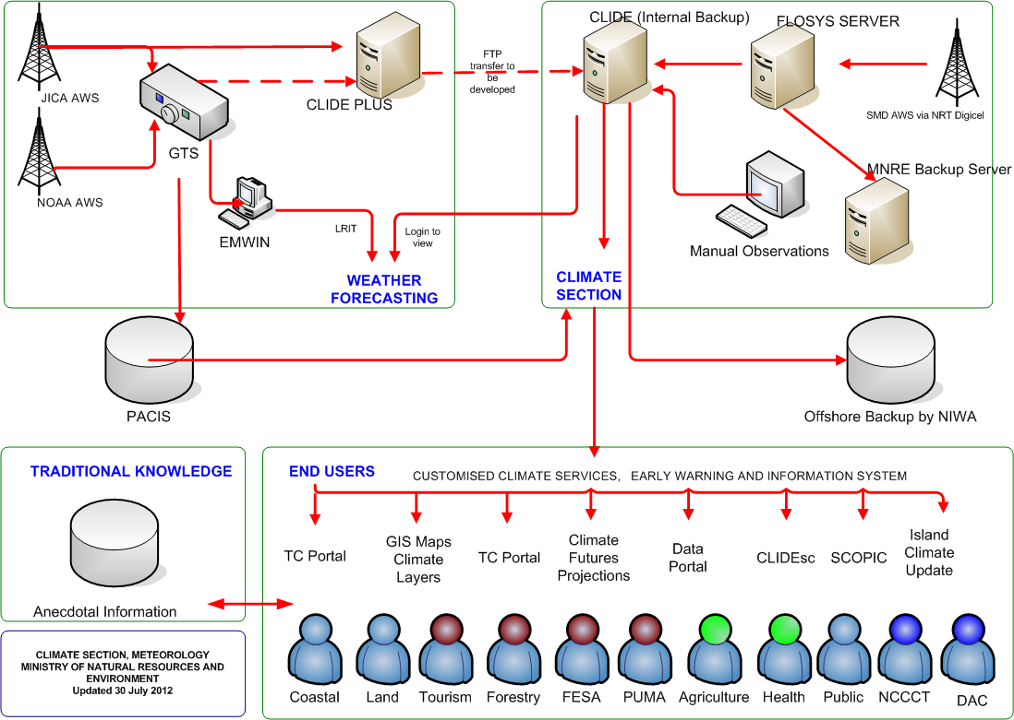

*Figure 1. Climate Early Warning System and Climate Information flow from Meteorology Component to various end users. NAPA 4 stakeholders are identified in red heads.*

The planning that has taken place foresee coordinated implementation with other components so that no duplication or overlaps in activities. This approach will allow expertise in other components that are not available in house to assist with the delivery. This includes the translation of the climate information to the different users within each NAPA 4 sector. These users will have different capacities, therefore education and awareness will ensure that different users understand the communication process of the information, how to understand the information but most importantly, how to apply the information to effectively minimise risk from climate variability and change.

**Climate Early Warning Communication Strategy**

A CLEWS Communication Strategy is also planned in the current work plan. This strategy aims to provide various strategies in which the Climate Early Warning information and report are relayed to different sectors and stakeholders. This will effectively address gaps and weaknesses in the fashion in which CLEWS products and information are provided.

The development of the strategy will involve a range of stakeholders and the capacity building component of the project. The strategy will also determine climate information needs of each sector and how the need can be fulfilled. The needs analysis exercise will allow the Meteorology component to tailor the climate information and reporting to match. Sector engagement workshops proposed will allow us to implement this activity vital to the successful dissemination of the CLEWS information.

This strategy will link into the sectors plans, development strategies that have approved

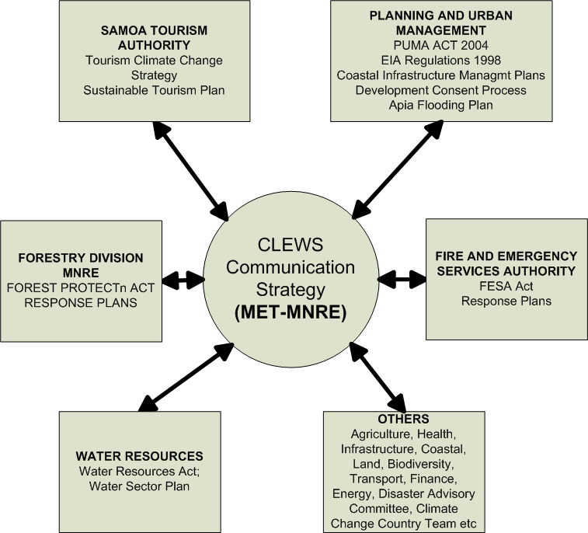

Figure 2. Linkages of the CLEWS Communication Strategy to NAPA 4 stakeholders and others.

**Technical Inspections**

* There were 6 inspections completed (including calibration) of manual rainfall and climate observations stations in Upolu and Savaii completed. The visits are critical to ensure the manual existing rainfall stations are fully operational and free of problems. If a fault is detected, the instrument is fixed or replaced to ensure there is continuity in the data collection hence the need to conduct these monthly visits. The other main objective of these monthly visits is to collect rainfall data from trained representatives in rural communities (village based operators). These rainfall and climate data are vital in the production of climate early warning reports to the end users for instance the “Seasonal Rainfall Outlook or Drought Watch” reports. The data is also used to complete verification study of how the forecasts simulated the observed conditions. This verification study allows us to adjust model projections to simulate climate conditions and improves confidence in the outlook.

The visits generally cover 42 rainfall stations (22 in Upolu and rest in Savaii island), 8 climate and synoptic stations and 4 automatic weather stations across the country. Rainfall, temperature, cloud cover, humidity, wind and extreme maximum and minimum data and statistics collected from 42 trained observers in rural communities.

Table 1. Number of manual rainfall stations across Samoa.

|  |  |  |  |  |
| --- | --- | --- | --- | --- |
| Name | Number of Manual Observations sites | Male  Observers | Female Observers | # of Village Rep trained |
| Upolu Island | 22 | 10 | 12 | 22 |
| Savaii Island | 20 | 9 | 11 | 20 |

The local communities benefit from these visits as there are opportunities for training to enhance their knowledge of climate and weather but also benefit from allowances provide by the government of Samoa. Other benefits to local communities include employment opportunities but also builds there awareness and knowledge of climate change affecting them and their livelihoods. Twelve of the 40 manual rainfall stations will be upgraded into automatic observation systems.

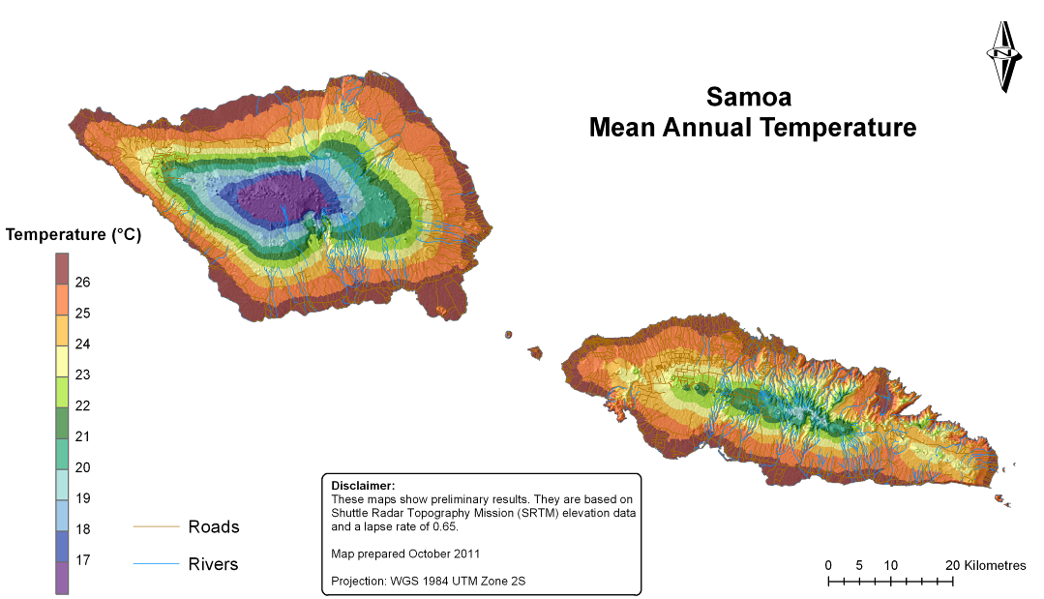The visits provide huge benefits, knowledge of climate in Samoa within each village and district has improved. This is being reflected in the development of rainfall and temperature maps (annual averages). Despite the huge cost that goes into these monthly visits there are massive benefits to better understanding the science of Samoa’s climate but also with the impacts as a result of its variability from day to day and season to season.

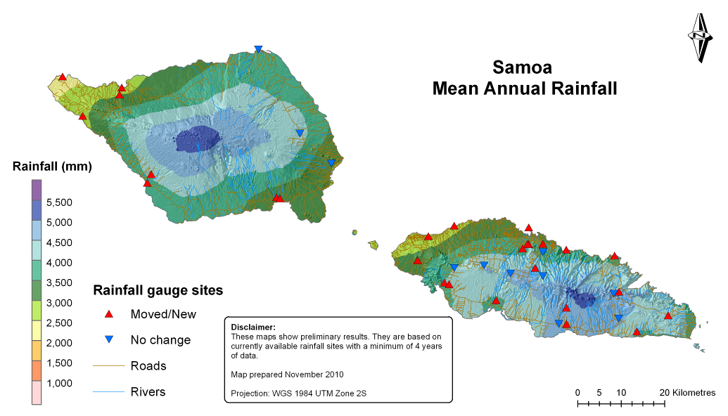

**Training for community based observers**

* Training is always a requirement when it comes to the science of climate as not many understand it to the fullest. For the community-based rainfall observers; training is a requirement as part of the climate monitoring process and selection. The meteorology component is always finding ways and avenues in which training can be done with its stakeholders and the local communities. This goes in hand in had with the science research that is happening. As more knowledge of climate is gain, more also is relayed to the community based observers to increase their capacity and their communities.

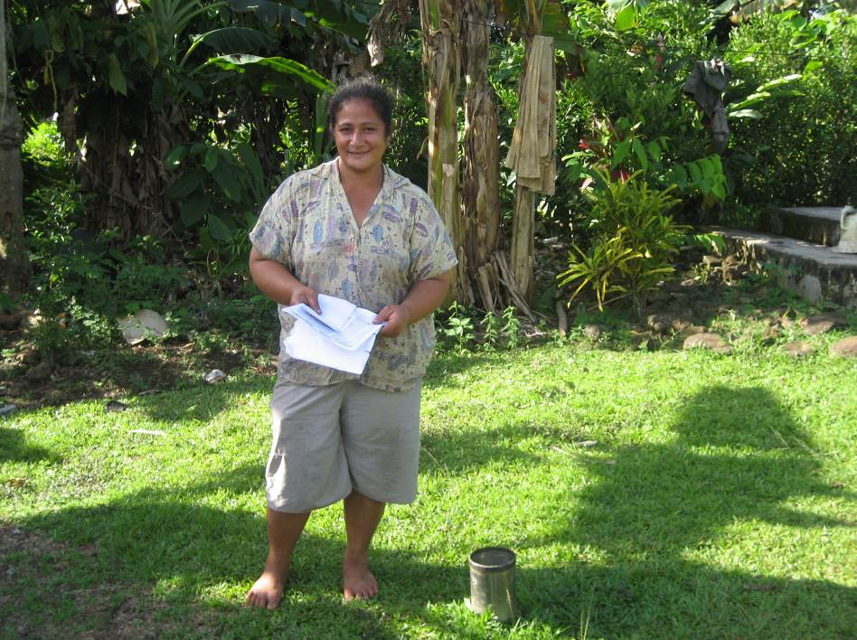

Rainfall Observer at Leauvaa Uta village.

**Technical Training for Forestry Staff**

A separate technical training was conducted for three newly recruited climate observers at Maota climate station. Two of three were forestry officers who deal with forestry management activities in Maota village, Savaii Island. These three recruits will man the climate and rainfall station within the Maota Airport and to take observations by hand on a daily basis.

This creates an excellent link between climate component and forest management component of the project. Building capacity of the forestry officers in the climate of Samoa and micro-climate of Maota itself is a great achievement.

The training included basics on taking climate observations and data recording. Other agenda items included the familiarisation with the climate instruments and recording of climate variables into the climate field books.

**Climate Early Warning Reports**

* Six bulletins of the Samoa Seasonal Rainfall Outlook report distributed to all NAPA 4 users. These bulletins were emailed out to Departmental Heads and Component Coordinators of NAPA 4. These reports provides a detail assessment of the observed rainfall in selected areas across Samoa in comparison to the 30 year average (long-term average or normal from 1971-2000). It also provides a rainfall projection/outlook for the upcoming three months based on current sea surface temperatures anomalies. These three months/seasonal projections are outputs from a climate prediction model developed by the Bureau of Meteorology under an AusAid project known as Pacific Islands Climate Prediction Project (PICPP). This model provides a downscaled output that is village based and is seen as the most suitable resolution for disaster risk reduction and adaptation work. Copies of the Seasonal Rainfall Outlook report can be downloaded from the Meteorology Component website [www.mnre.gov.ws/meteorology/climatesection.html](http://www.mnre.gov.ws/meteorology/climatesection.html).

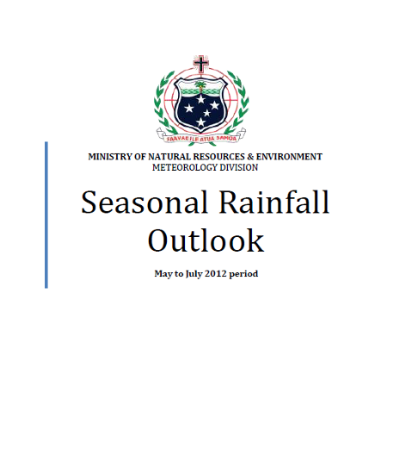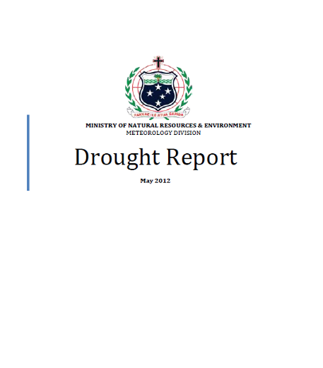

* Two bulletins of the Drought Warning Reports provided to all end users. These reports were issued in April and May 2012. These reports give an assessment of rainfall deficit for selected area across Samoa. The rainfall statistics collected from the technical inspections are used in the calculations of the drought index and generation of the drought reports. Below is a calculation of the Drought Index for Apia, one of the site that is near drought conditions.

**Terms of Reference for Meteorology Consultant**

* A Terms of Reference for consultancy in Installation of Automated Rain gauges around Samoa has been finalised and to be followed by Recruitment and Selection process. Now with the funding made available, this consultancy is to be advertised in the local newspapers and MNRE website shortly. The R&S process will adhere to the guidelines of the Government of Samoa with relevant policies and guidelines. The TOR will also cover the expansion of current climate early warning reports and information system to include the NAPA 4 stakeholders. Consultants to be hired in the current quarter.

**Stakeholders Engagement & Consultations**

* Face-to-face meetings and discussion with NAPA 4 end users on the requirements and needs for customised climate products and information services. Meetings completed included with Amiafolau Afamasaga STA, Susau Siolo, Moafanua-Forestry and Kirisimasi Seumanutafa PUMA.

## Issues and Challenges

The last six months have presented challenges to the implementation of the activities under this component. These challenges were identified during the planning stage of activities and course of implementation at different stages. These issues and challenges are current and potentially to provide resistance to the achievements of the project.

1. **Governance**

The limitation of planning to 12 months plans “Annual Plans” and budgets restricts long-term strategic planning / focus and sustainability of projects activities and thinking. There needs to be a longer term planning document developed for at least three to five years so that the activities are well laid out in a way it flows from year to year. That way, progress and performance can be better monitored ad evaluated. This will remove uncertainty that exist in the implementation of activities that there is possibility funding will be severed prematurely.

1. **Finances**

There are issues with the availability of funds from one instalment to the next. There should be a better way in which this is avoided and not to disrupt the implementation of activities.

1. ***Sustainability***

The installation of automatic rain gauges under this project to expand coverage of climate monitoring to areas those are important to NAPA 4 stakeholders warrants regular and sustained maintenance and calibration. This is critical in the sustainability and best practise and to be in line with Samoa Meteorological Instrument maintenance protocols. This is also consistent with World Meteorological Organisation standards as well. Maintenance and calibration exercise of sensors for different variables for example temperature or wind is to be implemented annually at minimum.

In the planning and risk analysis we have completed, we envisioned that a sudden halting in the provision of funds towards this component to maintain and calibrate these instruments without adequate training and capacity building component attached to the instruments may create problems in the long-term for the meteorology division.

It has been recommended by Ministry of Finance that these activities should be incorporated under the Ministry’s budget next financial year when the funding from AusAid ceases. The Ministry will start negotiations with MOF with regards to these ongoing activities.

## Risk Management

**Customary Land**

There is a risk in the use of customary land to install automated rain gauges, however agreements have been reached with regards to the use of these communal land. Formal lease agreements will also be developed for each of the sites and payment of leases. This may require additional funding in future as its always the experience in other government installations. Taking of Lands Act will employed as a last resort to ensure land issues will not cause any delays in the implementation.

## Work Plan *(next 6months)*

The following table summarise the work plan for the July to December 2012 period.

|  |  |  |
| --- | --- | --- |
| *Activity (derived from Meteorology Component Annual Work Plan 2012)* | *July-Sept* | *Oct--Dec* |
| *Advertisements of Contracts, Expression of Interest, Financial and Technical Proposals etc* | *X* |  |
| *Procure 12 sets of GPRS enabled, automatic rainfall monitoring stations at locations agreed by Met Div, including power supplies, mounting hardware, and installation* | *X* |  |
| *Engage an Expert on Meteorological Equipment installation to supervise installation of a subset of the 12 Automatic Raingauges and provide training to SMD staff to complete balance of sites.* | *X* |  |
| *Hire overseas contractor to conduct a technical instrument maintenance and calibration visit to the new 12 sites and train Climate staff* |  | *X* |
| *Engage Telemetry Expert to commission upgraded rainfall stations and to upgrade FLOSYS communications server to include NEON-FLOSYS WEB based communications server and interface.* | *X* |  |
| *Commission NEON Web enhancement to display data from rainfall and climate stations in near real time, including one-off software development licensing fee.* |  | *X* |
| *Hire Expert to develop GIS capability at Samoa Met Division to support mapping of Climate Elements such as rainfall, temperature, winds etc to customised requirements of the sectors* | *X* |  |
| Hire expert to develop Climate Services applications (CLIDEsc) from the Climate Database for Tourism, PUMA, FESA and Forestry. | *X* |  |
| Development and Conduct public awareness on seasonal rainfall prediction and drought monitoring tools and reports | *X* |  |
| *Consultation workshops for Rainfall Observers in Upolu and Savaii* |  | *X* |
| *Quarterly site inspection to Upolu and Savaii to supervise progress of implementation* | *X* | *X* |
| *Purchase Digicel Data Plans for 12 new sites/telemetry fees* | *X* |  |
| *Construction of security fencing around the 12 new auto-raingauges* | *X* | *X* |
| *Acquire office equipment for project use; maintenance of office equipment* | *X* |  |
| *Quarterly site inspection to Upolu and Savaii to supervise progress of implementation* | *X* | *X* |

*Report submitted by: Fata Sunny Seuseu Meteorology Coordinator*

**COMPONENT B - SURFACE WATER FLOODING, Planning and Urban Management Agency**

**Outcome 2** - Strengthen capacity of Samoa's planning sector to adapt to impacts of climate change.

**Background**

# Samoa’s National Action for Adaptation Framework 4 (NAPA 4) identified that long term solutions targeted towards land use planning creates a comprehensive and integrated approach to address the built environment’s resilience to climate change.

In 2004 the Government of Samoa adopted NAPA 4. It is a cross sectoral initiative that include climate, planning, water resources, forestry and tourism to address climate change adaptation.

The surface water and flooding component in particular is aimed at strengthening the planning system through developing a strategic framework to base development and investment decisions around climate change. The benefits are considered to be far reaching particularly targeting the Apia urban community’s environmental, social and economic well being.

# The total allocation to this component for the FY 2010/2011 is AUD$341,512.00

# Key Achievements

**Output 2.1: Project Management Office and Support Services**

The Agency’s Strategic Planning Section is responsible for overall project control, monitoring and evaluation. Regarding project execution the Strategic group have been assisted by the BECA International Consultants Ltd (NZ) (“the Consultants”) however full project tasks and work assignments have been integrated into the Strategic group’s operational workload.

**Output 2.2 Spatial Plan to incorporate Climate Change**

The draft Apia Spatial Plan (ASP) was developed and submitted by the Consultants to the Agency on 7 February 2012. The Agency reviewed the document for quality and verification.

The technical reports include:

* Draft Apia Spatial Plan.

**Output 2.3 Surface Flood Adaptation Strategy**

The technical reports include:

* Draft Surface Flood Adaptation Strategy;
* Draft Local Area Pilot Project Report; and
* Draft Apia Vulnerability and Adaptation Assessment.

The Flood Adaptation Strategy (‘the Strategy’) was submitted on 15 February 2012. The Agency reviewed the document for quality and verification.

The draft Local Area Pilot Project Report (LAPP) proposed improvement actions to improved flood management in the pilot project area. Furthermore it outlines priority actions and proposes execution plan for the implementation of works. The Agency reviewed the document for quality and verification.

**Output 2.4 Education and Awareness Program**

No progress to report.

**Output 2.5 Quality Planning Tools and Procedures for Improved Operations**

This output has been ear-marked for FY 2012/13 to procure services of an Institutional Specialist to assist organisational support mechanisms.

**Field Visit**

On 28 June 2012 representatives of the Agency, AusAID, and SOPAC carried out a site meeting at the outlet of the Vaisigano River. The purpose was to discuss progress, project issues and strategic opportunities in executing the remaining tasks for the project.

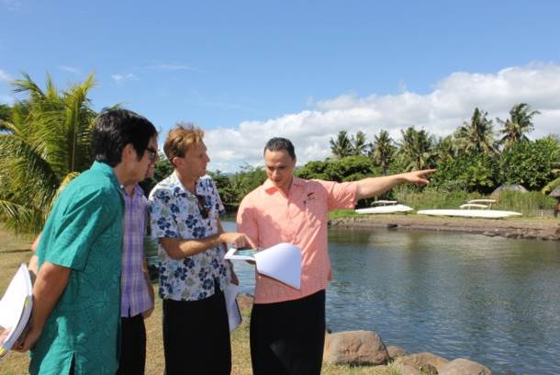

Figure 1: PUMA, AusAID, and SOPAC Site Visit, Vaisigano River

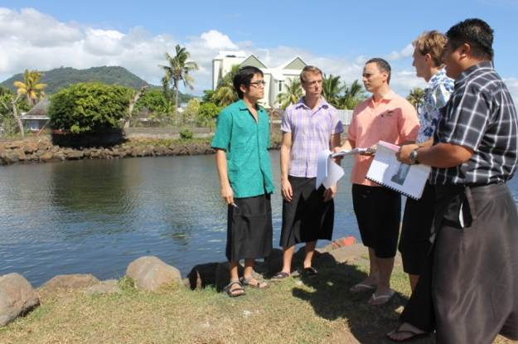

Figure 2: Site Discussions, opposite Aggie Greys Hotel

Issues and Challenges

Public Consultations

The primary issue that was a concern during the development of the draft documentation was the lack of wide public consultation. The outcome of the project is unique and has long lasting implications to the future urban development of the greater Apia area in light of growth pressures, economic development; and climate change. The degree of consultations required has been shifted to the next upcoming months to complete the scope of works required.

Outstanding Trainings

The capacity building component has been highly beneficial in up-skilling the Planning and Urban Management Agency staff on topics such as urban design, flood assessment, spatial planning, and structure planning. These professional training’s and on-the-job mentoring has improved employees consideration of climate change impacts, spatial analysis, and wider urban planning consideration in there regulatory and policy roles. Some specific training were not covered as planned, they include geotechnical, codes of environmental practice. Other trainings were identified and are to be carried forward.

Standard Operating Procedures (‘SOP’)

The development of SOPs is identified as critical; however this is being scheduled in the upcoming months. The primary purpose is to create greater certainty for officers to administer the process consistently and fairly; but also to establish transparency so that the delivery of the public service is certain about the level of service expected.

**Risk Management**

Project Scope

Resources have been assigned responsibility of the remaining tasks to ensure that the project still achieves the planned targets.

Work Plan FY2012/13 (attached.)

*Report Submitted by: Tagaloa Jude Kohlhase*

*ACEO PUMA*

|  |  |  |  |  |  |  |  |  |  |  |
| --- | --- | --- | --- | --- | --- | --- | --- | --- | --- | --- |
|  | | | |  | | | | | | |
| **NATIONAL ADAPTATION PROGRAMME OF ACTION** | | | | | | | | | | |
| **SAMOA AND AUSTRALIA PARTNERSHIP DEVELOMENT PROGRAMME** | | | | | | | | | | |
| **Ref** | **TASKS** | | | | **ACTIVITY** | **SUB-ACTIVITIES** | **QUARTER 1** | **QUARTER 2** | **TOTAL** | **JUSTIFICATION/COMMENTS** |
| **COMPONENT B - SURFACE WATER FLOODING, PUMA, MNRE – 2012/2013** | | | | | | | | | | |
| **Outcome 2 - Strengthen capacity of Samoa's planning sector to adapt to impacts of climate change** | | | | | | | | | | |
| **Output 2.1 - Project management office and support services established and maintain** | | | | | | | | | | |
| 1 | Maintenance of project management office | | | |  | Stationery for project unit administration | 3,000.00 |  | 3,000.00 | Office stationery, equipment and others for maintaining project unit operations |
|  |  | | | |  | **Sub-total** | **3,000.00** | **-** | **3,000.00** |  |
| **Output 2.2 - Spatial plan to incorporate climate change developed** | | | | | | | | | | |
| 2 | | Revise draft and implement methodology to complete spatial plan for greater Apia | | | Set priorities to allow better coordination of urban policies and infrastructure developments | Preparation for Community/Stakeholder Consultations on developing the spatial plan |  | 5,000.00 | 5,000.00 | Continue wide consultation throughout to secure and maintain the support and co-operation of infrastructure providers, public authorities, etc in the implementation of the Spatial Plan. |
| 3 | | Revise vulnerability and adaptation assessment for urban flooding areas | | | Use existing vulnerability assessment tool to assess vulnerability levels of urban area to flooding | Stakeholder workshop (2) |  | 2,000.00 | 2,000.00 | Conducting a vulnerability assessment will identify zones in urban area and their level of vulnerability. |
|  | |  | | |  |  | **-** | **7,000.00** | **7,000.00** |  |
| **Output 2.3 - Flood adaptation strategy 2012 - 2017 developed** | | | | | | | | | | |
| 4 | | Review and Finalise Draft Flood Adaptation Strategy | | | Review and finalise hydraulic modelling of urban flooding to develop background information for the strategy | Community consultation on Strategy |  | 6,000.00 | 6,000.00 | Baseline information will include assumptions, constraints, and medium and long term aspirations to base strategy objectives, project actions, streamlining climate change information into standard operating procedures for development control, and guidelines for adaptation measures |
| Develop and steamline climate change information into development control standards and guidelines. | Prioritise and develop standards for adaptation measures. |  |  |  |
|  | |  | | |  |  | **-** | **6,000.00** | **6,000.00** |  |
| **Output 2.4 - Education and awareness program on flooding and urban drainage issues developed and implemented** | | | | | | | | | | |
| 5 | | Continue implementation of urban drainage education and awareness programme | | | Continue implementing education and awareness programmes on wide-drainage and on-site drainage issues | Reprinting |  | 5,000.00 | 5,000.00 | Public education and awareness is critical to adapting to flooding caused by climate change. |
| media awareness (tv, radio, newspaper) | 5,000.00 | 5,000.00 | 10,000.00 |
|  | |  | | |  |  | **5,000.00** | **10,000.00** | **15,000.00** |  |
| **Output 2.5 - Quality planning tools and procedures to assist operations of the Planning and Urban Management Agency** | | | | | | | | | | |
| 6 | | | Procure an Institutional Development Advisor | | Hire an Institutional Development Advisor | Finalise TOR for Institutional Specialist Carry out research on urban development issues in relation to climate change and incresing environmental pressures |  | 30,000.00 | 30,000.00 | Institutional Development Advisor will provide planning advise and undertake research to strengthen the capacity and enhance quality performance of the Planning and Urban Management Agency |
|  | | |  | |  |  | **-** | **30,000.00** | **30,000.00** |  |
|  | | |  | |  | **Grand Total** | **8,000.00** | **53,000.00** | **61,000.00** |  |

**COMPONENT C - GROUND WATER, Water Resources Division**

**Outcome 3** - Establishing the capacity of Samoa's water resource managers and GIS planners to identify the impact of climate change on groundwater resources.

**Background**

The current NAPA 4 project, funded by the AusAID, is one of the priority outcomes from the overall Samoa Climate Change Synthesis Report: ***National Adaptation Programme of Action 2004***. In formulating this report, a countrywide consultation was done to rank what most communities conveyed as the most crucial climate change impact. The securing of water resources for local communities was ranked number one by locals as the most prioritized and vulnerable issue especially along the coastal settlements.  Furthermore, the National Water Resource Master Plan by Rofe, Kennard and Lapworth in 1996 which highlighted the mass distribution of water springs along the coastal areas whereby villages heavily relied for essential daily consumption. However, climate change and sea level rise threatens this resource through sea water intrusion into coastal springs. Sea water intrusion into water springs along the coastal areas has numerous adverse effects. Some coastal villages have reported increased sea water in their local springs. Reports and studies have revealed that sea water has strong connections with diarrhoea disease, which is not new to our shores.

The overall goal is to install at least 20 monitoring bores for Upolu. It will provide the project with sufficient quantitative and qualitative information regarding ground water quality profiles, freshwater column thickness as well as groundwater flows and recharge during the wet and dry season. Monitoring boreholes also monitor salt water intrusion and other pollution sources into the water table as impacts of sea level rise and various human activities affecting all water sources. Lastly, production boreholes abstraction rate will also be monitored for determining and reconfirming safe yields of various localized ground water basins. It is indeed a vital project and amongst the first ground water monitoring network in Samoa.

**Key Achievements**

The project for the past six months undertook one of its main objectives in the installation of ground water monitoring stations on selected sites around Upolu. The success in the installation of these stations is the outcome from intensive site survey, quantitative and qualitative data collection and also core drilling.

The four following sites were successfully drilled and the installations of monitoring stations were also completed. Geology formations and elevation highly dictate the amount of time spent on drilling each site. The maximum is the Mulifanua site which took two months to drill excluding months of continuous monitoring before the installations. The completed sites are;

1. Vaitele tai
2. Faleasiu
3. Leulumoega
4. Mulifanua

Secondly, a one major multi-skill training was carried out from the period of March to May by an Australian TA to further assist our drilling and hydrology team in drilling skills, bore well design and ground water monitoring station installations.

The following will further elaborate on the aforementioned major activities.

**Drilling Program for Monitoring Bore Holes**

We have already drilled and collected baseline data from installed monitoring borehole stations at Mulifanua, Leulumoega, Vaitele and Faleasiu sites on the western side of Upolu. These monitoring stations will monitor salt water intrusion into various aquifers as a result of sea level rise and ground water abstraction. The installation for each borehole involves a lot of technical skills such as drilling works, geological analysis, hydrological monitoring, borehole design and construction and piezometers installation. Figure 4 shows the installation of special monitoring pipes or (piezometers). Figure 5 showcase a complete monitoring station. Three piezometers monitored boundaries between fresh water, brackish and sea water bodies respectively.

**Capacity Building**

The drilling works in the past, faced challenges as it took months to complete one site due to machinery break down, run out of consumables parts, etc. Therefore an investment in the capacity building of the local drilling personnel to upgrade skills in borehole drilling resulted in effective equipment maintenance. Technical knowledge and drilling skills were shared by Mr Romano Grande, an Australian TA contracted to provide assistance. He is also currently an active member of the Australian Drilling Association.It was the first time for such a training of this sort in Samoa specifically focusing on;

**OUTCOMES PHASE 1 – (2 WEEKS)**

1. Assessment of current available drilling rigs capacity and available tools;(SWA, SLC and MNRE)
2. Assessment of current staff human resource capacity;
3. Assessment of drilled sites;
4. Drafting a drilling training manual specifically that will suit Samoa’s current situation and future prospects;
5. Assessing on the job health and safety for all staff.

**OUTCOMES PHASE 2 – (6 weeks)**

1. Occupational Health and Safety training for all rig crews (SWA, SLC and MNRE). It was well supported by the MCIL  responsible OHS Division as it is a first in Samoa and will further assist their current scheme;
2. Theoretical training in drilling methods, problem solving, equipment control etc both in the office and out in the workshops;
3. Practical – Groundwater Borehole design and installation demonstrations at Vaitele and Togitogiga site;
4. Mechanical and engineering.

**Public and School Awareness Program on Ground water and climate change**

Educating the younger generation on the importance of groundwater and water catchment areas is significant to the sustainable development of this critical resource in the future. As such, vital information about climate change and ground water was put out during the Watershed Section school awareness program for students both in Upolu and Savaii. Also, continuous contribution and active participation on newspaper articles such as the Samoa Observer Sunday issues and other media programs increases community awareness on the overall goal of this project.

## Issues and Challenges

1. **Governance**
2. **Finances**

* Funding assistance was sourced from the Water Sector Support Budget to cater for some of the project activities to await funding negotiations between the Government of Samoa and Australia.

1. **Sustainability**

* The importance of the project requires ample time to fully installed monitoring stations to determine future concrete and solid decisions by the Authorities. It is expected by 2015, the monitoring bore hole installations program will be completed and extensive information will be available to determine;
* Overall underground water capacity and quality;
* Recharge rates during wet and dry season;
* Yielding and extraction rates;
* Pumping rates, etc.
* Pollution

1. **Gender Equality**

* There is a fair balance in terms of gender equity within the project. The technical and analyst staff members include both males and females. The nature of the drilling works involved heavy equipments hence the all males in the drilling team.
* The female staffs in the hydrology team collect and analyse the data for updated reports.
* The active participation by village women committees in awareness programs, as well as the support of chiefs during drilling works is also noted.

**RISK MANAGEMENT**

One of the major risks involved in this project is the lease of customary lands where monitoring stations are located. The normal process will take months for a lease to be executed. The works at one of the site had to be on hold for a few months as family members solved some internal issues regarding lease and land ownerships. Currently, the matter has been resolved and works continued and completed. The land lease process through proper channels is now in progress.

**5. Annexes**

*5.*1 Drilling works and Monitoring Borehole Installation images

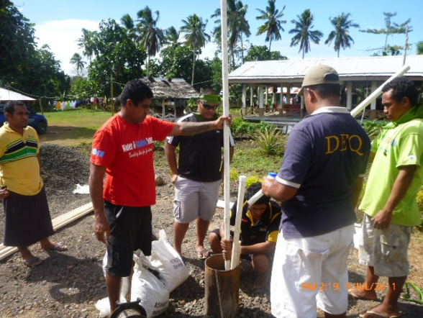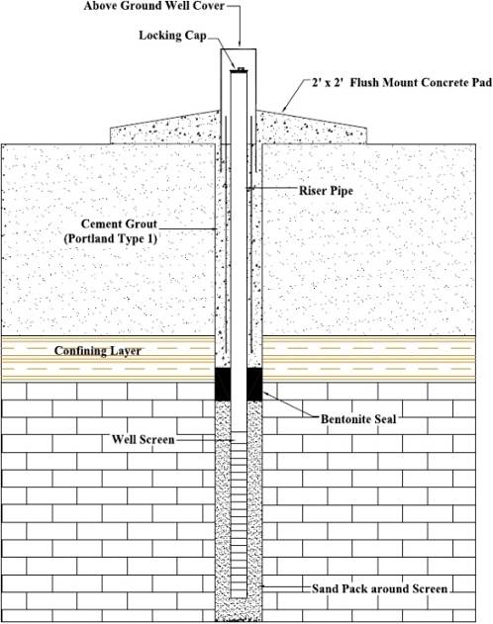

**Figure 3: Vertical view of monitoring station**

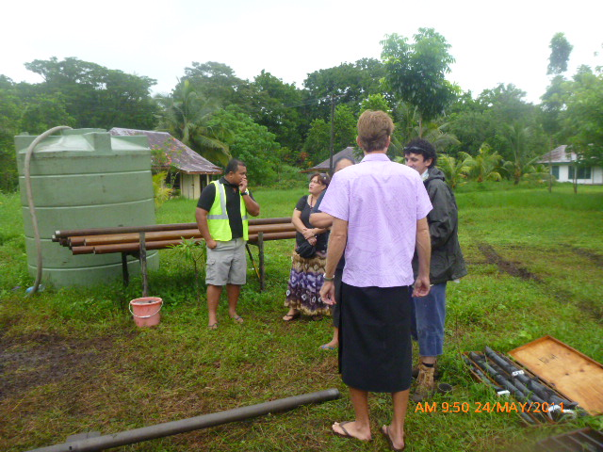

**Figure 4: AusAID visit to Togotogiga site**

**Figure 5: Water Resource Division – Leulumoega installation**

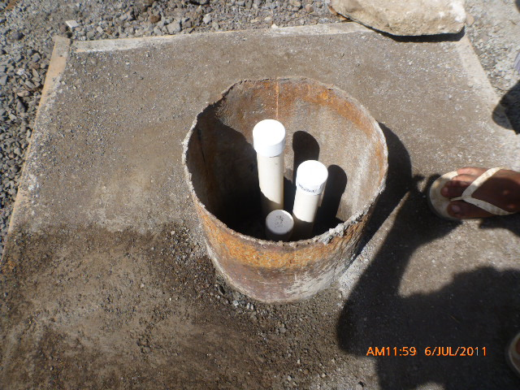

**Figure 6: Complete Monitoring Borehole.**

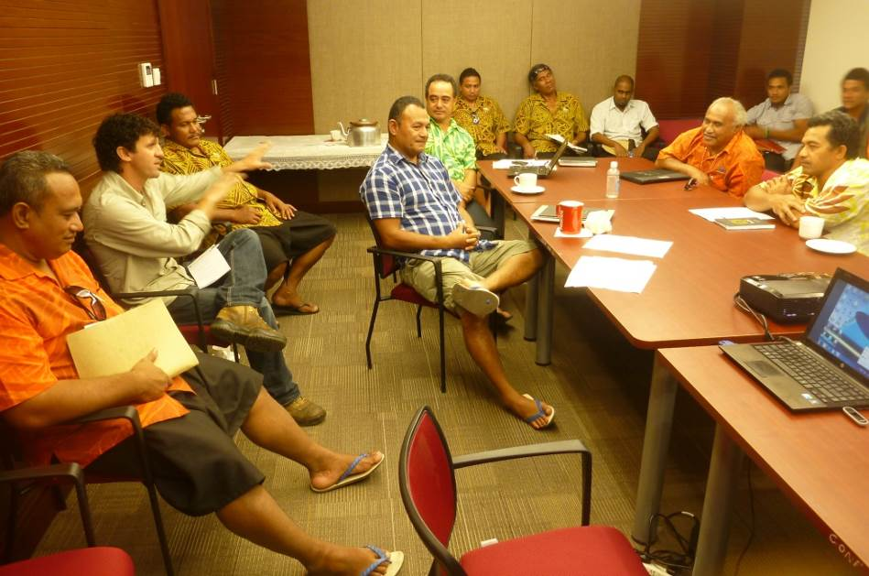

Figure 7: Participants of drilling and borehole design training – theory component

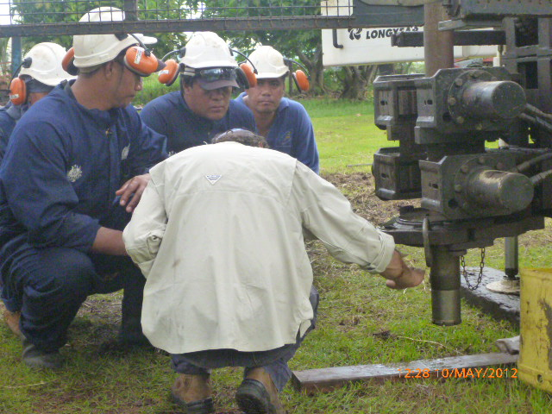

Figure 8: Participants of drilling and borehole design training – practical component

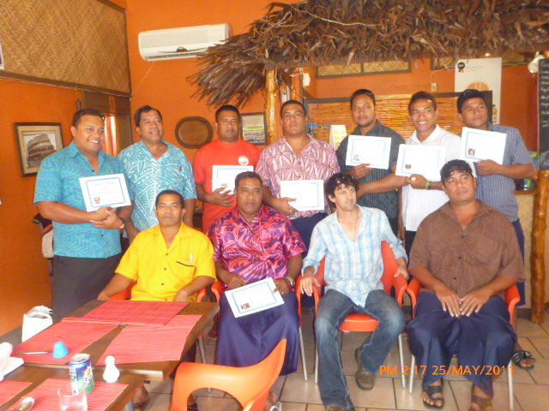

Figure 9: Graduates of the first drilling and borehole design training.

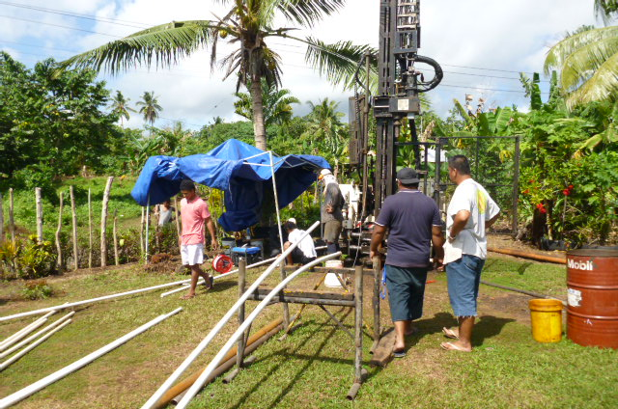

Figure 10: Monitoring borehole drilling and installation at Faleasiu.

***Report Submitted by*** *– Suifua Faamatuainu*

*Water Resources - NAPA4 coordinator*

**COMPONENT D - FOREST FIRE PREVENTION, FESA**

**Outcome 4**:- Strengthen Samoa's fire prevention and suppression capacity to reduce the impact of climate change on native forests and forest plantations during drought periods.

**Background**

The forest fire component is one of the key components of the NAPA4 Implementation Strategy. The overall outcome of this component is to strengthen the capacity of Samoa’s forest fire managers and GIS planners to reduce the impact of climate change on native forests during periods of drought and long dry spells.

The outputs to achieve this outcome include:

* Output 4.1 National forest fire prevention strategy 2010 – 2015 developed and implemented
* Output 4.2 Public awareness on forest fire adaptation planned and implemented
* Output 4.3 Forest fire prevention mechanisms developed and implemented
* Output 4.4 Volunteer forest fire system established
* Output 4.5 Forest fire prevention exercises conducted
* Output 4.6 Project management

The total fund earmarked for this component is $332,512.91 Samoan Tala under Phase 1 and $666,134.20 Samoan Tala budgeted for the 2012 – 2013.

**Key Achievements**

The achievements under the different outputs in the last six months are listed as follows:

* **Output 4.1**: National Fire Strategy developed and implemented

As stated in the progress report for March 2010 to December 2011, the strategy is given first priority for this next tranche of funds. FESA is liaising with the Metropolitan Fire Brigade (MFB) and Country Fire Authority (CFA) to identify two specialists one from MFB and one from CFA who is well versed with forest fires related policies to develop the strategy in collaboration with FESA, DMO, Forestry and other relevant national and local stakeholders.

* **Output 4.2**: Public awareness on forest fire adaptation planned and implemented

Thirteen village communities in the most vulnerable areas of Samoa have received in August – September of 2011 awareness programs to reinforce the messages of forest fire prevention and raise awareness on climate change impacts on forests and how these impacts increase vulnerability to fires especially during the dry season as well as the legal framework that governs forest fire prevention.

FESA continues to develop advertisements that promote forest fire prevention to complement the community awareness programmes conducted in 2011. These advertisements are currently being funded under ACC financial assistance to FESA for public awareness on fire hazards prevention.

* **Output 4.3**: Forest fire prevention mechanisms

The Asau station is 95% complete. The remaining works to be done to complete this station is the roof, gate and install the siren. FESA and DMO are planning to complete these remaining works and open the station before the end of September 2012.

FESA is currently recruiting twelve fire fighters for Asau Station including two fire fighters who have been recruited in late 2011. All staff recruited will be paid under FESA local budget.

Costing of required materials and labour to build Maota Station is currently being compiled by FESA.

The bulk of forest fire suppression equipment have been procured and fitted out for use by the stations. However there are still critical equipment, tools and forest fire response vehicles that need to be procured in the next six months.

* **Output 4.4:** Volunteer forest fire systems established

We started promoting volunteering as a fire fighter at the community awareness programs however we still need to do more awareness raising to promote this concept, register volunteers from the communities and train them. Once the Asau station is officially opened, then the staff will work to establish volunteers from all the villages located close to Asau to support the staff at this station.

The Forestry staff of MNRE based at Asau has also been identified to assist the FESA in preventing and suppressing forest fires.

* **Output 4.5**: Forest fire prevention exercises conducted

The planning and implementation of forest fire prevention exercise has not been undertaken due to the fact that the fire stations needs to be constructed, equipped and manned. Volunteers need to go through the process of recruitment and training before exercises can be conducted. It is envisaged that the initial series of exercises will be undertaken once Asau station is fully functional and that a group of volunteers is established.

It is also important to note that exercising is not limited to the timeframe of this project as it requires on-going implementation to test skills, familiarize new recruits for both volunteers and permanent staff and other stakeholders.

* **Output 4.6**: Project management

The management of the forest fire project component is undertaken using existing FESA staff mainly the Executive Staff. The DMO assists FESA through the provision of technical expertise in reporting, consultations, awareness programmes, training and other capacity building areas and the Forestry on forest areas that vulnerable to forest fires.

Since the inception of this project, 16 site and supervisory visits were undertaken in 2011 mainly by FESA. This year, about 3 site visits were undertaken by FESA to work out the costing for the remaining works to be undertaken to complete Asau and also to look at land preparation for the Maota Fire Station and check the suppliers located in Savaii to see if they have all the building materials needed for the construction of Maota Fire Station.

The Climate Change Unit of the MNRE also visited the Asau station during the community consultation held in August 2011 to check the progress of the construction phase. In addition, the Parliament Development Committee and the Cabinet Development Committee have also conducted development inspections throughout 2011 and 2012 to check the progress of all development projects undertaken throughout the country.

Both FESA and DMO attended meetings of the National Steering Committee (NSC) and have presented progress reports to the NSC and the Climate Change Unit.

There will be more site visits including one by the NSC once the construction of the Asau Fire Station is completed.

## Issues and Challenges

1. Governance

* None

1. Finances
2. Sustainability

* The FESA has included in its local budget the cost of personnel to man the new fire stations constructed under this project. The same applies for the cost of operating the stations to enable it to provide forest fire prevention and suppression.

1. Gender Equality

* This project involves both male and female employees of FESA and DMO. The recruitment of staff to man the new fire stations is open to both male and female. So far there are no gender equality issues.

## Risk Management

The project acknowledges the presence of the following risks and identified actions to address these risks.

**Achievement of deliverables within project timeframe**

There is a risk of not being able to achieve all the outcomes of the project within the timeframe of the project. To address this risk, the project technical team meets on a fortnightly basis to look at the progress, identify issues that might affect progress and address them. The project technical team comprised of the FESA Executive, and one representative each from the DMO and Forestry Divisions of the MNRE.

**Availability of staff**

The implementation of this project requires staff time to lead the implementation of the project as well as providing guidance and supervisory during implementation. The risk is that key staff might not be available at critical periods of the project implementation due to other work commitments. This risk will be addressed by ensuring that proactive pre-planning takes place to ensure that key staff is available at certain critical time periods of the project implementation.

**Insufficient funds**

The budget identified to fund the implementation of the project is based on estimates and there is a risk that the required activities might not be feasible given the total budget allocated. To address this risk, the project technical team has prioritized key activities to focus implementation on and for long term activities to be implemented using other sources funds.

***Report Submitted by*** *– Fire and Emergency Services (FESA)*

## Work Plan *(next 6months)*

This work plan has been developed based on the following aspects:

1. Order of priority and feasibility – the activities planned to implement within this six months are based on the fact that their completion is a pre-requisite to the other activities that will be implemented afterwards. For example, upon completion of the Asau Station, the fire fighters will be trained on forest fire prevention and suppression and also use of the forest fire suppression equipment and tools. Afterwards then the forest fire volunteers will then be selected and trained.
2. Financial resources available – in light of the amount of funding available under the project and the fact that this project will end in 2013 without renewal, the project technical team focus on the national forest fire strategy and the construction of the forest fire stations.

**Table 1: Work-plan for the next six months Aug 2012 - Jan 2013**

|  |  |  |  |  |  |  |  |
| --- | --- | --- | --- | --- | --- | --- | --- |
| **ACTIVITIES** | **TASKS** | **Aug** | **Sept** | **Oct** | **Nov** | **Dec** | **Jan** |
| **Outcome 4.1 National forest fire prevention strategy developed** | | | | | | | |
| Develop the nation forest fire prevention strategy | 1. Negotiate with the MFB to identify specialists in forest fires to lead the development of the strategy in collaboration with FESA and DMO and consult NSC and MoF on the arrangements; and develop a ToR for the specialists to develop the strategy |  |  |  |  |  |  |
|  | 1. Develop the plan for the development of the strategy including consultations and one-to-one meeting schedules |  |  |  |  |  |  |
|  | 1. Conduct consultations and develop the draft strategy |  |  |  |  |  |  |
|  | 1. Present final strategy to NSC, finalize and submit to Cabinet for endorsement |  |  |  |  |  |  |
| **Output 4.2 Public awareness on forest fire prevention planned and implemented** | | | | | | | |
|  | 1. Develop a documentary (15 minutes) on climate change impacts and forest fires? |  |  |  |  |  |  |
|  | 1. Community consultations for the development of the forest fire strategy to include awareness raising |  |  |  |  |  |  |
| **Output 4.3: Forest fire prevention mechanisms developed and implemented** | | | | | | | |
| Construction of fire stations | 1. Completion of Asau station (including construction of new roof, installation of blinds, gate and siren) and official opening of the station |  |  |  |  |  |  |
|  | 1. Construction of Maota Station  * land preparation, design of station and costing of materials and labour and procurement of construction labour services to construct the station * Construct Maota station |  |  |  |  |  |  |
| **Output 4.4 Volunteer forest fire system established** | | | | | | | |
| 1. Volunteer fire fighting systems | Identify and consult 2 villages in North West part of Savaii e.g. Asau and Aopo to identify and establish forest fire volunteers teams |  |  |  |  |  |  |
|  | Plan and conduct trainings for volunteer forest fire fighters |  |  |  |  |  |  |
|  | Identify other villages to replicate the same initiative and include lessons learned from the pilot setup to improve |  |  |  |  |  |  |
| **Output 4.5: Forest fire prevention exercises conducted** | | | | | | | |
| Implement forest fire prevention drills | Develop a simulation schedule for Asau Station |  |  |  |  |  |  |
|  | Plan including the development of simulation manual for planned simulations and conduct 2 simulations to test skills of trained Asau Station staff and the first two teams of volunteers from the first two pilot villages |  |  |  |  |  |  |
| **Output 4.6: Project management** | | | | | | | |
| Project management | Meeting of the technical team (FESA and DMO) – every fortnight |  |  |  |  |  |  |
|  | Site visits – weekly visits to Savaii to supervise Asau and Maota construction including the official launch of the Asau Station |  |  |  |  |  |  |
|  | Procurement of office equipment for the Asau Station |  |  |  |  |  |  |

Table 2: Budget for the next six months from Aug 2012 – Jan 2013

|  |  |  |  |  |
| --- | --- | --- | --- | --- |
| **ACTIVITIES** | **Particulars** | **Estimated Cost (SAT)** | **Total Estimated Cost (SAT)** | **Comments** |
| **Output 4.1: National forest fire prevention strategy developed** | | | | |
| Develop the nation forest fire prevention strategy | 1. Cost of two personnel from MFB and Country Fire Authority Australia:  * Airfare – 2 x $2,200 return * DSA to cover accommodation, meals and incidentals - $250 USD per day per person for an estimated period of 40 working days | $4,400.00  $22,000.00 | $26,400.00 |  |
|  | 1. Community consultations:  * Sites: 4 consultations in Savaii, 2 in Upolu targeting only forest areas that are vulnerable * Catering - $5000.00 per consultation * Cultural costs per site (ava - $600.00, faaaloaloga - $1000.00) * Transportation (ferry costs for vehicles and personnel including fuel)   + Savaii - $4,500.00   + Upolu - $1,500.00 * Accommodation for facilitators of about 10 people estimated @ $4500 per site consultation in Savaii only. Facilitators for Upolu consultations will commute | $30,000.00  $9600.00  $6,000.00  $18,000.00 | $63,600.00 |  |
|  | 1. Printing and distribution of endorsed strategy   (Launch of the strategy can be done together with the opening of the Maota Station) estimated cost of printing including layout and design is $60 per strategy, total amount of strategies to print is 200 documents | $12,000.00 | $12,000.00 |  |
| **Sub-Total** |  |  | **$102,000.00** |  |
| **Output 4.2: Public awareness on forest fire prevention planned and implemented** | | | | |
|  | 1. Develop a documentary (15 minutes) on climate change impacts and forest fires | $25,000.00 | $25,000.00 |  |
|  | 1. Community consultations for the development of the forest fire strategy to include awareness raising | Included in the cost of community consultations to develop the strategy |  |  |
| **Sub-Total** |  |  | **$25,000.00** |  |
| **Output 4.3: Forest fire prevention mechanisms implemented** | | | | |
| 1. Construction of fire stations | 1. Completion of Asau station (including construction of new roof, installation of blinds, gate and siren) and official opening of the station:  * Roof - $17,000.00 | $17,000.00 | $17,000.00 |  |
|  | 1. Construction of Maota Station  * land preparation – $30,000.00 per station * design of station - FOC * cost of materials - $93,000 per station * Transportation of materials * Labour - $50,000,00 per station | $30,000.00  0  $93,000.00  $16,000.00  $50,000.00 | $189,000.00 |  |
| Specialized equipment | 1. Procurement of specialized equipment  * 2 x bladders of 38,000 litres @$9,400.00 * 2 x buildings to house the bladders in selected sites within Asau Forestry plantations areas:   + 7 meters by 7 meters, height is about 1.5 meters high estimated cost per building is $12,000.00 | $18,800.00  $24,000.00 | $42,800.00 |  |
| **Sub-Total** |  |  | **$248,800.00** |  |
| **Output 4.5: Forest fire prevention exercises conducted** | | | | |
| Volunteer fire fighting systems | 1. Identify and consult 2 villages in North West part of Savaii e.g. Asau and Aopo to identify and establish forest fire volunteers teams (this will also be covered during the community consultations) | Cost covered in community consultations | 0 |  |
|  | 1. Trainings for volunteer forest fire fighters:  * Catering for a maximum # of volunteers estimated at 40 people @ $20.00 Tala for all meals for 5 days * Accommodation and meals for Trainers from Apia Fire Station $180.00 per person for two people * Transportation to and from Savaii @$250 for one return trip | $4000.00  $1800.00  $250.00 | $6,050.00 |  |
| **Sub-Total** |  |  | **$6,050.00** |  |
| **Output 4.5: Forest fire prevention exercises conducted** | | | | |
| Implement forest fire prevention drills | 1. Develop a simulation schedule for Asau Station | 0 |  |  |
|  | 1. Plan including the development of simulation manual for planned simulations and conduct 2 simulations to test skills of trained Asau Station staff and the first two teams of volunteers from the first two pilot villages | $5,000.00 | $5,000.00 |  |
| **Sub-Total** |  |  | **$5000.00** |  |
| **Output 4.6: Project management** | | | | |
| Project management | 1. Meeting of the technical team (FESA and DMO) – every fortnight | 0 |  |  |
|  | 1. Site visits – weekly visits to Savaii to supervise Asau and Maota construction:  * 10 site visits @ $800 per site visit including transportation, accommodation and meal costs * Official opening of the Asau Station:   + Catering for 150 people @$50 per head   + Accommodation and meals for Technical Project Team (6 people) and National Steering Committee members (10 people) @$180 per person, two nights in Savaii   + Transportation costs for 5 vehicles @190 return per vehicle | $18,000.00  $7,500.00  $5,760.00  $950.00 | $32,210.00 |  |
|  | 1. Office equipment for Asau Station:  * 1 computer * 1 printer * 1 telephone line and extensions * Stationeries * 2 x sign board * 4 x stickers and repainting of vehicles with forest fire appliances colours | $6000.00  $4000.00  $4000.00  $1500.00  $6000.00  $2500.00 | $24,000.00 |  |
| **Sub-Total** |  |  | **$56,210.00** |  |
| **Total Budget** |  |  | **$443,060.00** |  |

**COMPONENT E - Samoa Tourism Authority**

**Outcome 5**: Capacity of Samoa's tourism resource managers and climate change task force strengthened to reduce the impact of climate change on tourism resources.

# Background

# The main goal of the Samoa – Australia Partnership for Development Project is *“to safeguard human development in Samoa from risks associated with climate change on planning, water resources, fire prevention and tourism sectors while simultaneously reducing green house emissions across these sectors”*

The objectives are:

* To increase the resilience and adaptive capacity of Samoa’s meteorological, planning, water, fire and tourism sectors with ongoing sustainable sources of funding.
* To reduce the nation’s green house emissions through mitigation technologies within the agro-forestry sector.

The Tourism Component which is the Outcome 5 of the Samoa-Australia Partnership for Development Project aims t*o****” increase the resilience and adaptive capacity of the tourism sector in Samoa, by reducing current and future climate – related risks to the sector and its related economic, social and environmental systems”.***

The Tourism Component is executed by the Samoa Tourism Authority (STA) in close collaboration with the Ministry of Natural Resources & Environment which is the lead implementing agency and the Ministry of Finance. Tourism is the ninth priority sector identified under the National Adaptation Programme of Action (NAPA) and now concurrently implemented under the AusAid NAPA 4 project, and to be carried forward to the funding proposal preparation to the Global Environment Facility (GEF) under the Least Development Country Fund (NAPA 5).

This report will cover the full 12 months from July 2011 to June 2012 as this is in line with the end of the previous financial year’s activities. The new funding allocation will be used to fund the newly proposed activities for the progressing financial year commencing July 2012 to June 2013 in line with the timing of the new funding injection and financial acquittal from the Ministry of Finance.

**Financial Allocation**

Under the AusAid funding assistance, the first financial year, 2010 – 2011 received a budget allocation of SAT$387,918.29 followed by another injection of SAT$420,296.99 for the progressing period, 2011 – 2012 adding the total disbursement for the Tourism Component to SAT$808, 215.28. The total amount disbursed is SAT$519,479.23 with a remaining budget of SAT$299,221.75 as at July 17th, 2012 as per advice from the Ministry of Finance.

**Key Achievements**

The Tourism component with the assistance of the AusAid funding and the local STA Budget contributed to the achievement of the following activities since the project has started:

***Key outputs***

* ***Development of the National Tourism Climate Change Adaptation Strategy for Samoa, NTCCASS 2012 – 2017:***

The NTCCASS document is a planning tool which will greatly assist the Tourism sector as it tries to capture information on the risks and vulnerabilities that are already threatening the tourism sector from the impacts of climate change.

As outlined in this document, approximately 80 – 90% of the tourism product including all its accommodations and attraction sites are located within the Coastal Erosion Hazard Zone (CEHZ) and the Coastal Flooding Hazard Zone (CFHZ). Hence, this major task has been critical in laying the ground work through the undertaking of thorough assessments for all the identified vulnerable tourism properties to ensure their issues and concerns are documented as well as the most viable options available. As there is only limited funding available, the Implementation Work Plan has also outlined various sources of funding that this project and others will try to engage to assist with implementation of the activities outlined under the NTCCASS.

The following deliverables were achieved during the formulation of this major task:

* + Completion of the Final National Tourism Climate Change Adaptation Strategy for Samoa, (NTCCASS 2012 – 2017). The period for the document was also revised and approved by the Tourism Climate Change Taskforce from 2011 – 2016 to the current period, 2012 – 2017 for accuracy.
  + Translation into Samoan of the NTCCASS 2012 – 2017 document.
  + Printing of 300 copies of the NTCCASS Document
  + Official launch of the NTCCASS.
  + Completion of the Mainstreaming Report incorporating climate change impacts into all key Tourism policies.
  + Completion of Site Inspection Report.
  + Completion of the Communications & Training Strategy.
* ***Awareness Programmes***

A substantial amount is allocated for awareness raising as this was one of the critical areas that was identified during the consultations and site visits for the formulation of the NTCCASS. There is not much awareness at the operator level on climate change and its main key issues. Moreover, there is little understanding of the difference between the slow and creeping threats from climate change as opposed to the one – off disastrous events which are still interlinked and can both have detrimental impacts on the development of their tourism businesses. Hence, the production of the following outputs:

* + Production of a Tourism Climate Change Adaptation DVD targeting the accommodation sector on energy and water conservation. This DVD provides very helpful tips to the workers and staff of the tourism operations in their daily chores particularly the cleaners, receptionist, office assistants and all employees in general. This DVD will be copied and distributed to the tourism stakeholders particularly the accommodation sub – sector including the hoteliers and beach fale owners.
  + Production of TV Commercial on tourism business planning for new potential developments taking into account the impacts of climate change. As interest grows from the business community towards the tourism industry, this type of awareness is very crucial at this stage to highlight the climate change elements to incorporate in the planning and inception phases of any new business development.

This TV Commercial has been aired from time to time on TV1 & TV3 as well as on Kingdom TV.

* ***Establishment of a Tourism Climate Change Resource Center.***

The Tourism Climate Change Resource Center has been officially launched together with the NTCCASS and is now open for the tourism industry for information sourcing relating to climate change. The project has been able to gather posters and other information from the SPREP library, Conservation International and monthly updates from the Climate section of the Meteorology Division of MNRE. Tourism related information is also made available at the Resource Center. The following activities have been completed for the Tourism Climate Change Resource Center:

* + Remodelling existing STA reception area to accommodate for the Tourism Climate Change Resource Center.
    - Procurement of resources for Resource Center.
      * 3 filing tambours (1 x 6 tiers plus 2 x 4 tiers)
      * 2 filing cabinets
      * Lounge set, White board, screen & projector
* ***Establishment of a Tourism Climate Change Unit*** 
  + Recruitment of a Tourism Climate Change Coordinator
  + Procurement of Tourism Climate Change Project Vehicle
  + Procurement of Office Equipment:
  + Lockable drawers & laptops for Coordinator & Resource Center
* ***Tourism Climate Change Taskforce formulation.***
  + The Tourism Climate Change Taskforce since its formulation has been very active in its role to guide and advise the implementation of activities for the Project.

For the period reported, January to June 2012, the Taskforce has held meetings at every step of NTCCASS final processes:

* + - February 7th, 2012 meeting to decide on Panel for reviewing the applications for the Samoan translation of the document.
    - July 11th, 2012 meeting to finalise the NTCCASS. Comments raised by the Taskforce to be incorporated before printing.
    - July 25th, 2012 meeting to discuss on NAPA 5 consultations and introduce the next phase of the project under UNDP/LDCF GEF.

**Progress**

This second year has witnessed progress in terms of implementation of the Tourism Component’s stipulated activities.

The first main key task for this component has been instrumental in laying the groundwork and gathering the baseline information required for the preceding activities and tasks for the Tourism Component. More specifically the formulation of the NTCCASS required an initial site inspection report from the consultancy team which highlighted the existing threats and vulnerabilities faced by the tourism businesses which were documented in the Site Inspection Report. This information proved very helpful in setting the priority areas that the project will focus on. The identified Implementation Work Plan in the NTCCASS document itself has listed the tasks and activities to be implemented under this Partnership as well as following project from the GEF/LDCF NAPA 5 for Tourism.

Some of the activities that were already planned as well were again revisited following this Site Inspection Report and the actual NTCCASS document itself to prioritise and focus on the most critical areas.

## Issues and Challenges

1. Governance

The issues that we find challenging with the governance aspect is that there has not been enough meetings for the project for this whole six months for monthly updates and reporting. One meeting was held at the Australian High Commission organised by the AusAid Programme Manager for Climate Change in May 2012.

1. *Finances*

Funding was received in April 2012 and there were internal processes at the Ministry of Finance which further added to the delay in payment processes such as the delayed payment of our final consultancy fees and reimbursable payments for KVA Consult & PECL in early June 2012. The completion of our Strategy had been given the first priority when the new funding was received and now this has been completed, all other activities will now be looked at systematically.

1. *Sustainability*

There haven’t been any issues with sustainability yet as we have just begun our project, yet, there is already support from the tourism industry and the Samoa Tourism Authority given the importance of climate change to the sector. The Samoa Tourism Authority has readily given support through urgent activities requiring the support staff to assist the project coordinator particularly during field visits.

The NAPA 5 priority for Tourism through the LDCF/GEF funding of USD$2million which is currently undergoing proposal formulation will also add to the current project under this partnership focussing on “increasing the resilience of communities reliant on tourism sector to climate change and disaster risks”. This is channelled through UNDP as the agency of GEF and executed jointly by the Samoa Tourism Authority and MNRE which will contribute to additional resources for the implementation of some of the activities of the NTCCASS.

1. *Gender Equality*

The majority of the tourism operations are represented by females more than males during site visits, however with the community owned tourism operations, the men are mainly the village representatives present during consultations which results in equal representation of both genders.

## Risk Management

This is a Risk Management Framework extracted from the NTCCASS document on the risks and climatic threats that are experienced by the Tourism sector which includes not just the physical risks but the risks of the impacts of climate change on the environment, infrastructure and the social and economic systems. Also attached are some of the options identified together by the consultants and the project team for management of risks identified for the sector.

|  |  |  |  |  |  |
| --- | --- | --- | --- | --- | --- |
| *C***limatic Threats** | **Environmental Risks** | **Infrastructure Risks on Tourism Operations** | **Socio – economic risks** | **Management Options** | |
| **Soft Interventions** | **Hard Interventions** |
| **Sea Level Rise** | * Coastal erosion * Inundation * Exacerbates storm surge * Increased strong wave action | * Risk to beach fales foundations * Loss of attractive beaches * Physical damage to infrastructure – power, roads, water supply | * Reduced visitor numbers, length of stay and spending * Income loss in beach accommodation and catering * Income in recreational services (tours, diving, snorkelling, kayaking) * Loss of local jobs * Income loss in local supply of produce, goods and services (food, handicrafts, cultural performance, transportation, etc) * Knock off effects in urban accommodation facilities and related activities/ services | * Re-vegetation to stabilise coastline * Government and villages to ban and/or control sand mining operations affecting coastal areas * Establish new and support existing Marine Protected Areas (MPAs) * Encourage/Enforce village ban on sand mining and unsustainable fishing practices * Increased awareness for both private and public partners on impacts of climate change | * Construct relevant coastal protection measures following proper expert assessments e.g. sea walls or groynes, where necessary * Relocate buildings or other structures so they are set back from the coastal hazard zones |
| **Increased average temperatures** | * More hot days * Drought like conditions * Impacts on food & water resources * Warming of the ocean * Coral Bleaching * Biodiversity loss | * Degradation of major tourist attractions – coral reefs, waterfalls, biodiversity * Insecurity of water and food supplies * Increased use of power for air-conditioning | * Capacity building and awareness raising programmes on climate change impacts and the importance of conservation of food, water and environment * Encourage re-vegetation. * Reduce unsustainable human induced practices eg. sand mining | * Climate-proofing of tourist facilities * Adjusting seasonal tourism operation and recreational activities management * Tourism operations to monitor their energy and water usage and impose extra charges on excess use of these resources |
| **Increased extreme weather events** | * Flooding * Drought * Cyclones * High winds * Storm surges | * Damage to accommodation/infrastructure – access roads/power supply * Perceived high risk/negative publicity * Reduced reliability on food and water supplies * Increased health risks from water borne diseases * Forest fire hazard * Reduced safety and comfort of visitors and local residents * Diminished scenic value of coastal and marine areas | * Carry out awareness raising programmes on importance of maintaining drainages * Government and villages to monitor illegal dumping of waste in our drainage systems * Encourage/Enforce village bans on clearing of forests in water catchment areas * Encourage sustainable land use practices * Encourage replanting of coastal species as shelter from cyclones and storm surges * Review and improve EWS to include as many tourism operations as possible * Incorporate fire control or management plans in tourism site management plans for businesses on western side of Savaii * Provide training for villagers in fire fighting techniques * Develop green belts * Re-vegetation | * Improve and maintain culverts and drainage ditches to reduce flooding * Improve inland river crossings * Build house foundations at a level that takes into account flooding hazards at the sites * Construct proper coastal protection measures following expert assessment * Relocate buildings or other structures outside or set back from coastal hazard zones when buildings require replacement * Design buildings to withstand high intensity winds and use more durable building materials * Ensure all tourism properties implement water harvesting to be self sufficient * Provide fire-fighting equipment for village and community use * Underground investigation of ground water extraction |
| **Ocean acidification** | * Impacts on Marine biodiversity * Impacts on coral reefs and fish resources * Spread of invasive species | * Degradation of major tourist attractions – coral reefs * Degradation of marine ecosystems and decline in fish resources as a food source | * Training and awareness programmes on highlighting the links between sustainable land use and healthy marine environments at the community and village level * Training and awareness of the importance of marine protection at the community and village level * Strengthen village bans on unsustainable fishing practices contributing to marine degradation | * Coral replanting and conservation areas prioritized in secure locations |

## Work Plan *(July – December 2012)*

*Output 5.1 – National Tourism Climate Change Adaptation Strategy for Samoa, 2012 – 2017*

1. *Implementation of the Strategy for the first year of the Implementation Work Plan*

*Output 5.2 – Education, Training & Awareness*

1. *Training needs identified under the NTCCASS to be prioritised*
2. *Awareness Programs – Ongoing awareness programs for tourism sector based on priorities in the NTCCASS*

*Output 5.3 – Environmental standards for tourism services and properties developed*

1. *Research conducted for environmental standards for tourism services*

*Output 5.4 – Information system for tourism resource management – data collection, storage and analysis*

1. *Continue to collect updated information on tourism services and climate related information for the Tourism Climate Change Resource Center*

*Output 5.5 – Monitoring and Evaluation*

1. *Periodic Inspections to the tourism development areas on progress of their monitoring work done on the impacts of climate change and threats to their business operations.*

*Output 5.6 – Project Administration*

1. *Project Management*

***Report Submitted by*** *– Amiaifolau Afamasaga – Luatua*

*Tourism Climate Change Project Coordinator*