# Falepili Mobility Pathway Exposure Document

Contents

**Introduction** 1

**Background** 2

**Consultations** 3

**Goal, Objectives and End of Program Outcomes** 3

**Delivery Approach** 4

**Program Structure** 4

**Pre-ballot preparatory activities** 5

**Post-ballot / pre-departure preparatory activities** 6

**Settlement services in Australia** 7

**Organisational Structure** 9

**Monitoring, Evaluation and Learning (MEL)** 9

**Drawing on other Programs** 10

**Cross Cutting Issues** 10

## **Introduction**

As per the goals of the Australia-Tuvalu Falepili Union Treaty, Australia will support human mobility with dignity by providing Tuvaluan citizens the opportunity to migrate to Australia – temporarily or permanently – to live, work or study as permanent residents with the new Treaty stream visa (under subclass 192 Pacific Engagement visa).

To ensure the best possible settlement outcomes for Tuvaluans, the Department of Foreign Affairs and Trade (DFAT) is looking to partner with an Integrated Service Provider (ISP) or Managed Service Provider (MSP) to implement this new Falepili Mobility Pathway Program.

DFAT is open to creative approaches for information dissemination (pre-departure and on-arrival), settlement assistance, and cultural retention to make the most effective use of the program’s limited budget and considering the relatively small cohort of 280 initially. DFAT is keen to involve the Tuvalu diaspora in Australia in the settlement of visa holders and tap into the expertise of industry.

Services include:

* **Mobilisation support**, such as in-country and virtual information sessions to inform Tuvaluans’ decision to enter the ballot or not and improve cultural awareness of what life is like in Australia
* **Pre-departure support**, such as meeting all visa application criteria (e.g. online application form and health checks); briefings on how to access services (e.g. as school enrolment and Medicare); finding employment and housing; and life skills training courses (such as English literacy, digital literacy, financial literacy as integral parts of everyday life in Australia, but less so in Tuvalu).
* **Employment services** to increase employability for example through training and recognition of skills, and help migrants find a job, ideally before they arrive in Australia, but which will be available both pre- and post-departure.
* **Settlement assistance** in Australia similar to the service provided for migrants through dedicated liaison officers utilising a case management system.
* **Tuvaluan cultural support** to maintain and develop culture and tradition in Australia and inform Australians about Tuvaluan culture such as through a grants program.

The Mobility Pathway Program must help visa holders become established within the Australian community while maintaining cultural links, and foster a sense of belonging, security and safety supported by the settlement services. Note that some Tuvaluans are expected to use the pathway for temporary visits (e.g. for business or education) while others will settle in Australia permanently.

## **Background**

Australia’s bilateral relationship with Tuvalu is framed by the Falepili Union Treaty. The Treaty has been designed to promote a closer bilateral partnership between the two countries. It focuses on climate change mitigation and adaptation, regional security, and the establishment of a unique circular mobility pathway for Tuvaluan citizens to live, work or study in Australia. Concurrently, Australia and Tuvalu will work together to uplift the development partnership, including for climate adaptation, as announced in the 2023 Joint Statement.

The Falepili Mobility Pathway Program will fulfil a key policy requirement of the Falepili Union Treaty. The Program will establish a range of support mechanisms, including information dissemination about the Mobility Pathway; preparing visa holders for their move; facilitating their integration into Australian society; and promoting Tuvaluan cultural preservation in Australia.

Under the Falepili Mobility Pathway Program, the Treaty stream visa will establish a unique pathway for Tuvaluans that provides immediate permanent residency and has an indefinite travel facility, meaning visa holders can leave and re-enter Australia when it suits them. The requirement for a resident return visa will be waived for Treaty stream visa holders.

Visas will be allocated by random impartial ballot, with an initial allocation of 280 visas for 2025-26. The future number of visas allocated annually will be agreed mutually by the governments of Australia and Tuvalu. There is no maximum age requirement and no health or disability barriers (with the exception of tuberculosis). Police checks will also be part of the application process. The random nature of the ballot mitigates the potential for gendered or institutional imbalances within the visa process. Those successful in the ballot will be invited to apply for the Treaty stream visa. Once visa applicants have met all visa conditions and have been issued a visa, they will then be able to participate in the Falepili Mobility Pathway Program.

The Mobility Pathway Program design and the End of Program Outcomes (EOPO) draw from two Australian Government migration frameworks: i) the [National Settlement Framework](https://immi.homeaffairs.gov.au/settlement-services-subsite/files/the-national-settlement-framework.pdf), which “is a high level structural blueprint for the three tiers of government, Commonwealth, State and Territory and Local Government, to work in partnership to effectively plan and deliver services that support the settlement of migrants and new arrivals in Australia”; and ii) the [Refugee and Humanitarian Entrant Settlement and Integration Outcomes Framework](https://immi.homeaffairs.gov.au/settlement-services-subsite/files/refugee-humanitarian-entrant-settlement-integration-outcomes-framework.pdf), which “articulates Australia’s vision of successful settlement and integration in the Australian context”. Treaty visa holders are neither refugees nor humanitarian entrants and needs and support services will vary, but the frameworks provide a useful guide for delivering settlement services. Both frameworks acknowledge settlement is multifaceted and complex.

This document does not address the visa settings, regulations or processes as these have already been established, and are governed by the Department of Home Affairs.

## **Consultations**

Consultations with the Government of Tuvalu, academics, civil society and other invested Tuvaluans indicate widespread support for the scope of the Program’s proposed outcomes, and the types of support proposed in this design document. Consultations with the Tuvaluan diaspora in Australia also indicated a strong desire to be involved in the settlement process directly. A range of common views emerged from the consultations, including:

* The need to provide information to Tuvaluan citizens prior to the ballot in an easy to digest format will assist with informed decision-making (with a particular emphasis on understanding the costs and other challenges associated with moving to Australia).
* The importance of comprehensive preparation, pre-departure and on-arrival support should not be underestimated.
* The need to support Tuvaluan visa holders to securing employment, noting employment was often critical to successful integration and settlement.
* The importance of improving English language proficiency where required to mitigate the risk of participants feeling isolated and/or struggling to integrate into the workplace, society or educational institutions.
* The importance of involving the diaspora in the settlement process in a way that does not overburden this group.
* The need for Tuvaluans themselves to drive cultural retention initiatives.

The Government of Tuvalu (GoT) is engaging bilaterally to take shared ownership of the Mobility Pathway.

## **Goal, Objectives and End of Program Outcomes**

The Mobility Pathway is an important tool for building and sustaining deeper connections between Australia and Tuvalu, and fulfils two significant areas of cooperation under the Australia Tuvalu Development Partnership Plan (DPP), namely:

* **Mobility** by providing a viable pathway for Tuvaluans to live, work or study in Australia with pre-departure and settlement support services available.
* **Culture** by supporting the preservation and promotion of Tuvaluan culture, heritage and tradition in Australia through grants and other innovative support mechanisms.

Both elements of the DPP are fundamental to the architecture of the Falepili Mobility Pathway Program.

The underlying principles of Mobility Pathway End of Program Outcomes (EOPO) are self-efficacy and self-agency. Self-agency involves the ability to exercise control, influence, and responsibility over one’s environment. Self-efficacy involves a person’s belief in their capacity to act in the ways necessary to reach specific goals. These principles are intrinsic and subjective to each individual’s settlement journey.

While the Mobility Pathway aims to provide services across a range of fields, DFAT recognises that some visa holders may not achieve self-efficacy and self-agency in the period over which visa holders are supported by the program. However, the Service Provider is expected to facilitate progress across all aspects of settlement in Australia. The Mobility Pathway Program is designed to assist visa holders to work towards achieving, and where possible achieve self-agency and self-efficacy. The Service Provider is required to provide settlement services and help visa holders build skills cumulatively and over time.

The Program goal, objectives and EOPOs are summarised below:

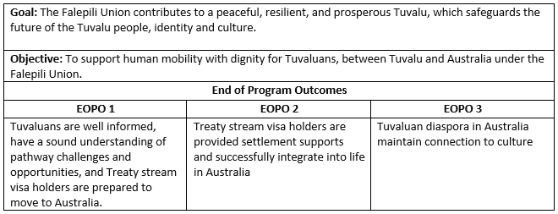

Contributing to each of these EOPOs, the Mobility Pathway Program should achieve a range of intermediate outcomes and the following underpinning enabling outcome: *Learning from investments in Pacific mobility (e.g. Pacific Engagement Visa, Pacific Australia Labour Mobility Family Accompaniment) informs Government of Australia (GoA) policy and programming*.

In general, a successful Mobility Pathway will:

* Provide information to participants in an effective, digestible, inclusive, practical, and culturally sensitive manner, which enables them to make informed decisions about whether to participate.
* Prepare visa holders for life in Australia prior to departure with a focus on specific initiatives for families with children who are going into Australia schools, addressing issues for those with disability and the elderly, and meeting the needs of women.
* Support participants to settle into life in Australia and gain access to services, education and training opportunities, employment, and accommodation while working closely with the diaspora.
* Promote opportunities to retain connection to culture for both the newly arrived and the diaspora.
* Keep families together.

## **Delivery Approach**

The delivery approach has been developed in consultation with Australia and Tuvalu and has been designed with a human centric approach and focused on the intended EOPOs. It has inbuilt flexibility and is scalable to accommodate changes in the visa settings and/or feedback from governments and visa holders. An integrated program of support was identified as the most appropriate option, maximising opportunities for the Mobility Pathway.

DFAT has engaged an interim service provider to deliver services in Tuvalu until 31 December 2025. DFAT is also planning to engage an interim service provider for settlement services in Australia from 1 July until 31 December 2025. From 1 January 2026, DFAT is considering engaging a single ISP or MSP to deliver services in both Australia and Tuvalu under one contract. However, DFAT is open to suggestions from industry on the best approach.

Results and lessons from the interim services provided in both Tuvalu and Australia will also contribute to the final program design and contract.

## **Program Structure**

Visa holders may face significant challenges when settling in Australia. Australian society comprises many social norms, customs and formal and informal rules and values with which Tuvaluans may not be familiar. Issues such as the relatively high cost of living in Australia, housing shortages, and the more individualist society, may present significant adjustments for visa holders. Liaison officers (LO) will be key to successful integration. The overall process is depicted below.

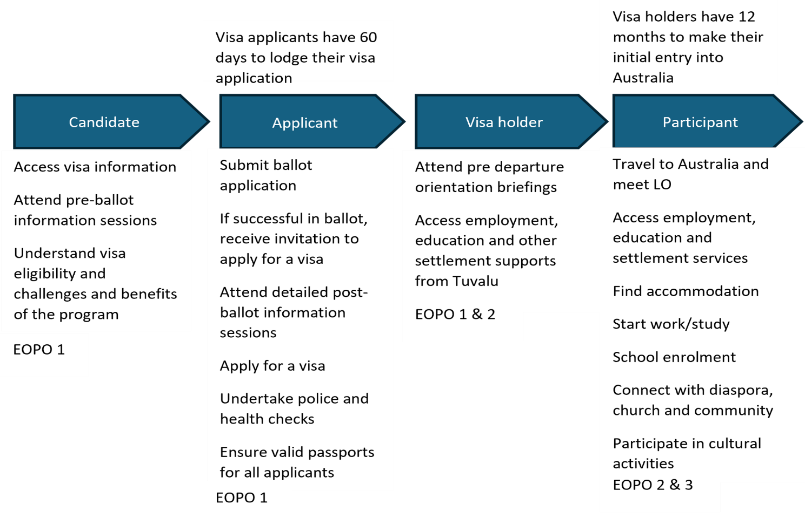

**Key features of the Mobility Pathway Program include:**

## **Pre-ballot preparatory activities**

Initial preparatory activities in Tuvalu ensure that Tuvaluans know about the Mobility Pathway, have an overview of life in Australia, and understand the realistic costs and challenges of moving to and living in Australia.

A Mobility Pathway Hub should be established by the interim and long-term service provider in Funafuti to provide and share information about the pathway and Australian life in general. The Hub should also provide computer facilities and support to submit ballot registrations and visa applications for people who do not have their own access to a computer or the internet and support other elements of the visa process (e.g. liaising with health providers in Tuvalu for mandatory checks).

First Nations communications contractor Wolf Lab, which specialises in storytelling and documentaries, has already begun to produce a series of short videos in Tuvaluan (with English subtitles) about various aspects of the Mobility Pathway and the challenges and opportunities of life in Australia. These will show day to day life in Australia, the scale of the Australian landmass, and the differences in climate and lifestyle. It will also include interviews with the Tuvaluan diaspora in Australia.

Wolf Lab will also develop a website for Tuvaluans considering applying for the Treaty stream visa. People can access the website and videos on their phones and computers, and at the Mobility Pathway Hub in Funafuti. It will include links to the Home Affairs website on the Treaty stream visa, including the ballot and visa application process. The long-term ISP or MSP may be required to support public diplomacy and communications activities beyond those outlined above.

A series of pre-departure briefings (PDBs) should also be held on all eight inhabited islands. The Government of Tuvalu will support and be active in the public awareness campaign to ensure all interested Tuvaluans have access to information. This will include disseminating communications materials and engaging with relevant ministries and agencies (such as health, police and passports) to support pre-departure activities and checks. Community and church leaders will also need to be engaged to play a role in information dissemination. This approach enables citizens to make an informed choice about ballot participation. All family members of a suitable age, not just family representatives, should attend the PDBs to increase understanding of the challenges and risks. It will be important to ensure the PDBs are customised to their audience, not seen as patronising, and not overloading participants with too much information at once. The information provided must be digestible and presented in a culturally suitable manner.

## **Post-ballot / pre-departure preparatory activities**

Briefings and services for applicants successful in the ballot prior to departure should contain more detail than the pre-ballot briefings, have a family focus, and include information (or how to access information) about:

* Preparation to leave Tuvalu, immigration processes, what to take to Australia.
* Support structures available through the Mobility Pathway Program and general support services in Australia.
* Life in Australia, including education, health care, welfare services, finance and banking, legal matters, driving, child protection, gender equality, labour rights, protections and laws against family and gender-based violence and sexual harassment, training and employment opportunities, religion, communications, and work values.
* Access to skills development
  + Life skills such as English language, financial literacy, digital literacy and safety, navigating insurance and superannuation, and safe driving.
  + Employability skills including job applications, communication, resume preparation, interview conduct, time management, understanding the role of unions, and teamwork.
  + Vocational skills and qualifications, including general construction ‘white cards’, forklift driving, trades, cookery, and occupational health and safety.
* The Tuvaluan diaspora and other Pacific communities, and Pacific culture in Australia.
* Specific initiatives to support the elderly, women and people living with disability, and other vulnerable groups, with tailored information and access to employment pathways.

The Government of Tuvalu could consider facilitating the use of national and other training institutes, such as Tuvalu Atoll Science Technology Training Institute (TASTTI), as possible venues for proposed training and briefings.

The interim service provider and longer-term ISP or MSP will be required to establish a case management system to collect information and organise client interactions in Tuvalu, prior to departure, and after arrival in Australia. Individual Case Management Plans (CMP) would be accessible and updateable both in Tuvalu and Australia and would be a key part of understanding and responding to individual needs and tracking their settlement journey. Prior to departure, this would include information such as visa holder biodata, accommodation, aspirations, skills, vulnerabilities, preparation training undertaken, and any required special supports. DFAT may seek access to the CMPs through the service providers.

## **Settlement services in Australia**

Visa holders should have access to a range of support services and benefits to facilitate their settlement in Australia. The diaspora community wants to be involved in the settlement process. This may be something the interim service provider and longer-term ISP or MSP seek to investigate further. However, DFAT is conscious of the demands this may have on diaspora members and welcome a solution that does not overburden them and ensures they are fairly compensated for services provided.

DFAT envisages the CMP being a key tool in the settlement process. During the interim service provider period up to 31 December 2025, individual CMPs should be provided by the interim service provider in Tuvalu to the interim service provider in Australia (prior to the visa holder’s departure). Liaison Officers (LOs – see text box) should review the client CMPs prior to arrival. Full-time LOs that understand the Tuvaluan culture and language, must be based in the main diaspora population centres. Their CMP review should identify issues including, but not limited to, the below:

* Required information to facilitate settlement.
* Required services and benefits, and eligibility for these.
* How current education, experience, and skills may be useful to secure employment (if employment is not secured in advance) and/or steps required to improve employability.

The LOs will be required update the CMPs by including developments such as, but not limited to:

* Challenges faced and actions taken
* Education and training undertaken, and skills, experiences and qualifications acquired
* Employment status and history
* Education status (for children)
* Family status
* Housing status
* Services and benefits accessed
* Participation in cultural activities
* Connection with the diaspora and broader community.

The LOs may be required / used to provide settlement support, including, but not limited to:

* Support for employment and skills training such as introduction to opportunities with possible employers; resume assistance; trade apprenticeships; and identification of gaps in the labour market.
* Provision of information on and support for application to government, non-government and private sector support services available, in line with their eligibility, including, but not limited to:
  + Medicare
  + Family Tax Benefit and Child Care Subsidy
  + National Disability Insurance Scheme
  + Settlement Engagement and Transition Support (SETS), medical and health care etc.
  + Adult Migrant English Program (AMEP)
  + Family services, including supports, counselling and emergency services relating to family violence and child protection
  + Allied and mental health services, including for sexual and reproductive health and family planning and disability service providers
  + Migrant resource centres
  + Financial management and digital literacy support
  + Crisis and emergency support.

Participants will not have access to income support payments, such as JobSeeker Payment, Parenting Payment, and Disability Support Pension, until the relevant waiting period for the payment is completed (some exemptions may apply).

In principle the individual CMPs and support by LOs should be maintained for a period of one-year after initial arrival in Australia (or from day-one of receipt of the visa if already residing in Australia). However, after one year, if the ISP or MSP identifies that further support is required, CMP and LO support may continue after written approval from DFAT.

Beyond the employment of Tuvaluan speaking LOs, sustainably harnessing the tightknit social networks of the Tuvaluan and broader Pacifica diaspora in Australia will be fundamental to families’ social and economic transition, whilst also offering significant opportunities to help sustain Tuvaluan values and culture. However, we must be cognisant of gender roles and cultural expectations, and ensure the diaspora is not unduly burdened.

Given the ongoing commitment to the Falepili Mobility Pathway by both governments beyond the close of this contract, service providers for services in Australia will be required to take a long-term approach to the development of LOs. DFAT is open to proposals on how LOs can be developed and best deployed to support the settlement of visa holders.

Service providers in Australia will be required to employ LOs that understand Tuvaluan culture and language in major diaspora population centres. DFAT is interested in seeing a proposal which helps LOs to gain the necessary skills, experience, and knowledge to support the visa holders in a skilled and professional manner.

The number of visa holders to arrive in Australia in calendar year 2025 is expected to be low due to departure preparation and visa processing. DFAT envisages LOs would be able to provide settlement services for other migrants outside of the Mobility Pathway as a form of on-the-job training to build skills. If appropriate, they may also undertake formal training in migrant settlement services.

To help ensure an ongoing suitable number of LOs, the establishment of a pipeline of new trainee LOs should be part of the proposal. The number of LOs working on the Mobility Pathway may be adjusted according to demand.

DFAT recognises the need for a Cultural Heritage Officer (CHO). This role will support ongoing connection to Tuvaluan culture (language, values, beliefs) and improve cultural understanding of Tuvalu in Australian society. The CHO should work with the diaspora, the Tuvaluan High Commission, civil society, and local government to identify and develop initiatives for cultural celebration and retention in Australia. DFAT is seeking a solution or proposal which combines the role of the CHO with other duties. The CHO may be a part-time position.

To further support cultural activities, DFAT will establish a Tuvaluan grants program. The CHO in consultation with stakeholders, would be involved in developing proposals for grant funding (including measures for success) for sustainability and wherever possible, elements of cost-sharing. The CHO will seek joint funding or in-kind support for cultural activities from other entities such as local and state governments, multicultural organisations, private industry, and non-government organisations. Recognising cultural variations across Tuvalu’s eight islands will be important. A Tuvaluan speaker is required for this position.

Examples of cultural activities include:

* Programs to promote language, traditions, handicrafts, music, storytelling, and dance.
* Celebrations of cultural significant days such as Independence Day, Gospel White Sunday, Gospel Day, Easter and Christmas.
* Events that showcase Tuvaluan culture, such as Pasifika festivals.

The important roles of Church and a communal meeting space such as a *maneapa* or *falekaupule* were also highlighted in diaspora consultations although provision of such a facility is out of scope for this program.

In consultations, the Tuvaluan diaspora indicated their willingness to be involved in settlement of visa holders as long as there was support to reduce possible burdens.

As well as Tuvaluan speaking LOs and the CHO, DFAT would like service providers to draw from their experience, think creatively, and propose ways to involve the diaspora in settlement assistance. The fact that the cohort of up to 280 visa holders is small compared to other migrant cohorts should also be taken into consideration.

Services provided by the diaspora would have to be of a professional standard, meet industry and safety requirements, and uphold the dignity of visa holders. The involved members of the diaspora should be fairly compensated for these services

The service provider would be responsible for: managing services provided by the diaspora; ensuring safety and quality standards are met; providing services equitably; and payment for services in a transparent and legal manner.

There may also be cases where a visa holder does not want to engage with the diaspora. Suitable support for such visa holders should also be considered in the proposal. There needs to be flexibility in the program design to accommodate the different levels and kinds of support needed.

## **Organisational Structure**

An indicative organisational structure is below (noting this will look different for the interim service provider versus the ISP or MSP). However, DFAT welcomes alternative suggestions from tenderers as part of the procurement process.

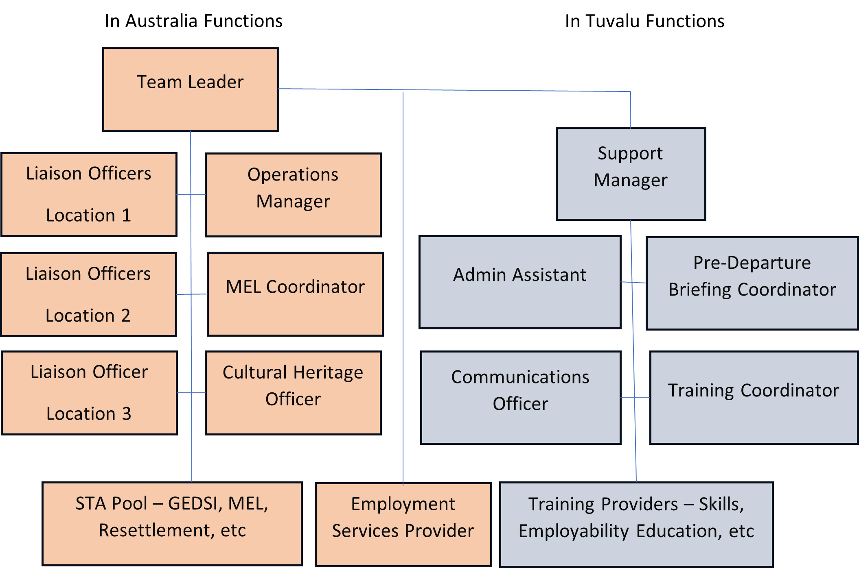

The in-Tuvalu team for the Mobility Pathway should work closely with the Falepili Union Implementation Unit within Government of Tuvalu to ensure good access to GoT, alignment with goals, coordination, and information sharing.

## **Monitoring, Evaluation and Learning (MEL)**

The service providers will be required to establish a Monitoring, Evaluation and Learning (MEL) system which provides opportunities to feed learning from program and participant’s experiences back into program planning and adaptation, to support outcomes. Participants and diaspora members must be provided with a mechanism to provide constructive feedback on the program. This could be achieved through the LOs and/or a web-based system. The MEL system should also aim to inform Australian Government Pacific migration policy settings and various mobility pathway designs. This will be important during the interim phase to the end of the 2025 calendar year.

The program must include the development of a MEL approach that meets DFAT standards and responds to three purposes:

* To guide learning and improvement within the program
* To demonstrate accountability to DFAT and Government of Tuvalu and their constituencies
* To share knowledge relating to Pacific mobility.

MEL planning and implementation should be guided by the following principles:

* **Focus on intended uses**. Key questions, data collection, learning and reporting processes are framed by the intended uses of MEL.
* **Keep it simple.** The MEL approach is relatively lean, focused on generating ‘just enough’ evidence to inform intended uses.
* **Work collaboratively with partners.** In line with the program’s focus on facilitating self-agency and local leadership, the program will work collaboratively with partners on data collection, analysis, and sense-making.
* **Use a mixed methods approach**. The MEL system will capture a mix of quantitative and qualitative data to enable tracking progress over time and rich insights about how change is happening.
* **Demonstrate cultural competence.** Data collection and sense-making processes will use methods appropriate to Tuvaluan culture, such as informal, lightly structured, and story-based interview methods in the first languages of participants.
* **Meet DFAT standards.** MEL planning and implementation will be guided by DFAT’s MEL standards and Ethical Research and Evaluation Guidance Note.

## **Drawing on other Programs**

While two other Australian visa offerings are currently available to Tuvaluans, namely, the Pacific Australia Labour Mobility Scheme (PALM), a temporary visa, and the Pacific Engagement Visa (PEV), a permanent residency visa, the Falepili Mobility Pathway will provide a more comprehensive range of support measures to participants and their families on arrival in Australia and have less restrictions on eligibility.

The Falepili Mobility Pathway can draw on lessons from the other two visas. For example, Experience from the PALM scheme has highlighted the importance of preparation, and the causal link between being well-prepared and the successful integration into life in Australia. As well as PALM and PEV, New Zealand’s Pacific Access Category and Samoa Quota (PAC and SQ) programs and its Recognised Seasonal Employment limited visa have also been reviewed.

The Pacific Australia Skills program is Australia’s new investment in skills development within the Pacific and Timor-Leste. There may be significant opportunities for connectivity and collaboration between Pacific Australia Skills and Falepili Mobility Pathway support. Importantly, Pacific Australia Skills may support the capacity development of local vocational training institutions.

## **Cross Cutting Issues**

*Gender Equality, Disability and Social Inclusion (GEDSI)*

Significant opportunities should be built into the design to ensure that women, people with disability, the elderly, and other vulnerable groups are provided with information about the forthcoming ballot, as well as tailored briefings and preparation, and targeted settlement support. DFAT recommends using specific GEDSI-based approaches, including:

* A twin track approach that applies a mainstreaming lens across program activities as well as pursuing targeted activities.
* Incorporating GEDSI indicators and disaggregated data within the program logic and MEL framework.
* Proactive monitoring of risks relating to GEDSI.

**Climate Change**

Whether Tuvaluans seek to emigrate or adapt in situ, climate change means life in Tuvalu will not remain as it is. In Tuvalu, the current and near-term impacts of climate change on livelihoods, and the longer-term existential threat, will be part of Tuvaluan’s decision to stay or leave. Australia has its own set of climate hazards. To avoid maladaptation – moving from one high-hazard location where the hazards are understood/familiar (Tuvalu), to an unfamiliar high-hazard location (e.g. extreme heat, peri-urban bushfire in Australia) – climate hazards in Australia need to be understood. As such, service providers must ensure ballot and visa applicants are aware of these and how they differ from hazards in Tuvalu.

**Locally led Development**

DFAT will establish a Consultative Committee made up of government, program participants and a representative from the ISP or MSP to guide decision-making, policy development and implementation. The in-Tuvalu support coordination will be accessed locally and will be accommodated within one of the Government of Tuvalu ministries.